Sulphide-toxic habitats are not refuges from parasite infections in an extremophile fish

Rüdiger Riesch^{1*}, Neil J Morley¹, Jonas Jourdan², Lenin Arias-Rodriguez³, Martin Plath⁴

¹ Department of Biological Sciences, Royal Holloway University of London, Egham, TW20 0EX, United Kingdom
² Department of Aquatic Ecotoxicology, Institute for Ecology, Evolution and Diversity, Goethe University Frankfurt am Main, Frankfurt am Main, Germany
³ División Académica de Ciencias Biológicas, Universidad Juárez Autónoma de Tabasco (UJAT), Villahermosa, Tabasco, México
⁴ College of Animal Science and Technology, Northwest A&F University, Yangling, Shaanxi 712100, P.R. China

* correspondence: Rudiger.Riesch@rhul.ac.uk
ABSTRACT
We still have a limited understanding of why animals colonize extreme environments, but one hypothesis (the Pathogen Refuge Hypothesis, PRH) posits that they might represent a safe haven from parasites and other pathogens. We tested this idea by quantifying endoparasite infections in five populations of the neotropical freshwater fish Poecilia mexicana, three populations from toxic, H₂S-rich habitats and two control populations from nearby rivers and creeks. Counter to predictions derived from the PRH, only P. mexicana from toxic habitats harboured heterophyid metacercariae in their hearts. We further uncovered differences in parasite prevalences and abundances between the three toxic habitats. Our results provide evidence against the PRH and add depth to our understanding of life in (and adaptation to) extreme environments.

Keywords: ecological speciation, Poecilia mexicana, parasitism, hydrogen sulphide, trematode metacercariae, Pathogen Refuge Hypothesis

1. Introduction
The colonization of extreme environments is, by definition, associated with costly adaptations to cope with the physical and/or chemical stressors that render these habitats extreme (Townsend et al. 2003). This makes it difficult to explain why organisms would ever actively invade and colonize such habitats, although it is also possible that some ‘extremophiles’ originally entered the extreme environment by accident, became trapped, and then had to ‘adapt or perish’ (Danielopol & Rouch 2005).
The Pathogen Refuge Hypothesis posits that one potential side-benefit of invading extreme environments might come into play if these environments act as a refuge from parasites and other pathogens, which could partially balance out the costs associated with survival (at an early stage) and local adaptation (at a later stage) to the extreme conditions (Kruckberg 1992; Springer et al. 2007; Tobler et al. 2007a). While recent research has shown that extreme environments are not entirely free of parasites (Tinsley 1999; Martinez & Merino 2011; Carlsson et al. 2012; Tobler et al. 2014), several studies have indeed provided evidence for a reduction of at least certain types of parasites in extreme habitats (e.g., oil-pollution and ectoparasites on guppies, Poecilia reticulata: Schelkle et al. 2012; pathogens on serpentine flax, Hesperolinon spp.: Springer 2009; fish ectoparasites in toxic hydrogen sulphide-rich habitats: Tobler et al. 2007a; high salinity and chytrid fungus infections in eastern dwarf tree frogs, Litoria fallax: Stockwell et al. 2015; but see Springer et al. 2007).
Here, we make use of the well-established study system of Mexican livebearing fishes (family Poeciliidae) undergoing population divergence and speciation in toxic hydrogen sulphide (H₂S)-rich aquatic habitats (Tobler et al. 2018). Previous research has investigated some aspects of host-parasite interactions in these systems (Tobler et al. 2007a, 2014), and suggested that H₂S-rich habitats might indeed act as a refuge from certain ectoparasites (Tobler et al. 2007a), while overall parasite diversity was quite high and individual-level parasite loads were actually higher in H₂S compared to non-H₂S habitats (Tobler et al. 2014). However, previous studies only focused on some external and internal organ systems, while internal organ systems critical to physiological homeostasis and immediate survival have so far not been screened for parasites. To fill this critical gap of knowledge, we quantified parasitism of internal organs while specifically focussing on the liver, heart and brain of Poecilia mexicana from three sulphidic habitats (including an H₂S-rich cave) and two non-sulphidic habitats, and we asked if sulphidic habitats might act as a refuge from parasites infecting these organs.

2. Material and methods
2.1. Study system
Male, female and juvenile Atlantic mollies (P. mexicana) were collected in 2014 in the southern Mexican state of Tabasco using seines or dip nets. We collected fish from three sulphidic sites of very similar H₂S concentrations (~20 µM; Tobler et al. 2008, 2011): the surface streams El Azufre (EA; latitude: 17.44225, longitude: -92.77447) and La Lluvia (LL; 17.46387, -92.89541), and from chamber V of a sulphidic cave, the Cueva del Azufre (CdA; 17.44234, -92.77542). We also collected them from two non-sulphidic reference sites: the Río Puyacatengo (Puy; 17.47000, -92.89573) and the Río El Azufre, west branch (REA; 17.55634, -93.00762; Fig. 1; for additional habitat descriptions, please see Tobler et al. 2011). Immediately upon capture, fish were anaesthetized with clove oil, and then preserved in 10% formaldehyde solution.
Despite the spatial proximity of CdA and EA, we argue that they constitute independent sampling sites: our previous research has demonstrated strong reproductive isolation between P. mexicana populations from both sites (e.g., Plath et al. 2007, 2010; Tobler et al. 2009). They are ecologically different habitats, with EA being a toxic surface creek while CdA represents a toxic subterranean habitat (Plath et al. 2007, 2010; Tobler et al. 2009), and a previous study reported differences in fish parasite communities (Tobler et al. 2014).

2.2. Data collection
The body length and weight of all specimens were recorded before they were dissected and all organs as well as body wall musculature were examined for metazoan parasites using standard parasitological techniques (Buchmann 2007). In short, the external body surface and mouth cavity were examined under a Zeiss stereo dissecting microscope. All internal organs, tissues, eyes, and gills were removed, dissected, and examined under a Zeiss Axioskop compound microscope. Any parasites found were noted and counted.

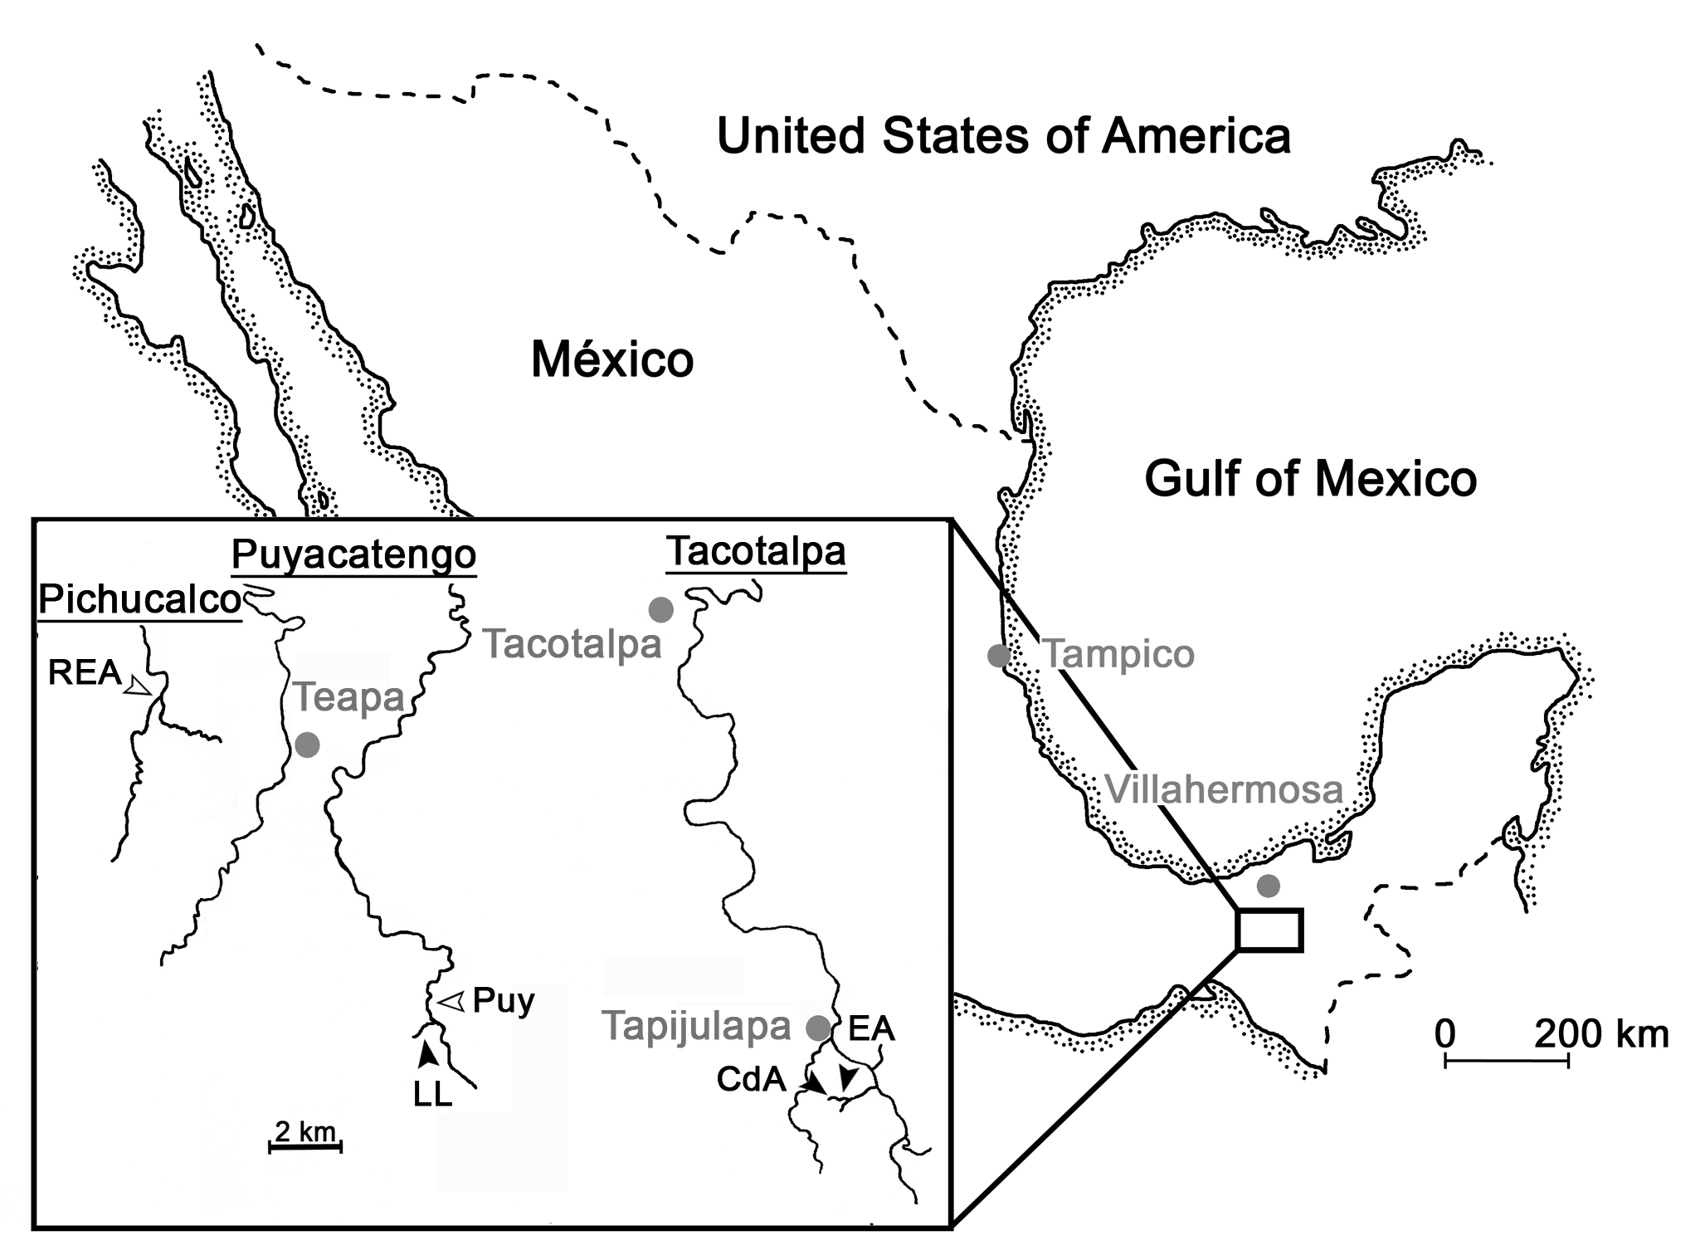
Figure 1. Overview of the study area with reference cities in grey. Drainages are underlined, and black arrows indicate the location of sulphidic sampling sites, while white arrows indicate the location of non-sulphidic sampling sites. CdA: Cueva del Azufre, chamber V; EA: El Azufre; LL: La Lluvia; Puy: Río Puyacatengo; REA: Río El Azufre, west branch (modified after Plath et al. 2013).
2.3. Statistical analyses
First, we compared the prevalence of parasites between sulphidic and non-sulphidic habitats by means of a Fisher’s Exact test. This was followed by another Fisher’s Exact test to investigate differences in prevalence of parasites between males, females, and juveniles. Both analyses were conducted in IBM SPSS Statistics Version 21.
The prevalence (percentage of fish in each sample infected with a parasite species), mean intensity (mean number of parasites per infected host), and mean abundance (average occurrence of a given parasite species among all members of a particular host population) were calculated according to Bush et al. (1997). We tested for differences in these indices between populations from sulphidic habitats by means of χ²-tests (prevalence) and bootstrap two-sample t-tests (mean intensity and abundance) using the Quantitative Parasitology 3.0 statistical package (Reiczigel & Rozsa 2005).

3. Results
3.1. Parasite infections
Examinations of 113 P. mexicana from the five habitats revealed no parasites in any organs except for the hearts of fish from sulphidic sites, which harboured infections with trematode metacercarial cysts of the family Heterophyidae. Metacercariae in the heart were found only in the bulbus arteriosus. Intensity of infections ranged from 1 to 33 in each infected fish. In heavily parasitized individuals, the bulbus arteriosus was enlarged, with metacercarial cysts occasionally observed lodged in the confluence with the ventral aorta. Cysts were found either individually within the lumen of the bulbus arteriosus (Fig. 2a) or in clusters held together by host-derived fibrous tissue (Fig. 2b). In non-sulphidic sites, the fish were not infected by any metazoan parasites (Table 1) and consequently, there was a significant difference in parasite prevalence between the two kinds of sites (Fisher’s Exact Test: P < 0.001; Fig. 2c).

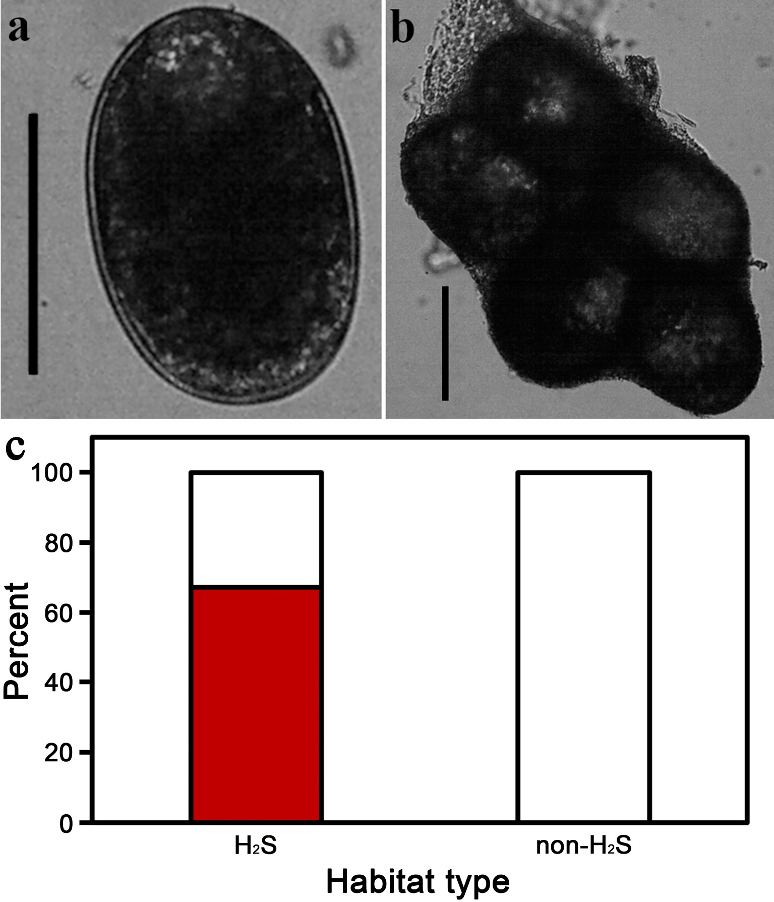
Figure 2. (a) Heterophyid metacercarial cyst isolated from the bulbus arteriosus of P. mexicana (scale bar = 100 μm). (b) Clusters of heterophyid metacercarial cysts surrounded by host-derived fibrous tissue from the bulbus arteriosus (scale bar = 100 μm), and (c) parasite prevalence with proportion of infected fish (dark red) and non-infected fish (white) in sulphidic vs. non-sulphidic habitats.
Table 1. Body size and weight of P. mexicana from sulphidic and non-sulphidic sites and level of infection with heterophyid metacercariae. Condition factor K was calculated as 1,000 × weight [g] / length [mm]³; following Tobler et al. (2006).

Habitat |  | N | Mean standard length ± s.d. (range) [mm] | Mean weight ± s.d. (range) [g] | Condition factor K ± s.d. (range) | Prevalence [%] | Mean intensity ± s.d. | Mean abundance ± s.d.
Sulphidic sites
 | Cueva del Azufre V | 33 | 23.15 ± 6.00  (12-36) | 0.32 ± 0.19  (0.06-0.80) | 0.025 ± 0.010  (0.016-0.075) | 63.6 | 10.57 ± 10.55 | 6.72 ± 9.81
 | El Azufre | 27 | 23.52 ± 11.22  (11-52) | 0.48 ± 0.64  (0.02-2.85) | 0.026 ± 0.012  (0.014-0.083) | 85.2 | 9.22 ± 8.37 | 7.82 ± 8.39
 | La Lluvia | 13 | 27.92 ± 4.97  (19-36) | 0.54 ± 0.26  (0.16-1.11) | 0.024 ± 0.005  (0.020-0.041) | 38.5 | 5.60 ± 4.78 | 2.15 ± 3.95
Non-sulphidic sites
 | Puyacatengo (upstream) | 31 | 27.74 ± 5.20  (19-38) | 0.55 ± 0.30  (0.18-1.37) | 0.024 ± 0.005  (0.020-0.046) | 0 | — | —
 | Río El Azufre  (west branch) | 9 | 34.67 ± 13.83  (22-69) | 1.69 ± 2.81  (0.26-9.12) | 0.026 ± 0.002  (0.023-0.028) | 0 | — | —-

3.2. Differences in metacercarial infections within sulphidic habitats
Comparing different age classes and sexes (N = 11 juveniles, N = 8 males and N = 54 females) of fish from sulphidic habitats, we found no significant differences with respect to the prevalence of heterophyid metacercariae (Fisher’s Exact test: P = 0.429; Fig. 3a). Comparisons of infections between the three sulphidic sites (interpreted at α = 0.025 to correct for multiple testing) revealed no significant differences between the cave habitat (CdA) and the two surface streams (EA and LL) in metacercarial prevalence (χ² ≤ 3.526, P ≥ 0.060; Fig. 3b) or mean intensity (t ≤ 1.583, P ≥ 0.123), although there was a non-significant trend for differences in abundance between CdA and LL (t₄₄ = 2.253, P = 0.033; Fig. 3c). Nonetheless, metacercarial prevalence and mean abundance, but not mean intensity, were significantly different between the two sulphidic surface stream sites (prevalence: χ² = 9.122, df = 1, P = 0.003; mean abundance: t₃₈ = 2.920, P = 0.005; mean intensity: t₂₆ = 1.312, P = 0.221).
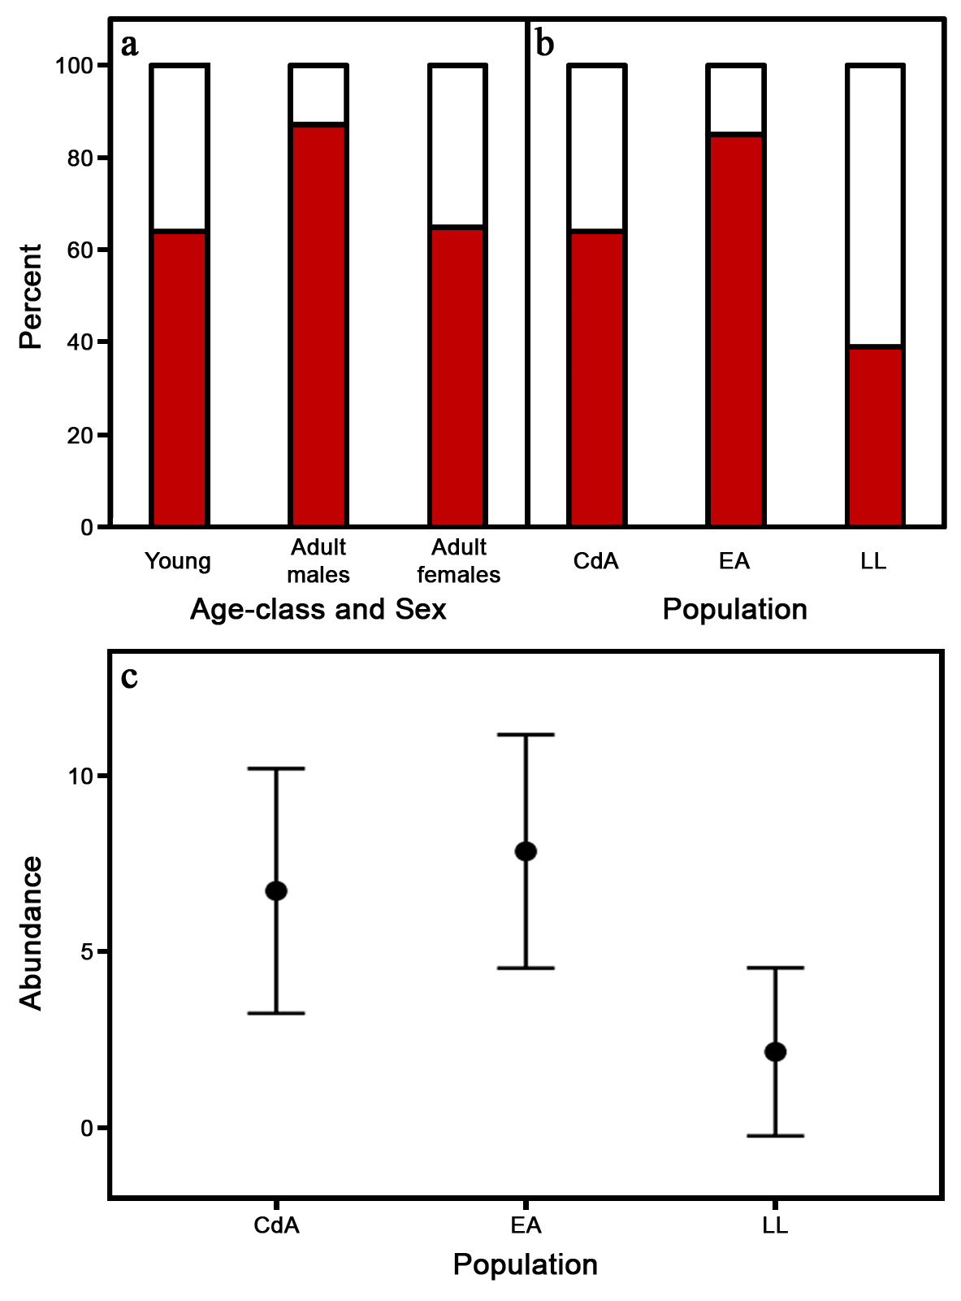
Figure 3. (a) Parasite prevalence in sulphidic habitats, with infected fish shown in dark red and non-infected fish in white, in juvenile fish and adults of both sexes, and (b) parasite prevalence across the three sulphidic habitats (across sexes and life stages); (c) mean (± 95% CI) parasite abundance across the three sulphidic habitats. CdA: Cueva del Azufre, EA: El Azufre, LL: La Lluvia.

4. Discussion
Contrary to our a priori prediction, we only found endoparasites in fish from sulphidic habitats, providing strong evidence against the Pathogen Refuge Hypothesis (Kruckeberg 1992; Springer et al. 2007; Tobler et al. 2007a). Surprisingly, we did not discover any parasites in fish from non-sulphidic sites, which could partly be explained by those habitats harbouring a diverse fish community (Riesch et al. 2009), so parasite prevalence in P. mexicana from those habitats might be diluted due to the parasites also having additional host species (including several other poeciliids) available (e.g., Civitello et al. 2015). Moreover, predatory fish are usually lacking from sulphidic habitats (e.g., Tobler et al. 2006), but bird predation rates are substantially greater in sulphidic surface than non-sulphidic surface habitats (Riesch et al. 2010), and invertebrate piscivores occur in high densities—and are strong predators of P. mexicana—in all sulphidic habitats including the cave (e.g., Belostoma sp.: Tobler et al. 2007b; several species of spiders: Horstkotte et al. 2010). Hence, it is possible that predators remove parasitized fish faster in non-sulphidic than sulphidic habitats, and this could help explain the lack of metacercariae in P. mexicana from non-sulphidic habitats in our present study. However, we find this scenario less likely.
We further found evidence for some differences between sulphidic habitats, with LL being different from CdA and EA. Since all three sites have very similar H₂S-levels (Tobler et al. 2008, 2011), this might reflect some, as yet unidentified, differences between the two different drainages in which these sites are situated (e.g., encounter rates with definitive hosts, see below).
Heterophyid metacercariae are a dominant group of trematodes parasitizing fish in Mexico (Scholz et al. 2001). Adult parasites typically live in the intestines of fish-eating mammals and birds. Eggs produced by sexually-mature worms are passed out with faeces and can be ingested by aquatic snails, in which asexual development, from sporocysts to redia, occurs. The redia eventually produce cercariae—a free-living stage—which emerge from the snail to locate and infect a fish host where it encysts into metacercariae, a largely dormant stage, waiting for the chance to complete its development if the fish is eaten by a piscivorous mammal or bird (Scholz et al. 2001). High intensity infections of heterophyid metacercariae in the bulbous arteriosus of fish are known to cause mechanical blockage of the heart, inhibiting normal blood flow and decreasing swimming endurance (Coleman 1993). Heavily parasitized fish are more quickly exhausted and consequently cease swimming, thereby increasing the likelihood of predation by a piscivorous vertebrate and promoting the continued maintenance of the parasite’s life cycle.
It is not known if the metacercariae recovered in the present study are the result of complete cycling of the parasite’s life history within sulphidic habitats or if the fish infections simply represent a ‘dead end’. However, while the exact species are currently unknown, snails are indeed available in all sulphidic habitats, including the sulphidic cave (Roach et al. 2011). Similarly, piscivorous birds are particularly common around sulphidic surface habitats (Riesch et al. 2010). While birds are absent from the sulphidic cave, tracks and scat found in the cave during our field work (RR, JJ, MP and LAR, personal observation) suggest that nocturnal piscivorous mammals, such as racoons (Procyon lotor) or the water opossum (Chironectes minimus argyrodytes), indeed venture into the cave on a fairly regular basis, and could thus act as definitive hosts for this parasite.
A previous study focusing on another trematode (Uvulifer sp.), encysting in the skin, found their prevalence on P. mexicana to be highly reduced in sulphidic habitats and to be absent in the sulphidic cave (Tobler et al. 2007a). Given the results from our current study, this is somewhat surprising since they would largely rely on similar hosts as the hetrophyid trematodes we discovered in the hearts of P. mexicana, and both have free-living cercaria stages. These differences in prevalence could be explained by two not mutually exclusive hypotheses. First, the location of infection within P. mexicana coupled with the extreme toxicity of hydrogen sulphide (Tobler et al. 2018): Uvulifer sp. burrow into the skin and then encyst relatively close to the body-water interface (Tobler et al. 2007a), while the hetrophyid trematodes we report on here encyst in the heart. For trematodes in the heart, the fish’s body acts as a shield against H₂S-toxicity. Poecilia mexicana has evolved several genetic modifications to detoxify H₂S entering the body or physiologically cope with H₂S-toxicity (e.g., cox-gene evolution; Pfenninger et al. 2014). Uvulifer metacercariae, on the other hand, would only have a relatively thin layer of fish tissue protecting them from direct long-term exposure to H₂S. Second, adult Uvulifer sp. typically live in the intestines of kingfishers (their preferred definitive host; Hoffman 1999), and piscivorous birds do not frequent the Cueva del Azufre.
Low quality environments can have varying effects on the occurrence of trematodes in fish and molluscs (Lafferty 1997; Morley et al. 2003, 2006; Vidal-Martinez et al. 2010), which may be the result of the exposure of free-living stages to environmental stressors. Unfortunately, the effects of sulphidic environments on trematodes are poorly understood, and so we currently do not know how the free-swimming cercariae of both trematodes cope with short-term H₂S toxicity. Future genomic studies including these parasites would be of great interest, and the evolution of, for instance, metabolic pathways in P. mexicana (see Kelley et al. 2016) and heterophyid parasites could be another example of host-parasite coevolution.
Regarding the Pathogen Refuge Hypothesis (Kruckberg 1992; Springer et al. 2007; Tobler et al. 2007a), the picture is now becoming more complex. While previous studies often found support for this hypothesis with respect to certain extreme environments and certain parasite species (Tobler et al. 2007a; Springer 2009; Schelkle et al. 2012; Stockwell et al. 2015), our study adds to the literature that found evidence against the hypothesis (see also Springer et al. 2007). Clearly, whether or not the colonization of extreme habitats is a result of patterns congruent with the Pathogen Refuge Hypothesis is system- and pathogen-specific. Nonetheless, our study demonstrates that selective regimes stemming from pathogens and parasites in extreme environments are more complex than often assumed.
Data availability
Data underlying this study can be found in the Supplementary material, Table S1.
Author contributions
JJ and LAR collected the fish; RR conceived the idea for the study; NM collected the data; NM and RR analysed data; RR and MP drafted the first manuscript version, all authors contributed to revisions, gave final approval for publication, and agree to be held accountable for the content herein.
Acta Oecologica journal policies
Have been reviewed.
Funding
Our field work was supported by the DFG (PL 470/3-1).
Declaration of competing interests
None.
Ethics
The study complies with the current laws on animal experimentation of the United Kingdom; no specific ethics approval was needed.
Acknowledgements
We thank S Hornung, K Lipkowski and C Zimmer for help during field work. We further thank C. Sommer-Trembo and an anonymous reviewer, whose valuable comments helped improve the manuscript. Collection of fish in Mexico was conducted under the authorization and regulations of the Mexican Federal Agency CONAPESCA: PRMN/DGOPA-003/2014.

References
Buchmann K (2007) An introduction to fish parasitological methods: Classical and molecular techniques. Biofolia, Freferiksberg.
Bush AO, Lafferty KD, Lotz JM, Shostak AW (1997) Parasitology meets ecology on its own terms: Margolis et al. revisited. J Parasitol 83:575-583.
Carlsson AM, Justin Irvine R, Wilson K, Piertney SB, Halvorsen O, Coulson SJ, Stien A, Albon SD (2012) Disease transmission in an extreme environment: Nematode parasites infect reindeer during the Arctic winter. Int J Parasitol 42:789–795.
Civitello DJ, Cohen J, Fatima H, Halstead NT, Liriano J, McMahon TA, Ortega CN, Sauer EL, Sehgal T, Young S, Rohr JR (2005) Biodiversity inhibits parasites: Broad evidence for the dilution effect. Proc Natl Acad Sci USA 112:8667-8671.
Coleman FC (1993) Morphological and physiological consequences of parasites encysted in the bulbus arteriosus of an estuarine fish, the sheepshead minnow, Cyprinodon variegatus. J Parasitol 79:247-254.
Danielopol DL, Rouch R (2005) Invasion, active versus passive. In: Encyclopedia of Caves (eds DC Culver, WB White), pp. 305–310. Elsevier Academic Press, Burlington, MA.
Hoffman GL (1999) Parasites of North American freshwater fishes. Second ed. Cornell University Press, New York.
Horstkotte J, Riesch R, Plath M, Jäger P (2010) Predation by three species of spiders on a cave fish in a Mexican Sulphur cave. Bull Brit Arachnol Soc 15:55-58.
Kelley JL, Arias-Rodriguez L, Martin DP, Yee M-C, Bustamante CD, Tobler M (2016) Mechanisms underlying adaptation to life in hydrogen sulfide-rich environments. Mol Biol Evol 33:1419-1434.
Kruckeberg A (1992) Plant life of Western North American Ultramafics. In: The Ecology of Areas with Serpentinized Rocks (eds Roberts BA, Proctor J), pp. 31–73. Kluwer, Dordrecht
Lafferty KD (1997) Environmental Parasitology: What can parasites tell us about human impacts on the environment? Parasitology Today 13:251-255.
Martinez J, Merino S (2011) Host-parasite interactions under extreme climatic conditions. Curr Zool 57:390–405.
Morley NJ, Irwin SWB, Lewis JW (2003) Pollutant toxicity to the transmission of larval digeneans through their molluscan intermediate hosts. Parasitology 126:S5-S26.
Morley NJ, Lewis JW, Hoole D (2006) Pollutant-induced effects on immunological and physiological interactions in aquatic host-trematode systems: implications for parasite transmission. J Helminthol 80:137-149.
Plath M, Hauswaldt JS, Moll K, Tobler M, García de León FJ, Schlupp I, Tiedemann R (2007) Local adaptation and pronounced genetic differentiation in an extremophile fish, Poecilia mexicana, inhabiting a Mexican cave with toxic hydrogen sulphide. Mol Ecol 16:967-976.
Plath M, Hermann B, Schröder C, Riesch R, Tobler M, García de León FJ, Schlupp I, Tiedemann R (2010) Locally adapted fish populations maintain small-scale genetic differentiation despite perturbation by a catastrophic flood event. BMC Evol Biol 10:256.
Plath M, Pfenninger M, Lerp H, Riesch R, Eschenbrenner C, Slattery PA, Bierbach D, Herrmann N, Schulte M, Arias–Rodriguez L, Indy JR, Passow C, Tobler M (2013) Genetic differentiation and selection against migrants in evolutionarily replicated extreme environments. Evolution 67:2647-2661.
Pfenninger M, Lerp H, Tobler M, Kelley JL, Funke E, Greshake B, Erkoc UK, Berberich T, Plath M (2014) Parallel evolution of cox genes in H2S-tolerant fish as key adaptation to a toxic environment. Nat Commun 5:3873.
Reiczigel J, Rozsa, L (2005) Quantitative parasitology 3.0. Budapest. Distributed by the authors.
Riesch R, Duwe V, Herrmann N, Padur L, Ramm A, Scharnweber K, Schulte M, Schulz-Mirbach T, Ziege M, Plath M (2009) Variation along the shy-bold continuum in extremophile fishes (Poecilia mexicana, Poecilia sulphuraria). Behav Ecol Sociobiol 63:1515-1526.
Riesch R, Oranth A, Dzienko J, Karau N, Schießl A, Stadler S, Wigh A, Zimmer C, Arias-Rodriguez L, Schlupp I, Plath M (2010) Extreme habitats are not refuges: poeciliids suffer from increased aerial predation risk in sulphidic southern Mexican habitats. Biol J Linn Soc 101:417–426.
Roach KA, Tobler M, Winemiller KO (2011) Hydrogen sulfide, bacteria, and fish: a unique, subterranean food chain. Ecology 92:2056–2062.
Schelkle B, Mohammed RS, Coogan MP, McMullan M, Gillingham EL, Van Oosterhout C, Cable J (2012) Parasites pitched against nature: Pitch Lake water protects guppies (Poecilia reticulata) from microbial and gyrodactylid infections. Parasitology 139:1772–1779.
Scholz T, Aguirre-Macedo ML, Salgado-Maldonado G (2001) Trematodes of the family Heterophyidae (Digenea) in Mexico: a review of species and new host and geographical records. J Nat Hist 35:1733-1772.
Springer YP (2009) Do extreme environments provide a refuge from pathogens? A phylogenetic test using serpentine flax. Am J Bot 96:2010–2021.
Springer YP, Hardcastle BA, Gilbert GS (2007) Soil calcium and plant disease in serpentine ecosystems: a test of the pathogen refuge hypothesis. Oecologia 151:10–21.
Stockwell MP, Clulow J, Mahony MJ (2015) Evidence of a salt refuge: chytrid infection loads are suppressed in hosts exposed to salt. Oecologia 177:901–910.
Tinsley RC (1999) Parasite adaptation to extreme conditions in a desert environment. Parasitology 119:S31–S56.
Tobler M, DeWitt TJ, Schlupp I, García de León FJ, Herrmann R, Feulner PGD, Tiedemann R, Plath M (2008) Toxic hydrogen sulfide and dark caves: Phenotypic and genetic divergence across two abiotic environmental gradients in Poecilia mexicana. Evolution 62:2643–2659.
Tobler M, Kelley JL, Plath M, Riesch R (2018) Extreme environments and the origins of biodiversity: Adaptation and speciation in sulphide spring fishes. Mol Ecol 27:843–859.
Tobler M, Palacios M, Chapman LJ, Mitrofanov I, Bierbach D, Plath M, Arias-Rodriguez L, García de León FJ, Mateos M (2011) Evolution in extreme environments: replicated phenotypic differentiation in livebearing fish inhabiting sulfidic springs. Evolution 65:2213–2228.
Tobler M, Plath M, Riesch R, Schlupp I, Grasse A, Munimanda GK, Setzer C, Penn DJ, Moodley Y (2014) Selection from parasites favours immunogenetic diversity but not divergence among locally adapted host populations. J Evol Biol 27:960–974.
Tobler M, Riesch R, Tobler CM, Schulz‐Mirbach T, Plath M (2009) Natural and sexual selection against immigrants maintains differentiation among micro‐allopatric populations. J Evol Biol 22:2298-2304.
Tobler M, Schlupp I, García de León FJ, Glaubrecht M, Plath M (2007a) Extreme habitats as refuge from parasite infections? Evidence from an extremophile fish. Acta Oecol 31:270–275.
Tobler M, Schlupp I, Heubel KU, Riesch R, García de León FJ, Giere O, Plath M (2006) Life on the edge: hydrogen sulfide and the fish communities of a Mexican cave and surrounding waters. Extremophiles 10:577–585.
Tobler M, Schlupp I, Plath M (2007b) Predation of a cave fish (Poecilia mexicana, Poeciliidae) by a giant water-bug (Belostoma, Belostomatidae) in a Mexican sulphur cave. Ecol Entomol 32:492-495.
Townsend CR, Begon M, Harper JL (2003) Essentials of Ecology. Blackwell Publishing, Malden, MA.
Vidal-Martinez VM, Pech D, Sures B, Purucker ST, Poulin R (2010) Can parasites really reveal environmental impact? Trends Parasitol 26:44-51.

