Dancing swords and somersaults: Precariousness in amateur traditional dancing

Libby Worth

The term ‘amateur’ is not usually applied to traditional dances in the UK, perhaps because they are already weighted down with so many terms, such as folk, heritage, Morris and national, each of which is infused with controversial histories. The examples I discuss here of English traditional dance, with specific focus on a short sword dance known as rapper, are all ‘amateur’ in the most obvious definition of typically being primarily non-commercial. However, practitioners of the form probably do not think of themselves as ‘amateur’ given the level of skills and knowledges inherited and passed forwards through dance practice and performance. Nor is the favoured trajectory of dancers to move from amateur to professional, as it is within many other forms of dance. By taking the term ‘amateur’ and amateur studies as a conceptual lens, I intend to re-view the currently thriving rapper dance as a form that is challenged by the precariousness of stepping into commercial stage performance while simultaneously embracing the affordances offered by its amateur status.

At the heart of such affordances are elements of physical risk embedded in the choreography and performance choices that encourage intimate spectator contact, despite an uncertain reception. I argue that the distinctive interdisciplinary nature of amateur performance studies, which draws on social geography, leisure studies, art and craft, performance and theatre studies as well as dance scholarship, offers potentially fresh perspectives on a traditional dance practice. For instance, Stephen Knott’s research into amateur craft takes a fluid theoretical approach that includes a definition, offered at a symposium, of the concept ‘amateur’ that it ‘does not represent a person or a group of people (amateurs) but a time-space state, or zone, that we all pass in and out of’ (2016: n.p.). The importance of inclusivity that we are all amateur at some time, referenced here and in Knott’s text Amateur Craft: History and theory (2015), proves useful in relation to the study of rapper, since contemporary practices continually press at the boundaries of the dance and who can dance it. Rapper dance has proved itself robust in retaining clear links to its original forms, transmission and characteristic performance style while allowing for innovation. Consequently, the dance is currently practised by sides (teams) most interested in keeping alive the original choreographies from the mining villages alongside others that prefer to collate sequences, invent new moves and dance in close collaboration with diverse dance genres. Debates over the balance between maintaining a tradition and accepting its changes inevitably bubble to the surface at times, as I illustrate later, but without inhibiting the international proliferation of dance sides.

Knott’s use of the term ‘zone’ can be productively applied to the kinds of dance illustrated below as it re-sites the label ‘amateur’ from the person -- or indeed from the dance --to a conceptual space. Freed from such labelling, it becomes more obvious that both dancers and dances can move, even if uncomfortably, between the amateur and the professional. Such movement is not, I argue, intended as progressive (from amateur to professional) but more haphazard and pragmatic, indicative of the appeal of the amateur zone in comparison to the professional. If this status is seen as precarious, what does it offer practitioners to offset this? Or indeed, is its very risky nature central to the draw of the activity? Conversely, are there disadvantages to the professionalizing of what is usually regarded as an amateur dance form? To look at these questions I draw on research undertaken between 2016 and 2019 into rapper short sword dancing (among other traditional dance forms), chosen for its complex interweaving between professional and amateur and, as importantly, for its apparent embracing of amateur status in a form of resistant rebelliousness. This is not to argue, romantically, that the amateur position enables escape from the realities of capitalism but to look more closely at how the spirit of a performance style, inherent to the dance form, has travelled across time and to consider how it now operates in a new context of the twenty-first century. This dance originated in the North East of England, in mining villages in Durham and Northumberland during the Industrial Revolution, but the focus here will be on contemporary practices of the rapper. The primary dance reference points are the Demon Barbers, based in Lincoln but who have toured nationally as a combined folk music and dance ensemble; rapper dancers Four Corner Sword, a mixed-gender group of young sword dancers from across the UK; and Tower Ravens, who are an all-women group based in Central London near the Tower of London. Other traditional dance forms such as Morris are occasionally referenced as comparable dance forms facing some of the same issues as rapper.

The dance

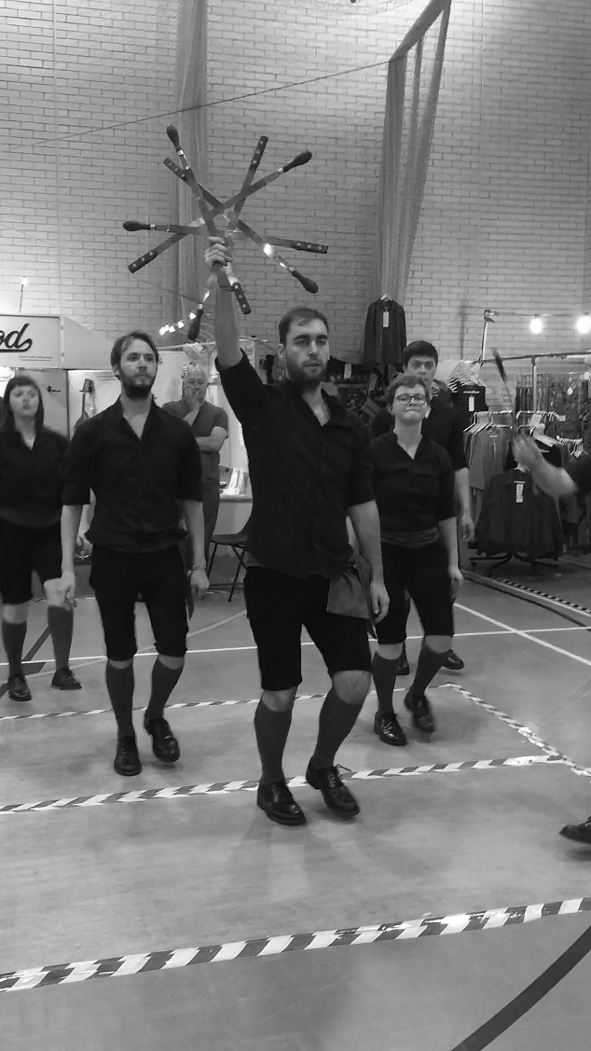

Figure 1. Four Corner Sword with Lock
Whitby Folk Week, 2019. Photo: Libby Worth
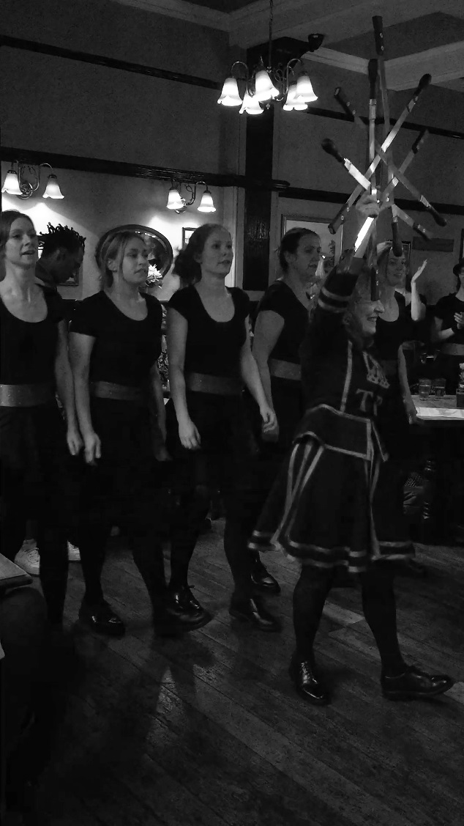

Figure 2. Tower Ravens Rapper, Pub crawl,
Kentish Town, London, 2016. Photo: Libby Worth

Rapper sword dances consist typically of five primary dancers linked together by rappers, which are short flexible steel swords with wooden handles on each end, one of which usually swivels. In effect these tie the dancers together for the duration of the dance unless they open to allow in another dancer or form a lock with all swords held up in a pattern at the end of the dance (fig. 1 and fig. 2). As the dancers move through a series of figures (sequences) they step with either a clog stepping pattern or sometimes with a simpler trot. The swords, held above the head, allow for complex weaving and, when lowered, jumping or spinning and somersaults. Comic ‘characters’ associated with the dance, the ‘Tommy’ and the ‘Betty’, would have traditionally introduced the dancers and act as both disrupters at points in the dance (including the skilled action of bursting into a dance with a rapper and joining the next figure) and as a direct link to the spectators through quips and as collectors of donations. Current dance sides employ these to a lesser or greater degree as suits their style, with all the sides I’ve seen having a ‘calling on’ the dancers moment whether through song or spoken introduction. The musical accompaniment is usually an Irish hornpipe, jig or waltz with musicians such as fiddle players and accordionists in the group often able to dance or play as required. Costume varies from one side to another but each side ensures a distinctive look with different combinations of colour. Similar to the images in Figures 1 and 2, the clothes are chosen for ease of movement together with hard shoes (often reinforced) that will sound out the dance rhythm. Occasionally, more distinctive costumes or props are adopted by teams. For instance, the character dancer for the Tower Ravens is dressed as a Beefeater with a model raven on her shoulder and the dancers in black costumes that fly out in fast movement all reference their base near the Tower of London (fig. 2).

There is historical evidence to show that rapper dances, although primarily performed as part of winter festivities, local events and competitions, were also valued beyond local borders and within a professional context. Some dance sides were paid for music hall performances and tours, blurring distinctions between what Nicholas Ridout describes in relation to theatre as the amateur who ‘acts out of love’ and the professional ‘who makes her living from theatre’ (2013: 29). For example, the Westerhope (Northumberland) side of miners were invited to perform for a week at the London Palladium in 1921. ‘During the following weeks they were absorbed into the country-wide music hall circuit and toured the provinces’ before returning to their jobs in the pits (Heaton 2012: 152). They were even offered ‘a five-year contract in Britain and America at £10 a week’ that they turned down despite the good wage compared to pit work (152). This was an exceptional example of more usual practices, particularly with clog dancers, of combining music hall performance with competitions and outside unfunded display. In 2019 at Whitby Folk Week the all-female side the Tower Ravens Rapper cited the Westerhope example with pride, prior to performing one of their dances as the traditional element within their performance.

Doubling up -- dancing across professional and amateur zones

There are occasional opportunities for paid work for clog, rapper and Morris dancers through teaching but these remain scarce since such dances are rarely included on Higher Education dance studies or school curricula. An exception to this is the Royal Ballet School in London, whose founder, Ninette de Valois, insisted on such dances being taught to the lower school, leading to a short period when a committed group of Royal Ballet dancers, the Bow Street Rappers, smitten by the rapper dance, performed professionally on the ballet stage in the evening and rapper dances on the street during the day whenever they had the chance (Worth 2012: 110). Contemporary rapper sides continue to practise primarily without funding other than the collections made after performing, which might contribute to rehearsal room rental, travel, etc. However, there are occasional bold moves made by innovators to include such dances within a broader dance field through collaborating with, for instance, practitioners of contemporary/jazz, Bhangra, hip hop and breaking. Such moves towards integration, even hybridization, together with recontextualizing rapper through professional stage performances, raise questions about the nature of ‘tradition’. These can expose tensions between a more inwardly focused traditional dance terrain, most concerned with preservation, and an outwardly engaged perspective that stimulates direct physical communication across a range of cultural and social dance spheres. I argue that both positions are necessary and that the amateur zone can sustain such inclusivity if it does not adopt rigid codification and strict monitoring, as has happened in examples of both professional and amateur dance practice. Folk Dance Remixed, a company run by Natasha Khamjani and Kerry Fletcher in East London, exemplifies the process of dance genre integration. Funded by Arts Council England and various sponsorships and donations, they brought together diverse English folk dances with house, break-dance, street and Bollywood to create hybrid forms. This could be viewed as risky, potentially snapping the links with each genre’s traditional heritage, but without such flexibility, dance traditions can become locked in cultural pockets with little opportunity for aesthetic development in response to societal change.

Laurel Swift, folk dancer and musician, took a different tack in founding the company Morris Offspring and in choreographing full-length works for theatre venues. Working closely with the music of the English Acoustic Collective Swift took basic elements of the Cotswold Morris that were then ‘extended into more complex group choreographies’ (Winter and Keegan-Phipps 2013: 72). Morris Offspring performances questioned the low/high cultural divide through demonstrating how a free street/festival form can be re-presented for stage performance and a paying audience. As Swift notes, this stage format took the company away from street performance: ‘If we want to dance in the street we want to do it really well, and we’d have to practise just doing that, and actually we’d rather concentrate on what we do’ (cited in Winter and Keegan-Phipps 2013: 71). Yet the amateur dancing continued alongside the company’s professional work as the individuals danced separately with very good sides in typical street/festival venues (71). Clearly these dancers saw equivalency, if not identical replication, of dance skills as they are situated within professional and amateur zones. And, despite the membership of a company, individuals continued to experience the lure of street dancing.

Both Morris Offspring and Folk Dance Remixed encountered the precarious economy of arts funding that shifts with changes in attitudes and fashions. It is particularly challenging to retain funding for such large and unusual ventures, as is illustrated in Damien Barber’s ‘Whitby interview’ (2019). Barber, a folk musician of thirty years’ standing and a skilled dancer taught by Black Swan Rapper, discussed his initiative in combining rapper and clog dancing with popular street forms of hip hop, breaking and body popping in a show for the theatre stage. One of his initial frustrations that spurred on the creation of his series of dance music shows was that he could not understand why, at Whitby Folk Week for instance, the dancers ‘were down at the sea front and the musicians on the stages’ (2019: n.p.). To counteract this apparent side-lining of the unpaid dancers and in response to his own dance involvement, Barber expanded his electric folk group, the Demon Barbers, in 2005 to include traditional dancing. ‘All the band’s members had links with dance and it was a natural progression as the band developed to incorporate Morris, Clog and Rapper Sword into the set. Thus the Demon Barbers became the Demon Barber Roadshow’ (Schofield 2010: n.p.).

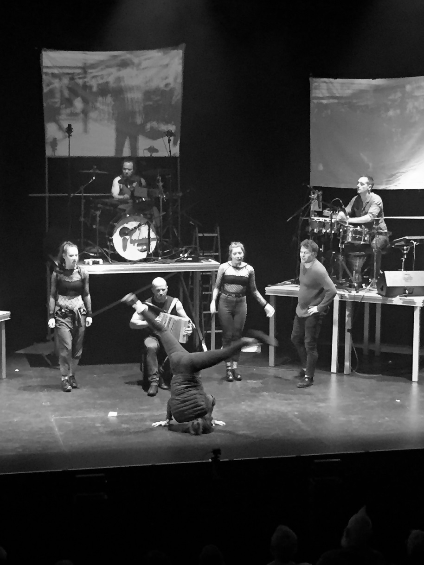

Figure 3. Demon Barbers XL, in an extract from Rise Up, Manchester, 2019. Hip hop dancers, clog dancers watching and band. Photo Libby Worth.

By 2010 Barber was expanding again to create a stage show called The Lock In that included other forms of popular dance such as hip hop and break-dancing. Further shows were created and performed beyond the traditional folk circuit including at Edinburgh Festival, Glastonbury and on extensive provincial theatre tours. The seeming success of these shows, demonstrated by selling out tickets, attracting a young demographic unaccustomed to watching traditional dance, winning awards and excellent reviews, did not seem to be leading to steady professional work. By the time of Barber’s Whitby interview in 2019, he spoke somewhat dispiritedly of the difficulty of finding funding for such a large group of performers and how without paid rehearsal periods the theatre performances became dependent on a more ad hoc approach, with whoever turned up to the regular Thursday rehearsals participating in the shows. Barber notes that these worked more like traditional dance rehearsals and along with the aging of the dancers -- ‘we are getting older and will run out of steam’ (2019) -- put the large-scale theatre performances under threat. At the vicissitudes of fashion and funding potential, with clubs and theatres wanting to book neither large-scale nor solo acts, Barber’s solution was to create a new four-piece band called Oman that would fulfil the venue demands of the moment.

Given his solution to the precarious nature of funding, it was surprising to find that at one of the increasingly rare performances of the Demon Barbers XL shows (Manchester, 19 October 2019), unannounced, the company were showcasing twenty-five minutes of a planned new XL theatre piece ‘Rise Up’, which would be created in conjunction with the release of the album of the same name. Some financing had been secured from Arts Council England as evidenced by the development and research questionnaire circulated post show. With The Lock In: ‘Christmas Carol’ booked for a solid tour perhaps Barber’s slightly gloomy predictions on the dance shows have been abated. Both the Demon Barbers and Folk Dance Remixed have taken a somewhat maverick attitude to more conservative views on authenticity and conservation of traditional dance forms. They inject energy into the processes by which dances change over time. This is achieved through multi-dance genre collaboration that exposes traditional dance to new influences and new audiences, thus better reflecting the current diversity of dance practices of a multicultural society. There is a risk in this strategy of destroying dances’ links with history and identity as they are incorporated into hybrid forms, especially if pressured through commercial as opposed to artistic drives. However, since rapper and other traditional dances exist within a broad ecology of practices expressive of diverse attitudes towards adaptation and change, I suggest that continuing contestation and managing of the bridge between history and the present are indicative of a vital, burgeoning dance terrain.

Risk and pleasure

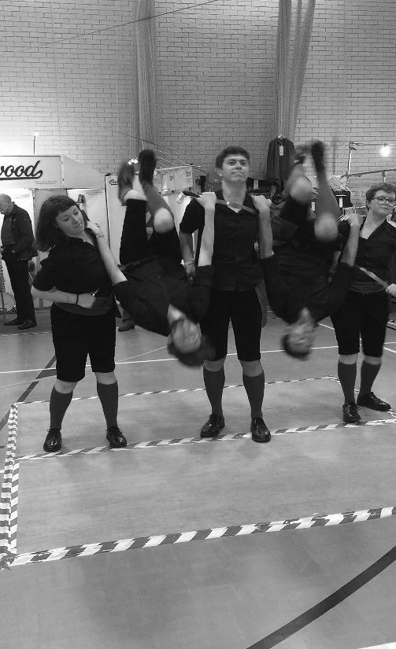

Figure 4. Four Corner Sword performing a double somersault,
Whitby Folk Week, 2019. Photo Libby Worth.

The examples of economic precarity outlined above are the exception, as most traditional dance practices are non-monetized. Instead, therefore, it must be that non-economic reasons determine the values and glue that bind the participants together and keep them practising new and difficult, even dangerous moves. In Serious Leisure: A perspective for our time (2007), Robert Stebbins analyses reasons for enduring participation in amateur activities and locates ten ‘rewards’ that are ‘predominantly personal’ (13). However, by adopting the term ‘leisure’ the analysis misses how the same activity (in this case dance) can move between professional and amateur zones. The emphasis in Stebbins’ list is on individual gain rather than the interactive nature of performance, which positions its values in relation to spectator response. Susan Foster takes a more urgent view on why we need to consider the value of dance within a broader framework than only personal gain. Her detailed study Valuing Dance: Commodities and gifts in motion (2019) reframes discourses on dance value by examining the current move towards labelling dance as labour. She asserts that ‘with the burgeoning of service industries and the consolidation of a pervasive culture of measuring and calculating human activity in terms of its productivity, even dance had been assimilated to machineries of economic assessment, market, and exchange’ (3). Prior to taking up Foster’s distinctions between commodities and gifts in processes of exchange, I return to one element of Stebbins’ taxonomy of reward, ‘thrills’, which he links with experiences of ‘flow’ drawing on the work of Mihalyi Csikszentmihalyi (1990; Stebbins 2007:15).

The Four Corner Sword dancers in Figure 4 are caught in the midst of one of their spectacular fast moves: the double somersault. The moment highlights the dangerous elements of the dance whereby heavy hard shoes come perilously close to the faces of supporting dancers, and the upside-down pair are, for an instant, utterly dependent on the group. Yet the dancers clearly relish these more spectacular moments not just for their own personal thrill, or sense of flow, but as part of the zone of precariousness that haunts rapper dancing. In the history of the form, this includes working on more and more intricate and eye-catching figures that become the sides’ own choreographies. As the Tommy for Four Corner Sword boasted in his introduction to a performance at Whitby, ‘What you are about to see is the most difficult and dangerous of all of the sword dances, made especially so because it’s in its unlubricated format’ (Whitby, 2019). The second comment refers to the morning performance prior to having a beer and after having had rather a few beers the night before. From my experience of attending rehearsals and workshops with Tower Ravens Rapper and Four Corner Sword, it becomes clear that the intricacies of the training, peer observation and teaching mitigate against accident. In the workshop by Four Corner Sword, for example, the leader brought the small groups together in order to show sword handling in detail and why holding the swords high, with wrists, rather than hands, close together, allowed the dancers to work more closely and safely together. He demonstrated a ‘scoop’ action if the sword seemed to be coming too close to the face and the importance of avoiding the white knuckle ‘death grip’ that spreads tension through the arm and into the shoulder. All such techniques, he suggested, led to the spectators’ gaze being drawn to the swords’ dancing rather than the dancers.

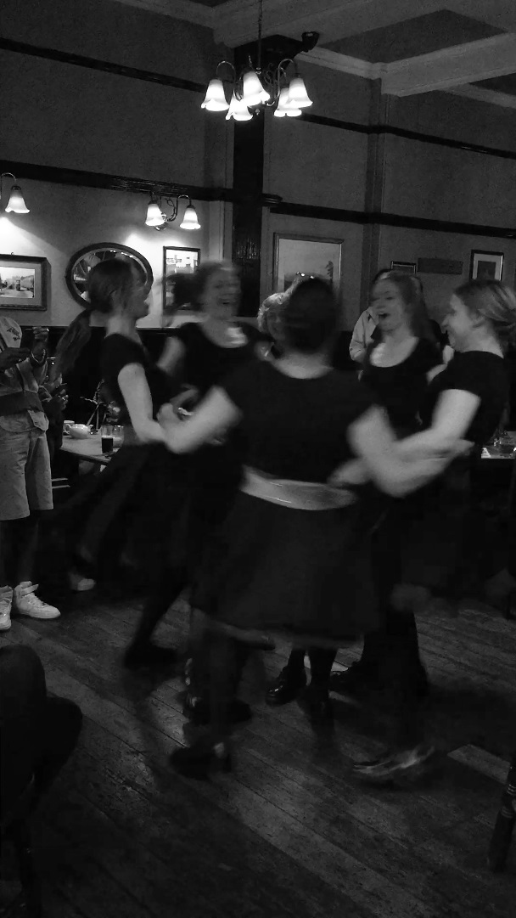

Figure 5. Tower Ravens performing a spin in
a pub in Kentish Town, London (2016). Photo Libby Worth

This idea of subsuming the dancers within the dance of the swords indicates the focus of attention being the importance of the aesthetic outcome reliant on rigorous group endeavour rather than merely individual ‘rewards’. In rapper dancing therefore, the group collaborative enterprise depends on individual skill and rigour but ultimately the individual is subsumed into the whole - a dance of the swords. The Tommy’s jokey mention of the lack of lubrication as making the dance more dangerous is not quite as throwaway as it might seem. Alcohol and/or rushes of adrenalin that come with performing over and again at high speed in crowded venues could facilitate the relinquishing of individual focus to the team. This is supported by comments of a dancer in a Tower Ravens rehearsal who noted that she could not describe her five moves but in the dance she can completely do them (Worth 2019: 221). Just as it is good practice to avoid the ‘death grip’, so too these examples suggest the need to fall in with the flow of the dance, following the movement of the swords and relying on kinaesthetic memory and, if necessary, instant improvisation rather than overly slow conscious recall.

Taking space to perform

Precariousness and the pleasure of risk are present in other forms in rapper dancing directly afforded through its amateur status. The ‘crawl’ is the most common performance format whereby the rapper side visits a series of pubs, performs for a few minutes, stays for a drink if they want and moves onto the next one. Tower Ravens typically take it in turns for a dancer to predetermine a route each month and check access with pub managers. Beyond that, the likely reception is unknown. This makes for a possibly testing encounter. My experience of watching a Tower Ravens’ crawl was that the pubgoers looked critical and uncomfortable when the group arrived in their costumes but were, without exception, won over by the spectacular nature and speed of the dancing, such that they would get phone cameras out, jostle to get a good view and whoop and clap as it ended. I was assured that this is not always the case. Indeed some of the members of a folk song group at Whitby Folk Week looked less than happy as I saw Four Corner Sword doing their robust and defiant final parade out of the room where, apparently, they had not been invited. A sense of assertive rebelliousness and joy at disrupting the status quo seemed to permeate these performances. Since the speed of the performances means the sides can be there and gone within a few minutes, there is little to lose at a poor reception other than having an emptier collection tin. Perhaps this is the kind of ‘autonomy’ to which Ridout refers in a definition of the amateur, where ‘acting out of love’ (2013: 29), in this case for the aesthetic form, occasions opportunities for subversion in the manner the dance is performed, in its intrusions and loud energetic assertiveness. My experience of rapper on a professional theatre stage, as opposed to in the street or pub, is that, inevitably, it loses some of its direct immediacy and brash encounter with its spectators. In pubs and streets or at the seaside, the ‘calling on’ introduction of the Tommy spoken or in song combined with the flurry of costume colour and music as the dancers arrive in a venue act as a magnet. In this opening moment the group must either attract distant spectators away from their other street activities or repel, as in fend off, crowds in the pub to generate a space just big enough in which to dance enclosed by the audience. Here, too, precariousness is part of the play, to risk hitting a chair or mantelpiece or fly close, perhaps too close, to the pressed-in spectators.

Foster’s examination of ways in which dance is valued focuses on the differences between ‘commodity exchange and gift exchange’, which together ‘construct a vibrant hypothetical matrix for analyzing dance as a form of social transaction’ (2019: 9). However, if, as she suggests, gifts ‘are given, and they are also received and then reciprocated’ (9), the dance examples described above sometimes slip out of either category. There are times when the rapper dances are imposed, resisted and certainly not reciprocated and nor are they usually part of commodity exchange. It is not only the intricacy of the sword manipulation and dance steps that have travelled through time but also a method and attitude of performance delivery that is bold, defiant, even rebellious at moments. Possibly this links to the intense competitiveness of the early mining village dancers with formal and informal competitions featuring as important and newsworthy events through the year. Competition continues currently to be of significance for many sides, with year-long work going into creating new dances or perfecting traditional inherited practices. The annual Dancing England Rapper Tournament (DERT) is a major competition that recognizes the many changes in rapper teams’ constituents and choreographies that have taken place since every dance was associated with a North East England mining village. The range of categories under which sides can compete reflects the changes in the industrial landscape, the dispersal of rapper dances across the country and internationally, the diversity of sides as they work with women only or mixed groups, young sides and very young sides. Innovation as well as traditional accuracy are rewarded but all with a sense that dance skill, musical accompaniment, the characters’ (Tommy and Betty) performances and imaginative inventiveness can be adjudicated.

This consideration of the current practice of just a single amateur traditional dance, rapper sword dancing, reveals a complex interweaving between professional and amateur zones and, as significantly, the manner in which amateur status is both a challenge and an incentive. Given the considerable distance from its industrial and specific geographic heritage, it is remarkable that rapper dancing, despite vicissitudes in popularity, is currently widely practised and valued. Precariousness is evident in rapper dancing, embedded in its risky movements, its street and pub crawl performance (even at DERT several competitions are judged on a crawl) and in its relationship to the professional stage. Yet just these elements of creating new spectacular sequences, confronting seaside tourists or pubgoers, not just folk dance enthusiasts, and bringing the rapper to professional stages in new integrations of a range of street and traditional dance forms clearly are appealing. Perhaps, as Four Corner Sword explained in their Whitby workshop, placing the emphasis on the swords’ dancing and necessity of the group performing as a bound unit entailing the closest of cooperation is one reason that this form maintains its attraction. The energetic attack required to perform rapper combined with the willingness to take risks builds attitudes that can respond to the threats or affordances of changing society. This is evident in the examples given above as industry recedes and new sides form far away from North East England, some consisting of all women or mixed-gender teams or children, and offer new choreographies. So too, rapid technological developments have been embraced by rapper sides whether to record the many histories of sides long since defunct, to show historic or contemporary recordings, to advertise shows or, more intimately, to share steps between rehearsals through social media.

Notes

From 2016 to 2019 I have undertaken research into contemporary practices of rapper sword dancing in Newcastle, Oxfordshire, Whitby and London. My most extensive contacts have been with the Tower Ravens Rapper, to whom I am very grateful. I have visited group practices as well as festivals, public performances, talks and workshops.
For detailed research into rapper dance’s history and development with accounts of many originating dance sides, see Heaton (2012), and Rapper Online (2018).
For the values of pursuing training in rapper etc. for highly disciplined ballet dancers see the analyses of two teachers of the forms in interview (Worth 2012: 105--16).
For example, in a conference paper dancer and researcher Annabelle Bugay noted how in the United States ‘Irish dance has evolved into an expression of the American ideals of competition, consumerism and conformity’ (2019: n.p.).
For detailed examples see Heaton (2012: 68 onwards).
For details of the competition, its categories, structure and awards see the DERT website. References Barber, Damien (2019) ‘Whitby interview’, by Derek Schofield, 21 August 2019, Whitby Folk Week, Whitby, Yorkshire. Bugay, Annabelle (2019) ‘Competition, consumerism and conformity: A study of the manifestation of American ideals in competitive Irish Dance culture’, paper given at ‘Stepping On: A conference on stepping in dance’, Cecil Sharp House, London, 16-17 November 2019. Csikszentmihalyi, Mihalyi (1990) Flow: The psychology of optimal experience, New York: Harper & Row. Dancing England Rapper Tournament (2019) Competition archive with videos and results, https://dert2019.co.uk/, accessed 12 November 2019. Foster, Susan Leigh (2019) Valuing Dance: Commodities and gifts in motion, Oxford: Oxford University Press. Heaton, Phil (2012) Rapper: The miners’ sword dance of North East England, London: English Folk Dance and Song Society. Knott, Stephen (2015) Amateur Craft: History and theory, London and New York: Bloomsbury. Knott, Stephen (2016) ‘Presentation notes’, ‘Amateur Studies Research Forum’, 9 November, Department of Drama, Theatre and Dance, Royal Holloway, University of London. Rapper Online (2018) Archive, videos, histories and photos, 1 December, https://www.rapper.org.uk/, accessed 10 November 2019. Ridout, Nicholas (2013) Passionate Amateurs: Theatre, Communism and love, Ann Arbor: University of Michigan Press. Schofield, Nigel (2010) ‘The Demon Barbers’, http://www.thedemonbarbers.co.uk/about/history-of-the-demon-barbers/, November 2010, accessed 6 November 2019. Stebbins, Robert A. (2007) Serious Leisure: A perspective for our time, New Jersey: Transaction Publishers. The Demon Barbers (2019) The Demon Barbers XL and Rise Up (work in progress), performed at Home, Manchester, 19 October 2019. Winter, Trish, and Simon Keegan-Phipps (2013) Performing Englishness: Identity and politics in a contemporary folk resurgence, Manchester: Manchester University Press. Worth, Libby (2012) ‘Interviews with Ron Smedley and Simon Rice on the teaching of folk dance and national dance at the Royal Ballet School’, in Richard Cave and Libby Worth (eds) Ninette de Valois: Adventurous traditionalist, Alton, Hampshire: Dance Books, pp. 105--16. Worth, Libby (2019) ‘Time moves: Temporal experiences in current London-based training for traditional clog and rapper sword dances’, in Mark Evans, Konstantinos Thomaidis and Libby Worth (eds) Time and Performer Training, Abingdon, Oxon: Routledge, pp. 208--24.

