Antimicrobial applications of silver nanoparticles to E. coli colony biofilms
James P. McEvoy, Kayra Genc, Priya Loi and William J. Walker
Centre for Biomedical Sciences, School of Biological Sciences, Royal Holloway, University of London, Egham, Surrey, TW20 0EX, UK
Abstract
Bacterial biofilms can cause problems in various arenas, from the fouling of water processing equipment to persistent in vivo infections. Silver nanoparticles are promising antimicrobial agents with activity against biofilm bacteria. Here we describe the synthesis of antimicrobial silver nanoparticles and the measurement of their antimicrobial activity against E. coli colony biofilms, which is a popular in vitro biofilm model for antibiotic assays.
- Introduction
Many bacteria are able to form biofilms either on solid surfaces or as unattached aggregates [1]. As the cells join the colony they secrete and surround themselves with slimy extracellular polymeric substances (EPS) which are mostly glycoproteins and polysaccharides. Biofilms are hard to remove from surfaces and their cells are partially protected from antimicrobials, both by virtue of their slow growth rate and for various other reasons [2]. Their persistence makes biofilms a serious problem in several domains, from the fouling of industrial equipment [3] to lung and medical implant infections in biomedical science [1]. Biocides that are effective against biofilms are therefore highly sought after.
Silver has been used as an antimicrobial for many centuries [4]. Silver nanoparticles (sometimes known as “colloidal silver” because the solid particles are suspended to form a sol colloid) have more recently been used as a way of delivering biocidal concentrations of silver to unwanted bacteria, biofilms being no exception [5]. Silver nanoparticles kill bacteria, including metabolically dormant biofilm cells [6], by mechanisms which include local dissolution of silver ions [7]. Silver’s broad mode of action makes it hard for bacteria to acquire genotypic resistance against it (although phenotypic resistance has been demonstrated [8]), which makes it all the more attractive in the context of increasing antimicrobial resistance. Silver nanoparticles may be synthesized in various ways, including the method presented here: the controlled reduction of silver nitrate by sodium borohydride in the presence of a stabilizing, polymeric capping agent [9].
While silver nanoparticles’ anti-biofilm activity has often been measured in microtiter plates, this assay can be complicated by bacterial detachment into the surrounding liquid [10], and the biofilm’s anutritive substrate lessens the model’s biomedical relevance beyond implant infection [11]. The colony biofilm assay we describe in this protocol is particularly suitable for the measurement of antibiotic effects [10], ruling out bacterial detachment and supplying nutrients to the growing biofilm along with the antimicrobial agent [5]. A colony biofilm model has been used, for instance, to study the antibiotic resistance of the opportunistic pathogen Pseudomonas aeruginosa, which was found to synthesize a tobramycin-binding periplasmic glucan [12]. Here we describe the synthesis of silver nanoparticle sols [9] and the measurement of their anti-biofilm effect against colony biofilms of E. coli., a widely studied and clinically significant gram-negative bacterium.
- Materials
  - Synthesis and spectrometric characterization of antimicrobial silver nanoparticles
Glassware used in the synthesis of silver nanoparticles must be scrupulously cleaned and rinsed; aqua regia may be used (with caution) to remove metallic contamination. Solid reagents must be of analytical grade and are stored at room temperature. Aqueous solutions should be freshly prepared with ultrapure water, with a resistivity of at least 18 MΩ.cm.
- Silver nitrate solution: 25 mL of 1.0 mM AgNO₃.
- Sodium borohydride solution: 50 mL of 2.0 mM NaBH₄.
- Polyvinylpyrrolidone solution: 100 mL 0.030% (w/v) 10k PVP (see Note 1).
- UV/Visible spectrophotometer.
  - Culture of Escherichia coli
Materials are stored at room temperature unless otherwise indicated. Aqueous solutions may be made up with standard, lab-grade deionized water.
- 15% glycerol stock of a biofilm-forming E. coli strain, stored at -80 °C.
- Solid carbon dioxide pellets (“dry ice”), stored at -80 °C.
- 150 mm x 15 mm Petri dishes (sterile).
- Lysogeny broth (LB): Dissolve 10.0 g powdered LB medium in 0.50 L deionized water and sterilize by autoclaving.
- LB agar: Dissolve 10.0 g powdered LB medium along with 7.5 g agar in 0.50 L deionized water and sterilize by autoclaving.
- Phosphate buffered saline (PBS): Dissolve a PBS tablet in deionized water according to the manufacturer’s instructions and sterilize with a 0.1 μm syringe filter or by autoclaving.
- Wire inoculation loop.
- Bunsen burner.
- Disinfectant spray.
- Plastic tweezers, sterile.
- L-shaped spreaders, sterile.
- Micropipette with sterile tips.
- 15 mL Falcon tubes, sterile.
- Polycarbonate filter membranes, 0.2 μm pore size, sterilized by autoclaving.
- Laminar flow cabinet.
- Static and shaking microbiological incubators.
- Vortex mixer.
- Methods
  - Aqueous synthesis of silver nanoparticles
- Add 30.0 mL 2.0 mM aqueous sodium borohydride solution to a conical flask. Chill the solution in an ice bath resting on a magnetic stirrer. The solution should be stirred rapidly enough to create a funnel vortex.
- Add 3 drops aqueous 0.030% (w/v) 10k PVP solution (see Note 2).
- Add 10.0 mL 1.0 mM aqueous silver nitrate solution dropwise, over the course of two minutes, to the chilled sodium borohydride solution. An intensifying yellow colour will accompany this addition as colloidal silver nanoparticles are formed at a concentration of 27 μg mL⁻¹ (see Note 3).
- Stop stirring the sol after the silver nitrate has been added.
- Store the clear, straw-yellow nanoparticle sol in a clean glass bottle at 4 °C in the dark (see Note 4).
- Obtain a UV-visible spectrum of the 5 – 10x diluted sol in the range 300 – 600 nm. The spectrum should contain a single absorption peak of λ_{max} = 400 ± 5 nm with a peak width at half maximum of 70 ± 5 nm. This peak is due to size-dependent surface plasmon resonance of the silver nanoparticles [13] and indicates the formation of particles between 10 – 14 nm diameter [9] (see Note 5) (Fig. 1).
  - Preparation of LB agar plates
- Working in a sterile environment, pour warm, liquid LB agar into a number of Petri dishes, using just enough agar to cover the base of each plate. Stack the plates on the bench and allow them to cool slowly to room temperature. The gelled LB agar plates can then be stored upside down in a refrigerator at 4 °C.

  - Culture of E. coli on LB agar plates and in liquid LB media
- Working in a sterile environment, heat a metal inoculating loop in the blue flame of a Bunsen burner and allow it to cool for several seconds beside the flame.
- Use the warm loop to streak out biofilm-forming E. coli onto an LB agar plate from frozen glycerol stock kept on dry ice (see Note 6).
- Incubate the plate overnight in a static incubator at 37 °C.
- Transfer 10 mL sterile liquid LB media into a 15 mL Falcon tube.
- Use a sterile loop to inoculate the liquid LB media with E. coli from the agar plate.
- Incubate the liquid E. coli culture overnight in a shaking incubator at 37 °C.
  - Application of silver nanoparticles to nascent E. coli colony biofilms
- Soak sterile polycarbonate membranes for 2 hours in appropriately diluted silver nanoparticle sols, using sets of three replicates for each concentration. Membranes for negative control experiments should either be soaked in sterile ultrapure water or left untreated.
- In a laminar flow hood, use sterile tweezers to transfer each set of three polycarbonate membranes onto a different LB agar plate. Ensure the membranes are laid shiny-side up on the agar surface, with no air bubbles trapped under the membrane (see Note 7).
- Still in the laminar flow hood, use a sterile-tipped micropipette to inoculate each membrane with 5 μL overnight liquid E. coli culture.
- Incubate the plates at 37 °C in a static incubator for 24 hours, by which time off-white colony biofilms will be visible on the surface of the inoculated membranes (see Note 8). The antimicrobial effect of the different concentrations of silver nanoparticles may now be measured (see section 3.6).

  - Application of silver nanoparticles to established E. coli colony biofilms
- In a laminar flow hood, use sterile tweezers to transfer three polycarbonate membranes onto each LB agar plate. Ensure the membranes are laid shiny-side up on the agar surface, with no air bubbles trapped under the membrane.
- Still in the laminar flow hood, use a sterile-tipped micropipette to inoculate each membrane with 5 μL liquid E. coli culture.
- Incubate the plates at 37 °C in a static incubator for 24 hours, by which time off-white colony biofilms will be visible on the surface of the inoculated membranes. Return the plates to the laminar flow hood and carefully transfer the biofilm-bearing membranes to fresh LB agar plates to avoid nutrient-limited growth.
- Use a sterile pipette to cover each biofilm with an appropriately diluted silver nanoparticle sol (see Note 9). Use the same volume for each biofilm and the same concentration for each plate, making a set of three replicates for each concentration. Negative control biofilms should be covered with the same volume of sterile ultrapure water.
- Incubate the plates at 37 °C in a static incubator for a further 24 hours, after which time the antimicrobial effect of the different concentrations of silver nanoparticles may be assessed (see section 3.6).
  - Assay of the antimicrobial effect of silver nanoparticles on E. coli colony biofilms
- Working under sterile conditions, use tweezers to transfer each biofilm-bearing polycarbonate membrane into 10 mL PBS solution in a 15 mL Falcon tube.
- Agitate each tube on a vortex mixer until the biofilms have been thoroughly disrupted and the cells suspended in the PBS solution (see Note 10).
- Serially dilute the homogenized PBS solutions and, using L-shaped spreaders, plate out an appropriate dilution (commonly 10⁻⁵) from each biofilm onto separate LB agar plates.
- Incubate the plates at 37 °C in a static incubator for 24 hours.
- Count the colonies on each plate. Calculate the density of colony forming units (CFU / mL) (see Note 11) using the equation:
$${CFU}/{mL}= {number of colonies per mL plated }/{ dilution factor}$$
- Compare these values with those obtained from the negative controls to measure the activity of the silver nanoparticle sols against E. coli colony biofilms (see Note 12) (Fig. 2).

- Notes
- PVP is a polymer which may be obtained in various molecular weights; 10k PVP has an average molar mass of 10,000 g mol⁻¹. The molar mass of each repeating unit of PVP is 111.14 g mol⁻¹.
- This makes the final concentration of the PVP repeating unit 5 μM, compared to ⪅ 10 nM silver nanoparticles; the latter figure is approximate because nanoparticle size and number are only known approximately from the UV/Vis spectrum. PVP is therefore effectively present in a large excess, able to coat and stabilize the nanoparticles as they form. If other sizes of PVP are used, the polymer’s concentration should be adjusted to maintain the concentration of the repeating unit.
- Given the uncertainty in nanoparticle size we report the concentration of silver rather than the number concentration of particles in the sol.
- Silver nanoparticle sols stored in this way are typically stable for several days.
- The λ_{max} value may be used to estimate the size of the nanoparticles [14]. Electron microscopy may be performed to further characterize the nanoparticles if necessary. We have used a Hitachi S3000N scanning electron microscope, drying the sols onto aluminium stubs and visualizing the nanoparticles at x5000 magnification with an acceleration voltage of 20 kV (Fig. 1).
- If the loop is too hot then not only will cells be killed but there is a risk of aerosol formation and bacterial inhalation. It is important when handling E. coli to comply with your institutional biological safety rules. E. coli Nissle 1917 is a readily available, non-pathogenic biofilm former and may be used with confidence. If other biofilm forming E. coli strains are used it may be necessary to check that they are non-hemolytic and/or to undertake 16S ribosomal DNA sequencing before use.
- Separating the membranes from their backing sheets can be fiddly, as can laying the membranes flat on the agar surface. Working in a laminar flow hood reduces the risk of contamination during these operations.
- Other biofilm growth times may be used. If longer times are used it is important to transfer the biofilm-bearing membranes to fresh LB agar plates every 24 h to avoid nutrient-limited growth.
- Water will evaporate from the aqueous silver nanoparticle sols over the subsequent incubation, increasing the amount of silver to which the biofilms are exposed as nanoparticles are concentrated near the membrane surface. To avoid this complication, nanoparticles may also be applied in a sterile 1% – 2.5% alginate gel made by the method of Draget and co-workers [15].
- E. coli colony biofilms are usually quite weakly attached to the membrane, and visual inspection is sufficient to ensure that the biofilm has been completely disrupted.
- It may also be useful to calculate CFU / cm² of biofilm growth, to measure the density of live cells within the biofilm itself.
- Because the biofilm has been disrupted before analysis, all spatial information is lost and the antimicrobial activity is averaged across the colony.

Acknowledgement
We thank Sharon Gibbons for her help with the scanning electron microscopy.

References
1. Bjarnsholt T, Alhede M, Alhede M, Eickhardt-Sørensen SR, Moser C, Kühl M et al. (2013) The in vivo biofilm. Trends Microbiol 21:466-474
2. Olsen I (2015) Biofilm-specific antibiotic tolerance and resistance. Eur J Clin Microbiol Infect Dis 34:877-886
3. Gule NP, Begum NM, Klumperman B (2016) Advances in biofouling mitigation: A review. Crit Rev Environ Sci Technol 46:535-555
4. Rai M, Yadav A, Gade A (2009) Silver nanoparticles as a new generation of antimicrobials. Biotechnol Adv 27:76-83
5. Martinez-Gutierrez F, Boegli L, Agostinho A, Sánchez EM, Bach H, Ruiz F et al. (2013) Anti-biofilm activity of silver nanoparticles against different microorganisms. Biofouling 29:651-660
6. Ruben Morones-Ramirez J, Winkler JA, Spina CS, Collins JJ (2013) Silver enhances antibiotic activity against gram-negative bacteria. Sci Transl Med 5:190ra181
7. Zheng K, Setyawati MI, Leong DT, Xie J (2018) Antimicrobial silver nanomaterials. Coord Chem Rev 357:1-17
8. Panáček A, Kvítek L, Smékalová M, Večeřová R, Kolář M, Röderová M et al. (2018) Bacterial resistance to silver nanoparticles and how to overcome it. Nature Nanotechnology 13:65-71
9. Solomon SD, Bahadory M, Jeyarajasingam AV, Rutkowsky SA, Boritz C, Mulfinger L (2007) Synthesis and Study of Silver Nanoparticles. J Chem Educ 84:322-325
10. Merritt JH, Kadouri DE, O'Toole GA (2011) Growing and analyzing static biofilms. Curr Protoc Microbiol 22:1B.1.1-1B.1.18
11. Roberts AEL, Kragh KN, Bjarnsholt T, Diggle SP (2015) The limitations of in vitro experimentation in understanding biofilms and chronic infection. J Mol Biol 427:3646-3661
12. Mah T-F, Pitts B, Pellock B, Walker GC, Stewart PS, Toole GAO (2003) A genetic basis for Pseudomonas aeruginosa biofilm antibiotic resistance. Nature 426:306-310
13. Eustis S, El-Sayed MA (2006) Why gold nanoparticles are more precious than pretty gold: Noble metal surface plasmon resonance and its enhancement of the radiative and nonradiative properties of nanocrystals of different shapes. Chem Soc Rev 35:209-217
14. Agnihotri S, Mukherji S, Mukherji S (2014) Size-controlled silver nanoparticles synthesized over the range 5–100 nm using the same protocol and their antibacterial efficacy. RSC Adv 4:3974-3983
15. Draget KI, Østgaard K, Smidsrød O (1989) Alginate-based solid media for plant tissue culture. Appl Microbiol Biotechnol 31:79-83

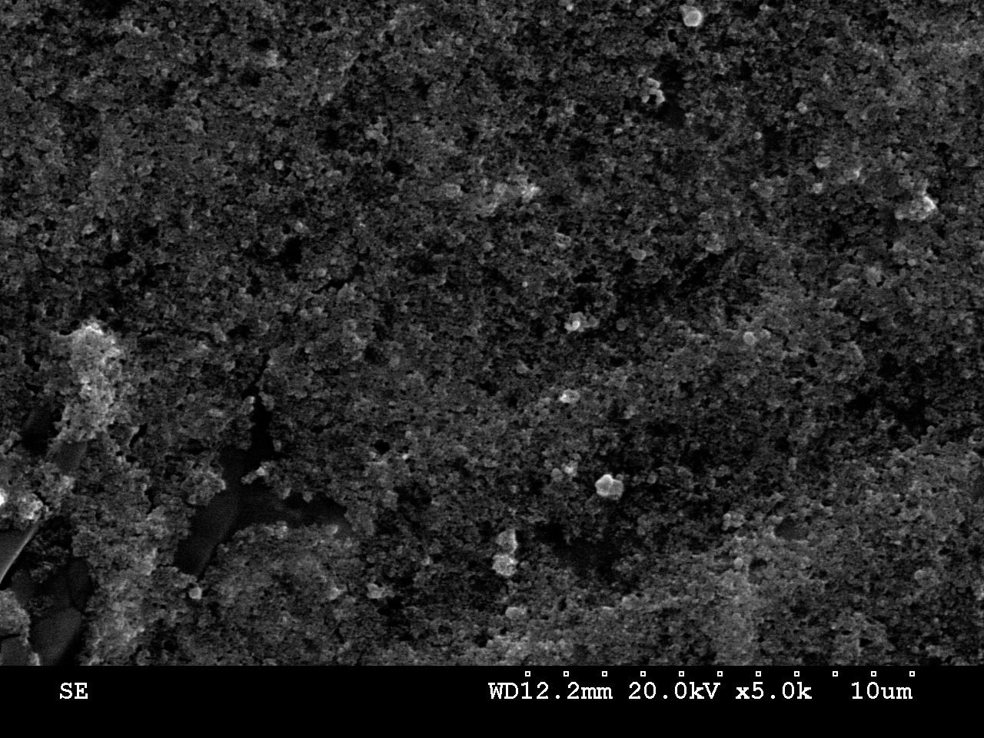
Fig. 1 Scanning electron micrograph of partially aggregated silver nanoparticles, dried onto an aluminium stub, acquired at an acceleration voltage of 20.0 kV at ×5000 magnification. The image shows discrete particles on the nanometre scale, although the resolution is not good enough to measure their diameter.

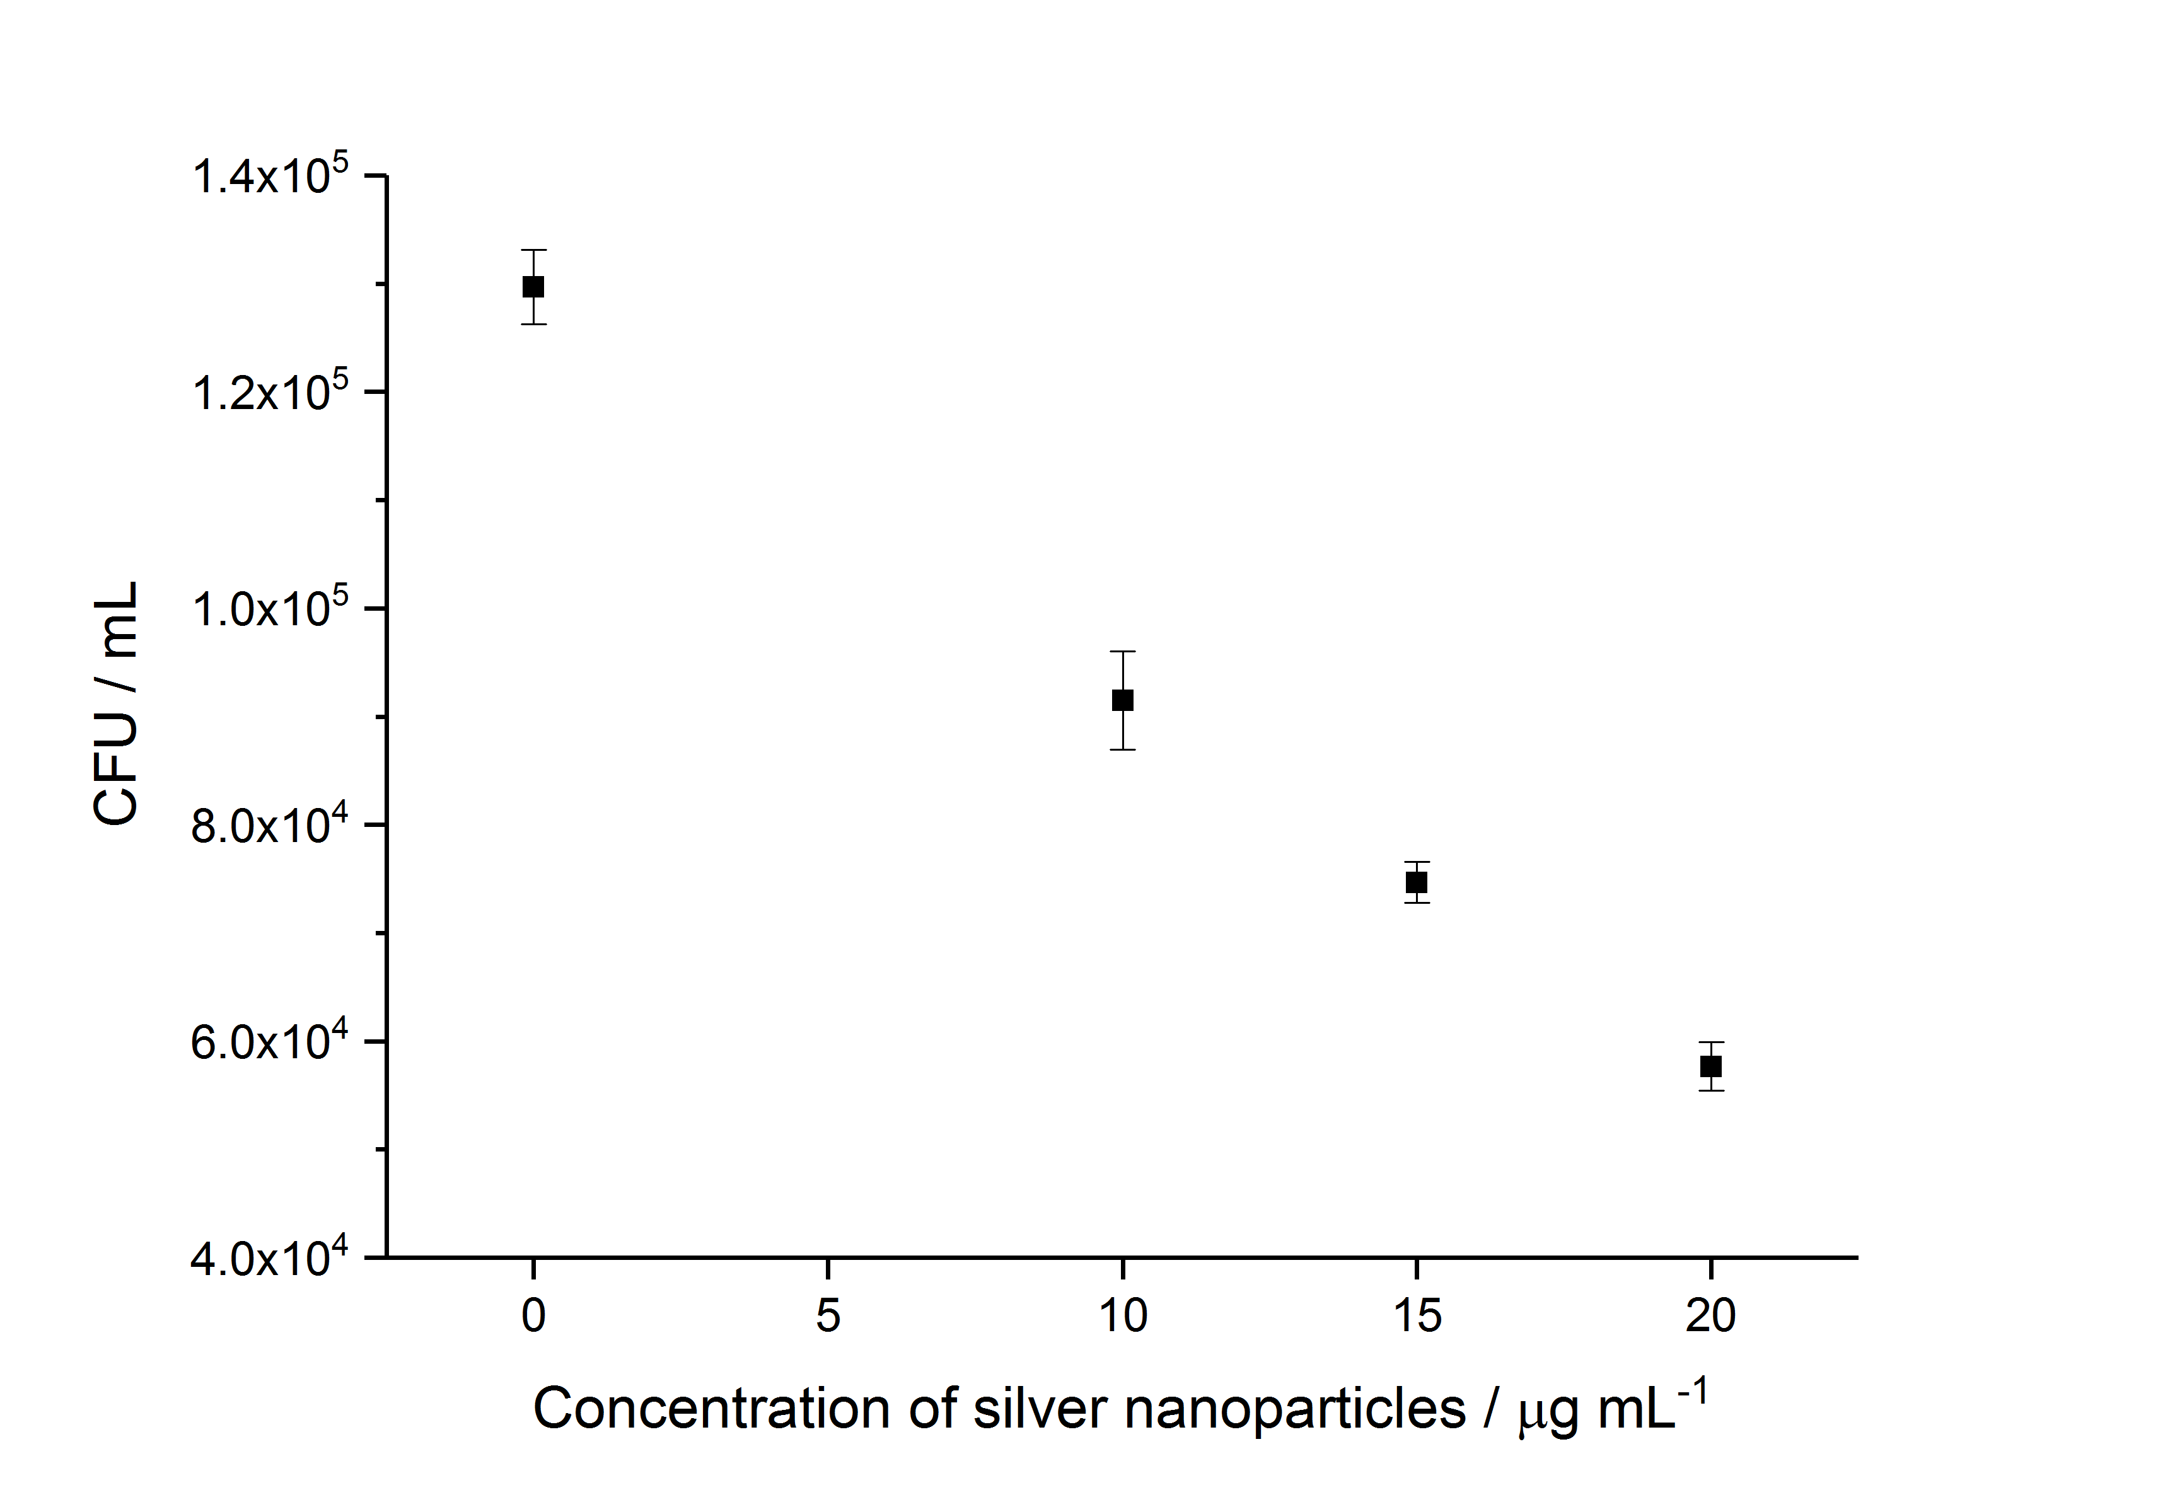
Fig. 2 Concentration-dependent antimicrobial activity of silver nanoparticle sols against nascent E. coli biofilms. The negative control membrane (0 μg mL⁻¹) was soaked in sterile ultrapure water. Error bars represent the standard error of six measurements.

