Linearization and Down-Conversion of Microwave Photonics Signal based on Dual-drive Dual-parallel Mach-Zehnder Modulator with Eliminated 3rd Intermodulation and 2nd Distortions
Shemsi Shaqiri¹ and Shyqyri Haxha¹*
¹Department of Electronic Engineering School of Engineering, Physical and Mathematical Sciences
Royal Holloway, University of London, Egham, Surrey, TW20 0EX, United Kingdom
*Shyqyri.Haxha@rhul.ac.uk

Abstract -In this paper, we propose and demonstrate a high linear analogue photonic link based on a Dual-drive Dual-parallel Mach-Zehnder Modulator (D-DPMZM) with Balanced Photo-Detector (BPD). Third order Intermodulation Distortion (IMD3) and Second-Order Distortions (SOD) products have been eliminated by controlling the phase of input RF signal and driving voltage of D-DPMZM. The proposed configuration of microwave photonic link is symmetrically single-sideband modulation in two D-DPMZM. For the proposed configuration and the purity of the system, mathematical modeling and simulations have been developed and tested by introducing additional RF signals. In addition, in the proposed configuration, a high linear down-converted signal is transmitted by changing only the operating modulator biasing point, from quadrature to maximum. The elimination of IMD3 and SOD products has been achieved simultaneously with suppressed higher order harmonic in this system. To the best of our knowledge, this is the first reported work in literature where IMD3, SOHs and second order distortion produces have been completely eliminated.

Index Terms: Harmonic Distortions, Intermodulation Distortion, Microwave Photonic Link.
- Introduction
Optical fiber communication systems offer significant benefits for current and future broadband wired and wireless communication systems, due to low losses, high data rate, low electromagnetic interference and potential high security [1-3]. These communication systems have enormous potential inters for researchers in commercial and defense applications, such as Radio over Fiber (RoF) which is also an important part of optical communication systems, which transmit microwave signals over fiber optics domains. RoF, in particular, is a low cost, flexible and promising technique for radio access systems [4]. Due to a great demand for high data rate and security in the current transmission systems, and their foreseeable prerequisite in the future, RoF systems have been wildly exploited. Nevertheless, RoF have their limitations, which need to be explored further in order to handle the significant increase of data capacity demands. These limitations are due to nonlinearity materials, loses due to conversion from electrical to optical, optical to electrical, and other associated signal scatterings. In order to overcome these limitations, in the literature key performance parameters are explored such as noise figure, gain and dynamic range [5], [6] and [7]. Dual-Electrode Mach-Zehnder Modulator (DE-MZM), which are key devices for such transmission systems, are used for elimination and suppression of Third order Intermodulation Distortion (IMD3) and suppress one side to gain single-sideband. By using DE-MZM, it is possible to increase dynamic range and eliminate or suppress Intermodulation Distortions (IMD’s) and higher harmonics, which are essential to improving the signal to noise ratio at the Photo-Detector (PD). However, complex radio-frequency arrangements and synchronizations are required.

It is widely known that the second and third order IMD’s and harmonics eliminations are paramount for any analogue communication system. There are many research papers that have been written where various systems, such as a new system configuration of analogue photonic link, have been proposed and investigated [8]. Proposals where optical polarizer, optic filter and phase modulator are deployed to improve the system performance. In this paper [8], 25.4 dB cancellation of IMD3 has been achieved by adjusting the state of polarization and sending the signal to the phase modulator across the polarizer. In Ref. [9], a new system configuration for analogue photonic link with digital signal is demonstrated. The proposed structure in Ref. [9] is based on an optical phase modulator and I/Q demodulator where a 30 dB dynamic range has been achieved. Furthermore in Ref. [10] an analogue link with digital signal is reported based on optical intensity modulator and I/Q demodulator, where a 26.8 dB dynamic range has been achieved. In both papers [9] and [10] reported systems, they require a high coherent part, which is not easy to implement.

An analogue photonic link linearization system is proposed in paper [11] by setting Mach-Zehnder Modulator (MZM) at minimum biasing point with a low modulation depth, which decreases nonlinearity without compromising the ratio between Carrier-to-Sideband Ratio (CSR), nonlinearity terms and carrier increases dynamic range. When the modulation depth of RF is higher than the IMD3, is introduced by high order sidebands, which leads to low RF conversion. In Ref. [12] a system configuration of dual parallel Interferometer is proposed using Dual Parallel Mach–Zehnder modulator (DPMZM) based on optical single sideband modulation technique. Different differential delay is achieved by balancing two parallel interferometers, whereas a result IMD3 is balanced, and limited link response has been limited from fifth-order distortion. However, differential delay and other parameters in link needs to be very accurate, which is a very difficult task to achieve. In Ref. [13] an analogue photo link system is demonstrated based on double sideband suppressed carrier and coherent BPD using D-DPMZM where a 46 dB IMD3 suppression has been achieved. However, except for coherent detection, the system may have extra polarization devices like polarization splitter, polarization combiner and linear polarizer. Therefore, an accurate polarization is required for such systems.

A system configuration to achieve a low distortion analogue photo link system is proposed and analyzed using DPMZM in paper Ref. [14]. Electrical driver signal ratio in Mach-Zehnder modulator is adjusted for linearization. This configuration enhanced linearization, in cost of increase power and essential driving voltage. This system first started using DPMZM and contributed a great deal a lot in linearization techniques. In Ref. [15] a RoF system is being demonstrated using single-drive DPMZM. By changing the operating point of modulator is achieved an opposite phase and equal intensity in sub MZM. As a result, the Third Order Distortion (TOD) is suppressed. When modulation depth of RF signal is high, then high order optical sideband increases. Hence, the TOD will be introduced.

In [16] a linearized system configuration for analogue photo link based on DPMZM and coherent detection is proposed by simultaneously adjusting ratios between input optical powers split, output optical power split and electrical signal power, whereas a result IMD3 has been theoretically eliminated. A new configuration system for analogue photo link based on DPMZM with electro-optic polymer material is demonstrated [17] by using two MZM in parallel with different lengths and with phase shifter in one arm. By changing the input and output optical power splitting ratio in the optical field and optimizing modulation depth at the same time. The IMD3 has been suppressed below the noise floor. However, in these two reports [16] and [17], they require combinations of special electric and optical splitting ratios, which are challenging to achieve. In Ref. [18] a photo link for microwave signal is proposed based on symmetric single sideband modulation using two sub MZM and three electrical phase shifters. The phase of electrical signal is controlled by using these three electrical phase shifters where IMD3 is suppressed by 30 dB. However, it is not easy to balance a symmetrical symmetric single sideband modulation.

An ultra-wideband microwave photonic frequency down converter based on carrier suppressed is reported [19]. Two radio frequency signals are combined to drive D-DPMZM through the electrical 90° hybrid coupler. The experimental results demonstrate that the proposed frequency downconverter can generate from 2 to 40 GHz. However, mixing spurs are suppressed under the noise floor in the electrical spectrum and if the modulation index increases, mixing spurs would arise, which will not be the case in our current proposed model reported in this study. An analogue photonic link with improved SOD and IMD3 base on two D-DPMZM and BPD is demonstrated [20] where the Spurious-Free Dynamic Range (SFDR) of second and third order with frequency 6 to 40 GHz are 91 dB${Hz}^{\frac{2}{3}}$ and 116 dB ${Hz}^{\frac{2}{3}}$ are achieved. However, the second and third order IMD’s have not been eliminated and if the modulation index increases, the IMD’s will appear. Whereas in our proposed model shown below IMD’s have been eliminated altogether. In our proposed paper, we report a high linearized microwave photonic link based on two D-DPMZM modulator and BPD with signal propagating in two separate channels. The IMD3 and SOD have been cancelled by symmetrically single side band modulation. Moreover, by controlling the phase of input signal and driving voltage of D-DPMZM, higher order harmonics distortion also have been suppressed.

- Mathematical model of the proposed system

The schematic diagram of the proposed linearized microwave photonic link and down-conversion using two D-DPMZM and BHD is illustrated in Fig. 1. Two D-DPMZM consist of two DPMZM. Each DPMZM consists of two sub MZMs with two-tone microwave frequency used as input RF to the DPMZM₁ and DPMZM₂ respectively, label as $ω_{1}$ and $ω_{2}$, correspondingly.

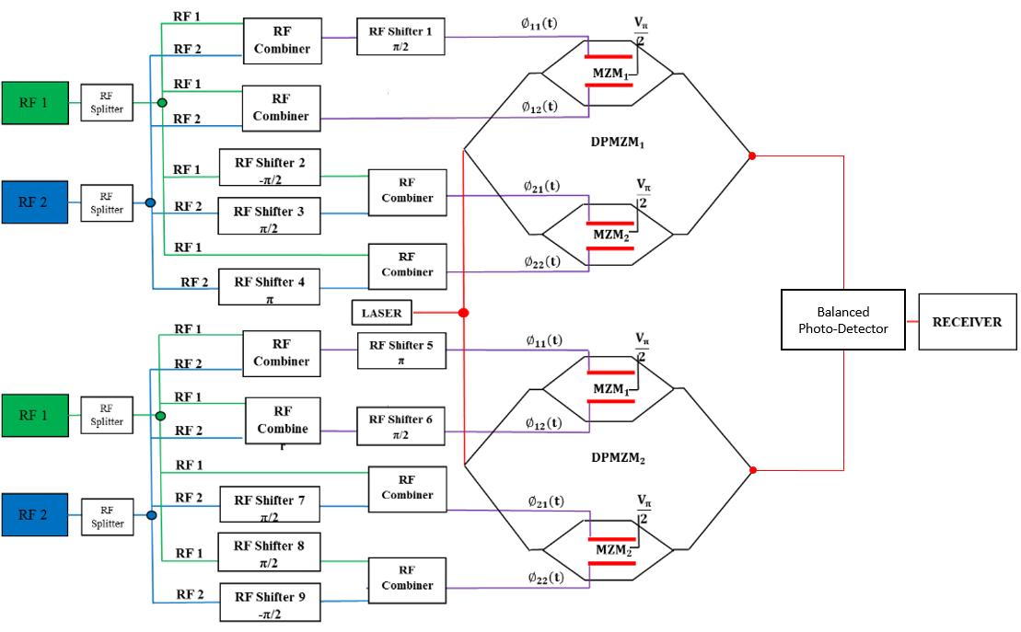

Fig. 1. Schematics of proposed D-DPMZM linearized microwave photonic linkwith two input frequencies.

The input RF frequencies of upper and lower sub MZMs of each D-DPMZM are shifted, as shown in Fig.1. External DC bias is applied to adjust the power ratio for system linearization. Recovered signal from BPD shows IMD3 and SOD are cancelled. The other IMD’s are suppressed simultaneously. Only fundamental frequencies and high order harmonic are present.

The drive voltage with DC biases of DPMZM₁ mathematically can be expressed as [21]:

$∅_{11}\left(t\right)=V_{m}\left\{cos\left(ω_{1}t+\frac{π}{2}\right)+cos\left(ω_{2}t+\frac{π}{2}\right)\right\}+\frac{V_{π}}{2}$ (1)
$∅_{12}\left(t\right)=V_{m}\left\{cos\left(ω_{1}t\right)+cos\left(ω_{2}t\right)\right\}$ (2)
$∅_{21}\left(t\right)=V_{m}\left\{cos\left(ω_{1}t-\frac{π}{2}\right)+cos\left(ω_{2}t+\frac{π}{2}\right)\right\}+\frac{V_{π}}{2}$ (3)
$∅_{22}\left(t\right)=V_{m}\left\{cos\left(ω_{1}t\right)+cos\left(ω_{2}t+π\right)\right\}$ (4)

Where $∅_{11}\left(t\right) and ∅_{12}\left(t\right)$ are drive voltages on two MZM₁ (DPMZM₁) electrodes; $∅_{21}\left(t\right) and ∅_{12}\left(t\right)$are drive voltages on two MZM₂ (DPMZM₁) electrodes,$V_{m}$ is the electrical amplitude of input RF signal. The optical power distributed by laser can be expressed as $E_{in}\left(t\right)=E_{c}e^{jω_{c}t}$, where $E_{c}$ is the input power and $ω_{c}$ is angular frequency of the laser. The output optical power driven by RF message signal in MZM₁ (DPMZM₁) can be expressed as:

$E_{out1{MZM}_{1}}\left(t\right)=E_{in}\left(t\right)\left\{exp\left(jπ\frac{∅_{11}\left(t\right)}{V_{π}}\right)+exp\left(jπ\frac{∅_{12}\left(t\right)}{V_{π}}\right)\right\}$ (5)

The output optical field driven by RF message signal in MZM₂ (DPMZM₁) can be expressed as:

$E_{out1{MZM}_{2}}(t)=E_{in}(t)\left\{exp\left(jπ\frac{∅_{21}\left(t\right)}{V_{π}}\right)+exp\left(jπ\frac{∅_{22}\left(t\right)}{V_{π}}\right)\right\}$ (6)

If equation 1 and 2 is substituted in to equation 5, then:
$E_{out1{MZM}_{1}}(t)=E_{in}(t)\left\{\begin{aligned}exp\left(jm\left\{-sin\left(ω_{1}t\right)-sin\left(ω_{2}t\right)\right\}+j\frac{π}{2}\right) \\ +exp\left(jm\left\{cos\left(ω_{1}t\right)+cos\left(ω_{2}t\right)\right\}\right)\end{aligned}\right\}$ (7)
Where $m=\frac{πV_{m}}{V_{π}}$;
By applying a Jacobi-Anger Expansion in equation 7 will lead to:

$E_{out1{MZM}_{1}}(t)=E_{in}(t)\sum_{n,m=-∞}^{∞}{J_{n}(m)J_{m}(m)}e^{j(nω_{1}t+ω_{2}t)}\left[{(-1)}^{n+m}e^{j\frac{π}{4}}+(j^{n+m})e^{j-\frac{π}{4}}\right]$ (8)

Similarly, by substituting equation 3 and 4 in to equation 6 then the output from MZM₁ (DPMZM₁) is;

$E_{out1{MZM}_{2}}(t)=E_{in}(t)\left\{\begin{aligned}exp\left(jm\left\{sin\left(ω_{1}t\right)-sin\left(ω_{2}t\right)\right\}+j\frac{π}{2}\right) \\ +exp\left(jm\left\{cos\left(ω_{1}t\right)-cos\left(ω_{2}t\right)\right\}\right)\end{aligned}\right\}$ (9)

By applying a Jacobi-Anger Expansion in equation 9;

$E_{out1{MZM}_{2}}(t)=E_{in}(t)\sum_{n,m=-∞}^{∞}{J_{n}(m)J_{m}(m)}e^{j(nω_{1}t+ω_{2}t)}\left[\begin{aligned}{\left(-1\right)}^{m}e^{j\frac{π}{4}}+ \\ {(-1)}^{m}(j^{n+m})e^{j-\frac{π}{4}}\end{aligned}\right]$ (10)

Biasing the sub MZM₃ to zero-point, the output of DPMZM₁ can be expressed as:

$E_{out{DPMZM}_{1}}\left(t\right)=\frac{E_{out1{MZM}_{1}}\left(t\right)+E_{out1{MZM}_{2}}(t)}{\sqrt{2}}$ (11)
$E_{out{DPMZM}_{1}}\left(t\right)=\frac{E_{in}\left(t\right)}{\sqrt{2}} \sum_{n,m=-∞}^{∞}{J_{n}(m)J_{m}(m)}\left\{\begin{aligned}{\left(-1\right)}^{n+m}e^{j\frac{π}{4}}+\left(j^{n+m}\right)e^{j-\frac{π}{4}}+ \\ {\left(-1\right)}^{m}e^{j\frac{π}{4}}+{(-1)}^{m}(j^{n+m})e^{j-\frac{π}{4}}\end{aligned}\right\}e^{j(nω_{1}t+ω_{2}t)}$ (12)

The photocurrent I(t) after the photodetector of ${DPMZM}_{1}$,mathematically can be obtained by following equation:

$I_{PD1}\left(t\right)=R{\left|E_{out{DPMZM}_{1}}\left(t\right)\right|}^{2}$ (13)

Where $R$ is responsivity of photodetector. By deploying the Taylor series expansion into the third order in m, the following expression of $I_{PD1}\left(t\right)$ can be derived:

$I_{PD1}\left(t\right)=\frac{1}{2} RP_{in}\left\{\begin{aligned}8+8m(\cos\left(ω_{1}t\right)+\sin\left(ω_{2}\right)) \\ +2m^{2}\left(-2+\cos\left(2ω_{1}t\right)-\cos\left(2ω_{2}\right)\right) \\ -\frac{2}{3}m^{3}\left(\begin{aligned}9\cos\left(ω_{1}t\right)-\cos\left(3ω_{1}t\right) \\ +9\cos\left(2ω_{2}t\right)+sin⁡(3ω_{2})\end{aligned}\right)\end{aligned}\right\}+{o(m)}^{4}$ (14)

Similarly, the drive voltage with DC biases of DPMZM₂ can be expressed as:

$∅_{11}\left(t\right)=V_{m}\left\{cos\left(ω_{1}t+π\right)+cos\left(ω_{2}t+π\right)\right\}+\frac{V_{π}}{2}$ (15)
$∅_{12}\left(t\right)=V_{m}\left\{cos\left(ω_{1}t+\frac{π}{2}\right)+cos\left(ω_{2}t+\frac{π}{2}\right)\right\}$ (16)
$∅_{21}\left(t\right)=V_{m}\left\{cos\left(ω_{1}t\right)+cos\left(ω_{2}t+\frac{π}{2}\right)\right\}+\frac{V_{π}}{2}$ (17)
$∅_{22}\left(t\right)=V_{m}\left\{cos\left(ω_{1}t+\frac{π}{2}\right)+cos\left(ω_{2}t-\frac{π}{2}\right)\right\}$ (18)

The output optical field driven by RF message signal in MZM₁ (DPMZM₂) can be expressed as:

$E_{out2{MZM}_{1}}(t)=E_{in}(t)\left\{exp\left(jπ\frac{∅_{11}\left(t\right)}{V_{π}}\right)+exp\left(jπ\frac{∅_{12}\left(t\right)}{V_{π}}\right)\right\}$ (19)

The output optical field driven by RF message signal in MZM₂ (DPMZM₂) can be expressed as:

$E_{out{2MZM}_{2}}(t)=E_{in}(t)\left\{exp\left(jπ\frac{∅_{21}\left(t\right)}{V_{π}}\right)+exp\left(jπ\frac{∅_{22}\left(t\right)}{V_{π}}\right)\right\}$ (20)

If equation 15 and 16 is substituted in to 19 then:

$E_{out2{MZM}_{1}}(t)=E_{in}(t)\left\{\begin{aligned}exp\left(jm\left\{-cos\left(ω_{1}t\right)-cos\left(ω_{2}t\right)\right\}+j\frac{π}{2}\right) \\ +exp\left(jm\left\{-sin\left(ω_{1}t\right)-sin\left(ω_{2}t\right)\right\}\right)\end{aligned}\right\}$ (21)
Where $m=\frac{πV_{m}}{V_{π}}$ ;

By applying the Jacobi-Anger Expansion in equation 21;
$E_{out2{MZM}_{1}}(t)=\frac{E_{in}\left(t\right)}{\sqrt{2}} \sum_{n,m=-∞}^{∞}{J_{n}(m)J_{m}(m)}e^{j(nω_{1}t+ω_{2}t)}\left[{(-j)}^{n+m}e^{j\frac{π}{4}}+({-1)}^{n+m}e^{j-\frac{π}{4}}\right]$ (22)

Similarly, by substituting equation 17and18 in to the equation 20, the output optical field in MZM₂ (DPMZM₂) is:

$E_{out2{DPMZM}_{2}}(t)=E_{in}(t)\left\{\begin{aligned}exp\left(jm\left\{cos\left(ω_{1}t\right)-cos\left(ω_{2}t\right)\right\}+j\frac{π}{2}\right) \\ +exp\left(jm\left\{-sin\left(ω_{1}t\right)+sin\left(ω_{2}t\right)\right\}\right)\end{aligned}\right\}$ (23)

Also by applying a Jacobi-Anger Expansion in equation 23;

$E_{out2{DPMZM}_{2}}(t)=E_{in}(t)\sum_{n,m=-∞}^{∞}{J_{n}(m)J_{m}(m)}e^{j(nω_{1}t+ω_{2}t)}\left[\begin{aligned}{\left(j\right)}^{n}{\left(-j\right)}^{m}e^{j\frac{π}{4}}+ \\ {(-1)}^{n}e^{j-\frac{π}{4}}\end{aligned}\right]$ (24)

When biasing the sub MZM₃ to zero-point, then the output of DPMZM₂ can be expressed as:

$E_{out{DPMZM}_{2}}\left(t\right)=\frac{E_{out2{DPMZM}_{1}}\left(t\right)+E_{out2{DPMZM}_{2}}(t)}{\sqrt{2}}$ (25)

$E_{out{DPMZM}_{2}}(t)=\frac{E_{in}\left(t\right)}{\sqrt{2}} \sum_{n,m=-∞}^{∞}{J_{n}(m)J_{m}(m)}\left\{\begin{aligned}{(-j)}^{n+m}e^{j\frac{π}{4}}+({-1)}^{n+m}e^{j-\frac{π}{4}}+ \\ {\left(j\right)}^{n}{\left(-j\right)}^{m}e^{j\frac{π}{4}}+{(-1)}^{n}e^{j-\frac{π}{4}}\end{aligned}\right\}e^{j(nω_{1}t+ω_{2}t)}$ (26)

The photocurrent I(t) after photodetector of DPMZM₂ can be obtained by following equation:

$I_{PD2}\left(t\right)=R{\left|E_{out{DPMZM}_{2}}\left(t\right)\right|}^{2}$ (27)

Where $R$ is responsivity of photodetector. By using the Taylor series expansion to the third order in m, the following expression can be derive;

$I_{PD2}\left(t\right)=\frac{1}{2} RP_{in}\left\{\begin{aligned}8+8\left[m\left(\cos\left(ω_{1}t\right)+\sin\left(ω_{2}\right)\right)\right] \\ +2m^{2}\left(-2-\cos\left(2ω_{1}t\right)+\cos\left(2ω_{2}\right)\right) \\ \frac{2}{3}m^{3}\left[\begin{aligned}-9\cos\left(ω_{2}t\right)+\cos\left(3ω_{2}t\right) \\ +9\sin\left(ω_{1}t\right)+sin⁡(3ω_{1})\end{aligned}\right]\end{aligned}\right\}+{o(m)}^{4}$ (28)

Recovered signal after BPD $I_{PD1}\left(t\right)+I_{PD2}\left(t\right)$ we will be obtain:

$I_{PD1+PD2}\left(t\right)=\frac{1}{2} RP_{in}\left\{\begin{aligned}8+8\left[\begin{aligned}m\left(\cos\left(ω_{2}t\right)-\sin\left(ω_{1}\right)\right)+ \\ +m\left(\cos\left(ω_{1}t\right)+\sin\left(ω_{2}\right)\right)\end{aligned}\right] \\ -8m^{2} \\ \frac{2}{3}m^{3}\left[\begin{aligned}-9\cos\left(ω_{2}t\right)+\cos\left(3ω_{2}t\right) \\ +9\sin\left(ω_{1}t\right)+\sin\left(3ω_{1}\right) \\ \begin{aligned}9\cos\left(ω_{1}t\right)-\cos\left(3ω_{1}t\right) \\ +9\cos\left(2ω_{2}t\right)+sin⁡(3ω_{2})\end{aligned}\end{aligned}\right]\end{aligned}\right\}+{o(m)}^{4}$ (29)

Equation 29 illustrates that the microwave photonic link based on two D-DPMZ and BPD can be used to linearize signals, resulting in the elimination of the IMD3 of frequency ${2ω}_{2}{-ω}_{1}$ and $2ω_{1}-ω_{2}$ and the SOD of frequency ${2ω}_{2},{ ω}_{2}-ω_{1}, { ω}_{1}+ω_{2}$ and $2ω_{1}$. SOD and IMD3 are the main contribution of the non-linearity. We have used the Taylor series for higher order (up to the ninth order) and the IMD3 and SOD still does not exist, which means that when the modulation index increases, the IMD3 and SOD will not exist in the proposed system configuration.

- Simulation results and discussions

In our proposed configurations and developed corresponding mathematical model, we have deployed the VPI commercial software to simulate the system illustrated in Fig. 1. Prior to simulating our proposed system, we have benchmarked our VPI model with an already published model in [21]. In this structure, we have used two D-DPMZM. A laser with optical power 20 dBm is used, two sinusoid signals with frequency of 17 GHz and 17.5 GHz are also used. The signal is split in equal ratio and modulated in DPMZM₁ and DPMZM₂
The phase shifting has been performed as follows; In DPMZM₁ RF signal $ω_{1}$ and $ω_{2}$ in MZM₁ upper branch have been shifted by $\frac{π}{2}$ and in MZM₂ signal $ω_{1}$has been shifted by $-\frac{π}{2}$ ; $ω_{2}$ signal has been shifted by $\frac{π}{2}$ in upper branch whereas in the lower branch the signal $ω_{2}$ has been shifted by $π$. In DPMZM₂ signal $ω_{1}$ and $ω_{2}$ have been shifted by $π$ in upper branch of MZM₁, RF signal $ω_{1}$ and $ω_{2}$ has been shifted by $\frac{π}{2}$ in lower branch of MZM₁, in MZM₂ signal $ω_{2}$ has been shifted by $π$ in upper branch as in lower branch of MZM₂; $ω_{1}$ has been shifted by $\frac{π}{2}$ and $ω_{2}$has been shifted by $-\frac{π}{2}$ .
The generated signal from DPMZM₁ is transmitted through channel 1 as shown in Fig. 2a, and the generated signal from DPMZM₂ is transmitted through channel 2 as shown in Fig. 2b. The recovered signals from BPD is shown in Fig. 2c.

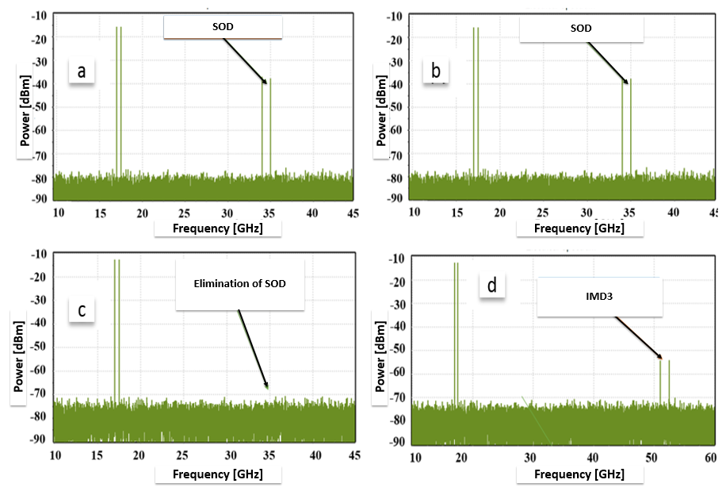

Fig.2 a Output Frequency from ${DPMZ}_{1}$; b Output Frequency from ${DPMZ}_{2}$; c Output field after balanced photo-detector; d Output field after modification;

From Fig. 2a we can clearly see the elimination of IMD3, whereas the SOH is still present. Similarly, Fig. 2b shows similar behavior as in Fig. 2a, however, with opposite SOH fields which enables the elimination of the SOH after BPD. From Fig. 2c it can be observed the SOH has been eliminated completely. However, higher distortion still exists. We have tested our system purity by changing the parameters of modulator (Table. 1) to match with our lab modulator, where we obtained same results as before. Furthermore, by using the same parameters in order for IMD3 and SOH to be suppressed under the noise floor shifters accuracy should be within four degrees, Fig 3a. We can only start seeing SOH when shifters accuracy is 5 degrees or more Fig. 3b. By adding universal fiber optic cable with length 1 kilometer for both channels, we find out that the results do not change Fig. 3c. However, if the length of fiber optic cable is not the same, then SOH starts coming up the noise floor. We have used 1 Km fiber optic cable for channel one and 1.2 Km fiber optic cable for channel two and the SOH can barely be seen, Fig. 3d.
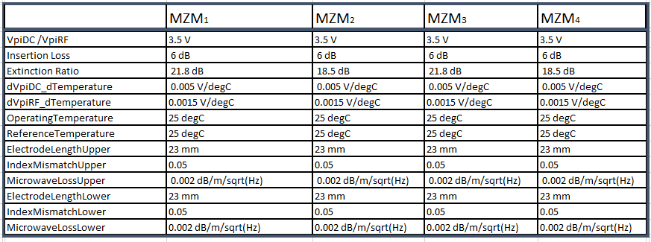
Table.1 MZM_{S} Parameters used in our simulation
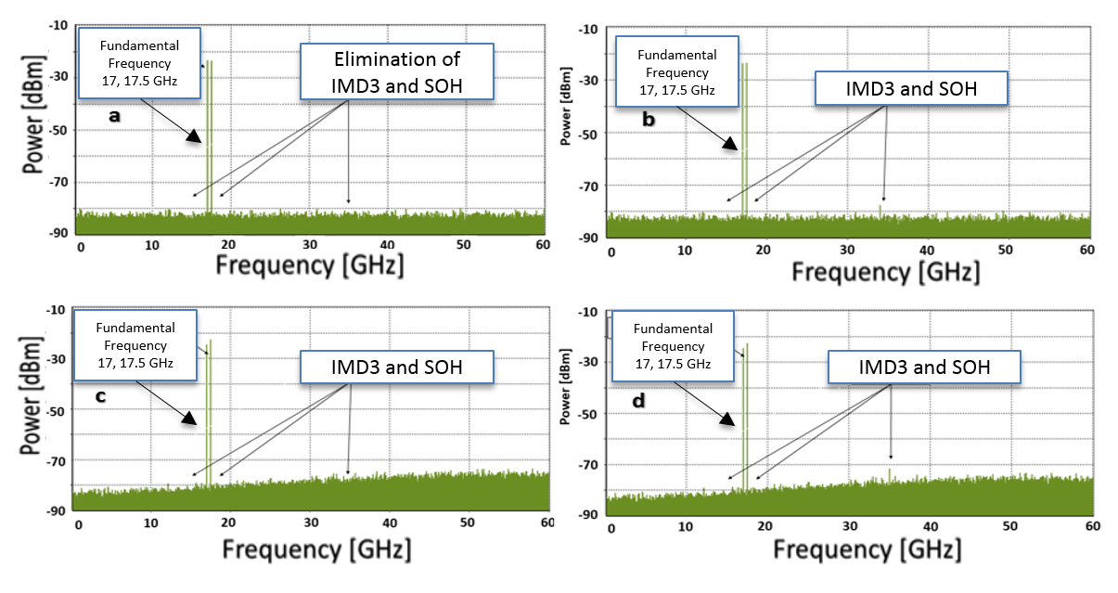
Fig. 3 a shifter accuracy within 4 degrees; b shifter accuracy 5 or more degrees; c output signal spectrum using 1 Km fiber optic cable for both channels; d output signal spectrum using 1 Km fiber optic cable for channel 1 and 1.2 Km fiber optic cable for channel 2;

- Microwave photonic down-conversion using two fiber optic channels

The schematic diagram of the down-conversion linearized microwave photo link deploying two D-DPMZM and two fiber optic channels is illustrated in Fig. 1. We have investigated the down-conversion of the same system configuration. As illustrated in section 2, we have only modified the operating biased point from quadrature to maximum, where we have achieved high linearized down-conversion signal. In the same model, as in the above section 2, we can derive the following mathematic modelling for the down-conversion of the proposed microwave photonic link;
The drive voltage with down-conversion biases of DPMZM₁ can be expressed as:

$∅_{11}\left(t\right)=V_{m}\left\{cos\left(ω_{1}t+\frac{π}{2}\right)+cos\left(ω_{2}t+\frac{π}{2}\right)\right\}+V_{π}$ (30)
$∅_{12}\left(t\right)=V_{m}\left\{cos\left(ω_{1}t\right)+cos\left(ω_{2}t\right)\right\}$ (31)
$∅_{21}\left(t\right)=V_{m}\left\{cos\left(ω_{1}t-\frac{π}{2}\right)+cos\left(ω_{2}t+\frac{π}{2}\right)\right\}+V_{π}$ (32)
$∅_{22}\left(t\right)=V_{m}\left\{cos\left(ω_{1}t\right)+cos\left(ω_{2}t+π\right)\right\}$ (33)

Where $∅_{11}\left(t\right) and ∅_{12}\left(t\right)$ are drive voltages on two MZM’s (DPMZM₁) electrodes; $∅_{11}\left(t\right) and ∅_{12}\left(t\right)$ are drive voltages on two MZM’s (DPMZM₂) electrodes,$V_{m}$ is the electrical amplitude of RF input signal which is the same for each input signal. The optical power distributed by laser can be expressed as; $E_{in}\left(t\right)=E_{c}e^{jw_{c}t}$, where $E_{c}$ is the input power and $ω_{c}$ is the angular frequency of the laser source. The output optical field driven by RF signal message in MZM₁ (DPMZM₁) can be expressed as:

$E_{out1{MZM}_{1}}(t)=E_{in}(t)\left\{exp\left(jπ\frac{∅_{11}\left(t\right)}{V_{π}}\right)+exp\left(jπ\frac{∅_{12}\left(t\right)}{V_{π}}\right)\right\}$ (34)

The output optical field driven by RF signal message in MZM₂ (DPMZM₁) can be expressed as:

$E_{out1{MZM}_{2}}(t)=E_{in}(t)\left\{exp\left(jπ\frac{∅_{21}\left(t\right)}{V_{π}}\right)+exp\left(jπ\frac{∅_{22}\left(t\right)}{V_{π}}\right)\right\}$ (35)

Where $m=\frac{πV_{m}}{V_{π}} ;$than by substituting equation 30 and 31 in to equation 34 then:

$E_{out1{MZM}_{1}}(t)=E_{in}(t)\left\{\begin{aligned}exp\left(jm\left\{-sin\left(ω_{1}t\right)-sin\left(ω_{2}t\right)\right\}+jπ\right) \\ +exp\left(jm\left\{cos\left(ω_{1}t\right)+cos\left(ω_{2}t\right)\right\}\right)\end{aligned}\right\}$ (36)

By applying a Jacobi-Anger Expansion in equation 36;

$E_{out1{MZM}_{1}}(t)=E_{in}(t)\sum_{n,m=-∞}^{∞}{J_{n}(m)J_{m}(m)}e^{j(nω_{1}t+ω_{2}t)}\left[{(-1)}^{n+m}e^{j\frac{π}{2}}+(j^{n+m})e^{j-\frac{π}{2}}\right]$ (37)

Similarly, by substituting equation 32 and 33 in to equation 35, we can find the output optical field driven by RF signal message in MZM₂ (DPMZM₁)

$E_{out1{MZM}_{2}}(t)=E_{in}(t)\left\{\begin{aligned}exp\left(jm\left\{sin\left(ω_{1}t\right)-sin\left(ω_{2}t\right)\right\}+jπ\right) \\ +exp\left(jm\left\{cos\left(ω_{1}t\right)-cos\left(ω_{2}t\right)\right\}\right)\end{aligned}\right\}$ (38)

By applying a Jacobi-Anger Expansion in equation 38;

$E_{out1{MZM}_{2}}(t)=E_{in}(t)\sum_{n,m=-∞}^{∞}{J_{n}(m)J_{m}(m)}e^{j(nω_{1}t+ω_{2}t)}\left[\begin{aligned}{\left(-1\right)}^{m}e^{j\frac{π}{2}}+ \\ {(-1)}^{m}(j^{n+m})e^{j-\frac{π}{2}}\end{aligned}\right]$ (39)
Optical field from DPMZM₁ can be expressed as:

$E_{out{DPMZM}_{1}}\left(t\right)=\frac{E_{out{MZM}_{1}}\left(t\right)+E_{out1{MZM}_{2}}(t)}{\sqrt{2}}$ (40)

$E_{out{DPMZM}_{1}}\left(t\right)=\frac{E_{in}\left(t\right)}{\sqrt{2}} \sum_{n,m=-∞}^{∞}{J_{n}(m)J_{m}(m)}\left\{\begin{aligned}{\left(-1\right)}^{n+m}e^{j\frac{π}{2}}+\left(j^{n+m}\right)e^{j-\frac{π}{2}}+ \\ {\left(-1\right)}^{m}e^{j\frac{π}{2}}+{(-1)}^{m}(j^{n+m})e^{j-\frac{π}{2}}\end{aligned}\right\}e^{j(nω_{1}t+ω_{2}t)}$(41)

The photocurrent I(t) after the photodetector, can be obtained by substituting output fields of DPMZM₁ into the following equation:

$I_{PD1}\left(t\right)=R{\left|E_{out{DPMZM}_{1}}\left(t\right)\right|}^{2}$ (42)

Where $R$ is responsivity of photodetector. Using Taylor series expansion to the third order in m, the following expression can be derived

$I_{PD1}\left(t\right)=\frac{1}{2} RP_{in}\left\{-4m^{2}*(j*cos\left(ω_{1}\right)+{(j*\sin\left(ω_{2}\right))}^{2}\right\}+{o(m)}^{4}$ (43)

Similarly, the drive voltage of DPMZM₂ can be expressed as:

$∅_{11}\left(t\right)=V_{m}\left\{cos\left(ω_{1}t+π\right)+cos\left(ω_{2}t+π\right)\right\}+V_{π}$ (44)
$∅_{12}\left(t\right)=V_{m}\left\{cos\left(ω_{1}t+\frac{π}{2}\right)+cos\left(ω_{2}t+\frac{π}{2}\right)\right\}$ (45)
$∅_{21}\left(t\right)=V_{m}\left\{cos\left(ω_{1}t\right)+cos\left(ω_{2}t+\frac{π}{2}\right)\right\}+V_{π}$ (46)
$∅_{22}\left(t\right)=V_{m}\left\{cos\left(ω_{1}t+\frac{π}{2}\right)+cos\left(ω_{2}t-\frac{π}{2}\right)\right\}$ (47)

Where $∅_{11}\left(t\right) and ∅_{12}\left(t\right)$ are drive voltages on two MZM₁ (DPMZM₂) electrodes; $∅_{11}\left(t\right) and ∅_{12}\left(t\right)$ are drive voltages on two MZM₂ (DPMZM₂) electrodes, $V_{m}$ is the electrical amplitude of input RF signal. The optical power distributed by the laser can be expressed as;$E_{in}\left(t\right)=E_{c}e^{jω_{c}t}$, where $E_{c}$ is the input power and $ω_{c}$ is angular frequency of the laser. Then the output optical field driven by RF signal message in MZM₁ (DPMZM₂) can be expressed as:

$E_{out2{MZM}_{1}}(t)=E_{in}(t)\left\{exp\left(jπ\frac{∅_{11}\left(t\right)}{V_{π}}\right)+exp\left(jπ\frac{∅_{12}\left(t\right)}{V_{π}}\right)\right\}$ (48)
The output optical field driven by RF signal message in MZM₂ (DPMZM₂) can be expressed as:

$E_{out2{MZM}_{2}}(t)=E_{in}(t)\left\{exp\left(jπ\frac{∅_{21}\left(t\right)}{V_{π}}\right)+exp\left(jπ\frac{∅_{22}\left(t\right)}{V_{π}}\right)\right\}$ (49)

Where $m=\frac{πV_{m}}{V_{π}}$ ; Then by substituting equation 44 and 45 in to equation 48;
$E_{out2{MZM}_{1}}(t)=E_{in}(t)\left\{\begin{aligned}exp\left(jm\left\{-cos\left(ω_{1}t\right)-cos\left(ω_{2}t\right)\right\}+jπ\right) \\ +exp\left(jm\left\{-sin\left(ω_{1}t\right)-sin\left(ω_{2}t\right)\right\}\right)\end{aligned}\right\}$ (50)

By applying the Jacobi-Anger Expansion in equation 50;

$E_{out2{MZM}_{1}}(t)=E_{in}(t)\sum_{n,m=-∞}^{∞}{J_{n}(m)J_{m}(m)}e^{j(nω_{1}t+ω_{2}t)}\left[{(-j)}^{n+m}e^{j\frac{π}{2}}+({-1)}^{n+m}e^{j-\frac{π}{2}}\right]$ (51)

Similarly, by substituting equation 46 and 47 in to equation 49, we can derive the output optical field in MZM₂ (DPMZM₂);

$E_{out2{MZM}_{2}}(t)=E_{in}(t)\left\{\begin{aligned}exp\left(jm\left\{cos\left(ω_{1}t\right)-cos\left(ω_{2}t\right)\right\}+jπ\right) \\ +exp\left(jm\left\{-sin\left(ω_{1}t\right)+sin\left(ω_{2}t\right)\right\}\right)\end{aligned}\right\}$ (52)

By applying the Jacobi-Anger Expansion in equation 52;

$E_{out2{MZM}_{2}}(t)=E_{in}(t)\sum_{n,m=-∞}^{∞}{J_{n}(m)J_{m}(m)}e^{j(nω_{1}t+ω_{2}t)}\left[\begin{aligned}{\left(j\right)}^{n}{\left(-j\right)}^{m}e^{j\frac{π}{2}}+ \\ {(-1)}^{n}e^{j-\frac{π}{2}}\end{aligned}\right]$ (53)
Combining output power from two MZMs will represent the optical field of DPMZM₂ and it can be expressed as;

$E_{out{DPMZM}_{2}}\left(t\right)=\frac{E_{out2{MZM}_{1}}\left(t\right)+E_{out2{MZM}_{2}}(t)}{\sqrt{2}}$ (54)
$E_{out{DPMZM}_{2}}\left(t\right)=\frac{E_{in}\left(t\right)}{\sqrt{2}} \sum_{n,m=-∞}^{∞}{J_{n}(m)J_{m}(m)}\left\{\begin{aligned}{(-j)}^{n+m}e^{j\frac{π}{2}}+({-1)}^{n+m}e^{j-\frac{π}{2}}+ \\ {\left(j\right)}^{n}{\left(-j\right)}^{m}e^{j\frac{π}{2}}+{(-1)}^{n}e^{j-\frac{π}{2}}\end{aligned}\right\}e^{j(nω_{1}t+ω_{2}t)}$ (55)

The photocurrent I(t) after photodetector, can be obtained by substituting the output fields of DPMZM₂ into the following equation:

$I_{PD2}\left(t\right)=R{\left|E_{out{DPMZM}_{2}}\left(t\right)\right|}^{2}$ (56)

where $R$ is responsivity of photodetector. Using Taylor series expansion into the third order in m, following expression can be derived.

$I_{PD2}\left(t\right)=\frac{1}{2} RP_{in}\{-m^2 (2j cos⁡(2ω_{1} t)+{(2jsin⁡(ω_{2} )) }^{2})\}+{o(m)}^{4}$ (57)

Combining the output fields of DPMZM₁ and DPMZM₂ after BPD $I_{PD}\left(t\right)=I_{PD1}\left(t\right)+I_{PD2}\left(t\right)$ we will obtain:

$I_{PD}\left(t\right)=\frac{1}{2} RP_{in}\left\{m^{2}*(8-8(\sin\left(ω_{1}-ω_{2}\right))\right\}+{o(m)}^{4}$ (58)

From equation 58, we can clearly see that the only existing frequency is the sideband Second Order Intermodulation of frequency $ω_{1}{-ω}_{2}$. Furthermore, SOH and Second Order sideband Intermodulation product do not exist. We have used the VPI commercial software to simulate the system configuration, as in section 2. From Fig. 4a we can see that the signal has been down converted from high frequency to low frequency. Frequencies used in this configuration are 17 GHz and 17.5 GHz; therefore, the difference of these two frequencies is 0.5 GHz ($ω_{1}-ω_{2}$). From the spectrum analyzer, we can clearly see that all nonlinear distortions that are close to down-converted signals are eliminated, resulting in a clear and highly linearized signal. In our proposed configuration, we have managed to eliminate IMD3 and SOH simultaneously, and suppress higher order harmonics as illustrated in Fig. 4b. If we expand the electrical spectrum Fig. 4c, we can see that down converted-electrical spectrum is clear up to 65 GHz, which means the SOD, frequency $ω_{1}+ω_{2}$ and TOD are completely eliminated in a very broad spectrum. However, the higher order harmonics still exists. In Fig. 4d we have investigate systems by using higher frequencies in order to see how the proposed system behaves and as can be seen in Fig. 4c, results are the same as in the previous case.
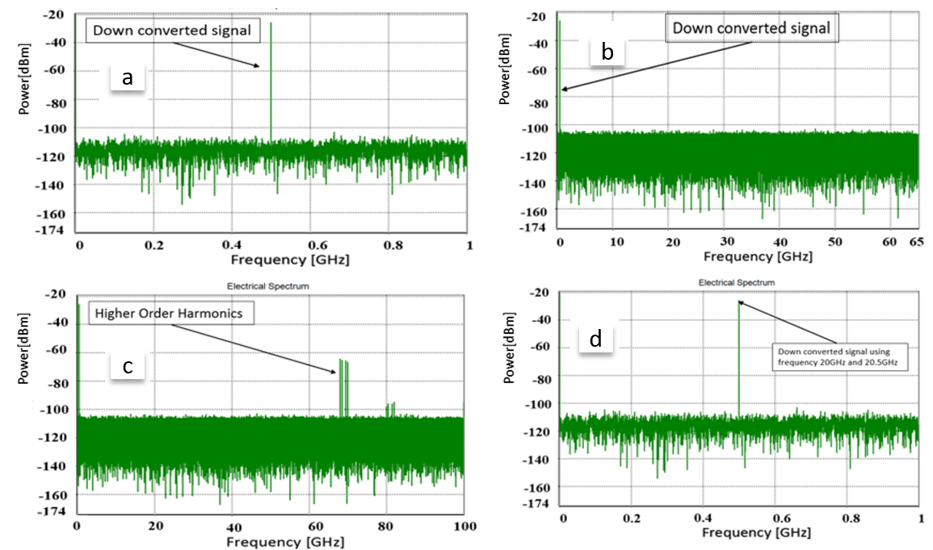
Fig. 4 a down-converted frequency 0.5 GHz; b proposed down-conversion spectrum up to 60 GHz; c proposed down-conversion spectrum up to 100 GHz; d down-conversion E.S for higher frequency

In this proposed and developed model for both cases, we have assumed that frequencies are split equally. Due to 9 phase shifters used, we are aware that there will be losses. However, these minor limitations can be overcome by deploying the RF structure as an integrated circuits and the physical length between RF and the shifters are minimum. The accuracy of shifting should be within one degree in order to achieve the elimination. Frequencies can be sent in the same fiber in two different channels using a polarizer, this way the signal travels in the same physical length of fiber, and hence this will lead to eliminate the SOH. In order to check the purity of the down-conversion linearized microwave photo link we performed the same measurements as in section 3. We can confirm the measurement holds the same accuracy as in section 3.

- Conclusion
In this paper, we have proposed, developed and demonstrated a high linear analogue photonic link with IMD3, SOH, second order distortion product eliminated, and with other higher order distortion products suppressed. We have demonstrated that by deploying two D-DPMZMs and insert frequencies in two different channels, then by combining the power through the BPD IMD3, SOH, and second order distortion can be eliminated, and other higher order harmonics can be suppressed completely. The proposed approach has led to a highly linearized signal with clean spectrum near the fundamental frequencies. The proposed configuration is suitable for application in short distances and long distances transmission systems. We have also managed to obtain a dynamic range of 58 dB with IMD3, SOHs eliminated, and other harmonics suppressed under the noise floor. To the best of our knowledge, this is the first demonstrated work in literature where IMD3, SOHs and second order distortion produces have been completely eliminated. Furthermore, we have also demonstrated that this configuration can be used for a down-conversion only by varying the operating biasing point of the modulator from quadrature to maximum. The optimized linearized proposed configuration, with the above stated high performances, has been used to down converted signals at a broad spectrum with a high dynamic range of 77.84 dBm. Our developed Mathematical models has been also simulated using commercial software where the obtained results seem to match well
References
- J. Yao, Microwave photonics, J. Lightw. Tcchnol. Vol. 27, No. 3, (2009), pp. 225-314.
- C. Cox, Analog Optical Links, Theory and Practice, Cambridge University, (2004).
- X. Zou, B. Lu, W. Pan, L. Yan, A. Stohr, J. Yao, Photonics for microwave measurements, Laser Photonics Rev. 10, No. 5, (2016), pp.711-734.
- F. Pail; S. Haxha, T. N. Mirza, M. S. Alom: Microwave Photonic Downconversion With Improved Conversion Efficiency and SFDR, IEEE Access, (2018), No. 6.
- A.J. Cooper, Electron. Lett. Vol.26, No. 24, (1990), pp.2054.
- J-M. Merolla, Y. Mazurenko, J-P. Goedgebuer, H. Porte, W. T. Rhodes: Phase modulation transmission system for quantum cryptography, Optics Letters, vol. 24, No. 2, (1999), pp. 104.
- L. Duraffourg, J-M. Merolla, J-P, Goedgebuer, Y. Mazurenko, W. T. Rhodes: Compact transmission system using single-sideband modulation of light for quantum cryptography, Optics Letters, vol. 26, No. 18, Sept.(2001), pp, 1427.
- Zhiyu Chen,1 Lianshan Yan, Wei Pan,1 Bin Luo, Xihua Zou, Yinghui Guo, Hengyun Jiang, and Tao Zhou: SFDR enhancement in analogue photonic links by simultaneous compensation for dispersion and nonlinearity, Opt. Exp., vol. 21, No. 18, Sep.( 2013), pp. 20 999–21 009.
- T. R. Clark, S. R. O'Connor, and M. L. Dennis: A phase-modulation I/Q-demodulation microwave-to-digital photonic link, IEEE Trans. Microw. Theory Tech., vol. 58, No. 11, Nov. (2010), pp. 3039–3058.
- Y. Cui et al.: Enhanced spurious free dynamic range in intensity modulated analogue photonic link using digital post processing, IEEE Photon. J., vol. 6, No. 2, Apr. (2014), Art. ID. 7900608.
- C. Lim, A. Nirmalathas, K. Lee, D. Novak, and R. Waterhouse: Inter-modulation distortion improvement for fiber-radio applications incorporating OSSBþC modulation in an optical integrated-access environment, J. Lightw. Technol., vol. 25, No. 6, Jun. (2007), pp. 1602–1612.
- Z. H. Zhu, S. H. Zhao, Q. G. Tan, and W. Jiang: A linearized optical single-sideband modulation analogue microwave photonic link using dual-parallel interferometers, IEEE Photon. J., vol. 5, No. 5, Oct. (2013), Art. ID. 5501712.
- X. Li, Z. H. Zhu, and S. H. Zhao: An intensity modulation and coherent balanced detection intersatellite microwave photonic link using polarization direction control, Opt. Laser Technol., vol. 56, Mar. (2014), pp. 362–366.
- S. K. Korotky and R. M. Ridder: Dual parallel modulation schemes for low-distortion analogue optical transmission, IEEE J. Sel. Areas Commun., vol. 8, No. 7, Sep. (1990), pp. 1377–1381.
- S. Li, X. Zheng, H. Zhang, and B. Zhou: Highly linear radio-over-fiber system incorporating a single-drive dual-parallel Mach–Zehnder modulator, IEEE Photon. Technol. Lett., vol. 22, No. 24, Dec. (2010), pp. 1775–1777.
- G. H. Zhu, W. Liu, and H. R. Fetterman: A broadband linearized coherent analogue fiber-optic link employing dual parallel Mach–Zehnder modulator,” IEEE Photon. Technol. Lett., vol. 21, No. 21, Nov. (2009), pp. 1627–1629.
- S. K. Kim, W. Liu, Q. Pei, L. R. Dalton, and H. R. Fetterman: Nonlinear intermodulation distortion suppression in coherent analogue fiber optic link using electro-optic polymeric dual parallel Mach–Zehnder modulator, Opt. Exp., vol. 19, No. 8, Apr. (2011), pp. 7865–7871.
- J. Li et al.: Third-order intermodulation distortion elimination of microwave photonics link based on integrated dual-drive dual-parallel Mach–Zehnder modulator, Opt. Exp., vol. 38, No. 21, Nov. (2013), pp. 4285–4287.
- Y. Wang, Jingnan Li, Dayong Wang, Tao Zhou: Ultra-wideband microwave photonic frequency downconverter based on carrier-suppressed single-sideband modulation, Optics Communications Vol. 1, March (2018), pp. 799-804.
- Q. Tan, Yongsheng GAO, Yangyu Fan, You He: Multi-octave analog photonic link with improved second and third-order SFDRs, Optics Communications Vol. 410, March (2018), pp. 685-689.
- J Li, YC Zhang, S Yu, T Jiang, Q Xie, W Gu: Third-order intermodulation distortion elimination of microwave photonics link based on integrated dual-drive dual-parallel Mach–Zehnder modulator, Optics letters, (2013), osapublishing.org Vol. 38, Issue 21, pp. 4285-4287.

