Pleistocene volcanism and the geomorphological record of the Hrazdan Valley, central Armenia: linking landscape dynamics and the Palaeolithic record
J. E. Sherriff¹*, K. N. Wilkinson², D. S. Adler³, D. Arakelyan⁴, E. J. Beverly⁵, S.P.E Blockley¹, B. Gasparyan⁶, D. F. Mark⁷, K. Meliksetyan⁴, S. Nahapetyan⁸, K. J. Preece⁹, R.G.O Timms¹
*Corresponding author: jenni.sherriff@rhul.ac.uk
¹Centre for Quaternary Research, Department of Geography, Royal Holloway, University of London, Egham, Surrey, TW20 0EX
2Department of Archaeology, Anthropology and Geography, University of Winchester, Winchester, SO22 4NR, UK.
³Department of Anthropology, Old World Archaeology Program, University of Connecticut, 354 Mansfield Road, Unit 2176, Storrs, CT 06269, USA
⁴Institute of Geological Sciences, National Academy of Sciences of the Republic of Armenia, 24a Marshall Baghramyan Avenue, 0019, Yerevan, Armenia.
⁵Department of Earth and Atmospheric Sciences, University of Houston, 507 Cullen Boulevard, Houston, TX 77204-5007, USA
⁶Institute of Archaeology and Ethnography, National Academy of Sciences of the Republic of Armenia, Charents 15, 375019 Yerevan, Armenia.
⁷NERC Argon Isotope Facility, Scottish Universities Environmental Research Centre, Scottish Enterprise and Technology Park, Rankine Avenue, East Kilbride, G75 0QF, UK.
⁸Department of Cartography and Geomorphology, State University of Yerevan, Alek Manukyan 1, 375049 Yerevan, Armenia.
⁹Department of Geography, College of Science, Swansea University, Singleton Park, Swansea, SA2 8PP, UK
Keywords
Pleistocene, palaeogeography, volcanism, geomorphology, Palaeolithic, Gegham Range, tectonism, ⁴⁰Ar/³⁹Ar chronology, Southern Caucasus
Abstract
The Southern Caucasus lies at the intersection of Africa, the Levant and Eurasia, and is thus a region of considerable interest in the study of Pleistocene hominin population dynamics and behaviour. While Palaeolithic archaeological sites in the region such as Dmanisi and Nor Geghi 1 attest to such palaeogeographic significance, a greater understanding of the chronology and nature of climatic and geomorphic changes in the region is needed to fully understand hominin settlement dynamics. The Hrazdan river valley, central Armenia, has the potential to offer such insights given its rich Palaeolithic record and complex history of Pleistocene infill as a result of alluvial, lacustrine, aeolian, and volcanic processes. We therefore present a stratigraphic framework for basin infill and hominin activity during the Pleistocene, based on extensive geomorphological and geological mapping, published chronometric results (⁴⁰Ar/³⁹Ar and K-Ar), and archaeological survey. We demonstrate that the onset of Pleistocene volcanism in the Gegham Range to the immediate east of the Hrazdan valley occurred around 700 ka BP, after which there were several phases of effusive eruption lasting until 200 ka. Interbedded with lava emplaced by these eruptions are alluvial and lacustrine sequences, some with evidence of pedogenesis and several of which have yielded Palaeolithic artefacts. Taken together these sequences suggest a cyclical model of infill whereby lava flow along the valley resulted in the blockage of the palaeo-Hrazdan river and lake formation in the lea of the lava dams. Breaching of these dams resulted in a shift to predominately fluvial deposition, and the consequent development of floodplain soils. Hominin populations exploited the floodplains at times when the last of these phases coincided with interglacial and interstadial climates, but they also occupied the surrounding valley sides during the same warm, humid phases.
- Introduction
Fluvial systems have long been recognised as important archives that link Pleistocene environmental change and the Palaeolithic archaeological record (see Chauhan et al., 2017 for a detailed review). In several geographical regions correlation of geomorphological development with records of human activity and climatic change in such systems has enabled the construction of Palaeolithic occupation chronologies (e.g., Bridgland, 2000; Bridgland et al., 2003; Antoine et al., 2015; Maddy et al., 2015). The Southern Caucasus (the modern-day Republics of Armenia, Azerbaijan, and Georgia) was a land bridge between Africa and Eurasia throughout the Quaternary and is therefore a key region for understanding hominin dispersal and behaviour during the Pleistocene. Several archaeological sites attest to the region’s importance; these include Dmanisi, Georgia, where the earliest evidence for Homo outside of Africa has been recovered (Gabunia et al., 2000, 2001; Ferring et al., 2011), and Nor Geghi 1, Armenia, which records early evidence for the use of complex stone tool technologies (Adler et al., 2014). Open-air and cave sites documenting Lower, Middle, and Upper Palaeolithic behaviours have been described (e.g., Adler et al., 2006; Liagre et al., 2006; Fernández-Jalvo et al., 2010; Mercier et al., 2010;Ghukasyan et al., 2011; Pinhasi et al., 2011; Adler et al. 2012; Tushabramishvili et al., 2011; Egeland et al., 2014, 2016; Gasparyan and Arimura 2014; Moncel et al., 2015; Glauberman et al., 2016; Pleurdeau et al., 2016; Kandel et al., 2017); however, the chronology and nature of climatic and geomorphological changes in the region require further attention before a better comprehension of the rich archaeological record can be achieved.
The Hrazdan river basin, central Armenia, has the potential to offer such insights given that its fluvial and Palaeolithic archaeological records are associated with volcanism that occurred during several intervals in the Pleistocene (Badalian et al., 2001; Arutyunyan et al., 2007; Lebedev et al., 2011, 2013). Over the last few decades the Hrazdan basin has been intensively studied by geologists, geomorphologists, and archaeologists (e.g. Karapetian, 1987; Karapetian et al., 2001; Adler et al., 2012, 2014; Frahm et al., 20117). These studies have primarily focused on understanding (a) the mode and chronology of volcanism in the mountain ranges either side of the Hrazdan river, and (b) site formation processes and developments of stone tool technologies in Palaeolithic archaeological sites within the Hrazdan basin. From these studies, it is clear that the Hrazdan valley contains an extensive record of volcanic strata with interbedded fluvial and lacustrine sequences. Moreover, the widespread occurrence of such volcanic deposits allows for both the correlation of sequences, but also the development of precise chronologies through by radiometric dating. Therefore this paper presents a stratigraphic framework for the Hrazdan valley, based on the results of geological and geomorphological mapping, archaeological survey and excavation. Through combining these field and desktop data with new and previously published chronometric results, we produce a model for volcanism, geomorphological development and hominin activity in the Hrazdan valley during the Pleistocene.
- Background
  - Geological and geographical setting
Armenia lies on the southern slopes of the Lesser Caucasus (the latter are approximately 2000–4000 m above sea level [asl]), which in turn is located 100–200 km S of the Greater Caucasus range (> 5000 m asl). Both ranges were formed as a result of crustal contraction caused by the collision of the Arabian and Eurasian continental plates from the Miocene onwards. Collision continues at the present day at an estimated rate of 20±3 mm yr⁻¹ (Reilinger et al., 1997), and in turn drives regional uplift of 0.3–1.0 mm yr⁻¹ in the eastern Great Caucasus and 0.2–0.3 mm yr⁻¹ in the Lesser Caucasus (Mitchell and Westaway, 1999). Associated with this tectonism has been the development of major E–W and N–S trending faults (Philip et al., 2001; Karakhanian et al., 2004), and several phases of volcanic activity spanning the Upper Miocene to the Holocene (Borsuk et al., 1989; Arutyunyan et al., 2007). The Hrazdan river is the main drainage of central Armenia and forms the link between two principal basins in the Central Armenian Highlands, Lake Sevan and the Ararat Depression. The former, a large intermontane lake of which the Hrazdan is the sole drainage, is a product of regional tectonic processes. Specifically, the lake has formed as a consequence of strike-slip motion along the Sevan-Pambak fault (Karakhanian et al., 2001). Prior to engineering works from 1937 onwards and which resulted in a lowering of c. 19 m to a present surface elevation of 1896 m asl, lake level was principally controlled by inputs from streams emanating from the Gegham, Vardenis, Sevan and Aregunyats mountain ranges, located SW, S, NE and NW of the lake, respectively. From its outflow at Lake Sevan (40°33’10”N, 44°59’18”S), the Hrazdan river trends in a SW direction towards the village of Karashamb, after which it flows S, through Armenia’s capital Yerevan, to meet the River Araxes near the village of Masis in the Ararat Depression (40°0’,29”N, 44°,26’,27”E; Figure 1). Along its 120 km course, the Hrazdan’s elevation drops from 1897 m asl at its outflow to 830 m asl at the confluence with the River Araxes, representing an average decrease of 9 m km⁻¹.
The Ararat Depression (also known as the Ararat Basin and Ararat valley) is a subsiding intermontane basin which also formed as a result of regional tectonism, i.e. NW-SE folding and faulting NE of the basin where the South Armenian Microplate (part of the Arabian plate) is subducted beneath the Eurasian plate (Avagyan et al., 2018). Soviet era boreholes recently examined for hydrogeological purposes demonstrate that up to 220 m of interbedded fine-grained sediment, sands and gravels, and volcanic deposits outcrop in the basin (Valder et al., 2018), albeit that there is presently only a very limited understanding of the timing and mechanism of basin infill. The Ararat Depression presently contains the River Araxes which flows E from headwaters in northern Anatolia to meet the River Kura (the main axial drainage of eastern Georgia and western Azerbaijan) and which discharges into the Caspian Sea south of Baku (Azerbaijan). While the Quaternary evolution of the Araxes has yet to be studied in any detail, work on the Lower and Middle Kura valley has demonstrated several phases of aggradation and incision in response to Caspian sea level change during the Late Pleistocene and Holocene (Ollivier et al,. 2016; von Suchodoletz et al., 2018).
Based on its geological setting, it is clear that Pleistocene geomorphological development of the River Hrazdan was controlled by the interplay of (a) water levels in Lake Sevan (which are ultimately controlled by tectonism, but also by temperature and precipitation regimes in the surrounding mountains), (b) subsidence in the Ararat Depression, (c) base level change associated with changing levels of the Caspian Sea, and (d) volcanic activity in the massifs bordering the Hrazdan valley. The Hrazdan valley itself can be split into four broad geological settings along its course (Figure 1): (1) Between its outflow and the confluence with the River Marmarik 19km to the W, it flows through a c. 150 m wide valley cut through Palaeogene marine sedimentary, volcano-sedimentary and volcanogenic formations to the north, and Quaternary volcanic and sedimentary formations to the S (Upper Hrazdan; Sevan-Jrarat reach); (2) between Jrarat and the village of Karashamb 26 km to the SE of Lake Sevan, the valley narrows to a width of around 50 m and passes through Cretaceous – Paleogene marine sedimentary and volcanogenic formations exposed on the NW side of the valley, and Quaternary volcanic strata exposed on the SE side (Upper Hrazdan; Jrarat-Karashamb reach); (3) between Karashamb and Yerevan 19 km to the S, the river has carved a 90m-deep gorge (termed ‘Hrazdan Gorge’ here and throughout the manuscript) through Quaternary and Pliocene-aged mafic volcanic strata and Miocene marine sands and clays of the Zangian Formation (Nalivkin, 1973); and (4) the 20 km stretch S of Yerevan in which the Hrazdan meets the Ararat Depression and flows as a series of meanders through Quaternary fluvial and lacustrine deposits before its confluence with the River Araxes (Lower Hrazdan; Kharazyan, 2005). The last of these reaches was not investigated as part of the present project and is not discussed further.
The area of the Hrazdan valley is presently characterised by a continental climatic regime, with annual precipitation varying from 800 mm at Lake Sevan to 400 mm in Yerevan (Acopian Center for the Environment, 2018). Precipitation is derived from evaporation in the eastern Mediterranean and Black Sea and subsequent transport by westerly winds (Joannin et al., 2014). However, the Quaternary climatic history of the Southern Caucasus is currently poorly understood, with evidence based principally on palaeobotanical evidence from Early Pleistocene lacustrine sequences in southern Armenia (Joannin et al., 2010; Ollivier et al., 2010), and the 600 kyr lacustrine record from Lake Van, eastern Turkey (Litt et al., 2014, Stockhecke et al., 2014; Pickarski et al., 2015; Pickarski and Litt, 2017). These records indicate that interglacial and interstadial periods are characterised by Mediterranean-type arboreal vegetation, while non-arboreal taxa indicating cooler and drier conditions typify glacial and stadial periods. There has similarly been limited study of Pleistocene glaciation in the Southern Caucasus, although observations made in southern Armenia (Ollivier et al., 2010) and the Javakheti Plateau, Georgia (Messager et al., 2013) suggest that local glaciers reached altitudes as low as c. 1450–1500 m asl during glacial periods.
  - Quaternary volcanism in the Hrazdan Valley
The Hrazdan valley lies at the boundary between the two Quaternary volcanic regions of central Armenia: the Aragats volcanic massive to the W, and Gegham volcanic massive to the E. The former comprises several vents including Mt Aragats (4095 masl), c.39 km NW of the Hrazdan valley; Pokr Arteni (1754 masl) and Mets Arteni (2047 masl) 65 km W of the Hrazdan valley, and Mt. Arailer (2576 masl) c. 11 km W of the Hrazdan valley. To the E, the Gegham Range forms a chain of around 100 volcanic centres occupying an area of c. 2800 km². Of particular importance for the Middle Pleistocene history of the Hrazdan valley are volcanoes that lie on the western margins of the Gegham Range, i.e .the Gutansar, Alapars and Fantan domes, which collectively form the Gutansar Volcanic Complex (GVC); Hatis; and Menaksar, and three linked vents, Mets Lchasar, E. Lchasar and W. Lchasar in the north-west margins of the valley (Figure 1). These volcanic features have been mapped and sampled by S. Karapetian and colleagues since the 1960s (e.g. Karapetian 1968, 1987; Karapetian et al., 2001; Lebedev et al., 2013), and therefore the nature and distribution of rhyolitic volcanic deposits are known, while a gross chronology for the entire Gegham Range is also in place. Nevertheless, Karapetian et al. (2001) do not differentiate mafic lavas within the Hrazdan valley, categorising all as ‘Quaternary andesite-basaltic and basaltic lavas’. Chronology of the volcanism has previously been reconstructed through a combination of potassium-argon (K-Ar), argon-argon (⁴⁰Ar/³⁹Ar) and fission track (FT) dating of effusive and intrusive products (Table 1). These dates indicate an eruptive history for the Aragats volcanic province ranging from 2.5 to 0.49 ma (Chernishev et al., 2002, Meliksetian et al., 2014,) and suggest that both the central edifice and andesitic-dacitic flows from Arailer span the interval 1.4 to 1.2 ma (Lebedev et al., 2011). The Gegham Range has a longer eruptive history. The earliest volcanic deposits comprise intermediate and felsic lavas of the Upper Miocene Kaputan Formation (Arutyunyan et al., 2007), which are exposed in the western part of the Hrazdan valley between the villages of Nurnus and Arzni (Karapetian et al., 2001) and thick Vokhchaberd volcanoclastic suite with pyroclastic and lava units of same age exposed in the upstream of Azat river (Baghdasaryan and Ghuaksyan, 1985). Late Pliocene lava, and ‘pyroclastic basaltic and basaltic andesite’ formations have also been described E of Hatis and Yerevan (Lebedev et al., 2013). Finally, multiple K-Ar and FT dates from the Gegham area suggest several eruptive phases spanning the Middle Pleistocene (0.8–0.2 ma BP [Badalian et al., 2001, Arutyunyan et al., 2007, Lebedev et al., 2013]). It is, however, important to note ambiguities associated with some K-Ar and FT dates due to the lack of a) technical detail included in papers published in the early 1990s and 2000s, and b) the precise context and geological material used for dating (Mitchell and Westaway, 1999).
  - The Palaeolithic record
The Hrazdan valley has arguably been the most important locale for the study of the Armenian Palaeolithic (see Gasparyan and Arimura, 2014 for a review). The first Palaeolithic artefacts recognised as such in Armenia were recovered from Arzni in the Hrazdan Gorge in 1933 (Demyokhin, 1956), followed by further prospection for and excavation of Palaeolithic sites in the middle part of the valley between 1944 and 1949. These later works resulted in the discovery of several open air sites in the area (e.g. Panichkina, 1950; Zamyatnin, 1950; Sardaryan, 1954). Surveys conducted in the vicinity of Gutansar in the 1950s led to the discovery of several open-air sites close to or directly on obsidian sources (e.g. Jraber I–X, Fantan I–II, Kyondarasi I–IV, Lyubin, 1961; Lyubin and Balyan, 1961). Further surveys in 1967 and 1968 in the Hrazdan valley led to the discovery of Yerevan and Lusakert group of Middle Palaeolithic cave sites (Martirosyan, 1970). Systematic excavation of Yerevan and Lusakert caves (the latter comprising two caves, Lusakert Cave 1 and Lusakert Cave 2) started in 1967 and continued until 1990 (Yeritsyan, 1975, Yeritsyan and Korobkov, 1979). The final phase of Soviet period investigation of the Palaeolithic of the Hrazdan started in 1983 with survey and excavation of open-air sites situated on the southern slopes of Hatis. The most important discovery was Hatis 1 where 420 handaxes were recorded among a total assemblage of c. 2100 artefacts, in both surface and stratified contexts (Ghazaryan, 1986). Following Armenian independence in 1991, investigation of the Palaeolithic of the Hrazdan valley has continued as a series of collaborations between the Armenian Institute of Archaeology and Ethnography of the National Academy of Sciences and international research groups. As a result, Lusakert Cave 1 was re-excavated by an Armenian-French team in 1999 and 2001 (Fourloubey et al., 2003) and then again by an Armenian-US-UK team in 2008–2011 (Adler et al., 2012), while an Armenian-Russian expedition examined the Nurnus 1 open-air site in the period 2007–2009 (Lyubin et al., 2010). Further Palaeolithic sites were also found as a result of field surveys conducted since 1999 by B. Gasparyan and colleagues, including the Lower Middle Palaeolithic site of Nor Geghi 1, the Middle Palaeolithic sites of Alapars 1 and Jraber 17, and the Upper Palaeolithic site of Solak 1.
Several of these sites merit further attention given their stratigraphical, geomorphological and chronological context. Although there is presently no chronology, Hatis 1, is on typological grounds the oldest of the known sites. It was reinvestigated by the authors in 2016–2017 during which the previous 1986 test pit was expanded leading to the recovery of 200 obsidian artefacts, and including 11 bifaces of various sizes, 1 core on a biface, and 1 large cutting tool recovered (Adler et al., unpublished data), all of which were provenanced by portable x-ray fluorescence to Hatis (c.f. Frahm et al., 2014a). Nevertheless, Nor Geghi 1 is arguably the most significant Palaeolithic site in the Hrazdan valley given its documentation of the local technological transition between the Lower and Middle Palaeolithic c. 400–325 ka (Adler et al., 2014). It was excavated between 2008 and 2016, and comprises scatters of obsidian artefacts (bifaces, Levallois flakes and cores, blades, non-hierarchical cores, and a variety of retouched tools) deposited on a previous Hrazdan floodplain, while the alluvium and palaeosol sequence is interbedded between two mafic lavas that have been dated using the ⁴⁰Ar/³⁹Ar technique (see Section 3, Adler et al., 2014). The remaining archaeological sites all post-date the latest phase of lava deposition. Lusakert Cave 1 comprises cave earth strata deposited within a rock shelter formed in the latest Hrazdan lava, but also an alluvial sequence that developed on the exterior. Both sediment suites include dense concentrations of obsidian tools and debitage accompanied by a vertebrate fauna dominated by Asiatic wild ass (Equus hemionus). A chronology is provided by published and unpublished ¹⁴C and OSL dates which suggest that occupation spanned 60–35 ka (Fourloubey et al., 2003, Adler et al., 2012). Alapars 1 in contrast is an open-air site high on the eastern flanks of the Hrazdan valley and 4 km N of the Gutansar vent. Scatters of Middle Palaeolithic flakes (including Levallois) and retouched tools were found within an early Late Pleistocene low energy alluvial, aeolian, and palaeosol sequence (Malinsky-Buller et al., unpublished data). Finally, excavation of a 2 x 1 m test pit at the stratified open-air Upper Palaeolithic site of Solak 1 in 2015 resulted in the recovery of a lithic assemblage rich in obsidian bladelets, cores, flakes, and tools derived from numerous sources (Adler et al., unpublished data). Collectively these Palaeolithic archaeological discoveries demonstrate that the Hrazdan was exploited by hominins during multiple time intervals of the Pleistocene, within a variety of topographic zones ranging from the Hrazdan floodplain to the foothills of the Gegham Range..
- Methodology
In order to better understand the Pleistocene volcanic and sedimentary sequences and Palaeolithic archaeology of the Hrazdan valley, we conducted desktop- and field-based geological and geomorphological mapping, and archaeological survey of a 70 km stretch between the outflow at Lake Sevan and the village of Ptghni, 8 km NE of Yerevan (and including the ‘Tsaghkadzor’ and ‘Buzakhan’ tributary valleys; Figure 1). Our work focused initially on understanding the stratigraphic relationships of the lava flows exposed along the valley and the sedimentary sequences in which archaeological remains have been found, and then on chronological and palaeoenvironmental investigation of particularly important sequences.
The first investigative step was a desktop interpretation of landforms, which was undertaken at scales of 1:5,000 to 1:50,000 using a combination of satellite imagery available from the ESRI™ ‘World Imagery’ service and Google Earth Pro v7.3. These were used in preference to publicly available low-resolution satellite imagery (for example, LANDSAT) as they allowed for better clarity when mapping subtle geomorphic features. Additional features were identified on the basis of topographic properties using relief-shaded (315° and 45° azimuth) and slope gradient-shaded models constructed from a 5 m digital elevation model provided by the Armenian Institute of Geological Sciences. Where possible, landforms were classified on the basis of their morphological properties, as summarised in Table 2.
Preliminary field study was undertaken in 2009, while more detailed and systematic mapping took place in 2015–2017. Mapping was carried out by walk over survey and vehicle inspection, during which landforms and outcrops were plotted onto 1:10,000 topographic maps. Precise positional information at outcrops and sampling localities was recorded using a Leica Zeno dGPS (resulting in sub-metre horizontal and vertical accuracy following post-processing). Geological units at exposure were identified and described using standard geological and sedimentological techniques (Jones et al., 1999; Jerram and Petford, 2011). In the absence of geochemical characterisation, lava flows were assigned broad classifications based on their colour and phenocryst phases (for example, ‘mafic’, ’intermediate’ and ’felsic’). Where this was not possible, for example in areas where deposits could not be reached on foot, or where outcrops were too heavily weathered to identify characteristic compositions, they were classified as ‘undifferentiated’. Individual lava flows were correlated along the valley sides using diagnostic structures and elevation wherever possible. In locations where the valley sides were obscured by vegetation, talus and/or buildings, flow positions were interpolated based on position and elevation of dGPS locations. Where individual lava flows were identifiable, they were named on the basis of their geographical and relative stratigraphic position, with ‘I’ representing the stratigraphically oldest flow in that area (e.g., ‘BJN I–IV’). In cases where the identification of individual flows was not possible because of the absence of exposures or the occurrence of flows with locally restricted distributions, lavas were classified as ‘flow groups’ (e.g., ‘Arailer Flow Group 1 ’[‘ARA FG-1’]). It is important to note that lava names are purely descriptive, and only interpreted as being derived from a specific volcano/volcanic complex when explicitly stated as such in the text. Also presented in this paper are two ⁴⁰Ar/³⁹Ar dates on mafic lava outcropping above a lacustrine and alluvial sequence at a site (Bird Farm 1) 2 km N of Nor Geghi village and which was sampled alongside lavas from the Nor Geghi 1 site in 2009. Analytical methods used to measure ⁴⁰Ar/³⁹Ar ratios are reported in Adler et al., (2014, online supplementary material). Archaeological survey was conducted in 2008 and 2009 during which the Hrazdan Gorge between Karashamb and Bjni was examined in a walk- and drive-over survey. The location of artefacts eroding out of sedimentary exposures and recovered from 0.5 x 0.5 m test pits dug in caves cut into the gorge sides was recorded while the archaeological excavations at Nor Geghi 1 and Alapars 1 were conducted on the basis of the survey findings. Results from the desktop and field-based mapping were vectorised using ArcGIS 10.4 and used to construct a geodatabase of identified geological units. Also incorporated into this database were the results of the archaeological survey, and previously published geological and chronological (where the location was known) data.
- Pleistocene landforms and the stratigraphy of the Hrazdan valley
  - Volcanic deposits
Maps showing the distribution of Pleistocene strata in the Hrazdan valley are presented in Figures 2–7; the GIS database containing a description of these features is available in Supplementary Information 1. As has been described in Section 2.1 the geology and geomorphology of the Hrazdan valley can conveniently be divided into four sections, three of which are reported here.
    - Upper Hrazdan: Lake Sevan outflow – Jrarat (Marmarik confluence)
The geological and geomorphological features along the northern side of the Sevan–Jrarat reach of the Upper Hrazdan Valley are characterised by step-sided hills formed of Palaeogene andesites, tuffs, limestones and sandstones (Figure 2, Kharazyan, 2005). Quaternary volcanic features are found predominately to the south of the present day river and here lava flows can be divided into three main complexes, representing at least 12 individual flows. Their morphological properties are detailed in S1, but all flows are mafic–intermediate, fine grained and vesicular, and in places, heavily weathered. Lavas emanating from the Lchasar Lava Complex (LSC) have the clearest surface expression and comprise eight individual flows (LSC I–VIII), each with undulating-lobate morphology and with clearly visible flow fronts. These flows extend N and NE from the Lchasar Volcanic Centres and terminate S and SW of the Hrazdan river (Figure 2). To the E they overlie the Sevan (SEV) lava complex, which in turn comprises at least three individual flows (SEV I–III), of which SEV-III has the clearest surface expression. The latter flow exhibits a lobate morphology and extends E from the village of Varser, where it terminates at the margin of Lake Sevan. The Jrarat valley Flow Group (JV-FG) lies to the west of the LSC flow complex, where it is found S and E of the Hrazdan river and thereafter extends downstream to outcrop on the present Hrazdan floodplain. JV-FG is characterised by a 'hummocky' morphology, which may represent the undulating flow top morphology of either a single flow or multiple flows.
Further volcanic landforms are also identifiable in the Lake Sevan outflow–Jrarat reach. These include a suite of low, elliptical (a-axis 165–175 m, H:W ratio 0.05–0.09) lavadomes with associated exposures of intermediate lava and several scoria cones, including the Mets Lchasar, E. Lchasar and W. Lchasar vents S of the Hrazdan valley, and Ddmashen-1, located on the N flanks of modern Hrazdan floodplain (Figure 2). Pyroclastic fall deposits comprising pumice lapilli were also identified south of the Ddmashen 1 scoria cone and at Zovaber, but there are no observable contacts between the pyroclastic fall, scoria and the lavas, and thus relationships cannot currently be elucidated.
South of the Marmarik confluence is a W–E trending valley (termed here the ‘Tsaghakadzor valley’). Outcropping on the valley sides are several distinct mafic and intermediate lava flows which rest unconformably on Palaeogene granites and diorites (Figure 2). At the base of the valley are several outcrops of pumice lapilli that form two distinct suites. The first is a pyroclastic fall deposit which contains frequent obsidian clasts and is limited to a small area on the S side of the valley. The second comprises ignimbrite deposits (pumice-rich pyroclastic flow deposits which outcrop extensively on the N side of the valley. The truncation of these beds by fluvial processes and subsequent infilling with gravel is notable in several localities.
    - Upper Hrazdan: Jrarat - Karashamb
The geological and geomorphological features of the Hrazdan valley between Jrarat and Karashamb are shown in Figure 3. In this stretch the Hrazdan river forms the topographic boundary between pre-Quaternary and Quaternary deposits. The pre-Quaternary geologies exposed are predominantly Palaeogene–Cretaceous marine sedimentary (limestones, shales and mudstones), volcanogenic (granites and diorites), and volcano-sedimentary formations (Kharazyan, 2005). These principally outcrop on the N/NW side of the valley, except locally N of the villages of Kaghsi and Solak, where they underlie the Quaternary volcanic deposits. Pre-Cambrian metamorphic and igneous intrusive formations (schists, phyllites, and granites) outcrop on both sides of the river S of Solak village where they underlie Quaternary sedimentary strata (at Solak-16 [Table 3]) and lavas.
Lava flows outcropping between Jrarat and Karashamb comprise several stratigraphically distinct complexes (Supplementary Information 1). Of these the Kaghsi valley Flow Group (KV-FG) is altitudinally the lowest (and may be a correlative of JV-FG), outcropping in the present valley floodplain between the villages of Kaghsi and Solak (Figure 3). At least two individual flows are clearly identifiable, both comprising dense fine-grained mafic-intermediate lava with large columnar joints, while Aʻā (mafic lava with a rough, blocky surface morphology) flowtops are also preserved in several localities. KAG-1 outcrops c.65 m higher than the KV-FG along the valley sides and comprises a single flow of heavily weathered intermediate lava. The flow is bounded to the S by several mafic–intermediate lavas that appear to emanate from the Menaksar Volcanic Centre (MEN-FG). To the W, the Bjni Lava Complex extends 12 km from Solak to Arzakan and includes multiple lava flows outcropping along a c.100 m-high cliff south of the Hrazdan (Figure 3). The complex comprises laterally extensive tabular flows that can be traced along the present valley sides (BJN I–IV). Further lava flow groups (BJN-FG) can be identified within the valley and occur as multiple localised fine-grained mafic-intermediate lavas forming compound braided flow facies. The BJN flows extend 1–2 km S from the valley where they are bounded by the MEN-FG and a suite of flows forming the N extent of the GVC. Associated with the spatially extensive BJN flows are several low, circular–ellipsoidal lava domes (a-axis length = 215–450 m, H:W ratio. 0.07–0.1), while localised felsic lava flows associated with the domes overlie the BJN flows.
    - Middle Hrazdan (Hrazdan Gorge); Karashamb – Ptghni
Results of the geomorphological survey of the Hrazdan Gorge are presented in Figure 4. Volcanic and sedimentary deposits in the gorge are constrained on their NW side by Palaeogene volcano-sedimentary formations, by lavas emanating from Arailer in the W and SW, and Upper Miocene volcanic deposits (the Kaputan Formation) in the SE (Karapetian et al., 2001; Kharazyan, 2005; Lebedev et al., 2018). Miocene shallow marine deposits outcrop in the southern part of the gorge (between Ptghni and Arzni) and are overlain by Quaternary volcanic deposits (Figures 4 and 5). A total of 18 lava flows and flow groups were mapped along the E and W gorge sides (Figure 6)). These occur as both spatially extensive tabular and localised mafic and mafic-intermediate flows, with frequent and well-developed entablature and colonnade structure (Figure 7). Only three of these lavas have a clear surface expression and the remainder are only exposed in section within the Hrazdan Gorge. Collectively the flows form a plateau on the west side of the gorge which extends from the village of Karashamb southwards towards Getamej. Less continuous lava plateaus are also present on the east side of the gorge between Karashamb and Karenis, and Nurnus and Arzni. The lavas thereafter extend S of Ptghni, the southernmost point of the study area, towards Yerevan and hence into the Ararat Depression (Kharazyan, 2005).

Lava flows associated with the Arailer Volcanic Centre outcrop on the W side of the gorge at a maximum elevation of 1600 m asl near Karashamb, and extend S down the valley to Ptghni, where they outcrop at 1320 m asl (ranging along the reach between 140 and 200 m above present river elevation). Four stratigraphically distinct flow groups are identifiable (ARA-1 to ARA-4), but because there are few clear exposures, individual flows could not be distinguished. The upper most flow group, ARA-4, can be traced E from the Hrazdan valley along a W to E trending valley (termed here the Buzhakan valley) where it caps several mafic-intermediate flows (BUZ-FG). In the SW part of the gorge, the stratigraphically lowest flow group (ARA-1) directly overlies Miocene shallow marine deposits.

The plateau forming the W side of Hrazdan Gorge and inset against the Arailer lavas, comprises six lava flows of which at least two HGW-VI [i.e. ‘Basalt 1’ of Adler et al., 2014] and HGW-IV [‘Basalt 7’ of Adler et al., 2014] are the most spatially extensive and can be traced 15 km SW from Argel. HGW-VI is the youngest lava flow exposed on the W side of the gorge and has the clearest surface expression. Underlying this is HGW-IV, which in the N part of the gorge is underlain by at least three individual flows (HGW-III, HGW-II, HGW-I), two of which (HGW-III and HGW-II) may in part correlate. In the SW part of the gorge, at least five individual lavas (PTG I–V) are identifiable, inset against ARA-1 (Figure 5 and Figure 7). These also overlie Miocene shallow marine deposits in the southern part of the gorge, but a stratigraphic relationship has yet to be established between the PTG and the HGW lavas exposed further north.

HGW-IV can be traced to the E side of the gorge (it is there named HGE-IV), where it forms part of a suite of six laterally extensive individual flows and flow groups. In the NE part of the gorge, HGE-VII has the clearest surface expression and extends over a 4 km² area north of Karashamb and towards Karenis. To the E, the flow rests against intermediate and mafic lavas mapped by Karapetian et al., (2001) as part of the GVC. HE-VII is underlain by HGE-VI, which in turn outcrops in the base of the gorge between Arzakan and Karenis, while further outcrops of HE-VI are also identifiable in the present-day valley floor of the Hrazdan at the intersection with the Buzhakan valley. HGE-VI overlies HGE-IV, which extends down the E side of the valley to the N of Nurnus. At the latter location, the flows rest on HGE-I, a vertically extensive flow (flow thickness in gorge ranges from 80–160 m) that has been truncated by channel-cutting along the Nurnus valley. The HGE-I flow directly overlies Miocene marine deposits at Arzni and HGE FG-II at Byureghavan. HE-FG-II extends as a single tabular flow S from Byureghavan to Getamej, where a channel feature cut into the gorge reveals at least four separate flows. HE-I and HGE FG-II abut the uppermost PTG flow (PTG-I) which can in turn be traced southwards to Ptghni where it overlies the PTG lava group (PTG II–V).. Between Nurnus and Getamej, HGE-I and HGE-FG II are capped by the stratigraphically youngest flow exposed on the E side of the gorge, HGE-III. The latter flow extends over an area of 8 km² and is constrained on is E extent by lavas forming part of the Kaputan Formation between Nurnus and Arzni (Karapetian, 1968; Karapetian et al, 2001; Lebedev et al, 2018) and ‘Doleritic Basalts’ as described by Karapetian (1968). A further suite of three individual flows (NUR-I to NUR-III) is also identifiable in the Nurnus valley (Figure 6); the upper most flow (NUR-III) can be found overlying HGE-I on the N side of the Nurnus valley.

In addition to the mafic intermediate flows described, two extensive (27 km² west of Gutansar and 50 km² centred on Hatis) and two more restricted (3 km² around the Alapars Vent and 1 km² between Gutansar and Hatis) outcrops of obsidian-bearing felsic lava were also recorded E of the Hrazdan Gorge. The distribution of these broadly matches the 'obsidian and perlite lava' previously mapped by Karapetian (1968). North of Gutansar the felsic lavas also occur on the plateau on the W side of the gorge in the Argel area where they both abut HGW-VI, but also outcrop above HGW-IV. Pyroclastic fall and flow deposits outcrop in several localities along the W side of the gorge. Most notably several discontinuous but morphologically and stratigraphically comparable sequences of pyroclastic fall deposits comprising interbedded scoria and pumice lapilli and ash are recorded around Karashamb (termed here the ‘Karashamb Pyroclastics’) in the Hrazdan Gorge, and extending W into the Buzhakan valley, where they are found stratigraphically below the ARA-4 Flow Group (Figure 6). Also identifiable in the Buzhakan valley are spatially extensive pyroclastic density current (PDC) deposits, comprising dark-coloured pumice clasts set in an ashy matrix (termed here the ‘Buzhakan PDC’). These deposits are indurated and in some places welded, include dark-coloured pumice fiamme, and have a clear surface expression along the valley. The Buzhakan PDC can be traced E towards the N flanks of Arailer where it caps a colluvial sequence W of Aramus, and further afield into the Aparan basin to the W of Arailer.

  - Fluvial landforms

Three principal types of fluvial terraces were identified in the Hrazdan valley: (1) accumulations of sands and gravels occurring on the modern floodplain of the Hrazdan river, (2) sands and gravels banked against lavas at the edge of abandoned channels of the Hrazdan, and (3) flat erosional surfaces cut into lava flows and Miocene shallow marine deposits along the valley sides (strath terraces). The first of are the result of late Holocene aggradation and incision of the Hrazdan in its present position, and are not considered further here. A single instance of the second phenomenon was noted butting lava HGW-VI on the outer bend of a cut-off meander at the Lusakert 1 archaeological site and an area to the SW. A 1 m-thick exposure of gravel was noted 11 m above the present stream channel in a bulldozed trench in the latter, while at least 3 m of alluvial sands and silts extending to 10 m above the same stream form part of the Lusakert 1 archaeological site. Strath terraces are infrequent in the Hrazdan Gorge, but are preserved as: (a) a single unpaired terrace at an elevation of 1444 m asl within HGE-VI on the east side of the gorge south of Karashamb, (b) two paired terraces at elevation of 1424 m asl and 1400 m asl on the west side of the gorge cut into the felsic lava outcrop, and on the east side of the gorge within the HGE-IV lava N of Argel, (c) a single unpaired terrace cut into HGW-IV at 1325 m asl S of Nor Geghi, and (d) a single unpaired terrace at 1245 m asl within HGE flow group II W of the village of Getamech.

  - Sedimentary and archaeological sequences

In addition to the features described in Sections 4.1–4.2, multiple sedimentary sequences, several of which have yielded Palaeolithic artefacts, have been found (1) underlying, (2) interbedded-with, and (3) overlying the lava flow sequences in the Hrazdan valley. Summary descriptions of the sequences are presented in Table 3 and shown in Figure 8, while the stratigraphic relationships of sequences and volcanic strata are described below.

The fluvio-lacustrine sequences of Sevan H and Sevan 1 are associated with the SEV-III flow in the vicinity of Lake Sevan. Sevan H, comprised of horizontally bedded ash-rich lake sediments capped by predominately rounded fluvial gravels, directly underlies SEV-III at an elevation of 1931 m asl. Sevan 1 abuts SEV-III at 1934 m asl and comprises a c.2 m-thick sequence of massive and horizontally bedded calcareous lacustrine sediments, the latter consisting of predominantly rounded fluvial gravels and sandy shell-rich lake marginal sediments. A survey of the Jrarat-Karashamb reach yielded two sedimentary sequences interbedded between pre-Quaternary bedrock and lava. Bjni 1 comprises a c. 1 m-thick sediment sequence of poorly sorted angular to sub-angular gravels (colluvium) resting on phyllite (part of the Pre-Cambrian metamorphic basement). The gravels are in turn capped by a medium ash, which is overlain by the BJN-II flow. Solak-16 is a 30m-thick alluvial-palaeosol sequence that also overlies phyllite and which terminates with coarse calibre alluvial fan gravels containing undiagnostic obsidian artefacts (Figure 8). Overlying these sediments are at least three spatially-restricted lava flows, in turn capped by the extensive BJN-I flow and atop which lies the Upper Palaeolithic site of Solak 1. Furthermore, above the volcanic deposits in this area is the Kaghsi 1 sedimentary sequence, which comprises a c. 300m-long, 25m-thick loess-palaeosol sequence with multiple tephra fall units and Middle Palaeolithic artefacts.

In the Hrazdan Gorge, several sequences have been found in association with HGW-VI. These include the fluvio-lacustrine sequence of Bird Farm 1 (Figure 8), which is found directly underlying HGW-VI 800 m W of the present gorge, and the alluvial sequence of Nor Geghi 1 described in Section 2.3. As has been reported elsewhere (Adler et al., 2014), that the northern stratigraphic section at Nor Geghi 1 contains evidence for the local transition from the Lower to the Middle Palaeolithic, with Acheulian bifaces and early hierarchical core technologies, specifically Levallois (Figure 9), bifaces recycled into hierarchical cores, blades, and steeply retouched transverse scrapers found associated in the same stratigraphic units. All the artefacts are made on obsidian, which pXRF measurement mostly attributes to Gutansar sources (domes and pyroclastic flows), but with a secondary component from Hatis, and far transported tertiary elements from Pokr Arteni (70 km W) and Pokr Sevkar (130 km SE). In combination with published data from Africa and Eurasia, the Nor Geghi 1 material is interpreted as additional evidence for the independent, intermittent, and spatially separated evolution of hierarchical core technologies from Acheulian roots rather than the origin and spread of such technologies, and their makers from a single point in Africa.

Sequences interbedded with lavas on the E side of the gorge include Music House, a c. 1m-thick alluvial palaeosol sequence capped by HGE-VIII. Further S, several sedimentary sequences have been recorded in the gorge near Ptghni (Frahm et al., 2017), although as with Music House, Palaeolithic artefacts have yet to be found in section. The Ptghni sequences are comprised of fine-grained alluvial-lacustrine facies representing two phases of sedimentation separated by multiple lava flows. The lowermost sequence (Ptghni A–C, Frahm et al, 2017) overlies mafic lava (PTG-II) and is capped by at least two separate lava flows. The uppermost of these flows, PTG-VI, forms the base of the second sedimentary sequence (Ptghni D–E, Frahm et al., 2017), which is in turn capped by another lava, PTG-IV (Figure 8). Interbedded lavas and lacustrine deposits have also been identified in the Nurnus valley as described in Section 2.3 (here termed ‘Nurnus 1’) (Lyubin et al., 2010), while the site was revisited as part the present survey, and found to directly overlie the uppermost lava flow exposure in the valley, NUR-II. Two further sediment sequences were identified in the vicinity, Nurnus 2, which comprises heavily weathered fine-grained lacustrine deposits lying between lava NUR II and NUR III, and Nurnus 3 which contains fine grained lacustrine deposits with interbedded ash and pumice lapilli found in association with HE-I.
- A model for Pleistocene development of the Hrazdan valley
The textural and structural properties of the lava flows identified in the Hrazdan valley are indicative of emplacement of principally low viscosity pāhoehoe (lava forming smooth undulating or ropy masses) sheet flows comprised of thick, tabular and laterally continuous facies. Small-scale flows identifiable in several localities represent compound-braided facies likely derived from thin anastomosing pāhoehoe sheet flows. Weathering of the surficial flows along the valley precludes an interpretation of the external flow structure. The exception to this is in the KV-FG, where flow tops consistent with ʻAʻā type lava are clearly preserved. Internal features are well preserved within individual flows, for example, both entablature and columnar jointing are common in the Hrazdan Gorge and Bjni localities, suggesting these are intra-canyon lava flows passing along the pre-existing river valley (Tolan and Beeson, 1984; Lyle, 2000; Reidel et al., 2013; Sheth et al., 2015). The fact that pyroclastic and clastic sediment strata, and mature palaeosols with well-developed Bt horizons are interbedded with the lavas suggest that the flows were not emplaced in rapid succession, but rather that they record multiple phases of effusive volcanism.
The suggested stratigraphic association of the lava flows and sedimentary sequences for the Upper-Middle Hrazdan valley is presented in Figure 10. Using the geological and geomorphical evidence presented in Section 4, it is possible to construct a six-phase model of infill of the Hrazdan basin during the Pleistocene. Chronological control for the emplacement of the lava flows in the Upper-Middle Hrazdan comes largely from the ⁴⁰Ar/³⁹Ar dating of the mapped flows at Nor Geghi 1 (Adler et al., 2014) and Bird Farm 1 (Table 1). These data demonstrate that HGW-VI was emplaced around 200 ka and HGW-VI/HGE-VI at c. 440 ka. Further chronological control is provided from dating of sedimentary sequences and pyroclastic deposits. An⁴⁰Ar/³⁹Ar date obtained on sanidines recovered from cryptotephra in the uppermost floodplain stratum at Nor Geghi 1 produced an age of 308±3 ka (Table 1, Adler et al., 2014). In addition, OSL dates from the top of artefact-bearing beds outside of the rockshelter at Lusakert Cave 1 suggest a terminus ante quem of c. 36 ka for human activity at this locality (Adler et al., 2012). Additional chronological information is also provided by previous dating of volcanic deposits by K-Ar and FT techniques as reviewed in Section 2.2.
  - Phase 1 – Volcanic activity in association with the Aragats volcanic area
ARA-1 to ARA-4 are the earliest identified lava flows in the Hrazdan valley. They originate in the Arailer volcanic centre and form a spatially extensive suite of deposits on the W side the Hrazdan Gorge. We found no direct association between these flows and the basement geologies and therefore it is presently unclear whether ARA-1–ARA-4 are the earliest Pleistocene deposits in the valley or whether earlier flows have no visible surface outcrop. Chronological control for the Arailer flows comes from a suite of K-Ar dates on lavas at the vent, flanks, and flows proximal to the edifice which span 1.4 to 1.2 ma (Lebedev et al., 2011). Evidence for pyroclastic deposits interbedded between these flows, most notably the ‘Karashamb pyroclastics’, suggest that effusive volcanism was punctuated by periods of explosive volcanic activity. Capping the Arailer flows in the Buzhakan valley is the ‘Buzhakan PDC’ ignimbrite deposit which indicates further explosive activity within the Aragats volcanic centre following Arailer’s final effusive phase. Other PDC deposits generated by explosive eruptions of the Aragats volcano are found throughout the Aragats volcanic massif and beyond (e.g. outcropping below mafic lavas at Aramus on the E side of the Hrazdan valley) and comprise at least six stratigraphically distinct ignimbrites (Gevorgyan et al., 2018). K-Ar age estimates on ignimbrite units to the W and S of Arailer span the period 0.9–0.6 ma (Mitchell and Westaway, 1999; IAEA-TECDOC-1795, 2016. Despite the broad age range of ignimbrite deposition, these deposits collectively act as an important chronostratigraphic marker that divides Lower and Middle Pleistocene strata throughout central Armenia.
  - Phase 2 – Formation of the Hatis and Gutansar volcanic edifices
There is limited evidence for the geomorphological development of the Hrazdan valley in the interval between the cessation of effusive volcanism from Arailer and the K-Ar dates from the Gegham Range that place the formation of the Hatis and Gutansar edifices at c. 700 ka (Karapetian et al., 2001; Lebedev et al., 2013). Associated with this early Gegham eruptive phase were the extrusion of ‘perlites and obsidians’ and ‘rhyolites and dacites’ (Karapetian, 1968, 1972; Karapetian et al., 2001; mapped as felsic and felsic-intermediate deposits in Figure 4), albeit that the previously published mapping suggests that the relevant flows did not extend as far N or W as the present Hrazdan valley.
  - Phase 3– Emplacement of the Ptghni lavas
The first Gegham-derived phase of mafic lava emplacement is associated with the PTG lava complex in the S part of the Hrazdan Gorge. These lavas directly overlie Miocene deposits and are thus the earliest flows in the area, but as is outlined in Section 4.3, there is no discernible stratigraphic relationship between the PTG lavas and the spatially extensive flows found in the Hrazdan Gorge further N. Rather, based on the mapping evidence, the PTG flows represent a SW extension of the NE–SW trending flows of ‘Quaternary andesites and basalts’ and ‘basalts of Doleritic structure’ from Gutansar and Hatis mapped by Karapetian (2001). The PTG lavas would have flowed SW from these volcanic centres, thereby crossing the area of the present Hrazdan valley at an oblique angle, and ultimately extending as far south as Yerevan. The Miocene marine deposits and Arailer lavas (ARA-1) outcropping at a higher elevation in the W side of the gorge north of Ptghni may have acted as a topographic barrier, causing the PTG lavas to flow S thereby blocking the palaeo-Hrazdan. The sedimentological evidence from Ptghni indicates the presence of lakes in the area during the intervals between lava emplacement and which were likely formed as a consequence of lava damming. Age estimates from these SE-trending Hatis and Gutansar flows in Yerevan suggest formation at 560–530 ka (Lebedev et al., 2013). Further evidence to suggest that the PTG lavas pre-date c. 500 ka is the absence of Gutansar- and Hatis-derived obsidian in alluvial and lacustrine sediments sandwiched between flows (as is discussed in Section 5.4, pyroclastic deposits and domes on the western side of Gutansar formed after this date [Aruntanyan et al., 2007, Lebedev et al., 2013]). Rather, the obsidian in the Ptghni alluvial and lacustrine deposits is from an unknown source that is not found in deposits interbedded with younger lavas in the Hrazdan valley (Frahm et al., 2017).
  - Phase 4– Emplacement of the Hrazdan Gorge lavas
The timing of lava emplacement in what is now the Hrazdan Gorge north of Ptghni is based principally on the occurrence of the ⁴⁰Ar/³⁹Ar dated spatially extensive HGE-IV/HGW-IV and HGW-VI lava flows. However, in trying to compile a narrative of deposition it is important to note that the correlation of lava flows across the gorge is problematic. Only one flow, HGE-IV/HGW-IV can be confidently mapped in both sides of the gorge and that only because of its association with the GVC felsic deposits that outcrop on the W and E side of the gorge at Argel. However, the elevation difference between HGE-IV/HGW-IV flow exposures on the W and E side of the gorge (a maximum altitudinal difference of 50 m, Figure 11) is instructive and might offer an explanation for the difficulties of cross-gorge lava correlation. These data strongly suggest that a fault runs along the gorge and along which the Hrazdan has down cut, while differential uplift has occurred either side raising lava flows to different levels. This process is in contrast to the upper reaches of the valley, where fluvial incision has principally exploited the geological contact between Quaternary and pre-Quaternary lithologies. Further evidence for deformation, albeit not directly associated with the putative Hrazdan Gorge fault, is the high angled lava flows observed in the Nurnus valley (NUR I and II) and strongly dipping beds in the Nurnus 1 sequence, neither of which correspond to present topography. The presence of a felsic lava dome beneath the Nurnus deposits is interpreted as causing the displacement of the earlier strata during dome emergence, demonstrating that endogenous volcanic activity occurred subsequent to the emplacement of the mafic lavas in the Hrazdan valley.
The flows observed in the Hrazdan Gorge likely originate from the Hatis, Gutansar and Menaksar vents, although it should be noted that no individual flow exposed in the gorge has a surface expression that can be traced to any of these edifices. The presence of alluvial sequences interbedded between the lavas indicates that flow was along the course of the palaeo-Hrazdan and in a southerly direction. As HGW-VI is stratigraphically the youngest flow, its 200 ka chronology provides a minimum age for lava emplacement in the Hrazdan Gorge. Therefore, given previous K/Ar ages that suggest volcanic activity in the western Gegham Range began at c. 700 ka (Karapetian et al, 2001; Lebedev et al., 2013), the⁴⁰Ar/³⁹Ar data demonstrate that the Hrazdan Gorge volcanic deposits formed entirely within the Middle Pleistocene. With this is mind, it is possible to build a relative chronology of lava emplacement in the gorge. At least five flows are found below HGW-IV/HGE-IV in the Hrazdan Gorge, and thus they must all predate 440 ka. On the E side of the gorge, HGE-I and HGE-II both have lower contacts on Miocene marine deposits and are thus the earliest flows in this part of the gorge. It is important to note that HGE-I outcrops across a broader range of elevations than the other flows within the gorge, while rather than following the present valley axis, HGE-I may have flowed obliquely across it, forming a topographic high point on the E side around which later lavas flowed. HGE-I cannot be identified at an equivalent position on the W side of the gorge, and thus the palaeo-Hrazdan may have flowed around the solidified HGE-I flow in a broadly similar position to that of the present river. NUR lavas outcrop above HGE-I in the Nurnus valley, while interbedded and capping lacustrine sediments indicate that lake formation occurred in the periods between effusive eruptions, likely due to lava damming of the Hrazdan and/or Nurnus valley.
The presence of further lacustrine and alluvial deposits between separate lava flows in the Hrazdan Gorge, for example at both Nor Geghi 1 and Bird Farm 1, suggests that the flows did not occur in rapid succession, but rather after the development of a lacustrine environment and/or the re-establishment of a fluvial system (likely the palaeo-Hrazdan). It is notable in this regard that several phases of pedogenesis are found within floodplain deposits at Nor Geghi 1, for example the occurrence of mature Bt horizons (e.g. Unit 2 of Adler et al., 2014) and multiple palaeosols, indicates landscape stability over a long period of time between intervals of effusive volcanism. Following the emplacement of HGE-IV/HGW-IV at c. 440 ka, there were several further phases of volcanic activity, resulting in the emplacement of HGE-V and HGE-VI, albeit that there is no direct stratigraphic relationship between these flows. Based on current chronological evidence, HGW-VI (c. 200 ka) is the youngest flow and represents the final period of volcanic activity affecting the Hrazdan valley.
  - Phase 5 – Emplacement of lavas in the Upper Hrazdan
Several stratigraphically distinct phases of lava emplacement are clear from mapping the Jrarat–Karashamb reach, but the paucity of chronological evidence means that it is difficult to reconstruct the timing of the relevant phases. Two K-Ar ages of 0.54±0.02 ma BP and 0.53±0.03 ma BP are associated with the Menaksar edifice S of the Hrazdan valley (Lebedev et al., 2013), providing a maximum age for the MEN-FG flows emanating from this volcanic centre. It is likely that the lavas forming the BJN lava complex flowed down the palaeo-Hrazdan valley, as the presence of alluvial sequences (Bjni 1 and Solak 16) underlying these lavas indicates that they flowed into a floodplain environment that had formed over the pre-Quaternary bedrock geologies. It is important to note, however, that mafic lava clasts are absent from the gravel-rich alluvial sequences, indicating that the MEN-FG lavas were the first to be emplaced in this part of the valley. Consequently, two hypotheses can be suggested regarding the sequence of events in this part of the valley. First, is that the emplacement of the MEN-FG lavas occurred initially and thereby formed a topographic barrier, funnelling the BJN lavas SW along the Hrazdan valley. Second is that the BJN lavas were emplaced first, followed by a later eruptive episode from Menaksar, producing the volcanic features at 0.5 Ma, and thus capping the BJN flows. Nevertheless, it is important to note that in the NE sector of the Hrazdan Gorge, BJN-I is found in association with HGE-VII, which post-dates 440 Ka, indicating that the BJN flows may have been emplaced during a later eruptive episode than the MEN flows. The presence of the KV-FG outcropping at the base of the Hrazdan valley (Figure 11) may indicate that the KV-FG lavas were emplaced at a later stage following incision of the Hrazdan in its current position; however, the relationship between KV-FG flows and the BJN and MEN lavas is presently uncertain.
  - Phase 6 – Emplacement of lavas associated with Lchasar Volcanic Centres
The LSC and SEV lava complexes lie stratigraphically above the valley fill lavas and are thus the youngest flows found in the northern part of the valley. The distribution and surface morphology of the LCS flows indicate that they emanated from the one or more of the three Lchasar volcanic centres (Figure 11) while chronology is provided by a single K-Ar age (Table 1) derived from eastern flank of Mets Lchasar, indicating an age of c. 250 ka (Lebedev et al., 2013). The origin of the SEV flows that outcrop to the E of the LCS flows is less clear. The former may represent older flows from the Lchasar volcanic centres, or from volcanic centres elsewhere in the northern sector of the Gegham Range. The SEV flows, however, form an important link between the Hrazdan valley lava/alluvial/lacustrine stratigraphy and the Lake Sevan sedimentary sequence. Indeed, the presence of lake sediments of the latter found in direct association with the stratigraphically oldest flow in the Sevan area (SEV-III) indicates that during the Middle and Late Pleistocene there was a close association between lava emplacement and water levels in Lake Sevan. The SEV lavas may have flowed directly into the lake body, however, the limited exposures in this area and absence of diagnostic sub-aqueous lava facies (e.g., pillow lavas), makes the lake-lava relationship difficult to elucidate.
- Discussion
  - Mode and chronology of volcanism in the Hrazdan valley
Until now the chronology of volcanism in the western part of the Gegham Range has been based on 31 K-Ar dates on flows and volcanic products around the principal volcanic centres in the area (e.g. Karapetian et al, 2001; Lebedev et al., 2013). Using such data, Lebedev et al. (2013) suggest the following phases of volcanic activity: (1) formation of the Hatis and Gutansar edifices with concomitant extrusion of felsic deposits around Hatis at c. 700 ka, (2) a second phase of activity c. 550–500 ka, during which mafic–intermediate lavas flowed from Gutansar and Hatis, as well as the newly formed Menaksar edifice, and (3) a further phase of mafic-intermediate lava flow from Mets Lchasar around 250 ka. However, an alternative chronology is provided by FT dates on obsidians from felsic deposits flanking the west slopes of Gutansar and Hatis, which suggests that these formed between 400 and 200 ka, i.e. several hundred thousand years later than is suggested by the K-Ar dating (Oddone et al., 2000; Badalian et al., 2001).
Results from the present geomorphological study and ⁴⁰Ar/³⁹Ar dates from the Hrazdan Gorge enables a reassessment of the published chronologies. Rather than a single phase of mafic-intermediate lava eruption from Gutansar, Hatis and Menaksar between 550 and 500 ka and then a second from Lchasar at c. 250 ka, there were in fact many eruptive events spanning the period 550–200 ka. Indeed, morphostratigraphic evidence from the Hrazdan valley reveals the complexity of the volcanic record which varies hugely by type and scale. In the northern part of the Hrazdan valley, for example, there were multiple phases of eruptive activity associated with the Lchasar volcanic centres. Earlier complexes were emplaced around Sevan and Jrarat followed by the later flows of the LCS lava complex. Furthermore, there were at least three eruptive episodes causing lava flows in the Middle Hrazdan valley and which resulted in stratigraphically distinct mafic-intermediate deposits: (1) the emplacement of lavas associated with the Menaksar edifice, likely occurring around 550 ka, (2) the eruption of lavas forming the southern valley side (the BJN lavas), and (3) the later infilling of the Hrazdan valley by the KV-FG lavas following a period of fluvial incision. There were also at least four lava-producing phases that resulted in flows down the Hrazdan valley and which lead to the mafic-intermediate deposits that are now exposed in the Hrazdan Gorge. The presence of lacustrine and alluvial sediments interbedded between these flows in several localities, indicates that eruption was not continuous. Rather, the thickness of the sediment sequences, and the development of mature pedogenic horizons within them indicate that alluvial and lacustrine depositional environments prevailed for the majority of the 550–200 ka time interval.
Geological mapping undertaken as part of this study and previously (e.g. Karapetian et al., 2001), has identified pyroclastic deposits outcropping in several localities in the Hrazdan valley. The significance of these is two-fold. First, they can be mapped semi-continuously across the present landscape and thereby provide an important stratigraphic marker. Second, given that the pyroclastic deposits occur within the mafic-intermediate lava sequence, their presence indicates that episodes of explosive eruption occurred as part of a system that was otherwise dominated by effusive volcanic processes. Furthermore, these explosive events produced tephras that were deposited on the Hrazdan river and floodplain, and within lakes, thereby causing their preservation within sedimentary sequences. Such deposits are evident in several outcrops in the Hrazdan valley, notably at Nor Geghi 1, Bird Farm 1, Kaghsi 1 and Nurnus 3, where they offer possibilities for correlation and absolute dating (the latter by ⁴⁰Ar/³⁹Ar), a potential that has only so far been realised for Nor Geghi 1 (Adler et al.,2014).
  - Geomorphical evolution of the Hrazdan valley
As noted in Section 6.1, an important characteristic of the Hrazdan stratigraphic record is the presence of sedimentary sequences interbedded with volcanic deposits, exposures of which can be used to further understand the geomorphological development of the Hrazdan valley during the Pleistocene. Outcrops where sedimentary deposits rest directly on pre-Quaternary bedrock are rare, however, those which have been found (e.g. at Solak and Bjni) indicate alluvial deposition within the valley prior to lava emplacement, in turn indicating that a fluvial system occupied the valley before the onset of Middle Pleistocene volcanism in Gegham. Evidence from Solak 16 suggests a more active fluvial system, as evidenced by multiple channels, and poorly-developed palaeosols (Figure 8D), than that which followed the ingress of Gegham-derived mafic lavas into the valley. The best evidence for landscape development in the intervals between lava emplacement is from the sequences of Nor Geghi 1 and Bird Farm 1, both of which underlie HGW-VI, but also at Ptghni and Nurnus. The lava-lacustrine-alluvial-lava sequences at these sites indicate the following sequence of events (Figure 12): (1) emission of mafic lava from the Gegham Range (it is unclear whether from Gutansar, Hatis or Menaksar), the flow entering the Hrazdan valley, solidifying and damming the river, (2) creation of lakes in the lea of lava dams, (3) readjustment to changing base levels as a consequence of regional tectonism, breaching of the lava dam and a change to predominantly fluvial deposition, (4) stasis, the development of floodplain soils and sub-aerial weathering, and (5) renewed eruption and lava flow starting the cycle again. Phases 2 and 4 are likely to represent by far the highest proportion of time within a single cycle. Based on our current stratigraphic framework, this cycle was repeated at least seven times between the earliest emplacement of lavas in the gorge prior around 550 ka, and the youngest lava emplacement at c. 200 ka. Consequently, although the records are spatially fragmentary, they collectively record a significant proportion of the Middle Pleistocene.
Using the ⁴⁰Ar/³⁹Ar dates of HGW-VI and the OSL dates from Lusakert Cave 1, it is possible to understand the rate of fluvial incision by the Hrazdan as a result of tectonism that occurred subsequent to the cessation of volcanic activity. Given that the present surface of HGW-VI at Lusakert Cave 1 is at 1437 m asl and the contact between the fluvial terrace on which Middle Palaeolithic occupation took place and the underlying mafic lava is at 1420 masl, there was at least 17 m of down cutting between 200 ka and 36 ka (c. 0.1 mm yr⁻¹). Furthermore, given the elevation difference between the Lusakert Cave 1 terrace and the present channel of the Hrazdan, 42 m of further base level readjustment has occurred since 36 ka (c. 1.7 mm yr⁻¹). The latter rate is considerably less than that observed for the Vorotan river in southern Armenia based on alluvial input into the Aghitu 3 (Layers 10 and 11) archaeological site (3.7 mm yr⁻¹ since 32 ka, [Kandel et al., 2017]), but much higher than the averaged rate of uplift for the region (0.2–0.3 mm yr⁻¹) as proposed by Mitchell and Westaway (1999).
Given that the Hrazdan is the sole drainage of Lake Sevan, it is likely that the emplacement of lava dams would have exercised some control on the level of the former lake. Identification of lacustrine sediments in association with lava flows in the Upper Hrazdan enables us to explore these relationships. For example, the presence of lacustrine sediments directly underlying mafic lava at Sevan H and at an elevation of 1931 m asl, indicates that during at least one phase of the Pleistocene, lake level was 15 m or more above the pre-1937 level, and therefore that the lake likely extended further west. Furthermore, the presence of lacustrine facies of Holocene age abutting lava at 1934 m asl at Sevan 1, suggest this was likely also the case during at least one phase of the Holocene. It may have been the case that lavas sourced from volcanic centres in the northern part of the Gegham Range flowed into the lake body; this may be evident through the identification of lava textures consistent with sub-aqueous emplacement along the western shore of Lake Sevan. Nevertheless, the relationship of the Hrazdan valley stratigraphy and the Lake Sevan sedimentary record potentially provides a means of linking the Hrazdan archaeological record) with a potentially high resolution and well-discriminated palaeoenvironmental archive.
  - Hrazdan valley palaeoenvironments and the Palaeolithic record
K-Ar and ⁴⁰Ar/³⁹Ar dates suggest that the Hrazdan valley volcanic stratigraphy spans at least MIS 13–7 (Figure 13), thus representing a time frame of several glacial and interglacial periods for which there are no published palaeoenvironmental and palaeoclimate records from the Southern Caucasus. While the broad vegetation regime of glacial periods is known for the region based on the evidence from Lake Van and Lake Urmia (Litt et al., 2014; Djmali et al., 2008) the timing and extent of glaciation is not. There are no published geomorphological data to indicate extensive glaciation of the Gegham Range. However, further afield, there are some indications of glacial landforms in the Aragats range (Fabel and Mark, unpublished data), while fluvioglacial deposits and glacial landforms in the Vorotan valley in the Syunik volcanic massif, southern Armenia, indicate glacial activity in the region during MIS 6 and MIS 12–14 (Olivier et al., 2010). Furthermore, based on data from the Greater Caucasus, Bondarev et al. (1997) estimate that during MIS 2 glaciers developed at elevations 1000–1100 m below those of today, i.e. c. 1900–2500 m asl. Thus, it is likely that mountain glaciers formed either side of the Hrazdan valley in both the Gegham Range and Aragats massive during Middle and Late Pleistocene cold stages, but that subsequent erosion and/or volcanism has obscured the evidence.
In addition to the Middle Pleistocene and later record from Lake Van, there are also palaeoenvironmental data of Early Pleistocene age from lacustrine sequences in the Sisian Basin of southern Armenia. Although arguably a poor analogue for the Middle Pleistocene, the palaeoenvironmental proxies from the Sisian deposits also suggest an alternation of dry steppic and humid forested phases during glacials and interglacials respectively (Joannin et al., 2010). Palaeobotanical data from the interglacial phases suggest that rainfall was twice that of today and that mean annual temperature was 4ºC higher (Bruch and Gabrelyan, 2002). Indeed, vertebrate and palynological data from the few Southern Caucasus cave strata that contain Palaeolithic artefacts and which predate 200 ka (e.g. Jruchula, Kudaro and Tsona) suggest that hominin activity took place in ubiquitously warm, humid and forested interglacial environments (Vekua and Lordkipanidze 1998, Mercier et al., 2011). Given these sites’ location in the Black Sea (Rioni) Basin and consequent association with humid climates, it is even more likely that the relatively arid Hrazdan Basin would have been occupied primarily during warm and humid phases, which indeed is what the limited data suggest. For example, the upper artefact-bearing layers of Nor Geghi 1 are associated with a stable floodplain environment attributed to the peak warmth of MIS 9 (MIS 9e). The lack of pollen preservation means that it is unclear what vegetation was associated with Middle Pleistocene hominin occupation of Nor Geghi 1, but the mature, rubified Bt horizons of the palaeosols in this sequence suggest the development of climax vegetation communities.
Vertebrate evidence associated with Late Pleistocene and later Middle Palaeolithic (c. 130–40 ka) sites in both the Black Sea (western and northern Georgia) and Caspian (eastern Georgia and Armenia) basins also suggests that hominins were present in the region primarily during interglacials and interstadials (Adler et al., 2006; Pinhasi et al., 2008). However, possibly in contrast to the earlier period, open environments also seem to have been exploited during the later stages of the Pleistocene, in turn suggesting that vegetation per se was not an overarching constraint. Thus, both open mountain pasture and valley grassland was used for hunting during MIS 5 and MIS 3 interstadials as attested by Palaeolithic sites with vertebrate fossil preservation such as Hovk 1, Kalavan 2 and Lusakert Cave 1 (Ghukasyan et al., 2011, Pinhasi et al., 2011, Adler et al., 2012). Albeit lacking faunal preservation, Alapars 1 is associated with palaeosol development in aeolian and alluvial sediments, suggesting hominin activity in the Gegham foothills during the Late Pleistocene (Malinsky-Buller et al., unpublished data). The position of Middle Palaeolithic sequences of Alapars 1 and Kaghsi 1 (although currently undated) is significant as they are associated with occupation at high altitude (1541 m and 1872 m asl, respectively), areas that would have been subject to severe periglacial conditions during Middle and Late Pleistocene cold stages.
A feature of all Palaeolithic sites identified in the Hrazdan valley, is that artefacts assemblages are produced almost entirely on obsidian, which geochemical data suggest was overwhelmingly sourced (>90% in each case) from the flows W and S of Gutansar and Hatis (Adler et al., 2012, 2014; Frahm et al.,2014a, 2014b, 2016; Figure 13). Furthermore, as discussed in Section 6.1, the K-Ar chronology for the main phase of obsidian extrusion is c. 480 ka, thereby suggesting that the presence of late Lower and Middle Palaeolithic sites is no coincidence. Both Nor Geghi 1 and Lusakert Cave 1 combined the advantages of a floodplain setting (e.g. access to water, the concentration of medium to large mammals) and proximity to primary and secondary obsidian sources, while the same might also have been true of Alapars 1 (Malinsky-Buller et al., unpublished data). Thus, it is likely that the availability of this high-quality raw material in the Hrazdan basin coupled with the rich floral and faunal resources common to Middle Pleistocene humid interglacials, favoured hominin occupation, and may have helped set the stage for the technological evolution documented at Nor Geghi 1 (Adler et al., 2014).
- Conclusions
- The Hrazdan valley offers a unique archive for understanding volcanism, landscape development, and Palaeolithic occupation during the Middle and Late Pleistocene. Through detailed geomorphical and geological mapping, archaeological survey and preliminary chronological work, we have demonstrated that in contrast to previous evidence, there were at least six phases of effusive volcanism in the western Gegham Range during the Middle and Late Pleistocene. Each phase comprised several intervals of volcanic activity resulting in the emplacement of mafic–intermediate lavas and associated pyroclastic deposits within the Hrazdan valley. Sedimentary sequences interbedded with these lavas indicate a clear pattern of landscape development subsequent to lava emplacement, i.e. lake formation, fluvial activity, and land surface stability. Although spatially fragmentary, collectively these depositional environments operated for the majority of the Middle Pleistocene.
- Landscape changes in the Hrazdan valley between 550 and 200 ka (i.e. MIS 13–7 were caused by a combination of volcanic activity, hydrological development and climate change. These developments created opportunities for Middle Pleistocene hominins at a time of significant biological, social, and technological evolution. The preservation and discovery of stratified Palaeolithic archaeological sites in the Hrazdan valley indicates that hominins were exploiting floodplain and lake environments primarily during interglacial and interstadial periods.
- The close association of the archaeological sequences and volcanic products from the Gegham and Aragats volcanic massifs provides a rare opportunity for dating Lower and Middle Palaeolithic occupations with a high level of precision through radiometric techniques. Furthermore, the association of the Hrazdan valley stratigraphy with the Lake Sevan lacustrine record means that the Palaeolithic record can be linked to a potentially high resolution palaeoenvironmental archive.
- Future work will focus on developing a robust chronology for the evolution of the Hrazdan valley through systematic ⁴⁰Ar/³⁹Ar dating of lava flows and the tephrostratigraphic correlation of sedimentary sequences, and the acquisition of a detailed regional palaeoenvironmental record through the drilling of Lake Sevan. By doing this, we hope to realise the potential of the Hrazdan valley for understanding the behavioural evolution of Middle Pleistocene hominins in the Southern Caucasus and the Armenian Highlands.

- Acknowledgments
Most of the research reported here was carried out as part of the Leverhulme Trust-funded Palaeolithic Archaeology, Geochronology and Environments of the Southern Caucasus (PAGES) project (RPG-2016-102). Additional funding was provided by the Armenian branch of the Gfoeller Renaissance Foundation (USA), the University of Connecticut (Norian Armenian Studies Program), the L.S.B. Leakey Foundation and the University of Winchester, while the ⁴⁰Ar/³⁹Ar dates from Nor Geghi 1 and Bird Farm were funded by an Isotope Geoscience Support grant (IP-1186-0510) awarded by the UK Natural Science Research Council. The authors would like to thank the following individuals for their help in the field and laboratory: Suren Kesejyan (Gfoeller Renaissance Foundation), Ellery Frahm (Yale University), Monika Knul (University of Winchester) and Christina Manning (Royal Holloway, University of London). Finally, we thank Pavel Avesetyan, Director of the Institute of Archaeology and Ethnography, RAS Armenia, for his consistent support of our archaeological work and Karen Bayramyan, Head of the Protection of Monuments of History and Culture Agency for the Kotayk and Gegharkunik Provinces, the Ministry of Culture, Republic of Armenia for his help in securing access to key sites.
- References
Acopian Center for the Environment, 2018. Vector Database Armenia. American University of Armenia. http://www.acopiancenter.am/GISPortal/ (Accessed 07/12/2018).
Adler, D.S., Bar-Oz, G., Belfer-Cohen, A., Bar-Yosef, O., 2006. Ahead of the game - Middle and Upper Palaeolithic hunting behaviors in the southern Caucasus. Current Anthropology, 47, pp. 89–118.
Adler, D.S., Wilkinson, K.N., Blockley, S., Mark, D.F., Pinhasi, R., Schmidt-Magee, B.A., Nahapetyan, S., Mallol, C., Berna, F., Glauberman, P.J.,Raczynski-Henk, Y., 2014. Early Levallois technology and the Lower to Middle Paleolithic transition in the Southern Caucasus. Science, 345 (6204), pp. 1609–1613.
Adler, D.S., Yeritsyan, B. Wilkinson, K.N., Pinhasi, R., Bar-Oz, G., Nahapetyan, S., Bailey, R., Schmidt, B.A. Glauberman, P., Wales, N., Gasparian. B. 2012. The Hrazdan Gorge Palaeolithic Project, 2008–2009. In Avetisyan, P. and Bobokhyan, A. (eds.) Archaeology of Armenia in Regional Context, Proceedings of the International Conference dedicated to the 50th Anniversary of the Institute of Archaeology and Ethnography held on September 15-17, 2009 in Yerevan, Armenia. NAS RA Gitutyn Publishing house, Yerevan, pp. 21–37.
Antoine, P., Moncel, M.H., Locht, J.L., Limondin-Lozouet, N., Auguste, P., Stoetzel, E., Dabkowski, J., Voinchet, P., Bahain, J.J., Falgueres, C., 2015. Dating the earliest human occupation of Western Europe: new evidence from the fluvial terrace system of the Somme basin (Northern France). Quaternary International, 370, pp. 77–99.
Arutyunyan, E.V., Lebedev, A.V., Chernyshev, I.V., Sagatelyan, A.K., 2007. Geochronology of Neogene–Quaternary volcanism of the Geghama Highland (Lesser Caucasus, Armenia). Doklady Earth Sciences 416, pp. 1042–1046.
Avagyan, A., Sosson, M., Sahakyan, L., Sheremet, Y., Vardanyan, S., Martirosyan, M. and Muller, C., 2018. Tectonic Evolution of the Northern Margin of the Cenozoic Ararat Basin, Lesser Caucasus, Armenia. Journal of Petroleum Geology, 41(4), pp. 495-511.
Badalian, R., Bigazzi, G., Cauvin, M.C., Chataigner, C., Jrbashyan, R., Karapetyan, S.G., Oddone, M., Poidevin, J.L., 2001. An international research project on Armenian archaeological sites: fission-track dating of obsidians. Radiation Measurements, 34 (1–6), pp. 373–378.
Baghdasaryan, G.P. and Ghukasyan, R.K., 1985. Geochronology of magmatic, metamorphic and ore formations of Armenian SSR. Yerevan, Armenia: Academy of Sciences of Armenian Soviet Socialist Republic (in Russian)
Bondarev, L.G., Gobedzhishvili, R.G., Solomina, O.N., 1997. Fluctuations of local glaciers in the southern ranges of the former USSR: 18,000–8000 BP. Quaternary International, 38, pp .103–108.
Borsuk, A.M., Ivanenko, V.V., Karpenko, M.I., Chernyshev, I.V., 1989. Precision K-Ar dating of neogenic intrusives of the Trans-Caucasian transversal zone and possible geodynamic effects. Doklady Akademii Nauk SSSR, 308(5), pp. 1188 - 1191.
Bridgland, D.R., 2000. River terrace systems in north-west Europe: an archive of environmental change, uplift and early human occupation. Quaternary Science Reviews, 19 (13), pp. 1293 - 1303.
Bridgland, D.R., Philip, G., Westaway, R. and White, M., 2003. A long Quaternary terrace sequence in the Orontes River valley, Syria: a record of uplift and of human occupation. Current Science, 84 (8), pp. 1080 - 1089.
Bruch, A.A., Gabrielyan, I.G., 2002. Quantitative data of the Neogene climatic development in Armenia and Nakhichevan. Acta Universitatis Carolinae e Geologica 46 (4), pp. 41 - 48.
Chauhan, P.R., Bridgland, D.R., Moncel, M.H., Antoine, P., Bahain, J.J., Briant, R., Cunha, P.P., Despriée, J., LimondinLozouet, N., Locht, J.L., Martins, A.A., 2017. Fluvial deposits as an archive of early human activity: progress during the 20 years of the Fluvial Archives Group. Quaternary Science Reviews, 166, pp. 114–149.
Chernyshev, I.V., Lebedev, V.A., Arakelyants, M.M., Dzhrbashyan, R.T. and Gukasyan, Y.G., 2002. Quaternary geochronology of Aragats volcanic center (Armenia) by K-Ar isotope dating. Doklady Akademii Nauk-Rossijskaya Akademiya Nauk, 384 (1), pp. 95–102.
de Silva, S., Lindsay, J.M., 2015. Primary volcanic landforms. Encyclopedia of Volcanoes. Academic Press, San Diego, pp. 273–297.
Demoyokhin, A.P. 1956. On the discovery of Palaeolithic type obsidian tools in Armenia. In Dolukhanova, N.I. and Yegoyan, V.I. (Eds.) Questions of geology and hydrogeology of the Armenian SSR. Armenian SSR Academy of Sciences Press, Yerevan, pp. 1113 (In Russian).
Egeland, C. P., Gasparian, B., Fadem, C.M., Nahapetyan, S., Arakelyan, D., Nicholson C.M., 2016. Bagratashen 1, a stratified open-air Middle Paleolithic site in the Debed river valley of northeastern Armenia: A preliminary report. Archaeological Research in Asia, 8, pp. 120.
Egeland, C.P., Gasparian, B., Arakelyan, D., Nicholson, C.M., Petrosyan, A., Ghukasyan, R., Byerly, R., 2014. Reconnaissance survey for Palaeolithic sites in the Debed River Valley, northern Armenia. Journal of Field Archaeology, 39(4), pp.370–386.
Fernández-Jalvo, Y., King, T., Andrews, P., Yepiskoposyan, L., Moloney, N., Murray, J., Domínguez-Alonso, P., Asryan, L., Ditchfield, P., Van der Made, J., Torres, T., 2010. The Azokh cave complex: Middle Pleistocene to Holocene human occupation in the Caucasus. Journal of Human Evolution, 58(1), pp.103–109.
Ferring, R., Oms, O., Agusti, j., Berna, F., Nioradze, M., Shelia, T., Tappen, M., Vekua, A., Zhvania, D., Lordkipanidze, D., 2011. Earliest human occupations at Dmanisi (Georgian Caucasus) dated to 1.85–1.78 Ma. Proceedings of the National Academy of Sciences, 108, pp. 10432–10436.
Fink, J.H., Anderson, S.W., 2000. Lava domes and coulees. Encyclopaedia of Volcanoes. Academic Press, San Diego, pp.307–319.
Fisher, R.V., Schmincke, H.U., 1984. Pyroclastic Rocks. Springer Science & Business Media, Berlin, Germany.
Folch, A., 2012. A review of tephra transport and dispersal models: evolution, current status, and future perspectives. Journal of Volcanology and Geothermal Research, 235, pp.96–115.
Fourloubey, C., Beauval, D., Colonge, D., Liagre, J., Ollivier, V., Chataigner, C., 2003. Le paléolithique en Arménie: état de connaissances acquises et données récentes. Paléorient, 29, pp. 5–18.
Frahm, E., Feinberg, J.M., Schmidt-Magee, B.A., Wilkinson, K.N., Gasparyan, B., Yeritsyan, B., Karapetian, S., Meliksetian, K., Muth, M.J., Adler, D.S., 2014b. Sourcing geochemically identical obsidian: multiscalar magnetic variations in the Gutansar volcanic complex and implications for Palaeolithic research in Armenia. Journal of Archaeological Science, 47, pp. 164–178.
Frahm, E., Schmidt-Magee, B., Gasparyan, B., Yeritsyan, B., Karapetian, S., Meliksetian, K., Adler, D.S., 2014a. Ten seconds in the field: rapid Armenian obsidian sourcing with portable XRF to inform excavations and surveys. Journal of Archaeological Science 41, pp. 333–348.
Frahm, E., Feinberg, J.M., Schmidt-Magee, B.A., Wilkinson, K.N., Gasparyan, B., Yeritsyan, B., Adler, D.S., 2016. Middle Palaeolithic toolstone procurement behaviors at Lusakert Cave 1, Hrazdan Valley, Armenia. Journal of Human Evolution, 91, pp.73–92.
Frahm, E., Sherriff, J., Wilkinson, K.N., Beverly, E.J., Adler, D.S., Gasparyan, B., 2017. Ptghni: A new obsidian source in the Hrazdan river basin, Armenia. Journal of Archaeological Science: Reports, 14, pp.55–64.
Gabunia, L., Antón, S., Lordkipanidze, D., Vekua, A., Justus, A., Swisher, C., 2001. Dmanisi and dispersal. Evolutionary Anthropology, 10, pp. 158–170.
Gabunia, L., Vekua, A., Lordkipanidze, D., Swisher, C.C., Ferring, R., Justus, A., Nioradze, M., Tvalchrelidze, M., Antón, S.C., Bosinski, G., Jöris, O., de Lumley, M.-A., Majsuradze, G., Mouskhelishvili, A., 2000. Earliest Pleistocene hominid cranial remains from Dmanisi, Republic of Georgia: taxonomy, geological setting and age. Science, 288, pp. 1019–1025.
Gasparyan, B., Arimura, M., (Eds.) 2014.Stone Age of Armenia: Guide-Book to the Stone Age Archaeology in the Republic of Armenia. Center for Cultural Resource Studies, Kanazawa University: Kanazawa.
Gevorgyan, H., Repstock, A., Schulz, B., Meliksetian, K., Breitkreuz, C., Israyelyan, A., 2018. Decoding a post-collisional multistage magma system: The Quaternary ignimbrites of Aragats stratovolcano, western Armenia. Lithos, 318, pp.267–282.
Ghazaryan, H.P., 1986. Upper Acheulian open air site Hatis-1. In Shokiov, V.P. (Ed.) Archaeological Discoveries for the Year 1984. Nauka Publishing House, Moscow, pp. 433–434 (In Russian).
Ghukasyan, R., Colonge, D., Nahapetyan, S., Ollivier, V., Gasparyan, B., Monchot, H., Chataigner, C., 2011. Kalavan-2 (north of Lake Sevan, Armenia): A new Late Middle Palaeolithic site in the Lesser Caucasus. Archaeology, Ethnology and Anthropology of Eurasia, 38(4), pp. 39–51.
Glauberman, P.J., Gasparyan, B. Wilkinson, K.N., Frahm, E., Raczynski-Henk, Y., Haydosyan, H., Arakelyan, D., Karapetyan, S., Nahapetyan, S., Adler, D.S., 2016. Introducing Barozh 12: A Middle Palaeolithic Open-Air Site on the Edge of the Ararat Depression, Armenia. ARAMAZD, Armenian Journal of Near Eastern Studies IX(2)-2015, pp. 7–20.
Harris, E.C., 1979. The Laws of Archaeological Stratigraphy. Routledge and Kegan Paul, London.
Harris, A.J. and Rowland, S.K., 2015. Lava flows and rheology. Encyclopaedia of Volcanoes. Academic Press, San Diego, pp. 321–342.
IAEA-TECDOC-1795, Aspinall, W.P., Charbonnier, S., Connor, C.B., Connor, L.J.C., Costa, A., Courtland, L.M., Delgado Granados, H., Hibino, K., Hill, B.E., Komorowski, J.C., McNutt, S., Meliksetian, K., Nakada, S., Newhall, C., Samaddar, S.K., Savov, I.P., Self, S., Uchiyama, Y., Wilson, T., Yamamoto, T., 2016. Volcanic Hazard Assessment for Nuclear Installations: Methods and Examples in Site Evaluation, International Atomic Energy Agency, Vienna, Austria.
Jerram, D.A. and Petford, N., 2011. The Field Description of Igneous Tocks. Second Edition, John Wiley & Sons, Chichester, UK
Jerram, D.A. 2002. Volcanology and facies architecture of flood basalts. Volcanic Rifted Margins, 362, p.119.
Joannin, S., Ali, A.A., Ollivier, V., Roiron, P., Peyron, O., Chevaux, S., Nahapetyan, S., Tozalakyan, P., Karakhanyan, A., Chataigner, C., 2014. Vegetation, fire and climate history of the Lesser Caucasus: a new Holocene record from Zarishat fen (Armenia). Journal of Quaternary Science, 29(1), pp.70–82.
Joannin, S., Cornée, J.J., Münch, P., Fornari, M., Vasiliev, I., Krijgsman, W., Nahapetyan, S., Gabrielyan, I., Ollivier, V., Roiron, P., Chataigner, C., 2010. Early Pleistocene climate cycles in continental deposits of the Lesser Caucasus of Armenia inferred from palynology, magnetostratigraphy, and ⁴⁰Ar/³⁹Ar dating. Earth and Planetary Science Letters, 291(1–4), pp.149–158.
Jones, A.P., Tucker, M.E., Hart, J., (Eds.) 1999. The description & analysis of quaternary stratigraphic field sections, vol. 7, London, UK. Quaternary Research Association Technical Guide, 7, 295 pp.,
Kandel, A.W., Gasparyan, B., Allué, E., Bigga, G., Bruch, A.A., Cullen, V.L., Frahm, E., Ghukasyan, R., Gruwier, B., Jabbour, F., Miller, C.E., 2017. The earliest evidence for Upper Paleolithic occupation in the Armenian Highlands at Aghitu-3 Cave. Journal of Human Evolution, 110, pp.37–68.
Karakhanian, A., Tozalakyan, P., Grillot, J.C., Philip, H., Melkonyan, D., Paronyan, P., Arakelyan, S., 2001. Tectonic impact on the Lake Sevan environment (Armenia). Environmental Geology, 40(3), pp.279–288.
Karakhanian, A.S., Trifonov, V.G., Philip, H., Avagyan, A., Hessami, K., Jamali, F., Bayraktutan, M.S., Bagdassarian, H., Arakelian, S., Davtian, V., Adilkhanyan, A., 2004. Active faulting and natural hazards in Armenia, eastern Turkey and northwestern Iran. Tectonophysics, 380(3-4), pp.189219.
Karapetian, S.G., 1968. About the age and stratigraphic position of recent rhyolite and rhyodacitic rocks of the Armenian SSR. Academy of Sciences of Armenian SSR, Earth Sciences. XXI (N1–2), 60–71 (in Russian).
Karapetian, S.G., 1987. Late-orogenic rhyolitic volcanism on the territory of the Armenian SSR and surrounding areas. Archives of the Institute of Geological Sciences, Armenian SSR Academy of Sciences, Yerevan, 302 pp (in Russian).
Karapetian, S.G., Jrbashian, R.T., Mnatsakanian, A.Kh. 2001. Late collision rhyolitic volcanism in the north-eastern part of the Armenian Highland. J. Volcanology and Geotherm. Res. 112, pp. 189–220.
Kharazyan H. 2005. Geological map of Republic of Armenia. In: Kharazyan, H, editor. Ministry of nature protection of Republic of Armenia [Internet]. Ministry of Nature Protection of Republic of Armenia, Yerevan.
Lebedev, V.A., Chernyshev, I.V., Yakushev, A.I. 2011 The initiation time and the duration of Quaternary magmatism in the Aragats neovolcanic area, Lesser Caucasus, Armenia, Doklady Earth Sciences, 437, pp. 808–812.
Lebedev, V.A., Chernyshev, I.V., Sagatelyan, A.K., Goltsman, Y.V., Oleinikova, T.I., 2018. Miocene–Pliocene Volcanism of Central Armenia: Geochronology and the Role of AFC Processes in Magma Petrogenesis. Journal of Volcanology and Seismology, 12(5), pp.310–331.
Lebedev, V.A., Chernyshev, I.V., Shatagin, K.N., Bubnov, S.N., Yakushev A.I. 2013. The Quaternary volcanic rocks of the Geghama Highland, Lesser Caucasus, Armenia: geochronology, isotopic Sr–Nd characteristics, and origin. Journal of Volcanology and Seismology, 7, pp. 204–229.
Liagre J., Gasparyan, B., Olivier, V., Nahapetyan, S., 2006. Angeghakot-1 and the Identification of the Mousterian Cultural Facies of “Yerevan Points” Type in the Southern Caucasus. Paléorient32, 5–18.
Litt, T., Pickarski, N., Heumann, G., Stockhecke, M., Tzedakis, P.C., 2014. A 600,000 year long continental pollen record from Lake Van, eastern Anatolia (Turkey). Quaternary Science Reviews, 104, pp.30–41.
Lockwood, J.P., Lipman, P.W., 1980. Recovery of datable charcoal beneath young lavas: lessons from Hawaii. Bulletin Volcanologique, 43(3), pp.609–615.
Lyle, P., 2000. The eruption environment of multi-tiered columnar basalt lava flows. Journal of the Geological Society, 157(4), pp.715–722.
Lyubin, V.P., 1961 The Upper Acheulian workshop of Jraber. Abstracts of Reports and Field Investigations of the Institute of Archaeology, N82. USSR Academy of Sciences Press, Moscow, pp. 59–67 (in Russian).
Lyubin, V.P., Belyaeva, Y.V., Sablin, M.V., 2010. Discovery of Early Palaeolithic site in the region of Nurnus paleolake (Central Armenia) In (Eds.) Studies in Archaeology of the Primitive Society of Eurasia, Collection of articles dedicated to the 60 anniversary of Professor Khizri Amirkhanovich Amirkhanov.pp. 36–59 (In Russian)
Lyubin, V.P. and Balyan, S.P., 1961. New findings of Palaeolithic culture on the volcanic highlands of the Armenian SSR. Report of the Armenian SSR Academy of Sciences 33. N2, pp 67–72 (In Russian).
Maddy, D., Schreve, D., Demir, T., Veldkamp, A., Wijbrans, J.R., van Gorp, W., van Hinsbergen, D.J.J., Dekkers, M.J., Scaife, R., Schoorl, J.M., Stemerdink, C., 2015. The earliest securely-dated hominin artefact in Anatolia? Quaternary Science Reviews, 109, pp.68-75.
Martirosyan, H.A. 1970. Investigation of caves in the Hrazdan river canyon and petroglyphs in the Gegham range and Shamiran. In Rbiakov, B.A. (Ed.) Archaeological Discoveries for the Year 1969. Nauka Publishing House, Moscow, 384 (In Russian).
Meliksetian, K., Savov, I., Connor, C., Halama, R., Jrbashyan, R., Navasardyan, G., Ghukasyan, Y., Gevorgyan, H., Manucharyan, D., Ishizuka, O. and Quidelleur, X., 2014, May. Aragats stratovolcano in Armenia-volcano-stratigraphy and petrology. In EGU General Assembly Conference Abstracts (Vol. 16).
Meikle, C., Stokes, M., Maddy, D., 2010. Field mapping and GIS visualisation of Quaternary river terrace landforms: an example from the Rio Almanzora, SE Spain. Journal of Maps, 6(1), pp.531–542.
Mercier, N., Valladas, H., Meignen, L., Joron, J.L., Tushabramishvili, N., Adler, D.S., Bar-Yosef, O., 2010. Dating the Early Middle Palaeolithic laminar industry from Djruchula Cave, Republic of Georgia. Paléorient, pp.163–173.
Messager, E., Belmecheri, S., Von Grafenstein, U., Nomade, S., Ollivier, V., Voinchet, P., Puaud, S., Courtin-Nomade, A., Guillou, H., Mgeladze, A., Dumoulin, J.P., 2013. Late Quaternary record of the vegetation and catchment-related changes from Lake Paravani (Javakheti, South Caucasus). Quaternary Science Reviews, 77, pp.125–140.
Mitchell, J., Westaway, R., 1999. Chronology of Neogene and Quaternary uplift and magmatism in the Caucasus: constraints from K–Ar dating of volcanism in Armenia. Tectonophysics 304, pp. 157–186.
Moncel, M-H., Pleurdeau, D., Pinhasi, R., Yeshurun, R., Agapishvili, T., Chevalier, T., Lebourdonnec, F-X., Poupeau, G., Nomade, S., Jennings, R., Higham, T., Tushabramishvili, N., Lordkipanidze, D., 2015. The Middle Palaeolithic Record of Georgia: A Synthesis of the Technological, Economic and Paleoanthropological Aspects. Anthropologie L/III (1 -2), pp. 93–125.
Montoya, C., Balasescu, A., Joannin, S., Ollivier, V., Liagre, J., Nahapetyan, S., Ghukasyan, R., Colonge, D., Gasparyan, B., Chataigner, C., 2013. The Upper Palaeolithic site of Kalavan 1 (Armenia): An Epigravettian settlement in the Lesser Caucasus. Journal of Human Evolution, 65, pp. 621–640.
Nalivkin, D.V., 1973. Geology of the USSR. Oliver and Boyd, Edinburgh, 855 pp (English translation from the original 1962 publication in Russian).
Oddone, M., Bigazzi, G., Keheyan, Y. and Meloni, S., 2000. Characterisation of Armenian obsidians: Implications for raw material supply for prehistoric artifacts. Journal of Radioanalytical and Nuclear Chemistry, 243(3), pp.673–682.
Ollivier, V., Nahapetyan, S., Roiron, P., Gabrielyan, I., Gasparyan, B., Chataigner, C., Joannin, S., Cornée, J.J., Guillou, H., Scaillet, S., Munch, P., 2010. Quaternary volcano-lacustrine patterns and palaeobotanical data in southern Armenia. Quaternary International, 223, pp.312–326.
Ollivier, V., Fontugne, M., Lyonnet, B.., Chataigner, C., 2016. Base level changes, river avulsions and Holocene human settlement dynamics in the Caspian Sea area (middle Kura valley, South Caucasus). Quaternary International, 395,pp. 79-94
Panichkina, M.Z. 1950. Palaeolithic of Armenia. State Hermitage Press, Leningrad (In Russian).
Pearce, J.A., Bender, J.F., Delong, S.E., Kidd, W.S.F., Low, P.J., Guner,Y., Sargolu, F., Yilmaz, Y., Moorbath, S., Mitchell, J.G., 1990. Genesis of collision volcanism in eastern Anatolia, Turkey. Journal of Volcanology and Geothermal Research 44, pp. 189–229
Philip, H., Avagyan, A., Karakhanian, A., Ritz, J.F., Rebai, S., 2001. Estimating slip rates and recurrence intervals for strong earthquakes along an intracontinental fault: example of the Pambak–Sevan–Sunik fault (Armenia). Tectonophysics, 343(3-4), pp.205–232.
Pickarski, N., Litt, T., 2017. A new high-resolution pollen sequence at Lake Van, Turkey: insights into penultimate interglacial–glacial climate change on vegetation history. Climate of the Past, 13(6), pp.689–710.
Pickarski, N., Kwiecien, O., Djamali, M., Litt, T., 2015. Vegetation and environmental changes during the last interglacial in eastern Anatolia (Turkey): a new high-resolution pollen record from Lake Van. Palaeogeography, Palaeoclimatology, Palaeoecology, 435, pp.145–158.
Pinhasi, R., Gasparian, B., Nahapetyan, S., Bar-Oz, G., Weissbrod, L., Bruch, A.A., Hovsepyan, R., Wilkinson, K.N., 2011. Middle Palaeolithic human occupation of the high altitude region of Hovk-1, Armenia. Quaternary Science Reviews, 30(27-28), pp.3846-3857.
Pinhasi, R., Gasparian, B., Wilkinson, K., Bailey, R., Bar-Oz, G., Bruch, A., Chataigner, C., Hoffmann, D., Hovsepyan, R., Nahapetyan, S., Pike, A.W.G., 2008. Hovk 1 and the Middle and Upper Paleolithic of Armenia: a preliminary framework. Journal of Human Evolution, 55(5), pp.803–816.
Pleurdeau, D., Moncel, M.H., Pinhasi, R., Yeshurun, R., Higham, T., Agapishvili, T., Bokeria, M., Muskhelishvili, A., Le Bourdonnec, F.-X., Nomade, S., Poupeau, G., Bocherens, H., Frouin, M., Genty, D., Pierre, M., Pons-Branchu, E., Lordkipanidze, D., Tushabramishvili, N., 2016. Bondi Cave and the Middle-Upper Palaeolithic transition in western Georgia (south Caucasus). Quaternary Science Reviews, 146, pp. 77–98.
Reidel, S.P., Camp, V.E., Tolan, T.L., Martin, B.S., 2013. The Columbia River flood basalt province: stratigraphy, areal extent, volume, and physical volcanology. In: Reidel, S.P., Camp, V.E., Ross, M.E., Wolff, J.A., Martin, B.S., Tolan, T.L., Wells, R.E. (Eds.), The Columbia River Flood Basalt Province. Geological Society of America Special Paper, 497, pp. 1–43.
Reilinger, R.E., McClusky, S.C., Oral, M.B., King, R.W., Toksoz, M.N., Barka, A.A., Kinik, I., Lenk, O., Sanli, I., 1997. Global Positioning System measurements of present‐day crustal movements in the Arabia‐Africa‐Eurasia plate collision zone. Journal of Geophysical Research: Solid Earth, 102(B5), pp.9983–9999.
Rust, B.R., 1978. A classification of alluvial channel systems. In: A.D. Miall (Editor), Fluvial Sedimentology. Canadian Society of Petroleum Geologists Memoirs, 5, Calgary, pp. 187–198.
Sardaryan, S.H. .1954. Palaeolithic in Armenia. Armenian SSR Academy of Sciences Press, Yerevan (In Russian).
Sheth, H., Meliksetian, K., Gevorgyan, H., Israyelyan, A., Navasardyan, G., 2015. Intracanyon basalt lavas of the Debed River (northern Armenia), part of a Pliocene–Pleistocene continental flood basalt province in the South Caucasus. Journal of Volcanology and Geothermal Research, 295, pp.1–15.
Stockhecke, M., Kwiecien, O., Vigliotti, L., Anselmetti, F.S., Beer, J., Çağatay, M.N., Channell, J.E., Kipfer, R., Lachner, J., Litt, T., Pickarski, N., 2014. Chronostratigraphy of the 600,000 year old continental record of Lake Van (Turkey). Quaternary Science Reviews, 104, pp.8-17.
von Suchodoletz, H., Gärtner, A., Hoth, S., Umlauft, J., Sukhishvili, L., Faust, D., 2016. Late Pleistocene river migrations in response to thrust belt advance and sediment-flux steering—The Kura River (southern Caucasus). Geomorphology, 266, pp. 53-65
Tolan, T.L., Beeson, M.H., 1984. Intracanyon flows of the Columbia River Basalt Group in the lower Columbia River Gorge and their relationship to the Troutdale Formation. Geological Society of America Bulletin, 95(4), pp.463–477.
Tushabramishvili, N., Pleurdeau, D., Moncel, M.H., Agapishvili, T., Vekua, A., Bukhsianidze, M., Maureille, B., Muskhelishvili, A., Mshvildadze, M., Kapanadze, N., Lordkipanidze, D., 2011. Human remains from a new Upper Pleistocene sequence in Bondi Cave (western Georgia). Journal of Human Evolution, 62(1), pp.179–185.
Vekua, A., Lordkipanidze, D., 1998. The Pleistocene paleoenvironment of the Transcaucasus [Le paléoenvironnement pléistocène du Caucase]. Quaternaire, 9(4), pp.261–266.
Valder, J.F., Carter, J.M., Medler, C.J., Thompson, R.F., Anderson, M.T., 2018. Hydrogeologic framework and groundwater conditions of the Ararat Basin in Armenia (No. 2017-5163). US Geological Survey.
Walker, G.P.L., 1973. Mount Etna and the 1971 eruption-Lengths of lava flows. Philosophical Transactions of the Royal Society of London. Series A, Mathematical and Physical Sciences, 274(1238), pp.107–118.
White, J.D., Ross, P.S., 2011. Maar-diatreme volcanoes: a review. Journal of Volcanology and Geothermal Research, 201(1–4), pp.1–29.
Wood, C.A., 1980. Morphometric evolution of cinder cones. Journal of Volcanology and Geothermal Research, 7(3–4), pp.387–413.
Yeritsyan, B.G., 1975. The New Lower Palaeolithic cave site Lusakert 1 (Armenia). In Kruglikova, I.T. (Ed.) Briefs of the Institute of Archaeology, 141, Nauka Publishing House, Moscow, pp.54–67 (in Russian).
Yeritsyan B.G., Korobkov, I.I., 1979. Study of Palaeolithic Sites in the Middle Stream of Hrazdan river. Archaeological Discoveries for the Year 1978, Nauka Publishing House, Moscow, 519–520 (in Russian).
Zamyatnin, S.N., 1950. Study of the Palaeolithic period in the Caucasus for the years 1936–1948. Materials for the Study of the Quaternary Period 2, pp. 127–139 (In Russian).
- Supplementary Information, Figures and Tables
Supplementary Information 1. GIS database of outcrop locations and lava flow distributions
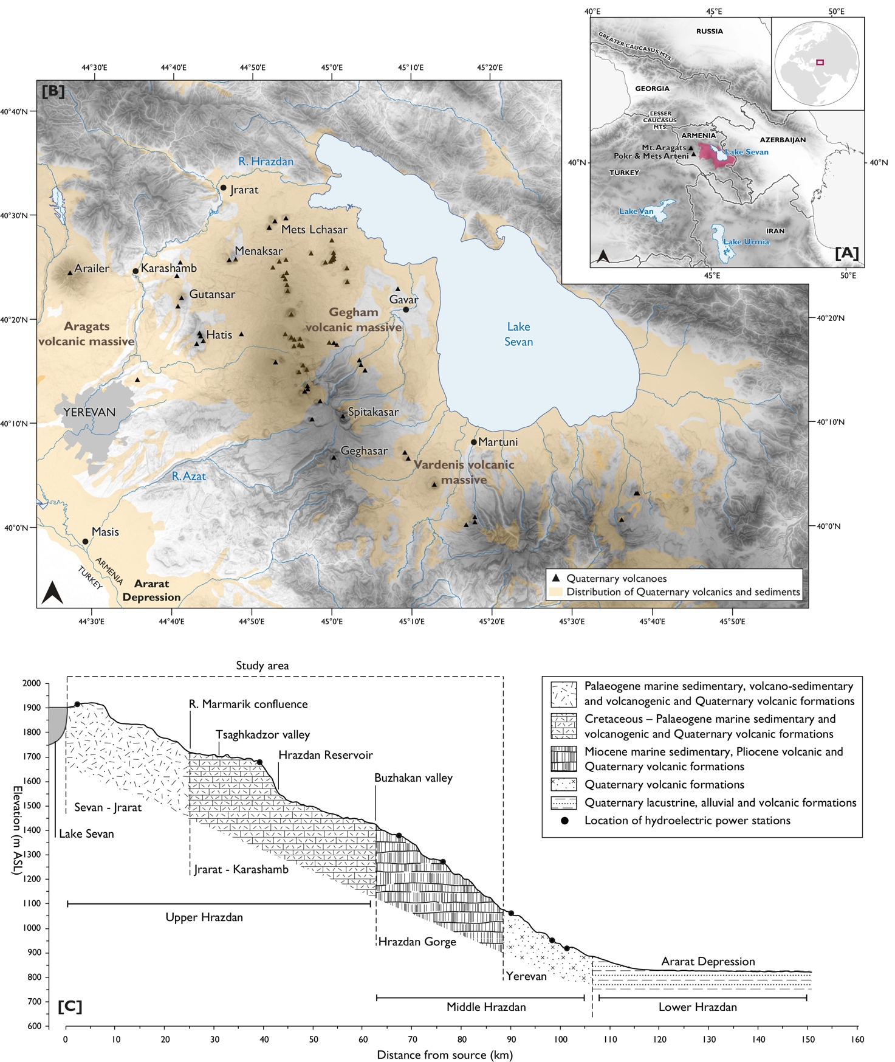
Figure 1. (A) Topographic map of the Southern Caucasus with the location of the Hrazdan catchment (in red), (B) Overview map of the study area, with the position of Quaternary volcanoes and the distribution of Quaternary volcanic and sedimentary formations (adapted from Kharazyan, 2007), and (C) Schematic elevation (m asl) profile of the Hrazdan valley with the broad geologic subdivision referred to in-text, the extent of the study area, and locations of hydroelectric power stations.
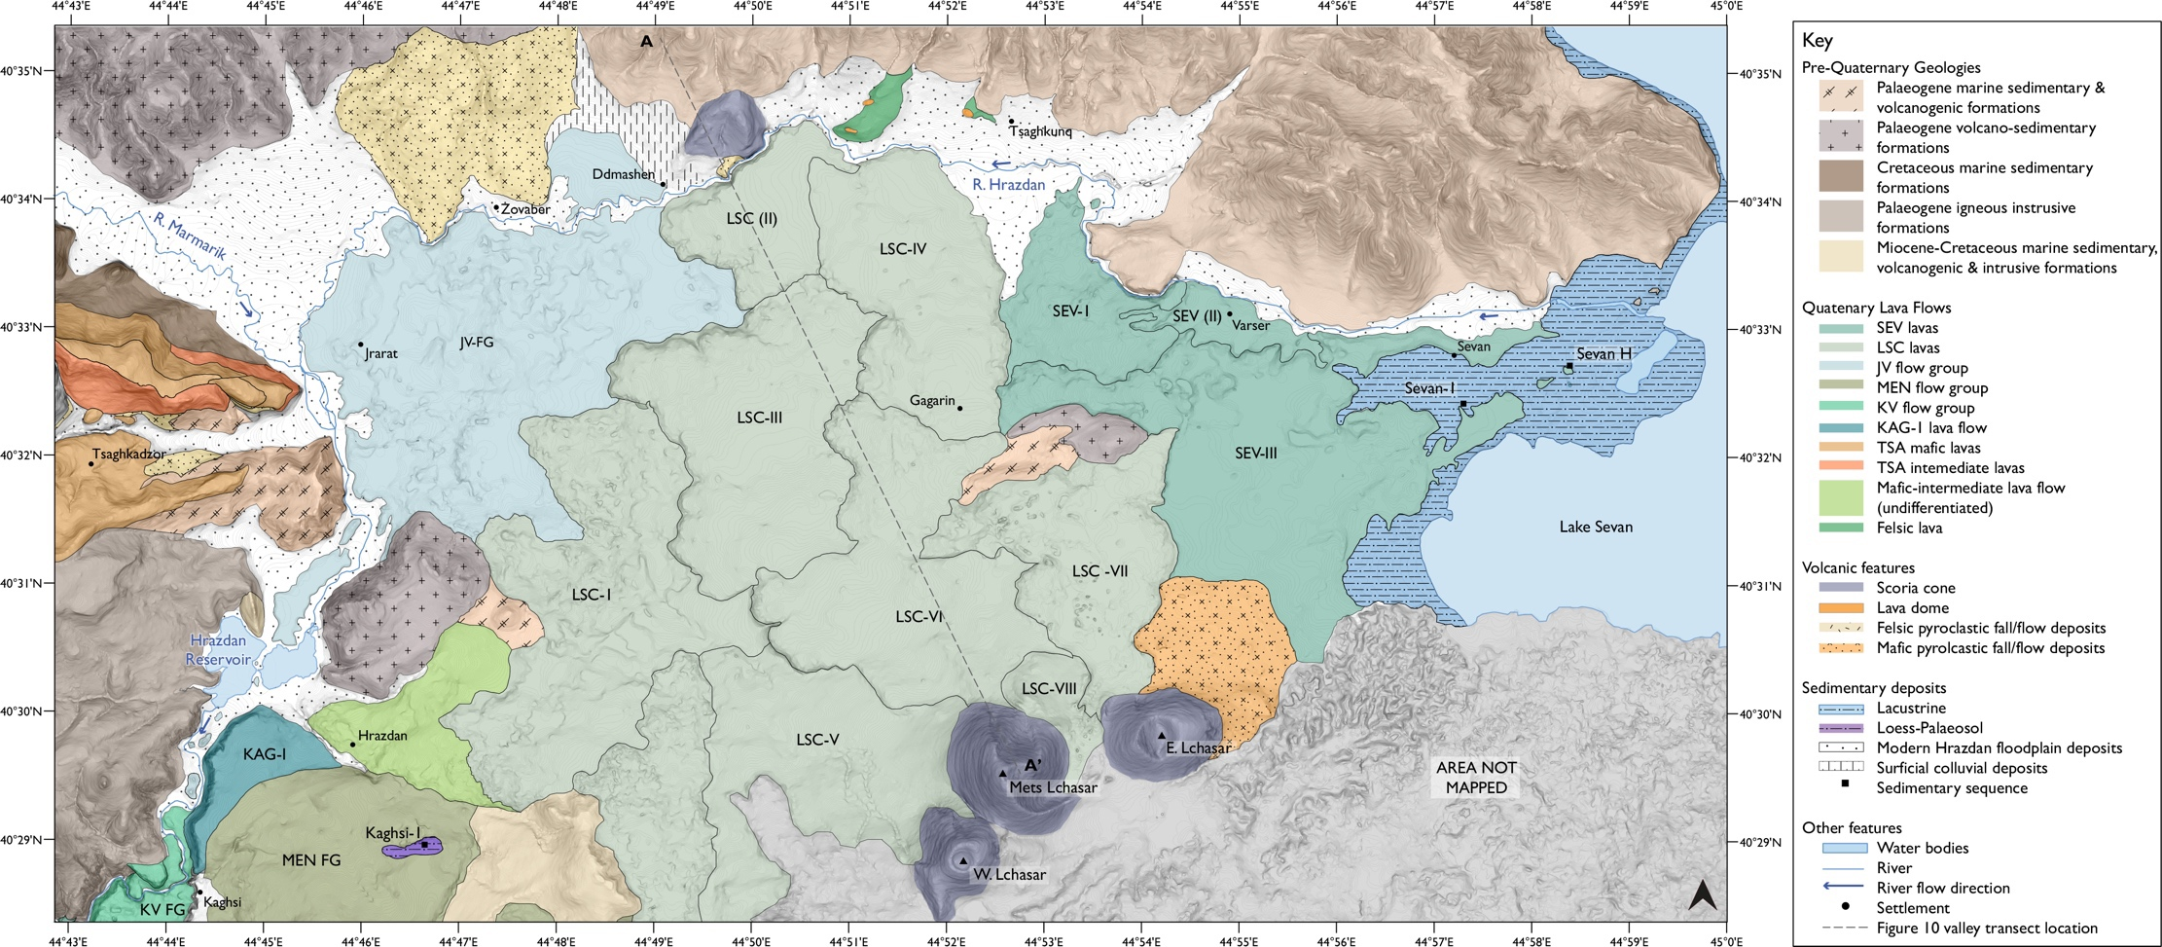
Figure 2. Geological map of the Sevan–Jrarat reach in the Upper Hrazdan valley.
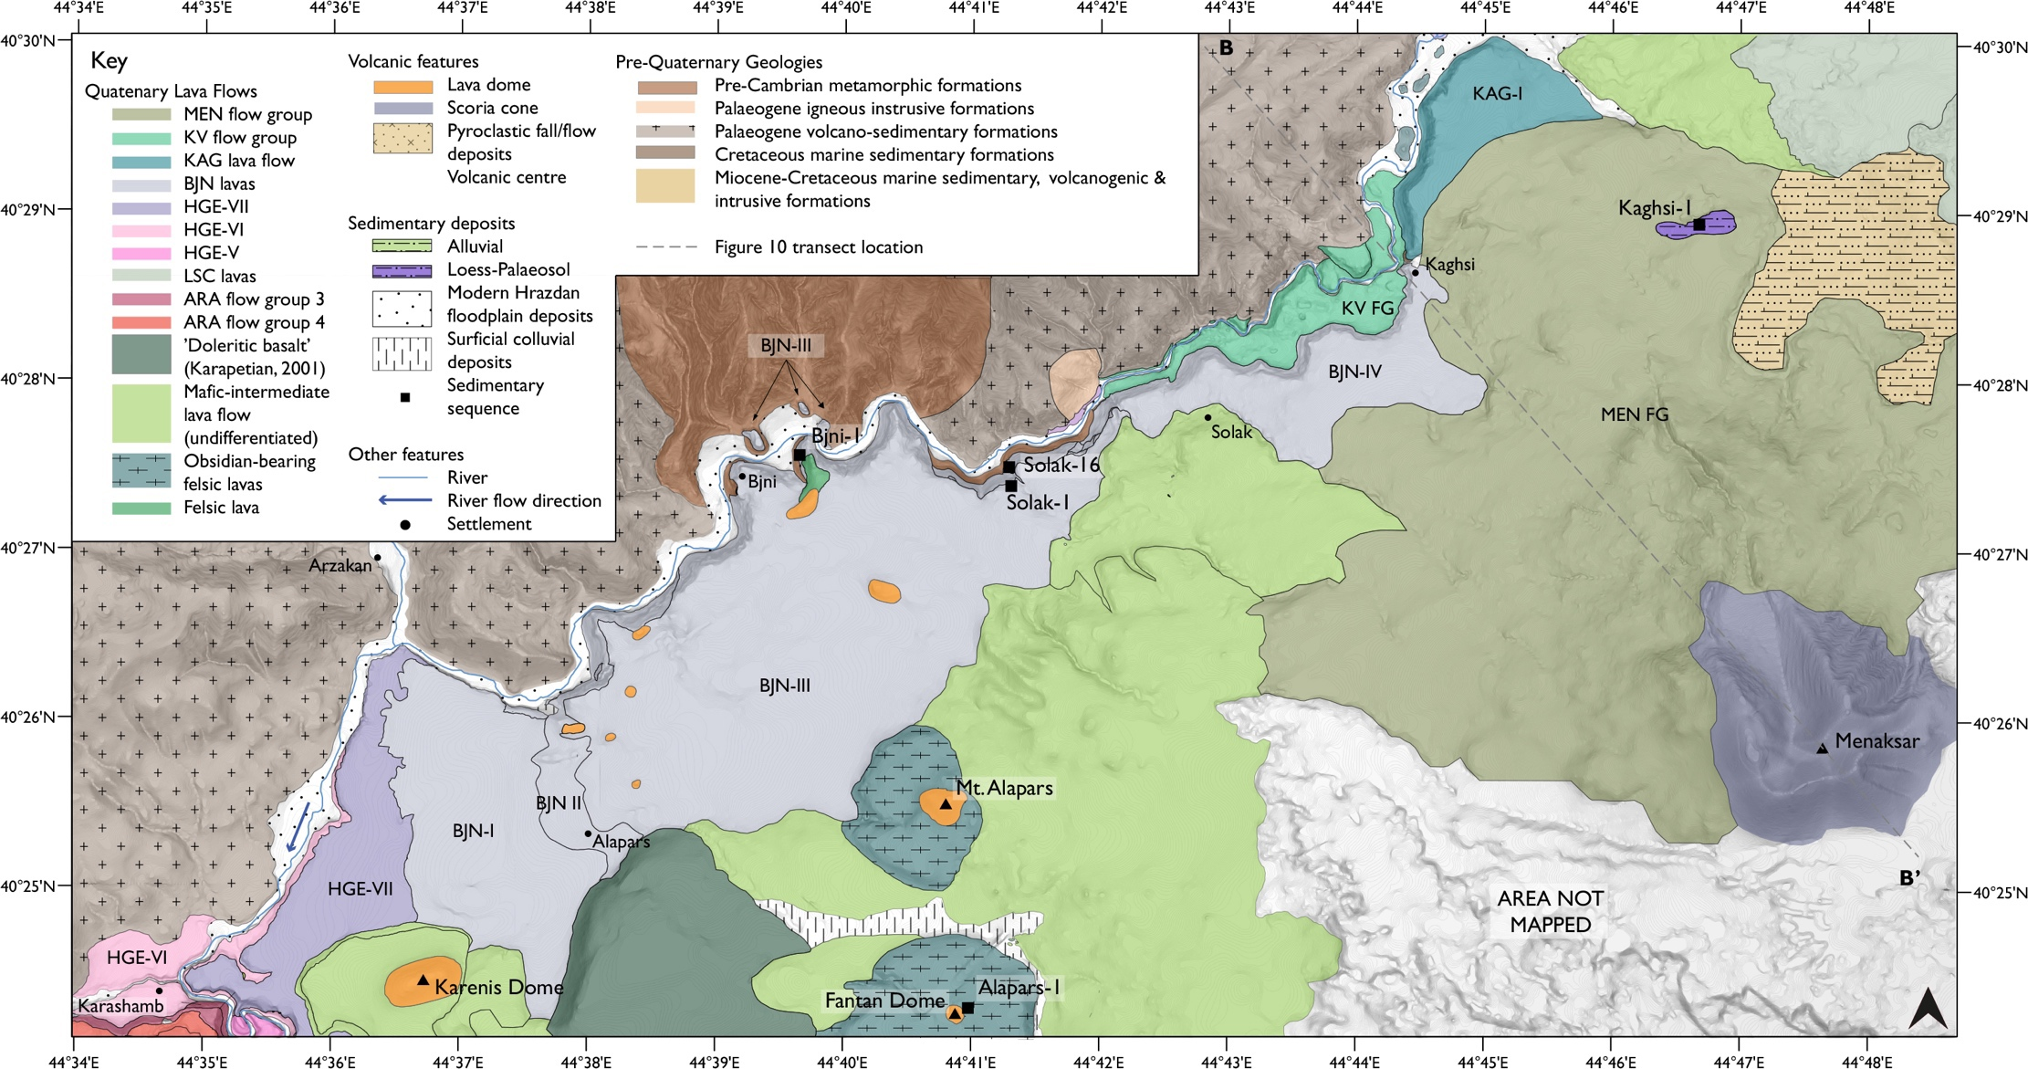
Figure 3. Geological map of the Jrarat–Karashamb reach in the Upper Hrazdan valley.
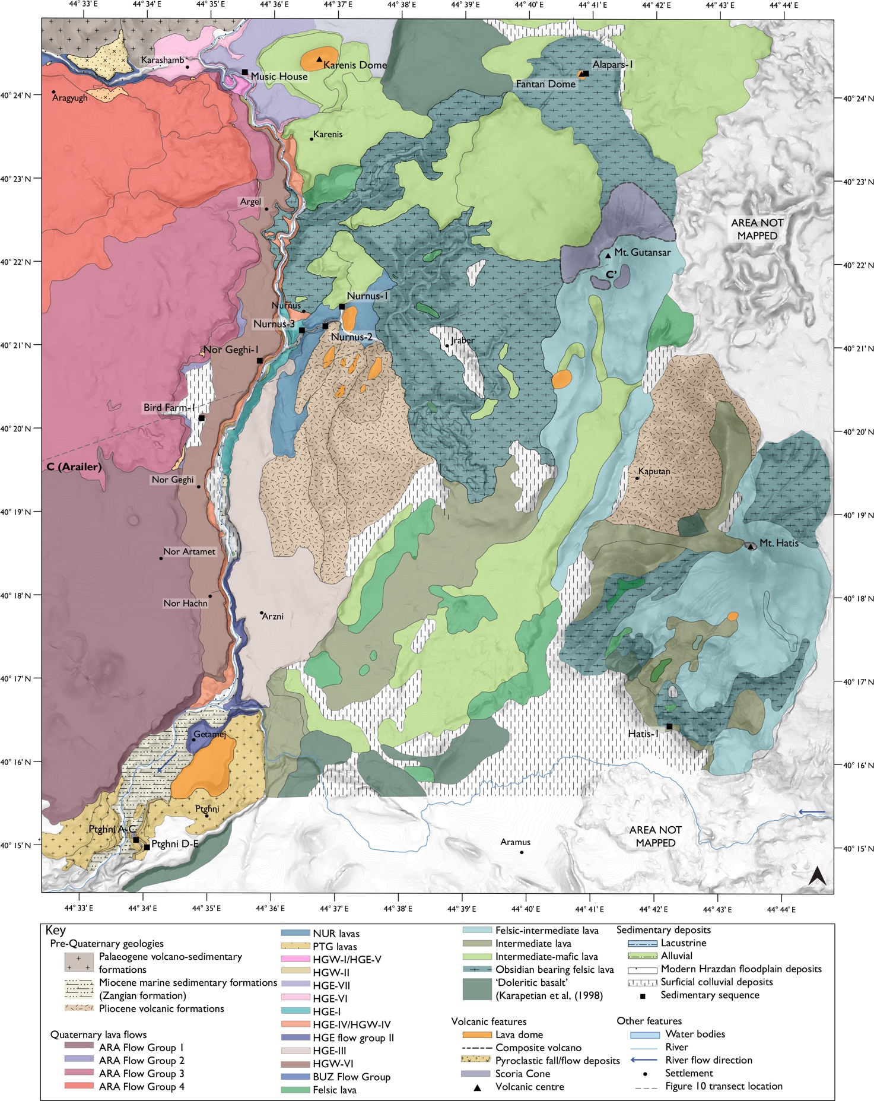
Figure 4. Geological map of the Hrazdan Gorge and NW Gegham Range in the Middle Hrazdan valley. Geological mapping around Hatis and Gutansar edifices adapted from Karapetian (1968) and Karapetian et al., (2001).

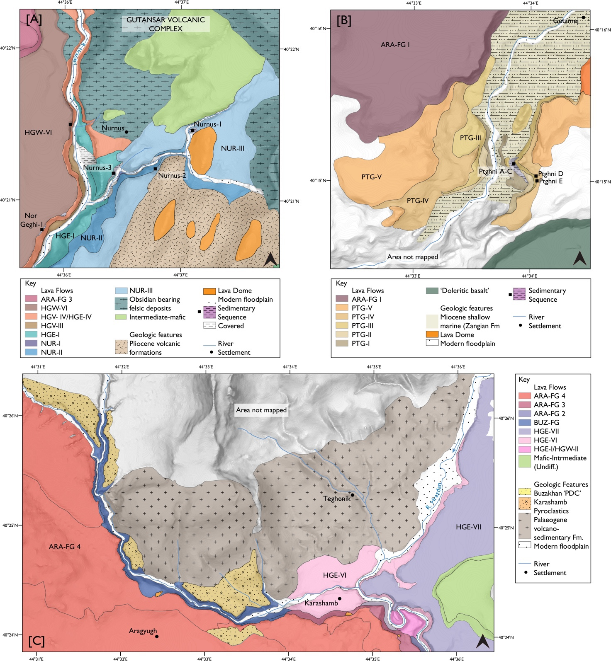
Figure 5. Geological map showing the distribution and position of sedimentary sequences, lava flows and other volcanogenic deposits in (A) the Nurnus valley, Hrazdan Gorge, (B) the reach of the Hrazdan Gorge around Ptghni, and (C) the NW sector of the Hrazdan Gorge and Buzhakan valley.

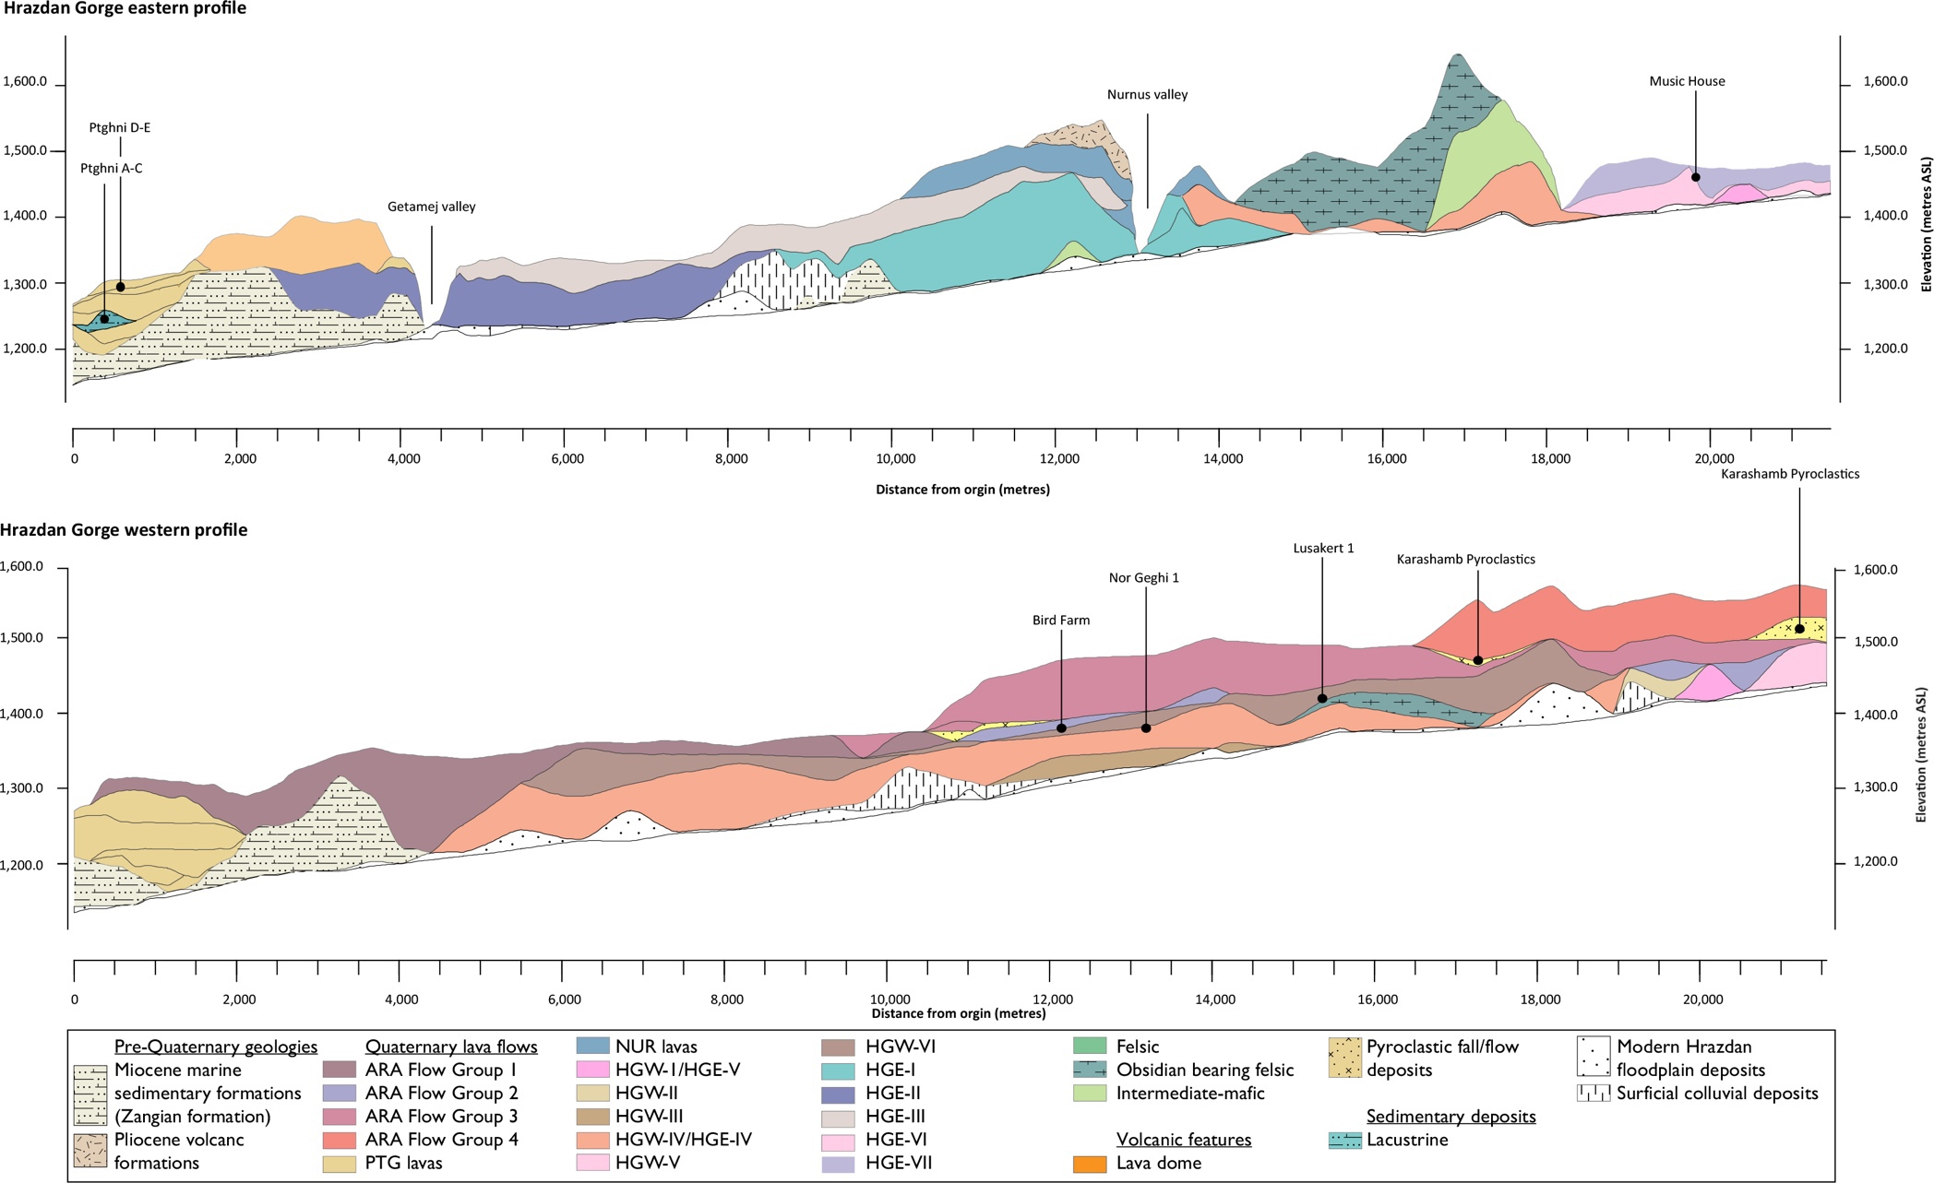 Figure 6. Schematic longitudinal profiles of the (A) east and (B) west side of Hrazdan Gorge showing the position (m asl) of lava flows and sedimentary sequences exposed along the gorge sides.
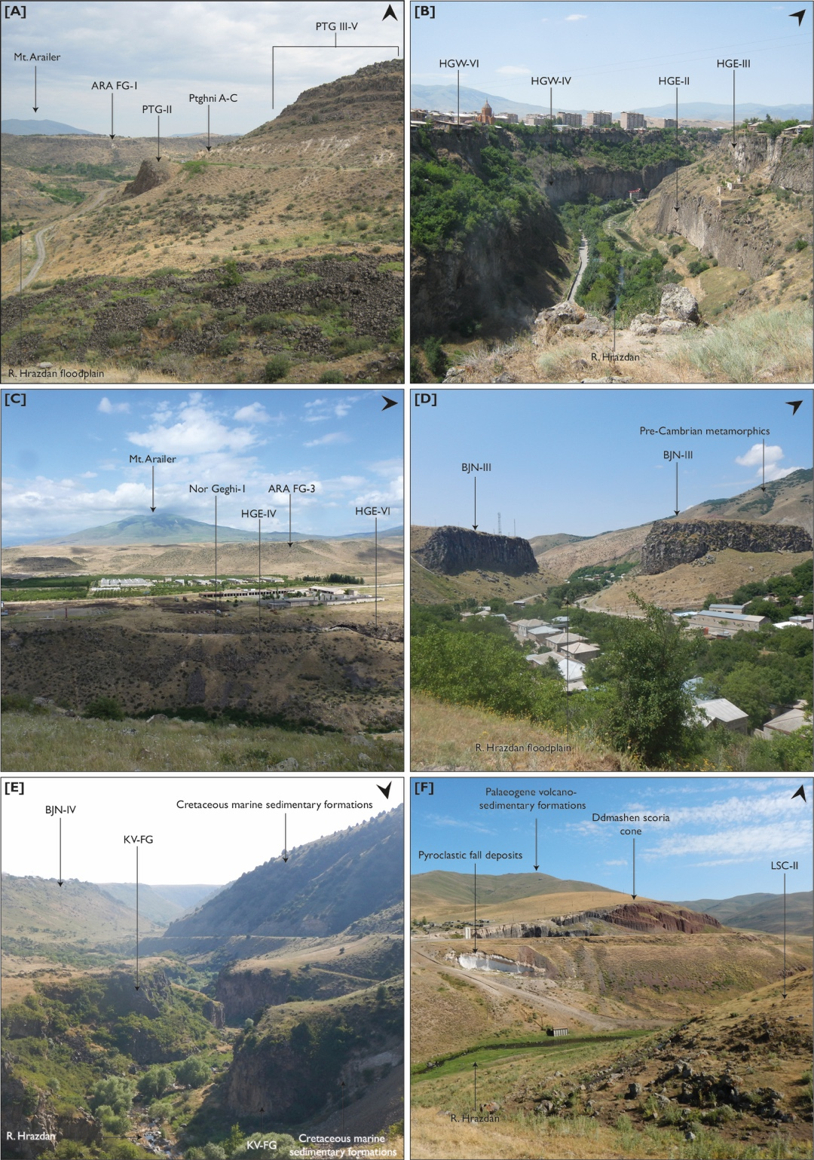
Figure 7. Photographs showing geomorphological setting in the Hrazdan valley. Highlighted are geological units, location of the modern Hrazdan river and, where appropriate, lava flow names. North arrow located in the top right corner of each image. Locations are (A) Ptghni, where several flows are found with interbedded lacustrine-alluvial sediments (Ptghni A–C), (B) the Hrazdan Gorge around Arzni, (C) the western side of the Hrazdan Gorge, showing the relative position of gorge lava flows, Arailer and Arailer lava flows, and the Nor Geghi 1 archaeological site, (D) the Hrazdan valley at Bjni, (E) Hrazdan valley at Kaghsi, showing higher elevation BJN flow and lower elevation lavas infilling the valley floor, and (F) Hrazdan valley at Ddmashen, showing the location of scoria cone, pyroclastic deposits and the northernmost extent of the LSC lava flows. Photograph credit, A, B, D–F: J. Sherriff; C: M, Knul.
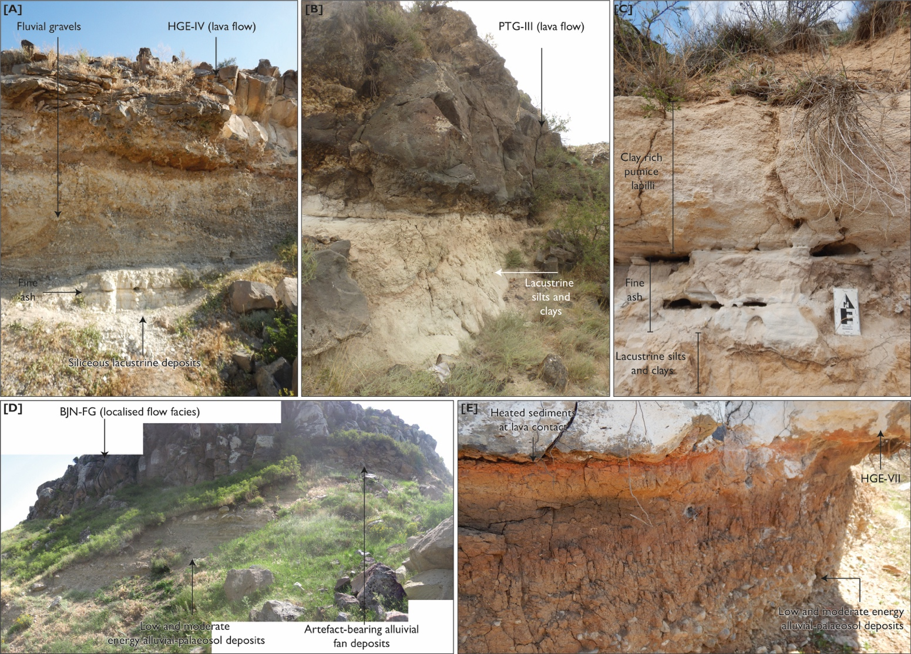
Figure 8. Representative sedimentary sequences in the Hrazdan valley (A) Bird Farm1, (B) Ptghni D–E, C) Nurnus3, (D) Solak 16 (not visible in the photograph is the Upper Palaeolithic site of Solak 1 which is located on the plateau above Solak 16), and (E) Music House. Sedimentological and stratigraphic summaries of these sequences is presented in Table 3. Photograph credit: A,C,E - J. Sherriff; B - M. Knul; D - E. Beverly.

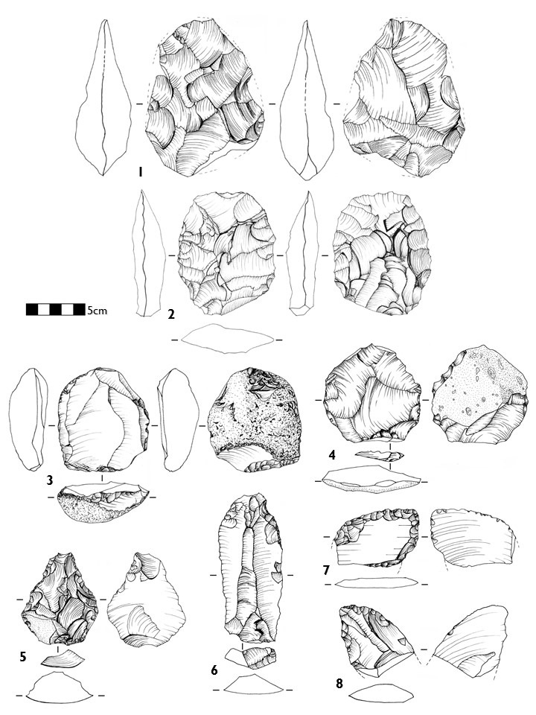
Figure 9. Sample of obsidian areifacts from Nor Geghi 1, 1–2 bifaces, 3–4 Levallois cores, 5 thick convergent scraper with edge and tip damage, 6 retouched point, 7–8, déjeté scrapers.

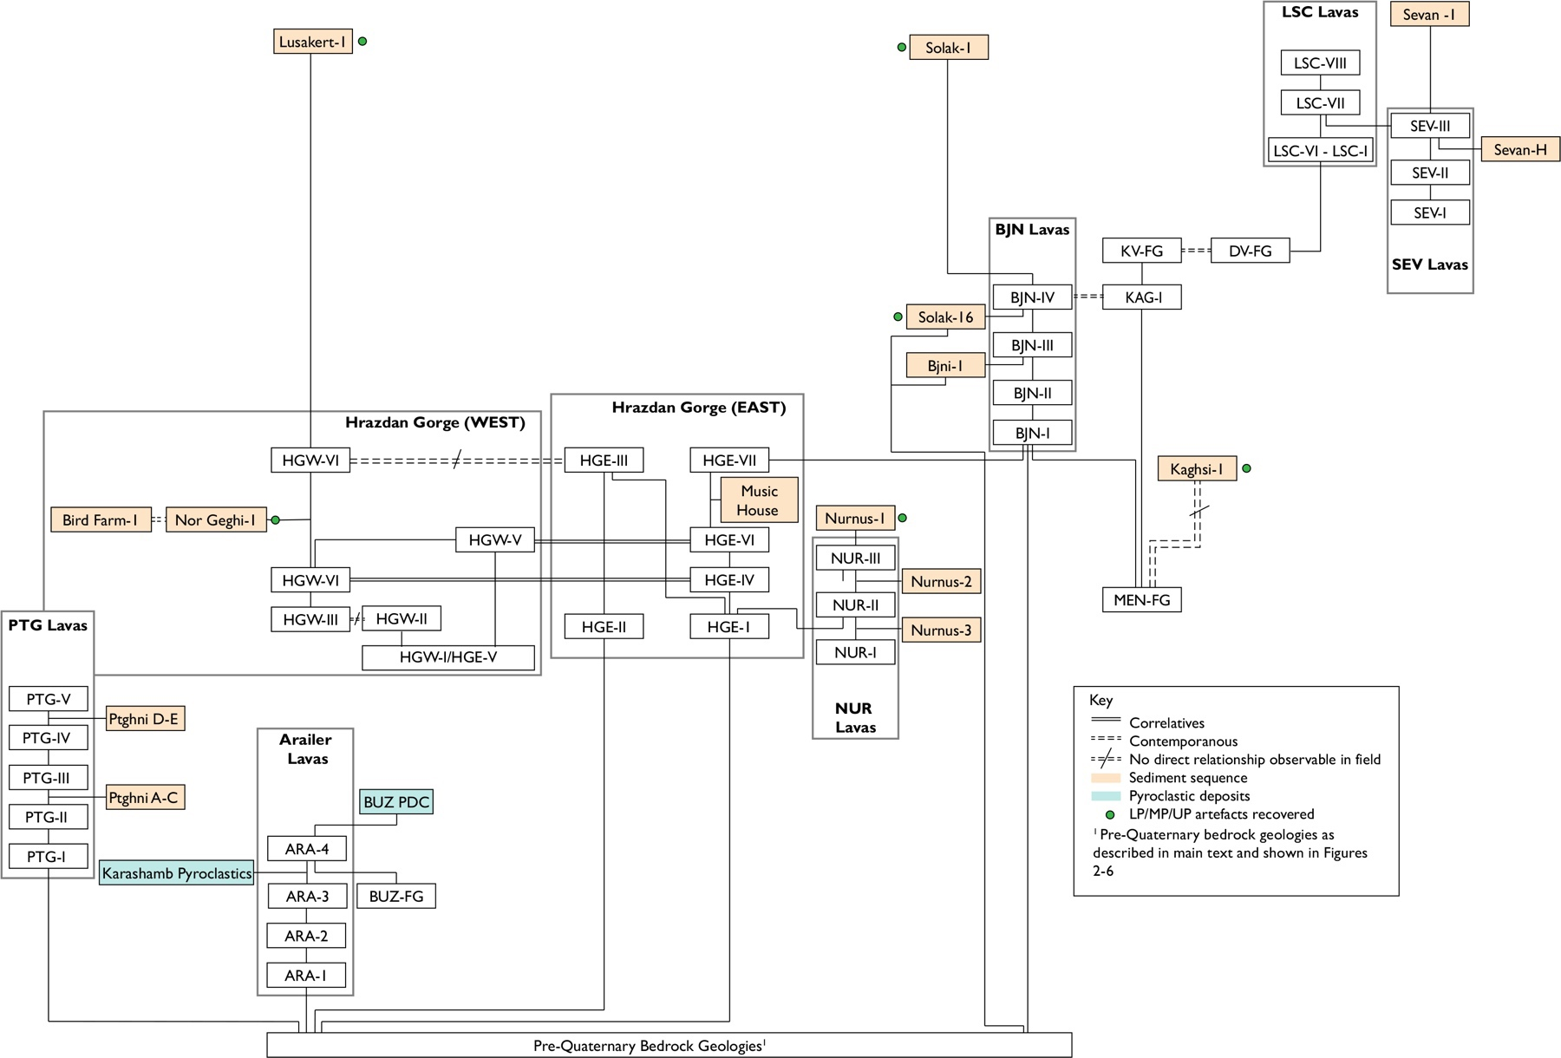
Figure 10. Harris matrix (Harris, 1979), showing the relative stratigraphic relationships between lava flows, sedimentary sequences, archaeological sites and other volcanic features in the Hrazdan valley based on geomorphic and geological mapping presented in this study.
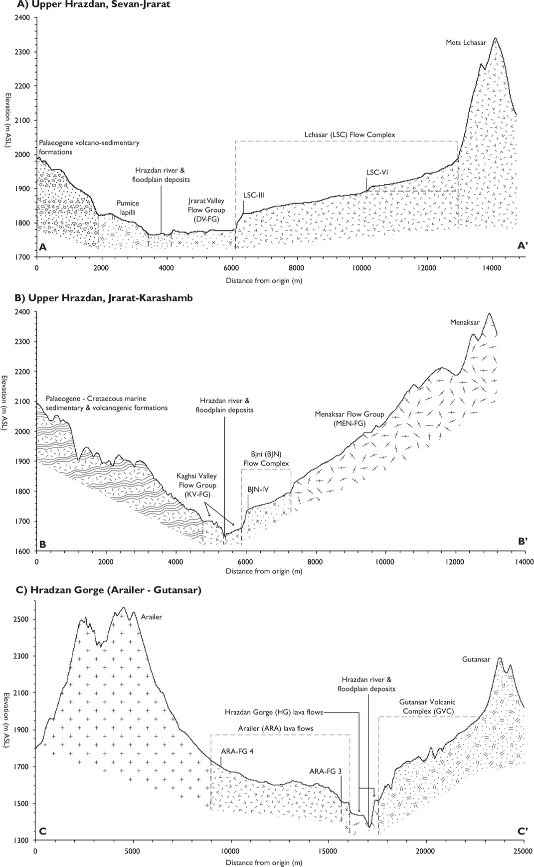
Figure 11. Schematic cross-sectional topographic profiles of the Hrazdan valley in the (A) Upper Hrazdan, Sevan-Jrarat reach, (B) Upper Hrazdan, Jrarat-Karashamb reach, and (C) Middle Hrazdan (Hrazdan Gorge) between Arailer and Gutansar volcanic centres. Shown are the principal lava flow groups and lava complexes, basement geologies and location of the Hrazdan river and modern floodplain deposits. The subsurface relationships between these deposits are not shown. Locations of cross sections are shown in Figures 2, 3, and 4.
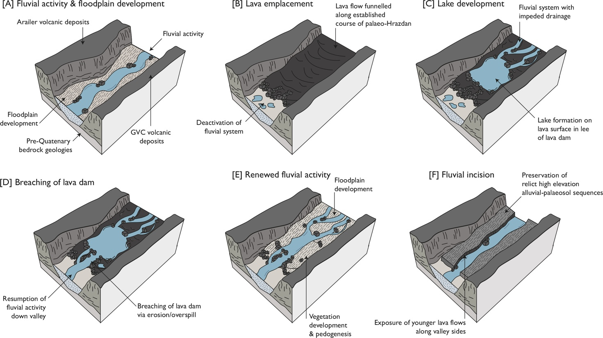Figure 12. Model of landscape evolution in the Hrazdan Gorge. Several stages are clear based on the geomorphic and sedimentary record. (A) Fluvial activity and floodplain development in the palaeo-Hrazdan valley, (B) volcanic activity, resulting in emplacement of lava along the course of the valley, (C) impeded fluvial drainage as a consequence of lava emplacement, resulting in the development of lacustrine systems on the newly formed land surface, (D) breaching and/or over spilling in the lava dam causing the reactivation of the Hrazdan fluvial system, (E) fluvial activity, floodplain development and relative landscape stability, (6) fluvial incision as a consequence of base level change and tectonic activity, resulting in the exposure of younger lava infilling the valley and preservation of high elevation alluvial sequences.
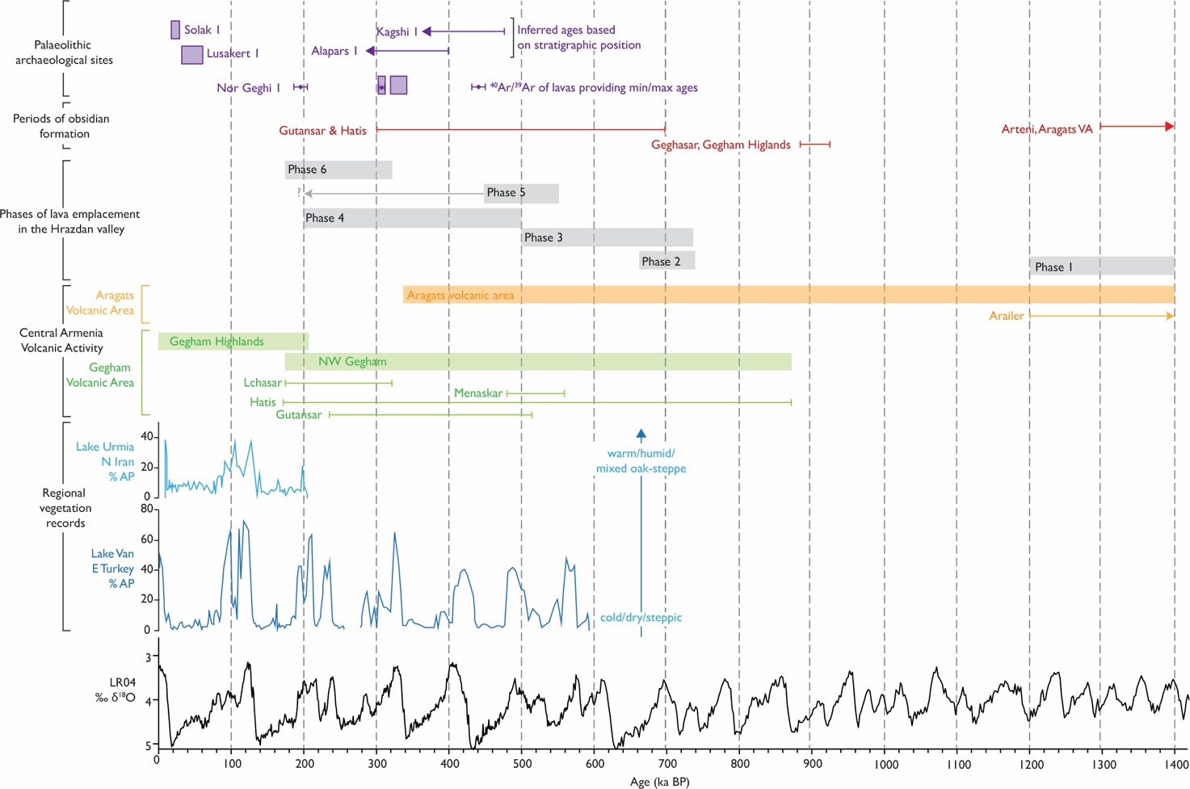
Figure 13. Summary diagram showing the phases of volcanic activity and lava emplacement in the Hrazdan valley as described in the text, based on lithostratigraphy and chronological evidence. Also shown are absolute and inferred ages of key archaeological sequences in the area, and the suggested timing of obsidian formation in the area (Frahm et al., 2014a,b). These are plotted against marine benthic δ¹⁸O stack (Lisecki and Raymo, 2005) and arboreal pollen % form Lake Van (Litt et al., 2014) and Lake Urmia (Djmali et al., 2008).

Table 1. Summary of chronological data from the Upper and Middle Hrazdan valley between Lake Sevan and Yerevan. In table references are: 1= Lebedev et al., 2013; 2= Lebedev et al., 2011; 3= Oddone et al., 2001; 4 = Badalian et al., 2001; 5 = Karapetian et al., 2001; 6 = Adler et al., 2014; 7 = Mitchell and Westaway, 1999. Age Error notation is: * 1σ uncertainty, ** 2σ uncertainty, *** uncertainty reported but unpublished sigma (σ) , - no data reported.
Sample Code | Location | Geological setting | Grid Reference | Technique | Material | Age (ma) | Uncertainty | Refs.
Arailer volcanic centre (Aragats volcanic area)
G110/03 | Arailer | Volcanic centre; lava flow | 40°17'5.1"N, 44°40'3.6"E | K-Ar | Rhyolite | 0.47 | 0.03** | 1
Ar1/07 | Arailer | Volcanic centre; lava flow (base of southern slope) | 40°21'49.5"N, 44°27'34.8"E | K-Ar | Andesite | 1.32 | 0.05** | 2
Ar3/07 | Arailer | Volcanic centre; lava flow (base of southern slope) | 40°22'53.3"N, 44°27'54.2"E | K-Ar | Andesite | 1.28 | 0.06** | 2
Ar6/07 | Arailer | Volcanic centre; lava flow (middle of southern slope) | 40°23'31.4"N, 44°27'22.2"E | K-Ar | Dacite | 1.29 | 0.03** | 2
Ar7/07 | Arailer | Volcanic centre; lava flow (middle of southern slope) | 40°23'36.1"N, 44°27'18.2"E | K-Ar | Dacite | 1.3 | 0.05** | 2
Ar9/07 | Arailer | Volcanic centre; lava flow (upper part of southern slope) | 40°23'45.5"N, 44°27'12.9"E | K-Ar | Dacite | 1.28 | 0.04** | 2
Ar11/07 | Arailer | Volcanic centre; lava flow (upper part of southern slope) | 40°23'42.2"N, 44°27'22"E | K-Ar | Dacite | 1.35 | 0.05** | 2
Ar13/07 | Arailer | Volcanic centre; lava flow (base of eastern slope) | 40°23'56.4"N, 44°29'40.7"E | K-Ar | Dacite | 1.23 | 0.03** | 2
Ar15/03 | Arailer | Volcanic centre (eastern summit) | 40°24'10.5"N, 44°28'5.3"E | K-Ar | Dacite | 1.37 | 0.04** | 2
Ar17/07 | Arailer | Volcanic centre (summit) | 40°24'11.2"N, 44°27'52.7"E | K-Ar | Dacite | 1.36 | 0.04** | 2
Gutansar volcanic complex (NW Gegham Volcanic area)
ALA 02 | Alapars | Lava Dome (Gutansar volcanic complex) |  | FT | Obsidian | 0.23 | 0.02* | 3
ALA 03 | Alapars | Lava Dome (Gutansar volcanic complex) |  | FT | Obsidian | 0.2 | 0.03* | 3
ALA 3 | Alapars | Lava Dome (Gutansar volcanic complex) |  | FT | Obsidian | 0.28 | 0.03* | 4
ALA 4 | Alapars | Lava Dome (Gutansar volcanic complex) |  | FT | Obsidian | 0.31 | 0.02* | 4
28G/01 | Jraber | Obsidian within 'Jraber extrusion' | 40°22'30.1"N, 44°36'29.3"E | K-Ar | Obsidian | 1.2 | 0.5** | 2
Font Av | Fantan | Lava dome (Gutansar volcanic complex) |  | FT | Obsidian | 0.32 | 0.02* | 4
Font Au 3 | Fantan | Lava dome (Gutansar volcanic complex) |  | FT | Obsidian | 0.3 | 0.02* | 4
29G/01 | Fantan | Lava dome (Gutansar volcanic complex) | 40°24'39.7"N, 44°41'17.4"E | K-Ar | Rhyolite | 0.48 | 0.05** | 2
1675 | Gutansar | Volcanic centre (Gutansar Volcanic Complex) |  | K-Ar | - | 0.55 | - | 5
1675 | Gutansar | Volcanic centre (Gutansar Volcanic Complex) |  | FT (?) | - | 0.33 | - | 5
GUT 01 | Gutansar | Volcanic centre (Gutansar Volcanic Complex), SW flank of volcano |  | FT | Obsidian | 0.33 | 0.02* | 3
GUT 02 | Gutansar | Volcanic centre (Gutansar Volcanic Complex), SW flank of volcano |  | FT | Obsidian | 0.27 | 0.02* | 3
Gut 1 | Gutansar | Volcanic centre (Gutansar Volcanic Complex) |  | FT | Obsidian | 0.32 | 0.03* | 4
Kap E 2 | Gutansar | Volcanic centre (Gutansar Volcanic Complex) |  | FT | Obsidian | 0.25 | 0.03* | 4
Gi 1 | Gutansar | Volcanic centre (Gutansar Volcanic Complex) |  | FT | Obsidian | 0.31 | 0.03* | 4
G117/03 | Gutansar | Volcanic centre (Gutansar Volcanic Complex) | 40°21'31.4"N, 44°40'47.5"E | K-Ar | Rhyolite | 0.9 | 0.3* | 1
19G/01 | Gutansar | Volcanic centre (Gutansar Volcanic Complex), lava flow | 40°19'7.3"N, 44°41'9.4"E | K-Ar | Rhyolite | 0.38 | 0.06** | 1
Hatis volcanic centre
1161 | Hatis | Volcanic centre |  | K-Ar | - | 0.65 | - | 5
1161 | Hatis | Volcanic centre |  | FT (?) | - | 0.33 | - | 5
Zer W Sup 2 | Hatis | Obsidian from rhyolite-perlite flows |  | FT | Obsidian | 0.21 | 0.04* | 4
Agu W Sup 3 | Hatis | Obsidian from rhyolite-perlite flows |  | FT | Obsidian | 0.34 | 0.04* | 4
Xian Xian | Hatis | Obsidian from rhyolite-perlite flows |  | FT | Obsidian | 0.4 | 0.03* | 4
13G/01 | Hatis | Volcanic centre; south slope | 40°17'17.7"N, 44°41'6.6"E | K-Ar | Rhyolite | 0.66 | 0.04** | 1
14G/01 | Hatis | Volcanic centre; south slope | 40°17'12.8"N, 44°41'4.4"E | K-Ar | Obsidian | 0.74 | 0.25** | 1
24G/01 | Hatis | Volcanic centre; summit | 40°18'13.5"N, 44°43'8.2"E | K-Ar | Rhyolite | 0.7 | 0.03** | 1
25G/01 | Hatis | Volcanic centre; summit | 40°18'28.8"N, 44°43'31.1"E | K-Ar | Rhyolite | 0.77 | 0.12** | 1
15G/01 | Hatis | Volcanic centre; Dyke on south slope | 40°16'27.3"N, 44°42'5.2"E | K-Ar | Obsidian | 0.48 | 0.05** | 1
26G/01 | Hatis | volcanic centre; dyke on summit | 40°18'43.7"N, 44°43'15.3"E | K-Ar | Obsidian | 0.48 | 0.04** | 1
17G | Tekblur (Hatis) | Lava flow (S slopes of Hatis) | 40°18'37.7"N, 44°40'45.1"E | K-Ar | Basaltic trachyandesite | 0.56 | 0.05** | 1
Hrazdan Valley Lavas
BF Basalt 1 1 | Bird Farm | Lava flow above sedimentary sequence (HGW-VI) | 40°20'9.4"N, 44°34'53.1"E | Ar-Ar | Basalt (groundmass) | 0.195 | 0.008* | This study
BF Basalt 1 2 | Bird Farm | Lava flow above sedimentary sequence (HGW-VI) | 40°20'9.4"N, 44°34'53.1"E | Ar-Ar | Basalt (groundmass) | 0.198 | 0.007* | This study
NG1 Basalt 1 | Nor Geghi 1 | lava flow overlying sedimentary sequence (HGW-VI) | 40°20'48.6"N, 44°35'49.9"E | Ar-Ar | Basalt (groundmass) | 0.197 | 0.007* | 6
NG1 tephra | Nor Geghi 1 | Tephra within sedimentary sequence (unit 1) | 40°20'48.6"N, 44°35'50"E | Ar-Ar | Ash (sanidine) | 0.308 | 0.003* | 6
NG1 Basalt 7 | Nor Geghi 1 | Lava flow underlying sedimentary sequence (HGW-IV) | 40°20'48.7"N, 44°35'50.1"E | Ar-Ar | Basalt (groundmass) | 0.441 | 0.006* | 6
1A1 | Yerevan | Lava flow |  | K-Ar | Basalt | 1.12 | 0.08* | 7
33G/01 | Yerevan | Lava flow | 40°11'30.1"N, 44°28'49.2"E | K-Ar | Latite | 0.53 | 0.04** | 1
34G/01 | Yerevan | Lava flow | 40°11'11.9"N, 44°30'6.7"E | K-Ar | Mugearite | 0.56 | 0.04** | 1
NW Gegham volcanic features
965 | Avazan | Lava dome (rhyolite-dacite) |  | K-Ar | - | 4.7 | 0.2*** | 5
968 | Gyumush | Lava dome (rhyolite-dacite) |  | K-Ar | - | 4.8 | 0.5*** | 5
GYU 02 | Gyumush | Lava dome (rhyolite-dacite) |  | FT | Obsidian | 0.22 | 0.02* | 3
GYU 04 | Gyumush | Lava dome (rhyolite-dacite) |  | FT | Obsidian | 0.23 | 0.02* | 3
NUR 01 | Nurnus | Obsidian outcrop |  | FT | Obsidian | 0.23 | 0.02* | 3
NUR 03 | Nurnus | Obsidian outcrop |  | FT | Obsidian | 0.26 | 0.02* | 3
G73/03 | Menaksar (Kovasar) | Dyke (N of summit) | 40°27'6.9"N, 44°47'14.1"E | K-Ar | Trachydacite | 0.54 | 0.02** | 1
G74/03 | Menaksar (Kovasar) | Volcanic centre (N of summit) | 40°26'24.8"N, 44°46'41"E | K-Ar | Mugearite | 0.53 | 0.03** | 1
G70/03 | Lchasar (Boghusar) | Volcanic centre | 40°29'44.7"N, 44°53'8.3"E | K-Ar | Mugearite | 0.25 | 0.035** | 1

Table 2. Criteria used for desktop-based identification of geomorphic landforms in the Hrazdan valley. References are as follows: 1 = Fisher and Schmicke, 1984, 1971; 2 = Wood, 1980; 3 = White and Ross, 2011; 4 = Fink and Anderson, 2000; 5 = Jerram 2002; 6 = Lockwood and Lipman, 1980; 7 = Walker, 1973; 8 = Harris, 2015; 9= Jerram and Petford, 2011; 10= Folch, 2012; 11= De Silva and Lindsay, 2015; 12= Rust, 1978; 13= Meikle et al., 2010
Feature | Morphology | GIS identification | Uncertainties | Significance | Refs.
Volcanic landforms (monogenetic landforms and features)
Scoria cone | Symmetrical conical-shaped feature with bowl-shaped crater at the apex, formed of pyroclastic material (primarily scoria lapilli). Slope angle ranges from 25–38°, height:width ratio 0.18–0.26. | Dark/light shadowing shows positive relief. Slope angle and height:width ratios consistent with morphology. Distinctive black/red colouration of exposed scoria on satellite imagery. | Vegetation and weathering of features cause difficulty in distinguishing from lava domes. Need to be distinguished in the field. | Regularly found in association with ‘basaltic’ volcanic fields. | 1,2,3
Endogenous & exogenous lava domes | Dome-shaped protrusion resulting from slow extrusion of high viscosity lava. Variable morphology. May be tabular-steep sided in cross section, and circular-elliptical – irregular in plan view. | Dark/light shadowing indicates positive relief. Circular-elliptical form, with clear boundary between surrounding material. Height:length ratio of 0.5–0.3. | Vegetation and weathering of features cause difficulty in distinguishing from scoria cones. Need to be distinguished in the field. | Extrusions related to a larger composite cone or caldera. May be located along faults. | 4
Lava flows and fields | Accumulations of lava-forming plateaus of varying surface roughness. Many have complex lobate structure at front of flow. Surface texture (if fresh) can be used to differentiate between ʻaʻā, pāhoehoe and block lava flows. | Shadowing indicates lava field front with slope angle of 20–30°. Low-moderate surface roughness based on lava texture. Superposition of several identifiable flows. Higher elevation than modern floodplain. | Modification of flows by weathering and fluvial activity. Lava structure and mineralogy needs to be distinguished in the field. | Emplacement of lava associated with effusive volcanic activity. Spatially extensive flows have stratigraphic significance. | 5, 6, 7, 8
Undifferentiated volcanogenic deposits | Covers a broad range of features associated with effusive and explosive (pyroclastic density currents, pyroclastic fall deposits, tephras). | Distinctive white colouration of terrain on satellite imagery. | Differentiation of type of deposit not possible using imagery. Best identified in the field. | Indication of interval of explosive and effusive volcanism, spatially extensive deposits enable correlation across wide area. | 7, 9, 10
Volcanic landforms (polygenetic landforms and features)
Polygenetic volcanic centres - composite volcanoes | Conical-shaped edifice, with basal diameter ranging from 10–20 km, slope angle of ca. 30° and height:width ratio of 0.15––0.33. Formed by multiple eruptions from single or migrating vent. Symmetrical-asymmetrical. | Dark/light shadowing shows positive relief. Slope angle and height:width ratios consistent with morphology. Occurrence of large central or several central craters. | Modification by post-eruptive processes. Association of cones and lava domes complicate morphology. | Reflect potential sources of lava flows/fields and pyroclastic deposits. Can be used on conjunction with lava flow/field morphology to elucidate relationship. | 11
Fluvial landforms and features
River terrace | Bench/step along valley side with flat top and step fore edge. May be paired or unpaired with opposite valley side. | Shadowing indicates terrace fore edge. High slope angle of fore edge, flat upper surface. | Field differentiation of bedrock and alluvial terrace | Marks former position of river and associated floodplain/ deposits. Can be used to estimate rate of incision. | 12, 13
Floodplain deposits | Flat accumulations of fine grained alluvial sediment located on and around channel margins of modern river systems | Flat surface with low surface roughness. Occurs at similar elevation to modern river course. | May represent a lower bedrock terrace. Frequently masked by vegetation and infrastructure. | Marks extent of river in its current position. | 12

Table 3. Summary of the sedimentary and archaeological sequences identified in the Hrazdan valley. BA= Bronze Age, UP = Upper Palaeolithic, MP = Middle Palaeolithic, LP = Lower Palaeolithic, UD = undiagnostic. In-table references are: 1 = this study, 2 = Adler et al., 2012, 3 = Adler et al., 2014,4 = Lyubin et al., 2010, 5 = Frahm et al., 2017. Locations of sequences are shown in Figures 2–5.
Site | Location | Elevation (m ASL) | Sedimentary description | Stratigraphic context | Archaeology | Refs.
Sevan 1 | 40°32´18.5"N, 44°57´9.3"E | 1930 | 2m-thick sequence of carbonate-rich silts and clays with cm-scale interbeds of shell-rich sand and fine ash. Base of sequence not reached. | Abuts lava flow SEV-III near modern shore of Lake Sevan | Pottery fragments (BA) | 1
Sevan H | 40°32´41.9"N, 44°58´22.4"E | 1930 | 1.5m-thick sequence of horizontally bedded volcanoclastic pumice lapilli, sand, silt and fine ash. Base of section not exposed | Underlies SEV-III lava flow | - | 1
Kaghsi 1 | 40°28´54.4"N, 44°46´43.6"E | 1872 | Approximately 200m long, 10–20m thick sequence of pedogenically modified Aeolian and colluvial deposits, with at least 6 distinct pedocomplexes identified. Present within sequence are 6 primary fine-medium ashes. Artefacts recovered from colluvial deposits in western edge of sequence. Base of sequence not reached. | Sequence location indicates it likely overlies MEN-FG lavas. However lower contact between sediments and underlying strata is not observable the field. | Lithics (MP) | 1
Solak 1 | 40°27´25.8"N, 44°41´16.7"E | 1634 | 1.0–1.5m-thick sequence of fine-grained colluvium containing a mature soil (Bt and Bk horizons) and resting on lava. UP artefacts are found throughout the sequence. | Sequence overlies BJN-III (BJN lava complex) | Lithics (UP) | 1
Solak 16 | 40°27´31.3"N, 44°41´11.9"E | 1580 | 30m-thick alluvial-palaeosol sequence comprising beds of pedogenically modified silty sand and clast rich gravel deposits. Sequence is capped by moderately sorted angular gravels presenting alluvial fan deposition. Undiagnostic obsidian artefacts recovered from the upper alluvial fan strata. | Overlies Precambrian metamorphic basements rocks and is capped by BJN-FG (BJN Lava Complex) | Lithics (UD) | 1
Bjni 1 | 40°27´30"N, 44°39´35.3"E | 1544 | 1m tripartite sequence composed of moderately sorted angular gravels of principally metamorphic lithologies (colluvium), fine-medium ash, and silt-sand (alluvium). | Overlies Precambrian metamorphic basements rocks and is capped by BJN-III (BJN Lava Complex) | - | 1
Lusakert1 | 40°22´18.6"N, 44°35´49.8"E | 1427 | Separate sequences within and outside the rockshelter. The former comprises 3–4m of floodplain deposits overlain by colluvium, and the latter of 1–2m of first channel sediments then cave earths. Archaeological artefacts and features, and vertebrate remains are associated with the cave earths and floodplain alluvium | Rock shelter within HGW-VI in the Hrazdan Gorge. | Vertebrate remains, Lithics (MP) | 2
Alapars 1 | 40°24´17.4"N, 44°40´52"E | 1798 | 6m-thick sequence comprising from the base upwards fluvial reworked pumice, gravels forming in fluvial environment, pedogenically modified floodplain alluvium, calcrete and pedogenically modified aeolian deposits. Artefacts recovered from alluvium, aeolian deposits and modern soil [derived]). | Sequence found in association with Fantan Dome (part of GVC). Exact stratigraphic relationship unclear. | Lithics (MP) | 1
Bird Farm 1 | 40°20´9.2"N, 44°34´52.1"E | 1388 | Comprises from the base upwards: tephric silt-sand, primary scoria lapilli, reworked scoria lapilli and sand, siliceous silt-clay lacustrine deposits with interbedded fine ash, cross and planar bedded clast rich gravels (principally mafic igneous lithologies, pedogenically modified silt-sand. Sequence capped by mafic lava (HGW-VI) which has been ⁴⁰Ar/³⁹Ar dated to 195±8 ka and 198±7 ka. | Sequence underlies HGW-VI. On W side of Hrazdan Gorge. Contact between sequence and underlying strata not visible. | - | 1
Nor-Geghi 1 | 40°20´48.2"N, 44°35´49.8"E | 1402 | 1–5m-thick sequence of (from base upwards) floodplain deposits in which a mature palaeosol has developed, high-energy fluvial deposits and a further floodplain sequence in which a second palaeosol has developed. Artefacts have been recovered from the upper floodplain deposits and associated palaeosol, and sand facies of the channel sediments. | Sediment sequence and archaeological artefacts are sandwiched between HGW IV and HGW VI | Lithics (LP/MP) | 3
Music House | 40°24´15.5"N, 44°35´35.9"E | 1486 | 1m-thick sequence of pedogenically modified silt-sand and clast rich gravels representing alluvial sedimentation. | Interbedded between HE-VII and HGE-VI. | - | 1
Nurnus 1 | 40°21´28.1"N, 44°37´8.3"E | 1539 | 5m+ sequence of clay-rich lake sediment overlain by diatomite and coarse fluvial deposits (tabular gravels and sands), above mafic lava. | Overlies NUR-III in Nurnus Valley. | Vertebrate remains | 4
Nurnus 2 | 40°21´11.3"N, 44°36´45.4"E | 1483 | 2m sequence of heavily weathered lacustrine silt-clay with plant imprints and discontinuous fine ash. | Underlies NUR-III in Nurnus valley. Contact with underlying strata not visible. | - | 1
Nurnus 3 | 40°21´7"N, 44°22´17.6"E | 1406 | 4m-thick sequence comprising from the base upwards; fine sand-silt (lacustrine), pumice lapilli, silt-clay with pumice lapilli fragments (lacustrine with reworked volcanics), fine sand-silt with interbedded fine-medium ash (lacustrine). | Underlies (NUR-II in Nurnus valley. Contact with underlying strata not visible. | - | 1
Hatis 1 | 40°16´26.2"N, 44°42´11.5"E | 1571 | 1.5 m-thick coarse-grained colluvial sequence derived from volcanic deposits to the north. LP artefacts including bifaces found throughout. | None, but sediments derived from obsidian-bearing rocks to the north | Lithics (LP) | 1
Ptghni D–E | 40°15´2.4"N, 44°34´2.8"E | 1294 | 1m-thick sequence of massive silt-sand. Lower and upper contact with lavas is visible. | Interbedded with PTG-III (cf. LF PTG 3) and PTG-VI (cf. LF PTG 2). | - | 5
Ptghni A–C | 40°15´7.6"N, 44°33´49.8"E | 1253 | 29m-thick sequence of alluvial lacustrine deposits comprising pedogenically modified silt and sand with obsidian clasts, overlain by horizontally bedded silts and clays, which in turn is overlain by fine-sand silt. Lower and upper contact with lavas is visible. | Interbedded with PTG-I (cf. LF PTG 5) and PTG-II (cf. LF PTG 3) | - | 5

