Catastrophic glacial-lake outburst flooding of the Patagonian Ice Sheet
Gerardo Benito and Varyl R. Thorndycraft
¹Department of Geology, National Museum of Natural Sciences (MNCN), CSIC, Serrano 115 bis, 28006 Madrid, Spain
²Department of Geography, Royal Holloway University of London, Egham TW20 0EX, UK

(*) Corresponding author:
E-mail: benito@mncn.csic.es
Museo Nacional de Ciencias Naturales (MNCN), CSIC, Serrano 115 bis, 28006 Madrid, Spain

Abstract:
Reconstructing the magnitude and timing of catastrophic drainage of proglacial lakes during Late Quaternary deglaciation of palaeo-ice sheets is important for understanding rates of landscape change and regional freshwater forcing of ocean currents. Here, we provide the first detailed reconstruction of catastrophic glacial lake outburst flooding from the Southern Hemisphere, focusing on the Río Baker catchment in central Patagonia. Firstly, we review the evidence for palaeolake drainage events in the Baker catchment showing the basin witnessed a number of events during Late Quaternary deglaciation. These floods helped re-establish the Pacific drainage pathway of the Río Baker by 12.6-11.7 ka, after millennia blocked by ice during the last glaciation. Secondly, we analyse the landform record and flow hydraulics of a catastrophic flood in Patagonia, focusing on the final, Early Holocene, drainage event of Lago General Carrera/Buenos Aires. Using two independent methods, a one-dimensional hydraulic model and dam break simulation, we estimate a minimum peak discharge of 110,000 m³s⁻¹ (0.1 Sv), large enough to form megaflood-type landforms. Using the flow hydrograph, we constrain timing of landform genesis. Eddy bars at the top of the water column (45-65 m above the valley floor) were inundated over 2-36 hours following the breach; while tractive bars, formed beneath ~20 m of water at sites of valley expansion, were flooded for ~100 hours. Raised deltas and palaeoshorelines provide geomorphic evidence for palaeolake drainage events across Patagonia indicating the likely role that catastrophic floods played in continental-scale palaeohydrology and the evolution of fjord ecosystems.
Keywords
Geomorphology; Landscape evolution; Megafloods; Palaeohydrology; South America
- Introduction
There is increasing geomorphological evidence from the Northern Hemisphere for the occurrence of Late Quaternary catastrophic proglacial lake drainage events during the deglaciation of palaeo-ice sheets (e.g. Baker, 2002; Baynes et al., 2015; Benito and O'Connor, 2003; Carling et al., 2010; Herget, 2005; Komatsu et al., 2009; Margold et al., 2018; Murton et al., 2010; Weckwerth et al., 2019). These floods include those defined as megafloods, where flow exceeded 1.0 Sv (1 Sv = x10⁶ m³s⁻¹; Baker, 2002) and catastrophic floods (0.1-1.0 Sv; Carrivick and Tweed, 2019; Tómasson, 2002; Komatsu et al., 2016). Reconstructing the magnitude and timing of such events is important for understanding landscape change in former glaciated regions (Baker, 2020; Baynes et al., 2015), and for assessing the role of freshwater forcing of oceanic processes (Condron and Winsor, 2012). To date, however, details on the processes and impacts of extreme flood processes during Late Quaternary deglaciation of the former Patagonian Ice Sheet (PIS) in southernmost South America is not known, despite the evidence for large palaeolake systems in this region (Fig. 1), which partially or totally drained at this time (Caldenius, 1932; Harrison et al., 2019). These proglacial lake systems extended over a wide latitudinal extent (42-49 ⁰S and 51-53 ⁰S) to the east of the former Patagonian Ice Sheet (Caldenius, 1932; García et al., 2014; García et al., 2018; Hein et al., 2010; Sagredo et al., 2011; Solari et al., 2012; Thorndycraft et al., 2019a; Turner et al., 2005). The geomorphological evidence for punctuated drainage events across Patagonia includes raised deltas (Bell, 2008; Bell, 2009; Bendle et al., 2017a; García et al., 2019), palaeoshorelines (Bendle et al., 2017b; García et al., 2014; García et al., 2019; Sagredo et al., 2011; Thorndycraft et al., 2019a) and subaerial lacustrine sediments (Bendle et al., 2017a; Caldenius, 1932; García et al., 2019), usually located tens to hundreds of metres above contemporary valley floors or lake levels. Many of these lake drainage events led to continental-scale drainage reversals and the re-establishment of Pacific drainage pathways through valleys previously blocked by the coalesced Patagonian Ice Sheet (Thorndycraft et al., 2019a); and potentially caused short-term forcing of regional climate (Glasser et al., 2016).
South American catastrophic floods have been documented from mapping of boulder bars in the Baker (Thorndycraft et al., 2019a), Simpson (Thorndycraft et al., 2019b) and Santa Cruz rivers (Austin and Strelin, 2011), and from inferred large-scale dunes along terraces of the Santa Cruz River (Pacifici, 2009), but to date there has been no detailed geomorphological or hydraulic reconstructions of such events. Herein, we address that gap in knowledge by presenting the geomorphology of exceptional Late Quaternary floods in the Río Baker catchment (Fig. 2). Firstly, we review the evidence for multiple lake drainage events during deglaciation in the region (Fig. 3). Secondly, we use the landform evidence from the upper Baker valley (between the Bertrand and Valle Grande sectors (Fig. 4), where the best preserved and most accessible evidence for catastrophic flooding is located) to provide the first detailed geomorphological and hydraulic analysis of a catastrophic outburst flood in the Southern Hemisphere. Thirdly, we combine flood hydrograph information from dam break modelling with flow hydraulics data from unsteady hydraulic flood modelling , to quantify the timing of landform genesis during a single catastrophic flood event.
- Study area
The study area (Fig. 4) is centred on the Río Baker catchment (Fig. 2) in Central Patagonia (45-46 °S). The Baker has a drainage basin area of ~29,000 km² and is Chile’s largest river in terms of mean annual discharge (1100 m³s⁻¹; Dussaillant et al., 2012). The drainage encompasses the Lago General Carrera/Buenos Aires and Lago Cochrane/Pueyrredón lake basins and much of the eastern ice shed of the Northern Patagonia Icefield (NPI; Figs. 1 and 2). In terms of geology and relief there are five major zones in the catchment: 1) the eastern limit of the watershed, at the present day Atlantic-Pacific drainage divide (Fig. 2), is located in a region of low relief (~71 °W) featuring Quaternary glacigenic (Fig. 2b) and fluvioglacial deposits (Bendle et al., 2017b; Caldenius, 1932; Douglass et al., 2006; Hein et al., 2010; Mercer, 1976); 2) a belt of Jurassic age acidic volcanics and volcano-sedimentary rocks (~72.5 °W); 3) Palaeozoic basement (73 °W); 4) the Cosmelli Basin (Fig. 2b) comprised of continental molasses; and 5) the Patagonian calc-alkaline granite batholith (73-74 °W).
Our geomorphological mapping and hydraulic analyses are focused on the upper and middle reaches of the Baker valley, from its source at Lago Bertrand to the confluence with the Ventisquero valley (Fig. 4). The lower valley is much wider and forested making geomorphological mapping by both remote sensing and field work difficult. For the analysis of the timing of landform genesis we focus on the upper reach between Lago Bertrand and the Baker’s entry into Valle Grande (Fig. 2); this was for three main reasons. Firstly, there was one single flood event through the upper reach of the Baker valley (see Section 5.3). Secondly, there is good control on lake elevation and volume at the time of the flood (Thorndycraft et al., 2019a), which allows dam break simulation in combination with unsteady flow modelling. Thirdly, the flood pathway is constrained by valley topography, where steeper bedrock reaches alternate with wider basins, preserving a suite of erosional and depositional flood landforms, and the best possible configuration for hydraulic flood modelling.
- Materials and Methods
Landform mapping and subsequent analysis in ArcMap was carried out to determine minimum floodwater elevations along the study reach. In the field, we investigated valley side cols and spurs to determine whether they had been exceeded, or not, by flood waters. The synthesized evidence for exceedance or non-exceedance was used to underpin discharge estimation using a flood modelling approach (Baker et al., 1993; Benito and O'Connor, 2003; Carling et al., 2010; Herget, 2005; O’Connor, 1993). Landforms were mapped using ArcGIS 10.1 based on aerial photograph interpretation and supported by field identification. Landforms were located using a hand GPS and plotted on GIS supported topographic maps at 1:10,000 scale, with some sectors at 1:5000. River bank sections and abandoned gravel pits provided exposures for sedimentological analysis. At exposures we determined the geomorphological setting, the stratigraphic relationships between landforms and their sedimentological characteristics, including flow structures, using standard procedures. Sediment volumes associated with depositional landforms were estimated from landform mapping and the DTM using ARCGIS tools, namely 3D analysis - Terrain and TIN surface - Polygon volume. A sediment volume of mapped shape above a reference plane was estimated.

For the hydraulic analysis of the Baker flood, we estimated flow discharge applying two independent methods: 1) one-dimensional steady state hydraulic modelling; and 2) one-dimensional unsteady dam break flow modelling. Discharge quantification by steady state hydraulic modelling used the one-dimensional step backwater method using HEC-GEORAS software V.5.0.1 (Hydrologic Engineering Center, 2010). Water surface profiles were calculated for multiple discharges at increments of 5,000 m³s⁻¹. The calculated water surface profiles were compared with the heights of geomorphological evidence of palaeostage in order to achieve an estimate of steady-discharge (O’Connor, 1993). The hydraulic model was completed for a 135 km reach between Lago Bertrand and the Río Ventisquero confluence (Fig. 4). Cross-sections were generated in ArcGIS 10.1 from a Digital Terrain Model (DTM) derived from 5 m contours. Cross-sections were spaced and oriented to characterise the effective flow geometry. The model was run in two different sub-reaches, an upper reach between Lago Bertrand and the Baker-Chacabuco confluence with 280 cross-sections along 55 km; and a lower reach from the Chacabuco confluence to Vargas with a total of 505 cross-sections for a length of 80 km. The hydraulic model was run assuming subcritical flow conditions with normal depth as boundary conditions, and flow was computed stepwise upstream resolving the energy-balance Bernoulli equation to obtain the energy line and water surface profile along the studied reach (O'Connor and Webb, 1988). Manning’s n and expansion and contraction energy-loss parameters were estimated on the basis of experience from modelling other extreme floods (Baker et al., 1993; Benito, 1997; Benito and O'Connor, 2003). Assigned Manning’s n values were 0.03 for the valley floor and 0.04-0.06 for the valley margins and upland zones. Uncertainty related to the assignment of energy-loss coefficients have minor effects on the computation results in reaches with sections of critical flow (O’Connor, 1993), such as the one conducted in this study.
A second method of discharge quantification was performed using a dam break analysis modelled by HEC-RAS (Hydrologic Engineering Center, 2010). This model allows one-dimensional unsteady flow routing subsequent to pre-defined breach development, and provides peak flow and stage, inundation mapping, velocity mapping, and flood arrival times. The major limitations are breach mechanism which is prescribed not computed, with a simple trapezoidal breach representation. The model input required lake-reservoir conditions, dam parameters, breach mechanism and unsteady flow boundary conditions. Lake drainage was defined by a lake level elevation versus volume curve obtained from ASTER G-DEM. Initial lake level was set at 260 m and a volume of 96 km³ (Thorndycraft et al., 2019a), with catastrophic drainage proceeding to the present Lago General Carrera lake level at 205 m. The dam was emplaced at the cross-section where currently the Río Baker flows out of Lago Bertrand. The initial breach wave was obtained by modelling both internal erosion (seepage and piping mode) and overtopping failures. Different breach formation times were used from 1 to 24 hours, resulting in a 3.5% difference in calculation of water stage through the study reach. The best match with the geomorphological flood evidence was obtained for a breach formation time of 3-6 hours. Although there were no major differences between breach processes, internal erosion leading to dam collapse failure mechanism gave a best fit to the geomorphology. The flow routing is based on the dynamic wave form of the Saint-Venant partial differential equations of conservation of mass (continuity) and conservation of momentum in the streamwise direction. Simplified versions of the full continuity and momentum equations were solved while keeping the main mechanisms of the hydraulic routings, i.e. kinematic, diffusion and dynamic flow waves.
Boundary conditions were set as normal depth at the most downstream cross-section with an initial flow of 1500 m³s⁻¹, which improves the model stability at the first unsteady flow time step without compromising the final discharge calculations. The computation intervals were set at 10 s with hydrograph output intervals of 30 minutes. In sections where the Froude Number approaches 1, the inertial terms of the Saint-Venant equations tend to propagate errors towards instability, which was avoided by computing hydraulics under mixed flow regime. At the dam break site, high turbulence causes higher water surface elevation. This was addressed in the model by doubling the Manning’s n value just downstream of the breached dam until a point downstream where sediment has settled out of the water column (Hydrologic Engineering Center, 2010). Here this section was defined as the first gravel bar deposited downstream of the breach site. The flood routing used a combination of one-dimensional hydraulic model with location of storage areas in the major tributaries (Nef, Colonia, and Los Ñadis valleys, Fig. 4). Multiple model conditions were carried out with a combination of morphological influences including moraine location and ice glacial retreat position at the time of failure, which could affect the flood route and stages.
The sensitivity of water surface elevation to geometric changes during the flood, due to inner channel incision, was evaluated along a reach between the Nef-Baker confluence and El Manzano gauge station (Fig. 4). This reach was selected due to availability of bathymetric depth, associated with a local gauging station, and the numerous remnants of fluvio-glacial terraces and hanging valley bottoms providing information of palaeovalley topography prior to the flood event. A pre-flood DTM of the pre-flood valley geometry was obtained based on this landform evidence of former valley conditions. A total of 96 cross- sections were used for the hydraulic calculations along a 7.5-km long reach. The geomorphological mapping of pre-flood terrain was used to average the incision along the study reach. In order to compare the hydraulic changes between the pre-flood and post-flood models, the channel bottom topography was set parallel. Therefore, intermediate hydrodynamic processes such as cataract retreat, longitudinal grooves, rock basin, and channel wall retreat were not considered in the hydraulic calculations. We used a one-dimensional unsteady flow routing using the flood hydrograph from the dam-break model as upstream boundary conditions, and normal depth at the downstream cross-section. Manning’s n established for the channel and overbank zones were also maintained for both scenarios.
- Late Quaternary lake drainage events during PIS deglaciation in central Patagonia (46-48 ⁰S)
Here we review current understanding on the glacial dynamics and associated palaeolake evolution history in the Baker catchment, pertinent to understanding lake drainage events, based on recent geomorphological mapping and geochronological information (Bendle et al., 2017a; Bendle et al., 2017b; Davies et al., 2018; Thorndycraft et al., 2019a). During the last glaciation in southernmost South America, a coalesced Patagonian Ice Sheet (Fig. 1) extended along the Andean Cordillera from the Lake District region in the north to Cape Horn, blocking fluvial drainage pathways to the Pacific. Hence, by the Last Glacial Maximum, large river systems, fed by meltwater, crossed eastern Patagonia to the Atlantic. Climate warming and ice recession from ~18.0 ka (Bendle et al., 2017a) led to the formation of large proglacial lake systems to the east of the Andean Cordillera (Fig. 3a; Caldenius, 1932; García et al., 2014; García et al., 2018; Turner et al., 2005). There is geomorphological evidence for partial palaeolake lowering prior to the Antarctic Cold Reversal (ACR), 14.0-12.8 ka (cf. Pedro et al., 2018) ice readvance. For example, the Atlantic draining outflow of Lago Pueyrredón was abandoned by 15.5 ka (Hein et al., 2010), as the Monte San Lorenzo ice-cap began to separate from the Andean ice fields (Davies et al., 2018). This process was likely due to an outburst flood via the Río Barrancos (Fig. 3b) as is evident by a bedrock spillway and fan deposit dipping into the Barrancos valley (Thorndycraft et al., 2019a). Further climate warming following the ACR led to a second phase of ice recession (Davies et al., 2018) causing further punctuated lake level falls (Bell, 2008; Thorndycraft et al., 2019a).
Subsequently, at least four lake drainage events in the Baker catchment released over ~1.0 to 5.0 x 10² km³ of water (Thorndycraft et al., 2019a), causing a series of extreme floods varying in space and time across the basin. Following the ACR, Lago Chelenko, a large unified lake formed by the connection of the General Carrera/Buenos Aires and Cochrane/Pueyrredón lake basins (Fig. 3c), was formed once the upper Baker valley became ice free. The drainage of this lake, likely in the Ventisquero reach of the Río Baker, led to the re-establishment of the contemporary Baker valley drainage route to the Pacific. The lake level lowering caused the emergence of moraines formerly inundated by lake waters. These moraines impounded a series of lakes in over-deepened basins (Fig. 3d) that led to the occurrence of glacial lake outburst floods (Thorndycraft et al., 2019a), as is evident from boulder bars located immediately downstream of moraines and/or lakes (Fig. 4). In the next section (Section 5), we provide an overview of the main landforms of the Baker valley floor to determine the relative chronology of flooding events in the catchment (Section 5.3) and underpin flood modelling (Section 6).
- Landform record of the Baker valley
The glacial and glaciolacustrine landforms of the Baker catchment have been detailed elsewhere (e.g. Bendle et al., 2017b; Davies et al., 2018; Glasser et al., 2012; Glasser et al., 2016; Martin et al., 2019; Thorndycraft et al., 2019a) so here we focus primarily on erosional and depositional fluvial landforms. The geomorphological map reveals a suite of landform assemblages that includes: (i) gravel and sand bars and antidune landforms and erosional evidence of catastrophic flooding, at elevations of up to ~70 m above the contemporary valley floor; (ii) fine grained sediments often deposited in slackwater zones by Holocene and contemporary glacial lake outburst floods (GLOFs) at elevations of ~5-25 m (Benito et al., 2014; Dussaillant et al., 2009); and (iii) fine grained palaeochannel infills, floodplains and floodbasins deposited by high flows driven by annual (October to March) snowmelt and ice ablation. Aeolian landforms, interpreted as reworked fluvial deposits were also mapped.
The following sections describe the main landform types recorded on the geomorphological maps (Fig. 5), with emphasis on: a) depositional features related to catastrophic flooding (large-scale antidunes, gravel bars, eddy bars, and slackwater flood deposits); and b) erosional features including eroded channels on valley margins, high elevation overflow spillways, cataracts and potholes, strath surfaces, and incised inner bedrock channels.
5.1. Depositional landforms
5.1.1. Large scale antidunes
Ridges and swales, interpreted as antidunes, were identified on high elevation alluvial gravel surfaces, upstream of the Nef tributary junction and at the Río Colonia confluence (Fig. 5a). The antidunes are difficult to recognise on the ground but the aerial photography, supported by contour lines (5 m intervals), reveals minor ridges and swales. The ridges are wavy transverse with 100 m in mean cord length and ~3 m in height (Fig. 6a). The cords are sharper near the valley margin and tend to disappear towards the main channel. At the Nef site, antidune cords are orientated transverse to a high elevation secondary channel carved at the valley side. These bedforms develop beneath standing waves (Carling et al., 2009), involving both erosion and accumulation of sediment within transcritical or supercritical flows (Carling and Shvidchenko, 2002). Their preservation on high elevation surfaces is consistent with the occurrence of shallow flood water (~6-15 m) moving at high velocity (flood wave celerity ~15 m s⁻¹), followed by a rapid fall in flow.
5.1.2. Gravel bars
Throughout the study area we identified three main types of gravel bars, namely longitudinal bars, expansion bars and pendant bars. The sediments are angular to rounded and are poorly sorted with dimensions ranging up to boulder size. Where observed in section gravel beds show downstream-directed foresets.
Longitudinal bars are elongated clast accumulations located at the channel margins (Fig. 5a,c), generally in steep bedrock reaches, where flow energy is enough to detach and transport material. Downstream of the Baker-Nef confluence, elongated gravel bars show imbricated boulders that flank the right side of the valley (Fig. 6b). In this reach, longitudinal boulder deposits overlay bedrock and old-alluvium surfaces at different heights up to 30-m above channel bottom. The bar features a scarp slope with two strath remnants with scattered, angular boulders, plucked from the upstream inner gorge, suggesting rapid incision at the site coincident with upstream bedrock incision
Expansion bars occur on the valley floors at the transition between confined and wider reaches. The largest mapped expansion bar (1.3 km in length; Fig. 6c), littered with flow-aligned boulders of up to 4 m in diameter, occurs on the valley floor upstream of Valle Grande. The bar is likely a reworked moraine (Thorndycraft et al., 2019a) that shows evidence of streamlining by fluvial processes including frontal scour and a sediment ridge at the outer section (Fig. 6d). These bedfoms are created at the front of an in-stream obstacle by deformation of the flow stream lines (Baker, 1978; Herget et al., 2013). This expansion bar is separated from the right valley side by a fossa channel (Fig. 6c), a feature typical of expansion bar landforms formed during the Missoula (Baker, 1973), Bonneville (O’Connor, 1993), and Altai floods (Carling et al., 2009; Herget, 2005). Expanding flow may also result in delta-like deposits formed by flow spilling from high upland channels or through high elevation cols into back-flooded areas (Figs. 5a, c). Their morphology is lobate in plan and sediments consist of well-sorted fine gravel with downstream-dipping foresets (Fig. 6e) with a scarp front termination. In the San Carlos area, flood water spilled over a valley side col depositing a fan shaped landform with an upstream scoured depression now filled with a lake (Fig. 5c).
Pendant bars are streamlined accumulations at the lee-side of bedrock obstacles and slope bedrock ledges (Baker, 1973). These sediments consist of coarse and poorly sorted gravels and boulders with downstream directed foresets. Pendant sediments include abundant soil clasts of up to 1 m in diameter, suggesting short travel distance. At La Isla, the bar tail accumulated downstream of a roche moutoneé, and it was later re-shaped during the waning stage of the flood (Figs. 5a, 6f).
5.1.3. Eddy bars
Eddy bars are the most ubiquitous depositional landform in the Baker valley and occur at valley margins and backflooded tributaries (Fig. 5a). East of El Manzano bridge, a 25-m thick deposit (Fig. 7a), reaching 65 m above the valley floor, contains course and medium sand beds, within a sequence of: basal large-scale foresets that dip towards the slope; horizontal-parallel bedded lamination; cross-bedded lamination and ripples (Fig. 7b); ending with parallel lamination. The contact below the cross-bedded sand is erosive and contains rip-up clay clasts (10 cm in diameter). The bar surface is capped by ice-rafted boulders of up to 4 m in diameter (Fig. 7a). Large convolute synsedimentary deformations occur within the basal deposits, related to imbalance in sediment and water loading during rapid deposition (Baker, 1973). The stratigraphic sequence is characteristic of eddy currents with intense fallout of sand from suspension (Carling, 2013; O’Connor, 1993) and this vertical continuity indicates constant sediment pumping to the site of deposition (O’Connor, 1993).
The basal foresets at the El Manzano site represent progradation of the bar towards the valley margin during an early stage of the flood; parallel lamination indicates intense fallout of sand onto weakly or strongly mobile beds, and cross-bedded and climbing ripple lamination (Fig. 7b) represent pulses of high rates of sand accumulation by tractive currents moving towards the valley embayment. The disconformity in the sequence is relatively common (Russell et al., 2007), and indicates interference of flow patterns between the backwater and main floodway caused by unsteady flow conditions or a flood surge (Carling, 2013).
Eddy bars accumulate at all depths of the water column, and at the highest elevation sites provide an excellent indicator of maximum flood stage (O’Connor, 1993). They were also mapped at tributary valleys and upstream of high elevation cols marginal to the main channel. An example of a tributary valley eddy bar was mapped in the right margin of the lower Nef valley, next to the confluence of the Maiten River (Fig. 5a). Here, the sediments are composed of coarse to very coarse sand and pebbles with diffuse cross-stratification, and a reverse flow direction, back up the main valley, due to flow separation.
Other distinctive eddy-bar facies associated with catastrophic flooding in the Baker valley are cross-bedded very coarse sand to granule-size sediments accumulated in relatively energetic and open eddy zones. For instance, in a valley embayment at the Fortuna site (Fig. 7c), coarse-grained deposits with high angle planar stratification, indicative of dune deposition by eddy currents with upstream flow direction (Fig. 7d), are located inset within the eroded inner channel (Section 5.2.2).
5.1.4. Slackwater flood deposits
Sedimentary sequences of sand and silt deposits with parallel bedding and cross-lamination are interpreted as slackwater flood deposits (SWDs). They are deposited away from the flood thalweg in areas of flow stagnation or slow moving water at high flood stage (Baker, 1987; Benito and O'Connor, 2013; Benito and Thorndycraft, 2005). This facies represents the washload component of suspended load that often grades to eddy deposits towards the main flow pathway (O’Connor 1993). Along the Baker valley we identified SWDs at higher (~40 m) and lower elevations (~5-25 m) relative to the present river level.
We mapped higher elevation SWDs in three sectors with backflooded water, including the Baker-Nef confluence, Valle Grande and Los Ñadis (Fig. 5). The most typical facies of these SWDs are 0.5-3 m thick sand and silt with parallel and cross-lamination covering valley slopes to a height of ca 40 m, or located up tributary valleys (e.g. Río Maiten). These sediments were formed during a single catastrophic flood event with a high floodwater stage, with flow structure indicating both upslope and downslope flow direction, likely representing the rising and waning stage of the hydrograph (Fig. 8a).
Lower elevation SWDs were found on the valley margin closer to the river, and sometimes, such as at the Fortuna site, overlying gravel eddy bar deposits (Figs. 5a, 8b). The sediments consist of multiple beds, each representing sedimentation during a single flood. A typical bed sequence grades upwards from parallel laminated coarse sands to ripple laminated sand and silt, with an upper thin laminae of silt and clay (Fig. 8d). The upper part of a single flood deposit may contain fluid-escape structures, whereas the lower contact is sharp and conformable. In the lower Nef valley, upstream of the Baker confluence, a 14 m thick SWD stratigraphy contains 116 flood units each well marked by horizontal to undulating, though conformable, contacts (Fig. 8c). The rhythmic bedding is broken by at least two buried soils (podzolic luvisols) indicating periods with a lack of flood deposition. The beds vary in thickness from 40 cm at the lower section to 6-7 cm at the top of the outcrop. We radiocarbon dated the most recent (highest) buried soil at the Nef valley site to ~0.7-0.9 ka, and a soil buried by ~4 m of SWD (at the Colonia site) to ~7.0 ka (Benito et al., 2014). These data confirm the lower elevation SWDs indicate a later lower magnitude glacier flood regime, including multiple GLOFs, a common feature of modern hydrology in the region (Dussaillant et al., 2009; Dussaillant et al., 2012; Wilson et al., 2019).
5.1.5. Holocene alluvium
The largest area of Holocene alluvial infill within the study area is at Valle Grande (Figs. 4, 5b). At the upstream end of the basin the Cochrane and Salto rivers merge with the Baker. The floodplain features infilled palaeochannels and flood basins. Coring at the edge of a flood basin, in the middle sector of the basin revealed minerogenic peats and fine grained overbank flood silts. We interpret the geomorphology of the Valle Grande basin to be shaped by Holocene floods, including GLOFs from both the upstream Nef, and downstream Colonia valleys. Remote sensing indicates that alluvium also flanks the Baker in narrow valley reaches, but here, where we observed bank sections, SWD type facies (Section 5.1.4) are more prevalent.
5.1.6. Aeolian dunes
At three locations, El Manzano, downstream of the Colonia confluence, and upstream of San Carlos (Fig. 4), we mapped vegetated aeolian dunes on the valley floor margins (Fig. 9a). Sediments were very well sorted fine sands, exhibiting cross-bedded stratification (Fig. 9b, c). Some had sinuous ridge crests that extended for 10s of metres (Fig. 9a), whilst others, such as in Fig. 9b, were more rounded and formed mounds on the edge of the Holocene floodplain. We interpret the dunes to be formed of reworked fines from exposed valley floor surfaces under three potential geomorphic scenarios: a) post-drainage of Lago Chelenko; 2) outwash planes; and 3) large magnitude floods.
5.2. Bedrock landforms
5.2.1 Potholes, waterfalls and strath surfaces
Erosion bedrock mesoforms (waterfalls, potholes, longitudinal groves and strath surfaces) were mapped within their associated macroforms (Fig. 5). These landforms are direct evidence of local flow hydrodynamics, and evidence of a phased process evolution to develop large inner channel landforms (Fig. 10a). At steep bedrock reaches, waterfalls (~5 m in height) occur at length intervals of 0.6-1 km. In plan view, waterfalls show multiple horse-shoe-shaped headcuts probably related to differential erosion (Fig 10d). Potholes (1-3 in diameter) occur on strath surfaces mainly created by abrasion processes (Richardson and Carling, 2005). Giant potholes of up to 70 m in diameter are mainly formed at vertical channel walls (Fig. 10b). These landforms were developed by plucking erosion produced by intense macroturbulent scour downstream of locally steep water-surface gradient (Baker, 1973).
A strath is a surface bevelled in bedrock that denotes former levels of channel floor abandoned as a result of channel entrenchment. In the Nef-Chacabuco reach two straths were identified at heights of ~25 m, and ~15 m, above the water level (Figs. 5a, 10a). These straths represent multiple phases of incision into bedrock during inner channel formation. The upper strath grades to bar features described in Section 5.1.2 so likely relates to the pre-flood topography. The lower (+15 m) strath grades to inset bar surfaces, beneath for example the scarp slope with locally sourced boulders (Fig. 6b), and lies above the lowest elevation gravel eddy bars e.g. at Fortuna.
5.2.2. Eroded channels
Large scale erosion landforms include eroded channels at valley margins, high elevation overflow spillways, and bedrock inner-channel erosion (Fig. 10a). The best examples of eroded channels are located between Bertrand Lake and the Baker-Nef confluence. Here, channel tracks develop a braided pattern carved on fluvio-glacial glaciolacustrine deposits. These eroded channels were formed at peak flood, and were abandoned soon after as hydrograph recession and channel incision took place. An overflow spillway is a subtype of erosion channel, marginal to the main channel, developed by floodwater flow across bedrock divides. Channel spillways provide valuable data about the stage exceed by the flow (Fig. 10c).
The most ubiquitous erosional landforms are vertically incised bedrock channels and eroded inner-channels (Fig. 10a). These are typically 15-75 m wide, with ~30m-deep vertical walls. Missoula floods carved similar type channels on unconfined landscapes known as the coulees of the Channeled Scabland (Baker, 1973), although the most analogous types to the Baker examples were those developed in the Columbia River Gorge (Benito, 1997; Bretz et al., 1956). The total length of mapped inner-channel landforms along the flood pathway is ca 17 km, most carved in metamorphic rocks (low-grade metapelites and greenschist facies; Hervé, 1993) and on highly fractured andesite lava flows (De La Cruz et al., 2004; Niemeyer et al., 1984). These inner-channels were formed by headwater recession of knickpoints with bedrock plucking by vertical flow vortices capable of extensive erosion (Baker, 1978; Matthes, 1947), as well as by block toppling (Lamb et al., 2014; Baynes et al., 2015). Evidence to support the attribution of inner channels to megaflood-type erosion are: (1) inner channels incised into previous fluvio-glacial sediments with no evidence of such deposits inside of the channels, which excludes an ex-ante formation, and (2) presence of coarse sand with large planar cross-bedding foresets at the inner channel side and bottom, which were unequivocally deposited by catastrophic flooding (Fig. 10b). In addition, it is common for the accumulation of angular boulders (up to 2 to 5 m in diameter) from locally-derived lithology at expansions emanating downstream from narrow inner channels (Fig. 10d). Such imbricated boulders occur on multiple high elevation surfaces between 15-30 m above the present river level. We interpret the boulders as the product of plucking erosion from the upstream canyon and were, therefore, unlikely to be deposited by the Holocene floods (Section 5.1.4) originating from the Nef River valley.
5.3. Synthesis of the landform evidence
The landform record of the Baker valley, from Lago Bertrand to its confluence with the Río Ventisquero, can be divided into three main assemblages. The older assemblage is characterised by erosional and depositional landforms indicative of catastrophic floods (Baker, 2020; Carling et al., 2009), and includes eroded spillways on valley margins, as well as boulder bars at zones of valley expansion and thick eddy bar deposits upstream of narrow gorges. We interpret these landforms to result from high magnitude GLOFs that occurred at the end of deglaciation (Thorndycraft et al., 2019a) due to glacier recession out of the Baker valley following climate warming (~12.5 ka) post-dating the Antarctic Cold Reversal (Davies et al., 2018; Martin et al., 2019). This megaflood-type landform assemblage contrasts with two Holocene fluvial assemblages: 1) SWDs typically located up to 25 m above the contemporary channel in bedrock gorge reaches or upstream of tributary junctions (Benito and O'Connor, 2013); and 2) a classic alluvial floodplain assemblage located in the large Valle Grande basin. In terms of flood geomorphology, the SWD-type assemblage typically resulted from floods of comparable with or of greater magnitude than the largest Baker observed floods in the gauged record, whereas the alluvial floodplain at Valle Grande would also be inundated during smaller floods of the Baker and Salto rivers.
One issue that arises for interpreting processes associated with the megaflood-type assemblage in the Baker valley is the possibility for multiple catastrophic floods. In addition to these landforms occurring in the upper Baker, (Thorndycraft et al., 2019a) we mapped boulder bars immediately downstream of Lago Cochrane indicating a catastrophic flood pathway following the course of Río Cochrane into Valle Grande. Furthermore, deltas were mapped where the Rio del Salto enters Valle Grande indicating a now drained palaeolake in the valley (Thorndycraft et al., 2019a), likely dammed by the moraine located at the Baker-Colonia confluence (Fig. 5b). All these events post-dated the drainage of palaeolake Chelenko, the timing of which is currently constrained to 12.6-11.7 ka (Thorndycraft et al., 2019a). The drainage of Lago Chelenko involved the release of the largest volume (~300 km³) of water down the lower Baker valley (Thorndycraft et al., 2019a), however to date there is limited geomorphic evidence for the breach site or downstream flood landforms due to the wide valley and forested landscape of the lower Baker. It is most likely that Lago Chelenko was released in the Los ñadis to Ventisquero reach, and we note a landscape, immediately downstream at Vargas, featuring lakes and infilled depressions, the size distribution of which is ‘sorted’ in a pattern consistent with high magnitude flow entering the wide valley floor at this locality. At the Colonia reach of the Baker, boulder bars were mapped downstream of the breach moraine (Thorndycraft et al., 2019a; Fig. 5b), which may suggest this was the next lake drainage event in the sequence, though we cannot rule out whether this was caused by overtopping of the moraine by floodwaters from Lago Cochrane.
In terms of the relative timing of floods, we can infer that a flood sourced from Lago Bertrand/General Carrera, which we name the Bertrand-Baker flood, occurred following drainage of the palaeolake in Valle Grande due to the fossa channel and expansion bar located at the entrance to Valle Grande, upstream of the Río Cochrane confluence. Along the reach from Lago Bertrand to Valle Grande the stratigraphy of high elevation gravel and eddy bar sediments do not show evidence of subaerial exposure at stratigraphic discontinuities, and we interpret deposition from a single flood event. This interpretation is supported by the palaeolake evidence, which suggests two drainage events of Lago General Carrera down the Baker valley. Following the drainage of Lago Chelenko through the lower Baker, from a lake level of ~350 m asl Lago General Carrera fell to 260 m asl before a further fall to its current level ~200 m asl (Thorndycraft et al., 2019a). We constrain the timing of this flood to the Early Holocene, following drainage of Lago Chelenko (~12.6-11.7 ka) and prior to a post-quem age of ~7.8 ka obtained from a loess deposit overlying eddy bar deposits (Thorndycraft et al., 2019a). We also note that the Lago Plomo moraine, located at the Bertrand outflow site, was dated to 10.5 ka (Glasser et al., 2016) and exhibits no evidence for flood reworking. One interpretation of the available geomorphological evidence, therefore, is that the Soler Glacier (Fig. 2a) stabilised at the Lago Bertrand margin following the lake drainage event.
Our mapping of SWDs in the upper Baker reach, indicate multiple floods of higher magnitude than the largest modern floods (~1100 m³s⁻¹) but significantly smaller than the event that formed the megaflood-type planform assemblage. The occurrence of gravel eddy bar deposits within the eroded bedrock gorge, and sometimes beneath Holocene SWDs, suggests the majority of channel incision occurred during the catastrophic flood.
6. Hydraulic analysis of the Bertrand-Baker catastrophic flood
Steady and unsteady flow models provided an independent estimation of the Bertrand-Baker flood magnitude. In the steady state method, water surface profiles were calculated for multiple discharges and then were compared to the highest altitude of the mapped depositional and erosional flood evidence. The discharge estimate results from the assumption that the position of the highest palaeostage geomorphological evidence relates closely to the maximum water stage of the identified flood (Benito and O’Connor, 2003). The unsteady flow model simulates the dam breach providing time series of flow and stage (i.e. flood hydrograph) throughout the river valley. In the dam break model, discharge estimates depend upon lake conditions (volume and height), dam-breach geometry, and cross-section valley geometry. Both models applied identical cross-section geometry, roughness n, and geometry coefficients, although in the unsteady model additional interpolated cross-sections were added to capture changes and transitions in storage volume within overbank marginal areas and tributary valleys.
6.1. Steady state model
A modelled discharge of 0.11 Sv results in a water surface profile with best-fit to high-elevation flood landforms (Figs. 11). The best discharge estimate is achieved for reaches with constricted sections where the back-flood water effect favors deposition of landforms upstream of the constriction (Figs. 12). In particular, the narrow bedrock constriction at the Nef-Baker junction influenced the flood profile for at least 3 km upstream and controlled the flow rate draining downstream through a mostly narrow bedrock valley. Similar low gradient water surface profiles occur upstream of constrictions at San Carlos, the Colonia confluence, and at El Manzano (Fig. 12). At the El Manzano and San Carlos constrictions, a minimum stage marked by eddy bar deposits and an upper limit, defined by a non-exceeded topographic col, constrain the flood discharge to 0.11 Sv. The discharge uncertainty related to inner-channel erosion, geometry changes and roughness parameter sensitivity was estimated at ~10%.
The impact of bedrock incision on the 0.11 Sv discharge estimate was evaluated by additional hydraulic modelling using pre-flood topography. This model resulted in a mean increase along the study reach of ±2 m for the water surface elevation at a peak flow of 0.11 Sv compared to the calculated peak discharge based on post-flood terrain. This adjustment in water elevation is explained by a change in roughness due to the increase in wetted perimeter, and as a result of an enhanced backwater effect caused by valley constrictions as streamflow lines converge into a deeper channel.
6.1.2. Dam break and unsteady flow modelling
Ice-dam failure mechanisms are difficult to establish ex-post, but review of published cases (Herget, 2005; Tweed and Russell, 1999; Walder and Costa, 1998) together with simple empirical relationships of peak flow versus reservoir characteristics (commonly dam height vs lake volume) contribute to understanding the most likely dam failure mechanism (Baker et al., 1993). According to Walder and Costa (1998), a typical glacial lake is formed by a glacier advancing from a side valley, such as the Soler Glacier into the Lago Bertrand (Fig. 2), and typically drains through a subaerial breach at the thinnest ice at the contact between the glacier and the valley wall contact. In the case that a subglacial tunnel developed, a hydraulic head of 60 m water column at the lake could produce the dam collapse. In this study, we applied a simplified breach mechanism used to model failed constructed earth dams, where the resulting peak flows in relation to dam volume have been shown to be similar to overtopped or collapsed ice-dammed lakes (Baker et al., 1993).
The HEC-RAS dam break model was set-up for a palaeolake stand at 260 m asl of a drained volume of 96 km³ (Thorndycraft et al., 2019a) and assumed drainage through a sub-aerial breach of Soler Glacier (Fig. 2a). The model resulted in a peak discharge of 0.13 Sv along Bertrand Lake and the Nef-Chacabuco reach (Fig. 13a), although at the dam site the peak flow reached ~0.14 Sv. The hydrograph attenuated downstream, particularly downstream at the Colonia-Baker confluence where the maximum discharge was 0.11 Sv. The discharge estimates from the dam-break unsteady modelling depends mainly on the initial lake level conditions, without using a priori assumptions about flow stage along the Baker river valley. These independent initial assumptions result in a close match to the peak flood estimate and flow stages of the steady and unsteady model results.
The dam-break model shows travel time of peak flow from Lago Bertrand to the Pacific Ocean at Caleta Tortel was 33 hours and after 7 days, 45% of the total lake volume had drained with discharge falling to 50,000 m³s⁻¹ (Fig. 13b). However, the flood’s high water effects lasted for about 26 days (75% flood volume). For comparison, the Missoula flood drainage lasted for about one week (Baker, 1973), the Bonneville flood for six weeks (O’Connor, 1993), and the Altai flooding (Kuray Lake) was drained in around one day (Carling et al., 2010). Such a long hydrograph tail is explained by the hydraulic control of the flow at the Bertrand lake outlet and a valley cross-section of ~350 m in width. Mean flow velocity ranged from less than 6 m s⁻¹ at wide reaches, to 20-30 m s⁻¹ in steep, narrow sectors (Fig. 14a). Flood wave celerity propagated down-valley with a current speed of 20-25 m s⁻¹ suggesting a very unsteady water surface front (Figs. 14b).
7. Discussion
The data presented in this paper are the first combined analysis of the geomorphology and flow hydraulics of a catastrophic flood in Patagonia, and demonstrate megaflood-type processes and landforms, as previously discussed for catastrophic flooding >0.1 Sv for outburst floods in Greenland and Iceland (Carrivick and Tweed, 2019; Tómasson, 2002). The Bertrand-Baker flood, estimated at 0.11 Sv, is two orders of magnitude larger than modern observed floods and one order of magnitude greater than the largest Holocene outburst floods, according to its flood stage exceeding the highest Holocene SWDs (Section 5.1.4) mapped in the Nef sector of the Baker valley. The landform record preserved from the Bertrand-Baker flood can therefore provide insights on catastrophic flood processes more generally. Herein, we evaluate the robustness of our discharge estimation given bedrock incision during the event (Section 7.1), discuss the timing of sedimentary landform emplacement during the flood (Section 7.2), and hypothesise the processes of bedrock erosion (Section 7.3). Finally, in Section 7.4, we outline some palaeogeographic implications of the Bertrand-Baker flood, and more generally across Patagonia given the evidence for multiple lake drainage events and continental-scale Atlantic-Pacific drainage reversals from 42-49 ⁰S and 51-53 ⁰S (Fig. 1).
7.1 Implications of bedrock erosion for discharge estimation
The modelling employed in this study is not a morphodynamic model that directly considers progressive incision of the bedrock canyon, so it is assumed that the post-flood topography and mapped landforms (palaeostage indicators) provide a sufficiently robust basis for estimating minimum discharge values. Recently, however, Larsen and Lamb (2016) argued that the discharge of Missoula megafloods may have been overestimated using palaeostage indicators and a brim full water level in flood-carved canyons (e.g. Baker, 1973; O’Connor and Baker, 1992; Benito and O’Connor, 1997). Using a shear stress model they argued that bedrock canyons adjusted their geometry (during megaflood events) to threshold shear stress by progressive downcutting at similar rates along lengths and widths of the channel bed. Their model indicated that maximum shear stresses during Missoula megafloods were adjusted to a level just above the 750 Pa threshold for bedrock incision (Larsen and Lamb, 2016). The implication was that modern valley geometry may not be appropriate for estimating flow in combination with erosional and sedimentary evidence of maximum-flow stage. Larsen and Lamb (2016) argued that floodwater elevation was lower than brim full level in the eroded canyon due to stepped bedrock incision occurring during multiple events.
Herein we tested the robustness of our discharge calculation by modelling the Bertrand-Baker flood using pre- and post-flood topography (Fig. 15). The event provides excellent geomorphological evidence to evaluate the sensitivity of water surface elevation to geometric changes because: a) inner channel incision occurred during a single catastrophic flood; b) multiple palaeostage indicators provided good constraint on water surface elevation (Fig. 12), and c) well-constained lake volume data allowed independent dam-break modelling (Fig. 13). Our comparison of model results using pre- and post-flood topography revealed a ±2 m difference in water surface elevation along the reach (Fig. 15) computed for a peak flow using the unsteady flow model. For the Bertrand-Baker catastrophic flood, therefore, the volume of inner channel erosion was relatively minor in relation to the total flood discharge, and we therefore consider 0.11 Sv a robust estimate of the flood discharge. This is further supported by the independent dam-break estimate of 0.13 Sv indicating that the use of post-flood topography and palaeostage indicators is an appropriate method of discharge estimation in this geomorphic setting.
7.2. Timing of sedimentary landform genesis
The flood landforms, stratigraphic sequences and modelling results support inferences about phased timing of landform genesis and associated stage and flow energy conditions. Eddy bars were formed at the top of the floodwater column upstream of valley constrictions by flows > 0.1 Sv (Figs. 5a, 12). For instance, a 15-25 m thick eddy bar at El Manzano (Fig. 7a), located 45-65 m above the valley floor, was inundated for 39 hours accumulating a sediment mass volume of ~4.1 10⁵·m³ of sand (~732 10³·t; for a dry density of 1800 kg m⁻³), at a minimum sedimentation rate of 0.54 m hr⁻¹ (Fig. 16a). In these areas of flow separation with markedly reduced velocity, suspended sediment is continuously pumped from the main downstream flow causing a rapid deposition of the majority of available suspended load (Carling, 2013; O’Connor, 1993). To determine suspended sediment concentration (SSC), a water volume crossing this eddy bar was calculated based on the hydrograph water surface elevation at 1 hr time steps (over 39 hours duration), a landform width of 95 m and a flow velocity of 0.2 m s⁻¹. This results in a SSC of 36 g l⁻¹ required to form this eddy bar within the prescribed time period (39 hr), assuming a 100% trap efficiency. In modern outburst floods, sampled SSC were >35 g l⁻¹ (Tómasson et al., 1980) and >121g l⁻¹ (Snorrason et al., 2002) in Icelandic jökulhlaups, and 70.7 g l⁻¹ during an outburst flood in the Alps (Beecroft, 1983). The Bertrand-Baker sediment concentration weighted with the discharge rate provides an estimated peak value of sediment yield of 468,000 tons per hour.
Gravel bars were formed in locations featuring sharp changes in estimated local velocity between the channel (>10 m s⁻¹) and valley margins (<3 m s⁻¹, Fig. 16b). At La Peninsula, a lateral bar (overlaying strath 1) was inundated for ~100 hours with flows > 52,000 m³s⁻¹, though the falling velocity at the site during this period indicates emplacement likely occurred during the first days of the flood. At the Valle Grande expansion bar (Fig. 16c), the hydraulic model shows a water depth of 10-12 m at the bar top, mean flow velocities of 4-5 m s⁻¹, with a shear stress of 75 Pa. Inundation occurred during 5-48 hours however modelling reveals a velocity peak >5.5 m s⁻¹ during 5-20 hours constraining the likely formation time. The unsteady model results at the pendant bar of La Isla (Fig. 6f) show a bracketing deposition time of 2-26 hours (Fig. 16a), indicating rapid deposition within a limited spatial area behind a bedrock obstacle.
7.3. Flow hydraulics and bedrock incision
The largest flow energy dissipation was produced at the narrows of the Nef-Chacabuco reach (Fig. 14) where water surface elevation dropped 46.6 m over a distance of 17.6 km (S=0.0026 m m⁻¹). The most prominent erosional features created by the Bertrand-Baker flood are the incised inner channels. Field observations and mapping of erosional forms within innerchannel bed and banks revealed a systematic spatial distribution that allow inferences to be made based on the relative weight of intervenient processes (cf. Whipple et al., 2000). Evidence for phased bedrock incision during the flood includes bedrock strath terraces, capped by isolated flow aligned boulders (Fig. 10d), and eroded inner bedrock channels with multiple knickpoints. We identify two principal strath terraces, caused by the Bertrand-Baker flood, ca. +25 m and +15 m above river level (Figs. 5a and 10a). The upper strath along the Nef-El Manazano reach is at the same relative height above the modern river as the upper surface of the gravel bar located in a zone of valley expansion indicating it relates to the pre-flood topography. These straths are likely the result of separate stages of cataract retreat as part of inner channel formation during the flooding. The flood hydrograph demonstrates the upper strath was inundated during 150 hours (6 days) after the dam-breach, and the second surface became subaerial after 350 hours (14 days).
By comparing reaches with deep, narrow inner channels and those without constricted channels, we determine a threshold channel shear stress for inner channel incision of ~800 Pa (Fig. 17b,c). Our shear stress threshold is similar to the upper shear threshold (~750 Pa) needed to produce block sliding and channel bed lowering on basalt bedrock in the Channeled Scabland (Larsen and Lamb, 2016). According to our flood model, maximum shear values reached 4000-5000 Pa (Fig. 14c), two orders of magnitude higher than values for any observed global flood (Baker, 1973; Baker, 2002; Benito, 1997). We note, however, that these shear stress values may be over-estimates because our hydraulic model is not a dynamic model that directly considers progressive incision of the bedrock canyon (cf. Larsen and Lamb, 2016). Comparison of our hydraulic model results shows a general decrease in flow energy parameters (velocity, shear stress, Froude number) from the pre-flood to present topography, indicating energy dissipation as a result of the geomorphic work performed during inner-channel formation (Fig. 15b,c). Despite this energy reduction, however, the valley geometry shows highly transient conditions and poor adjustment to the flow energy reached during peak flow (Fig. 15).
The highest shear stress values were associated with supercritical flow conditions (Froude Number, Fr >1 to 2.8, Figs. 14c,d, 16b) and high flow velocities in excess of 10 m s⁻¹. These high energy conditions and large boulders derived from local lithology suggest plucking erosion and abrasion as dominant incision processes. However, shock waves produced by bubble collapse (cavitation) near the bedrock walls may also initiate the formation of potholes (Barnes, 1956). Cavitation erosion might be significant for steep channel drops and high flows with low aeration level and velocities >10 m s⁻¹ (Pasternack et al., 2006). Reaches with inner-channel erosion along the Río Baker also show good agreement with cavitation index (σ_{c}) values <4. Local cavitation erosion during megafloods has been proposed as possible within the range of cavitation numbers below 3.0 and ideally at supercritical flow (Fr >1) (Carling et al., 2017; Carrivick, 2007; O’Connor, 1993). Laboratory studies indicate that at high Reynolds numbers (10⁶-10⁷) cavitation is observed at σ_{c} = 3.6 (Arndt, 1981; O'Hern, 1990), therefore, it is possible that, with Re = 10⁸⁻10⁹, cavitation can occur at σ_{c} < 4 as suggested by inner channel formation in our study (Fig. 17d). Nevertheless, the implication of cavitating flows on inner channel incision is difficult to demonstrate (Carling et al., 2017) because most erosional landforms would continue to enlarge by plucking and abrasion during subsequent flooding.
The inner-channel planform shows an alternating pattern of ~250-m long narrow reaches, usually at steeper channel drops (0.1-0.25 mm⁻¹), followed by ~500-m-long wider reaches with semi-circular re-entrants (in plan view) carved in the channel walls (Figs. 16a, 10b). A similar alternating pattern was described for straight bedrock channels, a morphology promoting energy dissipation and self-stabilising flow conditions (Wohl, 2013). The effect of suddenly varying flow along this alternating reach implies flow separation, with formation of coherent eddies behind the abrupt change of channel width (Nezu, 2005; Nezu and Nakagawa, 1989). The morphology of the inner-channel at valley expansions, i.e. semi-circular carved wall shapes (Fig. 17a) involves vorticity of various forms, which we cannot deduce from our one-dimensional hydraulic modelling. One potential, though at present speculative, explanation for these carved wall shapes involves the formation of a parallel vortex street (Fig. 18) close to channel walls with an alternating rotation of streamwise and spanwise vortices (Tamburrino and Gulliver, 1999). In laboratory experiments, these secondary flows present rows of eddies on the free surface that are shifting and interacting, reflecting the behaviour of large streamwise vortices (Rodríguez and García, 2008; Tamburrino and Gulliver, 1999). In the case of the Bertrand-Baker flood, the largest streamwise pothole-forms are ~75-80 m in diameter with the smaller, spanwise potholes measuring 25-40 m (Fig. 17a). The semi-circular vertical walls reflect hydrodynamic patterns mainly dominated by plucking erosion with a secondary role of abrasion erosion process (Richardson and Carling, 2005; Whipple et al., 2000; Baynes et al., 2005; Fig. 18).
7.4. Palaeogeographic implications
The Baker valley is located in a geologically active setting featuring various geophysical drivers such as dynamic topography (Guillaume et al., 2013) and glacio-isostasy (Dietrich et al., 2010; Thorndycraft et al., 2019a). Such uplift is considered a main driver of river incision in tectonically active regions with values up to 10–15 mm a⁻¹ (Lavé and Avouac, 2001; Yanites et al., 2010) however, a recent study in the Himalayas has demonstrated how outburst flooding can also be a key driver of fluvial erosion in tectonically active regions (Cook et al., 2018). Here, we constrain rates of inner channel incision during the Bertrand-Baker flood to ca. 0.27 m day⁻¹ (or 3.1 mm a⁻¹ averaged over 8 ka), compared with 0.2-0.4 mm a⁻¹ mean incision rates based on cosmogenic radionuclides in the Bolivian Andes (Safran et al., 2005). The geomorphic evidence for bedrock incision of the Río Baker during a catastrophic flood highlights the importance of meltwater erosion processes during deglaciation as a critical driver of fluvial landscape change (Baynes et al., 2015).
The preponderance of lake drainage events and Atlantic to Pacific drainage reversals across Patagonia (42-49 ⁰S and 51-53 ⁰S, Fig. 1) point to the role of glacio-lacustrine flood processes as dominant drivers of Late Quaternary landscape evolution in southernmost South America. In central Patagonia, drainage of Lago Chelenko re-established the Pacific drainage route along the lower Baker valley, creating the Pacific pathway for subsequent outburst floods, including the Bertrand-Baker event. Similar geomorphic events likely occurred therefore in the Cisnes (García et al., 2019) and Simpson (Vilanova et al., 2019) river valleys, where palaeoshorelines and raised deltas attest to total drainage of large palaeolakes that joined multiple valley systems (Fig. 1), like Lago Chelenko (Fig. 3c).
These lake drainage events, and the associated continental-scale drainage reversals that led to numerous underfit valleys across eastern Patagonia (Fig. 1), likely played an important role in Late Quaternary oceanographic processes in the complex fjord ecosystems of western Patagonia. The rapid (days to weeks) drainage of ~100 km³ of cold freshwater with high SSC, would have exerted short-term influences in the adjacent fjord marine ecosystems by changing circulation, productivity and microbial activity (Gutiérrez et al., 2015), as well as the abundance and distribution of planktonic and benthic organisms (González et al., 2013). Marín et al. (2013) modelled the impacts of a catastrophic palaeoflood from the Baker river, modelled at 16,000 m³s⁻¹ based on palaeoflood evidence of a Late Holocene GLOF event in the Colonia valley (Dussaillant et al., 2009). Their data indicated that high SSC, estimated at 960 mg l⁻¹ at the fjord’s head, would produce light extinction environments, negatively affecting primary production in fjord waters up to the oceanic frontier. A peak flow 10 times larger, with an estimated SSC of 36 g l⁻¹ at peak stage, would cause a large plume of low salinity, high turbidity, water to extend into the Pacific, likely influencing ecosystem and ocean current impacts beyond fjord limits. Furthermore, we note the role of outburst floods in re-establishing Lago General Carrera-Pacific Ocean connectivity may also explain the close phylogenetic relationships of fish populations of the Baker basin with the Atlantic watersheds (rivers Chubut, Negro and Colorado) instead of from glacial refugia in the north (e.g Diplomystes (Muñoz-Ramírez et al., 2014); Galaxias maculatus (Zemlak et al., 2008) and Percichthys trucha (Ruzzante et al., 2011).
Recent studies indicate that Patagonian lake drainage events may have caused possible freshwater forcing of regional climate (Glasser et al., 2016), although the role of specific flood events on potential ocean circulation changes driving abrupt climate changes is difficult to establish. For example, Glasser et al’s (2016) modelled drainage events were larger than those quantified by Thorndycraft et al. (2019a) and this study. However, as suggested by the spatial extent of continental drainage reversals and number of lake emptying events (Fig. 1), there was likely a complex, diachronous history of freshwater drainage to the Pacific, with concurrent reduction of freshwater and sediment influx to Atlantic estuaries (Thorndycraft et al., 2019a).
The timing of Lago Chelenko drainage (~12.6-11.7 ka) and the Bertrand-Baker flood (~11.7-7.8 ka) overlap earliest human occupation in central Patagonia, as is evident from an age of 12.0 ka for the Cueva de la Vieja archaeological site, located at ~45 ⁰S near the Pacific-Atlantic drainage divide (Méndez et al., 2018). Lake drainage events following the end of the Antarctic Cold Reversal (12.8 ka, Pedro et al., 2018) potentially altered the physical landscape encountered by early humans by changing the spatial distribution of water resources with either complete lake drainage and/or the reversal of lake outflow drainage.
We recommend, therefore, more detailed studies on reconstructing the timing and magnitude of lake drainage events throughout Patagonia, as catastrophic floods were an important geomorphic process driving landscape change during Late Quaternary deglaciation of the former Patagonian Ice Sheet.
8. CONCLUSIONS
- We present the first detailed geomorphological and flow hydraulic analysis for catastrophic flooding in the Southern Hemisphere. We estimate the minimum peak discharge of the upper Baker flood to be 110,000 m³s⁻¹ (0.11 Sv), with flow velocities and shear stresses reaching 20-30 m s⁻¹ and 4000-5000 Pa respectively. A comparison of model results using pre- and post-flood topography demonstrated that bedrock erosion during the event has a negligible influence on peak discharge quantification for the Bertrand-Baker flood. This supports the use of a palaeostage model of discharge quantification for catastrophic flows in similar geomorphic settings.
- The flood resulted in a megaflood-type landform assemblage, including bedrock erosion features both within channel and on valley margins, and eddy bars and slackwater flood deposits located up to 65 m above the valley floor. Best landform preservation occurred at zones of abrupt valley narrowing and expansion.
- We constrained the timing of landform genesis during the flood. Most sedimentary landforms, such as eddy and bedload gravel bars, were formed during the first 48 hours of the flood. Model results indicate that inner channel erosion took place over a longer timespan with shear stress exceeding the 800 Pa threshold value of bedrock incision for ~460 hours (19 days).
- The upper Baker flood was one of multiple catastrophic flood events (with flood volume ~100 km³ or greater) in the Baker catchment. These events included the drainage of Lago Chelenko (~300 km³), a large palaeolake that unified the basins of Lago General Carrera/Buenos Aires and Lago Cochrane/Pueyrredón following ice recession after the Antarctic Cold Reversal (Thorndycraft et al., 2019a).
- The known occurrence of palaeolake drainage events throughout Patagonia, from 42-49 ⁰S and 51-53 ⁰S, suggests catastrophic flooding was a major feature of the deglaciation of the former Patagonian ice sheet affecting Late Quaternary palaeogeography. Challenges in identifying other catastrophic floods remain due to extensive vegetation cover and the lack of high resolution topographic datasets such as LiDAR.
Acknowledgements
GB was supported by the Spanish Ministry of Science, Innovation and Universities. VT would like to thank the Natural Resources Defence Council and Royal Holloway University of London Research Strategy Fund (RHUL-RSF) for funding initial field visits that led to this research. Giovanni Daneri (Centro de Investigación en Ecosistemas de la Patagonia, CIEP) and Alejandro Dussaillant (Universidad de Aysén) provided logistical support for our field research. Jenny Thornton (Department of Geography, Royal Holloway University of London) drew Fig. 18. We thank Edwin Baynes, Goro Komatsu and Paul Carling for their constructive comments that improved the original manuscript.
References
Arndt, R.E.A., 1981. Cavitation in Fluid Machinery and Hydraulic Structures. Annual Review of Fluid Mechanics, 13(1): 273-326.
Austin, S.A., Strelin, J.A., 2011. Megafloods on the Santa Cruz River, Southern Argentina, Geological Society of America. Abstracts with Programs. Geological Society of America, Minneapolis Convention Center: , pp. 249.
Baker, V.R., 1973. Paleohydrology and sedimentology of Lake Missoula flooding in eastern Washington. Geological Society of America, Special Paper, 144: 1-79.
Baker, V.R., 1978. Large-scale erosional and depositional features of the Channeled Scabland. In: Baker, R.V.N., D. (Ed.), The Channeled Scabland. NASA Planetary Geology Program, Washington D.C., pp. 81-130.
Baker, V.R., 1987. Paleoflood hydrology and extraordinary flood events. Journal of Hydrology, 96(1-4): 79-99.
Baker, V.R., 2002. High‐Energy Megafloods: Planetary Settings and Sedimentary Dynamics. In: Martini, P.I., Baker, V.R., Garzón, G. (Eds.), Flood and Megaflood Processes and Deposits.
Baker, V.R., 2020. Global Megaflood Paleohydrology. In: Herget, J., Fontana, A. (Eds.), Palaeohydrology: Traces, Tracks and Trails of Extreme Events. Springer International Publishing, Cham, pp. 3-28.
Baker, V.R., Benito, G., Rudoy, A.N., 1993. Paleohydrology of Late Pleistocene Superflooding, Altay Mountains, Siberia. Science, 259(5093): 348-350.
Barnes, H.L., 1956. Cavitation as a geological agent. American Journal of Science, 254(8): 493-505.
Baynes, E.R.C., Attal, M., Niedermann, S., Kirstein, L.A., Dugmore, A.J.,Naylor M., 2015. Erosion during extreme flood events dominates Holocene canyon evolution in northeast Iceland. Proceedings of the National Academy of Sciences, 112(8): 2355-2360.
Beecroft, I., 1983. Sediment Transport During an Outburst from Glacier De Tsidjiore Nouve, Switzerland, 16–19 June 1981. Journal of Glaciology, 29(101): 185-190.
Bell, C.M., 2008. Punctuated drainage of an ice‐dammed quaternary lake in southern south america. Geografiska Annaler: Series A, Physical Geography, 90(1): 1-17.
Bell, C.M., 2009. Quaternary lacustrine braid deltas on Lake General Carrera in southern Chile. Andean Geology, 36: 51-65.
Bendle, J.M., Palmer, A.P., Thorndycraft, V.R., Matthews, I.P., 2017a. High-resolution chronology for deglaciation of the Patagonian Ice Sheet at Lago Buenos Aires (46.5°S) revealed through varve chronology and Bayesian age modelling. Quaternary Science Reviews, 177: 314-339.
Bendle, J.M., Thorndycraft, V.R., Palmer, A.P., 2017b. The glacial geomorphology of the Lago Buenos Aires and Lago Pueyrredón ice lobes of central Patagonia. Journal of Maps, 13(2): 654-673.
Benito, G., 1997. Energy Expenditure and Geomorphic Work of the Cataclysmic Missoula Flooding in the Columbia River GGorge, USA. Earth Surface Processes and Landforms, 22(5): 457-472.
Benito, G., O'Connor, J.E., 2003. Number and size of last-glacial Missoula floods in the Columbia River valley between the Pasco Basin, Washington, and Portland, Oregon. Geological Society of America Bulletin, 115(5): 624-638.
Benito, G., O'Connor, J.E., 2013. Quantitative Paleoflood Hydrology. Treatise on Geomorphology, 9: 459-474.
Benito, G., Thorndycraft, V.R., 2005. Palaeoflood hydrology and its role in applied hydrological sciences. Journal of Hydrology, 313(1): 3-15.
Benito, G. et al., 2014. Magnitud y frecuencia de inundaciones Holocenas generadas por vaciamiento de lagos glaciares en el Rio Baker, Campo de Hielo, Patagonico Norte, Chile. In: Schnabel, S., Gutiérrez, Á.G. (Editors). Sociedad Española de Geomorfología, Cáceres, Spain, pp. 24-27.
Bretz, J.H., Smith, H.T.U., Neff, G.E., 1956. Channeled Scabland of Washington: new data and interpretations. Geological Society of America Bulletin, 67(8): 957-1049.
Caldenius, C.C.Z., 1932. Las Glaciaciones Cuaternarias en la Patagonia y Tierra del Fuego. Geografiska Annaler, 14(1-2): 1-164.
Carling, P., Burr, D., Brennand, T., 2009. A review of open-channel megaflood deposition on Earth and Mars. In: Burr, D.M., Carling, P.A., Baker, V.R. (Eds.), Megaflooding on Earth and Mars
Cambridge University Press 2009, Cambridge, pp. 33-49.
Carling, P. et al., 2010. Unsteady 1D and 2D hydraulic models with ice dam break for Quaternary megaflood, Altai Mountains, southern Siberia. Global and Planetary Change, 70(1): 24-34.
Carling, P.A., 2013. Freshwater megaflood sedimentation: What can we learn about generic processes? Earth-Science Reviews, 125: 87-113.
Carling, P.A., Perillo, M., Best, J., Garcia, M.H., 2017. The bubble bursts for cavitation in natural rivers: laboratory experiments reveal minor role in bedrock erosion. Earth Surface Processes and Landforms, 42(9): 1308-1316.
Carling, P.A., Shvidchenko, A.B., 2002. A consideration of the dune:antidune transition in fine gravel. Sedimentology, 49(6): 1269-1282.
Carrivick, J.L., 2007. Hydrodynamics and geomorphic work of jökulhlaups (glacial outburst floods) from Kverkfjöll volcano, Iceland. Hydrological Processes, 21(6): 725-740.
Carrivick, J.L., Tweed, F.S., 2019. A review of glacier outburst floods in Iceland and Greenland with a megafloods perspective. Earth-Science Reviews: 102876.
Condron, A., Winsor, P., 2012. Meltwater routing and the Younger Dryas. Proceedings of the National Academy of Sciences, 109(49): 19928-19933.
Cook, K.L., Andermann, C., Gimbert, F., Adhikari, B.R., Hovius, N., 2018. Glacial lake outburst floods as drivers of fluvial erosion in the Himalaya. Science, 362(6410): 53-57.
Davies, B.J., Thorndycraft, V.R., Fabel, D., Martin, J.R.V., 2018. Asynchronous glacier dynamics during the Antarctic Cold Reversal in central Patagonia. Quaternary Science Reviews, 200: 287-312.
De La Cruz, R., Welkner, D., Suárez, M., Quiroz, D., 2004. Geología del área oriental de las hojas Cochrane y Villa O’Higgins, Región Aisén del General Carlos Ibáñez del Campo, escala1:250.000., Servicio Nacional de Geología y Minería, Santiago, Chile.
Dietrich, R. et al., 2010. Rapid crustal uplift in Patagonia due to enhanced ice loss. Earth and Planetary Science Letters, 289(1): 22-29.
Douglass, D.C., Singer, B.S., Kaplan, M.R., Mickelson, D.M., Caffee, M.W., 2006. Cosmogenic nuclide surface exposure dating of boulders on last-glacial and late-glacial moraines, Lago Buenos Aires, Argentina: Interpretive strategies and paleoclimate implications. Quaternary Geochronology, 1(1): 43-58.
Dussaillant, A., Benito, G., Buytaert, W., Carling, P., O. Link, a.F.E., 2009. Repeated glacial-lake outburst floods in Patagonia: An increasing hazard? Natural Hazards.
Dussaillant, A., Buytaert, W., Meier, C., Espinoza, F., 2012. Hydrological regime of remote catchments with extreme gradients under accelerated change: The Baker basin in Patagonia. Hydrological Sciences Journal, 57.
García, J.-L., Hall, B.L., Kaplan, M.R., Vega, R.M., Strelin, J.A., 2014. Glacial geomorphology of the Torres del Paine region (southern Patagonia): Implications for glaciation, deglaciation and paleolake history. Geomorphology, 204: 599-616.
García, J.-L. et al., 2018. The MIS 3 maximum of the Torres del Paine and Última Esperanza ice lobes in Patagonia and the pacing of southern mountain glaciation. Quaternary Science Reviews, 185: 9-26.
García, J.-L. et al., 2019. Early deglaciation and paleolake history of Río Cisnes Glacier, Patagonian Ice Sheet (44°S). Quaternary Research, 91(1): 194-217.
Glasser, N.F., Harrison, S., Schnabel, C., Fabel, D., Jansson, K.N., 2012. Younger Dryas and early Holocene age glacier advances in Patagonia. Quaternary Science Reviews, 58: 7-17.
Glasser, N.F. et al., 2016. Glacial lake drainage in Patagonia (13-8 kyr) and response of the adjacent Pacific Ocean. Scientific Reports, 6: 21064.
González, H.E. et al., 2013. Land–ocean gradient in haline stratification and its effects on plankton dynamics and trophic carbon fluxes in Chilean Patagonian fjords (47–50°S). Progress in Oceanography, 119: 32-47.
Guillaume, B. et al., 2013. Dynamic topography control on Patagonian relief evolution as inferred from low temperature thermochronology. Earth and Planetary Science Letters, 364: 157-167.
Gutiérrez, M.H., Galand, P.E., Moffat, C., Pantoja, S., 2015. Melting glacier impacts community structure of Bacteria, Archaea and Fungi in a Chilean Patagonia fjord. Environmental Microbiology, 17(10): 3882-3897.
Harrison, S., Smith, D.E., Glasser, N.F., 2019. Late Quaternary meltwater pulses and sea level change. Journal of Quaternary Science, 34(1): 1-15.
Hein, A.S. et al., 2010. The chronology of the Last Glacial Maximum and deglacial events in central Argentine Patagonia. Quaternary Science Reviews, 29(9): 1212-1227.
Herget, J., 2005. Reconstruction of Pleistocene Ice-Dammed Lake Outburst Floods in the Altai Mountains, Siberia. GSA Special Papers 386. Geological Society of America, Boulder, CO, USA.
Herget, J., Euler, T., Roggenkamp, T. & Zemke, J., 2013. Obstacle marks as palaeohydraulic indicators of Pleistocene megafloods. Hydrology Research, 44: 300-317.
Hervé. F, 1993. Paleozoic metamorphic complexes in the Andes of Aysén, southern Chile (West of Occidentalia). In: Ortega-Gutiérrez, F., Centeno-García, E., Morán-Zenteno, D.J., Gómez-Caballero, A. (Editors), Circum-Atlantic Terrane Conference. Instituto de Geología, Universidad Autónoma de Mexico, Mexico City, Guanajuato, pp. 64-65.
Hydrologic Engineering Center, 2010. HEC-RAS, River Analysis System, Hydraulics Version 4.1, US, Army Corps of Engineers, Davis, CA.
Komatsu, G., Arzhannikov, S.G., Gillespie, A.R., Burke, R.M., Miyamoto, H., Baker. V.R., 2009. Quaternary paleolake formation and cataclysmic flooding along the upper Yenisei River. Geomorphology, 104: 143-164. 10.1016/j.geomorph.2008.08.009.
Komatsu, G., Baker, V.R., Arzhannikov, S.G., Gallagher, R., Arzhannikova, A.V., Murana, A., Oguchi, T., 2016. Catastrophic flooding, palaeolakes and late Quaternary drainage reorganization in northern Eurasia. International Geology Review, 58: 1693-1722. 10.1080/00206814.2015.1048314.
Lamb, M.P., Mackey, B.H., Farley, K.A., 2014. Amphitheatre-headed canyons formed by megaflooding at Malad Gorge, Idaho. Proceedings of the National Academy of Sciences, 111(1): 57-62
Larsen, I.J., Lamb, M.P., 2016. Progressive incision of the Channeled Scablands by outburst floods. Nature, 538: 229.
Lavé, J., Avouac, J.P., 2001. Fluvial incision and tectonic uplift across the Himalayas of central Nepal. Journal of Geophysical Research: Solid Earth, 106(B11): 26561-26591.
Margold, M., Jansen, J.D., Codilean, A.T., Preusser, F., Gurinov, A.L., Fujioka, T. and Fink, D., 2018. Repeated megafloods from glacial Lake Vitim, Siberia, to the Arctic Ocean over the past 60,000 years. Quaternary Science Reviews, 187: 41-61.
Marín, V.H., Tironi, A., Paredes, M.A., Contreras, M., 2013. Modeling suspended solids in a Northern Chilean Patagonia glacier-fed fjord: GLOF scenarios under climate change conditions. Ecological Modelling, 264: 7-16.
Martin, J.R.V., Davies, B.J., Thorndycraft, V.R., 2019. Glacier dynamics during a phase of Late Quaternary warming in Patagonia reconstructed from sediment-landform associations. Geomorphology, 337: 111-133.
Matthes, G.H., 1947. Macroturbulence in natural stream flow. Eos, Transactions American Geophysical Union, 28(2): 255-265.
Méndez, C. et al.., 2018. The initial peopling of Central Western Patagonia (southernmost South America): Late Pleistocene through Holocene site context and archaeological assemblages from Cueva de la Vieja site. Quaternary International, 473: 261-277.
Mercer, J.H., 1976. Glacial history of southernmost South America. Quaternary Research, 6(2): 125-166.
Muñoz-Ramírez, C.P. et al., 2014. Phylogeography of the ancient catfish family Diplomystidae: Biogeographic, systematic, and conservation implications. Molecular Phylogenetics and Evolution, 73: 146-160.
Murton, J.B., Bateman, M.D., Dallimore, S.R., Teller, J.T. and Yang, Z., 2010. Identification of Younger Dryas outburst flood path from Lake Agassiz to the Arctic Ocean. Nature, 464: 740.
Nezu, I., 2005. Open-Channel Flow Turbulence and Its Research Prospect in the 21st Century. Journal of Hydraulic Engineering, 131(4): 229-246.
Nezu, I., Nakagawa, H., 1989. Turbulent Structure of Backward-Facing Step Flow and Coherent Vortex Shedding from Reattachment in Open-Channel Flows. Turbulent Shear Flows 6. Springer Berlin Heidelberg, Berlin, Heidelberg, pp. 313-337.
Niemeyer, H., Skarmeta, J., Fuenzalida, R., Espinoza, W., 1984. Hojas Península de Taitao y Puerto Aisén., Servicio Nacional de Geología y Minería, Santiago, Chile.
O'Connor, J.E., Webb, R.H., 1988. Hydraulic modeling for paleoflood analysis. In: Baker, V.R., Kochel, R.C., Patton, P.C. (Eds.), Flood Geomorphology. John Wiley & Sons, United States, pp. 393-402.
O'Hern, T.J., 1990. An experimental investigation of turbulent shear flow cavitation. Journal of Fluid Mechanics, 215: 365-391.
O’Connor, J.E., 1993. Hydrology, Hydraulics, and Geomorphology of the Bonneville Flood. In: O'Connor, J.E. (Ed.), Hydrology, Hydraulics, and Geomorphology of the Bonneville Flood. Geological Society of America.
O'Connor, J.E. and Baker, V.R., 1992. Magnitudes and implications of peak discharges from glacial Lake Missoula. GSA Bulletin, 104(3): 267-279.
Pacifici, A., 2009. The Argentinean Patagonia and the Martian landscape. Planetary and Space Science, 57(5): 571-578.
Pasternack, G.B., Ellis, C.R., Leier, K.A., Vallé, B.L., Marr, J.D., 2006. Convergent hydraulics at horseshoe steps in bedrock rivers. Geomorphology, 82(1): 126-145.
Pedro, J.B. et al., 2018. Beyond the bipolar seesaw: Toward a process understanding of interhemispheric coupling. Quaternary Science Reviews, 192: 27-46.
Richardson, K., Carling, P., 2005. A typology of sculpted forms in open bedrock channels, 392. Geological Society of America.
Rodríguez, J.F., García, M.H., 2008. Laboratory measurements of 3-D flow patterns and turbulence in straight open channel with rough bed. Journal of Hydraulic Research, 46(4): 454-465.
Russell, A.J., Sharpe, D.R., Bajc, A.F., 2007. Sedimentary Signatures of the Waterloo Moraine, Ontario, Canada. In: Montanez, I., Hambrey, M.J., Christoffersen, P., Glasser, N.F., Hubbard, B. (Eds.), Glacial Sedimentary Processes and Products. Blackwell, Oxford, pp. 85-108.
Ruzzante, D.E., Walde, S.J., Macchi, P.J., Alonso, M., Barriga, J.P., 2011. Phylogeography and phenotypic diversification in the Patagonian fish Percichthys trucha: the roles of Quaternary glacial cycles and natural selection. Biological Journal of the Linnean Society, 103(2): 514-529.
Safran, E.B. et al., 2005. Erosion rates driven by channel network incision in the Bolivian Andes. Earth Surface Processes and Landforms, 30(8): 1007-1024.
Sagredo, E.A. et al., 2011. Fluctuations of the Última Esperanza ice lobe (52°S), Chilean Patagonia, during the last glacial maximum and termination 1. Geomorphology, 125(1): 92-108.
Snorrason, A. et al., 2002. November 1996 Jökulhlaup on Skeiðarársandur Outwash Plain, Iceland. In: Martini, P.I., Baker, R.V., Garzón, G. (Ed.), Flood and Megaflood Processes and Deposits: Recent and Ancient Examples. Wiley, pp. 55-65.
Solari, M., Le Roux, J., F, H., Airo, A., Calderón, M., 2012. Evolution of the Great Tehuelche Paleolake in the Torres del Paine National Park of Chilean Patagonia during the Last Glacial Maximum and Holocene. Andean geology, 39: 1-21.
Tamburrino, A., Gulliver, J.S., 1999. Large flow structures in a turbulent open channel flow. Journal of Hydraulic Research, 37(3): 363-380.
Thorndycraft, V.R., Bendle, J.M., Benito, G., Davies, B.J., Sancho, C., Palmer, A.P., Fabel, D., Medialdea, A., Martin, J.R.V., 2019a. Glacial lake evolution and Atlantic-Pacific drainage reversals during deglaciation of the Patagonian Ice Sheet. Quaternary Science Reviews, 203: 102-127.
Thorndycraft, V.R., Bendle, J.M., Matthews, I.P., Palmer, A.P., Benito, G., Davies, B.J., Sancho, C., Pike, J.H., Martin, J.R.V., Fabel, D., Medialdea, A., 2019b. Reply to comments by Bourgois et al. (2019) on: Glacial lake evolution and Atlantic-Pacific drainage reversals during deglaciation of the Patagonian Ice Sheet. Quaternary Science Reviews, 213: 171-177.
Tómasson, H., 2002. Catastrophic Floods in Iceland. In: Snorrason, A., Finnsdóttir, H.P., Moss, M. (Eds.), The Extremes of the Extremes: Extraordinary Floods. IAHS, Wallingford, pp. 121-126.
Tómasson, H., Pálsson, S., Ingólfsson, P., 1980. Comparison of sediment load transport in the Skei∂ará Jökulhlaup in 1972 and 1976. . Jökull, 30: 21-32.
Turner, K.J., Fogwill, C.J., McCulloch, R.D., Sugden, D.E., 2005. Deglaciation of the eastern flank of the north patagonian icefield and associated continental‐scale lake diversions. Geografiska Annaler: Series A, Physical Geography, 87(2): 363-374.
Tweed, F.S., Russell, A.J., 1999. Controls on the formation and sudden drainage of glacier-impounded lakes: implications for jökulhlaup characteristics. Progress in Physical Geography: Earth and Environment, 23(1): 79-110.
Vilanova, I., Moreno, P.I., Miranda, C.G., Villa-Martínez, 2019. The last glacial termination in the Coyhaique sector of Central Patagonia. Quaternary Science Review 224. 10.1016/j.quascirev.2019.105976.
Walder, J.S., Costa, J., E., 1998. Outburst floods from glacier‐dammed lakes: The effect of mode of lake drainage on flood magnitude. Earth Surface Processes and Landforms, 21(8): 701-723.
Weckwerth, P. et al., 2019. Late Weichselian glacier outburst floods in North-Eastern Poland: Landform evidence and palaeohydraulic significance. Earth-Science Reviews, 194: 216-233.
Whipple, K.X., Hancock, G.S., Anderson, R.S., 2000. River incision into bedrock: Mechanics and relative efficacy of plucking, abrasion, and cavitation. GSA Bulletin, 112(3): 490-503.
Wilson, R. et al., 2019. The 2015 Chileno Valley glacial lake outburst flood, Patagonia. Geomorphology, 332: 51-65.
Wohl, E.E., 2013. Bedrock Channel Morphology in Relation to Erosional Processes. In: Tinkler, K.J., Wohl, E.E. (Eds.), Rivers Over Rock: Fluvial Processes in Bedrock Channels. America Geophysical Union, pp. 133-151.
Yanites, B.J. et al., 2010. Incision and channel morphology across active structures along the Peikang River, central Taiwan: Implications for the importance of channel width. GSA Bulletin, 122(7-8): 1192-1208.
Zemlak, T.S. et al., 2008. Across the southern Andes on fin: glacial refugia, drainage reversals and a secondary contact zone revealed by the phylogeographical signal of Galaxias platei in Patagonia. Molecular Ecology, 17(23): 5049-5061.

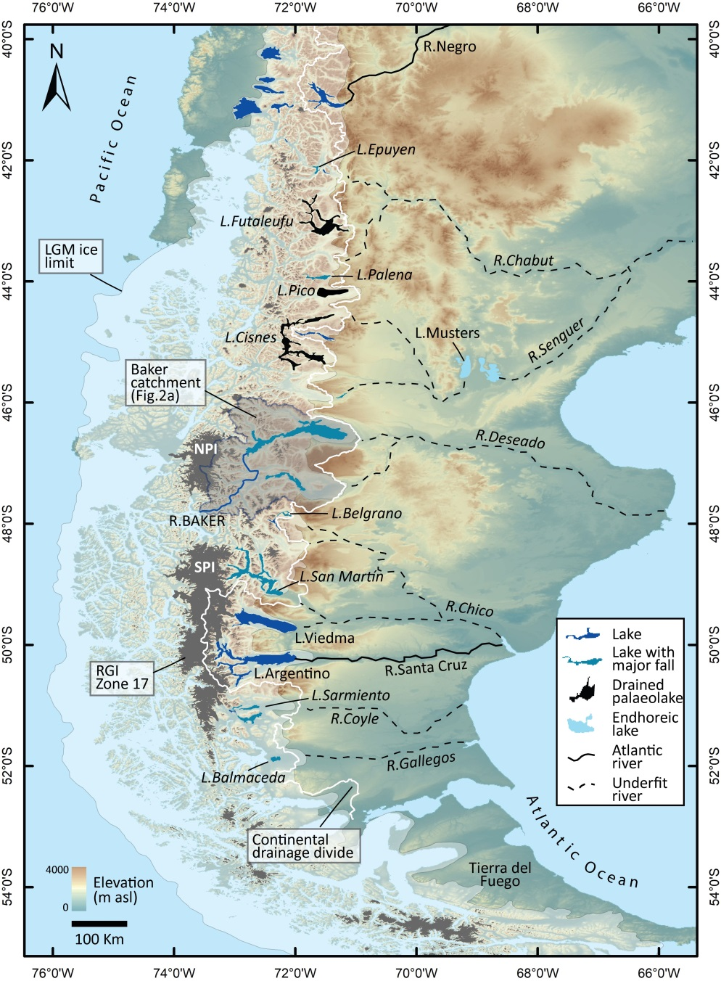
Fig. 1. Map of Patagonia in southernmost South America showing the location of the Río Baker catchment in central Patagonia, alongside the Last Glacial Maximum (LGM ) ice limit and the Randolf Glacier Inventory (RGI, Zone 17) showing the modern extent of glaciers, including the Northern and Southern Patagonia Icefields (NPI and SPI respectively). Also shown is the present continental drainage divide. Lakes that have undergone stage falls of ~10-100 m are indicated, including a number of totally drained lakes in the northern sector of the region. The underfit river valleys indicate major river systems that flowed to the Atlantic during the Last Glacial Maximum (LGM), which during deglaciation underwent drainage reversals to the Pacific.
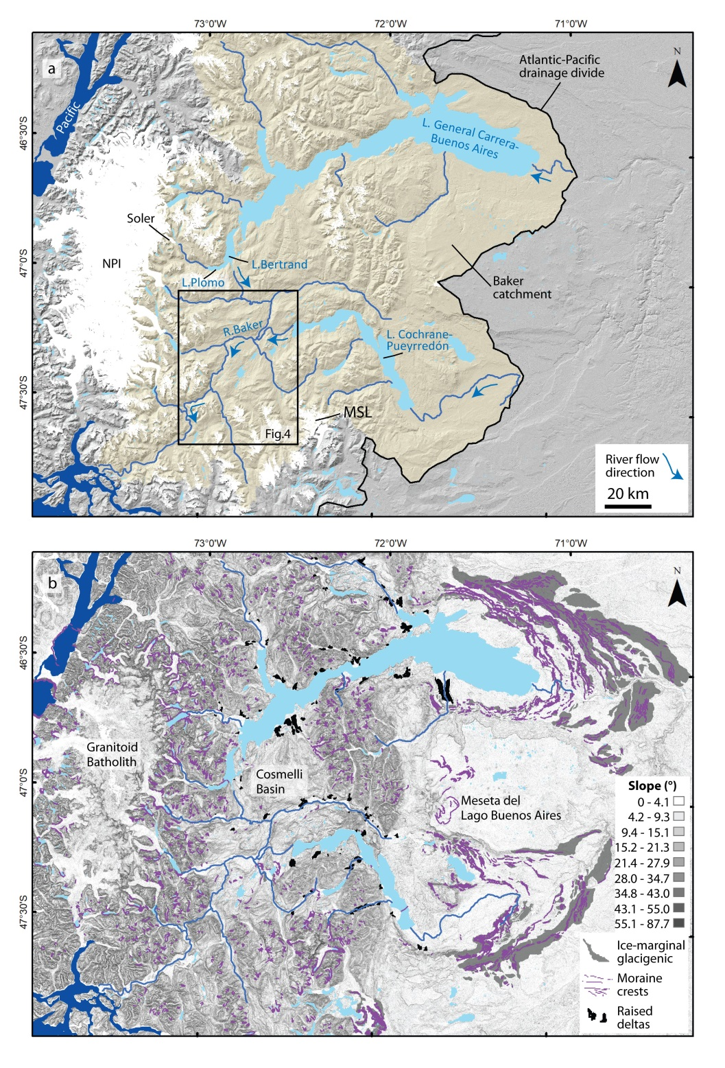
Fig. 2. a) The Río Baker catchment and study area in central Patagonia, showing the two large transboundary lakes Lago General Carrera/Buenos Aires and Lago Cochrane/Pueyrredón. The outflow of Lago Bertrand is the start of the Río Baker. Arrows indicate the reversed flow direction. The RGI Zone 17 is presented in white, showing the NPI and Monte San Lorenzo (MSL) ice cap, the two major ice sources that blocked Baker valley drainage until after the Antarctic Cold Reversal. b) Slope DTM of the same area with selected landforms (from Bendle et al., 2017): moraine crests, ice marginal glacigenic sediments, and raised deltas. Note the structural basin (Cosmelli Basin) occupied by the Río Baker.
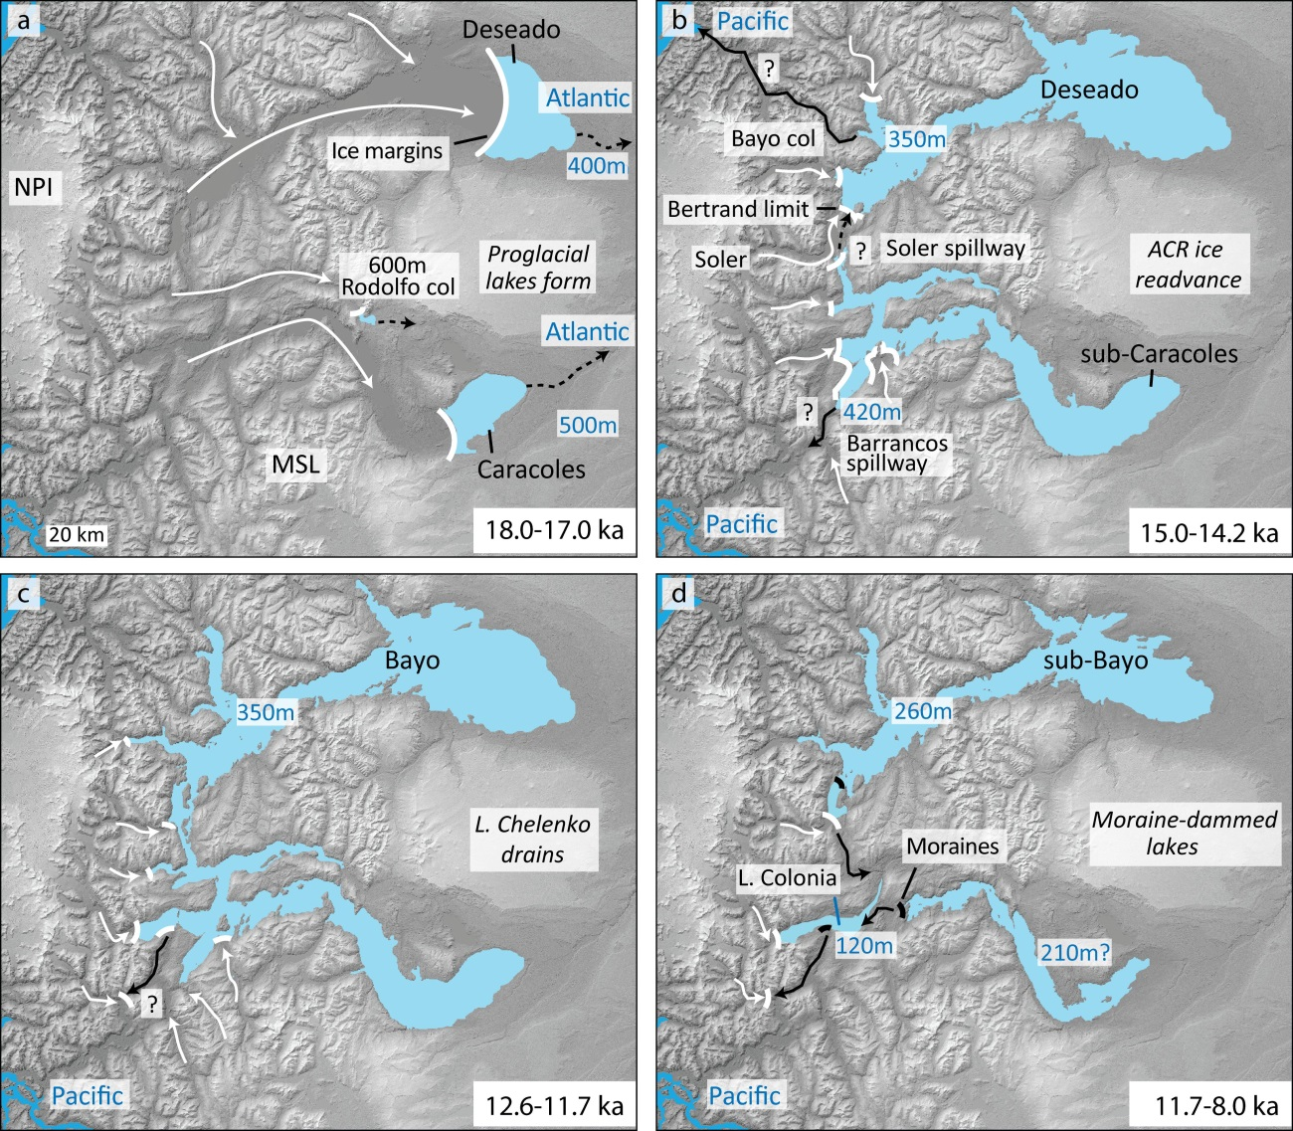
Fig. 3. Key stages in palaeolake evolution during deglaciation in the Baker catchment (modified from Thorndycraft et al. (2019): a) onset of palaeolake formation (18.0-17.0 ka); b) lake extent during the Antarctic Cold Reversal (15.0-14.2); c) drainage of the large unified lake system (Lago Chelenko); and d) exposure of previously drowned moraines forms a series of sub-aerially exposed moraines after Lago Chelenko drains. Dashed arrows indicate drainage pathways, solid arrows show likely GLOF pathways.

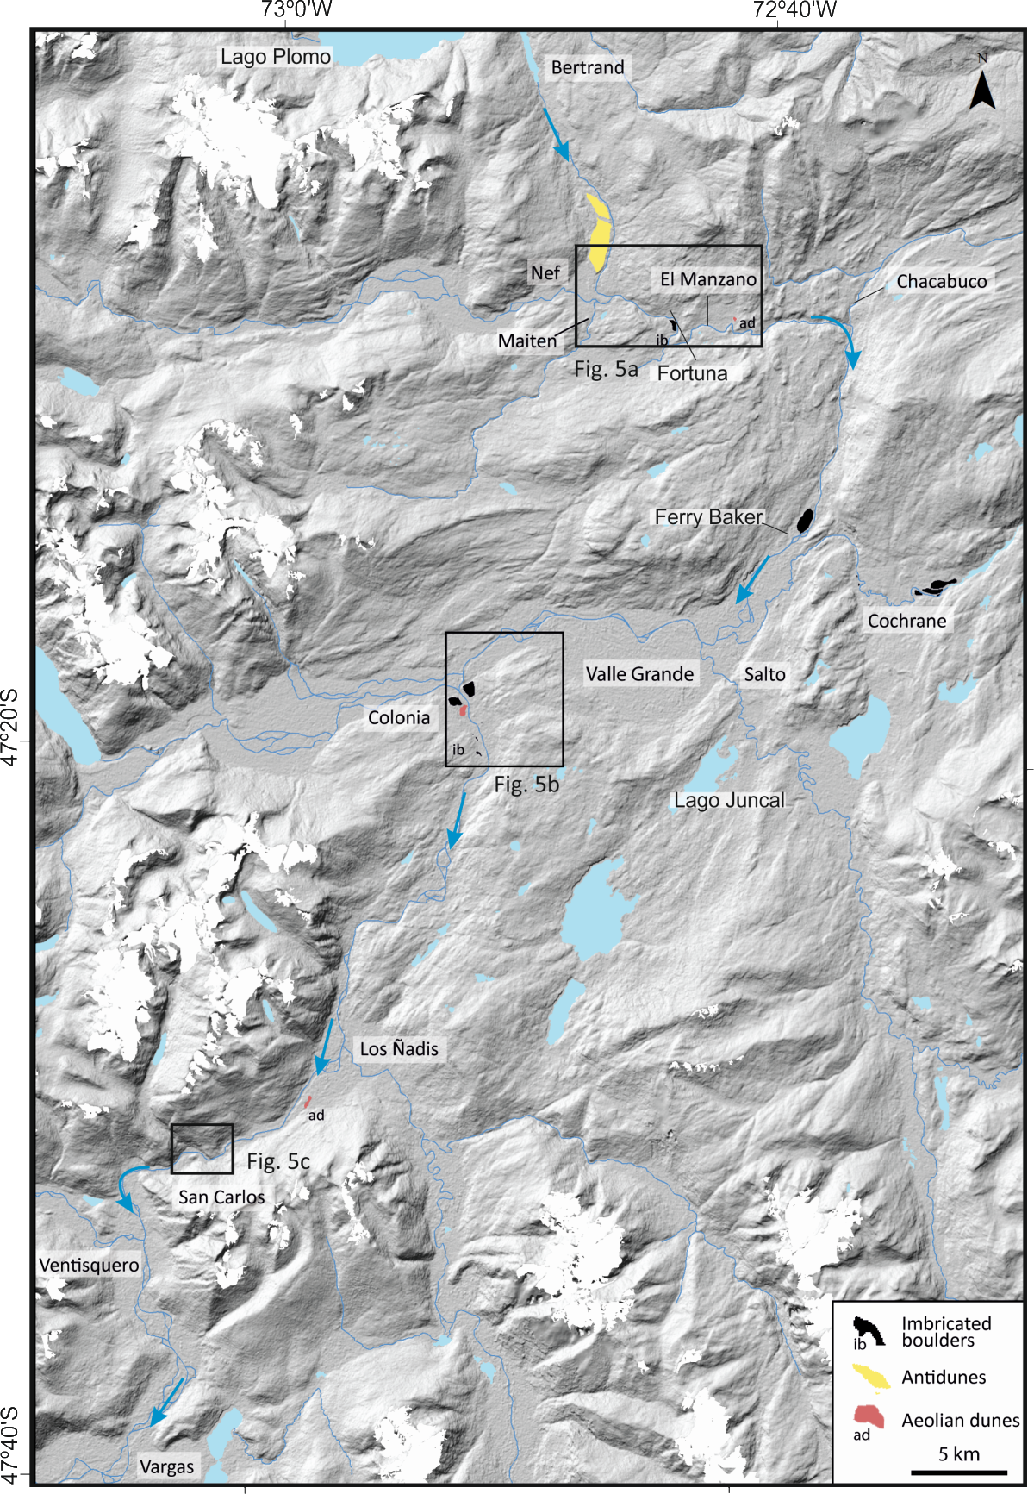
Fig. 4. The study area in the Baker valley between Lago Bertrand and Vargas. The preserved antidunes south of Lago Bertrand are shown, as are sites with imbricated boulders, indicating multiple flood pathways. Note the aeolian dunes between Los ñadis and San Carlos, which are photographed in Fig. 9.

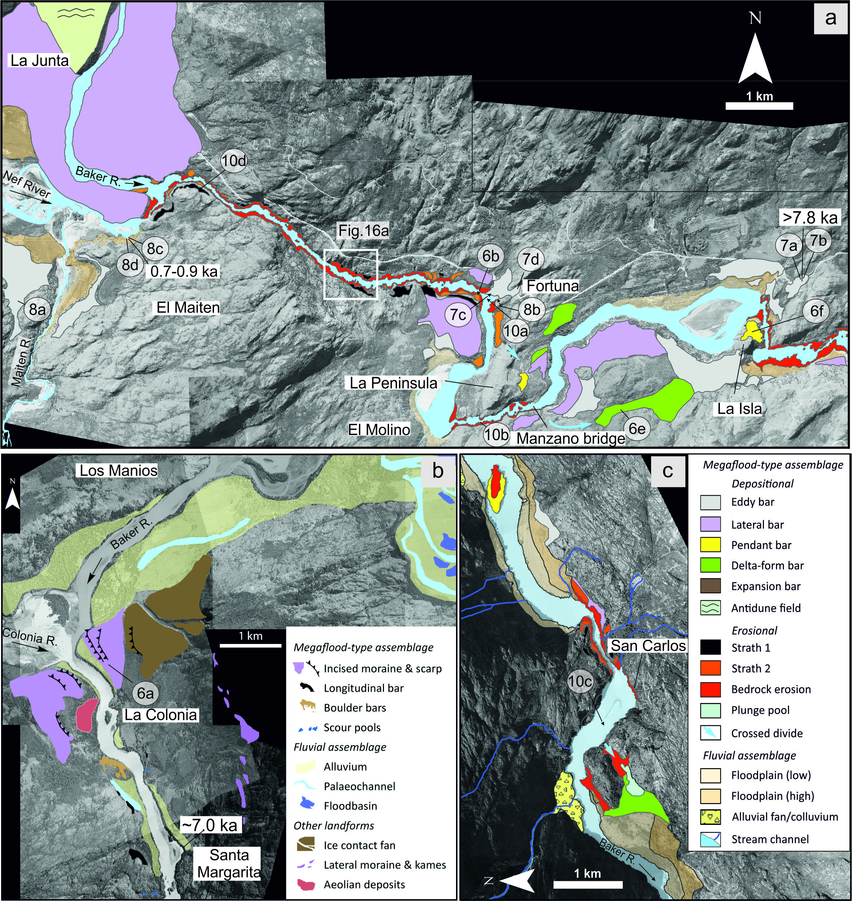
Fig. 5. Geomorphological maps of the study area showing landforms classified as either megaflood-type landform assemblage or Holocene fluvial assemblage at three reaches: a) the Baker-Nef confluence sector; b) the Baker-Colonia sector; and c) the San Carlos sector. Legend for map a is insert in c. Circled numbers show the locations of landform and sediment photographs in Figs. 6-8 and 10.

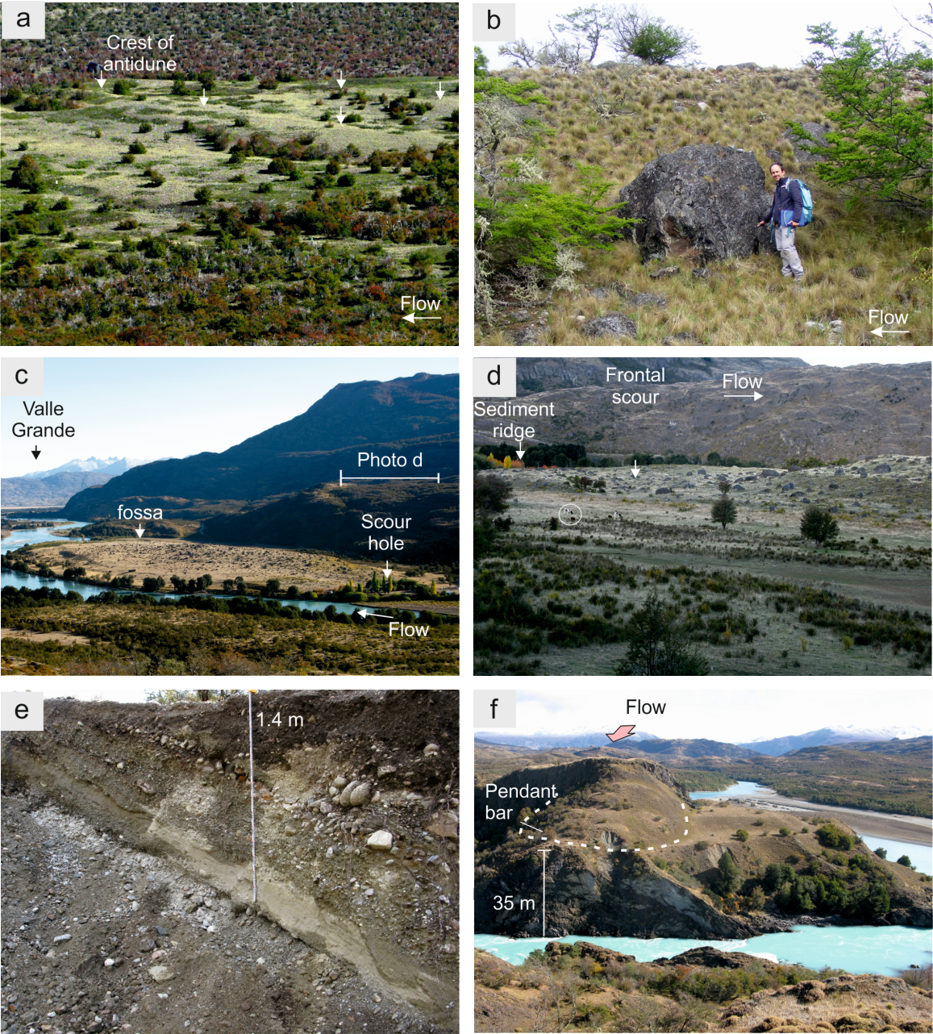
Fig. 6. Photographs of gravel landforms a) Set of antidune bedforms at the confluence of the Baker-Colonia rivers formed on a surface inclined 8 degrees towards the valley axis. Flow was from right to left in the photo, creating gravel antidunes with a mean height of 3 m. b) Scarp slope of a lateral gravel bar in a zone of valley expansion, downstream of the Nef confluence, with large angular boulders detached during bedrock erosion from a local source upstream. c) View downstream of an expansion bar with imbricated boulders located at a channel widening in the Valley Grande. The boulders are likely from a moraine deposit streamlined by the floodwaters. At the valley side, a wide secondary, fossa, channel was formed (Bretz et al., 1956). d) Lateral view of the frontal sector of the expansion bar (photo c) with bedforms related to deformation of flood flow stream lines by this in-stream obstacle, including a crescentic antidune at the outer sector and an inner scour hole. e) Gravel foresets in a delta-like bar on a lateral valley channel downstream of El Manzano bridge. f) Pendant bar (La Isla) deposited on the lee side of a bedrock hill during high flood stages. Note inset flood deposition to the right of the obstacle.

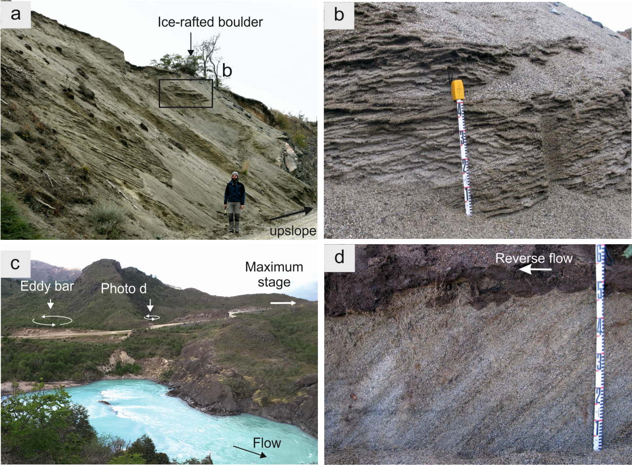
Fig. 7. Photographs of eddy bars. a) Large sand foresets facing towards the valley embayment at an eddy bar ca 65 m above the valley floor. The upper surface contains a cluster of ice-rafted granite boulders of up to 4 m in diameter. b) Climbing ripples on coarse sand composing the upper sedimentary facies of the eddy bar (location in a). c) Northeast view from La Peninsula and location of two eddy bars at the valley side. The flood stage almost reached the divide (indicated in the background). d) Detail of high angle planar stratification on very coarse sands and pebbles showing upstream migration of dunes at the eddy bar (photo c), 25m above valley floor. Maximum flood depth reached 65 m at this location.

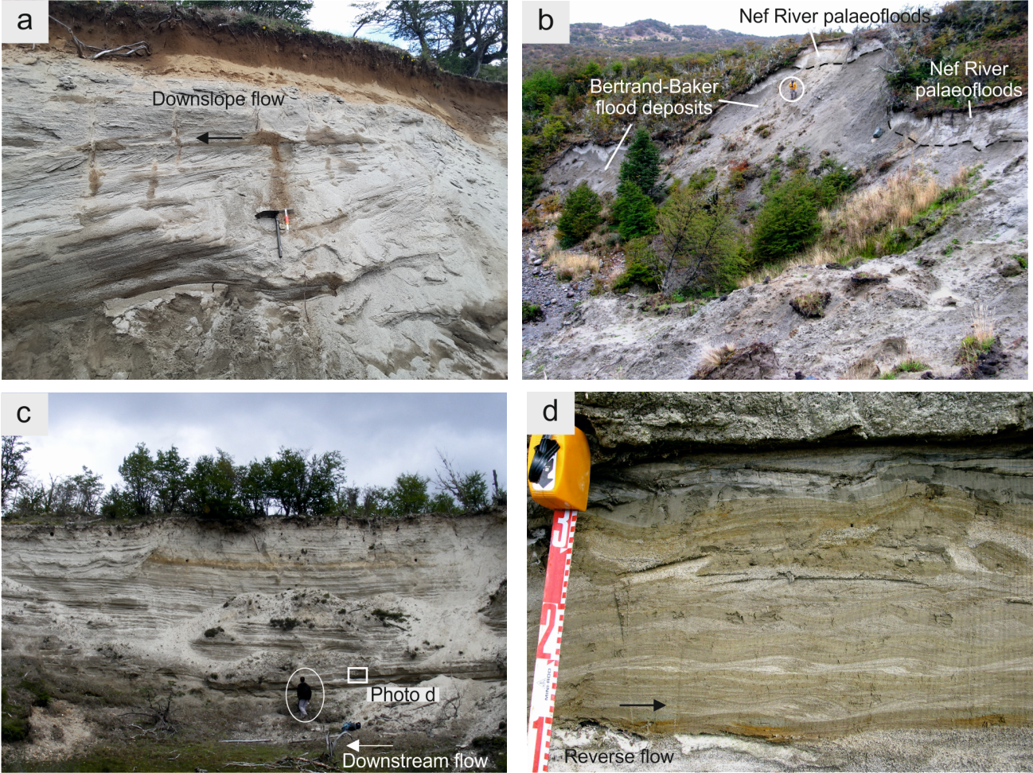
Fig. 8. Photographs of slackwater flood deposits. a) A 3-m thick sand flood deposit connected to an eddy bar deposit within a gully parallel to the Maiten River confluence. The bottom set consist of sand with parallel structure, and the upper set contains cross-stratification directed downslope, most likely reflecting the waning flood stage. b) Coarse grain sand deposits with large foresets dipping downstream, overlain by Holocene flood deposits. c) Sequence of 144 beds of Holocene slackwater flood deposits in the Nef valley, ca 2 km from the Baker-Nef confluence. d) Detail of a flood bed consisting of medium sand with climbing ripples (upstream flow direction) grading to fine sand with parallel lamination, and silty sand to clay laminae at the top. The upper sequence contains fluid escape deformations.

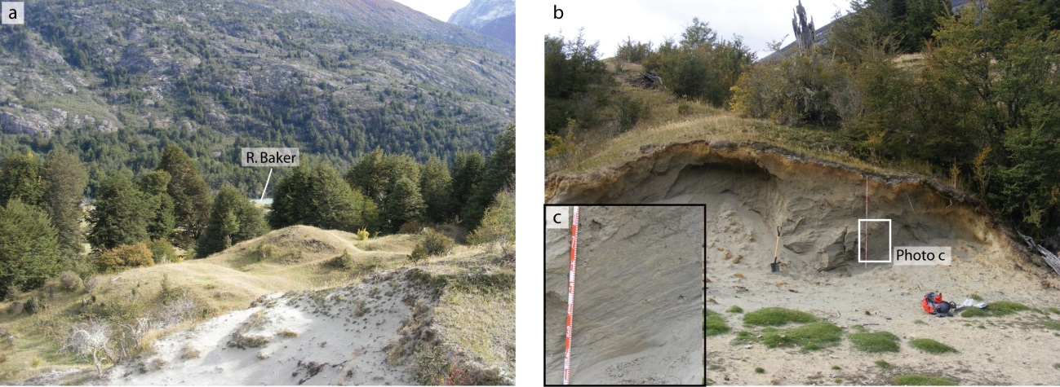
Fig. 9. Aeolian landforms located on the left margin of the Baker valley in the Los Nadis-San Carlos sector: a) view of dunes looking up-valley; b) a dune in section; and c) close-up of sedimentology.
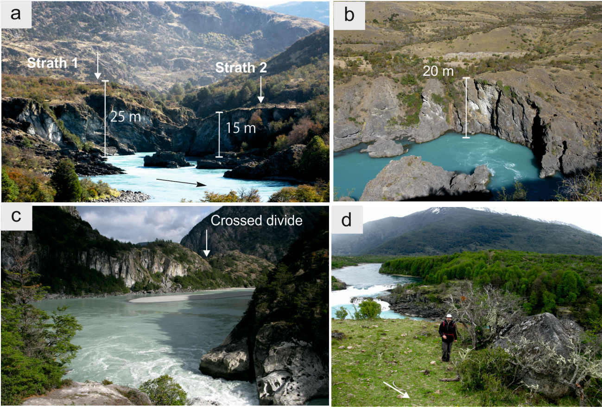
Fig. 10. Photographs of erosional landforms. a) Inner-channel cut in metamorphic rocks with channel obstacles that enhanced semi-circular wall erosion. Strath or high surfaces cut on bedrock are capped by rip-up boulders during the incision processes. b) Scour hole with semicircular erosion of the inner-channel wall, downstream of a channel hydraulic drop. c) Downstream view from the zone of inner-channel erosion at San Carlos showing a divide crossing at 22 m above the river level. This created a lake-filled scour hole downstream (see Fig. 5c). d) View upstream of strath 1 overlain by imbricated boulders composed by metamorphic rocks from local sources. Note the water fall formed at a bedrock channel knickpoint during the headcut erosion retreat.

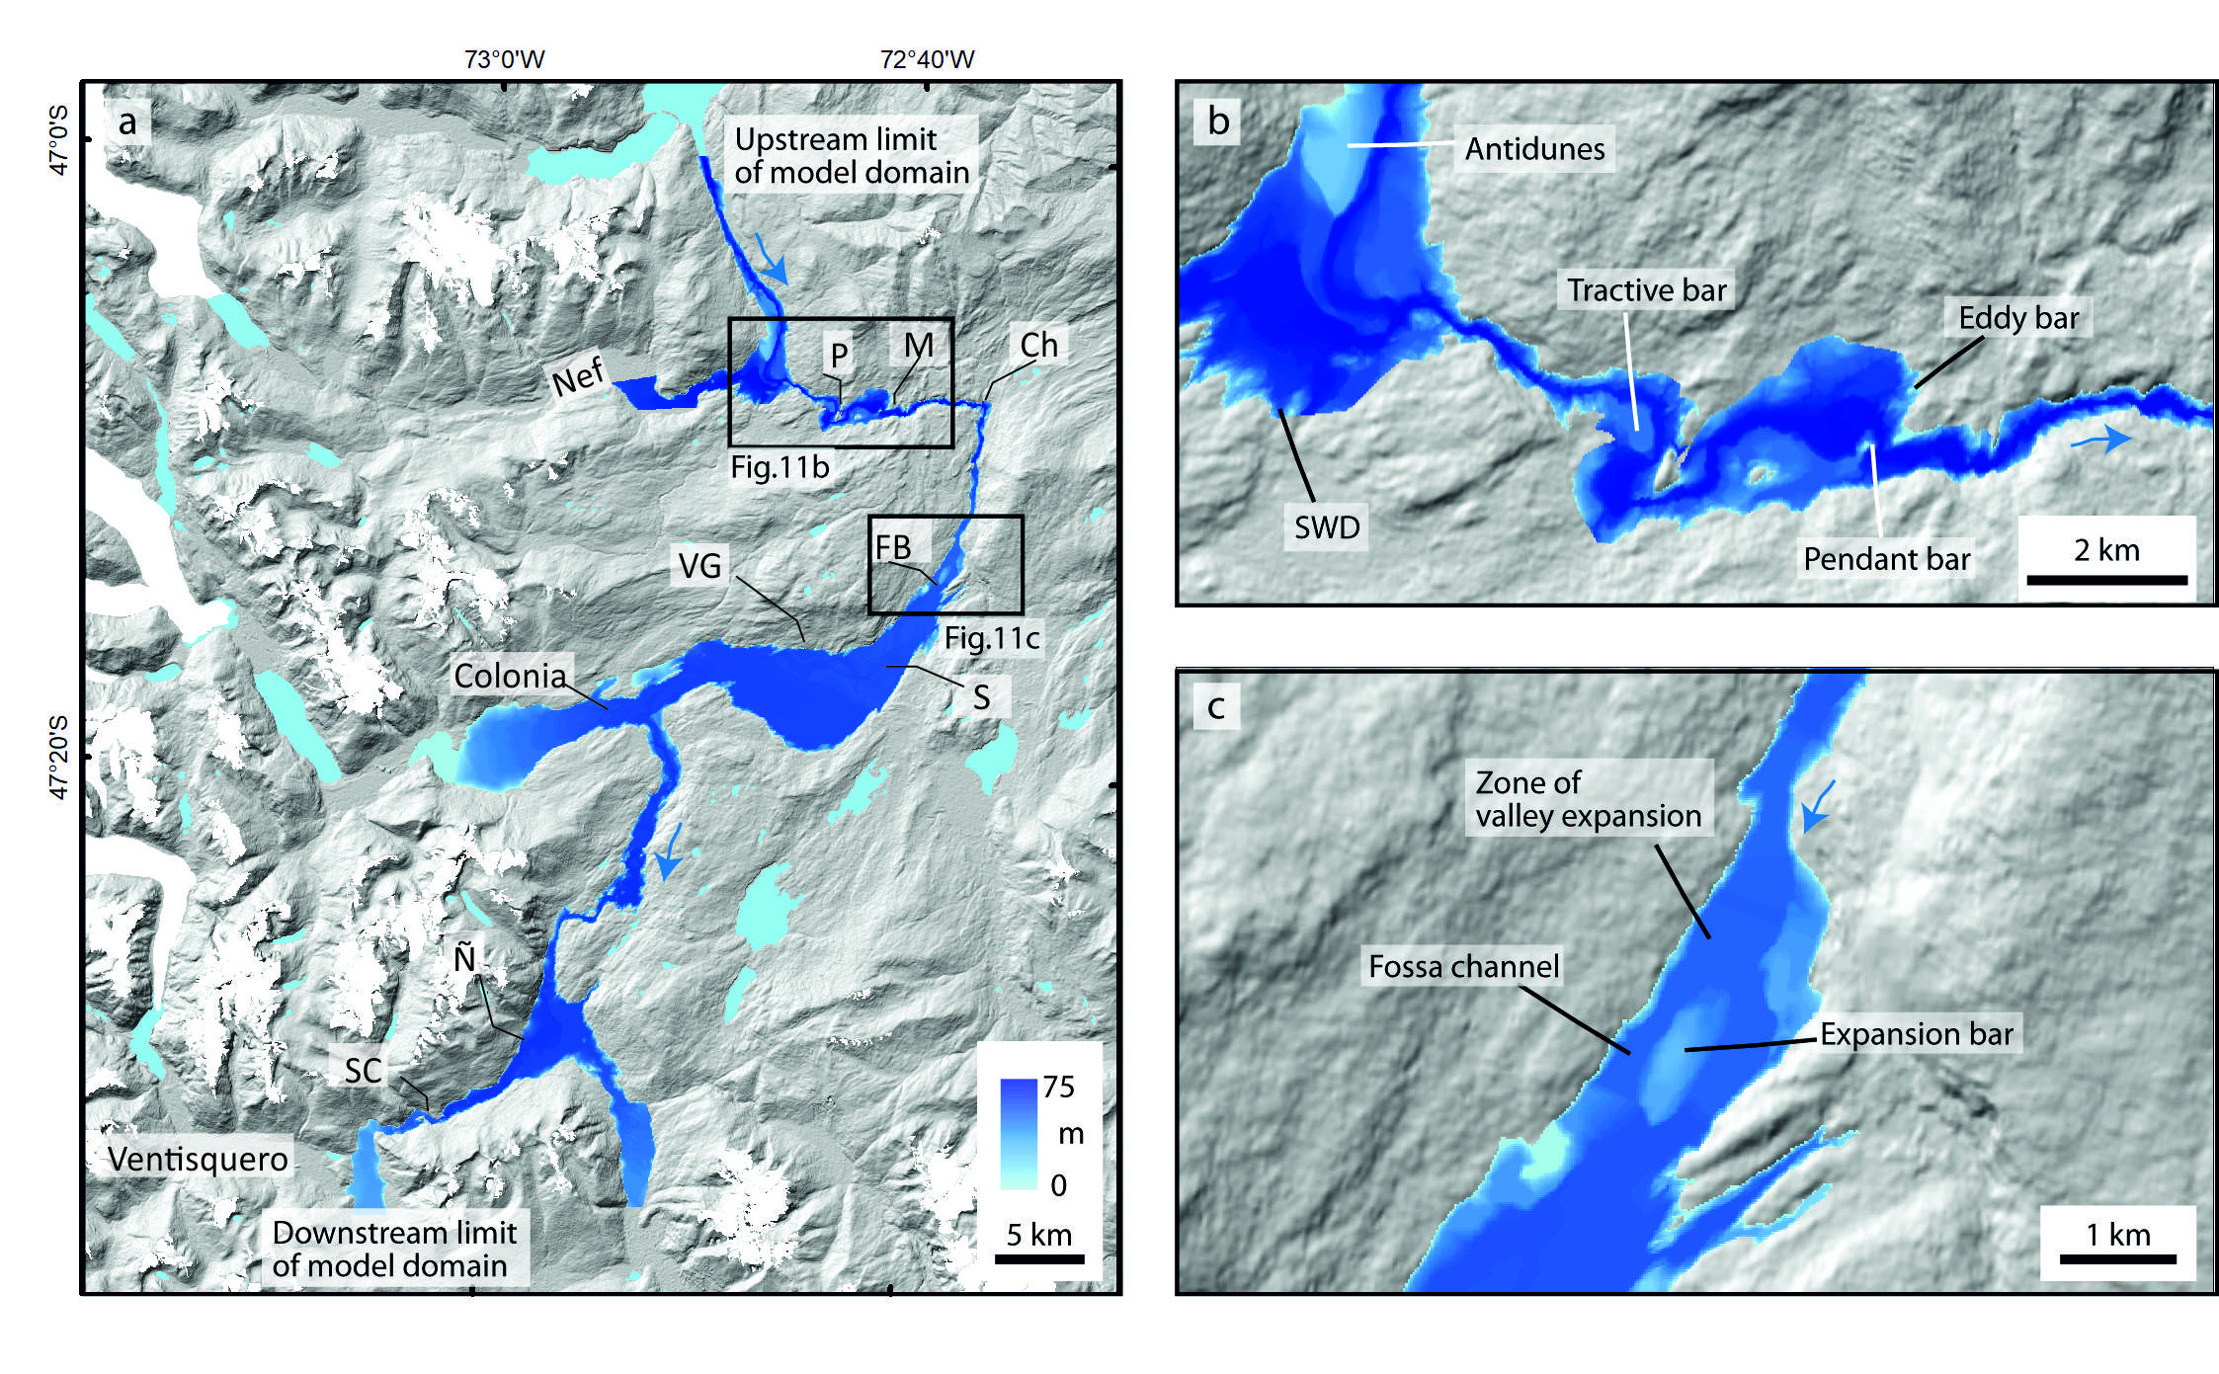
Fig. 11 Computed flood water depth and extent for a modelled flow of 110,000 m³s⁻¹: for: a) the entire modelled domain from Lago Bertrand to Rio Ventisquero; b) the Baker-Nef confluence sector; and c) the upstream reach of the Valle Grande sector. Initials refer to sites along the longitudinal profile in Fig. 12.

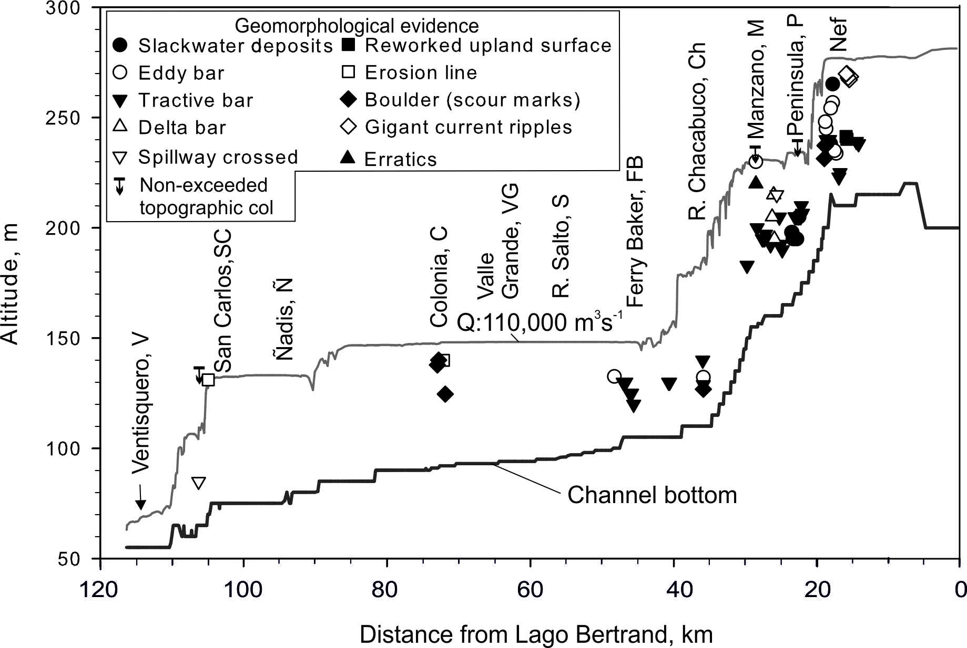
Fig. 12. Computed flood discharge by steady flow hydraulic modelling between the Lago Bertrand lake outlet and Ventisquero River confluence. Location of geomorphological indicators of flood water height matching a calculated water-surface profile for a discharge of 110,000 m³s⁻¹ (0.11 Sv). Location names along the Baker River valley are indicated in Figs. 4 and 11.

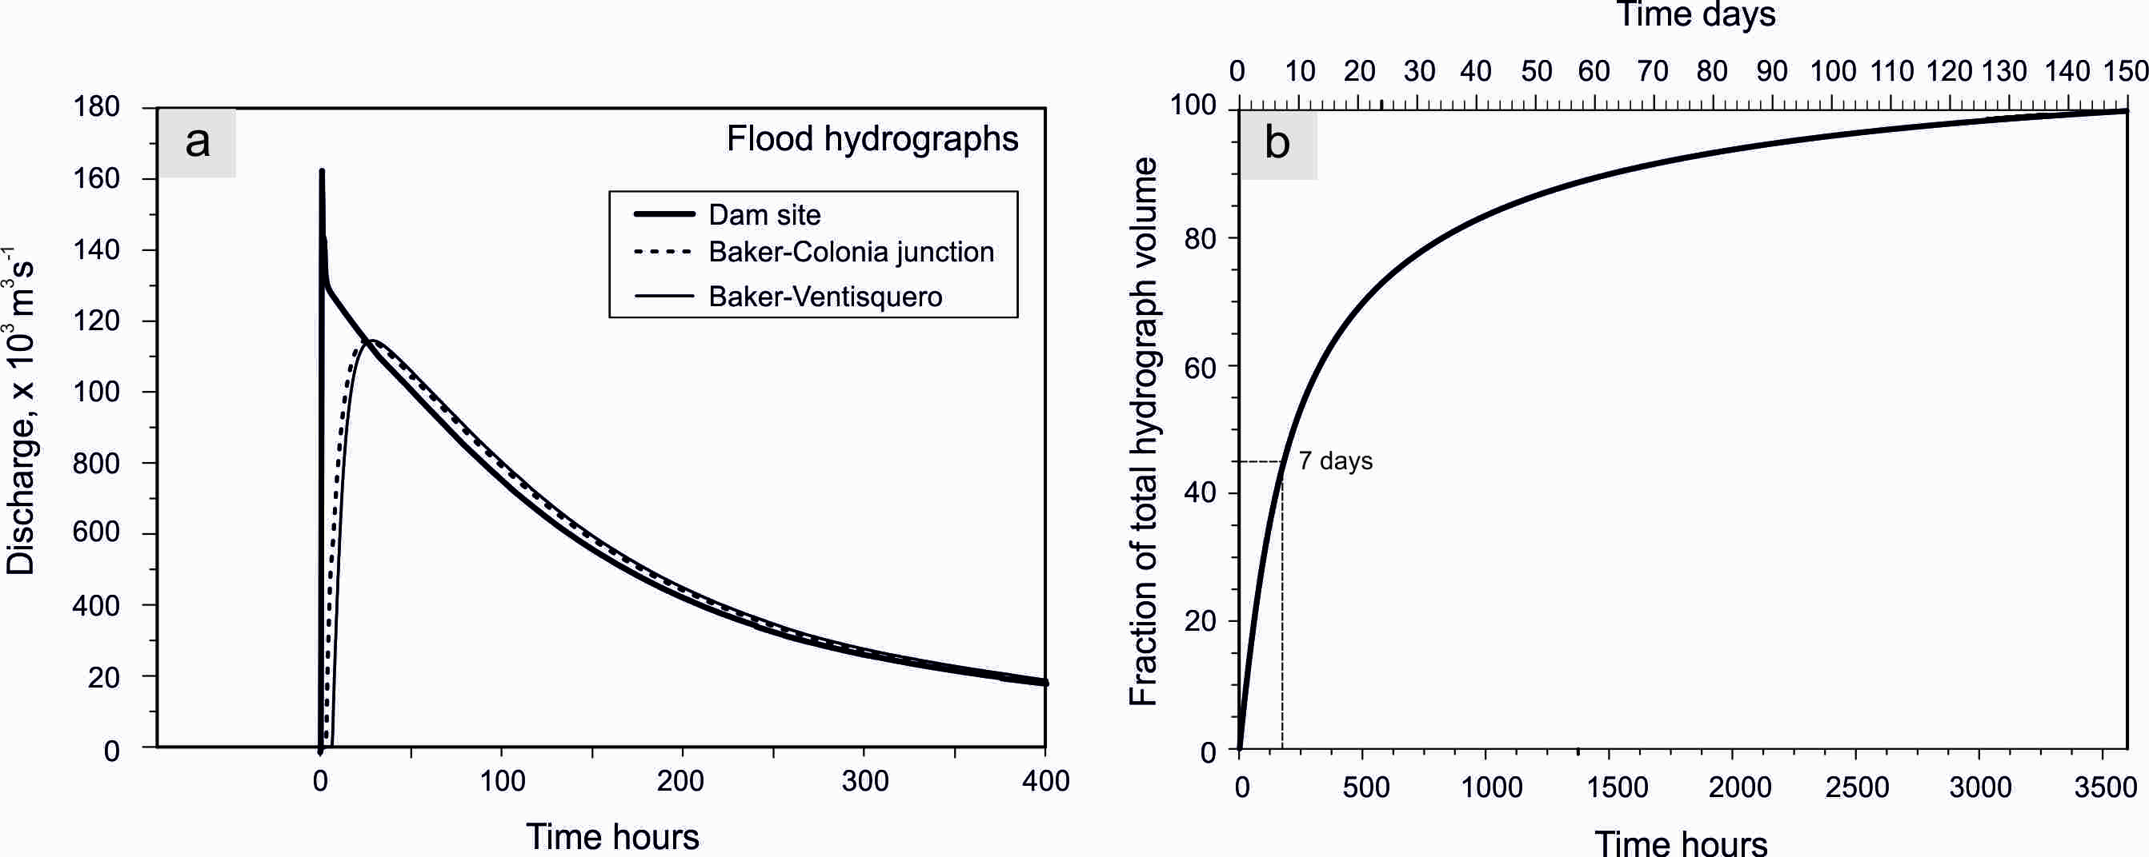
Fig. 13. Dam break and unsteady flow modelling of the Bertrand-Baker flood. a) Hydraulically routed Baker Flood hydrographs at three selected sites. b) Drainage rate of Lake General Carrera following the dam break.
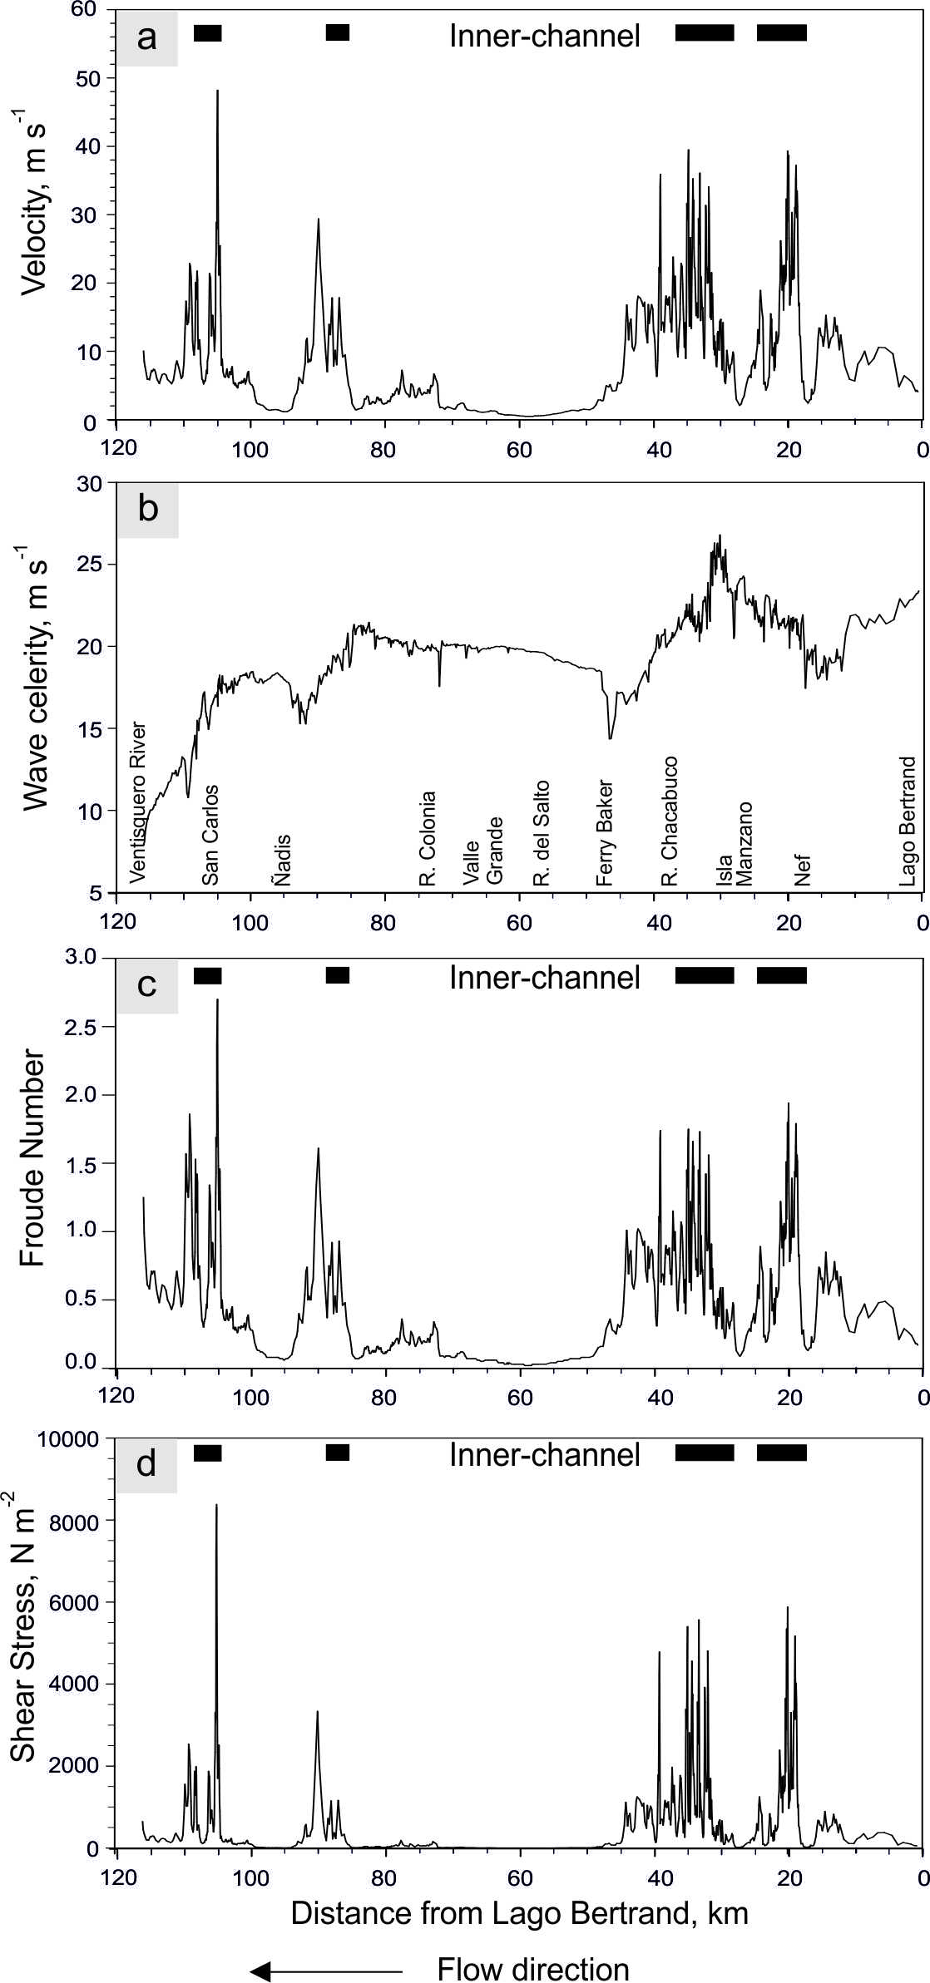
Fig. 14. Flow hydraulics calculated from the unsteady flow simulation: a) channel velocity; b) flood celerity; c) Froude number; and d) channel shear stress. Plotted values were calculated along the reach between the Lago Bertrand outlet (0 km) and the Baker-Ventisquero confluence (120 km). Note that high values of velocity, Froude Number and shear stress match the distribution of inner-channel erosion (locations indicated).
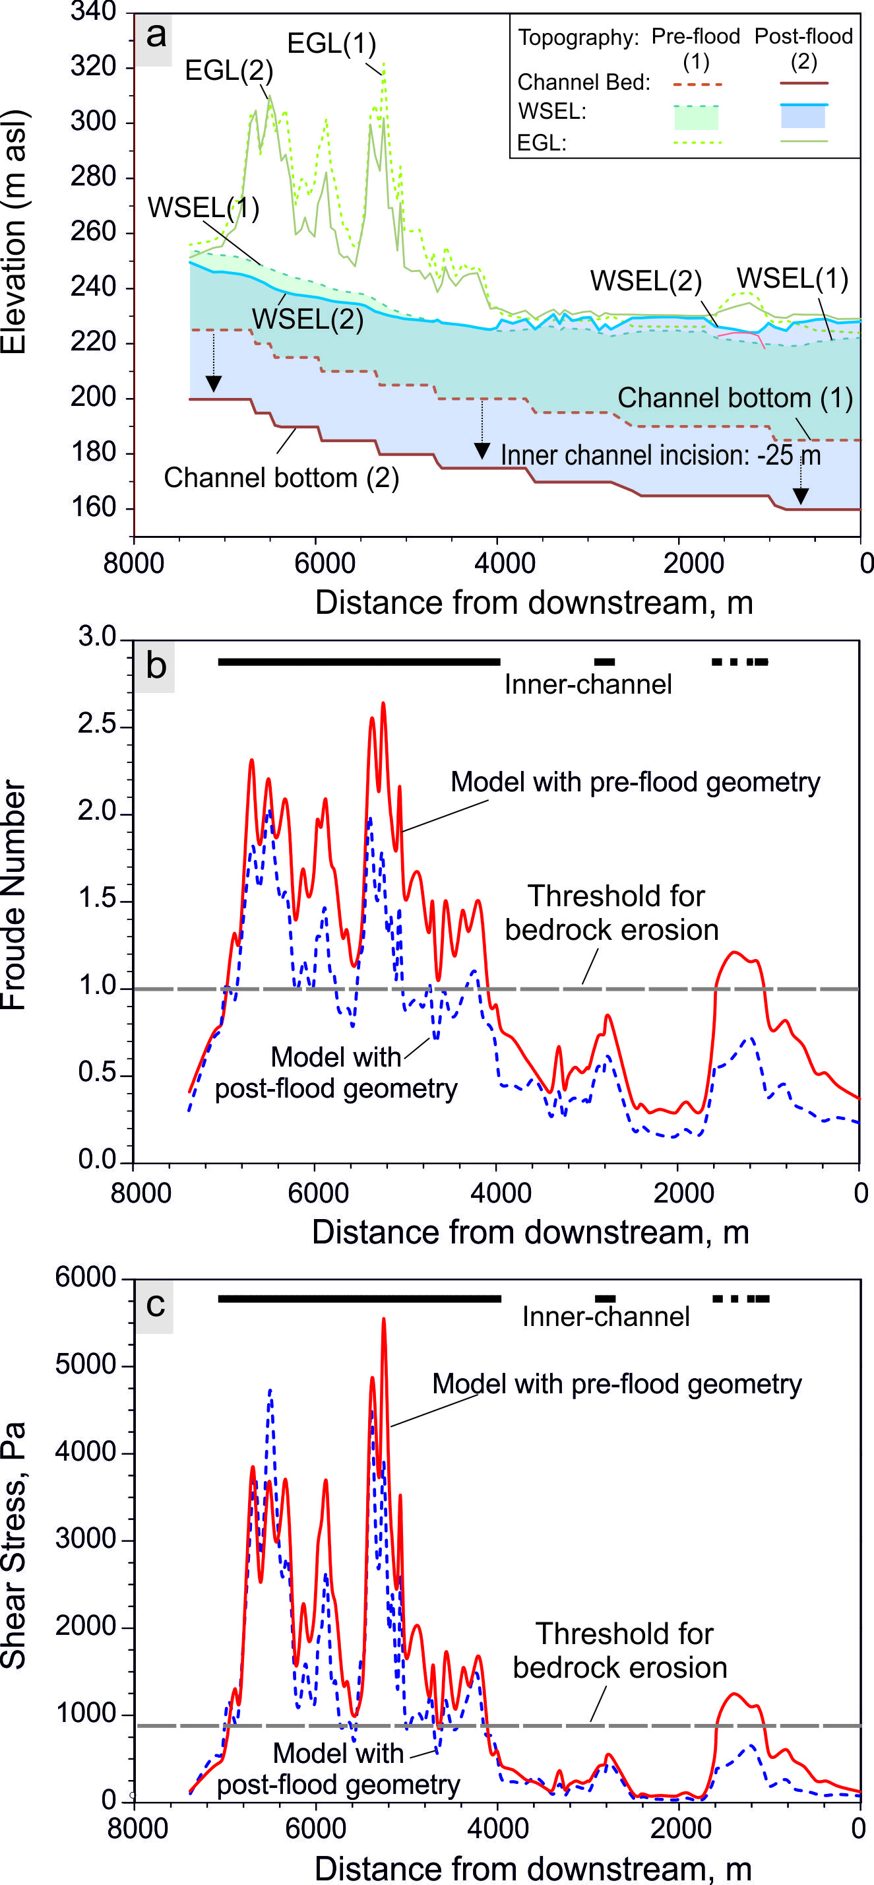
Fig. 15. Hydraulic modelling results from unsteady state modelling using modern channel geometry (post-flood) and a reconstructed pre-flood valley floor. The hydraulic parameters were calculated at peak flow of 0.11 Sv using unsteady state 1D modelling for an 8 km reach downstream of the Baker-Nef junction (location shown in Fig. 5a). a) Step-backwater water-surface elevation (WSEL) and energy grade line (EGL). (1) Model results based on pre-incision topographic scenario with valley bottom set to the elevation of pre-flood fluvio-glacial surfaces. (2) Model results based on the current post-flood topography. Note that despite 25 m of incision the water surface elevation was only lowered an average of ±2 m, mostly in the upstream reach. b) Froude number results from unsteady state modelling using modern channel geometry (blue dashed line) and a reconstructed pre-flood valley floor (red continuous line). c) Shear stress. The highest magnitudes are correlated with the development of inner-channel erosion (horizontal black points in b and c), with distinct threshold values (horizontal bars) for shear stress and Froude number exceeded during the pre-flood valley topography scenario (red line). The inner channel erosion allowed energy dissipation with post-flood (modern) topography decreasing the hydraulic parameters below the erosion threshold. The hydraulic results shows a decrease in shear stress and Froude number for the post-flood valley geometry (modern topography) as a result of energy expenditure in the inner-channel incision, and reflects also a change in hydraulic roughness as wetted perimeter and area of the channel increased in the post-flood topography.

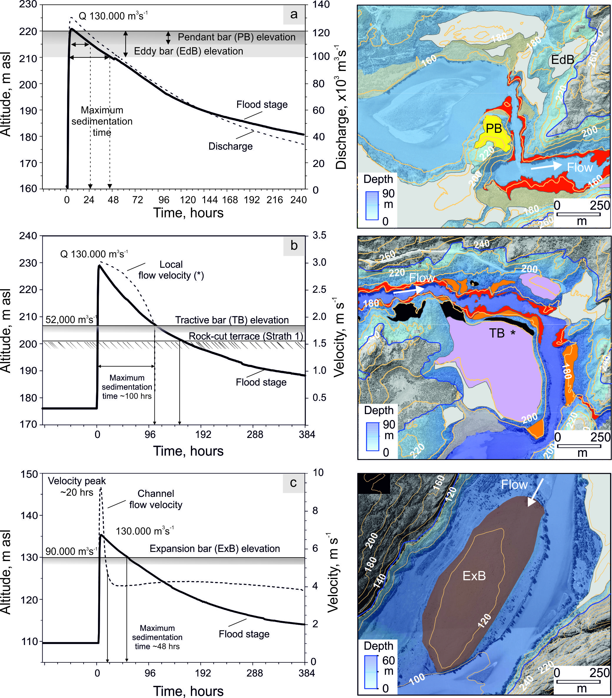
Fig. 16. Phased timing of landform genesis constrained by the modelled flood hydrograph. The flood stage hydrograph indicates the maximum time range for sedimentation and geomorphological work: a) high stage eddy (EdB) and pendant bars (PB). b) tractive bar (TB). c) expansion bar (ExB). Legend for flood landforms in Figure 5c. Contour intervals are 20 m.

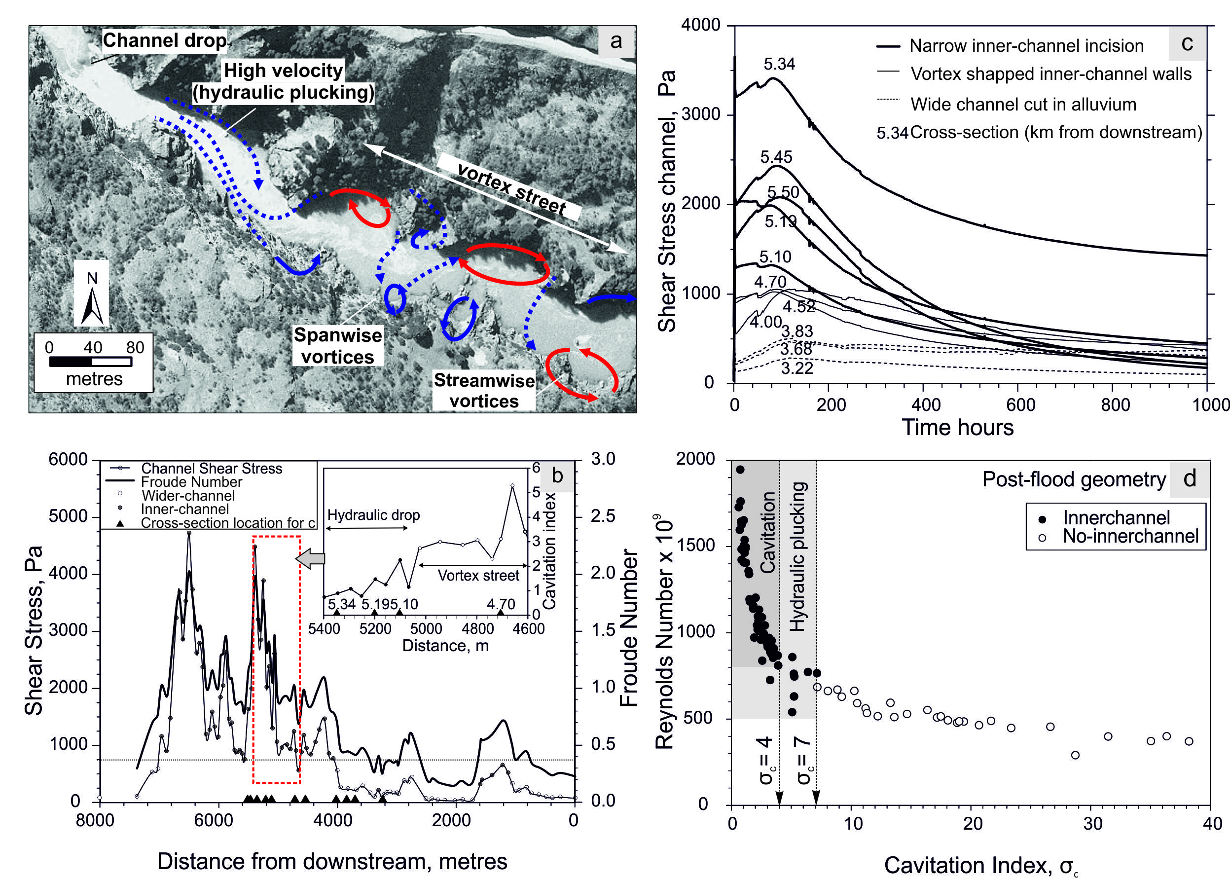
Fig. 17. Inner-channel erosion landforms and associated hydraulic parameters. a) Inner-channel plan view showing a narrow reach initiated at a channel drop and a wider downstream reach with semi-circular forms carved in the bedrock canyon wall. A schematic depiction of the vortex street is depicted with forms shaped by spanwise (blue) and streamwise (red) vortices. b) Channel shear stress and Froude number, calculated from the unsteady flow model at 0.13 Sv peak flow, plotted for each cross-section (locations shown in Fig. 1b). The inset figure plots the cavitation index calculated for the reach shown in Fig. 2a, along the hydraulic drop and vortex street segments. c) Time variation of channel shear stress at selected cross-sections representing different types of inner-channel geometry (locations in km refer to Figs 1b, 2b). d) Relationship between cavitation index and Reynolds number in the channel calculated from unsteady state model results based on post-flood geometry. Black dots correspond to cross-sections with inner-channel incision and white dots to wider channel geometry.

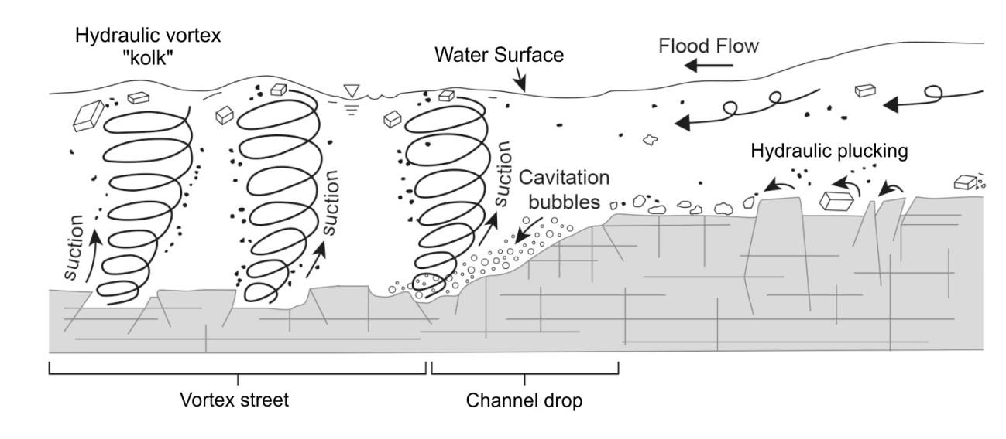
Fig. 18. Schematic diagram of a vortex street created downstream of a knickpoint. Most erosion is caused by hydraulic plucking detaching joint blocks from the bedrock. Collapse of multiple bubbles (cavitation) may be generated locally by high flow velocity at the channel drop.

