Multiple traits and multifarious environments: integrated divergence of morphology and life history

Rüdiger Riesch^{1*}, Ryan A. Martin² and R. Brian Langerhans³
¹ School of Biological Sciences, Centre for Ecology, Evolution and Behaviour, Royal Holloway, University of London, Egham, Surrey TW20 0EX, UK
² Department of Biology, DeGrace Hall, Case Western Reserve University, Cleveland, OH, 44106-7080, USA
³ Department of Biological Sciences & W. M. Keck Center for Behavioral Biology, North Carolina State University, 127 David Clark Labs, Raleigh, NC 27695-7617, USA
* corresponding author: rudiger.riesch@rhul.ac.uk

Keywords: adaptive radiation, convergent evolution, divergent natural selection, ecological speciation, Gambusia, Poeciliidae

Understanding complex responses of multiple character suites (e.g., behaviour, life history, morphology) to multifarious environments is a challenging task. Here we use a multivariate approach (partial least squares structural equation modelling) to disentangle drivers (i.e., predation, resource availability, and population demographics) of phenotypic divergence among populations of Bahamas mosquitofish (Gambusia hubbsi) inhabiting blue holes. We further employ a two-block partial least squares analysis in a novel approach to uncovering integrated and independent aspects of divergence in correlated character suites. Results suggest that phenotypic divergence mainly resulted from differences in predation regimes, with population demography and resource availability also influencing particular aspects of divergence. We uncovered statistically significant covariation of life histories and morphologies, and revealed that phenotypic divergence between predation regimes involved both integrated and independent responses. For instance, female life histories diverged mostly independently of morphology, although some morphological shifts (abdominal distension) resulted from changes in fecundity. In contrast, males showed strong morphological divergence independent of life history, but much of their life-history shifts reflected joint morphological changes (lean weight and body shape). Our study illustrates the utility of gathering disparate data types from multiple populations/species to understand the causes and nature of phenotypic divergence in the wild.

Introduction
Organisms possess various types of traits or character suites that are inherently multivariate, and may respond to selection independently or jointly. Phenotypic diversification typically occurs amidst an array of potentially influential environmental factors (Schluter 2000, Moore et al. 2016). However, unravelling the relative importance of particular factors among the myriad potential agents, how they interact or how traits respond in potentially integrated manners to these factors, is daunting due to the multivariate interplay between environment and phenotype. Nonetheless, insights into this complex interaction network will greatly improve our grasp of the process of adaptive diversification (MacColl 2011, Heinen et al. 2013).
Using the comparative approach, populations or species inhabiting different environments can be compared (accounting for evolutionary non-independence of taxonomic groups) to identify putative agents of natural selection driving adaptive divergence (Schluter 2000, Losos 2011). Here, close association between certain traits and potential selective agents (phenotype-environment correlation) can point to probable causes of trait divergence (Endler 1986, Losos et al. 2006). However, studies employing a comparative approach have often focused on single character suites, exemplified by many studies of variation in life histories (e.g., Stearns 1992) and morphologies (e.g., Wainwright and Reilly 1994). While these two character suites may often evolve in concert, they have traditionally been studied separately [e.g., the guppy Poecilia reticulata: Reznick and Endler 1982 (life history); Hendry et al. 2006 (morphology)]. In the comparatively rare cases where co-divergence in multiple trait suites are examined (e.g., Conner and Via 1993, Hendry and Quinn 1997, Wesner et al. 2011, Riesch et al. 2016), seldom is this combined with the study of multiple selective factors. However, only by simultaneously investigating multiple types of traits and multiple agents of selection can we more fully understand the complexity of adaptive diversification (Lardner 2000, DeWitt and Langerhans 2003).
Strong evidence now exists for evolutionary convergence in life history and morphology in livebearing fishes (Poeciliidae) in response to differences in predation regime (hereafter referred to as predation) (e.g., life history: Reznick and Endler 1982, Jennions and Telford 2002; morphology: e.g., Hendry et al. 2006, Langerhans et al. 2007). Yet, in most of these systems, differences in predation between populations are confounded with differences in other selective factors like resource availability (hereafter ‘resources’) or population demography (hereafter ‘demography’). This makes it difficult to disentangle the role of predation in shaping phenotypes from the potential impacts of resources and demography (e.g., Endler 1995, Johnson 2002). Moreover, life history and morphology may not represent independent character suites, but rather may exhibit correlations due to shared genetic or developmental causes, or architectonic influences on one another (e.g. larger reproductive organs can structurally alter external morphology; Langerhans and Reznick 2010). How might we attempt to disentangle the effects of predation, resources, and demography on the joint and independent divergence of life history and morphology?
During the past approximately 15,000 years (Fairbanks 1989), Bahamas mosquitofish (Gambusia hubbsi) have colonized many inland blue holes (i.e., water filled, vertical caves), which are analogous to aquatic islands in a sea of land, with no association between genetic relatedness and predation regime, and little gene flow among most populations (e.g., Schug et al. 1998, Langerhans et al. 2007, Riesch et al. 2013). In some of these blue holes G. hubbsi experience relatively predator-free environments devoid of any piscivorous fish (besides perhaps piscivorous invertebrates, no permanent fish predators of any kind are known from these blue holes). In other blue holes G. hubbsi are heavily preyed upon by the much larger bigmouth sleeper (Gobiomorus dormitor) (e.g., Langerhans et al. 2007, Martin et al. 2015). Analyses of population densities and age structure suggest that all age classes suffer higher mortality in the presence of this predator (Heinen et al. 2013). Because blue holes with divergent predation regimes do not systematically differ in abiotic environmental variables (Langerhans et al. 2007, Heinen et al. 2013, Riesch et al. 2013), this system provides a ‘natural experiment’ to test the relative importance of predation-mediated natural selection on life-history and morphological diversification, compared to natural and sexual selection as a result of differences in resources and demography (Downhower et al. 2000, Langerhans et al. 2007).
Using the post-Pleistocene radiation of Bahamas mosquitofish, we apply a partial least squares structural equation modelling (PLS-SEM) approach to uncover the complex causes of phenotypic divergence in the wild. We examine how three selective agents (predation, resources, and demography) and two character suites (life history and morphology) interact to shape ecological divergence. We chose these specific selective factors because previous studies have demonstrated that they are particularly likely to drive population divergence (predation: Law 1979; demography: Mylius and Diekmann 1995, resources: Twombly et al. 1998). Similarly, we chose life histories and morphology as our focal character suites because they are known to exhibit strong adaptive evolutionary divergence across blue holes (e.g., Langerhans et al. 2007, Langerhans 2009a, Riesch et al. 2013). Consistent with life-history theory, predation results in smaller offspring size and increased lean weight, testes size, and fecundity in Bahamas mosquitofish (e.g. Riesch et al. 2013). Predation is also known to drive a larger mid-body caudal region and smaller head in these fish. These differences alter locomotor abilities, leading to increased fast-start escape performance in populations coexisting with predatory fish (e.g. Langerhans et al. 2007, Langerhans 2009a). However, the importance of other selective factors in directly or indirectly explaining these differences is unknown, as is how the two character suites might exhibit joint responses or influence one another.
We attempt to address six specific questions on the nature of interactions between predation, resources, demography, life history, and morphology (Fig. 1): (a) The presence of predatory fish could depend on, or influence, resource availability. (b) Prey demography can be altered by predation (e.g. reduced density, altered sex ratio or age structure), although the reverse causality is unlikely in the present system. Demography could also be affected by resources (e.g. higher density or juvenile recruitment in high-resource environments), and reciprocally influence resources as well (e.g. high densities can lead to diminished resources). (c) We expect predation to drive life-history variation (see above), but some of these supposed impacts could actually reflect effects of resources or demography that covary with predation, or resources and demography might influence life-history traits independently of predation (e.g. more resources or lower densities can lead to r-selected life histories). (d) Previous work indicates that predation has driven adaptive divergence in body shape, but variation in resources or demography could partially explain some of these findings, or influence body shape directly (e.g. fewer resources or higher densities could select for more streamlined bodies to enhance foraging efficiency). (e) How might the two character suites diverge among populations jointly, and how might they correlate within populations owing to developmental / architectonic links? (f) What is the relative importance of the three selective agents in explaining phenotypic variation, and to what extent can differentiation in one character suite explain variation in the other? This final question evaluates whether either trait suite exhibits divergence between predation regimes that is statistically independent of covariation with the other trait suite, or whether divergence in one suite represents a pleiotropic consequence of divergence in the other (this centers on predation because it was identified as the most important, see Results).

Methods
Study populations
During the first two weeks of May 2011, we visited 14 blue holes (seven with predators, seven without; Supplementary material Appendix 1, Fig. A1) on Andros Island, The Bahamas. At this time, we collected G. hubbsi using dip nets and minnow traps, measured resource availability, and estimated specific demographic variables (see below). Predation regime was treated as a dichotomous variable based on the presence of G. dormitor, as this predator’s density exhibits little among-population variation (Martin et al. 2015) and thus variation in predation risk is largely captured by differences between the absence and presence of this predator (hereafter termed low-predation and high-predation populations). Immediately after collection we euthanized the fish with tricaine methanesulfonate (MS 222) and preserved them in 95% ethanol. Life histories and morphologies were subsequently measured using preserved specimens (see below).

Resource availability
Because Bahamas mosquitofish exhibit a broad diet (Araújo et al. 2014), it is not clear how to best estimate resource availability for these fish. We therefore measured multiple variables designed to capture relevant aspects of overall productivity of blue holes (Grether and Kolluru 2011). To estimate total algal biomass, we measured the photosynthetic pigment chlorophyll a using a fluorometer (AquaFluor model, Turner Designs, Sunnyvale, CA). Moreover, because zooplankton constitutes a significant proportion of the G. hubbsi diet (Gluckman and Hartney 2000, Araujo et al. 2014), zooplankton densities were estimated using a 60-m tow of a zooplankton net (20-cm diameter, 153-µm mesh) at 0.5-m depth. All plankton were counted within a 2.5-ml subsample of each plankton collection using a stereo microscope. While we used snapshot estimates of resource availability taken at the time of fish capture, blue holes comprise relatively stable environments, and previous work has shown high repeatability across seasons and years in resource measurements (intraclass correlation coefficients: 0.88-0.98; Heinen et al. 2013)—thus, our estimates should adequately capture salient differences among blue holes.

Demographics
We measured population density, tertiary (adult) sex ratio, and age structure of G. hubbsi using underwater visual census methods (English et al. 1994, Nagelkerken et al. 2000). Due to water clarity, ease of underwater identification of sex/age classes, and ability to approach fish without causing disturbance or alarm, visual census techniques are especially well suited for fish density estimation in inland blue holes, similar to other aquatic environments in the Bahamas (e.g., Layman et al. 2004; Heinen et al. 2013; Martin et al. 2015). While snorkeling, one author recorded the number of juvenile, adult male, and adult female G. hubbsi present in 1-m³ quadrats within each of four habitat types: (1) shallow near-shore (0-1 m deep, 1-2 m from shore), (2) deep near-shore (2-3 m deep, 1-2 m from shore), (3) shallow offshore (0-1 m deep, 9-10 m from shore), and (4) deep offshore (2-3 m deep, 9-10 m from shore). Counts were made immediately upon swimming within a 1-m distance of the pre-designated quadrat location to avoid disturbing the fish. Within each habitat type, we surveyed 10 quadrats distributed equidistant around the perimeter of each blue hole (40 quadrats per site). Previous work found significant repeatability of G. hubbsi density across time of day, seasons, and years (intraclass correlation coefficients of 0.64; Heinen et al. 2013), providing confidence in our snapshot estimates. Density was calculated as the average number of Gambusia observed within a 1-m³ quadrat (including all age/sex classes), and values were pooled across habitat types to provide overall density estimates. Tertiary (adult) sex ratio was calculated as the density of females divided by the density of males. Age structure was calculated as the proportion of juveniles in the population (juvenile density divided by total density).

Life histories and morphometrics
Using the same individuals (10 adult males and ~10 pregnant females from each of the 14 blue holes), we collected life-history and geometric morphometric body-shape data. While the morphological data is new to this study, the life-history data were also used in a previous study (Riesch et al. 2013). For females, we included standard length (SL, mm), lean weight (g; i.e., dry weight after fat extraction), fat content (%), fecundity (number of developing embryos), mean embryo lean weight (mg; i.e., per clutch), mean embryo fat content (%; per clutch), and reproductive allocation (percent dry weight consisting of developing embryos; hereafter referred to as female gonadosomatic index [GSI]), and for males we included standard length (SL, mm), lean weight (g), fat content (%), and GSI (percent dry weight consisting of testes) in our analyses. Among-population variation in these traits can reflect both genetically based divergence and phenotypic plasticity, although previous work in Bahamas mosquitofish has found that population differences in fecundity, egg size, and female GSI have a significant genetic basis (Riesch et al. 2013; other life-history traits not yet examined).
We then log10-transformed (all measures for SL, dry and lean weight), square root-transformed (fecundity), or arcsine(square root)-transformed (all fat contents, and male and female GSI) all life-history variables to meet assumptions of statistical analyses. To remove size/allometry effects on life-history traits other than SL, we regressed these variables against SL (and for females also against embryonic stage of development) separately for each sex. We tested heterogeneity of slopes among predation regimes and found that only female lean weight exhibited heterogeneous slopes (P = 0.043, all other P > 0.35). However, in this single case the slopes were only very slightly different (shared slopes explained 60.5% of variation, while difference in slopes explained only 0.08% of variation), and thus we calculated residuals in the same manner for all traits. The resulting residuals, along with SL, were used as dependent variables in all subsequent analyses.
For morphometrics, a lateral x-ray image was taken of each fish using a custom-built digital x-ray unit comprising a micro-focus x-ray source (Hamamatsu L6731-01) and a digital x-ray detector (PaxScan 2520E) housed in a lead-shielded cabinet. One of us digitized the following landmarks on digital images using tpsDig (Rohlf 2010a) to evaluate lateral body shape: (i) most anterodorsal point of premaxilla (tip of snout), (ii) most posterodorsal point of skull, (iii) anterior insertion of dorsal fin, (iv) posterior insertion of dorsal fin, (v) dorsal insertion of caudal fin, (vi) ventral insertion of caudal fin, (vii) posterior insertion of anal fin, (viii) anterior insertion of anal fin, (ix) insertion of pelvic fin, (x) most posteroventral point of skull, and (xi) center of the eye orbit (Supplementary material Appendix 2, Fig. A2). We used geometric morphometric methods to examine morphological variation (Marcus et al. 1996; Zelditch et al. 2004). Using tpsRelw (Rohlf 2010b), we performed generalized Procrustes analysis separately for each sex (i.e. align landmark coordinates by rotating, translating and scaling coordinates to remove positioning effects and isometric size effects; Marcus et al. 1996) and obtained shape variables (relative warps) for statistical analysis. We also employed the unbend function in tpsUtil (Rohlf 2010c) to eliminate the “bendiness” observed in a few specimens (using several points along vertebrae). This had an extremely minor influence in females (ca. 3 fish exhibited some bending, resulting in minor changes in relative warps), but a stronger effect in males (ca. 6 strongly bent fish, resulting in altered relative warp 1; although results are qualitatively similar if using unaltered geometric shape variables). Again, while variation in body shape can reflect both genetic differentiation and phenotypic plasticity, previous work has found a strong genetic basis for body shape differences among populations of Gambusia species, including eight of the populations examined here (Langerhans et al. 2007, Langerhans 2009a,b).

PLS-SEM
SEM represents an extension of path analysis originally developed by Sewell Wright (1921, 1934), and is conceptualized as a multivariate interaction network quantifying direct, indirect, and total effects of causal factors on response variables. PLS-SEM is essentially path analysis using latent variables (linear combinations of observed variables) derived to maximize explanatory ability. We employed PLS-SEM to directly examine the multivariate interaction network depicted in Fig. 1, so that our PLS-SEM approach links selective factors and traits in a path model—where each factor or trait suite may comprise a matrix of variables—and condenses the matrices to latent variables to investigate their joint associations. PLS-SEM, rather than covariance-based SEM, is ideally suited for such analysis for a number of reasons: e.g., we were interested in identifying key targets and drivers of trait divergence, we have a well-supported causal model, we examined formative constructs in our models, PLS has no distributional requirements, we examined a large number of latent and indicator variables relative to our sample size, and we wished to examine latent variable scores post-analysis (Henseler 2010, Hair et al. 2011). Although PLS-SEM has rarely been employed in evolutionary ecology research, the method is well suited for the types of data and questions addressed in the field (e.g., see Henseler 2010, Hair et al. 2011).
To avoid rank problems, only the first five relative warps were used to estimate morphology in our PLS-SEM. These were selected based on a natural break in the scree plot for each relative warp analysis, and they explained the majority of shape variance for each sex (82.5% of the variance in females and 79.1% in males). Furthermore, we used site means (least-squares means, controlling for multivariate allometry [centroid size] for relative warps to specifically examine “shape”) for all values in PLS-SEM, and employed SmartPLS (Ringle et al. 2005) to perform PLS-SEM for each sex.
First, we constructed a full model with no connection between life histories and morphology (path 10 in Fig. 1 absent) so that the latent variables were constructed to explain phenotypic associations with environmental factors irrespective of one another (life histories irrespective of morphology, and vice versa). We chose to have the arrow point from resources to demography (and not the opposite; path 2 in Fig. 1), because we were interested in the association between demography and resources while controlling for the effects of predation on demography. The direction of the arrow between predation and resources (path 1 in Fig. 1), however, was of minimal importance because the path coefficient and relevant latent variables are equivalent in this case regardless of the direction of this arrow. As it is generally preferable to keep categorical variables exogenous, we decided to draw the arrow from predation to resources; although, this arrow can effectively be treated as double-sided in the analyses. Using SmartPLS, we applied a path-weighting scheme with standardized data, and saved the latent variable loadings and latent variable scores, but we did not incorporate uncertainty in latent variable scores into analyses.
In a second step, we used these latent variable scores to conduct PLS-SEM in two ways for each sex. In the first model, life histories affected morphology, while morphology affected life histories in the second model (i.e., both causalities of phenotypic associations were examined). We wished to reduce full models to their most important paths, while also including potentially important paths that did not meet stringent significance criteria but might point toward hypotheses for future investigation. To this end, we first constructed in each case the full model described above using latent variable scores, and then deleted paths with the smallest path coefficients having P > 0.25 in a stepwise process until we arrived at a model with all path coefficients having P ≤ 0.25. We arrived at this cut-off value based on power analysis: our statistical power for detecting moderate effects (R² = 0.4) exceeded 0.80 (acceptable power) with α = 0.25. Models were checked for multicollinearity (average VIF < 3.1 in all cases), and direct and total path coefficients were calculated and tested for significance using 5000 bootstrap resampling iterations. All path coefficients reflect standardized (partial) regression coefficients. Because of relatively low statistical power, and to identify potentially biologically relevant effects for future investigation, we cautiously interpret effects with P values ≤ 0.10 and > 0.05 as suggestive trends. For α = 0.05, our statistical power to detect moderate effects ranged from 0.45 (4 direct paths influencing response variable) to 0.80 (1 direct path influencing response variable).

2B-PLS Approach
Certain aspects of the multivariate character suites (i.e., life histories and morphology) may influence each other within populations due to architectonic / developmental relationships in ways that influence their mutual divergence between populations. If we could eliminate this potential inter-individual shared covariance between life histories and morphology, we could observe “morphology-free” life-history divergence and “life-history-free” morphological divergence; or divergence in one trait might be largely “explained” by divergence in the other trait. To explicitly examine the nature of covariation between life histories and morphology, and examine independent phenotypic responses to the primary environmental factor correlated with divergence within each character suite (predation; see Results), we conducted a two-step procedure: 1) two-block partial least squares (2B-PLS) analysis (Sampson et al. 1989, Rohlf and Corti 2000) using the software program tpsPLS (Rohlf 2006), followed by 2) mixed-model MANCOVAs for each character suite where we compared models including and excluding vectors of shared covariance as covariates.
First, 2B-PLS analysis constructs pairs of vectors representing linear combinations of the variables within each matrix (life-history traits and geometric shape variables), accounting for as much of the covariation as possible between the two matrices. Examination of the associations between these pairs of dimensions reveals the nature and magnitude of covariation between the two datasets. For each sex, we conducted analyses separately within each predation regime, as spurious covariation across the two sets could obscure true causal associations (fish differ strongly in both life histories and morphology between predation regimes, see Results). Using tpsPLS, we assessed the relevance of each pair of vectors based on the amount of total covariance explained and their correlation with one another; if we found strong and statistically significant covariation, then we further examined their consistency within populations using ANCOVA to confirm homogeneity of slopes (morphology vector scores served as the dependent variable, and population, the corresponding life-history vector scores, and their interaction served as independent variables). For the ANCOVA, we only assessed the interaction term because we specifically wanted to evaluate any heterogeneity among populations, because mean differences between populations are not relevant for this analysis (population term), and association between the two sets of vector scores (term for phenotypic vector scores) are irrelevant since the 2B-PLS analysis provides the appropriate test for covariation and the axes were derived to maximize covariation.
Second, to examine divergence between predation regimes in either life histories or morphology, while controlling for architectonic / developmental covariation among the two character sets (i.e., their independent responses to predation with respect to one another), we projected individuals onto the 2B-PLS vectors and included the relevant latent variable scores (also called singular warp scores for geometric morphometric data) as covariates in mixed-model MANCOVAs. These models used the data for a given character suite as dependent variables (e.g. life-history traits, relative warps) and included ‘predation regime’ as a fixed effect and ‘population nested within predation regime’ as a random effect. For the morphology dataset, we further included ‘centroid size’ as an additional covariate to control for multivariate allometry. Heterogeneity of slopes was tested in all cases where covariates were included. We evaluated the relative importance of model terms using the effect size measurement of Wilks’s partial η² (measure of partial variance explained by a particular term; multivariate approximation of SS_{effect} ⁄ [SS_{effect} + SS_{error}], see appendix of Langerhans and DeWitt 2004). For a given trait type, we next examined the influence of shared covariance with the alternative character suite on the magnitude of divergence between predation regimes. We did this by comparing a measure of relative effect size across models with and without covariates of latent variable scores. Relative effect size was measured as the percentage differential in partial variance explained by predation regime compared to that explained by populations nested within predation regime: ([predation partial η² / population partial η²] - 1) × 100. Thus, this effect size is interpreted as the importance of predation in driving between-population differences relative to differences observed between populations within predation regimes (i.e., effect size of 50% indicates a 50% greater effect of predation regime than populations nested within predation regime). Values of effect sizes were of less interest than their comparison across models—if shared covariance between morphology and life history explained part of the observed divergence between predation regimes, then we should see these effect sizes decline when comparing models without and with a covariate. We examined effects of the covariate on the nature of divergence between predation regimes by examining correlations between canonical axes derived in models with and without covariates (traditional canonical axes derived from the predation regime term for life histories; divergence axis, d, for morphology; see Langerhans 2009b). These correlations should be near 1.0 if the covariate explains little-to-none of the nature of divergence between predation regimes, but will decline if covariance between life histories and morphology explained part of the nature of such divergence.

Data deposition
Datasets will be made available upon publication from the Dryad Digital Repository.

Results
Descriptive statistics for female and male life-history traits, along with univariate standardized effect sizes, are summarized in Supplementary material Appendix 3 (Tables A1 and 2).

Partial Least Squares Structural Equation Modeling (PLS-SEM)
The models, as well as the loadings of the latent variables derived for each sex, are presented in Fig. 2. For females, a single model was selected, and between-population associations of life histories and morphology were not evident (Fig. 2a). The selected model exhibited high explanatory ability (average R² = 0.87). For males, two models were selected based on our criteria, a separate model depending on whether life history influenced morphology or vice versa. The two models differed in one particular respect: one had a path from life histories to morphology but no path from resources to morphology, while the other model had a path from resources to morphology but no path between life histories and morphology. We chose the former model over the latter because we were interested in how life histories might influence morphology, and because an indirect effect of resources on morphology via life histories is more biologically likely than simply a direct effect of resources on morphology (e.g., resources could affect lean weight or fat content, which could then affect morphology). Thus, we focus exclusively on this model (Fig. 2b). [Note that results were similar among the two models with the only exception being that the latter model suggested that elevated resources directly resulted in deeper mid-body / caudal regions and a smaller head, while the former model suggested this pattern was indirectly mediated via life-history traits.] The selected model had high explanatory ability (average R² = 0.85).
Regarding interactions among the three selective factors, PLS-SEM results revealed no association between resources and the presence of predatory fish, but did uncover associations between demography and both predation and resources. Specifically, blue holes without predatory fish harbored G. hubbsi populations with higher population densities and proportionally more juveniles, while lower densities of zooplankton and higher densities of chlorophyll a were also associated with these G. hubbsi demographic variables (Fig. 2).
Evaluation of the total effects of each factor on life-history and morphological divergence revealed that predation was clearly the major driver of morphology in both sexes (Table 1): fish exhibited deeper mid-body / caudal regions, shallower heads, and a slightly more ventrally positioned eye in the presence of predators (Fig. 3). Predation was also the most important driver of divergence in female life histories, but resources played a role similar in importance to predation for male life histories.
In females, fish in blue holes with predators exhibited higher fecundity, greater lean weight, and reduced embryo lean weight and fat content compared to populations without predators (Figs. 2a, 3a). Additionally, results suggest that more zooplankton might also lead to greater lean weight and fecundity in females, coupled with smaller embryos. At the same time, higher population densities and proportionally more juveniles tended to lead to more streamlined body shapes in females (Fig. 2a). Demography had no observed effects on female life histories using PLS-SEM.
Males in blue holes with predatory fish exhibited greater relative lean weight and allocated more into reproduction (i.e., higher GSI) compared to males from populations without predators (Figs. 2b, 3b). More zooplankton and less chlorophyll a clearly led to greater lean weight and GSI in males, while also tending to correlate with a deeper mid-body / caudal region and smaller head.

2B-PLS Approach
In all cases, the first pair of vectors accounted for the majority of covariance between life histories and morphology, and these vectors exhibited consistent relationships within each population (Supplementary material Appendix 4, Table A3). Because subsequent vectors were either not correlated, explained a minimal amount of total covariance, or were not consistent across populations, we retained only the first pair of vectors for each predation-sex combination. For females, fish with greater relative lean weight and fecundity tended to have deeper mid-body / caudal regions and enlarged abdomens (for females in low-predation environments, this further involved fat content of the female and embryos) (Supplementary material Appendix 4, Fig. A3a, b). For males, fish with greater relative lean weight and standard length tended to have deeper mid-body / caudal regions and smaller heads (Supplementary material Appendix 4, Fig. A3c, d).
We used the first 2B-PLS vector for each trait type from each sex-predation combination as a possible covariate in models examining the influence of one trait type on divergence in the other. Controlling for shared covariance among the trait types, divergence between predation regimes persisted in all cases (Table 2), indicating some degree of independent predator-driven divergence for each character suite. For both sexes, some but not all of the observed divergence in body shape may be due to indirect effects of life-history traits or joint responses of the two character suites (reduction of magnitude of divergence in all cases). For females, the architectonic and developmental impact of fecundity and lean weight on body shape appears to explain some of the observed differences in shape between predation regimes, as indicated by the change in effect size (17-55% reduction in effect size) and the sole example of an alteration in the direction of phenotypic divergence (reduced correlation among divergence axes). Visualization of the divergence axis derived from the model including the 2B-PLS life-history vector from high-predation females as a covariate revealed that the more ventral positioning of the pelvic fin in high-predation environments in females was largely explained by the abdominal distension caused by increased fecundity (Fig. 4). However, even after controlling for covariation with life histories, strong body-shape divergence between predation regimes was still evident (e.g. effect sizes still large; Table 2). For males, the developmental influence of lean weight on body shape contributed to the overall magnitude of morphological divergence (37-48% reduction in effect size), but controlling for this effect did not alter the nature of divergence (Table 2). For life-history traits, controlling for body morphology made little-to-no impact in females, but eliminated some of the observed life-history differences in males (65-80% reduction in effect size). Follow-up univariate examination revealed that differences in lean weight and fat content in males were most altered by including the morphology covariate (although lean weight still differed significantly between predation regimes), while GSI differences were unaffected. Together, these results indicate that 1) some independent divergence between predation regimes occurred in both character suites for both sexes, 2) in females, life-history divergence (mainly fecundity) affected a particular aspect of morphological divergence but not vice versa, and 3) males showed some joint phenotypic responses where some aspects of both character suites appeared to diverge together.

Discussion
Using three selective factors (demography, predation, and resources) and two character suites (life histories and morphology), we addressed six questions on the influence, and potential interaction, of these agents of selection in shaping phenotypic divergence (see Fig. 1). Below we discuss our findings for each question in turn.

How do predation, resources, and demography interact?
Regarding the relationship of predation and resources (Question a, Fig. 1), PLS-SEM results provide further support for the assertion that in the post-Pleistocene radiation of Bahamas mosquitofish differences in resources between blue holes are not correlated with differences in predation (see also Langerhans et al. 2007, Heinen et al. 2013, Riesch et al. 2013). In contrast, demography is clearly associated with both resources and predation (Question b), with the absence of predators, as well as more chlorophyll a (but less zooplankton), accompanying higher total population density and greater proportional density of juveniles. We suggest this largely reflects differences in predator-induced mortality on G. hubbsi by G. dormitor (predationdemography), and the potentially reciprocal bottom-up and top-down effects of greater primary productivity sustaining higher G. hubbsi population growth (resourcesdemography) and the depletion of resources by G. hubbsi (demographyresources; greater densities lead to reduced zooplankton densities). This highlights the non-independence of some selective factors in the wild, and their potential to both jointly and independently influence trait evolution (e.g., Endler 1995, Anderson et al. 2014).

Do predation, resources, or demography influence life histories?
PLS-SEM revealed that in females, life histories were mainly influenced by differences in predation and only to a minor (marginally non-significant) extent by differences in resources, while demography did not seem to impact overall life-history divergence. In males, on the other hand, life histories were strongly influenced by both predation and resources, while demography again did not appear to impact life-history divergence (Question c).
Consistent with previous studies (Downhower et al. 2000, Riesch et al. 2013) and life-history theory (e.g., Law 1979), life histories in male and female G. hubbsi strongly diverged in a largely predictable manner between predation regimes. Female G. hubbsi from high-predation blue holes had greater size-corrected lean weight and fecundity, but smaller embryos that also had less embryo fat than in low-predation blue holes. Males had higher GSI and greater size-corrected lean weight in high-predation blue holes. We found no evidence that observed life-history differences between predation regimes simply reflected effects of resources or demography that happened to covary with predation, as was previously suggested (Downhower et al. 2009). Instead, these results match predictions of enhanced muscle mass (i.e., here we found greater size-specific lean weights) to power fast-start escape behaviors in the presence of predators (Langerhans et al. 2007, Riesch et al. 2013). They also match predictions of life-history theory regarding evolution in environments with different extrinsic mortality rates (Reznick et al. 2002), with the exception that females did not allocate more in reproduction in the presence of predators. As discussed before (see Riesch et al. 2013), this could reflect constraints on female life-history shifts because increased reproductive allocation can result in decreased locomotor escape performance and thus decreased survival in the presence of predators (Ghalambor et al. 2003, Langerhans and Reznick 2010, Banet et al. 2016). Our results add to the growing evidence of predation as a major driver of adaptive diversification in livebearing fishes (e.g., Reznick and Endler 1982, Martin et al. 2014, Heinen-Kay et al. 2016).
That said, life-history divergence in males (and weakly in females), was influenced by resources, albeit independent of predation. It appears that effects of resources on life histories mainly involved associations between elevated zooplankton densities (and reduced chlorophyll a) and 1) higher GSI in males, and 2) higher fecundity and lower embryo lean weight in females (see also Supplementary material Appendix 5 for a model averaging approach supporting these findings). These patterns match predictions of life-history theory, whereby organisms are predicted to exhibit increased allocation toward reproduction in environments with higher resource availability (Reznick et al. 2002).
Although theory also suggests that demography could play an important role in life-history divergence, we found little evidence for this in Bahamas mosquitofish inhabiting blue holes. Regarding multivariate phenotypic divergence, only in males did we observe very weak evidence for such an effect (see also Supplementary material Appendix 5). While this certainly could represent some effects of population regulation on life-history divergence, overall demography seems to play a relatively minor role in population variation in G. hubbsi life histories. Reciprocally, although life-history shifts could feedback and influence population demography, this does not appear to be the case in this system. However, we acknowledge that our estimate of population age structure as the proportion of juveniles in the population was relatively crude. As such, it would not be able to capture age-specific variation amongst adults (e.g., those subject to senescence or those who were in their post-reproductive life). While it is therefore possible, that a more fine-scale evaluation of age structure could have resulted in an increased importance of demography, we find it unlikely that this would have elevated the importance of demography to similar levels as uncovered for predation and resource availability.

Do predation, resources, or demography influence morphology?
Predation clearly produced the strongest influence on morphology in both sexes, with fish from high-predation environments exhibiting deeper mid-body / caudal regions, shallower heads, and a slightly more ventral positioning of the eye than their low-predation counterparts (Question d). These results are consistent with a priori predictions based on divergent selection on locomotor abilities (specifically, enhancement of the fast-start predator escape response; Langerhans 2010, Langerhans and Reznick 2010), and with some previous work in this system (Langerhans et al. 2007). This further strengthens the extensive literature on this ecomorphological paradigm of body shape divergence between predatory environments in fishes (Langerhans and DeWitt 2004, Burns et al. 2009, Langerhans 2010), and cements the crucial role of predation in driving morphological diversification in Bahamas mosquitofish inhabiting blue holes.
In addition to predation, demography appeared potentially important in influencing morphology in females, while resources exhibited suggestive effects in males. Females tended to exhibit more streamlined bodies in blue holes with greater total population density and proportional density of juveniles, irrespective of predation regime. This may reflect selection favouring greater steady-swimming abilities in sites with more intense intraspecific resource competition (Domenici 2003, Langerhans 2009b, 2010, Araújo et al. 2017), explaining some of the observed variation in body shape of females among populations within predation regimes. For males, resources appear to influence body shape indirectly through influences on relative lean weight and GSI, resulting in males exhibiting a deeper mid-body / caudal region and smaller head in blue holes with greater zooplankton density and lower levels of chlorophyll a. This could reflect indirect effects of resource levels on morphology via plasticity or evolutionary changes in condition (e.g., Bonduriansky and Rowe 2005). Such an effect is predicted, for example, by condition-dependence in sexual-selection models (e.g., Zahavi 1975). Again, this may explain some morphological variation among populations within predation regimes. Alternatively, an eco-evolutionary feedback could play a role here: populations with more streamlined bodies may more effectively forage on zooplankton, reducing their densities. This is consistent with the alternative selected PLS-SEM model—while we find the former explanation, and indirect of effect of resources on morphology, more likely, future work is needed to distinguish between these mechanisms.

How do life histories and morphology co-vary and do they diverge independently or jointly?
Concerning between-population associations, PLS-SEM only indicated such an association for males (Question e). While this seems surprising at first, this result is consistent with some work focusing on between-population associations between life histories and morphology in another livebearing fish species (Zúñiga-Vega et al. 2011; but see Riesch et al. 2018). However, focusing exclusively on inter-population variation and ignoring inter-individual variation per se, can miss important linkages among character suites. Thus, we used 2B-PLS analysis to examine more direct axes of covariation among individuals, and indeed uncovered covariation among life histories and morphology in both sexes. Life-history variation has morphological consequences, indicating that these two character suites should generally not be treated independently and likely evolve in an integrated manner. One of the clearest results involved links between relative lean weight and morphology, apparently indicating that fish with greater muscle mass exhibit deeper mid-body / caudal regions. Increased fecundity also led to ventrally distended abdomens in females (especially in blue holes with predatory fish). This effect is intuitive, and consistent with some work in livebearing fishes showing that female reproductive traits can influence abdominal body depth and consequently affect swimming performance (Ghalambor et al. 2003, Langerhans and Reznick 2010, Banet et al. 2016).
Our final question (Question f) involved how character suites independently diverge or may influence one another during divergence across blue holes. Trait correlations (especially multivariate associations) do not necessarily imply that population divergence will also be correlated. Understanding complex phenotypic divergence is critical for comprehending adaptive evolution. Yet few studies have explicitly investigated joint / independent changes of disparate type of phenotypes (e.g., Conner and Via 1993, Hendry and Quinn 1997, Wesner et al. 2011, Riesch et al. 2016). Here, our PLS-SEM results showed that the two character suites did not greatly influence one another during phenotypic divergence among blue holes. The only relevant finding was that in males a comparatively small amount of morphological differentiation may have resulted from divergence in life histories. However, this analysis was better suited for uncovering drivers of trait change and revealing whether divergence in one suite simply reflected covarying divergence in the other suite—not identifying specific associations between character suites per se. Thus, we employed our 2B-PLS approach to more narrowly investigate potential interactions among the character suites. Specifically, we focused on phenotypic divergence between predation regimes because this was revealed as the most important environmental driver.
We found that covariation between life histories and morphology did indeed influence observed phenotypic divergence between predation regimes, and the manners in which this occurred differed between the sexes. In females, shifts in life histories between predation regimes affected morphological divergence in a specific, isolated manner. This was related to reproductive traits: abdominal deepening of females in high-predation locales was simply a consequence of life-history differences. Females also exhibited what appeared to be a small, joint response of relative lean weight and body shape. However, body shape divergence between predation regimes (larger mid-body / caudal region, smaller head in high-predation sites) was otherwise very strong even after statistically controlling for covariation with life histories. In this regard, female Bahamas mosquitofish clearly differ from female Brachyrhaphis rhabdophora, for which maturation (Hassell et al. 2012) and pregnancy (Wesner et al. 2011) have been shown to result in decreased morphological divergence and even convergence between low- and high-predation females. In contrast to the effects of life history on morphological divergence, divergence in morphology in females had essentially no impact on life-history shifts. Female life histories apparently respond to divergent selection across predation regimes independently of any influence of morphology. Putative effects of morphology on life histories (or joint responses) have not been previously investigated much. This contrasts with the reverse, which has received at least some attention in recent years (e.g., Wesner et al. 2011, Hassell et al. 2012).
Males, on the other hand, exhibited a fairly substantial joint response of relative lean weight and body shape, apparently reflecting the integration of the character suites related to muscle mass. However, males also showed strong morphological divergence between predation regimes independent of life histories, and weakened life-history divergence independent of morphology. This difference between responses in males and females likely stems from the facts that while relative lean weight can alter morphology in both sexes, compared to the impact of embryos on body shape, male testes have a comparatively smaller influence on morphology. These findings highlight how different character suites might exhibit both integrated and independent responses to selective agents, and how their associations might be complex and sex-dependent.
Taken together, results of our study support the notion that predation represents the most important overall selective agent driving population divergence in life histories and morphology in both sexes of Bahamas mosquitofish inhabiting blue holes (see also Supplementary material Appendix 5 for a model averaging approach). However, certain aspects of phenotypic divergence, especially life histories, were further influenced by resources and demography. Moreover, we present and emphasize the utility of an underutilized method (PLS-SEM) to evaluate how multiple selective factors might drive multivariate phenotypic evolution. We also utilize a novel approach using 2B-PLS latent variable scores as covariates in multivariate analyses to examine integrated and independent responses of character suites to environmental variation. Previous work suggests that much of the observed trait divergence reflects evolution (e.g. Langerhans et al. 2007, Langerhans 2009a, Riesch et al. 2013), but we cannot discount the role of plasticity. Additionally, some of our results suggest the potential for some degree of eco-evolutionary feedbacks in the blue hole system (i.e., populations with a more streamlined body shape reduce zooplankton densities). Future work should therefore more closely examine the relative roles of plasticity vs. evolution in shaping these character suites, and investigate the suggested presence of eco-evolutionary feedbacks. Nonetheless, with the approaches we employed here, we can strengthen our understanding of (1) what selective agents are most important in driving complex trait variation, (2) which specific traits respond to which specific selective factors, and (3) to what extent different suites of phenotypes respond jointly and separately. Only by simultaneously investigating the influence and interaction of multiple selective agents on multiple character suites can we gain a more detailed appreciation of adaptive evolution.

Acknowledgements – We thank B. Bohl and the Forfar field station for support in the field and C. Hess for help with data acquisition.

Funding – Funding came from the National Science Foundation of the United States (DEB-0842364) and the W. M. Keck Center for Behavioral Biology at North Carolina State University.

Permits – We thank R. Albury and the Department of Fisheries of the Bahamas Government for permission to conduct this work.

References
Anderson, J. T., et al. 2014. The evolution of quantitative traits in complex environments. – Heredity 112: 4-12.
Araújo, M. S. et al. 2014. Ecosystem fragmentation drives increased diet variation in an endemic livebearing fish of the Bahamas. – Ecol. Evol. 4: 3298–3308.
Araújo, M. S. et al. 2017. Body streamlining is related to higher growth rates in Bahamian mosquitofish. – Evol. Ecol. Res. 18: 383-391.
Banet, A. I. et al. 2016. Linking reproduction, locomotion, and habitat use in the Trinidadian guppy (Poecilia reticulata). – Oecologia 181: 87-96.
Bonduriansky, R. and Rowe, L. 2005. Sexual selection, genetic architecture, and the condition dependence of body shape in the sexually dimorphic fly Prochyliza xanthostoma (Piophilidae). – Evolution 59: 138–151.
Burns, J. G. et al. 2009. The role of predation in variation in body shape in guppies Poecilia reticulata: a comparison of field and common garden phenotypes. – J. Fish Biol. 75: 1144-1157.
Conner, J. and Via, S. 1993. Patterns of phenotypic and genetic correlations among morphological and life-history traits in wild radish, Raphanus raphanistrum. – Evolution 47: 704–711.
DeWitt, T. J. and Langerhans, R. B. 2003. Multiple prey traits, multiple predators: keys to understanding complex community dynamics. – J. Sea Res. 49: 143–155.
Domenici, P. 2003. Habitat, body design and the swimming performance of fish. – In: V. Bels, L., Gsc, J.-P. and Casinos, A. (eds.) Vertebrate Biomechanics and Evolution. BIOS Scientific Publishers Ltd, pp. 137–160.
Downhower, J. F. et al. 2000. Life history variation in female Gambusia hubbsi. – Environ. Biol. Fishes 59: 415–428.
Downhower, J. F. et al. 2009. Predation, food limitation, phenotypic plasticity and life-history variation in Gambusia hubbsi. – Evolution 63: 557–560.
Elgar, M. A. and Catterall, C. P. 1989. Density-dependent natural selection. Trends Ecol. Evol. 4: 95–96.
Endler, J. A. 1986. Natural selection in the wild. – Princeton Univ. Press.
Endler, J. A. 1995. Multiple-trait coevolution and environmental gradients in guppies. – Trends Ecol. Evol. 10: 22–29.
English, S. et al. (eds.). 1994. Survey manual for tropical marine resources. – ASEAN-Australia Science Project, Australian Institute of Marine Science.
Fairbanks, R. G. 1989. A 17000-year glacio-eustatic sea level record: influence of glacial melting rates on the Younger Dryas event and deep-ocean circulation. – Nature 342: 637–642.
Ghalambor, C. K. et al. 2003. Multi-trait selection, adaptation, and constraints on the evolution of burst swimming performance. – Integr. Comp. Biol. 43: 431– 438.
Gluckman, T. L. and Hartney, K. B. 2000. A trophic analysis of mosquitofish, Gambusia hubbsi Breder, inhabiting blue holes on Andros Island, Bahamas. – Caribb. J. Sci. 36: 104–111.
Grether, G. F. and Kolluru, G. R. 2011. Evolutionary and plastic responses to resource availability. – In: Evans, J. P., Pilastro, A. and Schlupp, I. (eds.), Ecology and Evolution of Poeciliid Fishes. Univ. Chicago Press, pp. 61–71.
Hair, J. F. et al. 2011. PLS-SEM: Indeed a silver bullet. – J. Marketing Theory Pract. 19: 139–152.
Hassell, E. M. A. et al. 2012. Ontogeny and sex alter the effect of predation on body shape in a livebearing fish: sexual dimorphism, parallelism, and costs of reproduction. – Ecol. Evol. 2: 1738–1746.
Heinen, J. L. et al. 2013. Environmental drivers of demographics, habitat use, and behavior during a post-Pleistocene radiation of Bahamas mosquitofish (Gambusia hubbsi). – Evol. Ecol. 27: 971–991.
Heinen-Kay, J. L. et al. 2016. Predicting multifarious behavioural divergence between predation regimes in the wild. – Anim. Behav. 121: 3–10.
Hendry, A. P. et al. 2006. Parallel evolution of the sexes? Effects of predation and habitat features on the size and shape of wild guppies. – J. Evol. Biol. 19: 741–754.
Hendry, A. P. and Quinn, T. P. 1997. Variation in adult life history and morphology among Lake Washington sockeye salmon (Oncorhynchus nerka) populations in relation to habitat features and ancestral affinities. – Can. J. Fisheries Aquat. Sci. 54: 75–84.
Henseler, J. 2010. On the convergence of the partial least squares path modeling algorithm. – Comput. Stat. 25: 107–120.
Jennions, M. D. and Telford, S. R. 2002. Life-history phenotypes in populations of Brachyrhaphis episcopi (Poeciliidae) with different predator communities. – Oecologia 132: 44–50.
Johnson, J. B. 2002. Divergent life histories among populations of the fish Brachyrhaphis rhabdophora: detecting putative agents of selection by candidate model analysis. – Oikos 96: 82–91.
Langerhans, R. B. 2009a. Morphology, performance, fitness: functional insight into a post-Pleistocene radiation of mosquitofish. – Biol. Lett. 5: 488–491.
Langerhans, R. B. 2009b. Trade-off between steady and unsteady swimming underlies predator-driven divergence in Gambusia affinis. – J. Evol. Biol. 22: 1057–1075.
Langerhans, R. B. 2010. Predicting evolution with generalized models of divergent selection: a case study with poeciliid fish. – Integr. Comp. Biol. 50: 1167–1184.
Langerhans, R.B. and DeWitt, T. J. 2004. Shared and unique features of evolutionary diversification. – Am. Nat. 164: 335–349.
Langerhans, R. B. and Reznick, D. N. 2010. Ecology and evolution of swimming performance in fishes: predicting evolution with biomechanics. – In: Domenici, P. and Kapoor, B. G. (eds.), Fish locomotion: an etho-ecological perspective. Science Publishers, pp. 200–248.
Langerhans, R. B. et al. 2007. Ecological speciation in Gambusia fishes. – Evolution 61: 2056–2074.
Lardner, B. 2000. Morphological and life history responses to predators in larvae of seven anurans. – Oikos 88:169–180.
Law, R. 1979. Optimal life histories under age-specific predation. – Am. Nat. 114: 319–417.
Layman, C. A. et al. 2004. Degree of fragmentation affects fish assemblage structure in Andros Island (Bahamas) Estuaries. – Caribb. J. Sci. 40: 232–244.
Losos, J. B. 2011. Convergence, adaptation, and constraint. – Evolution 65: 1827-1840.
Losos, J. B. et al. 2006. Rapid temporal reversal in predator-driven natural selection. – Science 314: 1111.
MacColl, A. D. C. 2011. The ecological causes of evolution. – Trends Ecol. Evol. 26: 514–522.
Marcus, L. F. et al. 1996. Advances in Morphometrics. – Plenum Press.
Martin, R. A. et al. 2014. Evolution of male coloration during a post-Pleistocene radiation of Bahamas mosquitofish (Gambusia hubbsi). – Evolution 68: 397-411.
Martin, R. A. et al. 2015. Predicting ecological and phenotypic differentiation in the wild: a case of piscivorous fish in a fishless environment. – Biol. J. Linn. Soc. 114: 588–607.
Moore, M. P. et al. 2016. The predictability and magnitude of life-history divergence to ecological agents of selection: a meta-analysis in livebearing fishes. – Ecol. Lett. 14: 435-442
Mylius, S. D. and Diekmann, O. 1995. On evolutionary stable life histories, optimization, and the need to be specific about density dependence. – Oikos 74: 218–224.
Nagelkerken, I. et al. 2000. Importance of mangroves, seagrass beds and the shallow coral reef as a nursery for important coral reef fishes, using a visual census technique. – Estuar. Coast. Shelf Sci. 51: 31–44.
Reznick, D. N. and Endler, J. A. 1982. The impact of predation on life history evolution in Trinidadian guppies (Poecilia reticulata). – Evolution 36: 160–177.
Reznick, D. A. et al. 2002. r- and K-selection revisited: the role of population regulation in life-history evolution. – Ecology 83: 1509-1520.
Riesch, R. et al. 2013. Predation’s role in life-history evolution of a livebearing fish and a test of the Trexler-DeAngelis model of maternal provisioning. –Am. Nat. 181: 78–93.
Riesch, R. et al. 2016. Extremophile Poeciliidae: multivariate insights into the complexity of speciation along replicated ecological gradients. – BMC Evol. Biol. 16: 136.
Riesch, R. et al. 2018. Thermal regime drives a latitudinal gradient in morphology and life history in a livebearing fish. – Biol. J. Linn. Soc. 215: 126-141.
Ringle, C. M. et al. 2005. SmartPLS 2.0. Hamburg. < http://www.smartpls.de >
Rohlf, F. J. 2006. TpsPLS. Department of Ecology and Evolution, State Univ. New York.
Rohlf, F. J. 2010a. TpsDig2. Department of Ecology and Evolution, State Univ. New York.
Rohlf, F. J. 2010b. TpsRelw. Department of Ecology and Evolution, State Univ. New York.
Rohlf, F. J. 2010c. TpsUtil. Department of Ecology and Evolution, State Univ. New York.
Rohlf, F. J. and Corti, M. 2000. Use of two-block partial least-squares to study covariation in shape. – Syst. Biol. 49: 740–753.
Sampson, P. D. et al. 1989. Neurobehavioral effects of prenatal alcohol: part II. Partial least squares analysis. – Neurotoxicol. Teratol. 11: 477–491.
Schluter, D. 2000. The ecology of adaptive radiation. – Oxford Univ. Press.
Schug, M. D. et al. 1998. Isolation and genetic diversity of Gambusia hubbsi (mosquitofish) populations in blueholes on Andros island, Bahamas. – Heredity 80: 336–346.
Stearns, S. C. 1992. The Evolution of Life Histories. – Oxford Univ. Press.
Twombly, S. et al. 1998. Life history consequences of food quality in the freshwater copepod Boeckella triarticulata. – Ecology 79: 1711–1724.
Wainwright, P. C. and Reilly, S. M. (eds.). 1994. Ecological morphology: integrative organismal biology. – Univ. Chicago Press.
Wesner, J. S. et al. 2011. Morphological convergence during pregnancy among predator and nonpredator populations of the livebearing fish Brachyrhaphis rhabdophora (Teleostei: Poeciliidae). – Biol. J. Linn. Soc. 104: 386–392.
Wright, S. 1921. Correlation and causation. J. Agricult. Res. 20: 557–585.
Wright, S. 1934. The method of path coefficients. Ann. Math. Stat. 5: 161–215.
Zahavi, A. 1975. Mate selection—a selection for a handicap. J. Theor. Biol. 53: 205–214.
Zelditch, M. L. et al. 2004. Geometric Morphometrics for Biologists: A Primer. – Elsevier Academic Press.
Zúñiga-Vega, J. J. et al. 2011. Morphological and reproductive variation among populations of the Pacific molly Poecilia butleri. – J. Fish Biol. 79: 1029–1046.

Supplementary material (available online as Appendix XXXXX (insert manuscript number) at LÄNK). Appendix 1–5.

Table 1. Total effects (sum of direct and indirect effects) of each selective factor on life-history (LH) and morphological (MR) divergence in Bahamas mosquitofish based on PLS-SEM (results from 5,000 bootstraps). RA: resource availability, DM: population demographics, PR: predation regime.
 | Females |  |  |  | Males
Path | Coefficient | Std. Err. | P |  | Coefficient | Std. Err. | P
RA → LH | 0.21 | 0.13 | 0.1046 |  | 0.61 | 0.15 | < 0.0001
RA → MR | -0.06 | 0.06 | 0.3684 |  | 0.15 | 0.09 | 0.0997
DM → LH | - | - | - |  | 0.56 | 0.40 | 0.1577
DM → MR | -0.38 | 0.22 | 0.0884 |  | 0.12 | 0.19 | 0.5118
PR → LH | 0.87 | 0.08 | < 0.0001 |  | 0.64 | 0.13 | < 0.0001
PR → MR | 0.96 | 0.03 | < 0.0001 |  | 0.90 | 0.07 | < 0.0001

Table 2. Effect of removing shared covariance between life history and morphology on phenotypic divergence between predation regimes. Mixed-model MANCOVA results for the predation regime term for each character suite for each sex, either not including any covariate to account for the alternative trait type, or including one of two possible covariates. See text for details regarding effect-size calculation describing percentage increase in partial variance explained by predation regime compared to that explained by populations nested within predation regime. LP = low predation, HP = high predation; divergence axes represent canonical axes for life history and d for morphology.
Sex | Dependent Variable | Model | P | Effect > Pop (%) | Correlation of Divergence Axes
Female | Morphology | Original | < 0.0001 | 161.7
 |  | LP 2B-PLS life-history vector | < 0.0001 | 134.0 | 0.98
 |  | HP 2B-PLS life-history vector | < 0.0001 | 73.12 | 0.73
 | Life history | Original | < 0.0001 | 119.7
 |  | LP 2B-PLS morphology vector | < 0.0001 | 115.2 | 1.0
 |  | HP 2B-PLS morphology vector | < 0.0001 | 107.9 | 1.0
Male | Morphology | Original | < 0.0001 | 111.7
 |  | LP 2B-PLS life-history vector | < 0.0001 | 70.9 | 0.99
 |  | HP 2B-PLS life-history vector | < 0.0001 | 58.3 | 0.97
 | Life history | Original | < 0.0001 | 56.7
 |  | LP 2B-PLS morphology vector | < 0.0001 | 19.9 | 0.93
 |  | HP 2B-PLS morphology vector | < 0.0001 | 11.3 | 0.94

Figure legends

Figure 1. Conceptual framework for understanding life-history and morphological responses across divergent environments in Bahamas mosquitofish, illustrating hypothesized relationships among resource availability (RA), presence of predators (PR), population demographics (DM), life-history traits (LH), and body morphology (MR), as well as the six key questions posed by this study.

Figure 2. (A) Selected PLS-SEM model for female, and (B) selected PLS-SEM model for male Gambusia hubbsi, illustrating hypothesized relationships among resource availability (RA), presence of predators (PR), population demographics (DM), life history traits (LH), and body morphology (MR). Path coefficients reflect standardized (partial) regression coefficients; significance tested using bootstrap resampling; variance explained for endogenous variables and latent-variable loadings presented inside boxes for each factor.

Figure 3. Population variation for (A) females and (B) males in multivariate axes of phenotypic divergence between predation regimes based on latent variables from PLS-SEM. Means and standard errors depicted. Thin-plate spline transformation grids depict predicted shapes for the extreme ends of the observed range of variation along the latent morphological variable for each sex (lines drawn for the body outlines to aid interpretation). Green values represent latent variable scores for resource availability, with dark green values representing high zooplankton and low chlorophyll a, and light green values representing low zooplankton and high chlorophyll a values (see Fig. 2).

Figure 4. Illustration of divergence in body shape of female G. hubbsi between predation regimes based on the divergence axis (d) obtained in (A) a ‘standard’ mixed-model MANCOVA (with ‘Centroid Size’ as a covariate, ‘Predation Regime’ as the fixed factor, and ‘Population-nested-within-Predation Regime’ as a random effect), and (B) the MANCOVA including the 2B-PLS life-history latent variable scores from high-predation females as a covariate (i.e., statistically removing architectonic / developmental effects of life-history traits on morphological variation). Presented are vectors pointing from d scores associated with low-predation environments (landmarks connected with blue lines) to scores associated with high-predation environments (landmarks connected with red lines). Compared to A, note the absence of a ventral shift in the pelvic fin in B (effect of fecundity) and the reduction in the magnitude of mid-body / caudal depending (effect of lean weight).

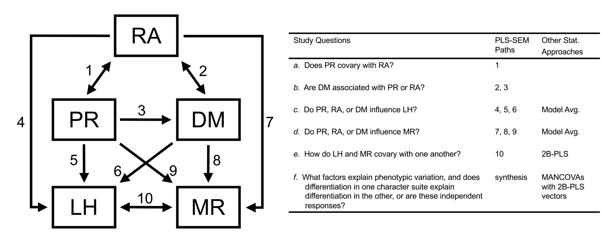
Figure 1
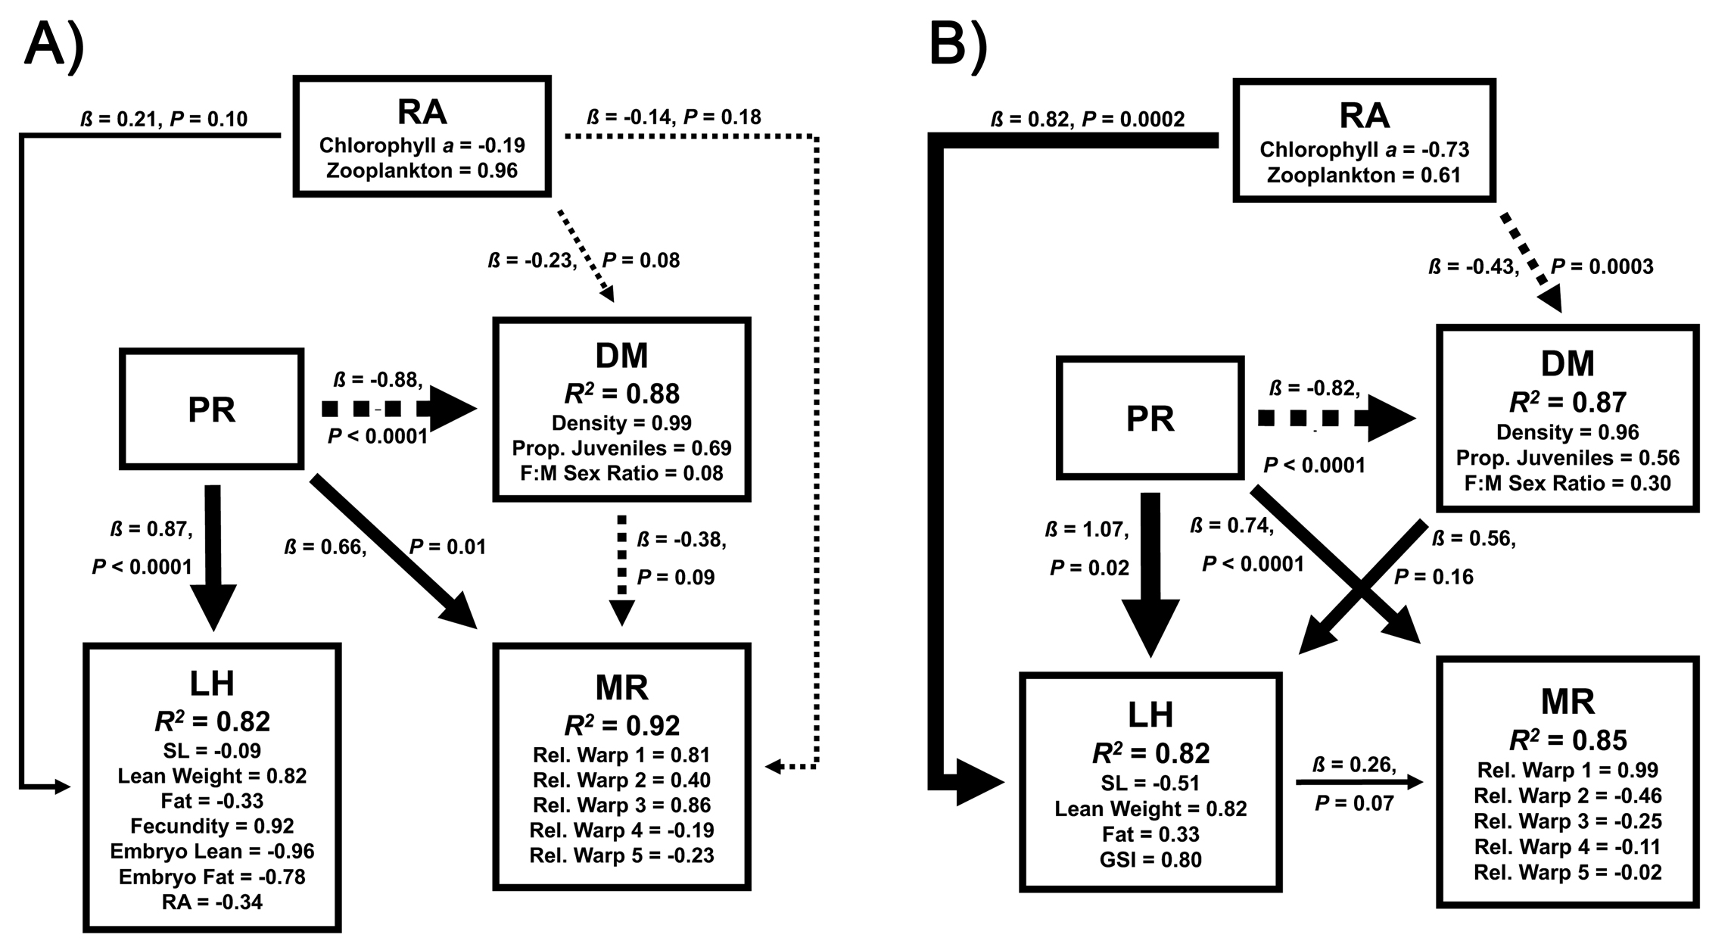
Figure 2

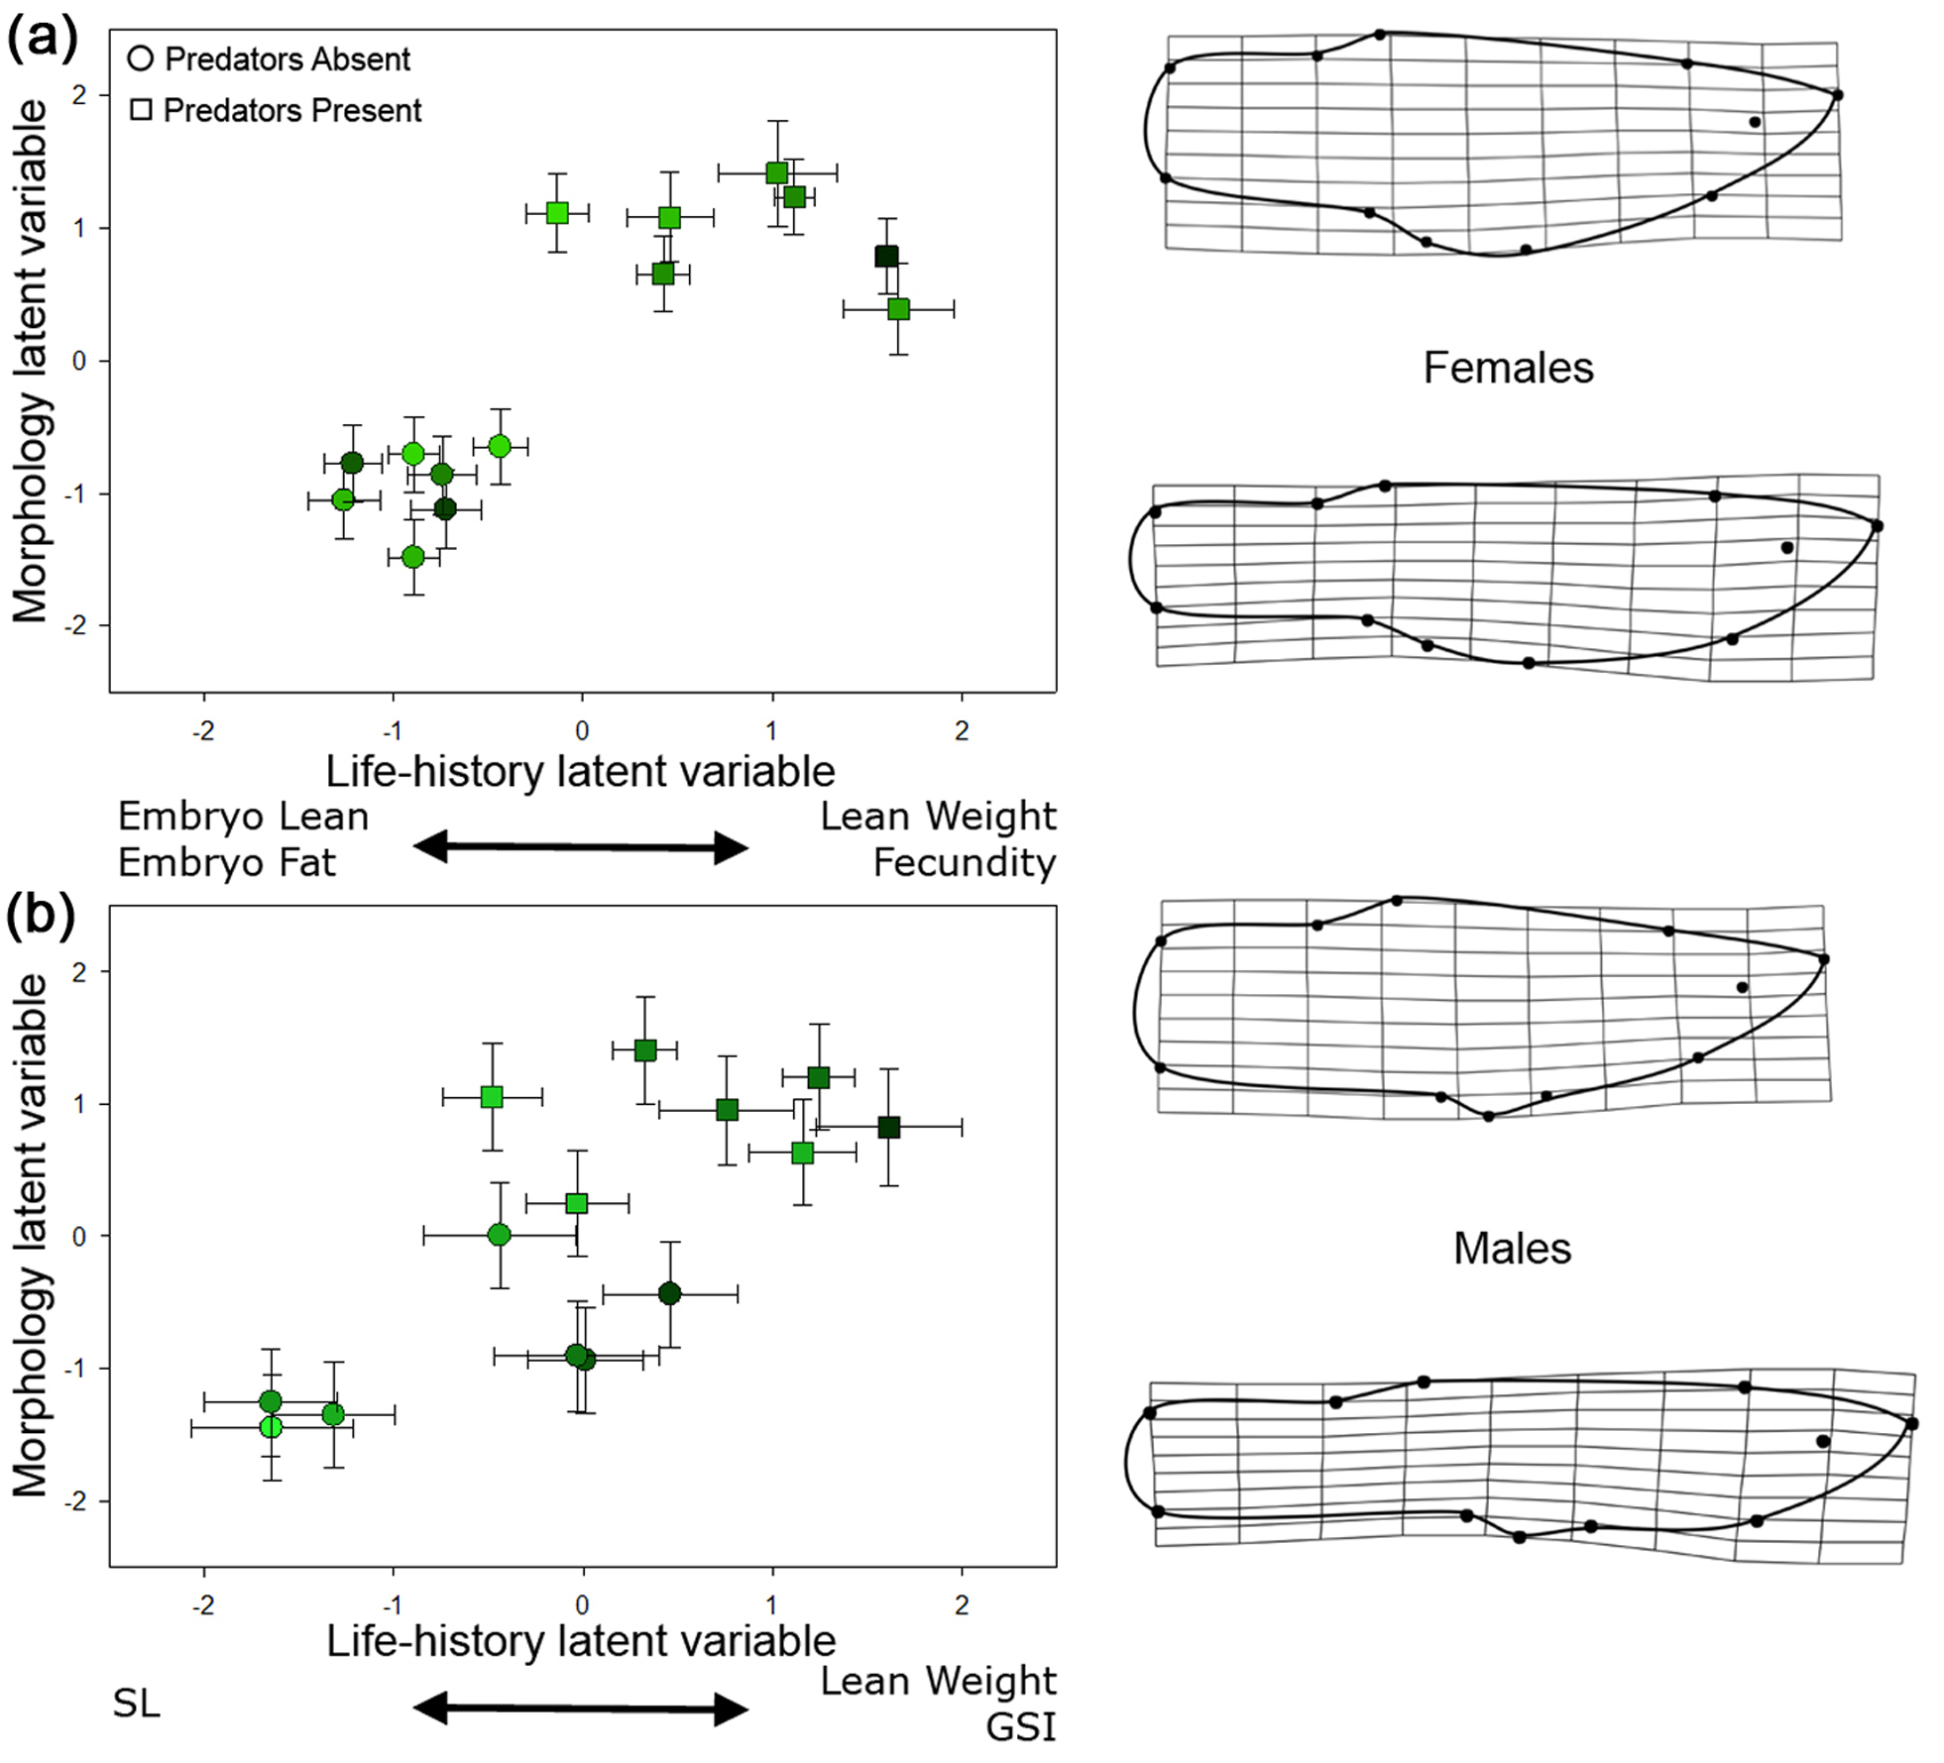
Figure 3

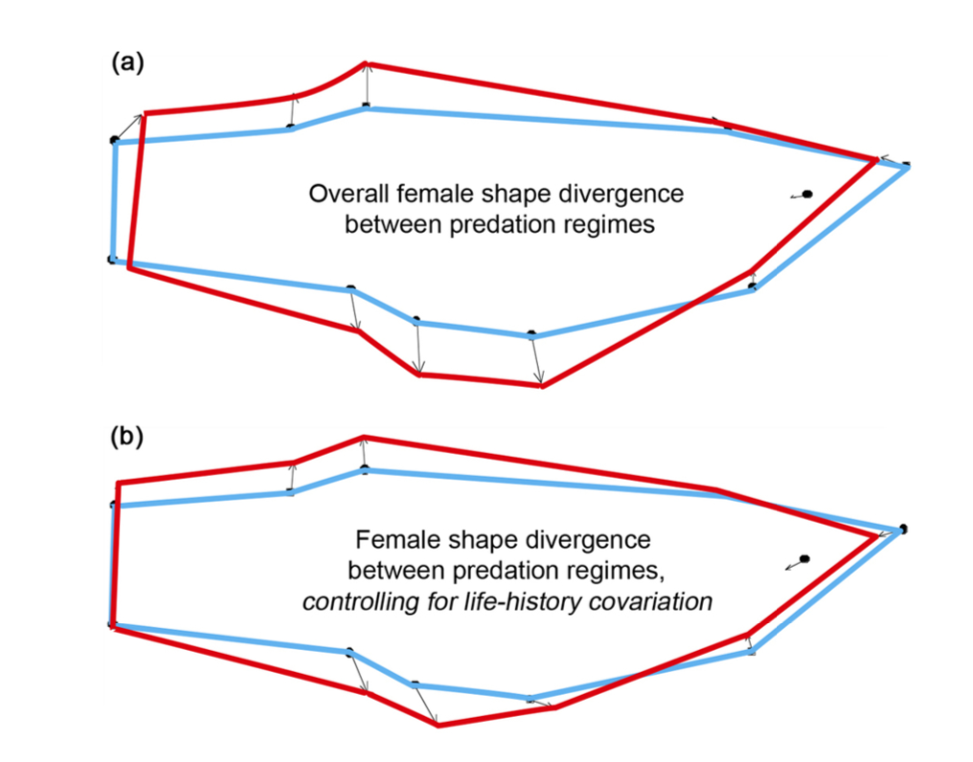
Figure 4

