The Bones Beneath the Streets: Drifting through London’s Quaternary

David Overend, University of Edinburgh
David.Overend@ed.ac.uk

Jamie Lorimer, University of Oxford
Jamie.Lorimer@ouce.ox.ac.uk

Danielle Schreve, Royal Holloway, University of London
Danielle.Schreve@rhul.ac.uk

Abstract

This article reflects on a situationist dérive in Central London, which mobilised a creative engagement with the city’s Quaternary history (the last 2.6 million years). The aim was to animate palaeoecological knowledge in the resistant, opaque and frenetic environment of a dense urban centre. This brief excursion into an alternative London is offered as a model for contemporary drifting that stretches out beyond our immediate situation to connect to successive geological and biological strata, reframing experiences of the urban environment through shifting scales and chronologies. The Situationists had declared ‘sous les pavés, la plage!" (under the paving stones, there is a beach!), evoking the playful space of possibility behind the veneer of the city’s systems and structures. This drift aimed to search even deeper, encountering spectral inhabitations revealed by the bones beneath the streets. The article argues that uncovering these hidden ecologies has the potential to counter the urban prevalence of spectacular representations of wildlife and develop an eco-politics of co-existence.

Keywords: Dérive, Palaeolithic, Quaternary, Rewilding, Situationists, Thames, Urban wildlife

Acknowledgements
We would like to thank our participants for joining us on the walk and for being so open to this experiment. Thanks to John Wylie and our three anonymous reviewers for their help developing our argument. We are also very grateful to Phil Smith for providing comments on a previous draft of this manuscript. All errors remain our own.

The Bones Beneath the Streets: Drifting through London’s Quaternary

Deep time [i]s a radical perspective, provoking us to action not apathy. For to think in deep time can be a means not of escaping our troubled present, but rather of re-imagining it; countermanding its quick greeds and furies with older, slower stories of making and unmaking. At its best, a deep time awareness might help us see ourselves as part of a web of gift, inheritance and legacy stretching over millions of years past and millions to come, bringing us to consider what we are leaving behind for the epochs and beings that will follow us
(Robert MacFarlane, Underland: A Deep Time Journey, Penguin (2019), 15)

Introduction: Sous les Pavés, les Os!
In the Spring of 2018, a small group of walkers ‘drifted’ for an afternoon in Central London through layers of Quaternary history (the last 2.6 million years). We drifted in the Situationists’ sense – responding to the psychogeography of the contemporary city – but we were also in search of obscured traces hinted at by an alternative meaning of the drift: as an old-fashioned term for Ice Age glacial deposits. Our aim was to employ situationist-informed tactics to animate paleoecological knowledge in the resistant, opaque and frenetic environment of a dense urban centre. In this article, we reconstruct this journey, which began at the Enlightenment Gallery at the British Museum and ended some time later in the Antelope pub in Belgravia. This brief excursion into an alternative London is offered as a model for contemporary drifting that stretches out beyond our immediate situation to connect to successive geological and biological strata, reframing our experience of the urban environment through shifting scales and chronologies. This event was part of an ongoing collaboration between the authors of this paper: a theatre director, a human geographer and a Quaternary scientist. Previously, we had explored the potential for transdisciplinary approaches to ‘wild geographies’ in a rural context.¹ Here, we turned our attention to questions of wildness in the city.

The drift, or dérive, has enjoyed enduring popularity following the dissolution of the Situationist International (SI) by Guy Debord in 1972. Freed from its moorings in the revolutionary politics of the French avant-garde, it has been appropriated, modified and redirected in multiple contexts for a variety of purposes. The modern history of the drift and its application to psychogeography is one of contradictions and variegated connections.² Rather than attempting to reconcile our own ambulatory disruptions with the original tensions in Debord’s project, our aim here was to apply a disjointed, contested and multiple form of urban wandering to an unresolved issue that has inflected the drift since its Lettrist roots: the negotiation of the constructed situation with the co-existence of expanded timescales.³ The Situationists had declared ‘sous les pavés, la plage!’ (under the paving stones, there is a beach!), evoking the playful space of possibility behind the veneer of the city’s systems and structures. We looked even deeper, encountering spectral inhabitations revealed by the bones beneath the streets. Uncovering these hidden ecologies might counter the urban prevalence of spectacular representations of wildlife and develop an eco-politics of co-existence.

Unbeknownst to many, London preserves a rich legacy of Quaternary mammal fossils; from the remains of extinct elephant and hippopotamus in ancient river gravels in what is now Trafalgar Square, to the bones of reindeer and bison that once roamed South Kensington.⁴ The vestiges of former Thames terrace deposits – laid down during successive cycles of warm and cold climates – can still be detected beneath two millennia of urbanisation, together with the stone tools of London’s Palaeolithic occupants, the last people to see these vanished species.⁵ These layered temporalities offer an expanded realm for the urban drifter, whose practice has typically been conceived as a predominantly spatial intervention that only engages, at best, with the recent past.⁶ In historicising the drift, we extend the temporal duration of this practice through an engagement with past inhabitations and vanished ecologies.

At each of the locations that we visited, we shared a story of shifting landscapes and habitats, which took us through the last climate cycle of Quaternary history and finally returned us to the present. Between sites, we walked alone, in pairs or as a group, investigating, gathering, contributing to, and becoming part of the multiple geographies and histories that we were travelling through. As walking artist and theorist Phil Smith argues, ‘the contemporary dérive will do best when it resists the drift towards reconciliation or antagonism; when it defers such syntheses in favour of dispersal and diffusion’.⁷ Embracing a ‘deferral of synthesis’, our journey through the city did not attempt to uncover an ideal or natural state that predated human intervention. Rather, it understood the conglomeration of the city to include the multiplicity of co-presences that we sought to reveal. We attended in particular to the disconcertion triggered by encounters with wildlife in the city. Here we were influenced by research that presents the city as a long neglected site for wildlife, with new found potential as a formative space for affective interspecies encounters.⁸

The Situationists pursued ‘the concrete construction of momentary ambiences of life and their transformation into a superior passional quality’.⁹ This involved creating artistic and experimental interventions into the spaces of the everyday city, which would have a directly transformational effect on the emotions and behaviours that determine such environments. The situation that we aspired to construct involved the reanimation of various forms of wildness in the everyday streets of the capital in order to draw attention to, and temporarily shift our relationship with, the more-than-human city. Like the SI, we pursued this playfully, but there was a political imperative for our artistic methods. Bringing participants into a creative encounter with urban animals past and present, we aimed to establish a productive engagement with the possibilities and potentials of a rewilded city.

Our situation was informed by Smith’s mythogeographical imagining of the city: ‘an experimental approach to the site of performance (in the very broadest, everyday sense) as a space of multiple layers’.¹⁰ To excavate and animate these layers (both material and semiotic), we employed a series of tactics adopted and adapted from the mythogeographer’s ‘tool bag’: a collection of ‘subtle devices, games and refrains for peeling away a layer of armour, extending a sympathetic organ or opening the eyes a little deeper’.¹¹ This would help us move beyond the ‘unitary urbanism’ of the Situationists to embrace a fractured, distorted, asynchronous and unresolved geographical imagination, which emphasises the multifarious myths and stories of the city, rather than attempting the ‘the composition of a unified milieu’.¹² Our mythogeographical tactics included: reimagining the streets as a museum of displaced species; rewilding the city with modelling clay animals, masks and cut-out images; and perpetually shifting our perceptual scale between the macro and the micro, and the past, present and future. As a simultaneously playful and political evolution of the dérive, we utilised this set of actions and interventions to collectively move against the typical flows and trajectories of contemporary London, sharing an exploratory journey into a wild city.

Drifting through time
In 1933 André Breton called for the grand staircase of the Paris Opera House to be replaced by the bones of prehistoric animals. This playful provocation was towards the irrational embellishment of the modern city, rather than arising from a genuine concern with prehistory.¹³ Some decades later, when the Lettrists inverted this Surrealist project, calling for a rational embellishment of Paris, their focus was on the contingent immediacy of urban inhabitation: ways of living in the here and now that countered the spectacular relations of global capital.¹⁴ The situationist project that developed from these origins can be understood as a quest for ‘moments, be they poetic or erotic, which seem to represent some pure pole of authenticity which will always survive the vacuous equivalence of commodity relations’.¹⁵ This goal brought with it a ‘distrust of all foundations, essences and absolutes’.¹⁶ With its relentless focus on the immediate moment, the Situationists subscribed to the political affordances of the transitory, ephemeral and impermanent present.

Debord refuted accusations of ‘presentism’, emphasising the temporal continuity of the situation, conceived as ‘a moment in the movement of time, a moment containing its factors of dissolution, its negation’.¹⁷ The situation is constantly undone by its movement into a yet-to-be-realised future. As a result, one of the key tensions to emerge from the work of the SI, exemplified in the drift, is that between a clearly formulated political ideal towards new models of urban existence, and the work of maintaining the unpredictable openness of their methods. Importantly, as Smith argues ‘such a tension between an “aimless stroll” and an instrument of urban transformation is not a problem within the dérive, it is the work of it’.¹⁸ Nonetheless, Debord’s assertion of the ‘inevitable disappearance’ of the present moment leaves little room for an understanding of space as conceived by human geographers such as Doreen Massey: constituted by the co-presence of multiple temporalities, including both the layered histories that determine urban configurations and the potentialities of future formations.¹⁹

Contemporary walking practice has expanded the scale of the situationist drift, critiquing its spatial politics by responding to its exclusions and limitations. For example, in their exploration of Women Walking, Deirdre Heddon and Cathy Turner argue that the dérive fixes space, separating it from its relational components.²⁰ Echoing the ‘princely incognito’ of the problematically gendered Baudelairean flâneur²¹, Debord encouraged his acolytes to ‘drop their relations, their work and leisure activities’.²² But Heddon and Turner point out that ‘relations (albeit multiple and shifting) are attached to bodies and travel with them’, and that moreover, relations are constitutive of space.²³ Their intention to ‘shift the scales and tales’ of contemporary walking can be understood as an assertion of temporality into a field of practice prone to spatial essentialism. If space can be understood as a ‘simultaneity of stories-so-far’, then it is an inherently open and relational construct.²⁴

Elsewhere, scale has been extended further to consider the way that historical events determine our experience of the present and open up space to future potential. Smith considers the destabilising effect of ruinous spaces, both ‘pre and post utility’ as ideal locations for contemporary iterations of the dérive.²⁵ Similarly, Tim Edensor explores an aesthetics of disorder, surprise and sensuality²⁶; and Hayden Lorimer and Simon Murray are drawn to the ruin ‘as a site of experiment, as a forum for open investigation’.²⁷ When the Scottish environmental arts company NVA enjoyed an all-too-brief residency at the iconic St Peter's Seminary in Cardross (an ambitious legacy project curtailed by funding cuts and the subsequent disbandment of the company), they invited visitors to walk through the iconic brutalist concrete ruin, hidden amongst semi-ancient woodland. The route was guided and enhanced by a sound and light installation, along with projection and human performers interacting with the architecture. As Cara Berger suggests, noting the project’s tagline, ‘A Future Reclaimed’, this event sought ‘to cultivate our ability to imagine the future by linking it to remainders of the past’.²⁸ It is a harsh reminder of the open potentiality of space that the ‘concrete future’ assumed for this building has not been able to materialise.

Absences have been explored in the overdetermined spaces of cities and other anthropocentric places in work associated with the ‘spectral turn’ in geography and humanities.²⁹ Landscapes, ruins and heritage sites are understood to resonate with a ‘vibrant materiality’ in which temporalities of different depths and durations come to haunt the present.³⁰ These are carefully curated sites with an excess of stories shaping experience and interpretation, and a superficial suspension of processes of change, including ruination and dereliction.³¹ In emphasising the ‘multiple nature of places’ and suggesting ‘ways of celebrating, expressing and weaving those places and their multiple meanings’, mythogeographical practices offer a way of engaging with space that challenges the singularity of predominant narratives and uses.³² For example, Smith’s Counter Tourism offers a series of tactics to look beyond the veneer of the heritage industry, ‘allowing each “voice” to break down’ and opening up sites to multiple readings and experiences.³³ Counter tourism invites visitors to seek the ‘past poking through’ and attune to a shifting landscape comprised of fossilised creatures, as well as more recent ‘hidden histories’.³⁴ But for Smith, ‘everywhere is a heritage site, still aching and sore from the events of the day before, and resting on foundations made from bodies that died 400 million years ago in seas generated by four billion years of cosmic, stellar and finally planetary development’.³⁵

This article takes its cue from Smith’s playful engagement with everyday urban spaces as heritage sites. We are interested in moving beyond the contingent trajectories of contemporary urban politics, to challenge an underlying anthropocentric relationship with the modern city that tends to forget or ignore the multiplicity of non-human stories, rhythms, and intensities that comprise space. The Situationists’ project was originally fundamentally humanist. But subsequent developments, in keeping with wider social and intellectual trends, have expanded the layers of psychogeographic concern to include a range of more-than-human actors and dynamics. It seems to us that this is achieved in two key ways: first, through a situational encounter with a suppressed and hidden wildness; and second through an expanded conceptualisation of the ecologies of the urban environment, which looks beyond situationist approaches to the city to consider wider political and scientific ways of knowing our contemporary world. In the following sections, we address each of these modes of urban imagination and then extend these artistic and conceptual antecedents through a critical reflection on our own drift.

Encountering urban wildness
In 2018, Deirdre Heddon and Alec Finlay led a series of walks exploring the ‘wild city’ of Glasgow.³⁶ These walks used the established model of the Walking Library; an ongoing collaboration between Heddon and Misha Myers, through which participants select books from a themed library to carry with them on a group drift.³⁷ Heddon and Myers’ project of reading in situ³⁸ recalls the Situationists, sometimes directly, as with Heddon’s ‘Walking Library for Athens, Ohio’, which explored a model based on situationist tactics of overlaying maps of one area onto the locale of another.³⁹ The situations created by these ambulatory libraries explicitly expand spatio-temporal scales. For example, for ‘Bedrock Walk’, two volumes of extracts were carried on a six-day walk along an old thieves road in the Scottish Highlands, as the facilitators ‘encouraged a small group of walkers to think about what lies underfoot, from the deep time of geology and the stories contained within sedimented layers of hard rock, to the tracks laid by the feet that pass over them – human and animal alike’.⁴⁰

The books on offer for the ‘wild city’ walks provided a mobile reading list of exemplary engagements with urban wildlife, many of them demonstrating a direct connection with situationist methods.⁴¹ These include Richard Mabey’s The Unofficial Countryside, Paul Farley and Michael Symonds Roberts’ Edgelands, Rob Cowen’s Common Ground and Alys Fowler’s Hidden Nature;⁴² along with works of fiction that circulate in similar territories, such as J.G. Ballard’s Concrete Island.⁴³ London features prominently in this wider genre of literary urban ecologies, as a city animated and haunted by a cosmopolitan and idiosyncratic flora and fauna.⁴⁴ While it would be misleading to claim these books as unproblematically psychogeographical (or, as has been suggested, psychoecological⁴⁵), they all at least echo the Situationists’ project, using walking as a method and narrative device to call for a poetic reimagining of our peripheral spaces: often the places where human inhabitation and non-human wildness most strikingly co-exist. And they advocate a particular way of looking at, and being in, our urban environments: a heightened attentiveness and responsibility to the wild beings with whom we share our worlds. This ambulatory sensitivity to the more-than-human city recurs throughout these literary examples, but it is also a founding principle of much of the art and performance practice that has borrowed models, ideas and processes from the derive. These writings and experiments came to shape our own interventions.

In Overend and Lorimer’s article on our attempts to create ‘wild performatives’ in the rural site of Knepp Wildland Project in West Sussex, our interest was in ‘playful, fantastical, or disconcerting techniques for recalibrating human senses and perceptions of the wild’.⁴⁶ This played out in that specific context as a series of performed actions that either imitated, evoked or collaborated with the non-human inhabitants. We were visitors to a site in which wildlife was phenomenologically accessible and clearly curated through safaris and walks guided by experts. We created temporary interventions in a designated wild site.⁴⁷ In contrast, when writers and artists have worked with wildness in urban environments, they often highlight a disconnection between the sites of human inhabitation or culture, and hidden, suppressed, excluded or extinct forms of wildness. The result can be an uncanny encounter with absent species, animal spirits and wild energies, along with various forms of wildness that incorporate and respond to human spaces and actions. For example, for The Nightwatch, Francis Alÿs released a fox into the National Portrait Gallery, capturing the results as CCTV footage (Figure 1). This was the only one of his collection of Seven Walks to reimagine the urban drift through non-human agency, in this case releasing a feral, urban animal into the anthropocentric space of a cultural institution.

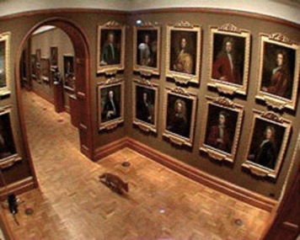
Figure 1: Still from The Nightwatch, © Francis Alÿs.

While The Nightwatch cordoned off a wild encounter from the surrounding streets, in other examples, wildness is ‘let loose’ on a wider scale, sometimes as a counterpoint to the human city. In A Ritual for Elephant and Castle, Marcus Coates responds to the planned demolition and corporate redevelopment of the Heygate Estate in South London, by performing a bizarre set of animalistic actions, with and for the area’s residents and corporate ‘consultants’. These range from shamanistic ceremonies, to a gig with the experimental chamber rock band, Chrome Hoof. Eventually assuming a part-animal guise (this time with a horse’s head juxtaposed with a sharp silver suit), Coates creates a collection of events that engage with, and operate within, the tensions between the commercial and social development of the area. As Jen Harvie suggests, Coates adopts an anti-rational mode, but one which results from a period of careful, rational listening to the residents of the area.⁴⁸ Here, Surrealist irrationality and Lettrist rationality come into new formations, embellishing the contemporary city with a range of actions and interventions that never seek reconciliation or antagonism, but rather keep a multiplicity of ideas, concerns and potentials in constant circulation.

These works elicit a shift in perception that opens up the experience of the urban environment to ecologies of wildness and to animals’ ways of being and becoming in the city. While not all of these examples take the form of the drift, or take their cue directly from the Situationists, in different ways, they are well placed to meet Debord’s call ‘to actively participate in the community of dialogue […] that up till now [has] merely been represented by poetic and artistic works’.⁴⁹ Enacting situations that are open and responsive to the urban environment, these performative encounters begin to access different models of urban ecology with the potential to shift the way we think about and engage with non-human co-existence – albeit in the present. In the following section, we consider further conceptions of the urban and of urban ecologies that have the potential to continue the development of this nascent interest in more-than-human urban situationism. Through the critical account of our drift that follows, our aim is to bring new scientific and ecological research into a dialogue with these more-than-human situations.

Urban ecologies
In spite of these recent forays, the urban is not the most common or intuitive place to begin an experimental encounter with deep time and its non-human inhabitants. Cities have generally been figured as sites of human achievement; the centres of civilisation in which the unruly forces of nature have been tamed or from which they have been excluded. In Western cartographies, natures are to be found out there in the countryside, or better yet the wilderness.⁵⁰ This binary geography has been a cause for both modernist celebration and for Romantic mourning, but in both cases animals and their ecologies are held to be out of place in the city.⁵¹ It is precisely for this general reason that we came to the centre of London to begin our Quaternary drift: inspired by others, we sought to scramble this geography and to mobilise the disconcerting power of urban wilds to prompt thought and action. We were helped in this project by the rise of urban paleoecology in the UK, a fortunate offshoot of the statutory commitment imposed on developers to have an archaeologist oversee new excavations.

Our planning was also informed by the rising interest in civil society and amongst policy makers in the pedagogical, therapeutic, and environmentalist potentials of encounters with nature in the city.⁵² Since at least the 1970s, there has been a marginal counter-current that takes issue with the pervasive anti-urbanism of British naturalism. Urban ecologists and conservationists, often defining themselves in opposition to their welly and tweed wearing rural contemporaries, have sought to make space for nature in the city. They have identified and protected flagship parks and gardens, alongside the scruffy edgelands and brownfield sites of Mabey’s ‘unofficial countryside’.⁵³ They have given talks and walks, and at sites like the London Wildlife Trust’s base at Camley Street near Kings Cross, have facilitated countless encounters between (often marginal) urban publics and their local ecologies. In so doing they have made contemporary natures visible in the city, celebrating surprising appearances and the little-known vestiges of functional ecologies that survive in churchyards, bombsites, and railway sidings.⁵⁴

Such encounters between urban publics and their local natures are often closely choreographed to shape good environmental subjects through power laden interventions that conjoin salvatory science, Protestant work as volunteerism, and the virtues of physical exercise.⁵⁵ The sites of urban natures are variously cast as ‘green gyms’, oases of calm, or places for epiphanic connection to animal lives and ecological flows. Critics argue that such projects are central to the post-political mode of environmentalism that has become prominent in the neoliberal ‘age of ecology’.⁵⁶ They differ markedly from the processes and politics of the SI. Nonetheless, both share an aspiration towards new subject formations. Our aims in this project were more open-ended. While few people in London can encounter ecologies and their histories outside of their contemporary guilty codings with concerns for past extinction and future climate change, we wished to hold these in suspension. Our aim was to start with curiosity, and to facilitate an openness to surprises.

We also wanted to form an alliance with a new body of work in ecology and ethology that has begun to take the city as a laboratory for studying the ‘novel ecosystems’ and feral animal worlds that are coming into existence in the Anthropocene.⁵⁷ These scientists have learnt to attune to urban animals and ecological surprises, and what they tell us about both future ecological adaptation and the ways in which the past comes to shape contemporary processes. For example, there is a growing interest in urbanisation as an evolutionary force in which the networked geographies of urban life and the novel ecologies of noisy, polluted, but warm and resource-rich cities are driving new rounds of speciation.⁵⁸ Likewise, ethologists have noted the rise of new behaviours amongst the ‘synurbic’ animals that thrive in urban settings: the pigeons, rats and seagulls of Trafalgar Square being well known examples.⁵⁹

Finally, there are some who trace how environmental improvements associated with London’s post-industrial transition have enabled self-willed processes of rewilding. They figure London as a geography of refuges and networks – rivers, canals, railways and flyways – from and along which missing organisms have returned. Once absent fish and seals are back in the Thames, peregrines circle the Shard, and foxes pad through gardens from salubrious Kensington to the council estates of Tottenham.⁶⁰ Anna Tsing figures this as a ‘resurgence’ in which novel and once common past denizens come to make new lives amongst people in post-industrial and urban centres.⁶¹ Some of those involved in this rewilding movement have suggested shifting the desired ecological baseline for such resurgence further back into the Quaternary. They imagine forms of ‘Pleistocene rewilding’, in which the UK might be repopulated with animals once common during the last interglacial. Provocative imaginaries – like those offered by George Monbiot – see hippos in the Humber or elephants in the Royal Parks.⁶² We suggest that these novel ecological approaches, that refold the binary geographies and static, moribund temporalities of much twentieth century conservation, have much to offer the turn to wildlife amongst urban performance artists. They offer captivating ‘future-pasts’ that chart deep time, identify the ‘ghost species’ that haunt dysfunctional contemporary ecologies, and imagine ambitious narratives and acts of restoration.⁶³

Quaternary Drift
Before we embark on our drift: a word on the relationship between expert knowledge and the creative tactics of disruption. The composition of our research collective required that we learned to speak across epistemic and disciplinary cultures and develop mutual respect for our heterogeneous methods of working. In the following text, a certain tension is maintained between forms of knowing that are based on a rational, scientific understanding of the Quaternary history of the city; and a playful, subversive departure from an ‘official’ narrative. One is neither intended to outdo nor subsume the other. In our walk, and in its subsequent (re)presentation, we have deliberately kept conflicts and discrepancies alive, allowing shifts in register to occasionally feel jarring or uncomfortable; but also allowing those moments of unexpected or unplanned convergence, when the scientific register drifts into the artistic; or when our playful tactics and experiments cast the information that surrounds them in a new light. To give one example, we identified a terminological overlap and shared interest between cultural geography and paleoecology in the idea of ‘deep time’, and what Holloway terms the ‘mapping of multifold history and the temporal reach of landscape’.⁶⁴ We are distrustful of dominant, exclusive narratives; but we believe that there is a clear place for expertise within the constellation of experiences, stories and journeys through which we can come to better understand, and affect, ourselves and our environments.

Drifting through London: the walk

British Museum. Gray’s Inn Lane handaxe
Our walk started at the British Museum, where the Gray’s Inn Lane handaxe is on display in the Enlightenment Gallery. This iconic specimen, the first Palaeolithic flint implement recorded in Britain, was discovered along with elephant bones near the Gray’s Inn Lane in central London by a Mr Conyers in 1679. Pre-dating the recognition of the antiquity of early humans by over a century, Conyers regarded the handaxe as ancient.⁶⁵ However, at a time when contemporary theological doctrine dictated that fossil remains be interpreted as the product of the Biblical Deluge, it was considered no more than a few thousand years old. The discovery was finally published a few years later by the antiquarian, John Bagford, who viewed the implement as the weapon of an ancient Briton, lost during battle with the Roman emperor Claudius, during his invasion of Britain (accompanied by elephants) in 43AD. In fact, the handaxe dates to at least 300,000 years old, its importance as an all-purpose butchery tool to the survival of its maker eclipsed by its subsequent significance to the emerging disciplines of geology, palaeontology and archaeology in the 19th Century.

The axe was a talisman for our urban exploration. Knowledge of its contested origins and collapsing timescales framed an investigatory drift into the various levels of Quaternary time. The axe offered a mythogeographical ‘wormhole’: somewhere where ‘wrinkles in the fabric of space [and in this case, time] bring far away places very close’.⁶⁶ A tactile exploration of the object would have allowed an immediate shift in perception. However, the axe was inaccessible to us in its enclosed situation in the museum’s display case (and to others without the cultural capital to access the museum). Our starting point was already compromised and we needed to break out of the institution, passing through boundaries and seeking more from heritage than ‘an old thing in a glass case’.⁶⁷ Unable to take the real thing with us, we distributed cardboard images of the axe head, and set out to reposition this object in different contexts. Attempting to shift this artefact from its hard-to-find location in a national institution, a street-side box of rubbish outside the museum served as a makeshift plinth, and one of the axe images was left behind on display to be noticed (or disregarded) by passersby.

As we moved towards our next location, we sought out and documented the spectacular ephemera of contemporary animal representations (Figures 2-5). This task had a tangible effect on our way of attending to the urban environment, which involved an intense, purposeful assessment and analysis of the myriad faunal stimuli that we encountered as we walked. Debord writes of ‘the domination of psychogeographical variations by the knowledge and calculation of their possibilities’.⁶⁸ While we are wary of any tendency to ‘dominate’ an environment, this active, analytical mode of wandering – ‘l’analyse écologique’⁶⁹ – was central to our project. This builds on Debord’s dérive to propose a model for situational ecology that has the potential to counter the spectacular representations of nature that abound in the city. In this mode, observing various animal presences, we noted differing degrees of spectacular representation. As with artist Kirsty E. Smith’s mythogeographical exploration of London’s variously exhibited animals or Nick Hunt’s ‘gonzo ornithology’ of London’s parakeets, we found many to be disconcerting or uncanny, with the potential to subvert expectations about ‘natural’ ecologies.⁷⁰ The public streets provided a collection of fauna: real, designed and imagined. These included the perpetually moved-on pigeons, ‘on duty’ animals at Horse Guards, a cormorant in the river, and many dogs with their owners; along with statues, doorknockers, murals and crests; and faunal patterns and textures, which suggested rather than revealed wilder presences.

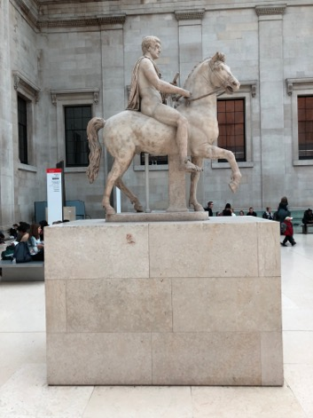
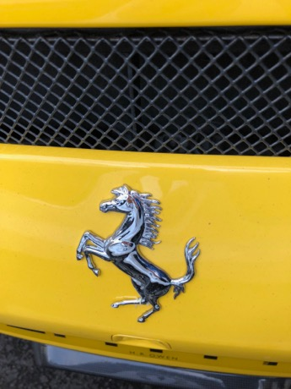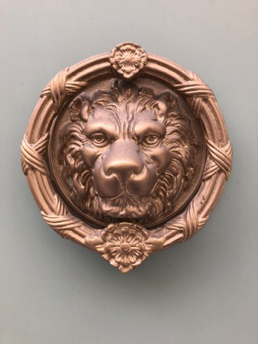
Figures 2-5: Spectacular representations of animals in Central London

Our encounter with the handaxe, and its subsequent recontextualisation, encouraged us to imaginatively wander into London’s deep time. This facilitated a shift in our perception of the spectacle of the streets, prompting us to consider how it has come to subsume the traces of non-human life beneath the asphalt. The knowledge of the abundance of prehistoric megafauna in these urban spaces drew attention to the disconnection of modern society from our planetary non-human cohabitants. Their spectacular embellishment (Ferrari horses and anthropomorphic toys) brought to mind John Berger’s observation of the proliferation of virtual animals in Western society, even as their fleshy kin disappear.⁷¹ The spectral inhabitations of vanished and displaced species haunt the urban imagination through their incarnation as charismatic visual representations. Because we could not take the handaxe or the material traces of these animals with us, this spectral quality was retained, troubling the coherence of our narrative. Our approach was to create situations that could give voice or form, or else to frame these absences, in order to develop a greater sensitivity to non-human pasts and futures. We wished to note their passing and their paradoxical persistence, and to begin to mobilise them as past-present prompts for envisioning wilder futures.

Trafalgar Square
A combination of cyclical climate change and the tectonic uplift of the land has left a ‘staircase’ of former Thames terraces running down to the modern river.⁷² Although much smoothed and transfigured by subsequent building, the gradient and its stepped topography were nonetheless perceptible as we descended the terraces deposited through the Pleistocene. While we had loosely pre-planned our route with the abstraction shown in figure 6 in mind, the descent exerted a gravitational, psychogeographical pull towards the river, which we followed without a clear guide or leader. Here, we followed Smith’s advice to ‘let the group develop its own instincts and make its own discoveries’.⁷³ We were particularly interested in the shifting architectural environment as it corresponded to, or contrasted with, the terraces. We paused first at Trafalgar Square, where we took stock of our ongoing collection of virtual and fleshy animal presences, and reflected on the corresponding story of absences and extinctions.

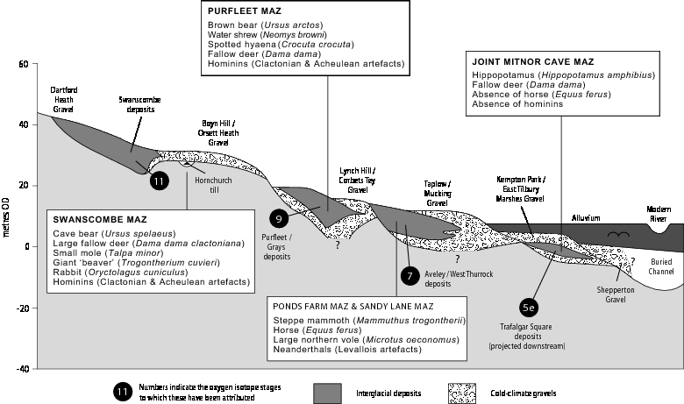
Figure 6 Idealized transverse section through the Lower Thames terrace staircase with features of the Mammalian Assemblage-Zones (MAZ) and suggested correlation with the marine oxygen isotope record indicated (modified from Schreve 2001).

The Thames flowed through this area 125,000 years ago, during the Last Interglacial, the most recent warm period before the current (Holocene) interglacial. In 1957, during the construction of Uganda House on the southern side of the Square, a remarkable series of fossils came to light in deposits representing the youngest of the Thames terraces. These included remains of hippopotamus, extinct straight-tusked elephant, rhinoceros and lion, as well as coprolites (fossilised dung) of spotted hyaena (Figure 7).⁷⁴ Although appearing ‘exotic’ to us today, these species were typical of British interglacials in the Pleistocene. The remains of pollen, beetles and snails from the site indicate that these animals inhabited a familiar landscape of oak, ash and hazel woodland bordering marshes and grassland adjacent to the river.⁷⁵

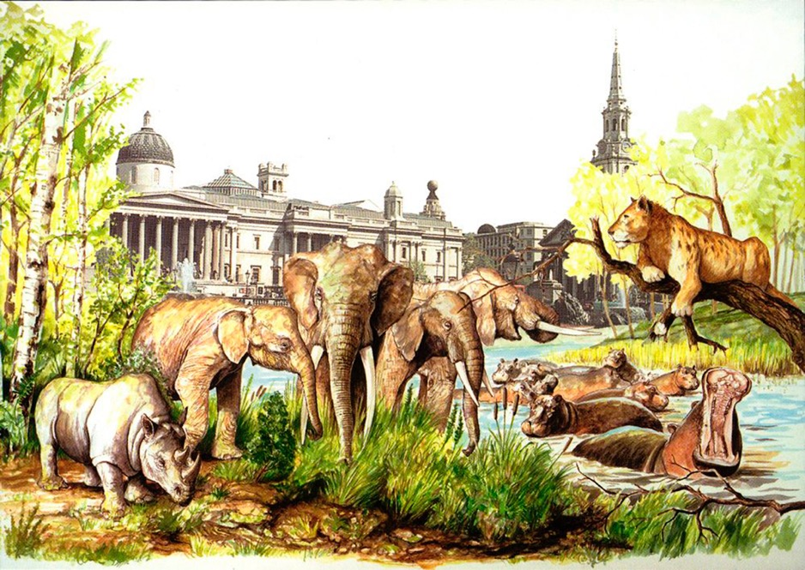Figure 7 An idealised view from Cockspur across the Square about 125,000 years ago during the last warm interglacial period. Image by Norman Fahy. CP18/074 BGS © UKRI 2018.

The wild things are long-gone and only Landseer’s lions remain today, but the findings at Trafalgar Square have particular relevance for questions of future climate change. The evidence points to summer temperatures in the Last Interglacial around 4°C higher than today, giving us a window into a once-warmer world and its inhabitants.⁷⁶ However, one of the most striking features of the Last Interglacial, in sharp contrast to previous warm stages, is that Britain was devoid of human occupation.⁷⁷ Neanderthals appear to have abandoned Britain during the preceding ice age and retreated south and east into continental Europe. At that time, Britain was periodically reconnected to the mainland as sea levels fell when ice sheets grew during major glaciations, thereby creating a land-bridge across what is now the Straits of Dover. As the climate warmed into the Last Interglacial, the ice melted and returned water to the ocean, causing sea levels to rise. A ‘window of opportunity’ therefore existed for animals and people to migrate back into Britain before it was returned to its island status. Despite the favourable climatic and environmental conditions, availability of game and other resources, Neanderthals did not make it back into Britain on this occasion and would be absent for around 100,000 years.⁷⁸

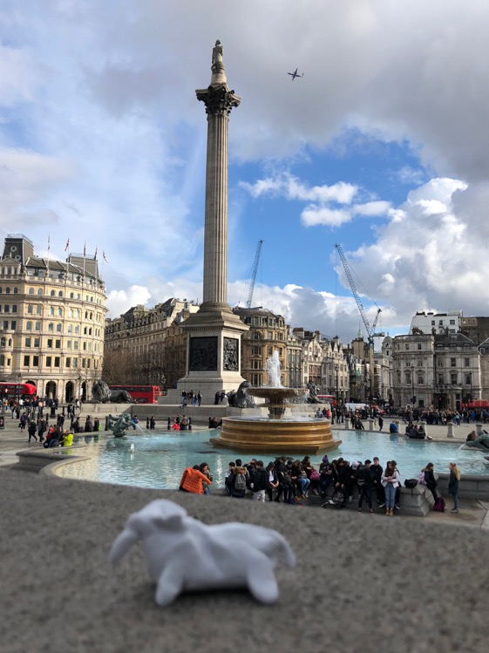
Figure 8: A clay elephant at Trafalgar Square

Standing in front of the (then) empty fourth plinth, we considered the difficulty of imagining these conditions, temporalities and mobilities of hominin absence in such a heavily populated location. We struggled to capture, record and document spaces without commuters, tourists and buskers, but searched for other ‘windows of opportunity’: those gaps between buildings and people where something else might be (re)imagined and (re)introduced. With this in mind, we engaged in a small-scale material shaping of the environment, achieved in this instance by modelling missing species (Figure 8). Such a tactile exploration was denied to us in the Enlightenment Gallery. Here we mobilised the potential of modelling to physically situate our bodies in a continuum that connected the modern city with the bones beneath the street: a movement away from the gaudy spectacle of the square towards the fragile, earthly – and now earthy – lifeforms buried beneath our feet. We animated modelling clay into the desired bodies of our de-extinct animals: votive offerings for future wilds.

At this point we were also introduced to faces of hyaenas and hippos, cut out laminated images of the descendants of London’s fossilised animals (Figure 9). The arrival of these animals prompted an explicit discussion of rewilding amongst participants and how it pushes the historical baselines of conservation back beyond the premodern cultural landscapes of fields, hedgerows, moors and fen. Rewilding asks us to imagine the ecologies that emerged at the end of the last ice age that were engineered by large herbivores – like beaver, elk, and aurochs – and regulated by their predators – like wolves and lynx. It draws our attention to how contemporary ecologies are haunted by the absence of these keystone species and proposes means of returning these animals and integrating them into functional modern landscapes.

In spite of our offerings, it proved difficult to imagine the reintroduction of large herbivores and the return of their ecological roles in spaces like Central London. Although hippos and hyaenas would readily survive in the temperate climates of the UK, it is hard to see them developing the types of largely convivial or synanthropic urban relations we associate with species like squirrels and foxes. We reflected on such challenges while wearing our masks. Subverting the prevalent site-specific tourist practice of the ‘selfie’, we created chimeric humanimal images with the faces of hyaenas and hippos to assert their presence in the busy, human spaces of the modern city. For Debord, the technologies of the society of the spectacle are constitutive of new forms of isolation.⁷⁹ Contemporary developments in tourism and social media, exacerbated by the internet, have stratified this power dynamic, ensuring the dominance of the spectacle across every facet of social life. This development in self-spectacularisation offers a further challenge to Debord’s call to revert from a human condition based on appearance.

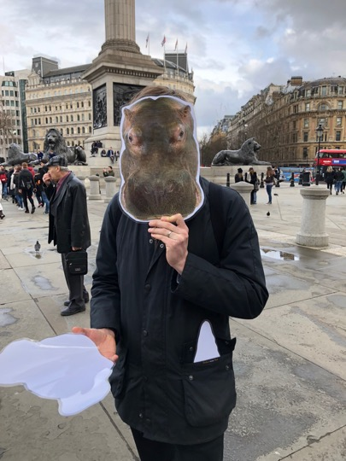
Figure 9: Jamie Lorimer as hippo

While our appropriation of spectacular technologies did little to challenge their prevalence, the situational encounter that they enabled opened up a space for past inhabitants and shifted our relationship with those present. This strategy risked a reinforcement of the spectacular representations of animals that we encountered at every turn, but it was the conspicuous presence of the part human, part hippo figures that momentarily asserted their co-existence in this place. The aim was not to speak for these animals or to claim we achieved any corporeal proximity with their lifeworlds. Instead we sought to bring other inhabitants of the city into a relationship with them.

In this chimeric mode, we enjoyed the bemusement of tourists and residents, amidst the residual population of pigeons that still survive in Trafalgar Square, after the controversial ban on their feeding, and the hidden presence of the peregrine falcons – both trained and wild – that have come to make a living from pigeon predation.⁸⁰ We decided that if Londoners can’t live with pigeons, they might struggle with hyaenas. In this darker vein, we discussed the place of resurgent plants and animals in the post-apocalyptic visions of London offered in science fiction, which have been celebrated in some strands of psychogeographic writing.⁸¹ One of the walkers questioned the materials they had been given, pointing out that the laminated cut-outs were at odds with the ecological aspirations and assumed sensitivities of the event. They noted that the modelling clay was made from polymers not river sediment and would not easily degrade. Improvising, we reflected on how these plastic objects might persist into the future, and what a future archaeologist, or (likely extra-terrestrial) geologist would make of them once they were fossilised amidst the stratified rubble of the Anthropocene. We joked about Plasticine figures for the Plasticene age.⁸²

Parliament and Victoria Tower Gardens
These reflections and ruminations took place during a gentle peregrination down the Thames’ terraces and along Whitehall. We left a hyaena near Downing Street and continued to the Houses of Parliament (Figure 10). Here we encountered a small but vibrant group protesting the UK’s decision to leave the EU. Amidst the chants and the flags, we reflected on the much longer history of the UK’s continental ambivalence. We reminded ourselves of the palaeogeographical rhythms of the rise and fall of sea levels that opened and closed the land bridge to Europe. As majority Remainers, the group found ironical solace in the idea that this cherished sovereign island is but a climatological accident, a transient artefact of freeze and melt. Its population – human and otherwise – has waxed and waned with the movement of ice. In our discussions, concepts of nature, nation and what and who is native became transitory as we began to view them from this deep time perspective. Historical and future migrations as adaptations to climatic change came to the fore as we caught sight of the river Thames and were reminded of the low-lying topography of London and its vulnerability to anticipated sea level rises. We reflected on the submarine rewilding of London that will result from its inevitable future submergence.

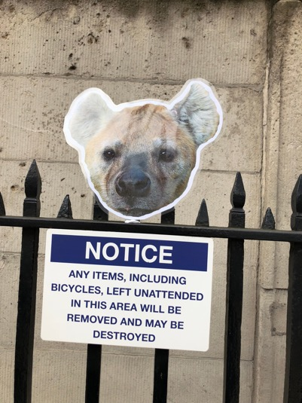
Figure 10: a spotted hyaena near Downing Street

From Parliament we came to Victoria Tower Gardens, on the banks of the river. In the more naturalistic setting of these gardens we returned to the cut-out images of animals that previously inhabited what we now call London and tried to place them in an ecological setting. We continued our imaginations of palaeoecological pasts and the rewilding futures they might inform. In this part of London, the area adjacent to the modern river is developed on top of the Thames gravels dating to the last Ice Age. Spectacular fossils of woolly rhinoceros and woolly mammoth, bison and reindeer, hint at the diversity and richness of life 50,000 years ago. This was the most temperate moment in the last Ice Age, although the climate was subject to extreme fluctuations, with periods of savage cold interspersed with brief periods of relative warmth (interstadials).⁸³ The terrain adjacent to the river was grazed by huge herds of herbivores and patrolled by spotted hyaenas, lions and wolves. The actions of the herbivores would have been obvious in the landscape, as they maintain an open environment of rich grasslands and restricting tree growth.⁸⁴ These lands were also home to the first Neanderthals, returning to Britain after an extended absence, and then to modern humans who occupied north-west Europe from 40,000 years ago. With global sea levels lowered by up to 120m, early hominins were able to move freely back and forwards over the area now under the North Sea, following the herds on a seasonal round.⁸⁵

Our attention was drawn to the river, as an increasingly vibrant ecology and as a dynamic hydrological agent right in the heart of the city. At this point, the modern Thames is extensively managed, hemmed in by concrete banks and flood defences, and much reduced by comparison to its former extent. We learnt how, in the Pleistocene, the river once ran to the north of London before its path was blocked by a major ice sheet 450,000 years ago, diverting it (through overspill from a massive ice-dammed lake in the Vale of St Albans) into its current path.⁸⁶ During interglacials, it was a slow-flowing and meandering river over a kilometre wide but during periods of cold climate, it was composed of multiple, braiding channels, typical of snowmelt-fed rivers in high latitudes today. The dynamics of the river channel and its flow regimes would have so dominated the ecology that it proved hard to cast ourselves back to any point or location in this landscape. We grappled with the phenomenological challenge of thinking with geomorphic processes as we walked West, following the river upstream.

Opposite Battersea Power Station
Future walks might explore Maureen Duffy’s literary experiment with the persistence of Neanderthal culture into modern London, or engage Will Self or Russell Hoban’s post-diluvial or post-nuclear holocaust Stone Age futures.⁸⁷ But sensing that the disconcertion of deep time was proving too much we began to shift scales, following Smith’s call to ‘stay as obsessively close to the detail as you can’.⁸⁸ In different ways, the group decided that a more practical starting point for drifting with rewilding might be to return to the quotidian, following David Harvey, to acknowledge that natures can be found even amidst the cracks in the pavement.⁸⁹ Some found mythogeographical ‘Z-worlds’, ‘apparently self-contained worlds confined within a small area’.⁹⁰ We became fascinated by the intricate patterns of mosses and lichens on the wooden balustrade that lines the Embankment, suggesting that they recalled, at the microscale, the patterns of the braiding river from 100,000 years ago (Figure 11).

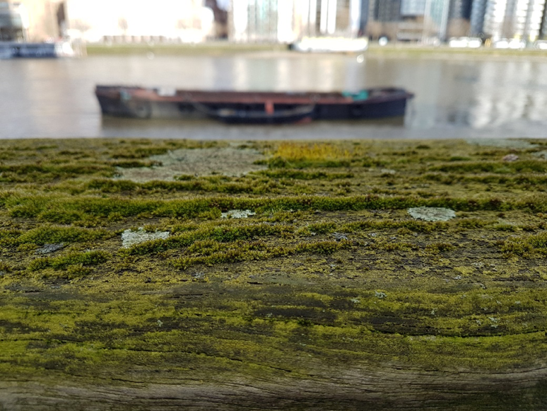
Figure 11: A new perspective on the Thames

As we reached the bank opposite the Power Station, others began to attune to these miniature landscapes – in barks, mosses and stones (Figure 12-14). Closing down our perspective allowed us to think differently about geomorphological processes and our place within them. Seeing weather patterns, glacial troughs and tectonic plates in the tiny detail of these natural phenomena, it was further possible to reimagine London as a fragile and temporary place, even as it plays its part in the disruption of natural and climactic systems. Following Smith’s cue to use shifts in scale to ‘think excessively, to think in surplus’,⁹¹ we were reminded of the microscopic landscapes of the bioartist Simon Park, and the surreal micro-urban worlds created by Slinkachu.⁹²

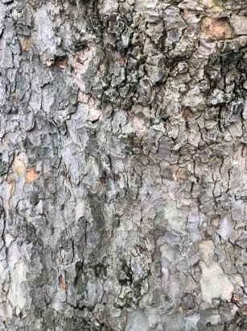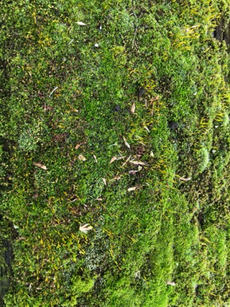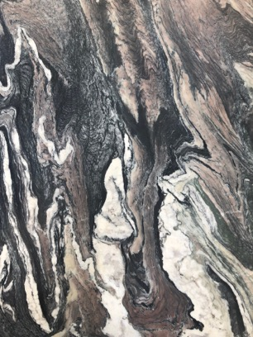
Figures 12-14: Playing with scale in barks, mosses and stones

Endings: The Antelope pub
The final leg of our journey took us to the Antelope pub through areas that were marshland in the early part of the current interglacial. The Holocene began 11,500 years ago with abrupt climate warming, the melting of the ice sheets and the return of Britain to island status. The marshes were drained and developed into what is now the Pimlico Estate, promoted by the philanthropist financier George Peabody in the 1870s as improved social housing. Today, the apartment blocks, with their walls of yellow London stock bricks, form a narrow conduit heading away from the river, calling to mind the tributary valleys where the last hunter-gatherers, the Mesolithic people, exploited the rich aquatic resources in the marshlands bordering the Thames and hunted the remnants of Britain’s megafauna, elk and aurochs.

We gathered in the pub and as our participants dispersed, we reflected on what we had achieved. In order to reanimate deep time in the spectacular spaces of the modern city, we had embellished a specialist knowledge of the Quaternary with a mythogeographical imagination. Searching for the bones beneath the streets, we adopted Smith’s conceptual (and mutable) tool kit. We sensed how, in his words, this offered us ‘a widening affordance to be added to and subtracted from, according to practical and theoretical needs, both an art of memory and an actual, physical, memorialised landscape’.⁹³ Bringing this practice into a dialogue with Schreve’s expert knowledge of the city’s fossil record, we engaged with a rich and complex setting for a situationist encounter with urban wildlife, and expanded conceptualisations of the urban environment. As we moved between specialist narrative and creative disruption, we accessed these stories through an imaginative exploration of Quaternary London.

Our mythogeographic drift with deep time offers at least three sets of tools and techniques for those planning similar experiments. We first mobilised objects and materials – found relics and animal icons, masks and modelling clay – using them to disconcert place-based urban doxa. Animal simulacra served as prompts for making visible extinct species and for imagining their return. Masks enabled parodic and carnivalesque acts of chimeric interspecies becoming. Second, we used visual, scientific abstractions – like the figure of river terraces shown in figure 8 – as diagrams (in a Deleuzian sense).⁹⁴ They provided a perceptual wormhole, provoking reflections on the deep time, yet persistent topography of London’s terraced landscape and its longitudinal hydrological rhythms. They allowed us to visualise the river, land and sea as mobile, to sense cycles of inundation, and to appreciate the fluidity of terrestrial belonging. Bringing scientific abstractions back to the field opened our analysis of the long and nonlinear temporalities that shape the present. Third, we developed practices that explicitly played with spatial scale – zooming in on miniature fauna, attending to local windows of opportunity for animal life, and building an ambulatory sensitivity to fragmentary moments and atmospheres in the urban experience in which nonhuman life makes its presence felt. We suggest that such disorientating objects, wormhole diagrams, and scale-sensitive practices offer great potential for future experiments.

Our walk aimed to enact an eco-politics of coexistence. We had appropriated a key situationist tactic in order to expand the typical focus of urban ecology to incorporate missing species and past inhabitations. Our simultaneously scientific and creative approach revealed an environment shaped by the lingering presences of these past inhabitants. This alternative city lingered on in London’s detritus and architecture, and was brought into focus through our mythogeographical methods. We opened a dialogue with those who consider the city as a dynamic and productive space for reassessing our relationship with wildlife. By appropriating the methods of the SI for a contemporary urban context, we avoided a tendency in conservation and rewilding to view a distant past as a natural or ideal baseline for non-human inhabitation. Rather, we understood co-presence as a necessary condition for wildlife in the Anthropocene.⁹⁵ Understanding space, after Massey, as a ‘simultaneity of stories-so-far’,⁹⁶ we were guided by principles of openness, dynamism and potentiality, rather than drifting towards antagonism or reconciliation.⁹⁷ Through our situation – constructed through the actions of collecting, recording, modelling and performing – we revealed multiple co-presences, whose continual and constitutive relationship with the modern city was momentarily brought into new configurations, affecting our understanding and experience of their histories and continuing legacy.

As our drift came to an end, we walked back through layers of Quaternary history, up the river terraces to train stations, hotels and houses. This was a temporary expedition into a hidden London: one that has continued to shape and determine the contemporary environment, but which has been increasingly obscured through millennia of urbanisation. The inaccessibility of its histories, and the absence of its past inhabitants, had been brought into new configurations through a situational encounter with the city’s wild geographies.

The route has been mapped at goo.gl/maps/ruy1DViQu6v

Notes

- D. Overend and J. Lorimer, 'Wild performatives: Experiments in rewilding at the Knepp Wildland Project', GeoHumanities (2018), 1-16.
- S. Pile, Real cities: Modernity, space and the phantasmagorias of city life (London SAGE, 2005); P. Smith, 'The contemporary dérive: A partial review of issues concerning the contemporary practice of psychogeography', Cultural Geographies 17 (2010), 103-22.
- The Lettrists were an important precursor to the SI. Founded in 1945 by the Romania-born French polymath Isidore Isou, the movement extended the formal experimentation of Dada and Surrealism and developed a political role for art and creativity in the specific context of post war Europe. See K. Cabañas, M., Off-screen cinema: Isidore isou and the lettrist avant-garde. (London, University of Chicago Press, 2014).
- A. Morigi, D. Schreve, and M. White, The Thames through time: The archaeology of the gravel terraces of the upper and middle Thames. Early prehistory to 1500 bc. Part 1 – the ice ages. (Oxford, Oxford Archaeology, 2011); D. Schreve and C. Juby, The Thames valley, in London: The illustrated history, C. Ross and J. Clark, Editors. 2008, Allen Lane: London. p. 20-1; G.R. Coope, P.L. Gibbard, A.R. Hall, R.C. Preece, J.E. Robinson, and A.J. Sutcliffe, 'Climatic and environmental reconstructions based on fossil assemblages from middle devensian (weichselian) deposits of the river thames at South Kensington, Central London, UK', Quaternary Science Reviews 16 (1997), 1163-95.
- M.J. White, 'Things to do in doggerland when you're dead: Surviving ois3 at the Northwestern-most fringe of Middle Palaeolithic Europe', World Archaeology 38 (2006), 547-75; J. Wymer. (London, John Baker, 1968).
- D. Pinder, 'Arts of urban exploration', Cultural Geographies 12 (2005), 383-411.
- Smith, 'The contemporary dérive’, 112-113.
- S. Hinchliffe and S. Whatmore, 'Living cities: Towards a politics of conviviality', Science as Culture 15 (2006), 123-38.
- Bureau of Public Secrets (no date) ‘Report on the Construction of Situations and on the International Situationist Tendency’s Conditions of Organization and Action’, available at www.bopsecrets.org/SI/report.htm [accessed August 2019].
- P. Smith, Mythogeography. (Axminster, Triarchy Press, 2010). 113.
- P. Smith, On Walking… and stalking Sebald: a guide to going beyond wandering around looking at stuff. (Axminster: Triarchy Press, 2014). 29.
- Bureau of Public Secrets, ‘Reports on the construction of situations’.
- A. Breton, What is surrealism?: Selected writings. (London, Pathfinder, 1978)
- S. Plant, The most radical gesture: The situationist international in a postmodern age. (London, Routledge, 2002)
- Plant, ‘The most radical gesture’. 62.
- Plant, ‘The most radical gesture’. 62.
- G. Debord. Concerning several errors of interpretation. 1960. Available from: http://www.notbored.org/several-errors.html#_edn7. [Accessed 8 November 2018].
- Smith, 'The contemporary dérive’, 105, emphasis in the original.
- D. Massey, For Space. (London, SAGE Publications, 2005)
- D. Heddon and C. Turner, 'Walking women: Shifting the tales and scales of mobility', Contemporary Theatre Review 22 (2012), 227.
- K. Tester, The flâneur. (London, Routledge, 1994), 4.
- G. Debord, 'Theory of the dérive', (1958).
- Heddon and Turner, 'Walking women’, 227.
- Massey, For space, 9.
- Smith, 'The contemporary dérive’, 112.
- T. Edensor, Industrial ruins: Space, aesthetics and materiality. (Oxford, Berg Publishers, 2005)
- H. Lorimer and S. Murray, 'The ruin in question', Performance Research 20 (2015), 58.
- C. Berger, 'Performance review: Hinterland', Scottish Journal of Performance 3 (2016), 143.
- Luckhurst R, ‘The contemporary London Gothic and the limits of the "spectral turn"’, Textual practice 16 (2002), 527–46; J. Holloway and J. Kneale J. "Locating Haunting: A Ghost-Hunter's Guide." cultural geographies 15, 3 (2008). 297-312; J. Maddern and P. Adey "Editorial: Spectro-Geographies." cultural geographies 15, 3 (2008). 291-95.
- J. Bennett, Vibrant matter: A political ecology of things. (London, Duke University Press, 2010); J. Holloway, ‘Spiritual Embodiment and Sacred Rural Landscapes’ in P. Cloke (ed.) Country Visions. (Harlow, Pearson). 158-175.
- P. Smith, 'Sites of dereliction: Beginnings and allies of performance', Performance Research 20 (2015), 67-74; C. DeSilvey, Curated decay: Heritage beyond saving. (Minneapolis, University of Minnesota Press, 2017).
- P. Smith. Not psychogeography. n.d. 20 September 2018]; Available from: http://www.mythogeography.com/not-psychogeography.html.
- P. Smith, Counter-tourism: The handbook. (Axminster, Triarchy Press, 2012), 206-207.
- Smith, Counter-tourism. 42.
- Smith, Counter-tourism. 42
- The Walking Library and A. Finlay, Wild city: Fiadh-bhaile, 2018. Also M. Myers and D. Heddon, ‘Walking Library for a Wild City’, Performance Research, 23:7 (2018), 48-49.
- D. Heddon and M. Myers, 'The walking library: Mobilizing books, places, readers and reading', Performance Research 22 (2017), 32-48.
- D. Heddon and M. Myers, 'Stories from the walking library', Cultural Geographies 21 (2014), 639-55.
- Heddon and Myers, 'The walking library’, 36.
- Heddon and Myers, 'The walking library’, 42.
- This catalogue is available at http://wildcityglasgow.blogspot.com/2018/07/a-catalogue-of-books-for-walking.html [accessed August 2109].
- R. Mabey, The unofficial countryside. (Dorset, Little Toller Books, 2014); P. Farley and M. Symmons Roberts, Edgelands: Journeys into England's true wilderness. (London, Vintage, 2012); R. Cowen, Common ground: Encounters with nature at the edges of life. (Chicago, University of Chicago Press, 2015); A. Fowler, Hidden nature: A voyage of discovery. (London, Hodder & Stoughton, 2017).
- J.G. Ballard, Concrete island. (London, Harper Collins, 2009)
- N. Papadimitriou, Scarp (London, Hodder & Stoughton, 2012); G. Rees and A. Jusic. Marshland: Dreams and Nightmares on the Edge of London (London, Influx Press, 2013); N. Hunt. The Parakeeting of London: An Adventure in Gonzo Ornithology (London, Paradise Road, 2019).
- S. Hunt, 'The emergence of psychoecology: The new nature writings of Roger Deakin, Mark Cocker, Robert Macfarlane and Richard Mabey', Green Letters 10 (2009), 70-7.
- Overend and Lorimer, 'Wild performatives’.
- J. Lorimer, S. Narbed, D. Overend, J. Swingler, and S. Twynholm, The six wild ways of the oak. Audio text. Recorded at Knepp Castle Estate, West Sussex., 2018.
- J. Harvie, Fair play: Art, performance and neoliberalism. (London, Palgrave Macmillan, 2013).
- G. Debord, Society of the spectacle. (London, Rebel Press, 1992), 102, emphasis in the original.
- W. Cronon, The trouble with wilderness; or, getting back to the wrong nature, in Uncommon ground: Rethinking the human place in nature. 1996, W. W. Norton: London. p. 69-90.
- C. Philo, 'Animals, geography, and the city: Notes on inclusions and exclusions', Environment and Planning D-Society & Space 13 (1995), 655-81.
- S. Whatmore and S. Hinchliffe, 'Living cities: Making space for urban nature', Soundings 22 (2003), 137-50.
- Mabey, ‘Unofficial countryside’.
- J. Lorimer, 'Living roofs and brownfield wildlife: Towards a fluid biogeography of UK nature conservation', Environment and Planning A: Economy and Space 40 (2008), 2042-60.
- J. Lorimer, 'International conservation ‘volunteering’ and the geographies of global environmental citizenship', 29 (2010), 311-22.
- M. Rosol, V. Béal, and S. Mössner, 'Greenest cities? The (post-)politics of new urban environmental regimes', Environment and Planning A: Economy and Space 49 (2017), 1710-8; A. Loftus, Everyday environmentalism: creating an urban political ecology. (Minneapolis, University of Minnesota Press, 2012)
- R.J. Hobbs, E.S. Higgs, and C. Hall, Novel ecosystems: Intervening in the new ecological world order. (Chichester, Wiley, 2013); M. Barua and A. Sinha. ‘Animating the Urban: An Ethological and Geographical Conversation.’ Social & Cultural Geography (2017). 1-21; J. Lorimer, T. Hodgetts and M. Barua. ‘Animals’ Atmospheres.’ Progress in Human Geography 43, 1 (2019): 26-45.
- M. Schilthuizen, Darwin comes to town. (London, Quercus, 2018)
- R.A. Francis and M.A. Chadwick, 'What makes a species synurbic?', Applied Geography 32 (2012), 514-21; M. Barua and A. Sinha, 'Animating the urban: An ethological and geographical conversation', Social & Cultural Geography (2017), 1-21.
- H. Adès and I. McDonnell, A field guide to East London wildlife. (London, Hoxton Mini Press, 2014); T. Donovan, Feral cities: Adventures with animals in the urban jungle. (Illinois, Chicago Review Press, 2015).
- A.L. Tsing, A threat to holocene resurgence is a threat to livability, in The anthropology of sustainability: Beyond development and progress, M. Brightman and J. Lewis, Editors. 2017, Palgrave Macmillan: New York. p. 51-65.
- G. Monbiot, Feral: Searching for enchantment on the frontiers of rewilding. (London, Penguin Books, 2013)
- We take the concept of ‘future pasts’ from C. DeSilvey and N. Bartolini. ‘Where Horses Run Free? Autonomy, Temporality and Rewilding in the Côa Valley, Portugal.’ Transactions of the Institute of British Geographers 44, 1 (2019). 94-109; S. McCorristine and W. Adams. ‘Ghost Species: Spectral Geographies of Biodiversity Conservation.’ cultural geographies (2019): 1474474019871645.
- J. Holloway, ‘Spiritual Embodiment and Sacred Rural Landscapes’, 162.
- J. Frere, 'Account of flint weapons discovered at hoxne in Suffolk', Archaeologia 13 (1800), 204-5.
- Smith, Mythography, 204.
- Smith, Counter-tourism.
- G. Debord. Theory of the dérive. 1958; Available from: http://www.bopsecrets.org/SI/2.derive.htm.
- Debord. Theory of the dérive
- K. Smith, ‘Mythogeography: museums, animals and Nina Saunders’ installation at Tracey Neuls’ (12 March 2010) avainable at http://blog.kirstyesmith.co.uk/2010/03/mythogeography-my-encounters-with.html [accessed August 2019]; Hunt, ‘The Parakeeting of London’.
- J. Berger, Why look at animals? (London, Penguin, 2009).
- D.R. Bridgland, Quaternary of the Thames. (London, Chapman and Hall, 1994). Figure eight is modified from D.C. Schreve, ‘Differentiation of the British late Middle Pleistocene interglacials: the evidence from mammalian biostratigraphy.’ Quaternary Science Reviews 20 (2001), 1693-1705.
- P. Smith, ‘Mythogeography starter kit’ (no date) available at www.mythogeography.com/starter-kit.html [accessed August 2019].
- J.W. Franks, 'Interglacial deposits at Trafalgar Square, London', New Phytologist 59 (1960), 145-52. The image in figure seven is eight is taken from E. Robinson, Trafalgar square: Holiday geology guide. (London, British Geological Survey, 1996).
- R.C. Preece, 'Mollusca from last interglacial fluvial deposits of the River Thames at Trafalgar Square, London', Journal of Quaternary Science 14 (1999), 77-89.
- G.R. Coope, 'Biostratigraphical distinction of interglacial coleopteran assemblages from Southern Britain attributed to oxygen isotope stages 5e and 7', Quaternary Science Reviews 20 (2001), 1717-22; I. Candy, T.S. White, and S. Elias, 'How warm was britain during the last interglacial? A critical review of Ipswichian (mis 5e) palaeotemperature reconstructions', Journal of Quaternary Science 31 (2016), 857-68.
- S.G. Lewis, N.M. Ashton, and R.M. Jacobi, Testing human presence during the last interglacial (mis 5e): A review of the British evidence, in The ancient human occupation of Britain, N. Ashton, S.G. Lewis, and C.B. Stringer, Editors. 2011, Elsevier: Amsterdam. p. 125–64.
- N. Ashton and S. Lewis, 'Deserted Britain: Declining populations in the British late middle Pleistocene', Antiquity 76 (2002), 388-96.
- Debord, Society of the spectacle, 15.
- For a discussion see M. Escobar. ‘The Power of (Dis)Placement: Pigeons and Urban Regeneration in Trafalgar Square.’ cultural geographies 21, 3 (2014). 363-87.
- R. Jeffries, After London; Or, Wild England (London: Cassell & Company, 1885); A. Shaw, The Trees (London, Bloomsbury Publishing, 2016); J. Wyndham. Day of the Triffids (London, Doubleday 1951). For a discussion see G. Budden, ‘Common Ground: Rob Cowen on Edgeland Literature, Psychogeography & Nature Writing’ (August 2015), available at www.unofficialbritain.com/common-ground-rob-cowen-edgeland-literature-psychogeography-nature/ [accessed August 2019].
- The idea of naming the Anthropocene after the age of plastics is explored in C. Reed, ‘Dawn of the Plasticene Age’ New Scientist 225, 3006 (2015). 28-32.
- P.M. Grootes, M. Stuiver, J.W.C. White, S. Johnsen, and J. Jouzel, 'Comparison of oxygen isotope records from the gisp2 and grip greenland ice cores', 366 (1993), 552.
- E.S. Bakker, J.L. Gill, C.N. Johnson, F.W.M. Vera, C.J. Sandom, G.P. Asner, and J.-C. Svenning, 'Combining paleo-data and modern exclosure experiments to assess the impact of megafauna extinctions on woody vegetation', Proceedings of the National Academy of Sciences 113 (2016), 847.
- White, 'Things to do in doggerland when you're dead’.
- Bridgland, Quaternary of the Thames.
- M. Duffy Capital: A Fiction (London, Jonathan Cape, 1975); W. Self, The Book of Dave, (London, Penguin, 2012); R. Hoban Riddley Walker, (Indiana, Indiana University Press, 1998).
- Smith, Counter Tourism, 99.
- D. Harvey, Justice, nature and the geography of difference. (Oxford, Blackwell, 1997)
- Smith, Mythogeography, 204.
- Smith, Mythogeography, 202
- Slinkachu and W. Self, Little people in the city: The street art of Slinkachu (Boxtree, 2008). For an introduction to the work of Simon Park see https://exploringtheinvisible.com/ [accessed November 2018]
- Smith, 'The contemporary dérive’, 120.
- D. McCormack, 'Geography and abstraction: Towards an affirmative critique', Progress in Human Geography 36 (2012), 715-34.
- J. Lorimer, Wildlife in the Anthropocene: Conservation after Nature. (Minneapolis, University of Minnesota Press, 2015)
- Massey, For Space, 9.
- Smith, The Contemporary Dérive.

