Running head: Overgrazing threatens relict birches
Title: Unprecedented herbivory threatens rear-edge populations of Betula in southwestern Eurasia (central Iberian Peninsula)

CÉSAR MORALES-MOLINO^{1,2,3,7}, WILLY TINNER¹, RAMÓN PEREA⁴, JOSÉ S. CARRIÓN⁵, DANIELE COLOMBAROLI^{6, 1}, MARÍA VALBUENA-CARABAÑA⁴, ELENA ZAFRA⁴, LUIS GIL⁴

¹ Institute of Plant Sciences and Oeschger Centre for Climate Change Research, University of Bern, Bern, 3013, Switzerland
² UMR CNRS 5805 EPOC Université de Bordeaux and EPHE Department of Palaeoclimatology and Marine Palaeoenvironments PSL Research University, Pessac, 33615, France
³ Swiss Federal Institute for Forest, Snow and Landscape Research WSL, Cadenazzo, 6953, Switzerland
⁴ Departamento de Sistemas y Recursos Naturales, ETSI de Montes, Forestal y del Medio Natural, Universidad Politécnica de Madrid, Madrid, 28040, Spain
⁵ Departamento de Biología Vegetal, Universidad de Murcia, Murcia, 30100, Spain
⁶ Centre for Quaternary Research, Royal Holloway University London, Egham, Surrey, TW20 0EX, United Kingdom
⁷ E-mail: cesar.morales@ips.unibe.ch; cesarmoralesdelmolino@gmail.com

Abstract
Western Mediterranean rear-edge populations of Betula, located at the current low-latitude margin of the distribution range, represent unique reservoirs of genetic diversity. However, increasing densities of wild ungulates, enhanced dryness, and wildfires threaten their future persistence. A historical perspective on the past responses of these relict populations to changing herbivory, fire occurrence and climatic conditions may contribute to assessing their future responses under comparable scenarios. We have reconstructed vegetation and disturbance (grazing, fire) history in the Cabañeros National Park (central-southern Spain) using the paleoecological records of two small mires. We particularly focused on the historical range of variation in disturbance regimes, and the dynamics of rear-edge Betula populations and herbivore densities. Changes in water availability, probably related to the North Atlantic Oscillation (NAO) index, and land-use history have played a crucial role in vegetation shifts. Our data suggest that heathlands (mainly Erica arborea and E. scoparia) and Quercus woodlands dominated during dry phases while Sphagnum bogs and Betula stands would have expanded during wet periods. Betula populations survived past moderately dry periods but were unable to cope with enhanced land-use, particularly increasing livestock raising since $\sim$1100-900 cal. BP (850-1050 CE), and eventually underwent local extinction. High herbivore densities not only contributed to the Betula demise but also caused the retreat of Sphagnum bogs. Ungulate densities further rose at $\sim$(400)200-100 cal. BP ((1550) 1750-1850 CE) associated to the historically documented intensification of land-use around the Ecclesiastical Confiscation. However, herbivory reached truly unprecedented values only during the last decades, following rural depopulation and subsequent promotion of big game hunting. For the first time in temperate and Mediterranean Europe, we have used the abundances of fossil dung fungal spores to assess quantitatively that current high herbivore densities exceed the historical range of variation. Contrarily, present fire activity lies within the range of variation of the last millennia, with fires (mainly human-set) mostly occurring during dry periods. Our paleodata highlight the need of controlling the densities of wild ungulates to preserve ecosystem composition and functioning, and the advisability of restoring Betula populations in suitable habitats where they mostly disappeared because of excessive human agency.
Key words: disturbance ecology; fire ecology; herbivory; Holocene; Spain; land-use history; mediterranean ecosystems; paleoecology; Quercus; Sphagnum; Sporormiella

INTRODUCTION
Rear-edge populations, i.e. ‘those populations residing at the current low-latitude margins of species’ distribution ranges’ (Hampe and Petit 2005), in or close to glacial refugia are long-term reservoirs of genetic diversity with a disproportionate importance for evolutionary processes (Hampe and Petit 2005, Lorenzo et al. 2009). Most rear-edge populations may have remained stable over a number of glacial-interglacial climatic oscillations inhabiting isolated and restricted habitats with suitable conditions, especially regarding water availability. Their long-term isolation has often resulted in genetic drift but also in local adaptation, remarkably to drought and heat stress, making them particularly valuable for future species survival under increasingly dry and warm conditions (Hampe and Petit 2005).
The southern Iberian and Moroccan Betula (birch) populations are paradigmatic examples of rear-edge populations, as they represent the southwestern limit of the distribution of tree Betula species in Eurasia, are highly fragmented (Fig. 1A), and bear strong inter-population genetic differentiation as well as high genetic diversity (Martín et al. 2008). Birches might have persisted here as glacial (‘cold’) relicts (sensu Hampe and Jump 2011), growing on particularly humid enclaves (e.g. mires, gorges) within a mediterranean setting characterized by long and pronounced summer droughts and the dominance of summer drought- and heat-resistant vegetation composed of e.g. Cistaceae, Ericaceae and evergreen sclerophyllous Quercus. These south-westernmost Eurasian birch populations are mostly composed of the endemic and critically endangered Betula pendula subsp. fontqueri (‘B. fontqueri’ onwards, Fig. 1A). Wildfire occurrence, habitat degradation, and particularly the lack of recruitment resulting from high seedling mortality due to summer drought and heavy wild ungulate browsing are regarded as major threats to this birch subspecies (Lorite et al. 2007, Sánchez-del-Álamo et al. 2010).
Wild ungulates, especially deer (Cervidae), have expanded their ranges and largely increased their abundances worldwide during the last decades, causing profound changes in ecosystem structure, diversity and functioning (Côté et al. 2004, Gordon et al. 2004). High densities of wild ungulates seriously hamper the regeneration of woody vegetation, particularly affecting the most palatable species (Kuijper et al. 2010, Perea and Gil 2014, Perea et al. 2014). Consequently, the management of large herbivore populations has become a major concern for foresters and conservation practitioners all over the world (Côté et al. 2004, Tanentzap et al. 2011). In the mountainous areas of central and southern Iberia, the abandonment of traditional farming activities and the promotion of big game in recent decades have led to extremely high densities of wild ungulates that are in turn severely threatening woodland regeneration (Perea and Gil 2014, Perea et al. 2014). This poses a serious dilemma over ecosystem management in many National Parks worldwide (Côté et al. 2004, Kuijper et al. 2010) because, on the one hand, controlling herbivore densities is needed to guarantee woodland and forest regeneration in the absence or rarity of natural predators but, on the other hand, hunting is usually forbidden.
Similarly, fire incidence represents a serious concern for nature managers in the Mediterranean realm. Rural abandonment has driven enhanced biomass accumulation and an increase in fire occurrence in Mediterranean Europe during the last decades (Moreira et al. 2011), and future warmer and drier conditions (Giorgi and Lionello 2008) are expected to further boost fire risk and threaten Mediterranean forests and woodlands (Moriondo et al. 2006). Anticipating the responses of Mediterranean ecosystems to enhanced fire occurrence is therefore crucial to envisage the future provisioning of ecosystem goods and services (Henne et al. 2015).
A historical perspective on the range of variation of disturbance regimes (here herbivory and fire) and ecosystem responses to changing disturbances (e.g. resilience, tipping points) may therefore provide sound scientific guidance for nature management (Valbuena-Carabaña et al. 2010, Whitlock et al. 2018) that may reduce future risks and hazards (Henne et al. 2015). In this context, paleoecology emerges as a unique discipline to study disturbance ecology at multi-decadal to multi-millennial timescales. Vegetation structure and composition, fire occurrence and grazing under varying climate and land-use may be reconstructed from the analysis of pollen/plant macrofossils, charcoal particles and dung fungal spores stored in lake sediments and peat deposits (e.g. Carrión 2002, Morales-Molino et al. 2017).
Here, we draw on two well-dated fine-resolution multi-proxy paleoecological sequences from small mires in conjunction with ordination results with the following aims: (i) to track the changes occurred in the vegetation of the Cabañeros National Park (‘Cabañeros NP’ or ‘Cabañeros’ onwards, Fig. 1), especially in the rear-edge populations of Betula, during the last millennia in response to disturbances, land-use changes and climate variability; (ii) to reconstruct quantitatively the historical range of variation of fire and herbivory, focusing on whether current high herbivore densities are unprecedented in the context of the last millennia; and (iii) to provide guidelines for the management of herbivore and relict Betula populations in the Mediterranean Basin.

Study area
The Cabañeros NP extends over >40,000 ha of mid-altitude mountainous terrain (600-1450 m asl) in the Toledo Mountains of central-southern Spain (Fig. 1A), protecting mostly western Mediterranean low- and mid-elevation ecosystems. Soils are acidic and nutrient-poor, developed from quartzite/slate bedrock. The climate is mediterranean with wet/mild winters and hot/dry summers. Specifically, mean annual temperature and precipitation (P) are 13-15ºC and 500-700 mm, respectively, in the widespread meso-Mediterranean belt, with summer drought lasting 3-4 months on average (P_{Jul-Sep}=45.4 mm). Generally, broadleaved evergreen oak woodlands (Quercus ilex subsp. ballota, Quercus suber) form the most widespread meso-Mediterranean plant communities, locally mixed with deciduous Quercus faginea subsp. broteroi where water availability is higher. Similarly, stands of deciduous Quercus pyrenaica grow along the bottom of some meso-Mediterranean valleys on deep and moist soils, and dominate at higher elevation in the supra-Mediterranean belt. Maquis replaces evergreen Mediterranean forests after disturbances and, if disturbances are frequent, maquis (tall shrubs, thickets) can develop into garrigue (low shrubs, heaths; Allen 2001). Under increasing degradation, disturbance-adapted Cistus- and Erica-dominated maquis, garrigue and grasslands turn dominant (Allen 2001). Several wildfires have affected Cabañeros in the last decades despite the significant amount of resources allocated by the Regional and National Governments to suppress them. Yet, the densities of wild ungulates are extremely high in Cabañeros (Cervus elaphus 15-70 individuals/km², Sus scrofa >8 individuals/km²), and browsing, trampling and uprooting are limiting woodland regeneration to an extent that the future persistence of many palatable woody species is seriously threatened (Perea and Gil 2014, Perea et al. 2014).
The two study sites are small groundwater-fed mires located on valley bottoms separated $\sim$10 km (Fig. 1B). La Viñuela mire (‘Viñuela’, 39°22'28"N, 004°29'18"W, 750 m asl, $\sim$600 m²) is within a relatively closed deciduous Q. pyrenaica stand with evergreen Erica scoparia, Rubus and Cistus in the understory. Molinia caerulea, Erica tetralix, Calluna vulgaris, Carex spp., Juncus spp. and Sphagnum spp. are the main plant taxa growing on the mire. El Brezoso mire (‘Brezoso’, 39°20'55"N, 004°21'43"W, 730 m asl, $\sim$1.5 ha) is surrounded by relatively open deciduous Q. pyrenaica woodland, with the local vegetation composed of wet heaths (Myrica gale, E. tetralix, E. scoparia, Calluna vulgaris) and meadows (Poaceae, Cyperaceae). Betula is currently absent from both study sites (excluding some B. fontqueri saplings recently planted along El Brezoso stream banks). Nearest extant natural populations of B. fontqueri are located $\sim$7 and 15 km from Viñuela and Brezoso, respectively, at elevations of 600-1000 m asl, while an isolated population of B. pubescens is $\sim$8 and 18 km away from and Brezoso, respectively. In the study area, modern relict Betula-dominated communities are always related to particularly high soil and/or air moist conditions, namely: (i) headwaters of permanent streams usually above 1000 m asl), in deep and shady gorges with other Mediterranean mesophytes such as Acer monspessulanum, Sorbus torminalis, Ilex aquifolium and Taxus baccata, and (ii) mires located on valley bottoms at mid-elevation (600-800 m asl), with Erica tetralix, Myrica gale and Erica scoparia usually dominating in the understory. See Perea et al. (2015), Morales-Molino et al. (2018), and Appendix S1 for further details on the Study Area and the Study Sites.

METHODS
Coring, radiocarbon dating and age-depth modeling
We retrieved peat cores from Viñuela (140-cm long) and Brezoso (175-cm long) using a Russian peat sampler. The chronology is based on 18 Accelerator Mass Spectrometry (AMS) radiocarbon dates (Viñuela 8, Brezoso 10), mostly on terrestrial plant macrofossils and peat (Table 1, Appendix S4: Table S1). At the Brezoso sequence, we dated charred macrofossils, but to minimize the two main sources of error when dating charcoal, i.e. ‘long terrestrial residence time’ and ‘in-built error of long-lived plants’ (see Oswald et al. 2005), we mostly selected short-lived and delicate plant organs (e.g. leaves, flowers, twigs, see Appendix S4: Table S1). Radiocarbon dates were converted to calendar years before present (i.e. before 1950 CE –Common Era-, cal. BP) using the IntCal13 calibration curve (Reimer et al. 2013). We then obtained the age models for the two sequences by fitting smoothing splines (‘smooth’ = Viñuela 0.25, Brezoso = 0.2) to the accepted radiocarbon dates with clam 2.2 (Blaauw 2010). Although classical age-depth modeling underestimates the uncertainties inherent to radiocarbon dating (Blaauw et al. 2018), we decided to continue using this approach because influx values (charcoal and dung fungal spores) result crucial for this study and the Bayesian routines currently available provide unrealistic estimates for the deposition times because they are based on piecewise linear models, therefore creating large jumps around the radiocarbon-dated levels (Trachsel and Telford 2017). However, for the sake of chronological precision, we have considered the 95% confidence intervals of the estimated ages obtained with Bacon 2.3.6 (Brezoso: default settings; Viñuela: ‘thick’ = 2, ‘acc.mean’ = 50, ‘acc.shape’ = 1.3), a Bayesian approach to age-depth modeling that takes into account chronological ordering and models sedimentation by sampling from gamma and beta distributions (Blaauw and Christen 2011), instead of those provided by clam. Both age-depth modeling packages run in R (R Core Development Team 2018).

Pollen, spore and charcoal analyses
We first processed sediment/peat subsamples to concentrate pollen and spores, and then identified and quantified pollen and spores according to standard procedures in palynology (see Appendix S2). Pollen percentages were calculated with respect to the terrestrial pollen sum (Viñuela 322±16, Brezoso 312±36). The Brezoso pollen record was already published in Morales-Molino et al. (2018). From the same slides, we identified and quantified spores of obligate coprophilous fungi (‘dung fungal spores’ hereafter), i.e. Sporormiella-type, Sordaria-type and Podospora-type (Baker et al. 2013), and microscopic charcoal particles (>10 µm) according to standard procedures (see Appendix S2). Dung fungal spores represent a proxy for local grazing activities of both wild and domestic ungulates (Raper and Bush 2009, Gill et al. 2013). We will mostly discuss total dung fungal spore influxes (# cm⁻² yr⁻¹) because, on the one hand, they are independent from changes in vegetation and sedimentation that may strongly bias percentages and concentrations, respectively, and, on the other hand, they show a highly significant correlation with local herbivore densities (Baker et al. 2016). Concerning microscopic charcoal, a proxy for regional fire activity (10⁴-m radii; Tinner et al. 1998, Adolf et al. 2018), we also focus on charcoal influxes or accumulation rates (CHAR, # cm⁻² yr⁻¹).
Finally, we produced high-resolution macroscopic charcoal series (contiguous subsamples at 1-cm intervals, Appendix S2) to reconstruct local to regional fire occurrence (10¹-10⁴-m radii; Higuera et al. 2011, Adolf et al. 2018). In this case, we mostly discuss CHAR values (# cm⁻² yr⁻¹) as well.

Numerical analyses
We delimited local pollen assemblage zones (LPAZs) in the pollen sequences using the optimal splitting by sums-of-squares method (Birks and Gordon 1985), and then assessed their statistical significance with the broken-stick model (Bennett 1996). We conducted redundancy analysis (RDA; Šmilauer and Lepš 2014) to quantify the impacts of fire and herbivory (inferred from microscopic CHAR and dung fungal spores influx, respectively) on vegetation dynamics (inferred from pollen data) through time. We previously checked that ordination methods based on linear response models were better suited for our datasets and the need for adding sample age as co-variable in the RDAs (Appendix S3, Colombaroli et al. 2009, Bisculm et al. 2012). The statistical significance of the relationships between the response variables (i.e., pollen types) and the explanatory variables (i.e., microscopic CHAR, dung fungal spores influx) was assessed by means of Monte Carlo permutation tests (Appendix S3). We used the variation partitioning procedure described in Šmilauer and Lepš (2014) to quantify the amount of variation in the pollen datasets independently and jointly explained by fire and herbivory. Given the relevance of Sphagnum in the local vegetation of the mires, we added it passively to the ordination bi-plots to assess its relationships with the rest of plant taxa potentially growing on the mires and adjacent areas, as well as with the disturbance factors considered. We conducted all the ordination analyses in Canoco 5 (ter Braak & Šmilauer 2012). Finally, we calculated the Spearman’s rank correlation coefficient between Sphagnum spore percentages and dung fungal spore influxes to further assess the impact of herbivory on Sphagnum populations.

RESULTS AND INTERPRETATION
Lithology and chronology
The Viñuela sedimentary sequence mostly consists of peat, with an intermediate sandy silt layer and silty peat towards the bottom (Fig. 2A). The chronology of the topmost meter of the Viñuela record is quite robust and precise (until $\sim$2600 cal. BP; Fig. 2A, Table 1). Then, the lower density of radiocarbon dates towards the base of the sequence results in a large uncertainty for the age of the bottom of the record ($\sim$5800-8100 cal. BP; Fig. 2A). Additionally, the deepest radiocarbon date was measured on woody charcoal (Table 1) and might therefore be too old, making the chronology of the lowermost section of the core unreliable. In summary, for the timeframe considered in this paper (i.e. the last $\sim$4000 years), the chronology of the Viñuela sequence would be rather accurate and precise until $\sim$2600 cal. BP, particularly for the last millennium, and then it should be considered with caution further back due to increasing uncertainty (Fig. 2A).
The Brezoso sequence is mainly peat, with some thin layers of silty peat, and comprises the last $\sim$4000 years (Fig. 2B, Appendix S4: Table S1; Morales-Molino et al. 2018). The chronology is accurate and precise for most of the record with the exception of the interval between $\sim$2900 and 1100 cal. BP, when an apparently abrupt slowdown in on-site peat production occurred (Fig. 2B). Although we cannot completely exclude that peat accumulation ceased for a certain period or that some peat was removed, the lack of evidence indicative of erosion and the significantly higher pollen concentrations recorded during this period suggest that peat continued accumulating but at a lower rate (see Morales-Molino et al. 2018). In any case, the results from this section of the sequence will be discussed with particular caution.

Pollen-inferred vegetation history
Considering their small size and position at the bottom of narrow valleys, both studied mires have most probably recorded local and extra-local vegetation (10¹-10³-m radii, Sugita 1994). This assumption is confirmed by the composition of core-top pollen assemblages (Fig. 3, Appendix S4: Figs. S1, S2), which mainly reflect the extant vegetation within a radius of $\sim$1 km. The Viñuela pollen sequence consists of four statistically significant LPAZs, but we only describe here those embracing the last $\sim$4000 years because this is the timeframe when most relevant shifts in vegetation, disturbance regimes and their interactions occurred (Fig. 3A, Appendix S4: Fig. S1). Erica- and Cistus-dominated shrublands were widespread during VIÑ-2 ($\sim$6400-2100 cal. BP), both on the mire (wet heaths: E. arborea/scoparia-t., E. tetralix-t.) and the adjacent slopes (maquis: E. arborea/scoparia-t., E. australis, Cistus, Phillyrea, Arbutus unedo). Deciduous and evergreen oaks (Quercus pyrenaica/faginea-t., Q. ilex-t.) were the only relevant trees, probably forming open woodlands. The local Betula population did not expand until $\sim$2800 cal. BP, but isolated birches were probably present around the mire much earlier ($\sim$10% at $\sim$3900 cal. BP, pollen clumps at $\sim$3100 cal. BP). Moderately high abundances of Sphagnum spores point to the presence of boggy areas during VIÑ-2.
During VIÑ-3 (2100-900 cal. BP), Betula woods would have dominated on the damp soils of the bottom of the valley, probably with hygrophilous heathers (E. scoparia. E. tetralix) in the understory. Deciduous oaks (Q. pyrenaica/faginea-t.) started to replace birches (B. pendula/pubescens-t.) at $\sim$1000 cal. BP according to both pollen percentages and influxes (Appendix S4: Fig. S3A). Upland vegetation might have consisted of Cistus-Erica shrublands with scattered oaks (mostly deciduous) or, alternatively, a mosaic with deciduous and evergreen oak stands, shrublands and grasslands. Higher Sphagnum percentages suggest that Sphagnum bogs spread.
Deciduous oak woodland (Q. pyrenaica/faginea-t.) became dominant along the Viñuela valley during VIÑ-4 ($\sim$900 cal. BP-2015 CE). Similarly, evergreen oaks (Q. ilex-t., Q. suber-t.) also spread upland, with Erica and Cistus as the main components of oak woodland understory and shrublands. Contrarily, Betula progressively declined during the last millennium (<1% since $\sim$1960 CE, reflecting long-distance transport). Cerealia-t. is only recorded as scattered occurrences since $\sim$350 cal. BP, and the cultivation of Olea europaea notably expanded during the last century. Poaceae and disturbance-tolerant herbs (Anthemis-t., Cichorioideae, Plantago coronopus-t., Plantago lanceolata-t., Rumex acetosa/acetosella-t.) spread, whereas Sphagnum declined, particularly between $\sim$1000 and 700 cal. BP.
The vegetation history at Brezoso is characterized by the alternation of Mediterranean woodlands, meadows, heathlands, and riparian forests (Fig. 3B, Appendix S4: Fig. S2, Table S2, Morales-Molino et al. 2018). The local population of Betula first established at $\sim$3900-3800 cal. BP, then (nearly) disappeared until $\sim$3100 cal. BP, and re-established and/or significantly expanded between $\sim$3100 and 2100 cal. BP. At this site, birches would have been growing on the drier areas of the mire and on the humid soils of the valley bottom, behaving as a riparian tree. Then, birches declined locally and were probably absent between $\sim$1500 and 900 cal. BP, and then they expanded quite abruptly forming a major component of the local vegetation until $\sim$500 cal. BP. Finally, Betula probably underwent local extinction at Brezoso by 350 cal. BP (<1%). Oak woodlands (largely dominated by deciduous species) were in general more stable through time but experienced several expansion/retreat episodes apparently related to competition with hygrophilous communities (Betula woods, wet heaths), recorded in both relative and absolute values (Fig. 3B, Appendix S4: S3B). Sphagnum was quite abundant between $\sim$2900 and 900 cal. BP, when it started to decline. Cerealia-t. attained important shares at $\sim$1300-1050 and 450-350 cal. BP, while other disturbance indicators like P. lanceolata-t. and P. coronopus-t. peaked at $\sim$3800, 3400, 2000-1500 and (450)350-100 cal. BP.

Fire and grazing history
The microscopic charcoal record suggests that regional burning around Viñuela followed an overall increasing trend since $\sim$3100 cal. BP (microscopic CHAR, Fig. 3A). Moderate regional fire activity characterized the period between $\sim$2700 and 700 cal. BP, with a significant rise in microscopic CHAR from $\sim$1700 to 1500 cal. BP and minor maxima at $\sim$2500, 2000, 1500-1100 and 900-700 cal. BP. Later, phases of high fire activity at $\sim$600-300 cal. BP and 150 cal. BP-1960 CE alternated with periods of moderate fire activity. Major trends in the macroscopic and microscopic CHAR records mostly match until $\sim$600 cal. BP, when they diverge as microscopic CHAR increases while macroscopic CHAR decreases (Fig. 3A). Large peaks of macroscopic CHAR at $\sim$1750, 1450, 1250-1200, 1000, 850, 750 and 100 cal. BP are probably related to local and/or extra-local fire episodes. Contrarily, regional fire activity peaked at Brezoso around 3800 cal. BP, with other periods of enhanced burning at $\sim$3500, 900-800, 500 and 250-100 cal. BP (Fig. 3B, Morales-Molino et al. 2018). Similarly, macroscopic CHAR reaches its maximum values at $\sim$3950-3800 cal. BP, then decreases and remains low until $\sim$800 cal. BP, when it slightly increases (Fig. 3B). The most significant peaks in the macroscopic CHAR record suggest pronounced local fire occurrence at $\sim$3550, 800, 650, 150 and 100 cal. BP.
Sporormiella-t. and, to a lesser extent, Sordaria-t. are the most abundant coprophilous fungi in both sequences (Fig. 3). At Viñuela, scattered occurrences of Sporormiella-t. and Sordaria-t. at $\sim$2050 to 850 cal. BP (Fig. 3A) indicate limited local grazing activities. Later, moderate dung fungal spore influx points to significant herbivory at $\sim$850-200 cal. BP. Finally, herbivore densities have markedly risen from $\sim$200 cal. BP onwards, with several episodes of particularly heavy grazing since $\sim$100 cal. BP that peaked during the last decades. Moderate influx of dung fungal spores at $\sim$3900-3800 cal. BP suggest the occurrence of significant grazing at Brezoso much earlier than at Viñuela (Fig. 3B). Afterwards, the continuous but mostly reduced record of dung fungal spores until $\sim$850 cal. BP suggests limited grazing pressure around the mire. Then, dung fungal spore influx increases to generally moderate values punctuated with significant peaks, pointing to intensified grazing during the last centuries and particularly during recent decades (Fig. 3B).

RDA and variation partitioning
Microscopic charcoal and dung fungal spores separately explain 3.6% (p=0.011) and 7.7% (p=0.002) of the variation in the Viñuela pollen record. Together, both environmental variables account for 16.8% (p=0.001) of the variation. Microscopic CHAR is positively correlated with several disturbance-tolerant and grazing-adapted herbs (Aster-t., R. acetosa/acetosella-t., P. coronopus-t., P. lanceolata-t.) and fire-resilient trees (Q. pyrenaica-t., Q. suber-t., Fig. 4A). Somewhat strikingly, fire likely disfavored several disturbance-adapted shrub taxa (E. arborea-t., E. tetralix-t., Cistus) and Pinus. Dung fungal spore influx is positively correlated with oaks (Q. ilex-t., Q. suber-t., Q. pyrenaica-t.), Olea and some disturbance-adapted herbs (P. coronopus-t., P. lanceolata-t., Fig. 4A). Interestingly, B. pendula-t. shows a highly negative correlation with dung fungal spores, along with E. arborea-t. and Calluna. Similarly, Sphagnum is heavily impacted by herbivory (r_{S} Sphagnum %/dung fungal spore influx=-0.744, p<0.0001, Fig. 4A). The high correlation between Sphagnum, B. pendula-t., E.arborea-t., Calluna and E. tetralix-t. indicates that all these taxa have mostly been growing together on the mire and adjacent areas during the last ~4000 years (Fig. 4A), in agreement with their modern ecology. Sample age explained a significant amount of variation of the Viñuela pollen dataset (21.9%, p=0.001), but in this case the relationship may be biased by the increasing anthropogenic impact during the last millennium, a not strictly time-related process. However, we also ran RDA considering sample age as a co-variable to check for the robustness of the results. Overall, the results are similar to those of the RDA without sample age as co-variable: microscopic charcoal and dung fungal spores explain 3.6% (p=0.075) and 8.3% (p=0.002) of the variation in the Viñuela pollen dataset when taken separately, and account for 11.3% of the variation (p=0.002) when considered together. Likewise, B. pendula-t. also shows a rather negative correlation with dung fungal spore influx (Appendix S4: Fig. S4A). Only the responses of some disturbance-related taxa that spread under increasing human influence (e.g., Q. pyrenaica/faginea-t., P. lanceolata-t.) changed significantly (see Appendix S4: Fig. S4A).
At Brezoso, microscopic charcoal and dung fungal spores explain 3.6% (p=0.001) and 3.9% (p=0.005) of the variation when considered separately. Together, they account for 7.3% of the variation in the pollen data (p=0.001). Quercus pyrenaica-t., Q. suber-t., Phillyrea, Pinus, Lamiaceae and Poaceae are positively correlated with microscopic charcoal (Fig. 4B), showing that oak parklands (including grasslands) benefitted from fire disturbance. Again, somewhat strikingly, heath, maquis or garrigue taxa (Calluna, E. arborea-t., E. tetralix-t. and P. coronopus-t.) are negatively correlated with microscopic charcoal, suggesting that these taxa were probably reduced by fire. Quercus ilex-t., crops (Olea, Cerealia-t.), disturbance-adapted herbs (Echium, Anthemis-t., Aster-t., P. lanceolata-t.) and certain shrubs (Cistus, Arbutus) show positive correlations with dung fungal spore influx, suggesting that they probably expanded with pastoral farming. Contrarily, B. pendula-t. is negatively correlated with obligate coprophilous fungi, which points to browsing contributing to reduce birch abundance. Like at Viñuela, Sphagnum is rather negatively affected by grazing (r_{S} Sphagnum %/dung fungal spore influx=-0.422, p=0.0003, Fig. 4B), while it shows a strong and positive correlation with the main woody taxa currently inhabiting the mires of the Toledo Mountains (i.e. B. pendula-t., E. arborea-t., Calluna, E. tetralix-t.; Fig. 4B). As for Viñuela, sample age explains a significant amount of variation in the pollen data at Brezoso (9.5%, p=0.001), so we also ran RDA considering sample age as a co-variable. The results obtained are very similar to those of the RDA without sample age as co-variable (Appendix S4: Fig. S4B), but the amount of variation explained by the environmental variables is significantly lower (microscopic CHAR 1.3%, p=0.369; dung fungal spores 2.6%, p=0.032; both together 4.2%, p=0.076).

DISCUSSION
Long-term ecology of Iberian rear-edge populations of Betula
Paleoecological data presented here provide firm evidence for the local presence, and even dominance, of Betula (most likely B. fontqueri) until relatively recent times in sites of central Iberia where birches are currently absent (Figs. 3, 5H). In our study sites, birch populations have oscillated at centennial timescales showing expansions and retreats in response to diverse ecological and environmental factors (consistently recorded by pollen percentages and influxes, Appendix S4: Fig. S3). Under limited land-use, Betula usually established and spread alongside Sphagnum bogs during humid phases and retreated with enhanced dryness (Figs 4, 5). For instance, Betula and Sphagnum started to expand along the bottom of the valleys where both study sites lie at the expense of Quercus woodlands and E. scoparia maquis at $\sim$2800 cal. BP at Viñuela and $\sim$3100-2700 cal. BP at Brezoso (Fig. 5).although these dates should be taken with caution given the significant age uncertainties for both sequences by that time (see Fig. 2). Later on, Betula and Sphagnum continued their expansion for several centuries, which could be related to the mostly wet ‘Iberian-Roman Humid Period’ (‘IRHP’, $\sim$(3100) 2600-1600 cal. BP, Martín-Puertas et al. 2009, Jiménez-Moreno et al. 2013). Our paleoecological data strongly suggest that modern observations reporting particularly high birch seedling mortality in Mediterranean Iberia during dry summers (Sánchez-del-Álamo et al. 2010, Sanz et al. 2011) and ‘preferential’ birch recruitment in Sphagnum bogs because of higher water availability in summer and limited competition (Fig. 4, Atkinson 1992, Sánchez-del-Álamo et al. 2010) might well extend to multi-decadal and centennial timescales. A correlative comparison suggests that wet pulses linked to NAO⁻ (or less NAO⁺) conditions generally preceded Betula and Sphagnum spreads (Fig. 5, Olsen et al. 2012), but this point deserves further scrutiny in the future with more intensively dated sequences from this region. We suggest that episodes of particularly intense winter rainfall usually associated to NAO⁻ in Iberia (Madrigal-González et al. 2017) would have contributed to recharge the aquifers that feed the mires and therefore attenuated summer-drought. Our results from Cabañeros agree with previous research suggesting that NAO-mediated climatic variability has been a major driver of vegetation change in southern Iberia (Fletcher et al. 2013, Ramos-Román et al. 2016).
Human activities replaced climate as the critical driver of Betula population dynamics as soon as farming became significant (as suggested by increases in the abundances of dung-related fungal spores and disturbance-favored plants), causing birch declines at $\sim$2100 and 500-350 cal. BP at Brezoso and $\sim$1000 cal. BP at Viñuela (Fig. 5). Considering the chronological uncertainties, these declines would have occurred during the Iron-Age/Roman Times and the City of Toledo’s Rule at Brezoso, and during the Middle Ages at Viñuela (Fig. 5, Molénat 1997, Jiménez de Gregorio 2001, Jiménez et al. 2011, Morales-Molino et al. 2018). Farming probably affected birch at Brezoso given the negative correlations between B. pendula-t. and several plants associated to agricultural practices such as Cerealia-t., P. lanceolata-t. and R. acetosa/acetosella-t. (Fig. 4B, Appendix S4: Fig. S4B). In contrast, RDA shows no significant correlation between anthropogenic pollen indicators and Betula at Viñuela, probably because of the later and more limited impact of agriculture at this more remote site (Figs. 4A, 5, Appendix S4: Fig. S4A). Conversely, paleodata from both sites consistently indicate that grazing/herbivory has hampered birch recruitment in Cabañeros (Fig. 4, Appendix S4: Fig. S4), in agreement with modern studies reporting a high sensitivity of birch seedlings to browsing (Atkinson 1992, Sánchez-del-Álamo et al. 2010). Our data indicate that livestock husbandry may have definitively contributed to trigger the replacement of Betula stands with deciduous oak woods at $\sim$1000-700 cal. BP at Viñuela, in agreement with enhanced farming during the Arab and ‘Border’ Periods as reported in historical sources (Fig. 5, Jiménez et al. 2011). Nevertheless, prolonged dryness in central Iberia after the IRHP, including the Medieval Climate Anomaly (‘MCA’, 1050-650 cal. BP; Moreno et al. 2012), likely also played a role in this process (Fig. 5, Martín-Puertas et al. 2008, Sánchez-López et al. 2016). High herbivore densities also had a highly significant negative impact on Mediterranean Sphagnum bogs (Fig. 4, Appendix S4: Fig. S4), probably because of trampling and increasing nutrient loads. Nowadays in the Mediterranean realm, ungulates indeed make an intensive use of mires in summer, when water availability is limited, and often cause severe damages (López-Sáez et al. 2014, Perea et al. 2015). Reduced land-use as a consequence of societal instability during short humid episodes (probably related to low NAO⁺, Olsen et al. 2012) might have allowed the spread of Sphagnum hummocks on the Brezoso fen at $\sim$1200 cal. BP (95% confidence interval=1200-850 cal. BP), during the overall dry Arab and ‘Border’ periods (Martín-Puertas et al. 2008, López-Blanco et al. 2016, Sánchez-López et al. 2016). This would have in turn facilitated the latter establishment of birch seedlings (probably via long-distance dispersal events, Fig. 5), as indicated by the close long-term linkages between Sphagnum and Betula (Fig. 4, Appendix S4: Fig. S4). Later, birch population did not recover in the area during the mostly cool/humid Little Ice Age (Fig. 5, Sánchez-López et al. 2016) despite the a priori favorable conditions, probably due to enhanced land use under the City of Toledo’s Rule and particularly following the Ecclesiastical Confiscation, documented in historical and palynological records (Fig. 5, Jiménez et al. 2011, Perea et al. 2015). Intensified human activities have also been responsible of noticeable reductions of Betula populations during the last centuries in other areas of the Toledo Mountains (Dorado-Valiño et al. 2014a) and the near Iberian Central Range (van der Knaap and van Leeuwen 1995, Morales-Molino et al. 2013, Silva-Sánchez et al. 2016). The fate of other Mediterranean rear-edge populations of birch during the late Holocene has been contrasting mostly depending on the local human pressure. While some of them underwent significant declines and even local extinctions related to human activities, others remained rather stable until today. For instance, in the mountains of Corsica pollen and macrofossil records have documented significant declines of the populations of Betula during the last two millennia and particularly during the last centuries (Reille et al. 1999, Leys et al. 2014), related to increased livestock grazing and browsing in the forest understory (Leys et al. 2014). Similarly, in the Pontic Mountains of northern Turkey, Betula declined at $\sim$3000 cal. BP probably because of overgrazing at the tree line (Bottema 1990). In contrast, in mountainous areas of the northern Apennines (Italy) and the Balkans (Greece, Bulgaria, Serbia), Betula was continuously present, yet at low abundances, during the last millennia without major fluctuations (e.g. Athanasiadis et al. 2000, Bozilova and Tonkov 2000, Vescovi et al. 2010, Finsinger et al. 2017).
Finally, several increases in Betula after fire occurrence suggest a positive response of birch to fire (see Fig. 5 and Morales-Molino et al. 2018), in agreement with the modern ecology of this taxon (Atkinson 1992, Costa et al. 2005). However, this hypothesis should be tested using high-resolution (contiguous sampling) and cross-correlation analyses, given the lack of significant relationship between Betula and fire in the RDAs (Fig. 4, Appendix S4: Fig. S4).

Historical range of variation in fire and herbivory
Herbivory shows two major phases during the last millennia in Cabañeros, highly dependent on the intensity and nature of land-use (Fig. 5F). Spatially variable grazing pressure characterized the first stage (~4000-850 cal. BP). On the one hand, pastoral farming seems to have occurred at (4100) 3900-3800 (3600), (3600) 3500-3100 (3000) and (2700) 2200-1600 (1100) cal. BP around Brezoso, during the Bronze Age and Iron Age/Roman Times or even the Visigothic and Arab Periods (Figs. 5F-G, Morales-Molino et al. 2018) while, on the other hand, herbivory was apparently irrelevant at Viñuela until the last millennium (Fig. 5F). The rougher topography of the Viñuela valley and its limited accessibility might account for its delayed use. During the second phase, dated at ~(1100) 850 cal. BP-2015 CE, grazing remarkably increased at both sites to moderate values first at $\sim$(1150) 900-500 (400) cal. BP, during the Arab/‘Border’ Periods and the early City of Toledo’s Rule (), and to high levels later at ~(400) 200-100 cal. BP, at the end of the City of Toledo’s Rule and the Ecclesiastical Confiscation (Fig. 5F). These rises in grazing match increasing livestock numbers according to historical archives (Jiménez et al. 2011, Perea et al. 2015). Our proxy data indicate several episodes of heavy grazing during the last decades in Cabañeros (Fig. 5F), which is in good agreement with the sharp increase of wild ungulates reported from ‘modern’ quantitative assessments (Perea et al. 2014, 2015). Other paleoecological evidence from the Toledo Mountains also shows this recent escalation in herbivory (Dorado-Valiño et al. 2014b, Luelmo-Lautenschlaeger et al. 2018). However, the Cabañeros paleocological records stress that current herbivore densities and the related grazing/browsing pressure are unprecedented by several-fold in the context of the last millennia. This is of crucial importance if due regard is given to herbivory as a major driver of long-term vegetation dynamics, locally disfavoring several keystone wetland species (B. pendula, E. scoparia, Calluna vulgaris, Sphagnum; Fig. 4).
Although longer records are necessary to assess the full range of variation of Holocene fire regimes in Cabañeros, especially under natural conditions, we can still make some relevant inferences about historical fire activity. First, our charcoal data show that fire has been a recurrent disturbance in this area for the last $\sim$4000 years. Interestingly, both microscopic charcoal records show overall similar trends for the last $\sim$3000 years, particularly since $\sim$1500 cal. BP (Figs. 3, 5D). Specifically, several periods of enhanced human-induced fire activity are recorded at both sites at ~800, 500 and 200-150 cal. BP, which could correspond to the ‘Border’ Period, the City of Toledo’s Rule and the Ecclesiastical Confiscation when historical archives report that local inhabitants were used to set fire to promote pasturelands and arable farming (Jiménez et al. 2011). However, our data suggest that fire mainly occurred during dry periods following humid pulses, thus pointing to combined human and climate controls for fire activity and to biomass feedbacks favoring fire spread. The latter ones probably acted via the accumulation of high fuel loads during humid periods, ultimately resulting in severe burning under the subsequent dry conditions. The significant mismatch observed at $\sim$3800-3500 cal. BP in the microscopic charcoal records (Fig. 5D) might be explained by local fire occurrence at Brezoso biasing the regional signal (rather high macroscopic CHAR values, Fig. 5E) or by distortions due to fire-erosion interactions (Vannière et al. 2008). Contrarily, the high-frequency patterns of macroscopic CHAR series (i.e. peaks) are significantly different, probably associated to the regular occurrence of local to extra-local fire episodes (Fig. 5E). Finally, despite the increase experienced during the last decades modern fire activity in Cabañeros remains within the range of variation of the last millennia (Fig. 5D). This finding is relevant because fire disturbance, mostly driven by humans, has been a significant ecological factor in the long-term in Cabañeros, favoring fire-resilient trees such as Q. pyrenaica, Q. faginea and Q. suber at the expense of hygrophilous heaths (E. arborea, E. tetralix, Calluna; Fig. 4) on moist valley bottoms.

CONCLUSIONS
Climate oscillations and disturbances have interacted for millennia to shape current Mediterranean landscapes and, in particular, the fate of rear-edge southwestern Eurasian birch populations. Hygrophilous communities such as relict Betula stands and Sphagnum bogs have proven to be highly sensitive to changes in water availability possibly associated to the NAO index variability. However, while under ‘semi-natural’ conditions Betula populations of the Toledo Mountains expanded and retreated tracking climatic oscillations, the onset of significant land-use resulted in their decline and local extinction. Herbivory played a major role in this process, related to the high sensitivity of birch to browsing. Similarly, we have shown that unprecedented high ungulate densities had a quite negative impact on Sphagnum bogs in the Mediterranean realm. Thus, herbivory can significantly contribute to defining long-term vegetation composition and structure in ecosystems where the natural equilibrium is disrupted by human activities (e.g. lack of predators). This main conclusion complements previous research showing that under natural conditions herbivory did not pose relevant constraints to vegetation dynamics (Jeffers et al. 2018).
Despite the relevance of understanding the long-term role of herbivores in shaping the current diversity of temperate wooded ecosystems (see Bakker et al. 2016, Boulanger et al. 2018, Fløjgaard et al. 2018), quantification of fossil dung fungal spores had not been used to assess the historical range of variation of grazing disturbance in temperate and Mediterranean Europe so far. We thus extend recent insights achieved for the African savannas (Ekblom and Gillson 2010) and the Fennoscandian boreal forests (Räsänen et al. 2007) to define baseline herbivory conditions. Further, we show that fossil dung fungal spores open a promising avenue to quantify past herbivore densities and to assess whether these are unprecedented or not. Such knowledge is valuable and argues for the use of paleodata in modern herbivore management. Indeed, the Cabañeros paleoecological data provide several practical recommendations for the management of this emblematic Mediterranean National Park, namely: (i) restoring birch stands is fully justified considering that land-use intensification in historical times caused their decline, and (ii) there is an urgent need to control the extremely high and unprecedented densities of wild ungulates and protect particularly sensitive habitats like Sphagnum bogs. Such controls might be reached by fostering essential natural processes in the NP, such as hunting of wild ungulates by their predators (e.g. Tinner et al. 2013). At a broader scale, our results should alert nature managers and conservation practitioners to the threats of increasing herbivore densities to relict and threatened mesophilous/hygrophilous plant species and communities at the drier limit of their distribution area. In areas such as the Mediterranean Basin where the food chain has been disrupted for millennia, it is urgent to actively protect these sensitive habitats, for instance fencing them or reducing the densities of wild and domestic ungulates, until predators may be re-introduced and the trophic equilibrium restored.

ACKNOWLEDGEMENTS
We kindly thank Mercedes García for lending us the Russian corer, Santiago Fernández for processing samples for pollen analysis, Á. Gómez Manzaneque (Cabañeros NP) for his support, and two anonymous reviewers for their thoughtful comments on previous versions of the manuscript that have contributed to improve it significantly. This research has been funded by the project 1148/2014 from the ‘Organismo Autónomo de Parques Nacionales (Ministerio de Agricultura, Alimentación y Medio Ambiente, Spain)’. C.M.-M. was supported by an IdEx Bordeaux Postdoctoral Fellowship (VECLIMED). JSC acknowledges funding by ‘Ministerio de Economía y Competitividad’ (CGL-BOS-2012-34717 and CGL-BOS 2015-68604) and ‘Fundación Séneca’ (19434/PI/14).

LITERATURE CITED
Adolf, C., S. Wunderle, D. Colombaroli, H. Weber, E. Gobet, O. Heiri, …, and W. Tinner. 2018. The sedimentary and remote-sensing reflection of biomass burning in Europe. Global Ecology and Biogeography 27: 199-212.
Allen, H.D. 2001. Mediterranean Ecogeography. Pearson Education, Harlow, UK.
Athanasiadis, N., S. Tonkov, J. Atanassova, and E. Bozilova. 2000. Palynological study of Holocene sediments from Lake Doirani in northern Greece. Journal of Paleolimnology 24: 331-342.
Atkinson, M.D. 1992. Betula pendula Roth (B. verrucosa Ehrh.) and B. pubescens Ehrh. Journal of Ecology 80: 837-870.
Baker, A.G., S.A. Bhagwat, and K.J. Willis. 2013. Do dung fungal spores make a good proxy for past distribution of large herbivores? Quaternary Science Reviews 62: 21-31.
Baker, A.G., P. Cornelissen, S.A. Bhagwat, F.W.M. Vera, and K.J. Willis. 2016. Quantification of population sizes of large herbivores and their long-term functional role in ecosystems using dung fungal spores. Methods in Ecology and Evolution 7: 1273-1281.
Bakker, E.S., J.L. Gill, C.N. Johnson, F.W.M. Vera, C.J. Sandom, G.P Asner, and J.-C. Svenning. 2016. Combining paleo-data and modern exclosure experiments to assess the impact of megafauna extinctions on woody vegetation. Proceedings of the National Academy of Sciences 113: 847-855.
Beck, P., G. Caudullo, D. de Rigo, and W. Tinner. 2016. Betula pendula, Betula pubescens and other birches in Europe: distribution, habitat, usage and threats. Pages 70-73 in J. San Miguel-Ayanz, D. de Rigo, G. Caudullo, T. Houston Durrant and A. Mauri editors. European Atlas of Forest Tree Species. Publications Office of the European Union, Luxembourg.
Bennett, K.D. 1996. Determination of the number of zones in a biostratigraphical sequence. New Phytologist 132: 155-170.
Birks, H.J.B., and A.D. Gordon. 1985. Numerical Methods in Quaternary Pollen Analysis. Academic Press, London, UK.
Bisculm, M., D. Colombaroli, E. Vescovi, J.F.N. van Leeuwen, , P.D. Henne, J. Rothen, …, and W. Tinner. 2012. Holocene vegetation and fire dynamics in the supra-mediterranean belt of the Nebrodi Mountains (Sicily, Italy). Journal of Quaternary Science 27: 687-698.
Blaauw, M. 2010. Methods and code for ‘classical’ age-modelling of radiocarbon sequences. Quaternary Geochronology 5: 512-518.
Blaauw, M., and J.A. Christen. 2011. Flexible paleoclimate age-depth models using an autoregressive gamma process. Bayesian Analysis 6: 457-474.
Blaauw, M., J.A. Christen, K.D. Bennett, and P.J. Reimer. 2018. Double the dates and go for Bayes – Impacts of model choice, dating, density and quality of the chronologies. Quaternary Science Reviews 188: 58-66.
Bottema, S. 1990. Notes on the history of the genus Betula in Turkey during the Late Quaternary. Ecologia Mediterranea 16: 145-150.
Boulanger, V., J.-L. Dupouey, F. Archaux, V. Badeau, C. Baltzinger, R. Chevalier, …, and E. Ulrich. 2018. Ungulates increase forest plant species richness to the benefit of non-forest specialists. Global Change Biology 24: e485-e495.
Bozilova, E.D., and S.B. Tonkov. 2000. Pollen from Lake Sedmo Rilsko reveals southeast European postglacial vegetation in the highest mountain area of the Balkans. New Phytologist 148: 315-325.
Carrión, J.S. 2002. Patterns and processes of Late Quaternary environmental change in a montane region of southwestern Europe. Quaternary Science Reviews 21: 2047-2066.
Colombaroli, D., W. Tinner, J. van Leeuwen, R. Noti, E. Vescovi, B. Vannière, …, and H. Bugmann. 2009. Response of broadleaved evergreen Mediterranean forest vegetation to fire disturbance during the Holocene: insights from the peri-Adriatic region. Journal of Biogeography 36: 314-326.
Costa, M., C. Morla, and H. Sainz (editors). 2005. Los bosques ibéricos. Una interpretación geobotánica. Ed. Planeta, Barcelona, Spain.
Côté, S.D., T.P. Rooney, J.-P. Tremblay, C. Dussault, and D.M. Waller. 2004. Ecological impacts of deer overabundance. Annual Review of Ecology, Evolution and Systematics 35: 113-147.
Dorado-Valiño, M., J.A. López-Sáez, and E. García-Gómez. 2014a. 26. Valdeyernos, Toledo Mountains (central Spain). Grana 53: 315-317.
Dorado-Valiño, M., J.A. López-Sáez, and E. García-Gómez. 2014b. 21. Patateros, Toledo Mountains (central Spain). Grana 53: 171-173.
Ekblom, A., and L. Gillson. 2010. Dung fungi as indicators of past herbivore abundance, Kruger and Limpopo National Park. Palaeogeography, Palaeoclimatology, Palaeoecology 296: 14-27.
Finsinger, W., C. Morales-Molino, M. Galka, V. Valsecchi, S. Bojovic, and W. Tinner. 2017. Holocene vegetation and fire dynamics at Crveni Potok, a small mire in the Dinaric Alps (Tara National Park, Serbia). Quaternary Science Reviews 167: 63-77.
Fletcher, W.J., M. Debret, and M.F. Sánchez Goñi. 2013. Mid-Holocene emergence of a low-frequency millennial oscillation in western Mediterranean climate: Implications for past dynamics of the North Atlantic atmospheric westerlies. Holocene 23: 153-166.
Fløjgaard, C., H.H. Bruun, M.D.D. Hansen, J. Heilmann-Clausen, J.-C. Svenning, and R. Sjmæs. 2018. Are ungulates in forests concerns or key species for conservation and biodiversity? Reply to Boulanger et al. (DOI: 10.1111/gcb.13899). Global Change Biology 24: 869-871.
Gill, J.L., K.K. McLauchlan, A.M. Skibbe, S. Goring, C.R. Zirbel, and J.W. Williams. 2013. Linking abundances of the dung fungus Sporormiella to the density of bison: implications for assessing grazing by megaherbivores in palaeorecords. Journal of Ecology 101: 1125-1136.
Giorgi, F., and P. Lionello. 2008. Climate projections for the Mediterranean region. Global and Planetary Change 63: 90-104.
Gordon, I.J., A.J. Hester, and M. Festa-Bianchet. 2004. The management of wild large herbivores to meet economic, conservation and environmental objectives. Journal of Applied Ecology 41: 1021-1031.
Hampe, A., and R.J. Petit. 2005. Conserving biodiversity under climate change: the rear edge matters. Ecology Letters 8: 461-467.
Hampe, A., and A.S. Jump. 2011. Climate relicts: past, present, future. Annual Review of Ecology, Evolution and Systematics 42: 313-333.
Henne, P.D., C. Elkin, J. Franke, D. Colombaroli, C. Calò, T. La Mantia, …, and W. Tinner. 2015. Reviving extinct Mediterranean forests increases ecosystem potential in a warmer future. Frontiers in Ecology and the Environment 13: 356-362.
Higuera, P.E., C. Whitlock, and J.A. Gage. 2011. Linking tree-ring and sediment-charcoal records to reconstruct fire occurrence and area burned in subalpine forests of Yellowstone National Park, USA. Holocene 21: 327-341.
Jeffers, E.S., N.J. Whitehouse, A. Lister, G. Plunkett, P. Barratt, E. Smyth, …, and M.B. Bonsall. 2018. Plant controls on Late Quaternary whole ecosystem structure and function. Ecology Letters 21: 814-825.
Jiménez, J., M. Carrasco, Á. Gómez, J. Bonache, and E. Fernández. 2011. Guía de visita del Parque Nacional de Cabañeros. Organismo Autónomo de Parques Nacionales, Madrid, Spain.
Jiménez-Moreno, G., A. García-Alix, M.D. Hernández-Corbalán, R.S. Anderson, and A. Delgado-Huertas. 2013. Vegetation, fire, climate and human disturbance history in the southwestern Mediterranean area during the late Holocene. Quaternary Research 79: 110-122.
Jiménez de Gregorio, F. 2001. La comarca histórica de los Montes de Toledo. Publicaciones del Instituto Provincial de Investigación y Estudios Toledanos serie VI: Temas Toledanos vol. 100. Diputación de Toledo, Toledo, Spain.
Kuijper, D.P.J., J.P.G.M. Cromsight, B. Jedrzejewska, S. Miscicki, M. Churski, W. Jedrzejewski, and I. Kweczlich. 2010. Bottom-up versus top-down control of tree regeneration in the Bialowieza Primeval Forest, Poland. Journal of Ecology 98: 888-899.
Leys, B., W. Finsinger, and C. Carcaillet. 2014. Historical range of fire frequency is not the Achilles’ heel of the Corsican black pine ecosystem. Journal of Ecology 102: 381-395.
López-Blanco, C., J. Andrews, P. Dennis, M.R. Miracle, and E. Vicente. 2016. North Atlantic Oscillation recorded in carbonate δ¹⁸O signature from Lagunillo del Tejo. Palaeogeography, Palaeoclimatology, Palaeoecology 441: 882-889.
López-Sáez, J.A., R. García-Río, F. Alba-Sánchez, E. García-Gómez, and S. Pérez-Díaz. 2014. Peatlands in the Toledo Mountains (central Spain): characterisation and conservation status. Mires and Peat 15: article 04.
Lorenzo, Z., C. Burgarella, U. López-de-Heredia, P. Fuentes-Utrilla, R. Lumaret, R.J. Petit, Á. Soto, and L. Gil. 2009. Relevance of genetics for conservation policies: the case of Minorcan cork oaks. Annals of Botany 104: 1069-1076.
Lorite, J., F.B. Navarro, and F. Valle. 2007. Estimation of threatened orophytic flora and priority of its conservation in the Baetic range (S Spain). Plant Biosystems 141: 1-14.
Luelmo-Lautenschlaeger, R., S. Pérez-Díaz, F. Alba-Sánchez, D. Abel-Schaad, and J.A. López-Sáez. 2018. Vegetation history in the Toledo Mountains (central Iberia): human impact during the last 1300 years. Sustainability 10: 2575, doi:10.3390/su10072575.
Madrigal-González, J., J.A. Ballesteros-Cánovas, A. Herrero, P. Ruiz-Benito, M. Stoffel, M.E. Lucas-Borja, …, and M.Á. Zavala. 2017. Forest productivity in southwestern Europe is controlled by coupled North Atlantic and Atlantic Multidecadal Oscillations. Nature Communications 8: 2222.
Martín, C., T. Parra, M. Clemente-Muñoz, and E. Hernández-Bermejo. 2008. Genetic diversity and structure of the endangered Betula pendula subsp. fontqueri populations in the south of Spain. Silva Fennica 42: 487-498.
Martín-Puertas, C., B.L. Valero-Garcés, M.P. Mata, P. González-Sampériz, R. Bao, A. Moreno, and V. Stefanova. 2008. Arid and humid phases in southern Spain during the last 4000 years: the Zoñar Lake record. Holocene 18: 907-921.
Martín-Puertas, C., B.L. Valero-Garcés, A. Brauer, M.P. Mata, A. Delgado-Huertas, and P. Dulski. 2009. The Iberian-Roman Humid Period (2600-1600 cal yr BP) in the Zoñar Lake varve record (Andalusia, southern Spain). Quaternary Research 71: 108-120.
Molénat, J.-P. 1997. Campagnes et monts de Tolède du XIIe au XVe siècle. Casa de Velázquez, vol. 63, Madrid, Spain.
Morales-Molino, C., M. García-Antón, J.M. Postigo-Mijarra, and C. Morla. 2013. Holocene vegetation, fire and climate interactions on the westernmost fringe of the Mediterranean Basin. Quaternary Science Reviews 59: 5-17.
Morales-Molino, C., W. Tinner, M. García-Antón, and D. Colombaroli. 2017. The historical demise of Pinus nigra forests in the Northern Iberian Plateau (south-western Europe). Journal of Ecology 105: 634-646.
Morales-Molino, C., D. Colombaroli, W. Tinner, R. Perea, M. Valbuena-Carabaña, J.S. Carrión, and L. Gil. 2018. Vegetation and fire dynamics during the last 4000 years in the Cabañeros National Park (central Spain). Review of Palaeobotany and Palynology 253: 110-122.
Moreira, F., O. Viedma, M. Arianoutsou, T. Curt, N. Koutsias, E. Rigolot, …, and E. Bilgili. 2011. Landscape-wildfire interactions in southern Europe: Implications for landscape management. Journal of Environmental Management 92: 2389-2402.
Moreno, A., A. Pérez, J. Frigola, V. Nieto-Moreno, M. Rodrigo-Gámiz, B. Martrat, …, and B.L. Valero-Garcés. 2012. The Medieval Climate Anomaly in the Iberian Peninsula reconstructed from marine and lake records. Quaternary Science Reviews 43: 16-32.
Moriondo, M., P. Good, R. Durao, M. Bindi, C. Giannakopoulos, and J. Corte-Real. 2006. Potential impact of climate change on fire risk in the Mediterranean area. Climate Research 31: 85-95.
Olsen, J., N.J. Anderson, and M.F. Knudsen. 2012. Variability of the North Atlantic Oscillation over the past 5,200 years. Nature Geoscience 5: 808-812.
Oswald, W.W., P.M. Anderson, T.A. Brown, L.B. Brubaker, F.S. Hu, A.V. Lozhkin, W. Tinner, and P. Kaltenrieder. 2005. Effects of sample mass and macrofossil type on radiocarbon dating of arctic and boreal lake sediments. Holocene 15: 758-767.
Perea, R., and L. Gil. 2014. Tree regeneration under high levels of wild ungulates: the use of chemically- vs. physically-defended shrubs. Forest Ecology and Management 312: 47-54.
Perea, R., M. Girardello, and A. San Miguel. 2014. Big game or big loss? High deer densities are threatening woody plant diversity and vegetation dynamics. Biodiversity and Conservation 23: 1303-1318.
Perea, R., D.F. Perea, and G.F. Giménez. 2015. Vegetación y Flora del Parque Nacional de Cabañeros, vol. I. El paisaje vegetal: ecología, conservación y rutas de interés geobotánico. Organismo Autónomo de Parques Nacionales, Madrid, Spain.
R Core Development Team. 2018. R: a Language and Environment for Statistical Computing. R Foundation for Statistical Computing, Vienna, Austria.
Ramos-Román, M.J., G. Jiménez-Moreno, R.S. Anderson, A. García-Alix, J.L. Toney, F.J. Jiménez-Espejo, and J.S. Carrión. 2016. Centennial-scale vegetation and North Atlantic Oscillation changes during the Late Holocene in southern Iberia. Quaternary Science Reviews 143: 84-95.
Raper, D., and M. Bush. 2009. A test of Sporormiella representation as a predictor of megaherbivore presence and abundance. Quaternary Research 71: 490-496.
Räsänen, S., C. Froyd, and T. Goslar. 2007. The impact of tourism and reindeer herding on forest vegetation at Saariselkä, Finnish Lapland: a pollen analytical study of a high-resolution peat profile. Holocene 17: 447-456.
Reille, M., J. Gamisans, V. Andrieu-Ponel, and J.-L. de Beaulieu. 1999. The Holocene at Lac de Creno, Corsica, France: a key site for the whole island. New Phytologist 141: 291-307.
Reimer, P.J., E. Bard, A. Bayliss, J.W. Beck, P.G. Blackwell, C. Bronk Ramsey, …, and J. van der Plicht. 2013. IntCal13 and Marine13 radiocarbon age calibration curves 0-50,000 years cal BP. Radiocarbon 55: 1869-1887.
Sánchez-del-Álamo, C., S. Sardinero, V. Bouso, G. Hernández-Palacios, R. Pérez-Badia, and F. Fernández-González. 2010. Los abedulares del Parque Nacional de Cabañeros: sistemática, demografía, biología reproductiva y estrategias de conservación. Pages 275-309 in Proyectos de Investigación en Parques Nacionales: 2006-2009. Organismo Autónomo de Parques Nacionales, Madrid, Spain.
Sánchez-López, G., A. Hernández, S. Pla-Rabes, R.M. Trigo, M. Toro, I. Granados, …, and S. Giralt. 2016. Climate reconstruction for the last two millennia in central Iberia: the role of East Atlantic (EA), North Atlantic Oscillation (NAO) and their interplay over the Iberian Peninsula. Quaternary Science Reviews 149: 135-150.
Sanz, R., F. Pulido, and J.J. Camarero. 2011. Boreal trees in the Mediterranean: recruitment of downy birch (Betula alba) at its southern range limit. Annals of Forest Science 68: 793-802.
Silva-Sánchez, N., A. Martínez-Cortizas, D. Abel-Schaad, J.A. López-Sáez, and T.M. Mighall. 2016. Influence of climate change and human activities on the organic and inorganic composition of peat during the ‘Little Ice Age’ (El Payo mire, W Spain). Holocene 26: 1290-1303.
Šmilauer, P., and J. Lepš. 2014. Multivariate analysis of ecological data using Canoco 5. 2nd edition. Cambridge University Press, Cambridge, UK.
Sugita, S. 1994. Pollen representation of vegetation in Quaternary sediments: theory and method in patchy vegetation. Journal of Ecology 82: 881-897.
Tanentzap, A.J., D.R. Bazely, S. Koh, M. Timciska, E.G. Haggith, T.J. Carleton, and D.A. Coomes. 2011. Seeing the forest for the deer: Do reductions in deer-disturbance lead to forest recovery? Biological Conservation 144: 376-382.
ter Braak, C.J.F., and P. Šmilauer. 2012. Canoco reference manual and user’s guide: software for ordination, version 5.0. Microcomputer Power, Ithaca, USA.
Tinner, W., M. Conedera, B. Ammann, H.W. Gaggeler, S. Gedye, R. Jones, and B. Sagesser. 1998. Pollen and charcoal in lake sediments compared with historically documented forest fires in southern Switzerland since AD 1920. Holocene 8: 31-42.
Tinner, W., D. Colombaroli, O. Heiri, P.D. Henne, M. Steinacher, J. Untenecker, …, and V. Valsecchi. 2013. The past ecology of Abies alba provides new perspectives on future responses of silver fir forests to global warming. Ecological Monographs 83: 419-439.
Trachsel, M, and R.J. Telford. 2017. All age-depth models are wrong, but are getting better. Holocene 27: 860-869.
Trouet, V., J. Esper, N.E. Graham, A. Baker, J.D. Scourse, and D.C. Frank. 2009. Persistent positive North Atlantic Oscillation mode dominated the Medieval Climate Anomaly. Science 324: 78-80.
Valbuena-Carabaña, M., U. López-de-Heredia, P. Fuentes-Utrilla, I. González-Doncel, and L. Gil. 2010. Historical and recent changes in the Spanish forests: a socio-economic process. Review of Palaeobotany and Palynology 162: 492-506.
van der Knaap, W.O., and J.F.N. van Leeuwen. 1995. Holocene vegetation succession and degradation as responses to climatic change and human activity in the Serra de Estrela, Portugal. Review of Palaeobotany and Palynology 89:153-211.
Vannière, B., D. Colombaroli, E. Chapron, A. Leroux, W. Tinner, and M. Magny. 2008. Climate versus human-driven fire regimes in Mediterranean landscapes : the Holocene record of Lago dell’Accesa (Tuscany, Italy). Quaternary Science Reviews 27: 1181-1196.
Vescovi, E., B. Ammann, C. Ravazzi, and W. Tinner. 2010. A new Late-glacial and Holocene record of vegetation and fire history from Lago del Greppo, northern Apennines, Italy. Vegetation History and Archaeobotany 19: 219-233.
Whitlock, C., D. Colombaroli, M. Conedera, and W. Tinner. 2018. Land-use history as a guide for forest conservation and management. Conservation Biology 32: 84-97.
TABLE 1. AMS radiocarbon dates from the sedimentary sequence of La Viñuela mire (Cabañeros National Park). Calibrated ages were obtained using the program CALIB 7.1 (www.calib.org/calib/) coupled with the INTCAL13 calibration curve (Reimer et al. 2013).

Laboratory code | Depth (cm) | Material | Radiocarbon age (¹⁴C BP) | Calibrated age (cal. BP, 95.4% confidence interval) | Calibrated age (cal. BP, median)
Surface | 0 | Core top |  | -65 | -65
UBA-33688 | 27 | Peat | 120 ± 30 | 11-271 | 119
UBA-33689 | 53 | Peat | 280 ± 30 | 155-452 | 374
UBA-33690 | 73 | Peat | 950 ± 40 | 768-934 | 855
UBA-34533 | 94 | Peat | 2190 ± 35 | 2118-2317 | 2231
UBA-33691 | 99 | Peat | 2530 ± 50 | 2439-2753 | 2600
UBA-33692 | 113 | Organic sediment | 2130 ± 30 | Rejected | Rejected
UBA-33693 | 127 | Silty peat | 4670 ± 40 | 5312-5575 | 5402
BE-4642 | 136-138 | Charcoal | 6960 ± 55 | 7681-7929 | 7792

FIGURE CAPTIONS
FIG. 1. Location of the Cabañeros National Park (NP) at the southwestern edge of the distribution of Eurasian tree Betula. (A) Native distribution range of the western Palearctic tree Betula species, B. pubescens (green) and B. pendula (red), according to Costa et al. (2005) and Beck et al. (2016). The map also shows the area where the distribution ranges of both species overlap (purple), and the fragmented distribution of B. pendula subsp. fontqueri (blue). The star denotes the location of the Cabañeros NP in central Spain. (B) Location of the La Viñuela and El Brezozo mires (white stars) in the Cabañeros NP.
FIG. 2. Lithology (left column), radiocarbon dates and age-depth models (left panel), and estimated deposition times (right panel) of the (A) La Viñuela and (B) El Brezoso sedimentary sequences. The radiocarbon dates (95.4% confidence intervals of the calibrated ages, Reimer et al. 2013) used to fit the age-depth models are represented in blue, while those rejected are in red. The age-depth models (smoothing splines fitted with clam, Blaauw 2010) are depicted as solid black lines, with the grayish envelopes delimiting the 95% confidence intervals of the estimated ages obtained with the Bayesian age-depth modeling routine Bacon (Blaauw and Christen 2011). The El Brezoso age-depth model has been adapted from Morales-Molino et al. (2018).
FIG. 3. Vegetation, fire and herbivory history in the Cabañeros NP since $\sim$4000 cal. BP inferred from the paleoecological records of the (A) La Viñuela and (B) El Brezoso mires. Only selected plant taxa playing a relevant role in the vegetation dynamics of the Toledo Mountains or related to land-use (crops, disturbance-adapted taxa) are represented. Spore influxes of the dung fungi Sporormiella-t. (‘t.’=type), Sordaria-t. and Podospora-t. provide an estimate of local grazing pressure. Finally, microscopic and macroscopic charcoal are proxies for fire activity, mostly extra local-to-regional and local-to-extra local, respectively. Asterisks to the left denote the position of radiocarbon dates, and dots in the Cerealia-t. pollen curve, the presence of isolated grains. VIÑ-2 to VIÑ-4 (Viñuela) and BRE-1 to BRE-10 (Brezoso) delimit the statistically significant local pollen assemblage zones. Note the different scales of the x-axes. We fitted locally weighted regressions (LOWESS, span=0.1) to the microscopic and macroscopic CHAR (‘CHAR’=charcoal accumulation rates or influx) series to discern trends in burning through time.
FIG. 4. Redundancy analysis (RDA) ordination bi-plots showing the relationships between most relevant pollen types (blue arrows), Sphagnum abundances as a proxy for mire/bog development (grey arrow), and disturbance-related environmental variables (i.e. ‘Microscopic CHAR’ and ‘Dung fungal spores’; red arrows) at (A) La Viñuela and (B) El Brezoso mires. Microscopic CHAR (proxy for extra-local to regional fire activity) and dung fungal spore influx (proxy for grazing) explain together 16.8% (p=0.001) and 7.3% (p=0.001) of the variation in the La Viñuela and El Brezoso pollen datasets, respectively. ‘CHAR’=charcoal accumulation rates or influx.
FIG. 5. Drivers of ecosystem change in the Cabañeros NP (La Viñuela and El Brezoso mires). (A) Historical periods/events affecting land-use according to archeological and historical sources (Molénat 1997, Jiménez de Gregorio 2001, Jiménez et al. 2011, Perea et al. 2015). (B) Regional arid phases from vegetation-independent paleoclimatic reconstructions: (b.1) Cimera Lake (Sánchez-López et al. 2016), (b.2) Lake Zóñar (Martín-Puertas et al. 2008, 2009), (b.3) Lagunillo del Tejo lake (López-Blanco et al. 2016). (C) Wet pulses in western Iberia associated to NAO⁻ (dark blue) and low NAO⁺ (light blue; Trouet et al. 2009, Olsen et al. 2012). (D, E) Microscopic and macroscopic CHAR from La Viñuela and El Brezoso. (F) Dung fungal spore influx, proxy for local grazing. (G) Percentages of anthropogenic pollen indicators, proxy for farming activities. (H) Pollen percentages of the main forest and woodland taxa, indicative of local-to-extra local (regional) vegetation changes. (I) Sphagnum spore percentages, indicative of mire vegetation. Orange shading represents dry periods, and blue triangles NAO⁻ phases. ‘NAO’: North Atlantic Oscillation index. ‘CHAR’: charcoal accumulation rates or influx.
FIG. 1
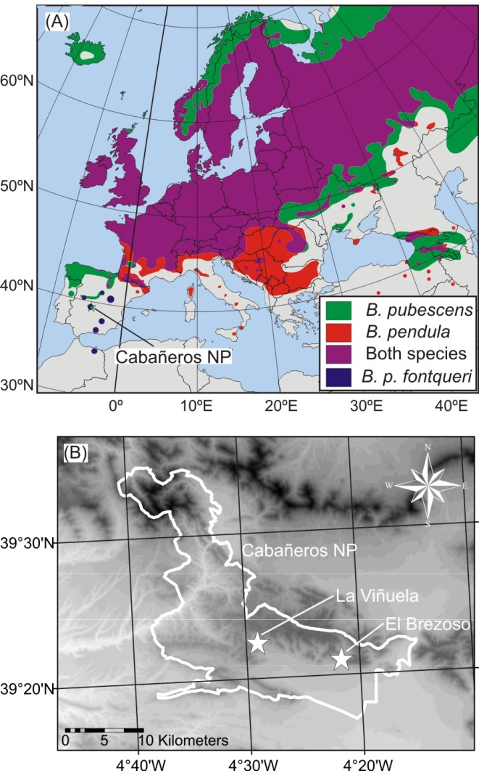

FIG. 2
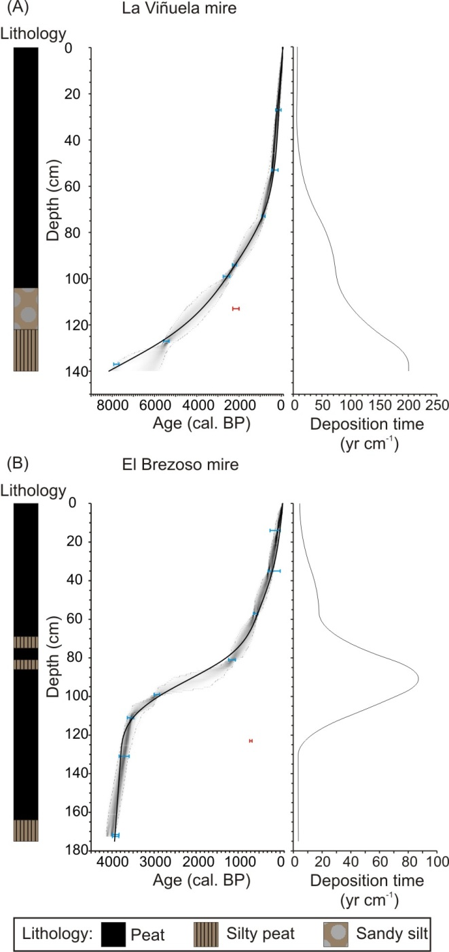

FIG. 3
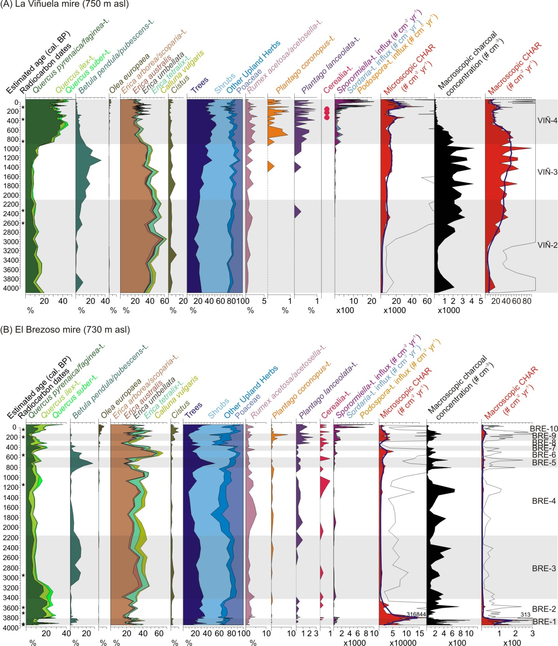

FIG. 4
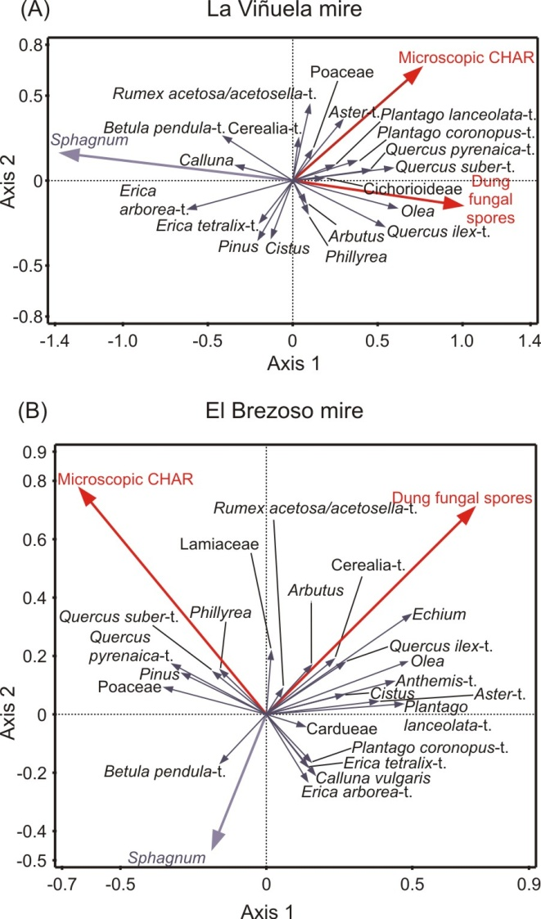

FIG. 5
