**Developing a Holocene tephrostratigraphy for northern Japan using the sedimentary record from Lake Kushu, Rebun Island**

Xuan-Yu Chen a,b,c,d,*, Danielle McLean e, Simon Blockley b, Pavel Tarasov f, Yi-Gang Xu a, Martin Menzies a,c

a State Key Laboratory of Isotope Geochemistry, Guangzhou Institute of Geochemistry, Chinese Academy of Sciences, Guangzhou, 510640, China

b Department of Geography, Royal Holloway University of London, Egham, Surrey, TW20 0EX, UK

c Department of Earth Sciences, Royal Holloway University of London, Egham, Surrey, TW20 0EX, UK

d University of Chinese Academy of Sciences, Beijing, 100049, China

e Research Laboratory for Archaeology and the History of Art, University of Oxford, Oxford, OX1 3QY, UK

f Institute of Geological Sciences, Palaeontology, Free University Berlin, Malteserstr. 74-100, Building D, 12249, Berlin, Germany

# Abstract

Palaeoclimate records in East Asia offer significant potential to further our understanding of monsoon dynamics and can serve as a link between North Atlantic and tropical climate systems. The sedimentary core from Lake Kushu, Rebun Island provides the first high-resolution palaeoclimate record from northern Japan. In order for this regionally significant archive to be synchronised to other records, and to generate a more detailed Holocene tephra lattice for East Asia, we present the first cryptotephra stratigraphy for northern Japan using the Kushu RK12 core. The detailed RK12 tephrostratigraphy integrates local and far-travelled tephras originating from Japan, Russia, China/North Korea and most likely Indonesia. Five key cryptotephra layers have been identified, precisely dated and correlated to the specific eruptions or the source region (B-Tm – Changbaishan; SH#12 – Shiveluch; Ko-g – Komagatake; Ma-f~j – Mashu and RK12-0819 with possible Indonesian origin). These tephra horizons are very widely dispersed, providing opportunities to synchronise widespread palaeoclimate records from the polar region through high northern latitudes to the tropics. In addition, a number of horizons consisting of minor population of glasses have been recognised and are also correlated to their source volcanoes. These glasses provide new insight into regional tephra dispersal (e.g., ash dispersal potential of Aira and Towada volcanoes) and could suggest that there are other undocumented eruptions that have yet to be identified in the geological record (e.g., Changbaishan eruptions). The integrated Lake Kushu cryptotephra record extends the ash dispersal of several key tephra horizons in the region. The presence of the Shiveluch SH#12 tephra in Lake Kushu (ca. 1900 km), documents the first example of a Russian tephra reaching the Japanese Archipelago. Furthermore, glass compositions suggest that the core could preserve an eruption event derived from Indonesia, highlighting the possibility to significantly extend the East Asian tephra lattice to the entire Asia region, which is an essential step for the understanding of how climate changes propagate over large geographical areas. Using the pollen proxy record for Lake Kushu, we also show that the Millennium Eruption from Changbaishan, China/North Korea, had no significant impact on northern Japan environments.

**Keywords:** Cryptotephra, Tephrostratigraphy, Lake Kushu, Northern Japan, Holocene, East Asia, Tephra Lattice, Mashu, Komagatake, Shiveluch, Changbaishan

# Introduction

Palaeoclimate records in East Asia preserve valuable information on past climate change and monsoon dynamics, linking the North Atlantic climate system and the tropical western Pacific Ocean where the monsoon originates (Dykoski et al., 2005; Wang et al., 2005; Wang et al., 2012). Precise comparison of widespread paleoclimate records is hindered by dating uncertainties (e.g., centennial scale errors in 14C based chronologies, cumulative counting errors in varve chronologies) or the limitations in terms of datable material for techniques such as U-series or Ar-Ar dating. For various sedimentary archives such as ice, marine and lacustrine records, this limits the resolution at which short-lived, centennial or multi-decadal scale climate changes can be studied (Lowe et al., 2015). Precise alignment and therefore detailed comparisons of proxy records can be facilitated using isochronous marker horizons and thus the identification of volcanic ash (tephra) horizons in these records have proved significantly important (Lowe et al., 2008a, 2008b; Davies et al., 2012, 2014; Blockley et al., 2012, 2014; Lane et al., 2013a). Volcanic ash horizons can be detected as visible layers or as non-visible cryptotephra layers in a range of palaeoenvironmental sequences (e.g., Blockley et al., 2005). Well dated tephra layers or those that fall close to palaeoclimatic/cultural transitions are particularly important (e.g., Lowe et al., 2012; Lane et al., 2013a), however it is essential that all widespread tephra horizons are categorised and geochemically fingerprinted to develop a robust regional tephra lattice for tephra correlation (Lowe et al., 2015).

Active volcanic regions like East Asia, have significant potential for the development of an important tephra lattice due to the number and widespread dispersal of ash layers (Machida and Arai, 2003). Combined with the important role the region plays in understanding monsoon dynamics, East Asia is an ideal area for optimising the use of tephra isochrons to synchronise palaeoclimate records. Extensive work undertaken by Machida and Arai (1983, 2003) underpin tephra investigations in this region. Since, tephrochronologists have also constructed numerous detailed regional frameworks of eruption events across Japan (e.g., Arai et al., 1986; Furuta et al., 1986; Moriwaki et al., 2016; Nakamura, 2016; Razzhigaeva et al., 2016). Meanwhile, long sedimentary cores have been increasingly utilized for distal tephra investigations, which have been able to integrate multiple volcanic eruptions within a single record (e.g., Aoki and Arai, 2000; Park et al., 2003; Nagahashi et al., 2004; Aoki et al., 2008; Moriwaki et al., 2011; Okuno et al., 2011; Smith et al., 2013; Tsuji et al., 2018).

The majority of tephrostratigraphic studies in Japan have focused on the visible ash layers preserved in the sediments. However, recent developments in cryptotephra studies have been demonstrated to effectively magnify the ash footprints of numerous volcanic eruptions and thus synchronise palaeoclimate records over thousands of kilometers (e.g., Pyne-O’Donnell et al., 2012; Lane et al., 2013b; Jensen et al., 2014; Sun et al., 2014; Bourne et al., 2016; Mackay et al., 2016; van der Bilt et al., 2017; Cook et al., 2018; Kearney et al., 2018). In addition, these investigations reveal the presence of ash layers in sedimentary records which are not apparent from visible tephra studies (e.g., Davies et al., 2010; Bourne et al., 2010, 2015, 2016; Matthews et al., 2015; Wulf et al., 2016, 2018). Most cryptotephra studies, however, have been undertaken in Europe and the North Atlantic region (c.f., Davies, 2015), whereas important palaeoclimate archives in East Asia thus far have only been subject to minimal cryptotephra investigation (e.g., Sun et al., 2015; Chen et al., 2016; Matsu’ura et al., 2017, 2018; McLean et al., 2018).

Sediment cores recovered from Lake Kushu, Rebun Island (Müller et al., 2016), allow the establishment of the first high-resolution palaeoenvironmental record from northern Japan. Published studies (Müller et al., 2016; Schmidt et al., 2016, 2019; Leipe et al., 2017, 2018) and on-going research from this site enable a better understanding of past climate changes and the dynamics of human-environment interaction in the region. In order for this regionally significant palaeoclimate archive to be precisely compared to other high-resolution records (e.g., Lake Suigetsu, Lake Sihailongwan, Lake Huguang Maar), and to aid the construction of a Holocene tephra lattice for East Asia, we present the first detailed cryptotephra stratigraphy in northern Japan using the Kushu sediment core. Our results demonstrate the great potential for cryptotephra studies in East Asia and have significant implications for future studies in the region.

# Study site and materials

Rebun Island is situated in the northeastern part of the Sea of Japan, ca. 45 km west off the northern coast of Hokkaido (Fig. 1). The elongated-shaped island occupies an area of ca. 82 km2, with its long axis (north-south) spanning about 20 km. Lake Kushu (45°25′55″N, 141°02′13″E, 4 m.a.s.l.) is a coastal freshwater lake located in the northern part of the island (Fig. 1c). With a catchment area of ca. 10 km2, the lake is fed by two inflows, the Oshonnai River from the south and a tiny stream from the east and has one outlet connecting with the sea (Sato et al., 1998). About 300 m away from the coast, the lake is surrounded by dense vegetation, which effectively limits sediment in-washing to the lake, where sediment is made up primarily from autochthonous biological productivity, aeolian input and minor fluvial input (Schmidt et al., 2016).

Following a preliminary survey, sediment coring was undertaken in the central part of the lake when it was covered by a thick ice layer (February 2012; Müller et al., 2016). Two parallel sediment cores RK12-01 and RK12-02 were recovered using a hydro-pressure thin-walled piston corer. After the drilling campaign, the cores were transported to Hokkaido University and stored under cool temperature. In April 2012, the cores were opened by splitting each into two identical halves and the sediments were photographed, described, archived and sub-sampled for multi-proxy analyses. One set of subsampled core sections were sent to the Centre for Quaternary Research at Royal Holloway University of London for the tephra study presented here. A composite sequence was also shipped to the Institute of Geological Sciences at the Free University of Berlin where a range of proxy studies (e.g., pollen, diatom, geochemical analyses) were performed (Müller et al., 2016; Schmidt et al., 2016, 2019; Leipe et al., 2017, 2018).

The composite RK12 sequence spans ca. 19.5 m long and is composed of continuous, partly laminated, organic-rich sediments. A total of fifty-seven bulk sediment samples (1 cm) throughout the composite sequence were processed for AMS radiocarbon dating (Müller et al., 2016). The obtained results allowed the construction of the RK12 age model, which indicates that the Holocene period covers the upper ca. 16.5 m sediments of the composite sequence. The uppermost 50 cm sediment could not be recovered due to its unconsolidated state. As such this study focuses on core sediment between composite depth (CD) 50-1650 cm.

The RK12 core from Lake Kushu is ideal for high-resolution cryptotephra investigations given that (a) the Holocene sediments span ca. 16.5 m and are well constrained by numerous radiocarbon ages (Müller et al., 2016), (b) the lake is not too close to large active volcanic centres (Fig. 1b) that would dominate the tephrostratigraphic record of the site and mask the cryptotephra record, (c) due to its positioning the Kushu sedimentary record provides a unique opportunity to understand more about ash dispersal reaching the northernmost regions of Japan and thus facilitate the construction of an East Asia tephra lattice through providing an important northern element.

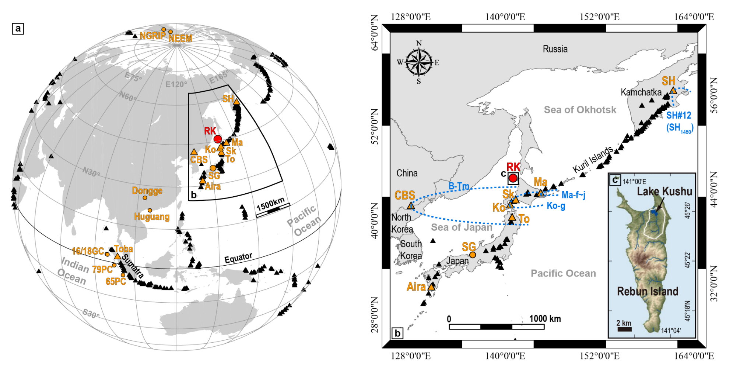

**Fig. 1.** (a) Map of the western Pacific rim region showing active volcanoes (triangle) and archives for palaeoclimate and/or tephra studies (circle) . The regionally significant palaeoclimate archive for this cryptotephra study – Lake Kushu (RK) is highlighted in red colour. Volcanoes and archives that are relevant to the text are highlighted in orange colour. (b) Enlarged map of the NE Asia showing volcanoes in Kamchatka Peninsula, Kuril Islands, Japanese Archipelago, China/North Korea and South Korea. The previous known dispersals of several regional tephra markers based on visible tephra studies are indicated using blue dashed lines. Dispersal data for B-Tm, Ko-g, Ma-f~j and SH#12 (SH1450) are from Machida (1999), Furakawa and Nanayama (2006), Katsui et al. (1975) and Kyle et al. (2011) respectively. (c) Detailed location of the Lake Kushu in Rebun Island. Abbreviations: SH-Shiveluch, RK-Lake Kushu Rebun Island, Ma-Mashu, Sk-Shikotsu, Ko-Komagatake, To-Towada, SG-Lake Suigetsu, CBS-Changbaishan. 16GC, 18GC, 79PC and 65PC are marine cores off Sumatra Island in the Indian Ocean. NGRIP and NEEM are Greenland ice-cores.

# Methods

## Tephra separation and identification

Tephra investigations were carried out on the RK12-01 core. Due to a technical issue while coring, there is a 9 cm gap at the bottom of each core segment. We thus report all the depth information using the CD for consistency with 14C chronology and other proxy studies (e.g. Müller et al., 2016; Schmidt et al., 2016, 2019; Leipe et al., 2017, 2018). Preliminary investigations revealed that no visible tephra layers were preserved during the Holocene sedimentation, thus the core was analysed in detail for the presence of cryptotephra layers. Cryptotephra deposits were detected and extracted using the density separation methods outlined by Turney (1998) and Blockley et al. (2005). The RK12 Holocene sequence was first contiguously sub-sampled at a 10 or 20 cm resolution for range-finder scanning to determine tephra presence. If an elevated shard concentration was observed in the range-finder samples, the sediments were resampled at 1 or 2 cm resolutions for point sampling to locate the precise stratigraphic position of the cryptotephra layer. Blank samples were prepared alongside all the samples to monitor possible laboratory contamination. Each extracted sample was mounted on one or more slides and examined for tephra shards using a plane polarizing microscope. Tephra concentrations were measured by counts normalized to shards per gram dry sediment (shards/g). Individual shards of each cryptotephra were hand-picked from point-samples with the highest tephra counts and embedded in epoxy resin, which were then sectioned and polished for geochemical analysis.

## Glass geochemical analysis

Single-grain major and minor element concentrations were measured using wavelength-dispersive electron probe microanalysis (WDS-EPMA) at 1) the Research Laboratory for Archaeology and the History of Art, at the University of Oxford with a JEOL JXA-8600, and 2) the Grant Institute, School of Geosciences at the University of Edinburgh with a Cameca SX100. Spot sizes of 10, 5 and 3 µm were used depending on the size of the area available for analysis in different shards. Secondary glass standards were analysed in the same session in order to monitor instrumental accuracy and analytical precision. Detailed machine set-ups for the electron probe JEOL JXA-8600 at Oxford are: 15 kV, 6 nA for the 10 µm beam size, with Si, Al, Mg, Ti, Ca, K, Fe analysed for 30 s on peak, Na for 12 s, Cl and Mn for 50s, and P for 60s; 15 kV, 5 nA for the 5 µm beam size, with Si, K, Ca, Ti analysed for 30 s on peak, Na for 12 s, Fe, Mg and Mn for 40 s, Al and Cl for 50 s, and P for 70 s. Machine set-ups for the Cameca SX100 at Edinburgh are: 15 kV, 2 nA (Na, Al, Si, K, Ca, Mg, Fe), 80 nA (P, Ti, Mn) for the 5 µm beam size; 15 kV, 0.5 nA (Na, Al), 2 nA (Si, K, Ca, Mg, Fe), 60 nA (P, Ti, Mn) for the 3 µm beam size (c.f., Hayward, 2011). Data were filtered to remove non-glass analyses, and those with analytical totals <93%, given the observed water contents in glass shards from the same region (e.g., McLean et al., 2018; Albert et al., 2018). For comparative purposes, all data presented in text, table and plots were normalized to 100 wt % on a volatile-free basis. Full dataset and glass standards are presented in the supplementary material.

## Chronology

The RK12 age model reported by Müller et al. (2016) is constructed following the free-shape algorithm outlined in Goslar et al. (2009). This free-shape algorithm is particularly useful when the age-depth curve is variable over time (Goslar et al., 2009), which is the case for dates older than ca. 8 ka in the RK12 core (Müller et al., 2016). The 95% uncertainty output of the best-fit age-depth model (Müller et al., 2016), with a precise age of the B-Tm tephra (946 CE; Oppenheimer et al., 2017) imposed in the upper part of the model (Chen et al., 2016), is used in this study for providing age estimate for cryptotephra identified in the sequence. While assigning ages, we use the depth range instead of sub-sampling mid-point for each cryptotephra to account for the full age uncertainty.

# Results

## Stratigraphy and age

The detailed stratigraphy and age results for tephra horizons in the RK12 Holocene sequence are presented in Fig. 2 and summarised in Table 1. Generally, glass shards were found in almost all range-finder samples (Fig. 2). In total, twelve horizons with significant peaks in glass shard concentrations were identified, subsampled and geochemically characterised, with four in each of the early, mid- and late Holocene (Fig. 2). Since none of these cryptotephra peaks fall in close proximity to the sampling gaps, we can be certain of their stratigraphic positioning. Cryptotephra layers were labelled by the mid-point of the CD in 2 cm samples or the lower point in 1 cm samples (e.g., RK12-0225 for CD 224-226 cm and RK12-0151 for CD 150-151 cm).

Low-resolution range-finder samples contained shard concentrations that differ by one to two orders of magnitude between the upper 1 m segment and the remaining 15 m sediment core. The sample with the greatest concentration of glass shards is positioned within the uppermost 1 m of sediment, and contains 3286 shards/g. This is probably due to the wind transportation of tephra material from the lake catchment or intra-lacustrine reworking of the highly concentrated tephra RK12-0151 (30671 shards/g) which was deposited 1 cm below (Fig. 2a). Low-resolution samples for the rest of the core barely exceed 50 shards/g (Fig. 2). Note that a sample at CD 1590-1600 cm was also studied at higher resolution but the low tephra concentration (Fig. 2k), coupled with the limited core materials we had, meant that it was not possible to obtain geochemical analyses.

### Early Holocene (11.7-8 ka)

The RK12 age model indicates that the early Holocene period spans the lowermost ca. 350 cm sediment (CD: 1650-1300 cm), within which four cryptotephra layers are identified: RK12-1507, RK12-1495, RK12-1391 and RK12-1361 (Fig. 2). The lower two layers RK12-1507 and RK12-1495 are stratigraphically closely located and were identified within the same range-finder sample. Both tephra layers contain glass concentrations of 60-80 shards/g that form peaks that are twice as high as the background value (ca. 20-30 shards/g, Fig. 2j). The upper two layers, RK12-1391 and RK12-1361, are also clearly defined from the background and contain 58 shards/g and 120 shards/g, respectively (Fig. 2h-i). These four horizons, from lower to upper by stratigraphic order, are dated to 8868-8596, 8788-8548, 8567-8283 and 8463-8203 cal. yr BP (95% confidence), respectively (Table 1).

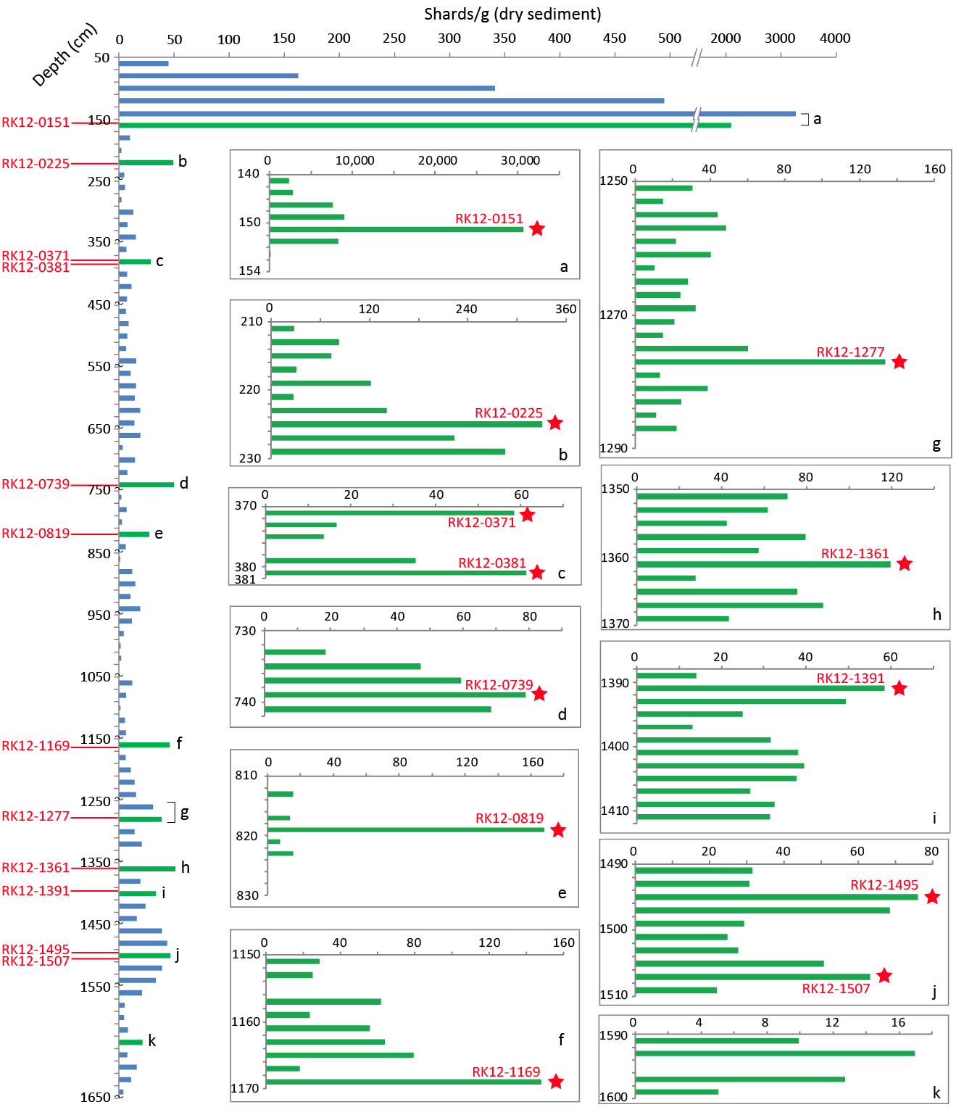

**Fig. 2.** Glass shard concentrations (shards/g dry sediment) measured in the Holocene sediments of the Lake Kushu RK12 core. Concentrations of range-finder samples (11 or 20 cm resolution) are shown in blue colour. Range-finder samples that revealed elevated shard concentrations (highlighted in green colour) were examined at a higher resolution (1 or 2 cm) which were termed point-samples. Inserted diagrams (a-k) show the tephra concentrations of the high-resolution point-samples. The pentagram denotes the stratigraphic position of each identified cryptotephra layer. Note that the tilde at the end of each 1 m core segment (except the first 1 m) indicates a 9 cm gap of sediment due to a technical issue while coring. As such the range-finder samples at the end of each 1 m core segment only represent 11 cm core sediments.

### Mid-Holocene (8-4 ka)

The mid-Holocene period spans ca. 600 cm of sedimentation (CD: 1300-700 cm) in the RK12 composite core (Fig. 2). Four cryptotephra layers are recognised at this interval: RK12-1277, RK12-1169, RK12-0819 and RK12-0739 (Fig. 2). The older three (i.e., RK12-1277, 1169 and 0819) are prominent tephra layers with very well defined stratigraphic positions, and contain relatively high concentrations of 130-170 shards/g (Fig. 2e-g). The uppermost RK12-0739 has a slightly lower shard count of 79 shards/g (Fig. 2d). These four layers are dated to 7981-7664, 6843-6571, 5222-4988 and 4527-4252 cal. yr BP (95% confidence), respectively (Table 1).

### Late Holocene (4-0 ka)

The late Holocene covers the uppermost ca. 650 cm sequence (CD: 700-50 cm) of the RK12 composite core. This portion contains four cryptotephra layers: RK12-0381, RK12-0371, RK12-0225 and RK12-0151. The RK12-0381 and RK12-0371 are closely located (10 cm apart), and contain glass concentrations of 61 and 59 shards/g respectively (Fig. 2c). The younger tephra (RK12-0225) is clearly defined and contains 331 shards/g dry sediment (Fig. 2b). The previously reported layer RK12-0151 (>30,000 shard/g) has been correlated to the B-Tm tephra (946 CE; Oppenheimer et al., 2017) erupted from Changbaishan (Chen et al., 2016). Based on the age model reported in Müller et al. (2016), the three newly identified tephra layers RK12-0381, RK12-0371 and RK12-0225 are dated to 2215-2013, 2165-1976 and 1374-1295 cal. yr BP (95% confidence), respectively (Table 1).

**Table 1** Summary information of twelve horizons with significant peaks in glass shard concentrations within the Lake Kushu RK12 Holocene sequence. Five key marker tephra layers and a number of compositional populations are identified within these horizons.



Note: Age of RK12-0151 is from Oppenheimer et al. (2017) based on the tephra correlation reported in Chen et al. (2016).

## Glass geochemistry

Major element glass compositions of the RK12 Holocene tephra layers are presented in selected bivariate plots in Fig. 3. Geochemical analyses regarded as outliers from the main group of data within each sample, based on multiple bivariate plots, are excluded from the presented datasets but included in the supplementary material. Glass compositions of Holocene tephra layers in Lake Kushu are mainly rhyolitic, with the exception of RK12-1277, RK12-0819 and one of the populations of RK12-0739 extending to less silicic dacitic compositions, and RK12-0151 to trachytic compositions (Fig. 3a). Glasses are classified into four series: the tholeiitic low-K series, the calc-alkaline medium-K and high-K series, and the shoshonitic high-K series based on the whole rock K-classification scheme of Peccerillo and Taylor (1976) (Fig. 3b).

The low-K series includes the dominant population of RK12-1277 (n=17, 0.6-0.9 wt.% K2O) and a minor population from RK12-0739 (n=2, ca. 1.2 wt.% K2O) (Fig. 3b). The medium-K series encompasses most of the prominent mid- to late Holocene tephra layers, including the dominant population of RK12-1169 (n=16, 1.6-1.8 wt.% K2O), RK12-0819 (n=26, mainly 2.0-2.9 wt.% K2O) and RK12-0225 (n=14, 2.9-3.4 wt.% K2O) (Fig. 3b).

A significant proportion of glasses from four early Holocene layers (i.e., RK12-1507, 1495, 1391 and 1361) are medium-K in composition and glasses from each layer cannot be distinguished from one another (Fig. 3b). Interestingly, these early Holocene glasses form three populations that can be discriminated using their K2O content (Fig. 3b). Glass compositions of two of these populations are not restricted within the early Holocene sediments, as minor population glasses of mid- to late Holocene layers were also plotted in their compositional envelops (Fig. 3b). These groups are highlighted using ellipses and are defined as compositional groups 1&2 (Fig. 3b-d). Group 1 (n=52, mainly 76.7-79.9 wt.% SiO2, 2.3-2.9 wt.% K2O; Fig. 3b) encompasses glasses from nine tephra layers with the exception of RK12-0819, RK12-0225 and RK12-0151, whereas group 2 (n=23, 74.9-78.6 wt.% SiO2, mainly 1.8-2.1 wt.% K2O; Fig. 3b) includes glasses from six layers with four in early Holocene and two in mid-Holocene. The remaining population with glasses only from the early Holocene sediments is defined as group A (n=19, 75.4-79.4 wt.% SiO2, 3.0-3.7 wt.% K2O; Fig. 3b). These group A glasses are clearly separated from other RK12 glasses on a TiO2-K2O plot (Fig. 3c).

Glasses in the calc-alkaline high-K series also show a compositional group hereby defined as group 3 (n=40, 75.1-79.1 wt.% SiO2, mainly 3.8-5.6 wt.% K2O; Fig. 3b). This group contains glasses that originate from eleven tephra layers excluding RK12-0151, and they cannot be geochemically distinguished from each other (Fig. 3b-d). Given that the glass within the three compositional groups (1, 2 and 3) are repeatedly identified throughout the Holocene sediments, for clarity they will be discussed separately and also excluded from diagrams while correlating specific chemical groups of a given layer. The calc-alkaline high-K series also comprises the rhyolitic components of RK12-0151, a minor population of RK12-0739 (n=4), and individual analyses of RK12-1391 (n=1) and RK12-1507 (n=1). The high-K shoshonite series mainly comprises the trachytic glasses of tephra layer RK12-0151 (Fig. 3b).

To summarise, two main characteristics of the RK12 Holocene tephra layers are observed:

1. many of the significant peaks in glass shard concentrations are comprised of more than one compositional population, but five of which display a unique and dominant composition (>70% of the total geochemical analyses; Table 1) and therefore represent prominent tephra horizons;
2. as for minor compositional populations, certain compositions are only observed within specific time periods (e.g., group A glasses in early Holocene sediments) whilst some other compositions occur throughout the sediment core (e.g., groups 1, 2 & 3).

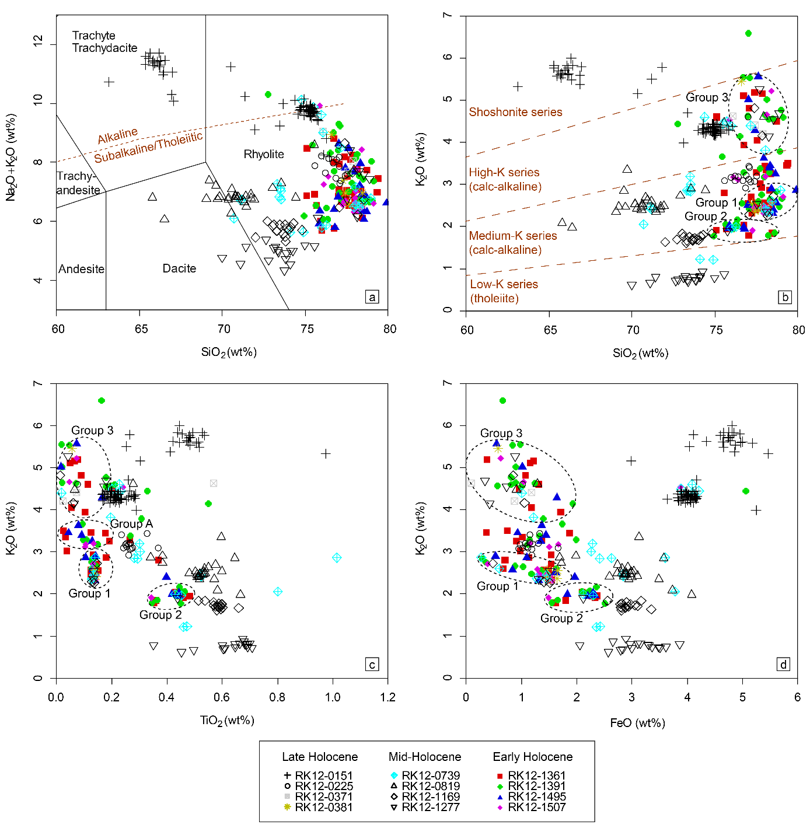

**Fig. 3.** Major element (a) total alkali versus silica (TAS) diagram (Le Bas et al., 1986), (b) K-classification diagram (Peccerillo and Taylor, 1976) and (c-d) bivariate plots showing glass chemistries of all cryptotephra layers identified in the Lake Kushu RK12 Holocene core. Glass shards from stratigraphically separated layers with indistinguishable compositions are defined as compositional groups 1, 2, 3 and A (see main text).

# Tephra correlation

Summary information of major element glass chemistries of the RK12 Holocene tephra layers are presented in Table 2 grouped by the provenance discussed in the following sections.

## Correlations for prominent tephra horizons

Given the geographical location of Lake Kushu, the most possible sources that could disperse tephra to the lake include volcanoes in Japan, Russia, China/North Korea and South Korea (Fig. 1). Glass chemistries of major Holocene tephra markers from the above-mentioned regions are shown in Fig. 4. When considered together, compositions of tephras from different volcanic regions in NE Asia display distinct features.

Generally, Russian Holocene tephras have the greatest geochemical variations, ranging from basaltic trachyandesite/andesite to rhyolite (ca. 50-80 wt.% SiO2; Fig. 4a). The majority of Russian tephras are in subalkaline/tholeiitic series (ca. 4-9 wt.% Na2O+K2O) with only few analyses extending to the alkaline field. These features clearly distinguish them from Holocene tephras from China/North Korea and South Korea (Fig. 4a). The Chinese tephras (ca. 61-77 wt.% SiO2, 8-12 wt.% Na2O+K2O) are mainly in the alkaline field (trachyte to rhyolite) with the most evolved compositions (i.e., rhyolitic) extending into the subalkaline/tholeiitic series (Fig. 4a). Tephras from South Korea have homogeneous compositions (ca. 60-62 wt.% SiO2) and are phonolitic to trachytic in composition. They have the highest total alkaline content (ca. 12-16 wt.% Na2O+K2O) among all tephras from NE Asia (Fig. 4a). In contrast, the Japanese tephras (ca. 63-78 wt.% SiO2) have the lowest total alkaline content (mainly 4-7 wt.% Na2O+K2O) among all NE Asian tephras, and they partly overlap with some of the Russian tephras in the subalkaline dacitic to rhyolitic fields (Fig. 4a). K-classification diagram (Peccerillo and Taylor, 1976) is a useful tool, which help pull apart some of the tephras from Japan and Russia (Fig. 4b). In addition, tephras from different volcanic regions in NE Asia form different evolutionary trends on SiO2-CaO bivariate plot (Fig. 4c). Consequently, it is possible to attribute an unknown tephra horizon to the specific region where it originates using these diagrams.

The most prominent tephra horizon in the RK12 core (RK12-0151; 30671 shards/g) has previously been correlated to the B-Tm tephra, which was erupted from Changbaishan volcano, China/North Korea (Chen et al., 2016; Fig. 4). Here we discuss four additional marker tephra horizons that were identified in this study (i.e., RK12-0225, 0819, 1169, 1277). Comparisons of glass chemistries indicate that RK12-1169 and RK12-1277 are very likely to be derived from volcanoes in Japan (Fig. 4b-c), whereas the RK12-0225 is more likely to have a Russian origin (Fig. 4a). The RK12-0819, however, does not show a clear match to known NE Asian Holocene tephras (Fig. 4a).

A combination of relative stratigraphy, geochemical compositions and depositional modelled age were then used to correlate the RK12 prominent tephra layers to their source volcanoes and if possible, to specific eruptions. In summary, these prominent tephra layers are from the following regions and volcanoes:

* Japan: Mashu – RK12-1277; Komagatake – RK12-1169,
* Russia: Shiveluch – RK12-0225
* Indonesia: Sumatra – RK12-0819
* China/North Korea: Changbaishan – RK12-0151

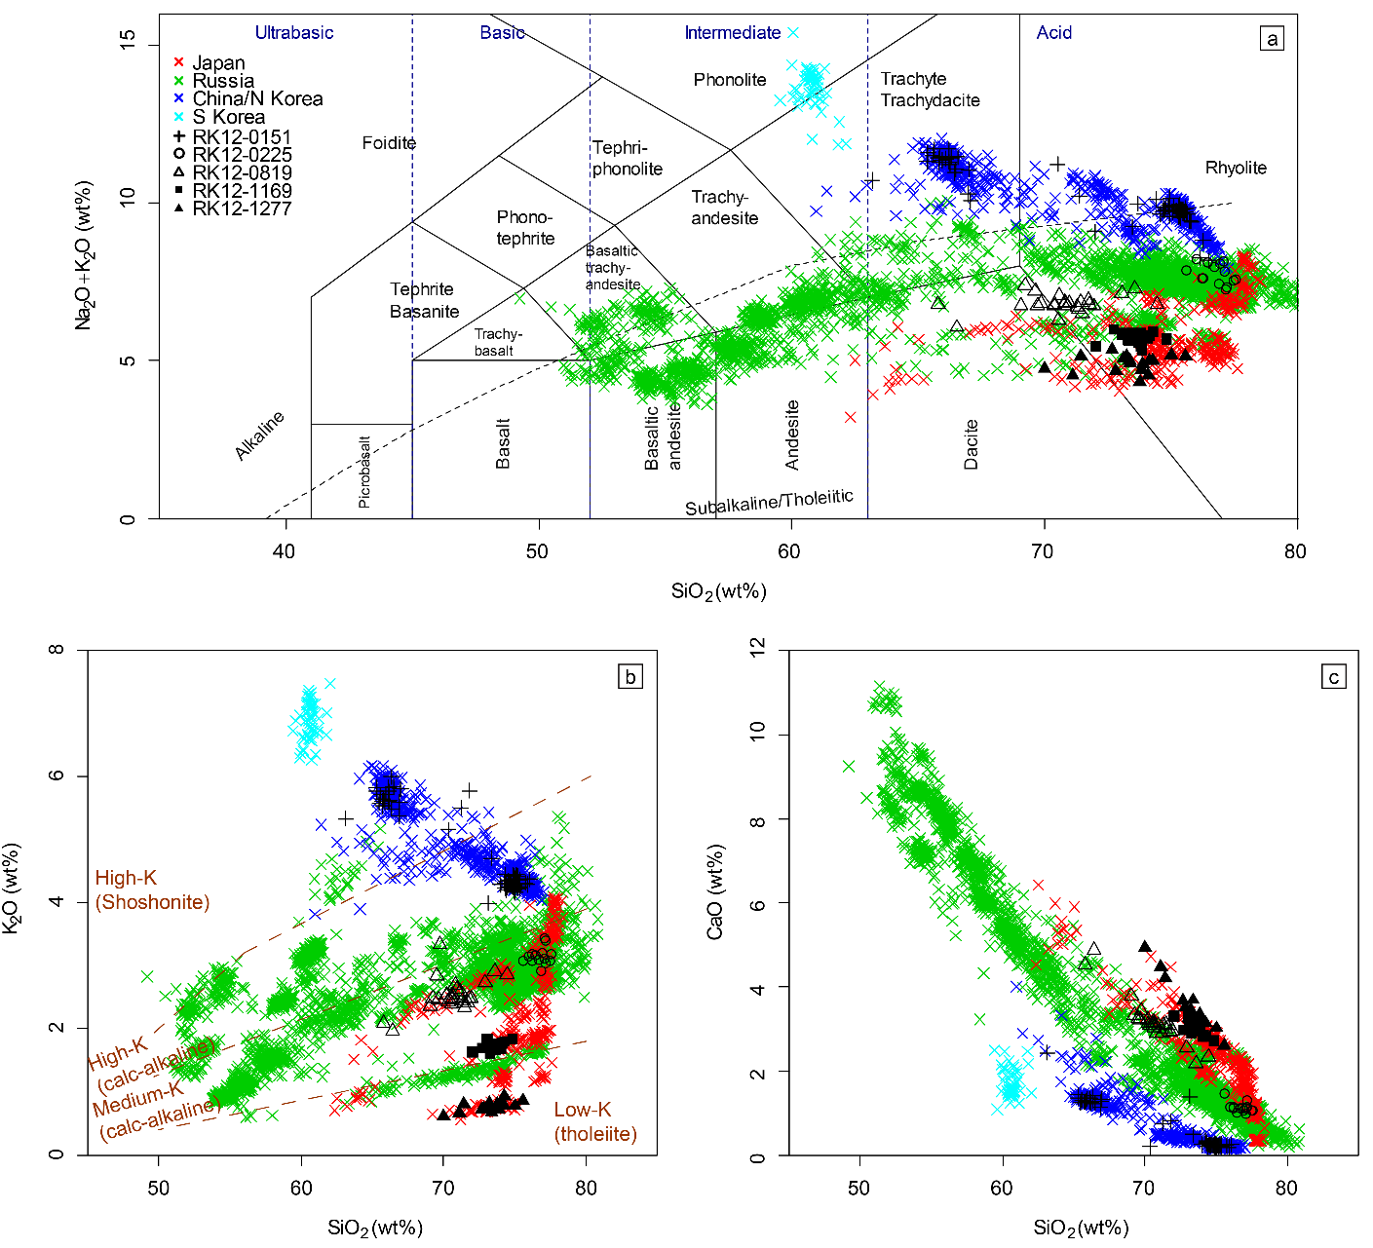

**Fig. 4** Major element (a) TAS classification diagram (Le Bas et al., 1986) and (b-c) bivariate plots showing glass compositions of five prominent tephra horizons identified in the RK12 Holocene sequence, along with known major Holocene tephra markers originated from different volcanic regions in NE Asia, including Japan (Smith et al., 2013; Nakamura, 2016; Razzhigaeva et al., 2016; McLean et al., 2018; Albert et al., 2018), Russia (Kyle et al., 2011; Ponomareva et al., 2013, 2015, 2017), China/North Korea (Sun et al., 2014, 2015, 2017; Chen et al., 2016; McLean et al., 2016, 2018) and South Korea (Smith et al., 2011a; McLean et al., 2018) for comparison.

**Table 2** Summary table of the compositions of geochemical populations identified in the Lake Kushu RK12 Holocene sequence grouped by the provenance. Tephra horizons in **Bold** indicate that they are prominent horizons.



Note: Data of the RK12-0151 are from Chen et al. (2016).

### Mashu (Ma-f~j/RK12-1277)

Mashu volcano is situated on the eastern side of Kutcharo caldera in eastern Hokkaido and is 350 km SE of Lake Kushu (Fig. 1). Ten individual Holocene eruptions have been identified in proximal locations, most of which were small volume phreatomagmatic eruptions (Kishimoto et al., 2009). Among these, two eruptions are estimated to have tephra volumes > 1 km3, which produced the Ma-b (4.6 km3) and Ma-f~j (18.6 km3) tephras (Kishimoto et al., 2009). The younger Ma-b tephra was recently identified as a cryptotephra layer in Lake Suigetsu and dated to 990-958 cal. yr BP (McLean et al., 2018), but the volumetrically larger Ma-f~j tephra has only been identified in the proximal to mid-range sites to date (e.g., Furukawa and Nanayama, 2006). The Ma-f~j tephra is associated with the caldera-forming activity (VEI=6, LaMEVE database; Crosweller et al., 2012), which began with a phreatomagmatic eruption (Ma-j), followed by Plinian falls (Ma-i,h,g) and concluded with a catastrophic pyroclastic flow (Ma-f) (Katsui et al., 1975). Although the 14C dates of the eruption vary considerably, ranging from 7840-7660 cal. yr BP (2σ; Yamamoto et al., 2010) to 8597-8379 cal. yr BP (2σ; Nakamura and Hirakawa, 2004), the Ma-f~j tephra can be distinguished from the proceeding and succeeding eruptions of the volcano, which produced the small volume Ma-k (ca. 11.7 cal ka) and Ma-e (ca. 5.5 cal ka) tephra deposits (Yamamoto et al., 2010).

Glasses of tephra layer RK12-1277 (n=17, 7981-7664 cal. yr BP) range from dacitic to rhyolitic in composition (70.0-75.6 wt.% SiO2; Fig. 3a). They have the lowest K2O values (<1.0 wt.%) among all the RK12 glasses and belong to the low-K tholeiite series (Fig. 3b). Comparison of glass chemistry with NE Asian Holocene tephras indicated that they originated from volcanoes in Japan (Fig. 4b-c). Moreover, the distinctive low-K feature suggests that these glasses are more likely to come from northern Japan (i.e., Hokkaido and northern Honshu), rather than central and southern Japan (i.e., Honshu and Kyushu) (McLean et al., 2018). Detailed geochemical comparisons with tephra layers from major Holocene volcanic centres in northern Japan (i.e., Komagatake, Mashu, Rausu, Tarumae, Tenchosan, Usu and Towada; Nakamura, 2016; Razzhigaeva et al., 2016; McLean et al., 2018) revealed that these glasses are from Mashu volcano (Fig. 5a). Particularly, these glasses are indistinguishable from the Ma-f~j tephra based on major and minor element compositions (Fig. 5b-d). In addition, the Kushu derived age of RK12-1277 matches the proximal age of Ma-f~j (7840-7660 cal. yr BP (2σ); Yamamoto et al., 2010), and importantly, there are no other contemporaneous tephras from Mashu during this period. The evidence of glass chemistry and independent chronology together, suggest that the RK12-1277 tephra can be confidently correlated to the Ma-f~j tephra.

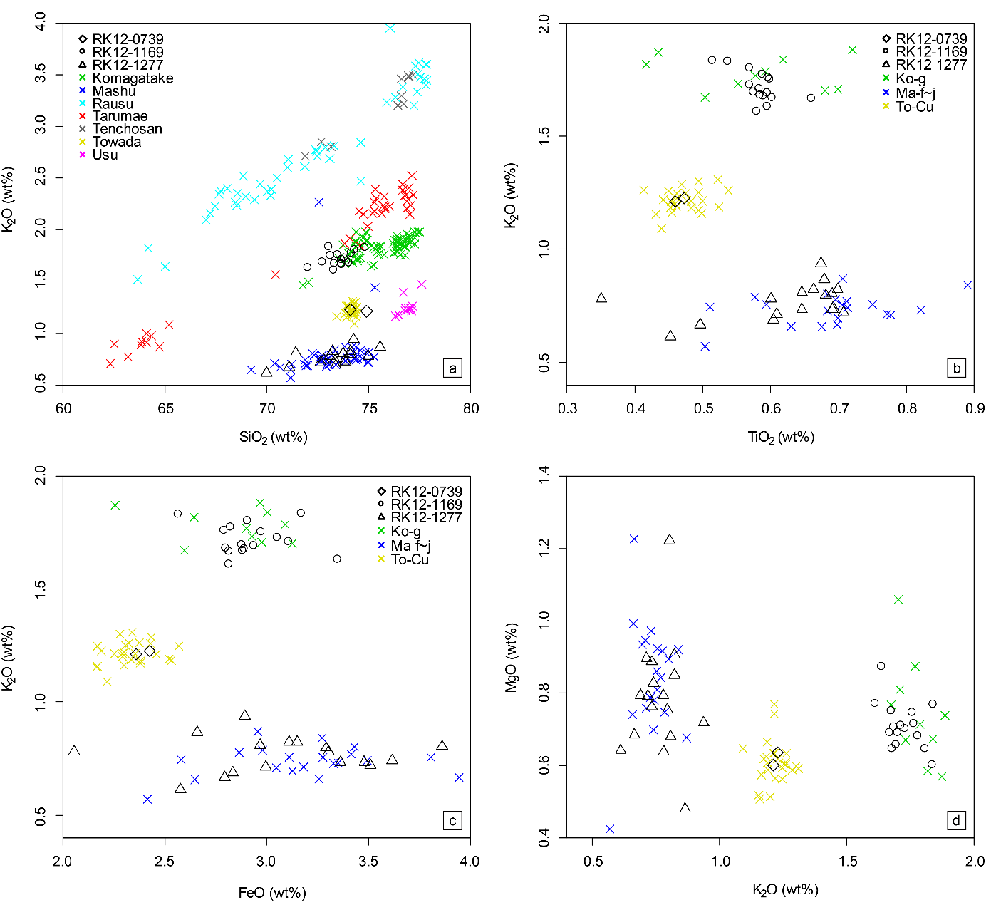

**Fig. 5.** Major element bivariate plots showing glass compositions of prominent tephra horizons RK12-1169, RK12-1277 and a minor population of RK12-0739 in Lake Kushu, northern Japan along with (a) glass compositions of tephra layers from major Holocene volcanic centres in northern Japan (i.e., Komagatake, Mashu, Rausu, Tarumae, Tenchosan, Usu and Towada; Nakamura, 2016; Razzhigaeva et al., 2016; McLean et al., 2018), (b-d) glass compositions of Ko-g tephra from Komagatake volcano (Nakamura, 2016), Ma-f~j tephra from Mashu volcano (Razzhigaeva et al., 2016) and To-Cu tephra from Towada volcano (McLean et al., 2018) for comparison.

### Komagatake (Ko-g/RK12-1169)

Komagatake volcano is situated on the Oshima Peninsula in southwestern Hokkaido, 375 km S of Lake Kushu (Fig. 1). The volcano is believed to have had six major Plinian eruptions during the Holocene, producing two key marker tephras in the mid-Holocene, and four in historic time (Ganzawa et al., 2005). These tephra layers include Ko-g which is dated to 6781-6453 cal. yr BP (2σ; Nakamura and Hirakawa, 2004), Ko-f which is dated to 6400-6189 cal. yr BP (2σ; Okuno et al., 1999), and Ko-d, Ko-c2, Ko-c1 and Ko-a dated by historical records to 1640 CE, 1694CE, 1856 CE and 1929 CE, respectively (Katsui and Komuro, 1984). The eruption that produced the widespread Ko-g tephra was estimated to have a bulk deposit volume of 2.4-3.8 km3, with a VEI of 5 (Nakamura and Hirakawa, 2004). The Ko-g tephra was dispersed towards the east-northeast (ENE) and has covered most of southern and eastern Hokkaido (Nakamura and Hirakawa, 2004; Furukawa and Nanayama, 2006).

Glasses of tephra layer RK12-1169 (n=16, 6843-6571 cal. yr BP) are rhyolitic (72.0-74.8 wt.% SiO2; Fig. 3a) and belong to the medium-K series (1.6-1.8 wt.% K2O; Fig. 3b). Step by step compositional comparisons revealed that they are derived from Japan (Fig. 4b-c) and overlap with glass compositions of tephras from the Komagatake volcano (Fig. 5a). Chronologically, the Kushu derived age of RK12-1169 significantly overlaps with the reported age of the Ko-g tephra (6781-6453 cal. yr BP (2σ); Nakamura and Hirakawa, 2004), and is different from the age of a younger Plinian eruption (i.e., Ko-f). Moreover, glasses of RK12-1169 are geochemically indistinguishable from those of the Ko-g tephra (Fig. 5b-d). On this geochemical and chronological basis, we confirm that the RK12-1169 is a distal occurrence of the Ko-g tephra.

### Shiveluch (SH#12/RK12-0225)

Shiveluch volcano is a highly explosive eruptive centre, located at the northern end of central Kamchatka Peninsula, Russia, and ca. 1900 km NE of Lake Kushu (Fig. 1). Detailed proximal tephrostratigraphic studies of the volcano have identified and dated 77 individual pyroclastic units erupted since ca. 11 ka (Ponomareva et al., 2015). Geochemical fingerprinting of the Shiveluch Holocene tephras revealed that their glasses display significant compositional variation (Ponomareva et al., 2015), though the time intervals between eruptions were relatively short, with an average eruptive frequency of 100-200 years during the Holocene (Kyle et al., 2011). An updated Bayesian age model, with a total of 223 14C dates, was presented in Ponomareva et al. (2017). This detailed tephrostratigraphy, chronology and comprehensive geochemical dataset allows any distal Shiveluch tephra to be closely correlated to specific proximal eruptions.

Glasses of tephra layer RK12-0225 (n=14, 1374-1295 cal. yr BP) are rhyolitic (75.6-77.6 wt.% SiO2; Fig. 3a) and plot in the calc-alkaline medium-K series (2.9-3.4 wt.% K2O; Fig. 3b). Geochemical comparison with NE Asian Holocene tephras indicated that these glasses have compositional affinity with Russian tephras rather than Japanese tephras (Fig. 4a). Further investigations on Russian Holocene tephras revealed that RK12-0225 glasses overlap with glass compositions derived from the Shiveluch volcano (Fig. 6a). Five Shiveluch proximal units chronologically overlap with the Kushu derived age of RK12-0225. They include SH#14, SH#13, SH#12, SH#11 and SH#10, which are dated to 1553-1358, 1499-1326, 1408-1311, 1371-1295 and 1365-1260 cal. yr BP (2σ), respectively (Ponomareva et al., 2017). Differences in the glass chemistry preclude a correlation with the SH#14, SH#11 and SH#10 for RK12-0225, but glasses of SH#13 and SH#12 are both indistinguishable from those of the RK12-0225 (Fig. 6b-d). Importantly, a detailed tephrostratigraphic study of eastern Kamchatka has been reported at a distance of ca. 50-100 km east of the Shiveluch volcano (Ponomareva et al., 2017). This study revealed that the SH#12 is the only unit among five (i.e., SH#14-SH#10) which can be traced across all the study sites, while the other four are absent in any of the mid-range tephra sites. An earlier study by Kyle et al. (2011) also suggested the SH#12 (i.e., SH1450) could probably reach the Bering Island ca. 300 km SE of the volcano according to the isopach map. Based on the field observation and tephra correlation, these studies concluded that the SH#12 is one of the major tephra markers in this region (Kyle et al., 2011; Ponomareva et al., 2017). Given the above mentioned evidence on independent chronologies, glass chemistries and field observations, we propose the correlation between RK12-0225 and SH#12, and this is the first identification of Russian tephra onshore in Japan.

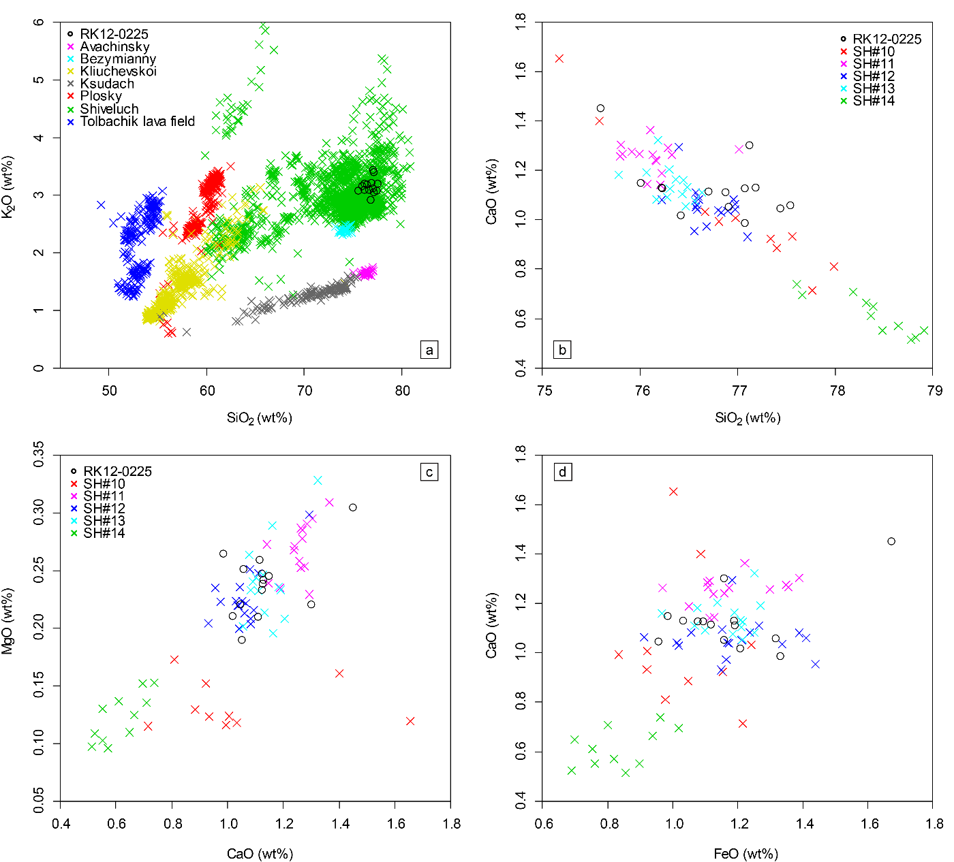

**Fig. 6.** Major element bivariate plots (a) showing glass compositions of RK12-0225 tephra in Lake Kushu, northern Japan and Holocene major tephra markers from different volcanoes in Kamchatka Peninsula, Russia (Kyle et al., 2011; Ponomareva et al., 2013, 2015, 2017); and (b-d) showing glass compositions of distal RK12-0225 tephra and contemporaneous proximal units (SH#14-SH#10) from Shiveluch volcano (Ponomareva et al., 2015).

### Sumatra (V-4/RK12-0819)

The V-4 tephra is found as a 3.5 cm thick distal layer in marine core 79PC ca. 250 km west of the central Sumatra Island (Fig. 1; Salisbury et al., 2012). The glass shards are medium-K dacitic to rhyolitic in composition (65.5-74.2 wt.% SiO2, 2.0-2.9 wt.% K2O) and the eruption is dated to 2120-1740 cal. yr BP (95% confidence) by interpolation between radiocarbon dates (Salisbury et al., 2012). Owing to the scarcity of available glass compositional data on land-based Holocene Indonesian tephras, it has not yet been possible to pinpoint the source for this marine tephra. Nevertheless, Salisbury et al. (2012) suggest that active volcanoes on Sumatra Island are the most probable sources.

Glasses of tephra layer RK12-0819 (n=26, 5222-4988 cal. yr BP) have heterogeneous compositions ranging from dacitic to rhyolitic (65.8-74.4 wt.% SiO2) and belong to the medium-K series (mainly 2.0-2.9 wt.% K2O; Fig. 3a-b). These compositions are very distinctive and do not correlate to any known Holocene tephra layers erupted from NE Asia (Fig. 4a), including tephras from Japan (e.g., Smith et al., 2013; Nakamura, 2016; Razzhigaeva et al., 2016; Moriwaki et al., 2016; McLean et al., 2018; Albert et al., 2018, 2019), Russia (e.g., Kyle et al., 2011; Plunkett et al., 2015; Ponomareva et al., 2013, 2015, 2017; Cook et al., 2018), China/North Korea (e.g., Sun et al., 2014, 2015, 2017, 2018; Chen et al., 2016; McLean et al., 2016, 2018) and South Korea (e.g., Shiihara et al., 2011; Smith et al., 2011a; McLean et al., 2018). Geochemical comparison of RK12-0819 with the V-4 tephra revealed identical compositions on major element glass chemistry (Fig. 7), but given the age discrepancy between RK12-0819 and the V-4, the two horizons cannot be directly correlated. However, their geochemical affinity indicates that they likely have the same provenance and that RK12-0819 could originate from Indonesia. Although the exact provenance of RK12-0819 is not clear at this time, the tephra has great potential to be developed as an important regional marker in Asia, particularly given its possible tropical origin. Further investigations exploring the tephrostratigraphy and geochemical compositions of Indonesian tephras are on-going to secure the source of this distal ash layer.

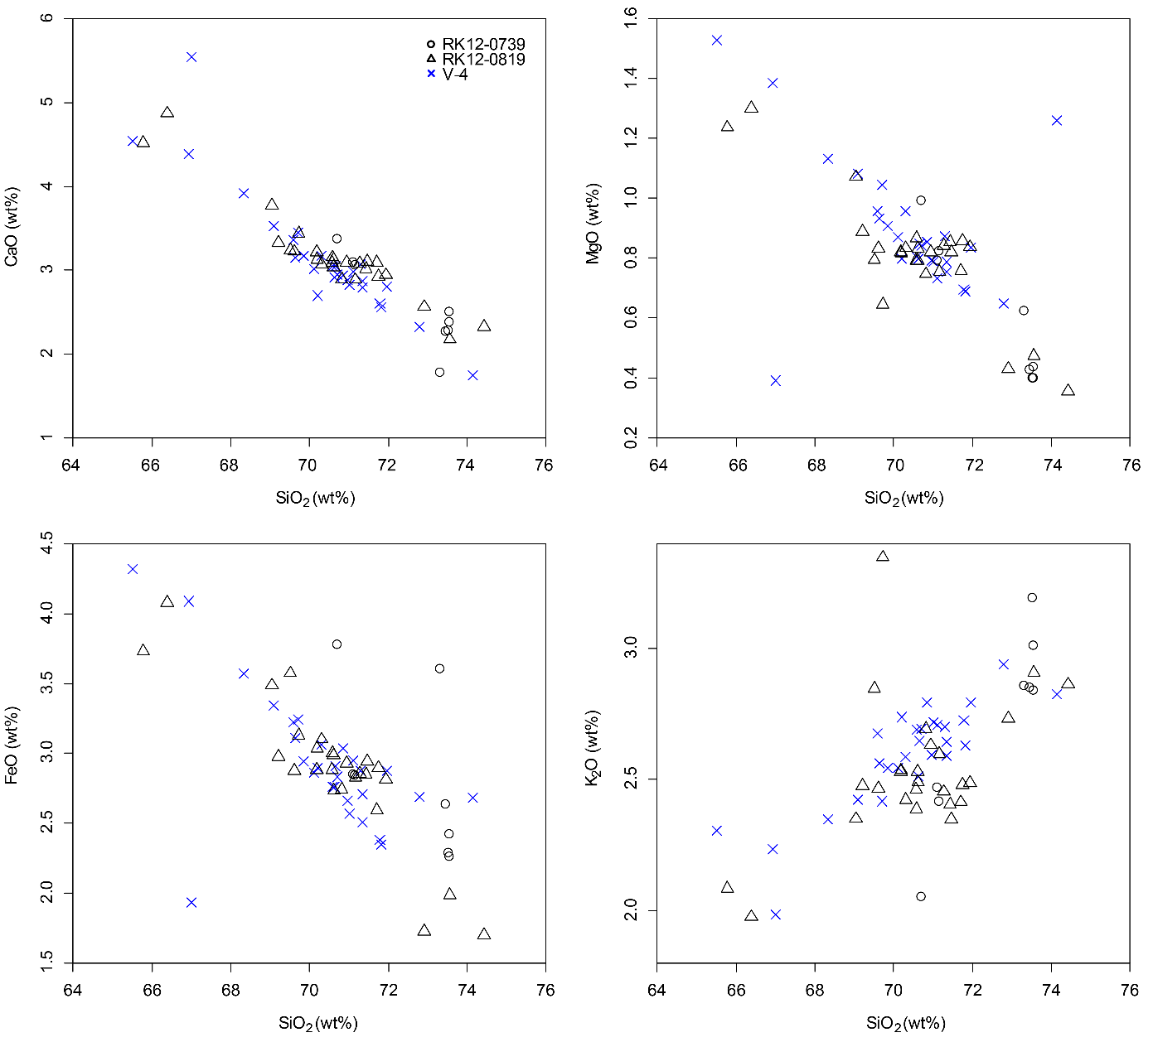

**Fig. 7.** Major element bivariate plots showing glass compositions of prominent tephra layer RK12-0819 and a minor population of RK12-0739 in Lake Kushu, northern Jpan along with glass compositions of the V-4 tephra identified in an Indian Ocean marine core (79PC; Salisbury et al., 2012) for comparison.

## Potential correlations for minor tephra horizons

A continuous background of glass shards are observed through the sediments of the Kushu core, which are likely to be the minor compositional populations geochemically analysed in this study. Their distinctive glass compositions mean that we can also confidently correlate these minor populations to the source regions as shown below:

* Northern Japan: Towada – RK12-0739, Shikotsu – Group 1, Komagatake – Group 2
* Southern Japan: Aira – Group A
* China/North Korea: Changbaishan – RK12-1507, 1391, 0739
* Indonesia: Sumatra – Group 3

### Towada (RK12-0739)

Towada volcano is located in northern Honshu, 555 km S of Lake Kushu (Fig. 1). The volcano has been active throughout the Holocene with eight eruptive episodes (Hayakawa, 1985; Kudo and Sasaki, 2007). Tephras To-a (915 CE; Hayakawa and Koyama, 1998) and To-Cu (6313-6180 cal. yr BP (2σ); Inoue et al., 2011) are the two volumetrically largest Plinian deposits from the volcano during the Holocene (Hayakawa, 1985).

Horizon RK12-0739 contains a minor population (n=2, 4527-4252 cal. yr BP) which is the only group that plots in the low-K series among the six populations of the horizon (Fig. 3b). These glasses are geochemically indistinguishable to the reported To-Cu glass chemistry (Fig. 5). Chronologically, this minor population does not match any known Towada eruptions, as it falls in between the ages of two known eruptive episodes dated to ca. 2.8 and 6.2 cal ka (Kudo and Sasaki, 2007). Furthermore, all significant tephra peaks in the RK12 sequence were examined for the presence of the ca. 6.2 cal ka To-Cu eruption event, however an isochron equivalent to this event was not geochemically identified in the sediments. It is therefore unlikely that RK12-0739 represents the reworked To-Cu in the sequence, and could suggest that Towada was also active at ca. 4.5 cal ka. This finding is consistent with recent observation that the volcano was able to disperse ash (i.e., To-H, ca. 15.7 ka) in a northerly direction over a long distance (i.e., reaching Greenland; Bourne et al., 2016).

### Aira (Group A)

Situated on the subduction zone between the Philippine Sea Plate and the Eurasian Plate, southern Kyushu hosts some of the largest calderas of all Japanese volcanoes (Fig 1). These include Kikai, Aira, Aso and Ata calderas which produced large caldera-forming eruptions (VEI≥7) during late Pleistocene and Holocene, and dispersed tephra layers that mantled most of the Japanese archipelago (Machida and Arai, 2003). The AT tephra (ca. 30 cal ka; Smith et al., 2013) from Aira caldera ca. 1800 km SW of Lake Kushu (Fig. 1), is one of the widespread Kyushu tephras and is estimated to have a bulk volume of over 450 km3 (Machida, 1999).

We find glasses whose compositions are similar with known tephra from Aira (i.e., AT ash), which are restricted within the early Holocene sediments in Lake Kushu. These minor compositional populations of glasses are identified in horizons RK12-1507 (n=3, 8868-8596 cal. yr BP), RK12-1495 (n=4, 8788-8548 cal. yr BP), RK12-1391 (n=5, 8567-8283 cal. yr BP) and RK12-1361 (n=7, 8463-8203 cal. yr BP) and they collectively define unique compositional fields among all RK12 glasses (i.e., group A; Fig. 3c). The group A glasses are geochemically comparable with glasses of the late Pleistocene AT tephra from the Aira caldera (Fig. 8a-b).

Given that (a) the group A glasses only occur within specific timeframe in the Kushu record (ca. 8.8 - 8.2 cal ka), (b) Rebun Island is outside the known extent of visible AT tephra dispersal (Machida and Aria, 2003), and (c) low tephra counts are observed through the older sediments of the Kushu core (i.e., ca. 11-9 cal ka, CD: 1640-1570 cm; Fig. 2), group A glasses are unlikely to be reworked AT tephra. Consequently, our findings indicate a possibility of other post-caldera eruptions from Aira that were not preserved proximally, and were capable of being dispersed intermittently to northern Japan. Nevertheless, in this study we have not identified the precise stratigraphic positioning of the primary ash fall event for these potential Holocene eruptions. As such, more work is needed to corroborate these findings.

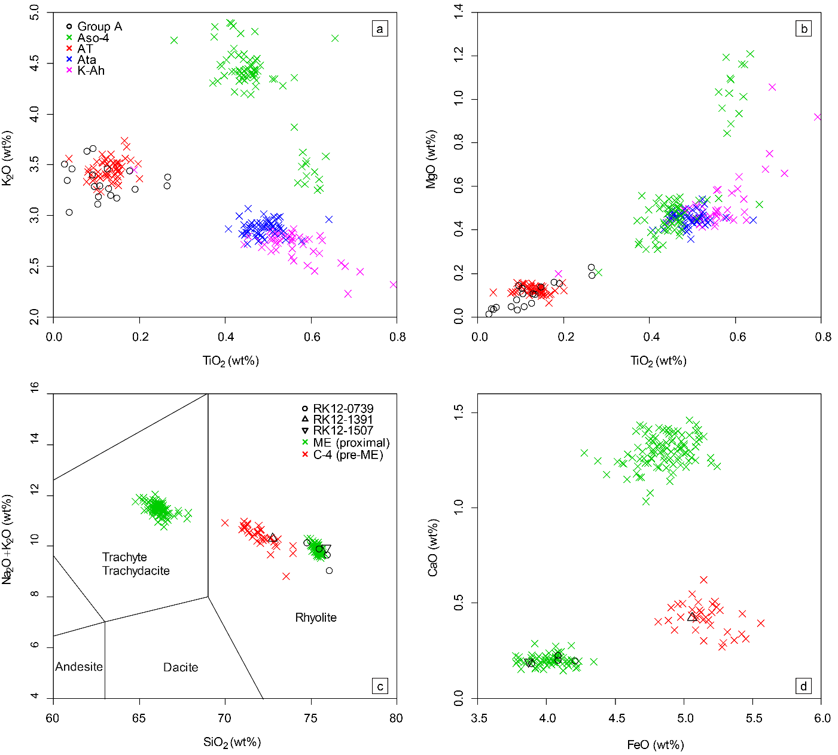

**Fig. 8.** (a-b) Major element bivariate plots showing glass compositions of group A tephras consisting of minor populations of glasses from four early Holocene tephra layers (i.e., RK12-1361, 1391, 1495 and 1507) in Lake Kushu, northern Japan, along with late Quaternary marker tephras derived from large caldera-forming eruptions (VEI≥7) in Kyushu, including K-Ah tephra from Kikai caldera, AT tephra from Aira caldera, Aso-4 tephra from Aso caldera and Ata tephra from Ata caldera (Smith et al., 2013; Albert et al., 2019) for comparison; (c) major element TAS classification diagram (Le Bas et al., 1986) and (d) bivariate plot showing glass compositions of minor population or individual analyses from tephra layers RK12-0739, RK12-1391 and RK12-1507 in Lake Kushu, northern Japan exhibiting typical Changbaishan features, along with glass compositions of the proximal ME tephra (Chen et al., 2016) and a pre-Millennial tephra (i.e., C-4; this study) from the Changbaishan volcano for comparison.

### Changbaishan (RK12-1507, 1391, 0739)

Changbaishan volcano is an intraplate stratovolcano on the border between China and North Korea, ca. 1100 km WSW of Lake Kushu (Fig. 1). The volcano is known for its Millennium Eruption (ME) that occurred at 946 CE (Xu et al., 2013; Sigl et al., 2015; Oppenheimer et al., 2017; Hakozaki et al., 2018) with tephra (i.e., B-Tm) dispersed to northern and central Japan (Chen et al., 2016; McLean et al., 2016) as well as Greenland (Sun et al., 2014). Recently, an additional Holocene distal Changbaishan tephra (i.e., SG14-1058) was reported in the sediments of Lake Suigetsu, central Japan (McLean et al., 2018), which has been correlated to a lacustrine layer in a proximal lake (Sun et al., 2018). In the following section we will investigate the glass chemistry of a proximal pre-Millennial deposit, the C-4 yellow pumice (ca. 4-5 ka; Wang et al., 2001; Yang et al., 2014) sampled at the crater rim (c.f., Chen et al., 2016), along with those of our distal tephras.

Glasses from Changbaishan exhibit distinctive trachytic to rhyolitic compositions and are clearly separated from glasses from volcanoes in the neighbouring regions (e.g., Russia, Japan and South Korea; Fig. 4). The B-Tm ash has been identified in the upper sequence of the Kushu core (i.e., RK12-0151, Fig. 4; Chen et al., 2016). Interestingly, in this study we find individual analyses with Changbaishan glass compositions in several older sections of the core. These glasses are identified in horizons RK12-1507 (n=1, 8868-8596 cal. yr BP), RK12-1391 (n=1, 8567-8283 cal. yr BP) and RK12-0739 (n=4, 4527-4252 cal. yr BP) and they geochemically overlap with proximal deposits from the Millennium and pre-Millennial eruptions (Fig. 8c-d). The oldest occurrence of these glass compositions is dated to ca. 8.7 cal ka (i.e., in RK12-1507), suggesting the eruption event is likely to be close to or prior to this date. We also analysed a single glass shard in horizon RK12-1391 (8567-8283 cal. yr BP) which compositionally overlaps with the proximal C-4 unit (Fig. 8c-d). This indicates that as expected this event was explosive and has dispersal potential. However, given its controversial distal and proximal ages, further work is required to determine the eruptive age and the primary plume dispersal of the event. A ca. 4.4 cal ka potential eruption is also identified in the sequence (i.e., in RK12-0739), whose glass compositions overlap with the rhyolitic end-member of the proximal ME tephra (Fig. 8c-d). Nevertheless, it does not match any known proximal records both geochemically and chronologically. As such, further work is needed to verify this potential event.

### Shikotsu (Group 1)

Shikotsu caldera is situated in southwestern Hokkaido and is 300 km S of Lake Kushu (Fig. 1). The caldera was formed ca. 39-40 ka ago (Katoh et al., 1995; Aoki and Arai, 2000) during the climactic eruption that produced the pumice fall deposit Spfa-1 and the subsequent pumice flow deposits Spfl-2 and Spfl-1 (Katsui, 1963). The Spfa-1 was dispersed towards ESE and found as visible layer in marine cores in the northwestern Pacific Ocean over 700 km from the source (Machida and Arai, 2003).

We find minor populations of glasses from nine layers in the RK12 core (group 1; Table 2) whose compositions closely resemble the Late Pleistocene Spfa-1 tephra (Fig. 9a-b). These glasses range from the early Holocene to late Holocene in age. However, Shikotsu caldera is not thought to have been active during the Holocene (Arai et al., 1986). The continuous inwash of the Spfa-1 tephra into Lake Kushu from ca. 40 cal ka until late Holocene will require a fairly thick deposit in the catchment area. On Rishiri Island, where an outcrop is ca. 40 km closer to Shikotsu compared to Lake Kushu, the Spfa-1 was only found as a 2 cm visible layer (Ishizuka, 1999). As a result it is less likely for the tephra with a < 2 cm thickness on the further Rebun Island to be reworked for a time period of over 38 ka (i.e., in RK12-0371, ca. 2 cal ka). Nevertheless, it has not been possible to identify the primary tephra input for these potential Shikotsu Holocene eruptions.

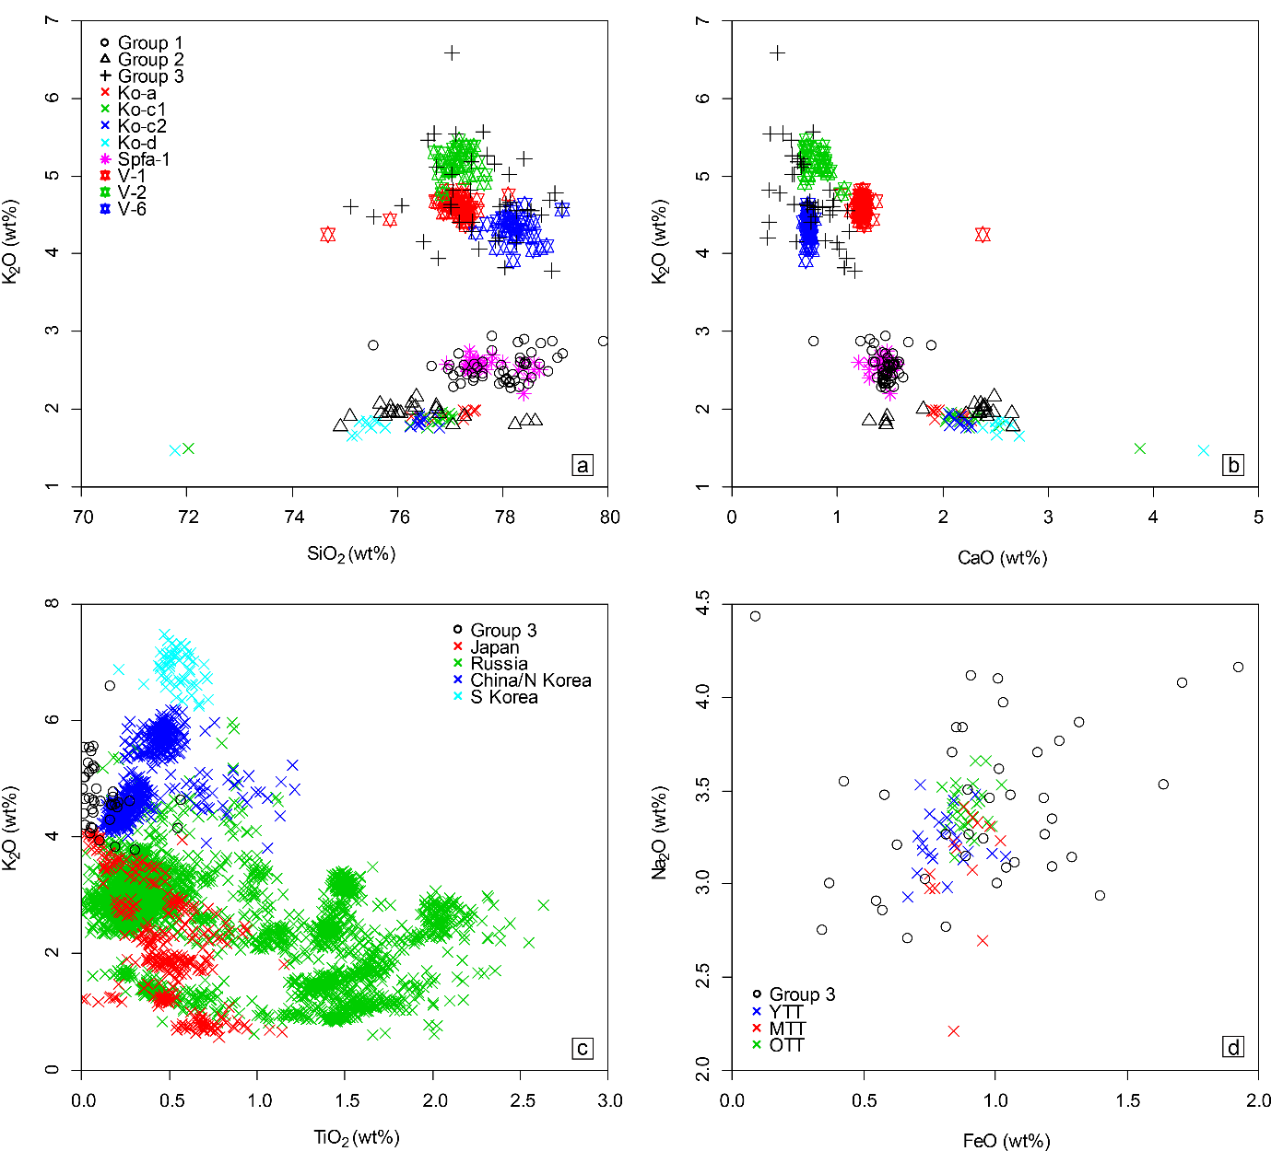

**Fig. 9.** Major element bivariate plots (a-b) showing glass compositions of compositional groups 1, 2 and 3 each containing tephras from multiple layers in Lake Kushu, northern Japan, which share similar glass compositions, along with tephra deposits from Shikotsu caldera (Spfa-1; Machida and Arai, 2003; Albert et al., 2019), Komagatake volcano (Ko-a, Ko-c1, Ko-c2 and Ko-d; Nakamura, 2016) and Indian Ocean marine cores (V-1, V-2 and V-6; Salisbury et al., 2012) for comparison; (c) showing compositional comparison between the group 3 glasses and Holocene tephras from NE Asia (data sources see caption of Fig. 4); and (d) showing compositional comparison between the group 3 glasses and glasses of Youngest Toba Tuff (YTT), Middle Toba Tuff (MTT) and Oldest Toba Tuff (OTT) from Toba caldera, Sumatra (Smith et al., 2011b).

### Komagatake (Group 2)

As mentioned earlier, Komagatake volcano is known to have produced six Plinian eruptions during the Holocene, two of which were in mid-Holocene while the other four were in historic time (Katsui and Komuro, 1984; Okuno et al., 1999; Nakamura and Hirakawa, 2004). Glass compositions of the historic tephras (i.e., Ko-d, Ko-c2, Ko-c1 and Ko-a) are more evolved compared to the mid-Holocene eruptions (e.g., Ko-g). The RK12 sequence records the mid-Holocene Ko-g tephra of the volcano (see section 5.1.2).

Compositional group 2 includes minor populations of glasses from six horizons in the RK12 sequence (Table 2) and they range from early to mid-Holocene in age (Table 1). These glasses compositionally overlap with the Komagatake historic tephras (Fig. 9a-b) and do not correlate to any reported tephra in their timeframe for geographically closer volcanoes. This indicates that either the volcano had early Holocene eruptions that were not preserved in the proximal sites, or the pre-Holocene Komagatake tephras (e.g., Ko-h; Ganzawa et al., 2005) were continuously reworked into the early to mid-Holocene. Nevertheless, glass chemistry of the pre-Holocene Komagatake tephras is not available at this time thus more work is required in the future for this productive volcano.

### Sumatra (Group 3)

Compositional group 3 encompasses minor populations of glasses from eleven horizons in the RK12 sequence (Table 2). These glasses are characterised by high SiO2 (75.1-79.1 wt.%) and K2O (mainly 3.8-5.6 wt.%), coupled with low TiO2 (mainly 0.0-0.3 wt.%) contents (Fig. 3). Compositional comparisons revealed no potential correlations to known Holocene tephra deposits from Japan, Russia, China/North Korea and South Korea for these group 3 glasses (Fig. 9c).

Late Pleistocene tephras V-1, V-2 and V-6 were reported from Indian Ocean marine cores ca. 300 km away from Sumatra (16GC, 18GC and 65PC; Fig. 1a) and dated to ca. 27-110 ka (Salisbury et al., 2012). Glasses from these three layers exhibit low TiO2 and high K2O features and are distinguishable from other late Pleistocene to Holocene marine tephras found in the same region (Salisbury et al., 2012). These three tephra layers, though compositionally separated from one another, collectively define compositional fields that overlap the group 3 glasses on all major elements (e.g., Fig. 9a-b). As with the V-4 tephra (see section 5.1.4), Salisbury et al. (2012) did not manage to correlate them to their proximal counterparts. However, they suggested that these tephras are very likely to come from volcanoes in Sumatra given the geographic proximity between the cores and the island. Meanwhile they pointed out that the V-2 tephra (ca. 110 ka) is geochemically similar to the Youngest Toba Tuff (ca. 75 ka, Mark et al., 2014) from the Toba caldera in northern Sumatra (Fig. 1a). Compositional comparisons with the known Toba tuffs (i.e., Oldest, Middle and Youngest Toba tuffs dated to ca. 790 ka, 500 ka and 75 ka respectively; Chesner et al., 1991; Lee et al., 2004) reveal that the group 3 glasses are similar to those of the three Toba tuffs but have greater compositional variations (e.g., Fig. 9d). These multiple lines of evidence indicate that Lake Kushu might receive tephras erupted from Sumatra probably under favourable weather conditions, but we have not yet been able to resolve the primary peaks for these potential far-travelled tephras.

## Tephra layer requiring further analysis

### Minor population in RK12-0739

Horizon RK12-0739 contains a population (n=8, 4527-4252 cal. yr BP) whose compositions partly resemble the RK12-0819 tephra. These glasses are dacitic to rhyolitic and overlap with the rhyolitic end-member compositions of the RK12-0819 glasses (Fig. 3a). Stratigraphically, the RK12-0739 and the underlying RK12-0819 are separated by over 60 cm of sediments that contain low glass shard concentrations (Fig. 2). Moreover, high-resolution point-sample counts suggest that tephra distribution of RK12-0819 within the sequence is largely restricted to CD 818-820 cm (Fig. 2e). These facts indicate that this minor population in RK12-0739 is less likely to be reworked from the underlying RK12-0819, though they exhibit similar glass chemistry (Fig. 7). However, at this time we are not able to completely rule out the possibility of redeposition of tephra due to high-energy or other post-depositional events. In addition, the limited geochemical variation (Fig. 7) and number of analyses of the population prevent the establishment of a second isochron that have the same origin with RK12-0819 in the sequence. Consequently, more analyses in terms of stratigraphy and geochemistry are required to identify whether this is a primary layer and its source.

# Discussion

## The integrated RK12 tephrostratigraphy and its implications

To date, the Lake Kushu RK12 record presents the first comprehensive Holocene cryptotephra stratigraphy in northern Japan, which integrates tephras from multiple regions including Japan, Russia, China/North Korea and most likely Indonesia. Twelve significant peaks in glass shard concentrations throughout the Holocene sediments have been investigated, within which five prominent cryptotephra layers are identified, precisely dated and correlated to the specific eruptions or the source region (Fig. 10). These marker tephra layers are extremely valuable for palaeoenvironmental studies. This is because on one hand, the RK12 record is the only available confidently-dated high-resolution palaeoenvironmental record from northern Japan (Müller et al., 2016; Leipe et al., 2018). On the other hand, the tephra layers are very widely dispersed. For example, the RK12-0151 is correlated to the B-Tm tephra that has been identified in the Greenland ice-cores (Sun et al., 2014), the RK12-0225 and RK12-0819 are correlated to tephras identified in Kamchatka and the Indian Ocean, respectively. These localities range from the polar region through high northern latitudes to the tropics. As a result, archives that span a vast geographical area are now possible to be synchronised with the Lake Kushu record, which facilitates the interreginal comparison of palaeoclimate and environmental data.

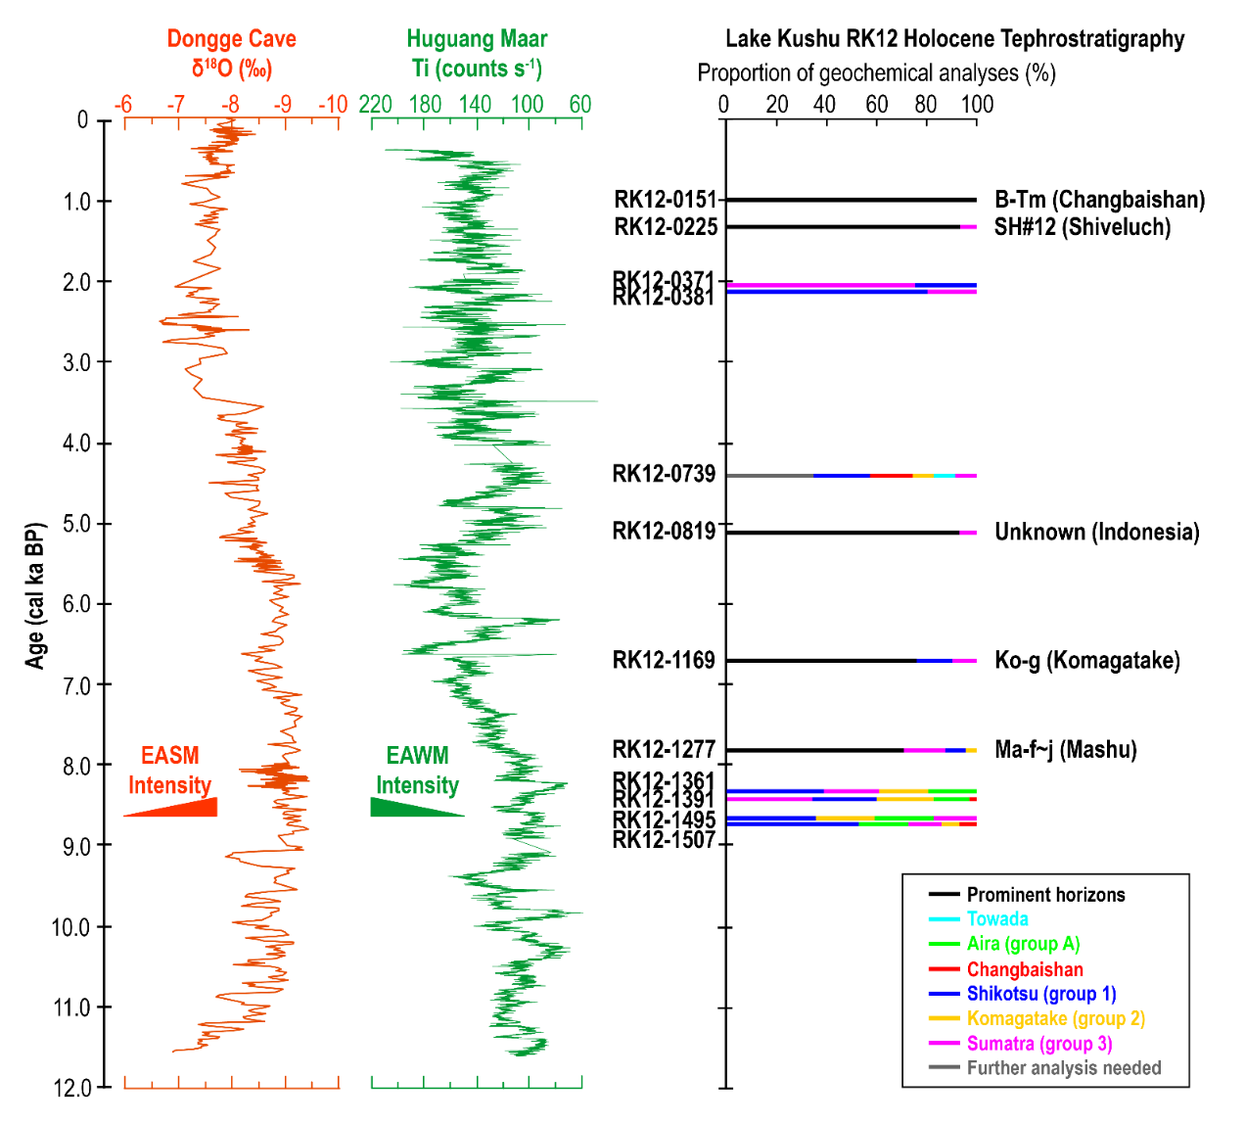

**Fig. 10** The summarised Lake Kushu RK12 Holocene cryptotephra stratigraphy plotted against the δ18O record from Dongge Cave (Dykoski et al., 2005) and the Ti content record from Lake Huguang Maar (Yancheva et al., 2007), SE China. The two records were plotted on their independent age models and interpreted as proxy of the intensity of the East Asian summer monsoon (EASM) and winter monsoon (EAWM), respectively. The depositions of some of the prominent tephra horizons in the record coincide with rapid climate change events (see main text). Stratigraphic positioning of the tephra horizons is based on the mid-point of their age arranges. The length of the bars in each horizon indicates the amount of glass shards (%) and are arranged in a descending order.

A high resolution pollen study is published for the upper part of the RK12 Holocene sequence (last ca. 6 ka; Leipe et al., 2018). This record documents the mid- to late Holocene vegetation and climate changes in northern Japan at a bi-decadal resolution. Three key maker tephra layers have been identified within this time period, they are the B-Tm erupted from Changbaishan (Chen et al., 2016), the SH#12 and RK12-0819 derived from Kamchatka and Indonesia, respectively. Interestingly, the oldest RK12-0819 (CD: 820-818 cm) falls very closely to the pollen boundary (CD: 822.5 cm) between local pollen zones 3 and 2b (Fig. 11; Leipe et al., 2018). At this time, the lake conditions significantly changed from an unstable lagoon phase characterising by short-term but intensive sea water influxes, to a stable freshwater lake system (Leipe et al., 2018; Schmidt et al., 2019), which might be related to past sea level changes. Identification of this tephra layer in other high-resolution records will permit an assessment of whether this change occurs simultaneously in other regions, which will provide a better understanding of regional variations of past climatic/environmental changes. In addition, the identification of the B-Tm tephra in the sequence (Chen et al., 2016), coupled with the pollen record (Leipe et al., 2018), indicates that the Millennium Eruption of Changbaishan volcano, though with the ability to disperse tephra to Greenland (Sun et al., 2014), had limited or no impact on environments of northern Japan, given that no significant changes were observed on the Kushu pollen record immediately after the eruption (Fig. 11). This provides additional evidence to support the limited regional environmental effects of the eruption, despite its great magnitude (6.8; Xu et al., 2013).

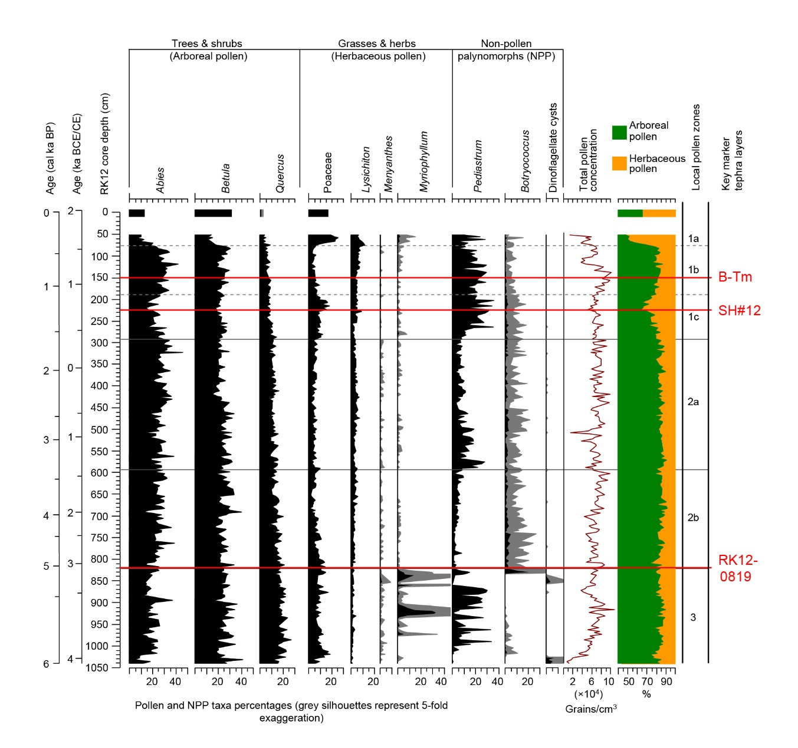

**Fig. 11** Key marker tephra layers identified in this study plotted against several representative pollen and NPP taxa from the last 6 ka high-resolution pollen record of the RK12 composite sequence (simplified from Leipe et al., 2018).

From a broader perspective, the timing of some of our marker tephra layers coincides with important climate changes. For instance, the Ko-g from Komagatake volcano (ca. 6.7 cal ka) was deposited prior to a decadal-scale event revealed by a dramatic oscillation of Ti content (Fig. 10; Yancheva et al., 2007) recorded in Lake Huguang Maar, SE China (Fig. 1a). This short-lived oscillation was followed by a significant multi-centennial-scale decrease of Ti content in the sediment, interpreted as weakened East Asian winter monsoon (EAWM; Yancheva et al., 2007), terminating its earlier intensifying trend since ca. 8 ka (Fig. 10). In contrast, the intensity of the East Asian summer monsoon (EASM) recorded in Dongge Cave, China (Fig. 1a), was not characterised by such dramatic changes at the same time (Fig. 10; Dykoski et al., 2005). The presence of the Ko-g in Lake Kushu, coupled with the on-going high-resolution proxy analyses, will allow the verification of the existence and the precise timing of these climatic events. We thus suggest that the Kushu RK12 archive, where widely dispersed marker tephra layers registered and high-resolution proxy records available, is one of the key study sites for future palaeoenvironmental research.

Cryptotephra analysis through the RK12 core has also revealed a number of horizons consisting of minor populations of glasses (Fig. 10). These minor populations of glasses are characterised by distinctive chemistries that allow them to be correlated to the sources. Although, at this time we can not be sure of the precise stratigraphic positioning of the primary ash fall, and therefore age of these eruptive events, the presence of these volcanic glasses indicates that their source volcanoes have the potential to disperse ash to the northernmost regions of Japan. For example, the AT tephra erupted from Aira caldera in southern Kyushu (Fig. 1) was known to reach the northern Honshu but has not been reported in Hokkaido (Machida, 1999). Our study, however, reported glasses from Aira (i.e., group A) in the northernmost Hokkaido, suggesting that tephras from Aira travelled further than previously thought. Moreover, we also find certain minor compositions that occur at or cluster within a specific time period. These include the presence of Towada derived glasses at ca. 4.4 cal ka, Changbaishan glasses at ca. 8.7, 8.4 and 4.4 cal ka and Aira glasses spanning 8.8-8.2 cal ka (Fig. 10). Compared to chemistries that occur throughout the core (i.e., groups 1, 2 & 3), these minor populations of glasses suggest that the primary depositions of the ash layers are likely to be stratigraphically closely positioned. Given that the age of these glasses in Lake Kushu do not correspond with known eruption events, these findings could suggest that there are other undocumented eruptions that have yet to be identified in the geological record. Consequently, further studies are required to constrain their eruptive histories.

## Updated tephra dispersal in East Asia

The RK12 cryptotephra record significantly extends the known dispersal of several key tephra isochrons in East Asia. These include the Ko-g and Ma-f~j from Hokkaido, the SH#12 from Kamchatka and the B-Tm from China/North Korea. Although the B-Tm tephra has previously been reported in Greenland (Sun et al., 2014), its correlative in Lake Kushu (i.e., RK12-0151; Chen et al., 2016) currently represents the most northerly occurrence of the tephra in East Asia (Fig. 12), which places constraint on the possible distribution route of the ash plume.

Owing to the prevailing westerlies, the Hokkaido Ko-g and Ma-f~j tephras were dispersed towards ENE and ESE, respectively (Furukawa and Nanayama, 2006; Katsui, 1963). The Lake Kushu is not located within the previously known dispersal areas of the two tephras, neither is it located in their main dispersal directions (Fig. 1b). The occurrences of these horizons in Lake Kushu have largely extended their distribution areas and help to constrain the western limits of tephra dispersal (Fig. 12). Our new data indicate that the Ko-g mantles the entire Hokkaido while the Ma-f~j covers at least its northern half (Fig. 12).

The SH#12 (SH1450) tephra from the Shiveluch volcano was known to have a SE dispersal axis (Fig. 1b) and was identified in the eastern Kamchatka (50-100 km; Ponomareva et al., 2017) and probably in the Bering Island (ca. 300 km; Kyle et al., 2011). The presence of the SH#12 in Lake Kushu documents the first example of a Russian tephra occurring in Japanese archipelago, confirming a distance of ca. 1900 km from its source (Fig. 12). Given that tephra study in southern Kuril Islands did not report Kamchatkan tephras (Razzhigaeva et al., 2016), the Lake Kushu thus provides the first stepping stone site to link the two volcanically active regions (i.e., Japan and Kamchatka) within the Holocene timeframe. More importantly, the lake is located SW of the Shiveluch volcano, not in the main axis of the eruption’s primary plume distribution (Fig. 1b). This indicates that the tephra is likely to be traced following its main dispersal direction over 1900 km into the Aleutian Arc, the Bering Sea and probably the SW Alaska. As a result, the SH#12 has great potential to be developed as an important marker linking records in the northwestern Pacific region.

The Kushu cryptotephra stratigraphy provides an important northern archive for the construction of a Holocene tephra lattice for East Asia, which for the first time, introduces Russian tephra into the regional tephra lattice. Lake Suigetsu, where lots of visible tephra and cryptotephra layers are recorded, is the other tephrostratotype in the region (McLean et al., 2018). The pioneering cryptotephra results from the two lakes (McLean et al., 2018; and this study) are currently constraining the up-to-date tephra dispersal in the region (Fig. 12). These fruitful outcomes demonstrate the significance potential of the cryptotephra technique (e.g., Blockley et al., 2005) in facilitating the establishment of a more comprehensive regional tephra lattice that is essential for high-resolution palaeo-proxies comparison.

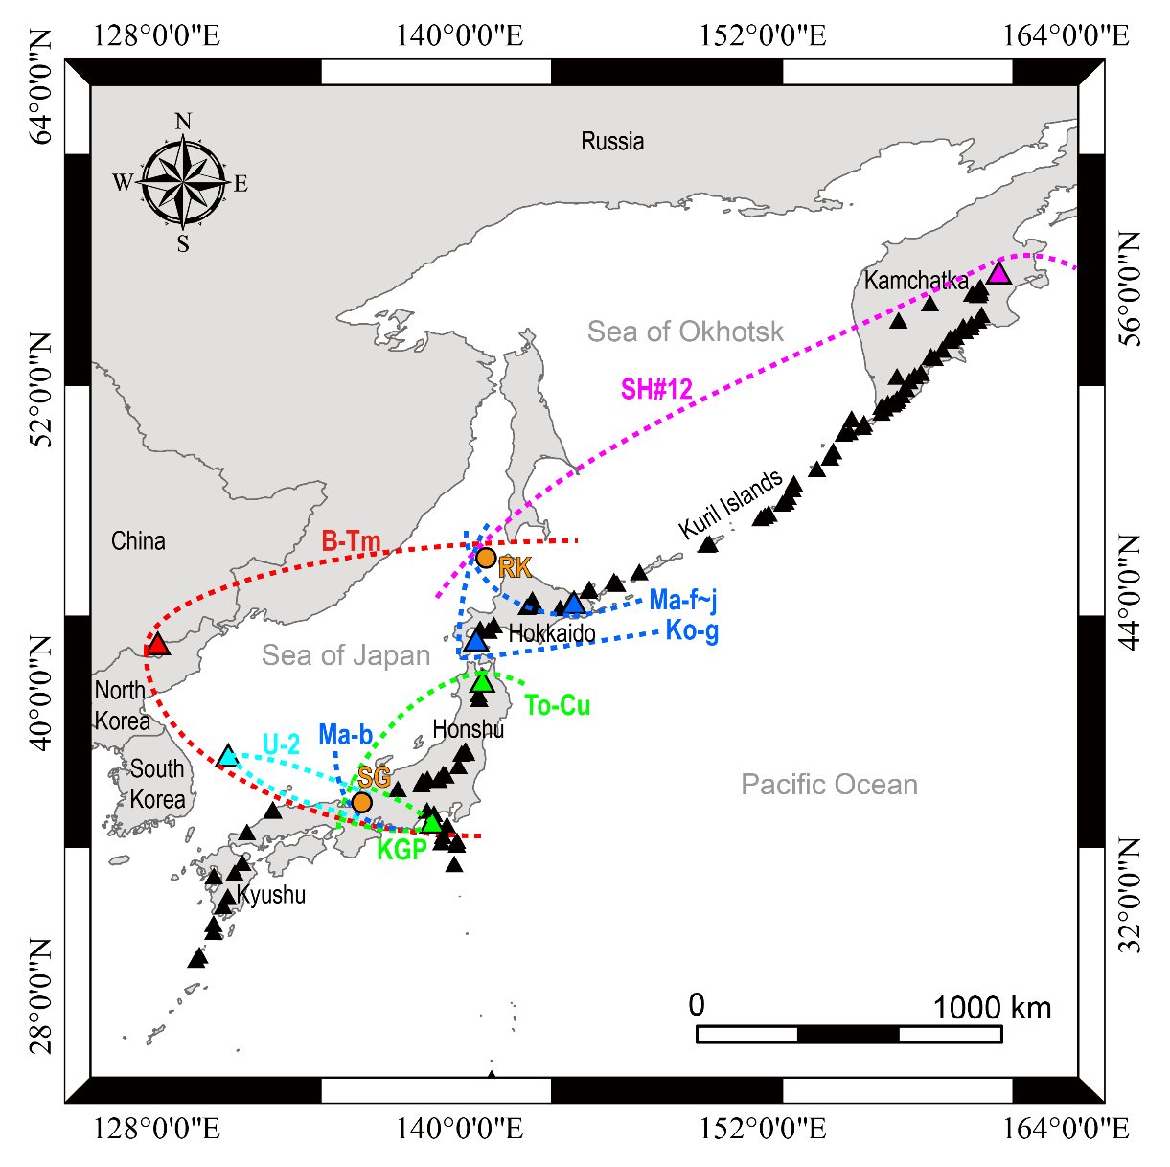

**Fig. 12** The cryptotephra results of two Holocene tephrostratigraphy studies from Lake Suigetsu (McLean et al., 2018) and Lake Kushu (this study) in East Asia. The findings of the cryptotephra horizons in the two lakes are currently constraining the known dispersal limits of the ash layers, which provide fundamental information for the construction of an up-to-date cryptotephra lattice in the region. The Lake Kushu archive, for the first time, introduces a Russian tephra (SH#12) and probably Indonesian tephras (not shown) into the East Asian tephra lattice.

## Implication of potential tropical tephras in northern Japan

Cryptotephra layers preserved in the sediments of Lake Kushu have been predominantly correlated to volcanoes in NE Asia (i.e., Japan, China/North Korea, Russia). However, a few remaining horizons in the sequence, including the prominent layer RK12-0819 exhibit chemical affinities that do not match with known NE Asian eruptions. These horizons have been compared to tephras identified in the Indian Ocean with possible Sumatran origins, whose glass chemistries have been demonstrated to provide better matches (see sections 5.1.4 & 5.2.6). Due to the fact that cryptotephra studies at tropical SE Asia (e.g., Indonesia, Philippines) are in their infancy, we are not able to pinpoint the specific eruptions for these potential Indonesian tephras. Nevertheless, our finding of Indonesian tephras in northern Japan indicates the possibility that we have just lifted the lid on a potential revolution in tephra studies and tephrochronology in the region. At present there are no long term cryptotephra studies published for East Asia, south of Lake Suigetsu. Even this important site has only one cryptotephra study published so far (McLean et al., 2018). Large volume tropical eruptions are also known to have the greatest chance of influencing climate as the atmospheric dispersal pattern in the tropics is most likely to disperse globally (Robock, 2000). Therefore, we believe that there is considerable potential to extend the East Asian tephra lattice to the entire Asia region. This would be important for a number of reasons not least testing proposed influences of past climate change on the Intertropical Convergence Zone and the Asian monsoon. However in order for this framework to be developed it is now essential that a more systematic approach to the application of cryptotephra studies is applied to lacustrine and marine records from the region.

# Conclusions

This study presents the first detailed Holocene cryptotephra stratigraphy for northern Japan using the high-resolution RK12 core from Lake Kushu, Rebun Island. The RK12 tephrostratigraphy integrates local and far-travelled tephras originating from Japan, Russia, China/North Korea and most likely Indonesia. The finding of the key tephra layers in the lake (i.e., B-Tm – Changbaishan; SH#12 – Shiveluch; Ko-g – Komagatake; Ma-f~j – Mashu and RK12-0819 with possible Indonesian origin) allows widespread palaeoclimate archives, spanning from the polar region through the high northern latitudes to the tropics, to be synchronised with the regionally significant Kushu record, thus facilitates interregional comparison of palaeoclimate and environmental data. In addition, our detailed tephra analysis also reveals a number of horizons that consist of minor populations of glasses. The presence of these glasses indicates wider ash dispersal for multiple volcanic sources, compared to results derived from visible tephra studies (e.g. Aira tephra reaching northernmost Japan). Moreover, some of these minor populations of glasses only occur at specific timeframe (e.g., Changbaishan glasses), which could indicate unknown eruptions at nearby time window. Nevertheless, further work on finding shards and geochemical analysis is needed to enhance the reliability of our correlations for these minor horizons.

The Lake Kushu cryptotephra record significantly extends the ash dispersal of several key tephra deposits in the region, including the most noteworthy finding of a Russian tephra (i.e., SH#12 from Shiveluch volcano) onshore in Japan (ca. 1900 km). This facilitates the construction of a Holocene tephra lattice for East Asia through providing an important northern element of the regional tephra lattice. Along with cryptotephra results from Lake Suigetsu (McLean et al., 2018), an updated tephra distribution map of the region is shown, where the edge of tephra dispersal is constrained by the identification of cryptotephra horizons. The identification of potential Indonesian tephras in the sequence (RK12-0819 and group 3 tephras) indicates a possibility to extend the tephra lattice from the East Asian region to entire Asia, which is essential for the understanding of how climate changes propagate over large geographical areas. Combined with high-resolution pollen record from the lake and records from a broader region, our tephra results confirm that the large magnitude Millennium Eruption (VEI=6.8) of the Changbaishan volcano, China/North Korea had limited impact on northern Japan environments, and indicate the potential of utilising tephra layers to test leads and lags in climate archives given that their depositions coincide with past climate changes.

# Acknowledgements

This study was supported by the External Cooperation Program of Bureau of International Co-operation, Chinese Academy of Sciences (Grant No. 132744KYSB20130005) and CAS Strategic Priority Research Program (B) (XDB18000000). XYC's stay at RHUL is supported by the collaboration scheme between GIGCAS and RHUL. DM is funded by NERC (grant: NE/L002612/1) as part of the Environmental Research Doctoral Training Program at the University of Oxford. We would like to thank Drs Yugo Nakamura, Akiko Matsumoto and Miki Shiihara for providing full dataset of glass chemistry in their published papers; Dr Eliza Cook for providing unpublished data from Greenland ice-cores for geochemical comparison; Dr Stefanie Müller for providing additional lake core materials. We are grateful to Drs Victoria Smith and Paul Albert for their analytical supports, Dr Chris Hayward for his assistance during geochemical analyses. XYC would like to thank Katy Flowers for her help at the cryptotephra laboratory at RHUL, and Dr Aike for his assistance on producing Figs. 1 and 12. The authors would like to thank Professor Siwan Davies, Dr Anna Bourne and an anonymous reviewer for their positive feedback on an earlier version of the manuscript. Last but not least, we would like to thank Dr Hitoshi Yonenobu who organized coring of Lake Kushu and Prof Mayke Wagner who greatly contributed to the AMS 14C dating of the RK12 core sediment. The Baikal–Hokkaido Archaeology Project (BHAP) supported by the Major Collaborative Research Initiative (MCRI) programme of the Social Sciences and Humanities Research Council of Canada greatly stimulated recent research activities on Rebun Island.

# References

Albert, P.G., Smith, V.C., Suzuki, T., McLean, D., Tomlinson, E.L., Miyabuchi, Y., Kitaba, I., Mark, D.F., Moriwaki, H. and Nakagawa, T., 2019. Geochemical characterisation of the Late Quaternary widespread Japanese tephrostratigraphic markers and correlations to the Lake Suigetsu sedimentary archive (SG06 core). Quat Geochronol, doi: https://doi.org/10.1016/j.quageo.2019.01.005.

Albert, P.G., Smith, V.C., Suzuki, T., Tomlinson, E.L., Nakagawa, T., McLean, D., Yamada, M., Staff, R.A., Schlolaut, G. and Takemura, K., 2018. Constraints on the frequency and dispersal of explosive eruptions at Sambe and Daisen volcanoes (South-West Japan Arc) from the distal Lake Suigetsu record (SG06 core). Earth-Sci Rev, 185: 1004-1028.

Aoki, K. and Arai, F., 2000. Late Quaternary tephrostratigraphy of marine core KH94-3, LM-8 off Sanriku, Japan. The Quaternary Research (Daiyonki-kenkyu), 39(2): 107-120 (in Japanese with English abstract).

Aoki, K., Irino, T. and Oba, T., 2008. Late Pleistocene tephrostratigraphy of the sediment core MD01-2421 collected off the Kashima coast, Japan. The Quaternary Research (Daiyonki-kenkyu), 47: 391-407 (in Japanese with English abstract).

Arai, F., Machida, H., Okumura, K., Miyauchi, T., Soda, T. and Yamagata, K., 1986. Catalog for late quaternary marker-tephras in japan ii : tephras occurring in northeast honshu and hokkaido. Geographical reports of Tokyo Metropolitan University, 21: 223-250.

Blockley, S.P.E., Bourne, A.J., Brauer, A., Davies, S.M., Hardiman, M., Harding, P.R., Lane, C.S., MacLeod, A., Matthews, I.P., Pyne-O’Donnell, S.D.F., Rasmussen, S.O., Wulf, S. and Zanchetta, G., 2014. Tephrochronology and the extended intimate (integration of ice-core, marine and terrestrial records) event stratigraphy 8–128 ka b2k. Quaternary Science Reviews, 106: 88-100.

Blockley, S.P.E., Lane, C.S., Hardiman, M., Rasmussen, S.O., Seierstad, I.K., Steffensen, J.P., Svensson, A., Lotter, A.F., Turney, C.S.M. and Bronk Ramsey, C., 2012. Synchronisation of palaeoenvironmental records over the last 60,000 years, and an extended INTIMATE event stratigraphy to 48,000 b2k. Quaternary Science Reviews, 36: 2-10.

Blockley, S.P.E., Pyne-O’Donnell, S.D.F., Lowe, J.J., Matthews, I.P., Stone, A., Pollard, A.M., Turney, C.S.M. and Molyneux, E.G., 2005. A new and less destructive laboratory procedure for the physical separation of distal glass tephra shards from sediments. Quaternary Science Reviews, 24(16–17): 1952-1960.

Bourne, A.J., Abbott, P.M., Albert, P.G., Cook, E., Pearce, N.J.G., Ponomareva, V., Svensson, A. and Davies, S.M., 2016. Underestimated risks of recurrent long-range ash dispersal from northern Pacific Arc volcanoes. Scientific Reports, 6: 29837.

Bourne, A.J., Cook, E., Abbott, P.M., Seierstad, I.K., Steffensen, J.P., Svensson, A., Fischer, H., Schüpbach, S. and Davies, S.M., 2015. A tephra lattice for Greenland and a reconstruction of volcanic events spanning 25–45 ka b2k. Quaternary Science Reviews, 118: 122-141.

Bourne, A.J., Lowe, J.J., Trincardi, F., Asioli, A., Blockley, S.P.E., Wulf, S., Matthews, I.P., Piva, A. and Vigliotti, L., 2010. Distal tephra record for the last ca 105,000 years from core PRAD 1-2 in the central Adriatic Sea: implications for marine tephrostratigraphy. Quaternary Science Reviews, 29(23): 3079-3094.

Chen, X.-Y., Blockley, S.P.E., Tarasov, P.E., Xu, Y.-G., McLean, D., Tomlinson, E.L., Albert, P.G., Liu, J.-Q., Müller, S., Wagner, M. and Menzies, M.A., 2016. Clarifying the distal to proximal tephrochronology of the Millennium (B–Tm) eruption, Changbaishan Volcano, northeast China. Quat Geochronol, 33: 61-75.

Chesner, C.A., Rose, W.I., Deino, A., Drake, R. and Westgate, J., 1991. Eruptive history of Earth's largest Quaternary caldera (Toba, Indonesia) clarified. Geology, 19(3): 200-203.

Cook, E., Portnyagin, M., Ponomareva, V., Bazanova, L., Svensson, A. and Garbe-Schönberg, D., 2018. First identification of cryptotephra from the Kamchatka Peninsula in a Greenland ice core: Implications of a widespread marker deposit that links Greenland to the Pacific northwest. Quaternary Science Reviews, 181: 200-206.

Crosweller, H.S., Arora, B., Brown, S.K., Cottrell, E., Deligne, N.I., Guerrero, N.O., Hobbs, L., Kiyosugi, K., Loughlin, S.C., Lowndes, J., Nayembil, M., Siebert, L., Sparks, R.S.J., Takarada, S. and Venzke, E., 2012. Global database on large magnitude explosive volcanic eruptions (LaMEVE). Journal of Applied Volcanology, 1(1): 4.

Davies, S.M., 2015. Cryptotephras: the revolution in correlation and precision dating. Journal of Quaternary Science, 30(2): 114-130.

Davies, S.M., Abbott, P.M., Meara, R.H., Pearce, N.J.G., Austin, W.E.N., Chapman, M.R., Svensson, A., Bigler, M., Rasmussen, T.L., Rasmussen, S.O. and Farmer, E.J., 2014. A North Atlantic tephrostratigraphical framework for 130–60 ka b2k: new tephra discoveries, marine-based correlations, and future challenges. Quaternary Science Reviews, 106: 101-121.

Davies, S.M., Abbott, P.M., Pearce, N.J.G., Wastegård, S. and Blockley, S.P.E., 2012. Integrating the INTIMATE records using tephrochronology: rising to the challenge. Quaternary Science Reviews, 36: 11-27.

Davies, S.M., Wastegård, S., Abbott, P., Barbante, C., Bigler, M., Johnsen, S.J., Rasmussen, T.L., Steffensen, J.P. and Svensson, A., 2010. Tracing volcanic events in the NGRIP ice-core and synchronising North Atlantic marine records during the last glacial period. Earth and Planetary Science Letters, 294(1-2): 69-79.

Dykoski, C.A., Edwards, R.L., Cheng, H., Yuan, D., Cai, Y., Zhang, M., Lin, Y., Qing, J., An, Z. and Revenaugh, J., 2005. A high-resolution, absolute-dated Holocene and deglacial Asian monsoon record from Dongge Cave, China. Earth and Planetary Science Letters, 233(1): 71-86.

Furukawa, R. and Nanayama, F., 2006. Holocene pyroclastic fall deposits along the Pacific coastal region of eastern Hokkaido. Bulletin of Volcanological Society of Japan, 51(6): 351-371 (in Japanese with English abstract).

Furuta, T., Fujioka, K. and Arai, F., 1986. Widespread submarine tephras around Japan — Petrographic and chemical properties. Marine Geology, 72(1): 125-142.

Ganzawa, Y., Kito, N., Yanai, S. and Sadakata, N., 2005. Discovery of primary tephra layers and research of the early stage of the volcanic history of Hokkaido-Komagatake volcano, Japan. Journal of the Geological Society of Japan, 111(10): 581-589 (in Japanese with English abstract).

Goslar, T., Van Der Knaap, W.O., Kamenik, C. and Van Leeuwen, J.F., 2009. Free‐shape 14C age–depth modelling of an intensively dated modern peat profile. Journal of Quaternary Science: Published for the Quaternary Research Association, 24(5): 481-499.

Hakozaki, M., Miyake, F., Nakamura, T., Kimura, K., Masuda, K. and Okuno, M., 2018. Verification of the annual dating of the 10th century Baitoushan volcano eruption based on an ad 774–775 radiocarbon spike. Radiocarbon, 60(1): 261-268.

Hayakawa, Y., 1985. Pyroclastic geology of Towada volcano. Bull. Earthq. Res. Inst. Univ. Tokyo, 60: 507-592.

Hayakawa, Y. and Koyama, M., 1998. Dates of two major eruptions from Towada and Baitoushan in the 10th century. Bulletin of the Volcanological Society of Japan, 43(5): 403-407 (in Japanese).

Hayward, C., 2011. High spatial resolution electron probe microanalysis of tephras and melt inclusions without beam-induced chemical modification. The Holocene, 22(1): 119-125.

Inoue, Y., Hiradate, S., Sase, T., Hosono, M., Morita, S. and Matsuzaki, H., 2011. Using 14C dating of stable humin fractions to assess upbuilding pedogenesis of a buried Holocene humic soil horizon, Towada volcano, Japan. Geoderma, 167-168: 85-90.

Ishizuka, K., 1999. Eruptive history of Rishiri volcano, northeastern Hokkaido, Japan. Bulletin of the Volcanological Society of Japan, 44: 23-40 (in Japanese with English abstract).

Jensen, B.J., Pyne-O’Donnell, S., Plunkett, G., Froese, D.G., Hughes, P.D., Sigl, M., McConnell, J.R., Amesbury, M.J., Blackwell, P.G., van den Bogaard, C., Buck, C.E., Charman, D.J., Clague, J.J., Hall, V., Koch, J., Mackay, H., Mallon, G., McColl, L. and Pilcher, J.R., 2014. Transatlantic distribution of the Alaskan white river ash. Geology, 42(10): 875-878.

Katoh, S., Yamagata, K. and Okumura, K., 1995. AMS-14C dates of Late Quaternary tephra layers erupted from the Shikotsu and Kuttara volcanoes. The Quaternary Research (Daiyonki-Kenkyu), 34(4): 309-313 (in Japanese with English abstract).

Katsui, Y., 1963. Evolution and magmatic history of some Krakatoan calderas in Hokkaido, Japan. Journal of the Faculty of Science, Hokkaido University. Series 4, Geology and mineralogy, 11(4): 631-650.

Katsui, Y., Ando, S. and Inaba, K., 1975. Formation and magmatic evolution of Mashu volcano, east Hokkaido, Japan. Journal of the Faculty of Science, Hokkaido University. Series 4, Geology and mineralogy, 16(4): 533-552.

Katsui, Y. and Komuro, H., 1984. Formation of fractures in Komagatake volcano, Hokkaido. Journal of the Faculty of Science, Hokkaido University. Series 4, Geology and mineralogy, 21(2): 183-195.

Kearney, R., Albert, P.G., Staff, R.A., Pál, I., Veres, D., Magyari, E. and Bronk Ramsey, C., 2018. Ultra-distal fine ash occurrences of the Icelandic Askja-S Plinian eruption deposits in Southern Carpathian lakes: New age constraints on a continental scale tephrostratigraphic marker. Quaternary Science Reviews, 188: 174-182.

Kishimoto, H., Hasegawa, T., Nakagawa, M. and Wada, K., 2009. Tephrostratigraphy and eruption style of Mashu volcano, during the last 14,000 years, eastern Hokkaido, Japan. Bulletin of the Volcanological Society of Japan, 54: 15-36 (in Japanese with English abstract).

Kudo, T. and Sasaki, H., 2007. High-precision chronology of eruptive products during the post-caldera stage of Towada volcano, northeast Japan. Journal of Geography (Chigaku Zasshi), 116(5): 653-663 (in Japanese with English abstract).

Kyle, P.R., Ponomareva, V.V. and Rourke Schluep, R., 2011. Geochemical characterization of marker tephra layers from major Holocene eruptions, Kamchatka Peninsula, Russia. International Geology Review, 53(9): 1059-1097.

Lane, C.S., Brauer, A., Blockley, S.P.E. and Dulski, P., 2013a. Volcanic ash reveals time-transgressive abrupt climate change during the Younger Dryas. Geology, 41(12): 1251-1254.

Lane, C.S., Chorn, B.T. and Johnson, T.C., 2013b. Ash from the Toba supereruption in Lake Malawi shows no volcanic winter in East Africa at 75 ka. Proceedings of the National Academy of Sciences, 110(20): 8025.

Le Bas, M.J., Le Maitre, R.W., Streckeisen, A. and Zanettin, B., 1986. A Chemical Classification of Volcanic Rocks Based on the Total Alkali-Silica Diagram. Journal of Petrology, 27(3): 745-750.

Lee, M.-Y., Chen, C.-H., Wei, K.-Y., Iizuka, Y. and Carey, S., 2004. First Toba supereruption revival. Geology, 32(1): 61-64.

Leipe, C., Müller, S., Hille, K., Kato, H., Kobe, F., Schmidt, M., Seyffert, K., Spengler, R., Wagner, M., Weber, A.W. and Tarasov, P.E., 2018. Vegetation change and human impacts on Rebun Island (Northwest Pacific) over the last 6000 years. Quaternary Science Reviews, 193: 129-144.

Leipe, C., Sergusheva, E.A., Müller, S., Spengler III, R.N., Goslar, T., Kato, H., Wagner, M., Weber, A.W. and Tarasov, P.E., 2017. Barley (Hordeum vulgare) in the Okhotsk culture (5th–10th century AD) of northern Japan and the role of cultivated plants in hunter–gatherer economies. PloS one, 12(3): e0174397.

Lowe, D.J., Shane, P.A.R., Alloway, B.V. and Newnham, R.M., 2008a. Fingerprints and age models for widespread New Zealand tephra marker beds erupted since 30,000 years ago: a framework for NZ-INTIMATE. Quaternary Science Reviews, 27(1): 95-126.

Lowe, J., Barton, N., Blockley, S., Ramsey, C.B., Cullen, V.L., Davies, W., Gamble, C., Grant, K., Hardiman, M., Housley, R., Lane, C.S., Lee, S., Lewis, M., MacLeod, A., Menzies, M., Mueller, W., Pollard, M., Price, C., Roberts, A.P., Rohling, E.J., Satow, C., Smith, V.C., Stringer, C.B., Tomlinson, E.L., White, D., Albert, P., Arienzo, I., Barker, G., Boric, S., Carandente, A., Civetta, L., Ferrier, C., Guadelli, J.-L., Karkanas, P., Koumouzelis, M., Mueller, U.C., Orsi, G., Pross, J., Rosi, M., Shalamanov-Korobar, L., Sirakov, N. and Tzedakis, P.C., 2012. Volcanic ash layers illuminate the resilience of Neanderthals and early modern humans to natural hazards. Proceedings of the National Academy of Sciences of the United States of America, 109(34): 13532-13537.

Lowe, J.J., Ramsey, C.B., Housley, R.A., Lane, C.S. and Tomlinson, E.L., 2015. The RESET project: constructing a European tephra lattice for refined synchronisation of environmental and archaeological events during the last c. 100 ka. Quaternary Science Reviews, 118: 1-17.

Lowe, J.J., Rasmussen, S.O., Björck, S., Hoek, W.Z., Steffensen, J.P., Walker, M.J.C. and Yu, Z.C., 2008b. Synchronisation of palaeoenvironmental events in the North Atlantic region during the Last Termination: a revised protocol recommended by the INTIMATE group. Quaternary Science Reviews, 27(1): 6-17.

Machida, H., 1999. The stratigraphy, chronology and distribution of distal marker-tephras in and around Japan. Global and Planetary Change, 21(1): 71-94.

Machida, H. and Arai, F., 1983. Extensive ash falls in and around the sea of Japan from large late quaternary eruptions. Journal of Volcanology and Geothermal Research, 18(1–4): 151-164.

Machida, H. and Arai, F., 2003. Atlas of Tephra in and around Japan, Revised ed. University of Tokyo press, Tokyo, Japan (In Japanese).

Mackay, H., Hughes, P.D.M., Jensen, B.J.L., Langdon, P.G., Pyne-O'Donnell, S.D.F., Plunkett, G., Froese, D.G., Coulter, S. and Gardner, J.E., 2016. A mid to late Holocene cryptotephra framework from eastern North America. Quaternary Science Reviews, 132: 101-113.

Mark, D.F., Petraglia, M., Smith, V.C., Morgan, L.E., Barfod, D.N., Ellis, B.S., Pearce, N.J., Pal, J.N. and Korisettar, R., 2014. A high-precision 40Ar/39Ar age for the Young Toba Tuff and dating of ultra-distal tephra: Forcing of Quaternary climate and implications for hominin occupation of India. Quat Geochronol, 21: 90-103.

Matsu'ura, T., Kimura, J.-I., Chang, Q. and Komatsubara, J., 2017. Using tephrostratigraphy and cryptotephrostratigraphy to re-evaluate and improve the Middle Pleistocene age model for marine sequences in northeast Japan (Chikyu C9001C). Quat Geochronol, 40: 129-145.

Matsu'ura, T., Komatsubara, J. and Ahagon, N., 2018. Using Late and Middle Pleistocene tephrostratigraphy and cryptotephrostratigraphy to refine age models of Holes ODP1150A and ODP1151C, NW Pacific Ocean: A cross-check between tephrostratigraphy and biostratigraphy. Quat Geochronol, 47: 29-53.

Matthews, I.P., Trincardi, F., Lowe, J.J., Bourne, A.J., MacLeod, A., Abbott, P.M., Andersen, N., Asioli, A., Blockley, S.P.E., Lane, C.S., Oh, Y.A., Satow, C.S., Staff, R.A. and Wulf, S., 2015. Developing a robust tephrochronological framework for Late Quaternary marine records in the Southern Adriatic Sea: new data from core station SA03-11. Quaternary Science Reviews, 118: 84-104.

McLean, D., Albert, P.G., Nakagawa, T., Staff, R.A., Suzuki, T. and Smith, V.C., 2016. Identification of the Changbaishan ‘Millennium’(B-Tm) eruption deposit in the Lake Suigetsu (SG06) sedimentary archive, Japan: synchronisation of hemispheric-wide palaeoclimate archives. Quaternary Science Reviews, 150: 301-307.

McLean, D., Albert, P.G., Nakagawa, T., Suzuki, T., Staff, R.A., Yamada, K., Kitaba, I., Haraguchi, T., Kitagawa, J. and Smith, V.C., 2018. Integrating the Holocene tephrostratigraphy for East Asia using a high-resolution cryptotephra study from Lake Suigetsu (SG14 core), central Japan. Quaternary Science Reviews, 183: 36-58.

Moriwaki, H., Nakamura, N., Nagasako, T., Lowe, D.J. and Sangawa, T., 2016. The role of tephras in developing a high-precision chronostratigraphy for palaeoenvironmental reconstruction and archaeology in southern Kyushu, Japan, since 30,000 cal. BP: An integration. Quaternary International, 397: 79-92.

Moriwaki, H., Suzuki, T., Murata, M., Ikehara, M., Machida, H. and Lowe, D.J., 2011. Sakurajima-Satsuma (Sz-S) and Noike-Yumugi (N-Ym) tephras: New tephrochronological marker beds for the last deglaciation, southern Kyushu, Japan. Quaternary International, 246(1): 203-212.

Müller, S., Schmidt, M., Kossler, A., Leipe, C., Irino, T., Yamamoto, M., Yonenobu, H., Goslar, T., Kato, H., Wagner, M., Weber, A.W. and Tarasov, P.E., 2016. Palaeobotanical records from Rebun Island and their potential for improving the chronological control and understanding human–environment interactions in the Hokkaido Region, Japan. The Holocene, 26(10): 1646-1660.

Nagahashi, Y., Yoshikawa, S., Miyakawa, C., Uchiyama, T. and Inouchi, Y., 2004. Stratigraphy and Chronology of Widespread Tephra Layers during the Past 430ky in the Kinki District and the Yatsugatake Mountains. The Quaternary Research (Daiyonki-Kenkyu), 43(1): 15-35 (in Japanese with English abstract).

Nakamura, Y., 2016. Stratigraphy, distribution, and petrographic properties of Holocene tephras in Hokkaido, northern Japan. Quaternary International, 397: 52-62.

Nakamura, Y. and Hirakawa, K., 2004. Mid-Holocene widespread tephra, Komagatake-g (Ko-g) in Hokkaido, northern Japan. The Quaternary Research (Daiyonki-Kenkyu), 43(3): 189-200 (in Japanese with English abstract).

Okuno, M., Torii, M., Yamada, K., Shinozuka, Y., Danhara, T., Gotanda, K., Yonenobu, H. and Yasuda, Y., 2011. Widespread tephras in sediments from lake Ichi-no-Megata in northern Japan: Their description, correlation and significance. Quaternary International, 246(1): 270-277.

Okuno, M., Yoshimoto, M., Arai, K.-i., Nakamura, T., Ui, T. and Wada, K., 1999. AMS radiocarbon age of the Ko-f tephra from Hokkaido-Komagatake volcano, southwestern Hokkaido, Japan. Journal of the Geological Society of Japan, 105(5): 364-369 (in Japanese with English abstract).

Oppenheimer, C., Wacker, L., Xu, J., Galván, J.D., Stoffel, M., Guillet, S., Corona, C., Sigl, M., Di Cosmo, N., Hajdas, I., Pan, B., Breuker, R., Schneider, L., Esper, J., Fei, J., Hammond, J.O.S. and Büntgen, U., 2017. Multi-proxy dating the ‘Millennium Eruption’ of Changbaishan to late 946 CE. Quaternary Science Reviews, 158: 164-171.

Park, M.-H., Kim, I.-S. and Shin, J.-B., 2003. Characteristics of the late Quaternary tephra layers in the East/Japan Sea and their new occurrences in western Ulleung Basin sediments. Marine Geology, 202(3-4): 135-142.

Peccerillo, A. and Taylor, S., 1976. Geochemistry of Eocene calc-alkaline volcanic rocks from the Kastamonu area, northern Turkey. Contrib Mineral Petrol, 58(1): 63-81.

Plunkett, G., Coulter, S.E., Ponomareva, V.V., Blaauw, M., Klimaschewski, A. and Hammarlund, D., 2015. Distal tephrochronology in volcanic regions: challenges and insights from Kamchatkan lake sediments. Global and Planetary Change, 134: 26-40.

Ponomareva, V., Portnyagin, M., Derkachev, A., Pendea, I.F., Bourgeois, J., Reimer, P.J., Garbe-Schönberg, D., Krasheninnikov, S. and Nürnberg, D., 2013. Early Holocene M~6 explosive eruption from Plosky volcanic massif (Kamchatka) and its tephra as a link between terrestrial and marine paleoenvironmental records. International Journal of Earth Sciences, 102(6): 1673-1699.

Ponomareva, V., Portnyagin, M., Pendea, I.F., Zelenin, E., Bourgeois, J., Pinegina, T. and Kozhurin, A., 2017. A full holocene tephrochronology for the Kamchatsky Peninsula region: Applications from Kamchatka to North America. Quaternary Science Reviews, 168: 101-122.

Ponomareva, V., Portnyagin, M., Pevzner, M., Blaauw, M., Kyle, P. and Derkachev, A., 2015. Tephra from andesitic Shiveluch volcano, Kamchatka, NW Pacific: chronology of explosive eruptions and geochemical fingerprinting of volcanic glass. International Journal of Earth Sciences, 104(5): 1459-1482.

Pyne-O'Donnell, S.D.F., Hughes, P.D.M., Froese, D.G., Jensen, B.J.L., Kuehn, S.C., Mallon, G., Amesbury, M.J., Charman, D.J., Daley, T.J., Loader, N.J., Mauquoy, D., Street-Perrott, F.A. and Woodman-Ralph, J., 2012. High-precision ultra-distal Holocene tephrochronology in North America. Quaternary Science Reviews, 52: 6-11.

Razzhigaeva, N.G., Matsumoto, A. and Nakagawa, M., 2016. Age, source, and distribution of Holocene tephra in the southern Kurile Islands: Evaluation of Holocene eruptive activities in the southern Kurile arc. Quaternary International, 397: 63-78.

Robock, A., 2000. Volcanic eruptions and climate. Reviews of Geophysics, 38(2): 191-219.

Salisbury, M.J., Patton, J.R., Kent, A.J.R., Goldfinger, C., Djadjadihardja, Y. and Hanifa, U., 2012. Deep-sea ash layers reveal evidence for large, late Pleistocene and Holocene explosive activity from Sumatra, Indonesia. Journal of Volcanology and Geothermal Research, 231-232: 61-71.

Sato, H., Kumano, S., Maeda, Y., Nakamura, T. and Matsuda, I., 1998. The Holocene development of Kushu Lake on Rebun Island in Hokkaido, Japan. Journal of Paleolimnology, 20(1): 57-69.

Schmidt, M., Leipe, C., Becker, F., Goslar, T., Hoelzmann, P., Mingram, J., Müller, S., Tjallingii, R., Wagner, M. and Tarasov, P.E., 2019. A multi-proxy palaeolimnological record of the last 16,600 years from coastal Lake Kushu in northern Japan. Palaeogeography, Palaeoclimatology, Palaeoecology, 514: 613-626.

Schmidt, M., Tarasov, P.E., Hoelzmann, P., Meyer, H. and Leipe, C., 2016. Diatoms from Lake Kushu: A pilot study to test the potential of a Late Quaternary palaeoenvironmental archive from Rebun Island (Hokkaido Region, Japan). Journal of Asian Earth Sciences, 122: 106-122.

Shiihara, M., Torii, M., Okuno, M., Domitsu, H., Nakamura, T., Kim, K.-H., Moriwaki, H. and Oda, M., 2011. Revised stratigraphy of Holocene tephras on Ulleung Island, South Korea, and possible correlatives for the U-Oki tephra. Quaternary International, 246(1): 222-232.

Sigl, M., Winstrup, M., McConnell, J.R., Welten, K.C., Plunkett, G., Ludlow, F., Buntgen, U., Caffee, M., Chellman, N., Dahl-Jensen, D., Fischer, H., Kipfstuhl, S., Kostick, C., Maselli, O.J., Mekhaldi, F., Mulvaney, R., Muscheler, R., Pasteris, D.R., Pilcher, J.R., Salzer, M., Schupbach, S., Steffensen, J.P., Vinther, B.M. and Woodruff, T.E., 2015. Timing and climate forcing of volcanic eruptions for the past 2,500 years. Nature, 523(7562): 543-549.

Smith, V.C., Mark, D.F., Staff, R.A., Blockley, S.P.E., Ramsey, C.B., Bryant, C.L., Nakagawa, T., Han, K.K., Weh, A., Takemura, K. and Danhara, T., 2011a. Toward establishing precise 40Ar/39Ar chronologies for Late Pleistocene palaeoclimate archives: an example from the Lake Suigetsu (Japan) sedimentary record. Quaternary Science Reviews, 30(21–22): 2845-2850.

Smith, V.C., Pearce, N.J., Matthews, N.E., Westgate, J.A., Petraglia, M.D., Haslam, M., Lane, C.S., Korisettar, R. and Pal, J., 2011b. Geochemical fingerprinting of the widespread Toba tephra using biotite compositions. Quaternary International, 246(1-2): 97-104.

Smith, V.C., Staff, R.A., Blockley, S.P.E., Bronk Ramsey, C., Nakagawa, T., Mark, D.F., Takemura, K. and Danhara, T., 2013. Identification and correlation of visible tephras in the Lake Suigetsu SG06 sedimentary archive, Japan: chronostratigraphic markers for synchronising of east Asian/west Pacific palaeoclimatic records across the last 150 ka. Quaternary Science Reviews, 67(0): 121-137.

Sun, C., Liu, J., You, H. and Nemeth, K., 2017. Tephrostratigraphy of Changbaishan volcano, northeast China, since the mid-Holocene. Quaternary Science Reviews, 177: 104-119.

Sun, C., Plunkett, G., Liu, J., Zhao, H., Sigl, M., McConnell, J.R., Pilcher, J.R., Vinther, B., Steffensen, J.P. and Hall, V., 2014. Ash from Changbaishan Millennium eruption recorded in Greenland ice: Implications for determining the eruption's timing and impact. Geophysical Research Letters: 2013GL058642.

Sun, C., Wang, L., Plunkett, G., You, H., Zhu, Z., Zhang, L., Zhang, B., Chu, G. and Liu, J., 2018. Ash from the Changbaishan Qixiangzhan eruption: A new early Holocene marker horizon across East Asia. Journal of Geophysical Research: Solid Earth, 0(ja).

Sun, C., You, H., He, H., Zhang, L., Gao, J., Guo, W., Chen, S., Mao, Q., Liu, Q., Chu, G. and Liu, J., 2015. New evidence for the presence of Changbaishan Millennium eruption ash in the Longgang volcanic field, Northeast China. Gondwana Research, 28(1): 52-60.

Tsuji, T., Ikeda, M., Furusawa, A., Nakamura, C., Ichikawa, K., Yanagida, M., Nishizaka, N., Ohnishi, K. and Ohno, Y., 2018. High resolution record of Quaternary explosive volcanism recorded in fluvio-lacustrine sediments of the Uwa basin, southwest Japan. Quaternary International, 471: 278-297.

Turney, C.S.M., 1998. Extraction of rhyolitic component of Vedde microtephra from minerogenic lake sediments. Journal of Paleolimnology, 19(2): 199-206.

van der Bilt, W.G.M., Lane, C.S. and Bakke, J., 2017. Ultra-distal Kamchatkan ash on Arctic Svalbard: Towards hemispheric cryptotephra correlation. Quaternary Science Reviews, 164: 230-235.

Wang, F., Chen, W.-j., Peng, Z.-c. and Li, Q., 2001. Activity of Cangbaishan Tianchi Volcano since Late Pleistocene: The constrain from geochronology of high precision U-series TIMS method. Geochimica, 30(1): 88-94 (in Chinese with English abstract).

Wang, L., Li, J., Lu, H., Gu, Z., Rioual, P., Hao, Q., Mackay, A.W., Jiang, W., Cai, B., Xu, B., Han, J. and Chu, G., 2012. The East Asian winter monsoon over the last 15,000 years: its links to high-latitudes and tropical climate systems and complex correlation to the summer monsoon. Quaternary Science Reviews, 32: 131-142.

Wang, Y., Cheng, H., Edwards, R.L., He, Y., Kong, X., An, Z., Wu, J., Kelly, M.J., Dykoski, C.A. and Li, X., 2005. The Holocene Asian Monsoon: Links to Solar Changes and North Atlantic Climate. Science, 308(5723): 854-857.

Wulf, S., Dräger, N., Ott, F., Serb, J., Appelt, O., Guðmundsdóttir, E., van den Bogaard, C., Słowiński, M., Błaszkiewicz, M. and Brauer, A., 2016. Holocene tephrostratigraphy of varved sediment records from Lakes Tiefer See (NE Germany) and Czechowskie (N Poland). Quaternary Science Reviews, 132: 1-14.

Wulf, S., Hardiman, M.J., Staff, R.A., Koutsodendris, A., Appelt, O., Blockley, S.P.E., Lowe, J.J., Manning, C.J., Ottolini, L., Schmitt, A.K., Smith, V.C., Tomlinson, E.L., Vakhrameeva, P., Knipping, M., Kotthoff, U., Milner, A.M., Müller, U.C., Christanis, K., Kalaitzidis, S., Tzedakis, P.C., Schmiedl, G. and Pross, J., 2018. The marine isotope stage 1–5 cryptotephra record of Tenaghi Philippon, Greece: Towards a detailed tephrostratigraphic framework for the Eastern Mediterranean region. Quaternary Science Reviews, 186: 236-262.

Xu, J., Pan, B., Liu, T., Hajdas, I., Zhao, B., Yu, H., Liu, R. and Zhao, P., 2013. Climatic impact of the Millennium eruption of Changbaishan volcano in China: New insights from high-precision radiocarbon wiggle-match dating. Geophysical Research Letters, 40(1): 54-59.

Yamamoto, T., Ito, J.-i., Nakagawa, M., Hasegawa, T. and Kishimoto, H., 2010. 14 C ages for the ejecta from Kutcharo and Mashu calderas, eastern Hokkaido, Japan. Bulletin of the Geological Survey of Japan, 61(5-6): 161-170 (in Japanese with English abstract).

Yancheva, G., Nowaczyk, N.R., Mingram, J., Dulski, P., Schettler, G., Negendank, J.F.W., Liu, J., Sigman, D.M., Peterson, L.C. and Haug, G.H., 2007. Influence of the intertropical convergence zone on the East Asian monsoon. Nature, 445: 74-77.

Yang, L., Wang, F., Feng, H., Wu, L. and Shi, W., 2014. 40Ar/39Ar geochronology of Holocene volcanic activity at Changbaishan Tianchi volcano, Northeast China. Quat Geochronol, 21: 106-114.