Giving as a Total Social Phenomenon: Linking Small Group Reciprocity and Community Hierarchy in Cambodia
This paper explores how small group sharing practices contribute to wider community hierarchies. Using a combination of qualitative, quantitative and network data, the paper shows how small group reciprocal practices overlap to generate key nodes within community scale networks, creating hierarchies and information inequalities in each site. Thus, the paper aims to draw closer conceptual linkages between close knit, “bonding” relationships, livelihoods and community hierarchy by emphasizing how reciprocal risk mitigation practices function as an intermediary process between climate dependent livelihoods and power relations within community-scale networks. By applying this broader, mixed methods interpretation of gift giving and reciprocity to an area usually interpreted with a single scalar and methodological approach, the paper makes a case for greater focus on the structural dimensions of giving and reciprocity in geography.
Introduction
Giving, as Marcel Mauss famously explained, is a process full of meaning. Though a gift may appear to be generously offered, it is never discrete or disinterested. Rather, the “formal pretence and social deception” (Mauss, 1967: 2) of generosity disguises a key role in social construction: givers and receivers are linked to each other in durable relationships, expectations are generated, and reciprocity is born. Giving and receiving are therefore acts with great social significance – each containing “all the threads of which the social fabric is composed” (Mauss, 1967: 2) – yet each is also linked to its environment. The meaning of an exchange depends upon the circumstances, from wealth to the weather, in which it takes place. It is a “total social phenomenon” (Mauss, 1967: 2) in which context, meaning and power interplay.

Yet despite this, the wider resonance of reciprocal practice has fragmented in contemporary geography. Conceptions of reciprocal behaviour remain narrowly defined and centred upon a simplistic conception of reciprocity as the exchange of equally valued goods between peers. In addition, its analysis has been impeded by metaphorical, often hierarchical, conceptions of power which have tended to be fixed at the community scale (Mistry et al., 2014) and rooted in longstanding and widespread conceptions of the village as the primary unit of analysis (Kemp, 1991).
Aiming towards a closer, more holistic focus on reciprocity, this paper explores sharing within the context of close knit ties or “bonds of affection”, using self-defined networks of close friends and associates to understand how these intimate relationships contribute to community-scale power structures. As it will show, loans in this context – given in times of need without formal conditions attached – take on many of the social characteristics of a gift, cementing close ties and strengthening social relations in a manner rarely focused upon in the economically dominated literature (e.g. Falk and Fischbacher, 2006; Dufwenberg and Kirchsteiger, 2004; Cox, 2004).
Moreover, by examining reciprocal behaviour in the context of contemporary economic development and ecological change, the paper follows Gibson et al. (2018: 131) in rejecting presentations of reciprocity as ‘persistent vestiges of pre-capitalist societies’. Rather, it explores how these close knit bonds and hierarchies are related in rural Cambodia through their dynamic interaction with the context in which they emerge. Specifically, by examining reciprocity at two scales – that of the small groups in which it is practiced and that of the community scale networks it engenders – it aims to bring the analysis of close-knit ties and “bonding” linkages back into the literature on social-ecological relations, by demonstrating the interrelationship of “bonds of affection” with livelihoods and community hierarchies.
After outlining the conceptual and contextual background to the study, the paper will proceed in four parts. The first of these, section 4, explores the practice of giving and lending in the context of Cambodia’s uncertain livelihoods. The second, section 5, presents data on community scale social structures, denoted by eigenvector scores, viewed through the lens of close knit, bonding linkages. Section 6 then compares the three community networks under study, examining their forms in relation to assets, risk and livelihoods. Finally, section 7 closes the paper with a discussion of the implications of these findings for the literature.
- Linking Reciprocity and Hierarchy in the Context of Livelihoods
Whilst the concept of reciprocity has been addressed in the geographical literature, its investigation has – unlike the accounts offered by Mauss (1967) and Sahlins (1972) elsewhere, tended to be as an intermediary relation, and a secondary focus. Yet recent literature has emphasised it somewhat more strongly, in particular via the twin foci on resilience (Berkes and Ross, 2013; Cutter et al., 2008; Adger, 2000; Holling, 1973) and social-ecological systems (Lambin and Meyfroidt, 2010; Crona and Bodin, 2010; Janssen et al., 2006), both globally and in Cambodia specifically (Bourdier, 2015; Pierdet, 2012).

The key achievement of these literatures has been to recognise that community relations are shaped by the livelihoods within which they emerge and persist (Chandi et al., 2015; Moritz, 2013), a point made with some clarity also within the literature on common pool resources in Cambodia (Travers et al., 2011; Ratner, 2011) and beyond (Agrawal, 1995). Nevertheless, as various commentators (e.g. Smith, 2013; Crona and Bodin, 2010; Hornborg, 2009; Leach, 2008) have argued, this act of conceptual rebalancing has come at the expense of nuance in the human side of the equation. The literature on social-ecological systems and resilience has tended to regard ‘questions of power as largely outside of its purview’ (Ingalls and Stedman, 2016: 3), leaving ‘relative silence’ as to the role of power in community livelihoods (Berkes and Ross, 2013: 17).
This lacuna has led to calls for a more meaningful incorporation of power and hierarchy into analyses of the social-ecological nexus (Lejano and Fernandez de Castro, 2014; Berkes and Ross, 2013; Marschke and Berkes, 2006). However, despite convincing evidence from the literature on common pool resources (e.g. Travers et al., 2011; Ratner, 2011), detailed studies of this relationship are few and often unsatisfactory.

Fuller attention is therefore needed both towards agency (Davidson, 2010) and the role of durable power structures in human-ecological interactions (Mannetti et al., 2015; Berkes and Ross, 2013; Hornborg, 2009; Bodin et al., 2006; Marschke and Berkes, 2006) in order to appreciate how everyday practices of resource management manifest in durable community structures. In particular, it is necessary to move away from the distinction between “vertical” and “horizontal” linkages and –more pressingly still – from that popularised by the social capital literature (Woolcock, 2002) between “bonding” linkages, which connect peers, and “bridging” linkages which denote hierarchical connections.

Viewed thus, the relationship between power and everyday social networks (Lejano and Fernandez de Castro, 2014: 73) is clarified, bringing inclusion, exclusion and hierarchy closer to the analysis of small scale reciprocal practices. Moreover, by highlighting that adaptation and inequality are closely interlinked (Diepart, 2015: 3), this approach demonstrates the interaction of risk response and its wider socio-economic context. Not only does this perspective contribute to resolving the hitherto limited attention towards ‘social and political change in adaptive dynamics’ (Cote and Nightingale, 2012: 476), but it demonstrates above all the complex social articulation of ecology. Power and hierarchy are therefore produced by neither local nor global forces alone, but by the dynamic interaction of the two.
With this in mind, the research presented here is directed towards two conceptual aims. First, it responds to the calls by Crona and Bodin (2010) and Janssen et al. (2006) call to link social network analysis to the resilience literature in a more effective manner by showing how reciprocity is linked to the context of livelihoods. Second, it uses the explorations by Mannetti et al. (2015), Bodin et al. (2006) and Smith (2013) of the role of information networks in community structure to explore how close-knit groups serve both a consumption-smoothing and hierarchical role within communities. Thus, as called for by various authors (Lejano and Fernandez de Castro, 2014; Hornborg, 2009; Leach, 2008), it will bring the analysis of close-knit ties and “bonding” linkages back into the literature on social-ecological relations.
- Context and Methodology
In the quarter century since Cambodia’s first post-war elections in 1993, Cambodia has undergone an ‘economic transformation’ (Hughes and Un, 2011) involving much growth and one of the most rapid increases in inequality in Asia (Hill and Menon, 2013: 57-58). Underpinning this process, what was always a mobile population (Kalab, 1968) has become a hyper-mobile one, as urban employment has become a key dimension of rural livelihoods (Lawreniuk and Parsons, 2017; Lim, 2007: 13). Now one of the most open economies in one of the most open regions in the world (TRAC, 2013), Cambodia’s rural areas – long vulnerable to the changing climate (Doch, Diepart and Heng, 2015) – have been transformed by debt (Bateman, 2017), migration (Bylander and Hamilton, 2015), rural marketization (Parsons, 2017a) and urbanisation (Flower, 2012).
Nevertheless, aggregate analyses are misleading here. This is an area where small differences are highly significant, both now and in terms of future trajectories. With a view to elucidating these small scale processes, the research which underpins this paper was conducted in Krang Yov (Figure 1), in Kandal province, a rural commune roughly ninety minutes drive from Phnom Penh. Designated the “Hun Sen Krang Yov Development Centre” in 1995 (Chim et al., 1998), it was once earmarked for ‘large increases in agricultural production’ (Chim et al., 1998: 59) – primarily through government policies of irrigation, infrastructure development, and agricultural credit schemes such as rice banks – after a severe drought the year before had seen the prime minister personally target it as a test case for integrated rural development. However, the rapid marketization of the area in the intervening decades would ultimately see it take a course more focused upon migrant industry.
Thus, as a commune combining fisheries, agriculture, migrant labour and other commercial activity – as well as a broad range of income and livelihood outcomes – Krang Yov provides an ideal test case for examining network behaviour across heterogeneous contexts. The commune as a whole has a population of just over 15,000, across 15 villages. Of the three target villages, Ampil contains 310 households and Go contains 305, whilst the third, Jake, is smaller, at 186 households.
Data collection here took place in two parts: an initial six week preliminary study between June and August 2012 and a second, six month period of fieldwork undertaken between March and August 2013. It began with qualitative interviews, followed by quantitative interviews with 175 male and female household heads. Following Smith (2013), and later Chandi et al. (2015), an approach was adopted wherein the relationship between local livelihoods, reciprocity and network structure was investigated in three neighbouring areas in order to highlight the relationship between livelihoods, small group reciprocity and community hierarchies. The core method is the identification of informants’ close-knit groups of friends and close associates, from which wider community scale structures were identified using the social network mapping tool Gephi. For comparative purposes, three initial informants (hereafter, nodes) were selected within a cluster of three villages.
These initial nodes were selected on the basis of proximity to the geographic centre of each site. The close-knit groups of each informant were ascertained using the question “Outside of this household, who are the people that you feel closest to in this village?”, at which point the geographic locations of group members at one, two and three degrees of separation were recorded using GPS, for a total of 175 network members interviewed. In total, over 98% of all network members selected by respondents were successfully interviewed during the course of the research timeframe.
Whilst the selection of the initial nodes will have played a significant role in the networks subsequently discerned, this was – for these purposes – neither avoidable nor problematic. Indeed, as highlighted by Borgatti and Halgin (2011: 2), the nature of network data is such that ‘the choice of nodes should not generally be regarded as an empirical question’. Thus, whilst a strictly ego-centric network (comprising a single ego and one or more alters) could offer few insights into ‘higher topological network properties’ (Illenberger and Flötteröd, 2012: 701), this sampling approach ‘reveals more complex network structures…because it is not constrained by first degree relations’ (Ibid.).
The results were subsequently analysed using Gephi to generate a social network map of the study site. Each household was in this way assigned an eigenvector centrality score to reflect centrality within the village network. This is a score that represents both the number of a node’s (i.e. a person’s) own linkages and the number of linkages possessed by those to whom they are linked. In this way, a connection to a node with, for example, ten linkages of its own, is worth more than a connection to a node with only one, rendering the eigenvector ‘an appropriate measure when one believes that actors’ status is determined by those with whom they are in contact’ (Bonacich and Lloyd, 2001: 199). The selection of eigenvectors as the key statistical measure is therefore crucial to the analysis here. Rather than using social influence statistics (Friedkin and Johnson, 2011) or contingency coefficients (Levine and Moreland, 2008), which are more often used in the study of small group membership, the methodology adopted here seeks to understand the inter-relationship of these groups.
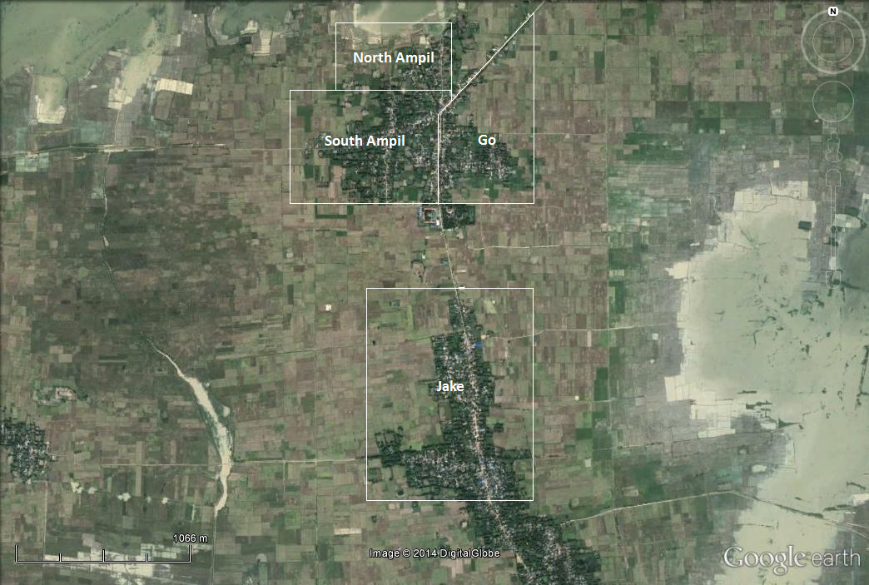
Figure 1. Satellite image of the Krang Yov study site, including sketched delineation of networks and villages (source: Google Earth, 2015)
This type of mapping cross-cuts the administrative boundaries shown in Figure 1. The people of South Ampil, for example, have little relationship with those of North Ampil but very close linkages to Go. Consequently, North Ampil has been analysed separately and South Ampil and Go as a unit, to reflect internally defined network boundaries rather than external categorisations. References to North Ampil, South Ampil and Go, and Jake, are therefore intended to convey information about the networks sampled in each area, as they existed at the time of mapping, rather than more general characteristics.
Thus, like any self-defined network, that ascertained here possesses limitations. The social preferences and prejudices associated with bonding networks such as these (Lee et al., 2016) means that certain groups may have been excluded from the analysis. In addition, a key limitation resulting from the network mapping methodology is the gender blindness of the methodology employed. Although one of the three initial nodes was a female household head, the propensity of women to name men in their close networks, whilst men very rarely named women, means that comparative data on the reciprocity networks of men and women are unavailable. An unanticipated feature of the methodology, this is clearly to the detriment of the analysis, not least in the light of recent work in Cambodia, which has highlighted the gendered power dynamics of agrarian change (Park and Maffi, 2017). Further research on the gender dimensions of networked reciprocity is therefore a key topic for future research.
4 Small Scale Reciprocity in Cambodia
Here, as everywhere, climate and economy do not manifest at the scale of the nation-state. Rather, they are articulated by a wide range of socio-economic factors, of which the natural environment itself is only one (Hulme, 2009). Understanding the environment at the scale of human interaction is therefore crucial to interpreting its manifestation. As shown in Table 1, economy and ecology differ markedly amongst the three adjacent communities under study. Household livelihoods in the North Ampil network, for example, are dominated by fishing, which provides 29.6% of total income, against only 12.7% from farming. Migrant remittance payments are also vital to those who receive them, accounting for 46.5% of total annual income, or an average of over $900 per household amongst those who possess them. Yet only a minority – 27.5% of households – possess a migrant working outside of the village.
Though barely three kilometres south, the economy of Jake is quite distinct. Far less reliant on remittances, which contribute only 20.5% of the area’s total income, the inhabitants of the area depend primarily on rice based agriculture, which contributes 54.6% of gross income. However, this heavy dependency on paddy farming has downsides for some. Agricultural land around Jake is widely spaced and split between lower areas vulnerable to flood and higher areas vulnerable to drought. In order to mitigate these risks, most larger farmers possess land of more than one type, have high levels of knowledge about seed varieties and hire machinery to save planting and harvesting time.
For smaller farmers, however, the land’s propensity to flood, combined with sporadic irrigation, has led to high levels of repeated crop failure in recent years. Consequently, rates of land transfer in Jake are high relative to the two other surveyed networks, with 13 plots changing hands since 1990 amongst the 51 households surveyed (excluding inter-generational or marriage transfer). Moreover, at $7530 – or 126% of mean income – the standard deviation of income is the highest in the area, indicating above average levels of inequality.
South Ampil and Go is a more complex case. As the only one of the three communities to include a permanent market, the local economy is less dependent than either North Ampil or Jake on primary produce, relying instead on the cash crops and rural non-farm activities that make up 28.4% of the economy in the sample. Indeed, the last two decades have seen the community diversify away from primary produce to such an extent that farming now constitutes just over a quarter of household income, whilst very few of the sampled population fish. Remittances, as in North Ampil, are also key, contributing a further 40% of mean annual earnings.
Table 1. Breakdown of Yearly Household Income in Each of the Three Networks (own data)
Yearly Income Breakdowns | North Ampil Network (N=40) | South Ampil and Go Network (N=84) | Jake Network (N=51)
Mean Total Income per household ($) | 2136 | 2843 | 5990
% Income from Rice Farming | 12.7% | 29.5% | 54.6%
% Income from Fishing | 29.6% | 1.8% | 2.5%
Other Rural Income as % of total income | 11.1% | 28.4% | 22.4%
Remittances as % of total income | 46.5% | 40.3% | 20.5%
Current Debt Value as % of income | 50% | 34% | 35%
Standard Deviation of Income (% of mean) | $1596 (75%) | $2430 (85%) | $7530 (126%)

Although longitudinal data are not available for these three sites, interviews conducted in each community highlight processes which echo those noted in the adaptation and resilience literature on Cambodia (e.g. Marschke and Berkes, 2006). In particular, the rise in formal debt in both North Ampil, and South Ampil and Go – mirroring a wider national trend (Bateman, 2017; Bylander and Hamilton, 2015) – was highlighted by the Ampil village chief as both a key strategy for meeting the rising costs of agricultural inputs and a growing problem in the area, alongside increasing levels of labour migration to urban areas.
Nevertheless, as in other uncertain environments (Di Falco and Bulte, 2013; Fafchamps and Lund, 2003), informal credit in Krang Yov continues to thrive as a key strategy for risk mitigation, albeit in an altered form. Whilst large-scale private lending (defined here as $100 or more in cash) appears to have declined markedly due to the competition presented by formal alternatives – thirteen sources of formal debt were identified in the area – smaller scale reciprocity remains commonplace.
Over half of respondents stated that they regularly participated in informal reciprocal lending within their close knit networks, arrangements which differ from formal loans in three respects. Firstly, as highlighted in Table 2, informal loans constitute relatively small amounts of money compared to formal loans which (as shown in Table 1) run into the thousands per household on average. Secondly, no interest charges were found to be associated with any of the informal loans reported by informants, nor was the practice viewed by those involved as systematic. Thirdly, loans were requested and repaid over a flexible duration ranging from a few days to a few months.
Table 2. Informal Lending Patterns Disaggregated by Location (own data)
Location | North Ampil Network (N=40) | South Ampil and Go Network (N=84) | Jake Network (N=51)
Mean Frequency of Lending/ Year per household | 2.32 | 4.88 | 6.66
Mean Frequency of Borrowing/ Year per household | 7.06 | 5.62 | 6.02
Mean Total Transactions per household | 9.38 | 10.5 | 12.68
Mean Value Lent/ Year per household | $12 | $113 | $109
Mean Value Borrowed/ Year per household | $50 | $88 | $101

They are, in other words, loans with many of the characteristics of gifts. Nevertheless, although the scale and duration of such lending, usually ‘just for three to five days during the farming season’ (Peakhdei, 15/05/13), is small compared to that undertaken with moneylenders or institutions, it appears to serve a vital role in smoothing consumption and facilitating the purchase of production inputs such as ‘fertiliser and fuel for the [water] pump’ (Wiasna, 03/06/13).

5 Bonding Linkages and Hierarchy
In exploring the linkages between reciprocity and power at a larger scale, the following graphics show each respondent positioned according to their geographic location, with edges (connecting lines) demonstrating linkages between them. Figure 2 shows the locations of networked households in the three sites, their connections to each other and their eigenvector centrality score, represented – as also in figures 3 and 4 – by the size of each circle and its colour from white (low eigenvector) to red (high eigenvector centrality). Rather than being specifically linked to any form of reciprocity, these linkages represent the people that each informant felt to be their closest friends.
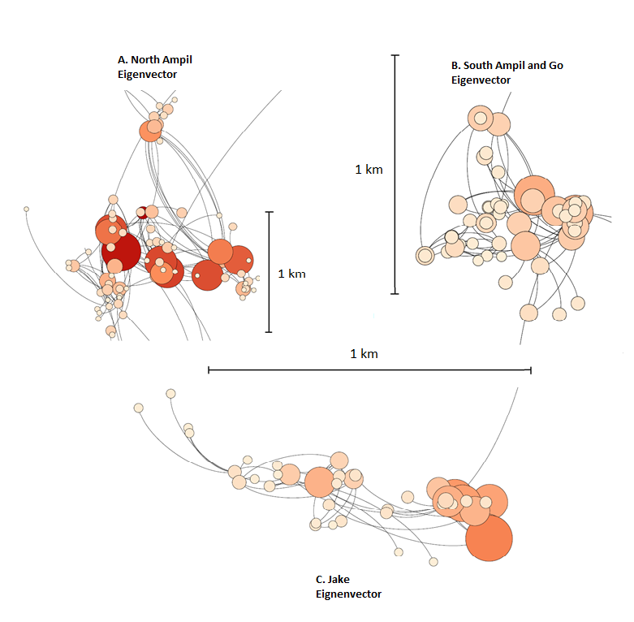
Figure 2. Eigenvector centrality of A. North Ampil network (n=40); B. South Ampil and Go network (n=84) and Jake network (n=51)

With the Krang Yov graph separated according to network, two features are immediately apparent. The first is the difference in the size of the three networks, indicated by the 1km scale bar beside each graphic. Excluding isolated outlying nodes, the South Ampil and Go network (B.) is considerably larger, at around 3.25km², than either Jake, at 1.2km² (C.), or North Ampil, at 0.36km² (A.), a difference which partly reflects the number of nodes in each network, but is also indicative of their respective geographical spreads. Secondly, differing patterns of node size may also be observed. Eigenvector centrality in North Ampil and Jake Village is considerably more homogenous than in South Ampil and Go, which contains more highly central individuals.

A second set of diagrams in Figure 3 shows degree scores within the same networks. Degree scores offer a different perspective on connectedness by weighting all connections equally, in contrast to eigenvector centrality scores, which give greater weight to connections with highly connected people. Degree scores are therefore less suggestive of community hierarchies, but provide a useful point of comparison by highlighting how “poorly connected” nodes in eigenvector diagrams do not necessarily lack connections themselves, but connections to more central nodes. As in Figure 2, these show the locations of networked households and their connections to each other. However, the size and colour of each circle here represents the raw number of connections possessed by each household from white (few/ no connections) to red (many connections). As also in Figure 2, the location of each household is geographically accurate according to GPS data.

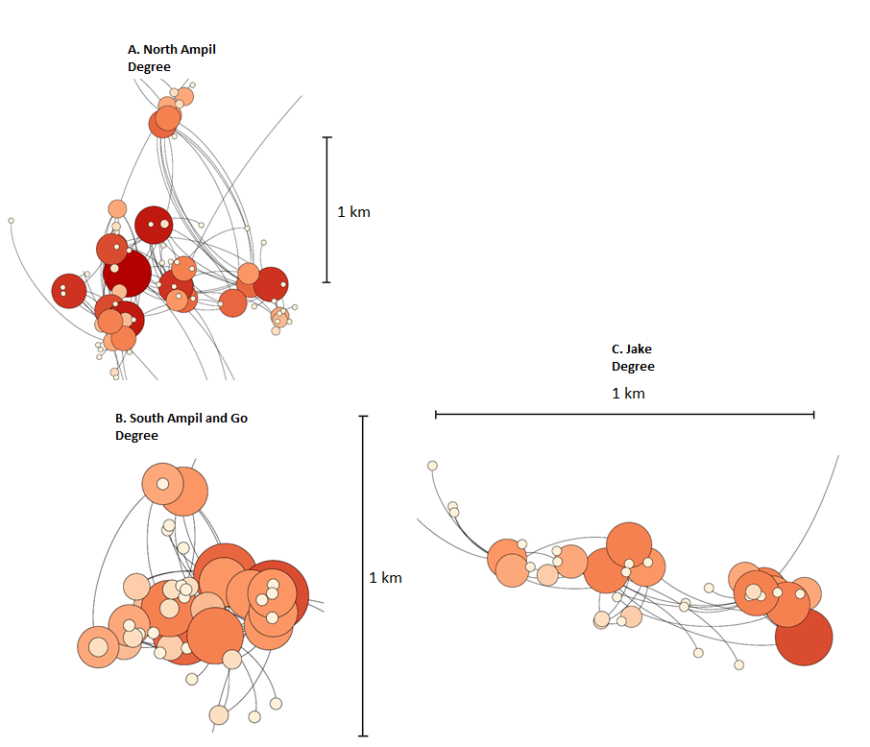

Figure 3. Degree centrality of A. North Ampil Network (n=40); B. South Ampil and Go network (n=84) and C. Jake network (n=51)

The key difference between Figure 2, showing eigenvector scores, and Figures 3, displaying degree (raw number of connections) is the greater homogeneity of node size in the latter case. There are more large – i.e. better connected – nodes than in the case of eigenvector scores, indicating that a number of people in each network have numerous connections without being central to the network as a whole. Indeed, the degree diagrams show little difference in the total number of connections reported, indicating that it is not the volume of connections that differentiates the nodes with the highest eigenvector centrality, but the way they are distributed that differs. The best connected people do not simply know the most people, but the “right” people. In other words, the networks created by close knit “bonding” networks – often viewed as horizontal in nature – create vertical hierarchical structures, in which certain people are highly central and others peripheral.

6 Reciprocity as Structure
Despite their intimacy, then, “bonding” relations are about more than affection. Not only do friendships emerge out of mutual concern with shared livelihoods, but there is a practical, livelihoods-focused dimension to social meetings. As one South Ampil landowner stated, ‘when we meet up it is to talk about work and how to make more money’ (Yorn, 17/05/13). Similarly, as another, from Jake, confirmed: ‘we meet each other when we go out to farm and then we meet each other again when we come home. Generally we just sit around and talk about rice farming and crop growing’ (Mao, 29/05/13). Reflecting the agro-ecological variance of the area, conversations differ amongst residents of North Ampil, where farming jostled with debt and expenses as the major themes of the area. There, it is a typical pronouncement that ‘we usually meet up to talk about our worries, especially farming and weddings, but in particular how to repay the banks’ (Sisirith, 28/04/13).
Villagers’ verbal accounts of their meetings therefore highlight how close bonding networks play a key part in information exchange. Moreover, by highlighting the simple point that people with different assets speak about different matters, they also raise the possibility that discourse of this sort plays a more active role in social structuring. Villagers may either seek out people with similar assets with whom to discuss livelihoods, or they may adopt livelihoods about which their connections are best informed, potentially engendering a degree of homophily – or associational preference – on the basis of income type.
The distinct ways in which this sort of preference is manifest are shown in Figure 4, a triad of Fruchterman-Reingold graphs – one for each network within the study site – that highlight homophily (see Traud et al., 2012) by arranging nodes according to network proximity, rather than GPS location. As above, bonding linkages are indicated via black network lines. However, here node size and colour indicate not eigenvector centrality, but the size of each household’s rice land holdings – on a scale from blue (no land) via pink (some land) to red (substantial land) – as the most generalizable variable to denote livelihoods across all three networks.
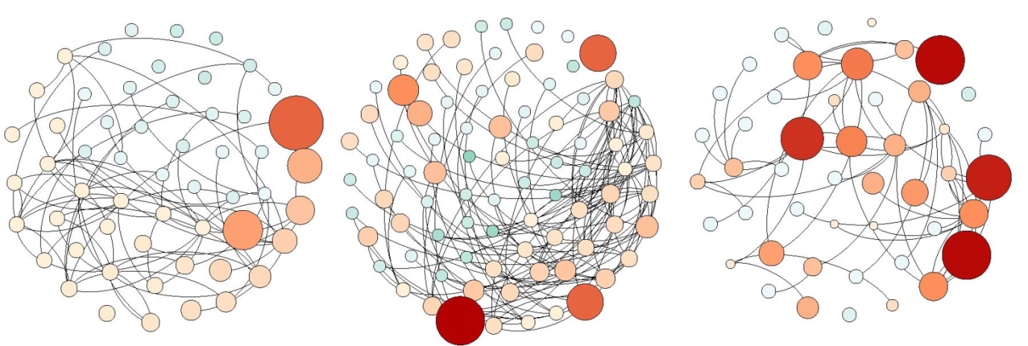
- North Ampil Network (n=40) B. South Ampil and Go Network (n=84) C. Jake Network (n=51)
Figure 4. Fruchterman-Reingold graphs showing nodes sized and coloured by rice land Area. Larger and redder nodes indicate larger rice land area. Each village network is arranged by homophily, meaning that the nodes closest together in network terms are grouped together in the graph.
It may be observed that the three communities exhibit significantly different patterns of association, linked to their different livelihoods and risk portfolios: North Ampil demonstrates both a clustering of larger landowners (along the right hand edge) and a notable network separation between landowners and non-landowners. This latter feature demonstrates the social distance between farmers and fishers (who usually possess no land in Ampil), as well as the relatively high number of network connections possessed by farmers compared with fishers. Both of these features are potentially explicable by the logistics of mutual insurance arrangements: first, the two groups cannot exchange labour and second, the need for labour sharing is in this case greater for farmers than for fishers, who reported helping each other only to recover boats and people from accidents in the water. Indeed, fishers lend money only 1.5 times per year on average, compared with over 5 times per year amongst farmers.
These divergent patterns of reciprocal behaviour are reflected in a negative correlation between fishing and the eigenvector centrality of the household head (Spearmans = -0.378, p =0.03). Moreover, the patterns of association undertaken by farmers appear also to have secondary benefits. Those inhabitants of North Ampil who obtain more than 50% of their income from fishing have fewer remitting migrants on average (1.33 per household against 2.17 for non-fishers), rendering them more dependent than their rice farming counterparts on primary natural resources. Given that pre-remittance net income is higher for fishers than for the very small scale farmers of North Ampil (mean land holding 0.3Ha), farmers’ greater integration into rural social networks (possibly resulting from their greater need to cooperate to pursue their livelihoods) emerges as a potential factor in gaining access to information about migrant opportunities.
Similar patterns of association may be observed in Jake village, where the skew of larger nodes towards the right hand side of the graph highlights the lack of interaction between the larger landowners they represent and those with less or no land. However, unlike in North Ampil, the division between smaller and larger landowners is a source of growing tension, as the former are forced to rely upon an increasingly small pool of agricultural employers in order to supplement income from their personal plots. As a farmer of a small plot complained:
‘The relationship between the rich and the poor is torn, as if it has been pulled apart…The rich act like bosses…[and]…poor people rarely go to rich people’s houses. You can see now that if the rich people have a party, then so many people will come. If a poor person has a party, then only the poor will come’ (Dara, 12/08/13).
Consequently, larger landowners report an increasing unwillingness to undertake rural wage labour ‘because people are embarrassed to be seen working for others in the village’ (Raksmey, 28/05/13 cited in Parsons, 2017b). The result is that rural labourers can be difficult to find, raising wages to previously unseen levels:
‘I myself need a lot of workers to do a large farm. I pay $7 per day plus three meals per day, but still many people don’t want to work for me because they are shy and ashamed to work for someone else in the same village, so they go elsewhere [to migrate]. It is very difficult to find enough workers here. It is difficult even to find workers for mouse catching. Even though the extra ten kg of rats would fetch 25k riel [on top of the daily wage he pays] and requires only that a trap be set, making the [total] over $10 per day, they still don’t want to try’ (Raksmey, 28/05/13 cited in Parsons, 2017b).
Perhaps most instructive, though, is the network graph of the South Ampil and Go community, which exhibits the highest network density (average connections per informant) of all three villages. This may be indicative of the greater need for a broad base of information exchange in an area which, as noted above, is both more marketized and less dependent on primary agriculture. However, the degree score fails to note the inequality of connectedness throughout the area. Rather, this is shown both in Figure 4 (part B), wherein the densest part of the network is clustered to one side; and Figure 2 (part B), which highlights a group of nodes far better connected than their neighbours.
Moreover, these well connected individuals are not merely distinct from their less integrated peers in terms of network structure. As Table 3 shows, the community quartile with the highest eigenvector scores obtain significantly more of their income from rice farming than the community average, have somewhat more agricultural land, and rely less upon rural non-farm income and cash crops. In part, this reflects the benefits available to rice farmers who associate to share risk but, more broadly, it is indicative of a wider correlation between eigenvector centrality and remittances (Spearmans = 0.411; p = 0.03) and debt (Spearman’s = 0.388; p = 0.04).
Table 3. Comparison of income distributions amongst high and low eigenvector households (N=151). Data aggregated across all three sites into top quartile against bottom three quartiles.
 | Top Quartile of Eigenvector Scores | Bottom Three Quartiles of Eigenvector Scores
Mean rice land area | 0.66 Ha | 0.48 Ha
Percentage of income from rice | 42 | 8
Percentage of income from cash crops and non-farm | 5 | 62
Percentage of income from remittances | 53 | 30
Current debt as percentage of annual income | 65 | 25

Indeed, the best connected quartile of South Ampil and Go’s community is notable for its dependency not only on rice farming, but also on remittances from sources external to the village, in which respect the data exhibit a strong correlation between eigenvector centrality and the percentage of annual income made up of remittances (Spearman’s = 0.66, p = 0.04). Alongside the higher proportional levels of debt held by this group, this suggests that the best connected residents of South Ampil and Go are also those who face the greatest modern sector dependency and agricultural risk.
- Discussion
Conceptualizing the impact of a changing environment on social relations is inherently difficult, but has been hamstrung in particular by the persistence of generalizing and often metaphorical interpretations of community in the developing world. Analysis of the Cambodian social structure, for instance, has generally been limited to the emphasis of two structural forms: a ‘net’ (Meas, 1999) or ‘web’ (Colletta and Cullen, 2000) of horizontal linkages, and a ‘pyramid’ of hierarchical, patron-clientist linkages (Ayres, 2000). Each of these typologies possesses a normative dimension. Whilst horizontal linkages have come to be viewed as performing a useful role in facilitating information and resource exchange, vertical ones remain, in spite of scattered arguments to the contrary (e.g. Platteau, 1995; Fafchamps 1992), cast as an instrument of iniquitous wealth extraction, as well as a key impediment to bureaucratic rationality.

Such normative assumptions reflect a longstanding distinction in the wider literature between vertical and horizontal (or “bridging” and “bonding”) linkages. Yet the data here present an alternative account. Although not externally bounded entities (Nartsupha, 1999), these communities derive much of their structure from the everyday reciprocal exchanges that emerge from vulnerable livelihoods. Consequently, these small scale relations form a key bridge between everyday livelihoods and the broader power structures of the communities in which they occur. Reciprocal behaviours, viewed thus, are not ad hoc or discrete phenomena, but merely networks ‘in which individuals are connected to a small number of other people, who, in turn, are connected to other people’ Fafchamps (1992: 158).

As such, the idea of a bounded village community, defined by a unified internal logic, ‘is little more than a chimera’ (Kemp, 1991: 312). Rather, what from one perspective may appear to be a vertical relationship many also be a horizontal one between peers; whilst the closest of relations may also serve a structural role in a wider network. This is both because the small, bounded groups in which reciprocal risk mitigation practices take place may be exclusionary at any given time, and because the members of each group fulfil different roles at different times depending on their circumstances. Indeed, whether an individual within a group acts as patron, client, co-worker, or friend, depends on a great variety of individualized and variable factors, from land location to livelihood to the possession of formal debt.

Notably, gross income is not the major factor here. Social hierarchy is more clearly evident in South Ampil and Go, which possesses intermediate wealth drawn from a wider variety of sources, than in the land-rich and more economically unequal community of Jake. This is not to suggest that the networks, roles and structures which underpin social differentials in Krang Yov are either fluid or independent of wealth. Despite the uncertainties facing rural livelihoods and their wider economic context, the linkages between livelihoods and networks mean that certain connections are unlikely to be made. The network segregation between those members of the North Ampil network who possess farmland and those who do not is one example of this, as is evidence of land size homophily in the Jake network.

The exclusive nature of reciprocity networks offers insights into the power relations involved in environmental adaptation, highlighting as it does that ‘someone’s resilience may be someone else’s vulnerability’ (Leach, 2008: 14). However, the lack of engagement between different sections of the population also reflects factors beyond the local. Migration, remittances and debt – key motivators of association beyond Cambodia as well as in Krang Yov – are the product of wider global forces, not least the neoliberal economic paradigm that has seen Cambodia’s economy opened so rapidly and extensively in recent years. Like the climate itself, these global systems are ‘articulated’ (Springer, 2011: 2554) through Cambodian hierarchies, operating at multiple scales, from the intimate (Brickell, 2014) to the authoritarian.
Indeed, scale is key here. As Ingalls and Stedman (2016: 6) have argued, ‘the political ramifications of scalar decisions are central to the resilience of social-ecological systems and have very material outcomes’. Yet such scalar issues remain understudied in the social-ecological systems literature, where a mono-scalar viewpoint continues to predominate (Mistry et al., 2014). Indeed, much apprehension over the “deterministic” nature of such studies (Berkes, 2017) has a scalar foundation, deriving as it does from their bounded nature and frequent blindness to power relations.

In particular, mono-scalarity underpins the absence of several key lenses, including norms (Persson et al., 2015; Cardona et al., 2014) and psychological factors (Le Dang et al., 2014), but most notably reciprocity (Crate, 2011). All three require, but have tended to lack, a multi-scalar analysis. A single scale can provide only the most superficial insights, examining only what has been exchanged, whilst leaving the meaning and longer term social significance of that exchange unexplored. The omission of this multi-scalar perspective from many previous analyses has been an impediment to effectively conceptualising issues of power in human-environmental interactions (Berkes and Ross, 2013; Hornborg, 2009; Marschke and Berkes, 2006), leading in turn to the assumption that it is communities that emerge and adapt to reflect community-scale conditions.

However, in Krang Yov this is not the case. By examining reciprocity at two scales, the data here show its multiple consequences; not only practical and flexible, but durable and structural also. Rather than responding as a community, households respond to the environment individually and, in doing so, shape power structures and affiliations in a broader network. Consequently, this network reflects the sum of individual, household conditions, rather than the condition of the community as a whole. Reciprocity, in other words, is laden within under-studied meaning.

In addition to its contextual value, this implies that a space is available for human geographical work on reciprocity that explores risk mitigation from the power-laden perspective of giving, receiving, and being denied. Such an area of inquiry has the potential to build on and cross-cut the resilience and social-ecological systems literatures, without being contained by the single scale of analysis that tends to predominate therein. Instead, this holistic geography of reciprocity must adopt a broader focus on the meaning of giving and its function as a “total social phenomenon” in the mould of Mauss and Sahlins, whilst retaining the firm ecological grounding offered by contemporary geographic resilience and social-ecological systems frameworks.

- Conclusion

Reciprocity is a powerful thing. It builds trust, from which springs durable connections. It forms, shapes and bounds groups. It is in many ways the basic unit of social relations, without which cooperation in all of its complexity ceases to function. Yet what this paper has aimed to show is that reciprocity has a role in form as well as functionality. Beyond each simple act, reciprocity shapes higher orders of power, playing a key role in the scalar transition between the commonplace and the community; the social and society.

In exploring this point, this paper has adopted a mixed methods approach, combining network mapping with quantitative data on practices and livelihoods to highlight the role of everyday reciprocity in structuring wider, community-scale networks. It has therefore aimed to show, first, how close-knit “bonding” linkages may engender community structures, and second, how these structures are linked, via close knit relations, to livelihoods. In doing so, the paper has aimed to re-connect classic conceptions of reciprocity as a ‘total social phenomenon’ (Mauss, 1967: 2) to the more recent geographic literature of resilience and socio-ecology by exploring both its structural dimensions and its linkages to environmental resources.

As such, the overarching aim has been to use contemporary, multi-scalar, methods to explore a more holistic perspective on reciprocity than has been a feature of recent geographic literature. By examining reciprocal networks at two scales – that of the small groups in which it is practised and that of the community scale networks it engenders – the paper therefore highlights the structural role of everyday relationships, arguing that the role of close-knit networks in mitigating environmental risk links “bonds of affection”, in complex ways, to community social structure.

Thus, it is argued, close-knit networks and community hierarchies are not discrete phenomena, but closely inter-linked features of social relations. Though also engendered externally, hierarchy is therefore born in part in the most personal of exchanges; the scale-bridging role of reciprocity endowing intimate relations with a higher order significance. Out of these most familiar exchanges emerge the most impersonal of structures.

Bibliography
Adger, W. N. (2000). Social and ecological resilience: are they related? Progress in human geography, 24(3), 347-364.

Agrawal, A. (1995). Dismantling the divide between indigenous and scientific knowledge. Development and change, 26(3), 413-439.

Agrawal, A., Lemos, M. C., Orlove, B., & Ribot, J. (2012) Cool heads for a hot world–Social sciences under a changing sky. Global Environmental Change, 22(2), 329-331.

Ayres, D. M. (2000). Anatomy of a crisis: Education, development, and the state in Cambodia, 1953-1998. University of Hawaii Press.

Bankoff, G. (2003). Cultures of disaster: society and natural hazards in the Philippines. New York: Routledge Curzon

Bateman, M. (2017). Post-war reconstruction and development in Cambodia and the destructive role of microcredit. In Conference Proceedings of the 8th International Scientific Conference “Future World by 2050” (Vol. 1, No. 3, p. 45).

Berkes, F., & Ross, H. (2013). Community resilience: toward an integrated approach. Society & Natural Resources, 26(1), 5-20.

Bonacich, P., & Lloyd, P. (2001). Eigenvector-like measures of centrality for asymmetric relations. Social Networks, 23(3), 191-201.

Bourdier, F. (2015), Socio-ecological transformations in a tributary region of the Mekong in Cambodia: Culture of resistance or resistance of culture?. Asia Pacific Viewpoint, 56: 282–296. doi: 10.1111/apv.12068

Borgatti, S. P., & Halgin, D. S. (2011). On network theory. Organization Science, 22(5), 1168-1181.

Brickell, K. (2014). “The Whole World Is Watching”: Intimate Geopolitics of Forced Eviction and Women's Activism in Cambodia. Annals of the Association of American Geographers, 104(6), 1256-1272.

Bylander, M., & Hamilton, E. R. (2015) Loans and Leaving: Migration and the Expansion of Microcredit in Cambodia. Population Research and Policy Review, 1-22.

Chim Charya, Srun Pithou, So Sovannarith, McAndrew, J., Nguon Sokunthea, Pon Dorina, and Biddulph, R. (1998) Learning from Rural Development Programmes. Working Paper 4. Phnom Penh: Cambodia Development Resource Institute [CDRI]

Cardona, W. C., De Jong, W., Boot, R. G., & Zuidema, P. A. (2014). The New Face of Debt-Peonage in the Bolivian Amazon: Social Networks and Bargaining Instruments. Human ecology, 42(4), 541-549.
Chandi, M., Mishra, C., & Arthur, R. (2015). Sharing Mechanisms in Corporate Groups may be More Resilient to Natural Disasters than Kin Groups in the Nicobar Islands. Human Ecology, 43(5), 709-720.
Colletta, N. J., & Cullen, M. L. (2000). Violent conflict and the transformation of social capital: Lessons from Cambodia, Rwanda, Guatemala, and Somalia. Washington: World Bank Publications.
Cote, M., & Nightingale, A. J. (2012). Resilience thinking meets social theory: situating social change in socio-ecological systems (SES) research. Progress in Human Geography, 36(4), 475-489.
Cox, J. C. (2004). How to identify trust and reciprocity. Games and economic behavior, 46(2), 260-281.
Crate, S. A. (2011). Climate and culture: anthropology in the era of contemporary climate change. Annual Review of Anthropology, 40, 175-194.

Crona, B., & Bodin, Ö. (2010). Power asymmetries in small-scale fisheries: a barrier to governance transformability. Ecology and Society, 15(4), 32.

Cutter, S. L., Barnes, L., Berry, M., Burton, C., Evans, E., Tate, E., & Webb, J. (2008). A place-based model for understanding community resilience to natural disasters. Global environmental change, 18(4), 598-606.

Davidson, D. J. (2010). The applicability of the concept of resilience to social systems: some sources of optimism and nagging doubts. Society and Natural Resources, 23(12), 1135-1149.

Di Falco, S., & Bulte, E. (2013). The impact of kinship networks on the adoption of risk-mitigating strategies in Ethiopia. World Development, 43, 100-110.
Diepart, J-C. (2015) Learning for social-ecological resilience: Conceptual overview and key findings in Diepart et al. (eds.) Learning for resilience: Insights from Cambodia’s rural communities. Phnom Penh: The Learning Institute, 1-16.
Doch, S., Diepart, J. C., & Heng, C. (2015). A multi-scale flood vulnerability assessment of agricultural production in the context of environmental change: The case of the Sangkae River watershed, Battambang province in Diepart et al. (eds.) Learning for resilience: Insights from Cambodia’s rural communities. Phnom Penh: The Learning Institute, 19-49.
Dufwenberg, M., & Kirchsteiger, G. (2004). A theory of sequential reciprocity. Games and economic behavior, 47(2), 268-298.
Fafchamps, M. (1992). Solidarity networks in preindustrial societies: Rational peasants with a moral economy. Economic development and cultural change, 147-174.

Fafchamps, M., & Lund, S. (2003). Risk-sharing networks in rural Philippines. Journal of development Economics, 71(2), 261-287.

Falk, A., & Fischbacher, U. (2006). A theory of reciprocity. Games and economic behavior, 54(2), 293-315.

Flower, B. C. R. (2012). Cambodia’s urbanization: Key trends and policy priorities. Cambodian Development Review, 16(2), 1-6.

Friedkin, N. and Johnson, E. (2011) Social Influence Network Theory: A Sociological Examination of Small Group Dynamics New York: Cambridge University Press

Gibson, K., Hill, A., & Law, L. (2018). Community economies in Southeast Asia : a hidden economic geography. In A. McGregor, L. Law, & F. Miller (Eds.), Routledge Handbook of Southeast Asian Development (pp. 131-141)

Hill, H., & Menon, J. (2013). Cambodia: rapid growth with weak institutions. Asian Economic Policy Review, 8(1), 46-65.

Holling, C. S. (1973). Resilience and stability of ecological systems. Annual review of ecology and systematics, 1-23.

Hornborg, A. (2009). Zero-sum world challenges in conceptualizing environmental load displacement and ecologically unequal exchange in the world-system. International Journal of Comparative Sociology, 50(3-4), 237-262.

Hughes, C., & Un, K. (2011). Cambodia's Economic Transformation. Copenhagen: Nias Press.

Hulme, M. (2009). Why we disagree about climate change: Understanding controversy, inaction and opportunity. Cambridge: Cambridge University Press.

Illenberger, J., & Flötteröd, G. (2012). Estimating network properties from snowball sampled data. Social Networks, 34(4), 701-711.

Ingalls, M., & Stedman, R. (2016). The power problematic: exploring the uncertain terrains of political ecology and the resilience framework. Ecology and Society, 21(1).

Janssen, M. A., Bodin, Ö., Anderies, J. M., Elmqvist, T., Ernstson, H., McAllister, R. R., Olson, P. and Ryan, P. (2006). Toward a network perspective of the study of resilience in social-ecological systems. Ecology and Society, 11(1), 15.

Kalab, M. (1968) Study of a Cambodian village. Geographical Journal, 521-537

Kemp, J. (1991). The dialectics of village and state in modern Thailand. Journal of Southeast Asian Studies, 22(2), 312-326.

Lambin, E. F., & Meyfroidt, P. (2010). Land use transitions: Socio-ecological feedback versus socio-economic change. Land use policy, 27(2), 108-118.

Lawreniuk, S., & Parsons, L. (2017). Mother, grandmother, migrant: Elder translocality and the renegotiation of household roles in Cambodia. Environment and Planning A, 49(7), 1664-1683.

Leach, M. (2008). Pathways to Sustainability in the forest? Misunderstood dynamics and the negotiation of knowledge, power, and policy. Environment and planning. A, 40(8), 1783.

Le Dang, H., Li, E., Nuberg, I., & Bruwer, J. (2014). Understanding farmers’ adaptation intention to climate change: a structural equation modelling study in the Mekong delta, Vietnam. Environmental Science & Policy, 41, 11-22.

Lee, S. K., Kim, H., & Piercy, C. W. (2016). The Role of Status Differentials and Homophily in the Formation of Social Support Networks of a Voluntary Organization. Communication Research, DOI: 0093650216641501.

Lejano, R. P., & de Castro, F. F. (2014). Norm, network, and commons: The invisible hand of community. Environmental Science & Policy, 36, 73-85.
Levine, J. and Moreland, M. (2008) Small Groups: Key Readings New York and Hove: Psychology Press
Lim, S. (2007). Youth Migration and Urbanisation in Cambodia. Phnom Penh: Cambodia development resource institute
Mannetti, L. M., Esler, K. J., Knight, A. T., & Vance-Borland, K. (2015). Understanding Social Networks to Improve Adaptive Co-Governance with the≠ Khomani Bushmen of the Kalahari, South Africa. Human Ecology, 43(3), 481-492.

Marschke, M. J., & Berkes, F. (2006). Exploring strategies that build livelihood resilience: a case from Cambodia. Ecology and Society, 11(1), 42.

Mauss, M. (1967). The Gift, translated by I. Cunnison. London: Cohen & West [original publication in French, l925]

Meas, N. (1999) Towards Restoring Life: Cambodian Villages Phnom Penh: JSRC Printing House

Mistry, J., Tschirhart, C., Verwer, C., Glastra, R., Davis, O., Jafferally, D., Haynes, L., Benjamin, R., Albert, G., Xavier, R., Bovolo, I. and Berardi, A. (2014). Our common future? Cross-scalar scenario analysis for social–ecological sustainability of the Guiana Shield, South America. Environmental Science & Policy, 44, 126-148.

Moritz, M. (2013). Livestock transfers, risk management, and human careers in a West African pastoral system. Human ecology, 41(2), 205-219.

Nartsupha, C. (1999 [1984]). The Thai village economy in the past, trans. C. Baker and Pasuk Phongpaichit. Chiang Mai, Silkworm Books.

Oeur, I. L., Sopha, A., & McAndrew, J. (2012). Understanding Social Capital in Response to Flood and Drought: A Study of Five Villages in Two Ecological Zones in Kampong Thom Province. Pellini, A. (ed.) Engaging for the Environment, 60-84

Park, C. M. Y., & Maffii, M. (2017). ‘We are not afraid to die’: gender dynamics of agrarian change in Ratanakiri province, Cambodia. The Journal of Peasant Studies, 44(6), 1235-1254.

Parsons, L. (2017a) Under pressure: environmental risk and contemporary resilience strategies in rural Cambodia in Brickell, K. and Springer, S. (eds.) The Handbook of Contemporary Cambodia London: Routledge, 146-156

Parsons, L. (2017b). Multi-scalar inequality: Structured mobility and the narrative construction of scale in translocal Cambodia. Geoforum, 85, 187-196.

Persson, J., Sahlin, N. E., & Wallin, A. (2015). Climate change, values, and the cultural cognition thesis. Environmental Science & Policy, 52, 1-5.
Pierdet, C. (2012). Spatial and social resilience in Phnom Penh, Cambodia since 1979. South East Asia Research, 20(2), 263-281.

Platteau, J. P. (1995). A framework for the analysis of evolving patron-client ties in agrarian economies. World Development, 23(5), 767-786.
Ratner, B. D. (2011). Common-pool resources, livelihoods, and resilience: critical challenges for governance in Cambodia (No. 1149). International Food Policy Research Institute (IFPRI).

Sahlins, M. (1972). Stone Age Economics. London: Tavistock Press.

Smith, J. W. (2013). Information Networks in Amenity Transition Communities: A Comparative Case Study. Human ecology, 41(6), 885-903.

Springer, S. (2011). Articulated neoliberalism: the specificity of patronage, kleptocracy, and violence in Cambodia's neoliberalization. Environment and planning A, 43(11), 2554-2570.

Trade Related Assistance Cambodia [TRAC] (2013). Helping Cambodia to become a Sophisticated Services Exporter: Trade Development Policy Note. accessed on 05/08/14 at [http://www.worldbank.org].

Traud, A. L., Mucha, P. J., & Porter, M. A. (2012). Social structure of Facebook networks. Physica A: Statistical Mechanics and its Applications, 391(16), 4165-4180.

Travers, H., Clements, T., Keane, A., & Milner-Gulland, E. J. (2011). Incentives for cooperation: The effects of institutional controls on common pool resource extraction in Cambodia. Ecological Economics, 71, 151-161.

Woolcock, M. (2002). Social capital in theory and practice: where do we stand? In Isham et al. (eds). Social capital and economic development: Well-being in developing countries. Cheltenham: Edward Elgar Press, 18-39.

For further information on the eigenvector, see supporting information
N.B. Rice produced for consumption is viewed here as part of household income. Income from rice is therefore calculated as the gross USD value of rice produced annually
Partial correlation controlling for network

