The Scientific Housewife: Gender, Material Culture and the Middle-Class Kitchen in England, c. 1870-1914

Katie Rachel Carpenter

Royal Holloway, University of London

Submitted for degree of Doctor of Philosophy

January 2019

Declaration of Authorship

I, Katie Carpenter, hereby declare that this thesis and the work presented in it is entirely my own. Where I have consulted the work of others, this is always clearly stated.

Signed:

Date: 8 January 2019

Abstract

In the Victorian and Edwardian periods, women were encouraged to embrace science and technology in domestic labour, an ideology which I call ‘scientific housewifery’. This thesis explores this ideology by looking at the middle-class kitchen in England in the period 1870 to 1914. I examine how scientific knowledge and behaviour was linked to daily tasks such as cooking, cleaning and the management of domestic servants, and how this contradicted and challenged gendered norms and traditional ideals of domesticity.

I use a range of textual and material primary sources, mainly domestic advice manuals, autobiographies, advertisements, objects and records from schools, to explore the representation and experience of science in housework. I pay particular attention to the material culture of the kitchen and how its depiction was shaped by popular ideas about the kitchen as a scientific space. I also consider how contemporary notions of domesticity were fashioned outside the home, by an examination of schools for middle-class girls.

I show that middle-class women were exposed to science and technology through domestic life in the nineteenth century, earlier than previous scholarship has suggested, which has focussed on the twentieth. Although scientific housewifery was a gendered construct, based on the premise that a woman’s rightful place was home, this thesis demonstrates that it also allowed women some agency in the fashioning and expression of their identities. Thus, an expert, professional femininity was already in formation in the Victorian period. I highlight the importance of the kitchen to the middle-class woman’s daily life and gender identity, despite concerns about social etiquette and degradation by housework, and establish the importance of the material culture to scientific housewifery.

Acknowledgements

My thanks to the institutions that have financially supported my research over the last four years. The first three years of my PhD were supported by a Royal Holloway Reid Scholarship. Research trips were funded by the Friendly Hand, and an Agnodike Research Travel Fellowship from the Commission on Women and Gender Studies in History of Science, Technology and Medicine.

I must thank my wonderful supervisor Jane Hamlett. Her support, patience and constructive feedback (not just on my thesis, but countless conference papers and job applications) has been utterly invaluable. I’d like to thank my thesis examiners, Alison Blunt and Victoria Kelley, for making the examination process so comfortable and productive. Their insightful feedback has been instrumental. Thanks also to everyone who read parts of this thesis and/or provided impromptu viva pep talks, especially Sandra Cavallo, Nicola Phillips, Zoë Thomas, Matthew Smith and Alex Windscheffel. Special thanks to Alex for his spirited advice, support and humour.

My thanks to everyone who kindly shared their expertise and knowledge with me. Lesley Hoskins shared her database of inventories and answered countless questions about them. Archivists at Bedales School, the North London Collegiate School and Manchester High School for Girls helped me identify source material used in chapter two. Paul Griffin shared with me his grandfather’s story which featured in the concluding chapter, and countless sellers on Ebay kindly answered my frankly bizarre questions about mincers and marmalade cutters. The editors at Grace’s Guide helped identify additional advertisements used in chapter five. Donald Day helpfully shared his knowledge of census records.

I am grateful to my wonderful friends who have provided much-needed laughter and have been unfailing in their support and generosity in offering to proofread. Claire Kennan and I have been working on our PhD’s together since the very beginning, and I could not have done it without her. She has been a tremendous source of support and encouragement as we have battled through our theses together. Steven Franklin, a fellow PhD comrade, has provided much-needed blunt advice as well as lending his expert proofreading skills. My heartfelt thanks to the brilliant Kathryn Martin for her emotional support and for generously reading portions of this thesis, and to my oldest friend, Claire Lloyd, who proofread chapter two.

My biggest thanks go to my wonderful family for their kindness, patience and encouragement over the past four years while writing this thesis, and the four years before that completing my BA and MA. Sam Carpenter shared his passion for bibliographies. My late grandmother, Joan Day, did not know what a PhD was or why I was doing one but had an extraordinary faith in me anyway. Finally, from the bottom of my heart, I thank my parents, Debbie and Richard Carpenter, for their unconditional and limitless support throughout my (many) ups and downs. They got me to where I am.

Table of Contents

Abstract | 3
Acknowledgments | 4
List of Abbreviations | 7
List of Illustrations | 8
List of Tables | 13
Introduction | 15
Chapter One: How to be the Scientific Housewife: Performance, Objects and Gendered Identity in Domestic Advice Manuals | 47
Chapter Two: Intellectual Domesticity? Science and Domestic Subjects in New Middle-Class Schools | 91
Chapter Three: Remembering Housework, Science and the Kitchen: Identity and Agency in Women’s Autobiographies | 135
Chapter Four: The Construction of Domestic Authority in Advertisements for Food and Kitchen Equipment | 165
Chapter Five: Mechanical Gadgets and the Gendering of Technical Skill in the Kitchen | 199
Conclusion | 241
Bibliography | 257

List of Abbreviations

BSA Bedales School Archive
EPO European Patent Office
ILN The Illustrated London News
MCL Manchester Central Library
MHSG Manchester High School for Girls
MHSGA Manchester High School for Girls Archive
NLCS North London Collegiate School
NLCSA North London Collegiate School Archive
NLCSDA North London Collegiate School Digital Archive
SMGC Science Museum Group Collection
TJJC The John Johnson Collection: An Archive of Printed Ephemera
TNA The National Archives

List of Illustrations

Figure 1.1 | Advertisement for Sugg’s ‘Westminster’ Gas Kitchener in the front pages, and an illustration of the same product from Marie Jenny Sugg, The Art of Cooking by Gas (London: Cassell & Co, 1890), 12. Reproduced by permission of the British Library. | 66
Figure 1.2 | Cover of N. R. de Lissa, Cooking by Gas: A Guide to the Correct and Economical Use of the Gas Cooking Stove (London: Andrew Melrose, 1913). Reproduced by permission of the British Library. | 67
Figure 1.3 | Illustration of a dresser cabinet from Lucy H. Yates, The Model Kitchen (London: Longmans, Green and Co., 1905), 11. Reproduced by permission of the British Library. | 70
Figure 1.4 | The original front cover of Mrs Willoughby Wallace, Woman's Kingdom: Containing Suggestions as to Furnishing Decorating and Economically Managing the Home for People of Limited Means, popular ed. (London: Constable and Co., 1910). Reproduced by permission of the British Library. | 76
Figure 1.5 | A diagram of the interior of an adapted kitchener from Catherine Buckton, Comfort and Cleanliness: The Servant and Mistress Question (London: Longmans, Green and Co., 1898), 10. Reproduced by permission of the British Library. | 82
Figure 2.1 | A diagram of equipment from an experiment, from the Chemistry exercise book of Lucy Hill, 1912, Box title: Hill Family, Archives d4, NLCSA. Reproduced by permission of the North London Collegiate School. | 101
Figure 2.2 | A sample of flannel showing sewing work, in the Housewifery exercise book of Violet Steadman, 1904, RS 4iv, NLCSA. Reproduced by permission of the North London Collegiate School. | 103
Figure 2.3 | Photograph of the interior of the Domestic Arts Room with Miss Macrae and Form, Sandall Road, c. 1912-13, Box Title: People and Buildings to 1939, NLCSA. Reproduced by permission of the North London Collegiate School. | 103
Figure 2.4 | The Cookery School at Manchester High School for Girls, 1911 (top) and the Biological Laboratory at Manchester High School for Girls, 1911 (bottom), from Sara A. Burstall, The Story of Manchester High School for Girls (Manchester: Manchester University Press, 1911), 182, 186. Reproduced by permission of the British Library. | 106
Figure 2.5 | Bedales’ pupils undertaking practical work in a woodwork class, from Exhibition Album (1908), BSA. Reproduced by permission of Bedales School. | 109
Figure 2.6 | Bedales’ pupils in the biological laboratory, from Exhibition Album (1908), BSA. Reproduced by permission of Bedales School. | 109
Figure 2.7 | Girls in cooking and sewing classes at Bedales, from Exhibition Album ([c. 1903]), BSA, 116. Reproduced by permission of Bedales School. | 111
Figure 2.8 | Bedales’ pupils tidying their dormitories, Exhibition Album ([c. 1903]), 115. Reproduced by permission of Bedales School. | 112
Figure 2.9 | Illustration of a Boracic Acid Flame, Muriel Sutton, Frontispiece, The Searchlight, ‘Volume III’, 1914, 1, RS 4iv, NLCSA. Reproduced by permission of the North London Collegiate School. | 127
Figure 2.10 | Miss Watherston’s reply to an invitation to the science tea, The Searchlight, Summer 1912, 59, RS 4iv, NLCSA. Reproduced by permission of the North London Collegiate School. | 129
Figure 2.11 | Miss Odell’s reply to an invitation to the science tea, The Searchlight, Summer 1912, 60, RS 4iv, NLCSA. Reproduced by permission of the North London Collegiate School. | 129
Figure 2.12 | A collage of comments from Miss Stern’s marking, The Searchlight, ‘Second Number’, Summer 1913, 53-54, RS 4iv, NLCSA. Reproduced by permission of the North London Collegiate School. | 131
Figure 4.1 | Advertisement for Cadbury's Cocoa, Ernest French, 28 October 1897, Records of the Copyright Office, paper 170, COPY 1/136, The National Archives, Kew. Reproduced by permission of The National Archives. | 173
Figure 4.2 | Image from advertisement for Puffed Rice and Puffed Wheat, Quaker Oats, Woman at Home, August 1914, 35. Reproduced by permission of the British Library. | 177
Figure 4.3 | Image from an advertisement for Nestlé’s Milo Food, Home Chat, vol. LXXVIII, no. 1005, 4 July 1914, 41. Reproduced by permission of the British Library. | 180
Figure 4.4 | Advertisement for Fry's Cocoa, The Queen, vol. CVII, no. 2762, 6 January 1900. Reproduced by permission of the British Library. | 182
Figure 4.5 | Illustration from an advertisement for Turog Best Brown Bread, Home Chat, vol. LXXVI, no. 981, 3 January 1914, 18. Reproduced by permission of the British Library. | 184
Figure 4.6 | Advertisement for Frame-Foods, The Queen, vol. CXXVII, no. 3288, 1 January 1910. Reproduced by permission of the British Library. | 184
Figure 4.7 | Advertisement for Lemco Cookery Book, Illustrated London News, vol. CXXVI, no. 3429, 7 January 1905, 32. | 187
Figure 4.8 | Advertisement for Lemco, Illustrated London News, vol. CXLIV, no. 3898, 3 January 1914, 32. | 188
Figure 4.9 | Advertisement for Panshine, Woman at Home, August 1910, 39. Reproduced by permission of the British Library. | 190
Figure 4.10 | Advertisement for Ponds Extract, Home Chat, vol. XLII, no. 537, 1 July 1905, 121. Reproduced by permission of the British Library | 192
Figure 4.11 | Illustration of a domestic servant from an advertisement for Guy’s Tonic, Home Chat, vol. XXII, no. 277, 7 July 1900, 182. Reproduced by permission of the British Library. | 192
Figure 4.12 | Advertisement for Bovril, Home Chat, vol. XX, no. 251, 6 January 1900, 174. Reproduced by permission of the British Library. | 194
Figure 4.13 | Advertisement for Brown and Polson’s “Patent” Corn Flour, Woman at Home, August 1910, 9. Reproduced by permission of the British Library. | 195
Figure 4.14 | Advertisement for Benger’s, Home Chat, vol. LX, no. 772, 1 January 1910, 111. Reproduced by permission of the British Library. | 196
Figure 5.1 | A ‘Magic’ marmalade cutter, c. 1904, Y1993.164, SMGC. | 205
Figure 5.2 | A ‘Rapid’ revolving marmalade machine, c. 1932, Y1992.169, SMGC. | 205
Figure 5.3 | Two models of the ‘Magic’ chopper, personal collection. | 206
Figure 5.4 | A no. 2 ‘Rapid’ mincer, c. 1900, personal collection. | 206
Figure 5.5 | A sausage-making machine, c. 1890, Y2004.19, SMGC. | 207
Figure 5.6 | The ‘Family’ knife cleaner, c. 1880, Y1993.68, SMGC. | 207
Figure 5.7 | Advertisement for a cake maker, Gill and Co. Catalogue, Winter Issue (1907-8), 28, TJJC. | 211
Figure 5.8 | Advertisement for the ‘Three-Minute’ bread maker, Gill & Co. Catalogue. Winter Issue (1907-8), 29, TJJC. | 211
Figure 5.9 | A page from a Silber & Fleming Catalogue, advertising knife cleaners, under the heading ‘Labour-saving Domestic Machinery’, [1880-1900], 541, TJJC. | 211
Figure 5.10 | The Follows and Bate hardwood stand, advertised in their Illustrated Catalogue, No. 750 (Manchester: Follows and Bate, 1905), 12b, 1995.11.3970, Cambridge University Library. | 214
Figure 5.11 | A Follows and Bate potato masher operated by isolated hands, showing the frilled sleeves of a maid’s uniform, Illustrated Catalogue, No. 750 (Manchester: Follows and Bate, 1905), 24, 1995.11.3970, Cambridge University Library. | 220
Figure 5.12 | Advertisement for the kidney-bean cutting machine showing a maid operating it, from the Illustrated Catalogue, No. 750 (Manchester: Follows and Bate, 1905), 32, 1995.11.3970, Cambridge University Library. | 220
Figure 5.13 | Advertisement for the ‘Magic’ chopper and marmalade cutter, showing hands with a man’s sleeves, Woman at Home, December 1910, 37. Reproduced by permission of the British Library. | 223
Figure 5.14 | Advertisement for the ‘Magic’ marmalade cutter showing hands with the sleeves of a traditional cook’s uniform, Illustrated Catalogue, No. 750 (Manchester: Follows and Bate, 1905), 38, 1995.11.3970, Cambridge University Library. | 223
Figure 5.15 | Illustration from an advertisement for a biscuit-making machines showing hands with no sleeves, Illustrated Catalogue, No. 750 (Manchester: Follows and Bate, 1905), 12b, 1995.11.3970, Cambridge University Library. | 224
Figure 5.16 | A full-page coloured advertisement for the marmalade cutter, Illustrated Catalogue, No. 750 (Manchester: Follows and Bate, 1905), 36, 1995.11.3970, Cambridge University Library. | 224
Figure 5.17 | An advertisement for the ‘Rapid’ rotary marmalade machine, depicted in use with hands without sleeves, Good Housekeeping, vol. XXII, no. 4, December 1932, 126. Reproduced by permission of the British Library. | 225
Figure 5.18 | Illustration from the instruction leaflet showing a housewife operating the marmalade machine, Y1992.169, SMGC. | 225
Figure 5.19 | Close-up of the ‘Magic’ marmalade cutter, showing the wingnut, personal collection. | 229
Figure 5.20 | The tin-plated ‘Magic’ chopper in pieces, in its original box, c. 1920s, personal collection. | 230
Figure 5.21 | A Spong and Co. bean slicer, with a revolving mechanism, personal collection. | 231
Figure 5.22 | Photograph of a Follows and Bate ‘Rapid’ rotary marmalade machine from Good Housekeeping, vol. XXII, no. 4, December 1933, 77. Reproduced by permission of the British Library. | 231
Figure 5.23 | The inside of the sausage-making machine, showing two cylindrical rollers, Y2004.19, SMGC. | 233
Figure 6.1 | Ed and Justine Miliband pictured in their kitchenette, from Sarah Vine, ‘Why Their Kitchen Tells You All You Need to Know about the Mirthless Milibands... and Why There’s Nothing to Suggest That Ed and Justine Are Not, in Fact, Aliens’, The Daily Mail, 12 March 2015, http://www.dailymail.co.uk/debate/article-2990810/Why-kitchen-tells-need-know-mirthless-Milibands-s-suggest-Ed-Justine-not-fact-aliens.html. | 242
Figure 6.2 | A still from a YouTube Video, showing an isolated arm operating a Follows and Bate marmalade cutter, ‘Marmalade January 2013’ [user-generated content, online], 12 February 2013, 50 secs, YouTube, accessed 6 June 2018, https://www.youtube.com/watch?v=RMAQsGtrY7I. | 253
Figure 6.3 | A still from a Vimeo video, showing Peter Griffin operating a marmalade machine, The Quest for the Follows and Bate Universal Marmalade Machine’ [user-generated content, online], Griffin Productions, 11 February 2013, 5 mins 50 secs, Vimeo, accessed 11 May 2017, https://vimeo.com/59425972. | 254

List of Tables

Table 1 | Summary of the quantitative data showing percentages of advertisements counted for each category. | 170

Introduction

‘Men have long ago made modern Science the willing slave of Business; women are fast following in their steps, and making not only a slave, but a friend of Science in the Home’. So wrote authoress and cookery teacher Margaret Alice Fairclough (1856-1919) in her domestic advice manual Practical Household Management (1912). In the Victorian and Edwardian periods, there was a perception that women, whilst excluded from professional science, were embracing scientific knowledge and domestic technology in housework. This I call ‘scientific housewifery’; an ideology that saw housewives and housework associated with science, technology and medicine as it aided home and family life. In this thesis, I examine this ideology of scientific housewifery, with a particular emphasis on the space of the middle-class kitchen and the people and objects within it. I ask how the kitchen and housewifery have intersected with science, technology and medicine, and how this informed and challenged gendered expectations and behaviour, especially notions of femininity, in England 1870 to 1914.

Broadly speaking, this thesis speaks to three main interwoven strands of scholarship: women and gender history; studies of home; and the history of science. The first part of this introduction reviews the relevant secondary literature, outlining questions to be answered and gaps to be filled. The second section establishes the definitions, methods and sources I will be using.

| I | Literature Review

History of Science and Gender

The history of science developed somewhat separately from mainstream history. In the 1950s, its pioneers considered the history of science as distinct from other types of history and maintained an emphasis on cumulative narratives and ‘great men’, such as Copernicus, Galileo, Newton and Darwin. A turn to social constructivism was prompted by influences from the sociology and philosophy of science. Robert Merton, an early pioneer of the sociology of science, considered the social and culture environment in which scientists worked, looking primarily at institutional influences in the direction scientists took. The sociology of scientific knowledge emerged in the 1970s in opposition to Merton’s work. These scholars, working under the so-called ‘strong programme’, sought to consider how knowledge itself is contingent on sociological factors, rather than just scientists.

Research following in this sociological tradition has established that science has been and is gendered as male. A flurry of research has shown how Victorian scientific and medical arguments were used to sustain women’s confinement in the domestic sphere. For instance, Cynthia Eagle Russett’s Sexual Science: The Victorian Construction of Womanhood (1989) argued that sexual science arose in the nineteenth century, to justify women’s inferiority. Sexual science, Russett argues, became more precise and empirical in this period. Elizabeth Fee sought to demonstrate how the London Anthropological Society used craniology to justify anti-suffrage sentiments in the 1860s. Science was used to justify distinct gender roles and female inferiority. Joan Burstyn has drawn attention to how opponents of higher education argued that women’s education could be dangerous to their health and fertility. Elaine and English Showalter concluded, in a chapter of Martha Vicinus’s Suffer and Be Still (1973), ‘[t]he Victorians’ ideas about menstruation furnish a remarkable example in which scientific knowledge reflects, rather than determines the moral biases of the era’. The emphasis on these studies was how science, as a male force, was used to reproduce power relations between men and women, where women were oppressed and kept in social, political and economic inferiority. Further questions along these lines were asked by Marina Benjamin, using a feminist methodology in her Science and Sensibility (1991): ‘How did relations between the sexes come to be enshrined as natural laws? In other words, how were gender relations scientized? What relationships did women have with the sciences? And how can feminists interpret these relationships, actual and symbolic?’

In recent years, historians of science, especially of the Victorian period, have examined how the wider population experienced science. Bernard Lightman has forcefully argued that ‘the Victorian era is a particularly important period, when significant features of the relationship between contemporary science and culture first assumed form’. The mid-nineteenth century saw science boom in popularity. The 1850s, for instance, saw natural history crazes for aquariums, ferns and dinosaurs. Other studies have illuminated how the middle-classes engaged in scientific culture. One study by Samuel Alberti has shown that conversaziones (social gatherings at learned societies) were an important aspect of the scientific culture with which the middle classes engaged. This research on science and the mass population has sometimes been termed ‘popular’ science, a label which has been analysed intensively. The concept of ‘popular’ science implies a general or uniform audience. Not only does it reduce different interest groups within the general public, it also implies a passive audience, distinct in its consumption and understanding of science from professionals. But as Aileen Fyfe and Bernard Lightman pointed out in the introduction to their edited volume, Science in the Marketplace (2007), the boundaries between ‘professional’ and ‘popular’ are particularly difficult to locate. In the nineteenth century, notions of expertise were in transformation. Scientific expertise was itself evolving in this period, and the term ‘popular’ does not account for the changing definitions of what it meant to be an expert. It has been argued that late-Victorian society professionalised. According to T. W. Heyck, ‘The Transformation of Intellectual Life’ brought the new concept of a distinct class of intellectuals by the 1870s. To Heyck, science and scientists played a critical role in this. However, such straightforward accounts of professionalisation have been criticised for being oversimplified; historians now warn against using the terms ‘professional’ and ‘amateur’. To Adrian Desmond, such terms have been ‘back-projected’ onto the nineteenth century. They create a false dichotomy between professional scientists and the general public; as Lightman has argued, they ‘were in a state of fluctuation in this period, and they were being worked out in relationship to each other’.

Historians have since examined how science was received by audiences other than the middle class, such as the working classes. Early studies on working-class engagement with science considered the popular science periodical press which was accessible to the literate upper-working class. The ‘Science in the Nineteenth-Century Periodical’ project (1999-2007), based at Leeds University, attempted a widespread identification and analysis of the representation of science, medicine and technology in the periodical press of the nineteenth century. The result was the ‘Science in the Nineteenth-Century Periodical’ database, an index of over 14,000 articles from periodicals printed between 1800 and 1900. As well as being a valuable research tool, it has also precipitated three related edited volumes: Culture and Science in the Nineteenth Century Media (2004), Science Serialized (2004) and Science in the Nineteenth Century Periodical (2008). A fundamental research question, identified by Geoffrey Cantor et al in Culture and Science, characterises much of the recent scholarship: ‘How [. . .] did writers, or the diverse constituencies of the general public, gain access to current scientific ideas and practices?’ These new questions have opened up research in the history of science to include women’s participation, and studies on women and gender are now well-established. However, such studies have tended to emphasise how middle-class women were able to participate in scientific culture as a form of leisure. There has been no research from historians of science on the housewife’s experience from within the home.

History of the Housewife

With this in mind, this thesis looks closely at the world of the middle-class housewife. Some of the earliest histories of middle-class women confirmed long-held stereotypes of a leisurely Victorian lady, concerned primarily with the maintenance of class status through the purchase and display of the ‘paraphernalia of gentility’. In her history of housework, Una Robertson noted that ‘By the time Queen Victoria was on the throne it was inconceivable for a woman of the middle classes or upwards to do her own housework’. This image of the idle Victorian woman was seemingly substantiated by myths about the prevalence of domestic servants in the average middle-class home. In an early history of domestic service, Frank Dawes stated of servants, ‘It was sometimes inconvenient, but necessary, that they should be on hand at all times because any work that had to be done, they had to do’. The impression from such statements was that the Victorian lady of the household had little involvement in practical household tasks, instead delegating all housework to her servants.

The suggestion that the middle-class women had a primarily idle lifestyle has since been debunked by Patricia Branca in her Silent Sisterhood (1975), in which she demonstrates the Victorian woman’s practical management in the middle-class home. In addition, scholars are now generally in concurrence that the average middle-class household would likely have had only one servant, a female maid-of-all work. Thus, scholars have assumed that the average middle-class Victorian women would have more practical involvement in housework than previously realised. For instance, in her study of late-Victorian and Edwardian Lancaster, Siân Pooley has shown that it was more common for servants to work with their employees, rather than for them. And, as Theresa McBride has pointed out, ‘The role that the housewife had to play required at least as much knowledge of domestic skills as would be necessary if she had to perform all of the household chores herself’.

There is a gap, however, in our understanding in precisely how and in what ways the middle-class woman was involved in housework. Research on modern women was for some time centred around Leonore Davidoff and Catherine Hall’s concept of ‘separate spheres’ which rested on a separation between home and work prompted by the industrial revolution. Moira Donald has revaluated this conception of the nineteenth-century home as distinct from work, arguing ‘it should not be forgotten that home was not the antonym of work’. Donald has pointed out that middle-class homes were workplaces, and ‘the locus of back-breaking toil’. This was the case for women for whom ‘the domestic space represented not so much a place of leisure as a place of work’. Donald specifically highlights the kitchen as ‘the working hub of the household’.

Subsequent research has also given a more nuanced picture of the middle-class woman and her agency in public and private life. For instance, Eleanor Gordon and Gwyneth Nair, in their analysis of the public lives of Victorian women, argued that ‘Victorian middle-class women had scope to make their own choices, shape their experiences and make their own histories’. More recent research on domestic service has established that the middle-class housewife could claim some authority as a mistress and manager. Lucy Delap has pointed out that servant keeping was ‘an arbiter of middle-class identity’. Power relations in the home were central to the formation of female domestic authority. As Ben Griffin, Lucy Delap and Abigail Wills have established: ‘It was central to the relatively restricted social positions open to women that they could construct themselves as authorities in the home, though to do so sometimes brought them into conflict with others who also laid claim to such authority’. Scholars such as Delap and Margaret Beetham have highlighted the ways in which mistresses managed their servants and asserted their authority over them. Such accounts have given us a more complex understanding of the formation of authority within the home.

The earliest histories that focused specifically on housewives (as opposed to middle-class women more broadly) generally emphasised the oppressive nature of domesticity, depicting women as trapped in an endless cycle of drudgery. Titles of such works suggest the endless monotony facing the housewife, such as A Woman’s Work is Never Done (1982) by Caroline Davidson, and for the case in the US, More Work for Mother (1985) by Ruth Schwartz Cowan, Never Done (1982) by Susan Strasser, and “Just a Housewife” (1989) by Glenna Matthews. Similarly, writing from a feminist perspective, Dena Attar questioned if home economics has ever done more than waste girls time. Collectively, these works depicted domesticity as an oppressive ideology, keeping women in the home.

This is particularly the case for histories of technology; in the 1980s, scholarship tended to view the emergence of labour-saving technologies in the home unfavourably. Science and technology were depicted as raising the standards of housework, ultimately increasing the amount of work for housewives. According to Erik Arnold and Lesley Burr, the inculcation of the idea of scientific progress into housework only mounted pressure on housewives. This led to, they argue, a ‘continual search for higher standards in the absence of criteria for knowing when those standards have been reached’. This is mirrored in the work of Cowan, whose seminal book argued that industrial progress and labour-saving technologies tended to favour men: ‘As the nineteenth century wore on, in almost every aspect of household work, industrialization served to eliminate the work that men (and children) had once been assigned to do, while at the same time leaving the work of women either untouched or even augmented’. In general, historians and feminist scholars have concluded that ‘We cannot rely on technology to liberate women’. In this view, housewives were excluded from this grand narrative of scientific and technological improvement. Instead, women were depicted as trapped in cyclical routines of daily housework.

It is no coincidence, of course, that such work emerged from the height of the Women’s Liberation Movement, which questioned women’s place in the home. There was, for instance, the Wages for Housework movement which called for financial recognition of women’s domestic role in a capitalist society. In leading campaigner Silvia Federici’s words:

Capital had to convince us that it is a natural, unavoidable and even fulfilling activity to make us accept our unwaged work. In turn, the unwaged condition of housework has been the most powerful weapon in reinforcing the common assumption that housework is not work, thus preventing women from struggling against it, except in the privatised kitchen-bedroom quarrel that all society agrees to ridicule, thereby further reducing the protagonist of a struggle.

Scholarly interest in the place of the housewife was thus critically stimulated by the social change happening across the 1970s and 80s. One of the earliest scholarly works on the housewife was a sociological study by Ann Oakley, first published in 1974. Oakley’s study was based on a series of interviews with London housewives and used a feminist methodology. She took ‘a new approach to women’s domestic situation by looking at housework as a job and seeing it as work, analogous to any other kind of work in modern society’. She also sought to rectify the ‘basically sexist orientation’ of sociology. In the same year, feminist and historian Catherine Hall wrote a piece on the history of housework in the second-wave feminist mouthpiece Spare Rib, in which she expressed her hope ‘to establish a case for a history of women at home as well as in the world of work’. But work that arose from this feminist surge sometimes obscured the agency of the housewife. In focussing on the structural forces that kept women in the home, the experience of the housewife, and the choices she made, were somewhat side-lined, or reduced as irrelevant. For instance, scholar Sheila Rowbotham, herself a prominent voice in second-wave feminism in the UK, stated of housewives:

The neurosis of nothingness comes directly from the nature of women’s work in the home. Self-affirmation can only come through self-abnegation. The ‘feminine’ woman, the good mother, can only realise herself by pouring herself into her husband and children. She has to give herself in service and find herself through other people and through the objects around her in the house.

It is unsurprising then, that the earliest histories of the housewife tended to emphasise her inferior and confined position in a patriarchal society, sometimes obscuring her agency and personal experience.

The housewife’s relationship with science has also been touched upon by social and cultural historians. This has often been associated with ‘modernity’. For Patricia Branca, the Victorian housewife’s relationship with modernity was about life, death and health:

Middle-class women were the first large group to establish a modern outlook toward life and death; they no longer tolerated pain and early death as uncontrollable aspects of existence, for both could and should be conquered. They demanded better health of themselves and, relatedly, for their children, who were increasingly seen as expressions of themselves and thus deserving the right to life.

According to Branca, modernity shifted attitudes to life, death and illness. Women were responsible for the health and hygiene of their family and their home, and thus were profoundly affected. Similarly, examining the 1840s, Kathryn Gleadle has suggested that the democratization of healthcare presented women with an alternative medical agenda that stimulated concern over hygiene and diet within the home. Furthermore, she indicates that many women embraced these changes to invest their household activities with political meaning.

Others have looked more specifically at the ideology of domesticity and its intersection with science in print. In a study of women’s magazines, 1800-1850, Ann Shteir showed that science was presented as serviceable to women because it had some value to their domestic lives, either in fulfilling their domestic duties or stimulating moral improvement. Caroline Lieffers has examined domestic advice manuals and recipe books published in the nineteenth century, demonstrating the ubiquity of scientific knowledge and modes of thought in advice and instructions directed at housewives. Rima Apple has outlined the ideology of ‘scientific motherhood’ in the US in the nineteenth and twentieth centuries, defined as ‘the insistence that women require expert scientific and medical advice to raise their children healthfully’. This ‘scientific motherhood’ is, in my opinion, only one element of scientific housewifery which incorporated a much broader range of domestic activities.

Women’s association with domesticity allowed some to carve a professional identity through the new technology industries. Anne Clendinning, for instance, has demonstrated how middle-class women found a professional place as demonstrators of gas appliances in late Victorian England. Research has also shown that the association of women with domestic subjects opened up professional avenues for women, such as members of school boards or teachers of domestic subjects.

The first half of the twentieth century has been identified by Judy Giles and Joanne Hollows as a critical time for the formation of a ‘modern’ femininity forged for housewives. For Hollows, the interwar period marked a transformation from the middle-class woman as a mistress of servants to a housewife. In her words, ‘This transformation is frequently linked to the decline of domestic service and the professionalization of housework through which “modern” ideas of science and rational planning were applied to the private sphere’. However, I suggest that elements of an ‘expert’ identity of the housewife, for the middle-class woman, were already detectable in the nineteenth century. Hollows suggests that ‘modern domestic lifestyles involved a break from tradition for many women’. I question the concept of modernity in this thesis, since it implies a discontinuity with past practice. In Lucy Delap’s words, ‘“Modernity” as an analytical concept tends to stress discontinuity with the past, and thus has lent itself to narratives of the decline of obsolescence of domestic service’. Indeed, Giles and Hollows have indicated that the emergence of a scientific, rational approach to housework was paired with the decline of domestic service. To the contrary, the scientific housewifery that I describe was expressed alongside the existing power relationship in the home, between mistress and servant. I suggest that a form of professional housewifery that relied on expert knowledge and specialist equipment was already in formation in the nineteenth century.

Research on domesticity and housework has also considered ‘scientific management’. Scientific management was pioneered by Frederick Winslow Taylor in the late nineteenth century and was originally applied to industrial production. In Marxist theorist Harry Braverman’s words, ‘Scientific management, so-called, is an attempt to apply the methods of science to the increasingly complex problems of the control of labor in rapidly growing capitalist enterprises’. On application of this to the home, this meant the ‘rationalisation’ of household management, with an emphasis on efficiency. Whilst it has been recognised that this ‘Taylorism’, as it came to be known, affected the household, there have been inconsistencies about precisely when this first happened. In many studies of housework in a variety of geographical contexts, it has been suggested that this was primarily in the twentieth century and has often been linked to the subsequent management theories of Henry Ford. Historians have often linked the domestic application of scientific management with the American home economics movement and the influence of home economist Christine Frederick, who published The New Housekeeping- Efficiency Studies in Home-Management (1914) and Household Engineering, Scientific Management in the Home (1915).

However, the influence of Christine Frederick has been overemphasised, obscuring from view earlier periods where rationalisation pervaded household tasks. This is the argument of Irene Cieraad who pointed out that ‘the first domestic application of efficiency principles was a nineteenth-century solution to economise domestic service and preceded in history the later publication of Christine Frederick’s book on efficiency in the home’. As this thesis will demonstrate, notions of scientific management were prevalent in Victorian culture, just as Lieffers has found ‘the more subtle application of scientific modes’ in nineteenth-century domestic advice manuals. In this thesis then, I seek to avoid over-emphasising the impact of one individual, or relying on concepts like ‘modernity’, that seem to represent a break with past practices rather than a continuation of earlier trends towards rational and scientific household management.

Over-emphasising the influence of any one individual, such as Frederick Taylor or Christine Frederick, assumes that their theories emerged in a social vacuum with no influence from pre-existing social and cultural trends or experiences. Michael Roper has shown that Taylor and Lyndall Urwick, a later management theorist, were themselves influenced by events and experiences in their personal lives. It would thus be a mistake to draw a direct causality between individual figures and the rationalisation of housework. It is likely that these figures were themselves drawing upon a pre-existing social and cultural trend.
Thus, in this thesis I am careful not to suggest that the impetus towards scientific management was necessarily novel to this period. Instead, I suggest that scientific housewifery was a continuation of earlier trends towards rational household management. Karen Harvey has shown that the discourse of ‘oeconomy’ was widespread since at least the seventeenth century. Harvey argues that in the eighteenth century the discourse of ‘oeconomy’ forged a link between household management and the civic sphere. As household ‘oeconomy’ was linked to the economy through the continued idea of the home as an economic unit, household orderliness was articulated through masculine authority and manly virtues. Thus, in my opinion, emphasis on scientific management in the nineteenth century was a reconstruction of older narratives on domestic economy, drawing on the rising popularity and prestige of science.

The Home

This thesis primarily focusses on the domestic kitchen. This follows a trend in the history of science which examines how science is transformed and appropriated through space. Central to these studies is an intersection with cultural geography, and the premise that ‘Place, in whatever guise, is like space and time, a social construct’. Aside from an article of 1988 by Steven Shapin on laboratories in seventeenth-century country homes, historians of science have only recently begun to recognise the potential of the home as a site of analysis. Studies that have engaged with the home and science and medicine have tended to focus on the early modern period. Alix Cooper has surveyed homes in early modern Europe as sites in which natural knowledge was accumulated. However, in establishing the case for studying the early-modern home, Cooper suggested that modern homes were less useful for the history of science:

During the nineteenth century in particular, as more and more people abandoned home-based workshops and began to travel to new places of employment, newly labeled “scientists” likewise increasingly came to work outside the home in institutional spaces that were perceived as religiously and emotionally neutral. In the process, considerable ideological boundaries were erected between work and family, and between public and private realms, which have continued to shape modern thinking.

As well as uncritically accepting the professionalisation thesis and a sharp division between the public and private realms, Cooper seems concerned only with spaces where scientific knowledge is made. In contrast, this thesis uses the late Victorian and Edwardian home as a space in which science was consumed, experienced and appropriated.

Whilst there have been few studies on the home emerging from the history of science using an approach from cultural geography, the relationship between home and science has been explored from other perspectives. Graeme Gooday has examined the social and cultural dimension of the reception of electricity into the home in the late-nineteenth and early-twentieth centuries. In a rejection of the idea of a passive audience, Gooday demonstrates the tension and apprehension regarding the adoption of electrical technologies, and how these anxieties were eventually overcome. Gooday shows how Victorian ideas about gender played a part in how fears of electricity manifested themselves. As a female servant or wife would most likely be responsible for the illumination of the home, anxieties emerged about the vulnerability of the female body. Similarly, Melanie Keene has investigated the early Victorian home, drawing attention to how science was taught to children. In an article published in 2008, Keene highlights how common objects were used as a familiar entry point into understanding scientific ideas in ‘object lessons’. Making a cup of tea, for instance, could be used to teach children concepts such as infusion, evaporation, and steam power.

Likewise, social and cultural historians of the nineteenth century have observed that the home was a site in which science was consumed. For instance, Thad Logan’s The Victorian Parlour (2001) paid great attention to collections as artefacts of middle-class domesticity. Logan explores the collections of ‘curiosities’ in the Victorian parlour, including natural objects that were classified and studied. Scientific ideas naturally entered the home as concerns about cleanliness. Judith Neiswander dedicated a section of The Cosmopolitan Interior (2008) to ‘Science, Progress, and the Role of Elite’, in which she explored refashioning of interiors to reflect new knowledge. Neiswander highlighted the role of decorators in promoting sanitation and hygiene, through the best selection of wallpapers or furnishings to ensure optimum cleanliness and ventilation. In her study of working-class homes and cleanliness in late-Victorian and Edwardian Britain, Victoria Kelley has shown how concepts of cleanliness were influenced by medical theories, such as the emergence of germ theory. But, as Kelley shows, ideas of hygiene and cleanliness cannot be reduced only to their medical meanings, as they were equally as contingent on a multitude of other factors, especially class and gender. Thus, the home is a fruitful site of analysis in consideration of how scientific ideas were intertwined with class and gender norms.

The home is not just a physical space but an imagined and emotional construction. As Alison Blunt and Robyn Dowling have demonstrated, ‘home’ has a multitude of meanings. Home is a physical structure, but it is also relationships and connections with other people, and a sense of belonging or attachment. Home has a dual meaning, as the physical site, and the imaginary feelings with which it is strongly associated. Doreen Massey has explored the gendered connotations of home. As she has demonstrated, women are typically the symbolic center of home and it is thus associated with stability, reliability and authenticity, ‘feminine’ qualities. Daniel Miller has established the importance of studying material culture in examinations of the home, in an anthropological context. Following the material turn in historical studies, recent research on the Victorian home has played close attention to its materiality.

This thesis focusses not just on the home, but a specific room: the kitchen. Cultural geographers, sociologists and anthropologists have recognized the kitchen as a distinct space in the home, and a locus of gendered power relations. Like the home, the kitchen is as much an idea as a physical space. In sociologist June Freeman’s words, ‘The idea of the kitchen exerts a powerful hold on the English imagination, evoking images and thoughts of hearth and home, family and domesticity’. Furthermore, in a recent ethnographic study, Rachael Scicluna has demonstrated how the kitchen can be a contested and political space, and a ‘symbolic signifier of lesbian feminist issues back in the 1970s and 1980s’. Historians have explored the kitchen, but these studies are primarily about kitchen design and modernity in mid-twentieth century Europe, such as the first fitted kitchens that were designed in Weimar Germany. Similarly, historians have considered the kitchen and domestic appliances as politicised, in studies examining the ‘kitchen debates’ of the Cold War, when US Vice-President Richard Nixon and Soviet Premier Nikita Khrushchev met at the opening of the American National Exhibition in Moscow, July 1959.

A number of studies have considered the development of the British kitchen across a long chronological period, including works by Molly Harrison and Doreen Yarwood. Histories of housework, such as that of Davidson or Robertson, naturally discuss technological change in the kitchen in great detail. Recently, the early-modern kitchen has received the most scholarly attention, in studies by Sara Pennell and Karin Dannehl. Both the work of Pennell and Dannehl has relied heavily on material culture, reflecting recent interest in objects in the home. There has been no research specifically on the British kitchen in the Victorian and Edwardian eras, except for a journal article of 1968 by Alison Ravetz tracing the development of the stove. There have also been a few books aimed at a general audience. In the past few years, there have been a handful of works making use of the kitchen as a site of analysis in other periods, such as three chapters on queer domesticity in the kitchen, written by Amy Tooth Murphy, Angela Meah and Rachael Scicluna, in an edited volume structured around different rooms in the home.

Although the kitchen has not been a site of analysis in the history of science, it has been recognised that in the early-modern period, and especially the seventeenth century, it was a site in which women could practice medicine. Some women practised ‘kitchen physic’: the preparation and recording of medicines domestically produced by women. Indeed, in this period, scientific experiments by men would likely have been practised in the kitchen for those not wealthy enough to have a purpose-built laboratory. Women’s association with the domestic sphere allowed them to pursue scientific interests within this space. Londa Schiebinger noted that ‘The association of chemistry with the kitchen gave women a certain confidence to publish in the field’, giving Marie Meurdrac’s La Chymie Charitable et Facile, en Faveur des Dames (1666) as an example of the first chemistry treatise written by a woman. In addition, Lynette Hunter has observed that the first printed scientific and technical books attributed to women included material on medicine, household science and fashion, and food preparation and cookery. Thus the scientific housewifery of the Victorian and Edwardian periods belongs to a much broader trend stretching back to the early modern period, in which women used domestic sites to practice medicine.

The kitchen has always been a site of innovation, but the nineteenth century saw a number of major technological changes. These include the introduction of piped water, gas and electricity, the invention of the first practical storage refrigerators, the change from open range to closed range stoves, and the mass-production of smaller-scale technologies such as mincers and other mechanical cutting agents. The nineteenth century saw arguably the first ‘celebrity chef’ in Alexis Soyer, whose kitchens at the Reform Club in London became world-famous for their size and technical ingenuity. However, there has been little research specifically focussed on or in the Victorian and Edwardian kitchen, but it has been mentioned in broader studies of material culture and the home.

This thesis is also concerned with how the intersection between kitchens and housework with science was formed outside the home. For instance, scholars have highlighted how national anxiety about the health and fitness of mothers prompted renewed focus on educating competent mothers for the home. At times of national anxiety, the nation pays closer attention to the health of the young, prompting new focus on the education of mothers. Celia Kingsbury, for instance, has shown how domestic science was used as propaganda directed at American women during World War One. It has also been suggested that teaching domestic subjects to middle-class girls was framed very differently than to that of the working classes. For instance, Annmarie Turnbull has pointed out the same subject matter would be presented differently to middle-class or working-class girls. Whilst the middle classes might be taught the ‘science of cleansing’, the working classes would learn laundry work.

Scholars have also observed the professionalisation of domestic subjects from the late-Victorian period. At the same time, the teaching profession was emerging. The rising importance of domestic subjects in this period is no more apparent than in the swell of teacher training centres for domestic subjects in this period. In July 1873, the National Training School of Cookery was founded in South Kensington. The establishment of schools of cookery quickly followed in 1877, with schools opening in Edinburgh, Glasgow, Leeds, Leicester, Liverpool and Manchester. Throughout the period 1870 to 1914, schools of cookery and domestic subjects continued to open, such as Sheffield (1889), Gloucester (1890), Aberdeen (1897), Cardiff (1897), Bristol (1893), Newcastle (1893) and Bath (1894). For Annmarie Turnbull, a symbolic moment in the birth of the domestic subjects’ movement came in April 1873, when J. C. Buckmaster of the South Kensington Museum gave a series of public lectures on the application of science to cookery. This movement, in Turnbull’s words, ‘was to promote tirelessly the re-education in housewifery of the British female’. Nancy Blakestad has analysed the ‘household and social science’ courses that were opened at King’s College for Women, which later led to the establishment of King’s College of Household and Social Science. The ideology of ‘scientific housewifery’ was also taking shape in educational institutions, training women for the home, rather than in it.

| II | Definitions, Methods and Sources

This thesis will draw on the scholarship from the history of science and the history of women. Following a well-established trend in the history of science to consider the experience of the mass population, I take the housewife as a consumer of science through her everyday activities. In consideration of the conceptual issues that have been raised in reference to so-called ‘popular’ science, I also consider the housewife as an active agent in the implementation and appropriation of science in everyday life, and in its representation. In a similar vein, whilst historians of women have clearly established the social, political and economic structures that kept women in the home, my focus is on her experience in everyday life. I seek to uncover how experience of science, technology, and housewifery, and their contemporary representation, came to shape gendered ideologies, expectations and behaviours in the home.

Cultural geography has stimulated new avenues of inquiry from historians of science, asking questions of space and place. Inspired by this research, I take the kitchen as my main site of analysis, drawing upon the work of geographers and sociologists that has proven the kitchen to be a nexus of gendered relations in the home. Following the lead of historians such as Pennell and Dannehl in their focus of objects, I will contribute to a burgeoning field on material culture and the home. Overall, this thesis is the first major study with a focus on the Victorian and Edwardian kitchen, and the first effort to write the housewife into the history of science. My primary focus is on how the experiences and representation of science were appropriated by the middle-class woman in her daily life, and in expressions of her agency. My main focus is England, especially as the educational system which I discuss in depth in chapter two was distinct from Scotland. However, scientific housewifery had an international dimension, and in places I have included some select pieces of evidence from individuals from elsewhere, particularly in chapter three. Having now given a broad overview of the related research, I will outline the definitions, methods and sources this thesis will use.

‘Science’ is a broad term that includes a multitude of sub-disciplines and has many connotations. Since I am paying close attention to the rationalization of housework and scientific management, I use a broad definition, similar to that used by Ruth Watts: ‘to mean all subjects based on objective knowledge of physical matters, including medicine, mathematics and technology’. As the existing literature on housework has shown, housewifery is impacted by changes in domestic technology and medicine. Consequently, these are necessarily included in my definition of science. A major theme of this project is the meaning of science to contemporaries, especially as it was used in relation to the kitchen and housework. In this respect, this project is primarily a cultural history. As Peter Mandler has argued, questioning how meaning is constructed complicates how cultural historians represent the past. As he explains, ‘The best cultural history can bring together sensitivity to the mechanisms of diffusion and reception with a sensitivity to the nuances of the text in order to produce a real social and cultural history of meaning.’ With this in mind, a range of sources and contexts are used to decipher the meaning of science in the kitchen and to the housewife.

Although I am including technology in my definition of science, there are some critical differences between ‘science’ and ‘technology’ that need outlining here. Unlike science, the word technology has particular connotations and usually refers to a physical object. My understanding of technology draws upon the work of Judy Wajcman. As she points out, technology is the physical objects themselves, but also a form of knowledge needed to operate them, and the human activity of doing so. This interaction between knowledge, object and behaviour is a central theme in my examination of technology, particularly in chapter five.

I take a relatively simple definition of housework, focussing primarily on activities associated with the kitchen and food, such as cooking, cleaning and food shopping. For want of more space, I exclude childcare, except where it overlapped with cooking and food shopping. Certainly, single women such as sisters or daughters would have undertaken this kind of household work living in the homes of their brothers or fathers. However, I am primarily concentrating on the normative housewife; as Robertson has pointed out, the word ‘housewife’ implies marriage. Precisely what type of woman was a ‘housewife’ is confused by issues of class. As I mentioned above, the majority of middle class households had one servant, and it is likely that the mistress of the household and the domestic servant worked together (see page 20). I am primarily focussed on the lower-middle-class woman, who took upon some household tasks herself, but also had a domestic servant.

This, of course, leads to the question of how to define ‘middle-class’. An economic characterisation of the middle class, based on income, is problematic owing to the lack of sufficient data, and disagreement regarding how much a ‘middle-class’ income actually was. Historians have acknowledged that there was not a distinct ‘middle-class’ recognised at the time. As David Cannadine has stated, ‘few Britons believed that there was one single middle class or one single working class’. According to Dror Wahrman, ‘the precise social referent of the notion of “middle class” was far from being well defined, and indeed that this vagueness often served the purpose of its users’. As Wahrman continues, ‘when conceived in “sociological” terms, the language of “middle-class” could refer to a surprisingly wide range of social groups, high and low, rural and urban’. This is particularly so in the case of housewives, whose experiences could be immensely varied depending on income, number of domestic servants and region, as well as personal preference. In reality, there was no such woman as the typical middle-class housewife.

It is generally agreed, however, that the middle-class expanded rapidly in the nineteenth century. Between 1803 and 1867, the middle class expanded by 223% compared to 206% for the general population. This was accompanied by a rise in the number of domestic servants, which rose from 100,000 in 1801, to 1,300,000 in 1851 and to 2,000,000 in 1881. The growth in the number of domestic servants is indicative of the expansion of families able to afford them. Since this thesis is concerned with cultural meanings of class and identity, I take the presence of a domestic servant in the home as an indicator that the family were middle-class. Seebohm Rowntree used this definition in Poverty: A Study of Town Life (1901): ‘the keeping or not keeping of domestic servants has in this inquiry been taken as making the division between the working classes and those of a higher social scale’. However, it has been acknowledged that not all middle-class families would have consistently employed domestic servants; this has been described as ‘an impossibility’ given ‘there were simply not enough servants to go around the whole subset of families who would otherwise be considered middle class’. With this in mind, I also take the profession of the male head of household as an indicator.
Finally, the term ‘kitchen’ also needs to be considered. Although in the present-day defining ‘kitchen’ seems fairly straight-forward, in the Victorian period it is less clear. This is in part owing to the Victorian trend of segregating and specialising rooms by function, although it has been observed that in practice this could work quite differently. In a conference paper given in February 2018, Lesley Hoskins discussed the classification of kitchens in mid-nineteenth century homes. In a database based on 492 inventories taken at death from 1841 to 1881, 25% of households had only a main single kitchen. The remainder had some additional service rooms, like a scullery, dairy, or back-kitchen; 75% of inventories that listed a kitchen room had one, two, or three additional service rooms. Hoskins also noted that the more separate additional service rooms were associated with higher wealth. Where I use the term kitchen, I refer to the room or rooms in which food was prepared and utensils were cleaned. In practice this was likely to be one or more separate rooms in wealthier households. However, as I will show, in many cultural representations, such as domestic advice manuals, autobiographies and advertisements, the kitchen is referred to as a single room. This perhaps reflects that the kitchen was as much an imagined concept as it was a physical space.

As I pointed out in the first section, the kitchen has been identified as a site of technological innovation, and a space in which women practiced medicine long before the nineteenth century. This thesis, however, starts in 1870 for a number of reasons. Firstly, by this point, there was a well-established middle-class, with, collectively, millions of domestic servants. The new middle-class bought with it the new middle-class woman and a flourishing consumer culture, which included new technologies for domestic use. Science was more popular than ever, and as a profession, was beginning to emerge. Changes in the educational landscape for women were expanding, with, as I mentioned, new opportunities for women as teachers, and new avenues to study science through domestic subjects. It is not necessarily the case that ‘scientific housewifery’ suddenly emerged in the late nineteenth century. I suggest that owing to these changes to British society, scientific housewifery is more visible at this point. Indeed, this is no doubt in part owing to the vast source material left because of these changes, such as new advice to the middle-class woman. The outbreak of the First World War marks the end point of this study, as it was a major point of domestic disruption.

My methodology for this project is primarily rooted in social history. I rely on social constructivism in my discussions of gender and science. The definition of gender that is to be taken, is in accordance with Joan Wallach Scott’s; ‘gender is a constitutive element of social relationships based on perceived differences between the sexes, and gender is a primary way of signifying relationships of power.’ The dynamics of social relationships in the home, and the place of science as a signifier of gender and class ideology, are key themes in this project. In the tradition of the sociology of scientific knowledge (as discussed above, page 15), I consider scientific knowledge as contingent on sociological factors.

I use ‘material culture’ to refer to a methodology as well as physical objects. In the words of Mary Beaudry, Lauren Cook and Stephen Mrozowski:

A common theme connecting interpretations of the material record of the past is how people engage the material world in cultural expression in the negotiation of everyday life. The relationship of behavior to the material world is far from passive; artifacts are tangible incarnations of social relationships embodying the attitudes and behaviors of the past.

In this study I am interested in how housewives and domestic servants were engaged in material objects in their kitchens, and how far this was an expression of the ideology of scientific housewifery in everyday life. In addition, I ask questions of the relationship between domestic objects and identity construction. These questions will be addressed by a focus on the material environment as it was represented in textual sources, and from an examination of physical objects.
Food, of course, also forms a central part of the kitchen’s material culture, although naturally it is ‘gone as soon as it is eaten’. Scholars have shown that food can be important signifiers of identity. Moreover, food naturally raises questions of health and medicine. Since food itself cannot have survived today, I use advertisements and kitchen utensils as representations.

This thesis might be described as a history of the everyday. Alltagegeschichte, as it is called in the German school of thought in which it initially emerged, is best described in the words of one its pioneers, Alf Lüdtke:

In doing the history of everyday life, attention is focused not just on the deeds (and misdeeds) and pageantry of the great, the masters of church and state. Rather, central to the thrust of everyday historical analysis is the life and the survival of those who have remained largely anonymous in history

An emphasis on material culture has been highlighted as particularly important for the history of everyday life. My emphasis on objects also belongs to an emerging sub-discipline in the history of technology: the history of everyday technology. As Timo Myllyntaus has said, gendered histories of everyday technology have two kinds of impact. Firstly, Myllyntaus considers how technology creates and changes the way people negotiate their own gender identities. Secondly, the opposing dynamic, of how gender changes the creation, production and use of technology in everyday activities. This thesis is particularly interested with the first kind- how science and technology shaped how housewives fashioned and expressed their own identities.

The first chapter of the thesis is based on a major new survey of domestic advice manuals. Such manuals have long been used in histories of the home. The domestic advice genre was tremendously popular, and collectively sold in the millions. Certainly some of the most popular, such as Enquire Within Upon Everything, sold over two million copies. A main critique of them is that they do not reflect the reality of most middle-class homes. Domestic advisors often presumed their readers had a budget and lifestyle out-of-reach for the average middle-class woman. To borrow Nicola Humble’s words, domestic advice manuals ‘can never be clear windows onto the kitchens of the past’. In particular, manuals tended to overestimate the number of domestic servants in the average middle-class home. These problems prompted Edward Higgs to remark, in a study of domestic servants:

To fall back on the evidence of manuals of domestic economy, as do practically all historians of this subject, is equivalent to using Vogue to reconstruct the lifestyle of the “typical” modern family. Such manuals reflected the aspirations, if not the day-dreams, of Victorians, rather than the detailed workings of their homes.’

When not read as reflections of reality, domestic advice manuals have proven a fruitful source material in understanding the ideologies and aspirations influencing the middle-class home. Caroline Lieffers has demonstrated that domestic advice manuals are rife with references to science. And, according to Patricia Branca, the ‘scientific approach’ was characteristic of the most successful type of domestic advice manual in the second half of the nineteenth century. As Branca continues, ‘The great benefit of this newer type of source was their claim to combine the advances of science with the practices of the day, thereby hopefully ensuring the proper and efficient running of the home’. In addition, it has been observed that domestic advice manuals are especially helpful for what they tell us about the relationship between identity and consumer goods. In this project, domestic advice manuals are read as representations of material culture, science, and the relationship between mistress and servant in the home.

I have consulted sixty autobiographies of women who lived through, or were born or died in, the period 1870 to 1914. The themes that emerge from autobiographies are markedly similar to domestic advice manuals; housework and domesticity are reoccurring topics. Many of the authors of the autobiographies referred to major change in science, technology and medicine in their lifetimes. Their autobiographies are useful for how they reconstruct scientific change against their own socially-imposed identity as a domestic woman. Admittedly, as Branca has pointed out, there is a ‘real lack of autobiographical data describing the life history of the “typical” middle-class female’. Most of the women whose autobiographies were consulted had some kind of public persona, such as suffragettes, authors, and social campaigners. Naturally, it is these types of women, with a public persona, that wrote autobiographies in the first place. Nevertheless, it is telling that the subjects covered in the autobiographies were not focussed solely on their public lives and included detailed descriptions of domestic life. Thus, in this thesis, autobiographies are used to explore how the past self is remembered and reconstructed, in relation to science and domesticity, in a way that complements the present self at the time of writing.

Although I am primarily concerned with the home and the kitchen, domestic ideologies are also formed outside the home. Thus, I draw on records from educational institutions to examine how the ideology of scientific housewifery impacted the education of young women. In the second chapter, I examine science and domestic subjects as they were taught at three new schools of the Victorian period: the North London Collegiate School; Manchester High School for Girls; and Bedales, one of the first co-educational schools for middle-class children. The source material in these archives is eclectic, including governor’s reports, exam papers, school magazines, photographs and speeches by teachers. Using these documents, I outline the ethos of each of the schools and their attitudes towards teaching science and domestic subjects to young middle-class women.
In keeping with my efforts to draw on the agency and experience of housewives, in my discussion of schools I seek to uncover the voice of the pupil. Ludmilla Jordanova has suggested that ‘there can be no authentic voice of childhood from the past’, as these childhood memories are always filtered through the adult voice recalling them, as is the case with autobiographies. However, school archives contain source materials produced by the pupils themselves, such as manuscript magazines. Although these are surely made with some adult influence, they represent a voice coming directly from a child, rather than recalled later in adult lifetime. And indeed, researchers have shown the value of manuscript and printed school magazines in histories of education. I thus examine how the ethos of the schools, and their teaching of science and domestic subjects, were interpreted by the students and expressed through their writings.

Given my emphasis on material culture, this thesis also looks closely at consumption. The proliferation of kitchen gadgetry, as well as the ‘commodity culture’ that was well established by the late Victorian period, has left a substantial amount of advertisements that are readily available to researchers. From a material culture perspective, advertisements are very useful to this project. As their function is to sell the product, advertisements can illuminate how kitchen equipment and foodstuffs were represented to the consumer. As Judith Williamson has described it, advertisements ‘create structures of meaning’. Although advertisements are not mirrors of reality, they are specifically tailored to fit the presumed attitudes of the targeted audience. The advertisements used in this thesis were primarily directed at women as the main shopper for the middle-class household. I draw on advertisements taken from samples of The Queen, The Lady’s Newspaper; Woman at Home; Home Chat; and the Illustrated London News. Contemporary advertisements made frequent references to science and medicine. They are, therefore, a critical source in illuminating the relationship between science, housewifery and consumer culture, especially for food and other items destined for the middle-class kitchen.

Finally, the last chapter focusses on Follows and Bate, a company which produced labour-saving gadgets for kitchens. The sources for this chapter are, as with many business histories, ‘eclectic in their methods, using public, private and official sources’. Analysis in this chapter is centred around the gadgets that Follows and Bate’s produced, and draws on patents of invention, advertisements, a speech by company director Frederick Follows, and, most significantly, the objects themselves. Objects have been analysed from my personal collection, and from the Museum of Science and Industry, Manchester. It is of particular importance that these objects are technologies. In Steven Lubar’s words ‘we should look at technological ideas and objects to see how they were made, communicated, and received, the ways in which they set forth meaning and intent, for both the maker and the user’. Analysis of the objects themselves is particularly useful since many activities that take place in kitchens are not regularly recorded in the written word. Unlike written sources, physical objects point towards the physical and intellectual experience of the housewife and/or the domestic servant in the process of animating the objects in everyday life.

The first chapter outlines the ideology of scientific housewifery through a reading of domestic advice manuals. I argue in this chapter that domestic advice manuals offered instruction in a performative, scientific housewifery that could be expressed by the purchase and use of the correct consumer goods for the kitchen. Collectively, they suggested that any woman could be the scientific housewife with the correct attitude and objects. Subsequently, I suggest that the material culture of the domestic kitchen was represented as central to the expression of middle-class femininity. Since domestic advice manuals were to some extent directed at the new bride furnishing her home for the first time, this chapter considers how scientific housewifery was linked to this stage in the middle-class woman’s lifecycle. Following on from this, the second chapter focusses on young women, as pupils at the North London Collegiate School, Manchester High School for Girls, and Bedales. In this chapter, I explore how the relationship between science and domesticity was framed differently when it was directed at children, and how educational institutions prepared them to be future housewives. I suggest that there was an impetus on stressing the intellectual benefits of domestic subjects, and the domestic benefits of science. As a result, pupils were exposed to an environment in which institutions shaped and endorsed a style of femininity which I name ‘intellectual domesticity’. The last section of this chapter considers the pupils own agency in the expression of their identities, and their response to the environment created for them.

Continuing with the theme of identity and self-expression, the third chapter is based on a major survey of autobiographies. Autobiographies shift the perspective to women near the end of their lifetimes, looking back at the Victorian and Edwardian periods. I demonstrate how in recalling major scientific change over the course of their lifetimes, the writers placed themselves in a male-dominated narrative of scientific progress, and fashion an identity for themselves that combined traditional femininity with rationality and intellect. The final two chapters engage more closely with consumer culture. The fourth chapter examines a range of advertisements taken from four publications. Following from the sub-theme of masculinity, which I introduce in chapter three, I examine the interplay between masculinity and femininity. I argue in this chapter that domestic power relations were recreated and negotiated around food and kitchen equipment. I suggest that material goods gave men and women a conceptual power in the kitchen to substitute the need for a physical one, thus providing a perceived level of social and financial control. The fifth chapter takes a closer examination at a particular set of kitchen products, namely labour-saving gadgets manufactured by Follows and Bate. I explore the gendering of skill and suggest that the entry of mechanical gadgets into the kitchen gave women, as housewives and domestic servants, a minor level of technical experience, that was denied to them professionally and was unacknowledged in contemporary culture

Chapter One

How to be the Scientific Housewife: Performance, Objects and Gendered Identity in Domestic Advice Manuals

Faced with being without her dependable servant Barbara for the first time, one-time domestic advice writer Miss Ella Burton desperately struggled to light her kitchen fire. Inspiration struck as she remembered a lecture on chemistry she had previously been to:

Suddenly a light flashed across my brain. Some lectures on heat, meant as an introduction to chemistry, which I had gone to, and had paid little attention to in theory, and none in practice, came to my recollection, and the fact of the carbon of the coals requiring oxygen in order to produce free combustion was borne in upon me.

Burton used a little scientific knowledge to aid her daily task of lighting the kitchen fire which she describes in her book Miss in the Kitchen (1877). As Caroline Lieffers has demonstrated, scientific knowledge was ubiquitous in nineteenth-century domestic advice manuals. The ‘scientific’, rationalised nature of advice in the second half of the nineteenth-century has been described as a characteristic feature of these manuals. In this chapter, I examine how these manuals propagated an ideology in which women were encouraged to use scientific and technological knowledge and behaviours in housework. Or, in other words, I describe how domestic advice manuals told the reader how to be the scientific housewife. This chapter builds upon the work of Lieffers by extending the discussion to the material culture of the kitchen, the housewife and the domestic servant. I argue in this chapter that the ideology of scientific housewifery was represented as contingent on consumer goods, particularly in the kitchen, and that this was appropriated into a discourse about the relationship between mistress and domestic servant.

In this chapter, my definition of science includes medicine, technology and the rationalisation of housework. This broad definition is reflective of its use in domestic advice manuals, which was extraordinarily varied. Judith Neiswander has pointed out the word ‘scientific’ was used as loosely synonymous with ‘systematic’, ‘methodical’, or ‘abstract’ in decorating literature. Throughout much of the literature, ‘science’ or ‘scientific’ did not have a stable, consistent definition. In addition, Neiswander notes that in books published before 1887, scientific ideas were rarely applied to the kitchen and the scullery. Neiswander explains that interest in science was focussed on rooms in which ‘the advanced character of the interior could be demonstrated and displayed to the best advantage’; she also suggests that writers were reluctant to exhibit ‘a familiarity with the quarters considered to be the servants’ domain’. To the contrary, I have found the kitchen to be upheld as a central site of scientific interest to the housewife, justified by concerns for hygiene, efficiency and orderliness. The lack of evidence for this in Neiswander’s study can be attributed to her focus on decorating literature, in which kitchens were of little interest.

Domestic advice manuals represented the kitchen as the epicentre of domestic management and hygiene in the home. As scholars have observed, descriptions of the kitchen often drew parallels with the space of the laboratory, and vice versa; Mrs Beeton, for instance, described the kitchen as ‘the great laboratory of the household’. The kitchen has, however, been underappreciated in studies of the middle-class home. Certainly, historians have demonstrated the importance of the home and domestic interiors to the middle classes, but such studies have often only mentioned the kitchen in passing. Domestic advice manuals are helpful for what they tell us about the material culture of the kitchen: in Grace Lees-Maffei’s words, advice literature ‘help[s] us to express our identities through a particular assemblage and use of consumer goods’. It has often been assumed that social etiquette dictated that middle-class women should avoid contact with their kitchen; Margaret Beetham noted in 2008 that ‘scholars are still in disagreement about how far the middle-class woman actually went into the kitchen and cooked’. Beetham also observed the importance of the middle-class kitchen as a nexus of class interaction. For instance, she notes that ‘Nowhere were the complex relationships of class more evident than in the middle-class kitchen and dining room’. Domestic advice manuals are especially helpful in understanding class relationships within the home as writers frequently discussed servants and how to manage them.

My findings are based on a major new survey of sixty-eight domestic advice manuals. Thirty-eight of these were female writers, twenty-three were male, and the remaining seven were published anonymously or without a named writer. Seventeen of the female-authored books could be considered ‘general management’, dealing with subjects such as household economy or domestic servants. The rest are a combination of decorating, cookery or textbooks. In contrast, none of the seventeen books written by men could be considered ‘general management’; instead they cover a range of topics, including architecture, cookery, sanitation or decorating. Aside from a few books on gastronomy or architecture, all of the books consulted were written for women, and all were written about the home. In this period there was a didactic literature for men on the topics of marriage or home. A few of these were consulted for this project, but they emphasised moral character and spiritual authority, rather than everyday practical advice. As Tosh has argued, late-Victorian manliness did not require a commitment to domesticity, in contrast to ideals of femininity.

It was crucial for the writers of domestic advice manuals to establish their authority on domestic matters, as public belief in their proficiency was critical for the success of the book. This was particularly pertinent when the writer was a woman. Women writers, including prominent figures Jane Ellen Panton, Mary Eliza Haweis and the Garret cousins made careers and reputations for themselves by trading in domesticity. Historians such as Deborah Cohen, Emma Ferry and Judith Neiswander have highlighted that women decorators made careers out of their expertise. By becoming experts on home decoration, women gained an acceptable form of paid employment and personal recognition, both of which were unattainable for women in most other professions. In addition, the process of writing an advice manual could be deeply personal and empowering. For instance, at the forefront of The Ideal Home and its Problems (1911), Mrs Eustace Miles insisted ‘It does not matter to me that there are other books. This is my book, in which I want to record, in a permanent form, my thoughts and ideals in connections with home’. The process of writing a domestic advice manual can be considered both professional and personal.

The domestic advice genre was tremendously popular, and collectively sold in the millions. Certainly some of the most successful books, such as Enquire Within Upon Everything, sold over two million copies. For less well-known manuals, the number of editions produced give some clue to its popularity, although precise sales figures are unknown. Some writers, such as Haweis, explicitly directed her book at ‘young ladies’ starting their own homes, including a chapter directed at her daughter. Others were less specifically directed at the new bride but included chapters on how to choose a house, or how to furnish it from scratch, suggesting the intended reader was just starting their first home. Branca has speculated that, given many domestic advice manuals were also cookbooks, some ‘probably sold for that reason alone’. Beetham suggests ‘most versions of Beeton’s Book- especially cheaper ones- did get read and used as practical manuals’. This would, presumably, have differed for other titles, depending on its popularity and content. Indeed, it is assumed that domestic advice manuals were written for and purchased by the middle classes. Even in texts seemingly written for domestic servants, a middle-class readership was still assumed. For instance, the preface of The Servant’s Practical Guide (1880) establishes: ‘Paradoxical it may appear, this work is expressly written for the use of Masters and Mistresses’. It is likely that many domestic advice manuals pitched for the domestic servant may have been purchased and read by middle-class employers. As Dena Attar has pointed out, reading by domestic servants, if they were literate, may have been ‘scrutinised and censored’. Thus even texts aimed at the domestic servant were likely to be encountered by the middle class, even if just to check the contents.

The impracticalities of the advice given has been widely acknowledged. Domestic advisors often presumed their readers had a budget and lifestyle out-of-reach for the average middle-class woman. The average advice book overestimated the number of servants available, providing time schedules ‘realistic only for those households served by several domestics and did not fit the situation of the woman whose only domestic assistance was a maid-of-all work’. Maids-of-all work were usually a single domestic servant in the home; according to Theresa McBride, they accounted for approximately two-thirds of all servants. Advice in different titles was, of course, tremendously varied and frequently contradictory. This is satirised in E. C. Gardner’s The House that Jill Built after Jack’s had Proven a Failure (1882), a narrative architectural guide. The character Jill receives letters from her ‘special friends, wise, practical people, who know everything about building and house-keeping’. The advice she receives, however, confuses things further, as she laments to Jack:

“We must have large halls to keep warm in cold weather, and we must have large halls “for style.” The stories [sic] must not be less than eleven nor more than nine feet high. It must be carpeted throughout and all the floors must be bare. It must be warmed by steam and hot water and furnaces and fireplaces and base-burners and coal grates.”

Thus, it is impossible to derive a single discourse of advice. This is no doubt in part owing to the non-existence of a singular, coherent middle class (as discussed in the introduction, page 37). However, domestic advice manuals still have plenty to offer for this thesis. Firstly, they expound the professional identities of the people writing them, which is particularly interesting if the writer is a woman. And secondly, they illuminate a discourse that was propagated to the lower middle-class reader, which was intimately connected to consumer culture and the material environment of the home.

I interpret domestic advice manuals as representative of idealised practices and values of the middle classes. Whilst such practices and values were not representative of actual behaviour, they were something to be aspired to. As Rachel Rich has explained, ‘Likely consumers of this literature were lower-middle-class women aspiring to acceptance in more elevated social circles, or perhaps wishing to impress their own acquaintances, or even simply to daydream about the lifestyles of the rich and famous’. Writers of domestic advice manuals were simultaneously expressing their own identities- personal, professional, classed and gendered- and providing instruction to their readers on how they could do the same. I articulate my argument in this chapter through a metaphor of performance, inspired by Judith Butler’s work on ‘gender performativity’. Butler has argued that gender identities are socially constructed and are a ‘performative accomplishment which the mundane social audience, including the actors themselves, come to believe and to perform in the mode of belief’. Historians such as Leonore Davidoff and Victoria Kelley have mentioned the ‘performance’ of identity, but there has yet to be any detailed study of this in a historic setting. I begin here on the basis that identities are performed, and that domestic advice manuals can be read as a type of script. Critically, I do not suggest that such identities were not real, or that they did not have tangible consequences for everyday life. For writers of these manuals, their advice is a form of their own gender performativity. For the reader, this is similar to reading a script on how to perform their gender identity, and scientific housewifery, for themselves.

Using this metaphor of performance, I argue in this chapter that domestic advice manuals offered instruction in a performative, scientific housewifery that could be expressed by the purchase and use of the correct consumer goods for the kitchen. Collectively, they suggest that any woman can be the scientific housewife with the correct attitude and objects. Subsequently, I suggest that the material culture of the domestic kitchen was central to the ideology of scientific housewifery, as it were represented in domestic advice manuals. As I noted above (page 50), many domestic advice manuals were explicitly or implicitly directed at the new bride. The ideology of scientific housewifery was thus closely linked to the lifecycle, as women encountered it through domestic advice manuals at the point of marriage, which was when they first became a housewife in their own home.

The first section demonstrates that domestic advice writers wrote the middle-class woman into her kitchen. I propose the kitchen serves as a ‘stage’ in which housewives perform their expert knowledge. In addition, I show that it was essential for female domestic advice writers to present themselves as an expert on this kitchen-stage, as a form of their own gender performativity. Given that the advice given is often impractical and sometimes impossible, domestic advice manuals together create a fictionalised version of the scientific housewife who has unlimited resources, skills and knowledge to follow all advice given. This imaginary scientific housewife reflected the reality of no-one but could be aspired to by everyone. Scientific rhetoric was essential to the creation of this protagonist, who takes centre stage in the domestic kitchen. The second section builds on the first, by offering the material culture of the kitchen as ‘props’ in the performance of identity. I suggest domestic advisors used descriptions of the objects in their kitchen as a way of demonstrating their own technical and scientific expertise. To the reader, therefore, the performance of scientific housewifery is linked to the acquisition of consumer goods for the kitchen. The final section outlines how the characterisation of servants served as the scientific housewife’s foil. Scholars have previously suggested that the application of ‘modern’ ideas to the home came with the decline of domestic service. To the contrary, I show how scientific ideas were appropriated into a discourse about the difference between mistresses and domestic servants. Domestic servants were often depicted as fundamentally irrational and unscientific, which highlighted the achievements of the scientific housewife. I outline how scientific and medical language came to be a marker of the class differences between the mistress and the servant in the home, and how objects were often markers of this distinction.

| I | Scientific Housewife as Protagonist, Kitchen as Stage

The importance of the kitchen was maintained across all sub-genres of domestic advice. As the site of the preparation of food, naturally the kitchen had a particular significance for health and hygiene. According to M. A. Fairclough, writer of Practical Household Management (1912), a general management guide, ‘The kitchen is one of the most important rooms in the house, and as the preparation of food is carried on there, it should be well ventilated, well lighted, and kept spotlessly clean.’ Fairclough was the Principal of the Gloucester Road School of Cookery and her other publication The Ideal Cookery Book, went through at least ten editions. Architect J. J. Stevenson noted in his House Architecture (1880) that ‘For health and comfort the kitchen is perhaps the most important apartment in the house’. In Catherine Moss’s view, as space in which mess naturally amassed, the kitchen should be kept immaculately clean: ‘not only because in the kitchen are all the different utensils used in the cooking of our food, but there is necessarily more dust and dirt accumulating there. The kitchen was the locus of concerns about health, hygiene and cleanliness, and therefore a room of vital importance in preserving the wellbeing of the family.

Moreover, the kitchen was one of the most expensive rooms to furnish in the middle-class home. Florence Mary Gardiner wrote Furnishings and Fittings for Every Home (1894), which went through one known edition, for families with a household income of £200 a year. She suggested spending £100 on furnishings, for which £12.14s.- was dedicated to kitchen furniture, plus an additional £5 on utensils. This made the kitchen the third most expensive room in the house, behind her recommendations for the dining room (£25.5s.) and the best bedroom (£18.19s.-). This was closely in agreement with Jane Ellen Panton, a highly popular domestic writer, who suggested spending £11.2s.1d. on the kitchen in 1890. Her From Kitchen to Garrett (1st ed. 1888) was tremendously popular and went through at least five known editions. For the middle classes, the kitchen was a centre of expense and consumption. Given that these domestic writers gave their recommendations for the entire kitchen, it seems they were implicitly addressing the new bride on furnishing her first home. The writers presented themselves as experts writing from a place of age and experience. In this example, the protagonist presented to the reader is the older, matriarchal woman, sharing her wisdom to the uncertain bride. The advice can be seen as a performance of the writer’s gender identity and professional expertise.

The famous Garrett cousins, who established their name as decorators, paid little attention to the kitchen in their Suggestions for House Decoration (1877), a popular furnishing guide that went through at least four editions. The kitchen, after all, was not a site likely to be seen by visitors. They did, however, contend:

In the well-regulated household, which it is the ambition of all housewives to maintain, the smooth running of the domestic machinery must depend on the efficiency of [the kitchens and sculleries], which, hidden away behind the baize-coloured doors of the service passage, are not visible to the eyes of the visitor.

As they suggested, social etiquette of the time saw the kitchen ‘hidden away’ from prying eyes. From a decorator’s perspective, kitchens and their utensils were ‘The Uninteresting Things’, as Mrs Alfred Praga described them in her decorating guide of 1901, one of her four books. But, she concurred with the Garretts, ‘It is possible to run a house without a drawing-room, but the house which can be run without the aid of a kitchen has yet to be invented.’ The industrial image of the home used by the Garretts is echoed in the words of Mrs Eustace Miles, who used a similar metaphor in her only book The Ideal Home (1911): ‘The kitchen is the motor and the cook supplies the oil that enables the whole machine to work.’ Control over the kitchen and its less pleasant chores may not have been the most exciting or pleasant parts of the middle-class woman’s day, but they were still depicted as essential. Thus, although the kitchen was not a stage that had a public audience, it was still a stage to perform one’s own gender identity in private.

Writers still, however, acknowledged the competing demands of social etiquette and practical housewifery. Most sought to encourage their readers to actively participate in housework. Mrs Kate Addison’s Economical Cookery for the Middle Classes went through two editions. In the preface for the second edition (1893), she urged her readers to surrender social anxiety about doing one’s own cookery: ‘I would beg my lady readers to study well the subject of cookery in all its branches, there being nothing menial, nothing derogatory to their dignity, in knowing how to cook, and how to make the nicest things with the least expensive materials’. Frederick Bishop, writer of The Wife’s Own Book of Cookery, directed a similar comment to his readers about their kitchens: ‘She should not be deterred from visiting it by any false delicacy, or deference to an absurd custom which makes it vulgar for a lady to visit a cook in her own domains’. This is not, however, to suggest that domestic advice manuals did not romanticise women’s domestic role. Mary Eliza Haweis drew upon the traditional Victorian imagery of ‘the Angel in the House’, noting in her The Art of Housekeeping (1889) that the housewife should be ‘the angel in the house, who is not too angelic to know what goes on in the kitchen, down to the very drains.’ In a similar manner, Jane Panton insisted on the importance of housework, but acknowledged it was not the most glamorous or exciting work. Panton exaggerated the desire for a life free from domestic toil:

Personally I would much rather regard life as a smooth chariot gliding along a rose-embowered road, propelled by some mysterious and wonderful power called Love, who is, of course, entirely ignorant of anything save kisses and blisses. I do not want in the very least really to know how dinner is cooked, how houses are managed, and the very names of chairs and dusters are properly obnoxious to me- or rather would be if we could only of without them. But also! we cannot; we must be clean, we should be healthy.

The specifics of housework were, in Panton’s view, not particularly appealing. However, she insisted that the knowledge and practice of housework was essential to the maintenance of cleanliness and health. Writers acknowledged and dismissed social concerns about the middle-class lady’s involvement in the kitchen, and subsequently placed the ideal housewife directly in its centre. Thus, the writers buttressed their own moral authority, representing themselves as willing to selflessly engage in the more unpleasant aspects of housework, in service of their homes and their families. Subsequently, the writers also elevated the kitchen as a central stage in which readers could do the same.

Furthermore, both Haweis and Panton were successful women with public careers. Haweis was a notable illustrator and wrote three books; Panton was a highly successful writer and journalist, who wrote thirty-three books, seven of which were on household matters. Panton in particular served as an exceptional example of what could be achieved by a woman if they embraced domestic life. Thus, through her writings, Panton was presented as a hero of domesticity; she is the protagonist of her own writings. By acknowledging the unenjoyable aspects of household work, a narrative was presented to the reader in which she too could perform domestic greatness despite the conflicting pulls of practical housework and social etiquette.

Domestic advice manuals also insisted that orderliness should be preserved as much as possible through the correct arrangement of domestic space. For instance, Gardiner advised on how to divide housework between the kitchen and the scullery: ‘Where there is a scullery, the cleansing of dishes, fish, vegetables, &c., and all processes in connection with cooking, which entail dirt and disorder, may be done here instead of the kitchen.’ The scullery has a prescribed role to contain the disorder, keeping the kitchen space as ordered as possible. Victoria Kelley has suggested the scullery served as a ‘backstage’ ‘that supported the social performance of intimate domesticity in the fluctuating cleanliness of the kitchen’. In reality, not all middle-class homes would have had a scullery. Based on an analysis on inventories from 1841-1881, Lesley Hoskins has argued that the number of sculleries and other kitchen service rooms was associated with increased wealth. In analysis of 353 middle-class inventories that listed a kitchen, only forty-two per cent had a ‘back-kitchen’ such as a scullery or wash room (see introduction, page 39 on classifying kitchens). Optimum performance of housewifery, using the available domestic space to preserve orderliness, required the best possible staging, or, in other words, an income to provide a specialised kitchen. The best kind of scientific housewife was seemingly a wealthy one.

The particular character designated to the kitchen and scullery was part of a wider trend to segregate and specialise each room in the home, which was advocated by architects such as Robert Kerr and J. J. Stevenson. As Stevenson summarised, ‘Keeping pace with our more complicated ways of living, we have not only increased the number of rooms, in ordinary houses, but have assigned to each a special use’. It has been suggested that this specialisation of the home in the Victorian period was stimulated by the application of scientific and medical thought to house design. Annmarie Adams has convincingly demonstrated that from 1870, the house began to be associated with the body. She argues that doctors treated the house as they would the body, by separating and categorising different systems/rooms as a means to understand the function of the house/body as a whole. The kitchen was thus also broken down into smaller rooms by function, such as front kitchen, back kitchen and scullery. In these architectural guides, it is suggested that a cultural trend toward rationalisation prompted change in the way domestic space should be arranged, and thus lived in. In practice, of course, this was more complicated. As Lorna Weatherill has observed in the early modern period, rooms tended to more specialised if the house was larger. Of the period 1850 to 1910, Jane Hamlett argues that in practice, ‘the everyday use of rooms and goods could be chaotic, and was often quite far away from the idealised representations of advice manuals’. How far the kitchen could be broken down into smaller rooms was tied to household income. Much like some of the advice given, the descriptions of the kitchen were not representative of the entire middle class. Again, the scientific housewife, the protagonist of this narrative, was not only expertly informed but also a woman of financial means.

The correct behaviour, however, was more important for a performance of the scientific housewife. The anonymous writer of Philosophy in the Kitchen (1885) advised that the behaviour of the cook should emulate that of a scientist. ‘The great Professor Fresenius advises the students in a chemical laboratory never to stand idle a moment, but to be always doing something in furtherance of the work they have in hand, as by intelligently conducting several operations concurrently’, wrote the writer, stipulating that ‘The same advice may be given to cooks.’ For this writer, the parallel between laboratory and kitchen prompted a recommendation that the domestic cook should emulate the behaviours and methodologies adopted for the laboratory. Although he does not use this phrase, the writer is essentially promoting a ‘scientific management’ of the kitchen, based on the principles of method and efficiency. Of course, in reality, few middle-class readers of domestic advice manuals would actually have had a personal cook in their home.

Nevertheless, the suitably scientific methods and attitudes were advised regardless of the budget available. In The Model Kitchen (1905), a guide aimed for those living in flats, Lucy Yates declared, ‘Wherever we find laws and principles at work we reach an exact science, and it is an exact science, rather than a necessary daily task, that we treat of cookery in even the smallest model kitchen.’ To Yates, who wrote at least ten books on cookery and home management, the underlying laws and principles were the defining characteristic of a science. According to other advice manuals, the size of a home should not dissuade the use of scientific principles. The Servant’s Practical Guide argued a methodical approach to housework should be maintained, regardless of the size of the household. It outlined at the beginning, ‘In the present work households conducted on every scale have been considered from the largest to the smaller, [ . . .] however the number of servants in establishments may differ, the style and method of service is identical in all.’ Domestic advice guides were providing codes of behavior, which gave an order and method to household work. As Yates suggested, adopting ‘principles’ within housework was to be practicing a science. Success in household management was rooted in a clear, rational method. As these manuals indicated, these values were integral to any housewife, regardless of the family income or the number of servants. Whilst some domestic advice manuals, such as Philosophy in the Kitchen, described an unlikely situation in which the reader had a domestic cook, others made no such assumptions. They were united, however, in their commitment to the scientific management of the home. Any woman, it seems, could become the scientific housewife if she exhibited the correct attitude.

Georgina Wilson, in the introduction to Catherine Dodd’s Domestic Economy for Scholarship Women (1897), also noted that an intellectual engagement with housework was critical for success. Wilson suggested the quality of housewifery had recently improved, commenting: ‘the weak link in the housekeeping of bygone days was the lack of intellectual grasp of, and interest in, their vocation on the part of the housewives’. She supposed that the quality of woman’s work in the home improved, ‘as women were able to approach their housekeeping, like in all other work in life, in scientific spirit?’ In this instance, the housewife was to be ‘scientific’ in the sense that she approached domestic chores with method and intellect. Moreover, Wilson also suggested that an engagement with scientific principles might make household work more enjoyable. Wilson speculated: ‘It is hoped that it may also be useful to the ordinary housewife; making her work more fruitful because it is better directed, and less laborious because it is more interesting.’ It was implicit in Wilson’s words that by engaging in the scientific aspects of housework, women were given the opportunity for intellectual stimulation through a socially acceptable route. As a well-established feminist thesis has asserted, science was unlikely to have rescued housewives from the drudgery of domestic life. The imaginary scientific housewife, however, was presented as more intellectually fulfilled as well as better at her domestic duties.

The importance of scientific housework was not usually justified on the grounds of personal satisfaction for the individual housewife. Domestic advice manuals were often didactic, and the work of the housewife could be deeply conflated with moral righteousness and family duty. For example, Reverend J. P. Faunthorpe, Principal of Whitelands College, Roehampton (1874-1907) wrote Household Science (1883) which was his only book directed at the housewife. He wrote of domestic economy: ‘This is the science of Domestic Economy, and every English girl ought to know it well, for upon girls and women depend almost entirely the domestic happiness of men, and the economical happiness of their earnings.’ To Faunthorpe and many of his contemporaries, domestic economy was a science. In the home alone, the health and happiness of the husband and children, rested upon the ability of women to understand scientific knowledge, and to apply, in this instance, the science of domestic economy to their housework. Thus, Faunthorpe presented domestic economy as the ultimate solution for middle-class women to secure their family’s happiness, and their finances. In doing so, he highlighted the value of domestic economy, and subsequently elevated the position of women practicing it. According to Faunthorpe, scientific housework, with a solid grounding in domestic economy, was capable of maintaining the household finances and the happiness of their male relatives.

Faunthorpe did not shy away from his description of the consequences should women fail in their duties. He leaned heavily on moral arguments to sway the conscience of his female readers, stating, ‘It is to be remembered, that those who do not take all reasonable and proper measures to prevent the spread of infectious diseases, can be punished by the law; but if they escape such punishment, they are still guilty of gross selfishness and wickedness.’ He depicted the consequences of women’s ignorance concerning the laws of the body: ‘There is much preventable disease; many early, miserable, and painful deaths; much dreaded suffering to the young, caused by wilful ignorance of its commonest laws of the body.’ To Faunthorpe, knowledge of biological processes and its application to childcare could act as a safeguard against the spread of disease. In his writings, Faunthorpe performed his own patriarchal and moral authority over the housewife. His indication that the disease is preventable suggested that it was within the power of the housewife to prevent the suffering of children. As Butler states, ‘Performing one’s gender wrong initiates a set of punishments both obvious and direct’. Faunthorpe suggested that the punishment for failure to perform the impossible task of total disease prevention was the death of a child.

The idea that women could actually prevent disease was clearly unrealistic, but it is interesting to see how this moral critique of women’s responsibilities intersected with an emerging language of scientific hygiene. As domestic advice writers accepted germ theory, they wasted no time in assigning the responsibility to combatting bacteria to the housewife. Margaret Fairclough recommended that sanitation should be made the ‘special study’ of the mistress of the household, ‘In these days when we hear so much about microbes, and the laws of health’. Marion Greenwood Bidder and Florence Baddeley, in their textbook Domestic Economy Theory and Practice (1901), explained the spread of disease by bacteria. They described the ‘power for evil’ of ‘disease-producing bacteria’ and insisted ‘it is within the power of a housekeeper to and or check their spread in a house, or even their admission to it.’ The expectations placed on women were such that they should have possessed the ability to ‘check the spread’ of bacteria within the home. As Kelley has pointed out ‘Accounts of germ theory stressed [. . . ] the role of science in rendering them visible’. Nevertheless, in this instance, Bidder and Baddeley seemed intent on asking the reader for the impossible: to somehow check how far invisible bacteria were spreading before any family member is inflicted with an illness. This is, of course, a classic example of the ‘continual search for higher standards in the absence of criteria for knowing when those standards have been reached’ stimulated by science and technology. The supremely high standards which women were held to in domestic advice manuals depicted women as protagonists in middle-class Victorian and Edwardian domestic life. Whilst this was not a reflection of the abilities of any housewife, it was an amplified version of the idealised housewife. Unintentionally, by placing impossible standards upon the reader, writers of domestic advice manuals created a protagonist of domesticity. The scientific housewife encompassed the values required to fulfil the ultimate classed and gendered middle-class identity and had abilities beyond the reach of any reader.

As expected, writers represented themselves as authorities on domestic life, as though they were professional scientific housewives. In contrast, Ella Burton’s only advice guide, Miss in the Kitchen was remarkably candid as she documented her struggles without her servant. Amongst other failures, she described accidentally causing a small explosion in her kitchen whilst trying to make pancakes.

No sooner had I placed a good deal of [lard] in the frying-pan than, in some horrible, unaccountable way, it blazed up after the manner of a conflagration. I rushed headlong for water, dashed it on the flames; but, behold! an explosion ensued.

Of the chemical cause of these appearances I know nothing, but they certainly gave me a nervous shock, and cast a gloomy foreboding over the coming pancakes.

Much like her contemporaries, Burton concluded that all mistresses should have a detailed knowledge of their servant’s duties. Unlike other domestic advisors, she was frank about her own domestic failures. The difference can perhaps be attributed to the difference in the marital status of Burton and other domestic advisors. As was implicit in the title of her book, Burton was a single woman, living in a household with an elderly aunt and her two brothers. Whilst she was the mistress of the household, she was not a married, maternal figure like many other domestic advisors. Subsequently, she had different expectations placed upon her. It was less necessary for Burton to conform to a traditional middle-class gender role, which was typically based on the assumption that women were married. Indeed, this is likely why it was common for domestic advisors to publish under their married names (such as Mrs Eustace Miles or Mrs C. S. Peel), since marriage was a prerequisite for domestic achievements. The performance of housewifery, through writing a domestic advice guide, needed to be all the more convincing if the writer were married.

| II | Objects as Props

In this section, I suggest that writers of domestic advice manuals represented the material culture of the kitchen as props in the performance of scientific housewifery. To the reader, their potential as the scientific housewife was depicted as contingent on their ability to purchase the correct products, and, more importantly, understand how to use them. Domestic advice manuals told the reader that she could perform scientific housewifery through an intellectual engagement with the objects in her kitchen.

Women’s relationship with technology was changing from the nineteenth century. Indeed, by the early twentieth century, some women were actively encouraging others to adopt labour-saving technologies. Most notably, this was the forte of electrical engineer Caroline Haslett, who devoted her lifetime to promoting electrical appliances for the home. Looking back on her career, Haslett hoped:

If I have made a small contribution to modern thought- it is that the new world of mechanics, of the application of scientific methods to daily tasks, especially in the home, need have no fear for the lay mind. I see in this new world a great opportunity for women to free themselves from shackles of the past and to enter into a new heritage made possible by the gifts of nature which Science has opened up to us.

Her successful book The Electrical Handbook for Women was first published in 1934 and went through many editions. Haslett was not alone, however, in using domestic advice as a means to promote technology to middle-class women. Journalist Constance Peel made a similar effort in 1917, with the publication of The Labour-Saving House in which she directed readers to a range of technological appliances. An epigraph explains: ‘When by turning a tap or a switch, water, gas, and electricity become our servants, we shall have done much to solve the Servant Problem’.

Women’s involvement with household technologies and objects, however, is visible in domestic advice guides produced in the late Victorian and Edwardian periods. As Anne Clendinning and Carolyn Goldstein have shown, from the late Victorian period, women had a new presence in the technology industries as they were able to appropriate their domestic expertise for a new professional role in consumer culture. In some cases, domestic advice manuals were written as advertisements for a specific set of products; Marie Jenny Sugg’s only book, The Art of Cooking by Gas (1890) included pages of advertising for her husband’s business, domestic gas appliance manufacturers William Sugg and Co. As Clendinning has pointed out, wives of gas engineers sometimes collaborated in their husband’s professions. Sugg’s manual included numerous illustrations of her husband’s gas cookers, which were evidently reproductions of company advertising. For instance, her illustration for the ‘Westminster Kitchener’ is evidently the same image as the official company advertisement in the front pages of her book (see Fig. 1.1). Similarly, Alice Gordon, wife of an electrical engineer, published Decorative Electricity (1891) drawing ‘heavily on her husband’s name and professional credentials’, publishing under the title Mrs J. E. H. Gordon. Constance Peel used the same tactic, using the name Mrs. C. S. Peel, a reference to her husband who was an electrical engineer. Eliza Priestley, who wrote an anecdotal guide Our Highland Home (1883) emphasised her credentials through her marriage when advising on building work: ‘I knew nothing of the technical part of sanitary engineering, but from the fact of being wedded to a man imbued with the importance of the subject, I had acquired a vague knowledge of fundamental principles’. These women, and others like them, were able to contribute to their husband’s careers whilst simultaneously bolstering their own status as an authority on technology within the home.
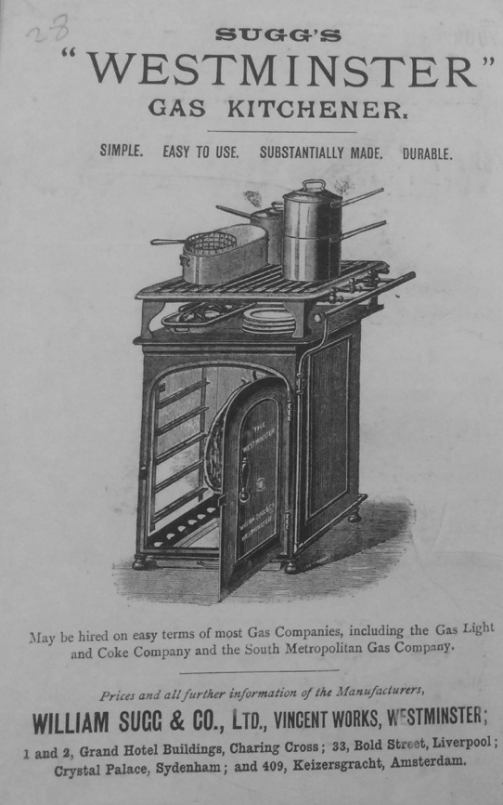 | 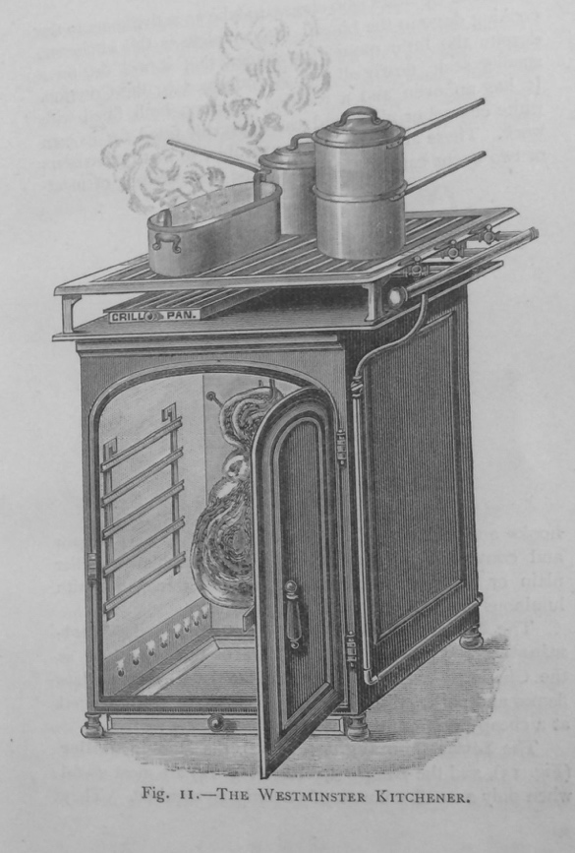
Figure 1.1 Advertisement for Sugg’s ‘Westminster’ Gas Kitchener in the front pages, and an illustration of the same product: Marie Jenny Sugg, The Art of Cooking by Gas (London: Cassell & Co, 1890), 12. Reproduced by permission of the British Library.

For others, it was in their own professional interests to promote certain products, without a familial link to a particular business. Clendinning has shown that lady demonstrators of gas products were able to establish their own professional identity from the late Victorian period. Amongst these women was N. R. de Lissa who published Cooking by Gas in 1913. Cooking by Gas was one of at least eight cookery books that she published between 1913 and 1919. She specifically styled herself as a ‘Practical Lecturer and Demonstrator to Gas Companies. Expert in Paper Bag Cookery and “Reform” Food Diet’ on her title page. Her own identity was evidently tied to the gas industry and its associated products. She dedicated a chapter to ‘On how to succeed with the gas cooker’, evidently demonstrating her own professional expertise at using them. This was, of course, intimately linked to mastery of the physical object- the gas cooker- which was illustrated on the front cover of her book (Figure 1.2). Other lady demonstrators such as the prominent Helen Edden also wrote domestic advice manuals; in Edden’s case the book was published by Gas Publications and featured advertisements for her then-employer The Gas Light and Coke Company. In these cases, women with professional links to the gas industries used their knowledge of these products as props for their own professional identity.

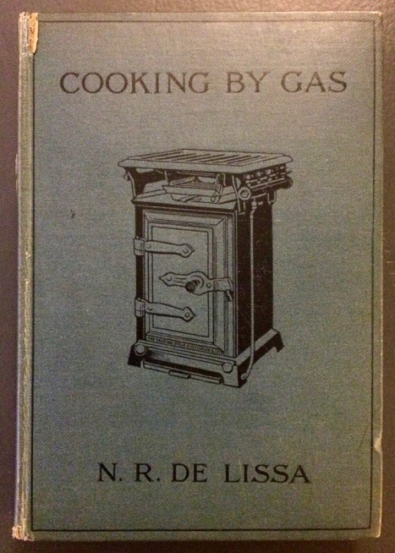
Figure 1.2 Cover of N. R. de Lissa, Cooking by Gas: A Guide to the Correct and Economical Use of the Gas Cooking Stove (London: Andrew Melrose, 1913). Reproduced by permission of the British Library.

Most domestic advice writers did not have such links to the gas or other technology industries. Nevertheless, the material culture of the kitchen was a recurrent topic of discussion, and it was regularly observed that objects had acquired a scientific character. The parallel imagery of the kitchen and the scientist’s laboratory was frequently evoked in Victorian literature. There was nothing original about Mrs Beeton’s comparison of the kitchen and the laboratory. German chemist Frederick Accum had made a similar comparison in his Culinary Chemistry (1821). According to Accum, ‘A kitchen is, in fact, a chemical laboratory; the boilers, stew-pans, and cradle spit of the cook, correspond to the digestors, the evaporating basins, and the crucibles of the chemist’. Alice Gordon described the interchangeability of objects in the laboratory and the kitchen. Her husband was a scientist and engineer who had a laboratory attached to their house. She recalled:

I do remember my dismay on finding one morning that all the kitchen crockery was full of acids and villainous compounds, and the cook informing me with an injured air “that we could have no more pastry till we released her rolling pin,” which was then covered with tin-foil and adjusted as one of the principal conductors in an experiment that I well knew would last many weeks.

In this instance, the apparent material affinity between the stuff of the laboratory and the kitchen allowed the objects to be practically exchanged. The equipment of the kitchen was depicted as having inherent scientific and technical qualities. The nature of kitchen utensils meant that they could, in exceptional circumstances, be exchanged for the objects of the laboratory.

This imagery was part of a wider trend in which the equipment of the kitchen was represented as becoming more complex. Robert Kerr, architect and writer of The Gentleman’s House (1865), described the kitchen as ‘attaining at last in our own day the character of a complicated laboratory, surrounded by numerous accessories specially contrived, in respect of the disposition, arrangement, and fittings, for the administration of the culinary art in all its professional details.’ When Mrs Beeton spoke of the ‘great laboratory’, she epitomized a wider cultural stream that saw domestic spaces and appliances acquire different meanings, reflecting technological and scientific change. To Robert Kerr, and his contemporaries making similar observations, the kitchen had garnered significance beyond its simple function as a space in which food was prepared. The kitchen, therefore, was not a marginalized space in the home with little change or importance. Domestic advice manuals depicted it an integral site in the home for technical innovation, down to its very objects which were perceived to have acquired more technical, specialist qualities.

Through demonstrating their scientific knowledge of kitchen equipment, domestic advice writers were able to assert their own knowledge and expertise. In this respect, the objects became props in their performance of expert housewifery. Technological innovation came to be associated with the contents of the kitchen. To Fairclough, this was most clear ‘in the modern kitchen, with its cleanly gas cooker in place of the antiquated coal-stove.’ The transition from coal to gas stoves was actually fairly complicated; the practical difficulties in changing stoves have been documented. Still, the closed range has been described as ‘the status symbol of the Victorian middle class’ and it has been suggested the cast-iron cooking stove could be ‘the single most important domestic symbol’. As Fairclough elevated the importance of a gas cooker, she also raised the importance of overcoming technological difficulties. If the stove can be considered simultaneously a symbol of the domestic values of the middle-class, and an invention of much technical and practical difficulty, it is all the more important. A marker of middle-class identity, therefore, becomes not the stove itself, but the ability of the household to implement and master its use. The reader was told that she too must overcome technological barriers in her kitchen.

Scientific knowledge was also used in descriptions of more mundane kitchen utensils. For instance, Lucy Yates demonstrated her knowledge of science through a description of kitchen utensils:

The utensils here described, and many others not included in this description, belong to the scientific development of cookery, wherein lies their fascination. Heat in some form is the agent employed in all cooking, but in the actual chemical changes brought about by the use of heat vary according to the degree attained, and the nature of the vessels in which cooking takes place.

As with Fairclough, to Yates, science in the kitchen was most detectable through the changes in its implements, brought by technological and scientific innovation. Yates also expressed her understanding of the scientific processes underpinning cookery. The peculiarly scientific character that the kitchen had acquired by this period was recognised by writers of domestic advice in their equipment and utensils. These goods, therefore, were not simply objects of utility with little meaning invested in them. In these instances, the objects within kitchens were used as props with which the writers could express an engagement with contemporary science. In doing so, they demonstrated their intellect and expertise, without deviating from the socially permissible role of the woman as the housewife. In reality, most women probably did not reflect deeply on the scientific significance of kitchen implements when they used them on a daily basis. Nevertheless, domestic advice manuals provided instruction on how descriptions of ordinary objects could be framed in a way that boasts feminine accomplishments, in the line of domestic duty. In this respect, the reader is told she could understand and demonstrate scientific knowledge of chemical change by the simple act of picking up a kitchen utensil.

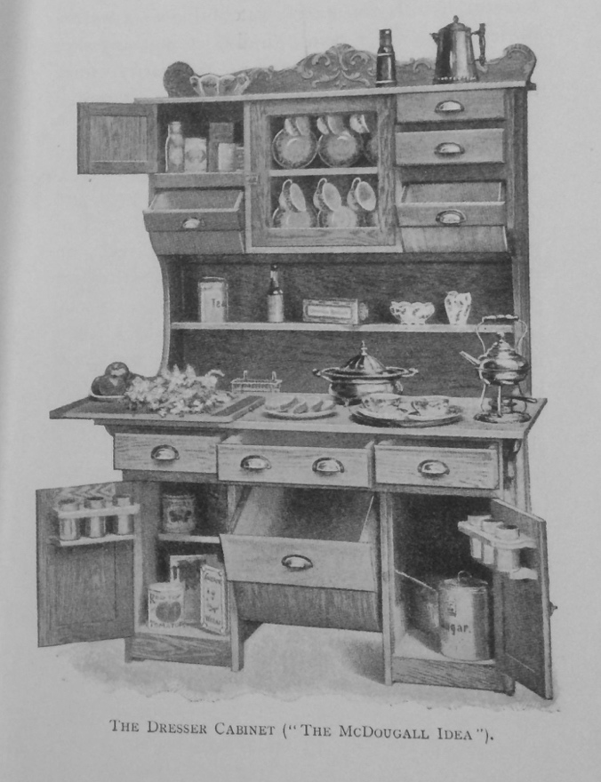
Figure 1.3 Illustration of a dresser cabinet from Lucy H. Yates, The Model Kitchen (London: Longmans, Green and Co., 1905), 11. Reproduced by permission of the British Library.
Yates also highlighted the innovation of the kitchen dresser cabinet with an accompanying illustration (Figure 1.3). Whilst praising its usefulness, Yates drew attention to the role of an ordinary housewife in its creation:

The cabinet was, I believe, the idea of a clever young housewife, brought to the notice for the firm of McDougall in the States, who called in the help of an artist, a cabinet-maker, and a man of science, and the result of their combined skill is known as “The McDougall Idea.” But is the tidy woman’s invention all the same.

Although named after a man, Yates celebrated the anonymous women who was responsible for its production. She represented the kitchen dresser as a housewife’s invention, and thus enhanced a fairly ordinary piece on furniture with scientific brilliance.

The truly scientific housewife must also have had expert knowledge on how to use her equipment for the best results. Some writers advised on the importance of understanding the materiality of utensils to minimise waste of fuel and food in the kitchen. A knowledge of types of metal and their properties was required, according to Helen Edden and N. Moser, to conserve gas. They noted: ‘Heavy iron pots take a much longer time to heat than lighter or tin vessels’. Ultimately, a wise choice of instruments was only sensible for the thrifty, economical housewife, as volume I of Cassell’s Household Guide attested to:

As a rule, people in this country do not pay sufficient attention to the matter of culinary vessels; quite forgetting that it is really the best economy to have such vessels as will enable them to cook their food easily and well without at the same time necessitating any great outlay

The housewife needed to be an expert in choosing the correct implements and using them correctly for the best economy. Edden and Moser implied that the housewife must understand the scientific properties of various metals, to ensure the minimum amount of heat is wasted in cookery. Furthermore, the principles of good economy came to be associated with certain new gadgets entering the kitchen. For instance, to Florence Mary Gardiner, a mincing machine was a valuable implement as ‘the smallest scraps of meat, fish and poultry can be turned to account’. The principles of scientific management, like efficiency, could become invested into certain implements. To effectively master household economy, the reader is presented with an ideology in which they must understand and appreciate the materiality of the implements they are using. In their performance of housewifery, there must also be an intellectual engagement with the props of the kitchen.

This significance of utensils was extended to how they were maintained and arranged by the housewife. Karin Dannehl has referred to the ‘performance’ of kitchen utensils in structuring space in the home. She points out that utensils are functional objects and are thus dynamic and have to be used rather than just displayed. Kitchen utensils are used in cooking, but also interacted with as they are cleaned and tidied away. Good economy was sought in economy of space: keeping the number of utensils available to the absolute minimum. This was recommended by a number of the writers, including Gardiner, Mrs Stallard and Panton, and was typically justified by the need for the maximum amount of space in the kitchen. Stallard, for instance, advised removing any utensils not in use, so as not to ‘cumber your limited space and air with its existence’. Stallard suggested that small implements are better, as she implied in her praise of a pot stand, which ‘is a very convenient invention. It is no trouble to keep clean and does not take up much room’. For Mary Eliza Haweis, keeping the material content of a kitchen to the minimum was a matter of cleanliness: ‘A huge kitchen with much furniture is difficult to keep tidy and spotless as a kitchen should be, unless there are several people to scrub and scour, and for that very reason enough implements are better than too many’. Keeping the number of utensils to a minimum implied an ordered management of the kitchen. Furthermore, the arrangement of the utensils was a marker of the method and order of a housewife’s management. Ada Colley, for instance, asserted that ‘a good methodical housewife may easily be tested by the way she keeps her working utensils’. Simple household implements were the tools of a housewife, and according to Isabel D. Marris, ‘in these she should show pride and pleasure’. The successful management of a home by a housewife was not simply evidenced in the ownership of the appropriate utensils, but in their maintenance. To truly use kitchen utensils as props in a performance of scientific housewifery, they must have been regularly maintained and kept in an orderly manner.

As a legacy of the pre-modern era, the scientific housewife should have been precise and accurate, guided by clocks and scales. The widespread prevalence of clocks in the household was pre-Victorian. According to Lorna Weatherill, clocks were three times more frequent by 1715 than in 1685. Frank Trentmann has recorded a similar proliferation of clocks from the late seventeenth century to the early eighteenth, stating that by 1725 one in two households had a clock, compared to one in ten in 1675. In addition, Lieffers and Pennell have observed that from the mid-eighteenth century, cookbooks got increasingly specific with measurements and timings. The importance of the clock for precise timings was sustained in the nineteenth century. In an introduction to Cookery for Working Men’s Wives (1889), Dr James B. Russell described the ideal cook: ‘Our model cook is methodical. She works, like the chemist, by weight and measure, and guides her process by the clock’. In this case, the parallel imagery of the kitchen and the laboratory was used in combination with a reference to the clock. Scales, which were common in the household prior to this period, were also upheld as significant for precision. To Mrs Beeton, ‘the most important kitchen utensil’ was weights and scales, to ensure a good balance of flavour in the food: ‘Preciseness in proportioning the various ingredients, in order that no one particular flavour shall predominate, should be the cook’s aim. We repeat, therefore, it is absolutely necessary to have scales, even if other utensils be dispensed with’. As a legacy of the pre-modern era, a precise, accurate attitude to cookery should have been supported by the correct equipment.

Domestic advice manuals on their own, however, give little evidence to how widespread clocks were at this period. An estimate is provided by inventories. In a database compiled by Lesley Hoskins, based on 492 inventories taken at death from 1841 to 1881, thirty-six percent of the inventories that specifically named the kitchen included a clock. This was considerably more likely to be in the ‘front kitchen’ (ninety-seven percent of kitchen clocks), i.e. the main kitchen, rather than the ‘back-kitchen’, which might be a smaller kitchen service room like a scullery. For fifty-two percent of the inventories that had a kitchen clock, this was the only clock in the household. In addition, four inventories listed watches found in a kitchen. As has been observed of the early modern period, clocks were most likely to be in the kitchen above any other room in the house. 238 sets of scales were reported in the sample of inventories, across 154 households. 75 sets of scales were listed as in a kitchen, scullery or pantry, although there were others listed somewhere in the house without a specified room. The evidence from inventories suggests that whilst clocks and scales were prominent in the home, they were by no means universally present, even if the omissions of inventories were considered. Furthermore, this particular set of inventories, whilst covering a wide social, occupational and geographical range, were derived from approximately 15% of the population who were wealthy enough to pay death duties. It is likely that some proportion of the average lower-middle class readership of domestic advice manuals did not have the clocks and scales they were told were necessary. They were told that in order to perform the scientific housewifery of the wealthier, who already have clocks and scales, they must make a monetary investment in material possessions.

Certain objects were described as inherently superior to relying on the bodily senses.
Of scales, for instance, de Lissa advised:

Be most careful to measure accurately each and every ingredient. The eye, however practised, is never a sure guide [ . . .]. It is always worth the little extra time needed to weigh up, and absolute success is the reward. Accuracy is nowhere more valuable than in the art of cookery. A little too much or too little makes all the difference, and in time of cookery or quantity of ingredients will certainly disturb a scientifically arranged balance, and the good materials are spoilt, and wasted, also gas and many other good things.

Scales, in this instance, were linked with a balance of ingredients, as well as the elimination of waste. As the eye ‘is never a sure guide’, scales shifted the dependency for good, healthy food, onto the implements. In order to perform scientific, rational housewifery, the housewife (or, indeed, the servant) needed to make skilful use of the correct consumer products. Such objects were essential for this performance of meticulous housework.

The advent of germ theory also prompted changes in the sensory depiction of housework. Dust in this period was often conflated with germs; the first British scientist to publicly lecture on germ theory was John Tyndall, in a lecture at the Royal Institution entitled ‘Dust and Disease’. As Victoria Kelley has supposed, ‘perhaps dust’s nature as a substance comprising tiny particles just detectable by the eye suggested its association with the tiny undetectable particles that were germs’. Many of the writers paid great attention to combating dust. Mary Hill was a teacher at a school in Sheffield, who wrote Homecraft in the Classroom (1914). She described demonstrating the use of a vacuum cleaner to a group of young students. Before the demonstration, ‘no sign of dust was seen or smelt!’ Following the cleaning of the carpet, the demonstrator:

removed the bag by unscrewing the metal ring and carefully emptied its contents upon a sheet of newspaper. The result was amazing! From an apparently clean carpet a heap of dust quite 4 in. in diameter and over an inch in depth had been drawn, and this without sending any into the air!

The appearance of an ‘apparently clean’ carpet could no longer be trusted. Modern technology, such as a vacuum cleaner, demonstrated that dust could lurk out of view of the human eye. The relationship between material culture and rational or scientific housework can be seen as two-way. Whilst clocks and scales prompted advice to rely on them for precision and accuracy, inventions such as the vacuum cleaner offered solutions to the problems posed by advancements such as germ theory. Either way, the descriptions of such items present them as props in the performance of domestic expertise. This performance was inextricably linked to the possession and use of the correct consumer goods.

| III | Domestic Servants: The Scientific Housewife’s Foil

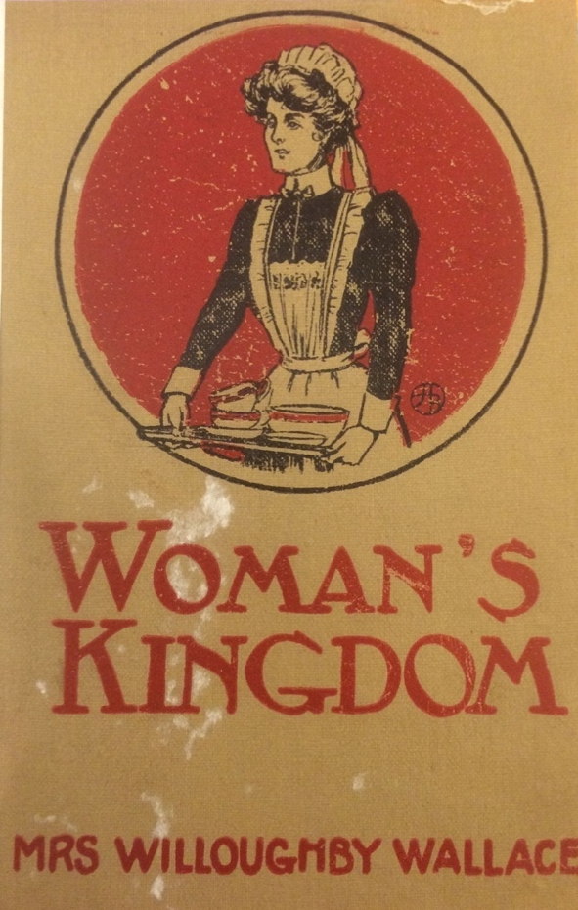
Figure 1.4 The original front cover of Mrs Willoughby Wallace, Woman's Kingdom: Containing Suggestions as to Furnishing Decorating and Economically Managing the Home for People of Limited Means, popular ed. (London: Constable and Co., 1910). Reproduced by permission of the British Library.

As the introductory chapter established, having a domestic servant was a signifier of middle-class identity (see introduction, page 21). The cover of Mrs Willoughby Wallace’s Woman’s Kingdom (1910), which went through at least two editions, shows an image of a housemaid, wearing the traditional maid’s uniform, holding a tray of crockery (Fig 1.4). Wallace’s advice was a classic overestimation of the resources available to the average middle-class family, as described on page 51. Despite being pitched at ‘people of limited means’, the advice was clearly for an upper-middle-class household, having made the rather inaccurate statement that ‘A large percentage of households keep two maids, to whom they either give the designation of cook-general and house-parlourmaid or of cook and housemaid’. As this section will show, the excess of domestic servants in advice manuals accentuated the abilities of the scientific housewife, often in descriptions of a particular object or technology. The rational, scientific housewifery depicted was not necessarily a response to a diminishing number of servants, as some scholars have suggested of the twentieth century. Instead, the ideology of scientific housewifery was appropriated into a discourse about the power relationship between mistress and servant.

Given the significance assigned to the kitchen in preserving family health, the domestic cook was of critical importance. N. R. de Lissa ended the foreword to Cooking by Gas with a short poem:

We look to the Doctor for Physic and Pills
To cure us of our little ills,
But spite of all that’s in his book
Our health depends upon
THE COOK!

The importance of the cook to the health of the family was a central theme of much of the domestic advice consulted. To Mrs Beeton, the cook had ‘an absolutely crucial place in the creation of a civilised and happy home’. Like the scientific housewife, the cook must have had a working knowledge of science to create healthy food. The first ‘Cardinal virtue required in a good cook’, according to the writer of Philosophy in the Kitchen, was, ‘an intelligent knowledge of the art and science of cookery, and of the materials required, with correct judgment in adapting means to ends and vice versa.’ In these instances, however, it is unclear if ‘the cook’ referred to was a domestic servant, or simply the person in the home who did the cookery. Either way, their role as the preparer of food saw them placed in high importance.

Nevertheless, most domestic servants were depicted as ignorant and irrational. Domestic advice manuals depicted the understanding of scientific knowledge as distinctly middle-class. Despite the apparent dependency on an intelligent cook, the general assumption was that they were ignorant of scientific principles, typically owing to their innate intellectual inferiority. Volume I of Cassell’s Household Guide defined the cook as ‘a skilful practical chemist who knows nothing of chemistry’. Similar sentiments were expressed in Volume II of Cassell’s as it was assumed that the cook was ‘sublimely ignorant of chemistry’. The household must depend on the cook for health and sustenance, and yet it was generally assumed that the cook could not understand the theories of chemistry that were essential to the housewife. This attitude was extended to all domestic servants. In her guide to girls in domestic service, Catherine Moss clearly demonstrated her belief in the innate stupidity of servants, advising them to ‘Try to act without having to be continually driven along, as if you were some dumb animal instead of one of the human race, God’s noblest work, full of wonderful means of thought and action.’ Class ideologies depicted the working-class domestic servant as inherently inferior in their ability to think and understand. The character of the domestic servant that emerged from domestic advice manuals can be seen as the middle-class housewife’s foil. The representation of servants as fundamentally unscientific served to highlight the competency of the housewife.

The allocation of domestic chores between the mistress and the domestic servant was deeply contradictory, even within individual texts. On the one hand, it was argued that a methodical approach to housework, and a sound knowledge of science as it concerned health and hygiene, were responsibilities of the housewife. On the other hand, where servants were involved, there were some contradictions regarding ‘where the supervision by the mistress should begin and where end.’ Many of the writers took the view that ‘The mistress should be able to perform every single detail of household work herself’. Mrs Arthur Stallard demonstrated some particular contradictions in this respect. Stallard professed, ‘It is not at all necessary to be a good cook yourself to make the girls you employ proficient.’ However, the mistress must have been able to identify ‘what is wrong with a dish and the way to put it right, but to be able to do it yourself requires a training few housewives can get.’ The mistress thus must have known how to correct a faulty recipe but did not need to know how to actually cook it. Stallard continued on the next page: ‘No mistress should be without her store of tested recipes, as well as half a dozen cookery books’ and ‘In no case should a woman rely on her cook’s knowledge alone’. After all, if the mistress knew from her own experience the recipe is reliable, ‘then you know the fault lies with the cook if things go wrong’. Mrs Stallard’s contradictory attitude to domestic service and cookery is a crucial example of the complex web of gender and class ideologies that complicated the advice given in this period. The mistress, as a lady of middle-class standing, did not need to be a proficient cook, which after all, might have tainted her with the drudgery of household labour. But, she must have had enough knowledge of the cookery processes to exceed her cook’s efforts. The cook, however, must have been competent, as the health of the family depended on her, but she was not to be relied on. The mistress must have known better, despite knowing little of cookery herself. Significantly, this tangled web of advice was potentially useless to the majority of the lower-middle-class readership, who most likely only had one maid-of-all-work, and thus did not have a cook anyway. Nevertheless, an image emerges of the idealised housewife as the protagonist who observes and guides the less able domestic servant.

Orderliness was an integral part of the performance of class. The mistress’s outward display of order and control, regardless of its authenticity, was integral to keeping the servants in their place. For instance, without her servant Barbara, Ella Burton considered leaving the washing up for the next morning,

but was told, with some truth, that the state of muddle at this rate would increase every day until Barbara [her domestic servant], returning and finding everything out of sorts awaiting her return, in a state of desperation, would feel still more ascent over the gentry than before; and that, therefore, at any cost we should let her see the house when she came back in spick-and-span order.

As I have already noted, the arrangement of objects in the kitchen could be as important as possessing them (see above, page 72). As Burton’s failures over the week demonstrated, orderly household management was not her strength, but this could not be admitted to Barbara. Burton noted with some satisfaction that on Barbara’s return, she was ‘much astonished at the tidy condition of the kitchen and the general undisturbed appearance of everything’. Certainly orderliness was pitched as essential to the health of the family, but, as Burton’s example suggested, it was equally a mark of social standing. According to Burton, the working classes were not accustomed to disciplined methods, and thus it was the burden of the middle classes to maintain a display of orderliness through a tidy kitchen, in protection of their precious class position. As can be seen in this instance, the orderliness is only a performance for the domestic servant; Burton’s description of her housework without Barbara was chaotic. She performed orderliness to keep Barbara in her place.

If kitchen equipment can be seen as ‘props’ in the performance of middle-class scientific housewifery, the same objects were the downfall of domestic servants. They were often presented as disorganised and messy. Mary Eliza Haweis recommended writing the motto ‘A place for everything and everything in its place’ across the kitchen cupboards as a reminder to the cook. As the first section demonstrated, a methodical arrangement of kitchen equipment was as important as the objects themselves. As I stated above (page 72), some authors recommended keeping the number of utensils to a minimum. This could also be a signifier of the mistress-servant relationship. Domestic servants were deemed to demand more utensils than were necessary to get the job done. ‘Cooks often ask for utensils which are only really adding to their work and care’, contended Stallard, singling out lemon squeezers and egg poachers as particularly useless. Panton concurred, claiming the ‘idea of superfluity has done more harm in the kitchen than enough, no servant being sufficiently strong-minded to resolutely put aside anything she can do without’. To control one’s servants and rein in their requests for an abundance of tools came to be a sign of authority and successful management over the servant class. Panton insisted that the mistress, ‘must show her cook that she really does know her duties as mistress of the household and she must be able to hold her own when cook demands extravagant supplies and a judicious selection of kitchen utensils will point out to her own on the subject of household management’. The mistress, of course, was responsible for buying the tools, and so her selection became a marker of her ability to do her job. As the mistress should have known better than her servants, her insistence on a smaller quantity of utensils was a performance of her superior knowledge of kitchen affairs, and her commitment to orderly and rational household management.

Stoves and ranges were a particular concern. Cassell’s Household Guide noted that ranges had ‘far too much ingenuity about them for any but an engineer to manage’. The complexity of the ranges was all the more problematic when ‘in the hands of ignorant girls- who are thankless pupils, even if they can be taught’. Fairclough criticised cooks use of the stove, describing the overuse of gas as an ‘extravagance frequently indulged by cooks’. Mastery over the equipment of the kitchen could be a signifier of class for the housewife, but as Fairclough suggested, the inability to use them was a marker of the domestic servant’s apparently lesser understanding and abilities. Thus, it was not just possession of the correct equipment that made one’s class, but how they were interacted with; the ability to use these ‘props’ was the true signifier of class. The new kitchen ranges in this period thus become symbolic of the uneasy balance between labour-saving ingenuity and over-complication, and mistress expertise and the maintenance of class difference.

Catherine Buckton, writer of Comfort and Cleanliness (1898), gave a detailed account of the problems she encountered with her cook and her kitchener (a closed-top cooking range). Buckton was heavily involved in women and girls’ education, having been ‘instrumental’ in persuading the Education Department to teach domestic economy to girls in elementary schools, and she sat on the Leeds School Board in 1873. Buckton described moving to a new house and discovering she had no previous experience of the kitchener installed, so she ‘sent for a skilled workman to explain its exterior arrangements and the heating apparatus hidden from view.’ She continued, ‘When I understood the stove, I soon learnt how to regulate the heat and how to rectify its defects. She included in Comfort and Cleanliness detailed diagrams of the adaptation of her cooking range (Figure 1.5). These diagrams expressed to her reader her detailed technical knowledge of an ordinary household object. Her descriptions of her cook’s interaction with the stove demonstrated Buckton’s expertise further. She described the cook’s accident with the kitchener: ‘Soon after we came to the house the servants were much alarmed one evening by the arrival of fire-engine’, although on investigation, there was no such fire, only smoke. ‘Had the cook simply closed every damper the flames would have died out at once for lack of fresh air to feed the flames. Having learnt by this unpleasant occurrence that the cook neither understood how to regulate the heat of her stove nor how to clean the flues, I arranged with her to be present one day when they were swept by a qualified sweep.’ Interestingly, however, the scientific and technological expertise here did not come from Buckton herself. Her initial understanding of the arrangements of the kitchener came from a skilled workman, a working-class man. When her cook needed to see the arrangements of the flues, Buckton relied upon another working-class man- the qualified sweep. The responsibility for teaching the cook lay with Buckton, although she acted only as a mediator between the cook and the qualified sweep. The knowledge itself could not simply pass from the person who had it (the sweep), to the person who needed it (the cook); instead the diffusion of knowledge had to pass through the ideologically prescribed network within the middle-class home. Despite this, Buckton’s account of her stove maintained archetypical characterisations of herself and her cook. She was responsible, and knowledgeable; her cook was not, to the point she was actually dangerous.

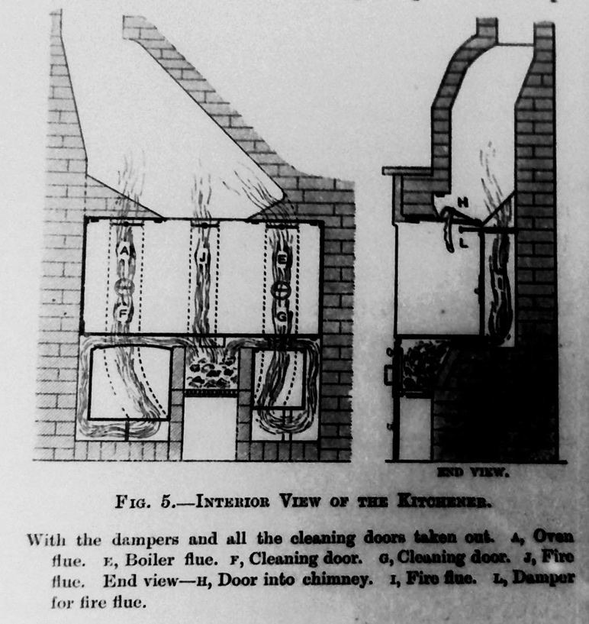
Figure 1.5 A diagram of the interior of an adapted kitchener from Catherine Buckton, Comfort and Cleanliness: The Servant and Mistress Question (London: Longmans, Green and Co., 1898), 10. Reproduced by permission of the British Library.
[This photograph was originally taken of a microfilm; the colours of this image have been digitally inverted to improve the print quality on reproduction.]

Buckton’s cook, of course, did not own the kitchener. Domestic servants were depicted as the primary users of kitchen equipment, and the main inhabitants of the domestic kitchen, but they had no financial claim to any utensils. Whilst servants were held to the same standards of rational housekeeping as their middle-class mistresses, they did not have the means to purchase the necessary equipment. Tellingly, Mrs Beeton advised to the domestic servant, ‘Punctuality is an indispensable quality in a cook; therefore, if the kitchen be not provided with a clock, beg your mistress to purchase one’. Of the early modern kitchen, Pennell has noted that the presence of a clock suggested a certain level of number competency and ‘is a significant challenge to existing readings of non-elite women’s and especially female servants’ skill sets’. The same argument could be made of the Victorian and Edwardian kitchen. The trend towards rationalisation was encouraged in domestic servants, including the ability to read a clock, but they were unable to physically possess the clock required. The mistress’s superiority was not only in her middle-class intellect, but also in her financial control over the equipment in the kitchen. The mistress could be a barrier or a facilitator to the domestic servant’s own performance of scientific housework, by purchasing the correct products. Even when they were provided, the mistress, as in the example from Buckton, still had control and authority over how the object was to be used correctly. Even when the object was primarily used by the domestic servant, it still belonged to the mistress owing to her superior knowledge of it.

According to Harry Bravermann, control over work instruments was central to Frederick Winslow Taylor’s concept of ‘scientific management’. Although control was not new to management theory, Taylor’s scientific management included control over the precise manner in which work was performed. In Bravermann’s words, ‘Not only do the workers lose control over their instruments of production, but they must now lose control over their own labour and the manner of its performance’. In a similar manner, the mistress’ choice of certain technologies was a form of control over the domestic servant, as the domestic servant is forced to perform, for instance, cooking, in a particular manner with a particular technology. The provision of kitchen technologies by the mistress could be seen as a form of scientific management with parallels to industry.

Authority and prestige were always expressed within the confines of middle-class expectations of gendered behaviour and identity. This is particularly clear in an example from Eliza Priestley, the wife of a doctor, who sought to demonstrate her more advanced scientific knowledge than the workmen she employed. Undoubtedly, she exhibited a general class prejudice towards the rural working classes, referring to them throughout Our Highland Home as simple, backward and primitive. As is typical of other domestic advice guides published at this time, she also suggested the working classes were incapable of mastering new technologies or understanding the progress of science. She commented, ‘It was useless to argue that in the last twelve years new inventions had been made, and that sanitary science was a thing which grew’ Plumbers, in her view, were ‘not sufficiently educated to understand the scientific meaning of their work’. Indeed, Priestley even recalled an incident where she rectified the workers apparent building blunder:

I at once drew an outline on the wall- as if teaching a child with the blackboard- to indicate where a window was to be cut, and made a similar mark where a second door was to lead into the grounds, and to the coal-cellar

Evidently, Priestley believed in her own superiority on the building work to be done. And yet, she still cast herself in a role that was indubitably in line with ideals about feminine behaviour. As I suggested earlier (page 55), age and experience were central to the matriarchal expertise of the domestic advisor. Priestley believed that her workers viewed her as ‘an equal, a universal mother to whom they all came in their troubles domestic and private, or professional and public’. She later described her success during this project as gratifying her ‘feminine instincts’. Priestley clearly sought to demonstrate her superiority on sanitation, construction and science in general, but while casting herself in a mothering role. Like Buckton, Priestley demonstrated a femininity that was based on the traditional roles cast for women, such as motherhood and household management, but demonstrated a superiority on scientific matters such as sanitation. In this respect, she was using her own agency in the formation of her identity through a contrast with the working-class other.

A critical contradiction in the depiction of domestic servants was their simultaneous responsibility for, and ignorance of, health and hygiene. It was dictated that the kitchen must be kept meticulously clean, but domestic servants were deemed naturally dirty. The solution was for the mistress to rigorously supervise her domestic servants.

Cleanliness in the kitchen should be strictly enforced; anything to do with the cooking of food should be spotless. The mistress should examine the saucepans occasionally, and not only the saucepans themselves, but the lids, to see if they are clean.

Again, close interactions with objects of the kitchen were critical for the maintenance of health. Cleanliness, of course, was not simply an objective category and scholars from across disciplines have examined its implications. Adrian Forty, amongst others, has drawn attention to a middle-class imposition of cleanliness on the working-class body, around the fin-de-siècle. The ability of the mistress to check cleanliness was not just a matter of health and hygiene: the assumed higher standards of cleanliness were a distinctive characteristic of the middle class. For the mistress to check the cleanliness of the kitchen objects, she was not only preventing the spread of disease, she was also recreating presumed class differences between her and her servants.

Drains were a particular source of concern in this period, owing to the risk of sewer gas entering the home from faulty or absent drain traps, insufficient ventilation, or irregular flushing. The dangers of the household drain were emphasised in general management guides, as well as a specialist literature on household sanitation and plumbing. According to E. Gregson Banner, writing in 1882, ‘house drains proper are, in nine cases out of ten, improperly constructed, and therefore are pregnant sources of constant danger’. Sanitary engineer William Eassie warned in 1872 of built-up gas ‘invad[ing] the atmosphere of the house’. Gardiner described drains as ‘absolutely innocent of ventilation and reeking with an atmosphere which would put the Black Hole of Calcutta to the blush’, and suggested using permanganate of potass diluted with water to flush them. To Panton, the drains were simply too dangerous to be left to a servant. She stipulated: ‘The drains are too important a matter, you can tell her [the domestic servant], to leave to any one, and therefore you must see after them yourself’. The mistress, according to Panton’s advice, must actively take responsibility for kitchen tasks that could pose a danger. The domestic servant created by domestic advice manuals highlighted the importance of the tasks assigned to the mistress. The achievements of the housewife, as the protagonist, are all the more impressive as she was depicted as actively pre-empting threats to her family’s health: the danger of the drains, compounded by the incompetency of domestic servants.

The apparent incompetency of the standard domestic servant was exaggerated by depicted bodily differences in servants that required more rigorous surveillance by the mistress of the household. Of the drains, Panton stated:

I am no advocate for mistresses spending their lives in perpetual harassment of their unfortunate servants, but there is one thing that should never be left to the tender mercies even of the best servant that ever lived; and that is the sink, or, in fact, any drain that may be in the kitchen regions. I cannot tell how it is, but a domestic appears to me to be born into the world bereft of any sense of smell.

To Panton, the failure of the servant class was apparently attributable to a difference in their ability to identify bad smells. As she implied, servants are naturally born different. Their bodies, it was suggested, are acclimatised to a lower standard of cleanliness. To one writer, even the air from which the servants breathed was contaminated. The Servant Problem recommended that where possible, ‘from a hygienic point of view’, a separate servants’ room should adjoin the kitchen. In addition, the writer suggested that it was not in the interests of hygiene for the servants to be breathing in and out in the same space that food is prepared: ‘A kitchen from which the servants are never absent must of necessity be filled with certain exhalations and exudations from their lungs and bodies, and yet it is there the family food frequently lies during its preparation for cooking’. In this instance, the differences between the servant and the family went down to the very air that they were exhaling. The servant body was depicted as possible of contaminating virtually anything. This is surely not a reflection of any widespread view that the bodies of domestic servants were actually different. Instead, it can be interpreted as exaggerations by writers, to articulate a language of class difference based on medical rhetoric.

In a further paradox of the dependency on servants for healthy food, domestic advisors frequently referred to the dirty bodies of domestic servants. Medical and scientific rhetoric reinforced the portrayal of domestic servants as physically and racially different. Towards the end of the century, concerns increasingly mounted about the physical degeneration of the working classes. This was particularly prevalent in concerns about domestic servants, or, as Wallace noted, ‘at least so the mistresses affirm’. Ella Burton’s description of her servant Barbara draws on the notion that the working classes were a separate race. Whilst Barbara was ‘clever, active, administrative’, Burton described her flaws as ‘very natural to the half-developed or half-civilised human being’. A lack of cleanliness was considered a major flaw of the working classes. According to Mrs Miles, ‘In every country it is the servant class who need above all to be taught and trained in the art of cleanliness’, but it was the English working classes who were ‘especially negligent in this respect’. Unsurprisingly, the apparent innate dirtiness of the servant class instigated particular cautiousness in the mistress’s supervision of food preparation.

The cleanliness of servants’ hands was of particular concern, especially in kitchens where they would be touching food. For instance, Mrs Miles drew unfavourable comparisons between the English method of preparing food and the Japanese: ‘With regard to cleanliness in preparing food, we are far behind the Japanese. This is especially so with respect to the free use of dirty hands by our cooks.’ To the writer of Philosophy in the Kitchen, even the use of soap could not counter the dirtiness of the servant’s hand. Servants, he suggested, could not wash properly.

Even the most lavish use of detergent soap does not always imply scrupulous personal cleanliness. I have often seen cooks wash their hands in plenty of water and soap, yet leave them unclean for want of thorough wiping and drying, and plunge them, still soapy, into delicate messes they were deftly mixing.

Natural dirtiness and the inability to practice hygiene effectively was a worrying combination in servants who were handling food. In this account, the incompetency of domestic servants meant that they could not even correctly use soap.

Utensils, however, could be used as a safer alternative to the bare hands of servants. Ada Colley recommended that ‘The dairymaid should possess a clean, cool hand’, adding that ‘this is not so important on account of the improvements and additions to dairy utensils, whereby butter may be made without being touched by hand.’ The utensils in this instance serve to replace the hand of the servant. Unfortunately for mistresses, it was frequently attested in advice literature that cooks were notoriously picky in their choice of implement. As one writer deplored: ‘It is quite a common thing also to see them rubbing down bread for crumbs in their hands instead of grating it upon a grater. This was the usual modus operandi with the cook of whom I have just been writing, although she had a beautiful grater.’ The cook, alleged to be ignorant of good hygiene, was naturally more comfortable using her hands rather than the instruments supplied. New technologies in this period, such as kitchen utensils, were often associated with advancement and progress. Domestic servants’ alleged reluctance to use them suggested that they were not capable of physically adapting to technical advancement. Food in the middle-class home was a physical link between the bodies of servants and the bodies of the family. It was physically touched and prepared by the domestic servants but ingested into the bodies of the middle class. In this example, kitchen utensils were not only a prop in a performance of class; utensils are represented as literal barriers between the bodies of the different classes. The objects prevent a social class contamination in the kitchen becoming a literal contamination of disease.

Conclusion

This chapter has described the ideology of scientific housewifery and outlined how it co-existed alongside domestic servants and physical objects in the Victorian and Edwardian kitchen. I have argued that the material culture of the kitchen was critical for the ideology of scientific housewifery within domestic advice manuals. If we read domestic advice manuals as scripts, then scientific discourse may be seen as a dialogue. And this dialogue was used throughout domestic advice manuals to transform ordinary kitchen objects into specialist, technical equipment that required detailed knowledge and expertise. Domestic advice writers thus depict these objects as props, which readers can buy and use to express their own scientific expertise, carefully circumscribed by the bounds of gender and class.

This incarnation of the scientific housewife that depends on material possessions is a particular product of the nineteenth century. Certainly aspects, such as a reliance on clocks and scales, predate this period. However, from the nineteenth century, consumer culture exploded, the middle-class expanded and domestic advice manuals peaked in popularity. It is also in this period, as the introductory chapter established (page 17), that science moved into popular culture for the masses, as well as beginning to become recognised as a profession. Simultaneously, major new technologies such as ranges entered the kitchen.

No one woman, of course, could possibly hope to follow all the advice given across the genre. Aside from the impracticalities, some of the instructions concerning the prevention of disease were simply impossible. An image, therefore, emerges of a fictional woman that could achieve everything. I have named this the scientific housewife, who had skills beyond the means or abilities of any Victorian or Edwardian woman. Women thus could read domestic advice manuals in the hope to emulate this idealised housewife.

Critically the scientific housewife was only convincingly performed through a careful interaction between stage, props and other characters. The best staging was the large house with specialised rooms, including a kitchen with plenty of servants to supervise and teach, and filled with the necessary items such as clocks, scales, and the latest ranges. It was not enough, of course, to be surrounded by the correct objects to become the scientific housewife. The truly scientific housewife was intellectually engaged with the material culture of her kitchen. Like Catherine Buckton, she knew the technical ins and outs of her closed range, or like Lucy Yates, she thought about the scientific processes affecting her kitchen utensils.

Whilst it has been suggested that the application of science and technology to housework was a response to the decline of the servant class in the mid-twentieth century, this chapter has indicated that this was not the case. Evidently, an identity of the expertly-informed housewife who drew on science was emerging prior to the twentieth century. Writers of domestic advice manuals appropriated their scientific, technological and medical knowledge into an existing discourse about the differences between mistress and servant. This was, as the third section of this chapter showed, interwoven with ideas about material culture and bodily difference. Scientific discoveries, such as the establishment of germ theory, are popularly considered milestones in a progressive history of science. Domestic advice manuals suggest how such ‘science’ was experienced as part of daily, cyclical activities. Domestic advice writers granted themselves greater power and authority by drawing on scientific discovery and contemporary technology. In doing so, writers created a version of everyday science that was practised in daily life. Thus, the opportunities for studying historical experiences of science are expanded, from not just purposefully ‘scientific’ activities, such as discoveries or ‘popular’ leisure activities (such as botany or conversaziones), but in the cyclical patterns of everyday life.

Of inspirational literature, Kenneth Burke has said ‘The reading of a book on the attaining of success is in itself the symbolic attaining of success’. Autobiographies- the topic of the third chapter- offer some fragmentary evidence of how domestic advice manuals were used. To Canadian Letitia Youmans, Catherine Beecher’s work was a critical aid. She recalled: ‘I resolved to purchase it, and if ever I became a housekeeper, avail myself of its aid. It has been in my possession ever since, and if there ever was a helper to an amateur housekeeper, it is this same volume’. Alison Uttley fondly remembered the treasures kept in her mother’s drawer in the parlour, which she called ‘the Cave of Aladdin’. In the drawer her mother kept a number of sentimental relics, including Sunday toys and a scrapbook of Christmas cards for her mother’s childhood, and, ‘Mrs. Beeton’s Household Management, complete with coloured plates of fruits and puddings in pyramids of beauty, such as I imagined existed only in the Royal Palace’. Perhaps then, the ultimate prop for the housewife was the domestic advice manual itself

Chapter Two

Intellectual Domesticity? Science and Domestic Subjects in New Middle-Class Schools

Is science, as the exposition of truth in due order of development, to be used for the purpose of secondary education; or shall the activity of girls in the laboratory be regulated by inquiry into important and interesting problems arising out of desire to penetrate the mysteries of diet, cooking, washing and household cleaning?

So asked Sophie Bryant, headmistress of the North London Collegiate School (NLCS) (1885-1918), in a paper given to the College of Preceptors, 20 November 1912, in which she contemplated the relationship between ‘Science and the Home Arts’. The question of what school pupils should be learning, and why were central questions surrounding girls’ education in the Victorian and Edwardian periods. This was particularly the case for middle-class girls and for two subjects that were entering formal schooling for the first time: science and domestic subjects. From the mid-nineteenth century, new day schools for girls were opening which aimed to offer an education of the same standard as public schools for boys. As Bryant suggests, various subjects, including science, were often publicly justified owing to their apparent practical benefits in the girls’ future lives as housewives, or for their role in intellectual development. In this chapter, I examine science and domestic subjects as they were taught at three new schools of the Victorian period: the NLCS; Manchester High School for Girls (MHSG); and Bedales. I suggest that by emphasising academic achievement and the importance of domestic work to their pupils, such institutions redefined what it meant to be a housewife, casting domestic life in an intellectual light. Moreover, I highlight how this emphasis on academic and intellectual freedom also allowed girls to assert their own agency in the fashioning of their identities.

The first chapter introduced the ideology of scientific housewifery through analysis of domestic advice manuals, which were read as representations of the idealised practices of the middle class. In this chapter, I pointed towards the importance of the lifecycle, suggesting that middle-class women encountered scientific housewifery through domestic advice manuals targeted at new brides. This chapter builds upon the previous by exploring how this ideology influenced the ethos and practice of new institutions founded for the education of middle-class girls. It shifts the focus from the new bride to the young woman and her teachers. This chapter, therefore, takes a step out of the domestic kitchen, and into the middle-class school, to consider ‘domesticity beyond the home’. As Jane Hamlett has established, the influence of the relationships, material culture and everyday practices that define domesticity ‘went far beyond the four walls of the middle-class house’. Thus, I examine the relationship between science and housework as it was articulated through girls’ schools. Drawing on sociological theory, I endorse a symbiotic relationship between society and educational institutions. As Felicity Hunt has argued, ‘The reflection of particular values in our schooling is one half of the equation where education ≡ society. The other half demonstrates the reinforcement of these societal values through our educational system’. Each of the three case studies examined here could be described as embodying the ‘catch-22’ of new girls’ schooling, namely that educators adhered to ‘two sets of rigid standards: those of ladylike behaviour at all times and those of the dominant male cultural and educational system’. Each school offered a liberal curriculum, defined as one designed to develop the mind and character, but with a continued emphasis on traditional notions of domesticity and femininity.

Educational opportunities in the nineteenth century were expanding. At the beginning of the nineteenth century, most middle-class girls would have been educated to learn social accomplishments, with little time devoted to any kind of intellectual activity. A major turning point came mid-century with the establishment of two pioneering day schools: the NLCS, founded in 1850 by Frances Mary Buss, and Cheltenham Ladies’ College, founded in 1853 and led by Dorothea Beale from 1858. These ground-breaking schools aimed to mirror the educational standards of the equivalent boys’ public schools. In 1872, the Girls’ Public Day School Company was established with the aim to provide more day schools for girls. By 1900, the company had thirty-two schools with seven thousand pupils. With these new schools came new questions about the appropriate course of study for middle-class girls. For the purposes of this thesis, I pay particular attention to science and domestic subjects. I favour the term ‘domestic subjects’ for consistency, but in practice a variety of terms were used in contemporary debate and within individual schools, such as domestic science, domestic economy and housewifery. My definition of ‘domestic subjects’ is broad, including any classes that incorporated instruction on managing a home, and particularly activities that would take place in the kitchen. I exclude needlework, which is arguably a domestic subject, but not one associated with the kitchen, and thus beyond the scope of this thesis.

Increasingly across the period 1870 to 1914, domestic subjects and science were linked. Domestic subjects were, after all, sometimes termed domestic science, although there was no clear definition of the term. The content of science and domestic subjects could be similar. Topics, for instance, on human digestion, health, and cleanliness, naturally have a bearing on home life, as well as the study of science. The potential overlap between the two subjects is evident in the words of Margaret Gilliland, the headmistress of Haberdashers' Aske's School for Girls (1904-1919), who advocated all girls studying science and domestic subjects side-by-side: ‘Starch, sugar, and alcohol, and fermentation generally in the laboratory, at once tell you that bread-making is the subject of the cookery lessons at the time. Processes of cleaning in the housewifery class suggest experiments with certain acids in the corresponding science lesson’. Gilliland’s words exemplified the potential for overlap between science and domestic subjects. However, her views were certainly not representative of all public commentators, and indeed, even within the same volume, Lillian Faithful, principal of Cheltenham Ladies’ College (1907-1922), disagreed with Gilliland’s proposed outline of science and cookery classes. To all contemporaries, the potential overlap between domestic subjects and science was clear, but there was a broad spectrum of opinion on if they should overlap in girls’ school programmes, and if so, how this should work in practice.

The Education Department (1856-1899) and its successor, the Board of Education (1899-1944), were increasingly occupied with domestic subjects from the late-Victorian period. The Edwardian period has been highlighted as particularly significant in the development of a state-imposed teaching of domestic subjects, as national anxiety about the health and fitness of the population prompted a renewed focus on educating competent mothers. In 1902, the Education Act introduced state school secondary education, and in 1905, the Board demanded ‘housecraft’ be introduced into curriculums. Confusion over the relationship between science and domestic subjects had peaked by the late Edwardian period, at which point the Board of Education published two reports dealing with the subject: the Interim Memorandum on the Teaching of Housecraft Girls’ Secondary Schools (1911) and the Report of the Consultative Committee on Practical Work in Secondary Schools (1913). Both documents acknowledged the wide range of opinion on the matter, ultimately recommending in the latter report that teaching of domestic subjects, namely cookery, laundry and housewifery, should be preceded by two years of study of pure science. Domestic subjects, under its various names, was thus rising in importance as the state became increasingly involved in education, although no consensus ever emerged. It has been suggested that the debates over domestic subjects effectively ended after World War One, which ‘pushed domestic subjects back to their old status’.
Early scholarship on the teaching of domestic subjects generally took a negative view. Dena Attar, for instance, asked ‘whether home economics has ever succeeded in doing much more than systematically waste girls’ time’. Scholars have suggested that Edwardian concerns about the health of the nation prompted educational reforms particularly directed at working-class girls. According to Felicity Hunt, ‘Crudely speaking, the further down the social scale a girl was the more she was perceived as needing a domestic training’. Others have argued that concerns about the health of the nation impacted the education of girls of all classes. Revisionist accounts have since explored how domestic subjects also opened up professional avenues for women, as, for instance, members of school boards or teachers of domestic subjects. Historians have also emphasised the class differentiation in the teaching of domestic subjects. It has generally been agreed that middle-class institutions devalued and marginalised domestic work due to its association with working-class girls. According to Elizabeth Bird, ‘If it were necessary to elevate the status of these subjects to make them acceptable to all classes then they would have to become scientific’. For instance, as Annmarie Turnbull has stated, whilst the ‘science of cleansing’ might be taught to the middle-class girl, the working-class girl learned ‘laundry work’.

However, the view that science raised the prestige of domestic subjects is complicated by a consideration of the status of science in public schools. To some contemporaries, the way to elevate girls’ education was to introduce the classics, not the sciences. Traditionally, boys’ public schools marginalised science in favour of the classics, which were deemed to develop character in young men. This was in part owing to a class prejudice against science; according to Colin Shrosbree there was ‘a gentlemanly mistrust of studies associated with trade and engineering’. Indeed, the 1868 Taunton Commission had found, to some surprise, that the sciences emerged much stronger in girls’ schools than in the equivalent institutions for boys. For instance, assistant commissioner Mr. Giffard noted that he found in some upper-schools, up to seventy-two percent ‘learn some branch of natural science’ and that botany was preferred. The provision of science in girls was not necessarily seen as inherently intellectual; as historians have suggested, within nineteenth-century boys’ public schools, science was ‘Devoid of prestige’. But, governmental reports reveal an increased interest in science for boys. The 1875 report of the Devonshire Commission argued ‘science is as yet very far from receiving the attention to which, in our opinion, it is entitled’.

Furthermore, in a recent PhD thesis, Sayaka Nakagomi has revised much of the feminist account of domestic subjects, particularly the widespread assumption that new middle-class schools for girls devoted little time to domestic subjects. Nakagomi demonstrated that domestic subjects always had a place in new middle-class schools, and outlined a different trajectory for their development, based on case studies of Camden School for Girls, NLCS, and MHSG. Nakagomi has suggested a model with three stages. The first, roughly from 1871, saw domestic subjects included as compulsory, individual subjects. The second stage, from the 1880s, saw an increased emphasis on ‘technical’ training which often involved classes such as dressmaking and cookery offered to pupils outside the regular school timetable. The third stage, from 1900, saw the development of separate comprehensive specialist courses, which included a range of domestic subjects, such as cookery, laundry and housewifery, that were optional and for older pupils. Certainly, there was a lingering social and cultural prejudice about the type of girl who took domestic subjects, especially the specialised courses offered at schools from 1900. It was sometimes assumed that an academic curriculum was for the more capable girls who were to go on to careers, whereas a practical education was for those destined for home life. Even within schools this was sometimes stated, especially by Sara Burstall, headmistress of MHSG from 1898 to 1924, who in 1909 referred to such pupils as ‘the more backward type of girls’.

As a pioneering school for its intellectual curriculum for girls, the NLCS provides an interesting case study for examining the relationship between domestic subjects and science. As the first public school for girls, the NLCS encountered the struggles of designing an appropriately ‘scientific’ or ‘domestic’ education for girls, in negotiation with middle-class ideals about what it meant to feminine. MHSG offers an interesting comparison. Manchester was of course within the industrial north and has commonly been associated with Edwardian concerns about the degeneration of the race. Manchester was a locus of concerns about the health of the nation owing to a widely-touted statistic that out of 11,000 volunteer military recruits, 8000 were rejected for physical defects. In addition, Sara Burstall was a leading voice in the debates over domestic subjects and was ground-breaking in establishing a specialist housewifery course at MHSG in 1901. Bedales School is the third case study. In 1898 it became the first middle-class school to educate boys and girls together- for both domestic subjects and science. Subsequently, it provides an invaluable comparison to the girls’ schools.

In this chapter, I analyse these three schools to evaluate the representation of housewifery and its relationship with science. In my opinion, much of the earlier scholarship has presented a false dichotomy between domestic subjects and the more ‘academic’ subjects of the new institutions, such as science and modern languages. Domestic subjects, it seems, have often been considered an addition to rather than a part of the liberal curriculums of these new institutions, as they involve practical work, rather than the mental work required of, for instance, modern languages or mathematics. By ‘practical work’, I mean work in which the pupils performed an activity themselves, by use of real objects. Specialist equipment and the correct teaching spaces were thus essential to this type of teaching.

I argue that new institutions collectively propagated a broader definition of ‘intellectual’, to include practical work, scientific knowledge, and rationalised behaviour, especially in domestic subjects and science. There were, of course, differences in the programme of study that pupils took, especially older pupils, which towards the Edwardian period, especially at the NLCS and MHSG, were split between those taking specialist domestic subjects courses, and those continuing the general programmes. However, I suggest that there was an impetus on stressing the intellectual benefits of domestic subjects, and the domestic benefits of intellectual subjects. As a result, students on either pathway were exposed to an environment in which institutions shaped and endorsed a version of femininity which I name ‘intellectual domesticity’. Domestic subjects and science as school subjects were not as distinct as previously assumed, and both were incorporated into a culture of intellectual domesticity.

In the first section, I introduce each of the three schools, and demonstrate the place of science and domestic subjects in their curriculums across the period 1870 to 1914. In accordance with the research of Nakagomi, I demonstrate that domestic subjects were not devalued and marginalised as earlier feminist scholarship would have it. To the contrary, I show the importance of practical work in both domestic subjects and science, across the period, although changing in its precise form. The second section demonstrates that practical work in domestic subjects and science classes was recast as intellectual work that required intelligence, and they were justified by the benefits on the mental faculties of the students. This also mirrored the changes to the teaching profession in this period, as reforming schools created a new professional type for headmistresses, who rested their claim to elite status on their intellectual accomplishments, rather than social characteristics. The final section considers how pupils responded to the intellectual environment created for them. I demonstrate, as Carol Dyhouse has suggested, that these new institutions gave girls space to consider themselves an individual. Sally Mitchell has described ‘a provisional free space’ which teenage girls occupied, between childhood and adulthood, in which they could possess different behaviours and attitudes that were not necessarily acceptable for adult women. Using evidence from school magazines, I suggest that at least some older girls occupied an intellectual ‘free space’ in which they expressed their identities through written celebrations of domesticity and science.

| I | Practical Work in Domestic Subjects and Science

The NLCS was modelled on the equivalent middle-class schools for boys, and sought to offer girls the same educational opportunities, including an academic curriculum and competitive examinations. According to Sara Burstall, one of the intentions of educational pioneers such as Buss and Beale was ‘that the woman should have her rights as a human being to mental culture’. Thus, its curriculum offered intellectual subjects, including those that were not traditionally taught to middle-class girls or boys including modern languages and science. Giving evidence to the Taunton Commission in November 1865, Buss described the courses of natural science, which included ‘properties of matter, the law of motion, the mechanical powers, simple chemistry and electricity, with the outlines of geology, botany, natural history, and astronomy’. Given that at this point, science was yet to be established in the equivalent boys’ schools, this liberal curriculum and its inclusion of science was fairly radical for its time in the mid-nineteenth century. This marked a break from the tradition of educating middle-class girls at this time, which was generally an education for ‘the marriage market, with the emphasis on social accomplishments before any sort of intellectual activity’. The intellectual programme at the NLCS, including the inclusion of science, marked a pivotal point in the history of girls’ education.

In its infancy, domestic economy was a compulsory subject at the school. Buss was a traditionalist in her view of women’s social role and though she sought to widen the opportunities for girls, she still very much believed that a woman’s place was at home. This perhaps accounts for the place of domestic subjects on the curriculum: ‘domestic economy’ and ‘laws of health’. Surviving examiner reports and test questions demonstrate that laws of health and domestic economy were taught at least in the 1870s and 1880s. An exam paper from Easter 1875 for domestic economy reveals that ‘science’ emerged in questions clearly intended to prepare the pupil for her future housework, by reference to contemporary ideas about nutrition, cleanliness and the spread of disease. Such questions included ‘What are the effects of breathing impure air? Give practical directions for ventilating ordinary bedrooms and dwelling-rooms’, ‘Distinguish between fibrin, albumen, and gelatine; and state why beef and mutton are more nutritious than veal and lamb’, and ‘Show how imperfect drainage and impure water produce disease’. The questions show clear parallels to the content of domestic advice manuals, as discussed in chapter one. In quantitative research undertaken by Nakagomi, these exam questions were shown to be about cookery most frequently. Questions about laundry and infant care were in the minority, which, as Nakagomi suggests, may be owing to the assumption that they would be taken care of by domestic servants. Although there was a clear emphasis on applying such knowledge in the home, the surviving documentation does not suggest that these classes held any practical element. This might be explained by the title ‘domestic economy’. In a report commissioned by the Education Department in 1897, Margaret Pillow noted that domestic economy was theoretical, whereas domestic science was ‘treated experimentally’. In the 1870s and 80s, this domestic economy teaching was evidently geared towards intellectual study, with a strong crossover with scientific subject matter.

However, the NLCS also had provisions for practical work in domestic subjects, in ‘cookery’ classes. Cookery classes were optional and started in January 1876. The school magazine Our Chronicle reported the rationale for these classes: ‘When mamma goes away for a week or two, her alegbro-hydrostatical daughter, now, with soups, entrées, and omelettes at the fingers’ ends, will no longer in agonizing despair, address cook with the words, “What are we to have for dinner?”’ Such classes then were promoted as affording some balance in a girls’ education; some practical knowledge should be alongside the academic studies. Initially, the classes were taught by observation only, but by the 1890s there were two lessons a week: one a demonstration, and the other a practical. It has been generally assumed that practical teaching of domestic subjects was associated with pupils of a lower class and the ‘first-grade’ schools of the GPDST were ‘reluctant’ to include courses of domestic subjects. To the contrary, the NLCS was providing practical cookery lessons, and openly celebrating the achievements of cookery pupils. For instance, the pupils of the cookery class regularly provided the refreshments for the annual Founder’s Day celebration, and staff organised competitions for the pupils, such as a ‘Curry Competition’ in November 1896 which was judged by a panel of four external judges. Although the cookery class was not compulsory, it was offered alongside the liberal, intellectual curriculum, which was characteristic of the school’s ethos. Practical domestic work, it seems, was not in opposition to the school’s ethos, but complementary to it.

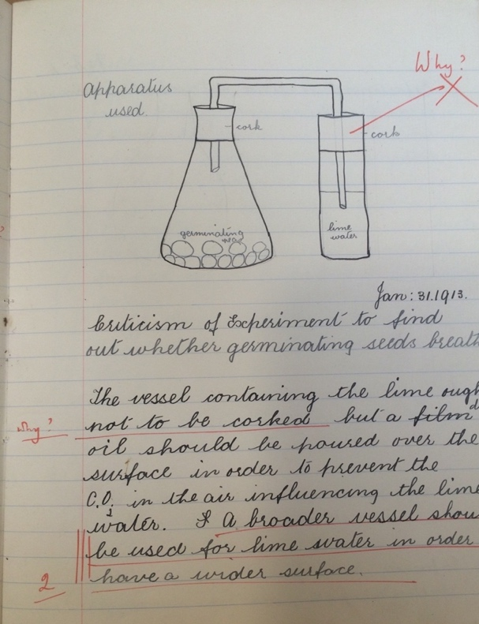
Figure 2.1. A diagram of equipment from an experiment, from the chemistry exercise book of Lucy Hill, 1912, Box title: Hill Family, Archives d4, NLCSA. Reproduced by permission of the North London Collegiate School.

The teaching of science also required practical work, which is particularly clear under the leadership of Buss’s successor, Sophie Bryant, who was headmistress from 1895 to 1918. In the 1890s, Bryant and Edith Aitken (the school science teacher) reformed science teaching at the school. In a lecture given in 1898, Bryant outlined the time spent on science. She described the youngest pupils (aged twelve to thirteen) dedicating two hours a week on science, progressing until eight hours a week in Form VI (aged seventeen to nineteen). Chemistry, it was stated, was the most preferable science to specialise in but botany or biology would be allowed for girls with a certain aptitude for them. A surviving science exercise book from 1912, belonging to chemistry pupil Lucy Hill, shows clear evidence of pupils’ physical engagement with the laboratory themselves. For instance, content included descriptions of experiments performed by the pupils, and diagrams of scientific equipment evidently handled and used by them (Fig. 2.1). Science teaching at this point, it seems, involved the pupils’ own physical and practical work inside the laboratory.

By 1904, the NLCS was teaching classes in ‘housewifery’, evidenced by a surviving exercise book from a former pupil, Violet Steadman. This ‘housewifery’ class was most likely a sub-class of the domestic economy course established in that year. As it were reported in the school magazine Our Chronicle, ‘The Domestic Economy Course is designed especially as a training for home life, and includes instruction in Cookery, Dressmaking and Housewifery, each of these subjects being dealt with as thoroughly as time permits, and more particularly with a view to understanding the principles involved’. Pupils on this course studied other subjects at half-time, with the remainder spent on domestic economy. In contrast to the exam questions from the domestic economy classes of the Buss era, the exercise book had little content that suggested science might have played a part in the classes. The subject was, however, clearly taught with emphasis on practical work, and the moral and spiritual duties of the housewife. The first page, written in Steadman’s handwriting, reads ‘Housewifery is skill in the art of managing a home so that it can be comfortable / happy / healthy’. To achieve this, the housewife needs ‘General tact / Good tempter / Gentleness’. Topics within the book included servants, budgets and spring-cleaning. Practical experience of at least needlework is evident in many samples of fabrics that were stuck in the book, under the sub-section ‘Mending’ (Fig. 2.2). The content of this housewifery exercise book suggests an increased emphasis on practical work compared to the theoretical domestic economy of the school’s infancy.
Figure 2.2 A sample of flannel showing sewing work, in the Housewifery exercise book of Violet Steadman, 1904, RS 4iv, NLCSA. Reproduced by permission of the North London Collegiate School.

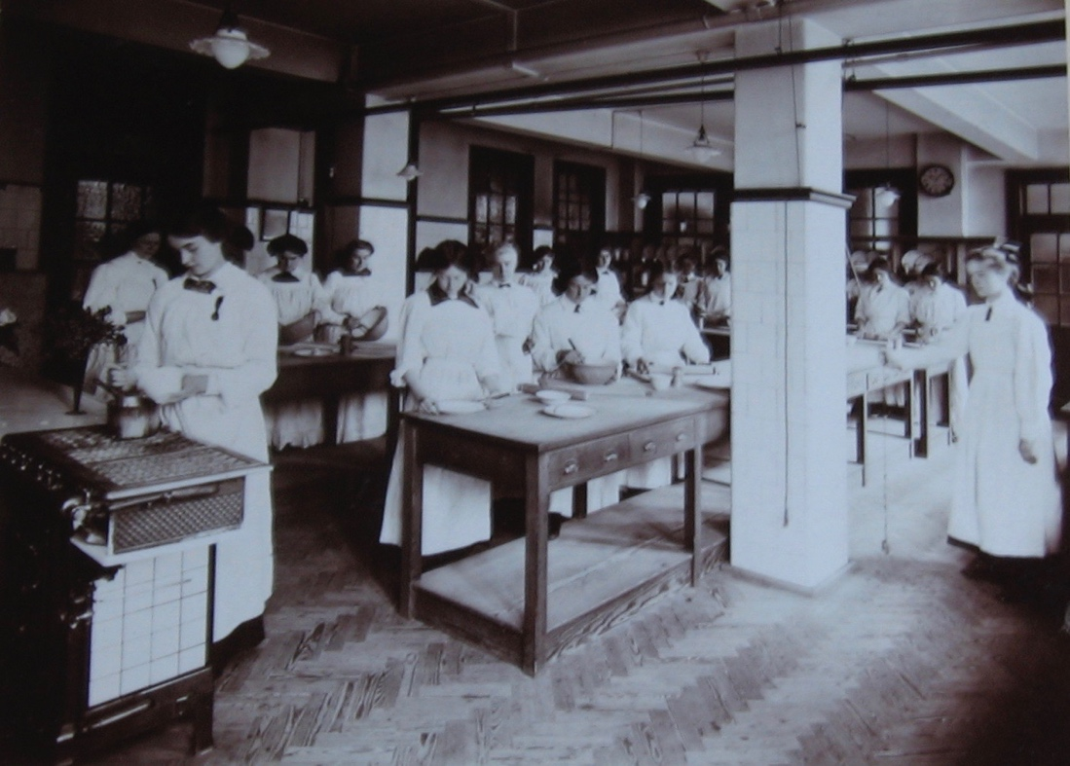
Figure 2.3 Photograph of the interior of the Domestic Arts Room with Miss Macrae and Form, Sandall Road, c. 1912-13, Box Title: People and Buildings to 1939, NLCSA. Reproduced by permission of the North London Collegiate School.
The term ‘housewifery’ implies a more practical course of study than the ‘domestic economy’ classes under Buss. This followed a national trend; according to Nakagomi, terms such as ‘housewifery’, ‘housecraft’ and ‘home craft’ first emerged around 1900. The shift towards ‘housewifery’ was perhaps influenced by the increased state involvement in middle-class education, and public scrutiny on housewives in the Edwardian period. Referring to the introduction of teaching hygiene in elementary schools in 1906, a Board of Education document noted that ‘housecraft’ had been introduced as an optional subject. Of the word ‘housecraft’, the report explained, ‘This special title has been adopted in order to lead to the treatment of the subject upon somewhat different lines’. It continued that ‘The teaching must be essentially practical and thoroughly applicable to the circumstances of working people’. It seems that the official opinion at this point was that domestic subjects should include practical elements that could easily be replicated in the home for future life, for which the term ‘housewifery’ seemed more appropriate than domestic economy or domestic science. The NLCS, of course, was not populated with pupils that might be considered ‘working people’. However, the inclusion of housewifery classes, on seemingly the same lines as that outlined in recommendations of the Board, seems to suggest that any former class prejudice that might have prevented practical domestic subjects being taught to middle classes was since mitigated. Indeed, official school photographs from c. 1912 show pupils working in the cookery school, on the specialist domestic course, which by this point was rebranded as ‘Domestic Arts’ (Fig. 2.3). This might, of course, have been for financial reasons, as the Board of Education was increasingly offering grants for domestic subjects such as cookery. Against the national backdrop of a renewed emphasis on training all women for the domestic sphere, it seems the NLCS had reframed its teaching of domestic subjects.

MHSG followed a similar pattern in expanding its science and domestic subjects teaching across the late-Victorian and Edwardian periods. It was opened in 1874 under its first headmistress Elizabeth Day. It was not a member of the Girls Public Day School Company but was based on a similar model. Initially, the timetables at Manchester gave little space to science teaching. In 1881 the school moved buildings, and the new one included a science laboratory. Around the same time, the science teaching was reformed. In an outline of the proposed changes, Day recommended two hours a week on plants, animals and natural philosophy to girls aged eleven to thirteen, moving on to an optional specialist course from the age of fourteen, of experimental physics, chemistry, botany and zoology, geography and physiography, or cosmic physics and astronomy. Older girls, aged sixteen to seventeen, studied elementary animal physiology and laws of health. Laws of health included content similar to the NLCS’s programme, such as respiration and ventilation. As the former chapter showed, ventilation was a particular concern for the Victorian housewife (see pages 85). In a paper given to the school governors, Day stressed the benefits of science programmes for the girls’ role as housewives, referring to their future duties as a mother or a teacher. However, there is little evidence at this point that this science teaching was directly applied to a domestic setting. Furthermore, for Day’s era, there is no evidence that any kind of domestic subject was on the curriculum; Day was described in a parliamentary report of 1895 as holding the view ‘that such subjects had better be learnt after a girl has left school’.

Under Sara Burstall’s leadership (1898-1924), Manchester High School reformed its teaching. Amongst Burstall’s many changes was the opening of a Department of Housewifery in 1901, and thus the school became the first to submit pupils, aged sixteen to eighteen, to the housecraft certificates issued by the Joint Matriculation Board of the Northern Universities. Similarly to the NLCS, the term ‘housewifery’ was favoured, possibly as a means to attract pupils and parents who were not as invested in the liberal and intellectual curriculum that the new institutions were known for. In a press report of 1914, Burstall was quoted as saying ‘Not all girls…. are fitted for the formal academic studies’. She later described in her autobiography that the introduction of housewifery courses was an effort to encourage girls to stay on at school longer, either by making school life more attractive to the girl, or by introducing subjects that would seem of practical value to the parents. According to Burstall, the housewifery course was
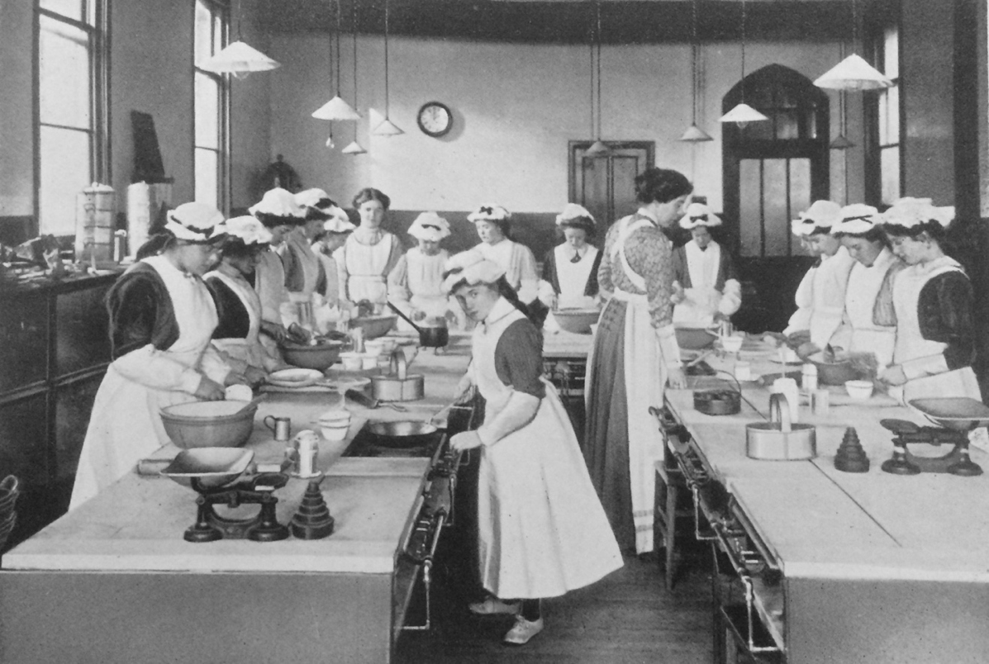

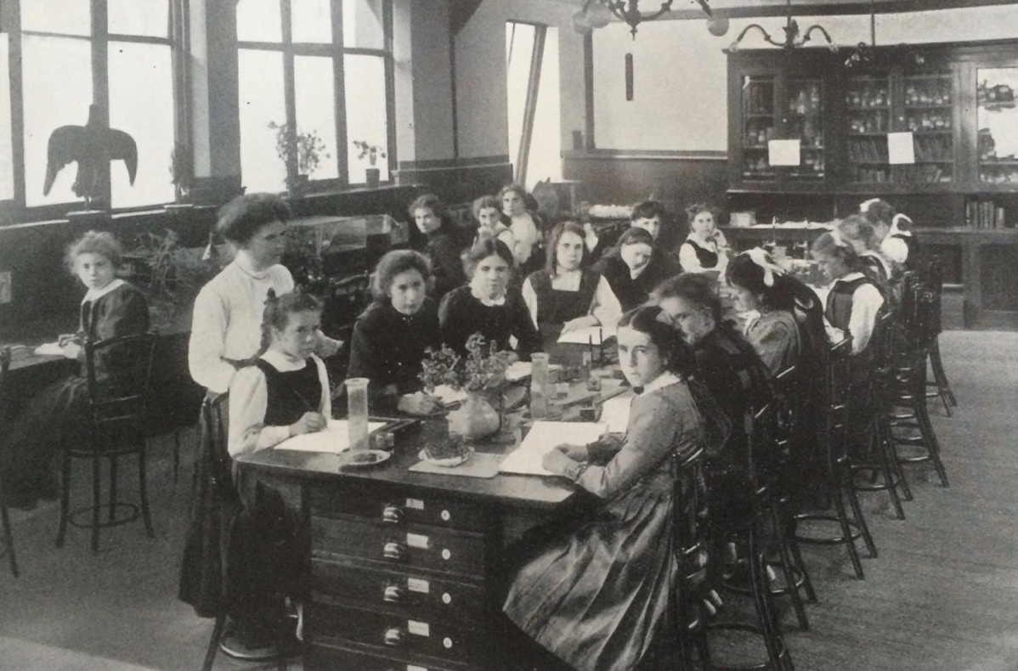
Figure 2.4 The Cookery School at Manchester High School for Girls, 1911 (top) and the Biological Laboratory at Manchester High School for Girls, 1911 (bottom), from Sara A. Burstall, The Story of Manchester High School for Girls (Manchester: Manchester University Press, 1911), 182, 186. Reproduced by permission of the British Library.

initially for one year, but it was expanded to two years following popular demand. By November 1910, the content of the two-year housewifery course included laundry, hygiene (including physiology, such as circulation and digestion), household management, dress making, needlework and arithmetic (household accounts and measurements). Interpretations of Burstall’s reforms have been varied. At MHSG, housewifery was given a place in formal schooling, alongside other academic subjects, and girls were given the opportunity to compete in examinations to literally qualify as housewives. Whatever the interpretation of Burstall’s reforms, she certainly represented housewifery as a professional vocation that required academic study and was formally recognised by universities. This paralleled change in higher education; for instance, from 1908, ‘Household and Social Science’ courses were opened at King’s College for Women, which later led to the establishment of King’s College of Household and Social Science. It has been suggested that Burstall’s introduction of housewifery might have been ‘a betrayal of everything feminist educators had spent fifty years campaigning to achieve’. However, the admission of girls to competitive examinations, that paralleled widening opportunities in higher education and employment in the same field, saw practical housewifery occupy a place in the curriculum that does not seem so contradictory to the school’s otherwise intellectual ethos and history.

Practical teaching of domestic subjects or science naturally prompted the need for specialist spaces. At MHSG, a new biological laboratory and cookery school were opened in 1905 (Fig. 2.4 ). In addition, MHSG acquired a cottage in 1911 for the teaching of housewifery. As The Magazine of the Manchester High School reported it:

Experience is a great thing - experience which teaches a girl to be able to manage a household, whether working herself or showing others how to work. No girl can make a good mistress who does not herself know how things should be done.

This is the aim of Gap Cottage. The thousand and one difficulties which do not come in the regular routine of a cookery school have to be met and grappled with in a house.

In this case, it was deemed necessary to recreate a legitimate domestic environment for the teaching of domestic subjects. This view was similarly expressed in the Report of the Consultative Committee in 1913; ‘Household management, routine and organisation cannot be satisfactorily attempted unless special accommodation is provided and conditions of a household set up’. Sara Burstall noted in her evidence given to the Consultative Committee in 1909 that ‘Sometimes parties of girls not in the Housewifery department visit the cottage’. The value of practical experience was not just doing the work themselves, but doing it in an environment specially recreated to mirror realistic material living conditions.

The third case study, Bedales, offers an interesting comparison to the NLCS, and MHSG, as the school admitted boys and girls. Bedales, in Petersfield, Hampshire, was founded by John Haden Badley in 1893, and initially only enrolled boys. From its foundation, Bedales’ ethos was a radical departure from similar institutions for middle-class boys, offering a wide range of subjects, including science and modern languages, breaking away from the tradition of classics and Latin. In a further departure from other boys’ public schools, in 1898, the first female pupils were admitted. According to a prospectus from 1909:

our aim is to give the girls the same healthy life and the same range of intellectual training as we give to the boys, together with the intercourse and wider interests of a school-life shared with them. And we do this in the belief that the aim is equally great for both sexes.

For the younger pupils (aged approximately eight), half an hour a week was dedicated to science. This progressed to nine and a half hours a week by the time a pupil reached the upper school (aged approximately seventeen), where they studied chemistry, mechanics
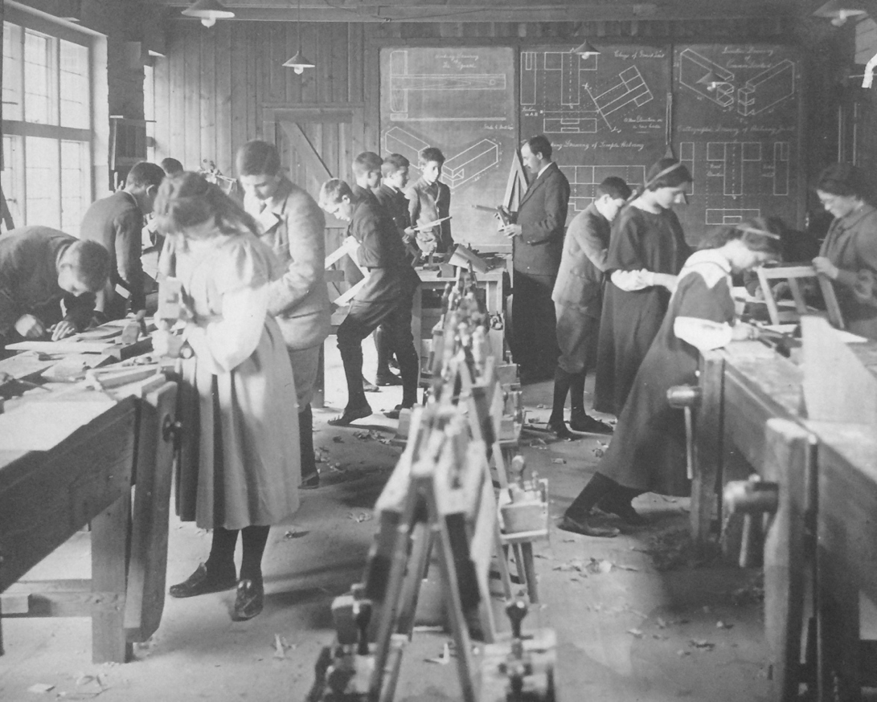
Figure 2.5 Bedales’ pupils undertaking practical work in a woodwork class from Exhibition Album (1908), BSA. Reproduced by permission of Bedales School.

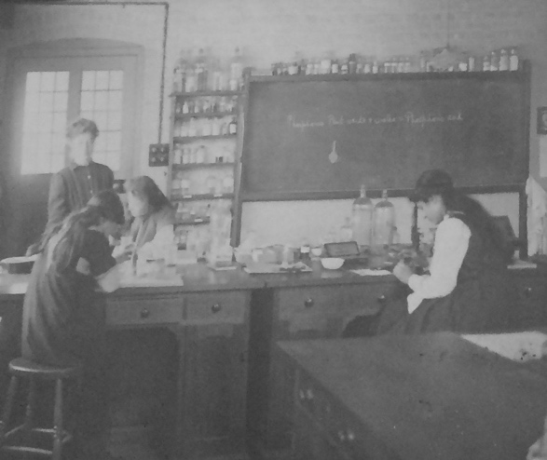
Figure 2.6 Bedales’ pupils in the biological laboratory from Exhibition Album (1908), BSA. Reproduced by permission of Bedales School.

of liquids and electricity. Their liberal ethos saw boys and girls undertake a range of subjects deemed ‘handiwork’. These were divided into five main categories: woodwork; domestic economy; outdoor work; drawing; and optional handicrafts such as modelling or basket-making. Both young boys and girls took ‘simple sewing and cooking’. Thus, although the ethos of Bedales openly endorsed an ‘intellectual training’, this did not eliminate practical work alongside it.

Female pupils at Bedales were given a range of practical training. Fig. 2.5 shows girls and boys working together in a woodwork class, using carpentry tools, with technical diagrams visible on the blackboard in the background. Pupils of the middle school would have undertaken this woodwork class for three years. Bedales’ teaching of science also included a strong practical element. The exhibition scrapbook of 1908 contained extracts of pupils’ work, including descriptions and diagrams of experiments. Of elementary physics, text in the album noted: ‘while the study of the methods of heating and ventilating a house gives opportunity for applying the knowledge of physics to the needs of everyday life’. This was accompanied by an image of pupils, notably boys and girls, performing experiments (Fig. 2.6). For boys and girls, practical skills were integrated into the liberal curriculum at Bedales, in a range of subjects such as woodwork or science.

Though the prospectus framed their ethos around co-education, it should be noted that this did not necessarily mean boys’ and girls’ education was exactly the same at all stages of their school life. Badley, for instance, noted in a lecture of 1914 that ‘by education together I don’t mean identical’. This was evidently the case for domestic subjects in the latter years of a pupil’s education. Bedales did not offer specialist domestic courses like the NLCS and MHSG, presumably as it was not a girls’ school. However, in the final years of their education, only the boys continued metal and woodwork whilst the older girls took a more advanced course on domestic economy, which included household management and sick nursing. Photographs (Fig. 2.7) show girls undertaking this work,
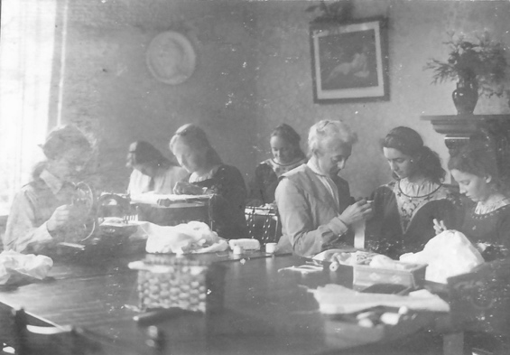
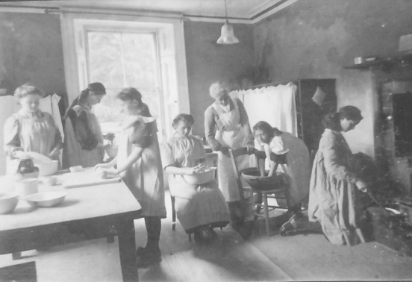
Figure 2.7 Girls in cooking and sewing classes at Bedales from Exhibition Album ([c. 1903]), 116. Reproduced by permission of Bedales School.

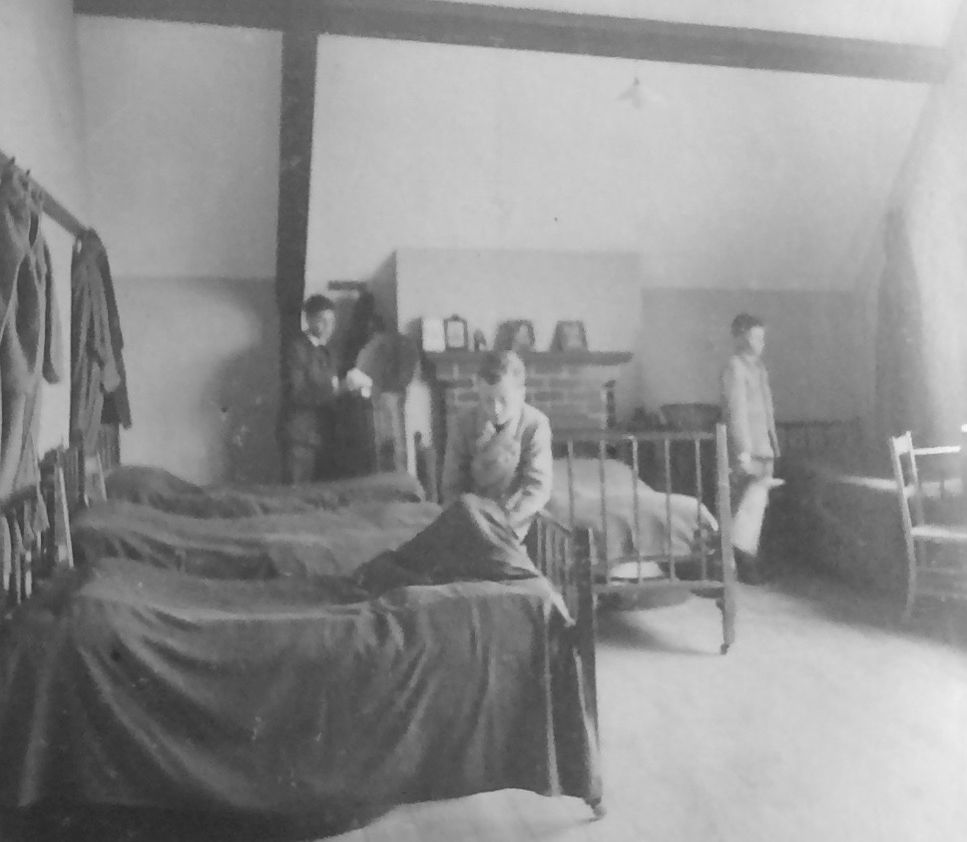
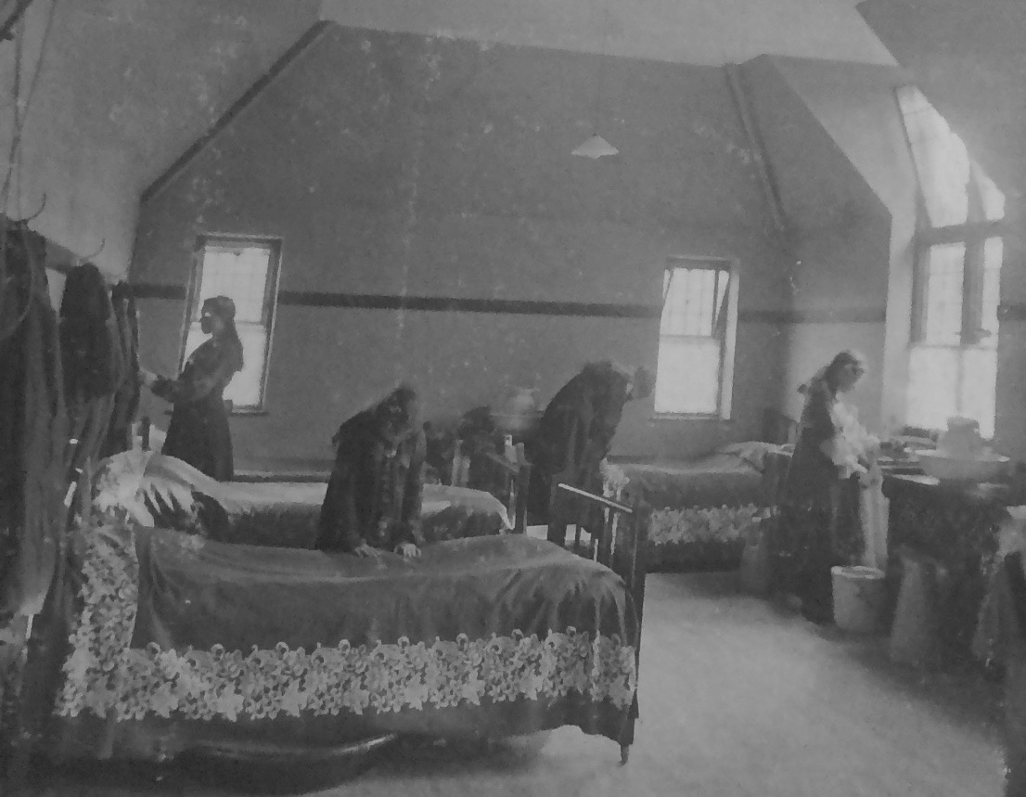
Figure 2.8 Bedales’ pupils tidying their dormitories from Exhibition Album ([c. 1903]), 115. Reproduced by permission of Bedales School.
in a recreated domestic environment, with framed pictures hanging on the walls, decorative plants and a fireplace. Like at MHSG, a particular material environment has been created that mirrored a real home.

Alongside the formal teaching in domestic subjects, both boys and girls undertook household duties, such as making their beds and cleaning their own clothes (Fig. 2.8). Interestingly, the material environment in which the pupils lived was highly similar for boys and girls, although notably the girls’ bedsheets have a decorative pattern not present on the boys’. As Jane Hamlett has described, there were gendered differences in the provision for decoration at Bedales. These household duties changed with age, as whilst boys ‘above a certain age clean their own boots’, girls ‘take various household duties in rotation, such as the tidying of rooms, laying and clearing of tables, &c, in their own house’. The gender segregation in practical, domestic work took place in the later years of a pupils’ school time in both formal teaching and the chores assigned to pupils outside class time.

The teaching of domestic subjects to boys was rationalised on different grounds to that of girls. For girls, it was naturally assumed that they would learn skills required for later in life. An undated inspection report written by Elizabeth Phillips Hughes, a teacher and advocate for girls’ education, gives some insight into why boys were taught domestic subjects. In her view, the teaching of domestic subjects to boys was worthy of praise as it gave them an ‘intelligent sympathetic insight in this large and important area of work’. It was not, of course, intended that boys would need these skills themselves in adulthood, but instead it was hoped the teaching might develop character, and produce more mutually sympathetic partnerships in marriage. In Hughes’ view, it could elevate the status of women’s domestic labour to men by highlighting it as ‘important’.

| II | Intellectual Domesticity and Science

In this section, I demonstrate the schools had a common goal in promoting intellectual domesticity for middle-class girls. This intellectual domesticity was produced by maintaining an emphasis on acquiring scientific knowledge and using the scientific method, in teaching for both science and domestic subjects. The distinction between the two subjects was thus not as clear-cut as previously scholars have suggested.

According to Catherine Manthorpe, Burstall and Bryant had quite distinct opinions on science teaching. Bryant’s view on science, Manthorpe argues, was the more academic, whereas Burstall’s was more practical. Certainly in the case of Burstall, ‘practical’ meant application to the household. Burstall was heavily influenced by Professor Arthur Smithells (1860–1939), a chemist and lecturer at the University of Leeds, who has been described as a ‘key catalyst’ in the domestic science movement. Smithells was also a science teacher at MHSG, and an examiner for Bedales, where incidentally, he sent his son, Colin. In his belief, girls were not interested in science, especially physics and chemistry. Thus, he sought to link science with common and domestic life to stimulate their engagement. This view seeped into his 1903 examiner’s report for Bedales, in which he stated:

Another point I should like to raise is as to whether there is not room for more to be done both in the physics and chemistry to relate the subjects to affairs of the household. It has been found possible to devise excellent courses with this bias and they are of particular value and interest to girls.

According to Burstall, Smithells’ views could be summarised as ‘Physics for girls should be physics for the household’. This meant ‘domesticating’ or ‘feminising’ science teaching to appeal to female pupils. In this view, there was no distinction to be made between science and domestic subjects. Smithells endorsed their teaching as one subject, with the intention to prepare girls for domestic life.

Burstall estimated in 1909 that ‘say 55 per cent’ of her pupils were destined to stay at home in future life. Nevertheless, she sought to prepare all her pupils for their future domestic responsibilities, even those that opted to continue with general education rather than the housewifery course. Burstall suggested that some parents may not have wanted to pay for a housewifery course when it could have been taught at home. Thus, for all older girls, science was compulsory. In her words, ‘The Science, however, could be, and was, enforced, and it was hoped by this means to equip the girls much better for home duties even if they did no practical work in the school’. The lack of practical experience in domestic subjects, however, could be substituted for practical science with a domestic slant, as, like Smithells, she thought ‘if science was coloured by reference to the needs of the home the girls would learn in school the principles of Domestic work’. In Burstall’s view, whether or not pupils opted to take the general education route including science, or the specialised domestic subjects option, the course was designed to prepare the girls for home duties.

Bryant, however, was less convinced by Smithells' views. Whilst she was not against making domestic subjects more scientific, Bryant was against ‘the substitution of domestic science for science in the schools’. In her view, ‘Extrinsic underlying motives are not needed by the average girl as a stimulus to interest’ but she did believe that the application of science to practical matters was essential. In her recommendations, ‘The science foundation must be science’ but that schools should ‘make the domestic arts teaching itself more scientific’. Science, in her view, should not be domesticated, but domestic subjects could be made more scientific. The result was that whether they were studying natural science or domestic subjects, girls were exposed to science.

In practice, Bryant’s view that domestic subjects should be scientific was reflected in the structure of the domestic subjects’ classes taking place under her leadership. A booklet outlining the ‘Summary of Organisation and Schemes of Study’, pasted into a volume about the school from 1909-1910, describes the course of study for cookery, housewifery and laundry, dressmaking and millinery, hygiene, and household arithmetic. These classes were presumably part of the domestic economy course instigated in 1904, which by 1906 was renamed ‘Domestic Arts’. In the outlined programme for cookery, and housewifery and laundry, classes were split between work in the laboratory, taught by then-science teacher Rose Stern, and domestic subjects’ teacher Charlotte Macrae. A similar teaching strategy was used at MHSG, where they employed ‘a Science Mistress (Cambridge Tripos) who knows some Housewifery and a Domestic Arts Mistress who knows some Science.’ This split of the class at the NLCS seems very much in line with the suggested programmes by Margaret Gilliland, described in the introduction of this chapter (page 93), in which domestic teaching is paired with parallel science work. For instance, for household work, Miss Macrae taught ‘Cleaning and Care of the Home’ under the subtitle ‘Kitchen Work’. Miss Stern taught the corresponding ‘Laboratory Work’ and ‘Science of Cleaning’, which included: ‘Removal of stains caused by- / (1) Action of atmosphere on metal / (2) Action of acids from fruits on metals and fabrics’. As the former chapter described, parallels between the kitchen and the laboratory were frequent in contemporary domestic advice literature. In this case, this manifested itself in a course at the NLCS, in which domestic subjects were streamlined through two separate but related courses of study. The practical work of both domestic subjects and science, or the kitchen and the laboratory, were used together to train scientifically-informed housewives. Both the material environments of the kitchen and the laboratory were considered suitable environments with the correct equipment for this kind of domestic training.

‘Science’ emerged in each of the case study schools, not just as a subject, but as a manner of teaching. To Badley, this was the essence of a ‘liberal’ education propagated at schools. He endorsed teaching physics, biology and chemistry, ‘not merely for their utility in every kind of practical application, but no less for the sake of the training thus given in scientific method and the scientific outlook which are an essential element in the modern idea of a liberal education’. This was mirrored in a prospectus for Bedales (1892), in which the stated purpose of teaching science was to furnish ‘the learner with training in accurate observation, inductive reasoning and the applications of principles - in a word, scientific method.’ In this case, ‘scientific method’ seems used as analogous to intellectual behaviour, based on method and logic.

At Bedales, teaching was taught under what Badley called ‘the Laboratory method’. He described its aim as ‘to turn each class-room into a laboratory in which - with help and suggestion, when necessary, from the teacher, but by their own efforts - children can find out answers to questions’. The Laboratory method of Bedales was central to the teaching of all subjects, not only science and domestic subjects. Emphasis was placed on the pupils finding the answers for themselves, and thus gaining an intellectual curiosity and independence that could be sustained for life. As Mary Waring has established, ‘For heurists, invoking “scientific method” in order to train certain important faculties, namely observation, communication and reasoning, meant putting the learner in the position of the discoverer’. This method (heurism) emphasised practical experience. At Bedales, when the Laboratory method was used, classes of all subjects were taught like the children were conducting a scientific experiment.

The intellectual benefits of teaching science had been acknowledged by the Taunton Commission in the 1860s, which made a distinction between the content of teaching and its desired mental effect. Whilst giving evidence, Buss was asked ‘What value do you attach to instruction of this kind in its effect in calling out the intellectual powers of girls apart from the mere effect of instruction in interesting knowledge?’ Buss replied that, at the time, the NLCS favoured other subjects for mental training, conceding that perhaps too much had been made of ‘interesting knowledge’. Nevertheless, the distinction had been made between mental training and the acquisition of knowledge.

In the earlier years of MHSG, the study of natural science was linked to housewifery, not because the content of the classes overlapped, but because of the belief it would produce a more intellectual outlook in future housewives. Elizabeth Day pointed out that the natural sciences were not taught as a precursor to professional science. She noted in her paper to the governors that ‘It is seldom necessary for girls to pursue any branch of science to what may be called a professional extent’. It was instead, in Day’s view, for the future social role of the girls:

a few fundamental principles of Physics, and Chemistry, and Physiology will ensure for young women who have to look forward to the duties of the teacher or the mother a lasting incapacity to be content with bad ventilation in the house, the nursery, or the schoolroom, with unhealthy clothing or feeding for herself and for the children at home or abroad, amongst whom so much of her life will have to be spent

The benefits of science teaching were not necessarily about the content or knowledge gained. Like Badley, Day highlighted the importance of the scientific method in the development of the mental faculties of pupils:

For older ones, minute and accurate study, systematic arrangement, and analytic and synthetic reasoning on matters of more or less constant association with daily life, actually form an admirable discipline and furnishment for their mental and moral no less than for their physical duties.

At MHSG under Day, the point of teaching science was not about learning specific information that could be practically applied later in life. It was instead about cultivating an intellectual mind that was capable of system, order and accuracy. This echoed comments made by Bryant thirty years later: ‘What we want is the housewife trained to the most attentive observation of the effect she is producing throughout every operation that she undertakes’. She continued, ‘Also, she will stand a fair chance of growing up with a logical mind as capable of inductive reasoning on the problems of experience in the social world as if she had spent the same time working in the science laboratory’. The future housewife was not necessarily ‘scientific’ in the sense that she was expected to have detailed knowledge, but ‘scientific’ in her mind-set: intellectual and academic.

The belief that teaching science could develop the intellectual faculties did not subside across the period, nor did it differ across institutions. In a speech of 1898 to the Association of Assistant Headmistresses, Edith Aitken outlined her belief that the teaching of science ‘supplies a quite special form of training, a kind of mental gymnastic essential to intellectual symmetry’. Although Aitken noted that ‘some information’ had practical value, the primary use of science teaching was not to gather knowledge. In her words:

it always seems to me that the pursuit of information is something like the pursuit of happiness, which we are always told eludes the man who seeks for it directly. For though some people appear able to retain a wonderful amount of miscellaneous information, it never seems to do them any good. And this is particularly the case with regard to Science.

Aitken, therefore, did not see the role of teaching science as a means to pass on information that would be of use to the girls in the future. Instead, it was the principles and behaviours finessed through the study of science that would contribute to their development as successful housewives.

Aitken highlighted botany for the skills it inculcated in observation. The history of botany is one inextricably bound up with gender. As Ann Shteir has stated, ‘Gender, in fact, was integral to discipline formation in nineteenth-century botany’. The teaching of botany in schools was not simply a means to teach ‘feminine’ science. Shteir has pointed out professional botanists such as John Lindley sought to defeminise botany by making it more scientific and modernised. To Aitken, the choice of botany for girls was not about gender ideology. In her words, ‘In the earliest stages it is treated as a subject of pure observation, and is so far perfectly satisfactorily. Classification follows and is undeniably an excellent logical exercise’. Observation, as with classification, was deemed to be a vital skill in developing the reasoning faculties. Much like domestic subjects, botany was deemed to be inherently female. It was not, however, presented that way by its female proponents. Instead, its intellectual and mental benefits were stressed.

The development of intellect in pupils was linked to their moral growth. To Aitken, science had a moral purpose in teaching pupils about the principle of causation. In Aitken’s view, science provided ‘Moral training in neatness, thoroughness and accuracy, with recognition of the inevitableness [sic] of consequences’. Practical science’s ‘importance is very great on the moral side: partly because it is almost the only means to bring a child into direct personal communication with Nature, and partly because the rewards and punishments are so immediate, and so clearly connected with the nature of the action’. ‘Slovenliness and forgetfulness’, Aitken continued, ‘are punished logically on the spot, and it should be one chief aim of the teacher to make this clearly felt.’ Although Aitken does not specifically describe housewifery in this instance, her reference to slovenliness and forgetfulness strikes a chord with criticisms aimed at supposedly incompetent and disinterested housewives in this period. The intellectual faculties were thus intertwined with moral character; experimental work in the science laboratory was deemed to produce intellectual and moral character for future life.

A similar reference to the principles of causation was made in regard to domestic subjects. As with the sciences, Bryant upheld the importance of practical experience of housewifery, complaining of the ‘housewife who has no notion of patiently discovering the conditions of success and failure in her various operations, who does not know how to learn from her wide sphere of interesting experience, who clings to old saws and pretentious theories accidentally acquired and never put personally to the test’. A similar view was expressed by a pupil at Manchester, who wrote in a 1911 edition of The Magazine of the Manchester High School that ‘One learns that scones require a certain amount of baking powder, but in the practical part one does not discover the result of an omission until the scone appears - well, not the light inviting dish that was intended’. According to Waring, by 1900 it was firmly established that learning science was crucially linked with practical work. To Margaret Pillow, this was the definition of domestic science: ‘It consists of the science of domestic economy and hygiene treated experimentally’. The practical, experimental nature of science and domestic subjects was integral to its intellectual benefits. One such benefit was a deepened understanding of cause-and-effect which was deemed important to housewifery.

Of course, in describing the intellectual effects of the natural sciences, Edith Aitken was promoting her own personal and professional accomplishments. She herself became one of the new professional headmistresses like those described by Joyce Senders Pederson, becoming, in 1902, headmistress of Pretoria High School for Girls in South Africa. Her descriptions of science teaching thus mirrored the values important to her own professional role. As Senders Pederson has argued, new schools created the new social type of the professional female teacher. She suggests that headmistresses rested their claim to elite status on their intellectual accomplishments, rather than social characteristics, and suggests that new public schools for girls served ‘almost as an institutional analogue to what here is termed the professional ideal’.

This could be the case for teachers of any subject. Blanche Henry, teacher of housewifery at Manchester, wrote a piece in the school magazine on the importance of domestic economy. She asked: ‘Now what is the career that awaits the majority of girls? Is it not something to do with the home?’ She acknowledged that increasingly male professions were opening up to women,

But, speaking generally, I am right in saying that home life is the life that awaits the large majority of girls after leaving school. Surely then that education is the best education which has reference to, and prepares them for that home life. In every vocation there must be the preliminary training to qualify for that vocation.

Annmarie Turnbull has pointed out that the domestic subjects teacher, a relatively new occupation at this time, occupied a paradox as both ‘reinforcing ideas of women’s home-centeredness and dependency’, but still ‘provided some women with the opportunity to expand their horizons outside the household’. In this example, Henry reiterated the traditional ideal of the domestic female, but recast it in a professional light. As it was in the school magazine, it would likely have been read by the pupils of MHSG. They were thus exposed to the opinion that housewives needed a formal training led by professionals for their ‘vocation’ or ‘career’ in the home.

As early as 1878, the NLCS was seemingly promoting the career options available to pupils of domestic subjects outside the home. For instance, an article was reprinted from The Englishwoman’s Gazette into the school magazine Our Chronicle, which described employment opportunities for a lecturer in cookery. As James Mangan has pointed out, school magazines are official records and thus ‘[perpetuate] established values rather than [challenge] them’. Thus, in this example, the NLCS was encouraging pupils of domestic subjects to pursue a career. It has previously been assumed that domestic subjects were aimed at those who were not likely to have a career. In Ailsa Yoxall’s words, in schools ‘where the ideal was purely intellectual, backward girls only were instructed in the domestic arts’. To the contrary, the presence of such an article in the school magazine suggested that domestic subjects could lead to a career. In data quantified by Nakagomi, out of 155 students from the housewifery course at MHSG between 1909 and 1914, ninety-nine pursed the subject further, such as study at training colleges, gaining certificates and entering related occupations. In this respect, there was not such a clear-cut dichotomy between ‘intellectual’ subjects and domestic subjects, since such specialist courses may have led to professions and further study for many students. The practical content of both science and domestic subjects was inculcated into a culture of intellectual domesticity that opened up employment opportunities for either route.

| III | Pupils, Identity and Agency

The former two sections have sought to demonstrate two main strands of argument; firstly, each of these schools, from their inception, held a place for practical work, especially domestic subjects and science, and secondly, that this practical work was written into a narrative of producing ‘scientific’ or ‘intellectual’ minds, which could later in life be put to use in the home or a career. In this final section, I demonstrate how pupils responded to the culture of intellectual domesticity created for them, drawing on school magazines. I suggest that pupils could express their own intellectual identities that included both science and domesticity.

The interests and values of pupils can be seen in school magazines. Scholars such as James Mangan and Paul Deslandes have demonstrated how institutional magazines give some insight into the voice of the pupil or student. For instance, in a 1913 edition of The Magazine of the Manchester High School, housewifery pupil Mary Evans wrote a poem entitled ‘The Charge of the Dish-Cloth Brigade’. Based on Tennyson’s ‘The Charge of the Light Brigade’ (1851), the four-stanza piece romanticised the chaos of the school kitchen:

‘Half-a-sink! Half-a-sink!”
Bellowed the young cooks.
All in a muddled crush
Struggled the young cooks
“Please pass the soap,” they said.
“Who’s got the stove black-lead?”
On each one’s toes they tread.
Boisterous young cooks.

By this time, MHSG had opened its specialist housewifery course. Thus, it is not surprising to find evidence of pupils’ passion for their domestic role from this time; evidently, in this case, admission of students to a specialist housewifery course incited an imagination and passion for the subject that prompted the writing of this poem.

To give another example, the June 1911 edition of The Magazine of Manchester High School reported on the opening of Gap Cottage, which was acquired by the school for use in the housewifery programmes. The anonymous pupil reported:

A rumour has got abroad that, in order to complete the perfection of the cottage, a baby must be found on which the girls may try their skill. Babies, however, seem hard to procure; mothers do not seem willing to part with them. How is it! Surely the parents have perfect confidence in these enterprising people!

If within a month or two one should come across the following advertisement, it will be known to which school it refers:-

WANTED, a BABY. Eight girls and two Mistresses are willing to undertake management of a young Baby for several days.
Guaranteed to be safely returned.

The author of this piece also celebrated the intelligence required in the correct management of a home, praising the acknowledgement ‘That housekeeping requires the use of brains as well as of hands is a fact which is being realised more and more every day.’ The author continued, ‘No longer is housewifery treated as a subject to be taught only to girls who are too dull for other work, but as a subject which is a science and which needs intellect to enlighten it’. Certainly to this pupil, the status of housewifery had been elevated by the acknowledgement that it was a science that required intellect. In these examples, the girls conformed to a certain type of femininity that rested on domesticity. However, this does not necessarily need to be read as a form of successful social control, in which the girls’ identities were shaped by the school and its housewifery course. Instead, as Susan Miller has asserted, ‘we should be attentive to the ways in which children willingly conform to adult agendas, not necessarily because youth acquiesce to power, but because their interests often align with those promoted by adults’. In these examples, the inherent playfulness and humour indicate the girls’ own agency in articulating their educational experience and their identities.

A similar example is visible in the NLCS magazine. In June 1907, an anonymous pupil wrote a passionate defence of the perceived inferiority of domestic subjects amongst her peers. The author quoted fellow students: ‘Oh, yes, I’d love to be in the Technical; the girls don’t do any work, and have a splendid time.’ In her defence of the hard work and intelligence required of ‘The Technical’ (which was by this point the predominant term for the specialist domestic subjects course at the NLCS), she highlighted the difficulty and technicality of the exam questions: ‘such as “What per cent of nitrogenous material is contained in a potato?” “How should a bodice be fitted?” “Give the recipe for furniture polish.” “How would you read a gas metre?”’ By quoting these exam questions, the pupil emphasised the range of scientific and practical knowledge and skill required to do well in ‘The Technical’ class. Evidence like this is naturally fragmentary, and no claims can be made for its representativeness. However, it is clear that, even if only on an individual level, the ‘intellectual’ approach to domestic subjects, including crossovers with scientific content and competitive examinations, stimulated a sense of pride and personal worth. For this pupil, her sense of self-worth was derived from the difficulty of the exam questions and thus the intellect required to do well in domestic subjects.

An 1888 article from The Manchester High School Magazine articulated the wide range of cultural tropes about girlhood, in the imagination of an anonymous pupil who went by the pseudonym ‘Sappho’ (a reference to the celebrated Greek female poet). The authoress described a variety of ‘sorts and condition of girls’, including ‘the intellectual’, ‘the original’, ‘the sentimental’, ‘the scapegrace’, ‘the domesticated’ and ‘the frivolous’. Of ‘the intellectual’, Sappho complained, ‘This species, unfortunately, is rather apt to degenerate into the prig, than whom not more objectionable exists’. The most important, however, was ‘the popular girl’. Not, the author sought to stress, ‘the girl who strives to be a general favourite, but the one who really is so because she possesses qualities that appeal to all alike’. Evidently in the view of Sappho, the best type of girl achieved balance; she was ‘Thoroughly intellectual’ and useful at home ‘when her services are called for’. Notably this girl is intellectual but not an intellectual; her intellect is only one part of her balanced personality.

Although pupils were not necessarily active agents in public discourse about education, they still had opinions which were expressed within schools. MHSG had a debating society; details of its meetings were published in the school magazine. One such debate, reported in July 1886, reveals the pupils’ engagement in contemporary debate about the prestige of classics. The motion was proposed ‘That the study of the modern languages and sciences is more profitable than that of the classics’, a clear reference to the contemporary debates about the value of traditional subjects against newer ones. The pupil in opposition, Amy Mullock, expressed the traditional opinion of the early nineteenth century, that classics have ‘unequalled power of training the memory’. A similar debate emerged a few years later: ‘That the study of science is more calculated to promote general culture than that of classics’. According to the mover, Miss Hodgkinson, ‘Science requires observation; a classical scholar may be observant, but he is so in spite of his classical learning’. Thus the pupils, who were exposed to the liberal curriculums of the new high schools, had opportunities to express their own opinions. In these meetings, the proposed motions mirrored the values of their own institutions; that newer subjects such as science and modern languages were of higher educational value than the traditional male subjects such as classics.

Evidence from the archives suggests that the NLCS had a tradition of fostering a culture that celebrated science amongst its pupils. Their Science Club was first formed in February 1890. It aimed to host a number of activities, including papers read by students, discussions, field trips and founding a museum of natural objects. By 1891, the Science Club had produced one volume of Our Science Club Magazine, although no copies survive. However, in 1912, a later generation of Science Club students were producing their own manuscript magazine, The Searchlight. Three editions were produced by the Sixth Form between 1912 and 1914. The aims of the magazine were outlined in the first issue:

“The Searchlight” is a scientific magazine, in which will be published experiments done in the cause of Science, papers of Scientific matters, & in fact any matters of interest to Science, & more especially anything concerned with that remarkably intellectual body, the Scientific Sixth. But we shall not confine the pages of the magazine to those who are well up in the technical details of Science, by dealing with subjects all too difficult of comprehension; it will be a popular magazine, containing stories & poems by scientists & it thus will appeal to many who can read it for pure pleasure

The set of magazines demonstrates the vibrant and lively culture that was fostered by the NLCS and its pupils. For instance, content ranged from experimentations, artistic interpretations of a boracic acid flame (Fig. 2.9) and an article giving instructions on how to emulate the hairstyles ‘as seen in the laboratories of our great metropolis’. As Catherine Sloan has argued of manuscript magazines at Croydon Friends’ School in the mid-Victorian era, they demonstrate the ‘dynamic interchange’ between adults and children, rather than a straightforward top-down movement from teacher to pupil. Sloan concludes that such texts ‘[enable] us to view children as agents in the production and circulation of knowledge within their schools and communities’. In this case, we can see the results of an interchange between their pupils and their science classes. The magazine issues were circulated through a list of ‘subscribers’; the list for 1914 includes forty names. Evidently, pupils had a creative output for their own interests.

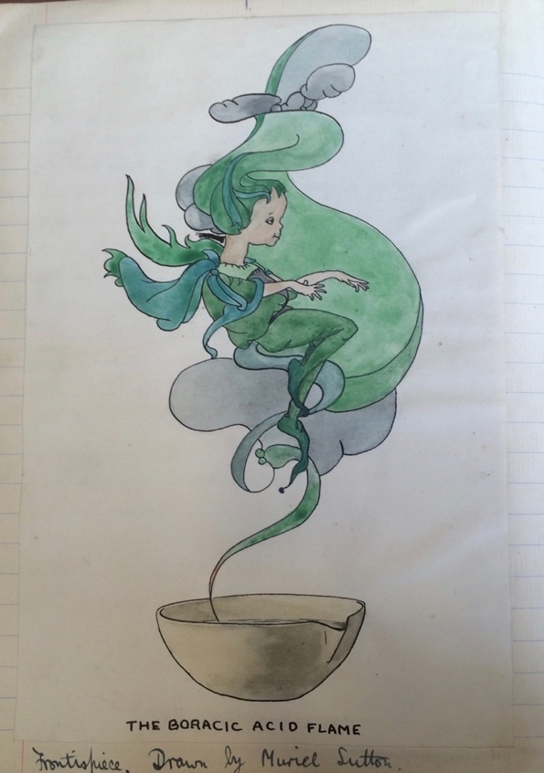
Figure 2.9 Illustration of a Boracic Acid Flame, Muriel Sutton, Frontispiece, The Searchlight, ‘Volume III’, 1914, 1, RS 4iv, NLCSA. Reproduced by permission of the North London Collegiate School.
The Searchlight featured a number of articles that demonstrated a wit and playfulness that is undetectable in other archival material. For instance, one issue featured a series of riddles, the solution to which was an element or compound, such as:

I am a little molecule
I contain some SO₄
If you are not careful
I’ll burn your pinafore. Sulfuric Acid

From within the pages of The Searchlight, the pupils’ active engagement with science is apparent. The magazine appointed a ‘Chief Experimenter’ who was assigned with doing scientific experiments and reporting on the results. An issue from 1912 reported the following experiment:

Object | To do something exciting
Experiment | We placed a considerable quantity of potassium chlorate + crushed sugar in a trough, + poured onto it a little concentrated sulphuric acid.
Results | - The mass burst into flames.  - Miss Stern was much alarmed + required a lengthy explanation, but even after she had received this, would only concede that the brilliant experiment might have been a success if we had used smaller quantities
Conclusion | Experiments which may be thought in any way exciting should not be performed when nervous people are about.

As articles such as this suggest, the pupils took much delight in scientific experiments, and in reporting their results to a public audience. Their experience, and representation of it, was fuelled by the humour and playfulness of the pupils. Clearly this group of students embraced a scientific, intellectual aspect of their own characters, and used their own agency in its expression through the magazine.

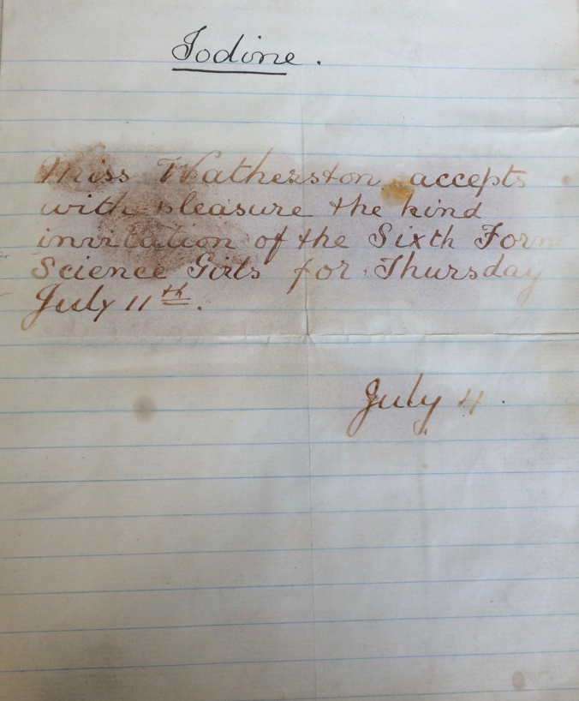
Figure 2.10 Miss Watherston’s reply to an invitation to the science tea, which could only be read when heated with iodine, The Searchlight, Summer 1912, 59, RS 4iv, NLCSA. Reproduced by permission of the North London Collegiate School.

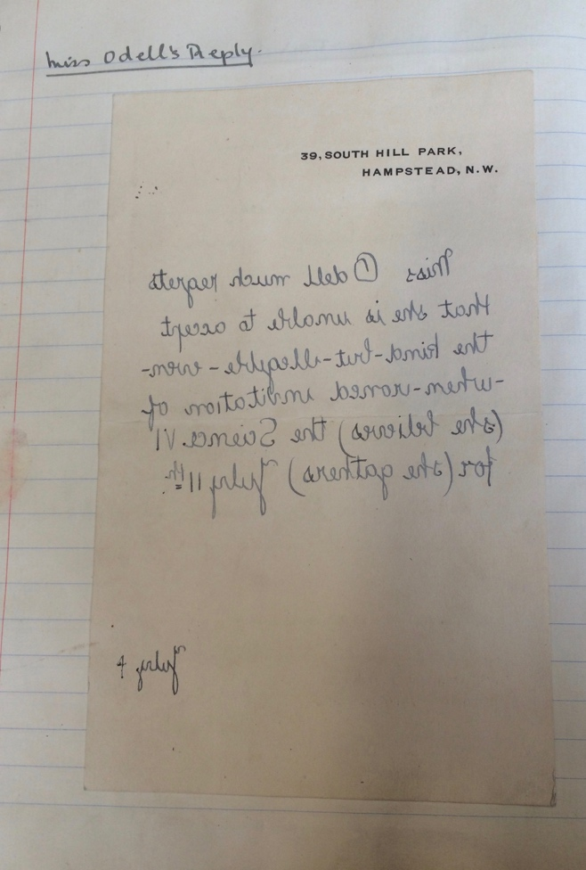
Figure 2.11 Miss Odell’s reply, which could be read with a mirror, The Searchlight, Summer 1912, 60, RS 4iv, NLCSA. Reproduced by permission of the North London Collegiate School.

The Searchlight was produced with the support and involvement of the teaching staff. According to one issue, it was patronised by science teachers Rose Stern, and Isabella Drummond, who would later become headmistress in 1918. The list of subscribers from 1914 included Stern, Drummond and retired headmistress Bryant, as well as at least six other names that appear to be teaching staff. Staff were invited to a tea party hosted by the ‘Sixth Form Science Girls’; interestingly, this celebration of science was done in the domestic setting of a tea party. One invitation reply, from Miss Watherston, could only be read when heated with iodine (Fig. 2.10). Another, from Miss Odell, could only be read with a mirror (Fig. 2.11). The science tea was described in detail in the official school magazine, Our Chronicle, in a report written by ‘one who was there’. The article expressed with much enthusiasm the joy of the party, describing how pupils and staff ‘drank out of beakers, and stirred it with long glass wands. We ate carbon, nitrogen and hydrogen combined in varying proportions according to the dish’. Games were also played, such as scientist and element charades. Thus, there is evidence that staff were actively involved in the shaping of the lively scientific community that was fostered for at least a short while between 1912 and 1914. The process through which the pupils engaged with science was evidently the product of an interchange between staff and pupil, fuelled by enthusiasm from each side.

Through The Searchlight, the pupils were also capable of asserting their humorous outlook on aspects of science classes that were less popular. The 1913 edition explains that whilst they were ‘unable to obtain a story for “the Searchlight” from our honoured patron, Miss Stern, we are able to publish a few words from her own pen’. The two-page spread (Fig. 2.12) features a collage of comments seemingly cut from exercise books marked by Stern, such as ‘No’, ‘Very poor work’, and ‘Is this all you did?’! A similar comical approach was taken to pupil work in The Manchester High School for Girls Magazine, although the agency of the pupils in this official publication is less clear. For instance, the magazine sometimes printed comical or nonsensical exam mistakes, such as a pupil who provided the definition of ‘weathering’ as ‘Bearing and being able to live happily in any kind of weather’ and another who claimed ‘Sublimation’ was ‘The making beautiful of all things and persons’. At the NLCS, evidently the three-hour practical exam was also unpopular with pupils but dealt with the same tongue-in-cheek humour. A five-stanza poem, for instance, from the 1913 edition of The Searchlight ends:

When does each finger feel a thumb?
When does your tired brain feel numb,
And who’s not glad when the end does come
of three hours Practical?

Similar sentiments were expressed in an appeal to Miss Stern and Miss Drummond, written in the 1914 edition. The writer, identified as ‘Our School Representative’, asks her teachers: ‘Consider the effect produced on a normal candidate by a practical exam. She goes in fresh, bright, hopeful, she comes out of the examination room weary, trembling, depressed - in short, a nervous wreck’. Despite the pupil’s evident engagement with science, this did not equate to enjoyment with all aspects of the class. Evidently, pupils had their own voice and agency in expressing opinions about their own education. The Searchlight, of course, is a rare surviving relic of this pupil agency.

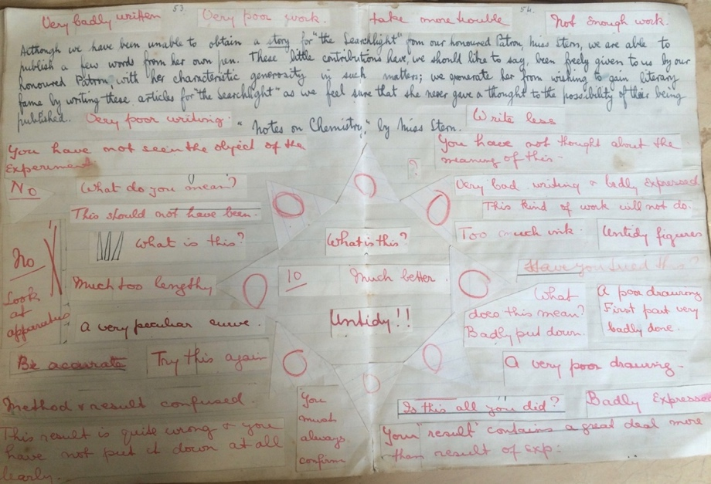
Figure 2.12 A collage of comments from Miss Stern’s marking. The Searchlight, ‘Second Number’, Summer 1913, 53-54, RS 4iv, NLCSA. Reproduced by permission of the North London Collegiate School.

Conclusion

This chapter has demonstrated that these three middle-class schools which admitted girls included practical work in their definitions of intellect, especially in the teaching of domestic subjects and science. By including practical work in science and domestic subjects, and specifically linking it to housework, the schools acknowledged the realities of domestic life with daily housework. This was not externally presented as fundamentally in opposition to the pioneering liberal curriculums of schools like the NLCS. They thus recast housewifery in a different light, and created an intellectual domesticity for all girls, which often involved ‘scientific’ practices, whether they specialised in domestic subjects or not. In this respect, the schools blurred the boundary between what might be cautiously described as ‘professional’ science (such as discoveries, experiments and innovation) with science as an integral component of domestic practice. Domestic practice and science then need not been seen as distinct and were, by these schools, understood together. As the final section showed, this was sometimes internalised and expressed by the pupils. In content and status within the schools, domestic subjects and science were more closely related than scholars have previously suggested. Both were incorporated into an intellectual culture, and this was in part owing to an emphasis on scientific knowledge and rational behaviour in the teaching of domestic subjects and science.

These schools were not, of course, representative of the entire middle class, as the educational experience of girls was still tremendously varied. Nevertheless, they demonstrate how new educational institutions for girls shaped and reflected changing notions of domesticity and housewifery. The curriculums of these schools were ground-breaking, not just for girls, but for middle-class public schools, as they offered subjects like science which were yet to be fully adopted in the equivalent boys’ institutions. But as scholars have established, they justified their broad and non-traditional curriculums by emphasising the benefits for the future housewife and mother. The result, as I have shown, was an outward emphasis on fostering intellectual development in girls, which, as teachers and headmistresses explained, could benefit their later domestic lives. It is no coincidence, of course, that the intellectual qualities alleged to result from scientific study, of the natural sciences and domestic science, mirrored the values of the new class of female teachers that centred their own professional role on their own academic and intellectual accomplishments.

As the third section illuminated, the emphasis on intellectualism could produce unexpected results, as seen through the pages of The Searchlight. In an institution that allowed independent thought, pupils expressed identities and interests that were likely denied to them as adult women. Childhood is ephemeral, and evidence that comes directly from the voice of the past pupil is fragmentary and rare. Nevertheless, this chapter has sought to suggest how we might compare and contrast the public voice of the teacher commenting outside the school, with the private expressions of the pupil, whose opinion is often absent from contemporary discourse and present-day scholarship on the history of education.

Educational institutions like the new public school for middle-class girls played a part in the creation of an ideology of scientific housewifery, or, in the case of these schools, an academic and professional housewifery. This did not mean a direct shaping of the pupils’ identities and future social roles; as I have shown, children’s identities, whilst temporary, were independent and as much about their own interests and imagination as the social aims of an institution. The former chapter suggested that domestic advice manuals targeted the ideology of scientific housewifery at the young wife. This chapter, however, has shown that a form of scientific housewifery, intellectual domesticity, pervaded educational institutions that admitted children and young women. It was not only through domestic advice manuals and in adulthood that women encountered scientific housewifery.

Chapter Three

Remembering Housework, Science and the Kitchen: Identity and Agency in Women’s Autobiographies

‘Science confronts man with the electric sweeper in one hand and the atom bomb in the other’. So wrote prominent anti-suffragist Violet Markham (1872-1959), aged eighty-one, in her autobiography Return Passage (1953). Science, like housework, is a blanket term that has many connotations. At the end of Markham’s lifetime in the mid-twentieth century, she recalled ‘science’ in two distinct forms: as both the advancement of domestic technology and the nuclear weaponry of the 1940s. Markham’s view of science was evidently shaped by the atomic bombings in the final stages of World War Two and does not reveal what her view might have been before these incidents. Autobiographies are generally written in the later stages of the writer’s lifetime and look back and see earlier events through the prism of later ones. This presents a methodological barrier for interpreting how science or housework might have been originally encountered and experienced earlier in the writer’s lifetime, without the influence of later events. However, it also allows an analysis of how writers construct their life and identity as a wide-ranging narrative over a period of history. In this chapter, I analyse how ‘housework’, ‘science’ and ‘the kitchen’ emerge in autobiographical writings written by a selection of women who lived through the late Victorian and Edwardian periods. I argue that female writers of autobiographies appropriated the prestige of science with a celebration of home to fashion an identity that was expert and rational, without deviating from the traditional feminine role as homemaker. In doing so, I suggest that writing an autobiography granted women agency to fashion how their lives and social roles were perceived.

Whilst domestic advice writers were seeking to profit by trading in domesticity, it is not so obviously in the financial interests of writers of autobiographies to present themselves as expert or professional in domestic affairs. The last section of the second chapter also considered the representation of the self in the example of school pupils. As I suggested, the expressions of identity from school pupils were indubitably impacted by their age. In contrast, as in the example from Violet Markham, writers of autobiographies were typically writing at the end of their lifetimes, and thus look back at the Victorian and Edwardian periods. This chapter, therefore, builds upon the themes of the first two, by demonstrating how a rational housewife persona was a construct formed by the writers, that remained important to their self-representation at the end of their lives.

Whilst pioneering literary theorist Georges Gusdorf argued that a sense of individualization was a prerequisite to writing an autobiography, this explanation has since been revised by feminist critics. Susan Stanford Friedman has pointed out that ‘A white man has the luxury of forgetting his skin color and sex. He can think of himself as an “individual”. Women and minorities, are reminded at every turn in the great cultural hall of mirrors of their sex or color, have no such luxury.’ Women have both a socially and culturally imposed identity and their own agency when writing their autobiographies. From the beginning of the autobiographies, the impact of culturally-imposed identity is clear. As scholars have pointed out, women’s autobiographies are often apologetic and self-deprecatory in tone, which is particularly clear in prefaces, prologues and forewords. Charlotte Barrington (1850-1935), for instance, whose autobiography was published when she was in her mid-eighties, established in her ‘Preface and Apologia’ that by writing an autobiography she was not seeking ‘egotistical ambition to figure in the limelight of literary fame!’ Likewise, Lady Violet Greville (1842-1932), writing aged eighty-five, established that she did not aspire to rival political, scandalous autobiographies; instead she wished to ‘draw a tiny picture of an ordinary life, neither hectic nor idle’. There was, it seems, a perceived vanity or egotism in writing an autobiography; as Richard Coe has pointed out ‘in the autobiography it is the writer himself who is the center of interest’.
In a similar vein, Sheila Rowbotham has argued with her ‘through the looking glass’ metaphor, women’s identities have historically been enforced by the prevailing social order. Oppressed groups, she argues, ‘must at once shatter the self-reflecting world which encircles it and, at the same time, project its own image onto history.’ However, whilst Rowbotham has argued that ‘Like other groups that are subordinate in society women have however also devised their own strategies to maintain an alternative myth of self-respect’. The use of the word ‘myth’, however, suggests that housewives sense of self-respect was not real. Autobiographies, like domestic advice guides, are a written form of performance of the writer’s identity, and it would be a mistake to view their agency over their representation as only a false coping strategy, which reduces women to passive victims of the patriarchy. Instead, I suggest that the written forms of identity construction were a legitimate means of asserting their agency.

I use Penny Summerfield’s concept of ‘composure’ in explaining how people present their own life narratives in oral history, autobiography or other forms of self-presentation. According to her theory, life narratives are ‘composed’: ‘“Composure” indicates the dual process of composing a story about a life and achieving personal composure or psychic equilibrium in so doing.’ Thus, these autobiographies can be used to explore how the memories of the Victorian and Edwardian periods were reconstructed in a way that presented the life narrative as psychically acceptable to the women at the time of writing. This process of writing one’s life story had been termed ‘Rewriting the self’. In addition, I suggest that the writers rewrote their personal histories, to be interwoven into a male-dominated narrative of scientific progress. A wealth of scholarship has established that science is and was typically gendered as masculine. According to feminist scholar Evelyn Fox Keller:

The ideology of modern science gave (at least some) men a new basis for masculine self-esteem and male prowess. If concepts of rationality and objectivity, and the will to dominate nature, supported the growth of a particular vision of science, they supported at the same time the institutionalization of a new dimension of manhood.

The relationship between science and masculinity has been analysed by Jan Golinski and Heather Ellis. In this chapter, I consider how this ‘masculine’ ideology of science was integrated into feminine identities, as writers of autobiography frequently presented their own lifespans as interwoven with a major historical narrative of progress. As I indicated in the introduction, earlier feminist scholarship suggested women were excluded from the benefits of scientific and technological progress. As this chapter will indicate, the daily realities of domestic life were framed in autobiographies as belonged to a wider narrative of scientific change. The cumulative narratives of scientific progress and domestic life were not in opposition, and could be experienced simultaneously by writers.

In total sixty autobiographical writings have been consulted, written by fifty-five different writers. All but three of these were independent autobiographies written by one main writer; the remaining three were autobiographical writings taken from edited volumes written by several writers. All of the writers were female. Each of the writers either lived through, or was born or died between 1870 and 1914, the main chronology of this thesis. The birth dates of the writers range from the 1780s to the 1900s, but the majority (eighty-five percent) were born between 1840 and 1900. Only seven of the fifty-five writers published their autobiography under the age of sixty; thirty-one writers, or fifty-two percent, wrote their first autobiography over the age of seventy.

The problem of defining class is particularly acute considering the social mobility of writers over their lifetimes. However, in keeping with the rest of the thesis, the class of a writer has been defined by the occupation of their father; in places it is acknowledged that some women moved between social strata. Since class was a determining factor in the domestic lives of women in this period, women from all classes have been consulted. Fifteen out of the fifty-six writers were born into the working classes; five of these fifteen were from the rural working class. Aside from one exception from the aristocracy, the rest of the writers were from the middle classes but from across the range of economic circumstances within this category. By their point of writing, however, most women were financially comfortable, and many had notable public profiles. As well as renowned anti-suffragist Violet Markham, the group of women who wrote these autobiographies include suffragettes, journalists and domestic advisors. The problem of representativeness of autobiographies has been widely acknowledged; John Burnett has pointed out that nineteenth-century autobiographies were written more ‘by professional people than by manual workers, more by skilled craftsmen than by labourers, more by men than by women’. Certainly in this sample women with professions or other public profiles dominate. Most were born and lived in England for their entire lives, although I have selected a few examples of women from elsewhere to demonstrate the international parallels in my argument.

In this chapter, I argue that through their autobiographies this select group of women were able to assert agency in the fashioning of their identity. Through reference to science and technology, they articulated a femininity that combined elements of the traditional female activity of housework with a rational, scientific expertise. As the second section will highlight, the writers often referred to the significance of their own lifespan with reference to grand scientific, medical and technological innovation. This in itself was an important means of contemplating one’s own lifetime, by situating it within a period of immense significance to the quality of people’s lives and writing their own lives into a masculine narrative. Moreover, they appropriated science and other forms of rational knowledge in their representation of housework, borrowing its prestige and demonstrating a mastery in scientific and intellectual fields in which women were professionally marginalised. I demonstrate that the memory of housework and domesticity was reconstructed with an emphasis on rationality and intellect as a legitimate means to assert agency over their representation, on a much more personal level than within domestic advice manuals.

In the first section, I draw attention to the construction of domesticity in autobiographies. I suggest that housework and especially kitchens were often recalled with intense emotion, particularly owing to a strong association with close female figures in childhood, such as mothers and domestic servants. I will demonstrate that recollections of the kitchen heavily correspond to the popular imagery of the room as the heart of the home. This, I suggest, often rested on the association of the kitchen as a centre of social activity, which was more common in working-class homes where the idealised segregation of domestic space was financially unfeasible. The second section will highlight that the writers often integrated their domestic lives and daily routines into a broader narrative of major scientific, medical and technological change. I suggest that by referring to major scientific change across their lives, they were writing themselves into a male-dominated narrative, and thus raising the significance of their own lives. This final section brings together the previous strands of argument. I show here that the writers combined the ideas of home and domesticated femininity with the prestige of science, to fashion an identity that conformed to traditional gender roles but still afforded them agency in establishing their objective expertise.

| I | Reconstructing the Kitchen and Housework

Autobiographies reveal the value of housework and domestic life to the writer’s sense of self, and as the section shows, the kitchen was often recalled as an emotional lynchpin in this construction of domesticity. This is not to suggest that all memories of housework were positive. Many women still reflected on the early period of their marriages and documented struggling at managing a household for the first time. For instance, Eliza Priestley (1836-1909), the wife of a doctor, looked back aged seventy-one ‘across the years that have since intervened’ and saw herself as ‘anxiously trying to qualify myself to be the wife of a poor man’. Priestley was born into the upper classes and was the daughter of controversial geologist and publisher Robert Chambers, but married a middle-class doctor. As a woman, she evidently felt it was her duty to adapt to her new economic circumstances. Census records suggest that this period of poor fortune was only for a few years, since by 1861, five years after her marriage in 1856, she was managing a household with three servants including a cook. She described, that for the first time in her life, ‘I began to make my own clothes, trim my bonnets, and even re-cover my white satin shoes! Strict economy was the order of the day, and the things I never thought of before I thought of now.’ She saw her role in the household as integral to the work of her husband, a doctor:

Still, notwithstanding the alarming independence of the physician, there remained the husband’s trusting dependence on the wife which every physician feels when merged in the business that centres in the home, goes on around the home, and yet is more or less outside the home life. Thus it falls to the doctor’s wife so to arrange the home that her husband can command peace of mind as much in the professional as in the domestic routine of daily life. She ought, in fact, to be “the guardian angel sitting on the ladder of her husband’s fame,” as Victor Hugo’s wife was said to be.

Priestley suggested that domestic work ‘falls to’ the wife and reflected on the struggles she experienced as a young bride. And yet, she did not present herself as oppressed or trapped in the home. Instead, she shared her husband’s success, owing to the importance she assigned to her work in the home. As M. Jeanne Peterson has argued, women could contribute to their husband’s careers in ‘non-trivial ways’. Most women, of course, were not able to become doctors themselves in the Victorian and Edwardian periods. But by describing her role in supporting her husband through domestic work, Priestley was able to write herself into the success and prestige of her husband’s career as a doctor, without deviating from a traditional feminine role as homemaker. Priestley maintained a highly romanticised and idealised version of domestic life by comparing herself to a guardian angel; ‘The Angel in the House’ was the epitome of romanticised notions of the Victorian wife and mother.

Priestley’s view of housework was echoed in the sentiments of Florence White (1863-1940). White was born into the middle-classes, as the daughter of a lace-buyer, but had mixed financial fortunes over the course of her lifetime. She worked as a domestic servant from 1916 to 1927, and wrote her autobiography aged seventy-five. In a similar manner to Priestley, White constructed her own sense of validation by drawing on the professional role of the men who employed her. Reflecting on her time working for a Catholic priest, White explained:

it was here that I first began to realize the full value of good food and cookery. All these three priests worked very hard, and they couldn’t possibly have done their duty properly if they had not been properly fed and had a happy, comfortable, peaceful home to which they could return and rest, beginning again refreshed. I honestly felt that in looking after them I was not merely attending to the fire in the kitchen, but that I had a share in the sermons they preached, the parish work they did, and the comfort they gave to the sick and sorrowful. It is true my work was like the seed sown in the earth, hidden and unnoticed, but it was very well worth doing.

White and Priestley’s recollections of housework are remarkably similar. Both saw their role as integral to the professional success of the men they live with; in White’s case it was her employer, and in Priestley’s it was her husband. Both were reflecting on times in which they were financially struggling, albeit White more so than Priestley, but they still presented their role in the home with pride and nostalgia. Indeed, White suggested that the priests she worked for were unwilling or unable to feed and take care of themselves, presenting her own role as all the more critical. Rather than seeing themselves as confined to the kitchen, White and Priestley viewed their role in the home as having insurmountable benefits to the outside world through the men in their lives. Thus, in their writing they asserted their agency in the presentation of their lives, as they drew on the emotional value of domestic labour.

There were frequent references to the kitchen as homely and the centre of family life. For instance, Agnes Weston (1840-1918), a philanthropist who worked in social welfare for the navy, described the kitchen of a family friend Mrs Wintz (the mother of her close friend Sophie Wintz, fellow naval philanthropist): ‘the very word “kitchen” spelt comfort and home.’ She recalled at the age of sixty-nine seeing the kitchen [of the c. 1870s] used as a social space for naval workers, noting ‘I can see the boys cramming the kitchen, sitting on the floor and window-sills when the benches were full, and some on the kitchen stove with its cold plate.’ Incidentally, although Weston was herself from a middle-class background, as were the Wintzs, her definition of the kitchen as the centre of the home rested on its association with social activity.

Frequently, however, the enduring image of the kitchen as ‘the heart of the home’ emerged strongly from childhood memories. In contrast to the middle-aged writers of domestic advice manuals, the kitchen was described with a fond nostalgia, underpinning its emotional centrality in conceptions of home. In working-class homes, the kitchen was more likely to be a centre of activity in comparison to the segregated and specialised ideal arrangement of rooms described in the first chapter (page 58). Alison Uttley (1884-1976), who grew up on a farm and documented her family poverty, recalled at the age of sixty-seven: ‘The centre of life for me as a child was the farm kitchen, where all was bustle and motion, where people passed and repassed, to save the longer journey round the house walls, on their way to farm buildings, or to water-troughs…’. In addition, Mathena Blomefield (1879-?) also of the rural farming class, recalled aged sixty-seven, memories of children cramming ‘In the kitchen, before a low hearth in which a bright ember fire was burning, a mattress lay on the rush-covered floor, on which five small children sat, four of them nursing a large basin of milk and bread.’ Similarly, working-class Elsie Oman (1904-?) remembered at age seventy-nine that her favourite place to sit as a child was under the kitchen table: ‘How lovely it was to sit under the table with its brown coloured cloth, the fringe reaching to within a foot of the floor! That was where I spent as much time as I could, listening to the voices in the kitchen.’ The emotional importance of the kitchen in conceptions of home is evident in these recollections from working-class childhoods. Kitchens in these homes seem to have literally been at the centre of the house, filled with people, rather than the basement kitchens of the new urban middle-class.

Familial and individual differences varied the memory of the kitchen and housework. Uttley, for instance, grew up in a rural environment. The importance of the farm in her memories of the kitchen is evident in her description:

There were smells of varying intensity, the scent of wood-fire, and sticks in the kindling box, the sweet rank smell of rainwater, drugged with moss and ferns and decaying leaves of a past year, the strangely exciting smells of pepper and brine, of herbs and cowdrinks, of newly baked bread and strong tea, and also the animal smells which assailed my quivering nostrils, absorbing, breathing, taking in all around me- the smell of rabbits which were flung under the tallboy by my father as he hung up his gun, the smell of manure on boots, of horses and cattle, of stable and byre, all came surging into the farm kitchen, part of its life.

The smells Uttley associated with her kitchen- animals and manure- were not a universal feature of all kitchens at this time. Naturally, her personal experience of her family and home shaped the memory of the kitchen. In this description, Uttley mentioned the presence of her father in her childhood kitchen. As Julie-Marie Strange has described, in working-class homes, especially those where the family lived in one room, fathers were a regular presence. There was, of course, an immense variation in the representation of the kitchen, depending on factors such as class or location.

However, despite these factors, there are common themes that emerge in childhood recollections of the kitchen, despite major class and family differences. In middle-class households with more servants or rooms, children were not necessarily allowed in the kitchen. For instance, Winifred Peck (1882-1962) explained of her middle-class upbringing that ‘We were never allowed by our old nurse to go into the kitchen, and I still feel a pang of envy when I read in memoirs of other authoresses how they were allowed to make little figures of dough.’ Census records from 1891 show Peck’s Leicestershire household had four domestic servants; a cook, a nurse, a nursemaid and a ‘domestic servant’ who was presumably a maid. More servants and more money perhaps led to the more segregated arrangement of the household rooms. However, it is of note that despite not being allowed in the kitchen herself, the lack of familiarity with the space was apparently still important enough to Peck for it to be noted in her autobiography. Despite not having childhood memories of the kitchen herself, she clearly still endorsed a nostalgic view of the kitchen, hence her envy that she was denied access to it as a child. Similarly, it was the childhood ‘dream’ of upper-middle-class Anna Buchan (1877-1948) to live with her younger sister ‘in a very small cottage, and sleep together in a box-bed in the kitchen’. Buchan continued, writing aged sixty-nine, that she ‘thought how snug it must be to sleep in the kitchen, with people all about, drinking tea and talking; no loneliness, no long passages between you and other friendly humans.’ Evidently her dream to live in a cottage was in stark contrast to her own middle-class upbringing; census records confirm that throughout Buchan’s childhood, they had at least one servant. Her own childhood home presumably had multiple rooms, given the ‘long passages’ that prompted feelings of isolation. Peck and Buchan still considered the kitchen as a central site for nostalgia owing to its association with activity and warmth, despite not experiencing this personally in their own childhoods.

Nostalgic memories of the kitchen were often coupled with fond memories of mothers. As Victoria Kelley has shown, in working-class autobiographies mothers were often confined spatially to the domestic kitchen. For instance, Grace Foakes (1901- 1979) grew up in a working-class home in London. She remembered her childhood kitchen at the age of seventy-one: ‘it was warm and it was home. It was the place where my mother could always be found- and that was all that mattered.’ There is no doubt that the kitchen was deemed a feminine space, and one which was often emotionally tied to memories of mothers. Morally, though not legally, the kitchen was a woman’s space. For instance, Weston described the kitchen of Mrs Wintz, with whom she lived while working for the navy, casually referring to it as ‘her large comfortable kitchen’; the ownership of the kitchen was depicted as very much belonging to the female figures who most frequently occupied it.

Memories of housework were also often paired with emotional accounts of the writer’s mother. For instance, Buchan depicted her mother as deeply enjoying her housework. Writing of the 1870s, she described spring cleaning as ‘the sweet of the year to her [mother].’ Buchan wrote that her mother:

prided herself on being able to get the house cleaned meticulously with the minimum of discomfort to its inhabitants, and how she enjoyed it! She began in the attics and worked down, superintending everything herself, glorying in letting the clear cold March sunlight into every corner.

Buchan painted a picture of her mother as deeply engrossed in her housework, taking pride and pleasure in its successful execution. The ‘superintending’ of the spring clean was evidently important; Buchan’s mother took great joy in being in charge of the household. Florence White made similar comments about the ‘fun Victorian girls and women got out of their homely housewifely tasks, and what pride they took in their skill.’ White continued, ‘Talk about imagination! They had it and no mistake. And they never seemed to think the work drudgery.’ Like Buchan, White recalled how Victorian women did not believe themselves to be victims confined in the home. It is, however, important to remember that such descriptions of housework as ‘fun’ were, as in these cases, descriptions of other people’s experiences rather than their own. Kelley has suggested that by celebrating their mothers, writers were validating ‘their own maternal role’. By extension, I suggest that by celebrating the achievements of former housewifery practices in more difficult circumstances, writers were also validating their own domestic work.

Autobiographies featured memories of domestic servants for those wealthy enough to have them. In some examples, comments on domestic servants are made in a similar tone and style to domestic advice manuals. After all, some of the women used in this chapter also wrote domestic advice manuals, such as Constance Peel (1872-1934), Jane Panton (1848-1923) and Priestley (the latter two featured in the first chapter). Thus, in places the class prejudice and judgment that seeped into domestic advice manuals is also detectable in autobiography. For instance, distinctions were sometimes made between the work of the middle-class housewife and her working-class domestic servant. Middle-class writer Isabella Mayo (1843-1914) sought to distinguish between domestic service and household work. Mayo questioned the character of female domestic servants who were willing to be ‘the mere hired tool of a woman as able in mind and body as herself’. But, ‘Household work, on the other hand—the preparation of good food and the maintenance of domestic hygiene, cleanliness, and beauty—lies, like agricultural labour, at the very root of human living’. In comparing housework to domestic service, Mayo implied that the latter is degrading as it involves working for another woman. To be a housewife, however, means managing the household, which is of the utmost importance to ‘human living’. According to Mayo, respectable femininity can be achieved as a housewife, who manages the home, but not as a domestic servant, who is employed by another. In Mayo’s view, a celebration of housework was reserved for those who commanded their own home, rather than those who were in another’s employment.

It was more common in autobiographies than domestic advice manuals to depict domestic servants with warmth and affection. Some strongly associated their childhood kitchen with fond memories of a family servant. According to Buchan, their servants held close friendships with the family:

Marget was a great figure in our childhood. She was a large woman with a broad, plain face, and a most capacious and comfortable lap. I never remember any servant troubles in our house. Mother often said that her servants had been her best friends, and certainly they made all the difference to the peace and comfort of our home. A kitchen without Marget moving methodically about was unthinkable.

Eleanor Acland (1878-1933), an upper-class daughter of a paper-mill owner, fondly remembered her childhood cook in similar terms as Buchan. She explained: ‘I must not forget one other grown-up who played a distinctive part in our childhood- Anne Parke, our cook, who was indeed one of our dearest friends.’ The importance of domestic servants to one’s experience of home must depend on family and economic circumstances. Acland was from the upper classes, which was surely a prerequisite for even having a cook, and Buchan was middle class. Domestic advice manuals generally sought to distinguish between the housewife and the servant, much like Mayo; in contrast, in these extracts, the servants were integrated into the family unit. The difference might be attributed to two factors. Firstly, since the writers of autobiographies were not seeking to make a profit on the grounds of their professional domestic expertise, they did not necessarily seek to actively recreate the class difference between housewife and domestic servant in the manner described in the first chapter. And secondly, in both these instances, the domestic servant was recalled from childhood memory. Delap has pointed out that children often had emotional relationships with domestic servants, noting that children from the upper and upper-middle classes, like Acland and Buchan, sometimes recalled a stronger affection for servants than their mothers. Delap continues that the authority relationships between servants and children were often complicated; as middle-class children they were in a higher social strata than the household servant, but were, after all, still a child. Writers of all classes often fondly recalled the women in their kitchens, whether they be domestic servants or mothers. The importance of the kitchen as an emotional space transcended class boundaries.

Some writers recalled specific instances where a female figure taught them how to cook or bake, often as a child. Acland fondly remembered their domestic servant Anne, who taught her how to make sponge cakes. Florence White recalled staying at home from church to help roast the Sunday joint with the family servant Eliza, and Blomefield described operating a complicated chopping device for meat. Such memories were not only from childhood; sixty-nine-year-old Enid Lyons (1897-1981), who was born into the working class, but married upwards, described struggling at cooking in her early marriage and seeking help from her landlady:

Miss Innes, our landlady, can best be described by the one word lady. Her kindness and her gentle speech and manners encouraged me to seek her help. At home I had cooked on a wood stove. Here there was only gas. Such little cookery as I had done involved fairly large quantities, here I dealt in spoonsful. Miss Innes was most helpful. Under her direction I learned to judge the appropriate heat for the dish in hand and in no time at all (or so my indulgent husband said) I was “the best little cook in the world”!

Like the childhood memories of Acland and White, the formative experiences of cooking and baking were inextricably bound up with fond memories of the women who taught them. Thus, cooking was presented as fundamentally feminised in the autobiographies.

The material culture of the kitchen sometimes held specific emotional memories. In her description of a relative’s kitchen, Clare Cameron (1896-1983) depicted the atmosphere and material culture as personifying its owners:

Tea was ready in the big comfortable kitchen, whose ceiling came low to the head. The kitchen reflected every quality of its owners. There were brown eggs and new scones, fresh country butter and home-made jam, and we drank from the china that had been handed down through many generations. Oh, it was good to be there! Like coming home- coming to all the things that I loved and that fed my many hungers.

The kitchen was also sometimes recalled as a sensory space. As the space in which food is cooked, it was often unsurprisingly associated with smell, taste, and heat, as in Alison Uttley’s description of the smells in her childhood farm kitchen. Similarly, Blomefield recalled: ‘Wednesday morning came and the cooking preparations began. How good the kitchen smelled! There was a roaring fire on the hearth and another in the brick oven.’ More subtle descriptions give a clue into the noise and bustle of the domestic kitchen; Cameron, for instance, described ‘Cups clink[ing] in the kitchen.’ The appearance of the kitchen was often mentioned, such as Violet Greville’s description of ‘the spacious kitchen gleaming with pots and pans, sparkling spick and span, with a grand cook in cap and apron and her satellites waiting round her, beside the large glowing fire in the stove’. Uttley personified the saucepans from her childhood memory, noting ‘the room sparkled and twinkled with a thousand watching eyes, and I knew very well they were there, sharing our life.’ The dazzling appearance of the kitchen was not restricted to wealthier households. Eighty-three-year-old Kay Pearson (1896- 1979), for instance, described her working-class childhood kitchen as ‘the pride of the house, grate splendidly black leaded, hearth white-washed and the tiles cleaned with red bath brick surmounted by one hearthrug made from bits and pieces of old coats and trousers.’

Even individual objects within the kitchen were highlighted as holding specific memories or emotions attached to them. As Cameron noted, there was some emotional connection to drinking ‘from the china that had been handed down through many generations’. In a similar vein, Uttley described that ‘Every article in the cosy room had its own story, told to me many times. A deep oven built in the wall bearing a bright brass plaque with the words “Rumford Roaster, 1803”, was the bread oven in my grandfather’s childhood.’ Specific objects thus had their own history. Jane Panton, writing in 1908 noted that her ‘Mama’ had a ‘small and precious silver saucepan’, and Florence White recalled receiving as a gift a ‘saucepan which my father had bought me from Paris.’ Indeed, the material culture of the kitchen was important enough to change how the room and, more broadly, the home were experienced and remembered. For women of various backgrounds, the childhood kitchen had positive associations, underlining its emotional centrality in conceptions of home, and memories of childhood. Although there are classed and familial differences in how the writers personally experienced the kitchen, there are common themes in its depiction, such as social activity or female figures.

| II | Science and Domestic Life

This section will establish how memories and experiences of science influenced conceptions of housewifery and domesticity. From the writer’s perspective, advancements in science and technology were important contributing factors that led to their domestic routines as they knew them at the time of writing. They thus write their own domestic lives into a male-dominated narrative about the progress of science, from which they were otherwise excluded.

Scientific change, of course, encompassed a broad range of change across the nineteenth and twentieth centuries, and naturally the writers recalled the impact of science on society and culture in a multitude of ways outside the domestic sphere. However, what most of these descriptions have in common is the presentation of a narrative that corresponds to early teleological historians of science (as described in the introduction, page 15). Looking back from the end of their life to the beginning, the writers referenced specific events which they considered pivotal points in history, viewing scientific change as a progression of cumulative advancements. For instance, multiple women referred to the impact of Charles Darwin and the publication of On the Origin of Species (1859), and related religious doubt in the Victorian period. Violet Markham wrote that her own mother had ‘came to maturity at a time when great ideas were stirring in the world. The Origin of Species published in 1859 had set on foot a revolution extending far beyond the scientific matters to which Darwin’s work was primarily directed.’ In Markham’s view, Darwin’s publication of Origin signalled the beginning of a new era. Mentions of prior scientific work, such as Chambers’ Vestiges of the Natural History of Creation (1844), were depicted as a precursor to Darwin. Middle-class essayist Eliza Lynn Linton (1822-1898), writing through the male pseudonym of Christopher Kirkland aged sixty-three, described Robert Chambers as ‘the dawn but not the full day’ whereas Charles Darwin was ‘our greatest man of all, the true epoch-maker and torch-bearer of this century’. Even Eliza Priestley, daughter of Robert Chambers, saw her father’s work through the prism of the later work by Darwin. She describes the impact of Vestiges as falling ‘like a bomb among the Darwinites of the future’. These examples are typical of the interpretative difficulties of using autobiographies. All events are seen through the lens of the knowledge of the events and discoveries that followed. Furthermore, by referencing the scientific changes across their lives, these women demonstrated how their life span coincided with a critical period of history. As psychologist Mark Freeman has said, people seek to place their own experiences in some kind of narrative ‘for the sake of “containing” their experience in a meaningful way’. Thus, they write their own lifetime into a wider narrative of major scientific and technological breakthrough, from which they, as women, were excluded professionally and publicly.

Memories of domestic change were depicted in the same way. This is, perhaps, more revealing about the time of writing rather than the time written about. In Mary Chamberlain’s words: ‘Memories are complex historical sources, in which what is recalled and recounted may be less revealing than why, how, or when recollection takes place’. The writers of autobiographies recalled the domestic circumstances of the late Victorian and Edwardian periods from a later vantage point. Forty-three of the writers published after 1918, and nineteen after 1950. Thus, they were written from a time with different domestic amenities, which are unsurprisingly described in a positive manner. Psychologists Mark Freeman and Rick Robinson have established that ‘the difference between the old and the new, after having been identified and articulated, must be “made one’s own” by being integrated into a superior vision’. In consequence, science is described as overwhelmingly positive for its impact on everyday and domestic life.

Science and technology were presented as fundamental in changing the domestic routines and habits of women. The ability to freeze food was noted by at least two writers as having an impact on eating practices. As Naomi Mitchison (1897-1999) pointed out, writing aged seventy-eight, prior to the invention of the fridge and freezer, ‘fruit and vegetables were seasonal and all the more looked forward to and enjoyed.’ Elizabeth Haldane (1862-1937) also noted the difference made by the introduction of meat frozen from abroad. As well as changing the availability of certain foods, Haldane highlighted the social impact of new foods from abroad, noting that ‘butchers came under suspicion for selling this pernicious merchandise.’ Although born over thirty years apart, Mitchison and Haldane were united in elevating the freezer to vital significance for transforming daily activities such as shopping and eating. Their own experience of science and technology was through its impact on domestic life. The introduction of freezers, for instance, did alter eating and shopping practices that were primarily female responsibilities. They used their domestic experiences, which were crucially impacted by technological innovation, as a means to write themselves into the male history of science.

Inventions which improved the comfort of domestic life were naturally prevalent in the autobiographies. Many of the women referred to the lack of certain ‘modern’ amenities, in their efforts to stress the difficulties of earlier times. Grace Foakes noted: ‘This was not the world as it is today. Hot water systems were unheard of, lighting was by gas or paraffin lamps and there was no electricity.’ The absence of ‘modern’ conveniences was frequently used to emphasise the discomfort of the time before. Pearson described how in her childhood, to keep warm, heated bricks were kept in beds. She added that there was ‘no central heating or electric blankets in those days.’ The writers simultaneously presented a picture of the importance of modern technologies in changing the lives of many, whilst also highlighting the difficulties of living in the time before. Their mention of the absence of ‘modern’ amenities served to accentuate their distancing of their earlier living practices. As women were, for the most part, excluded from the scientific, medical and technological professions, highlighting the changes in domestic life was a small window into demonstrating knowledge of major change, and rewriting their own lives into a period of historic significance. Although science was gendered as male, the domestic sphere was female, and women used this association as a means to demonstrate their knowledge of a male-dominated area.

The absence of particular inventions emerges as central to the women’s recollections of the late Victorian period. For instance, the late-nineteenth century was depicted as a time before the telephone. Writing in 1933, domestic advisor Constance Peel mentioned that the telephone was ‘not as usual a piece of domestic equipment as it now is.’ Similarly, Haldane commented of the 1890s:

There were also other interesting developments at this time, such as the coming into use of the telephone on certain main lines. Of course this did not in any degree mean the setting up of a telephone service as we understand it, which a little later made such a change in social life.

As expected, Peel and Haldane wrote of the past through the prism of their present-day in the twentieth century. In Haldane’s case, her reflections of the development of the telephone line was prompted by her understanding of the importance of the telephone at her time of writing in 1937. Similarly, Sara Burstall (1859-1939) saw the latter part of the nineteenth century as critical to ‘the advance in the use of electricity as power, which characterises the age in which we live.’ Like Haldane, Burstall’s comments were driven by her belief in the importance of electricity at her time of writing, in 1933, aged seventy-four. Both women were placing their own lives in relation to what they deem important at their time of writing. Their description of the innumerable benefits of inventions like electricity or the telephone were not just important to the writers because of obvious practical consequences. This sense of living through major technological change was critical to their sense of identity at the time of writing. Inventions and other forms of scientific change became a way in which writers could make sense of their own lifespans and show they had personal experience of the history of inventions so important at their time of writing.

References to earlier times often created a stark contrast to the time written about against the time at which the autobiography was written. Domestic advisor Jane Ellen Panton described the domestic medical practices favoured by her mother in her childhood of the 1850s and 60s. Writing in 1908 aged sixty, she commented that ‘The domestic arrangements of those days were very different to what they are now, and as such, I think, deserve a few words here. My mother was a great believer in medicine, especially in domestic medicine, and we suffered in due course.’ Drawing a comparison to her present day, Panton warned ‘Mama’s domestic medicine would cause a scare nowadays, as would her cheerful way of treating infectious diseases.’ In this instance, Panton included details of domestic medicine, because they ‘were very different to what they are now’. Thus, in contrasting her mother’s medical practices, Panton highlighted the scientific competency of her generation, and integrated major medical improvement into her own life story. She thus wrote her own life into the history of medicine, from which she would otherwise be excluded.

The writers expressed a great deal of hope for labour-saving technologies. Many of the women looked back at a time before particular inventions and recalled it as much harder. The difficulty in cleaning knives before stainless steel was a reoccurring gripe with the writers. White, for instance, noted: ‘There was no stainless steel in those days, and although there were knife-cleaning machines, we did not possess one.’ Indeed, Constance Peel and Edith Mumford (1869- 1953) both commented on the difficulty of cleaning knives before stainless steel; the former described it as the ‘man of all work’. Other writers made similar comments about household labour before domestic machinery. Pearson noted that before soap powders or detergents, washing up relied on a ‘carbolic soap, Sunlight or soft soap plus a handful of soda, a good strong scrubbing brush and elbow grease.’ Letitia Youmans (1827-1896) drew attention to the invention of the sewing and knitting machines, suggesting that ‘Woman’s hands were the family machinery of the day.’ As with other inventions and scientific discoveries, the women depicted a march of progress, of which their own domestic lives and experiences were a central part. Technology, like science, was gendered as masculine. In these examples, the writers depicted technology as feminised by emphasising its impact on the daily lives of women.

Other women believed that labour-saving technologies would ultimately relieve women of hard domestic labour. Ranges in particular were a point of concern in the Victorian period, as I discussed in chapter one, page 69. As Alison Ravetz has documented, the development of the stove across the nineteenth century was not motivated by labour-saving principles. Ruth Schwartz Cowan has pointed out that developments in stoves tended to relieve men of their domestic duties rather than women. For instance, stoves that halved the amount of fuel needed also halved the male duty of cutting, hauling and splitting wood. Nevertheless, contemporaries expressed hope that technology would make a stove easy to use. Violet Markham, for instance, predicted of the future:

Every sort of mechanical and labour-saving device will replace the bucket and brush of my youth. Kitchens will no longer be equipped with Moloch-like ranges, devouring coal and human effort in equal proportions. A wilderness of underground cubby-holes and passages will be replaced by compact reconstructed units, lighted and heated by electricity.

Anne Tibble (1905-1980) described the iron range of her working-class childhood, and the hard labour that it required of her mother:
To warm the big kitchen, my Mother carried coals up two dozen steep steps. She fed our black, insatiably monster of an iron range with logs. It devoured six-foot boughs, whole deadwood tree trunks; and then, when Mother had been to the wood and filled up the range’s reckless maw until she at least was streaming with heat, that oven was still only warm enough to cook our rice pudding.

As Markham suggested, considerable faith was placed in science in order to transform the lives of housewives. And as Tibble showed, in many ways it was perceived that, at their time of writing, this had already been done. In this respect, the writers present their own lives as positively intertwined with major scientific progress and lay claim to a narrative of historical change from which they would otherwise be excluded.

| III | Rational Housework

Clearly then, as the first two sections have shown, domesticity as it was constructed in autobiographies could have different associations. On the one hand, housework and kitchens could be recalled with strong affection, often tied to memories of a benevolent female figure from childhood. On the other hand, at their viewpoint towards the ends of their lives, the depiction of domestic life was shaped by the scientific and technological change that had happened in the ensuing time up to the point of writing the autobiography. This section draws these separate strands together, by demonstrating how writers combined the ideas of home and domesticated femininity with the prestige of science, to fashion an identity that conformed to traditional gender roles but still afforded them agency in their expression of their importance and expertise.

In a very similar manner to domestic advice manuals, the language of science was applied fairly liberally across the autobiographies, particularly in descriptions of domestic tasks. For instance, reflecting on dining habits, Violet Greville described carving meat as a ‘delicate and scientific operation’. In this instance, Greville was using ‘scientific’ to describe the accuracy required ‘to give just the right bit of fat, to cut the slices thin, and not too thin.’ In addition, Greville pointed out the medical significance of the correct slicing of meat. She continued, ‘Doctors tell us that gastric juices are produced by the pleasure with which we eat our meal; how important, therefore, is the preparation of that meal.’ Greville expressed her own authority on the topic of food and cookery, by drawing attention to its medical importance. Similarly, White described her former ignorance of fermentation in the process of making Sussex pudding. She recalled seeing the family servant make Sussex pudding as a child. But, ‘Only about two years ago’ [c. 1936], she ‘learnt the secret of the lightness of the fatless pudding; a mixture of meal and water undergoes spontaneous fermentation if allowed to remain for some hours in a moderately warm place.’ As she suggested, the knowledge of fermentation was not required to make the pudding, just as many other scientific processes can be ignored during a household task. However, her understanding of why a fatless pudding is light is still considered important enough to include in her autobiography. The scientific knowledge, therefore, was important for White, so she can profess her expert understanding in her autobiography, but less so when actually making the pudding.

As a food journalist it was particularly important for White to demonstrate her academic knowledge of cookery. She described in her autobiography how she studied dietetics, to enhance her knowledge of food, commenting that ‘My education in cookery was progressing side by side with my academic education, and this is as it should be’. She later stated ‘The books in the Patent Office Library led me to study food values, diet, and especially vitamins, thus adding another interest to my work. The exercise-books and note-books I possess are evidence of the work done during this period.’ Her desire to point out the ‘evidence’ of her studies indicates how important it was to her, especially in bolstering her credibility as a food journalist. In addition, White recalled of the period 1909-1912: ‘At this time scientists were discovering that vitamins were an essential part of food; the subject of diet was evidently in the air’. White suggested, therefore, that her own studies were up-to-date with the latest scientific areas of inquiry, and subsequently reinforced her prestige as a food expert. She wrote her own profession into a wider narrative of scientific discovery. White presented her femininity as closely linked to traditional female tasks, in this case cooking, but elevated her status by expressing an academic, intellectual engagement with it.

However, most mentions of rational housework featured as subtle additional details alongside personal memories. For instance, Grace Foakes recalled her mother’s expertise at managing the household economy in times of difficulty. She remembered the difficulties of living on a small budget as a child, but also celebrated the thrift and ingenuity of her mother:

Perhaps you can now get some idea of what household management had to be like in my early childhood. In all, those three dinners and a breakfast cost about fourpence. My mother was not alone in her economy. The force of circumstances demanded it. Money was short and appetites were large, so women in those days were obliged to be thrifty.

Thriftiness and household management were essential in homes where money was not readily available. Foakes presented her mother’s good economy as integral to the survival of her family. She celebrated her mother’s success at providing the family with food. This view of household economy was echoed in the autobiography of Beatrice Holmes (1884-?), who described her mother’s thriftiness with pride, looking back at the age of sixty. Holmes was middle-class, the daughter of a physician, but she too praised her mother’s ability to run the household on a small budget. She noted: ‘my amazing mother ran the household on 30s. a week, including food for all and clothes for us children and herself (yes, she did!), and owing to her genius for household management and cookery we never knew a badly cooked or insufficient meal’. Both Holmes and Foakes described the good economy and effective management of their mothers which was essential for their survival. Their celebration of their mother’s domestic skill is demonstrated not through sentimentalised descriptions of their mothers’ love and care, but by describing their mastery at the household budget. Subsequently, their mothers, and housewives more broadly, were attributed rational and intellectual skill in housework, which was not regularly afforded to women of the period.

In more exceptional cases, there is evidence that women were purposefully using scientific and mathematical reasoning in their housework. Eighty-one-year-old Edith Mumford, a middle-class writer and doctor’s wife, described how she applied mathematical knowledge to increase her enjoyment of household work. Mumford had excelled in mathematics at the North London Collegiate School and later at Girton College. She recorded in her autobiography how she drew links between household tasks and her mathematical education. Writing in the third-person as ‘Grannie’, Mumford described how:

Cooking gave Grannie many a thrill. To her it was creative work. Certain ingredients were put together, treated in a certain way and, lo and behold, something other than the mere sum of the ingredients, so to speak, resulted.

In cooking, as in individual and social development, the ‘whole’ was seen to be greater than the sum of the ‘parts’.

Undoubtedly, she described how she intellectually engaged with the process of cooking. This intellectual fascination with household chores was not restricted to cookery. Of dress making, Mumford explained:

The intricacies of cutting out a pattern of a dress which would fit exactly, though only a few measurements had been taken and dealt with according to a certain mathematical computation, fascinated Grannie in somewhat the same way. And it was the same with the other things which were done in the house.

Mumford noted with some pride in her autobiography that her education in mathematics gave her training in ‘clear-cut reasoning’. Evidently, she described taking enjoyment and pride in applying these principles to her housework. To Mumford, the application of mathematical ideas was a means to gain control and assert agency over her socially prescribed place within the home. In her writings, she was articulating a femininity that combined the traditional female role as a homemaker and an intellectual quality taken from her mathematical education.

Interestingly, however, Mumford did not attribute this rational expertise at housewifery to the knowledge acquired at the North London Collegiate School. When at school, ‘Her mother had fed her, clothed her- even darned her stockings for her- leaving her free to live the fullest intellectual life possible’. She had ‘once earned a special prize for Domestic Economy, but she had no practical knowledge whatever, as far as the management of a house was concerned’. The domestic economy classes to which Mumford refers are likely the same theoretical domestic economy classes taught under the Buss era of the North London Collegiate school, as described on page 99 of the former chapter. Mumford described ‘her ignorance of what constituted the running of a home might well have been described as abysmal!’ in the early years of her marriage, and sought to educate herself on domestic affairs by attending lectures on cooking, dressmaking and millinery. Her time at the North London Collegiate School and Girton College had stimulated an ‘intellectual’ identity, but had not provided the practical experience needed as a housewife.

Mumford was not alone in presenting herself as intellectually engaged in her housework. Canadian housewife Letitia Youmans documented at age sixty-six a similar engagement with science in soap-making. Youmans describes how her ‘chemical knowledge of the combination of alkaline and oil came to [her] aid.’ In her words,

I proceeded on a small scale at first, carefully experimenting upon the union of the ingredients. Sometimes the alkaline was too strong, then I would test its affinity for water; and the oil, or soap grease, as it was commonly called, predominating, then I would increase the quantity of alkaline. This I labored with as much earnestness as the great philosopher did in his search for specific gravity.

Youmans described a direct application of scientific understanding into a practical task. She also suggested an enthusiasm and engagement with the activity by comparing herself to ‘the great philosopher’. Her knowledge of alkalis gave her mastery over a common household task. Interestingly, she sought to record this in an autobiography that is otherwise focussed on her career as an activist for the temperance movement. As a woman with an active public life, Youmans occupied a contested role at her time of writing in the late-nineteenth century. By documenting her household success, she drew attention to her continued success as a housewife, combined with a rational expertise suited for a public career.

Time-keeping was closely associated with rational housewifery. Violet Markham, for instance, dedicated an entire chapter of her autobiography on ‘domestic economy’, with particular attention paid to the meticulous housekeeping of her mother. As Markham explained, her mother timed each domestic activity, which ‘made for their efficient and prompt performance.’ Likewise, Edith Mumford timed her domestic duties. Writing about herself in the third person, Mumford described her enjoyment at this: ‘She was interested for example, in seeing just how long it took to do certain jobs- dusting and turning out of rooms, the cleaning of knives and so forth’. As well as applying these principles in her own housework, Mumford went on to describe how the element of ‘timing’ became a critical component of her relationship with her housemaid. Despite the fact her maid was ‘not quite all there’:

She delighted in being ‘timed’ in her work, so that she could enjoy the excitement of beating her own record. ‘How long will you give me, madam, to do the upstairs sweeping and dusting?’ she would ask; ‘How long to do the washing up?’ and Grannie, knowing how long these tasks should take, would tell her. When she had finished, she would put her head just inside the door- ‘How long have I taken?’ she would ask eagerly, delighted when she had improved on Grannie’s estimate by a few minutes!

In this instance, the application of the ‘timed’ quality of the housework, was not simply applied in order to maximise efficiency; it also made the work more enjoyable. Mumford and her domestic servant’s roles were enhanced by their ability to find enjoyment during household labour and simultaneously achieve mastery over the task. Mumford depicts herself as an expert housewife, who could find enjoyment in domestic labour for herself and her servant.

Conclusion

Through their autobiographies this select group of women were able to assert agency in the fashioning of their identity. Through reference to science and technology, they articulated a femininity that combined elements of the traditional female activity of housework with a rational, scientific expertise. As the second section highlighted, the writers often referred to the significance of their own lifespan with reference to grand scientific, medical and technological innovation. This in itself was an important means of contemplating one’s own lifetime, by situating it within a period of immense significance and laying claim to a major historical narrative from which women were largely excluded. Moreover, they appropriated science and other forms of rational knowledge in their representation of housework, borrowing its prestige and demonstrating a mastery in scientific and intellectual fields in which women were professionally marginalised.

Memories of science appear in two overlapping forms in autobiographies. Firstly, science features as a cumulative narrative of progress that swept across society. Secondly, it appears as integrated into daily activities, such as Youmans’ candle-making, or Mumford’s dress making. These activities, whilst recalled once in the autobiography, would have been regularly repeated throughout the writers’ lifetimes. The writers’ understanding of science was thus a complicated interweaving of cyclical, repetitive domestic activities, and the major historical changes in scientific understanding they could observe from the end of their lifetimes. Accordingly, science as an activity can be understood not only a professional or recreational task; it was recalled as underpinning and shaping domestic practice in everyday life.

In the first chapter, I drew attention to Ella Burton, and pointed out that her domestic advice guide is unusual, as it reads as a story of domestic accidents and failures rather than a progressive tale of domestic triumph and expertise. This, I suggested, can be attributed to the fact that at the time Burton was writing, she was single and childless. Her need to present herself as domestically accomplished was less socially urgent prior to marriage and children. The writers of the autobiographies construct their identities in much the same way, resting on their role as wife and mother. Memories of domestic life prior to running their own households are emotionally-charged, particularly, as the first section showed, of the domestic kitchen. When they describe their own homes once married, emphasis has shifted to rational management. Similarly, their recollections of their own mothers are markedly similar to how they present themselves: expert domestic managers.

As I stated at the beginning, the form and identity expressed within the autobiographies was indubitably shaped by the fact the writers were women, and subject to gendered ideologies that specified they should effectively manage the home. Notably, most recollections of housework were framed in the past tense, as though it no longer was a major part of the writer’s lives but was previously important enough to mention. Yet despite many of the women having public careers and personas, they still frequently refer to housework and domestic life, in a way that has not been observed in men’s autobiographies. Whilst Sheila Rowbotham has suggested that women have historically ‘maintain[ed] an alternative myth of self-respect’, I suggest this is not such an example of a false narrative created by women. Instead the appropriation of science in the representation of housework was a process of remembering their lives and asserting agency in their representation; this agency is real in the same sense that gender identities are real even if considered performed. Thus, I have sought to demonstrate the importance of autobiographies, not just as a source with which to recover memory, but their significance to their writers, as a personal process of reconstructing one’s life story, and thus the representation of their identity

Chapter Four

The Construction of Domestic Authority in Advertisements for Food and Kitchen Equipment

‘SCIENCE versus HARD WORK!’ proclaimed an advertisement for the ‘True Vacuum’ clothes washer, printed in The Queen, the Lady’s Newspaper & Court Chronicle (July 1914). It was common for Victorian and Edwardian advertisements to draw upon the prestige of contemporary science, presenting it as a solution to a range of domestic troubles, including physical drudgery, low budget, and poor family health. The prevalence of science in advertising was not limited to domestic equipment; other advertisements from The Queen included rubber tyres that were ‘constructed on scientific principles’, and a seamstress who could make ‘a scientifically cut corset’. Drawing on scientific and medical references in advertisements, in this chapter I consider the construction of domestic authority, especially the interplay between contemporary ideas of masculinity and femininity. I am especially concerned with advertisements for food and kitchen equipment. Food anthropologist Carole Counihan has argued that ‘The power relations around food mirror the power of the sexes in general’. Food can be a nexus of gendered power relations, raising issues of control, expertise and authority in the home and in the family. Food is, of course, a central part of the material culture of the kitchen but is also ‘gone as soon as it is eaten’. The potent advertising industry of the time, however, leaves us with a wealth of source material to examine how food was marketed around gendered norms. I argue in this chapter that food and kitchen equipment were presented as material manifestations of the power relationships structured around the home, between husband and wife, and mistress and servant.

This chapter and the next mark a turning point in this thesis as I move my attention more explicitly to the intersection between scientific housework and consumer culture. The mid-to-late Victorian period saw the rapid development of a modern consumer culture, a symptom of which was ‘the crazy material culture of Victorian advertisements’. As a source material, they offer a different insight to domestic advice guides and autobiographies. Naturally, advertisements are produced with the intent of convincing a viewer to purchase the product. As their primary function was to sell, their claims of scientific and medical brilliance cannot be taken as reliable, not least because there were few legal restrictions regulating such statements. Advertisements are, however, ideological and cultural carriers, and in Judith Williamson’s words, they ‘create structures of meaning’ in their efforts to relate their product to the wider values of the target audience. Advertisements also mirror and shape gendered ideals. In her study of advertisements in the Ladies Home Journal, Bonnie Fox suggests that within advertisements there must be a clue to housewives’ consciousness since advertisers were trying to appeal to it. Victorian and Edwardian advertisements encompassed a male perspective as, after all, they were the product of male-dominated businesses and advertising agencies. Thus ‘they inevitably incorporated their masculine biases and preconceptions into their advertisements’. In this respect, advertisements, even when the target audience was female, represent a reconstruction of gendered identity through a masculine and consumerist prism.

This is certainly the case in the Victorian and Edwardian periods when shopping for food was indubitably considered a feminine responsibility, and images and references to women in advertisements were frequent. Psychologist Kurt Lewin described women as ‘the gatekeepers’ of the entry of food into the home. Sociological revisionist accounts of Lewin, however, pointed out that this ‘Responsibility is not equivalent to control’. On the one hand, women’s power as consumers grew in the nineteenth century, and expansion in the market for all kinds of commodities including food meant women had the power of choice. This power of choice could have real financial consequences for businesses that depended on the female consumer. On the other hand, from around the turn of the century, women’s relationship with food was increasingly scrutinised, as national anxiety about the health of the nation peaked. Much criticism for a supposed degeneration of the race was launched at women in their roles as mothers and housewives. The Inter-Departmental Committee on Physical Deterioration (1904), for instance, described British housewives as ‘tainted with incurable laziness and distaste for the obligations of domestic life’.

However, this is not to say that men and contemporary notions of masculinity were entirely absent, especially where references to science and medicine were employed. As I described in the former chapter, science was gendered as masculine. Moreover, scholars have recognised the importance of domesticity to masculine identity, most notably in the scholarship of John Tosh. I build upon these histories of masculinities, by considering how they manifest themselves in a consumerist culture that primarily targeted women.

In addition, this chapter engages with medicine and medical theories more so than others. In an effort to focus on everyday housewifery and the space of the kitchen, I have largely eschewed analysis of patent medicine, instead favouring food, cleaning products, and domestic equipment. However, there are no shortage of references to medicine and health in advertisements for these products. Many foods were depicted as medically ‘functional’ or, in other words, having some kind of direct physiological effect on the eater, which blurred the distinction between food and medicine. Food advertisements were rife with references to health, no doubt owing to the increased medical and cultural significance that the stomach acquired in the nineteenth century; in Ian Miller’s history of the stomach, he argues that it was ‘widely prioritised as the most significant of the bodily organs whose dysfunction was the cause of virtually all other bodily ailments’. Miller also draws attention to a metaphor frequently used by John Abernethy, famous surgeon and anatomy teacher: the stomach was the kitchen of the house, and if it was not in working order, every room in the house is affected.

Interpreting how contemporary consumers would have understood medical and scientific language in advertisements is problematic. As Rima Apple has asked, ‘How much faith did consumers place in late-nineteenth-century advertisements? How much of the text did they read and understand?’ In her study of infant formula food, Apple suggested that at the very least companies must have thought housewives would be familiar enough with scientific concepts for it to be a convincing argument. In contrast, however, a contemporary guide to advertising suggests it might be in the interests of businesses to purposefully confuse the reader. The twenty-first edition of Successful Advertising (1902), produced by Smiths’ Advertising Agency, warned against using overtly specialist language in advertising, owing to the ‘amount of public ignorance’. The guidebook noted, however, that some ‘will be impressed simply because they don’t understand- will be mystified, in fact.’ Thus, it is possible that the abundance of scientific language was placed in the advertising not because it was necessarily assumed that the average consumer would understand. Instead, regardless of whether or not it was fully understood, the prestige of science was considered persuasive to the consumer.

The advertisements for this chapter have been drawn from four different publications, each with distinct demographics: 1) The Queen, the Lady’s Newspaper & Court Chronicle, 2) Woman at Home; Annie S. Swan’s Magazine, 3) Home Chat: A Weekly Journal for the Home, and 4) the Illustrated London News (ILN). It is not possible to prove who was actually reading each publication, nor is there much reliable data on circulation figures. Each publication, however, had a distinct demographic. The Queen was a weekly 6d. newspaper written for ‘ladies', or, in other words upper-class and upper-middle-class women. It marginalised domesticity in favour of social graces and accomplishments. Woman at Home was a monthly 6d. magazine aimed squarely at middle-class women. In accordance with middle-class gender ideology, femininity was equated with domesticity, and the content of the magazine emphasised women's role in the home and family. Home Chat, a penny weekly, was representative of the new, cheaper magazines that surged at the end of the nineteenth century, which were accessible to the lower middle class and the freshly literate working classes. It would likely have been read by the whole family. Lastly, ILN, also 6d., was for the general audience, which was often assumed to be male.

The value of periodicals in gender studies has long been recognised, but these studies are primarily in relation to femininity and women rather than masculinity and men. Ann Shteir demonstrated the abundance of scientific rhetoric in women’s magazines in the first half of the nineteenth century. This chapter is concerned with the advertisements which were printed in them, but, as Victoria Kelley has argued, the context in which an advertisement appears is central to its analysis. As Kelley asked, ‘were there particular products which were advertised to particular classes, genders and demographic groups?’ In consideration of this question, samples were taken from every five years from 1870 to 1914, and the advertisements counted. Two samples were taken from each year, a January edition and a July edition, to account for seasonal changes in advertising. For The Queen and ILN, samples were available from across the entire period. As Home Chat began in 1895, samples were taken from the available years. Surviving copies of Woman at Home were bound without the advertisements, except for the samples from 1910 and 1914. Advertisements from Woman at Home, Home Chat, and ILN were mostly illustrated, as were the advertisements from the external advertising covers of The Queen. Advertisements from the internal pages of The Queen tended to take the form of small bullet points at the bottom of columns. In practice, most of the advertisements referenced are from the Edwardian period, since many of the earliest issues had been stripped of such content.

 | Food | Domestic Equipment | Cleaning Products | Fashion | Medicine | Soaps and Cosmetics | Other
The Queen (1870-1914) | 4.31 | 1.50 | 1.50 | 39.50 | 7.38 | 9.40 | 36.40
Illustrated London News (1870-1914) | 8.92 | 0.89 | 1.23 | 13.74 | 10.42 | 5.23 | 59.57
Home Chat (1895-1914) | 12.23 | 2.60 | 1.68 | 30.12 | 20.95 | 13.00 | 19.42
Woman at Home (1910-1914) | 13.00 | 3.18 | 5.84 | 18.83 | 13.00 | 10.08 | 36.07
Average | 9.61 | 2.04 | 2.56 | 25.55 | 12.94 | 9.43 | 37.87
Table 1 Summary of the quantitative data collated, showing percentages of advertisements counted for each category

Quantitative data has been assembled (for a summary, see Table 1). Six main categories were used: food; domestic equipment (such as sewing machines and kitchen products); cleaning products (such as disinfectants and polishes); fashion; medicines; and soaps and cosmetics (including other personal hygiene products). As expected, advertisements for fashion were highest in The Queen (39.50%), reflecting its upper-middle-class readership, and lowest in ILN (13.74%) with its male readership. Likewise, there were three times as many advertisements for food in Home Chat and Woman at Home, compared to The Queen, and marginally more for domestic equipment. These differences could be attributed to the more domestic focus of Home Chat and Woman at Home, whose readers might have had less or no domestic servants, and thus were more actively involved in housework themselves, and less expendable income for clothing. In addition, the male readership of ILN is reflected in a much broader range of product type, as nearly sixty percent were not for any of the chosen categories.

In a consumer culture that relied heavily on science and health rhetoric, material goods in the kitchen came to embody a web of gendered and classed power relations. I argue in this chapter that food and kitchen equipment became a site in which power relations were recreated and negotiated. I suggest that material goods were represented as giving men and women a conceptual power in the kitchen to substitute the need for a physical one, thus providing them with a form of social and financial control.

The first section suggests that masculinity had a material presence in the kitchen through objects and foods, as experts on health, hygiene and eating were exclusively represented as male. In their efforts to sell material goods, advertisements depicted scientists, doctors and inventors as experts on various aspects of domestic life, such as food and cleaning. They asked the female consumer to place their trust in the superior expertise of the professional male. The first section shows how this seemingly endorses a patriarchal model of scientific popularisation, in which the female consumer is passive and reliant on male spheres of authority. This argument has an interesting parallel with the rise of Taylorism; as management theorist Harry Braverman has described, ‘Not only do the workers lose control over their instruments of production, but they must now lose control over their own labor and the manner of its performance’. Women consumers were presented with new instruments of production, and thus lost control over their performance of household tasks as particular technologies necessitated new and different behaviour.

However, as the second section will show, women retained their agency as the ‘gatekeepers’ of food in the home, particularly as their decisions on what to buy had real financial consequences for businesses. This section explores the interplay between scientific and domestic masculinities and femininity as depicted in the advertisements. Advertisements offered to empower women with science and medicine if they purchased the correct products, which could be appropriated for their own practical or social means. Advertisements did, however, remind women of the disastrous consequences to their families should they choose poorly. The final section looks at the visual representation of domestic servants in advertisements that were still aimed at the mistress of the household. These illustrations suggest a further material power relationship between the mistress and domestic servant. I suggest that the scientific and health benefits of a particular product were depicted as a means for the mistress to have a presence and control within the kitchen without having to physically be there herself. As with the relationship between the patriarchal scientist and the middle-class woman, the domestic servant had to perform her work in a particular way depending on the equipment she was provided with by the mistress.

| I | Masculinity in the Kitchen

Given the well-established gendering of science as male, the prevalence of science in advertising suggests an undercurrent of masculinity. Throughout modern history ‘the stereotypical scientist is invariably male and also associated with distinctly masculine character traits’. This is evident in an image trademarked by advertising agency T. B. Browne in 1897 for Cadbury’s, which depicts a bearded man, surrounded by scientific implements, holding a tin of Cadbury’s cocoa (Fig 4.1). To the modern viewer, this image could easily be mistaken as a depiction of Charles Darwin, who by the late-nineteenth century, had become a cultural icon. In James Secord’s words, ‘with his great beard and deep, sad, eyes Darwin helped sharpen stereotypes of the scientific genius as sage and seer.’ Whilst this advertisement might not have been a deliberate depiction of Darwin, and we cannot know if contemporaries would have read it as such, the image of the analyst is clearly supposed to exude masculine and scientific authority. The sage, bearded man depicted can also be interpreted as an archetypal emblem of Victorian patriarchy. In addition, the microscope is a classic symbol of professional science, and was referenced by Cadbury in the 1872 Select Committee into the Adulteration of Food, as a vital tool for assessing the quality of foodstuffs. In response to a question on
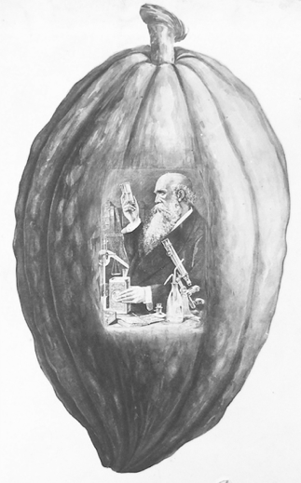
Figure 4.1 Advertisement for Cadbury's Cocoa, Ernest French, 28 October 1897, Records of the Copyright Office, paper 170, COPY 1/136, The National Archives, Kew. Reproduced by permission of The National Archives.

powdered additives, Cadbury stated that ‘without a microscope they cannot be detected'. In this respect, the patriarchal scientist and his specialist material culture can assess the quality of foodstuffs where the consumer’s own senses cannot. Whilst the female consumer was responsible for feeding the family, in this advertisement, it was the male scientist who has control and authority over the safety of cocoa.

The accompanying copyright, which includes a description of the work by the copyright holder, described the advertisement as a: ‘Drawing of Cocoa-pod upon which is shown an analyst holding in his right hand a test tube containing a liquid at which he is looking. His left hand is holding a tin of Cadbury’s cocoa which is on the table. Several analytical appliances are shown’. The Sale of Food and Drugs Act of 1875 stipulated that food and medicines could no longer be adulterated, or in other words, it was illegal to fraudulently add extra substances to products. In addition, the Act stipulated that analysts could be appointed under local authorities to have samples of food analysed to check their purity. Any purchaser could pay to have food analysed if it were suspected to be contaminated, as could local authorities, such as the medical officer for health or police constables. In examples found by Michael French and Jim Phillips, Cadbury’s also explicitly referenced the food legislation of the 1870s in their advertising. The image in many ways represents the ‘analyst’ as the epitome of professional science, in service of food quality and safety. By depicting such an image in an advertisement, Cadbury’s and their advertising agency granted scientific masculinity a vital role in the process of eating and drinking. Whilst the eventual publication place of this particular advertisement is unknown, if it were ever printed, it is the visual personification of the interlinked triad of food, science, and masculinity forged by advertisers in this period. The female viewer was seemingly passive and told to defer to the authority of the scientific and food professional.

Similar themes of scientific masculinity and patriarchy pervaded other advertisements from the case-study publications. Eighteen percent of all food advertisements were for cocoa; in ILN alone, this amounted to forty-two percent. The alleged medical qualities of chocolate had a long history in Europe since its import from the New World, and from the 1880s sales of chocolates flourished in Northwestern Europe and North America. Highlighting the medicinal qualities of cocoa was a popular marketing technique; across all four publications, twenty-four percent of all advertisements of cocoa used explicitly medical or scientific language. Companies themselves, including Cadbury’s, were of course run by men and invariably named after them. Epps Cocoa, run by James and Dr John Epps, was a major cocoa company and rival to Cadbury’s. In an advertisement from ILN (January 1890), readers were left in no doubt that ‘Epps’ was a man, by referring to him as ‘Mr’.

By a thorough knowledge of the natural laws which govern the operations of digestion and nutrition, and by a careful application of the fine properties of well-selected Cocoa, Mr. Epps has provided our breakfast tables with a delicately flavoured beverage which may save us many heavy doctors’ bills. It is by the judicious use of such articles of diet that a constitution may be gradually built up until strong enough to resist every tendency to disease. Hundreds of maladies are floating around us ready to attack wherever there is a weak point. We may escape many a fatal shaft by keeping ourselves well fortified with pure blood and a properly nourished frame.”- Civil Service Gazette.

As well as relying on typical references to digestion and purity, this advertisement also referred to an economy of health. By reminding readers of the cost of becoming ill in ‘heavy doctors’ bills’, an alternative option was offered, in which medical expertise was included in the everyday activity of eating breakfast. This, of course, was beneficial not just for immediate health issues, but for saving money in the long-term by investing in one’s health in daily life. Advertisements for this kind of ‘preventative' eating appeared alongside a parallel movement in public health. According to Anne Hardy, the 1872 Public Health Act marked a major extension of the preventative medical authority throughout the country with the establishment of medical officers of health in every public health authority. Whilst new public health legislation marked an increased state intervention into eating and domestic sanitation, advertisements offered a subtler patriarchal interference into the health of everyday life. With his expert medical knowledge, Mr Epps could be present at the breakfast table, in the form of a tin of cocoa. A power relationship was constructed in which the female consumer was reliant on the expert knowledge of businesses such as Epps Cocoa, through a material object and food.

After all, regardless of the type of product, naturally they were named after their male creators or inventors. Richard William Welbank was a Banbury-based manufacturer of cooking utensils. His steam cooker was always marketed under his name: ‘Welbank’s Boilerette’. An advertisement for the Boilerette, from Woman at Home (December 1910), was built around grand claims of innovation and wonder. ‘The Wonderful Cooker’ had ‘extraordinary testimonials!’ and was ‘Received from the Medical and Scientific Press, Doctors…’. As Loeb has noted, by tapping into the wider discourse of scientific marvel and wonder, seemingly mundane products were transformed into the extraordinary fruits of modern science. The technological brilliance of the Boilerette was emphasised through its remarkable autonomous abilities: ‘Gets intensely hot (above 212 degrees), yet never burns the food. As it is self-acting, it requires no attention, and can be left for hours to “look after itself.”’ Science, or rather Welbank, has animated the pot, which can achieve the seemingly impossible without supervision; it reaches intense levels of heat and yet never burns the food. Welbank thus had a place in the consumer kitchen; it was, after all, his Boilerette. The housewife was practically irrelevant in this version of reality, since the Boilerette was self-acting. She was apparently substituted by Welbank- not a man literally in the kitchen, but in a material product. If, for instance, the milk was not properly sterilized and posed a health risk to the family, this would be the housewives’ fault for not buying the correct product. But the praise and brilliance of safely sterilized milk was transferred to the object itself, and subsequently its male inventor.

It was not only domestic equipment which employed the wonder of invention framed around a particular man. Alexander Anderson, an American botanist, inadvertently created the first puffed rice cereal in 1901 during an experiment trying to extract water from starch. Subsequent advertising from Quaker Oats was heavily built around his name and image as a scholarly professor. For instance, an advertisement from Woman at Home (August 1914) described a fictionalised version of how puffed rice was first made: ‘Prof. Anderson said, “I’ll find a way to turn that moisture to steam and explode it. I shall literally blast those food granules to pieces.” And he did it- after years of experiment.’ The focal point of the advertisement was an image of the wheat or rice exploding from the barrel of a gun, captioned with the slogan ‘The Foods Shot from Guns’ (Fig. 4.2). Guns, of course, were associated with masculinity and male power. The accompanying text emphasized the health benefits of this new technique: ‘The grains are made fully twice as digestible as the best other method makes them.’ As Williamson has argued, this advertisement is an example of the image of manufacture being given to natural objects, or in this case, the natural wheat. The result is that the advertisement presented the cereal as having all the health benefits of a natural product, but also associated with the marvel and prestige of scientific authority. It also reinforced an imagery of patriarchal and top-down science. In this case, Anderson was represented as at the top, discovering the process for puffed wheat, and disseminating it down society to female consumers. As a food ‘shot from guns', it was clear that this was a product that must be bought from male experts by female shoppers, as it could not be made in the home.

Figure 4.2 Image from advertisement for Puffed Rice and Puffed Wheat, Quaker Oats, Woman at Home, August 1914, 35. Reproduced by permission of the British Library.

Medicine and the medical press were dominated by men in this period. Cadbury’s frequently relied on favorable comments from the medical press in their advertising. This was not a peculiarity of Cadbury’s. As Rima Apple has noted of the United States, companies ‘were acutely aware of the rising prestige of science, which was often linked to medicine, and that women were being told to listen to experts’. Likewise, it was not uncommon for advertisements to use quotes from publications to authenticate their claims. An advertisement for Cadbury’s Cocoa in Home Chat (March 1895) featured a number of appraisals from esteemed medical journals. A testimonial from medical journal Lancet reminded readers that Cadbury’s is run by men, stating ‘the Cocoa is just what it is declared to be by Cadbury’s Brothers’. A quote from Braithwaite’s Retrospect of Medicine reads: ‘Of absolute purity and freedom from alkali, Cadbury’s may be prescribed without hesitation . . . An invaluable addition to our dietetic resources in the treatment of all forms of digestive disorders.’ The purchasing of Cadbury's, in this case, was depicted as a medical process. It was ‘prescribed', and not bought; it was invaluable for ‘treatment', and not thirst. Companies such as Cadbury's used the public's apparent trust in professional medical and scientific communities to influence the reader’s consumption choices. The readers of Home Chat were reminded that the opinions of the professional medical community were directly related to shopping and eating habits. Braithwaite’s was a medical journal edited by its namesake W. Braithwaite, a surgeon and medical lecturer, and articles were produced by male physicians for male physicians. Whilst the average female consumer was unlikely to have read the latest research in contemporary medical journals, advertisements gave them easy access, by highlighting the relevant information that was most useful to the housewife, as the household shopper.

Much like Welbank's Boilerette, the Aymard Milk Sterilizer was named after its inventor, physician John Aymard. Two advertisements for the Aymard Milk Sterilizer, from The Queen (January 1900) and Home Chat (January 1900), relied on the threat posed by milk. Both adverts for this product drew heavily on these fears in their bold, opening lines: ‘Milk is one of the most dangerous foods’, and ‘Raw milk the cause of consumption’. Both authenticated their claims with quotes from Sir Richard Thorne Thorne, Chief Medical officer (1892–1899), who had made the association between tuberculosis and cow’s milk the subject of his 1898 Harben Lectures. Jacob Steere-Williams has drawn attention to the anxiety prompted by epidemiological claims that milk could carry infections. From the 1870s, milk was implicated in outbreaks of typhoid, scarlet fever, diphtheria and tuberculosis. Although there was some effort on a national level to regulate milk, it remained ‘a significant hazard until after the First World War and into the 1920s’. The advertisements for the Aymard Milk Sterilizer subtly referred to the responsibilities of the housewife in providing safe milk. Both advertisements remarked: ‘Milk that has not been properly sterilized is such dangerous food that those who allow it to be served to their families take a great responsibility’. Both also appeared in women's magazines; evidently, the ‘those’ referred to is the wife and mother of the family. In this advertisement, the woman of the household must be subservient to the superior knowledge of the inventor of the milk sterilizer to ensure the safety of her own family. She was reminded, after all, that the consequence of not using expertly invented products was the potential death of her family.

This was also the case in advertisements for baby foods, which accounted for twenty-one percent of all food advertisements in Home Chat. One such advertisement for Maltico Food, from January 1905, began ‘MOTHERS’, written in a large typeface, followed by, ‘remember the great duty which devolves on you/ Your children’s well-being is important to you, therefore you should avail yourself at once our Great Free Offer’. It alluded to the risk of child mortality by referring to ‘our little book with hints you cannot afford to be without’. Indeed, it has been observed that such advertisements frequently made reference to the high risk of losing a child. As Ann Dally has stated, ‘Throughout history until recent times motherhood was always close to death. A high proportion of babies always died, and in certain times and places most babies died.’ An advertisement for Dr Ridge’s food from Home Chat (July 1914) gave a stark caution: ‘WARNING TO MOTHERS. During the summer months infant mortality becomes greater. Thousands of children die from diaarhœa, caused by unsuitable or impure. Are you going to let your baby run the risk of diarrhœa and death?’ Digestive problems in children were a particular threat in the Victorian and Edwardian periods where diarrhoea was considered a major cause of infant mortality; in 1911 twenty-eight percent of infant deaths were attributed to it. Obviously, this brand of baby food was promoted under the medical authority of Dr Ridge, and it was presented as a preventative medicine that could protect a child from natural disease. A similar advertisement for Nestlé’s Milo Food captioned a picture of an infant with ‘It isn’t enough to love your baby’ (Fig. 4.3). It continues, ‘If you want him strong and healthy, you must feed him with food that he can digest, that will nourish, and that is above all suspicion of tuberculosis or other disease germs./ Feeding with the wrong “food” has been responsible for the loss of thousands of infant lives’. Though less obviously than Dr Ridge, Nestlé’s Milo Food was also promoted under the name of its medical expert founder; Henri Nestlé was a German-born Swiss pharmacist. Such men, in advertising, were written into a fantasy where the risk of death was eliminated when children were fed with their products. The natural role of the mother, it would seem, was substituted by the medical brilliance of a manmade product.

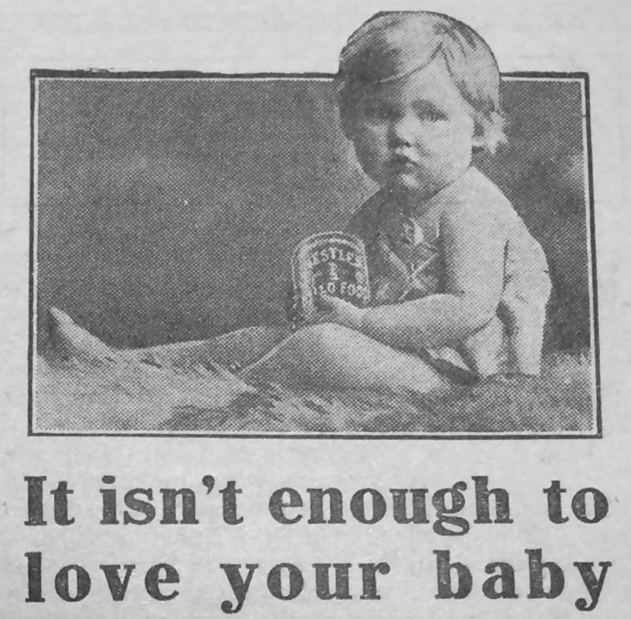
Figure 4.3 Image from an advertisement for Nestlé’s Milo Food, Home Chat, vol. LXXVIII, no. 1005, 4 July 1914, 41. Reproduced by permission of the British Library.
An advertisement for Benger’s, another baby food brand, from ILN (January 1890), drew more specifically on the idea of ‘digestibility’. Benger’s food, for ‘infants, children, and invalids’, noted in bold writing that it was ‘Self-Digestive’. The caption below reads: ‘A Delicious and Highly Nutritive FOOD, distinguished from all others by the ease with which it can be digested and absorbed’. Another advertisement, from ILN (January 1914), for ‘the Allensburys’ diet’ described itself as ‘A Partially Predigested Milk & Wheaten Food’. Made by Allensbury’s, an infant food company, the Allensbury diet is ‘intended chiefly for adults’. As the advertisement explained, ‘It is taken with relish by the Invalid, the Aged, the Dyspeptic, and those with Weakened Digestion, restoring bodily vigour and giving tone to the system.’ The suggestion was that manmade baby foods were more easily digested than natural foods as they were pre-digested or peptonised, or, in other words, the food had been treated with enzymes at the manufacturing stage, breaking it down into smaller particles, making it easier for the stomach and digestive system to absorb. In this respect, food companies represented their products as having the power to enhance basic biological processes and replace maternal milk with medically designed foodstuffs. Their foods, therefore, were physically ‘labour-saving’ for the human body, and thus less testing for the delicate digestive system of infants or invalids. Whilst the nurturing of infants had always been a female responsibility, and a natural one at that, in these types of advertisements, the role of the mother was enhanced but also somewhat side-lined by professional science and the manufacture of foodstuffs.

| II | Familial Masculinity and Domestic Femininity

Nevertheless, as this section will show, scientific masculinity existed in advertisements alongside familial masculinity and domestic femininity. Although the advertisements were almost always directed at women, men did appear in domestic roles, although they were scarcely illustrated. The man of the household was, after all, going to eat the food purchased by his wife. A Fry’s Cocoa advertisement from The Queen (January 1900) seemed tailored to the values of their upper-class readership, depicting a delicate teacup with the image of an attractive, elegant woman on the side (Fig. 4.4.). The rim of the teacup reads ‘“My ideal of perfection” Dr Andrew Wilson F. R. E. S., &c.’, suggesting a double meaning of referring to the purity of the cocoa, and the perfection of the woman depicted. Yet despite the obvious femininity expressed within this illustration, the caption below suggests that it was a male relative, likely a husband, who this product was for: ‘When the heart of a man/Is o’er clouded with fears/ The mist is dispelled/ When a woman appears/ With a cup of FRY’S COCOA to cheer him.’ The advertisement gave instruction in feminine domestic behaviour, by pointing out that it was the responsibility of the lady of the house to provide physical sustenance and emotional support to her husband. Indeed, unlike serving a meal, serving a teacup of cocoa did not offend upper-class ladies’ notions of appropriate feminine behavior. Two types of men appeared in the advertisement: the medical authority, Dr Andrew Wilson, and the unseen man whom the woman was making cocoa for. The health of the unseen man was dependent on both the scientific purity of the cocoa, ensured by the endorsement of a member of the medical community, as well as his wife’s ability to purchase the correct product. In this scenario, the correct product also allowed the upper-class housewife to fulfill her social obligations as an emotional crutch to her husband.
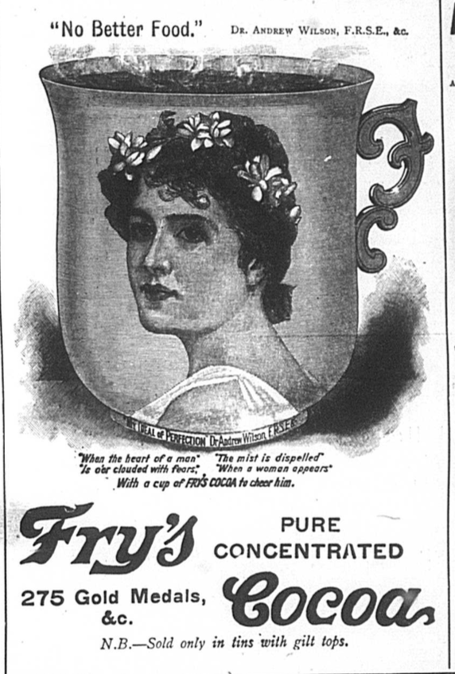
Figure 4.4 Advertisement for Fry's Cocoa, The Queen, vol. CVII, no. 2762, 6 January 1900. Reproduced by permission of the British Library.
Horlick’s used a similar strategy. An advertisement from The Queen (July 1900) reads: ‘FOR VALUE RECEIVED- A remarkably soothing and recuperative effect is experienced by all who take HORLICK’S MALTED MILK. It is satisfying as well, and enables business men and brain workers to dispense with stimulants, and to obtain something for their money which will do them permanent good.’ The ‘value’ was not just the good value for money in the original purchase, but the health benefits which sustained the male head of household who it was assumed is the breadwinner. By referring to business men and brain workers, the advertisement appealed to the values of the upper-middle class readers of The Queen, many of whom may have been married to professionals. In addition, it alluded to a popular belief that the stomach and brain were medically linked, and an upset stomach could cause a head malady. In another Horlick’s advertisement, published in ILN (January 1914), the same text is adapted slightly to read: ‘There is no one to whom the use of Horlick’s Malted Milk will not prove beneficial [ . . . ] To the Business-man the regular use of Horlick’s is especially valuable as it prevents fatigue and restores energy, and the Athlete finds in it the best training diet.’ In ILN, where the readership was more general but presumed to be male, the suggested professions are adapted to appeal to a wider class range of male occupations. Whatever the profession of the male head of household, he too benefited from the apparent nutritive benefits of Horlick's Malted Milk. Since the household shopper was likely his wife, she was given an integral role in the professional performance of her husband by purchasing the correct product.

The future masculinity of young boys rested on the correct food. An advertisement for brown bread, from Home Chat (January 1914), featured an illustration of a young boy, captioned with ‘Give your boy all of the wheat that is fit to eat’ (Fig. 4.5). It explained to the reader that ‘Without the use of medicines and tonics, you can improve your boy’s whole bodily health by simply giving him TUROG Bread instead of the kind he is eating now.’ The association between fitness, strength and young boys is hinted at in another advertisement for Frame-Food. From The Queen (January 1910), the advertisement showed an image of a male child: ‘LITTLE HORACE, STRONG AND HEALTHY’(Fig. 4.6). Evidently notions of health and masculine, physical strength were associated
Figure 4.5 Illustration from an advertisement for Turog Best Brown Bread, Home Chat, vol. LXXVI, no. 981, 3 January 1914, 18. Reproduced by permission of the British Library.

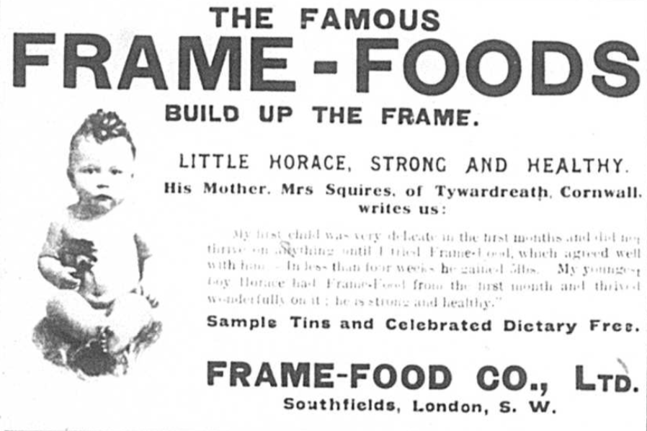
Figure 4.6 Advertisement for Frame-Foods, The Queen, vol. CXXVII, no. 3288, 1 January 1910. Reproduced by permission of the British Library.

with the consumption of food. In the Edwardian period and on the eve of the First World War, concerns about the physical strength of the nation were rife and children in advertisements were presented as future citizens. As Laura King has shown of the mid-twentieth century, the ideal future citizen was ‘almost always focused on male, white, middle-class children’. Foods for children were particularly worrying owing to the late-Victorian and Edwardian anxiety about milk as a disease carrier. In Deborah Dwork’s words, ‘it was easy to presage that this meant the ultimate casualty would be the Empire’. Dwork continues that ‘Contaminated milk not only killed potential Empire-Builders, it could also permanently weaken those infants who had sickened but not died, causing them to grow up frail, infirm, and feeble’. In the narrative presented by these advertisements, the future of masculinity, or rather, the physical strength required of manliness in the face of national decline, rested on the purchase of the correct foods by their mother.

Advertisements directed specifically at a father or husband figure were exceedingly rare, but not entirely absent. Such advertisements were found only in Home Chat, where a total of four advertisements directed at the male head of the household were spotted in all ten issues sampled, compared to eighteen directed at mothers. An advertisement for Frame-Food (baby food) in Home Chat (January 1905) specifically addressed a father figure. ‘FATHER/ ask you wife if she is feeding your child on FRAME-FOOD! If she is, then you may be sure that your little one will grow up WELL and STRONG’. As John Tosh has established, men had a stake in the masculine prospects of their sons. This advertisement, printed in 1905, appeared at a time where the strength of young men and the competency of their mothers was bought into question on a national scale. The failings of women were frequently used as an explanation to the perceived social, racial and moral degeneration that preoccupied Europe in the 1880 to 1914 period. In this advertisement, Frame-Food suggested a solution to the problem: increased involvement of the child’s father in infant feeding. In this version of domestic life, the father too depended on the authority of expertly-produced baby foods to ensure the strength and health of his children. Furthermore, the practice of infant feeding was shifting in the mid- to late-Victorian period; women of the higher classes were opting for new proprietary baby foods as an alternative to breastfeeding themselves or hiring a wet nurse. The domestic father also relied on the medical authority of certain food stuffs for the manly prospects of their sons, and the health of their daughters. It is inescapable, however, that women have some control over this since they were responsible for feeding the children and buying the food; even this advertisement, that addressed the father, acknowledged that feeding the children was the mother’s responsibility. The mother figure was a conduit between the scientific masculinity of the food creator and the domestic father and child.

Whilst there were many advertisements aimed at women as wives and mothers, only two were found that specifically directed a husband. These advertisements were both for Catesby’s Cork Lino. For instance, one such advertisement from Home Chat (July 1905) reads:

LOVE IS BLIND
Is an old proverb, but nevertheless it cannot blind your wife to the fact that the floor covering now down is looking dingy and old. It wants replacing with something brighter, bonnier, and useful: something to afford the wife more time to enjoy the nicer days. The floor covering you need is CATESBY’S CORK LINO

By appealing to the husband, the advertisement reminded the reader that the happiness and efficiency of the housewife depended on the ease of which she can clean. Another advertisement for Catesby’s Cork Lino used a similar ‘economy of health’ as Epp’s Cocoa, pointing towards the importance of the housewife’s health:

A BIG QUESTION for the ladies to decide is how to save domestic toil. They are fully aware that undue labour may make a woman ill, and lead to heavy medical expense. Ladies are always eager and willing to consider anything that truly saves work in a wise way. That’s the reason FOR CATESBY’S CORK LINO being so successful when proposed to the experienced housewife. She sees immediately the value of a floor-covering that saves scrubbing; that harbours no dust; collects no dirt; wears longer and costs less than others.

The advertisement suggested that the purpose of saving bodily labour was not so much about the quality of life or enjoyment of the wife, as it was a cost-saving measure. While the second advertisement was less explicitly aimed at men, it still referred to ‘the ladies' in the third person, as though not directed at them. The advertising agency for Catesbys, Smiths’ Advertising Agency, described the reasoning of this technique in Successful Advertising. The guide explained that ‘Women resent the drudgery of household work more than they used to do’ and advertisements appealed to this instinct. As a fairly expensive item, at 15s.5d. per three square yards, there was a presumption that it would be the husband’s decision to buy it. But, ‘Many a man too dense to otherwise save his wife’s work, is induced by Catesbys’ methods to invest in linoleum.’ The advertisement thus provided instruction in the male domestic social role as much as the female. The husband was reminded that it is his responsibility to relieve his wife’s physical toil by purchasing the correct flooring. Whilst advertisements of this kind were rare, which is particularly unsurprising considering this chapter has primarily relied on advertisements from women’s periodicals, it demonstrates the interaction between the professional authority of Catesbys and Smiths’ Advertising Agency, with the domestic husband. In this respect, the female consumer was represented as empowered by the correct purchase, as her physical toil was supposedly reduced.

This image has been removed for copyright reasons.

Figure 4.7 Advertisement for Lemco Cookery Book, Illustrated London News, vol. CXXVI, no. 3429, 7 January 1905, 32.

Similar themes of empowerment and natural female domesticity were expressed in advertisements for Lemco, a beef extract. The Lemco Cookery Book was advertised in ILN (January 1905). The image shows a woman standing protectively at the door of the sickroom in which her husband lies. Another man, perhaps a gentleman doctor, stands in front of her, seemingly giving her medical instruction (Fig. 4.7). A quote from the Medical Times stated, ‘this book should prove invaluable to Medical men’. Interestingly, the phrasing of the advertisement and the quote from the Medical Times seem directed at doctors. Yet, the image, which dominates half the advertisement, seems to highlight the role of the wife over the doctor. The result was the suggestion that wives should listen to the same advice given for experts, and that they could use the same medicine as doctors would prescribe, which, in this case, was presented as Lemco. Whilst in many ways this empowered the housewife by allowing for a more professional and expert feminine role in the home, it also blurred the boundaries between medicine and the everyday activity of cooking and eating food. Subsequently, Lemco, a regular food item, acquired the qualities of a medicine endorsed and prescribed by physicians. Women, administering physician-recommended products, could act as professional doctors in their own homes, if it was to serve their family.
This image has been removed for copyright reasons.

Figure 4.8 Advertisement for Lemco, Illustrated London News, vol. CXLIV, no. 3898, 3 January 1914, 32.

Another advertisement for Lemco, taken from ILN (January 1914) used a comparable tactic. Entitled ‘My Secret', it depicted a housewife preparing a meal at a stove holding a can of Lemco; as the advertisement explained, Lemco is the secret of culinary success (Fig. 4.8). Thus, the advertisement created the impression that scientifically-produced Lemco was not only the secret to the health of the family but also the key to success at the social expectations placed on housewives. If women had the correct scientific competency as consumers, they could ensure their families' health and fulfil their social expectations. Indeed, the image of the tin of Lemco included the signature of chemist Justus von Liebig; the appearance of the signature was used to distinguish genuine Liebig Beef Extract from similar products made by other companies, who could legally market it as ‘Liebig’s’. The advertisement suggested that women should have deferred to the knowledge and product of von Liebig, whose name was printed and signed across the bottle. Von Liebig’s role, however, could be kept a ‘secret’; the woman could maintain her image as an expert at cookery without external help.

| III | Mistress and Servant

The first two sections of this chapter have examined the interplay between masculinity and femininity, and I have suggested that advertisements represented food and food equipment as signifiers of power dynamics prompted by the expansion of consumer culture and the prevalence of science and health rhetoric. This section examines a parallel relationship between the mistress and the domestic servant, as shop-bought products were represented as increased power of the mistress over the servant in the kitchen.

There were, admittedly, few illustrations of domestic servants in the samples; for instance, there were only six domestic servants illustrated in all samples of Home Chat. However, this is not owing to a reluctance to depict domestic servants; it was actually reflective of the very few figures pictured at all. For instance, out of eighty food advertisements printed in every sample of Home Chat only nine depict a person. This was made up of three middle-class women, three infants, two domestic servants and one man. Domestic servants were most likely to be seen in advertisements for kitchen products, such as food or equipment, as was the case for four out of six illustrations of domestic servants in Home Chat. Even when the advertisement was not for a kitchen product the illustration still depicted the domestic servant in the kitchen. For instance, an advertisement for Pond’s Extract, a medicine, showed a maid injuring herself whilst slicing bread. Although such a small number of advertisements makes it difficult to draw generalized conclusions, in the samples taken for this chapter, more often than not, the illustrated domestic servant was spatially confined to the kitchen, and naturally, always depicted doing housework.

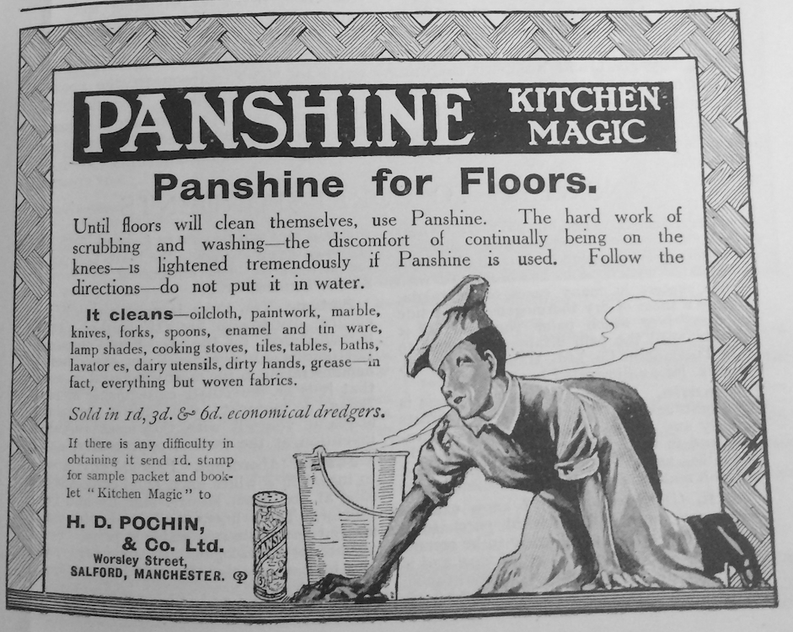
Figure 4.9 Advertisement for Panshine, Woman at Home, August 1910, 39. Reproduced by permission of the British Library.

Domestic cooks, as expected, were exclusively depicted as female. However, in one advertisement for Eglah Table Cream, an illustration featured a male cook, or, to be more accurate, a male chef. Male cooks, of course, were hired in professional settings such as restaurants and hotels. In this example, the reliability of the product is bolstered by the professional prestige of the male cook. An advertisement for Panshine, from Woman at Home (August 1910) a floor cleaning product, is described as ‘kitchen magic’. Rather unusually, the accompanying image is of a male domestic servant cleaning the floor (Fig. 4.9). This was the only image of a male servant spotted. Perhaps in this case the image of a male servant was supposed to save the illustrated middle-class woman or even a maid the indignity of bent on all fours scrubbing the floor. Or, as with the male chef, the male domestic servant conveyed a professional authority, giving the impression that Panshine was used on the floors of hotels and restaurants. In a parallel to the scientist, the gendered identity of the domestic servant was used to promote professional authority.

Other advertisements hinted at an ‘economy of servants’ health’ to protect the families wellbeing and finances. As I suggested in the third section of the first chapter, an unhealthy servant could be perceived as a medical and financial threat to the middle-class home. An advertisement for Pond’s Extract, from Home Chat (July 1905), pitched as ‘The old family doctor’, depicted a maid cutting herself while slicing bread. The text began, ‘Have you anything handy in the house in case you cut yourself? A cut is not only painful and inconvenient, but it may lead to blood poison’ (Fig. 4.10). Of course, an injured domestic servant was particularly inconvenient for the household, if she was too unwell to work. Similarly, the advertisement for Panshine from Woman at Home explained, ‘The hard work of scrubbing and washing- the discomfort of continually being on the knees- is lightened tremendously if Panshine is used’. A full-page advertisement for Guy’s Tonic, a digestion remedy, from Home Chat (July 1900) was made up almost entirely of text, explaining the health benefits of the tonic, and showing testimonials from satisfied customers. The only illustration was a small oval depicting a maid pouring some Guy’s Tonic (Fig. 4.11). It is not clear from the image alone if it was meant that the domestic servant is using the Tonic for themselves, or preparing it for someone in the family. Either way, the family employing the domestic servant benefit. If it was for a member of the family, they could enjoy the health benefits of the Tonic. But, if it was for the servant, her indigestion was alleviated and she could continue working. It was, of course, the mistress of the household who controlled which foods and medicines the servant had access to. These products were represented as signifiers of the power dynamic between the middle-class woman and the domestic servant, in which the mistress exerted her control over the purchase of products that protect her financial investment: the servant’s health.
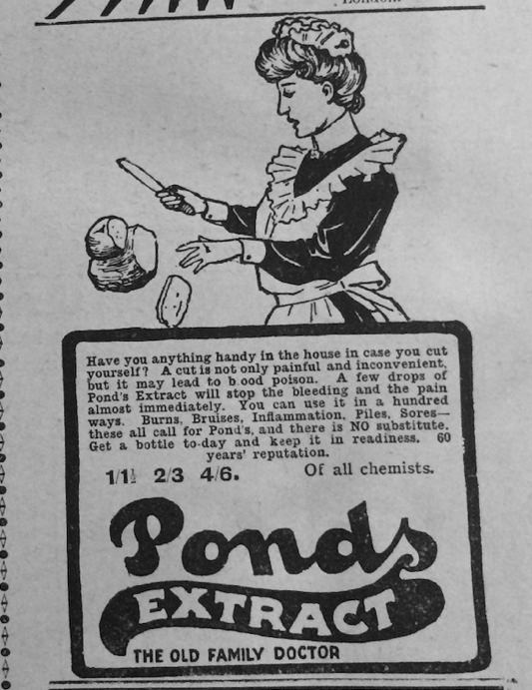
Figure 4.10 Advertisement for Ponds Extract, Home Chat, vol. XLII, no. 537, 1 July 1905, 121. Reproduced by permission of the British Library.

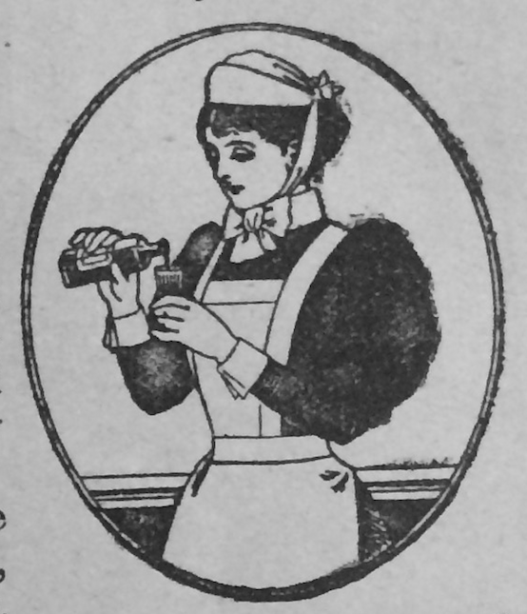
Figure 4.11 Illustration of a domestic servant from an advertisement for Guy’s Tonic, Home Chat, vol. XXII, no. 277, 7 July 1900, 182. Reproduced by permission of the British Library.

A similar material control from mistress to servant was suggested by references to saving time and labour. For instance, an advertisement for Stephenson’s Furniture Cream depicted a housemaid polishing a table. The caption reads: ‘produces the best possible polish in the least possible time’. An advertisement for Bradford’s “Vowel’ Washer, from Home Chat (January 1914) used a similar tactic, stating: ‘No more hard work, and the washing done in less than one quarter the usual time. The old “tub and scrub” method is superseded by -BRADFORD’S ‘VOWEL’ WASHER’. The text also added that the washer is easier to use, adding ‘No internal mechanism. Easy and operation & lasts a lifetime’. The presence of the labour-saving rhetoric alongside images of domestic servants doing housework raises questions about precisely whose labour was meant to be saved. Purchasers of the Vowel washer, priced from 22s., would presumably have been fairly wealthy and thus had servants to operate the machine. In this case, the washer might have been for the benefit of the domestic servant, or, in other words, a ‘concession to their comfort’. This does not, of course, reflect the reality of the readership of Home Chat. Ideals of ‘labour-saving’ might, however, be interpreted as an assertion of power from the mistress to the servant. The mistress has control over financial expenses, including servants’ wages. To provide labour-saving gadgets was to reduce the time spent by domestic servants on a particular task, allowing them to fit more domestic labour into one paid day. E. P. Thompson argued in his classic thesis that industrialization prompted a new time-discipline, and he notes how this impacted employer-employee relationships, suggesting that ‘those who are employed experience a distinction between their employer’s time and their “own” time’. As Thompson suggests, time is thus a commodity that is not only passed but spent. In a similar parallel, consumer items such as Stephenson’s Furniture Cream or Bradford’s ‘Vowel’ Washer were represented as providing a similar time-control over domestic servants. As domestic servants were paid employees, the items represented financial control as well as a replication of class values.

As the first chapter highlighted, the importance of food to the health of the family put domestic servants in somewhat of a paradox. They had some responsibility for food preparation, but were also, as domestic advice guides would have it, inherently incompetent. Descriptions of the medical benefits of certain products, coupled with an
illustration of a domestic servant suggested that the risk posed by domestic servants is mitigated if the housewife purchases the correct food. For instance, an advertisement for
Bovril, taken from Home Chat (January 1900), showed a maid preparing dinner in a middle-class kitchen, under the title ‘An Economical Table’ (Fig. 4.12). It continued:

is always possible where Bovril is used in the kitchen. It is much cheaper and much easier to prepare a savoury stew or hash with the aid of Bovril than by ordinary methods, and soups, gravies, and sauces made on a Bovril basis are as delicious and nourishing as they are economical. Bovril is an easily digestible nutrient of absolute purity.

In this narrative, there are two key benefits of Bovril- good economy, and good health. The advertisement, of course, was aimed at the female consumer. It was suggested then, that rather than directly supervising the domestic servant with a physical presence in the kitchen, the mistress could be assured by the purchase of the right ingredients- in this case, Bovril. In reality, of course, the readers of Home Chat would likely be doing the cooking themselves. In this scenario, their own labour was presented as easier.

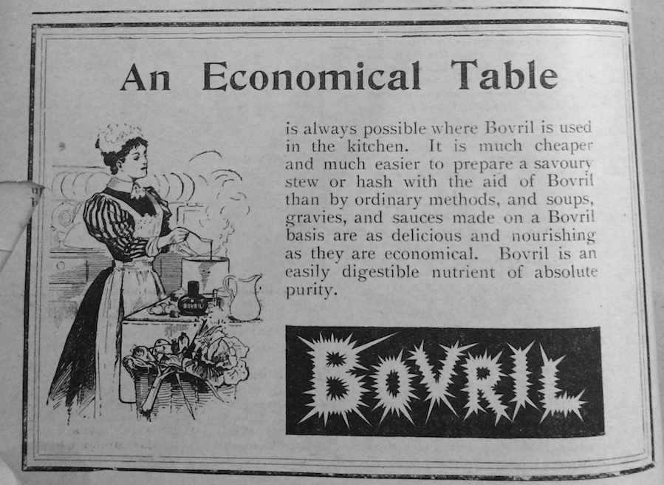
Figure 4.12 Advertisement for Bovril, Home Chat, vol. XX, no. 251, 6 January 1900, 174. Reproduced by permission of the British Library.

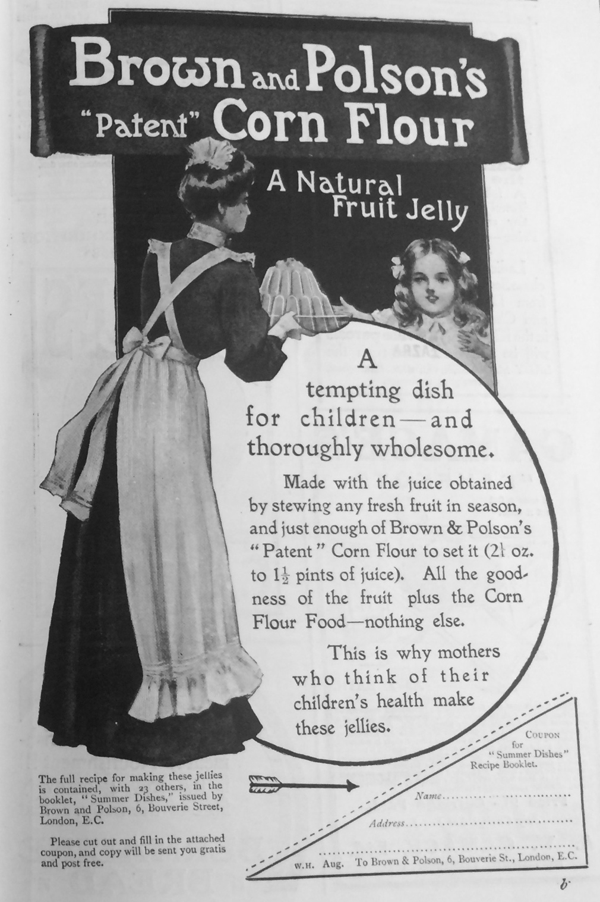
Figure 4.13 Advertisement for Brown and Polson’s “Patent” Corn Flour, Woman at Home, August 1910, 9. Reproduced by permission of the British Library.

Like the majority of advertisements examined, all of the advertisements that featured illustrations of domestic servants were directed at the housewife, or mistress. This usually presented a rather contradictory narrative. For instance, advertisements for Brown and Polson’s “Patent” Corn Flour were spotted in Woman at Home (August 1910) and Home Chat (July 1910) (Fig. 4.13). The advertisements refer to the health benefits of the product, beginning with: ‘A tempting dish for children- and thoroughly wholesome’. The accompanying image shows a domestic servant serving a dish of jelly to a child. From the image alone, it might be assumed that in this scenario the domestic servant had prepared the food. The text, however, gave a different version of events. It reads, ‘This is why mothers who think of their children’s health make these jellies’. Not only was the advertisement directed at the woman as the primary consumer, but it also suggested that the mother of the children prepared the food herself, seemingly in direct contradiction to the advertisement’s own illustration. The readers of Home Chat were perhaps the least likely to have a domestic servant. These advertisements perhaps address both a social ideal and a practical reality. On the one hand, the text seemingly addressed the reality of how most housewives would encounter the product themselves, with some, if not all, the responsibility for preparing the food themselves. The imagery, on the other hand, showed the social ideal, in which the household has a domestic servant to manage the children’s food themselves. Either way, the female consumer still retained the power of choice which is depicted as having consequences for the health of her children.
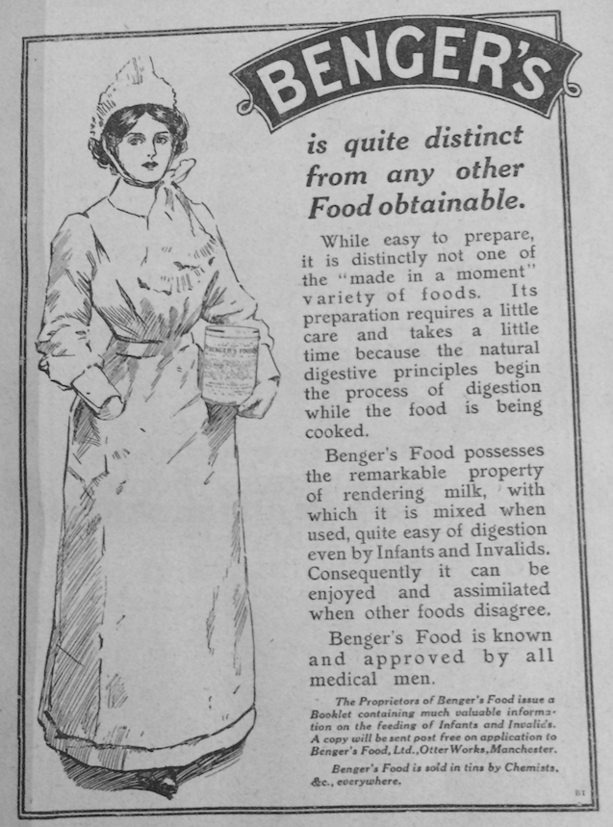
Figure 4.14 Advertisement for Benger’s, Home Chat, vol. LX, no. 772, 1 January 1910, 111. Reproduced by permission of the British Library.

Similarly, advertisements represented the health of children as protected by the purchase of the correct food. As the former section showed, baby food advertisements were typically, and unsurprisingly, directed at mothers. Benger’s Food was for infants and invalids. In an advertisement from Home Chat (January 1910), like many other advertisements of this kind, Benger’s noted that it was ‘known and approved by all medical men’ and relied heavily on a health rhetoric about its digestibility. Half the advertisement was taken up by an image of a woman clutching a packet of Benger’s. Her cap and apron suggest she is a domestic servant, perhaps a nurse or cook (Fig. 4.14). In this example, it seems the health of infants and invalids was safeguarded against the domestic servant by the purchase of the correct foods by the consumer housewife. Another advertisement, also for Benger’s, taken from Woman at Home, used a very similar imagery, depicting a woman in the same clothes, although a photograph rather than an illustration. The advertisement used much of the same rhetoric about digestibility, only in this instance the text specifically addressed the power it afforded to the consumer: ‘Benger’s Food is a power in the hands of the intelligent man or woman because it can be made to suit infant, invalid or aged person’. Interestingly, the advertisement made a rare reference to the ‘man’. The ‘power’ in this scenario perhaps referred not to the person serving the food, but the person who bought it, namely, the housewife. Although she was not necessarily feeding the children herself, the housewife had a vital role in maintaining their health through her choice of Benger’s. No doubt this also incorporated an aspirational quality, as the images of cooks in these advertisements gave a glimpse of the domestic arrangements and excess of servants from the upper classes.

Conclusion

I have argued that within food advertisements, domestic authority is constructed as a reciprocal interplay between masculine scientific expertise and feminine consumer power. Female exclusion from professional science and their social duty to their husbands and children ensured that authorities on healthy food were depicted as male in advertisements. This seemingly creates a patriarchal model in which food and related scientific expertise is communicated from men to women. But, as I have shown, women retained the power of choosing which foods to buy, which was critical to businesses, who had to appeal to the female consumer. Certainly, advertisements could take highly critical and sometimes ruthless attitudes to women, especially in referring to the possible death of a child. They never, however, completely eliminated the power of women in their capacity as mothers, wives, and shoppers. Material goods represented a male presence in the kitchen, but, equally, they could signify the mistress’s presence in a kitchen peopled with domestic servants.
As I suggested in the previous chapter, the grand narrative of scientific progress is usually gendered as male. In these advertisements, scientific progress and technological innovation were represented by male figures: the inventors, scientists and doctors that created or endorsed these products. These items, however, also fit into the daily lives of housewives, through their cyclical routines of, for instance, feeding the children or cleaning the kitchen. The science that emerges from an analysis of advertisements exists at an intersection between gendered ideologies and domestic practices, and simultaneous conceptions of science as a major force of progress and the source of knowledge underpinning everyday routines.

By using advertisements that were predominantly directed at women, the intersection between masculine, scientific authority and the traditional feminine social role has been examined. The period 1870 to 1914 marked a number of changes in the relationship between medicine, food and the state, such as the Food and Drug Acts, and increased concern about the threat posed by drinks, such as milk and water. Whilst official governmental reports often took a critical stance against housewives, advertisements presented a different narrative. Naturally, as they were targeting the wife and mother as a consumer, advertisements were less critical. Instead, they sought to represent their own products as complementary to traditional ideals of femininity. Rather than women having to have expert knowledge of the science behind feeding the family, or cleaning the home, this was outsourced to seemingly expert scientists and doctors, who worked within consumer culture so the housewife could buy their equipment. This ideology was, of course, a fantasy; the Aymard Milk Sterilizer did not substantially reduce the number of milk-borne epidemics, nor were proprietary baby foods responsible for lowering infant mortality rates. Nevertheless, advertisements represented a version of reality in which modern science provided the answers to complex medical problems, and in the process, figures like Welbank, Aymard or Cadbury were given a space in the contemporary home through their products. In advertisements, the material culture of the kitchen, in branded foods and equipment, was represented as the material culture of good health, informed and validated by medical and scientific experts. Although food itself might be gender-neutral, an examination of advertisements has shown it can be a nexus of gendered power relations, and a productive source is analysing the interplay between masculinity and femininity.

Chapter Five

Mechanical Gadgets and the Gendering of Technical Skill in the Kitchen

Writing in Household Words in 1853, journalist George Dodd reflected on the changing perception of kitchen equipment. ‘A coffee-pot’, he stated, ‘is not a coffee-pot now: it is a mechanical pneumatic-hydrostatic piece of apparatus’. Dodd was referencing a cultural trend in which the kitchen was perceived to have acquired a more complex materiality, and individual objects were reinterpreted as having technical and scientific qualities- as I discussed in the first chapter. Dodd’s coffee-pot was no longer just a mundane, functional object within the home; it was perceived as an invention of technical and mechanical design. These observations coincided with the influx of labour-saving gadgets into the kitchen, from around 1850. In the previous chapter, I suggested that advertising gave masculinity and men a conceptual place in the kitchen through the consumer goods and technologies men invented, produced or endorsed. In this chapter, I consider how technologies made by men were used in the kitchen, by examining a selection of gadgets made from the 1870s by Manchester-based company Follows and Bate. Based on a material analysis of these objects, I argue in this chapter that new mechanical gadgets entering the kitchen from the second half of the nineteenth century would have required technical skill by the user, who would have most likely been a middle-class housewife or a domestic servant. This skill, however, was denied to women in public representations of the gadgets.

Early-modern historians such as Sara Pennell and Karin Dannehl have examined the material culture of the kitchen. However, domestic labour-saving technologies have yet to be subjected to a material culture analysis. As the introduction established, much literature on labour-saving technology is on the impact (or lack thereof) on decreasing women’s time and physical labour in domestic work. In general, functional objects have been paid less attention in historical material culture studies.

Most interdisciplinary studies of technology in the home have focussed on devices of the twentieth century, and/or powered by electricity. Kitchen technology from the beginning of the analysed period (c. 1870) was not electrified. From analysis of all available material, Follows and Bate only advertised one product powered by electricity. This was a boot-polishing machine intended for hotels and other institutions. It was not until after the First World War that electric motors were used for small kitchen appliances. Studies of technology have raised questions of how ‘skill’ is socially constructed in different settings. For the most part, it has been agreed that technical skill has been gendered as male. There have been few studies on skill in relation to domestic work, but those that have engaged with the theme have focussed on the twentieth century. Of the interwar period, Joanne Hollows has stated ‘the introduction of new technologies cannot really be thought of in terms of deskilling but more in terms of reskilling, or, indeed, simply skilling’. However, in this chapter, I show that mechanical gadgets in the home from at least the mid-Victorian period meant that the housewife or the domestic servant had to already be skilled in the use of technology. When I refer to skill, I borrow my definition from Charles More’s study of the English working-class, which combined ‘manual skill’, i.e. the ability ‘to perform quickly and effectively complex actions which necessitate the coordination of perceptual and motor activity’ and the knowledge of different types of material and mechanisms. I favour the term ‘technical skill’ over ‘technological skill’ but consider the two terms interchangeable, meaning one’s ability to use and understand technology.

Technology is ‘anything that helps us do the tasks we need to do most effectively, whether that be better or faster or with less mess’. As I outlined in the thesis introduction, my definition here includes the objects themselves, and the knowledge of how to operate them, as well as the human activity of using them. Sara Pennell has pointed out that the kitchen has always been a site of technological innovation. However, in the nineteenth century in particular a number of technological changes were brought into the kitchen. These included major structural changes, including utilities, such as piped water, gas, and at the end of the nineteenth century, the introduction of electricity. The development of the stove industry across the century- from an open range, to closed, and from gas to electric- has received the most scholarly attention. Aside from changes in stoves, the nineteenth century also saw the first practical storage refrigerators in the 1880s, and the invention of the tin can in 1813. Furthermore, there were a number of inventions which changed the classed experience of certain technologies; for instance, in 1888 W. E. Price invented the gas prepayment meter which opened the market to a less affluent audience. This chapter is particularly concerned with ‘gadgets’, by which I mean mechanical, hand-operated appliances that were mass-produced for the first time from about the mid-Victorian period. As David Miller has established for the case in the US, it was in the nineteenth century that technological and manufacturing innovation meant that metal utensils could be mass produced.

Follows and Bate was established in the late 1860s, and was absorbed by Qualcast, a lawnmower company, in 1938. The company made machines and gadgets for cooking and for agricultural purposes, such as lawnmowers. Many of their cooking utensils were designed for institutions such as hotels and restaurants, and scaled-down versions were aimed at the domestic kitchen.

Follows and Bate and their range of products make an ideal case study for understanding middle-class interactions with machinery in the kitchen. The company made an extraordinary range of products, many of which had a similar function in grinding, slicing, or mashing raw foods in some manner. The nature of these devices- cutting agents, typically operated by turning a handle, with mechanical workings such as wingnuts, blades and screws- allow for a consideration of how the female user was physically encountering machinery. Although the exact reach of the company is difficult to estimate, their products were in catalogues for ironmongers based in Bristol, London, and Oxford. A further indicator of their success is the quantity of their products which have survived to the present-day. The National Trust, for instance, has forty-six Follows and Bate domestic items in their collections, of which twenty-seven are on display. Thus, for this study, Follows and Bate products have been easily accessible. I consulted objects from the Museum of Science and Industry, Manchester, which was one of few places that had a selection of different Follows and Bate gadgets. I also have accumulated my own collection of Follow and Bate products by sourcing them in antique shops and Ebay.

In addition, focussing specifically on Follows and Bate presents an opportunity for a detailed object-centred case study, owing to the availability of supporting source materials. I have collated a substantial body of additional sources related to the objects, including advertisements from magazines, trade catalogues, patents of invention and instruction leaflets. The company’s records, including minutes, share records and director’s reports, are listed in the National Archives catalogue, but have been lost for several years. As a result, the objects themselves and their representation in other sources has driven the analysis. An examination of Follows and Bate’s products also offers a rare opportunity to consider the views of the company director and inventor. Frederick Follows gave a lecture to the students of Manchester School of Domestic Economy, in his capacity as a local businessman and member of the Manchester Technical Instruction Board. This lecture, entitled ‘Economy of Time’ as part of a series on Common Sense for the Housewife was later printed. It thus can be read as a form of domestic advice that outlines the inventor’s views on the relationship between women, housework and technology.

I use the term ‘material culture’ to refer to the objects themselves, although it also suggests a particular methodology. My initial analysis of the objects followed the stages outlined in the methodology proposed by Jules Prown: description, deduction and speculation. I began examining the physical objects and have contextualised these using printed sources. Prown suggested that functional objects had, at his time of writing in 1982, been the least useful in material culture studies: ‘Devices constitute the most problematic and, to date, a relatively unproductive range of artifacts for the study of material culture’. More recently, in 2009, Frank Trentmann described that the work of the past few decades has often focused on what objects reveal about ‘processes of symbolic communication and identity formation’. Likewise, he notes that personal possessions and domestic objects loom largest in such studies because of the emotion invested in them, which can be incredibly fruitful for histories of personal and family identity. However, since then, historians like Pennell and Dannehl have demonstrated the use of functional objects to social historians. Indeed, Alastair Owens et al proved the usefulness of the ‘mundane, if not banal’ objects retrieved from cesspits of Victorian London.

I focus primarily on seven objects, all of which are mechanised and operated by physically turning a handle. Two models of marmalade cutter (a device to slice orange-peel) were examined: the ‘Magic’ marmalade cutter, dating from 1904, (Fig 5.1) and the ‘Rapid’ marmalade machine, from the interwar period (Fig. 5.2). This later object is included as it provides an interesting comparison in how later technologies were marketed differently, especially in the depiction of the user in advertisements. Three mincers were assessed: two different models of the ‘Magic’ chopper (Fig. 5.3) and a No. 2 ‘Rapid’ mincer (Fig. 5.4). In addition, I have examined a sausage–making machine, c. 1890 (Fig. 5.5) and the ‘Family’ knife cleaner, c. 1880. (Fig. 5.6). Numerous other products and models are referred to in this chapter, usually where the objects were unattainable, but were mentioned in other source materials.

This image has been removed for copyright reasons. | This image has been removed for copyright reasons.
Figure 5.1 A ‘Magic’ marmalade cutter, c. 1904, Y1993.164, SMGC. | Figure 5.2 A ‘Rapid’ revolving marmalade machine, c. 1932, Y1992.169, SMGC.

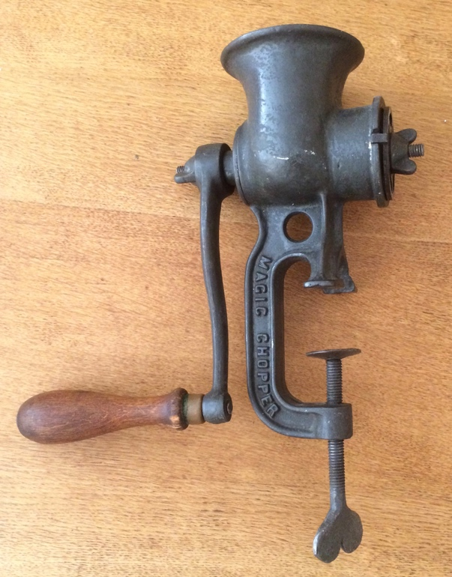 | 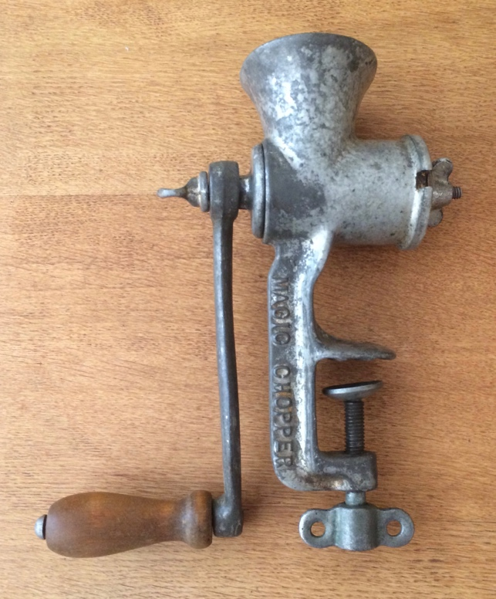
Figure 5.3 Two models of the ‘Magic’ chopper. Left: the earliest, cast-iron model. Right: the later, tin-plated model, c. 1920s. Both personal collection.

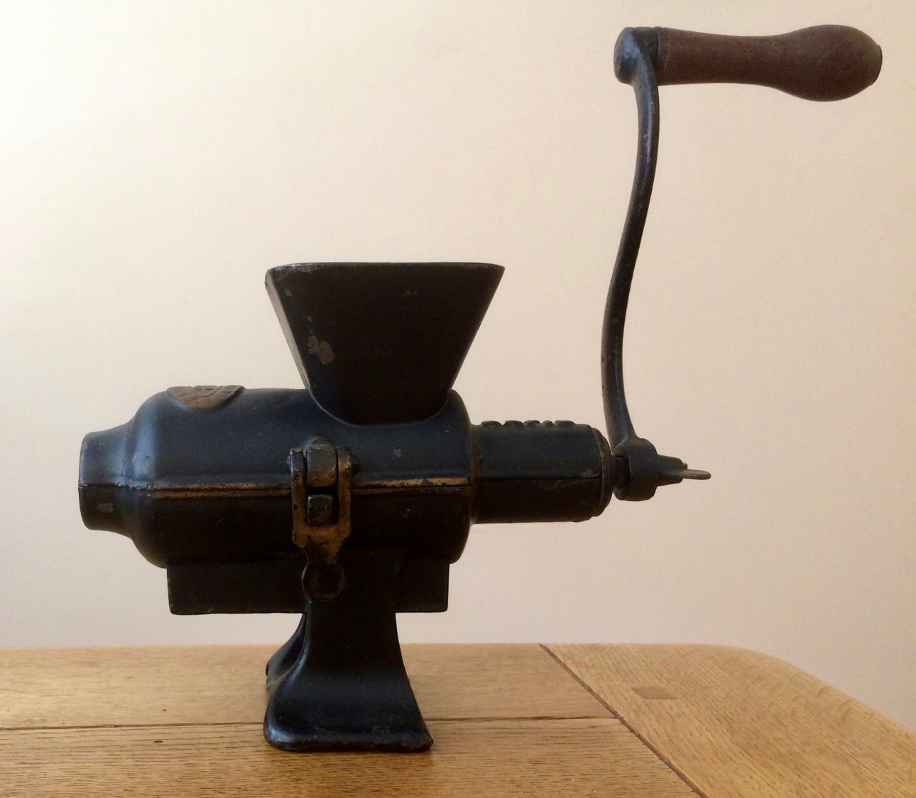
Figure 5.4 A no. 2 ‘Rapid’ mincer, c. 1900, personal collection.
This image has been removed for copyright reasons.

Figure 5.5 A sausage-making machine, c. 1890, Y2004.19, SMGC.

This image has been removed for copyright reasons.

Figure 5.6 The ‘Family’ knife cleaner, c. 1880, Y1993.68, SMGC.

Follows and Bate products would most likely have been acquired from an ironmonger. There has been little historical research on the ironmonger, but it has been observed that this was the place in which most kitchen equipment would have been purchased. The lists of kitchen equipment provided in domestic advice guides, such as those discussed in chapter one, page 55, suggest it was expected that the woman of the household would have responsibility for stocking the kitchen.

The majority of their utensils would have most likely been purchased by a middle-class household. In 1905, the smallest of the ‘Family’ knife cleaners was £1.5s.- and the most expensive was £3.5s.-. If, for instance, a working-class family were working on the £5.7s.8d. kitchen budget given by J.W. Laurie in Home and Its Duties (1884) (approximately the equivalent of £6.4s.8d. in 1905), which was meant for ‘women of the humbler classes’, the cost of a ‘Family’ knife cleaner would take up between one-fifth and a half of the total. Even to a family working on the more generous kitchen budgets proposed by women such as Jane Panton (£11.2s.1d.) and Florence Gardiner (£12.14s-) (which, for reasons discussed in chapter one, page 51 were likely overestimated to begin with), the most expensive knife cleaner would still cut into between one-third and one-quarter, or the cheapest, one-tenth, of the allocated money. Other items, such as the mincers, were much cheaper; the smallest model of the ‘Magic’ chopper was advertised for four shillings in 1905. Such items were not considered necessities at the beginning of the examined period. In Mrs Beeton’s Book of Household Management (1879 ed.), the complete list of recommended kitchen items, ‘suitable for any mansion’ with an absurd budget of £99.3s.6d. for the kitchen alone, did not recommend the purchase of a mincing machine. It might be reasonably assumed that smaller-scale items, such as mincing machines, were becoming more common towards the Edwardian period. However, they were not regularly endorsed by all domestic experts, with many continuing to favour the cheaper mincing knife, such as Mrs Panton, who recommended buying one for 1s.4½d. in 1890. The catalogues and products of Follows and Bate, and their rival companies, might be considered the material equivalent of an advice guide- seemingly directed at anyone, but in reality, only accessible to (or perhaps, even desired by) a wealthy minority.

It is possible that the male head of household was involved in the maintenance of kitchen technologies; men were sometimes illustrated in advertisements, rather than middle-class women. As Siân Pooley has pointed out of Victorian and Edwardian Lancaster, the ‘male domestic presence was far greater than is often acknowledged’, using an example of a father involved in home improvements. Indeed, scholars have agreed that domesticity held greater importance to masculinity than previously thought. However, since housework was primarily a female activity, undertaken either by the housewife and/or the domestic servant, I am working on the assumption that women were likely the regular users of these gadgets. As Leonore Davidoff has suggested, it was central to the power relationship between husband and wife that she provide ‘protection from mundane matters’ concerning domestic labour.

I argue in this chapter that new mechanical gadgets entering the kitchen from the second half of the nineteenth century would have required technical skill by the user, who would have most likely been a middle-class housewife or a domestic servant. In order to use them, I suggest that the female user would have needed an intellectual and physical engagement with the objects, which required certain technical skills, such as manual dexterity, maintenance and repair of metalwork, and a detailed knowledge of how they fit together and work. There was, however, an inherent contradiction between the presence of these gadgets in the kitchen and the way in which ‘skill’ has been socially constructed. In the private space of the middle-class kitchen, the objects would have required a technical and mechanical skillset from the female user, and thus encouraged women to learn certain behaviours usually associated with working-class factory labour. However, in public, women were denied ‘owning’ any such skill, as it did not fit into contemporary ideas about domestic femininity. Since a higher household income would allow for the purchase of more technology, I suggest that this challenge to traditional notions of classed and gendered behaviour in the kitchen was likely most acute in wealthier households. In addition, drawing upon management theory, I highlight attention to some correlations between the changes prompted by technology in the home and Taylorism, that was emerging in the engineering industry from the late Victorian period. I am reluctant, however, to suggest that there was a direct causation between the two for reasons I suggested in the introduction (see page 27).

The first section examines the time- and labour-saving rhetoric which emerged in the advertisements for the machines, and in the views of Frederick Follows, company director and inventor. I suggest that the machines, and others like them, were written into a narrative in which women’s traditional responsibility and skill for cooking, time-thriftiness and good economy were substituted with a machine. The second section demonstrates that any skill required of the housewife in operating the machines was somewhat side-lined in advertisements, by a preference for illustrating domestic servants or men operating the devices, rather than middle-class women. This suggests a reluctance to aesthetically represent the middle-class housewife using the machines herself, despite her having been the likely user. In this section, I also use a comparison with advertisements for the interwar ‘Rapid’ marmalade machine, which typically did depict a housewife using the device. In the third section, I focus more on an analysis of the objects themselves. Contrary to the advertisements and comments made by Follows, which implied the gadgets were easy to use, I suggest that to use them effectively, housewives and servants would have to have had a familiarity and a physical engagement with machinery to use, clean, and maintain them. This physical and intellectual engagement with machinery would have required a knowledge and skill that has not yet been acknowledged in studies of the housewife or the domestic servant.

| I | Follows and Bate and Labour-Saving Gadgets

The rhetoric of ‘labour-saving’ was a key selling point for Follows and Bate kitchen gadgets. Despite comments by kitchen historian Molly Harrison that ‘“labour-saving” was an expression unknown to the Victorian or Edwardian housewife’, this was a major theme of Follows and Bate’s marketing, and many of their rivals. Most of their items were pitched as saving time and labour; their 1929 catalogue was entitled Modern Labour-Saving Appliances. But this emphasis on saving labour was present before the interwar period. A trade catalogue for the season 1902-3 featured the slogan on the front cover as ‘To lighten labour is to lengthen life’. Follows and Bate were particularly targeting bodily labour, or, in other words, the physical labour required of housework. The lessening of the toil of physical work was linked to good health and longevity. The female consumer was presented with a narrative in which it was within her shopping power to purchase less physically demanding housework.
This image has been removed for copyright reasons.

Figure 5.7 Advertisement for a cake maker, Gill and Co. Catalogue, Winter Issue (1907-8), 28, TJJC.

This image has been removed for copyright reasons.

Figure 5.8 Advertisement for the ‘Three-Minute’ bread maker, Gill & Co. Catalogue. Winter Issue (1907-8), 29, TJJC.

This image has been removed for copyright reasons.

Figure 5.9 A page from a Silber & Fleming Catalogue, advertising knife cleaners, under the heading ‘Labour-saving Domestic Machinery’, [1880-1900], 541, TJJC.

A comparison to other companies’ advertising reveals the prominence of the labour-saving rhetoric for kitchen gadgets. For instance, an advertisement for a cake maker (Fig. 5.7), advertised in a catalogue (c.1907-1909) for Gill and Co., a department store, noted that it ‘saves time and labour in mixing ingredients for all kinds of cake’. Another advertisement (Fig. 5.8), on the next page, for the ‘Three-Minute’ bread maker completed ‘Twenty to thirty minutes of the work of hand kneading done in Three Minutes’. According to the advertisement, ‘The kneading is done scientifically’. A page of knife cleaners in a catalogue for Silbur and Co (c. 1880-1900) was titled ‘Labour-Saving Domestic Machinery’ (Fig. 5.9). By at least the late nineteenth-century, the kitchen was already being conceived of as a space in which time should be conserved. In his classic thesis, E. P. Thompson argued that the industrialisation of Britain prompted a new time-discipline; one in which time was seen as a commodity, which ultimately bled into all aspects of society rather than just the factory floor. These technologies, themselves products of the factory floor, seemed to offer a new conception of time in daily activities, in which individual tasks, such as kneading bread, could be broken down into the smallest unit of time as possible. As Rachel Rich has established of the second half of the nineteenth century, there were multiple overlapping temporalities in the home, such as daily, seasonal and annual. New labour-saving technologies offered to save time for the housewife; the purchase of them presented her with the ability to conserve time in her kitchen simply by the use of the correct technology.

There was nothing particularly unique about Follows and Bate labour-saving products; they were sold at a time where kitchen gadgets, designed to complete a cooking or cleaning task quicker and/or easier, were becoming common. Given the absence of company records, it is impossible to accurately quantify sales’ figures of individual products. If the advertisements were to be taken as reliable, the ‘Patent’ marmalade machine (an older, heavier model of the ‘Magic’ cutter) was bought by the thousands, all over the world. 66,000 ‘Star’ rotary knife cleaners, a similar model to the ‘Family’, was said to have been sold from 1870 to 1905. It is quite possible, however, that the products, especially specific models, were not particularly successful on the market. Nevertheless, an indication of the prevalence of labour-saving technologies on the market is the proliferation of similar products being sold by rival companies. For instance, from the 1880s, rotary knife cleaners, like the ‘Family’, were sold by rival companies such as George Kent Ltd., and Spong and Co. According to one author of a kitchenalia guide, George Kent was making a machine for slicing orange-peel from about 1879. The products made by Follows and Bate were thus neither original nor unique on the market. The market for labour-saving kitchen gadgets was becoming crowded from the 1870s.

Gadgets for the kitchen were no exception from the potent consumer culture of this period which exploited spectacle and display. In their illustrated catalogue of 1905, Follows and Bate advertised a three-tiered hardwood stand for the display of their products on shop counters on windows. This kind of catalogue would have been presented to local ironmongers to stock their products, as well as potentially being seen by the consumer. In the illustration (Fig. 5.10), the stand was emblazoned with the words ‘Domestic labour saving appliances’. The tagline beneath the advertisement reads: ‘Useful Domestic Labour Saving Machines displayed in this attractive manner catch the eye of the Public and practically become their own Salesmen’. Window displays, especially in big cities, were a product of industrialisation and urbanisation. As Kelley Graham has pointed out window displays also allowed people of all classes to see the fashionable clothing worn by those who could afford it. Similarly, the potential display of kitchen gadgets exhibited them to an audience, presenting them as items to be desired. Much of Follows and Bate’s products would have originally been finished in shiny black paint, with gold accents. Although japanning the metals in black paint would partly have been to protect the metal, it also gave the gadgets a decorative appearance. Other features of the products seem to have an aesthetic intention, such as the curved handles of the no.2 mincer and sausage-making machine, or the cut-out shapes on the ‘Magic’ marmalade cutter. Thus, while it might be assumed that functional kitchen utensils are outside conspicuous consumption, these objects seem written into a narrative of shopping and consumer culture in which they become markers of wealth, style, and status. The labour-saving rhetoric was a key focus of Follows and Bate marketing, but it was still situated within a Victorian and Edwardian spectacle of selling. Thus potentially the housewife was exposed to the labour-saving narrative constructed around these technologies just by looking through a shop window.

This image has been removed for copyright reasons.

Figure 5.10 The Follows and Bate hardwood stand, advertised in their Illustrated Catalogue, No. 750 (Manchester: Follows and Bate, 1905), 12b, 1995.11.3970, Cambridge University Library.

Frederick Follows’ views on technology were expounded in his lecture of 1896. He described in his lecture familiarising himself with the American market, having taken two extended trips to the US and Canada, for the Centennial Exhibition of 1876 and the great Exhibition at Chicago in 1893. At this time, he inspected factories, workshops and schools in big industrial cities. A portion of his lecture was dedicated to ‘American Ideas of Labour-Saving Appliances v. English’. He observed what he described as ‘American Notions’- which he defined as the desire to look at something new and innovative:

Wherever I went I noticed the eagerness of the people to buy, use, and adopt almost any and every appliance, whether for domestic use or for manufacturing purposes, if it were new, and had a particle of claim on the attention of the public as a saver of time.

For instance, Follows gave the example of the apple-paring machine which ‘spins a thin peel off an apple like lightning, is in every house, to save time and to save the best part of the fruit’. He questioned, however, ‘whether these machines would be used if they were to be had for nothing in England’. In America, the traditional shortage of servants stimulated the need for more labour-saving gadgets. He noted, of labour-saving technology in Britain, ‘their general adoption has yet to come’. Nevertheless, Follows and Bate and rival companies were producing and advertising domestic gadgets designed to save time and labour. Although in Follows’ view they might not have been tremendously popular within the average home, it is clear that businesses were targeting the domestic kitchen and the housewife for these new technologies.

Follows described a gendered narrative of the production process. The objects made by Follows and Bate were invented by men and were products of a male-dominated industry. Women were, of course, excluded from the production of domestic technologies, which has been attributed to women’s lack of economic and political power. Frederick Follows is listed as the inventor on nineteen of the twenty patents of inventions from the European Patent Office, and the remaining invention, for the ‘Rapid’ marmalade machine, was produced after his death. As sociologist of technology Madeline Akrich has stated, ‘when technologists define the characteristics of their objects, they necessarily make hypotheses about the entities that make up the world into which the object is to be inserted’. In Follows opinion, women had a critical role in the invention and production of kitchen appliances; women should tell inventors what they want. This, he notes, was the difference between American and English women. ‘In America’, Follows explained,

ladies discover their wants, I think, more quickly that they do in England- I mean their needs so far as labour-saving appliances are concerned. When a constructor or inventor knows what is required, that is half-way towards making it, and I am sure manufacturers will be willing to pay for it handsomely. When the necessity for time and labour-saving appliances is more keenly felt than it is at present, I feel that English manufacturers, aided by the expressed needs of society, and the enthusiasm of their lady friends, will not come one whit behind their American cousins.

On the one hand, Follows empowered women by including them in the narrative of technology production. On the other, he did not deviate from the view that the manufacturing industry was a male-dominated sphere, with women only playing a subsidiary role by deciding what they need. This conception of a patriarchal technology industry has been observed by Arwen Mohun in the commercial laundry businesses from the late-nineteenth century. Mohun argues that whilst laundry was considered women’s work, as the commercial laundry industry took off, it was shaped as technological and thus masculine. British laundrymen, according to Mohun, cast themselves as a paterfamilias. The parallels in the domestic technology industry are apparent. As cooking was traditionally female work, the industry in which Follows worked was conceived as a realm of technical skill, and subsequently dominated by men such as himself. The difference, of course, was that the products of the domestic technology industry were moved directly into the kitchen. It would seem, in this narrative, that it is male inventors like Follows who owned the skill that could save time and effort in domestic labour, whilst women were the grateful consumers. As I described in the first section of the fourth chapter, women were largely denied the skill themselves in actually using household technology.

Such equipment was, of course, replacing the work of women’s hands. As Sigfried Giedion pointed out in his Mechanisation Takes Command (1948), ‘The curtailing of household labor is achieved through the mechanization of the work processes once performed by hand’. As the advertisements would have it, women’s hands could no longer match the speed and accuracy of a mechanical gadget. This was particularly evident in the advertisements for the marmalade cutters, which used testimonials from satisfied customers. In one such testimonial, for the ‘Universal’ marmalade machine, a quote from ‘F. B. Rooke’ described how ‘twelve oranges can be cut up beautifully fine in five minutes with this machine. It takes my wife two hours to cut up the same quantity by hand.’ It is of note that despite Rooke’s wife obviously having been the user of the machine, it was her husband who provided the testimony. Within this advertisement, even opinions on the machine in a public domain are filtered through a male voice. Moreover, the marmalade cutters were frequently advertised with the phrase ‘Cuts 3 oranges per minute’. Slicing orange peel by hand posed the risk of accidentally cutting oneself. Subsequently, advertisements stressed the safety of the marmalade cutters, such as the example show card in their 1902 catalogue which proclaimed ‘No more cut fingers’. Although the marmalade cutter, and many of their other products, contained a sharp blade, ‘It is a “Safety” Machine, the Knife being encased and so guarded there is no possibility of the fingers being cut.’ This was in contrast to the former method of painstakingly cutting orange peel into thin strips with a knife, which depending on the amount made, could potentially take hours. According to this advertising, women’s hands could not possibly have sliced orange peel as efficiently and safely as a mechanised gadget. The marmalade cutter was represented as curtailing bodily labour and handiwork, and solving the limitations of the female body. In a parallel to the effects of the industrial revolution, the machine offered an alternative to handiwork in the home.

Moreover, the advertising emphasised that the marmalade cutter could provide precision that human hands could not. A testimonial from Mrs Fleming, of Manchester, noted that ‘I know I shall be the envy of all my friends when they see how nicely and finely cut my Marmalade is this season’. Again, the fine cut of orange peel provided by the machine surpassed the abilities of the female handiwork. In this example, the precision of the machine was also presented as an aid to social success. The production of homemade goods was seen as a form of social currency. Making marmalade was not necessarily solely about fulfilling domestic or familial obligations, as much as it was a means to demonstrate one’s success at a social level in kinship groups. The marmalade cutter embodied social qualities and was written into a narrative in which it helped promote a sense of domestic superiority among community circles. As their advertising would have it, Follows and Bate’s machines had meanings and implications beyond the physical space of the kitchen and into society more broadly. This is represented as a direct consequence of replacing the female hand with a machine.

The use of a marmalade cutter, as indicated in the discussed advertisements, standardised the thickness and quality of the orange peel shredded. The standardisation of work processes was a vital feature of Taylor’s scientific management. Taylorism was not, as Marxist economist Harry Braverman has pointed out, about technology, as much as it was about the development of management and the organisation of labour. Central to Taylor’s management, in Braverman’s view, was the raising of ‘the concept of control to an entirely new plane when he asserted as an absolute necessity for adequate management the dictation to the worker of the precise manner in which work is to be performed’. In advertising, gadgets like the marmalade cutter fulfilled a similar function. As a gadget that worked in a particular way, that produced a standardised result (evenly shredded orange peel), the gadget dictated how the marmalade must be made and eliminated any variation that might arise by the former process of slicing orange peel by hand. This has parallels with my argument in chapter four, that the purchase of a material object by the mistress of the household could ensure the work of the domestic servant was performed in a particular way (see page 193).

In practice, the objects still required a bodily interaction with the task, only through the use of a machine. Items with handles, such as the ‘Rapid’ mincer or the sausage-making machine may have provided some physical relief by the turning of a handle, in comparison to former methods of mincing by hand with a knife. It remained, however, a physical action to mince the meat. Whilst machines such as these may have replaced the physical task of, for instance, polishing a knife by hand, such actions were replaced with interactions with machinery, either though operating them, or through the extra activities entailed in cleaning and maintaining them. This too has parallels with Taylorism. In Richard Rogers’ words, ‘Taylorism rationalized the labour process and instrumentalized the worker’s body’. Gadgets could seemingly redirect bodily labour into a different type which involved physical interaction with a machine. In the advertisements depiction of this, the new physical action of operating the machine is presented as undemanding and certainly easier than the former method.

| II | The Gendered User in Illustrations

This section demonstrates that any skill required of the housewife in operating the machines was somewhat side-lined in advertisements, by a preference for illustrating domestic servants or men operating the devices, rather than middle-class women. As Judy Wajcman has argued in reference to employment, women’s skill is often downgraded or denied, as male workers ‘protect and secure their conditions of employment-by retaining skill designations for their own work and defending that skill to the exclusion of others’. I suggest in this section that there was a reluctance to depict housewives using these gadgets, as a refusal to acknowledge the technical skill of the middle-class women and preserve a gendered power balance.

In Follows and Bate’s catalogues, if a utensil was depicted in use, this was usually shown by isolated hands operating it. For instance, in their 1929 catalogue, out of the thirty-eight domestic kitchen implements that are advertised, five depict a person operating them. All five show only the hands with no body attached. A comparison to other catalogues from The John Johnson Collection suggest that it was the norm to present equipment as independent from human interaction. More often than not, when hands were portrayed they belonged to domestic servants. Identifying precisely who was depicted is problematic from the hands alone, but some of the illustrations seem to show the frilled sleeves of a maid’s uniform (Fig. 5.11). For instance, in the illustrated catalogue of 1905, out of ten people depicted using products for the kitchen, eight of them appeared to be domestic servants. Out of these eight images of domestic servants, two of them showed the full body of the maid: once for a kidney-bean cutting machine, and once for a biscuit-making machine (Fig. 5.12). The biscuit-making machine advertisement noted that with the machine ‘any ordinary cook can make Fancy Biscuits of the most approved shape’. Based on these illustrations alone, it could be concluded that the gadgets were at least promoted as being for the use of domestic servants. Whilst this might not have been a reflection of how they might be used in the domestic kitchen, it reinforced standard notions of middle-class identity by using the domestic servant as a signifier of class. Furthermore, it also suggested that at least the fictitious domestic servant within the advertising was technically skilled enough to operate the gadgets.
This image has been removed for copyright reasons.

Figure 5.11 A Follows and Bate potato masher operated by isolated hands, showing the frilled sleeves of a maid’s uniform, Illustrated Catalogue, No. 750 (Manchester: Follows and Bate, 1905), 24, 1995.11.3970, Cambridge University Library.
This image has been removed for copyright reasons.

Figure 5.12 Advertisement for the kidney-bean cutting machine showing a maid operating it, from the Illustrated Catalogue, No. 750 (Manchester: Follows and Bate, 1905), 32, 1995.11.3970, Cambridge University Library.

In Follows’ view, the domestic servant was the primary user of his products, but like the writers of domestic advice, he believed they did not possess the necessary skill to use them effectively. He had ‘always held that any machine, especially for domestic use, should be so simple in construction that even the most unmechanical person in the world cannot use it the wrong way (or damage it, except wilfully).’ Follows referred to examples where ‘the most trivial thing’ hastened the success of a certain product, despite it requiring ‘little skill’ and ‘still less patience, but the average domestic servant possessed neither’. Of food, he explained, ‘we know how often it is spoiled or wasted and made not fit to eat, either for want of a good cooking apparatus, or because the cook does not know how to use it when she has one’. Furthermore, Follows also indicated that the materiality of an object was experienced differently by the working-class user, in part because of the ignorance of domestic servants. For instance, he stated:

Not one domestic servant in fifty knows how to polish a dish cover without scratching it, or that the various pastes now sold under so many names (the foundation of them all being oxide of iron), are ruinous to all silver and electro-plated ware.

His prejudice was not solely based on discrimination against the working classes, since Follows himself was presumably socially mobile. He is listed in the 1861 census as an Assistant Ironmonger, so he was at this point a skilled working-class labourer. Twenty years later he owned a business with twenty-nine employees and had two domestic servants. His view on domestic servants, it seems, was both occupational and gendered. The female domestic servant was assumed not to possess the necessary technical skill to operate the gadgets. Depicting servants using them in advertisements was perhaps to communicate that the products were so easy to use, even a domestic servant could manage it. In this respect, the advertisements denied that there was much skill needed to operate them.

It was also perhaps considered ungenteel for the middle-class woman to be seem operating the gadgets herself, with her bare hands. According to Leonore Davidoff, the function of domestic service was ‘the protection of superiors from defiling contact with the sordid, or disordered parts of life’. Middle-class women’s hands were expected to retain some manual dexterity, but this was intended for ladylike accomplishments such as embroidery or playing the piano. According to Davidoff:

it was only the actual physical or literally manual work which came to be particularly despised as ungenteel. Following on from this, it is not accidental that hands, their whiteness, smoothness, smallness, their encasing in gloves, or conversely largeness, filthiness, roughness, redness, bareness, should become a preoccupation of this period [late eighteenth- and nineteenth centuries].

Working with metalwork and mechanical gadgets, even within the setting of the home, would not have been considered ladylike. It was thus preferable for the domestic servant to be depicted using the gadgets, as she was ungenteel to begin with.

Working-class men were afforded the technical skill to operate a machine. The various models of marmalade cutter were often depicted being used by a man. Even when advertised to women, the illustration still used an image of a man’s hands. For instance, in an advertisement from Woman at Home, which was aimed at the middle-class woman, hands that seem to have the sleeves of a man’s jacket operated the ‘Magic’ chopper and marmalade cutter (Fig 5.13). In the illustrated catalogue of 1905, two models of the marmalade cutter are advertised- the larger, ‘Patent’ marmalade machine, and the ‘Magic’ marmalade cutter. The marmalade machine is a larger version of the ‘Magic’ cutter and is depicted as being operated by a man’s hands. In contrast, the ‘Magic’ marmalade cutter, described as ‘designed to meet the requirements of small families’, is operated by hands that seem to belong to a cook (Fig. 5.14). Thus, the impression is given that for the family model, it was more appealing to the consumer for it to be shown being used by a domestic servant. For the larger model, more suitable for institutions such as hotels and restaurants, a man, presumably a male worker, was depicted operating it. Whilst the mechanism is the same in each machine, albeit one is larger, the manner in which the depicted user is classed and gendered is entirely situational.

Curiously, in the text of the advertisements, it was often implicit that it would be a housewife using the marmalade cutter, as in shown in the testimonials from Rooke or Fleming. Previously, scholars have gendered kitchen utensils as ‘feminine’. In her study of feminine technologies, Judith McGaw includes kitchen utensils, on the basis that their social roles dictated they would be the primary users. However, the illustrations in these advertisements suggested a discomfort with the visual representation of a middle-class woman using a piece of machinery. Thus, the object, despite being intended for the housewife, is not straightforwardly gendered as ‘female’ at the advertising stage. It embodied male qualities, as a mechanical device, but was not depicted being used by a man within the home. It was closely associated with the female activity of making preserves but was not depicted being used by a middle-class woman, only domestic servants. In this respect, the object does not fit neatly with either masculine or feminine middle-class gender ideals.
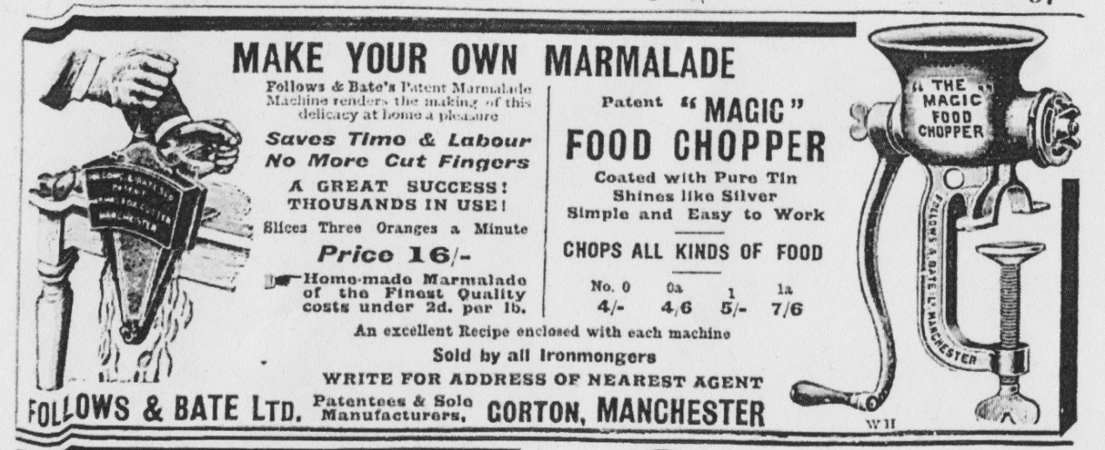
Figure 5.13 Advertisement for the ‘magic’ chopper and marmalade cutter, showing hands with a man’s sleeves, Woman at Home, December 1910, 37. Reproduced by permission of the British Library.

This image has been removed for copyright reasons.

Figure 5.14 Advertisement for the ‘magic’ marmalade cutter showing hands with the sleeves of a traditional cook’s uniform, Illustrated Catalogue, no. 750 (Manchester: Follows and Bate, 1905), 38, 1995.11.3970, Cambridge University Library.

Illustrations of the objects being used by a middle-class woman were rare. Only one advertisement for a kitchen implement in their Illustrated Catalogue of 1905 was depicted by a sleeveless figure that could be a housewife (Fig. 5.15). This was a second advertisement for the biscuit-making machine, and an accompanying description noted that the machine was ‘designed to enable the thrifty housewife to make her own “fancy” Biscuits instead of giving a fancy price for them at the Confectioners’. Perhaps the housewife making foodstuffs that were luxuries, such as biscuits, and not main meals, was more in line with middle-class notions of ladylike baking, in a similar manner to Mrs Fleming’s testimonial about her marmalade.

The signature products of Follows and Bate- the marmalade cutters and magic choppers- were the only ones in which coloured advertisements have been found. The full-page coloured advertisement for the ‘Magic’ chopper is depicted without a user. The image of the marmalade cutter, however, shows a woman operating it, surrounded by a large quantity of oranges and lemons (Fig. 5.16). Unlike many depictions of middle-class women at this time, she is wearing brightly coloured, loose-fitting clothing, with visible bare shoulders, and her hair adorned with accessories. The impression is given that the woman is expressing a new, modern femininity that breaks from the traditional imagery of the stuffy, oppressive era before. The marmalade cutter was subsequently presented as a symbol of a new type of housewifery in which women were embracing technologies, for efficiency at traditional female tasks, such as making marmalade. This advertisement was a rare example of where the object itself seems gendered as straightforwardly feminine which was achieved only by depicting a ‘modern’ woman, rather than a traditional Victorian or Edwardian housewife. Whilst it has been argued that a kind of ‘modern’ femininity emerged in the mid-twentieth century, examples such as this suggest it was happening earlier, when labour-saving gadgets first entered the home.

This image has been removed for copyright reasons.

Figure 5.15 Illustration from an advertisement for a biscuit-making machines showing hands with no sleeves, Illustrated Catalogue, no. 750, 12b.

This image has been removed for copyright reasons.

Figure 5.16 A full-page coloured advertisement for the marmalade cutter, Illustrated Catalogue, no. 750, 36.
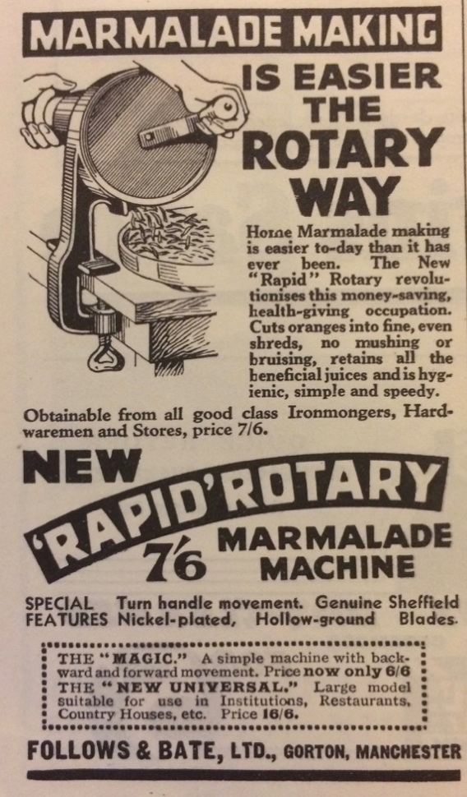 | This image has been removed for copyright reasons.
Figure 5.17 An advertisement for the ‘rapid’ rotary marmalade machine, depicted in use with hands without sleeves, Good Housekeeping, Vol. XXII, No. 4, December 1932, 126. Reproduced by permission of the British Library. | Figure 5.18 Illustration from the instruction leaflet showing a housewife operating the marmalade machine, Y1992.169, SMGC.

Nevertheless, by the mid-twentieth century it was more common for kitchen technologies to be illustrated in use by a middle-class housewife in advertisements. From around the 1930s, Follows and Bate produced the ‘Rapid’ marmalade machine. Images of this model generally depicted a woman, presumably a housewife, in their regular advertising. For instance, from at least 1932, the ‘Rapid’ marmalade machine was advertised in Good Housekeeping, depicted in use by hands notably without the frilled sleeves of a domestic servant’s uniform (Fig. 5.17). This is in line with the image on the instruction leaflet for the machine, which showed a woman, presumably a housewife, operating the marmalade machine herself (Fig. 5.18). Her outfit, with an apron, is clearly not the traditional servants’ uniform and she is depicted in a modern tiled kitchen. By this point, of course, the servant class had declined. According to Miriam Glucksmann this changed the status of the kitchen: ‘Since [the middle-class woman] was going to spend so much time in it, the kitchen was often designed as the pride of the home, spacious, light and airy, overlooking the garden and with ample space for all the appliances she should acquire.’ Moreover, the change in women’s relationship to kitchen technology was linked to the impact of World War One. As Joy Parr has commented, the relationship between kitchen design, technology and work was different in Britain in the interwar years. Parr points out that after the war there was an increased female employment in the engineering industries, as well as the formation of female-led organisations such as the Women’s Engineering Society (1919) and the Electrical Association for Women (1924). The latter was formed specifically with the intent of introducing technology into the home. Women’s relationship with technology was thus framed differently in Follows and Bate advertising. By the late 1930s, it was apparently less problematic to illustrate a middle-class woman operating machinery in her own kitchen. A comparison to advertisements from the interwar period demonstrates how the representation of utensils in use are shaped by social and cultural understandings of gender, class and technology. Evidently, the social and cultural norms regarding women and machinery fundamentally impacted the representation how the gadgets were visually gendered. By this time, a gadget designed for use in the kitchen was more straightforwardly feminine. The representation of the user of a piece of technology was inextricably linked to contemporary norms about women and technology.

| III | Mechanics in the Kitchen

In this section, I suggest that housewives and/or domestic servants must have had manual experience and technical skill in order to use these gadgets. I thus argue that the presence of such objects in the kitchen prompted women to behave in ways usually associated with the space of the factory, which went unacknowledged in the company’s own advertising.

The importance of the housewife understanding the metals in her kitchen was evident in Mrs Beeton’s Book of Household Management. Beeton, for instance, offered ‘A few words on the metals and compositions used in the manufacture of cooking utensils’. She went on to describe the benefits and drawbacks of different metals for kitchen utensils, including a discussion of aluminium, copper, and wrought steel. As this thesis has shown, it is clear that the housewife was directly targeted with this kind of specialist knowledge. In this chapter, an analysis of the objects themselves reveals the ways in which new gadgets further necessitated an engagement with metals and mechanisms. Follows himself noted in his lecture that women should be aware of the metals used in their kitchen utensils. He gave examples of the importance of knowing the difference between hammers and cutlery made of ‘cast-iron instead of steel’. Metals, of course, had long been in kitchens, especially in pots and pans. Although it is not often acknowledged, surely the presence of such materials in the home, especially on new gadgets with unfamiliar mechanisms, must have required a practical knowledge from the female user.

For Follows, the mechanical nature of the products made it challenging for the housewife to operate them. In his lecture of 1896, he referred to the technical handiwork that should be employed in domestic life, especially in using technologies:

if the hand and eye were specially cultivated, the use of common tools taught, and the processes employed in the manufacture of objects in daily use in our houses explained, then I maintain that the value of such a manual, industrial and technical knowledge would add to the pleasures, the duration, and the happiness of life, and would promote the better fulfilment of women’s mission at home.

Follows certainly subscribed to a traditional view of gendered domesticity, in which women were assigned the wellbeing of the home. But in his view, this could be better achieved with the adoption of manual knowledge and skill. In his references to ‘hand and eye’, Follows advocated better hand-eye coordination and thus an improvement in manual skill for the housewife.

Follows particularly sought to impress on his audience the importance of applying principles of working-class manual labour to housework. He described the behaviour of his employees at Follows and Bate who had been given ‘the materials for erecting, say, twenty-five somewhat complicated machines, each machine made up of numerous parts’. According to Follows, the good workman took his time to think about how the machine goes together:

For some time there is no show, little noise, no bustle, but the man is thinking of everything, and bringing together in orderly array all that he is likely to require in a piece of work that may last for perhaps a fortnight. Little by little all is made ready, divided and sub-divided; the time of action has arrived, and the work entrusted to him seems to grow as if by magic under his touch; he literally does in a given time twice as much work as his comrades, who often look with jealously upon his. Superior power of arrangement and method, and subsequent vigour, place him at an immense advantage.

Follows also referenced agricultural innovations and its parallels in domestic work. For instance, he described the revolutions in America in crop-gathering, and reaping and mowing machinery. Whilst this thesis has shown that contemporary ideas about science were frequently applied to housework, it was unusual for middle-class women to be encouraged to replicate the behaviour of working-class men. Follows represented his domestic products as a bridge between the seemingly disparate worlds of middle-class housewifery and factory or agricultural work. Much like Thompson’s argument that industrialisation prompted a new time-discipline, Follows suggested that the method and order of factory life should be adopted by the housewife. In other words, her own domestic skill set should draw upon the expert methods of working-class labour.

An analysis of the objects suggests the female user would need a familiarity with basic mechanics and metalwork. As Wajcman has pointed out, ‘Technological “things” are meaningless without the “know-how” to use them, repair the, design them, and make them. That know-how often cannot be captured in words. It is visual, even tactile, rather than simply verbal or mathematical’. To operate the marmalade cutter or the ‘Magic’ choppers, users must have physically and intellectually engage with metalwork, clamps, and wingnuts. Every time the ‘Magic’ marmalade cutter needs to be cleaned, a wingnut at the base of the blade must be unscrewed (Fig. 5.19). An item such as the tin-plated ‘Magic’ chopper comes in a small box measuring 10 x 8 x 23 cm, which is too small for the mincer to fit in unless it is taken to pieces (Fig. 5.20). Thus prior to the mincer even being used, someone in the household must have put the parts together. The use of such items required a necessary engagement with mechanics in a way that is difficult to imagine either middle-class housewives or domestic servants would have encountered in any other room in the home. In this respect, the kitchen can be seen as an important space for the manual and technical abilities of women. The advertisements solely showed the items in use and they did not demonstrate how the items were put together and taken apart. The instructions of the ‘Magic’ chopper do not give advice on how the mincer is
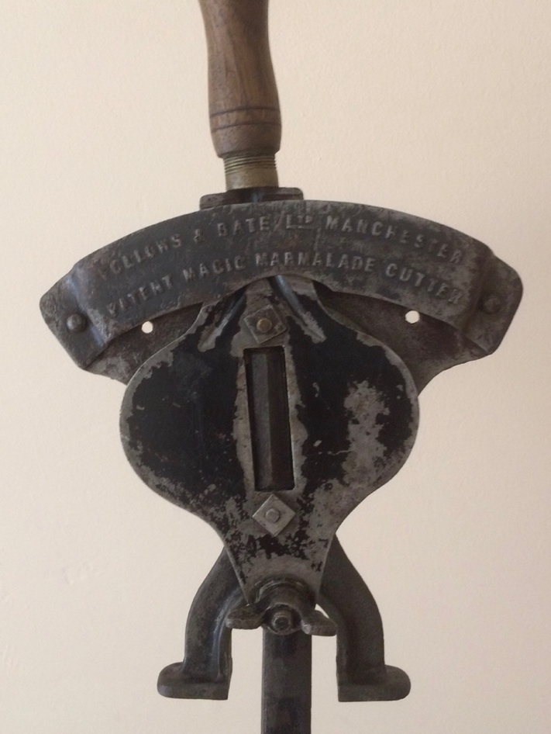
Figure 5.19 Close-up of the ‘Magic’ marmalade cutter, showing the wingnut, personal collection.
put together, or what the different parts are called. Thus, a certain level of manual ability and knowledge was required of the housewife or the domestic servant to put it together on first use.

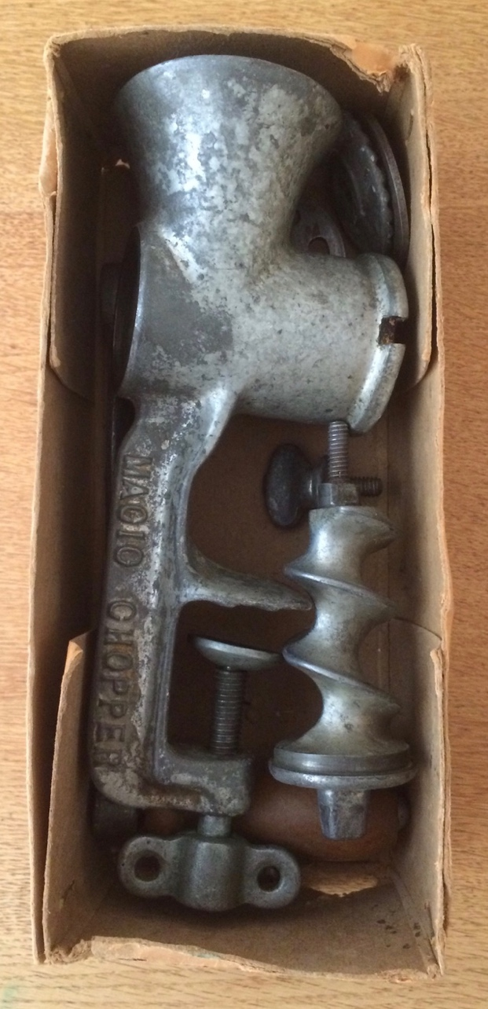
Figure 5.20 The tin-plated ‘Magic’ chopper in pieces, in its original box, c. 1920s, personal collection.

The later models of the marmalade cutter actually got more technical and fiddlier to use. The Follows and Bate ‘Rapid’ marmalade machine seems remarkably more inconvenient to use than their earlier ‘Magic’ models. The ‘Rapid’ marmalade machine, patented in 1934, is almost twice the weight of earlier ‘Magic’ models at 4.6lbs. As a bulky item made of cast-iron, it has and could be easily mistaken as Victorian. As well as being heavy, the ‘Rapid’ marmalade machine was also more complicated to clean and maintain. The blade is on the inside of the machine and access requires undoing two wingnuts, removing the handle and taking off the front piece. As the instructions put it, ‘After use, remove the two Wing Nuts and loosen the Cover Plate, then remove the knurled thumbnut on the spindle end and draw out the spindle which carries the cutter plate.’ Essentially, to clean the machine it must have been taken entirely apart. This was an interesting design decision; rival companies such as Spong and Co. were producing cutting agents with a similar revolving mechanism, but without a front piece, which meant the blade was accessible to the user without having to take it apart (Fig. 5.21). Likewise, earlier ‘Magic’ models required only one wingnut be undone and the blade was released. The taking apart of the ‘Rapid’ marmalade machine involved unscrewing a knurled nut, or, in other words, one with a pattern indented around the edges, so hands could grip it. Evidently, the makers intended users to have to unscrew and take apart the machine with their bare hands. Operating this marmalade machine would require more mechanical and technical skill and behaviour than earlier models, as well as more physical engagement with the parts. This was, perhaps, owing to a more open acknowledgement that the interwar housewife was technically skilled.

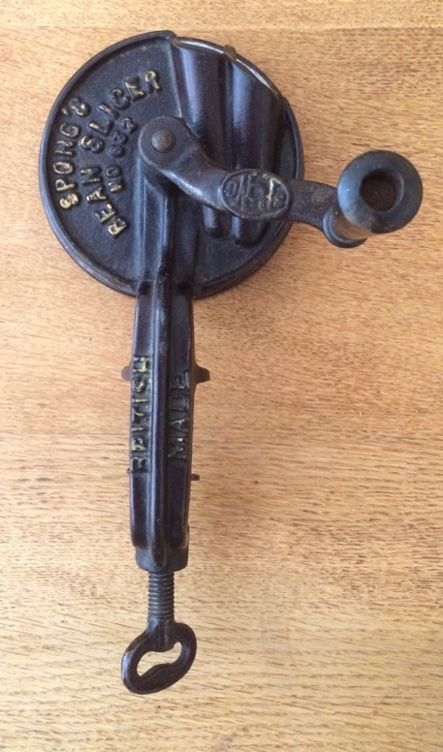 | 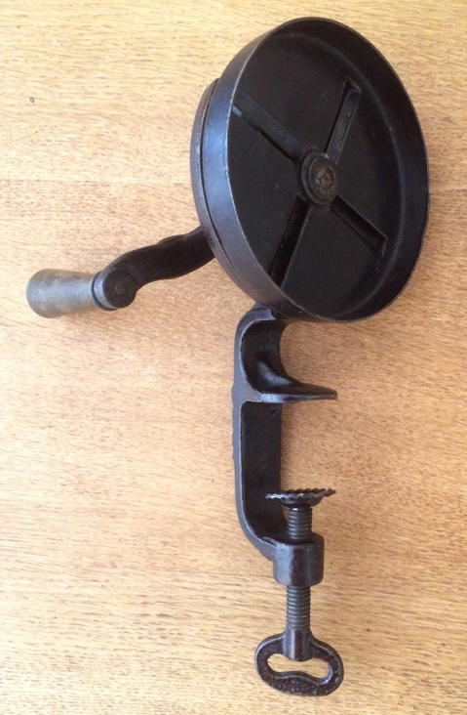
Figure 5.21 A Spong and Co. bean slicer, with a revolving mechanism, personal collection.
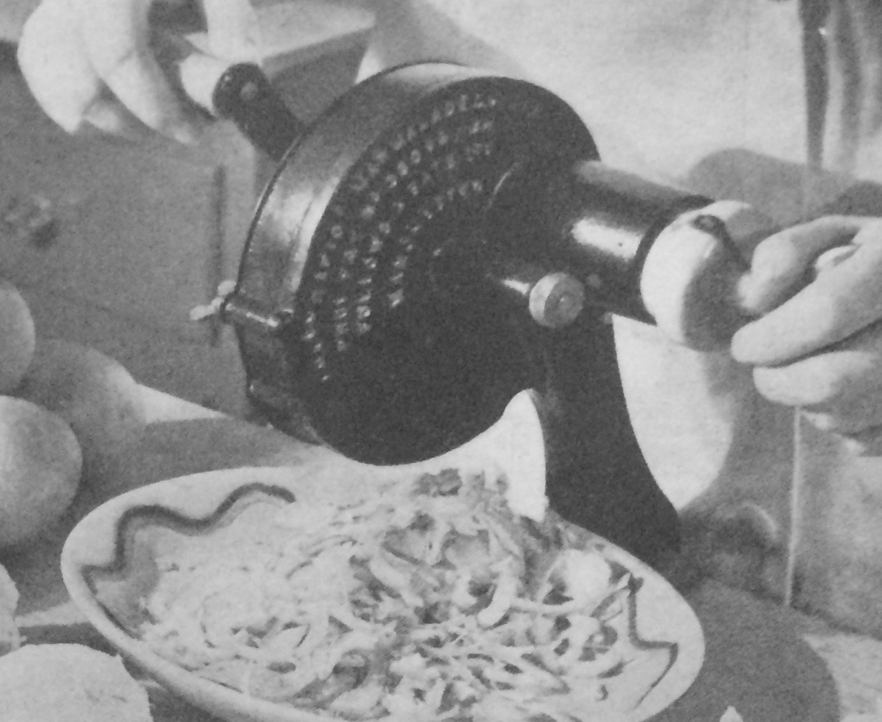
Figure 5.22 Photograph of a Follows and Bate ‘Rapid’ marmalade machine from Good Housekeeping, Vol. XXII, No. 4, December 1933, 77. Reproduced by permission of the British Library.

The decision to make the ‘Rapid’ marmalade cutter more complicated was perhaps a safety concern. An article in a December 1933 issue of Good Housekeeping gave instructions for making marmalade. Although the article does not specifically name Follows and Bate, it featured an image of two marmalade cutters, one of which is clearly the ‘Rapid’ marmalade machine (Fig. 5.22), noting that ‘The latest model has been further improved by a safety device in the form of a steel cover over the rotary disc’. Nevertheless, the added complication of this addition was acknowledged in the instructions on how to use it:

Before use the makers advocate the application of a little bit of oil between the thumb nut and the bottom of the spindle. In order to keep a machine of this type in good condition it should be thoroughly cleaned and dried each time it is used. Merely drying with a tea-cloth is not sufficient. The two-wing nut should be removed to loosen the cover plate, and the spindle which carries the cutting blades drawn out. The parts should be dried and placed in a warm oven or some similar spot where they can get really thoroughly heated through, so that surplus moisture is evaporated and rust prevented.

By the interwar period then, it was not unusual to ask the average housewife (who, at this point, probably did not have a domestic servant) to oil a metal implement, and refer to technical parts of a gadget, such as ‘thumb nut’ and ‘two-wing nut’. By this point, contemporary women’s magazines like Good Housekeeping were acknowledging the technicality involved in operating a mechanical cutting device.

The gadgets were made of the same materials as industrial machinery, such as metals, wingnuts and screws. Provisional specifications for patents of invention outlined the literal materials and mechanisations of the product. For instance, in 1901, Follows filed a patent for ‘improvements to roller mills’ described as ‘applicable for grinding pigments, chocolate, and other substances’. Presumably, this particular invention could be used in agricultural industries for, for instance, grinding white lead or for the mass-production of chocolate by grinding cocoa beans. But roller mills were also used in small-scale kitchen implements. The sausage-making machine was essentially operated by two cylindrical rollers crushing meats between a blade when the handle is turned. The parts of machines, either domestic or industrial, were essentially made of the same moving parts (Fig. 5.23). The wingnuts, screws, and blades used in large-scale machinery were literally the same pieces used in domestic products. On a micro-scale, the housewife and the domestic servant were exposed to materials used in factories and expected to successfully use them in domestic labour.

This image has been removed for copyright reasons.

Figure 5.23 The inside of the sausage-making machine, showing two cylindrical rollers., Y2004.19, SMGC.

In addition, Follows and Bate produced grindstones for the engineering and agricultural industries, and an advertisement from their illustrated catalogue of 1905 suggested they might be used in the domestic kitchen. The advertisement explained ‘these capital little Grindstones will be found exceedingly useful for kitchen purposes, in sharpening Cleavers, Choppers, Carving Knives, &c., and equally handing in the Amateur’s Workshop’. This advertisement was presumably not aimed specifically at the housewife (although it was in the same catalogue as others that clearly were), but at a business. Perhaps it was assumed that households with this kind of equipment could also appropriate it for domestic use. In this case, the objects were represented as belonging to the material culture of a workshop and the domestic kitchen.

The female user, servant or housewife, would have to take apart and put together parts of machines. Some models were made so that they could be adapted into another. For instance, the 1905 catalogue advertised a ‘Magic’ marmalade cutter attachment that could be used with the No.1 ‘Magic’ chopper, ‘instantly converted into A PERFECT MARMALADE MACHINE’. Similarly, the ‘Rex’ meat and suet chopper could ‘be instantly converted into a continuous Sausage Filler by simply removing the perforated steel plate and attaching in its place the patent nozzle’. Thus, as mechanical products, items could be adapted to be used for different purposes. These smaller, cheaper machines might have been purchased by a lower middle-class family which perhaps only had one servant or none at all. Presumably then, this technical rearrangement of the kitchen gadgets would have been undertaken by a single domestic servant, or the housewife herself. Either of these women would have to implement a certain level of manual dexterity and mechanical knowledge to adapt the gadgets.

Many components of the items would also have required manual maintenance to keep them working effectively. The blade of the marmalade cutters, for instance, required regular sharpening. Despite claims by the advertisements of the ‘Magic’ marmalade cutter that ‘the Double-Edged Cast Steel Knife is easily detached for sharpening’, physical examination of the object suggests it would actually have been fairly problematic. For instance, whilst the handle piece is easily detachable, this does not release the blade piece for sharpening. Instead, it would require using a screwdriver to release the small blade. As it was a double-edged and very small, it was presumably fiddly and dangerous to sharpen it manually. In addition, as with all metal implements, over an extended period of time, they would also require lubrication by oil to prevent the bearings from seizing up. Precisely who took on this responsibility in the middle-class home is not clear. As chapter one established, domestic servants were often represented as technically incompetent, and the average middle-class home likely only had one. Neither the female housewife nor the male head of the household maintaining the equipment fits comfortably with our existing understanding of domestic behaviour and the allocation of housework in the home. But, to successfully operate one of these objects somebody must have done, and it was, most likely, a female member of the household. Thus, the domestic servant or the middle-class housewife likely had the knowledge and skill set to, for instance, manually sharpen a blade.

This use of machinery was not necessarily regular. Whilst something like a mincer might be used on a fairly regular basis, a marmalade cutter, if used for its advertised purpose, would perhaps only be used once a year. Traditional British marmalade, made from Seville oranges, can only be made when the fruit comes into season, from December to March. Thus, if a family were to use a marmalade cutter to make traditional British Seville marmalade, it would perhaps only have been used in a small window of the year. Given most families would not regularly be making marmalade, some models of marmalade cutter could be rented from an ironmonger. Sample showcards for the ‘Patent’ marmalade machine, included in their 1902-3 trade catalogue, stated: ‘LENT ON HIRE AT ONE SHILLING PER DAY’. Thus a cheaper alternative was available for machines where regular use was not required. Of course, when an item was hired from an ironmonger, it never became a permanent fixture of the material culture of the kitchen. Instead, it remained a specialist piece of equipment belonging to an ironmonger. Whilst such gadgets might be described as ‘everyday technology’, in the sense that they were within the home and used as part of a daily task (cooking and baking), they were not truly used every day. Instead, many of their products, like the marmalade cutters, were perhaps used for a specific annual activity. When specialist equipment was used, the task moved from an ordinary, traditional home craft, to a technical and mechanical activity. The female experience of machinery could be associated with a particular task, which required a particular gadget, at a particular time of the year.

The products designed by Follows and Bate were often pitched to the consumer as for a specific purpose; for instance, the various models of marmalade cutter were always pitched as slicing orange peel. Nevertheless, in physical design, the marmalade cutter could essentially cut any fruit or vegetable. This is evident in the patents of invention, which often list multiple uses for a product that is advertised as having only one. For instance, a 1903 specification for a marmalade cutter describes the invention as ‘apparatus for cutting or slicing oranges cucumbers potatoes carrots apples and other fruits or vegetables which it is desired to cut into thin slices or shreds by means of a knife or knife blade carried by a reciprocating lever [sic]’. The potential function of the cutter for a range of other fruits and vegetables was largely absent from the advertising. This was clearly not a reflection of the technical specifications of the product, but a desire by advertisers to appeal to the values of the audience by targeting a particular use. As I discussed in chapter one (page 58), the idealised home was becoming more segregated and specialised. Businesses could potentially maximise sales figures by describing the purpose of an individual utensil as for a highly specific task, encouraging the purchase of multiple items.

There were limits to how far Follows and Bate expected the household to maintain their own equipment. It would be at best very difficult for any member of the household to have repaired a rotary knife cleaner, owing to how the machines are put together. Access to the central mechanism of the ‘Family’ knife cleaner, inside the wooden barrel, is not easily achieved. The main piece is screwed together by eleven screws on each side, and to take it apart would require unlatching the cast iron metal legs from the wooden barrel. Indeed, the screws holding it together are not knurled and would require the use of tools such as a screwdriver. Follows and Bate offered a repair service so rotary knife cleaners could be sent to Gorton, Manchester, and ‘made practically equal to new’. The plans for their works from 1877 in Carnarvon Street, Manchester, show an entire part of the floor dedicated to knife cleaners. No other specific product had its own space on their floor plans, suggesting a great deal of time and space was required for making and repairing them. Given that knife cleaners were recommended to be sent back to the manufacturers for repair, it is clear that the makers expected the consumer’s technical skill to be limited. While it was assumed that a smaller piece of equipment could be maintained by the household, for larger objects, skill in repairing belonged solely to the manufacturers. As I have already stated, knife cleaners were also the most expensive of Follows and Bate products, and thus likely only present in the wealthier households, which typically had more servants. Perhaps then, the wealthier the household, the more the family could afford to rely on external expertise, rather than depending on the housewife or domestic servant for mechanical knowledge.

These wealthier households, of course, may also have had more domestic servants, and thus less housework for the mistress. It might be speculated that the most expensive technologies were more likely to be used by a domestic servant. Although advertisements are of course unreliable for showing how gadgets were actually used, a Spong and Co. knife cleaner was named ‘The Servant’s Friend’. This was a miniature version of rotary models like the ‘Family’ and sold for a reasonable 12s.6d. Items like ‘The Servant’s Friend’ could be interpreted as an example of the concessions to servant’s comfort to which I referred in chapter four (page 193).

The physical dimensions of the objects also give some insight into how they would have been arranged in the home. As well as being fairly heavy at twenty-two pounds, the ‘Family’ knife cleaner was 36cm across the main barrel. The kitchen must have had space for a permanent location for it to be used regularly, or it had to be physically moved every time it was needed, which was presumably an arduous task. The ‘Family’ model of the knife cleaner only polished two knives at a time, making its desirability as a tool for convenience difficult to understand. However, as chapter three showed, writers of autobiographies depicted cleaning knives as particularly troublesome prior to the invention of stainless steel (see page 154). Other items were similarly heavy, such as the ‘Rapid’ sausage maker, which, with all the parts, weighed ten pounds. In addition, devices such as the mincers and marmalade cutters, which clamped onto the table, were presumably not permanently attached to the kitchen table. Thus the nature and weight of these devices make it unlikely that they were permanent fixtures in one place in the kitchen. These kinds of technologies in the kitchen, therefore, suggest a material culture of the space that was regularly in transition, to accommodate the operations and dimensions of new items. Larger items, of course, also tended to be the most expensive. A household which could afford the ‘Family’ knife cleaner may well have also had a larger kitchen with space to keep one.

Of course, whether or not consumers regularly used such objects, even if they did own them, is a different matter. Personal testimonies are rare and not representative. The testimony of the previous owner of the tin-plated ‘Magic’ chopper described their mother’s use of it in the mid-twentieth century:

Mum said it was a difficult thing to use, if not clamped tightly to the table it would move about and would mark the table. When used to mince suet the sinews would clog it up and it had to be repeatedly taken apart and cleaned to get it working again. Also the fat would turn the metal black.

The representativeness of this statement is impossible to qualify, although it is of note that in this instance, it was clearly a woman who was operating the device. As feminist historians such as Ruth Schwartz Cowan have shown, the introduction of labour-saving technologies into the home did not necessarily equate to less work, or more convenience for the female user. To the contrary, it can mean more time spent on household tasks and more bother. For instance, the weight of the ‘Family’ knife cleaner, and sending it to Manchester for repairs, was surely inconvenient. Again, certain objects can be seen as potentially transforming domestic behaviour, but not necessarily for the better. Instead, they transformed one type of housework, such as preparing food by hand, into another, with a machine. This change must have been accompanied with new technical behaviour and skill in the domestic kitchen.

Conclusion

I have argued that the emergence of these new technologies stimulated a technical skill set required of the housewife and the domestic servant that was primarily ignored in advertisements. In addition, this technical experience of housewifery has yet to be recognised in histories of the Victorian and Edwardian period. This change may not have been particularly widespread, but it is the seed of a movement that would later take clearer shape with the introduction electricity in the home. I demonstrated that a select set of kitchen gadgets gave women active experience with machinery, especially in physically engaging with metalwork such as wingnuts, screws and blades. These gadgets represented a bridge between the otherwise ideologically and physically distinct spaces of the factory and the middle-class home. With the emergence of these new technologies came new behaviours, concerning the use and maintenance of small-scale pieces of machinery.

It is less clear if this technical skill would have been required of the middle-class housewife or the domestic servant. In reality, it was likely tremendously varied. I have suggested that there was a probable relationship between household income and the mechanical and technical experience within the kitchen. The more challenging technologies, such as the knife cleaners, would be more likely to have been present in the kitchens of the wealthier. Such items may have required sending out of the home for maintenance, but within the home, they were more likely to have been used and maintained by a domestic servant. Households on a smaller income, could potentially afford a mincing machine or a marmalade cutter, but, with less servants, the housewife herself was more likely to interact with it.

There is, of course, the issue of representativeness. Whilst Follows and Bate products might not have been particularly widespread, they do represent a type of gadget, a mechanical cutting agent, that were being sold by rival companies. A further difficulty, however, is that the heyday of mechanical cutting agents was actually fairly short. Whilst they started to become readily available from the mid-nineteenth century, by the interwar period the small electrical motor was entering the kitchen. This was of course alongside social changes prompted by World War One, which prompted a different view of the relationship between women and technology. An analysis of Follows and Bate and their products thus provides an interesting case study, in which the gadgets were compared to a selection of other source material. In this pre-war, pre-electric period, these inventions gave women a window into the world of mechanics. The technicality which was evidently involved in using them seems contradictory to the company’s advertising, which shied away from depicting the middle-class woman. Such objects thus present a tension between gendered and classed identity and new mechanical products, at a time before social and cultural norms and ideologies had fully adapted. By extension, the kitchen can be interpreted as a site that stimulated technical skill and mechanical experience that is not usually afforded to the middle-class housewife or the domestic servant.

Conclusion

In the run up to the 2015 General Election, an unusual scandal hit the papers concerning Ed Miliband’s kitchen. The then-leader of the Labour party and his wife Justine were photographed sipping tea in a small, bare kitchen inside their North London home (Fig. 6.1). The media’s reaction was unexpected. In a particularly venomous attack on the Milibands, The Daily Mail’s Sarah Vine had a lot to say of the ‘sad, self-consciously modest Miliband kitchen’. The links she drew between the kitchen, its material contents (or lack of) and the character of Justine Miliband were particularly interesting: ‘No home-making for Justine: she’s far too busy sticking to her feminist principles as an environmental lawyer. And that doesn’t include nice crockery or other homely touches. Or even, it would appear, a half-decent set of curtains.’ When it was revealed the photographed kitchen was in fact a second kitchenette and not the house’s main kitchen, the label ‘two kitchens Miliband’ was coined. It would seem even the sight of someone’s kitchen can be used to read into their character. Thus, a perceived link between domesticity, femininity, the kitchen and its material culture, was used to launch a political and personal attack on the leader of the Labour party and his wife. This instance highlights the ongoing emotional and political resonance of the domestic kitchen.

The first part of this concluding chapter draws together the five main research chapters. It highlights my contribution to our existing knowledge and evaluates the findings of this study. The second part suggests some avenues for future research, centred around the material culture of past kitchens. I examine the ‘afterlife’ of Victorian and Edwardian kitchen gadgets, reflecting on their ongoing significance in today’s culture.

This image has been removed for copyright reasons.

Figure 6.1 Ed and Justine Miliband pictured in their kitchenette, from Sarah Vine, ‘Why Their Kitchen Tells You All You Need to Know about the Mirthless Milibands... and Why There’s Nothing to Suggest That Ed and Justine Are Not, in Fact, Aliens’, The Daily Mail, 12 March 2015, http://www.dailymail.co.uk/debate/article-2990810/Why-kitchen-tells-need-know-mirthless-Milibands-s-suggest-Ed-Justine-not-fact-aliens.html.

Concluding Thoughts

This thesis has examined the relationship between science, middle-class housewifery and the kitchen in the period 1870 to 1914. As housewifery and the kitchen are classed and gendered spaces, this thesis has focussed on women, and how the ideology I have called scientific housewifery intersected, informed and challenged gender norms in this period. Each of the five research chapters have sought to piece together fragments of Victorian and Edwardian scientific housewifery.

The first chapter argued that domestic advice manuals offered instruction in a performative, scientific housewifery that could be expressed by the purchase and use of the correct consumer goods for the kitchen. I demonstrated in this chapter that the idealised figure of the scientific housewife was critically linked to consumer goods, as material objects could be used to express an expert femininity. The second chapter showed that new educational institutions for middle-class girls created a culture of ‘intellectual domesticity’. Domestic subjects and science were both included in the schools’ liberal curriculums, and the difference in content and status of the two subjects was not always as clear-cut as historians have suggested. The third chapter, based on an analysis of autobiographies, built on this argument by demonstrating that writers expressed their own intellect through descriptions of housework. Memories of housework were reconstructed with an emphasis on rationality and expertise and female writers drew on the prestige of science to write themselves into a male-dominated narrative of scientific progress. They thus used references to science to assert agency over the representation of their own lifespans. The fourth chapter, on advertisements, analysed the interplay between masculinity and femininity over food and science, suggesting that consumer goods came to represent a power exchange. Although the masculine gendering of some foods extended male power into the kitchen, the woman’s power of choice also gave her some control, including over the depicted domestic servant. Finally, the fifth chapter analysed a set of mechanical gadgets and explored the concept of technical skill. It suggested that gadgets necessitated female users acquiring technical skill in order to use them effectively. This technical skill, however, was denied to women in public discussions of the gadgets use, as well as in the majority of the illustrations for the products themselves. Thus, this chapter showed that, despite a cultural trend towards applying scientific knowledge to domestic life, there were limits to how far this would publicly contradict contemporary gender norms about middle-class women’s ability to operate technology and the visibility of housework.

Collectively, these chapters have analysed the ideology of ‘scientific housewifery’ from a number of angles. I have particularly sought to emphasise the importance of the material environment to the scientific housewife. As the material culture of the home is inextricably linked to consumer culture, evidently the idealised scientific housewife was wealthy. This is perhaps why the ideology of scientific housewifery emerged so clearly in the nineteenth century, as it saw the expansion of the middle class and the parallel flourishing of consumer culture. In addition, science was rising in popularity amongst the mass population as a form of leisure and developing as a profession which commanded prestige and authority over matters such as health, food and cleanliness, all of which clearly impacted the home.

Previous scholarship on a range of international contexts has argued that the twentieth century was the period in which housework and the kitchen were modernised and rationalised, with particular emphasis on the influence of Christine Frederick. In British history, scholars such as Joanne Hollows and Judy Giles have suggested that science and technology prompted a re-evaluation of the servantless housewife as modern in this later period. However, I have shown in this thesis that science and technology were directed at the housewife in the nineteenth century, in a way that challenged and reshaped middle-class women’s gender identity. An expert, scientific housewife was already in formation, earlier than previously suggested. I have described a Victorian and Edwardian scientific housewifery that was not prompted by the decline of domestic servants. Instead, the ideology was interwoven with popular notions of class difference between mistress and servant.

There were limits to how far women’s relationship with science and technology was acknowledged in the Victorian and Edwardian periods. Chapter five indicated the tension between women’s technical abilities and social etiquette, by a reluctance to illustrate middle-class housewives operating mechanical devices. I compared Edwardian and interwar advertisements for the marmalade cutters to show that by the 1920s, it was seemingly less problematic to show a middle-class housewife operating small-scale kitchen machinery. Women’s technical skill and knowledge was not yet fully accepted in Edwardian contemporary culture, but it was clearly still happening in the space of the domestic kitchen. Nevertheless, the idea of a technically competent housewife was clearly in formation, as indicated by domestic advice guides and advertisements encouraging women to adopt technology in domestic life.

In the introduction, I established continuity between the Victorian and Edwardian periods and the early modern period. For instance, Lynette Hunter has shown that women’s association with domesticity allowed them to practise ‘kitchen physic’ in the seventeenth century. The Victorian imagery of the kitchen as a scientific space had its roots in early modern culture. Likewise, early modern domestic labour was rationalised with an emphasis on efficiency and economy, as Karen Harvey’s work on oeconomy has shown. The late nineteenth century was a period of scientific and technological change that affected women and the domestic sphere, which prompted these trends to crystallise against a flourishing consumer culture. These changes include the emergence and wide-acceptance of germ theory, inventions from new stoves to marmalade cutters, and a cultural trend that encouraged efficiency and strict time-keeping. There were also changes in the food industry which saw stricter adulteration laws and the development of new products, such as infant formula. As this thesis has shown, scientific and medical ideas were encountered by women through daily activities such as cooking, cleaning, shopping and supervising servants. In addition, scientific ideas influenced a particular conception of domestic space, in which rooms were specialised and segregated. Likewise, the expansion of educational opportunities and national anxiety about the health of the nation had implications for women and girls’ relationship with science.

In practice, the experience of scientific housewifery would have been tremendously varied, especially given the range of household income within the middle class. If the middle-class woman was rich, she might have had too many servants to do much practical housework herself, which is reflected in the quantitative results presented in chapter four. It was, after all, The Queen, the newspaper for ‘ladies’, that had the fewest advertisements for food or domestic equipment compared to the other two women’s magazines. Nevertheless, the lady of the household was expected to undertake a managerial role. As I have suggested in chapter three, where women were not physically present in the kitchen, they exerted control over the space by the selection of healthy and scientifically-sound foods and equipment which their domestic servants would be handling.

Men and masculinity played a part in the construction of the scientific housewife. As John Tosh has argued, ‘Home was the place where, in theory, masculine and feminine were brought together in a proper relation of complementarity’. This is equally true for the construction of scientific housewifery, which was based on an interdependency between men and women. If scientific housewifery was dependent on consumer culture, it was also contingent on male spheres of authority, such as invention, nutrition and the manufacturing industries. Although this thesis has only touched upon the place of men in the kitchen, it might prove to be a promising avenue of future research. Men were directly involved in the making of scientific housewifery as writers of domestic advice manuals, teachers of domestic science, and inventors of domestic technology. Further questions might be asked of the practical role played by husbands and fathers in everyday life. Did men enter the kitchen, or do practical housework, more than we might think? Research in this direction could deepen our understanding of contemporary masculinity and the gendered dynamics of housework and everyday life.

As the introductory chapter described, early work on housework stressed the negative impact of science and technology on women’s domestic lives, by elevating the required standards. Feminist analysis depicted science and technology as an imposition of male power, ultimately further confining women to the domestic sphere. Later research has recognised that domestic science and technology opened up professional opportunities for women. This thesis has shown that the intersection between housework and science could provide women with professional and personal agency. For writers of domestic advice manuals, especially women, expressing their own scientific and medical expertise in matters concerning the home was a means to bolster their professional identity. It may also have empowered the readers of domestic advice guides as they were presented with a narrative in which they too could be experts in their home, through purchasing the correct goods and intellectually engaging with them. In autobiographies, even when recalling times of financial difficulty, as did Eliza Priestley or Florence White, housework or domestic service were not recalled with bitterness or resentment. They did not feel powerless, and they found ways to make meaning in their lives that empowered them. Writers embraced a conception of housewifery that included scientific, medical and technological strands of knowledge and expertise. And although women were certainly marginalised in science and technology professionally, I have suggested that they had a means of entering this field through their housework, by, for instance, operating a mechanical cutting agent, or examining their closed range. New educational institutions that admitted young women also endorsed a form of scientific housewifery, which I have called intellectual domesticity. And as the last section of the second chapter indicated, pupils were capable of articulating their own identities in this environment, sometimes playfully embracing their enjoyment of science, or protectively asserting their own sense of domesticity.

The national emphasis on science may well have been, as historians of education have shown, a state-imposed pressure on housewives to raise healthy children, and more importantly, the soldiers, of the future. However, this does not mean women were passive victims. From school pupils to domestic advisors to writers of autobiography, science was embraced as a means of asserting their own agency and expertise, and to suit their own personal or professional agendas.

I have hinted at the importance of the lifecycle to expressions of scientific housewifery. For the writer of a domestic advice manual, it was a means to express their authority as a married woman. To the reader of a domestic advice manual, the scientific housewife was presented to them as a gendered ideal that should be emulated for success at managing their first home. Teachers and educational institutions sought to prepare young women with an intellectual domesticity that would be of use for later life. But some pupils responded to this environment by establishing their own identities that would have been denied to them as adults. For writers of autobiographies, referring to science and its relationship with domestic life wrote their own lives into a major period of historical significance otherwise dominated by men.

This thesis has demonstrated that functional objects, and their representation in written and visual sources, could be at the centre of classed and gendered power relations. Expert housewifery could be expressed by mastery over new technologies, or by the reinterpretation of others as akin to the equipment of a laboratory. Ordinary functional objects like stoves and utensils, seemingly enhanced by their technological and scientific brilliance, became a site at which classed and gendered identities and relationships were recreated. Catherine Buckton’s kitchener became a marker between her and her domestic servant as she presented herself as having the expertise and intellect to understand the inner workings. Objects like food and cooking utensils might be thought of as feminine since women were the primary users, but they are also masculine, as items of technology or as foods endorsed by male scientists and doctors. In advertisements, they represented a web of power relationships between scientist and consumer, husband and wife, and mistress and servant. Indeed, a simple mincer or marmalade cutter might be thought of as gender neutral, or devoid of classed connotations, but clearly the illustrations in advertisements were circumscribed by social norms.

Owing to the nature of the source material, this thesis has focussed on the middle-classes, and has primarily been written through a middle-class lens. Although domestic servants in the kitchen have been a reoccurring theme, they primarily appear as middle-class representations, through advertisements, domestic advice manuals, and memories. As Erin McLaughlin-Jenkins pointed out in 2001, much research on ‘popular’ science was on middle-class participants, and when not, it tends to be on the wealthier, artisan portions of the working class. As she states: ‘The study of popular culture has been fruitful in showing the dialogue between science and society. If it has one major flaw, it is that it rarely steps outside middle-class culture’. To some extent, this statement is true of this thesis. However, it does point towards some of the ways we might derive the domestic servant’s experience of science and technology from within the middle-class home.

Chapter five suggested that the domestic servant user of a mechanical gadget would have had technical skill to use it effectively. Research on domestic servants could potentially be enhanced with closer attention to other objects that they used. In Leora Auslander’s words, the understanding of domestic service:

might be easy if one researched not only the relation between servants and mistresses, but also servants and the domestic things they animated through their labor. The history of domesticity itself, particularly of the housewife and the mechanization of labor in the home, would be a richer one if, in addition to consideration of expenditures of time, physical force and standards of cleanliness, historians thought harder about the change in relation to time, to space, and to bodies brought about by the replacement of the broom by the vacuum cleaner and other improvements that distanced domestic labor from the objects of their attention.

I have suggested that domestic servants, especially those in wealthier households, would have had to have a certain skill set in technology to use the gadgets studied. A broader adoption of objects as source material could illuminate our understanding of everyday life for domestic servants, and what this tells us about the formation of class ideology. Owing to the lack of written sources directly from domestic servants, placing material objects at the centre of discussion could expand our understanding of their daily lives. Therefore, material objects are more significant in the history of domestic service, for what they could tell us that written sources cannot.

The emphasis on material culture has also allowed for an analysis of the Victorian and Edwardian kitchen. Architecturally, the kitchen might have been, to use the Garrett cousins’ phrase, ‘hidden away behind the baize-coloured doors of the service passage’. The kitchen of this period has arguably also been hidden in scholarship, as historians have favoured analysis of other rooms and other objects. But in the ideology of scientific housewifery, the kitchen occupied a large space. Scholars might have been ‘in disagreement about how far the middle-class woman actually went into the kitchen and cooked’, but this thesis has shown that it was always at the centre of her domestic responsibilities, even if she were not in there regularly. Popular concerns about food, health and cleanliness naturally prompted the application of science and technology to domestic labour in the kitchen. This made the kitchen, as an imagined space, what it came to be seen as: ‘the great laboratory of the household’.

As I highlighted in the introduction, it was a popular observation to compare the scientific laboratory and the domestic kitchen in the nineteenth century. Their material cultures were seen as parallel, with functional objects designed to aid ‘scientific’ tasks. Subsequently, the housewife was told to emulate the efficient and rational behaviours of the scientific laboratory. However, there is a critical difference between a laboratory and a domestic kitchen. In the laboratory, scientific tasks are undertaken with a specific purpose- to advance human knowledge and make scientific or medical advancements. There is an ‘end-point’ to scientific experiment; the scientist stops repeating his/her experiments and moves on once the answer is reached. To the housewife, however, the activities which take place in the kitchen are never ending. Cooking and cleaning were cyclical, routine activities which would repeat until the end of the woman’s lifetime. There is no end goal, except to feed the family, knowing they will eventually get hungry again. Yet these activities were imagined as having a close relationship with scientific knowledge and were positioned as a regular practice of that knowledge by women in the home.

National concerns about the health of the nation put the everyday routine of the housewife into a wider narrative of racial progress. According to those concerned about the degeneration of the race, state intervention into cooking and mothering would stimulate a stronger healthy nation. However, contemporary housewives would not have experienced science as part of a grand march of progress. Instead, it would have been in the everyday routines of undertaking housework or supervising domestic servants

Therefore, this thesis suggests a new angle in viewing ‘science’ in the past. The same scientific processes, such as boiling water or disinfecting a surface, were repeated over and over again by the housewife. This is not to suggest that every housewife thought about the scientific process behind her housework every single time- like Edith Mumford described applying mathematical reasoning to dress-making, in chapter three. However, scientific knowledge informed practice even if it were not consciously thought about. The housewife cleaned the table to prevent the spread of germs, and she purchased healthy foods for the welfare of her children. Scientific knowledge then was embedded in the practice of everyday life in the middle-class kitchen, even if it were not always consciously acknowledged by contemporaries. Sources like domestic advice guides and advertisements strongly suggest that daily household activities were underpinned by contemporary scientific and medical knowledge and change. Given the importance of the kitchen as the centre of food preparation, the relationship between scientific knowledge and daily practice is particularly clear. Similarly, it is the progress of science and industry more broadly that led to the consumption of smaller gadgets like those discussed in chapter five. The fruits of science and industry also became integrated into daily activities such as chopping meat or fruit. The kitchen then, was a central site in examining how key developments in scientific and medical understanding were played out in practice.

This thesis began giving the definition of science as ‘objective knowledge of physical matters’. This broad definition has allowed the thesis to incorporate science in various forms. However, implicit in this definition is that ‘science’ is primarily theoretical knowledge, borne from experimental processes. I have demonstrated that science can also be viewed as a popular practice which was embedded in everyday, cyclical routines and rituals. Sometimes, this may have the subject of conscious reflection- such as in autobiographies- or sometimes not. Nevertheless, domestic routines and space formed an important site at which science was applied and became as much a practice as knowledge. These practitioners of science were not the male scientists with which early histories of science were preoccupied, but women- housewives and domestic servants- within the home.

Thus, to historians of science, this thesis has value in demonstrating how scientific and technological ideas, objects and behaviours were appropriated and reshaped in the home. Science was encountered and perceived by contemporaries not just in periodicals or through leisure activities, but in the cyclical routines of everyday life. Certainly in domestic advice manuals and autobiographies, science was written into a version of everyday life where it was possible to make impressive statements of knowledge through, for instance, a description of one’s cooking utensils, as did Lucy Yates. Or, as chapter four showed, women were exposed to a plethora of scientific and technological ideas simply by viewing advertisements. But more significantly, broader ideas about health, hygiene, food and medicine were embedded into domestic practice. Whilst this thesis has mostly looked at the housewife, questions might be asked of how other people in pre-1914 England experienced science whilst going about their daily lives, or how their daily routines were underpinned by contemporaries’ ideas about science.

Overall, this thesis has woven together fragments of the scientific housewife from a reading of domestic advice manuals, autobiographies, advertisements, school records, and objects. Collectively, I have presented the ideology of scientific housewifery as interdependent on material consumer culture, and fundamentally linked to the other factors shaping the home, such as masculinity, domestic servants, and family wealth. What it meant to be a middle-class woman in the home surely meant a constellation of different things at any one given time. The scientific housewifery I have described is one type of middle-class femininity that existed alongside others. I have suggested in places how scientific housewifery intersects with other notions of domesticity, such as emotional notions of the loving mother and the warm kitchen, or social etiquette that dictated middle-class women should not be seen doing housework herself.

| II | The Afterlife of a Kitchen Gadget

The machines discussed in the previous chapter, such as knife-cleaning machines, marmalade cutters, and apple parers, are, for the most part, no longer used in present-day kitchens. The prevalence of, for instance, stainless steel, has made domestic knife-cleaning machines redundant, and the mass production of readymade, cheap foodstuffs have replaced the necessity to make marmalade and other foods at home. Such items do, however, have an ‘afterlife’. Or in other words, they have lost their value for their original purpose but have gained other functions and meanings in today’s culture. In the final section of this thesis, I explore potential directions for future research using material objects from past kitchens.

Historic items from kitchens are readily available in the hundreds of thousands from sites such as Ebay. Their value is no doubt owing to their status as collectables, specifically for collectors of ‘kitchenalia’. As one kitchenalia guide put it, ‘To acquire even one old kitchen utensil or implement is to possess a piece of local and social history, of craftsmanship and often, of beauty’. Since their original use has declined, such items have acquired a secondary significance. Igor Kopytoff has described this phenomenon in relation to old beer cans, matchbooks and comic books, as they ‘suddenly become worthy of being collected, moved from the sphere of the singularly worthless to that of the expensive singular’. Pieces of kitchenalia are, however, usually relatively cheap and there remains an audience interested in their collection.

Old kitchen utensils, as often bulky, mechanical and metal devices, have a certain aesthetic appeal that is capable of capturing the imagination of a modern viewer. For instance, in a curious animated video posted on YouTube in 2013, a hand-drawn Follows and Bate ‘Patent’ marmalade machine shreds paper as it is operated by an arm (Fig. 6.2). Old kitchen utensils have also sometimes been appropriated by the ‘steampunk’ movement. The steampunk style is used in home décor amongst other things, in which items such as copper pipes, taps and cogs are upcycled into decorations for the home. Mincers, particularly, the ‘clamped’ style produced by Follows and Bate, are repurposed into lamps. As heavy, metal objects, with visible wingnuts, screws and clamps, they are evocative of an industrial era now gone. For instance, in a search of Ebay in May 2017, there were six mincer lamps for sale, from five different sellers, and a Spong and Co coffee grinder lamp conversion. Although the particular dating and models of the original objects in upcycled furniture is problematic, it is clear that old kitchen utensils continue to exist within a wider culture of appropriating historic items for their aesthetic value and using them as home design features. This phenomenon, however, has yet to be studied in a scholarly setting, although there is a small literature on how the material culture of the kitchen is present in museums and heritage sites. There is a space in scholarship to consider how historic domestic objects appropriated and integrated into the domestic spaces of the present day, and what this can tell us about links and discontinuities with the home of the past.

This image has been removed for copyright reasons.

Figure 6.2 A still from a YouTube Video, showing an isolated arm operating a Follows and Bate marmalade cutter, ‘Marmalade January 2013’ [user-generated content, online], 12 February 2013, 50 secs, YouTube, accessed 6 June 2018, https://www.youtube.com/watch?v=RMAQsGtrY7I.

The Follows and Bate products discussed in the fifth chapter have survived particularly well into the present day. The online database of the National Trust shows forty-six Follows and Bate domestic items in their collections, of which twenty-seven are on display. The Trust has a comparatively large portion of marmalade cutters; out of the forty-six items, thirty-nine, or eighty-five per cent, are various models of marmalade cutter. Indeed, the Follows and Bate brand of cutter seems to have survived in an abundance. There are only two other marmalade cutters listed in their collections produced by other companies. This is possibly owing to the novelty of the marmalade cutter, which saw it featured in a recent book, 101 Forgotten Gadgets (2016). The marmalade cutter evidently retains a gendered association today, as the book described it as a ‘Grandma’s Gadget’. As I demonstrated in chapter five, in the Victorian and Edwardian kitchen, the gendering of the marmalade cutter was not so straightforward. Questions then could be raised as to how historic objects are perceived and gendered in the present day, especially those devices that have no place in the current domestic kitchen.
This image has been removed for copyright reasons.

Figure 6.3 A still from a Vimeo video, showing Peter Griffin operating a marmalade machine, The Quest for the Follows and Bate Universal Marmalade Machine’ [user-generated content, online], Griffin Productions, 11 February 2013, 5 mins 50 secs, Vimeo, accessed 11 May 2017, https://vimeo.com/59425972.

In exceptional circumstances, it is also clear that particular items retain an emotional value. Remarkably, a deep emotional attachment to a Follows and Bate marmalade machine has been captured on a short movie posted on video-sharing website Vimeo. The video, entitled ‘The Quest for the Follows and Bate Universal Marmalade Machine’, (2004), features a ninety-two year-old man, Peter Griffin, describing his childhood memories of making marmalade with a Follows and Bate cutter, and later seeking to find one later in life. The video was made by his grandson and features shots of Griffin operating the cutter whilst explaining its significance to him (Fig. 6.3). The motivations in making such a movie are explained on the site as ‘to record the method [of making marmalade] passed on by his mother Frances Griffin who died in 1951’. The act of actually using the machine serves as a memorial to a lost family member, which has parallels with Kate Hill’s comments about ‘family memory being bound up in the material minutiae of everyday life’. The description also explains that there is no surviving written record of Frances Griffin’s recipe. Peter Griffin noted in a written testimony provided by his family that ‘I am confident her method is safe in the hands of the next generation and beyond’. Thus, by making the movie, the family were preserving an important piece of familial knowledge, and thus capturing a slice of domestic and social history that would otherwise be lost. The locus of the memorialisation is the object itself, and the physical act of using it. Potentially, future material culture research could examine how the bodily act of using a historic object prompts an intellectual and emotional link with the past.

In his description of the marmalade cutter, Griffin recalled his childhood memories making marmalade in the 1920s. He depicted the making of marmalade as an annual family ritual, citing himself as at age 6:

I used to make the marmalade with my sisters in 1926 and we had one of these [marmalade cutter]. My sisters used to cut the oranges and I used to slice them. There was about nine people in the family so we had to do everything in a vast quantity and of course you couldn’t cut up what we used to make, fifty, sixty pounds of marmalade.

In this instance, the marmalade machine could evoke nostalgia about an earlier time in which the activity of cooking was family-centred. Evidently then, in this instance, the process of cooking and operating a food-production device was not simply functional, but one which had profound familial and sentimental significance. Having found a marmalade cutter in a Welsh antique shop, purchased for £12, the marmalade cutter continued to have an emotional hold on Griffin. He described, after having seen the cutter in an antique shop window and finding it closed, ‘I couldn’t sleep all night cos’ I was worried about somebody having walked in and bought it’. In this remarkable case-study, the presence of the marmalade cutter, seen in an antique shop window, prompted an emotional reaction. On correspondence with the Griffin family, the marmalade cutter continues to be used and passed down generations. Three of Griffins’ grandsons now participate in the making of marmalade in January every year. It is impossible to quantify how many of these items still exist in people’s homes. Nevertheless, the example of the Griffins’ family demonstrates that it is possible for an object’s agency to resonate a long way into its afterlife. Although an oral case study in this manner is out-of-reach for people who used them in the Victorian and Edwardian periods, there are implications for future research in material culture studies. Oral histories centred around particular objects have the potential to enhance our understanding of functional objects that have been previously disregarded by historians, and reveal more objects to be the locus of highly personal, familial and emotional experiences.

Anthropologist Daniel Miller has stated: ‘In industrialized societies, most of what matters to people is happening behind the closed doors of the private sphere’. Much of what happened to the majority of middle-class Victorian and Edwardian housewives also happened behind closed doors. This thesis has indicated the complexities of the ideology of scientific housewifery and how it was deeply intertwined with gendered and classed behaviours and norms. It has demonstrated how the relationship between science and housework, which has previously been interpreted negatively, was embraced and appropriated by women for their own agendas. In addition, it has demonstrated the significance of the kitchen and its objects in the formation of certain ideologies, as well as sites around which emotions are centred.

The late Judy Giles once stated, ‘All historians know it is impossible to state a final conclusion. We can only ever possess fragments of the past from which we continually attempt to create a whole . . .’ Scientific housewifery is only a fragment of the housewife of the past. Immense variation by class, region, income, and countless other factors, ensure that one thesis will never consider every possible variation. In this study of scientific housewifery and the material culture of the kitchen, I have demonstrated the value of the housewife to historians, and her experience of science and technology over a period of great change. The housewife was a gendered and socially circumscribed role, based on the premise that a woman’s rightful place was in the home. However, middle-class women were granted some agency by the application of science, medicine and technology to housework.

Bibliography

Primary Sources

Manuscript and Museum Collections

Bedales School Archive, Petersfield, Hampshire

Bedales School. Prospectus. Cambridge: Printed at the University Press, 1909.
Exhibition Album ([c. 1903]).
Exhibition Album (1908).
Hughes, Elizabeth P. ‘To the headmaster of Bedales School’. Inspection Report.
Smithells, Arthur. Bedales School. Examiner’s Report. December, 1904. Petersfield: A.W. Childs, “News” Office, 1904.

Museum of Science and Industry, Manchester, Science Museum Group Collection

‘Family’ Knife Cleaner. Follows and Bate, [c. 1880], Y1993.68.
Sausage-Making Machine. Follows and Bate, [c. 1890], Y2004.19.
The ‘Magic’ Marmalade Cutter. Follows and Bate, [after 1904], Y1993.164.
The ‘Rapid’ Marmalade Machine. Follows and Bate, [c. 1934], Y1992.169.

Manchester High School for Girls Archive, Manchester

‘A. T. P.’. ‘Gap Cottage’. The Magazine of the Manchester High School, vol. XIII, no. 33, June 1911.
Day, Elizabeth. ‘As to the Present Arrangements for the Teaching of Science in the School’, 22 April [1882], Governors’ Meetings, July 1881-July 1883.
‘Debating Society’. The Manchester High School Magazine, vol. II, no. 14, July 1886.
‘Debating Society’. The Manchester High School Magazine, vol. II, no. 24, December 1888.
‘Education of Our Girls. Given Short Measure in the Past’. Daily News and Leader, 3 July 1914, NA 1914 E3.
Editorial. The Magazine of the Manchester High School, vol. VII, no. 19, April 1905.
Evans, Mary. ‘The Charge of the Dish-Cloth Brigade’. The Magazine of the Manchester High School, vol. XV, no. 38, December 1913.
Henry, Blanche. ‘The Importance and Growth of the Teaching of Domestic Economy in Schools’. The Magazine of the Manchester High School, vol. II, no.6, November 1900.
‘Housecraft Education: Manchester Girls’ High School’s Success’. August 1911, NA 1911 G1.
‘Sappho’. ‘All Sorts and Conditions of Girls’. The Manchester High School Magazine, vol. II, no. 21, March 1888.
Syllabus of Work in Housewifery Forms V and VI. November 1910, Misc 1910 G1.
The Manchester High School Magazine, vol. II, no. 9, May 1885.

North London Collegiate School Archive, London

Aitken, Miss Edith. ‘The Teaching of Science in Schools as a Method of Induction from the Concrete’, A paper read at the Annual Meeting of the Association of Assistant Headmistresses, January 1898. London: Published at the office of The Educational Review, MDCCCXCVIII. Box title: Curricula, Archives a1.
Booklet pasted into North London Collegiate School 1909-1910: Summary of Organisation and Schemes of Study. Bound volume. Box Title: Curricula, a1, NLCSA.
Bryant, Mrs. ‘The Teaching of Science in Schools’, Paper given to the Conference of Head Mistresses and University Teachers of Women Students, 7 – 8 October 1898, Box title: Sophie Bryant Notes, Archives b2.
Bryant, Mrs. ‘Science and the Home Arts’, Educational Times, December 1912, Box title: Sophie Bryant Notes, Archives b2.
Chemistry Exercise Book of Lucy Hill, 1912, Box title: Hill Family, Archives d4.
Domestic Economy Exam Questions. Easter 1875. Insert into N. L. C. S. L. Special Examinations, Bound Volume.
Housewifery Exercise Book of Violet Steadman, 1904. RS 4iv.
The Searchlight, ‘Second Number’, Summer 1913. RS 4iv.
The Searchlight, ‘Volume III’, 1914. RS 4iv.
The Searchlight, Summer 1912. RS 4iv.

Digital Archives

European Patent Office
(http://www.espacenet.com)

Fleming, John Mason and William Henry Barnes. Improved apparatus for slicing orange and other fruits and vegetables. UK application no.25866/32, filed 17 September 1932, and completed 19 March 1934.
Follows, Frederick William. Improvements in Apparatus for slicing oranges for marmalade, cucumbers, potatoes, and other similar articles, UK application no. 21072, filed 1 October 1903 and issued 12 November 1903.
Follows, Frederick William. Improvements in roller mills applicable for grinding white lead pigments, chocolate, and other substances. UK application no. 6323, filed 4 April 1900, and issued 23 February 1901.

North London Collegiate School Digital Archive (http://nlcsarchives.daisy.websds.net/Account/Login?ReturnUrl=%2f)

‘Instruction in Cookery- an Employment for Ladies’, Our Magazine, April 1878.
Our Magazine, April 1876.
Our Magazine, December 1875.
Our Magazine, November 1896.
‘Science Club’. Our Magazine, March 1890.
‘Science Club’. Our Magazine, March 1891.
‘Science Tea’. Our Magazine, December 1912.
‘The Technical’. Our Magazine, June 1907.
‘Training in Domestic Economy and Secretarial Work’. The Chronicle, Vol. XXIX, No. 86, March 1904.

The John Johnson Collection: An Archive of Printed Ephemera.
Bodleian Library, University of Oxford. (https://johnjohnson.chadwyck.co.uk)

Advertisement for Byron Hunt, Ironmonger. c. 1920.
Bunney’s. Catalogue. 1909.
Gill & Co. Catalogue. Winter Issue. 1907-8.
Gill & Co., Furnishing Ironmongery. Catalogue. Winter Issue. 1907-8.
John Goundrey, Furnishing & General Ironmonger. Catalogue. Summer ed. 1902.
Pearson & Co’s Cash Price List of Ironmongery. c. 1890-1900.
Silber & Fleming. Catalogue. c.1880-1900.
Silber & Fleming’s Labour-saving Domestic Machinery. Catalogue. c. 1880-1900.
Spong & Co.’s “General” Food Choppers, &c. Catalogue. c. 1902.
Wyatt & Son, Ironmongers, Catalogue, No. VI. August 1898.

Ancestry
(https://www.ancestry.co.uk)

UK Census Records of 1841, 1851, 1861, 1871, 1881, 1891, 1901 and 1911.

Additional Manuscripts

Follows and Bate Ltd. Follows and Bate’s Circular, No. 284. Manchester: Follows and Bate, 1881. TR SCM P2/B360, Museum of English Rural Life, Reading.
Follows and Bate Ltd. Illustrated and Descriptive Catalogue. Manchester: Follows and Bate, 1874. TR SCM P2/B359, Museum of English Rural Life, Reading.
Follows and Bate Ltd. Illustrated Catalogue, No. 750. Manchester: Follows and Bate, 1905. 1995.11.3970, Cambridge University Library.
Follows and Bate Ltd. Our Specialties for the Household, &c. Season 1902-3, no. 595. Manchester: Follows and Bate, October 1902. 158/2009, Special Collections, The Geffrye Museum of the Home.
French, Ernest. 28 October 1897, Records of the Copyright Office, paper 170, COPY 1/136, The National Archives, Kew.
Nodal, Joseph. ‘Drawing No. 1’ of Carnarvon Street Works, July 1877, Follows and Bates’ Building Plans, GB127.M601, Manchester Libraries, Information and Archives.

Acts and Governmental Reports

Regulations for the Training of Teachers and for the Examination of Students in Training Colleges (1906), Cd. 3049.
Report from the Select Committee on Adulteration of Food Act (1872); together with the proceedings of the committee, minutes of evidence, and appendix (1874), HC 262.
Report of the Consultative Committee on Practical Work in Secondary Schools (1913), Cd. 6849.
Report of the Inter-Departmental Committee on Physical Deterioration. Vol I- Report and Appendix (1904), Cd. 2175.
Reports of the Royal Commission on Secondary Education: Vol. VI Reports of Assistant Commissioners on the Counties of Bedford, Devon, Lancaster (the Hundreds of Salford and West Derby), Norfolk (1895), C.7862-VI.
Sale of Food and Drugs Act (1875), 38 & 39 Vict., c.63.
Schools Inquiry Commission. Vol. V. Minutes of Evidence Taken Before the Commissioners, Part II (1868), Cd. 3966-V.
Schools Inquiry Commission. Vol. VII. General Reports by Assistant Commissioners. Southern Counties (1868), Cd. 3966-VI.
Sixth Report of the Royal Commission on Scientific Instruction and the Advancement of Science (1875), C. 1279.
Special Reports on Educational Subjects (1897), C. 8447.

Magazines and Newspapers

Dodd, George. ‘Pot and Kettle Philosophy’. Household Words 8, no. 193 (3 December 1853): 333–36.
Good Housekeeping, vol. XXII, no. 4, December 1932.
Good Housekeeping, vol. XXII, no. 6, February 1933.
Home Chat: A Weekly Journal for the Home, vol. I, no. 1, [23 March] 1895.
Home Chat: A Weekly Journal for the Home, vol. II, no. 16, 6 July 1895.
Home Chat: A Weekly Journal for the Home, vol. XX, no. 251, 6 January 1900.
Home Chat: A Weekly Journal for the Home, vol. XXII, no. 277, 7 July 1900.
Home Chat: A Weekly Journal for the Home, vol. XL, no. 512, 7 January 1905.
Home Chat: A Weekly Journal for the Home, vol. XLII, no. 537, 1 July 1905.
Home Chat: A Weekly Journal for the Home, vol. LX, no. 772, 1 January 1910.
Home Chat: A Weekly Journal for the Home, vol. LXII, no. 798, 2 July 1910.
Home Chat: A Weekly Journal for the Home, vol. LXXVI, no. 981, 3 January 1914.
Home Chat: A Weekly Journal for the Home, vol. LXXVIII, no. 1005, 4 July 1914.
Illustrated London News, vol. LVI, no. 1574, 1 January 1870.
Illustrated London News, vol. LVII, no. 1610, 2 July 1870.
Illustrated London News, vol. LXVI, no. 1847, 2 January 1875.
Illustrated London News, vol. LXVII, no. 1873, 3 July 1875.
Illustrated London News, vol. LXXVI, no. 2118, 3 January 1880.
Illustrated London News, vol. LXXVII, no. 2144, 3 July 1880.
Illustrated London News, vol. LXXXVI, no. 2385, 3 January 1885.
Illustrated London News, vol. LXXXVII, no. 2411, 4 July 1885.
Illustrated London News, vol. XCVI, no. 2646, 4 January 1890.
Illustrated London News, vol. XCVII, no. 2672, 5 July 1890.
Illustrated London News, vol. CVI, no. 2907, 5 January 1895.
Illustrated London News, vol. CVII, no. 2933, 6 July 1895.
Illustrated London News, vol. CXVI, no. 3168, 6 January 1900.
Illustrated London News, vol. CXVII, no. 3194, 7 July 1900.
Illustrated London News, vol. CXXVI, no. 3429, 7 January 1905.
Illustrated London News, vol. CXXVII, no. 3454, 1 July 1905.
Illustrated London News, vol. CXXXVI, no. 3689, 1 January 1910.
Illustrated London News, vol. CXXXVII, no. 3715, 2 July 1910.
Illustrated London News, vol. CXLIV, no. 3898, 3 January 1914.
Illustrated London News, vol. CXLV, no. 3942, 4 July 1914.
The Director, ‘Marmalade Making’. Good Housekeeping, Vol. XXII, No. 4 (December 1933): 76-77.
The Queen, The Lady’s Newspaper & Court Chronicle, vol. XLVII, No. 1201, 1 January 1870.
The Queen, The Lady’s Newspaper & Court Chronicle, vol. XLVIII, 2 July 1870.
The Queen, The Lady’s Newspaper & Court Chronicle, vol. LVII, 2 January 1875.
The Queen, The Lady’s Newspaper & Court Chronicle, vol. LVIII, 3 July 1875.
The Queen, The Lady’s Newspaper & Court Chronicle, vol. LXVII, 3 January 1880.
The Queen, The Lady’s Newspaper & Court Chronicle, vol. LXVIII, 3 July 1880.
The Queen, The Lady’s Newspaper & Court Chronicle, vol. LXXVII, 3 January 1885.
The Queen, The Lady’s Newspaper & Court Chronicle, vol. LXXVIII, 4 July 1885.
The Queen, The Lady’s Newspaper & Court Chronicle, vol. LXXXVII, no. 2245, 4 January 1890.
The Queen, The Lady’s Newspaper & Court Chronicle, vol. LXXXVIII, no. 2271, 5 July 1890.
The Queen, The Lady’s Newspaper & Court Chronicle, vol. XCVII, no. 2506, 5 January 1895.
The Queen, The Lady’s Newspaper & Court Chronicle, vol. XCVIII, no. 2532, 6 July 1895.
The Queen, The Lady’s Newspaper & Court Chronicle, vol. CVII, no. 2762, 6 January 1900.
The Queen, The Lady’s Newspaper & Court Chronicle, vol. CVIII, no. 2793, 7 July 1900.
The Queen, The Lady’s Newspaper & Court Chronicle, vol. CXVII, no. 3028, 7 January 1905.
The Queen, The Lady’s Newspaper & Court Chronicle, vol. CXVIII, no. 3053, 1 July 1905.
The Queen, The Lady’s Newspaper & Court Chronicle, vol. CXXVII, no. 3288, 1 January 1910.
The Queen, The Lady’s Newspaper & Court Chronicle, vol. CXVII, no. 3028, 2 July 1910.
The Queen, The Lady’s Newspaper & Court Chronicle, vol. CXXXV, no. 3497, January 1914.
The Queen, The Lady’s Newspaper & Court Chronicle, vol. CXXXVI, no. 3523, 4 July 1914.
Tyndall, John. ‘Dust and Disease: Being Part of a Lecture Delivered at the Royal Institution of Great Britain’. The British Medical Journal 1, no. 547 (24 June 1871): 661–62.
Woman at Home; Annie S. Swan’s Magazine, August 1910.
Woman at Home; Annie S. Swan’s Magazine, January 1914.
Woman at Home; Annie S. Swan’s Magazine, August 1914.

Autobiographies

‘A Victorian Child’ [Olive Haweis]. Four to Fourteen. London: Robert Hale, 1939.
Acland, Eleanor. Good-Bye for the Present: The Story of Two Childhoods. London: Hodder and Stoughton, 1935.
Ashby, Lilian, with Roger Whately. My India: Recollections of Fifty Years. Boston: Little, Brown and Company, 1937.
Barnes, Annie. Tough Annie: From Suffragette to Stepney Councillor. London: Stepney Books Publications, 1980.
Barrington, Charlotte. Through Eighty Years. London: John Murray, 1936.
Barry, Alice F. Armchair Reflections: Reminiscences of an Old Lady. Brighton: Southern Publishing, 1950.
Becher, Augusta. Personal Reminiscences in India and Europe 1830-1888. Edited by H. G. Rawlinson. London: Constable and Co., 1930.
Blomefield, Mathena. Nuts in the Rookery. London: Faber and Faber, 1946.
Bond, Alice. Life of a Yorkshire Girl. Hull: Bradley Publications and Co., 1981.
Buchan, Anna. Unforgettable, Unforgotten. London: Hodder and Stoughton, 1946.
Burstall, Sara. Retrospect and Prospect: Sixty Years of Women’s Education. London: Longmans, Green and Co., 1933.
Cameron, Clare. Rustle of Spring: Simple Annals of a London Girl. London: Cecil Palmer, 1927.
Diehl, Alice M. The True Story of My Life: An Autobiography. London: John Lane The Bodley Head, 1908.
Eyles, Leonora. The Ram Escapes: The Story of Childhood. London: Peter Nevill, 1953.
Farringham, Marianne. A Working Woman’s Life: An Autobiography. London: James and Co., 1907.
Foakes, Grace. Between High Walls: Childhood. London: Shepheard-Walwyn, 1972.
Fyvie Mayo, Isabella. Recollections of What I Saw, What I Lived Through, and What I Learned. London: John Murray, 1910.
Gawthorpe, Mary. Up Hill to Holloway. Maine: Traversity Press, 1962.
Gibbs, Rose. In Service. Cambridge: Archives for Bassingbourn and Comberton Village Colleges, 1981.
[Gosse, Edmund]. Father and Son: A Study of Two Temperaments. London: William Heinemann, 1907.
Greenwood, M. Passing Strange: Record of Experiences in Life and Christian Work. London: John F. Shaw, 1900.
Greville, Lady [Beatrice] Violet. Vignettes of Memory. London: Hutchinson and Co., 1927.
Haldane, Elizabeth S. From One Century to Another. London: Alexander Maclehose and Co., 1937.
Haslett, Caroline. ‘Caroline Haslett C.B.E.’ In Myself When Young by Famous Women of To-Day, edited by The Countess of Oxford and Asquith, 97–116. London: Frederick Muller, 1938.
Head, Alice M. It Could Never Have Happened. London, William Heinemann, 1939.
Holmes, Miss Gordon [Beatrice]. In Love with Life: A Pioneer Career Woman’s Story. London: Hollis and Carter, 1944.
Hughes, M. V. A London Family 1870-1900. Originally published as three separate vols. Oxford: Oxford University Press, 1991.
Kirby, Mary. Leaflets from Life: A Narrative Autobiography. London: Simpkin, Marshall and Co., 1888.
Linton, Eliza Lynn. The Autobiography of Christopher Kirkland. Rprnt. New York and London: Garland Publishing, 1976.
Llewelyn Davies, Margaret, ed. Life as We Have Known It: By Co-Operative Working Women. London: Leonard and Virginia Woolf at the Hogarth Press, 1931.
[Luke, Jemima]. Early Years of My Life. London: Hodder and Stoughton, 1900.
Lyons, Dame Enid. So We Take Comfort. Rprnt. London: Heinemann, 1966.
Macartney, Lady [Catherine]. An English Lady in Chinese Turkestan. London: Ernest Benn, 1931.
Markham, Violet. Return Passage: The Autobiography of Violet R. Markham. London: Oxford University Press, 1953.
Mitchison, Naomi. All Change Here: Girlhood and Marriage. London: The Bodley Head, 1975.
Mumford, Edith E. Read. Through Rose-Coloured Spectacles. Leicester: Edgar Backus, 1952.
Oman, Elsie. Salford Stepping Stones. Swinton: Neil Richardson, 1983.
[Panton, Jane Ellen]. Fresh Leaves and Green Pastures. New York: Brentano’s, 1909.
———. Leaves from a Life. London: Eveleigh Nash, 1908.
———. More Leaves from a Life. London: Eveleigh Nash, 1911.
Pearson, Kay. Life in Hull: From Then till Now. Hull: Bradley Publications and Co., 1979.
Peck, Winifred. A Little Learning or A Victorian Childhood. London: Faber and Faber, 1952.
Peel, Mrs C. S. Life’s Enchanted Cup: An Autobiography (1872-1933). London: John Lane The Bodley Head, 1933.
Pollock, Alice. Portrait of My Victorian Youth. London: Johnson, 1971.
Priestley, Lady [Eliza]. The Story of a Lifetime. London: Kegan Paul, Trench, Trübner and Co., 1908.
Slater, Lilian. ‘Think on!’ Said Mam: A Childhood in Bradford, Manchester 1911-1919. Swinton: Neil Richardson, 1984.
Somerville, Martha, ed. Personal Recollections, from Early Life to Old Age, of Mary Somerville. London: John Murray, 1873.
Soothill, Lucy. A Passport to China: Being the Tale of Her Long and Friendly Sojourning Amongst a Strangely Interesting People. London: Hodder and Stoughton, 1931.
Spencer, Herbert. An Autobiography: Vol. 1. New York: D. Appleton and Company, 1904.
Stopes, Marie. ‘Marie Stopes, D.SC., PH.D’. In If I Had My Time Again: An Anthology Contributed by Twenty Distinguished Men and Women, edited by Sir James Marchant, 82–92. London: Hodder and Stoughton, 1950.
Sturge, Elizabeth. Reminiscences of My Life: And Some Account of the Children of William and Charlotte Sturge and of the Sturge Family of Bristol. Bristol: Printed for Private Circulation, 1928.
Syrett, Netta [Janet]. The Sheltering Tree. London: Jonathan Cape, 1939.
Taylor, H. M. No One to Blame. London: Jonathan Cape, 1939.
Tibble, Anne. Greenhorn: A Twentieth-Century Childhood. London and Boston: Routledge and Kegan Paul, 1973.
Trollope, Anthony. Anthony Trollope: An Illustrated Autobiography. Gloucester: Sutton, 1987.
Uttley, Alison. Ambush of Young Days. Rprnt. London: Faber and Faber, 1951.
———. Country Things. London: Faber and Faber, 1946.
Walsh, Jane. Not Like This. London: Lawrence and Wishart, 1953.
Webb, Beatrice. My Apprenticeship. Reprint. Cambridge: Cambridge University Press, 1979.
Weston, Agnes. My Life Among the Bluejackets. 9th ed. London: James Nisbet and Co., 1912.
White, Florence. A Fire in the Kitchen: The Autobiography of a Cook. London: J.M. Dent, 1938.
Youmans, Mrs Letitia. Campaign Echoes. Toronto: William Briggs, 1893.

Domestic Advice Manuals

‘A Member of the National Health Society’ [Eliza Priestley]. Our Highland Home. London: Allman and Son, 1883.
‘A Mistress and Mother’. At Home. London: Macintosh and Co, 1874.
Accum, Frederick. Culinary Chemistry: Exhibiting the Scientific Principles of Cookery. London: R. Ackermann, 1821.
Addison, Mrs Kate. Economical Cookery for the Middle Classes. Second Edition. London: Hodder & Co., 1893.
‘An Old Bohemian’ [Dr Gustave Louis Maurice Strauss]. Philosophy in the Kitchen: General Hints on Foods and Drinks. London: Ward and Downey, 1885.
Bainton, George. The Wife as Lover and Friend. London: J. Clarke and Co., 1895.
Banner, E. Gregson. Wholesome Houses: A Handbook of Domestic Sanitation and Ventilation. Rev. ed. London: Edward Stanford, 1882.
Beeton, Isabella. The Book of Household Management. London: Ward, Lock and Co., 1879.
———. Mrs Beeton’s Household Management: A Complete Cookery Book. New ed. London: Ward, Lock and Co., 1929.
Bell, John. The Servant’s Guide: A Series of Practical Recipes Culled from Personal Experience. London; York: Simpkin, Marshall and Co; John Sampson, 1895.
Bishop, Frederick. The Wife’s Own Book of Cookery. London: Houlston and Wright, 1862.
Brillat-Savarin, Jean. Gastronomy as a Fine Art, or, The Science of Good Living. Translated by R. E. Anderson. London: Chatto & Windus, 1877.
Broadbent, Albert. Science in the Daily Meal. 4th ed. Manchester: Albert Broadbent, 1903.
Brown, James Baldwin. The Home: In the Light of Its Divine Idea. New York: Appleton and Company, 1867.
Buckton, Catherine. Comfort and Cleanliness: The Servant and Mistress Question. London: Longmans, Green and Co., 1898.
———. Our Dwellings Healthy and Unhealthy. London: Longmans, Green and Co., 1885.
Burton, Ella. Miss in the Kitchen: Or a Week’s Misadventures in Housekeeping. London: Simpkin, Marshall and Co., 1877.
Butterworth, Annie. Manual of Household Work and Management. 2nd ed. London: Longmans, Green and Co., 1906.
Cassell’s Household Guide: Being a Complete Encyclopaedia of Domestic and Social Economy and Forming a Guide to Every Department of Practical Life. Vols. I-IV. London: Cassell, Petter and Galpin, 1869.
Colley, Ada. Domestic Economy for Students and Teachers. Hull and York: A Brown and Sons, Scholastic Publishers, 1895.
‘Cordon-Bleu’ [Emilie Lebour-Fawcett]. Economical French Cookery for Ladies: Adapted to English Households. London: J. S. Virtue & Co, 1887.
Dodd, C. I. Domestic Economy for Scholarship Students. London: Joseph Hughes, 1897.
Eassie, William. Healthy Houses. A Handbook to the History, Defects, and Remedies of Drainage, Ventilation, Warming, and Kindred Subjects with Estimates for the Best Systems in Use and Upwards of 200 Illustrations. London: Simpkins, Marshall & Co, 1872.
Edden, Helen, and N. Moser. The Household Gas Cookery Book. London: Gas Publications, 1908.
Edis, Robert W. Decoration & Furniture of Town Houses. London: C. Kegan Paul & Co., 1881.
Edmunds, Mrs H. Sweet, Sweet Home or the Mother’s Guide and Servant’s Chart Containing Rules, Rhymes, and Methods for Domestic Duties. Mere: H. H. Edmunds, 1897.
Elder-Duncan, J. H. The House Beautiful and Useful: Being Practical Suggestions on Furnishing and Decoration. London: Cassell and Company, 1907.
Ellis, Mrs. H [Edith Mary Oldham]. Democracy in the Kitchen (A Lecture). [n.p.], 1894.
Fairclough, M. [Margaret] A. [Alice]. Practical Household Management. London: Stanley Publishing Co., 1912.
———. The Ideal Cookery Book. London: George Routledge and Sons, 1911.
Faunthorpe, Rev. J. P. Household Science: Readings in Necessary Knowledge for Girls and Young Women. London: Edward Stanford, 1883.
Follows, Mr. F. W. ‘Economy of Time in Household Work, &c.’ In Common Sense for Housewives: A Course of Lectures given at the Manchester School of Domestic Economy, South Parade, Deansgate. Manchester: John Heywood, 1896.
Fothergill, J. Milner. The Food We Eat: Why We Eat, and Whence It Comes. London: Griffith & Farran; E. P. Dutton and Co, 1882.
Gardiner, Florence Mary. Furnishings and Fittings for Every Home. London: The Record Press, 1894.
Gardner, E. C. The House That Jill Built After Jack’s Had Proven a Failure. New York: Fords, Howard, and Hulbert, 1882.
Garrett, Rhoda and Agnes. Suggestions for House Decoration in Painting, Woodwork, and Furniture. 2nd ed. London: Macmillan and Co., 1877.
Gordon, Martha H. Cookery for Working Men’s Wives. Paisley and London: A. Gardner, 1889.
Gordon, Mrs J. E. H. Decorative Electricity. London: Sampson Low, Marston, Searle, and Rivington, 1891.
Greenwood Bidder, Marion, and Florence Baddeley. Domestic Economy Theory and Practice: A Text-Book for Teachers and Students in Training. Cambridge: At the University Press, 1901.
Haslett, Caroline, ed. The Electrical Handbook for Women. London: Hodder and Stoughton, 1934.
Hassell, Joseph. Lessons in Domestic Economy for Elder Girls. London and Glasgow: William Collins, Sons, & Company, 1873.
Haweis, Mary Eliza. The Art of Housekeeping, A Bridal Garland. London: Sampson Low, Marston, Searle, and Rivington, 1889.
Hellyer, S. Stevens. The Plumber and Sanitary Houses. 5th ed. London: B. T. Batsford, 1893.
Hill, Mary. Homecraft in the Classroom. London: Sir Isaac Pitman and Sons, 1914.
Hobbs, Samuel. The Kitchen Oracle or Modern Culinary Art. London: Dean and Son, 1886.
Kerr, Robert. The Gentleman’s House; or, How to Plan English Residences, From the Parsonage to the Palace. London: John Murray, 1865.
Laurie, J. W. Home and Its Duties: A Practical Manual of Domestic Economy for Schools and Families. Rev. ed. Edinburgh: Thomas Laurie, 1884.
Lissa, N. R. de. Cooking by Gas: A Guide to the Correct and Economical Use of the as Cooking Stove. London: Andrew Melrose, 1913.
Mann, Robert James. Domestic Economy and Household Science: For Home Education; and for School Mistresses and Pupil Teachers. London: Edward Stanford, 1878.
Marris, Isabel D. Mistresses and Maids: A Handbook of Domestic Peace. London: Jarrold and Sons, 1904.
Miles, Mrs Eustace [Hallie Kinnick]. The Ideal Home and Its Problems. London: Methuen and Co., 1911.
Moss, Catherine. Every-Day Work in the Household: A Book for Girls in Domestic Service. London and Derby: Bemrose and Sons, 1883.
Panton, J. E. From Kitchen to Garret: Hints for Young Housekeepers. London: Ward and Downey, 1890.
Peel, Mrs C. S. The Labour-Saving House. London: John Lane The Bodley Head, 1917.
Phillip, Robert Kemp. Enquire Within Upon Everything. 88th ed. London: Houlston and Sons, 1893.
Praga, Mrs Alfred. How to Furnish Well and Cheaply. London: G. Newnes, 1901.
[Pugh, S. S.]. Christian Home-Life. A Book of Examples and Principles. London: The Religious Tract Society, 1872.
Ronald-Taylor, Mrs [Aline]. Amongst the Pots & Pans (Dainty Cookery). London: The Southern Publishing Company, 1899.
Stallard, Mrs Arthur [Constance Louise]. The House as Home. London: Andrew Melrose, 1913.
Stevenson, J. J. House Architecture. Vol. I. London: Macmillan and Co., 1880.
Sugg, Marie Jenny. The Art of Cooking by Gas. London: Cassell & Co, 1890.
The Handy Book of the Household. London: Biggs & Co, 1892.
The Servant Problem: An Attempt at Its Solution by An Experienced. London: Simpkin, Marshall, Hamilton, Kent & Co, 1899.
The Servants Practical Guide: A Handbook of Duties and Rules. London: Frederick Warne and Co., 1880.
Wallace, Mrs Willoughby. Woman’s Kingdom: Containing Suggestions as to Furnishing Decorating and Economically Managing the Home for People of Limited Means. Popular ed. London: Constable and Co., 1910.
Warren, Eliza. How the Lady-Help Taught Girls to Cook and Be Useful. London: Houlston and Sons, 1879.
Weaver, Lawrence, ed. The House and Its Equipment. London: The Offices of Country Life, and George Newnes; New York: Charles Scribner’s Sons, 1912.
White, Florence. Good Things in England: A Practical Cookery Books for Everyday Use. London: Jonathan Cape, 1932.
William, Mrs Hamilton [Mary Frances]. Home Hygiene. London: Henry Frowde, Hodder and Stoughton, 1913.
Yates, Lucy H. The Model Kitchen. London: Longmans, Green and Co., 1905.

Additional Printed Primary Sources

Badley, J. H. Bedales: A Pioneer School. 2nd ed. London: Methuen and Co., 1924.
———. Co-Education in Practice. Cambridge; London: W. Heffer and Sons; Simpkin, Marshal and Co, 1914.
Burstall, Sara. English High Schools for Girls. London: Longmans and Co., 1907.
———. ‘Rise and Development of Public Secondary Schools for Girls, 1850-1910’. In Public Schools for Girls: A Series of Papers on Their History, Aims, and Schemes of Study, edited by Sara Burstall and M. A. Douglas, 1–21. London: Longmans, Green and Co., 1911.
———. The Story of the Manchester High School for Girls 1871-1911. Manchester: Manchester University Press, 1911.
Faithfull, L. M. ‘Home Science’. In Public Schools for Girls: A Series of Papers of Their History, Aims, and Schemes of Study, edited by Sara A. Burstall and M. A. Douglas, 166–69. London: Longmans, Green and Co., 1911.
Gilliland, Margaret A. ‘Home Arts’. In Public Schools for Girls: A Series of Papers of Their History, Aims, and Schemes of Study, edited by Sara A. Burstall and M. A. Douglas, 153–65. London: Longmans, Green and Co., 1911.
Rowntree, B. Seebohm. Poverty: A Study in Town Life. 2nd ed. London: Macmillan and Co., 1908.
Successful Advertising; Its Secrets Explained by Smiths’ Advertising Agency. 21st ed. London: Smiths’ Printing and Publishing Agency, 1902.
The Advertiser’s Guide to Publicity. 2nd ed. Birmingham: Moody’s Printing Co., 1887.

Secondary Sources

Printed

Adams, Annmarie. Architecture in the Family Way: Doctors, Houses, and Women 1870-1900. Montreal: McGill-Queens University Press, 1996.
Adams, James Eli. Dandies and Desert Saints: Styles of Victorian Manhood. Ithaca and London: Cornell University Press, 1995.
Akrich, Madeleine. ‘The De-Scription of Technical Objects’. In Shaping Technology/Building Society: Studies in Sociotechnical Change, edited by Wiebe Bijker and John Law, 205–24. Cambridge: MIT Press, 1992.
Alberti, Samuel J. M. M. ‘Conversaziones and the Experience of Science in Victorian England’. Journal of Victorian Culture 8, no. 2 (2003): 208–230.
Allen, Brigid. ‘Miles, Eustace Hamilton (1868-1948)’. Oxford Dictionary of National Biography, 25 September 2014. https://doi.org/10.1093/ref:odnb/50457.
———. ‘White, Florence Louisa (1863–1940)’. Oxford Dictionary of National Biography, 23 September 2004. https://doi.org/10.1093/ref:odnb/50486.
Anderson, Nancy Fix. Woman against Women in Victorian England: A Life of Eliza Lynn Linton. Bloomington: Indiana University Press, 1987.
Apple, Rima D. ‘“Advertised by Our Loving Friends”: The Infant Formula Industry and the Creation of New Pharmaceutical Markers, 1870-1910’. Journal of the History of Medicine and Allied Sciences 41, no. 1 (1986): 3–23.
———. ‘Constructing Mothers: Scientific Motherhood in the Nineteenth and Twentieth Centuries’. Social History of Medicine 8, no. 2 (1995): 161–78.
———. Mothers and Medicine: A Social History of Infant Feeding, 1890-1950. Wisconsin: The University of Wisconsin Press, 1987.
———. Perfect Motherhood: Science and Childrearing in America. New Brunswick, New Jersey and London: Rutgers University Press, 2006.
———. ‘Science Gendered: Nutrition in the United States, 1840-1940’. In The Science and Culture of Nutrition, 1840-1940, edited by Harmke Kamminga and Andrew Cunningham, 129–54. Amsterdam: Rodopi, 1995.
———. ‘“They Need It Now”: Science, Advertising and Vitamins, 1925-1940’. Journal of Popular Culture 22, no. 3 (1988): 65–83.
Arnold, Erik, and Lesley Burr. ‘Housework and the Appliance of Science’. In Smothered by Invention: Technology in Women’s Lives, edited by Wendy Faulkner and Erik Arnold, 162–81. London: Pluto Press, 1985.
Åström, Berit. ‘A Narrative of Fear: Advice to Mothers’. Literature and Medicine 33, no. 1 (2015): 113–131.
Atkins, P. J. ‘White Poison? The Social Consequences of Milk Consumption, 1850–1930’. Social History of Medicine 5, no. 1 (1992): 207–27.
Attar, Dena. A Bibliography of Household Books Published in Britain 1800-1914. London: Prospect Books, 1987.
———. Wasting Girls’ Time: The History and Politics of Home Economics. London: Virago, 1990.
Auslander, Leora. ‘Beyond Words’. The American Historical Review 110, no. 4 (2005): 1015–1045.
Avery, Gillian. The Best Type of Girl: A History of Girls’ Independent Schools. London: André Deutsch, 1991.
Baldwin, Kate A. The Racial Imaginary of the Cold War Kitchen: From Sokol’niki Park to Chicago’s South Side. Hanover: Dartmouth College Press, 2016.
Balkwill, Don. 101 Forgotten Gadgets: An Essential Guide to Identifying Obscure and Unusual Treasures for All Flea Market and Antique Fair Enthusiasts. Torfaen: Black Sheep, 2016.
Bamford, T. W. ‘Thomas Arnold and the Victorian Idea of a Public School’. In The Victorian Public School: Studies in the Development of an Educational Institution, edited by Brian Simon and Ian Bradley, 58–71. Dublin: Gill and Macmillan, 1975.
Banks, J. A. Prosperity and Parenthood: A Study of Family Planning among the Victorian Middle Classes. London: Routledge and Kegan Paul, 1954.
Barton, Ruth. ‘Just before Nature: The Purposes of Science and the Purposes of Popularization in Some English Popular Science Journals of the 1860s’. Annals of Science 55, no. 1 (1998): 1–33.
Barton, Stuart. Kitchenalia: Buyer’s Price Guide. Kent: MJM Publications, 1982.
Bayliss, Robert A. ‘Flexner, Smithells and Home Economics’. Journal of Educaitonal Administration and History 8, no. 2 (1976): 9–18.
Beaudry, Mary C., Lauren J. Cook, and Stephen A. Mrozowski. ‘Artifacts and Active Voices: Material Culture as Social Discourse’. In The Archaeology of Inequality, edited by Randall H. McGuire and Robert Paynter. Oxford: Blackwell, 1991.
Beetham, Margaret. A Magazine of Her Own?: Domesticity and Desire in the Woman’s Magazine 1800-1914. London: Routledge, 1996.
———. ‘Good Taste and Sweet Ordering: Dining with Mrs Beeton’. Victorian Literature and Culture 36, no. 2 (2008): 391–406.
———. ‘Domestic Servants as Poachers of Print: Reading, Authority and Resistance’. In The Politics of Domestic Authority in Britain since 1800, edited by Lucy Delap, Ben Griffin, and Abigail Wills, 185–203. London: Palgrave Macmillan, 2009.
Beetham, Margaret, and Kay Boardman. Victorian Women’s Magazines: An Anthology. Manchester: Manchester University Press, 2001.
Behrman, Joanna. ‘Domesticating Physics: Introductory Physics Textbooks for Women in Home Economics in the United States, 1914-1955’. History of Education 46, no. 2 (2017): 193–209.
Benjamin, Marina, ed. Science and Sensibility: Gender and Scientific Enquiry, 1780-1945. Oxford: Basil Blackwell, 1991.
Bennett, Katy. ‘Kitchen Drama: Performances, Patriarchy and Power Dynamics in a Dorset Farmhouse Kitchen’. Gender, Place & Culture 13, no. 2 (2006): 153–60.
Bereano, Philip, Christine Bose, and Erik Arnold. ‘Kitchen Technology and the Liberation of Women’. In Smothered by Invention: Technology in Women’s Lives, edited by Wendy Faulkner and Erik Arnold, 144–61. London: Pluto Press, 1985.
Bergier, Jean-François. ‘Food and Material Culture’. In Food and Material Culture: Proceedings of the Fourth Symposium of the International Commission for Research into European Food History. East Linton: Tuckwell Press, 1998.
Bernal, J. D. Science in History. New ed. Vol. I, The Emergence of Science. Harmondsworth: Penguin, 1969.
Berner, Boel. ‘The Meaning of Cleaning: The Creation of Harmony and Hygiene in the Home’. History and Technology 14, no. 4 (1998): 313–52.
Bhattacharya, Sumangala. ‘Kitchen Magic: Reforming the Victorian Kitchen with Alexis Soyer’. In The Objects and Textures of Everyday Life in Imperial Britain, edited by Deirdre H. McMahon and Janet C. Myers, 113–34. Farnham: Ashgate, 2016.
Bird, Elizabeth. ‘High Class Cookery: Gender, Status and Domestic Subjects’. Gender and Education 10, no. 1 (1998): 117–31.
Bix, Amy Sue. ‘Equipped for Life: Gendered Technical Training and Consumerism in Home Economics, 1920-1980’. Technology and Culture 43, no. 4 (2002): 728–54.
Bloor, David. Knowledge and Social Imagery. 2nd ed. Chicago and London: The University of Chicago Press, 1991.
Blunt, Alison, and Robyn M. Dowling. Home. London: Routledge, 2006.
Boardman, Kay. ‘The Ideology of Domesticity: The Regulation of the Household Economy in Victorian Women’s Magazines’. Victorian Periodicals Review 33, no. 2 (2000): 150–64.
Bourke, Joanna. Husbandry to Housewifery: Women, Economic Change, and Housework in Ireland 1890-1914. Oxford: Clarendon Press, 1993.
Branca, Patricia. Silent Sisterhood: Middle-Class Women in the Victorian Home. London: Croom Helm, 1975.
Braudel, Fernand. Civilization and Capitalism 15th-18th Century. Translated by Siân Reynolds. Vol. I The Structures of Everyday Life: The Limits of the Possible. Berkeley: University of California Press, 1992.
Braverman, Harry. Labor and Monopoly Capital: The Degradation of Work in the Twentieth Century. New York: Monthly Review, 1974.
Brewer, Priscilla J. ‘“We Have Got a Very Good Cooking Stove”: Advertising, Design, and Consumer Response to the Cookstove, 1815-1880’. Winterthur Portfolio 25, no. 1 (1990): 35–54.
Broomfield, Andrea. Food and Cooking in Victorian England: A History. London: Praeger, 2007.
———. ‘Rushing Dinner to the Table: The Englishwoman’s Domestic Magazine and Industrialization’s Effects on Middle-Class Food and Cooking, 1852–1860’. Victorian Periodicals Review 41, no. 2 (2008): 101–123.
Broughton, Trev Lynn, and Helen Rogers, eds. Gender and Fatherhood in the Nineteenth Century. Basingstoke: Palgrave Macmillan, 2007.
Bullock, Nicholas. ‘First the Kitchen- Then the Façade’. Journal of Design History 14, no. 3/4 (1988): 177–92.
Burke, Kenneth. The Philosophy of Literary Form: Studies in Symbolic Action. 3rd ed. Berkeley: University of California Press, 1973.
Burnett, John, ed. Destiny Obscure: Autobiographies of Childhood, Education and Family from the 1820s to the 1920s. London: Allen Lane, 1982.
Burstyn, Joan N. ‘Education and Sex: The Medical Case against Higher Education for Women in England, 1870-1900’. Proceedings of the American Philosophical Society 117, no. 2 (1973): 79–89.
———. Victorian Education and the Ideal of Womanhood. London: Croom Helm, 1980.
Butler, Judith. ‘Performative Acts and Gender Constitution: An Essay in Phenomenology and Feminist Theory’. Theatre Journal 40, no. 1 (1988): 519–31.
Bynum, W. F., ed. Medical Fringe and Medical Orthodoxy, 1750-1850. Kent: Croom Helm, 1987.
Cannadine, David. Class in Britain. New Haven and London: Yale University Press, 1998.
Cantor, Geoffrey, Gowan Dawson, Graeme Gooday, Richard Noakes, Sally Shuttleworth, and Jonathan R. Topham, eds. Science in the Nineteenth-Century Periodical: Reading the Magazine of Nature. Cambridge: Cambridge University Press, 2008.
Cantor, Geoffrey, and Sally Shuttleworth, eds. Science Serialized: Representation of the Sciences in Nineteenth-Century Periodicals. Cambridge: MIT Press, 2004.
Chamberlain, Mary. ‘Small Worlds: Childhood and Empire’. Journal of Family History 27, no. 2 (2002): 186–200.
Cieraad, Irene. ‘“Out of My Kitchen!” Architecture, Gender and Domestic Efficiency’. The Journal of Architecture 7, no. 3 (2002): 263–279.
Clarence-Smith, William Gervase. Cocoa and Chocolate, 1765-1914. London: Routledge, 2000.
Clendinning, Anne. Demons of Domesticity: Women and the English Gas Industry, 1889–1939. Burlington: Ashgate, 2004.
Coe, Richard N. When the Grass Was Taller: Autobiography and the Experience of Childhood. New Haven and London: Yale University Press, 1984.
Cohen, Deborah. Household Gods: The British and Their Possessions. New Haven: Yale University Press, 2006.
Collini, Stefan. Public Moralists: Political Thought and Intellectual Life in Britain 1850-1930. Oxford: Clarendon Press, 1991.
Collins, E. J. T. ‘Food Adulteration and Food Safety in Britain in the 19th and Early 20th Centuries’. Food Policy 18, no. 2 (1993): 95–109.
Connolly, Margaret. ‘Haweis [Née Joy], Mary Eliza’. Oxford Dictionary of National Biography, 23 September 2004. https://doi.org/10.1093/ref:odnb/33764.
Connor, R. D. The Weights and Measures of England. London: Her Majesty’s Stationery Office., 1987.
Cooper, Alix. ‘Homes and Households’. In The Cambridge History of Science, edited by Katharine Park and Lorraine Daston, Vol. 3 Early Modern Science:224–37. New York: Cambridge University Press, 2006.
Corley, T. A. B. Domestic Electrical Appliances. London: Jonathan Cape, 1966.
Coser, Lewis A. ‘Servants: The Obsolescence of Occupational Role’. Social Forces 52, no. 1 (1973): 31–40.
Counihan, Carole M. ‘Introduction- Food and Gender: Identity and Power’. In Food and Gender: Identity and Power, edited by Carole M. Counihan and Steven L. Kaplan, Rprnt., 1–10. Oxon: Routledge, 2004.
Courtney, Alice E., and Sarah Wernick Lockeretz. ‘A Woman’s Place: An Analysis of the Roles Portrayed by Women in Magazine Advertisements’. Journal of Marketing Research 8, no. 1 (1971): 92–95.
Coutts, Elizabeth. ‘Buss, Frances Mary (1827–1894)’. Oxford Dictionary of National Biography, 5 January 2006. https://doi.org/10.1093/ref:odnb/37249.
Cowan, Ruth Schwartz. More Work for Mother: The Ironies of Household Technology from the Open Hearth to the Microwave. Rprnt. London: Free Association Books, 1989.
Cowan, Ruth Schwartz, Donald MacKenzie, and Judy Wajcman. ‘The Industrial Revolution in the Home’. In The Social Shaping of Technology, Second., 281–97. Buckingham: Open University Press, 1985.
Cox, Nicole, and Silvia Federici. Counter-Planning From the Kitchen: Wages for Housework a Perspective on Capital and the Left. New York: Wages for Housework Commitee and Falling Wall Press, 1975.
Dally, Ann. Inventing Motherhood: The Consequences of an Ideal. London: Burnett Books, 1982.
Dannehl, Karin. ‘Object Biographies: From Production to Consumption’. In History and Material Culture: A Student’s Guide to Approaching Alternative Sources, edited by Karen Harvey, Rprnt., 123–38. London: Routledge, 2010.
———. ‘“To Families Furnishing Kitchens”: Domestic Utensils and Their Use in the Eighteenth-Century Home’. In Buying for the Home: Shopping for the Domestic From the Seventeenth Century to the Present, edited by David Hussey and Margaret Ponsonby, 27–46. Aldershot: Ashgate, 2008.
Davidoff, Leonore. ‘Mastered for Life: Servant and Wife in Victorian and Edwardian England’. Journal of Social History 7, no. 4 (1974): 406–28.
———. The Best Circles: Society Etiquette and the Season. London: Croom Helm, 1973.
———. ‘The Rationalisation of Housework’. In Sexual Divisions Revisited, edited by Diana Leonard and Sheila Allen, 59–94. Basingstoke: Macmillan, 1991.
Davidoff, Leonore, and Catherine Hall. Family Fortunes: Men and Women of the English Middle Class, 1780-1850. Chicago: University of Chicago Press, 1987.
Davidson, Caroline. A Woman’s Work Is Never Done: A History of Housework in the British Isles 1650-1950. London: Chatto & Windus, 1982.
Davies, Jennifer. The Victorian Kitchen. London: BBC Books, 1989.
Davin, Anna. ‘Imperialism and Motherhood’. History Workshop 5 (1978): 9–65.
Dawes, Frank. Not in Front of the Servants: Domestic Service in England 1850-1939. London: Wayland, 1973.
Delamont, Sara. ‘Burstall, Sara Annie (1859–1939)’. Oxford Dictionary of National Biography, 19 May 2011. https://doi.org/10.1093/ref:odnb/45782.
———. ‘The Contradictions in Ladies Education’. In The Nineteenth Century Woman: Her Cultural and Physical World, edited by Sara Delamont and Lorna Duffin, 134–64. London: Croom Helm, 1978.
Delamont, Sara, and Lorna Duffin, eds. ‘The Domestic Ideology and Women’s Education’. In The Nineteenth Century Woman: Her Cultural and Physical World, 164–87. London: Croom Helm, 1978.
Delap, Lucy. Knowing Their Place: Domestic Service in Twentieth-Century Britain. Oxford: Oxford University Press, 2011.
Delap, Lucy, Ben Griffin, and Abigail Wills, eds. The Politics of Domestic Authority in Britain Since 1800. London: Palgrave Macmillan, 2009.
Deslandes, Paul R. Oxbridge Men: British Masculinity and the Undergraduate Experience, 1850-1920. Bloomington: Indiana University Press, 2005.
Desmond, Adrian. ‘Artisan Resistance and Evolution in Britain, 1819-1848’. Osiris 3 (1987): 77–110.
———. ‘Redefining the X Axis: “Professionals,” “Amateurs” and the Making of Mid-Victorian Biology: A Progress Report’. Journal of the History of Biology 34, no. 1 (2001): 3–50.
Digby, Anne. ‘New Schools for the Middle Class Girl’. In Educating the Victorian Middle Class: Proceedings of the 1981 Annual Conference of the History of Education Society of Great Britain, edited by Peter Searby. [n. p. ]: History of Education Society, 1982.
Digby, Anne, and Peter Searby. Children, School and Society in Nineteenth-Century England. London and Basingstoke: The Macmillan Press, 1981.
Dillinger, Teresa L., Patricia Barriga, Sylvia Escárcega, Martha Jimenez, Diana Salazar Lowe, and Louis E. Grivetti. ‘Food of the Gods: Cure for Humanity? A Cultural History of the Medicinal and Ritual Use of Chocolate’. The Journal of Nutrition 130, no. 8 (2000): 2057S-2072S.
DiMeo, Michelle, and Sara Pennell, eds. Reading and Writing Recipe Books 1550-1800. Manchester: Manchester University Press, 2013.
Dodds, Rachel E., Efrat Tseëlon, and Emma L. C. Weitkamp. ‘Making Sense of Scientific Claims in Advertising: A Study of Scientifically Aware Consumers’. Public Understanding of Science 17, no. 2 (2008): 211–30.
Donald, Moira. ‘Tranquil Havens? Critiquing the Idea of Home as the Middle-Class Sanctuary’. In Domestic Space: Reading the Nineteenth-Century Interior, edited by Inga Bryden and Janet Floyd, 103–20. Manchester: Manchester University Press, 1999.
Douglas, Mary. Purity and Danger: An Analysis of Concept Pollution and Taboo. Routledge Classics. London and New York: Routledge, 2002.
Driver, Elizabeth. A Bibliography of Cookery Books Published in Britain 1875-1914. London and New York: Prospect Books, 1989.
Dwork, Deborah. War Is Good for Babies and Other Young Children: A History of the Infant and Child Welfare Movement in England 1898-1918. London and New York: Tavistock Publications, 1987.
Dyhouse, Carol. Girls Growing up in Late Victorian and Edwardian England. 2013 ed. London and New York: Routledge, 1981.
———. ‘Towards a “Feminine” Curriculum for English Schoolgirls: The Demands of Ideology 1870–1963’. Women’s Studies International Quarterly 1, no. 4 (1978): 297–311.
Egan, Bridget, and Joyce Goodman. ‘Household and Domestic Science: Entangling the Personal and the Professional’. History of Education 46, no. 2 (2017): 176–92.
Ehrenreich, Barbara, and Deirdre English. For Her Own Good: Two Centuries of Experts’ Advice to Women. London: Pluto Press, 1979.
Ellis, Heather. Masculinity and Science in Britain, 1831-1918. London: Palgrave Macmillan, 2017.
Esbester, Mike. ‘Designing Time: The Design and Use of Nineteenth-Century Transport Timetables’. Journal of Design History 22, no. 2 (2009): 91–113.
Etherington-Wright, Christine. Gender, Professions and Discourse: Early Twentieth-Century Women’s Autobiography. Basingstoke: Palgrave Macmillan, 2008.
Eveleigh, David J. ‘Cast Iron Progress- The Development of the Kitchen Range’. In Cast Iron Progress- The Development of the Kitchen Range, edited by Ivan Day, 19–53. Devon: Prospect Books, 2009.
———. Old Cooking Utensils. Princes Risborough: Shire, 1986.
Federici, Silvia. Wages Against Housework. Bristol: Power of Women Collective and the Falling Wall Press, 1975.
Fee, Elizabeth. ‘Nineteenth-Century Craniology: The Study of the Female Skull’. Bulletin of the History of Medicine 53, no. 3 (1979): 415–33.
Fildes, Valerie. Wet Nursing: A History from Antiquity to the Present. Oxford: Basil Blackwell, 1988.
Finlay, Mark R. ‘Early Marketing of the Theory of Nutrition: The Science and Culture of Liebig’s Extract of Meat’. In The Science and Culture of Nutrition, 1840-1940, edited by Harmke Kamminga and Andrew Cunningham, 48–74. Amsterdam: Rodopi, 1995.
Finnegan, Diarmid. ‘The Spatial Turn: Geographical Approaches in the History of Science’. Journal of the History of Biology 41, no. 2 (2008): 369–388.
Fitzgerald, Tanya, and Jenny Collins. Historical Portraits of Women Home Scientists: The University of New Zealand 1911-1947. New York: Cambria, 2011.
Fix Anderson, Nancy. ‘Linton, Elizabeth Lynn (1822–1898)’. Oxford Dictionary of National Biography, 23 September 2004. https://doi.org/10.1093/ref:odnb/16742.
Flintham, A. J. ‘The Contribution of Arthur Smithells, F.R.S. to Science Education’. History of Education 6, no. 3 (1977): 195–208.
Floyd, Janet. ‘Coming out of the Kitchen: Texts, Contexts and Debates’. Cultural Geographies 11, no. 1 (2004): 61–73.
Forty, Adrian. Objects of Desire: Design and Society 1750-1980. London: Thames and Hudson, 1986.
Foster, Gwendolyn Audrey. Troping the Body: Gender, Etiquette, and Performance. Carbondale and Edwardsville: Southern Illinois University Press, 2000.
Fox, Bonnie J. ‘Selling the Mechanized Household: 70 Years of Ads in Ladies Home Journal’. Gender and Society 4, no. 1 (1990): 25–40.
Foy, Karen. Life in the Victorian Kitchen: Culinary Secrets and Servants’ Stories. Barnsley: Pen & Sword History, 2014.
Francis, Martin. ‘The Domestication of the Male? Recent Research on Nineteenth- and Twentieth-Century British Masculinity’. The Historical Journal 45, no. 3 (2002): 637–52.
Freeman, June. The Making of the Modern Kitchen. Oxford and New York: Berg, 2004.
Freeman, Mark, and Rick E. Robinson. ‘The Development Within: An Alternative Approach to the Study of Lives’. New Ideas in Psychology 8, no. 1 (1990): 53–72.
Freeman, Martin. Rewriting the Self: History, Memory, Narrative. Rprnt. London and New York: Routledge, 1995.
French, Michael, and Jim Phillips. Cheated Not Poisoned? Food Regulation in the United Kingdom 1875-1938. Manchester and New York: Manchester University Press, 2009.
Fromer, Julie E. ‘“Deeply Indebted to The Tea-Plant”: Representations of English National Identity in Victorian Histories of Tea’. Victorian Literature and Culture 36, no. 2 (2008): 531–547.
Frost, Robert L. ‘Machine Liberation: Inventing Housewives and Home Appliances in Interwar France’. French Historical Studies 18, no. 1 (1993): 109–30.
Fyfe, Alieen, and Bernard Lightman, eds. Science in the Marketplace: Nineteenth-Century Sites and Experiences. Chicago and London: University of Chicago Press, 2007.
Gathorne-Hardy, Jonathan. The Old School Tie. New York: The Viking Press, 1977.
Gay, Hannah. ‘Clock Synchrony, Time Distribution and Electrical Timekeeping in Britain 1880-1925’. Past & Present, no. 181 (2003): 107–40.
Giedion, Sigfried. Mechanization Takes Command: A Contribution to Anonymous History. New York: Oxford University Press, 1948.
Giles, Judy. ‘Help for Housewives: Domestic Service and the Reconstruction of Domesticity in Britain, 1940-50’ 10, no. 2 (2001): 299–324.
———. The Parlour and the Suburb: Domestic Identities, Class Femininity and Modernity. Oxford: Berg, 2004.
———. Women, Identity and Private Life in Britain, 1900-50. Basingstoke: Macmillan, 1995.
Gill, Sean. ‘How Muscular Was Victorian Christianity? Thomas Hughes and the Cult of Christian Manliness Reconsidered’. In Gender and Christian Religion, edited by R. N. Swanson, 421–30. Woodbridge: Ecclesiastical History Society in association with the Boydell Press, 1998.
Gleadle, Kathryn. ‘“The Age of Physiological Reformers”: Rethinking Gender and Domesticity in the Age of Reform’. In Rethinking the Age of Reform: Britain 1780–1850, 200–219. Cambridge: Cambridge University Press, 2003.
Glennie, Paul, and Nigel Thrift. Shaping the Day: A History of Timekeeping in England and Wales 1300-1800. Oxford: Oxford University Press, 2009.
Glucksmann, Miriam. Women Assemble: Women Workers and the New Industries in Inter-War Britain. London: Routledge, 1990.
Goffman, Erving. The Presentation of Self in Everyday Life. Rprnt. London: Penguin, 1990.
Goldstein, Carolyn M. Creating Consumers: Home Economics in Twentieth-Century America. Chapel Hill: The University of North Carolina Press, 2012.
Golinski, Jan. ‘Humphrey Davy’s Sexual Chemistry’. Configurations 7, no. 1 (1999): 15–41.
Goodall, Francis. A Bibliography of British Business Histories. Aldershot: Gower, 1987.
Gooday, Graeme. ‘Electricity and the Sociable Circulation of Fear and Fearlessness’. In Geographies of Nineteenth-Century Science, edited by David N. Livingstone and Charles W. J. Withers. Chicago and London: University of Chicago Press, 2011.
———. Domesticating Electricity Technology, Uncertainty and Gender, 1880-1914. London: Pickering & Chatto, 2008.
———. The Morals of Measurement: Accuracy, Irony, and Trust in Late Victorian Electrical Practice. Cambridge: Cambridge University Press, 2004.
Gordon, Eleanor, and Gywneth Nair. ‘Domestic Fathers and the Victorian Parental Role’. Women’s History Review 15, no. 4 (2006): 551–59.
———. Public Lives: Women, Family, and Society in Victorian Britain. New Haven: Yale University Press, 2003.
Gorman-Murray, Andrew, and Matt Cook, eds. Queering the Interior. London and New York: Bloomsbury, 2018.
Graeme Gooday. Domesticating Electricity Technology, Uncertainty and Gender, 1880-1914. London: Pickering & Chatto, 2008.
Graham, Kelley. Gone to the Shops: Shopping in Victorian England. Westport: Praeger, 2008.
Groft, Tammis Kane. ‘Cast with Style: Nineteenth-Century Cast-Iron Stoves’. Gastronomica: The Journal of Critical Food Studies 5, no. 1 (2005): 19–24.
Gusdorf, Georges. ‘Conditions and Limits of Autobiography’. In Autobiography: Essays Theoretical and Critical, translated by James Olney. Princeton: Princeton University Press, 1980.
Hall, Catherine. ‘History of the Housewife’. Spare Rib, August 1974.
Hamlett, Jane. At Home in the Institution: Material Life in Asylums, Lodging Houses and Schools in Victorian and Edwardian England. Basingstoke: Palgrave Macmillan, 2014.
———. Material Relations: Domestic Interiors and Middle-Class Families in England, 1850-1910. Manchester: Manchester University Press, 2016.
———. ‘“The Dining Room Should Be the Man’s Paradise, as the Drawing Room Is the Woman’s”: Gender and Middle-Class Domestic Space in England, 1850–1910’. Gender & History 21, no. 3 (2009): 576–91.
Hand, Martin, and Elizabeth Shove. ‘Orchestrating Concepts: Kitchen Dynamics and Regime Change in Good Housekeeping and Ideal Home, 1922–2002’. Home Cultures 1, no. 3 (2004): 235–56.
Hardy, Anne. The Epidemic Streets: Infectious Diseases and the Rise of Preventive Medicine 1856–1900. Oxford: Oxford University Press, 1993.
Hardyment, Christina. From Mangle to Microwave: The Mechanization of Household Work. Cambridge: Polity Press, 1988.
Harris, Howell J. ‘Inventing the U. S. Stove Industry, c.1815-1875: Making and Selling the First Universal Consumer Durable’. The Business History Review 82, no. 4 (2008): 701–33.
———. ‘Conquering Winter: US Consumers and the Cast-Iron Stove’. Building Research & Information 36, no. 4 (2008): 337–50.
Harrison, Molly. The Kitchen in History. Reading: Osprey Publishing, 1972.
Hartmann, Heidi. ‘Capitalism, Patriarchy, and Job Segregation by Sex’. Signs 1, no. 3 (1976): 137–69.
Harvey, David. Justice, Nature and the Geography of Difference. Cambridge: Blackwell, 1996.
Harvey, Karen. The Little Republic: Masculinity and Domestic Authority in Eighteenth-Century Britain. Oxford: Oxford University Press, 2012.
Heggie, Vanessa. ‘Domestic and Domesticating Education in the Late Victorian City’. History of Education 40, no. 3 (2011): 273–90.
———. ‘Lies, Damn Lies, and Manchester’s Recruiting Statistics: Degeneration as an “Urban Legend” in Victorian and Edwardian Britain’. Journal of the History of Medicine and Allied Sciences 63, no. 2 (2008): 178–216.
Henson, Louise, Geoffrey Cantor, Gowan Dawson, Richard Noakes, Sally Shuttleworth, and Jonathan R. Topham, eds. Culture and Science in the Nineteenth-Century Media. Aldershot: Ashgate, 2004.
Herman, Bernard L. The Stolen House. Charlottesville: University Press of Virginia, 1992.
Heyck, T. W. The Transformation of Intellectual Life. London and Canberra: Croom Helm, 1982.
Higgitt, Rebekah, and Charles W. J. Withers. ‘Science and Sociability: Women as Audience at the British Association for the Advancement of Science, 1831–1901’. Isis 99, no. 1 (2008): 1–27.
Higgs, Edward. ‘Domestic Servants and Households in Victorian England’. Social History 8, no. 2 (1983): 201–10.
Hill, Kate. ‘Collecting Authenticity’. Museum History Journal 4, no. 2 (2011): 203–22.
Hindley, Diana, and Geoffrey Hindley. Advertising in Victorian England 1837-1901. London: Wayward, 1972.
Hollows, Joanne. ‘Science and Spells: Cooking, Lifestyle and Domestic Femininities in British Good Housekeeping in the Inter-War Period’. In Historicizing Lifestyle: Mediating Taste, Consumption and Identity from 1900s to 1970s, edited by David Bell and Joanne Hollows, 21–40. Aldershot: Ashgate, 2006.
Horsfield, Margaret. Biting the Dust: In Praise of Housework. London: Fourth Estate, 1997.
Houlbrook, Ceri. ‘The Concealed Revealed: The “Afterlives” of Hidden Objects in the Home’. History Workshop Journal 85 (2018): 195–216.
Humble, Nicola, ed. Mrs Beeton’s Book of Household Management. Oxford World’s Classic. Oxford: Oxford University Press, 2000.
Hunt, Felicity. Gender and Policy in English Education: Schooling for Girls 1902-44. Hemel Hempstead: Harvester Wheatsheaf, 1991.
———, ed. Lessons for Life: The Schooling of Girls and Women, 1850-1950. Oxford: Basil Blackwell, 1987.
Hunter, Lynette. ‘Sisters of the Royal Society: The Circle of Katherine Jones, Lady Ranelagh’. In Women, Science and Medicine 1500-1700, edited by Lynette Hunter and Sarah Hutton, 178–97. Thrupp: Sutton Publishing, 1997.
———. ‘Women and Domestic Medicine: Lady Experimenters, 1570-1620’. In Women, Science and Medicine 1500-1700, edited by Lynette Hunter and Sarah Hutton, 89–107. Thrupp: Sutton Publishing, 1997.
Jalland, Pat. Women, Marriage and Politics 1860-1914. Oxford: Clarendon Press, 1986.
Jerram, Leif. ‘Kitchen Sink Dramas: Women, Modernity and Space in Weimar Germany’. Cultural Geographies 13, no. 4 (2006): 538–556.
Johnson, Frederick L. ‘Professor Anderson’s “Food Shot from Guns”’. Minnesota History 59, no. 1 (2004): 4–16.
Jordanova, Ludmilla. ‘Children in History: Concepts of Nature and Society’. In Children, Parents and Politics, edited by Geoffrey Scarre, 3–24. Cambridge: Cambridge University Press, 1989.
Kamm, Josephine. A Biography of Miss Buss & Miss Beale: How Different From Us. London: The Bodley Head, 1958.
———. Hope Deferred: Girls’ Education in English History. London: Methuen and Co., 1965.
Kanner, Barbara. Women in Context: Two Hundred Years of British Women Autobiographers. New York: G. K. Hall & Co., 1997.
Keeble, Trevor. ‘“Everything Whispers of Wealth and Luxury”: Observation, Emulation and Display in the Well-to-Do Late-Victorian Home’. In Women and the Making of Built Space in England, 1870-1950, edited by Elizabeth Darling and Lesley Whitworth, 69–86. Aldershot: Ashgate, 2007.
Keene, Melanie. ‘Domestic Science: Making Chemistry Your Cup of Tea’. Endeavour 31, no. 1 (2008): 16–19.
———. ‘Familiar Science in Nineteenth-Century Britain’. History of Science 51, no. 1 (2014): 53–71.
———. ‘From Candles to Cabinets: “Familiar Chemistry” in Early Victorian Britain’. Ambix 60, no. 1 (2013): 54–77.
Keller, Evelyn Fox. Reflections on Gender and Science. 10th anniversary ed. New Haven and London: Yale University Press, 1995.
Kelley, Victoria. Soap and Water: Cleanliness, Dirt and the Working Classes in Victorian and Edwardian Britain. London: I. B. Tauris, 2010.
———. ‘“The All-Conquering Advertiser”? Magazines, Advertising and the Consumer, 1880-1914’. In Design and the Modern Magazine, edited by Jeremy Aynsley and Kate Forde, 76–94. Manchester: Manchester University Press, 2001.
———. ‘“The Virtues of a Drop of Cleansing Water”: Domestic Work and Cleanliness in the British Working Classes, 1880–1914’. Women’s History Review 18, no. 5 (2009): 719–735.
———. ‘Time, Wear and Maintenance: The Afterlife of Things’. In Writing Material Culture History, edited by Anne Gerritsen and Giorgio Riello, Rprnt., 191–97. London: Bloomsbury, 2016.
Kennerley, Alston. ‘Weston, Dame Agnes Elizabeth (1840–1918)’. Oxford Dictionary of National Biography, 24 May 2008. https://doi.org/10.1093/ref:odnb/36842.
King, Laura. Family Men: Fatherhood and Masculinity in Britain , c. 1914-1960. Oxford: Oxford University Press, 2015.
———. ‘Future Citizens: Cultural and Political Conceptions of Children in Britain, 1930s-1950s’. Twentieth Century British History 27, no. 3 (2016): 389–411.
———. ‘Hidden Fathers? The Significance of Fatherhood in Mid-Twentieth-Century Britain’. Contemporary British History 26, no. 1 (2012): 25–46.
———. ‘“Now You See a Great Many Men Pushing Their Pram Proudly’’: Family-Orientated Masculinity Represented and Experienced in Mid-Twentieth-Century Britain”’. Cultural and Social History 10, no. 4 (2013): 599–617.
Kingsbury, Celia Malone. For Home and Country: World War I Propaganda on the Home Front. University of Nebraska Press, 2010.
Kopytoff, Igor. ‘The Cultural Biography of Things: Commoditization as Process’. In The Social Life of Things: Commodities in Cultural Perspective, edited by Arjun Appadurai, 64–91. Cambridge: Cambridge University Press, 1986.
Krohn, Deborah L. ‘Picturing the Kitchen: Renaissance Treatise and Period Room’. Studies in the Decorative Arts 16, no. 1 (2008): 20–34.
Le May, G. H. L. Revised by M. C. Curthoys. ‘Hughes, Elizabeth Phillips (1851–1925)’. Oxford Dictionary of National Biography, 4 October 2008. https://doi.org/10.1093/ref:odnb/37579.
Lees-Maffei, Grace. Design at Home: Domestic Advice Books in Britain and the USA since 1945. Oxon: Routledge, 2014.
Lejeune, Philippe. ‘Autobiography in the Third Person’. New Literary History 9, no. 1 (1977): 27–50.
Lewin, Kurt. ‘Forces Behind Food Habits and Methods of Change’. In Bulletin of the National Research Council: The Problem of Changing Food Habits, No. 108:35–65. Washington, D.C.: National Research Council, 1943.
Lewis, Jane. ‘The Place of Social Investigation, Social Theory and Social Work in the Approach to Late Victorian and Edwardian Social Problems: The Case of Beatrice Webb and Helen Bosanquet’. In The Social Survey in Historical Perspective 1880-1940, edited by Martin Bulmer, Kevin Bales, and Kathryn Kish Sklar, Rprnt. Cambridge: Cambridge University Press, 2011.
———. The Politics of Motherhood: Child and Maternal Welfare in England, 1900-1939. London; Montreal: Croom Helm; McGill-Queen’s University Press, 1980.
———. Women and Social Action in Victorian and Edwardian England. Aldershot: Elgar, 1991.
Lieffers, Caroline. ‘“Every Family Might Be Its Own Economical Housekeeping Company (Limited)”: Managing the Middle-Class Home in Nineteeenth-Century England’. Women’s History Review 21, no. 3 (2012): 447–71.
———. ‘“The Present Time Is Eminently Scientific”: The Science of Cookery in Nineteenth-Century Britain’. Journal of Social History 45, no. 4 (2012): 935–59.
Lightman, Bernard. Victorian Popularizers of Science: Designing Nature for New Audiences. Chicago and London: University of Chicago Press, 2007.
———. ed. Victorian Science in Context. Chicago: University of Chicago Press, 1997.
Livesey, Ruth. ‘Reading for Character: Women Social Reformers and Narratives of the Urban Poor in Late Victorian and Edwardian London’. Journal of Victorian Culture 9, no. 1 (2004): 43–67.
Livingstone, David N. Putting Science in Its Place: Geographies of Scientific Knowledge. Chicago: University of Chicago Press, 2003.
Livingstone, David N., and Charles W. J. Withers, eds. Geographies of Nineteenth-Century Science. Chicago and London: University of Chicago Press, 2011.
Llewellyn, Mark. ‘Designed by Women and Designing Women: Gender, Planning and the Geographies of the Kitchen in Britain 1917-1946’. Cultural Geographies 11, no. 1 (2004): 42–60.
Loeb, Lori Anne. Consuming Angels: Advertising and Victorian Women. Oxford: Oxford University Press, 1994.
Logan, Thad. The Victorian Parlour: A Cultural Study. Rprnt. Cambridge: Cambridge University Press, 2006.
Long, Helen C. The Edwardian House: The Middle-Class Home in Britain, 1880-1914. Manchester and New York: Manchester University Press, 1993.
Lubar, Steven. ‘Learning from Technological Things’. In Learning from Things: Method and Theory of Material Culture Studies, edited by W. David Kingsley. Washington and London: Smithsonian Institution Press, 1996.
———. ‘Men/Women/Production/Consumption’. In His and Hers: Gender, Consumption, and Technology, edited by Roger Horowitz and Arwen Mohun, 7–37. Charlottesville and London: University Press of Virginia, 1998.
Lüdtke, Alf. ‘Introduction: What Is the History of Everyday Life and Who Are Its Practitioners?’ In The History of Everyday Life: Reconstructing Historical Experiences and Ways of Life, edited by Alf Lüdtke, translated by William Templer, 3–40. Princeton: Princeton University Press, 1995.
Lykknes, Annette, Donald L. Opitz, and Brigitte Van Tiggelen. For Better or For Worse? Collaborative Couples in the Sciences. Heidelberg: Birkhäuser, 2012.
Mandler, Peter. ‘The Problem with Cultural History’. Cultural and Social History 1, no. 1 (2004): 94–117.
Mangan, J. A. Athleticism in the Victorian and Edwardian Public School: The Emergence and Consolidation of An Educational Ideology. London: Frank Cass, 2000.
Manthorpe, Catherine. ‘Men’s Science, Women’s Science or Science? Some Issues Related to the Study of Girls’ Science Education’. Studies in Science Education 9, no. 1 (1982): 65–80.
———. ‘Science Education in the Public Schools for Girls in the Late Nineteenth Century’. In The Private Schooling of Girls, edited by Geoffrey Walford, 56–78. London: Woburn Press, 1993.
———. ‘Science or Domestic Science? The Struggle to Define an Appropriate Science Education for Girls in Early Twentieth Century England’. History of Education 15, no. 3 (1986): 196–213.
Martin, Jane. Women and the Politics of Schooling in Victorian and Edwardian England. London and New York: Leicester University Press, 1999.
Massey, Doreen B. Space, Place, and Gender. Minneapolis: University of Minnesota Press, 1994.
Matthews, Glenna. ‘Just a Housewife’: The Rise and Fall of Domesticity in America. Oxford University Press, 1989.
McBride, Theresa. The Domestic Revolution: The Modernisation of Household Service in England and France 1820-1920. London: Croom Helm, 1976.
McGaughey, Sarah. ‘Kitchen Stories: Literary and Architectural Reflections on Modern Kitchens in Central Europe’. In Crossing Central Europe: Continuities and Transformations, 1900 and 2000, edited by Helga Mitterbauer and Carrie Smith-Prei, 100–118. Toronto: University of Toronto Press, 2017.
McGaw, Judith A. ‘No Passive Victims, No Separate Spheres: A Feminist Perspective of Technology’s History’. In In Context: History and the History of Technology, edited by Stephen H. Cutcliffe and Robert C. Post, 172–91. Bethlehem: Lehigh University Press, 1989.
———. ‘Why Feminine Technologies Matter’. In Gender & Technology: A Reader, edited by Nina E. Lerman, Ruth Oldenziel, and Arwen P. Mohun, 13–36. Baltimore and London: The Johns Hopkins University Press, 2003.
McIntosh, Wm. Alex, and Mary Zey. ‘Women as Gatekeepers’. In Food and Gender: Identity and Power, edited by Carole M. Counihan and Steven L. Kaplan, Rprnt., 125–44. Oxon: Routledge, 2004.
McLaughlin-Jenkins, Erin. ‘Common Knowledge: Science and the Late Victorian Working-Class Press’. History of Science 39, no. 4 (2001): 445–65.
McLennan Citrine, Walter. Revised by Eleanor Putman Symons. ‘Haslett, Dame Caroline Harriet (1895–1957)’. Oxford Dictionary of National Biography, 6 January 2011. https://doi.org/10.1093/ref:odnb/33751.
McKellar, Susie. ‘Guns: The “Last Frontier on the Road to Equality”?’ In The Gendered Object, edited by Pat Kirkham, 70–79. Manchester and New York: Manchester University Press, 1996.
Meadows, A. J., and W. H. Brock. ‘Topics Fit for Gentlemen: The Problem of Science in the Public School Curriculum’. In The Victorian Public School: Studies in the Development of an Educational Institution, edited by Brian Simon and Ian Bradley, 95–114. Dublin: Gill and Macmillan, 1975.
Meadows, Cecil A. The Victorian Ironmonger. 3rd ed. Princes Risborough: Shire, 2003.
Meah, Angela. ‘Reconceptualizing Power and Gendered Subjectivities in Domestic Cooking Spaces’. Progress in Human Geography 38, no. 5 (2013): 671–690.
Megson, Barbara E. ‘Aitken, Edith (1861–1940)’. Oxford Dictionary of National Biography, 25 May 2006. https://doi.org/10.1093/ref:odnb/58463.
Merton, Robert K. The Sociology of Science: Theoretical and Empirical Investigations. Edited by Norman W. Storer. Chicago and London: The University of Chicago Press, 1973.
Milam, Erika Lorraine, and Robert A. Nye. ‘An Introduction to Scientific Masculinities’. Osiris 30, no. 1 (2015): 1–14.
Miller, Daniel. ‘Appropriating the State on the Council Estate’. Man 23, no. 2 (1988): 353–72.
———, ed. Home Possessions: Material Culture Behind Closed Doors. London: Berg, 2001.
———, ed. Material Cultures: Why Some Things Matter. London: UCL Press, 1997.
Miller, David W. ‘Technology and the Ideal: Production Quality and Kitchen Reform in Nineteenth-Century America’. In Dining in America 1850-1900, edited by Kathryn Grover, 47–84. New York: The University of Massachusetts Press Amherst and the Margaret Woodbury Strong Museum, 1987.
Miller, Ian. A Modern History of the Stomach: Gastric Illness, Medicine and British Society, 1800-1950. London: Pickering & Chatto, 2011.
Miller, Susan A. ‘Assent as Agency in the Early Years of the Children of the American Revolution’. The Journal of the History of Childhood and Youth 9, no. 1 (2016): 48–65.
Millward, R., and F. Bell. ‘Infant Mortality in Victorian Britain: The Mother as Medium’. The Economic History Review 54, no. 4 (2001): 699–733.
Mitchell, Charlotte. ‘Panton [Née Frith], Jane Ellen (1847-1923)’. Oxford Dictionary of National Biography, 23 September 2004. https://doi.org/10.1093/ref:odnb/55642.
Mitchell, Sally. The New Girl: Girls’ Culture in England 1880-1915. New York: Columbia University Press, 1995.
Mohun, Arwen. ‘Why Mrs. Harrison Never Learned to Iron: Gender, Skill and Mechanization in the American Steam Laundry Industry’. Gender & History 8, no. 2 (1996): 231–51.
———. ‘Industrial Genders: Home/Factory’. In Gender & Technology: A Reader, edited by Nina E. Lerman, Ruth Oldenziel, and Arwen P. Mohun, 153–76. Baltimore and London: The Johns Hopkins University Press, 2003.
Moore, Abigail Harrison, and Graeme Gooday. ‘Decorative Electricity: Standen and the Aesthetics of New Lighting Technologies in the Nineteenth Century Home’. Nineteenth-Century Contexts 35, no. 4 (2013): 363–83.
Moran, Joe. ‘History, Memory and Everyday’. Rethinking History 8, no. 1 (2004): 51–68.
More, Charles. Skill and the English Working Class, 1870-1914. London: Croom Helm, 1980.
Morgan, Maggie. ‘Jam Making, Cuthbert Rabbit and Cakes: Redefining Domestic Labour in the Women’s Institute, 1915–60’. Rural History 7, no. 2 (1996): 207–19.
Myllyntaus, Timo. ‘Prologue: Constructing Technology for Everyday Life’. Icon 16 (2010): 3–21.
———. ‘The Entry of Males and Machines in the Kitchen: A Social History of the Microwave Oven in Finland’. Icon 16 (2010): 226–43.
Neddam, Fabrice. ‘Constructing Masculinities under Thomas Arnold of Rugby (1828–1842): Gender, Educational Policy and School Life in an Early‐Victorian Public School’. Gender and Education 16, no. 3 (2004): 303–26.
Neiswander, Judith A. The Cosmopolitan Interior: Liberalism and the British Home 1870-1914. New Haven: Yale University Press, 2008.
Nelson, Claudia. Invisible Men: Fatherhood in Victorian Periodicals, 1850-1910. Athens and London: The University of Georgia Press, 1995.
Nevett, T. R. Advertising in Britain: A History. London: Heinemann, 1982.
Nickles, Shelley. ‘“Preserving Women”: Refrigerator Design as Social Process in the 1930s’. Technology and Culture 43, no. 4 (2002): 693–727.
Nolan, Mary. ‘“Housework Made Easy”: The Taylorized Housewife in Weimar Germany’s Rationalized Economy’. Feminist Studies 16, no. 3 (1990): 549–77.
Oakley, Ann. The Sociology of Housework. Rprnt. Oxford: Basil Blackwell, 1988.
Oldenziel, Ruth, and Karin Zachmann, eds. Cold War Kitchen: Americanization, Technology, and European Users. Cambridge: MIT Press, 2009.
Olsen, Stephanie. ‘The Authority of Motherhood in Question: Fatherhood and the Moral Education of Children in England, c. 1870–1900’. Women’s History Review 18, no. 5 (2009): 765–80.
Opitz, Donald L. ‘Domestic Space’. In A Companion to the History of Science, edited by Bernard Lightman, 252–67. Chicester: Wiley Blackwell, 2016.
———. ‘“The House Is a Temple of Research”: Country-House Centres for Late Victorian Science’. In Repositioning Victorian Sciences: Shifting Centres in Nineteenth-Century Thinking, edited by David Clifford, Elisabeth Wadge, Alex Warwick, and Martin Willis, 143–54. London: Anthem Press, 2006.
Opitz, Donald L., Staffan Bergwik, and Brigitte Van Tiggelen. Domesticity in the Making of Modern Science. Basingstoke: Palgrave Macmillan, 2016.
Osiris, Special Issue: Women, Gender, and Science: New Directions, 12 (1997): 1-222.
Owens, Alastair, Nigel Jeffries, Karen Wehner, and Rupert Featherby. ‘Fragments of the Modern City: Material Culture and the Rhythms of Everyday Life in Victorian London’. Journal of Victorian Culture 15, no. 2 (2010): 212–25.
Parker, Joan E. ‘Lydia Becker’s “School for Science”: A Challenge to Domesticity’. Women’s History Review 10, no. 4 (2001): 629–50.
Parr, Joy. ‘Introduction: Modern Kitchen, Good Home, Strong Nation’. Technology and Culture 43, no. 4 (2002): 657–67.
———. ‘Shopping for a Good Stove: A Parable about Gender, Design, and the Market’. In His and Hers: Gender, Consumption, and Technology, edited by Roger Horowitz and Arwen Mohun, 165–87. Charlottesville and London: University Press of Virginia, 1998.
Peavitt, Helen. Refrigerator: The Story of Cool in the Kitchen. London: Reaktion, 2017.
Pederson, Joyce Senders. ‘The Reform of Women’s Secondary and Higher Education: Institutional Change and Social Values in Mid and Late Victorian England’. History of Education Quarterly 19, no. 1 (1979): 61–91.
Pennell, Sara. ‘“Pots and Pans History”: The Material Culture of the Kitchen in Early Modern England’. Journal of Design History 11, no. 3 (1998): 201–16.
———. The Birth of the English Kitchen, 1600-1850. London: Bloomsbury Publishing, 2016.
Peterson, M. Jeanne. Family, Love, and Work in the Lives of Victorian Gentlewoman. Bloomington and Indianapolis: Indiana University Press, 1989.
Phillips, Anne, and Barbara Taylor. ‘Sex and Skill: Notes towards a Feminist Economics’. Feminist Review, no. 6 (1980): 79–88.
Phillips, Patricia. The Scientific Lady: A Social History of Women’s Scientific Interests 1520-1918. London: Weidenfeld and Nicolson, 1990.
Pooley, Siân. ‘Domestic Servants and Their Urban Employers: A Case Study of Lancaster, 1880-1914’. The Economic History Review 62, no. 2 (2009): 405–29.
Pooley, Siân K., and Colin G. Pooley. ‘“Such a Splendid Tale”: The Late Nineteenth-Century World of a Young Female Reader’. Cultural and Social History 2, no. 3 (2005): 329–51.
Porter, Roy, ed. The Popularisation of Medicine 1750-1850. London: Routledge, 1992.
Prown, Jules David. ‘Mind in Matter: An Introduction to Material Culture Theory and Method’. Winterthur Portfolio 17, no. 1 (1982): 1–19.
Purvis, June. ‘Domestic Subjects Since 1870’. In Social Histories of the Secondary Curriculum: Subjects for Study, edited by Ivor F. Goodson, 145–76. East Sussex: Falmer Press, 1986.
Ravetz, Alison. ‘The Victorian Coal Kitchen and Its Reformers’. Victorian Studies 11, no. 4 (1968): 435–460.
Reid, Susan E. ‘The Khrushchev Kitchen: Domesticating the Scientific-Technological’. Journal of Contemporary History 40, no. 1 (2005): 289–316.
Reimer, Suzanne, and Deborah Leslie. ‘Identity, Consumption, and the Home’. Home Cultures 1, no. 2 (2004): 187–210.
Rich, Rachel. Bourgeois Consumption: Food, Space and Identity in London and Paris, 1850-1914. Manchester: Manchester University Press, 2011.
———. ‘“If You Desire to Enjoy Life, Avoid Unpunctual People”: Women, Timetabling and Domestic Advice, 1850-1910’. Cultural and Social History 12, no. 1 (2015): 95–112.
Richards, Thomas. The Commodity Culture of Victorian England: Advertising and Spectacle, 1851-1914. California: Stanford University Press, 1990.
Robertson, Una A. The Illustrated History of the Housewife, 1650-1950. Thrupp: Sutton Publishing, 1997.
Rogers, Richard A. ‘Rhythm and the Performance of Organization’. Text and Performance Quarterly 14, no. 3 (1994): 222–37.
Roper, Michael. ‘Masculinity and the Biographical Meanings of Management Theory: Lyndall Urwick and the Making of Scientific Management in Inter-War Britain’. Gender, Work & Organization 8, no. 2 (2001): 182–204.
———. ‘Maternal Relations: Moral Manliness and Emotional Survival in Letters Home During the First World War’. In Masculinities in Politics and War: Gendering Modern History, edited by Stefan Dudink, Karen Hagemann, and John Tosh, 295–315. Manchester and New York: Manchester University Press, 2004.
Ross, Ellen. Love and Toil: Motherhood in Outcast London, 1870-1918. New York; Oxford: Oxford University Press, 1993.
Rowbotham, Sheila. Threads Through Time: Writings on History and Autobiography. London: Penguin, 1999.
———. Woman’s Consciousness, Man’s World. Harmondsworth: Penguin, 1973.
Rudolph, Emanuel D. ‘How It Developed That Botany Was the Science Thought Most Suitable for Victorian Young Ladies’. Children’s Literature 2, no. 1 (1973): 92–97.
Russett, Cynthia Eagle. Sexual Science: The Victorian Construction of Womanhood. Cambridge: Harvard University Press, 1989.
Saarikangas, Kirsi. ‘Displays of the Everyday. Relations between Gender and the Visibility of Domestic Work in the Modern Finnish Kitchen from the 1930s to the 1950s’. Gender, Place & Culture 13, no. 2 (2006): 161–172.
Sánchez-Eppler, Karen. ‘In the Archives of Childhood’. In The Children’s Table: Childhood Studies and the Humanities, edited by Anna May Duane, 213–37. Athens and London: The University of Georgia Press, 2013.
Sanders, Valerie. The Private Lives of Victorian Women: Autobiography in Nineteenth-Century. New York: Harvester Wheatsheaf, 1989.
Sarton, George. A Guide to the History of Science: A First Guide for the Study of the History of Science with Introductory Essays on Science and Tradition. Waltham: Chronica Botanica Company, 1952.
Schaffer, Simon. ‘Physics Laboratories and the Victorian Country House’. In Making Space for Science: Territorial Themes in the Shaping of Knowledge, edited by Crosbie Smith and Jon Agar, 149–80. Basingstoke: Macmillan, 1998.
Schiebinger, Londa. Nature’s Body: Sexual Politics and the Making of Modern Science. London: Pandora, 1993.
———. The Mind Has No Sex? Women in the Origins of Modern Science. Cambridge: Harvard University Press, 1989.
Scicluna, Rachael M. Home and Sexuality: The ‘Other’ Side of the Kitchen. London: Palgrave Macmillan, 2017.
Scott, Joan Wallach. Gender and the Politics of History. Rev. ed. New York: Columbia University Press, 1992.
Secord, Anne. ‘Science in the Pub: Artisan Botanists in Early Nineteenth-Century Lancashire’. History of Science 32, no. 3 (1994): 269–315.
Secord, James A. ‘Introduction: Focus: Darwin as a Cultural Icon’. Isis 100, no. 1 (2009): 537–41.
———. Victorian Sensation: The Extraordinary Publication, Reception, and Secret Authorship of Vestiges of the Natural History of Creation. Chicago: University of Chicago Press, 2000.
Shapin, Steven. ‘The House of Experiment in Seventeenth-Century England’. Isis 79, no. 3 (1988): 373–404.
Sheets-Pyenson, Susan. ‘Popular Science Periodicals in Paris and London: The Emergence of a Low Scientific Culture, 1820–1875’. Annals of Science 42, no. 6 (1985): 549–72.
Sheffield, Suzanne Le-May. ‘Gendered Collaborations: Marrying Art and Science’. In Figuring It Out: Science, Gender, and Visual Culture, edited by Ann B. Shteir and Bernard Lightman, 240–64. Hanover and London: University Press of New England, 2006.
Showalter, Elaine. Sexual Anarchy: Gender and Culture at the Fin de Siècle. New York: Viking, 1990.
Showalter, Elaine, and English Showalter. ‘Victorian Women and Menstruation’. In Suffer and Be Still, edited by Martha Vicinus, 38–44. Bloomington and London: Indiana University Press, 1973.
Shrosbree, Colin. Public Schools and Private Education: The Clarendon Commission 1861-64 and the Public Schools Acts. Manchester: Manchester University Press, 1988.
Shrum, Rebecca K. ‘Selling Mr. Coffee: Design, Gender, and the Branding of a Kitchen Appliance’. Winterthur Portfolio 46, no. 4 (2012): 271–98.
Shteir, Ann B. Cultivating Women, Cultivating Science: Flora’s Daughters and Botany in England, 1760-1860. Baltimore and London: The Johns Hopkins University Press, 1996.
———. ‘Gender and “Modern” Botany in Victorian England’. Osiris 12 (1997): 29–38.
———. ‘Green Stocking or Blue? Science in Three Women’s Magazines, 1800-1850’. In Culture and Science in the Nineteenth Century Media, edited by Louise Henson, Geoffrey Cantor, Gowan Dawson, Richard Noakes, Sally Shuttleworth, and Jonathan R. Topham, 3–19. Aldershot: Ashgate, 2004.
Sillitoe, Helen. A History of the Teaching of Domestic Subjects. Rprnt. London: Cedric Chivers, 1966.
Silva, Elizabeth B. ‘The Cook, the Cooker and the Gendering of the Kitchen’. The Sociological Review 48, no. 4 (2000): 612–628.
———. ‘Time and Emotion in Studies of Household Technologies’. Work, Employment and Society 16, no. 2 (2002): 329–40.
Simon, Brian, and Ian Bradley, eds. The Victorian Public School: Studies in the Development of an Educational Institution. Dublin: Gill and Macmillan, 1975.
Sloan, Catherine. ‘“Periodicals of an Objectionable Character”: Peers and Periodicals at Croydon Friends’ School, 1826-1875’. Victorian Periodicals Review 50, no. 4 (2017): 769–86.
Sparke, Penny. Electrical Appliances. London: Unwin Hyman, 1987.
St. John, Diana E. ‘Educate or Domesticate?: Early Twentieth Century Pressures on Older Girls in Elementary School’. Women’s History Review 3, no. 2 (1994): 191–218.
Stage, Sarah, and Virginia B. Vincenti, eds. Rethinking Home Economics: Women and the History of a Profession. Ithaca and London: Cornell University Press, 1997.
Stanford Friedman, Susan. ‘Women’s Autobiographical Selves: Theory and Practice’. In The Private Self: Theory and Practice of Women’s Autobiographical Writings, edited by Shari Benstock, 34–62. London: Routledge, 1988.
Steere-Williams, Jacob. ‘The Perfect Food and the Filth Disease: Milk-Borne Typhoid and Epidemiological Practice in Late Victorian Britain’. Journal of the History of Medicine and Allied Sciences 65, no. 4 (2010): 514–45.
Stern, Rebecca. Home Economics: Domestic Fraud in Victorian England. Ohio: Ohio State University, 2008.
Strange, Julie-Marie. Fatherhood and the British Working Class, 1865-1914. Cambridge: Cambridge University Press, 2015.
Strasser, Susan. Never Done: A History of American Housework. New York: Pantheon, 1982.
Sugg Ryan, Deborah. ‘Peel, Constance Dorothy Evelyn (1868–1934)’. Oxford Dictionary of National Biography, 23 September 2004. https://doi.org/10.1093/ref:odnb/56783.
Summerfield, Penny. ‘Concluding Thoughts: Performance, the Self, and Women’s History’. Women’s History Review 22, no. 2 (2013): 345–352.
———. ‘Cultural Reproduction in the Education of Girls: A Study of Girls’ Secondary Schooling in Two Lancashire Towns, 1900-50’. In Lessons for Life: The Schooling of Girls and Women 1850-1950, edited by Felicity Hunt, 149-70. Oxford: Basil Blackwell, 1987.
———. ‘Culture and Composure: Creating Narratives of the Gendered Self in Oral History Interviews’. Cultural and Social History 1, no. 1 (2004): 65–93.
Supski, Sian. ‘“It Was Another Skin”: The Kitchen as Home for Australian Post-War Immigrant Women’. Gender, Place & Culture 13, no. 2 (2006): 133–41.
———. It Was Another Skin: The Kitchen in 1950s Western Australia. Bern: Peter Lang, 2007.
Thompson, E. P. ‘Time, Work-Discipline, and Industrial Capitalism’. Past & Present, no. 38 (1967): 56–97.
Tillotson, Shirley. ‘“We May All Soon Be ‘First-Class Men’”: Gender and Skill in Canada’s Early Twentieth Century Urban Telegraph Industry’. Labour / Le Travail 27 (1991): 97–125.
Tolley, Kim. ‘Science for Ladies, Classics for Gentlemen: A Comparative Analysis of Scientific Subjects in the Curricula of Boys’ and Girls’ Secondary Schools in the United States, 1794-1850’. History of Education Quarterly 36, no. 2 (1996): 129–53.
Tosh, John. A Man’s Place: Masculinity and the Middle-Class Home in Victorian England. New Haven and London: Yale University Press, 2007.
———. ‘Domesticity and Manliness in the Victorian Middle Class’. In Manful Assertions: Masculinities in Britain since 1800, edited by Michael Roper and John Tosh, 44–73. London and New York: Routledge, 1991.
———. ‘Home and Away: The Flight from Domesticity in Late-Nineteenth-Century England Re-Visited’. Gender & History 27, no. 3 (2015): 561–75.
———. Manliness and Masculinities in Nineteenth-Century Britain: Essays on Gender, Family, and Empire. Harlow: Pearson Longman, 2005.
———. ‘Methodist Domesticity and Middle-Class Masculinity in Nineteenth-Century England’. In Gender and Christian Religion, edited by R. N. Swanson, 323–45. Woodbridge: Ecclesiastical History Society in association with the Boydell Press, 1998.
Trentmann, Frank. Empire of Things: How We Became a World of Consumers, from the 15th Century to the 21st. London: Penguin, 2017.
———. ‘Materiality in the Future of History: Things, Practices, and Politics’. The Journal of British Studies 48, no. 2 (2009): 283–307.
Turnbull, Annmarie. ‘An Isolated Missionary: The Domestic Subjects Teacher in England, 1870-1914’. Women’s History Review 3, no. 1 (1994): 81–100.
———. ‘Learning Her Womanly Work: The Elementary School Curriculum, 1870-1914’. In Lessons for Life: The Schooling of Girls and Women, 1850-1950, edited by Felicity Hunt, 83-100. Oxford: Basil Blackwell, 1987.
Van Caudenberg, Anke, and Hilde Heynen. ‘The Rational Kitchen in the Interwar Period in Belgium: Discourses and Realities’. Home Cultures 1, no. 1 (2004): 23–49.
Vestergaard, Torben, and Kim Schrøder. The Language of Advertising. Oxford: Basil Blackwell, 1985.
Waddington, Keir. ‘More like Cooking than Science: Narrating the Inside of the British Medical Laboratory, 1880-1914’. Journal of Literature and Science 3, no. 1 (2010): 50–70.
———. ‘“We Don’t Want Any German Sausages Here!” Food, Fear, and the German Nation in Victorian and Edwardian Britain’. Journal of British Studies 52, no. 4 (2013): 1017–1042.
Wahrman, Dror. Imagining the Middle Class: The Political Representation of Class in Britain, c. 1780-1840. Cambridge: Cambridge University Press, 1995.
Wajcman, Judy. ‘Domestic Technology: Labour-Saving or Enslaving?’ In Inventing Women: Science, Technology and Gender, edited by Gill Kirkup and Laurie Smith Keller, 238–54. Cambridge: Polity Press, 1992.
———. Feminism Confronts Technology. Cambridge: Polity Press, 1991.
Waring, Mary. ‘“To Make the Mind Strong, Rather than to Make It Full”: Elementary School Science Teaching in London 1870-1904’. In Social Histories of the Secondary Curriculum: Subjects for Study, edited by Ivor F. Goodson, 121–43. East Sussex: Falmer Press, 1985.
Warren, Geoffrey. Kitchen Bygones: A Collector’s Guide. London: Souvenir Press, 1984.
Watts, Ruth. ‘Gender, Science and Modernity in Seventeenth-Century England’. Paedogogica Historica 41, no. 1/2 (2005): 79–93.
———. ‘Whose Knowledge? Gender, Education, Science and History’. History of Education 36, no. 3 (2007): 283–302.
Weatherall, Mark. ‘Bread and Newspapers: The Making of “a Revolution in the Science of Food”’. In The Science and Culture of Nutrition, 1840-1940, edited by Harmke Kamminga and Andrew Cunningham, 179–212. Amsterdam: Rodopi, 1995.
Weatherill, Lorna. Consumer Behaviour & Material Culture in Britain 1660-1760. 2nd ed. London and New York: Routledge, 1996.
Williamson, Judith. Decoding Advertisements: Ideology and Meaning in Advertising. London: Marion Boyais, 1995.
Wilson, Adrian, and T. G. Ashplant. ‘Whig History and Present-Centred History’. The Historical Journal 31, no. 1 (1988): 1–16.
Withers, Charles W. J. ‘Place and the “Spatial Turn” in Geography and in History’. Journal of the History of Ideas 70, no. 4 (2009): 637–658.
Wohl, Andrew S. Endangered Lives: Public Health in Victorian Britain. London: J. M. Dent & Sons, 1983.
Wolpe, Ann Marie. ‘The Official Ideology of Education for Girls’. In Educability, Schools and Ideology, edited by Michael Flude and John Ahier, 138–59. London: Croom Helm, 1974.
Worboys, Michael. Spreading Germs: Disease Theories and Medical Practice in Britain, 1865-1900. Cambridge: Cambridge University Press, 2000.
Yarwood, Doreen. The British Kitchen. London: B. T. Batsford, 1981.
Yoxall, Ailsa. A History of the Teaching of Domestic Economy. London: Association of the Teachers of Domestic Subjects, 1914.
Zmroczek, Christine. ‘Dirty Linen: Women, Class, and Washing Machines, 1920s-1960s’. Women’s Studies International Forum 15, no. 2 (1992): 173–85.

Unpublished Theses and Conference Papers

Blakestad, Nancy L. ‘King’s College of Household & Social Science and the Household Science Movement in English Higher Education, c. 1908-1939’. Phd diss., University of Oxford, 1994.
Dannehl, Karin. ‘A Life-Cycle Study of Eighteenth-Century Metal Cooking Vessels: A Reflexive Approach’. PhD diss., University of Wolverhampton, 2004.
Ferry, Emma. ‘Advice, Authorship and the Domestic Interior: An Inter-Discliplinary Study of Macmillan’s "Art at Home Series 1876-1883’. PhD diss., Kingston University, 2004.
Hoskins, Lesley. ‘Kitchen Spaces and Places in the Mid-Nineteenth Century: the Evidence of Inventories’. Conference paper, Home: New Histories of Living Conference, Institute of Historical Research, London, 8 February 2018.
Hoskins, Lesley. ‘Reading the Inventory: Household Goods, Domestic Cultures and Difference in England and Wales, 1841-81’. PhD diss., Queen Mary, University of London, 2011.
Humphreys, Laura. ‘Domestic Labour, Metropolitan Middle–Class Households, and the Wider World, 1850-1914’. PhD diss., Queen Mary, University of London, 2016.
Milburn, Jan. ‘The Secondary Schoolmistress: A Study of her Professional Views and Their Significance in the Educational Developments of the Period 1895 - 1914’. PhD diss., University of London, 1969.
Nakagomi, Sayaka. ‘English Middle-Class Girls’ High Schools and “Domestic Subjects” 1871-1914’. PhD diss., UCL Institute of Education, University of London, 2016.
Pederson, Joyce Babette Senders. ‘The Reform of Women’s Secondary and Higher Education in Nineteenth Century England: A Study in Elite Groups’. PhD diss., University of California, 1974.
Ritchie, Rachel. ‘The Housewife and the Modern: The Home and Appearance in Women’s Magazines, 1954-1969’. PhD diss., University of Manchester, 2010.

Online

‘Follows and Bate’. Grace’s Guide to British Industrial History. Accessed 1 April 2017. https://www.gracesguide.co.uk/Follows_and_Bate.
Martin, Daniel. ‘“Two Kitchens Miliband”: Labour Leader Says He Prefers the SECOND “Kitchenette” at £2.5 Mansion Where He Posed for TV’. The Daily Mail, 12 March 2015. Accessed 4 June 2018. http://www.dailymail.co.uk/news/article-2992073/Two-kitchens-Miliband-Labour-leader-posed-SECOND-functional-kitchenette-2-5m-mansion-interview-wife.html.
National Trust Collections. Accessed 26 June 2018. http://www.nationaltrustcollections.org.uk.
Science in the Nineteenth-Century Periodical. Accessed 3 November 2014, https://www.sciper.org.
Vine, Sarah. ‘Why Their Kitchen Tells You All You Need to Know about the Mirthless Milibands... and Why There’s Nothing to Suggest That Ed and Justine Are Not, in Fact, Aliens’. The Daily Mail, 12 March 2015. Accessed 4 June 2018. http://www.dailymail.co.uk/debate/article-2990810/Why-kitchen-tells-need-know-mirthless-Milibands-s-suggest-Ed-Justine-not-fact-aliens.html.

Audio-Visual

‘Marmalade January 2013’ [user-generated content, online]. 12 February 2013. 50 secs, YouTube. Accessed 6 June 2018. https://www.youtube.com/watch?v=RMAQsGtrY7I.
‘The Quest for the Follows and Bate Universal Marmalade Machine’ [user-generated content, online]. Griffin Productions. 11 February 2013. 5 mins 50 secs. Vimeo. Accessed 11 May 2017. https://vimeo.com/59425972.

M. [Margaret] A. [Alice] Fairclough, Practical Household Management (London: Stanley Publishing Co., 1912).
For examples of these early histories of science, see George Sarton, A Guide to the History of Science: A First Guide for the Study of the History of Science with Introductory Essays on Science and Tradition (Waltham: Chronica Botanica Company, 1952), 3; J. D. Bernal, Science in History, new ed., vol. I, The Emergence of Science (Harmondsworth: Penguin, 1969).
Robert K. Merton, The Sociology of Science: Theoretical and Empirical Investigations, ed. Norman W. Storer (Chicago and London: The University of Chicago Press, 1973).
For an outline of the ‘strong programme’ from one of its pioneers, see: David Bloor, Knowledge and Social Imagery, 2nd ed. (Chicago and London: The University of Chicago Press, 1991).
Evelyn Fox Keller, Reflections on Gender and Science, 10th anniversary ed. (New Haven and London: Yale University Press, 1995); Londa Schiebinger, The Mind Has No Sex? Women in the Origins of Modern Science (Cambridge: Harvard University Press, 1989); Londa Schiebinger, Nature’s Body: Sexual Politics and the Making of Modern Science (London: Pandora, 1993).
Cynthia Eagle Russett, Sexual Science: The Victorian Construction of Womanhood (Cambridge: Harvard University Press, 1989).
Elizabeth Fee, ‘Nineteenth-Century Craniology: The Study of the Female Skull’, Bulletin of the History of Medicine 53, no. 3 (1979): 415–33.
Joan N. Burstyn, ‘Education and Sex: The Medical Case against Higher Education for Women in England, 1870-1900’, Proceedings of the American Philosophical Society 117, no. 2 (1973): 79–89.
Elaine Showalter and English Showalter, ‘Victorian Women and Menstruation’, in Suffer and Be Still, ed. Martha Vicinus (Bloomington and London: Indiana University Press, 1973), 43.
Marina Benjamin, ‘Introduction’, in Science and Sensibility: Gender and Scientific Enquiry, 1780-1945, ed. Marina Benjamin (Oxford: Basil Blackwell, 1991), 2.
Bernard V. Lightman, ‘Introduction’, in Victorian Science in Context (Chicago: University of Chicago Press, 1997), 3.
Bernard Lightman, Victorian Popularizers of Science: Designing Nature for New Audiences (Chicago and London: University of Chicago Press, 2007).
Samuel J. M. M. Alberti, ‘Conversaziones and the Experience of Science in Victorian England’, Journal of Victorian Culture 8, no. 2 (2003): 208–230.
Aileen Fyfe and Bernard Lightman, ‘Science in the Marketplace: An Introduction’ to Science in the Marketplace: Nineteenth-Century Sites and Experiences, ed. Aileen Fyfe and Bernard Lightman (Chicago and London: University of Chicago Press, 2007), 2.
T. W. Heyck, The Transformation of Intellectual Life (London and Canberra: Croom Helm, 1982).
Stefan Collini, Public Moralists: Political Thought and Intellectual Life in Britain 1850-1930 (Oxford: Clarendon Press, 1991), 199–250.
Adrian Desmond, ‘Redefining the X Axis: “Professionals,” “Amateurs” and the Making of Mid-Victorian Biology: A Progress Report’, Journal of the History of Biology 34, no. 1 (2001): 5.
Lightman, Victorian Popularizers, 13.
Ruth Barton, ‘Just before Nature: The Purposes of Science and the Purposes of Popularization in Some English Popular Science Journals of the 1860s’, Annals of Science 55, no. 1 (1998): 1–33; Adrian Desmond, ‘Artisan Resistance and Evolution in Britain, 1819-1848’, Osiris 3 (1987): 77–110; Erin McLaughlin-Jenkins, ‘Common Knowledge: Science and the Late Victorian Working-Class Press’, History of Science 39, no. 4 (2001): 445–65; Anne Secord, ‘Science in the Pub: Artisan Botanists in Early Nineteenth-Century Lancashire’, History of Science 32, no. 3 (1994): 269–315; Susan Sheets-Pyenson, ‘Popular Science Periodicals in Paris and London: The Emergence of a Low Scientific Culture, 1820–1875’, Annals of Science 42, no. 6 (1985): 549–72.
Barton, ‘Just before Nature’; Sheets-Pyenson, ‘Popular Science Periodicals’.
Science in the Nineteenth-Century Periodical, accessed 3 November 2014, https://www.sciper.org.
Louise Henson et al., eds., Culture and Science in the Nineteenth-Century Media (Aldershot: Ashgate, 2004); Geoffrey Cantor and Sally Shuttleworth, eds., Science Serialized: Representation of the Sciences in Nineteenth-Century Periodicals (Cambridge: MIT Press, 2004); Geoffrey Cantor et al., eds., Science in the Nineteenth-Century Periodical: Reading the Magazine of Nature (Cambridge: Cambridge University Press, 2008).
Geoffrey Cantor et al., ‘Introduction’, in Culture and Science in the Nineteenth-Century Media, ed. Louise Henson et al. (Aldershot: Ashgate, 2004), xvii.
Ann B. Shteir, Cultivating Women, Cultivating Science: Flora’s Daughters and Botany in England, 1760-1860 (Baltimore and London: The Johns Hopkins University Press, 1996), 176; Patricia Phillips, The Scientific Lady: A Social History of Women’s Scientific Interests 1520-1918 (London: Weidenfeld and Nicolson, 1990); Rebekah Higgitt and Charles W. J. Withers, ‘Science and Sociability: Women as Audience at the British Association for the Advancement of Science, 1831–1901’, Isis 99, no. 1 (2008): 1–27; Osiris 12, no. Women, Gender, and Science: New Directions (1997): 1–222.
J. A. Banks, Prosperity and Parenthood: A Study of Family Planning among the Victorian Middle Classes (London: Routledge and Kegan Paul, 1954).
Una A. Robertson, The Illustrated History of the Housewife, 1650-1950 (Thrupp: Sutton Publishing, 1997), 9.
Frank Dawes, Not in Front of the Servants: Domestic Service in England 1850-1939 (London: Wayland, 1973), 24.
Patricia Branca, Silent Sisterhood: Middle-Class Women in the Victorian Home (London: Croom Helm, 1975).
Ibid., 54; Theresa McBride, The Domestic Revolution: The Modernisation of Household Service in England and France 1820-1920 (London: Croom Helm, 1976), 10.
Siân Pooley, ‘Domestic Servants and Their Urban Employers: A Case Study of Lancaster, 1880-1914’, The Economic History Review 62, no. 2 (2009): 427.
McBride, Domestic Revolution, 28.
Leonore Davidoff and Catherine Hall, Family Fortunes: Men and Women of the English Middle Class, 1780-1850 (Chicago: University of Chicago Press, 1987).
Moira Donald, ‘Tranquil Havens? Critiquing the Idea of Home as the Middle-Class Sanctuary’, in Domestic Space: Reading the Nineteenth-Century Interior, ed. Inga Bryden and Janet Floyd (Manchester: Manchester University Press, 1999), 104.
Ibid., 109.
Ibid., 114.
Eleanor Gordon and Gywneth Nair, Public Lives: Women, Family, and Society in Victorian Britain (New Haven: Yale University Press, 2003), 8.
Lucy Delap, Knowing Their Place: Domestic Service in Twentieth-Century Britain (Oxford: Oxford University Press, 2011), 19.
Ben Griffin, Lucy Delap, and Abigail Wills, ‘Introduction: The Politics of Domestic Authority in Britain Since 1800’, in The Politics of Domestic Authority in Britain since 1800, ed. Lucy Delap, Ben Griffin, and Abigail Wills (London: Palgrave Macmillan, 2009), 1.
Delap, Knowing Their Place, 63–97; Margaret Beetham, ‘Domestic Servants as Poachers of Print: Reading, Authority and Resistance’, in The Politics of Domestic Authority in Britain since 1800, ed. Lucy Delap, Ben Griffin, and Abigail Wills (London: Palgrave Macmillan, 2009), 185–203.
Caroline Davidson, A Woman’s Work Is Never Done: A History of Housework in the British Isles 1650-1950 (London: Chatto & Windus, 1982); Ruth Schwartz Cowan, More Work for Mother: The Ironies of Household Technology from the Open Hearth to the Microwave, rprnt. (London: Free Association Books, 1989); Susan Strasser, Never Done: A History of American Housework (New York: Pantheon, 1982); Glenna Matthews, ‘Just a Housewife’: The Rise and Fall of Domesticity in America (Oxford University Press, 1989).
Dena Attar, Wasting Girls’ Time: The History and Politics of Home Economics (London: Virago, 1990).
Erik Arnold and Lesley Burr, ‘Housework and the Appliance of Science’, in Smothered by Invention: Technology in Women’s Lives, ed. Wendy Faulkner and Erik Arnold (London: Pluto Press, 1985), 160.
Cowan, More Work, 63–64.
Philip Bereano, Christine Bose, and Erik Arnold, ‘Kitchen Technology and the Liberation of Women’, in Smothered by Invention: Technology in Women’s Lives, ed. Wendy Faulkner and Erik Arnold (London: Pluto Press, 1985), 181.
Silvia Federici, Wages Against Housework (Power of Women Collective and the Falling Wall Press, 1975), 2–3.
Ann Oakley, The Sociology of Housework, rprnt. (Oxford: Basil Blackwell, 1988).
Catherine Hall, ‘History of the Housewife’, Spare Rib, August 1974, 13.
Sheila Rowbotham, Woman’s Consciousness, Man’s World (Harmondsworth: Penguin, 1973), 76.
Judy Giles, The Parlour and the Suburb: Domestic Identities, Class Femininity and Modernity (Oxford: Berg, 2004); Rachel Ritchie, ‘The Housewife and the Modern: The Home and Appearance in Women’s Magazines, 1954-1969’ (PhD diss., University of Manchester, 2010); Branca, Silent Sisterhood.
Branca, Silent Sisterhood, 62.
Kathryn Gleadle, ‘“The Age of Physiological Reformers”: Rethinking Gender and Domesticity in the Age of Reform’, in Rethinking the Age of Reform: Britain 1780–1850 (Cambridge: Cambridge University Press, 2003), 200–219.
Ann B. Shteir, ‘Green Stocking or Blue? Science in Three Women’s Magazines, 1800-1850’, in Culture and Science in the Nineteenth Century Media, ed. Louise Henson et al. (Aldershot: Ashgate, 2004), 3–19.
Caroline Lieffers, ‘“The Present Time Is Eminently Scientific”: The Science of Cookery in Nineteenth-Century Britain’, Journal of Social History 45, no. 4 (2012): 935–59.
Rima D. Apple, ‘Constructing Mothers: Scientific Motherhood in the Nineteenth and Twentieth Centuries’, Social History of Medicine 8, no. 2 (1995): 161; See also: Rima D. Apple, Mothers and Medicine: A Social History of Infant Feeding, 1890-1950 (Wisconsin: The University of Wisconsin Press, 1987); Rima D. Apple, Perfect Motherhood: Science and Childrearing in America (New Brunswick, New Jersey and London: Rutgers University Press, 2006).
Anne Clendinning, Demons of Domesticity: Women and the English Gas Industry, 1889–1939 (Burlington: Ashgate, 2004); For a similar situation in the US, see Carolyn M. Goldstein, Creating Consumers: Home Economics in Twentieth-Century America (Chapel Hill: The University of North Carolina Press, 2012).
Jane Martin, Women and the Politics of Schooling in Victorian and Edwardian England (London and New York: Leicester University Press, 1999); Annmarie Turnbull, ‘An Isolated Missionary: The Domestic Subjects Teacher in England, 1870-1914’, Women’s History Review 3, no. 1 (1994): 81–100; A similar argument has been made concerning home science and the University of New Zealand: Tanya Fitzgerald and Jenny Collins, Historical Portraits of Women Home Scientists: The University of New Zealand 1911-1947 (New York: Cambria, 2011).
Judy Giles, Women, Identity and Private Life in Britain, 1900-50 (Basingstoke: Macmillan, 1995); Joanne Hollows, ‘Science and Spells: Cooking, Lifestyle and Domestic Femininities in British Good Housekeeping in the Inter-War Period’, in Historicizing Lifestyle: Mediating Taste, Consumption and Identity from 1900s to 1970s, ed. David Bell and Joanne Hollows (Aldershot: Ashgate, 2006), 21–40.
Hollows, ‘Science and Spells’, 24.
Ibid., 23.
Delap, Knowing Their Place, 3.
Harry Braverman, Labor and Monopoly Capital: The Degradation of Work in the Twentieth Century (New York: Monthly Review, 1974), 86.
Giles, The Parlour, 117.
Leif Jerram, ‘Kitchen Sink Dramas: Women, Modernity and Space in Weimar Germany’, Cultural Geographies 13, no. 4 (2006): 538–556; Martin Hand and Elizabeth Shove, ‘Orchestrating Concepts: Kitchen Dynamics and Regime Change in Good Housekeeping and Ideal Home, 1922–2002’, Home Cultures 1, no. 3 (2004): 235–56; Mary Nolan, ‘“Housework Made Easy”: The Taylorized Housewife in Weimar Germany’s Rationalized Economy’, Feminist Studies 16, no. 3 (1990): 549–77; Mark Llewellyn, ‘Designed by Women and Designing Women: Gender, Planning and the Geographies of the Kitchen in Britain 1917-1946’, Cultural Geographies 11, no. 1 (2004): 44–45; Elizabeth B. Silva, ‘Time and Emotion in Studies of Household Technologies’, Work, Employment and Society 16, no. 2 (2002): 330; Christina Hardyment, From Mangle to Microwave: The Mechanization of Household Work (Cambridge: Polity Press, 1988), 186.
Irene Cieraad, ‘“Out of My Kitchen!” Architecture, Gender and Domestic Efficiency’, The Journal of Architecture 7, no. 3 (2002): 267.
Lieffers, ‘Science of Cookery’, 937.
Michael Roper, ‘Masculinity and the Biographical Meanings of Management Theory: Lyndall Urwick and the Making of Scientific Management in Inter-War Britain’, Gender, Work & Organization 8, no. 2 (2001): 182–204.
Karen Harvey, The Little Republic: Masculinity and Domestic Authority in Eighteenth-Century Britain (Oxford: Oxford University Press, 2012), 24–63.
David N. Livingstone and Charles W. J. Withers, eds., Geographies of Nineteenth-Century Science (Chicago and London: University of Chicago Press, 2011); David N. Livingstone, Putting Science in Its Place: Geographies of Scientific Knowledge (Chicago: University of Chicago Press, 2003); Diarmid Finnegan, ‘The Spatial Turn: Geographical Approaches in the History of Science’, Journal of the History of Biology 41, no. 2 (2008): 369–388; Charles W. J. Withers, ‘Place and the “Spatial Turn” in Geography and in History’, Journal of the History of Ideas 70, no. 4 (2009): 637–658.
David Harvey, Justice, Nature and the Geography of Difference (Cambridge: Blackwell, 1996), 261.
Steven Shapin, ‘The House of Experiment in Seventeenth-Century England’, Isis 79, no. 3 (1988): 373–404.
Donald L. Opitz, Staffan Bergwik, and Brigitte Van Tiggelen, Domesticity in the Making of Modern Science (Basingstoke: Palgrave Macmillan, 2016); Donald L. Opitz, ‘“The House Is a Temple of Research”: Country-House Centres for Late Victorian Science’, in Repositioning Victorian Sciences: Shifting Centres in Nineteenth-Century Thinking, ed. David Clifford et al. (London: Anthem Press, 2006), 143–54; Alix Cooper, ‘Homes and Households’, in The Cambridge History of Science, ed. Katharine Park and Lorraine Daston, vol. 3 Early Modern Science (New York: Cambridge University Press, 2006), 224–37; Donald L. Opitz, ‘Domestic Space’, in A Companion to the History of Science, ed. Bernard Lightman (Chicester: Wiley Blackwell, 2016), 252–67.
Cooper, ‘Homes and Households’, 224.
Graeme Gooday, Domesticating Electricity Technology, Uncertainty and Gender, 1880-1914 (London: Pickering & Chatto, 2008).
Graeme Gooday, ‘Electricity and the Sociable Circulation of Fear and Fearlessness’, in Geographies of Nineteenth-Century Science, ed. David N. Livingstone and Charles W. J. Withers (Chicago and London: University of Chicago Press, 2011), 204.
Melanie Keene, ‘Domestic Science: Making Chemistry Your Cup of Tea’, Endeavour 31, no. 1 (2008): 16–19; See also: Melanie Keene, ‘From Candles to Cabinets: “Familiar Chemistry” in Early Victorian Britain’, Ambix 60, no. 1 (2013): 54–77.
Thad Logan, The Victorian Parlour: A Cultural Study, rprnt. (Cambridge: Cambridge University Press, 2006).
Judith A. Neiswander, The Cosmopolitan Interior: Liberalism and the British Home 1870-1914 (New Haven: Yale University Press, 2008), 57–81.
Victoria Kelley, Soap and Water: Cleanliness, Dirt and the Working Classes in Victorian and Edwardian Britain (London: I. B. Tauris, 2010), esp. 21-25.
Alison Blunt and Robyn M. Dowling, Home (London: Routledge, 2006).
Doreen B. Massey, Space, Place, and Gender (Minneapolis: University of Minnesota Press, 1994), 180.
Daniel Miller, ed., Material Cultures: Why Some Things Matter (London: UCL Press, 1997); Daniel Miller, ed., Home Possessions: Material Culture Behind Closed Doors (London: Berg, 2001).
Deborah Cohen, Household Gods: The British and Their Possessions (New Haven: Yale University Press, 2006); Jane Hamlett, Material Relations: Domestic Interiors and Middle-Class Families in England, 1850-1910 (Manchester: Manchester University Press, 2016); Kelley, Soap and Water.
Two issues of feminist geography journal Gender, Place & Culture have featured multiple articles on kitchens: 13, no. 2 (2006) and 13, no. 6 (2006); Janet Floyd, ‘Coming out of the Kitchen: Texts, Contexts and Debates’, Cultural Geographies 11, no. 1 (2004): 61–73; Angela Meah, ‘Reconceptualizing Power and Gendered Subjectivities in Domestic Cooking Spaces’, Progress in Human Geography 38, no. 5 (2013): 671–690; Daniel Miller, ‘Appropriating the State on the Council Estate’, Man 23, no. 2 (1988): 353–72.
June Freeman, The Making of the Modern Kitchen (Oxford and New York: Berg, 2004), 1.
Rachael M. Scicluna, Home and Sexuality: The ‘Other’ Side of the Kitchen (London: Palgrave Macmillan, 2017), 6–7.
On European mid-twentieth century kitchen design, see: Nicholas Bullock, ‘First the Kitchen- Then the Façade’, Journal of Design History 14, no. 3/4 (1988): 177–92; Jerram, ‘Kitchen Sink Dramas’; Sarah McGaughey, ‘Kitchen Stories: Literary and Architectural Reflections on Modern Kitchens in Central Europe’, in Crossing Central Europe: Continuities and Transformations, 1900 and 2000, ed. Helga Mitterbauer and Carrie Smith-Prei (Toronto: University of Toronto Press, 2017), 100–118; Anke Van Caudenberg and Hilde Heynen, ‘The Rational Kitchen in the Interwar Period in Belgium: Discourses and Realities’, Home Cultures 1, no. 1 (2004): 23–49; Kirsi Saarikangas, ‘Displays of the Everyday. Relations between Gender and the Visibility of Domestic Work in the Modern Finnish Kitchen from the 1930s to the 1950s’, Gender, Place & Culture 13, no. 2 (2006): 161–172; Llewellyn, ‘Designed by Women’; For a sociological study of the kitchen in 1950s Western Australia, see: Sian Supski, It Was Another Skin: The Kitchen in 1950s Western Australia (Bern: Peter Lang, 2007).
Ruth Oldenziel and Karin Zachmann, eds., Cold War Kitchen: Americanization, Technology, and European Users (Cambridge: MIT Press, 2009); Kate A. Baldwin, The Racial Imaginary of the Cold War Kitchen: From Sokol’niki Park to Chicago’s South Side (Hanover: Dartmouth College Press, 2016).
Molly Harrison, The Kitchen in History (Reading: Osprey Publishing, 1972); Doreen Yarwood, The British Kitchen (London: B. T. Batsford, 1981).
Robertson, Illustrated History.
Sara Pennell, The Birth of the English Kitchen, 1600-1850 (London: Bloomsbury Publishing, 2016); Sara Pennell, ‘“Pots and Pans History”: The Material Culture of the Kitchen in Early Modern England’, Journal of Design History 11, no. 3 (1998): 201–16; Karin Dannehl, ‘A Life-Cycle Study of Eighteenth-Century Metal Cooking Vessels: A Reflexive Approach’ (PhD diss., University of Wolverhampton, 2004); Karin Dannehl, ‘“To Families Furnishing Kitchens”: Domestic Utensils and Their Use in the Eighteenth-Century Home’, in Buying for the Home: Shopping for the Domestic From the Seventeenth Century to the Present, ed. David Hussey and Margaret Ponsonby (Aldershot: Ashgate, 2008), 27–46.
Alison Ravetz, ‘The Victorian Coal Kitchen and Its Reformers’, Victorian Studies 11, no. 4 (1968): 435–460.
Karen Foy, Life in the Victorian Kitchen: Culinary Secrets and Servants’ Stories (Barnsley: Pen & Sword History, 2014); Jennifer Davies, The Victorian Kitchen (London: BBC Books, 1989). This book was an accompaniment to a BBC series of the same name, also in 1989.
Andrew Gorman-Murray and Matt Cook, eds., Queering the Interior (London and New York: Bloomsbury, 2018), Section Two: Kitchens, 49-91.
Lynette Hunter, ‘Sisters of the Royal Society: The Circle of Katherine Jones, Lady Ranelagh’, in Women, Science and Medicine 1500-1700, ed. Lynette Hunter and Sarah Hutton (Thrupp: Sutton Publishing, 1997), 189.
Schiebinger, Mind Has No, 113.
Lynette Hunter, ‘Women and Domestic Medicine: Lady Experimenters, 1570-1620’, in Women, Science and Medicine 1500-1700, ed. Lynette Hunter and Sarah Hutton (Thrupp: Sutton Publishing, 1997), 89–107.
Pennell, Birth.
For detailed accounts of technological change in the kitchen, see: Davidson, Woman’s Work; Hardyment, From Mangle; Harrison, The Kitchen in History; Yarwood, The British Kitchen.
Sumangala Bhattacharya, ‘Kitchen Magic: Reforming the Victorian Kitchen with Alexis Soyer’, in The Objects and Textures of Everyday Life in Imperial Britain, ed. Deirdre H. McMahon and Janet C. Myers (Farnham: Ashgate, 2016), 113–34; Davies, The Victorian Kitchen, 159–64.
Such as: Clendinning, Demons of Domesticity; Delap, Knowing Their Place; Kelley, Soap and Water.
Vanessa Heggie, ‘Domestic and Domesticating Education in the Late Victorian City’, History of Education 40, no. 3 (2011): 273–90; Anna Davin, ‘Imperialism and Motherhood’, History Workshop 5 (1978): 9–65; Elizabeth Bird, ‘High Class Cookery: Gender, Status and Domestic Subjects’, Gender and Education 10, no. 1 (1998): 117–31; Diana E. St. John, ‘Educate or Domesticate?: Early Twentieth Century Pressures on Older Girls in Elementary School’, Women’s History Review 3, no. 2 (1994): 191–218.
This was a key argument of Deborah Dwork, War Is Good for Babies and Other Young Children: A History of the Infant and Child Welfare Movement in England 1898-1918 (London and New York: Tavistock Publications, 1987).
Celia Malone Kingsbury, For Home and Country: World War I Propaganda on the Home Front (University of Nebraska Press, 2010), 27–65.
Annmarie Turnbull, ‘Learning Her Womanly Work: The Elementary School Curriculum, 1870-1914’, in Lessons for Life: The Schooling of Girls and Women, 1850-1950, ed. Felicity Hunt (Oxford: Basil Blackwell, 1987), 99.
Joyce Senders Pederson, ‘The Reform of Women’s Secondary and Higher Education in Nineteenth Century England: A Study in Elite Groups’ (PhD diss., University of California, 1974); Jan Milburn, ‘The Secondary Schoolmistress: A Study Of Her Professional Views and Their Significance in the Educational Developments of the Period 1895 - 1914’ (PhD diss., University of London, 1969).
Helen Sillitoe, A History of the Teaching of Domestic Subjects, rprnt. (London: Cedric Chivers, 1966), xiii–xxi.
Turnbull, ‘An Isolated Missionary’, 81.
Ibid.
Nancy L. Blakestad, ‘King’s College of Household & Social Science and the Household Science Movement in English Higher Education, c. 1908-1939’ (Phd diss., University of Oxford, 1994); See also: Bridget Egan and Joyce Goodman, ‘Household and Domestic Science: Entangling the Personal and the Professional’, History of Education 46, no. 2 (2017): 176–92.
Ruth Watts, ‘Whose Knowledge? Gender, Education, Science and History’, History of Education 36, no. 3 (2007): 283.
Peter Mandler, ‘The Problem with Cultural History’, Cultural and Social History 1, no. 1 (2004): 114.
Judy Wajcman, Feminism Confronts Technology (Cambridge: Polity Press, 1991), 14–15.
Robertson, Illustrated History, 2.
Branca, Silent Sisterhood, 39–41.
David Cannadine, Class in Britain (New Haven and London: Yale University Press, 1998), 60.
Dror Wahrman, Imagining the Middle Class: The Political Representation of Class in Britain, c. 1780-1840 (Cambridge: Cambridge University Press, 1995), 16.
Branca, Silent Sisterhood, 2.
Ibid., 25.
B. Seebohm Rowntree, Poverty: A Study in Town Life, 2nd ed. (London: Macmillan and Co., 1908), 14.
Laura Humphreys, ‘Domestic Labour, Metropolitan Middle–Class Households, and the Wider World, 1850-1914’ (PhD diss., Queen Mary, University of London, 2016), 17–18.
Lesley Hoskins, ‘Reading the Inventory: Household Goods, Domestic Cultures and Difference in England and Wales, 1841-81’ (PhD diss., Queen Mary, University of London, 2011), 43–50; Hamlett, Material Relations; Jane Hamlett, ‘“The Dining Room Should Be the Man’s Paradise, as the Drawing Room Is the Woman’s”: Gender and Middle-Class Domestic Space in England, 1850–1910’, Gender & History 21, no. 3 (2009): 576–91.
Lesley Hoskins, ‘Kitchen Spaces and Places in the Mid-Nineteenth Century: the Evidence of Inventories’, (Conference paper, Home: New Histories of Living Conference, Institute of Historical Research, London, 8 February 2018).
Joan Wallach Scott, Gender and the Politics of History, rev. ed. (New York: Columbia University Press, 1999), 42.
Mary C. Beaudry, Lauren J. Cook, and Stephen A. Mrozowski, ‘Artifacts and Active Voices: Material Culture as Social Discourse’, in The Archaeology of Inequality, ed. Randall H. McGuire and Robert Paynter (Oxford: Blackwell, 1991), 151.
On the connections between home consumption and the construction of identity, see: Suzanne Reimer and Deborah Leslie, ‘Identity, Consumption, and the Home’, Home Cultures 1, no. 2 (2004): 187–210.
Jean-François Bergier, ‘Food and Material Culture’, in Food and Material Culture: Proceedings of the Fourth Symposium of the International Commission for Research into European Food History (East Linton: Tuckwell Press, 1998), 2.
On national identity and food, see: Julie E. Fromer, ‘“Deeply Indebted to The Tea-Plant”: Representations of English National Identity in Victorian Histories of Tea’, Victorian Literature and Culture 36, no. 2 (2008): 531–547; Keir Waddington, ‘“We Don’t Want Any German Sausages Here!” Food, Fear, and the German Nation in Victorian and Edwardian Britain’, Journal of British Studies 52, no. 4 (2013): 1017–1042.
Alf Lüdtke, ‘Introduction: What Is the History of Everyday Life and Who Are Its Practitioners?’, in The History of Everyday Life: Reconstructing Historical Experiences and Ways of Life, ed. Alf Lüdtke, trans. William Templer (Princeton: Princeton University Press, 1995), 3–4.
Fernand Braudel, Civilization and Capitalism 15th-18th Century, trans. Siân Reynolds, vol. I The Structures of Everyday Life: The Limits of the Possible (Berkeley: University of California Press, 1992).
Timo Myllyntaus, ‘Prologue: Constructing Technology for Everyday Life’, Icon 16 (2010): 7.
Dena Attar, A Bibliography of Household Books Published in Britain 1800-1914 (London: Prospect Books, 1987), 13.
Ibid., 20.
Nicola Humble, ed., Mrs Beeton’s Book of Household Management, Oxford World’s Classic (Oxford: Oxford University Press, 2000), xv–xvi.
McBride, Domestic Revolution, 29.
Edward Higgs, ‘Domestic Servants and Households in Victorian England’, Social History 8, no. 2 (1983): 203.
Hamlett, Material Relations; Rachel Rich, Bourgeois Consumption: Food, Space and Identity in London and Paris, 1850-1914 (Manchester: Manchester University Press, 2011).
Lieffers, ‘Science of Cookery’.
Branca, Silent Sisterhood, 13.
Grace Lees-Maffei, Design at Home: Domestic Advice Books in Britain and the USA since 1945 (Oxon: Routledge, 2014), 3.
Branca, Silent Sisterhood, 11.
Ludmilla Jordanova, ‘Children in History: Concepts of Nature and Society’, in Children, Parents and Politics, ed. Geoffrey Scarre (Cambridge: Cambridge University Press, 1989), 5.
Paul R. Deslandes, Oxbridge Men: British Masculinity and the Undergraduate Experience, 1850-1920 (Bloomington: Indiana University Press, 2005); J. A. Mangan, Athleticism in the Victorian and Edwardian Public School: The Emergence and Consolidation of An Educational Ideology (London: Frank Cass, 2000); Catherine Sloan, ‘“Periodicals of an Objectionable Character”: Peers and Periodicals at Croydon Friends’ School, 1826-1875’, Victorian Periodicals Review 50, no. 4 (2017): 769–86.
Thomas Richards, The Commodity Culture of Victorian England: Advertising and Spectacle, 1851-1914 (California: Stanford University Press, 1990).
Judith Williamson, Decoding Advertisements: Ideology and Meaning in Advertising (London: Marion Boyais, 1995), 12.
Torben Vestergaard and Kim Schrøder, The Language of Advertising (Oxford: Basil Blackwell, 1985), 23.
Francis Goodall, A Bibliography of British Business Histories (Aldershot: Gower, 1987), 5.
Steven Lubar, ‘Learning from Technological Things’, in Learning from Things: Method and Theory of Material Culture Studies, ed. W. David Kingsley (Washington and London: Smithsonian Institution Press, 1996), 32.
Ella Burton, Miss in the Kitchen: Or a Week’s Misadventures in Housekeeping (London: Simpkin, Marshall and Co., 1877), 11.
Caroline Lieffers, ‘“The Present Time Is Eminently Scientific”: The Science of Cookery in Nineteenth-Century Britain’, Journal of Social History 45, no. 4 (2012): 935–59.
Dena Attar, A Bibliography of Household Books Published in Britain 1800-1914 (London: Prospect Books, 1987), 12; Patricia Branca, Silent Sisterhood: Middle-Class Women in the Victorian Home (London: Croom Helm, 1975), 13.
Judith A. Neiswander, The Cosmopolitan Interior: Liberalism and the British Home 1870-1914 (New Haven: Yale University Press, 2008), 57–58.
Ibid., 67.
Lieffers, ‘Science of Cookery’; Keir Waddington, ‘More like Cooking than Science: Narrating the Inside of the British Medical Laboratory, 1880-1914’, Journal of Literature and Science 3, no. 1 (2010): 50–70.
Isabella Beeton, The Book of Household Management (London: Ward, Lock and Co., 1879), 23.
Thad Logan, The Victorian Parlour: A Cultural Study, rprnt. (Cambridge: Cambridge University Press, 2006); Jane Hamlett, ‘“The Dining Room Should Be the Man’s Paradise, as the Drawing Room Is the Woman’s”: Gender and Middle-Class Domestic Space in England, 1850–1910’, Gender & History 21, no. 3 (2009): 576–91.
Grace Lees-Maffei, Design at Home: Domestic Advice Books in Britain and the USA since 1945 (Oxon: Routledge, 2014), 3.
Margaret Beetham, ‘Good Taste and Sweet Ordering: Dining with Mrs Beeton’, Victorian Literature and Culture 36, no. 2 (2008): 403.
Ibid., 393.
Such as George Bainton, The Wife as Lover and Friend (London: J. Clarke and Co., 1895); James Baldwin Brown, The Home: In the Light of Its Divine Idea (New York: Appleton and Company, 1867).
For instance, for the writer of Christian Home-Life, the solution to a ‘disorderly household’ was to ‘set themselves seriously and prayerfully to consider how they should fulfil their duties.’ Advice is then articulated through a series of chapters with religious overtones, such as ‘Home Piety and Home Happiness’ and ‘Family Worship’. [S. S. Pugh], Christian Home-Life. A Book of Examples and Principles (London: The Religious Tract Society, 1872).
John Tosh, ‘Home and Away: The Flight from Domesticity in Late-Nineteenth-Century England Re-Visited’, Gender & History 27, no. 3 (2015): 162.
Deborah Cohen, Household Gods: The British and Their Possessions (New Haven: Yale University Press, 2006); Emma Ferry, ‘Advice, Authorship and the Domestic Interior: An Inter-Discliplinary Study of Macmillan’s "Art at Home Series 1876-1883’ (PhD diss., Kingston University, 2004); Neiswander, The Cosmopolitan Interior.
Women undertaking professional work by giving domestic advice has also been explored in the context of late-Victorian and Edwardian social work. Whilst women social workers and investigators were typically advising the working classes, their role was strikingly similar to domestic advisors. Both female social investigators and domestic advisors were placed in positions of authority to advise and instruct based on their domestic expertise. Both professions enabled women to work outside the home and gain some authority. See Ruth Livesey, ‘Reading for Character: Women Social Reformers and Narratives of the Urban Poor in Late Victorian and Edwardian London’, Journal of Victorian Culture 9, no. 1 (2004): 43–67; Jane Lewis, ‘The Place of Social Investigation, Social Theory and Social Work in the Approach to Late Victorian and Edwardian Social Problems: The Case of Beatrice Webb and Helen Bosanquet’, in The Social Survey in Historical Perspective 1880-1940, ed. Martin Bulmer, Kevin Bales, and Kathryn Kish Sklar, rprnt. (Cambridge: Cambridge University Press, 2011); Jane Lewis, Women and Social Action in Victorian and Edwardian England (Aldershot: Elgar, 1991).
Mrs Eustace [Hallie Kinnick] Miles, The Ideal Home and Its Problems (London: Methuen and Co., 1911), vii.
Attar, Bibliography of Household, 13.
Ibid., 20.
Mary Eliza Haweis, The Art of Housekeeping, A Bridal Garland (London: Sampson Low, Marston, Searle, and Rivington, 1889).
Branca, Silent Sisterhood, 15.
Beetham, ‘Good Taste’, 395.
The Servants Practical Guide: A Handbook of Duties and Rules (London: Frederick Warne and Co., 1880), v.
Attar, Bibliography of Household, 30.
Theresa McBride, The Domestic Revolution: The Modernisation of Household Service in England and France 1820-1920 (London: Croom Helm, 1976), 29.
Ibid., 12.
E. C. Gardner, The House That Jill Built After Jack’s Had Proven a Failure (New York: Fords, Howard, and Hulbert, 1882), 13.
Ibid., 10.
Rachel Rich, Bourgeois Consumption: Food, Space and Identity in London and Paris, 1850-1914 (Manchester: Manchester University Press, 2011), 28.
Judith Butler, ‘Performative Acts and Gender Constitution: An Essay in Phenomenology and Feminist Theory’, Theatre Journal 40, no. 1 (1988): 520.
Leonore Davidoff, The Best Circles: Society Etiquette and the Season (London: Croom Helm, 1973), 28–29; Victoria Kelley, ‘“The Virtues of a Drop of Cleansing Water”: Domestic Work and Cleanliness in the British Working Classes, 1880–1914’, Women’s History Review 18, no. 5 (2009): 278; The concept of a ‘kitchen performance’ has also been articulated in research by human geographer, Katy Bennett, based on observational work undertaken in 1994: Katy Bennett, ‘Kitchen Drama: Performances, Patriarchy and Power Dynamics in a Dorset Farmhouse Kitchen’, Gender, Place & Culture 13, no. 2 (2006): 153–60.
For a sociological account of performance in everyday life, see Erving Goffman, The Presentation of Self in Everyday Life, rprnt. (London: Penguin, 1990); On etiquette and performance, see Gwendolyn Audrey Foster, Troping the Body: Gender, Etiquette, and Performance (Carbondale and Edwardsville: Southern Illinois University Press, 2000).
Judy Giles, Women, Identity and Private Life in Britain, 1900-50 (Basingstoke: Macmillan, 1995); Joanne Hollows, ‘Science and Spells: Cooking, Lifestyle and Domestic Femininities in British Good Housekeeping in the Inter-War Period’, in Historicizing Lifestyle: Mediating Taste, Consumption and Identity from 1900s to 1970s, ed. David Bell and Joanne Hollows (Aldershot: Ashgate, 2006), 21–40.
M. [Margaret] A. [Alice] Fairclough, Practical Household Management (London: Stanley Publishing Co., 1912), 125.
Elizabeth Driver, A Bibliography of Cookery Books Published in Britain 1875-1914 (London and New York: Prospect Books, 1989), 251–52.
J. J. Stevenson, House Architecture, vol. I (London: Macmillan and Co., 1880), 82.
Catherine Moss, Every-Day Work in the Household: A Book for Girls in Domestic Service (London and Derby: Bemrose and Sons, 1883), 13.
Florence Mary Gardiner, Furnishings and Fittings for Every Home (London: The Record Press, 1894), 69.
J. E. Panton, From Kitchen to Garret: Hints for Young Housekeepers (London: Ward and Downey, 1890), 226.
Attar, Bibliography of Household, 167–68.
Rhoda and Agnes Garrett, Suggestions for House Decoration in Painting, Woodwork, and Furniture, 2nd ed. (London: Macmillan and Co., 1877), 18.
Attar, Bibliography of Household, 187–88.
Mrs Alfred Praga, How to Furnish Well and Cheaply (London: G. Newnes, 1901), 60.
Miles, Ideal Home, 118.
Mrs Kate Addison, Economical Cookery for the Middle Classes, Second Edition (London: Hodder & Co., 1893), viii.
Frederick Bishop, The Wife’s Own Book of Cookery (London: Houlston and Wright, 1862), 31.
Haweis, Art of Housekeeping, 5.
Panton, From Kitchen, 9.
Neiswander, The Cosmopolitan Interior, 107–9.
Gardiner, Furnishings and Fittings, 55.
Kelley, ‘“Virtues”’, 728.
Lesley Hoskins, ‘Kitchen Spaces and Places in the Mid-Nineteenth Century: the Evidence of Inventories’, (Conference paper, Home: New Histories of Living conference, Institute of Historical Research, London, 8 February 2018.
Stevenson, House Architecture, I:47.
Annmarie Adams, Architecture in the Family Way: Doctors, Houses, and Women 1870-1900 (Montreal: McGill-Queens University Press, 1996), 6.
Lorna Weatherill, Consumer Behaviour & Material Culture in Britain 1660-1760, 2nd ed. (London and New York: Routledge, 1996), 11; For discussion on the problems of specialisation and segregation of domestic space, see Lesley Hoskins, ‘Reading the Inventory: Household Goods, Domestic Cultures and Difference in England and Wales, 1841-81’ (PhD diss., Queen Mary, University of London, 2011), 43–50.
Jane Hamlett, Material Relations: Domestic Interiors and Middle-Class Families in England, 1850-1910 (Manchester: Manchester University Press, 2016), 41.
‘An Old Bohemian’ [Dr Gustave Louis Maurice Strauss], Philosophy in the Kitchen: General Hints on Foods and Drinks (London: Ward and Downey, 1885), 13–14.
Lucy H. Yates, The Model Kitchen (London: Longmans, Green and Co., 1905), 38–39.
For details of all of Yates’ publications, see Attar, Bibliography of Household, 221; Driver, Bibliography of Cookery, 665–67.
Servants Practical Guide, 4.
Georgina Wilson, ‘Introduction’, in Domestic Economy for Scholarship Students, by C. I. Dodd (London: Joseph Hughes, 1897), 6: Wilsons’s credentials for writing an introduction to a domestic economy textbook are unknown. The only hint to her background is that she names ‘Rochdale Vicarage’ at the end of the introduction.
Ibid., 5.
Rev. J. P. Faunthorpe, Household Science: Readings in Necessary Knowledge for Girls and Young Women (London: Edward Stanford, 1883), 4.
Ibid., 369.
Ibid., 66.
Butler, ‘Performative Acts’, 528.
This is in accordance with the arguments of Barbara Ehrenreich and Deirdre English, who pointed out that the medical profession in America sought to place the responsibility to combat the ‘ubiquitous bacterial menace’ with the housewife: Barbara Ehrenreich and Deirdre English, For Her Own Good: Two Centuries of Experts’ Advice to Women (London: Pluto Press, 1979), 142.
Fairclough, Practical Household Management, 16.
Marion Greenwood Bidder and Florence Baddeley, Domestic Economy Theory and Practice: A Text-Book for Teachers and Students in Training (Cambridge: At the University Press, 1901), 16.
Victoria Kelley, Soap and Water: Cleanliness, Dirt and the Working Classes in Victorian and Edwardian Britain (London: I. B. Tauris, 2010), 22.
Erik Arnold and Lesley Burr, ‘Housework and the Appliance of Science’, in Smothered by Invention: Technology in Women’s Lives, ed. Wendy Faulkner and Erik Arnold (London: Pluto Press, 1985), 160.
Burton, Miss in the Kitchen, 13.
Caroline Haslett, ‘Caroline Haslett C.B.E.’, in Myself When Young by Famous Women of To-Day, ed. The Countess of Oxford and Asquith (London: Frederick Muller, 1938), 113.
Mrs C. S. Peel, The Labour-Saving House (London: John Lane The Bodley Head, 1917), unnumbered page.
Anne Clendinning, Demons of Domesticity: Women and the English Gas Industry, 1889–1939 (Burlington: Ashgate, 2004); Carolyn M. Goldstein, Creating Consumers: Home Economics in Twentieth-Century America (Chapel Hill: The University of North Carolina Press, 2012).
Marie Jenny Sugg, The Art of Cooking by Gas (London: Cassell & Co, 1890).
Clendinning, Demons of Domesticity, 103.
Graeme Gooday, The Morals of Measurement: Accuracy, Irony, and Trust in Late Victorian Electrical Practice (Cambridge: Cambridge University Press, 2004), 257.
‘A Member of the National Health Society’ [Eliza Priestley], Our Highland Home (London: Allman and Son, 1883), 15.
Clendinning, Demons of Domesticity.
Driver, Bibliography of Cookery, 205.
N. R. de Lissa, Cooking by Gas: A Guide to the Correct and Economical Use of the as Cooking Stove (London: Andrew Melrose, 1913).
Ibid., 21–34.
Helen Edden and N. Moser, The Household Gas Cookery Book (London: Gas Publications, 1908); On Edden’s career, see: Clendinning, Demons of Domesticity, 85.
Frederick Accum, Culinary Chemistry: Exhibiting the Scientific Principles of Cookery (London: R. Ackermann, 1821), 3.
Mrs J. E. H. Gordon, Decorative Electricity (London: Sampson Low, Marston, Searle, and Rivington, 1891), 156.
Robert Kerr, The Gentleman’s House; or, How to Plan English Residences, From the Parsonage to the Palace (London: John Murray, 1865), 204.
Fairclough, Practical Household Management, 114.
Andrea Broomfield, Food and Cooking in Victorian England: A History (London: Praeger, 2007), 111; Alison Ravetz, ‘The Victorian Coal Kitchen and Its Reformers’, Victorian Studies 11, no. 4 (1968): 345–460.
Broomfield, Food and Cooking, 111.
Ruth Schwartz Cowan, More Work for Mother: The Ironies of Household Technology from the Open Hearth to the Microwave, rprnt. (London: Free Association Books, 1989), 54.
Yates, The Model Kitchen, 38–39.
Ibid., 12.
Edden and Moser, Household Gas, 12.
Cassell’s Household Guide: Being a Complete Encyclopaedia of Domestic and Social Economy and Forming a Guide to Every Department of Practical Life, vol. I (London: Cassell, Petter and Galpin, 1869), 5.
Gardiner, Furnishings and Fittings, 60.
Karin Dannehl, ‘“To Families Furnishing Kitchens”: Domestic Utensils and Their Use in the Eighteenth-Century Home’, in Buying for the Home: Shopping for the Domestic From the Seventeenth Century to the Present, ed. David Hussey and Margaret Ponsonby (Aldershot: Ashgate, 2008), 29.
Gardiner, Furnishings and Fittings, 58; Panton, From Kitchen, 15; Mrs Arthur [Constance Louise] Stallard, The House as Home (London: Andrew Melrose, 1913), 121.
Stallard, House as Home, 120.
Ibid., 119.
Haweis, Art of Housekeeping, 35.
Ada Colley, Domestic Economy for Students and Teachers (Hull and York: A Brown and Sons, Scholastic Publishers, 1895), 100.
Isabel D. Marris, Mistresses and Maids: A Handbook of Domestic Peace (London: Jarrold and Sons, 1904), 35.
Weatherill, Consumer Behaviour, 25.
Frank Trentmann, Empire of Things: How We Became a World of Consumers, from the 15th Century to the 21st (London: Penguin, 2017), 60.
Lieffers, ‘Science of Cookery’, 938; Sara Pennell, The Birth of the English Kitchen, 1600-1850 (London: Bloomsbury Publishing, 2016), 98.
James B. Russell, ‘Introduction’, in Cookery for Working Men’s Wives, by Martha H. Gordon (Paisley: A. Gardner, 1889), 10.
Beeton, Household Management, 23.
Paul Glennie and Nigel Thrift, Shaping the Day: A History of Timekeeping in England and Wales 1300-1800 (Oxford: Oxford University Press, 2009), 174.
Personal correspondence, database of Lesley Hoskins, based on inventories in the IR19 series at The National Archives, Kew. For the methodological problems using these inventories, see Hoskins, ‘Reading the Inventory’, esp. 54-96.
Ibid., 14–15.
de Lissa, Cooking by Gas, 29.
John Tyndall, ‘Dust and Disease: Being Part of a Lecture Delivered at the Royal Institution of Great Britain’, The British Medical Journal 1, no. 547 (24 June 1871): 661–62.
Kelley, Soap and Water, 23–24.
Mary Hill, Homecraft in the Classroom (London: Sir Isaac Pitman and Sons, 1914), 49.
Ibid., 50.
Mrs Willoughby Wallace, Woman’s Kingdom: Containing Suggestions as to Furnishing Decorating and Economically Managing the Home for People of Limited Means, popular ed. (London: Constable and Co., 1910), 152.
Giles, Women, Identity; Hollows, ‘Science and Spells’.
de Lissa, Cooking by Gas, 6.
Beetham, ‘Good Taste’, 403.
Philosophy in the Kitchen, 6.
Cassell’s, 1869, I:328.
Cassell’s Household Guide: Being a Complete Encyclopaedia of Domestic and Social Economy and Forming a Guide to Every Department of Practical Life, vol. II (London: Cassell, Petter and Galpin, 1869), 54.
Moss, Every-Day Work, 2–3.
Fairclough, Practical Household Management, 13.
Miles, Ideal Home, xvi.
Stallard, House as Home, 125.
Ibid., 126.
Burton, Miss in the Kitchen, 17.
Ibid., 23.
Haweis, Art of Housekeeping, 95.
Stallard, House as Home, 123–25.
Panton, From Kitchen, 15.
Ibid.
Cassell’s, 1869, I:19.
Fairclough, Practical Household Management, 88.
Attar, Bibliography of Household, 95.
Catherine Buckton, Comfort and Cleanliness: The Servant and Mistress Question (London: Longmans, Green and Co., 1898), 8–9.
Ibid., 11–12.
Beeton, Household Management, 37.
Pennell, Birth, 99.
Harry Braverman, Labor and Monopoly Capital: The Degradation of Work in the Twentieth Century (New York: Monthly Review, 1974), 116.
‘A Member of the National Health Society’ [Eliza Priestley], Our Highland Home, 18.
Ibid., 34.
Ibid., 27.
Ibid., 28.
Ibid., 38.
Fairclough, Practical Household Management, 21.
Adrian Forty, Objects of Desire: Design and Society 1750-1980 (London: Thames and Hudson, 1986), 156–81; For an anthropological account, see Mary Douglas, Purity and Danger: An Analysis of Concept Pollution and Taboo, Routledge Classics (London and New York: Routledge, 2002).
Forty, Objects of Desire, 156–81; On the working classes and cleanliness, see Kelley, ‘“Virtues”’; Kelley, Soap and Water.
E. Gregson Banner, Wholesome Houses: A Handbook of Domestic Sanitation and Ventilation, rev. ed. (London: Edward Stanford, 1882), 10.
William Eassie, Healthy Houses. A Handbook to the History, Defects, and Remedies of Drainage, Ventilation, Warming, and Kindred Subjects with Estimates for the Best Systems in Use and Upwards of 200 Illustrations (London: Simpkins, Marshall & Co, 1872), 2.
Gardiner, Furnishings and Fittings, 47.
Panton, From Kitchen, 14.
Ibid., 13.
The Servant Problem: An Attempt at Its Solution by An Experienced (London: Simpkin, Marshall, Hamilton, Kent & Co, 1899), 167.
Ibid., 168.
Vanessa Heggie, ‘Lies, Damn Lies, and Manchester’s Recruiting Statistics: Degeneration as an “Urban Legend” in Victorian and Edwardian Britain’, Journal of the History of Medicine and Allied Sciences 63, no. 2 (2008): 178–216.
Wallace, Woman’s Kingdom, 149.
Burton, Miss in the Kitchen, 3.
Miles, Ideal Home, 68.
Ibid., 70.
Ibid., 73.
Philosophy in the Kitchen, 17.
Colley, Domestic Economy, 26.
Servant Problem, 136.
Italics in original. Kenneth Burke, The Philosophy of Literary Form: Studies in Symbolic Action, 3rd ed. (Berkeley: University of California Press, 1973), 298.
Mrs Letitia Youmans, Campaign Echoes (Toronto: William Briggs, 1893), 72.
Alison Uttley, Country Things (London: Faber and Faber, 1946), 21.
Mrs Bryant, ‘Science and the Home Arts’, Educational Times, December 1912, 7, box title: Sophie Bryant Notes, archives b2, North London Collegiate School Archive (Hereafter, ‘NLCSA’).
Jane Hamlett, At Home in the Institution: Material Life in Asylums, Lodging Houses and Schools in Victorian and Edwardian England (Basingstoke: Palgrave Macmillan, 2014).
Felicity Hunt, ‘Introduction’, in Lessons for Life: The Schooling of Girls and Women, 1850-1950, ed. Felicity Hunt (Oxford: Basil Blackwell, 1987), xiii.
Sara Delamont, ‘The Contradictions in Ladies Education’, in The Nineteenth Century Woman: Her Cultural and Physical World, ed. Sara Delamont and Lorna Duffin (London: Croom Helm, 1978), 140.
A. J. Meadows and W. H. Brock, ‘Topics Fit for Gentlemen: The Problem of Science in the Public School Curriculum’, in The Victorian Public School: Studies in the Development of an Educational Institution, ed. Brian Simon and Ian Bradley (Dublin: Gill and Macmillan, 1975), 95.
Jane Martin, Women and the Politics of Schooling in Victorian and Edwardian England (London and New York: Leicester University Press, 1999), 73.
Gillian Avery, The Best Type of Girl: A History of Girls’ Independent Schools (London: André Deutsch, 1991), 76.
Catherine Manthorpe, ‘Science or Domestic Science? The Struggle to Define an Appropriate Science Education for Girls in Early Twentieth Century England’, History of Education 15, no. 3 (1986): 200.
Margaret A. Gilliland, ‘Home Arts’, in Public Schools for Girls: A Series of Papers of Their History, Aims, and Schemes of Study, ed. Sara A. Burstall and M. A. Douglas (London: Longmans, Green and Co., 1911), 162.
L. M. Faithfull, ‘Home Science’, in Public Schools for Girls: A Series of Papers of Their History, Aims, and Schemes of Study, ed. Sara A. Burstall and M. A. Douglas (London: Longmans, Green and Co., 1911), 166–69.
Vanessa Heggie, ‘Domestic and Domesticating Education in the Late Victorian City’, History of Education 40, no. 3 (2011): 273–90; Anna Davin, ‘Imperialism and Motherhood’, History Workshop 5 (1978): 9–65; Elizabeth Bird, ‘High Class Cookery: Gender, Status and Domestic Subjects’, Gender and Education 10, no. 1 (1998): 117–31; Diana E. St. John, ‘Educate or Domesticate?: Early Twentieth Century Pressures on Older Girls in Elementary School’, Women’s History Review 3, no. 2 (1994): 191–218.
Penny Summerfield, ‘Cultural Reproduction in the Education of Girls: A Study of Girls’ Secondary Schooling in Two Lancashire Towns, 1900-50’, in Lessons for Life: The Schooling of Girls and Women 1850-1950, ed. Felicity Hunt (Oxford: Basil Blackwell, 1987), 155.
Report of the Consultative Committee on Practical Work in Secondary Schools (1913), Cd. 6849, 52.
Helen Sillitoe, A History of the Teaching of Domestic Subjects, rprnt. (London: Cedric Chivers, 1966), 182.
Dena Attar, Wasting Girls’ Time: The History and Politics of Home Economics (London: Virago, 1990), 24.
Felicity Hunt, Gender and Policy in English Education: Schooling for Girls 1902-44 (Hemel Hempstead: Harvester Wheatsheaf, 1991), 122; See also: June Purvis, ‘Domestic Subjects Since 1870’, in Social Histories of the Secondary Curriculum: Subjects for Study, ed. Ivor F. Goodson (East Sussex: Falmer Press, 1986), 145–76.
Bird, ‘High Class Cookery’, 128; Manthorpe, ‘Science or Domestic’, 196.
Martin, Women; Annmarie Turnbull, ‘An Isolated Missionary: The Domestic Subjects Teacher in England, 1870-1914’, Women’s History Review 3, no. 1 (1994): 81–100.
Purvis, ‘Domestic Subjects’; Hunt, Gender and Policy, esp. 122.
Bird, ‘High Class Cookery’, 125.
Annmarie Turnbull, ‘Learning Her Womanly Work: The Elementary School Curriculum, 1870-1914’, in Lessons for Life: The Schooling of Girls and Women, 1850-1950, ed. Felicity Hunt (Oxford: Basil Blackwell, 1987), 99.
Patricia Phillips, The Scientific Lady: A Social History of Women’s Scientific Interests 1520-1918 (London: Weidenfeld and Nicolson, 1990), 249.
Colin Shrosbree, Public Schools and Private Education: The Clarendon Commission 1861-64 and the Public Schools Acts (Manchester: Manchester University Press, 1988), 51; On boys and science, see also: Meadows and Brock, ‘Topics Fit’; Anne Digby and Peter Searby, Children, School and Society in Nineteenth-Century England (London and Basingstoke: The Macmillan Press, 1981).
Schools Inquiry Commission. Vol. VII. General Reports by Assistant Commissioners. Southern Counties. (1868) Cd. 3966-VI, 207; on the Taunton Commission and science teaching, see Phillips, Scientific Lady, 235–49.
Digby and Searby, Children, 33.
Sixth Report of the Royal Commission on Scientific Instruction and the Advancement of Science (1875), C. 1279, para. 5, 1.
Sayaka Nakagomi, ‘English Middle-Class Girls’ High Schools and “Domestic Subjects” 1871-1914’ (PhD diss., UCL Institute of Education, University of London, 2016), 223–27.
Report of the Consultative Committee, 301.
Vanessa Heggie, ‘Lies, Damn Lies, and Manchester’s Recruiting Statistics: Degeneration as an “Urban Legend” in Victorian and Edwardian Britain’, Journal of the History of Medicine and Allied Sciences 63, no. 2 (2008): 178–216
Joyce Senders Pederson, ‘The Reform of Women’s Secondary and Higher Education in Nineteenth Century England: A Study in Elite Groups’ (PhD diss., University of California, 1974).
Carol Dyhouse, Girls Growing up in Late Victorian and Edwardian England, 2013 ed. (London and New York: Routledge, 1981), 172.
Sally Mitchell, The New Girl: Girls’ Culture in England 1880-1915 (New York: Columbia University Press, 1995), 3.
Sara Burstall, ‘Rise and Development of Public Secondary Schools for Girls, 1850-1910’, in Public Schools for Girls: A Series of Papers on Their History, Aims, and Schemes of Study, ed. Sara Burstall and M. A. Douglas (London: Longmans, Green and Co., 1911), 1.
Schools Inquiry Commission. Vol. V. Minutes of Evidence Taken Before the Commissioners, Part II. (1868), Cd. 3966-V, paras 11,629-11,631, 265-66.
Martin, Women, 32.
Elizabeth Coutts, ‘Buss, Frances Mary (1827–1894)’, Oxford Dictionary of National Biography, 5 January 2006, https://doi.org/10.1093/ref:odnb/37249.
Domestic Economy Exam Questions, Easter 1875, Insert into N. L. C. S. L. Special Examinations, bound volume, NLCSA.
Nakagomi, ‘English Middle-Class’, 109.
Margaret Eleanor Pillow, ‘Domestic Economy Teaching in England’ in Special Reports on Educational Subjects (1897) c. 8447, 172.
Our Magazine, December 1875, 57, North London Collegiate School Digital Archive, accessed 1 May 2018, http//:nlcsarchives.daisy.websds.net/Account/Login?ReturnUrl=%2f. Hereafter the abbreviation ‘NLSDA’ is used to refer to this database, with the same access date and URL.
‘Camden Collegiate Cooking Class’, Our Magazine, April 1876, 139, NLCSDA.
‘Cookery Class’, Our Magazine, April 1893, 7, NLCSDA.
Hunt, Gender and Policy, 122.
‘Cookery Class- “Curry” Competition’, Our Magazine, November 1896, 102-3, NLCSDA.
Mrs Bryant, ‘The Teaching of Science in Schools’, Paper given to the Conference of Head Mistresses and University Teachers of Women Students, 7 – 8 October 1898, box title: Sophie Bryant Notes, archives b2, NLCSA.
Chemistry Exercise Book of Lucy Hill, 1912, box title: Hill Family, archives d4, NLCSA.
‘Training in Domestic Economy and Secretarial Work’, The Chronicle, vol. XXIX, no. 86, March 1904, 14-15, NLCSDA.
Housewifery Exercise Book of Violet Steadman, 1904, RS 4iv, NLCSA.
Nakagomi, ‘English Middle-Class’, 229.
Regulations for the Training of Teachers and for the Examination of Students in Training Colleges (1906), Cd. 3049, ix.
Purvis, ‘Domestic Subjects’, 159.
Elizabeth Day, ‘As to the Present Arrangements for the Teaching of Science in the School’, 22 April [1882], Governors’ Meetings July 1881-July 1883, 8-10, Manchester High School for Girls Archive (Hereafter, ‘MHSGA’.)
Ibid., 6.
Reports of the Royal Commission on Secondary Education: Vol. VI Reports of Assistant Commissioners on the Counties of Bedford, Devon, Lancaster (the Hundreds of Salford and West Derby), Norfolk (1895), C.7862-VI, 286.
‘Housecraft Education: Manchester Girls’ High School’s Success’, August 1911, NA 1911 G1, MHSGA.
‘Education of Our Girls. Given Short Measure in the Past’, Daily News and Leader, 3 July 1914, NA 1914 E3, MHSGA.
Sara Burstall, Retrospect and Prospect: Sixty Years of Women’s Education (London: Longmans, Green and Co., 1933), 146.
Ibid., 149.
Syllabus of Work in Housewifery Forms V and VI, November 1910, Misc 1910 G1, MHSGA.
Nancy L. Blakestad, ‘King’s College of Household & Social Science and the Household Science Movement in English Higher Education, c. 1908-1939’ (Phd diss., University of Oxford, 1994); Bridget Egan and Joyce Goodman, ‘Household and Domestic Science: Entangling the Personal and the Professional’, History of Education 46, no. 2 (2017): 176–92.
Sara Delamont, ‘Burstall, Sara Annie (1859–1939)’, Oxford Dictionary of National Biography, 19 May 2011, https://doi.org/10.1093/ref:odnb/45782.
Editorial, The Magazine of the Manchester High School, vol. VII, no. 19, April 1905, 1, MHSGA.
‘A. T. P.’, ‘Gap Cottage’, The Magazine of the Manchester High School, vol. XIII, no. 33, June 1911, 29, MHSGA.
Report of the Consultative Committee, 31.
Ibid., 303.
J. H. Badley, Bedales: A Pioneer School, 2nd ed. (London: Methuen and Co., 1924), 6.
Bedales School. Prospectus. (Cambridge: Printed at the University Press, 1909), 6, Bedales School Archive (Hereafter, ‘BSA’).
Timetable B: Mathematics and Science, Exhibition Album ([c. 1903]), BSA, 20. Further references to this album are with the abbreviation ‘Bedales Album, 1903’.
‘General Purpose of Hand Work in the School’, Exhibition Album (1908), BSA. Further references to this album are with the abbreviation ‘Bedales Album, 1908’. Pages in this album were not numbered.
‘Cookery and Sewing’, Bedales Album, 1903, 115.
‘Elementary Physics’, Bedales Album, 1908.
J. H. Badley, Co-Education in Practice (Cambridge; London: W. Heffer and Sons; Simpkin, Marshal and Co, 1914), 20.
Hamlett, At Home, 106.
‘Cookery and Sewing’, Bedales Album, 1903, 115.
Elizabeth P. Hughes, ‘To the headmaster of Bedales School’, Inspection Report, 5 BSA.
Catherine Manthorpe, ‘Science Education in the Public Schools for Girls in the Late Nineteenth Century’, in The Private Schooling of Girls, ed. Geoffrey Walford (London: Woburn Press, 1993), 56–78.
Blakestad, ‘King’s College’, 93.
Arthur Smithells, Bedales School. Examiner’s Report. December, 1904. (Petersfield: A.W. Childs, “News” Office, 1904) 8, BSA.
Sara Burstall, English High Schools for Girls (London: Longmans and Co., 1907), 111.
Report of the Consultative Committee, 302.
Ibid.
Ibid., 301.
Bryant, ‘Science’, 7
Ibid., 8.
Ibid.
Ibid., 11.
Report of the Consultative Committee, 304.
‘Housewifery and Laundry’, booklet pasted into North London Collegiate School 1909-1910: Summary of Organisation and Schemes of Study, bound volume, box title: Curricula, a1, NLCSA.
Badley, Bedales, 6–7.
Bedales A School for Boys: Outline of Its Aims and System. (Cambridge: Printed at the University Press, 1892), 11, BSA
Badley, Bedales, 132.
Mary Waring, ‘“To Make the Mind Strong, Rather than to Make It Full”: Elementary School Science Teaching in London 1870-1904’, in Social Histories of the Secondary Curriculum: Subjects for Study, ed. Ivor F. Goodson (East Sussex: Falmer Press, 1985), 122.
Ibid., 138.
Schools Inquiry Commission. Vol. V, para 11639, p. 266.
Day, ‘As to the Present Arrangements’, 4.
Ibid., 6.
Ibid., 5.
Bryant, ‘Science’, 11.
Miss Edith Aitken, ‘The Teaching of Science in Schools as a Method of Induction from the Concrete’, A paper read at the Annual Meeting of the Association of Assistant Headmistresses, January 1898 (London: Published at the office of The Educational Review, MDCCCXCVIII), 6, NLCSA.
Ibid., 5.
Ann B. Shteir, ‘Gender and “Modern” Botany in Victorian England’, Osiris 12 (1997): 29.
Shteir, ‘Gender’.
Aitken, ‘Teaching of Science’, 3.
Ibid., 6.
Bryant, ‘Science’, 10-11.
‘A.T.P.’, ‘Gap Cottage’, 29.
Waring, ‘Make the Mind’, 137.
Pillow, ‘Domestic Economy’, 170.
Barbara E. Megson, ‘Aitken, Edith (1861–1940)’, Oxford Dictionary of National Biography, 25 May 2006, https://doi.org/10.1093/ref:odnb/58463.
Pederson, ‘Reform of Women’s’.
Ibid., 281.
Blanche Henry, ‘The Importance and Growth of the Teaching of Domestic Economy in Schools’, The Magazine of the Manchester High School, vol. II, no.6, November 1900, 106, MHSGA.
Turnbull, ‘An Isolated Missionary’, 82.
‘Instruction in Cookery- an Employment for Ladies’, Our Magazine, April 1878, 30, NLCSDA.
J. A. Mangan, Athleticism in the Victorian and Edwardian Public School: The Emergence and Consolidation of An Educational Ideology (London: Frank Cass, 2000), 243.
Ailsa Yoxall, A History of the Teaching of Domestic Economy (London: Association of the Teachers of Domestic Subjects, 1914), 46.
Nakagomi, ‘English Middle-Class’, 242.
Mangan, Athleticism, 243–45; Paul R. Deslandes, Oxbridge Men: British Masculinity and the Undergraduate Experience, 1850-1920 (Bloomington: Indiana University Press, 2005).
Mary Evans, ‘The Charge of the Dish-Cloth Brigade’, The Magazine of the Manchester High School, vol. XV, no. 38, December 1913, 44.
‘A. T. P.’, ‘Gap Cottage’, 29.
Susan A. Miller, ‘Assent as Agency in the Early Years of the Children of the American Revolution’, The Journal of the History of Childhood and Youth 9, no. 1 (2016): 49.
‘The Technical’, Our Magazine, June 1907, 46, NLCSDA.
Ibid., 47.
‘Sappho’, ‘All Sorts and Conditions of Girls’, The Manchester High School Magazine, vol. II, no. 21, March 1888, 213, MHSGA.
Ibid., 215.
‘Debating Society’, The Manchester High School Magazine, vol. II, no. 14, July 1886, 58-59, MHSGA.
‘Debating Society’, The Manchester High School Magazine, vol. II, no. 24, December 1888, 290, MHSGA.
‘Science Club’, Our Magazine, March 1890, 42-43, NLCSDA.
Science Club, Our Magazine, March 1891, 41-42, NLCSDA.
‘The Editor’, ‘Introduction to the Searchlight’, The Searchlight, Summer 1912, 4, RS 4iv, NLCSA. Further references to this edition are abbreviated to ‘The Searchlight, 1912’.
Muriel Sutton, Frontispiece, The Searchlight, ‘Volume III’, 1914, 1, RS 4iv, NLCSA. Further references to this edition are abbreviated to ‘The Searchlight, 1914’.
Doris Allen, ‘Hints on Hairdressing: As Seen in the Laboratories of Our Great Metropolis’, The Searchlight, ‘Second Number’, Summer 1913, RS 4iv, NLCSA. Further references to this edition are abbreviated to ‘The Searchlight, 1913’.
Catherine Sloan, ‘“Periodicals of an Objectionable Character”: Peers and Periodicals at Croydon Friends’ School, 1826-1875’, Victorian Periodicals Review 50, no. 4 (2017): 780.
Notice to Readers, loose sheet with The Searchlight, 1914.
Florence Silk, ‘An Introduction to Chemistry’, The Searchlight, 1913, 6.
‘Chief Experimenter’, ‘Another Experiment’, The Searchlight, 1912, 25.
‘The Editor’, ‘Introduction’, The Searchlight, 1912, 5.
Notice to Readers.
The Searchlight, 1912, 56-60.
‘Notes by one who was there’, ‘Science Tea’, Our Magazine, December 1912, 89, NLCSDA.
Ibid., 90.
‘By Miss Stern’, ‘Notes on Chemistry’, The Searchlight, 1913, 53-54.
‘A Few Chemical Sparks from the Lab’, The Magazine of the Manchester High School, vol. II, no. 6, November 1900, 98, MHSGA.
‘Three Hours Practical Exam’, The Searchlight, 1913, 17
‘Our School Representative’, ‘Practical Exams’, The Searchlight, 1914, 10.
Violet Markham, Return Passage: The Autobiography of Violet R. Markham (London: Oxford University Press, 1953), 240.
The ages of the writers at the time of writing are estimates, based on the year of their birth and the year the autobiography was published. Without knowing their precise birth date and when the autobiography was first written, it is impossible to calculate the exact figure.
Georges Gusdorf, ‘Conditions and Limits of Autobiography’, in Autobiography: Essays Theoretical and Critical, trans. James Olney (Princeton: Princeton University Press, 1980), 30.
Susan Stanford Friedman, ‘Women’s Autobiographical Selves: Theory and Practice’, in The Private Self: Theory and Practice of Women’s Autobiographical Writings, ed. Shari Benstock (London: Routledge, 1988), 39.
Christine Etherington-Wright, Gender, Professions and Discourse: Early Twentieth-Century Women’s Autobiography (Basingstoke: Palgrave Macmillan, 2008); Valerie Sanders, The Private Lives of Victorian Women: Autobiography in Nineteenth-Century (New York: Harvester Wheatsheaf, 1989), 1.
Charlotte Barrington, Through Eighty Years (London: John Murray, 1936), 1.
Lady [Beatrice] Violet Greville, Vignettes of Memory (London: Hutchinson and Co., 1927), Foreword.
Richard N. Coe, When the Grass Was Taller: Autobiography and the Experience of Childhood (New Haven and London: Yale University Press, 1984), 14.
Sheila Rowbotham, Woman’s Consciousness, Man’s World (Harmondsworth: Penguin, 1973), 27.
Ibid., 78.
Penny Summerfield, ‘Concluding Thoughts: Performance, the Self, and Women’s History’, Women’s History Review 22, no. 2 (2013): 350.
Martin Freeman, Rewriting the Self: History, Memory, Narrative, rprnt. (London and New York: Routledge, 1995).
Evelyn Fox Keller, Reflections on Gender and Science, 10th anniversary ed. (New Haven and London: Yale University Press, 1995), 64; see also, Londa Schiebinger, The Mind Has No Sex? Women in the Origins of Modern Science (Cambridge: Harvard University Press, 1989).
; Jan Golinski, ‘Humphrey Davy’s Sexual Chemistry’, Configurations 7, no. 1 (1999): 15–41; Heather Ellis, Masculinity and Science in Britain, 1831-1918 (London: Palgrave Macmillan, 2017).
Identified with the aid of Barbara Kanner, Women in Context: Two Hundred Years of British Women Autobiographers (New York: G. K. Hall & Co., 1997).
There is no shortage of references to science within Victorian men’s autobiographies; Herbert Spencer even refers to his own autobiography as a ‘natural history of myself’: Herbert Spencer, An Autobiography: Vol. 1 (New York: D. Appleton and Company, 1904), vii; Men’s autobiographies have been used for histories of the family, such as [Edmund Gosse], Father and Son: A Study of Two Temperaments (London: William Heinemann, 1907); However, for the majority of men who wrote autobiographies in this period, a record of domestic life is eschewed in favour of public life and professional achievements. See, for instance, Anthony Trollope, Anthony Trollope: An Illustrated Autobiography (Gloucester: Sutton, 1987).
Based on the classification system used in Kanner, Women in Context.
John Burnett, ed., Destiny Obscure: Autobiographies of Childhood, Education and Family from the 1820s to the 1920s (London: Allen Lane, 1982), 12.
For instance, the epigraph on the back cover of Karen Foy, Life in the Victorian Kitchen: Culinary Secrets and Servants’ Stories (Barnsley: Pen & Sword History, 2014) reads ‘for the Victorians, the kitchen was the heart of the home’. In addition, Foy titles one chapter ‘The Heart of the Home: Inside the Cottage Kitchen’, 9-16; The opening sentence of Doreen Yarwood, The British Kitchen (London: B. T. Batsford, 1981) is ‘For 2000 years the kitchen has been the heart of the British home’, 11.
Census of 1861, Ancestry, accessed 3 June 2016, www.ancestry.co.uk
Lady [Eliza] Priestley, The Story of a Lifetime (London: Kegan Paul, Trench, Trübner and Co., 1908), 83.
Ibid., 141–42.
M. Jeanne Peterson, Family, Love, and Work in the Lives of Victorian Gentlewoman (Bloomington and Indianapolis: Indiana University Press, 1989), 166; Historians of science have also examined scientific collaborations between husband and wife: Annette Lykknes, Donald L. Opitz, and Brigitte Van Tiggelen, For Better or For Worse? Collaborative Couples in the Sciences (Heidelberg: Birkhäuser, 2012); Suzanne Le-May Sheffield, ‘Gendered Collaborations: Marrying Art and Science’, in Figuring It Out: Science, Gender, and Visual Culture, ed. Ann B. Shteir and Bernard Lightman (Hanover and London: University Press of New England, 2006), 240–64.
Florence White, A Fire in the Kitchen: The Autobiography of a Cook (London: J.M. Dent, 1938), 277.
Agnes Weston, My Life Among the Bluejackets, 9th ed. (London: James Nisbet and Co., 1912), 86. The first edition of Weston’s autobiography was published c. 1909 making her an estimated sixty-nine at the time.
Alison Uttley, Ambush of Young Days, rprnt (London: Faber and Faber, 1951), 13.
Mathena Blomefield, Nuts in the Rookery (London: Faber and Faber, 1946), 25.
Elsie Oman, Salford Stepping Stones (Swinton: Neil Richardson, 1983), 1.
Uttley, Ambush, 13.
Julie-Marie Strange, Fatherhood and the British Working Class, 1865-1914 (Cambridge: Cambridge University Press, 2015), 86.
Winifred Peck, A Little Learning or A Victorian Childhood (London: Faber and Faber, 1952), 32.
Census of 1891, Ancestry, accessed 3 June 2016, www.ancestry.co.uk
Anna Buchan, Unforgettable, Unforgotten (London: Hodder and Stoughton, 1946), 32.
Census of 1881 and 1891, Ancestry, accessed 3 June 2016, www.ancestry.co.uk
Victoria Kelley, Soap and Water: Cleanliness, Dirt and the Working Classes in Victorian and Edwardian Britain (London: I. B. Tauris, 2010), 96-98.
Grace Foakes, Between High Walls: Childhood (London: Shepheard-Walwyn, 1972), 5.
Weston, Bluejackets, 86.
Buchan, Unforgettable, Unforgotten, 19.
White, Fire, 27.
Kelley, Soap and Water, 96.
Isabella Fyvie Mayo, Recollections of What I Saw, What I Lived Through, and What I Learned (London: John Murray, 1910).
Buchan, Unforgettable, Unforgotten, 20.
Eleanor Acland, Good-Bye for the Present: The Story of Two Childhoods. (London: Hodder and Stoughton, 1935), 99.
Lucy Delap, Knowing Their Place: Domestic Service in Twentieth-Century Britain (Oxford: Oxford University Press, 2011), 95.
Ibid., 93–94.
Acland, Good-Bye, 99–100.
White, Fire, 22; Blomefield, Nuts in the Rookery, 75.
Dame Enid Lyons, So We Take Comfort, rprnt. (London: Heinemann, 1966), 83–84.
Clare Cameron, Rustle of Spring: Simple Annals of a London Girl (London: Cecil Palmer, 1927), 149.
Blomefield, Nuts in the Rookery, 80.
Cameron, Rustle of Spring, 190.
Greville, Vignettes of Memory, 54.
Alison Uttley, Country Things (London: Faber and Faber, 1946), 11.
Kay Pearson, Life in Hull: From Then till Now (Hull: Bradley Publications and Co., 1979), 26.
Cameron, Rustle of Spring, 149.
Uttley, Ambush, 13.
[Jane Ellen Panton], Leaves from a Life (London: Eveleigh Nash, 1908), 53.
White, Fire, 28.
Peck, Little Learning, 132–34; Uttley, Ambush, 221–23; Weston, Bluejackets, 38–39.
Markham, Return Passage, 21.
It has since been suggested that the pivotal moment in the social history of science was the publication of Robert Chambers Vestiges of the Natural History of Creation (1844): James A. Secord, Victorian Sensation: The Extraordinary Publication, Reception, and Secret Authorship of Vestiges of the Natural History of Creation (Chicago: University of Chicago Press, 2000), 2.
Eliza Lynn Linton, The Autobiography of Christopher Kirkland, rprnt. (New York and London: Garland Publishing, 1976), 75.
Ibid., 77.
Priestley, Story, 41.
Freeman, Rewriting the Self, 28–29.
Mary Chamberlain, ‘Small Worlds: Childhood and Empire’, Journal of Family History 27, no. 2 (2002): 187.
Mark Freeman and Rick E. Robinson, ‘The Development Within: An Alternative Approach to the Study of Lives’, New Ideas in Psychology 8, no. 1 (1990): 66.
On the history of fridges, see: Helen Peavitt, Refrigerator: The Story of Cool in the Kitchen (London: Reaktion, 2017).
Naomi Mitchison, All Change Here: Girlhood and Marriage (London: The Bodley Head, 1975), 49–50.
Elizabeth S. Haldane, From One Century to Another (London: Alexander Maclehose and Co., 1937), 147.
Foakes, High Walls, 2.
Pearson, Life in Hull, 28.
Mrs C. S. Peel, Life’s Enchanted Cup: An Autobiography (1872-1933) (London: John Lane The Bodley Head, 1933), 125.
Haldane, From One Century, 147.
Sara Burstall, Retrospect and Prospect: Sixty Years of Women’s Education (London: Longmans, Green and Co., 1933), 133.
[Jane Ellen Panton], Leaves, 52.
Ibid., 54.
White, Fire, 64.
Peel, Life’s Enchanted Cup, 37; Edith E. Read Mumford, Through Rose-Coloured Spectacles (Leicester: Edgar Backus, 1952), 76.
Pearson, Life in Hull, 23.
Mrs Letitia Youmans, Campaign Echoes (Toronto: William Briggs, 1893), 71.
Alison Ravetz, ‘The Victorian Coal Kitchen and Its Reformers’, Victorian Studies 11, no. 4 (1968): 459.
Ruth Schwartz Cowan, More Work for Mother: The Ironies of Household Technology from the Open Hearth to the Microwave, rprnt. (London: Free Association Books, 1989), 61.
Markham, Return Passage, 33.
Anne Tibble, Greenhorn: A Twentieth-Century Childhood (London and Boston: Routledge and Kegan Paul, 1973), 16.
Greville, Vignettes of Memory, 24.
Ibid., 25.
White, Fire, 23.
Ibid., 221.
Ibid., 298.
Ibid., 266.
Foakes, High Walls, 14.
Miss Gordon [Beatrice] Holmes, In Love with Life: A Pioneer Career Woman’s Story. (London: Hollis and Carter, 1944), 18.
Mathena Blomefield also wrote parts of her autobiography in the third-person. Blomefield, Nuts in the Rookery; See also Philippe Lejeune, ‘Autobiography in the Third Person’, New Literary History 9, no. 1 (1977): 27–50.
Mumford, Rose-Coloured Spectacles, 76.
Ibid.
Ibid., 52.
Ibid., 70.
Ibid.
Ibid., 75.
Youmans, Campaign Echoes, 72.
Ibid., 73.
Markham, Return Passage, 27.
Mumford, Rose-Coloured Spectacles, 76.
Ibid.
The Queen, the Lady’s Newspaper & Court Chronicle [Hereafter, ‘The Queen’], vol. CXXXVI, no. 3523, 4 July 1914. Where no page number is given, the advertisement appeared in unnumbered advertising covers.
The Queen, vol. CXVIII, no. 3053, 1 July 1905.
The Queen, vol. CVIII, no. 2793, 7 July 1900.
Carole M. Counihan, ‘Introduction- Food and Gender: Identity and Power’, in Food and Gender: Identity and Power, ed. Carole M. Counihan and Steven L. Kaplan, rprnt. (Oxon: Routledge, 2004), 4.
Jean-François Bergier, ‘Food and Material Culture’, in Food and Material Culture: Proceedings of the Fourth Symposium of the International Commission for Research into European Food History (East Linton: Tuckwell Press, 1998), 2.
Thomas Richards, The Commodity Culture of Victorian England: Advertising and Spectacle, 1851-1914 (California: Stanford University Press, 1990), 9.
Lori Anne Loeb, Consuming Angels: Advertising and Victorian Women (Oxford: Oxford University Press, 1994), 105.
Judith Williamson, Decoding Advertisements: Ideology and Meaning in Advertising (London: Marion Boyais, 1995), 12.
Bonnie J. Fox, ‘Selling the Mechanized Household: 70 Years of Ads in Ladies Home Journal’, Gender and Society 4, no. 1 (1990): 26.
On the history of advertising agencies, see T. R. Nevett, Advertising in Britain: A History (London: Heinemann, 1982); Diana Hindley and Geoffrey Hindley, Advertising in Victorian England 1837-1901 (London: Wayward, 1972).
Loeb, Consuming Angels, viii.
Loeb, Consuming Angels.
Kurt Lewin, ‘Forces Behind Food Habits and Methods of Change’, in Bulletin of the National Research Council: The Problem of Changing Food Habits, No. 108 (Washington, D.C.: National Research Council, 1943), 35–65.
Wm. Alex McIntosh and Mary Zey, ‘Women as Gatekeepers’, in Food and Gender: Identity and Power, ed. Carole M. Counihan and Steven L. Kaplan, rprnt. (Oxon: Routledge, 2004), 126.
Report of the Inter-Departmental Committee on Physical Deterioration. Vol I- Report and Appendix (1904), Cd. 2175, para. 216, p. 40.
John Tosh, A Man’s Place: Masculinity and the Middle-Class Home in Victorian England (New Haven and London: Yale University Press, 2007); Eleanor Gordon and Gywneth Nair, ‘Domestic Fathers and the Victorian Parental Role’, Women’s History Review 15, no. 4 (2006): 551–59; Stephanie Olsen, ‘The Authority of Motherhood in Question: Fatherhood and the Moral Education of Children in England, c. 1870–1900’, Women’s History Review 18, no. 5 (2009): 765–80.
On functional foods in advertising, see Rachel E. Dodds, Efrat Tseëlon, and Emma L. C. Weitkamp, ‘Making Sense of Scientific Claims in Advertising: A Study of Scientifically Aware Consumers’, Public Understanding of Science 17, no. 2 (2008): esp. 211-12.
Ian Miller, A Modern History of the Stomach: Gastric Illness, Medicine and British Society, 1800-1950 (London: Pickering & Chatto, 2011), 9.
Ibid., 15–16.
Rima D. Apple, ‘Science Gendered: Nutrition in the United States, 1840-1940’, in The Science and Culture of Nutrition, 1840-1940, ed. Harmke Kamminga and Andrew Cunningham (Amsterdam: Rodopi, 1995), 134.
Rima D. Apple, ‘“Advertised by Our Loving Friends”: The Infant Formula Industry and the Creation of New Pharmaceutical Markers, 1870-1910’, Journal of the History of Medicine and Allied Sciences 41, no. 1 (1986): 17–18.
Successful Advertising; Its Secrets Explained by Smiths’ Advertising Agency, 21st ed. (London: Smiths’ Printing and Publishing Agency, 1902), 69.
Ibid., 70.
Margaret Beetham, A Magazine of Her Own?: Domesticity and Desire in the Woman’s Magazine 1800-1914 (London: Routledge, 1996), 10.
Margaret Beetham and Kay Boardman, Victorian Women’s Magazines: An Anthology (Manchester: Manchester University Press, 2001); Kay Boardman, ‘The Ideology of Domesticity: The Regulation of the Household Economy in Victorian Women’s Magazines’, Victorian Periodicals Review 33, no. 2 (2000): 150–64.
Ann B. Shteir, ‘Green Stocking or Blue? Science in Three Women’s Magazines, 1800-1850’, in Culture and Science in the Nineteenth Century Media, ed. Louise Henson et al. (Aldershot: Ashgate, 2004), 3–19.
Victoria Kelley, ‘“The All-Conquering Advertiser”? Magazines, Advertising and the Consumer, 1880-1914’, in Design and the Modern Magazine, ed. Jeremy Aynsley and Kate Forde (Manchester: Manchester University Press, 2001), 77–78.
On the difference between types of advertising, see Victoria Kelley, Soap and Water: Cleanliness, Dirt and the Working Classes in Victorian and Edwardian Britain (London: I. B. Tauris, 2010), esp. 140-1.
Where issues were missing, they have been substituted with the next available issue. Seven issues of The Queen were without their external advertising covers. Likewise, samples of Woman at Home were only taken from 1910 and 1914. There are surviving copies of earlier issues but these are multi-volume books in which individual issues were re-published together. There are also issues from 1895 in the libraries of Birmingham University and Liverpool University, but the advertisements have been stripped. Issues accessible on the Gale NewsVault database have been digitised without the advertisements.
Harry Braverman, Labor and Monopoly Capital: The Degradation of Work in the Twentieth Century (New York: Monthly Review, 1974), 116.
Jan Golinski, ‘Humphrey Davy’s Sexual Chemistry’, Configurations 7, no. 1 (1999): 15.
Ernest French, 28 October 1897, Records of the Copyright Office, paper 170, COPY 1/136, The National Archives, Kew.
James A. Secord, ‘Introduction: Focus: Darwin as a Cultural Icon’, Isis 100, no. 1 (2009): 538.
Mr G. Cadbury, 18 May 1874, evidence given to Report from the Select Committee on Adulteration of Food Act (1872); together with the proceedings of the committee, minutes of evidence, and appendix (1874), HC 262, para. 2178, 111.
French, COPY 1/136.
Michael French and Jim Phillips, Cheated Not Poisoned? Food Regulation in the United Kingdom 1875-1938 (Manchester and New York: Manchester University Press, 2009), 47.
Teresa L. Dillinger et al., ‘Food of the Gods: Cure for Humanity? A Cultural History of the Medicinal and Ritual Use of Chocolate’, The Journal of Nutrition 130, no. 8 (2000): 2057–72.
William Gervase Clarence-Smith, Cocoa and Chocolate, 1765-1914 (London: Routledge, 2000), 27.
Illustrated London News [Hereafter, ‘ILN’], vol. XCVI, no. 2646, 4 January 1890, 31.
Anne Hardy, The Epidemic Streets: Infectious Diseases and the Rise of Preventive Medicine 1856–1900 (Oxford: Oxford University Press, 1993), 3.
Woman at Home; Annie S. Swan’s Magazine [Hereafter, ‘Woman at Home’], December 1910, 11.
Loeb, Consuming Angels, 10.
Woman at Home, December 1910, 11.
Frederick L. Johnson, ‘Professor Anderson’s “Food Shot from Guns”’, Minnesota History 59, no. 1 (2004): 4.
Susie McKellar, ‘Guns: The “Last Frontier on the Road to Equality”?’, in The Gendered Object, ed. Pat Kirkham (Manchester and New York: Manchester University Press, 1996), 70–79.
Woman at Home, August 1914, 35.
Williamson, Decoding Advertisements, 103–4.
French and Phillips, Cheated Not Poisoned, 38.
Apple, ‘Science Gendered’, 134.
Loeb, Consuming Angels, 78.
Home Chat: A Weekly Journal for the Home [Hereafter ‘Home Chat’], vol. 1, no. 1, [23 March] 1895, vi.
The Queen, vol. CVII, no. 2762, 6 January 1900.
Home Chat, vol. XX, no. 251, 6 January 1900, 237.
Jacob Steere-Williams, ‘The Perfect Food and the Filth Disease: Milk-Borne Typhoid and Epidemiological Practice in Late Victorian Britain’, Journal of the History of Medicine and Allied Sciences 65, no. 4 (2010): 518.
P. J. Atkins, ‘White Poison? The Social Consequences of Milk Consumption, 1850–1930’, Social History of Medicine 5, no. 1 (1992): 226; On state efforts to combat the threat of milk, see French and Phillips, Cheated Not Poisoned, 158–84.
The Queen, vol. CVII, no. 2762, 6 January 1900; Home Chat, vol. XX, no. 251, 6 January 1900, 237.
Home Chat, vol. XL, no. 512, 7 January 1905, ii.
Ann Dally, Inventing Motherhood: The Consequences of an Ideal (London: Burnett Books, 1982), 26.
Home Chat, vol. LXXVIII, no. 1005, 4 July 1914, 15.
Jane Lewis, The Politics of Motherhood: Child and Maternal Welfare in England, 1900-1939 (London; Montreal: Croom Helm; McGill-Queen’s University Press, 1980), 62.
Home Chat, vol. LXXVIII, no. 1005, 4 July 1914, 41.
ILN, vol. XCVII, no. 2672, 4 July 1890, 23.
ILN, vol. CXLIV, no. 3898, 3 January 1914, 37.
The Queen, vol. CVII, no. 2762, 6 January 1900.
The Queen, vol. CVIII, no. 2793, 7 July 1900, 33.
Miller, Modern History, 17.
ILN, vol. CXLIV, no. 3898, 3 January 1914, 36.
Home Chat, vol. LXXVI, no. 981, 3 January 1914, 18.
The Queen, vol. CXXVII, no. 3288, 1 January 1910.
Laura King, ‘Future Citizens: Cultural and Political Conceptions of Children in Britain, 1930s-1950s’, Twentieth Century British History 27, no. 3 (2016): 397.
Deborah Dwork, War Is Good for Babies and Other Young Children: A History of the Infant and Child Welfare Movement in England 1898-1918 (London and New York: Tavistock Publications, 1987), 93.
Late-Victorian advertisements that depict a family rarely include a paternal figure. See Loeb, Consuming Angels, 23.
Home Chat, vol. XLII, no. 537, 7 January 1905, ii.
Tosh, A Man’s Place, 3.
Valerie Fildes, Wet Nursing: A History from Antiquity to the Present (Oxford: Basil Blackwell, 1988), 203.
Home Chat, vol. XLII, no. 537, 1 July 1905, 126.
Home Chat, vol. XL, no. 512, 7 January 1905, 133.
Successful Advertising, 74.
ILN, vol. CXXVI, no. 3429, 7 January 1905, 32.
ILN, vol. CXLIV, no. 3898, 3 January 1914, 32.
Mark R. Finlay, ‘Early Marketing of the Theory of Nutrition: The Science and Culture of Liebig’s Extract of Meat’, in The Science and Culture of Nutrition, 1840-1940, ed. Harmke Kamminga and Andrew Cunningham (Amsterdam: Rodopi, 1995), 48–74.
Home Chat, 1 July 1905, 121.
Woman at Home, August 1910, 29.
Ibid., 39.
Home Chat, 1 July 1905, 121.
Woman at Home, August 1910, 39.
Home Chat, 7 July 1900, 182.
Ibid., 29.
Home Chat, 3 January 1914, 46.
Laura Humphreys, ‘Domestic Labour, Metropolitan Middle–Class Households, and the Wider World, 1850-1914’ (PhD diss., Queen Mary, University of London, 2016), 196.
E. P. Thompson, ‘Time, Work-Discipline, and Industrial Capitalism’, Past & Present, no. 38 (1967): 61.
Home Chat, 6 January 1900, 174.
Woman at Home, August 1910, 9; The main text on the Home Chat version is almost identical, although the illustration is different and depicts a boy instead of a girl: Home Chat, 2 July 1910, 157. The ILN also featured a variation of this advertisement, with a domestic cook depicted: ILN, 1 January 1910, 35.
Home Chat,1 January 1910, 111.
Woman at Home, August 1914, 13.
George Dodd, ‘Pot and Kettle Philosophy’, Household Words 8, no. 193 (3 December 1853): 334.
Doreen Yarwood, The British Kitchen (London: B. T. Batsford, 1981), 35.
Sara Pennell, The Birth of the English Kitchen, 1600-1850 (London: Bloomsbury Publishing, 2016); Sara Pennell, ‘“Pots and Pans History”: The Material Culture of the Kitchen in Early Modern England’, Journal of Design History 11, no. 3 (1998): 201–16; Karin Dannehl, ‘A Life-Cycle Study of Eighteenth-Century Metal Cooking Vessels: A Reflexive Approach’ (PhD diss., University of Wolverhampton, 2004); Karin Dannehl, ‘“To Families Furnishing Kitchens”: Domestic Utensils and Their Use in the Eighteenth-Century Home’, in Buying for the Home: Shopping for the Domestic From the Seventeenth Century to the Present, ed. David Hussey and Margaret Ponsonby (Aldershot: Ashgate, 2008), 27–46.
Such as T. A. B. Corley, Domestic Electrical Appliances (London: Jonathan Cape, 1966); Robert L. Frost, ‘Machine Liberation: Inventing Housewives and Home Appliances in Interwar France’, French Historical Studies 18, no. 1 (1993): 109–30; Timo Myllyntaus, ‘The Entry of Males and Machines in the Kitchen: A Social History of the Microwave Oven in Finland’, Icon 16 (2010): 226–43; Shelley Nickles, ‘“Preserving Women”: Refrigerator Design as Social Process in the 1930s’, Technology and Culture 43, no. 4 (2002): 693–727; Rebecca K. Shrum, ‘Selling Mr. Coffee: Design, Gender, and the Branding of a Kitchen Appliance’, Winterthur Portfolio 46, no. 4 (2012): 271–98; Penny Sparke, Electrical Appliances (London: Unwin Hyman, 1987); Christine Zmroczek, ‘Dirty Linen: Women, Class, and Washing Machines, 1920s-1960s’, Women’s Studies International Forum 15, no. 2 (1992): 173–85; A recent exception to this emphasis on twentieth-century electrical appliances is a recent PhD thesis which examined the mechanical carpet sweeper: Laura Humphreys, ‘Domestic Labour, Metropolitan Middle–Class Households, and the Wider World, 1850-1914’ (PhD diss., Queen Mary, University of London, 2016), esp. 195-204.
Follows and Bate Ltd., Illustrated Catalogue, No. 750 (Manchester: Follows and Bate, 1905), 12b, 1995.11.3970, Cambridge University Library. Later references to this catalogue are with the abbreviation ‘Illustrated Catalogue, No. 750’.
Yarwood, The British Kitchen, 35.
On the gendered construction of skill, see: Arwen P. Mohun, ‘Industrial Genders: Home/Factory’, in Gender & Technology: A Reader, ed. Nina E. Lerman, Ruth Oldenziel, and Arwen P. Mohun (Baltimore and London: The Johns Hopkins University Press, 2003), 153–76; Arwen Mohun, ‘Why Mrs. Harrison Never Learned to Iron: Gender, Skill and Mechanization in the American Steam Laundry Industry’, Gender & History 8, no. 2 (1996): 231–51; Anne Phillips and Barbara Taylor, ‘Sex and Skill: Notes towards a Feminist Economics’, Feminist Review, no. 6 (1980): 79–88.
Maggie Morgan, ‘Jam Making, Cuthbert Rabbit and Cakes: Redefining Domestic Labour in the Women’s Institute, 1915–60’, Rural History 7, no. 2 (1996): 207–19; Joanne Hollows, ‘Science and Spells: Cooking, Lifestyle and Domestic Femininities in British Good Housekeeping in the Inter-War Period’, in Historicizing Lifestyle: Mediating Taste, Consumption and Identity from 1900s to 1970s, ed. David Bell and Joanne Hollows (Aldershot: Ashgate, 2006), 33.
Hollows, ‘Science and Spells’, 33.
Charles More, Skill and the English Working Class, 1870-1914 (London: Croom Helm, 1980), 15.
Pennell, Birth, 13.
Pennell, Birth.
Caroline Davidson, A Woman’s Work Is Never Done: A History of Housework in the British Isles 1650-1950 (London: Chatto & Windus, 1982), 7–32.
Anne Clendinning, Demons of Domesticity: Women and the English Gas Industry, 1889–1939 (Burlington: Ashgate, 2004); Davidson, Woman’s Work, 33–43.
Davidson, Woman’s Work, 33–43; Graeme Gooday, Domesticating Electricity Technology, Uncertainty and Gender, 1880-1914 (London: Pickering & Chatto, 2008).
David J. Eveleigh, ‘Cast Iron Progress- The Development of the Kitchen Range’, in Cast Iron Progress- The Development of the Kitchen Range, ed. Ivan Day (Devon: Prospect Books, 2009), 19–53; Tammis Kane Groft, ‘Cast with Style: Nineteenth-Century Cast-Iron Stoves’, Gastronomica: The Journal of Critical Food Studies 5, no. 1 (2005): 19–24; Howell J. Harris, ‘Conquering Winter: US Consumers and the Cast-Iron Stove’, Building Research & Information 36, no. 4 (2008): 337–50; Howell J. Harris, ‘Inventing the U. S. Stove Industry, c.1815-1875: Making and Selling the First Universal Consumer Durable’, The Business History Review 82, no. 4 (2008): 701–33; Alison Ravetz, ‘The Victorian Coal Kitchen and Its Reformers’, Victorian Studies 11, no. 4 (1968): 435–460.
On the history of the refrigerator, see Helen Peavitt, Refrigerator: The Story of Cool in the Kitchen (London: Reaktion, 2017).
David W. Miller, ‘Technology and the Ideal: Production Quality and Kitchen Reform in Nineteenth-Century America’, in Dining in America 1850-1900, ed. Kathryn Grover (New York: The University of Massachusetts Press Amherst and the Margaret Woodbury Strong Museum, 1987), 51.
‘Follows and Bate’, Grace’s Guide to British Industrial History, accessed 1 April 2017, http://www.gracesguide.co.uk/Follows_and_Bate.
David J. Eveleigh, Old Cooking Utensils (Princes Risborough: Shire, 1986), 12–13. Eveleigh uses a catalogue from Gardiner and Sons of Bristol, c. 1910, which stocked Follows and Bate products; A catalogue for Silber and Fleming, London, advertised a Follows and Bate knife cleaner: Silber and Fleming Catalogue (c. 1880-1900), 541, The John Johnson Collection: An Archive of Printed Ephemera. Bodleian Library, University of Oxford, accessed 26 March 2018, johnjohnson.chadwyck.co.uk. Further references to this collection are with the abbreviation ‘TJJC’. The access date and URL are the same; Likewise, Byron Hunt, an ironmonger based in Hammersmith, advertised the ‘Magic’ Chopper: The Patent ‘Magic’ Food Chopper. Advertisement for Byron Hunt, Ironmonger, (c. 1920), TJJC; Oxford-based Pearson and Co stocked a Follows and Bate knife cleaner: Pearson & Co’s Cash Price List of Ironmongery, (c. 1890-1900), 95, TJJC.
National Trust Collections, accessed 26 June 2018, https://www.nationaltrustcollections.org.uk.
In addition to the sources used in the main section of this chapter, I have found two catalogues produced by Follows and Bate held at the Museum of English Rural Life, Reading: Follows and Bate Ltd, Follows and Bate’s Circular, No. 284 (Manchester: Follows and Bate, 1881), TR SCM P2/B360 and Follows and Bate Ltd, Illustrated and Descriptive Catalogue (Manchester: Follows and Bate, 1874), TR SCM P2/B359. However, since these catalogues are almost entirely advertisements for the company’s agricultural equipment, they have not been used in this thesis.
The National Archives, Kew, lists the records of Follows and Bate as ‘minutes, share records, directors' reports and accounts, ledgers, catalogues etc’ and in a private collection, NRA 28631 Business. They have been lost for over thirty years. See the National Archives online catalogue for their entry, accessed 26 June 2018, http://discovery.nationalarchives.gov.uk/details/r/N13893143.
Jules David Prown, ‘Mind in Matter: An Introduction to Material Culture Theory and Method’, Winterthur Portfolio 17, no. 1 (1982): 1–19.
Prown, ‘Mind in Matter’, 14.
Frank Trentmann, ‘Materiality in the Future of History: Things, Practices, and Politics’, The Journal of British Studies 48, no. 02 (2009): 286–87.
Alastair Owens et al., ‘Fragments of the Modern City: Material Culture and the Rhythms of Everyday Life in Victorian London’, Journal of Victorian Culture 15, no. 2 (2010): 213.
The ‘Magic’ marmalade cutter, Follows and Bate Ltd., [from 1904], personal collection. The Science Museum Group Collection [hereafter, ‘SMGC’] also holds the same model, which is in better condition: Y1993.164. Engraved on the inside of the cutter has the registered design no. 442023. The corresponding register for design has not been found, but the number indicates it was registered in 1904; Two ‘Rapid’ marmalade machines have been consulted, one from my personal collection, and another from the SMGC with the original instructions: Y1992.169. A provisional patent number is engraved on the outside of the cutter, no. 25866/32. The number corresponds to the application number of a patent of invention, dating this model from 1934. John Mason Fleming and William Henry Barnes. Improved apparatus for slicing orange and other fruits and vegetables. UK application no.25866/32, filed 17 September 1932, and completed 19 March 1934, European Patent Office, https://www.espacenet.com, accessed 1 May 2017 [Hereafter, ‘EPO’].
Two ‘Magic’ choppers have been consulted, both from my personal collection. Whilst the mechanism is the same on both models, one is made of cast-iron, presumably the earlier model, whilst the latter is coated with tin. The latter also came with the original box and the instructions. Estimating the precise dates of the mincers is problematic in the absence of corresponding documents. The model number of tin-plated ‘magic’ chopper- No. ooo- and the accompanying mincing disks seem to match advertisements from the 1920s, suggesting a similar date; No. 2 ‘rapid’ mincer, Follows and Bate, [c. early 1900s], personal collection. No corresponding documentation has been found that might aid in dating this mincer, but the seller from which I acquired it estimated early 1900s.
Sausage-making machine, Follows and Bate, [c. 1890], Y2004.19, SMGC and the ‘Family’ knife cleaner, Follows and Bate, [c. 1880], Y1993.68, SMGC.
Kelley Graham, Gone to the Shops: Shopping in Victorian England (Westport: Praeger, 2008), 85; The Shire Publications series also has an title on the ironmonger, see Cecil A. Meadows, The Victorian Ironmonger, 3rd ed. (Princes Risborough: Shire, 2003).
Follows and Bate Ltd., Our Specialties for the Household, &c. Season 1902-3, no. 595 (Manchester: Follows and Bate, Oct. 1902), 6, 158/2009, Special Collections, The Geffrye Museum of the Home.
J. W. Laurie, Home and Its Duties: A Practical Manual of Domestic Economy for Schools and Families, Rev. ed. (Edinburgh: Thomas Laurie, 1884), 1.
Ibid., 20–22.
Illustrated Catalogue, no. 750.
Isabella Beeton, The Book of Household Management (London: Ward, Lock and Co., 1879), 32b-32c.
J. E. Panton, From Kitchen to Garret: Hints for Young Housekeepers (London: Ward and Downey, 1890), 226.
Siân Pooley, ‘Domestic Servants and Their Urban Employers: A Case Study of Lancaster, 1880-1914’, The Economic History Review 62, no. 2 (2009): 421.
John Tosh, A Man’s Place: Masculinity and the Middle-Class Home in Victorian England (New Haven and London: Yale University Press, 2007); Eleanor Gordon and Gywneth Nair, ‘Domestic Fathers and the Victorian Parental Role’, Women’s History Review 15, no. 4 (2006): 551–59; Stephanie Olsen, ‘The Authority of Motherhood in Question: Fatherhood and the Moral Education of Children in England, c. 1870–1900’, Women’s History Review 18, no. 5 (2009): 765–80.
Leonore Davidoff, ‘Mastered for Life: Servant and Wife in Victorian and Edwardian England’, Journal of Social History 7, no. 4 (1974): 419.
Molly Harrison, The Kitchen in History (Reading: Osprey Publishing, 1972), 133.
Follows and Bate Ltd, Modern Labour-Saving Appliances, Food Preparing and Domestic Machinery, &c. no. 935 (Manchester: Follows and Bate, 1929), Booklet inserted into Illustrated Catalogue, no. 750.
Our Specialties, 1.
Gill & Co. Catalogue. Winter Issue (1907-8), 28, TJJC.
Ibid., 29.
Silber & Fleming Catalogue [1880-1900], 541, TJJC.
E. P. Thompson, ‘Time, Work-Discipline, and Industrial Capitalism’, Past & Present, no. 38 (1967): 56–97; Davidoff makes a similar point about household labour and time, see: Davidoff, ‘Mastered for Life’, 420–21; For revisionist research on this conception of time, see Hannah Gay, ‘Clock Synchrony, Time Distribution and Electrical Timekeeping in Britain 1880-1925’, Past & Present, no. 181 (2003): esp. 110.
Rachel Rich, ‘“If You Desire to Enjoy Life, Avoid Unpunctual People”: Women, Timetabling and Domestic Advice, 1850-1910’, Cultural and Social History 12, no. 1 (2015): 95–112.
Illustrated Catalogue, no. 750, 37.
Ibid., 41.
Geoffrey Warren, Kitchen Bygones: A Collector’s Guide (London: Souvenir Press, 1984), 109.
Ibid., 107.
Illustrated Catalogue, no. 750, 39.
Graham, Gone to the Shops, 2.
Ibid., 2–3.
Mr. F. W. Follows, ‘Economy of Time in Household Work, &c.’, in Common Sense for Housewives: A Course of Lectures given at the Manchester School of Domestic Economy, South Parade, Deansgate (Manchester: John Heywood, 1896), 15.
Ibid., 16; Follows was by at least 1905 making his own fruit-paring machine, the ‘Carlton’, as seen in Illustrated Catalogue, no. 750, 31. The advertisement made unfavourable comparisons to similar American devices, stating ‘It is well known that the light and flimsy and consequently cheap American Machines hitherto sold for Peeling Fruit although expeditious, are simply toys, quickly getting out of order, and possessing serious drawbacks for general use; they soon wear out, and are not worth repairing’.
Yarwood, The British Kitchen, 35; It has been suggested that apple-parers were more popular in the US for specifically this reaosn: Christina Hardyment, From Mangle to Microwave: The Mechanization of Household Work (Cambridge: Polity Press, 1988).
Follows, ‘Economy of Time’, 19.
Davidson, Woman’s Work, 198–99.
Madeleine Akrich, ‘The De-Scription of Technical Objects’, in Shaping Technology/Building Society: Studies in Sociotechnical Change, ed. Wiebe Bijker and John Law (Cambridge: MIT Press, 1992), 207–8.
Follows, ‘Economy of Time’, 21; The decision to label their ‘magic’ choppers as choppers, instead of mincers, which is essentially what they are, was perhaps an effort to appeal to an American audience. Follows notes that in America at this time mincers were known as ‘meat choppers’: Ibid., 20.
Mohun, ‘Industrial Genders’, 163.
Sigfried Giedion, Mechanization Takes Command: A Contribution to Anonymous History (New York: Oxford University Press, 1948), 512.
Our Specialties, 11.
Modern Labour-Saving Appliances, 2.
Our Specialties, 11.
Ibid.
Illustrated Catalogue, No. 750, 37
Harry Braverman, Labor and Monopoly Capital: The Degradation of Work in the Twentieth Century (New York: Monthly Review, 1974), 85.
Ibid., 90.
Richard A. Rogers, ‘Rhythm and the Performance of Organization’, Text and Performance Quarterly 14, no. 3 (1994): 228.
Judy Wajcman, Feminism Confronts Technology (Cambridge: Polity Press, 1991), 37.
Modern Labour-Saving Appliances.
For example, Wyatt & Son, Ironmongers, Catalogue, No. VI August 1898; Bunney’s. Catalogue, (1909); John Goundrey, Furnishing & General Ironmonger, Catalogue. summer ed., (1902); Gill & Co., Furnishing Ironmongery, Catalogue, Winter Issue, (1907-8); Silber & Fleming’s Labour-saving Domestic Machinery, Catalogue, (c. 1880-1900); Pearson & Co’s Cash Price List of Ironmongery, (c. 1890-1900); Spong & Co.’s “General” Food Choppers, &c. Catalogue (c. 1902), all TJJC.
Illustrated Catalogue, No. 750, 32.
Ibid., 44.
Follows, ‘Economy of Time’, 20.
Ibid., 21.
Ibid., 18.
Census of 1861. Ancestry, accessed 3 June 2016, www.ancestry.co.uk
Census of 1881. Ancestry, accessed 3 June 2016, www.ancestry.co.uk
Davidoff, ‘Mastered for Life’, 412.
Leonore Davidoff, ‘The Rationalisation of Housework’, in Sexual Divisions Revisited, ed. Diana Leonard and Sheila Allen (Basingstoke: Macmillan, 1991), 66.
Woman at Home, December 1910, 37.
Illustrated Catalogue, no. 750, 38
Judith A. McGaw, ‘Why Feminine Technologies Matter’, in Gender & Technology: A Reader, ed. Nina E. Lerman, Ruth Oldenziel, and Arwen P. Mohun (Baltimore and London: The Johns Hopkins University Press, 2003), 16.
Illustrated Catalogue, no. 750, 12b.
Judy Giles, The Parlour and the Suburb: Domestic Identities, Class Femininity and Modernity (Oxford: Berg, 2004); Hollows, ‘Science and Spells’.
Good Housekeeping, Vol. XXII, No. 4, December 1932, 126, and Vol. XXII, No. 6, February 1933, 122.
Miriam Glucksmann, Women Assemble: Women Workers and the New Industries in Inter-War Britain (London: Routledge, 1990), 238.
Joy Parr, ‘Introduction: Modern Kitchen, Good Home, Strong Nation’, Technology and Culture 43, no. 4 (2002): 662.
[Isabella Beeton], Mrs Beeton’s Household Management: A Complete Cookery Book, New ed. (London: Ward, Lock and Co., 1929), 64.
Ibid., 64–66.
Follows, ‘Economy of Time’, 17.
Ibid., 13.
Although it is of course expected that all of Follows employees would be male, this is confirmed in the census records of 1871 when he was employing fifteen men and nine boys, and twenty-eight men and two boys in 1881: Census Records of 1871 and 1881. Ancestry, accessed 3 June 2016, www.ancestry.co.uk
Follows, ‘Economy of Time’, 11.
Ibid., 16.
Wajcman, Feminism Confronts Technology, 14.
Instructions for the tin-plated ‘Magic’ chopper, [c. 1920s], personal collection. On dating this ‘Magic’ chopper and its instructions, see page 205, footnote 30.
Stuart Barton, Kitchenalia: Buyer’s Price Guide (Kent: MJM Publications, 1982), 42. Barton mistakenly dates a ‘Rapid’ marmalade machine as Victorian.
Instructions for the ‘Rapid’ marmalade machine, c. 1934, Y1992.169, SMGC. On dating this machine and its instructions, see page 204, footnote 29.
The Director, ‘Marmalade Making’, Good Housekeeping, Vol. XXII, No. 4 (December 1933): 76-77.
Frederick William Follows, Improvements in roller mills applicable for grinding white lead pigments, chocolate, and other substances, UK application no. 6323, filed 4 April 1900, and issued 23 February 1901, EPO.
Illustrated Catalogue, no. 750, 50.
Ibid., 11.
Ibid., 13.
Ibid., 38.
This point has been made about the relatively limited use of apple-parers: Hardyment, From Mangle, 170.
Our Specialties, 11.
Frederick William Follows, Improvements in Apparatus for slicing oranges for marmalade, cucumbers, potatoes, and other similar articles, UK application no. 21072, filed 1 October 1903 and issued 12 November 1903, EPO.
Illustrated Catalogue, no. 750, 40.
Joseph Nodal, ‘Drawing No. 1’ of Carnarvon Street Works, July 1877, in Follows and Bate’s building plans, GB127.M601, Manchester Libraries, Information and Archives.
Spong & Co.’s “General” Food Choppers, &c. Catalogue, (c. 1902), back cover, TJJC.
Humphreys, ‘Domestic Labour’, 196.
Personal correspondence, 10 February 2017.
Ruth Schwartz Cowan, More Work for Mother: The Ironies of Household Technology from the Open Hearth to the Microwave, rprnt. (London: Free Association Books, 1989).
Sarah Vine, ‘Why Their Kitchen Tells You All You Need to Know about the Mirthless Milibands... and Why There’s Nothing to Suggest That Ed and Justine Are Not, in Fact, Aliens’, The Daily Mail, 12 March 2015, http://www.dailymail.co.uk/debate/article-2990810/Why-kitchen-tells-need-know-mirthless-Milibands-s-suggest-Ed-Justine-not-fact-aliens.html.
Daniel Martin, ‘“Two Kitchens Miliband”: Labour Leader Says He Prefers the SECOND “Kitchenette” at £2.5 Mansion Where He Posed for TV’, The Daily Mail, 12 March 2015, http://www.dailymail.co.uk/news/article-2992073/Two-kitchens-Miliband-Labour-leader-posed-SECOND-functional-kitchenette-2-5m-mansion-interview-wife.html.
On kitchen design and modernity, see introduction, page 31, footnote 86. On Christine Frederick’s influence in scholarship, see introduction, page 27, footnote 63.
Joanne Hollows, ‘Science and Spells: Cooking, Lifestyle and Domestic Femininities in British Good Housekeeping in the Inter-War Period’, in Historicizing Lifestyle: Mediating Taste, Consumption and Identity from 1900s to 1970s, ed. David Bell and Joanne Hollows (Aldershot: Ashgate, 2006), 21–40; Judy Giles, Women, Identity and Private Life in Britain, 1900-50 (Basingstoke: Macmillan, 1995).
Lynette Hunter, ‘Sisters of the Royal Society: The Circle of Katherine Jones, Lady Ranelagh’, in Women, Science and Medicine 1500-1700, ed. Lynette Hunter and Sarah Hutton (Thrupp: Sutton Publishing, 1997), 189.
Karen Harvey, The Little Republic: Masculinity and Domestic Authority in Eighteenth-Century Britain (Oxford: Oxford University Press, 2012), 24–63.
John Tosh, A Man’s Place: Masculinity and the Middle-Class Home in Victorian England (New Haven and London: Yale University Press, 2007), 7.
Erin McLaughlin-Jenkins, ‘Common Knowledge: Science and the Late Victorian Working-Class Press’, History of Science 39, no. 4 (2001): 447.
Leora Auslander, ‘Beyond Words’, The American Historical Review 110, no. 4 (2005): 1021–22.
Rhoda and Agnes Garrett, Suggestions for House Decoration in Painting, Woodwork, and Furniture, 2nd ed. (London: Macmillan and Co., 1877), 18.
Margaret Beetham, ‘Good Taste and Sweet Ordering: Dining with Mrs Beeton’, Victorian Literature and Culture 36, no. 2 (2008): 403.
Isabella Beeton, The Book of Household Management (London: Ward, Lock and Co., 1879), 23.
Ruth Watts, ‘Whose Knowledge? Gender, Education, Science and History’, History of Education 36, no. 3 (2007): 283.
On the afterlife of things, see: Ceri Houlbrook, ‘The Concealed Revealed: The “Afterlives” of Hidden Objects in the Home’, History Workshop Journal 85 (2018): 195–216; Victoria Kelley, ‘Time, Wear and Maintenance: The Afterlife of Things’, in Writing Material Culture History, ed. Anne Gerritsen and Giorgio Riello, rprnt. (London: Bloomsbury, 2016), 191–97.
Geoffrey Warren, Kitchen Bygones: A Collector’s Guide (London: Souvenir Press, 1984), 9.
Igor Kopytoff, ‘The Cultural Biography of Things: Commoditization as Process’, in The Social Life of Things: Commodities in Cultural Perspective, ed. Arjun Appadurai (Cambridge: Cambridge University Press, 1986), 80.
‘Marmalade January 2013’ [user-generated content, online], 12 February 2013, 50 secs, YouTube, accessed 6 June 2018, https://www.youtube.com/watch?v=RMAQsGtrY7I.
Pennell, Birth, 159–71; Deborah L. Krohn, ‘Picturing the Kitchen: Renaissance Treatise and Period Room’, Studies in the Decorative Arts 16, no. 1 (2008): 20–34; On food and public history, see: The Public Historian 34, no. 2, Special Issue: Time's Tables: Food in Public History (2012): 1–135.
National Trust Collections, accessed 26 June 2018, www.nationaltrustcollections.org.uk
Don Balkwill, 101 Forgotten Gadgets: An Essential Guide to Identifying Obscure and Unusual Treasures for All Flea Market and Antique Fair Enthusiasts (Torfaen: Black Sheep, 2016), 60.
‘The Quest for the Follows and Bate Universal Marmalade Machine’ [user-generated content, online], Griffin Productions, 11 February 2013, 5 mins 50 secs, Vimeo, accessed 11 May 2017, https://vimeo.com/59425972.
Written testimony, 2017, provided by personal correspondence.
Kate Hill, ‘Collecting Authenticity’, Museum History Journal 4, no. 2 (2011): 211–12.
Written testimony.
Daniel Miller, ‘Behind Closed Doors’, in Home Possessions: Material Culture behind Closed Doors, ed. Daniel Miller (Oxford: Berg, 2001), 1.
Judy Giles, Women, Identity and Private Life in Britain, 1900-50 (Basingstoke: Macmillan, 1995), 25.

