Solo versus Joint Bimanual Coordination

Peter Dixon
University of Alberta

and

Scott Glover
Royal Holloway University of London

RUNNING HEAD: SOLO VERSUS JOINT BIMANUAL COORDINATION

Address correspondence to:
Peter Dixon
Dept. of Psychology
University of Alberta
Edmonton, AB, Canada
T6G 2E9
peter.dixon@ualberta.ca

Abstract
Understanding the differences between solo and joint action control is an important goal in psychology. The present study represented a novel approach in which participants performed a bimanual finger oscillation task, either alone or in pairs. It was hypothesized that performance of this task relies heavily on attention and utilizes two independent processes that differentially affect solo and joint performance. One process attempts to align the fingers correctly regardless of oscillation speed, and this is reflected in an alignment error evident even at slow oscillations. A second process attempts to minimize the time lag between the fingers as the oscillation speed increases, reflected in a temporal error indexed by the rate of error increase with increasing movement speed. In three experiments, alignment and temporal error in the finger oscillation task were compared in solo and joint actors. Overall, solo actors had much lower alignment error than joint actors. Solo actors also showed a reduction in temporal error when the fingers moved in a symmetrical rather than parallel fashion, consistent with previous research showing an increase in error with increasing movement speed. However, the effect of symmetry on temporal error did not occur with joint actors. Similar results were found with one hand inverted, suggesting that the pattern of results was not due to the use of homologous muscles. In order to test the role of visual feedback, we examined the effect of denying visual feedback to one of the actors in the joint condition. Paradoxically, under these conditions, there was lower temporal error in the symmetrical condition. These results are interpreted in terms of the organization of solo versus joint actions and the control of bimanual tasks in general.
Keywords: motor control, joint action, attention, bimanual
Solo versus Joint Bimanual Coordination
Understanding how people coordinate joint actions is an important goal in psychology (Camponogara, Rodger, Craig, & Cesari, 2017; Khoramshahi, Shukla, Raffard, Bardy, & Billard, 2016; Sebanz, Bekkering, & Knoblich, 2006; Sebanz, Knoblich, & Prinz, 2003, 2005). A common theme of research on this topic has been to reveal how the organizing principles of individual actions often generalize to joint performance. The principles shown to be common to the organization of solo and joint action include the use of motor representations (Atmaca, Sebanz, Prinz, & Knoblich, 2008; Sebanz, Knoblich, & Prinz, 2003, 2005), a reliance on predictive models (Glover & Dixon, 2017; Kourtis, Sebanz, & Knoblich, 2013; Vesper, Schmitz, Safra, Sebanz, & Knoblich, 2016; cf. Wolpert & Gharamnani, 2000), the application of Fitts’ Law (Fine & Amazeen, 2011; Meulenbroek, Bosga, Hulstijn, & Miedl, 2007; cf. Fitts, 1954), and violations of same (Vesper, Knoblich, & Sebanz, 2014).
Despite these important demonstrations of commonalities between solo and joint actions, an equally vital yet relatively neglected issue in motor control concerns how the respective organization of solo and joint actions differ. One seemingly fundamental distinction between the two would be that of unified versus divided control. Specifically, when an individual attempts to coordinate the movement of different effectors, each effector is controlled by, and feeds back to, the same motor system that controls the others. However, when the coordination of different effectors is split between two actors, control is divided between two separate motor systems, each with an independent set of perceptual inputs and motor plans. Although perceptual motor systems may have evolved to facilitate joint action (e.g., Wolpert, Doya, & Kawato, 2003), the division of control between multiple motor systems in joint action should in principle make it more difficult for different people to coordinate the actions of multiple effectors.
It is easy to conceive of situations in which solo performance ought to be superior to joint execution due to this unified versus divided control. For example, in the bimanual task of holding a bottle with one hand and unscrewing the cap with the other, there must be a coordination of forces such that the bottle is held with sufficient stability with one hand while the cap is loosened with the other. The force required to maintain a stable grip on the bottle will depend on the torque required to unscrew it, which itself can only be determined through the resistance felt by the hand doing the unscrewing. When such a task is carried out by an individual, feedback from each hand can inform the movements of the other. However, if the task were performed jointly, with one person holding the bottle and the other unscrewing the cap, there would be no such feedback loop between the two hands. Thus, it seems likely that when finely tuned coordination between effectors is required, this will be more efficiently achieved through solo rather than joint control. Some interesting questions are under what circumstances and in what ways the advantage of unified over divided control will be evident, and if and how the inherent disadvantages of divided control can be overcome. In the present research, we examined this question, as well as other unique constraints that occur on joint action due to the roles of visual attention and feedback.
Bimanual Control
One well-studied example of a bimanual coordination task is the simultaneous oscillations of two opposing effectors (Kelso, 1981, 1984; Kovacs, Buchanan, & Shea, 2009a; Riek, Carson, & Byblow, 1992; Scholz & Kelso, 1989; Spencer & Irvy, 2007; Temprado, Zanone, Monno, & Laurent, 1999). In a common variant of this task, a participant attempts to horizontally oscillate the index fingers of the left and right hand either symmetrically (so that the fingers move towards and then away from each other) or in parallel (so that the fingers both move first to the left and then to the right). Typically, angular error between the two fingers is less in the symmetrical than in the parallel conditions and there is a natural tendency to shift into a symmetrical pattern by default, especially at higher speeds (e.g., Kelso, 1981, 1984; Mechsner, Kerzel, Knoblich, & Prinz, 2001; Riek et al., 1992; Scholz & Kelso, 1989). The present study employed this finger oscillation task, but with the novel addition of having it sometimes performed by joint actors, each controlling one of the fingers.
An attentional account of bimanual control. Several different explanations have been offered for the lower error observed in the symmetrical versus parallel conditions of the finger oscillation tasks, including the use of homologous muscle groups (Carson, 1996; Cattaert, Semjen, & Summers, 1999; Marteniuk, MacKenzie, & Baba, 1984; Swinnen, Lee, Verschueren, Serrien, & Bogaerts, 1997) and a preference for movements that are symmetrical along the body midline (Mechsner & Knoblich, 2004). However, our preferred account emphasizes the use of attention to minimize error. In particular, we contend that when the task is performed in a symmetrical manner, participants can use what we refer to as an “attentional focus” strategy in which attention is anchored to a single stimulus or location in order to detect and minimize movement error online (cf. Kovacs, Buchanan, & Shea, 2009; Kovacs & Shea, 2010). Thus, when moving the fingers symmetrically, participants can direct an attentional spotlight to a central location so that they can efficiently sample error periodically when both fingertips converge on that location (Posner, Snyder, & Davidson, 1980). We argue that this attentional focus strategy provides a relatively efficient sampling of the error signal and leads to the generally good performance in the symmetrical version of the task.
In the parallel version of the task, in contrast, the fingers never come into proximity, making an attentional focus strategy impossible. We suggest that instead, participants are forced to use a strategy we refer to as “attentional switching.” Here, one first attends to one digit in order to access information about its position and movement, then switches attention to the other digit, and finally integrates the two in order to compute the error. This strategy is comparatively ineffective because it involves a time lag between samples of each finger in which additional error may accumulate. The inefficiency of this attentional switching strategy manifests in the generally inferior performance observed in the parallel version of the task in solo actors (Kelso, 1981, 1984; Mechsner et al., 2001; Riek et al., 1992; Scholz & Kelso, 1989).
Apart from the common finding of superior performance with symmetrical movements, further support for the attentional focus account comes from studies that manipulate perceptual inputs during bimanual actions (Kovacs, Buchanan, & Shea, 2009; Kovacs & Shea, 2010). An example of this type of manipulation is Lissajous feedback, which involves replacing vision of the effectors with a stimulus on a computer screen. Here, movements of one effector are translated into horizontal movements of the stimulus, and movements of the other effector into vertical movements. The sum of these translations is a stimulus that moves in a regular (typically circular) pattern when the two effectors are properly synchronized. The use of Lissajous feedback allows participants to achieve much greater stability in bimanual actions, even for movement patterns that are otherwise quite difficult to implement, such as a 90˚ degree phase offset (Swinnen, Jardin, Meulenbroek, Dounskaia, & Den Brandt, 1997). We argue that the benefits of Lissajous feedback accrue because it allows participants to focus attention on a single stimulus rather than divide it between two separate effectors moving in separate locations.
To summarize, we posit that during the standard bimanual finger oscillation task, performance is dependent on the strategy used. When the relatively efficient attentional focus strategy is employed during symmetrical movements, performance is superior. Conversely, when the relatively inefficient attentional switching strategy is used during parallel movements, performance is inferior.
Alignment error versus temporal error. Whereas previous studies have evaluated bimanual coordination mainly in terms of the phase angle error at different times in the movement sequence (e.g., Kelso, 1981, 1984; Mechsner et al., 2001; Mechsner & Knoblich, 2004), we argue that this measure can usefully be decomposed into alignment error and temporal error. In this framework, alignment error reflects the difficulty in aligning the fingers precisely, regardless of movement speed, whereas temporal error reflects the time required to use an error signal to implement corrections. These two types of error can be understood by reference to a typical implementation of the bimanual coordination paradigm: Participants start by moving their fingers back and forth, either in parallel or symmetrically, in time to a metronome. At the outset, the metronome speed is slow, and participants generally have little trouble in performing the task. Subsequently, the metronome speed is increased systematically, and at each higher speed, the task becomes progressively more difficult.
We use the term alignment error to refer to the phase angle error at slow oscillation speeds. In contrast, temporal error is the increase in error that accrues as the speed of oscillation increases. More precisely, we define temporal error as the increment in angular error per unit increase in metronome speed. Each of these two sources of error contribute to the overall phase angle error but in unique ways. In the remainder of this section, we expand on the distinction between alignment and temporal error and offer predictions regarding how each type of error ought to manifest in various conditions of the finger oscillation task.
Alignment error represents misalignment in the position of the two fingers over a given oscillation. This may arise because the digits may not have precisely the same acceleration or deceleration phases, or the movements may not start and end at precisely the same time. Figure 1 illustrates how alignment error can be either large or small depending on the conditions. The top left panel shows the displacement of the fingers along the main axis of movement on a portion of a representative trial. The trial was taken from an epoch during the early (slow speed) portion of the solo, symmetric movement condition with the position of one finger reversed for clarity. Although one finger moves substantially farther than the other, the movement paths are generally aligned so that both fingers are at their extreme positions at nearly the same time and are in motion at the same time. In contrast, the lower left panel illustrates the larger alignment error in a corresponding trial in the joint, symmetric condition. In this case, the extreme, resting positions generally correspond, producing a sense that the two fingers are in synch. However, one finger starts and finishes the movement somewhat ahead of the other finger, producing phase angle error on average over the course of the movement. The righthand panels provide another illustration of this difference. Here, the position of one finger is plotted as a function of the position of the other. In the upper panel, where there is minimal error, there is a strong correlation between the two positions. Because phase angle error corresponds to the lack of a correlation, the error on this trial would be minimal. In the lower panel, although a correlation between the two movements can be discerned, there is also substantial deviation from the diagonal. In both conditions, the fingers appear to be moving in synch. However, phase angle error is substantially higher in the joint action condition.
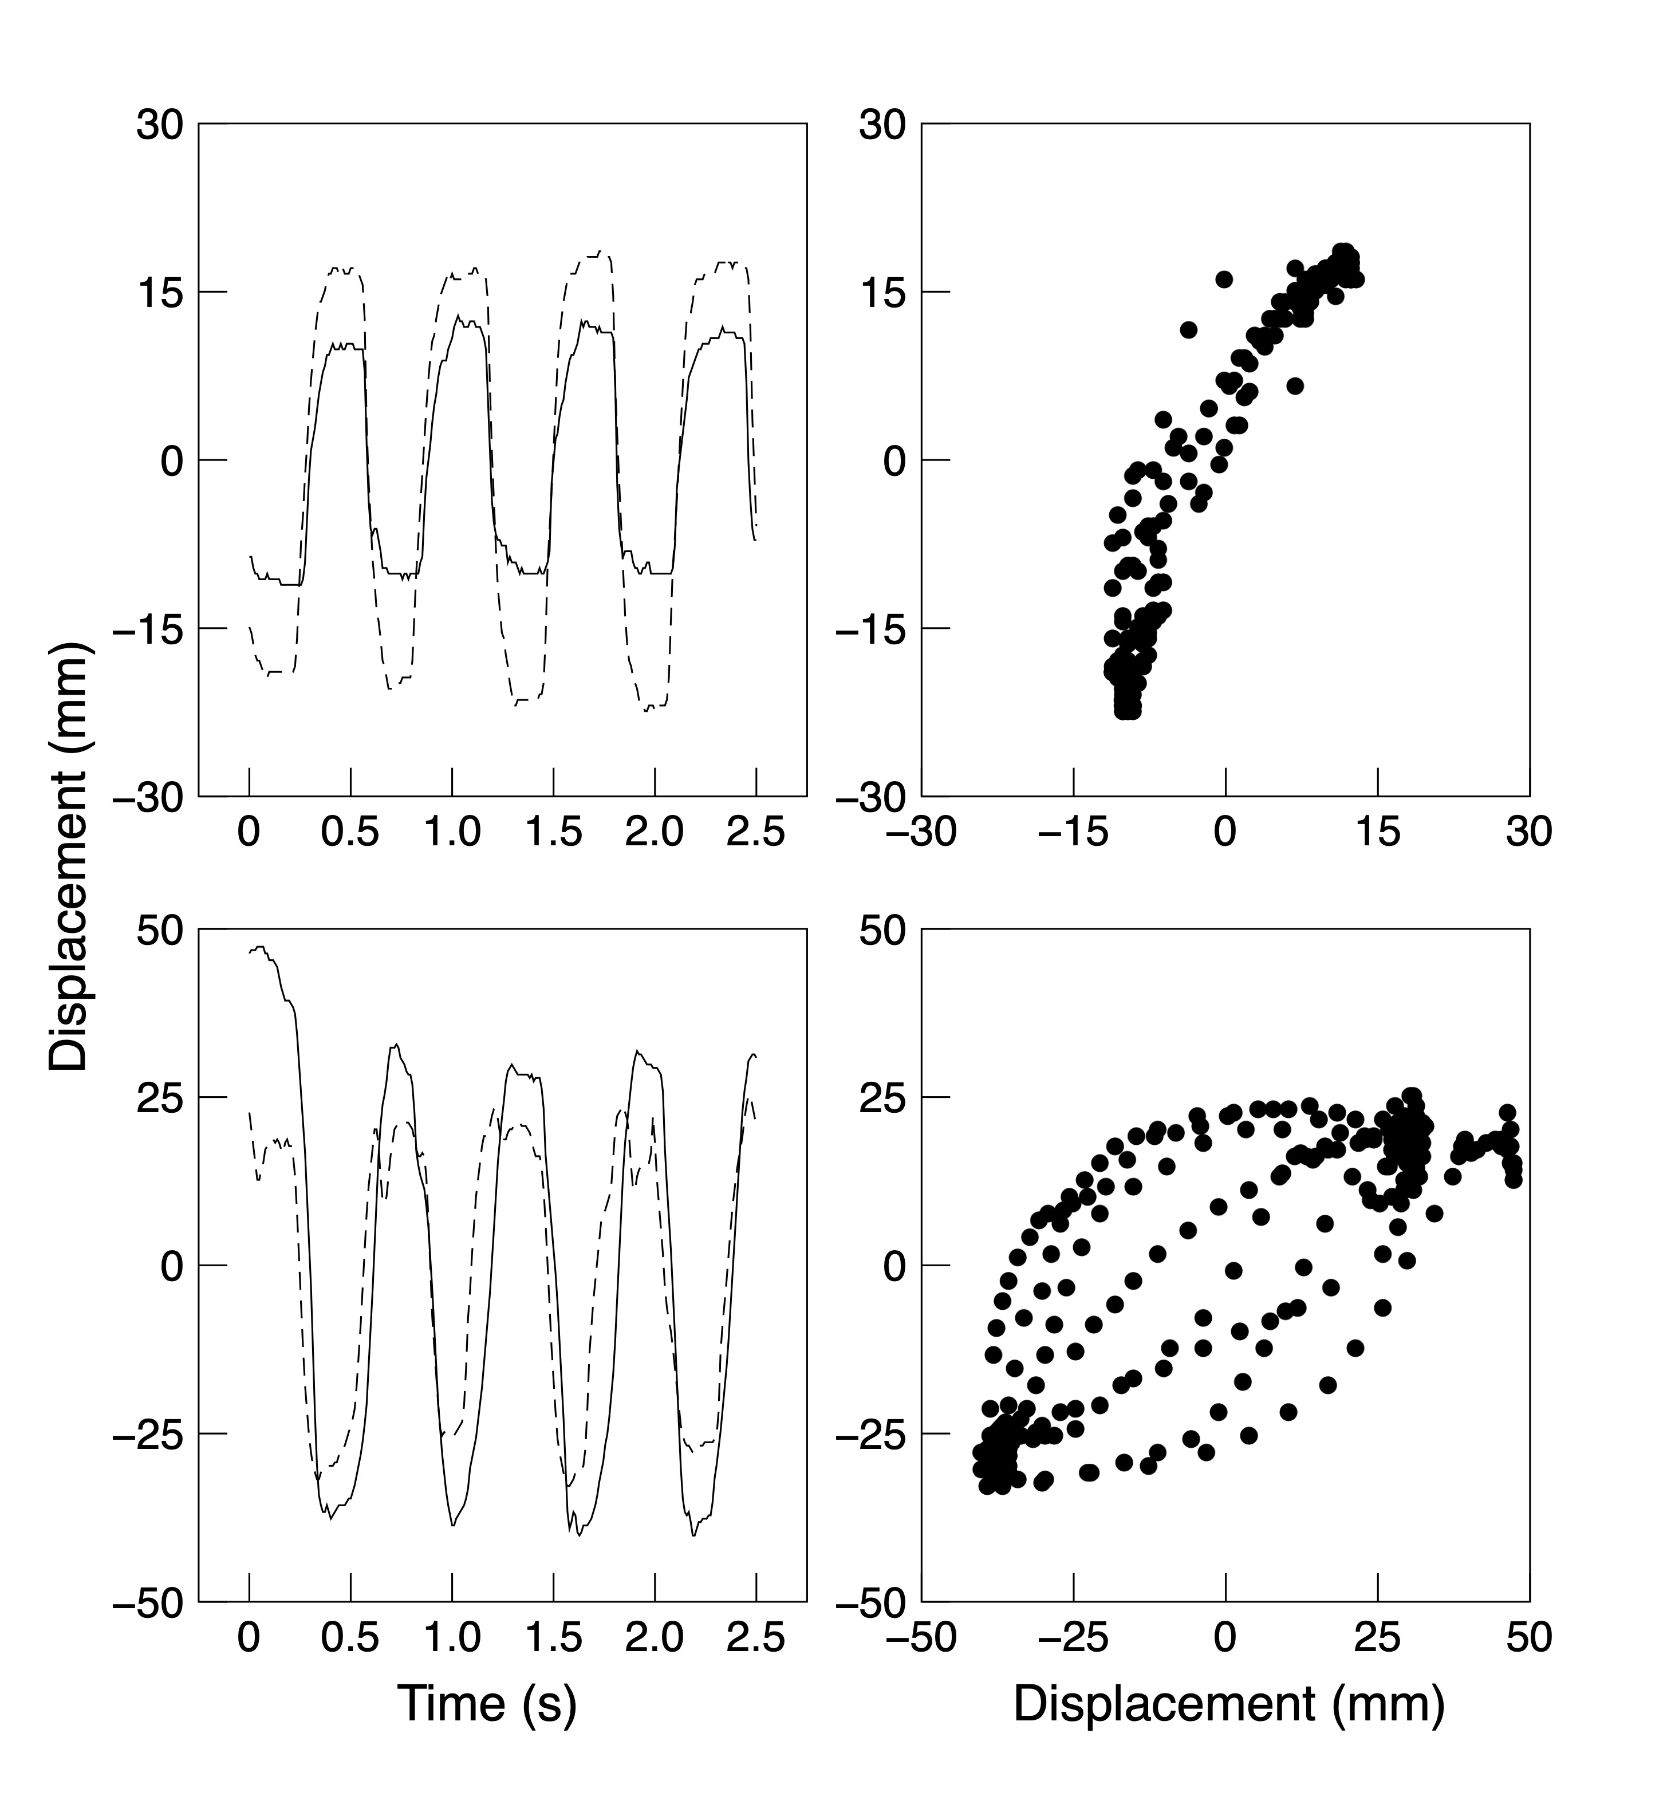
Figure 1. Representative position displacement along the main axis of movement at slowest speed. Left top: Solo symmetrical movement. Left bottom: Joint symmetrical movement. In both left-side panels, the displacement of one finger has been reversed for ease of comparison. Right: Plot of one finger position versus the other over time for the corresponding trajectories shown in the left-side panels.
In contrast to alignment error, temporal error is hypothesized to depend on the time it takes to generate error signals necessary for movement adjustments. In particular, if processing the error signal takes time, t_{e}, this will translate into a phase angle error that depends on the metronome speed: The faster the metronome, the greater the phase angle error that will be generated in a given time delay. Thus, we can write
$$Ψ_{e}=t_{e}r$$
where Ψ_{e} is the phase angle error measured in radians, t_{e} is the time delay in seconds, and r is the metronome speed in radians/second. As shown below in the description of the results, this contribution to phase angle error increases with metronome speed in an approximately linear fashion. This means that for a given increase in speed, there is a fixed increase in phase angle error. This can be expressed as:
$$ΔΨ_{e}=t_{e}Δr$$
In particular, this implies that the slope of the linear increase provides an estimate of the time delay:
$\frac{ΔΨ_{e}}{Δr}=t_{e}$ (1)
A simple interpretation of such a linear increase is that one finger lags the other by a fixed amount of time. This produces greater phase angle error with greater metronome speed, and the slope of the linear increase provides a measure of the time delay. The greater the slope, the greater the time delay between the fingers. Our interpretation is that conditions that lead to larger temporal error are those that correspond to a larger time lag between the fingers. We further suggest that the minimization of temporal error is likely the key element in the superior performance observed for symmetrical as compared to parallel movements (Kelso, 1981, 1984; Mechsner et al., 2001; Riek et al., 1992; Scholz & Kelso, 1989).
If our hypothesized separation of error into alignment and temporal error is valid, the distinction should be evident in different variants of the finger oscillation task. First, as the minimization of alignment error is hypothesized to be largely due to the ability to construct a movement in which the angles of the different effectors are aligned as closely as possible over the course of a cycle, then alignment error should be greater for joint as opposed to solo actors. This is because the former involves fingers with differing anatomical details, operating under divided control. However, this difference ought to be largely unaffected by whether the movements are symmetrical or parallel. Second, the minimization of temporal error is hypothesized to involve the updating of a motor plan based on an error signal. This process is likely to be relatively efficient for symmetrical movements for which an attentional focus strategy is available. However, it should be less efficient for parallel movements for which an attentional switching strategy is employed. Thus, we would expect temporal error to be smaller for symmetrical as opposed to parallel performance of the finger oscillation task. Further, this should be true regardless of whether the task was performed by an individual or shared in a joint action.
Overview of the Present Investigation
To evaluate our hypotheses regarding alignment versus temporal error in solo versus joint action, as well as the attentional account of bimanual control, we tested performance in the finger oscillation task in symmetrical and parallel movement conditions in both individuals and pairs. In our version of the task, participants attempt to keep the two fingers in synchrony with each other while simultaneously moving in time to a metronome. As in many previous studies (e.g., Kelso, 1981, 1984; Mechsner et al., 2001), trials started off at a slow pace and then gradually increased in speed. In contrast to those studies, however, we instructed participants to maintain the target movement pattern as best as they could and to actively resist the temptation to lapse into an easier mode. This instruction was intended to challenge participants to optimize their performance regardless of how difficult the task might become at higher speeds.
In Experiment 1, we tested two hypotheses. First, solo performance should correspond with lower alignment error than joint performance due to better coordination during unified versus divided control. However, there should be little impact of solo versus joint condition on temporal error because both solo and joint actors should use an attentional focus strategy to minimize temporal error. Second, performance in the symmetrical and parallel conditions should differ on temporal error due to the use of an attentional focus strategy to minimize such error. However, no such effect should be found on alignment error which depends on internal factors of divided/unified control and anatomical considerations. The results were partially consistent with these predictions: Alignment error was larger for joint performance than for solo, and temporal error was smaller in the symmetrical movement condition than in the parallel condition, but only for solo actors. Interestingly, joint actors did not show a symmetry effect on temporal error, suggesting that other processes might be involved.
In Experiment 2, we examined the possibility that the symmetry effect might be unique to solo performance because it benefits from the use of homologous muscle pairings (Carson, 1996; Cattaert et al., 1999; Marteniuk et al., 1984; Swinnen et al., 1997). This was tested by including conditions in which one hand was inverted relative to the other (cf. Mechsner et al., 2001). Results showed that the symmetry effect on temporal error in solo performers occurred regardless of hand orientation, again supporting our attentional focus explanation.
Finally, in Experiment 3, we examined the hypothesis that the failure to find a symmetry effect for joint actors in the earlier experiments might be due to feedback interference, the idea that joint performance suffered because feedback-based adjustments made by each actor were uncoordinated, leading to overcorrections. When visual information was eliminated for one actor, the predicted effect of symmetry on joint performance was obtained.

Experiment 1
Experiment 1 compared alignment and temporal error during either symmetrical or parallel oscillations of the index finger in solo and joint action. Overall, we expected alignment error to be smaller when both fingers were under unified control (solo condition) than when control was divided (joint condition). This was based on the notion that unified control would make it easier than divided control to coordinate the movement paths of the two fingers. We also expected that both solo and joint actors would have lower temporal error in the symmetrical versus parallel conditions. This prediction was based on the idea that with symmetrical movements both solo and joint actors would be able to use an attentional focus strategy due to the two fingers converging on an attentional spotlight once per cycle, whereas both individuals and pairs would have to use the less effective attentional switching strategy when performing parallel movements.
Method
Participants. Twenty-two undergraduates at the University of Alberta (randomly assigned to eleven pairs) served as participants in exchange for course credit. All participants had normal or corrected vision, no motor impairments, and all gave informed consent prior to participating. The experimental protocol for all experiments reported here was approved by the University of Alberta Research Ethics Board. Neither author had any conflict of interest in this investigation.
Procedure. Participants rested their hand(s) on a table top and held their index fingers pointed away from their body and initially parallel to each other. Participants were told to move their fingers back and forth, parallel to the table top in time with a metronome recording and in synchrony with each other. On solo trials one participant used both their left and right hand to perform the task, whereas on joint trials each participant used one hand to perform the task and rested the non-moving hand comfortably in their lap. These movements are illustrated in Figure 2: Panel a shows two positions for the solo symmetrical movements, while panels b and c show two positions for joint parallel movements.
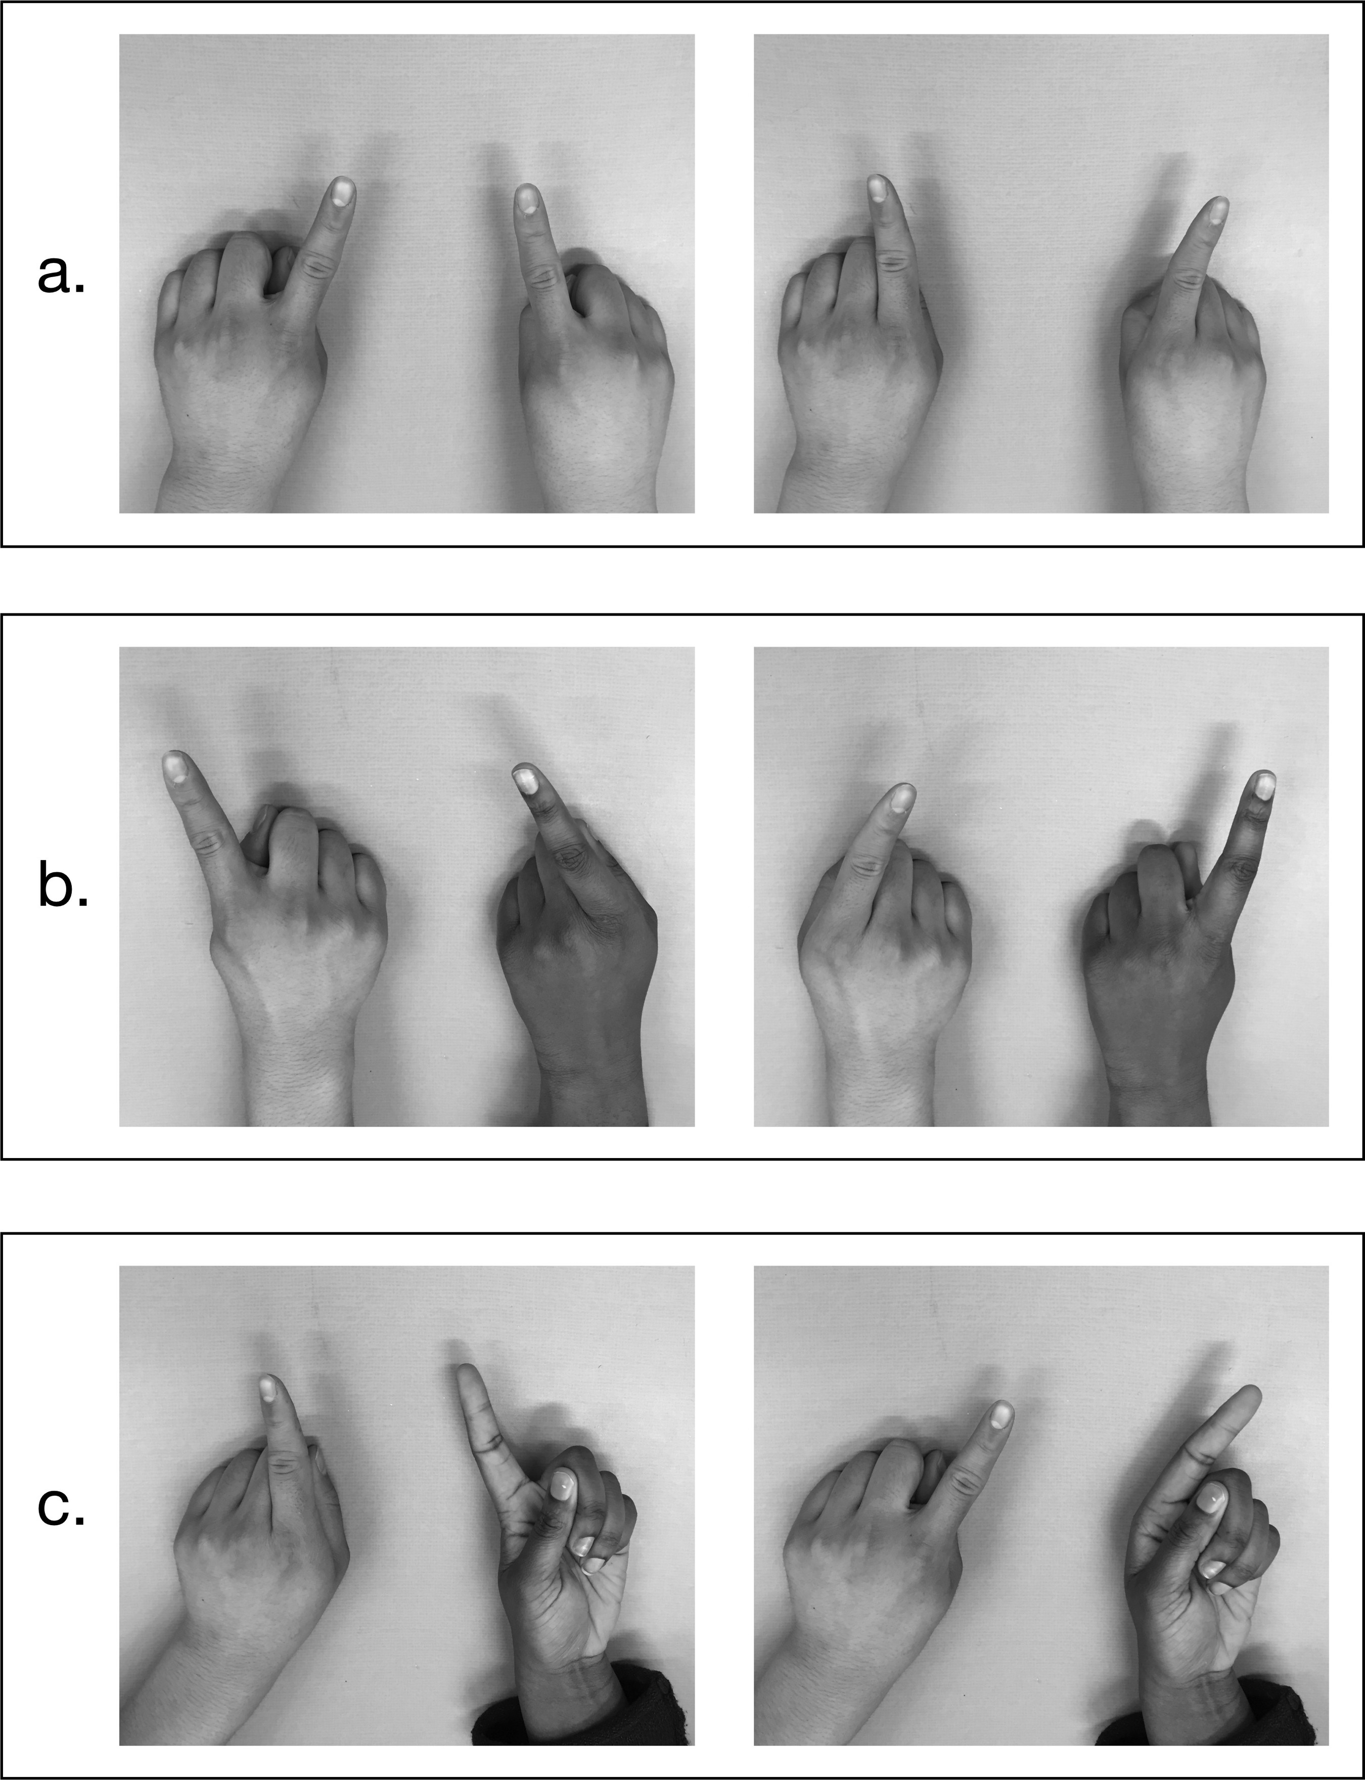
Figure 2. Example hand positions: a. Solo symmetrical; b. Joint parallel; c. Joint parallel, opposite hand orientation (Experiment 2).

The timing signal on each trial was a series of metronome “ticks” and “tocks,” gradually increasing in speed, that was played over the computer speaker. The signal consisted of 12 epochs, with each epoch consisting of 8 metronome beats, or 4 movement cycles. The first and second epoch were at 8.80 radians/s, and each subsequent epoch increased by 1.26 radians/s, with the last epoch presented at 21.36 radians/s. The first epoch was used for familiarization and preparation, and participants began moving their index fingers in time to the beat when the experimenter signaled the start of the second epoch. Participants were encouraged to stay with the designated task, either parallel or symmetrical movements, even at higher speeds. It is possible that some temporary phase transitions occurred in the more difficult conditions, but these were not explicitly identified.
Design. There were four conditions determined by combining movement condition (symmetrical or parallel) and task (solo or joint). There was a total of 42 trials in the experiment. The trial types were arranged in a fixed order as shown in Table 1. The two types of solo trials each began with two practice trials followed by three test trials; the eight types of joint trials began with a single practice trial followed by three test trials. Note that joint trials varied in terms of which hand each participant contributed to the task. On solo trials, data were collected from the left and right hands of both participants simultaneously; on joint trials, data were collected from one hand of the participant seated on the left and one hand of the participant seated on the right. The easiest conditions were generally presented first. Although practice effects were minimal, any improvement over the course of the session tended to work against the obtained effects.

Table 1. Trial Order in Experiment 1
Condition | Task | Hand on Left | Hand on Right
Solo | Symmetrical | Left | Right
Solo | Parallel | Left | Right
Joint | Symmetrical | Right | Left
Joint | Parallel | Right | Left
Joint | Symmetrical | Left | Right
Joint | Parallel | Left | Right
Joint | Symmetrical | Left | Left
Joint | Parallel | Left | Left
Joint | Symmetrical | Right | Right
Joint | Parallel | Right | Right

Apparatus. Motion of the fingers was recorded using an Ascension Technologies MiniBird motion tracking system and stored for offline analysis. Data were recorded from each sensor at 100 Hz with a resolution of 0.5 mm in three dimensions. The system had an RMS static positional accuracy of 1.8 mm averaged over the translational range of 180 cm. Sensors were attached to the fingertips of the left and right index fingers of both participants using medical tape.
Analysis. For each finger and epoch within a trial, a fast Fourier transform was performed on the x and y coordinates separately. These transformed signals were filtered by omitting the dc component and components beyond 20 cycles/epoch. Although participants were instructed to hold their index fingers straight ahead, there was some variation across participants, hands, and conditions in the precise range of angles that each finger moved. In order to measure the oscillations independent of these variations in the angle at which the finger was held, the Fourier-transformed x and y signals for each finger were summed in the complex plane at each frequency. The combined signal was then normalized to have a total power of 1 to control for differences in how far participants moved their fingers. To construct a measure of performance, we computed the error power, that is, the power in the signal constructed by subtracting the signal for one finger from that for the other. For symmetrical conditions, the signal for one finger was rotated 180˚. Error power was then converted to an aggregate phase angle difference using an inverse cosine transformation: a = cos⁻¹(1-p/2), where p is the error power. This measure is comparable to mean phase angle difference across frequencies, weighted by the power at each frequency. Henceforth, we use the terms “phase angle difference,” “phase angle error,” or simply “error” to refer to the (Fourier-transformed) difference in phase angle between the two fingers. Note that there is no simple relationship between phase angle (in the Fourier domain) and the finger joint angle (in the time domain).
For each participant and condition, a linear regression was performed to distinguish alignment and temporal error. In the regression, the aggregate phase angle difference during each epoch was predicted as a function of metronome speed in that epoch. Temporal error was taken to be the slope of the regression line, as per Equation 1. Alignment error was taken to be the error (estimated from the regression line) at the slowest speed used in design. Any contribution of temporal error at this speed should be minimal since participants generally had little difficulty in keeping up with the metronome. (Theoretically, it might be possible to estimate alignment error by examining the zero intercept of the regression line. However, such estimates involve extrapolating well beyond the range of speeds used in our design and were unstable in our data. More generally, the clear difference in the patterns of effects observed for temporal and alignment error supports the argument that these two sources of error are distinct.)
These measures were analyzed using linear mixed-effects models. In this approach, the random-effects structure must be explicitly identified. The pair was assumed to be the random sampling unit. Preliminary analyses suggested that the best models included an effect of performance type (solo or joint) that varied randomly with pair.
Evidence for different interpretations of the results were assessed by comparing nested models using likelihood ratios. Following the suggestion of Glover and Dixon (2004), the likelihood ratios were adjusted for the varying number of parameters in the models based on the Akaike Information Criterion (AIC; Akaike, 1973); we use the symbol, λ_{adj}, to indicate the adjusted likelihood ratio. Model comparisons based on these adjusted likelihood ratios were thus tantamount to model comparisons based on AIC values, a common approach to model selection. Burnham and Anderson (2002) refer to such adjusted likelihood ratios as evidence ratios.
Results
The aggregate phase angle difference is plotted as a function of metronome speed for each condition in Figure 3. From here, it is evident that alignment error (i.e., phase angle error at the slowest speeds) was smaller for solo versus joint actors, and was largely independent of symmetrical versus parallel movement condition. Further, temporal error (i.e., the rate of inflation of phase angle error as metronome speed increased) was much smaller in the solo/symmetrical condition than in the other three conditions. Below we present the analyses of alignment error and temporal error as a function of group and condition.

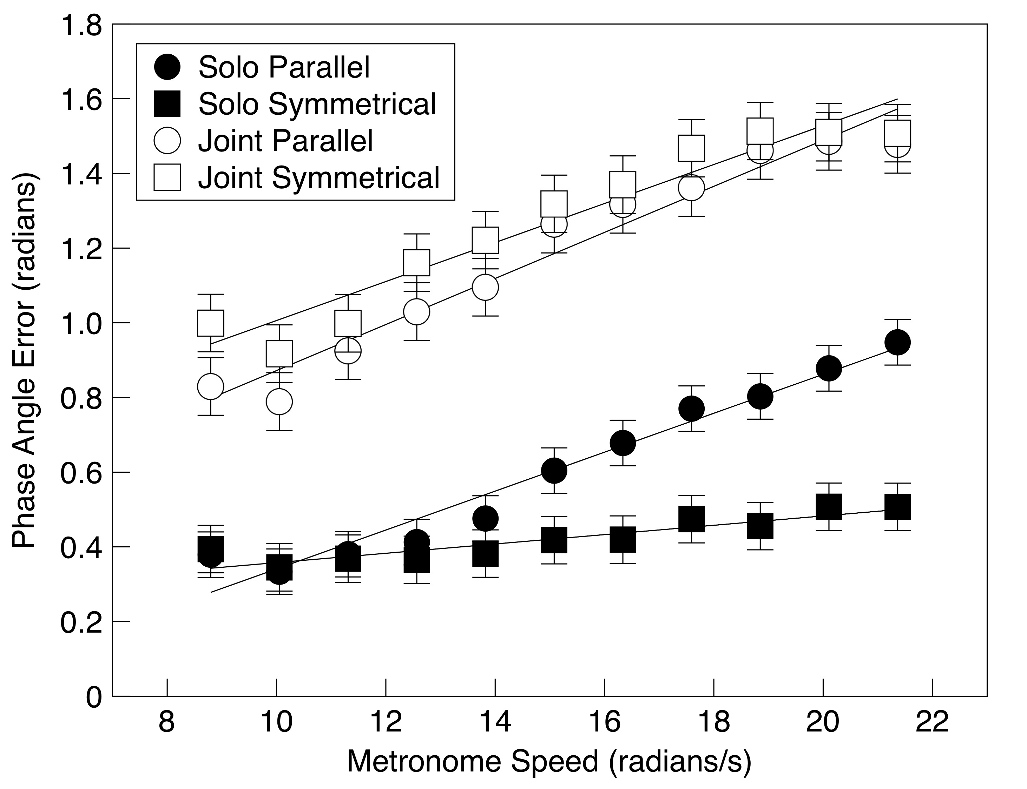

Figure 3. Phase angle error (in radians) as a function of metronome speed and condition in Experiment 1.

Alignment error. Figure 4 depicts alignment error as a function of condition. As predicted, alignment error was substantially larger for joint than for solo performance, suggesting joint actors had greater difficulty aligning their fingers, λ_{adj} > 1000. Alignment error was also smaller for parallel than for symmetrical movements in the joint condition, λ_{adj} = 22.33. There was no evidence that symmetry had an effect on alignment error during solo performance, λ_{adj} = 0.42.
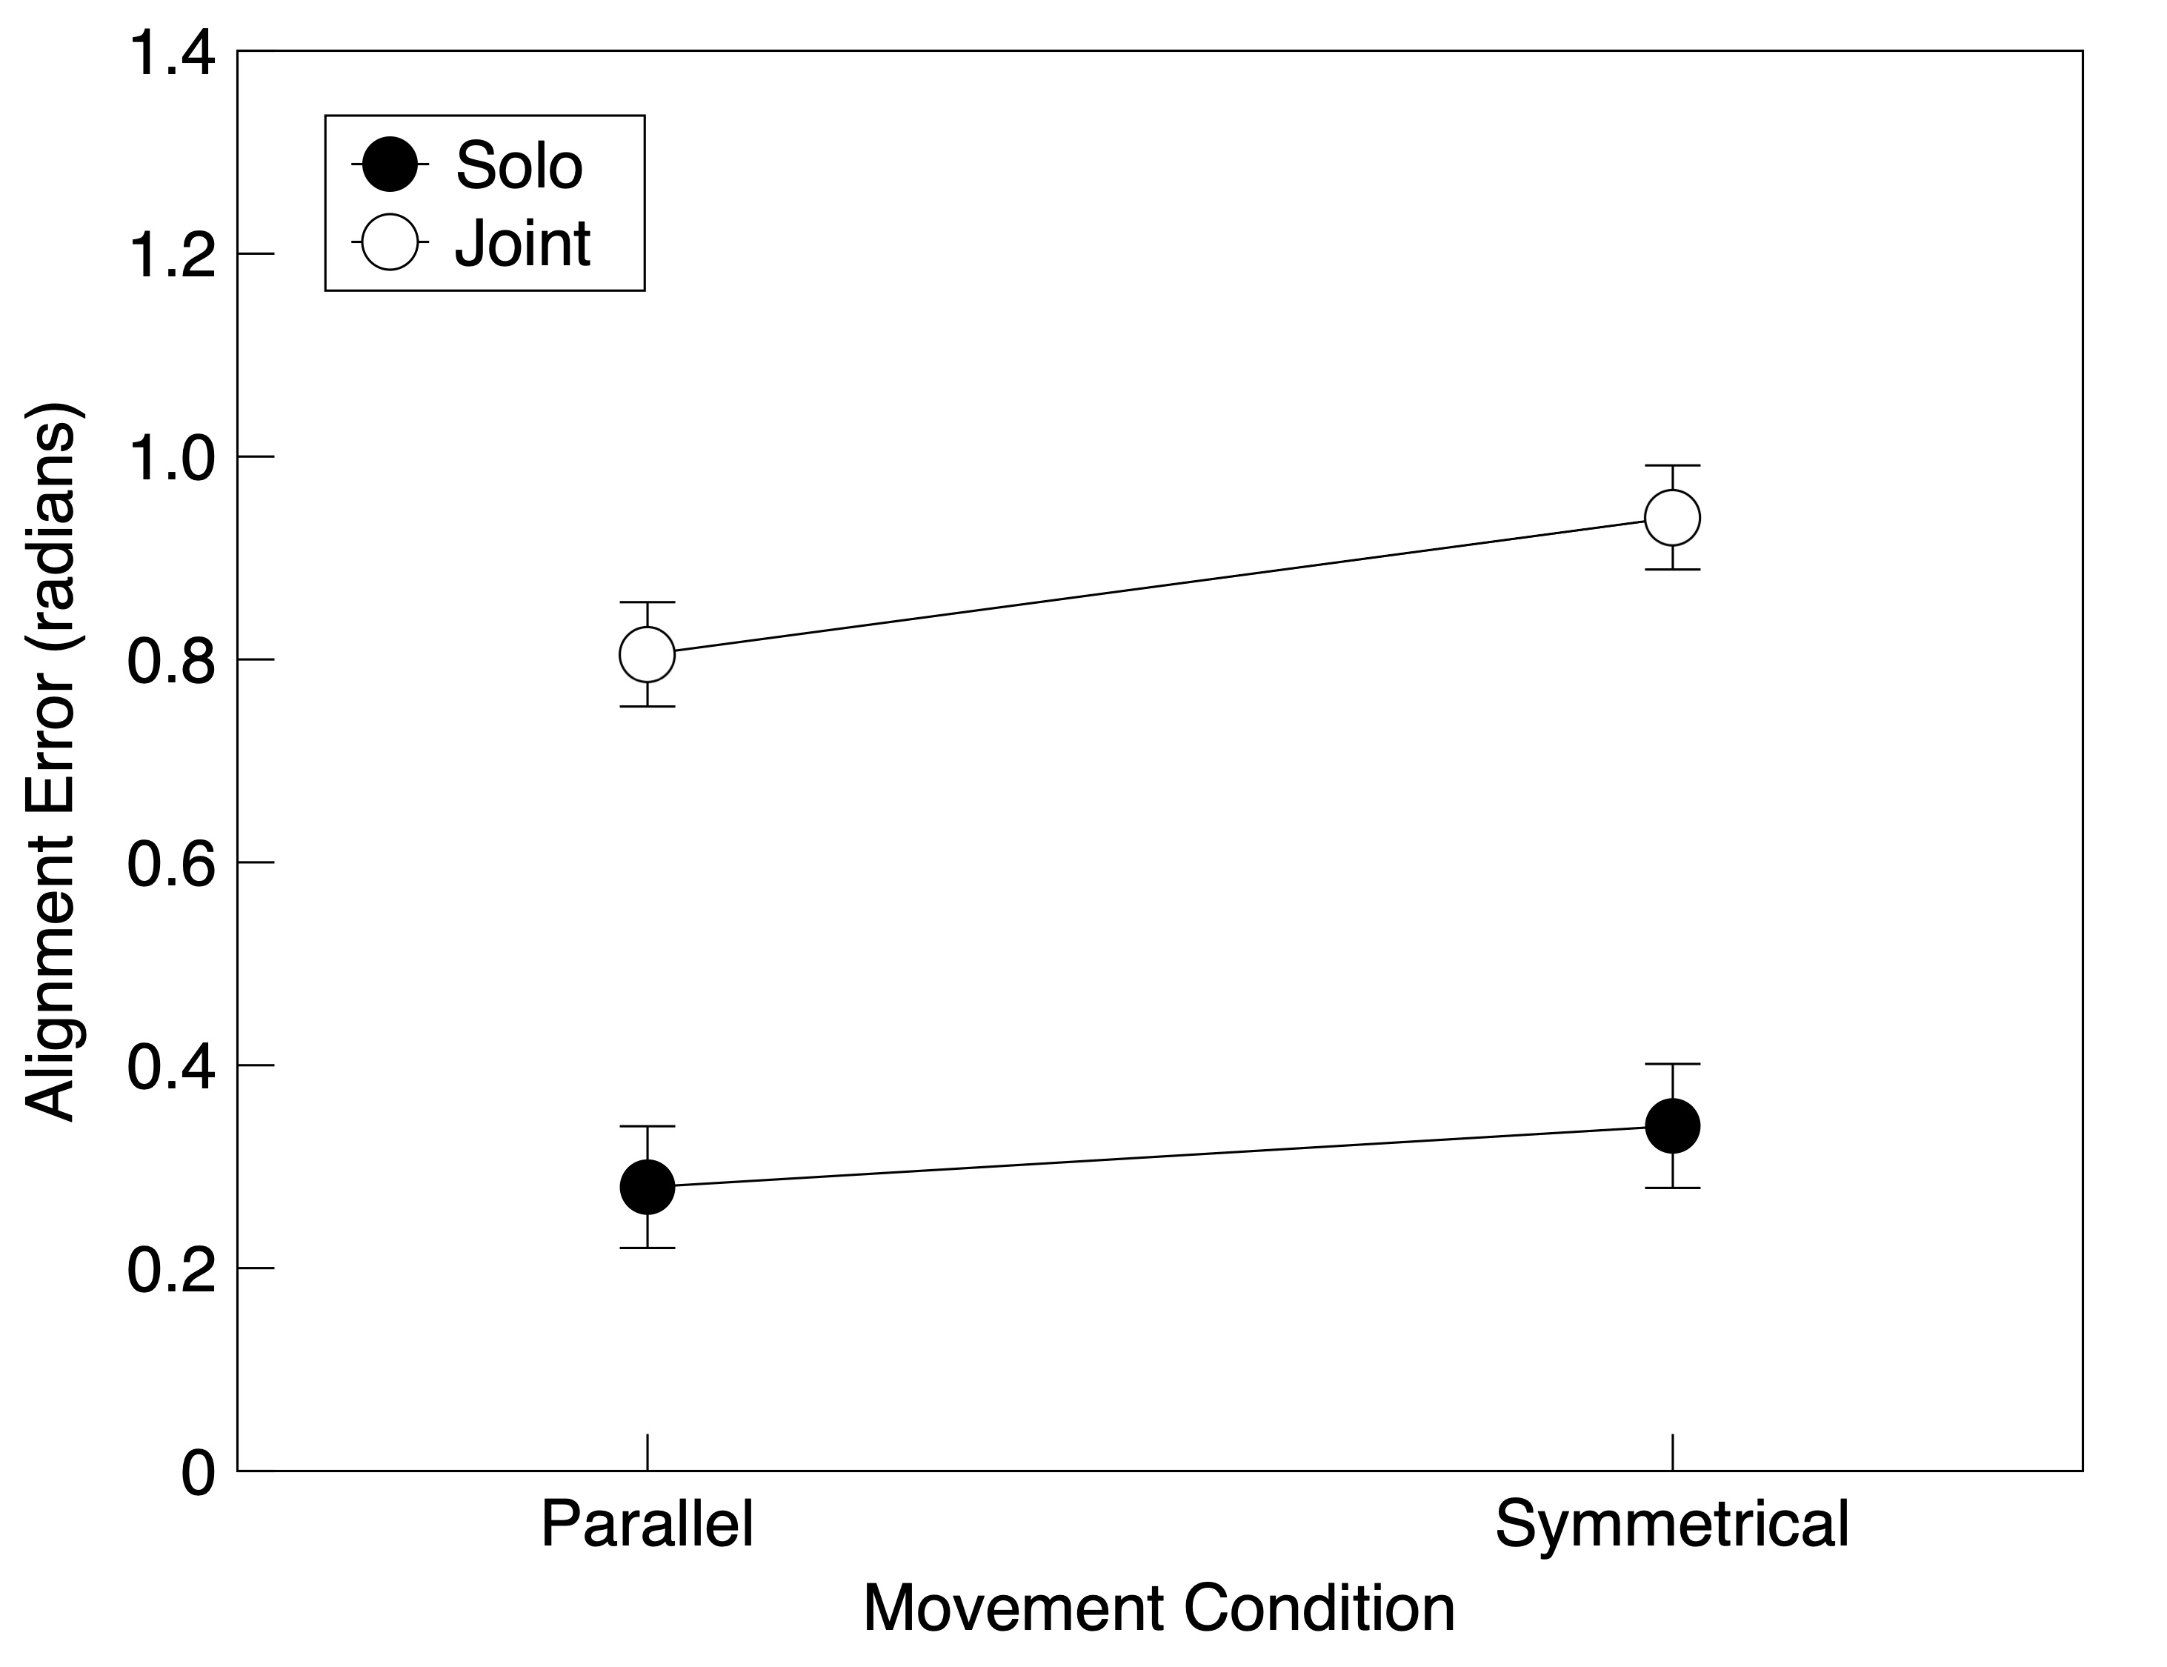

Figure 4. Alignment phase angle error (in radians) as a function of condition in Experiment 1. Error bars represent the standard error of the mean in each condition derived from the error terms in a full model fit.

Temporal error. Temporal error, the slope of the linear increase in phase angle error over time, is shown as a function of condition in Figure 5. As predicted, temporal error was minimal in the solo/symmetrical condition, but substantially higher in the solo/parallel condition, λ_{adj} > 1000. Further, there was some evidence that joint actors had greater temporal error on average than solo actors, λ_{adj} = 2.98. Finally, and in contrast to our prediction, there was little evidence for an effect of symmetry on temporal error in the joint condition, λ_{adj} = 0.79.
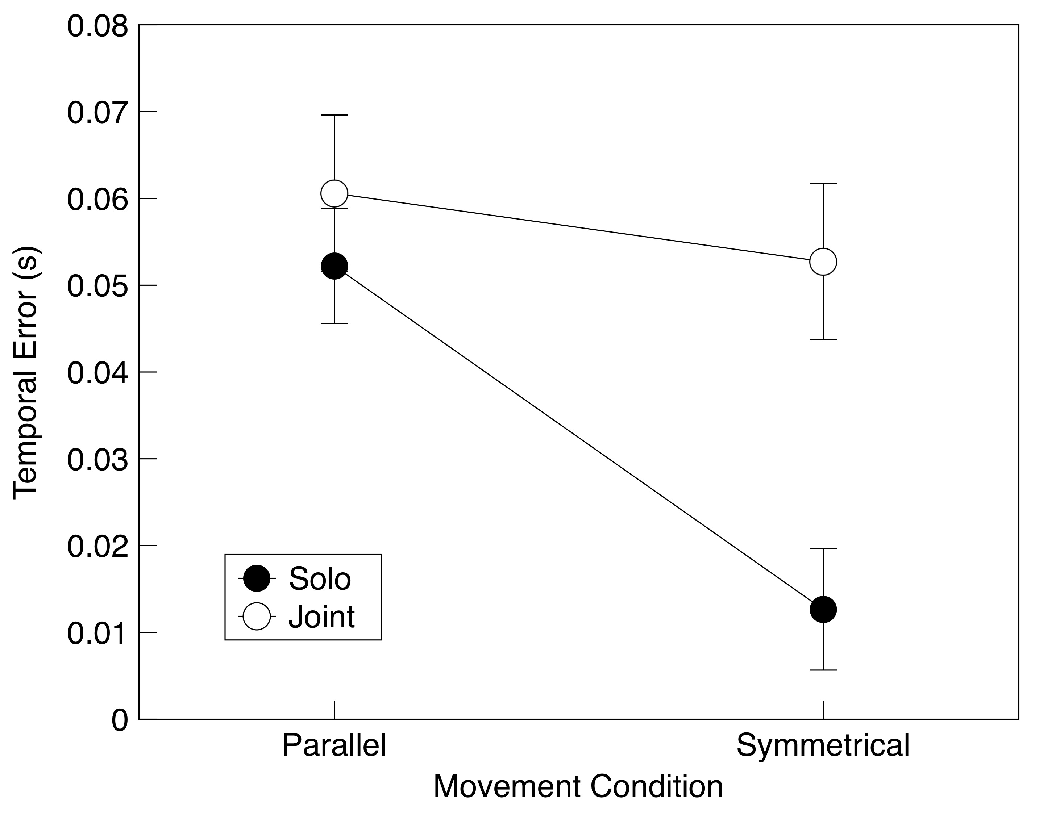

Figure 5. Temporal error as a function of condition in Experiment 1. Error bars represent the standard error of the mean in each condition derived from the error term in a full model fit.

Discussion
We found that different sources of error contributed to performance under different conditions of the finger oscillation task. For one, alignment error was larger for joint than for solo actors, as predicted based on the difficulty joint actors should have in aligning their effectors under divided control. For another, temporal error was affected by symmetry in solo actors. This is consistent with previous observations that performance deteriorates in the parallel condition mainly at higher speeds (Kelso, 1981, 1984; Mechsner et al., 2001; Riek et al., 1992; Scholz & Kelso, 1989). Our interpretation is that temporal error translates into an increasing phase angle error as oscillation rate increases. The main discrepancy from our predictions was that symmetry did not affect temporal error in the joint action conditions. This was surprising because we assumed that joint actors would be able to use an attentional focus strategy using a spatial locus centered between the two fingertips, just as solo actors would. We consider this result further in Experiments 2 and 3.
There was also a small and unanticipated effect of symmetry on alignment error with joint actors. We suspect that joint actors found it somewhat easier to align movement trajectories with parallel movements. In this condition, both fingers began moving in the same direction, and this may have made it easier to match their positions over the course of the movement cycle than when they moved in opposite directions.

Experiment 2
Although our attentional focus account was able to explain major aspects of the results of Experiment 1, previous researchers have proposed alternative explanations for the advantage of symmetrical movements. One argument is that coordination is easier for symmetrical oscillations because they involve the use of homologous muscle groups which tend to be activated together due to cross-talk between the two brain hemispheres (e.g., Cattaert et al., 1999; Swinnen et al., 1997). This view could explain why joint actors did not now show a performance advantage for symmetrical movements as solo actors did, as joint actors operate under divided control in which no internal cross-talk could occur. In an earlier study, Mechsner et al. (2001) provided evidence against the cross-talk view for solo actors. These authors disentangled the internal control from external feedback information by having participants perform the finger oscillation task with one palm down and the other up. Thus, when homologous muscles were used, the fingers would move in parallel rather than symmetrically. Their results showed that the advantage for the symmetrical pattern of movement was present even when non-homologous muscles were used, as was the case when the two hands were held in opposite orientations.
In the present experiment, we replicated the hand orientation manipulations used by Mechsner et al. (2001), included joint action conditions, and again separated error into alignment and temporal categories. If our attentional account of the finger oscillation task is correct, participants in the symmetrical versions of the task should still be able to use an attentional focus strategy regardless of whether hand orientation was matching or opposite. On this view, error could still be monitored once per cycle when the fingers came in close proximity to each other. This should result in a lower temporal error in the symmetrical condition regardless of hand orientation, consistent with Mechsner et al.’s results. Conversely, if the homologous muscle account is correct, relative hand orientation ought to interact with movement symmetry such that temporal error should be lower when homologous muscles are activated (the symmetrical/matching and parallel/opposite orientation conditions) and higher when non-homologous muscles are activated (the parallel/matching and symmetrical/opposite orientation conditions).
For alignment error, we again predicted that it would be greater in the joint action than in the solo action condition due to divided versus unified control. For solo actors, we also predicted an effect of hand orientation in which inverting one hand ought to result in greater alignment error relative to when both hands were held in the same orientation. This prediction was based on the intuition that matching trajectories should be more difficult when the hands were held in opposite orientations. In contrast, if the homologous muscle explanation for the symmetry view is correct, an advantage in alignment error might be expected whenever homologous muscle activations were involved, resulting in the same interaction between symmetry and hand orientation as this view predicted for temporal error.
Method
Participants. Twenty University of Alberta undergraduates (ten pairs) served as participants in exchange for course credit. Data from one other pair was not used because of a software error, and data from another pair was omitted because one participant failed to move her finger as prescribed.
Design. There were a total of 56 trials in the experiment. The sequence of trials is shown in Table 2. The first two types of solo trials each began with two practice trials followed by two test trials; the second two types of solo trials as well as the joint trials began with a single practice trial followed by two test trials.
Analysis. The data were analyzed as in Experiment 1.

Table 2. Trial Order in Experiment 2
Condition | Task | Hand on Left | Hand on Right | Left Hand Orientation | Right Hand Orientation
Solo | Parallel | Left | Right | Palm Down | Palm Down
Solo | Symmetrical | Left | Right | Palm Down | Palm Down
Solo | Parallel | Left | Right | Palm Up | Palm Down
Solo | Symmetrical | Left | Right | Palm Up | Palm Down
Joint | Parallel | Right | Left | Palm Down | Palm Down
Joint | Symmetrical | Right | Left | Palm Down | Palm Down
Joint | Parallel | Left | Left | Palm Down | Palm Down
Joint | Symmetrical | Left | Left | Palm Down | Palm Down
Joint | Parallel | Right | Right | Palm Down | Palm Down
Joint | Symmetrical | Right | Right | Palm Down | Palm Down
Joint | Parallel | Right | Left | Palm Up | Palm Down
Joint | Symmetrical | Right | Left | Palm Up | Palm Down
Joint | Parallel | Right | Left | Palm Down | Palm Up
Joint | Symmetrical | Right | Left | Palm Down | Palm Up
Joint | Parallel | Right | Right | Palm Up | Palm Down
Joint | Symmetrical | Right | Right | Palm Up | Palm Down
Joint | Parallel | Left | Left | Palm Down | Palm Up
Joint | Symmetrical | Left | Left | Palm Down | Palm Up

Results
Alignment error. Figure 6 shows alignment error as a function of condition. As we predicted, alignment error was again larger in joint than in solo conditions, λ_{adj} = 14.50. For solo actors, it was also smaller when the hands were held in matching as opposed to opposite orientations, λ_{adj} = 17.07, again consistent with our prediction. Similar to Experiment 1, there was a fairly small symmetry effect in the joint action conditions in which alignment error was smaller in the parallel than symmetrical condition, λ_{adj} = 206.88. There was no evidence that a full model that included all effects and interactions was better than a model including only the aforementioned effects, λ_{adj} = 0.05. Thus, there was no evidence for the prediction of the homologous muscle view of an interaction between symmetry and hand orientation on alignment error.

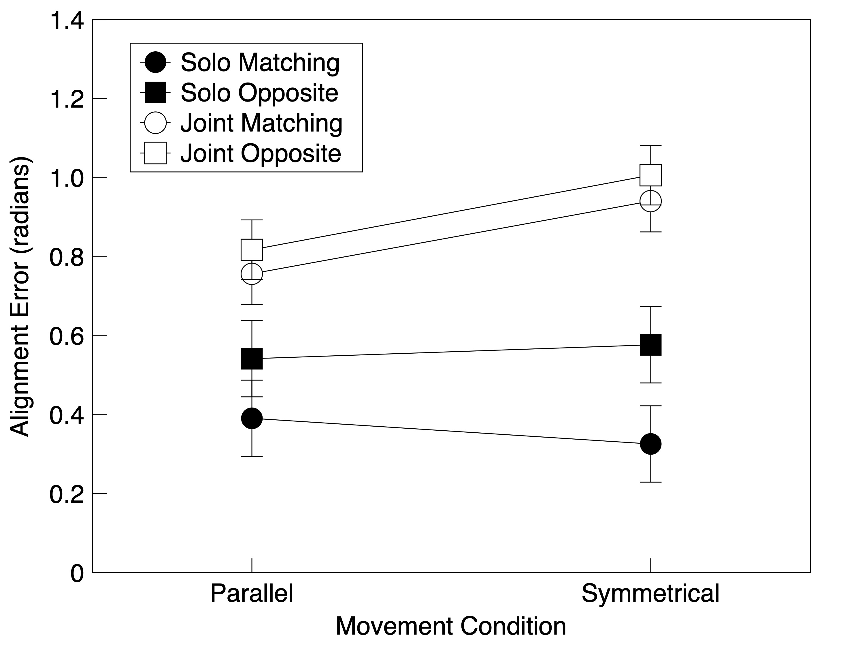
Figure 6. Effects of task (solo or joint) and matching or opposite hand orientation on alignment error in Experiment 2, measured in radians. Error bars represent the standard error of the mean in each condition derived from the error term in a full model fit.

Temporal error. As shown in Figure 7 and in line with our prediction, temporal error was small in the solo/symmetrical condition regardless of whether the hands were held in matching or opposite orientations. In all of the other conditions, temporal error was larger and comparable. Similar to Experiment 1, temporal error for the joint conditions was unaffected by symmetry, and temporal error in the solo/parallel condition was similar to overall joint performance.
This interpretation was supported by the comparison of nested models. A model incorporating a contrast between the effect in the solo/symmetrical conditions and that in the other conditions was superior to a null model in which there were no differences across conditions and tasks, λ_{adj} = 67.67. There was no evidence that incorporating all of the effects and interactions among hand orientation, task, and movement condition improved the fit, λ_{adj} = 0.01. The effect of symmetry on temporal error, and the lack of an interaction between symmetry and hand orientation, further supported the attentional focus view but was inconsistent with the homologous muscle view.

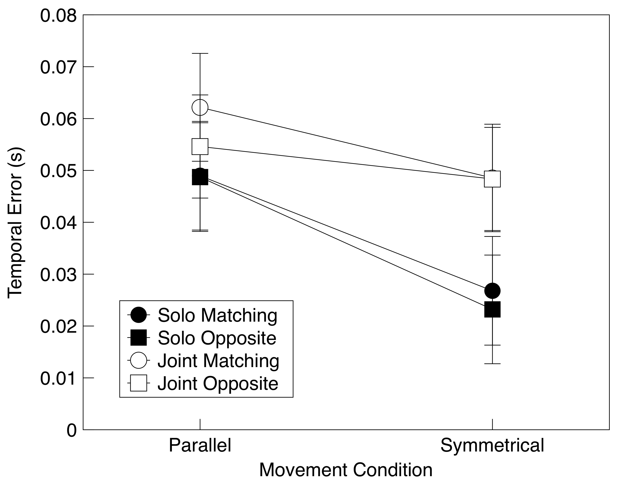
Figure 7. Effects of task (solo or joint) and hand-orientation (matching or opposite) on temporal error in Experiment 2. Error bars represent the standard error of the mean in each condition derived from the error term in a full model fit.

Discussion
The results in the solo conditions were consistent with those of Experiment 1 and of Mechsner et al. (2001). Symmetrical movements led to substantially less temporal error than did parallel movements regardless of the orientation of the hands. This result confirms that external perceptual information is more critical to this task than the internal organization of the muscle commands. It is also consistent with our view that the symmetrical version of the task allows solo participants to use an attentional focus strategy based on the convergence of the fingers at an attentional anchor point, as this strategy would have been available regardless of whether the hand orientations matched. The lack of an interaction between symmetry and hand orientation argues against the notion that the symmetry effects on temporal error observed with solo actors in Experiments 1 and 2 could be ascribed to the use of homologous muscles.
The results for alignment error replicated the advantage of solo over joint performance found in Experiment 1. It seems apparent that solo actors are better able to align their movement trajectories than are joint actors. Not surprisingly, this was more difficult with different hand orientations because the positions of the two fingers may be less likely to align when one hand is inverted relative to the other. Finally, the lack of an interaction between symmetry and hand orientation on alignment error in the solo action condition was again inconsistent with the homologous muscle view.

Experiment 3
In both Experiments 1 and 2, there was no symmetry effect on temporal error in the joint action condition, suggesting that joint actors were unable to effectively utilize an attentional focus strategy in the symmetrical condition. We speculated that the difficulty joint actors have under these conditions may be due to interference caused by the simultaneous use of feedback by two independent motor systems under divided control. In particular, if both participants make use of the same error signal and adjust their own finger’s movement accordingly, the net result for both fingers may be an overcorrection. For example, if the first participant notices that he or she is leading the other participant by 0.2 s, they may slow their next cycle down by 0.2 s. However, if the other participant uses the same feedback in the same way, they might speed up the next cycle by 0.2 s. The net result would be that the two fingers will still be out of synch by 0.2 s, but in the opposite direction. Our reasoning was that the use of feedback under divided control could prevent joint actors from using an attentional focus strategy effectively. This would clearly not be the case for solo actors, however, as unified control would allow for the coordinated use of feedback.
To evaluate this hypothesis, we used the same basic task conditions as in Experiment 1, but added a condition in which only one person in each joint action pair was allowed visual feedback. In this “joint/single-vision” condition, one participant was asked to close their eyes during the trial and to simply coordinate their movements with the timing of the metronome, while the other participant was instructed to keep their eyes open and to coordinate their movements both with their partner and the metronome. The same joint conditions used in Experiment 1, referred to here as “joint/dual-vision,” were included for comparison, as were the standard solo conditions from Experiment 1. If the failure to minimize temporal error in the joint/symmetrical conditions in Experiments 1 and 2 was due to feedback interference, removing feedback from one of the actors ought to improve joint performance and result in a smaller temporal error for symmetrical than parallel movements on joint/single-vision trials.
Method
Participants. Twenty-four University of Alberta undergraduates (twelve pairs) served as participants in exchange for course credit.
Design. There were a total of 56 trials in the experiment. The sequence of trial types is shown in Table 3. In each case, the trial type began with a practice trial followed by three test trials.
Analysis. Data were analyzed as before.
Table 3. Trial Order in Experiment 3
Condition | Task | Hand on Left | Hand on Right | Vision
Solo | Parallel | Left | Right | –
Solo | Symmetrical | Left | Right | –
Joint | Parallel | Right | Left | Dual
Joint | Symmetrical | Right | Left | Dual
Joint | Parallel | Left | Right | Dual
Joint | Symmetrical | Left | Right | Dual
Joint | Parallel | Right | Left | Single-Right
Joint | Symmetrical | Right | Left | Single-Right
Joint | Parallel | Right | Left | Single-Left
Joint | Symmetrical | Right | Left | Single-Left
Joint | Parallel | Left | Right | Single-Right
Joint | Symmetrical | Left | Right | Single-Right
Joint | Parallel | Left | Right | Single-Left
Joint | Symmetrical | Left | Right | Single-Left

Results
Alignment error. Figure 8 shows that as before, joint actors exhibited larger alignment error than solo actors, λ_{adj} > 1,000. Also as before, there was a modest effect of symmetry for joint actors in which symmetrical movements had higher alignment error than parallel movements, λ_{adj} > 1,000. There was also evidence for a symmetry effect for individuals, with larger alignment error with parallel movements, λ_{adj} = 10.62. There was no evidence that a full model including all effects and interactions was any better than a model including only the above-mentioned factors, λ_{adj} = 1.24.

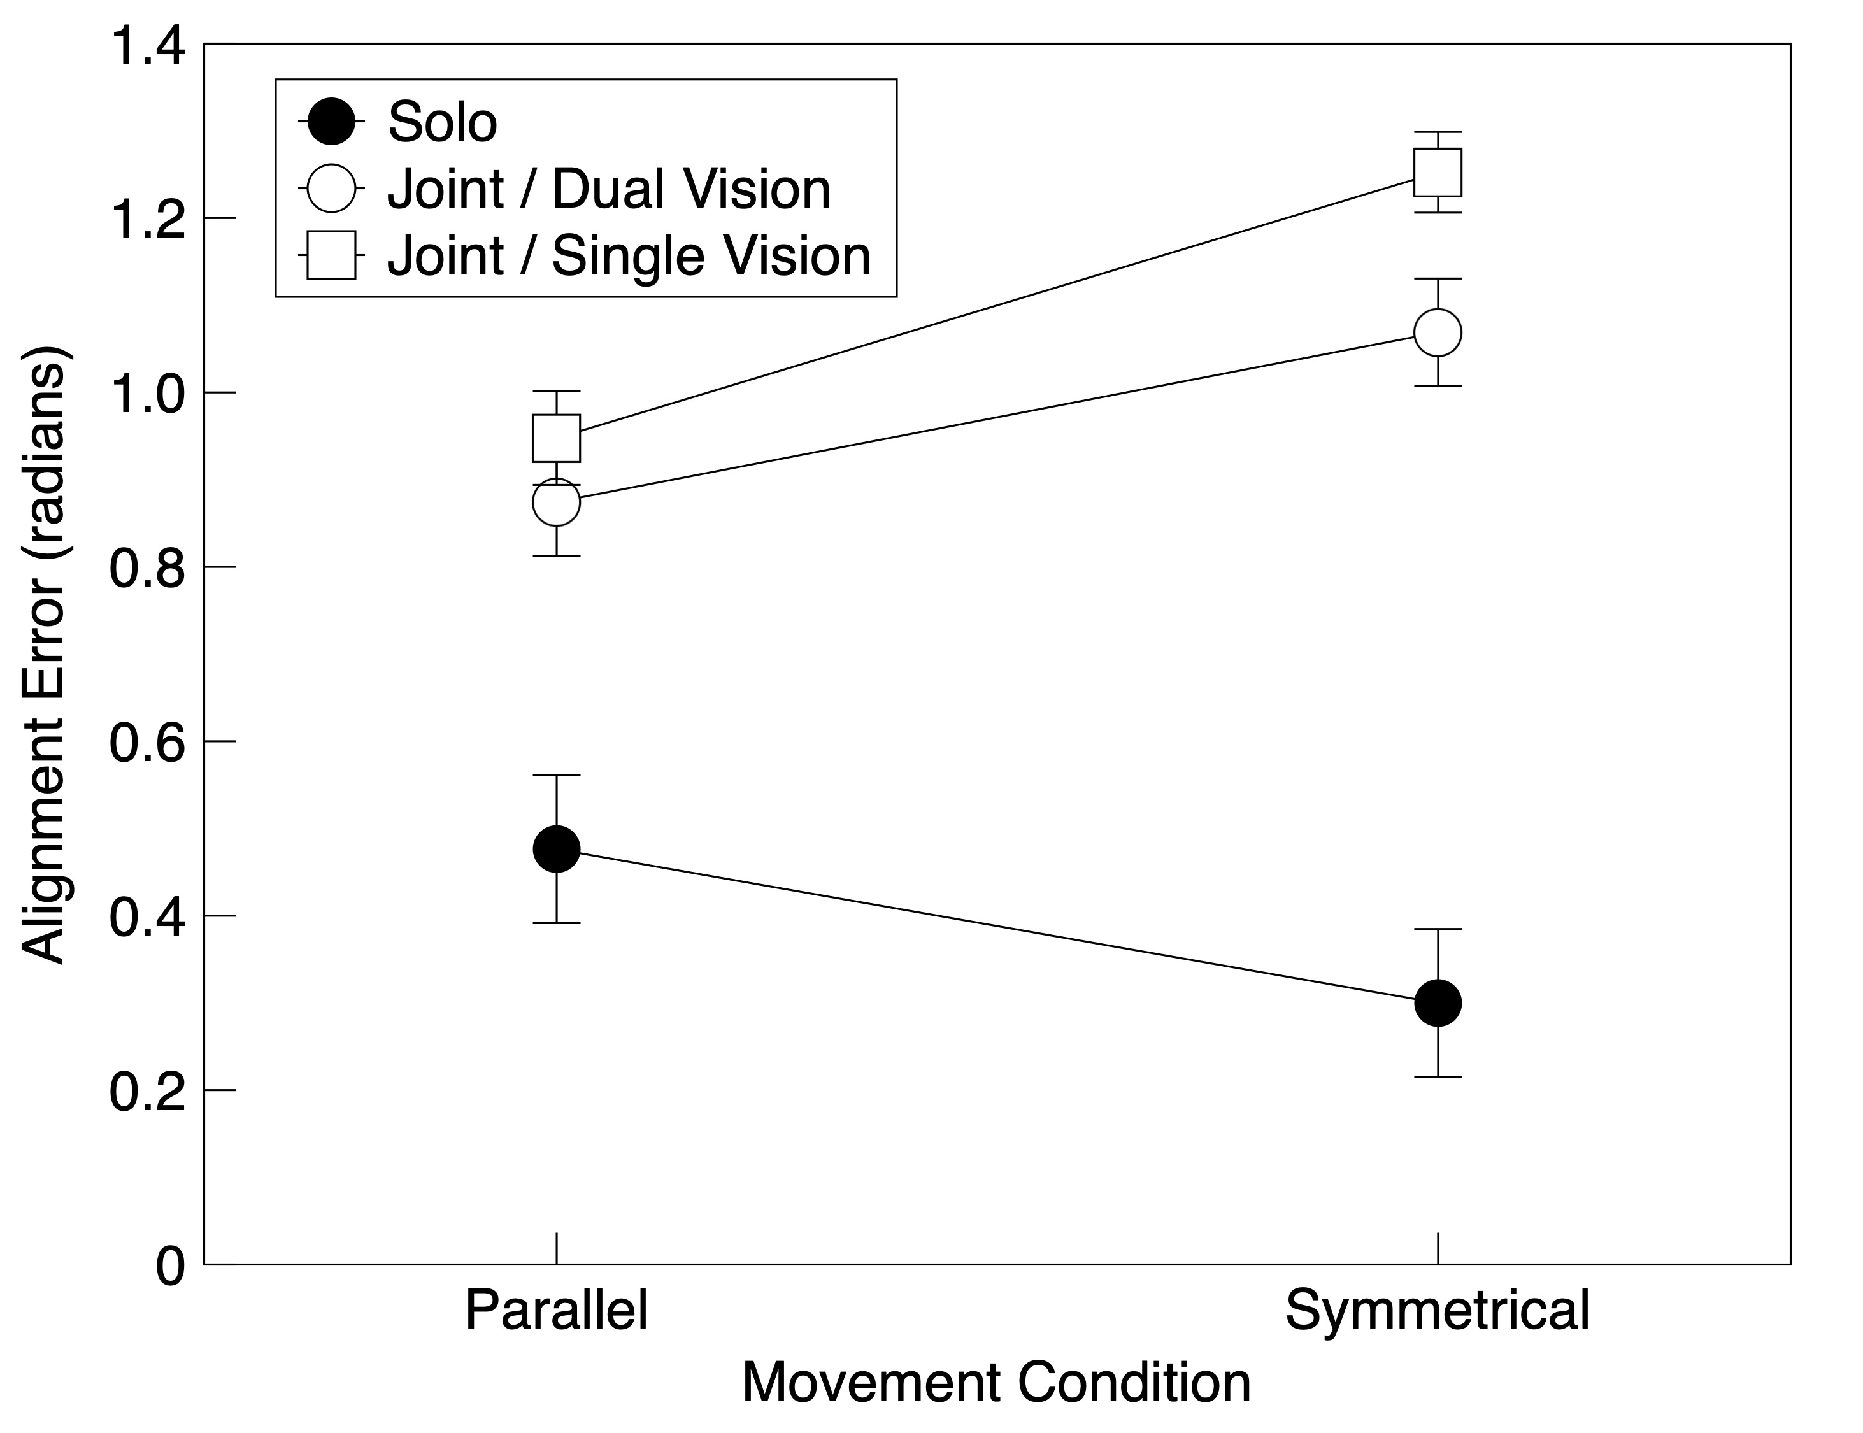

Figure 8. Alignment error as a function of condition in Experiment 3, measured in radians. Error bars represent the standard error of the mean in each condition derived from the error term in a full model fit.

Temporal error. Consistent with our prediction, temporal error in the joint/single-vision condition was comparable to that in the solo condition. In both cases, error was small for symmetrical movements but larger for parallel movements (Figure 9). Performance in the joint/dual-vision condition replicated the pattern of results found in Experiments 1 and 2, with little difference between temporal error for symmetrical and parallel movements.
A comparison of linear model fits provides evidence for this interpretation. A model that included a symmetry effect for the solo condition was better than a null model in which all of the slopes were identical, λ_{adj} = 83.44. A model that also included an effect of symmetry in the joint/single-vision was better still, λ_{adj} = 268.93. Finally, there was no evidence that adding a symmetry effect in the joint/dual-vision condition improved the model, λ_{adj} = 1.53.

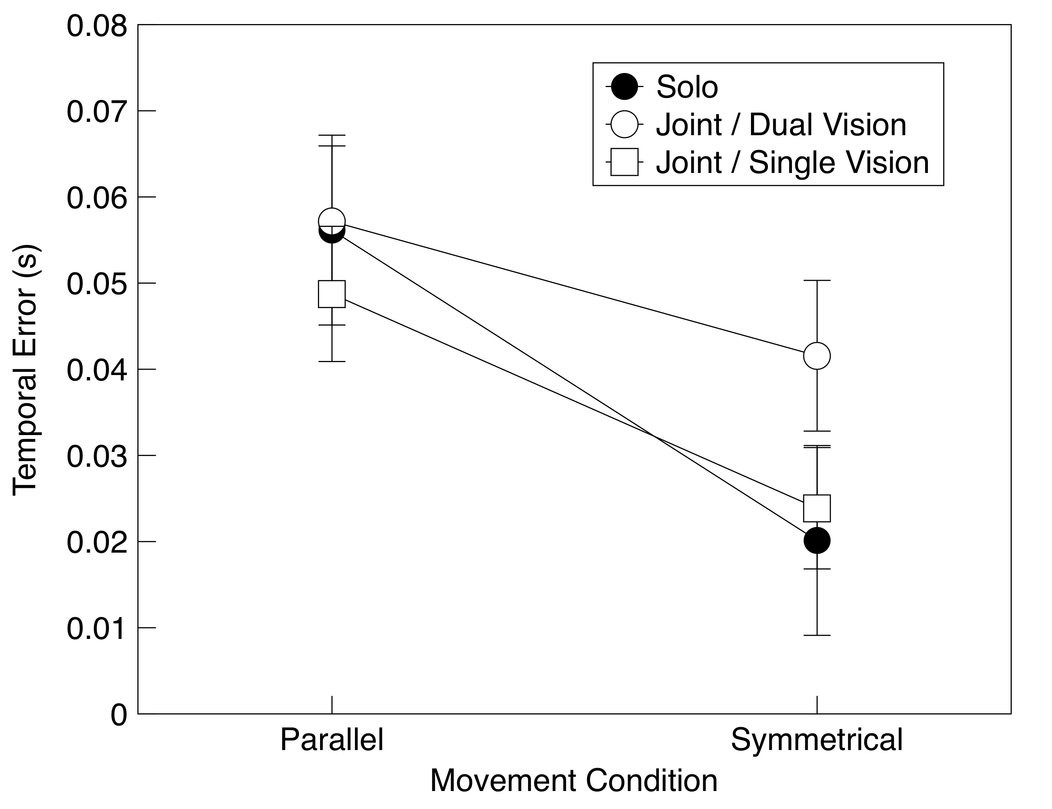

Figure 9. Temporal error as a function of condition in Experiment 3. Error bars represent the standard error of the mean in each condition derived from the error term in a full model fit.

Discussion
A clear symmetry effect on joint action was observed when visual feedback was limited to one participant in each pair. This supports our hypothesis that the lack of a symmetry effect on temporal error in joint performance in the previous experiments was due to the conflicting use of feedback under divided control. On this analysis, interference occurred because the concurrent use of a visual signal to guide adjustments by two independent motor systems can result in a net overcorrection. Such an issue would not have arisen in the joint/single-vision condition because only one participant was using visual feedback. Rather, the attentional focus strategy would have been viable in the joint/single-vision condition with symmetrical movements, resulting in the reduced temporal error observed here. Another way of describing this result is that the participants with closed eyes were not involved in performing a joint coordination task. Rather, they were merely timing their movements to the metronome, while the burden of coordinating the two movements fell to the other participant. Nonetheless, this interpretation is consistent with our analysis that the interference observed in Experiments 1 and 2 was due to the use of feedback by two independent motor systems.
An alternative explanation for the pattern of results in Experiments 1 and 2 might be based on the larger alignment error in the joint conditions. In particular, the magnitude of the alignment error might have meant that the fingers spent less time in close proximity to one another from the outset. As a consequence, participants would have had less opportunity to take advantage of an attentional anchor point for perceiving error, which might then lead to greater temporal error. Although plausible, this argument is undermined by the fact that alignment error in the joint/single-vision condition of Experiment 3 remained high and, in fact, was larger than that in the joint/dual-vision condition. Had the symmetry effect in temporal error depended on a smaller alignment error, we should not have observed it in the joint/single-vision condition here. Instead, the fact that the symmetry effect was observed is consistent with our overall argument that alignment and temporal error reflect two separate sources of error in the finger oscillation task, each sensitive to different factors.

General Discussion
The present work combined two novel approaches to bimanual control and joint action research. First, we sought to highlight the differences between the organization of solo and joint action rather than focusing on the similarities (e.g., Atmaca et al., 2008; Fine & Amazeen, 2011; Glover & Dixon, 2017; Vesper et al., 2016). Second, unlike previous studies of bimanual coordination which focused on analyzing a monolithic phase angle error over time (e.g., Kelso, 1981, 1984; Mechsner et al., 2001), we here decomposed this into alignment and temporal error, with our results suggesting that these two categories were differentially sensitive to task conditions. These novel approaches to both joint action and bimanual coordination led to several insights.
As we expected, alignment error was invariably larger in the joint than in the solo conditions, reflecting the greater difficulty in matching the orientation of the fingers under divided versus unified control. An effect on alignment error was also observed for solo actors when the orientation of the hands was manipulated in Experiment 2; in this case, alignment error was somewhat larger when the two hands were held in opposite orientations. More importantly, the smaller phase angle error for symmetrical compared to parallel movements previously reported in solo actors (Kelso, 1981, 1984; Mechsner et al., 2001) was not evident in alignment error, suggesting that the typically observed symmetry advantage reflects the ability to minimize temporal error only.
Contrary to our expectation, we found joint actors showed no effects of symmetry on temporal error in Experiments 1 and 2, suggesting that pairs were unable to make use of the attentional locus available to solo actors with symmetrical movements. It was only in the joint/single-vision condition of Experiment 3, when visual feedback was denied to one of the actors, that temporal error was reduced for joint symmetrical movements. Here, temporal error was lower than in the joint/parallel condition and comparable to error in the solo/symmetrical condition.
Although it may seem paradoxical that removing a source of error information from one of the actors in a joint task actually improved performance, this result follows logically from the assumption that when the same error signal is used by two actors, overcorrection can occur. When the error signal is only provided to one actor, in contrast, the error correction may be more accurate because there is no possibility of their partner making the opposite adjustment. Framed another way, when both actors have access to the error signal, the presence and/or magnitude of an upcoming adjustment by each actor will be difficult, if not impossible, for their partner to anticipate. In contrast, when one actor is denied access to the error signal, they ought to remain relatively consistent in their behavior, and the other actor’s adjustments will tend to be appropriate. This explanation is in line with previous research showing that being predictable to one’s partner confers significant advantages in joint action coordination (Glover & Dixon, 2017; Glowinski, Mancini, Cowie, Camurri, Chiorri, & Doherty, 2103; Kourtis et al., 2013; Vesper, van der Wel, Knoblich, & Sebanz, 2011; Vesper et al., 2016).
Our attentional focus explanation is in line with the argument of Bingham and colleagues (e.g., Bingham, 2004; Wilson, Collins, & Bingham, 2005) that performance of a bimanual oscillation task relies on the perception of the relative motion of the effectors. If this is true, one would expect perception of relative motion to be relatively accurate when using the simultaneous sampling of the two fingers allowed by the attentional focus strategy, but relatively poor when an attentional switching strategy is employed. Similarly, Lissajous feedback, in which separate hand movements are mapped onto the movements of a single stimulus on a computer screen, also provides a single focus for attention. Thus, the improvements in performance observed with this method are likewise in harmony with the attentional focus hypothesis (Lee et al., 1995; Swinnen et al., 1995; Swinnen et al., 1998). A further test of this hypothesis would be to monitor eye movements during performance. Presumably, single participants in the symmetrical condition would maintain fixation on a central point, whereas those in the parallel condition might be expected to saccade back and forth between the two fingers. Of course, it is also possible that attention might be moved covertly between locations, which would not be evident from measuring eye movements.
An alternative explanation for our results might be that the motor system prefers to operate in symmetry along the body midline (Mechsner & Knoblich, 2004). Using a bimanual finger tapping task, these authors found that even when nonmatching pairs of fingers were used across the two hands, the preferred mode was one in which the two “inside” fingers tapped concurrently and then the two “outside” fingers. According to this body symmetry view, the lack of a symmetry effect in the joint action conditions of Experiments 1 and 2 would likely be due to the fact that the positioning of the two actors next to each other meant that the movements took place entirely to one side of each person’s body midline, meaning neither would be influenced by the symmetry preference that arises in solo actors. This account would have difficulty explaining the symmetry effect we observed in the joint/single-vision condition of Experiment 3, however. In this case, movements still involved the fingers moving to the side of the midline for both actors, but performance in the symmetrical movement condition was nonetheless superior to that in the parallel condition.
One previous study examined joint performance of a leg oscillation task roughly analogous to the finger oscillation task used here. Schmidt, Carello, and Turvey (1990) had pairs of participants sit 1.5 m apart facing in the same direction and sway their outer leg in time with their partner and paced by a metronome that increased in tempo from 0.6 to 2.0 Hz. Instructions could require movements to be made in either a symmetrical or parallel pattern. Although they only measured phase angle error and the probability of spontaneous switching between modes, Schmidt et al. did show a symmetrical movement advantage with joint actors. The authors inferred from this that the coordination of two effectors might operate under similar constraints in joint actors as in individuals. However, it is unclear whether the leg oscillation task would have been as demanding for joint actors as the finger oscillation task used here: The relatively large size of the effectors used and relatively slow oscillation rate might mean that different types of constraints were operating in their task.
Finally, our findings also have implications for understanding solo performance of bimanual coordination. For example, Experiment 2 supported the work of Mechsner et al. (2001) that the use of homologous muscle groups could not be responsible for the symmetry effect observed previously in solo actors because the same symmetry advantage was present in solo actors when one hand was inverted. Further, homologous muscle activations through neural cross-talk would not have been possible in the joint/single-vision condition of Experiment 3. Rather, we argue that the use of different attentional strategies in different versions of the task is the most consistent explanation for the findings observed in the present study
Conclusion
In the present investigation, we examined how solo and joint actions differ in a finger oscillation task. An important tool in this investigation was the decomposition of phase angle error into alignment error, reflecting a general difficulty in aligning the fingers and evident even with slow movements, and temporal error, reflecting a fixed time lag in applying error corrections online. Generally, alignment error was higher for joint than for solo actors. Conversely, temporal error depended on the ability of actors to use a strategy in which attention could be focused on a single spatial locus once per cycle. Joint performance of the finger oscillation task eliminated the symmetry effect under most conditions, as it appeared joint actors were unable to make coordinated corrections. It was only when visual feedback was limited to a single actor in a pair that the symmetry advantage in temporal error was observed. Overall, these findings provide important insights into the differences in the organization and control of solo versus joint actions in a coordinated bimanual task.

References
Akaike, H. (1973). Information theory and an extension of the maximum likelihood principle. In B. N. Petrove & F. Csaki (Eds.), Second international symposium on information theory (pp. 267-281). Budapest: Academiai Kiado.
Atmaca, S., Sebanz, N., Prinz, W., & Knoblich, G. (2008). Action co-representation: the joint SNARC effect. Social Neuroscience, 3, 410-420.
Bingham, G. P. (2004). A perceptually-driven dynamical model of bimanual rhythmic movement (and phase perception). Ecological Psychology, 16, 45-53.
Burnham, K. P., & Anderson, D. R. (2002). Model selection and multi-model inference: A practical information-theoretic approach. New York: Springer.
Camponogara, I., Rodger, M., Craig, C., & Cesari, P. (2017). Expert players accurately detect an opponent’s movement intentions through sound alone. Journal of Experimental Psychology: Human Perception and Performance, 43, 348-359.
Carson, R. G. (1996). Neuromuscular-skeletal constraints upon the dynamics of perception-action coupling. Experimental Brain Research, 110, 99-110.
Cattaert, D., Semjen, A., & Summers, J. J. (1999). Simulating a neural cross-talk model for between-hand interference during bimanual circle drawing. Biological Cybernetics, 81, 343–358.
Fine, J. M., & Amazeen, E. L. (2011). Interpersonal Fitts’ Law: When two perform as one. Experimental Brain Research, 211, 459-469.
Fitts, P. M. (1954). The information capacity of the human motor system in controlling the amplitude of movement. Journal of Experimental Psychology, 47, 381-391.
Glover, S., & Dixon, P. (2004). Likelihood ratios: A simple, intuitive statistic for empirical psychologists. Psychonomic Bulletin and Review, 11, 791-806.
Glover, S., & Dixon, P. (2017). The role of predictability in cooperative and competitive joint action. Journal of Experimental Psychology: Human Perception and Performance, 43, 644-650.
Glowinski, D., Mancini, M., Cowie, R., Camurri, A., Chiorri, C., & Doherty, C. (2013). The movements made by performers in a skilled quartet: a distinctive pattern and the function it serves. Frontiers in Psychology, 4, 841.
Kelso, J. A. S. (1981). On the oscillatory nature of movement. Bulletin of the Psychonomic Society, 18, 63.
Kelso, J. A. S. (1984). Phase transitions and critical behavior in human bimanual coordination. American Journal of Physiology: Regulatory, Integrative, and Comparative Physiology, 15, 1000–1004.
Khoramshahi, M., Shukla, A., Raffard, S., Bardy, B. G., & Billard, A. (2016). Role of gaze cues in interpersonal motor coordination: towards higher affiliation in human-robot interaction. PLOS One, 11, 10.1371/journal.pone.0156874
Kourtis, Z., & Sebanz, N., & Knoblich, G. (2013). Predictive representation of other people’s actions in joint action planning: an EEG study. Social Neuroscience, 8, 31-42.
Kovacs, A. J., Buchanan, J. J., & Shea, C. H. (2009a). Bimanual 1:1 with 90º continuous phase: Difficult or Easy? Experimental Brain Research, 193, 129–136.
Kovacs, A. J., & Shea, C. H. (2010). Amplitude differences, spatial assimilation, and integrated feedback in bimanual coordination. Experimental Brain Research, 202, 519-525.
Lee, T. D., Swinnen, S. P., & Verschueren, S. (1995). Relative phase alterations during bimanual skill acquisition. Journal of Motor Behavior, 27, 263–274.
Marteniuk, R. G., MacKenzie, C. L., & Baba, D. M. (1984). Bimanual movement control: Information processing and interaction effects. Quarterly Journal of Experimental Psychology, 36, 335–365.
Mechsner, F., Kerzel, D., Knoblich, G., & Prinz, W. (2001). Perceptual basis of bimanual coordination. Nature, 414, 69–73.
Mechsner, F., & Knoblich, G. (2004). Do muscles matter for coordinated action? Journal of Experimental Psychology: Human Perception and Performance, 30, 490-503.
Meulenbroek, R., Bosga, J., Hulstijn, M., & Miedl, S. (2007). Joint-action coordination in transferring objects. Experimental Brain Research, 180, 333-343.
Posner, M. I., Snyder, C. R., & Davidson, B. J. (1980). Attention and the detection of signals. Journal of Experimental Psychology: Human Perception and Performance, 109, 160-174.
Riek, S., Carson, R. G., & Byblow, W. D. (1992). Spatial and muscular dependencies in bimanual coordination. Journal of Human Movement Sciences, 23, 251-265.
Schmidt, R. C., Carello, C., & Turvey, M. T. (1990). Phase transitions and critical fluctuations in the visual coordination of rhythmic movement between people. Journal of Experimental Psychology: Human Perception and Performance, 16, 227–247.
Scholz, J. P., & Kelso, J. A. S. (1989). A quantitative approach to understanding the formation and change of coordinated movement patterns. Journal of Motor Behavior, 21, 122–144.
Sebanz, N., Bekkering, H., & Knoblich, G. (2006). Joint actions: bodies and minds moving together. Trends in Cognitive Sciences, 10, 70-76.
Sebanz, N., Knoblich, G., & Prinz, W. (2003). Representing others’ actions: Just like our own? Cognition, 88, B11-21.
Sebanz, N., Knoblich, G., & Prinz, W. (2005). How two share a task: corepresenting stimulus-response mappings. Journal of Experimental Psychology: Human Perception and Performance, 31, 1234-1246.
Spencer, R. M., & Ivry, R. B. (2007). The temporal representation of in-phase and anti-phase movements. Human Movement Science, 26, 226-240.
Swinnen, S. P. (2002). Intermanual coordiation: from beahvioural principles to neural-network interactions. Nature Reviews Neuroscience, 3, 348-359.
Swinnen, S. P., Dounskaia, N., Verschueren, S., Serrien, D. J., & Daelman, A. (1995). Relative phase destabilization during interlimb coordination: The disruptive role of kinesthetic afferences induced by passive movements. Experimental Brain Research, 3, 439–454.
Swinnen, S. P., Jardin, K., Meulenbroek, R., Dounskaia, N., & Den Brandt, M. H. (1997). Egocentric and allocentric constraints in the expression of patterns of interlimb coordination. Journal of Cognitive Neuroscience, 9, 348-377.
Swinnen, S. P., Jardin, K., Verschueren, S., Meulenbroek, R., Franz, L., Dounskaia, N., & Walter, C. B. (1998). Exploring interlimb constraints during bimanual graphic performance: effects of muscle grouping and direction. Behavioral Brain Research, 90, 79-87.
Swinnen, S. P., Lee, T. D., Verschueren, S., Serrien, D. J., & Bogaerts, D. J. (1997). Interlimb coordination: Learning and transfer under different feedback conditions. Human Movement Science, 16, 749–785.
Temprado, J. J., Zanone, P. G., Monno, A., & Laurent, M. (1999). Attentional load associated with performing and stabilizing preferred bimanual patterns. Journal of Experimental Psychology: Human Perception and Performance, 25, 1579–1594.
Vesper, C., Knoblich, G., & Sebanz, N. (2014). Our actions in my mind: motor imagery of joint action. Neuropsychologia, 55, 115-121.
Vesper, C., Schmitz, L., Safra, L., Sebanz, N., & Knoblich, G. (2016). The role of shared visual information for joint action coordination. Cognition, 153, 118-123.
Vesper, C., van der Wel, R. P., Knoblich, G., & Sebanz, N. (2011). Making oneself predictable: reduced temporal variability facilitates joint action coordination. Experimental Brain Research, 211, 517-530.
Wilson, A. D., Collins, D. R., & Bingham, G. P. (2005). Human movement coordination implicates relative direction as the information for relative phase. Experimental Brain Research, 165, 351–361.
Wolpert, D. M., Doya, K., & Kawato, M. (2003). A unifying computational framework for motor control and social interaction. Philosophical Transactions of the Royal Society B: Biological Sciences, 358(1431), 593-602.
Wolpert, D. M., & Ghahramani, Z. (2000). Computational principles of movement neuroscience. Nature Reviews Neuroscience, Suppl. 3, 1212-1217.

Author Notes
This research was supported by a grant to the first author from the Natural Sciences and Engineering Research Council of Canada.

