Appendix A
Site | Nets | Latitude | Longitude | Depth | Sediment
Thames
Thamesmead | 5 beam trawls | 51º 30.637ʹN | 000º 06.591ʹE | Ca. 4.5m
Erith | 4 beam trawls & 1 fyke net | 51º 29.221ʹN | 000º 12.952ʹE | Ca. 4.5m
 | 1 shrimp net & 1 trammel trawl | 51º 29.492ʹN | 000º 11.271ʹE | Ca. 4.5m
 | 1 beam trawl | 51º 25.302ʹN | 000º 12.145ʹE | Ca. 4.5m
Isle of Grain/Sheppey | 1 beam trawl | 51º 29.558ʹN | 000º 30.104ʹE | Ca. 4.5m – 10.5m
 | 1 beam trawl | 51º 29.832ʹN | 000º 35.504ʹE | Ca. 4.5m – 10.5m
 | 1 trammel trawl | 51º 28.805ʹN | 000º 44.684ʹE | Ca. 4.5m – 10.5m
 | 1 beam trawl | 51º 28.588ʹN | 000º 46.851ʹE | Ca. 4.5m – 10.5m
 | 1 beam trawl | 51º 28.517ʹN | 000º 47.106ʹE | Ca. 4.5m – 10.5m
 | 1 beam trawl | 51º 29.347ʹN | 000º 44.949ʹE | Ca. 4.5m – 10.5m
 | 1 beam trawl | 51º 28.692ʹN | 000º 43.402ʹE | Ca. 4.5m – 10.5m
Clyde Sea
 | 1 beam trawl | 53º 45.289ʹN | 4º 53.300ʹW | 45.9m | Muddy
 | 1 beam trawl | 55º 46.683ʹN | 4º 52.892ʹW | 45.8m | Rocky/Weedy
 | 1 beam trawl | 55º 47.033ʹN | 4º 52.678ʹW | 44.6m | Muddy
 | 1 beam trawl | 55º 46.062ʹN | 4º 52.654ʹW | 44.3m | Muddy
 | 1 beam trawl | 55º 47.256ʹN | 4º 53.086ʹW | 46.1m | Muddy
 | 1 beam trawl | 55º 47.502ʹN | 4º 53.445ʹW | 46.1m | Muddy
 | 1 beam trawl | 55º 45.698ʹN | 4º 52.998ʹW | 48.2m | Muddy
 | 1 beam trawl | 55º 46.457ʹN | 4º 52.893ʹW | 48.2m | Muddy
 | 1 beam trawl | 55º 45.525ʹN | 4º 53.023ʹW | 48.4m | Weedy
 | 1 beam trawl | 55º 45.899ʹN | 4º 52.688ʹW | 43.0m | Rocky/Weedy
Table A.1 Location, depth and the type of trawl used during sampling in the River Thames and Firth of Clyde.

Appendix B
Species | Location | Sample Number | Lower Recorded Length (mm) | Highest Recorded Length (mm) | Percentage to ingest plastic (%) | Mean number of plastic pieces ingested
Flatfish
European flounder, Platichthys flesus (Linnaeus, 1758) | Thames | 118 | 53 | 321 | 35 | 3.10
 | Clyde Sea | 8 | 142 | 202 | 0 | 0
sole, Solea solea (Linnaeus, 1758) | Thames | 18 | 96 | 324 | 17 | 1
 | Clyde Sea | 0 | n/a | n/a | n/a | n/a
dab, Limanda limanda (Linnaeus, 1758) | Thames | 1 | 247 | 247 | 100 | 2
 | Clyde Sea | 307 | 77 | 207 | 50 | 4.50
long rough dab, Hippoglossoides platessoides (Fabricius, 1780) | Thames | 0 | n/a | n/a | n/a | n/a
 | Clyde Sea | 104 | 44 | 212 | 23 | 2.67
plaice, Pleuronectes platessa (Linnaeus, 1758) | Thames | 0 | n/a | n/a | n/a | n/a
 | Clyde Sea | 99 | 81 | 227 | 31 | 2.52
Norwegian topknot, Phrynorhombus norvegicus (Günther, 1862) | Thames | 0 | n/a | n/a | n/a | n/a
 | Clyde Sea | 1 | 60 | 60 | 0 | 0
witch, Glyptocephalus cynoglossus (Linnaeus, 1758) | Thames | 0 | n/a | n/a | n/a | n/a
 | Clyde Sea | 23 | 105 | 253 | 9 | 1
Flatfish total | Thames | 137 |  |  | 33 | 2.93
 | Clyde Sea | 541 |  |  | 39 | 3.96
Pelagic fish
whiting, Merlangius merlangus (Linnaeus, 1758) | Thames | 29 | 121 | 281 | 10 | 4.67
 | Clyde Sea | 0 | n/a | n/a | n/a | n/a
pouting, Trisopterus luscus (Linnaeus, 1758) | Thames | 7 | 135 | 234 | 29 | 1
 | Clyde Sea | 0 | n/a | n/a | n/a | n/a
cod, Gadus morhua (Linnaeus, 1758) | Thames | 1 | 528 | 528 | 0 | 0
 | Clyde Sea | 2 | 176 | 213 | 0 | 0
poor cod, Trisopterus minutus (Linnaeus, 1758) | Thames | 0 | n/a | n/a | n/a | n/a
 | Clyde Sea | 1 | 107 | 107 | 0 | 0
haddock, Melanogrammus aeglefinus (Linnaeus, 1758) | Thames | 0 | n/a | n/a | n/a | n/a
 | Clyde Sea | 6 | 99 | 156 | 100 | 5.83
Pelagic fish total | Thames | 37 |  |  | 14 | 3.20
 | Clyde Sea | 10 |  |  | 60 | 5.83
Other benthic fish
roker, Raja clavata (Linnaeus, 1758) | Thames | 7 | 275 | 683 | 14 | 1
 | Clyde Sea | 0 | n/a | n/a | n/a | n/a
lesser spotted dogfish, Scyliorhinus canicula (Linnaeus, 1758) | Thames | 7 | 391 | 443 | 28 | 1.5
 | Clyde Sea | 1 | 430 | 430 | 0 | 0
red gurnard, Chelidonichthys cuculus (Linnaeus, 1758) | Thames | 5 | 206 | 263 | 0 | 0
 | Clyde Sea | 1 | 132 | 132 | 0 | 0
butterfish, Pholis gunnellus (Linnaeus, 1758) | Thames | 0 | n/a | n/a | n/a | n/a
 | Clyde Sea | 1 | 132 | 132 | 0 | 0
hooknose, Agonus cataphractus (Linnaeus, 1758) | Thames | 0 | n/a | n/a | n/a | n/a
 | Clyde Sea | 3 | 60 | 90 | 0 | 0
bull rout, Myoxocephalus Scorpius (Linnaeus, 1758) | Thames | 0 | n/a | n/a | n/a | n/a
 | Clyde Sea | 5 | 127 | 158 | 0 | 0
European eel, Anguilla anguilla (Linnaeus, 1758) | Thames | 2 | 496 | 657 | 50 | 2
 | Clyde Sea | 0 | n/a | n/a | n/a | n/a
sea scorpion, Taurulus bubalis (Euphrasen, 1786) | Thames | 0 | n/a | n/a | n/a | n/a
 | Clyde Sea | 3 | 154 | 189 | 67 | 2
Other benthic fish total | Thames | 21 |  |  | 19 | 1.5
 | Clyde Sea | 14 |  |  | 14 | 2
Shrimp
brown shrimp, Crangon Crangon (Linnaeus, 1758) | Thames | 116 | 18 | 47 | 6 | 1
 | Clyde Sea | 0 | n/a | n/a | n/a | n/a
Total |  | 876 |  |  | 32 | 3.70

Table B.1 (summarised in Table 1). The number of individuals studied across 21 species, divided into four functional feeding groups: bottom feeding flatfish, other benthic fish, pelagic fish and shrimp, sampled from the Firth of Clyde and Thames Estuary. The size range of each species was recorded for comparison. Plastic ingestion is reported after contamination had been considered. The mean number of plastic pieces in the stomach of fish was calculated for fish which ingested plastic, excluding individuals which did not consume any plastic.

Appendix C
Library | Used in initial analysis | Used after correction
Aldrich Condensed Phase Sample Library | X
Aldrich Vapor Phase Sample Library | X
Georgia State Crime Lab Sample Library | X
HR Aldrich Alcohols and Phenols | X
HR Aldrich Aldehydes and Ketones | X
HR Aldrich Dyes, Indicators, Nitro and Azo Compounds | X
HR Aldrich Esters, Lactones and Anhydrides | X
HR Aldrich Hydrocarbons | X
HR Aldrich Organometallic, Inorganic, Silanes, Boranes, and Deuterated Compounds | X
HR Aldrich Phosphorous and Sulfur Compounds | X
HR Aldrich Solvents | X
Hummel Polymer Sample Library | X | X
Sigma Biological Sample Library | X

Table C.1 The spectral libraries used to identify sample polymers before and after correction of FTIR spectra with OMNIC Specta. Before correction, spectra were compared to all 13 software libraries due to software restrictions in choosing libraries.
Appendix D
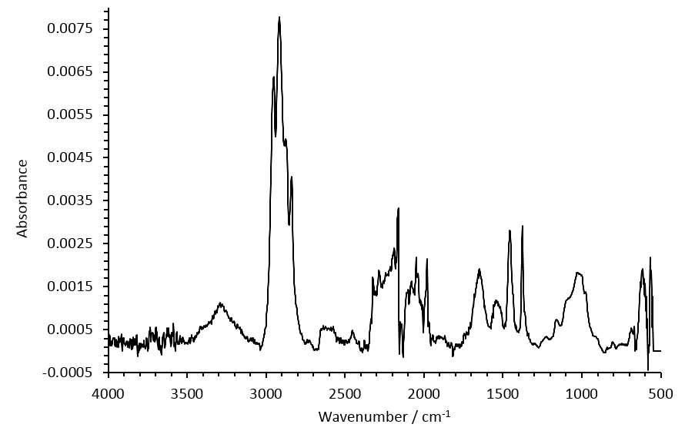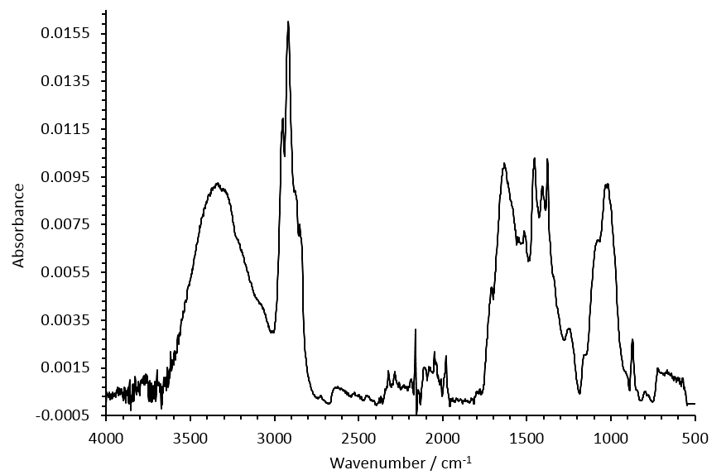
A
B
Fig. D.1 A. Corrected FTIR spectrum produced from by a clear fibre recovered from a dab from the Firth of Clyde. It produces a match of 77.65% to polypropylene. B. Corrected FTIR spectrum produced by a clear fibre recovered from a dab from the Firth of Clyde. It produces a 69.90% match to polypropylene and a match of 35.86% to the combined spectra of cellulose (considered to be organic matter) and polypropylene.

Appendix E
Polymer | Volume
polyester [including poly(ethylene terephthalate), poly(ester tere-&iso-phthalate), poly(ester), poly(ester terephthalate)] | 369
nylon | 227
poly(propylene) | 173
poly(vinylidene fluoride) | 73
poly(ethylene : propylene : diene) | 69
poly(acrylonitrile) | 67
poly(ethylene) | 44
poly(trimellitaminde imide) | 31
poly(vinyl acetate : ethylene) | 19
poly(styrene : 4 vinylpyradine) | 12
poly(vinyl chloride) | 11
poly(phthalamide) | 9
poly(aryl ether) | 6
poly(ethylene : vinyl chloride) | 4
poly(vinyl chloride : methyl methacrylate) | 4
poly(ethylene:propylene) | 4
acrylic | 2
poly(isobutene) | 1
poly(methyl phenyl siloxane) | 1
poly(ether urethane) | 1
tygon | 1
polystyrene | 1
poly(ethylene terephthalate : propylene) | 1
Table E.1 A full list of the polymers identified by FTIR spectroscopy in order of abundance (overall count data) after contamination was removed.

