Contesting Borders in the Arctic
Klaus Dodds

Preamble
If and when we think about borders, and specifically the US-Canadian border, they are likely to be considered fixed and uncontroversial. Any typical map of North America represents three main international boundary lines—the US-Mexican border, the US-Canadian border, and a northern extension of the latter between the American state of Alaska and the Canadian territory of Yukon. These borders matter because they are recognised by the three state parties as delimiting national territories, sovereign authority and jurisdiction. While those states have negotiated with one another special border arrangements (facilitating approved mobility of trade and citizens for example), the US-Canadian continental border is settled. However, if we journey further north, and focus on the maritime boundaries between the US and Canada, things appear less straightforward.
In the Arctic, as a consequence of a variety of factors including sea ice melt, globalisation, indigenous rights, and commercial opportunities, there is growing interest in how this region is bordered and defined. This sense of dynamism was captured in an infographic issued by the Washington DC-based Wilson Center in December 2014. Under the banner headline, “I didn’t know that! Arctic borders still aren’t settled,” it stipulates that, “Even with the world’s longest peaceful border and advanced mapping capabilities, Canada and the United States disagree about where their Arctic border begins and ends, specifically in the Beaufort Sea” (emphasis in original). The underlying conceit appears to be one in which the reader is expected to be surprised that liberal democratic states such as Canada and the US have any border issues to discuss (see Figure 1).

Figure 1 Surprising? Borders are not fixed; sea, ice and seabed intersect; the Arctic is inhabited by human communities, flora and fauna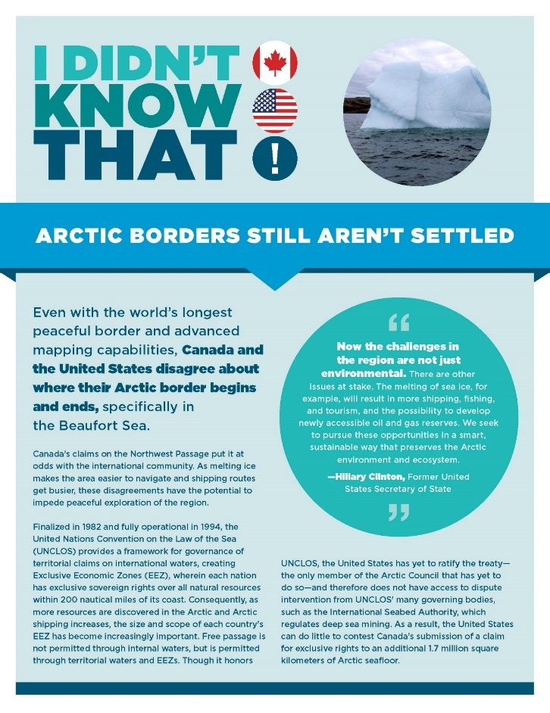
Source: Wilson Center (2014).
The text therein alerts the reader that the United States and Canada disagree over the maritime delimitation of the Beaufort Sea, and dispute the international legal status of the Northwest Passage. The reader’s attention is drawn to Canadian interests in establishing sovereign rights over an extended continental shelf, stretching ever closer towards the central Arctic Ocean (CAO). In 2018, Canada expects to submit materials to a UN body, the Commission on the Continental Shelf (CLCS), regarding a continental shelf claim. Until recently very few people had heard of the CLCS but this technical-scientific body is going to play an important role in helping to shape the sovereign rights of coastal states like Canada to vast areas of the seabed. The United States, as a non-party to the United Nations Convention on the Law of the Sea (UNCLOS), is not able to submit such a claim to the CLCS but this has not stopped it from mapping and surveying its seabed in the Arctic, Atlantic and Pacific Oceans.
The infographic provides an entrée into something that must appear desperately obscure to many readers. While the seabed in question is undeniably remote, it points to how active states like Canada are in maximizing their sovereign rights over territory, including possible resources. But in the Arctic Ocean, all of this interest and endeavor is occurring in the midst of concern that the region is being discombobulated by climate change and growing interest in its future by “outsiders,” and this in turn has implications for the interests and rights of Indigenous peoples. Arctic borders are far from settled.

Introduction
The aforementioned infographic on Arctic borders is not an innocent intervention. It foregrounds two issues but avoids one. First, borders, and what might be reasonably thought of as “bordering,” is a process, not a fixed outcome (Johnson et al. 2011; Jones and Johnson 2016). The border, let alone an internationally recognized boundary between two countries, is not static. Even the well-established and fully-functioning southern US-Canadian border is not just a line on a map but an assemblage of policies, practices and discourses that make possible a tightly integrated international boundary (Nicol 2015). Borderlines need to be maintained, surveyed and patrolled. For example, the International Boundary Commission for the US-Canadian border maintains a visible line through over 1,300 miles of forested land; the narrow vista is known colloquially as “the slash.” It requires work crews cutting back vegetation along the border every 4-5 years depending on the vigour of regrowth. The Alaskan-Canadian border has a separate border management regime in part because the growing season is shorter and the vegetation is shorter. There, the strip is approximately 20 feet wide.
Sometimes the US-Canadian border can be a site of controversy, as it was earlier this year when news broke of refugee seekers dying of hypothermia in the middle of a brutal winter. In particular areas of the shared border, such as in and around the St Lawrence river, US-Canadian border management has created friction and conflict with cross-border Mohawk communities, which claim historic Indigenous sovereignty (Phaneuf 1979). Recent disputes over Indigenous sovereign rights have included protests over trans-shipment of radioactive material through Mohawk/Akwesasne territory and the intensification of maritime security measures, which have been implemented without the consultation of the Saint Regis Mohawk Tribal Council. The critically acclaimed film, Frozen River (2008), addressed well the contested sovereign geographies of this riparian environment and the differential impact it had on particular white, Sioux and illegal immigrants.
These observations suggest that if and when the US and Canada agree on a maritime boundary in the northerly Beaufort Sea, it will require an ongoing process of consultation with Indigenous peoples as well as state-sponsored mapping, surveying, patrolling and administering. At the moment, there is no agreement as to where the line dividing the Beaufort Sea should begin, and without that agreement it is not possible to delimit territorial seas and exclusive economic zones in the disputed portion.
The roots of the international disagreement lie with an 1825 Treaty involving Russia (then the occupants of Alaska) and the UK. The treaty failed to establish a maritime boundary north of the coastline. The point about consultation lies in the context of the 1984 Inuvialuit Final Agreement (IFA) signed between Inuvialuit communities and Canada. It stipulates that local communities must be able to fully participate in decisions about conservation and economic development related to the Beaufort Sea. The United States believes that the boundary between the US and Canada in the Beaufort Sea should follow the equidistant principle. The Canadians maintain that the border should follow the 141st meridian and thus become a linear extension of the land border. At present, no agreement exists on how to proceed. Both countries believe that the Beaufort Sea contains valuable living and non-living resource potential.
All of which suggests that we are likely to see more Arctic border-work in the coming years. So while the infographic is right to suggest that “Arctic borders still aren’t settled,” the nature of the “unsettlement” varies in geographical extent, geopolitical significance and legal sensitivity.
Borders can and do move, for example. Sometimes border shifts are proposed for perfectly peaceful reasons. In 2016, discussions about altering the mountainous border between northern Norway and Finland took place so as to ‘gift’ a new high point to Finland on the eve of its 100th independence anniversary in 2017. After much public campaigning, the Norwegian government declined to do so fearing that it might be unconstitutional as Article 1 of the Norwegian Constitution declares that the kingdom of Norway is “indivisible and inalienable.” Although the mountain-swap proposal was no doubt well-intentioned, it reaffirms a basic geopolitical adage that nation-states rarely “give up” territory once it has been claimed and recognised by others.
Such rarity should not distract us from something less rooted and infinitely more mobile. Historically, a raft of border scholarship has made the point that sailors, pirates, buccaneers and their ships were “vectors of law” that allowed sponsoring states to extend their sovereign authority over seas and oceans (Benton 2009). Moving offshore, over the last twenty years we have witnessed a slow and steady legal-technical process of continental shelf delimitation as icebreakers and survey ships play a crucial role in tracking up and down the Arctic Ocean. As they measure and assess underwater geology and take stock of bathymetry, these voyages are integral to coastal state expansion of sovereign rights.
These efforts consolidate a massive expansion of state sovereignty in the maritime realm courtesy of UNCLOS, which entered into force in 1994. Coastal states have been able to appropriate exclusive economic zones and territorial seas, and establish an array of sovereign rights over seabed, islands and water column (Rothwell and Stephens 2016; see Figure 2). In the case of outer continental shelves in the Arctic Ocean, it is fully expected that the Canadian, Danish and Russian technical submissions to the CLCS will overlap one another. The three coastal states will engage in formal negotiations in the expectation that they will resolve where their respective sovereign rights begin and end. All three believe that, under Article 76 of UNCLOS, they will demonstrate that their sovereign rights will extend beyond 350 nautical miles from the coastal baseline (Dodds 2010). The areas involved are vast, and will encompass much of the Arctic Ocean seabed (Jensen 2015). For all the speculation about Russia and its strategic intentions (recall the infographic cited earlier was produced prior to Russia’s annexation of Crimea in March 2014), most commentators expect future negotiations over Arctic outer continental shelves to be consensual.
The second point relevant to our discussion is that the three examples listed by the infographic involve the intersection of sea, ice and the seabed. The terrain of the maritime

Figure 2 Zones of Maritime Rights

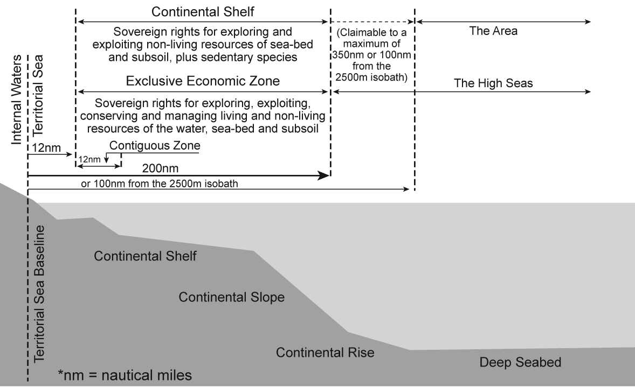

Arctic is integral to any discussion of borders. The intersection of law, territory and geopolitics helps to make and remake the Arctic (Steinberg et al. 2015). Territory is not simply a passive backdrop to those intersectional relationships. Canada and the United States disagree over whether the Northwest Passage (NWP) is part of Canada’s “internal waters” (Lajeunesse 2016). The US position, which is shared by other parties including the EU, is that the waterways of the Canadian Arctic are international straits, where third parties enjoy far greater freedoms of transit and navigation than in internal waters. Part of the longstanding argument pertaining to the NWP is the role of ice-covered waters, and whether they have not only prevented regular transit shipping in the past but also acted as an exceptional hazard requiring the Canadian government as the relevant coastal state to act as an “exceptional” environmental steward (Burke 2017). So while both sides appeal to international law as a guide, the historic and contemporary presence of sea ice is pivotal to these rival legal, political and cultural narratives (Griffiths 1987).
What emerges from this discussion about the NWP is not just a multitude of legal and political argumentation, but something rooted in the geophysical. Continental shelves, ocean seabed, maritime passages, ice-covered waters and the polar water column provide raw material for legal and political intervention and strategy (Steinberg and Peters 2015). The physical geographies of the maritime Arctic and their capacity to block, enable and frustrate the spatial strategies of territorial states matter. If past experience suggests anything it is that the mobility of people and things has been a powerful platform for the expansion of law and opportunities for data capture about those mobile objects. The changing fate of Arctic sea ice is integral to many discussions concerning the future of the Arctic, not least in determining future regulatory patterns of mobility and resource exploitation. Arctic states, including Canada, Denmark/Greenland, Norway, Russia and the United States represent themselves as Arctic Ocean coastal states with substantial resource and strategic interests in their territorial seas, exclusive economic zones and continental shelves (Dodds 2013). They are predominate in ongoing discussions about the future management of the central Arctic Ocean, which will also involve extra-territorial parties such as China and the European Union in the long-term (Pin and Huntingdon 2016).
The third relevant element the infographic raises is something it does not address. Nowhere in the description that follows about Arctic borders is there any recognition that the Arctic is inhabited by human communities and flora and fauna. Borders and border delimitation are presented as legal-technical phenomena involving relevant coastal states and their geopolitical/strategic interests. Under the title of “Contested Canadian claims to the Arctic,”, the three examples (Beaufort Sea, Northwest Passage and Continental Shelf) show no recognition that Indigenous peoples in Canada have substantial land and maritime claims, and that they contest the sovereign authority of the Government of Canada to act exclusively in such matters (Nicol 2010, Powell 2010). Agreements with Indigenous peoples exist. They stipulate Canada’s obligation to consult Indigenous people and respect Indigenous rights onshore and offshore (see section 35 of the 1982 Canadian Constitution).
The right to consult does not apply just to border issues like those involving the US and Canada in the Beaufort Sea. Underwater objects that were lost but now found in “Canadian waters” are also enrolled in this nation (Crown) to nation (Indigenous peoples) partnership. The National Maritime Museum and the Canadian Museum of History have collaborated this year on a new “Death in the Ice” exhibition, which considers the material and imaginative legacies of the doomed Victorian-era Sir John Franklin expedition. In the last three years, the remains of Franklin’s ships HMS Erebus and Terror were discovered in Canadian waters. Some of the artefacts are to be displayed in the exhibition, but even before its official opening it was mired in controversy. Who owns the artefacts? Parks Canada, which was instrumental in leading the recent search for the ships, argued that it was a matter for the federal government citing a 1997 bilateral agreement with the UK about the remains of the ship. However, the Inuit Heritage Trust contends that the government of Nunavut should have been consulted about ownership. In other words, the remains of the ships were not straightforwardly Canadian. In 2017, the UK government formally transferred ownership of the ships to Canada and the Trudeau government has entered into formal discussions with relevant Inuit organizations.
It follows that reasoned discussion of Arctic borders must recognize that it is a complex subject. Even if we to extend our remit to flora and fauna, a case could be made that what constitutes the Arctic is ever more contested, thanks in no small part to the warming of the region. Melting permafrost, sea ice shrinkage, ocean acidification and alteration to the local and regional albedo is producing amplification and perturbation. It is not too fanciful to claim that the Arctic is being “scrambled” in the sense that ecosystem change is disrupting food supplies, habitats, migratory routes of land and sea-based animals and settlement patterns. Scientists warn increasingly of invasive species, habitat domain disruption and the “greening” of the Arctic (Arctic Council 2017). Where the Arctic begins and ends is being scrambled (Dodds and Nuttall 2016). Bio-geographical borders are being re-drawn as tundra retreats and boreal forest advances. The shrinkage of Arctic sea ice is also promising to reveal further potential for maritime space to be reimagined and reorganized as open polar sea as opposed to frozen polar desert. Nowadays, it is commonplace to read of the potential for commercial fishing in the central Arctic Ocean. This would have been unthinkable in the 1970s.
For the purposes of this paper attention will focus on three thematic areas. Initially, some observations will be offered regarding recent scholarship on borders and geopolitics. Thereafter, attention turns to Arctic borders with specific focus on Arctic states and their bordering strategies. Finally, mindful of the year of writing, the paper concludes with some reflections on Indigenous geopolitics and Canada 150, and ruminates on how borders are corporeal as much as material, legal and representational. If we are interested in how Arctic borders are contested then we need to consider Arctic states such as Canada and their own border work in the broader context of structural racism (Milloy 1999), racial violence and assimilation (Thobani 2007), settler colonialism (Baker 2009), entrenched inequality (Porter 1965) and Cold War geopolitics (Lackenbauer and Farish 2007).

Borders, Geopolitics and Critical Border Studies
Over the last 20 years, the fields of critical geopolitics and critical border studies have contributed to a rich and diverse body of work on borders. What we can take from this literature are several fundamentals—the border is never just a static line; the border is crucial to expressions of identity politics and the identification and policing of the inside/outside of territorial states; the border is shaped by the intersection of material and infrastructural geographies; and the border is always embodied and corporal. In other words, experiences of the border are unevenly distributed. In a post 9/11 environment, nation-states including Canada and the United States have invested heavily in border management in the light of fear of more terrorism, crime and unregulated migration (Panquin and James 2014). While ambulatory networks provoke concern, the border makes itself manifest in a diverse array of sites and spaces, operating far beyond the formal border with other nation-states.
The border makes itself manifest in particular environments and locales. It always involves placing and displacing. Borders are, therefore, never simply lines on the map nor are they simply made manifest through security infrastructure and practices such as fences, barbed wire, surveillance towers and watching and border patrolling respectively. Borders are more productively thought of as always institutionally thick, spatially multi-faceted and always embodied. The border is at once topographical and topological—finding expression in particular areas of the earth like international boundary lines between sovereign states but also corporal and relational in the sense of making their presence felt on some bodies more than others. Relationships with the border extend far beyond formal border line, as people of colour and migrants often note that it is they who fall under the watchful gaze of citizen and officials alike (De Leon 2015; Neyers 2012).
Borders can and do regularise the relationship between the state, the citizen and the alien but they also generate an array of alternative border economies and solidarities. The border might help define the limits of state hospitality but it also generates opportunities for others to circumvent, contest and capitalise on. In the fall of 2015, for example, Norwegian citizens offered support to Afghan, Kurdish, Syrian and Iraqi refugees crossing the Norwegian-Russian border. Over 5,000 people sought asylum in Norway that year, and in 2016 local Norwegian citizens and support groups protested a Norwegian government decision to forcibly return some of those who had crossed the border with valid Russian visas. Forced returns soon became politically impossible, and again local citizens and churches offered hospitality and support to those affected.
By 2017, the Russian authorities put an end to asylum seekers cycling to Norway, and refugees transferred to reception centres across Norway. In the meantime, the Norwegian government invested in new security fencing, which proved divisive with local residents who argued that it might unsettle existing cross-border relationships with Russia. The Norwegian-Russian borderlands have had their own distinct agreement dating from 2010, which created a visa-free border zone allowing residents either side of the border to enter in and out of that zone. It coincided with an agreement between the two countries over the maritime delimitation of the Barents Sea. So from a local resident’s point of view, unsettling a national border agreement had immediate implications for everyday life.

Bordering and Boundary-Making the Arctic
A series of photographs of the planting of a Russian flag at the bottom of the central Arctic Ocean in August 2007 precipitated a wave of commentary warning of a new scramble for the Arctic. While we can speculate about whether the febrile media and political reaction would have been similar if the flag in question had been the United Nations, the event itself coincided with news of a record low in Arctic sea ice distribution. Diminishing sea ice in combination with stories of new trade routes and a treasure-house of oil and gas fed a geographical imagination positing the Arctic as an ungoverned resource frontier awaiting exploration and exploitation. For all the geopolitical hype, many commentaries neglected to mention that the maritime Arctic was subject to the legal framework of UNCLOS. Far from being divorced from governance structures, the Arctic Ocean coastal states enjoyed sovereign rights over considerable areas of the maritime Arctic, and were actively positioning themselves as environmental stewards as well as sovereign actors (Dodds 2010).
However, the scrambling discourses did arguably provoke Arctic Ocean coastal states such as Canada and Russia to articulate, frame and implement spatial strategies designed to remind domestic and international audiences that they were Arctic Ocean coastal states. Domestically, former Canadian Prime Minister Stephen Harper emerged as the most prominent advocate of Canadian Arctic sovereignty, with annual summer trips to the Canadian North designed explicitly to highlight the scale and extent of that sovereign authority (Dodds and Nuttall 2016). New plans and strategies were drawn up and publicised, including spending commitments on military and civilian infrastructure in the Arctic. Internationally, the Arctic Ocean coastal states met in Greenland to develop a common position regarding their role as environmental stewards in the maritime Arctic and to reaffirm the importance of UNCLOS and the “Law of the Sea” (in recognition of the United States non-ratification of UNCLOS) in providing an orderly legal framework. Four out of the five Arctic Ocean coastal states also committed themselves to following UNCLOS rules for the definition and delimitation of the outer limits of their continental shelves (Article 76). In what was called the Ilulissat Declaration, the five countries of Canada, Denmark/Greenland, Norway, Russia and the United States committed themselves to the following:

Notably, the law of the sea provides for important rights and obligations concerning the delineation of the outer limits of the continental shelf, the protection of the marine environment, including ice-covered areas, freedom of navigation, marine scientific research, and other uses of the sea. We remain committed to this legal framework and to the orderly settlement of any possible overlapping claims.

This framework provides a solid foundation for responsible management by the five coastal States and other users of this Ocean through national implementation and application of relevant provisions. We therefore see no need to develop a new comprehensive international legal regime to govern the Arctic Ocean. We will keep abreast of the developments in the Arctic Ocean and continue to implement appropriate measures (Ilulissat Declaration 2008).

The Declaration was intended to counter any suggestion that the maritime Arctic was either thinly governed and/or riven with dangerous historic border disputes over sea and islands. The formal “disputes” affecting the maritime Arctic in May 2008 (the date of the declaration) included the unresolved status of the Northwest Passage, the unsettled marine delimitation of the Beaufort Sea and Barents Sea, and the disputed ownerships of Hans Island involving Canada and Denmark. The definition and delimitation of outer continental shelves in the Arctic was ongoing and the international waters of the central Arctic Ocean had not attracted sustained international attention.
However orderly the UNCLOS framework may appear at first glance, there are likely to be contested borders in the delimitation of outer continental shelves. Under Article 76 of UNCLOS, coastal states such as Canada, Denmark and Russia can collect geophysical and oceanographic materials in accordance with stipulated procedures. Rules exist for how coastal states can extend their sovereign rights over the continental shelf, involving distance, depth and seabed geology. Put concisely, Article 76 outlines a process by which coastal states can submit materials to the UN Commission on the Continental Shelf (CLCS) for the purpose of obtaining a recommendation regarding delimitation. The CLCS does not issue legal judgements but if the coastal state follows the recommendation from the Commission, then the outer limits of the continental shelf become final and binding.
Where things becomes more complicated is when the delimitation of outer continental shelves involves overlapping submissions. In the case of the Arctic Ocean, it is well understood that submissions from Canada, Denmark/Greenland and Russia are likely to overlap. The CLCS has considered submissions from Russia (2001 and 2013) and Denmark/Greenland (2013) but not from Canada. The CLCS does not involve itself in legal disputes, so in the case of extended continental shelves in the Arctic Ocean, the three parties will have to negotiate with one another. All three parties have invested much time and money mapping the Arctic Ocean seabed. They believe, for example, that their sovereign rights extend all the way to the seabed around the North Pole. Ultimately, if the process outlined in Article 76 is followed then the three will eventually agree to a trilateral accommodation of their respective outer continental shelf submissions.
The negotiation has not formally begun because the CLCS has yet to receive the Canadian submission pertaining to the Arctic Ocean. When it begins, it will involve more than the three main state parties. The delimitation of the outer or extended continental shelf matters to other state parties because under Article 77 of UNCLOS all relevant coastal states enjoy exclusive rights over the continental shelf. Articles 76 and 77 represent in short the furthest extension of sovereign rights of the coastal states. Thereafter, the remaining seabed forms part of “The Area” and falls under the jurisdiction of the International Seabed Authority as far as resource exploration and exploitation are concerned. The Area is in effect a common heritage of humankind and in the case of the central Arctic Ocean there might be a few small regions that will be classified as part of The Area.
As noted earlier, the United States is not a state party to UNCLOS so thus far it has not been able to make a formal submission to the Commission. However, it has proceeded under the assumption that relevant Articles on the continental shelf codify customary international law. The US is thus delineating its continental shelf, including areas that go beyond the Exclusive Economic Zone and extended continental shelf. In other words, the US can delineate on the basis of customary international law but cannot secure the stamp of “final and binding.” As Article 76(8) notes, “the Commission shall make recommendations to coastal States on matters related to the establishment of the outer limits of their continental shelf. The limits of the shelf established by a coastal State on the basis of these recommendations shall be final and binding”.
What UNCLOS privileges, by its very nature, is coastal states and their sovereign rights on the one hand and on the other hand the interests of third (state) parties moving through the territorial waters and exclusive economic zones of coastal states. It creates rights for and obligations on state parties, and a distinct zonation of the seas and oceans. The further from the coastline, the more the sovereign rights of the appurtenant coastal state are checked and balanced with regard to other parties. Comparatively speaking, the Arctic and Southern Oceans were not given a great deal of prominence during the long negotiations that led to UNCLOS (1973-1982). UNCLOS was envisaged as a global legal framework for all the world’s oceans and seas.
As international attention has grown, it is possible that the governance of the Arctic Ocean could become more controversial. One example will suffice. Article 234 of UNCLOS acknowledges that ice-covered areas might raise additional challenges to shipping and pollution control. Accordingly, the Article stipulates that coastal states such as Canada and Russia can

adopt and enforce nondiscriminatory laws and regulations for the prevention, reduction, and control of marine pollution from vessels in ice-covered areas within the limits of the exclusive economic zone, where particularly severe climatic conditions and the presence of ice covering such areas for most of the year create obstructions or exceptional hazards to navigation, and pollution of the marine environment could cause major harm to or irreversible disturbance of the ecological balance (UNCLOS 1982).

Coastal states are allowed to impose additional regulations on international shipping but they do so because of the presence of ice-covered areas for “most of the year.” If sea ice continues to diminish, would other parties ignore and/or resist such measures? Could Article 234 in the future become mired in disputes involving the spatial extent of coastal state authority to impose environmental/pollution control measures on transit parties?
While we can speculate about what might happen to the Arctic Ocean in the future, it is notable that shortly after the May 2008 Ilulissat Declaration of the five Arctic Ocean coastal states, a Circumpolar Inuit Declaration on Sovereignty in the Arctic was released in April 2009 (Circumpolar Inuit Declaration 2009). Challenging the exclusive authority of Arctic Ocean coastal states, the Declaration challenged those states to respect Inuit values, interests, wishes and to ensure Indigenous participation. Arguably, the Declaration spelled out the legal position of Indigenous peoples in the maritime Arctic by advocating a transnational identity that spans the North American and Euro-Asian Arctic. Legal authorities such as Michael Byers argue that the Inuit Declaration, when taken alongside the UN Declaration on the Rights of Indigenous Peoples, represents a real challenge to the limits of the relevant coastal states (Byers 2013). As Article 4.2 of the Inuit Declaration notes:

The conduct of international relations in the Arctic and the resolution of international disputes in the Arctic are not the sole preserve of Arctic states or other states; they are also within the purview of the Arctic’s indigenous peoples. The development of international institutions in the Arctic, such as multi-level governance systems and indigenous peoples’ organizations, must transcend Arctic states’ agendas on sovereignty and sovereign rights and the traditional monopoly claimed by states in the area of foreign affairs (Circumpolar Inuit Declaration 2009).

The net result of this declaration is to caution those who assume that the future management of the maritime Arctic will involve only Arctic Ocean state parties. While formal boundary disputes involve Canada and Denmark (Hans Island) and Canada and the United States (Beaufort Sea), the Inuit Declaration is intended to remind Canadian, Danish and US audiences that Inuit are active transnational Arctic actors with interests in shipping, fishing and environmental protection. Other matters of jurisdiction involving transit rights regarding the NSR and NWP, and the uncertain legal status of the maritime areas around the Norwegian archipelago of Svalbard will require further negotiation and compromise.
Non-Arctic states such as China and South Korea enjoy certain navigation rights and are entitled to be involved in negotiations involving areas beyond national jurisdiction given their interests in high seas fisheries in the Central Arctic Ocean and mineral resources in any seabed classified as part of The Area. In July 2015, the Arctic Ocean coastal states signed a declaration agreeing to prevent their flagged vessels from conducting commercial fishing in the central Arctic Ocean until regulations were in place to manage such activity. Thereafter, the five state parties engaged with extra-territorial actors including China, the European Union, Iceland, Japan and South Korea. A high seas fisheries agreement was concluded in 2017. In effect, it places a moratorium on fishing activity in the CAO for at least sixteen years. The expectation is that, in the meantime, a regional fisheries management organization will be put in place to regulate development of commercial fishing.
Ultimately, what has transpired is an accommodation between coastal states and extra-territorial state parties with some recognition that Indigenous peoples of the Arctic need to be consulted. In 2015, the UN agreed to develop a new global instrument for the protection of marine biodiversity in areas beyond national jurisdiction. While designed to address gaps in governance and regulation, the central Arctic Ocean will require a strong consensus of opinion regarding marine conservation to prevail in the face of uncertainty regarding fish stock migration and maritime accessibility. Arctic maritime borders could still prove contentious if existing forms of circumpolar co-operation (as embodied by forums such as the Arctic Council) and international treaties (the Spitzbergen Treaty and UNCLOS) are unable to manage a diverse group of regional and extra-regional stakeholders.

Bordering and De-Bordering Indigenous Bodies
Thus far, much of the discussion has been dominated by the interests and visions of sovereign territorial states. While Arctic borders have practical and formal variability, the contemporary operational space of the Arctic is more complex than envisaged during the Cold War period when the region was exploited, militarised, policed and securitised by Arctic states and their sanctioned actors. The position of Indigenous peoples was often uncomfortable. In the North American Arctic, northern communities were on the one hand mobilised as a “living embodiment” of sovereign presence (in some cases enrolled in military units such as the Canadian Rangers) and yet on the other hand subject to forced relocation, structural racism, and assimilationist policies. Such policies, we could argue, were unquestionably bordering in the sense of Indigenous peoples being ordered, classified and dis-placed throughout Alaska and the Canadian North.
Thus, when the 2009 Circumpolar Inuit Declaration on Sovereignty in the Arctic spoke of the need to ensure that Inuit and other northern peoples were consulted and treated as partners, it occurred against a backdrop of resistance to centuries of Euro-American settler colonialism and boundary-making projects, involving land theft, dispossession, and infrastructural investment designed to advance the borders of Anglo-Canadian settlement. For much of Canada’s political history, culminating in the celebration of the 150th anniversary of Confederation, the North has been appropriated, bordered, exploited and settled. The entry of the Yukon and Northwest Territories into Confederation in 1898 and 1870 respectively represented a shift in sovereign authority away from the Hudson’s Bay Company toward the Canadian stated. It was not until April 1999 that the Northwest Territories were decisively altered with the creation of a new territory, Nunavut, which followed on from the 1993 Nunavut Land Claims Agreement. The latter gave title to Inuit-owned lands encompassing 350,000 square kilometers and represents the largest aboriginal land settlement claim in Canadian history. The Nunavut Act also established self-governance in Nunavut and recognized the Inuit as traditional and current users of resources and wildlife as well as allowing them to engage with other stakeholders for non-renewable resource development.
On its face, the establishment of Nunavut represented a different sort of Arctic border (see Figure 3). The creation of Nunavut was the culmination of more than 20 years of

Figure 3 New Types of Arctic Border

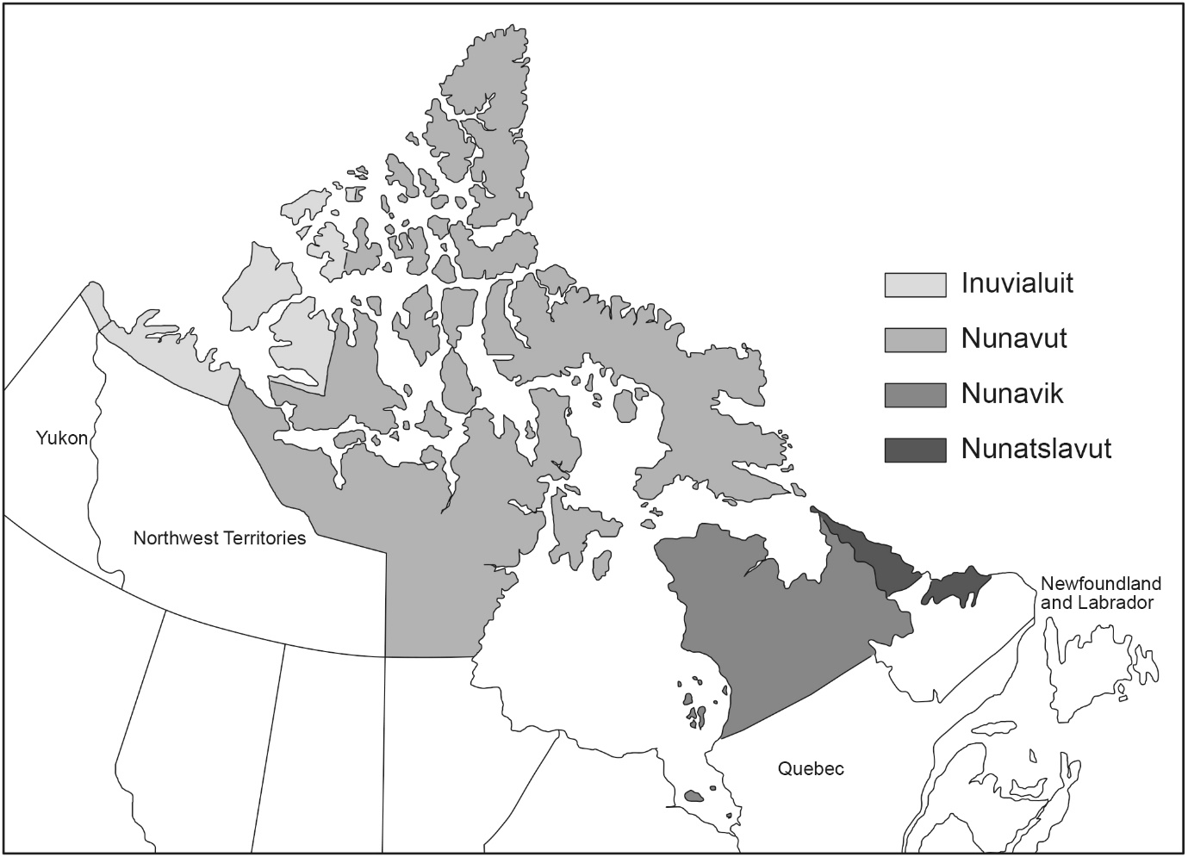

negotiation with Indigenous peoples. It reaffirmed the North as a site of border-work—territory as something to be controlled, distributed and divided—and, critically, where obligations and rights were specified within the newly created territory. Since its establishment, however, controversy has existed with the Nunavut Tunngavik Incorporated (NTI), the organization that represents the Inuit under the Nunavut Land Claim Agreement. Allegedly, the federal agreement has been failing to fulfill its obligations. In May 2015, the NTI and the Harper government reached an out-of-court settlement concerning the law suit brought by the NTI. It implicitly recognized that the implementation of the 1993 Nunavut Land Claims Agreement required substantial and sustained financial support, in the process highlighting the uneasy relationship between federal and territorial-level governance and border management.
In other words, for all the Canadian sovereignty talk by the Stephen Harper government, it was failing to invest in northern governance and civilian infrastructure as opposed to “sovereignty exercises,” military hardware, underwater surveillance in the NWP and border security (Abele 2016). But perhaps there was something else here that made itself more manifest in the recent Canada 150 celebrations: the ambivalent position of the Canadian North and its residents with the geographical imagination of southern Canadians including Prime Ministers. Hashtags such as #Reoccupation and #Resistance150 have generated considerable social media and traditional media coverage, explicitly challenging the “bordering” of Canadian history and geography.
For all the claims to significance of the North within Canadian national identity and sovereignty projects, it is a vast region that few Canadians will actually visit let alone inhabit (Globe and Mail 2014). If there is an imaginary border at play then perhaps it pivots around the register of apprehension (Is Canadian sovereign territory in the north vulnerable to perfidious others?) and incomprehension (Is it simply cold, underpopulated and expensive?). As Nunavut-based performance artist, Laakkuluk Williamson Bathory mused:

The North is an extremely cold place, barren actually, without a single tree in sight. You walk on the streets that are not even paved and you go into the stores and you pay exorbitant fees for things like milk and eggs and lettuce. Prices that are four or five times higher than any city in the South. And the people that you see in the aisles of the store are people who have the highest statistics of all the worst things. Highest suicide rates, the highest rates of unemployment, the lowest rates of education. It's an extremely difficult life here in the North…For somebody like me who is racialized in mainstream Canadian society, I always have to describe who I am, where I come from, and why (quoted in CBC 2014).

As a Greenlandic artist living and working in Iqaluit, Bathory makes a case for the border as something inherently embodied. It is affecting and intensely felt—something that separates and stratifies her and other indigenous peoples away from mainstream (predominantly white, Anglophone, settler-colonial) Canadian society. The Arctic border transmogrifies from being something rooted in place to an altogether more mobile assemblage of ideas, policies and practices that can and does make itself manifest far away from the Arctic/Canadian North. As Bathory notes, there are limits to assimilationist logics as Indigenous peoples are asked to account for their background, names and heritage. So when former Prime Minister Stephen Harper declared “We are a northern nation,” he didn’t stop to articulate who the “we” involved, and how and where Canadians might be enrolled in this national identity project.
As Indigenous activists noted throughout the planning and implementation of the Canada 150 celebrations, Indigenous peoples were living in the North for thousands of years before Confederation. When Canadian prime ministers speak of northern identities and northern nationalism, they don’t dwell on the legacies of residential schools, racism, gendered violence, assimilation and a lack of basic infrastructure. If bordering strategies are at play, then they involve an Arctic which emptied out of a complex history and geography of militarism, pollution, under-investment and displacement, often in the name of addressing “the Indian problem.” It is an Arctic where many southern Canadians can grow up with little awareness of what specific legislation such as the 1876 Indian Act entailed for Indigenous peoples in terms of their education, welfare and citizenship rights. Notwithstanding the work of the Truth and Reconciliation Commission on the legacy of residential schools and segregation, no northern communities was left untouched by this social-cultural border-work of the Canadian territorial state (Truth and Reconciliation Commission of Canada 2015).
As part of speaking against the epistemic violence of Canada 150, Indigenous activists mobilised different stories about Canada. They gave all Canadians the opportunity to learn about the vicarious nature of borders and bordering. Extending far beyond the Arctic region as defined by a line of latitude or territorial boundary line, this bordering asks us to question what is at stake—a vision of reconciliation where the everyday experiences of Indigenous peoples in the Arctic and further south are subsumed within logics of assimilation and reconciliation, logics in which Indigenous peoples would become “Canadianized” (sic) and embrace Canadian values and practices. For Indigenous scholars, #Colonialism150 and #Resistance150 are opportunities to highlight enduring colonial settler dynamics, which position northern peoples as equal treaty partners welcoming Canadian benevolence.
What might de-bordering the Canadian North/Arctic look and feel like? For one thing, it might start by recognising that for too long stories about Arctic borders have privileged territorial states and their strategies and interests. It might involve different stories about periodization, with due recognition of multiple temporalities involving millennia and not simply the last 150 years, let alone the last decade (McGhee 2008). Second, it would involve an acknowledgement that Indigenous peoples in the North were neither victims nor willing partners of the Crown and federal government. What the last 400 years of Indigenous-British-French-Canadian relations reveals is something inherently more complicated involving resistance, accommodation and negotiation on the basis of Canada being invited to enter into a relationship with First Nations, tribal and Indigenous peoples. Third, the renaming places to reflect their Indigenous origins and recognizing that some places rendered invisible by colonial settlers need to be restored to their former significance as recognized and named by Indigenous peoples. In other words, place names not only signify location but also help to shift the bordering of human and physical geographies. In 2017, Google confirmed that Google Maps and Earth had been updated with an additional 3000 Canadian indigenous place-names added to maps of Canada (CBC 2017). Finally, it will involve more humility, listening (rather than talking) and appreciation that the story of Arctic borders and border-work is not always one “we” get to tell.

Epilogue
My rumination lacks a neat conclusion. “Our” stories have limits; we emphasise some places, relationships and places more than others. The Arctic border is anything but fixed, and it reveals uneven topographies both physical and corporeal. The physical terrain of the region clearly matters when it comes to shaping the prevailing legal framework governing the zonation of the maritime Arctic (Steinberg and Kristoffersen 2017). Coastal states such as Canada and Russia loom large in this rendition of borders, and their border-work is noteworthy when it comes to protecting their exclusive economic zones and extending sovereign rights over the continental shelf. International legal measures have encroached further on the seabed and water column of the Arctic Ocean. As a political technology, the legal migrates, settles and colonizes space. The intersection of sea ice, prevailing darkness, and the cold are elemental in this border-work, contributing to facilitation and occasional frustration of the expansion of the sovereign rights of territorial states.
The Beaufort Sea and the undetermined maritime border between the US and Canada involve an area of disagreement of about 625 square miles. On face value, it appears to be an area of disagreement requiring bilateral negotiation. No one expects the two countries to become embroiled in conflict over this matter but it could be highly controversial in both countries. Indigenous peoples in the Arctic have rights over water and ice. The delimitation of a maritime boundary between the two countries has implications for local communities on both sides of any border. Under Section 35 of the Canadian Constitution, every government has an obligation to respect and protect Indigenous peoples and their rights; land claim agreements across Canada facilitate the sharing of territories but do not extinguish Indigenous rights over land, sea and seabed. Can Canada cede any maritime territory to the US if it violates the interests and rights of Indigenous peoples? All of this occurs against a backdrop of increasing international interest in these waters from fishing and resource extraction to commercial access to the Northwest Passage.
But as the penultimate section of this essay suggests, borders and bordering are also felt. They do more than enclose and exclude material spaces and inscribe themselves on maps and geopolitical discourses. They stick to some bodies more than others (Ahmed 2014). They mark what we might consider a form of “slow violence” against Indigenous peoples in the North, where residents were and are still displaced, relocated and disappear (Nixon 2013). While there is no shortage of stories about a “new North” and how climate change will transform the geophysical and geopolitical boundaries of the Arctic, we might pause and listen to others as they express their unease with past, current and possibly future borders, and the border-work that accompanies these assemblages (Stuhl 2016). The Arctic border is not and never has been simply a line on the earth, water and ice, let alone the map. As the mythical Greek river god, Scamander, recognised borders like rivers have the capacity to be displaced, unsettled and disturbed.

Acknowledgements
My sincere thanks to Professor Robert Brym of the University of Toronto for extending an invitation to participate in the 3rd S D Clark Symposium on the Future of Canadian Society in November 2017 and for his skillful editing of this chapter. Thanks also to Grace Ramirez at the Department of Sociology at the University of Toronto for her support.

References
Abele, F. 2016. “The North in New Times: Revising Federal Priorities”. Pp. 5-11 in North of 60: Toward a Renewed Canadian Arctic Agenda, edited by J. Higginbotham and J. Spence. Waterloo: Centre for International Governance Innovation.
Ahmed, S. 2014. The Cultural Politics of Emotion Edinburgh: Edinburgh University Press 2014.
Arctic Council’s Conservation of Arctic Fauna and Flora (CAFF). 2017. Arctic Invasive Alien Species Strategy and Action Plan (2017). https://www.caff.is/strategies-series/415-arctic-invasive-alien-species-strategy-and-action-plan.
Anker, E. 2013. “In the Shadowlands of Sovereignty: The Politics of Enclosure in Alejandro Gonzalez Inarritu’s Babel.” University of Toronto Quarterly 82(4): 950-73.
Baker, A. 2009. “The contemporary reality of Canadian imperialism: Settler colonialism and the hybrid colonial state” The American Indian Quarterly 33(3): 325-51.
Benton, L. 2009. A Search for Sovereignty. Cambridge UK: Cambridge University Press.
Burke, D. 2017. “Leading by example: Canada and its Arctic stewardship role.” International Journal of Public Policy 13(1/2): 36-52.
Byers, M. International Law and the Arctic. Cambridge UK: Cambridge University Press.
Cameron, E. 2016. Far Off Metal River: Inuit Lands, Settler Stories, and the Making of the Contemporary Arctic. Vancouver: University of British Columbia Press.
CBC News. 2017. “Over 3000 indigenous lands added to Google Maps, Earth”. 21 June. https://globalnews.ca/news/3546031/over-3000-indigenous-lands-added-to-google-maps-earth/.
CBC Radio. 2017. “Inuk performance artist challenges ‘Southern Canadians’ on their perceptions of ‘the North.’ 2 July. http://www.cbc.ca/radio/outintheopen/hyphen-state-1.4184855/inuk-performance-artist-challenges-southern-canadians-on-their-perceptions-of-the-north-1.4184921?cmp=rss.
“A Circumpolar Inuit Declaration on Sovereignty in the Arctic.” 2009. http://www.inuitcircumpolar.com/sovereignty-in-the-arctic.html.
De Leon, J. 2015. The Land of Open Graves. Berkeley CA: University of California Press.
Dodds, K. 2010. “Flag waving and finger pointing: The Law of the Sea, the Arctic and the political geographies of the outer continental shelf.” Political Geography 29(2): 63-73.
__________. 2013. “The Ilulissat Declaration (2008): The Arctic States, “Law of the Sea,” and Arctic Ocean.” SAIS Review of International Affairs 33(2): 45-55.
Dodds, K. and Nuttall, M. 2016. The Scramble for the Poles. Cambridge UK: Polity.
“How we misunderstand the Canadian North.” 2014. Globe and Mail 20 January. https://www.theglobeandmail.com/news/national/the-north/arctic-circle-panel-how-we-misunderstand-the-canadian-north/article16404201/?page=all
Griffiths, F. 1987. Politics of the Northwest Passage Kingston and Montreal: McGill-Queens University Press.
“The Ilulissat Declaration.” 2008. Arctic Ocean Conference. Ilulissat, Greenland. http://www.oceanlaw.org/downloads/arctic/Ilulissat_Declaration.pdf.
Jensen, O. 2015. “Maritime Boundary Delimitation Beyond 200 Nautical Miles: The International Judiciary and the Commission on the Limits of the Continental Shelf.” Nordic Journal of International Law 84(4): 580-604.
Johnson, C., Jones, R., Paasi, A., Amoore, L., Mountz, A., Salter, M., and Rumford, C. 2011. “Interventions on rethinking “the border” in border studies.” Political Geography 30(2): 61–9.
Jones R., and Johnson, C. 2016. “Border militarization and the re-articulation of sovereignty.” Transactions of the Institute of British Geographers 41(2): 187-200.
Lackenbauer, W. and Farish, M. 2007. “The Cold War on Canadian soil: Militarizing a northern environment.” Environmental History 12(4): 920-50.
Lajeunesse, A. 2016. Lock, Stock and Icebergs: A History of Canadian Arctic Maritime Sovereignty. Vancouver: UBC Press.
McGhee, R. 2008. The Last Imaginary Place: A Human History of the Arctic. Chicago: University of Chicago Press.
Milloy, S. 1999. A National Crime: The Canadian Government and the Residential School System. Winnipeg, University of Manitoba Press.
Neyers, P. 2012. “Moving borders: the politics of dirt.” Radical Philosophy 174. https://www.radicalphilosophy.com/commentary/moving-borders
Nicol, H. 2010. “Reframing sovereignty: Indigenous peoples and Arctic States” Political Geography 29(2): 78-80.
Nicol, H. 2015. The Fence and the Bridge: Geopolitics and Identity along the Canada-US Border. Waterloo ON: Wilfred Laurier Press.
Nixon, R. 2013. Slow Violence and the Environmentalism of the Poor. Cambridge MA: Harvard University Press.
Panquin, J. and James, P. 2014. Game Changer: The Impact of 9/11 on North American Security. Vancouver: University of British Columbia Press.
Phaneuf, R. 1979. “Indian reserve boundaries and rights: enforcement of the St. Lawrence River.” Canadian Water Resources Journal 4(3): 30-4.
Porter, J. 1965. The Vertical Mosaic: An Analysis of Social Class and Power in Canada. Toronto: University of Toronto Press.
Powell, R. 2010. “Lines of possession? The anxious constitution of a polar geopolitics.” Political Geography 29(2): 74-7.
Rothwell, D. and Stephens, T. 2016. The International Law of the Sea. Oxford: Hart 2016.
Steinberg, P., Tasch, J., and Gerhardt, H. 2015. Contesting the Arctic: Politics and Imaginaries in the Circumpolar North. London: I B Tauris 2015.
Steinberg, P. and Peters, K. 2015. “Wet Ontologies, Fluid Spaces: Giving Depth to Volume through Oceanic Thinking.” Environment and Planning D: Society and Space 33(2): 247-64.
Steinberg, P. and Kristoffersen, B. 2017. “The ice edge is lost … nature moved it”: mapping ice as state practice in the Canadian and Norwegian North” Transactions of the Institute of British Geographers 42(4): 625-41.
Stuhl, A. 2016. Unfreezing the Arctic: Science, Colonialism and the Transformation of Inuit Lands. Chicago: University of Chicago Press.
Thobani, S. 2007. Exalted Subjects: Studies in the Making of Race and Nation in Canada. Toronto: University of Toronto Press 2007.
Truth and Reconciliation Commission of Canada. 2015. Honouring the Truth, Reconciling for the Future: Final Report of the Truth and Reconciliation Commission of Canada. http://www.trc.ca/websites/trcinstitution/index.php?p=890.
UNCLOS. 1982. The United Nations Law of the Sea Convention http://www.un.org/depts/los/convention_agreements/texts/unclos/unclos_e.pdf
Wilson Center. 2014. “I didn’t know that! Arctic borders are still not settled. https://www.wilsoncenter.org/publication/arctic-borders-still-arent-settled.

