Supplementary Material
S1. Sampling settings
A total of six samples were collected at the Nata Island study site (main paper, Fig. 1C). Three were taken in a borehole (IS-1.1, IS-1.2, IS-1.3) next to the island in non-carbonated sandy layers, two were taken from the carbonate rocks (IS-P1, IS-P2) and a single sample was taken in the soil (IS-4) developing on top of the carbonate rock (Fig. S1). The carbonate platform has an unknown thickness, and the shape of the carbonate basement was not observed. The surrounding sandy sediment is enriched in siliceous nodules (Fig. S1, IS-1.1, IS1.2) and the extension of this sediment under the carbonate platform or on the other side of the island is unclear. Siliceous nodules also occur in the carbonate rocks, and it is not clear whether they were formed before and/or after the carbonate precipitation, both possibilities are plausible (Nash and Shaw, 1998).
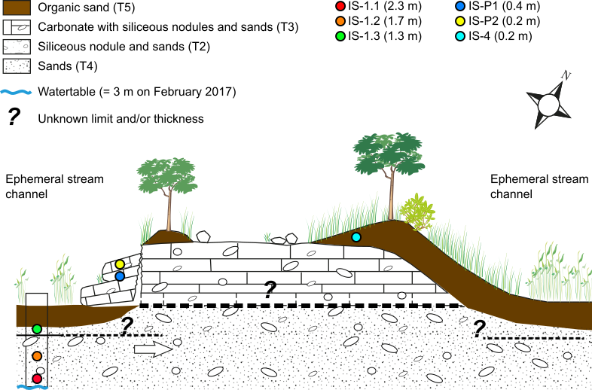
Figure S1: The sedimentary and geomorphic settings of the Nata Island, showing the location of OSL samples, whose present-day depths are indicated in parentheses in the legend. Dashed lines and question marks indicate unclear contacts between the various sedimentary layers. These contacts have only been observed in a single borehole, indicated by the rectangle on the left-hand side of the figure, i.e. only on one side of the island. The boundary below sample IS-1.3, illustrated by the solid black line, is clearly observed and sharp.

S2. Protocol selection for equivalent dose measurement
A first set of luminescence measurements was performed with a Risø TL/OSL instrument at the Institute of Earth Surface Dynamics at the University of Lausanne (IDYST, UNIL, Switzerland). The $D_{e}$ values were determined using a single-aliquot regeneration (SAR) protocol (Wintle and Murray, 2000), using a pre-heat of 260°C (PH1) for 10 seconds (s) and a blue LEDs stimulation for 40s at 125°C to determine the natural or the regenerate dose luminescence (L_{x}), and a pre-heat of 2200°C for 10 s (PH2) and the same optical stimulation to determine the test dose luminescence (T_{x}, 10.8 Gy s⁻¹). Each cycle of measurement ended with a high-temperature bleach (280 °C for 100 s) with the blue LEDs. From these initial measurements, the samples were classified as high-$D_{e}$ value (hv) samples (IS-1.1, IS-1.2 and IS-P1) or as low-$D_{e}$ value (lv) samples (IS-1.3, IS-P2 and IS-4). A dose recovery test was applied on one sample of each category and this second run of data acquisition was performed at the Department of Geography of Royal Holloway University of London (RHUL, United Kingdom).

The dose recovery test is used to assess the ability of the SAR protocol to recover a known laboratory dose (Roberts et al., 1999; Wallinga et al., 2000; Murray and Wintle, 2006). A dose recovery test involves emptying the OSL source traps in a natural sample, administering a known laboratory radiation dose (the “known dose”; $D_{kw}$), and then performing a full SAR measurement sequence (Table S1) to generate an equivalent dose (the “recovered dose”; $D_{rc}$). From these data, a « dose recovery ratio » ($D_{rc}$/$D_{kw}$) may be calculated. Measurement conditions which yield a dose recovery ratio close to unity are conventionally regarded as being suitable for equivalent dose estimation measurements. In the present study, dose recovery experiments were performed on two samples (IS-1.1 $D_{e}$ ≈ 60 Gy and IS-1.3 $D_{e}$ ≈ 2 Gy), using a range of commonly adopted preheating regimes (Fig. S2). The aim of this test is to determine the most appropriate preheating regime for the Nata Island samples.

Dose recovery experiments were performed as follows. Firstly, aliquots were illuminated for 100 seconds (s) at room temperature using blue LEDs, and, after a pause of 10’000s, illuminated for a second time. Aliquots were then given a known dose, chosen to be close to the expected natural $D_{e}$, and then measured using a standard SAR measurement sequence (Table S1). Four aliquots were measured using each of six preheating regimes. Five preheating regimes involved preheat 1 (PH1, the preheat prior to measurement of the natural or regenerated luminescence intensity) temperatures of 180, 200, 220, 240 and 260°C, each held for 10 s, paired with a preheat 2 (PH2, the preheat prior to measurement of the test dose luminescence intensity) at a temperature of 160 °C held for 5 s. The sixth preheating regime used a PH1 temperature of 260°C and a PH2 temperature of 220°C, both held for 10 s. Figure S2 shows the results of the dose recovery test performed on sample IS-1.3 (green, $D_{e}$ ~2 Gy) and sample IS-1.1 (red, $D_{e}$ ~60 Gy).

Table S1: Pre-heat recovery test testing the sensitivity of the SAR protocol to different thermal treatments.
Steps | Treatments | Observed
1 | Blue LED bleaching for 100 s | -
2 | Pause 10’000 s | -
3 | Blue LED bleaching for 100 s | -
4 | Beta Dose, D_{i} | -
5 | Pre-heat (PH1_{j}) | -
6 | Blue LEDs OSL for 60 s or 240 s at 125°C | L_{x}
7 | Beta test Dose, 10 s or 100 s | -
8 | Pre-heat (PH2_{j}) | -
9 | Blue LEDs OSL for 60 s or 240 s at 125°C | T_{x}
10 | Blue LEDs OSL bleaching for 100 s at 280°C | -
IS-1.3: D_{i} i=known dose (1.2 Gy), 1.2 Gy, 0 Gy, 2.3 Gy, 3.5 Gy, 4.7 Gy, 7.0 Gy, 9.3 Gy, 0 Gy, 2.3 Gy
IS-1.1: D_{i} i= known dose (11.7 Gy), 11.7 Gy, 0 Gy, 23.3 Gy, 35.0 Gy, 46.7 Gy, 70.0 Gy, 93.4 Gy, 0 Gy, 23.3 Gy
Paired pre-heat (°C) treatments (PH1/PH2): j=180/160, 200/160, 220/160, 240/160, 260/160, 260/220

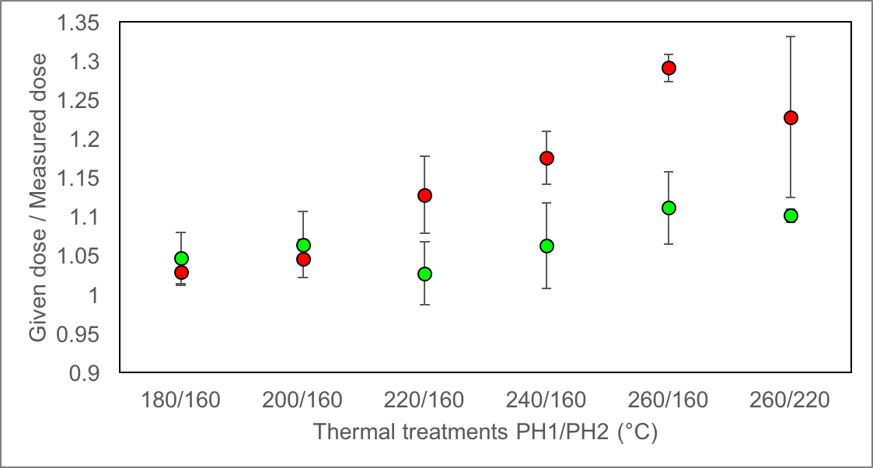
Figure S2: Dose recovery data for samples IS-1.3 ($D_{kw}$=1.1 Gy; green dots) and IS-1.1 ($D_{kw}$=11 Gy; red dots). Each point is the mean of four aliquots, with uncertainties being ±1σ. The x-axis shows the paired PH1/PH2 thermal treatments.
The results suggest that higher temperature preheats are unsuitable for both samples, possibly due to the thermal transfer of charge during PH1. However, beyond the explanations, the dose recovery ratio deviates more from unity (black line) at high PH1 temperatures for the higher $D_{e}$ value sample (IS-1.1, red dots). From the results presented in Figure S2, we conclude that the best thermal treatment to adopt in the present study is 180 °C for 10 s (PH1) and 160 °C for 5s (PH2). However, even using this preheat regime, the dose recovery ratio exceeds unity. One possible cause for the D_{rc} overestimate is the high temperature bleaching (blue LEDs at 280°C for 100 s) step performed after measurement of T_{x} (Table S1, step 10). This bleach is intended to reduce any residual OSL signal carried from one SAR cycle to the next, but since it is conducted at a much higher temperature than the ideal preheating regime identified above, it may be responsible for sub-optimal dose recovery performance. To test this hypothesis, a second dose recovery test was performed on each sample, using the 180/160 preheat regime but either a) replacing the 280°C high temperature bleach with a lower temperature (blue LEDs bleaching for 100 s at 125 °C) bleach, or b) omitting the bleaching step entirely. Mean dose recovery ratio for this experiment are 1.20±0.05 (a) and 1.16±0.05 (b) for sample IS-1.1, and 1.06±0.06 (a) and 1.04±0.02 (b) for sample IS-1.3. Consequently, we omit the bleaching step for low $D_{e}$ samples, but retain a 280°C bleach for high $D_{e}$ samples.

S3. Equivalent dose determination
Equivalent doses ($D_{e}$) for each sample were determined using the SAR protocol (Table S1, but with steps 1-3 omitted in all cases, and step 4 omitted for the first (natural) luminescence measurement). For each sample, a total of 24 small aliquots (Silkospray silicone oil applied to an aluminum disc via a ~1 mm mask) was measured. Four aliquots of each sample were used to perform a dose recovery test, using the preheating and measurement regime described above. The remaining 20 aliquots were used to determine the equivalent dose (Table S2). The results of the dose recovery tests (Fig. S3) indicate that the measurement conditions used are appropriate for our samples. For the remaining 20 aliquots, individual aliquots were accepted where the recycling ratio (Murray and Wintle, 2000) and IR-depletion ratio (Duller, 2003) were consistent with unity and the luminescence signal in response to a zero dose (“recuperation”) did not exceed 5% of the natural luminescence intensity. Depending on the duration of the stimulation, i.e. 60 s or 240 s, the signal was integrated between the first 0.04 s and 0.32 s of stimulation or between the first 0.16 s and 1.28 s of stimulation, and the background was integrated between 56 s and 60 s, or between 224 s and 240 s, respectively. Table S2 shows the $D_{e}$ measured for each sample (18 < n < 20) with the central age model values (CAM, Galbraith et al., 1999) and the overdispersion values (OD). Typical decay curves and grow curves for low and high $D_{e}$ samples are given in Figure S4.
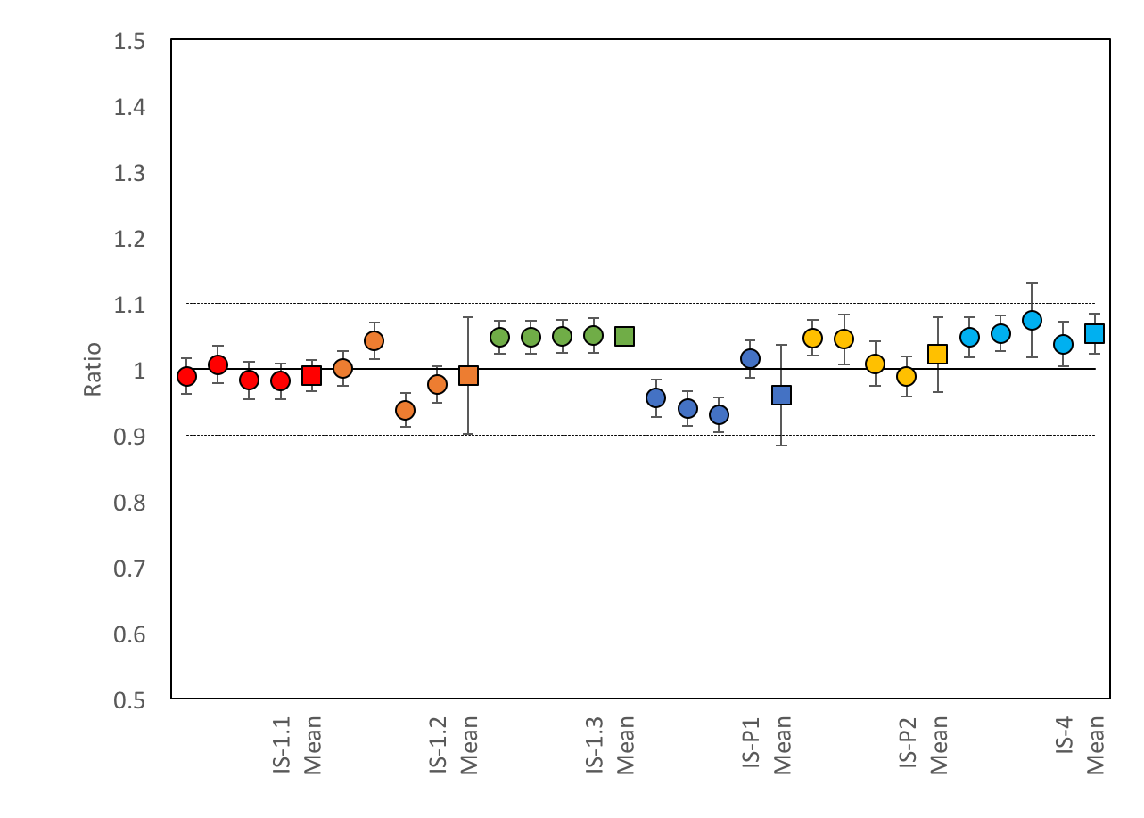

Figure S3: Dose recovery test (n=4) for each sample. Markers represent the dose recovery ration (recovered dose/known dose), with circles representing individual aliquots and squares representing the sample average. All uncertainties are ±2σ.

Table S2: Central age model (CAM) $D_{e}$ values for each sample and overdispersion (OD). Errors are the standard errors (±SE). n/m are the accepted aliquots (n) and rejected aliquots (m) according to the acceptance criteria described in the text.
Sample | n/m | CAM $D_{e}$ (Gy) | OD (%)
IS-1.1 | 18/20 | 64.6±2.0 | 12.2±0.5
IS-1.2 | 20/20 | 63.2±3.3 | 22.7±0.8
IS-1.3 | 20/20 | 1.7±0.1 | 14.9±0.5
IS-P1 | 20/20 | 29.9±1.9 | 28.5±1.0
IS-P2 | 18/20 | 5.1±0.4 | 32.2±1.3
IS-4 | 18/20 | 1.5±0.2 | 56.9±2.2

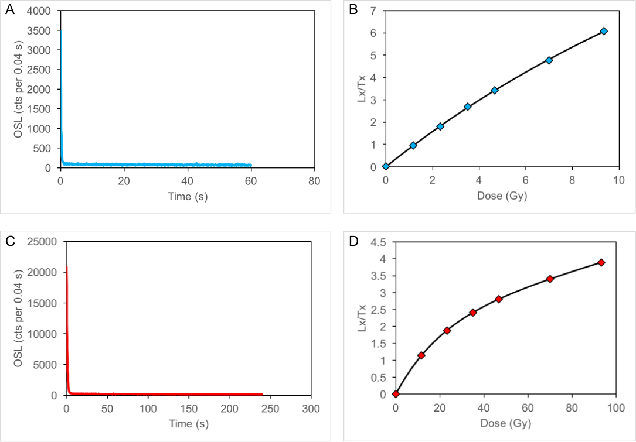
Figure S4: Example decay (A, C) and growth curves (B, D) for a low$D_{e}$ sample (IS-4 in blue) and a high $D_{e}$ sample (IS-1.1 in red).

S4. Dose Rate determination and age calculations
The environmental dose rate ($\dot{D}$, Gy/ka) is the rate at which a luminescence dosimeter (quartz grain in the present instance) receives ionising radiation during burial (Aitken, 1985). This radiation is derived from the decay of radioisotopes in the uranium (U) and thorium (Th) decay series, as well as contributions from rubidium (Rb) and potassium (K), all of which are present in the sediment. Combined, these sources provide the sediment dose rate (${\dot{D}}_{sed}$). This latter is assessed on the basis of present-day geochemical settings (Table S3), assuming the infinite matrix and secular equilibrium of radioisotope series (e.g. Guérin et al., 2012). A dose due to cosmic rays (${\dot{D}}_{cos}$) represents an additional component of $\dot{D}$. Its contribution is determined by latitude, longitude, and altitude, but also by the density and depth of overburden above the present-day position of the sample. The parameters F, H and J, used for the Chobe Enclave ${\dot{D}}_{cos}$ assessment, are 0.37, 4.31 and 0.58 (Prescott and Hutton, 1994). The overburden values taken for sandy samples is 1.8 g cm⁻³ and 2.7 g cm⁻³ for the carbonate rocks.

The Chobe Enclave is located in the Middle Kalahari Basin (Fig. 1, main paper). The sediments in the Kalahari Basin are from the Kalahari Group and have a thickness of ~200 m in this part of the basin (Thomas and Shaw, 1991; Thomas, 1988). Different lithologies compose this group, in addition to the main body of unconsolidated sand, i.e. Si-rich duricrusts, carbonate duricrusts, or sandstones, these last facies witnessing different transportation and weathering processes of the primary unconsolidated sediment. At Nata Island, the sandy layers can be enriched in siliceous nodules (IS-1.1 and IS-1.2), calcified (carbonated sand, IS-P1 and IS-P2), unconsolidated (IS-1.3) or soil-influenced (organic matter rich sand, IS-4, Fig. S5). Chemical changes in the sedimentary layers are prone to change the radioisotope content, and it is likely that ${\dot{D}}_{sed}$ has changed over time for some samples. Moreover, in the context of secondary carbonate precipitation, the uranium decay series are likely to be in disequilibrium. Unlike thorium, uranium is soluble and is included in the calcite lattice (Chabaux et al., 2008), meaning that uranium isotopes are initially deposited without any of their decay products. To assess the effect of ²³⁸U-series disequilibrium, it was assumed that all ²³⁴U daughters were initially missing. However, not all ²³⁸U content is in disequilibrium, as a proportion was likely to have been present in the sediment before precipitation. To assess this proportion, it is possible to compare the ²³²Th/²³⁸U ratio (Table S3) of an unconsolidated sand (IS-1.3=2.5) with that of the carbonate rock (IS-P1=0.29). Due to the difference of solubility of U and Th explained above, we can assume that all the ²³²Th present in the carbonate rock is detrital, and that this detrital ²³²Th was accompanied by detrital ²³⁸U in equilibrium with its entire decay series at the ²³²Th/²³⁸U ratio of unconsolidated sand (2.5). This analysis suggests that ~ 12% ²³⁸U content in the carbonate rock is detrital. This fraction of ²³⁸U is assumed to be in secular equilibrium.
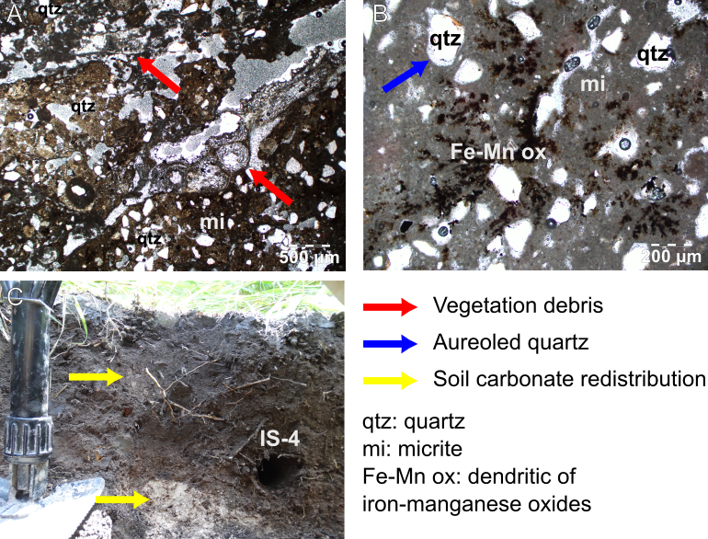
Figure S5: A) Thin section of the Nata Island carbonate observed in polarized light: a micrite is cementing vegetation debris (red arrows) and primary minerals. B) Thin section of Nata Island carbonate showing aureoled quartz (blue arrow) with a sparitic rim in a micritic (mi) matrix, also including late diagenetic dendritic Fe-Mn oxides. C) Location of sample IS-4 in the soil profile developing on the carbonate platform: yellow arrows point to the weathered platform (bottom yellow arrow) and a carbonate redistribution along the profile (top yellow arrow).

Finally, the ${\dot{D}}_{cos}$ should have also changed through time due to deposition-erosion processes shaping the landscape. An increase in overburden (sediment deposition) lowers ${\dot{D}}_{cos}$, and a decrease in overburden (exhumation) increases ${\dot{D}}_{cos}$. Consequently, in this study it was necessary to model changes in both ${\dot{D}}_{sed}$ and ${\dot{D}}_{cos}$ over time. For the Nata Island samples, changes in $\dot{D}$ over time were modelled by hypothesizing separate phases ($T_{i}$), each with an associated dose rate ($\dot{D_{i}}$). The depositional model underpinning this analysis is illustrated in Figure S6. The phases are: the time in which a sample consists of unconsolidated Kalahari sand ($T_{1}$); the time during which the sample contains siliceous nodules ($T_{2}$); the time during which the sample is cemented by a carbonate precipitate ($T_{3}$), and the time following exhumation of the carbonate platform ($T_{4}$). To simplify calculations, the transitions between phases are assumed to be instantaneous. During these phases, there were different $\dot{D}$, (i) a ${\dot{D}}_{1}$ during $T_{1}$ with a more or less pure sand, (ii) a ${\dot{D}}_{2}$ during $T_{2}$ with the precipitation of amorphous silica, (iii) a ${\dot{D}}_{3}$ during $T_{3}$ with the precipitation of carbonate, and (iv) a ${\dot{D}}_{4}$ after the increase of erosion during $T_{4}$. The equivalent dose ($D_{e}$) accumulated by a mineral grain is:
$D_{e}=\left(T_{1}*{\dot{D}}_{1}\right)+\left(T_{2}*{\dot{D}}_{2}\right)+\left(T_{3}*{\dot{D}}_{3}\right)+(T_{4}*{\dot{D}}_{4})$ (1)
where, $T_{i}$ are the different event succession through time with their corresponding dose rate (${\dot{D}}_{i}$). The ${\dot{D}}_{i}$ is the sum of ${\dot{D}}_{sed}$ and the ${\dot{D}}_{cos}$, which are specific to each sample as illustrated in Figure S5. For the samples which did not experience calcification, i.e. IS-1.1, IS-1.2, IS-1.3 and IS-4, $T_{3}$ is zero. Similarly, for samples without siliceous nodule occurrence, i.e. IS-1.3, IS-P1, IS-P2 and IS-4, $T_{2}$ is zero. Moreover, we use the chemistry of sample IS-1.3 to assess the ${\dot{D}}_{sed}$ during $T_{1}$. Finally, for the carbonate precipitation period ($T_{3}$), whose processes of formation and rates are poorly constrained, a phase $T_{3a}$ was distinguished from a phase $T_{3b}$ in order to separate samples IS-P1 and IS-P2, respectively (Fig. S6).

The processes leading to carbonate precipitation are still unclear. However, thin section observations (Fig. S5) show that the matrix phase is a micritic carbonate (carbonate crystals from 3 to 5 microns) surrounding vegetation debris, primary minerals (quartz) that are aureoled by a sparitic carbonate crystals (> 15 microns; aureoled quartz), and redistributions of dendritic Fe-Mn oxides. These petrographic features point out to a precipitation that took place in a palustrine environment, possibly affected by pedogenesis at some points (Freytet and Verrecchia, 2002).
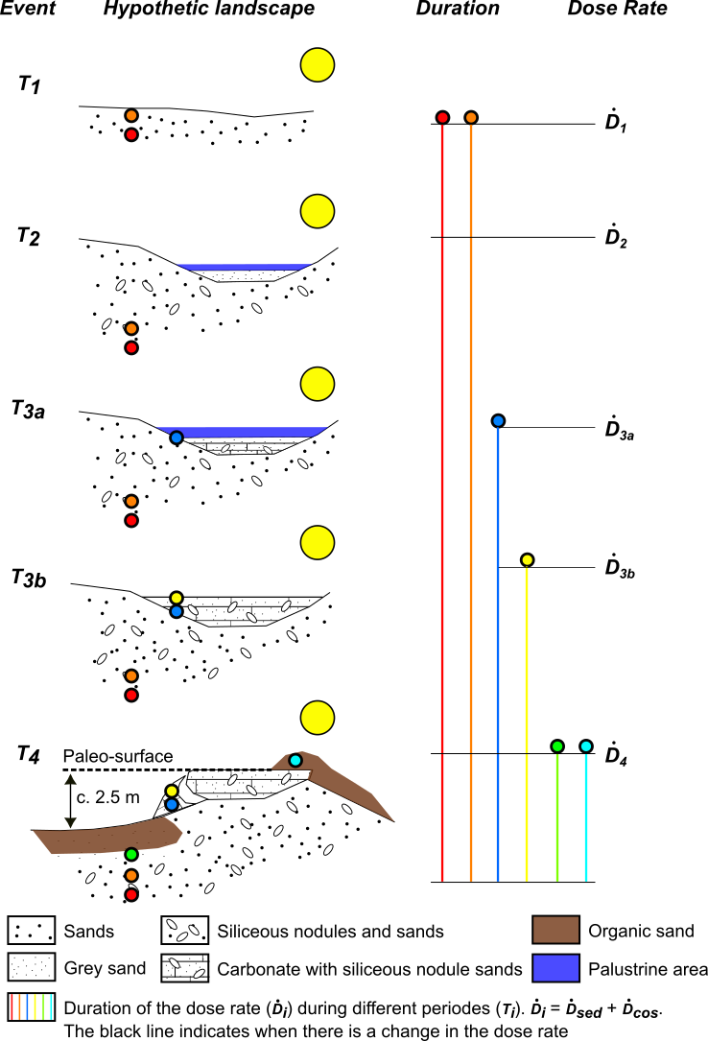
Figure S6: Hypothesis emphasizing the minerals complex sedimentological history, with 1) mineral deposition and sedimentation ($T_{1}$), 2) siliceous nodule formation ($T_{2}$), 3) carbonate precipitation (rate?) ($T_{3}$). The last phase is an erosion ($T_{4}$) to which are related the concomitant depositions of IS-1.3 and IS-1.4 and the exhumation of the carbonate platform. This succession of events led to chemical and geomorphological changes influencing the dose rate ($\dot{D}$) through time. The geochemical composition of sample IS-1.3 is used in order to assess the ${\dot{D}}_{sed}$ during ($T_{1}$). The timing of the palustrine phase is unclear but we suppose it occurred any time since $T_{2}$ as water is needed to mobilized Si; in addition, this period should have been wet enough for swamp formation.

Table S3: Geochemical composition of different sedimentary layers. Samples were prepared using lithium metaborate/tetraborate fusion and their lithochemistry was analysed using an Inductively Coupled Plasma-Mass Spectrometer (ICP-MS). The detection limit of this instrument was ~0.01 % (0.1 ppm).
Sample | Depth (m) | U ppm | Th ppm | Rb ppm | K% | Th/U
IS-1.1 | 2.3 | 1.0 | 1.6 | 13 | 0.22 | 1.60
IS-1.2 | 1.7 | 0.6 | 1.3 | 13 | 0.13 | 2.17
IS-1.3 | 1.3 | 0.2 | 0.5 | 3 | 0.07 | 2.50
IS-P1 | 0.4 | 0.7 | 0.2 | 4 | 0.05 | 0.29
IS-P2 | 0.2 | 0.7 | 0.2 | 4 | 0.05 | 0.29
IS-4 | 0.2 | 1.8 | 0.9 | 19 | 0.27 | 0.50

The IS-1.3 dose rate evolution
The deposition of IS-1.3 (Fig. S1) is linked to the most recent sedimentary cycle. It is a grey sand, 40 cm thick, overlaying a siliceous nodule-rich sand. The boundary between these sands is sharp attesting the role of an erosion increase. It is thus suggested that the deposition age of sample IS-1.3 can constrain the phase $T_{4}$ through time, i.e. an increase in erosion and the exhumation of the carbonate platform (Fig. S6). The ${\dot{D}}_{4}$ for this sample is assessed according to its radioisotope content (IS-1.3, Table S3) giving the ${\dot{D}}_{sed}$ with a water content of 5%±2%. Assuming that the grey sand was deposited geologically instantaneously, three different sediment accumulation scenarios were formulated to test the sensitivity of ${\dot{D}}_{cos}$, and therefore the age of the sample, to changes in overburden depth. In the first “ancient burial” scenario, sample IS-1.3 was buried geologically instantaneously to a depth of 1.3 m, and thus ${\dot{D}}_{cos}$ can be calculated using the present-day depth (Fig. S1). In the second “recent burial” scenario, the grey sand lenses from which IS-1.3 was taken, was not buried until very recently, and ${\dot{D}}_{cos}$ can be calculated using a 0.3 m burial depth, i.e. the thickness of the grey sand layer above the sampling point. In the third “gradual burial” scenario, the sediment overlying the grey sand accumulated at a constant rate from deposition of the grey sand through to the present-day. We propose that the gradual burial scenario most closely approximates the true sediment deposition history, while the ancient and recent burial scenarios define the minimum and maximum ${\dot{D}}_{cos}$, respectively.

The following procedure was used to calculate the age of sample IS-1.3 under the gradual burial scenario. The luminescence signal begins to accumulate in the sample immediately upon burial, with a constant${\dot{D}}_{sed}$ but with ${\dot{D}}_{cos}$varying with burial depth. Two parameters are known: (i) the present-day $D_{e}$, which is 1.7 Gy, and (ii) the thickness of the overlaying material, which is 1 m. Using different accretion rates, it is possible to calculate what would be the $D_{e}$ after 1 m of material accretion. The aim is to match the calculated $D_{e(mod)}$ with the measured $D_{e}$ in order to know how much time is needed, i.e. the deposition age of IS-1.3, to accumulate 1 m of material and to build 1.7 Gy of dose in the sample. The most correct model giving a $D_{e}$ of 1.7 Gy after 1.3 m of accumulation requires a sediment accumulation rate of 0.028 cm/yr, i.e 1.3 m accumulated in ~3.6 ka. Although we regard the gradual burial age estimate as the most appropriate for this sample, the adoption of ages based on either one the other sediment accumulation scenarios would not alter the geological interpretation of this sample (Table S4).
Table S4: Ages calculated for IS-1.3 with different scenarios: 1) instantaneous ancient burial, 2) instantaneous recent burial, and 3) gradual burial.
IS-1.3 | Age (ka)
Scenario 1 | 3.7
Scenario 2 | 3.3
Scenario 3 | 3.6

The IS-1.1 and IS-1.2 dose rate evolution
The age of IS-1.3 gives the time elapsed since the start of the $T_{4}$ time period, i.e. a date for the exhumation of the carbonate island. This date is important in assessing the temporal evolution of ${\dot{D}}_{cos}$ for samples IS-1.1 and IS-1.2. At the present-day, these samples are buried to a depth of 2.3 m and 1.7 m respectively (Fig. S1), and we regard these as the true burial depths for these samples since exhumation of the carbonate island at 3.6 ka (these samples are much older than IS-1.3, so modelling changes in ${\dot{D}}_{cos}$ due to the accumulation of sediment since 3.6 ka is unnecessary). Before this event occurred, these samples must have been buried to a greater depth (Fig. S6). The real depth before $T_{4}$ is unknown, but we assume that at least 2.5 m of overburden (the height difference between the present-day surface and the top of the carbonate platform) was removed when the platform was exhumed. Consequently, before $T_{4}$, the depths for IS-1.1 and IS-1.2 were 4.8 m (${\dot{D}}_{cos}$ is 0.128±0.013 Gy/ka) and 4.2 m (${\dot{D}}_{cos}$ is 0.137±0.014 Gy/ka), respectively. After $T_{4}$, the depths are 2.3 m (${\dot{D}}_{cos}$ is 0.171±0.017 Gy/ka) and 1.7 m (${\dot{D}}_{cos}$ is 0.184±0.018 Gy/ka) for IS-1.1 and IS-1.2, respectively. The dose accumulated before $T_{4}$ ($D_{e pre-T4}$) is:
$D_{e pre-T4}=D_{e}-D_{eT4}= D_{e}-(\left({\dot{D}}_{sed4}+ {\dot{D}}_{cos4}\right)* T_{4})$ (3)
where, the $D_{e}$ is the equivalent dose measured for samples IS-1.1 and IS-1.2, ${\dot{D}}_{sed4}$ is the dose rate calculated from the geochemistry of samples IS-1.1 and IS-1.2 (Table S11) and ${\dot{D}}_{cos4}$ is assessed from present-day depths (see above). Finally, $T_{4}$ is 3.6 ka.

Before $T_{4}$, the ${\dot{D}}_{sed}$ changed through time (Fig. S6) due to the formation of siliceous nodules in the sandy layer ($T_{2}$). It is possible to assume that during $T_{1}$, the ${\dot{D}}_{sed1}$ was equal to the one assessed for sample IS-1.3, i.e. without siliceous nodule occurrence, and during $T_{2}$, the ${\dot{D}}_{sed2}$ was similar to the one calculated using present-day IS-1.1 and IS-1.2 geochemistry, i.e. with the siliceous nodules. Consequently, the $D_{e}$ accumulated before $T_{4}$ ($D_{e pre-T4}$) is also:
$D_{e pre-T4}=\left(\left({\dot{D}}_{ext1}+ {\dot{D}}_{cos1}\right)* T_{1}\right)+(\left({\dot{D}}_{ext2}+ {\dot{D}}_{cos2}\right)* T_{2})$ (3)
where, ${\dot{D}}_{cos1}$ = ${\dot{D}}_{cos2}$ is the one calculated for paleo-depths (see above), ${\dot{D}}_{sed1}$ is the dose rate calculated with IS-1.3 geochemistry, and ${\dot{D}}_{sed2}$ is the dose rate calculated with present-day IS-1.1 and IS-1.2 geochemistry (Table S3, Table S5). Maximum and minimum periods of time from the sample deposition and $T_{4}$ refer to a scenario where $T_{2}$ = 0 and $T_{1}$ = 0, respectively (Table S5).
Table S5: Maximum and minimum periods of time between the deposition of IS-1.1 and IS-1.2, and $T_{4}$ are represented by scenarios where $T_{2}$ =0 and $T_{1}$ = 0, respectively. ${\dot{D}}_{cos1}$ = ${\dot{D}}_{cos2}$, because the depth does not change between the two scenarios.
Samples | Depth (cm) | $D_{e pre-T4}$ (Gy) | ${\dot{D}}_{cos}$ (Gy/ka) | ${\dot{D}}_{sed1}$ (Gy/ka) | Max dur. (ka) | ${\dot{D}}_{sed2}$ (Gy/ka) | Min dur. (ka)
IS-1.1 | -480 | 60.03 | 0.128 | 0.270 | 150.8 | 1.120 | 48.1
IS-1.2 | -420 | 60.05 | 0.137 | 0.270 | 147.5 | 0.690 | 72.6

Both durations are unlikely, it is more probable that there was first the deposition of an unconsolidated sand and then the formation of siliceous nodules due to Si mobilization. Consequently, we modelled $T_{2}$ with different values of $T_{1}$ ranging from 0 ka to the maximum duration (Equ. 4, Table S6). Knowing the different values for ${\dot{D}}_{i}$ and the $D_{e}$, it is possible to find $T_{2}$ by varying $T_{1}$ (for samples IS-1.1 and IS-1.2):
$T_{2}=\frac{D_{e pre-T4}-(T_{1}*({\dot{D}}_{sed1}+{\dot{D}}_{cos1}))}{{\dot{D}}_{sed2}+{\dot{D}}_{cos2}}$ (4)

Table S6: Ages of IS-1.1 and IS-1.2 before $T_{4}$ using different $T_{1}$ and $T_{2}$ between a proposition of 0 to 100%. ∆ (ka) is the different between IS-1.2 and IS-1.1 ages. Bold ages are the most probable range of ages that follows the stratigraphy, i.e. IS-1.1 was deposited before IS-1.2. ${\dot{D}}_{cos1}$ = ${\dot{D}}_{cos2}$.
 | IS-1.1 |  |  |  | IS-1.2
$$T_{1}$$ | $$T_{2}$$ | $D_{eT1}$ (%) | $D_{eT2}$ (%) | Age (ka) | $$T_{2}$$ | $D_{eT1}$ (%) | $D_{eT2}$ (%) | Age (ka) | ∆ (ka)
0 | 48.1 | 0 | 100 | 48.1 | 72.6 | 0 | 100 | 72.6 | -24.5
5 | 46.5 | 3 | 97 | 51.5 | 70.1 | 3 | 97 | 75.2 | -23.7
10 | 44.9 | 7 | 93 | 54.9 | 67.7 | 7 | 93 | 77.7 | -22.8
20 | 41.7 | 13 | 87 | 61.7 | 62.8 | 14 | 86 | 82.8 | -21.1
30 | 38.5 | 20 | 80 | 68.5 | 57.8 | 20 | 80 | 87.9 | -19.3
40 | 35.3 | 27 | 73 | 75.3 | 52.9 | 27 | 73 | 92.9 | -17.6
50 | 32.2 | 33 | 67 | 82.2 | 48.0 | 34 | 66 | 98.0 | -15.9
60 | 29.0 | 40 | 60 | 89.0 | 43.1 | 41 | 59 | 103.1 | -14.1
70 | 25.8 | 46 | 54 | 95.8 | 38.2 | 47 | 53 | 108.2 | -12.4
80 | 22.6 | 53 | 47 | 102.6 | 33.2 | 54 | 46 | 113.2 | -10.7
90 | 19.4 | 60 | 40 | 109.4 | 28.3 | 61 | 39 | 118.3 | -8.9
100 | 16.2 | 66 | 34 | 116.2 | 23.4 | 68 | 32 | 123.4 | -7.2
110 | 13.0 | 73 | 27 | 123.0 | 18.5 | 75 | 25 | 128.5 | -5.5
120 | 9.8 | 80 | 20 | 129.8 | 13.6 | 81 | 19 | 133.6 | -3.7
130 | 6.6 | 86 | 14 | 136.6 | 8.6 | 88 | 12 | 138.6 | -2.0
140 | 3.5 | 93 | 7 | 143.5 | 3.7 | 95 | 5 | 143.7 | -0.3
141 | 3.1 | 93 | 7 | 144.1 | 3.2 | 96 | 4 | 144.2 | -0.1
142 | 2.8 | 94 | 6 | 144.8 | 2.7 | 96 | 4 | 144.7 | 0.1
143 | 2.5 | 95 | 5 | 145.5 | 2.2 | 97 | 3 | 145.2 | 0.3
144 | 2.2 | 95 | 5 | 146.2 | 1.7 | 98 | 2 | 145.7 | 0.4
145 | 1.9 | 96 | 4 | 146.9 | 1.2 | 98 | 2 | 146.2 | 0.6
146 | 1.5 | 97 | 3 | 147.5 | 0.8 | 99 | 1 | 146.8 | 0.8
147 | 1.2 | 97 | 3 | 148.2 | 0.3 | 100 | 0 | 147.3 | 1.0
147.54 | 1.0 | 98 | 2 | 148.6 | 0.0 | 100 | 0 | 147.5 | 1.0
148 | 0.9 | 98 | 2 | 148.9
149 | 0.6 | 99 | 1 | 149.6
150 | 0.3 | 99 | 1 | 150.3
150.82 | 0.0 | 100 | 0 | 150.8
In order to respect the soundness of the stratigraphy, i.e IS-1.1 was deposited before IS-1.2, the most probable duration of time since deposition and until $T_{4}$ ranges between 144.8 ka and 148.2 ka for IS-1.1 and from 144.7 ka to 147.3 ka for IS-1.2. To obtain the final deposition age, the duration of $T_{4}$ needs to be added, i.e. 3.6 ka (Table S10).

The IS-P1 and IS-P2 dose rate evolution
IS-P1 and IS-P2 are the carbonate rock samples (Fig. S1). IS-P2 overlays IS-P1 and thus before its deposition the depth of IS-P1 is a least 20 cm shallower. To distinguish both samples during $T_{3}$, we use $T_{3a}$ and $T_{3b}$ for IS-P1 and IS-P2, respectively. As the depth of IS-P1 over time changed due to the deposition of IS-P2, we first need to assess the duration of time when IS-P2 overlayay IS-P1. As $T_{4}$ is known, we need to assess $T_{3b}$. The equivalent dose accumulated before $T_{4}$, i.e. $D_{e pre-T4}$, in sample IS-P2 is $D_{eT3b}$:
$D_{eT3b}=D_{e}-D_{eT4}= \left({\dot{D}}_{sed3}+ {\dot{D}}_{cos3}\right)* T_{3b}$ (5)
as the rate of carbonate precipitation is unknown, we can propose two extreme scenarios: In the first scenario (I) carbonate precipitated after the quartz deposition but recently (i.e. 0 ka). In the second scenario (II) the carbonate precipitated at the same time as the quartz was deposited. To assess the dose rate for scenario I, we propose to use the ${\dot{D}}_{sed}$ calculated from IS-1.3 chemistry (i.e ${\dot{D}}_{sed1}$, Table S8). For scenario II, ${\dot{D}}_{sed}$ is assessed with IS-P2 chemistry and taking into account that 88% (see section S4) of U is in disequilibrium (${\dot{D}}_{sed3}$, Table S8). The ${\dot{D}}_{cos3}$ is the same for both scenarios and is calculated for a depth of 20 cm (Table S8).
Table S7: Range of possible durations for period $T_{3b}$. $T_{3b 1}$ represents the duration of time without carbonate, and $T_{3b 2}$ represents the duration of time with carbonate. If $T_{3b 1}$ = 0 ka, so $T_{3b 2}$ explains 100% of the $D_{eT3b}$, i.e the carbonate precipitated at the same time as sediment deposition (scenario II). If $T_{3b 2}$ = 0 ka, so $T_{3b 1}$ explains 100% of the $D_{eT3b}$, i.e the carbonate only precipitated recently (scenario I). Between both scenarios, we can model different proportions of $D_{eT3b}$ accumulated during variable $T_{3b 1}$ and $T_{3b 2}$ durations. The final possible ages of IS-P2 deposition is $T_{3b}$ + $T_{4}$ and the possible carbonate ages are $T_{3b 2}$ + $T_{4}$.
$$T_{3b 1}$$ | $$T_{3b 2}$$ | $$D_{e 3b 1}$$  prop. | $$D_{e 3b 2}$$  prop. | $T_{3b}$ (ka) | Age (ka) | Carb. Age (ka)
0 | 2.7 | 0.0 | 1.0 | 2.7 | 6.3 | 6.3
1 | 2.1 | 0.2 | 0.8 | 3.1 | 6.7 | 5.7
2 | 1.4 | 0.5 | 0.5 | 3.4 | 7.0 | 5.0
2.7 | 1.0 | 0.6 | 0.4 | 3.7 | 7.3 | 4.6
3 | 0.8 | 0.7 | 0.3 | 3.8 | 7.4 | 4.4
4 | 0.2 | 0.9 | 0.1 | 4.2 | 7.8 | 3.8
4.2 | 0.0 | 1.0 | 0.0 | 4.2 | 7.8 | 3.6

The ${\dot{D}}_{cos}$ for IS-P1 is different before and after IS-P2 deposition ($T_{3b}$+$T_{4}$). Consequently, the $D_{e}$ accumulated before IS-P2, i.e. $D_{e 3a}$ is:
$D_{e 3a}=D_{e}-D_{e 4}- D_{e 3b}= \left({\dot{D}}_{sed3}+ {\dot{D}}_{cos3}\right)* T_{3a}$ (6)
where, the ${\dot{D}}_{cos3}$ is the cosmic dose rate for a 20 cm depth. As with IS-P2, the rate of IS-P1 carbonate formation is unknown. We can thus use the same scenarios given above to assess ${\dot{D}}_{sed3}$ and calculate the maximum and minimum durations of $T_{3a}$ (Table S8), using the scenarios II and I, respectively.
Table S8: Maximum and minimum durations (dur.) of $T_{3b}$, i.e from IS-P2 deposition until $T_{4}$ (see also Table S7), and maximal and minimal durations of $T_{3a}$, i.e. since deposition of IS-P1 until IS-P2 deposition (see also Table S9).
 | cm | $${\dot{D}}_{cos}$$ | $${\dot{D}}_{sed3}$$ | $${\dot{D}}_{sed1}$$ | $D_{e pre-T4}$ (Gy) | Min dur. | Max dur. | $D_{e pre-3a}$ (Gy) | Min dur. | Max dur.
IS-P2 | -20 | 0.248 | 0.57 | 0.27 | 2.2 | 2.7 | 4.2 | - | - | -
IS-P1 | -20 | 0.248 | 0.57 | 0.27 | 27.1 | - | - | 24.2 | 29.8 | 47

Then using different proportion of time $T_{3a 1}$ and $T_{3a 2}$, during which the $D_{e 3a}$ is accumulated, duration of $T_{3a}$ can be assessed for sample IS-P1 (Table S9) between both extreme scenarios (i.e. max and min durations; Table S8).
Table S9: Ranges of possible duration of time $T_{3a}$, i.e from IS-P1 deposition until IS-P2 deposition, where $T_{3a 1}$ represents the time without carbonate and $D_{e 3a 1}$ represents the proportion of the $D_{e 3a}$ (Equ. 6) accumulated during $T_{3a 1}$, and where where $T_{3a 2}$ represents the time with carbonate and $D_{e 3a 2}$ represents the proportion of the $D_{e 3a}$ (Equ. 6) accumulated during $T_{3a 2}$. Consequently, scenario I, i.e. the carbonate precipitated recently, gives the maximum duration of $T_{3a}$ (47.0 ka) where $T_{3a 2}$ is 0 ka. Conversely, scenario II, i.e. the carbonate precipitated instantaneously after the sediment deposition, gives the minimum duration of $T_{3a}$ (29.8 ka) where $T_{3a 1}$ is 0 ka. “Age” refers to the possible deposition ages of IS-P1 ($T_{3a}$ + $T_{3b}$ + $T_{4}$) and the “Carb. Age” to the possible ages for carbonate precipitation ($T_{3a 2}$ + $T_{3b}$ + $T_{4}$).
$T_{3a 1}$ (ka) | $T_{3a 2}$ (ka) | $D_{e 3a 1}$ (prop.) | $D_{e 3a 2}$ (prop.) | $T_{3a}$ (ka) | Age (ka) | Carb. Age (ka)
0.0 | 29.8 | 0.00 | 1.00 | 29.8 | 36.9 | 36.9
5.0 | 26.6 | 0.11 | 0.89 | 31.6 | 38.7 | 33.7
10.0 | 23.5 | 0.21 | 0.79 | 33.5 | 40.6 | 30.6
15.0 | 20.3 | 0.32 | 0.68 | 35.3 | 42.4 | 27.4
20.0 | 17.1 | 0.43 | 0.57 | 37.1 | 44.2 | 24.2
25.0 | 14.0 | 0.53 | 0.47 | 39.0 | 46.1 | 21.1
30.0 | 10.8 | 0.64 | 0.36 | 40.8 | 47.9 | 17.9
35.0 | 7.6 | 0.74 | 0.26 | 42.6 | 49.7 | 14.7
40.0 | 4.5 | 0.85 | 0.15 | 44.5 | 51.6 | 11.6
45.0 | 1.3 | 0.96 | 0.04 | 46.3 | 53.4 | 8.4
47.0 | 0.0 | 1.00 | 0.00 | 47.0 | 54.1 | 7.1

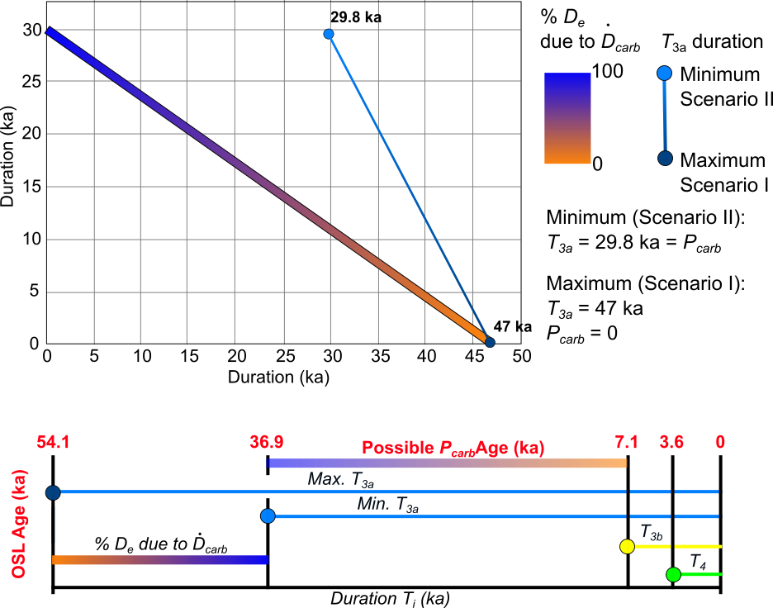
Figure S7: Relationships between OSL age and carbonate age for sample IS-P1. The upper graph represents the possible duration of $T_{3a}$ depending on the dose rate proportion contribution from the carbonate rock (${\dot{D}}_{carb}$) to the $D_{e 3a}$. The schematic diagram below shows the link between durations of $T_{i}$ and OSL ages. Different ${\dot{D}}_{carb}$ proportion contributions to $D_{e 3a}$ give $T_{3a}$ durations from 54.1 ka (maximum duration, scenario I) to 36.9 ka (minimum duration, scenario II), meaning as well that the possible ages for the carbonate precipitation (P_{carb}) ranges from 36.9 ka to 7.1 ka.

Tables S7 and S9 show the results of different carbonate precipitation timing (Carb. Age) for samples IS-P2 and IS-P1, respectively, based on dose rate changes. Consequently, in this study, the results suggest that it is also possible to constrain the carbonate precipitation through time. As a detailed example for sample IS-P1 (upper graph in Fig. S7), we can see that if 100% of the $D_{e 3a}$ is produced by the ${\dot{D}}_{sed3}$ from the carbonate rock (${\dot{D}}_{carb}$), i.e. 0 % is produced from an unconsolidated sediment (IS-1.3, ${\dot{D}}_{sed1}$), so the duration of $T_{3a}$ is 29.8 ka (minimum duration, scenario II). If 0% of the $D_{e 3a}$ is produced by the ${\dot{D}}_{sed3}$ from the carbonate rock, i.e. 100% is produced from an unconsolidated sediment, so the duration of $T_{3a}$ is 47 ka (maximum duration, scenario I). These minimum and maximum durations are the durations of $T_{3a}$ and are not the deposition age of IS-P1. The durations of $T_{3b}$ and $T_{4}$ need to be added to yield the deposition age, which is 36.9 ka for the minimum age and 54.1 ka for the maximum age (lower graph, Fig. S7). As $T_{3a}$ depends on the proportional contribution of ${\dot{D}}_{carb}$, it is thus possible to make an approximate estimate of the timing of carbonate precipitation. In this instance, the age of carbonate precipitation ranges from 36.7 ka, i.e. 100% of the $D_{e 3a}$ is produced by ${\dot{D}}_{carb}$, and 7.1 ka, i.e. 0% of the $D_{e 3a}$ is produced by ${\dot{D}}_{carb}$. This last age means that IS-P1 precipitated just before IS-P2, whose OSL age and carbonate age, should range from 7.1 ka to 3.6 ka ($T_{3b}$), if we hypothesize that carbonate does not form after the increase in erosion ($T_{4}$=3.6 ka).
The possible OSL ages range is huge, due to the unknown carbonate precipitation age. However, Burrough et al. (2009) proposed different lacustrine transgressions during the last 100 ka (main paper, Fig. 2). Hypothesizing that the palustrine areas in which carbonate formed were contemporaneous to lake highstands, we can look at IS-P1 deposition ages calculated with a carbonate age c. 8 ka (IS-P1_1, Table S10) and c. 18 ka (IS-P1_2, Table S10), i.e. the two last lacustrine transgressions (Fig. 2, main paper). The deposition of IS-P1 then would then be c. 53 ka or c. 48 ka, respectively (bold, Table S9 and Table S10). These results show the importance of coupling OSL dating of carbonate samples with independent carbonate dating. Nevertheless, the study of the dose rate evolution can already give a time range for carbonate precipitation, which is quite interesting in continental contexts, where carbonates are challenging to date (Durand et al., 2016).
Table S10: Final deposition ages for each sample. The age of IS-P1 was calculated using a dose rate calculated assuming that carbonate precipitation occurred between 7 and 10 ka (IS-P1_1) or between 15 and 20 ka (IS-P1_2). See Table S9 bold rows.
Sample | Age (ka) | ±
IS-1.1 | 150.1 | 30.0
IS-1.2 | 149.6 | 29.9
IS-1.3 | 3.6 | 0.7
IS-P2 | 7.2 | 1.4
IS-P1_2 | 48.2 | 9.6
IS-P1_1 | 53.4 | 10.7
IS-4 | 0.7 | 0.1

Table S11: Evolution of the sediment dose rate (${\dot{D}}_{sed}$) and the cosmic dose rate (${\dot{D}}_{cos}$) for each sample and for each period of time. For IS-P1 and IS-P2, the dose rates for both scenarios are given for: I) recent precipitation of carbonate, II) instantaneous precipitation after quartz deposition. The water content was estimated to be 5±2 %, except for $T_{2}$ where a value of 10±3 % was used, based on the assumption that it is the main wet period for palustrine-lacustrine development, thereby allowing silica mobilization and siliceous nodule formation.
Sample | $$T_{4}$$ |  | $$T_{2}$$ |  | $$T_{3a}$$ |  | $$T_{3b}$$ |  | $$T_{4}$$
 | $${\dot{D}}_{cos1}$$ | $${\dot{D}}_{sed1}$$ | $${\dot{D}}_{cos2}$$ | $${\dot{D}}_{sed2}$$ | $${\dot{D}}_{cos3}$$ | $${\dot{D}}_{sed3}$$ | $${\dot{D}}_{cos3}$$ | $${\dot{D}}_{sed3}$$ | $${\dot{D}}_{cos4}$$ | $${\dot{D}}_{sed4}$$
IS-1.1 | 0.13 | 0.27 | 0.13 | 1.12 | 0.13 | 1.12 | 0.13 | 1.12 | 0.17 | 1.12
IS-1.2 | 0.14 | 0.27 | 0.14 | 0.69 | 0.14 | 0.69 | 0.14 | 0.69 | 0.18 | 0.69
IS-1.3 | 0.00 | 0.00 | 0.00 | 0.00 | 0.00 | 0.00 | 0.00 | 0.00 | 0.19 | 0.27
IS-P1-I | 0.00 | 0.00 | 0.00 | 0.00 | 0.25 | 0.27 | 0.25 | 0.57 | 0.25 | 0.60
IS-P1-II | 0.00 | 0.00 | 0.00 | 0.00 | 0.25 | 0.60 | 0.22 | 0.57 | 0.22 | 0.60
IS-P2-I | 0.00 | 0.00 | 0.00 | 0.00 | 0.00 | 0.00 | 0.22 | 0.27 | 0.22 | 0.60
IS-P2-II | 0.00 | 0.00 | 0.00 | 0.00 | 0.00 | 0.00 | 0.22 | 0.57 | 0.22 | 0.60
IS-4 | 0.00 | 0.00 | 0.00 | 0.00 | 0.00 | 0.00 | 0.00 | 0.00 | 0.26 | 1.88

Table S10 gives a summary of the OSL ages calculated for all samples. The dose rate values for each period of time and for each sample are given in Table S11.

Reference
Aitken, M.J., 1985. Thermoluminescence Dating. Academin Press, Inc., London, UK.

Burrough S.L., Thomas, D.S.G, Singarayer, J.S., 2009. Late Quaternary hydrological dynamics in the Middle Kalahari: Forcing and feedbacks. Earth-Science Reviews, 96, 313-326.

Chabaux, F., Bourdon, B., Riotte, J., 2008. U-Series Geochemistry in Weathering Profiles, River Waters and Lakes. Radioactivity in the Environment, 13, 49-104.

Duller, G.A.T., 2003. Distinguishing quartz and feldspar in single grain luminescence measurements. Radiation Measurements, 37, 161-165.

Durand, N., Hamelin, B., Deschamps, P., Gunnel, Y., Curmi, P., 2016. Systematics of U–Th disequilibrium in calcrete profiles: Lessons from southwest India. Chemical Geology, 446, 54-69.

Freytet, P., Verrecchia, E.P., 2002. Lacustrine and palustrine carbonate petrography: an overview. Journal of Paleolimnology 27, 221-237.

Galbraith, R.F., Roberts, R.G., Laslett, G.M., Yoshida, H., Olley, J.M., 1999. Optical dating of single and multiple grains of quartz from Jinmium rock shelter, northern Australia: Part 1, experimental design and statistical models. Archaeometry, 41, 339-364.

Guerin, G., Mercier, N., Nathan, R., Adamiec, G., Lefrais, Y., 2012. On the use of the infinite matrix assumption and associated concepts: A critical review. Radiation Measurements, 47, 778-785.

Nash, D.J., Shaw, P.A., 1998. Silica and carbonate relationships in silcrete-calcrete intergrade duricrusts from the Kalahari of Botswana and Namibia. Journal of African Earth Sciences, 27, 11-25.

Prescott, J.R., Hutton, J.T., 1994. Cosmic ray contributions to dose rates for luminescence and ESR dating: Large depths and long-term time variations. Radiation Measurements, 23, 497-500.

Roberts, R.G., Galbraith, R.F., Olley, J.M., Yoshida, H., Laslett, G.M., 1999. Optical dating of single and multiple grains of quartz from Jinmium rock shelter northern Australia: Part II, results and implications. Archaeometry, 41, 365-395.

Wallinga, J., Murray, A., Wintle, A., 2000. The single-aliquot regenerative-dose (SAR) protocol applied to coarse-grain feldspar. Radiation Measurements, 32, 529-533.

Wintle, A.G., Murray, A.S., 2000. Quartz OSL: Effects of thermal treatment and their relevance to laboratory dating procedures. Radiation Measurements, 32, 387-400.

Wintle, A.G., Murray, A.S., 2006. A review of quartz optically stimulated luminescence characteristics and their relevance in single-aliquot regeneration dating protocols. Radiation Measurements, 41, 369-391.

