Conceptualising Development in Information and Communication Technology for Development (ICT4D)
Editorial

Yingqin Zheng, Mathias Hatakka, Sundeep Sahay, Annika Andersson,

Abstract

ICT4D research is faced with the challenge of rapidly changing technologies and increasingly complex social dynamics and development processes. We argue that ICT4D research requires a more acute sense of where our research is situated within a broader picture of development, e.g. with a better understanding of development processes, their ideological nature, the power structures and driving forces, and the mechanisms through which ICTs may be embedded in and shape these processes. Such a reflexivity is crucial not least in justifying our claims of contribution, but also in understanding the implications and potential impact of our research and practice. This editorial seeks to explore key conceptual components in ICT4D and their relationships, including dimensions of development, perspectives of development, conceptions of artefacts, and theory of change. A tentative conceptual schema is presented that connects these conceptual components.

Introduction

Many information and communication technologies for development (ICT4D) researchers consider the subject to be studies of the application of information and communication technologies (ICTs) in the context of the so-called “developing countries”. Such a view is flawed because all societies are still “developing” in a sense. Firstly, all societies, no matter how economically developed and technologically advanced, have to address issues of employment, inequality and social exclusion, and continue to face challenges in education, healthcare, public administration, civil society and so on. Secondly, this notion implies a primary interest in the ICT artefact rather than its transformative potential to make a better world (Walsham, 2012). A limited focus on so-called “developing” contexts or ICTs leads to a proliferation of publications that highlight case examples of ICT applications in the global south rather than a quest to understand the implications of ICTs for development.

Nevertheless, the ICT4D field has come a long way since its early days when the design of computers and systems were the main drivers. Many of us consider ICT4D not as a static destination to be reached, but multifaceted and dynamic social processes which are often full of tensions, contradictions, and always contested and situated in time and place (Avgerou 2010). There is now broad consensus that ICTs are no silver bullets providing simple and linear solutions to complex and wicked social problems. In fact, ICTs may even exacerbate inequality, often coming with high investments of resources and time (Heeks, 2010).

Therefore, the term ICT4D can be conceived as a research question, i.e. “what does ICT mean for development?”, reflecting a primary interest in understanding the implications of ICTs for development and not merely their adoption and diffusion. This also helps differentiate ICT4D from technical fields like Computer Science and Human Computer Interaction, including technical research in developing contexts, as they are mainly concerned with the design and development of digital technologies and their practical applications, and largely ignore broader social processes and outcome of development. After all, decades of ICT4D research indicates that information technology (IT) intervention has not produced substantial and sustainable impact (Heeks, 2010, Andersson & Hatakka, 2013), unless they are embedded in long term development processes.

ICT4D literature covers a wide range of topics in development, yet most research does not critically reflect on what development really means and how ICTs are implicated in these processes. It has been repeatedly argued that ICT4D researchers should be more explicit about what they mean by “development” in ICT4D (Andersson & Hatakka, 2013; Brown & Grant, 2010; Thapa & Sæbø, 2014; Walsham & Sahay, 2006). Early ICT4D research tends to implicitly follow the prevailing development perspective of modernization (Avgerou, 2003), which often “implies the imposition of a development model” (Pieterse, 2010a, p.170) that perpetuates Western values, and fosters globalisation and economic liberalisation (ibid). A lot of research focused on digital divide, ICT readiness and access and how ICTs could foster economic growth (Heeks, 2009).

With the introduction of the millennium development goals, the focus of ICT4D research started to change to a more holistic view of development beyond economic growth. The Sustainable Livelihood Framework and Amartya Sen’s human development perspective, articulated through his Capability Approach, has been frequently adopted in ICT4D analysis (Andersson & Hatakka 2013, Zheng, 2015). However, this focus has remained largely static and reflects a striking absence of discussions on other topics of relevance such as neoliberalism and its consequences which arguably is the dominant development model in the world today.

The ICT4D discourse, following that of mainstream development thinking, tends to perceive development from a temporal perspective, namely, moving along trajectories of linear progress. As Anderson (2008) explains:

“[c]entral to the history of modernity, for example, has been a translation of spatial heterogeneity into temporal sequence. Different places are interpreted as occupying different stages in a single temporal sequence in the various stories of unilinear progress that define the West against the rest (such as modernization or development). Talk of the ‘inevitably’ of neoliberal ‘globalization’, to give another example, assumes both a free unbounded space and that globalization takes only one form” (p. 229).

This comment is based on Massey (2005) who advances a conception of space “as the sphere in which distinct trajectories coexist; as the sphere therefore of coexisting heterogeneity” (p 9). In other words, multiple development paths and heterogeneous possibilities co-exist in different development contexts and should be recognised and respected (Jiménez and Zheng, 2017).

It is with a sense of multiplicity, heterogeneity and openness that we called for different conceptualisation of development in ICT4D in this special issue. Without attempting to build a prescriptive framework, we will explore various conceptual components in ICT4D in the next section and will suggest a conceptual schema that might be useful for future research.

Conceptualising Development in ICT4D

To start with, the core components of ICT4D research are ICTs, development and the so-called “theory of change”. We argue that ICT4D should answer the question of how, under what circumstances and for whom, do ICTs, embedded in social practices and processes, lead to development? In the rest of the section, we discuss various conceptual components that should be considered in any ICT4D research: dimensions of development, perspectives of development, and theory of change.

Dimensions of Development

Sumner and Tribe (2008) identify three definitions of “development”, which represent different schools of thought in development studies: 1) a long term process of structural societal transformation, 2) a short to medium term outcome of desirable targets, and 3) a dominant discourse of Western modernity. We believe these three definitions put together signify as a prism of three coexisting dimensions of development which are connected. For example, as Figure 1 indicates, development discourses have a strong influence on government policies, international funding and allocation of resources that drive long term processes of societal change, which, in turn, define and inform short to medium term targets. Each dimension is discussed below.

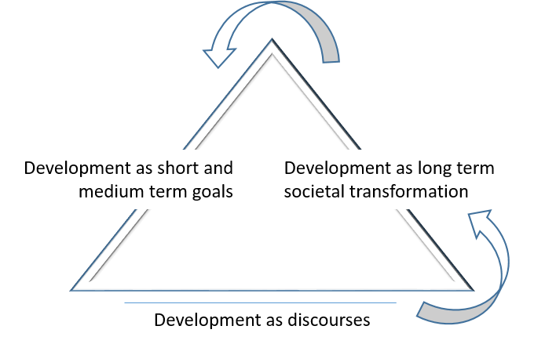
Figure 1 Dimensions of Development

Development Perspectives as Discourses

Development perspectives are usually manifested through discourses (both academic and practitioner), which influence policies, institutional arrangements and resource allocations. However, development is not just one discourse but multiple discourses. In the global context, Western-centric views tend to dominate, whereas in regional contexts, development manifests in different voices and value systems, such as nationalism, autonomy, equality, or happiness. While sometimes contradictory and problematic, development discourses inevitably influence public policy and directions of social change as they define institutional logics (Hayes & Rajão, 2011), and provide framing and legitimisation for the role of technology (see Ismail et al. in this special issue).

Escobar (1995) argues that development is a social constructed discourse of Western ideology of modernity, which gives rise to the post-colonial and post-development theories (see De´ et al. in this special issue). Critical ICT4D research seeks to unveil the power structure and ideological biases behind development discourses (Díaz Andrade & Urquhart, 2012; Krauss, 2013; Thompson, 2004). While it is not necessary for every researcher to use critical theory, it is nevertheless beneficial for ICT4D researchers to cultivate a critical awareness and sensitivity to the assumptions, discourses, power structure, possible corporate interests and ideological influences behind ICT4D projects.

Development as long term societal transformation

Development as a long term structural societal transformation refers to changes in socio-economic structures such as property ownership, the organisation of production, technological infrastructure, and institutional arrangements. For example, the modernisation theory represents the aspiration for countries to adopt the socio-economic order and institutional model championed by Western industrialised countries, which emphasise market-based economic growth, technological innovation, private property ownership, production organised by capital, trade and division of labour (Díaz Andrade & Urquhart, 2012; Pieterse, 2010b).

On the other hand, countries are historically and spatially diverse and complex, thus often a hybrid of development approaches are used in the same context. China, for example, adopts a development model that combines relentless market-based economic development and an authoritarian political structure. Digital technology is thus seen as a double-edged sword, supporting information flow for economic growth, fostering consumerism and improving quality of life on the one hand, and facilitating information sharing and collective action that threatens the authority on the other (Yang, 2003). This explains the paradoxical Internet policies in China, government support for internet companies vs. tightening political control and online censorship, which has significant implications for ICT4D projects.

Development as a short to medium term outcome

Most ICT4D research literature falls under the second dimension of Development mentioned above, namely, a short to medium term outcome of desirable targets. They are often case studies of technocratic ICT4D projects implemented by government agencies, NGOs or international donors. It is thus important to recognise the development perspectives and discourses that underlie the evaluation frameworks and indicators that are used to measure the outcome. For example, the neoliberal model advanced by the World Bank, IMF and many government agencies tend to measure contribution of ICT4D projects to economic growth, market-based innovation, or generation of employment. Sen’s capability approach, on the other hand, is more likely to take a holistic view and evaluate the outcome of development in terms of the expansion of capabilities, namely, wellbeing, choices, and the agency of individuals to actualise available opportunities (See Jimenez & Zheng as well as Mthoko & Pade-Khene in this special issue).

Keeping in mind the different dimensions sensitise ICT4D researchers to the broader picture of development, ideological nature and the power structures behind development processes and knowledge systems, with a more acute sense of where our research is situated. Such a reflexivity is crucial not least in justifying our claims of contribution, but also in understanding the implications and potential impact of our research and practice.

2.2 Perspectives of Development

It is difficult to summarise different perspectives of development as even scholars from Development Studies do not have a definitive list. Development Studies as a field is multidisciplinary and draws upon economics, sociology, political science, etc. Mabogunje (1980) suggests four main ways to categorise development perspectives: development as economic growth, as modernization, as distributional justice and as socio-economic transformation. Within the category of economic growth there are different schools of thought, such as the Keynesian school and the neoliberal approach, the latter moves away from state intervention and centralised planning, emphasizing market-led growth and the “trickle-down” effect (see discussion of the Washington Consensus in De’ et al. in this special issue).

Development as modernisation is broader than economic growth in that it involves social, psychological and political processes, investment in education and skills to shape individual and social values towards wealth generation and consumerism. Development as distributed justice seeks to reduce poverty and satisfy basic needs, whereas the fourth category is a Marxist-leaning view which argues that distributive justice cannot be independent of society’s fundamental mechanism of production and distribution. Class struggle is therefore perceived as an important aspect of development.

In addition, efforts to explain underdevelopment gives rise to neo-colonial and dependence theory which emphasise power structures, such as post-colonial and core-peripheral relations that many countries in the global south are situated. These relations are argued to hinder self-reliance, economic progress and reinforces inequality (both international and domestic), although such perspectives could be criticised to sometimes ignore the agency and capability of southern countries to develop (Chang, 2002; Smith, 1979).

Other development perspectives, such as the human development approach, sustainable development, and the feminist movement have thrived across a vast number of disciplines. Alternative development (Friedmann, 1992) moves away from grand theories, recognising historical and geographical diversity of contexts which are constantly in flux, resist top-down development models, emphasising human creativity, pragmatism, and flexibility, and seeking public-private collaboration. It is important to recognise that multiple notions of development co-exist in different contexts, across different levels, often upheld by multiple stakeholders.

Pieterse (2001) provides another list of development perspectives since the 19th century, which Thapa and Sæbø (2014) adapted to include what they consider as the role of technology from each perspective (Table 1). Different development perspectives entail distinct assumptions about essential values of development, reasons of under-development, and potential theory of change. For example, sustainable development advocates a distinct set of values, goals and processes for development compared to those of economic growth (see for example Jimenez & Zheng in this special issue). However, it is not our intention, nor is it practical, to provide a comprehensive review of the different meanings of development. Instead we seek to raise awareness to the wide spectrum and evolving notions of development, and to encourage a more critical and nuanced view of development in ICT4D research in general.

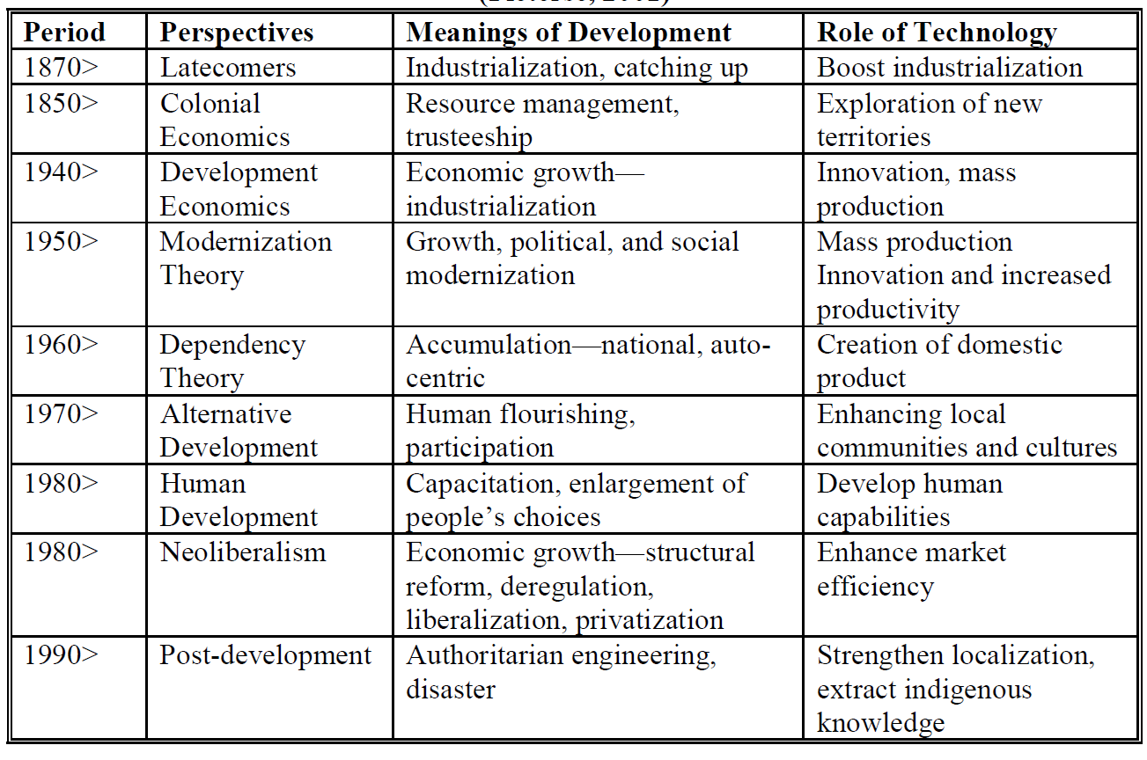
Table 1. Development Perspectives and Role of Technology (Thapa and Sæbø, 2014)

2.3 Theory of Change

While sensitivity to the assumption of development is important, we also agree with Avgerou (2017) who suggests that:

“the engagement of ICT4D research with socio-economic development discourse is not confined to the debates on the general definitions and approaches to ‘development’. It is dispersed in a much broader theoretical literature that addresses transformative options in a range of domains of human activity” (p.18).

What Avgerou (2017) calls mechanisms are often referred to as theory of change (ToC) elsewhere. While ToC usually refer to pathways to achieve desirable change, we define it in this context very broadly and loosely as how and why socio-technical changes may take place in a certain context.

Middle range theories, as Avgerou (ibid.) argues, enable ICT4D researchers to explain the mechanisms with which development outcome may or may not be achieved through digitisation. After all, most ICT4D research is applied in a specific domain, such as healthcare, e-government, open development, migration, etc. Each of these domains require nuanced understanding of the socio-technical processes.

A plurality of middle range theories have been employed in ICT4D (Andersson and Hatakka, 2013; Zheng, 2015), some are more related to development than others. For example, in general, while Technology Adoption Model implies a ToC for technology adoption, but not for development, unless we narrowly define technological adoption and diffusion as equivalent to development. Similarly, an open education project that examines the design or adoption of digital devices or platforms, while ignoring the impact on education practices and outcome, would be considered an inadequate ToC for ICT4D (Smith et al., 2011).

ToCs could be largely conceived at a structural level, an agency level or as structurational (Giddens, 1984), namely, structure and agency being mutually constitutive. The previous discussion on the gig economy and future of work, and research that examines institutional change (Avgerou, 2003; Avgerou et al., 2011; Ciborra & Navarra, 2005) are examples of change at a structural level. ToC at an agency level perceives individuals as either means or ends of development, or both (Sen, 1992). Individuals are not only recipients of development benefits, but also agents for change. E-government and open government, for example, can be said to imply a ToC at both levels as it is based on a hypothesis that open government data could lead to greater transparency, accountability and citizen participation (Bentley & Chib, 2016; Smith & Reilly, 2013).

It should be noted the application of ToCs are based on deeper assumption of development and therefore do not replace critical understanding of development perspectives. Very often ToCs need to be tested and refined in practice. For example, as mentioned earlier, e-government and open government data initiatives often claim to empower individual agency and encourage citizen participation. In reality these expectations are rarely fulfilled due to a wide range of existing barriers. ToCs also tend to be one dimensional, partial, and incurs paradoxical effects. It is thus crucial to pursue ICT4D as part of a broader, more complex process of social transformation in conjunction with other social policies and/or development endeavours.

2.4 A Conceptual Schema of ICT4D

Before we bring all of the above discussions together, a final element that was not addressed in the call for this special issue is the conception of IT artefacts. There are again disparate conceptions of IT artefacts in the multidisciplinary field of ICT4D. One of the best categorisation of IT perceptions comes from a seminal paper by Orlikowski and Iacono (2001) “Desperately seeking the IT in IT research”, which remains the most comprehensive and useful analysis. They identify five views of IT artefacts: 1) the nominal view, where IT is “absent” in the sense that it is not the focus of research; 2) the computational view, where IT is presented as an algorithm, a model or a design; 3) the tool view, which perceives IT as a tool for productivity, information processing, social relations, and so on; 4) the proxy view, where IT could represent something else, such as innovation, capital or modernity; 5) the ensemble view, which may be more holistic and conceptualises IT as embedded in a system, a network, a project, or a social structure. All these views are present and valid in ICT4D research, including the nominal view, as barriers in ICT4D projects often stems from other aspects than IT itself.

Figure 3 seeks to capture all key conceptual components of ICT4D in a schema which serves as a conceptual map. Incorporating a conceptualisation of development and IT artefact improves the rigour of ICT4D research, while a theory of change enhances its relevance. The point is not to prescribe particular conceptions of development, IT artefact or ToC, but to provide a scaffolding for discussions and reflections of these elements in ICT4D research. While most studies probably focus on only one component, we urge researchers and practitioners to critically reflect on their implicit assumptions about development and technology, consider where the research or practice is situated in the broader picture of social transformation, and what may be missing in their implicit ToC of ICT4D.

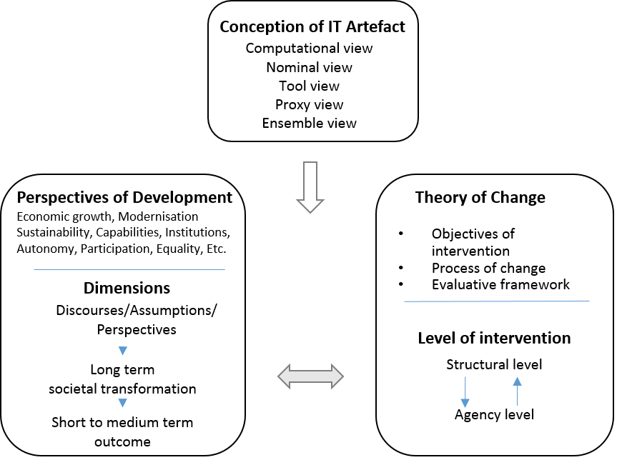
Figure 2 Key conceptual components of ICT4D research

Relating the schema to the special issue, the selected papers include empirical studies as well as conceptual pieces, covering a wide range of topics such as technological design, education, technology hubs, conflict management and evaluation frameworks. Due to the call of the special issue, most papers focus on the concept of development and takes a nominal view of IT artefacts. Each of the papers explicitly or implicitly adopt one or more development perspectives such as the capability approach (Poveda & Roberts, and Jimenez & Zheng), aspiration (Toyama), post-development (De’, Pal, Sethi, Reddy & Chitre) or a combination of different perspectives in an evaluative framework (Mthoko & Pade-Khene). Most of these studies are based on critical scrutiny of particular streams of current development discourse, e.g. the focus on needs in HCI, innovation and development, and evaluative frameworks in ICT4D. The most critical take on ICT4D discourses comes from De’, et al. who review the ICT4D literature and propose what they call a “strong critical approach” based on post-development perspectives.

In terms of ToCs, a common theme in this special issue relate to the agency of individuals for social change. Toyama argues that interventions to inspire and fulfil people’s aspirations, rather than to satisfy their immediate needs, will produce long term effect in development. In comparison, Poveda and Roberts, drawing upon Freire’s critical pedagogy and Sen’s capability approach, believe that social change could be engendered by enabling critical agency of individuals to identify and challenge structural root causes of unjust social norms. Interestingly, both studies hold the view that, the expansion of agency, either in terms of critical consciousness or aspiration could start the processes that ultimately lead to structural change of norms and social conditions. A similar structurational view is embedded in the study by Sing et al. who adopt Bourdieu’s practice theory to examine ICT-enabled development. Jimenez and Zheng critique the “invisibility of people” in the innovation for development discourse and argue for a human-centred approach in innovation, whereas Ismail et al. shed lights on the importance of negotiating the conflicts of institutional logics and participation of the poor in the process of impact sourcing.

Detailed introduction of each paper will be presented at the end of the editorial.

An Agenda for Future ICT4D Research

To recap, ICT4D is, ultimately, for development. Taking stock, ICT4D should take as a point of departure the following ideas: 1) ICT4D is not about achieving a designated level of technology adoption or diffusion, but multifaceted, dynamic and contentious socio-technical processes; 2) ICT4D is relevant in all societies; 3) ICT4D may give rise to unintended consequences and contradictory effects on development; 4) development is not a linear progress, nor is there a one-size-fit-all solution; 5) it is important to embrace the multiplicity, heterogeneity and openness of development, both as a concept and as a socio-technical process.

Contemporary societies are faced with novel challenges related to immigration, security, conflict, cyber-crime, radical political changes, and many others. All these processes have ICTs deeply implicated in them and will challenge our very notions of development. The ICT4D field is uniquely positioned to study these challenges and reconfigure our notions of development. It has a contribution to make as most mainstream development scholars, from development studies, social and political science to human geography, often ignore the role of digital technology in shaping development processes. However, the flip side is that ICT4D researchers often lack nuanced appreciation of what is development, both in terms of what constitute a developmental outcome, and which development processes are involved.

A more sophisticated and nuanced understanding of the meaning of development and development processes are crucial to avoid the “unbearable lightness of ICT4D” (Pieterse, 2010a). Critical appreciation of the existing hegemony of development discourses and assumptions, as several articles in this special issue demonstrate, would open up the conceptual repertoire and discourses and alternative paths towards social change. It will also provide better justification to our claims of contribution to both theory and practice.

There is a significant amount of reinvention of the wheel in ICT4D, as new entrants to the field tend to neglect earlier research for the reason that technologies have changed rapidly. However, the basic processes and challenges in ICT4D often remain similar, as the greatest barriers in ICT4D usually arise from social, cultural, institutional and political aspects of society. For example, while open development is a recent paradigm that brings novel challenges (Heeks and Renken, 2016), most research on this topic generates similar observations and arguments to those of ICT4D research conducted decades ago. Taking stock of ICT4D research and capitalising on existing knowledge may enable the field to move forward quicker without repeating earlier pitfalls.

On the other hand, the nature of technologies being used in development projects is dynamically evolving, with the growth of mobile computing, social media, artificial intelligence, internet of things and many others. ICT4D research thus needs to become more multi-disciplinary than ever before. To avoid technology determinism, linkages need to be developed between computer sciences, information systems, development studies and many others such as political economy, ethics, human geography, development economics and applied fields of public health and rural development. Understanding how to take multi-disciplinarity seriously will be a serious future challenge for ICT4D researchers.

In recent years, the Internet has given rise to the sharing economy or gig economy, e.g. Amazon Mechanical Turk, Deliverloo, Uber, and so on, following earlier trends of global outsourcing and open source movements. All of these have started to challenge the organisation of production, organization of labour and property rights. The rapid advancement of artificial intelligence will no doubt also have major impact on many industries including manufacturing and service in the near future, which raises the question of the future of work (Nubler, 2016). How do we, as ICT4D researchers, make sense of these phenomena?

Moreover, the notion of context in ICT4D is being challenged, as it is not only about a particular country or region, but the novel inter-connections between countries and groups. The recent scandals around the hacking of elections in USA and Kenya are a case in point. We thus need to expand our understandings of the notion of context, and find unique ways in trying to theorize it in ICT4D research (Hayes and Westrup, 2012). We will be increasingly confronted with complex models to measure development such as for monitoring progress towards the Sustainable Development Goals or Universal Health Coverage. ICTs will be deeply implicated in building, analysing and interpreting these measurement models, and the inherent complexity in them will have the potential to both make visible and also obfuscate development concerns. Unpacking these complexities will no doubt represent future challenges for ICT4D research.

Finally, the ICT4D field needs to pay more attention to the “dark side” of ICT4D. For example, ICTs are often used for surveillance and control (Introna, 2000; Lyon, 2014; Zuboff, 2015), and big data, cloud computing and smart city applications will further enhance such capacity not only by authorities but also commercial players. There is little discussion on the implications of ICT4D driven mostly by capital and commercial interests. The impact of industrial application of artificial intelligence may in the near future disrupt global value chains with considerable socio-economic consequences in the global south. And should we be concerned about the power of algorithms in shaping the future of our work and life?

This special issue is a small attempt to move towards the direction outlined above. It incorporates contributions from scholars from multiple disciplines such as information systems, Human Computer Interaction, management, and geography. A brief introduction of each paper is presented in the next and last section.

Papers in this special issue

This special issue has seven papers. The first six papers use various development theories to show how ICTs are linked to the concept of development. An additional paper is included to illustrate the application of the concepts of development on empirical data.

The first paper, From Needs to Aspirations in Information Technology for Development, by Toyama, Kentaro, advance an ICT4D approach based on aspirations instead of needs, the latter is a core concept in technological design and the basic needs approach in development. Toyama defines aspiration as “a desire that is persistent and aiming for something higher than one’s current situation”, and build it upon Maslow’s hierarchy of needs. He argues that individual aspirations can be a basis – though by no means a complete explanation – for mass shifts that underlie socioeconomic development. The paper use an international survey and three case studies illustrate the importance of aspiration in development.

The second paper, The practice of ICT-enabled development, by Harminder Singh, Angsana Techatassanasoontorn and Antonio Díaz Andrade, is a conceptual paper that seeks to examine how Bourdieu’s practice theory could contribute to our understanding of ICT4D. They argue that practice theory is able to capture the multi-level, generative, and processual nature of ICT4D, which can be conceptualised, through the practice lens, as “an ongoing activity that is recreated, reinforced, and restricted by the interaction between the dispositions of the stakeholders involved and changes in the various forms of capital that are valued in a community”. Three ICT4D initiatives from the literature are used to illustrate the utility of practice theory.

The third paper, ICT4D Research: A Call for a Strong Critical Approach, by Rahul De’, Abhipsa Pal, Rupal Sethi, Sunil K. Reddy and Chetan Chitre, review the ICT4D literature and propose what they call a “strong critical approach” built upon the writings of two prominent social theorists, Arturo Escobar and Gayatri Spivak. The authors seek to help motivate, conceptualize and conduct an inquiry in ICT4D with a sensitivity to large scale social, political and historical issues as well as individual representation and subjectivity. In-depth review of eight critical ICT4D papers are presented as illustration.

In the fourth paper, Tech Hubs, Innovation and Development, Andrea Jimenez and Yingqin Zheng critically discuss the relationship between innovation and development by drawing on Amartya Sen’s capability approach and present a case on technology hubs in Zambia. The paper shows impact of technology hubs on individuals’ well-being and agency, and argue for a human-centred perspective on technology hubs as a contribution to the discourse of innovation for development.

The fifth paper, Critical Conceptualisations of Development: applying Freire & Sen to ICT4D in Zambia and Brazil, by Sammia Poveda and Tony Roberts, argues for a conceptualisation of development as a process designed to enable people to free themselves from structural disadvantage. By combining Freire’s critical pedagogy and Sen’s capability approach the authors argue that disadvantaged and marginalized people can 1) identify the structural root causes of unjust social norms and 2) have the agency to challenge and change these norms. These theories are employed in two different case studies in Brazil and Zambia - both founded on Freirean epistemology.

The six paper, Building Theory in ICT4D Evaluation: A Comprehensive approach to assessing Outcome and Impact, by Hafeni Mthoko and Caroline Pade-Khene, presents a holistic evaluative framework for comprehensive evaluations of development impacts and outcomes of ICT4D implementations. The key themes identified in the paper for an outcome and impact evaluation include strategic value, most significant change, empowerment, livelihoods and sustainability.

In the seventh paper, Analysing Conflict and its Management within ICT4D Partnerships: An Institutional Logics Perspective, Shahifol Arbi Ismail, Richard Heeks, Brian Nicholson & Aini Aman focus on public-private partnerships in impact sourcing with a case study from Malaysia. Drawing upon institutional logic and conflict management strategy, the authors conceptualise conflicts of goals, cultures and practices that underlines ICT4D partnerships and how these conflicts manifest in the partnerships. Among other things, the findings from the study show that there is a need to include a spokesperson for the marginalized in the negotiation process and that there should be a representative that prioritises “the needs of the poor”.

Acknowledgements

We would like to thank the Journal of IT and Development for hosting this special issue, Geoff Walsham and Maung Sein for their comments on the editorial, as well as the support and guidance provided by the Editor-in-Chief, Sajda Qureshi.

References

Andersson, B. (2008). For space (2005): Doreen Massey. In P. Hubbard, R. Kitchin, & G. Valentine (Eds.), Key Texts in Human Geography (pp. 227-235). London: SAGE Publications Ltd.
Andersson, A., & Grönlund, Å. (2012). Development as Freedom - How the Capability Approach can be Used in ICT4D Research and Practice. Information Technology for Development, 18(1), 1-4. doi:10.108ca0/02681102.2011.632076
Andersson, A., & Hatakka, M. (2013). What are we doing? - Theories Used in ICT4D research. Paper presented at the 12th International Conference on Social Implications of Computers in Developing Countries, Ocho Rios, Jamaica.
Avgerou, C. (2003). IT as an institutional actor in developing countries. In The digital challenge: information technology in the development context (p. 46–62.). London: Ashgate.
Avgerou, C. (2010). Discourses on ICT and Development. Information Technologies & International Development, 6(3), 1–18.
Avgerou, C. (2017). Theoretical Framing of ICT4D Research. In Information and Communication Technologies for Development (pp. 10–23). Springer, Cham. https://doi.org/10.1007/978-3-319-59111-7_2
Avgerou, C., Li, B., & Poulymenakou, A. (2011). Exploring the Socio-Economic Structures of Internet-Enabled Development: A Study of Grassroots Netrepreneurs in China. The Electronic Journal of Information Systems in Developing Countries, 49.
Bada, A. O., & Madon, S. (2006). Enhancing human resource development through information and communications technology. Information Technology for Development, 12(3), 179-183.
Bentley, C. M., & Chib, A. (2016). The impact of open development initiatives in lower-and middle income countries: A review of the literature. The Electronic Journal of Information Systems in Developing Countries, 74.
Brown, A. E., & Grant, G. G. (2010). Highlighting the Duality of the ICT and Development Research Agenda. Information Technology for Development, 16(2), 96-111. doi:10.1080/02681101003687793
Byrne, E., Nicholson, B., & Salem, F. (2011). Information communication technologies and the millennium development goals. Information Technology for Development, 17(1), 1-3.
Chang, H.-J. (2002). Kicking Away the Ladder: Development Strategy in Historical Perspective. London: Anthem Press.
Ciborra, C., & Navarra, D. D. (2005). Good governance, development theory, and aid policy: Risks and challenges of e-government in Jordan. Information Technology for Development, 11(2), 141–159.
Díaz Andrade, A., & Urquhart, C. (2012). Unveiling the modernity bias: a critical examination of the politics of ICT4D. Information Technology for Development, 18(4), 281–292.
Escobar, A. (1995). Encountering Development : The Making and Unmaking of the Third World. Princeton: Princeton University Press.
Friedmann, J. (1992). Empowerment: the politics of alternative development. Blackwell.
Giddens, A. (1984). The Constitution of Society, Outline of the Theory of Structuration. Cambridge: Polity Press.
Hayes, N., & Rajão, R. (2011). Competing institutional logics and sustainable development: the case of geographic information systems in Brazil’s Amazon region. Information Technology for Development, 17(1), 4–23.
Hayes, N., & Westrup, C. (2012). Context and the processes of ICT for development. Information and Organization, 22(1), 23–36. https://doi.org/10.1016/j.infoandorg.2011.10.001
Heeks, R. (2010). Do Information and Communication Technologies (ICTs) Contribute to Development? Journal of International Development, 22(5), 625-640.
Heeks, R. (2009). The ICT4D 2.0 Manifesto: Where Next for ICTs and International Development? Paper No. 42. Manchester: Institute for Development Policy and Management.
Heeks, R., & Renken, J. (2016). Data justice for development: What would it mean? Information Development. https://doi.org/10.1177/0266666916678282
Introna, L. D. (2000). Workplace surveillance, privacy and distributive justice. SIGCAS Comput. Soc., 30(4), 33–39.
Jiménez, A., & Zheng, Y. (2017). A Spatial Perspective of Innovation and Development: Innovation Hubs in Zambia and the UK. In Information and Communication Technologies for Development (pp. 171–181). Springer, Cham.
Krauss, K. (2013). Collisions between the Worldviews of International ICT Policy-Makers and a Deep Rural Community in South Africa: Assumptions, Interpretation, Implementation, and Reality. Information Technology for Development, 19(4), 296–318.
Lyon, D. (2014). Surveillance, Snowden, and Big Data: Capacities, consequences, critique. Big Data & Society, 1(2), 2053951714541861. https://doi.org/10.1177/2053951714541861
Mabogunje, A. (1980). The development process: A spatial perspective. London: Hutchinson University Library.
Massey, D. B. (2005). For space. London ; Thousand Oaks, Calif: SAGE.
Nubler, I. (2016). New technologies: A jobless future or golden age of job creation? (Working paper). International Labour Organization. Retrieved from http://www.ilo.org/global/research/publications/working-papers/WCMS_544189/lang--en/index.htm
Orlikowski, W., & Iacono, S. C. (2001). Desperately Seeking the "IT" in IT Research - A Call to Theorizing the IT Artifact. Information Systems Research, 12(2), 121-134.
Pieterse, J. N. (2010a). Development theory: deconstructions/reconstructions (2nd ed). Los Angeles : London: SAGE.
Pieterse, J. N. (2010b). Digital capitalism and development: The unbearable lightness of ICT4D. In Emerging Digital Spaces in Contemporary Society (pp. 305–323). Springer.
Pieterse, J. N. (2001). Development theory: deconstructions/reconstructions. London: Sage.
Qureshi, S. (2013). Information and Communication Technologies in the Midst of Global Change: How do we Know When Development Takes Place? Information Technology for Development, 19(3), 189-192. doi:10.1080/02681102.2013.818827
Roztocki, N., & Weistroffer, H. R. (2016). Conceptualizing and Researching the Adoption of ICT and the Impact on Socioeconomic Development: Taylor & Francis.
Sen, A. (1992). Inequality Reexamined. Oxford: Oxford University Press.
Silva, L., & Westrup, C. (2009). Development and the promise of technological change. Information Technology for Development, 15(2), 59-65.
Smith, M. L., & Reilly, K. M. A. (Eds.). (2013). Open development: networked innovations in international development. Cambridge, Massachusetts: The MIT Press.
Smith, M. L., Elder, L., & Emdon, H. (2011). Open Development: A new theory for ICT4D. Information Technologies & International Development, 7(1), iii–ix.
Smith, T. (1979). The Underdevelopment of Development Literature: The Case of Dependency Theory. World Politics, 31(2), 247–288.
Sumner, A., Tribe, M.A., 2008. International development studies: theories and methods in research and practice. Sage, Los Angeles; London.
Thapa, D., & Sæbø, Ø. (2014). Exploring the link between ICT and development in the context of developing countries: A literature review. Electronic Journal of Information Systems in Developing Countries, 64, 15.
Thompson, M. (2004). Discourse, “Development” & the “Digital Divide”: ICT & the World Bank. Review of African Political Economy, 31(99), 103–123.
Walsham, G. (2012). Are we making a better world with ICTs? Reflections on a future agenda for the IS field. Journal of Information Technology, 27(2), 87-93.
Walsham, G., & Sahay, S. (2006). Research on Information Systems in Developing Countries: Current Landscape and Future Prospects. Information Technology for Development, 12(1), 7–24.
Yang, G. (2003). The co-evolution of the Internet and civil society in China. Asian Survey, 43(3), 405–422.
Zheng, Y. (2009). Different Spaces for e-Development: What Can We Learn from the Capability Approach? Information Technology for Development, 15(2), 66-82.
Zheng, Y. (2015). Overview of Theories in ICT4D. In The International Encyclopedia of Digital Communication and Society.
Zuboff, S. (2015). Big other: surveillance capitalism and the prospects of an information civilization. Journal of Information Technology, 30(1), 75–89. https://doi.org/10.1057/jit.2015.5

The Journal of Information Technology for Development has published various work that illustrate the importance of this issue – see for instance Roztocki and Weistroffer (2016), Andersson & Grönlund (2012), Byrne, et al. (2011), Bada & Madon (2006), Silva & Westrup (2009), Zheng (2009), and Qureshi (2013).

