**Improving chronological control for environmental sequences from the last glacial period**

Briant, Rebecca M.1, Brock, Fiona2,3, Demarchi, Beatrice4,6, Langford, Harold E.1, Penkman, Kirsty E.H.4, Schreve, Danielle C.5, Schwenninger, Jean-Luc2, Taylor, Sheila4

1Department of Geography, Birkbeck, University of London, Malet Street, London, WC1E 7HX, UK.

2Research Laboratory for Archaeology and History of Art, University of Oxford, Dyson Perrins Building, South Parks Road, Oxford OX1 3QY, UK.

3Cranfield Forensic Institute, Cranfield University, Defence Academy of the United Kingdom, Shrivenham, Oxon, SN6 8LA, UK.

4BioArCh, Department of Chemistry, University of York, York, YO10 5DD, UK.

5Department of Geography, Royal Holloway, University of London, Egham, Surrey, TW20 0EX, UK.

6Department of Life Sciences and Systems Biology, University of Turin, Italy

**Abstract**

Recognition of palaeoclimatic instability in the Greenland ice cores has spurred researchers to identify corresponding evidence in other terrestrial records from the last glacial stage. Such evidence is critical for establishing how much environmental stress precipitated Neanderthal and Late Pleistocene megafaunal extinctions, although a need for improved chronology has been consistently highlighted. In formerly glaciated and periglaciated areas of northern Europe, palaeoenvironmental sequences are frequently discontinuous. These often yield high-resolution proxy-based quantitative palaeotemperature estimates but can be hard to date, due to difficulties in removing contamination from biological samples at the limits of the radiocarbon technique (c.30-50kya). Here we demonstrate, for the first time using samples with independent age control, that different radiocarbon pretreatments can generate different age data and that gentler, less effective treatments applied to avoid sample loss may not yield reliable age-estimates. We advocate alternative harsher pretreatment using a strong acid-base-acid protocol. This provides an acceptable balance between contamination removal and excessive sample loss and generates more accurate ages, significantly enhancing our ability to detect and understand the impacts of palaeoclimatic instability in the terrestrial record of the last glacial.

**Keywords**

Radiocarbon dating, pretreatment, MIS 3, Paleoclimatology, Europe

1. **Introduction**

Quantifying the impact of abrupt climate change on terrestrial palaeoenvironments during the bulk of the last glacial (MIS 4 and 3 (Dansgaard et al., 1993; Lisiecki and Raymo, 2005), GI-19.2-GS-5.1[Rasmussen et al., 2014]) remains a major challenge for Quaternary research, necessitating the development of integrated high-precision chronologies (eg. Blockley et al., 2012). This is critical, for example, in evaluating the role of environmental instability in the replacement of Neanderthals by modern humans (Bradtmöller et al., 2012) and in the Late Pleistocene megafaunal extinctions (Barnosky et al., 2004). New studies suggest discrepancies in the timing of disappearance of individual mammalian taxa (e.g. Stuart and Lister 2011, 2012) and changes in climate-driven hominin subsistence behaviour (El Zaatari et al., 2016). Also questioned is the degree of overlap between Neanderthals and modern humans (Jöris et al. 2003). All these debates demand reliable dating to make sense of the evidence. However, synchronisation of palaeoenviromental records from the complex succession of stadials and interstadials is hampered by chronological constraints, particularly in northern Europe, where the timing of maximum ice limits was geographically variable (Hughes et al., 2013). Similarly, palaeotemperature estimates from discontinuous last glacial sequences are a powerful tool for assessing climatic instability but are meaningful only when chronology is secure.

Many last cold stage deposits in northwest Europe are formed discontinuously in shallow depressions or fluvial sequences (Figure 1a). Optically-stimulated luminescence (OSL) dating of sand beds (where present) can provide age control (e.g. Van Geel et al., 2010) but most studies undertaken prior to ten years ago depend on radiocarbon dating, which at 50-30kya is near the analytical limits of the technique, since concentrations of radiocarbon are very low and thus prone both to measurement uncertainty and contamination by younger carbon (Figure 2, Pigati et al., 2007). Several sequences formerly attributed to MIS 3 using early radiocarbon analyses have been overturned by later independent age estimation methods, e.g. Isleworth, UK (Coope and Angus, 1975), now re-dated to MIS 5a (Currant and Jacobi, 2001; Penkman et al., 2011). Furthermore, plant macrofossils radiocarbon-dated to c. 35kya were systematically too young compared to OSL samples from exactly the same channel fills, which yielded ages between 7 and 70ky older (Briant and Bateman, 2009). This effect wrongly attributed many older sites to later parts of the last glacial period. This has gradually been corrected over time, e.g. Chappell and Magee (1996). The frequency of this offset compared with multiple OSL samples suggests a consistent error lies with many of the radiocarbon ages.

Removal of modern contamination has therefore become a priority in producing more reliable radiocarbon ages, chiefly through harsher chemical pretreatments e.g. ultrafiltration on bone (Higham et al., 2006) and ABOx-SC on charcoal (Bird et al., 1999). However, palaeoenvironmental sequences commonly lack bone or charcoal, requiring use of wood, plant macrofossils and sediments instead (Figure 1b). These are susceptible to contamination from soluble, labile, organic acids, especially humic acids, which permeate sediments through groundwater. Their incomplete removal from a sample can produce an erroneously young radiocarbon age. Significantly, all samples showing an offset in Briant and Bateman (2009) underwent standard, more gentle pretreatments, either acid-wash only or mild ABA (acid-base-acid) – Dunbar et al., 2016). Mild ABA pretreatments on plant macrofossils *can* yield reliable results, as demonstrated at Lake Suigetsu (Ramsey et al., 2012), where ages concur with an annual varve chronology. However, where no cross-check is available, all that can currently be said is that older radiocarbon ages with acid-only treatment or mild ABA should be treated more cautiously (Briant and Bateman, 2009). It was the aim of this study to improve the radiocarbon dating of plant macrofossils near to the limits of the technique, by experimenting with different pretreatments and assessing which removed the most contamination.

* 1. **Sample details and independent age control**

Two samples used in this experiment have previously been reported (Briant and Bateman, 2009). The independent age control for these are OSL ages on sand beds within the same channels from which radiocarbon-dateable material was recovered. Sample DSJ34 came from the same channel fill as an OSL sample (DSJ32) that gave an age of 73,900 ± 5,700 BP (Table 2). Sample ST93 came from the same channel fill as an OSL sample (ST93) that gave an age of 34,400 ± 2,100 BP (Table 3). Full details of the OSL dating are in the original reference.

Two samples used in the experiment are from a sequence of deposits at Bradley Fen A in eastern England (Figure S1). The sequence is part of a complex of Quaternary-age sediments observed to contain deposits from multiple glacial-interglacial cycles, with fossiliferous channel fills dating from marine oxygen isotope stage (MIS) 7 (Langford et al., 2007, 2014a), the Ipswichian (last interglacial, MIS 5e, Channel C – Figure 4 – Langford et al., 2004, 2017) and within the last glacial period, possibly MIS 3 (Channel D –Figures S2 and S3 - Langford et al., 2004, 2014b, 2017). The channels from the last interglacial and last glacial have the advantage of being exposed within the same quarry section (Figures S2 and S3).

Sample BFC<2b> is from Channel C, which is last interglacial in age. The biological assemblages from Channel C at Bradley Fen A contain strong diagnostic elements suggesting a last interglacial age (Langford et al., 2004, 2017). To further constrain the samples, amino acid racemization analysis was undertaken on exactly the same sample from which the seeds for radiocarbon analysis were taken. The range of amino acid data for British sites has been compared to the Bradley Fen dataset (Figure S5), and it is clear that the Bradley Fen samples have amino acid ratios that are similar to sites correlated with MIS 5e (Penkman et al., 2011, 2013).

Sample BFA15<1> is from Channel D, which is last glacial in age. Channel D is up to c. 2.5 m thick and characterised by fine sands and silts overlying and interbedded with gravel beds. Fossiliferous material including shell and bone in addition to plant macrofossils is present throughout the sequence. Radiocarbon dating using ultrafiltration (discussed below) of a foot bone from a woolly rhinoceros *Coelodonta antiquitatis* provides age control for dating of seeds from Channel D (Figure S3). The bone was found *in situ* within the channel deposits immediately adjacent to the location of sample BFA15<1>. Channel D and the channel from which sample ST93 was taken represent end members of the range of sedimentology of cold stage fluvial deposits observed in the British Isles (West, 2000). It is shown below that this sedimentology is significant for interpreting radiocarbon ages, particularly in relation to local reservoir effects.

All the samples used come from fluvial deposits preserved in quarries. These were chosen because of the larger size of the samples that can be obtained from such settings. These large samples were more likely to yield the large amount of seeds needed to undertake this experiment. Whilst there is potential for reworking of organic material within fluvial deposits, this is most often wood rather than seeds (e.g. Rogerson et al., 1992), as wood is more robust when carried in saltation at the bed of a gravel bed stream. Reworked material can be avoided by careful selection of well preserved identified species that were likely to have been growing in a periglacial environment (Rixhon et al., 2017).

1. **Materials and Methods**

Previous studies of harsher pretreatments on seeds (Hatté et al., 2001; Hajdas et al., 2007; Gillespie et al., 2008; Santos and Ormsby, 2013)did not identify an optimum stronger pretreatment, although it is unlikely that a universal solution exists. Hatté et al. (2001) suggested that ABA pretreatment may cause contamination due to incorporation of modern CO2 during the alkali phase which is not adequately removed by the final acid treatment. They stated that ABOx (without stepped-combustion (SC)) was required to remove contamination from a palaeosol whose age was given as MIS 3 (presumably based on loess stratigraphy), whereas ABA with a final acid step comprising 2 h of 2 M H2SO4 instead of HCl (1 h, 1 M) was deemed sufficient for a wood sample of unknown age. Gillespie et al. (2008) also suggested that a strong ABA pretreatment may be sufficient for some wood samples but did not investigate plant macrofossils. Hajdas et al. (2007) applied ABOx (without SC) to wood, peat and a *Picea* cone. Satisfactory ages appeared to be achieved, although there was no independent age control. Gillespie et al. (2008) pretreated plant material from the gut of a *Diprotodon* skeleton and also suggested that effective removal of contamination from cellulose-based material might not require full ABOx-SC. Chlorite was used instead of dichromate because it is more selective and does not attack cellulose. Their most effective pretreatment was a twice-repeated chlorite-alkali-acid sequence with SC. None of these studies had robust independent age control on their samples, so all pretreatments were tested in our study, since there was too little evidence to determine which was likely to be the best. More seriously, because none of these studies had independent age control, they ‘cannot be confident that even the oldest, apparently finite age is not affected by residual contamination. The only way of obtaining such assurance would have been to obtain similar material to the sample of interest that was known to be >70 ka and put this through the entire procedure’ (Gillespie et al., 2008, p. 78).

We therefore tested pretreatments on two categories of samples with independent age control: seeds from within the range of the radiocarbon technique and those placed beyond the radiocarbon limit using amino-acid racemisation (AAR) and OSL (>50 ka). Bulk organic matter and peat were excluded because of likely mixing of materials and the consequent difficulty of interpreting radiocarbon results. *Carex* and *Potamogeton* seeds (Figure S4) were chosen because they are almost ubiquitous in cold stage floral assemblages (e.g. West, 2000). *Carex*, used in the Lake Suigetsu study (Ramsay et al., 2012), is also advantageous because it photosynthesises directly with the atmosphere (Deevey et al., 1954). Hatté et al. (2015) argued that *Carex* should be avoided because its round shape impedes evaluation of potential bioturbation. However, in the discontinuous sequences targeted here, organic sediments are usually laid down too rapidly for bioturbation to affect them. Whilst modern and Holocene-age samples of the aquatic plant *Potamogeton* from calcareous lakes demonstrate a freshwater reservoir effect of 1.5-2ka (Deevey et al., 1954), the reservoir effect in fluvial settings is less clear (Philippsen, 2013). Furthermore, in samples near to the radiocarbon limit, measurement uncertainties are sometimes large enough to render such effects less problematic. Therefore *Potamogeton* was also included because it is often the most abundant seed by weight in many last glacial assemblages, is larger than *Carex* and has previously yielded reliable age estimates for this time period (Briant and Bateman, 2009). Pairing the two species also allows the influence of any freshwater reservoir effect on *Potamogeton* from fluvial deposits to be assessed.

Previously published samples (Briant and Bateman, 2009) were processed in deionised water and stored dry from 2001 until remeasurement in 2012/13. Samples BFC1 <2b> and BFA15 <1> from Channels C and D at Bradley Fen A (Figures S1-S3) were sieved in tap water and stored dry. Seeds from these dry sample residues (Figure S4) were identified and sorted under a low-power microscope using non-organic instruments.

All samples were pretreated, combusted, graphitised and measured at the ORAU. The experiment had two phases. In the first phase, eight pretreatments (detailed in Table 1) were trialled on the abundant last interglacial material (Table 2), based on various published alternative pretreatments in addition to the ABOx method (Bird et al., 1999). In the second phase, using those samples expected to be within the radiocarbon limit, only three pretreatments were chosen (Table 3) – strong ABA (Santos and Ormsby, 2013). ABOx and chlorite-alkali-acid were not chosen because our studies showed that the yields are too low (Figure 3) to be practicable, particularly with the smaller sample sizes available from these samples. The mild ABA with bleach was not chosen because the chlorite bleach stage is most effective as a less harsh version of the full alpha-cellulose method, so this pretreatment is more appropriate for use on more woody material, rather than the seeds targeted here. The two H2SO4 pretreatments (Hatté et al., 2001) were not chosen because the very low concentration of NaOH used in the base stage is difficult to use in the laboratory and the length of the time step may potentially account for the inclusion of atmospheric carbon dioxide from the atmosphere. Indeed, analyses (Santos and Orsmby, 2013, p.540)suggest that this low concentration base step fails to ‘remove postdepositional young labile and recalcitrant C from the sample matrix.’ Our analyses also suggested that the sulphuric acid in the final step acted very similarly to hydrochloric acid. For these reasons, we chose instead strong ABA (Santos and Ormsby, 2013), which uses a high concentration base for a shorter time period, cleaning the sample without undue exposure to atmospheric carbon dioxide. It is also more straightforward, using hydrochloric acid for both acid wash stages. The strong ABA provides a good trade-off between sample loss and contaminant removal. Following chemical pretreatment, samples were combusted and graphitised, before being AMS-dated (Brock et al., 2010).

The *Coelodonta antiquitatis* bone (OxA-31962) used as independent age control from Channel D (BFA12<2>, <2a>, BFA15<1>) underwent routine bone pretreatment (lab code AF – Brock et al., 2010). This involves a modified Longin (1971) method, including a base wash, gelatinization and ultrafiltration and has been shown to be effective in removing contamination and producing reliable ages near the limit of the technique (e.g. Higham et al., 2006). The reliability of this age is shown in the close agreement with the OSL ages from the adjacent Channel E, of which BFA12-01 (41.6 ± 4.3 ka) is most reliable. It is also shown by the ages obtained on the associated background standard from an Alaskan bison longbone bone that is well beyond the radiocarbon limit (ca. 60-70,000 years old – Brock et al., 2007). The standard was dated twice: one 'high mass' i.e. the same size as most of the bones in the batch, and one 'low mass' which has a lower starting weight to represent low yielding samples. The dates are as follows:

Low mass background bone standard (starting weight 221 mg, 8.7% wt collagen yield, C:N ratio 3.4) : >50100 BP (F14C: 0.000 ± 0.001)

High mass background bone standard (starting weight 580 mg, 7.0% wt collagen yield, C:N ratio 3.4): >50200 BP (F14C: 0.000 ± 0.001)

OxA-31962 (starting weight 600 mg, 3.4% wt collagen yield, C:N ratio 3.4): 40400 ± 1200 BP (F14C: 0.007 ± 0.001)

The robustness of the pretreatments undertaken on the seed samples is shown by high and low mass measurements taken on background age charcoal and wood pretreated alongside the seeds as follows: background age charcoal: high mass: >55800 BP, low mass: >51700 BP; background age charcoal: high mass > 55200, low mass >53300 BP; background age wood sample (TIRI sample G41): high mass: 54100 ± 3200 BP, low mass >50900 BP.

1. **Results**
   1. **Radiocarbon sample yields**

Abundant seeds from last interglacial age material allowed testing of eight pretreatments, including harsh ones usually reserved for charcoal. Even with starting weights of c. 100 mg, neither *Carex* nor *Potamageton* from BFC1 <2b> (Figures S1-S3) survived the harshest pretreatment, ABOx, being lost in the dichromate oxidation step (Figure 3, Table 2). Survival rates for chlorite-alkali-acid on *Potamageton* were also low (20-40%) despite starting weights of c. 40 mg. Survival rates of last interglacial seeds for all other pretreatments showed that the percentage mass yield for *Carex* (34-42%) was much lower than for *Potamageton* (72-89%) although both seed types contained similar % carbon (Table 2). These improved yields and preservation are likely due to the larger size of the *Potomageton*, as well as potentially higher levels of iron sulphide mineralisation observed within the *Potamageton*, which may therefore make it a better target for analysis when there is limited material available. DSJ34 also showed lower percentage yields for *Carex* (33% cf. 71% for mild ABA, 30% cf. 58% for strong ABA –Table 2).

In contrast, material was less abundant for younger samples and only three pretreatments were tested. Again, the percentage yield for *Carex* (61-79% acid wash; 48-61% mild ABA; 36% strong ABA) is lower than for *Potamageton* (68-78% acid wash; 58-84% mild ABA; 63-80% strong ABA) for both ABA pretreatments (Figure 3, Tables 3, S3).

This research suggests that due to the yield of 10-15% less with strong ABA than mild ABA, to successfully achieve a single AMS date using a strong ABA a minimum of 8 mg dry weight of *Carex* seeds should normally be required to yield 1 mg of carbon for dating, although one sample in the current study was successful with only 5.6 mg. Similarly, c. 4 mg is recommended for *Potamageton,* although some samples as small as 2.5 mg generated the necessary 1 mg of carbon. This is potentially problematic for last glacial age samples. Harsh climatic conditions in the last glacial were associated with lower biomass and the yield of seeds per weight of sediment is accordingly much lower than from interglacial sequences. In last glacial sample BFA15<1> (Table 3), yields of *Carex* were c. 1 mg of seeds per 1.7 kg initial sample, whereas *Potamageton* yields were c. 1 mg per 0.3 kg. Whilst this may partly reflect the greater mineralisation observed in some of the *Potamageton* seeds,the total numbers of seeds were also higher as well as their weight. These seed yields are typical for last glacial samples in northwest Europe. Thus, 45 kg (about 4 half-filled rubble sacks) of last glacial sediment was sieved in order to extract sufficient seeds to test only three pretreatments, and multiple bags of sediment should be retrieved when sampling fluvial deposits, as is already standard practice if analysing vertebrate or beetle remains. When coring lacustrine deposits from the last glacial, wide gauge cores or multiple borings from immediately adjacent locations should be considered to provide sufficient material for dating using this harsher pretreatment.

* 1. **Seeds known to be beyond the radiocarbon limit (older than 50 ka) yield infinite radiocarbon ages**

Seeds from last interglacial sediments allowed testing of eight pretreatments, including very harsh ones usually reserved for charcoal (Figure 3, Table 2). Results showed that even with 100 mg starting weights, neither *Carex* nor *Potamogeton* survived the harshest pretreatment, ABOx (acid-base-oxidation). Chlorite-alkali-acid survival rates were also too low to be useful. For all other pretreatments, the percentage mass yield for *Carex* was much lower than for *Potamogeton*, possibly because *Carex* seeds have a larger surface:volume ratio and their smaller size makes loss of material during pretreatment preparation more likely.

Both *Potamogeton* and *Carex* last interglacial seeds yielded predicted infinite radiocarbon ages from the mild ABA pretreatment test so further dating was abandoned. Radiocarbon dating of *Carex* from DSJ34 (c. 73 ka old) was problematic due to small samples with low yields (>37200 and >33300 BP – Table 2). Radiocarbon dating of *Potamogeton* from DSJ34 was much closer to the expected age than previous acid-washed dates on different species, with all pretreatments close enough to background radiocarbon levels to be considered infinite (Table 2).

* 1. **Seeds within the range of the radiocarbon technique indicate harsher pretreatments can remove more recent contamination**

As with the older samples, the percentage mass yield for *Carex* is lower than for *Potamogeton* across all pretreatments (Table 3). These results strongly suggest that if the reservoir effect can either be accounted for or discounted, *Potamogeton* is a good target for radiocarbon dating.

Figure 4a shows thatsuccessively harsher pretreatments on acid-washed archive *Potamogeton* from ST93 yielded older ages, with the calibrated radiocarbon age using strong ABA matching almost exactly with the midpoint of the associated OSL age of 34.4 ± 2.1 ka (Table 3, Figure 4a - the reservoir effect is unclear because *Carex* were too few for dating). Whilst other laboratory procedures have improved in the fourteen years since the acid-washed date was generated, these results show that harsher pretreatments enhance the removal of recent contamination (Table 3). In this case, the quality of the conclusion that can be drawn is affected by the large error bar on the OSL age, which spans all three of the radiocarbon ages reported. Thus the comparison is based on the median value of each age estimate. It is possible to achieve higher precision on OSL age estimates, but scatter means that it may sometimes be difficult to do so for fluvial samples (Rixhon et al., 2017). The advantage of OSL ages, however, is that they are truly independent and will not be affected by the same contamination that this experiment is seeking to remove. Future experiments would ideally combine OSL dating to establish whether the radiocarbon age is in the correct part of the last glacial with more precise radiocarbon dating of different material such as bone to establish more firmly the difference between the ages produced using different pretreatments.

Sample BFA15<1> (Figures S1-S3) shows a smaller difference between those ages produced using different pretreatments, but the independent age control has lower error bars (Figure 4b). Nonetheless, these error bars are still large due to the less precise calibration possible near the limits of the technique. These are sufficient to blur the differences between samples somewhat. Both mild and strong ABA *Carex* dates match the ultrafiltered radiocarbon-dated bone best, with only acid-wash noticeably younger. *Potamogeton* dates are all older (c. 4-5,000 radiocarbon years). There are two possibilities for this difference between the species. The first is that the *Carex* and bone are still recording some contamination that has been removed from the *Potamageton*. The second, and more likely, explanation relates to a freshwater reservoir effect that for some reason is greater than that observed in the channel from which ST93 came.

Reservoir effects are lower in rivers than lakes because residence times of water in the system are lower (Philippsen, 2013). Residence times of water are lower when surface runoff is dominant. Surface runoff would have been dominant during much of the last glacial, when the hydrological regime of periglacial river systems was dominated by spring snow melt and ice break floods rather than groundwater (Woo, 1990). It is possible to use the sedimentology of a fluvial deposit to determine how long lived the channel that is being sampled was. As stated above, there are two end members of fluvial channels within last glacial deposits in lowland Britain. These are represented in this study by the ephemeral scour-fill of ST93, filled with sand with plant beds. This is likely to have been eroded and filled within a single flood event, with seeds entrained into the sediments from surface runoff and no *in situ* plant growth (West et al., 1993). In contrast, Channel D is filled with much finer grained sediments (Figure S3), which would have settled out slowly over time through suspension. In such more persistently flooded settings, groundwater influence and thus reservoir effects will be greater.

1. **Discussion and Conclusions - Importance of changing pretreatments on future radiocarbon-dated samples for understanding terrestrial climatic instability in the last glacial**

Radiocarbon dating of seeds is likely to remain a key technique in dating discontinuous last glacial environmental sequences, emphasising the need to improve the reliability of such dates. After standard precautions (Rixhon et al., 2017), this can be achieved through the chemical pretreatments applied in the radiocarbon laboratory to remove modern contamination, the choice of which should be discussed between the sample submitter and the laboratory.

Our experiments, the first with independent age control, show that a simple acid wash, still undertaken frequently in many laboratories (e.g. Dunbar et al., 2016) yields ages that are too young across all samples (Figure 4, Tables 2, 3). However, harsher chemical pretreatments developed for use on charcoal are too destructive to use on seeds (Figure 3). A pretreatment that provides a trade-off between sample loss and contamination removal is therefore needed. Whilst we agree with previous studies (e.g. Hajdas et al., 2007)that a mild ABA pretreatment *can* yield reliable ages, we suggest that strong ABA is wiser. The results presented above need to be replicated from other sequences, but there is nonetheless an indication that strong ABA removes more contamination. Often, sample material or financial resources are limited and only a single age determination can be undertaken from a sample, meaning that it would not be possible to detect whether the mild ABA pretreatment had been sufficient. In this case, the precautionary principle would be to apply strong ABA, because it only requires a little more sample material and may yield a significantly more reliable age (Table 3). Similarly, even though harsher pretreatments such as ABOx on charcoal or ultrafiltration on bone have revised previous dates in only some samples (Brock et al., 2009), many laboratories apply them to most samples as a precaution. The lower survival rates (10-15% greater sample loss by mass) of material using strong ABA will necessitate slightly larger sample collection, which should be allowed for in the field. An alternative to collecting more sediment is to consider the use of *Potamogeton* in dating such sequences. It has a much better yield by weight than *Carex* because each seed is larger (Figure S4). Whilst freshwater reservoir effects may be relevant where residence times of water were high during deposition, they are small compared with the scale of effect that may come from the presence of younger carbon (Figure 2). The likelihood of a large reservoir effect can be determined by sedimentological interpretation of the sample context, as discussed above.

These results have significant implications for interpreting published studies and planning future work in the last glacial. Figure 5 is a compilation of published age and temperature estimates from papers published since radiocarbon dating was developed in the late 1950s. The temperature estimates are all mean July temperatures (for beetles, this involved taking the midpoint of a range). For each age estimate, consideration of the pretreatments and materials used (Figure 1b), in addition to evidence from independent age control, allowed us to traffic light code each sample. Where independent age control was available, dates either agreed (green shading) or were significantly too young (red shading). Those samples without independent age control were given amber shading because none of the samples had pretreatments that the results of this study would suggest were sufficient to remove contamination. In addition, many were sediment samples and very few come from a full stratigraphic sequence or were replicated for quality control (see Small et al., 2016). It is important to note that all the interstadial events identified from discontinuous northern European sequences in the last glacial (July temperatures c.>15oC, dates circled) have radiocarbon ages traffic light coded either amber or red (Figure 5, Table S3). The warmest climatic conditions in the sequences in Figure 5 are predominantly dated to c. 40-45kya, with fewer sequences dated to 30-40kya. Where tested, many samples yielding ages between 30-40kya agreed with independent age control (as predicted, Figure 2). Samples dated to beyond 40kya are more contested. It is critical to determine their reliability, since it is this period that coincides with the Neanderthal-modern human transition. However, of the few published sequences where independent age control exists for samples yielding evidence for warmer temperatures, only at Sokli does it confirm the radiocarbon age (and even here with an OSL age range of 32-64kya relating to infinite radiocarbon ages). Elsewhere, the independent ages are around 80-90kya (Nochten [Engels et al., 2008], Isleworth [Currant and Jacobi, 2001; Penkman et al., 2011]) or possibly 40-64kya at Kaarreoja, where an OSL age of 52 ± 12 ka underlies an infinite age on wood of >45kya (Sarala et al., 2016). If these interstadials actually date to MIS 4 (57-71 ka) or the end of MIS 5 (5a 71-85 ka; 5b 85-92 ka) rather than MIS 3, the implication is that Neanderthals preferentially survived in the warmest interstadial landscapes (Stewart et al., 2003) but lacked the adaptability of modern humans in colder stadials and interstadials. Until sequences currently placed using radiocarbon to c. 40kya can be more reliably assigned to the correct part of the last glacial period, we are forced to treat with caution all gently pre-treated radiocarbon ages older than ca. 35ka (Briant and Bateman, 2009) radiocarbon years ago.

The absence of reliable age constraints on palaeoenvironmental and palaeoclimatic records thus severely limits our ability to link, for example, periods of hominin occupation or mammalian extinction events to individual Greenland (Inter)stadial events. Identification of such events is critical for establishing the degree of environmental stress on fauna (and hominins) and the drivers behind adaptive strategies such as dietary change or seasonal movements. The situation cannot be resolved by simply creating databases of historically-published records (e.g. Figure 5), however well ‘audited’, because fundamental chronological accuracy may be unreliable, even for recently-produced age-estimates. Here we have shown experimentally that the pretreatment used can affect the radiocarbon age yielded on seeds, as has previously been shown for bone and charcoal. The independent age control used (as discussed above), could be improved by having smaller error bars on both the OSL ages and the radiocarbon calibrations. Nonetheless, there is a strong suggestion that the gentle acid-only pretreatment is insufficient for samples this close to the limit and should be abandoned. Furthermore, the precautionary principle would suggest that slightly larger samples should be submitted so that the harsher pretreatment of strong ABA can be used in preference to mild ABA to provide greater confidence in contaminant removal. It is our contention that this approach will be able to more effectively identify those sequences that are beyond the radiocarbon limit, and more reliably assign others to MIS 3. In addition to future work that we plan to consolidate these results, we look forward to seeing the results of others who choose to implement our recommendations.

**Acknowledgements**

All radiocarbon dating was undertaken at the Oxford Radiocarbon Accelerator Unit, financially supported by the NERC radiocarbon facility, both through in-house funding for pilot dates (with thanks to Professors Tom Higham and Christopher Bronk Ramsey) and NRCF grant 1848.1014. We thank Hanson Aggregates and especially Andrew Mortlock for access to the Bradley Fen A site. The figures were prepared by Ed Oliver at Queen Mary, University of London. Final thanks go to the School of Social Science, History and Philosophy at Birkbeck who provided considerable financial support. The amino acid work was partially supported by the Leverhulme Trust.

**References**

Barnosky, A.D., Koch, P.L., Feranec, R.S., Wing, S.L., Shabel, A.B. 2004. Assessing the Causes of Late Pleistocene Extinctions on the Continents. *Science* **306**, 70-75.

Bird MI, Ayliffe LK, Fifield LK, Turney CSM, Cresswell RG, Barrows TT, David B. 1999. Radiocarbon dating of ’old’ charcoal using a wet oxidation-stepped combustion procedure. *Radiocarbon* 41: 127–140.

Blockley, S.P.E, Lane, C.S., Hardiman, M., Rasmussen, S.O., Seierstad, I.K., Steffensen, J.P., Svensson, A., Lotter, A.F., Turney, C.S.M., Ramsey, C.B., INTIMATE members. 2012. Synchronisation of palaeoenvironmental records over the last 60,000 years, and an extended INTIMATE1 event stratigraphy to 48,000 b2k. *Quaternary Science Reviews*, **36**, 2-10.

Bradtmöller, M., Pastoors, A., Weninger, B., Weniger, G.-C. 2012. The repeated replacement model – Rapid climate change and population dynamics in Late Pleistocene Europe. *Quaternary International* **247**, 38–49.

Briant, R.M., Bateman, M.D. 2009. Luminescence dating indicates radiocarbon age under-estimation in Late Pleistocene fluvial deposits from eastern England. *Journal of Quaternary Science* **24**, 916-927.

Brock, F., Bronk Ramsey, C., Higham, T. 2007. Quality assurance of ultrafiltered bone dating. *Radiocarbon* **49,** 187-192.

Brock, F., Higham, T.F.G. 2009. AMS Radiocarbon dating of Paleolithic-aged charcoal from Europe and the Mediterranean rim using ABOx-SC. *Radiocarbon* **51,** 839-846.

Brock, F., Higham, T.F.G., Ditchfield, P., Bronk Ramsey, C. 2010. Current pretreatment methods for AMS radiocarbon dating at the Oxford Radiocarbon Accelerator Unit (ORAU). *Radiocarbon* **52**, 103-112.

Bronk Ramsey, C., Staff, R.A., Bryant, C.L., Brock, F., Kitagawa, H., van der, J., Schlolaut, G., Marshall, M.H., Brauer, A., Lamb, H.F., Payne, R.L., Tarasov, P.E., Haraguchi, T., Gotanda, K., Yonenobu, H., Yokoyama, Y., Tada, R., Nakagawa, T. 2012. A complete terrestrial radiocarbon record for 11.2 to 52.8 kyr BP. *Science*, **338**,370-374.

Chappell, J., Head, J., Magee, J. 1996. Beyond the radiocarbon limit in Australian archaeology and Quaternary research. *Antiquity* **70**, 543-552.

Coope, G.R., Angus, R.B. 1975. An ecological study of a temperate interlude in the middle of the last glaciation, based on fossil Coleoptera from Isleworth, Middlesex. *Journal of Animal Ecology* **44**, 365-391.

Currant, A., Jacobi, R.. 2001. A formal mammalian biostratigraphy for the Late Pleistocene of Britain. *Quaternary Science Reviews* **20**, 1707–1716.

Dansgaard, W., Johnsen, S.J., Clausen, H.B., Dahl-Jensen, D., Gundestrup, N.S., Hammer, C.U., Hvidberg, C.S., Steffensen, J.P., Sveinbjörnsdottir, A.E., Jouzel, J. and Bond, G., 1993. Evidence for general instability of past climate from a 250-kyr ice-core record. *Nature*, **364**, 218-220.

Deevey, E.S., Gross, M.S., Hutchinson, G.E., Kraybill, H.L. 1954. The Natural C14 contents of materials from hard-water lakes. *Proceedings of the National Academy of Sciences* **40,** 285–288.

Dunbar, E., Cook, G.T., Naysmith, P. Tripney, B.G., Xu, S. 2016. AMS 14C dating at the Scottish Universities Environmental Research Centre (SUERC) radiocarbon dating laboratory. *Radiocarbon*, **58**, 9–23.

El Zaatari, S., Grine, F.E., Ungar, P.S., Hublin, J.-J. 2016. Neandertal versus Modern Human Dietary Responses to Climatic Fluctuations. *PLoSOne* http://doi.org/10.1371/journal.pone.0153277

Engels, S., Bohncke, S.J.P., Bos, J.A.A., Heiri, O., Vandenberghe, J., Wallinga, J. 2008. Environmental inferences and chironomid-based temperature reconstructions from fragmentary records of the Weichselian Early Glacial and Pleniglacial periods in the Niederlausitz area (eastern Germany). *Palaeogeography, Palaeoclimatology, Palaeoecology* **260**, 405-416.

Gillespie R, Fifield, LK, Levchenko, V, Wells, R. 2008. New 14C ages on cellulose from *Diprotodon* gut contents: explorations in oxidation chemistry and combustion. *Radiocarbon* **50**, 75-81.

Hajdas I, Bonani G, Furrer H, Mäder A, Schoch W. 2007. Radiocarbon chronology of the mammoth site at Niederweningen, Switzerland: results from dating bones, teeth, wood and peat. *Quaternary International* **164–165**: 98–105.

Hatté C, Morvan J, Noury C, Paterne M. 2001. Is classical acid–alkali–acid treatment responsible for contamination? An alternative proposition. *Radiocarbon* **43**: 177–182.

Hatté, C., Jull, A.T. 2015. 14 C in Plant Macrofossils. *Encyclopedia of Scientific Dating Methods*, pp.127-132.

Higham, T.F.G., Jacobi, R.M., Bronk Ramsey, C. 2006. AMS radiocarbon dating of ancient bone using ultrafiltration. *Radiocarbon* **48**, 179-195.

Higham, T., Douka, K., Wood, R., Ramsey, C.B., Brock, F., Basell, L., Camps, M., Arrizabalaga, A., Baena, J., Barroso-Ruíz, C. and Bergman, C., 2014. The timing and spatiotemporal patterning of Neanderthal disappearance. *Nature*, **512**, 306-309.

Hughes, P.D., Gibbard, P.L., Ehlers, J. 2013. Timing of glaciation during the last glacial cycle: evaluating the concept of a global ‘Last Glacial Maximum’ (LGM). *Earth-Science Reviews* **125**, 171–198.

Huntley, B., Allen, J.R., Collingham, Y.C., Hickler, T., Lister, A.M., Singarayer, J., Stuart, A.J., Sykes, M.T. and Valdes, P.J., 2013. Millennial Climatic Fluctuations Are Key to the Structure of Last Glacial Ecosystems. *PLoSOne* <http://dx.doi.org/10.1371/journal.pone.0061963>.

Jöris, O.E., Fernández, A., Weninger, B. 2003. Radiocarbon evidence of the middle to upper Palaeolithic transition in Southwestern Europe. *Trabajos de Prehistoria*, **60,** 15–38.

Langford, H. E., Bateman, M. D., Penkman, K. E. H., Boreham, S., Briant, R. M., Coope, G. R. & Keen, D. H. 2007. Age-estimate evidence for Middle–Late Pleistocene aggradation of River Nene 1st Terrace deposits at Whittlesey, eastern England. *Proceedings of the Geologists’ Association*, **118**, 283–300.

Langford, H.E., Boreham, S., Coope, G.R., Fletcher, W., Horne, D.J., Keen, D.H., Mighall, T., Penkman, K.E.H., Schreve, D.C. and Whittaker, J.E., 2014a. Palaeoecology of a late MIS 7 interglacial deposit from eastern England. *Quaternary International* **341,** 27–45.

Langford, H.E., Boreham, S., Briant, R.M., Coope, G.R., Horne, D.H., Schreve, D.C., Whittaker, J.E., Whitehouse, J.E. 2014b. Middle to Late Pleistocene palaeoecological reconstructions and palaeotemperature estimates for cold/cool stage deposits at Whittlesey, eastern England. *Quaternary International* 341, 6-26.

Langford, H.E., Boreham, S., Briant, R.M., Coope, G.R., Horne, D.J., Penkman, K.E.H., Schreve, D.C., Whitehouse, N.J. and Whittaker, J.E., 2017. Evidence for the early onset of the Ipswichian thermal optimum: palaeoecology of Last Interglacial deposits at Whittlesey, eastern England. Journal of the Geological Society, pp.jgs2017-001.

Lisiecki, L.E. and Raymo, M.E. 2005. A Pliocene‐Pleistocene stack of 57 globally distributed benthic δ18O records. *Paleoceanography*, **20**, PA1003, doi:10.1029/2004PA001071.

Longin R. 1971. New method of collagen extraction for radiocarbon dating. *Nature* **230,** 241-242.

Moreno, A., Svensson, A., Brooks, S.J., Connor, S., Engels, S., Fletcher, W., Genty, D., Heiri, O., Labuhn, I., Perşoiu, A., Peyron, O., Sadori, L., Valero-Garcés, B., Wulf, S., Zanchetta, G. 2014. A compilation of Western European terrestrial records 60-8 ka BP: towards an understanding of latitudinal climatic gradients. *Quaternary Science Reviews* **106**, 167-185.

Penkman, K E H, Preece, R C, Bridgland, D R, Keen, D H, Meijer, T, Parfitt, S A, White, T S & Collins, M J, 2011. A chronological framework for the British Quaternary based on *Bithynia* opercula. *Nature*, **476**, 446-449.

Philippsen, B. 2013. The freshwater reservoir effect in radiocarbon dating. *Heritage Science* **1,** 24.

Pigati, J.S., Quade, J., Wilson, J., Jull, A.J.T., Lifton, N.A. 2007. Development of low-background vacuum extraction and graphitization systems for 14C dating of old (40–60 ka) samples. *Quaternary International* **166**: 4–14.

Rasmussen, S.O., Birks, H.H., Blockley, S.P., Brauer, A., Hajdas, I., Hoek, W.Z., Lowe, J.J., Moreno, A., Renssen, H., Roche, D.M. and Svensson, A.M., 2014. Dating, synthesis, and interpretation of palaeoclimatic records of the Last Glacial cycle and model-data integration: advances by the INTIMATE (INTegration of Ice-core, MArine and TErrestrial records) COST Action ES0907. *Quaternary Science Reviews*, **106**, 1-13.

Reimer, P.J., Bard, E., Bayliss, A., Beck, J.W., Blackwell, P.G., Bronk Ramsey, C., Buck, C.E., Cheng, H., Edwards, R.L., Friedrich, M., Grootes, P.M., Guilderson, T.P., Haflidason, H., Hajdas, I., Hatté, C., Heaton, T.J., Hoffmann, D.L., Hogg, A.G., Hughen, K.A., Kaiser, K.F., Kromer, B., Manning, S.W., Niu, M., Reimer, R.W., Richards, D.A., Scott, E.M., Southon, J.R., Staff, R.A., Turney, C.S.M., van der Plicht, J., 2013. INTCAL13 and MARINE13 Radiocarbon age calibration curves 0-50,000 years cal BP. *Radiocarbon*, **55**, 1869-1887.

Rixhon G, Briant RM, Cordier S, Duval M, Jones A, Scholz D, 2017. Revealing the pace of river landscape evolution during the Quaternary: recent developments in numerical dating methods. *Quaternary Science Reviews* **166**, 91-113.

Santos G.M., Ormsby K. 2013. Behavioral variability in ABA chemical pretreatment close to the 14C age limit. *Radiocarbon* **55**, 534-544.

Small, D., Clark, C.D., Chiverrell, R.C., Smedley, R.K., Bateman, M.D., Duller, G.A., Ely, J.C., Fabel, D., Medialdea, A. and Moreton, S.G., 2017. Devising quality assurance procedures for assessment of legacy geochronological data relating to deglaciation of the last British-Irish Ice Sheet. *Earth-Science Rev*iews **164**, 232-250.

Sarala, P., Väliranta, M., Eskola, T., Vaikutiené, G. 2016. First physical evidence for forested environment in the Arctic during MIS 3. *Nature Scientific Reports* 6, Article number: 29054.

Scott, E.M., Bryant, C., Carmi, I., Cook, G.T., Gulliksen, S., Harkness, D.D., Heinemeier, J., McGee, E., Naysmith, P., Possnert, G. and van der Plicht, J., 2003. Part 2: The Third International Radiocarbon Intercomparison (Tiri), *Radiocarbon*, **45**, 293–328.

Stewart, J.R, van Kolfschoten, M., Markova, A., Musil, R. 2003. Neanderthals as part of the broader Late Pleistocene megafaunal extinctions? In: van Andel, T.H., Davies, W. (Eds.), Neanderthals and Modern Humans in the European Landscape during the Last Glaciation, 60,000 to 20,000 Years Ago: Archaeological Results of the Stage Three Project. McDonald Institute Monograph Series, pp. 221–231.

Stuart, A.J., Lister, A,M. 2011. Extinction chronology of the cave lion *Panthera spelaea. Quaternary Science Reviews*, **30**, 2329-2340.

Stuart, A.J., Lister, A.M. 2012. Extinction chronology of the woolly rhinoceros Coelodonta antiquitatis in the context of late Quaternary megafaunal extinctions in northern Eurasia. *Quaternary Science Reviews*, **51**, 1-17.

Van Geel, B., Bos, J.A.A., Van Huissteden, J., Pals, J.P., Schatz, H., Van Mourik, J.M., Van Reenen, G.B.A., Wallinga, J. and Van der Plicht, J., 2010. Palaeoecological study of a Weichselian wetland site in the Netherlands suggests a link with Dansgaard-Oeschger climate oscillation. *Netherlands Journal of Geoscience*, **89**, 187-201.

West, R.G. 2000. *Plant Life of the Quaternary Cold Stages: Evidence from the British Isles.* CUP, Cambridge.

West, R.G., Andrew, R., Pettit, M. 1993. Taphonomy of plant remains on floodplains of tundra rivers, present and Pleistocene. *New* *Phytologist* **123**, 203-221.

Wolff, E.W., Chappellaz, J., Blunier, T., Rasmussen, S.O., Svensson A. 2010. Millennial-scale variability during the last glacial: The ice core record. *Quaternary Science Reviews* **29**, 2828–2838.

Woo, M-k. Permafrost hydrology. In: *Northern Hydrology: Canadian Perspectives* (Eds T.D. Prowse and C.S.L. Ommanney) National Hydrological Research Institute Science Report 1,

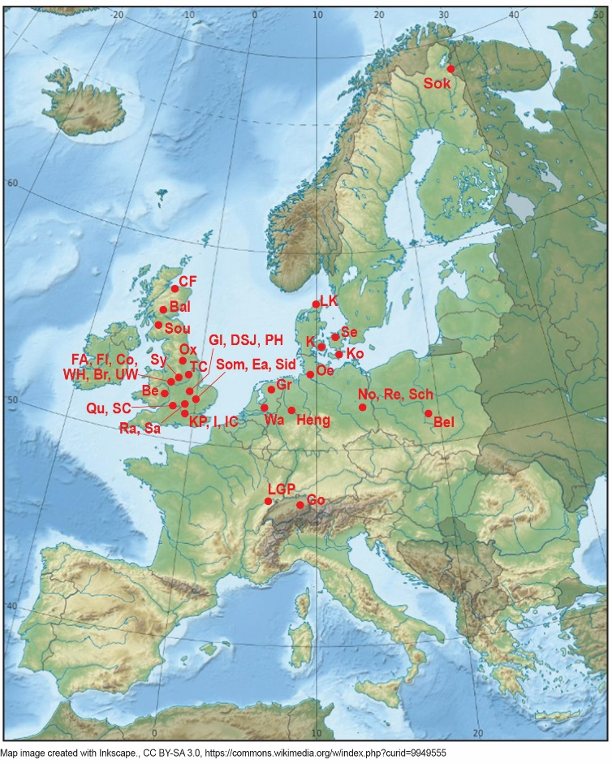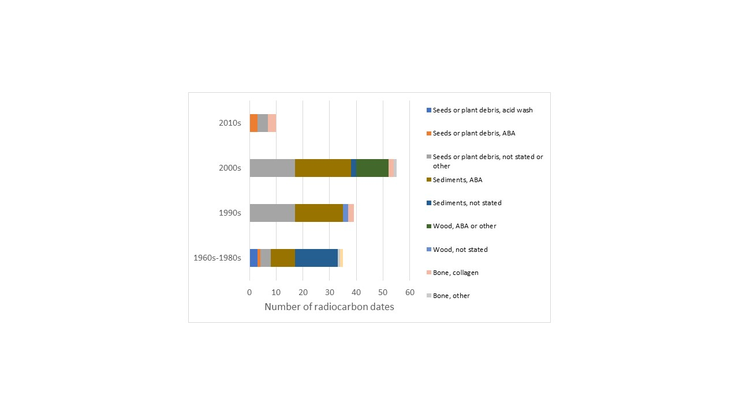

**Figure 1. a) Map of semi-continuous and discontinuous environmental sequences from northern Europe from which data is presented. Map image created with Inkscape., CC BY-SA 3.0, https://commons.wikimedia.org/w/index.php?curid=9949555. b) Materials and pretreatments used in radiocarbon dates from these publications by decade. Site codes: Bal = Balglass, Be = Beckford, Bel = Bełchatow, Br = Brandon, Co = Coleshill, CF = Camp Fauld, Tame Valley, DSJ = Deeping St James, Ea = Earith, GI = Gibbons Pit, Baston, Fl = Fladbury, FA = Four Ashes, Go = Gossau, Gr = Grouw, Heng = Hengelo, I = Isleworth, IC = Ismaili Centre, K = Klintholm, Ko = Kobbelgard, KP = Kempton Park, Lyn = Lynford, LGP = La Grande Pile, LK = Lonstrup Klint, No = Nochten, Oe = Oerel, Ox = Oxbow, PH = Pode Hole, Qu = Queensford, Ra = Radwell, Re = Reichwalde, Sa = Sandy, Sch = Scheibe, Se = Sejerø, Sid = Sidgwick Avenue, Sok = Sokli, Som = Somersham, Sou = Sourlie, Sy = Syston, SC = Sutton Courteney, TC = Tattershall Castle, UW = Upton Warren, Wa = Wageningen, WH = Whitemoor Haye (citations in Supplementary Reference List).**

**Figure 2. Impact of modern contamination (0.25–2% by weight) on measured radiocarbon ages (thin lines) compared to the 1:1 or uncontaminated line (thickest line), after Pigati et al., 2007.**

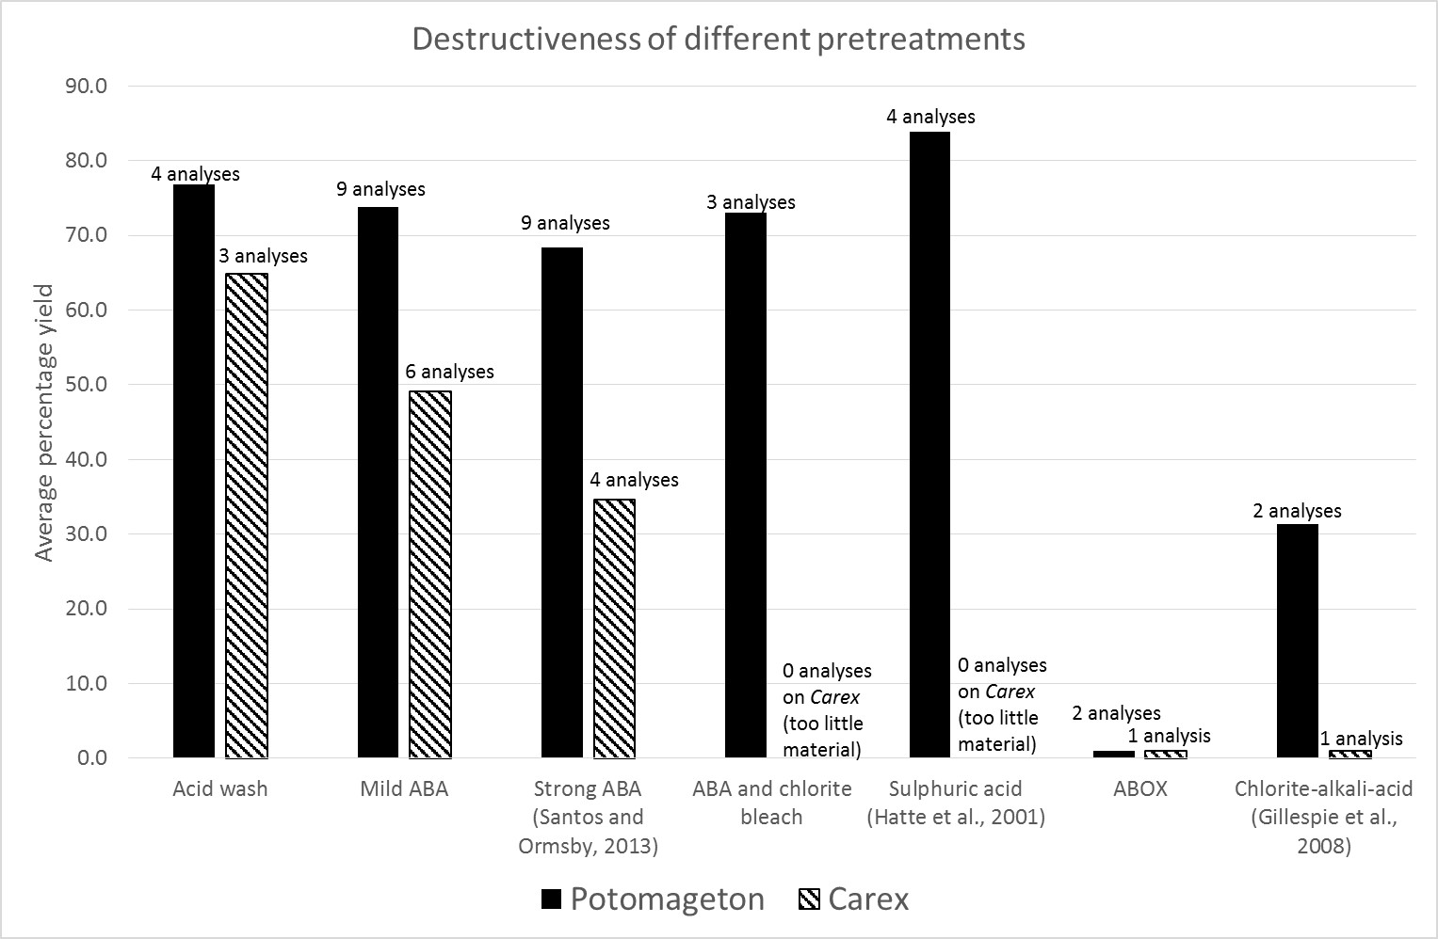**Figure 3. Sample yields by weight of different seeds under the different pretreatments applied (Full details of pretreatments in Table S1, pretreatments D and E aggregated as sulphuric acid in Figure 3). Pretreatments become progressively harsher from left to right.**

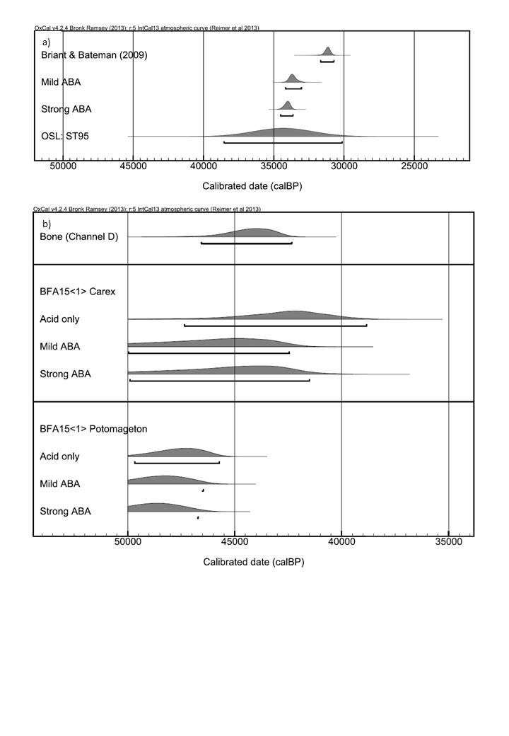**Figure 4. Radiocarbon ages compared with independent age control: a) Calibrated ages from ST93 compared with an independent OSL age from ST95 from Stanwick, Northamptonshire15; b) Calibrated ages from seeds from sample BFA15 <1> compared with a calibrated age on bone, adjacent to the sample within the channel, all from Channel D at Bradley Fen A (stratigraphic details in Figure S1).**

**Figure 5. Quantitative temperature estimates from published environmental sequences using three different methods (b,c,d), compared with the a) NGRIP ice core 18O record (Wolff et al., 2010), used here as a proxy for temperature. Chironomid-based temperatures (b) are mean values, beetle-based temperatures (c) are the mid point of a range, plant-based temperatures (d) are minimum values. Errors are not shown because they are too large and not consistently reported, but are approximately the size of the symbols used. Alignment of ice core and radiocarbon age timescales was undertaken using IntCal13 (Ramsay et al., 2013) through OxCal online, with tie points and 20,000 and 45,000 radiocarbon years BP. Megafauna extinction dates (grey shaded box) after Barnosky et al. (2004) and Neanderthal / Anatomically Modern Human (AMH) ages from Higham et al. (2014). Green shapes have independent dating control that agree with radiocarbon dating, amber shapes have no independent dating control, red shapes have independent dating control that disagrees with published radiocarbon dating. Circles are sediment dates, with pretreatments either not stated or ABA. Squares are wood or seed dates, all of which are either acid washed or pretreatments are not stated. Triangles are bone dates, mostly collagen extractions. Black oval outlines show which data points suggest July temperatures of 15oC or higher. Full details in Table S2, and reference list in Supplementary Information.**

|  |  |  |  |  |  |
| --- | --- | --- | --- | --- | --- |
| **Method** | **Pretreatment** | **Step 1** | **Step 2** | **Step 3** | **Step 4** |
| A | Acid only | 1M HCl, 80oC, 80 min |  | - | - |
| B | Mild ABA1 | 1M HCl, 80oC, 20 min | 0.2M NaOH, 80oC, 20 min | 1M HCl, 80oC, 1 hour | - |
| C | Mild ABA + chlorite bleach2 | 1M HCl, 80oC, 20 min | 0.2M NaOH, 80oC, 20 min | 1M HCl, 80oC, 1 hour | 2.5% wt/vol NaClO2, pH3, 80oC, 30 min |
| D | H2SO4 (Hatte et al., 2001) | 1M HCl, RT, 30 min | 0.1M NaOH, RT, 2 hours | 2M H2SO4, RT, 2 hours | - |
| E | H2SO4 (Hatte et al., 2001) –  For direct comparison of effectiveness of H2SO4 with HCl cf. VV | 1M HCl, RT, 30 min | 0.2M NaOH, 80oC, 20 min | 2M H2SO4, RT, 2 hours | - |
| F | Strong ABA (Santos and Ormsby, 2013) | 1M HCl, 90oC, 30 min | 1M NaOH, 90oC, 1 hour | 1M HCl, 90oC, 30 min | - |
| G | ABOx | 6M HCl, RT, 1 hour | 1M NaOH, RT, 30 min | 0.1M K2Cr2O7 in 2M H2SO4, sealed at 60oC for 24 hours | - |
| H | Chlorite-alkali-acid | 0.01M HCl, 80oC: 100 mg NaClO2 added at 0, 1, 2, 3 hours | 2M HCl, 80oC, 1 hour | 1M NaOH, 80oC, 1 hour | 1M HCl, 80oC, 1 hour |

**Table 1. Full chemical details of the pretreatments used in this study. 1Method VV in Brock et al. (2010). 2Method UV in Brock et al. (2010). RT: room temperature. Pretreatments D and E aggregated as sulphuric acid for display in Figure 3**

|  |  |  |  |  |  |
| --- | --- | --- | --- | --- | --- |
| ***Potamageton* from BFC1 <2b> (age: last interglacial, based on AAR, see Supplementary Figure 4)** | | | | | |
| **Pretreatment** | **Dry start weight (mg)** | **% yield** | **%C** | **d13C** | **Radiocarbon age** |
| B: mild ABA | 14.7 | 80.5 | 48.8 | -24.5 | >52600 BP  (OxA-29428) |
| B: mild ABA | 15.9 | 82.2 | 45.3 | -24.6 | n.d. |
| C: ABA and bleach | 15.5 | 74.9 | 43.0 | -20.9 | n.d. |
| C: ABA and bleach | 15.3 | 72.5 | 42.2 | -22.8 | n.d. |
| D: mild base, H2SO4 | 14.5 | 89.3 | 47.6 | -25.0 | n.d. |
| D: mild base, H2SO4 | 15.6 | 83.9 | 44.2 | -24.4 | n.d. |
| E: stronger base, H2SO4 | 15.0 | 79.6 | 47.8 | -23.4 | n.d. |
| E: stronger base, H2SO4 | 15.7 | 82.8 | 49.4 | -24.2 | n.d. |
| F: strong ABA | 15.2 | 74.3 | 51.3 | -22.7 | n.d. |
| F: strong ABA | 15.5 | 72.0 | 46.2 | -25.3 | n.d. |
| G: ABOx | 101.7 | 0.0 |  |  | n.a. |
| G: ABOx | 102.39 | 0 |  |  | n.a. |
| H: chlorite-alkalite-acid | 35.6 | 23.7 | 44.1 | -23.7 | n.d. |
| H: chlorite-alkalite-acid | 34.3 | 38.9 | 45.6 | -23.8 | n.d. |
| ***Carex* from BFC1 <2b> (age: last interglacial, based on AAR, see Figure 5)** | | | | | |
| B: mild ABA | 2.9 | 41.5 | 56.5 | -28.0 | >42900 BP  (OxA-29691) |
| F: strong ABA | 2.9 | 34.1 |  |  | n.d. |
| G: ABOx | 3.2 | 0 |  |  | n.a. |
| ***Potamageton* from DSJ34 J** | | | | | |
| A: acid only | 6.7 | 77.3 | 42.8 | -21.6 | 50500 ± 3100 BP  (OxA-X-2580-18) |
| B: mild ABA | 6.4 | 70.5 | 42.5 | -19.5 | 49500 ± 2200 BP  (OxA-29987) |
| C: ABA and bleach | 6.3 | 71.6 | 42 | -18.9 | >49600 BP  (OxA-30202) |
| F: strong ABA | 6.5 | 58.1 | 41.5 | -20.4 | 52100 ± 3700 BP  (OxA-X-2580-17) |
| ***Carex* from DSJ34 B** | | | | | |
| B: mild ABA | 2.9 | 33.4 | 42.5 | -26.7 | >37200 BP  (OxA- X-2575-44)* |
| F: strong ABA | 3.2 | 30.7 | 38.3 | -26.1 | >33300 BP  (OxA- X-2575-45)* |

**Table 2. Results from samples known to be older than 70 ka. B, C and G follow Brock et al. (2010); E follows Hatté et al. (2001); H follows Gillespie et al. (2008) and F follows Santos and Ormsby (2013). Full details are given in Table S1. OxA-X numbers are issued to research measurements using non-standard or experimental methods (see Brock et al. 2010). OxA-X samples labelled * should be treated as rangefinders only due to small sample size (low C mg graphitized for dating). OxA-X-2575-44 also had a low target current, thus reducing the precision relative to a standard sample.**

|  |  |  |  |  |  |  |  |
| --- | --- | --- | --- | --- | --- | --- | --- |
| **Sample** | **Dry start wgt (mg)** | **Pretreatment** | **% yield** | **%C** | **d13C** | **Radiocarbon age** | **Calibrated age (cal BP)** |
| **Stanwick Quarry, Northamptonshire, facies association ST-2**  **Original age (Briant and Bateman, 2009): AA-48182 - 27,190 ± 330 BP (31670-30731 cal BP (95.4%)**  **OSL age estimate (ST95, Briant and Bateman, 2009): 34,400 ± 2100 BP** | | | | | | | |
| ST93 *Potamageton* - archive samples previously pretreated with an acid wash | 3.1 | B: mild ABA | 84.1 | 52.8 | -13.9 | 29480 ± 280 BP  (OxA-30029) | 34155-33036 cal BP (95.4%) |
| 4.0 | F: strong ABA | 77.8 | 51.5 | -15.2 | 29940 ± 250 BP  (OxA-30113) | 34514-33640 cal BP (95.4%) |
| **Bradley Fen A Channel D**  **Independent age control – radiocarbon on *Coelodonta antiquitatis* bone from location of BFA15<1>: 40400** ± **1200 BP (OxA-31962)**  **Initial bulk sample weights: BFA12<2> 19.6 kg; BFA12<2a> 23.3 kg; BFA15<1> 44.6 kg** | | | | | | | |
| BFA15<1>  Trigonous *Carex* – 18 seeds, 7 mg  1.7 kg of bulk sample = 1 mg of seeds | 2.1 | A: acid only | 48.5 | 46.9 | -26.3 | 37900 ± 2000 BP  OxA-X-2627-55 | 47347-38839 cal BP (95.4%) |
| 2.1 | B: mild ABA | 53.3 | 48.0 | -27.6 | 41400 ± 2700 BP  OxA-32033 | 49948-42450 cal BP (95.4%) – out of range |
| 2.7 | F: strong ABA | 38.3 | 46.6 | -27.3 | 40300 ± 2700 BP  OxA-X-2627-56 | 49892-41512 cal BP (95.4%) – out of range |
| BFA15<1>  *Potamageton* – 166 seeds, 131 mg  0.3 kg of bulk sample = 1 mg of seeds | 8.9 | A: acid only | 84.3 | 48.5 | -18.2 | 44100 ± 1000 BP  OxA-X-2629-40 | Beyond curve – out of range |
| 9.2 | B: mild ABA | 81.3 | 48.5 | -18.3 | 44900 ± 1100 BP OxA-32108 | Beyond curve – out of range |
| 9.2 | F: strong ABA | 70.1 | 50.9 | -18.3 | 45200 ± 1100 BP  OxA-X-2629-39 | Beyond curve – out of range |

**Table 3. Results from samples within the range of the radiocarbon technique. B follows Brock et al. (2010) and F follows Santos and Ormsby (2013). Full details are given in Supplementary Table 1. Dates calibrated using OxCal v. 4.2.4 (Bronk Ramsey 2009) and IntCal13 (Reimer et al. 2013). OxA-X numbers are issued to research measurements using non-standard or experimental methods (see Brock et al. 2010).**

**Supplementary Information**

**Improving chronological control for environmental sequences from the last glacial period**

Briant, Rebecca M.1, Brock, Fiona2,3, Demarchi, Beatrice4, Langford, Harold E.1, Penkman, Kirsty E.H.4, Schreve, Danielle C.5, Schwenninger, Jean-Luc2, Taylor, Sheila4

1Department of Geography, Environment and Development Studies, Birkbeck, University of London, Malet Street, London, WC1E 7HX, UK.

2Research Laboratory for Archaeology and History of Art, University of Oxford, Dyson Perrins Building, South Parks Road, Oxford OX1 3QY, UK.

3Cranfield Forensic Institute, Cranfield University, Defence Academy of the United Kingdom, Shrivenham, Oxon, SN6 8LA, UK.

4BioArCh, Department of Chemistry, University of York, York, YO10 5DD, UK.

5Department of Geography, Royal Holloway, University of London, Egham, Surrey, TW20 0EX, UK.

1. **Figures showing sample locations and type**

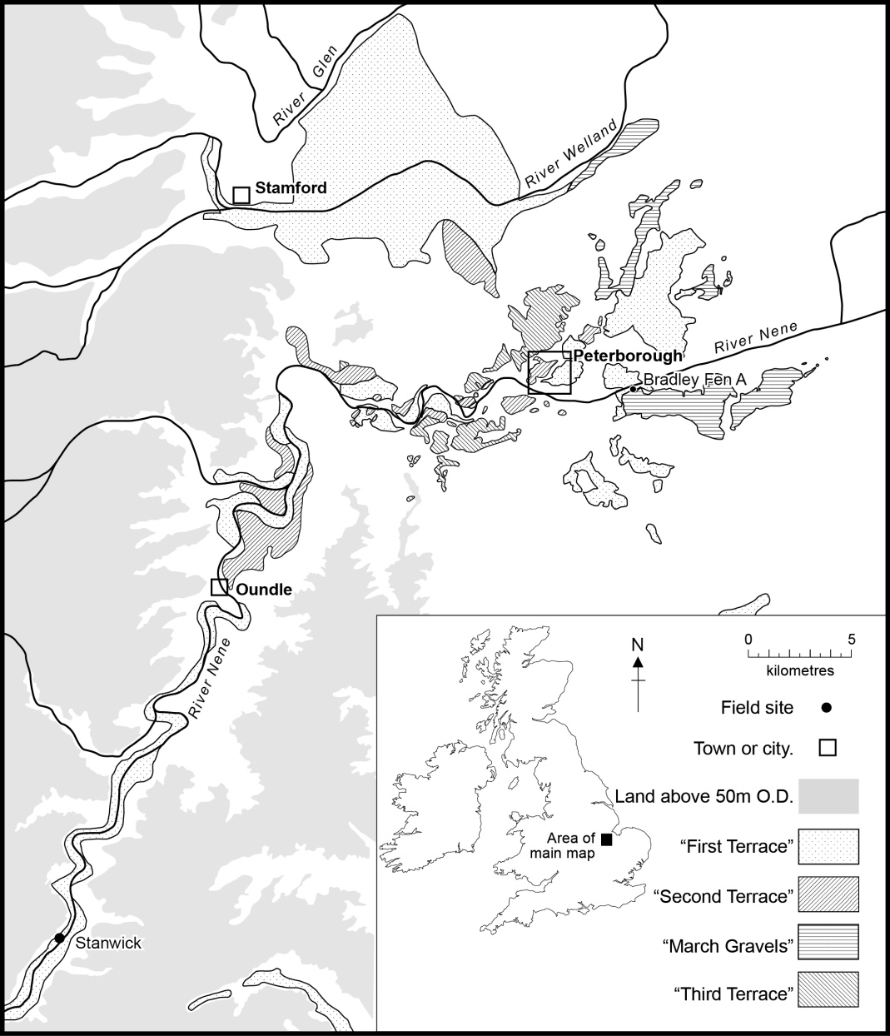

**Figure S1. Location of Bradley Fen A, near Whittlesey, Cambridgeshire, England. © Crown Copyright and Database Right [2016]. Ordnance Survey (Digimap Licence). Terrace locations are based on British Geological Survey 1:50,000 mapping of the area (sheets 144, 145, 158 and 159).**

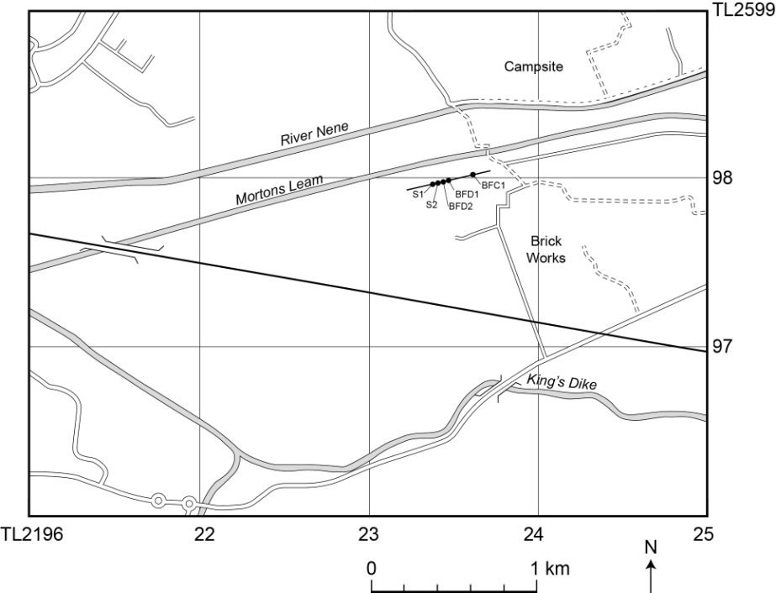

**Figure S2. Location of sequence at Bradley Fen A, near Whittlesey, Cambridgeshire. © Crown Copyright and Database Right [2016]. Ordnance Survey (Digimap Licence).**

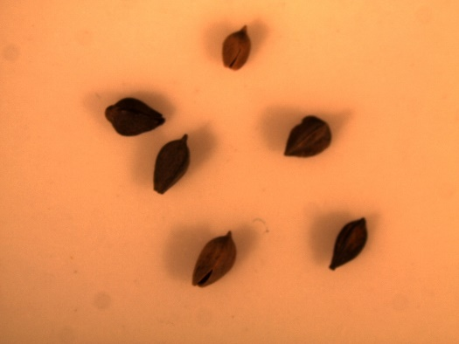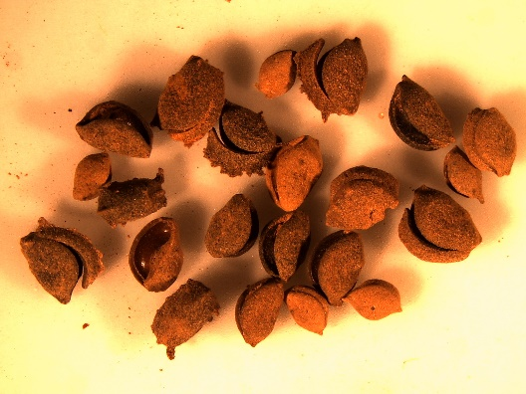

I mm

I mm

**Figure S4. *Carex* and *Potamageton* seeds from BFC1<2b>.**

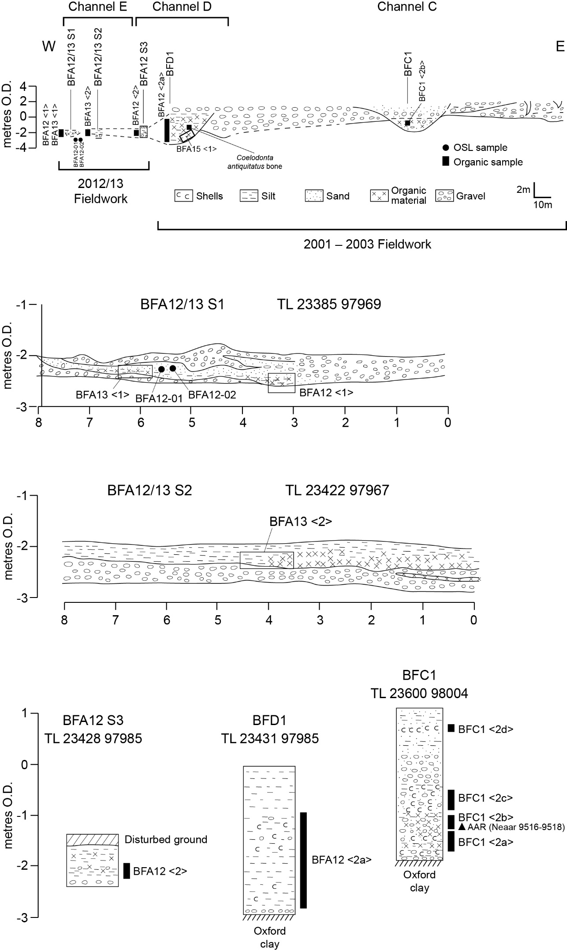

**Figure S3. Section at Bradley Fen A, showing location of samples dated.**

1. **Background information on chronological control**

**2.1 Amino-acid racemization**

Amino acid racemization (AAR) analyses were undertaken on three individual *Bithynia tentaculata* opercula (freshwater snail shell) from Bradley Fen A, BFC1 <2b> (NEaar 9516 - 9518). All samples were prepared using procedures to isolate the intra-crystalline protein by bleaching (Penkman et al., 2008). Two subsamples were then taken from each shell; one fraction was directly demineralised and the free amino acids analysed (referred to as the 'free' amino acids, FAA, F), and the second was treated to release the peptide-bound amino acids, thus yielding the 'total' amino acid concentration, referred to as the ‘total hydrolysable amino acid fraction (THAA, H*). Samples were analysed in duplicate by RP-HPLC. The amino acid ratios of the FAA and the THAA subsamples are highly correlated, strongly suggesting that the samples are from a closed system and therefore that the age estimation is robust.



**Figure S5. Free vs Total D/L values of aspartic acid/asparagine and alanine from bleached Bithynia tentaculata opercula from Bradley Fen (Neaar 9516-9518), compared with shells from UK sites correlated with MIS 5e (yellow), MIS 7 (green) and MIS 9 (blue) from Penkman et al. (2013).**

**2.2 Optically-stimulated luminescence dating (OSL)**

Preparation to quartz involved separation of the modal size fraction by wet sieving and treatment with hydrochloric and hydrofluoric acids, removal of heavy minerals using sodium polytungstate and further dry sieving. Equivalent dose was determined in the Research Laboratory for Archaeology and the History of Art, Oxford, using automated Chronos Risø measurement systems with blue diodes. The Single Aliquot Regenerative (SAR) protocol (Murray and Wintle, 2000) was used, with the addition of a post-IR blue OSL procedure within the SAR protocol (Banerjee et al., 2001) to further minimise feldspar contributions and remove problems of anomalous fading. Small (4 mm) aliquots of sand-sized (125 – 180, 180 – 255 or 255 - 355 m) quartz were measured (Supplementary Table 2). Luminescence measurements were made at 125oC, with a default preheat 1 (PH1) value of 260oC for 10 s, preheat 2 (PH2) of 220oC for 10 s and up to 6 regeneration dose points. Equivalent doses (De) for individual aliquots were calculated using a sum of 2 exponentials with late background subtraction which gives better counting statistics. Analyst 4.31.9 was used. Luminescence behaviour (i.e. recycling ratios and lack of IR contamination) of both samples was good, showing that the SAR protocol used was appropriate. In addition, shine down curves showed clear exponential decay. The use of 4 mm diameter discs provides a good balance between being bright enough to give good counting statistics and yet small enough to detect rare unbleached grains affecting this signal. This latter effect led to the removal of a single aliquot from sample X4210 which had an equivalent dose of 195 Gy, rather than the c. 40 Gy of the rest of the aliquots. Mean recycling ratios were at unity and in most cases (10 aliquots from 12) within 15% (Table S2). Mean recuperation is below 15%, and again only 2 aliquots from 12 exceeded 15%. Supplementary Figure 6 shows that overdispersion is similar to standard values for fluvial samples, with most aliquots falling within two standard deviations of the Central Age. For all these reasons, these ages provide robust independent age control for the radiocarbon pretreatment experiments described in Table S5.

Details of dosimetric data and calculations are given in Table S2. Environmental dose rates were calculated only on the basis of geochemical analysis by ICP-MS using a fusion preparation method. Radioisotope concentrations were converted to dose rates using conversion factors (Adamiec and Aitken, 1998) and grain-size attenuation factors (Mejdahl, 1979). Cosmic dose rates were calculated using Prescott and Hutton (1994) and it was assumed that overburden accumulated soon after deposition and was negligible relative to the burial period. Interstitial water content attenuates dose rates, and this was corrected for using an absorption coefficient (Zimmerman, 1971). It was assumed that present-day moisture content is representative of water contents throughout burial (percentage dry weight of sample). Whilst beta dose rates are the same for the two adjacent samples, gamma dose rates are slightly different. Gamma dose rates were calculated from measured concentrations of radioactive nuclides from the different sediments near the samples, whose contribution was then calculated using the equations in Aitken (1982). Dose rates were given a 10% error because this was necessary. The dose rates vary because the two samples were in a slightly different microstratigraphic setting (Figure S3). In particular, sample BFA12-02 (X4211) was adjacent to a gravel scour feature, which affected the calculations integrating the gamma dose over the 30 cm diameter adjacent to the sample. For this reason, sample BFA12-01 (X4210) should be taken as more reliable.

Ages were calculated by dividing the mean equivalent dose (De) ± one standard error (i.e. standard deviation / √n) by dose rate.

|  |  |  |  |  |  |  |  |  |  |  |  |  |  |
| --- | --- | --- | --- | --- | --- | --- | --- | --- | --- | --- | --- | --- | --- |
| **Field code** | **Labo-ratory code** | **Sample mois-ture (%)** | **K**  **conc. (%)** | **Th conc. (%o)** | **U conc. (%o)** | **Gamma dose integrated over 30 cm diameter (Gy)** | **Over-burden thickness (m)** | **Cosmic dose rate (Gy/ka)** | **Total dose rate (Gy/ka)** | **Mean De (Gy)** | **Mean recyc-ling ratio** | **Mean recup-eration (%)** | **Age estimate (ka)** |
| BFA12-01 | X4210 | 20 | 0.66±0.03 | 2.20±0.11 | 0.7±0.04 | 0.38±0.04 | 4 ± 1 | 0.11±0.02 | 1.00±0.06 | 40.4±3.2 | 1.0±0.1 | 13.5±0.8 | 41.6±4.3 |
| BFA12-02 | X4211 | 20 | 0.66±0.03 | 2.20±0.11 | 0.7±0.04 | 0.37±0.04 | 4 ± 1 | 0.11±0.02 | 0.99±0.06 | 44.9±3.1 | 1.0±0.1 | 8.9±0.6 | 44.6±4.2 |

**Table S1. Details of OSL ages from Channel E. Measured field moisture content was c. 15% but the site is artificially drained at present, hence the use of 20% in dose estimation. Fully saturated values of water content of 30% were deemed likely to be an overestimate because of the known low sea levels and high aridity during the last glacial period. The 20% value is therefore a compromise between measured and saturated values. Gamma dose was calculated from K, Th and U concentrations of the full range of sediments, integrated over the full 30 cm diameter surrounding the sample after Aitken (1982).**

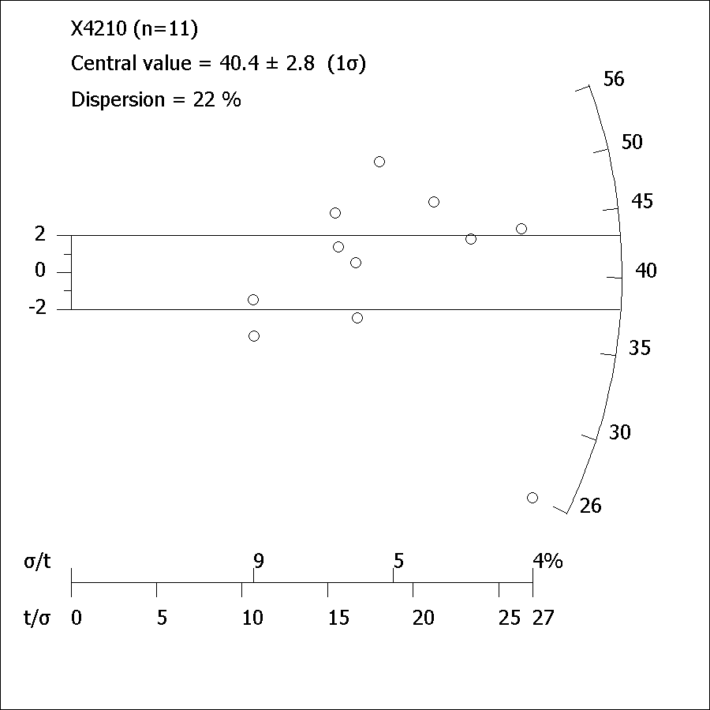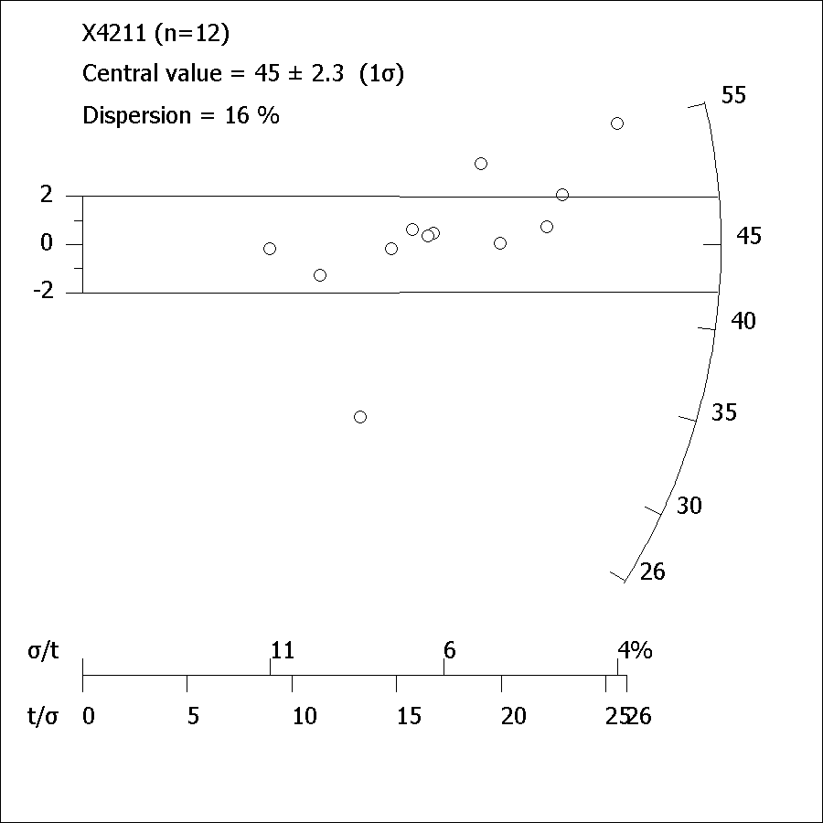

**Figure S6. Equivalent dose distributions of X4210 and X4211, showing Central Age and overdispersion calculations using Radial Plotter (Vermeesch, 2009).**

**References**

Adamiec, G., Aitken, M.J. 1998. Dose-rate conversion factors: new data*. Ancient TL* **16,** 37-50.

Aitken, M.J. 1982. *Thermoluminescence dating.* New York, Academic Books.

Banerjee D., Murray A.S., Bøtter-Jensen L., Lang A. 2001. Equivalent dose estimation using a single aliquot of polymineral fine grains. *Radiation Measurements* **32,** 833-840.

Mejdahl V. 1979. Thermoluminescence dating: beta-dose attenuation in quartz grains. *Archaeometry* **21,** 61-72.

Murray A.S., Wintle A.G. 2000. Luminescence dating of quartz using an improved single aliquot regenerative-dose protocol. *Radiation Measurements* **32,** 57-73.

Penkman, K E H, Preece, R C, Bridgland, D R, Keen, D H, Meijer, T, Parfitt, S A, White, T S & Collins, M J, 2013, An aminostratigraphy for the British Quaternary based on *Bithynia* opercula, *Quaternary Science Reviews*, **61**, 111-134.

Penkman, K. E. H., Kaufman, D. S., Maddy, D., Collins, M. J. 2008. Closed-system behaviour of the intra-crystalline fraction of amino acids in mollusc shells, *Quaternary Geochronology* **3**, 2-25.

Prescott, J.R., Hutton, J.T. 1994. Cosmic Ray contributions to dose rates for luminescence and ESR dating: large depths and long term time variations. *Radiation Measurements* **23,** 497-500.

Vermeesch, P. 2009. RadialPlotter: a Java application for fission track, luminescence and other radial plots. *Radiation Measurements* **44**, 409-410.

Zimmerman D.W. 1971. Thermoluminescent dating using fine grains from pottery. *Archaeometry* **13,** 29-52.

1. **Data supporting Figures 1 and 5**

|  |  |  |  |  |  |  |  |  |  |
| --- | --- | --- | --- | --- | --- | --- | --- | --- | --- |
| **Site code** | **Name of sequence and sample** | **Beetle-based MCR minimum July temperature (degrees C, after Coope et al., 1998)** | **Pollen / Macrofossil-based July temperature (degrees C)** | **Chironomid-based July temperature (decrees C)** | **Radiocarbon age (years)** | **Radiocarbon error (years)** | **Independent age control?** | **Material and pretreatment** | **Traffic light rating** |
| LGP | La Grande Pile 29 - Pile Interstadial | 10 |  |  | 49,800 | 1400 | None | Sediments, mild ABA | Amber |
| LGP | La Grande Pile 30 - Pile Interstadial | 7 |  |  | 49,800 | 1400 | None | Sediments, mild ABA | Amber |
| LGP | La Grande Pile 32 - Charbon Interstadial | 12 |  |  | 40,000 | 600 | None | Sediments, mild ABA | Amber |
| LGP | La Grande Pile 34 | 14 |  |  | 34,100 | 290 | None | Sediments, mild ABA | Amber |
| LGP | La Grande Pile 35 - Grand Bois Interstadial | 11 |  |  | 30,820 | 210 | None | Sediments, mild ABA | Amber |
| LGP | La Grande Pile 36 - Grand Bois Interstadial | 12 |  |  | 29,980 | 970 | None | Sediments, mild ABA | Amber |
| LGP | La Grande Pile 37 - Grand Bois Interstadial | 6 |  |  | 29,740 | 260 | None | Sediments, mild ABA | Amber |
| Oe | Oerel 455-440 cm - Oerel Interstadial | 10 |  |  | 55,400 | 900 | None | Sediments, mild ABA | Amber |
| Oe | Oerel 440-430 cm - Oerel Interstadial | 12 |  |  | 57,700 | 1300 | None | Sediments, mild ABA | Amber |
| Oe | Oerel 293-281 cm - Glinde Interstadial | 9 |  |  | 50,200 | 700 | None | Sediments, mild ABA | Amber |
| Sok | Sokli 5.7-5.9 m core 900, Tulppio Interstadial |  | 13 | 14 | 42,450 | 3570 | Agree | Wood, thorough | Green |
| Sok | Sokli 5.5 m, borehole B Series - Tulppio Interstadial |  | 13 | 14 | 54,000 | 7400 | Agree | Not stated | Green |
| GI | Gibbons Pit, Baston GI25 14C GI27 OSL - Unit GI1b | 9 |  |  | 29,070 | 340 | Agree | Seeds, acid wash | Green |
| GI | Gibbons Pit, Baston GI25 14C GI27 OSL - Unit GI1b | 9 |  |  | 29,270 | 350 | Agree | Seeds, acid wash | Green |
| GI | Gibbons Pit, Baston GI25 14C GI27 OSL - Unit GI1b | 9 |  |  | 28,310 | 320 | Agree | Seeds, acid wash | Green |
| DSJ | Deeping St James DSJ34 14C DSJ32 OSL - Unit DSJ1 | 7 |  |  | 35,700 | 800 | Disagree | Seeds, acid wash | Red |
| DSJ | Deeping St James DSJ34 14C DSJ32 OSL - Unit DSJ1 | 7 |  |  | 37,240 | 890 | Disagree | Seeds, acid wash | Red |
| DSJ | Deeping St James DSJ34 14C DSJ32 OSL - Unit DSJ1 | 7 |  |  | 40,300 | 1300 | Disagree | Seeds, acid wash | Red |
| PH | Pode Hole PH21 14C PH27 OSL - Unit PH3 | 7 |  |  | 36,900 | 900 | Disagree | Seeds, acid wash | Red |
| PH | Pode Hole PH21 14C PH27 OSL - Unit PH3 | 7 |  |  | 37,900 | 1200 | Disagree | Seeds, acid wash | Red |
| PH | Pode Hole PH21 14C PH27 OSL - Unit PH3 | 7 |  |  | 38,600 | 1300 | Disagree | Seeds, acid wash | Red |
| Gr | Grouw Unit d |  | 10 |  | 43,900 | 1400 | None | Sediments, mild ABA | Amber |
| Gr | Grouw Unit f |  | 10 |  | 38,700 | 1050 | None | Sediments, mild ABA | Amber |
| Gr | Grouw Unit h base |  | 13 |  | 37,750 | 850 | None | Sediments, mild ABA | Amber |
| Gr | Grouw Unit h top |  | 8 |  | 36,850 | 775 | None | Sediments, mild ABA | Amber |
| Gr | Grouw Unit k |  | 10 |  | 38,350 | 950 | None | Sediments, mild ABA | Amber |
| No | Nochten SJ 7-3a/b, Unit 1b |  | 9 |  | 48,400 | 2400 | Agree | Seeds, not stated | Green |
| No | Nochten SJ 7-2, Unit 1b |  | 12.5 |  | 38,500 | 700 | Agree | Seeds, not stated | Green |
| No | NochtenSJ 7-1, Unit 1b |  | 12.5 |  | 42,100 | 1100 | Agree | Seeds, not stated | Green |
| No | Nochten SJ 4-4, Unit 3 |  | 14 |  | 35,300 | 600 | None | Seeds, not stated | Amber |
| No | Nochten SJ 4-3, Unit 3 |  | 14 |  | 35,500 | 700 | None | Seeds, not stated | Amber |
| No | Nochten SJ 4-2, Unit 3 |  | 14 |  | 34,400 | 600 | None | Seeds, not stated | Amber |
| No | Nochten NAR 8-2, Unit 3 |  | 14 |  | 38,000 | 900 | None | Seeds, not stated | Amber |
| No | Nochten NAR 8-1, Unit 3 |  | 14 |  | 34,300 | 500 | None | Seeds, not stated | Amber |
| No | Nochten NAR 3, Unit 3 |  | 14 |  | 35,600 | 700 | None | Seeds, not stated | Amber |
| No | Nochten JF11 base, Unit 4 |  | 10 |  | 24,440 | 190 | Agree | Seeds, not stated | Green |
| No | Nochten JF11 top, Unit 4 |  | 10 |  | 25,780 | 220 | Agree | Seeds, not stated | Green |
| No | Nochten B/2742 | 8 |  |  | 22990 | 120 | None | Seeds, not stated | Amber |
| No | Nochten B/2695 | 8 |  |  | 25970 | 220 | None | Seeds, not stated | Amber |
| No | Nochten B/2696 | 8 |  |  | 26430 | 240 | None | Seeds, not stated | Amber |
| No SR-X1 | Nochten Unit N1, box core SR-X1 |  | 15 | 14.5 | 45000 |  | Disagree | Seeds, not stated | Red |
| No SR-X1 | Nochten Unit N1, box core SR-X1 |  | 15 | 14.5 | 43,000 | 800 | Disagree | Seeds, not stated | Red |
| Re | Reichwalde Unit RW3, box core LM8 |  | 12.5 | 15.5 | 47000 |  | None | Seeds, not stated | Amber |
| Re | Reichwalde Unit RW3, box core LM8 |  | 12.5 | 15.5 | 45800 | 3200 | None | Seeds, not stated | Amber |
| Bel | Middle fluvial B/2742 | 8 |  |  | 22990 | 120 | None | Seeds, not stated | Amber |
| Bel | Middle fluvial B/2695 | 8 |  |  | 25970 | 220 | None | Seeds, not stated | Amber |
| Bel | Middle fluvial B/2696 | 8 |  |  | 26430 | 240 | None | Seeds, not stated | Amber |
| KP | Kempton Park | 10 |  |  | 35230 | 185 | None | Seeds, not stated | Amber |
| I | Isleworth | 17 |  |  | 43140 | 1350 | Disagree | Seeds, not stated | Red |
| K | Klintholm 14.00–14.25 | 8 | 11 |  | 35900 | 1900 | Agree | Seeds, not stated | Green |
| K | Klintholm 14.00–14.25 | 8 | 11 |  | 35600 | 350 | Agree | Seeds, not stated | Green |
| K | Klintholm 13.75–14.00 | 8 | 11 |  | 34270 | 240 | Agree | Seeds, not stated | Green |
| K | Klintholm 13.75–14.00 | 8 | 11 |  | 33240 | 240 | Agree | Seeds, not stated | Green |
| WH | Whitemoor Haye Upper Gravels | 8 |  | 11 | 43350 | 500 | Agree | Bone, collagen | Green |
| WH | Whitemoor Haye Upper Gravels | 8 |  | 11 | 42850 | 450 | Agree | Bone, collagen | Green |
| WH | Whitemoor Haye Upper Gravels | 8 |  | 11 | 41690 | 400 | Agree | Bone, collagen | Green |
| Ea E7 | Earith E7 | 15 | 16 |  | 42140 | 1700 | None | Seeds, acid wash | Amber |
| Ea E9 | Earith E9 | 8 | 13 |  | 45000 |  | None | Seeds, acid wash | Amber |
| Sa | Sandy SD010301, Lower organic layer | 8 |  |  | 34055 | 320 | None | Seeds, not stated | Amber |
| UW | Upton Warren, band no 2 | 16 |  |  | 41500 | 1200 | None | Seeds, acid wash | Amber |
| UW | Upton Warren, band no 2 | 17 |  |  | 41900 | 800 | None | Seeds, not stated | Amber |
| IC E2 | Ismaili Centre E2 | 7 |  |  | 45000 |  | None | Woods, not stated | Amber |
| IC C2 | Ismaili Centre C2 | 16 |  |  | 38000 | 2000 | None | Seeds, not stated | Amber |
| Br | Brandon | 10 |  |  | 29000 | 1000 | None | Not stated | Amber |
| Sou | Sourlie HB12/GRC4 | 9 |  |  | 33270 | 370 | None | Sediments, not stated | Amber |
| Sou | Sourlie HB10 | 9 |  |  | 29900 | 420 | None | Bone, collagen | Amber |
| Sou | Sourlie HB2/GRC3 | 9 | 10 |  | 30230 | 280 | None | Sediments, not stated | Amber |
| Sou | Sourlie HB2/GRC3 | 9 | 10 |  | 29290 | 350 | None | Seeds, not stated | Amber |
| Fl | Fladbury sample' | 10 |  |  | 38000 | 700 | None | Sediments, not stated | Amber |
| Lyn | Channel fill | 10 |  |  | 50000 |  | Agree | Bone, not stated | Green |
| Ox | Lower Silt | 10 |  |  | 38600 | 1570 | None | Tusk, not stated | Amber |
| Ko | Previous sample |  | 11 |  | 28500 | 600 | Agree | Seeds, not stated | Green |
| Ko | Previous sample |  | 11 |  | 29800 | 1000 | Agree | Seeds, not stated | Green |
| Ko | 74979 |  | 11 |  | 24700 | 5500 | Agree | Bone, collagen | Green |
| Ko | 74979 |  | 11 |  | 34000 | 5500 | Agree | Teeth, collagen | Green |
| Ko | 74979 |  | 11 |  | 32000 | 1000 | Agree | Wood, not stated | Green |
| Ko | 74973 |  | 11 |  | 36000 |  | Agree | Wood, not stated | Green |
| Ko | 74980 |  | 11 |  | 36000 |  | Agree | Wood, not stated | Green |
| TC | TC Lower organic silt | 10 |  |  | 42100 | 1250 | none | Not stated | Amber |
| TC | TC Lower organic silt | 10 |  |  | 44300 | 1450 | none | Not stated | Amber |
| TC | TC Upper organic silt | 16 |  |  | 43000 | 1250 | none | Not stated | Amber |
| TC | TC Upper organic silt | 16 |  |  | 42000 | 1000 | none | Not stated | Amber |
| Go | Upper lignite | 9 |  |  | 29450 | 1150 | Agree | Sediments, not stated | Green |
| Go | Upper lignite | 9 |  |  | 28550 | 310 | Agree | Sediments, not stated | Green |
| Se | Single bulk archive sample |  | 8 |  | 36710 | 460 | None | Sediments, not stated | Amber |
| Se | Single bulk archive sample |  | 8 |  | 36900 | 460 | None | Wood, not stated | Amber |
| Se | Single bulk archive sample |  | 8 |  | 36000 | 500 | None | Wood, not stated | Amber |
| LK | GI 104152 | 10 |  |  | 29120 | 1415 | None | Seeds, not stated | Amber |
| LK | GI 104153 | 10 |  |  | 30900 | 530 | None | Seeds, not stated | Amber |
| Bal | Balglass Burn organic sand | 8 |  |  | 35575 | 415 | None | Sediments, ABA | Amber |
| Bal | Balglass Burn organic sand | 8 |  |  | 32460 | 420 | None | Sediments, ABA | Amber |
| Bal | Balglass Burn organic sand | 8 |  |  | 32800 | 280 | None | Seeds, not stated | Amber |
| Bal | Balglass Burn organic sand | 8 |  |  | 34480 | 340 | None | Seeds, not stated | Amber |
| Bal | Balglass Burn organic sand | 8 |  |  | 28050 | 160 | None | Seeds, not stated | Amber |
| Bal | Balglass Burn organic sand | 8 |  |  | 32770 | 290 | None | Seeds, not stated | Amber |
| Bal | Balglass Burn organic sand | 8 |  |  | 30080 | 200 | None | Insects, not stated | Amber |
| Bal | Balglass Burn organic sand | 8 |  |  | 30650 | 220 | None | Insects, not stated | Amber |
| Sy | Pit B, site 2 | 10 |  |  | 37420 | 1450 | None | Sediments, not stated | Amber |
| FA | Group 2 fauna, locality 4 | 15 |  |  | 42530 | 1215 | None | Sediments, not stated | Amber |
| FA | Group 2 fauna, locality 12 | 15 |  |  | 38500 | 1100 | None | Sediments, not stated | Amber |
| FA | Group 2 fauna, locality 34 | 15 |  |  | 40000 | 1300 | None | Sediments, not stated | Amber |
| FA | Group 3 fauna, locality 2 | 10 |  |  | 30655 | 750 | None | Sediments, not stated | Amber |
| FA | Group 3 fauna, locality 3 | 10 |  |  | 36340 | 750 | None | Sediments, not stated | Amber |
| FA | Group 3 fauna, locality 20 | 10 |  |  | 43500 |  | None | Sediments, not stated | Amber |
| FA | Group 3 fauna, locality 45 | 10 |  |  | 30500 | 440 | None | Sediments, not stated | Amber |
| Co | Fluvial channel fill | 10 |  |  | 32160 | 1550 | None | Sediments, not stated | Amber |
| Be | Sample A from upper silt | 10 |  |  | 27650 | 250 | None | Wood, not stated | Amber |
| CF | Pit B, Peat B | 10 |  |  | 40060 | 990 | None | Sediments, ABA | Amber |
| Qu | channel fill | 10 |  |  | 39300 | 1350 | None | Sediments, not stated | Amber |
| SC | channel fill | 10 |  |  | 29200 | 300 | None | Sediments, not stated | Amber |

**Table S2. Details of radiocarbon dated quantitative temperature estimates from discontinuous sequences in northwest Europe, displayed in Figure 3. Site codes: Bal = Balglass, Be = Beckford, Br = Brandon, Co = Coleshill, Tame Valley, DSJ = Deeping St James, Ea = Earith, GI = Gibbons Pit, Baston, Fl = Fladbury, FA = Four Ashes, Go = Gossau, Gr = Grouw, I = Isleworth, IC = Ismaili Centre, K = Klintholm, Ko = Kobbelgard, KP = Kempton Park, Lyn = Lynford, LGP = La Grande Pile, LK = Lonstrup Klint, No = Nochten, Oe = Oerel, Ox = Oxbow, PH = Pode Hole, Qu = Queensford, Re = Reichwalde, Sa = Sandy, Sch = Scheibe, Se = Sejerø, Sok = Sokli, Sou = Sourlie, Sy = Syston, SC = Sutton Courteney, TC = Tattershall Castle, UW = Upton Warren, WH = Whitemoor Haye (citations in Supplementary Reference List below).**

**Supplementary Reference List (Figures 1 and 5)**

Aa, A.R. and Sonstegaard, E., 2001. Middle Weichselian interstadial sediments in Sogndalsdalen, western Norway. *Norsk Geologisk Tidsskrift*,**81(1),** pp.17-24.

Behre, K.E. and van der Plicht, J., 1992. Towards an absolute chronology for the last glacial period in Europe: radiocarbon dates from Oerel, northern Germany. *Vegetation History and Archaeobotany,* **1(2),** pp.111-117.

Behre, K.E., Hölzer, A. and Lemdahl, G., 2005. Botanical macro-remains and insects from the Eemian and Weichselian site of Oerel (northwest Germany) and their evidence for the history of climate. *Vegetation History and Archaeobotany*, **14(1),** pp.31-53.

Bell, F.G., 1970. Late Pleistocene floras from Earith, Huntingdonshire. *Philosophical Transactions of the Royal Society of London B: Biological Sciences,* **258(826),** pp.347-378.

Bell, F.G., Coope, G.R., Rice, R.J. and Riley, T.H., 1972. Mid-Weichselian fossil-bearing deposits at Syston, Leicestershire. *Proceedings of the Geologists' Association*, **83(2),** pp.197-211.

Bennike, O., Houmark-Nielsen, M., Böcher, J. and Heiberg, E.O., 1994. A multi-disciplinary macrofossil study of Middle Weichselian sediments at Kobbelgård, Møn, Denmark. *Palaeogeography, Palaeoclimatology, Palaeoecology*, **111(1-2),** pp.1-15.

Bennike, O., Houmark‐Nielsen, M. and Wiberg‐Larsen, P., 2007. A Middle Weichselian interstadial lake deposit on Sejerø, Denmark: macrofossil studies and dating. *Journal of Quaternary Science,* **22(6),** pp.647-651.

Boreham, S., 2002. *The Pleistocene stratigraphy and palaeoenvironments of the Cambridge District*. Thesis, Open University.

Bos, J.A.A., Bohncke, S.J., Kasse, C. and Vandenberghe, J., 2001. Vegetation and climate during the Weichselian Early Glacial and Pleniglacial in the Niederlausitz, eastern Germany—macrofossil and pollen evidence. *Journal of Quaternary Science*, **16(3),** pp.269-289.

Bos, J.A., Dickson, J.H., Coope, G.R. and Jardine, W.G., 2004. Flora, fauna and climate of Scotland during the Weichselian Middle Pleniglacial–palynological, macrofossil and coleopteran investigations. *Palaeogeography, Palaeoclimatology, Palaeoecology*, **204(1),** pp.65-100.

Bos, J.A., Helmens, K.F., Bohncke, S.J., Seppä, H. and BIRKS, H., 2009. Flora, vegetation and climate at Sokli, northeastern Fennoscandia, during the Weichselian Middle Pleniglacial. *Boreas,* **38(2),** pp.335-348.

Boismier, W.A., Schreve, D.C., White, M.J., Robertson, D.A., Stuart, A.J., Etienne, S., Andrews, J., Coope, G.R., Field, M.H., Green, F.M.L. and Keen, D.H., 2003. A Middle Palaeolithic site at Lynford Quarry, Mundford, Norfolk: interim statement. In *Proceedings of the Prehistoric Society* (Vol. **69**, pp. 315-324). Cambridge University Press.

Briant, R.M. and Bateman, M.D., 2009. Luminescence dating indicates radiocarbon age underestimation in late Pleistocene fluvial deposits from eastern England. *Journal of Quaternary Science*, **24(8),** pp.916-927.

Briant, R.M., Coope, G.R., Preece, R.C., Keen, D.H., Boreham, S., Griffiths, H.I., Seddon, M.B. and Gibbard, P.L., 2004. Fluvial system response to Late Devensian (Weichselian) aridity, Baston, Lincolnshire, England. *Journal of Quaternary Science*, **19(5),** pp.479-495.

Briant, R.M., Coope, G.R., Preece, R.C. and Gibbard, P.L., 2004. Evidence for early Devensian (Weichselian) fluvial sedimentation: geochronological and palaeoenvironmental data from the upper pleistocene deposits at deeping St James, Lincolnshire, England [Mise en évidence d'une sédimentation fluviatile du Devensien (Wechselien) ancien: données géochronologiques et paléoenvironnementales des dépôts du Pléistocène supérieur de deeping St James, Lincolnshire, Angleterre.]. *Quaternaire,***15(1),** pp.5-15.

Briant, R.M., Bateman, M.D., Russell Coope, G. and Gibbard, P.L., 2005. Climatic control on Quaternary fluvial sedimentology of a Fenland Basin river, England. *Sedimentology*, **52**(6), pp.1397-1423.

Briggs, D.J., Coope, G.R. and Gilbertson, D.D., 1975. Late Pleistocene terrace deposits at Beckford, Worcestershire, England. *Geological Journal*,**10**(1), pp.1-16.

Briggs, D.J., Coope, G.R. and Gilbertson, D.D., 1985. *The chronology and environmental framework of early man in the Upper Thames Valley: a new model* (Vol. **137**). British Archaeological Reports Limited.

Brown, E.J., Rose, J., Coope, R.G. and Lowe, J.J., 2007. An MIS 3 age organic deposit from Balglass Burn, central Scotland: palaeoenvironmental significance and implications for the timing of the onset of the LGM ice sheet in the vicinity of the British Isles. *Journal of Quaternary Science,* **22**(3), pp.295-308.

Coope, G.R., 1962. A Pleistocene coleopterous fauna with arctic affinities from Fladbury, Worcestershire. *Quarterly Journal of the Geological Society*,**118**(1-4), pp.103-123.

Coope, G.R., 1968. An insect fauna from Mid-Weichselian deposits at Brandon, Warwickshire. *Philosophical Transactions of the Royal Society of London B: Biological Sciences,* **254**(796), pp.425-456.

Coope, G.R., 2000. Middle Devensian (Weichselian) coleopteran assemblages from Earith, Cambridgeshire (UK) and their bearing on the interpretation of ‘Full glacial’floras and faunas. *Journal of Quaternary Science*, **15**(8), pp.779-788.

Coope, G.R. and Angus, R.B., 1975. An ecological study of a temperate interlude in the middle of the last glaciation, based on fossil Coleoptera from Isleworth, Middlesex. *The Journal of Animal Ecology*, pp.365-391.

Coope, G.R. and Sands, C.H.S., 1966. Insect faunas of the last glaciation from the Tame Valley, Warwickshire. *Proceedings of the Royal Society of London B: Biological Sciences*, **165**(1000), pp.389-412.

Coope, G.R., Shotton, F.W., Strachan, I. and Dance, S.P., 1961. A late Pleistocene fauna and flora from Upton Warren, Worcestershire. *Philosophical Transactions of the Royal Society of London B: Biological Sciences,* **244**(714), pp.379-421.

Coope, G.R., Gibbard, P.L., Hall, A.R., Preece, R.C., Robinson, J.E. and Sutcliffe, A.J., 1997. Climatic and environmental reconstructions based on fossil assemblages from Middle Devensian (Weichselian) deposits of the river Thames at South Kensington, Central London, UK. *Quaternary Science Reviews*, **16**(10), pp.1163-1195.

Engels, S., Bohncke, S.J.P., Bos, J.A.A., Heiri, O., Vandenberghe, J. and Wallinga, J., 2008. Environmental inferences and chironomid-based temperature reconstructions from fragmentary records of the Weichselian Early Glacial and Pleniglacial periods in the Niederlausitz area (eastern Germany). *Palaeogeography, Palaeoclimatology, Palaeoecology*, **260**(3), pp.405-416.

Gao, C., Coope, G.R., Keen, D.H. and Pettit, M.E., 1998. Middle Devensian deposits of the Ivel Valley at Sandy, Bedfordshire, England. *Proceedings of the Geologists' Association*, **109**(2), pp.127-137.

Gaunt, G.D., Coope, G.R. and Franks, J.W., 1970, October. Quaternary deposits at Oxbow opencast coal site in the Aire Valley, Yorkshire. In *Proceedings of the Yorkshire Geological and Polytechnic Society* (Vol. **38**, No. 2, pp. 175-200).

Gibbard, P.L., Coope, G.R., Hall, A.R., Preece, R.C. and Robinson, J.E., 1982. Middle Devensian deposits beneath the ‘Upper Floodplain ‘terrace of the River Thames at Kempton Park, Sunbury, England. *Proceedings of the Geologists' Association,* **93**(3), pp.275-289.

Girling, M.A., 1974. Evidence from Lincolnshire of the age and intensity of the mid-Devensian temperate episode.*Nature*

Helmens, K.F., 2014. The Last Interglacial–Glacial cycle (MIS 5–2) re-examined based on long proxy records from central and northern Europe. *Quaternary Science Reviews*, **86**, pp.115-143.

Helmens, K.F., Räsänen, M.E., Johansson, P.W., Jungner, H. and Korjonen, K., 2000. The last interglacial-glacial cycle in NE Fennoscandia: a nearly continuous record from Sokli (Finnish Lapland). *Quaternary Science Reviews*, **19**(16), pp.1605-1623.

Helmens, K.F., Bos, J.A.A., Engels, S., Van Meerbeeck, C.J., Bohncke, S.J.P., Renssen, H., Heiri, O., Brooks, S.J., Seppä, H., Birks, H.J.B. and Wohlfarth, B., 2007. Present-day temperatures in northern Scandinavia during the last glaciation. *Geology*, **35**(11), pp.987-990.

Hiller, A., Junge, F.W., Geyh, M.A., Krbetschek, M. and Kremenetski, C., 2004. Characterising and dating Weichselian organogenic sediments: a case study from the Lusatian ice marginal valley (Scheibe opencast mine, eastern Germany). *Palaeogeography, Palaeoclimatology, Palaeoecology,* **205**(3), pp.273-294.

Houmark-Nielsen, M., Bennike, O., Björck, S., 1996. Terrestrial biotas and environmental changes during the late Middle Weichselian in north Jylland, Denmark. *Bulletin of the Geological Society of Denmark*, **43**, pp.169-176.

Houmark-Nielsen, M., Bennike, O., Lemdahl, G., Lüthgens, C., 1996. Evidence of ameliorated Middle Weichselian climate and sub-arctic environment in the western Baltic region: coring lake sediments at Klintholm, Møn, Denmark. *Boreas*, **45**, pp.347-359.

Jost‐Stauffer, M., Coope, G.R. and Schlüchter, C., 2001. A coleopteran fauna from the middle Würm (Weichselian) of Switzerland and its bearing on palaeobiogeography, palaeoeclimate and palaeoecology. *Journal of Quaternary Science*, **16**(3), pp.257-268.

Kasse, C., Bohncke, S.J.P. and Vandenberghe, J., 1995. Fluvial periglacial environments, climate and vegetation during the Middle Weichselian in the Northern Netherlands with special reference to the Hengelo Interstadial. *Mededelingen Rijks Geologische Dienst*, **52**, pp.387-414.

Kasse, C., Huijzer, A.S., Krzyszkowski, D., Bohncke, S.J.P. and Coope, G.R., 1998. Weichselian Late Pleniglacial and Late‐glacial depositional environments, Coleoptera and periglacial climatic records from central Poland (Bełchatów). *Journal of Quaternary Science*, **13**(5), pp.455-469.

Kerney, M.P., Gibbard, P.L., Hall, A.R. and Robinson, J.E., 1982. Middle Devensian river deposits beneath the ‘Upper Floodplain’ terrace of the River Thames at Isleworth, West London. *Proceedings of the Geologists' Association*, **93**(4), pp.385-393.

Lambert, C.A., Pearson, R.G., Sparks, B.W. and Dickson, J.H., 1963, March. A flora and fauna from Late Pleistocene deposits at Sidgwick Avenue, Cambridge. *Proceedings of the Linnean Society of London*, **174**, pp. 13-29.

Morgan, A., 1973. Late Pleistocene environmental changes indicated by fossil insect faunas of the English Midlands. *Boreas*, **2**(4), pp.173-212.

Ponel, P., 1995. Rissian, Eemian and Würmian Coleoptera assemblages from La Grande Pile (Vosges, France). *Palaeogeography, Palaeoclimatology, Palaeoecology*, **114**(1), pp.1-41.

Ran, E.T.H., Bohncke, S.J.P., van Huissteden, K. and Vandenberghe, J., 1990. Evidence of episodic permafrost conditions during the Weichselian Middle Pleniglacial in the Hengelo basin (The Netherlands). *Geologie en Mijnbouw*, **69**(3), pp.207-218.

Rogerson, R.J., Keen, D.H., Coope, G.R., Robinson, E., Dickson, J.H. and Dickson, C.A., 1992. The fauna, flora and palaeoenvironmental significance of deposits beneath the low terrace of the River Great Ouse at Radwell, Bedfordshire, England. *Proceedings of the Geologists' Association,* **103**(1), pp.1-13.

Schlüchter, C., Maisch, M., Suter, J., Fitze, P., Keller, W.A., Burga, C.A., Winistorf, E. 1987. Das Schieferkohlen-Profil von Gossau (Kanton Zürich) und seine stratigraphische Stellung innerhalb der letzten Eiszeit. *Vierteljahrsschrift der Naturforschenden Gesellschaft in Zürich* **132**/3, pp. 135-174.

Schreve, D., Howard, A., Currant, A., Brooks, S., Buteux, S., Coope, R., Crocker, B., Field, M., Greenwood, M., Greig, J. and Toms, P., 2013. A Middle Devensian woolly rhinoceros (Coelodonta antiquitatis) from Whitemoor Haye Quarry, Staffordshire (UK): palaeoenvironmental context and significance. *Journal of Quaternary Science*, **28**(2), pp.118-130.

Shotton, F.W., Williams, R.E.G., 1973. Birmingham University radiocarbon dates VII. Radiocarbon **15**, pp. 451-68.

Smith, G.M., 2012. Middle Palaeolithic subsistence: the role of hominins at Lynford, Norfolk, UK. *Quaternary International*, **252**, pp.68-81.

Van Geel, B., Bos, J.A.A., Van Huissteden, J., Pals, J.P., Schatz, H., Van Mourik, J.M., Van Reenen, G.B.A., Wallinga, J. and Van der Plicht, J., 2010. Palaeoecological study of a Weichselian wetland site in the Netherlands suggests a link with Dansgaard-Oeschger climate oscillation. *Netherlands Journal of Geosciences*, **89**(3-4), pp.187-201.

West, R.G., Andrew, R., Catt, J.A., Hart, C.P., Hollin, J.T., Knudsen, K.L., Miller, G.F., Penney, D.N., Pettit, M.E., Preece, R.C. and Switsur, V.R., 1999. Late and Middle Pleistocene deposits at Somersham, Cambridgeshire, UK: a model for reconstructing fluvial/estuarine depositional environments. *Quaternary Science Reviews*, **18**(10), pp.1247-1314.

Whittington, G., Hall, A.M. and Jarvis, J., 1993. A pre‐Late Devensian pollen site from Camp Fauld, Buchan, north‐east Scotland. *New Phytologist*, **125**(4), pp.867-874.

Woillard, G.M. and Mook, W.G., 1982. Carbon-14 dates at Grande Pile: correlation of land and sea chronologies. *Science*, **215**(4529), pp.159-161.

1. **Reporting of additional data not referred to in the main text**

Four further samples close to the radiocarbon limit were also investigated, but the dates were either substantially enriched or considerably too young, subsequently found to stem from a freeze-drier used at Birkbeck for these samples only, which contained enriched carbon up to 365 times modern levels. The dates are not presented in the main text as it is not possible to prove that each sample was equally enriched. They are presented here for completeness. It is significant that the enriched data consistently showed the oldest ages were achieved with the strong ABA treatment, whilst acid-only samples failed to remove enough contamination to reduce radiocarbon levels even to modern values (Table S5).

Samples BFA12 <1>, <2>, <2a> and BFA13 <1> was stored at ambient temperature in sealed plastic bags until processed (c. 10 years for sample BFA12 <2a>, 6 months for other samples). Samples were sieved in tap water followed by deionised water and the residue was stored in a refrigerator in deionised water in clean glass jars with plastic lids. Seeds were identified and sorted under a low-power microscope using non-organic instruments. Seeds were then stored in refrigerated conditions in small glass vials with plastic lids and later freeze dried in a different laboratory within Birkbeck in sterile plastic tubes. All processing was undertaken wearing clean unpowdered vinyl gloves. Later analysis by Lawrence Livermore National Laboratory of a swipe from the freeze drier showed that it was enriched with radioactive radiocarbon to values of 365 times modern levels (F14C: 365.4), causing these samples only to become enriched. The laboratory used for wet processing of these samples was also swiped and tested but yielded no values above background, showing that enrichment happened only in the freeze drier. The data from these samples is only presented in Table S5 and not in the main text.

It should be noted that the enrichment event was confined to a single step of the preparation process (freeze drying), and that none of the other steps were carried out in a laboratory that yielded any evidence of enrichment (all locations were swabbed and sent for analysis). There was no exchange of material between the samples presented in the main text (BFC1 <2b> and BFA15 <1>) and those presented here. None of the archive samples came into contact with the enriched freeze drier and swabs showed that no equipment used for seed picking and sample storage yielded enriched radiocarbon values. The samples presented in the main text are therefore reliable.

Due to the nature of the pretreatment processes at the ORAU, none of the enriched samples came into contact with any laboratory equipment other than tubes in which they were treated, which were washed immediately after use. Samples are graphitised at ORAU in individual sealed systems. The glass tubes in which the samples are graphitized are disposed of after single use, and the graphitisation lines are flushed out immediately after use. Hence contamination of the graphitisation lines, or the introduction of memory effects into the system, is unlikely. Despite the high levels of contamination found on the freeze-drier at Birkbeck University, the most enriched sample yielded a date of only 4 x modern values, and so these samples were unlikely to be a cause of significant risk of contamination to the ORAU laboratory, especially given their small size. After the discovery of the enrichment of these samples once they were dated in 2014, a thorough investigation of background standards was undertaken and no contamination was detected. ORAU remains confident that no other samples treated at the laboratory were contaminated during the pretreatment and dating of these enriched samples.

|  |  |  |  |  |  |  |  |
| --- | --- | --- | --- | --- | --- | --- | --- |
| **Sample** | **Starting wgt (mg)** | **Pretreatment** | **% yield** | **%C** | **d13C** | **Radiocarbon age**  **OR**  **F14C if greater than modern values** | **Calibrated age (cal BP)** |
| **Bradley Fen A Channel D**  **Independent age control – radiocarbon on *Coelodonta antiquitatis* bone from location of BFA15<1>: 40400** ± **1200 cal. BP**  **Initial bulk sample weights: BFA12<2> 19.6 kg; BFA12<2a> 23.3 kg; BFA15<1> 44.6 kg** | | | | | | | |
| P38219 BFA12<2a> Potamageton - 198 seeds, 151 mg  0.3 kg of bulk sample = 1 mg of seeds | 9.6 | B: mild ABA | 83.7 | 49.2 | -16.5 | 26190 ± 270 BP  OxA-X-2619-57 | 30957-29746calBP (95.4%) |
| 12.1 | F: strong ABA | 79.9 | 51.4 | -21.6 | 28710 ± 180  OxA-X-2629-37 | 33445-32120calBP (95.4%) |
| P38220 BFA12<2> + BFA12<2a>  Mixed Carex - 17 seeds, 7 mg  6.1 kg of bulk sample = 1 mg of seeds | 2.7 | B: mild ABA | 61.0 | 49.7 | -26.5 | 1.521 ± 0.004  OxA-2617-19 | N/A |
| **Bradley Fen A Channel E**  **Independent age control – OSL ages BFA12-01 41.6 ± 4.3 ka; BFA12-02 44.6 ± 4.2 ka**  **Initial bulk sample weights: BFA12<1> 19.4 kg; BFA13<1> 58 kg** | | | | | | | |
| P38213 BFA12<1> Potamageton - 114 seeds, 72 mg  0.3 kg of bulk sample = 1 mg of seeds | 7.5 | A: acid only | 67.9 | 42.9 | -19.7 | 10770 ± 50  OxA-X-2614-22 | N/A |
| 6.9 | B: mild ABA | 57.6 | 48.9 | -20.9 | 9070 ± 90  OxA-X-2619-53 | N/A |
| 6.6 | B: mild ABA | 58.7 | 49.3 | -18.0 | 11925 ± 50  OxA-31610 | N/A |
| 6.5 | F: strong ABA | 60.5 | 48.1 | -21.7 | 25730 ± 170  OxA-X-2617-13 | N/A |
| P38214  BFA12<1>  + BFA13<1>  Biconvex Carex **-** 83 seeds, 12 mg  6.5 kg of bulk sample = 1 mg of seeds | 4.2 | A: acid only | 78.5 | 62.3 | -26.9 | 4.156 ± 0.008  OxA-X-2617-14 | N/A |
| 4.6 | B: mild ABA | 57.6 | 50.7 | -26.8 | 2.214 ± 0.005  OxA-X-2617-15 | N/A |
| P38215  BFA12<1>  + BFA13<1>  Trigonous Carex - 48 seeds, 15 mg  5.2 kg of bulk sample = 1 mg of seeds | 3.2 | A: acid only | 67.4 | 47.7 | -27.0 | 3.317 ± 0.007  OxA-X-2617-16 | N/A |
| 3.3 | B: mild ABA | 47.7 | 48.4 | -26.4 | 2.143 ± 0.005  OxA-X-2617-17 | N/A |
| 3.5 | F: strong ABA | 35.5 | 45.7 | -27.3 | 12160 ± 75 BP  OxA-X-2617-18 | N/A |
| P38216  BFA13<1>  Potamageton - 376 seeds, 173 mg  0.3 kg of bulk sample = 1 mg of seeds | 6.7 | A; acid only | 77.9 | 47.7 | -20.8 | 11900 ± 100  OxA-X-2619-54 | N/A |
| 6.6 | B: mild ABA | 65.3 | 50.2 | -22.4 | 15890 ± 130  OxA-X-2619-55 | N/A |
| 6.5 | F: strong ABA | 63.3 | 49.8 | -22.1 | 28220 ± 340  OxA-X-2619-56 | N/A |

**Table S3. Results from samples believed to be within the range of the radiocarbon technique, but subjected to unknown enrichment up to 365 times modern values of radioactive radiocarbon during freeze drying at Birkbeck. B follows Brock et al. (2010) and F follows Santos and Ormsby (2013). Full details are given in Table S1. Dates calibrated using OxCal v. 4.2.4 (Bronk Ramsey 2009) and IntCal13 (Reimer et al. 2013).**