Getting close to clothes: using material objects to rethink the creative geographies of post-war London fashion

Bethan Bide

Geography Department

Royal Holloway, University of London

bethan.bide.2013@live.rhul.ac.uk

This work was supported by an AHRC CDA in conjunction with the Museum of London (grant number AH/L003430/1).

Bethan Bide is Lecturer in Fashion Visual Cultures at Middlesex University. She recently completed an AHRC CDA funded PhD entitled ‘Austerity fashion: rebuilding London fashion after the Second World War’. This was jointly supervised by Professor David Gilbert at Royal Holloway, University of London, and Beatrice Behlen, senior curator at the Museum of London.

Acknowledgements
This research owes a large amount to discussions with Beatrice Behlen about reading the materiality of garments and to David Gilbert for his guidance on fashion cities and the role of objects within them. Thanks are also due to Ruth Slatter and the anonymous referees whose clear and thoughtful comments provided new ideas and perspectives.

Amid the uniform rows of rolling stacks in the museum store, I unzip a white Tyvek garment bag. The dress revealed on the hanger beneath looks similar to many others in the collection. There is nothing unusual about the fabric or the cut. Made in 1948, its full skirt and colourful stripes make it a typical example of a cotton sundress from this period, one of many mass-produced by London factory workers remembered only as statistics. But turn it inside out and look at the seams. Note the neatness of the stitching and the slightly wonky hand finishing in hard to reach corners. See where the seam meanders slightly near the hem—a momentary lapse of concentration from the machinist, but not a big enough mistake to unpick and redo. Not when you are being paid by the garment.

We encounter clothes everyday but rarely pause to really look at them and consider the processes by which they were made and what these tell us about the people who made them. Close study of the materiality of everyday fashion objects bridges the divide between the front and back room activities of design and manufacture. It allows us to focus in from a broad overview of fashion systems to encounter the makers that work within them—to see the machinist at a workroom bench and the shears in a cutter’s hand (Adamson 2016). As a result, getting close to clothes provides new perspectives on the geographies of fashion cities and the processes and collaborations by which they function.

In this paper I propose that studying garments can contribute to more nuanced understandings of historical commodity chains and the development of fashion cities. Using objects from the Museum of London’s fashion collection, I expose the important contribution that 1940s garment workers made to the city’s creative cultures and post-war growth as a symbolic fashion capital. Through this I suggest that using material objects to increase the visibility of historic garment workers might help us see makers in contemporary globalised fashion systems as individuals who make significant creative contributions rather than an exploited, homogenous mass.

Finding creativity in material processes

This work draws on established commodity chain literatures (Cook 2004; Leslie 2017) and more recent publications that consider the geographical narratives contained within the processes of making clothes (Hall & Jayne 2016). Garment manufacture has long been a subject of interest to those studying inequality in contemporary commodity chains (McRobbie 1997; Fletcher 2010; Pollard 2013) and interest in making has been piqued more recently by the growing body of work concerned with craft processes (DeSilvey et al. 2013; Thomas et al. 2013). Although crafting has often been considered as an alternative to mass production (Fletcher 2016), this paper builds on work interested in collapsing distinctions between crafting and manufacture (Gibson 2016), considering how literatures of crafting and creativity can be applied more broadly to cultures of fashionable making.

Looking at material sources reminds us that fashion is about fashioning, about shaping physical garments as well as designing, imagining, purchasing and wearing. The symbolic status of fashion cities relies upon physical networks of production built around highly skilled garment workers (Gilbert 2006). Numerous studies of agglomerations of fashion-related businesses have demonstrated how small firms engaged in flexible specialisation share knowledge and skills in order to facilitate competitive global fashion businesses (Crewe 1996; Green 1997; Weller 2007). However, these studies do not pick apart individual objects in order to better understand the actual making processes that facilitate these relationships, nor do they adequately explore the full breadth of making process—including mass manufacture—that comprise the activities of fashion cities such as London.

Historically, much of this oversight stems from a lack of material in collections and archives that documents fashionable making processes. Makers are particularly absent from the information recorded about objects in museum catalogues, which primarily detail named designers or the location where a garment was purchased or worn. Such labelling ignores many of the transformational processes undergone by an object up to the point of sales as, unless a garment is home sewn, the donor is unlikely to know much about its pre-purchase history. To a certain extent this missing information also reflects the power structures which shaped collections and deemed material concerning the processes of making non-couture clothing and the individuals involved as insufficiently important to include (Steedman 2001, 91; Ogborn 2011, 89).

In this paper I demonstrate how lost and hidden making stories might be recovered through the close study of garments. I draw on the methodology of ‘slow looking’, which encourages researchers to make informed speculations about fashion objects using material and contextual knowledge (Mida and Kim 2015), in combination with literature that considers material objects as processes, rather than things containing a single, clear set of information to be read (DeSilvey 2007). Understanding material objects as processual (Gregson and Crang 2010) makes it possible to read multiple narratives of fashionable production in old clothes since these extant objects contain evidence of the numerous different processes that transformed their materiality as they moved from sketch to final product. Building on object-based studies of commodity chains and manufacturing (Cook 2004, 644; Moon 2009, 196), I use the processes of material transformation to track technologies and divisions of labour across the post-war city where possible. Where information is missing, I consider how informed speculation might play a necessary role in recovering the making processes of certain types of commodities.

Reading the seams, hems and cuts of a garment as products of numerous different places and individual makers reconnects the material objects to the sites and bodies that shaped them (Gibson 2016). This opens up our understanding of where creativity is located in the processes of fashion manufacture by uncovering new stories of how makers evolved and translated making processes (Patchett 2015). Careful looking at the minute details of fashion objects reveals how garment workers shaped the clothes they made through novel decisions about where to put a seam or which colour thread to use. By acknowledging the agency of individuals to shape objects during making processes—even if only in small ways—this paper evidences the important contributions made by garment workers (whose female, immigrant and working-class voices are too often forgotten) to the creative cultures of the post-war fashion industry. It also destabilises the creative hierarchies of fashion—which place high-end bespoke and couture making above mass-market ready-to-wear—by considering how closely making the latter corresponds with standard definitions of creative practice.

Post-war change in London fashion

Post-war London provides a fruitful setting to study the creative relationship between garment makers and fashion cities because government regulations and the physical disruption caused by the Second World War accelerated London’s transition from a place known for its concentration of highly-skilled garment workers producing high-end fashions to a more symbolic fashion city (Bide 2017). London’s share of U.K. garment manufacturing fell dramatically between 1935 and 1948 by all measures (HMSO 1952, Table 1). This can be traced to both the devastating effect of the Blitz on the garment districts of the East End and rapid growth in mass manufacture prompted by the government Utility scheme, which hit London particularly hard due to the city’s reliance on bespoke manufacturing (Sladen 1995). At the same time, London’s global status as a fashion city was boosted by the damage wartime occupation caused to Paris’s reputation and by the formation of groups such as the Incorporated Society of London Fashion Designers and the London Model House group, dedicated to enhancing London’s international reputation (and increasing exports) through glamorous shows, tours and publicity campaigns (Ehrman 2004).

Existing histories of post-war London fashion describe how a new creative energy was brought to the West End when many of the companies that survived wartime losses chose to relocate there from the badly bomb-damaged East End, creating a particularly strong creative cluster (Breward 2006, 21). This written narrative is reinforced by the addresses associated with the manufacturers labels present in extant garments in museum collections. However, Post Office Directories demonstrate that the geographical distribution of fashionable networks was considerably more diverse. The same firms that opened headquarters and showrooms in the West End simultaneously expanded their East End and suburban factories. Yet although the number of East End workrooms grew in the late 1940s, the workers in these factories play little part in current narratives of the creative rise of post-war London fashion.

To uncover the contributions such individuals made to London’s creative economy, I turn to four garments from the Museum of London’s fashion collection produced between 1945 and 1950. These were chosen to represent the range of making stories contained within the collection and give a snapshot of how different making processes changed during this period. I use these objects to trace the creative role of makers through the four major stages of garment production—pattern making, fabric cutting, machining and finishing—analysing evidence of the historic labour which shaped these items.

Contextualising this material evidence through research in trade union and business archives allows these garments to challenge the prevailing historical orthodoxies that value and memorialise well-known designer names and famed fashion streets at the expense of acknowledging the creative contributions made by other makers in other places. At first sight each of the four garments discussed seems to adhere to familiar historical agglomerations, with high-end bespoke making located in the West End and low-quality mass-market clothing produced in the East End. However, each provides an example of how London making processes interconnected spatially through practices of outworking and hidden subcontracting, revealing the fluid boundaries and shared spaces of post-war fashion.

The processes of making

i. Pattern Cutting. The construction of object 45.15 from the Museum of London’s collection (Figure 1) is astonishingly clever. The skirt of this ready-to-wear day dress comprises four panels of fabric, slightly gored towards the hem in order to give shape while using the smallest amount of material possible. Similarly, the careful positioning of the five darts which sculpt the back bodice gives the garment a sense of structural tailoring, imitating more expensive bespoke items. Although convention would call this garment ‘well designed’, in reality these features likely owe more to the considerable efforts of a pattern cutter than a dress designer. Pattern cutting is the process by which an illustrated design idea is translated into a three dimensional object. This highly skilled role involves breaking a design down into component parts that can be stitched together to form a garment, creatively translating a designer’s concept into an innovative and well-functioning fashion object.

The creativity of pattern cutters working for wholesale manufacturers such as Messrs W and O Marcus Ltd, owners of the Jersey De Luxe brand, was bounded by economic concerns. Their aim was to create the best possible finished garment in the most economical way possible, minimising the amount of fabric and labour involved in its construction. This made their role particularly important in Britain between 1942-1946 when clothing design was regulated by government restrictions that stipulated the maximum number of pleats, buttons and seams any garment was allowed (Sladen 1995). Object 45.15 reflects the technical understanding of garment construction required to ‘cheat’ this system. For example, the vertical diagonal line that runs from the shoulder seam to the waist of this dress is formed from a fold of fabric that gives the impression of a tuck—a design feature prohibited under the Making of Civilian Clothing (Restrictions) orders—but is in fact a constructional join.

The pattern cutter was not only responsible for imagining designs into objects, but also for translating this vision into a practical template that could be understood by a range of machinists. Due to the operational organisation of London’s wholesale manufacturers, patterns were often sent out of the workroom where the cutter was based to the various factories and outworkers who made up the business’s supply network. In this case, while Otto Marcus’s business was run from a central office in Wells Street, in the heart of the West End’s wholesale garment district, the company’s factory was located 350 miles away in Hawick, a town in the Scottish boarders. Examples of the the patterns sent from London workroom to Scottish factory still exist, and these rare survivals of industry patterns are covered in notches, line diagrams and scribbled notes—ciphers that reveal the importance of the pattern cutter’s communication skills in facilitating outsourcing.

Although the entirety of the company’s production occurred outside of London, the fact they retained their pattern cutters and model makers in a workroom in their West End headquarters is a reflection of the high skill level of London’s workforce. Even at a time when ready-to-wear firms were expanding their mass-manufacture capabilities to out-of-town factories, the back pages of Draper’s Record remained filled with vacancies for pattern cutters in London, demonstrating the central role played by the creativity of London’s practitioners in the growth of British mass-market fashions.

ii. Fabric Cutting. Object 67.49, a grey wool coat (Figure 2), was cut with one specific body in mind—that of the purchaser for whom it was created by Harrods’ made-to-measure department. Harrods’s workroom offered a personalised service to customers, who were able to commission garments based on the latest fashions, modified by workroom staff to fit their individual tastes and bodies. Unlike ready-to-wear coats from this period, which rely on tucks and adjustable belts to provide best fit across a range of body shapes, the back of this coat is comprised of six long panels, shaped by constructional seams that are cut to mirror the dimensions of the wearer’s back and waist. This means that the coat needed to fit the wearer precisely in order to hang properly, requiring the services of a highly-skilled cutter who could translate the numerical measurements of a customer’s body into three dimensions and adapt designs to suit.

Although mass-produced ready-to-wear was of growing importance to the fashion industry during this period, the Board of Trade Censuses of Production demonstrate that bespoke items still accounted for a significant proportion of London’s gross output. Crucially, this figure is higher for London than elsewhere in the country (HMSO 1952, Table 5), indicating a concentration of skilled makers in the city. Yet, while the historic agglomerations of Savile Row’s bespoke tailors and Mayfair’s court dressmakers are still well known today, history has largely forgotten the department store workrooms through which a significant proportion of London’s bespoke making was commissioned at this time.

Skilled cutters often worked between multiple firms, and many apprentice cutters transferred from the workrooms of famous couturiers to department stores. This knowledge sharing meant the creative talents of department store workroom staff were well respected, giving London retailers a competitive advantage over their provincial rivals. Managers investigating the high sales figures attained by Peter Jones’s fashion departments between 1946-1950 found that bespoke workroom orders formed the backbone of fashion sales in the store, with reports indicating that made-to-measure services were popular due to the quality of their output and the creative possibilities they offered for individual customisation.

iii. Making up. The somewhat sloppy construction of object 67.39 (Figure 3) suggests that this unlabelled dress of unknown origin likely represents the mid-to-low end of London’s garment industry. It is unlined, its seams are unfinished, its hem hastily overlocked and the machine stitching around the back of the neck is distinctly wonky. This dress was put together at speed, most likely by a machinist getting paid per garment, and yet there is creativity even in this time-poor making process.

Unlike the new production line factories emerging outside of London, which employed up to 200 machinists, London factories still commonly comprised only 10-20 machines and an individual machinist would often complete the entire construction of a dress. London’s machinists faced rising pressure from out-of-town competition during this period, with well-known brands such Windsmoor closing their London factories and relocating to areas such as South Wales where wages were cheaper. Recognising that it was increasingly difficult to compete with the large out-of-town factories and their modern machinery, London’s workforce compensated by offering speed, efficiency and flexibility to firms looking to subcontract work.

London’s small workrooms and subcontracting factories trained machinists who could respond to industry demands and new fashion trends by turning over orders in a few days (Newby 1985). Machinists were given a great deal of autonomy as to how they translated a pattern and ready cut pieces of cloth into a finished garment, and machinists who succeeded in this environment creatively evolved novel ways to make garments as efficiently as possible. Much of the construction of object 67.39 seems to have been done by eye, utilising fast freehand skills rather than laboriously following a carefully marked and measured pattern. This is particularly evident in the uneven pleating at the front of the garment, which looks aesthetically correct but, when measured, reveals that the size of the pleats varies by up to 1cm. The type of piece-work offered to London’s subcontracted machinists was highly varied and rewarded workers who could reinterpret patterns to be made up faster. Although their employment was more precarious than their counterparts in large, unionised factories, this method of working allowed them to develop their skills, often leading to promotion to the higher-paid roles of fabric and pattern cutters.

iv. Finishing. Under lights, the visual effect of the panels of dart-shaped embroidery that dominate the front of object 2002.155/2a (Figure 4) is dazzling. Each glass bead has been selected based on the way its size and shape will reflect light and contribute to the overall aesthetic and hand sewn to the fabric. The work of specialist embroiderers, as seen on this jacket, was a time consuming and repetitive process, but one that demanded both skill and creativity. While a designer would specify a type of surface decoration and the shape of the pattern, it was up to the embroiderer to translate those ideas into specific materials, scale patterns and then decide how those materials were to be applied to achieve the desired look.

London’s garment workers were renowned for their embellishment skills. These were nurtured by a mixture of in-house training provided by bespoke workrooms and a concentration of educational establishments including Barrett Street Technical School (now the London College of Fashion), which had a national reputation for producing excellent workroom staff from its three-year training programme. Records from this period demonstrate that its alumnae frequently went on to work in the high-end bespoke workrooms of the West End, including the company which made this jacket—a well-established dressmaking business situated on Whitfield Street in London’s West End called Peggy Lewis & Co.

However, the type of elaborate embroidery the company was known for was hit hard by the Making of Civilian Clothing (Restrictions) orders, which limited surface decoration, and then by post-war inflation. In response, it is likely that Peggy Lewis outsourced some of the time-consuming embroidery work as a cost-saving measure, making it doubtful whether this jacket was entirely produced in a West End workroom. The number of outworkers and homeworkers operating in London grew in the post-war period after nearly thirty years of decline, providing a cheaper alternative source of labour at a time of rising rents and unionised wage agreements. The role played by this hidden network of skilled workers undermines our understanding of bespoke agglomerations, revealing that the geographies of London’s post-war fashion industry stretched into numerous suburban kitchens and spare rooms all over the city.

Connecting past and present making processes

London’s post-war fashion producers went to considerable lengths in order to conceal the diversity of their production networks. Successful wholesale manufacturers advertised their new, prestigious West End addresses while simultaneously removing the locations of their East End factories from letter heads. Smaller bespoke manufacturers sold their products by emphasising the traditions of their West End workrooms without mentioning the army of outworkers who enabled their businesses to function. They believed this deception was necessary in order to capitalise on the growing reputation of the West End as creative centre, revealing the power structures of a fashion system that privileged the cultural capital of well-connected designers, managers and publicists above predominantly working class garment workers. Their efforts have left gaps in the archive that have shaped the way the geographies of London fashion are understood in popular culture to this day.

The nature of these archival gaps indicate that the types of companies who produced garments without labels in unrecorded locations likely relied upon the most disenfranchised makers operating in the city at the time. This further emphasises the importance of trying to recover the contribution these individuals made to London fashion by using material objects as sites to bring together information about known making processes and locations with speculation and imagined spaces.

This resulting attempt shows how London’s highly skilled garment workers operated in conjunction with designers as part of the same creative production processes. It draws connections between well-known creative clusters in the West End and Mayfair and a much broader network of workrooms and factories, reintegrating distinctly unfashionable locations such as Walthamstow and Peckham back into the story of London fashion. It also demonstrates how the skills of the city’s garment workers shaped its fashionable output. Since the cultural image of a fashion city needs to be supported by the presence of specialist makers in order to thrive (Scott 2002, 1304; Gilbert 2006, 27), the creativity evident in the making processes discussed highlights the important role played by garment workers in attempts to revive London’s fashion industry following the Second World War. At the same time, the material evidence of the deskilling that resulted from the changing technologies, education and economic systems of the late 1940s can be understood to have diminished the unique making cultures of the city and so paved the way for future outsourcing of production as processes of deindustrialisation took hold in subsequent decades.

Understanding the creative role played by London’s garment workers in the past has implications for the way we see the networks of garment workers across the world who support London fashion today. To understand the fashion city in a globalised world, we must strive to know more about the flows of creativity between places rather than just follow the movement of goods. Recent studies of Western fashion cities have focused on activities that have largely resisted offshoring, namely design, promotion and display (Martínez 2007; Rantisi 2004), but this paper suggests that studies of fashion cities should look beyond these local clusters of creativity to consider how creative making shapes fashion in an age of globalisation, where design and manufacturing are increasingly separated by oceans rather than postcodes.

Acknowledging how London brands and businesses benefit from the creative skills of workers in other parts of the world has the potential to enhance London’s fashionable status rather than diminish it. Aware that offshore production negatively impacts consumer perceptions of quality and authenticity (Johns and Brenton 2011, 3), some fashion businesses are already experimenting with the way they use place-image in their marketing (Tokatli 2012), hoping that publicising garments as hybrid products of multiple places can positively contribute to brand cultures (Woodward 2016, 54). Incorporating multiple places into their brand stories by combining the value of a symbolic fashion city with the perceived qualities of production methods in a separate location could clearly be beneficial for London fashion businesses.

Beyond increasing brand value, understanding how the interconnected nature of historic labour practices shaped London fashion provides a fresh appreciation of the creative contribution that contemporary garment workers make to fashion cities, in spite of geographical distance. Attempts to trace the voices of garment workers through complex supply chains often results in narratives that focus on exploitation and hardship (Crewe 2008, 25). This risks reducing makers to two-dimensional figures only interesting in relation to Northern consumers, rather than significant in their own right (Daya 2014, Pardy 2014). Building on the work of groups such as Fashion Revolution who are already harnessing curiosity about making processes by encouraging consumers to ask ‘Who Made My Clothes?’ (Fashion Revolution 2015), I conclude by suggesting that historical geographies of fashion cities which promote a better understanding of the creative contributions made by makers could be used to attribute greater agency to garment workers operating within the new international division of labour, prompting greater appreciation of their skills and perhaps even encouraging consumers to ascribe increased value to the material products they produce.

Adamson G 2016 Looking at Craft: Upside Down, Backwards, and Inside Out (http://garlandmag.com/article/looking-at-craft-upside-down-backwards-and-inside-out/) Accessed 25 June 2016

Bide B 2017 ‘Austerity Fashion’ Unpublished PhD thesis Department of Geography, Royal Holloway, University of London.

Breward C 2006 Fashion's Front and Back: 'Rag trade' Cultures and Cultures of Consumption in Post-war London c. 1945–1970 The London Journal 31:1 15-40

Conekin B 2012 Eugene Vernier and "Vogue" Models in Early "Swinging London": Creating the Fashionable Look of the 1960s Women's Studies Quarterly 41:1/2, 89-107

Cook I 2004 Follow the Thing: Papaya Antipode 36:4, 642-664

Crewe L 1996 Material Culture: Embedded Firms, Organizational Networks and the Local Economic Development of a Fashion Quarter Regional Studies 30:3, 257-272

Crewe L 2008 Ugly beautiful: counting the cost of the global fashion industry Geography 93, 25–33.

Daya S 2014 Beyond exploitation/empowerment: re-imagining Southern producers in commodity stories Social & Cultural Geography 15:7, 812-833

DeSilvey C 2007 Art and archive: memory-work on a Montana homestead Journal of Historical Geography 33:4, 878-900

DeSilvey C, Ryan J and Bond S 2013 21 stories Cultural Geographies 21:4, 657–672

Ehrman E 2004 Broken Traditions in Breward C, Ehrman E and Evans C eds The London Look: Fashion From Street to Catwalk Yale University Press, New Haven

Fashion Revolution 2015 White Paper (http://fashionrevolution.org/fashion-revolution-launches-white-paper-on-transparency-in-fashion-supply-chain/) Accessed 25 June 2016

Fletcher K 2010 Slow Fashion: An Invitation for Systems Change Journal of Design, Creative Process and the Fashion Industry 2:2, 259–266.

Fletcher K 2016 Craft of Use: Post-Growth Fashion Routledge, London.

Gibson C 2016 Material Inheritances: How Place, Materiality, and Labor Process Underpin the Path-dependent Evolution of Contemporary Craft Production Economic Geography 92:1, 61-86

Gilbert D 2006 From Paris to Shanghai: The Changing Geographies of Fashion’s World Cities’ in
Breward C and Gilbert D eds Fashion's World Cities Berg, Oxford

Green N 1997 Ready-to-Wear and Ready-to-Work: A Century of Industry and Immigrants in Paris and New York Duke University Press, Durham NC

Gregson N and Crang M 2010 Materiality and waste: inorganic vitality in a networked world Environment and Planning 42, 1026-1032

Hall S and Jayne M 2016 Make, mend and befriend: geographies of austerity, crafting and friendship in contemporary cultures of dressmaking in the UK Gender, Place & Culture 23:2, 216-234

HMSO 1952 Final Report on the Census of Production for 1948 HMSO, London

Johns A and Brenton S 2011 The effects of ‬ production location on perceptions ‬‬‬‬‬‬‬‬
of ‬ product authenticity in creative industries (https://www.researchgate.net/publication/260952149) Accessed 30 May 2016‬‬‬‬‬‬‬‬

Leslie D 2017 Global Commodity/Value Chains The International Encyclopaedia of Geography, 1-10.

Martínez J G 2007 Selling Avant-garde: How Antwerp Became a Fashion Capital (1990–2002)
Urban Studies 44:12, 2449–2464

McRobbie A 1998 British Fashion Design: Rag Trade or Image Industry? London: Routledge

Mida and Kim 2015 The Dress Detective: A Practical Guide to Object-Based Research in Fashion London, Bloomsbury

Moon C 2009 From factories to fashion: An intern’s experience of New York as a global fashion capital in Paulicelli E and Clark H eds The Fabric of Cultures: Fashion, Identity, and Globalisation
Routledge, Abingdon

Newby E 1985 Something Wholesale: My life and Times in the Rag Trade Pan, London

Ogborn M 2011 Archive in Agnew J and Livingston D eds The Sage Handbook of Geographical Knowledge Sage, London

Pardy M 2014 Hien's shed: (re)framing images of female immigrant home-based clothing workers Gender, Place & Culture 21:1, 68-86

Patchett M 2015 The taxidermist’s apprentice: stitching together the past and present of a craft practice Cultural Geographies 1-19

Pollard J 2013 Gendering Capital: Financial Crisis, Financialization and (an Agenda for)
Economic Geography Progress in Human Geography 37:3, 403–423

Rantisi N 2004 The Ascendance of New York Fashion International Journal of Urban and Regional Research 28:1, 86-106

Runco M and Jaeger G 2012 The Standard Definition of Creativity Creativity Research Journal 24:1, 92-96

Scott A 2002 Competitive Dynamics of Southern California’s Clothing Industry: The Widening Global Connection and its Local Ramifications Urban Studies 39:8, 1287–1306

Sladen S 1995 The Conscription of Fashion: Utility Cloth, Clothing and Footwear 1941-1952 Scholar Press, Aldershot

Steedman C 2001 Dust Manchester University Press, Manchester

Thomas N, Hawkins H and Harvey D 2013 Crafting the region: creative industries and practices of regional space Regional Studies 47:1, 75–88

Tokatli N 2012 The Changing Role of Place-Image in the Profit Making Strategies of the Designer Fashion Industry Geography Compass 6, 35–43

Weller S 2007 Fashion as viscous knowledge: Fashion’s role in shaping trans-national garment production Journal of Economic Geography 7, 39–66

Woodward S 2016 “Humble” blue jeans: Material culture approaches to understanding the ordinary, global, and the personal in Jenss H ed Fashion Studies: Research Methods, Sites and Practices Bloomsbury, London

Images

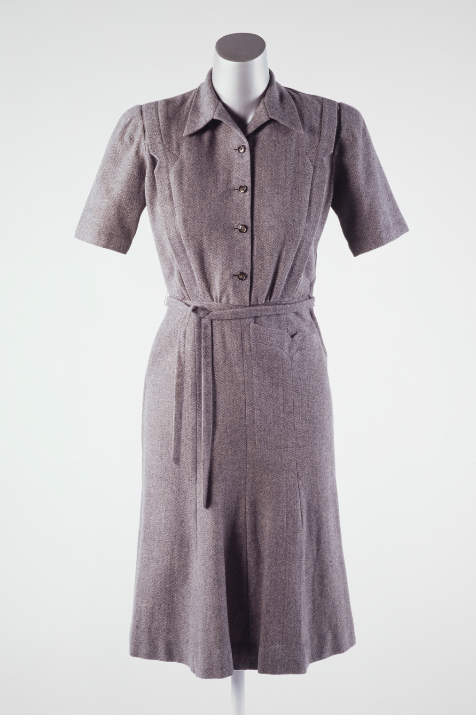
Figure 1. 45.15. Slim cut day dress in grey wool. Made in 1944 by Jersey De Luxe, a subsidiary of Messrs W and O Marcus Ltd of Wells Street, London W1. Picture credit Museum of London.

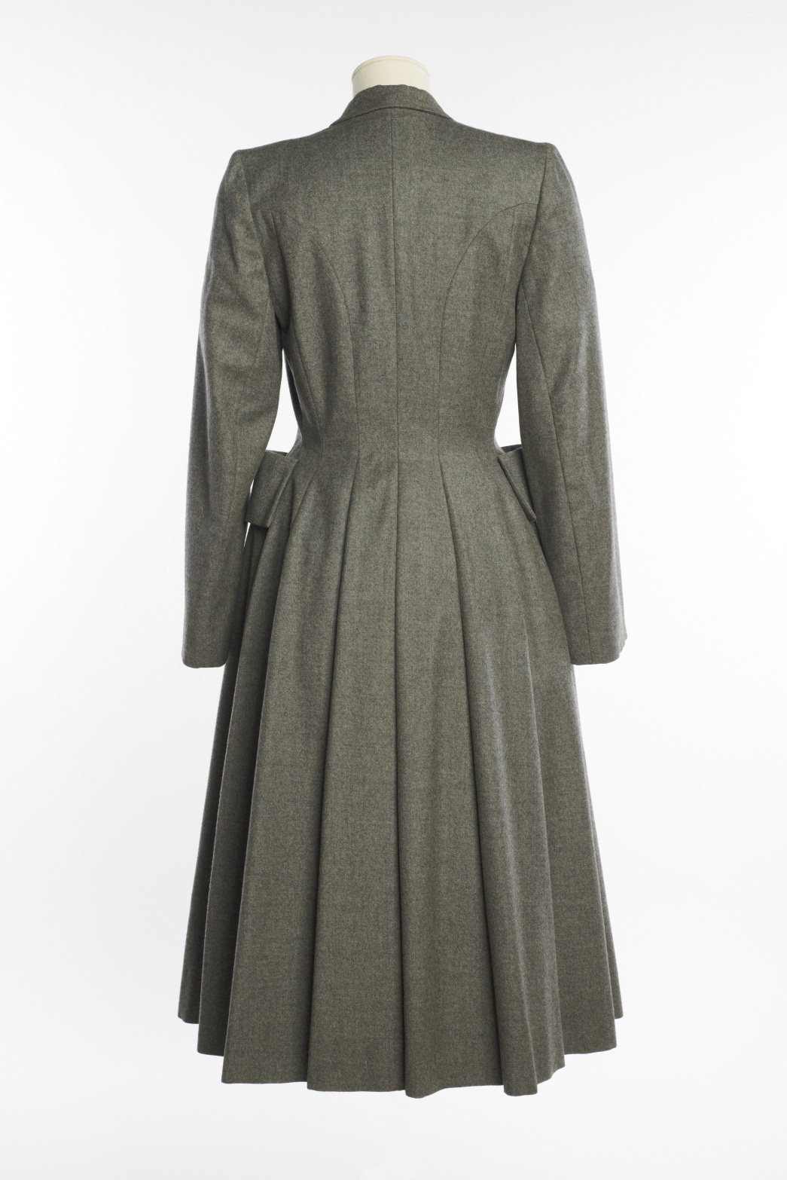
Figure 2. 67.49. Full skirted coat in grey wool. Made in 1946 by Harrods Ltd, a department store in Kensington, London. Picture credit Museum of London.

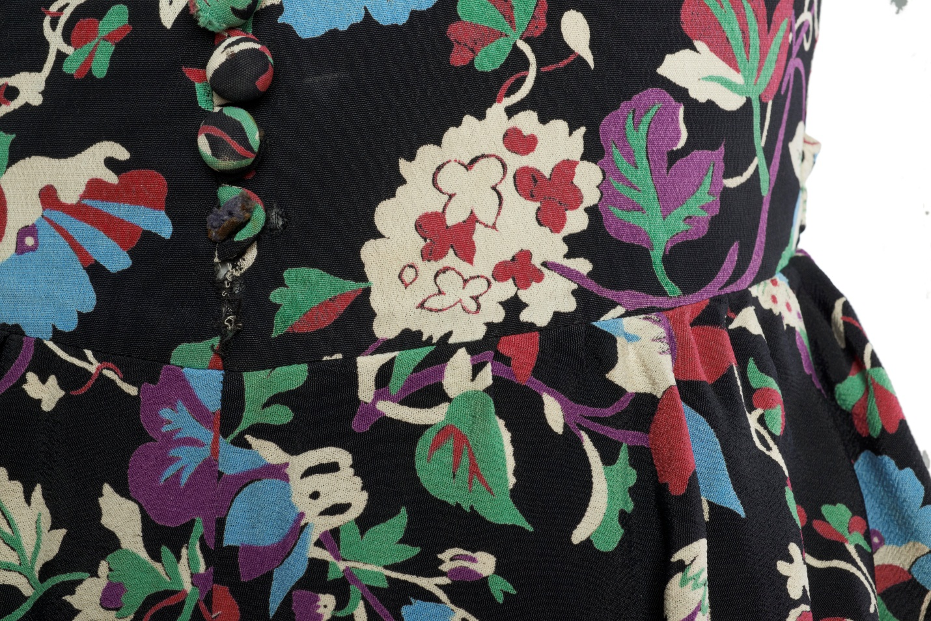
Figure 3. 67.39. Floral rayon print day dress with peplum. Unlabeled, but likely the product of an East London workroom c.1947-50. Picture credit Museum of London.

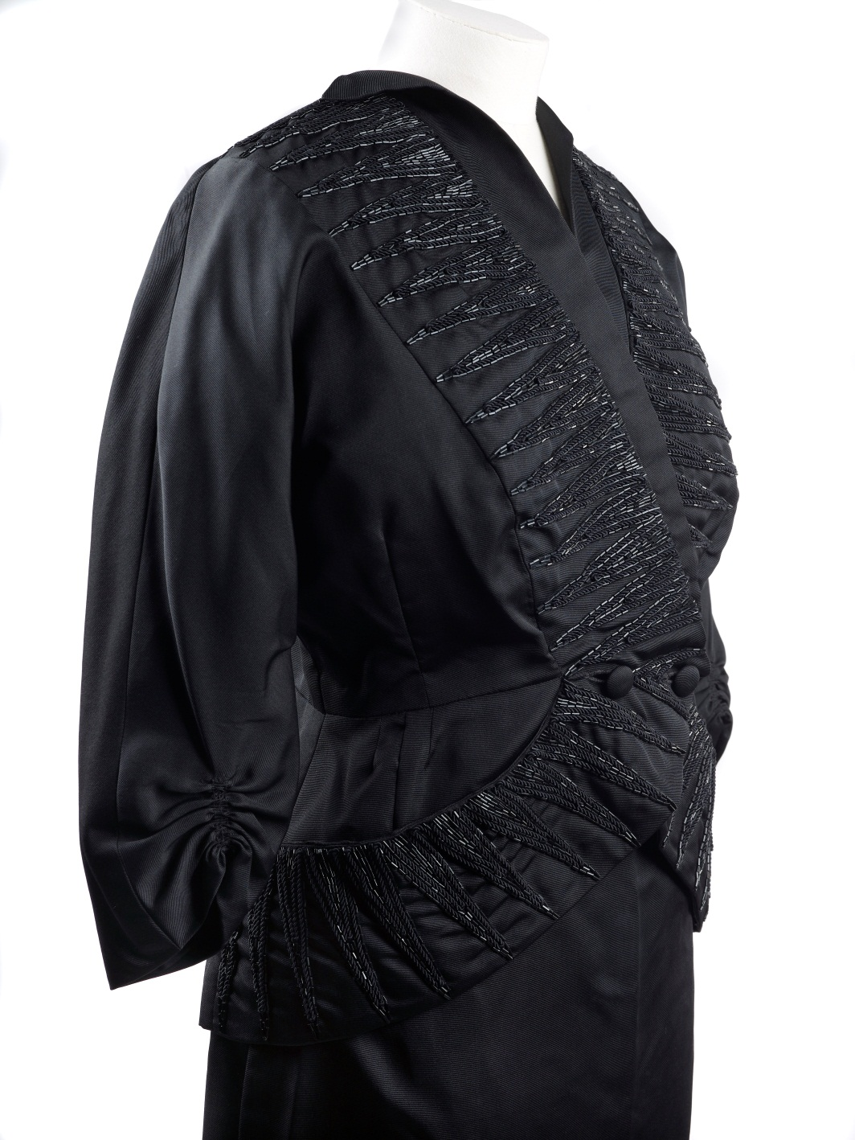
Figure 4. 2002.155/2a. Black silk jacket embroidered with glass beads, part of a cocktail suit. Made in 1949 by bespoke dressmakers Peggy Lewis & Company of Whitfield Street, London W1. Picture credit Museum of London.

Ready-to-wear makers producing economically cut products in a novel range of colours and styles clearly demonstrate the ‘originality and effectiveness’ Runco and Jaeger (2012, 92) use to define creative practice.
Kelly’s Post Office London Directory 1939, 1946, 1948 and 1950, Guildhall Library.
Marked paper pattern pieces, c. 1945-1950. The Messrs W & O Marcus Ltd. archive at Herriot-Watt University
Membership Records of the National Union of Tailors and Garment Workers. Hackney Archive D/S/24/3/9
John Lewis Gazette 15 May 1948. John Lewis Archive
Record of disputes by National Union of Tailors and Garment Workers. Hackney Archive D/S/24/4/9
An Oral History of British Fashion. British Library 2003-02-28.
Barrett Street Trade School Prospectuses 1930-1950. London College of Fashion Archive
London Ladies Tailor’s Union reports on factories and conditions of employment. Hackney Archive D/S/24/3/6
Dispute record for Harris Ltd, compiled by National Union of Tailors and Garment Workers. Hackney Archive D/S/24/4/9.

