Signs of wear: encountering memory in the worn materiality of a museum fashion collection

Bethan Bide

Geography Department

Royal Holloway, University of London

bethan.bide.2013@live.rhul.ac.uk

This work was supported by an AHRC CDA in conjunction with the Museum of London (grant number AH/L003430/1).

Bethan Bide is an AHRC CDA supported PhD candidate working between the Museum of London and Royal Holloway, University of London. Her thesis, entitled ‘Austerity Fashion’, explores the various ways that post-war austerity policies and cultures reshaped London as a fashion city. Bethan has contributed to the Imperial War Museum’s 2015-2017 ‘Fashion on the Ration’ exhibition, and was one of the co-organisers of the 2015 ‘Look of Austerity’ conference at the Museum of London. Bethan is a visiting lecturer at Nottingham Trent and Middlesex universities.

Acknowledgements

Thanks to Beatrice Behlen and David Gilbert for their ideas and tireless support developing this research, to Felix Driver for many helpful conversations, and to the anonymous referee whose thoughtful comments gave new vigor and direction to this paper. Thanks also to the Museum of London, the AHRC, and the members of my family who contributed their stories. Thank you Grandma for the memories.

Abstract

Historical clothes are more than just examples of how past societies dressed—they are imbued with small details of individual lives in their marks of wear. In this article I explore how these marks evoke memories, and how setting up interactions between personal memories and the materiality of fashion objects creates opportunities for new perspectives in the field of fashion history. I open this article by considering how historians might draw on the methodologies of material culture and archival co-authorship to bring memories into collections research. In order to illustrate these ideas, I then present objects from the Museum of London’s fashion collection alongside my own family photographs and stories to show how integrating my grandmother’s memories into my material culture research disrupted the conventional narratives of 1940s austerity fashion. I conclude by considering how the application of memory to collections research might inform the way that fashion objects are displayed in museums. I suggest that, by focusing on the relationship between visitor memories and the small details of how a garment has been worn and used, museums could create displays which disrupt historical orthodoxies and reveal how echoes of the past continue to shape contemporary fashion cultures.

Key words

Memory, materiality, austerity, object-based research, museum, worn clothes

The materiality of memory

It arrived without warning, unceremoniously wrapped in a bin bag.
‘What do you think?’ asked Grandma, ‘I thought it might suit you now your style is getting a little more grown up.’

At the age of sixteen, my great-grandmother’s slightly shabby 1930s fur coat was about as far away from my style as I could imagine, and, in truth, it repulsed me a little; I wasn’t used to handling real fur, and the combination of rabbit and black plastic brought to mind road kill rather than glamour. Yet the care with which Grandma handed over the neatly folded package indicated that this was an important thing and a significant gift, and so, unsure of what else to do, I asked her to tell me more about it.

Sitting with the coat on her lap, one hand carelessly petting a dangling sleeve, she narrated a chronology of memories evoked by this strange object: the smell of her mother’s perfume when her parents went dancing before the war; the sensation of burying her face in its fur while the air raid siren sounded unexpectedly on an afternoon bus journey; watching her mother replace the worn lining with its current pink silk, repurposed from an old evening dress she no longer had occasion to wear since they didn’t go dancing anymore. I had never heard these stories before, and it seemed as if the coat provided a new connection through which I could explore Grandma’s memories and the complexity of her lived experiences. I wondered if she had given it to me so I could understand her better.

The coat’s quiet presence in my wardrobe raised questions I wanted to ask Grandma about her life before I knew her, but sadly I never got the chance as she died shortly after making the gift. Notwithstanding this coat, Grandma was not sentimental about her own clothes. In her final days, she emptied her drawers and cupboards into bin bags that were sent to the Cancer Research charity shop, leaving me no further material clues as to her fashionable past. Objects evoke memories: they connect the past and the present. And, without any material connection to her wardrobe, the chance to understand how my grandmother’s experiences of fashion had shaped both her life and my own felt impossibly out of reach. She seemed lost to me.

This is an account of how I came to find her again in the materiality of a social history museum’s fashion collection. Historical clothes in museum collections are more than just examples of how past societies dressed—they are imbued with details of individual lives in their marks of wear. Moreover, these marks have the power to evoke memories—both first and second-hand—and reveal how the experiences of past individuals continue to resonate and shape societies today. My grandmother appeared to me in the museum store in the form of second-hand memories, formed from the stories she had shared with me about her experiences of post-war austerity. These inherited memories shaped the way I looked at and understood objects from the 1940s and, in doing so, revealed alternative and disruptive historical narratives. As Grandma suspected when she gave me the coat all those years before, old clothes could indeed help me towards a more nuanced understanding of what it meant to live through that austere time.

The first section of this article explores the relationship between memory and material fashion objects in further detail. Drawing on the methodologies of material culture and experimental archivism, it explains how researchers might harness the power of memory to open up new ways of using fashion objects to tell disruptive narratives. In particular, it considers how the relationship between materiality and memory could be used to encounter a more diverse range of voices and experiences in fashion collections.

The second section of this article shows how integrating memory into material culture research has enriched my own work on post-war fashion. Looking at objects through the lens of my grandmother’s second-hand memories allowed me a different perspective on austerity fashion. This perspective disrupted the established ‘austerity’ tropes through which 1940s garments are conventionally understood, revealing that ‘austerity experiences’ in post-war London were far from uniform. I demonstrate this disruptive effect by presenting objects from the Museum of London’s fashion collection alongside my own family photographs and stories. Juxtaposing evidence of different individuals’ diverse, and sometimes contradictory, experiences of post-war austerity exposes the relationship between the small details of how garments have been used and the memories they articulate and evoke in others. It is this relationship that makes it possible to experience echoes of the past in material fashion objects.

The third and final section of this article invites consideration of how the application of memory to collections research might inform the way that fashion objects are displayed in museums. This comes in response to increasing opportunities for academic institutions and museums to collaborate on research and exhibition projects (Humphreys 2015). In this section, I argue that fashion objects should be used to create individual encounters with the past, rather than just as representations of existing historical narratives. I suggest that museum displays could better embrace the disruptive potential of objects by foregrounding details of how objects have been used and call for display methodologies that focus on the key relationship between memory and the material details of wear.

Encountering personal memories in a museum collection

After her death, I went in search of my grandmother’s lost fashionable past. The gift of the coat hinted at how objects can facilitate and inform intergenerational learning and revealed the role that giving and receiving second-hand clothing has to play in the relational construction of fashionable identity, negotiating notions of kinship and furthering an understanding of shared aesthetics and social roles (Woodward 2007, 101; Corrigan 2008, 109-128). Because I lacked a legacy of material fashion objects that had belonged to her, I felt a part of my history was missing. This sensation of loss provoked an interest in family history (Kramer 2015).

I searched for glimpses of Grandma in the letters, photographs and stories that were left behind, and found myself particularly drawn to a series of meticulously annotated photograph albums dating from her life as a young adult, between the end of the Second World War, when she was fifteen, and her marriage to my grandfather in 1952. The seven-year window during which the albums were compiled is the same period that many historical accounts describe as a time of ‘austerity’ in British fashion, bookmarked between the end of the Second World War and the final closure of the government’s Utility Clothing Scheme (Sladen 1995). However, the albums present a more complex account of austerity fashion than is usually considered in history books.

Grandma’s photo albums reveal a young woman engaged in an ongoing process of fashionable experimentation and record the impacts of different hairstyles and clothing combinations. The captions and layout of the albums give a sense that she carefully selected the images and text in order to present an edited, and rather glamorous, impression of her life at this time—an impression that sharply contrasts with the stories she later told me about the shortages and frustrated consumption that characterised the immediate post-war period. This disconnect between the fashion-conscious face that smiled out from the 1949 photograph (Figure 1) and the woman who once lectured my teenage self on the benefits of making do and mending left me with a sense that something material was missing from my understanding. The photographs did not fit with many of the prevailing tropes about the late 1940s, but without further evidence, my quest to know more about how my grandmother had encountered fashion at a time of austerity hit a frustrating dead end.

The gap between these images of my grandmother and the austerity narrative I encountered in books and exhibitions encouraged me to explore the discrepancies between official histories and individual experiences of austerity fashion further through my academic research, as I embarked on a study of London fashion during the period of government regulation that followed the Second World War. This research centres around the Museum of London’s extensive and varied fashion collections, where I have been embedded as a collaborative PhD student for the last three years.

Much of the value of the Museum’s collection lies in its diversity. It is a social history collection containing items from a range of sources, and the majority of its holdings are ordinary, everyday clothes. Worn over a long period of time, these garments speak of lingering and changing experiences rather than representing the brevity of a passing fashion trend or a single occasion of wear. As I revisited the collection again and again, I too found that my experiences of the objects changed and developed over time. I learned to look beyond the surface of their design and construction to notice the stains and ripped seams and patches of darning that indicated how they had been worn, and I began to consider how these marks of wear communicated the messy realities of individual histories. The more intimately acquainted I became with the clothes, the more I found myself relating to them through my own personal fashion experiences, until one day, moving through the rolling stacks and grey archival boxes, I found myself thinking about Grandma. The fragmented stories of post-war London I inherited from her started to shape the way I explored the collection and her memories seeped into my hands as I inspected hems and sketched sleeve constructions. For the first time since she died, I was elated by the possibility of connecting with Grandma through the materiality of fashion, but I also felt a sense of rising panic as the objectivity of my research was overwhelmed.

Incorporating memory into object-based research

Rather than suppressing the personal relationship that emerged between myself—the researcher—and the research collection, I embraced it. Numerous historians have noted the impossibility of approaching an archive with total objectivity, free from the motivations of ‘longing and appropriation’ (Steedman 2001, 81; Sassoon 2000). Researching garments without subjectivity seems especially difficult due to the shared bodily knowledge through which we relate to clothes. Even clothes from the past that differ substantially in their materials and construction from contemporary fashions contain elements of a shared language of wear in frayed hems and loose stitching.

For many years I tried to ignore this subjective connection between my body and the clothes I was researching because of the stigma attached to mixing the study of fashion objects with personal experiences. In their recent guide to object-based research, Alexandra Kim and Ingrid Mida (2015) describe how a researcher’s ability to observe closely and interpret a garment can be clouded by emotions and personal bias. For best practice, Mida and Kim recommend acknowledging this bias so it can be ‘overcome’ in order to prevent it tainting objective analysis (62). But this approach overlooks the fact that material objects act as both triggers and containers of memory, and that memory has an important contribution to make to our historical understanding (Samuel 1996, 6). In response, this paper offers a way of researching the material culture of fashion that brings theories of memory and archival co-authorship into dialogue with methodologies advocating the close study of material objects and the benefits of ‘Slow Looking’ (Prown 1982; Steele 1998; Mida and Kim 2015). In doing so it suggests a way of looking at garments that shifts focus from the study of material objects as representations of broader historical narratives towards the minute details that reveal how clothes were used and experienced.

Refocusing collections research in this way requires only small methodological adjustments. Drawing on the methodology of Jules Prown (1982), Mida and Kim (2015) advocate a tripartite system for analysing material fashion objects, advising researchers to work through stages of observation, reflection and interpretation. This final process asks researchers ‘to draw widely from their experience, as well as from fashion theory, to synthesize the material gathered’ (31), applying historical knowledge to garments in order to contextualise them within broader debates and historical narratives. Instead of focusing exclusively on how garments provided evidence that reinforced official historical knowledge, my research process considered how personal memories and inherited stories could also be used to contextualise a collection. My second-hand memories gave me a different way of relating to the hints of experience contained within worn clothes, providing new ideas and perspectives.

Bringing personal memories and experiences into the archive requires engagement with ideas of co-authorship and experimental archivism. The work of cultural geographers such as Gillian Rose, who demonstrated the complex cultural politics of authorship in archival research by reflexively situating herself in the archives she researched, is particularly relevant here (Rose, 2000). Archives and collections do not contain a single, clear set of factual information to be uncovered, and as researchers we are drawn not only to the material that best fits the story we want to tell, but also to that which speaks to us personally (DeSilvey 2007). Hayden Lorimer has explained how, by embracing archival research as a series of ‘chance occurrences’ between researcher and fragments of material, it is possible to develop a collaborative approach where remembered stories, objects and theories interact to tease out new narratives in a ‘creative form of cultural recycling’ (2009, 259). The close study of material fashion objects offers particularly rich opportunities for exploring themes of co-authorship in the interaction between personal histories and archival research due to the strength of the connection between memory and the materiality of garments. Our knowledge and understanding of the past is rooted in the body (Csordas 1996), and clothes and textiles play a special role in recalling the past due to the way they take an imprint of the body that wears them and are left marked by the ‘sweat and stains of everyday life’ (Hunt 2014, 208).

Narrating material memories of austerity

In order to understand how the meaning of material objects changes when unofficial histories are incorporated into their analysis, the second section of this article juxtaposes museum objects with my family’s stories and images. These sources are arranged into four sets of ‘austerity experiences’. In each, I first acknowledge a widely accepted historical orthodoxy about austerity fashion, before disrupting this narrative by inserting photographs and memories from my grandmother which offer a different perspective on fashion in the 1940s. This is followed by a close study of how a fashion object from the Museum of London’s collection has been worn, demonstrating how my grandmother’s disruptive legacy changed the way I encountered and interpreted the materiality of the Museum’s collection.

My grandmother’s accounts of austerity derive from a variety of sources, which range from my recollections of her stories to memories she committed to paper in letters and interviews with my grandfather and great aunt. The featured museum pieces were selected because they do not fit comfortably into existing orthodoxies about austerity fashion and, as such, would usually be overlooked by curators and researchers looking to tell the story of post-war austerity. Bringing these disparate sources together creates space for the Museum’s more unusual objects by broadening the definition of post-war austerity. In addition to this, moving back and forth between personal memories and encounters with museum garments allows me to incorporate diversity, speculation and uncertainty into the stories these garments tell.

The need for this alternative way to tell the story of austerity fashion results from tensions between the key objects of official histories and extant garments, which reveal the messier details of individual lives. Historical orthodoxies present British fashion in the 1940s though three well established tropes: Utility and government control, Make Do and Mend, and the New Look and post-war recovery (Wood 1989; McDowell 1997; Reynolds 1999; Walford 2011; Howell 2013; Summers 2015). Running through each of these is an assumption that austerity fashion was a top-down power structure in which the acts of a benevolent, male-dominated government impacted upon British women through rationing and design regulations (Laver 1969, 252-259; Sladen 1995; Brown 2014). These narratives overlook individual experiences in favour of authoritative public histories and ignore theories suggesting that fashionable experience occurs within a network of social and cultural influences (Partington 1992, 145-146; Mort 1999, 383; Banim, Green and Guy 2001, 1-17; Woodward 2007). While this period represents the greatest government intrusion into the personal realm of dressing since the days of sumptuary laws, accounts of how official regulations impacted women too often ignore the fact that austerity experiences were filtered through individual circumstances. In doing so, these accounts remove the power of fashion objects to tell ‘history from below’ (Thompson 1966, 279-80).

These particularly prescriptive orthodoxies of austerity are also present in museums. Attempts to impose such narratives on to chronological fashion displays commonly distill museum collections into two oppositional groups of garments in a display case: simple and austere pieces of Utility, contrasted with the full-skirted New Look. Examples of these types of display range from museums with specialist fashion collections, such as London’s Victoria and Albert Museum, to smaller museums of place. Sale prices of such exemplary pieces indicate that this narrative is growing rather than waning in popularity—the record breaking £1,700 raised by a ‘typical’ Utility suit sold through Kerry Taylor Auctions in October 2015, nearly ten times its estimate, was primarily driven by a bidding war between museums.

But fashion objects themselves can push back against orthodoxies by speaking of individual experiences, as was demonstrated by the Imperial War Museum’s 2015 exhibition Fashion on the Ration: 1940s Street Style. Many of the objects on display themselves disrupted the familiar austerity narrative that was otherwise broadly adhered to by the exhibition’s structure. The darned overalls, worn thin with the toil of manual labour; the playful underwear set, a lustful gift from a boyfriend; the communal hope of a wedding dress, lent out twelve times—these garments oozed messy, embodied experiences and reminded visitors that the British population was as diverse and contrary as ever during the 1940s, in spite of clothing controls. My research seeks to harness this power and transform everyday garments into disruptive objects that are capable of subverting and challenging accepted historical tropes.

Austerity experiences

- Austerity and making do

Themes of mending and repurposing old clothes are central to accepted understandings of how austerity shaped 1940s fashion. With access to new clothes restricted by rationing and stock shortages, the nation was encouraged to ‘Make Do and Mend’ by the Ministry of Information (Walford 2008, 126; Brown 2014, 18-22). This campaign has been researched extensively, resulting in publications that reproduce the pragmatic mechanics of mending and remaking by providing diagrams to show darning techniques or how old trousers could be cut up to form a new skirt (Wood 1989, 26; Howell 2012, 137). However, these studies rarely consider how the meaning of old clothes changed over time in relation to prolonged austerity conditions.

Photograph of Grandma on a bicycle, 1947 (figure 2)

Three women pose on bicycles in a suburban street. Lined up in age order, Grandma is third and last, behind her two elder sisters-in-law. This position of distance leaves her slightly out of focus, but the inelegant cut of her school blazer over a weekend dress is still clearly visible. In contrast, her brothers’ wives wear newer, better tailored outfits with more stylistic confidence.

Grandma’s new clothes were rarely unworn. Her wardrobe largely consisted of hand-me-downs and, in an oral history interview in February 2016, her sister recalled Grandma’s jealousy of other people’s new clothes, particularly those belonging to her sisters-in-law. The age and income gap between Grandma, still in full-time education, and her in-work sisters-in-law meant that they had the resources to buy fashions she could only dream of. Her envy of their wardrobes was heightened by their habit of gifting her their old clothes, which she wore with understandable resentment since only the shabbiest and most out-of-date styles seemed to work their way into her hands. Although these gifts were once deeply fashionable, they were years too late to reach her, and worse still they gave her mother yet another excuse to put off shopping for anything new.

But Grandma also knew that old clothes could accrue value over time in the form of memories and emotions. In my wardrobe, I have a dress she sewed for me when I was eleven years old. She made the dress from an old Laura Ashley frock of her own, worn thin under the arms and at the neck, and I remember watching as she cut it up to make a smaller dress that would fit me—a process, she said, that she had learned from her mother when she was a child herself. Whenever I wore the dress, Grandma would weave stories about the occasions the fabric reminded her of, its memories living on through the process of remaking. Sewing and the transmission of memories subsequently became connected practices in our relationship and the act of teaching me to mend and remake clothes evoked memories for Grandma. Instructing me on the best way to patch an elbow, she found herself repeating long-forgotten lessons from her mother, passing on embodied memories that I perform when I repeat her sewing techniques. To this day, I remain unable to distinguish between her hand stitching and my own.

Mends in a black wool dress (figures 3a and 3b)

It is August 2015 in the Museum of London costume store, and laid out in front of me is a black wool dress about which little is recorded in the Museum’s catalogue. I am looking for clues that might illuminate something about the circumstances in which it was worn, and what it might have meant to its wearer. Turning the dress over, inside out and searching along each seam of its voluminous skirt, it took nearly half an hour to find what I was looking for. In a hidden section of seam allowance, there is a small rectangular hole where the fabric had been carefully cut to provide a patch used to invisibly mend a hole in the dress’s underarm gusset. This exemplary mend stands out as being the best executed I have seen in the Museum’s collection of 1940s garments, a period which evidences a higher proliferation and greater variety of mending techniques than either the decades before or after, indicating that austerity conditions required Londoners to prolong the life of their clothes.

Mends in garments confuse our usual notions of fashion’s temporality, reminding us that the date of manufacture that features on the catalogue entry does not reflect the true life (or lives) of the garment, which may have been worn and altered and kept for a much longer period of time. Traina-Norell adverts suggest this dress dates from 1948, when the exaggeratedly slim silhouette of its top half and contrastingly full skirt would have represented the very latest fashion. However, the marks of wear on the dress indicate that it was worn long beyond this date, as do differences in the quality of its various mends.

On the opposite side from the invisible mend, the corresponding underarm gusset has also been repaired. Although the dress has worn in the same place under each arm, the two mends are not alike. The barely perceptible stitches of the left underarm (Figure 3a) contrast sharply with considerably cruder mend on the right (Figure 3b), where the longer, more careless stitches show little attempt has been made to conceal the mend into existing seams. The differences between these mends indicate that they likely occurred at different times, and were possibly executed by different hands, one professional and one amateur. These mends indicate the changing value of the dress over time, and as such the labour bestowed upon it. The older the garment became, the less likely the owner was to mend it with care. To see such a crude example of hand mending on an expensive garment is a reminder that a single piece of clothing can be imbued with multiple experiences.

- Austerity and home sewing

Creative home sewing (as distinct from mending) is now widely celebrated as a key output of austerity. Examples of ingenious fabric-saving cuts and unconventional fabric choices proliferate texts and exhibitions on the subject (Wood 1989, 21-15; McDowell 1997, 98; Walford 2008, 130-132). Championed as a practical solution to the shortages and difficulties of the era, the version of home sewing that is depicted in mainstream historical narratives has come to represent a form of austerity morality that symbolises the determination and grit of the British public (Summers 2015, 151). However, this characterisation rarely questions how enjoyable and fulfilling the experience of home sewing really was at a time of austerity.

Photograph of Grandma under a plum tree, 1948 (figure 4)

Grandma is pictured eating the fruit of a victoria plum tree in the garden of her family home in suburban New Malden. She wears a homemade summer dress in stripped cotton. Aside from two conspicuously large patch pockets, the cut of the dress is simple and it features few technically difficult construction features. Judging by the shape of the collar and sleeves, it is likely that structural additions such as shoulder pads and interfacing were omitted, sacrificing the final shape of the garment for speed during making.

Shortly after I purchased my first sewing machine in November 2001, Grandma wrote me a letter detailing memories of her teenage sewing experiences. In this she recalled that the family sewing machine, which lived in the dining room sideboard, was a Singer 99k. This model was designed and marketed to meet public demand for a light, portable machine, making it perfect for an amateur like Grandma who needed to clear the dining table of sewing equipment before laying it for tea. Grandma suspected that her mother tolerated sewing messes in the house by comforting herself with the thought of the savings being made—a few yards of fabric cost considerably less than a ready-to-wear garment, and the labour involved was likely to make her daughter think twice about how much she wanted a new dress in the first place.

Grandma remembered with vivid detail the tedium and hard work involved with home dressmaking. The Singer 99k was a hand crank sewing machine and it required considerable energy and skill to coordinate unwieldy fabric with one hand while powering the machine with the other. Worse than the physical difficulty was the boredom of repetitive tasks, especially the seemingly endless areas of hand stitching. In response, Grandma developed a rather slapdash approach to dressmaking, finding it easier to remain creatively enthused about a project by cutting corners in order to finish it faster. Her seams were rarely finished, her buttonholes machined, and linings treated as a rare addition.

Hand stitched buttonholes in a homemade bedspread dress (figure 5)

It is September 2014 and I am unlacing Tyvek garment bags in the rolling stacks, trying to match objects to their catalogue descriptions. Hung in between a hand-painted Norman Hartnell ballgown and and a Hardy Amies suit, I locate a humbler item: a homemade dress, crafted from bedspread material. From each immaculately rolled section of piping to the precision hand stitching of the buttonholes, this dress reads like a sewing manual. The collar lays flat, the fabric pattern is matched at the seams and its skirt falls evenly into a dead straight hem. Its careful workmanship represents a considerable investment of time and care on the part of the sewer, suggesting that, if the maker was not professionally trained, they were certainly an extremely accomplished amateur who had worked long and hard to develop their skills.

While some saw home dressmaking as a means to a quick fashion fix, others derived satisfaction from investing time and energy into achieving technical excellence. It is highly likely that austerity shortages, exemplified by the use of bedspread fabric due to the unavailability of dress fabric, made it more difficult for this dressmaker to practice their craft. This may explain why, although the hand of the skilled sewer is clearly present in this object, there is no evidence that this dress has ever been worn. Make do and Mend was not always about fulfilling a material need for a new item of clothing. Even during a period of intense shortages, sewers derived pleasure from challenging their sewing skills and a sense of purpose from this performance of austerity. Government documents indicate that this type of home sewing required ample leisure time and means, revealing that Make do and Mend, as presented in government literature and classes, was largely the preserve of materially comfortable housewives (Zweiniger-Bargielowska 2000, 121). Perhaps the hours and attention expended by the sewer meant that this dress took on the status of a decorative, rather than practical, object, to be admired for the beauty of its construction rather than its place on a living body.

- Austerity and comfort

1947 is a year with almost mythical status in fashion history. Popular books on the subject explain how, following years of stagnation when skirts hovered around the knee and were accompanied by square-shouldered jackets, the late 1940s witnessed a dramatic fashion change. This came in the form of Christian Dior’s New Look, characterised by its nipped-in waists, full skirts and rounded silhouette (Breward 1995, 191; McDowell 1997, 45; Steele 1997, 4-6). The New Look is discussed primarily in terms of its aesthetics, but by focusing on the look of this new trend, many histories fail to explore what it was like to actually wear it. However, as the journalist Margaret Beckett pointed out, the question of comfort was in fact a key issue for many women: ‘imagine voluntarily adding to the fatigue of standing in the fish queue by having twenty yards of [tweed] hanging from one’s waist’ (Beckett, Picture Post, September 27, 1947).

Photograph of Grandma on a wall, 1950 (figure 6)

Grandma sits on a stone wall surrounded by long grass, probably pausing midway through a walk. She wears a simple knitted top and flat, t-bar sandals. Her relaxed pose shows off a loose-fitting skirt, which would allow her to move with long strides. A piece of casually discarded knitwear lies heaped across her lap, revealing the ease with which she wears her informal outfit.

With the new freedoms that accompanied her later teens, Grandma increasingly turned her back on London’s bomb-damaged urban centre and spent her weekends exploring the green spaces of the city’s outer suburbs with her new boyfriend, later to become my grandfather. He remembers these excursions vividly, and in an oral history interview in October 2015 he detailed the long circular walks they enjoyed together around Wimbledon Common and how, by bicycle, they even ventured as far as Box Hill in Surrey. He also remembered how these activities shaped her wardrobe. She wore shorts made from colourful printed cottons or her brother’s hand-me-down trousers for cycling, the latter altered to give a more flattering fit. For walking, she knitted her own loose-fitting jumpers and chose skirts with hemlines high enough to avoid picking up grass stains. She developed an intolerance for clothes without pockets or anything with structural boning, and she instead selected clothes for the softness of their fabric. These items were valued for the freedom they gave her to move as she pleased and go where she wanted.

Dirt on orange trouser hems (figure 7)

It is April 2015, and I am peering through a hand lens at the discoloured and frayed hems of a pair of orange trousers. I am trying to identify whether the dark marks are caused by soil or soot, seeking some clue as to the kinds of places where these trousers were worn in the hope it will help me understand more about what they meant to the wearer. The evidence suggests that they were worn extensively in an urban environment. The fabric at the back of the hems has frayed in an arc about the heel, indicative of the wearer’s stride, and what remains of the hems is caked in dark traces of inorganic dirt, likely gathered from repeated contact with dusty London pavements. Although no record remains of where exactly these trousers were worn, their heavy marks of wear indicate that they probably travelled many miles on the city’s bomb-damaged streets.

The fabric and construction of these trousers provide further clues as to why they received so much wear. Worn clothes often reveal how a body has resisted the restrictive construction of a garment through signs such as pulled threads and loose stitching at seams, which indicate they once fitted a body uncomfortably tightly. In contrast, these trousers hint that they were worn by a body that found comfort and freedom in their fabric and cut. The corduroy, which is still remarkably soft, creates an accommodating structure that moves with, rather than against, the body. It is rubbed thin at the knees and hips where it has been shaped by the wearer’s limbs over a long period of use.

But one further feature of the trousers remains to be considered. The fabric is not only soft, but unusually brightly coloured, reminding us that comfortable clothes can also make dramatic fashion statements. The matted dirt still visible on the hems root the garment in the post-war landscape. Because of this, their vivid orange colour challenges the prevailing image of austerity London as a city inhabited by shabby figures in worn shades of grey (Kynaston 2007, 191). Clothes are a stitched medium through which we make sense of our surroundings; by repeatedly wearing these trousers in a public setting, it is likely that their wearer not only brought colour to their own life, but changed the city’s aesthetics for those who passed them on the pavement or glimpsed an unexpected flash of orange out of a bus window.

- Austerity and the performance of glamour

Histories of austerity are often deeply interested in how government policies coopted fashion into the nation’s economic struggle during the difficult aftermath of the war. They describe how, in a world where even shampoo manufacturers reminded customers that ‘beauty is a duty too’ (Clampin 2014, 182), fashion’s role as a performance of personal desire and pleasure was suppressed; it is generally accepted that ‘turbans, jazzed up with sunglasses, were as near to glamour as most women could hope to get’ (McDowell 1997, 89). But fashionable glamour is as much about fantasy as it is about access to things. Austerity heightened the appeal of Hollywood Films and their exotically dressed stars—1946, a year commonly remembered in historical accounts for fuel shortages and the introduction of bread rationing, marked the peak of British cinema attendance, with audience numbers reaching 1,635 million (Hennessy 1992, 276-277; Williams 1998, 194).

Grandma in a garden with her family, 1951 (figure 8)

Grandma and her surrounding family members seem to be dressed in party clothes. She wears a lightweight summer dress with a long-sleeved cardigan and bead necklace. Far right is my great-grandmother in an old-fashioned embroidered black suit. In the setting of a suburban garden, Grandma seems to have posed for this photograph by emulating the sideways look and half smile that gave her screen heroines an air of mysterious allure. Flanked by the realities of her daily life, in particular her mother who is dressed in clothes that seem to date from the 1930s, this pose hints at a desire to escape these surroundings through the imaginative power of dress.

Grandma often referenced old Hollywood movies. The woman who read the weather forecast on the six o’clock news reminded her of Joan Crawford, and the style of my new jeans was ‘very Jane Wyman’. Like many young women of the post-war period, Grandma had been an avid reader of film magazines. Her sister told me that ‘Picturegoer’ was her favourite, and that she liked few things better than to spend a grey afternoon in her suburban bedroom with the latest edition, her family firmly shut out on the other side of the closed door. The magazines provided a style guide that shaped the way she looked. While she couldn’t obtain the clothes they featured, she tried to emulate the Hollywood styling through her hair, posture and make-up. In a letter written to me in March 2005, Grandma told me how taking on this Hollywood aesthetic gave her a sense of power. It enabled her to transform the post-war London landscape into a glamorous place by playing at being the leading lady, even if her costume wasn’t quite right, through the way she wore a new belt or the positioning of a hairclip.

CC41 stamp on a pair of red platform shoes (figure 9)

It is October 2015, and I am looking down at a tray of women’s shoes from the 1940s, neatly arranged in pairs. Most are instantly recognisable as Utility shoes, identified by practical markers such as their thick, low heels. Amidst the sea of Utility browns and maroons, one pair catches my eye; they are bright red. I reach to pick the left shoe up. From the towering three-inch heel to the highly decorative uppers, with their lattice effect cut outs and scalloped edging, this is a shoe that demands attention. It is a shoe that would draw passersby to notice the body of the wearer by highlighting their ankles in a crisscrossing of delicate red straps, and a shoe that, thanks to the height of its heel, would alter the way the wearer stood or walked, causing them to take on the performance of a new physicality. Yet, in the midst of this visual feast, I see the unmistakable thick black of a CC41 stamp, which brands these shoes as part of the official government regulated Utility scheme.

Red shoes have well documented cultural associations with adventure and escape (Davidson 2006). Although there seems little space for such associations in a narrative of austerity that equates shortages and Utility with consumer demands for practicality, these shoes are no anomaly. The Museum of London collection alone boasts two pairs of bright red Utility shoes, and there are many more examples tucked away in other museums. The carefully repaired heels of this particular pair indicates that austerity conditions did not dampen the attraction of red shoes for whomever regularly wore them, hinting that the relationship between regulated austerity and fashionable fantasy was nuanced at this time, and that Utility and glamour were certainly not mutually exclusive.

Memory, materiality and museum display

In order to reach the Museum of London’s fashion store, it is necessary to negotiate a route through the busy museum foyer, past the hubbub of the cafe and the toilet queues. This journey is a powerful reminder that the activities and discoveries that occur within the store impact how the collections are seen by the wider public, prompting me to reflect on how museums might consider the questions this article raises about materiality, memory and co-authorship in the way that fashion collections are displayed. In response, I conclude this article by considering the limitations of displaying objects as straightforward representations of the past and suggest that, by focusing on the relationship between visitor memories and the small details of how a garment has been worn and used, museums could better use objects to create displays that disrupt and challenge historical orthodoxies.

Although this exploration of austerity fashion in London has focused on the intensely personal process of connecting fashion objects with my own family history, it is clear that processes of co-authorship and the application of unofficial historical knowledge to material culture analysis have the potential to broaden the narratives told in histories of fashion. Bringing together material objects and memories offers a way of approaching collections that, if embraced by multiple researchers from different backgrounds, has the potential to diversify the range of voices and experiences that can be read in fashion objects. The subjectivity of memory can be a creative and constructive force through which new discoveries are made (Kwint 1999, 1-4). Its performative and discursive nature offers new opportunities for engaging in collaborative research and curating collaborative museum displays.

These types of collaborations have the potential to expand our understanding of the multiple meanings contained within clothes and broaden our understanding of fashion’s role in social and cultural history. Museum collections, particularly those held by institutions with a social history remit such as the Museum of London, contain material evidence that helps to explain the development of societies, cultures and the individuals who exist within them. However, the way these items are publically displayed commonly emphasises broad historical narratives over individual experiences, using objects to exemplify rather than challenge existing historical interpretations. Using objects as representative tools to make history more easily comprehensible risks reducing museums to ‘showcases for the popular narratives that used to be reserved for books or movies’ (Miller 2016, 7). Prescriptive representational displays threaten the role of the museum as a space for exploring the past because they shut down the opportunity for visitors to personally engage with the materiality of objects in a way that opens up space for speculation and alternative viewpoints. Although the simplicity and certainty of representational displays might seem attractive to some visitors, it alienates others by excluding memories of divergent experiences that destabilise established narratives.

Moreover, representational displays can lead to a narrowing pool of first and second-hand memories. Museum displays have the power to shape the stories we tell about ourselves, as the making of personal memories is a life-long, ongoing process, in which memories are constantly reconstituted and created by exposure to changing cultural narratives, including those encountered in museums (Hirsch 1997, 249; Tarlo 2007, 145). Representative displays predominantly appeal to a sense of collective memory, making the museum a site in which visitors can confirm their place in history by validating particular sets of memories that fit the dominant narrative (Lowenthal 1985, 191; Misztal 2003, 10-16). This can only be achieved by excluding individual experiences that do not fit. In this way, personal memories can be mediated and altered through the representation of shared memories in museum displays, and the museum risks colluding in a process of collective forgetting (Hirsch 1997; Liss 1998).

Preserving and sharing memories should be a priority for both researchers and curators as incorporating biographies into the stories told about objects has the power to illuminate the relationships between people, places and things (Hill 2012). Bringing Grandma’s voice into dialogue with the collection exposed a diversity of austerity experiences because her memories provided an alternative form of contextual knowledge that disrupted historical orthodoxies. The multiple and diverse voices contained in individual memories like hers have the power to break through representational narratives about austerity experience, preventing them from being reconstituted in the form of a cosy cultural nostalgia that promotes a deeply socially conservative ideal of domestic womanhood and reinforces a social order that empowers an elite (Bramall 2013; Hatherly 2016).

Displaying the materiality of diverse experiences

Museums can play an important role in retelling history by experimenting with alternative display methodologies that open up the stories they tell about objects in order to incorporate multiple narratives, with a focus on integrating visitor memories and disruptive objects into fashion displays.

A disruptive object is one that changes or challenges historical narratives by insisting on ‘telling us the story of its pre-museal past’ (Hoberman 2011, 79). In garments, this disruptive quality is often revealed in the small material details of how it was worn. As such, it is necessary to recognise garments as the products not just of time and place, but also of the individual(s) who shaped them through use. Although the individuals themselves may have left few written or oral clues, their clothes are imbued with material memories capable of evoking their past experiences (Stallybrass 1999). Clothes straddle the divide between the personal, intimate nature of the body and its public interactions, and so, by balancing both the social and bodily aspects of the material record, we are able to use material memory to explore how real people lived and experienced past fashions (Young 2005, 63-74).

Due to their ability to tell personal and social stories simultaneously, clothes represent an opportunity for museums to experiment with display methodologies that encourage a process of co-authorship between the institution and individual visitor. Drawing on theories of multidirectional memory, it is possible to break the hierarchy that privileges museum narrative over personal memory. Contextual information included in displays (such as images and written accounts) need not tell the same story as the clothes they sit alongside. These sources are not in competition with each other, but engaged in an ongoing process of negotiation, building upon each other and exploring both their differences and similarities rather than fighting for supremacy (Rothberg 2009, 3). This presents an opportunity to make space for visitor memories within displays, allowing visitors to engage with the materiality of objects through their own personal histories and cultural understanding in a way that is both inclusive and historically informative.

Museums have long recognised the value of visitor memories to illuminate collections through activities such as reminiscence activities, but these memories are usually utilised as supplementary information to objects, not displayed alongside or in dialogue with them (Pye 2006, 20). Using the memories of multiple individuals to speak to a single fashion object can illuminate its complex social and cultural meanings, and, borrowing from the methodology of memory-work, museums should invite visitors to contribute knowledge and respond to objects in a way that actively incorporates personal responses into displays. Social media provides a potential means for visitors to upload stories and images that can be displayed in the gallery, changing the narrative position of the display by providing a stream of new contextual information. Such methodologies prompt a dialogue that explores the tiny details of material memory by removing the barriers separating the visitor’s knowledge from the information contained within the collection (Crawford, Kippax, Onyx, Gault and Benton 1992, 41). This is an empowering process due to the role that remembering and reconstructing the past plays in the formation of identities, and it highlights the power that we, as individuals, have to change and shape society (Onyx and Small 2001).

Finally, museums should consider display methodologies that enable visitors to engage with the materiality of a range of objects that tell different stories. Too often, objects that do not quite fit prevailing historical tropes are left in the storeroom and not made available for public view. In order to display these more unusual objects, museums might consider incorporating different types of knowledge into exhibition labels. For example, objects could be labelled with date ranges that detail the duration of time a piece was worn rather than its date of production, and labels might even discuss aspects of a garment’s story that remain uncertain or unknown.

Once on display, museums should then consider how visitors could engage with the materiality of these objects. Close observation of fashion objects is a hugely rewarding task, but one usually reserved for individual researchers. It provides intimate and experiential access to history and allows us to interrogate our understanding of the past by asking sensory questions, exploring both what a garment was for and what it felt like to wear. The experience of close observation is often difficult to define or translate into museum display labels but technology offers increasing opportunities for visitors to partake in experiential looking through video and virtual reality, enabling them to explore the rips and seams of objects that they cannot touch or scrutinise at close proximity due to conservation or curatorial reasons.

Towards more-than-representational fashion histories

Central to the development of new display and research methodologies is the question of how curators and researchers can move away from telling fashion histories with linear narratives. In this article, I have sought to do this by creating a space in which materiality and memory can be explored together. As my second-hand memories forged a personal connection to my research topic, I became more interested in the process of encountering garments than in finding discrete points of information that could be digested and used to support an argument. These encounters enabled me to gain different perspectives on austerity experiences because they made space for speculation, diversity and doubt.

The aim of creating encounters, rather than telling a coherent narrative, changes the position of both the researcher and the curator. In order to understand how, it is helpful to turn to non-representational theory, which provides a model through which material objects can be freed from their representational role as containers of meaning awaiting interpretation (Thrift 2007). Instead, it proposes a focus on the small details that shape lived experience, the ‘everyday routines, fleeting encounters, embodied movements’ (Lorimer 2005, 84). By conceiving of museum objects as ‘more than representational’, it is possible to evoke the shape and energy of their experiences (Lorimer, 2005). Although the study and interpretation of fashion objects still has much to add to our historical understanding, taking a more-than-representational approach to the details of material memories could contribute to a powerfully different sensory experience of historical fashion in museum collections for both researchers and visitors.

More-than-representational approaches to experiencing history offer opportunities to explore how the past and present resonate (Patchett 2015). My research into austerity fashion
gave me a personal insight into the lingering cultural legacy of post-war Britain by showing me echoes of austerity in contemporary life. Combining personal and public sources revealed how inherited memories continue to shape my own relationship to fashion. Grandma may not have left any clothes, but, through the repetition of habit memories in the form of shared sewing and shopping habits, she left me an understanding of fashion shaped by the austerity policies and practices of the 1940s (Connerton 1989, 102). Understanding how austerity echoes down through generations in this way is particularly relevant with the passing of time; as my grandmother’s generation enters their late 80s and 90s, it is important we take the opportunity to understand how their memories and experiences have shaped our own.

My research experience highlights the potential for memory to bridge the gap between the empty, bodiless existence of garments in a museum store and their capacity to invoke the past. Through the non-linear temporality of memory, in which the past gets reconstituted in the present, the uncanny materiality of the Museum objects brought distant memories of my grandmother’s past into the present (Hacking 1995; Ricoeur 1999). This demonstrates how material and remembered traces of austerity still haunt contemporary London. More broadly, it serves as a reminder of the importance of accommodating the ghosts contained within extant garments so that we might begin to make sense of how the intergenerational echoes and emotional inheritances of the past continue to shape the present (Till 2005, 16; Pile 2005, 160).

References

Banim, M., Green, E. and Guy, A. 2001. “Introduction.” In Through the Wardrobe: Women's Relationships with Their Clothes edited by M. Banim, E. Green and A. Guy, 1-17. Oxford: Berg.

Bramall, R. 2013. The Cultural Politics of Austerity: Past and Present in Austere Times. Basingstoke: Palgrave Macmillan.

Breward, C. 1995 The Culture of Fashion. Manchester: Manchester University Press.

Brown, M. 2014. CC41 Utility Clothing: The Label that Transformed British Fashion. Sevenoaks: Sabrestorm.

Clampin, D. 2014. Advertising and Propaganda in World War II: Cultural Identity and the Blitz Spirit. I. B. Tauris: London.

Connerton, P. 1989. How Societies Remember. Cambridge: Cambridge University Press.

Corrigan, P. 2008. The Dressed Society. London: Sage.

Crawford, J., Kippax, S., Onyx, J., Gault, U. and Benton, P. 1992. Emotion and Gender: Constructing Meaning from Memory. London: Sage.

Csordas, T. J. 1996. “Introduction: The Body as Representation and Being-in-the-World.” In Embodiment and Experience: The Existential Ground of Culture and Self, edited by T. J. Csordas. Cambridge: Cambridge University Press.

Davidson, H. 2006. “Sex and Sin: The Magic of Red Shoes.” In Shoes: A History from Sneakers to Sandals, edited by G. Riello and P. McNeil, 272-289. Oxford: Berg.

DeSilvey, C. 2007. “Art and archive: memory-work on a Montana homestead.” Journal of Historical Geography 33 (4): 878-900.

Edwards, E. 1999. “Photographs as Objects of Memory.” In Material Memories, edited by J. Aynsley, C. Breward and M. Kwint. Oxford: Berg.

Hacking , I. 1995. Rewriting the Soul: Multiple Personality and the Sciences of Memory. Princeton: Princeton University Press.

Hatherly, O. 2016. The Ministry of Nostalgia. London: Verso.

Hennessy, P. 1992. Never Again: Britain 1945-1951. London: Jonathan Cape

Hill, K. 2012. Museums and Biographies: Stories, Objects, Identities. Woodbridge: Boydell Press.

Hirsch, M. 1997. Family Frames: Photography, Narrative and Postmemory. Cambridge MA: Harvard University Press.

Hoberman, R. 2011. Museum Trouble: Edwardian Fiction and the Emergence of Modernism. Charlottesville: University of Virginia Press.

Howell, G. 2013. Wartime Fashion. London: Bloomsbury.

Humphreys, L. 2015. “Research on Display: A Guide to Collaborative Exhibitions for Academics”. Queen Mary, University of London. http://www.studiesofhome.qmul.ac.uk/activities/items/147187.pdf

Hunt, C. 2014. “Worn Clothes and Textiles as Archives of Memory.” Critical Studies in Fashion & Beauty 5 (2): 207-232.

Kramer, A. M. 2015. ‘The Generational Transmission of Memory and Identity through Family Heritage.” Paper presented at the IHR Public History Seminar, London, December 2.

Kwint, M. 1999. “Introduction: The Physical Past.” In Material Memories, edited by J. Aynsley, C. Breward and M. Kwint. Oxford: Berg.

Kynaston, D. 2007. Austerity Britain: 1945-51. London: Bloomsbury.

Laver, J. 1969. A Concise History of Costume. London: Thames and Hudson.

Liss, A. 1998. Trespassing Through Shadows: Memory, Photography and the Holocaust. Minneapolis: University of Minnesota Press.

Lorimer, H. 2005. “Cultural geography: the busyness of being ‘more-than-representational.” Progress in Human Geography 29 (1): 83-94.

Lorimer, H. 2009. “Caught in the Nick of Time: Archives and Fieldwork” In The SAGE Handbook of Qualitative Research in Human Geography, edited by D. DeLyser, S. Aitken, M. Crang, S. Herbert and L. McDowell. London: Sage.

Lowenthal, D. 1985. The Past is a Foreign Country. Cambridge: Cambridge University Press.

McDowell, C. 1997. Forties Fashion and the New Look. London: Bloomsbury.

Mida, I. and Kim A. 2015. The Dress Detective: A Practical Guide to Object-Based Research in Fashion. London: Bloomsbury.

Miller, P. 2016. “A New Republic of Letters.” The Chronicle of Higher Education, April 3.

Misztal, B. 2003. Theories of Social Remembering. Maidenhead: Open University Press.

Mort, F. 1999. “Social and Symbolic Fathers and Sons in Postwar Britain.” Journal of British Studies 38 (3): 353-384.

Onyx, J. and Small, J. 2001. “Memory-Work: The Method.” Qualitative Inquiry 7 (6): 773-786.

Partington A. 1992. “Popular Fashion and Working Class Affluence.” In Chic Thrills: A Fashion Reader, edited by J. Ash and E. Wilson, 145-161. Berkeley: University of California Press.

Patchett, M. 2015. “The taxidermist's apprentice: Stitching together the past and present of a craft practice”. Cultural Geographies 23: 401-419.

Pile, S. 2005. Real Cities. London: Sage.

Prown, J. 1982. “Mind in Matter: An Introduction to Material Culture Theory and Method.” Winterthur Portfolio 17 (1): 1-19.

Pye, E. 2006. “Introduction.” In The Power of Touch, edited by E. Pye. Walnut Creek: Left Coast Press.

Reynolds, H. 1999. The 40s and 50s: Utility to New Look. Oxford: Heinemann.

Ricoeur, P. 1999. “Memory and Forgetting.” In Questioning Ethics: Contemporary Debates in Philosophy, edited by R. Kearney and M. Dooley. London: Routledge.

Rose, G. 2000. “Practising photography: an archive, a study, some photographers and a researcher.” Journal of Historical Geography 26 (4): 555-71.

Rothberg, M. 2009. Multidirectional Memory: Remembering the Holocaust in the Age of Decolonization. Stanford: Stanford University Press.

Samuel, R. 1996. Theatres of Memory: Past and Present in Contemporary Culture. London: Verso.

Sassoon, J. 2000. “Chasing Phantoms in the Archives: The Australia House Photographic Collection.” Archivaria, January.

Sladen, S. 1995. The Conscription of Fashion: Utility Cloth, Clothing and Footwear 1941-1952. Aldershot: Scholar Press.

Stallybrass, P. 1999. “Worn Worlds: Clothes, Mourning and the Life of Things.” In Cultural Memory and the Construction of Identity, edited by D. Ben-Amos and L. Weissberg. Detroit: Wayne State University Press.

Steedman, C. 2001. Dust. Manchester: Manchester University Press.

Steele, V. 1998. “A museum of fashion is more than a clothes-bag.” Fashion Theory 2 (4): 327-335.

Steele, V. 1997. Fifty Years of Fashion: New Look to Now. New Haven: Yale University Press.

Summers, J. 2015. Fashion on the Ration. London: Profile Books.

Tarlo, E. 2007. “Islamic Cosmopolitanism: The sartorial biographies of three Muslim women in London.” Fashion Theory: The Journal of Dress, Body & Culture 11 (2-3), 143-172.

Thompson, E. P. 1966. “History from Below.” Times Literary Supplement, April 7.

Thrift, N. 2007. Non-representational theory: Space, Politics, Affect. London: Routledge.

Till, K. 2005. The New Berlin: Memory, Politics, Place. Minneapolis: University of Minnesota Press.

Walford, J. 2011. Forties Fashion. London: Thames and Hudson.

Williams, K. 1998. Get Me a Murder a Day!: A History of Mass Communication in Britain London: Arnold.

Wood, M. 1989. “We Wore What We’d Got”: Women’s Clothes in World War II. Exeter: Warwickshire Books.

Woodward, S. 2007. Why Women Wear What They Wear. Oxford: Berg.

Young, I. M. 2005. “Women Recovering Our Clothes.” In On Female Body Experience: “Throwing Like a Girl” and Other Essays. Oxford: Oxford University Press.

Zweiniger-Bargielowska, I. 2000. Austerity in Britain: Rationing, Controls, and Consumption, 1939-1955. Oxford: Oxford University Press.

Images

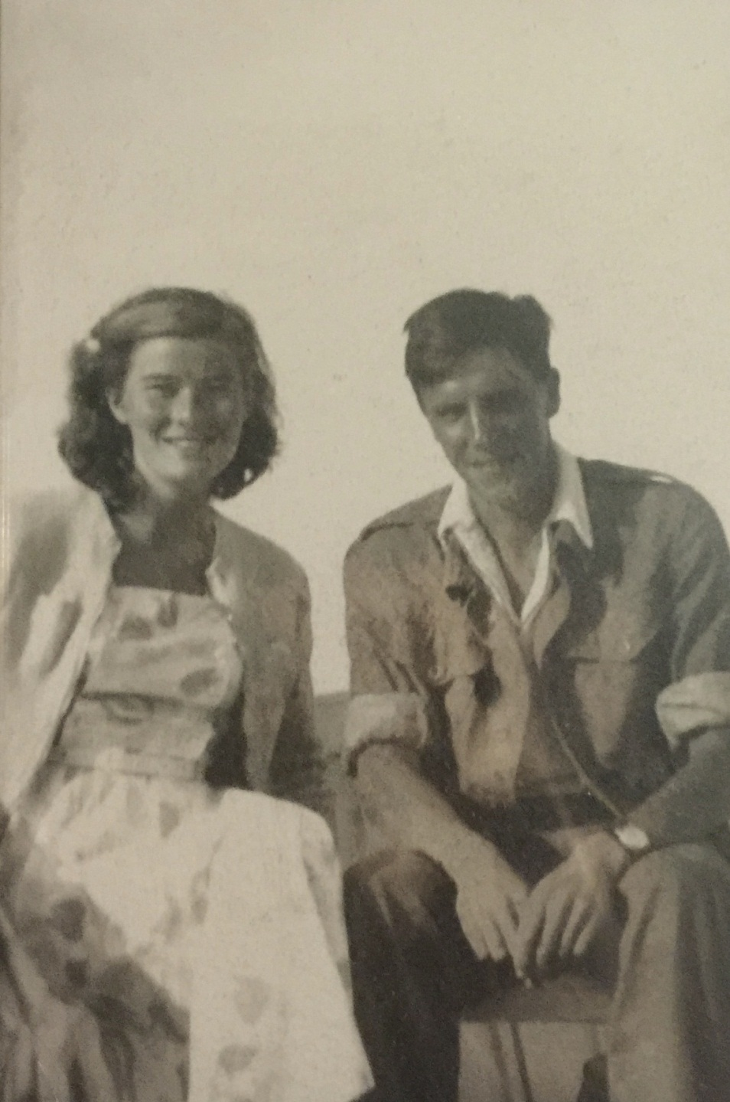
Figure 1
Photograph of Grandma and Grandad in Cornwall, 1949. Grandma’s suntan is highlighted by the impractically pale fabric of her dress, which captures a sense of leisure and ease at odds with the way she later described the difficulties of post-war austerity. Reproduced by permission of Peter Bide.

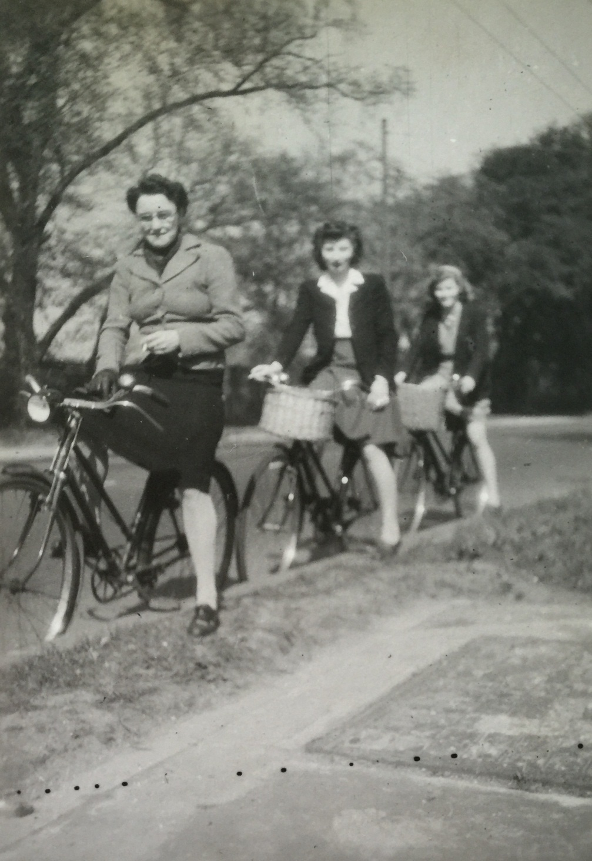
Figure 2
Photograph of Grandma (far right) on a bicycle, 1947. Unlike her two on-trend sisters-in-law (left and centre), Grandma’s skirt sits inelegantly above her knees, betraying its old age in its unfashionably short length. Positioned last in line, it seems she has been left behind by changing hem-line trends. Reproduced by permission of Peter Bide.

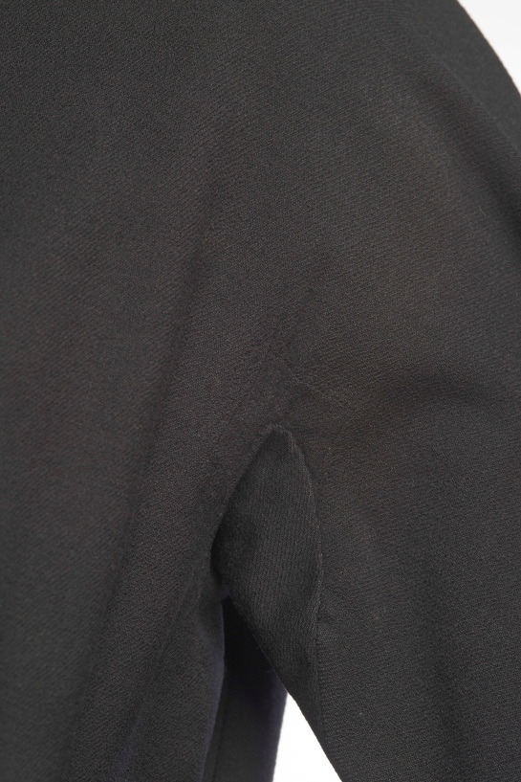

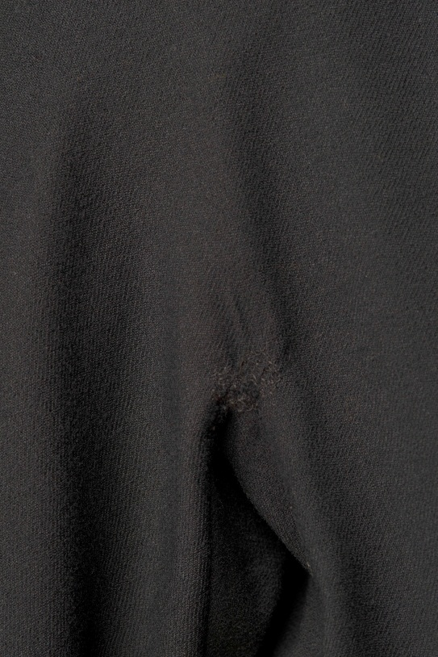

Figure 3a & 3b
Details of underarm mends in a black wool dress with Traina-Norell label (Museum of London 82.31/2). Reproduced by permission of the Museum of London.

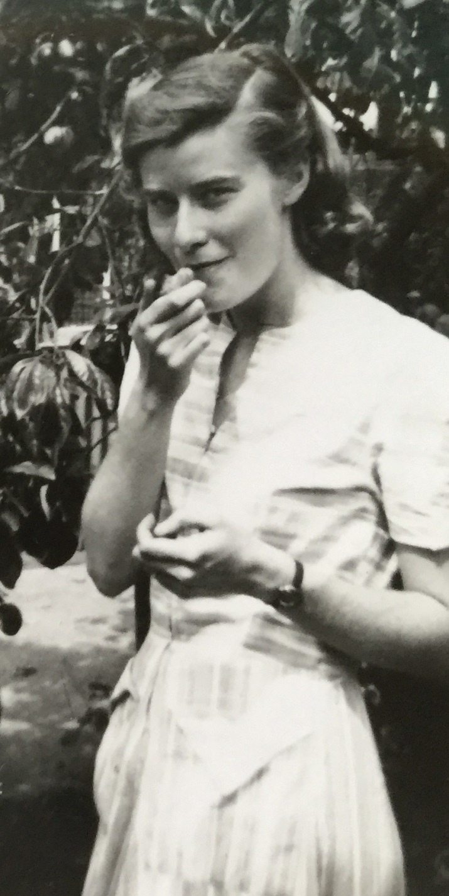

Figure 4

Photograph of Grandma under a plum tree, 1948. In contrast to her carefully styled hair, Grandma’s dress is slightly crumpled around the bodice. Behind her confident half-smile, it is hard to tell how much this is the result of a happy afternoon lounging on the summer grass or due to the fact that, when making it, she cut corners by omitting the interfacing and padding that would have given it greater internal structure. Reproduced by permission of Peter Bide.

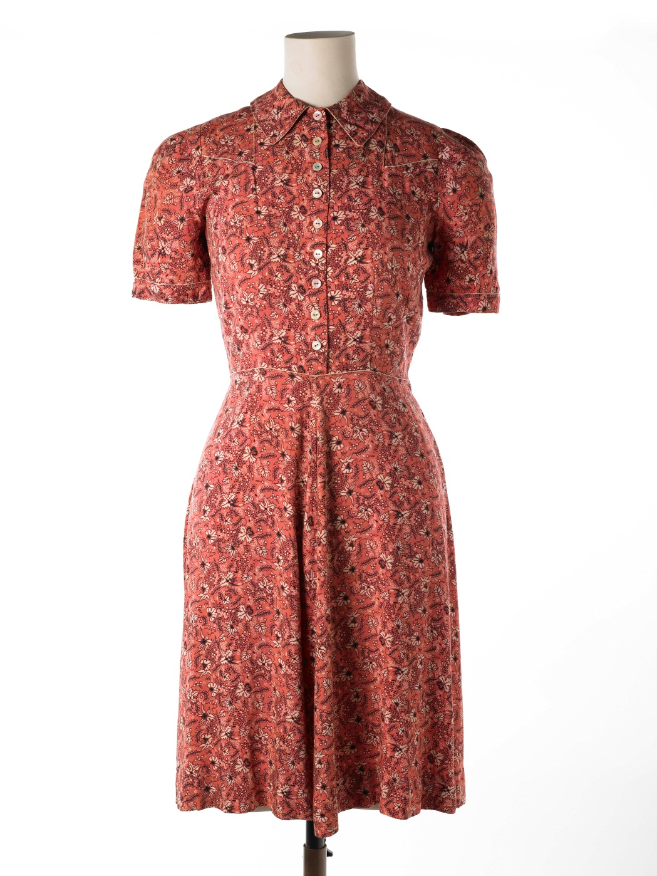

Figure 5
Dress with fitted bodice, flared skirt and Peter Pan collar. Buttoned from neck to waist with white insertion piping on collar, cuffs and bodice. Machine stitched, hand finished. Made by the donor from bedspread material released onto the market in 1944, using a Butterick pattern. (Museum of London, 77.122/3). Reproduced by permission of the Museum of London.

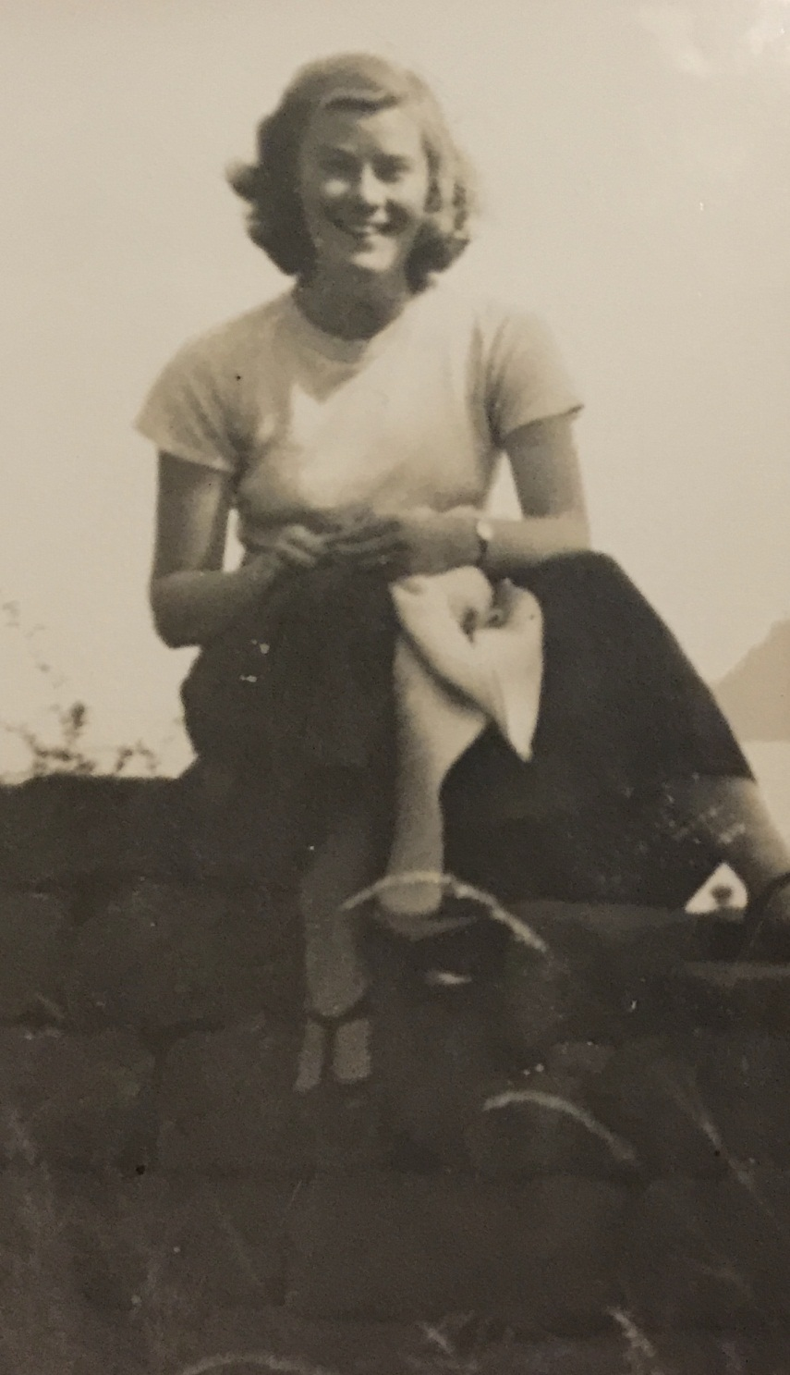
Figure 6

Photograph of Grandma on a wall, 1950. Grandma’s sense of comfort in her relaxed, loose clothing is almost tangible in her casual pose and broad smile. In contrast to the prevailing New Look fashions, her slight slouch indicates she is not wearing anything restrictive around her waist that would keep her sitting more upright. Reproduced by permission of Peter Bide.

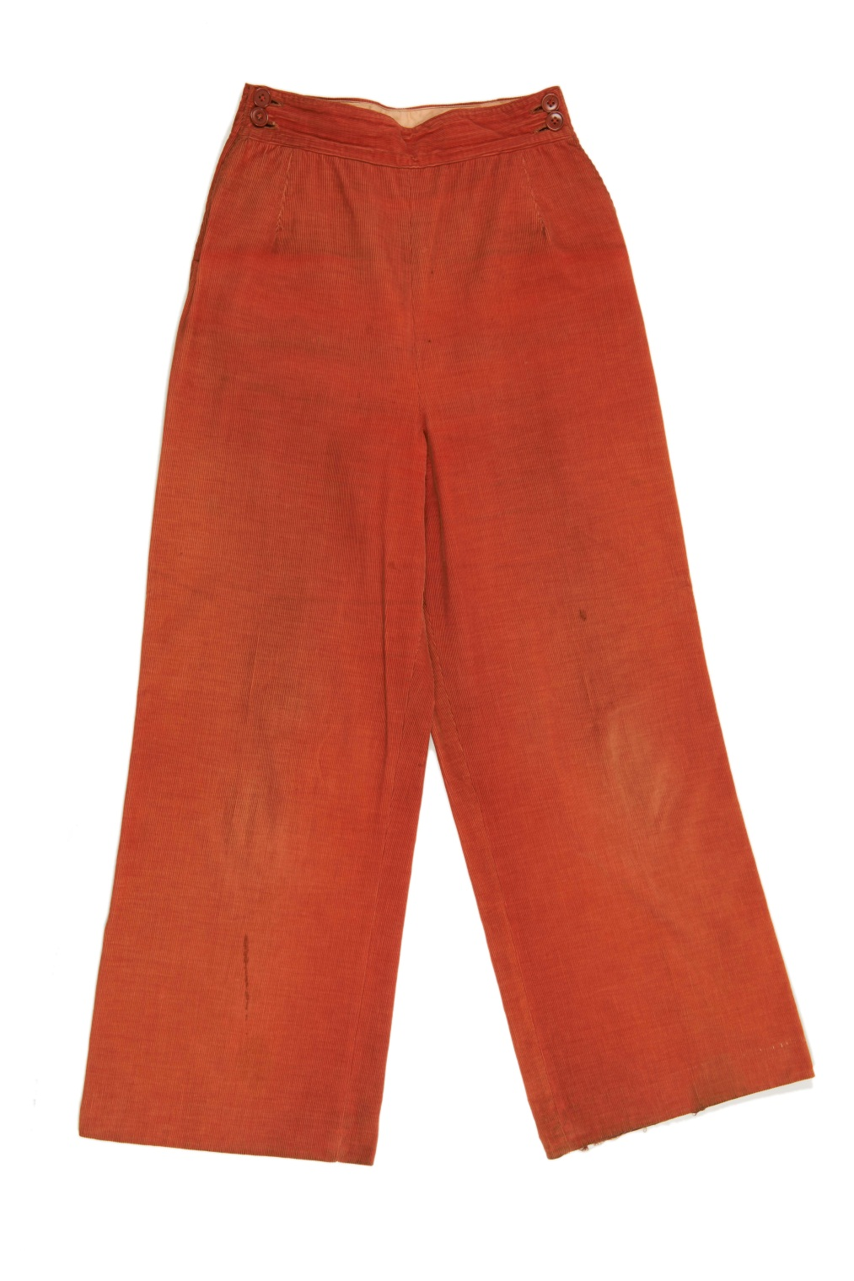

Figure 7
Orange trousers in velvet corduroy c. 1945-1950. Seamed centre back, centre front and at inside and outside leg. Hips shaped with darts and fastened with buttons. Label reads ‘D. H. Evans London W1’. (Museum of London, 66.12/3). Reproduced by permission of the Museum of London.

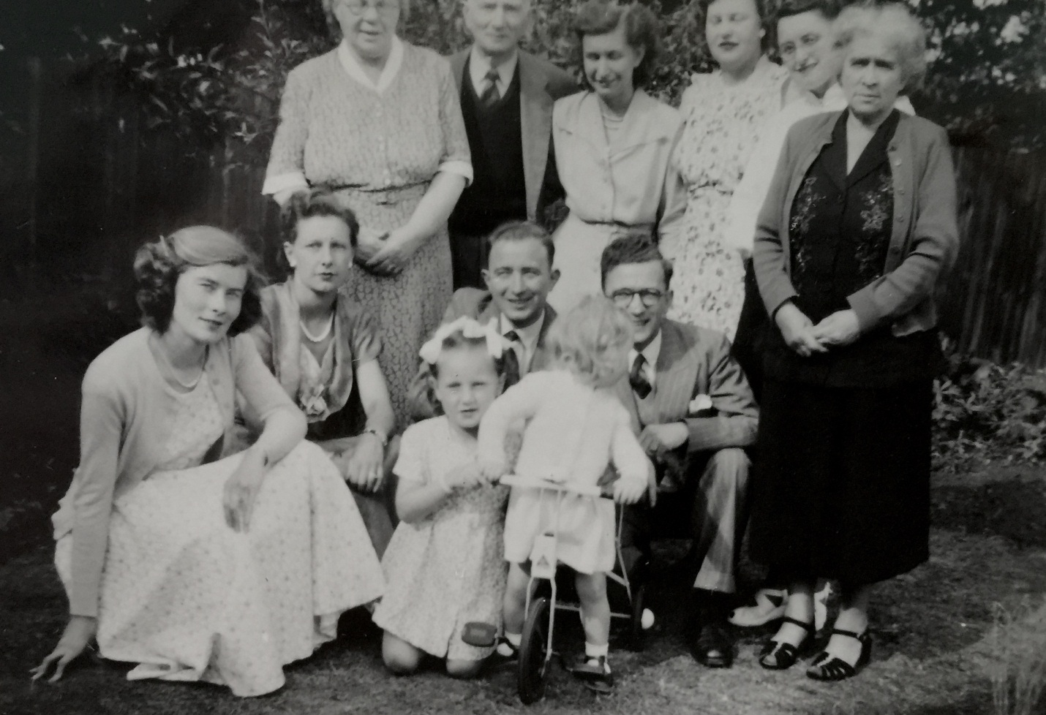
Figure 8

Photograph of Grandma (far left) in a garden with her family, 1951. Grandma has separated herself slightly from the close group pose adopted by the other family members, choosing instead to sit individually and slightly in front of the others. Her stance and facial expressions are also distinct, more akin to those seen in magazine spreads than at family gatherings. Staring confidently down the camera lens, she crouches in a way that shows off the fashionable fullness of her skirt and draws attention to her slender arms and neck. Reproduced by permission of Peter Bide.

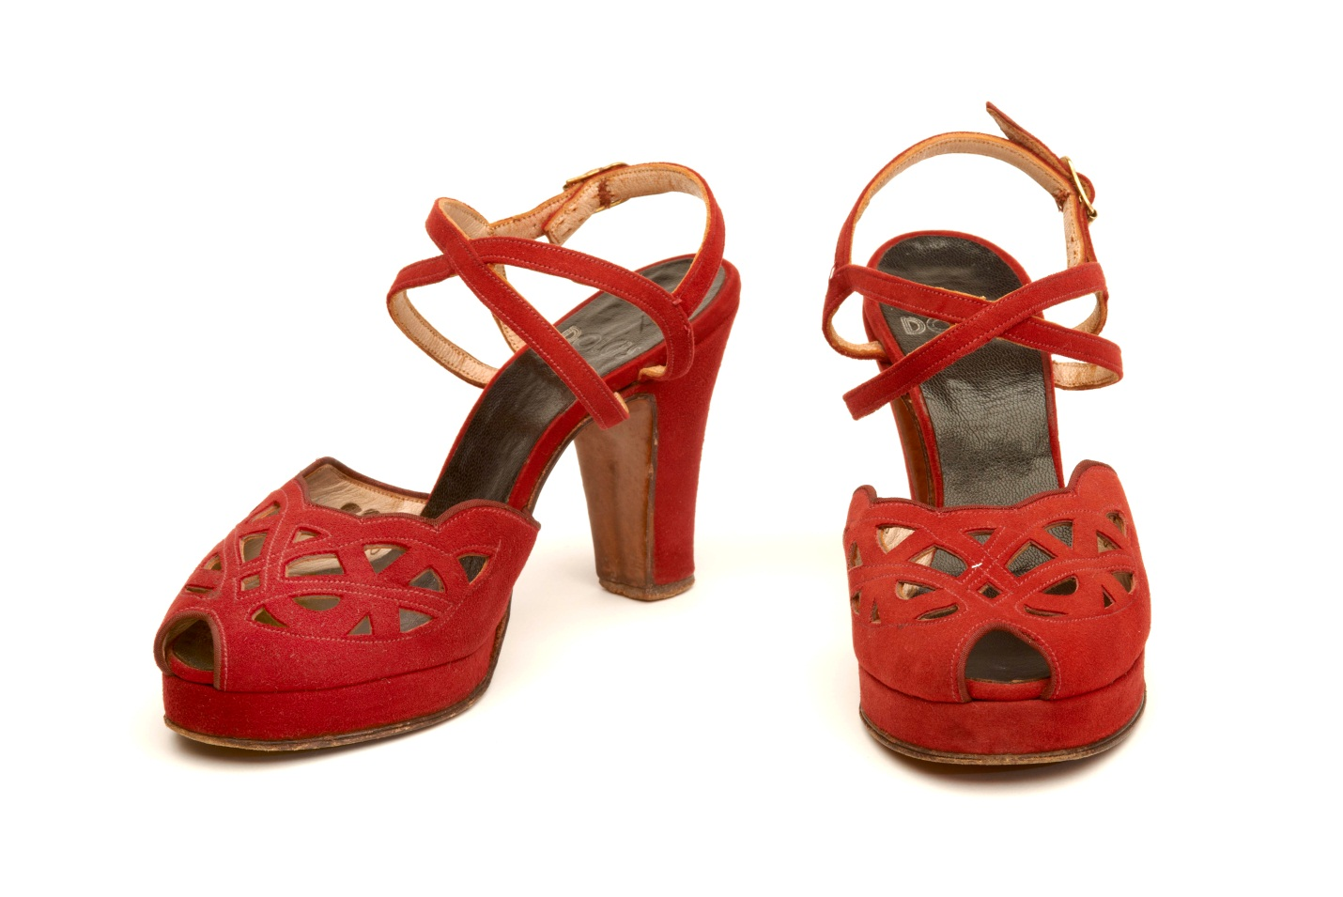

Figure 9
Red suede shoes from Dolcis with platform soles and ankle straps. CC41 marked. (Museum of London, Z875a-b). Reproduced by permission of the Museum of London.

The British Utility Clothing Scheme was a government programme that ran from 1941-1952. It regulated clothing wholesale and retail prices and controlled fabric supplies to manufacturers.
The edited, idealised image the Grandma presented in her albums is common in the way people select images of themselves (see Edwards 1999, 221-236).
The Museum of London is an institution with a long history of recognising the valuable role that clothes can play in telling the social history of the city. As far back as 1933, the Museum became the first in Britain to publish a catalogue of its costume collection, and today it is home to over 24,000 fashion objects, which represent more than six hundred years of London lives.
In 2004, curator Deirdre Murphy used the memories of multiple individuals to speak to a single dress in an exhibition at Kensington Palace, entitled ‘French Connections: Memories of Her Majesty the Queen in Paris’. In this exhibition, Murphy introduced the dress through its impact on different individuals, from one of the embroiderers who crafted it to an usher at the event to which it was worn, creating a fuller understanding of the dress and its various social and cultural meanings.
The Museum of London is actively considering how uncertainty and curatorial research processes could be incorporated into displays in their new museum building (Curator’s Workshop Presentation, Museum of London, 16 March 2016).
A number of institutions have started to experiment with the use of video to present ‘curator’s eye views’ of collection objects, for example the Metropolitan Museum of Art’s ‘82nd & Fifth’ project. Additionally, the experiments in 360 degree filming and virtual reality catwalk shows being undertaken by brands such as Balenciaga, Hussein Chalayan and Dior might provide a useful model for museums (Dazed and Confused, March 4 2016).

