drive-witness acceleration scheme based on Corrugated dielectric mm-scale capillary
K. Lekomtsev^{†,4}, A. Lyapin, S. Boogert, P. Karataev, John Adams Institute at Royal Holloway
University of London, Egham, UK
A. Aryshev^{1,2}, M. Shevelev^{1,3}, N. Terunuma^{1,2}, J. Urakawa¹, ¹KEK: High Energy Accelerator
Research Organization, Tsukuba, Japan, ²SOKENDAI: The Graduate University for Advanced studies, Tsukuba, Japan, ³Tomsk Polytechnic University, Institute of Physics and Technology, Tomsk, Russia
A. A. Tishchenko⁴, ⁴National Research Nuclear University MEPhI, Moscow, Russia

Abstract
In this paper, we investigate a corrugated mm-scale capillary as a compact accelerating structure in a drive – witness acceleration scheme, and suggest a methodology to measure acceleration of a witness bunch. Two typical measurements and the energy gain in a witness bunch as a function of the distance between bunches are discussed. A corrugated capillary is considered as an accelerator/decelerator with an adjustable wakefield pattern depending on a transverse beam position.

INTRODUCTION
Dielectric wakefield acceleration (DWA) in planar and circular dielectric structures has seen major developments in understanding of the maximum achievable accelerating gradients [1], dielectric breakdown limits [2] as well as the applications for beam compression [3], modulation [4] and correlated energy spread compensation [5]. Achieving high accelerating gradients ($\sim$GeV/m) using extremely compact structures (fraction of a millimetre aperture or diameter and few millimetre length) is one of the major motivations behind these developments. In DWA schemes a high charge drive bunch excites Cherenkov radiation in a dielectric that is reflected by metallic coating and can be used as an acceleration mechanism for a low charge witness bunch following the drive [6]. Key advantages of the DWA compared to laser wakefield or plasma wakefield acceleration schemes are: dielectric structures themselves can be manufactured relatively easily using variety of techniques; high power laser systems are not needed, because a short and intense drive bunch serves as a source of a powerful accelerating wakefield.

Experiment
An experimental study was carried out at the Laser Undulator Compact X-ray facility (LUCX) in KEK, Japan [7]. The mm-scale capillary used in the experiment was constructed as a set of dielectric cylindrical rings mounted into a copper casing and secured by holders on both sides. The term “mm-scale” was used to differentiate the structure discussed here with typical transverse sizes in the order of mm from $μ$m scale capillaries. A scheme of a corrugated channel is shown in Fig. 1(a), a cross-section of the assembly of the capillary with holders is shown in Fig. 1(b). The capillary was attached to a manipulator that was used to position the structure with respect to an electron beam in a vacuum chamber (the chamber location marked as “THz chamber” in Fig. 2). The positioning of the capillary in the chamber was performed using so called gamma scans, when the beam was scanned transversely across the capillary and bremsstrahlung radiation produced when the beam was hitting the material was detected by an air - Cherenkov detector. The scanning region where the weakest signal was detected corresponded to the beam propagation through the capillary aperture.

† email address Konstantin.Lekomtsev@rhul.ac.uk

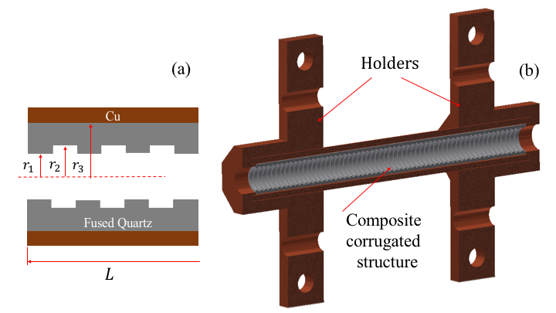
Figure 1: Section of corrugated channel (a), cross-section of corrugated mm-scale capillary with holders (b).
An electron beam was produced by illuminating a photocathode using a Titanium-Sapphire laser system with fs duration pulses. Drive and witness bunches of unequal charge were produced by introducing laser pulses intensity imbalance by mechanical adjustment of a half-wave plate inside the laser buncher system [8].
Table 1: Parameters.
Parameter | Value
Drive bunch charge | $$\sim 2 pC$$
Drive bunch $σ_{transv}$ | $$\sim 300 μm$$
Drive bunch $σ_{long}$ | $$\sim 70 fs$$
Witness bunch charge | $$\sim 0.67 pC$$
Witness bunch $σ_{transv}$ | $$\sim 100 μm$$
Witness bunch $σ_{long}$ | $$\sim 70 fs$$
Capillary radii $r_{1}; r_{2}; r_{3}$ | 2; 2.2; 2.7 mm
Capillary length, L | 60 mm
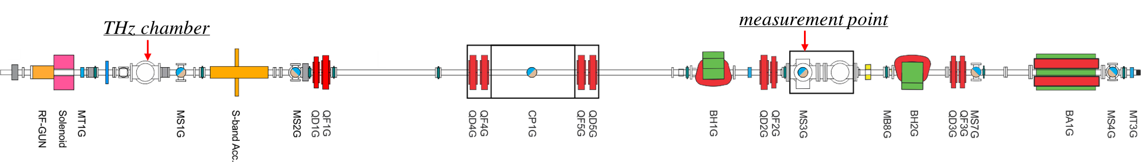
Figure 2: LUCX beamline.

The distance between bunches was controlled in the range of 1 to 4 mm by moving a mirror inside the buncher. The two bunches were accelerated up to 8 MeV in a 3.6 cell S-band RF gun. The RF gun introduced time – energy correlation in the beam, producing a drive and a witness of slightly different energies. When the beam was dispersed by the bending magnet BH1G the different time slices were projected to the different transverse coordinates on the Yttrium Aluminium Garnet screen (YAG, MS3G in Fig. 2).
The beam parameters and the capillary dimensions are given in Table 1. The beam parameters at the location of the beam interaction with the capillary were simulated using A Space Charge Tracking Algorithm (ASTRA). According to the simulation, the transverse beam dimensions varied depending on the distance between the drive and the witness bunch, Table 1 demonstrates the average values of the transverse dimensions.

results and discussion
During the experiment the energy distribution in the beam was measured as a function of the bunch-to-bunch distance. We discuss two cases: beam propagation without the capillary (a reference measurement) and an off-central beam propagation through the structure with an off-set of 1.5 mm with respect to the capillary central axis. The off-central propagation provides more efficient interaction of the drive self-field with the dielectric, therefore yielding a higher intensity wakefield.
The diameter of the capillary is much larger than the typical $σ_{transv}$ of the drive beam, so beam clipping can be avoided, allowing one to study wakefield maps for different off-central propagations. We show two typical measurements, firstly without capillary (Fig. 3) and secondly with capillary (Fig. 4). To obtain an absolute value of the energy difference between the drive and the witness, the YAG screen CCD image was projected in the vertical direction within a narrow vertical region of interest. Pixel units were then converted into distance on screen. As a final step, using a distance-energy calibration the energy difference was recalculated to units of energy. Light blue lines in Figs. 3 and 4, mark integration regions where a skew-double-Gaussian fitting procedure was applied:

$f\left(x,μ_{w},σ_{w}, α_{w},μ_{dr},σ_{dr},α_{dr}\right)=\frac{\left[1+erf\left(\frac{α_{w}(x-μ_{w})}{\sqrt{2}}\right)\right]}{\sqrt{2πσ_{w}^{2}}}×exp\left(-\frac{{\left(x-μ_{w}\right)}^{2}}{2σ_{w}^{2}}\right)+\frac{\left[1+erf\left(\frac{α_{dr}(x-μ_{dr})}{\sqrt{2}}\right)\right]}{\sqrt{2πσ_{dr}^{2}}}×exp\left(-\frac{{\left(x-μ_{dr}\right)}^{2}}{2σ_{dr}^{2}}\right)$,

where $μ_{w}, σ_{w}, α_{w}$ are mean, standard deviation and skewness parameter for the energy distribution of the witness beam, $μ_{dr}, σ_{dr}, α_{dr}$ are the same parameters but for the drive beam. For the results discussed here a measure of the witness bunch acceleration is the relative energy difference between the drive and the witness with respect to the reference measurement. If the value ${∆E}_{capillary }<{∆E}_{ref }$we observe acceleration of the witness beam, on the contrary, if ${∆E}_{capillary }>{∆E}_{ref }$ we observe deceleration.
Fig. 3 shows the energy distribution on the YAG screen without the capillary for the initial distance between bunches $≅2.7$ mm. The direction of energy increase is from left to right, the energy difference between the drive and witness centroids is ${∆E}_{ref}=91.5±0.4$ keV, skewness of the drive bunch energy distribution is $α=0.25±0.02$.

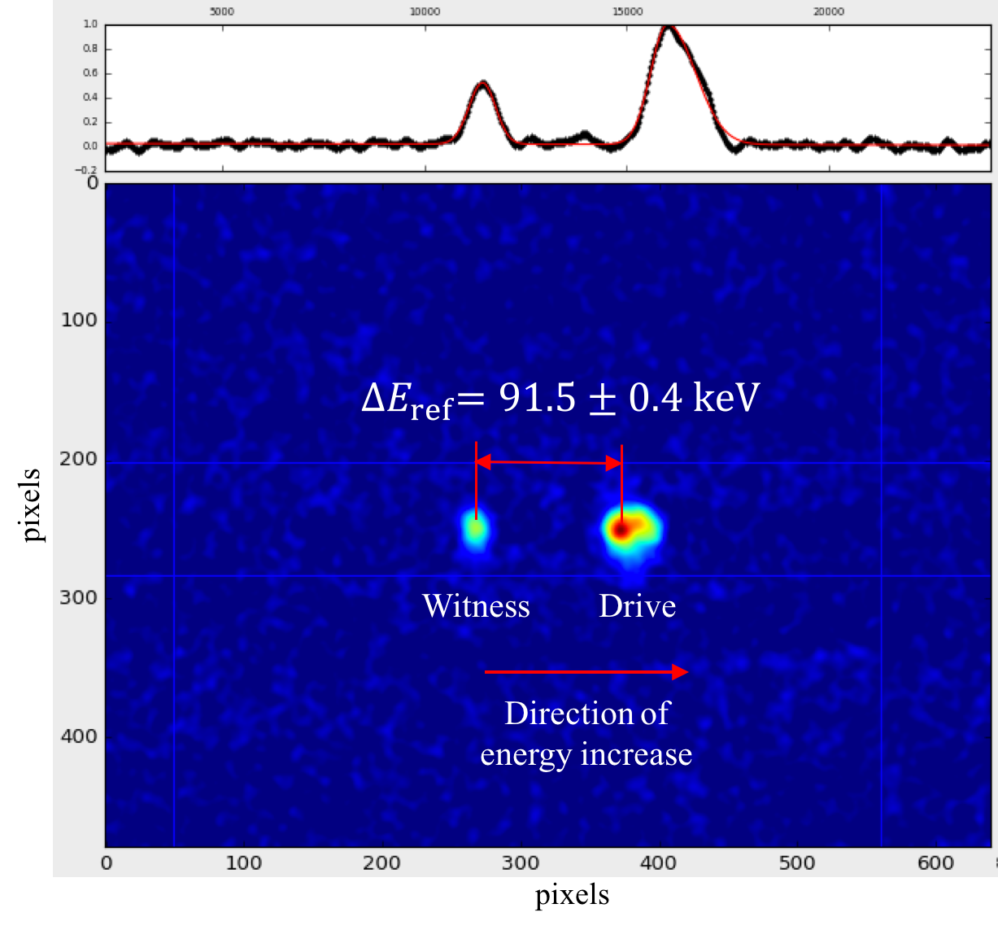
Figure 3: Energy dispersion on MS3G screen for beam without capillary (reference).
Fig. 4 demonstrates the same measurement as in Fig. 3, but this time the beam was propagating through the capillary at an off-set of 1.5 mm from its central axis. For this measurement, skewness of the drive bunch energy distribution is $α=0.35±0.02$ and the energy difference is${ ∆E}_{capillary}=79.8±0.4$ keV, giving the energy gain of the witness beam ${ ∆E}_{witness}=11.7±0.6$ keV in 60 mm of the corrugated structure, or $\sim$200 keV/m accelerating gradient. In principle, the gradient could be significantly increased if a larger drive charge and a larger drive – witness charge imbalance were achievable in this experiment.

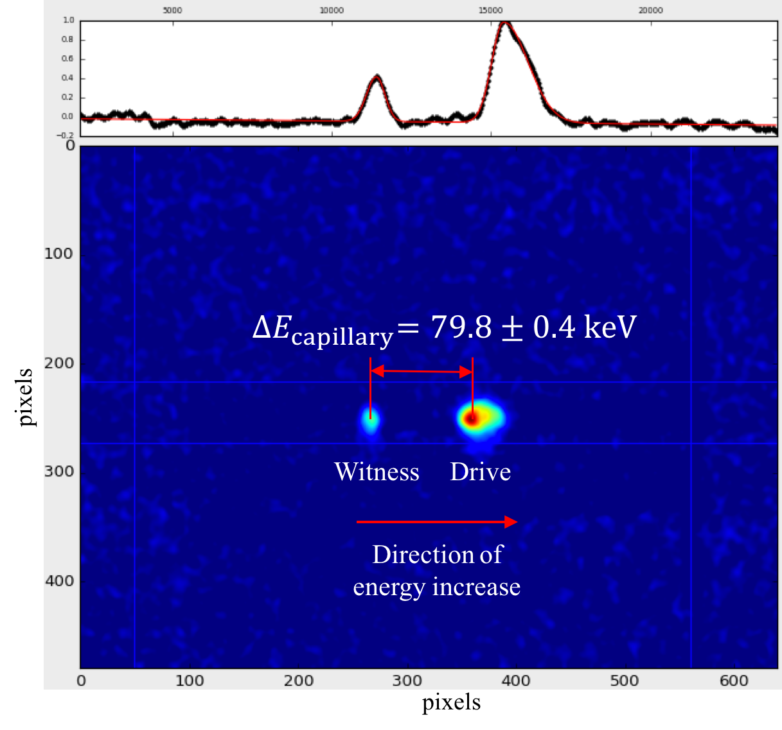
Figure 4: Energy dispersion on MS3G screen for beam with capillary.
Two typical measurements from the complete data sets were discussed to provide a demonstration of the methodology used for data analysis. The calculation of the energy difference for the reference measurement, for the measurement with capillary and the resulting energy gain of the witness bunch are summarized in Table 2.
Table 2: Energy measurements.
Parameter | Value
$${∆E}_{ref}$$ | $91.5±0.4$ keV
$${∆E}_{capillary}$$ | $79.8±0.4$ keV
$${∆E}_{witness}$$ | $11.7±0.6$ keV
Acceleration gradient | $\sim$200 keV/m

Fig. 5 shows the measurement of the distance between centroids on the YAG screen as a function of a drive-witness separation.

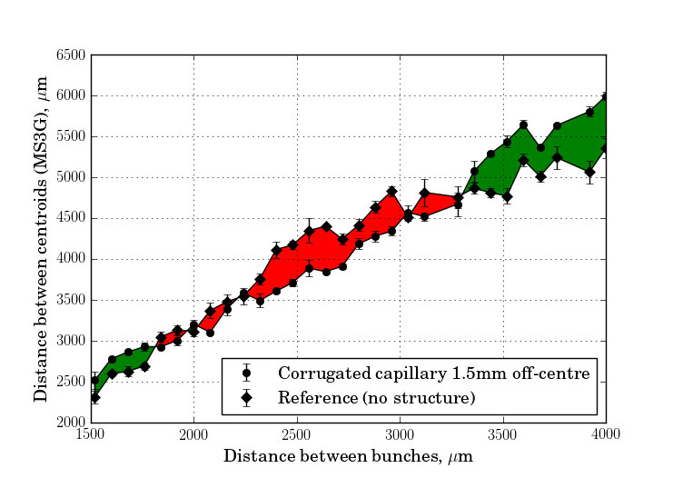
Figure 5: Red filling – acceleration, green filling – deceleration. Transverse beam off-set 1.5 mm.
For each drive-witness separation the difference between the centroids was binned and the mean and the RMS error computed. This is shown in Fig. 5, with the means as points and the RMS errors as point errors. Regions in the plot with red or green filling, correspondingly, show acceleration or deceleration of the witness bunch in the capillary. Different transverse beam off-sets can produce different acceleration/deceleration patterns, so the structure can be used as an accelerator or a decelerator by displacing a beam transversely. However, one needs to consider that other beam parameters may deteriorate, for example due to beam clipping by the capillary aperture or due to the change in the efficiency of the beam’s self-field interaction with dielectric.

Conclusions
We discussed the measurement of the energy gain of a witness bunch due to the wakefield generated by a drive bunch for an off-central beam propagation through the mm-scale corrugated capillary. We have demonstrated that the measurement of the relative energy change between the centroids of the drive and the witness bunches provided information about the distances between bunches leading to either acceleration or deceleration. The corrugated capillary and the beam used in the experiment produced only a moderate $\sim$200 keV/m acceleration gradient due to limitations on the beam parameters. The suggested experimental scheme based on a mm-scale corrugated capillary can be very important for studies of beam dynamics at different transverse beam off-sets, and, potentially, it may also be explored further as an accelerator/decelerator with an adjustable wakefield pattern.

acknowledgement
This project has received funding from the European Union’s Horizon 2020 research and innovation programme under the Marie Skłodowska-Curie grant agreement No 655179. One of the authors (A.T.) is thankful for support to the Ministry of Science and Education of the Russian Federation, grant № 3.2621.2017/PCh, and the Competitiveness Programme of National Research Nuclear University “MEPhI”. This work was supported by the Science Technology Facilities Council [grant numbers ST/J002038/1 and ST/P00203X/1].

REFERENCES
[1] B.D. O’Shea et al., “Observation of acceleration and deceleration in gigaelectron-volt-per-meter gradient dielectric wakefield accelerators”, Nat. Commun.,7:12763 doi: 10.1038/ncomms12763 (2016).
[2] M.C. Thompson et al., “Breakdown Limits on Gigavolt-per-Meter Electron-Beam-Driven Wakefields in Dielectric Structures”, Phys. Rev. Lett., vol. 100, no. 21, p. 214801-1, May. 2008.
[3] Liang Jie Wong et al., “Compact electron acceleration and bunch compression in THz waveguides”, Optics Express, vol. 21, no. 8, pp. 9792-9806, Apr. 2013.
[4] S. Antipov et al., “Experimental Observation of Energy Modulation in Electron Beams Passing through Terahertz Dielectric Wakefield Structures”, Phys. Rev. Lett., vol. 108, no.14, p. 144801-1, Apr. 2012.
[5] Y.C. Nie et al., “Potential applications of the dielectric wakefield accelerators in the SINBAD facility at DESY”, Nucl. Instr. Meth., vol. 829, pp. 183-186, 2016.
[6] W. Gai et al., “Experimental demonstration of Wake-Field Effects in Dielectric structures”, Phys. Rev. Lett., vol. 61, no. 24, p. 2756, Dec. 1988.
[7] A. Aryshev et al., “Femtosecond response time measurements of a Cs2Te photocathode”, arXiv:1507.03302v2 [physics.acc-ph] 11 Jan 2017.
[8] M. Shevelev et al., “Generation of a femtosecond electron micro-bunch train from a photocathode using twofold Michelson interferometer”, Phys. Rev. Accel. Beams, to be published.

