The Role of Semantic Knowledge in Learning to Read Exception Words
Nicola Dawson & Jessie Ricketts
Royal Holloway, University of London

In press, Perspectives of the ASHA Special Interest Groups, Vol. 2 (SIG 1),

Author Note
Correspondence concerning this article should be addressed to Nicola Dawson, Department of Psychology, Royal Holloway, University of London, Egham, Surrey, TW20 0EX
This research was supported by an Economic and Social Research Council grant awarded to the second author (grant number ES/K008064/1)

Abstract
In research and clinical practice, oral and written language skills have often been treated as separate domains. Yet they do not exist independently. Reading skills are contingent upon earlier acquired oral language skills, and the process of reading fosters growth in oral language. The importance of semantic knowledge for reading comprehension is well-documented, but there is growing evidence that it also plays a significant role in word reading. In English, a distinction can be made between regular words that follow predictable spelling-sound mappings, and exception words that do not. Oral language knowledge may be particularly important for the latter as it functions to supplement partial decoding. For speech and language pathologists, it is important to consider how remediation targeted at improving oral language skills may also elicit benefits for reading development, and conversely how reading might be used to support oral language development. Practitioners should be aware of the pattern of literacy impairments that they are likely to encounter in children with developmental language disorder, and how this relates to their oral language profiles. The purpose of this paper is to enable practitioners to generalize their knowledge and skills across the artificial boundaries that have traditionally separated these two domains.
Keywords: reading, exception word, irregular word, vocabulary, semantics

The Role of Semantic Knowledge in Learning to Read Exception Words

Reading and language skills are closely intertwined throughout development. Traditionally, the remit of speech and language pathology has been to promote the development and remediation of oral language and communication skills, and so for speech and language pathologists, the fundamental importance of language development for educational progress, emotional development and social integration is well known. Yet as children move through the education system, language is increasingly embedded in literacy, which is central to learning and academic outcomes. Conversely, reading development is dependent upon earlier oral language acquisition, and difficulties learning to read are usually associated with underlying impairments in phonology or broader oral language skills (Bishop & Snowling, 2004).
So what is involved in learning to read? In the same way that language knowledge broadly encompasses expressive and receptive grammar, semantics and phonology, at a basic level reading skills can be divided into two components: word reading and comprehension (Gough & Tunmer, 1986 - see Figure 1). Existing oral language skills provide a foundation for the acquisition of both of these components, with phonological skills supporting word reading and other aspects of oral language such as vocabulary and grammar supporting reading comprehension (Muter, Hulme, Snowling, & Stevenson, 2004).
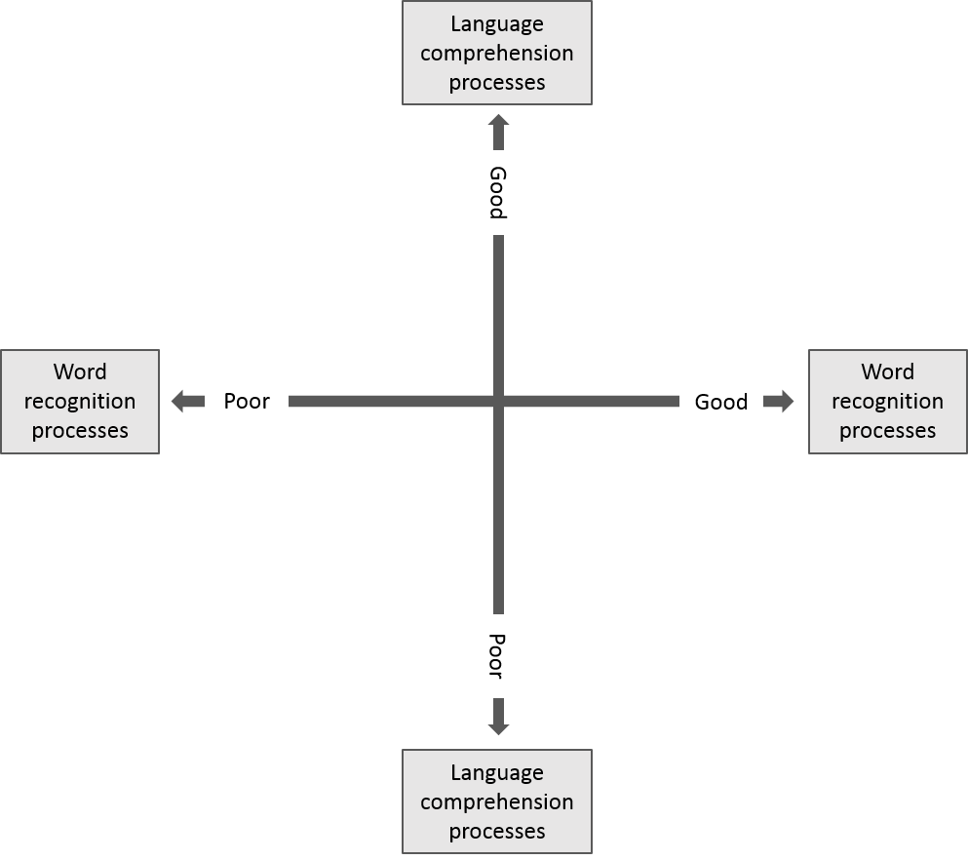
Figure 1: The Simple View of Reading (after Gough & Tunmer, 1986)
The primary aim of early reading instruction is for children to learn how to read words accurately and fluently. In the UK, this is taught through systematic phonics instruction, which has received unequivocal support as the most effective approach for teaching children to read in English (e.g., Ehri, Nunes, Stahl, & Willows, 2001). Phonics instruction involves the explicit teaching of mappings between letters and sounds, and the ways in which sounds combine to form words (Duff, Mengoni, Bailey, & Snowling, 2014). For example, a child will learn that the letter c can be pronounced /k/, the letter a as /æ/, and t as /t/ and so on. Once they have established these mappings, children are then able to blend these sounds together to give the correct pronunciation when they read the word cat. This process is known as decoding, and with this system established, children should successfully be able to read regular words that follow these alphabetic principles and contain predictable spelling-sound mappings. Although phonics teaching is mandatory in the UK, it has been less widely adopted in other English-speaking countries (Washburn, Binks-Cantrell, Joshi, Martin-Chang, & Arrow, 2016).
English is unusual amongst alphabetic languages in that the mappings between spelling and sound are, in comparison to other languages, sometimes unpredictable (Share, 2008). English contains many examples of words that cannot be readily decoded, including some of the most commonly occurring words (e.g., some, was). These are known as exception or irregular words. Thus, a child learning to read English must develop an adaptable word reading system that can accommodate words with varying regularity in their spelling-sound mappings, and oral language is a central component of this system.

Models of word reading
What are the mechanisms behind a flexible reading system that can accommodate both regular and exception words? Theoretical accounts of word reading can be broadly divided into dual-route and connectionist approaches. Essentially both approaches posit that two sets of processes are involved in word reading: alphabetic decoding skills (phonics) and whole-word knowledge. According to the dual-route cascaded model (DRC, Coltheart, Rastle, Perry, Langdon, & Ziegler, 2001 - see Figure 2), words can either be read via a sublexical or lexical route. Using the sublexical route, the orthographic input is broken down into graphemes (letters and letter combinations), which are subsequently converted to phonemes based on spelling-sound mappings (grapheme-phoneme conversion rules). These are then reassembled to give the pronunciation. This route is necessary for decoding of novel and nonsense words, and can also be used for reading words with regular spelling-sound mappings. Meanwhile, the lexical route is necessary for reading exception words. Here, the orthographic input activates the relevant entry in the orthographic lexicon, which subsequently activates the whole-word entry in the phonological lexicon either directly (nonsemantic lexical route), or indirectly via the semantic lexicon (semantic lexical route). Access to the phonological lexicon entry activates its associated pronunciation.
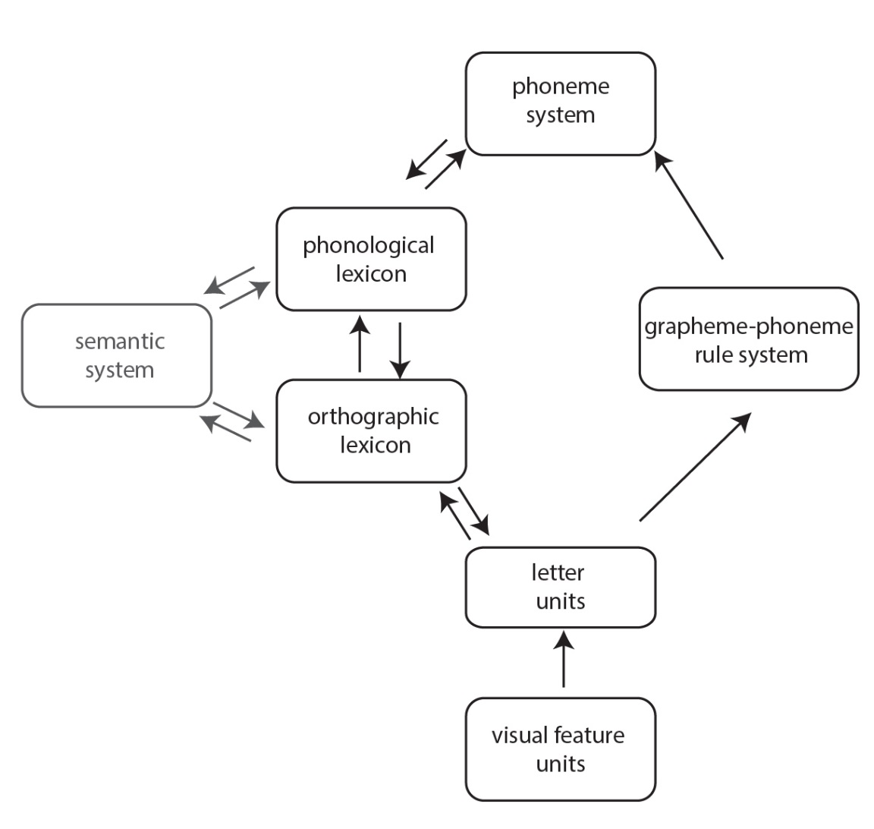
Figure 2: Dual-Route Cascaded Model (DRC, after Coltheart et al., 2001)
Proponents of an alternative connectionist approach argue that the separation of regular and exception words is misleading, and that dual processes are not necessary to account for a word reading system that can accommodate both word types (e.g., Seidenberg, 2005). They propose that English spelling-sound correspondence is quasi-regular. In other words, the consistency of spelling-sound mappings in a word is not all-or-nothing because most exception words contain some level of regularity – e.g., in yacht, the y and t are pronounced according to regular spelling-sound principles. Within the connectionist framework, the triangle model (e.g., Harm & Seidenberg, 2004; Plaut, McClelland, Seidenberg, & Patterson, 1996), posits that all words are processed via a single mechanism. According to this model, word reading involves associations between three critical components: orthography (the written form of the word), phonology (the pronunciation of the word) and semantics (the meaning of the word) – see Figure 3. These associations are learned over the course of reading development, and reflect the statistical properties of the language input, resulting in a ‘division of labor’ between a phonological pathway and a semantic pathway. The phonological pathway involves direct connections between orthographic and phonological information, and word reading via this pathway involves the conversion of letters into sounds (decoding) to access a word’s pronunciation. In the semantic pathway, orthography activates word meaning (semantics), which subsequently activates pronunciation.
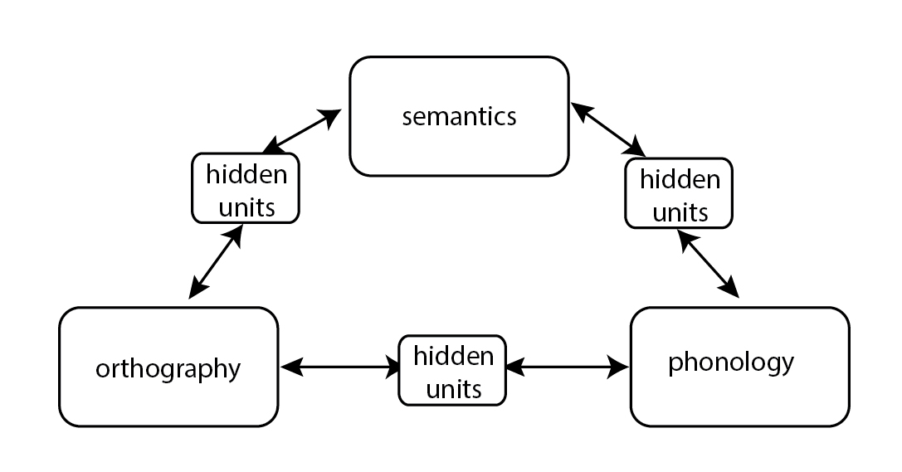
Figure 3: The Triangle Model (after Harm & Seidenberg, 2004)
Simulations of the triangle model have indicated that early on in reading development, words are likely to be read via the phonological pathway. As reading ability develops, there is increasing reliance on the semantic pathway. Additionally, exception words (e.g., yacht) rely more heavily on the semantic pathway because the phonological pathway will be less efficient for words that do not have regular spelling-sound correspondences. Thus, the relative contribution of the phonological and semantic pathway to word reading is modified by learning and is dependent on whether regular or exception words are read (see Taylor, Duff, Woollams, Monaghan, & Ricketts, 2015 for an overview).
The role of semantic knowledge in exception word reading
The dual-route framework and triangle model differ in their approach to the role of semantics in word reading. In the DRC model (Coltheart et al., 2001), while semantic knowledge may be activated via the semantic lexical route, words can be read using the nonsemantic lexical route. As discussed above, the nonsemantic lexical route involves the direct activation of phonological representations from orthographic representations, with no influence from semantics. Thus, semantic knowledge is not necessary for successful word reading but may be involved. According to the triangle model (e.g., Plaut et al., 1996) however, semantic knowledge is necessary for successful word reading and impacts on word reading directly during the reading process. In both instances, semantic knowledge may be particularly important when decoding skills are weak, as in the case of poor readers, and when decoding skills are not sufficient for accurate pronunciation, as in exception words. For example, if a word like yacht were read using knowledge of the way that letters usually map to sounds, it would be pronounced /jætʃt/. Nevertheless, such words can be partially decoded. Typically, consonants in exception words are pronounced according to their usual spelling-sound mappings – for example, the y and t of yacht – and this can provide a cue for word reading. Importantly, partial decoding of exception words can be combined with top-down semantic knowledge (knowledge of word meanings and the relationships between them), incorporating both lexical and contextual information (Share, 1995). This way, a child reading yacht can use semantic knowledge and the context of the sentence in which the word appears to select correctly from the small number of words in their lexicon that possess word-initial y and word-final t.
Alternatively, the relationship between semantic knowledge and word reading may be indirect and occur before words are encountered. The lexical restructuring hypothesis (Walley, Metsala, & Garlock, 2003) proposes that as a child’s oral vocabulary develops, their existing phonological representations of words become more fine-grained. Thus, as children begin to encounter more words that overlap phonemically, there is greater need to distinguish between them. To achieve this, existing phonological representations are restructured to be less holistic and more segmental. In turn, this facilitates the development of phonological awareness, which underpins word reading skill. In a similar vein, Wegener et al. (under review) have described their orthographic skeleton hypothesis. They propose that, once children can read, they may draw on their knowledge of orthography and how it maps to phonology to lay down initial or ‘skeletal’ orthographic representations for words, even before they have seen them. If these orthographic skeletons are relatively accurate, they can then support word reading once the word is encountered in print. Importantly here, orthographic skeletons are more likely to be accurate for regular words, so vocabulary may exert more influence for regular than exception words. It is worth noting that different mechanistic accounts are not mutually exclusive. Semantic knowledge might well influence word reading directly at the point of word reading, as well as indirectly via earlier influences on word knowledge.
Empirical evidence from adult neuroimaging literature and individuals with semantic dementia strongly supports the idea that semantic knowledge is important for word reading, and in particular for exception word reading (for a review see Taylor et al., 2015). Several studies have addressed whether this relationship between semantic knowledge and word reading is also evident in developing readers. Nation and Snowling (2004) conducted a longitudinal study with 72 children in which they completed measures of word reading and semantics (expressive vocabulary, semantic fluency, synonym judgement) at 8 years and 13 years. The authors found that individual differences in semantic knowledge and skills at age 8 explained variance in word recognition both concurrently and at age 13, even once other factors, including phonological skills and decoding ability, were taken into account.
In the triangle model (Plaut et al., 1996), words that cannot be readily decoded are more likely to be processed via the semantic pathway. Based on this view, the benefit of semantic knowledge for word reading should be greater for exception words than for words that contain regular spelling-sound mappings (see also Share, 1995), a prediction that has received empirical support. For instance, Ricketts, Nation, and Bishop (2007) looked at the relationship between semantic knowledge and component word reading skills by assessing 81 children aged 8-9 years on measures of expressive oral vocabulary, nonword reading (decoding), and word reading. In this study, regular and exception word reading were measured separately. The authors found that oral vocabulary showed a closer relationship with exception word reading than with regular word reading and nonword reading (for similar findings see Ouellette & Beers, 2010, but cf. Ricketts, Davies, Masterson, Stuart, & Duff, 2016). It is important to highlight that the contribution of semantic knowledge to word reading is only partial, and that semantic knowledge may not contribute equally to all exception words. Many function words (e.g., some, was) do not follow usual spelling-sound mappings, but because they are less concrete than content words such as yacht, the contribution of semantic knowledge may be reduced. Reader characteristics, including existing vocabulary knowledge, are also likely to have an impact. If yacht is not in a child’s vocabulary, then it is highly unlikely that semantic knowledge will support reading of that item. In the case of exception words with low semantic association, there may be a role for learning to recognize words by sight (Shapiro & Solity, 2016).
Studies conducted by Nation and Snowling (2004) and Ricketts et al. (2007) used broad measures of vocabulary and word reading. Thus, they can only ever capture general relationships between these constructs. According to the triangle model (Plaut et al., 1996) and to Share (1995), semantic knowledge should support word reading at the item level. In other words, semantic knowledge of individual words should relate to reading performance of those same words. Nation and Cocksey (2009) tested this prediction in 7-year old children. To determine the level of lexical knowledge necessary to support word reading, they examined both children’s familiarity with the phonological form of the word (lexical phonology) and their ability to define the word (lexical semantics). They predicted that if word reading draws on semantic knowledge, then performance on the definitions task should be a better predictor of reading than performance on the lexical phonology task. They additionally expected stronger relations between lexical knowledge and exception word reading, than between lexical knowledge and regular word reading. Their findings provided evidence of an item-level relationship between word knowledge and word reading. Words that were known were more likely to be read accurately than words that were unknown, and this effect was greater for exception words than for regular words. However, the authors found no evidence that semantic knowledge (as measured by the definitions task) was a better predictor of word reading than lexical phonological knowledge, even for exception words. They therefore concluded that lexical phonology may be enough to support decoding attempts in reading exception words.
In contrast to Nation and Cocksey (2009), Ricketts et al. (2016) did find evidence that lexical semantics provides support for word reading over and above lexical phonology. However, their study showed that the benefit of semantics was evident for regular as well as exception words. Thus, there was no evidence that semantics was specifically important for exception word reading. Ricketts et al. (2016) proposed that one explanation for this seemingly incongruent finding is that the children they included were younger and by implication less skilled readers than in previous studies. Consequently, semantic knowledge may have been more important for the reading of regular words because children’s knowledge of spelling-sound mappings was less well-established. These findings also resonate with the orthographic skeleton hypothesis, in which semantic knowledge is seen as promoting the reading of words through pre-existing ‘fuzzy’ orthographic representations that are more likely to be helpful for the reading of regular words. An additional finding from this study was that children were more likely to read exception words accurately when they were presented in a sentence context than when they were presented in isolation, and this effect was greater than it was for regular words (cf. Nation & Snowling, 1998a). Importantly, semantic knowledge and context made separable contributions to word reading, indicating that both mechanisms support word reading. This is in line with Share's (1995) proposal that item-specific semantic knowledge and contextual information combine with partial decoding attempts in the reading of exception words.
Exception word reading in children with developmental language disorder
Typically, children find exception words more difficult to read than regular words and this pattern has also been observed in poor readers, including children with dyslexia (e.g., Castles & Coltheart, 1993; Manis, Seidenberg, Doi, McBride-Chang, & Petersen, 1996). To our knowledge, exception word reading has not been directly addressed in children with developmental language disorder (previously known as specific language impairment, or SLI), defined as a language disorder in the absence of a known biomedical condition (Bishop, Snowling, Thompson, Greenhalgh, & CATALISE-2, 2016). Yet there are overlaps between children with developmental language disorder and those who experience reading difficulties. Most children diagnosed with dyslexia will also have some form of language impairment. Equally, high rates of literacy problems are found in children with developmental language disorder (e.g, Bishop, McDonald, Bird, & Hayiou-Thomas, 2009; Catts, Adlof, Hogan, & Weismer, 2005). Deficits in phonological processing are a core feature of developmental dyslexia (Snowling, 1995), and are also common in developmental language disorder. In the latter, phonological deficits are part of broader pattern of oral language impairment (Bishop & Snowling, 2004). Nevertheless, while co-occurrence of developmental language disorder and dyslexia is common, it is far from ubiquitous. Children with developmental language disorder are a heterogeneous group, and for some word reading will be unimpaired (Bishop et al., 2009; Catts et al., 2005).
The broader oral language impairments seen in children with developmental language disorder are a further possible source of reading difficulties. Bishop and Snowling (2004) modified The Simple View of Reading to provide a basic framework for understanding developmental language disorder in relation to both dyslexia and poor comprehension (see Figure 4). For many children with developmental language disorder, difficulties in both phonological and nonphonological language skills create a ‘double deficit’ for word reading and reading comprehension. According to the triangle model of word reading (Plaut et al., 1996), both the phonological and semantic pathways are involved in word reading, but the relative contribution of each pathway will depend on both reader and word characteristics. This ‘division of labor’ between pathways means that word reading in children with phonological deficits may depend more on the semantic pathway. However, many children with developmental language disorder present with weaknesses in semantic knowledge (Bishop, 2014; McGregor, Newman, Reilly, & Capone, 2002), meaning that the semantic pathway may not compensate for phonological weaknesses. While phonological impairments are highly prevalent in children with developmental language disorder early on in development, evidence suggests that, in the absence of comorbidity with dyslexia, these difficulties often resolve over time (Catts et al., 2005). Yet even in the absence of phonological deficits, oral language impairments may negatively impact word reading (as well as reading comprehension), with exception word reading particularly affected. Furthermore, as word reading develops, typical readers increasingly access meaning directly from the printed word via the semantic pathway (Taylor et al., 2015). Consequently, children with developmental language disorder may not develop the automatic print-meaning mappings that are characteristic of skilled readers, which might help to explain why, by adolescence, word reading deficits become increasingly apparent in this group (Snowling et al., 2000).
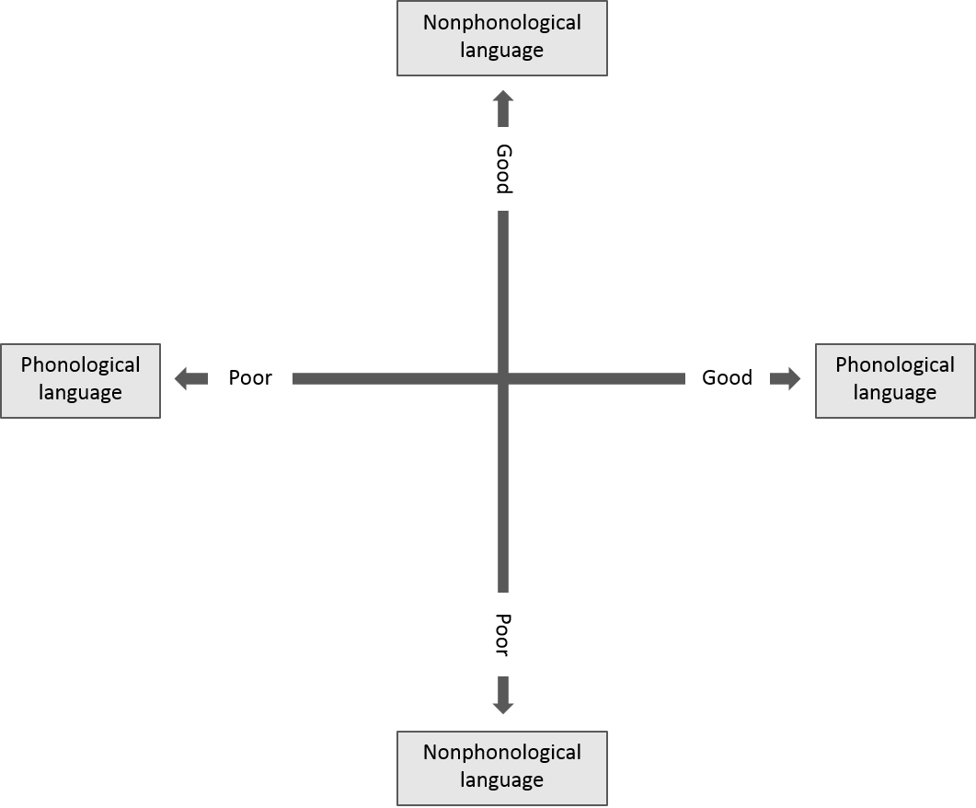
Figure 4: Relationship between developmental language disorder and developmental dyslexia (after Bishop & Snowling, 2004)
In supporting reading in children with developmental language disorder, it is important to maximize capacity to access both phonological and semantic contributions to word reading. Based on the theoretical models and evidence discussed above, interventions that target semantic knowledge may also confer benefits for both regular and exception word reading. Additionally, recent evidence from a robust intervention study suggests that teaching children some sight words alongside phonics instruction may be particularly beneficial for children with poorer phonological awareness compared to phonics instruction alone (Shapiro & Solity, 2016).
Parallels can be drawn between children with developmental language disorder and a group of children known as poor comprehenders, or children with specific reading comprehension difficulties. Poor comprehenders are children who show impaired reading comprehension, despite being able to read words and texts accurately (Hulme & Snowling, 2009). Poor comprehenders typically show oral language weaknesses and some would meet criteria for developmental language disorder (Nation, Clarke, Marshall, & Durand, 2004). Despite their strengths in word reading relative to reading comprehension, poor comprehenders still show subtle difficulties with exception word reading, which have been explained in terms of their concomitant semantic weaknesses (Nation & Snowling, 1998b; Ricketts et al., 2007). Arguably, children with developmental language disorder who show some similarities to poor comprehenders in their oral language profiles may likewise experience difficulties with exception word reading. More broadly, the deficits in semantic and syntactic knowledge commonly found in developmental language disorder are likely to undermine children’s ability to use contextual cues to support word reading. Because context appears to be particularly beneficial for exception word reading (Nation & Snowling, 1998a; Ricketts et al., 2016), these limitations may disproportionately undermine exception word reading.
Clinical implications
Building on the evidence discussed above, an important consideration for speech and language pathologists is the impact that different profiles of language impairment may have on a child’s literacy development. Weak phonological awareness may be associated with poor word reading, and in particular with difficulties decoding novel words and using decoding skills to build an orthographic lexicon (Share, 1995). What is clear is that, while phonological knowledge is crucial for learning to read, skilled reading also draws on broader oral language skills. In particular, deficits in semantic knowledge (e.g., vocabulary) are likely to mean that children struggle with reading comprehension as well as word reading, with exception word reading particularly affected. This has implications for clinical practice and education. The high concomitance of language and reading difficulties points to the need to include assessment of reading ability alongside language ability. A holistic assessment approach incorporating both domains will not only reveal the impact of a child’s language difficulties on their literacy skills, but will also ensure that any benefits of oral language interventions on literacy are acknowledged. This is particularly important as children move through the education system and literacy skills become increasingly central to meeting the demands of the curriculum. Theoretical and empirical evidence strongly suggests that different components of reading relate to different component language skills, so assessment of reading should take account of performance across both reading comprehension and word reading, including both regular and exception words.
The models of word reading presented here indicate that word-level semantic knowledge may play an important role in word reading, and that it may be particularly helpful for poor word readers and in instances of unusual spelling-sound mappings (i.e. exception words). For clinicians, this suggests that vocabulary interventions should incorporate orthography as a facet of word knowledge, as this is likely to benefit reading in addition to the targeted language skills. However, more research is required to test this directly in a clinical setting.
Concluding remarks
Learning to read exception words is a critical step in becoming a skilled reader. While words with regular spelling-sound mappings may be readily decoded, additional knowledge is required for a child to read exception words fluently. Word knowledge, and in particular semantic knowledge, has been shown to play a role in facilitating fluent word reading, but this may be particularly important for exception words which can only be partially decoded. For children with language difficulties, such as developmental language disorder, their oral language profile will determine their relative strengths and weaknesses in reading. Deficits in phonology are likely to inhibit word reading, while impaired semantic knowledge is likely to be associated with poorer exception word reading and reading comprehension. The co-dependency of oral and written language skills throughout development underlies a need for speech and language pathologists to consider the impact of language difficulties on reading, as well as the benefits that reading can have for language development. An understanding of the relationship between the patterns of impairments seen in oral language and those associated with reading will enable practitioners to apply their skills and foster progress across both domains.

References
Bishop, D. V. M. (2014). Ten questions about terminology for children with unexplained language problems. International Journal of Language and Communication Disorders, 49(4), 381–415. http://doi.org/10.1111/1460-6984.12101
Bishop, D. V. M., McDonald, D., Bird, S., & Hayiou-Thomas, M. E. (2009). Children Who Read Words Accurately Despite Language Impairment: Who Are They and How Do They Do It? Child Development, 80(2), 593–605.
Bishop, D. V. M., & Snowling, M. J. (2004). Developmental Dyslexia and Specific Language Impairment: Same or Different? Psychological Bulletin, 130(6), 858–886. http://doi.org/10.1037/0033-2909.130.6.858
Bishop, D. V. M., Snowling, M. J., Thompson, P. A., Greenhalgh, T., & CATALISE-2. (2016). CATALISE : a multinational and multidisciplinary Delphi consensus study of problems with language development . Phase 2 . Terminology. PeerJ Preprints4. http://doi.org/https://doi.org/10.7287/peerj.preprints.2484v1
Castles, A., & Coltheart, M. (1993). Varieties of developmental dyslexia. Cognition, 47(2), 149–180. http://doi.org/10.1016/0010-0277(93)90003-E
Catts, H. W., Adlof, S. M., Hogan, T. P., & Weismer, S. E. (2005). Are specific language impairment and dyslexia distinct disorders? Journal of Speech, Language, and Hearing Research, 48(December), 1378–1396. http://doi.org/10.1044/1092-4388(2005/096)
Coltheart, M., Rastle, K., Perry, C., Langdon, R., & Ziegler, J. (2001). DRC: A dual route cascaded model of visual word recognition and reading aloud. Psychological Review, 108, 204–256. http://doi.org/http://dx.doi.org/10.1037/0033-295X.108.1.204
Duff, F. J., Mengoni, S. E., Bailey, A. M., & Snowling, M. J. (2014). Validity and sensitivity of the phonics screening check: implications for practice. Journal of Research in Reading. http://doi.org/10.1111/1467-9817.12029
Ehri, L. C., Nunes, S. R., Stahl, S. A., & Willows, D. M. (2001). Systematic Phonics Instruction Helps Students Learn to Read: Evidence from the National Reading Panel’s Meta-Analysis. Review of Educational Research, 71(3), 393–447.
Gough, P. B., & Tunmer, W. E. (1986). Decoding, Reading, and Reading Disability. Remedial and Special Education, 7, 6–10.
Harm, M. W., & Seidenberg, M. S. (2004). Computing the Meanings of Words in Reading : Cooperative Division of Labor Between Visual and Phonological Processes. Psychological Review, 111, 662–720.
Hulme, C., & Snowling, M. J. (2009). Developmental Disorders of Language Learning and Cognition. Oxford, UK: Wiley-Blackwell.
Manis, F. R., Seidenberg, M. S., Doi, L. M., McBride-Chang, C., & Petersen, A. (1996). On the bases of two subtypes of development dyslexia. Cognition, 58(2), 157–195. http://doi.org/10.1016/0010-0277(95)00679-6
McGregor, K., Newman, R. M., Reilly, R., & Capone, N. C. (2002). Semantic representation and naming in children with specific language impairment. Journal of Speech, Language, and Hearing Research, 45(October), 998–1014.
Muter, V., Hulme, C., Snowling, M. J., & Stevenson, J. (2004). Phonemes, Rimes, Vocabulary, and Grammatical Skills as Foundations of Early Reading Development: Evidence From a Longitudinal Study. Developmental Psychology, 40(5), 665–681. http://doi.org/10.1037/0012-1649.40.5.665
Nation, K., Clarke, P., Marshall, C. M., & Durand, M. (2004). Hidden Language Impairments in Children: Parallels Between Poor Reading Comprehension and Specific Language Impairment? Journal of Speech, Language, and Hearing Research, 47, 199–211.
Nation, K., & Cocksey, J. (2009). Journal of Experimental Child The relationship between knowing a word and reading it aloud in children ’ s word reading development. Journal of Experimental Child Psychology, 103(3), 296–308. http://doi.org/10.1016/j.jecp.2009.03.004
Nation, K., & Snowling, M. J. (1998a). Individual Differences in Contextual Facilitation : Evidence from Dyslexia and Poor Reading Comprehension. Child Development, 69(4), 996–1011.
Nation, K., & Snowling, M. J. (1998b). Semantic Processing and the Development of Word-Recognition Skills : Evidence from Children with Reading Comprehension Difficulties. Journal of Memory and Language, 39, 85–101.
Nation, K., & Snowling, M. J. (2004). Beyond phonological skills : broader language skills contribute to the development of reading. Journal of Research in Reading, 27(4), 342–356.
Ouellette, G., & Beers, A. (2010). A not-so-simple view of reading: how oral vocabulary and visual-word recognition complicate the story. Reading and Writing, 23(2), 189–208. http://doi.org/10.1007/s11145-008-9159-1
Plaut, D. C., McClelland, J. L., Seidenberg, M. S., & Patterson, K. (1996). Understanding normal and impaired word reading: Computational principles in quasi-regular domains. Psychological Review, 103, 56–115.
Ricketts, J., Davies, R., Masterson, J., Stuart, M., & Duff, F. J. (2016). Evidence for semantic involvement in regular and exception word reading in emergent readers of English. Journal of Experimental Child Psychology, 150, 330–345. http://doi.org/10.1016/j.jecp.2016.05.013
Ricketts, J., Nation, K., & Bishop, D. V. M. (2007). Vocabulary Is Important for Some, but Not All Reading Skills. Scientific Studies of Reading, 11(3), 235–257. http://doi.org/10.1080/10888430701344306
Seidenberg, M. S. (2005). Connectionist Models of Word Reading. Current Directions in Psychological Science, 14(5), 238–242.
Shapiro, L. R., & Solity, J. (2016). Differing effects of two synthetic phonics programmes on early reading development. British Journal of Educational Psychology, 86(2), 182–203. http://doi.org/10.1111/bjep.12097
Share, D. L. (1995). Phonological recoding and self-teaching: sine qua non of reading acquisition. Cognition, 55, 151–218.
Share, D. L. (2008). On the Anglocentricities of current reading research and practice: the perils of overreliance on an “outlier” orthography. Psychological Bulletin, 134(4), 584–615. http://doi.org/10.1037/0033-2909.134.4.584
Snowling, M., Bishop, D. V. M., & Stothard, S. E. (2000). Is pre-school language impairment a risk factor for dyslexia in adolescence? Journal of Child Psychology and Psychiatry, 41, 587–600.
Snowling, M. J. (1995). Phonological processing and developmental dyslexia. Journal of Research in Reading, 18(2), 132–138. http://doi.org/10.1111/j.1467-9817.1995.tb00079.x
Taylor, J. S. H., Duff, F. J., Woollams, A. M., Monaghan, P., & Ricketts, J. (2015). How Word Meaning Influences Word Reading. Current Directions in Psychological Science, 24(4), 322–328. http://doi.org/10.1177/0963721415574980
Walley, A. C., Metsala, J. L., & Garlock, V. M. (2003). Spoken vocabulary growth : Its role in the development of phoneme awareness and early reading ability. Reading and Writing: An Interdisciplinary Journal, 16, 5–20.
Washburn, E. K., Binks-Cantrell, E. S., Joshi, R. M., Martin-Chang, S., & Arrow, A. (2016). Preservice teacher knowledge of basic language constructs in Canada, England, New Zealand, and the USA. Annals of Dyslexia, 66(1), 7–26. http://doi.org/10.1007/s11881-015-0115-x
Wegener, S., Wang, H.-C., de Lissa, P., Robidoux, S., Nation, K., & Castles, A. (n.d.). Children reading spoken words: Interactions between vocabulary and orthographic expectancy. Developmental Science.

Continuing Education Questions

1. According to which model or hypothesis is there a ‘division of labour’ between a phonological pathway and a semantic pathway during word reading?
a. the dual-route cascaded model
b. the lexical restructuring hypothesis
c. the triangle model
d. the simple view of reading
2. Children with developmental language disorder
a. will always show deficits in both word reading and reading comprehension.
b. will show greater deficits in regular word reading than in exception word or nonword reading.
c. will mainly show deficits in reading comprehension.
d. will sometimes show deficits in word reading, reading comprehension, or both.
3. According to Share (1995), exception words such as ‘yacht’
a. cannot be decoded.
b. can be partially decoded.
c. can be fully decoded.
d. have to be learned as sight words.
4. The lexical restructuring hypothesis proposes that
a. children use orthographic knowledge to lay down initial orthographic representations of words even before they have seen them.
b. as children’s vocabulary develops, their phonological representations of words become more fine-grained which aids word reading.
c. nonwords are read via a sublexical route in which orthographic inputs are broken into graphemes and converted into phonemes based on grapheme-phoneme conversion rules.
d. orthographic knowledge interacts with both semantic and phonological knowledge during word reading.
5. A child with age-appropriate phonological processing skills and weak oral vocabulary is most likely to exhibit which of the following profiles of reading skills?
a. deficits in exception word reading and reading comprehension relative to regular word and nonword reading
b. deficits in regular word reading and nonword reading relative to exception word reading and reading comprehension
c. deficits in regular word reading and reading comprehension relative to exception word and nonword reading
d. deficits in exception word and nonword reading relative to regular word reading and reading comprehension
Continuing Education Answers
1. c
2. d
3. b
4. b
5. a

Learner objective
As a result of this learning activity, the reader will be able to summarize the importance of semantic knowledge for exception word reading

