Lines of flight: intersubjective training across intercultures as the basis for a comparison between Japanese nô and Chinese jingju (“Beijing opera”).

Ashley Thorpe

Abstract

Intersubjectivity offers a methodology for the comparison of performance training in Chinese jingju and Japanese nô. By connecting intersubjectivity with the concept of the rhizome, I suggest that intercultural encounters arise from the intertwining of two subjectivities, the master and the student, neither of whom totalize the theatrical form. I illustrate the limits and opportunities this methodology affords through an interrogation of my own experiences of training. In particular, I focus on the deployment and channelling of energy (qi/ki) through the body. I suggest that intersubjectivity enables me to offer concrete points of comparative reference, but also enables me to account for the specificities of my own training.

Much has been made of the correspondences between Chinese and Japanese culture via Korea. Migration from China to Japan occurred from at least the fifth century, and the relative unity of the Chinese nation during the Sui (581-618) and Tang (618-906) dynasties made it an important superpower in Asia, facilitating socio-cultural, religious and political exchange between Japan, Korea and China (Varley, 2000:25). As Ju Brown highlights, ‘although the origination of many things historical and cultural is to this day contested […], we know that China, Korea, and Japan all established common cultural values through Confucianism, Buddhism, and Daoism’ (Brown and Brown, 2006:33). Yet, existing research has been unable to convincingly evince meaningful formal connections between Chinese and Japanese dramas. Although published some time ago, the proceedings of a conference held at the University of Michigan in 1971 place Chinese xiqu [戏曲, “traditional theatre”] in counterpoint with Japanese nô [能楽], but no direct relationship is proposed (Crump and Malm, 1975). More recent research suggests that the Chinese regional ritual/quasi-ritual tradition of nuoxi [傩戏] relates to nô. Min Tian, for instance, has argued that the essential function of Japanese tsuina (追儺) rites were derived from Chinese nuo, and that tsuina played an important part in the development of nô, even more so than its medieval antecedent, saragaku (猿楽). Min Tian’s comparisons are interesting, but with a paucity of written documentation, he recourses to circumstantial supposition to evidence his conclusions that nuo ‘played a significant role in the early formation of Japanese Noh drama’ (Tian, 2004:356).
In this article, I do not argue that one form influenced, or influenced the antecedents of, the other. In fact, I would propose that the two points of comparison, Japanese nô and Chinese jingju [京剧], do not share clear theatrical genealogies. Nô emerged in an approximately recognisable form to today’s performance in the late fourteenth century, whilst jingju emerged in Beijing in the middle of the nineteenth century. Given that nô and jingju were either improvements or amalgamations of pre-existing forms, any attempt to find direct historical lines of correspondence between them is difficult to evidence.
Yet, if some tenets of Chinese and Japanese culture are rooted to parallel esoteric concepts, might nô and jingju still be compared? How? Here, I propose using a reflective analysis of my own training in both forms to explore specific points of convergence. However, using one’s own phenomenological experience of training as the basis for a comparative discussion raises methodological questions about reliability, legitimacy, and cultural decontextualisation. This is especially the case since, as a white British male academic, the research underpinning this essay spans across a diverse range of performance geographies: Britain, China and Japan. How can embodied training in intercultural contexts be used as the basis for comparative analysis? How can the particularity of one person’s training be extrapolated to speak for the larger dynamism of each form? In order to consider these questions, the first half of the article synthesizes intercultural theory, Said’s theory of Orientalism, Deleuze and Guattari’s notion of rhizomatic multiplicity, and intersubjectivity derived from cognitive science. I argue that acknowledging the inherent multiplicity of performance forms, and the partiality of all players in constituting them, destabilises authenticity and reveals all training to be subjective. I propose that this contextualising methodology enables the corporeal resource of acting technique and performance expression to account for the power dynamics that produce the research, but also to complicate the self/other binary that has been at the heart of debates on theatre and interculturalism. I suggest that an intersubjective approach advances a concrete basis for comparative discussions of Chinese and Japanese theatre, but also offers a wider framework within which practice-based researchers might situate their own subjective presence as central to intercultural research questions, methods and outcomes.

Intersubjective intercultures

Theoretical perspectives on intercultural practice have been critiqued for their reliance on universalist assumptions that erase difference (Lo and Gilbert, 2002:37) or, at the other end of the spectrum, abstracted models that position the self and the other on an indissoluble unilateral axis of power (Holledge and Tompkins, 2000:10-12). In the latter case, Said’s influential thesis on Orientalism, as expressed in the self/other dichotomy, has been centrally resonant to Bharucha’s famous critique of Peter Brook’s attempt at “universalising” The Mahabharata (Bharucha, 1990:97) and Patrice Pavis’ source/target hourglass model (Pavis, 1992). As Said argues in Culture and Imperialism, at the heart of cross-cultural endeavours there are:

deep, profoundly perturbed and perturbing questions of our relationships to others – other cultures, states, histories, experiences, traditions, people, and destinies. [… T]here is no vantage outside the actuality of relationships among cultures, among unequal imperial and non-imperial powers, among us and others (Said, 1994:65).

The assertion that embodied relations of power function offer the only possible vantage point for analysis is significant to my argument. It leads me to consider that intersubjectivity is a theoretically valuable position from which to analyse the power dynamics invoked through intercultural training in a manner that is neither universal nor abstract. But, how can this approach be defined, and what are its limits?
As a departure point, let us consider where Said’s “other” might be situated in a globalised world. Of course, globalization may be seen to exemplify the worst attributes of imperialism, with unregulated neoliberal expansion offering greater social, cultural and economic capital to those most capable of accessing it (Rodrik, 2005:379). Yet, the conceptual threat to national culture arising from the homogenising force of globalisation is not straightforward. John Tomlinson has persuasively argued how ‘globalization, far from destroying it, has been perhaps the most significant force in creating and proliferating cultural identity’ (2005:270). Tomlinson suggests that globalisation activates an amplification of national identity by generating a cosmopolitan “identity surplus” (2005:272), leading him to conclude that:

all nation-states now contain and seek to govern populations whose identities are both multiple and complex. [… T]he way in which national identity is experienced within globalization is, like everything else, in flux. Political subjects can now experience and express, without contradiction, both attachments to the nation, multi-ethnic allegiances and cosmopolitan sensibilities (Tomlinson, 2005:276).

The multiple and fluctuating nature of national identity in a globalized world raises difficulties for an inflexible, all-encompassing model of interculturalism based on a unilateral self/other dichotomy. Difference is not erased; it is multiplied and recontextualised. Indeed, reterritorialized performance training is now a pervasive fact. My own training is both local and global to myself (locally in London and globally in East Asia) and local and global to the forms themselves (locally in East Asia and globally in London). Training frequently takes place across the local and the global, amongst the self and the other, as a product of globalisation, migration, diaspora formation, soft power politics, international touring and intercultural enquiry.
The multiplicity of national identities observed by Tomlinson also resonates with the formal structure of nô and jingju, which themselves are complex performance multiplicities. Not only is there a large repertoire of plays in each form, but important differences arise between the five shite [シテ] principal actor traditions within nô, and across the many liupai [流派] styles of acting – styles that arise from the work of an individual actor that eventually become regarded as orthodox – that constitute jingju. As I have identified elsewhere, whilst jingju performances may ‘share essential structures (be it music, the use of role-types, specific acting styles or some structural device), it is also the case that these structures are worked through in very different ways, with different results. […] Which of these styles can, in actuality, claim ultimate creative authority?’ (Thorpe, 2011:287).
In contrast, some Japanese scholars have asserted a relatively rigid structure for nô. Yokoyama Tarô, for instance, identifies five elements essential to any nô performance: script, acting or production, mask, the nô stage, and the performer (Yokoyama, 2015:119). Yokoyama suggests that some elements can be removed and the performance can still be “nô–like”, but there is relatively limited formal freedom because the acceptance of new forms into the professional nô repertoire rests with the creative authority of the iemoto (lit. “family foundation”, the head of an artistic school), which curbs possibilities (Yokoyama, 2015:118). Yet, my own experience suggests that there remains a great deal of creative diversity within this framework. In nô, innovation within kata (movement blocks) enables shite performers from within the same school to perform the same dances with a great deal of variation (Thorpe, 2014:331). Indeed, although it is usual for nô professionals or amateurs to be taught by one master actor, in some workshops in Japan, I have been taught by as many as three. Each actor taught me the same dance slightly differently, and they would correct my ‘mistakes’ if I followed the version of a different teacher in their presence. In the end, I learnt three variations of the same dance, and this leads me to conclude that neither nô, nor jingju, can be totalized as singular, static, practices.
In seeking to find a more flexible way of accounting for the dynamism of performance forms and the effects of globalization upon training, I find myself turning to Deleuze and Guattari’s concept of rhizomatic multiplicity. In their famous introduction to A Thousand Plateaus, they suggest that:

A multiplicity has neither subject nor object, only determinations, magnitudes and dimensions that cannot increase in number without the multiplicity changing in nature […]. An assemblage is precisely this increase in the dimensions of multiplicity that necessarily changes in nature as it expands its connections. […] Multiplicities are defined by the outside: by the abstract line, the line of flight or deterritorialization according to which they change in nature and connect with other multiplicities (Deleuze and Guattari, 2009:9).

I find that the erasure of the self/other in place of magnitudes and determinations offers an opportunity to move beyond unilateral binaries that have simplified intercultural perspectives. Instead, because rhizomatic multiplicities are constituted by lines of flight – a metaphor conducive to considering the effects of late twentieth century globalisation – it becomes possible to conceive of training as the formation of assemblages that resist totality and universality. Furthermore, conceptualising performance forms as assemblages of “intercultures” (i.e. plural) reveals them to be always ‘in the middle, between things, interbeing’ (Deleuze and Guattari, 2009:27).
It is my contention that the lines of flight connecting the multiplicity of intercultures can be best observed in the specificities of the intersubjective encounter. Intersubjectivity is a term derived from cognitive science, where, in its most generalised use, it articulates the relationship between cognitive action and the existence of the self as an active subject in the world. Because of its interdisciplinary applicability, the term has a number of definitions, but Peter Keller has suggested, in his analysis of intersubjectivity and music, that performance produces a creative intersubjective synchronicity between performers (Keller, 2008:206). For synchronicity to occur, the self must become intertwined with the other. Yet, training in the master-student mode can also be conceived of as a kind of altercentric participation that facilitates intersubjective attunement. Stein Braten has, for instance, observed altercentric participation in infants as a type of ‘other-centered participation [that] entails the empathetic capacity to identify with the other in a virtual participant manner that evokes co-enactment or shared experience as if being in the other’s bodily centre’ (Braten, 2008:136). The need for a student to imitate the master, to fumble towards embodying their mastery of technique, is a form of other-centred, or altercentric, intersubjective attunement. Co-enactment and shared experience is, after all, the lifeblood of the idealized equitable intercultural encounter (as exchange, for instance, or as barter).
Yet, the intersubjective mode is also capable of accounting for multiplicity and partiality. In his study of the distinction between self and other in cognitive development, Manos Tsakiris has highlighted the centrality of the subjective perspective, where ‘at the experiential level, the body imposes a point of view on the world. […] In that sense, the bodily self can be thought of as a “perspectival” source from where all actions emanate and to where all experiences are returned’ (Tsakiris, 2008:151). The master, the student, and the form can thus be conceived of as constituent parts of a dynamic “perspectival” assemblage of multiplicities. Implicitly, then, the self and the other become connected on a continuum – lines of flight. This is not to erase the “self”/“other” dichotomy; merely to state that they do not exist in a permanent and inflexible state of separation. Indeed, whilst Tsakiris’ analysis chimes with Said’s assertion that power structures are always embodied through relations, the altercentric nature of that embodiment may also facilitate lines of flight that connect the self with the other in globalised multiple connections that produce ever-shifting assemblages. In these instances, embodied research is a statement of partiality rather than totality, and imperialist forms of closure can be resisted.

Acknowledging difference in basic training

The particularity of my comparative analysis arises from my training in the nô Kita school [喜多流] under Richard Emmert (an American who has studied nô for decades and is a licenced instructor) and the master actor Akira Matsui, ostensibly at the Noh Training Project UK held at Royal Holloway, but also from training in Tokyo and Kyoto, Japan. I have trained in jingju as a student of Ione Meyer in London (a British woman who trained intensively for a number of years in Beijing), the wu chou [武丑] “martial clown” role under Nian Jinpeng [年金鹏] in Beijing, and, following injury, the lao sheng [老生] “dignified male” role under Tong Qiang [童强] of the Qi style [麒派] in Shanghai. The training thus spans a number of different physical and cultural geographies. Furthermore, I am an amateur, not a professional actor in nô and jingju. Yet, what is a clear training limitation also opens up new avenues for the exploration of comparative embodied practice-based research by operating at the peripheries of multiplicities. As a consequence, I am able to open up new lines of flight: here, a comparison between the koshi [腰] and the yao [腰] in nô and jingju. The analysis that follows is a record of these lines of flight, an assemblage that connects up different perspectives from these multiplicities, but one that I consider offers a viable methodology for the comparison of intercultures. Drawings from my own notebooks are included to highlight the subjectivity of the research.
The problems of using phenomenologically reflective analysis as the basis for comparative enquiry is particularly apparent when exploring a concept as elusive as ‘energy’, a culturally specific and corporeal phenomenon. In Chinese, qi [气] can mean ‘breath’, ‘air’ or ‘spirit’, but it is also a technical term used in traditional Chinese medicine to refer to a ‘vital life energy’. The conception of qi as referring to the energy of the actor is evident in jingju, as Jo Riley explains: ‘Qi means more than mere breath control. A performer who has qi is considered to be ‘in-spired’, moved by a special kind of energy or filled with presence’ (Riley, 1997:206). Shelley Fenno Quinn has suggested that qi [in Japanese, ki, 気] was used by Zeami Motokiyo (c.1363-c.1443) to describe the technique of the nô actor in producing his voice, where ki refers ‘to a vital energy harnessed in the abdomen that gives rise to breathing and the determination of tempos’ (Quinn, 2005:213). Although qi/ki may be discerned in both nô and jingju, through my own training and reflection, I have found important differences and equivalences as my technical understanding of what it means to perform has grown. Thus, my focus here is on the basic principles of movement, not because that is the limit of my experience, but because it enables me to articulate how qi/ki energy has flowed around my own body. Those who have familiarity with the forms may well find the principles I discuss documented in detail elsewhere, yet they have not been placed in dialogue before.
The focus on basic training automatically raises significant differences between the two forms. It is difficult to summarise the underpinning skills of the actor in nô. This is in no small part due to the writings of Zeami, which draw upon a range of complex metaphors requiring careful explanation, or even better, direct experience in nô, to be comprehensible. Furthermore, an actor – either professional or amateur – develops through the learning of kata [型], movement patterns that form the basis of plays. Techniques that might be regarded as ‘basic’, such as the posture of kamae [構え] and the ‘sliding walk’ of suriashi [摺り足], described below, underpin all kata, are used on stage in performance, and thus cannot easily be demarcated as a distinct set of basic training exercises (even though these techniques might still be described as the ‘basics’ [基本]).
In contrast, jingju has training explicitly conceptualised as jiben gong [基本功], ‘basic techniques’ that are only practised off-stage, but nevertheless are central to underpinning the quality of movement on-stage. Jiben gong includes exercises designed to cultivate specific skills, fitness and endurance in the actor, including in the yao [腰] ‘lower abdomen and thighs’, tui [腿] ‘legs’, taibu [台步] ‘stage walking’, yuanchang [圆场] lit. ‘circular course’ – a training exercise in which the actor practices fast stage walking by repeatedly circling around the room, shanbang [山膀] ‘mountain arms’, yunshou [云手] ‘cloud hands’, tanzigong [毯子功] lit. ‘carpet training’ but meaning the conditioning of the body for acrobatics, and bazigong [把子功] ‘weapons training’ (Shanghai, 1981:97). Thus, professional jingju performers rarely begin by studying particular plays or characters, but by focussing on how these foundational skills and movements should be mastered. Once central aesthetic ideas are understood and the body has become accustomed to the demands placed upon it, jiben gong is extended according to the conventional requirements of one of four role types in which the actor may specialise: male [sheng, 生], female [dan, 旦], painted face [jing, 净], and clown [chou, 丑]. A professional actor must have technique “inside the heart” (xinli you, 心里有), a state fully achieved only by solid training in jiben gong as a child, and further consolidated throughout adulthood. Thus, the conceptualisation of the ‘basics’ and its relationship to the actual material performed on stage is different in each form.
Jiben gong provides the performer with the basics that underpin jingju, summarised as the ‘four skills and five canons’. These are identified as:

‘four skills’ [si gong, 四功]:
singing [chang, 唱]
speech [nian, 念]
dance-acting [zuo, 做]
combat [da, 打]

‘five canons’ [wu fa, 五法]:
hands [shou, 手]
eyes [yan, 眼]
body [shen, 身]
skill [fa, 法]
steps [bu, 步]

All actors, no matter which role type they become, must have mastery of these skills and canons.

Building presence – harnessing tension: the significance of yao/koshi [腰]

Despite differences in training processes, I have experienced energy emanating from the lower section of the trunk of the torso (yo or koshi in Japanese, yao in Chinese) in both forms. The term yao/koshi is difficult to neatly translate into English. As George Donahue has usefully identified in relation to Japanese martial arts, koshi can variously refer to the pelvis (to include the hips, pelvic carriage, lower spine, sacrum and coccyx), the lower abdomen, the upper thighs, the centre of gravity in the lower abdomen, and all the muscle and other bodily material situated around these areas (Donahue, 2010). Similarly, in his discussions of Chinese Taijiquan, Adam Frank highlights how his own understanding of the form altered once he recognised that ‘yao’, often translated as ‘hips’, also included the upper torso above the hips, and even the ribcage (Frank, 2006:251).
In my own experiences of training, although I can locate the central locus of energy reasonably precisely to a specific area of the body, I would never describe it as the only element of the lower trunk working to produce, support and distribute energy. Rather, as both Donahue and Frank have identified, I find the yao/koshi to exist as a kind of ‘interconnectedness’ between the skeletal and muscular structures in the lower section of the torso. For instance, in nô, I find that the locus of energy emanates from the base of the spine. Yet, tension is also achieved by pushing the base of the spine inwards and extending the hips backwards, creating a solid central focus of compressed energy around the lower back more generally, which is then forced further downwards. Indeed, teachers have often stressed to me the importance of having good koshi, which supports the basic kamae stance (illustrated in Fig. 1). Maintaining this posture throughout movement appears crucial to providing a slightly lower centre of gravity that also pushes the weight towards the front (important in giving emphasis to the mask when wearing it). By establishing this firmness, the body pushes into the floor, creating a resistance that supports and facilitates the suriashi (‘sliding feet’) movement.
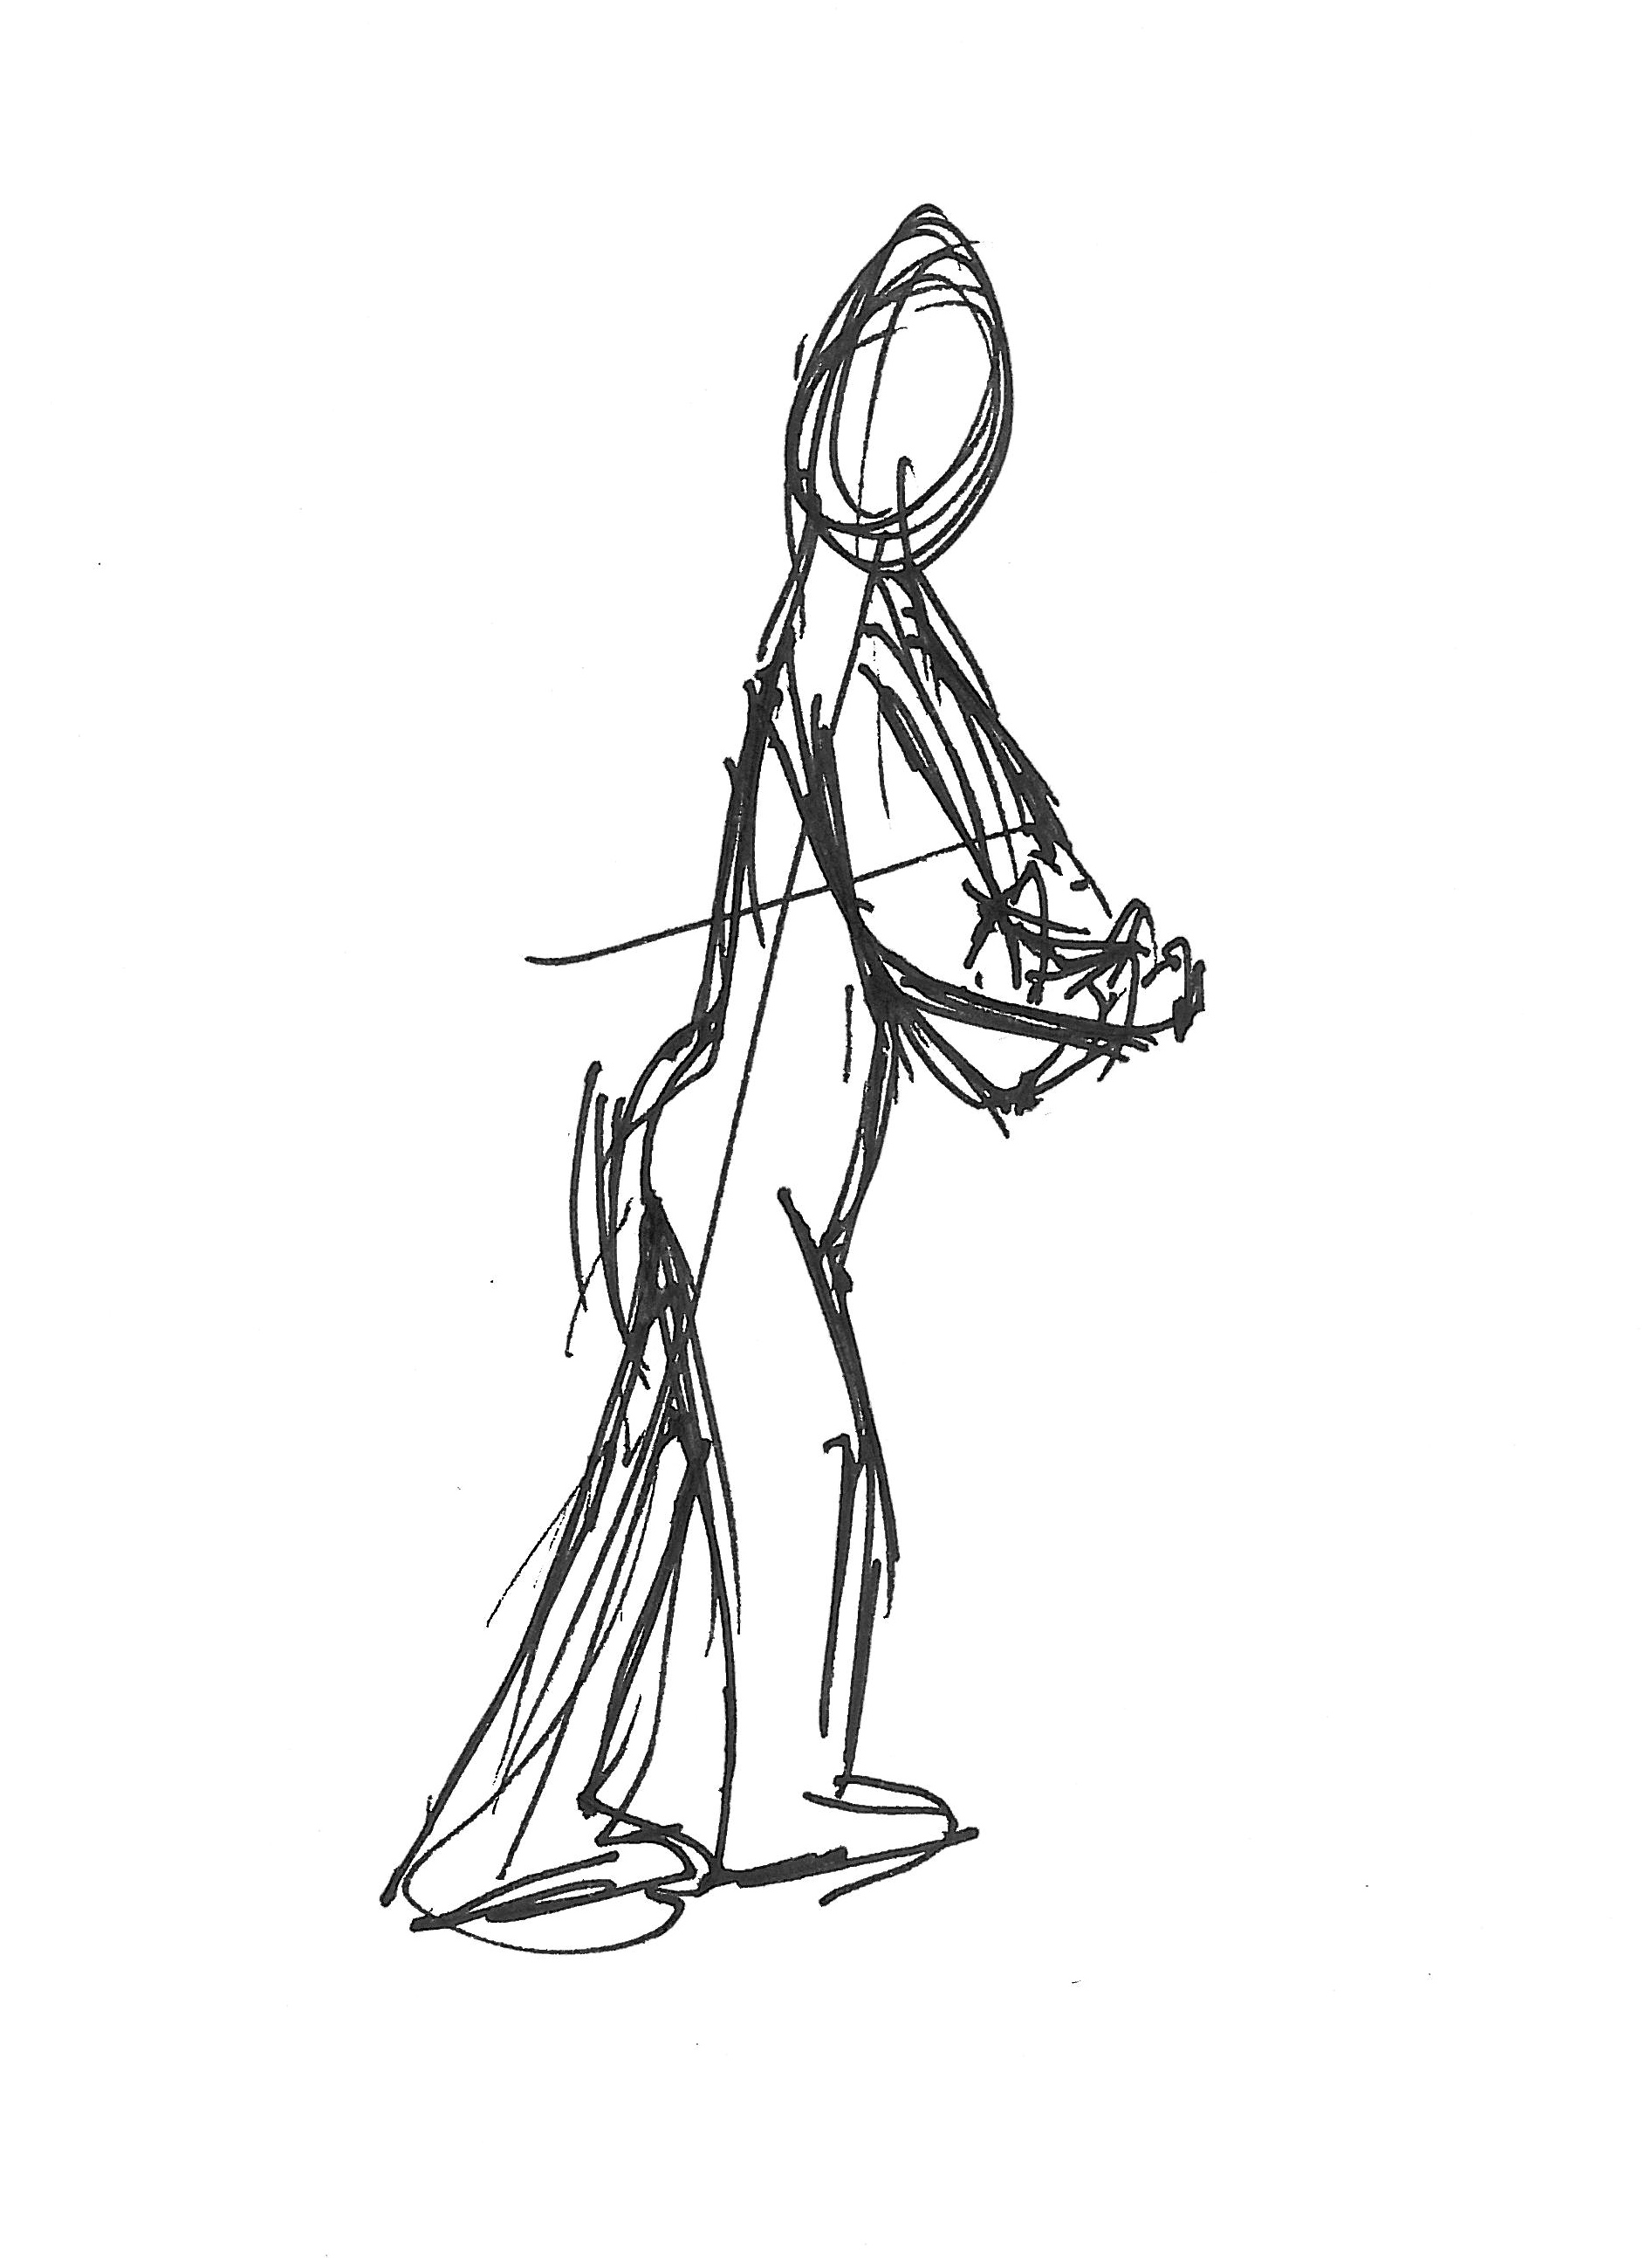
Figure 1: Notebook drawing to aid memorisation of the positioning of the body in kamae.

In jingju, teachers have told me that energy is considered to emanate from an area described as the dantian [丹田], an ‘energy centre’ situated towards the front of the waist just below the navel which is also cited in relation to Chinese martial arts, Qigong, and Taiji. Basic exercises aim to strengthen the yao as a means to cultivate stamina and suppleness in the dantian, which, in turn, supports all movement, from walking, to gesturing, to acrobatics. For instance, the feijiao [飞脚] ‘flying kick’ is one of the first acrobatic movements that an actor will learn, and involves kicking one leg outwards away from the body, followed by kicking the other leg inwards across the body so that it touches the opposite hand, whilst the body circles in the air (see figure 2, below). A strong and supple yao not only supports the strength of the kicks, but also enables the actor to leap higher into the air during the move by pushing the body upwards. That the yao supports movement in different directions is clear by comparing the above with the xuanzi (旋子), a jump that involves kicking the legs out backwards one after the other, with the upward motion extended into the hip, and with the navel facing towards the floor. When I first trained in this movement, the teacher would stand behind me, and as I executed the move, he would grab my belt, forcing my hips upwards, enabling me to experience the kind of ‘flight’ that was essential to the movement. A supple yao allows the legs to extend flexibly, but a strong yao enables the kicking movements to generate power to assist the actor in travelling through the air.

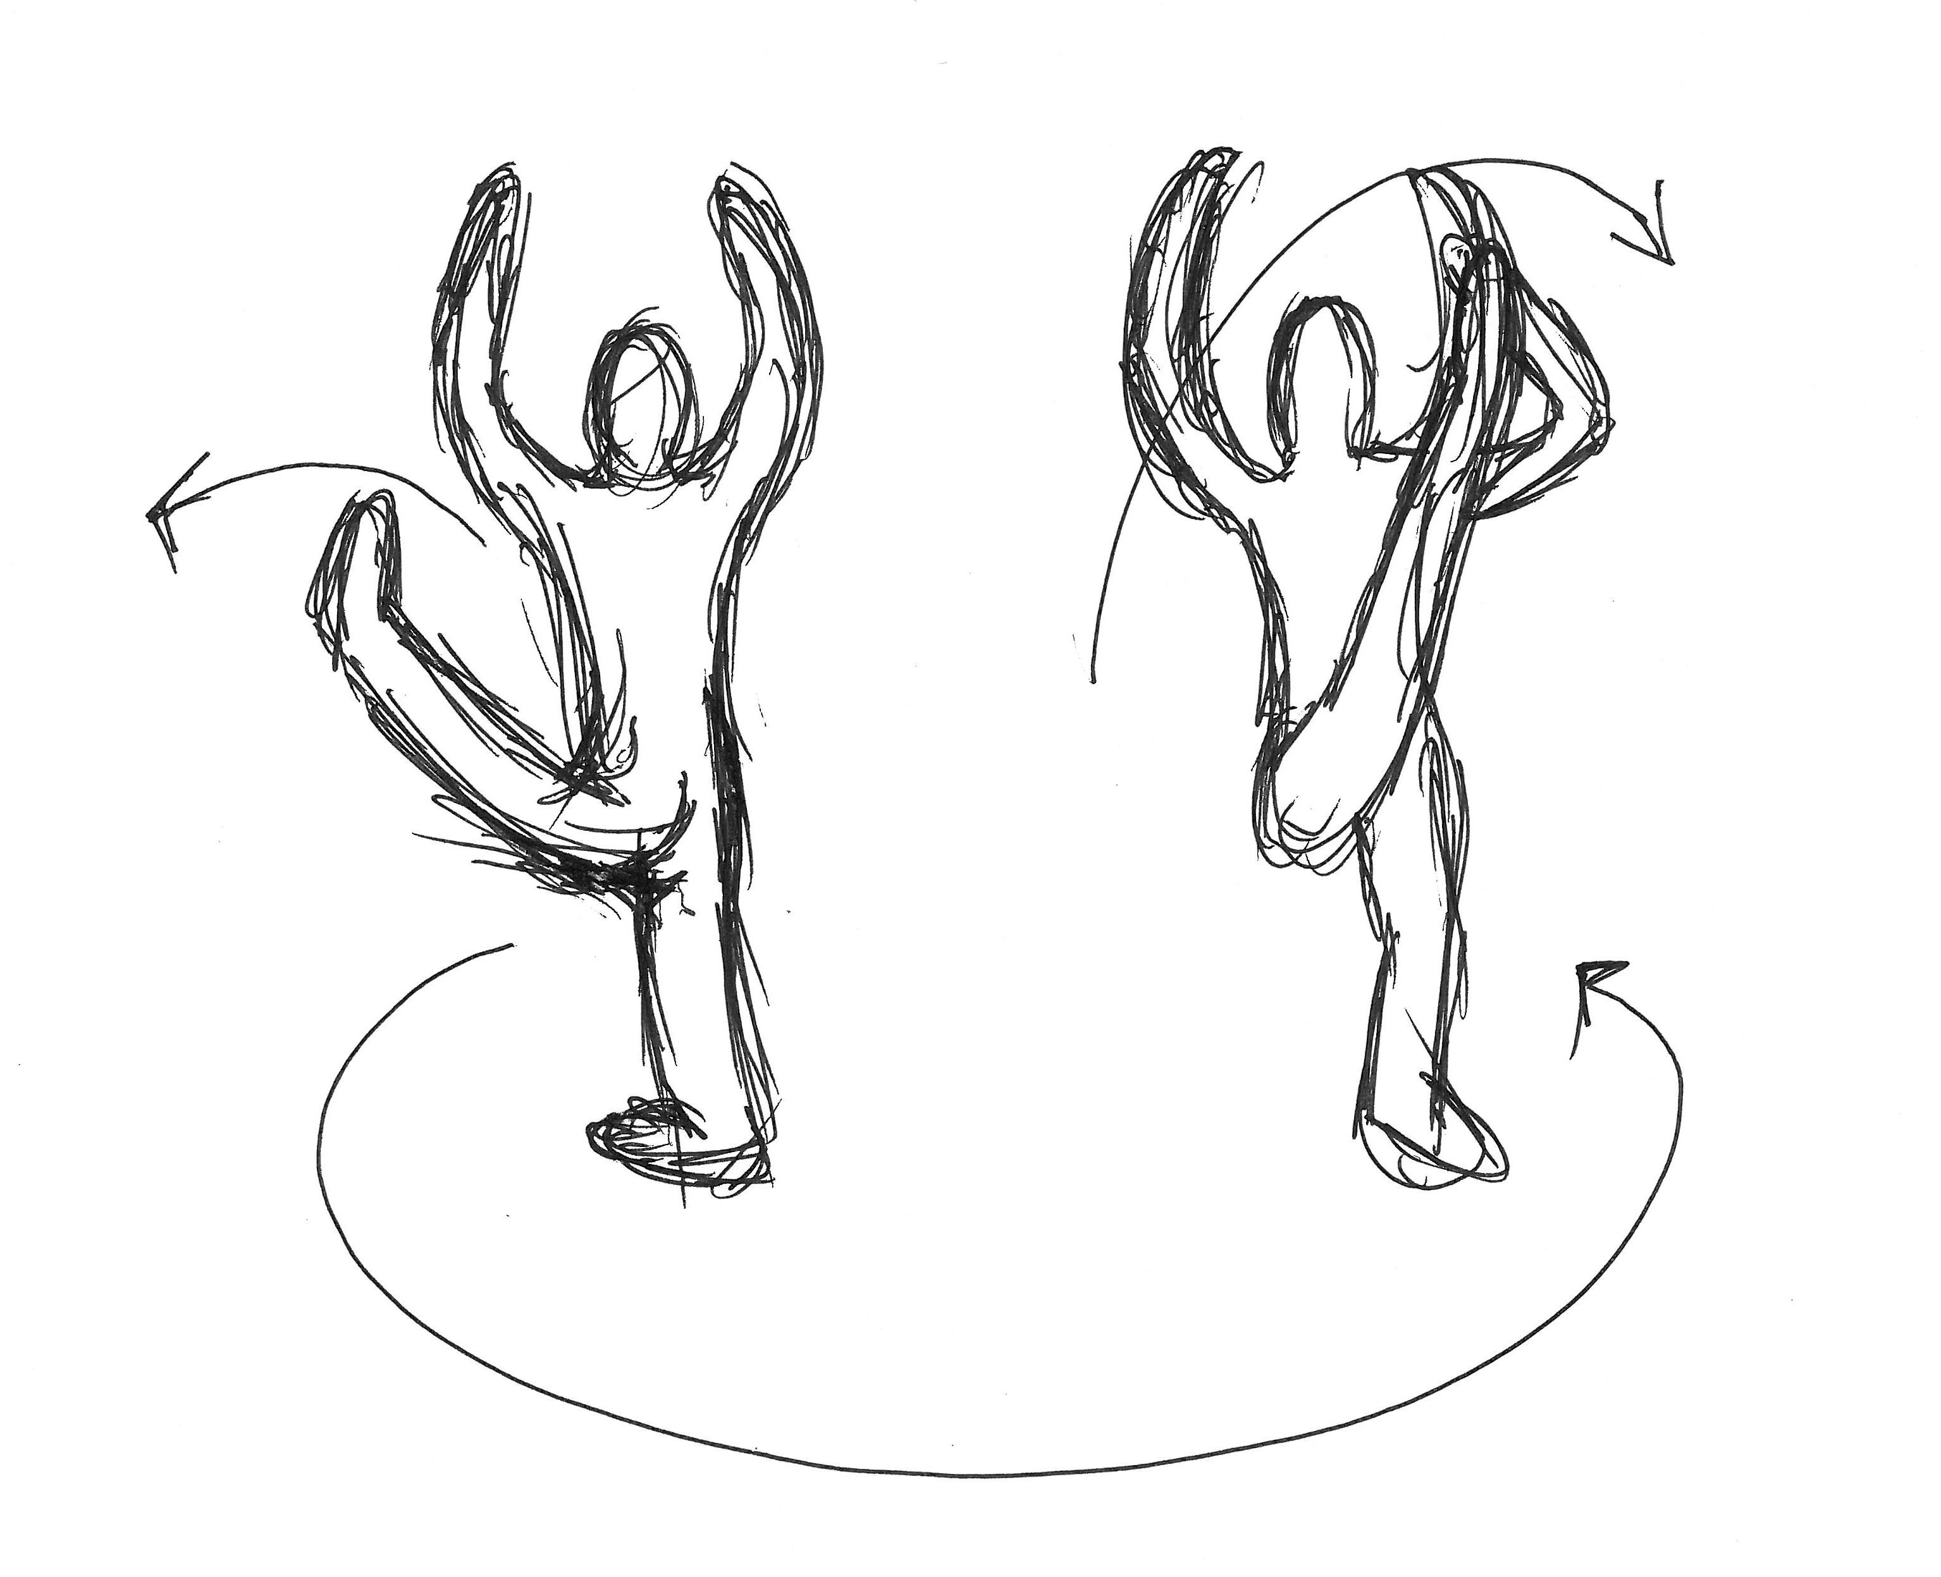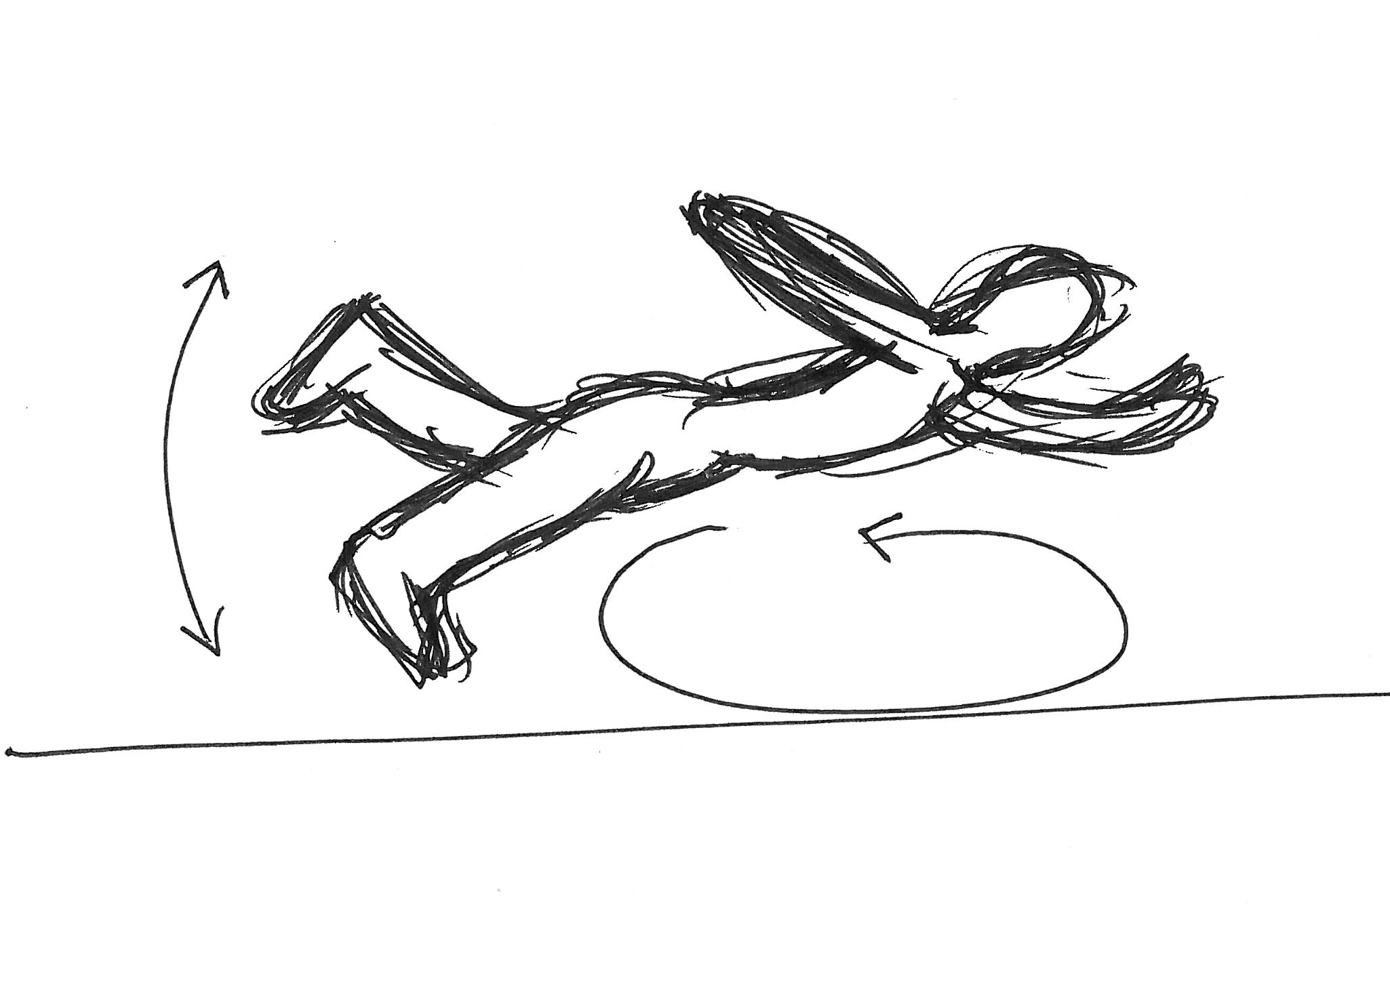
Figure 2: Notebook drawings of the feijiao (left) and xianzi (right) jumps.

The dantian, or tanden [丹田] in Japanese, is also significant to the management of energy in nô. As Mark Nearman has noted, the tanden is ‘located in the belly approximately two inches below the navel’ and is an important resource for the production of voice and movement (Nearman, 1982:347). I have found the tanden to be particularly crucial to voice projection when attempting to sing gôgin (‘hard’ style singing, in which microtonal shifts form melodic contours) passages. Not supporting the voice from the tanden strains the vocal chords, and the throat becomes sore very quickly. Yet, during longer periods of singing, a strong tanden is crucial to giving and sustaining strength in the voice. Whilst performing, at my current level at least, I remain challenged by the need to utilise the tanden to support the production of the voice upwards and outwards, but to utilise the rest of the koshi to enable movement. Dancing and singing requires absolute mastery of breathing, and I sometimes find myself struggling to simultaneously dance and sing the chorus lines (e.g. for teaching/demonstration purposes).
From the above, I have discerned that energy is generated from different areas in the yao/koshi in nô and jingju. Yet, controlling the production of energy from this area of the body, and channelling it in a productive way according to the demands of the specific movement being undertaken, is centrally important to the actor’s movement in both forms. Energy is channelled around the body by holding different parts in states of relaxation and tension. In nô, I have found that tension is held in the koshi as a means to help push the weight down the legs. This, in turn, creates appropriate resistance against the floor as weight is manipulated from one leg to the other as the foot slides along the floor during suriashi. The tension in the lower torso also acts as a foundation upon which the upper half of the spine rests. Yet, the shoulders need to carry tension without becoming stiffened or hunched, otherwise the spine ceases to be straightened and the shape of the body starts to collapse inwards. Similarly, the arms need to be held out with support coming from the underneath of the arm, through the triceps, and with the biceps relaxed. A small amount of tension may be found in the wrist, but the hand is essentially relaxed. I found this combination of relaxation and tension to be crucial in giving movement energy and shape, but also expression and fluidity.
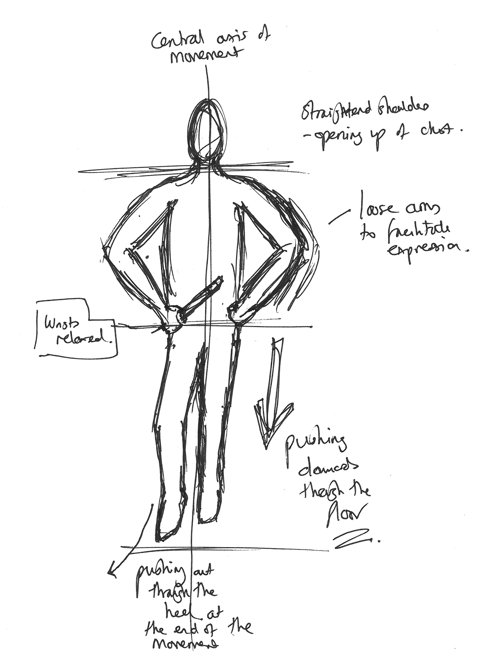
Figure 3: Notebook drawing exploring tension and relaxation in the body. The guidelines I originally used to draw out the body in proportion coincidentally came to highlight lines of energy flow as I experienced them (e.g. from koshi, up the spine, out through the shoulders and down through the arms).

I also discerned a similar opposition between tension and looseness in jingju. The shanbang [山膀] ‘mountain arms’ position (see figure 4, left), which as a part of the basic training can be held for several minutes to build strength in the arms, is also configured according to the distribution of tension and relaxation. As in nô, the chest must remain open but it must also work to ‘contain’ [hanxiong, 含胸] qi via a slight bringing in of the shoulders. This facilitates the upward channelling of qi from the dantian, crucial in the maintenance of posture, the production of the voice, and in understanding how the concept of yao extends upwards through the body.
The holding in of the stomach – pulling the navel inwards as though it were attempting to reach the spine – emphasises the importance of the yao in supporting the movement. Actors speak of elongating the torso [zhangshen长身] from the waist to the head. This elongation is crucial in supporting each of the ‘five canons’ described above, and in freeing up the lungs for breath to support the voice. The arms are held in place from the triceps, and I was always encouraged to seek a straight line between my shoulders, elbow and the soft part of the hand between the little finger and wrist on the vertical plane, even though my arm was extending slightly forwards on the horizontal plane.
Furthermore, in shanbang, the legs are positioned in dingzibu [丁字步], the ‘ding character step’, where the right foot is placed in front of the left forming a shape similar to the Chinese character ding 丁. The effect of this position is to force the body into a slight twist: the upper body faces the front, but the waist points 45° to the right. The body is effectively facing two directions at once, and the twist is predominantly felt across the yao – the point where the upper and lower bodies meet. This twisting of the body is regarded as being aesthetically interesting for the audience: the lower part of the body becomes foreshortened, and the upper part appears more imposing. Thus, the tension produced by the dingzibu across the central axis of the yao has potency in the creation of stage presence.
This combination of tension and looseness was also required in movement, especially when training in walking at speed by circling the room (yuanchang). Here, the lumbar muscles play a central role in supporting the arms, else the shoulders begin to tire and become tense. The yao also plays an important part in keeping movement stable, so that the actor’s pelvis remains in a horizontal parallel to the floor. The achievement of this stability rests upon the containment of the chest [hanxiong] and the elongation of the torso [zhangshen] described above, coupled with pressing down into the floor [yatai, 压台] whilst keeping the knees supple. This facilitates the reconciliation of the upper and lower sections of the body [shangxia jiehe, 上下结合], affording the desired stability and control in all jingju movements, regardless of role-type.
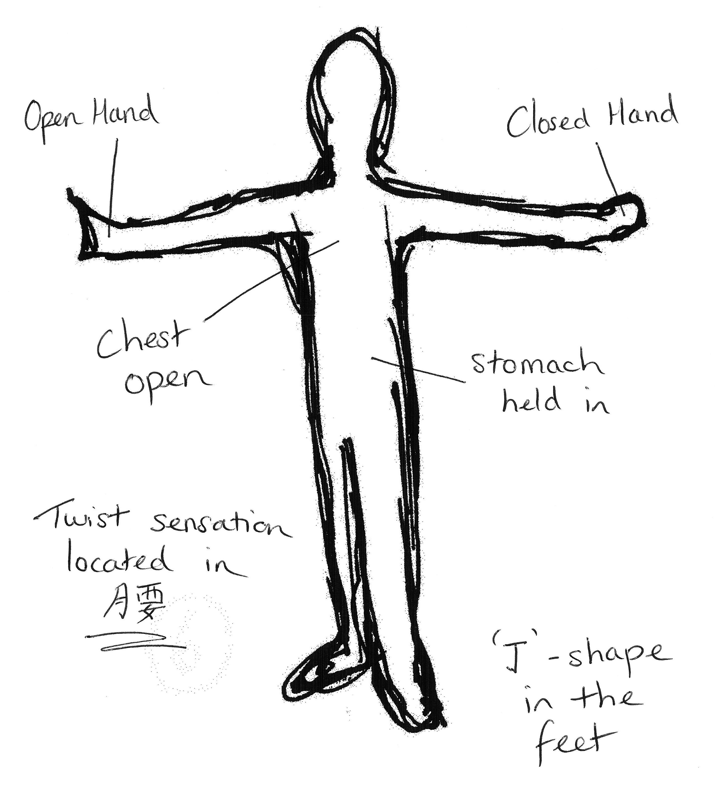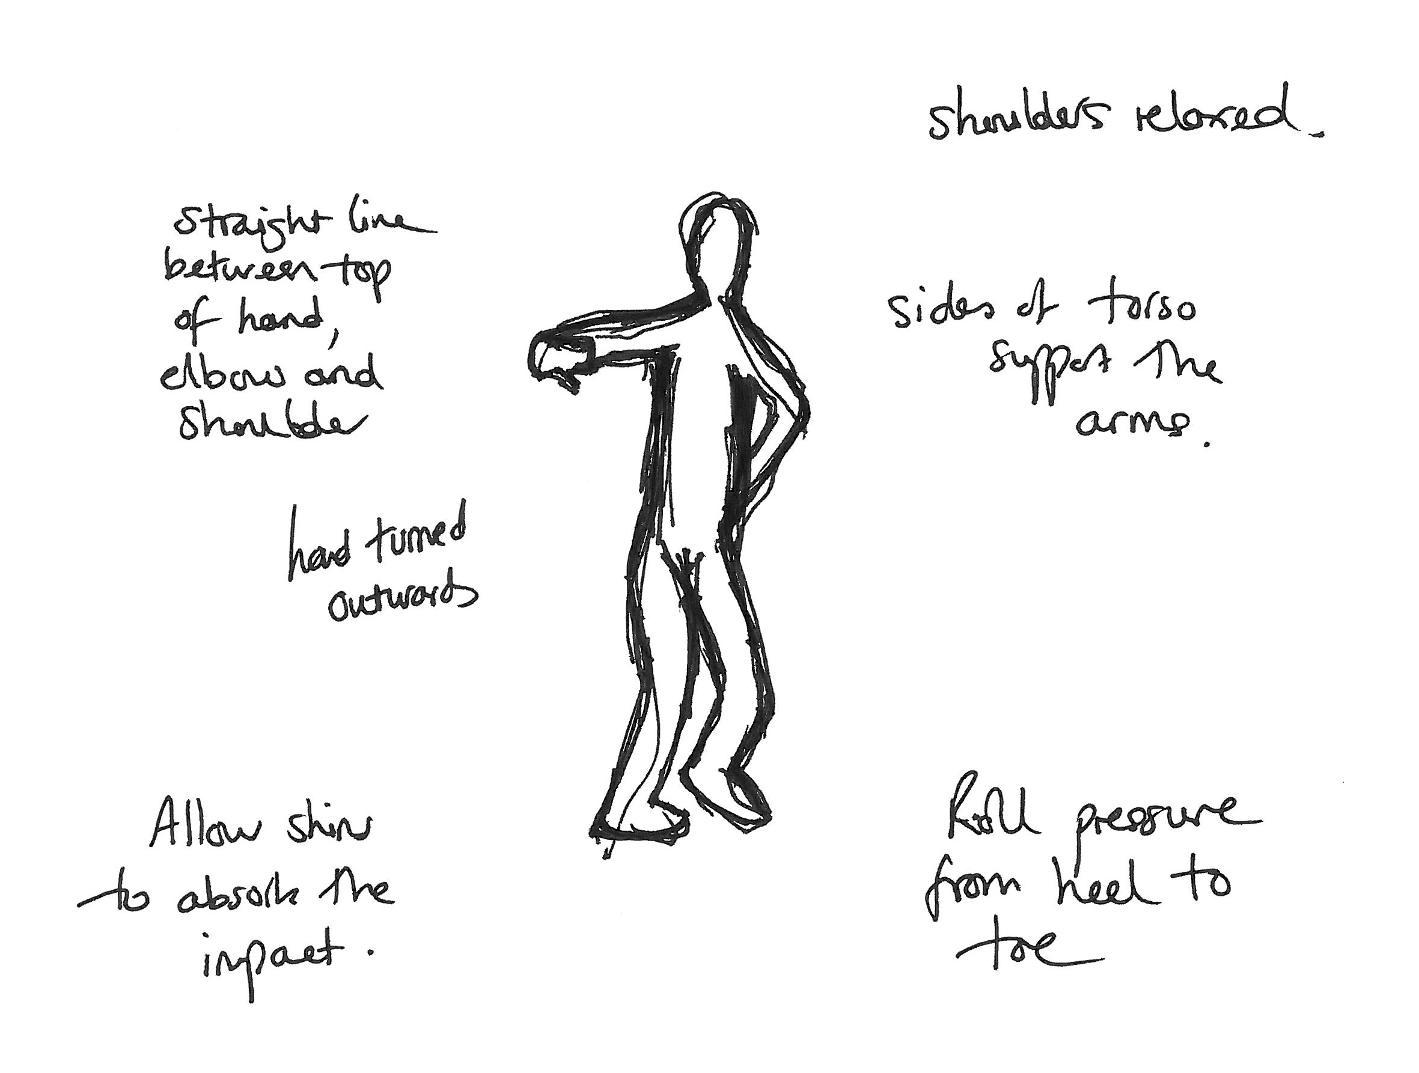
Figure 4: The shanbang or ‘mountain arms’ (left), and the male posture adopted when practising stage walking in the yuanchang exercise (right).

From my experiences, tension in the yao/koshi produces qi energy that is integral to sustaining posture in both nô and jingju. Ultimately, tension, held in balance and controlled effectively, functions as a productive force that supports movement. The cultivation of internal resistance is harnessed for expression through the looseness of certain areas of the body that enables energy to be released towards the audience. Thus, a gesture, supported by tension but released through looser parts of the body, can become more meaningful and aesthetically interesting. Control over the energy created in the waist also establishes important spatial axes between the performer’s yao/koshi and the floor, which, in turn, offers greater stability to the movement (this is, in fact, common across movement genres, including in Western dance). In both nô and jingju, the stability produced in the lower abdomen enables the actor to move across the stage whilst maintaining a horizontal parallel between the pelvis and the floor. This creates a distinct aesthetic effect: in nô, the actor seems to be rooted to the floor; in jingju, it gives the impression of the actor ‘floating’ across the stage.
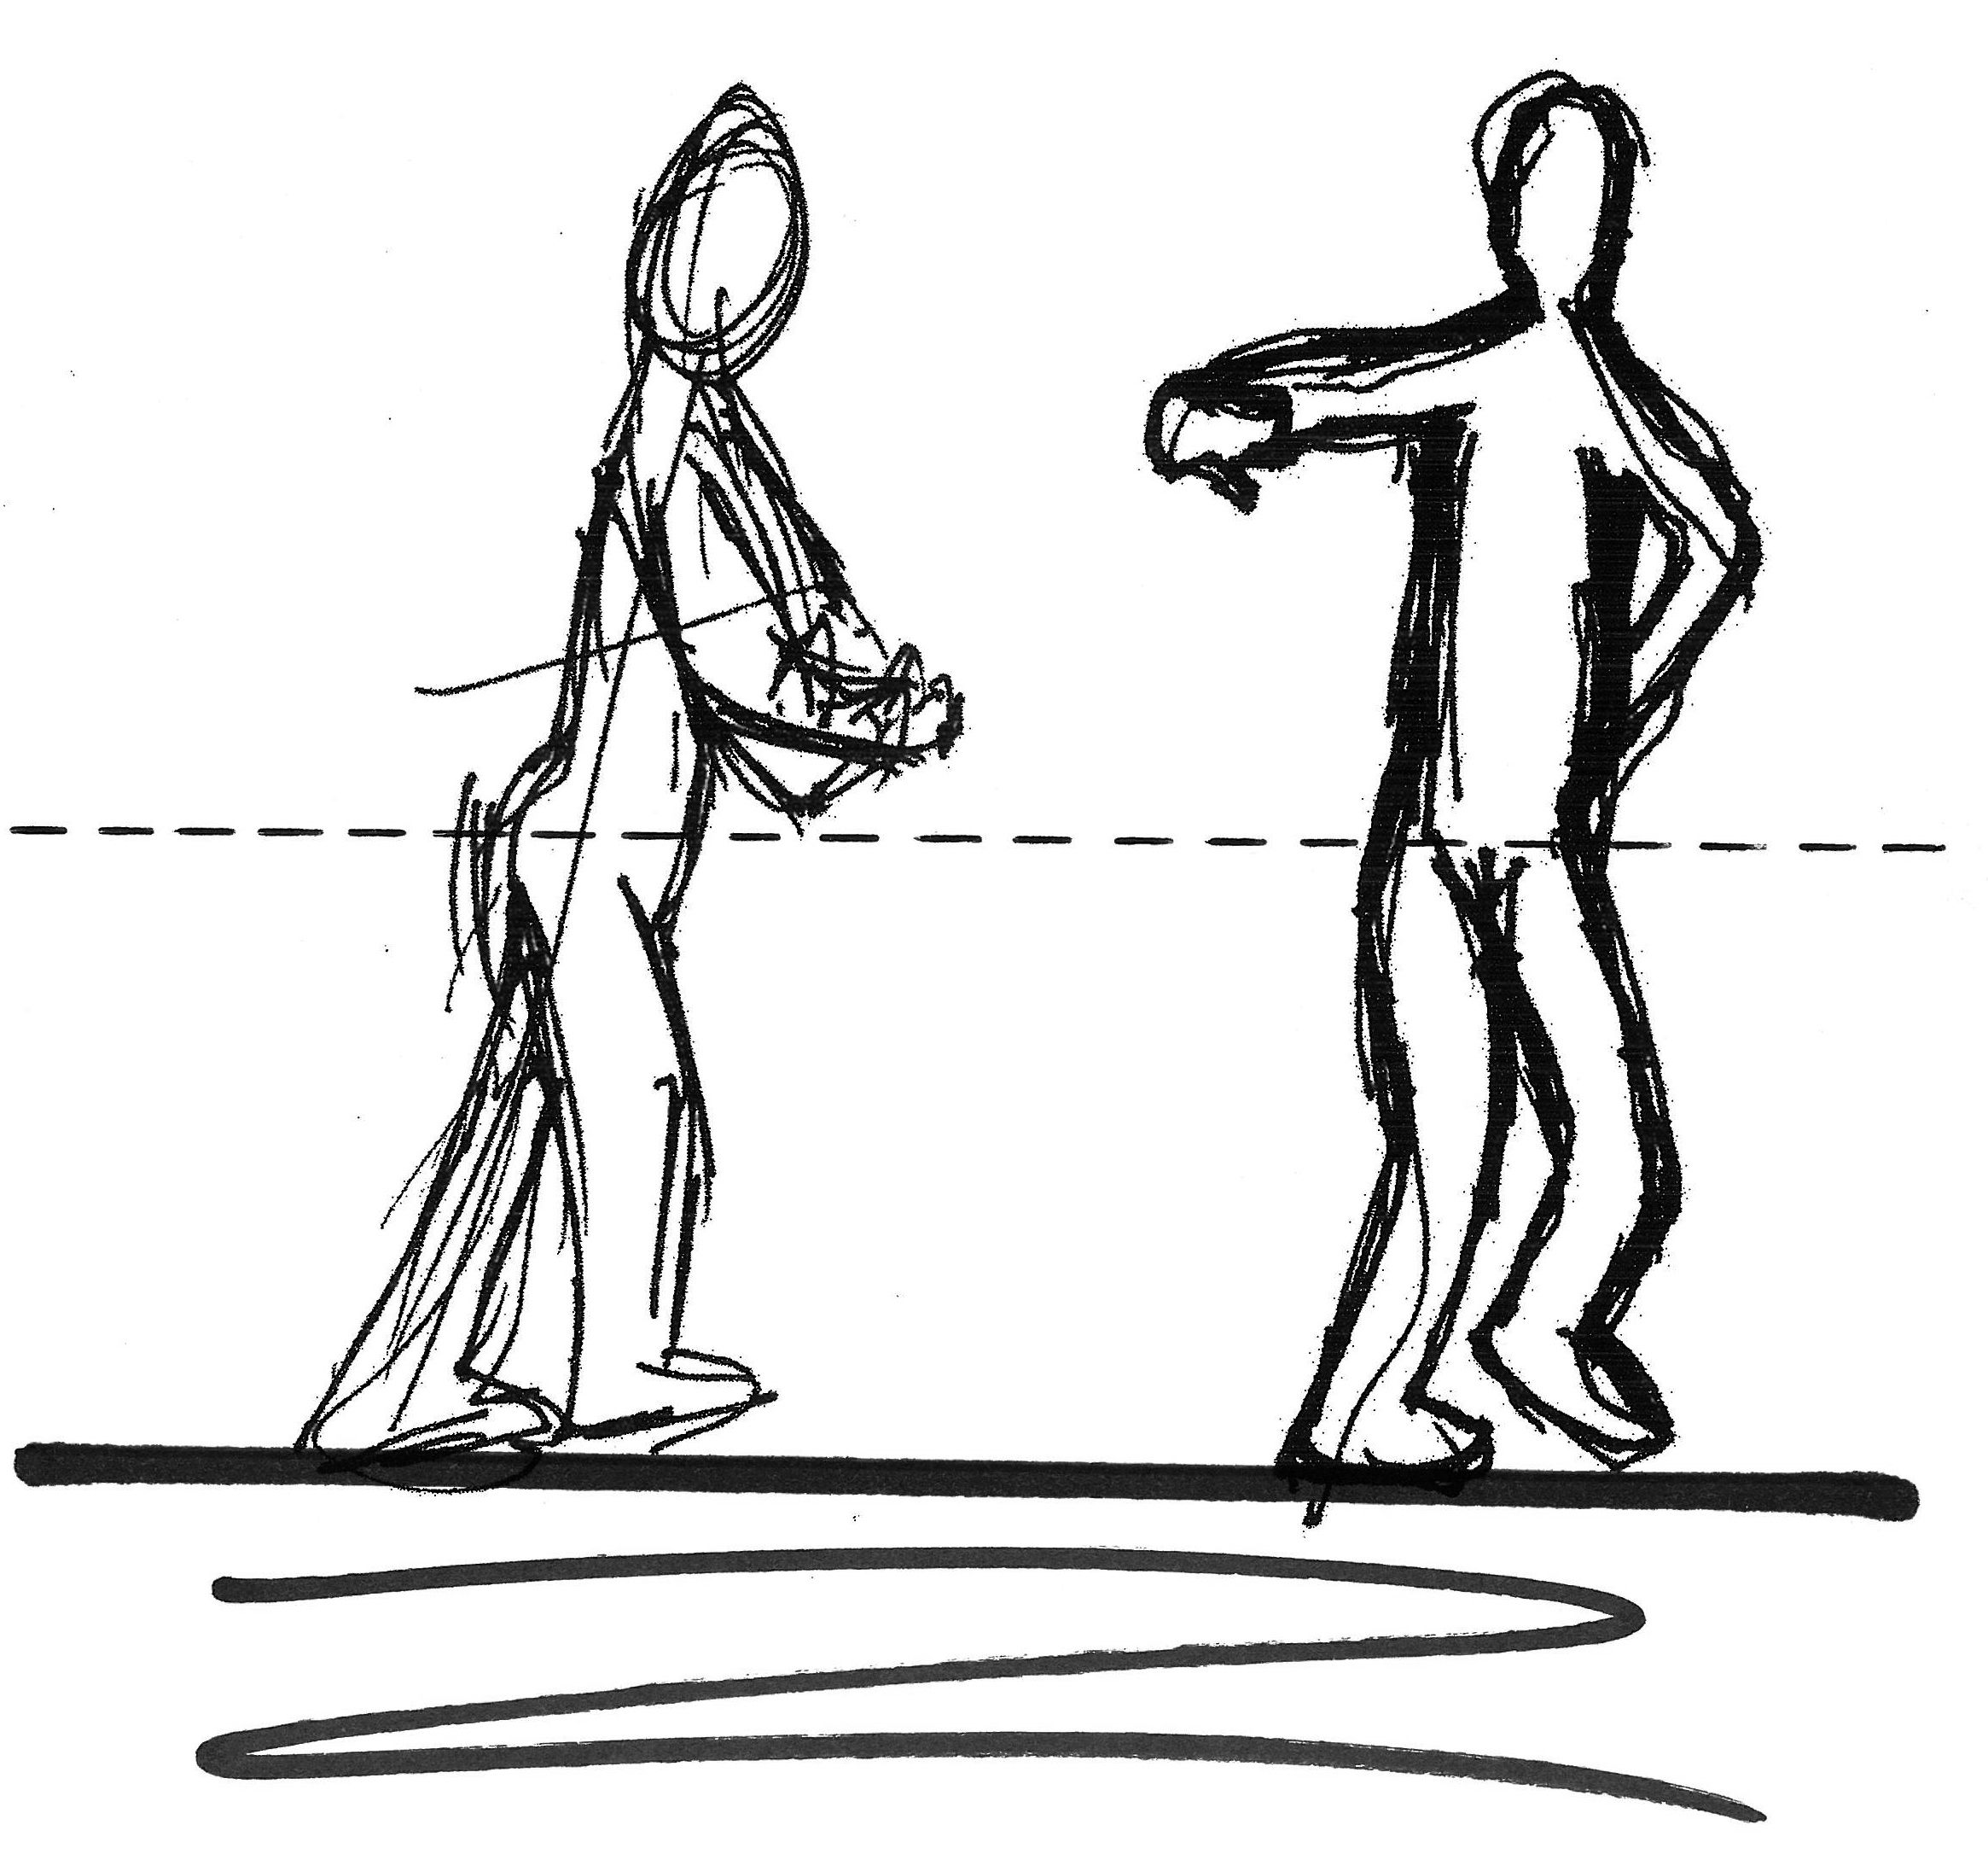
Figure 5: The importance of the yao/koshi moving horizontally parallel to the floor in nô (left), and jingju (right). The solid horizontal black line represents the floor, whilst the dotted horizontal line represents the imaginary line that the waist traces through space. Vertical arrows with a solid line represent the energy being pushed up or down, whilst the arrows with a dotted line represent acts of resistance to create presence.

The yao/koshi and the feet

The way in which the body makes contact with the floor through the feet in nô and jingju has been repeatedly stressed to me as important. In the initial stages of training in each form, I concentrated on how the foot engages with the surface of the floor. Yet, as I progressed, this shifted towards a consideration of how the feet engage with the core of energy emanating from the yao/koshi. I found this to be a particularly salient discovery in nô. The nature of the suriashi movement, the sliding of the foot along the floor, enables the performer to sense the contours of the floor surface. Yet, this only becomes truly possible once the relationship between the koshi and the feet is controlled, exerted by the shifting of weight between the two legs. This is not only crucial to suriashi, but to all kata that I have so far experienced: to misplace weight makes it difficult to move between kata, and I become more prone to mistakes when I am uncertain of how to distribute weight around my body. In addition, pressing into the floor too much creates excessive resistance that impedes the flow of the movement. Similarly, pressing too little liberates the body from tension, the horizontal parallel between the koshi and the floor weakens, and the body begins to ‘wobble’ when in motion.
In jingju, the connection between yao and feet is equally pronounced. One of the jiben gong exercises is called yatui, ‘stretching the legs’ [压腿], which involves increasing the flexibility of the legs by raising one leg on to a bar and pulling the torso closer to pull on the muscles. Daily repetition of these exercises, as well as through the kicking of the legs [ti, 踢] above the head, gradually builds strong and flexible leg muscles. This enables the concept of yao to extend into the upper thigh, which, in turn, distributes power down the legs. This connection of energy is required for the actor to perform even the most basic acrobatic move, such as the feijiao flying kick, described above.
In jingju stage walking, I have found that the relationship between the foot and the floor is differentiated to a higher degree than it is in nô. In nô, robust characters – warriors and demons etc. – are represented with feet positioned more widely apart and taking larger steps than the female, which tends to be closer with a slighter gait. Nevertheless, without seeking to diminish the variation this creates for both the performer and the audience, the differentiation arises from the same basic suriashi technique. In jingju, there is a wider variety of differentiation between gaits resulting from the role-type system. For example, the lao sheng ‘dignified male’ role makes a greater use of leg extensions by walking from side-to-side with legs turned out 45° from the body. In contrast, as in nô, the female roles have a smaller gait, but the sensation of movement is quite different. The foot ‘rolls’ across the floor in a more pronounced way, touching the floor from heel to toe. Lowering the centre of gravity means that the impact of the movement is felt most keenly in the ankles and lower shins. When first practicing, it is not uncommon to feel tension, even discomfort, in these areas once this has been practiced as a part of yuanchang (‘circling the floor’) for ten or fifteen minutes. It is as though one must push into the floor, yet resist sinking into it.

Principles of opening and closing

In summary, what I have felt is that, in both forms, energy is held in tension in the body emanating from a centre located in the core: situated towards the front of the body for jingju, and towards the back for nô. The release of energy through movement, unrestricted by the looseness of the knees, arms, wrists and hands, facilitates expression. Given that the internal body is held in a combined state of opposites, of tension and looseness, it is perhaps a logical outcome that specific movements may, depending on their form and whether they appear in isolation or as part of a series, also exhibit opposition as an aesthetically significant feature.
In these phenomenological sensations of tension and looseness, opening and closing, perhaps one possible point of connection between nô and jingju lies in the cosmological forces of in and yô, yin and yang [陰陽/阴阳] – dual forces identifiable in both Japanese and Chinese esotericism. The significance of yin and yang to jingju, both as an aesthetic principle and its function in constructing presence in the actor, is well documented. In nô, this discussion is perhaps less pronounced, yet Monica Bethe and Karen Brazell highlight the significance of yin and yang to the nô stage itself (Bethe and Brazell, 1982:17-20), Arthur Thornhill has translated into English Ichijô Kaneyoshi’s (1402-1481) Confucian interpretation of Komparu Zenchiku’s (1405-c.1470) Rokurin Ichiro no Ki [六輪一露之記], ‘A Record of Six Circles and One Dewdrop’, which explicitly draws upon the I-Ching (Thornhill, 1993:122-149) and Zeami himself explains in Kakyô how tone in the voice is achieved by the inhalation of breath (yin) and its exhalation (yang) (Zeami, 1984:75).
In nô, two movements that are often paired together are shikake [シカケ] and hiraki [ヒラキ]. Shikake involves stepping forward a number of steps (anything between two and eight or ten, depending on requirements), and ending with the right hand extended forwards and the fan pointing outwards perpendicular from the body, with the left hand extended at a lower level underneath. This movement, which is forward in motion and has a sense of closing in, is oftentimes followed by hiraki, a backward movement (usually three steps) that involves the extension of the arms outwards and away from the body, before returning them to their original kamae position. Paired together, these two kata express forward and backward motion, and have a visual rhythm of closing and opening, giving them a feeling of balance and totality in movement.
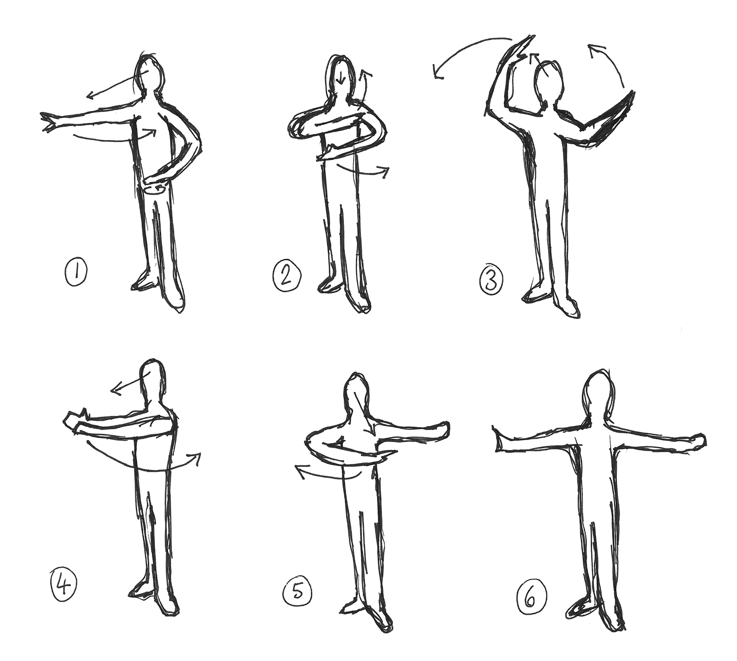
Figure 6: The yunshou (‘cloud hand’) movement from jingju.

In jingju, the same aesthetic ideas are present, but they can be discerned relatively clearly in one distinct movement. Yunshou (‘cloud hands’) is a practice movement that begins with the right arm extended outwards to the right side, and the left hand positioned at the base of the left rib cage (see figure 6, point 1). The right hand is first brought across the body (2), and is then raised to trace a clockwise circle above the head (3). During the movement of the right hand, the left hand follows behind it (3). Both hand cross to the right side of the body (4) and then over to the left, where the left hand forms a fist (5). The right hand then traces an arc across the body and returns to its original place. The movement ends with a liangxiang [亮相], in which the face (which has been following the movement of the right hand) is snapped forwards towards the front, and the eyes are opened (6). In considering this movement as a structure of oppositions, it can be seen that the body modulates between closure (2, 4, 5) and openness (1, 3, 6). Yunshou is part of the basic training in jingju because it encapsulates the essential qualities of all movement: opposition and circularity.
Although the above analysis is based upon my own experiences in training, they have been articulated elsewhere. For example, in discussing his own performances, the actor Zheng Faxiang has highlighted how in jingju:

The upper half of the body focuses on “revealing”, the lower half on “hiding”. The upper and lower halves of the body can be differentiated in nature but when in movement must become an organic whole. [… The four role-types of] sheng, dan, jing and chou all work on the same principle (Zheng, 1963:57-8, translation my own).

The coordination of tension, and the unification of opposing tendencies within the body, is crucial to generating roundness, circularity and beauty. Similarly, in Fûshikaden [風姿花伝], ‘Style and the Flower’, Zeami suggests that a nô actor may communicate the sentiments of a character more dramatically by uniting opposing energies;

When he moves himself about in a powerful way, he must stamp his foot in a gentle way. And when he stamps his feet strongly, he must hold the upper part of his body quiet (Zeami, 1984:58).

Here, the unification of opposites implies the actor should control the flow of energy around the body, and that there is dramatic potential in the bursting forth of energy, as well as in its restraint. Indeed, Zeami extended his explanation of restraint in Kakyô [花鏡] ‘Mirror Held to the Flower’, suggesting that ‘in terms of general stage deportment, no matter how slight a bodily action, if the motion is more restrained than the emotion behind it, the body will become the Substance and the emotion its Function, thus moving the audience’ (Zeami, 1984:75). Zeami thus implies that recognition of the actor’s own subjectivity through the imposition of enhanced restraint facilitates greater expression. In connecting this with my own experiences detailed above, I have come to recognise how tension is not an automatically obstructive force in performance. Rather, tension represents the building up of energy, and the control of its release from the yao / koshi creates expression and accentuation.

Conclusions

Whilst nô and jingju have different exterior aesthetics, an intersubjective analysis of my own training has revealed that the internal manipulation of flows of energy emanating from the bodily centre (dantian/tanden), the aesthetics of opening and closing movements in the generation of that energy, and the deployment of tension and its release as a means of creating stage presence and artistic expression, appear centrally significant to both forms. Intersubjective reflections reveal how key Daoist esoteric principles (in/ying and yô/yang, as well as ki/qi) are foundational to performance technique in both forms. More importantly, reflections on training enable me to pinpoint with precision how these principles are manifested in the body in corresponding and opposing ways.
There is a real risk, however, that the intersubjective metholodology I have proposed simply replicates the neo-imperialist impulse to use the personal to lay claim to the universal. Yet, resistance to the universal is, in fact, central to this methodology. This essay is itself an assemblage of intercultures: a written record of experiential lines of flight arising from the peculiarities of one person’s intercultural altercentric training. The conclusions are relative and context dependent, and the lines of flight pursued by another researcher, perhaps from a closer geographical locale to the originating context of the forms (e.g. in China or Japan), would produce different kinds of insights as they vault between different points in a multiplicity. They would, however, be equally subjective studies; it is important to resist the ethnic absolutist, and racist, notion that peoples of a particular geography must embody an irrefutably “authentic” understanding of local cultural contexts (Nascimento, 2009:49). My own subjective insights are gleaned from the subjective insights of my teachers who, themselves, are partial actors working within a multiple form in the context of globalisation. I propose that acknowledging the multiple positions from which I speak has the capacity to resist imperialist forms of closure that totalise the production of knowledge. In the first instance, of course, I speak of and for myself, but out of globalisation and the intersubjective nature of training methods, ‘since each of us was several, there was already quite a crowd’ (Deleuze and Guattari, 2009:3).

Bibliography
Bethe, M., and Brazell, K. (1982) Dance in the Nô Theater, Vol. 1, Dance Analysis.
Ithaca: Cornell University East Asia Programme.
Bharucha, R. (1990) Theatre and the World: Essays in Performance and Politics of
Culture. New Delhi: Manohar.
Braten, S. (2008) ‘Intersubjective Enactment by Virtue of Altercentric
Participation Supported by a Mirror System in Infant and Adult,’ in Enacting Intersubjectivity: A Cognitive and Social Perspective on the Study of Interactions. Morganti, F., Carassa, A. and Riva, G. (eds.) Amsterdam: IOS Press, 133-148.
Brown, J., and Brown, J. (2006) China, Korea, Japan: Culture and Customs. North
Charleston, South Carolina: BookSurge.
Crump, J. I., and Malm, W. P. (eds.) (1975) Chinese and Japanese Music-Dramas.
Ann Arbor: Center for Chinese Studies, The University of Michigan.
De Poorter, E. (2002) Zeami’s Talks on Saragaku. Amsterdam: Hotei.
Deleuze, G. and Guattari, F. (2009) A Thousand Plateaus. Massumi, B. (trans.)
London: Continuum.
Donahue, G. (2010) ‘Koshi / Yao: An Introduction’,
<http://www.fightingarts.com/reading/article.php?id=663> [Date accessed: 10 November 2014].
Dong W. 董维贤 (1981) Jingju Liupai (Schools of Jingju, 京剧流派). Beijing:
Wenhua Yishu Chubanshe.
Frank, A. (2006) Taijiquan and the Search for the Little Old Chinese Man. New
York: Palgrave.
Griffiths, D. (1998) The Training of Noh Actors and The Dove. Amsterdam:
Harwood.
Hare, T. (trans.) (2008) Zeami: Performance Notes. New York: Columbia
University Press.
Holledge, J. and Tompkins, J. (2000) Women’s Intercultural Performance. London
& New York: Routledge.
Keller, P. (2008) ‘Joint Action in Music Performance,’ in Enacting
Intersubjectivity: A Cognitive and Social Perspective on the Study of Interactions. Morganti, F., Carassa, A. and Riva, G. (eds.) Amsterdam: IOS Press, 205-222.
Komparu, K. (1983) The Noh Theater: Principles and Perspectives, Corddry, J. and
Comee, S. (trans.). New York: Weatherhill.
Li, R. (2010) The Soul of Beijing Opera: Theatrical Creativity and Continuity in the
Changing World. Hong Kong: University of Hong Kong Press.
Lo, J. and Gilbert, H. (2002) ‘Toward a Topography of Cross-Cultural Theatre
Praxis,’ TDR, 46.3, 31-53.
Nascimento, C. T. (2009) Crossing Cultural Borders Through The Actor’s Work.
New York: Routledge.

Nearman, M. (1982) ‘Kakyo: A Mirror of the Flower. Part One,’ Monumenta
Nipoonica, 37:3, 343-374.
Pavis, P. (1992) Theatre at the Crossroads of Culture. London and New York:
Routledge.
Quinn, S. F. (2005) Developing Zeami: The Noh Actor’s Attunement in Practice.
Honolulu: University of Hawaii Press.
Riley, J. (1997) Chinese Theatre and the Actor in Performance. Cambridge:
Cambridge University Press.
Rodrik, D. (2005) ‘Has Globalization Gone Too Far?’ in The Global
Transformations Reader. Held, D. and McGrew, A. (eds.) Cambridge: Polity Press, 379-383.
Said, E. (1994) Culture and Imperialism. London: Vantage.
Shanghai Yishu Yanjiusuo上海艺术研究所. (1981) Zhongguo Xiqu Quyi Cidian (A
Dictionary of Chinese Xiqu Artistry,中国戏曲曲艺词典). Shanghai: Shanghai Cishu Chubanshe.
Tian, M. (2004) ‘Chinese Nuo and Japanese Noh: Nuo's Role in the Origination
and Formation of Noh’, Comparative Drama, 37:3, 343-360.
the-Noh.com. (2010) ‘doshite enja ga ugokanai jikan ga nagai no?’ (‘Why do
performers spend so much time in stillness?’ ‘どうして演者が動かない時
間が長いの？’) <http://www.the-noh.com/jp/trivia/077.html>[Date accessed: 23 October 2014].
Thornhill, A. (1993) Six Circles, One Dewdrop: The Religio-Aesthetic World of
Komparu Zenchiku. Princeton: Princeton University Press.
Thorpe, A. (2007) The Role of the Chou (“Clown”) in Traditional Chinese Drama:
Comedy, Criticism, and Cosmology on the Chinese Stage. Lewiston: Edwin Mellen Press.
--------. (2011) ‘Style, experimentation and Jingju (Beijing Opera) as a decentered
multiplicity,’ Studies in Theatre & Performance, 31:3, 275-291.
--------. (2014) ‘How can Westerners study Japanese Noh? An Interview with
Richard Emmert, Director of Noh Training Project and Theatre Nohgaku,’ Theatre, Dance and Performance Training, 5:3, 321-333.
Tomlinson, J. (2005) ‘Globalization and Cultural Identity,’ in The Global
Transformations Reader. Held, D. and McGrew, A. eds. Cambridge: Polity Press, 269-77.
Tsakiris, M. (2008) ‘The Self-Other Distinction: Insights from Self-Recognition
Experiments,’ in Enacting Intersubjectivity: A Cognitive and Social Perspective on the Study of Interactions. Morganti, F., Carassa, A. and Riva, G. (eds.) Amsterdam: IOS Press, 149-164.
Varley, H.P. (2000) Japanese Culture. 4th edn. Honolulu: University of Hawaii
Press.
Yokoyama T. 横山 太郎 (2015) ‘Doko made ga nōdatta no ka?― Rekishi-teki ni
mita nō no rinkaku,’ (‘To What Extent was it Nô? – the Historical Contours of Nô’, ‘どこまでが能だったのか？―歴史的に見た能の輪郭’), in Nôgaku no Genzai to Mirai (The Present and Future of Nô, 能楽の現在と未来), ed. Yamanaka R.. Tokyo: Hosei University, 115-135.
Zeami, M. (1984) On the Art of the Nô Drama: The Major Treatises of Zeami.
Rimer, J.T. and Masakasu, Y. (trans.). Princeton: Princeton University Press.
Zheng F. 郑法祥 (1963) Can Wukongxi Biaoyan Yishu (Talks on the Artistry of
Wukong Performance, 谈悟空戏表演艺术). Shanghai: Shanghai Wenyi Chubanshe.

There are five main actor shite schools [シテ方] in Nô: Kanze [観世], Hôshô [宝生], Komparu [金春], Kongô [金剛], and Kita [喜多]. Supporting Waki actors and musicians also have different schools.
Dong Weixian suggests that there might be as many as eighty liupai in Jingju, though this seems a little generous. See Dong, 1981.
Important insights concerning technique in Nô can be found in: Bethe and Brazell, 1982; Komparu, 1983, and Griffiths, 1998. For an excellent overview of jiben gong, see Li, 2010:55-81. The significance of cosmological ideas to the principles of jingju movement is discussed in Riley, 1997.
For a translation of Zeami’s writings, see: Zeami 1984; De Poorter, 2002; and Hare, 2008.
See, for example, the-Noh.com, 2010.
The fourth of the five canons, fa, is sometimes written as fa [发], used to specifically refer to a number of skilled, technical movements used for expression, such as shuaifa [甩发], which involves swinging a long tuft of hair around the head to express distraction or agitation.
See: Li, 2010:63-4; Riley, 1997:237-48 and Thorpe, 2007:240-46.
The term ‘shikake’ is used by the Kita, Hôshô and Kongô schools. In the Kanze school, this movement is called ‘sashikomi’ [さし込み], and in the Komparu school, it is called ‘sashi’ [さし].

