Are organic films from atmospheric aerosol and sea water inert to oxidation by ozone at the air-water interface?
Stephanie H. Jones^{1,2}, Martin D. King¹, Andrew D. Ward², Adrian R. Rennie³, Alex C. Jones¹, Thomas Arnold⁴
¹Department of Earth Sciences, Royal Holloway, University of London, Egham, Surrey, TW20 0EX, United Kingdom
²STFC, Central Laser Facility, Research Complex at Harwell, Rutherford Appleton Laboratory, Harwell Oxford, Didcot, Oxfordshire, OX11 0FA, United Kingdom
³Department of Physics and Astronomy, Uppsala University, 75120 Uppsala, Sweden
⁴Diamond Light Source, Harwell Oxford, Didcot, OX11 0DE, United Kingdom
Correspondence to: Martin D. King (m.king@rhul.ac.uk)
Abstract
The heterogeneous oxidation of thin films of organic material extracted from real aerosol and sea-water samples was studied at the air-water interface using X-ray reflectivity. Oxidation of thin films of organic material extracted from real aerosol and sea-water are important in further understanding the impact of coated aerosols on the climate. Surface active insoluble organic material extracted from the atmosphere was found to form stable films at the air-water interface. On exposure of the films to gas-phase ozone, no reaction (or change in the relative scattering length of the interface) was observed, indicating a potential lack of unsaturated organic material in the samples. Gas chromatography and electrospray ionization mass spectrometry showed the presence of saturated compounds in the samples. It is therefore proposed that the amount of unsaturated compounds as compared to saturated compounds in the atmospheric material is so low that the mass spectrometry analyses, as well as gas-phase oxidation are dominated by saturated material. A reaction was observed on exposure of the same films to aqueous phase hydroxyl and nitrate radicals and a film thinning mechanism is proposed to explain the change in scattering length of the film at the air-water interface. It can be suggested tentatively that oxidation by gas-phase ozone is not important in the atmosphere for organic films on aqueous atmospheric aerosol and that further studies should focus on radical induced oxidation of saturated organic material instead of unsaturated proxies that are typically studied.
Keywords: atmospheric aerosol, sea-water, thin film, heterogeneous oxidation, ozone, OH radical, X-ray reflectivity

1 Introduction
Atmospheric aerosols play a critical role in the Earth’s climate by directly scattering and absorbing solar radiation, and indirectly, through their involvement in cloud formation and their associated influence on cloud radiative properties (e.g. Ellison et al., 1999, Pandis et al., 1995, Pöschl, 2005, Quinn et al., 2015, Stocker et al., 2013). The indirect effect i.e. aerosol contribution to cloud condensation nuclei formation (CCN) and cloud properties (Lohmann et al., 2005, McFiggans et al., 2005, Stocker et al., 2013), remains largely uncertain and a number of studies have been conducted to reduce the level of uncertainty (e.g. Lohman et al., 2005, Pandis et al., 1995, Pöschl, 2005, Ramanathan et al., 2001).
Aerosols are chemically complex (Pöschl, 2005, Prather et al., 2013, Wang et al., 2015) and studies have shown that a significant number of tropospheric aerosols are coated with a thin organic film that can affect aerosol properties and behaviour, therefore impacting on aerosol contribution to the climate (Blanchard, 1964, Donaldson and Vaida, 2006, Finlayson-Pitts, 2009, Gill et al., 1983, Tervahattu et al., 2002 a), 2002 b)). One of the major types of natural aerosol, sea-salt aerosol, forms by wave breaking and/or bubble bursting action over the ocean (e.g. Woodcock et al., 1953, Mason, 1954, etc.). On formation, sea-salt aerosol becomes coated with a thin organic film that originates from the sea surface microlayer (see e.g. Donaldson and Vaida, 2006 and references therein). The sea surface microlayer consists of accumulated organic chemicals, specifically lipids and fatty acids arising from oceanic biota, that have decayed (see e.g. Donaldson et al., 2012 and references therein, Patterson et al., 2016). Owing to the variety of chemicals present in the troposphere, it is also possible for uncoated aerosols to become coated during their lifetime, when low volatility compounds partition to a particle, (see e.g. Andrews and Larson, 1993, Falkovich et al., 2004). Aerosols coated with thin organic films are naturally abundant in the atmosphere and in order to better understand aerosol contribution to the indirect effect, it is pertinent to study the reactions that they may undergo in order to assess the impact of the presence of a thin film on their behaviour.
Tropospheric aerosol will undergo oxidation by common gas and liquid phase oxidants such as O₃, ·OH and NO₃· radicals (see e.g. Herrmann, 2003). Chemical oxidation of an aerosol will alter the hygroscopic properties of the aerosol which in turn can affect aerosol ability to act as CCN as well as the surface tension of the aerosol (Eliason et al., 2004, Sun et al., 2006).
The aim of the experiment described here was to study the oxidation of real organic thin films, ~10-50 Å in thickness (organics extracted from aerosol and sea-water samples) at the air-water interface using X-ray reflectivity. X-ray reflectivity allows the determination of film thickness and the scattering length density of material at air-water interface to be monitored. Scattering length density is a function of the amount and identity of nuclei at the air-water interface. Oxidation with gas-phase ozone, a prevalent atmospheric oxidant, was initially studied with organic material extracted from either atmospheric aerosol or sea-water samples. Subsequently, studies with the aqueous ·OH radical (Herrmann, 2003) and the aqueous NO₃· radical (Herrmann, 2003) were conducted with organic material extracted from atmospheric aerosol and sea-water samples respectively. Different reactions were studied in order to observe the difference between addition to a carbon-carbon double bond (i.e. reaction with ozone) and a hydrogen abstraction (i.e. reaction with ·OH and NO₃· radicals) from a saturated part of the film molecule. The overall study will allow comparison between the oxidation of real atmospheric samples with studies conducted using atmospheric proxies.
To date, as far as the authors are aware, no previous studies have been conducted on the oxidation of organic films spread at the air-water interface extracted from real atmospheric aerosol or sea water samples. Related studies have been conducted using real sea water samples focussed on the composition of the sea surface microlayer (Ciuraru et al., 2015 and Zhou et al., 2015) and on the effect of actinic radiation (Vaida, 2016) in the bulk (Ciuraru et al., 2015) and at the air-water interface (Rossignol et al., 2016). Ciuraru et al., 2015 studied how dissolved organic matter in subsurface water can affect the composition of the sea surface microlayer when exposed to light from a Xenon lamp mimicking natural sunlight. Ciuraru et al., 2015 showed that a photosensitive process caused unsaturated organic compounds to be released into the gaseous phase. Rossignol et al., 2016 focussed their study on a monolayer of nonanoic acid at the air-water interface and also used a Xenon lamp to illuminate the air-water interface. Following illumination, unsaturated compounds were measured in both the gaseous and condensed phases. Rossignol et al., 2016 discussed formation mechanisms for these products and concluded that the production of these compounds could affect the oxidative nature of the atmosphere as well as secondary organic aerosol formation thus impacting on the climate. Zhou et al., 2015 investigated the heterogeneous oxidation of a bulk sea surface microlayer sample and measured a number of oxygenated volatile carbonyls. The work presented here determines whether chemical material extracted from atmospheric aerosol and sea-water forms a thin film on aqueous atmospheric aerosol and whether such films react with common atmospheric oxidants using X-ray reflectivity. The outcome of the reactions will also provide insight into whether common atmospheric proxies, usually selected on the basis of analytical studies conducted on ensemble aerosol samples (e.g. Tervahattu et al., 2002, a), b), Ebben et al., 2012, Rogge et al., 1991, 1993), chemically react and behave in the same way as coatings extracted from natural aerosols.

2 Material and methods

2.1 Aerosol sampling and extraction
Atmospheric aerosol samples were collected using two different sampling methods. Tropospheric air was drawn through clean stainless steel tubing into either an inline flow through filter sampler (Savillex, 47 mm Stage Filter Assembly, made from perfluoroalkoxyalkane polymer (PFA)) or a ChemComb Model 3500 speciation sampling cartridge, using an SKC flow metered aerosol pump at a controlled flow rate of 10 L min⁻¹, at ambient temperature (~10-20 °C) and pressure. Samples were collected on 47 mm pre-combusted quartz filters (SKC, Type R-100, 380 µm thick).
The ChemComb sampling cartridge consisted of two glass denuders which were either coated or uncoated (e.g. Koutrakis et al., 1993, Helmig, 1997) and a quartz filter. ChemComb denuders coated in sodium thiosulfate were used to remove ambient gas-phase ozone from the sampled air in order to prevent oxidation of material on the filter by ambient ozone. The ChemComb sampling cartridge also had a built in PM-2.5 impactor at the inlet. All samples were collected on site at Royal Holloway University of London, in Egham, Surrey, UK, 51.4289 N, 0.5479 W, approximately 20 m above the ground (see Table A.1). Samples were collected for time periods ranging from one to five weeks between September 2013 and February 2014. The site is a few km from three of the UK’s busiest motorways and a few km from a major international airport and central London.
To determine the origin of the sampled air masses, archived back trajectories were run using the online National Oceanic and Atmospheric Administration Hybrid Single Particle Lagrangian Integrated Trajectory (NOAA HYSPLIT) model (Draxler and Rolph, 2015, Rolph, 2015). A basic map of air mass sources was devised to estimate the origin of the sampled air masses, three air mass regions were allocated; marine (originating from the Atlantic ocean), polluted/European and Arctic. For each day that a sample was collected, the NOAA HYSPLIT model was used to calculate a normal trajectory from one starting location using GDAS meteorology for 240 hours, starting in Egham, at 100 m above ground level with isentropic vertical motion. A back trajectory map was produced and the general air mass character of the source for each sample was allocated based on the predominant air source for the filter period.
The materials used during the sampling collection and preparation were either Pyrex or polytetrafluoroethylene (PTFE) and had been thoroughly washed and rinsed with chloroform prior to use. The quartz filters were pre-combusted by the manufacturer to remove any organics prior to use. All sample manipulation, assembly and disassembly using both methods i.e. filter sampler and ChemComb sampling cartridge were performed in a controlled clean atmosphere in a glove bag to prevent any contamination. The samples were stored at ~ -18 °C post sampling and were usually extracted within 1-2 weeks of being stored and within at least 6 weeks of being stored. To extract the film forming organic material, the quartz filters were halved and one half was cut into small pieces using a stainless steel knife on a clean PTFE cutting block in a glove bag. The pieces were subsequently placed into a flask and pure water (>18 MΩ cm) and chloroform (Sigma-Aldrich, Chromosolv Plus, for HPLC, ≥99.9%, contains 0.5-1.0% ethanol as stabilizer) were added in a 1:1 ratio and the mixture was thoroughly shaken. A separating funnel was then used to extract the organics dissolved in chloroform from the water. Once separated, the chloroform was evaporated under a flow of pure dry nitrogen to leave the organics. Following evaporation, ~2 mL of chloroform was subsequently added to each dry sample and the samples stored at ~ -18 °C, before analysis by X-ray reflection. Filter blanks were also prepared, i.e. unused quartz filters were cut up and chloroform and water added in the same ratio as used for the aerosol samples and the same separation and drying procedure performed. A summary of samples and X-ray measurements is provided in Table A.1. Throughout the paper, a thin film of material extracted from atmospheric aerosol in chloroform will be referred to as ‘atmospheric film material’.

2.1.1 Sea water sampling and extraction
Surface sea-water samples (top ~10 cm of the ocean) were collected from the English Channel using a clean polypropylene bucket attached to a long reach (2-3 m) sampler at Milford-on-Sea on the south coast of England in April 2013, 50.7260° N, 1.5890° W. Samples were collected on shore by skimming the bucket over the top of incoming waves. Samples were then transferred to clean glass bottles for transport and storage. The glass bottles had been thoroughly cleaned and rinsed with chloroform prior to use. Approximately twenty × 1 L samples were collected.
In order to extract the organics, samples were coarsely filtered using Whatman filter paper, (grade 1) into a clean glass beaker to remove any macro coastal detritus that may have been present, and freeze dried to remove water. Once freeze dried, ~100 mL chloroform (Sigma-Aldrich, Chromosolv Plus, for HPLC, ≥99.9%, contains amylenes as stabilizer) was added to ~500 mL of freeze dried sea water to dissolve any organic material that was present as well as ~50 mL of pure water to dissolve the sea salt. The chloroform (containing organic film forming material) was removed from the water with a separating funnel. The chloroform was subsequently evaporated under a flow of dry nitrogen. The organics remained as a clear or pale yellow oily residue and samples were stored at ~ -18 °C until use in the X-ray reflectivity experiments. Processing of approximately 2 L of sea water produced < 1 mg of organic material. Prior to use in the X-ray reflectivity experiments, chloroform (between 5-20 mL) was added to the sea water samples to form sea-water film material. Further experimental details are provided in Table A.2. A bubble extraction process (Gevod, 2008) was not employed as it would have been inefficient for the small aerosol samples. A thin film of material extracted from sea-water in chloroform will be referred to as ‘sea-water film material’.

2.2 GC-MS and ESI-MS analysis
Following the experiments, the samples were sent for GC-MS and ESI-MS analysis at the Mass Spectrometry Facility King’s College, London. Two atmospheric aerosol samples, one filter blank and a chloroform blank (the same chloroform used to extract the organics) were analysed as well as the deuterated standards oleic, stearic and linoleic acid. Two sea-water samples were also analysed with a chloroform blank.

2.3 Films on a Langmuir trough
Thin films can be studied at the air-water interface using a Langmuir trough and their use has been described by Barnes and Gentle, 2005. The trough is made from PTFE and has a shallow indentation into which a liquid such as water can be added. The liquid in the trough is often referred to as the subphase because a thin film can be added to its surface, i.e. at the air-water interface. The liquid sits proud of the trough owing to surface tension and the surface pressure of the thin film can be monitored with a Wilhelmy plate tensiometer. Film forming material typically consists of long chain amphiphilic molecules with a hydrophilic head group that is oriented into the aqueous subphase and a hydrophobic tail group that sticks up into the air. The film forming material is typically dissolved in chloroform and spread on the surface of the subphase by adding drops using a micro-litre syringe. The chloroform evaporates in ambient air to leave a film at the air-water interface.
Two troughs were used in the work presented here. A model 302A Nima Langmuir trough (dimensions: 354 mm × 98 mm × 5 mm) fitted with a PS4 Wilhelmy plate tensiometer and Delrin barriers to measure isotherms, typical values ~14-25 mN m⁻¹ (Figure A.1, Appendix A), and a smaller custom trough having dimensions, 240 mm × 70 mm and a liquid depth of approximately 3.5 mm, fitted with a 25 L Tedlar gas bag for use in the X-ray reflectivity experiment. The latter trough had no tensiometer or barriers in order to keep the volume small and prevent interaction with the X-ray beam. Gas-phase ozone and UV radiation, required to photolytically generate the aqueous radicals, would have degraded the barriers and the tensiometer.

2.4 Typical experimental procedure
The custom Langmuir trough was thoroughly cleaned with chloroform prior to use and was filled with ~80 mL pure water (>18 MΩ cm) and the surface of the water was cleaned using a pipette attached to a pump. A monolayer of either atmospheric film material or sea-water film material was added using a micro-litre syringe. Typically ~40 µL of atmospheric film material was added and the chloroform was allowed to evaporate or ~600 µL of sea-water film material was added and the chloroform was allowed to evaporate. These volumes give surface pressures of ~14-25 mN m⁻¹, and ~25 mN m⁻¹ for atmospheric film material and sea-water film material respectively from preliminary measurements conducted prior to X-ray experiments. The trough was contained in a 25 L Tedlar bag with input and output PFA tubing for addition and exhaust of gas-phase ozone in order to maintain a constant mixing ratio of ozone in the trough environment. The Tedlar bag was cut open for the experiments conducted using the hydroxyl radical because the bag would attenuate the radiation from the lamps at ~254 nm. The bag remained closed for the experiments conducted using the nitrate radical as the bag would not significantly attenuate the radiation from the lamps at ~360 nm.

2.5 Oxidant generation
Ozone was generated using a commercial ozoniser (UVP) by the photolysis of molecular oxygen. A flow of dry oxygen at a flow rate of 1 L min⁻¹ passed through the ozoniser and was admitted to the Tedlar bag containing the trough from the start of the experiment. The ozoniser was switched on and off remotely and was observed to be working during each experimental run. A constant mixing ratio of 0.1 or 1 ppm (dependent on the settings) of ozone was produced within three minutes of switching on the ozoniser, and the mixing time in the bag was estimated to be ten minutes. The ozone mixing ratio was measured prior to use in the X-ray reflectivity experiment with a calibrated electrochemical sensor (Eco sensors A-22 portable ozone meter).
Aqueous nitrate and hydroxyl radicals were generated in the subphase from photolysis of precursors, also in the aqueous subphase. UV fluorescent lamps were located directly above the trough and along its length using 16 cm bulbs to evenly illuminate the liquid subphase. The hydroxyl radical was generated from the photolysis of a 0.03 M KNO₃ solution (Mack and Bolton 1999) using a germicidal lamp (two bulbs centred at ~254 nm) at a height of ~90 mm above the trough surface (reactions R6-R8). Whereas the nitrate radical was generated from photolysis of 0.1 M NaNO₃ and 0.03 M K₂S₂O₈ solution using two black lamps (four bulbs with a spectral distribution centred at 360 nm) at a height of 195 mm above the trough base (Herrmann, 2003), (reactions R1-R5). All bulbs were situated in a retro reflector.
$S_{2 }O_{8(aq)}^{2-}+hv\left(λ\sim 360 nm\right)⟶SO_{4\left(aq\right)}^{.-}+SO_{4\left(aq\right)}^{.-}$ R1
$SO_{4\left(aq\right)}^{.-}+NO_{3\left(aq\right)}^{-}⟶SO_{4\left(aq\right)}^{2-}+NO_{3\left(aq\right)}^{.}$ R2

$NO_{3\left(aq\right)}^{-}+hv\left(λ\sim 254 nm\right)⟶NO_{2\left(aq\right)}^{-}+O_{(aq)}$ R3
$NO_{3\left(aq\right)}^{-}+hv\left(λ\sim 254 nm\right)⟶{NO}_{2(aq)}+O_{(aq)}^{.-}$ R4
$O_{(aq)}^{.-}+H_{2}O_{(l)}⟶{OH}_{(aq)}+{OH}_{(aq)}^{-}$ R5
The liquid phase concentration of OH and NO₃ radicals in the sub-phase was estimated to be 10⁻¹⁴ —10⁻¹⁵ mol L⁻¹ and 10⁻¹¹—10⁻¹⁵ mol L⁻¹ respectively. The lower limit is based on assumption of diffusion controlled kinetics (~10⁻¹⁰ L mol⁻¹ s⁻¹) and a typical first order decay of order 10⁻⁵ from the data in Figure 6. The estimated upper limit is based upon steady-state kinetic modelling of photochemical processes in solution (Jones, 2016). It was not the aim of the study to record accurate quantitative kinetics and these concentrations are estimated on imperfect measurements at the request of other workers.

2.5.1 Aerosol sample experiments
Experiments were performed with gas-phase ozone as the reactant and three different types of atmospheric film material: no denuder; a coated denuder and an uncoated denuder. Experiments were also conducted with the hydroxyl radical and atmospheric film material sampled with a coated and uncoated denuder.
Specific control experiments were also performed to verify whether any reaction that did occur was due to the presence of either gas-phase ozone or the hydroxyl radical. The following experiments were conducted, an oxygen blank with only O₂ and a UV blank with only UV light at ~254 nm (no radical precursor subphase). A filter blank was also measured to verify that the surface coverage of the atmospheric film material was not influenced by the extraction process from blank, unused, quartz filters. Any potential film at the air-water interface was generated from unused quartz filters and exposed to oxygen only.

2.5.2 Sea-water sample experiments
Experiments were performed with both gas-phase ozone and the nitrate radical. Similarly to the experiments performed with atmospheric film material, control experiments were also conducted. An oxygen blank with only O₂, a UV blank with only UV light at ~360 nm (no radical precursor subphase), and a nitrate anion subphase blank, using the nitrate anion subphase without UV radiation, were all measured.

3 X-Ray Reflectivity
X-ray reflectivity is a surface specular reflection technique that probes the electron density of a thin film perpendicular to the surface (Arnold et al., 2012, Nicklin et al., 2016). Information on the film thickness, amount of material, and roughness of the film may be obtained. The reflectivity is measured as a function of the incident X-ray angle. X-ray reflectivity was chosen because it is sufficiently sensitive to measure the electron density of a film at the air-water interface, as well as having a low background and a high Q range.
The X-ray measurements were conducted at the I07 beamline at the Diamond Light Source, Didcot, UK (Nicklin et al., 2016). The energy of the X-ray beam was 12.5 keV which corresponded to X-rays of wavelength 0.992 Å. The custom trough was used for the sample environment and mounted on an anti-vibration table. Two thin Kapton windows were located at either end of the trough to allow X-rays to pass into the Tedlar gas bag. The I07 double-crystal-deflector (Arnold et al., 2012) was used to define the grazing angle of incidence at which the X-rays hit the air-water interface where they were specularly reflected on to a region-of-interest defined on a Pilatus 100k detector (Arnold et al., 2012, Schlepütz et al., 2005). Several attenuation settings with overlapping angles were used to collect the full reflectivity curve that covers a dynamic range. The data were normalised to the variable incident flux using separate normalisation scans and scaled to unity at the critical edge. A footprint correction was applied to account for over-illumination of the sample and ignoring meniscus effects. An additional region of interest offset from the specular position was used to simultaneously collect an approximate background, which was then subtracted from the data.
The reflectivity of the film is measured as a function of momentum transfer of the X-rays perpendicular to the interface, Q, which is defined as:
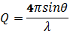$Q=\frac{4πsinθ}{λ}$ (1)
where θ is the grazing angle of specular reflection and λ is the X-ray wavelength. Q is varied by changing the angle of incidence of the X-ray beam. The reflectivity of the film was recorded before and during reaction with gas-phase ozone and the aqueous radicals. The X-ray reflectivity was recorded continuously in intervals of approximately 1200 s to measure the desired Q range (i.e. scan through the whole Q range in 1200 s) and the duration of each kinetic run (reaction with oxidant) was between 9000 to 24000 s. To avoid possible beam damage the sample was moved in a raster pattern so as to expose different areas during the scan.

3.1 Thin film model and data analysis
In order to model the resulting experimental X-ray data, the following model was employed. The thin film of either atmospheric film material or sea-water film material at the air-water interface was modelled as a series of parallel layers. The thin film was located between two semi-infinite media: air and the aqueous subphase as depicted in Figure 1.
Figure 1: Slab model for an organic thin film at the air-water interface.
A model comprising a series of layered media with defined scattering length density and thickness was used to calculate a reflectivity profile using Abelès method (Abelès, 1950). The calculated reflectivity profile was then compared with the measured data and modified within physically realistic constraints until a good fit was achieved using MOTOFIT (Nelson 2006). The data described here were fitted using the simple one-layer model shown in Figure 1 and an example plot is shown in Figure 2. To achieve a fit, the following parameters were varied; scattering length density, film thickness and roughness at the air-film interface. The roughness and the scattering length density of the subphase were held constant at 4 Å and 9.45 × 10⁻⁶ Å⁻² (Nelson, 2006) respectively. It was also assumed that the absorption of the X-rays was negligible. In an X-ray reflectivity study, the scattering length density is controlled by the electron density of the molecule, thus heavy atoms having more electrons have a larger electron density and thus signal. For a reacting system, the relative scattering length per unit area of the layer at the interface was considered, i.e. the product of the scattering length density, ρ and film thickness, δ at time t, ρ_{t}δ_{t}, relative to the product of the initial scattering length density and film thickness at time zero, ρ₀δ₀.
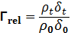$Γ_{rel}=\frac{ρ_{t}δ_{t}}{ρ_{0}δ_{0}}$ (2)
The Q range available on I07 at the Diamond Light Source is essential for the values of scattering length density, thickness and roughness of the film to be found.

4 Results and Discussion
The following section discusses the experimental X-ray reflectivity data and the associated fitted parameters for the surface layers during the oxidation of: atmospheric film material with gas phase ozone; atmospheric film material with the hydroxyl radical; sea-water film material with gas phase ozone and sea-water film material with the nitrate radical. The findings are then compared to relevant studies in the literature. Throughout the following sections, the phrase, ‘reflectivity profile’ will be used to describe a plot of reflectivity as RQ⁴ against Q such as the one shown in Figure 2 that shows the excellent fit of the model to the plotted experimental data.
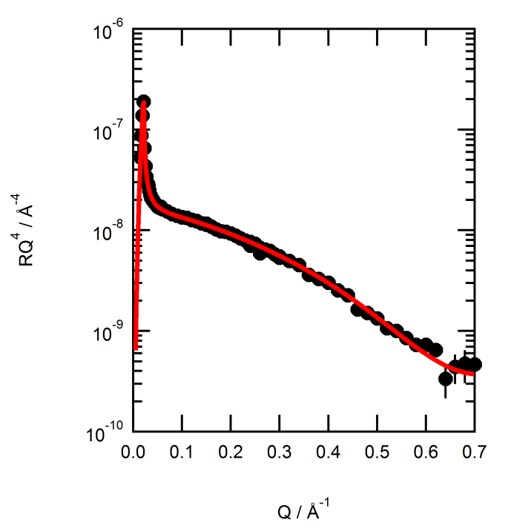
Figure 2: Example reflectivity profile, RQ⁴ vs. Q, for atmospheric film material (Run 12 in Table A.1) during exposure to the aqueous hydroxyl radical. The model fit is the solid red line and the experimental data are black circles.

4.1 Filter blanks and mass spectrometry analysis
Three filter blanks were considered and measured in exactly the same way as the samples. Figure 3 shows the reflectivity of filter blanks compared to pure water and a sample of atmospheric film material. One of the filter blanks demonstrated no surface film was obtained by the extraction process. However, two of the filter blanks did give a small reflectivity signal equivalent to ~5 % of that measured for atmospheric film material extracted from a loaded filter (non-blank sample).
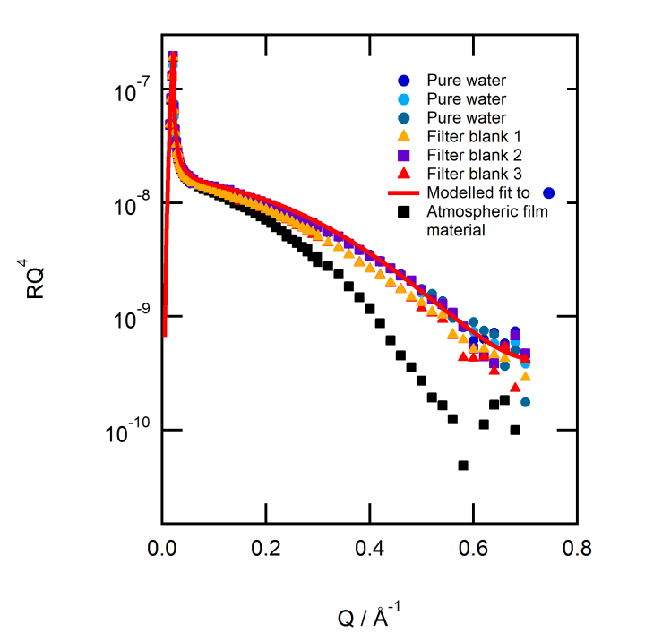
Figure 3: The reflectivity profiles for three different pure water subphases and three filter blanks compared to atmospheric film material. The model fit for pure water is the red line. Filter blank 2 as depicted by the purple squares overlies the reflectivity profile for the pure water subphase. The reflectivity for filter blanks 1 and 3 depicted by triangles do not directly overlie the reflectivity profiles for the pure water subphase. Experimental data (black squares) for atmospheric film material are also shown for comparison. The igure also demonstrates some filter blanks were slightly contaminated to <5% of a typical filter containing an atmospheric sample.
GC-MS analysis provided further useful information on the atmospheric film material and filter blanks. All samples appeared to have low concentrations and required derivatisation. Analysis of filter blank 1 was indistinguishable from the GC-MS analysis of the pure chloroform used in the film solution. Thus, the material shown in the filter blanks in Figure 3 is probably trace contamination from incomplete cleaning of the trough between experiments and may even be sample from an atmospheric filter from the previous run. In conclusion, the atmospheric sample has a much larger reflectivity signal than the filter blanks and the contribution from any impurities is deemed negligible.
GC-MS analysis of an atmospheric sample obtained with no denuder identified the presence of 22-hydroxydocosanoic acid and stearic acid. However, the abundance of the stearic acid was particularly low when compared to the signal arising from a stearic acid standard of 20 µg mL⁻¹ (approximately 1/5th of the standard abundance). It is therefore proposed that unsaturated compounds may be present in the samples in such small concentrations compared to saturated compounds that the unsaturated material could be below the detection limit of GC-MS. A low concentration of unsaturated compounds could also mean that no significant reaction would be observed between atmospheric film material and gas-phase ozone. The aerosol samples were collected from a suburban site downwind from a major polluted conurbation, i.e. the air mass was old and well oxidised, and therefore it is prudent to repeat the experiment in future with air collected from sites that have new aerosol generation such as forests or biomass burning areas (e.g. Tervahattu et al., 2005). Another possible explanation for the lack of compounds observed by GC-MS is that they were not eluted from the column or that the material giving rise to the surface pressure could not be resolved by GC-MS.

4.2 Aerosol samples and gas-phase ozone
No change in the amount of material (represented by no change in the relative scattering length, ρδ) at the air-water interface was observed for the interaction between atmospheric film material and gas-phase ozone whether the material was sampled with no denuder, an uncoated denuder or a coated denuder as shown in Figure 4. The modelled values show a constant scattering length at the air-water interface which is consistent with a constant amount of material at the air-water interface throughout the experiment, suggesting that atmospheric film material may not be reactive to gas-phase ozone. It is noted that a reaction at the air-water interface would cause a change in the electron density at the very least, and thus the scattering length of the interface. A change in the scattering length of the interface would also occur if the interface lost or gained film or solvent molecules. Prior experiments using a Langmuir trough with a tensiometer showed that a film did form at the air-water interface from the aerosol samples (Figure A.1, Appendix A) and there was no evidence of a film in the filter blank, only a small impurity, in some of the filter blanks as seen in Figure 3.
For the initial experiment conducted on atmospheric film material sampled without a denuder (blue triangles in Figure 4), a mixing ratio of ~0.1 ppm of gas-phase ozone was used. No change in the scattering length of the layer was observed, and therefore the mixing ratio of gas-phase ozone was increased to ~1 ppm, also shown in Figure 4. However, the increased mixing ratio of ozone also did not cause a change in the scattering length of the interface, which supports the idea that atmospheric film material was unreactive to gas-phase ozone. The other two experiments (atmospheric film material sampled with a coated and with an uncoated denuder) plotted in Figure 4 were both conducted with a ~1 ppm mixing ratio of gas-phase ozone throughout the experiment and no change in surface coverage was observed.
The modelled atmospheric film thickness is also constant on exposure to ozone as shown in panel b) of Figure 4. The constant scattering length and film thickness are interpreted to mean that there is no significant reaction between gas-phase ozone with the film material, which suggests that the atmospheric film material may not contain any readily oxidisable unsaturated bonds as observed in the GC-MS analysis. If unsaturated bonds were present in the film, ozone would effectively cleave these bonds resulting in the production of smaller, more polar molecules which would either escape into the liquid subphase or into the gas-phase above the film (e.g. King et al., 2009, González-Labrada et al., 2007, Voss et al., 2006, 2007). In doing so, there would be a reduction in the amount of the material at the air-water interface and an associated change in the scattering length, ρδ and film thickness (King et al., 2009).
The modelled fit to RQ⁴ vs. Q was very sensitive to changes in the scattering length density but reasonably insensitive to changes in the film thickness. The value for the estimated uncertainty of scattering length has therefore been determined as the deviation in the fit of RQ⁴ vs. Q from the accepted fit of RQ⁴ vs. Q to give an acceptable fit as an uncertainty of 20-60 % in the quantity ρδ. The uncertainty was estimated by varying both the scattering length density and film thickness in order to achieve the same modelled fit to the experimental data of RQ⁴ vs. Q as judged by eye. The uncertainty was estimated to be typically ~20 % at the start of the kinetic run, ~40 % during the run and ~60 % towards the end of the run. Therefore, the amount by which the variables can be changed that still results in an acceptable fit to the experimental data is 20-60 %. An uncertainty in the scattering length of the material at the air-water interface of 20% may be used to construct an imperfect argument that up to 20% of the surface material may be unsaturated. However, examination of the variation of scattering length of the interface with time exposed to gas-phase ozone in the upper pane in Figure 6 would suggest that perhaps that an uncertainty of 3—5% for the scattering length of the interface might be a more acceptable estimate for the amount of unsaturated material at the air-water interface that is unsaturated. As opposed to the conservative 20% uncertainty, this would be in more reasonable agreement with the 2% of the total organic material from atmospheric aerosol that is estimated to be unsaturated from the literature to be presented in section 4.5.1. The argument is imperfect as a linear relationship is assumed between the scattering length and amount of material at the air-water interface and that the scattering efficiency of the unsaturated material is similar to the scattering length of the saturated material, i.e. they have a similar chemical composition with the exception of a carbon-carbon double bond
Figure 4: The upper panel, a), shows the relative amount of atmospheric film forming material at the air-water interface during exposure to gas-phase ozone. The dashed black line indicates when gas-phase ozone was admitted to the trough. Prior to this only molecular oxygen was present. The three traces represent the different types of aerosol sampling methodology. Red squares represent aerosol sampled with a coated denuder to remove gas-phase ozone (Run 7 in Table A.1). Black circles represent aerosol sampled with an uncoated denuder (Run 8 in Table A.1). Blue triangles represent aerosol sampled with no denuder (Run 1 in Table A.1). For the red squares and black circles, the mixing ratio of gas-phase ozone is ~1 ppm throughout the experiment, whereas for the initial experiment (blue triangles), the mixing ratio of gas-phase ozone was initially ~ 0.1 ppm and was then increased to ~ 1 ppm marked by the dotted black line. The lower panel, b), shows the fitted film thickness for the three runs shown in panel a).
The modelled thickness for the atmospheric film material sampled with a coated denuder (red squares) is noticeably larger than those modelled for samples obtained without a denuder and an uncoated denuder. However, it is within the uncertainty possible for the determined film thickness and does not change significantly but within the errors detailed previously.
As the behaviour observed in Figure 4 for aerosol sampled with a coated and with an uncoated denuder is similar, it can be deduced that there is no difference between them. Thus ambient atmospheric ozone pulled through the filter during aerosol sampling did not result in an artefact in the experiment, i.e. oxidation of all organic material before removal from the filter. Further experiments noted no loss of material was observed with oxygen only, and no beam damage was observed. In conclusion no reaction between ozone and the organic material at the air-water interface was observed.

4.3 Aerosol samples and the hydroxyl radical
The data in Figure 4 were unexpected and therefore to confirm that the technique is sensitive to a reaction, the experiment was repeated using a more reactive and less selective, aqueous based reactant, the hydroxyl radical (Mack and Bolton, 1999), which can abstract hydrogen as well as add to double bonds. Figure 5 shows the experimental reflectivity profiles of atmospheric film material in the presence of the hydroxyl radical. The uppermost traces in Figure 5 represent the aqueous nitrate anion subphase with no surface film and the lowest trace represents the aqueous nitrate anion subphase with a thin film of atmospheric material. On exposure to UV radiation, the hydroxyl radical was produced and the reflectivity was observed to increase at high Q from the unreacted atmospheric film material on the aqueous nitrate anion subphase with increasing time towards the aqueous nitrate anion sub-phase alone. The change in the reflectivity signal is indicative of a reaction between the atmospheric film material and the hydroxyl radical.
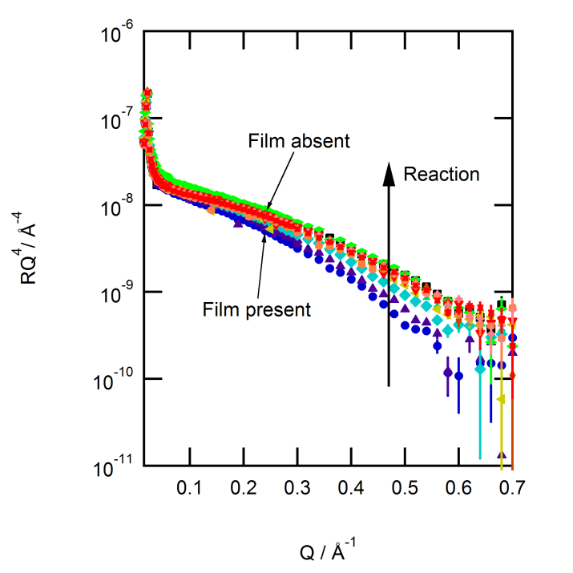
Figure 5: RQ⁴ vs. Q profile showing the change with time when atmospheric film material on an aqueous nitrate anion sub-phase is exposed to the hydroxyl radical. The dark blue circles represent the unreacted material at the air-aqueous solution interface. On exposure to UV radiation at ~254 nm, the reflectivity increases, which is indicative of a reaction between the atmospheric film material and the hydroxyl radical.
Figure 6 shows the modelled scattering length per unit area of the interface and the film thickness for the reaction of the hydroxyl radical with atmospheric film material. In comparison to the lack of change observed in Figure 4 for reaction with gas-phase ozone, there is a clear decrease in the scattering length of the layer at the air-aqueous interface as well as a decrease in film thickness on exposure to the hydroxyl radical. Note that the films in Figure 6 have different thicknesses as they are different samples and therefore contained different amounts of surface active material.
Figure 6: Panel a) shows the relative scattering length of the interface and panel b) shows the film thickness versus time. The purple squares and orange triangles show the decrease in scattering length when atmospheric film material sampled with an uncoated denuder, (Run 12 in Table A.1) and atmospheric film material sampled with a coated denuder, (Run 10 in Table A.1) are exposed to the aqueous hydroxyl radical. The black circles highlight the constant scattering length observed when atmospheric film material (sampled with an uncoated denuder, Run 8) is exposed to gas-phase ozone. The vertical dashed line represents the time when the oxidant is admitted to the trough environment, i.e. the time that the UV lamp or ozoniser is switched on. No reaction is observed with the oxygen blank (red diamonds, sampled with no denuder, Run 3, Table A.1). The UV blank alone is shown by the unfilled squares (sampled with uncoated denuder, Run 11, Table A.1) that represent atmospheric film material on water in the presence of UV radiation (~ 254 nm) alone i.e. no radical subphase present. The lower panel, b), shows film thickness for the same experimental runs as in a) excluding the two blanks for clarity. A clear decrease in the film thickness is observed on exposure to the hydroxyl radical whereas there is no change in film thickness on exposure to gas-phase ozone.
A reaction between the atmospheric film material and the hydroxyl radical can be observed from the decrease in the relative scattering length seen in Figure 6 and the thickness also decreases which may potentially suggest a thinning mechanism. The proposed thinning mechanism is a reduction in the length of molecules at the interface, i.e. consecutive reactions by the hydroxyl radical reduce the chain length of the surface active molecule by a small amount following each successful reaction (Jones et al., submitted). After repeated reactions, the surface active molecules are likely to be reduced to small soluble or gaseous products and to be removed from the interface. The reaction profile ((ρδ)_{t}/(ρδ)_{t=0} vs. time) is consistent with a large part of the molecule remaining at the air-water interface after each successive hydroxyl radical attack as shown by the lack of an exponential decay. It is noted that an alternative interpretation of the thinning mechanism could be that as molecules are removed from the film and the interface is less densely populated, the remaining molecules relax their orientation and ‘tip over’, i.e. a molecule’s long axis is no longer perpendicular to the interface of the film. The data in Figures 5 and 6 demonstrate a change of the air-water interface consistent with a reaction with the hydroxyl radical but not between a thin film of atmospheric material and gas-phase ozone.
Control experiments were performed to eliminate the possibility that the change in surface coverage was due either to damage directly from the UV radiation required to generate the hydroxyl radical or from reaction with molecular oxygen. The data for the two blank runs shown in Figure 6 were measured on atmospheric film material on a pure water subphase. No changes were observed in the surface coverage for either, indicating that no reaction was induced by either molecular oxygen or UV radiation alone.
In conclusion, organic material extracted from real atmospheric aerosol samples can form stable surface active layers with surface pressure ~ 14-25 mN m⁻¹ at the air-water interface. These atmospheric films appear to be unreactive to both ambient and large gas-phase ozone concentrations which could suggest the presence of little or no unsaturated material. The films are reactive to hydrogen abstraction as shown during reaction of the film with aqueous hydroxyl radical. Experiments prior to the X-ray study showed that the isotherm (surface pressure vs. interfacial area) of the film had no phase transition and that it did not collapse below 25 mN m⁻¹ (Figure A.1).

4.4 Sea water samples and gas-phase ozone and the nitrate radical
No change in surface coverage was observed for the reaction of sea-water film material and gas-phase ozone, as shown by the black circles in Figure 8, suggesting that sea-water material is also unreactive to gas-phase ozone. As for the atmospheric film material, a reaction was performed using the more reactive aqueous nitrate radical. It is known that both the nitrate and hydroxyl radicals abstract hydrogen atoms and therefore have a different mechanism to reactions with gas-phase ozone (Herrmann et al., 1994, Herrmann, 2003, Moise and Rudich, 2002). The aqueous nitrate radical may add to a carbon-carbon double bond or abstract a hydrogen atom, whereas ozone tends only to add to double bonds. Thus the nitrate radical will react with the organic material at the air-water interface and confirm that the X-ray reflectivity technique is sensitive to loss of material at the air-water interface and also confirm the lack of reaction with ozone. A change in reflectivity signal (Figure 7) and relative scattering length at the air-water interface (Figure 8) was observed for the reaction of the nitrate radical with a thin film of sea-water material. The relative scattering length of the air-sea-water film interface decreases by a small amount as shown in Figure 8, indicating that the film does react with the nitrate radical.
The nitrate radical is a proposed cloudwater oxidant (Herrmann et al., 1994) and is also generated by photolysis of S₂O₈²⁻ and rapid titration with NO₃⁻ at longer wavelengths (~360 nm) than generation of the hydroxyl radical (~254 nm). Previous work has demonstrated that ~360 nm is less damaging to lipid films at the air-water interface than ~254 nm. A UV only blank experiment demonstrated that the film did not degrade in the presence of ~360 nm light. The shorter wavelength UV lamp may be expected to degrade the organic film in the absence of the radical precursors, but as confirmed by the UV blank and the use of the longer wavelength UV lamp, direct photolysis of the film does not describe the behaviour seen with ozone and the hydroxyl and nitrate radicals. However, this will be verified in future experiments.
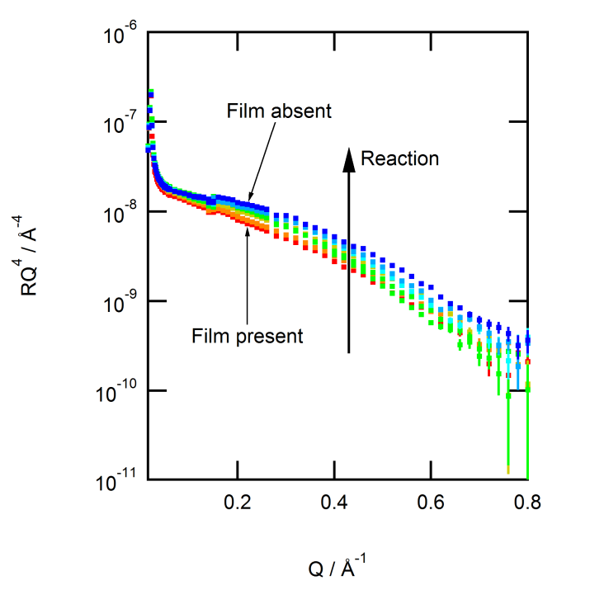
Figure 7: RQ⁴ vs. Q profile showing the change with time when sea-water film material is exposed to the nitrate radical. The red squares represent the unreacted material at the interface. On exposure to UV radiation at ~360 nm, the reflectivity signal increases (arrow direction) indicative of a reaction with the nitrate radical.
Figure 8: The blue squares (Run 2, Table A.2 in the appendix) show a decrease in the relative scattering length for the reaction of the sea-water film and the nitrate radical. The black circles (Run 4, Table A.2 in the appendix) show no decrease in the relative scattering length when exposed to gas-phase ozone. The vertical dashed line indicates when the oxidants are generated, either aqueous nitrate anion or gas-phase ozone.
The uncertainty in the scattering length per unit area is estimated to be between 20-60 % and is rather insensitive to changes in the film thickness.
GC-MS and ESI-MS analysis indicated a lack of unsaturated material in the two sea-water samples which is in keeping with the modelled lack of reaction between sea-water film material and gaseous ozone shown in Figure 8. A number of saturated compounds were identified in the sea-water samples using ESI-MS, notably the saturated fatty acids, stearic and palmitic acid were detected in both of the samples that were analysed. As for the atmospheric aerosol samples, it is also possible that there is a much greater proportion of saturated material compared to unsaturated material in the sea-water.
In summary, organic material extracted from sea-water samples can form stable surface active layers with a surface pressure of ~25 mN m⁻¹ at the air-water interface. As for the atmospheric film material, the sea-water films also appear to be unreactive to large gas-phase ozone concentrations suggesting the presence of little or no unsaturated material in sea-water samples. However, the films do react with radicals that are capable of hydrogen abstraction as shown by the changes in reflectivity (Figure 7) and relative scattering length (Figure 8) during exposure to the nitrate radical.

4.5 Comparison to previous studies
Ciuraru et al., 2015 and Rossignol et al., 2016 conducted photochemical studies on a bulk sea-water sample and a monolayer of nonanoic acid at the air-water interface respectively. The reactions resulted in the formation of unsaturated organic compounds in the gaseous phase (Ciuraru et al., 2015) and in both the gaseous and condensed phases (Rossignol et al., 2016). The focus of these studies was on the formation mechanism of the products and how their production may affect secondary organic aerosol formation and the oxidative nature of the atmosphere thus impacting on the climate.
Zhou et al., 2014 conducted studies into the heterogeneous oxidation of a thin film of linoleic acid, (a polyunsaturated fatty acid) at the air-artificial sea water interface with gas phase ozone. Two experiments were performed in a glass boat, one on the heterogeneous oxidation of a thin film of linoleic acid at the air-artificial sea-water interface and a second on the heterogeneous oxidation of a real bulk sea surface microlayer sample (no added film). It is useful to compare the study by Zhou et al., 2014 to the one presented here because it involves the heterogeneous oxidation of real sea-water material with gas-phase ozone.
Zhou et al. investigated the reaction mechanism and the gas phase oxidation products resulting from the reactions using proton transfer mass spectrometry and light emitting diode cavity enhanced differential absorption spectroscopy. Their sea surface microlayer samples were collected from Patricia Bay, Canada and the eastern equatorial Pacific Ocean. Volatile carbonyls were formed from the oxidation of a thin film of linoleic acid on artificial sea water, specifically, the reactive gas phase dicarbonyls; malondialehyde and glyoxal. It was therefore expected that similar volatile carbonyl species would form from the oxidation of real sea surface microlayer samples, assuming that polyunsaturated fatty acids such as linoleic acid are present in the sea-surface microlayer and indeed a variety of oxygenated VOCs were formed. Zhou et al. concluded that heterogeneous oxidation of sea-surface microlayer samples with gas-phase ozone may lead to VOC production but the identification of the reactants was not possible owing to the complex chemical composition of the sea-surface microlayer sample.
In the current X-ray reflectivity study, a constant relative scattering length for both atmospheric and sea-water film material at the air-water interface on exposure to gas-phase ozone was observed. Combining this information with the GC-MS and ESI-MS analysis of the atmospheric and sea-water film material, which both did not show any unsaturated material, suggests that there is a very small proportion of unsaturated material in our samples. Zhou et al., 2014 stated that VOCs are believed to form from the oxidation of unsaturated materials such as polyunsaturated fatty acids, and VOCs were detected from the oxidation of their sea-surface microlayer sample. A decrease in relative scattering length was observed in the X-ray reflectivity study for the exposure of atmospheric film material to the hydroxyl radical and sea-water film material to the nitrate radical. From the decrease in scattering length, it can be inferred that the material at the air-aqueous interface was oxidised and resulted in the formation of either a volatile or a soluble species which is consistent with the formation of gas-phase products as observed in Zhou et al.’s study. In the current reflectivity study, there could be a low concentration of unsaturated material present in both the atmospheric and sea-water film material that could be below the analysis detection limit and may also be unresolvable on a GC-MS and ESI-MS column. A low concentration of unsaturated material could explain why no reaction was observed with gas-phase ozone. It is therefore useful to determine the ratio of unsaturated material to saturated material detected in studies of other atmospheric samples.

4.5.1 Ratio of unsaturated to saturated material detected in other atmospheric sampling studies
There are numerous studies of organic aerosol in the atmosphere, e.g. Saxena and Hildemann, 1996, Turpin et al., 2000, Hamilton et al., 2005, and the following section will focus on pertinent studies that report the ratio of unsaturated to saturated organics in atmospheric aerosol. The results of the current study are consistent with atmospheric aerosol containing a small amount of unsaturated material and a large amount of saturated material that is able to form films at the air-water interface. Rogge et al., 1993, determined the concentration of organic compounds present in fine particulate matter sampled from ten sites in southern California over a year (1982) using GC-MS. Carbonaceous material constituted between 20-40% of fine particle mass and around two thirds of aerosol carbon was attributed to organic material (Gray et al., 1986). Figure 9 was adapted from Rogge et al., 1993 and summarises the percentage chemical composition of the mean annual fine particle concentration sampled in West Los Angeles in 1982. Of the organic material, 45-60% was elutable using GC-MS. It was only possible to resolve 23-29 % of the elutable organics and from this fraction, only 78-85% were identified as singular molecular entities i.e. only 8-15 % of the organic mass captured could be identified. The proportion of n-alkenoic acids (unsaturated) detected was extremely low in comparison to n-alkanoic acids (saturated) as emphasised in the resolvable organics data shown in Figure 9. Approximately ~2% n-alkenoic acids were identified compared to ~25% n-alkanoic acids. Oleic acid was the only n-alkenoic acid to be positively identified. The largest proportion of identified compounds was n-alkanoic acids and aliphatic dicarboxylic acids. In a previous study by Rogge et al., 1991, oleic acid was detected from meat cooking emissions but was not detected in the 1993 study, and therefore it was suggested in the 1993 study that atmospheric reactions likely provided a sink for mono and poly unsaturated fatty acids. The low percentage of unsaturated fatty acids determined by Rogge et al., 1993, supports both the GC-MS, ESI-MS and the X-ray reflectivity results observed in the current study. No unsaturated material was observed in our GC-MS and ESI-MS analysis, which could indicate that the signal from our aerosol filters was dominated by saturated organics such as n-alkanoic acids or aliphatic dicarboxylic acids. Given that only ~50% of organic material was eluted in the study by Rogge et al., it is possible that ~ 50% of the organic material obtained in the current atmospheric aerosol samples remained on the filter paper and therefore was not eluted by GC-MS. A predominance of saturated material would also support the lack of reaction observed with gas-phase ozone. It should be noted that the X-ray reflectivity study presented here includes all material extracted from aerosol and not just that identified in a GC-MS analysis.
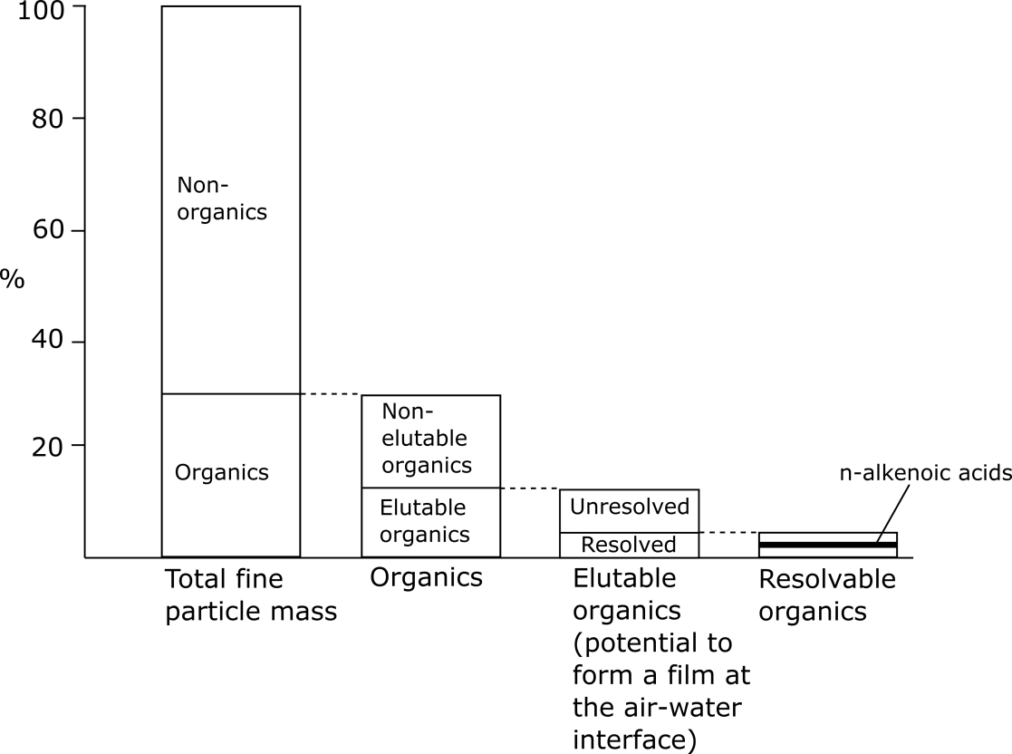
Figure 9: Diagram adapted from Rogge et al., 1993 showing the percentage chemical composition (annual mean) of material identified from samples collected in West Los Angeles in 1982. The adapted diagram emphasises the small percentage of n-alkenoic acids (~2 %) determined by GC-MS analysis compared to n-alkanoic acids.
A number of studies on aerosol samples from different locations have shown that unsaturated fatty acids are present in much lower concentrations than saturated fatty acids (e.g. Kawamura and Gagosian, 1987, Simoneit and Mazurek, 1982, Abas and Simoneit, 1996, Mochida et al., 2002, Fang et al., 2002). It has been proposed that unsaturated fatty acids are not stable in the atmosphere and will either be rapidly oxidised (Kawamura and Gagosian, 1987, Simoneit and Mazurek, 1982) or decompose (Abas and Simoneit, 1996). Rapid oxidation by common oxidants such as gas-phase ozone, the hydroxyl radical or hydrogen peroxide is possible and large concentrations of ω-oxocarboxylic acids of hydrocarbon chain length 9 have been detected in marine samples (Kawamura and Gagosian, 1987). It was proposed that oleic acid is cleaved at C9 when oxidised and thus oleic acid is not detected in marine aerosols but many shorter saturated C9 chain acids are found. Small concentrations of unsaturated fatty acids have been detected in aerosol samples collected over western USA (Simoneit and Mazurek, 1982) and their presence attributed to biogenesis close to the time of sample collection. Again it is proposed that their low concentration is due to the reactivity of unsaturated compounds to oxidation and environmental decomposition. Abas and Simoneit, 1996, also found trace levels of unsaturated fatty acids in particulate samples obtained in Kuala Lumpur in Malaysia in the early 1990’s that they also attributed to biogenesis. Mochida et al., 2002 collected aerosols over the North Pacific from October 1996-June 1997 and analysed them for fatty acids and determined a smaller concentration of unsaturated fatty acids compared to saturated fatty acids. With regards to polyunsaturated fatty acids, trace amounts were detected by Simoneit and Mazurek, 1982, in their study of aerosol samples collected over rural and urban western USA but no polyunsaturated fatty acids were detected by Fang et al., 2002 in marine aerosols collected over 41 months over the western North Pacific from April 1990-November 1993. Typical organic chemicals found in sea spray are saturated and unsaturated fatty aids, fatty acid derivatives and saturated hydroxyl-fatty acids, organo sulfate and sulfonates, (Cochran et al, 2016).

Gilardoni et al., 2007, used Fourier transform infra red spectroscopy to determine the concentrations of functional groups present in submicron aerosol samples collected from four sampling locations during the International Consortium for Atmospheric Research on Transport and Transformation in the summer of 2004. Aerosol samples were collected on Teflon filters from two mainland sites in Nova Scotia, Canada and in Maine, USA and samples were also collected by an aircraft over Ohio, USA and from a research ship in the Gulf of Maine. Saturated and unsaturated material was found to dominate the organic mass and much larger masses of saturated aliphatic C-C-H groups compared to unsaturated aliphatic C=C-H groups were observed in samples from all locations. The ratio of unsaturated aliphatic C-C-H to saturated aliphatic C=C-H groups was 0.1 for the aerosol sampled by the aircraft over Ohio, whereas a ratio of 0.2 was obtained for the other three sampling locations which were also all coastal locations. These ratios are similar to the concentration ratios of unsaturated to saturated C-H groups in water soluble organic carbon determined by Fuzzi et al., 2001 and Decesari et al., 2000, using H-NMR spectroscopy. Gilardoni et al., 2007 postulated that the reason for the higher ratios of unsaturated to saturated compounds at the coastal sites could have been due to either more unsaturated material resulting from biogenic sources or less saturated material from unprocessed primary combustion emissions. Gilardoni et al.’s 2007 findings of low concentrations of unsaturated compounds present in aerosol sampled from both inland and coastal locations support the current X-ray reflectivity results.
The available evidence from the cited studies indicates that unsaturated materials are present in atmospheric samples in much lower concentrations than saturated materials and therefore films in the atmosphere are predominantly saturated, in keeping with the results found here. In the current study, organic film forming material is extracted from atmospheric aerosol and sea-water samples in chloroform. Therefore, only the unsaturated material that can be extracted in chloroform can be estimated. Given the above literature studies it is estimated that the upper detection limit for unsaturated material that is extractable in chloroform in our samples is ~ 5 %.

4.5.2 Thin film studies
Previous studies have been conducted on the oxidation of thin films at the air-water interface (e.g. Eliason et al., 2003, 2004, Voss et al., 2006, 2007, González-Labrada et al., 2006, 2007) and have typically followed the oxidation of a thin film using surface pressure measurements or spectroscopy. There have been many studies of the reactions between ozone and PAHs (e.g. Mmereki et al. (2004)) and octanol (e.g. Mmereki and Donaldson 2003) and PAH mixed with unsaturated organics (e.g. Kahan et al. 2006) at the air-water interface. Mmereki et al. (2003, 2004) demonstrated. The ozone followed Langmuir Hinshelwood kinetics and Kahan et al 2006 demonstrated that reactions rate were 0.5×10¹⁴ to 2.3×10¹⁶ molecule cm⁻³ and that unsaturated species such as oleic acid and squalene reduced the observed rates significantly. Langmuir-Hinshelwood kinetics have also been demonstrated for the heterogeneous reaction of PAHs with gas-phase ozone to be independent of relative humidity (Kwamena et al 2006). Consideration of these studies with those presented here suggest that material at the air-water interface and material extracted from the atmospheric aerosol is less reactive than PAHs that are reasonably unreactive, although by no means inert, to gas-phase ozone. Enami et al (2010,2015) have shown that the oxidation of terpenes at air-water interface by ozone is faster than expected and that the oxidation of dicarboxylic acids by gas-phase OH radicals is stepwise. Tinel et al,(2016) demonstrated that a fatty acid film at the air-water interface concentrates photosensitizers at the air-water interface which may generate radical reactions during irradiation. Enami et al. (2014,2015), demonstrated the chemical mechanism for oxidation of fatty acid by gas-phase hydroxyl radicals at the air-water interface. Enami and Sakamoto (2016) showed that gas-phase OH radical could oxidise cis-pinoic acid at the air-water interface and also described the following chemical mechanistic breakdown.
Particularly relevant studies on the oxidation of thin films at the air-water interface have been conducted using neutron reflectivity (King et al., 2009, 2010, Pfrang et al., 2014, Thompson et al., 2010, 2013). Pfrang et al., 2014 used neutron reflectivity to follow the oxidation of a monolayer of methyl oleate at the air-water interface by gas-phase ozone and were able to determine a bimolecular rate constant that highlighted how a minor change in the molecular structure of a film (methyl oleate compared to oleic acid) strongly influences film reactivity. King et al., 2009 studied the gas-phase oxidation of a monolayer of deuterated oleic acid at the air-water interface with ozone using neutron reflectivity. Oleic acid was chosen as a proxy for unsaturated organic material found in the atmosphere. The surface coverage of the oleic acid at the air-water interface was modelled and a clear decrease was observed with time on exposure to gas-phase ozone. The study by King et al. 2009 shows that gas-phase ozone does react with a monolayer of oleic acid at the air-water interface causing a decrease in surface coverage. A similar trend was expected on addition of gas-phase ozone to atmospheric and sea-water film material in the current X-ray reflectivity experiment but was not observed, i.e. there was constant surface coverage on exposure to gas-phase ozone.
Studies have also been conducted on individual aerosol particles on films at the air-solid interface (Jones et al., 2015) that used Mie scattering theory calculations to determine the thickness and refractive index of laboratory generated core-shell aerosol. The study presented here indicates that at moderate surface pressures, material extracted from both atmospheric and sea-water samples form stable films of ~10-15 Å in thickness at the air-water interface, which may be useful for future Mie scattering models of core-shell atmospheric aerosol.

5 Conclusions
Stable films (> 6 hours) can be formed from material extracted from atmospheric aerosol and sea-water at the air-water interface. The X-ray reflectivity study of the heterogeneous oxidation of such thin films demonstrates that the films are unreactive to gas-phase ozone and can be modelled as a constant amount of material at the air-water interface. The atmospheric and sea-water samples either do not contain unsaturated organic material, or contain unsaturated organic material in very low concentrations. It is likely that unsaturated material is present in very low concentrations in comparison to saturated material given the evidence in the literature (Kawamura and Gagosian, 1987, Simoneit and Mazurek, 1982, Abas and Simoneit, 1996, Mochida et al., 2002, Fang et al., 2002, Gilardoni et al., 2007). Therefore, oxidation by gas-phase ozone may not be an important atmospheric reaction for thin organic films and unsaturated oleic acid could be a poor choice as a proxy for organic film forming material in the atmosphere. Ideally future studies should be conducted on aerosol samples collected at different stages in the aerosol lifetime to deduce which reactions are important and at what stages. Future studies should also consider the oxidation of saturated compounds by radical reaction.
The X-ray reflectivity study of a thin film of material extracted from atmospheric aerosol with the hydroxyl radical and a thin film of material extracted from sea-water with the nitrate radical can both be modelled as a decrease in relative scattering length of the layer at the air-water interface. Therefore the film reacts and a thinning mechanism is proposed where radical attack of the hydrocarbon chain results in reduction in chain length of the surface active material. The observed decrease in scattering length on exposure of the thin films to radicals and the constant scattering length observed on exposure of the thin films to gas-phase ozone could also suggest that gas-phase oxidation by ozone is not important in the atmosphere.
In conclusion, X-ray reflectivity has been used to study the oxidation of thin films of material extracted from atmospheric aerosol and sea-water at the air-water interface. Results indicate that heterogeneous oxidation of thin organic films by gas-phase ozone may not be important in the atmosphere given the low concentration of unsaturated organics to saturated organics in sampled aerosol, whereas radical oxidation appears to be important and induces a possible thinning mechanism in the organic films. It is recommended that future studies consider aerosol samples collected at different stages in the aerosol lifetime to determine whether specific reactions such as gas-phase oxidation by ozone are important at particular stages. It is also proposed that future proxy studies should consider radical oxidation of saturated organics because compounds like oleic acid may not be the most atmospherically relevant proxies.

6.0 Data
The raw data can be found at doi:10.5281/zenodo.496171.

Acknowledgements
The authors wish to acknowledge Diamond beam time grants SI8744 and SI9632. The authors would also like to acknowledge the Mass Spectrometry Facility at King’s College London for GC-MS and ESI-MS analysis of the atmospheric aerosol and sea-water samples. SHJ wishes to thank NERC for funding of grant NE/H019103/1 and the Research Complex at Harwell for use of their laboratories for sample preparation.

References
Andrews, E. and Larson, S. M.: Effect of Surfactant Layers on the Size Changes of Aerosol-Particles As a Function of Relative-Humidity, Environ. Sci. Technol., 27(5), 857–865, doi:10.1021/es00042a007, 1993.
Abas, M. R. Bin and Simoneit, B. R. T.: Composition of extractable organic matter of air particles from Malaysia: Initial study, Atmos. Environ., 30(15), 2779–2793, doi:10.1016/1352-2310(95)00336-3, 1996.
Abelès, F.: La théorie générale des couches minces, Le Journal de Physique et le Radium 11, 307-310, 1950.
Arnold, T., Nicklin, C., Rawle, J., Sutter, J., Bates, T., Nutter, B., McIntyre, G. and Burt, M.: Implementation of a beam deflection system for studies of liquid interfaces on beamline I07 at Diamond., J. Synchrotron Rad., 19, 408–416, doi:10.1107/S0909049512009272, 2012.
Barnes, G. T. and Gentle, I.R.: Interfacial Science: An Introduction, Oxford University Press, 2005.
Blanchard, D. C.: Sea-to-Air Transport of Surface Active Material, Science, 146(13), 396–397, 1964.
Ciuraru, R., Fine, L., van Pinxteren, M., D’Anna, B., Herrmann, H. and George, C.: Photosensitized production of functionalized and unsaturated organic compounds at the air-sea interface., Sci. Rep., 5(August), 12741, doi:10.1038/srep12741, 2015.
Cochran, R.E, O. Laskina, T. Jayarathne, A. Laskin, J. Laskin, P. Lin, C. Sultana, C.Lee, K. A. Moore, C.D. Cappa, T.H. Bertram, K.A. Prather, V.H. Grassian, and E.A. Stone.: Analysis of Organic Anionic Surfactants in Fine and Coarse Fractions of Freshly Emitted Sea Spray Aerosol.Environ. Sci. Technol., 2016, 50 (5), pp 2477–2486, DOI: 10.1021/acs.est.5b04053
Decesari, S., Facchini, M. C., Fuzzi, S. and Tagliavini, E.: Characterization of water-soluble organic compounds in atmospheric aerosol: A new approach, J. Geophys. Res., 105(D1), 1481–1489, 2000.
Donaldson, D. J. and George, C.: Sea-Surface Chemistry and Its Impact on the Marine Boundary Layer., Environ. Sci. Technol., 46(19), 10385–10389, 2012. doi:10.1021/es301651m
Draxler, R.R. and Rolph, G.D.: HYSPLIT (HYbrid Single-Particle Lagrangian Integrated Trajectory) Model access via NOAA ARL READY Website (http://ready.arl.noaa.gov/HYSPLIT.php). NOAA Air Resources Laboratory, Silver Spring, MD, 2015.
Ebben, C. J., Shrestha, M., Martinez, I. S., Corrigan, A. L., Frossard, A. A, Song, W. W., Worton, D. R., Petäjä, T., Williams, J., Russell, L. M., Kulmala, M., Goldstein, A. H., Artaxo, P., Martin, S. T., Thomson, R. J. and Geiger, F. M.: Organic constituents on the surfaces of aerosol particles from Southern Finland, Amazonia, and California studied by vibrational sum frequency generation., J. Phys. Chem. A, 116(32), 8271–8290, doi:10.1021/jp302631z, 2012.
Eliason, T. L., Aloisio, S., Donaldson, D. J., Cziczo, D. J. and Vaida, V.: Processing of unsaturated organic acid films and aerosols by ozone, Atmos. Environ., 37(16), 2207–2219, doi:10.1016/S1352-2310(03)00149-3, 2003.
Eliason, T. L., Gilman, J. B. and Vaida, V.: Oxidation of organic films relevant to atmospheric aerosols, Atmos. Environ., 38(9), 1367–1378, doi:10.1016/j.atmosenv.2003.11.025, 2004.
Ellison, G. B., Tuck, A. F. and Vaida, V.: Atmospheric processing of organic aerosols, J. Geophys. Res., 104, 11633–11641, 1999.
Enami, S., M.R.Hoffman and A.J.Colussi.: Prompt formation of organic acid in pulse ozonoation of terpenes on aqueous surfaces, J. Phys Chem. Lett., 1, 2374-2379 , doi: 10.1021/jz100847a, 2010
Enami, S., M.R.Hoffman and A.J.Colussi.:: Stepwise oxidation of aqueous dicarboxylic acids by gas-phase OH radicals, J. Phys Chem. Lett., 6, 527-534 , doi: 10.1021/jz502432j, 2015
Enami,S., Hoffmann, M.R., and Colussi, A.J,: In Situ Mass Spectrometric Detection of Interfacial Intermediates in the Oxidation of RCOOH(aq) by Gas-Phase OH-Radicals, J. Phys. Chem. A, 2014, 118 (23), pp 4130–4137 DOI: 10.1021/jp503387e
Enami, S. and Y. Sakamoto: OH-Radical Oxidation of Surface-Active cis-Pinonic Acid at the Air–Water Interface, J. Phys. Chem. A, 2016, 120 (20), pp 3578–3587
DOI: 10.1021/acs.jpca.6b01261
Falkovich, A.H., Schkolnik, G., Ganor, E. and Rudich, Y.: Adsorption of organic compounds pertinent to urban environments onto mineral dust particles, J. Geophys. Res., Atmos., 109, D02208, 2004.
Finlayson-Pitts, B. J.: Reactions at surfaces in the atmosphere: integration of experiments and theory as necessary (but not necessarily sufficient) for predicting the physical chemistry of aerosols, Phys. Chem. Chem. Phys., 11, 7760–7779, doi:10.1039/b916865f, 2009.
Fuzzi, S., Decesari, S., Facchini, M., Matta, E., Mircea, M. and Tagliavini, E.: A simplified model of the water soluble organic component of atmospheric aerosols, Geophys. Res. Lett., 28(21), 4079–4082, 2001.
Gevod, V.S.: Bubble-Film extraction fundamentals and application, in Handbook of Surface and Colloid Chemistry, Third Edition Edited by Birdi, K.S., CRC Press, 585–630, 2008.
Gilardoni, S., Russell, L. M., Sorooshian, A., Flagan, R. C., Seinfeld, J. H., Bates, T. S., Quinn, P. K., Allan, J. D., Williams, B., Goldstein, A. H., Onasch, T. B. and Worsnop, D. R.: Regional variation of organic functional groups in aerosol particles on four U. S. east coast platforms during the International Consortium for Atmospheric Research on Transport and Transformation 2004 campaign, J. Geophys. Res., 112(D10S27), 1–11, doi:10.1029/2006JD007737, 2007.
Gill, P. S., Gradel, T. E. and Weschler, C. J.: Organic Films on Atmospheric Aerosol Particles, Fog Droplets, Cloud Droplets, Raindrops and Snowflakes, Rev. Geophys. Sp. Phys., 21(4), 903–920, 1983.
González-Labrada, E., Schmidt, R. and DeWolf, C. E.: Real-time monitoring of the ozonolysis of unsaturated organic monolayers, Chem. Commun., 23, 2471–2473, doi:10.1039/b603501a, 2006.
González-Labrada, E., Schmidt, R. and DeWolf, C. E.: Kinetic analysis of the ozone processing of an unsaturated organic monolayer as a model of an aerosol surface, Phys. Chem. Chem. Phys., 9(43), 5814–5821, doi:10.1039/b707890k, 2007.
Gray, H. A, Cass, G. R., Huntzicker, J. J., Heyerdahl, E. K. and Rau, J. A: Characteristics of atmospheric organic and elemental carbon particle concentrations in Los Angeles., Environ. Sci. Technol., 20(6), 580–589, doi:10.1021/es00148a006, 1986.
Hamilton, J. F., Webb, P. J., Lewis, A. C. and Reviejo, M. M.: Quantifying small molecules in secondary organic aerosol formed during the photo-oxidation of toluene with hydroxyl radicals, Atmos. Environ., 39, 7263–7275, doi:10.1016/j.atmosenv.2005.09.006, 2005.
Helmig. D.: Ozone removal techniques in the sampling of atmospheric volatile organic trace gases, Atmos. Environ., 31(21), 3635–3651, 1997.
Herrmann, H., Exner, M. and Zellner, R.: Reactivity trends in reactions of the nitrate radical (NO₃) and organic cloudwater constituents, Geochim. Cosmochim. Acta, 58(15), 3239–3244, 1994.
Herrmann, H.: Kinetics of aqueous phase reactions relevant for atmospheric chemistry, Chem. Rev., 103(12), 4691–4716, doi:10.1021/cr020658q, 2003.
IPCC, 2013: Climate Change 2013: The Physical Science Basis. Contribution of Working Group I to the Fifth Assessment Report of the Intergovernmental Panel on Climate Change [T. F. Stocker, D. Qin, G.-K. Plattner, M. Tignor, S. K. Allen, J. Boschung, A. Nauels, Y. Xia, V. Bex and P. M. Midgley (eds.)]. Cambridge University Press, Cambridge, United Kingdom and New York, NY, USA, 1535 pp, doi:10.1017/CBO9781107415324.
Jones, S. H., King, M. D. and Ward, A. D.: Atmospherically relevant core–shell aerosol studied using optical trapping and Mie scattering, Chem. Commun., 51(23), 4914–4917, doi:10.1039/C4CC09835H, 2015.
Jones, S. H., King, M. D., Rennie, A.R., Ward, A. D., Campbell, R.A., and Hughes, A.V.: Aqueous radical initiated oxidation of an organic monolayer at the air-water interface as a proxy for thin films on atmospheric aerosol studied by neutron reflectometry, submitted.
T.F. Kahan, N.-O.A. Kwamena, D.J. Donaldson, “Heterogeneous ozonation kinetics of polycyclic aromatic hydrocarbons on organic films”, Atmospheric Environment, 40(19), 2006, 3448-3459, doi:10.1016/j.atmosenv.2006.02.004.
N.-O. A. Kwamena, M.E. Earp, C.J. Young, and J.P. D. Abbatt,” Kinetic and Product Yield Study of the Heterogeneous Gas−Surface Reaction of Anthracene and Ozone”, J. Phys. Chem. A, 2006, 110 (10), pp 3638–3646
Kawamura, K. and Gagosian, R. B.: Implications of ω-oxocarboxylic acids in the remote marine atmosphere for photo-oxidation of unsaturated fatty acids, Nature, 325, 330–332, doi:10.1038/325330a0, 1987.
King, M. D., Rennie, A. R., Thompson, K. C., Fisher, F. N., Dong, C. C., Thomas, R. K., Pfrang, C. and Hughes, A. V.: Oxidation of oleic acid at the air–water interface and its potential effects on cloud critical supersaturations, Phys. Chem. Chem. Phys., 11(35), 7699, doi:10.1039/b906517b, 2009.
King, M. D., Rennie, A. R., Pfrang, C., Hughes, A. V. and Thompson, K. C.: Interaction of nitrogen dioxide (NO₂) with a monolayer of oleic acid at the air–water interface – A simple proxy for atmospheric aerosol, Atmos. Environ., 44(14), 1822–1825, doi:10.1016/j.atmosenv.2010.01.031, 2010.
Koutrakis, P., Sioutas, C., Ferguson, S. T., Wolfson, J. M., Mulk, J. D. and Burton, R. M.: Development and evaluation of a glass honeycomb denuder/filter pack system to collect atmospheric gases and particles, Environ. Sci. Technol., 27(12), 2497–2501, doi:10.1021/es00048a029, 1993.
Lohmann, U. and Feichter, J.: Global indirect aerosol effects : a review, Atmos. Chem. Phys., 5, 715–737, 2005.
Mack, J. and Bolton, J. R.: Photochemistry of nitrite and nitrate in aqueous solution: a review, J. Photochem. Photobiol. A Chem., 128, 1–13, doi:10.1016/S1010-6030(99)00155-0, 1999.
Mason, B. J.: Bursting of Air Bubbles at the Surface of Sea Water, Nature, 174, 470–471, 1954.
McFiggans, G., Artaxo, P., Baltensperger, U., Coe, H., Facchini, M. C., Feingold, G., Fuzzi, S., Gysel, M., Laaksonen, A., Lohmann, U., Mentel, T. F., Murphy, D. M., O’Dowd, C. D., Snider, J. R. and Weingartner, E.: The effect of physical and chemical aerosol properties on warm cloud droplet activation, Atmos. Chem. Phys., 6, 2593–2649, doi:10.5194/acpd-5-8507-2005, 2005.
B.T. Mmereki and D. J. Donaldson “Direct Observation of the Kinetics of an Atmospherically Important Reaction at the Air−Aqueous Interface”, J. Phys. Chem. A, 2003, 107 (50), 11038–11042, DOI: 10.1021/jp036119m
B. T. Mmereki, D.J. Donaldson, J.B. Gilman, T.L. Eliason, V. Vaida, “Kinetics and products of the reaction of gas-phase ozone with anthracene adsorbed at the air–aqueous interface”, Atmospheric Environment, 38(36), 2004, 6091-6103, doi:10.1016/j.atmosenv.2004.08.014.
Mochida, M., Kitamori, Y., Kawamura, K., Nojiri, Y. and Suzuki, K.: Fatty acids in the marine atmosphere: Factors governing their concentrations and evaluation of organic films on sea-salt particles, J. Geophys. Res., 107(D17), 4325, doi:10.1029/2001JD001278, 2002.
Moise, T. and Rudich, Y.: Reactive Uptake of Ozone by Aerosol-Associated Unsaturated Fatty Acids: Kinetics, Mechanism, and Products, J. Phys. Chem. A, 106(27), 6469–6476, doi:10.1021/jp025597e, 2002.
Nelson, A.: Co-refinement of multiple-contrast neutron/X-ray reflectivity data using MOTOFIT, J. Appl. Cryst., 39(2), 273–276, doi:10.1107/S0021889806005073, 2006.
Nicklin, C., Arnold, T., Rawle, J. and Warne, A.: Diamond beamline I07: a beamline for surface and interface diffraction, J. Synchrotron Rad., 23(5), 1245–1253, doi:10.1107/S1600577516009875, 2016.
Pandis, S. N., Wexler, A. S. and Seinfeld, J. H.: Dynamics of Tropospheric Aerosols, J. Phys. Chem., 99(24), 9646–9659, doi:10.1021/j100024a003, 1995.
Pfrang, C., Sebastiani, F., Lucas, C. O. M., King, M. D., Hoare, I. D., Chang, D. and Campbell, R. A: Ozonolysis of methyl oleate monolayers at the air-water interface: oxidation kinetics, reaction products and atmospheric implications, Phys. Chem. Chem. Phys., 16(26), 13220–13228, doi:10.1039/c4cp00775a, 2014.
Pöschl, U.: Atmospheric aerosols: composition, transformation, climate and health effects., Angew. Chem. Int. Ed. Engl., 44(46), 7520–7540, doi:10.1002/anie.200501122, 2005.
Prather, K. A, Bertram, T. H., Grassian, V. H., Deane, G. B., Stokes, M. D., Demott, P. J., Aluwihare, L. I., Palenik, B. P., Azam, F., Seinfeld, J. H., Moffet, R. C., Molina, M. J., Cappa, C. D., Geiger, F. M., Roberts, G. C., Russell, L. M., Ault, A. P., Baltrusaitis, J., Collins, D. B., Corrigan, C. E., Cuadra-Rodriguez, L. A, Ebben, C. J., Forestieri, S. D., Guasco, T. L., Hersey, S. P., Kim, M. J., Lambert, W. F., Modini, R. L., Mui, W., Pedler, B. E., Ruppel, M. J., Ryder, O. S., Schoepp, N. G., Sullivan, R. C. and Zhao, D.: Bringing the ocean into the laboratory to probe the chemical complexity of sea spray aerosol., Proc. Nat. Acad. Sci. U. S. A., 110(19), 7550–7555, doi:10.1073/pnas.1300262110, 2013.
Quinn, P. K., Collins, D. B., Grassian, V. H., Prather, K. A. and Bates, T. S.: Chemistry and Related Properties of Freshly Emitted Sea Spray Aerosol, Chem. Rev., 115(10), 4383–4399, doi:10.1021/cr500713g, 2015.
Ramanathan, V., Crutzen, P. J., Kiehl, J. T. and Rosenfeld, D.: Aerosols, Climate, and the Hydrological Cycle, Science, 294, 2119–2125, 2001.
Rogge, W. F., Hildemann, L., Mazurek, M. A., Cass, G. R. and Simoneit, B.: Sources of fine organic aerosol. 1. Charbroilers and meat cooking operations, Environ. Sci. Technol., 25, 1112–1125, doi:10.1021/es00018a015, 1991.
Rogge, W. F., Mazurek, M. A., Hildemann, L. M., Cass, G. R. and Simoneit, B. R. T.: Quantification of urban organic aerosols at a molecular level: Identification, abundance and seasonal variation, Atmos. Environ. Part A. Gen. Top., 27(8), 1309–1330, doi:10.1016/0960-1686(93)90257-Y, 1993.
Rolph, G.D.: Real-time Environmental Applications and Display sYstem (READY) Website (http://ready.arl.noaa.gov). NOAA Air Resources Laboratory, Silver Spring, MD, 2015.
Rossignol, S., Tinel, L., Bianco, A., Passananti, M., Brigante, M., Donaldson, D. J. and George, C.: Atmospheric photochemistry at a fatty acid-coated air-water interface, Science, 353(6300), 699–702, doi:0.1126/science.aaf3617, 2016.
Saxena, P. and Hildemann, L. M.: Water-soluble organics in atmospheric particles: A critical review of the literature and application of thermodynamics to identify candidate compounds, J. Atmos. Chem., 24(1), 57–109, doi:10.1007/BF00053823, 1996.
Schlepütz, C. M., Herger, R., Willmott, P. R., Patterson, B. D., Bunk, O., Brönnimann, C., Henrich, B., Hülsen, G. and Eikenberry, E. F.: Improved data acquisition in grazing-incidence X-ray scattering experiments using a pixel detector, Acta Cryst. Sect. A Found. Cryst., 61(4), 418–425, doi:10.1107/S0108767305014790, 2005.
Simoneit, B. R. T. and Mazurek, M. A.: Organic Matter of the Troposphere-II. Natural Background of biogenic lipid matter in aerosols over the rural western United States, Atmos. Environ., 16(9), 2139–2159, doi:10.1016/j.atmosenv.2007.10.056, 1982.
Sun, J. and Ariya, P. A.: Atmospheric organic and bio-aerosols as cloud condensation nuclei (CCN): A review, Atmos. Environ., 40(5), 795–820, doi:10.1016/j.atmosenv.2005.05.052, 2006.
- Tervahattu, H., Hartonen, K., Kerminen, V., Kupiainen, K., Koskentalo, T., Tuck, A. F. and Vaida, V.: New evidence of an organic layer on marine aerosols, J. Geophys. Res., 107(D7), 4053, doi:10.1029/2000JD000282, 2002.
- Tervahattu, H., Juhanoja, J. and Kupiainen, K.: Identification of an organic coating on marine aerosol particles by TOF-SIMS, J. Geophys. Res., 107(D16), 4319, doi: 10.1029/2001JD001403, 2002.
Tervahattu, H., Juhanoja, J., Vaida, V., Tuck, A. F., Niemi, J. V., Kupiainen, K., Kulmala, M. and Vehkamaki, H.: Fatty acids on continental sulfate aerosol particles, J. Geophys. Res., 110(D6), D06207, doi:10.1029/2004JD005400, 2005.
Tinel, L., S. Rossignol, A.Bianco, M. Passananti, S. Perrier, X. Wang, M. Brigante, D. J. Donaldson, and C. George,: Mechanistic Insights on the Photosensitized Chemistry of a Fatty Acid at the Air/Water Interface, Environ. Sci. Technol., 2016, 50 (20), pp 11041–11048 DOI: 10.1021/acs.est.6b03165
Thompson, K. C., Rennie, A. R., King, M. D., Hardman, S. J. O., Lucas, C. O. M., Pfrang, C., Hughes, B. R. and Hughes, A. V: Reaction of a phospholipid monolayer with gas-phase ozone at the air-water interface: measurement of surface excess and surface pressure in real time., Langmuir, 26(22), 17295–17303, doi:10.1021/la1022714, 2010.
Thompson, K. C., Jones, S. H., Rennie, A. R., King, M. D., Ward, A. D., Hughes, B. R., Lucas, C. O. M., Campbell, R. A and Hughes, A. V: Degradation and rearrangement of a lung surfactant lipid at the air-water interface during exposure to the pollutant gas ozone., Langmuir, 29(14), 4594–4602, doi:10.1021/la304312y, 2013.
Turpin, B. J., Saxena, P. and Andrews, E.: Measuring and simulating particulate organics in the atmosphere: Problems and prospects, Atmos. Environ., 34, 2983–3013, doi:10.1016/S1352-2310(99)00501-4, 2000.
Vaida, V.: Atmospheric radical chemistry revisited, Science, 353(6300), 650–650, doi:10.1126/science.aah4111, 2016.
Voss, L. F., Hadad, C. M. and Allen, H. C.: Competition between Atmospherically Relevant Fatty Acid Monolayers at the Air / Water Interface, J. Phys. Chem. B, 110(39), 19487–19490, 2006.
Voss, L. F., Bazerbashi, M. F., Beekman, C. P., Hadad, C. M. and Allen, H. C.: Oxidation of oleic acid at air/liquid interfaces, J. Geophys. Res., 112(D6), 1–9, doi:10.1029/2006JD007677, 2007.
Wang, X., Sultana, C. M., Trueblood, J., Hill, T. C. J., Malfatti, F., Lee, C., Laskina, O., Moore, K. A., Beall, C. M., McCluskey, C. S., Cornwell, G. C., Zhou, Y., Cox, J. L., Pendergraft, M. A., Santander, M. V., Bertram, T. H., Cappa, C. D., Azam, F., DeMott, P. J., Grassian, V. H. and Prather, K. A.: Microbial Control of Sea Spray Aerosol Composition: A Tale of Two Blooms, ACS Cent. Sci., 1(3), 124–131, doi:10.1021/acscentsci.5b00148, 2015.
Woodcock, A. H., Kientzler, C. F., Arons, A.B . and Blanchard, D. C.: Giant Condensation Nuclei from Bursting Bubbles, Nature, 172, 1144–1145, 1953.
Zhou, S., Gonzalez, L., Leithead, A., Finewax, Z., Thalman, R., Vlasenko, A., Vagle, S., Miller, L. A., Li, S.-M., Bureekul, S., Furutani, H., Uematsu, M., Volkamer, R. and Abbatt, J.: Formation of gas-phase carbonyls from heterogeneous oxidation of polyunsaturated fatty acids at the air–water interface and of the sea surface microlayer, Atmos. Chem. Phys., 14(3), 1371–1384, doi:10.5194/acp-14-1371-2014, 2014.
Appendix A

Table A.1 Details the X-ray reflectivity experiments performed on atmospheric film material and Table A.2 details X-ray reflectivity experiments performed on sea-water film material at the air-water interface.

Table A.1. Atmospheric film material experiment details
Run Number | Sample | Aerosol collection time/ hours (time of year) | Experiment | Reaction  observed | Provenance of aerosol  (from back trajectories)
1 | Aerosol filter | 96  October 2013 | Reaction with 0.1-1 ppm O₃ | No | EU, polluted
2 | Filter blank | NA | Blank, pure O₂ 1 L min⁻¹ | No | -
3 | Aerosol Filter | 96  October 2013 | Blank, pure O₂ 1 L min⁻¹ | No | EU, polluted
4 | Filter blank | NA | Blank, pure O₂ 1 L min⁻¹ | No | -
5 | Aerosol with uncoated denuder | 190  February 2014 | Reaction with 1 ppm O₃ | No | Atlantic
6 | Aerosol with coated denuder | 217  February 2014 | Reaction with 1ppm O₃ | No | Atlantic
7 | Aerosol with coated denuder | 574  March 2014 | Reaction with 1ppm O₃ | No | EU, polluted and Atlantic
8 | Aerosol with uncoated denuder | 574  March 2014 | Reaction with 1ppm O₃ | No | EU, polluted and Atlantic
9 | Aerosol Filter | 140  October 2013 | Test run for amount of material | No | EU, polluted
10 | Aerosol coated denuder | 217  February 2014 | Reaction with OH radical | Yes | Atlantic
11 | Aerosol with coated denuder | 217  February 2014 | Blank UV light only | No | Atlantic
12 | Aerosol with uncoated denuder | 190  February 2014 | Reaction with OH radical | Yes | Atlantic
Table A.2. Sea water film material experiment details

Run number | Sea-water sample amount | Experiment | Reaction observed
1 | 43 µl | Reaction with ~0.9 ppm O₃ | No
2 | 42 µl | Reaction with NO₃^{.-} radical | Yes
3 | 42 µl | Blank UV light only | No
4 | 43 µl | Reaction with ~0.9 ppm O₃ | No
5 | 41 µl | Blank NO₃⁻ subphase and no light | No

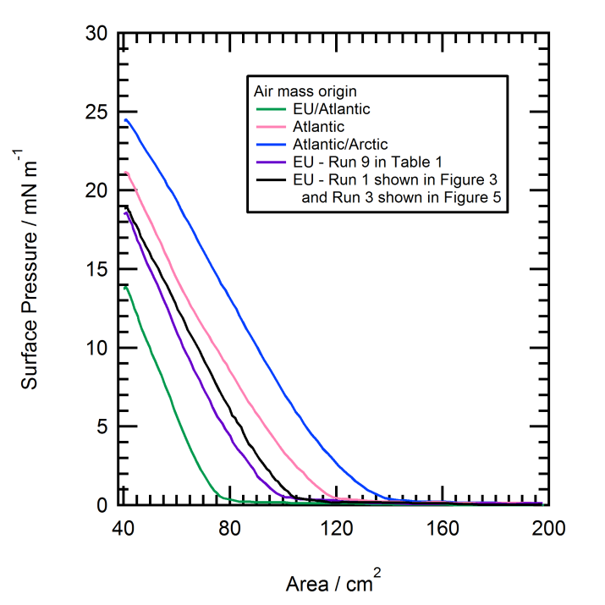
Figure A.1. Pressure vs. area isotherms for atmospheric film material prior to X-ray reflectivity experiments. Note that the purple and black isotherms (data shown in Figure 1 and 5) are very similar in shape.

