The Muteness of Dogs: Pablo Larraín’s El club (2015)

SARAH WRIGHT
Royal Holloway, University of London

In Pablo Larraín’s dark and disquieting film, El club, from 2015, four former Catholic priests and their carer, Hermana Mónica, apparently a former nun, live out their days in a Vatican safe-house in a coastal village in northern Chile: as we will learn during the unraveling of the plot, all of them have been disgraced in some way. Close to the start of the film, a fifth priest arrives to disturb their tranquility. The priests have been spending their days praying, tending an allotment, and racing their dog, Rayo, at a local track, in spite of the prohibition placed upon them to go down to the village during the day. But it soon becomes apparent that the newcomer Padre Lazcano (José Soza), a solemnly grave priest, has been responsible for child sex abuse, when a former altar boy, Sandokán (Roberto Farías), turns up outside the house and begins shouting obscenities which describe in graphic detail the sexual practices he was subjected to as a child. One of the priests hands Padre Lazcano a gun telling him to scare off the interloper, but Lazcano goes outside and shoots himself in front of his former victim. After a grisly shot of the priest lying face down in a pool of blood, the camera cuts to the greyhound, Rayo, who appears to be cowering in the bushes. The camera rests reflectively for a few moments on the dog, before cutting away. After the suicide of Padre Lazcano, Padre García (Marcelo Alonso), arrives to investigate the suicide and to close down the safe-house. But Hermana Mónica (Antonia Zegers) tells him that if he does so she will go to the press with the story of child abuse and other crimes committed by the priests. They come up with a plan to rid themselves of Sandokán: they will kill all of the dogs in the village, including Rayo (to place themselves above suspicion), and then tell the villagers that Sandokán was the culprit. The villagers respond in turn: becoming a mob, they set out to lynch Sandokán. All of the priests are therefore complicit (they kill the dogs themselves and stand by and watch while Sandokán is beaten) with the exception of Padre Vidal, who knows nothing about the scheme and meanwhile has been trying to enlist the support of some surfers to lynch Sandokán: the plan backfires when they beat up Vidal and he returns to the house, bloodied, to find his beloved Rayo has been killed, suffocated, by Hermana Mónica. At the end of the film, Padre García offers Sandokán refuge in the safe-house and the priests welcome the newcomer.
Cases of real dog deaths haunt the film. As he was scouting out the film’s location (La Boca in a coastal region of Chile), Larraín noticed the local practice of dog racing. This was soon incorporated into the script and became a central plank of the plot line. But during research for the film, Pablo Larraín discovered that greyhounds are ritually slaughtered in Spain after the racing season is over using a variety of violent methods. Dogs, then, for Larraín, are more than ciphers for human concerns. The treatment of dogs is critiqued on its own terms; the relationship between the dogs and the humans is questioned, whilst the film lays bare the question of how dogs can be killed with impunity. But, moving fluidly between the literal and the figurative, the killing of dogs also acts as an allegory for the abuse referred to in the film. As we learn, Padre Vidal (Alfredo Castro), like Padre Lazcano, is guilty of the sexual abuse of minors; Padre Ortega (Alejandro Goic), was responsible for child abduction and trafficking; Hermana Mónica, purportedly their carer, has been accused of the maltreatment of a child she brought back from a supposed mission to Africa; Padre Silva (Jaime Vadell) has been in receipt of secrets about torture and other human rights abuses in his position as military priest; and Padre Ramírez (Alejandro Sieveking) is an old man with dementia – no one quite knows why he is there. The film therefore makes reference both to the sexual abuse of minors by Catholic priests, and the wider culture of human rights atrocities in Chile (Padre Ramírez’s loss of memory is symbolic of the raging issues of memory politics in Chile and how best to bring to justice those responsible for human rights atrocities, many of whom are now old men): what unites these cases is the shared culture of impunity surrounding them and it is this aspect (together with a sense of the exercise of power over a vulnerable victim) which links them to the death of the dogs. Child abuse is a sensitive topic and care must be taken not to replicate the abuse on screen. At the same time, the ‘allegorical mode’, (whereby the murder of a dog stands in for other crimes), seems fitting for the cultures of abuse referred to here. Child abuse and human rights atrocities have both been shrouded in a culture of exemption, with few cases being brought to trial. The allegorical mode seems appropriate for the slipperiness of these cases and their habit of evading justice or retribution.
In his book Animal Rites, Cary Wolfe coins the term ‘speciesist’ to reflect on the unequal relationship between human and non-human animals; the sacrificial fate of nonhuman animals and animalized humans; the symbolic economy in which we can engage in what Derrida calls the ‘noncriminal putting to death’ of other humans by marking them as animal. As Wolfe explains, non-human animals constitute precarious lives which are dependent on humans for their survival. But, Wolfe warns, ‘as long as this humanist and speciesist structure of subjectivization remains intact, and as long as it is institutionally taken for granted that it is all right to systematically exploit and kill nonhuman animals simply because of their species, then the humanist discourse of species will always be available for use by some humans against other humans as well, to countenance violence against the social other of whatever species – or gender, or race, or class, or sexual difference.’ Wolfe’s point is that (post)human theories of the subject have nothing to do with, as he puts it, ‘whether or not you like animals’, and everything to do with whether one group of (human) animals should have rights over another group of (human or nonhuman) animals. In this light, El club becomes a meditation on the human. In particular, how can humans be driven to commit acts of abuse, torture or killing against other humans, or animals, and furthermore, how can those acts be institutionalized to the extent that they go without punishment? By addressing the death of dogs, then, the film simultaneously addresses the ways that one group of humans can abuse or kill another group with impunity. In the wake of revelations about child abuse and human rights atrocities in Chile and when human beings are capable of such ‘speciesist’ behaviour towards one another, as well as towards animals, the film begs the question, is it time to rethink the parameters of the human?
If this is a film which, ostensibly at least, ‘refuses to judge’ and offers ‘compassion’ towards its characters, in this article I want to explore the ways in which the dog’s mute presence and later suffering might be said to function as a critique of the cover-ups of both child abuse and human rights atrocities in Chilean society. With recourse to Alice Kuzniar’s moving portrait of human-canine relations in her book Melancholia’s Dog, I will explore the fleeting projections and shifting inter-subjective embodiments occasioned by the dog in this film as well as the extent to which the dog gestures towards a state of melancholia which captures the psychic pain at large in the Chilean panorama. I will turn to Jacques Derrida (in particular, his relationship with his cat) on the relationship between human and non-human animals, in order to explore further the ways in which the nonhuman animal in this film (a greyhound), functions as allegory or projection of human concerns as well as the extent to which the dog’s suffering can be seen on its own terms. Other themes of interest are animal muteness versus the babble of human speech as well as the film’s aesthetics and the acting on screen of human and nonhuman animals. The article turns to the works of Derrida and Wolfe for a post-humanism which articulates shared vulnerability between beings. Using Derrida’s assertion, ‘The animal looks at us, and we are naked before it. Thinking perhaps begins there’, this article aims to critique hierarchies of oppression. By stressing a shared vulnerability, the article will seek to find ways to move beyond a structure of ‘speciesism’ in relations between human and non-human animals.
Digital film, coproduction opportunities, and the promotion of new talent through international and domestic prizes have contributed towards a boom in filmmaking in Chile in the new millennium. Pablo Larraín (together with his brother and producer Juan de Dios Larraín) stand out in terms of the international success they have garnered. Their most recent film is a widely-distributed English-language biopic of Jackie Kennedy, Jackie [2016], and 2016 also saw the release of Neruda, a sophisticated literary pseudo-biopic of the poet starring Mexican-Hollywood cross-over star Gael García Bernal. In their trilogy of films Tony Manero (2008), PostMortem (2010) and No (2012), the latter also starring García Bernal, their work traces a trajectory of films dealing with the Pinochet dictatorship and its legacies. In Tony Manero the film’s protagonist (Alfredo Castro) is willing to commit murder to maintain his Saturday Night Fever costume pristine, in a dark satire of the neoliberalist policies inherited by Chile from the US; in Postmortem, the morgue-worker (Castro again) deals with the influx of dead bodies on the night of the coup in which Pinochet took power, turning Chile into a night of the living dead. Finally, in No, an advertising exec (Gael García Bernal) invents an upbeat jingle and advertising campaign to persuade the Chilean nation finally to get rid of Pinochet in a satirical twist on the Hollywood feel-good movie. El club, meanwhile, is a meditation on human frailty and on the culture of impunity at large not just in the Catholic Church but as a legacy of the Pinochet regime. The film picks up on high-profile cases within Chile (such as the case of Padre Fernando Karadima from the upper class district in Santiago of El Bosque who, despite being found guilty of sex abuse by a Vatican investigation, has never been brought to judicial trial, and that of Padre Gerardo Joannon, who, it was discovered, stole babies from young mothers at birth and gave them to well-to-do families during the 70s and 80s, as well as international cases such as those documented by the film Spotlight. In its depiction of the death of a dog, the film also chimes with other contemporary Chilean films such as Fernando Guzzoni’s Carne de perro (2012) and Las niñas Quispe (Sebastián Sepúlveda, 2013) where the death of a dog also comes to stand in for bio-political crimes committed by the Pinochet regime.

Tropes and Terror

In The Animal That Therefore I Am, a late, posthumously collected, but ‘characteristically exorbitant and playful text’, Jacques Derrida traces the ways that humans have ‘made of the animal a theorem’, which parallels the way literature uses the animal as a trope or symbol. On being confronted while naked by his cat, who stares at him as he emerges from his shower, Derrida reflects upon the separation between humans and animals. His text stages an encounter between human and nonhuman animals, in a work that by turns is a pastiche of, amongst others, the Sartrean look, the Levinasian face-to-face encounter and the Heideggerian ‘being-with’ the other. In Derrida’s conception, the animal unnerves and disrupts the smooth surface of human supremacy. Animals have the capacity to see us and know us in ways we are entirely unable to comprehend. Returning to the image of the greyhound, named Rayo in the film, as the camera rests on him following the suicide, the surrounding shrubbery is dark and it is difficult to make out the outline of the dog’s body, but his eyes shine out through the gloom. I found it useful to compare the image of Rayo in this sequence with Alice Kuzniar’s discussion in her book Melancholia’s Dog (2006) of Keith Carter’s photograph ‘Lost Dog’ (1992). Within a chapter on the muteness of dogs, Kuzniar speaks of the dog’s ineffability, the sense that it ‘seems to be on the verge of saying something that we know it never will; it remains inaccessible to us in its silence’. It seems to be looking out of the frame, and despite the close-up ‘the hound is lost to the viewer, as its muzzle, ears and the rest of its body recede into darkness’. She writes, ‘however long we scrutinize the photo, we cannot penetrate the thoughts and worries of the dog: it lives in an enigmatic world that we cannot perceive or read. Consequently, we are the ones who are lost’. The image of Rayo in El club is similarly ineffable, the gloom surrounding the dog seems symptomatic of our inability to grasp what the dog is thinking. For Stanley Cavell, this is the terror, what he calls the ‘skeptical terror of the independent existence of other minds’ – the awareness of consciousness beyond our understanding and knowledge. As Derrida points out, we can only conceptualize the animal through language. The animal is always already symbolic to us. We name the animal, yet we cannot really know it. Perhaps it is for this reason that humans attempt to tether and control the animal. Turning to another artistic representation of a dog: Goya’s painting of a drowning dog, I wonder if this might be the double terror it inspires: just as the dog is drowning, unable to gain a foothold in the shifting sands, so are we unable to understand the gaze of the inscrutable dog, signaling the limits of human understanding, the fallibility of human knowledge and a sense of the abyss that lies beyond the limit of our consciousness.

Ambivalence pervades the aesthetics of the El club, the manifestation of a drive to move closer to the priests (to pin them down, finally, for their misdeeds, where the judicial process has let them off scot-free, or to understand them) and a simultaneous retreat (we recoil from the hints of their crimes). Cinematographer Sergio Armstrong’s experimentalism led him to use a blue Day For Night filter, normally used to film nighttime scenes, but here employed for the scenes during the day, combined with an Enhancing filter. The former diluted the colours; the latter brought them out. The combination of filters, with a palette of blues, greys and browns which give texture to the light, functioned in such a way as to blur the edges, breaking down boundaries and confusing the markers of time so that one is neither sure what time of day the scenes take place nor whether this is a story set in the past or the present. The inmates of the house are in a ‘shadowy pre-hell limbo’, and ambiguity pervades the film, made palpable through the murky, gloomy light, symbolic in turn perhaps of the moral turpitude of the film’s protagonists, whom the film refuses to condemn outright. This aesthetic is also reminiscent of Derrida’s ‘abyssal limit of the human: the inhuman or the human, the ends of man, that is to say the border crossing from which vantage man dares to announce himself to himself, thereby calling himself by the name that he believes he gives himself. And in these moments of nakedness, under the gaze of the animal, everything can happen to me, I am like a child ready for the apocalypse.’ Bruns refers to this space as the ‘anomalous space-between’ where ‘no-one is anything, ahuman, without horizons or markers’. There is also scope here to home in on the ‘inhuman’ element of this description, so that the limits of human consciousness become ineluctably bound up in the limits of the humane, the limits of humanity (in turn this space is embodied by the animal - in his essay, Derrida makes the link between the slaughtering of animals and genocide - as an animal, even before his death, Rayo is hu/man’s other, in the ‘zone of indistinction’, a bare life). This may be the terror: that human evil may not be beyond the limits of our consciousness. As Armour puts it, this space is the ‘abyssal border between who we human beings like to think we are and what we are all capable of’. For Bruns, quoting Agamben, ‘bare-life’, is a ‘zone of indistinction’, the space of the ‘outcast’ and ‘absolute exteriority’, but it is also connected to the child and the animal. In El club, the uncanny trace of human ‘others’ circulates within this amorphous aesthetic: snatched references to children kidnapped or abused, to victims of torture, to the disappeared (now lodged in the memories of Padre Silva) who move between bare life and the ghostly, and the dog, Rayo, whose death will not, unlike like Padre Lazcano’s, be marked and memorialized with a marble headstone (a reference in turn, perhaps, to the imperfect burial of Chile’s disappeared).



Figure 1: Rayo becomes a sliver of shadow against the light (photo courtesy of Fábula)

The decision to use Soviet (LOMO) lenses from the early 1960s may have created a ‘geopolitical texture’ for this film, but it also embeds a blur into the film’s fabric in the sequences where Rayo is captured in movement while training. He leaps (to catch the bait on the lure) and becomes just a sliver of a shadow against the light. Thus the dog is here materially bound up in spectral projections, creating phantom alliances and divisions. Resisting uncritical anthropomorphisation, Kuzniar has shown the irresistible pull of the dog to draw out shifting projections and inter-subjective embodiments in artistic production where they feature. For Kuzniar, there is a fundamental melancholy at work in the artistic recreation of human-canine relations. For her, at the root of this melancholy lies the human attempt at closeness that becomes a yearning when that closeness is thwarted by dogs’ unknowability. If for Kuzniar the dog ‘mourns for what it senses yet cannot articulate’, it mourns the impasse, the separation between humans and dogs.
El club suggests this yearning in the relationship between Rayo and Padre Vidal. In one vignette, Vidal and Rayo are photographed in similar pose, their heads bowed. Vidal is reading, whilst Rayo is tethered to a running machine. The palette of browns, which envelops them both, suggests their intimacy, a moment of repose for the normally jumpy, highly-strung Vidal (with a particularly skittish performance from Alfredo Castro) and the energetic greyhound. Rayo is physically tethered to Vidal; Vidal is psychologically tethered to his dog: both are prisoners of the house. Rayo is represented as an inter-subjective manifestation of Padre Vidal who cares for him (the other priests treat the dog only as a means to earn cash and as a diversion). Vidal defends his affection for Rayo against the threats from Padre García that he will sell Rayo and put an end to their relationship. Rayo seems at first to declare Vidal’s ‘ethical health’, the affection between dog and man (or even briefly indulging what Bradshaw refers to as the film’s ‘[defense of] paedophilia’). But comparisons of sequence of the film in the light of Derrida’s encounter with his cat bear some analysis. During one of García’s interviews with Vidal, the latter exclaims:

‘El perro […] camina conmigo. A veces me mira’
‘Me imagino que Usted sabe que ese perro no es una persona?’ asks Padre García,
‘Por supuesto. Pero cuando paso mucho tiempo con él a veces siento que se humaniza. Que quiere humillarme. Que quiere saber que es lo que yo estoy pensando’
‘Usted humaniza al perro y el perro…?’,
‘qué pasa con el perro?’
‘el perro le animaliza a Usted?’

Of his encounter with the (unnamed) cat, Derrida remarks, ‘I often ask myself, just to see, who I am – and who I am (following) at the moment when, caught naked, in silence, by the gaze of an animal, for example the eyes of a cat, I have trouble, yes, a bad time overcoming my embarrassment (2002, p. 372)’ and he expounds on his ‘shame’. Derrida’s shame derives from the knowledge that he is naked, but it gives rise to reflections on the way he is seen by the cat: the cat reveals, ‘the point of view of the absolute other, and nothing will have ever done more to make me think through this absolute alterity of the neighbour than these moments when I see myself seen naked under the gaze of a cat’. This is achieved through a ‘feeling that one is seen by that which we call animal’, an intersubjectivity which seems echoed in this sequence in El club by the reference here to, ‘Usted humaniza al perro y el perro … […] el perro le animaliza a Usted?’ Derrida’s self-realisation is comparable to the Biblical Fall, ‘a coming to know oneself that means knowing oneself ashamed, in short, a consciousness of good and evil’ as he comes to terms with the limits of the human. Vidal feels a sense of shame and exposure, that the dog: ‘quiere humillarme’. Yet this does not lead to insights of the difference between good and evil (however much Rayo may seem to act as Vidal’s conscience). Rather, for García, the relationship with the dog turns Padre Vidal into a delusional animal: ‘el perro le animaliza a Usted’, ‘Usted sabe que ese perro no es una persona?’, and this in turn becomes linked with a certain mental instability (‘quiere humillarme’) that is in turn connected to the way Vidal speaks of the love he experiences with young children, while ignoring the damage he inflicts in the pursuit of his ideals. Vidal treats Rayo as a pet. Dogs and children are often twinned in the popular imagination, for example, Levinas writes that, ‘In the dog, what we like is perhaps his childlike character. [...] A dog is like a wolf that doesn’t bite. ...Children are often loved for their animality. The child is not suspicious of anything. He jumps, he walks, he runs, he bites. It’s delightful’. It is only at the denouement that we will realize this view of Rayo as pet is also delusional, when he is eliminated as part of a greater cause. In the intersubjective identification suggested by this exchange (verbally in dialogue with García and via cinematography) Rayo is a phantom manifestation both of the child loved and yearned for and of the child-victim as accuser (‘quiere humillarme’). For all the priests, Rayo is connected to transgression; he becomes the embodiment of their secrets. As Cavell has noted of the animal, it often ‘allegorizes the escape from human nature’. Rayo’s mute melancholy is not so much attributed to the chasm that separates man and beast, but to a psychic pain at large in the house, caused by a generalized sense of the unspoken child abuse in a film which offers no visual images to convey an abuse that has never been brought to trial.

The cut to the image of Rayo following Padre Lazcano’s death connects the dog’s gaze with guilt and silent recrimination, and the suicide that has just taken place. A visual contrast is established between Rayo, and Sandokán, who is also photographed against a gloomy shrubbery outside the house. But where Rayo is sleek, fast, slender and mute, the verbally incontinent Sandokán is unkempt, noisy and, on occasion, drunk. Sandokán brings with him an assortment of thrown out furniture to set up camp outside the house: where once he was the altar boy, now grown he is shameful, undesirable. Between them Rayo and Sandokán represent the child as a projection of hope and innocence, and the corruption of that innocence, abject and ashamed.

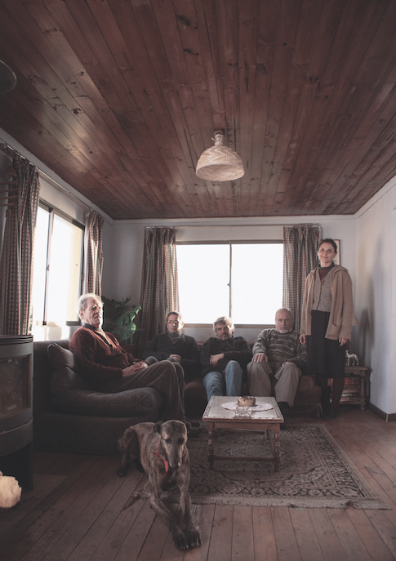

Figure: The Club: “a retirement home for kindly old men” (photo courtesy of Fábula)

If Rayo is the most recent manifestation of the priests’ transgression (they are not supposed to interact with the villagers), and a symbol of their lack of remorse: ‘it is as if all their suppressed sensuality and sin and self-hate has been channeled into this new addictive vice of dog-racing’, Sandokán is noisy and unruly. He disrupts the impression that ‘the club’ is a retirement home for kindly old men. Sandokán is filled with a self-loathing (a metonymic manifestation of the priests’ self-hate) that is specifically related to sex (his language is a transgressive blend of the sacred and the profane). He regards the sex he has with a woman from the village as ‘dirty’ (he wants to be cleansed by the priests’ ‘holy touch’); the sex is messy, uncomfortable for us to watch. He is an embarrassment to the priests and represents both the embarrassment that the priests in turn represent to Chilean society, and the embarrassment of the testimony of the victim – impolitic, distasteful, often ideologically messy. There is an unspoken commentary here on the difference between the unruly Sandokán and the stoic, mute, dignity of the dog which has to do with the way that it is easier to repress the testimonies of the victims than to deal with their untidy distastefulness. Graphic, sensational testimonies (not just those of the victims of child abuse, but also the victims of torture) scandalize everyday popular discourse in Chile. Roberto Farías, playing Sandokán, spoke to victims of child sexual abuse for an earlier play, devised with Pablo Larraín, Acceso, on which El club is partly based, and he found them to be baldly frank about their experiences of abuse. El club underlines the importance of testimony as well as the graphic and often distasteful or impolitic way that the violent language of abuse (or torture) flares up in popular discourse in a way that is possibly unsustainable in the long term. But it also articulates the whispers and cover-ups that also circulate and the ineluctable pull towards silence and stoicism which leads to repression, silence and political amnesia. Sandokán’s speech ‘immoderately babbles’ in comparison to the solemnly mute dog. By contrast, Rayo is silently censorious of abuse. Together, Sandokán and Rayo ventriloquise the unheard voices of the victims of abuse, as well as the surrounding culture of silence and impunity.

The Anthropomorphism of the face

The cinematic currency of El club is the face in close-up. There are no establishing shots as a prelude to the close-ups deployed during Padre García’s interviews: the faces appear hyperbolic, gigantic on the screen, their magnitude reminds us of the aura in the close-up which is the preserve of the star, or seems like a silent comment on the way that the church sanctifies the mundane. Armstrong shot on high-resolution digital camera, but used anamorphic lenses (old Russian lenses favoured by Tarkovsky) from the 1960s. These create intimacy with their subject, but they are also distorting, their fish-eye-effect is distancing. Our instinctive response to the faces is compassion, particularly in the light of the frailty and infirmity of these old men, offered up to us close-up in a face-to-face encounter. The close-up balances extremes: it draws us closer to the characters who are then distanced from us by the hinted revelations of their misdeeds. Mary Ann Doane notes that the close-up may verge on the obscene. She quotes Jean Epstein: ‘everything is movement, imbalance, crisis. Crack. The mouth gives way, like a ripe fruit splitting open. As if slit by a scalpel, a keyboard-like smile cuts laterally into the corner of the lips’. This description is particularly apt for Alejandro Goic’s performance as Padre Ortega, the priest who has given away babies stolen at birth. His performance is by turns self-justificatory, defensive and then, when confronted by his crimes, he erupts into cackling laughter, his face a fascinating play of movement that seems obscene in its ruthlessness. The close-up, as Doane reminds us, is a ‘fragment for itself’, an ‘Entity’, like a deictic finger pointing ‘here it is’. Formally, the close-up pins down the subject, presenting it for scrutiny. Moreover, as Doane notes, close-ups ‘seem to constitute the very revelation of the soul’. ‘It is barely possible to see a close-up of a face without asking: what is he/she thinking, feeling suffering? What is happening beyond what I can see?’ Or, in Baláz’s terms, the close up of the face allows us to understand that ‘there is something there that we cannot see’. For David Wills, this is the paradox of Balazs’ thought: ‘close-ups are often dramatic revelations of what is happening under the surface of appearances […] the creative instruments of a mighty visual anthropomorphism’, but at the same time, the ‘facial expression on a face is complete and comprehensible in itself’. As Wills notes, this is, ‘ether an image of fullness and light, or one brought back from less visible depths’. We could add that this paradox creates an emptiness behind the depth; where the ‘microphysiogomy’ of the face appears to reveal, in fact it refuses to divulge. In El club, Padre Ramírez, for example, provides graphic descriptions of sexual activity, but it is unclear if he is recounting something seen, or repeating something heard or imagined. Despite the detail engendered by the close-up, we are unable completely to grasp the facts, as if the close confrontation eclipses our sense of mastery (which parallels the sense of the impunity surrounding these crimes). But perhaps this is a relief. Perhaps the nothingness behind the face suggests our incomprehensibility, the limits of our understanding of evil.
El club was filmed in just three and a half weeks during a break in filming for Neruda. Larraín collaborated with writers Guilermo Calderón and Daniel Villalobos, rewrites were happening as filming took place, and three different endings were conceived. The actors were given the scripts the night before filming took place and they interacted with one another before the camera (placing the actors almost on a level with the dog-actors, unconscious as they were of the narrative arc). There is a rawness and immediacy to their performances, but the cuts between talking heads sequences is bewildering, distancing. The inhabitants of the house reveal their crimes in the whispers of the confessional. Larraín stated in an interview that ‘this is the tone of voice used by the Church, a whisper. Nobody speaks loudly. A priest never shouts. It’s all in a lower tone of voice like something is said but it’s not being said’). By turns the priests are self-justificatory, defensive, they never speak of remorse. Padre Garcia, a Jesuit priest whose smooth, chiseled earnestness speaks of his hope for reform, questions them about their crimes but for all their words these are often difficult to pin down. Padre Ramírez’s dementia (the fragility of Alejandro Sieveking’s face quivers as he speaks and we are drawn in by his compelling, tremulous performance) leads him to repeat fragments of conversation overheard – but these are often graphically sexual and repellent. Hermana Mónica explains her mistreatment of a child from Africa that she brought back from a ‘missionary’ visit (although as we later learn, she has never taken vows to become a nun). Her disturbing words contrast with the apparent guilelessness of her face (which begins to take on sinister contours), and it is as if we are trying to piece together the truth almost in spite of what she says.

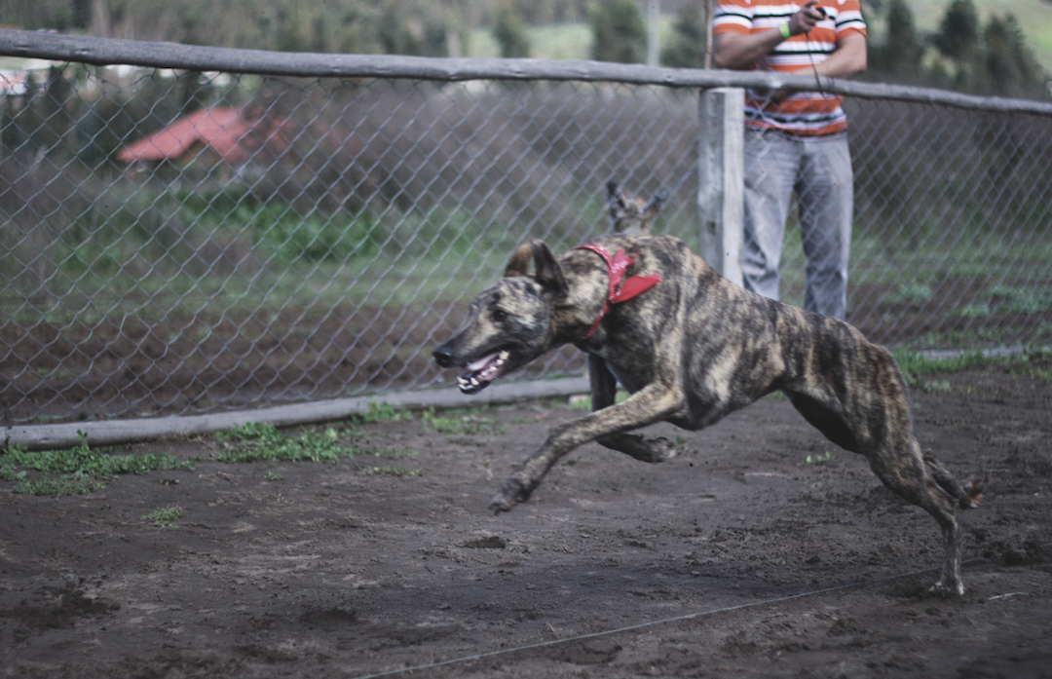

Figure 3: ‘Rayo’ at the race-track (photo courtesy of Fábula)

This dog on film

The dog, Rayo, in El club is, of course, a technological construction, what Ryan Prout in his paper for this issue calls a ‘skeuomorph’. The dog I have been calling Rayo is in fact different dogs - the male dog used in the main scenes (cited as Donka in the credits), was not a fast runner, so a female, dog (unnamed) was used for the racing scenes. The ‘dog’ is framed and edited to create symmetries and correspondences, whilst even his barks and other noises are a complex mixture of direct and library sounds. Nevertheless, real dogs were also subjected to material conditions (dogs from the village which had a strong tradition of racing greyhounds rather than trained performers). Lourdes Orozco is surely right to guide us towards the theories of Michael Peterson when considering the performance of dogs: these are social interactions with humans whether on stage or screen (and it is our knowledge of the constructedness of these scenes - however much this knowledge is disavowed as we watch - that saves the film from accusations of animal cruelty when we witness the terrible scenes at the end of the film where the dogs are killed). Animals (and children) may often be deemed incapable of giving a ‘proper’ performance, as Alan Read notes Theatre, Intimacy and Engagement, but these scenes with dogs retain the sense of a life captured on screen, of ineffability or contingency captured on celluloid. The sense of there having been a real dog, of a dog’s ‘thereness’ seeps through these scenes. As the dog’s face is covered with a plastic bag, to suffocate him according to the plot, as we hear whimpers (even if these were artificially produced), and we wonder how much the real dog understood of what was happening. As John Burt writes, animals, in spite or maybe because of their ‘semantic overload’, also point beyond their significance in a scene to their treatment in terms of welfare. The dog’s presence, its ‘thereness’ is important to the horror of the scene even as we trust to the tagline ‘no animals were harmed in the making of this film’. For Derrida, the reductive unitariness of the naming of a mute animal may be juxtaposed with the uniqueness of the animal (in his case his cat). As Kuzniar glosses, ‘to the naming’ [he juxtaposes] the facticity or thereness of this particular living thing with which he stands face to face’. Rayo is both more and less than a metaphor, akin to Derrida’s figure of the animot, or what Lippit, in his vivid discussion of animal death on screen, has termed the anti-metaphor or animetaphor ‘a metaphor made flesh, a living metaphor’, that ‘marks a limit of figurability’. The gaze of Derrida’s cat, as it contemplates Derrida naked, beyond the figurative, and before the naming or identification (in terms of species or gender), is reduced to a ‘mortal existence’ that ‘refuses to be conceptualized’—an ‘unsubstitutable singularity’. The animetaphoric death of the dogs in El club ‘irrupts into the symbolic fabric of the film’, simultaneously confirming and resisting allegorisation, becoming a living metaphor.
Towards the end of the film, the priests murder the village dogs. One village dog pushes his face through the bars to greet Padre Silva, trusting and open, but Padre Silva kills the dog with an axe (we cut to black so that we do not see the final blow). The close-up offers the opportunity for an ethical engagement with the other. But Levinas’s ethical thinking relies on a discussion of the human face. ‘Human beings acknowledge the nonhuman other through a sense of pity or a delight in their servile, childlike non-reality’. For Levinas, even animals have a hierarchy. A dog may have a face, but the snake does not. Nevertheless, even in the case of the dog’s face, ‘the best that the animal face can do is to recognize the human face as different from itself’. And in his essay on the cat, Derrida maps ‘onto his cat-encounter (something like) the ethical relation described by Emmanuel Levinas.’
Derrida confirms that animal muteness performs a violence: humans name the animal. To name ‘animal’ is to enter into an unequal relationship between human and nonhuman animals. John Burt has also written of the loss and mourning associated with animals, but for him this has to do with profound sense of the way that animals are maltreated. For Wolfe, death is never far from our projection of the animal. Any allegorical use of the animal to suggest loss, mourning or death, is underwritten by the violence to which it has been subjected by humans. In the film we see several close-ups of Rayo’s face: at the start of the film after the suicide as he cowers in the shrubbery; when Vidal goes to give the dogs some meat he has brought from the village; exercising Rayo at the racetrack and at the end of the film when Hermana Mónica goes to suffocate Rayo (we have also seen Padre Ortega preparing broken glass to place inside a piece of bread to give to another dog, and a third dog pushed his face out to greet Padre Silva and was rewarded with death at the hands of an axe. In fact, the final scene of this dog is censored, only Padre Silva’s facial expression allows us to register and reflect the death of the animal). El club therefore focuses on the animal face as if to make a plea for animals to be treated ethically. But we also see close-ups of both bloodied faces of Sandokán and Padre Vidal, and they similarly cower, wrapping their arms around their bodies after their lynching, sharing with Rayo a sense of vulnerability and shared finitude, through their intersubjective embodiments.

Animal Acoustics
Sound designer Miguel Hormazábal created the sounds of the natural world as a backdrop to the events in the house: the wind that never lets up until the scene where Sandokán is attacked and everything goes quiet; the sounds of barking that punctuate the film, and the sounds of birds specific to the area that can be heard against the rolling waves when the priests visit the beach. When Rayo is killed he is far from mute. Rather, he utters cries of distress as he is killed (suffocated by Hermana Mónica with a plastic bag). We might be reminded of Judith Butler’s discussion of the face that says ‘thou shalt not kill’ in her book Precarious Lives. Butler notes that this ‘need not be spoken in a human language, ‘so the face, strictly speaking, does not speak, but what the face means is nevertheless conveyed by the commandment’. Instead of speaking, the face may be a ‘cry’, a ‘sob, a ‘scream’. It is ‘an utterance, that is not strictly speaking linguistic’, a ‘scene of agonized vocalization’, the ‘wordless vocalization of suffering’. ‘the face, if we are to put words to its meaning, will be that for which no words really work; the face seems to be a kind of sound, the sound of language evacuating its sense, the sonorous substratum of vocalization that precedes and limits the delivery of any semantic sense’. Chloe Taylor takes Butler to task for what she terms her anthropocentrism, but nevertheless she shows the value of Butler’s writing to animal studies. For Taylor, Butler ‘seems to be setting the stage to be able to claim - or allow others to claim - that the cries of animals in slaughterhouses, the sight of their struggling bodies as they are dragged to their deaths, of their silence, corporeally-expressed grief as they live out their brief lives in factory farms, fur farms and laboratory cages, addresses us with the ethical command, ‘thou shalt not kill’ which is our ethical responsibility’. Taylor goes on to discuss our shared vulnerability (both animal and non animal) but she notes that ‘Butler recognizes that some bodies are more vulnerable than others’. As Butler also notes, some animals are not mournable. It is interesting that in El club, Vidal mourns the death of Rayo, but the others see it as a necessary death to ensure the functioning of the group. On one level Rayo’s is an ‘ungrievable’ death, but for Anat Pick, a ‘creaturely ethics’ obtains in cinema via ‘the recognition of the materiality and vulnerability of all living bodies, whether human or not’.

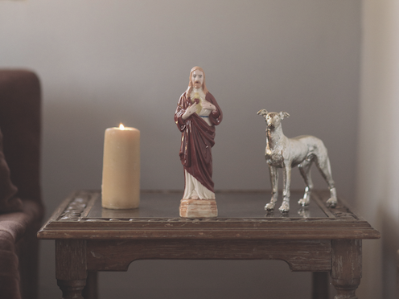

Figure4 : “Greyhounds are the only dogs mentioned in the Bible” (photo courtesy of Fábula)

The analogy between abuse of dogs, children and the ‘disappeared’ is a valid one, however obscene it may at first appear. It is not that the terms of the analogy are equal, but whereas Haraway demands a different language for animals and atrocity, in El club the point seems to be what the dog can reveal about the ideologies of violence, redemption and sacrifice that permit abuses of power. Larraín was impressed that greyhounds are the only dog mention in the Bible. In El club the dogs become scapegoats: necessary deaths to preserve the community (what Butler refers to as ‘the sanctity of life’). Burt reminds us that dogs are mired in notions of sacrifice and loss, in part because of the cruel way they have been treated at the hands of humans. Wolfe speaks of the ‘tacit agreement that the full transcendence of the “human” requires the sacrifice of the “animal” and the animalistic, which in turn makes possible a symbolic economy in which we can engage in what Derrida will call a “noncriminal putting to death “ of other humans as well by marking them as animal’. The analogy stands: in El club, the violence towards precarious lives nestles below the surface and can be incited quickly, a reminder of the legacies in Chile of institutionalized violence operated with impunity. Guilt, abuse and repression cohere around the figure of the dog. But Sandokán, who is gathered up by Padre García who tends to his wounds, remains imperfectly assimilated into the household (at the end of the film we see him demanding a range of drugs and relishing his move into the house where he will be near the priests), a perpetual reminder of the priests’ transgression.

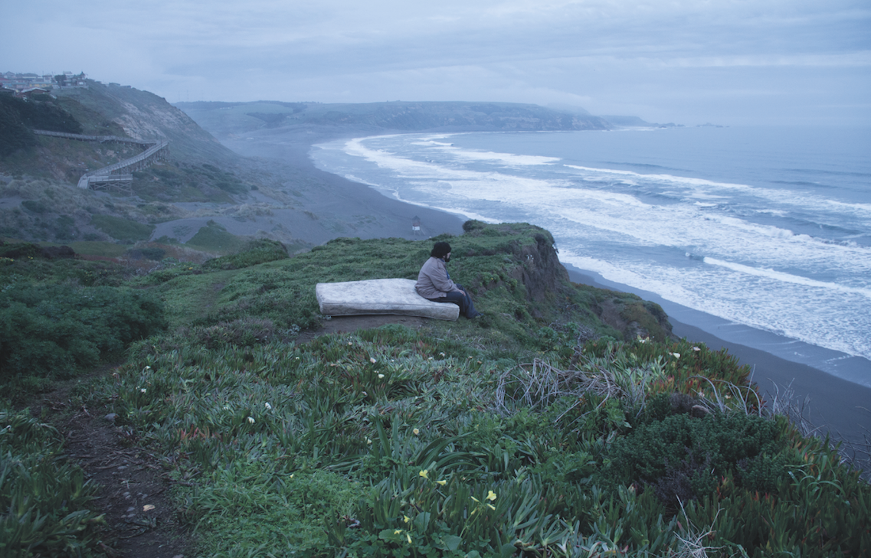

Figure 4: Sandokán as the blot on the landscape

Rob Stone has written eloquently on the allegorical uses to which real non-human animal deaths have been put in Spanish cinema. In El club, our faith that (as the credits inform us) ‘no animals were harmed in the making of this movie’, confirms our understanding of the dog as caught in a shifting fretwork of projections in this film. But even as the dog underwrites this reading of the film as revelatory of the exercise of biopolitical processes silently ongoing in present-day Chile, the dog also to some extent refuses or resists that anthropomorphisation, with the result that the hierarchies of power between humans and other humans, and between humans and non-human animals, are laid open to critique. El club leaves us with a sense of mutual embodiments and vulnerability between humans and animals, what Anat Pick describes in relation to cinema as ‘a zoomorphic stage that transforms all living beings – including humans – into creatures’. The film is shot through with what Jonathan Burt calls the ‘assymetries of species difference’, a non-correspondence at work in human-animal relations. But in its attentiveness to damage, suffering and vulnerability, El club traces a mode of relationality between the animal and human that poses urgent ethical and political demands. In spite of Derrida’s description of the abyssal encounter with his cat, he also understands the encounter with the animal look as a ‘being-with’ – a form of ungraspable commonality. Rayo is a ‘living metaphor’ but the parallels established between Rayo and Sandokán serve to underscore a ‘being-with’, an intersubjectively embodied commonality in terms of suffering, damage and vulnerability and a shared finitude. In tracing relations between fictional and real events of human and animal suffering, El club reminds us of the ethical, political and juridical implications at stake in a sustained questioning of the human-animal divide.

I would like to offer my profound thanks to Sergio Armstrong, Miguel Hormazábal and Estefanía Larraín for talking to me about their work on this film. I am also very grateful to María Delgado for sending me her interview with Pablo Larraín prior to publication and to Rocío Jadue Zarhi at Fábula Producciones and to Jo Evans for her helpful comments.
From a private interview with Sergio Armstrong, 5.9.16.
Gregorio Belinchón, ‘Pablo Larraín arrasa Berlinale con ‘El club’’, http://cultura.elpais.com/cultura/2015/02/09/actualidad/1423496577_587535.html Accessed 7.1.16.
A debate raged, for example, regarding whether Pinochet could be brought to trial given his advanced age and infirmity.
See Cary Wolfe, Animal Rites: American Culture, the Discourse of Species, and Posthumanist Theory (Chicago and London: University of Chicago Press), 6 and Jacques Derrida, “Eating Well, or the Calculation of the Subject,” in Points: Interviews 1974-1994, ed. Elisabeth Weber, trans. Peggy Kamuf (Stanford, Stanford University Press, 1995), 278.
Wolfe, Animal Rites, p. 8.
Wolfe, Animal Rites, p. 7.
Pablo Larraín remarks that ‘the first reaction is rage and a desire to punish, but once you get past that, what you really have is compassion for these characters. Compassion is a key word in this film’, cited in Mar Diestro-Dópido, ‘Sins of the Fathers’, Sight and Sound, April 2016, volume 26, issue 4, 28-30, (p.29).
Alice Kuzniar, Melancholia’s Dog: Reflections on our Animal Kinship (Chicago and London: University of Chicago Press, 2006).
Jacques Derrida, ‘The Animal That Therefore I am (More to Follow)’, Critical Inquiry, trans. by David Wills, 28:2 (Winter 2002), 369-418 (p. 397).
The Karadima case was made into a film, El bosque de Karadima (Matías Lira, 2015). Larraín cites the Joannon case as inspiration. See Delgado, ‘The Capacity to Create Mystery: An Interview with Pablo Larraín’, in A Companion to Latin American Cinema, eds. Maria M. Delgado, Stephen Hart and Randall Johnson (London: John Wiley & Sons, Inc, 2017), 459-72 (p. 465).
I have written on Guzzoni’s film in ‘’Spectral Voices and Resonant Bodies in Fernando Guzzoni’s Dogflesh (Carne de perro, 2012), in Tom Whittaker and Sarah Wright, Locating the Voice in Film: Critical Approaches and Global Practices, Oxford: Oxford University Press, 2017, 243-262.
Gerald L. Bruns, ‘Derrida’s Cat (Who Am I?)’, Research in Phenomenology 38 (2008),404-423, (p.405).
Derrida, ‘The Animal’, 383.
Bruns, ‘Derrida’s Cat’, 406.
Kuzniar, Melancholia’s Dog 40-63;
Kuzniar, Melancholia’s Dog, 43.
Cavell, quoted in ,Wolfe, Animal Rites p. 4.
Derrida, ‘The Animal’.
Francisco Goya, El perro, c. 1819-1823, Museo del Prado. With thanks to John Beusterien for drawing my attention to Goya’s painting in this context.
From a private interview with Sergio Armstrong 5.9.16. Set design also contributed towards this blurring of the period of the film, with old furniture from indeterminate periods and the brief that a sofa, for example, should ‘give the impression that a lot of people had used the sofa over the years’. From a private interview with Estefanía Larraín, 17.1.17.
Diestro-Dópido, ‘Sins of the Fathers’, 29.
Derrida, ‘This Animal’, 382.
Bruns, ‘Derrida’s Cat’, 411.
Ellen T. Armour, Signs and Wonders: Theology After Modernity (New York: Columbia University Press, 2016), 152. Drawing on the phrase, ‘calling himself by the name he believes he gives himself’, Armour reflects on the blurring of the border between human and animal in the photographs of Abu Ghraib in the light of Derrida’s confrontation with his cat. In spite of the aporia between human and nonhuman animals, as Armour notes ‘there is no simple or clean line separating “man” from “animal”’ in these pictures (p. 151).
Bruns, ‘Derrida’s Cat’, 411.
From an interview with Maria Delgado: ‘When movies were made on film they would all look different because during the developing process you washed the film negatives, and countries around the world have different kinds of water. So every film would look different and they would have a kind of geopolitical texture. […]. Nowadays, the CCDs – the chops used to capture the image in a digital camera – are made in the same place with the same technology. As such, all images look pretty much the same. I think this is very dangerous and horrible. So […] we tried to find a look and a texture that could only belong to this movie’. Delgado, ‘The Capacity to Create’. 469.
On the possibilities of the blur in digital filmmaking, see Hito Steyerl, ‘In Defense of the Poor Image’, e-flux, November 2009, http://www.e-flux.com/journal/10/61362/in-defense-of-the-poor-image/. (accessed 2.2.17).
Rayo seems to some extent to declare Vidal’s ‘ethical health’ in a way that reminded me of Levinas’s discussion of the dog Bobby, who happily greeted prisoners in the concentration camp. Levinas writes that the dog humanized those who had been made to feel less than human by their surroundings. Emmanuel Levinas, ‘The name of a dog, or natural rights’, Difficult Freedom, trans. Sean Hand (Baltimore: John Hopkins University Press, 1990), 3. See also Max Hantel, ‘Bobby Between Deleuze and Levinas, or Ethics Becoming-Animal’, Angelaki, 18:2, 2013, 105-126.
Bradshaw,
Derrida, ‘The Animal’, 380.
Sliwinski, ‘The Gaze Called Animal: Notes for a Study on Thinking’, CR: the new Centennial Review, 11, 2, Fall 2012, 61-81 (p. 372).
Alfredo Castro, playing Vidal, has played a series of delusional characters in Larraín’s films: in Tony Manero, he plays a John Travolta imitator who will stop at nothing in his desire to emulate his icon (and we will discover he is a psychopathic murderer) – the film is a dramatic allegory for the introduction of neoliberalist policies to Chile during Pinochet that were imported from the US, using any violent means possible to assure their implementation.
Emmanuel Levinas, The name of a dog, or natural rights’, Difficult Freedom, trans. Sean Hand (Baltimore: John Hopkins University Press, 1990), 3.
Cavell, cited by Wolfe, Animal Rites, p.4.
Peter Bradshaw, ‘The Club review – dark drama skewers sinning priests’, The Guardian, 24.3.16, https://www.theguardian.com/film/2016/mar/24/the-club-review-pablo-larrain-catholic-church-chile (accessed 4.2.17).
As Peter Bradshaw ‘The Club review’, writes, ‘Larraín allows some of his priests to defend paedophilia, eliding it with homosexuality, in a provocative way ‘ – this provocation remains unresolved in the film.
For example, the testimony of women who were raped by dogs emerged in popular discourse around 2014. See Verónica Romero, ‘Uno de los secretos más aberrantes de los vejámenes en dictadura: el adiestramiento de perros policiales para violar detenidas’, Cambio 21, 22.9.14 http://cambio21.cl/cambio21/site/artic/20140917/pags/20140917152640.html, (Accessed 2.4.17). See also ‘Informe de la Comisión Nacional sobre Prisión Política y Tortura’, http://www.indh.cl/informacion-comision-valech, [Accessed 05.08.2010].
The play was first performed at Alfredo Castro’s Teatro de la memoria in 2004, see Delgado ‘The Capacity to Create’, 469n.
On the dangers of forgetting (in relation to human rights abuses under Pinochet), see Nelly Richard, Residuos y metáforas: ensayos de crítica cultural sobre el Chie de la Transición (Santiago: Editorial Cuarto Propio, 2001). On testimony and the difficult questions it raises, see Michael Lazzara, Luz Arce and Pinochet’s Chile: Testimony in the Aftermath of State Violence (London: Palgrave, 2011).
Anamorphic lenses were used throughout the film, but particularly angular ones were used for the talking heads sequences, which created enhanced distortion. Author’s interview with Sergio Armstrong, 5.9.16.
Levinas’s repudiation of art has meant that ‘there is no easy bond to be forged between this philosopher and film’, but in her work Cooper has offered a convincing case. Ruti observes that for Judith Butler, ‘even the executioner has a face’ when she discusses the condemnation of Eichmann that Hannah Arendt stages at the end of the Eichmann in Jerusalem. See Mari Ruti, Between Levinas and Lacan: Self, Other, Ethics (London: Bloomsbury, 2015).
Mary Ann Doane, ‘The Close-Up: Detail and Scale in Cinema’, differences: A Journal of Feminist Cultural Studies, vol 14:3, Fall 2003, 89-111; 90.
I have written elsewhere on Goic’s performance in his body of work with an emphasis on his voice. See Wright, ‘Spectral voices’.
Doane, ‘The Close-Up’, 90.
David Wills, Dorsality: Thinking Back Through Technology and Politics (Minneapolis: Universty of Minnesota Press, 2008) 163 quoting Béla Balázs, Theory of the Film: Character and the Growth of a New Art, trans, Edith Bone (New York: Dover, 1970) 61.
Wills, Dorsality, 163.
From a private interview with Sergio Armstrong, 5.9.16.
Diestro-Dópido, 30.
From a private interview with Estefanía Larraín, production designer, 17.1.17.
(Miguel Hormazábal’s sound studio Plató CinecolorSonido). From a private interview with Miguel Hormazábal, sound designer for El club, 20.8.16.
Lourdes Orozco, Theatre and Animals (London: Palgrave), 42 citing Michael Petersen, ‘The Animal Apparatus: From a Theory of Animal Acting to an Ethics of Animal Acts’, TDR: The Drama Review, 51, 1, Spring 2007, 33-48.
Alan Read,Theatre, Intimacy and Engagement:The Last Human Venue (London: Palgrave, 2007),
John Burt, Animals in Film (London: reaction, 2004) Laura McMahon writes that ‘the presence of the animal onscreen often confounds clear distinctions between the diegetic and the extradiegetic’ Laura McMahon ‘ Screen Animals Dossier: Introduction’, Screen 56 (1), 2015, 81-87 (p. 82).
Kuzniar p. 5 citing Jacques Derrida, ‘The Animal’, 378..
Akira Mizuta Lippit, ‘The Death of an Animal’, Film Quarterly 56:1 (2002), 9–22 (p. 10).
Derrida, ‘The Animal’, 378.
See Laura McMahon, ‘Unwinding the Anthropological Machine: Animality, Film and Arnaud des Pallières’, Paragraph 35.3 (2012), 373-388 (p. 378).
Dibyakusum Ray, ‘The Mute, the Stoic and the Rebel: Animals in the Works of Mikhail Bulgakov and Nabarun Bhuttacharya’, Rupkatha Journal on Interdisciplinary Studies in Humanities, vol VIII, no. 3 (2016), 42-51, (p. 44).
Emannuel Levinas, ‘The Paradox of Morality: an Interview with Emmanuel Levinas.’ Conducted by Tamra Wright, Peter Hughes and Alison Ainley, in The Provocation of Levinas: Rethinking the Other. ed. Robert Bernasconi and David Wood (London and New York: Routledge & Kegan Paul, 1988),168-180 (p. 171).
Dibyakusum Ray, ‘The Mute’, 45.
Bruns, ‘Derrida’s Cat’, 409.
Judith Butler, Precarious Life: The Powers of Mourning and Violence, London and New York: Verso, 2004, p. 132.
Chloe Taylor, ‘The Precarious Lives of Animals: Butler, Coetzee and Animal Ethics’, Philosophy Today, 52:1 (Spring 2008), 60-72 (p. 60).
Anat Pick, Creaturely Poetics: Animality and Vulnerability in Literature and Film (New York: Columbia University Press, 2011).
Haraway is speaking of fiction dealing with the Holocaust. She writes, ‘it is not that the Nazi killings of the Jews and others and mass animal slaughter in the meat industry have no relation; it is that analogy culminating in equation can blunt our alertness to irreducible difference and multiplicity and their demands. Different atrocities deserve their own languages, even if there are no words for what we do’, Donna J. Haraway, When Species Meet (Minneapolis: University of Minnesota, 2008) 336.
Proverbs 30:31. (Delgado notes that dogs are generally considered with disdain in the Bible (as in Judges 7:5, Proverbs 26:11, Philippians 3:2). Delgado, ‘The Capacity to Create’, 471n. Some think the word greyhound may, in fact, be a misunderstanding of the Hebrew: John George Wood, in 1894, writes that the word may have referred to a horse, or human athlete preparing for battle. Estefanía Larraín dressed the table in the living room with a statuette of Christ and a greyhound (see image).
Judith Butler, Precarious Life: The Powers of Mourning and Violence, London and New York: Verso, 2004, 103-4.
Jonathan Burt, ‘Morbidity and Vitalism: Derrida, Bergson, Deleuze, and Animal Film Imagery’, Configurations, 14 (2006), 157-179.
Derrida, ‘Eating Well’, 278. See also Wolfe, Animal Rites, 66. Boria Sax notes that a Holocaust was a Hebrew sacrifice in which an animal was consumed by fire ‘the usage of the word for the Nazi murders is based on an identification between the Jewish people and the sacrificed animal’, Boria Sax, Animals in the Third Reich: Pets, Scapegoats, and the Holocaust, New York: Continuum 2000, 156.
The nurture after violence was in itself characteristic of the perpetrators of torture, as researched by Fernando Guzzoni as background for his film Carne de perro (2012), about an ex-torturer who pours boiling water on his dog and then tends to his wounds. See Wright, ‘Spectral voices’.
Rob Stone, ‘Animals Were Harmed During the Making of This Film: A Cruel Reality in Hispanic Cinema’, Studies in Hispanic Cinemas, 1:2 (2004), 75-84.
Anat Pick, Creaturely Poetics, 106.

