The Not-so-Concrete Jungle: Material precarity in the Calais Refugee Camp

Introduction:

FIGURE 0 ABOUT HERE

As darkness fell in the Jungle, we [the build crew I was a part of] decided to finish building this particular prefab and head to the “3 idiots” restaurant for some JFC – Jungle Fried Chicken. The restaurant is one of the largest prefabs on site, at least 5 or 6 times the size of the ones I’ve been building the last few days. Inside there is the same lively din one would expect in any downtown eatery. An old cathode ray TV is showing Bollywood films, and a giant stuffed tiger sits among a field of balloons. For brief moments, the joviality of the restaurant (ably catalysed by Jamil the perma-smiling proprietor) obfuscated the reality of the world we inhabit as a collective. The vivid colours, smells and laughter emanating from the place were a small moment of escapism from the continued precarity and instability that everyone faced on a daily basis in the Jungle.

In October 2016, the French police bulldozed and demolished the majority of the makeshift refugee camp on the outskirts of Calais, known as ‘the Jungle’. What remains are a few small isolated educational structures (the school and library) and the memories of a site of intense precarity and instability that existing, in various forms, for nearly two decades. This event exemplified the latest (and most violent) disruptive act in an on-going cycle of home-making, un-making an re-making that acts to continually destabilise the lives of the people who try to call it home. This domicidal cycle is part of the interplay between excluded bodies and state oppression that has come to defined as ‘precarity’.

Precarity is a concept that is gaining the attention of cultural geographers, but in the short time it has been part of the social science lexicon, it has taken on vastly different ontological and empirical variations. It has been analysed in a multitude of forms; geographical, social, economic and psychological, but the common factor in the majority of these analyses is the precarity is caused by the prevailing and hegemonic (largely neoliberalised) political discourse. Furthermore, a cultural geographic approach to the places of neoliberally-induced precarity articulates their ontological ‘messiness’; they are near and far, networked and hierarchical, present and absent, rooted and routed. Critically, these places have what Doreen Massey famously articulated as a ‘progressive sense of place’ in which a place’s identity is heterogeneous, fluid and contingent, and “can be either, or both, a source of richness or a source of conflict”. Massey’s work is critical in this regard because she articulated the conflicting politics, emotions and experiences that can emanate from these sites. Protest sites are fleeting, but their politics can be globally permanent; eco-villages can be socially and politically derided, but they can provide joy and hope to local populations; temporary activist sites can celebrate subversive activities and capture the imagination of millions, but can be subjected to intense gentrification; refugee camps are brutally policed, but they can be places of intimate homes.

Using the refugee camp in Calais, Northern France known as the ‘Jungle’, in this paper I utilise Massey’s seminal work on the ‘progressive sense of place’ to highlight how there is a material precarity that is ‘inbuilt’ into these places via a multitude of conflicting processes, resulting in the kind of richness and conflict she theorised about. Indeed, she argued that;

“We need… to think through what might be an adequately progressive sense of place, one which would fit in with the current global-local times and the feelings and relations they give rise to, and what would be useful in what are, after all, political struggles often inevitably based on place”.

In this case, the political struggles of the Jungle manifest in enforced violence by the State, and the democratic humanitarian responses to it. However the material precarity of this political struggle means there is a cyclical nature of home making, unmaking and remaking. In the Jungle intimate homes via place-making activities were made, but even before their violent material termination in October 2016, these homes were being constantly attacked (or ‘unmade’) and undermined by prevailing ideological State forces meaning people were forced to constantly remake and reimagine their home place. Specifically, by focusing on the materiality of the shelters of the camp, and the ‘social services’ that were constructed there, the paper argues that the material precarity of the site was, and still can be, a source of ‘richness and conflict’.

When the Sangatte refugee centre was closed in 2002, many of the refugees and asylum seekers seeking to gain entry into the UK formed a number of makeshift camps around the port of Calais. In more recent years, many of these camps were violently demolished and their inhabitants forced into one site, which became known in popular media throughout 2015 and 2016 as the ‘Jungle’. The camp grew in geographical size, occupants and notoriety and at the time of its demolition, it was estimated to have over 10,000 inhabitants. The kind of precarious living that existed in the Jungle (and many other camps like it) has been brought to the fore most vociferously with the current refugee crisis that is seeing millions of people fleeing war-torn countries in the Middle East and North Africa (notably though Syria and Iraq) seeking asylum in Europe. Our TV screens, newspapers and social media feeds are littered with images of large scale camps, some officially recognised by the United Nations and non-governmental humanitarian bodies (such as those in Lebanon where at the time of writing over 500,000 people are currently situated according to the UN), and those ‘unofficial’ camps set up at border bottlenecks, such as the Idomeni camp on the Greece-Macedonia border, and the Jungle camp in Calais. In all these sites, temporary shelter was built in order to provide some semblance of ‘housing’ provision, while doing so as quickly and efficiently as possible. In the ‘unofficial’ camps, there is an influx of volunteers who, often in conjunction with the inhabitants themselves, provide the basic shelter and social infrastructure in lieu of any official intervention. In so doing, these camps create sites of alternative and ‘other’ notions of home, in that they very much engender a progressive sense of place that is (as Doreen Massey would have would argued) a source of richness for the displaced people who are attempting to make their home there, but also a place of violent conflict. Moreover, many of these camps are ‘unofficial’ precisely because the overseeing prefectural government (be that the local authority, national government, supra-national policy, local police or a governance assemblage of all of them) do not want to apply to the UN for official status. Having no official status means that the camp can be ‘cleared’ at will, often violently without complicated legal proceedings. In the Jungle, each time there was a partial clearance (before it was totally demolished) the camp reconfigured around the available land, and the building of temporary shelters began again. So despite the constant attempts (via physical clearances but also media and political narratives) to marginalise and ‘other’ these people, they continued to make, and remake the site as their home place.

Over a three-month period (January to March 2016), I visited the camp on three separate occasions (and once later in the year). I initially went out of a desire to volunteer rather than engage in deliberate research, so my intention was as an activist first and foremost. But, as has been noted by geographers in the past, activism is one part of a continuum of academic life, and within the context of the increasing neoliberalisation of the academy, is becoming further intertwined. As I spent more time with the inhabitants of the Jungle and the volunteers, it became clear that we were producing knowledge collaboratively through working and talking together, knowledge that was important to current geographical debates. I was fully aware of the ethical difficulties of extracting a research agenda from what was an activist undertaking (and indeed, this formed the basis of many of the conversations I had with volunteers). In this way, the ‘research’ of this paper has many methodological parallels with participatory action research (PAR) in that I was acutely aware of my own positionality as a UK-based, white male going into an environment to work with marginalised people, many of who were seeking a life in the UK for themselves. Ultimately, it is the knowledge we produced together, as a collective of the refugees and asylum seekers with the volunteers that forms the basis of the empirics of this paper.

I worked on the ‘build crew’ of one of the volunteer groups, which involved me helping to assemble and repair prefabricated housing units (‘prefabs’) for camp inhabitants, but I also helped with social services such as giving the occasional music lesson, helping out with child care and food distribution. I used this time to talk to refugees and asylum seekers, eat with them, and engage with the leisure, retail and cultural services (such as the theatre, going to a church service, visiting youth clubs and so on). From this ‘lived ethnography’ we talked and debated the goings the general life of the camp for the people living there, the workings of the NGOs and volunteers and the actions of the authorities, and what this meant about the feelings of home. Rather than direct quotes (I didn’t record any conversations but wrote up observations on each day in the evening in a fieldwork diary), this paper uses vignettes and general observations to colour the theoretical arguments.

Using this co-produced knowledge, this paper will argue that there was a material precarity ‘inbuilt’ to the Jungle that made it a site of cultural and social richness, but also a site that was constantly in conflict with official attempts to control and define it. It will do so by first discussing critical geographies of home, and how these were manifest in the Calais Jungle through home making processes of its inhabitants, and home unmaking (or domicidal) processes by the prefecture. The second section will focus on the empirical detail of the materiality of the Jungle. Describing the processes of the construction and assembly of the prefabricated houses and the materials used, this section also details how there was a material aspect to the prefecture’s violent enactment of precarity. The third section details a process that was highly democratic and utilises ‘grass-roots’ humanitarianism; the precarious nature of which actually was able to bring about the creation of a conflicting but rich ‘sense of place’, namely the celebrated process of autogestion. However, this in turn maintains social instability and conflict, which allowed for the prefecture to enforce precarity; starting the cycle again once more until its eventual material destruction. The paper then overall posits that the Jungle was (and is) a site of material precarity that had benefits in that it created new home-making process that were democratic and humanitarian, but it also allowed continual undermining of this sense of place via the rapid eradication of temporary material by violent authoritative force.

The Jungle as Home?

“My old house was destroyed… But my home I take with me to here, and then, God wiling, to England”

When travelling to Calais from the UK, driving off the ferry or the cross-Channel train, you are immediately shuttled onto the main motorway, with the fences on either side immediately looming up over the roadside. Built in striking white mesh and around 5 or 6 meters tall (and double-lined in some stretches), the fences are laced with razor wire. Intermittently, ripped clothes caught up in the wire flap in the wind; material residue and macabre evidence of people’s attempts to scale them and jump on the lorries bound for the ferry port. In all of my visits, when driving on the stretch of motorway that bordered the Jungle camp, police vans were stationed bumper to bumper (see Figure 1). With their blue lights flashing, they were lined up, sometimes 25 strong forming another highly visible and enforced barrier to the main arterial routes of the transportation terminals. On the main roads into the camp, police men lined up, with highly militarised aesthetics; black armour plated shoulder pads, heavy duty helmets, tear gas cannons strapped over their shoulders, pistols fastened to their thighs. Also, driving through the border points at the ferry terminals (on both sides), my car was thoroughly searched, and my intentions scrutinized. This was a process that many of the other volunteers experienced, particularly those with vans, or non-Caucasians. This intense tightening of the border in recent months (both pre- and post-Brexit) has created a bottleneck through which fewer and fewer refugees and asylum seekers are able to pass, and hence led to the growth of the Jungle.

FIGURE 1 ABOUT HERE

The presence of the Jungle on the doorstep of the UK and within French local authority jurisdiction was overtly characterised in the majority of UK mainstream outlets as a threat. Evoking notions of Said’s seminal work on Orientalism, the people of the Jungle were represented as a group of people attempting to force their way illegally into the UK in order to claim benefits, sap the already austerity-riddled social services and enforce Sharia Law throughout the British ‘homeland’. But such idealised notions of the (national) home are however based on it as rooted in a particular place, in that home plays a critical role in “grounding people to a particular place like no other”. However, recent scholarship on the critical geographies of home have highlighted how home is a multi-sited process that crosses borders, boundaries and is inherently messy and deeply personal. Aligned with Massey’s notion of a progressive sense of place, home has roots and routes that link the idea of home to the increasingly mobile and globalised characteristics of the blurring of presence and absence, stasis and mobility. Such mobility though, when considered through the lives of refugees, asylum seekers and migrants complicates further the notion of home. According to Sara Ahmed being at home and away are not oppositional but “there is movement and dislocation within the very forming of homes as complex and contingent spaces of inhabitance”. The dualistic notion of home created by mobile groups of people can be a choice (i.e. migrant workers, ex-pats, transnational elite workers), yet for many critical geographers, the idea of home as dispersed and ephemeral is coupled with analysis of the home as a site of oppression and violence. Drawing on feminist critiques, home is framed as a contested site, not as a ‘sacred space’ to be revered. As such, home as a concept can no longer be idealised and romanticized, given that it can also be an arena of violence, oppression and prejudice.

So, as the elderly man in the Jungle told me one dreary morning in January 2016 (in the quote that opens this section), his home is with him wherever he goes; it is not ‘placed’ back where he lived in Syria, nor it is not a locality that can be pinpointed on a map. Instead, for him, home was more about his ability to go about daily activities, which may or may not incur the threat of physical violence. His story was not uncommon. I spoke to many young men and some children who had fled across Europe because of violence perpetuated on their families. One young man (he told me he was 17, but he looked a lot younger) spoke of how he witnessed his parents and older brother killed in an explosion at his home in Singar, Iraq (the origin of which he was not sure). This story was not unique, with other young men recounting the horrors of Islamic State’s brutal regime and their desperation to escape, often paying local people traffickers to get them to Europe. Many of the people in the Jungle were looking to get to the UK in order to meet up with relatives or because friends of theirs have already made it over the border (often illegally). Some of the people I spoke to had extended families in the UK (brothers, cousins, grandparents etc.), and some were ex-military personal from the Afghan or Iraqi forces that had fought alongside British troops in recent Middle Eastern wars.

So these people found themselves in the Jungle as they attempted to find a ‘new home’ in the UK, and while they waited (to successfully cross the border illegally or be given asylum status) they are making home for themselves in Calais – but, as the critical geographies of home literature has taught us, it is a home that often entails violence, oppression and prejudice. They are violent because the prefecture was enforcing precarity; they used deliberate technologies to increase instability. Drawing on Judith Butler’s work on precarity and her broad conceptualisation of violence as the constant ‘derealisation’ of the Other, the Jungle was (and still is) ‘”interminably spectral” in that for the authorities who look to control and eradicate it, the inhabitants are unnamed bodies; they are unstable, precarious and hence disposable. Violence therefore, according to Butler is the continual act of making a subject precarious; it is enacting precarity. Therefore the continual violence in the Jungle was a technology of precarity, one that deliberately destabilises the home-making practices of the inhabitants; in other words it is domicidal. Domicide is the intentional destruction of home, and can take the form of extreme events such as war and genocide, but also can be more ‘everyday’ via acts of local policy that evict social housing tenants for example. Other scholars talk of home ‘unmaking’ which is “the precarious process by which material and/or imaginary components of home are unintentionally or deliberately, temporarily or permanently, divested, damaged or even destroyed”. Within the Jungle, the home unmaking processes were evidently very deliberate and so fall very much in line with domicidal practices. It was performed in varied ways; via legal technologies, physical acts of destruction and/or forced eviction and detention-centre style accommodation. The final clearance symbolising the most recent and violent act of domicide in the material destruction, but also in forcing the inhabitants to dispersed places across France (and further afield), breaking up friendship networks in the process. Such violence is a deliberate attempt to enforce precariousness via the constant and deliberate attack on home life. As Butler noted, the violent ‘derealisation’ maintains the othering process, and as such the materiality of the Jungle facilitated this derealisation by being easily removed, burnt and/or destroyed. Butler’s seminal work in this area also speaks to how precarity is enacted by the eradication of life – for Butler, in the eyes of the oppressors, the refugees are neither ‘alive nor dead’, they are ‘unreal’. In so doing, violence removes the possibility of inhabitation and of home-making; it is domicidal. But what were the specifics of this violently enforced precarity the Jungle? In essence, it was its materiality.

Material Precarity

Throughout my time in the Jungle, it became very clear that there was a materiality that is analogous with the home-making/unmaking process. The inhabitants’ shelters, shops, food collection points, social services, places of worship – their home – had a specific materiality that was temporary, makeshift but functional, adaptable and easily movable. But, such temporary materiality was also a way for the local prefecture to enforce violence more easily. By insisting the inhabitants (and the volunteers) to construct shelters out of makeshift materials, they were keeping the Jungle in a state of perpetual temporariness that could be (and often was) cleared quickly and efficiently at will. For example the police imposed a strict ban on volunteers bringing in any ‘durable’ building materials such as brick, concrete or cinder blocks. Only wood, plastics and tarpaulin were allowed to be used by volunteers and aid agencies. This is justified by the fact that the site was not an official refugee camp. The French and UK authorities were reticent to apply to the United Nations to designate the Jungle as an official refugee camp, because giving the site ‘legal’ status as a refugee camp would have only made the restriction of its growth by violent means all the more problematic, but also, it would have allowed more durable materials to be used as shelter.

The camp therefore had a material temporality that allows for makeshift shelters and social services to be constructed and amended, but at the same time, kept the site in a state of precarity, in that it could be easily dismantled and destroyed. In my time on the ‘build crew’ I was involved in the construction and erection of many prefabs and social structures. In what follows, I empirically describe the process of designing, constructing and erecting the prefabs and how the materiality of them created precarious conditions of working and living.

Construction

FIGURE 2 ABOUT HERE

In the off-site warehouse (seen in Figure 2), a production line was in place, where sections of timber were cut to length from templates, and screwed together to make each of the sides of the shelter, with the front panel fitted with a door and a bolt. The floor came in two sections, each was a couple of wooden pallets layered with plastic and chipboard. Two rolls of tarpaulin were used as ‘wrap-arounds’ and as the roof. Finally, insulation was either a roll of silver thermal lining, or blocks of foam insulation cut to fit into the panels. So in total, each pre-built prefab consisted of 4 panels, two slabs for the floor, two rolls of tarpaulin and insulation. Three sets of these could snuggly fit inside a 7.5 tonne truck. This ‘assembly line’ of construction was fluid but rarely ran smoothly.

The people at each station were there for perhaps a few days at a time, having to learn on the job and take over in other places where needed. The warehouse did not have a manager as such, but there were long-term volunteers who were able to direct people where necessary and tell them the ‘usual’ way of doing things. Even the warehouse structure itself was precarious, as was our tenure in it. The structure was unsafe with one wall missing, a leaking roof and an uneven floor (which make moving palette trucks a very dangerous activity). Indeed, in one of my later visits, the warehouse had been condemned and the workshop forced to move into the neighbouring structure that was used for clothes sorting.

The materiality of the shelters in the camp was a direct result of the resources available to the volunteers. Given that much of the timber, tarpaulin, palettes, insulation and chipboard were donated, the specifications changed regularly, meaning that the way the prefabs had to be built changed also. The materials used in the construction of these prefabs were out of necessity and of course, in response to the often-changing ‘regulations’ enforced by the prefecture. The materials used to construct the prefabs were (reasonably) lightweight, malleable and could be constructed using portable machinery. There was no paint or varnish used, and one afternoon I spent a good 20 minutes looking for some sandpaper before being told there was none in the warehouse. After asking why, the simple answer given was it wasn’t needed; it was very much subsistence living.

On-site Assembly

Upon arrival in the Jungle (after being thoroughly inspected by the police), the truck would be unloaded, with each piece of the prefab carried to where it needed to be built. The tent would be cleared, and construction could begin. The floors would go down first, and levelled out if needed by digging into the ground, or using spacers underneath. The sides would be screwed to the floor and each other (see Figure 3). The tarpaulin would then be wrapped around the shell of the prefab and nailed and stapled-gunned into place. Another roll of tarpaulin would be lifted over the top and nailed in place on the sides. The insulation would then be nailed to the inside of the prefab, or if foam blocks, they would be cut to fit into the wooden joists of the walls.

FIGURE 3 ABOUT HERE

The production line in the warehouse would take around 4 or 5 people an hour or so to put together each part of the prefab. Once in the Jungle, a team of three people could put together the prefab in around 2 hours. On my most productive day, my team of 3 people managed to put up 3 prefabs in various locations around the Jungle. The wind and rain made particular aspects difficult; carrying the panels, nailing down the tarpaulin, making the floors level in very muddy ground, so environmental conditions played a part in how long each prefab would take to erect. The tools used were portable; hammers, saws and electric, battery-operated hammer drills. While there were generators on site, no mains-operated machinery was allowed in. The people who were to live in these prefabs were encouraged to help build them (some more willing than others). Often though, when they did, they suggested changes, made recommendations and essentially ‘tailored’ their dwellings to their choosing.

The materials used in this process were ubiquitous throughout the site. Charities, NGOs, faith-groups and volunteers all selected these materials because they were quick and easy to put up, and importantly, because they were ‘allowed’ by the prefecture. The precarity therefore was in effect ‘in-built’ into the site from the beginning. The temporary architecture of the site was a means to create shelters, but also social services. There were youth centres, theatres, educational services, playground construction, immunisation programs, cooking programs and even an embroidery class; all being offered by the volunteers. The services brought into the Jungle were then being adapted by the inhabitants, and becoming permanent provisions. They brought their own unique skills too, combining them with the material provisions from the volunteers and donations to create their own services, activities and instances of urbanity. For example, the ‘Good Chance Theatre’ was erected and provided theatrical, performance and artistic pursuits for the inhabitants. Over time though, they have been able to begin running their own workshops and events based on their own cultural inflections, entirely independently from those who set it up; it was a culturally rich and vibrant place that acted as a site of creative resistance to the broader landscape of domicide.

FIGURE 4 ABOUT HERE

However, upon one of my later visits, the Theatre had gone. It hadn’t been demolished; it was left untouched in one of the ‘humanitarian clearance’ by the prefecture (in March 2016). Standing alone surrounded by the charred detritus of prefabs, makeshift shops and other services, it was a stark symbol of the practices of enforced precarity performed by the prefecture via materiality; it was a symbol of conflict. It was subsequently taken down by the volunteers, because as it was now isolated, it was rarely used. All that was left was the charred landscape of a once culturally rich, but violently conflicted place – it very much encapsulated Massey’s idea of a progressive sense of place (see Figure 4). The fact that all of the structures were made out of wood, plastic, tarpaulin and without foundations provided the ability to swiftly and efficiently react to the needs to the inhabitants, but it also became the means to enact domicide. Moreover, the Jungle’s unofficial legal status made it a space for which to ‘test’ methods of societal control and encampment (alluding to what Claudio Minca calls ‘camp geographies’). This is no more clearly evident with the imposition by the French government of the containers as living modules (see Figure 5).

FIGURE 5 ABOUT HERE

The whitewashed façades, wired perimeter fence, patrolling security guards with attack dogs and overtly detention camp aesthetics were an imposing presence in the Jungle. They have been described as the ‘industrialised storage of humans’ and upon viewing them for the first time, it was hard to disagree. These containers offered warm, clean and semi-permanent shelter for Jungle inhabitants (although who is picked to go into them remains a closely-guarded secret, and rumours were that stays were limited to a few weeks), but crucially, they required the surrender of biometric data to use them (in the form of a palm print). The camp inhabitants I spoke to were highly suspicious of these new living quarters, as saw it is a databasing technique by stealth, which could potentially hamper their chances of asylum in the UK. The ‘permanence’ of these containers and their clean, clinical aesthetics stood in stark contrast to the haphazard and more temporary ‘look’ of the rest of the camp. The use of containers again has material significance given that they have come to symbolise late-capitalistic, flexible, mobile and temporary urban economies; indeed as Alexander Klose has noted, the container “has become an icon of globalisation”. In modern urban place-making, containers are used for their flexibility, ephemerality and mobility, denoting the broader image of the city as footloose, mobile and always open to shifting possible futures. The use of containers however as detention centres and places of ‘interrogation’ and torture also use their flexibility, manoeuvrability and perhaps more insidiously, their structural opacity. The use of containers in the Jungle therefore was another process of a violent enforcement of precarity, one that utilises distinct material characteristics of temporality and opacity. As a refugee or asylum seeker, living in a shipping container, a material that is so wedded to mobility, commodification and transience, cannot fail to instil a sense of instability, of not belonging, of not being in place. The (rumoured) constant rotation of families and people in and out was another technology of precarity that only layered instability upon instability to the Jungle inhabitants’ agency in making it a home place.

But despite the prefectures attempts to enforce precarity through violent material means and destabilising the refugee’s sense of place, the continual humanitarian efforts by the volunteers and the refugees acted against this. It was the ‘richness’ that a progressive sense of place can engender. To describe this, I turn to the collaborative place-making processes that I participated in, and how it can be considered a process of Lefebvrian autogestion.

Autogestion

What follows is an exert for my typed notes after the first day doing repairs to the prefabs in the Jungle:

After arriving at the warehouse, I went to meet my ‘team’ Maurice and Petra [names changed]. There was no official designation of our team; no one told me to go and join them, but after chatting yesterday, we got on well and they had a space in their van. So after meeting with them in the morning, we had a coffee, checked the inventory for the days’ repair jobs and made our way into the Jungle.

It’s my first visit on site. I’d seen the pictures on the news, read all about the various ‘landmarks’ (including the legendary ‘pink caravan’) and studied the ever-evolving map in the warehouse, so I felt very comfortable seeing it, despite it being my first visit. We meandered through the ‘streets’, parked up and walked to the house that was first on our list. Maurice had promised this guy a new roof tarpaulin yesterday, and given the heavy rains overnight, it was a relatively urgent task. When we got to the house, we were met with three older men, barking instructions at each other in Arabic as they tried to remove a broken roof in what can only be described as a stagnant pond of mud and filth. It transpired the roof had caved in completely last night and soaked them all, along with their belongings, with mud from the neighbouring grassy bank pouring in under the floor. I looked around to see clothes on makeshift drying lines strung from the trees, shoes drying in the morning sun, and a soaked gas stove fire upturned in the mud.

Upon seeing this, Petra phoned up another member of the build crew for assistance (we needed another sheet of tarpaulin and some rope). The more elderly man (who it transpired was from Syria, called Akram [name changed]) managed to convey to us that the roof had split because the joist holding it up had weakened due to it rotting. So I went to retrieve some more wood from the van to fashion a joist, and upon returning, the extra tarpaulin had arrived. I didn’t recognise the person who had brought it, so I inquired where they were from. He said he had arrived that morning from Bournemouth, having been in the Jungle a few weeks prior. He was a freelance set designer who had experience of carpentry so was able to help us create a far more sturdy frame for the roof. We proceeded to try and hoist the tarpaulin over the tent, but the irregular shape and viscous winds made this very difficult. However, the four of us volunteers, the elderly Syrian man and a passer by managed to secure the new roof, after nearly half an hour of battling the material complexities of the dwelling, and the environmental difficulties created by the harsh wind and sludge like conditions under foot.

After, Akram offered us all tea on the now dry gas stove (being offered tea after every repair job soon became the norm). Trying to converse in broken English, showing us photos on his phone and overly dramatic hand gestures, Akram told us he’d been there for 6 months, and he had learned how to fix and amend his ‘house’ by watching the volunteers that had come to help him over that time.

These collaborative acts of action were not uncommon in the Jungle. As I walked around performing repairs or putting up the prefabs themselves, I witnessed countless acts of inhabitants and volunteers overcoming language barriers and sometimes extreme weather conditions to construct shelters that while far from ideal, were sturdy, warm and kept the rain out (although not always, as in Akram’s case). The collective action of people was in direct response to the material violence enacted by the authorities in the Jungle, and in some cases actively resisted it. For example, in January 2016, after the announcement by the prefecture that part of the camp next to the motorway was to be cleared in the next 48 hours, there was a chaotic, but coordinated scramble to move shelters that occupied the targeted site. Many of the volunteer and camp groups ceased their daily activities and set about moving shelters and prefabs to alternative areas of the Jungle en mass. Lorries, low-loading vans, carts, forklift trucks and teams of people lifting were all used to transport assembled prefabs across the camp. Without the collective mobilization of the inhabitants and the volunteers, the bulldozers and diggers would have destroyed these shelters, which would have no doubt incurred further violent clashes with the police.

The intense mobilisation of volunteers over this time is very much part of the process that Henri Lefebvre called ‘autogestion’. While referring to the much broader process of class struggle and radical democracy, Lefebvre articulated autogestion thusly;

“Each time a social group (generally the productive workers) refuses to accept passively its conditions of existence, or life, or survival, each time such a group forces itself not only to understand but to master its own conditions of existence, autogestion is occurring… [It is a] practical struggle that is always reborn with failure and setbacks”.

It is the process of collective action bringing about its own survival in response to pressures from the State, but never in order to produce another hierarchy or alternative State; it is the act of collective production free from externalised control. The process of autogestion has been used to describe workers movement such as the fábricas recuperadas in Argentina, Occupy London and the right to the city more broadly. Lefebvre himself was intricate in his detailing of autogestion, and related it primarily to the productive force of workers in reaction to the State. He is clear that it is not a utopian state, and must include elements of centralised control and bureaucracy, which it must then absorb. It is an “opening towards the possible” that allows workers to take control of their production and their own lives. Often autogestion is realised by workers and inhabitants who themselves embody precariousness, pointing to the political emancipatory potential of precarity. As such, autogestion provides a clear example of how in some instances; precarity creates “possible rallying points of resistance”. This is evident in the Jungle with many of the longer-term volunteers being freelancers, on zero-hour or part-time contracts, students, homeless people and from other socio-economic situations that are traditionally considered precarious.

As the Jungle entered the popular media narrative across Europe in 2015 and 2016 (I witnessed many news and radio crews from the Netherlands, Germany and the UK), there was an influx of volunteers looking to help (along with other shorter-term volunteers). The lack of official UN status as a refugee camp means that NGOs were severely curtailed in what they can do. In my time in the camp, I saw Medical Sans Frontier (MSF) officials, but no other NGOs at all – it was the volunteers and other volunteer institutions (such as churches) that were providing the majority of services (in terms of shelter, food, medical, legal and social services). The influx of these people from across countries in Northern Europe (although most of the people I encountered were from the UK, but some from the Netherlands, Sweden, Germany and France) created a cadre of workers, all offering their labour for the common goal of improving the living conditions for the inhabitants. As the visibility of the camp increased via mass media, the numbers of volunteers swelled, providing further opportunities for people to increase the capacity of the Jungle’s living conditions. Conversely, as the Jungle dissipated from the media (as it did over the summer of 2016), numbers and donated provisions fell; it seems the precarity of the Jungle’s autogestion is largely dependent upon media recognition.

The volunteers who came to help had various skills, which rarely matched up with the tasks they needed to do. Moreover, the ‘churn’ of volunteers was large; there were only a handful of long term volunteers (some of which are still there post-demolition), with the rest (myself included) staying on average less than a week (some only coming for a day). This has led to the highly decentred, but collaborative and ‘horizontalised’ form of working. Such methods of work are not uncommon in the ‘new economy’ and indeed are promoted by neoliberalised labour agendas (i.e. zero-hour contracts, freelancing and project-based work, which is how many of the longer-term volunteers were employed in their home country). However, while there were clear and unquestionable merits and humanitarian benefits to the autogestion displayed in the Jungle, there was a precariousness that was specific to this site that was inherently bound up in its materiality. Such autogestion, however inspiring and positive it was in inculcating a progressive sense of place that defied attempts by the prefecture to enact domicidal processes, it was always on the cusp of dissipation and destruction. The violence enacted by the Anglo-Franco authority limited the autogestion via direct action – sudden clearances, dismantling shelters and enforcing different building rules. The positivity that can arise from the humanitarian autogestion that reimagines place can all too quickly shift to exhaustion and despair with the onset of a new ruling of another camp clearance, attacks by local neo-Nazi groups or the firing of tear gas into a Jungle restaurant (all of which took place during my time there). So, the coming together of inhabitants and volunteers to make homes and engender a sense of place via temporary materials had marbled through it the possibility of its dismantling and destruction; it was a place of richness, but also of conflict. Precarity was materially embedded into the process, meaning that the home-making/home-destroying/home-remaking cycle characterised the Jungle throughout its existence, and will no doubt continue to characterise whatever form of ‘camp’ inevitably replaces it.

Conclusion

The Calais Jungle was, and in many respects still is, a site that bares all the characteristics of precarity as defined thus far in the geographical literature. At the same time, it ha a site-specific precariousness that plays out most readily materially. The baroness of the current landscape post-demolition, with feral vegetation now beginning again to encroach upon the detritus of a once busy and vibrant urban place is further evidence of the material precarity still at play on the site. The construction of the shelters and social services has a distinct aesthetic that is temporary and precarious. The prefab shelters that I helped to construct and assemble were constantly adapted, moved and changed in reaction to specific needs, individual tastes and violent acts. The prefecture themselves used material means to violently enforce precarity, most notably with the use of containers as makeshift temporary homes. The act of humanitarian ‘autogestion’ aided in building a progressive sense of place by offering cultural and social richness, and reifies the act of home-making as a multifaceted and a distinctly multi-scalar process. But given that it can only be undertaken within strict material confines embeds precarity into the very aesthetic of the Jungle. The violence and conflict that this material precarity engendered, was infused into this richness of the place, thereby formulating the progressive sense of place that Massey so lucidly detailed. The makeshift shelters, the ingeniously designed shop fronts, the impressively sacred churches and mosques, the vibrant schools and youth centres, the surprisingly safe and secure women and children shelters, the rudimentary drainage and electrical systems, the roads and walkways; they all espoused a hope in humanitarian autogestion that creates a viable, liveable and at times, enjoyable place of home. But, as was proved with the ruthlessly swift and efficient demolition in October 2016, they were also intensely precarious. This dialectic of hope and precarity that resonates so vividly with Massey’s conceptualisation became more and more apparent the more time I spent there.

The Jungle was ‘tolerated’ by the French and UK authorities for a time, but during which, the narratives of the site as criminal, dangerous and ‘other’ were very prominent and created further instability and conflict not only in the site itself, but in how it was represented in the global media (with traditional ‘right’ and ‘left’ wing media outlets all telling vastly different stories). It was a site of violence that ensnared the inhabitants into a constant state of precarity that manifested psychologically and socially. Yet the very nature of this precarity, the very fact that it was part of a humanitarian crisis in one of the most prosperous parts of the world stirred many into action; action which brought about vast cultural, social and personal richness and reward. The autogestion was seen in the camp created a thriving urban infrastructure of social services, shops, and leisure activities and helped people to forge their own home place in existence beyond State-sanctioned, containerised living; much like the moment I experienced at the 3 Idiots restaurant in the quote that opens this paper, it allowed moments of laughter, fun and escape within the broader landscape of violence and precarity. The richness, but also the conflict of the site was truly progressive.

After it’s violent, swift and ugly demolition that I was there to bear witness too, the site may have most of its material infrastructure, but the precarity is etched into the atmosphere; it is vividly present in the thick memories that pervade the site, and in the lives of the inhabitants who have been dispersed throughout France and the rest living rough on the streets of Calais. It is etched on the walls of people’s homes; it is evidenced in the charred remains of once thriving social centres; it is blatantly apparent in the industrialised storage of humans in containers; it is touchable in the empty tear gas canisters that littered the site in the mornings; it is joyful in the imaginative and creative reuse of everyday objects; it is audible with the constant din of hammering, sawing and drilling; it is edible in the way that the food was cooked with camping equipment and served in makeshift receptacles; it is written in spray paint on the side of a prefab “England is my home”.

Acknowledgments:

I would like to thank three anonymous reviewers for their insightful comments and steer in getting the most of this paper. I am also indebted to Mel Nowicki and Ella Harris for encouraging me to write it in the first place. I am also grateful to Alasdair Pinkerton and Thomas Dekeyser for accompanying me on separate visits. Most importantly though, I am hugely grateful to all the people (Jungle inhabitants and volunteers) who gracious allowed me into their world, and who helped in my dark times.

I humbly dedicate this paper (and any hope that stems from it) to Doreen Massey. Her contribution to geography and academia more broadly is immeasurable, and how we interact with the places around us have changed irrevocably for the better because of her incredible and dedicated work.

Figures

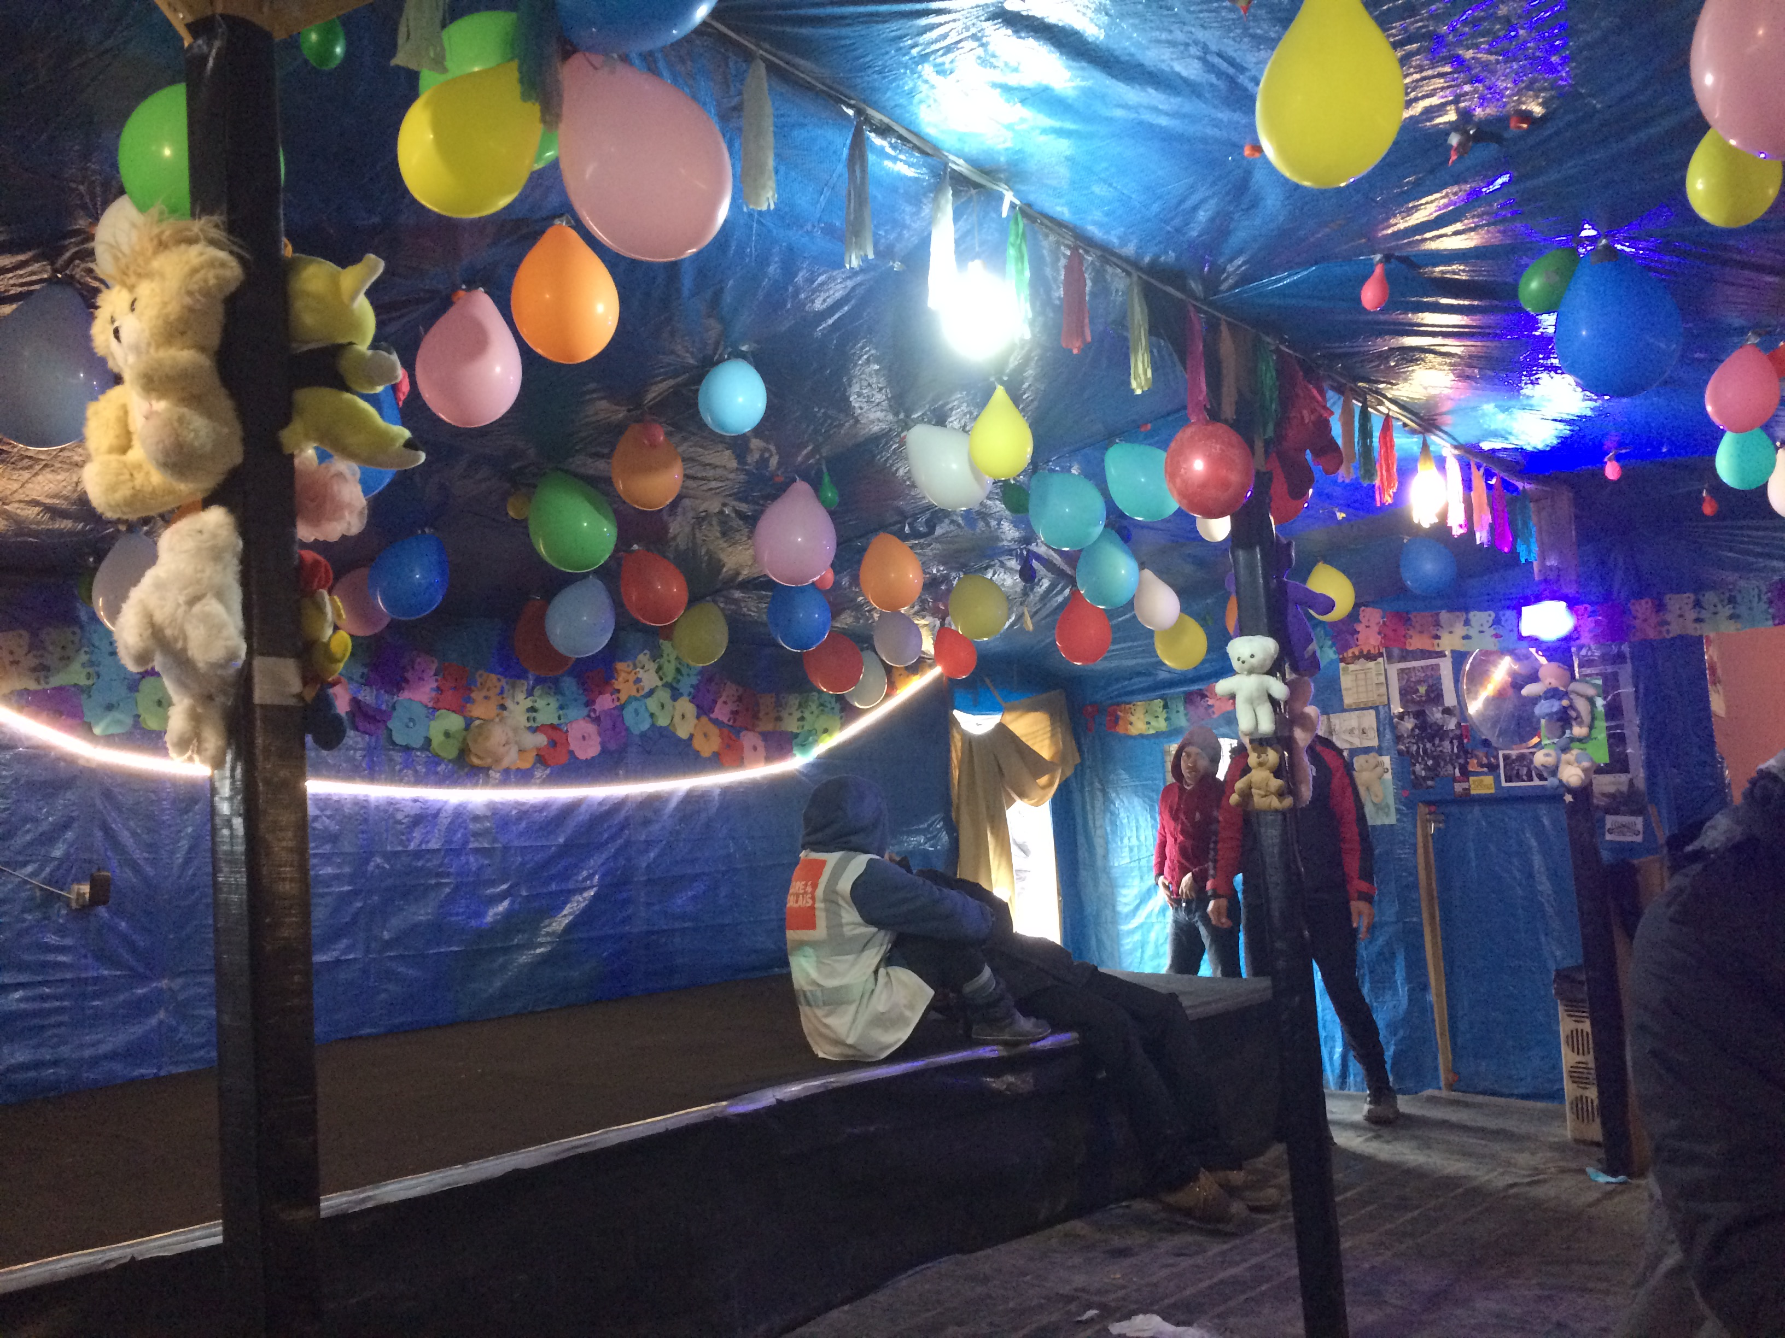
Figure 0: Inside the “3 Idiots” Restaurant” (Source: Author’s photo, March, 2016)

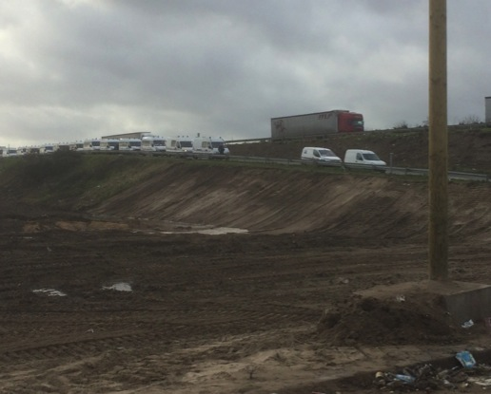
Figure 1: Line of police vans on the motorway slip road (Source: Authors photo, January 2016)

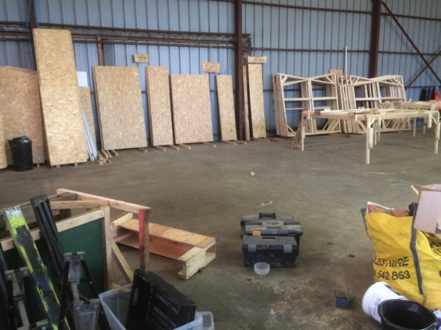
Figure 2: The off-site warehouse where the prefabricated homes were built (Source: Authors photo, January 2016)

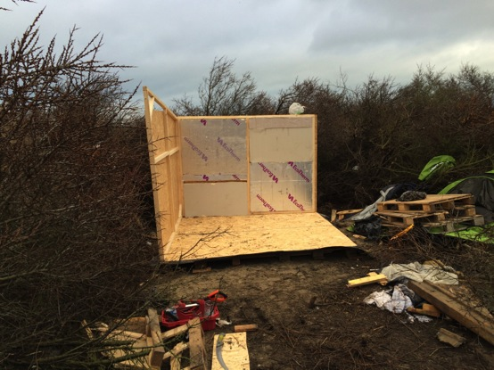
Figure 3: A prefab house mid-construction (Source: Authors photo, January 2016)

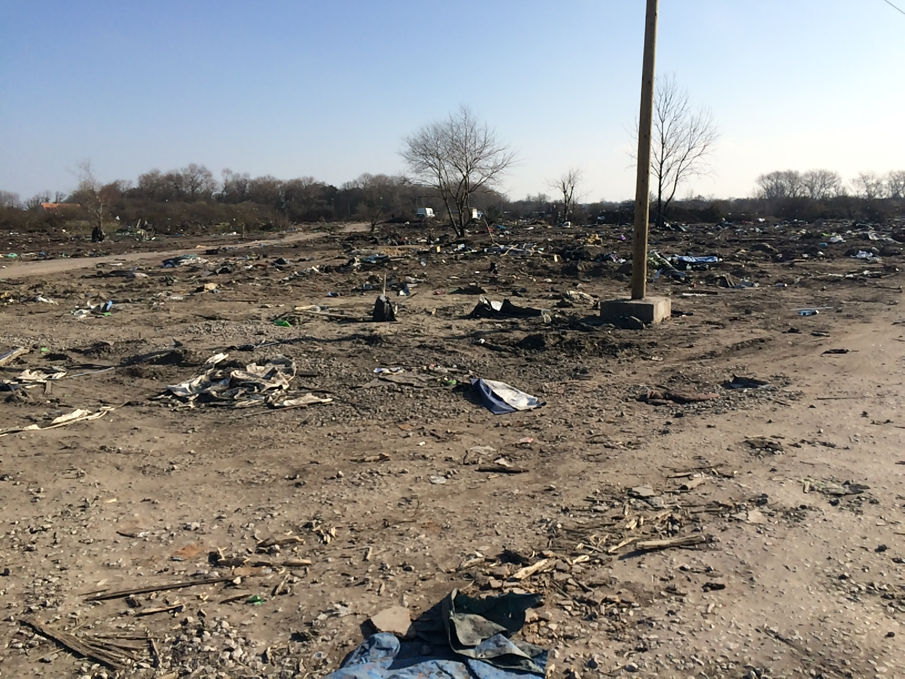
Figure 4: The site on which the Theatre (and hundreds of prefabs) used to stand (author’s photo: March, 2016)
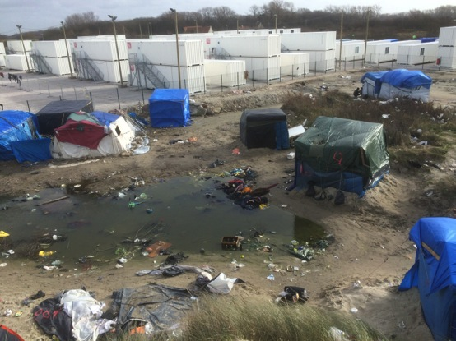
Figure 5: The Jungle container camp (Source: Authors photo, January 2016)

Excert from my field diary, February 17th 2016.
Waite, L. (2009) A place and space for a critical geography of precarity?. Geography Compass, 3(1): 412-433
Waite, L. (2009)
Schram, S. (2013) Occupy precarity. Theory & Event, 16(1).
Neilson, B. & Rossiter, N. (2008) Precarity as a political concept, or, Fordism as exception. Theory, Culture & Society, 25(7-8): 51-72.
Schram, S. F. (2015). The Return of Ordinary Capitalism: Neoliberalism, Precarity, Occupy. Oxford University Press.
I am fully aware that this assertion in itself commands an entire paper, but for the purposes of brevity of introduction, I am referring to the seminal works of Butler, J. (2006) Precarious life: The powers of mourning and violence. Verso and Standing, G. (2011) The precariat: The new dangerous class. A&C Black, New York, as examples of how neoliberealism has been analysed as a major contributing ideology to the perpetuation of precariousness throughout the contemporary societies across the world.
See the seminal work of Cresswell, T. (2013) Place: A short introduction. John Wiley & Sons, London.
Massey, D. (1994). Space, place and gender. Polity Press, Bristol, page 153.
Massey (1994: 151)
Baxter, R., & Brickell, K. (2014) For Home Un Making. Home Cultures, 11(2): 133-143.
Davies, T. & Isakjee, A. (2015). Geography, migration and abandonment in the Calais refugee camp. Political Geography, 49, 93-95 Millner, N. (2011) From “refugee” to “migrant” in Calais solidarity activism: Re-staging undocumented migration for a future politics of asylum. Political Geography, 30(6): 320-328.
UNRWA (2016) “Where we work: Lebanon” Available at http://www.unrwa.org/where-we-work/lebanon, accessed 14th March, 2016.
In Calais, the governance of the Jungle is an assemblage of the local council, the national government, the UK government (albeit covertly) and local police. The most visible form is the heavily armed police. In this paper I refer to this assemblage as the ‘prefecture’, the term used by the volunteers and in the press.
Pain, R. (2003). Social geography: on action-orientated research. Progress in Human Geography, 27(5): 649-658.
Russell, B. (2015) Beyond activism/academia: militant research and the radical climate and climate justice movement (s). Area, 47(3): 222-229.
These conversations gravitated around the narratives that could be gleaned from the Jungle. For example, who was most vulnerable was not a straightforward question, as at many times, I felt very vulnerable in the Jungle (particularly when I was being mugged for my camera). This slippery notion of vulnerability only served to add to the complexity of the site, thereby adding to it’s ‘progressiveness’ in the Masseyian sense.
Kindon, S., Pain, R., & Kesby, M. (2007). Participatory action research: approaches and methods. Taylor and Francis, London.
The difference between these terms is important and often used interchangeably in mainstream media to the detriment of both groups. For further discussion of this point, see Squire, V (2009) The Exclusionary Politics of Asylum, Palgrave, Basingstoke.
Exact dates of my work in the Jungle were January 22nd to January 30th, February 16th to 20th, March 15th and 16th, April 5th to 11th and then again on October 25th to help out while the camp was being demolished (all in 2016).
Gray, A. (2002). Research practice for cultural studies: Ethnographic methods and lived cultures. Sage, London.
Many of the people living in the camp spoke good English. This meant that talking to people was surprisingly easy for me, given my complete lack of foreign language skills. If the person I was chatting to did not speak English, there was often someone on hand who did and was willing to translate. Failing that, it is amazing how much you can get across with overly expressive hand gestures and a basic grasp of sign language.
Interview with male refugee in the Jungle, conducted informally on 27th January, 2016.
Said, E. (1979). Orientalism. 1978. New York: Vintage, 1994.
Casey, E. S. (1998) The fate of place: a philosophical history. University of California Press, Berkley.
Ralph, D., & Staeheli, L. A. (2011) Home and migration: Mobilities, belongings and identities. Geography Compass, 5(7): 517-530, page 518.
Blunt, A. & Varley, A. (2004) Geographies of home. Cultural Geographies, 11(1): 3-6, Blunt, A. (2005) Cultural geography: cultural geographies of home. Progress in Human Geography 29 (4): 505–515.
Morley , D. (2001) Belongings: place, space and identity in a mediated world. European Journal of Cultural Studies, 4(4): 425–448.
Ahmed, S. (1999) ‘Home and Away: Narratives of Migration and Estrangement’, International Journal of Cultural Studies, 2(3): 329–347, page 340.
Blunt, A. and Dowling, R. (2006). Home. Routledge, Oxford.
The Jungle is overwhelmingly populated by men, with the small numbers of women and children often placed in sanctuaries hidden away from other refugees and even most of the volunteers.
Butler (2006: 33-34)
Porteous, D. and Smith, E. (2001) Domicide: the global destruction of home. McGill Queen’s University Press, Kingston.
Nowicki, M. (2014) Rethinking Domicide: Towards an Expanded Critical Geography of Home. Geography Compass, 8(11): 785-795.
Baxter and Brickell (2014: 134).
Butler (2006: 33).
BBC (2016a) Shakespeare's Globe theatre takes Hamlet to Jungle, BBC News Website, http://www.bbc.co.uk/news/entertainment-arts-35481668, accessed 7th June, 2016.
Dyer, T. (2016) 'This is industrialised storage of humans'. B24/7, available at: http://www.bristol247.com/channel/opinion/your-say/politics/what-are-we-prepared-to-tolerate-next, accessed 14th March, 2016.
Klose, A. (2015) The Container Principle: How a Box Changes the Way We Think. MIT Press, Boston, page 74.
Harris, E. (2015) Navigating Pop‐up Geographies: Urban Space–Times of Flexibility, Interstitiality and Immersion. Geography Compass, 9(11): 592-603, Mould, O. (2014) Tactical Urbanism: The New Vernacular of the Creative City. Geography Compass 8(8), pp. 529-539.
Pugliese, J. (2013) State violence and the execution of law: biopolitical caesurae of torture, black sites, drones. Routledge, London.
However, with regards the clearance of the Southern part of the camp in late February 2016, the scale of the clearance was such that the mobilization of the volunteers was not enough to clear it all in time, and indeed many of the volunteers expressed dismay and disillusionment at the scale of the task.
Lefebvre, H. (2009) State, space, world: selected essays. University of Minnesota Press, Minnesota.
Purcell, M. (2013). The down-deep delight of democracy. John Wiley & Sons, London.
Lefebvre (2009: 135).
de Souza, M. L. (2009) Cities for people, not for profit—from a radical‐libertarian and Latin American perspective. City, 13(4): 483-492.
Halvorsen, S. (2015). Encountering Occupy London: boundary making and the territoriality of urban activism. Environment and Planning D: Society and Space, 33(2), 314-330.
Harvey, D. (2003) The right to the city. International journal of urban and regional research, 27(4): 939-941.
Lefebvre (2009: 150).
Waite (2009: 417)
Blunt and Dowling (2006).

