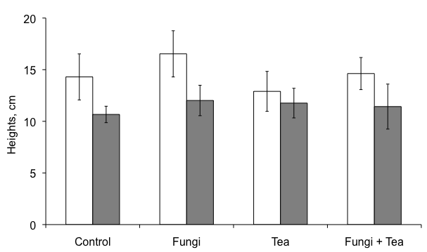
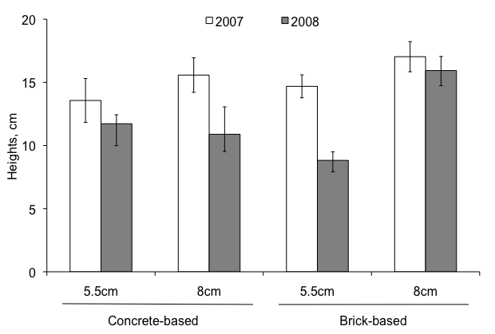
(a)
(b)

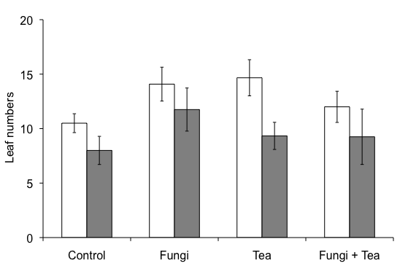
(d)
(c)
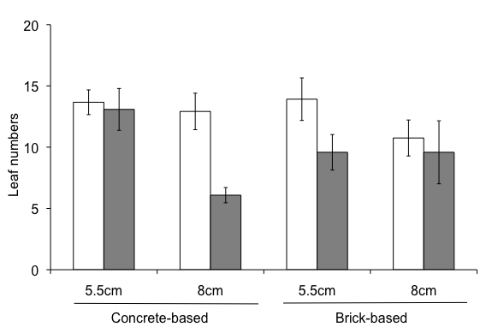

Figure 1. (a) Bait plant heights and (c) bait plant leaf numbers, with regards to underlying substrate type and depth; and (b) bait plant heights and (d) bait plant leaf numbers, with microbial treatments on London Zoo green roof experimental site, where: 2007 = after treatments and 2008 = one year after treatments applied. Bars represent means ± S.E.
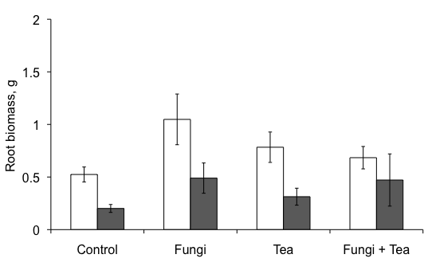
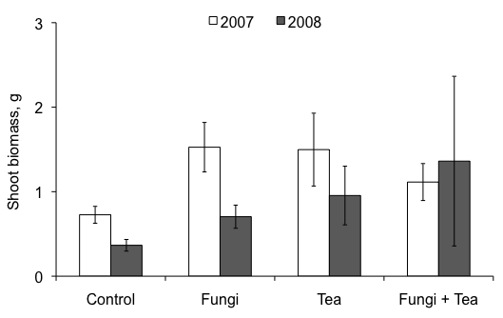
(b)
(b)
(a)
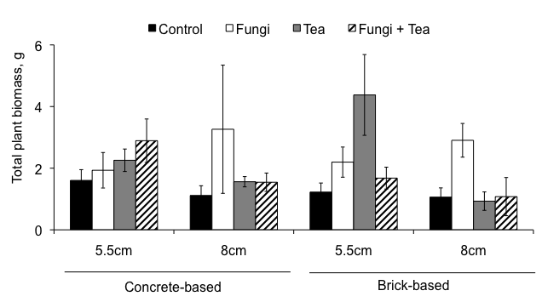
(d)
(c)

(d)

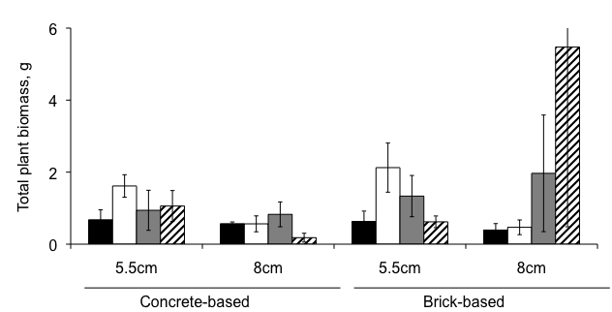

Figure 2. Bait plant from the treated plots on London Zoo green roof experimental site, where (a) shoot biomass and (b) root biomass in grams from 2007 = after treatments and 2008 = one year after treatments applied, means from 12 replicates per year; and total bait plant biomass with respect to underlying substrate type/depth in (c) 2007 and (d) 2008, means from three replicates. Bars represent means ± S.E.

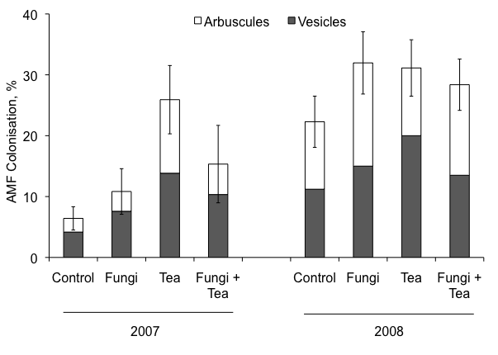

Figure 3. Bait plant root colonisation with AM fungi, from the treated plots on London Zoo experimental site in 2007 and 2008. Bars represent both arbuscule and vesicle colonisation means ± S.E. (of total AMF colonisation).

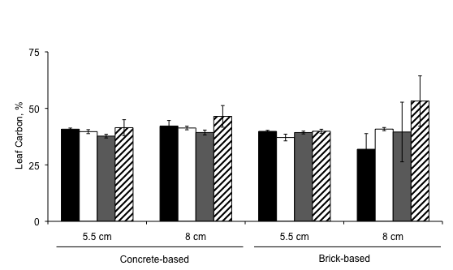
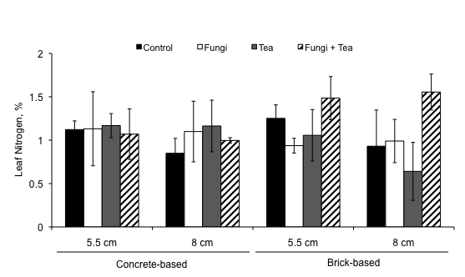
Figure 4. Leaf nitrogen (a) and leaf carbon (b), % content in bait plant shoots from each microbial treatment in 2007. Means from three replicates, bars represent means ± S.E.
(b)
(a)

(a)
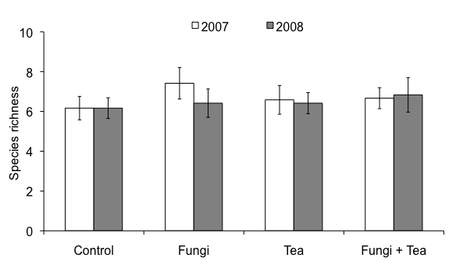

(b)
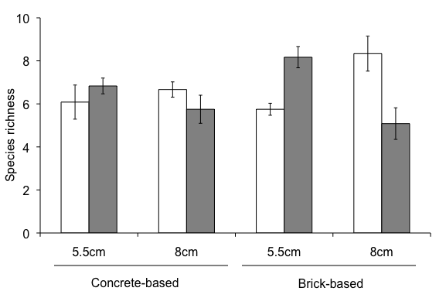

Figure 5. Species richness in (a) the four treatment types irrespective of underlying substrate and (b) in different substrate types, irrespective of treatment where: 2007 = after treatments and 2008 = one year after treatments. Bars represent means ± S.E.

