The Women’s Guild of Arts: Gender, Space, and Professional Identity in London, 1870–1930

Zoë Thomas

Thesis submitted for the degree of PhD
In the Department of History,
Royal Holloway, University of London

2016

Declaration of Authorship

I, Zoë Thomas, hereby declare that this thesis and the work presented in it is entirely my own. Where I have consulted the work of others, this is always clearly stated.

Zoë Thomas, 1 September 2016.

Abstract
This thesis provides the first comprehensive study of the Women’s Guild of Arts. Established in 1907 by textile designer May Morris, it included the most prestigious women in the Arts and Crafts movement. This is not simply a history of the WGA, however, and the experiences of this group of approximately sixty women are explored, 1870–1930, to argue that women were central to the movement, and changed the ways British society thought about middle-class women and work. These women exerted a quiet feminism in their actions, consistently striving for artistic equality. The guild was founded because women were not allowed to join the Art Workers’ Guild, an institution that remains synonymous with current understanding of the movement. This has influenced the now widely-held view that female participation was severely limited in consequence. This thesis argues that despite gendered hierarchies, women were active in the movement from its beginnings, reaching particular acclaim by the Edwardian era. At the point at which female artistic engagement was expanding, the movement has erroneously been considered as being in the midst of decline. The chapters are structured around the principal spaces in which the guild interacted—guild halls, studios, homes, workshops, shops, exhibitions, and in the city. Female artistic professionalism had to be continually asserted, and spaces claimed, in ways that have often left little trace. Members asserted the respectable historic nature of their craftsmanship to carve out a space at the heart of London’s artistic scene, negotiate a place in the international art market, and to broaden the scope of the arts in public life. The overarching aim of this thesis is to show the role of spatial practices in the shaping of individual and organisational female professional identity in the Arts and Crafts movement in Britain between 1870 and 1930.

Table of Contents
Abstract 3
Acknowledgements 5
Abbreviations 6
List of Illustrations 7
Introduction 12
I. 15
II. 36
A Short History of the WGA 48
Chapter One 54
At the Guildhall: A Professional Institution for Female Art Workers 54
I. 60
II. 75
Chapter Two 90
The Artistic Household: Family, Relationships, and the Lifecycle 90
I. 94
II. 107
III. 127
Chapter Three 141
“At Home” in the Studio: An Urban Network for Exhibitions and Sociability 141
I. 146
II. 159
III. 177
Chapter Four 186
Art Enterprises: The Ideal of the “Medieval” Workshop 186
I. 193
II. 198
III. 215
IIII. 220
Chapter Five 235
Out of the Guildhall and into the City: Suffrage, World War One, and the Post-War Years 235
I. 240
II. 250
III. 263
Conclusion 268
Bibliography 309

Acknowledgements
I was very lucky to be supported by an Arts and Humanities Research Council doctoral award which enabled me to write this doctorate. This thesis also received financial support from Royal Holloway, University of London, the Friendly Hand Trust, the Huntington Library, the North American Conference on British Studies, the Paul Mellon Centre for Studies in British Art, the Royal Historical Society, the Fran Trust Foundation, and Gladstone Library.
The descendants and holders of papers belonging to Women’s Guild of Arts members have enthralled me with personal memories, letters, diaries, photographs, and sketchbooks. Special thanks to Susan Connell, Wendy Duwell, Sue Field, John Henderson, Sarah Humphries, Phil Johnson, S. R. Kaplan, Chris Moore, Jane Nissen, David Robinson, Arthur Rope, and Richard Wallington. Archivists, curators, librarians, volunteers, and local historians have been most kind. Particular thanks to Lorna Beckett, Hannah Carroll, Helen Elletson, Monica Grose-Hodge, Rebecca Green, Victoria Osborne, Diana Parkin, and Christopher Woodham. Many thanks to David Birch, current Master of the Art Workers’ Guild, for inviting me to speak about my research at 6 Queen Square and the attendees for their kind words and interest.
A number of scholars and friends have helped me greatly by sharing sources, ideas, and support: Sarah Barber, Geoffrey Beare, Charlotte Brown, Annette Carruthers, Irene Cockroft, Gerald Cinnamon, Edward S. Cooke, Becky Conekin, Peter Cormack, Elizabeth Crawford, Magdalena Droste, Heidi Egginton, Miranda Garrett, Freya Gowrley, Ian Hamerton, Janice Helland, Betsy Lewis-Holmes, J. M. Massing, Virginia Nicholson, Stella Panayotova, Melinda Parsons, Michael Saler, Derek Sayer, and Peter Stansky. Special thank you to Laura Carter, Alan Crawford, Helen Glew, Leslie Howsam, Lyndsey Jenkins, Chris Manias, Laika Nevalainen, Stella Moss, Alex Windscheffel, and Susan Woodall for reading my work, proposing new perspectives, or kindly writing references. Thank you also to my family.
My greatest thanks goes to Jane Hamlett, Simon Thomas Parsons, and Yoke-Sum Wong. Thank you so much for your support and kindness.

Abbreviations
ACES Arts and Crafts Exhibition Society.

AWG Art Workers’ Guild.

AWGA Art Workers’ Guild Archive, 6 Queen Square, London.

V&A Victoria and Albert Museum.

WGA Women’s Guild of Arts.

WGAA Women’s Guild of Arts Archive, the William Morris Society, London.

WSPU Women’s Social and Political Union.

List of Illustrations
Figure 1.1 The location of Clifford’s Inn on Fleet Street. William Page, Particulars, Plan and Condition of Sale of Clifford’s Inn (London: Willett Estate Office, 1921), no page numbers.

Figure 1.2 The Hall. William Page, Particulars, Plan and Condition of Sale of Clifford’s Inn (London: Willett Estate Office, 1921), no page numbers. Reproduction of an etching by W. W. Burgess (1856–1908).

Figure 1.3 Queen Square by Mary A. Sloane. Early-twentieth century. Private collection.

Figure 1.4 6 Queen Square today. With kind thanks to Monica Grose-Hodge at the AWG.

Figure 1.5 E. C. Woodward’s card for the ’91 Art Club, “The ’91 Art Club at Home”, The Studio, 1894, (3), p. 96.

Figure 2.1 Estella Canziani wearing her painting smock working at her home-studio, 3 Palace Green. To her direct left is her father. Date unknown. Kensington Museum and Archive K/2048/B.

Figure 2.2 Estella Canziani and Louisa Starr’s studio. Date unknown. Kensington Museum and Archive K/2048/B.

Figure 2.3 Rhoda and Mary Dawson in the Dawson's home studio, c. 1905. Private collection.

Figure 2.4 Front page of photo album made by Edith B. and Nelson Dawson for Edith’s parents. 1895. Private collection.

Figure 2.5 Nelson and Edith B. Dawson. Family album 1895. Private collection.

Figure 2.6 Nelson and Edith B. Dawson. The fringed sign to Edith’s left says “Laborare est Orare” which means to work is to pray and reflects their Quaker beliefs. Family album 1895. Private collection.

Figure 2.7 Nelson Dawson sitting below paintings by both himself and his wife Edith B. Dawson. Family album 1895. Private collection.

Figure 2.8 Nelson and Edith B. Dawson and one of his sisters. Edith’s handmade bonnet is now in the V&A collections. Family album 1895. Private collection.

Figure 2.9 Edith B. Dawson enamelling. Family album, 1895. Private collection.

Figure 2.10 Edith B. Dawson back at her childhood home in Scarborough. Family album 1895. Private collection.

Figure 2.11 Edith B. Dawson enamelling in later life at home. Private collection.

Figure 2.12 Lady Feodora Georgina Maud Gleichen by unknown photographer. Photographic print, 1905 or after. National Portrait Gallery, London/unknown collection.

Figure 3.1 1900 Ordinance Survey map depicting houses and studios of London based WGA members and associates showing a visible concentration around West London.

Figure 3.2 Close up of the same map.

Figure 3.3 Concentration of members around Chelsea.

Figure 3.4 Concentration of members around Hammersmith River.

Figure 3.5 Concentration of members in Kensington and around Holland Park.

Figure 3.6 The studio network of the Rope family in London as depicted by Clare Dawson. Private collection of Arthur Rope.

Figure 3.7 Page from the visitor book of Pamela Colman Smith. Illustration by Alphaeus Cole. Collection of S. R. Kaplan. Further reproduction prohibited.

Figure 3.8 “At Home” for the Technical Education Board of The Camberwell School of Arts and Crafts. Huntington Library MS 2000.5.3392.25.

Figure 3.9 George Frampton studio viewing. Huntington Library MS 2000.5.3392.36.

Figure 3.10 “At Home” for E. C. Woodward. WGAA.

Figure 3.11 Margaret M. Jenkin “At Home” at 52 ½ Campden Street. WGAA.

Figure 3.12 Margaret M. Jenkin “At Home” exhibition in her home at 52 ½ Campden Street. WGAA.

Figure 3.13 “At Home” for the Pandora Club at the Woodward household, 129 Beaufort Street, Chelsea (1893). Huntington Library Add. MS 2000.5.3392.52.

Figure 3.14 The ’91 Art Club “At Home” at Clifford’s Gallery. WGAA.

Figure 3.15 Mrs Martin Pirie’s exhibition. WGAA.

Figure 4.1 The Green Sheaf advertisement, c. 1904. Pamela Colman Smith Collection, Bryn Mawr College Library Special Collections.

Figure 4.2 The Green Sheaf advertisement, c. 1904. Pamela Colman Smith Collection, Bryn Mawr College Library Special Collections.

Figure 4.3 Advertisements in The Englishwoman, 9/27 (March 1911), p.xi.

Figure 4.4 Lowndes & Drury advertisement The Englishwoman, 1/1 (February 1909), p. 95.

Figure 4.5 Annie Garnett’s The Spinnery. Undated but c.1890s.

Figure 4.6 Inside The Spinnery. Undated but c.1890s.

Figure 4.7 Inside The Spinnery. Undated but c.1890s.

Figure 4.8 The weaving looms at The Spinnery. Undated but c.1890s.

Figure 4.9 Montague Fordham’s showroom advertisement. Undated. Huntington Library MS 2000.5.3392.14.

Figure 4.10 Pomona Toys advertisement The Saturday Review (25 March 1922), p. 322.

Figure 4.11 Pomona Toys advertisement The Studio, 68 (15 June 1916), p. iii.

Figure 4.12 Charlotte Newman advertisement The Sketch: A Journal of Art and Actuality, 111 (1920), p. 378.

Figure 4.13 Postcard for Pomona Toys. 64 Cheyne Walk, Chelsea. Private collection.

Figure 4.14 Close up of window display. Private collection.

Figure 4.15 Close up of sign of Pomona Toys. Postcard. Private collection.

Figure 4.16 E. C. Woodward, “Jewellery and Metalwork”, Mrs Strang’s Annual for Girls (Oxford: Oxford University Press, 1921), p. 51.

Figure 4.17 E. C. Woodward, “Jewellery and Metalwork”, Mrs Strang’s Annual for Girls (Oxford: Oxford University Press, 1921), p. 52.

Figure 5.1 Illustration titled “The Art of Peace/of War” by stained-glass window maker, M. E. Aldrich Rope (1919). Private collection of Arthur Rope. WGAA.

Figure 5.2 Card requesting WGA members and friends visit the War Refugee Camp at Earl’s Court. May 1915. WGAA.

Figure 5.3 Invitation card to the Exhibition of Handicrafts by Wounded Soldiers organised by the WGA in 1918. WGAA.

Figure 5.4 “Joint Meeting” of the AWG and WGA in 1919. WGAA.

Introduction
On Friday 18 January 1907, at the suffragist and fresco painter Mary Sargant Florence’s studio in the heart of artistic Chelsea, a group of the leading women art workers in Britain gathered together to discuss the formation of a guild for women “seriously engaged as craftworkers and designers in the arts”. Textile designer May Morris was the driving force in initiating this meeting, and the other middle-aged women had all established prestigious reputations as part of the artistic elite by this point. They were: tempera painter and art patron Christiana Herringham; gilder Mary Batten; embroiderer, teacher, and writer Grace Christie; muralist Mary Sargant Florence; sculptor Feodora Gleichen; calligrapher Florence Kate Kingsford; and stained-glass artist Mary Lowndes. At this studio, the women wrote a list of the most renowned female artists working across the fine and applied arts in Britain and sent out letters inviting them to join as foundation members. In doing so, these women began the process which would lead to the establishment of the WGA, an institution which sought to represent the significant professional contributions of women to the Arts and Crafts movement. It was necessary to create this guild as women were not allowed to join the male-only AWG, which was formed in 1884, and is an organisation that continues to be seen today as the intellectual, creative core to the movement. Women were refused entry to the ranks of the AWG until 1964, and as such, from its creation, the WGA functioned as a quietly subversive institution hoping to change the position of women in art and in society.
Problematically, however, the history of the WGA remains unknown. It has not been included in histories of the movement which has led to a general perception that the activities of women art workers were peripheral to the professional institution that was the AWG. A few individual women such as May Morris, Evelyn De Morgan, and Mary Seton Watts are heralded as the exceptional few who created beautiful pots, paintings, and textiles, amidst the stream of androcentric narratives about the surge of male artisanal creativity that is seen to have constituted the Arts and Crafts movement. The discovery of boxes filled with documents pertaining to the activities of the WGA in a Hammersmith attic once belonging to the etcher Mary A. Sloane (1867–1961), which were gifted to the William Morris Society by her great-nephew, enabled the writing of this thesis and the story of the WGA to finally be told. The archive roughly corresponds to the years in which Sloane was Honorary Secretary: 1909–1924. These hitherto unexamined documents—annual reports, lecture notes, meeting minutes, letters, and ephemera—alongside a large collection of Sloane’s personal correspondence, provide a significant window into female associational life in the movement. A paper copy of the WGA’s roll reveals the startling array of women involved in the early years: interior decorator Agnes Garrett; war poet Alys Fane Trotter; painters Annie Swynnerton and Marianne Stokes; jewellers Georgie Gaskin, E. C. Woodward, and Charlotte Newman; embroider Jane Morris; illustrator Alice B. Woodward; amongst approximately sixty other women such as Sloane who was an integral member for a staggering fifty-three years, from 1908 until her death in 1961.
The WGAA provides a new way of linking together the activities of these women who clearly perceived themselves to have been at the heart of the Arts and Crafts movement. Alongside providing the history of this institution, this project researches the individual life experiences and collaborative network formed by members across the nineteenth century, before the official formation of the guild, alongside analysing their activities in the early twentieth century. The experiences of women artists are consistently ignored by women’s, feminist, and gender historians, who focus instead on the successes and failures of middle-class women to gain entry into more traditionally-recognised professional fields such as medicine, law, social work, and teaching. This social history incorporates the lives of women in the arts into existing debates about middle-class women and work, examining the flexible opportunities the arts afforded, and attesting to the importance of this generation of art workers in opening up new routes for women to gain creative satisfaction and an income during the years, 1870–1930.
This thesis pushes past the limited model of analysis of focusing on the influence of patriarchy in shaping the ways middle-class women experienced work and creative expression—although acknowledging that gendered constraints could be extremely restrictive—to instead focus on female agency and daily life for women artists. An analytical thread that weaves its way throughout this project is consideration of how WGA members individually, and as a group, sought to actively portray themselves as professionals. A spatial approach will be used to uncover how members used and altered the built environment—their homes, studios, workshops and shops, galleries, and their guild halls—to construct and assert new professional identities.
This is a history of gender, society, and culture, which contributes to a number of other disciplines, most notably art history. The first half of this introduction situates the project within the wider interdisciplinary historiography. It explores the approaches taken by women’s, gender, and feminist historians who have extensively researched middle-class women and work cultures, and the developments over the last fifty years in the ways scholars investigate gender, class, spatial theory, and material culture. This section also investigates how professional identity has traditionally been conceived, concluding that this definition must be expanded to take into account the diverse experiences of women artists who carved out professional positions during the years spanning the late nineteenth and early twentieth centuries. The final half of this introduction defends the selected methodology, justifies the sources used, and reflects on the parameters and limits to the thesis. It evaluates how the chapters build upon the existing literature, and establishes the significance of this project as a whole. Finally, a brief history of the WGA is provided to determine the timeline and parameters of the organisation. This thesis constitutes of the first comprehensive study of the WGA, who, although during their lives were seen as the most prominent group of women art workers in Britain, have since received very little attention from scholars. It establishes how members asserted new professional identities and instigated changes in the ways British society thought about women and work through a close reading of their use of the built environment during the years 1870 to 1930.

I.

This thesis builds upon the florescence of research into women’s, gender, and art history over the last fifty years that has emerged as a result of second wave feminism. In the 1960s scholars such as art historian Linda Nochlin began to question, “Why have there been no great female artists?” Nochlin, and her interdisciplinary feminist peers, disrupted the masculinist canon and restored the names of a number of women painters, alongside women deemed “significant” in other walks of life, to the historical record. Initially, scholars continued to work within a paradigm that had previously marked out “significant” white middle and upper-class men, but increasingly singled out women and held them up to society as equally exceptional figures. This approach—of celebrating exemplary women or “women worthies”—has since become problematic to many historians who feel this method does not adequately aid understanding of how women across society lived and tried to adapt patriarchal models to suit individual needs. Still, this early determination to restore women to the historical record should be commended and the efforts of these scholars substantially opened up the field for further research.
Amidst these scholarly debates, work naturally became a central category of analysis for historians because work practices pinpoint how society has constructed ideals of masculinity and femininity, and designated different roles for men and women. As the main focus of this study is exploration of how women experienced artistic labour it is necessary to consider the historiography of women and work in depth. Historians have put considerable energy into tracing women’s work cultures during the longue dureé post-industrialisation. Research was initially dominated by labour historians tracking the contribution of working-class women to the economy, as here scholars felt there to be no doubts about the integral contribution of women. Surviving evidence contradicts the idea that women’s work in post-industrialised society was a temporary point in the lifecycle, neatly positioned between school and marriage. Particularly instrumental was Maxine Berg’s argument that working-class women’s contributions were more significant to an industrial economy than recognised, whilst M. Jean Peterson highlighted the continued potential middle-class women had to work at home or part-time, remaining involved in the family economy. Collectively, this research dismantled a perception of working and middle-class families solely reliant on a male breadwinner, and a multifaceted picture emerged of the diverse ways in which women have worked and lived since industrialisation.
Historians of gender are aware of the problems in using class as a centrally defining category, as “middle-class” could, for instance, encompass the families of small shopkeepers but also merchant capitalists. From the 1960s, historians have adapted Marxist models which had emphasised the influence of one’s relationship to the means of production in the creation of class identity. Scholars now routinely implement E. P. Thompson’s framework: recognising class as a social, economic, and political relationship, produced through “shared experience”, and “embodied in traditions, value-systems, ideas and institutional forms”. This approach facilitates consideration of how middle-class women in the arts self-identified, and the prominence of family circumstances and social networks, alongside occupation, in describing how women understood their positions in society. Studying artists complicates attempts to tidily define class status through income, as many artists—male and female—had unstable incomes. Class remained a powerful identity marker across this period and substantially shaped the lives of WGA members: in the ways they worked, who they married, how they socialised, and in daily performances at home. Simultaneously, being middle and upper-middle class also had benefits that must be taken into consideration: enabling women artists the financial resources to buy materials, travel, pay servants, participate in influential social networks, and have the time and space to visualise lives as artists.
Early research into middle-class women and work focused on educating readers about the ways women have historically been subjugated: drawing evidence from acts enshrining inequality in law, personal papers, and troubling cultural representations in printed sources. Researchers such as Jane Lewis emphasised the clearly segregated division of work for women, seeing women’s work as doubly gendered, arguing that women were forced into feminine roles, whether paid or unpaid, whilst women were also subordinated in their positions to men both in the workplace and in the home. Lewis emphasised the undoubtedly restrictive nature of industrial Britain. Married women were not permitted to own property or make contracts in their own names, and for the first time, the 1832 Reform Bill explicitly excluded women from political citizenship.
In art historical circles, 1979 marked the year Anthea Callen published the inspiring book Angel in the Studio: Women in the Arts and Crafts Movement, 1870–1914, the only scholarly book to date seeking to provide insight into female engagement across the movement in Britain. Callen was writing as part of this much wider salvage operation pursued by feminist scholars such as Lewis. Her objective was to recover the presence of women in the movement rather than to analyse their absence from its histories, and she did an admirable job in restoring the names of large numbers of women. Callen’s concluding judgment was, however, that the Arts and Crafts movement simply perpetuated prevailing gendered hierarchies in society, and thus instigated few long-term changes for women. She blamed these gendered hierarchies on the AWG, feeling that because the AWG made no attempt to integrate men and women “at this central, influential level” or to “institutionalize alternative patterns of male-female labor divisions” the movement instead “ … reproduced, perpetuated and thus reinforced dominant Victorian patriarchal ideology. It recreated in microcosm traditional divisions between male and female roles.” Perceiving the AWG to have functioned as the consistent, powerful life-force of the movement, she placed women’s segregated lives in polarised opposition. Callen was not aware of the extensive activities of the WGA, and her book contains no exploration of the alternative, influential networks female artists quickly formed. Her work was also composed using advice literature and press clippings principally relating to the years 1860–1880. Evidently, there is a need to trace the changing environment for women into the twentieth century, and to use sources which hold more potential to capture female agency: diaries, letters, and records from female organisations.
Since the 1980s there has been a sustained move away from early methodological approaches which centered analysis on patriarchy and cultural representations of women. Historians are now rather more cautious of advice literature, and try to use a wide array of sources to examine how women combated gendered restrictions and attempted to modify their lives to find satisfaction in public and private life. Martha Vicinus provides a useful example in emphasising this change in approach. Unlike her rather more extreme views expressed within the aptly named edited collection Suffer and Be Still in 1972, her later works instead more sensitively explored the realities of life for “ordinary” women. Her 1977 edited collection A Widening Sphere: Changing Roles of Victorian Women, and her later monograph Independent Women: Work and Community for Single Women, 1850–1920, were path breaking. Vicinus argued scholars could no longer ignore gendered differences, as social and economic change proceeded differently dependent on the gender of those within a society, but she also explored how middle-class single women began to push for working lives as a “revolt against redundancy”, feeling paid public work gave women dignity and independence.
Another pivotal moment came in 1983 when historian Joan Scott insisted on the use of gender—or the study of sexual difference—as a necessary category of historical analysis. Scott stated that analysing gender had the potential to provide a genuine rewriting of history. Scott encouraged use of Jacques Derrida’s definition of deconstruction, of “analyzing in context the way any binary opposition operates, reversing and displacing its hierarchical construction, rather than accepting it as real or self-evident or in the nature of things”. This approach requires defining gender as experience and analysing how relationships and institutions—such as the WGA and AWG—functioned in lived experience, rather than an overreliance on printed records which often focused on what men and women should be doing. Additionally, Scott argued a need to stop seeing power as a stable force, and to instead use Michel Foucault’s theory of power as “dispersed constellations of unequal relationships”. Scott’s arguments were not new, and she did not claim them to be, but she helped to establish gender as an analytical category of enquiry, and highlighted the need to explore how forms of difference such as gender, sexuality, class, race, and religion work together to, in the words of Alexandra Shepard and Garthine Walker, “legitimate or undermine historically specific relationships of power.” Scott’s arguments are now widely accepted, and it is believed that masculinity and femininity—gendered attributes ascribed to men and women—are learnt ways of acting and feeling rather than simply being defined by anatomical difference. As Lucy Delap has cautioned, “women” is also often not a helpful category of analysis as women’s experiences have historically been so diverse. Using the late nineteenth and early-twentieth centuries as an example, Delap highlighted the huge rise in educational and professional opportunities for some women, “matched by a probably more widely felt desire of others to leave the workplace and secure a comfortable home life.”
Despite academic study beginning to problematise categories of class and gender, work is still consistently understood as an activity defined by payment. Women’s labour has, however, often been “hidden”, “free”, and carried out part-time at home. For women—and men—in the Arts and Crafts movement artistic labour was embedded throughout domestic and professional life. Artistic, professional, and personal identity were intrinsically linked. Krista Cowman and Louise Jackson have pointed out that studies of work which create hierarchies between paid and unpaid work perpetuate gendered ideologies which have historically valued business and industry over the “free” work women have done, such as cleaning and being in charge of the household. They instead urge historians to take a more analytical approach, and examine the ways ideas about work and the workplace were negotiated, interpreted, and experienced. Similarly, Peterson has rightfully suggested work “serves other human needs than earning and mere survival” and could be a way of finding self-expression and gratification, and establishing social identity. Ability to work was also substantially influenced by the lifecycle which altered how women interacted with work cultures alongside how they were viewed by society. Ideas about what work meant have been exacerbated by attempts to sort “work” and “leisure” into two discrete categories. As Claire Langhamer has discussed, historians routinely position leisure in direct opposition to paid labour. Ideas about work remain rooted in male working-class experience, structured within a clearly defined time and space, such as enjoyment of football or boxing in contrast to paid work at a factory. Influenced by these approaches, this thesis does not arbitrarily define “work” in opposition to “leisure”; understanding leisure as a distinct category from work is unhelpful when studying female artistic experience. For men and women in the Arts and Crafts movement their wish to make art was simultaneously work and leisure, a way to make income, provided personal enjoyment, showcased religious devotion, and was even a way to assert political dedication. Trying to cut away different sections of the lives of WGA members into neatly defined categories would result in a deficient depiction of how these women actually worked. For women art workers especially, “leisure” and “work” were inextricable, a deliberate gendered strategy by some wishing to disguise a need to make an income, but for others a natural by-product of middle-class life and nurtured cultural interests.
In relation to this, historians routinely argue that when middle-class women wished to work they did so through articulating a need to perform social maternalism; a wish to make, in the words of Peterson, “some useful contribution to their society.” Middle-class women emphasised their classed positions and feelings of civility and duty as a way to contribute towards public life, moving into public roles seen as nurturing, compassionate, and thus feminine, such as nursing and teaching, alongside philanthropic roles. Pam Sharpe has labelled this approach the deliberate creation of a “façade” of gendered domesticity which masked the extent of female involvement in public life and work. Vicinus described the “passion for meaningful work” as an animating force for unmarried, middle-class women, as it provided “a means out of the garden, out of idleness, out of ignorance, and into wisdom, service, and adventure”. These debates interconnect with the commonly held view that middle-class women were constantly trying to maintain appropriate femininity. Sara Delamont has used the term “double conformity” for women working in education: “No whisper of impropriety, masculinity or lowered standards must sully the occupants of educational institutions, or the whole cause could be lost.” It is clear that many middle-class women did feel a huge need to conform in these ways, however, Helen Doe and Jennifer Aston have recently cautioned assumptions that middle-class women always asserted their need to work through use of this language of femininity and socially maternal instincts. Doe has researched women entrepreneurs who owned businesses and managed men in the nineteenth-century shipping industry—at times whilst juggling roles as single mothers—and Aston’s doctoral thesis contended that middle-class women in business in nineteenth-century Birmingham and Leeds did not necessarily work in gendered fields or present their work as feminine. Throughout, this thesis pays close attention to the ways women in the Arts and Crafts movement asserted a wish to work, taking care to consider, alongside gendered discourses, other identity markers such as occupational field, location, marital status, and age, rather than just accepting the traditional view that some artistic fields such as needlework were seen as more naturally suited to women.
Another area worthy of more research is how middle-class women who worked conceived of feminism and women’s rights. How did the fight for suffrage fit with the strategies middle-class women had already implemented in their working lives? Nascent nineteenth-century “feminism”—or the women’s movement—had many intersecting, but also separate, strands, mirroring the equally complex range in feminist perspectives across the twentieth and twenty-first centuries. Some women of this era used religion to promote a desire for greater public roles for women, others rejected religion as the direct route through which they sought to bring about female equality, and a number of women even identified as anti-suffrage as they felt suffrage could disrupt their already established professional positions. Lewis traced how female social activists related to feminism, finding “the Woman Question” deeply touched their lives even if it was not the direct focus of their energies, whilst Alison Oram analysed the lives of female teachers and discovered that many of these women were involved in the women’s movement. Their political consciousness was stirred due to the inherent conflict of their structural position in the profession, often being paid less and treated differently. Delap, however, has cautioned that assumptions that the main focus of Edwardian feminist politics was the vote must be reconsidered. Her work uncovered an influential elitist strand within feminism, made up of avant-garde women who had numerous other concerns about women’s rights aside from suffrage. As such, she considers it “anachronistic to treat suffrage as coterminous with feminism”.
It is clear that although many contemporary women frowned upon the radical implications of suffrage and feminism their daily actions could still be deeply motivated by a wish to better the lives of women. As will be shown over the course of this thesis, the WGA represent this complexity in views: including members who individually identified as socialists, conservatives, liberals, and suffrage campaigners. Collectively, the WGA avoided discussions about women’s rights or suffrage, but the guild still functioned as an organisation for female empowerment. Drawing on Karen Hunt and June Hannam’s argument of the need to explore local community life in the interwar years to find the answers to how feminism was actually acted out, and reworked, in everyday life, this thesis uses the term “quiet feminism” as a way to clearly articulate the consistent commitment of the WGA in their particular battle to raise the status of women in the Arts and Crafts movement. These efforts were not always in line with the political perspectives of individual members, the views of other contemporary women’s organisations, or modern day standards of appropriate feminist activity.
Although historians and literary scholars are increasingly interested in piecing together the past lives of “the ordinary” and the material culture of “the everyday”, art historical studies of the Arts and Crafts movement rarely take this approach. There continues to be an androcentric view of the movement as the work and ideals of “great” men such as William Morris and John Ruskin. Morris is repeatedly held up as representative of the entire movement. This fixation with Morris—something Elizabeth Darling and Lesley Whitworth describe generally as “reinforcing an obsession with the [male] designer as hero”—becomes problematic when it starts to distort understanding of a movement which influenced, and was influenced by, a great many people. Stained-glass historian Peter Cormack has critiqued Morris’s long-term involvement, describing him as a “somewhat disengaged” Brother and Master of the AWG by 1892. Cormack proposed it would be more useful to assess the movement’s long-term social dimension: “not least because it actively involved large numbers of people—probably far more than any art movement before or since.” Focus on such a narrow canon of material has “seriously undervalued activities, objects and people that, to its protagonists, would have been seen as central.”
The AWG, the ACES, and the Home Arts and Industries Association, are usually seen to form the tripartite institutional representation of the three main strands of the Arts and Crafts movement from the 1880s onwards. The lack of research into the WGA means that the institutional networks of women art workers have not been included in histories of the movement. Although the ACES and the Home Arts and Industries Association did have significant female participation, there is still inadequate understanding of the sophisticated and rapidly growing tactics women in art implemented to interact with the art market and to make an income. This is addressed in detail in Chapter Four which adds the entrepreneurial strategies of WGA members to the scholarly literature on the art market.
The importance of the Arts and Craft movement to considerable numbers of people in twentieth-century artistic life remains understated. The early twentieth century saw a second wave of the movement, a blossoming evident through the plethora of activities taking place in the movement during this later period, and bolstered by a continued public interest in art and history. Books about the movement however, on the whole, focus on William Morris, which has influenced this nineteenth-century periodisation, orbiting around the years Morris lived. This perspective neatly fits with ideas about the movement’s decline in response to the emergence of the modernist Bloomsbury group. In recent years a small group of scholars have moved away from the perspective that the movement died in 1896 alongside the death of Morris. A change came in 1988 when Stella Tillyard argued modernism was so groundbreaking in Edwardian London, not because it disbanded the past in a revolutionary way, but because it grew out of the nineteenth-century roots of the radical Arts and Crafts movement. In 2001, Michael Saler pushed this view much further, redefining the interwar period as an era when society continued to be captivated with the Arts and Crafts movement, now redefined as “medieval modernism”. Saler asserted his view through analysing the work of individuals such as transport administrator Frank Pick who revitalised the design of the London Underground. Previously, modernism had been defined too narrowly. The Arts and Crafts movement did constitute a form of modern art in the eyes of its designers and makers and for many in society. The movement was one of many forms of modernism in Europe and America. Saler swept away arguments claiming the movement “remained mired in the past and had little influence on twentieth-century England” attesting that the “movement was complex, consisting of both antiquarians and progressives; it continued to adapt and thrive in the interwar period”. Reinforcing this perspective, Tanya Harrod, Lynne Walker, Nicola Gordon Bowe, Rosalind P. Blakesley, and Cormack have all agreed that during the early twentieth century a vast number of artistic groups, some who had definable links to Morris and his circle, but many who did not, continued to use “Arts and Crafts” to demonstrate an emphasis on careful design and handcrafted methods.
Building on this approach, which shattered traditional periodisation, this thesis uses the WGA to contribute to these debates, adding a vital new dimension by incorporating female contributions on a large scale. Women were central to this growth in interest and dissemination of artistic ideas through their extensive networks and organisations. For women, assertion of knowledge about “medieval” craft techniques provided a fortuitous way to maintain respectability whilst forging new, subversive lifestyles. This later period was a vibrant, clashing historical moment when women thought deeply about female political and artistic equality.
Despite the many developments in gender history since Callen’s 1979 portrayal of women in the movement, in 2002 Jan Marsh rightfully mused that it “is instructive that … Callen remains the prime authority on the subject.” Marsh reflected that “somewhat ironically, her work has resulted not in the inclusion of women … but in the creation of a separate sub-category, that of ‘Arts and Crafts Women’.” Marsh makes a persuasive point, although it should be noted that a corrective did come to Callen’s argument in 1989 when Walker argued that Callen had over emphasised “the extent to which the Arts and Crafts Movement reinforced Victorian patriarchal ideology” and that “instead of further alienating women, the Arts and Crafts Movement provided women with alternative roles, institutions and structures which they then used as active agents in their own history.” However, there have been no monographs subsequently published on the movement which tackle these issues directly, dedicate sufficient room to the professional lives of these women, or provide insight into the WGA.
That being said, an army of feminist art and design historians have, across the last thirty years undertaken excellent work in exploring many of the gendered challenges faced by women in art and design more generally. Rozsika Parker published The Subversive Stitch in 1984 which analysed the gendered complexities caught up within the act of embroidery. Perceived ideologically to be an appropriately feminine pastime across history, Parker emphasised that needlework did still provide opportunities for creativity and pleasure, and could be used to subvert ideological intentions. Other notable works include Marianne Tidcombe who fastidiously analysed the work of female bookbinders; Elizabeth Crawford and Emma Ferry have done much to tell the story of Agnes and Rhoda Garrett, the famed female interior designers; Elaine Chasley Paterson, Melanie Unwin, and Lucy Ella Rose have all written about the painter and muralist Mary Seton Watts; whilst recently, Alla Myzelev repositioned Ethel Bount and Maude King as central figures in the Haslemere craft industries. This body of work has led to Anne Anderson writing optimistically in 2009 about the future potential for research into female artists, stating that visitors to the Watts Gallery in Compton, Surrey were now more likely to be in search of information about Mary Seton Watts than her famed painter husband G. F. Watts.
In art historical circles, however, there remains a tendency for projects to focus on biographies, or the experiences of very small numbers of women. Although this method undoubtedly still produces fascinating contributions, the most helpful art historical investigations have been the monographs written by Deborah Cherry and Janice Helland. Their work moved away from personality-driven texts, instead considering the material conditions of women artists and questioning how social and economic factors influenced identity. Cherry traced female painters’ experiences of exhibitions, institutions, family, and friendships. Mirroring the trajectory in historical debates, Cherry problematised simplistic concepts of femininity, arguing that femininity was not fixed but was shaped through unstable processes and daily practices. She also revealed the significant contribution of women in shaping the political visual culture of nineteenth-century Britain. Likewise, Helland has illuminated the rewarding lifestyles forged by women painters in nineteenth-century Scotland, attested to the active presence of women in the British and Irish Home Arts and Industries, and has published edited collections refiguring, through analysis of space and material culture, understanding of women in the decorative arts.
The scholarly rigour of these publications makes the absence of similarly ambitious projects about the Arts and Crafts movement in Britain more noticeable. There remains a dearth of research which contextualises the organisational experiences of women and takes into account the interdisciplinary scholarly developments of the last thirty years. Cherry and Helland, alongside Laura Prieto and Kirsten Swinth—who researched professional women painters in America—have all regarded women painters in professional terms. The lack of consideration of how women in the Arts and Crafts movement defined themselves, and asserted their authority as professionals, is problematic. Although artists were in contemporary terms understood in different ways to the classic professions of medicine, law, and the clergy, the “professional artist” became a circulating term during the nineteenth century. Artists adopted tactics commonly associated with professional culture: joining clubs, gaining qualifications, and stressing social codes such as possessing studios, whilst new commercial galleries altered the conventional patronage-based method of selling, and disrupted hierarchies that had historically regulated market value. In the Arts and Crafts movement, men and women sought to promote themselves as professionals, whilst at the same time asserting their dual roles as skilled art workers. This was a particularly fraught discussion point in architecture, where the increasing drive for greater professional status was seen to be threatening architecture’s position as an artistic pursuit.
The individuals identifying as professionals across the late nineteenth century and early twentieth centuries are often understood to have fit amidst a broader middle class that encompassed merchants, manufacturers, and industrialists. Professionals, however, in the view of Harold Perkin, were a distinct social class, increasingly judged on trained expertise and selection by merit. This selection was not made by the open market but through the decisions of comparably educated experts. The eighteenth and nineteenth centuries saw consolidation of career hierarchies, specialised occupations, and encouragement of trained expertise. The ideal professional in the eyes of Perkin was a “self-made man of sorts, who had risen by native ability (with a little help from his educational institutions) to mastery of a skilled service vital to his fellow citizens.” Despite this view, as the current project “The Professions in Nineteenth-Century Britain and Ireland” at Oxford University indicates, what constituted professional identity, and how professionals fit amidst wider society, remains poorly defined.
Female professional identity in the applied arts remains sorely under-theorised, reflecting a wider need for historians to explore what professional identity meant for middle-class women. In 2006, Cowman and Jackson lamented that “the non-working-class working woman remains exceptional and under-researched”. Writing in 2015, Sutherland felt similarly; pointing to the “mass presence” of middle-class working women present in their thousands. Sutherland felt: “if we are looking for signs of real change in the labour force and in social structures, they deserve much fuller scrutiny than hitherto they have received.” Across the professions, Cowman and Jackson suggested women come across a “dual block”. Firstly, women often lacked institutional capital, through their inability to possess key educational qualifications and inequality was enshrined in the law. Christine Krueger, discussing female historians, voices the common argument that the professionalisation of a field actually led to female practitioners being increasingly excluded. The second block women faced was that, barred from masculine social groups, they did not have the necessary social capital to advance. In the arts, a number of strategies were closed to women: such as life study at many institutions and membership of the AWG and the Royal Academy. Informal processes of discrimination and gendered ideologies also continued to prevail, stressing the centrality of marriage, maternity, and domesticity to women’s lives. Helen McCarthy has argued that, across the twentieth century, professional identity was infused with “prevailing ideologies identifying femininity with religiosity, philanthropy and, most crucially, motherhood” which “served to structure professional identity differently for women.”
Sociological approaches can also inform the study of professionalism. Sociologist Anne Witz critiqued that although Perkin highlighted the relationship between the professions and class structure there has been little attention placed on gender and professional life. Witz wrote of the need to abandon any universal, ahistorical conception of the professional. She instead applied the phrase “professional projects” to highlight the process of negotiation the term involves. WGA members themselves veered between defining themselves as “professionals”, “art workers” and women “seriously engaged as craftworkers and designers in the arts.” Historian David Kennerley—when researching debates about female musical professionalism in the press in the early nineteenth century—rightfully suggested it is necessary to explore how these women themselves adopted professional identity, “even if this was highly specific to their circumstances and not accepted by the rest of society as equivalent to that of doctors or lawyers.” Chris Nottingham has agreed, suggesting that through conceptualising non-traditional professions as social formations themselves and as “ladders of social mobility” it becomes possible “to create a different picture both of their internal and broader influence.” Members of these groups “fostered types of social and political activity that became a recognizable feature” in society.
Nottingham and Kennerley’s arguments and Witz’s “professional projects” provide a new way to understand professional identity as contested, in flux, and historically specific. This approach enables this project to move away from retrospectively trying to categorise WGA members’ activities as professional simply through emphasising a particular strand such as ability to sell work, engage with the exhibition scene, or educational background. Use of the term “professional” in this thesis, generates appropriate understanding of the expertise and competency WGA members achieved and regulated in the guild, whilst labelling the WGA as a professional group helps appropriately portray the high-status its members held within society. This wide-scale study of the foremost women in the Arts and Crafts movement—some who received educations, some who did not, some who focused on the art market and financial profit, some who did not, some who married, and some who did not—highlight the multitude of attitudes and methods women implemented in their personal professional projects. Female artistic professionalism was often constructed in different ways to male professionalism, but it was intermeshed with field specific and classed similarities with other men, rendering it impossible to categorise female professionalism as a segregated category of analysis or define it as a simple process of feminisation. Artists occupied a unique position in society, and artistic professionalism cannot be mapped in the same way it can be for law or medicine. But it is this very elasticity that made art so attractive to women, and it is within these ambiguities that the full range of female professionalism can be discovered.
Something that disguised female artistic professional identity was that it routinely took place at home, hidden amidst a sphere of refined accomplishment. The most enduring enquiry in women’s and gender history over the last forty years has been examination of the permeable relationship between home and work, which makes it surprising that historians have not considered in more detail how professional women used the home. Catherine Hall and Leonore Davidoff brought to the fore considerations about the gendered ideology of middle-class “public and private spheres” of work and home. Broadly, it is thought that post-industrialisation it was seen appropriate for males to inhabit the public world of work, whilst women were seen to have increasing authority in the private world of home. This generated a surge of publications questioning “separate spheres” in lived experience. Historians have since refined understanding of this ideology, showing men and women, working and middle-class, post-industrialisation, could still use the home for work, and the concept of the home as a “private” space came under particular criticism. Clarissa Campbell Orr has made a vital contribution, highlighting that gendered codes were less restrictive than assumed for women in art. Within the last ten years “public and private sphere” ideology has become understood to provide a useful, basic starting point that did represent a prevalent ideology, from which one should also explore the intricacies of lived practices, which rarely stood up to prescribed norms. Anne Digby has suggested the phrase “social borderland” as women could, and did, act outside of the immediate private sphere without being challenged, but often needed to employ a discrete demeanour. The extensive nature of these debates highlights the changes in the field since Callen’s publication, and the need to rectify understanding of how women—and men—in the Arts and Crafts movement used their homes.
Since the 1980s, an interconnected area of enquiry has emerged seeking to understand how different environments, be these built “places” or conceptualised “spaces”, influenced political power, social experience, and cultural production. The term “space” and “place” are not synonymous. David Harvey’s work was vital in shaping a turn towards a conceptualisation of “space” rather than “place”. Space is now understood by historians as removed from traditional ideas of a “static” geographical “place”, and is instead “dynamic, constructed and contested” and where “sexuality, race, class, and gender—amongst a myriad of other power/knowledge struggles—were sited, created, and fought out.” Henri Lefebvre theorised the concept of space as historically produced, simultaneously both the medium, but also the outcome of social existence. In his view, space encompasses all areas of the built environment, including “the building users as well as designers and builders as producers of space.” Cultural geographers, such as Don Mitchell, stressed the need to probe the interconnected nature of space and place as it has the potential to yield insight into the construction of identity. Spaces were gendered and influenced societal hierarchies. Daphne Spain conceived there to be a strong contrast between constructions of femininity and masculinity within different sites such as the home, workplace, and in public life. Gillian Rose in contrast cautioned that spaces can have “multiple and intersecting, provisional and shifting” uses and meanings. It is clear that space is a useful way to study gender formation as, in the words of feminist theorist Linda McDowell—“the mapping of a place or location onto gender identities has been a key part of the establishment and maintenance of women’s position and is reflected in both the materiality and the symbolic representation of women’s lives.” Recently, Kathryn Gleadle et al reflected on the past thirty years since the spatial turn, arguing it is no longer enough to simply recognise that “female” and “male” spaces have been “constructed”. What is now needed is consideration of the “social and political use of space” which “lies at the heart of its construction”. They echo Setha Low and Denise Lawrence-Zuninga’s contention that social practice “activates” spatial meaning, Michel de Certeau's emphasis of spatial practice as the actions which took place in space and transformed understanding of that space, and Pierre Bordieu's theory of “practice”, meaning the ways “people act and interact in various ways to reproduce and reinforce culture”.
Testament to the success of this approach is Walker’s research into women’s space making in nineteenth-century London. Women were both producers and consumers of the built environment, and the presence of women determined “the spaces that were provided, the buildings constructed, the needs represented—how it felt to be in a public space”. Clearly influenced by Walker’s innovative perspectives into how women in the suffrage campaigns—as well as women in professional life—operated and reconfigured public and private sites across London, Cherry and Helland have also recently explored these themes. In 2006, they wrote that “What a woman artist made, and what she aspired or desired to make, were, then, closely connected to the spaces she might inhabit and to the webs of social and spatial relations in which she was placed: subjectivity, sociability and spatiality were intimately entwined.” Drawing on this sophisticated scholarly work by art historians Walker, Cherry, Helland, theorists such as Rose, and sociologist Witz, this project uses space and the built environment to analyse how WGA members constructed professional identity. This focus on space derives from the documents of the WGAA and other members’ personal letters, which consistently link spatial practices and the establishment of professional identity. Spatiality reveals the ways women appropriated spaces as highly politicised and conscious acts, but also the daily, often unconscious, gendered appropriation of spaces, and the ways different lifestyle patterns became engrained within society. The performative way professional women interacted with the urban landscape and tried to negotiate power imbalances is extremely telling. There has been a profound failure to capture the multitude of ways women in the Arts and Crafts movement set up new sites of work in their homes, studios, workshops, shops, and institutions and how these sites formed a multi-layered female professional artistic network spread across the city. This thesis thus uses spatiality as the selected approach to investigate how WGA members carved out professional and artistic lives in London during the years 1870 to 1930.

II.

The overarching aim of this thesis is to assess the impact of spatial practices in the shaping of individual and organisational female professional artistic identity in Britain, from 1870 to 1930. The introduction now turns to the parameters of this thesis and the justification for the sources selected for analysis so as to evaluate how best to achieve this aim. Focusing the project on the WGA predetermined certain aspects: the emphasis on gender, scrutiny of the urban environment, exploration of middle-class lifestyles, and the period of study. The WGA began in 1907, and Sloane’s archive ends c.1924. However, the chapters span the years 1870–1930 in order to evaluate the lifecycles of members and to distinguish long-term shifts in models of professionalism and gender roles across this period. The time frame brings together a number of traditionally distinct fields of research, connecting what Saler has termed the “amorphous interval spanning late ‘Victorianism’ and early ‘Modernism’”. This period saw rapid changes: debates about the “New Woman”; discussions in the Edwardian art scene about new formalist approaches to art; World War One; suffrage; partial political emancipation for women; and full political emancipation for women in 1928. Although none of these changes are the central focus of this thesis, this research adds to these areas as part of its wider scope. The selected end date also moves discussions away from the persistent focus of studies on nineteenth-century female painters, when there is a great need to extend knowledge about women in the Arts and Crafts movement into the early-twentieth century.
The geographical focus of this project is London; this was where the guild was based and many members lived. Yet it is crucial to encourage understanding of the Arts and Crafts movement as a national movement that had extensive international impact. May Morris lectured in North America, Mary Lownde’s stained-glass commissions came from as far away as South Africa, Myra K. Hughes wrote about and illustrated her experiences in Palestine for The Studio, whilst Edith Harwood lived in Rome, and wrote and illustrated her book Notable Pictures in Rome. A wish to provide detailed insight into the spatial networks produced by members justifies the focus here on London, although hopefully future studies will expand this scope. Some could suggest the experiences of the WGA were not indicative of the broader opportunities for middle-class women. As Deborah Epstein Nord has reasoned, London was in many ways unique in the freedoms it offered. Sutherland’s research into young women who attended Cambridge University also argues that the circumstances of middle-class provincial girls were more restrictive than their urban counterparts. Although members undoubtedly represent the “success” stories of their generation through their entry into this strictly-regulated guild, members were brought up in counties across Britain such as Yorkshire and Sussex, before gravitating towards London for work and new experiences. Together, this group of approximately sixty women constitute a satisfactory number through which to suggest greater conclusions about both the evolving opportunities, and also the realities of daily life, for women in the Arts and Crafts movement.
Having established in this introduction that members are to be defined as professionals enables the chapters that follow to delve deeper into the lives of members, using a spatial approach to showcase the ways women negotiated new positions in society. Using spatiality as the dominant theoretical model results in a more sophisticated way to grasp the subtle ways women asserted their new identities: to themselves, to each other, and to society. The spatial approach is justified due to the consistency of references to space made explicitly, and implicitly, in personal papers and by the women writing the documents in the WGAA. These materials established the myriad of ways women thought about how to navigate through different spaces within their position as a group. Members saw their use of space as a crucial, complicated tool that could modify engrained societal ideas about gendered norms in relation to women and work. An exploration of the processes of daily life—in direct response to Beebe, Davis, and Gleadle’s assertion of the need to examine the social and political use of space—leads to a more competent analysis of how women asserted these new positions.
As such, this thesis does not debate whether or not women artists actually were professionals; it categorically insists they were. Instead, this thesis studies the processes through which women artists became professionals, and how WGA members negotiated, and manipulated, the gendered daily patterns to life in London’s middle-class, artistic community. The tactics members employed are explored across the following chapters, which are structured around the guildhall, homes, studios, workshops, shops, and the guild’s negotiation of a public presence in the metropolis.
The first chapter will examine how use of the AWG’s two guildhalls—recognised sites of professional masculine activity—helped the WGA to foster aspiration, institutional recognition, and provided opportunities for female sociability. Close examination of these halls enables a deeper reading of how women tried to professionalise themselves and insight into the type of new institution being formed. The WGA bolstered ideas about the prestige of their institution through maintaining a professional rhetoric and creating a guild roll. The next two chapters leave the guildhall and enter the homes and studios of members. Chapter Two explores the domestic sphere, locating the changes that took place in the houses of members, and their increasing use of studios, as women fought to bring professional experiences into their lives. Tracing the individual lifecycles of these women, the chapter analyses relationships and use of the home during three defined life stages: during youth, married life, and unmarried life. It shows the efforts with which women reorganised the spaces available to them to focus their lives around work, and argues that these spaces were vital, symbolic spaces that enabled WGA members to assert artistic identity to their family, friends, and wider society.
Chapter Three considers how members used these studios and homes as sites for professional exchange across the city. It is argued that middle-class etiquette norms such as “At Homes”—which are normally seen as restrictive and oppressive by feminist historians—must be reconsidered. WGA members reformulated “At Homes” for their own usage, using these meetings to stage popular artistic events where women could show off their work, and in doing so embedded these new professional routines within accepted weekly domestic schedules. This network spanned the final decades of the nineteenth century, and was well established by the formation of the WGA in 1907. The final section considers how this approach of “At Homes” and studio meetings was incorporated into the guild, and provided an additional sphere of informal WGA events away from the guildhall.
Chapter Four forces a reexamination of the ways female activity in the Arts and Crafts movement has been portrayed. Research remains dominated by focus on philanthropic and unpaid work, but women were far more invested in making money than this approach allows, an unsettling notion perhaps in understanding a movement that sought to remove itself from commercialism. This chapter focuses on members who set up small art enterprises so as to bring these economically driven activities sharply into focus. Again, use of space was central to female negotiation of professional identity. Members’ firmly promoted the “medieval” nature of their workshops and apprentices. Upholding the historicity and respectability of workshop production enabled enterprising members to engage in business practices without negating their positions as middle-class women and respected artists. Finally, Chapter Five moves the lens of analysis back to the WGA. Leaving the private world of the guildhall and entering the public world of the city, this last chapter explores how the guild used the cityscape in the early twentieth century and promoted the potential for women to be involved in public life. Focus is placed on the impact that suffrage and World War One had on shaping these tactics and changing how the WGA used “public” and “private” spaces. It cultivates understanding that women artists played an integral role in the public, cultural life of the city and reflects on how, post-war, and post partial emancipation, women continued to construct professional artistic identities in 1920s Britain.
This thesis does not analyse the art members designed and made, many of which do not survive in official collections, nor does it debate the aesthetic contribution of these women’s art works to the culture of their period. Detailed exploration of field specific details in the applied arts has also not been undertaken, although is a theme touched on in numerous chapters, most noticeably in Chapter Four which has a section on training across fields such as bookbinding and metalwork. It is necessary to recognise the prevalent hierarchies between the fine and applied arts however, as the applied arts were—and are—often observed to be less artistically rigorous than painting, architecture, and sculpture. There is also often a gendered hierarchy which Melanie Unwin has positioned as “art: craft/ male: female dichotomies in relation to the hierarchies of the arts.” Additionally, the ephemeral nature of many handcrafted objects has led to women being omitted from histories. As such, women in the applied arts were influenced by both gender and choice of craft, during the period in which they were active, and in later histories of the movement. Cheryl Buckley’s 1986 survey of design literature, theory, and practice led her to announce that the omission of women has been so overwhelming that “one realises these silences are not accidental or haphazard; rather, they are the direct consequence of specific historiographical methods.”
The Arts and Crafts movement is challenging to delineate, both as a style and in locating its actors. Throughout, this thesis uses terms which were used in the WGAA: “applied arts”, “Arts and Crafts”, “design” and “crafts” as a way to encompass the fields members worked in. These terms should be seen as interchangeable in meaning within the context of this thesis, in a manner appropriate to their fluid usage at the time. The designers and makers of Arts and Crafts objects and buildings did not uniformly conform to any neat, identifiable style. Elizabeth Cumming and Wendy Kaplan have argued that indeed, “the very word ‘style’, as applied to historicist revivalism, was anathema to them.” Imogen Hart proposed that a sophisticated way of looking at art developed during the second half of the nineteenth century, but was far more complex than crudely differentiated “movements” allow for. Hart took this argument so far as to suggest that Arts and Crafts practitioners did not perceive themselves to be connected to a recognisable movement. Similarly, Susan Cahill has argued it is impossible to define the movement in terms of one single social or artistic narrative as objects and ideals contain a hybrid of influences. Hart and Cahill’s arguments provide helpful analytical points, and it is vital to acknowledge the interconnections between different artistic movements during this era such as the huge interest in exotic goods, Art Nouveau, the Gothic Revival, Aestheticism, alongside the Arts and Crafts movement. Still, it is necessary to implement some coherency here for practicality, and it is also important to understand how contemporaries viewed their pursuits. WGA members did have an understanding they were part of the Arts and Crafts movement, as did their peers and the array of exhibitions, journals, and newspapers advertising “Arts and Crafts”. The most helpful depiction of the movement to date has been articulated by Saler, and it is this approach which has most influenced this thesis. Saler argues that the movement must be seen as “referring to a specific discourse in which ideas about aesthetics, society, science, and religion were interfused, a conceptual framework about art and its relations to life espoused by an informal network of individuals at a discrete historical moment”.
The project to reclaim the position of women artists in history has been ongoing for five decades now. There are obvious problems in continuing to study women as a segregated category, but quite simply women in the Arts and Crafts movement continue to be underrepresented, and the substantial new findings within the WGAA demanded a full project. It is hoped this project will lead to the incorporation of the WGA into mainstream narratives. As a way to combat female segregation this thesis does—where possible—discuss the comparably multifaceted nature of male artistic identities. Although men connected to the Arts and Crafts movement have received considerable attention in terms of their creative outputs, there remains a lack of research into how male artists, designers, and architects constructed masculinity and sought to assert fledgling professional and artistic identities. By exploring the relationships members had with fellow male collaborators, husbands, fathers, brothers, sons, and male friends, this research provides a more rounded account of how artistic men and women constructed working lives and promoted new lifestyle choices together. For a project exploring how power was negotiated in society and how gender was performed, it is essential to explore the interplay between the sexes. This method avoids setting up dichotomous distinctions between men and women, a tactic that fails to capture the complexities to identity formation, and highlights that men and women in the applied arts often faced comparable difficulties which would have not have been experienced by men and women in other professions.
Members of the guild interacted with an array of spaces relevant to their professional identities and formation of selfhood. These included architectural sites such as the church, school, and art college, alongside exhibitions, the multitude of international sites these well-travelled women visited, and the private mental space of the mind. The church was meaningful on both a personal and professional level to members such as Quaker Edith B. Dawson and Emily Ford, who was brought up a Quaker before converting to Anglicanism in 1890. Historians have questioned how the secularisation of western society has influenced the writing out of the religious motivations that were present in the lives of many historical subjects. Delap, Griffin, and Wills have noted that the transition from a mostly religious to a more secular understanding of gender roles is one of the most profound changes in modern gender history. For religious women art might be as motivated by spiritual dedication as much as by a desire to articulate professionalism. More research is also needed to explore the role the spatial environment of the church provided for women artists, alongside the impact religious belief had on artistic style and medium—member and stained-glass artist Margaret Rope became a Carmelite nun in 1923 for instance—although this absence in the literature is slowly being rectified through a number of comprehensive projects. School and art college functioned as another crucial space in which some members must have begun to conceptualise professional identities. A scarcity of detailed source materials relating to education or religion for WGA members however meant it was decided to focus the thesis around the spaces that members most consistently referred to, alongside the primary aim of telling the history of the guild.
Like all archives, the WGAA is incomplete. The surviving papers present a perspective mediated through the pens and decision-making processes of Mary A. Sloane and May Morris. Documents were often handwritten in the early years, not dated, in draft form, and had input from other members, some written in unknown hands. These testimonies represent a dialogic process which involved not just the narrator but also an array of different audiences. As eloquently discussed by Cowman and Jackson, texts: “rather than providing clear windows onto an objective social reality” are “subject to processes of mediation” and need to be used with care. Purely focusing on the text does not allow “space for the agency of individuals and the processes of negotiation that are present in all forms of social interaction.” Similar considerations were undertaken when reviewing institutional archival material for the AWG and the Junior Art Workers’ Guild.
So as to achieve the goal of providing a history of this group of women, above and beyond their institutional engagement in the WGA—in order to provide adequate insight into the relationship of this generation of artistic women to the Arts and Crafts movement—a hunt for relevant papers was carried out. This led to the discovery of memoirs, craft manuals, letters, diaries, poems, photographs, paintings, handcrafted objects, and articles from newspapers, art journals, and the women’s press. Materials were found in local depositories such as Wiltshire Museum, alongside a number of university libraries. Research in America enabled access to papers for Katharine Adams, Sarah Prideaux, Pamela Colman Smith, Mary A. Sloane, and May Morris at Berkeley University, Yale University, Bryn Mawr University, and the Huntington Library. London archives were used extensively, such as the British Library, the Women’s Library at the London School of Economics, the London Metropolitan Archives, and local borough archives and libraries in Hammersmith, Bushey, Kensington and Chelsea, and Westminster. Private archives belonging to the descendants of a number of members were consulted. Census, birth, death, and marriage records helped the collection of biographical data.
Archives pertaining to the historic adventures of women are notoriously fragmentary, having often been subjected to gendered processes of compilation and destruction. The majority of papers consulted for this thesis were uncatalogued or were accessed privately through family descendants. The archiving process has indelibly altered the ways histories are told, leading to specific ideas, objects, and memories being saved for posterity and engrained in subsequent cultures, whilst others are destroyed. Due to the uneven nature of the personal papers of members, this thesis uses prosopography to bring together these incomplete sources to build a fuller picture. Prosopography traditionally uses materials such as diaries and letters but this thesis looks further afield, building on the method proposed by William Whyte, to also examine homes and “material” lifestyles to provide a fuller depiction. Whyte proposed this model as a way to more fruitfully conceptualise nineteenth-century intellectual life, but this model applies to artists equally well, when he wrote we must explore “its material culture and through its lifestyle: through the clubs and colleges; the homes and clothes and tastes it fostered.” Sources about the homes and material lifestyles of members facilitate a clearer picture of how women artists sought to define their experiences. Although there are few actual surviving artifacts this project draws upon how material culture was described in texts and shown in photographs. A close study of the material environment allows the chapters to demonstrate “why people want and need things to objectify the self, organize the mind, demonstrate power” and how members sought to symbolise their positions in society.
Each chapter demanded use of different sources. This was due to the nature of the topics but was also strategic, as it provided pluralistic insight into artistic life. Chapter Four, for example, which inspected art enterprises, reviewed advertisements and articles in newspapers, the women’s press, and art journals. Chapters One and Five, in contrast, focused on the guild as an institution, and used meeting minutes and annual reports, whereas Chapter Two, on the home, assessed memoirs, photographs, and letters. Bringing together this array of sources created a multilayered effect, and avoided an overreliance on one outlook, to illuminate shared patterns of female identity alongside dominant societal views. All of these sources received scrutiny. For instance, it was born in mind that memoirs were influenced by the time that had elapsed between the period when the events were supposed to have taken place, the current period in which the author lived, and the authors potential wish to portray a selective version of their past. Across multiple chapters photography was used, and although essential to acknowledge the staged nature of photographs, as Hamlett has commented: “the subjectivity of the photograph may be its most useful aspect as it can show the home as its occupants wished to represent it.” Other sources included diaries and letters. Edith B. Dawson and Ethel Sandell kept sketchbooks and diaries during youth, and Dawson maintained a pocket diary. Pocket diaries kept by Mary A. Sloane provided snapshots into her life in 1893 and 1897. Letters were consulted: including Edith B. and Nelson Dawson’s letters when courting, May Morris to Emery Walker and Sydney Cockerell, alongside the hundreds of uncatalogued letters in Sloane’s archive. A number of members wrote technical articles and books, some of which offered insight into their lives. Enamels, for instance, was in no way intended to document Dawson’s private life. It was written as an introduction to the history of enamelling, however she also fortuitously happened to tell readers about her joy of having a domestic workroom for making art in.
This project benefits from the digitalisation of historic newspapers and periodicals. These sources were mined for references. This approach has the shortcoming that some words may not be picked up, and many periodicals have not been digitised. Yet the benefits of this process far outweigh the negatives, and enable an additional layer of evidence to be used. The woman-friendly pages of Hearth and Home, The Women’s Penny Paper, The Englishwoman, The Girl’s Own Paper, and Mrs Strang’s Annual for Girls provided extensive insight. The Times and The Pall Mall Gazette also proved beneficial as did a number of local newspapers. Other printed sources were consulted manually. The Studio, the celebrated art journal, was studied for the years in question, alongside publications such as The Years Art, which provided an annual list of key names, institutions, and exhibitions of artistic practitioners.
The value of this thesis lies in its extensive potential to provide detailed insight into how this large group of women constructed identities as artists and adapted their environments, and as such the aim of this thesis is not to provide biographies of individual members. Unavoidably, dependent on the extant materials, certain members did receive more analysis. The decision was also made to incorporate a small selection of sources pertaining to artists who were not members in the chapters. Non-guild members are clearly labelled as such. This approach ensured it could be confidently argued that the experiences of members had comparative resonance with other women in the arts. Care was taken to include women with known links to members, who came from similar backgrounds, or were active in the same period in Britain. For example, memoirs were briefly used relating to non-members such as painter Louise Jopling (1843–1933) and woodcarver Gwen Raverat (1885–1957).
Women art workers offer a valuable prism for analysis, and this is not simply because they have been neglected by historians and are worthy of study, but because WGA members were agents of change in their communities and their lives impacted on how society thought about women and work. The Arts and Crafts movement should be seen as a social movement, through which a generation of women formed new opportunities for creative and financially rewarding work, altered patterns of marriage and family life, and awakened a reconfiguration of female selfhood which fed into the suffrage campaign. Within these thematic chapters numerous other questions will be explored: about the significance of friendships and artistic marital relationships in invigorating these women in their life choices, and the quiet feminism espoused by members who together all encouraged equality in the arts and new working roles for middle-class women. This research adds to discussions in the fields of gender, socio-cultural, design, architectural, and art history, and will also be of interest to a public audience, who remain captivated by the movement.

A Short History of the WGA
The WGA was formed in 1907 to provide a way for women active in the Arts and Crafts movement to be professionally connected with each other, as women were not allowed to join the male-only AWG, an organisation formed in 1884. The AWG, which consisted of a large network of male artists, architects and designers, wished to counter what they saw to be a growing division between different branches of the arts. The criterion of entry to the AWG was to be a designer, in addition to which one could also be a maker, although not the reverse. It took great efforts for these artists and architects to establish reputations as professional gentlemen instead of tradesmen amidst the hierarchical societal structures of nineteenth-century society. The AWG is widely perceived to have been the most prestigious institution of its kind in Britain and by the 1890s many of its members had powerful jobs in art and design establishments. Like many professional institutions of this era, it had a conservative approach to women, evident through its decision not to allow female members until 1964. On an individual level, however, a small number of AWG members were rather supportive of the WGA. W. R. Lethaby and Emery Walker became Honorary associates of the WGA and lectured at meetings, gave practical demonstrations, and attended exhibitions.
In 1907, founding members of the WGA were established artists at the midpoints of their lives. Friendships between these women ran deep, as the majority had met in the 1870s and 1880s when training to be artists or through pre-established kinship networks. May Morris and Katharine Adams, for instance, had been friends since childhood, whilst others were friends through their connections to workshops such as The Glass House, the purpose-built stained-glass workshops belonging to member Mary Lowndes and her business partner Alfred Drury, or through membership of the Tempera Society which was established by member Christiana Herringham.
May Morris played a fundamental role in starting the WGA, and managed the guild in its early years: giving inspiring speeches at meetings, organising events, and forever determined to maintain the highest standards of membership. Thirty-six women joined in the first year and included many artists associated with the movement, such as bookbinders Katharine Adams and S. T. Prideaux; muralist Mary Seton Watts; interior decorator Agnes Garrett; and painters Marianne Stokes, Annie Swynnerton, and Evelyn De Morgan. The WGA was keen to acquire members from across Britain; demonstrating the understanding of the committee of the need to participate on a national level in securing patrons, customers, and in spreading word about female engagement in the movement. The 1911 membership list shows the painter Edith Bateson was based in Yorkshire; weaver Annie Garnett was in the Lake District; Clara Tustain lived in North Wales; and the stained-glass worker Ethel Rhind was based in Dublin. From 1907 until at least the late 1920s the WGA fluctuated around sixty members. This was in comparison to the AWG which was much larger: in 1907 having 242 members, and in 1936, 280 members. Another key difference between the two organisations was that, unlike the AWG, the WGA included no architects, although its members did work as interior decorators and in metal, woodwork, stained-glass, leather, needlework, amongst other fields.
Like their male peers, the WGA membership included women in authoritative educational positions. This included Grace Christie who was the first instructor of embroidery at the Royal College of Art from 1909 to 1921, Eleanor Rowe who managed the School of Art Wood Carving in South Kensington, and Julia Bowley who was a lecturer in woodwork at Reading College. These women were very well respected and were seen to represent the highest echelons of the Arts and Crafts movement. Grace Christie, for instance, was commended for having visited, examined and, where deemed necessary, photographed, every known example of medieval embroidery across Europe. WGA members were often perceived to have been the pioneers within their respective fields, something which can be evidenced by the International Congress of Women conference in 1899 on “Women in Professions.” In the subfield of women in the handicrafts, which began with a paper by W. R. Lethaby who discussed the “Special Aptitude of Women for Handicrafts” four future WGA members were included: May Morris provided a paper on needlework, Charlotte Newman on metal work, Mary Lowndes on stained-glass, and Julia Hillliam on woodwork in which she stressed “Do we realise what an influence we have on the taste of the future, as our work lives after us?”
After the founding WGA members had joined a formal joining process was quickly introduced to ensure potential members from this point onwards were working at a high enough level. There was a rigorous application process: women desiring election needed to find a nominator at the guild and present “several examples of their work or other proofs of efficiency for inspection.” They also needed to find a proposer and a seconder, one of whom must belong to the committee. Upon admittance members paid a small annual subscription fee, enabling them to attend meetings. Appendix One lists the known members, and Appendix Four lists the known general meetings, showing members met formally at least six-seven times a year at Clifford’s Inn Hall on Fleet Street and then at 6 Queen Square in Bloomsbury. Alongside general meetings, members met regularly for meetings in their studios and arranged a number of events together, especially during World War One when there was a shift towards philanthropic, public activities. This included their “Lady’s Bedroom” room as part of the ACES exhibition at Burlington House in 1916.
The WGA’s social makeup was middle-to-upper-middle-class with members from professional, trading, and artistic families. Members were usually brought up in the leafy suburbs of North and South-West London and the surrounding countryside of South East England, although a small number came from across Europe such as German writer Anna Simons and Austrian painter Marianne Stokes. In 1911, approximately forty-one percent of members had married, and those that married almost exclusively married males working in the arts. The WGA provided options for social mixing: in class, artistic media, political views, upbringing, and nationality. Members established themselves during heated debates about the “New Woman” in the 1880s and many were actively involved in the suffrage movement such as Christiana Herringham, Emily Ford, Mary Sargant Florence, Mary Lowndes, and Agnes Garrett. A large number of members had trained at art schools such as the South Kensington Schools, the Royal College of Art, and Herkomer’s School in Bushey, alongside extended periods at art schools in Europe, usually in Paris due to the opportunities there to draw life models. There was however a vast range in life experiences and some received no formal artistic training.
The WGA ran until at least 1961 when Sloane died. Her obituary in The Times listed her as President of the WGA that year. At the time of submitting this thesis Sloane’s great-nephew was continuing to sporadically donate materials to the William Morris Society relating to the WGA, most recently in Spring 2016. Meetings after the mid-1920s are currently unknown apart from two cards which reveal meetings were still taking place at 6 Queen Square in 1938. The documentation for post-World War One hints at the involvement of a number of young female artists who were keen to immerse themselves in the activities of the WGA. The Years Art reveals woodcarver Phyllis Gardner and painter Madeline Green were Honorary Secretaries of the WGA during this period: Gardner between 1925–1930 and Green from 1933–1939.
After the death of May Morris in 1938 and the outbreak of World War Two, less is known. It is likely that from this point the guild functioned as a meeting point for a number of older, founding members to relive memories of the movement. Fragmentary details can be pieced together from an 1968 article about Morris by neuroanatomist Una Fielding, originally written as a speech to be presented to members after Morris’s death. This document suggests Morris had little formal involvement in the WGA after the 1920s. Two transcripts of lectures to members, from 1938 and 1940, written by Katharine Adams, reveal Adams became President in 1935 in her seventies. Both lectures were obituaries to mark the deaths of Morris and Sarah Prideaux. These transcripts reveal a close female network determined to commemorate the memories of the lives of women they felt to have been important. Another glimpse of the close relationships sustained between these women can be found in 1939, when after the death of Morris’s companion Mary Lobb, Morris’s belongings were auctioned off at her home at Kelmscott House. A number of WGA members turned up to bid for her possessions, with a letter from Emery Walker’s daughter Dorothy Walker showing the efforts of Sloane to purchase items: “Were you able to set Amy Tozer’s heart at rest with the little chair seat? … I felt it was better for Miss Sloane to get the things for I believe the other bidders realised she meant business and so refrained from going on … ” A final glimpse of WGA activity can be seen on the 15 November 1946 when a record number of attendees turned up at a special event at the AWG to commemorate the fiftieth anniversary since the death of William Morris. Mary A. Sloane, President of the WGA chaired the event and there was a record attendance.
Adams’ obituary in The Times reveals her presidency of the guild continued until her 1952 death, and hints at a continuing comradeship, as it states “Her fellow-members revered her”. At this point Sloane took over as President: her obituary reveals she had been President since 1953. Sloane’s death in 1961 appears to have marked the end of the WGA and after considerable fractious debates between members of the AWG, women were finally allowed to join the AWG in 1964. That year sculptor Majorie Crossley, wood engraver Joan Hassall, artist and calligrapher Dorothy Hutton, silk weaver Ursula Brock, and potter and stained-glass worker Moira Forsyth, took their rightful places as AWG members, with Joan Hassall becoming the first female Master in 1972.

Chapter One

At the Guildhall: A Professional Institution for Female Art Workers

The WGA held its first official meeting in December 1907 in a fourteenth-century hall at Clifford’s Inn on Fleet Street, nestled amidst the law district in central London. Clifford’s Inn had previously been one of a number of male-only Inns of Chancery, but had been dissolved of this function in 1903. During the era in question the hall was rented by a number of professional organisations; most notably the male-only AWG. Painter and ceramicist Mary Seton Watts chaired this first meeting, which was crowded with guests and included speeches from members of both the AWG and the nascent WGA. Tempera painter Christiana Herringham and stained-glass designer Mary Lowndes gave speeches, as did speakers from the AWG, including architects W. R. Lethaby and Halsey Ricardo, book illustrator Walter Crane, and portrait painter William Rothenstein. This initial spirit of collaboration appeared to usher in a new egalitarian phase of the movement, uniting the participation of key individuals of the male guild with their female peers. At the heart of this new union was the hall. Clifford’s Inn Hall provided a fitting site for these artisans to act out their professional lives in, as the building had a celebrated medieval aesthetic and conjured up associations of professional fraternalism. This chapter examines how the WGA infiltrated the AWG’s guildhall and argues that it constituted a key space in the WGA’s quest for gender equality and recognition in the Arts and Crafts movement.
Martha Vicinus, investigating how professional women used the built environment during this era, suggested women rarely acquired usage of male institutional spaces. For university education, for example, women established segregated female colleges. This chapter, however, reveals the significant attempts made by women art workers to rework the spatial and ideological gender divisions inherent in the arts, and retraces the material, spatial, and ideological significations of the hall at Clifford’s Inn. In these rooms the AWG and the WGA separately held meetings during the years 1907 to 1913. From 1914, the built environment changed, and the WGA followed the AWG to its new purpose-built guildhall at 6 Queen Square, Bloomsbury, a site which continues to provide the home for the AWG today. Here, general meetings continued, separately, until women were allowed to join the AWG in 1964, although this chapter focuses on the WGA’s activities in the early twentieth century. Although women were not allowed to attend the designated time slots set aside for AWG meetings, from 1907, women shared the same spatial home as their male peers, a great achievement in the eyes of many. Anthea Callen has been too simplistic in dismissing the WGA’s artistic institutional life, which she described as a “minor off-shoot” to the AWG, founded “too late by then to fulfill the functions needed.” Alison Light has questioned the imposition of frameworks of feminist narratives on the “mess of immediacy” which characterised contemporary women’s actions, asking whether historical actors “felt what we now know to be their future pressing upon them, how far they lived in expectation or in suspense, reading in the entrails of the present signs of what was to come”.
This chapter analyses how the WGA explored the implications of this continued segregation, tried to mitigate its effects, and emphasised the halls as venues which bonded their activities to the AWG. In reality, the AWG remained institutionally ambivalent to the WGA across the twentieth century, consumed in its own guild building and associated masculine rituals. But a study of how the WGA behaved in reaction shows how women sought to disrupt gendered spaces and enact change. Members were engaged in a conscious quest to reformulate female participation in the Arts and Crafts movement on a more formal footing, something that made use of these halls an absolute necessity. Reminiscent of the battles faced by professional women across society, the WGA pursued partially separatist strategies, sustained through creating formal networks for women, but also tried to achieve “absorption into existing networks in which masculinity was intrinsically valued”. Members used both halls to temper what they themselves perceived as their problematic feminine presence—which visibly represented their segregation as a women’s organisation to society—to instead materially advertise their respectable, professional identities. Continually battling against gendered segregation, the WGA traded heavily on the medieval presence of Clifford’s Inn Hall, and later on the known connotations of 6 Queen Square as a place for professional artisans.
Positioning their story amidst the wider socio-political landscape, the WGA were influenced by fractious societal debates about women’s art clubs and gendered institutional sociability. Male-only sociability had become an entrenched part of urban life; book illustrator Walter Crane dubbed it “the age of societies”. Male clubs characterised bourgeois metropolitan culture through gender and class exclusivity. Male-only organisations were crucial to the maintenance of professional identities: providing opportunities for socialising and reinforcing bourgeois networks. In the subfield of art, institutions such as the AWG and the Royal Academy persisted in being male-only, which created a feeling of isolation for many female artists. In response, new female arts organisations flourished across the second half of the nineteenth century. Deborah Cherry, Katy Deepwell, and Pamela Gerrish Nunn have provided histories for the most well-known of these. The London-based Society of Female Artists was founded in 1855 (renamed the Society of Lady Artists from 1869, then Society of Women Artists from 1899). The Glasgow Society of Lady Artists, was established in 1882, and the Women’s International Art Club, although founded in a Parisian studio in 1900 on modernist principles, quickly moved to London to “promote contacts between women artists of all nations.” Historiographical enquiry has persistently focused on the nineteenth-century roots of these female art clubs, whilst research into women’s applied art organisations, in contrast, often focuses on philanthropic work.
As the numbers of women artists increased, anxiety grew in Britain and on a global scale. There was concern that female networks might supplant the established order of family and home. Simultaneously, there was mounting unease that female groups were concessionary, strengthening perceptions of the differentiated feminine persona of the perceived amateur “woman artist”. Future WGA member Julia Hilliam lamented in 1899 about the number of women making “nice little things for the house and bazaars, but they are only amateurs, and how we wish there were only half the number”. In 1907, the year the WGA was founded, French bibliophile Octave Uzanne declared in The Modern Parisienne that female artists were “a veritable plague, a fearful confusion, and a terrifying stream of mediocrity.” Similar views were also prevalent in America. Kirsten Swinth has argued American female art clubs experienced corresponding problems to other professional organisations for women, all “caught in the difficult position of advancing their interests as women without undermining the apparent gender neutrality of professionalism”. Dealers began to create designated space especially for female exhibitions; holding group shows solely of women artists, and promoting individuals as “the lady artist”.
By the start of the twentieth century tensions reached breaking point. Professional women were acutely aware of separatism and wanted ungendered recognition. The WGA was formed at the exact point these concerns reached a head. This atmosphere is key to understanding the WGA’s approach. In a 1913 letter from member Feodora Gleichen to May Morris, Gleichen insisted there “ought to be no such thing as distinction of sexes in art.” She continued: “I have always been dead against any women’s societies of art … and if this society is going to become one of the many women’s society things, I shall certainly leave it. I only joined because I understood it to be on a totally different basis to these other narrow societies.” Women were determined to remove potential links with amateurism, which ruptured an earlier sense of community with amateurs in favour of specifically professional alliances. Across the period there continued an underlying prejudice against female artists, who were seen not to have the right qualities or the dedication to the lifestyle demanded of the male artistic genius. There were also no easy answers to gendered segregation: although there was a general sentiment that female art organisations were anachronistic, this did not result in their decline. These organisations flourished across the first half of the twentieth century—though there was an eventual drop by the mid-point of the century—actively promoting models of professionalism for women. Female institutions provided venues for women to sell work and offered valuable sociability. They existed amidst a growing number of mixed sex art clubs and the continued presence of male-only clubs.
It is clear then, that the relationships sustained between women regularly provided the central route through which women forged professional identities. Vicinus and Sharon Marcus have both asserted the need for further research into female relationships. Within Leonore Davidoff and Catherine Hall’s groundbreaking book Family Fortunes female friendship took up only a few sentences. Women’s relationships are still largely understood as essentially domestic, hence it is implied, non-professional networks. By contrast, male sociability is unproblematically seen as crucial in constructing artistic professionalism. Although males did hold institutional power in defining the lives of women, scholarship has too often assumed that “those structural forces precluded the strong, complex, and socially acknowledged bonds between women.” This chapter begins a thread that weaves its way across this thesis: exploring how women sought out other women in the pursuit of professional endeavours, and the ways they were sustained through these relationships, although there were often substantial differences in opinions about artistic identity and appropriate professionalism between members.
The WGAA of annual reports, meeting minutes, transcripts of speeches, and pamphlets, alongside letters, all stress the centrality of the guildhall to the attempts by members to establish a professional institution. The first section examines the theoretical discussions the WGA had about the significance they felt the halls had as beacons of artistic professionalism in the city. It explores how the WGA fostered respectability through formal rhetoric, and promoted a model of professionalism for female artists through the term “art workers”, and the creation of a guild roll. A guild identity was cultivated, firmly anchored in, and shaped by, the artistic and cultural semiotics of the hall. The second section steps into the two halls to analyse how members experienced these buildings: the sort of meetings they held, the need for sociability in the construction of female artistic identity, and the WGA’s relationship with the AWG. The physical grounding of the hall was complemented by these invisible, but just as tangible, networks of female sociability which bound members together in dedication to exhibiting professional status. These two halves—the ideological implications of the halls alongside the actual use of these buildings—provide a constructive route through which to explore the tactics the most well-known female art workers were using in early-twentieth century Britain to formulate an institutional identity.

I.

This first section explores the power the two guildhalls held in the eyes of members and their peers. There had been an initial meeting at fresco painter Mary Sargant Florence’s studio on the 18 January 1907 to consider forming a guild for women art workers but it quickly became apparent it would be essential to acquire an appropriate building to host regular meetings in, as early studio meetings had been arranged rather haphazardly. As such, the WGA held its first proper “crowded meeting” in Clifford’s Inn Hall in December 1907. (Figure 1.1 and Figure 1.2) From this point on the WGA continued using the hall. Here, women adapted the respectability and social cachet attached to this recognised masculine space to create a female institution. The WGA’s decision to call its organisation a guild was ostensibly shaped by a wish to emulate the AWG. The term guild linked the two groups together to a wider public, and, crucially, to other professionals. “Guild” articulated the type of institution being formed, and suggested the cultural dedication of members as investors in British heritage. The term stressed the sophistication and timeless nature of the organisations, as it tapped into popular late nineteenth and early-twentieth century middle-class enthusiasm for a pseudo-medieval aestheticism. Alan Powers described the 1884 decision of the AWG to name itself a guild a “typical archaism of the period”. The AWG and the WGA were not guilds in the traditional, historical sense of the word, of regulating entry and training to crafts and trades, whilst controlling prices and rates of pay. Neither were the guilds similar to city livery companies. In fact, as Powers wrote, when discussing the AWG, “it is easier to say what it is not than what it is … It represents an unchanging commitment to an ideal rather than a particular objective or method.” After naming their organisations guilds, these men and women could focus on their modern desire to form an elite middle-class community of artists.

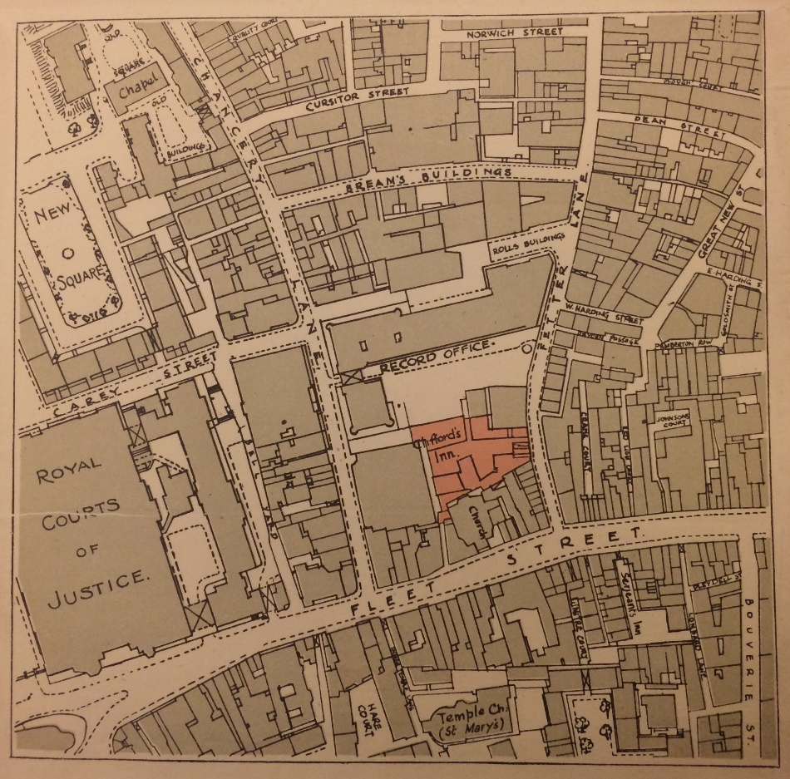
Figure 1.1 The location of Clifford’s Inn on Fleet Street. William Page, Particulars, Plan and Condition of Sale of Clifford’s Inn (London: Willett Estate Office, 1921), no page numbers.

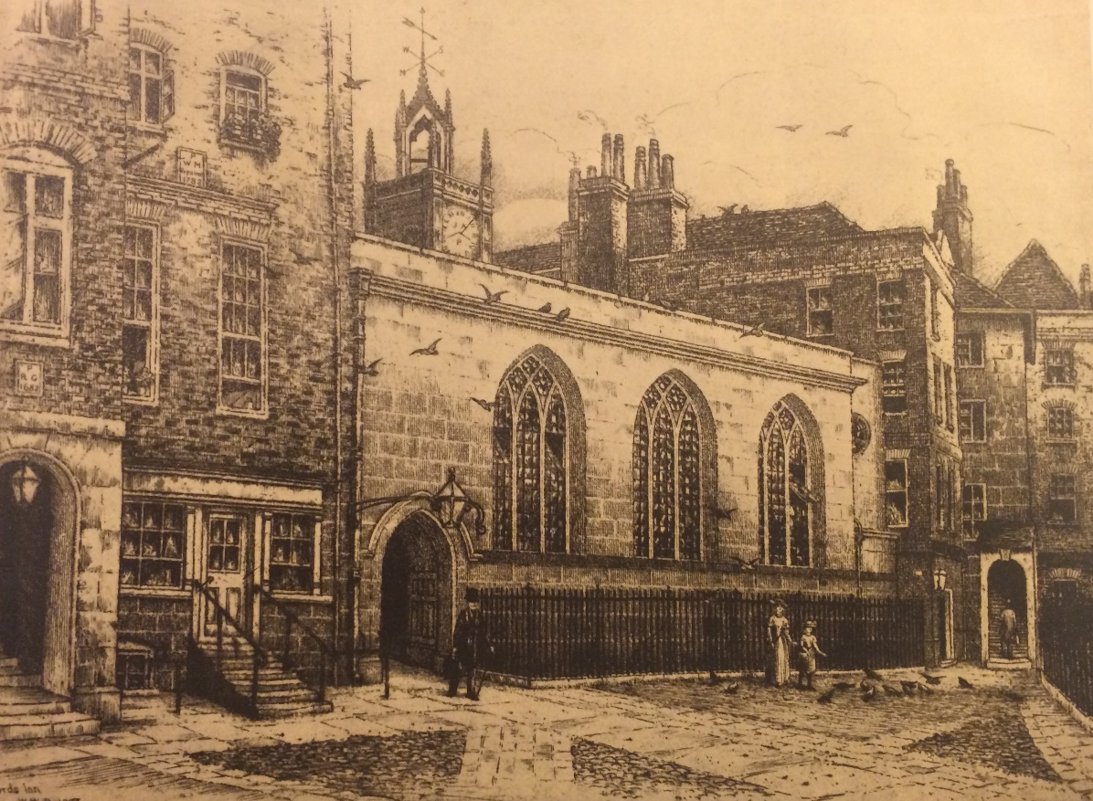
Figure 1.2 The Hall. William Page, Particulars, Plan and Condition of Sale of Clifford’s Inn (London: Willett Estate Office, 1921), no page numbers. Reproduction of an etching by W. W. Burgess (1856–1908).

The two halls, Clifford’s Inn and 6 Queen Square, are still written about as artistic meeting points for male intellectual discussions about art, architecture, and design, key in cementing the emotional and professional bonds between middle-class men. The AWG encouraged members to assert their roles as radical new thinkers and designers. The guild offered a much-needed space for men to establish professional contacts, bolstered by regular meetings, and providing significant opportunities for collaboration with other designers, educators, and policy-makers. In the 1890s its members—which numbered over two hundred—included all the leading Arts and Crafts men except William De Morgan. Alan Crawford has described AWG meetings as having the atmosphere of “a slightly Bohemian gentleman’s club, smoky and exclusive. It was the single most important organisation in the Movement, and in some ways its heart”. The beliefs of the AWG can best be understood through an eloquent speech made by Walter Crane in 1888 when Master of the AWG. Crane, clearly intending to inspire a male collectivist spirit, told members: “There can be no doubt that the A.W.G. is a force—that it represents a very real, very important movement in the Arts.” Positioning the AWG as the representative “force” of the entire movement, he went on to compare the founding of the guild with the launching of a ship, stating: “We have long ago launched and christened our Guild; long may our good ship float upon the waters of fellowship and have an influence for good.” This seafaring metaphor expresses the core principles of the AWG. The evocation of a “real” movement of the arts, shows its separation from the observed corruption of an industrialised, consumerist society. The AWG, “floating upon the waters of fellowship” represented its concern for members to have solidarity and a common identity. Sustaining this space for fraternal artistic sociability in the city dominated the energies of the AWG across the years the WGA was in existence.
Drawing from quotes such as Crane, scholars have conceptualised Clifford’s Inn Hall and 6 Queen Square as centralising masculine sites of comradeship from which women were assumed absent. The perception of women’s overarching exclusion from the movement stems from the exclusive, fraternal rhetoric asserted by the AWG, which has had the effect of encouraging researchers to perceive female activity as amateur and in polarised contrast. Elizabeth Cumming and Wendy Kaplan observed that: “For the majority of professional designers, the idea of a brotherhood of craftsmen denied the inclusion of women as full members. Women who were art school-trained were confined to the pursuit of craft as a pastime or as philanthropy.” Yet, although fraternal aspects of the AWG were heavily stressed—often due to their own instability as a new organisation—and de facto segregation was in force, it does not necessarily follow that women had no involvement in professional artistic life, or indeed in the premises of such male organisations.
The known connotations of Bloomsbury and Holborn helped the WGA to associate their association with art, as this was of course the area where William Morris had lived and worked. Both Clifford’s Inn Hall and 6 Queen Square were also situated in the legal district spanning Bloomsbury and Holborn, and there was a bustling community of lawyers and journalists. Status, location, and definition are instrumental in shaping societal grasp of art movements. Clifford’s Inn Hall, the first hall used by both guilds, provided a way to materially embody dedication to the past. The building represented a rare fragment of the medieval fabric of the city, as the inn had previously been an Inn of Chancery. It was founded in 1344 to train students in the art of jurisprudence and dissolved in its use for this function in 1903. The hall itself was remodeled in 1767, although few details survive about this redesign. The historical significance of the hall was commented upon regularly by members and in contemporary descriptions. Societal commentator C. M. Hay Edwards wrote that: “Many men have come and gone, and many events happened in the little world of Clifford’s Inn, one of the most ancient parts of London.” Edwards carefully noted for readers “the old-world atmosphere that pervades these ancient nooks.”
The historic sense of professionalism the building awakened in its visitors was necessary for the newly formed WGA due to its position as a women’s group. Formally attaching their activities to Clifford’s Inn Hall enabled members to tell customers and friends about these associations, which could reap financial benefits alongside societal reverence. The halls enabled members to evoke an “invented traditionalism” for users, who were striving to assert aesthetic authority. Situating their activities amongst an inspiring, “old-world” backdrop imbued their modern activities with a feeling of prestige and cultural heritage, and assured people of the seriousness of their endeavour. Within the hall, female artists could promote their role as taste makers and conjure up utopian ideas for an equal society through their quiet ambition to remove gendered segregation.
During the period the AWG and the WGA used Clifford’s Inn Hall, the groups who rented its chambers were varied, but were also meeting for professional reasons. The Society of Women Journalists met there for seven years in the early-twentieth century; “and to its rooms have come most of the leading women writers of the day.” Inexplicably the book failed to mention the WGA, but Edwards acknowledged a shift away from the halls previous male-only stance, writing that from 1903 “Women—in all contradistinction to the ancient laws—came and went, and worked in their rooms there.” However, the other Inns of Court surrounding Clifford’s Inn were still used for legal purposes until 1919, and it continued to be an area dominated by professional male activity until the Sex Disqualification (Removal) Act was passed, which opened the bar to women. Ren Pepitone has emphasised the importance it was felt these halls had in assuring the fraternal, ritualistic lifestyles of male lawyers. In these halls adjacent to Clifford’s Inn, male lawyers continued to use medieval customs—donning black gowns and drinking from goblets whilst flanked by brethren members—to create solidarity and a standardised professional outlook. Men in the legal professions tried to control the built environment and its ties to tradition through maintaining “resolutely masculine institutions” and used dining halls, offices, and even the toilets at the Inns “as both excuses and devices for marginalizing women.” In the halls surrounding Clifford’s Inn, male lawyers demanded the continued spatial separation of men and women, stating that male sociability was intrinsically linked to professional success. Spatial segregation and masculine culture was in fact also intrinsically connected to the subordination of women lawyers, and as this chapter shows, space was also being used nearby to try to assert authority over women art workers.
The use of Clifford’s Inn Hall was a contested issue for members of the WGA. A 1908 letter to May Morris from the metalworker Edith B. Dawson discussed the influence she personally felt the hall wielded, but she hinted at the unease felt by other members when writing:

Since I heard of the offer of Clifford’s Inn Hall by the Art Workers’ Guild to our new Women’s Guild, I have been wondering whether all of us realise how important an offer it is and what a very great mistake we shall make if we lightly refuse it. For years the Art Workers’ Guild has held its meetings there and perhaps only those of us who have men folk belonging to the guild know how attached they are to the fine old hall with its many associations, and what a dignifying and benign influence such a place of meeting would have on any gathering.

Dawson was puzzled that other women had not seen this offer from the AWG as enticing, and felt the “fine old hall” would have a constructive impact on their own gatherings. Dawson also suggested evening meetings for these working women: “which to several of us is more practical and also preferable, as we are women whose work makes daylight and daytime valuable”. It is noteworthy that in the early days the AWG allowed the WGA to use the hall rent-free, perhaps as a way of showing implicit support. This was certainly how Dawson felt, writing the hall was “a proof of good-will which we much appreciate, for, as you are aware, it is much in demand for meetings.” She went on to say that the hall:

has been offered to the women’s guild in a spirit of welcome and comradeship which we should not at any rate put lightly aside, and to some of us it seems a poor substitute to wander homelessly from one member’s workplace to another, ever changing and having nowhere to call our own, as well as giving much more trouble to the officers of our guild.

Concerns the WGA would be “homeless”, reliant on meeting at each other’s workplaces, demonstrates the guild’s desire to physically anchor their organisation, in emulation of the male guild, within a professional meeting space. Dawson finished by writing she had “the interest of our new Guild at heart, with the hopes and ambitions for it that all its members must feel”. She hoped “that we may be a united body of women at workers, looking at things broadly and responsibly and that we may grow into a strong and influential guild, whose voice will be a real power in the land.” This letter provides a rare glimpse into the prominence this new guild had in the eyes of this generation of women art workers who hoped to become a powerful force in society.
A desire to base the activities of the WGA on the AWG is evident throughout the early days of the guild. In Dawson’s view the WGA would be most successful if the WGA were “to be like the Men’s Guild, as Mr Rooke who was here last night said, it was for ‘no use at all’ and was all the better for it. Really he knew it was a great deal of use to its members, but not in a business way.” The WGA committee reiterated the need to maintain a similar approach to the AWG in annual reports. The Annual Report for 1913 stated: “The Art Workers’ Guild, as you know, has been established for a great many years, and seeing the extraordinary benefit this body has been to its members, it was thought that a service might be rendered to women art-workers by the formation of an organization on similar lines.” Again, the WGA’s belief in the customs of the male guild is highlighted by this rhetoric, and the WGA hoped Clifford’s Inn Hall would shape the fortunes of its female members in a similar way.
The WGA eschewed holding general meetings at the homes of members. Meeting in domestic premises was however a popular method of meeting for other groups of London-based artists during this period, unlike in European cultures such as Vienna where the coffee shop was central. The WGA were determined not to convene within spaces that held domestic connotations and could subsequently associate their activities with those of an amateur. Dawson warned Morris about the need to “prevent the feeling of ‘drawing-room’ meeting to which I think we may all object”. Whilst male groups could, and did, host meetings in the homes of members, this reflects the different gendered expectations of artistic groups. A woman was all too easily relegated into a non-professional role by virtue of her social environment. The drawing-room was perceived as domestic and feminine when appropriated by female users, whereas these same rooms could be viewed as professional sites when used by male artists.
May Morris sought out ways to publically familiarise her contemporaries with the rich cultural tradition of female involvement in the guild system. An appropriate example can be seen in 1909 when she travelled to America where, amongst other business, she gave a lecture in New York on “Mediaeval Embroidery”, in the auditorium of the Horace Mann School. Here, Morris promoted the historical tradition of female involvement within the guild system, and the need for prolonged, intensive training to achieve quality work. This lecture was reported in the New York Times, which reveals Morris had given an “account of the first woman’s trade union league whose historic record remains, the Parisian guild of female embroiderers.” She told her American audience about “Alys, Erningarde [sic], Blanche, and Eloise”, central “embroidery mistresses” who had had to “undergo a grueling six years apprenticeship to join the guild.” Morris’s international drive to further knowledge about the established history women had in craft helped to expand the sphere of influence and the legitimacy of the WGA.
In 1914, the AWG bought a Georgian house at 6 Queen Square, Bloomsbury and had a new hall built for members by Brother Francis W. Troup. (Figure 1.3 and Figure 1.4) This site stood as a public symbol of the guild’s presence in the city and helped the AWG embody its aims with renewed enthusiasm. An address by Master Harold Speed in 1915 said he knew members would miss the “picturesque and lovable old Hall and Inn” but they should look forward to having “the satisfaction of being our own masters in our own home, and shall doubtless accumulate, in the future, traditions and properties, in Queen Square, which will render the new home even dearer and more interesting to us than the old.” At the new hall, WGA general meetings now took place in a room purposely designed to exhibit male artistic identity. The walls were covered with golden-inked names listing male members, alongside a pantheon of portraits and busts of Past Masters, which enabled the AWG to promote its fraternal brotherhood and visually enforce the reputations of past and present members. The WGA archive contains no record about whether members debated if it would be advisable to follow the AWG to 6 Queen Square, and the ways female members felt about this new, even more overtly masculine environment. However, as Jane Hamlett has suggested, although masculine spaces and decorative styles could be intimidating to women and reinforced a sense of male power, their “very presence provoked resistance” and encouraged “a questioning of the gendered system of power relations”. The WGA chose to continue its stoic presence within these new rooms until c. 1961.

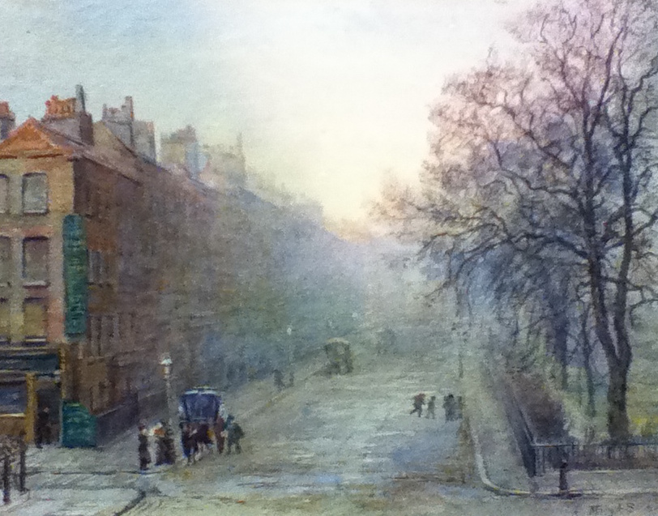
Figure 1.3 Queen Square by Mary A. Sloane. Early-twentieth century. Private collection.

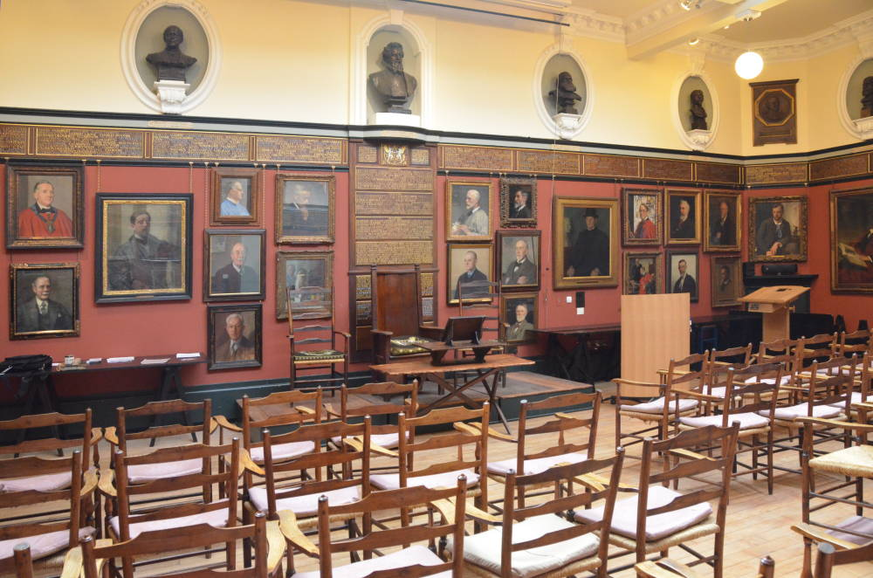
Figure 1.4 6 Queen Square today. With kind thanks to Monica Grose-Hodge at the AWG.

The tactics the WGA used to emulate the male guild in order to avoid gendered discrimination was also used in official documentation. The tone in written documents noticeably separates the WGA from their female contemporaries in the suffrage movement who were explicitly writing about gender politics in the national press. WGA official papers consistently avoided inflammatory statements about why the WGA had been required to form a guild for women. Each annual report acknowledged the AWG for its apparent continued support—even when there was little evidence for this—likely to avoid appearing hostile to male artists, a cluster of whom were very conservative in their views about women. A handwritten version of the WGA 1912 Annual Report composed by May Morris stated: “I believe too we are agreed that we are not banded together to show what we can do alone—an isolated society in the community bound together by sex rather than by art.” The female guild instead aimed to mirror the AWG, “men already having their own organisations”, and simply “to do what they are doing, i.e. to keep at the highest level the arts by which and for which we live … Perhaps also, we have the mission of heartening up the weary (among which may sometimes be ourselves and each other in times of doubt and depression) and generally of exuding an atmosphere of camaraderie without which ones work would surely be dead sea fruit.”
Official records promoted the image of the WGA as a professional institution. The level of effort put into annual reports and documents, which were available to guests but also to the public, reveal the dedication of Morris and the committee. Lectures and reports were written and rewritten, crossed out and amended, with final versions being typed up by the Chiswick Press, a short walk away in Chancery Lane. The visual appearance of these documents built the WGA’s sense of community spirit and the language used sustained a feeling of group identity. In the 1908 Secretary Report May Morris discussed the problems that had recently taken place in the very naming of the guild:

There was a good deal of discussion over the naming of it, and its present title has been severely criticized by some of the members and their friends as ungrammatical and unmeaning. I myself could never see why we should not have been content in the simple and obvious [‘and unaffected’ crossed out] name of The Guild of Women Art Workers.

This quote demonstrates the strength of feeling over the naming of the guild at its formation, and what the institution’s purpose was to be for members and their social group. The fact the title “the WGA” was chosen, regardless of the opposition of members such as Morris, shows the range of opinions within the guild, and the diplomatic approach being employed, at this point at least, towards decision-making.
Guild documents consistently reiterated the role of members as “art workers” to articulate their specialised roles. The word “art worker” was an increasingly common term used across the late-nineteenth century to describe those working in the arts, and the term was claimed by members and journalists in the women’s press to denote women professionally dedicated to craft. Scholars often fail to recognise women were asserting their new roles as art workers in this way. Together, the respected connotations of “art” alongside the more socialist implications of the term “worker” enabled women to attach themselves to the Arts and Crafts movement, and confidently assert a wish to work. The term eschewed gendered connotations, and moved away from the approach taken by journalists to label women as “lady” artists. This confident use of “art worker”, by the WGA problematises the argument that public emphasis of work was seen to be such a troubling notion for middle-class women.
Both guilds consistently articulated the need for activities to remain private, and pursued a firm policy of producing little publicity. The private associations of the hall are crucial in understanding its appeal to users. For AWG members, this privacy linked their activities with intellectual and anti-commercialist pursuits, whilst the secretive nature of meetings subtly added to the prestige of events. Privacy was seen as a vital element for other intellectual clubs of this era, such as the Cambridge Apostles. The AWG Annual Report of 1922 curtly reminded members that “all meetings, whether ordinary, special, or ladies’ meetings, are absolutely private, and that it is a distinct breach of courtesy for anyone to describe or report in any daily paper or other periodical the proceedings of the Guild”. The WGA adopted a correspondingly private approach, and although its general meetings, like the AWG, were advertised in the Journal of the Royal Society of Arts and in The Year’s Art these advertisements were basic, simply stating the guild met at the hall. WGA members clearly enjoyed this privacy. In her unpublished poem “Rhyme of the Ancient Inn” WGA member and illuminator, Ethel Sandell, wrote that Clifford’s Inn Hall held great significance due to its private nature, entered through “A little passage dim and grey”, but still based at the heart of the artistic scene. Member Feodora Gleichen even used the argument of privacy to justify the gendered stance of the male guild, stating that segregation was merely due to practicalities, writing in 1913 that it “would do away with the whole character of the meetings if they took place in a large hall where both Guilds could meet; it would be like a large unwieldy public meeting!” Gleichen’s letter, written at the summit of suffrage militancy, alongside her own high social standing in the royal family, highlights her reticence against the WGA becoming immersed in public debates away from the private hall.
The WGA continually sought out ways to promote a dedication to medievalist aesthetics. A formal guild roll listing all members was presented in 1914. Designed to imitate a traditional guild roll, it took the form of an engraved, illuminated booklet bound in red pigskin. The roll embodied group meaning for members, and as they did not have their own permanent meeting space the roll provided a powerful way to symbolise shared identity. The committee commissioned two members, Ethel Sandell and Katharine Adams, to make this roll and paid them their requested rates. Letters were exchanged which reiterated the need for “lots of room” for the names of future members to be scribed, revealing the optimism of the committee about the future. There was much deliberation about how to present the names of members, indicating the extent to which members were thinking about the ways they could visibly and permanently represent their professional activity. Demonstrating the range of respective crafts practiced by members was essential to the WGA, as it showed they were fulfilling their commitment to equality and collaboration in the arts.
Meeting privately, in sites widely known for male artistic sociability, meant the WGA avoided a public proclamation of institutional femininity. Both halls marked a deviation from the feminised institutionalism used by professional women and suffragists to assert their roles as female citizens. This public femininity was increasingly embodied in the architecture and interior arrangements of the premises women established. For example, the architectural design of Westfield College for women, near London, opened in 1882, was selected by its first Mistress Constance Maynard to be resolutely domestic in style. New women’s educational colleges made concerted efforts to show off the domestic, feminine character of these residences. Newnham College, Cambridge, was designed by architect Basil Champneys to “combine a sense of collegiate life with a wholly feminine atmosphere; his white-trimmed brick buildings were pleasantly inviting”. A comparable approach was taken with a number of suffrage organisations. The London headquarters for the International Woman Suffrage Alliance was an elegant eighteenth-century town house, which Lynne Walker has written was considered “appropriate to the femininity of the suffrage occupants”, due to the “dainty honeysuckle ornament on the pilasters and the rich plasterwork detailing of the interiors”. Similarly, the Glasgow Society of Women Artists had its own clubhouse at 5 Blythswood Square from 1893, where members “organized sewing-bees for running up curtains and cushions” and “gave, or begged for furniture, carpets and crockery” to furnish the house to an appropriately domestic level. These approaches, all emphasising the femininity of the occupants, was not adopted as a strategy by the WGA. Having a visible presence through their own designated clubhouse would have gone against their attempts to merge their activities with the male guild.
Whilst this steadfast adoption of characteristics used by the AWG could lead to suggestions that the WGA was derivative, conservative, and accepting of male patriarchal control, this view would be simplistic. It belies the achievement and respectability attained by the organisation. Before 1907 women’s engagement with the central institution of the Arts and Crafts movement was informal at best, prohibited at worst. After the foundation of the WGA, the two guilds shared a spatial home, and women’s contributions were formalised and integrated with those of their male peers, despite the segregation of actual meetings. The WGA saw the guild as having a fundamental role in society; members such as the painter Estella Canziani felt the WGA to be “the counterpart of the Art Workers’ Guild” when writing her memoir. This section has highlighted the ways women art workers adapted themselves to contemporary structures of power, behavioural constraints, and male control, as a way to further their own ambitions. Whilst the women in the WGA did not act in an obviously modern feminist way, they did work to dismantle particular inequalities impeding on their professional needs. It was hoped this would blur the boundaries between male and female artistic activity in the Arts and Crafts movement, and raise the status of the women in their organisation.

II.

The second half of this chapter peers into the two guildhalls, exploring the activities of the WGA in lived experience, to compliment the idealised implications it was felt the halls could have, discussed in section one. The halls acted as essential sites of centralising institutionalism but the survival and health of the guild depended on the sociability played out within its walls. A second institutional guild space was constituted by the social interactions between members. Across this period, female friendships and kinship networks were central in summoning a sense of professionalism. Through using female networks of sociability, women could act in ways which were less acceptable in wider society, although conversely this segregation could reinforce notions of femininity and female separation, something the WGA were continually trying to balance in their actions.
The female networks of artistic sociability that came to underpin the guild’s presence in the hall preceded the creation of this institution. The sisters Alice and E. C. Woodward. later to become WGA committee members, had already been on the committee of the all-female art club, the ‘91 Art Club, in 1896. The Studio that year approvingly noted the sisters were involved in a competition to design invitation cards for members of the ‘91 Art Club, to advertise its activities. An “At Home” meeting of the ‘91 Art Club had been organised in a Chelsea home where, alongside an exhibition of pictures, a competition took place and ‘91 Art Club members laid their cards out for winners to be picked. Figure 1.5 shows a card by E. C. Woodward which illustrated a series of women’s faces, personalised enough to allow one to wonder whether they were the actual faces of members. Their hair, which flows around them, connects all of the women, and creates a harmonious representation of feminine sisterhood, and a united artistic front. The writing on the card is curiously presented on the back of a large framed canvas, as a demonstration of their artistic nature, and suggesting an element of secrecy. It presented an idealised portrayal of the club’s camaraderie and organisation, yet its maker evidently thought it characteristic of their aims.

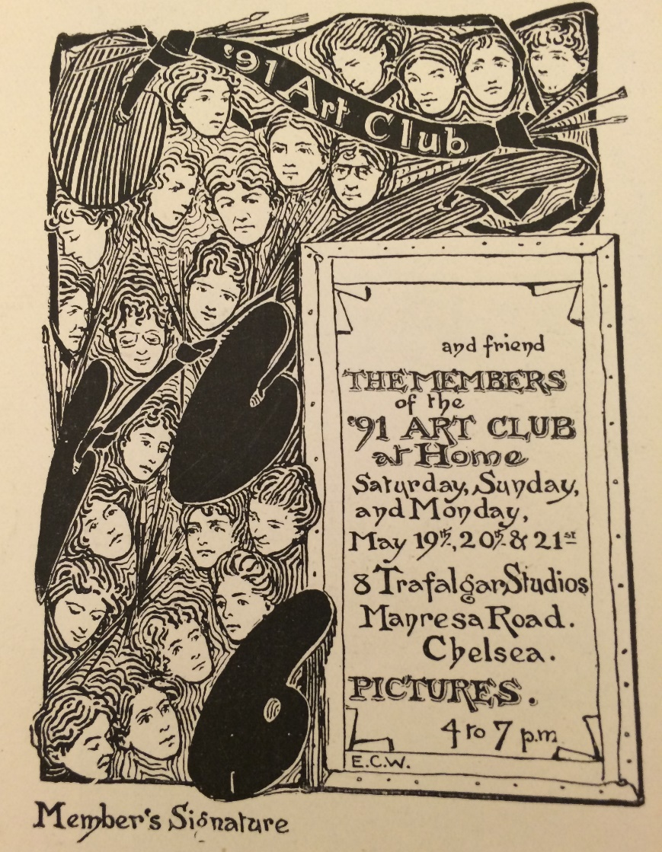
Figure 1.5 E. C. Woodward’s card for the ’91 Art Club, “The ’91 Art Club at Home”, The Studio, 1894, (3), p. 96.

Clearly then, in the late-nineteenth century women were competently devising sophisticated strategies within their female artistic communities, in the face of a society structured around gendered hierarchies. Alice and E. C. Woodward’s later membership of the WGA as middle-aged women must be seen as concordant with these earlier efforts. By reframing their long-established friendships within these organisations, women were seeking to use their relationships as part of a wider network of professional activity. In the words of Clarissa Campbell Orr: “Women could do together what it was hard or impossible to do singularly.” Members were involved in many such organisations. For example, a cluster of future WGA members were involved in the esteemed mixed-sex group ‘The Society of Painters in Tempera’, founded by Christiana Herringham in 1901, but also including Mary Sargant Florence, Mary Batten, Emily Ford, and Estella Canziani.
As such, although the WGA provided a new professional venue for women, it was by no means the only option available for this artistic circle of women. The women who joined the guild already had confident ideas about how associational life should be organised. From 1907, members used these established methods within the newly established WGA, which did have the power of the celebrity-like figures of a number of its founding members—which included embroider Jane Morris—and prestigious rooms in central London. Official general meetings were held six-seven times a year at designated dates and times, alongside an additional annual meeting held in December. At these events papers were read, there were demonstrations, and the tables and walls were adorned, along with the walls, with examples of female craftwork. Members spoke about their expertise, visually enticing their audience, projecting images using lantern slides. At a number of the meetings there was the opportunity to sell work, although this was never discussed in detail in written literature. It could be assumed this was to maintain respectability, but this is unlikely, and was probably due to the ease of the word-of-mouth approach these women often used when gifting and selling work to their contemporaries.
A sense of the hectic and eventful nature of general meetings comes across in Mary A. Sloane’s scrawled pages of private notes. She wrote down her frustrations about members not having tickets ready for these busy events: “members should not be foolish virgins but should be wise virgins and keep by them a few tickets for visitors” and noted the high expectations for her own role “no one can expect the Sec to provide for someone to be always on the spot.” Members were allowed to bring guests—male and female—and although it is not known whether it was at WGA events, a favourite activity of the writer Constance Smedley during this era was to be “thrilled at lectures from May Morris.” Although the WGA focused on the prestige of its members, it also sought to invite visitors from across society, and in doing so reshaped perceptions of the positions of women in society and in the art world.
A crucial feature of the WGA’s early life was that women often led meetings in the hall, lecturing on topics in which they were specialists. The committee encouraged female artists to speak and lead discussions. This is important to note as it later took a different approach in relying upon male speakers. In the early years, WGA members lectured and demonstrated their skills to members, and attempted to inspire more women to participate in the Arts and Crafts movement. The 1908 Secretary’s report discloses that members had enjoyed papers by: Christiana Herringham on Indian Architecture, May Morris on embroidery, and Eleanor Hallé and Feodora Gleichen had given a joint paper on “Relief in Sculpture.” The annual meeting cards for 1909 list topics such as “Fresco” by Mary Sargant Florence, and “Thoughts which have occurred to me about Arts and Crafts during a long struggle with both” by the sculptor Esther Moore. In 1910 there were eight meetings including a discussion on “Imagination in Education” by Emily Ford “and others”. There was also an intriguing paper labelled a “Debate”, on “The Scope and Power of Guilds.” The title suggests the WGA may have used this opportunity to discuss guilds more generally and to invite their male peers.
Founding members made a sustained effort to create a firm circle of female sociability and support. The hall created a framework of social interaction, where women could temporarily claim the space to exhibit their professional skills to each other, and advertise their expertise. These transitory displays and collective presentation of artistic proficiency were key early attempts by middle-class women to create an institutional space in order to foster support and recognition. Although the private conversations that took place at these meetings will never be known, the cultural, social, and didactic role of art in society were clearly central topics under discussion. As the theorist Thomas A. Markus has written, teaching is the customary way of producing knowledge, and by framing this learning within the characteristic teaching space of the lecture hall, this space helped to invigorate members in their professional pursuits. Vicinus has argued that the privacy of new nineteenth-century female institutional communities gave women the “gift of privacy and time for self-development. Community life validated individuality in a culture that assumed women never needed time alone and would always be at the beck and call of others”. Similar parallels can be drawn with women art workers in the early twentieth century, and the hall provided communal space and the gift of privacy and time for the WGA, in ways that leave little audible trace today.
In keeping with its self-conceptualisation as a private, exclusive organisation, the WGA sought to maintain professional standards by exercising strict control over membership. After founding members had been “specially invited to form a nucleus” the WGA implemented a formal policy by which a prospective member had to be nominated by a proposer and a seconder who was a member of the committee. Potential members then had to “submit several examples of their work or other proofs of efficiency for inspection at the meeting” at which the election was to take place. This work would be displayed in exhibition format, in a separate small room (if available), where it would be examined by members, usually at the annual general meeting, before a formal election took place to decide whether the art work was to a suitable standard. Members were expected to assert their artistic knowledge during the election process of new candidates and individuals were especially requested to attend meetings when candidates in their specific artistic field would be showing artwork. Members were required to put a cross against the names they wished to vote for and a two-thirds majority of those present was necessary for election. For these professionally minded women it was vital the guild should be restricted to providing a space only for women with demonstrable artistic skill to meet and discuss work.
These women feared otherwise they would “lose the kind of influence we wish to have, and become a mediocrity.” In 1913, for example, the question of whether candidates needed official qualifications was brought up as a matter of debate. Although no conclusion was reached on such requirements, it was decided it was desirable to know from this point on if candidates had any educational qualifications as part of the election process. This reflected the national increase in women artists receiving formal art education. In 1913–14 the process of joining was formalised even further and the rules were changed so that no visitors were allowed to enter the rooms to hear the lecture until after the ballot had been taken. This shows the wish of the guild to spatially separate the professional space belonging to members from that occupied by prospective candidates and visitors. In an early speech in 1908 May Morris discussed how the guild had begun having only “picked artists”, and could not grow quickly as the highest skills were demanded. In this meeting, she took care to address the whole guild on this point:

Your committee only presents to you names of candidates whose work they judge competent and sincere, so to belong to the Guild is by no means an empty honour. The process of selection may seem troublesome to candidates—as it is to the Committee and Secretary: but one of the points of our body is that it is not easy of access, and we have no wish to slacken the rules in that respect.

A speech from 1912 again reiterated to members their role as artistic connoisseurs. Morris spoke to members about the responsibility the guild had in maintaining its professional reputation. She described the problems members faced: “that of freezing at the North Pole, of splendid isolation, and that of getting a little too good-natured in admitting people who have not reached the necessary standard of work.” Morris warned members again on this final point: “To the extent to which we lower the standard of taste … we shall lose the kind of influence we wish to have, and become a mediocrity … and that we might as well break up our body.” In Morris’s opinion, there was no point in meeting if their efforts were not professional and she equated a lack of taste with amateur artistry. In a private letter a few years later, future member Phyllis Gardner wrote to her sister Delphis, who was also to become a member, discussing this same problem: of the desire to socialise with fellow artists, whilst needing to maintain high standards of taste. She discussed how a Mrs Gomme had shown her a picture “very attractive, in a simple clean sort of a style … I want to see some more. I’m glad I like her drawings, because she’s nice herself, and the two don’t always go together.”
Attempts made by amateur women to join were firmly refuted. Decisions about what made someone an amateur seems to have been decided by the reputation that the artist had established, alongside close scrutiny of numerous pieces of their work. Committee members replied to letters from women they deemed amateurs writing that membership was reserved for members “seriously engaged” in the arts, although amateur women could come to meetings as visitors if wished. A decorative painter known only as “Mrs. Greig”, for example, submitted samples of work by post in 1914 but apparently the committee “did not see their way to nominate on the limited number of examples sent”. Mary A. Sloane was asked to write and propose that Mrs. Greig should let the Committee see a greater amount of her work. Evidence of concerns about standard of work can be found as late as 1926 when May Morris wrote to Mary A. Sloane anxiously saying “I don’t think Miss G. Bowman should have been passed as a candidate by the committee on the strength of the one piece … we often find people doing one good show piece and thereafter fall off in taste.” Morris was fixated with the high standard and taste of members, and was anxious about their need, as a body of women, to maintain absolute professionalism in the face of societal expectations to the contrary. In a letter she sent to Walter Crane, discussing the forthcoming publication of her edited collection of her father’s work, her gendered anxieties are quite clear: “People will pull me up pretty stiff if I fall into any blunders, and they’ll shrug and say ‘After all a woman why didn’t they give the job to Mackail?’”
The guild was well aware that an integral part of being seen to be a successful artist was through socialising so as to become celebrated within society and to acquire a wide sphere of patrons. To this end, from 1909 they established associate members, “friends interested in art”, all female, in order to stimulate networking opportunities for members, and to spread knowledge about the WGA. The role of associate members in the WGA was:

To assist the production of good art. By helping to keep up the right spirit—in the workers—by helping to keep the good ones (tried and trained and tested ones) from being driven, by want of funds and employment, into work which wastes them, and their training … etc. The Associates are there to be shown the right quality, if they don’t know it already, to be told where they can obtain good work, of good quality, if they don’t know it already and to back up the Guild.

Members, described as “the workers”, proven “good” artists, were seen to need the associates, who could provide a wide female sphere of support and community, which would assist full members from having to seek employment, which “wastes them”. The report went on to discuss the difficulties of being an artist, perhaps alluding to the gendered struggles for female artists, stating the role of the associate was to help by “keeping art from getting swamped and artists from falling out, or succumbing to the onset of the hostile forces constantly besetting their paths.” Many prominent women joined as associates, from middle- and upper-middle-class backgrounds, and with a huge diversity of interests such as actress Hilda Trevelyan; art collector and patron Juliet M. Morse; painter Catherine Ouless, writer and poet, Alix Egerton; bookbinder; bookbinder Winifred Stopes (sister of Marie Stopes, pioneer in the field of birth control); and historian of domestic Parisian life in the fifteenth century, Valentine Hawtrey. Associates paid ten shillings a year and were allowed to bring one friend to meetings. Unlike full members, associates could not vote in general elections. An approving account in one report described the behaviour of the ideal associate: “One engagement ring I know one Associate secured as a commission for a guild member—that is the right line for an Associate!” Introducing associates was an astute strategy because it allowed members to show their wares to women who had the finances to buy and who could advertise their work across expansive social networks. Members were uneasy about being perceived to have commercial motivations, and associates provided an acceptable format through which to considerably broaden the scope of the guild, and build its power amidst wealthy, intellectual, and artistic circles.
Members tried to participate in guild life alongside negotiating roles as middle-class women, which held extensive gendered expectations of them as wives, daughters, sisters, and mothers, alongside their own professional work loads. Mary A. Sloane discussed with members in her resignation speech as Honorary Secretary in 1923 the sheer lack of time she had, unable to dedicate any more time to the guild as she was “exceptionally busy with one’s own work—whatever it may be—models or clients or domestic catastrophes a burst boiler, or all these at once.” The WGA papers provide ample evidence of domestic problems taking considerable time away from artistic production. A letter to Sloane from a Miss Coles lamented that “she is unable after all to join” because her father is in “delicate health and cannot be left in the evening”. Miss Coles’ desire to maintain this connection with the WGA comes across clearly as she was “greatly sorry for the trouble she has given Miss Sloane and hopes that some other year she will be allowed to join.” A similar letter to Estella Canziani from Edith K. Martyn discussed her concern about taking on paid artistic work as she wanted “to make a special effort to do more at home to help—my sister won’t let me do that if I’ve big work on hand—so I have just written to Mr Butler … to give it up.” This letter is significant: it shows that although Martyn’s family were supportive, her own personal sense of responsibility to fulfill her domestic duties made her diminish the time she dedicated to art.
The guild’s network of sociability did not solely orbit around physical meetings. The correspondence between members was a vital area of sociability which built an additional layer of institutional experience and intellectual exchange. Letters, written at the studios and homes of members, travelled between domestic boundaries and connected members to an invisible sphere of female artistic professionalism. This was often in lieu of being able to physically attend meetings due to domestic commitments or distance to travel. As Sarah Richardson has noted, the sheer scale of female correspondence over this period is astounding. Face-to-face encounters were kept sustained by “the correspondence networks that nurtured and encouraged them”. With these letters another layer of guild intimacy was created. Marta Bowerley wrote to Sloane in 1919 expressing her opinions about an upcoming committee meeting as she could not physically travel and be there as she was unable to travel about at night. Another member felt similar, and resigned, “regretfully”, because “it is such a long dark journey on winter nights that I cannot often come. I hope that I may turn up on some evenings during the year and I do hope to get a sight of you sometimes.” There are many examples of members not having enough time to travel for guild meetings, and friendships could run for years relying on letter writing in place of physical contact.
Official mixed-sex professional artistic sociability away from WGA meetings and within the remit of the AWG’s meetings remained nonexistent until 1964. However, in lived practice, the boundaries between single-sex organisations are rarely impermeable. There were interactions between the two guilds through the many marriages, families, and friendships linking the two guilds, and also through professional ties, as will be established over the course of this thesis. Male and female friendships have received little attention from historians; something Sharon Marcus has argued has been due to perceptions that men and women of this era who were not related could only be linked by sex. Examples of friendships with AWG members can be found through photographs of male members on guild trips abroad in Europe together, as these sometimes include female figures. Katharine Adams, a single woman at this time, went on one of these trips. In 1903, the architect, and AWG Master Charles Harrison Townsend wrote to Adams asking if he could use the photographs she had taken on a recent trip to Rome with the AWG for a meeting at Clifford’s Inn on the topic. Sensing the hypocrisy of asking Adams if he could use her materials for a meeting at which she was not allowed to attend, he awkwardly added “I wish ladies could come on the 18th and that you could be at Clifford’s Inn to hear and see.” Adams evidently maintained a close relationship with the male guild as in 1911 she received a letter lamenting her inability to be at a holiday that year, and showing the camaraderie and respect which her male peers had for her: “Greetings and Love (in the most A.W.G and respectful sense) to Miss Kate Adams from the following, her sincere friends and admirers now wobbling … across the Bay of Biscay … and regretting intensely that the said Miss K. Adams is not of the party.” The WGA archive also reveals continuing support from a number of well-known members of the AWG, such as Emery Walker, and W. R. Lethaby. As Kathryn Gleadle has argued, the “interplay between individual subjectivities and formal processes was very subtle”.
During the years 1907 to 1913 reports alluded that there were concerns that there were not enough opportunities for female artistic sociability. Even in the 1908 WGA Secretary Report, read by Morris at the December meeting, Morris addressed the need for the guild to provide more frequent gatherings for “business and social intercourse”. Morris encouraged members to take more time to talk to one another that very evening, and to make sure they attended future meetings “in a spirit of comradeship” eager “to give out some of your own mental activity and to absorb that of your fellows.” She asserted that individual members needed to make effort, and indicated they should not expect all attempts to arrange meetings to fall to the committee:

The future of the Guild is in the hands of those who came to the meetings, who make suggestions, and generally show some interest in the working of the body to whom they belong. Those members who stay away and ask ‘After all what will the Guild do for me?’ I would answer by a counter-question and ask them: ‘What will you do for the Guild?’ People cannot take without giving.

The report that was read out at the annual general meeting in 1910 was particularly significant for its discussions about sociability. Likely to have been written by Mary Lowndes as Morris was away in America it reveals a number of growing internal tensions in the guild:

What has been said before has perhaps to be repeated: that members of the Guild from one cause or another do not seem to have come into close contact as much as could be wished. Six or seven meetings in the year are not enough to keep the Guild going according to the scheme as originally thought out. We want to see more of each other’s work, know more of each other’s outlook … we have to change views on theory and practice in our various subjects—and listening to lectures at such long intervals will severely affect this. If the guild had some permanent home we should meet in the social way desired, as the men art-workers do, but the conditions are different.

To this May Morris later added a comment saying “Personally, I am very anxious that we should continue the monthly evenings here, the traditions of the place being so friendly and familiar.” The report then went on:

The Guild … has in the first place its ideal and in the second, its material and immediate aim … Its material object is, in gathering together representatives of the different arts, to be of use to the members of the Guild, a usefulness which partly consists of our encouraging each other to think in common, to watch the progress of each other’s work and the work of those moving on similar (and dissimilar) lines, and to do everything possible to bring ourselves in touch with the best thought, the best work, of the world outside our circle … We must meet, we must discuss, we must brush up against other people … we have already accomplished something of our immediate aim, which is, to socialize our art, as it were, by some sort of record of work done year by year, and by an exchange of experience and of thought.

This quote reveals the deep concern felt by members about the need to relate more to other artists across British society. From 1913, however, the tactic at WGA general meetings was to increasingly have lectures given by male speakers, as can be seen in Appendix Four. This approach continued until c.1961. This tactic should be viewed within the context of the WGA actively trying to encourage mixed-sex sociability in the Arts and Crafts movement. The following chapters, alongside charting the personal lives of individual members, will consider how members of the WGA responded to these worries about sociability. Chapter Three analyses the studio and domestic meetings WGA members began to host—so members could discuss their work informally away from the hall—whilst Chapter Five comes back to the themes of this chapter. The final chapter will analyse how the WGA was influenced in its institutional tactics by suffrage militancy in the city, its public presence in the city during war, and the approach the guild took in the post-war years.

* * *

This first chapter introduced the WGA, the strategies of members, and the two halls where general meetings took place. The decisions the guild made have been placed within a wider contextual framework that explored institutional sociability and the prevailing gendered tensions about female art organisations circulating in society. There had been mounting debates about the problems of women’s organisations since the late nineteenth century. From 1907, the WGA had deep concerns about how to arrange meetings so as to avoid exacerbating what members saw as their segregated feminine presence. Members emphasised the private, historic, masculine buildings of Clifford’s Inn Hall and 6 Queen Square as its chosen way to subtly disrupt gendered segregation, encourage mixed-sex artistic sociability, and formally establish the work of women to the Arts and Crafts movement. At its core, the WGA wished to function in emulation of the AWG, seeking the same high professional standards, and acting as a nexus of artistic sociability, but with a different set of gendered expectations.
The decision of the guild to focus its energies on using these halls has masked the professional endeavours of the female guild within the broader remit of the AWG, and the movement, due to the private nature of guild life, and the already established male presence of the AWG at these sites. There was no neat process of institutional professionalism and female members had to constantly negotiate their presence at the hall. But from their perspective, the halls functioned as useful buildings where women could meet to discuss art and education and question the way society was structured. Friendships, networks, and emotional lives were nurtured. Members created opportunities for self-assertion and leadership, and forged professional lifestyles through hosting formal meetings, official ballots for membership, and paperwork promoting the roles of women as art workers.
This chapter reframed understanding of women in the Arts and Crafts movement, and made broader suggestions about how to analyse early attempts at female professional collectivism. An examination of the spaces where women met, results in a more sophisticated perspective of the tactics women artists were implementing in retaliation to rigid institutional gender divisions, and greater understanding of the plurality of ways women tried to achieve professional equality. This opening chapter has established that although the Arts and Crafts movement is routinely seen as a display of masculine creativity, there were significant numbers of female practitioners who gathered their energies in the early-twentieth century, to espouse Arts and Crafts principles, inspire handcrafted creativity, and promote educational tactics that outlined the integral role these women felt art had to play in twentieth-century society. Chapter Two moves away from the two halls to enter the houses and studios of members, exploring how members structured daily life around work and reformed homes into sites for artistic creativity.

Chapter Two

The Artistic Household: Family, Relationships, and the Lifecycle

From a distance, The Mulberry Tree in Beaufort Street, Chelsea, does not betray itself as the abode of an artificer in metals … at first sight it is just a pleasant house of old-world aspect, but you are no sooner past the outer gate than a wonderful arrangement of a copper ball suspended upon a copper chain by way of door-knocker, and a repoussé name-plate, also in copper, prove that you have not come to the wrong house, but you are at Mr. Nelson Dawson’s home.

This introduction to “A chat with Mr. & Mrs. Nelson Dawson on enameling” published in 1896, in the art journal The Studio, invited readers into the household of metalwork partners and married couple WGA member Edith B. Dawson, and her husband Nelson Dawson. This quotation encapsulates the main theme of this chapter: to explore the role home and family played in the construction and shaping of the artistic identities of WGA members. The Mulberry Tree was one of a number of houses belonging to members and their families which will be discussed. The status of the family and ideals about the home were widely cultivated in the nineteenth century, yet there lacks a wide-scale investigation into the homes of female art workers or consideration of how middle-class women used the home to evoke a professional world in which they were central participants. Chapter One emphasised the WGA’s attempts to avoid the taint of domesticity by using halls in Bloomsbury and Holborn. This chapter is concerned with the family at home, analysing the relationships between family members and considering how the home was structured to facilitate artistic work.
The interconnected nature of home and work for men and women of the nineteenth-century middle classes has been much discussed. Debates about whether the home was a site of empowerment or confinement for women do, however, continue to divide historians. Carol Dyhouse wrote that women could “discover both their greatest sources of emotional strength, and yet also the root of their deepest frustrations, through family life”. It was in the home that women began to visualise their classed position in society, and Dyhouse made a direct link between formative domestic experiences and how the agendas of adult feminists continued to be pursued within class boundaries. In contrast, Eleanor Gordon and Gwyneth Nair argued that middle-class women were not trapped at home and could lead busy public lives. The subject of work was not separate from the arena of the home; it was completely integrated within the experiences of those living in these spaces. The topic of work was part of the discursive world of the middle-classes and, whether or not these were “reworked and articulated in gender-specific ways”, the need to self-improve and learn defined middle-class identity.
More research is needed to clarify how women professionals used the domestic environment. Historians rely on the term “bohemian” as the catchall phrase for those pursuing artistic lifestyles, thereby rendering the artistic home as liminal, separate to ideas about the “typical” middle-class home, and less worthy of investigation. Recent historical studies have moved away from stereotypical formulations of the middle-class home making it an appropriate time to add the homes of artists to this more nuanced understanding. When the lives of female artists at home have been researched, there tends to be focus on individuals, usually female painters. Literary scholar Julia Gergits highlighted that nineteenth-century novelists represented the homes of unmarried female painters as temporary and small compared to wealthy, spacious marital homes. Cherry alluded to the “material and psychic spaces” provided for children from painting families, suggesting domestic rooms provided nurturing spaces. Art historians have considered how women depicted domestic interiors in paintings. It is also widely acknowledged that by the late-nineteenth century women had increasing power in the decoration of the home, and there has been much interest in interior decoration and domestic advice writing.
Louise Campbell and Lynne Walker have shown that the illustrator Kate Greenaway’s home, commissioned by architect Norman Shaw, was “a key element in the creation of Greenaway’s professional and artistic identity.” Her home and studio disguised her lower-middle class status and commercial work as an illustrator as her appropriately domesticated home next to Hampstead Heath was filled with “young models, who posed for her portrayals of a sweet, simple, pre-industrial childhood”. Middle-class women artists, designers, and architects “devised, altered and/or subverted private space” to “advance social, political and artistic projects and to promote cultural change”. Callen had dismissed female artistic activity at home, categorising this as an oppressive experience for women. Although societal anxiety about domesticity and respectable womanhood were prevalent, fixing analysis around these points hinders attempts to illuminate the strategies women implemented to use the home for work.
Scholars have, in recent years, examined the ways homes were spatially gendered. As Walker established, how the home was used was: “central to the making of identity and to lived experiences of space.” Juliet Kinchin used domestic advice literature to demonstrate the firm promotion of middle-class divisions such as the “manly dining room” and the “feminine drawing room”, although this material demonstrates the promotion of ideology, rather than being testament to lived experience. Hamlett advanced debates by using memoirs to examine actual practice. Although attuned to the tendency of memoirs to present life in retrospective gloss, her research revealed the “web of power relations between parents, children and servants within the walls of the middle-class home”. The material environment and the structure of rooms did create demarcations of gendered and classed power, but family life was rich and varied. Spatial divisions were “not immutable but were amenable to the intervention of living agents.” Lucy Delap et al have also shown the home to be a site for “micro politics”; a space for the negotiation of different authorities, and an area of active negotiation in identity formation. William Whyte has scrutinised the material culture of the home to more distinctly demarcate the set of people labelled the intellectual aristocracy in the nineteenth century. Within their homes, “with their William Morris wallpaper, peacock feathers, blue china and fans; with their idiosyncratic clothes and eccentric sense of style” these intellectuals were easily identified as such by the rest of society.
The middle-class home was often carefully filled with markers of cultured identity such as easels or needlework samplers. Craftwork was widely promoted as a well-suited hobby for the leisured woman. Although frustrating to modern researchers that the activities of professionals were blurred behind this guise of domesticity, to many women the home was a useful tool, enabling them to fit their lives within accepted societal views about feminine activity, whilst subtly altering ideas to create a house structured around work and artistic beauty.
The first section of this chapter, based in the homes of young members, draws evidence from memoirs, art journals, and the press to explore the relationships between young women and parents, alongside a number of their contemporaries. Forty-one percent of members married, and the second section considers how marriage and children shaped aspiration. Focus is placed on a rich archive of letters and photographs relating to Edith B. and Nelson Dawson. Contemporary articles are analysed, to show the public interest in the lives of artistic couples, and memoirs were consulted to explore the strategies used by the small cluster of members who married non-artistic men to assert their need for space and time at home to make art. Fifty-nine percent of the WGA were unmarried in 1911, and formed the principal category of members. The final section evaluates the effect remaining unmarried had on the homes of single female artists and their relationships with artistic sisters and friends. This section collates diaries, memoirs, letters, census records, and periodicals, to analyse how women negotiated professional and domestic lives amidst prominent cultural discourses about “the spinster”.
In this chapter, the home is portrayed in a more positive light than in many previous histories. Although WGA members were keen to meet at 6 Queen Square and Clifford’s Inn Hall for official meetings, in daily life the home functioned as a very useful site for women with the means and supportive families to put artistic ambitions into practice. Women exerted considerable efforts to reform the domestic around their own needs, particularly in the quest to find “a room of one’s own”. For women artists this room increasingly became the studio, a hybrid space of professionalism, which could be set up in a room of the house, or a private rented room a short walk away. Their declared positions as artists justified WGA members in a move towards using these sites with increasing regularity. Through this examination of female artistic life at home and in the studio, a significant but under examined sector of artistic life in London is revealed, and a far more comprehensive understanding of the models of professionalism women implemented in daily life is achieved.

I.

This first section explores the relationships young members had with their parents and how the home environment influenced artistic aspiration. Of course, not all future members knew they wished to be artists when grown up, however their experiences elucidate the way gendered models of identity and aspiration were fostered at home. As many members stayed in the family home for their whole lives these spaces had significant impact on identity formation. There has been extensive research into youthful identity and gendered roles at home, as the family was positioned “at the heart of the Victorian moral economy: it was the school for the formation of character, the cradle of all social life”. With significantly less state intervention and fragmented experiences of formal education for young women, the family played a sizeable role in the shaping of adult identities. Davidoff has described girlhood as a difficult stage: “not just because of their own physical and psychological development but because they had no place socially.” Similarly, Dyhouse’s book about feminism and the family suggests, “images of confinement, claustrophobia and belittlement abound in feminist discourse on family life. Home was frequently depicted as a prison.” Elsewhere, she has written that the home was a site “to suppress (or conceal) ambition, intellectual courage or initiative—any desire for power or independence.”
Deborah Cherry presents a more optimistic view, however. She established that a painting background helped women to develop a professional mindset “in contradistinction to the amateur practice which signified dependent domesticity”. Still, even within artistic families women had to negotiate their practice of art in relation to family duties and expectations, and artistic families could influence an artist’s choice of genre, or access to workspace and materials. Less is known about whether parents from non-artistic backgrounds were concerned about their daughters working in fields aside from painting, although it is likely there was similar variability. Cheryl Buckley argues that artistic and non-artistic parents alike supported their daughters’ aspirations as potters. In the WGA, members came from artistic and non-artistic backgrounds, and indicate that a new generation of women, irrespective of their parents’ positions, began to carve out artistic occupations.
Members were brought up in middle-class households across the country, before gravitating towards London for art school, training, and new experiences in adulthood. Daughters were customarily educated at home with governesses and members. Dyhouse maintains that the home was where girls first began to perceive differences in treatment, particularly if they had brothers, as brothers routinely received higher levels of education. However, a contemporary to WGA members, wood engraver Gwen Raverat, recalled in her memoir that although her mother was progressive in her childrearing style there was a “strong theory” in society “that day-schools for girls were Bad” and so the Raverat daughters were “condemned to the dull confinement of the schoolroom at home, under a series of daily governesses”. As such home education, though gendered, did not uniformly signify a wish to diminish female ambition in later life and parents could have great hopes for the future professional opportunities of their daughters. Sarah Richardson, writing recently about the nineteenth-century political worlds of women determined that the infrastructure of the home “nurtured and mobilized” the political views of numerous girls, who used their homes as an “arena for their active participation in public life.”
Richard’s research resonates with the youthful experiences of members; there is little suggestion that childhood constrained later aspirations. In a short memoir in 1930, member Alice B. Woodward described how she and her sisters had governesses at home as this was cheaper than school. Woodward reflected fondly that from earliest childhood the sisters all wanted to be artists and their parents encouraged them to “draw from the variety of objects they saw as well as from their imagination” alongside, as Woodward gleefully told readers, arranging for John Ruskin to give them a drawing lesson. As many members did, the sisters learned to draw in the Greek and Roman galleries at the British Museum. Their proximity in age and time spent together created an environment that heightened their sisterly pursuit of creativity. Similarly, Mary Lowndes, the eldest of eight children, and the daughter of a vicar, had a family motto “Ways and means” which she was said to interpret as “If you can’t do it one way, do it in another.” The family moto helped to inspire Lowndes in her career as a stained-glass worker. Early relationships conducted within the home were one of the main ways young women constructed interactive worlds of creativity, and helped to sustain their aspiration in later life, and probably provided more scope for creativity than at the public schools to which brothers were often sent to.
Ideals of nineteenth-century parenting, with the mother as “angel in the household” in contrast to the “stern, patriarchal, distant, father”, are now dismissed as stereotypes. Children had many types of relationships with their parents, and fathers could provide emotional warmth and support. Members made repeated references to fathers being aspirational figures. Member the writer Freda Derrick wrote that her chief indebtedness was to her father when dedicating a book to him. Agnes Garrett said in an 1890 interview in the Women’s Penny Paper that she and her nine siblings “were all brought up together in a healthy, practical way, no distinctions of any sort being made, and the girls had full and equal privileges with the boys in every respect”. Her father played a central role; he was a “singularly well-educated, liberal man, of large ideas, and he brought up his children to think and act for themselves.” Although caution needs to be taken when evaluating Garrett’s comments in the women’s paper, she presents her life as backing up her adult view that “every girl should, like her brothers, be brought up to some profession or business, she will be better in all respects with a definite occupation”. Helena Gleichen, sister to member Feodora, wrote flippantly in her memoir that although “in those days it was a terrible thing for one’s daughters to insist on having professions”, her father, naval officer and sculptor Prince Victor of Hohenlohe-Langenburg, still “encouraged us each to go ahead as if we had been boys.” Her father “[loomed] largest in my early memories”, and Helena spent much of her time, when finished with lessons, with her father in his smoking room.
Fathers promoted the professional sphere and the need for daughters to attract waged work. The experiences of young women who later became members do not tally with Callen’s uniform assumption about the perceived shame connected to middle-class women artists needing to work for payment. An expected need to make money comes across in many accounts. Member Annie Swynnerton began to paint watercolours when her solicitor father Francis Robinson suffered a financial setback. Whilst for Edith Robinson (later Dawson), who lived in Scarborough and was the middle daughter of a Quaker schoolmaster, her home was “sober and pious, and far from wealthy.” Her painting was considered “frivolous” until her parents realised she could earn a small income, at which point it was actively encouraged. Living at home before marriage in the 1880s, Robinson made the sum of £100 a year giving art lessons, selling her work in shops, and painting for commissions. In the Woodward household, the emotional and financial support of their father in youth helped the sisters to carve out professional lives in adulthood. In Alice B. Woodward’s opinion, her father’s work as a geologist, palaeontologist, and Keeper of Geology at the Natural History Museum did not pay well and his daughters needed to fund their own adult lives. Henry Woodward commissioned his daughters to do paid, skilled scientific illustrations for himself and his colleagues, which they did “easily”. Another sister, Gertrude Woodward, was employed part-time at the Natural History Museum where she drew paleontological specimens for the museum’s catalogue and for her father’s publications, whilst Alice provided scientific illustrations for lectures and for the biologist Sir Richard Owen and American paleontologist Othniel Marsh. She received £20 for one job, a large amount in her eyes, which enabled her to study at the National Art Training School (later the Royal College of Art) in South Kensington, and for three months in Paris at the Académie Julien. She continued to pay for her studies and clothes by teaching and studying when she could afford it.
The relationships members had with their mothers, although mentioned less, could still be supportive. Alice B. Woodward told her publisher she tested out her illustrations on her mother at home because she provided “an excellent example of the great B[ritish] P[ublic].” Her mother provided a useful way to evaluate whether her work would be admired and profitable in public life. In the small number of instances where mothers were artists, daughters took care to promote their mother’s achievements. There is clear intergenerational impact and daughters regularly went on to pursue artistic occupations. Estella Canziani dedicated much room in her memoir—the title of which was the name of her family home 3 Palace Green in Kensington—to her mother the noted portrait painter Louisa Starr. Starr told The Woman’s Herald in 1892 that she would “dearly like her [daughter] to be an artist, as it opens out the senses to all that is beautiful in life”. Canziani went on to live at the family home for her whole life. Similarly, the artist Rhoda Bickerdike wrote an article titled “An Equal Partnership of Artists” which discussed her mother Edith B. Dawson’s life in detail as a way to rectify the way she felt her mother’s role in her artistic partnership with her husband Nelson had been misrepresented in Callen’s portrayal. In contrast, Agatha Bowley, daughter of member Julia Bowley, used her memoir of her parents to reconcile what she saw as the gradual diminishment of her mother’s professional role as a lecturer in woodcarving due to marriage. This cemented Agatha’s own assured ideas about how she wished to lead her adult life as a psychologist. Agatha’s attitude fits with the argument made by Hamlett that a significantly gendered childhood could impact on a child’s growing sense of selfhood, and influence decisions to refute these behavioural patterns in adulthood.
Parental authority at home caused tension when parents had competing aspirations for their children. Although Feodora Gleichen was encouraged by her father to become a sculptor, upon his death her mother took a different stance with the younger daughter Helena. Helena lamented that: “when I came along, demanding also to go to art schools to study drawing, I was told that I might go to an animal school if I wished but not to study from the nude.” Helena “knew” her father would have been supportive, but had to wait “two or three years” before her mother would allow her to attend life-classes. This example shows in micro the way women across society had to repeatedly push for professional opportunities, often facing setbacks even if older daughters or their peers had been granted certain privileges. In the Raverat household, Gwen’s mother was the one who had firm ideas about her daughter’s future, writing when Gwen was a baby: “I believe in every girl being brought up to have some occupation when they are grown-up, just as a boy is; it makes them much happier. Gwen is to be a mathematician.” These comments show mothers and fathers could switch between performing different roles dependent on the household.
Surviving source materials indicate artistic households often nurtured the creative identity of those born within these walls. Many artistic families anticipated daughters would, as noted by Cherry, “become self-supporting, economically and socially, and equipped them with spaces to work, paid for tuition, and helped to advise their children about the commercialized art market.” Members from artistic backgrounds focused on creative projects from early life. Louise Powell (born Ada Louise Lessore) was born into a distinguished family of ceramicists. Her grandfather Émile Lessore was a famed china painter and designer in the 1860s for Wedgwood. Both his children worked for the firm, and Louise went to train at the Central School of Art and Design and continued the family tradition. Similarly, May Morris and her sister Jenny were taught, as soon as deemed old enough, to assist family embroideries. The esteemed reputation of their father, William Morris, influenced the way tasks were perceived as skilled work. By also dressing his children in “medieval” style robes, not a common practice for young women, their artistic nature was materially authenticated from youth.
Known artistic family names—both male and female—were valuable. This link associated the work of members with the artistic sphere. The press played an essential role in authenticating the cultural heritage of women from artistic backgrounds as professionals. There was an assumption that skill would be inherited from an artistic parent; part of the prevailing nineteenth-century idea that a person’s makeup was determined by biological influence. Member Pamela Colman Smith had an artistic heritage that was frequently commented on. American newspapers noted her father “was artistic to his fingertips” whilst “her mother was one of the very cleverest Brooklyn amateur drawing room actresses of her day.” Even her uncle Samuel Coleman had been president of the National Academy in America. The press saw it as inevitable that she would pursue art due to these family ties. Similar ideas appear across the press. An 1892 Hearth and Home article informed readers that animal painter Fanny Moody had “derived her artistic talent from her father”, Francis Moody, Instructor of Decorative Art at South Kensington Museum. Fanny and her father lived a “very quiet life” at home as her father “cared little for society”. Apparently she received “her earliest and best lessons … from him”.
The children of artists were immersed in activities in their parent’s studios and workspaces from youth. Memoirs and interviews were rich in emphasis of inspirational belongings, usually treasured objects in workrooms, and they routinely formed the focal point of childhood memories. May Morris had a fixation with a wardrobe painted by Edward Burne-Jones and her mother’s jewellery box. Her father’s study was a “centre of attraction for May”. Here she was allowed to grind his sticks of Chinese ink, but touch nothing else, such as his gold leaf for illuminating. These professional-domestic hybrid spaces were central to contented family life. Helena Gleichen associated her father’s home studio with joyful family events, as “whenever my father made some money in the studio he used to give us all some treat or some lovely present”. Estella Canziani, reflecting in a similar way, wrote that before the age of twelve she had no regular lessons due to constant illness, “but the surrounding of artists and interesting people, who were in and out of the house, could not fail to be an educational influence”. She was introduced to people who could shape her future profession without even having to leave the house. John Callcott Horsley, Treasurer of the Royal Academy, took interest in her drawings, and whenever he visited the family studio he would ask Louisa about Estella, saying “How is she getting on? Is she going to be an artist?”
Members of the household found daily life revolving around the needs of the artist. In the Canziani household, the servants rose at dawn with Estella’s mother Louisa Starr when Starr had painting deadlines and needed full days for painting. One of Canziani’s youngest memories was being cared for in the home studio: “I remember my mother’s beautiful, soft voice, when she walked up and down the studio with me in her arms.” Canziani spent hours drawing on the back of canvasses in her mother’s studio, and the walls were stacked with paintings by both mother and daughter. Here, Canziani began to conjure up her own sense of selfhood in which her artistic identity and family life were permanently linked. Later, Canziani wrote she “grew up to realise that my mother was a very busy professional women, always occupied by her portraits, that work of any kind must not be interrupted, except out of necessity.” Figure 2.1 and Figure 2.2. It was common practice in middle-class households for parents to see children in the morning, and Edith B. Dawson used this accepted family ritual to arrange the family schedule so that her children could visit her workroom, and then Nelson’s, each morning before breakfast and after morning prayers. Edith’s duties in her workroom made a considerable impression on her daughter Rhoda. Rhoda wrote: “One remembers her sitting there, cutting out gold foil.” Key to Rhoda’s memories of her mother was the materiality of this room: “her little chests of drawers containing tools … tidily stored, her pestle and mortar … and the portrait of George Fox, founder of Quakerism … on the mantelpiece.” Edith and Nelson took many photographs of their daughters playing in the home studio. Figure 2.3 shows the submergence of their daughters in this artistic lifestyle, and both daughters became artists in later life.

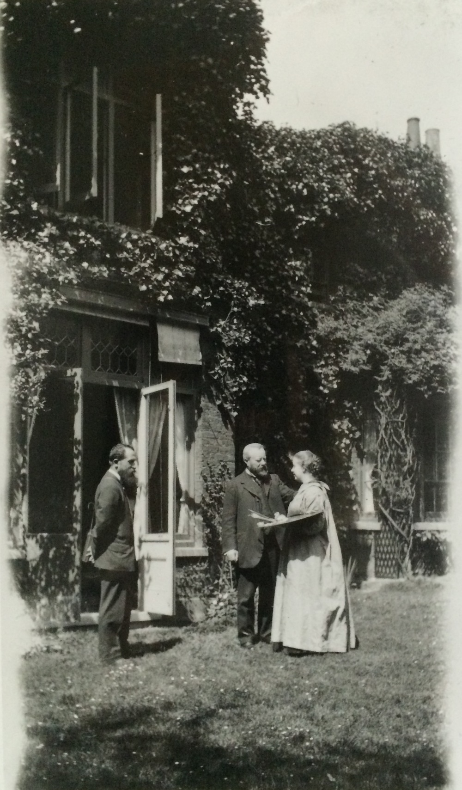
Figure 2.1 Estella Canziani wearing her painting smock working at her home-studio, 3 Palace Green. To her direct left is her father. Date unknown. Kensington Museum and Archive K/2048/B.
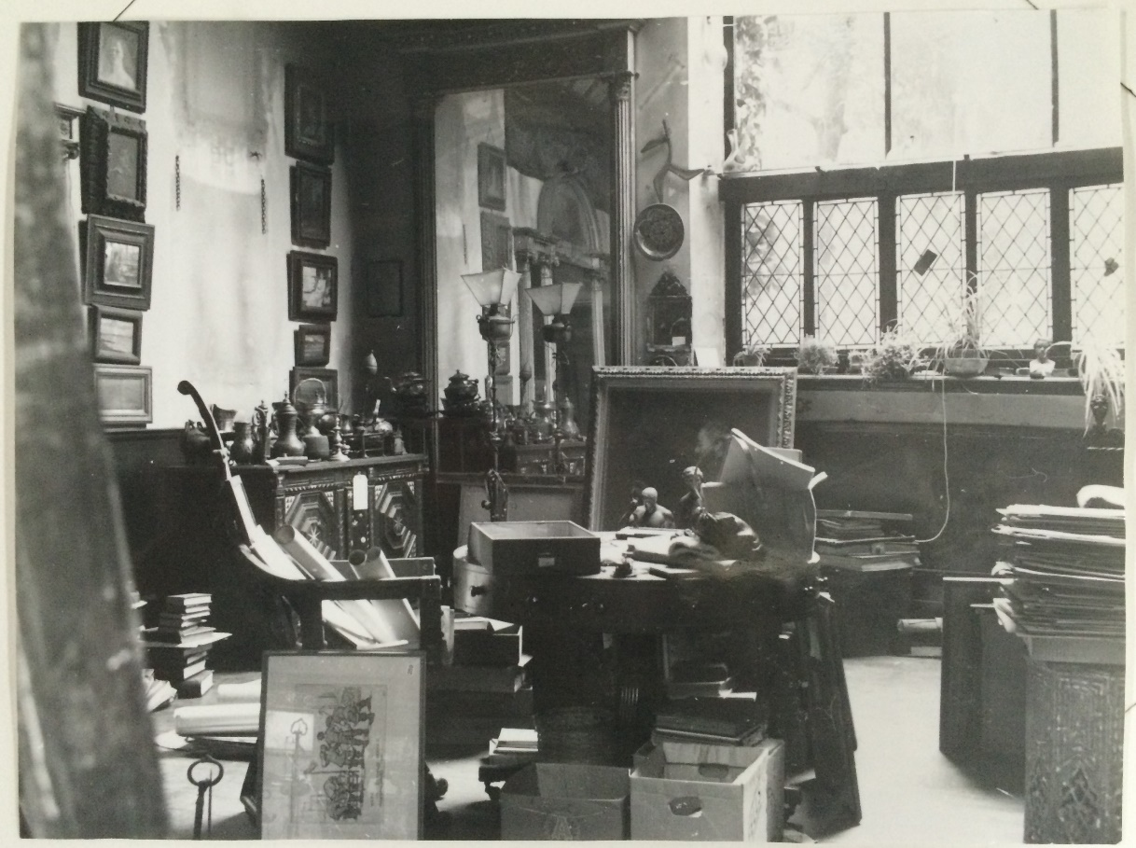
Figure 2.2 Estella Canziani and Louisa Starr’s studio. Date unknown. Kensington Museum and Archive K/2048/B.

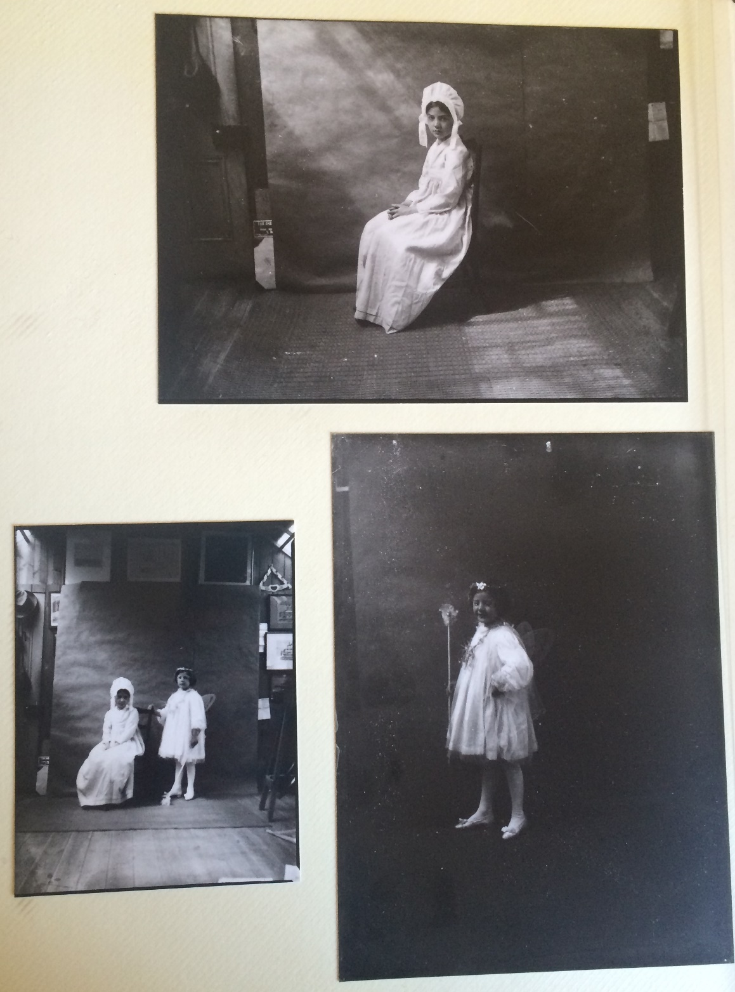
Figure 2.3 Rhoda and Mary Dawson in the Dawson's home studio, c. 1905. Private collection.

Representing artistic aspiration in the non-artistic home could present problems, especially in gaining space to work and parental support. Member Evelyn Pickering (later De Morgan) grew up during the years 1855 to 1870, a period when her sister Wilhelmina Stirling, who wrote a book about Pickering and her husband, felt there was a shift occurring regarding the acceptability of women becoming artists. Pickering’s youthful battles with her parents about her painting were seen as a “passing mania”. Her drawing-master was secretly told to tell her she had no talent. The fact that she was female played into her family’s reticence. Her mother took issue, “I want a daughter—not an artist!” she complained. The large size of the family home, however, enabled Pickering to dedicate considerable time to practice her talent in secret, an option unavailable for those in the crowded homes of the lower-middle classes. When she moved from the nursery to her own rooms she rearranged the space in pursuit of her painting needs. Her bedroom provided privacy and a workspace. Pickering pasted up the doorways to mask the smell of paint, kept the key carefully turned in the lock, and hid evidence of the paint and canvasses that she bought with pocket money. She relied on those in her home, namely servants and sisters, to pose as models, and kept a piece of drapery close by to “fling over the paraphernalia which might otherwise have revealed her occupation”. These attempts at artistic self-representation were privately expressed, and when her parents visited her bedroom all evidence was concealed. Pickering even added a false bottom to her bag so that she could secretly carry around her drawing materials. When her mother did find out about her secret workroom Pickering was finally allowed to enroll at the Slade School of Art. Her re-appropriation of domestic space into a temporary studio is a powerful testament to her agency. It is illuminating to consider the numerous other private workspaces young privileged women may have secreted within their homes during these fledgling pursuits of creativity. Other members from non-artistic families managed to orchestrate youthful attempts at professional practice within the home more openly however. Alice B. Woodward stated that she and her sisters reorganised rooms for professional need without concealment. As the sisters began to make an income, often choosing drawing jobs to “boil the pot”, they would use rooms and stables in their garden for artistic work at 13 Arundel Gardens in Chelsea.
The youthful experiences of members show that although their lives were mediated by gender, principally through receiving fragmentary educations, extant sources do not indicate that many members found the home oppressive. Throughout childhood, class, location, parents, and religion were all features which enabled members to be creative. Unsurprisingly, there was diversity in experience, but both non-artistic and artistic families could provide empowering domestic bases. At this early stage, members tended to pursue sketching and painting projects, and there is insufficient evidence to speculate as to whether different artistic fields impacted ideas about respectability. Artistic families did hold a certain ability to provide creative stimulation for children and to ensure the activities of daughters were positioned within the professional sphere. Even in non-artistic families, however, parents could be supportive and shape ambition. Those from both artistic and non-artistic backgrounds consistently saw the childhood home in terms of its potential to provide a venue for artistic projects. Rooms were assessed for their potential to be reformed into rooms for painting, whilst negotiated time in the home studio of an artistic mother or father were written about as inspirational and providing the space in which young women embryonically started to visualise their own adult artistic identities.

II.

This second section examines the homes of members who married to consider how domestic life and models of professionalism were modified by this decision. For professional women the question of whether to marry required deep thought. Philippa Levine has described nineteenth-century marriage as “perhaps the single most profound and far-reaching institution that would affect the course of her life”. Members alleviated societal concern that they were working through being based at home or in a close-by studio, and these spaces provided space to work, socialise, and have privacy. Marriage symbolised change to this established structure. Nineteenth-century middle-class marriage is well-studied and has been viewed through a number of approaches: romantic, patriarchal, and companionate. In recent years, emphasis has been placed on the diversity of marriage in lived experience. Peterson has challenged the idea that couples led uncommunicative separate lives, showing that upper-middle-class married women were regularly active helpers to husbands. In the literary field, wives made typescripts of manuscripts and read proofs of books and articles written by their husbands. The conventions and rituals of marriage were malleable to suit the varying demands of partners, but ideas of shared work were central, alongside tenderness and passion.
Despite this, there has been surprisingly little research by historians into marriages of this period where both husband and wife continued to work after marriage, and how couples negotiated this new lifestyle. There remains an assumption that all middle-class women faced a choice between marriage and professional single life. Artists, unlike many other professionals, had more flexible options. In 1911, approximately forty-one percent of members had married, and those marrying almost exclusively married males working in the arts. Members often married in their thirties when they had already established themselves, later than the national average of twenty six, and routinely continued to design and make art. The high proportion of artistic men members sought as marriage partners reveals artistic marriage was seen to be beneficial. Such an alliance could provide stimulating mutual creativity, be financially profitable, and benefitted the social prestige of each partner. These artist couples included painters Marianne and Adrian Stokes; the gilder, Mary Batten and painter and book illustrator, John Dickson Batten; potters Louise and Alfred Powell; painter Evelyn and potter William De Morgan; jewellers Georgie and Arthur Gaskin; sculptor and modeller, Phoebe Stabler and her husband, the silversmith Harold Stabler; and sculptors Gertrude and Gilbert Bayes, amongst others. Upon marriage these couples set up life together, with many starting professional partnerships, such as the Powells, who had a shared studio and employed two assistants in London, alongside having the provisions of a studio with facilities at Wedgwood’s Etruria factory. Member and embroider Eve Simmonds even lived and worked along with her husband William on the top floor of Louise Powell’s house in Hampstead c.1915. Here they would prepare works together for ACES exhibitions. Eve and William, who were puppet makers as well, also held puppet shows, in “the drawing room of a large house in the West End”. Married artists used the home and home studio as venues for artistic, professional activities, and as such this study of artistic couples at home has the opportunity to show how individuals cultivated professional and personal life through the shared use of domestic space.
Art historians who have examined nineteenth-century artistic couples are divided between those arguing women became subsumed into their husband’s identity upon marriage, and those suggesting female artists could continue in professional roles. Callen suggested that marrying a male artist left “the woman veiled in mystery”. More recently Melanie Unwin has written about member Mary Seton Watts, and how even though she moved away from painting after marrying G. F. Watts, she still managed to “negotiate a space in which to pursue her practice as a professionally trained artist” through her design of the Watts Chapel, made by her and the people of Compton, Surrey. Watts used craft to “disrupt the established boundaries between the arts, and both to resist and to manipulate the persona ‘wife of the great artist’.” Cherry has also offered an optimistic view of the lives of married painters, suggesting artistic marriage followed middle-class conventions of “cementing business interests through marriage”. In her view, artistic marriage provided opportunities for women beyond those available in other fields and enabled women to be active agents in a partnership which “united kinship and capital, paid productive labour and home life.” This section takes these alternating assessments as the starting point from which to consider the experiences of members; focusing on how the spatial layout of the home and marital relationships impacted upon the construction of artistic identity.
A survey of articles in the press reveals the extensive nature of debates about the impact it was thought artistic marriage could have on the home. Myra’s Journal warned female readers against marrying penniless artists. Women were inundated with information about what “sort of man makes the best husband.” A tongue-in-cheek article of 1895 asked a Mr. Juggins about this much-debated question. Juggins contrasted with Myra’s Journal and suggested male artists as a sensible choice, because they were thought to have the creative “qualities which go far to convert a house into a home.” The masculinity of husbands was increasingly tested in relation to their marital conduct, and not only their breadwinning capacities. These two comments—the stereotype of the penniless artist, alongside the perception that male artists had the necessary personality traits to establish a pleasant home—were two of many circulating discourses about the substantial impact marrying an artist could have.
In response to the growing numbers of women artists, the press presented new discussions about normative female domesticity which included these roles. The Girl’s Own Paper told readers that: “Even the literary woman and the female artist need to know something of housekeeping; it is a branch of knowledge which cannot be left out of any woman’s daily life unless under the most peculiar circumstances.” The article assured readers these women could “make the best of wives and mothers” because of the “extra refinement and delicacy” cultivated through creative endeavours. In fact, artists could be expected to “exceed all other women in the way in which she holds both positions; while her greater breadth of mind should show her that it is no indignity to lay down her pen in order that she may make a pudding.” Here, female artistic credentials were at once reconciled with domestic duty, and also appropriated as markers of cultural sophistication and desirable feminine characteristics of sensitive expression. Throughout, the pressures on women to conform in both arenas were pervasive.
Although social moralists hoped marriage would train men and women in “the (different) virtues appropriate to their sex, driving men towards assiduity, temperance and self-control and women towards patience and unselfish love” women discussed the suitability of artists as marriage partners in more practical terms. The marriage of artists to non-artists did still cause concern, as it was thought an artistic temperament might not be suited to domestic life. In 1882, Louisa Starr was worried her fiancée Enrico’s lack of artistic persona could have an adverse effect on their relationship as he was a civil servant. A friend called Starr a “clever little woman, to have got it all your own way”, but added she thought Enrico “must be an angel, worthy to inhabit the sky with the Star [Louisa], for I think there are very few men who would do what he is doing”. Enrico’s mother did not at first like him being engaged to an artist, thinking he “might be happier with a beautiful young countess of the conventional type … and who would not have painting to interfere”. Starr, in response, was reticent to marry, concerned “the sacrifice from an independent life” could be too much. In one frustrated letter Enrico Canziani even wrote “Do not English artists marry; would it harm your position at the R.A.?”
In contrast, when both partners had artistic interests there was confidence that marriage would be a triumph. Upon the curator Sydney Cockerell’s engagement to member Florence Kate Kingsford, he excitedly wrote to a friend, taking care to detail the media his future wife worked in: “I am engaged to be married to Miss Kingsford, the painter of Hornby’s Song of Songs. The ceremony will take place in some quiet country church in about ten weeks. No more book buying for me!” Sydney Cockerell saw Kingsford’s calligraphy skills as key to marital success. Cockerell clearly perceived marriage to have the potential to have impact on his own lifestyle, and his bachelor’s book-buying habit, and functions as a reminder that male artists also saw marriage as a turning point in their personal and professional lives.
Courtship was a critical stage when marriage and work were discussed to ensure compatibility. Starr wrote to her fiancée about the gendered negotiations she was prepared to undertake for marriage: she did not think it “wise or right” to depend upon what she made financially, although “as you said you have about £500 or £600 a year, I could in one way or another add £300, or even £400” but she also refused a conventional marriage service, and removed the words “promise to obey”. Paid work had the potential to alter the construction of married power relations. As Helen McCarthy has noted when looking at marriage and paid work after World War Two, women’s wages often did not free women from economic dependency, but they did offer “a small slice of financial autonomy and elevated wives’ status within the marriage relationship”. Practical discussions about making a household income can also be seen in the case of the Dawsons. Edith Robinson met and became engaged, even though her parents disapproved, to “penniless painter” Nelson Dawson, who had moved to Scarborough to work in an art shop owned by his uncle. Nelson later moved back to London for work and their courtship was conducted through letter writing. The surviving letters focus on their artistic ambitions which they saw as central to their future unity and financial stability. Edith sent Nelson her paintings for comment, and so that they could be exhibited to other artists. An 1892 letter from Nelson about a painting she had sent described how “C. J. Watson was looking at them today, Walter Sickert and thy brother yesterday”. The couple also had frank discussions about which artistic media was most profitable, and Nelson advised Edith to continue with flower paintings, describing these as “likely to sell”.
For female artists, marriage could offer new opportunities. Sutherland has recently argued that for the writer Ada Radford, who was connected to the same social group as the WGA, there was no “indication in Ada’s surviving papers that she saw her marriage as representing any kind of disjunction in her life; rather, it contributed to an evolution, a response to circumstances, but also a set of fresh choices.” A similar observation can be made about the Dawson partnership. Nelson commended Edith on joining a life class in Scarborough, but thought she should have regular access to undraped models, and suggested she move to London where the artistic scene was well-established and she would be able to draw nude models. In 1892, he thought it appropriate to invite her to London for a “month or two” with her sister, framing this around the progression of Edith’s professional career. He suggested she could:

work in the evening life class at South Kensington and I should be only too pleased to help you with your work in the studio in the day time. It would do you any amount of good (professionally) and besides I think studio life at the schools would be a decided novelty to you and rather enjoyable probably, it has a refreshing independence about it. Several women-painters have studios here and there are some empty lodgings.

Nelson complied with contemporary behavioural norms by suggesting Edith brought a companion and reassured her there were other women but there is little anxiety about her status as a woman. It is clear that Edith’s blossoming relationship with Nelson had the potential to draw her into an unprecedented sphere of artistry.
Marriage to a male artist enabled the home to be curated around the representation of artistic identity. After marrying in 1893, the Dawsons’ first home marked a substantial shift in the lifestyles of both. Since they could not afford to have a studio separate from their home, or a grand studio house, Edith moved into what had previously been Nelson’s bachelor rooms at Wentworth Studios, built in 1885, and located at the centre of artistic life in Chelsea, just off the King’s Road. The Dawson’s daughter Rhoda described Wentworth Studios as the place where the couple “camped out, having their kippers cooked on the studio stove.” Their shared studio-home was “a very well-staged studio that was hung with paintings and metalwork, beaten copper dishes, a candelabra with a sailing ship, doors with hand-wrought iron hinges … all common objects made beautifully.”
Wentworth Studios was emblematic of the Dawson’s early joint attempt at professionalism, but it was also, through necessity, their sole domestic space. Edith even had to buy their bed due to Nelson’s poverty. Edith later confided in her daughters that she had found it hard to adapt to this new rhythm of life, having to “work all and every day, and missed very much the companionship of her cheerful girlfriends, now so far away”. Financial necessity drove the Dawsons, and so they stopped painting and focused their energies on producing artistic metalwork, with Nelson designing and Edith enamelling, as a way to establish a financially sustainable family business. Their business brought rapid financial success, enabling them to move to the Mulberry Tree, Manresa Road by 1896. The Mulberry Tree, located close to the studio they had previously shared, was on a road of studios linked together by courtyards, and was again centrally positioned within the artistic community.
During this period, many in the middle-classes tried to demonstrate artistic sophistication through the decoration of their homes. The popular press, art journals, newspapers, and advice literature all reveal mass societal interest in how to appropriately furnish and live life at home. Members of the public clamoured to buy Arts and Crafts objects to place in the home to demonstrate their sophistication. Art journals began to include detailed interviews with male artists in their homes and studios. The Pall Mall Gazette conducted interviews with male painters such as W.P. Frith whilst The Manchester Times invited viewers to read an article on “An Artist’s Home. An Afternoon with Alma-Tadema.”
Correspondingly, as public interest in the domestic interiors of artists grew, journalists began to focus articles around the homes of artistic couples. The homes of married artists were depicted as providing the perfect site for unity of work and marriage. Journalists emphasised the historic nature of these relationships, and romanticised the recreation of pre-industrial cottage industries where the whole family would have been involved. Mary Seton Watts and G. F. Watts’ town and country houses were described in the press as “beautiful specimens of the artist-home. Not on the gorgeous scale of more fashionable and less ideal artists, but more consonant with the seriousness of the phase of art of which Mr. Watts is the chief exponent”. Restrained taste was key in demonstrating appropriate commitment to the artistic lifestyle. Hearth and Home noted approvingly that Henrietta Rae (not a member) and her husband Ernest Normand lived in: “an artist’s house, like its neighbours in the Holland Park Road built for an artist and designed by an artist.” In an increasingly competitive consumerist environment couples also marketed their work together to generate interest and often hosted joint public exhibitions of their work. Alfred and Louise Powell’s collaborative “Hand Painted Pottery” exhibitions were frequently listed in The Times across the interwar years, whilst the Dawson’s exhibited regularly together in London and at the Paris Salon.
A key feature of the artistic marital home was that wives tended to have studios or workrooms located at home, whereas before marriage studios may have been located away from the household. After marriage, the husband and wife took care to try to demarcate separate rooms, studios, or areas to do individual work in, although gendered domestic struggles regularly intervened in daily life. In the Rae and Normand household their studio was “a bare and workaday one. There is little in it beyond the easels and the pictures. On the one side is the husband’s work, a Moorish subject: on the other side the wife’s.” The columnist suggested their studio represented “partnership in the day’s task which, since they first met at Heatherley’s school both have found mutually useful.” The painter Christabel Cockerell described her studio house as “a perfect painting room in which comfort and utility are happily combined”. Designed by her husband, the sculptor George Frampton, it included studios for both of them to work in. The married artistic home functioned as an enticing visual advertisement of the inhabitants’ artistic potential to the public and was a powerful marketing device. In an 1896 interview in The Studio the interviewer described the home of the Dawsons at the Mulberry Tree in opulent detail: “In the hall your eye is attracted by delightful and ingenious appliances in wrought copper, while the reception-rooms … are full of most fascinating experiments in all sorts of metals.” The interviewer noted that art works, such as fire-screens, which had been viewed at exhibitions across London had now been placed back within the home; hinting to potential readers of the ways they could furnish their own homes. The aesthetic appeal of these objects dominated the discussion, and the interviewer had to studiously avoid “the counter-attractions—the oil paintings by your host, and the beautiful old furniture that fills the rooms”. The house was filled with: “things which are too tempting to resist, and infect you with a covetous desire to carry them away.” Another article, this time in The Architectural Review, wrote comparably. The interviewer complimented the unique nature of the Dawson’s work and sent a powerful advertisement to readers: “No design of theirs is repeated, and you have the satisfaction of knowing you possess something that is yours alone, not to be found in the houses of Mrs. Afternoon-Tea or Mr. Heavymeal.”
Rooms in middle-class households were conceptualised and used in gendered ways. Scholars have emphasised the gendered styles and customs of dining rooms, smoking rooms, and drawing rooms. In artistic households these spaces were little mentioned. Instead, studios and workrooms were the centre of household life. In the Dawson household, rooms were divided for work: “Edith Dawson for her enamelling, Nelson Dawson for his drawing—and both rooms look out and away over the garden.” Edith’s room was on the top floor, “on a level with the Mulberry Tree top that gives its name to the house”. Her room was described in The Studio as an “artistic laboratory” which contained all the necessary tools for her craft, such as pestle and mortar and a furnace for firing the enamels. Nelson worked in a separate room on the ground floor, sketching and designing in “the draughtsman’s workroom”. An interviewer said it was “distinguishable by the lesser neatness—a matter which is remedied from time to time by feminine incursions and alarms”. In these two rooms “they do their own and personal work.” The Dawsons also had workshops manned by a group of men in a street close by, “surrounded by the studios of the Chelsea painters and sculptors—so close that they are able to watch the progress of their work”. These workrooms had the potential to be viewed in gendered terms, and it is clear they were seen as such in the eyes of the interviewer. Edith’s enamelling room upstairs, likely to have been strategically placed close to the nursery, was portrayed as appropriately clean and neat, attributes commonly used in to describe assumed feminine personality traits, whilst Nelson’s draughtsman’s workroom was presented as chaotic and requiring cleaning by female servants.
Callen argued that contemporary articles about the Dawsons were troubling because the “impression given is that she [Edith] furnished nothing but the manual labour while he [Nelson] was the ‘ideas man’, when Edith did have complete charge of the enamelling work”. Callen’s discussion of the Dawson’s relationship is formed through selective quotations drawn from these articles, but The Architectural Review explicitly informed readers that a highlight of the visit was the “dual regard and delightful co-operation in the work of the Dawsons” which was “rare in national domestic life”. Admittedly, their labour was segregated within artistic roles historically perceived as hierarchically gendered: Edith enamelling, and Nelson designing. However, Edith took much pleasure in her role. The interviewer also seemed remarkably impressed with their partnership: “That they have managed to make such inter-dependence practical, as well as, in several ways, ideal, is, in itself, one of the grateful surprises the Mulberry Tree has under its shade.” A review of a wider range of source materials also provides fresh insight. In her 1906 book on the enamelling process Edith discussed her joy of now having a room of her own for work, proudly writing she had spent “during the last few years, a considerable portion of the passing days of existence in a little workroom which looks over the river, seated at a table spread with the implements of the enameller’s craft, or standing, tongs in hand, before the furnace”.
A photo album which Edith and Nelson made for Edith’s parents to celebrate Christmas 1895 also demonstrate the energies the Dawsons took to decorate their home in a suitably artistic fashion, and to document what they saw to be their marital and professional union. The first page included a miniature picture of the couple. Below this their hand-inked initials are inscribed within sketched leaves linked together on the branch of a tree, suggesting an equal partnership of artistic endeavour. (Figure 2.4) Alongside shots of Edith and Nelson both together and alone in Figure 2.5, Figure 2.6, and Figure 2.7, the couple included images of Edith’s parents and Nelson’s sister in Figure 2.8, binding family life with artistic production. A closely framed image of Edith at work in her new home in Figure 2.9. directly contrasts with another, which shows Edith looking contemplative at her parent’s drawing room in Scarborough in Figure 2.10. Although both pictures were taken at home, Edith’s daily life had changed profoundly with marriage, and now the home was a place for her to work in with her husband. A later photograph shows Edith continuing her enamelling in the home. (Figure 2.11) The Dawson’s photographed themselves working at home across their lives, which suggests that they continued to derive a vital sense of artistic identity from documenting this environment.

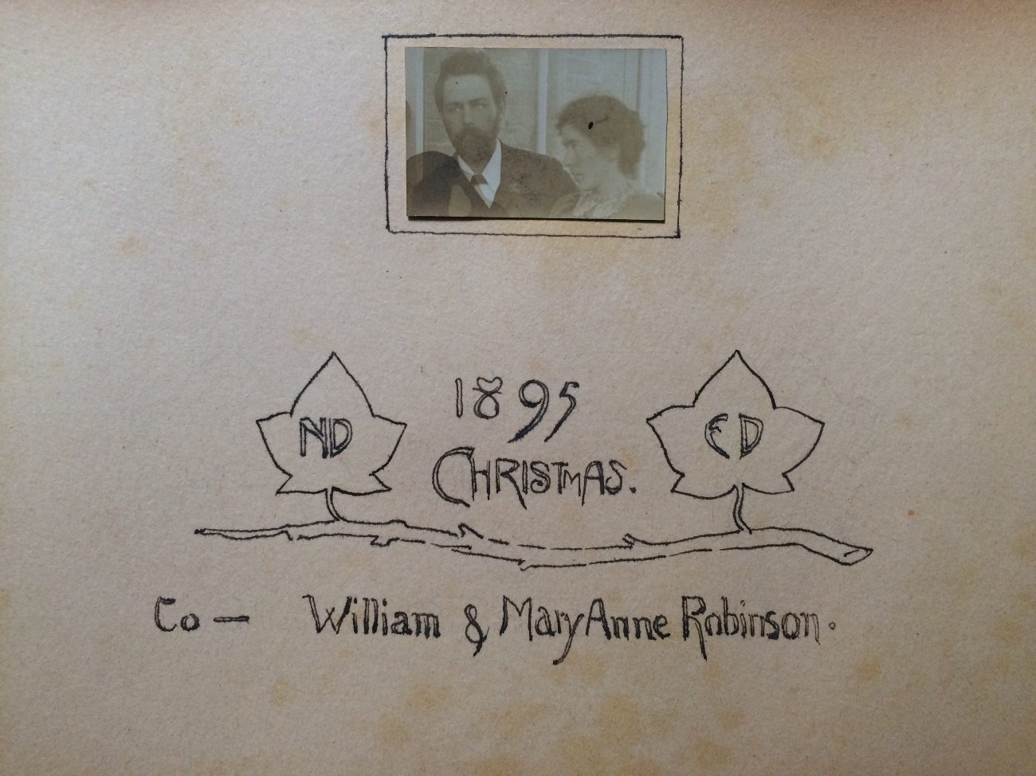
Figure 2.4 Front page of photo album made by Edith B. and Nelson Dawson for Edith’s parents. 1895. Private collection.

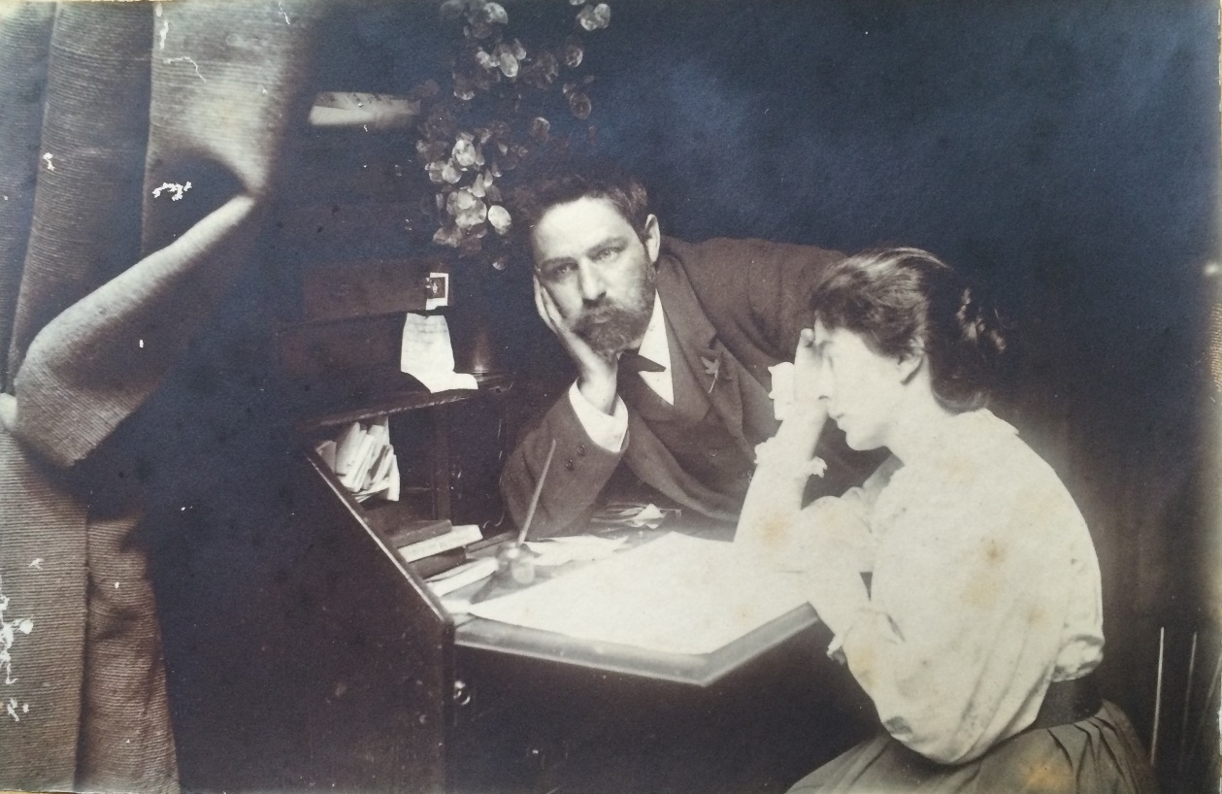
Figure 2.5 Nelson and Edith B. Dawson. Family album 1895. Private collection.

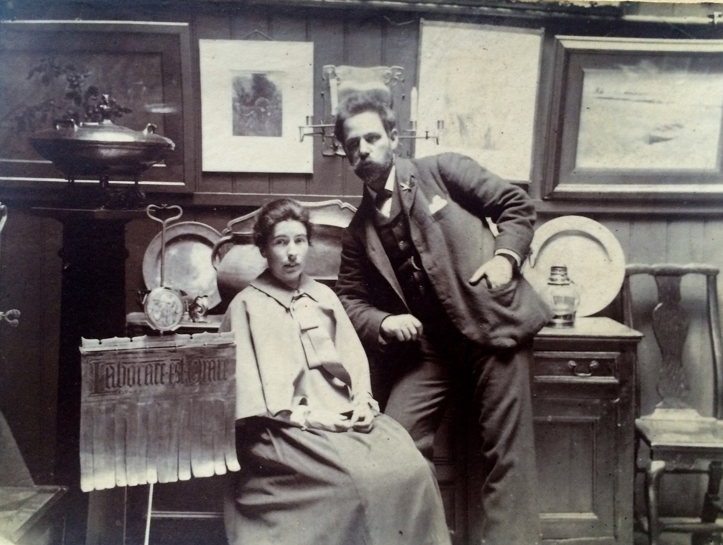
Figure 2.6 Nelson and Edith B. Dawson. The fringed sign to Edith’s left says “Laborare est Orare” which means to work is to pray and reflects their Quaker beliefs. Family album 1895. Private collection.

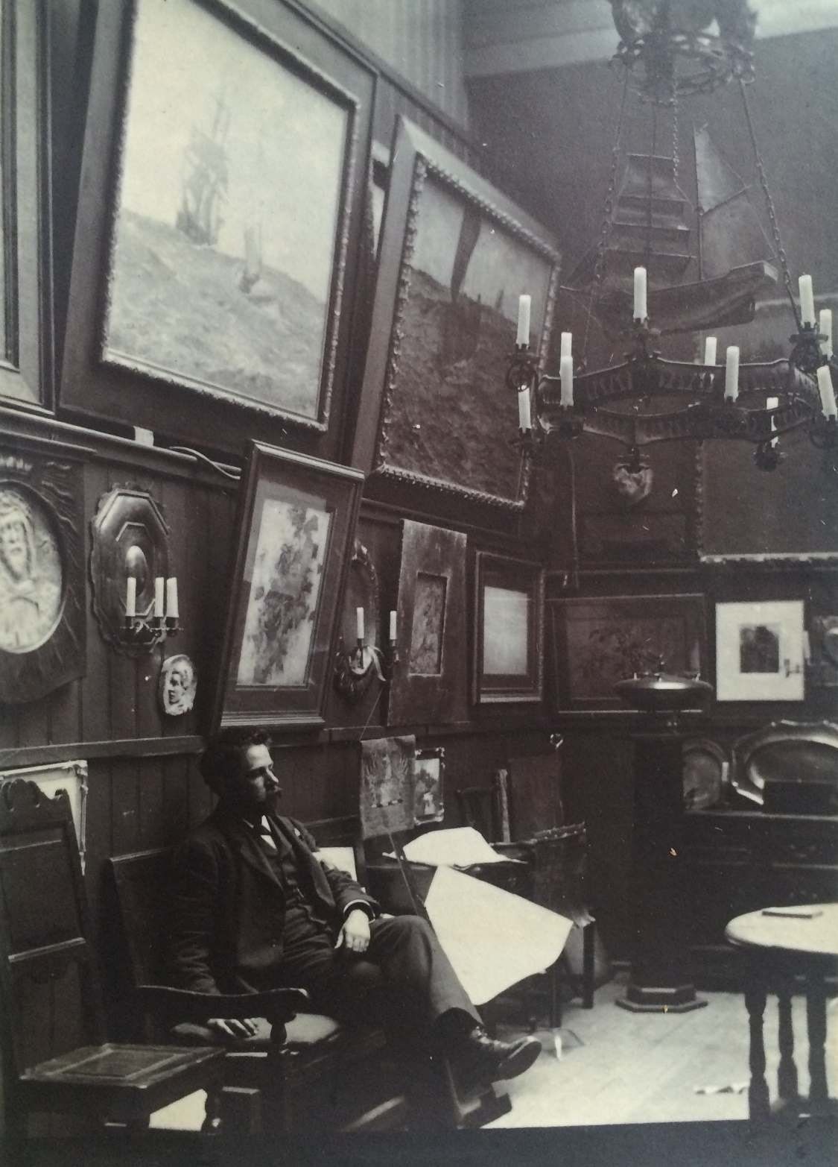
Figure 2.7 Nelson Dawson sitting below paintings by both himself and his wife Edith B. Dawson. Family album 1895. Private collection.

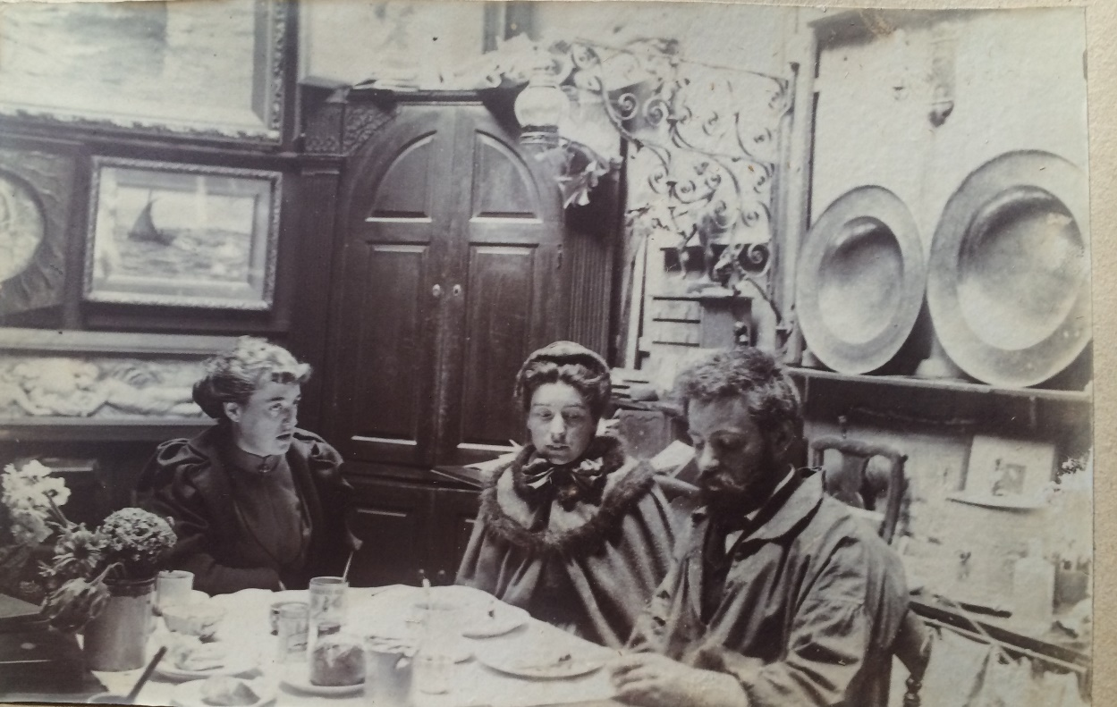Figure 2.8 Nelson and Edith B. Dawson and one of his sisters. Edith’s handmade bonnet is now in the V&A collections. Family album 1895. Private collection.

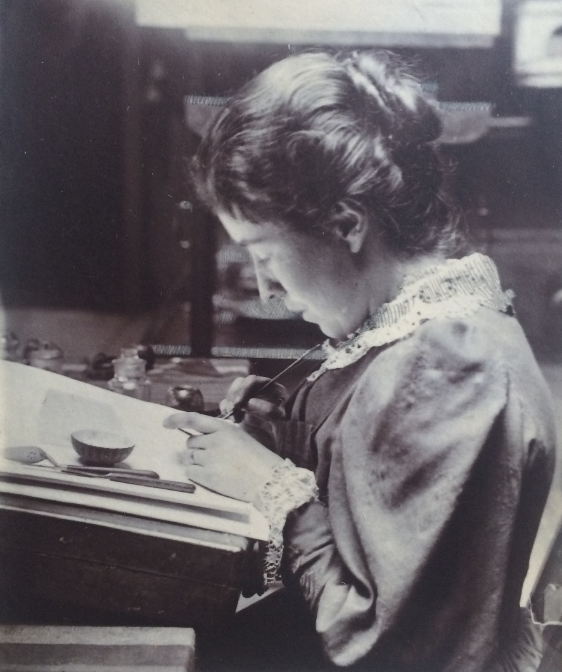
Figure 2.9 Edith B. Dawson enamelling. Family album, 1895. Private collection.

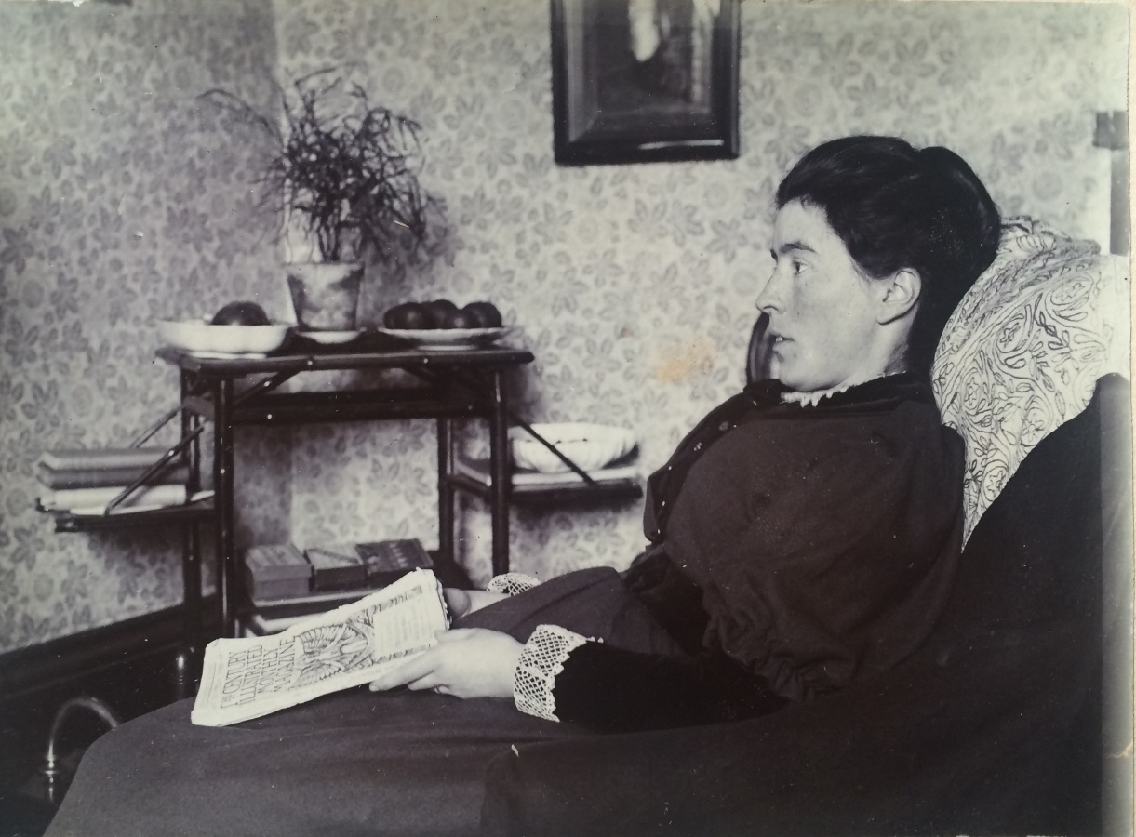
Figure 2.10 Edith B. Dawson back at her childhood home in Scarborough. Family album 1895. Private collection.

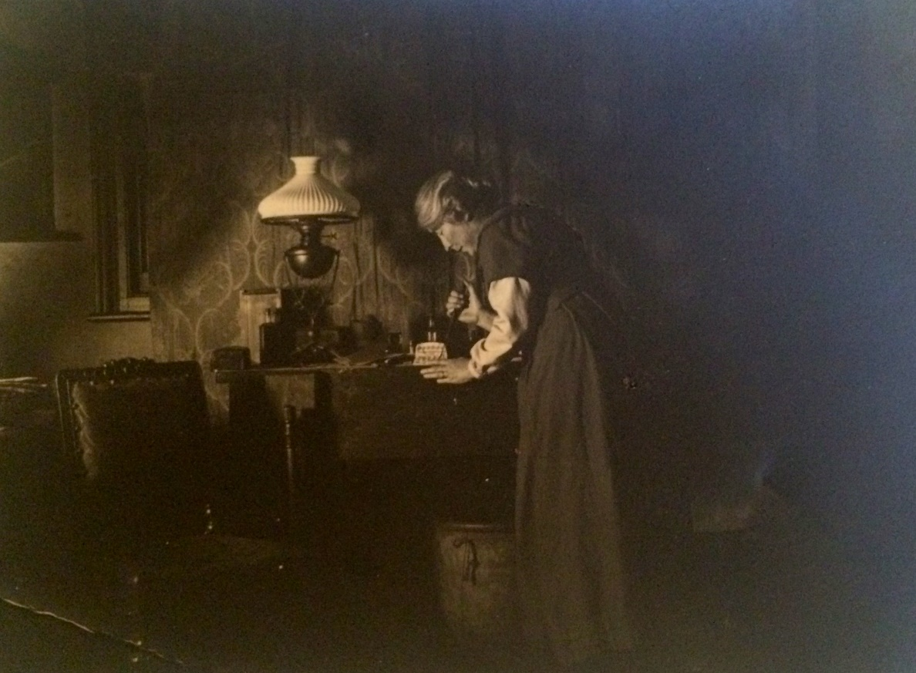
Figure 2.11 Edith B. Dawson enamelling in later life at home. Private collection.
Husbands could make concerted efforts to showcase the creativity of their wives. In a letter to the V&A in 1921, Alfred Powell took care to ensure Louise Powell’s work was clearly labelled, writing: “Mrs Powell’s full name to be given, viz. Mrs Louise Powell not Mrs Alfred Powell” and “The ordinary title we use is as given AH and LP but if you have to mention Mrs Powell then it is Mrs Louise Powell.” In a letter touching on his wife’s work in 1952, Alfred wrote: “I’ve been thinking about the vast amount of work she has done, and so well done—we are near our 6000th pot and she was always quicker than I a-doing! And then the embroidery—flower painting— illumination—a lot of work and all, as I have seen it, done right at the beginning and never altered and very beautiful.” Similar comparisons can be found with the Dawsons. When they were commissioned to make a copper bowl with an enamel lid for Queen Victoria in 1896 they made the decision to inscribe this object with the lettering “Nelson and Edith B. Dawson me made”. Nelson Dawson took care to showcase the work of his wife in interviews, crediting her as an equal partner, stating, “My wife and I work together in this”.
Clearly then, artistic marriage could offer a creative new stage, with different gendered models of behaviour being introduced, but also diversification of opportunities. Yet despite the artistic equality promoted by supportive husbands such as Alfred Powell and Nelson Dawson, for married members, the wife remained responsible for orchestrating household tasks alongside any artistic work they wished to undertake. The prevailing patriarchal model of the role of the wife in the domestic management of the household was therefore upheld in this regard. As Louisa Starr wrote for a lecture she gave in 1900: “When a [married] woman has a profession, it means in most cases that she has two professions.” Analysis of members’ papers reveals they were usually expected to act as informal secretary for their husbands alongside overseeing servants and guests, looking after children, and managing the household. Edith wrote to her artist friend Josephine Webb about the strains of domestic management, and Josephine reminded her: “you can’t be quite equal”. The two women regularly discussed Edith’s household duties, which Josephine knew “must take a large share of your thoughts and energies—and you can have only a limited amount of time for Art”. A retrospective letter from member Phoebe Stabler to art collector Eric Millar in 1952, looking back on her life after her marriage to Harold Stabler in 1906, discussed the extensive domestic duties facing married women:

I found it impossible to work when my husband was in. I meant of course, creative work, one must be alone, and unworried to do fresh work, all day I was busy housekeeping and sewing, then at 5.30 H and his secretary went off teaching. I would gladly go into my studio and do real work. I must have been strong in those days. I could not do it all now. For a long time I have wanted to tell you this, that my work is my own, no one believed me with it, I feel I might have done something fine if I had had help in the house, and freedom to work when I wanted to.

Phoebe added she had rewritten the letter several times, but needed Millar to know “my work is really my own!” Her anxiety to claim ownership of the work she produced suggests her concern that it would be misattributed to her husband. In this instance, a female artist was all too aware her own artistic production could get subsumed by that of her husband in the eyes of wider society, while she herself greatly felt the weight of her gendered, domestic role.
Only around five percent of members married non-artistic men, and here the far-reaching demands of domesticity appear even more pervasive. The case of member and woodcarver Julia Hilliam shows how life could change after marriage. Hilliam came from a wealthy background, but her family ran into financial difficulties and she was obliged to live with aunts. They moved to London and she trained in woodcarving at South Kensington Art School, alongside a brief stint in Paris. Financial necessity drove her work; her aunts had burned through their capital “with remarkable speed”. She taught woodcarving for several county councils and spent her time “on her bicycle rushing across Berkshire, to visit her classes”, whilst contributing to projects such as the 1899 publication of Home Art Work with Walter Crane and Selwyn Image. Before marriage, she also shared a studio in Reading with her friend Miss Cromwell, c.1897, where the public could view specimens of the women’s works ranging from “tea-trays to floral panels”. Highly successful, she was given a Royal Commission by Princess Louise to undertake woodcarvings for the royal family, and secured a position as a Lecturer in Arts and Crafts at Reading College. After marrying statistician and economist Arthur Lyon Bowley, Julia’s public activities were reformed around domestic life, and having children meant she had to resign from her Reading College position. A memoir written by her daughter Agatha reveals that “to some extent she [Julia] was merged in his work while neglecting her own talents, which had not been the intention when they married”. Julia lost contact with her colleagues, which was a “great disappointment”.
Members who married non-artists tried to approach their twin roles as wife and artist holistically, running the household in a way that reasserted their identity as both artist and homemaker. Although Julia could no longer dedicate herself full-time to her work, a close look at her home shows she tried to continue to envisage herself as an artist. Channelling her talent into interior decoration, she designed their first family home to have a “verandah, balcony, a large studio for herself and a study” for her husband. Clearly, it was initially intended that the home would allow both partners to pursue their chosen occupations within separate workspaces. Even in old age Julia continued to use her home for craft, with her loom taking up most of the bedroom. Authority regarding her daughter’s upbringing was also shared between husband and wife. Julia won numerous “battles” for her daughters as they:
found it pretty difficult trying to live up to his [her father’s] intellectual standards and we disagreed with many of what we called his ‘old-fashioned’ ideas, about daughters staying at home and behaving in a conventional way. We won the battle for ‘bobbed’ hair, the fashion at the time. We also demanded a University education … with Mother’s support won my way to London University and a year’s study in America as well. He was extremely fair and just in his dealings with us, but left important decisions to his wife.

Clearly, as Delap, Griffin, and Wills have indicated, “relations of equality and of authority were not mutually exclusive, but rather existed in creative tension.”
In Louisa Starr’s household, despite her husband’s explicit support, she had similar difficulties. After marriage to her civil servant husband, she had to make do with painting in an adapted drawing room in her house at 14 Russell Square with Estella’s “grandmother on guard.” The desire to have her own studio, and her willingness to move to fulfill this need, consumed her thoughts. The following anecdote by her daughter provides insight:

My mother needed a better studio than her adapted drawing room, and was always looking for a house. One night she dreamed of an ideal house, but she thought no more of the dream. When one day, driving in Kensington Palace Gardens, she saw a board up, ‘House to Let’, and recognized the house and the surroundings of her dream, she telegraphed to my father, who had reached Paris on his way to Italy: ‘Found a house, come back,’ and he returned.

The couple purchased 3 Palace Green in 1886 and Louisa “built the studio” in the court yard to the house, and could finally “work alone in a real studio” which “was a great advantage”. Although caution needs to be taken when evaluating this treasured family anecdote, she seems to have had little concern about asking her husband to travel back from Paris in the quest to find the perfect studio home. Starr made special efforts to adorn the walls of the drawing room in her new home with paintings by female artists, “her sisters in art both English, French, and Italian”. Wealthy member Julia Chance also had a painting and scuplture studio specially made for her, part of her large house in Surrey that was designed by the architect Edwin Lutyens, which she shared with her barrister husband. She carefully used her artistic skills to decorate the house, such as making a blue and white tiled fireplace. As such, the workspace and professional activities of these middle and upper-middle class women who married non-artists were adapted to fit into the domestic daily life of the family, but still provided a daily reminder of their artistic capabilities and the artistic credentials of other women.
Members reconfigured traditional understanding of femininity and domesticity through their creative pursuits and changed the culture of the home. Although domestic activities were gendered, women repeatedly tried to alter their homes to reflect the sorts of lives they wished to lead. Clearly, the demands of marriage, which brought with it expectations of adherence to conventional classed and gendered domestic practices, and sometimes children, impacted enormously on daily life and ability to pursue artistic professions. However, the marital home provided a powerful material way to display dedication to art; in ways that have often not survived today, but which would have been visible on a daily basis. It has been argued that after marriage female artists were subsumed into, and concealed behind, those of husbands, but if we look past the narrow lens of the periodical to analyse marriage through a wider array of source materials, the extensive attempts made by married women artists to pursue both marriage and professional lives come into sharper focus, and we get a fuller depiction of how these women would have been viewed by their families and in society.

III.

This final section considers how single life impacted on professional identity and the home. To date, the principal study into single women for the slightly later period of 1914–1960 is by Katherine Holden. Holden hypothesised that single people played a crucial part in maintaining the power base of marriage as they were “doing so from a position which was always marginal when set against models of marriage and the nuclear family”. Curiously, Holden’s book does not examine female friendship. Holden’s findings do not resonate with the experiences of the privileged women artists in London in the years preceding her study. Admittedly, there is little evidence about the private opinions of unmarried members but lack of evidence does not mean we can assume women wished to marry or felt pressure to do so. Single life could provide an effective option for women wishing to remain independent. This was particularly true before the Married Women’s Property Act of 1882, when married women’s properties became the legal property of their husbands. The fact that in the WGA unmarried members outnumbered married women emphasises that single life was not necessarily a marginalised experience. Rebecca Jennings questions why historians still perceive there to have been an assumption that all women wished to marry. Similarly, Gordon and Nair have dismissed the idea that single, unsupported women were “fettered by an all-powerful ideology which decreed that they languish in the home of a male relative”.
In the WGA, a number of wealthy unmarried members purchased grand houses designed and decorated by respected architects, which bolstered their reputations as tastemakers. Member Maud Beddington enlisted W. A. S. Benson to design and decorate the cottages she shared with her sister Beatrice, an associate of the WGA, in Winchelsea, whilst divorcee May Morris had a stream of visitors keen to inspect the interiors of Kelmscott Manor. Widower Mary Sargant Florence designed her Queen Anne property called Lords Wood near Marlow, an area which was a hub of artistic and literary activity. These women were based across the South East, although had additional properties in London. Other members in London had similarly privileged life choices. Feodora Gleichen spent her life working and living in her father’s domestic studio at St. James Palace, as depicted in Figure 2.1, as did Estella Canziani who was based close by. These houses are not representative of the typical living situations of all unmarried members however. The properties of members were often much smaller, and can be categorised into four groups: those living in newly-built institutional residences for professional women, and those living in houses, or mansion flats and studios with a friend or with family. Members often experienced all these situations at different life stages, as did many women who worked. This section provides insight into the fluid range of domestic experiences unmarried professional women had and how this influenced their ability to produce work and engage in the artistic milieu.

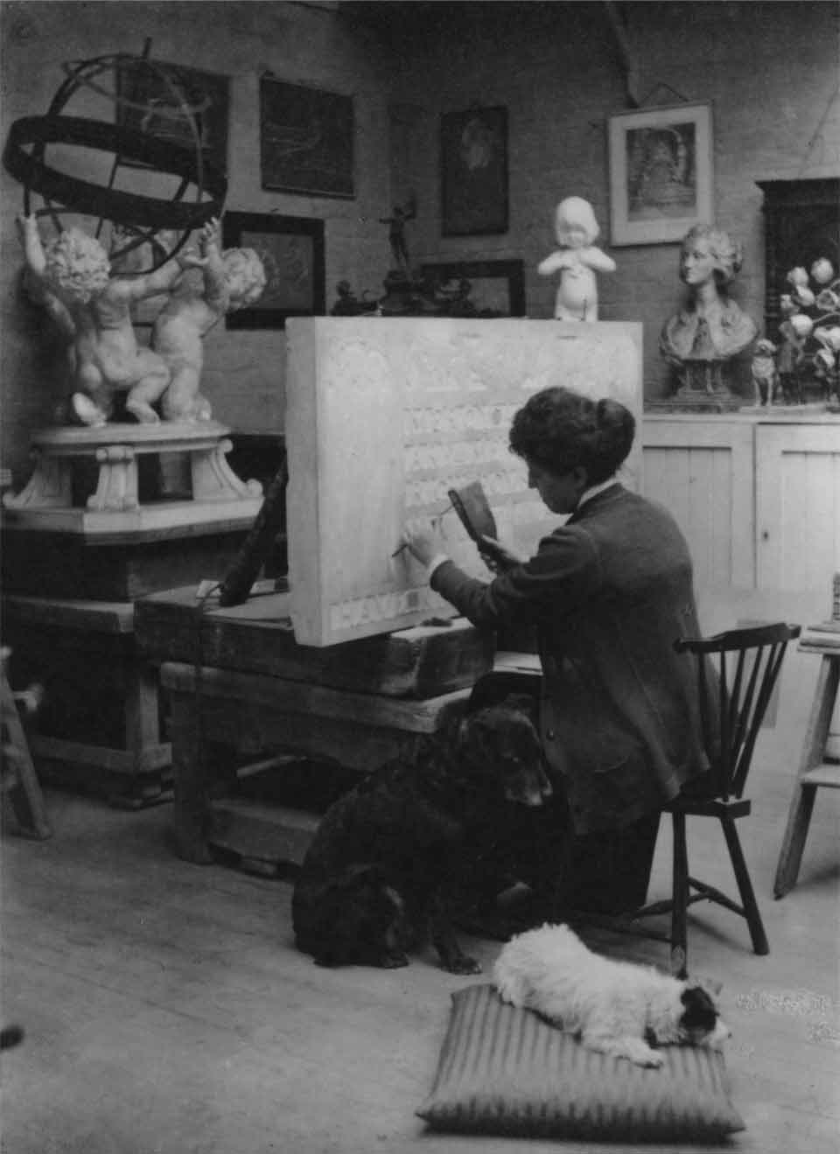
Figure 2.12 Lady Feodora Georgina Maud Gleichen by unknown photographer. Photographic print, 1905 or after. National Portrait Gallery, London/unknown collection.
The 1851 census revealed there were more women than men; concerns remained across the century about the “surplus” women who would never marry. Increasing numbers of women sought occupations, and by the 1880s debates had expanded to worry about the emergence of the “New Woman”, a term coined to reflect the influx of feminist, educated, working women, although in the view of Gillian Sutherland this was largely a cultural stereotype and not representative of actual life. Questions about the position of women in society were however potent: “The Marriage Question”, sexuality, and economic independence preoccupied feminist and anti-feminist campaigners alike. Although individual motivations played a part in these decisions, the WGA members who committed to unmarried life as a working artist, and promoted the need for equality in the arts, clearly embodied a dedication to a move away from a societal model that saw non-working married life as the appropriate route for women.
Central to debates were questions about where to house this new generation of unmarried women. From the 1870s, the choice of housing for women away from the family home grew. Women promoted the morally redeeming power of work as a way to acquire positions in female church communities, hospitals, educational establishments, settlement houses, and as artists. Purpose-built accommodation began to be built for unmarried professional women in areas of London deemed suitable such as Bloomsbury and Kensington. One of these was the Ladies Dwelling Company, which was founded in 1888 and was a project which WGA members such as Christiana Herringham and Agnes Garrett were instrumental in establishing. Members moved to London and began to live in these newly-built residential houses, which were seen as less restrictive than traditional boarding houses, whilst still reassuring the public that women were partially supervised. Member Mary Lowndes lived at Sloane Gardens House, Ladies Dwelling Company in 1891, whilst member Edith Harwood lived at York Street Chambers in 1894. From this base Harwood advertised in The Woman’s Signal about the paid lecture courses she was giving on “Italian pictures in the National Gallery” alongside writing a series of articles such as “Studies from Pictures of Women in the National Gallery”.
Other women rented rooms in family homes. Bertha Newcombe lived at the home of a wool merchant in Camberwell whilst studying to be a painter at the Slade School of Art, before returning to her family home from where she worked as a painter and illustrator. Non-member, the painter Kate Sadler, specified that when studying at the South Kensington School she had “boarded with a family for two years, and had a very pleasant time, although I worked very hard from about ten to four and six to eight in the evening.” She coordinated this alongside tending to her dying mother, and keeping house for her brother. Women artists dealt with considerable challenges to find urban bases appropriate for their needs. WGA Honorary Secretary Mary A. Sloane was regularly contacted with housing enquiries. One such letter wrote: “They hope to go to London … I suppose you do not know anyone who has a boarding house or a hotel not too expensive there. They are girls quite ignorant of these places.” These letters demonstrate the matter-of-fact way middle-class networks worked together to find appropriate housing for young woman wishing to work.
Large numbers of women artists moved into mansion flats and studios where they lived and worked with friends. Having access to a studio connected unmarried women to a professional sphere of work, although satirical journals quickly began to publish articles about the amateur women artist now dabbling in the studio. The cost of maintaining a studio was difficult for many. In a 1900 article titled “Women Workers: How They Live, How They Wish to Live”, Emily Hobhouse noted that nearly a third of the average income of a woman artist was needed to rent a studio. The fact that many unmarried members were able to rent studios, or even to have the room and resources to rearrange rooms at home, demonstrates their social standing. It would have been much harder, impossible even, to set up as a professional artist without this support.
Studios and mansion flats provided the opportunity to recreate domesticity on one’s own terms and gave members relative social freedoms. The studio was a site in which discourses of femininity, domesticity, and professional identity blurred due to the hybrid nature of the space. Member M. V. Wheelhouse moved from her family home in Yorkshire to find work in London and took up a flat at the suitably artistic location of 3 Pomona Studios, 111 New Kings Road, Fulham, where she lived with a married artistic couple and another male artist. Member, the writer and illustrator Freda Derrick provided a glimpse into her nomadic lifestyle when she told readers of one of her books that each summer, across the early-twentieth century, she lived in a simple hut her brother had built for her in a field in Somerset. She also told publishers “When I am away, I am often away for a long time, and completely out of touch with London, letters may not reach me for a long time, as sometimes I have no address to which they can be forwarded.” In this hut, Derrick would sleep and write about her daytime adventures researching rural traditional crafts.
Correspondingly, Pamela Colman Smith spent her teens touring across Britain with the Lyceum theatre group. Throughout her life Colman Smith moved regularly, flitting between flats in South London, staying with friends, and long stretches abroad. A letter from embroiderer Lily Yeats to her father, when staying with Colman Smith, detailed that Colman Smith: “has a big-roomed flat near Victoria Station with black walls and orange curtains. She is now an ardent and pious Roman Catholic, which has added to her happiness but taken from her friends.” Supposedly, Colman Smith would “lie in bed until midday, to do all her painting and designing under artificial light”. Her unusual black walls, contrasted with orange curtains, alongside what are suggested as flighty religious interests, were seen as markers of her bohemian spirit. One of Colman Smith’s homes was 84 York Mansions, Battersea which is depicted in the postcard in Figure 2.13. Across Colman Smith’s life she continued to find ways to display artistic identity at home. Shortly after World War One her uncle died, leaving an inheritance, which enabled her to buy a property in Cornwall, at Parc Garland in the Lizard peninsula. Here she started a vacation home for Catholic clergymen, having herself converted to Roman Catholicism. Melanie Boyd’s research shows Colman Smith to still be at the centre of artistic interest even in this rural community, living: “in a moderately-sized house, situated in its own grounds, very tastefully decorated both within and without, showing a display of colour in advance of the custom of those years.”

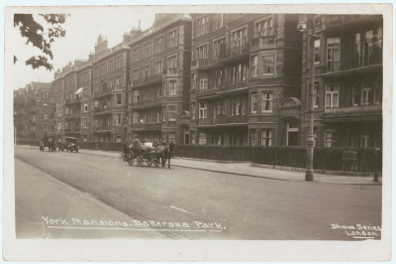
Figure 2.13 Postcard of York Mansions in the early-twentieth century. Private collection.

In comparison to the gendered use of workrooms in the marital home, the unmarried homes of women artists were often centres of female activity, with family members, friends, and maids, although of course there were interactions between males and females. Unmarried women often received less detailed write-ups in the mainstream art press, but interviews with single women artists in the women’s press were still very popular. These interviews were ordinarily conducted in the homes and studios of unmarried women. The women’s press regularly tried to domesticate and feminise these spaces to showcase the continued respectability of the woman artist. Fannie Moody was interviewed at her “pretty residence in Grosvenor road” and although Irish painter Lizzie McGill deliberately chose to move into the admired studio of male animal painter Briton Rivière, when she worked there the same rooms became known as the “prettiest and most spacious studios in Kensington at 8 Strathmore Gardens in Kensington”.
As the number of unmarried women artists working and living in different types of housing increased, so did concerns about respectability. Member Feodora Gleichen’s sister, the painter Helena, managed to take on her own cottage to paint in whilst training, until her mother learnt of this and forced her to employ a servant so that Helena was not alone at night. When Lizzie McGill moved from Ireland to take up a studio in Kensington her friends and relations in Ireland were “rather scandalized at the extraordinary temerity of a young and attractive woman taking such a bold step as to set up en garçon in London, and live alone with no companions but her servant and dog in a studio.” Yet, as The Women’s Penny Paper emphatically told its readers, McGill had made a success of it, and was “a bright example of what a woman can do to make herself independent, unaided and alone, and in face of such opposition and discouragement from friends and families.” In this hybrid domestic workspace she made an income by holding classes for women three days a week, usually with animal models.
Respectability and propriety in female studios was assured through the employment of servants and the watchful gaze of caretakers. Member, the woodcarver and leather worker Eleanor Rowe, lived for a time on Pembroke Road where there was a cluster of studios set around a central courtyard area. The studios were enclosed within an ornamental gatehouse that also housed a caretaker. The caretaker could vet any comings and goings, and, in this patriarchal role, was seen as helpful in preserving the reputation of female artists. Caretakers were also of practical use, at least theoretically, in removing the need for these women to spend time cleaning. Member Rose Barton, a painter, mentioned having a caretaker to look after her studio, but was dismissive of his role. She described her studio as: “charming as regards light and furniture, but handicapped with a caretaker whose only object in life was to save himself trouble. Nothing was ever dusted except by me. In vain I used to expostulate. He put on a dignified and injured look, and assured me he swep’ this and swep’ that the day before.” This quotation is illuminating in Barton’s assertion of her class authority, whilst simultaneously maintaining a sense of domestic expertise and appreciation of the choice of furniture in this space. In comparison however, member the painter and etcher Julia Alsop displayed pleasure at having a caretaker to do the cleaning in her studio, giving her more time to focus on her mezzotint engravings.
Social commentators remained worried across this period about the conditions unmarried women were thought to live in. As Davidoff has noted, respectability was maintained through “being identified with a home, a family status” and once this was less tangible, society became anxious. Member Florence Kate Kingsford lived in “chronic poverty” before marrying curator Sydney Cockerell. Pamela Colman Smith struggled to retain an income, writing desperate letters to publishers trying to get money. There were also worries about respectability if women lived alone. The need for chaperones for daily adventures, but also for domestic life, persisted even though women often sidestepped this. The writer Alice Dew-Smith described WGA member, Sarah Prideaux, the woodworker, as a “poisonous cat” for supposedly spreading rumours about the propriety of the living arrangements of classical scholar Jane Ellen Harrison. Although Harrison did live with a female friend, there were worries about Harrison’s propriety as the friend regularly made trips out of town leaving Harrison alone. Due to Prideaux, Harrison felt she had to be “more than ordinarily cautious about her living arrangements”, and to combat this, implemented a tactic used by many single women: she spent extended periods of time abroad.
Unmarried women were often also expected to look after family, a gendered practice that could significantly hinder independent life, and showed little sign of changing by 1930. Sarah Prideaux went to Newnham College, Cambridge in 1877 but her father became ill and she was needed at home, so she had to leave. A 1922 letter from “Cecilia” to Mary A. Sloane discussed similar issues. Cecilia lamented her lack of time to work due to family commitments: “I have had very little opportunity not being able to go sketching by myself—my brother is to be married next month, so my time will be rather scanty till that is over.” Unmarried members faced the same restrictions as their non-working female peers when family required care.
Large numbers of unmarried members sidestepped concern and financial worries by living with sisters. This option provided companionship and support and sisters often set up in quasi-marital life together. Although little recognised, sibling relationships have historically held a major role in shaping identity, and this was just as true in shaping professional identity. A great many female artists had artistic sisters, and within the WGA this included Alice and E. C. Woodward; Phyllis and Delphis Gardner; Maud and Beatrice Beddington (Beatrice was an associate); Kate and Myra Bunce; and Amelia and Bauerle (later changed to Bowerley). Other members had artistic sisters who did not join the guild. Member and sculptor Esther Mary Moore for example had two sisters: Florence, a painter, and Charlotte, a woodcarver, whilst jeweller Violet Ramsay was based at 15 Cromwell Crescent in Kensington with her two other single “picture artist” sisters, a sister who was a nurse, along with their mother, and three female servants. Unmarried embroiderer Una Taylor, Honorary Associate of the WGA, lived with her single sister Ida, the novelist and biographer, at Montpelier Square from 1891, where The Times wrote they, after the death of their mother, “conducted a literary salon, of which the characteristic notes were intellectual interest and Irish warm-heartedness.” Women often took special care to promote the professional capabilities of sisters and this could shape the built environment, with member Edith Bateson for example creating a sculpture of her sister, historian and suffrage activist Mary Bateson, reading a book, which today stands at the entrance to Newnham College Library, Cambridge.
For sisters the shared home provided a space within which women had considerable power to create a nurturing environment. Alice and E. C. Woodward lived close to each other throughout their lives. In the early-twentieth century the sisters moved to Bushey in Hertfordshire. With the opening of the Herkomer art school in 1883, Bushey became known for its artistic community. A 1907 article described it as “a picturesque village, with its roofs of curved red tiles … its grey old church and lichen dotted walls; its country lanes ... ” Here, Alice illustrated books and E. C. Woodward pursued metalwork projects. A letter to Alice’s publisher in 1920 reveals that the middle-aged Woodward sisters all lived together in an artistic “colony” in a series of “almshouses” with their father:

We have a colony here, sort of almshouses. We first, many years since, bought the “Mulberry Bush” & then “Lawn Cottage” & last year “Tudor”. My father & some of my sisters live, and we all dine, at Tudor. One of my sisters & I live at the “Mulberry Bush” & we let “Lawn Cottage”. I give the address “Tudor” as a general rule as we have paper, stamps etc. [there] & it [is our] headquarters & so many addresses are confusing. My studio, which is exactly opposite, is No. 19 so you see I am a person of even more addresses … I believe you would like it. It's very big, 40ft. long & now that it is painted & cleaned & cleared out generally I confess gives me a good deal of pleasure, especially at this time of year.

These almshouses functioned as a professional community to invited guests and for the family, and different connected buildings gave space for individuality and privacy.
Other members lived with female companions. Long-term relationships between two women who were otherwise unattached and were pioneers in professional work were common and accepted. These relationships have often been associated with lesbianism, but there is insufficient evidence to speculate. Members were keen to find friends who were artistic to share their hybrid domestic work spaces with. In a letter from member Ruby Levick to Mary A. Sloane she asked her if she knew of anyone who would “like to share a studio, either to work in or to hold classes” at Edwardes Square. Levick was “anxious to let half of mine if possible”. It was: “A nice bright one with a very good north light. I think it would do excellently for black and white or etching etc.” This is but one of many similar letters in the WGAA which show how women frequently attempted to live with supportive artistic friends.
Another member, stained-glass window maker Mary Lowndes, lived with her long-term partner Barbara Forbes as “co-occupier” with one female servant at 259 King’s Road, Chelsea. In a short story written by Lowndes in 1912 she told the story of two female artists, the protagonist was called Cecilia and her friend a woman named “Tinker”. The story echoed the lifestyle choice of Lowndes and Forbes as the story was centered around the shared Chelsea studio of Cecilia and Tinker, which was based “in a turning off the King’s Road, and contained very little furniture … a settee or divan, a table, and one or two chairs, which, with Tinker’s rather grand easel and my very rickety one, made up, we felt, a strictly professional if unimposing interior”. Their respectability was ensured because they had a caretaker, but although Cecilia lived in this space Tinker’s parents disapproved and she often went home at night to sleep. Still, their shared studio provided new freedoms for these two women, and “The dark, cold studio after midnight seemed strangely empty and peaceful—at last we have it all to ourselves”. Although unmarried women continued to face unflattering representations of the “spinster” across this era, this quote shows that in daily life living with an artistic companion or a sister provided a valuable way to enable the home or studio to be orientated around artistic production, and provided emotional support and remarkable freedoms.

* * *

Barbara Caine’s study of the upper-middle-class sisters of social reformer Beatrice Webb, a group of women living during the same era as WGA members, focused on the domestic lives of these sisters who she felt were “not the stuff from which great pioneering women were made”. She concluded that her book serves as a reminder of “the narrowness and rigidity of the framework in which late Victorian women lived”. Gendered attitudes about womanhood and structures of patriarchal control did substantially alter life choices, often in ways exceedingly detrimental for female professional aspiration. This chapter, however, argues that for members, many of whom were of the same social standing as Webb’s sisters, the home was a useful site. The home provided a locus for members to subvert societal ideals, as for many of these women the home was one of the only areas they had available to try to mitigate the effects of societal restrictions, and they tried to use these spaces and the relationships conducted within these rooms to represent themselves as art workers.
Examination of youthful experience showed support from parents that the arts were seen as appropriate pursuits, and crucially, making an income was accepted and encouraged within this circle, both as a marker of artistic capability, but also through its potential to bring in money. The childhood home provided the site where members began to materially envisage professional futures. These memories had implications throughout life, as did close family ties. Marriage was a less-popular option for members and those who married almost exclusively married artists to further the association between artistic and domestic life. These decisions to marry, evidently not taken lightly, add much to knowledge about female agency in the pursuit of appropriate partners during this period. In the marital home members continued to make regular attempts to show commitment to art. The final section focused on how unmarried women used homes and studios and the role of sisters and female partners. Unmarried members also adapted the home for work, moving into studios and rented flats or through buying studio houses. These single women negotiated new strategies to live as professionals and, although general society remained concerned, often had surprising freedom.
Whilst in other middle-class homes the drawing room, dining room, and the hall could be given pride of place, in the artistic home, designated workrooms and studios were persistently described as special sites of activity. These workrooms could in fact be bedrooms, drawing rooms, or stables, which were repurposed by female artists—and their male peers—to create space for work. This chapter aids multi-disciplinary debates seeking to reconceptualise understanding of the home and work, because this detailed exploration of the home lives of the WGA pinpoints the strategies women used in the domestic to assert and delineate professional status. A study of female artists at home requires an excavation of often-fragmentary archival materials, but through piecing together these threads, a more nuanced depiction emerges, away from the conventional narrative of the bohemian bachelor, of the efforts of women artists to turn their homes into workspaces. The next chapter explores how members—jointly—used these homes and studios to create an extensive web of professional sociability across West London.

Chapter Three

“At Home” in the Studio: An Urban Network for Exhibitions and Sociability

On the 26 June 1916, Mary A. Sloane, Ethel Everett, Mabel Esplin, and Letty Graham opened the doors to 9 St Paul’s Studios in Kensington to host a weeklong WGA event consisting of lectures, exhibitions, music, and discussions about art for invited guests. 9 St Paul’s Studios was one of a row of studios, built in 1891, and designed to suit the requirements of bachelor artists, yet was rented by member Maud Beddington and used on a regular basis to host WGA events. In a similar approach to the decision made by the guild to hold all general meetings at halls in central London, which was felt to alleviate connotations of the WGA as amateur or feminised, studios such as 9 St Paul’s Studios were significant venues in the professional lives of members. Members felt freer—away from the formal, masculine atmosphere at the hall—to arrange additional WGA meetings in their studios, and occasionally even their homes, in whatever format they wished. Studios, in particular, provided the ideal professional backdrop for these modern women, both before and during the WGA’s existence. The majority of WGA events were arranged as “At Homes”, a gendered etiquette event for middle-class women of this period, when women were supposed to dedicate a day each week to entertain guests at their homes. It is commonly argued by feminist historians that “At Homes” were restrictive, oppressive events. Yet WGA members reformed “At Homes” practice to craft a respectable, but subversive, professional framework. “At Homes” provided opportunities to organise artistic, intellectual events including exhibitions and lectures, which embedded a new professional routine within an accepted domestic schedule. Chapter Three argues members used their premises, and established etiquette rituals, to create a vibrant network of artistic exchange in the city, an argument which has received little scholarly attention in narratives of the Arts and Crafts movement.
Caroline Dakers, Giles Walkley, and Charlotte Gere have written about a number of the celebrated artists who set up homes in grand new studio houses in West London in the second half of the nineteenth century. The design and development of these new architectural sites helped fashion the enhanced positions in society of their occupants. These architectural premises, often understood as masculine enclaves for male painters clustered around Holland Park, helped form a visible network of artistic sociability that shaped the built environment of the city. In contrast, Callen emphasised the isolation of women in the Arts and Crafts movement, representing women as working alone at home, cut off from male professional collaborations. The previous chapter moved away from Callen’s perspective, influenced by recent scholarly perspectives, such as Melanie Unwin, who suggested Mary Seton Watts used her home to subvert ideals of the domestic as a haven from the public world, and to instead “draw the public sphere into the physical geography of her own private realm”. When studying the WGA, Unwin’s argument can be extended to demonstrate how women navigated between individual sites, using these spaces to create an urban network of professional sociability. Lynne Walker has chosen this approach, locating the political networks forged between artist and political activist Barbara Bodichon and her female friends. Their network was physically grounded in the built environment through their homes and the new clubs for women. Walker has also written about suffragette Emmeline Pankhurst who used her home as a political base for herself and her husband, employing performance and self-representation to create “an identity as a modern, public woman”, and suffragist Millicent Fawcett, who thought the home “the most important institution in the country.” Similarly, Deborah Epstein Nord emphasised the benefits of metropolitan female networks for social reformer Beatrice Webb, suggesting that although Webb did not participate in an organised feminist community, membership of fluid social groups gave her, and her female friends, identity and purpose structured around work. Recently, Tara Morton’s article about the Suffrage Atelier—an artistic group active from 1909 to 1914 which produced propaganda for the women’s suffrage campaign and had members also in the WGA—emphasised that the Suffrage Atelier’s headquarters were located across a series of artists’ houses. These dwellings were decorated by suffrage supporters for political, artistic activity such as the creation of suffrage banners and the selling of art. The venues became known sites of political activism, and although to the people living there they could be intimate places, dependent on the day of the week, they also served as “cooperative hubs for feminist and artistic activities”. This chapter builds on this recent wealth in research, to address how women in the Arts and Crafts movement forged urban networks which interlinked with many of these other arenas of female sociability.
Practitioners connected to the Arts and Crafts movement were more concerned about the dictates of etiquette than ordinarily assumed. The social lives of artists continue to be categorised as bohemian, spontaneous affairs, separate to “normal” middle-class society. Leonore Davidoff argued that although artists were increasingly accepted in polite society, the charisma of the artist was their perceived rejection of social conventions. Artists apparently saw themselves as “outsiders, foreign to normal society.” Davidoff supports this assertion with a quotation from the period stating: “Curious that there should be men, who never enter a drawing-room, or leave a card, or make a formal call ... ” Yet examination of many artists’ lives in this period reveals acute anxieties about propriety, social customs, etiquette, and establishing networks of acquaintances and friends in wider fields. More research is clearly needed to explore how female—and male— artists forged and maintained friendships across the city and how these relationships were influenced by dominant class and gender codes.
The art events happening within the guise of “At Homes” reveal a now lost world of socialising, and also the extensive nature of domestic exhibitions in London. The exhibition scene and the art market have received a surge of scholarly attention in recent years and more is now known about how the art market expanded and commercialised. Exhibitions were key to the construction of artistic reputation, displayed production, and facilitated critical commentary from the community. Women were heavily involved in this culture. Charlotte Yeldham has shown there were large numbers of one-woman exhibitions taking place in England and France in the nineteenth century. Pamela Fletcher and Anne Helmreich have argued that by the Edwardian era the art market was highly commercialised and there was an array of public exhibitions for women to sell work at, from bohemian counter-cultural spaces, the “plush spaces of the West End”, through to Chelsea “with its village-like atmosphere”. Despite this outpouring of research, exhibitions are predominantly still viewed as events taking place at public art galleries. This chapter extends this definition, as the WGA reveals the multifaceted relationship members had with exhibitions as a group, and in their activities across the late-nineteenth century. The sociability taking place at the homes and studios of male and women artists is worthy of far more research, due to its potential to enrich understanding of how art works were viewed, understood, and the importance of sociability and established middle-class networks in shaping appreciation of art and building artistic reputation. Women artists also had far more power in how they curated these domestic events than at male dominated public exhibitions. This approach builds on the work of Janice Helland who explored the domestic exhibitions held by the Home Arts and Industries Association, formed in 1884. The items produced were exhibited in the grand town houses of patrons which were temporarily converted into exhibition venues. Taking a similar approach, Emma Ferry researched the Loan Exhibition of Women’s Industries in Bristol in 1885. This exhibition took place at the Queen’s Villa, and organisers turned the empty house into a building that functioned as a museum and art gallery, exhibition hall, and lecture theatre. This chapter compliments this research by specifically exploring the professional art exhibitions WGA members staged, transforming their houses and studios across London.
This chapter is divided in three parts. Section one introduces readers to the metropolitan artistic community members forged across the late nineteenth and early twentieth centuries. Using membership lists, census records, and memoirs, this section places members back in the artistic community alongside their male peers. Maps are used to show the physical placement of members in artistic regions. The second section explores how this built network was sustained through the quotidian activities of inhabitants, and how artistic identity was performed and fostered. Focus is placed on the practice of hosting “At Homes” by members and their circle—often but by no means exclusively women—to stage regular professional events. Evidence is drawn from a collection of “At Home” cards in the WGAA, alongside memoirs and the press. “At Home” cards, memoirs and press reports provide insight into artistic sociability of this period, and how the homes and studios of members were described and staged. The final section focuses specifically on the WGA and highlights how the pre-established use of “At Homes” helped to, from 1907, provide an additional sphere of activity for members in their studios and houses away from general meetings at the guild hall. These three sections enable the chapter to establish that members used their web of homes and studios to place themselves at the heart of the artistic scene, and argues that these tactics need to be seen as professional strategies, not simply as the domestic activities of middle-class women.

I.

Across the nineteenth century, artists no longer had to visit homes through the tradesman’s entrance. Instead they became a valued asset through their role as purveyors of cultural knowledge. Artists worked hard to maintain positions within the middle-classes and to assert respectability, and where you lived mattered. Two of the most well-known painters, Frederic Leighton and Lawrence Alma-Tadema, cemented their famed positions through their homes, sites which received streams of visitors, friends, customers, and reporters who all spread word about the art being produced within, and the personalities of those in the house. Members of the WGA were part of this artistic community. A 1903 article detailed Alice B. Woodward’s integral contribution to the Chelsea art scene, saying she “lives and works in Chelsea, where so many artists foregather; here as everywhere she is a general favourite. She has in her studio, by apt advice and skilled direction, inspired more than one girl who is now in the front rank of black and white illustrators.” For Woodward, already born into this area of London, by acquiring a studio nearby, she had a ready base from which she could inspire a future generation of women illustrators.
Membership lists reveal that Woodward’s experiences were common amongst the WGA. By 1911–12, the majority of members lived and worked in artistic regions across South-West London, in semi-rural Kensington, Chelsea, and Hammersmith, and also in North London in Hampstead. Their addresses functioned as a signifier of classed status, alongside physically positioning members amidst a network of established artists. Campbell Orr has described these neighbourhoods as known areas for writers, actors, and artists, which enabled residents to mix “in overlapping circles, linked on the one hand to the demi-monde and on the other to Bohemian-minded members of high society, with the utterly respectable in between.” Although suitable sites became scarcer in the early-twentieth century, with the price of developments continuing to rise, the artistic status of Chelsea was confirmed in the 1921 population census. This noted the area had the greatest concentration of male artists, at nine per 1000 men. The next highest was Hampstead with six per 1000 men. Books of the period are rich with their descriptions of the rural, romantic aesthetic of these areas. St. John’s Wood, in Hampstead, was described in a 1913 history as:

A metropolitan oasis—a district with peculiar architectural and domiciliary features of its own, with a peculiar moral and aesthetic character … To St. John’s Wood both Art and Nature may be said to have fled some decades ago from the commercial and industrial banalities of Town.

The large size of the houses and the gardens in St. John’s Wood enabled the area to preserve its rural atmosphere, whilst a typical 1881 account of Chelsea detailed how this area had: “in all times been the home of the refined arts.” Estella Canziani’s lifelong home, introduced in the last chapter, 3 Palace Green in Kensington, was described in a similar way by a journalist in Hearth and Home in 1896. It was said to be the perfect house for an artist, “in an ideal situation, absolutely quiet, for no street-singers or itinerant musicians are allowed to disturb the peace of Palace Gardens.” The article approvingly noted that the house was “within easy range of the picture galleries and the most highly cultured and civilised districts”.
For members born into artistic households, the home already had an established part in this network. Canziani was presented to her local community, many of whom had powerful positions in the art world, from a young age. A regular visitor to 3 Palace Green was Leighton himself, who lived a short stroll away at 12 Holland Park Road, and with whom a young Canziani would discuss art problems, such as how to correctly handle pigeons for painting. Central to Canziani’s memories of youthful domesticity, but also central to the professional networking of her mother, were the regular visits of her family to others in their artistic circle. They visited future member Nelia Casella’s house when Canziani was a child: “I also loved to visit [her] … her delicate work and colour greatly appealed to me.” Canziani, reflected nostalgically about the other homes she visited in her memoir:

The Alma-Tademas’ house and garden fascinated me … The glow on the brass stairs- led into an enchanted studio with translucent marble windows through which shone a subdued beautiful light. Both Lady Alma-Tadema and Miss Alma-Tadema sometimes showed their small pictures.

The Val Prinseps’ house in Holland Park Road was magnificent, the entrance was of gold paneling and the rooms were filled with objets d’art, furniture, tapestry, and pictures. This road was a colony of artists. There were many tea-parties in the garden, and while we children played by the pool of water … artists dropped in for a chat.

This circle of houses, and the names of those associated with them, were key to Canziani’s understanding of London and the potential which she felt the city held.
Other members, not born in London or from non-artistic families, used professional success, family wealth, or marriage to strategically move and place themselves in known boroughs. Painter and member Rose Barton moved from Ireland to live at 37 Dover Street. Dover Street was known for its grand Georgian architecture and was the site of many famed clubs such as the Arts Club. However, Barton also enjoyed the artistic character of Chelsea, as this inspired her paintings, and so also she rented a studio for a winter in Glebe Place to immerse herself within this community. Many women rented studios for a season to test out the artistic culture in these environments whilst continuing to maintain domestic lives nearby. Barton wrote in her memoir Familiar London that Chelsea was “a happy hunting-ground for artists, professional and amateur.” She was pleased she was able to carry a “sketching stick” or an easel without attracting much public attention, “and beyond a small crowd of interested playmates have suffered no inconvenience whatever”. She contrasted Chelsea favourably with other areas of London where her painting adventures attracted too much public attention such as when she sketched near the National Gallery.
Barton was not alone in her decision to rent a studio in Glebe Place. Fellow member, the painter Emily Ford, also maintained a studio there, as did member the metalworker Letty Graham. The houses on Glebe Place had triple height ceilings and large windows, which flooded the studios with natural light. The opportunity to work there was advantageous for their work, as it was well known as an area favoured by artists. Dora Meeson Coates, a fellow artist, neighbour and friend of Emily Ford, said Emily’s studio was indispensable, as it “was a meeting-ground for artists, suffragists, people who did things.” Studios held multifaceted importance, providing space to plan and enact a range of artistic and political activities. Tara Morton has described the borough of Kensington as a “hive of suffrage activity … with a considerable feminist pedigree.” Other members enjoyed comparable privileges. A five-minute stroll from Glebe Place was Cheyne Walk and members appropriated studios in this area as well. The enamellist and medallist Elinor Hallé worked from No. 8 Upper Cheyne Row. Fellow member, Mary Sargant Florence, had a studio at No. 1 Cheyne Walk. She later rented No. 43 Glebe Place in 1913. C. R. Ashbee had developed a small group of studio houses on Cheyne Walk with bedrooms and shared servant quarters in the basement. Ashbee built No. 37 for himself, his mother and sisters in 1893–94, a studio house, which he and his wife then moved into, and a studio project at No. 38 Cheyne Walk in 1898 for the still-life painter, Clara Christian. Ashbee also designed No. 75 in 1901–02 for Mrs William Hunt, an art collector, and No. 71 in 1912–1913 for Adeline Trier, a flower painter. Many clients of Ashbee’s studios were women artists and there was clearly a market for both single and married middle-class women wanting to live and work in these properties.
The full range of members and associates who set up studios and households across London are depicted on maps across the following pages, which show the networks of members in 1912–1913. (Figure 3.1 - Figure 3.2) There was a strategic concentration of members in South West London with particular clusters in Chelsea, Hammersmith, Kensington, and Holland Park. (Figure 3.3 - Figure 3.5) The first of these shows the strong concentration of members around the north side of Battersea park in Chelsea: including Mary Sargant Florence, Evelyn De Morgan, and Emily Ford, whereas Figure 3.4 shows the grouping of women along Hammersmith river: Phoebe Stabler, May Morris, and Edith B. Dawson amongst others. The final map, Figure 3.5 of Kensington and Holland Park, shows the extremely close nature of the premises of fourteen members there, alongside the east side of Kensington Park, even revealing Edith Harwood and Mary A. Sloane were living together at 57 Bedford Gardens, Campden Hill.
These maps help to illustrate the close proximity between these homes and studios, and reveal these premises must have sustained the emotional ties and bonds of loyalty between WGA members. Feminist scholars researching how women have historically used spaces in the city—in Berlin, Paris, or London—have indicated that propinquity, that is the impact of the close physical geography between people, helped to form and sustain support systems between groups of women. Morton has convincingly suggested that the close proximity between artists and suffrage campaigners in London meant women could be drawn into suffrage debates due to local encounters on the street. The familiar physical presence of friends in walkable areas surrounding the home helped to create and sustain a spirit of comradeship, be this explicitly political or in the confidence to pursue a professional lifestyle. This chapter expands knowledge about the extensive networks between WGA members in the city, part of a larger quest to disband the myth of women as lone outliers away from a masculine network of professionalism. In doing so, this chapter provides useful context about how the Arts and Crafts movement functioned as an artistic movement in London, and not just from a gendered perspective: this chapter shows how men and women interacted in a series of intermeshing artistic communities in the city. These friendships were linked across numerous artistic movements, and provided a fertile way for new ideas to blossom.
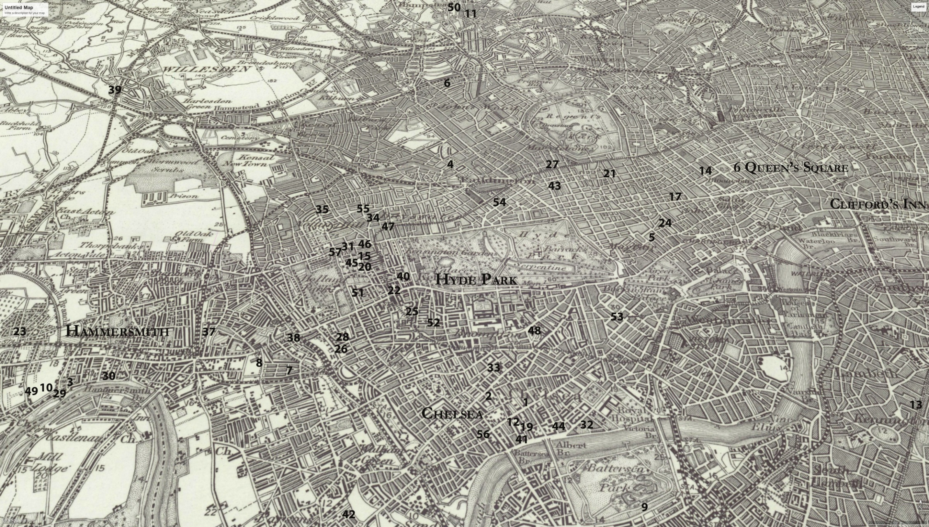
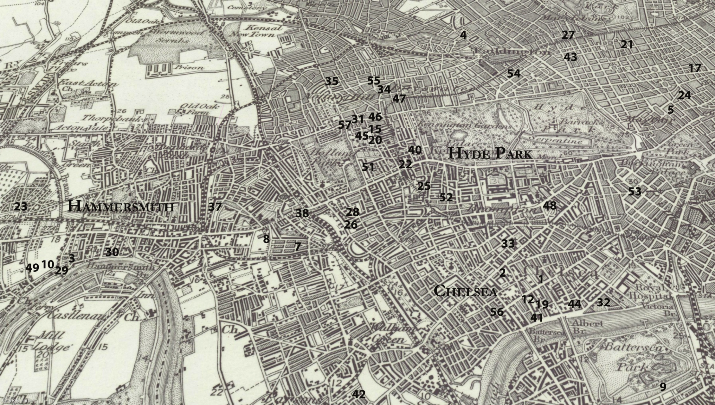
The previous two pages depict:
Figure 3.1 1900 Ordinance Survey map depicting houses and studios of London based WGA members and associates showing a visible concentration around West London.
Figure 3.2 Close up of the same map.

Key for London members and associates compiled from WGAA 1911 and 1912 membership lists

Members
- Mary Lowndes, Brittany Studios, 259 King’s Road, Chelsea.
- Evelyn De Morgan, 137 Church Street, Chelsea.
- May Morris, 8 Hammersmith Terrace.
- Winifred Austen, 3 Warwick Avenue, Maida Hill.
- Rose Barton, 37 Dover Street.
- Gertrude Bayes, 40 Boundary Road, St John’s Wood.
- Maud Beddington, 9 St Paul’s Studios, 9 Talgarth Road.
- Helen Bedford, 101 Gunterstone Road, West Kensington.
- Pamela Colman Smith, 84 York Mansions, Battersea Park.
- Edith Dawson, Swan House, Chiswick Mall, then 27 St Peter’s Square, Hammersmith.
- Mabel Esplin, 43 Willow Road, Hampstead.
- Emily Ford, 44 Glebe Place, Chelsea.
- Ethel Everett, 170 Kennington Park Road.
- Agnes Garrett, 2 Gowe Street.
- Margaret May Giles, 64 Bedford Gardens, Campden Hill.
- Feodora Gleichen, The Studio, St James’s Palace.
- Letty Graham, 28 Poland Street.
- Jean Hadaway and Anna Simons both listed at the Lyceum Club.
- Eleanor Hallé, 8 Upper Cheyne Row, Chelsea.
- Edith Harwood and Mary Sloane both listed at 57 Bedford Gardens, Campden Hill.
- Christiana Herringham, 40 Wimpole Street, W.
- Edith K. Martyn, 8 King Street, Kensington Square.
- Esther Moore, 4 Bath Road, Chiswick.
- Charlotte Newman, 10 Savile Row.
- Sarah Prideaux, 11 Eldon Road, Kensington.
- Violet Ramsay, 15 Cromwell Crescent, S.
- Ellen Mary Rope, 107 Marylebone Road, N.
- Eleanor Rowe, 46 Pembroke Road, W.
- Minnie Dibdin Spooner, Eyot Cottage, Chiswick Mall
- Phoebe Stabler, 34 Upper Mall, Hammersmith.
- Marie Stillman, 12 Campden Hill Gardens, W.
- Marianne Stokes, River House, Chelsea Embankment, S.W.
- Annie Swynnerton, 1A The Avenue, 76 Fulham Road, S.W.
- Alys Trotter, 44 Chepstow Place, W.
- Alice B. Woodward, 13 Arundel Gardens, Notting Hill, W.
- E. C. Woodward, 5 Johnson Street, Notting Hill Gate, W.
- Lola Frampton, 2 Brook Green Studios, Brook Green.
- Ruby Levick Bailey, 8 Addison Bridge Place, West Kensington.
- Amelia Bowerley, 59 Craven Park, W.
- Estella Canziani, 3 Palace Green, Kensington.
- Mary Sargant Florence, 1 Smollet Studios, Cheyne Walk.
- M. V. Wheelhouse, 3 Pomona Studios, 111 New Kings Road, S.W.

Associates
- Catherine Ouless, 12 Bryandston Square, W.
- Mabel Newcombe, 1 Cheyne Walk, Chelsea.
- Juliet Tylor Morse, 14 Airlie Gardens, W.
- Bertha Johnson, 5 Johnson Street, Notting Hill Gate, W.
- Beatrice Beddington, 59 Palace Court, W.
- Mrs Wickham Flower, 50 Egerton Crescent, S.W.
- A. G. Pike, Bedford House, Chiswick Mall, W.
- Christina Smith, 121 Heath Street, Hamsptead.
- L. Strode, 7 Stafford Terrace, Campden Hill.
- Mrs Jenkins, 3 Cornwall Gardens, S.W.
- Hilda Trevelyan, 19 Eaton Place, S.W.
- Mrs Hans Sauer, 22 Gloucester Square, Hyde Park.
- Mrs H. J. Tozer, 12 Chepstow Villas, W.
- Valentine Hawtrey, 104 Beauford Mansions, Beaufort Street.
- Annette Hullah, 8 Aubrey Road, Kensington.
All known details about WGA members and associates have been included.

The next three pages depict:
Figure 3.3 Concentration of members around Chelsea.
Figure 3.4 Concentration of members around Hammersmith River.
Figure 3.5 Concentration of members in Kensington and around Holland Park.

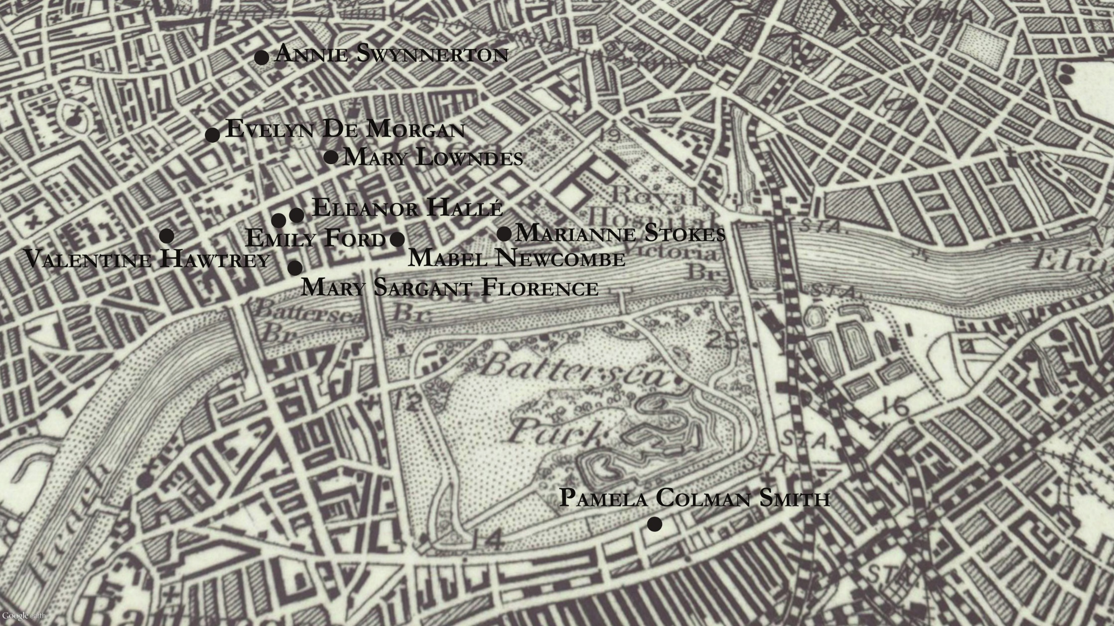
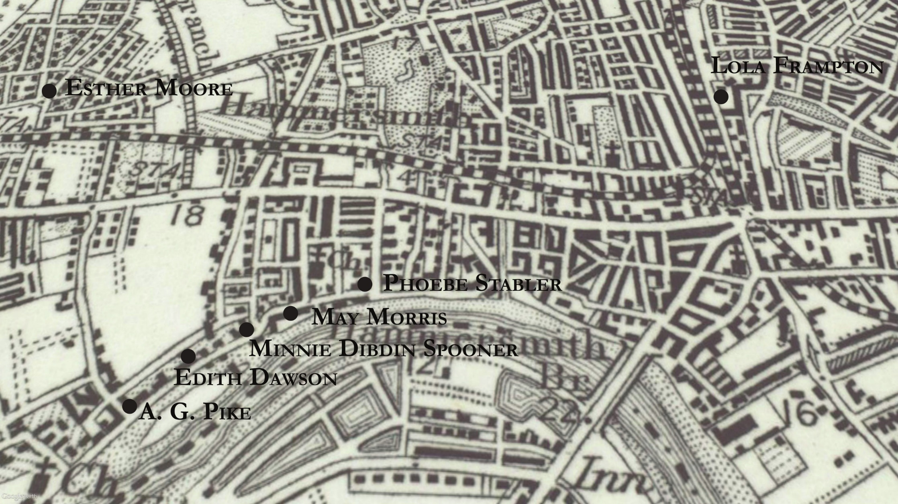
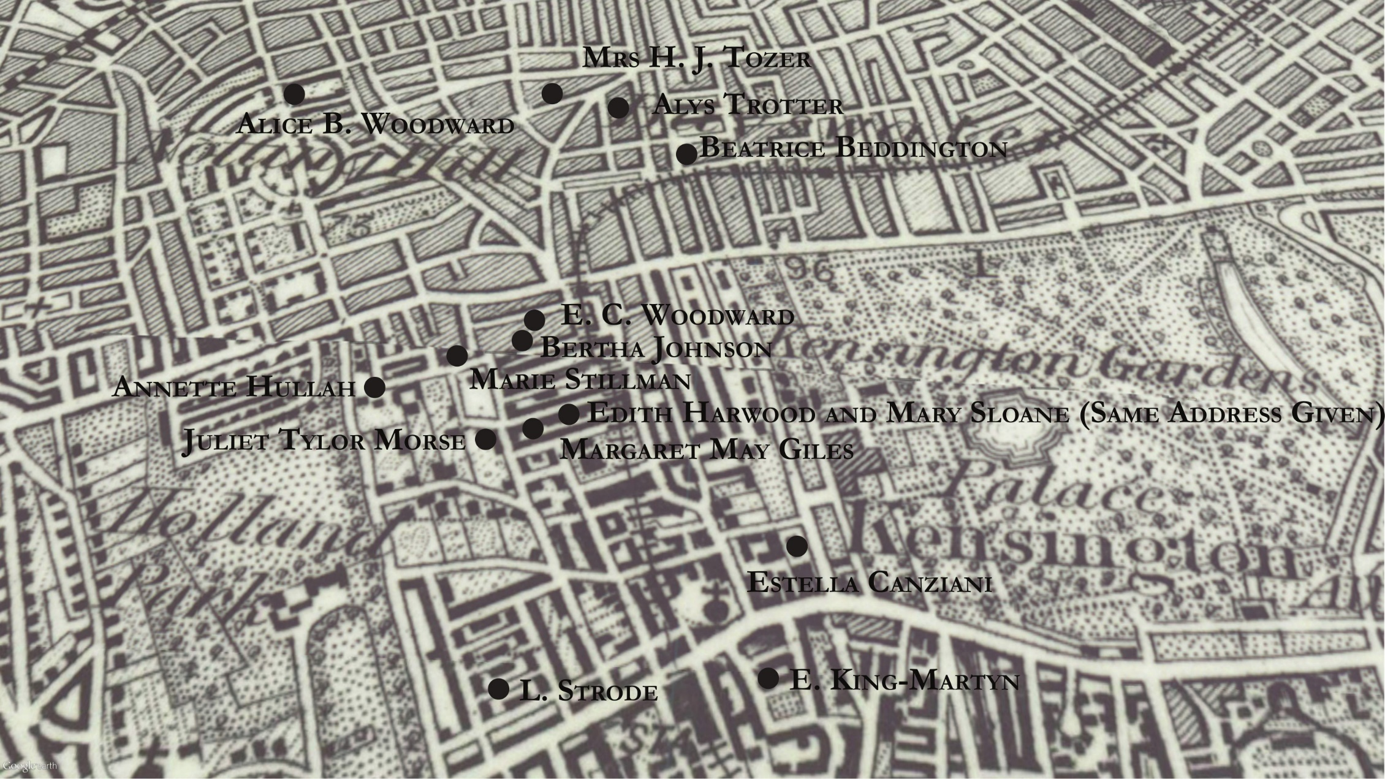
Members envisaged the city in terms of the potential the built environment had to enable them to forge artistic friendships and collaborations. Stained-glass artist Clare Dawson even represented her social network in early-twentieth century London in her own handmade map of the city. Figure 3.6 It depicted the homes of three WGA members who were family members: sculptor, Ellen Mary Rope and her niece, sculptor, Dorothy A. A. Rope shared a studio. Another Rope, Ellen’s niece, stained-glass window maker, Margaret Edith Aldrich Rope, was shown to have a studio nearby. The fact that Dawson chose to represent this network of studios provides further insight into the ways women artists viewed the city in its ability to form a network of support. This section has shown that WGA members, and their female peers, were heavily involved in acquiring artists’ studios, often identical to those used by many of their male counterparts. Furthermore, there was a demonstrable concentration of members living in West London. Community, organised along professional lines, was clearly a key factor in the acquisition of studios and homes by women.

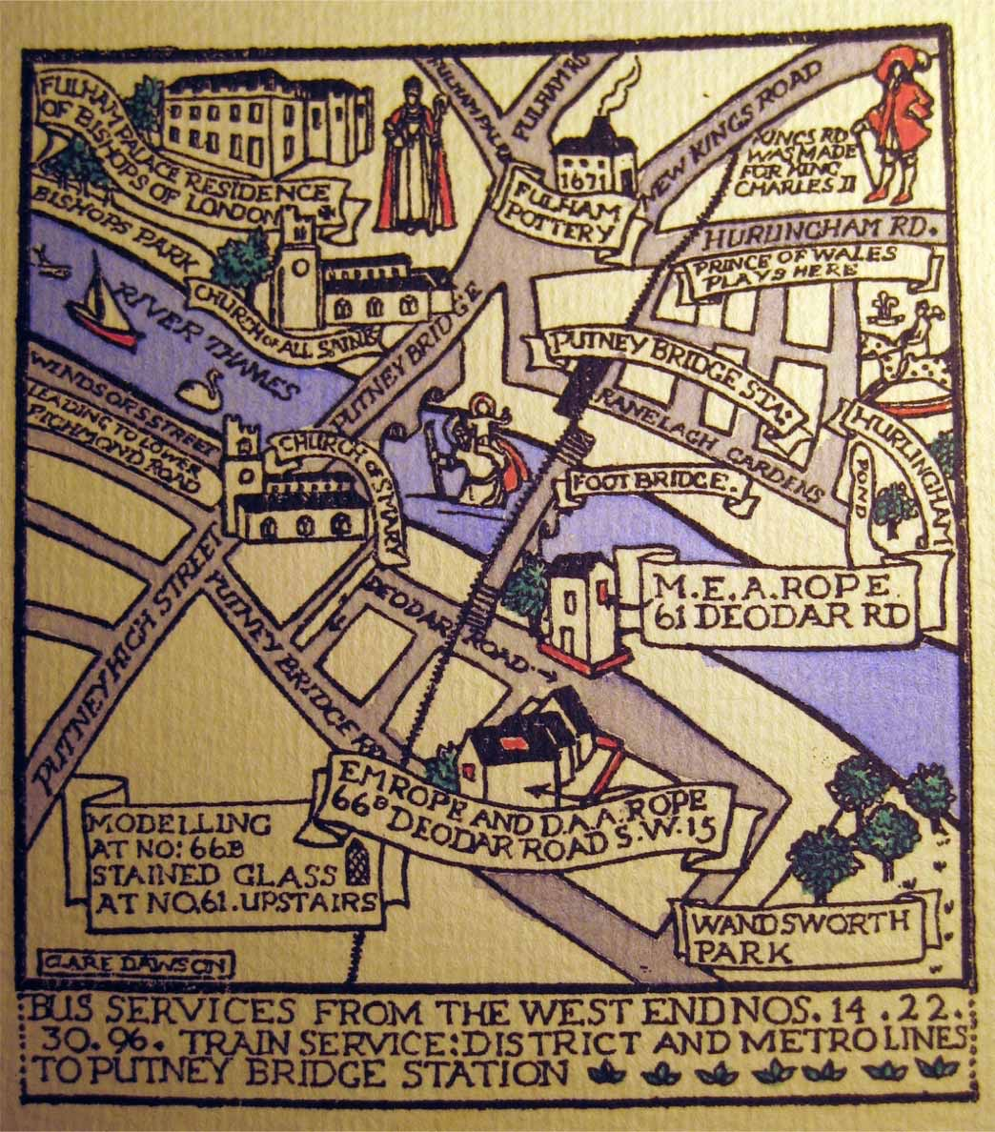
Figure 3.6 The studio network of the Rope family in London as depicted by Clare Dawson. Private collection of Arthur Rope.

II.

This next section explores how women sustained these networks across the late nineteenth and earliy twentieth centuries. Artistic contacts were kept alive through “Show Sundays” “At Homes” and fashionable parties, meetings, and exhibitions. Estella Canziani quickly became immersed in the artistic social events taking place at her mother’s home studio. One of these was the annual “Show Sunday”, at which Starr’s studio was always “crowded with visitors.” Canziani continued this popular tradition and one meeting in 1914 was acutely memorable to her. She wrote in her memoir that “members of nine nations, including Germans, met in friendliness for tea in my studio. The barriers were forgotten in mutual admiration of one another’s works.” The practice of taking tea together created a space of shared identity between different groups of artists and, as the work of Morton has shown, in suffrage circles. In this instance, taking tea in Canziani’s studio helped forge a sense of group identity focused around art, which temporarily minimised other identity markers such as the fraught issue of nationality.
Although members were deeply involved in studio sociability, when women were portrayed in studios in mainstream publications their expected role often continued to be as a model sitter, where they were seen as significant due to their beauty. Writer Arthur Ransome’s Bohemia in London, published the year the WGA was formed in 1907, provides a helpful way to demonstrate the complexities of contemporary views about gender and the studio lifestyle. A chapter titled “In the studios” presumes the studio to be a masculine space. The imagined artist is male, “his coat off ready for work”, absorbed in painting his model during the day, “slashing in the rough work”, he would then spend the evening in one of London’s many male-only artists’ clubs. However, in another chapter titled “A Chelsea Evening”, Ransome chooses to detail a quintessential bohemian evening in the capital. This takes place at the studio of WGA member, Pamela Colman Smith, although she is given the pseudonym of “Gypsy”. See Figure 3.7. This was where Ransome felt he could “meet the best poets and painters and men and women of spirit in the town.” Ransome described Colman Smith’s studio as “a mad room out of a fairytale.” Great emphasis was placed on the materiality of the rooms, as archetypal examples of London’s artistic scene. The studio had dark green walls adorned with drawings, etchings and pastel sketches, the tables with “bottles of painting inks” and a big blue sofa upon which a “broadly whiskered picture-dealer” pored over a book of Japanese prints. Aside from this convincing display of an artistic lifestyle, the space abounded in its eccentricity, with cigarette boxes, incense, heaps of crimson silks, a medley of Eastern pottery and Indian goods, a grand piano, and candles. There was even a “woolly monkey perched ridiculously on a pile of portfolios”, which appeared to grin “at the cast of a woman’s head.” Colman Smith’s rooms demonstrate how studios could materially transform women into known artistic figures. This space physically expressed the intentions of its inhabitant, and proved she was not partaking in art as a hobby. Colman Smith’s artistic identity was irrevocably tied up in this mass of material possessions that made her professional status both incredibly personal but also a constant presence. Her rooms provided the perfect place for sociability, and Colman Smith entertained friends and potential customers once a week, even keeping a guest book to record visitors. These guests included William Butler Yeats, John Masefield, Arthur Ransome, and the American painter Alphaeus Cole. As such, the two chapters in Ransome’s Bohemia in London clash in their juxtaposition of gendered roles in the studio and show the conflicting discourses circulating in society. Colman Smith’s experiences demonstrate that although gendered stereotypes existed, women subverted these tropes and could be at the heart of the artistic scene.
Members used sophisticated methods to manipulate the domestic convention of hosting events at home and in the studio for their own needs. Colman Smith took advantage of middle-class enjoyment of artistic domestic sociability as a way to establish her oeuvre. She told folklore stories in private houses and clubs across London and New York. The Brooklyn Daily Eagle entertained its readers in 1904 with stories about how: “In London drawing rooms the enthusiasm and the fashion of the hour is Pamela Coleman [sic] Smith” who “in a brilliant frock of orange with a red turban”, would sit on a board with two lit candles in front of her and “tells before crowds of delighted people weird and strange folklore tales of Jamaica”. She even had a folder printed to advertise these performances, and arranged for appreciations to be contributed by W. B. Yeats, Arthur Symonds, J. M. Barrie, Maurice Hewlitt, and G. K. Chesterton amongst others.
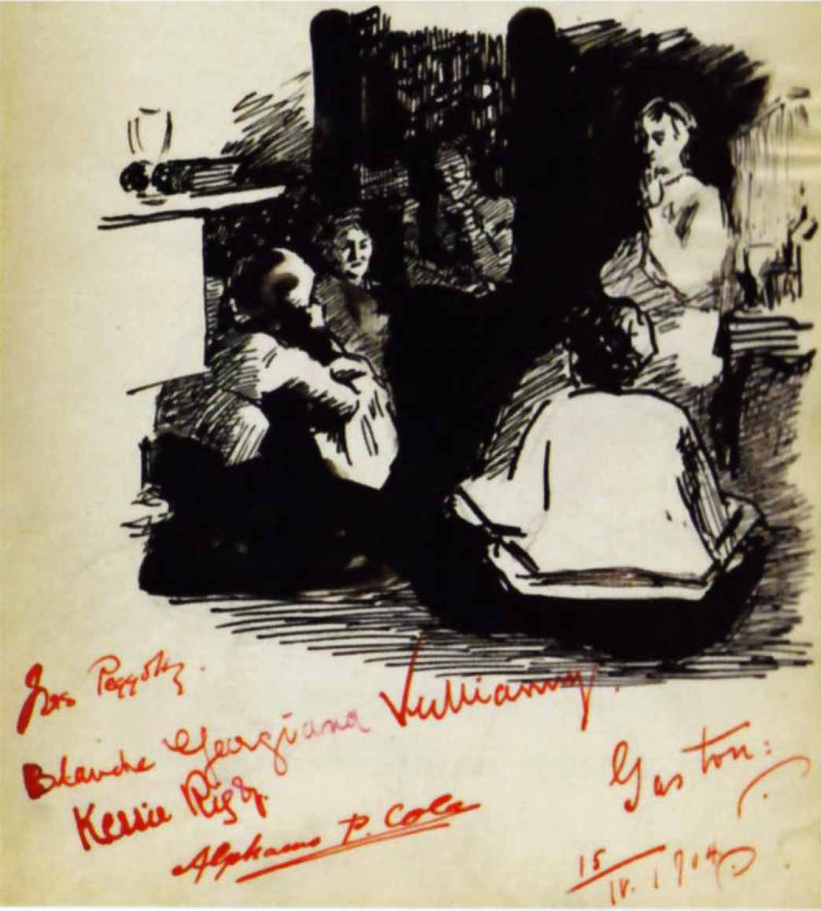
Figure 3.7 Page from the visitor book of Pamela Colman Smith. Illustration by Alphaeus Cole. Collection of S. R. Kaplan. Further reproduction prohibited.
Women took care to detail their active involvement in artistic sociability in their memoirs as a way to evidence they had been centrally involved. Unlike the more restrictive public sphere, and male-only art clubs, homes and studios were spaces women were seen to already have an established propensity to manage. In her autobiography military history painter Elizabeth Butler, (not a member), wrote about her busy schedule hosting events at her studio. Butler took care to decorate the room with traditionally masculine adornments, to reflect her interest in war, and: “From one till six to-day people poured in. My studio was got up quite charmingly with curtains and screens, and with wild beast skins disposed on the floor, and my arms and armour furbished up.” Rose Barton expressed similar enjoyment, writing about the new types of friendships having a studio afforded her. Through this altered form of domesticity, she found she could relax more easily with fellow artists. She wrote: “What a delightful contrast one finds in the cosy fire in one’s studio, in one’s own ingle-nook, with the kettle on the hob” and that “dish of tea with one’s greatest pal! Oh! ’tis all glorious ... ” She perceived all “minor grievances” in public life to be forgotten when:

two or three of us, after trying to sketch on the Embankment in the short winter evenings, till one’s fingers were too much numbed to hold the brush, used to get back to a cheerful fire and discuss one’s failures over tea and rounds of buttered toast and muffins. Only those initiated into ‘studio tea’ can know to what a pitch of excellence toast and muffins can rise!

Studio sociability provided extensive, unprecedented interaction with her peer group, which helped Barton cope with the difficulties of professional life. Barton also noted she had asked a flower girl she met in the street to sit for her in her studio. The girl was “much pleased at the project” and informed Barton that “all the other girls were ‘fit to be tied with envy’”. Barton took care to detail the girls reaction to the busy working environment of her studio:
She had never been in a studio before, and all the time she was sitting I saw her eyes wandering round the room, taking in everything. At last she said triumphantly, ‘I knowed you to be a lydy [sic] the first day you came down to paint.’ ‘How so?’ I asked. ‘Well,’ said she, ‘when you had done your painting you packed up your things and carried them off yourself.’ From the way she said it, I imagine there had been a heated argument over this point.

The exchange between Barton and the unnamed flower girl shows class remained a constant fixture in the studio, alongside demonstrating the public intrigue in Barton’s position as a painter.
The diaries and letters of members demonstrate the far-reaching nature of female engagement in artistic social events before the formation of the WGA and the complete absorption of artistic culture into their daily lives. Almost all social events contained some mention of art, again highlighting the heightened interest in art amongst middle and upper-middle class circles, but also the commitment of these women. Their interest in art and hence their professionality was completely bound up in their domestic lives. Unmarried Mary A. Sloane’s 1893 and 1897 daily diaries depict frequent trips to “At Homes” at the studios and homes of fellow, often single, female artists in her circle. She received numerous visitors to her family home in Leicester, usually wishing to be sketched. Sloane also regularly took the train to London to attend exhibitions, lectures and art classes at Westminster and in Bushey. On the average day of 3 December 1897 she painted her mother’s portrait, visited a Miss Pott’s studio, had tea, went to the Women Writer’s Club, and then to a modelling class.
Often refused entry to male art classes, or feeling unwelcome in masculine settings, women made art together in sympathetic environments. Mary A. Sloane’s rich archive of letters shows the extent of female artistic socialisation and the close friendships between future WGA members across the 1890s. Future member and renowned sculptor Margaret M. Jenkin invited Sloane to a “memory sketch party” hosted at the Gower Street studio of painter Blanche Baker in the 1890s. All attending had to “do a memory sketch of anything we happen to have noticed. Water colour or any medium. I have tried to bring back a picture from Rome—but my watercolours are very unprofessional”. Another letter from Jenkin invited Sloane to a lecture at the home of a third future guild member Margaret Rope:

Would you care to hear a lecture on 5th century Greek sculpture by Mr Hill of British Museum?—it will be held on Wednesday next at 8 in Miss Rope’s rooms 107 Marylebone Rd. I am going and if you care to go I will ask her if I may bring you. She is an old Slade student (modeling) and is such a nice woman that I think you might like to know her—Mr Hill is of course tremendously well up in his subject though not exactly fluent. I shall be arriving at Baker St Station at 7.48 … if you can meet me there …

This extract is noteworthy for a number of reasons. Firstly, it reveals these women were at ease with a male speaker talking in Rope’s private rooms, and were confident about travelling around the city at night. Letters such as this reveal the temporal spaces of professionalism and invisible networks women artists established across the city, and the long-term friendships between these three women who all later joined the WGA.
Studios and households were not regulated in the same ways as male-only clubs. Instead entrance was decided by the individual wish of the owner and pre-established kinship and friendship networks, through which new mixed-sex relationships were forged. Studio meetings provided a way for women to negotiate what Anne Digby has theorised as the “social borderlands” of society; an acceptable grey area between the public and private sphere. Mary A. Sloane would often visit Edward Burne Jones’s studio on Sunday afternoons when it was open for visitors to peer in and see the paintings of this artistic personality. One of Edith B. Dawson’s friends wrote to Dawson in delight in 1892 writing:
It was so jolly of you to write about Mr Dawson’s ‘Literary’. We went, and enjoyed it immensely, it was most delightfully informal and sociable, it is so nice to go amongst people who don’t try to be ‘genteel’ if you know what I mean. Four of us Slade girls went, and Win, so they must have been rather overdone I am afraid with aspiring female students.

Nelson Dawson was to marry Edith the next year, and he had evidently invited her and her friends to a literary event he was hosting. Through these networks new mixed-sex relationships were established, which changed the way societal relations were understood and regulated.
Both unmarried and married women engaged in the artistic scene. During one typical married “At Home” Phoebe and Harold Stabler invited WGA members to their home in Hammersmith to view “the mace for Westminster cathedral”. The gender of the married artist did usually dictate the way social interactions were orchestrated. During an evening Ransome spent at Colman Smith’s studio he made friends with “Benn” (thought to have been the painter, etcher, and engraver Alphaeus Cole). Benn asked Ransome to visit his studio at a later date and “he gave me a card with his address upon it, for which he had to ask his wife”. Social etiquette and domestic details were seen as a task for his wife, who was also an artist. Benn also got overexcited with a “gigantic two-edged sword” hanging on the wall and tried to swing for it. His wife “instantly brought him to sense and saved the place from devastation. Instead, he described the picture he was painting.” Ransome also detailed a time when Pegotty (Alphaeus Cole’s wife):
who was strong on the social side of a painter’s life, gave an ‘at home’ in their studio for the benefit of some American visitor who was likely to buy a picture ... I used to go round and do my part in making the buyer feel that he was lucky to get it.

Husbands and wives worked together to ensure that paintings and objects were sold as their futures could depend on it. Within the artistic community then, broader gendered social ideals were reinscribed and married women artists often had a separate gendered role to that of their artist husbands, with women being seen as the primary social organisers and restorer of decorum. There is also little evidence of what John Tosh has described as the “flight from domesticity” of men from the home in the late-nineteenth century. Artistic couples routinely socialised with other artists. Although both sexes also met in single-sex groups—for example through the WGA and the AWG—this was never to the exclusion of mixed-sex domestic events. The artistic couples examined also did not adhere to the exhausting social obligations described in Davidoff’s The Best Circles. Instead married members advocated a simple home life structured around work, family, and pleasurable artistic socialisation. Social visits to the houses of others in the artistic community functioned as useful, ritualistic elements to marital life, which maintained professional acquaintanceships.
Many of the events taking place in the studios and homes of unmarried and married artists were labelled “At Homes”. As established, “At Homes” were a widespread ritual of this era; widely understood to be organised by women when the female head of the household would designate time away from domestic duties to entertain guests, on a designated day, once a week. The wife of Punch cartoonist Linley Sambourne, Marion Sambourne discussed a vigorous schedule of “At Homes”, and is testament to their regularity amongst literary and artistic circles: “Mrs. Alma-Tadema had her at home day on Monday, Mrs. Rider Haggard on Wednesday, Mrs. du Maurier on Thursday, and Mrs. Marcus Stone on Sunday.” Writer of house decoration advice Mary Haweis also hosted “At Homes” in her Chelsea drawing room, and invited speakers such as William Holman Hunt and watercolour artist Lady Jephson. Feminist historians repeatedly describe these etiquette practices as enforcing restrictions in the lives of women. Davidoff takes a broadly negative view of nineteenth-century codes of gentility, in her words “one of the most effective instruments for social control ever devised.” She felt “At Homes” part of a repressive social model that encouraged the trapping of women within private domesticated positions. Carol Dyhouse similarly suggests that “endless round of ritualized social visiting, the minutiae of social etiquette … offered scant food for the soul of a budding feminist”. Suffragette Evelyn Sharp, in her short story The Other Anna, written in 1897, shared this view. She released her main character by having her turn her back on her “At Home” day, writing: “no one who was a bit nice ever called on her At Home day … the only interesting people were the people who never called on one at all … and at this point of her reflections she laughed unaccountably, and resolved to give up her At Home day.”
Clearly, for some contemporary women “At Homes” exemplified the domestic gendered restrictions inherent within their lifestyles. For women working in new professional fields however, “At Homes” were most useful. Effectively functioning as business cards, “At Homes” cards provided a way for women to take control of how they were perceived by society. Members united together to use their houses and studios to create a collaborative sphere of intellectual exchange, sociability, and demonstration of taste. “At Home” cards could be slipped into pockets, added to letters, and placed on hall tables when making visits, and facilitated an invisible network of like-minded women. One glance could conjure a vast network of artistic sociability.
As established in the previous chapter, the home was often used to stage interviews with artists, and artists increasingly needed to find innovative ways to market work and gather interest. Deborah Cohen has uncovered that by the 1880s “at home articles” had become a popular staple of the press. Reporters interviewed notable personalities, adapting the actual hosting of these event to a meeting between the journalist and the interviewee, which would then be transmitted to a mass readership on a national level, allowing the general public to voyeuristically imagine they were at an “At Home”. Cohen argued that the popularity of the “at home feature” was due to the public “avid appetite for celebrity gossip” and fascination with the home, commenting it was connected to the “conviction … that the domestic interior expressed its inhabitant’s inner self, especially in the case of women.” In the art scene, male artists were usually selected for these interviews in mainstream art journals. Artists at Home (1884) published regular photographs and interviews about male artists in their studios. The Art Record: A Weekly Illustrated Review of the Arts and Crafts (1901–1902) continued this trend, under the title “The Artist at Home.” These articles are also testament to the fact that studios were predominantly envisaged as spaces for male artists to inhabit, through the regular selection of male interviewees.
A review of these art journals suggests that artists of both sexes used “At Homes” to cement their professional lives and social networks. In 1901 The Art Record stated that “Studio At Homes were general all over London last Sunday”, referencing male and female artists. Later on the page it detailed specifically that male artists had refused to admit “the casual visitors” of “Show Sunday”. Male artists central to the art scene were clearly more concerned with etiquette, particularly for special events, than previously thought. Many artists were, instead of rejecting social conventions, reforming etiquette to create a new model of professional rhetoric which still loosely aligned with acceptable middle-class sociability. This can be seen in the below advertisement for the Technical Education Board of the Camberwell School of Arts and Crafts in Figure 3.8. This flyer told potential visitors that the Headmaster, the staff, and the students were having an “At Home”. Through these events the original gendered nature of “At Homes” were further blurred in the eyes of contemporary users.

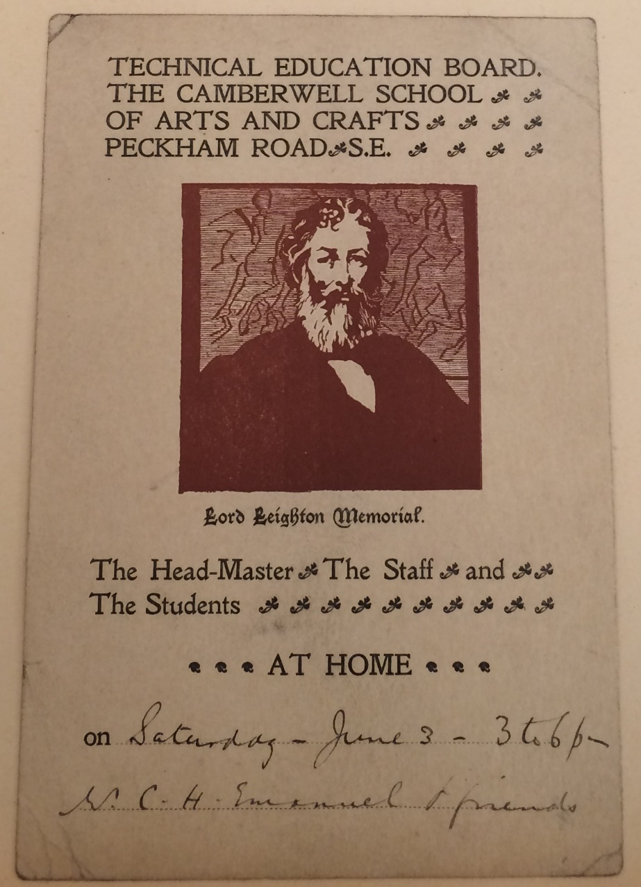
Figure 3.8 “At Home” for the Technical Education Board of The Camberwell School of Arts and Crafts. Huntington Library MS 2000.5.3392.25.

In the women’s press, regular space was set aside to discuss the “At Homes” of female artists. These articles took the form of interviews with women, but also depicted actual “At Homes” that had taken place. Journalists routinely emphasised the femininity of these studio events as a way to demonstrate the continued respectability of women artists. At an “At Home” in the studio of portrait painter Maud Coleridge on William Street in Knightsbridge, Coleridge covered her studio with daffodils and tulips and positioned “the pictures of pretty women” on tall easels laid out across the room. This “made up a charming interior” which was enjoyed by visitors from across “high society”. Another artist, a Mrs Earnshaw, “entertained a host of smart people … at her pretty studio” in York Place, Portland Square. In a similar way to the militant suffrage organisation the WSPU—who advised members to dress fashionably so as to maintain connotations of traditional femininity, which it was thought would legitimise their efforts to an audience potentially hostile to the cause—the women’s press made great efforts to show that women artists were reputable. Asserting a degree of conformity to traditional femininity provided a fruitful route for some women to forge successful new positions, often as portrait painters of women from high society. It should be noted that not all women decorated their studios in styles deemed feminine, and there is little evidence of WGA members doing so, but those that did were not necessarily passive in their decisions to do so: they were strategically marketing themselves, as the following chapter shall show.
If we see “At Homes” as tactics used by both male and female artists, the calling cards used by members appear remarkably lacking in a gendered style, and show how women chose to represent themselves away from the filtered lens of the women’s press. These cards often showed no discernable difference or feminisation to male studio events, as can be seen in this example of a studio viewing at sculptor George Frampton’s studio in Figure 3.9. Single women negotiated considerable freedoms and artistic opportunities through using these established frameworks, which created a facade of respectability. E. C. Woodward hosted many artistic “At Homes” in her workshop as seen in Figure 3.10. A card for fellow member Margaret M. Jenkin invited visitors to “come to tea at her studio” where they could see a marble sculpture she had been working on, see Figure 3.11. These are two of many cards which were subverted for professional needs by women. The cards labelled the media that the artist was working in, giving the invitee vital clues about the artistic nature of the meeting.

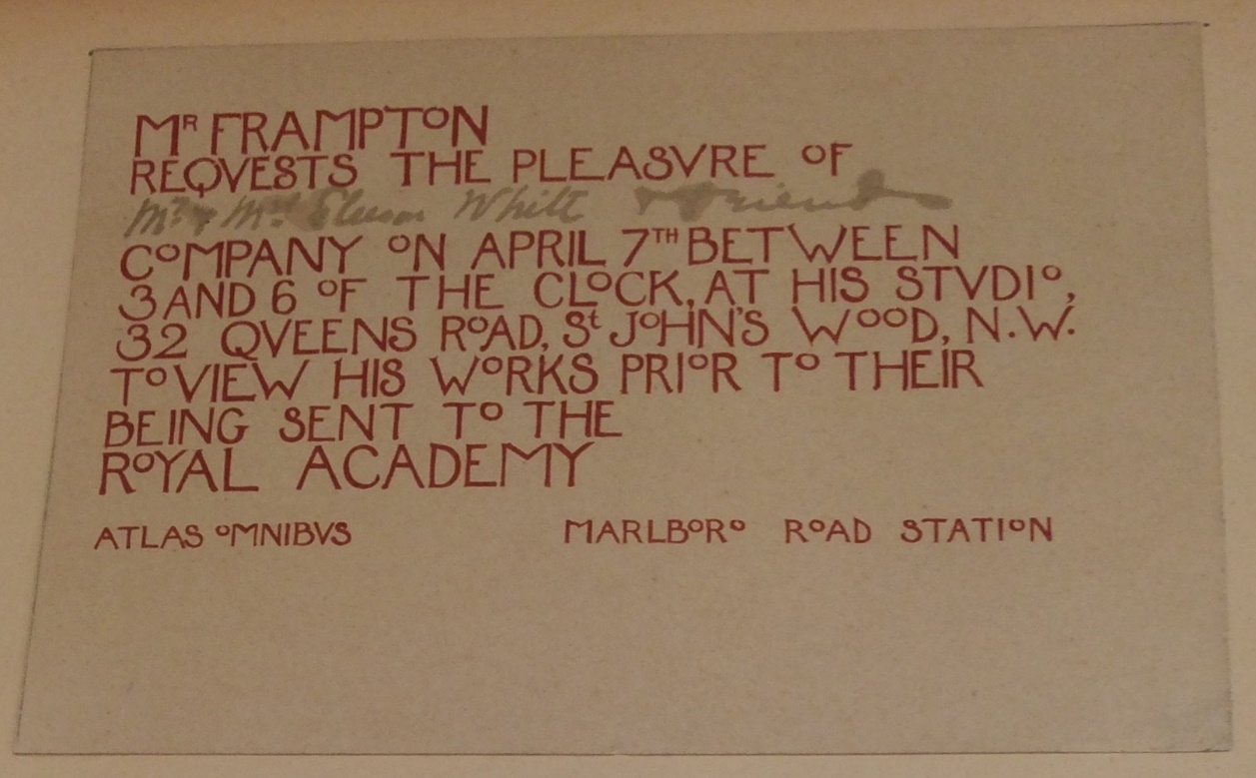
Figure 3.9 George Frampton studio viewing. Huntington Library MS 2000.5.3392.36.

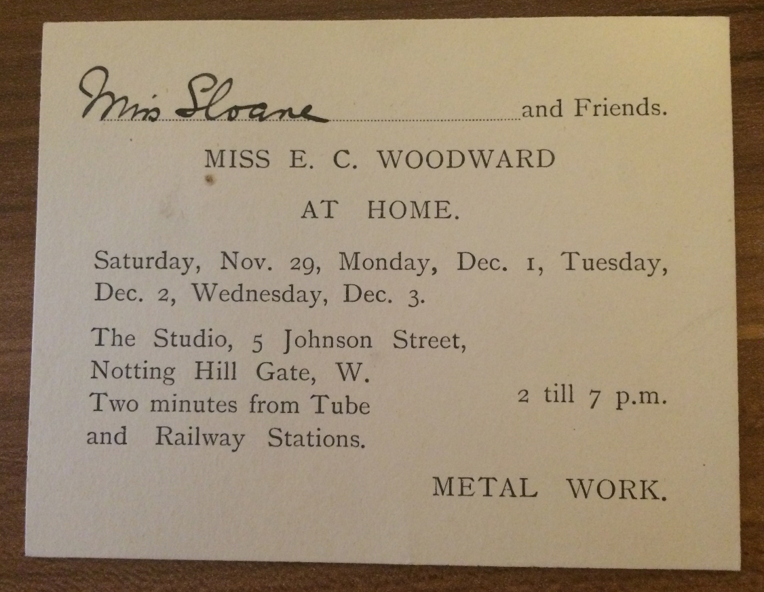
Figure 3.10 “At Home” for E. C. Woodward. WGAA.

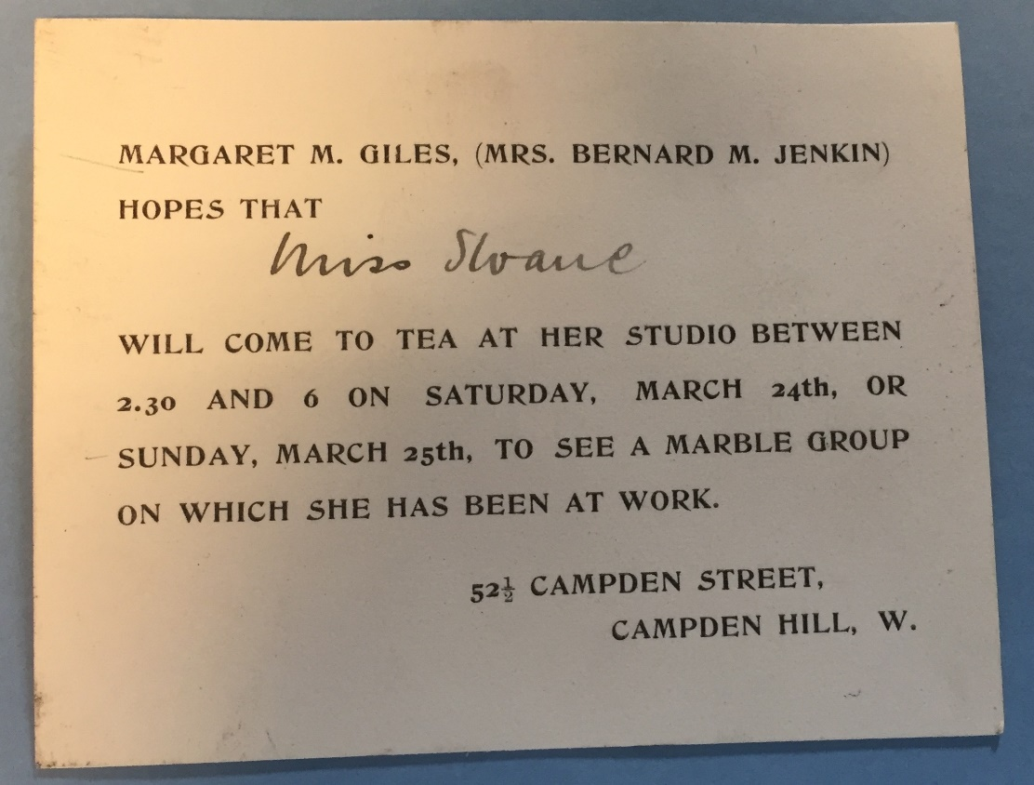
Figure 3.11 Margaret M. Jenkin “At Home” at 52 ½ Campden Street. WGAA.

“At Homes” provided the opportunity to stage exhibitions at home, and signalled the temporary transformation of the house into an exhibition venue. Members had considerable control in managing how these events were run and who was invited, in contrast to the dominance at large exhibitions where male figures—often including male jury, curators, art dealers, and reporters—were routinely designated representatives. Margaret M. Jenkin showed off all sorts of projects she was working on at her “At Homes”. At one she invited artists and fellow studios to see a frieze of boys and garlands she was modelling for the façade of a house in Newgate street. (Figure 3.12) Whereas at another she chose not to show her own work, but instead brought out a Japanese embroidery and had “an old Italian frame on view.” At yet another, individuals were invited to see her collection of watercolour drawings and engravings before she sent them to Burma.
Other domestic exhibitions were even more extensive, leading to the temporary reorganisation of rooms, in ways that leave little trace today. Morton has argued that “homes became feminist galleries” during the domestic exhibitions of the Suffrage Atelier. One of these one-women shows at Stanlake Villas included water colours and lithographs contributed by WGA member Louise Jacobs, part of a larger exhibition which took place on the last Thursday of each month at which postcards, posters, and needlework were shown. Figure 3.13 shows an adapted artistic “At Home” for the “Pandora Club”, an event organised by Mrs Woodward. The card was designed by Alice B. Woodward, and her mother Mrs Woodward presumably fronted this event for her daughters and the art club. At this event pictures were shown. A later event shows an “At Home” for another club the sisters were involved in, the ’91 Art Club. This took place at a traditional exhibition venue at Clifford’s Gallery, showing the fluid way women moved between “public” and “private” spaces, and perhaps showing how exhibitions, first held at home, could move to public venues, in response to the growing successes of the organisers. Figure 3.14.

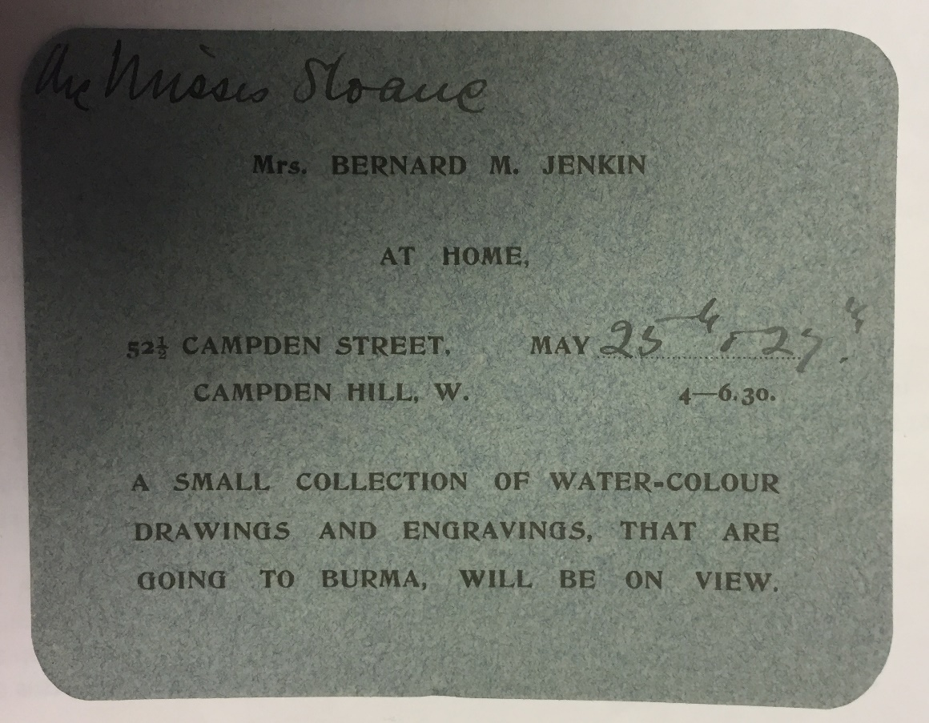
Figure 3.12 Margaret M. Jenkin “At Home” exhibition in her home at 52 ½ Campden Street. WGAA.

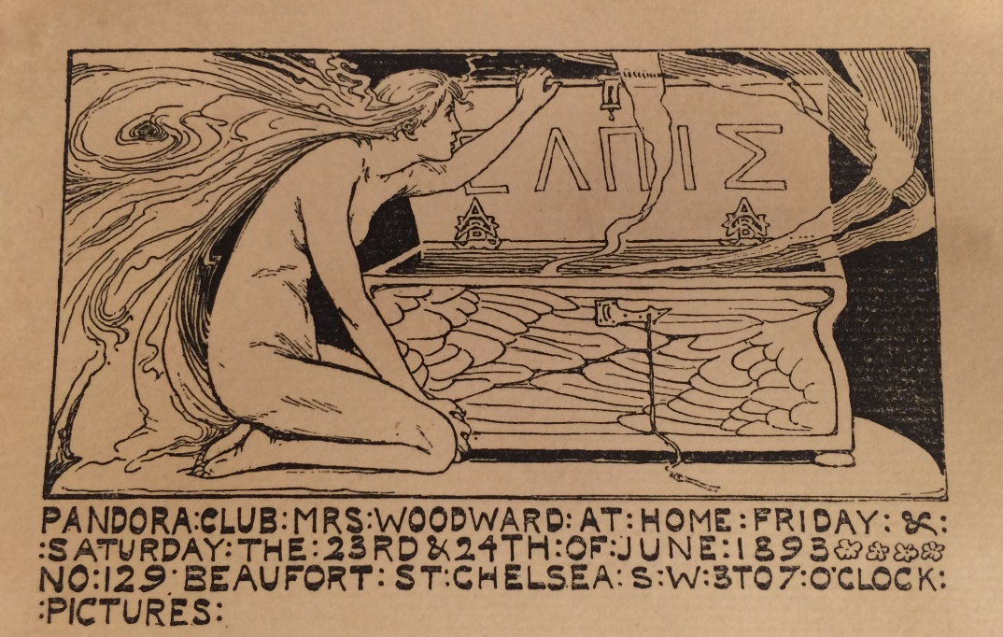
Figure 3.13 “At Home” for the Pandora Club at the Woodward household, 129 Beaufort Street, Chelsea (1893). Huntington Library Add. MS 2000.5.3392.52.

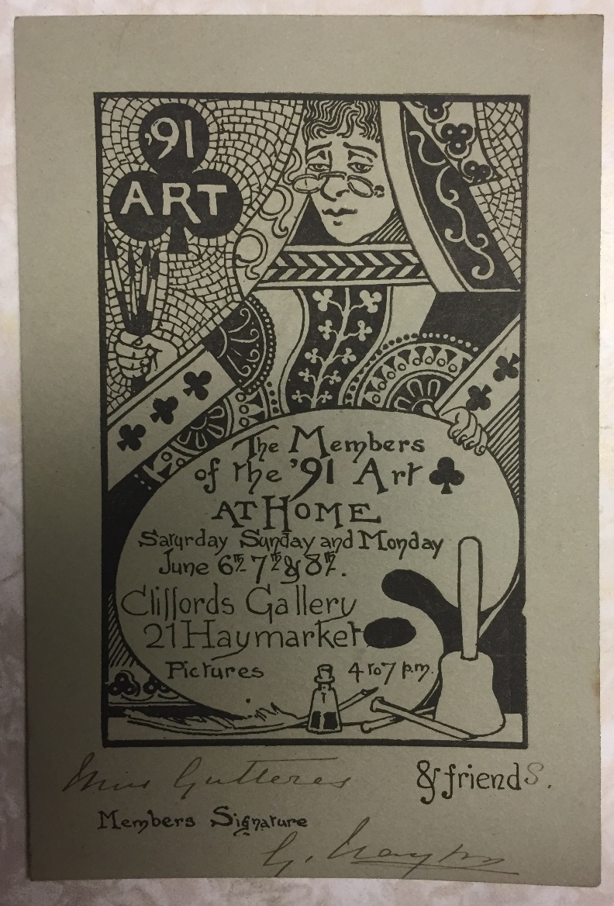
Figure 3.14 The ’91 Art Club “At Home” at Clifford’s Gallery. WGAA.
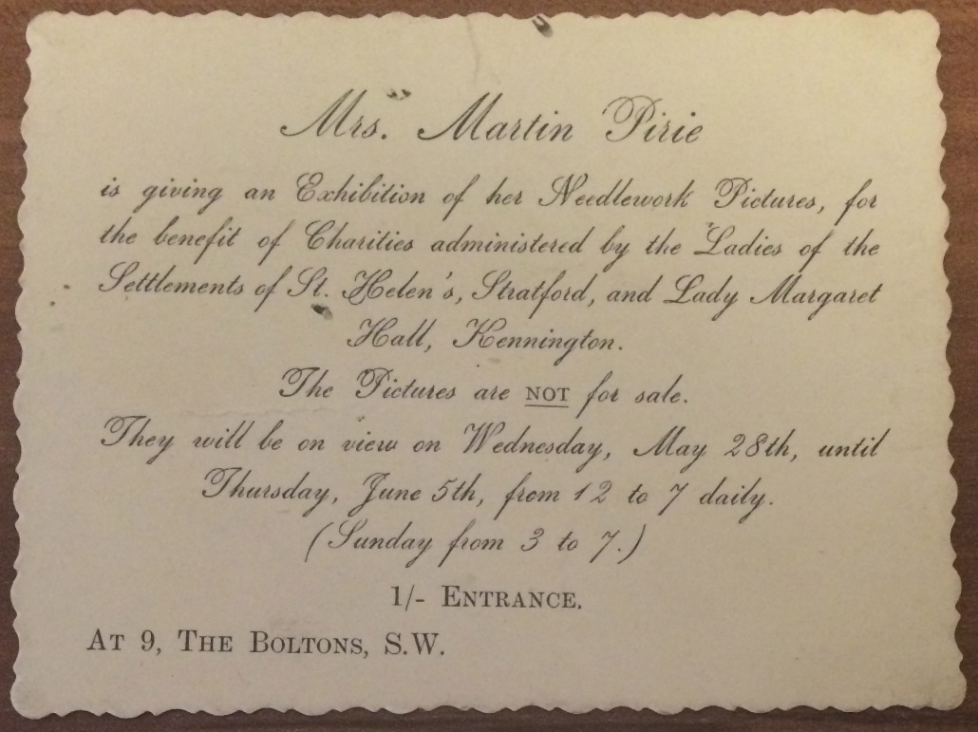
Figure 3.15 Mrs Martin Pirie’s exhibition. WGAA.

Although the marketing opportunities these domestic exhibitions afforded is obvious, evidence of financial reward is less evident. Figure 3.15 shows an undated card, found in the WGAA which details an exhibition given by a married Mrs. Martin Pirie of an exhibition of her needlework pictures at her home in the Boltons, a street in the Brompton district of Kensington and Chelsea. The card firmly noted that “The Pictures are not for sale” but were for charity. In asserting this, Mrs Martin Pirie informed society that she did not need to make money from her work, instead her domestic exhibition simply showcased her talent and accomplishment. Arguably, however this decision to highlight her items were not for sale suggests this may have been unusual. It is likely to have been normal for women to rely on word of mouth to establish payment for the objects that were exhibited at these events, as this would have been the most practical, and affordable, method of advertising.
WGA members represent the opportunities afforded for certain middle and upper-middle-class women, but many would have been unable to socialise in these ways. Contemporary writer Constance Smedley described the restrictions faced by women with little money, a factor which strongly influenced her reason for setting up the Lyceum Club for women artists and writers. She wrote “These girls told me of the difficulty of maintaining acquaintance with hostesses who through family connections at first invited them to their homes but whom they could never ask back to any interesting form of entertainment. Meeting people is a great need, especially when one is alone in London and has to launch oneself unassisted.” She went on:

The girls I knew came of decidedly respectable homes and we must remember the date was 1902. There was a very distinct line between sheltered women whom men were courteous too, and a rather frowsy half-world, not exactly a “demi-monde” but on the road to it, where women had no alternative between constant accepting of lunches and dinners and theatres from men acquaintances or offering the too great intimacy of reception in their bed-sitting rooms or the narrow confines of a cheap club. Men and women were still sensitive about their financial and social relationships. A girl in a substantial home has a background, a circle of friends and relations who are there as an invisible guard, however great the freedom she enjoys. A girl alone in those days missed that tactic chaperonage and sense of shelter and recognized the need of protecting her reputation: but this led to inevitable isolation and drove her into too feminine a world.

Class and privilege were evidently central to the ability of women to host events and be socially secure, and this quotation illuminates the high social status many WGA members held in society. These problems were however sometimes resolved through establishing friendships with wealthy female contacts, as well as through membership of organisations such as the Lyceum Club and the WGA. Canziani regularly encouraged less wealthy women to use her home to host their own small exhibitions, as did Maud Beddington. For the relatively wealthy professional women who engaged with this system of middle-class sociability, which included WGA members, these ritualistic elements were crucial for securing commissions and support.
Members were central to the artistic scene and were not simply socialising within segregated feminised networks. “At Homes” enabled women to implement sophisticated marketing strategies to sell work and assert artistic status. These events, concealed behind sociability, helped to maintain middle-class statuses whilst providing the opportunity to find customers and collaborations with other artists through strategic invitations. Both married and unmarried members invited their kinship networks, peers, servants, reporters, and customers, to participate with them in these semi-public spaces, which were aesthetically constructed to signify professional status. Their lives reveal that the London artistic scene was, for many, not a bohemian otherworld, but rather, in many ways, reinforced norms prevalent across middle-class society. For men and women working in the “lesser” arts it was particularly useful to engage in these events as a way to assert a position within the middle-classes.

III.

This network of female-managed studios and houses, which merged professional endeavours within the rhythm and structure of domestic daily life, was set up in the late-nineteenth century, and was well established by the formation of the WGA. This final section explores how members incorporated these tactics into the way they ran the guild from 1907. The WGAA contains a number of “At Home” cards which allude to the range of lectures, exhibitions, parties, and practical demonstrations taking place within the WGA’s remit. They show that general meetings at Clifford’s Inn Hall and 6 Queen Square provided only one level of guild activity. In fact, from its earliest days, members had questioned what the guild’s main purpose should be: lectures, socialising, or exhibitions. The 1908 Annual Report wrote that consultations had taken place about “in the near future … holding an exhibition in one of the small West End galleries or a private house.” As the first chapter of this thesis demonstrated, the guild was concerned about how to present itself, and appreciated the private sanctity of the guildhall. Yet this early report was confident in its hope that members would be able to exhibit together at a gallery if they wished. Members had exhibited work at West End venues since the mid-nineteenth century, and “count among our members many names already well known at exhibitions, and I have reason to think that more than one of the galleries would be glad to have us.” In response to this announcement, however, letters were received from anxious members writing that they hoped the guild would not be used as a public exhibition society. Edith B. Dawson wrote May Morris a letter specifically to tell her that many members were having heated debates about how the guild was to be used. She said she had: “heard several members of the Women’s Guild speak very strongly against the Guild being used as an exhibition society or for business purposes at all, and I feel so myself and promised a member I would tell you.” In her role as group representative, Dawson stated she did:

not know how the foundation members felt about it or if the Guild was originally planned to become at some future time an Exhibition Society, but when I think of the very good letter that you sent, with I think Mrs. Herringham, to the Edinburgh exhibition I feel we would be making a mistake to exhibit anywhere else as a body for business. Several women workers I know wish to protest against women’s art exhibitions and I do very much myself and I think your letter did too.

She warned Morris that members of the guild had discussed leaving if the guild began to be used “for Exhibition purposes. I could give you their names if you like, they are some of the best and really serious workers we have. There are so very many places now where we can show our work, men and women too know of these, and take advantage of them”. She then added on the end that she would not mind an exhibition as long as it “were to be done in the same way as the men’s guild have exhibitions, in which members may become familiar with work done by other members of the guild, that I think, no one could have objection to and is quite good but I don’t think the exhibitions of the men’s guild have been for business purposes directly at all”. The ideas expressed in Dawson’s letter must have been representative of many in the committee as this was the model the WGA decided to take for its exhibitions from this point onwards.
The letter by Christiana Herringham to which Dawson referred had been written to the secretary for the Women’s Section of the National Scottish Exhibition who had invited them to exhibit as a guild and to which the WGA had replied:

We object as a matter of principle to women’s sections in Art exhibitions. There can surely be no doubt that the work of artists should be judged without regard to questions of sex … The standard of Art for women will be debased and prices lowered, women being forced to work for less terms than men will accept.

At a later meeting in 1913 the committee also discussed a letter they had received about an international women’s exhibition in Leipzig, Germany, from the Women’s Section of Book-Production, inviting the WGA to take part. This too was rejected as an option for the WGA, even though it would have enhanced their international reputation. Mary A. Sloane was asked to reply on behalf of the committee “explaining their objection on principle to supporting any separate section for women in art exhibitions—the letter to be based on the one sent to the Secretary of the Women’s Section of the National Scottish Exhibition.” Feodora Gleichen also felt it important the guild were not: “At all to be any kind of a society for display of what has been accomplished (except in so far as showing their works to each other may conduce to mutual help).” Members were caught in a difficult position, as they thought to exhibit together would publically broadcast their separation, and further isolate them. The fact that a number of members were against exhibiting together, and appearing segregated by sex, resonates with the first chapter of this thesis, and research by Deborah Cherry, who has shown the exasperation felt by many women about exhibition societies for women such as the Society of Women Artists. A letter by WGA member Julia Bowley to Sloane discussed the problems with this very society: “Look at the failure of the Women’s Society of Art exhibitions at least a great many of them the work was very poor.”
The WGA committee had increasing difficulties in encouraging members to speak formally at Clifford’s Inn Hall after the early years. A list was even written to document all of those who had refused. The below representative sample shows the types of responses Mary A. Sloane got to her requests:

Bedford - refused once in committee.
Bowerley - very delicate.
Bowley - country.
Canziani - relatives implored me not to allow her to do anything additional. Not strong.
Christie - we have had 2 lectures and one extra—meeting on her subject—embroidery.
Garrett - refused twice firmly 1908 and 1911 will let us know if she changes.
Gleichen - would certainly never be able.
Hallé - twice asked to give lecture. No reply to that point.
Harwood - complained of being asked by a private member. Refused.
Prideaux - failed. Refused to help find sub.

Those who did speak were firm about how the meeting was to be labelled and how the rooms were to be arranged. A letter from Mary Sargant Florence to Mary A. Sloane stated:

I shall be quite willing to open a discussion on wall painting, which ought to prove a very prolific subject … It would be better to have … a discussion rather than a debate, as wall painting is a large subject upon which one would like to have the expression of opinion of any who have knowledge on whatever material they may have worked. It would be best to hold it in a studio to avoid the set character of a paper read to support a particular theory; and the discussion thrown open to guests as well as to members.

A second letter from Sargant Florence reiterated these aims again, although it appears she had been compromised into giving a “discussion” at the hall rather than in a studio as she had hoped. The labelling of this meeting and the interaction it would encourage, alongside the platform area upon which the women were supposed to stand to speak, were seen as problems:

Please particularly avoid word ‘Debate’. I asked Miss Sloane to put it down as ‘Discussion’ and refuse to debate on anything. It is a discussion—informal discussion is the best term. I want to […unclear] out other people’s knowledge on the subject. Could we not arrange Clifford’s Inn Hall leaving out the platform business? Shall refuse to speak unless one can do so without ... Please also name … printed as above—no Mrs.

Before the meeting Sargant Florence contacted several of her friends who were members and also asked non-members “to come prepared to speak on the subject.” She announced she wished to sit below the platform although she would lay out some samples of illustration on the platform itself and on benches and tables. She also wanted to arrive two hours early to “set the hall into shape”. Speaking at the hall was obviously seen as an event of great importance—and considerable stress—and members had strong views against certain rituals such as standing on the stage. In fact, many members found lecturing stressful. May Morris wrote privately to her friend the American book illustrator, Richard Buhlig, that she was glad he did not attend a lecture she gave as “the audience was cold which hindered me very much, and I was tired, and it was not one’s best … Besides which, my chairman (chairwoman) went away in the middle, leaving me to wind up the meeting all by my tired self, which did not help to make things go.” Morris, on a personal level, battled with her feelings about female artistic sociability; although at her home, in the relaxed setting she knew well, Morris did more successfully forge professional and emotionally satisfying relationships.
A WGA sub-committee was even set up to encourage women to speak, but it had “not any report to make except that members asked were reluctant”. Georgie Gaskin wrote “regretting her inability to lecture or demonstrate in public”. It is evident that women were anxious about being expected to speak at Clifford’s Inn Hall.
The Annual Report for 1911 even had a crossed out section that had originally stated “while the secretaries have found quick response to their invitations to lecture from friends, from outside, it is quite difficult to coax the members of the Guild to accept, and lecture.” The report stated the lists of each year “represent more effort and persuasion on our part than you would imagine.” It lamented their inability to have their own “permanent home” in which they could meet:

… in the social way desired, as the men art-workers do, but the conditions are different. For the present meeting at each other’s houses now and then seems to be the most practical and simple thing to do … one of the points about the social gatherings suggested if we can establish them, is that members should bring, quite informally, any work they have in had that they care to discuss with their fellows, we cannot but be aware that men meet much more at studios and clubs than women do and while keeping in mind that we are a Guild of workers and not a social club I think it is in this way that we may expect our guild to develop and fulfill the expectations of its founders.

This section to the report is one of the few instances of guild literature that admitted the different gendered realities for men and women, whilst also showing anxieties about opportunities for specifically female-led sociability. In 1912, it was reported that several extra meetings had been held in the form of “informal demonstration meetings in studios at which some members might be more inclined to speak about their work than in a larger hall.”
The committee began a concerted effort to host regular additional meetings in members’ studios and homes. In the absence of their own guildhall, the studios and studio homes of members began to constitute a framework of social interaction, where women exhibited their professionality to each other. The spatiality of the studio was useful due to the semi-private, relaxed atmosphere it encouraged, in contrast to the masculine atmosphere in the guildhall. This approach is apparent across the rest of the archive, and studio meetings led by women took place regularly, whilst WGA lectures at the hall routinely began to be given by men. As part of this new approach, the WGA held a number of private exhibitions across the early-twentieth century, which appear to have been invite only as the cards were usually addressed to individual people, stated for the WGA “and friends”, or were expressly labelled as “private”. 9 St Paul’s Studios was a much-used exhibition venue for the WGA due to its large size and the ability for the WGA to use it as and when they wished. In 1912 the WGA also held its first official exhibition in rented rooms at Lindsey Hall, Notting Hill Gate between 19 to 22 June. The event was listed as “private”. The 1912 Annual Report noted the WGA had tried to organise the exhibition at Clifford’s Inn Hall but it had not been available, so they had instead rented Lindsey Hall, where a “successful private exhibition” was held. The guild “showed great activity, and all united to make it a success, and sent important work”. Intriguingly, the Royal Society of Arts included in their 1912 journal a review of this exhibition. It is unknown why a reporter attended: it suggests the exhibition had become much larger than intended in scope. The review began with—as usual—a rather formulaic consideration of women’s exhibitions in relation to male exhibitions: “A certain number of the exhibitions devoted exclusively to women’s work are not of such a character as to prove superiority over, or even her equality with, man in the field of Arts and Crafts.” After getting this out of the way the review began in proper, writing that this “little show” did “demonstrate what really capable, competent, and workmanlike work women are doing in the various branches of applied art”. The article provides rare insight into the Royal Society of Arts’ perception of how members were viewed within the artistic milieu, when the journalist wrote: “The guild includes many of the better-known women craft-workers as well as painters and sculptors, and they exhibited for the most part of their best.” The review was overall very positive: “the little exhibition more than justified itself by the high standard which was maintained by many of the exhibitors in the various crafts represented.” Jane Morris exhibited two pieces of needlework; May Morris “a very dainty piece of boldly executed embroidery on muslin”; Grace Christies’ four d’oyleys were “dainty and instructive pieces of workmanship”; Georgie Gaskin’s jewellery “daintily shown on a background of mousy brown velveteen’ was seen as “well designed and characterised by a sense of style.”
Members continued to attend and host small WGA exhibitions and “At Homes” in studios, homes, and workshops across the century. These small exhibitions were a key part of members’ social calendars, and provided a way for female artists to socialise, network, and curate their work. At the end of 1915, for instance, WGA members held “A series of private shows of members’ works held by invitation”, at the premises of Mrs Wallace Bruce, Estella Canziani and Cecilia Roberts. The WGA deliberately targeted these wealthy women to lend their studios and large drawing rooms for these shows. The purpose of the 1915 exhibition was to show the work of members which had been specifically “done or designed for public buildings … Banners, stained-glass, designs, cartoons, photographs of memorials and other works”. As such, members asserted their contribution to public life through the art they were creating to adorn the built environment within these private exhibitions. At this event there were also no qualms about payment. The exhibition resulted in sales of £44 50s and women who exhibited paid a twenty percent commission, which covered any expenses, whilst enabling them to make a profit. These small domestic exhibitions created the opportunity for members to supportively applaud each other’s style, alongside creating opportunities to make money. In comparison to the unease with domesticity displayed in Chapter One, over time members seem to have reconciled themselves to—alongside general meetings in the guild hall—hosting additional events at their homes, studios, and even in their drawing rooms.

* * *

Members of the WGA used their studios and houses to their advantage to create an extensive female urban network across the late-nineteenth and early-twentieth centuries. These women often lived next door to each other, or on the same street, in artistic areas of London—in particular in Hammersmith, Chelsea, and Kensington—emotionally supported through the extensive kinship and friendship networks established across these households. Their lives were completely dedicated to art, and social events usually focused around the furthering of these artistic lifestyles. This chapter demonstrated that the studios of WGA members were to be found at the centre of the contemporary artistic scene. Members were bolstered by the fact that in London the art world was largely staged in domestic sites, which women had increasing authority over, and these women used their homes and studios to assert their positions in the Arts and Crafts movement.
Central to this web of sociability was the hosting of “At Homes” which ranged from small events consisting of a few women through to grand, mixed-sex social occasions at the height of the season. Disguised within this ostensibly normative middle-class practice was a key tactic of professional practice for WGA members. For women artists, already dealing with inherent and inextricable gendered tensions, “At Homes” may have reestablished women artists with their feminine and domestic personas. Their dependence on etiquette arguably exacerbated their separation from male artists, who were part of a broader masculine artisan culture, through the AWG, and in the male-only art clubs littered across the city. However, although appearing in many ways similar to non-working friends, and amateur women, “At Homes” provided a justification for members to invite the art world into their homes, to judge their work, and to forge new acquaintances. “At Homes” may have been repressive in their initial gendered ideology, but in lived experience, provided a space in which to subvert these norms. From the early twentieth century the WGA as a group incorporated these tactics, and the cyclical repetition and ritualistic structure of these “At Homes” now routinely took place in studios, which helped in the formation of a professional, respectable artistic identity for members in a period where norms for middle-class women in the workplace had not been established. These events also provided an additional sphere of guild activity away from the guildhall, which allowed women more freedom and confidence to speak about their crafts, and socialise in an informal manner. The next chapter analyses a select group of these women within the guild who took this approach even further, as they began to turn their studios into workshops, and set up enterprises with employees, to assert their professional identities and to generate an income.

Chapter Four

Art Enterprises: The Ideal of the “Medieval” Workshop

In an 1895 interview titled “A Lady Goldsmith”, the goldsmith in question, future WGA member Charlotte Newman (née Gibbs), described her jewellery shop at 18 Clifford Street in central London. Newman informed readers: “I took these premises four years ago, and set up my own workshops.” She had “a competent set of workmen, and take apprentices. I am my own foreman, and never have any trouble with my employés—indeed, I fancy that they like a lady ‘boss.’ I alloy all the gold myself, and tell the men what is to be done.” This interview in The Woman’s Signal, a publication keen to promote the new opportunities available for middle-class women wishing to work at the fin-de-siècle, clearly hoped to align Newman’s business with this greater political objective, but the source also provides a glimpse into an unexplored world of female entrepreneurship in the applied arts. Other contemporary publications give further details about Newman’s respected status. She lectured for the Royal Society of Arts in 1894, was the first woman to join the prestigious Jeweller’s Guild, and sat on the Arts and Crafts Board for the international women’s organisation The Lyceum Club. The status of Newman, and the women like her in the WGA who established enterprises, deviate greatly from the narratives about male artisanal life which dominate understanding of the Arts and Crafts movement. This chapter casts light on the WGA members who, from the 1870s onwards, developed sophisticated strategies to bypass their gendered and classed positions in society to create new economic roles through their establishment and management of small art enterprises.
In the WGA, out of approximately sixty members, a third had enterprises. This chapter argues it is crucial that histories of the Arts and Crafts movement, and histories of middle-class women and work, include these women’s efforts to make an income, assert design expertise, business skills, and historical knowledge. Scholars commonly argue that female artists—normally depicted as painters—were under increasing pressure by the turn of the century to create a celebrity image. Unfortunately, this public visibility is thought to have brought about “fierce and sometimes condemnatory scrutiny.” In the opinion of Gillian Sutherland this limited the genres in which women worked and “was never cost-free in social terms.” This chapter suggests an amended interpretation. Members, who were typically very well respected in artistic circles and in the press, routinely used their enterprises as the targeted route through which to assert professional status.
Yet these women exemplified a complex relationship with commerce. They disguised commercialism for two main reasons. Firstly, so not to incite disapproval from wider society due to this deviation from normative behavioural models of middle-class femininity, but secondly, to remain within the artistic network of the Arts and Crafts movement, which frowned upon excessive commercialism. The prevailing opinion during this era was that “real” artists should be guided by artistic motivation rather than commercial concerns. Papers such as Judy informed readers that “the artist is a simple creature, devoid of business instincts”. The refusal of the ACES to set up a profit-making saleroom in 1913, a clear demonstration of an unwillingness to engage in the commercial world, has been used by art historians to pinpoint the failure of the movement to modernise in the twentieth century. But for all this public avoidance of profit, the outputs of the Arts and Crafts movement did feed into a booming international art market, something many artists quietly encouraged. Prevailing societal ideals about the movement—the production of handcrafted items in small medieval-style workshops surrounded by apprentices—provided a fertile route for women to discretely start businesses. The idealised medievalist workshop was key. Members justified moving into business by arguing they wished to adequately fulfill respected medieval ideals of artistic production. As Michael Saler has maintained, adoption of cultural concepts of the past, “especially the ‘medieval’ past as concocted by nineteenth-century romantics like John Ruskin and William Morris” were used to legitimise modernism. It was particularly critical for women to maintain this dedication to tradition so as to assure their respectability and position in society. The historic traditions evoked by these staged sites cloaked commercial intent, distanced women from the associated connotations of trade, and placed them firmly in the artistic sphere.
Scholars have been captivated by the story of William Morris, who in 1861 started Morris & Co. (originally Morris, Marshall, Faulkner & Co.) with a number of male peers. The workshop-based communities of designer C. R. Ashbee and sculptor Eric Gill have also been studied in detail. The majority of these famed enterprises tended to exclude women through their traditional attitudes and apprenticeships. Callen has suggested that “because of family ties or of the need for chaperoning, many craftswomen … tended to avoid production-oriented tightly-knit workshops.” Jan Marsh has pointed to the open hostility towards women in ventures such as the Guild of Handicraft founded by Ashbee in 1888. Marsh verified her argument about female exclusion by quoting from Ashbee: “In the Guild’s workshops our fellows are rightly nervous of the competition of the amateur, especially the lady amateur … she is very versatile, she makes jewellery, she binds books, she enamels, she carves, she does leather work, a hundred different graceful and delicate crafts.” Yet it is possible to read this source differently: evidently women were disliked in Ashbee’s workshop, but the fact that Ashbee and his male peers were so anxious suggests there was a growing female presence in this sphere. This chapter sets out to explore this alternative world of female workshop creativity, and builds on the work of those who have examined the entrepreneurial activities of individuals. Elizabeth Crawford and Emma Ferry have researched Agnes Garrett and her cousin Rhoda, who set up what is thought to have been the first interior design company by women in 1874 called A. & R. Garrett House Decorators. Embroiderer Lily Yeats, who managed the Dun Emer workshops near Dublin, is now relatively well-known. Other scholars have shown women gravitated towards particular artistic fields in the late nineteenth century. Marianne Tidcombe researched the mass surge of female interest in bookbinding, whilst Maria Quirk pointed to the emergence of female-run embroidery agencies. Further research is needed to emphasise that these women—working across a range of artistic fields—were part of a growing web of women art entrepreneurs, who managed to maintain multilateral positions as middle-class women, business owners, and respected artists.
Economic historians have often produced an androcentric portrayal of past economic endeavours, although there has been a recent move away from this approach by those who have unearthed evidence of women’s work across historic European commercial cultures. There has been a preoccupation with the period before 1850, although interest in female economic roles across the nineteenth century is expanding. Geoffrey Crossick and Heinz-Gerhard Haupt argued that as guilds lost corporate legal statuses retail became part of family patrimony in the European petite bourgeoisie and opportunities for women grew. However, they concluded that by the end of the century women had become invisible in business. Beachy, Craig, and Owens disagreed, pointing to the evidence showing middle-class women actively working across the century. Alison Kay has shown the continued potential for women in small businesses, expanding the limits of the traditional, narrow use of the term “entrepreneurship”, arguing the activities of the many women who provided for themselves and their families “need to be examined as businesses, rather than as minor extensions of their domestic lives. Anything less would be to ignore the economic evidence and diminish the achievements of female proprietors”.
“Art enterprises” encompassed a range of dedicated sites of production set up by this cluster of WGA members, who asserted their professional status through entrepreneurship. A flexible approach has been taken to the term enterprise due to the gendered ways women have historically worked. Members defined here as having enterprises were those setting up premises for the purposes of conducting business, usually a workshop or shop, and/or had designated business names. Many also had staff. Enterprises like The Asphodel Press, a printing press, and The Spinnery, a weaving workshop, two businesses set up by members in designated rooms connected to the home were also included so as to accurately reflect the breadth of entrepreneurial activities in which members engaged. Adding “art” as a prefix was a common tactic, signifying the founders’ conception of how they wished to be positioned in the market. Newly designated “art” businesses were not necessarily connected to the Arts and Crafts movement. As Alan Crawford has written: “the shibboleth ‘art’ could be attached to anything from a tea tray with a couple of peacock’s feathers painted on it to radical craftsmanship of the most Ruskinian kind.” These objects resonated with people wanting their homes “touched by the influence of real artists.” In Crawford’s opinion, “Arts and Crafts men often found such people silly”, but admitted artists could not do without them.
Statistical data determining exact numbers for women setting up art enterprises is beyond the remit of this chapter, which is focused on WGA members, but at any rate it would be very difficult to measure this growth statistically due to the lack of sources. Unlike female traders in other studies, members avoided advertising in trade directories as this went against their anti-commercial philosophy. The managerial roles members undertook were usually not captured in census records. Basic information can be gleaned from post office and telephone directories but there is often little other evidence. As Kay has noted, the relative absence of women in the historical record has been enhanced by the proprietor’s decision to “entertain a restricted audience of customers”. Women actively encouraged ideas about their uncommon presence as a marketing strategy: Newman was presented in periodicals as the only woman jeweller. Yet similar publications described others, such as jeweller Amy Sandheim, as the “pioneer of the vogue in Artistic Jewellery.” In this chapter, the wish to provide an overview of the entrepreneurialism of members precluded a detailed study of individual fields. The contribution this chapter makes is to evaluate the ways in which female entrepreneurs working across the Arts and Crafts movement interacted with the art market and forged new profitable roles.
A reduction in taxes on paper and advertising during the second-half of the nineteenth century meant printed publications expanded rapidly. The bulk of evidence was collected from printed materials: advertisements and articles found in the women’s press, newspapers, and art journals. The press cannot provide complete access to the lives of these women, and articles were often carefully edited. Usually having close links to the women’s movement, the editors of the women’s press—for instance—were keen to promote female entrepreneurs, and journalists obscured the problems women faced and overemphasised the ease with which women could find success. Careful usage of these documents however provides insight into how cultural representations of women and work in the arts changed, and bolstered by other sources such as letters, postcards, photographs, and receipts, enables a suitable reconstruction.
This chapter is divided in four sections. The first examines how members negotiated past gendered barriers to receive training, whilst section two explores the range of enterprises women set up. Section three assesses marketing techniques, specifically how customers were targeted through advertisements and exhibitions. The final section explores the material environment of these workshops and shops. Throughout, this chapter shows the dedication of members to the Arts and Crafts movement, through their persistent focus on advertising the authentic, historic nature of their crafts, alongside illuminating how women realigned societal ideals with the need to make an income. Women promoted workshop culture so as to adhere with the ideals of the movement, and in doing so attained respected new professional positions in the eyes of fellow members, the press, and in public life.

I.

The majority of members who opened businesses justified their positions by stating they had needed to learn a profession due to financial instability. Members often set up enterprises at different points in the lifecycle because of this. Bookbinder Katharine Adams only started work in her thirties when, due to financial insecurity, it became necessary for her to make an income. Echoing the words of many women, Newman openly told The Women’s Penny Paper about her own reduced economic circumstances, which made it necessary for her to find an occupation during youth. She was part of a generation benefitting from the founding of several art schools that admitted women, and studied at the South Kensington Art School where she dreamed “like so many young ladies, of becoming a great pictorial artist”. Whilst training, however, the civil servant and inventor Henry Cole advised her to go into design. She chose to do so, and began making designs for carpets, china, paper hangings, and textile fabrics. Mary Lowndes took a similar path, studying at the Slade School, and becoming “self-supporting” within two years of study: initially selling sketches, making drawings for illustration, and painting panels for churches.
Aside from art school, training with a male firm for a substantial period was also seen as appropriate before it was thought a woman should set up on her own, although actual lengths of training could be considerably less, or non-existent, dependent on financial resources and location. Annie Garnett, who set up The Spinnery textiles workshop in the Lake District, had no formal training although consoled herself in her diary that John Ruskin had admired her paintings. Founding members of the WGA trying to find apprenticeships were amongst the first generation of nineteenth-century women asserting their rights to work in this way. Agnes Garrett arrived in London with her cousin Rhoda in 1867 in search of employment and commenced upon a “weary and fruitless search”. The Garrett cousins eventually became apprentices to the architect John McKean Brydon for three years, although being female pupils in an architect’s office was at that point “altogether undreamt and unheard of”. Fortunately Brydon was sympathetic to their cause and once the cousins had gained access to this apprenticeship they “thoroughly studied every branch of the profession they had taken up, learning even the mechanical parts, from the mixing of paint, upwards … There was plenty of hard work and drudgery”. Women wanting to train in artistic fields often had to search for male professionals willing to give private lessons or apprenticeships as women were repeatedly barred from classes. Member Sarah Prideaux learnt her lessons in bookbinding from the well-known trade binder Joseph Zaehnsdorf in London in 1888. Prideaux went on to train Katharine Adams for three months in 1897. Adams supplemented this with one month’s training with Douglas Cockerell which was all she could afford before she set up her own business.
Female inauguration into artisanal life was often initially linked to male networks of support. In the 1870s, Newman became pupil and assistant of John Brogden, a jewellery designer in Covent Garden famed for the elegance of his work. Reflecting upon her inauguration into business during later life Newman stated she had begun to work for Brogden unexpectedly after he asked if she could recommend someone to produce jewellery designs for him: “After making fruitless inquiries to find someone, it occurred to me to undertake it myself.” A fictional story written by member Mary Lowndes for The Englishwoman in 1915, which clearly drew upon her own experiences, told of two young women called Miss James (“James”) and “Kit-cat” who had worked at a large stained-glass firm in the late-nineteenth century. In the story, James told a group of her younger female friends about the difficulties of working in stained-glass as a woman at this point:

I used to make designs for stained-glass; and the windows they were for were painted and carried out by one of the great glass firms. It didn’t answer for me at all. I got the orders and had all the bother, and the people who made the windows got all the money. Then some architect asked us why we didn’t paint the glass ourselves. We said we’d like to, but didn’t know how. He declared it was quite easy, and we could find out; and he introduced us to a little stained-glass firm that doesn’t exist now, which had old ramshackle premises under some railway arches in the slums near King’s Cross. Kit and I went there every day.

James and Kit-cat felt the mid to late-nineteenth century to have been a challenging time in comparison with the relative ease for young women in the early-twentieth century wishing to work in stained-glass. At the end of the story James told her younger female peers “You can all learn glass-painting now, of course—and everything is quite different; but when I was young, women had very little choice in the matter of professions.” Lowndes’s own early life had striking resemblance to the characters in her story as she had also had to travel to a busy industrial area for her work at Britten & Gilson stained-glass window makers at 180 Union Street, Southwark.
Opportunities for middle-class women to train were hampered by the need for separate rooms to be made available away from the men so as to maintain respectability. At the beginning of her role at Brogden’s shop, Newman was separated from the main business, upstairs: “sitting in my little room, out of sight, designing.” She routinely left the shop to sketch historical jewellery displayed in museums and galleries across the city. Newman was slowly incorporated into a more senior role, eventually becoming manager and chief jewellery designer. Her perceived skill at dealing with female customers was responsible for this shift. Princess Louise, the sculptor and feminist, had visited the shop wanting a locket to be made. Brogden asked Newman to offer suggestions, and Newman’s talent at dealing with this wealthy female client led to Newman being selected to attend to all of Brogden’s customers. A similar progression out of segregated gendered space into the main rooms of the business is evident in the story told by Lowndes. The two women were initially segregated in their own room: “very dirty and queer, containing two long benches and some rickety chairs; and on the bench along the windows were two table-easels for the glass.” Here the two women made designs for the production of stained-glass although struggled as “Nobody would tell us anything”. Over time, however they became more absorbed into the business because a number of men were placed in the room due to a lack of separate space, and the two women began to interact with them. Although fictional, this account suggests that in daily life at work, due to practicalities, middle-class women did sometimes work in mixed-sex environments.
The conception of improving opportunities for female apprenticeships by the turn of the century was replicated amongst the accounts of countless female art workers. Enameller Edith B. Dawson reflected in her 1906 book Enamels about the difficulties she and her husband Nelson had faced when trying to find work together in the 1890s. She felt they had lived in a period of great change, saying: “Ten or eleven years ago it was extremely difficult to gain any information on the subject, and the present writer … had not the advantages that students of the present day possess, from which we may hope to see great results in the future.” Edith and Nelson trained at silversmith Alexander Fisher’s studio, “not as pupils but as co-workers. In those days it was very difficult to get instruction in the art of enameling.” There was a similar opening up of opportunities in other artistic fields. Writer and artist Annie Clive Bayley wrote to the editor of The Times in 1896 advising of new opportunities for girls aged fifteen and upwards, who could make money in silk weaving. These women could train at the Spinning and Weaving School at Blenheim Street, just off New Bond Street. In 1887, The Messrs. Simpson at 100 St. Martin’s Lane employed “many ladies in various kinds of decorative work, at salaries commencing at forty pounds a year, and rising according to the value of their services”. The hours were from nine till six with an hour for dinner. Whilst T. J. Cobden-Sanderson, who ran the Doves Bindery in Hammersmith from 1895 to 1909, took on women pupils who were required to pay £100 to train in his workshops for the year. The amounts women paid, or were paid, varied wildly. There were few regulations and initial costs could be extremely restrictive. Women often deliberately took up opportunities in smaller firms which enabled them the chance to engage in workshop life more fully than large companies were they were excluded from high-status work. In trade bookbinderies, for instance, women were forced to do the folding and sewing jobs. Similarly, in the pottery industries women were often relegated to unskilled jobs and as assistants to skilled men.
The difficulties in obtaining training were, in part, due to the guarded nature of commercial traders, a problem faced by artists of both sexes. Member Jean Hadaway noted that in metalwork “Trade enamellers would not impart what they deemed to be their secrets” and “would not teach an outsider, and of other jewelers there were none”. Mass trade production was perceived as an entirely different sphere of activity to this creative work.Assertion of this difference provided the fundamental way for artists to maintain status. Slowly however, a group of male and female metalworkers—which included many WGA members such as Dawson, Jean Hadaway, and E. C. Woodward—learnt their craft. The group professionalised the field by “finding out a little here and a little there” and gradually gathered together the necessary knowledge. A similar transition occurred in the field of bookbinding. In her 1906 book Modern Bookbinding, Sarah Prideaux felt this field had improved for women and now “many more women might adventure starting a business in the country or in a provincial town”. She remained cautious however about the women hoping to financially sustain themselves through this work. Providing insight into the financial troubles faced by many women she wrote:

Experience has shown that properly trained women can do as good binding as men, though not upon large and heavy work, and if they do it well enough some of them can earn a fair wage, while if they fail to reach a high standard they had better for all practical purposes let it alone. But to hold out any inducement to the woman who really needs bread-and-butter to take up binding as a lucrative employment, as is done in some quarters, should be characterized with the severity it deserves. Many women need but an addition to their income, and to such, if they are willing to incur the expense of training … and if they realize the experimental nature of the undertaking, binding may be recommended as a sufficiently pleasant occupation.

Prideaux’s cautious comments were likely written in reaction to the amount of women who were trying, and struggling, to live entirely off this wage. This section has shown that although apprenticeships and training were often difficult to obtain on the basis of the protectionism of commercial interests, the demands of gendered segregation, and variable access to the right networks, the period under discussion was one of expanding opportunity. WGA members, and other contemporary female artistic entrepreneurs made use of these limited opportunities to prepare for setting up their own enterprises.

II.

Members set up a wide variety of enterprises across the end of the nineteenth and the start of the twentieth centuries, which changed the built environment in London and impacted on community life in rural areas across Britain. Members formed clusters of businesses in fields often deemed suitable for women such as metalwork, bookbinding, textiles, and interior decoration, and through their efforts they opened up these fields for future generations. In part their endeavours were influenced by the growing acceptability of middle-class female employment. In the later years of the century a number of women’s magazines were established which repeatedly told readers about the benefits of work, germinating the idea within society that work was necessary to have a fulfilling life. The Ladies’ Treasury, addressing the topic of female shop-owners directly in 1886, was one of many publications telling readers that “The foolish prejudge which not so many years ago debarred ladies from standing behind a counter, or engaging in trade of any kind, has happily almost entirely passed away”. The thriving, relatively inexpensive periodical market, and the attached “conversational communities” generated by this, opened up a new realm in which women could consider their expansion into public life. A wide variety of contemporary sources exalted the potential and respectability of the women setting up art enterprises. Alfred Harmsworth, writing in The Young Folks’ Paper, advised that women with “capital and artistic tastes could make a very good income by starting a business of this kind”.
Even mainstream newspapers included articles on the topic; demonstrating the impact debates about middle-class female entrepreneurship were having in British society. In 1887, The Pall Mall Gazette published the article “Ladies as Shopkeepers” by women’s rights campaigner Emily Faithfull who discussed the irony that although most people would now be proud to see the name of their daughters or sisters on the cover of books, in contrast, the most “daring innovation in England at the moment is the lady shopkeeper. At present but few women have had the courage to brave the current social prejudice”. Faithfull castigated those who judged women who set up shops and:

look down on the lady who has sufficient brains, capital, and courage to open a shop. That an artist should sell her own paintings in her own studio is proper and becoming, but many people are shocked at the lady who trades in paintings done in other studios. But the old world moves faster than it did in former days, and before the end of the nineteenth century it is probable a gentlewoman will be recognized in spite of her having entered on commercial pursuits ...

Positioning those who were disapproving of middle-class women working in shops as old-fashioned and out of touch, Faithfull sought to encourage change in thinking about women and work. Female shopkeepers were seen to be so noteworthy that even the pictorial press became interested. A reporter from Punch informed readers about the “Ladies who, in order to correct the inequalities of fortune, or to counteract a spendthrift husband, have betaken themselves to the keeping of shops.” These women were said to form a large, rapidly-increasing body. Middle-class women in financial difficulty were advised to put the occupation of governess, or retiring to the countryside, to one side in “favour of the advice that a shop could be started, a nom de commerce adopted and a circle of friendly customers be acquired by discreet advertisement.”
Setting up shop required substantial start-up capital, which was a persistent setback for hopeful retailers. In the field of hairdressing, but in a message applicable across multiple fields, “lady hairdressers” were advised to “have in hand the rent for three months, and to be able to spend £5 or £10 in apparatus” before going into business. This was seen as the smallest outlay appropriate for one small room, although if the hairdresser already had a “connection and command of sufficient capital, she might, of course, make more of a show in starting”. Members implemented strategies to sidestep financial difficulties: drawing on kinship networks and setting up shop through acquiring money from family, or by forming partnerships with a friend or family member. Member Sarah Prideaux initially began bookbinding with her friend Olive Macmillian at a rented room in a warehouse close to the Strand before Macmillan ceased work upon marriage. One advertisement in 1900 even advertised for a: “Lady with a little capital to join another, also with small sum at her disposal, to start a business. Lady has special facilities for procuring an article always much in demand. Prospects of very dainty business, very profitable, exceptionally small risk.” Evidently at the turn of the century it was acceptable to advertise for a female stranger to act as partner in setting up shop, although demonstrating class and femininity remained paramount.
Some articles were more cautious. Myra’s Journal advised a woman named Ethel to think carefully about business ownership: “you want capital to lock up in material, to pay away in rent, wages, and food. You must find your customers, and when they are found you must wait for their money.” Materials could also be expensive. Writer Constance Smedley wrote about the difficulties for female workers with small capital who could not afford to “tie up all her money in material for work, which if it does not sell at once may leave her with no further capital to expend on the metal and gems she requires for the pursuit of her craft.” She advised “the genuine wage-earner” to take into consideration that alongside costs for materials, and the wear and tear of tools, one had to pay for rent and extra servants “for if the artist works all day she has no time for housework”.
Due to this, the enterprises members set up were small-sized. Properties ranged from shops with showrooms through to workshops based at home. The approach taken by some was to set up establishments directly following apprenticeships. After the Garretts trained for three years they set up as partners: “calling themselves simply house decorators, and taking a small flat, they commenced business upon a small scale.” They were celebrated in the press as the first firm registered by ladies. The Women’s Penny Paper told readers the cousins became successful for a number of reasons, namely: their connections, dedication to “honest good work”, and artistic taste. Comparably, Katharine Adams began her bookbinding business by taking a room in Lechlade in the southern edge of the Cotswolds above a sadler’s shop. With second-hand equipment, she “worked very hard, alone, for a year”, before she had enough money or commissions to form her own bindery in a cottage. She named it the Eadburgha Bindery and worked there c. 1901–1915, and advertised in local newspapers that she gave classes in bookbinding. Adams maintained a domestic life in line with societal conventions by living nearby with her vicar father in his vicarage.
Goldsmith and jeweller Newman waited until Brogden died in 1884, and when she was in her late forties, before setting up shop herself. She advertised widely that she had learned her craft from a recognised male jeweller, an astute strategy that convinced the public of her own capabilities, and her ability to use “the old traditions by herself”. Her associations with Brogden’s business also had practical advantages in allowing her to retain a number of his skilled workmen who were not superannuated, alongside models, references, and recipes which “otherwise would have been dispersed and lost.” Newman strategically set up shop in the bustling West End at an eighteenth-century property on 18 Clifford Street off New Bond Street c. 1895. She named her business simply Mrs Newman. During a period when the jewellery trade was chiefly male, Newman deliberately marketed her womanhood to distinguish herself from her competition. Her marital status reassured the public as married women were not thought to need chaperoning in the same ways as single women. At her new business, Newman was praised in the national and international press for feats such as designing and making a diamond tiara in a week, which was said to be an achievement “unparalleled in goldsmith’s annals”, alongside manufacturing popular items such as heraldic designs and badges. She was even commissioned by the French Government in 1899 to design a gift for the Empress of Russia which consisted of twelve gold medallions, each bearing the portrait of a Frenchwoman celebrated in political, literary, and social history, beginning with the first Christian Queen of France, and ending prior to the French Revolution.
Enterprises offered opportunities for women to secure financial stability, rather than the worries of having to rely solely on ad hoc commissions or exhibitions. Two members of the WGA, M. V. Wheelhouse and Louise Jacobs, set up Pomona Toys around 1915 and sold handcrafted artistic toys such as wooden dolls and dolls’ houses, with Wheelhouse playing a leading role in the business. Louise Jacobs was also a painter whilst Wheelhouse was an illustrator of popular children’s books. Notable Londoners chose to include Wheelhouse in 1924, writing she had “met with great success as an illustrator, but turned her attention to the demand for artistically designed toys”. Letters she wrote to her publishers during World War One suggest a rather different story, and she struggled financially. Running a toyshop provided a more profitable option, bolstered by the increased nationalism during war which disrupted a field previously dominated by German manufacturers. By 1924, Wheelhouse was heralded as Principal of the “famed” Pomona Toy Company. The toyshop was discussed repeatedly in the press across the early-twentieth century. In 1929, The Times admiringly discussed how Pomona Toys had “revived old traditional toys like the monkey-up-a-stick and the weather-house with the little man and woman presented in Tudor dress”. History and tradition were at the heart of demonstrating cultural knowledge in the eyes of these modern business owners. In 1931, Homes and Gardens described the toys as “truly representative of the taste of the modern child, and truly British in idea and execution”. The company supplied Harrods, Fortnum and Mason, and Liberty, handcrafted items for the royal family such as a gipsy caravan for Princess Elizabeth, and even made nursery school bricks for the London County Council.
The enterprises belonging to members were not all such successful, long-term ventures. Pamela Colman Smith established the Green Sheaf Press c. 1904 with a Mrs Fortescue at 3 Park Mansions Arcade, Knightsbridge (Figure 4.1 and Figure 4.2). Colman Smith had begun her foray into printing in 1903 by producing a short-lived broad sheet called The Green Sheaf which ran for thirteen issues. The publication was produced on antique, hand-coloured paper and the subscription was thirteen shillings annually. In 1904, she opened her printing press shop. Her advertisements were detailed, providing vital clues about this little-known business. She composed rhymes telling customers “At ‘The Green Sheaf’ may be found, Many prints both square and round. Post Cards two pence, three pence, more—Just come in and see our store”. Hoping to appeal to a wide audience she offered an array of services: “orders promptly executed for Christmas & Invitation Cards, Menus, Ball Programmes, Book Plates & every kind of Decorative Printing & Hand Colouring. Sign Boards painted, Rooms decorated & Book Illustrating.” She published at least ten books including those by Alix Egerton, Alphaeus Cole, and Laurence Alma-Tadema. No other evidence has been found for the shop and publications ceased shortly after this point.

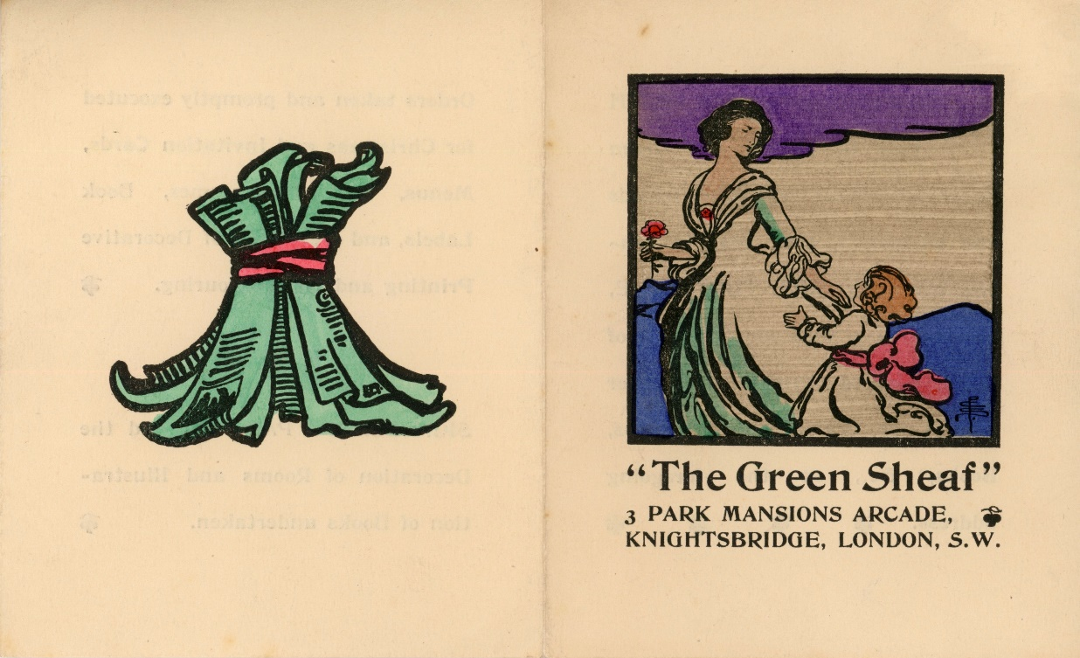
Figure 4.1 The Green Sheaf advertisement, c. 1904. Pamela Colman Smith Collection, Bryn Mawr College Library Special Collections.

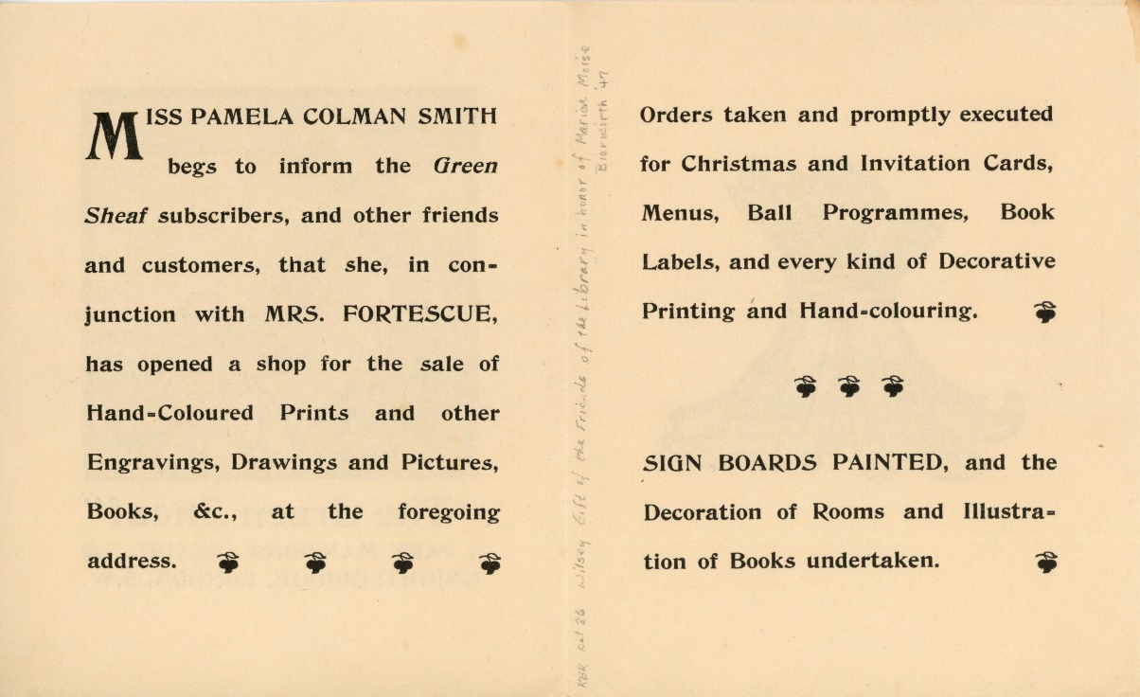
Figure 4.2 The Green Sheaf advertisement, c. 1904. Pamela Colman Smith Collection, Bryn Mawr College Library Special Collections.

Members routinely established enterprises with female friends, but at least two members did enter partnership with men, and appear to have received little public discrimination for these decisions. Brogden and Newman worked together, both dedicated to reviving societal appreciation of jewellery as an art form. Newman had also married fellow artist Philip Harry Newman and had two children, which seems to have presented few problems in her desire to work. Brogden and Newman’s union suggests that in the arts, Dyhouse’s assertion that in the nineteenth century “Married women’s work—for a wage, outside the home—was decidedly not respectable” had less resonance. A reflective article in 1902 by the expert on engravings Alfred Whitman, felt Newman and Brogden’s association was fortunate for both individuals. Newman’s “practical art training and power of design” enabled Brogden and his skillful workmen, “almost to rival the charm of the antique … while preserving much of that charm in newer forms of beauty”. Another mixed-sex collaboration can be found through the case of unmarried member Mary Lowndes. Lowndes co-founded a stained-glass firm titled Lowndes and Drury with her business partner Alfred Drury in 1897 at 35 Well Walk, Chelsea. Lowndes met Alfred Drury while she trained at Britten & Gilson’s where he was employed as a foreman. They later set up The Glass House at Lettice Street, Fulham, together in 1906. This was a series of purpose-built stained-glass workshops intended for independent artists, and was a “haven” for many craftswomen. These mixed sex business partnerships complicate understanding of the business world as having been historically organised through gendered segregation.
As with artistic studios, geographical location was essential for success. Many occupations required a vibrant urban environment. Members in London purposefully sought premises in artistic Chelsea and close to the West End. Pomona Toys was based in Chelsea at 64 Cheyne Walk in a picturesque location facing the River Thames, in an area occupied by small shopkeepers. The property itself had previously been home to a popular restaurant called The Good Intent, a known haunt for artists. The shop later moved to 14 Holland Street, and had separate workshops at 28 Gunter Grove. At these carefully selected sites, Pomona Toys found a steady market of customers. Newman’s first shop was located at 18 Clifford’s Street, just off New Bond Street. The areas around Bond Street became for many well-off women at the fin-de-siècle, in the words of Jessica Clark, a “symbol of elite associations and activities, a spatial representative of metropolitan female society”. Connected to this prosperous network of female beauty business owners, Newman’s jewellery enterprise thrived. In 1897, she tactically moved her business around the corner to the respected address of 10 Savile Row, where she asserted her position as a female jeweller in the heart of the men’s tailoring district.
For other members, the countryside offered an amenable location. Katharine Adams secured a steady trade in Lechlade, whilst Annie Garnett had a thriving business in the Lake District. In this conservative, rural environment however Garnett had to disguise her activities by calling herself an “Honorary Manageress.” She justified her actions through asserting a philanthropic desire to help the women in her village. By contrast, Colman Smith found little success after her move to the countryside. Colman Smith wrote to theatre director and suffragist Edith Craig in 1928 offering prints and drawings of Edith’s mother, famed actress Ellen Terry, with a price list. In the letter she mentioned she had turned a room in her house into a shop to try and sell her illustrations, although had sold nothing. For Colman Smith, her home became the only space she had available to exhibit her artistic skills and to try and make money, but this appears to have had little success away from the capital.
Members who owned artistic businesses consistently asserted a dedication to invigorating lost traditions and old historical methods as the key marketing strategy. Dawson’s book on enamels included a detailed history of the craft spanning several hundreds of years, whilst Woodward advised trainee metalworkers to track down jewellery from the Middle Ages alongside instructing them to inspect “the good examples of heavy elaborate pendants of the sixteenth and seventeenth century” at the British Museum. One article about Newman wrote: “There is something far more than the clever businesswoman, or even the skilled worker about Mrs Newman”. Instead she was “a student of ancient history and art. Her productions are more than mere trinkets, they recall and preserve the beauty of the world’s early designers … She has exalted the ordinary craft of the jeweler into a fine art”. The virtues of being a good artist, a respectable craftswoman, and a scholar of history intertwined and provided the route through which women forged new positions.
By the early-twentieth century there was an active circle of London-based female business owners advertising their small art enterprises in supportive publications. In 1910 The Englishwoman encouraged women to visit the studio of trained artist and photographer Agnes Jennings at 10 Charles Street and the “portraits she has lately taken of eminent men and women of the day” before visiting a Mrs Wright at 49 Old Bond Street who painted “hand-pierced and embossed silver casement teapots”. One could then walk to see the leather work of Roberta Mills at The Studio on Baker Street. In this same shop artistic dresses could be procured which were “purely hand-embroidery of the best craftsmanship”. Advertisements from the following year demonstrate the spread of metalwork as a remunerable business option for women (Figure 4.3). Member E. C. Woodward and her partner Agnes Withers advertised here, an advertisement which appeared regularly in this feminist publication, as did advertisements for Mary Lowndes (Figure 4.4), but also included were advertisements for their female competitors, non-members such as Florence M. Rimmington, metalworker and Beth Amoore, a Chelsea-based “craftswoman in repoussé and enamel”. The density of female artistic and craft-based entrepreneurship on display in this one publication depicts the startling new array of opportunities to women, in which WGA members participated fully.
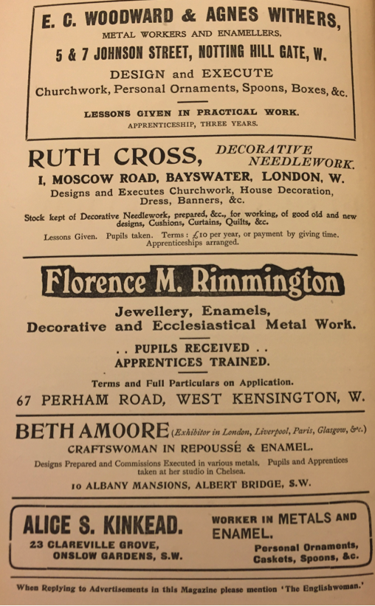
Figure 4.3 Advertisements in The Englishwoman, 9/27 (March 1911), p.xi.

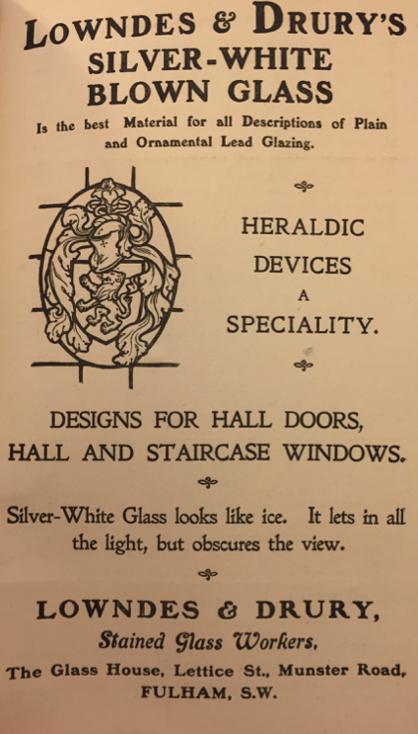
Figure 4.4 Lowndes & Drury advertisement The Englishwoman, 1/1 (February 1909), p. 95.

Some members did not set up shops but rather workshops, an approach increasingly popular with women across this period. Having a workshop, and not a shop front, enabled women to carefully avoid using commercial vocabulary. Annie Garnett’s weaving workshops were set up in outbuildings in the grounds of her family home at Fairfield in the Lake District. See Figure 4.5 - Figure 4.8. E. C. Woodward started a metal workshop named Woodward and Withers with an unmarried friend Agnes Withers at 5 and 7 Johnson Street, Notting Hill Gate, c. 1905–1913. The two women produced women’s jewellery, chalices, christening-bowls and spoons, crucifixes, and even two trowels for the Prince of Wales. The workshop of Woodward and Withers must have been of considerable size as it was organised into different departments. A principal department reconstructed old jewellery, where with their team of female apprentices, they melt down old jewellery and refashioned bracelets into necklaces, and converted brooches or earrings into rings. Sometimes Woodward asked architects to sketch designs for her, although contemporary Constance Smedley noted that “naturally the craftswomen prefers to design and carry out the work according to her own invention.” Designing was the most prestigious form of skilled work for women, and as such was repeatedly exalted.

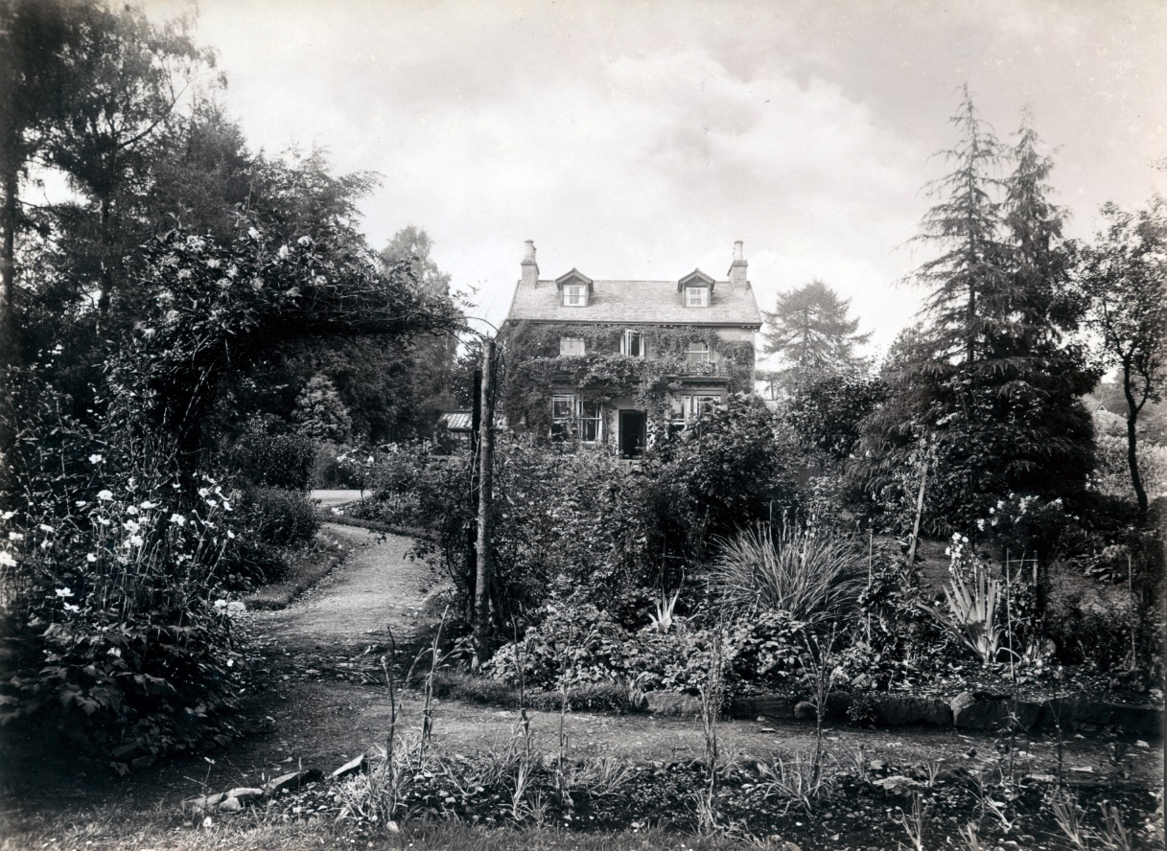
Figure 4.5 Annie Garnett’s The Spinnery. Undated but c.1890s.

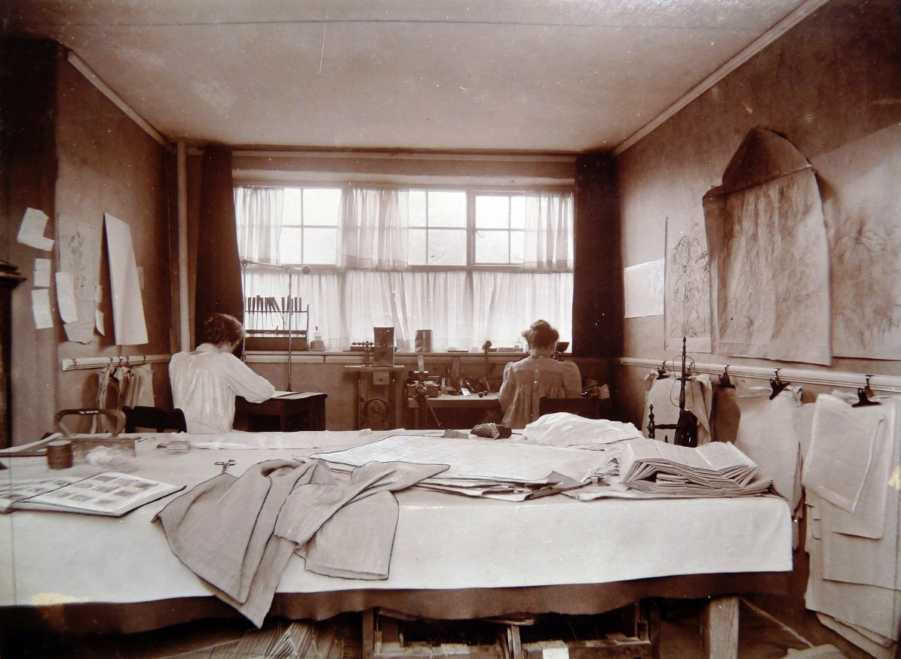
Figure 4.6 Inside The Spinnery. Undated but c.1890s.

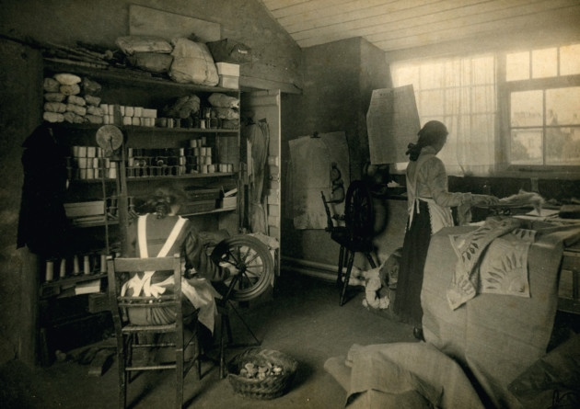
Figure 4.7 Inside The Spinnery. Undated but c.1890s.

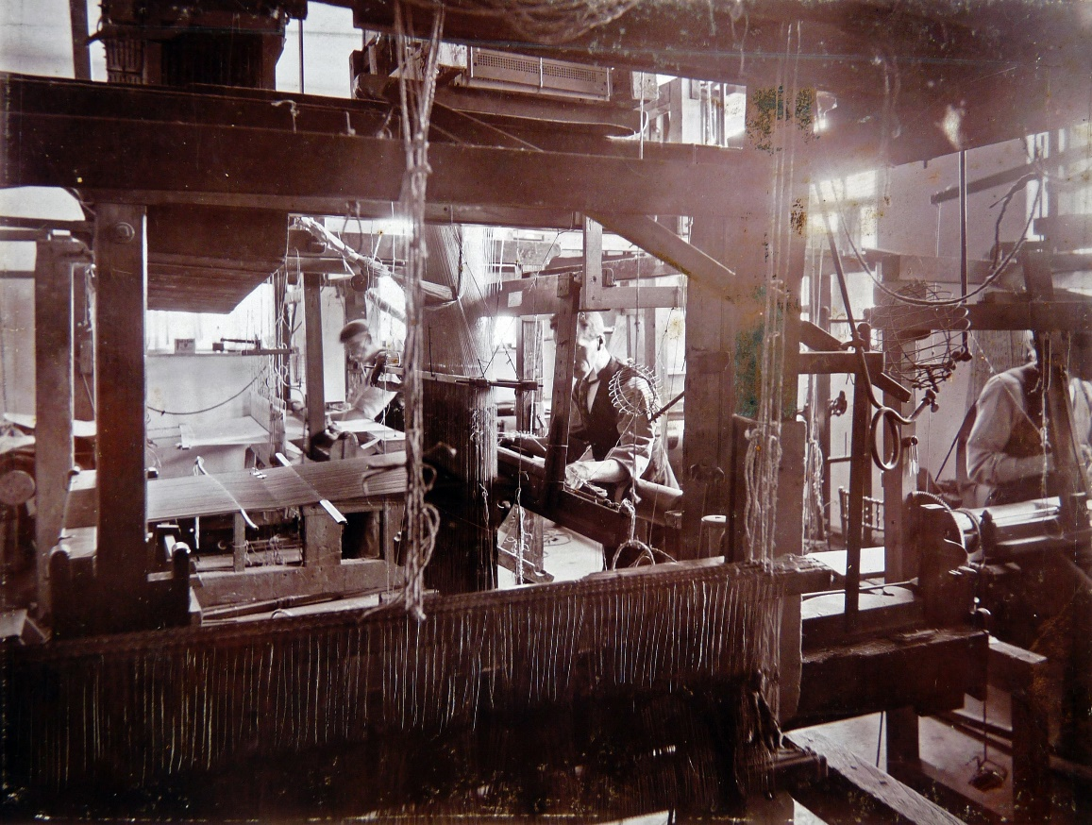
Figure 4.8 The weaving looms at The Spinnery. Undated but c.1890s.

The arts offered a way to generate an income without needing capital for a shop. Publications began to adapt requirements for women trying to make money at home. The writer Constance Smedley advised readers who wished to pursue bookbinding for an income that “The operation needs great skill, and a year’s training in a head craftsworker’s studio is essential.” However, Smedley reassured women that once trained women could pursue this craft at home as “the calling is a comparatively convenient one to follow, for only a room with sufficient space for bench, press, and a small stove is required”. Choice of field, concerns about respectability, and the need for money to set up a separate business influenced use of the home. Interior decorators Agnes and Rhoda Garrett, for instance, used their home in Gower Street as a specific marketing strategy; something Elizabeth Crawford has succinctly argued was due to the fact that, in interior design, “their home was their best show room”. The Garrett’s subverted prevailing gender ideologies and used their own domestic spaces to demonstrate expertise in the business of house decoration. Meanwhile, members, the sisters Phyllis and Delphis Gardner, founded a publishing house in their home called the Asphodel Press in 1922, firstly at 3 Cannon Place in Hampstead, and later in Maidenhead. The press produced woodcut prints, broad sheets, cards, and limited edition books. An advertisement for their publication of The Famous History of Troy showed one hundred and one copies were printed. The books were bound with blue suede and cost thirty-two shillings each. Alongside this they designed and handcarved a number of chess sets depicting famous scenes from across history, many of which were exported to eager buyers in America. The activities of these sisters, taking place in the home, but otherwise exhibiting many of the same characteristics as independent enterprises, expose a difficulty in the ways the professional endeavours of female artists have previously been analysed. Patently, it is unhelpful to understand activities which took place in the home simply as amateur pursuits.
Women also sold work in the shops of others, as demonstrated in an advertisement for antiquarian Montague Fordham’s showroom for handcrafted art at 9 Maddox Street, Regent Street, where members’ works were exhibited and sold. Figure 4.9 shows an advertisement for illustrations and plaster work by member E. M. Rope. Other women used the women’s press as a quasi-shop front, a place to advertise their wares in place of owning a shop. An unknown lady artist repeatedly advertised in Myra’s Journal in 1900: “LADY ARTIST. Paints cards, any flower, at 6d. each. Orders wanted.” Although hardly the pinnacle of artistic fame, this modern platform provided a way for women to maintain respectability through relative anonymity whilst making money.

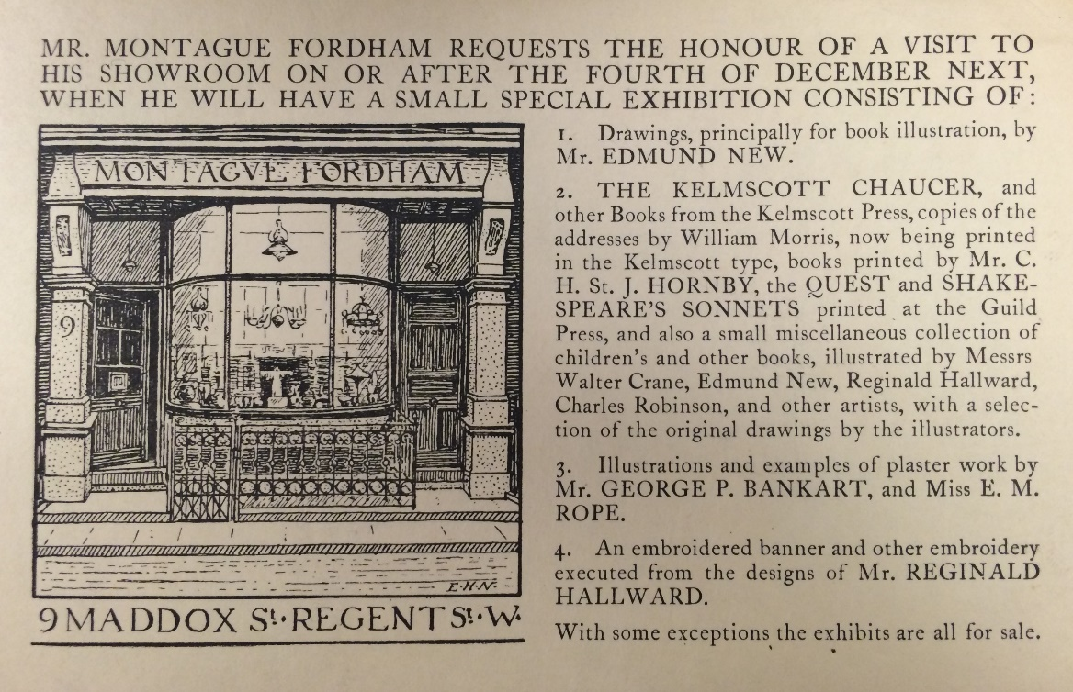
Figure 4.9 Montague Fordham’s showroom advertisement. Undated. Huntington Library MS 2000.5.3392.14.

The experiences of members were influenced by location, finances, family, the lifecycle, and personal circumstance. After World War One, E. C. Woodward, for example, gave up her metal workshop when she and her sisters moved to Bushey. She acquired a new workshop there but also began to meet clients at the Halcyon Club for professional women in London. She became significantly involved with this club, which provided rooms for female artists to meet with clients. Woodward travelled to meet clients there, conveniently arranging interviews by appointment. One meeting at the club on 28 August 1925 led to Woodward being commissioned to make a pendant, using moonstones and silver with a chain, and to repair an agate brooch for £2 15s. Developing understanding of the diversity of ways in which women engaged in business activity, often concealed within social practices in semi-private spaces, changes conceptions of how women have historically worked. This section has introduced the entrepreneurial activities of members and has shown how women worked both within and around the expectations of wider society to assert positions as business owners in the arts.

III.

Section three explores how customers were targeted through exhibitions and advertisements. There has been surprisingly little research into the customers of Arts and Crafts products, aside from the popularity of Morris & Co. pieces, where customers included wealthy buyers from country estates alongside middle-class households. Historians have emphasised the growth of large-scale consumption in London, with its grand department stores, which were at the centre of an economy fed by Britain’s worldwide commercial ambitions. The public were fixated with new department stores such as Liberty and Harrods. But nestled in the side streets nearby, and within small villages across the country, there were an array of small art enterprises filled with handcrafted objects. These small shops, and the commercial side to the Arts and Crafts movement, is a phenomenon yet to receive study, although the influence of these small enterprises was significant. Annie Garnett’s business had a customer base including clients from America and she told interviewers in 1898 she had to send out “parcels of embroideries every day, and that the sale of them last season was extremely large”. The Times told readers about “the hundreds of pots painted in lustre and colour” made by member Louise and Alfred Powell, “which are treasured in English homes” whilst The Architectural Review informed readers that “Nelson and Edith B. Dawson have already given the cachet of Craft to no inconsiderable number of such homes”. Members disseminated the work of the movement into the homes of the public through their handcrafted items, and the small size of the enterprises did not mean societal interest was small, or the customer base was limited geographically.
Some entrepreneurs tried to make items available for a wide set of price brackets. Pomona Toys, for example, advertised, “artistically designed and carefully executed toys appeal to all classes” and “Wooden Toys, large and small, to suit all purses”. Wealthy customers were however extremely attractive to female entrepreneurs. Moneyed women were sought out. Juliet Kinchin argued that there was relentless social pressure upon women “to assert their identity and status through the purchase of ‘artistic’, preferably expensive, household goods”. Clarke has provided a more positive outlook, writing “in the forum of consumption women exercised a considerable degree of free choice”. Newman proudly advertised that she was a court jeweller from 1897, and a 1902 article described her customers as “grand dames”. Apparently, women wore Newman’s jewellery as it gave them “a certain satisfaction in the knowledge that they will not see similar designs in catalogues or shop windows”. She deliberately appealed to the higher echelons of society, justifying the cost of her items, through their individuality and links to the past. In keeping with this desired audience of sophisticated female patrons, word of mouth and “At Homes” were often favoured means of advertisement. Female networks, cemented through organisations such as the WGA, provided helpful ways to disseminate knowledge about these new businesses. The jeweller Amy Sandheim was described as working for “a very distinguished circle of patrons”, of which guild member Feodora Gleichen was “one of the most constant of these.” Mary Lowndes, in an article for those hoping to become stained-glass designers, advised that women “should consider in the first place whether among the circle of her friends and acquaintances there are likely to be people who might be in a position to entrust her with such orders”.
Women did not exclusively sell to other women, and this was not just a feminised network. In Katharine Adams’ obituary, in which she was described by curator Sydney Cockerell as “one of the leading English craftswomen of this century” her bindery was said to have been “much visited by English and American tourists”. She also attracted “the most prominent book collectors in the country”. These wealthy patrons gave Adams “carte blanche commissions which enabled her to employ her utmost powers on valuable printed books and manuscripts worthy of her skill”. A number of her clients were old associates of William Morris, and Cockerell and Emery Walker would send “a constant stream of books and manuscripts to be ‘Katied’, as Cockerell called it”. Adams also found plenty of work binding local prayer books, making calligraphic exercises, and binding back numbers of Country Life for the local gentry.
Surviving advertisements help to untangle the subtle marketing strategies used to acquire customers. Advertisements were crucial in constructing the public reputation, status, and trust of women business owners; three attributes Kay has argued were “key ingredients to retailing business strategy”. Use of advertisements remained dependent on financial ability, and members, as ever avoiding commercialism, used minimal advertisements stating name, craft, and short, strategic messages. A review of the main art journals shows the approach these women implemented was similar to their male peers in the arts. Aside from Newman’s decision to brand herself as “Mrs Newman”, few gender specific details can be deciphered. M. V. Wheelhouse and E. C. Woodward deliberately hid their sex through gender-neutral names. Pomona Toys focused on the skilled craftwork at the onsite workshop and placed advertisements across major national publications such as The Saturday Review and The Studio (Figure 4.10). There was continuous emphasis that the toys were made on site and sold for reasonable prices; Figure 4.11 provides a rare photograph. Ever faithful to a wish to show the traditional nature of these handcrafted toys Wheelhouse chose for her advertisement photographs of toys depicting a medieval battle. Staged knights wielded swords in the air and rode horses. Other advertisements, not pictured, emphasised Pomona Toys were “English Toys.” Another stated: “English Toys for English children, designed and made in Chelsea, from 2s. to £5.” This tactic was to target the emergent nationalism provoked by World War One.

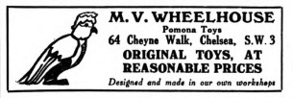
Figure 4.10 Pomona Toys advertisement The Saturday Review (25 March 1922), p. 322.

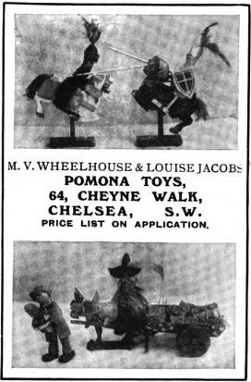
Figure 4.11 Pomona Toys advertisement The Studio, 68 (15 June 1916), p. iii.

Newman focused her energies on placing frequent advertisements in The Times. She too mentioned her workshops and the high artistic quality of her work. One advertisement proclaimed she “does not publish illustrated catalogues, but has, at moderate prices, a selection of the most Artistic jewelry. Diamonds re-mounted and jewelry re-made on the premises”. Another in 1895 wrote her “Artistic Jewelry Designs are not published in trade catalogues. She employs her own skilled workmen, alloys her own gold, and selects the finest precious golds”. Emphasis in her advertisements was, ironically, focused on asserting she did not advertise. She also used advertisements to tell of her relationship with her, now deceased manager. One explicitly stated: “John Brogden deceased. Mrs Newman, many years designer and manageress to the above, announces her new show rooms.” These adverts show the approach Newman used to appeal to readers of The Times, themes which have been touched on throughout this chapter: avoidance of commercialism, secrecy, employment of skilled apprentices and workmen, promotion of the unity of her design and craft processes; and the heritage she exploited through the traditions of her craft. These tactics were still used in 1920, now including journals such as The Sketch: see Figure 4.12.

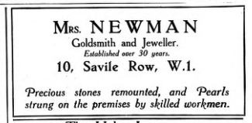
Figure 4.12 Charlotte Newman advertisement The Sketch: A Journal of Art and Actuality, 111 (1920), p. 378.

Exhibitions provided another way to entice customers. As the painter Louise Jopling informed Atlanta Magazine: “The ‘Arts and Crafts’ Exhibitions have done good service in bringing designers and buyers in touch with each other.” Members names are listed in exhibition catalogues across the major art journals: they evidently used this opportunity to assert their artistic skill whilst also advertising their businesses. Constance Smedley advised readers that exhibitions were, for the female “master craftsworker”, “a great source of advertisement and revenue.” Newman and Brogden’s artistic union reached its pinnacle at a Parisian exhibition, where Brogden received the croix de la légion d’honneur and Newman received from the French jury the unique award of a médaille d’honneur as “collaboratrice.” Similarly, Annie Garnett was awarded the “gold cross”, “the highest award of the Association” for a bleached and embroidered linen tablecloth at the Home Arts and Industries Exhibition at the Royal Albert Hall. Similarly, Pomona Toys attracted “much favourable attention at the several Exhibitions of Arts and Handicrafts” across Britain. Members competently maintained their position within the artistic milieu through attendance at exhibitions, whilst also using these occasions to spread word about their businesses. Alongside this, women discretely placed advertisements in national newspapers, the art press, and the women’s press, and used word of mouth to market their artistic products. This multifaceted approach, which has left little textual evidence behind, ensured customers were targeted across middle and upper-class society.

IIII.

This final section focuses on the environment of these enterprises, which was another key marketing strategy. Reminiscent of the WGA’s wish to use guildhalls that evoked a sense of respectability and heritage at meetings, members with enterprises validated their commitment to medievalist production through the craftsman-like environment of their workspaces. Members hired staff and apprentices and decorated the rooms with boxes of raw materials and historic tools. For those with shops, the shop provided a site where women artists could exhibit the artistic, professional, and respectable nature of their livelihoods to customers. An 1891 visit to Newman’s shop at 18 Clifford Street described in The Woman’s Signal provides insight into the marketing strategies and daily life at Newman’s business. The interviewer Sarah Tooley had initially been “a little puzzled” when visiting the “brilliant display of jewellery in West End shops” because as she approached Newman’s business she found “nothing to indicate her occupation but her name simply inscribed across the window”. Competing against a competitive jewellery trade Newman kept her shop front intriguingly bare, and said customers “come to me without advertisement; and, as a designer, I have no wish to exhibit my things in a window and run the risk of having them copied”. The fact that Newman’s jewels were not on general view encouraged customers to enter her private establishment. In a similar manner, Agnes and Rhoda Garrett advertised simply by placing “a neat brass plate upon the dark green door of No. 2, Gower Street.” These modest approaches contrast with the tactics used in fields such as textiles where lavish shop fronts and extensive window-dressing was increasingly expected.
Tooley’s article focused in detail on the interior to Newman’s premises, and the professional material culture she worked in. Entering the shop, Tooley was relieved to discover “that the treasures were all inside”. The showroom was said to be “a place of dazzling beauty.” Customers could find Newman sitting behind the long glass-lidded cases “filled with specimens of her craft.” On this instance, Newman showed-off a bracelet designed from an “original Greek Pompeii bracelet,” a brooch expertly copied from a Japanese antique, and a crystal dolphin with a black pearl in its mouth. A report of an 1893 burglary gives further insight into the daily practice of the business. Two men were charged with having stolen a diamond bracelet valued at £120 from the shop, and Newman was the person to greet, help the men select the bracelet, and make out an invoice for them. She was clearly the main person responsible for the daily management of the shop.
A postcard photograph of Pomona Toys provides a glimpse into Wheelhouse and Jacob’s approach in decorating their shop front, which differed significantly from the guarded privacy of Newman (Figure 4.13 - Figure 4.15). Pomona Toys aimed to attract potential families by putting an array of toys on display. The window shows crafted toys balanced on the windows, including carved giraffes, a hobbyhorse, and a horse-drawn carriage. The front door was enticingly open, and the sign was a simple Noah’s Ark. Working in a different field, and during this slightly later period, Pomona Toys had no need to disguise the shop front, instead using the shop window as a permanent space to exhibit the artistic nature of the toys.

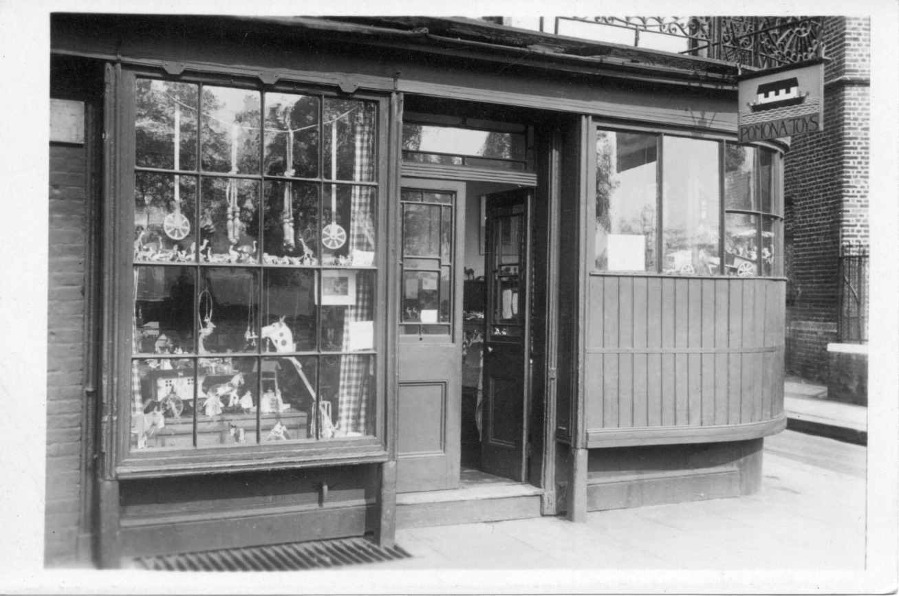
Figure 4.13 Postcard for Pomona Toys. 64 Cheyne Walk, Chelsea. Private collection.

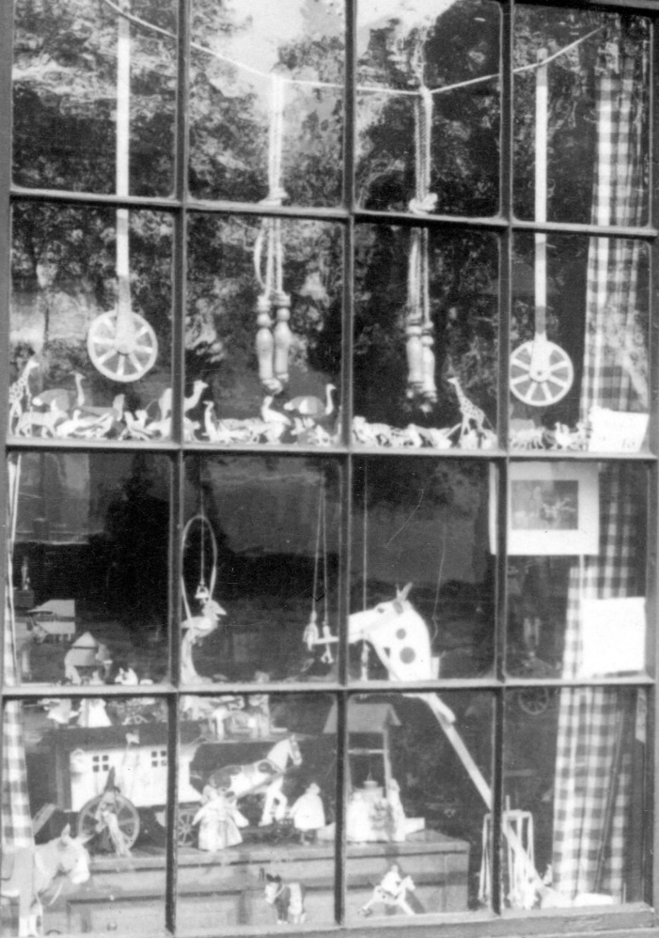
Figure 4.14 Close up of window display. Private collection.

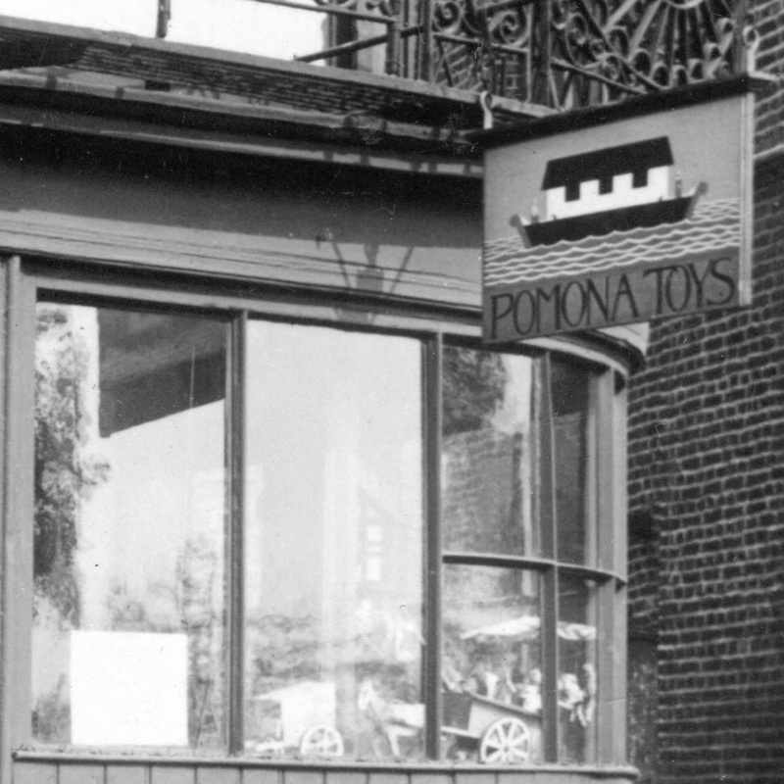
Figure 4.15 Close up of sign of Pomona Toys. Postcard. Private collection.

Workshops provided a site for women to visibly assert dedication and assured customers of the authenticity of their art. Workshop production received deep-rooted approval from those concerned about the decline of traditional methods of industry and death of old systems, such as the age-old tradition of apprenticeships. C. R. Ashbee argued that although the Arts and Crafts movement did not revolutionise modern industry it made a great social discovery: “it rediscovered the small workshop.” Edith B. Dawson told readers of Enamels that “A modern writer has laid down the axiom that an art can only be learned in the workshop of those who win their bread by it—a severe saying, but one which contains some germ of truth.” She amended this “severe” rule for herself by working at a designated workroom at home, but was keen to align her lifestyle with workshop culture.
Depictions of workshops became a focal point of discussions, with some articles reassuring readers of the woman entrepreneurs continued femininity. During an interview with Newman, Tooley had not wanted to touch unfinished jewellery items. An apprentice brought out a “grimy, smutty-looking object” from the workshop which Tooley wrote “did not look the most inviting kind of thing to handle” and although she did not like to admit to Newman her “woman’s weakness” of wanting to ask for gloves she felt sure other “girl-workers” and “lady goldsmiths of the future will solve the difficulty of the ‘hands’ as the lady gardeners have done.” Work perceived to be clean has historically held more prestige for women than work seen to be dirty, due to the association of cleanliness with moral purity. Distinctions such as these were important to middle-class women who needed to assert class distinction. Newman repeatedly presented herself as a designer, separating her role from the jewellery making in the workshop; a task she asserted was carried out by male staff. Likewise Agnes Garrett, although designing all her own plans, “first drawing them in inch scale and afterwards enlarging them to full size before tracing them”, left men to work from her drawings, which was conventional within interior design and architectural practice.
Other articles however, were remarkably ungendered in their descriptions of workshop owners, although promotion of these women as role models to other women was always a feature. Mrs Strang’s Annual for Girls marketed Woodward as a representative of the modern working-woman in 1921 (Figure 4.16 and Figure 4.17). She was photographed in her large workshop, confidently holding tools such as mouth blowpipes and footbellows for “big work”. In the photographs her hair is tied back, she is dressed in a white smock, and she looks utterly consumed by her work. Woodward’s workshop contained a number of sketches on the walls but aside from that there appear no domestic touches. She informed readers she felt jewellery making was “perhaps specially suited to women, who, being the chief wearers of jewellery, should know what they want.” The material culture of the workshop conferred upon women art workers the legitimacy afforded to professional artisans. Woodward mentioned the plethora of tools she used, including: “the mouth blow-pipe, a long taper tube bent near the point … pliers, tweezers, files, hammers, shears, spring dividers … ” This demonstrated her serious commitment to her craft. “Such are the most important of the hundred and one things that go to make up the fittings of a workshop,” she lamented. Woodward was keen to encourage other women to participate in workshop culture, extolling women to take up “the bigger and heavier branches of metalwork” such as the construction of altar furniture and processional crosses for churches. She was however sensitive to the problems this could present for female readers, as this “bigger” work was costly and less practical. Practitioners would need to acquire “a more isolated and regular workshop, as neighbours often object to hammering … a metalworker is not welcome in a block of studios, and such work is certainly impossible in a flat.” Finances and access to space clearly dictated ability to pursue metalwork. Yet Woodward also encouraged women who could not obtain separate premises, to pursue jewellery making as an occupation, as this could be made “in an ordinary room” at home “where the light is good and where gas is available for the blowpipe.” Workshop spaces were rarely absolutely distinct from the domestic or the social; instead a spectrum of different options were becoming available for, and promoted to, women.

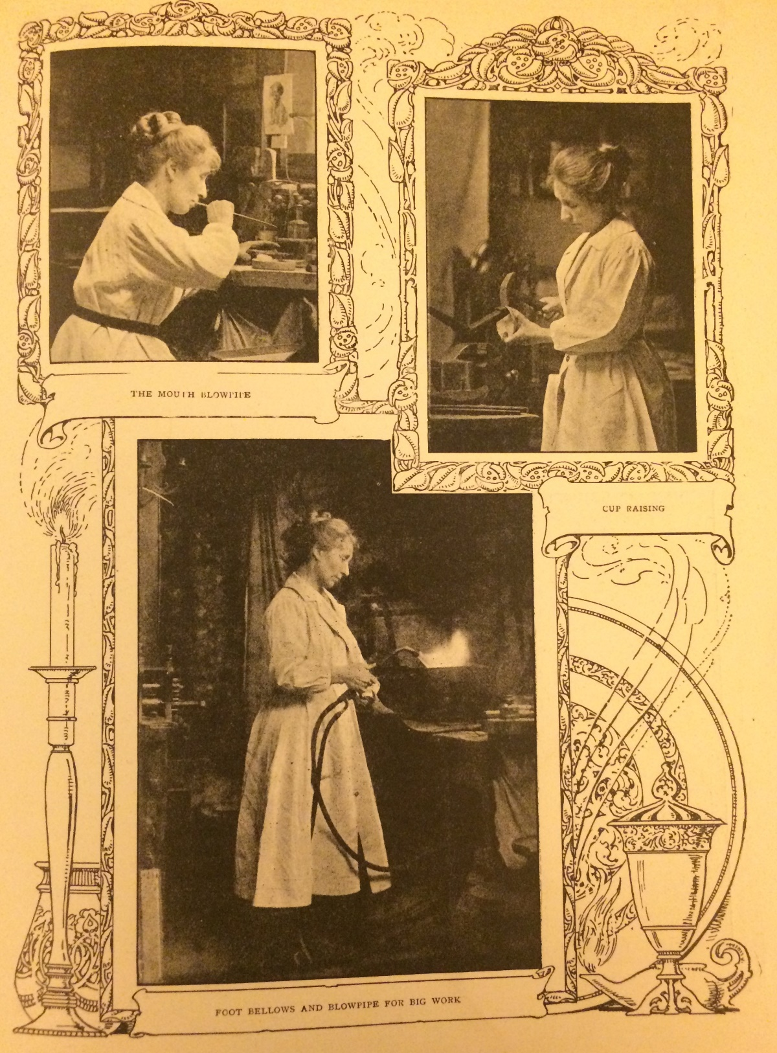
Figure 4.16 E. C. Woodward, “Jewellery and Metalwork”, Mrs Strang’s Annual for Girls (Oxford: Oxford University Press, 1921), p. 51.
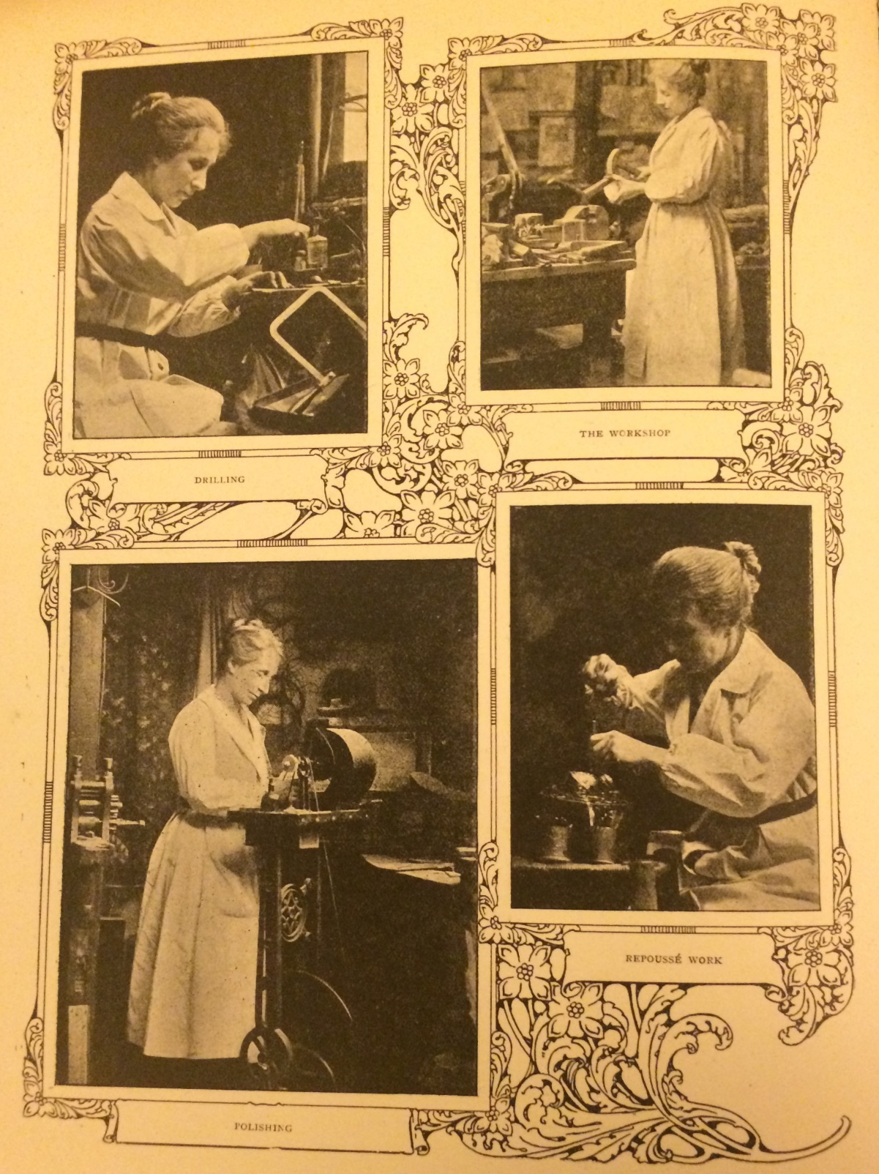
Figure 4.17 E. C. Woodward, “Jewellery and Metalwork”, Mrs Strang’s Annual for Girls (Oxford: Oxford University Press, 1921), p. 52.

As a result, the professional artistic sociability which already surrounded the homes and studios of female artists, likewise incorporated this network of workshops and commercial premises. Although neglected in modern historiography, regular workshop visits became a central activity in artistic circles, and women were deeply immersed in this culture. In 1904, artist Josephine Webb wrote to Edith B. Dawson telling her about her enjoyment of attending a “stained-glass tea party” at a workshop in Ireland. Webb listed all the stained-glass windows she had seen, noting windows by prestigious designers such as Christopher Whall, and the plans for further tea parties to “honour” art workers. Webb wrote to Dawson numerous times in 1909 enquiring about Edith’s own workshop party at her London workshop with her husband Nelson. The final letter from Webb said she had heard the Dawson’s “workshop party” was a success, and that it was “delightful and mediaeval!” Similarly, designer Gordon Russell said that when visiting Katharine Adams he was “free to wander round the bindery at any time I liked”. Adams’ credentials as an artist were directly linked to the authenticity of her workrooms. Russell had been impressed by “the absolute integrity which she applied as a matter of course to every detail of her work, coupled with her fine sense of design and intuitive skill in handling material, have inspired me ever since.” He felt her workshops had great “value to the community” as in her business the “finest traditions of a craft are upheld”.
Workshop sociability was not just intended for artistic designers and practitioners. Public participation was actively encouraged. An 1895 report in The Ladies’ Treasury told readers about a trip to see bookbinder Joanna Birkenruth in Cromwell Road during a hunt for Christmas presents. As usual Birkenruth was advertised as “the only lady bookbinder in London” and her workspace “a thoroughly artistic abode, where purchasers, and visitors merely desirous of inspecting, are equally welcome.” The hybridity and blurring of public and private conceptions of artistic space, as well as those of domestic/professional interplay discussed above, are evident. In writer Constance Smedley’s view, workshops, by the turn of the century, were effectively functioning as shops to the public. She wrote female artists were particularly involved in: “helping the public here, by beginning to regard their studios more and more as workshops, and keeping them always open and accessible”. Smedley tutored women craftworkers, writing, “the worker must learn to not mind being interrupted” and:

She must, however, encourage friendly relationships with the public, and encourage patrons to get used to the idea of dropping into the studio to see what new things are being made, and of bringing their friends to see the interesting processes. Even if the people come and do not buy, one never knows when they may recommend one’s work …

Encouraging sociability at the workshop was critical for “those master craftswomen who have large workshops”—women Smedley listed as including Woodward and Newman— “who regard their work as a serious profession, and are always engaged in creating new objects for sale and exhibition”. She wrote “it is of the greatest importance that this work should be readily accessible.” The scale of these workshop events could be large. Woodward organised an event at her Notting Hill workshop in 1907 which had over five hundred visitors in a week. Smedley reiterated their popularity, writing, “It is encouraging to note how greatly people are patronising such workshops”, describing Woodward’s workshop as “a good example of what the mediaeval workshop of a craftsman must have been.” The Studio felt similarly, signalling out Woodward’s studio for special praise in 1909, noting “There is nothing of the amateur about the studio of Miss Woodward, whose little ornaments in silver and enamel are eminently calculated to please a public that is not satisfied by the conventional machine-made produce of the shops.”
For women art workers with established shops and showrooms, the workshop was still a key selling point. As already stated, Pomona Toys used adverts to show that the toys were “designed and made in our own workshops”. In advertisements, Newman told customers her business was unique because her workshops were physically connected to her shop. She had several workers working in these workshops, although she refused to let interviewers see, saying these “skilled workers do not care to be shown off to visitors” which added to the mysterious allure of these spaces. This reinforced the rhetorical association between private spheres of activity and artistic creation, but in reality, Newman’s enterprise, all on one site, blurred the boundaries with the public commercialism of the shop. In 1902, The Magazine of Art praised Newman for her workshops, admiring this “far larger view” of the role art had in society, rather than a “merely selfish one”, feeling Newman was “looking to a future that must be beyond her time”. Promoting the workshop style of production had far greater connotations than artistic; it connected one to a group of people whom held deep rooted political and social fears about work and modern society.
Members regularly advertised they had apprentices working on site, again emphasising the dedication of the business to traditional methods. Although we have seen members often fought for apprenticeships in male-run firms, members routinely went on to employ female apprentices. Adams “had two of three assistants, artistically-dressed ladies organized and paid in the conventional way” at the Eadburgha Bindery. Garrett had “pupils qualifying for her profession, and these girl bachelors, seated upon stools, studying the mysteries of measure and proportion, and copying Early English designs, look as if they had found a congenial outlet in life”. They were trained for three years, and were expected to work from ten to four. Woodward’s female apprentices were also bound for three years. Her apprentices worked five days a week, from nine to five, with six weeks holiday a year. During the apprenticeship, Woodward had “the use of their entire time in her workshop”. They were “engaged in the practical making of all sorts of articles: every sort of work, big and small, passes through their hands. They learn resourcefulness and initiative, through working under the actual conditions of a workshop, not a school.” Woodward helped women to find their artistic style through arranging for them to have “expert lessons in designing in addition”. In contrast to Newman, Woodward was far more practically engaged in the making of objects. She taught girls to enjoy the physicality of workshop life, how “to hammer with a poker-head, to use the tool at hand. Also, they have the joy of feeling that they are executing real orders, and that the professional credit of the workshop rests to some extent in their hands.” It is clear these women—both managers and apprentices—were spending most of their daily lives working in these spaces. There was regular assertion by WGA members that this was necessary. As member Julia Bowley wrote in 1899, in response to the surge of female interest in woodcarving:

It seems as if they think it is a craft that can be turned into money at once, and not worked at as an artist, for the love of it. As a profession it is hard work, though most interesting, with plenty for the mind as well as for the hands to do … working as near perfection as possible, not to time like the mechanic. A woman ought to train herself to work six or eight hours a day, day after day, not in fits and starts.

Employing female apprentices was beneficial to members for a number of reasons besides extending to the next generation the opportunities which had only been occasionally offered to themselves. The social respectability of female art entrepreneurs was bolstered by employing women, and masked commercial activity behind a guise of philanthropy as providing work for others fell within a more acceptable category of middle-class endeavour. For some women, purposely promoting working roles for women helped to align their activities with progressive politics. Employing women was also economically expedient as women could be paid less. Little is known about the women that were employed, although apprentices and employees appears to have been lower-middle-class. Garnett felt working-class girls were too “hemmed in by tradition” and preferred to employ village girls and tradesmen’s daughters.
A small number of female art business owners took on male apprentices. In 1896 Newman male staff consisted of three articled pupils plus a large staff of working jewellers who executed her designs. Newman publicised she liked to hire male apprentices with family connections to the craft, proudly revealing one of her apprentices was “fifth in direct line who has followed the trade, and others are sons or grandsons or goldsmiths.” She felt you could “tell the difference at once in a boy whose family has not been in the craft”. Newman followed “the old system of apprenticeship” of promoting the method of “teach[ing] a boy to be a thoroughly good all-round workman”. Garnett used a similar rhetoric when she told Atlanta she had a male weaver who was “a delightful old Welshman, at work the year round, and he is able to weave all the yarns the spinsters bring in”. Newman only had a single woman, a pearl stringer, working for her. This employee was currently away “seeing about some necklaces for the Drawing Room tomorrow.” The pearl stringer was likely selected to prepare necklaces because of her perceived aesthetic competency endowed by femininity. The other male workers were based behind the scenes in the workshops. Even within these new hybrid spaces, the association of femininity with domesticity was partially maintained. Newman claimed she wished to employ more women, telling her interviewer that “Many girls have applied to be taken as apprentices, but unfortunately I have no room for them here.” The physical limitations in size of her premises apparently made it impossible for her to designate a separate room where she could train female employees, and as such Newman upheld the need to have separate rooms for women even though she herself had worked in a mixed sex environment. She was waiting till she had a more “commodious place,” and would “be very glad in the future, when I have accommodation, to receive girl apprentices.” However, although Newman did move to prestigious premises at 10 Savile Row, the 1906–1907 article by Constance Smedley described Newman as known for employing men. In fact, for Newman, forging her own reputation, her position as a “lady boss” gave her enterprise enhanced prestige. The ingrained ideal of male craftsmanship handed down over the generations was maintained, whilst, Newman subverted gendered ideologies to promote the power she had over her male employees.
Although the limitations of the women’s press as source material for the growth in female art entrepreneurship and apprenticeship is evident, a distinct picture does emerge, supported by the weight of this evidence and corroborated by snippets of external material. It is clear there was a surge in female-run art businesses, and opportunities for female training in the applied arts, between 1870 and 1930. Advertisements called for full-time female apprentices, expected to work five days a week, and established models of professional life for these women, their managers, and in the eyes of society. Apprenticeships evidently afforded a marker of learned skill for women seeking occupations, and members advertised their experiences as testament of their professionalism. These factors, alongside the physical site of the shop and the workshop, provided a way, in an increasingly competitive market, for women to separate themselves from the many other women working with little training at home.

* * *

This chapter provided a corrective to traditional accounts of female activity in the Arts and Crafts movement, which emphasise female domestic, philanthropically orientated activities, to instead focus on the growing numbers of women setting up enterprises. This approach enriches knowledge about the attempts made by women art workers to generate an income from art, how women manipulated conventions of public/private spaces for their own needs, and the range of ways middle-class women worked. It has been established that women could be heavily immersed, as producers and not just as consumers, in taking advantage of, and shaping, the thriving art market. This research contradicts a historiographical model which assumes middle-class women who worked outside of the home during this period were subject to social shame. From the 1880s, the number of reports about middle-class women working on a daily basis in artistic shops and workshops demonstrates these women were not exiled from polite society. In fact, owning a small enterprise could provide a way to establish a respected, professional identity. Members with enterprises constituted many of the most significant, well-known female art entrepreneurs in Britain, and the tactics they employed were crucial to shifting societal perceptions about women and work.
The tactics members used were shaped by their gender: this influenced choice of staff, the fields they worked in, the small-size of the enterprise, and daily use of space. A marketing tactic common in the activities of members was to promote the authentic historical methods of production to an eager public, which helped to assert the respectability of their modern businesses. Members used the language of artists and not that of commerce, designed their work using historic methods, and employed apprentices. Advertising that there was a workshop onsite was a much-used marketing tool, as it conjured a conceptual, semi-private space of historical authenticity and craftsmanship. By presenting themselves as artists rather than as shop owners, women appealed to wealthy and artistically inclined customers, as well as to their artistic peers. Some members with shops and workshops openly promoted their femininity, whilst others preferred instead to use gender-neutral initials in advertisements, on receipts, and in articles. Whatever their individual strategies, WGA members, by together asserting artistic intent rather than trade, bolstered by their new use of workshops as hybrid spaces of professionalism, commerciality, and artistic rigour, maintained adherence to the ideals of the Arts and Crafts movement, whilst also creating a new model for middle-class women to establish an income in the business world.

Chapter Five

Out of the Guildhall and into the City: Suffrage, World War One, and the Post-War Years

For the 1916 ACES exhibition, hosted at the Royal Academy’s Burlington House in London, the WGA were asked by the society to decorate a room with craftwork, as a way to represent the guild to the public. The ACES transformed the Royal Academy’s premises into a series of staged rooms aiming to demonstrate the breadth of creativity taking place in the applied arts. Alongside themed rooms by art workers which transformed traditional galleries into a “hall of heroes”, a municipal hall, and a university room, amongst others, the WGA decided to arrange the work of members to fit the theme of a “Lady’s Bedroom”. It is not known whether the guild suggested this theme or were assigned it, but in decorating their room in this visibly feminine way—at an exhibition of the finest Arts and Crafts creativity in Britain—the guild was segregated through this presentation to the public by their gender. The exhibition tactics members agreed to for this 1916 exhibition are puzzling, because as this thesis has shown, before World War One members had pursued a policy of not submitting work to female sections at art exhibitions, or exhibiting together publically as a guild. Members preferred instead the private sanctity of the guildhall, as explored in Chapter One, alongside hosting social events and exhibitions at studios and houses, as evidenced in Chapter Three. During war, however, the WGA changed tactics to publically proclaim the feminine expertise of its members in their knowledge of the appropriate design and decoration of the ideal bedroom for a woman. This chapter showcases the ways the WGA was influenced by societal changes—namely suffrage and war—and also argues that the activities of these women silence arguments that the Arts and Crafts movement was in a process of decline by the early twentieth century. Analysing the activities of this group shows their continued dedication to the movement, and the manifold ways women sought to broaden the scope of the arts in public life.
Chapters One to Four showcased the agency of members: locating how women artists altered the built environment to suit professional and personal need. However, the tactics these women pursued were also grounded within a specific historical moment. The model of professionalism the guild promoted was deeply shaped by suffrage, the wider women’s rights movement, and by World War One which caused seismic shifts to twentieth-century society. Suffrage militancy in the years immediately before the war influenced the WGA’s decision to maintain a private presence at the hall, avoiding debates about women’s rights, although in their actions they exerted a consistent commitment to female professional equality. War was a catalyst for change in the institutional life of the guild. A principal feature of war has often been seen to be its “refraction of the everyday”, upon which social practices previously considered private or sub-political shifted through the lens of war and became reinterpreted in different ways. During war, members, headed by May Morris, fitted this model, becoming far more interested in asserting a group presence in public life as dutiful citizens. Members were swept up in a wave of British nationalism, which reinforced their belief that professional women artists should use art to enact progressive changes to society. This new focus alleviated concerns about their presence as a woman’s art group. Public exhibitions, conferences, and philanthropic schemes were organised to enable members to contribute towards the war effort. Although the WGA was a small elite institution, their activities were profoundly influential, and for these women, war introduced a new realm of creative experimentation.
The historians who have analysed women’s voices of this era have focused their energies on examining the different approaches taken by feminist and suffrage organisations, in particular the constitutional National Union of Women’s Suffrage Societies, the militant WSPU, and other socialist organisations. Krista Cowman, June Hannam, and Karen Hunt, amongst others, have greatly aided understanding of these groups. Scholars, however, continue to disagree over the extent to which suffrage organisations were single-issue—focused on getting the vote—or more broadly interested in improving women’s rights. It is still much debated whether it was the militants, suffragists, or the new opportunities for women to work during war—as bus conductors, police, and in engineering, amongst other fields—which led to the enfranchisement of women. There has also been a surge of recent interest in highlighting the many different forms of feminism women were invested in. These are all worthy topics, however, this chapter is interested in casting light on the little explored topic of how suffrage and war influenced the professional tactics of women artists in the WGA, a group of women who represented the most respected women art workers of the day. There has been little exploration of how female artistic activity was shaped by societal changes across the early-twentieth century, most noticeably during the years leading up to the World War One when suffrage militancy was at its peak. By doing so, this chapter will add to these wider debates in suffrage historiography.
This chapter also seeks to dismiss the traditional argument employed by art historians who suggest that by World War One the Arts and Crafts movement had lost momentum, overtaken by societal interest in the founding of the Design and Industries Association in 1915 and new formalist art ventures such as Roger Fry’s Omega workshops. This chapter shows that across the early twentieth century the core thread of the movement continued, but was now more democratic and diffused. Many artists continued to try and inculcate society about the important social potentials of art and used the language of the “Arts and Crafts”. The activities of the WGA align with the argument made by Tanya Harrod that war actually provoked the movement into new life. The movement became a source of national pride as crafts were used to present “a bit of old England”, although many activities also continued to be “radical and subversive”. Harrod felt war “inspired Arts and Crafts leaders to take up political and social issues in the spirit of Morris at his most revolutionary. Ordinary working men were laying down their lives. Their surviving comrades might return as heroes, but, it was argued, only a craft revival would prevent them returning to dull, monotonous lives as mere wage slaves.” Michael Saler has also suggested the interwar period was the very moment “when Morris’s followers did manage to convince many within the worlds of government, industry, education and art that the cause of art was indeed that of the people”.
Harrod and Saler have shown that war acted as a catalyst in altering public attitudes to the Arts and Crafts movement—and the attitudes of its designers and makers—but there has been little emphasis on the creative input of female artists in promoting the Arts and Crafts movement during wartime, and in the aftermath. This is indicative of a widespread failure to incorporate women artists in histories of the era. James Fox’s 2015 book, which aimed to provide a comprehensive account of artistic activity during World War One, contained one lone reference to women artists, and female artistic contributions to the home front remain sorely under researched. Harrod did point out that female participation in the movement was growing; in 1906 the ACES had nineteen women members whilst by 1916 there were thirty-four. By the inter-war period Harrod suggests crafts finally offered a new generation of women space in which to operate as designers. Taking this forward, this chapter casts light on the significant efforts of professional women in the WGA who continued to actively promote the ethos of the Arts and Crafts movement during and post-war.
By taking this approach, this final chapter contributes to scholarly debates about female associational life in the interwar years. There have been numerous competing interpretations of the nature of female associations after the Representation of the People Act in 1918. Scholars traditionally portrayed the decades post-war as one of conservatism, with women who previously identified as suffrage supporters moving their focus back to domestic life. This perspective has been subsequently dissected by historians showing the vibrancy of the women’s rights movement in the 1920s and 1930s. Although often avoiding the vocal feminist rhetoric of second wave feminism in the 1970s, women’s associations were still deeply concerned about women’s rights. Maggie Andrews and Catriona Beaumont have argued interwar women’s organisations were committed to fighting for the rights of newly enfranchised women citizens, but focused on the concept of citizenship, as opposed to feminism, as the way to secure social and economic rights for women. Alison Light and Adrian Bingham have pointed to the increased public appetite for debates about femininity, domestic life, and the female body in the 1920s, arguing femininity started to take on new forms of power in public society. The changes taking place in the WGA were clearly part of a greater shift in female associational life, which responded to the thrust of emotional, nationalistic responses to war, and fed into a nationwide atmosphere post-war, in which women’s rights were still a much debated issue, but which differed in approach dependent on the needs of the organisations.
This chapter is chronological and divided into three sections. The first section draws from WGA meeting minutes and letters to argue that the heightened militant suffrage presence in the city before the war influenced the guild’s decision to avoid discussing women’s rights and its private stance at the hall, and led to an eruption of conflicts in 1912 about the opposing strategies of members. The WGA remained institutionally committed to supporting women’s equal rights within the arts. The second section proposes that the changed societal mood during war offered new opportunities for members to promote their role as artistic connoisseurs to the public, and lessened anxieties about their gendered position in public life. This is evidenced most obviously through the WGA’s relationship to exhibitions—which changed substantially—from early unease through to the design of the 1916 “Lady’s Bedroom” exhibition. This was indicative of their larger private-to-public shift in tactics. The final section suggests the way in which the guild operated from this point onwards. Although the guild went back to adopting a private, quiet stance at the guildhall, members individually contributed greatly towards the women’s movement and artistic life in the 1920s and 1930s. The WGA itself fitted comfortably within a wide sphere of female post-war organisations, and through these female networks women disseminated ideas about the role of art, and models of middle-class female professionalism, across society. Together, these three sections enable this final chapter to consider how female institutional professionalism was altered by the pressures of external demands in society, and to depict how the WGA influenced public life. Members were important interlocutors of Arts and Crafts ideals across the early-twentieth century, both amidst their artistic communities and in wider society.

I.

Section one explores the views of a large number of women artists about suffrage. As this thesis has demonstrated, the WGA attempted to function as an art organisation removed from questions about politics at the exact moment the suffrage campaign became increasingly militant; a more vibrant presence on the streets of London through use of visual spectacle. In 1905, two years before the formation of the WGA, the Liberal party had won a landslide victory in the general election, and as Diane Atkinson has argued “moderate and militant campaigners alike were optimistic about the prospects of women’s enfranchisement; there was real hope that new ideals and policies would emerge.” Suffrage organisations grew rapidly in memberships and funds. The militant WSPU even moved its offices in 1906 to 3 and 4 Clements Inn, a short five-minute walk from the WGA at Clifford’s Inn. For suffrage campaigners the public world of the city provided a crucial arena to make spectacle. In a very different approach to the WGA’s use of this area, the WSPU saw their new placement in the city as helpful for publicity, and a way to conveniently campaign outside of the law courts. Suffrage was a constant feature in the press, novels, and avant-garde theatre productions in London’s art scene, and made debates about women’s rights potent across society, and a topic of discussion difficult to ignore.
Militancy—alongside members’ ongoing anxieties about women’s art organisations being understood as amateur—profoundly influenced the WGA’s decision to refrain from commenting on, or entering, public life as a group. In fact, there is little evidence to connect other mainstream women’s art organisations with the cause. Pamela Gerrish Nunn has highlighted the lack of evidence testifying to the support for suffrage from women art groups such as the Society of Women Artists in the early-twentieth century. Whilst female art groups unquestionably advocated support for women artists, “whether they regarded themselves as feminist is a more complex question”. It would be “ultimately impossible to infer from the running of the Society, the work displayed or its manner of self-presentation, any precise political let alone militant premise; the evidence for such a conclusion is not apparent, however much a conclusion would seem probable.” This evidence contrasts sharply with the richness of female engagement in politics through visual culture displayed across the nineteenth century.
Women artists had a complex range in views about suffrage. Callen seems to suggest women in the Arts and Crafts movement had little involvement in suffrage due to their interest in socialism, and thus, had different battles in mind rather than the political emancipation of middle-class women. Since this point, Lisa Tickner has evidenced that many Arts and Crafts women, such as stained-glass designer Mary Lowndes, could be heavily involved, using their artistic skills to market the campaign, individually and within suffrage art organisations explicitly established for these purposes. This visual stimulus had a powerful effect in stimulating press interest and international understanding. Callen’s point that suffrage was often not seen as the most important battle for many working women artists is broadly supported by the evidence of WGA members. May Morris, for instance, consented to having her name included in a list of contributors to suffrage paper The Coming Citizen but was reluctant to join in any work to which she could only lend occasional aid. She hoped the paper would bring about women’s suffrage so people could then “give place to other matters”. Natasha Thoreson’s research agrees with this perspective. Her analysis of May Morris’s tour of America in 1909–10 showed the huge public interest in Morris there, and assumption that she was intimately involved in the suffrage campaign in Britain. Although Morris was said to have “shrank into herself as a snail into its shell as she was bombarded with questions about woman suffrage and such topics of the hour” in one American newspaper, overall she showed fierce commitment to female involvement in the arts, and when pushed to express her views on suffragettes specifically, she said her “interest with suffrage is linked with the guild workers in the arts and crafts.”
The WGAA reveals members’ views about the vote fell into two broad, often intersecting strands: those who wished to use the WGA as an institution to subtly, and privately, blur the gendered boundaries between the AWG, the WGA, and the Arts and Crafts movement, and the group of women whose artistic identity became subsumed within a greater desire for female political emancipation through their activities within organisations such as the Artist’s Suffrage League. This second group of women found it difficult to disconnect the WGA from their broader political stance, and became increasingly concerned about the WGA’s focus on encouraging male involvement.
In 1907, the very year the WGA was formed, Mary Lowndes, alongside a number of her female artistic peers, also founded the Artist’s Suffrage League to provide a forum for professional artists to use their creative skills to help publicise the suffrage campaign. Suffrage scholars have written about the history of the Artist’s Suffrage League and suffrage spectacle such as posters, postcards, and banners. What is less known however is that in the spring of that same year many of these same women also met to consider the formation of the WGA. Members of both the Artist’s Suffrage League and the WGA included Mary Lowndes, Mary Sargant Florence, Alice B. and E. C. Woodward, Louise Jacobs, M. V. Wheelhouse, amongst others. Although the two organisations were not officially linked, and had very different aims, there was a clear connection through membership from the beginning.
Whilst pre-war the WGA used “private” metropolitan buildings as the model through which to build its professional institution, suffrage campaigners such as the Artist’s Suffrage League tirelessly used the streets and the creation of public spectacle to demand equal political rights for women. Those WGA members attached to the Artist’s Suffrage League stitched colourful suffrage banners and marched in parades to demonstrate support. A 1908 article in The Times described a National Union of Women’s Suffrage Societies procession in which:

Thousands and thousands of women representative of every class in society, will march in procession at 3 o’clock … to the Albert-hall, where a mass meeting will be held to demand the abolition of the legal disqualification which prevents women from voting in the election of members of Parliament.

The Times took particular note of the Artist’s Suffrage League’s contribution. The league had organised the creation “of nearly a thousand beautiful banners … each different, each wrought in gorgeous colour and in rich materials, and each … of some famous woman leaders and pioneers, or of the locality whence the processionists are drawn.” The article pointed out many “distinguished women artists” had been involved, picking out women who were all at this point WGA members, such as Marianne Stokes, Mary Lowndes, May Morris, and Emily Ford. These women had “generously given their services in the production of these banners; and the result is that a display of colour may be expected such as seldom gladdens the eyes and heart of the Londoner”.
Numerous members then, separate to their involvement in the guild, were at the heart of artistic suffrage activity. Julia Chance, for example, even resigned from the WGA, giving the reason: “the suffrage movement takes up all her time and interest.” Some used suffrage marches as a direct, visual way to article their role as professionals, as was evidenced by member and stained-glass artist Mabel Esplin who made banners to represent artists in the 1909 Pageant of Women’s Trades and Professions. Often in lieu of extensive written evidence, support can also be traced through signatures on postcards or banners. Louise Jacobs designed the famed “The Appeal of Womanhood” poster whilst three other members, Pamela Colman Smith, Ada Ridley, and Alice B. Woodward, contributed stencils to ‘An Anti-Suffrage Alphabet for the Suffrage Atelier’.
Those associated with the WGA also used their skills for other political demonstrations. Honorary Associate Una Taylor worked in silk a Nationalist banner, designed by Walter Crane, “as a labour of love, and presented by her to the Nationalist party in Ireland, in order that it might hang in the first Home Rule Parliament”. May Morris was a member of the Fabian Women’s Group and designed the banner the group made for the suffrage processions of 1908. Mary Sargant Florence was a founding member and on the committee of the Women’s Tax Resistance League, for which she designed and donated a banner and badge. Alongside industriously carving out professional lives in the arts, these women also used their artistic skills to visually depict support for women’s rights.
Although on an individual level members engaged in the creation of suffrage pins, banners, and postcards, on a group level suffrage remained problematic to members wishing to minimise gender tensions as an intrinsic part of their battle for artistic equality. This included women who individually showed support for suffrage. In sharp contrast to the theatrical politics outside, members in the guildhall continued to focus their energies on trying to mirror the AWG—as shown in the first chapter to this thesis—although after the first few years there were increasing anxieties about the growing number of male speakers at WGA meetings. The problem was that key members, such as May Morris, did not want to be what they called “self-supporting” for lectures (meaning to be reliant on female speakers) or to encourage separatist strategies as the guild wanted to encourage “stimulating intercourse with … other workers outside”. Members were forever trying to balance their desire to provide opportunities for female artistic sociability, whilst also dealing with their concerns not to be ghetto-ised as a group for women. There was a certain ease to getting male speakers, who tended to be confident and well-honed to talk, and were idealised figures by many in the guild. Morris promoted male involvement, writing in the 1911 report that “one of our traditions which from the first included men in the invitations to attend our meetings and to lecture before us, is really one of our strong points as a body of artists.” Morris then emphasised that the guild was “a body of artists, preoccupied solely with questions of art”, strongly emphasising that the WGA was not to get involved with debates about women’s rights.
Unsurprisingly, however, a number of women grew increasingly concerned about the lack of direct female involvement in leading WGA discussions at the hall. They became frustrated that their already limited use of Clifford’s Inn Hall, which had seemed to hold such promise as a new site for women art workers in its first few years, was now being reduced to listening to male artists speak, rather than providing opportunities for women to show off their own artistic talents. An unnamed member wrote in 1912 that she thought the lecture list that year looked “Beautiful” but went on to say “O! I so hope they are not all professors” (and therefore men) “ … or what will Miss Ford say.” Suffrage supporter Emily Ford evidently deeply disapproved of the numbers of male speakers leading discussions, and felt the WGA should focus on female sociability.
The WGA focused its energy on emulating the AWG, but this created an inherent tension in its activities. In adapting the private, self-sufficient fraternal mechanisms and institutional structure of the AWG, and attempting to escape the connotations of amateurism associated with female artists, the women participated in their own segregation. WGA members wanted to be considered as art workers on the same level as, and linked to, the men, rather than as a sisterhood. However, their need to focus on the guildhall, and the gendered inequalities in society, meant they were unable to have the guild they hoped for. By 1912, inside and outside of the hall, tensions about the position of women in society had reached breaking point. Historians routinely portray this year and the following as the point when societal anxiety reached a climax about the escalating militancy of the suffragettes, the nationwide arson attacks, vandalism, and destruction of art works. As Lucy Delap has argued, in these years leading up to war suffrage was “demanding a more wholesale commitment that might run counter to suffragists’ other political affiliations”. The WSPU became increasingly isolated in its outlook, and other suffragists “became disillusioned with the entire campaign and looked for alternatives”. In fact, evidence of a number of WGA members’ anxieties about the militant WSPU can be seen as early as 1908 when WGA member Christiana Herringham, alongside Bertha Newcombe, sent a petition to The Times, taking care to write that the signatures were from “leading women” and not as “the act of a party or society.” These women included May Morris, Millicent Garrett Fawcett, and Beatrice Webb. There had been promise of a speech from Chancellor of the Exchequer Lloyd George at a meeting of the Women’s Liberal Federation at the Royal Albert Hall, “which had aroused a great interest and expectation among women of all shades of political opinion who desire the Parliamentary vote”. The petition was raised because these women were concerned as the WSPU planned to break up the meeting, and prevent Lloyd George from speaking: “as part of their usual tactics.” Newcombe, Herringham, Morris, and Webb, amongst many others wanted “to point out that nothing can, from any point of view, be gained by such action equal to the advantage of having a Cabinet Minister’s pronouncement on this burning question”. They felt this statement from Mr Lloyd-George must “in the first instance, be heard, and then reported, as it would be, all over the English-speaking world”. Here we can see the disconnection between the motivations of the militants and many professional women in society.
Similarly, within the WGA, internal politics became tense between members who thought the guild should take a more active stance against male involvement, and those who wished to continue to encourage the blurring of the gendered segregation of sociability in the hall. Sharon Marcus has argued that female friendship “introduced an element of play into the gender system, licensing women to be more assertive and spontaneous” with female peers than they were with men. The actions of the WGA provide valuable insight into the rupturing of opinions of a large number of professional women about how to appropriately engage as an organisation amidst a wider sphere of female political activism. At the annual meeting in 1912, the soon-to-be famed war poet Alys Fane Trotter proposed to members they needed to do more to encourage mixed-sex sociability. She suggested the creation of Honorary Associates, as a way to invite eminent male figures such as Emery Walker and W. R. Lethaby to join. These proposals led to a flurry of letters from concerned members and an “Extra-ordinary General meeting” to debate the issue. Thirteen women, all known suffragists such as Mary Lowndes and Emily Ford, wrote a joint letter of complaint arguing men should not be allowed to join as Honorary Associates, feeling it created a gendered hierarchy, worsened as it was a free position, whilst women had to pay an annual sum. It also “endorsed a policy which has of late limited the functions of the Guild almost entirely to listening to lectures.” The concern of these women were felt by other women’s art organisations, who also felt the need to keep a visibly demarcated space for women artists. A history of the Glasgow Society of Women Artists noted “the proposal to permit men guests into the Club has been many times defeated.” By 1950, rules were still strict and space was still carefully segregated, as men could be “invited any day, within certain hours, to the Dining-room, Smoke-room and Gallery but not to the Drawing-room.”
In early 1912, however, thirty-seven members of the WGA wrote to disagree with the suffragists who wanted to stop male participation in the WGA. They stated:

We welcome any means of widening the scope of the Guild, such as stimulating and interesting lectures, not only from our own members but from men and women outside. Such lectures we have been in the custom of having and they help to keep our body in touch with the work and thought of the world in a way perhaps not otherwise possible for many women whose time is much occupied.

This letter, a unique example of the views of such a large number of members, reveals the majority of these women art workers did not wish to use separatist strategies, seeing “outside” artists—which seemed to largely symbolise men—as a useful link through which the WGA could keep their body connected to the world of work.
Alongside this group letter a series of individual letters were sent. All of the surviving letters are from women who were in favour of having male involvement: making it impossible to determine whether Mary A. Sloane chose to simply keep those letters in favour of male members, or whether these supporting letters were the only ones sent. Still, these letters provide unusual insight into the contemporary views of female art workers. Illuminator Ethel Sandell thought the concerns were “excessively silly and feminine.” She warned she had stopped scribing the guild roll as “she didn’t want to go down in posterity as being involved in making the roll of a Guild of man-eaters!” Decorative painter Edith K. Martyn’s letter revealed she had had long-term worries about the motives of the WGA:

… the strong movement against it seemed to me to be from a purely anti-man tendency and to go towards weakening the Guild altogether … I have felt rather doubtful whether I ought to remain in the Guild if it stood at all for the possibly political or above tendency for years … I’ll resign if the Guild is evidently going to be an anti-man affair.

Similarly, illustrator Ethel Everett felt “that our great art should be ideally human and neither man nor woman should be excluded from anything connected to it.” Everett worked through her justifications for the WGA being separated from the male guild in the letter by writing “Tho’ of course it’s necessary sometimes to have clubs and societies for one and other. But to get a feminine element into art is a mistake which must be unless there is somewhere an interchange of ideas.” An unnamed member wrote “Personally, I do not feel strongly about it, except that I loathe the thought of suffrage sex wars being brought into it and warmly welcome new lecturers … instead of … little papers by half-baked people who think it their duty to stand on their legs because they are members.”
These letters provide evidence of the weight members placed on this issue. There was a general consensus, articulated most fully by sculptor Feodora Gleichen, that the “letter from the … malcontents seems … very vague and disconnected ... looks to me as if it was only a cloak for their real reason … the objection to admitting men at all, however of course that is my private opinion!” She felt to “Reject any form of external help, such as lectures by outsiders whether men or women is narrowing it all down to a silly sort of childish game. There can be no possible question of politics in such a society and the sort of retaliation about not admitting men as associates, because they do not admit us to their Guild seems to me unutterably small and petty.” In a later letter Gleichen did however comment that if having Honorary Associates “causes such dismay amongst certain members … that it is not of sufficient importance to allow it to make a permanent split in the Society”. Pamela Colman Smith confided in Sloane she felt members were “old enough” to know their own minds, but to her, limiting male involvement meant going against the founding principles, as it would “make this Guild into a purely woman’s affair—which it was never originally started on.” Even though the guild had been created for women in reaction to the male-only control of the art scene these women evidently did not want to associate themselves as separatist and showed remarkable distain for female self-segregation. It is important to reiterate again here that this did not mean the same women were against female emancipation, Colman Smith, for instance, created a number of suffrage posters.
At the “Extraordinary” meeting on 28 February 1913 Mary Sargant Florence, backed by gilder Mary Batten, proposed it be reconsidered that men be allowed to join the guild as Honorary Associates. However, after a vote of twenty-one for and sixteen against the principle of admitting male Honorary Associates was re-affirmed. This caused considerable frustrations, and some members felt there had been no opportunity to work through these problems diplomatically. At the October 1913 committee meeting, Mary Sargant Florence drew attention to the fact the committee had not met since the previous April and she felt the work of the WGA “could not be properly continued on during the summer in the absence of one secretary or the vice chair as the business was more than one secretary in England could deal with. She was dissatisfied with the way the guild was managed and she must resign from the Committee.” This frustration appears to have been directed deliberately towards May Morris who was often away. A scribbled note in the margin to the minute book then reveals many of the same members who had been concerned about male involvement supported her in this, as they dramatically left mid-meeting. These members then resigned, which the committee accepted “with regret.” Mary Batten added that she “entirely agreed with the protest that had been made and entirely disagreed with the way in which it had been done.” The 1913 Annual Report stated that invitations to join the guild as Honorary Associates had been sent to Una Taylor, Laurence Binyon, W.R. Lethaby, and Emery Walker whom had all accepted. The report finished by stating:

Now, the Art Workers’ Guild for reasons of their own are unable to admit women, but as far as our Guild is concerned, there is no principle involved in keeping men at a distance. It is undeniable that the principal workers in most crafts are men, and from the first our Guild has felt that the best authorities in every branch of Arts and Crafts should, regardless of sex or distinction, be encouraged to come into our midst and talk to us in the intimate and comrade-like way that is so stimulating to an artist’s work capacity.

Overall, this evidence suggests the majority of members were content with male participation. Their attitude could be seen to have reinforced hierarchies between male and female artists but sensitivity needs to be given to the specific situation female members found themselves in. These women, such as May Morris and Alys Fane Trotter, believed collaboration, rather than separation, was a more effective strategy in the long-run, even if this meant losing support from a number of women who felt the guild was failing in its original aims of providing a separated platform for women to showcase involvement in the Arts and Crafts movement. An examination of WGA activity which takes into account these outside pressures in the city and across Britain, permits greater understanding of the decisions members made within the hall, and the way suffrage fervour contributed to the guild’s focus on private sociability pre-World War One.

II.

This second section examines how World War One shaped the aspirations of the WGA and directed its energies into a new creative and civic-minded sphere of activity away from the guildhall. In 1914 the WGA, now lacking a significant number of founding members, followed the AWG to the new hall at 6 Queen Square. Meetings were now almost entirely male-led. However, when suffrage militancy abated due to the outbreak of World War One, and the move to a new hall was complete, the WGA began to participate publically in London life. Although there has traditionally been an assumption that the Arts and Crafts movement was in decline during this era, war led to an unprecedented amount of activity in the WGA. That is, of course, not to say that the reputation of the movement in Britain went uncontested. In an article for The Times in 1914 May Morris pointed out how strange it was that: “when our Belgian, Dutch, Danish, Finnish, German friends come here, when our American friends come here, to visit the original home of the ideas that have taken root in their own country, they marvel to find we have no nucleus, no visible symbol of our activity, no record of the men whose work has inspired their own schemes.” Morris was clearly responding to some general apathy towards the movement, and debates such as these were common. Ideas about the role of art in society were regularly contested and debated in the pages of the national press. The early twentieth century was a period in which Jose Harris has aptly suggested: “people felt themselves to be living in many different layers of historic time.”
The same year—1914—Morris gave a speech at the WGA annual general meeting. In this speech she reflected in detail about how she personally felt the movement to have blossomed, spoke of its increased international prominence, and presented a rather optimistic perspective of the movement’s recognition in Britain:

… from those early memories of the quickening of one side (and a large side) of the artistic life of England, one’s thought travels naturally to the latest development of the Arts and Crafts movement. This movement, long since recognised by the principal cities of Great Britain, has in the last few years received official recognition by the Government. In the British section at the International Exhibition at Ghent in 1913, you will remember a large space was allotted to the Arts and Crafts Exhibition Society, who designed and carried out a successful show. This collection, carefully chosen to represent English achievements in that line, was invited to Paris this last spring, where, under the auspices of the Société des Arts Decoratifs, it was shown at the Louvre, in the Pavilion de Marsan.

Morris schooled members in this narrative arc of how she perceived the Arts and Crafts movement to be gaining increasing recognition, and claimed 1914 as a high point of the movement.
Morris’s perspective in 1914 provides helpful insight into her perspective of the international flourishing of Arts and Crafts principles and the frustrating impact of war. Morris sought to encourage members to continue their role in helping the movement enter into this “new phase of existence—a new sphere of utility to the community.” She told members that: “The interest created by this last Exhibition made one hope great things for the future of the Arts and Crafts movement to which all of us here present belong.” Morris took care to include the guild, asserting their role, and going on to say: “Ours is professedly not a body of strenuous activities, nor do we court public attention … But we have always gone gently on our way in pursuance of our original idea of quiet development—perhaps towards something bigger and more immediately practical.”
World War One was a challenging time for artists, as schools and workshops were closed down, and materials became more expensive. Mary Lowndes lamented, to readers of The Englishwoman, of the specific problems for women artists: “‘War-prices means working for almost nothing if you have anything to sell, and paying a frightful price if you have to buy anything … How girls who pay their way are going to keep their heads above water I can’t think, for the newspapers do nothing but say that nobody must buy the things women make, because they are luxuries.” For individual members war could mean a time when energies had to be taken away from art, as depicted in Figure 5.1, a depiction of member Margaret Rope who battled to negotiate her war work alongside her design of stained-glass. War also brought about significant changes for members in the types of art they produced, and members were resourceful and adapted to these new conditions. Member Alys Trotter decided to write a series of war poems where her intention was “to present the poet as the historian, and to illustrate the different aspects and phases of the war”. Member Elinor Hallé used her artistic skills to invent anatomically accurate splints. Estella Canziani’s watercolour “The Piper of Dreams” sold 250,000 reproductions in 1915 alone and became a talisman for trench-bound combatants.

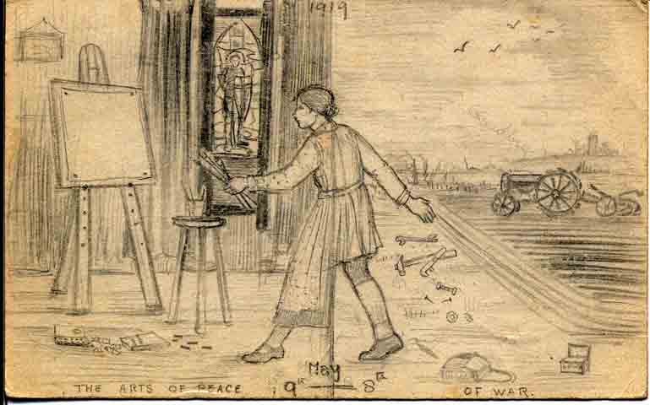
Figure 5.1 Illustration titled “The Art of Peace/of War” by stained-glass window maker, M. E. Aldrich Rope (1919). Private collection of Arthur Rope. WGAA.

War altered how artists thought about themselves, their art, and their role in society. C. R. Ashbee argued that whilst war changed “everything”, the wars “commercial vandalism” also made “men turn to the past as to a citadel that had to be defended.” War invigorated pubic appreciation of the arts and architecture, and raised concern about the historic landscape of London due to the repeated destruction of buildings. These debates can be seen reflected in a number of contemporary papers given at WGA meetings at 6 Queen Square. W. R. Lethaby gave a paper titled “Tidy up London” in 1917 and Henry Wilson gave a paper titled “History, Civilisation and Reconstruction” in 1918.
As established, scholars have asserted the conservative retrenchment of the AWG by the early-twentieth century, feeling it failed to innovate and modernise. The activities of the WGA have not been included in these debates. The WGA, in fact, were keen to discuss new progressive ideas. Although by no means always radical—even if they did consider themselves “modern” in artistic style—members were eager to gain insight into differing approaches to artistic expression, continued to experiment with different tools, artistic styles, and absorbed a variety of artistic influences. These women distributed ideas about art and society across their social and professional networks. This interest is demonstrated in the WGA’s excitement when the painter Roger Fry was asked to lecture in 1915, which he did, telling May Morris he would “be delighted to lecture in Post Impressionism at your Queens’ Square Guild … Would you like me to say something about the new ideas in applied art?” The WGA also targeted young women studying at art schools, sending out information and cards advertising lectures and giving reduced rates for student attendance from schools such as the Royal College of Arts. In return, the WGA received invitations to events hosted by these schools. For example, in 1916, the guild was invited by Goldsmith’s College to view the technical work of etching. In return, a number of women with different approaches to art, often not traditionally associated with the Arts and Crafts movement, began to join, such as Elsie Henderson, the maker of lino prints and designer of posters for the London Underground. Here, in practice, we can see the convergence of different artistic mediums, and the impact the WGA and the Arts and Crafts movement continued to have on twentieth-century society.
During war the WGA engaged in activities which took them away from the hall and into the city, and the guild built a reputation with other female organisations across Britain. They collaborated with Ethel Spiller in 1914, the Honorary Secretary of the Art Teachers’ Guild, who invited members to lectures and sent tickets. The Art Teachers’ Guild was an association for women teachers that proclaimed “If art is to be national its ethical value must become a social part of the fabric of our life.” Many women artists during this period held partial employment as teachers alongside their artistic careers. Spiller had recently given a presentation to the Prime Minister Herbert Asquith on “Art and Education” and the WGA urged her to speak at the hall. The WGA also exchanged letters with Kaye Shuttleworth, who established the Gawthorpe Textile Collection. Shuttleworth sent particulars about a new society for “helping arts and crafts” in 1915, and there were discussions about hosting an “informal guild show” in support. There are many other examples. It is clear that the WGA were starting to link their activities to a broader network of middle-class women who were adapting and circulating artistically minded principles about the role of art in twentieth-century society, with particular emphasis on the role of art in education.
The institutional life of the WGA became entirely focused on contributing to the war effort. In November 1914, the committee consulted members “with a view to the Guild doing something to help the refugees or other victims of the war.” In early 1915, Estella Canziani wrote suggesting support on a rather more grand scale, requesting members combine their artistic efforts and make a frieze for Belgian refugees based at Earl’s Court. May Morris, Pamela Colman Smith, Ethel Everett, Lola Frampton, and Eleanor Rowe all volunteered. These members made an 83 foot by 5 foot frieze for the Women’s Recreation Room at the Belgium Refugee Camp at the request of the authorities. A card reveals an officer asked the WGA: “to visit the Workrooms, Clubrooms and Schoolrooms for women and children, and to inspect the Frieze designed, painted, and presented to the Camp.” (See Figure 5.2) Members painted their designs onto the walls of this temporary establishment, although, unfortunately, it is not known what this frieze depicted as it does not appear to have survived. That the guild had been specially requested to design a frieze for the Women’s Recreation Room shows it was felt female artists would have particular aptitude in its design. The feminisation of the guild’s activities are evident, as they entered the public sphere, as members asserted their feminine knowledge, as a way to engage with this section of the public. War provided a way for members to acceptably publicise their activities, taking focus away from their activities as a segregated female art group, but in other ways reaffirmed tropes that social practices should be appropriately divided by the gender of the individual.

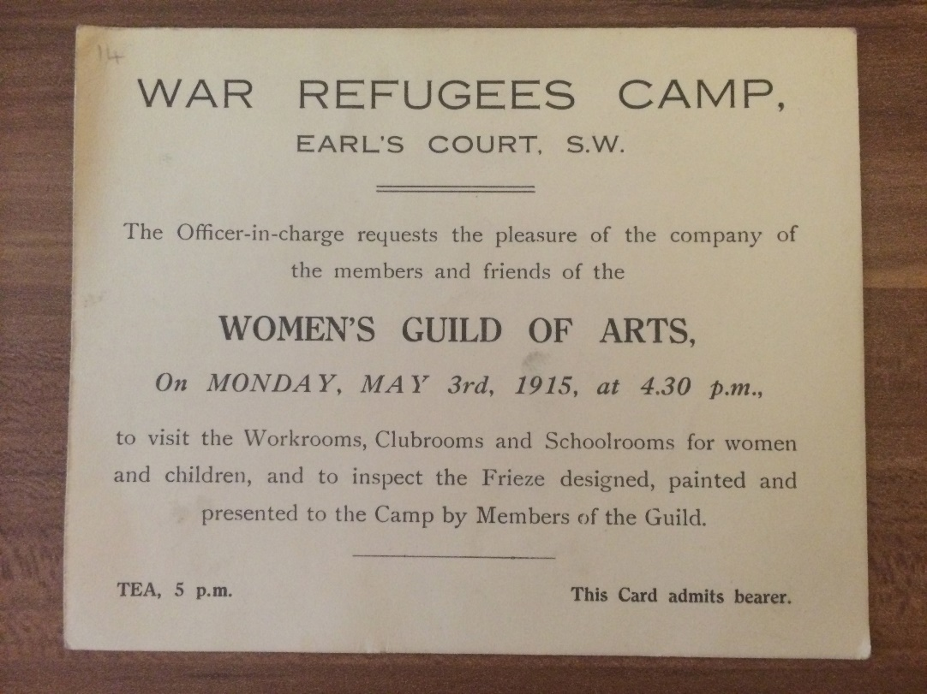
Figure 5.2 Card requesting WGA members and friends visit the War Refugee Camp at Earl’s Court. May 1915. WGAA.

The wartime activities the WGA arranged were regular and were intended to include the public. On 27 June 1916, A. J. Dickinson discussed at a general meeting her experiences with a hospital unit in Serbia and as a prisoner of war. Examples of Serbian crafts were on view, and the meeting was addressed by Serbian visitors, among them the Chief Officer of the Army Medical Service. A card from 1917 attests to an “At Home” hosted by Mary A. Sloane, at the studio of Maud Beddington at 9 St Paul’s Studios, where Serbian handicrafts and etchings were on show, as part of a series of exhibitions by the Serbian Relief Fund. Each day Dorothy Radford, organiser of the Serbian Relief Funds workrooms in Corsica, spoke on Serbian handicrafts and design. The same year the guild was asked to undertake embroidery teaching at the Bethnal Green Military Hospital. Violet Cooper consented to do this work: “Her aim has been to develop the men’s individual gifts, and the results have been very interesting.” Members were also told of an opportunity being run by the WGA for “the training of disabled and discharged soldiers in Hand weaving and in Hand Dyeing of materials”. The course consisted of six months training in a country neighbourhood, after which facilities were given for taking up work. A number of these ventures were primarily organised by individual members but membership of the WGA allowed them to draw from their team of female friendships and to advertise these charitable events more productively. Undeniably, many of these events were idealistic and were not long-term successes, but during the war years and immediately after they were seen in artistic circles as vital for the future survival of British society.
By 1916, the WGA had decisively shifted from its private prewar motivations as members organised a public conference titled “Art and the Public”. The conference took place at 6 Queen Square and fliers announced the event was to “bring about a closer understanding between art-workers and writers on art, so that the public might be informed of the need for art in modern cities”. Headed by May Morris, W. R. Lethaby, and an unnamed female subcommittee, the event was intended “to encourage support from prominent art-workers and art critics”. A flier was created which stressed the role of art in the city:

We wish that those who write about the Arts and those who work at them should meet and talk together, and consider the need of laying stress on the wide and natural aspect of Art, so that the public may come to view it familiarly and as part of the practical everyday life of the City.

A letter Morris read to the WGA gave details about this meeting, which was “to talk over the relation of Art to public life, and the desirability of widening the scope of art-criticism, and of turning some part of its activities into productive channels for the welfare of the nation.” In Morris’s opinion war had “awakened a sense of citizenship throughout the country, and we think that the feeling, after concentrating on the immediate needs of production for War, will develop demands of less material nature, demands for a wholesome and dignified public and private life.” She promoted the idea the WGA hoped to:

foster these demands; we wish to focus them and give them voice; and we hope that many of the large group of able writers on art, whose work up to the present has, by long custom, too generally been limited to the consideration of shows of pictures, &c., unrelated to public life and the beauty of the city, will feel disposed to take a larger view of art, and use their influence, their power in the press, by directing public taste and stimulating effort towards bettering of towns and public services.

The WGA firmly articulated the role that they felt they, as a group of women, had to play, alongside their male artistic peers, in reconstructing modern society. The guild used their location as an advantage. Its ready connections with the AWG enabled them to enter these debates with ease. There were many influential speakers, including George Bernard Shaw, Lawrence Binyan, and William Rothenstein. At the event Lawrence Binyon “urged the creation of a Ministry of Fine Arts” and W. R. Lethaby lamented that editors continued to exclude architecture and the applied arts. The Burlington Magazine praised the “admirable intentions” of Morris in organising the event but lamented the “not very effective discussion about art critics” which took place, dominated by the views of William Rothenstein and the views of “retired veterans” D. S. MacColl and George Bernard Shaw. Morris felt differently, discussing the “sense of citizenship” the meeting had raised, and the need for art workers “to raise their voices and assert themselves, not as a sheltered clan of artists, but as practical members of a community who felt it their duty and their right to take part in the ordering of the life of the city.” The quote represents the shift that had taken place, and the feeling of the need to make the movement more accessible across society. It also shows the way Morris, and other women, justified their actions through their commitment to public life and their duty as citizens, an approach implemented by many women’s groups during this period.
The same year, in 1916, the WGA was asked to contribute a room for the ACES exhibition at Burlington House. This exhibition, organised by the architect Henry Wilson, was designed to be the grandest ACES exhibition in history. Wilson seized the opportunity to redesign the galleries at the Royal Academy, and to demonstrate the breadth of Arts and Crafts activity taking place in Britain within a series of themed rooms. A letter was sent by the society to all “distinguished” artists and craft workers, seeking their involvement and stating that “The Committee feel that place, circumstance, and time combine to make the decision one of capital importance, not only to the Society but also to the Nation.” Notably, the WGA were included in this list. The letter stated that the workmanship should be “the root-force of National reconstruction, and … that handicraft is the primitive, the enduring, the most potent means of individual and national development.”
The decision to host the exhibition at Burlington House was very important to the society, its exhibitors, and in public consciousness. Linda Parry, taking a traditionalist approach, argued the Royal Academy became “an institution of privilege and limited scope” by the late-nineteenth century as it continued to promote the work of painters, and showed little interest in the applied arts. Parry felt the failure of the Royal Academy to change “led to such drastic outside reform that within ten years the attention of practicing artists and the general public had been so forcefully turned away from the Academy” and “it never regained its prestigious place as the ultimate exhibiting institution for the arts in Britain.” Yet the Royal Academy continued to exert huge influence across the Edwardian period. Pamela Fletcher has argued that scholars continue to cling to the writings of Virginia Woolf and simplistically use the Royal Academy as “a symbol of the dead Victorian past”. In reality the Royal Academy represented a varied and modern site for early-twentieth century artists and the public, and it was significant the ACES exhibition was held there. The period was a “time of change and negotiation, when the seeming conflicts between old and new, academic and modern, were deeply productive ones, sparking new forms of art and new ideas about the relationship of art to the individual and the public.”
The reasons the WGA decided to design and arrange a “Lady’s Bedroom” were multifarious. May Morris set the criteria for exhibition: the opportunity to contribute to the exhibition was open “to all members” who should “submit work in the usual way” for this “interesting and well thought-out scheme.” She went on to say that she hoped members “whether exhibiting or not” would “share in the prestige of this special room. It is felt that this is an unprecedented opportunity of which we should avail ourselves to the utmost.” The event was also not segregated by gender aside from this room—many WGA members also had their work in mixed sex rooms at the same exhibition—and as such the WGA was not going back on its original aim of not exhibiting at women’s exhibitions. The catalogue provides evidence that the guild as a majority was supportive of this venture as so many members contributed works, with 131 objects exhibited. Intriguingly, many members who had left out of outrage at the decision to have male Honorary Associates in 1913 were also involved.
The “Lady’s Bedroom” was filled with items handcrafted by members and which represented, from their perspective, the ideal room for a lady. The catalogue description for the room was short, stating the room was designed purposely in a way “in which elaboration and luxury have been purposely avoided” and that the bedrooms of women could only be appropriately designed by their individual users, as “the Unseen Lady’s personality alone could supply these”. This statement suited the general ethos of the Arts and Crafts movement and the restrained mood of war time. However, the room was in fact filled with a large number of items. Three prominent features were a “richly painted crucifix” demonstrating the belief of members in Christianity, a bed with “gaily embroidered bed-furniture”, and a wardrobe. Students from the Birmingham School of Art helped paint the bed, whilst the embroidery of the hangings, the article was careful to note, had been made with wool dyed under William Morris’s direction. The quilt on the bed was illustrated with a Russian prayer: “for the beasts who have served humanity in the present War.” The wardrobe was arranged to display: “embroidered clothes, and various trinkets, and a small collection of books, also the Roll of Membership of the Guild.” The embroidered clothes included a cloak by May Morris and a white dress designed by Jane and May Morris. The short text in the catalogue admitted that the wardrobe “it is true, has a touch of her, but no more than a touch”. The Daily Mail saw the room as the ultimate expression of femininity: “No more dainty bedroom for a child princess can be conceived than that which Miss May Morris has arranged.” The guild went together to observe the room, which was described as “most successful and very well attended” and afterwards went for a “very enjoyable tea party at Miss Rowe’s club by her invitation” to discuss the event. In the minute book it was also noted shortly after that the guild had received a letter from a Mrs McDowall who had been to the exhibition, praising the “Lady’s Bedroom” greatly, and “desiring advice on the furnishing of a small flat.” Evidently this exhibition had convinced her of the guild’s prowess at interior decoration and Morris replied to the letter offering advice.
Overall, the exhibition received good reviews. C. R. Ashbee discussed the layout of the exhibition in detail, telling readers of The American Magazine of Art how spaces at Burlington House were transformed from “old conventional galleries, with their gilded frames” into “some twenty rooms, civic, ecclesiastical, ‘domus’ with seven delightful interiors, a hall of heroes, a retrospective room, a municipal hall, a ‘University’ room, a treasury for jewels and silver work, a weaving room, and at the entrance, a painted screen work showing a reconstruction of Trafalgar Square … ” Ashbee felt the exhibition showed the “real effort that is being made to determine the proper limitations of mechanism in modern life” which he felt right to take place in “the sacred precincts of the Royal Academy.” He felt the exhibition evidenced that:

Arts and Crafts are no longer to be frill work, and pastime for rich men and dilettantes, but a part of the structure of society. They are to be ‘hung up’ no longer in gilded frames, or stuck into niches on buildings built by mechanical power. They are to be part of life.
The exhibition generated many debates about the role of art in society and although Ashbee was in many ways pleased with the art included, pointing out that the exhibition “was right, and meant a revelation to thousands” he also felt that the nineteenth-century obsession with “how we can best exhibit and ‘get before the public’ in galleries and shows” simply not enough. “We cannot go on in the old way”, he wrote, feeling art exhibitions were a “worn out way.” The ACES exhibition took place when there were great debates in society about the role of art in national life, but it did not simply represent an old order. These rooms triggered new debates about how the public and artistic elite should interact.
May Morris described 1916 as having been “a wonderful year for many of us” due to the exhibition enabling members to have “experienced the exhilaration of co-operative labour in the arts”. In May 1918 the WGA arranged another public exhibition, this time an exhibition of soldiers’ work. (see Figure 5.3) They held this exhibition at the Theosophical Society’s rooms at 155 Brompton Road, and advertised the event in The Times. A poster proudly stated that alongside the involvement of Mary Seton Watts and the committee of the WGA there were a great many high profile members of the AWG, including: Master of the AWG Earl Ferrers, President of the ACES Henry Wilson, Laurence Binyon, J. Paul Cooper, George Clausen, George Frampton, Selwyn Image, W. R. Lethaby, Robert Mitchell, Thomas Okey, Harold Speed, Emery Walker, and Arthur Yapp.” This exhibition led to the WGA being given a grant to help soldiers to take up craft under the management of Charles Spooner. As such, a study of women in the Arts and Crafts movement, shows that women—alongside their male peers—were in fact deeply involved in embracing new progressive ideas during this era, and had grand, outward-looking aims.

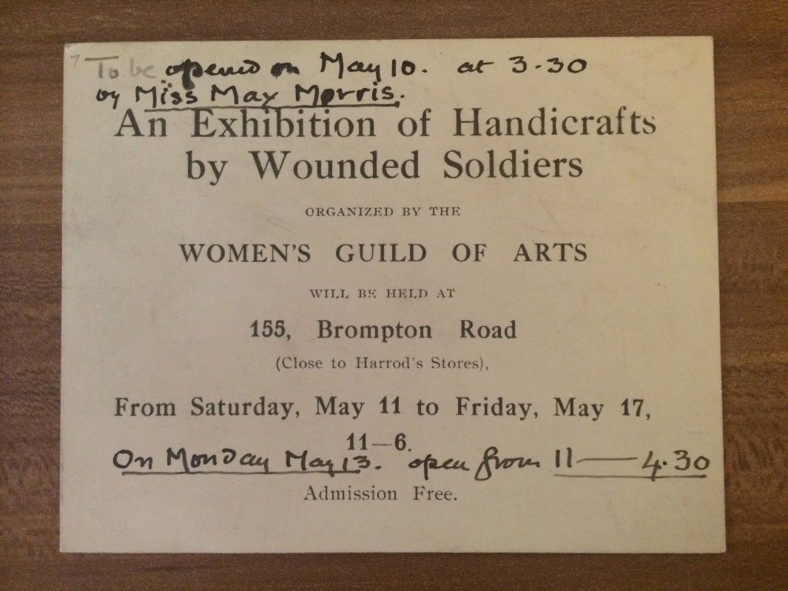
Figure 5.3 Invitation card to the Exhibition of Handicrafts by Wounded Soldiers organised by the WGA in 1918. WGAA.

III.

Post-war, there was a noticeable shift from the politicised, pre-war tensions about women’s rights in the WGA into an acceptance of the guild’s role as a women’s organisation. Helen McCarthy has argued that in the post-suffrage world after partial emancipation for women in 1918, there was a “classical feminist dilemma of how to reconcile the claims of equality with those of difference, a conundrum which underscored women’s wider public activities”. These issues are reflected in the activities of the WGA. Although archival material for the guild drops off after the war, traces of the guild’s post-war activity can be found in gallery catalogues and newspapers. The Woman’s Year Book stated in 1923–1924 that “The Women’s Guild of Arts rarely holds exhibitions of women’s work” which suggests that post-war the guild went back to its stance from earlier years. The article went on to reveal that the activities of the guild were “mainly in the direction of bringing together, in a social sense, artists and other interested persons; and of meeting to discuss art subjects and to see works of art not available for public exhibition.” However, the article did note that members had “contributed, among other things, a good deal this last winter to the Arts and Crafts show at Burlington House”. Members had also apparently submitted work to the 1922 Women’s Art Exhibition organised at Olympia, by the Daily Express, part of a mass exhibition at which 1,039 exhibits were catalogued and aimed to show off the work of prominent women artists of the day. An advertisement in Colour magazine said the exhibition would focus on “the stupendous business and social activities of the twentieth-century woman. It will be the outstanding feminine event of the year.” It appears that members continued to use the WGA for regular private social use but at the same time were happy to contribute work together at segregated female exhibitions in the 1920s.
The guild also continued its focus on events at the hall and at the homes and studios of members, in its quest to unite men and women in the Arts and Crafts movement. Members hosted a number of joint events with the AWG, one of which is depicted in Figure 5.4, and were always hopeful about mixed-sex collaboration. One letter in 1921 from Morris to the AWG suggested three joint meetings that year, but questioned if three “would be overdoing it?” There was a thread of continued collaboration with the male guild. For instance, an AWG Ladies’ Night was held in 1926 where WGA member Phyllis Gardner, alongside Noel Rooke, and C.R. Ashbee gave a paper on “Wood Engraving and Wood Cuts” at the hall. The WGA also continued to secure a future legion of women for the Arts and Crafts movement. A letter from May Morris to Mary A. Sloane in 1922 wrote that “The Committee are anxious to secure work by the ‘younger craftsmen’ for the shows at Burlington House, and one is asked to hunt about for good work. It would be naturally one of our Guild’s ‘jobs’ to help in this, and I thought at once of some of our recent acquisitions.” They had numerous letters from young women wishing to join, and in 1919 it was even noted there were hopes to create a “Business Guild’s Who’s Who” for members to learn more about each other.
The guild also increased the scope of its social activities away from the guildhall, and the committee arranged day trips for its members, usually with an architectural focus. These trips could be perceived to be the typical leisure activities of middle-class women, but in fact provided the opportunity for women to assert their knowledge and skill about history, craft, architecture, and design. Members formalised these trips through guild membership, and presented themselves as cultural purveyors. Notes from the Annual General Meeting in 1922 reported that “Mr. and Mrs. Ernest Debenham had invited the Guild to tea and to see their house and garden and art treasures.” Ernest Debenham was an entrepreneur who was the grandson of William Debenham, who created the drapery and department store enterprises. The Debenhams invited members to look around their home, part of the Bladen Estate, which was a major building programme started in 1919 to harmoniously build a new village, sympathetic to its workers. Similarly, Prudence Maufe, designer, interior decorator and later director of Heals, also invited the WGA to the property of her mother-in-law, Red House, in Bexleyheath on 8 July 1916. A flyer took care to remind members that Red House had once been the home of William Morris, “built for him by Philip Webb”.

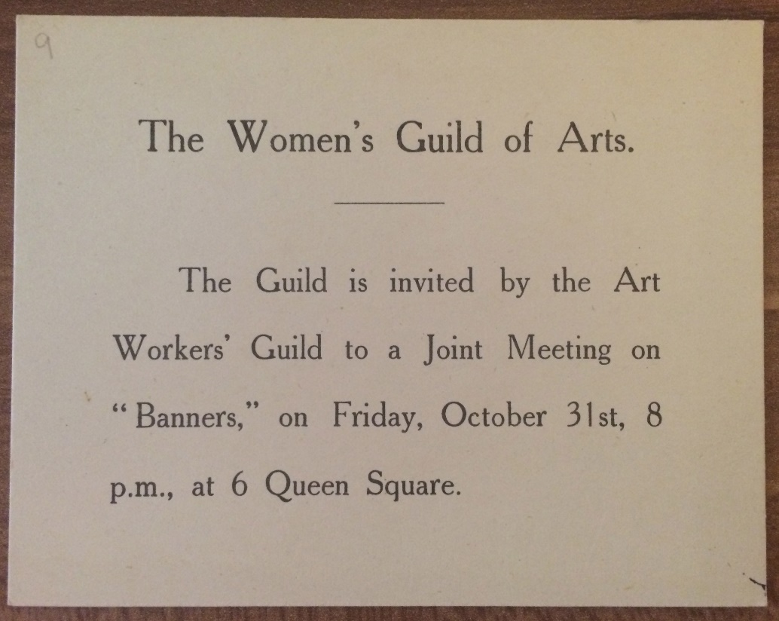
Figure 5.4 “Joint Meeting” of the AWG and WGA in 1919. WGAA.

Members also individually continued to pursue a whole range of projects: May Morris was highly influential in founding a Women’s Institute in her village, whilst others such as Freda Derrick, May Morris, and Mary A. Sloane channelled their efforts into providing a strong female presence in Arts and Crafts ventures such as the Kelmscott Fellowship, an organisation which aimed “To extend the knowledge of the Life, Work, and Teaching of William Morris”. Many of their activities fit within a broad conception of feminism. Interwoven in Sloane’s archive are letters, posters, and lists detailing that women candidates were standing for the Kensington Borough Council, giving information about the Women’s International League, and the National Union of Women Workers. Many members stayed committed to women’s political rights across the 1920s. Mary Lowndes’ last public appearances, for instance, were at a Queen’s Hall meeting in London “in connection with the full enfranchisement of women”, and at the House of Lords, “when the Bill received the King’s assent”. The WGAA only gives a glimpse of the activities of its members post-war, but it is clear that members continued to be active in the arts and in public life together. Members such as May Morris continued to remain respectful of the AWG across this era, Morris wrote in 1936 that “the Guildsmen always had the tradition of an Eve-less Paradise, though they have ever been hospitable to the Women’s Guild and on the friendliest terms”. In the long term, the WGA functioned as one of a number of women’s organisations that women artists interacted with in the interwar years, which all sought to help women carve out professional roles in twentieth-century society.

* * *

Chapter Five explored the changes that took place in the institutional life of the WGA in the years leading up to, during, and post-World War One. Members moved out of the private guildhall to interact with public society, asserting their role as a group of professional female citizens, and driven by a need to educate the public about the prominence of art in twentieth-century life. This chapter, using the new sources provided by the WGAA, began by analysing the impact suffrage had on the guild as an institution before the war. Although members could be considered feminist through their promotion of artistic equality, their professional needs and intellectual perspectives often differed to the militant tactics of suffrage campaigners in the WSPU. A large number of WGA members were however involved in the campaign as suffragists, and, in 1912, tensions reached a head both inside, and outside, of the guildhall. The members—usually those who were the most active suffragists—wished to use separatist tactics in the WGA, but other members wanted to encourage mixed sex sociability by asking male artists to join the WGA through the hierarchical position of Honorary Associates. As a result of this decision many suffrage supporters left the guild in 1913.
The next section explored how the WGA interacted with the city during war, and began to assert the importance of the guild in public life. War marked a move away from the WGA’s unease with itself as a segregated organisation for women. From this point on guild decisions became focused around encouraging artistic ventures it was thought could help reconstruct society. Analysis of the WGA’s relationship with exhibitions firmly supports this argument that the guild transitioned from a private to public focus, as during war they designed a “Lady’s Bedroom” for the 1916 ACES exhibition. After the war, the WGA functioned as a way for women to formally continue to link their activities with the continuing ethos of the Arts and Crafts movement—now broadened in scope as “medieval modernism” and other socio-artistic concepts—and provided significant emotional satisfaction for many members. The WGA began meeting within the masculine, private, nurturing home of the guildhall, buoyed by ideas of their guild as “a real power in the land”. Yet over time, while consistently negotiating the use of public and private space in the hybrid sites of the studio, home and workshop, they progressed towards having a role in public life during and post-war, seeking to familiarise the public with the Arts and Crafts movement in the twentieth century.

Conclusion
This thesis provides the first history of the WGA, the institution formed by the most highly respected women art workers active in the Arts and Crafts movement. This is not simply a history of the institution, however, and the life experiences of this group are explored in detail during the years 1870–1930 so as to effectively analyse the broader significance of these women in British society and culture. Moving away from the dominant art historical approach that focuses on individual women, this project examines the lives of approximately sixty women art workers, arguing that WGA members were central to the blossoming of the movement, and were agents of change in their communities who altered societal attitudes towards middle-class women and work.
This project offers a new model for understanding the Arts and Crafts movement, incorporating female participation and suggesting that we view the movement over a longer timespan. Women were active in the movement from its beginnings, and reached particular heights in recognition and professional opportunities by the early Edwardian era. This makes it troubling that at the very point at which female artistic engagement was expanding, the movement has subsequently been heralded in androcentric histories as having been in decline. Scholars and art institutions must stop seeing the movement as simply the—usually unresolved—ideology espoused by a cluster of male architects and designers in the second half of the nineteenth-century. The Arts and Crafts movement was a cultural and social movement which changed the philosophies, professional opportunities, and use of the built environment for many women in both noticeable and subtle ways. This argument is made throughout all five chapters by using the WGA as the case study, an organisation which has been eliminated from critical discourse: both the formal network from 1907 but also the close network these women forged throughout the final decades of the nineteenth century.
Michael Saler has used the term “medieval modernism” to delineate the diffuse flowering of male Arts and Crafts activities by the interwar period, but this term, in fact, works just as well in depicting the activities of WGA members across the years 1870 to 1930, who worked as metal, leather, and wood workers, interior decorators, painters, illustrators, writers and as textile artists. “Medieval modernism” captures the beliefs of this group of women who included antiquarians, progressives, craft workers, and those pursuing these aesthetic, historic, and social ideas through writing and lifestyle alongside artistic production. Female participation in “medieval modernism” was often gendered and followed a definable path—as depicted through the very need to form the WGA, an institution women could participate in—alongside providing an exceptionally useful avenue for middle-class women to remove their artistic activities from connotations of trade, despite their often active commercialism. As shown in Chapter Four, scholars, often captivated by the utopian sentiments of the movement, have underplayed the significant potential of the movement to generate money. A marketing tactic for all of the members with enterprises was assertion of their historical methods of production to demonstrate the respectability of these modern businesses whilst making an income.
Taking a social history approach allowed professional women in the arts to be resituated within the broader sphere of women’s, gender, and feminist historiography, which has for too long focused on growing engagement in “traditional” professions for middle-class women, such as teaching and social work. New opportunities opened up in the arts during the second half of the nineteenth century, in ways which could be more easily adapted to the gendered patterns of life with which many middle-class women wished to remain associated. Perhaps the most helpful aspect of the arts was the ability to make money from within the home: from small amounts which supplemented the family economy through to complete independence.
During this era there were many competing discourses about what it meant to be professional. Yet increasingly, these discourses, in the field of art work, included middle-class women artists; and their virtues were extolled, and sometimes criticised, in the press and printed literature, through use of terms such as “professional” and “serious art worker”. This thesis argued WGA members engaged in an active process of professionalisation, however, no single factor, for example a secure commercial income or art school training, guaranteed the designation of “professional”: the reality was more fluid. Chapter Two revealed that forty-one percent of WGA members married and the other fifty-nine percent remained unmarried, probably a deliberate strategy to maintain professional lives. Marriage and single life helped to form two distinct forms of professionalism. Those that did marry almost exclusively married men also working in artistic fields, and often collaborated with their husbands in professional practice, usually working from studios at home. Single women often had surprising freedoms, lived with supportive sisters or friends, and immersed themselves in associational life. As Chapter Five shows, female artistic professionalism was also substantially influenced by societal changes such as war, which changed the types of crafts some women pursued and imbued WGA members collectively with a feeling of their important presence as taste makers who needed to influence public understanding of the moral purpose of art.
To analyse this active process of professionalisation, the women’s use of studios, halls, institutions, homes, and workshops, in short, the built environment, were scrutinised. Women spent their working lives travelling from workshop to home to guild meeting to art lecture. Consideration of these women’s conceptions of how space influenced action and identity has elucidated the many ways in which professionalism was asserted on a daily basis. It was found that female artistic professionalism had to be continually reiterated and asserted, and spaces had to be claimed and reshaped, usually in temporary ways that have left little trace. Structuring the chapters around the principal spaces with which the WGA individually and institutionally interacted, revealed the fissures between ideals and practice and the complexities inherent in being a female artist during this era. In many ways, it was impossible to maintain an ungendered presence in society and the special high status of artistic “genius” was usually reserved for male artists. Members were intimately aware of these frictions and sought to adapt and amend understanding through the spaces they used. As such, this project is both testament to the impact of “public and private” sphere ideology on the lives of women of this era, but also of the need to evaluate how women visualised, refashioned, and “colonised” spaces.
Chapter One, for instance, revealed that members saw Clifford’s Inn Hall and 6 Queen Square as key sites within which to showcase female professionalism, but also as a way to maintain a largely private presence, far removed from the public feminised institutionalism other women’s organisations were choosing, such as the suffrage movement. These guildhalls helped to anchor their female institution through drawing from visible “male” professionalism. The position of WGA members as middle-class women also complicated understanding of their use of spaces such as the home: a place that groups of professional men could unproblematically use without the same implications of amateurism. But a study of the homes and studios of members in Chapters Two and Three also pinpointed how unmarried and married women used material culture and rooms at these sites to assert professional and cultural status within their community. Members fashioned an extensive artistic network in the city and were emotionally and professionally supported through this tactic. Although historians commonly assume bohemian artists rejected middle-class models of etiquette, WGA members and their artistic circle in fact used “At Homes” extensively to bind together their network and as a strategic tactic to assert middle-class status. These practices offered a respected way to invite a whole host of people into the home to view work. Away from the male control of public galleries, domestic exhibitions in homes, studios, and workshops—which were popular events in the social calendar—enabled the work of members to be viewed through their own curatorial management.
Moving away from the focus on high culture often necessarily adopted by art historians, this project paid close attention to what may be seen by some to be the irrelevant minutiae of daily life. But it is argued that through close study of these daily practices—such as tea parties in the studio and the exhaustive orbit of letters between members and their friends who also functioned as customers—that we discover just how central WGA members, associates, and their extensive kinship, friendship, and patronage networks were, as disciples in disseminating Arts and Crafts ideas about careful design, handcrafted objects, and the role of art, women’s rights, and labour in modern life across society. Sociability and relationships were a key theme throughout, and through this continued cultivation of middle-class standards, women quietly crafted subversive new lifestyles, whilst in the very act of compliance. Professional identity has thus been conceived of throughout this project in an expansive and elastic way. Traditional understanding of professional identity, as understood by Harold Perkin, has been enhanced to include the impact gender had on professional life, with particular focus on artistic professional life for women, an approach which should be of great interest to researchers of women’s history.
It would be wrong, however, to take from this thesis that the WGA simply forged a new feminised spatial network, separately to their male peers. A number of strategies were gendered, but these women were also heavily involved with husbands, male business partners, fathers and other male family members, male friends, and patrons. Numerous examples show that contemporaries understood women to be integral to the Arts and Crafts movement, rather than just forming a feminised strand. There was surprising societal interest in, and support of, working roles for middle-class women in the art press and national newspapers. Although anxieties about feminisation and amateurism were often present in articles, there was much admiration for the activities of WGA members, heralding them as working at the highest levels, and much promotion of their artistic entrepreneurship. Alongside the favourable reports of female exhibitions in The Times and The Studio, descriptions of the “Show Sundays” and “At Homes” hosted by members, and the many customers buying female handcrafted products which were shipped across Britain, Europe, and North America, it becomes impossible to ignore this celebration of the extensive female participation in the WGA and the wider Arts and Crafts movement. Future projects need to reevaluate the movement on a national and international level.
Gender was also by no means the only identity marker, and professionalism was substantially shaped by location, training, family support, studio access, and ability to participate in artistic middle-class social networks. Feminist scholars have problematised the fact that women were often channelled into artistic fields seen fit for women, their “nimble fingers” perceived as well-suited to enamelling for instance, but WGA members were usually deeply involved in designing alongside their male peers. It should be noted that many women actively chose to work in fields such as needlework and enamelling, and discussed their great pleasure with these crafts; as such they cannot be dismissed because they do not fit with the standards of subsequent academic feminists. Similarly, from a feminist perspective it can be hard to reconcile the ways in which married life could subsume professional identity with a positive reading of the agency of members, but we should take into account that women may have actively chosen to change or stop working at different stages in the lifecycle.
This thesis, Chapter Five in particular, was confronted with the many different types of feminism, women’s rights, and concerns about artistic equality being articulated in Britain during this era. In a similar manner to the fluidity of female experiences of professional identity, feminisms took many different forms and this project has demonstrated this in its exploration of the plurality of voices in the WGA. One key contribution this project makes is to argue that women in the Arts and Crafts movement were profoundly influenced by feminism, and usually felt that women should get the vote, but were often preoccupied by their professional desires to achieve artistic equality. The increasing militancy of the WSPU by 1912 influenced the WGA in focusing its energies on events in the guild hall and avoiding debates about women’s political rights. Caitriona Beaumont has argued that mainstream women’s groups in the interwar years focused on promoting women citizenship, but avoided the term feminism, and a similar approach can be found in the activities of the WGA as an organisation across the late nineteenth and early twentieth centuries, although individual members’ involvement in suffrage could still be extensive.
The use of different types of sources alters the way all histories are told and this project has incorporated evidence from the press, photographs, memoirs, diaries, letters, and annual reports so to, as fully as possible, evaluate how women represented themselves and how they were represented. Using the example of the women’s press here, in particular Hearth and Home and the Women’s Penny Paper, interviewers and editors showed huge support for women artists, but usually took the approach of stressing the continued feminine nature of women who chose to be artists. The physical appearance of women was repeatedly depicted as refined and feminine, their studios and showrooms as domesticated and pretty, and their crafts as dainty and delicate. Straightforward acceptance of these portrayals, imposed by the women’s press who were attempting to legitimise female activity in the face of prevalent societal concerns, preserves an erroneous focus on the use of femininity to make female art workers’ endeavours more socially acceptable. WGA members themselves, with few exceptions, did not assert their femininity publically to gain acceptance. In advertisements, calling cards, lectures, and books written by members, they took considerable care to avoid gender differences, often used initials, and asserted their authority as artists on a par with men.
Although this thesis captured the experiences of a large group of women who managed to reach the highest levels of acclaim in the Arts and Crafts movement, caution should be applied when considering the difficulties which were faced by the many creative women who did not have the money, kinship and social networks of support, or enviable locations in artistic districts. The often staggering sexism women faced should not be forgotten, and this account in no way means to minimise the uneven playing field from within which women had to fight for professional and artistic opportunities. At the same time, it is important to look past representations of patriarchy, and to move away from simply seeing certain masculine institutions in the context of male inclusion and female exclusion, if we wish to truly try to understand how women actually participated in artistic culture. It is important to accept that although patriarchal structures were a recognised part of life they did not always dictate women’s everyday lives. Additionally, although WGA members were privileged, many came from backgrounds which were not financially wealthy, and moved from, or lived across Britain, thus suggesting the significance of the movement in providing new opportunities for women from across the country.
It is hoped this project will provide a productive starting point for future interdisciplinary scholars, both in the new biographical information revealed throughout this thesis, but also through the theoretical and methodological approach. This project hints at a number of key themes which other projects could take on board. As noted, there is great need for research into the national and international impact of women in spreading ideas about the ethos of the movement, but also a need for analysis into the many close female and male friendships between artists, the interrelation between women, socialism, suffrage and the Arts and Crafts movement, and more exploration of how religious belief and educational opportunities shaped artistic practice on a national level. The women studied for this thesis were predominantly in middle age by the formation of the WGA in 1907, and far more work needs to be undertaken to explore the next generation of women—a number of whom joined the WGA—who worked as lecturers, teachers, art workers, writers, and shop owners, and who were often educated at art school in the 1920s and 1930s. Hopefully, this project will encourage such research now that the activities of the WGA have been restored to the historical record. This study has sought first and foremost to discover how WGA members constructed professional artistic identities during the years 1870–1930, and achieved this through a close study of their interaction with the built environment of London.

Appendix One
Members of the WGA

Known members of the WGA compiled from the WGAA and census records. All known biographical details have been included. There are some gaps where information could not be traced. Names have been listed as requested in the roll and so differ in terms of style e.g. some married women used their husband’s surnames, whilst other married women did not, and other women used initials. Additional information for married members has been included in italics.

Name | Artistic field | Dates | Marital status
1907
Katharine Adams  subsequently Webb | Bookbinder | 1862–1952 | Married scholar Edmund James Webb
Mary Batten  née Bott | Carver and gilder | c. 1874–1932 | Married painter and illustrator John Dickson Batten
Julia Bowley  née Hilliam | Woodcarver | c. 1872–1959 | Married statistician Arthur Lyon Bowley
Nelia Casella | Glass enameller | 1859–1950 | Unmarried
J. C. Chance  née Strachey | Decorative sculptor | c. 1864–1949 | Married barrister William Chance
Grace Christie  née Chadburn | Embroiderer and tapestry weaver | 1872–1953 | Married designer  Archibald Christie
M. Sargant Florence  née Sargant | Fresco painter | 1857–1954 | Married musician Henry Smyth Florence
Emily Ford | Decorative painter | 1850–1930 | Unmarried
Agnes Garrett | House decorator | 1845–1935 | Unmarried
Feodora Gleichen | Sculptor | 1861–1922 | Unmarried
Elinor Hallé | Enameller and medallist | 1856–1926 | Unmarried
Christiana J. Herringham  née Powell | Tempera painter | 1852–1929 | Married physician Wilmot Herringham
Margaret M. Jenkin  née Giles | Sculptor | 1868–1949 | Married civil engineer Bernard Maxwell Jenkin
Florence K. Kingsford | Illuminator | 1871–1949 | Married curator Sydney Cockerell
Mary Lowndes | Stained-glass painter | 1857–1929 | Unmarried
May Morris | Embroiderer and jeweller | 1862–1938 | Divorced, was married to socialist Henry Halliday Sparling
S. T. Prideaux | Bookbinder | 1853–1933 | Unmarried
Eleanor Rowe | Woodcarver and leather worker | 1853–1920 | Unmarried
Marianne Stokes  née Preindlsberger | Painter | 1855–1927 | Married painter and poet Adrian Stokes
Annie L. Swynnerton  née Robinson | Painter | 1844–1933 | Married sculptor Joseph Swynnerton
M. E. Turner  née Powell | Embroiderer | 1854–1907 | Married architect Hugh Thackeray Turner
Mary Seton Watts  née Tytler | Designer and Modeller | 1849–1938 | Married painter G. F. Watts
Alice B. Woodward | Designer and illustrator | 1862–1951 | Unmarried
E. Bateson | Sculptor | c. 1867 | Unmarried
Evelyn De Morgan  née Pickering | Painter | 1855–1919 | Married potter William De Morgan
Georgie Cave Gaskin  née France | Jeweller | 1866–1934 | Married illustrator and jeweller Arthur Gaskin
Ethel F. Gill | Gilder | c. 1877 | Unmarried
Jane Morris  née Burden | Embroiderer | 1839–1914 | Married designer and poet William Morris
Ella L. Moore | Embroiderer | Unknown | Married
Mary J. Newill | Embroiderer and glass painter | c.1861–1947 | Unmarried
Ethel Offer | Illuminator | Unknown | Unknown
Ada P. Ridley | Carver and gilder | Unknown | Unknown
Eliza M. Southall | Embroiderer | Unknown | Unknown
Lisa Stillman | Pastellist | 1865–1946 | Unmarried
Marie Stillman  née Spartali | Painter | 1844–1927 | Married journalist and painter William J. Stillman
E. C. Woodward | Metalworker | c.1860–1943 | Unmarried
1908
Edith Brearey Dawson  née Robinson | Enameller and painter | 1862–1928 | Married painter and designer Nelson Dawson
Esther M. Moore | Sculptor | 1857–c.1934 | Unmarried
Kate E. Bunce | Painter | 1856–1927 | Unmarried
Pamela Colman Smith | Painter and illustrator | 1878–1951 | Unmarried
Edith Goodman | Embroiderer | Unknown | Unknown
Jean Carré Hadaway  née Carré | Jeweller | 1865–1939 | Married book illustrator and jeweller William Snelling Hadaway
Louisa Preece | Metalworker | Unknown | Unmarried
E. M. Rope | Sculptor | 1855–1934 | Unmarried
Alys Fane Trotter  née Keatinge | Decorative painter | 1862–1961 | Married civil engineer Alexander Trotter
Anne Heynes | Embroiderer | Unknown | Unmarried
Clara Tustain | Embroiderer | Unknown | Unmarried
Helen Bedford  née Carter | Painter | 1874 –1949 | Married illustrator Francis Donkin Bedford
Annie Garnett | Weaver | 1864–1942 | Unmarried
Mary A. Sloane | Painter and etcher | 1867–1961 | Unmarried
M. D. Spooner née Davison | Painter | 1867–1949 | Married architect Charles Spooner
Phoebe Stabler née McLeish | Sculptor | 1879–1955 | Married silversmith Harold Stabler
Maud Beddington | Painter | 1862–1939 | Unmarried
Mabel Esplin | Stained-glass worker | 1874–1921 | Unmarried
Camilla Edith Harwood | Writer and illustrator | Unknown | Unmarried
Violet G. M. Ramsay | Jeweller | 1866– 1948 | Unmarried
1909
Lallie Ionides | Illuminator | 1871–1967 | Unmarried
E. K. Martyn | Decorative painter | 1863– | Unmarried
Winifred Austen | Painter and etcher | 1877–1964 | Married engineer Oliver O’Donnell Frick
1910
Rose Barton | Painter | 1856–1929 | Unmarried
C. I. Newman  née Gibbs | Jeweller | 1836–1920 | Married designer Philip Newman
Ethel F. Everett | Illustrator | c.1878–1951 | Unmarried
Letty Graham | Metalworker | Unknown | Unknown
Gertrude Bayes née Smith | Sculptor | c. 1870–1952 | Married sculptor Gilbert Bayes
Anna Simons | Writer | 1871–1951 | Unmarried
1911
Ethel Armitage | Lace worker | Unknown | Unknown
Ruby Winifred Bailey  née Levick | Sculptor | c.1871-1872–1940 | Married architect Gervase Bailey
Louise Jacobs | Lithographer | 1880–1946 | Unmarried
Amelia M. Bowerley | Painter and etcher | 1874–1916 | Unmarried
Lola Frampton  née Clark | Embroiderer | c.1870– | Married painter Reginald Frampton
Estella Canziani | Painter | 1887–1964 | Unmarried
M. V. Wheelhouse | Illustrator and toy designer | 1868–1947 | Unmarried
1912
H. Mabel White | Sculptor | 1870–1949 | Unmarried
Margaret Kemp Welch | Painter and etcher | 1874–1968 | Unmarried
February 1913
Myra K. Hughes | Painter and etcher | 1878–1918 | Unknown
December 1913
Caroline C. Townshend | Stained-glass worker | 1878–1944 | Unmarried
Dorothy A. A. Rope | Sculptor | 1883–1970 | Unmarried
Margaret Agnes Rope | Stained-glass worker | 1882–1953 | Unmarried
1915
Lillian M. Frost | Unknown | Unknown | Unknown
February 1917
Louise Powell  née Lessore | Pottery painter | 1865–1956 | Married potter Alfred Powell
M. E. Aldrich Rope | Stained-glass worker | 1891–1988 | Unmarried
Eve Simmonds  née Peart | Embroiderer | 1884–1970 | Married woodcarver and painter William Simmonds
April 1917
Elsie M. Henderson | Lithographer | 1880–1967 | Married French Consul of Guernsey Henri Baron de Coudenhove
Alice Gimson | Jeweller | 1882–1950 | Unmarried
May 1917
Joan Kingsford | Engraver | c.1884 | Unmarried
May 1919
Katherine Grasett | Weaver | Unknown | Unmarried
December 1919
Mabel C. Barnes  née Robinson | Painter and etcher | c.1875–1953 | Married civil servant James Burden Barnes
Marta C. Bowerley | Illuminator | c.1880–1945 | Unmarried
Eleanor Freda Derrick | Writer and illustrator | 1893– | Unmarried
Wilhelmina Margaret Geddes | Stained-glass worker | 1887–1955 | Unmarried
Kate Elizabeth Olver | Illustrator | 1881–1960 | Married Charles Higgins
Edith L. Patterson | Painter-etcher | Unknown | Married
Helen Frazer Rock | Sculptor | 1878–1932 | Unmarried
1920
Ethel Mary Rhind | Stained-glass worker | 1877–1952 | Unmarried
1921
Julia E. Alsop | Painter and etcher | Unknown | Married
Madeline Green | Painter and etcher | 1884–1947 | Unmarried
Muriel Dawson | Illustrator | 1897–1974 | Unknown
Phyllis Gardner | Illustrator and woodcarver | 1891– | Unmarried
Dorothy E. G. Woollard | Painter and etcher | 1886–1986 | Unmarried
1922
Elizabeth Cowen | Weaver | Unknown | Unknown

WGA members who are known to have joined post 1922:
G. Bowman, embroiderer
Stella Crofts, potter, 1898–1964
Delphis Gardner, wood engraver and wood carver
Isabel Catterson-Smith, painter, 1891–1996
Mrs Byron Noel, weaver
Charlotte M. Lawrenson, née Thompson, lithographer, 1883–
A. Achesen, sculptor, 1882 –1962
Beatrice Hindley, miniature flowers
R. Ratcliffe
Joane Wood
Kathleen Secker
Blance Dutton
Amy Tozer
F. E. Rowe
M. Ellis
M. S. Middlemore
Louise C. Slowde
Mrs Rooper
M. E. Stephenson
Violet Cooper
E. Winifred Hensman
Appendix Two
Honorary Associates and associates of the WGA
Associate membership was established in 1909 for “friends interested in art” in order to stimulate networking opportunities for members and to spread knowledge about the WGA. The category of Honorary Associates (which included men) was established in 1913 for particularly prestigious individuals who were asked to join and did not have to pay membership.

Known associates
C. Allen, Evelyn Armstrong, Blanche Baker, Beatrice Beddington, Mrs E. Borough Johnson, Miss Bothwell-Gosse, Mrs Wallace Bruce, Mrs Buckland, Myra Bunce, Mrs Campbell Dodgson, Estella Canziani, M. A. Cohen, Agnes E. Conway, Ellen Dakin, Alix Egerton, Ada Grasett, Winifred E. Harrison, Mrs Hare, Valentine Hawtrey, Mrs Hensman, Miss Hollyer, Lady Holroyd, Mrs Edgar Horne, Annette Hullah, Mrs Jackson, Margaret M. Jenkin, Mrs W. H. Jessop, Bertha Johnson, F. Kensington, Miss Leaf, Mrs Leeming, Mrs Massey, Mrs Sydney Morse, Miss Mostyn, Mrs Murray, Mrs Neville, Mabel Newcombe, M. Norgate, Catherine Ouless, A. G. Pike, Winifred Roberts, Gertrude Robinson, Mrs Hugh B. Rooper, Mrs Rowe, Eileen L. Rynd, Edith Rynd, Mrs Hans Sauer, Mrs Scott, Mrs H. Sefton-Jones, E. J. Sloane, Christina Smith, Lady H. Somerset, L. Strode, Winifred Stopes, Mrs H. J. Tozer, Hilda Trevelyan, Miss Urquhart, Mrs Alan F. Vigers, Mrs Walter, Janet Y. White, Mrs Wickham Flower, Maud Worsfold.

Known Honorary Associates
Laurence Binyon, Edith Goodman, W. R. Lethaby, Eric Maclagan, Una Taylor, Emery Walker.

Appendix Three
The WGA committee
The WGA committee was composed of approximately twenty-two members during the years 1907–1911 and from 1913 eight members. There was an Honorary Chairman, Honorary Vice-Chairman, Honorary President (from 1914), Honorary Treasurer and a number of Honorary Secretaries. The committee met additionally aside from at general meetings, normally at their homes and studios, and had the most involvement in managing the guild. To be elected to the committee you needed to find “a nomination from amongst the members of the Guild, who will present applications to the Committee. The work of the candidate must satisfy the Committee.” Evidence for the early years for this table was gathered from the WGAA, whilst later details were gathered from The Year’s Art (unless stated otherwise) whom the WGA advertised with. The WGAA contains incomplete, and at times conflicting, information so the following table should be seen as a rough guide of who was involved and at which point.

Name | Role | Known dates involved
Mary Seton Watts | Honorary Chairman  Honorary President | 1907–1914  1914–
May Morris | Honorary Secretary  Honorary Chairman | 1907–1914  1915–1938
Mary A. Sloane | Honorary Secretary  Honorary Treasurer  Chairman and Secretary  President | 1909–1924  1916  1951  1953
Christiana Herringham | Honorary Vice-Chair  Member of the committee | 1907–1909  1911–1912
Mary Lowndes | Vice-Chair  Member of the committee | 1909  1911–1912
Katharine Adams | Member of the committee  Honorary President | 1908  c. 1938–1952
Julia Bowley | Member of the committee | 1908  1911
Agnes Garrett | Member of the committee | 1907–1908
Sarah Prideaux | Member of the committee | 1907–1908
Mary Batten | Honorary Treasurer | 1911–1913
Helen Bedford | Member of the committee | 1911
Edith B. Dawson | Member of the committee | 1911–1913
A. P. Trotter | Member of the committee | 1911–1913
Margaret M. Jenkin | Member of the committee  Not listed on the Roll | 1911–1913
Countess Feodora Gleichen | Member of the committee | 1911–1912
Elinor Hallè | Member of the committee | 1911–1912
Ethel Sandell | Member of the committee | 1911–1912
Edith K. Martyn | Member of the committee | 1911–1914
Annie Swynnerton | Member of the committee | 1911–1912
Edith Harwood | Member of the committee | 1911
Alice B. Woodward | Member of the committee | 1911–1913
E. C. Woodward | Member of the committee | 1911–1913
Ruby Winifred Bailey | Member of the committee | 1912–1913
Helen Bedford | Member of the committee | 1912
Grace Christie | Member of the committee | 1912
Pamela Colman Smith | Member of the committee | 1912–1915
Emily Ford | Member of the committee | 1912–1913
Phoebe Stabler | Member of the committee | 1912
Mary Sargant Florence | Member of the committee | 1913
Eleanor Rowe | Honorary Treasurer | Date unknown but pre-World War One
M. V. Wheelhouse | Member of the committee | 1913
E. M. Rope | Member of the committee | 1912–1916
Louisa Preece | Honorary Secretary  Honorary Treasurer | 1917  1919
Maud Beddington | Member of the committee | 1913–1916
M. D. Spooner | Member of the committee  Honorary Secretary | 1911–1915  1920
Violet Ramsay | Member of the committee | 1914
Lola Frampton | Honorary Secretary | 1915–1916
Mabel Esplin | Member of the committee | 1915–1916
Ethel Everett | Member of the committee | 1916
Estella Canziani | Member of the committee | 1920
Dorothy A. A. Rope | Honorary Secretary | 1920-1939
Margaret Agnes Rope | Honorary Secretary | 1917–1919
Phyllis Gardner | Honorary Secretary | 1925–1930
Joan Joshua | Member of the Committee | c. 1938
Madeline Green | Honorary Secretary | c. 1933–1939

Appendix Four
WGA general meetings
The following table lists the date, topic, and speaker for all known WGA general and annual meetings. This list was compiled from WGA meeting cards held at the WGAA and from AWG Annual Reports held at the AWGA. Information for 1937 was taken from a private archive. WGA members arranged meetings approximately six-seven times a year from 1907 until at least 1961. This table does not include the additional joint events at which the WGA arranged with the progressively-minded Junior Art Workers’ Guild.

Date | Title of Topic | Speaker
Meetings for 1909
27 January | Fresco | Mary Sargent Florence
26 February | Thoughts which have occurred to me about Arts and Crafts during a long struggle with both | Esther Moore
12 March | Heraldry | W. H. St. John Hope
26 March | Heraldry | W. H. St. John Hope
30 April | Gilding | Mary Batten
25 May | Colour Printing | Alice B. Woodward
2 November | Book-binding | Sarah Prideaux
10 December | Annual Meeting
Meetings for 1910
28 January | Enamels | Edith B. Dawson
25 February | Imagination in Education (Discussion) | Emily Ford “and others”
11 March | Lithography | Mary Sargant Florence
29 April | Manuscripts | Graily Hewitt
27 May | The Virtues and Symbolism of Precious Stones | E. C. Woodward
20 October | The Scope and Power of Guilds (Debate)
11 November | Pageants | May Morris
9 December | Annual Meeting
Meetings for 1911
27 January | Greek Coins | G. F. Hill (Lantern)
24 February | Tempera Painting | J. D. Batten
24 March | Chinese Art | Laurence Binyon (Lantern)
28 April | Armour | Charles Ffoulkes (Lantern)
26 May | Stained-glass | Mary Lowndes
10 November | Varnishes | Alys Fane Trotter
8 December | Annual Meeting
Meetings for 1912
19 January | Figures in Glazed Earthenware | Harold and Phoebe Harold Stabler (Demonstration)
23 February | Printing | Emery Walker (Lantern)
22 March | Lace | A. J. Dickinson and others
26 April | Imagination | Pamela Colman Smith
24 May | Miniatures | Dudley Heath (Lantern)
8 November | Furniture | Charles Spooner (Lantern)
5 December | Annual Meeting
Meetings for 1913
17 January | Medieval Stained-glass | Hugh Arnold (Lantern)
14 February | Agostino di Duccio | T. Sturge Moore (Lantern)
14 March | Embroidery and the method of teaching employees at the Birmingham Municipal School of Art | Mary J. Newill (Lantern)
11 April | Wall Painting, an informal discussion | Mary Sargant Florence “and others”
23 May | Plaster Work | Laurence A. Turner (Lantern)
28 November | English Influence on the Revival of Arts and Crafts in Germany | Anna Simons (Lantern)
11 December | Annual Meeting
Meetings for 1914
16 January | The Sculptured Tombs of England | Arthur Gardner (Lantern)
13 February | Greek Dress | Arthur and Mary Gardner (Lantern)
13 March | Bookbinding | Katharine Adams (Lantern)
24 April | George Morland | Selwyn Image (Lantern)
22 May | Some Discussion of the Problem of Beauty | W. R. Lethaby
13 November | Historic Jewellery | May Morris (Lantern)
11 December | Annual General Meeting

Meetings for 1915
22 January | Illustration | Pamela Colman Smith (Lantern)
12 February | Post Impressionism | Roger Fry (Lantern)
12 March | Roman London | Philip Norman (Lantern)
23 April | Ancient Crete | Theodore Fyfe (Lantern)
14 May | Wood-carving, showing the different characters of each county | Julia Bowley (Lantern)
12 November | William Morris | Arthur Clutton-Brock
10 December | Annual General Meeting
Meetings for 1916
21 January | Holbein Portraits | William Strang (Lantern)
1 February | Persian Painting | T. W. Arnold (Lantern)
10 March | Dürer | Campbell Dodgson (Lantern)
14 April | William Blake | Selwyn Image (Lantern)
12 May | The Houses of Philip Webb | W. R. Lethaby (Lantern)
8 December | Annual General Meeting
Meetings for 1917
19 January | Joint meeting with the AWG about William Morris | May Morris (Lantern)
9 February | Japanese Painting | Laurence Binyon (Lantern)
9 March | Stained-glass | T. M. Legge (Lantern)
20 April | English Medieval Wall Paintings | E. W. Tristram (Lantern)
18 May | Tidy up London | W. R. Lethaby
23 November | Leicestershire Villages | G. M. Henton (Lantern)
14 December | Annual General Meeting
Meetings for 1918
18 January | The Development of Design in Lace | Mrs. John Hungerford Pollen (Lantern)
8 February | City Churches | Philip Norman (Lantern)
8 March | History, Civilisation and Reconstruction | Henry Wilson
12 April | Jewellery | Papers by May Morris and. Paul Cooper (Lantern)
10 May | The History of Decorative Painting | George Clausen (Lantern)
8 November | The Minor Sculptures of our Churches | Arthur Gardner (Lantern)
11 December | Annual General Meeting
Meetings for 1919
21 January | The History of Decorative Painting | George Clausen (Lantern)
14 February (crossed out with no alternative suggested) | Basket-work | Thomas Okey (Lantern)
14 March | The Gradual Decay of Hand-weaving in England | Gertrude Robinson
11 April | Medieval Influences on William Morris | Robert Steele
9 May | Leicester Villages | G. M. Henton (Lantern)
31 October | Joint meeting of the AWG and the WGA on Banners
13 November | Rossetti | Charles Aitken (Lantern)
12 December | Annual General Meeting
Meetings for 1920
16 January | Landscape East and West | Laurence Binyon (Lantern)
13 February | Home Industries in Serbia | A. J. Dickinson (Lantern)
12 March | The Development of Weaving Appliances | Luther Hooper (Lantern)
16 April | Holbein’s Dance of Death | William Strang (Lantern)
14 May | Symbols and Patterns | May Morris (Lantern)
12 November | Annual General Meeting
10 December | Some Early Textiles found in Egypt | A. F. Kendrick (Lantern)
Known meetings for 1921
24 June 1921 | Joint meeting of the AWG and the WGA on Lace | Hilda Gaskell spoke on Lace and its history and gave a demonstration of bobbin lace-making. Past-Masters Edward Warren, W. R. Lethaby and R. W. S. Weir are listed as having spoken
Known meetings for 1922
31 March | Joint Meeting of the AWG and the WGA on Tapestry | May Morris opened the Meeting. A. F. Kendrick, Keeper of the Department of Textiles, V&A, read a short paper, illustrated by lantern-slides; J.H. Dearle of Messrs. Morris and Company, gave a demonstration, and spoke followed by Luther Hooper AWG Master, and Brothers F. V. Burridge and H. M. Paget
Known meetings for 1937
8 January | Folk-songs | Basil Gimson
12 February | Some Tendencies in Modern Architecture | Arnold Silcock  (Lantern)
5 March | Special meeting: “Den Gamble By” (The Old Town) | Peter Holm, Curator of the Folk Crafts Museum, Aarhus Denmark. Eric Maclagan in the Chair.
12 March | Ancient and Famous Clocks of the World with Exhibits | R. P. Howgrave-Graham  (Lantern)
28 May | Blake’s Paintings | Laurence Binyon  (Lantern)
12 November | The Way of the Forger  Photographs of member Wilhelmina Geddes Rose Window for Ypres Cathedral were shown | George Hill  (Lantern)
Known meetings for 1942
1942 | Joint meeting of the AWG and the WGA: Gardens, Landscape and Formal.  Speakers: Brenda Colvin and Inigo Thomas.

Appendix Five
AWG Ladies’ Nights

Ladies’ Nights were organised by the AWG and were not connected to the WGA. As membership and lecture lists for the WGA are not known after the mid-1920s, Ladies’ Nights provide additional information about the topics taking place on the evenings women could attend across the midcentury. Ladies’ Nights were clearly labelled as separate evenings where women were allowed to listen to talks or music. Great care was taken to only allow male speakers and visitors at other AWG meetings.

“Ladies’ Nights” seem to have started c. 1913 although the pre-war events were rather haphazard in their occurrence. The retiring Master in 1913 Edward Warren suggested that “surplus” Fridays could be used to host evenings which women could attend. Warren informed his male peers that there were “many ladies who are vicariously interested in the Guild, and many of whom are more than capable of contributing papers, or of speaking, upon matters somewhat without the ken of the average Guildsmen, but well within the range of his appreciations.” Warren also highlighted the marriages connecting the two guilds, and how “It seems to me only fair that the ladies, by whose continual and kindly sufferance many of us attend the meetings of the Guild, should be given the occasional chance, greatly to our gain, of attending in person.” Ladies’ Nights enabled women to attend Friday events, usually two or three a year, dependent on the number of Fridays available in the ten working months.

Speakers at Ladies’ Nights were often male, but there were occasionally female speakers. The names listed as “continuing the discussion” after the main talks at Ladies’ Nights were usually also male, although this may reflect the editorial decisions of the writer. The papers given ranged hugely and provide insight into a rather more progressive AWG than is usually depicted. For example: Gordon Craig gave a paper on stage decoration and costume in 1920, vegetarian couple Hallie and Eustace Miles gave a paper on ‘The Art of Dressing and Presenting Food’ in 1922, the art of Walt Disney was discussed in 1934, as was Dartington hall in 1937, and there were a number of high profile women speakers, such as in 1939 when famed travel writer Penelope Chetwode told the history of the Dravidian Temples of India and their sculptors. These events appear to have been popular: in 1927 all three Ladies’ Nights that year were said to be “exceedingly popular, the Hall on these occasions being filled to overflowing.” It is important to note that Ladies’ Nights do not seem to have been as popular for professional women. Massé reported in the 1930s that: “It has always been difficult, if not impossible, to convince the ladies that the meetings were not concocted or faked to suit the taste that was imagined to be peculiar to them. It has been almost as difficult to induce a lady to speak on a Ladies’ Night.” All known details have been included in the below table.

Date | Details
1914
5 March | A Ladies’ Night took place that consisted of repeating the play Rip Van Winkle which had been performed for male members a week earlier
1916
30 June | Dolls, Puppets and Effigies  Gair Wilkinson spoke about puppets and William Simmonds showed his puppets at work. The Master and Past-Master spoke on the subject
1917
23 February | Art in Household Things  The Master introduced the subject and was followed by Frank Pick, Hamilton T. Smith, Mr Thorp, Pamela Colman Smith, J. Paul Cooper, Past Masters Halsey Ricardo, W. Strang, George Clausen, R. W. S. Weir, Gilbert Bayes, Leonard Walker
1919
2 May | Clothing
1920
18 June | Gordon Craig read a paper on Stage Decoration and Costume. N. Macdermott showed slides. George Bernard Shaw and others spoke on the subject
30 October | The Martins—A Nineteenth Century Family of Potters  Papers by S. K. Greenslade, Edward Spencer, F. Holbrook Jackson
1921
27 May | British Civic Administration in Jerusalem with some reference to the Arts and Crafts in Jerusalem and in Palestine generally by C. R. Ashbee
The Plantin Museum at Antwerp

C. T. Jacobi, E. J. Sullivan and Laurence A. Turner spoke
1922
30 June | The Art of Dressing and Presenting Food  Hallie and Eustace Miles were the chief speakers alongside a Mrs H. V. Lanchester
29 September | Humorous Art  L. Ravel Hill, Bert Thomas, Mr Druce, Lewis Baumer, and Will Owen spoke
1923
23 March | The Design and Treatment of Street Furnishing  Stanley D. Adshead and Frank Pick amongst many others
29 June | The Craftsman and the Commercial Man  Paper by W. L. Wood amongst many others
30 November | The AWG Masque of 1899  Numerous AWG members spoke about this event
1924 | 29 February: The Three Egypts  30 May: Fundamental principles in Art Training  Amongst many others a “lady art-teacher” was listed as taking part alongside a Miss Hallward  31 October: Crocks and Pots
1925 | 30 January: Art in its relation to Conduct and Morals  25 February: Annual Revels (Ladies’ Night version)  29 May: Sculptors and Painters Use of Architecture and Architects Use of Sculpture and Painting  30 October: The Relation of the Arts to Literature
1926 | 29 January: Design and Construction of St. Paul’s Cathedral  30 April: Italian Gardens  29 October: Wood Engravings and Wood Cuts. WGA member Phyllis Gardner read a paper illustrated by lanternslides and C. R. Ashbee showed slides. Noel Rooke spoke, also showing slides, and other speakers were Bro. Hall Thrope, the Master, Bro. Campbell Dodgson and a Mr Emanuel
1927 | 29 April: Art and the Cinematograph, Alice Grein read a paper amongst others  28 October: Blake. Mrs Robert Auston amongst other male figures spoke
1928 | 30 March: Japanese Flower Arrangement  29 June: Rossetti and the Pre-Raphaelites. Patience Hallward and Mrs Wilson engaged in debates
1929 | 24 May: Costume with Janet Ashbee being involved in discussions (although not giving the paper)
1930 | 31 January: English Sculpture of the XVII and XVIII Century. Katharine Arundell Esdaile gave a paper  30 May: M. Clayton read a paper  31 October: Form in Pottery
1931 | 30 January: Persian Art  28 February: Women allowed to the Annual Shrovetide Revels  30 October: Porcelain
1932 | 29 January: Origin and History of Dress  28 October: Convention or Realism in Stage Production
1933 | 31 March: The Craft of Shipbuilding  30 June: Psychology of Art. Discussion opened by Patience Hallward
1934 | 11 May: women were allowed to attend the Jubilee Commemoration Dinner  23 March: The Art of Walt Disney  29 June: Victorian Art
1935 | 29 March: British Art in Industry  29 November: Modernism
1936 | 27 May: Rossetti  30 October: Can an Artist do what he likes, or are there Universal Principles of Art? Patience Hallward contributed to discussions
1937 | 30 April: The English Village  21 May: The Dartington Hall Experiment  22 October: Musical Evening. Included songs by Menetta Marriott the daughter of the Master. Pianoforte solo by Edith E. Page.
1938 | 28 October: The Technique of Film Settings. A Mrs Leonard Merrifield spoke.
1939 | 31 March: Analysis of Humour  30 June: Dravidian Temples, and Temple Sculpture. Penelope Chetwode spoke and aided by a large map and lantern-slides, told the history of the Dravidian Temples of India and their sculptors. She was followed by art historian Stella Kramrisch who described the technique of the Temple Sculptors and the tools used by them
1940 | 29 June: What I like and dislike in Art
1941 | 28 June: Music and Printing  Dora Stevens spoke
1942 | None
1943 | 30 April: The Birth of the Ballet in England  4 December: Embroidery by Kathleen M. Harris
1944 | 28 April: Happy Accidents in Art
1945 | 29 June: Seventeenth and Eighteenth Century Sculpture in Churches by Katharine Arundell Esdaile  23 November: Fifty Years of the National Trust
1946 | 30 May: A Visit to Whitefriars Glass-Works  15 November: The AWG held an evening on William Morris to commemorate the fiftieth anniversary since his death. It was held at the guild with Mary A. Sloane, President of the Women’s Guild, acting as Chairman. There was a record attendance. Not listed as a Ladies night but instead “Ladies Invited.”  22 November: Design of Household Things paper by a Mrs Darcy Braddell
1947 | 30 May: Women Painters and Sculptors by Cora Gordon  31 October: Traditional Stage Costumes of the World
1948 | 30 April: Colour Reproduction  29 October: London in 1948
1949 | 22 April: The Caricaturist in Action by Punch Staff  The event was said to have a record attendance. The hall was decorated with flowers by AWG secretary Margaret Nelson
1950 | 31 March: The Creative Mind and the Sister Arts by “The Lady Guests”  Two speakers were unable to attend and so a Mrs Hamilton Smith gave an address on The Creative Mind, and an exposition on How to Write a Song; she was followed by Miss K. Dick who gave a paper titled How to Write a Book. Apparently, “encouraged by the kindliness of the Master many, even of the shyest guests, were persuaded to join in the discussion.”  29 June: Humour in Architecture by Eric Ambrose and female guests
1951 | 30 March: The Gentle Art of Everyday Enjoyment by a Rosemary Ellis, Mrs Hamilton Smith and other female Guests  29 June: Design for the Theatre by F. Bentham and guests
1952 | 29 February: Art and the Modern Critic  30 May: Ballet Workshop in Action  31 October: Art as a Healing Force
1953 | 30 January: Brains Trust  29 May: Post-War Visits to France  30 October: the City and Minster of York
1954 | 30 April: Ely Octagon  30 July: Modern Architecture in West Africa  29 October: Recorder Making
1955 | 29 April: Designing for the Stage by Jeanetta Cochrane  27 July: Medieval Drama and the Modern Audience  18 November: Architecture versus Arts and Crafts
1956 | 20 January: Portuguese Art  25 January: Visit to R.A. Exhibitions of Portuguese Art and English XVIII Century Taste  30 May: Landscape in the Town
1957 | 29 March: An Evening with Brother Low  31 July: Is the Amateur necessary to the Arts?  29 November: Sketching at Dubrovnik
1958 | 21 February: Visit to R. A. Exhibition of Seventeenth Century French Art  30 July: St. Sophia at Constantinople  31 October: George Stubbs  5 December: Is There Progress in Art. A discussion on Indian Cave Paintings and Contemporary Murals at the New UNESCO Building. Marie Katchadourian spoke.
1959 | 6 February: Russian Painting by Mary Chamot  20 February: Visit to R. A. Exhibition of Russian Painting  20 May: Versailles  29 July: The Mermaid Theatre Puddle Dock  30 October: The Cotswold Way of Life  4 December: ‘The American Scene’
1960 | 29 January: Italian Art and Britain, Visit to R.A. Exhibition  11 March: Experiment in Colour Music  29 Jun: Lecture Recital on the Viola  21 October: Chinese Ceramics: The Percival David Collection by Margaret Medley  16 December: The Beauty of Slow Motion
1962 | 26 January: Modern Jewellery  23 February: Visit to R.A. Winter Exhibition, Primitives to Picasso  6 June: Art Jargon  14 December: The work of Richard Gilbert Scott’s father Giles
1963 | 26 February: Informal Conversazione Mediterranean Films  19 April: Fountains, waterfalls and cascades by Catherine Moggridge  22 May: Conversazione Reception at the Tate Gallery  5 June: American Ceramics by Bernard and Muriel Leach  17 July: Crusader Castles  15 December: Perpendicular and Flamboyant: The Parting of the Ways
1964 | 11 February: Romanesque Churches in Italy, Colour Films  21 February: Master’s Reception and R.A. Party, Goya and His Times  24 April: American Art  13 November: Scene Changes, or Thirty Years Later

Bibliography
Primary Sources
- Printed materials
Advertisements in The Englishwoman, 9/27 (March 1911), p.xi.
'Address by Harold Speed to Members of the AWG on His Taking the Masters Chair on 14 January 1916', in 1915 Annual Report (London: Arden, 1916), pp. 7-8.
'Advertisements', The Times, 30 May 1894, p. 15.
'Advertisements', The Englishwoman, 9/27 (March 1911), p. xi.
'Advertisements', The English-speaking World, 19 (1937), p. 286.
'Advertisements', Colour, 16 (1922), p. i.
Alma-Tadema, Laurence, Four Plays (London: The Green Sheaf, 1905).
Anon, 'Answers to Correspondents', Myra's Journal, 1894.
———, 'Curio Dealing as a Business Opening', Votes for Women, 10 September 1908.
———, 'Interview with Miss L. McGill', The Women's Penny Paper, 99 (13 September 1890), pp. 1-2.
———, The Lady's Who's Who (London: Pallas, 1938).
———, 'The Proceedings of The Society of Designers, Some Goldsmiths and Their Work', The Artist, 24 (1899), pp. 154-157.
Anonymous, 'Untitled', Le Follet: Journal du Grand Monde, Fashion, Polite literature, Beaux arts, &c., 606 (1 May 1896), p. 13.
'Arrangements for Today: Women's Guild of Arts Exhibition', The Times, 11 May 1918.
'An Artist At Home: An Interview with Mr W. P. Frith, R. A.', The Pall Mall Gazette, 6299 (22 May 1885).
'Arts and Crafts Exhibition Society Catalogue of the Eleventh Exhibition' (London: Chiswick Press, 1916).
Ashbee, C. R., Craftsmanship in Competitive Industry (Campden: Essex House Press, 1908).
Ashbee, C. R. , Where the Great City Stands: A Study in the New Civics (London: The Essex House Press and B. T. Batsford, 1917).
AWG Annual Report (1973).
AWG Annual Report (London: Chaseton, 1960).
AWG Annual Report (London: Chaseton, 1959).
AWG Annual Report 1951, (London: Chaseton Press).
AWG Annual Report (London: Chaseton, 1946).
AWG Annual Report (London: Chaseton, 1936).
AWG Annual Report (London: Henry Williams, 1907).
AWG Annual Report (London: Williams, 1927).
AWG Annual Report January 1922 (London: Williams).
AWG Annual Report (London: Henry Williams, 1907), pp. 3, 7.
B., 'Art and the Public', The Burlington Magazine, 29 (1916).
Barton, Rose, Familiar London (London: Black, 1904).
Benson, A. C. , and Lawrence Weaver, eds., Everybody's Book of the Queen's Doll's House (London: Methuen, 1924).
Bickerdike, Rhoda, 'The Dawsons: An Equal Partnership of Artists', Apollo, 128 (November 1988), pp. 320-325.
Binyon, Mrs Laurence, The Mind of the Artist: Thoughts and Sayings of Painters and Sculptors of their Art (London: Chatto & Windus, 1909).
Blomfield, A. W. and others, 'Architecture- A Profession Or An Art?', The Times, 3 March 1891
'Board of Trade British Industries Fair Catalogue' (London: 18 February- 1 March 1929)
'Bookbinding', Cheltenham Looker-On, 24 November 1906.
Bowley, Agatha, A Memoir of Sir Arthur Bowley (1869-1957) and his Family (Great Britain: Self published, 1972).
British Phone Books, 1880-1984 (London: 1925).
British Phone Books, 1880-1984 (London: 1926).
British Phone Books, 1880-1984 (London: 1939).
Butler, Elizabeth, An Autobiography (London: Constable, 1922).
Canziani, Estella, Round about Three Palace Green (London: Methuen, 1939).
'A Chat with Miss Fannie Moody (The Animal Painter)', Hearth and Home (11 August 1892).
'Chats with Celebrities: Miss Henrietta Rae', Hearth and Home (13 August 1891), p. 406.
Chips, Dorothy, 'Miss Chips' Chatter: About Love, Dress, and Home Affairs', Illustrated Chips, 237 (16 March 1895), p. 7.
Clarke, William Spencer, The Suburban Homes of London: A Residential Guide to Favourite London Localities, their Society, Celebrities, and Associations, with Notes on their Rental, Rates and House Accommodation (London: Chatto & Windus, 1881).
'Classified Advertising, Mrs Newman', The Times 26 March 1897.
'Classified Advertising: John Brogden Deceased', The Times 2 May 1891, p. 3.
'Classified Advertising: Mrs Newman's Artistic Jewelry', The Times 9 Jan 1895, p. 1.
'Classified Advertising: Pomona Toys', The Times 8 December 1925, p. 1.
'Classified Advertising: Pomona Toys', The Times 4 December 1928, p. 29.
Clive Bayley, Annie, 'An Industry for Ladies', The Times, 35066 (5 December 1896).
Cockerell, Sydney, 'Obituary: Mrs Edmund Webb, A Notable Bookbinder', The Times 20 October 1952, p. 8.
Correspondent, A, 'Miss Ida Ashworth Taylor', The Times 22 October 1929.
Crane, Walter, An Artist's Reminiscences (New York: Palgrave Macmillan, 1907).
'Current News about Women', Women's Penny Paper, 40 (27 July 1889).
Dawson, Edith, Enamels (London: Methuen, 1906).
Derrick, Freda, A Traveller Among the Farms (Woking: Unwin Brothers, 1936).
Derrick, Freda. “Freda Derrick’s Somerset Craftsmen” pamphlet published by the Friends of the Abbey Barn, Glastonbury with text by Gillian Lindsay. British Library YK.1995 b.4697 pp.2-3.
'Developments in the Art of Jewellery', Journal of the Royal Society of Arts, 7 February 1908 1908, pp. 287-297.
Dewar, DeCourcy Lewthwaite, History of the Glasgow Society of Lady Artists' Club (Glasgow: Robert Maclehose, The University Press, 1950).
'A Dorset Woman Pioneer', Western Gazette, 15 March 1929.
Edwards, C. M. Hay, A History of Clifford's Inn, with a Chapter on its Present Owners by Willoughby Bullock (London: Thomas Werner Laurie, 1912).
'The English Arts and Crafts Exhibition at the Royal Academy: An Open Letter from C. R. Ashbee', The American Magazine of Art, February 1917, pp. 137-145.
'English Wartime Poetry', The Contemporary Review, 1921.
Evelyn Gates, G., ed., The Woman's Year Book, 1923–1924 (London: National Union of Societies for Equal Citizenship, 1923).
Evors, E. M., 'Some Women Illustrators of Children's Books', The Girls' Realm, 5 (1903), pp. 455-463.
'Exhibition: Paintings and Sculpture at Lord's Wood', Country Life, 203 (2009), p. 98.
Eyre, Alan Montgomery, Saint John’s Wood: It’s History, it’s Houses, its Haunts and its Celebrities (London: Chapman & Hall, 1913).
Fairbank, Alfred, 'Obituary: Mrs Louise Powell', The Times, 10 October 1956.
Faithfull, Emily, 'Ladies as Shopkeepers', The Pall Mall Gazette, 23 December 1887.
Fielding, Una, 'Memories of May Morris: 1923-1938', The Journal of the William Morris Society, II/3 (1968), pp. 2-5.
'First Trade Union of Woman Workers ', The New York Times, 19 December 1909.
Fitzmaurice, Blanche, 'Art of the Needle', Hearth and Home, 28 September 1899, p. 795.
'Glass Painting as a Profession', Sheffield Independent, 30 November 1915.
Gleichen, Helena, Contacts and Contrasts (London: Murray, 1940).
'The Green Sheaf', The Venture: An Annual of Art and Literature, 2 (1905), p. 192.
Guild, Presented by the Members of the Art Workers', The Studio Summer Number 1899: Beauty's Awakening, A Masque of Winter and Spring (London: 1899).
Harmsworth, Alfred C., 'What shall I be?', Young Folks Paper: Literary Olympic and Tournament, 878 (24 September 1887).
Harwood, Edith, Notable Pictures in Rome (London: J. M. Dent, 1907).
Haweis, Mary, Beautiful Houses: Being a Description of Certain Well-Known Artistic Houses (New York: Scribner & Welford, 1882).
Hobhouse, Emily, 'Women Workers: How They Live, How They Wish to Live', Nineteenth-Century Magazine, 47 (1900).
Horton, Margaret, 'A Visit to May Morris', The Journal of the William Morris Society, 5/2 (1982), pp. 14-19.
Howe, Bea, Arbiter of Elegance (London: Harvill, 1967).
Hughes, M. K., 'Impressions of Palestine', The Studio: An Illustrated Magazine of Fine and Applied Art 1918, pp. 3-7.
Huish, M. B., The Year's Art (London: 1909).
'An Interesting Commission', The Illustrated London News 15 July 1899.
'Interview with Mr. and Mrs. Nelson Dawson', The Studio: An Illustrated Magazine of Fine and Applied Art, 6 (1896), pp. 173-18.
'Interview, Louisa Starr', The Woman's Herald, 211 (12 November 1892).
'Interview: Agnes Garrett', Women's Penny Paper, 65 (18 January 1890), p. 145.
'Interview: Miss Agnes Garrett', Women's Penny Paper, 65 (18 January 1890).
Jones, Winifred M., 'The Revival of an Old World Industry', Atlanta (1 June 1898).
Jopling, Louise, 'Occupations for Gentlewomen', Atlanta unknown.
———, Twenty Years of My Life, 1867-87 (London: Lane, 1925).
King, Alice, 'Higher Thoughts on Housekeeping', The Girl's Own Paper, 211 (12 January 1884), p. 235.
'Lectures and Meetings "Alfred H. and Louise Powell"', The Times 17 December 1928.
'Lectures, Edith Harwood', The Woman's Signal, 51 (20 December 1894), p. 395.
Lowndes, Mary, 'Doctor Faustus', The Englishwoman, xiii/38 (February 1912), pp. 206-220.
———, 'Their Training', The Englishwoman, 82/28 (October 1915), pp. 69-78.
Lowndes & Drury advertisement The Englishwoman, 1/1 (February 1909), p. 95.
Mahoney, Bertha E., and Elinor Whitney, Contemporary Illustrators of Children's Books (Boston: The Bookshop for Boys and Girls, Women's Educational and Industrial Union, 1930).
Marryat, Florence, 'For Ever and Ever', Myra's Journal, 5 (1 May 1891), p. 17.
Massé, H. J. L. J., The Art Workers' Guild, 1884-1934 (London: Shakespeare Head, 1935).
Meredith, M, 'Housing of Educated Women Workers', The Englishwoman, 9/26 (February 1911), pp. 159-164.
Miller, Fred, 'Women Workers in the Arts Crafts', Art Journal April 1896, pp. 116-118.
'Modern Craftsmanship', The Times, 28 October 1929, p. 9.
'Modern Toys', Homes and Gardens, December 1931, p. 34.
'Modern Types', Punch, 4 July 1891.
Morris, May, 'Arts and Crafts', The Times, 26 January 1914.
———, 'Chairman's Address at the Annual Meeting of the WGA, Printed Version', (WGAA, 8 December 1916).
———, 'Secretary's Report, 1912, Handwritten'.
———, 'WGA Secretary's Report 1908, Handwritten'.
———, William Morris: Artist, Writer, Socialist (Blackwell: Oxford, 1936), 1.
Newman, Charlotte, advertisement The Sketch: A Journal of Art and Actuality, 111 (1920), p. 378.
Newton, Ernest, 'Nelson and Edith Dawson', The Architectural Review, 1 (1897), pp. 35-45.
Notable Londoners: An Illustrated Who's Who (London: London Publishing Agency, 1924)
'Notes', The Women's Trades Union Review, 1 (1 April 1891).
'Notes by the Way', The Englishwoman, 6/16 (May 1910), p. 121.
'Notice of Dissolution of Partnership: Wheelhouse and Jacobs', The London Gazette 23 May 1922, p. 3988.
'Notice of Dissolution of Partnership: Woodward and Withers', The London Gazette 5 December 1913, p. 9023.
'Obituary: Miss Mary A. Sloane', The Times, 7 December 1961, p. 21.
'Obituary: Mr Philip Newman', The Times, 23 December 1927, p. 5.
'Obituary. Mrs Edmund Webb', The Times, 20 October 1952, p. 8.
'Our Employment Bureau', Hearth and Home, 20 April 1899.
'Our Free Bargain Columns', Myra's Journal, 1 May 1900.
Parkes, Kineton, 'Modern Artists and Their Methods', Atlanta: The Victorian Magazine (1 April 1896), p. 460.
Parry, Maude, 'Pen-and-Ink Sketches', Routledge's Every Girl's Annual, 52 (No date), p. 302.
———, 'Rhoda Garrett', Routledge's Every Girl's Annual, 52 (1882), p. 302.
'People, Places, and Things', Hearth and Home, 7 April 1898.
'Police', The Times, 5 July 1893, p. 13.
Pomona Toys advertisement The Saturday Review (25 March 1922), p. 322.
Pomona Toys advertisement The Studio, 68 (15 June 1916), p. iii.
Post Office London Directory, Part 4: Professional Directory (London: Kelly, 1895).
Post Office London Directory: Part 6, Postal, City Etc. (London: Kelly, 1899).
Prideaux, S. T., Modern Bookbindings, their Design and Decoration (London: A. Constable, 1906).
R., H. H., 'Art As a Profession', The Englishwoman's Review, 219 (16 October 1893).
Ransome, Arthur, Bohemia in London (New York: Dodd, Mead, 1907).
Raverat, Gwen, Period Piece: A Cambridge Childhood (London: Faber & Faber, 1952).
'Recent Designs in Domestic Architecture: Sir George Frampton's New House in St. John's Wood', The Studio: An Illustrated Magazine of Fine and Applied Art (February 1910), pp. 213-218.
Rowe, Eleanor, Practical Wood-Carving: A Book for the Student, Carver, Teacher, Designer, and Architect (London: Batsford, 1907).
Russell, Gordon, 'Mrs Edmund Webb', The Times, 14 November 1952, p. 8.
S., E. B., 'Interview with Mr. and Mrs. Nelson Dawson', The Studio International, 6 (1896), pp. 173-182.
Sadler, Kate, 'Chats with Celebrities: Miss Kate Sadler, The Rose Painter', Hearth and Home (2 July 1891), p. 205.
'Sale 4325 'Toys, Dolls and Teddy Bears'', Christie's, (27 June 1991) [ 14 June 2015].
Smedley, Constance, Crusaders: The Reminiscences of Constance Smedley (Mrs Maxwell Armfield) (London: Duckworth, 1929).
———, 'A Guild of Craftswomen', The World's Work: An Illustrated Magazine of National Efficiency and Social Progress, 9 (1907), pp. 314-322.
'Social Studies', Judy 17 October 1900, p. 495.
Starr, Louisa, 'The Spirit of Purity in Art', in Transactions of the International Council of Women, ed. by Ishbel M Gordon (London: T Fischer Unwin, 1900), p. 86.
Stillman, Frances, 'An-Artist's Home', Manchester Times (27 June 1885).
Stirling, A. M. W., William De Morgan and his Wife (New York: Holt, 1922).
'Studies from Pictures of Women in the National Gallery by Edith Harwood', The Woman's Signal, 79 (4 July 1895), p. 6.
'Studio At Homes', The Art Record: A Weekly Illustrated Review of the Arts and Crafts (6 April 1901).
'Studio Talk', The Studio, 46/191 (15 February 1909), p. 62.
'Studio Talk', The Studio: An Illustrated Magazine of Fine & Applied Art, 15 October 1917.
T.M.W., 'British Arts and Crafts', The Daily Mail, 9 October 1916.
Tooley, Sarah A., 'Famous Bachelor Women', The Woman at Home (Unknown c.1890), pp. 684-696.
———, 'A Lady Goldsmith: An Interview with Mrs Philip Newman', The Woman's Signal, 71 (1895), p. 289.
Trewartha, Jan, 'Broken Glass', The Guardian, 15 January 1993.
Unknown, 'Applied Art Section, 'Goldsmith's Work: Past and Present' by Mrs Philip Newman', Journal of the Society of Arts, 42 (1893-1894), pp. 312-322.
Unknown, ‘The ’91 Art Club at Home’, The Studio, 1894, (3), p. 96.
Uzanne, Octave, The Modern Parisienne (London: Heinemann, 1907).
'Wanted', Hearth and Home, 7 June 1900, p. 225.
WGA Annual Reports, 1910–1913, 1916.
WGA Members, Associates, Rules 1911, (London: Chiswick Press, 1911).
WGA Members, Associates, Rules 1914, (London: Chiswick Press, 1914).
WGAA Meeting Minutes Book 1913–1917.
'What One Hears At Afternoon Tea', The Ladies' Treasury: A Household Magazine, 1 December 1895.
'What To Do With Our Girls', The Ladies' Treasury: A Household Magazine, 1 October 1886, p. 590.
Whitman, Alfred, 'The Jewellery of Mrs Philip Newman', in The Magazine of Art (London: Cassell and Company, 1902), pp. 465-467.
'Winsome Witchery in London Drawing Rooms', The Brooklyn Daily Eagle, 1 November 1904
'Woman Suffrage by Christiana J. Herringham and Bertha Newcombe', The Times, 3 December 1908.
Woodward, E. C., “Jewellery and Metalwork”, Mrs Strang’s Annual for Girls (Oxford: Oxford University Press, 1921), p. 51.
Woodward, E. C., “Jewellery and Metalwork”, Mrs Strang’s Annual for Girls (Oxford: Oxford University Press, 1921), p. 52.
'The Woman Suffrage Procession', The Times, 13 June 1908, p. 9.
Women in Professions: Being the Professional Section of the International Congress of Women, London, July 1899 (London: T. Fisher Unwin, 1900).
'Women in the World of Art', Hearth and Home, 283 (15 October 1896), p. 827.
'The Women's Guild of Arts and Crafts', Journal of the Royal Society of Arts, July 12 12 July 1912.
'Women's War Work', The Encyclopedia Britannica: A Dictionary of Arts, Sciences, Literature and General Information, 1922.
Woodward, E. C., 'Jewellery and Metal Work', in Mrs Strang's Annual for Girls (Oxford: Oxford University Press, 1921), pp. 47-53.
Woolf, Virginia, A Room of One's Own (Blackwell: Oxford, 1929).

- Photographs and illustrations
Canziani, Estella. Family photographs. Kensington Museum and Archive K/2048/B.
Colman Smith, Pamela. Visitor book. Collection of S. R. Kaplan. Further reproduction prohibited.
Dawson, Nelson and Edith B. Family album 1895. Private collection.
Dawson, Clare. The studio network of the Rope family in London. Private collection of Arthur Rope.
Garnett, Annie. The Spinnery photographs. Unknown photographer. Undated but c.1890s.
Gleichen, Lady Feodora Georgina Maud. Unknown photographer. Photographic print, 1905 or after. National Portrait Gallery, London/unknown collection.
Rope, M. E. Aldrich. Illustration titled “The Art of Peace/of War” (1919). Private collection of Arthur Rope. WGAA.

- Cards and unpublished advertisements
Asphodel Press announcement. Undated. British Library Add MS 89076/3/5.
Belgium Refugees card. 3 May 1915. WGAA.
Exhibition of Handicrafts by Wounded Soldiers organised by the WGA in 1918. WGAA.
“Joint Meeting” of the AWG and WGA in 1919. WGAA.
Fordham, Montague. Showroom advertisement. Undated. Huntington Library MS 2000.5.3392.14.
Frampton, George. Studio viewing. Huntington Library MS 2000.5.3392.36.
Jenkin, Margaret M., “At Home” at 52 ½ Campden Street. WGAA.
Jenkin, Margaret M., “At Home” exhibition in at 52 ½ Campden Street. WGAA.
Meeting cards for 1909. WGAA
Meeting cards for 1910. WGAA.
Pandora Club “At Home” at the Woodward household, 129 Beaufort Street, Chelsea (1893). Huntington Library Add. MS 2000.5.3392.52.
Pirie, Mrs Martin. Exhibition card. WGAA.
Pomona Toys postcard. 64 Cheyne Walk, Chelsea. Private collection.
Stabler, Phoebe and Harold “At Home” card for WGA members. Undated. WGAA.
The ’91 Art Club “At Home” at Clifford’s Gallery. WGAA.
The Green Sheaf advertisement, c. 1904. Pamela Colman Smith Collection, Bryn Mawr College Library Special Collections.
The Technical Education Board of The Camberwell School of Arts and Crafts. “At Home”. Huntington Library MS 2000.5.3392.25.
War Refugee Camp at Earl’s Court. May 1915. WGAA.
Woodward, E. C. “At Home”. WGAA.
9 St Paul’s Studios “At Home” card. 1917. WGAA.

- Letters
Alsop, Julia, to Mary A. Sloane. 27 February 1923. WGAA.
Baker, Blanche, to Mary A. Sloane. 6 February. No year. WGAA.
Bowley, Julia, to Mary A. Sloane. 1913. WGAA.
Burne Jones, Georgiana, to Mary A. Sloane. 19 January 1890. WGAA.
Chance, Julia to Mary Sloane. Undated. WGAA.
Colman Smith, Pamela, to May Morris. 22 January 1913. WGAA.
Colman Smith, Pamela, to Edith Craig. 29 October 1928. British Library AD MS EC-Z3, 149.
Colman Smith, Pamela, to Alfred Bigelow Paine. 17 March 1901. Huntington Library AP 1677.
Dawson, Nelson, to Edith Robinson. No date. Private archive.
Dawson, Nelson, to Edith Robinson. 24 March 1892. Private archive.
Dawson, Edith B., to May Morris. 4 January, c. 1908. WGAA.
Dawson, Edith B., to May Morris. 5 February 1908. WGAA.
Derrick, Freda, to a Mr Muller. 8 June 1934. British Library Add MS 63234-63235.
Fry, Roger to May Morris. 30 September 1914. Huntington Library MOR 195.
Fry, Roger to Mary A. Sloane. 5 December 1914. Huntington Library MOR 196.
Gardner, Phyllis to Delphis Gardner. 13 February 1919. British Library Add MS 89076/1/4.
Gleichen, Feodora, to May Morris. February 1913. WGAA. (Multiple).
Gleichen, Feodora, to Mary A. Sloane. 25 February 1913. WGAA.
Herringham, Christiana, and May Morris to the Secretary of the Women’s Section of the National Scottish Exhibition. Date unknown. WGAA.
Jenkin, Margaret M., to Mary A. Sloane. No date. WGAA.
Jenkin, Margaret M., to Mary A. Sloane. 19 February. No year. WGAA.
Jenkin, Margaret M., to Mary A. Sloane. 9 July. No year. WGAA.
Jenkin, Margaret M., to Mary A. Sloane. 5 December 1896. WGAA.
Levick, Ruby, to Mary A. Sloane. 19 February 1902. WGAA.
Morris, May to Emery Walker saying she was preparing the “Guild Rules” for the printer. 1907. William Morris Gallery, WMG J389.
Morris, May to Richard Buhlig. 27 May 1908. Huntington Library MOR 295.
Morris, May to Miss Ward 3 January 1909. The Women’s Library, London School of Economics 9/01/0457.
Morris, May to the WGA. 1916. WGAA.
Morris, May to H. J. L. J. Massé. 1922. WGAA.
Morris, May to Mary A. Sloane, 23 August 1922. WGAA
Morris, May to Mary A. Sloane. 25 January 1926. WGAA.
Powell, Alfred to “Smith”. 30 December 1921. V&A Ceramic Collection.
Sandell, Ethel, to Mary A. Sloane. 4 February 1912. WGAA.
Sandell, Ethel, to Edith K. Martyn. 9 March 1913. WGAA.
Sargant Florence, Mary, 22 August 1912. WGAA.
Sargant Florence, Mary, March 1913. WGAA.
Sargant Florence, Mary, to Mary A. Sloane. 20 March 1913. WGAA.
Sloane, Mary A., to Ethel Sandell. 12 August 2012. WGAA.
Stabler, Phoebe to Eric Millar. 1 January 1952. Huntington Library. Eric Millar Papers.
Townsend, Charles Harrison, to Katharine Adams. 3 December 1903. University of Berkeley, Bancroft Library. BANC MSS 2011/262. Box 1.
Walker, Dorothy, to Katherine Whitaker. 30 July 1939. The Women’s Library, London School of Economics. KM: 320 7/MMO/Z.
Walker, Emery, and others to Katharine Adams. 3 October 1911. University of Berkeley, Bancroft Library. BANC MSS 2011/262. Box 1.
Webb, Josephine, to Edith B. Dawson. 24 January 1897. Private archive.
Webb, Josephine, to Edith B. Dawson. 20 July 1904. Private collection.
Wheelhouse, M. V., to George Bell & Sons 13 January 1915. University of Reading Special Collections MS 1640/350/198.
Wheelhouse, M. V., to George Bell & Sons on 8 and 11 March 1915. University of Reading Special Collections MS 1640/350/199 and MS 1640/350/200.
Wilson, Harold, and Edward S. Prior to the WGA. 15 May 1916. WGAA.
Woodward, Alice B., to George Bell & Sons 6 Nov 1907. University of Reading Special Collections. MS 1640/321/287-288.
Woodward, Alice B., to Edward Bell. 16 September 1908. University of Reading Special Collections 329/260 Bell Papers.
Woodward, Alice B., to George Bell. 24 May 1920. University of Reading Special Collections MS 353/237.
Letter to the Chairman of the WGA. “To be read out at the Extraordinary General Meeting.” WGAA. From: Elinor Hallé, Katharine Adams, Marianne Stokes, Feodora Gleichen, Julia Bowley, Eleanor Rowe, May Morris, Ethel K. Martyn, M. A. Sloane, M. D. Spooner, Ethel Sandell, E. M. Rope, Maud Beddington, Alys Fane Trotter, Pamela Colman Smith, Amelia M. Bowerley, Kate E. Bunce, Estella Canziani, Evelyn De Morgan, Mabel Esplin, Ethel F. Everett, Lola Frampton, Georgie Cave Gaskin, Edith Goodman, Letty Graham, Camilla Edith Harwood, Margaret Kemp Welch, Esther M. Moore, Ella L. Moore, Jane Morris, Clara Tustain, Mary Newill, Violet G. M. Ramsay, Anna Simons, Marie Stillman, H. Mabel White.
Letter to the Chairman of the WGA. From Ruby W. Bailey, Mary Batten, Helen Bedford, A. G. J. Christie, Edith B. Dawson, M. Sargant Florence, Emily Ford, Mary Lowndes, Phoebe Stabler, M. V. Wheelhouse, Alice B. Woodward, E. C. Woodward. 22 February 1913. WGAA.

- Letters with incomplete details/copies
Addressed “Dear Madam” sender unknown. 1921. WGAA.
Bowerley, Marta. Ripped in half, no date. WGAA.
“Cecilia” to Mary A. Sloane. 1922. WGAA.
Copy of circular letter. 1907. WGAA.
Copy of anonymous letter. Note attached saying “From a member who had not quite understood.” WGAA.
Everett, Ethel. Copy of letter from Everett. 1913. WGAA.
Letter from “The WGA” to all members. July 1916. WGAA.
Martyn, Edith K. 10 August, no year. WGAA.
Martyn, Edith K. letter to Mary A. Sloane. Copied section. 22 January 1913. WGAA.
“Miss Cole”. 29 October. No year. WGAA.
Royal College of Arts dated 31 January 1913. WGAA.
“Sophia” to Edith B. Dawson. 12 January 1892. Private archive.

- Diaries
Dawson, Edith B. 1890–1910. Private archive.
Garnett, Annie. Diary 1899-1909, 22 January 1900. The Museum of Lakeland Life and Industry.
Sloane, Mary A. Diaries for 1893 and 1897. WGAA.

- Additional unprinted materials
Canziani, Estella. Uncatalogued papers. Handwritten document depicting a day in the life of Louisa Starr by Starr. Birmingham Museum and Art Gallery.
Document listing events in 1919. WGAA.
Flyer for Red House event. 1916. WGAA.
Flyer for conference. 1916. WGAA.
List of requested speakers for WGA meetings. Undated. WGAA.
Masterman, Elizabeth. Notes about May Morris. The Women’s Library, London School of Economics. KM: 319 7/YYY7/2.
Paper stating “Suggestions received for 1913.” WGAA.
Receipt signed by E. C. Woodward. 28 August 1925. Bushey Museum. Uncatalogued, Woodward file.
Rough draft of meetings proposed for 1914. WGAA.
Sandell, Ethel. Papers of the Sandell family. Wiltshire Museum and Archive. MSS. 3906 (i) “Sundry Poems.”
Simmonds, Eve. “A Personal Account Compiled from Conversations and Letters to Heather and Robin Tanner.” 1971. Cheltenham Art Gallery and Museum.
Simmonds, Eve. “A taped conversation with John Gwynne, of Quenington, Gloucestershire on the subject of William and Eve Simmonds.” 1980. Cheltenham Art Gallery and Museum.
Sloane, Mary A. Resignation speech. December 1923. WGAA.
WGA leaflet about associates, undated. WGAA.

Secondary Sources
Aiston, Sarah Jane, 'Women, Education and Agency, 1600-2000, An Historical Perspective', in Women, Education, and Agency, 1600-2000, ed. by Jean Spence and others (London: Routledge, 2010), pp. 1-8.
Alberti, Johanna, Beyond Suffrage: Feminists in War and Peace, 1914-1928 (London: Palgrave Macmillan, 1989).
Alfoldy, Sandra, and Janice Helland, eds., Craft, Space and Interior Design, 1855-2005 (Farnham: Ashgate, 2008).
Anderson, Anne, 'The China Painter: Amateur Celebrities and Professional Stars at Howell and James's 'Royal Academy of China Painting'', in Crafting the Woman Professional in the Long Nineteenth Century: Artistry and Indusry in Britain, ed. by Kyriaki Hadjiafxendi and Patricia Zakreski (Farnham: Ashgate, 2013), pp. 123-144.
———, 'Introduction, Women, Art and Culture: Creators and Consumers', Women's History Review, 18/4 (2009), pp. 523-530.
———, 'Victorian High Society and Social Duty: The Promotion of Recreative Learning and Voluntary Teaching', History of Education, 31/4 (2002), pp. 311-334.
Anderson, Anne, and Elizabeth Darling, 'The Hill Sisters: Cultural Philanthropy and the Embellishment of Lives in Late-Nineteenth Century England', in Women and the Making of Built Space in England, 1870-1950, ed. by Elizabeth Darling and Lesley Whitworth (Farnham: Ashgate, 2007), pp. 33-50.
Andrews, Maggie, The Acceptable Face of Feminism: The Women's Institute Movement 1915-1960 (London: Lawrence and Wishart, 1997).
———, Domesticating the Airwaves, Broadcasting, Domesticity and Femininity (London: Continuum, 2012).
Armstrong, Barry, and Wendy Armstrong, The Arts and Crafts Movement in the North East of England: A Handbook (Wetherby: Oblong Creative, 2013).
———, The Arts and Crafts Movement in the North West of England: A Handbook (Wetherby: Oblong Creative, 2005).
———, The Arts and Crafts Movement in Yorkshire: A Handbook (Wetherby: Oblong Creative, 2013).
Ashton, Rosemary, Victorian Bloomsbury (New Haven: Yale University Press, 2012).
Aston, Jennifer, 'Female Business Owners in England, 1849-1901' (University of Birmingham, 2012).
Atkinson, Diane, The Suffragettes in Pictures (Stroud: The History Press, 2010).
Barclay, Katie and others, 'Introduction, Gender and Generations: Women and Life Cycles', Women's History Review, 20/2 (2011), pp. 175-188.
Barker, Hannah, The Business of Women: Female Enterprise and Urban Development in Northern England, 1760-1830 (Oxford: Oxford University Press, 2006).
———, 'Women, Work and the Industrial Revolution: Female Involvement in the English Printing Trades, c. 1700-1840', in Gender in Eighteenth-Century England: Roles, Representations and Responsibilities, ed. by Hannah Barker and Elaine Chalus (London: Longman, 1997), pp. 81-100.
Barker, Hannah, and Jane Hamlett, 'Living Above The Shop: Home, Business, and Family in the English “Industrial Revolution”', Journal of Family History, 25/4 (2010), pp. 311-328.
Barron, Caroline M., The Medieval Guildhall of London (Chichester: Moore & Tillyer, 1974).
Beachy, Robert, Béatrice Craig, and Alistair Owens, eds., Women, Business and Finance in Nineteenth-Century Europe: Rethinking Separate Spheres (London: Bloomsbury, 2005).
Beaumont, Caitriona, 'Citizens not Feminists: the Boundary Negotiated Between Citizenship and Feminism by Mainstream Women's Organisations in England, 1928-39', Women's History Review, 9/2 (2000), pp. 411-429.
Beebe, Kathryne, Angela Davis, and Kathryn Gleadle, 'Introduction: Space, Place and Gendered Identities: Feminist History and the Spatial Turn', Women's History Review, 21/4 (2012), pp. 523-532.
Benstock, Shari, Women of the Left Bank: Paris, 1900-1940 (Texas: University of Texas, 1986).
Berg, Maxine, 'What Difference did Women's Work Make to the Industrial Revolution?', History Workshop Journal, 35/1 (1993), pp. 22-44.
Bingham, Adrian, 'The Digitization of Newspaper Archives: Opportunities and Challenges for Historians’', Twentieth Century British History, 21/2 (2010), pp. 225-3.
———, Gender, Modernity and the Popular Press in Inter-War Britain (Oxford: Oxford University Press, 2004).
Birney Vickery, Margaret, Buildings for Bluestockings: The Architecture and Social History of Women's Colleges in Late-Victorian England (London: Associated University Press, 1999).
Black, Barbara J., A Room of his Own: a Literary-Cultural Study of Victorian Clubland (Athens, OH: Ohio University Press, 2012).
Bordieu, Pierre, Outline of a Theory of Practice (Cambridge: Cambridge University Press, 1977).
Bounia, Alexandra, 'Exhibiting Women's Handicrafts: Arts and Crafts Exhibitions in Greece at the Dawn of the Twentieth Century', Gender & History, 26/2 (2014), pp. 287-312.
Bourke, Joanna, Working Class Cultures in Britain, 1890-1960: Gender, Class, and Ethnicity (London: Routledge, 1993).
Bowe, Nicola Gordon, Wilhelmina Geddes: Life and Work (Dublin: Four Courts, 2015).
Braybon, Gail, and Penny Summerfield, Out of the Cage: Women's Expreriences in Two World Wars (London: Pandora, 1987).
Brunton, Jennie, The Arts & Crafts Movement in the Lake District: A Social History (Lancaster: Centre for North-West Regional Studies, University of Lancaster, 2001).
Buckley, Cheryl, 'Made in Patriarchy: Towards a Feminist Analysis of Women and Design', Design Issues, 3/2 (Autumn 1986), pp. 3-14.
———, Potters and Paintresses: Women Designers in the Pottery Industry, 1870-1955 (London: Women's Press, 1990).
Butler, Judith, Gender Trouble: Feminism and the Subversion of Identity (London: Routledge, 1990).
Butlin, Susan, 'A new matrix of the arts: A history of the professionalization of Canadian women artists, 1880–1914' (Carleton University (Canada), 2008).
Cahill, Susan, 'Crafting Culture, Fabricating Identity: Gender and Textiles in Limerick Lace, Clare Embroidery and the Deerfield Society of Blue and White Needlework' (Queen's University, 2007).
Caine, Barbara, Destined to be Wives: The Sisters of Beatrice Webb (Oxford: Clarendon Press, 1986).
———, 'Feminist Biography and Feminist History', Women's History Review, 3/2 (1994), pp. 247-261.
Callen, Anthea, Angel in the Studio: Women in the Arts and Crafts Movement, 1870-1914 (London: Astragal, 1979).
———, 'Sexual Division of Labor in the Arts and Crafts Movement', Woman's Art Journal, 5/2 (1984-1985), pp. 1-6.
———, 'Sexual Division of Labour in the Arts and Crafts Movement', in A View from the Interior: Feminism, Women and Design, ed. by Judy Attfield and Pat Kirkham (London: The Women's Press, 1989), pp. 151-164.
Campbell, Louise, 'Questions of Identity: Women, Architecture and the Aesthetic Movement', in Women's Places: Architecture and Design, 1860-1960, ed. by Brenda Martin and Penny Sparke (London: Routledge, 2003), pp. 1-21.
Campbell Orr, Clarissa, 'Introduction', in Women in the Victorian Art World, ed. by Clarissa Campbell Orr (Manchester: Manchester University Press, 1995), pp. 1-30.
Carruthers, Annette, and Mary Greensted, Simplicity or Splendour, Arts & Crafts Living: Objects form the Cheltenham Collections (Cheltenham: Cheltenham Art Gallery and Museums, 1999).
Casteras, Susan P., and Linda H. Peterson, A Struggle for Fame: Victorian Women Artists and Authors (New Haven: Yale Center for British Art, 1994).
Cheasley Paterson, Elaine, 'Decoration and Desire in the Watts Chapel, Compton: Narratives of Gender, Class and Colonialism', Gender and History, 17/3 (2005).
Cherry, Bridget, and Nikolaus Pevsner, The Buildings of England, London 3: North West (London: Yale University Press, 2002).
Cherry, Bridget, Nikolaus Pevsner, and Ian Nairn, Surrey (The Buildings of England) (London: Penguin, 1971).
Cherry, Deborah, Beyond the Frame: Feminism and Visual Culture, Britain 1850-1900 (London: Routledge, 2000).
———, Painting Women: Victorian Women Artists (London: Routledge, 1993).
Cherry, Deborah, and Janice Helland, 'Introduction', in Local/Global: Women Artists in the Nineteenth Century, ed. by Deborah Cherry and Janice Helland (Aldershot: Ashgate, 2006), pp. 1-14.
———, Local/Global, Women Artists in the Nineteenth Century (Farnham: Ashgate, 2006).
Clark, Alice, Working Life of Women in the Seventeenth Century (London: Routledge, 1919).
Clark, Jessica P., 'Pomeroy v. Pomeroy: Beauty, Modernity, and the Female Entrepreneur in Fin-de-siècle London', Women's History Review, 22/6 (2013), pp. 877-903.
Clarke, Meaghan, 'The 'triumph of perception and taste': Women, Exhibition Culture, and Henry James', Henry James Review, 31/3 (2010), pp. 246-253.
Cluckie, Linda, The Rise and Fall of Art Needlework: Its Socio-Economic and Cultural Aspects (Suffolk: Arena, 2008).
Coatsworth, Elizabeth, '"A Formidable Undertaking": Mrs. A. G. I. Christie and English Medieval Embroidery', in Medieval Clothing and Textiles 10, ed. by Robin Netherton and Gale R. Owen-Crocker (Woodbridge: Boydell & Brewer, 2014), pp. 165-193.
Cockroft, Irene, and Susan Croft, Art, Theatre and Women's Suffrage (Twickenham: Aurora Metro, 2010).
Codell, Julie, ''Artists' Professional Societies: Production, Consumption, and Aesthetics', in Towards a Modern Art World, ed. by Brian Allen (London: Yale University Press, 1995), pp. 169-188.
Cohen, Deborah, Household Gods: The British and Their Possessions (New Haven: Yale University Press, 2006).
Corfield, Penelope J., Power and the Professions in Britain, 1700-1850 (London: Routledge, 1995).
Cormack, Peter, Arts & Crafts Stained Glass (New Haven: Yale University Press, 2015).
———, 'A Truly British Movement', Apollo: The International Magazine of the Arts (April 2005), pp. 48-53.
Cowman, Krista, Women of the Right Spirit: Paid Organisers of the Women's Social and Political Union, 1904-1918 (Manchester: Manchester University Press, 2007).
———, 'Women's Suffrage Campaigns in Britain', Women's History Review, 9/4 (2000), pp. 815-823.
Cowman, Krista, and Louise A. Jackson, 'Introduction: Middle-class Women and Professional Identity', Women's History Review, 14/2 (2005), pp. 165-180.
———, 'Introduction: Women's Work, a Cultural History', in Women and Work Culture, Britain c.1850-1950, ed. by Krista Cowman and Louise A. Jackson (Farnham: Ashgate, 2005), pp. 1-24.
Crawford, Alan, 'The Arts and Crafts Movement: A Sketch', in By Hammer and Hand: The Arts and Crafts Movement in Birmingham, ed. by Alan Crawford (Birmingham: Birmingham Museums and Art Gallery, 1984).
———, 'Broadway, Worcestershire-II', Country Life 31 January 1980.
Crawford, Elizabeth, Enterprising Women: The Garretts and Their Circle (London: Boutle, 2002)
———, The Women's Suffrage Movement: A Reference Guide, 1866-1928 (London: UCL Press, 2000).
Croot, Patricia E. C., ed., Settlement and Building: Artists and Chelsea, A History of the County of Middlesex, Volume 12, Chelsea (2004).
Crossick, Geoffrey, and Heinz-Gerhard Haupt, The Petite Bourgeoisie in Europe, 1780-1914: Enterprise, Family and Independence (London: Routledge, 1995).
Culme, John, The Directory of Gold and Silversmiths, Jewellers and Allied Traders 1838-1914, From the London Assay Office Registers (Woodbridge: Antique Collectors' Club, 1987).
Cumming, Elizabeth, and Wendy Kaplan, The Arts and Crafts Movement (London: Thames & Hudson, 1991).
Dakers, Caroline, The Holland Park Circle: Artists and Victorian Society (New Haven: Yale University Press, 1999).
Darling, Elizabeth, and Lesley Whitworth, eds., Women and the Making of Built Space in England, 1870-1950 (London: Ashgate, 2007).
Davidoff, Leonore, The Best Circles: Society, the Season and Etiquette (London: Croom Helm, 1973).
———, Thicker than Water: Siblings and their Relations, 1780-1920 (Oxford: Oxford University Press, 2013).
Davidoff, Leonore, Megan Doolittle, and Janet Fink, The Family Story: Blood, Contract and Intimacy, 1830-1960 (London: Longman, 1999).
Davidoff, Leonore, and Catherine Hall, Family Fortunes: Men and Women of the English Middle Class, 1780-1850, 2nd edn (London: Routledge, 2002).
Davies, Celia, 'The Sociology of Professions and the Professions of Gender', Sociology, 30 (1996), pp. 661-678.
Davies, Colin, Key Houses of the Twentieth Century: Plans, Sections and Elevations (London: King, 2006).
Davin, Anna, Growing Up Poor: Home, School, and Street in London, 1870-1914 (London: Rivers Oram, 1996).
de Certau, Michel, The Practice of Everyday Life, trans. Steven Rendall (Berkeley: University of California Press, 1984).
De Montfort, Patricia, 'Exhibition Culture in London, 1878-1908', University of Glasgow, (20 May 2015].
Deepwell, Katy, ''A Fair Field and No Favour': Women Artists Working in Britain Between the Wars', in This Working-Day World: Women's Lives and Cuture(s) in Britain, 1914-1945, ed. by Sybil Oldfield (London: Taylor & Francis, 1994), pp. 141-155.
———, 'A History of the Society of Women Artists', in Society of Women Artists Exhibitors, 1855-1966, ed. by Charles Baile de Laperriére and Joanna Soden, 4 vols (Calne: Hilmarton Manor, 1996), 1, pp. xvii-xxxi.
———, Women Artists Between the Wars: 'A Fair Field and No Favour' (Manchester: Manchester University Press, 2010).
———, ed., Women and Modernism (Manchester: Manchester University Press, 1998).
Delamont, Sara, and Lorna Duffin, 'The Domestic Ideology and Women's Education', in The Nineteenth-Century Woman: Her Cultural and Physical World, ed. by Sara Delamont (London: Routledge, 1978), pp. 164-187.
Delap, Lucy, The Feminist Avant-Garde: Transatlantic Encounters of the Early Twentieth Century (Cambridge: Cambridge University Press, 2007).
Delap, Lucy, Maria DiCenzo, and Leila Ryan, Feminist Media History: Suffrage, Periodicals and the Public Sphere (London: Palgrave Macmillan, 2010).
Delap, Lucy, Ben Griffin, and Abigail Wills, 'Introduction', in The Politics of Domestic Authority in Britain since 1800, ed. by Lucy Delap and others (Basingstoke: Palgrave Macmillan, 2009), pp. 1-24.
Derrida, Jacques, Archive Fever: A Freudian Impression (Chicago: University of Chicago, 1996)
Deutsch, Sarah, Women and the City: Gender, Space and Power in Boston, 1870-1940 (Oxford: Oxford University Press, 2000).
deVries, Jacqueline, and Sue Morgan, eds., Women, Gender and Religious Cultures in Britain, 1800-1940 (London: Routledge, 2010).
DiCenzo, Maria, '‘Our Freedom and its Results’: Measuring Progress in the Aftermath of Suffrage', Women's History Review, 23/3 (2014), pp. 421-440.
Digby, Anne, 'Victorian Values and Women in Public and Private', Proceedings of the British Academy, 78 (1992), pp. 195-215.
Dockray-Miller, Mary, 'Mary Bateson (1865-1906) Scholar and Suffragist', in Women Medievalists and the Academy, ed. by Jane Chance (Wisconsin: University of Wisconsin Press 2005), pp. 67-78.
Doe, Helen, Enterprising Women and Shipping in the Nineteenth Century (Woodbridge: Boydell, 2009).
Doughan, David, and Peter Gordon, Women, Clubs and Associations in Britain (Milton Park: Routledge, 2006).
Doughty, Terri, 'Representing the Professional Woman: The Celebrity Interviewing of Sarah Tooley', in Women in Journalism at the Fin de Siècle: Making a Name for Herself, ed. by F. Elizabeth Gray (London: Palgrave Macmillian, 2012), pp. 165-181.
Dyhouse, Carol, Feminism and the Family in England, 1880-1939 (Oxford: Blackwell, 1989).
———, Girls Growing up in Late Victorian and Edwardian England (London: Routledge, 1981).
Edwards, Clive, ''Home is Where the Art Is" Women, Handicrafts and Home Improvements, 1750-1900', Journal of Design History, 19/1 (Spring 2006), pp. 11-21.
Egginton, Heidi, 'Popular Antique Collecting and the Second-Hand Trade in Britain, c. 1868–1939' (University of Cambridge, 2016).
Ella Rose, Lucy, 'A Feminist Network in an Artists' Home: Mary and George Watts, George Meredith, and Josephine Butler', Journal of Victorian Culture, 21/1 (2016), pp. 74-91.
Elliott, Bridget, and Janice Helland, eds., Women Artists and the Decorative Arts 1880-1935: The Gender of Ornament (Farnham: Ashgate, 2002).
Epstein Nord, Deborah, Walking the Victorian Streets: Women, Representation, and the City (Ithaca: Cornell University Press, 1995).
Epstein, Steven A., Wage Labor and Guilds in Medieval Europe (Chapel Hill: University of North Carolina Press, 1991).
Escobar, Arturo, and Wendy Harcourt, eds., Women and the Politics of Place (Bloomfield, CT: Kumarian, 2005).
Etherington-Wright, Christine, Gender, Professions and Discourse: Early Twentieth-Century Women's Autobiography (Basingstoke: Palgrave Macmillan, 2009).
Ferry, Emma, '"Decorators May be Compared to Doctors": An Analysis of Rhoda and Agnes Garrett's Suggestions for House Decoration in Painting, Woodwork and Furniture', Journal of Design History, 16/1 (2003), pp. 15-33.
———, ''Everything whispers of wealth and luxury': Observation, Emulation and Display in the Well-to-do Late-Victorian Home', in Women and the Making of Built Space, 1870-1950, ed. by Elizabeth Darling and Lesley Whitworth (Farnham: Ashgate, 2007).
———, '"A Novely among Exhibitions": The Loan Exhibition of Women's Industries, Bristol, 1885', in Women and the Making of Built Space in England, 1870-1950, ed. by Elizabeth Darling and Lesley Whitworth (Farnham: Ashgate, 2007), pp. 51-68.
Fletcher, Pamela, 'The Grand Tour on Bond Street: Cosmopolitanism and the Commercial Art Gallery in Victorian London', Visual Culture in Britain, 12/2 (2011), pp. 139-153.
———, 'Victorians and Moderns', in Edwardian Opulence: British Art at the Dawn of the Twentieth Century, ed. by Angus Trumble and Andrea Wolk Rager (New Haven: Yale Center for British Art, 2013).
Fletcher, Pamela, and Anne Helmrich, eds., The Rise of the Modern Art Market in London, 1850-1939 (Manchester: Manchester University Press 2012).
Fox, James, British Art and the First World War, 1914-1924 (Cambridge: Cambridge University Press, 2015).
Freeman, Mark, Rewriting the Self: History, Memory, Narrative (London: Routledge, 1993).
Gamber, Wendy, 'A Gendered Enterprise: Placing Nineteenth-Century Businesswomen in History', The Business History Review, 72/2 (1998), pp. 188-217.
Garrett, Miranda, 'Professional Women Interior Decorators in Britain, 1874–1899' (Central St. Martins, 2017).
Gee, Emily, 'Where Shall She Live? The History and Designation of Housing for Working Women in London, 1880-1925', Journal of Architectural Conservation, 15/2 (2009), pp. 27-46.
Gere, Charlotte, Artistic Circles: Design and Decoration in the Aesthetic Movement (London: V&A, 2010).
———, Jewellery in the Age of Queen Victoria: A Mirror to the World (London: British Museum Press, 2010).
———, Victorian Jewellery Design (London: Kimber, 1972).
Gere, Charlotte, and Geoffrey C. Munn, Pre-Raphaelite to Arts and Crafts Jewellery, 2nd revised edition edn (Suffolk: ACC Art Books, 1999).
Gergits, Julia M., 'Women Artists at Home', in Keeping the Victorian House: A Collection of Essays, ed. by Vanessa D. Dickerson (New York: Garland, 1995), pp. 105-130.
Gerrish Nunn, Pamela, Canvassing: Recollections by Six Victorian Women Artists (London: Camden Press, 1986).
———, 'Dorothy’s Career and Other Cautionary Tales', in Crafting the Woman Professional in the Long Nineteenth Century: Artistry and Industry in Britain, ed. by Kyriaki Hadjiafxendi and Patricia Zakreski (London: Ashgate, 2013), pp. 167-184.
———, Victorian Women Artists (London: Women's Press, 1987).
Gibbs, A. M., ed., Shaw: Interviews and Recollections (London: Palgrave Macmillan, 1990).
Gleadle, Kathryn, 'The Imagined Communities of Women's History: Current Debates and Emerging Themes, a Rhizomatic Approach', Women's History Review, 22/4 (2013), pp. 524-540.
———, 'Revisiting Family Fortunes: Reflections on the Twentieth Anniversary of the Publication of L. Davidoff & C. Hall (1987), Family Fortunes: Men and Women of the English Middle Class, 1780-1850', Women's History Review, 16/5 (2007), pp. 773-782.
Goebel, Stefan, The Great War and Medieval Memory: War, Remembrance and Medievalism in Britain and Germany, 1914–1940 (Cambridge: Cambridge University Press, 2009).
Gordon, Eleanor, and Gwyneth Nair, Public Lives: Women, Family and Society in Victorian Britain (New Haven: Yale University Press, 2003).
Gould, Charlotte, and Sophie Mesplède, eds., Marketing Art in the British Isles, 1700 to the Present (London: Routledge, 2012).
Greenless, Janet, Female Labour Power: Women Workers' Influence on Business Practices in the British and American Cotton Industries, 1780-1960 (London: Routledge, 2007).
Halsey, Katie, '"Faultless Herself, As Nearly As Human Nature Can Be": The Construction of Jane Austen's Public Image, 1817-1917', in Women Writers and the Artifacts of Celebrity in the Long Nineteenth Century, ed. by Ann R. Hawkins and Maura C. Ives (London: Routledge, 2012), pp. 33-49.
Hamerton, Ian, W. A. S. Benson: Arts and Crafts Luminary and Pioneer of Modern Design (Suffolk: Antique Collectors' Club, 2005).
Hamlett, Jane, At Home in the Institution: Material Life in Asylums, Lodging Houses and Schools in Victorian and Edwardian England (Basingstoke: Palgrave Macmillan, 2015).
———, '"The Dining Room Should be the Man's Paradise, as the Drawing Room is the Woman's": Gender and Middle-Class Domestic Space in England, 1850-1910', Gender and History, 20/3 (2009), pp. pp. 576-591.
———, Material Relations: Domestic Interiors and Middle-Class Families in England, 1850-1910 (Manchester: Manchester University Press, 2010).
———, 'Materialising Gender: Identity and Middle-Class Domestic Interiors, 1850-1910' (Royal Holloway, University of London, 2005).
———, ''Tiresome trips downstairs': Middle-class Domestic Space and Family Relationships in England, 1850-1910', in The Politics of Domestic Authority in Britain since 1800, ed. by Lucy Delap and others (Palgrave Macmillan, 2009), pp. 111-131.
Hamlett, Jane, and Lesley Hoskins, eds., Special Issue: Home and Work (Home Cultures, 2011).
Hannam, June, and Karen Hunt, Socialist Women: Britain, 1880s to 1920s (London: Routledge, 2001).
———, 'Towards an Archaeology of Interwar Women’s Politics: The Local and the Everyday', in The Aftermath of Suffrage: Women, Gender, and Politics in Britain, 1918–1945, ed. by Julie V. Gottlieb and Richard Toye (London: Palgrave Macmillan, 2013), pp. 121-141.
Hannan, Leonie, 'Making Space: English Women, Letter-Writing, and the Life of the Mind, c. 1650-1750', Women's History Review, 21/4 (2012), pp. 589-604.
Harrod, Tanya, The Crafts in Britain in the Twentieth Century (New Haven: Yale University Press, 1999).
Hart, Imogen, Arts and Crafts Objects (Manchester: Manchester University Press, 2010).
Hart-Davis, Rupert, ed., The Autobiography of Arthur Ransome (London: Jonathan Cape, 1976).
Harvey, David, 'From Space to Place and Back Again: Reflections on the Condition of Postmodernity', in Mapping the Futures, ed. by Jon Bird and others (London: Routledge, 1993), pp. 3-29.
———, The Limits to Capital (Oxford: Blackwell, 1982).
———, The Urbanization of Capital (Oxford: Blackwell, 1985).
Heath, Kay, Aging by the Book: The Emergence of Midlife in Victorian Britain (Albany, NY: SUNY, 2009).
Helland, Janice, British and Irish Home Arts and Industries 1880-1914: Marketing Craft, Making Fashion (Sallins: Irish Academic Press, 2007).
———, Professional Women Painters in Nineteenth-Century Scotland: Commitment, Friendship, Pleasure (Farnham: Ashgate, 2000).
———, The Studios of Frances and Margaret MacDonald (Manchester: Manchester University Press, 1996).
Helland, Janice, and Beverley Lemire, eds., Craft, Community and the Material Culture of Place and Politics, 19th-20th Century (Farnham: Ashgate, 2014).
Helmreich, Anne, 'The Socio-Geography of Art Dealers and Commercial Galleries in Early Twentieth-Century London', Tate, ([Accessed 2 June 2015].
Helmreich, Anne, and Pamela Fletcher, 'Local/Global: Mapping Nineteenth-Century London's Art Market', Nineteenth-Century Art Worldwide, a Journal of Nineteenth-Century Visual Culure, (2012) [Accessed 1 July 2014.
Helmrich, Anne, and Ysanne Holt, 'Marketing Bohemia: The Chenil Gallery in Chelsea, 1905-1926', Oxford Art Journal, 33/1 (2010), pp. 43-61.
Hicks, Philip, 'Women Worthies and Feminist Argument in Eighteenth-Century Britain', Women's History Review, 24/2 (2015), pp. 174-190.
Hobsbawm, Eric, The Age of Empire, 1875-1914 (London: Weidenfeld and Nicolson, 1987).
Hobsbawm, Eric, and Terence Ranger, The Invention of Tradition (Cambridge: Cambridge University Press, 1983).
Holden, Katherine, The Shadow of Marriage: Singleness in England 1914-1960 (Manchester: Manchester University Press, 2007).
Holt, Ysanne, 'The Camden Town Group and Early Twentieth-Century Ruralism', Tate, ([Accessed 15 March 2015].
Hone, Joseph, ed., J. B. Yeats: Letters to his Son W. B. Yeats and Others, 1869-1922 (London: Secker & Warburg, 1983).
Hunt, Felicity, ed., Lessons for Life: The Schooling of Girls and Women, 1850-1950 (Oxford: Basil Blackwell, 1987).
Hunt, Karen, 'Negotiating the Boundaries of the Domestic: British Socialist Women and the Politics of Consumption', Women's History Review, 9/2 (2000), pp. 389-410.
Ingleby, Matthew, 'Bulwer-Lytton, Braddon, and the Bachelorization of Legal Bloomsbury', Nineteenth-Century Gender Studies, 8.2: Law and Gender in Nineteenth-Century England (Summer 2012), (http://www.ncgsjournal.com/issue82/issue82.htm) [accessed March 2016].
———, 'Utopian Bloomsbury: the Grounds for Social Dreaming in William Morris’s News from Nowhere', in Utopian Spaces of Modernism: British Literature and Culture 1885-1945, ed. by Rosalyn Gregory and Benjamin Kohlmann (London: Palgrave Macmillan, 2012), pp. 87-104.
Jeffreys, Sheila, The Spinster and Her Enemies: Feminism and Sexuality, 1880-1930 (London: Pandora, 1985).
Jennings, Rebecca, A Lesbian History of Britain: Love and Sex between Women since 1500 (Oxford: Greenwood, 2007).
Jones, Claire, 'Femininity and Mathematics at Cambridge circa 1900', in Women, Education, and Agency, 1600-2000, ed. by Jean Spence and others (London: Routledge, 2010), pp. 147-167.
Jones, Timothy Willem, and Lucinda Matthews-Jones, eds., Material Religion in Modern Britain: The Spirit of Things (London: Palgrave Macmillan, 2015).
Karlin Zorn, Elyse, Jewelry & Metalwork in the Arts & Crafts Tradition (Pennyslvania: Schiffer, 2004).
———, Maker and Muse: Women and Early Twentieth Century Art Jewellery (New York: Monacelli, 2015).
Kavanagh, Gaynor, Museums and the First World War: A Social History (Leicester: Leicester University Press, 1994).
Kay, Alison, The Foundations of Female Entrepreneurship: Women in Business in Mid-Victorian London (London: Routledge, 2009).
———, 'Retailing, Respectability and the Independent Woman in Nineteenth-Century London', in Women, Business and Finance in Nineteenth-Century Europe: Rethinking Separate Spheres, ed. by Robert Beachy and others (London: Bloomsbury, 2006), pp. 152-166.
Kennerley, David, 'Debating Female Musical Professionalism and Artistry in the British Press, c. 1820-1850', The Historical Journal, 58/4 (December 2015), pp. 987-1008.
Kinchin, Juliet, 'Interiors: Nineteenth-century Essays on the "Masculine" and the "Feminine" Room', in The Gendered Object, ed. by Pat Kirkham (Manchester: Manchester University Press), pp. 12-29.
Krueger, Christine L., 'Why She Lived at the PRO: Mary Anne Everett Green and the Profession of History', Journal of British Studies, 42/1 (2003), pp. 65-90.
Langhamer, Claire, Women's Leisure in England, 1920-60 (Manchester: Manchester University Press, 2000).
Langland, Elizabeth, Nobody's Angels: Middle-Class Women and Domestic Ideology in Victorian Culture (Ithica, NY: Cornell University Press, 1995).
Laucks Walter, Hilary, 'Another Stitch to the Legacy of William Morris: May Morris's Designs and Writings on Embroidery', in William Morris in the Twenty-First Century, ed. by Philippa Bennett and Rosie Miles (Bern: Lang, 2010), pp. 73-90.
Lawrence-Zuniga, Denise, and Setha M. Low, 'Locating Culture', in The Anthropology of Space and Place: Locating Culture, ed. by Denise Lawrence-Zuniga and Setha M. Low (Oxford: Blackwell, 2003), pp. 1-47.
Ledger, Sally, 'The New Woman and the Crisis of Victorianism', in Cultural Politics at the Fin de Siècle, ed. by Sally Ledger and Scott McCracken (Cambridge: Cambridge University Press, 1995), pp. 22-44.
Lees-Maffei, Grace, and Linda Sandino, 'Dangerous Liasions: Relationships between Design, Craft and Art', Journal of Design History, 17 (2003).
Lefebvre, Henri, The Production of Space (Oxford: Wiley-Blackwell).
Levine, Philippa, ''So Few Prizes and So Many Blanks': Marriage and Feminism in Later Nineteenth-Century England', Journal of British Studies, 28/2 (1989), pp. 150-174.
Levine, Philippa Feminist Lives in Victorian England: Private Role and Public Commitment (Oxford: Basil Blackwell, 1990).
Lewis, Gifford, The Yeats Sisters and the Cuala (Blackrock: Irish Academic Press, 1994).
Lewis, Jane, Women in England 1870-1950: Sexual Divisions and Social Change (Brighton: Wheatsheaf, 1984).
———, ed., Labour and Love: Women's Experience of Home and Family, 1850-1940 (Oxford: Blackwell, 1986).
Light, Alison, Forever England: Literature, Femininity and Conservatism between the Wars (London: Routledge, 1991).
Loeb, Lori Anne, Consuming Angels: Advertising and Victorian Women (Oxford: Oxford University Press, 1994).
Londraville, Janis, ed., On Poetry, Painting, and Politics: the Letters of May Morris and John Quinn (London: Associated University Presses, 1997).
Lubar, Steven, and David W. Kingery, eds., History From Things: Essays on Material Culture (Washington: Smithsonian Institution Press, 1993).
MacCarthy, Fiona, Eric Gill (London: Faber, 1989).
———, The Simple Life: C. R. Ashbee in the Cotswolds (California: University of California Press, 1992).
———, William Morris: A Life For Our Time (London: Faber & Faber, 1994).
Macdonald, Stuart, The History and Philosophy of Art Education (James Clarke, 2004).
Mack, John, The Museum of the Mind: Art and Memory in World Culture (London: British Museum, 2003).
Madsen-Brooks, Leslie, 'A Synthesis of Expertise and Expectations: Women Museum Scientists, Club Women and Populist Natural Science in the United States, 1890-1950', Gender & History, 25/1, pp. 27-46.
Malone, Carolyn, 'The Art of Rememberance: The Arts and Crafts Movement and the Commemoration of the British War Dead, 1916-1920', Journal of Contemporary British History, 26/1 (2012), pp. 1-23.
———, 'A Job Fit for Heroes? Disabled Veterans, the Arts and Crafts Movement and Social Reconstruction in Post-World War I Britain', First World War Studies, 4/2 (2013), pp. 201-217.
Maltz, Diane, British Aestheticism and the Urban Working Classes, 1870-1900: Beauty for the People (Basingstoke: Palgrave Macmillan, 2005).
———, 'Living by Design: C. R. Ashbee's Guild of Handicraft and Two English Tolstoyan Communities, 1897-1907', Victorian Literature and Culture, 39/2 (September 2011), pp. 409-426.
Mangion, Carmen M., ''Good Teacher' or 'Good Religious'? The Professional Identity of Catholic Women Religious in Nineteenth-Century England and Wales', Women's History Review, 14/2 (2005), pp. 223-242.
Marcus, Sharon, Between Women: Friendship, Desire, and Marriage in Victorian England (Princeton: Princeton University Press, 2007).
Markus, Thomas A., Buildings & Power: Freedom and Control in the Origin of Modern Building Types (London: Routledge, 1993).
Marsh, Jan, 'Art, Ambition and Sisterhood in the 1850s', in Women in the Victorian Art World, ed. by Clarissa Cambell-Orr (Manchester: Manchester University Press, 1995), pp. 33-48.
———, Jane and May Morris: A Biographical Story, 1839-1938 (London: Pandora, 1986).
———, 'May Morris: Ubiquitous, Invisible Arts and Crafts-Woman', in Women Artists and the Decorative Arts 1880-1935: The Gender of Ornament, ed. by Bridget Elliott and Janice Helland (Farnham: Ashgate, 2002), pp. 35-52.
Martin, Brenda, and Penny Sparke, eds., Women's Places: Architecture and Design, 1860-1960 (London: Routledge, 2003).
Massey, Doreen, Space, Place and Gender (Cambridge: Polity Press, 1994).
McCarthy, Fiona, William Morris: A Life For Our Time (London: Faber & Faber, 1994).
McCarthy, Helen, 'Book review of Gender, Professions and Discourse: Early Twentieth-Century Women's Discourse. By Christine Etherington-Wright (Basingstoke, Palgrave Macmillan, 2009)', Twentieth Century British History, 20/2 (2009), pp. 275-277.
———, The British People and the League of Nations: Democracy, Citizenship and Internationalism, c. 1918-1945 (Manchester: Manchester University Press, 2011).
———, 'Women, Marriage and Paid Work in Post-War Britain', Women's History Review (2016)
McDowell, Linda, 'Place and Space', in A Concise Companion to Feminist Theory, ed. by Mary Eagleton (Oxford: Wiley-Blackwell, 2003), pp. 11-31.
McNeil, Peter, 'Designing Women: Gender, Sexuality and the Interior Decorator, c. 1890-1940', Art History, 17/4 (1994), pp. 631-657.
Mercer, John, 'Shopping for Suffrage: The Campaign Shops of the Women's Social and Political Union', Women's History Review, 18/2 (2009), pp. 293-309.
Mitchell, Don, Cultural Geography: A Critical Introduction (Malden, Mass: Blackwell, 2000).
Mitchell, Rosemary, 'A Stitch in Time? Women, Needlework, and the Making of History in Victorian Britain', Journal of Victorian Culture, 1/2 (1996), pp. 185-202.
Montz, Amy L., '"Now She's All Hat and Ideas": Fashioning the British Suffrage Movement', Critical Studies in Fashion and Beauty, 3/1-2 (2010), pp. 55-68.
Moorby, Nicola, 'Her Indoors: Women Artists and Depictions of the Domestic Interior', Tate, [Accessed 2 June 2015].
Moran, Joe, Reading the Everyday (London: Routledge, 2005).
Morowitz, Laura, and William Vaughan, Artistic Brotherhoods in the Nineteenth Century (Farnham: Ashgate, 2000).
Morton, Tara, 'Changing Spaces: Art, Politics, and Identity in the Home Studios of the Suffrage Atelier', Women's History Review, 21/4 (2012), pp. 623-637.
Myzelev, Alla, 'Craft Revial in Haslemere: She, Who Weaves...', Women's History Review, 18/4 (2009), pp. 597-618.
Neiswander, Judith A., The Cosmopolitan Interior: Liberalism and the British Home 1870-1914 (New Haven: Yale University Press, 2008).
Nenadic, Stana, 'Gender and the Rhetoric of Business Success: The Impact of Women Entrepreneurs and the 'New Woman' in Later Nineteenth-Century Edinburgh', in Women's Work in Industrial England: Regional and Local Perspectives, ed. by Nigel Goose (Hatfield: Local Population Studies, 2007), pp. 269-288.
———, 'The Rise of the Urban Middle-Class', in People and Society in Scotland: 1760-1830, ed. by Tom Devine and Rosalind Mitchison (Edinburgh: John Donald, 1988), 1.
Nicholson, Bob, 'The Digital Turn: Exploring the Methodological Possibilities of Digital Newspaper Archives', Media History, 19/1 (2013), pp. 59-73.
Nochlin, Linda, 'Why Have There Been No Great Women Artists?', Art News, 69 (1971), pp. 22-39.
Nochlin, Linda, and Ann Sutherland Harris, Women Artists: 1550-1950 (New York: Knopf, 1978)
Nottingham, Chris, 'The Rise of the Insecure Professionals', International Review of Social History, 52/3 (2007), pp. 445-475.
O'Neill, Morna, 'Rhetorics of Display: Arts and Crafts and Art Nouveau at Turin, 1902', Journal of Design History, 20/3 (2007), pp. 205-225.
Oram, Alison, Women Teachers and Feminist Politics, 1900-29 (Manchester: Manchester University Press, 1996).
Orme, Kate, 'Artists' Studios Supplementary Planning Guidance', ed. by The Royal Borough of Kensington and Chelsea (London: The Planning Information Office, 2002).
Ormiston, Rosalind, and Nicholas Michael Wells, William Morris: Artist, Craftsman, Pioneer (London: Flame Tree, 2010).
Panayotova, Stella, I Turned it into a Palace: Sydney Cockerell and The Fitzwilliam Museum (Cambridge: Fitzwilliam Museum, 2008).
Parker, Rozsika, The Subversive Stitch: Embroidery and the Making of the Feminine (London: Routledge, 1984).
Parkinson, Frederick, The Artist's Guide, Fifth Issue (London: The Artist Publishing, 1951).
Parry, Linda, Textiles of the Arts and Crafts Movement (London: Thames & Hudson, 2005).
Parsons, Melina Boyd, 'To All Believers: The Art of Pamela Colman Smith ', ed. by Delaware Art Museum (Newark: University of Delaware, 1975).
Parsons, Melinda Boyd, To All Believers: The Art of Pamela Colman Smith (Newark: University of Delaware, 1975).
Pedersen, Susan, and Peter Mandler, After the Victorians: Private Conscience and Public Duty in Modern Britain (Hove: Psychology, 1994).
Pepitone, Ren, 'Gender, Space, and Ritual: Women Barristers, the Inns of Court, and the Interwar Press', Journal of Women's History, 28/1 (2016), pp. 60-83.
Perkin, Harold, The Rise of Professional Society: England since 1880 (London: Routledge, 1989).
Perkin, Joan, Victorian Women (London: John Murray, 1993).
Peterson, M. Jeanne, Family, Love, and Work in the Lives of Victorian Gentlewomen (Bloomington: Indiana University Press, 1989).
Phillips, Nicola, Women in Business, 1700-1850 (Woodbridge: Boydell and Brewer, 2006).
Pinchbeck, Ivy, Women Workers and the Industrial Revolution, 1750-1850 (London: Routledge, 1930).
Platman, Lara, Art Workers Guild: 125 Years (Norwich: Unicorn, 2009).
Pollock, Griselda, Vision and Difference: Feminism, Femininity and the Histories of Art (London: Routledge, 1988).
Pomeroy, Jordana, ed., Intrepid Women: Victorian Artists Travel (Farnham: Ashgate, 2005).
Potvin, John, Material and Visual Cultures beyond Male Bonding, 1870-1914: Bodies, Boundaries and Intimacy (Aldershot: Ashgate, 2008).
Powers, Alan, 'The Art Workers Guild at 125', in Art Workers Guild: 125 Years, ed. by Lara Platman (Norwich: Unicorn, 2009), pp. 7-19.
Prieto, Laura R., At Home in the Studio: The Professionalization of Women Artists in America (Cambridge, MA: Harvard University Press, 2001).
'The Professions in Nineteenth-Century Britain and Ireland', 21 June 2015].
Pugh, Martin, The Pankhursts (London: Allen Lane, 2001).
———, Women and the Women's Movement in Britain, 1914-59 (Basingstoke: Macmillan, 1992).
Purvis, June, 'Gendering the Historiography of the Suffragette Movement in Edwardian Britain: Some Reflections', Women's History Review, 22/4 (2013), pp. 576-590.
Quirk, Maria, 'Reconsidering Professionalism: Women, Space and Art in England, 1880-1914' (The University of Queensland, 2015).
———, 'Stitching Professionalism: Female-Run Embroidery Agencies and the Provision of Artistic Work for Women, 1870-1900', Journal of Victorian Culture, Advanced access, published online (2016).
Rappaport, Erika, Shopping for Pleasure: Women in the Making of London's West End (New Jersey: Princeton University Press, 2001).
Readman, Paul, 'The Place of the Past in English Culture c.1890–1914', Past & Present, 186/1 (2005), pp. 147-199.
Richardson, Sarah, The Political Worlds of Women: Gender and Politics in Nineteenth-Century Britain (Abingdon: Routledge, 2013).
Roberts, Elizabeth, A Woman's Place: An Oral History of Working-Class Women, 1890-1940 (Oxford: Blackwell, 1985).
Robertson, Lisa C., '‘We Must Advance, We Must Expand': Architectural and Social Challenges to the Domestic Model at the College for Ladies at Westfield', Women's History Review, 25/1 (2016), pp. 105-123.
Robinson, Annabel, The Life and Work of Jane Ellen Harrison (Oxford: Oxford University Press, 2002).
Rose, Gillian, Feminism and Geography (Cambridge: Polity Press, 1993).
Rose, Peter, '"It Must be Done Now": The Arts and Crafts Exhibition at Burlington House, 1916', The Journal of the Decorative Arts Society 1850 - the Present, 17 (1993), pp. 3-12.
Rosser, Gervase, 'Crafts, Guilds and the Negotiation of Work in the Medieval Town', Past & Present, 154 (February 1997), pp. 3-31.
Saler, Michael, The Avant-Garde in Interwar England: Medieval Modernism and the London Underground (Oxford: Oxford University Press, 2001).
———, ed., The Fin-de-Siècle World (London: Routledge, 2014).
Samuel, Raphael, Theatres of Memory: Past and Present in Contemporary Culture (London: Verso, 1994).
Sanders, Valerie, The Private Lives of Victorian Women: Autobiography in Nineteenth-Century England (New York: Harvester Wheatsheaf, 1989).
Sandra, Stanley Holton, Feminism and Democracy: Women's Suffrage and Reform Politics in Britain, 1900-1918 (Cambridge: Cambridge University Press, 1986).
Schaffer, Talia, 'Women's Work: The History of the Victorian Domestic Handicraft', in Crafting the Woman Professional in the Long Nineteenth Century: Artistry and Industry in Britain (Farnham: Ashgate, 2012), pp. 25-42.
Schwartz, Laura, Infidel Feminism: Secularism, Religion and Women's Emancipation, England, 1830-1914 (Manchester: Manchester University Press, 2013).
Schwarz, Arthur L., Dear Mr Cockerell, Dear Mr Peirce: An Annotated Description of the Correspondence of Sydney C. Cockerell and Harold Peirce in the Grolier Club Archive (High Wycombe: Rivendale Press, 2006).
Scott, Joan W., 'Gender: A Useful Category of Historical Analysis', The American Historical Review, 91/5 (1986), pp. 1053-1075.
Seddon, Jill, and Suzette Worden, 'Women Designers in Britain in the 1920s and 1930s: Defining the Professional and Redefining Design', Journal of Design History, 8/3 (1995), pp. 177-193.
Shapiro Sanders, Lise, Consuming Fantasies: Labor, Leisure, and the London Shopgirl (Columbus, Ohio: Ohio State University Press, 2006).
Sharp, Evelyn, 'The Other Anna (1897)', in Nineteenth-Century Short Stories by Women, ed. by Harriet Devine Jump (London: Routledge, 1998), pp. 383-400.
Sharpe, Pam, ed., Women's Work: The English Experience, 1650-1914 (Oxford: Oxford University Press, 1998).
Shepard, Alexandra, and Garthine Walker, 'Introduction', in Gender and Change: Agency, Chronology, and Periodisation, ed. by Alexandra Shepard and Garthine Walker (Oxford: Wiley-Blackwell, 2009), pp. 1-12.
Smith, Harold, 'British Feminism in the 1920s', in British Feminism in the Twentieth Century, ed. by Harold Smith (Amherst: University of Massachusetts Press, 1990), pp. 47-65.
Spain, Daphne, 'Gendered Spaces and Women's Status', Sociological Theory, 11/2 (1993), pp. 137-151.
Speck, Caroline, Beyond the Battlefield: Women Artists of the Two World Wars (London: Reaktion, 2014).
Stamp, Gavin, Beauty's Awakening, The Centenary Exhibition of the Art Workers' Guild 1884-1984 (Brighton: Brighton Museum, 1984).
Staniland, Kay, Embroiderers (Medieval Craftsmen) (London: British Museum Press, 1991).
Stephenson, Andrew, 'Strategies of Display and Modes of Consumption in London Art Galleries in the Inter-War Years', in The Rise of the Modern Art Market in London, 1850–1939, ed. by Pamela Fletcher and Anne Helmrich (Manchester: Manchester University Press, 2011).
Stratigakos, Despina, A Women's Berlin: Building the Modern City (Minneapolis: University of Minnesota Press, 2008).
Sutherland, Gillian, In Search of the New Woman: Middle-Class Women and Work in Britain, 1870-1914 (Cambridge: Cambridge Univerity Press, 2015).
Swinth, Kirsten, Painting Professionals: Women Artists & the Development of Modern American Art, 1870-1930 (Chapel Hill: University of North Carolina Press, 2001).
Thane, Pat, 'What Difference Did the Vote Make? Women in Public and Private Life in Britain Since 1918', Historical Research, 76/192 (2003), pp. 268-285.
Thom, Deborah, Nice Girls and Rude Girls: Women Workers in World War One (London: I. B. Tauris, 2000).
Thompson, E. P., The Making of the English Working Class (London: Penguin, 1963).
Thoreson, Natasha, 'The Reluctant Reformer: May Morris' United States Lecture Tour of 1909-1910', Textile Society of America Symposium Proceedings, [no number] (2012).
Tickner, Lisa, 'Men's Work? Masculinity and Modernism', in Visual Culture: Images and Interpretations, ed. by Norman Bryson and others (Middletown, CT: Wesleyan University Press, 1994), pp. 42-82.
———, The Spectacle of Women: Imagery of the Suffrage Campaign 1907-1914 (London: Chatto & Windus, 1987).
Tidcombe, Marianne, Women Bookbinders, 1880-1920 (London: The British Library, 1996).
Timms, Edward, 'Coffeehouses and Tea Parties: Conversational Spaces as a Stimulus to Creativity in Sigmund Freud's Vienna and Virginia Woolf's London', in The Viennese Café and Fin-de-Siècle Culture, ed. by Charlotte Ashby and others (New York: Berghahn, 2013), pp. 199-219.
Todd, Pamela, William Morris and the Arts & Crafts Home (London: Thames & Hudson, 2012)
Todd, Selina, Young Women, Work, and Family in England, 1918-1950 (Oxford: Oxford University Press, 2005).
Tosh, John, A Man's Place: Masculinity and the Middle-Class Home in Victorian England (New Haven: Yale University Press, 1999).
Tuft, Eleanor, Our Hidden Heritage. Five Centuries of Women Artists (London: Paddington Press, 1974).
Unwin, Melanie, 'Significant Other: Art and Craft in the Career and Marriage of Mary Watts', Journal of Design History, 17/3 (2004), pp. 237-250.
Van Remoortel, Marianne, Women, Work and the Victorian Periodical: Living by the Press (Basingstoke: Palgrave Macmillan, 2015).
Verdon, Nicola, 'Business and Pleasure: Middle-Class Women's Work and the Professionalization of Farming in England, 1890-1939', The Journal of British Studies, 51/02 (2012), pp. 393-415.
Vicinus, Martha, Independent Women: Work and Community for Single Women, 1850-1920 (Chicago: University of Chicago Press, 1985).
———, A Widening Sphere: Changing Roles of Victorian Women (Bloomington: Indiana University Press, 1977).
———, Women Who Loved Women, 1778-1928 (Chicago: University of Chicago Press, 2004).
———, ed., Suffer and Be Still: Women in the Victorian Age (Bloomington, Indiana: Indiana University Press, 1972).
Vickery, Amanda, 'Golden Age to Separate Spheres? A Review of the Categories and Chronology of English Women's History', The Historical Journal, 36/2 (June 1993), pp. 383-414.
Vincent, David, I Hope I Don't Intrude: Privacy and its Dilemmas in Nineteenth-Century Britain (Cambridge: Cambridge University Press, 2015).
Walker, Lynne, 'The Arts and Crafts Alternative', in A View from the Interior: Feminism, Women and Design, ed. by Judy Attfield and Pat Kirkham (London: The Women's Press, 1989), pp. 165-173.
———, 'Golden Age or False Dawn? Women Architects in the Early 20th century'12 January 2013].
———, 'Home and Away: The Feminist Remapping of Public and Private Space in Victorian London', in The Unknown City: Contesting Architecture and Social Space, ed. by Iain Borden and others (London: MIT Press, 2001), pp. 296-311.
———, 'Locating the Global/Rethinking the Local: Suffrage Politics, Architecture and Space', Women's Studies Quarterly 34/1/2 (2006).
———, 'Vistas of Pleasure: Women Consumers of Urban Space in the West End of London 1850-1900', in Women in the Victorian Art World, ed. by Clarissa Campbell Orr (Manchester: Manchester University Press, 1995), pp. 70-85.
———, 'Women and Church Art', Studies in Victorian Architecture and Design, 3 (2010), pp. 121-143.
———, 'Women Patron-Builders in Britain: Identity, Difference and Memory in Spatial and Material Culture', in Local/Global: Women Artists in the Nineteenth Century, ed. by Deborah Cherry and Janice Helland (Farnham: Ashgate, 2006), pp. 121-136.
Walkley, Giles, Artists' Houses in London, 1764-1914 (Aldershot: Scolar, 1994).
Walkowitz, Judith R., City of Dreadful Delight: Narratives of Sexual Danger in Late-Victorian Britain (London: Virago, 1992).
Ward, Jennifer, Women in Medieval Europe: 1200-1500 (London: Routledge, 2002).
Weiner, Martin J., Reconstructing the Criminal: Culture, Law, and Policy in England, 1830-1914 (Cambridge: Cambridge University press, 1990).
White, Horace. C, Bushey's Painting Heritage, Bushey Then and Now (Bushey: B.S.P. Industries, 1976), 7.
Whyte, William, 'Founding Members of the Art Workers' Guild (act. 1884-1899), Oxford Dictionary of National Biography', 2015.
———, 'The Intellectual Aristocracy Revisited', Journal of Victorian Culture, 10/1 (2005), pp. 15-45.
Witwit, May, 'An Evaluation of Anti-Feminist Attitudes in Selected Professional Victorian Women' (University of Bedfordshire, 2012).
Witz, Anne, Professions and Patriarchy (London: Routledge, 1992).
Wolf, Toni Lesser, 'Women Jewellers of the British Arts and Crafts Movement', Journal of Decorative and Propoganda Arts, 14 (Autumn 1989), pp. 28-45.
Yeandle, Peter, Citizenship, National, Empire: The Politics of History Teaching in England, 1870-1930 (Manchester: Manchester University Press, 2015).
Yeates, Amelia, and Serena Trowbridge, eds., Pre-Raphaelite Masculinities: Constructions of Masculinity in Art and Literature (Farnham: Ashgate, 2014).
Yeldham, Charlotte, Women Artists in Nineteenth-Century France and England (London: Garland, 1984).
Zakreski, Patricia, 'Creative Industry: Design, Art Education and the Woman Professional', in Crafting the Woman Professional in the Long Nineteenth Century: Artistry and Indusry in Britain, ed. by Kyriaki Hadjiafxendi and Patricia Zakreski (Farnham: Ashgate, 2013), pp. 145-165.
———, Representing Female Artistic Labour, 1848-1890: Refining Work for the Middle-Class Woman (Farnham: Ashgate, 2006).
Zemon Davis, Natalie, 'Women in the Crafts in Sixteenth-Century Lyon', Feminist Studies, 8/1 (1982), pp. 46-80.
Zipf, Catherine W., Professional Pursuits: Women and the American Arts and Crafts Movement (Tennessee: University of Tennessee Press, 2007).

Copy of circular letter. 1907. WGAA.
May Morris, WGA Secretary's Report 1908, Handwritten. Corroborated in an uncatalogued document announcing the formation of the WGA in the William Morris Gallery. Additionally, Massé describes the WGA as having been founded by May Morris and the embroiderer Mary Thackeray Turner. Turner died in 1907 and so May Morris must have been largely responsible for setting up the guild. H. J. L. J. Massé, The Art Workers' Guild, 1884-1934 (London: Shakespeare Head, 1935), p. 28. In 1907 May Morris also wrote to Emery Walker saying she was preparing the “Guild Rules” for the printer. 1907. William Morris Gallery, WMG J389.
Peter Cormack recently questioned why museums still fail to capture the momentous input of Arts and Crafts women, querying why the 2005 V&A “International Arts and Crafts” exhibition failed to provide “any specific comment on the whole phenomenon of Arts and Crafts feminism.” Peter Cormack, 'A Truly British Movement', Apollo: The International Magazine of the Arts, (April 2005), pp. 48-53 (p. 50).
Jan Marsh, 'May Morris: Ubiquitous, Invisible Arts and Crafts-Woman', in Women Artists and the Decorative Arts 1880-1935: The Gender of Ornament, ed. by Bridget Elliott and Janice Helland (Farnham: Ashgate, 2002), pp. 35-52 (p. 45).
The WGAA also includes a small number of earlier documents such as the 1908 Secretary Report by May Morris and a scattering of loose documents written post-1924.
Linda Nochlin, 'Why Have There Been No Great Women Artists?', Art News, 69 (1971), pp. 22-39.
See for instance, Eleanor Tuft, Our Hidden Heritage. Five Centuries of Women Artists (London: Paddington, 1974); Linda Nochlin and Ann Sutherland Harris, Women Artists: 1550-1950 (New York: Knopf, 1978).
Barbara Caine has argued that “The model of biography as the study of great or exceptional people makes women marginal, as only very few can ever fit into its framework. It reinforces the idea that only public achievement is significant and that those women who lead predominantly domestic lives are of no particular interest. But it is precisely the lives of ordinary women that are the primary concern of women’s history.” Barbara Caine, 'Feminist Biography and Feminist History', Women's History Review, 3/2, pp. 247-261 (p. 250); Philippa Levine, Feminist Lives in Victorian England: Private Role and Public Commitment (Oxford: Basil Blackwell, 1990). See also Philip Hicks, 'Women Worthies and Feminist Argument in Eighteenth-Century Britain', Women's History Review, 24/2 (2015), pp. 174-190.
Women’s experiences of work have long preoccupied the attention of female historians. Alice Clark argued in 1919 that women had been centrally involved in industry and agriculture in the sixteenth century although she suggested that female participation slowly declined due to the industrial revolution, whilst Ivy Pinchbeck argued the industrial revolution was, in the long term, liberating for women. Alice Clark, Working Life of Women in the Seventeenth Century (London: Routledge, 1919); Ivy Pinchbeck, Women Workers and the Industrial Revolution, 1750-1850 (London: Routledge, 1930).
Maxine Berg, 'What Difference did Women's Work Make to the Industrial Revolution?', History Workshop Journal, 35/1 (1993), pp. 22-44. Peterson examined the networks of urban professional families over three generations and showed women went beyond charity visiting, rescue work, and teaching. Women could lead self-defined lives without having to break away from their social circle or be perceived not to be adhering to the norms of what it meant to be a middle-class woman. Peterson encouraged scholars to move away from recovery projects of individual women, to instead focus on “ordinary, obscure gentlewomen” as a more effective way to research nineteenth-century society and culture. M. Jeanne Peterson, Family, Love, and Work in the Lives of Victorian Gentlewomen (Bloomington: Indiana University Press, 1989), p. 145.
Research into working-class women has become increasingly sophisticated in its analytical depth over the last thirty years, and provides a model which proposes similar questions necessary for a study of middle-class women. Social histories have emphasised the impact of regional variations in altering work patterns. Counties such as the textile region of Lancashire provided opportunities for higher patterns of employment for married women. Janet Greenless, Female Labour Power: Women Workers' Influence on Business Practices in the British and American Cotton Industries, 1780-1960 (London: Routledge, 2007), pp. 50-52; Joanna Bourke, Working Class Cultures in Britain, 1890-1960: Gender, Class, and Ethnicity (London: Routledge, 1993). Others pointed out the role of class in determining experience; Elizabeth Roberts’ oral history of factory workers suggested Lancashire women were conscious of their exploitation but felt it due to class rather than gendered discrimination. Elizabeth Roberts, A Woman's Place: An Oral History of Working-Class Women, 1890-1940 (Oxford: Blackwell, 1985), p. 2. Selina Todd’s study of servants and their employees showed the continuing forceful role that class played in shaping experience in twentieth-century Britain. Selina Todd, Young Women, Work, and Family in England, 1918-1950 (Oxford: Oxford University Press, 2005), p. 8.
E. P. Thompson, The Making of the English Working Class (London: Penguin, 1963), pp. 8-10.
Todd analyses family circumstances and social networks to help establish the class of the young twentieth-century women she researches. Todd, Young Women, p. 9.
The majority of members had servants which provides an additional way to recognise their positions were amongst the middle and upper-middle classes.
Jane Lewis, Labour and Love: Women's Experience of Home and Family, 1850-1940 (Oxford: Blackwell, 1986).
Jane Lewis, Women in England 1870-1950: Sexual Divisions and Social Change (Brighton: Wheatsheaf, 1984), p. x.
Anthea Callen, Angel in the Studio: Women in the Arts and Crafts Movement, 1870-1914 (London: Astragal, 1979). For the American context see the more updated example of Catherine W. Zipf, Professional Pursuits: Women and the American Arts and Crafts Movement (Tennessee: University of Tennessee Press, 2007). This account, focusing on a small number of case studies, provides a decidedly more positive perspective of the movement in America.
Anthea Callen, 'Sexual Division of Labor in the Arts and Crafts Movement', Woman's Art Journal, 5/2 (1984-1985), pp. 1-6 (p. 6).
Anthea Callen, 'Sexual Division of Labour in the Arts and Crafts Movement' [revised], in A View from the Interior: Feminism, Women and Design, ed. by Judy Attfield and Pat Kirkham (London: The Women's Press, 1989), pp. 151-164 (p. 151).
Martha Vicinus, Suffer and Be Still: Women in the Victorian Age (Bloomington, Indiana: Indiana University Press, 1972).
Martha Vicinus, A Widening Sphere: Changing Roles of Victorian Women (Bloomington: Indiana University Press, 1977); Martha Vicinus, Independent Women: Work and Community for Single Women, 1850-1920 (Chicago: University of Chicago Press, 1985).
Vicinus, Independent Women, p. 6.
Joan W. Scott, 'Gender: A Useful Category of Historical Analysis', The American Historical Review, 91/5 (1986), pp. 1053-1075 (p. 1074).
Ibid. p. 1066.
Ibid. p. 1067.
Alexandra Shepard and Garthine Walker, 'Introduction', in Gender and Change: Agency, Chronology, and Periodisation, ed. by Alexandra Shepard and Garthine Walker (Oxford: Wiley-Blackwell, 2009), pp. 1-12 (p. 4).
Robert Beachy, Béatrice Craig, and Alistair Owens, Women, Business and Finance in Nineteenth-Century Europe: Rethinking Separate Spheres (London: Bloomsbury, 2005), p. 1; Judith Butler, Gender Trouble: Feminism and the Subversion of Identity (London: Routledge, 1990).
Lucy Delap, The Feminist Avant-Garde: Transatlantic Encounters of the Early Twentieth Century (Cambridge: Cambridge University Press, 2007), p. 16.
Krista Cowman and Louise A. Jackson, 'Introduction: Women's Work, a Cultural History', in Women and Work Culture, Britain c.1850-1950, ed. by Krista Cowman and Louise A. Jackson (Farnham: Ashgate, 2005), pp. 1-24 (p. 2).
Ibid. pp. 2-3.
Peterson, Family, Love, and Work, p. 161.
The consideration now given to the lifecycle helps question the primacy scholars have accorded to gender. In Todd’s study, the employment patterns of young women were in some ways more similar to the experiences of young men, rather than to older female peers. Todd, Young Women, p. 8. See also Felicity Hunt, Lessons for Life: The Schooling of Girls and Women, 1850-1950 (Oxford: Basil Blackwell, 1987); Katie Barclay and others, 'Introduction, Gender and Generations: Women and Life Cycles', Women's History Review, 20/2 (2011), pp. 175-188; Anna Davin, Growing Up Poor: Home, School, and Street in London, 1870-1914 (London: Rivers Oram, 1996); Kay Heath, Aging by the Book: The Emergence of Midlife in Victorian Britain (Albany, NY: SUNY, 2009); Carol Dyhouse, Girls Growing up in Late Victorian and Edwardian England (London: Routledge, 1981).
Claire Langhamer, Women's Leisure in England, 1920-60 (Manchester: Manchester University Press, 2000), p. 2.
Ibid.
Peterson, Family, Love, and Work, p. 161.
Pam Sharpe, Women's Work: The English Experience, 1650-1914 (Oxford: Oxford University Press, 1998), p. 10.
Vicinus, Independent Women, p. 1.
Sara Delamont and Lorna Duffin, 'The Domestic Ideology and Women's Education', in The Nineteenth-Century Woman: Her Cultural and Physical World, ed. by Sara Delamont (London: Routledge, 1978), pp. 164-187 (p. 146). Ideas about femininity were influenced by prevailing views about women’s biology. Claire Jones has pointed out there was a consistent equation of maths and science with masculinity and the positioning of femininity in binary opposite in educational institutions. Men were understood as rational in comparison to women’s emotional natures. Claire Jones, 'Femininity and Mathematics at Cambridge circa 1900', in Women, Education, and Agency, 1600-2000, ed. by Jean Spence, Jane Sarah Aiston, and Maureen M. Meikle (London: Routledge, 2010), pp. 147-167.
Helen Doe, Enterprising Women and Shipping in the Nineteenth Century (Woodbridge: Boydell, 2009); Jennifer Aston, 'Female Business Owners in England, 1849-1901' (University of Birmingham, 2012).
Laura Schwartz, Infidel Feminism: Secularism, Religion and Women's Emancipation, England, 1830-1914 (Manchester: Manchester University Press, 2013); May Witwit, 'An Evaluation of Anti-Feminist Attitudes in Selected Professional Victorian Women' (University of Bedfordshire, 2012).
Lewis, Women in England, p. 1.
Alison Oram, Women Teachers and Feminist Politics, 1900-29 (Manchester: Manchester University Press, 1996), p. 220. Also, Sarah Jane Aiston, 'Women, Education and Agency, 1600-2000, An Historical Perspective', in Women, Education, and Agency, 1600-2000, ed. by Jean Spence, Jane Sarah Aiston, and Maureen M. Meikle (London: Routledge, 2010), pp. 1-8 (p. 5).
Delap, The Feminist Avant-Garde, p. 5.
June Hannam and Karen Hunt, 'Towards an Archaeology of Interwar Women’s Politics: The Local and the Everyday', in The Aftermath of Suffrage: Women, Gender, and Politics in Britain, 1918–1945, ed. by Julie V. Gottlieb and Richard Toye (London: Palgrave Macmillan, 2013), pp. 121-141. It has also been convincingly argued that although many mainstream interwar organisations such as the Women’s Institute avoided the term “feminism” they were heavily involved in trying to improve women’s lives. Maggie Andrews, The Acceptable Face of Feminism: The Women's Institute Movement 1915-1960 (London: Lawrence and Wishart, 1997); Caitriona Beaumont, 'Citizens not Feminists: the Boundary Negotiated Between Citizenship and Feminism by Mainstream Women's Organisations in England, 1928-39', Women's History Review, 9/2 (2000), pp. 411-429.
Joe Moran, Reading the Everyday (London: Routledge, 2005); Raphael Samuel, Theatres of Memory: Past and Present in Contemporary Culture (London: Verso, 1994).
This view is perpetuated across the major books on the topic. Pamela Todd, William Morris and the Arts & Crafts Home (London: Thames & Hudson, 2012); Fiona McCarthy, William Morris: A Life For Our Time (London: Faber & Faber, 1994); Rosalind Ormiston and Nicholas Michael Wells, William Morris: Artist, Craftsman, Pioneer (London: Flame Tree, 2010). It is not being argued here that Morris did not have monumental influence as he did; Jan Marsh has aptly described him as standing as a “sort of artistic godfather” for those involved. Marsh, 'May Morris', p. 35. WGA members themselves heralded Morris as a trailblazer, a strategic way to assert their own centrality due to their close links through his daughter May Morris, but also due to a genuine belief in his importance.
Elizabeth Darling and Lesley Whitworth, Women and the Making of Built Space in England, 1870-1950 (London: Ashgate, 2007), p. 3.
Cormack, 'A Truly British Movement'.
Ibid. p. 51.
There has been little detailed attempt to discuss how these institutions existed alongside each other, or were understood in public consciousness. The ACES, founded in 1887 (and the point at which the phrase “Arts and Crafts” was coined) provided exhibition opportunities for both men and women. Alan Crawford, 'The Arts and Crafts Movement: A Sketch', in By Hammer and Hand: The Arts and Crafts Movement in Birmingham, ed. by Alan Crawford (Birmingham: Birmingham Museums and Art Gallery, 1984), pp. 5-9 (p. 5). The Home Arts and Industries Association, founded in 1884, functioned as an umbrella organisation for numerous small craft-based industries and had a philanthropic, gendered, and classed ethos, seeing the handicrafts as a way to improve society. It offered positions for middle-class women to teach working-class students in London and in rural areas. Anne Anderson, 'Victorian High Society and Social Duty: The Promotion of Recreative Learning and Voluntary Teaching', History of Education, 31/4 (2002), pp. 311-334; Janice Helland, British and Irish Home Arts and Industries 1880-1914: Marketing Craft, Making Fashion (Sallins: Irish Academic Press, 2007).
Paul Readman, 'The Place of the Past in English Culture c.1890–1914', Past & Present, 186/1 (2005), pp. 147-199.
S. K. Tillyard, The Impact of Modernism, 1900-1920: Early Modernism and the Arts and Crafts Movement in Edwardian England (London: Routledge, 1988)
Michael Saler, The Avant-Garde in Interwar England: Medieval Modernism and the London Underground (Oxford: Oxford University Press, 2001).
Ibid. p. viii.
Tanya Harrod, The Crafts in Britain in the Twentieth Century (New Haven: Yale University Press, 1999); Lynne Walker, 'The Arts and Crafts Alternative', in A View from the Interior: Feminism, Women and Design, ed. by Judy Attfield and Pat Kirkham (London: The Women's Press, 1989), pp. 165-173. Nicola Gordon Bowe’s sophisticated recent biography of “medieval modernist” Wilhelmina Geddes (who was a WGA member) indicates a move away from previous interpretations. Nicola Gordon Bowe, Wilhelmina Geddes: Life and Work (Dublin: Four Courts, 2015). Cormack’s recent monograph also marks a much needed change as he discusses female designers of stained-glass across the twentieth century in detail. Peter Cormack, Arts & Crafts Stained Glass (New Haven: Yale University Press, 2015). Rosalind P. Blakesley’s recent book also took care to suggest the continued influence of the Arts and Crafts movement in twentieth-century life. Rosalind P. Blakesley, The Arts and Crafts Movement (London: Phaidon, 2006), pp. 239-245.
Marsh, 'May Morris', p. 46.
Walker, 'The Arts and Crafts Alternative', p. 165.
Helpful introductions to the design context are Peter McNeil, 'Designing Women: Gender, Sexuality and the Interior Decorator, c. 1890-1940', Art History, 17/4 (1994), pp. 631-657; Jill Seddon and Suzette Worden, 'Women Designers in Britain in the 1920s and 1930s: Defining the Professional and Redefining Design', Journal of Design History, 8/3 (1995), pp. 177-193.
Rozsika Parker, The Subversive Stitch: Embroidery and the Making of the Feminine (London: Routledge, 1984). The 1980s was also a fertile period for the publication of studies about nineteenth-century women painters and jewellers. Charlotte Gere, Victorian Jewellery Design (London: Kimber, 1972); Pamela Gerrish Nunn, Victorian Women Artists (London: Women's Press, 1987); Pamela Gerrish Nunn, Canvassing: Recollections by Six Victorian Women Artists (London: Camden Press, 1986); Charlotte Gere, Jewellery in the Age of Queen Victoria: A Mirror to the World (London: British Museum Press, 2010); Charlotte Gere and Geoffrey C. Munn, Pre-Raphaelite to Arts and Crafts Jewellery, 2nd revised edition edn (Suffolk: ACC Art Books, 1999).
Marianne Tidcombe, Women Bookbinders, 1880-1920 (London: The British Library, 1996).
Elizabeth Crawford, Enterprising Women: The Garretts and Their Circle (London: Boutle, 2002); Emma Ferry, '"Decorators May be Compared to Doctors": An Analysis of Rhoda and Agnes Garrett's Suggestions for House Decoration in Painting, Woodwork and Furniture', Journal of Design History, 16/1 (2003), pp. 15-33.
Alla Myzelev, 'Craft Revial in Haslemere: She, Who Weaves...', Women's History Review, 18/4 (2009), pp. 597-618; Elaine Cheasley Paterson, 'Decoration and Desire in the Watts Chapel, Compton: Narratives of Gender, Class and Colonialism', Gender and History, 17/3 (2005); Melanie Unwin, 'Significant Other: Art and Craft in the Career and Marriage of Mary Watts', Journal of Design History, 17/3 (2004), pp. 237-250; Lucy Ella Rose, 'A Feminist Network in an Artists' Home: Mary and George Watts, George Meredith, and Josephine Butler', Journal of Victorian Culture, 21/1 (2016), pp. 74-91.
Anne Anderson, 'Introduction, Women, Art and Culture: Creators and Consumers', Women's History Review, 18/4 (2009), pp. 523-530 (p. 524).
Deborah Cherry, Painting Women: Victorian Women Artists (London: Routledge, 1993).
Deborah Cherry, Beyond the Frame: Feminism and Visual Culture, Britain 1850-1900 (London: Routledge, 2000).
Janice Helland, The Studios of Frances and Margaret MacDonald (Manchester: Manchester University Press, 1996); Janice Helland, Professional Women Painters in Nineteenth-Century Scotland: Commitment, Friendship, Pleasure (Farnham: Ashgate, 2000); Bridget Elliott and Janice Helland, Women Artists and the Decorative Arts 1880-1935: The Gender of Ornament (Farnham: Ashgate, 2002); Helland, British and Irish Home Arts and Industries; Sandra Alfoldy and Janice Helland, Craft, Space and Interior Design, 1855-2005 (Farnham: Ashgate, 2008); Janice Helland and Beverley Lemire, Craft, Community and the Material Culture of Place and Politics, 19th-20th Century (Farnham: Ashgate, 2014).
Prieto took the approach that women pioneered a separate path to men, using separatism as a specific strategy, through which women were still perceived as professionals, whilst Swinth felt art held the promise of gender neutrality for many women, arguing women tried to remain within this system by focusing on gaining access to its systematic training system, although she too admitted that professionalisation, was a gendered process. Kirsten Swinth, Painting Professionals: Women Artists & the Development of Modern American Art, 1870-1930 (Chapel Hill: University of North Carolina Press, 2001); Laura R. Prieto, At Home in the Studio: The Professionalization of Women Artists in America (Cambridge, MA: Harvard University Press, 2001).
For instance, whether architecture should be seen an art or a profession was a much discussed point. See debates in The Times across the 1890s: A. W. Blomfield and others, 'Architecture—A Profession Or An Art?', The Times, 3 March 1891, p. 9. Many articles in the women’s press also assumed women artists were professionals, see: H. H. R., 'Art As a Profession', The Englishwoman's Review, 219 (16 October 1893).
Pamela Fletcher and Anne Helmrich, The Rise of the Modern Art Market in London, 1850-1939 (Manchester: Manchester University Press 2012).
Harold Perkin, The Rise of Professional Society: England since 1880 (London: Routledge, 1989), p. 2.
Penelope J. Corfield, Power and the Professions in Britain, 1700-1850 (London: Routledge, 1995).
Perkin, The Rise of Professional Society: England since 1880, p. 2.
The Professions in Nineteenth-Century Britain and Ireland, (http://www.victorianprofessions.ox.ac.uk) [accessed 21 March 2015].
There has, however, been a recent helpful flurry of publications in fields as diverse as farming and music. David Kennerley, 'Debating Female Musical Professionalism and Artistry in the British Press, c. 1820-1850', The Historical Journal, 58/4 (December 2015), pp. 987-1008; Nicola Verdon, 'Business and Pleasure: Middle-Class Women's Work and the Professionalization of Farming in England, 1890-1939', The Journal of British Studies, 51/02 (2012), pp. 393-415.
Krista Cowman and Louise A. Jackson, 'Introduction: Middle-class Women and Professional Identity', Women's History Review, 14/2 (2005), pp. 165-180 (p. 169).
Gillian Sutherland, In Search of the New Woman: Middle-Class Women and Work in Britain, 1870-1914 (Cambridge: Cambridge Univerity Press, 2015), p. 161.
Cowman and Jackson, 'Introduction: Women's Work, a Cultural History', p. 16.
Christine L. Krueger, 'Why She Lived at the PRO: Mary Anne Everett Green and the Profession of History', Journal of British Studies, 42/1 (2003), pp. 65-90. In the sciences, for instance, the rise of women participants was thought to bring about “a crisis of impending feminization.” Leslie Madsen-Brooks, 'A Synthesis of Expertise and Expectations: Women Museum Scientists, Club Women and Populist Natural Science in the United States, 1890-1950', Gender & History, 25/1, pp. 27-46 (p. 27).
Cowman and Jackson, 'Introduction: Women's Work, a Cultural History', p. 16.
Women were not allowed to study nude figures at the Royal Academy schools until 1903 when most of the classes became mixed sex. Charlotte Yeldham, Women Artists in Nineteenth-Century France and England (two volumes) (London: Garland, 1984), p. abstract. Women were however allowed to study with men at the preliminary level and to draw life models at The Slade School of Art (founded in 1871). Cherry, Painting Women, p. 58.
Cowman and Jackson, 'Introduction: Women's Work, a Cultural History', p. 2.
Helen McCarthy, 'Book review of Gender, Professions and Discourse: Early Twentieth-Century Women's Discourse by Christine Etherington-Wright (Basingstoke, Palgrave Macmillan, 2009)', Twentieth Century British History, 20/2 (2009), pp. 275-277 (p. 275).
Anne Witz, Professions and Patriarchy (London: Routledge, 1992), p. 5. Also Celia Davies, 'The Sociology of Professions and the Professions of Gender', Sociology, 30 (1996), pp. 661-678.
Witz, Professions and Patriarchy, p. 192.
Copy of circular letter. 1907. WGAA.
Kennerley, 'Debating Female Musical Professionalism and Artistry in the British Press, c. 1820-1850'.
Chris Nottingham, 'The Rise of the Insecure Professionals', International Review of Social History, 52/3 (2007), pp. 445-475 (p. 445).
Nicola Moorby has argued that “The mark of the professional artist … was the sale of work.” Nicola Moorby, Her Indoors: Women Artists and Depictions of the Domestic Interior (http://www.tate.org.uk/art/research-publications/camden-town-group/nicola-moorby-her-indoors-women-artists-and-depictions-of-the-domestic-interior-r1104359#fn_1_11: Tate) 2015. Maria Quirk’s 2015 thesis came to the same conclusion that women painters and illustrators only achieved professionalism through paid interactions with the market. Maria Quirk, 'Reconsidering Professionalism: Women, Space and Art in England, 1880-1914' (The University of Queensland, 2015).
Literary scholars, such as Katie Halsey, have examined how women writers used the home for professional needs. Jane Austen kept her manuscripts covered with a large piece of muslin work for when “genteel people” visited. Katie Halsey, '"Faultless Herself, As Nearly As Human Nature Can Be": The Construction of Jane Austen's Public Image, 1817-1917', in Women Writers and the Artifacts of Celebrity in the Long Nineteenth Century, ed. by Ann R. Hawkins and Maura C. Ives (London: Routledge, 2012), pp. 33-49 (p. 46).
Leonore Davidoff and Catherine Hall, Family Fortunes: Men and Women of the English Middle Class, 1780-1850, 2nd edn (London: Routledge, 2002).
Amanda Vickery, 'Golden Age to Separate Spheres? A Review of the Categories and Chronology of English Women's History', The Historical Journal, 36/2 (June 1993), pp. 383-414.
Jane Hamlett and Lesley Hoskins, Special Issue: Home and Work (Home Cultures, 2011). Leonore Davidoff, Megan Doolittle, and Janet Fink, The Family Story: Blood, Contract and Intimacy, 1830-1960 (London: Longman, 1999), pp. 25-31.
Clarissa Campbell Orr, 'Introduction', in Women in the Victorian Art World, ed. by Clarissa Campbell Orr (Manchester: Manchester University Press, 1995), pp. 1-30.
Kathryn Gleadle has made clear there is still much explanatory power in domestic ideology. Kathryn Gleadle, 'Revisiting Family Fortunes: Reflections on the Twentieth Anniversary of the Publication of L. Davidoff & C. Hall (1987), Family Fortunes: Men and Women of the English Middle Class, 1780-1850', Women's History Review, 16/5 (2007), pp. 773-782; Kathryn Gleadle, 'The Imagined Communities of Women's History: Current Debates and Emerging Themes, a Rhizomatic Approach', Women's History Review, 22/4 (2013), pp. 524-540. Delap et al have reasoned it makes no sense to set up “separate spheres” as a straw man: “a theory whose only utility lies in the insights we can develop by disproving it.” They instead encourage examination of how “the rhetoric of domesticity operated and was made meaningful in particular contexts, how contemporaries used it to make sense of their experiences, how it shaped the actions of particular individuals or groups, and how it changed over time.” Lucy Delap, Ben Griffin, and Abigail Wills, 'Introduction', in The Politics of Domestic Authority in Britain since 1800, ed. by Lucy Delap, Ben Griffin, and Abigail Wills (Basingstoke: Palgrave Macmillan, 2009), pp. 1-24 (pp. 11-12).
Anne Digby, 'Victorian Values and Women in Public and Private', Proceedings of the British Academy, 78 (1992), pp. 195-215. Elizabeth Langland has agreed, describing bourgeois woman as implementing tactics so as to be “unobtrusive yet central, unperceived yet all-seeing”. Elizabeth Langland, Nobody's Angels: Middle-Class Women and Domestic Ideology in Victorian Culture (Ithica, NY: Cornell University Press, 1995), p. 72.
Kathryne Beebe, Angela Davis, and Kathryn Gleadle, 'Introduction: Space, Place and Gendered Identities: Feminist History and the Spatial Turn', Women's History Review, 21/4 (2012), pp. 523-532 (p. 523).
David Harvey, The Limits to Capital (Oxford: Blackwell, 1982); David Harvey, The Urbanization of Capital (Oxford: Blackwell, 1985). David Harvey, 'From Space to Place and Back Again: Reflections on the Condition of Postmodernity', in Mapping the Futures, ed. by Jon Bird and others (London: Routledge, 1993), pp. 3-29.
Beebe, Davis, and Gleadle, 'Introduction: Space, Place and Gendered Identities', p. 524.
Henri Lefebvre, The Production of Space (Oxford: Wiley-Blackwell), p. 6.
Don Mitchell, Cultural Geography: A Critical Introduction (Malden, Mass: Blackwell, 2000).
Griselda Pollock, Vision and Difference: Feminism, Femininity and the Histories of Art (London: Routledge, 1988), pp. 50-90; Doreen Massey, Space, Place and Gender (Cambridge: Polity Press, 1994).
Daphne Spain, 'Gendered Spaces and Women's Status', Sociological Theory, 11/2 (1993), pp. 137-151.
Gillian Rose, Feminism and Geography (Cambridge: Polity Press, 1993), p. 155.
Linda McDowell, 'Place and Space', in A Concise Companion to Feminist Theory, ed. by Mary Eagleton (Oxford: Wiley-Blackwell, 2003), pp. 11-31 (p. 12).
Beebe, Davis, and Gleadle, 'Introduction: Space, Place and Gendered Identities', p. 530.
Denise Lawrence-Zuniga and Setha M. Low, 'Locating Culture', in The Anthropology of Space and Place: Locating Culture, ed. by Denise Lawrence-Zuniga and Setha M. Low (Oxford: Blackwell, 2003), pp. 1-47 (p. 2).
Beebe, Davis, and Gleadle, 'Introduction: Space, Place and Gendered Identities', p. 524; Pierre Bordieu, Outline of a Theory of Practice (Cambridge: Cambridge University Press, 1977); Michel de Certeau, The Practice of Everyday Life, trans. Steven Rendall (Berkeley: University of California Press, 1984).
Lynne Walker, 'Home and Away: The Feminist Remapping of Public and Private Space in Victorian London', in The Unknown City: Contesting Architecture and Social Space, ed. by Iain Borden and others (London: MIT Press, 2001), pp. 296-311.
Deborah Cherry and Janice Helland, Local/Global, Women Artists in the Nineteenth Century (Farnham: Ashgate, 2006), p. 4.
Michael Saler, The Fin-de-Siècle World (London: Routledge, 2014), p. 1.
Cormack, 'A Truly British Movement'. Jennie Brunton, The Arts & Crafts Movement in the Lake District: A Social History (Lancaster: Centre for North-West Regional Studies, University of Lancaster, 2001); Barry Armstrong and Wendy Armstrong, The Arts and Crafts Movement in the North West of England: A Handbook (Wetherby: Oblong, 2005); Barry Armstrong and Wendy Armstrong, The Arts and Crafts Movement in Yorkshire: A Handbook (Wetherby: Oblong, 2013); Barry Armstrong and Wendy Armstrong, The Arts and Crafts Movement in the North East of England: A Handbook (Wetherby: Oblong, 2013). Of more general interest about the international context see: Jordana Pomeroy, Intrepid Women: Victorian Artists Travel (Farnham: Ashgate, 2005).
Natasha Thoreson, 'The Reluctant Reformer: May Morris' United States Lecture Tour of 1909-1910', Textile Society of America Symposium Proceedings, [no number] (2012); Edith Harwood, Notable Pictures in Rome (London: J. M. Dent, 1907); 'A Dorset Woman Pioneer', Western Gazette, 15 March 1929, p. 11; M. K. Hughes, 'Impressions of Palestine', The Studio: An Illustrated Magazine of Fine and Applied Art 1918.
A number of members did study in Paris but a lack of sources makes further research difficult. Louise Jopling’s autobiography provides useful information about her experiences in Paris. Louise Jopling, Twenty Years of My Life, 1867-87 (London: Lane, 1925). Louise Hardiman’s current book project suggests a promising new perspective about the international threads to the movement, provisionally titled “The Firebird’s Flight: Russian Art in Britain”.
Deborah Epstein Nord, Walking the Victorian Streets: Women, Representation, and the City (Ithaca: Cornell University Press, 1995), pp. 181-207.
Sutherland, In Search, p. 78.
Beebe, Davis, and Gleadle, 'Introduction: Space, Place and Gendered Identities', p. 530.
Helland argues that just because women’s art has often been lost does not mean we cannot research these women. She uses an example of social historians analysing the work of female farmworkers without viewing their gleanings, to assert that “female art-workers may have to be discussed without viewing their pictures.” Helland, Professional Women Painters, p. 2.
Grace Lees-Maffei and Linda Sandino, 'Dangerous Liasions: Relationships between Design, Craft and Art', Journal of Design History, 17 (2003).
Unwin, 'Significant Other', p. 1.
Cheryl Buckley, 'Made in Patriarchy: Towards a Feminist Analysis of Women and Design', Design Issues, 3/2 (Autumn 1986), pp. 3-14 (p. 3).
Elizabeth Cumming and Wendy Kaplan, The Arts and Crafts Movement (London: Thames & Hudson, 1991), p. 9.
Imogen Hart, Arts and Crafts Objects (Manchester: Manchester University Press, 2010).
Susan Cahill, 'Crafting Culture, Fabricating Identity: Gender and Textiles in Limerick Lace, Clare Embroidery and the Deerfield Society of Blue and White Needlework' (Queen's University, 2007), p. 5.
Saler, The Avant-Garde, p. viii.
Recent publications, however, suggest this could be an area of exciting future enquiry. Amelia Yeates and Serena Trowbridge, Pre-Raphaelite Masculinities: Constructions of Masculinity in Art and Literature (Farnham: Ashgate, 2014); John Potvin, Material and Visual Cultures beyond Male Bonding, 1870-1914: Bodies, Boundaries and Intimacy (Aldershot: Ashgate, 2008).
Gleadle, 'Imagined Communities', p. 534.
Leonie Hannan, 'Making Space: English Women, Letter-Writing, and the Life of the Mind, c. 1650-1750', Women's History Review, 21/4 (2012), pp. 589-604.
Elizabeth Crawford, The Women's Suffrage Movement: A Reference Guide, 1866-1928 (London: UCL Press, 2000), p. 225.
Cowman and Jackson, 'Introduction: Women's Work, a Cultural History', pp. 8-9.
Delap, Griffin, and Wills, 'Introduction', p. 10.
Carmen Mangion has suggested that Roman Catholic women were keen to maintain their cultural identities as religious women rather than as professional workers. Carmen M. Mangion, ''Good Teacher' or 'Good Religious'? The Professional Identity of Catholic Women Religious in Nineteenth-Century England and Wales', Women's History Review, 14/2 (2005), pp. 223-242.
Lynne Walker, 'Women and Church Art', Studies in Victorian Architecture and Design, 3 (2011), pp. 121-143; Jacqueline deVries and Sue Morgan, Women, Gender and Religious Cultures in Britain, 1800-1940 (London: Routledge, 2010); Timothy Willem Jones and Lucinda Matthews-Jones, Material Religion in Modern Britain: The Spirit of Things (London: Palgrave Macmillan, 2015).
Patricia Zakreski, 'Creative Industry: Design, Art Education and the Woman Professional', in Crafting the Woman Professional in the Long Nineteenth Century: Artistry and Indusry in Britain, ed. by Kyriaki Hadjiafxendi and Patricia Zakreski (Farnham: Ashgate, 2013), pp. 145-165; Stuart Macdonald, The History and Philosophy of Art Education (James Clarke, 2004).
Mary A. Sloane’s presence in the archive is discreet but consistent. Numerous documents have penciled annotations in her hand and letters about guild matters were customarily addressed to her. During different stages in the guild’s existence other voices are brought into sharp focus in the archive.
Cowman and Jackson, 'Introduction: Women's Work, a Cultural History', p. 5.
Ibid.
Ibid. pp. 4-5.
Annual reports, albums, letters, and meeting minutes were consulted at the AWGA.
Cowman and Jackson, 'Introduction: Women's Work, a Cultural History', p. 5.
William Whyte, 'The Intellectual Aristocracy Revisited', Journal of Victorian Culture, 10/1 (2005), pp. 15-45 (p. 17).
Ibid.
Steven Lubar and David W. Kingery, History From Things: Essays on Material Culture (Washington: Smithsonian Institution Press, 1993), p. ii.
This thesis uses Estella Canziani’s Round about Three Palace Green; Contacts and Contrasts, written by Helena Gleichen, sister to member Feodora Gleichen; member Phyllis Gardner and her mother Mary Gardner’s unpublished memoirs; Agatha Bowley’s memoir about her mother and father, member and woodcarver Julia Bowley and her economist husband Arthur Bowley; as well as Rhoda Bickerdike’s article about her mother and father, member and metalworker Edith B. Dawson and her husband Nelson. Members Alice B. Woodward and M. V. Wheelhouse both also wrote short memoirs for an American publication aimed at school children in 1930 which were consulted, as were a number of short memoirs about May Morris. Bertha E. Mahoney and Elinor Whitney, Contemporary Illustrators of Children's Books (Boston: The Bookshop for Boys and Girls, Women's Educational and Industrial Union, 1930); Una Fielding, 'Memories of May Morris: 1923-1938', The Journal of the William Morris Society, II/3 (1968), pp. 2-5; Margaret Horton, 'A Visit to May Morris', The Journal of the William Morris Society, 5/2 (1982), pp. 14-19. Christine Etherington-Wright notes that there has often been a focus on “what autobiography cannot provide, rather than allowing for what autobiography can tell us.” She feels that “the extant research appears to ignore what I consider to be one of the fundamental assets of autobiographical writing: access to the mentality of the writer and by extension to the intimate life of the period under scrutiny.” Christine Etherington-Wright, Gender, Professions and Discourse: Early Twentieth-Century Women's Autobiography (Basingstoke: Palgrave Macmillan, 2009), p. 4. See also Mark Freeman, Rewriting the Self: History, Memory, Narrative (London: Routledge, 1993); Valerie Sanders, The Private Lives of Victorian Women: Autobiography in Nineteenth-Century England (New York: Harvester Wheatsheaf, 1989).
Jane Hamlett, 'Materialising Gender: Identity and Middle-Class Domestic Interiors, 1850-1910' (Royal Holloway, University of London, 2005), p. 41.
Private archive of the Dawson family. Ethel Sandell Papers, Wiltshire Archive and Record Office.
Mary A. Sloane diary 1893 and 1897. WGAA.
Rose Barton, Familiar London (London: Black, 1904); S. T. Prideaux, Modern Bookbindings, their Design and Decoration (London: A. Constable, 1906); Edith Dawson, Enamels (London: Methuen, 1906).
Bob Nicholson, 'The Digital Turn: Exploring the Methodological Possibilities of Digital Newspaper Archives', Media History, 19/1 (2013), pp. 59-73; Adrian Bingham, 'The Digitization of Newspaper Archives: Opportunities and Challenges for Historians’', Twentieth Century British History, 21/2 (2010), pp. 225-31.
Jopling, Twenty Years of My Life, 1867-87; Gwen Raverat, Period Piece: A Cambridge Childhood (London: Faber & Faber, 1952).
Lisa Tickner, The Spectacle of Women: Imagery of the Suffrage Campaign 1907-1914 (London: Chatto & Windus, 1987).
William Whyte, Founding Members of the Art Workers' Guild (act. 1884-1899), Oxford Dictionary of National Biography (http://www.oxforddnb.com/view/theme/96545) 2015. [accessed 21 March 2016].
Alan Powers, 'The Art Workers Guild at 125', in Art Workers Guild: 125 Years, ed. by Lara Platman (Norwich: Unicorn, 2009), pp. 7-19 (p. 10).
AWG member and its biographer H. J. L. J. Massé even called the AWG the “parent guild” when summing up the activities of the WGA in one paragraph for his biography of the AWG in 1935. Massé, The Art Workers' Guild, 1884-1934, p. 28.
The Tempera Society was a mixed-sex society which was set up by WGA member Christiana Herringham in 1901 and included numerous WGA members such as Mary Sargant Florence, Estella Canziani, and Mary Batten, alongside Roger Fry, and Walter Crane.
WGA paper version of the guild roll. WGAA.
Including seventy-three painters, sixty-three architects, twenty-five sculptors, sixteen metalworkers, eleven designers, and thirty-four other fields (such as three printers and one jeweller). AWG Annual Report (London: Henry Williams, 1907), pp. 3, 7. AWGA.
Including seventy-four architects, sixty-three painters, twenty-eight sculptors, nineteen designers, sixteen etchers and forty-one other fields (such as one puppet-master and two painters of pottery). AWG Annual Report (London: Chaseton, 1936), pp. 17, 18. AWGA.
The first women who formally entered the profession of architecture was Ethel Charles who became a member of the Royal Institute of British Architects, the foremost professional body for architecture in Britain, in 1898. Her sister and architectural partner Bessie Charles joined in 1900. Lynne Walker, Golden Age or False Dawn? Women Architects in the Early 20th century (http://women-in-architecture.com/fileadmin/wia/pdfs/WIA02032012/women-architects-early-20th-century.pdf) 12 January 2013 [accessed March 2016].
Elizabeth Coatsworth, '"A Formidable Undertaking": Mrs. A. G. I. Christie and English Medieval Embroidery', in Medieval Clothing and Textiles 10, ed. by Robin Netherton and Gale R. Owen-Crocker (Woodbridge: Boydell & Brewer, 2014), pp. 165-193 (p. 171).
She is described as “Twenty Years Manager of the School of Art Wood-Carving, South Kensington” on the title page of Eleanor Rowe, Practical Wood-Carving: A Book for the Student, Carver, Teacher, Designer, and Architect (London: Batsford, 1907).
Agatha Bowley, A Memoir of Sir Arthur Bowley (1869-1957) and his Family (Great Britain: Self published, 1972).
Coatsworth described the great respect Christie commanded during the period she was active. Coatsworth, ''A Formidable Undertaking.''
Women in Professions: Being the Professional Section of the International Congress of Women, London, July 1899, (London: T. Fisher Unwin, 1900), p. 201.
WGA Members, Associates, Rules 1911, (London: Chiswick Press, 1911), pp. 9-10.
The fee was 10/- for town members and 5/- for country members throughout the years 1907–1922. The Women’s International Art Club was charging an entrance fee of £1 1s, and an annual subscription of £2 2s for exhibitions and for foreign members, 25 francs, in comparison. M. B. Huish, The Year's Art (London: 1909), p. 169.
This estimate derives from the first typed membership list for 1911 in the WGAA. Of fifty-nine members, twenty-four were married (forty-one percent).
'Obituary: Miss Mary A. Sloane', The Times, 7 December 1961.
Listed in The Year’s Art for the relevant years. Dorothy A. A. Rope was Honorary Secretary in 1939.
Fielding, 'Memories of May Morris: 1923-1938'.
The notes were prepared for a March 1940 meeting of the WGA at 6 Queen Square, however Fielding was unable to present. The document has little to say about the WGA although Fielding does state that May Morris continued to travel to London for WGA meetings throughout the 1920s. Ibid.
Copy of letter from Dorothy Walker to Katherine Whitaker. 30 July 1939. Describing the “scandalous way Hobbs & Chambers mis-managed the whole affair” at the auction of May Morris’s belongings. The Women’s Library, London School of Economics. KM: 320 7/MMO/Z.
AWG Annual Report, (London: Chaseton, 1946). AWGA.
'Obituary. Mrs Edmund Webb', The Times, 20 October 1952, p. 8.
'Obituary: Miss Mary A. Sloane', p. 21.
The 1959 AWG Annual Report stated: “ladies should be eligible for election as members was discussed at length but not put to the vote, it being felt that so revolutionary a proposal needed further careful study.” AWG Annual Report, (London: Chaseton, 1959), p. 6. Debates continued over the next few years, the 1960 Annual Report pointed out that “women now take their place beside men in the arts as in many other walks of life.” AWG Annual Report, (London: Chaseton, 1960), p. 7. At a meeting of the committee in 1962 Past Master Brian Thomas asked “whether there was evidence that women wished to join the guild” to which Brother Llewellyn Smith said that this was “hardly relevant; as a principle was at stake.” Meeting of the AWG committee was held on 13 June 1962. On the 27 May 1964 a “Special General Meeting” took place, where by “decisive majority” women became eligible to join the male guild. Minutes of a Meeting of the Committee of the Guild held on 8 July 1964. AWGA.
AWG Annual Report, (1973), p. 1. AWGA.
The exact date of the first official meeting at Clifford’s Inn was not stated, although was at “the end of the year”. Morris, WGA Secretary's Report 1908, Handwritten.WGAA. Clifford’s Inn was founded in 1344, dissolved as an Inn of Chancery in 1903, and demolished in 1934. All that remains today is the entrance gateway off Fleet Street.
Ibid. The Master of the AWG changed every year, something that affected the relationship the AWG had with the WGA. Of the above men who attended this event Walter Crane was Master of the AWG in 1888 and 1889, Halsey Ricardo in 1910, and W. R. Lethaby in 1911.
Vicinus, Independent Women.
Callen, Angel in the Studio, p. 9.
Alison Light, Forever England: Literature, Femininity and Conservatism between the Wars (London: Routledge, 1991), p. 2.
The tactics the WGA implemented mirror the approach taken by other female professional groups such as teachers. Teachers tended to focus on working towards equality rather than difference feminism; meaning teachers stressed their equal potential as a way to maintain professional identity, rather than focusing on perceived feminine traits of domesticity or women’s nurturing temperaments. Oram, Women Teachers and Feminist Politics, 1900-29, p. 221.
Cowman and Jackson, 'Introduction: Women's Work, a Cultural History', p. 16.
Julie Codell, ''Artists' Professional Societies: Production, Consumption, and Aesthetics', in Towards a Modern Art World, ed. by Brian Allen (London: Yale University Press, 1995), pp. 169-188 (p. 169).
Cherry, Painting Women, p. 164. Leonore Davidoff agreed, feeling male organisations were “part of a general growth of semi-private institutions where rules of selectivity would guarantee social acceptability.” Leonore Davidoff, The Best Circles: Society, the Season and Etiquette (London: Croom Helm, 1973), p. 78.
Sutherland, In Search, p. 66.
Women were not openly forbidden to enroll at Royal Academy schools but before 1860 there were no female members. WGA member, the painter Annie Swynnerton was elected as the first female associate of the Royal Society of Arts in 1922.
This thesis refers to organisations such as guilds, clubs, and institutions, without implying these terms all held the same meaning. Most however, were similar in that they were independent and autonomous, offering well-off or professional people a social space to meet. For a general overview of different types of female organisations see David Doughan and Peter Gordon, Women, Clubs and Associations in Britain (Milton Park: Routledge, 2006), p. 106. For information about feminist clubs and networks see Lynne Walker, 'Vistas of Pleasure: Women Consumers of Urban Space in the West End of London 1850-1900', in Women in the Victorian Art World, ed. by Clarissa Campbell Orr (Manchester: Manchester University Press, 1995), pp. 70-85. Also Barbara J. Black, A Room of his Own: A Literary-Cultural Study of Victorian Clubland (Athens: Ohio University Press, 2012), pp. 219-236.
Katy Deepwell, Women Artists Between the Wars: 'A Fair Field and No Favour' (Manchester: Manchester University Press, 2010); Katy Deepwell, 'A History of the Society of Women Artists', in Society of Women Artists Exhibitors, 1855-1966, ed. by Charles Baile de Laperriére and Joanna Soden, 4 vols (Calne: Hilmarton Manor, 1996), 1, pp. xvii-xxxi; Katy Deepwell, Women and Modernism (Manchester: Manchester University Press, 1998); Gerrish Nunn, Victorian Women Artists; Cherry, Painting Women; Cherry and Helland, Local/Global, Women Artists in the Nineteenth Century.
Deepwell, Women Artists Between the Wars, p. 195.
Philanthropic activity is thought to have concealed problematic female public action behind a societally acceptable practice of women acting as charitable individuals. Anderson, 'Victorian High Society and Social Duty: The Promotion of Recreative Learning and Voluntary Teaching'; Diane Maltz, British Aestheticism and the Urban Working Classes, 1870-1900: Beauty for the People (Basingstoke: Palgrave Macmillan, 2005); Anne Anderson and Elizabeth Darling, 'The Hill Sisters: Cultural Philanthropy and the Embellishment of Lives in Late-Nineteenth Century England', in Women and the Making of Built Space in England, 1870-1950, ed. by Elizabeth Darling and Lesley Whitworth (Farnham: Ashgate, 2007), pp. 33-50.
In the 1901 census under the category Painters, Sculptors, Artists there were listed 3,699 women compared to 10,250 males, and in 1911 there were 4,202 women and 7,417 males in the same category. Lisa Tickner, 'Men's Work? Masculinity and Modernism', in Visual Culture: Images and Interpretations, ed. by Norman Bryson, Michael Ann Holly, and Keith Moxley (Middletown, CT: Wesleyan University Press, 1994), pp. 42-82 (pp. 60, 78).
Susan Pedersen and Peter Mandler, After the Victorians: Private Conscience and Public Duty in Modern Britain (Hove: Psychology, 1994), p. 14. Also, Sally Ledger, 'The New Woman and the Crisis of Victorianism', in Cultural Politics at the Fin de Siècle, ed. by Sally Ledger and Scott McCracken (Cambridge: Cambridge University Press, 1995), pp. 22-44.
Swinth, Painting Professionals, p. 123.
Women in Professions: Being the Professional Section of the International Congress of Women, London, July 1899, p. 199.
Octave Uzanne, The Modern Parisienne (London: Heinemann, 1907), p. 129.
Swinth, Painting Professionals, p. 123.
Ibid. p. 115.
Feodora Gleichen to May Morris. February 1913. WGAA.
Swinth, Painting Professionals, p. 123.
The belief that art should be all-encompassing and was more naturally suited male artists who were freed from domestic restraints was widely perpetuated. For example, a 1909 book on “the Mind of the Artist” by historian Cicely Margaret Powell, writing as Mrs Laurence Binyon, whose husband Laurence gave talks to the WGA, is made up of quotes solely by male artists, and perpetuates a view that “Art, like love, excludes all competition, and absorbs the man.” (Quote by painter Henry Fuseli). Mrs Laurence Binyon, The Mind of the Artist: Thoughts and Sayings of Painters and Sculptors of their Art (London: Chatto & Windus, 1909), p. 1.
Katy Deepwell, ''A Fair Field and No Favour': Women Artists Working in Britain Between the Wars', in This Working-Day World: Women's Lives and Cuture(s) in Britain, 1914-1945, ed. by Sybil Oldfield (London: Taylor & Francis, 1994), pp. 141-155 (p. 144).
Katy Deepwell has shown that women accounted for twenty-five to thirty-three per cent of the exhibitors at three of the largest mixed exhibiting groups in London. Deepwell lamented that the histories of these groups are rarely mentioned in histories of British art. Deepwell, p. 194.
Sharon Marcus, Between Women: Friendship, Desire, and Marriage in Victorian England (Princeton: Princeton University Press, 2007); Martha Vicinus, Women Who Loved Women, 1778-1928 (Chicago: University of Chicago Press, 2004); Vicinus, Independent Women; Vicinus, A Widening Sphere.
Marcus, Between Women, p. 9.
See, for instance, discussions by Alan Powers about male sociability in the AWG. Powers, 'The Art Workers Guild at 125'.
Marcus, Between Women, p. 22.
Official documents were customarily written by May Morris, who had an instrumental role in shaping the stance of the guild in its early years. Morris felt it vital the WGA focused its energies on build a relationship with the AWG. She measured female artistic success through ability to integrate within established male cultural life.
Morris, WGA Secretary's Report 1908, Handwritten. WGAA.
Readman, 'The Place of the Past in English Culture’.
Powers, 'The Art Workers Guild at 125', p. 10.
Gervase Rosser, 'Crafts, Guilds and the Negotiation of Work in the Medieval Town', Past & Present, 154 (February 1997), pp. 3-31; Steven A. Epstein, Wage Labor and Guilds in Medieval Europe (Chapel Hill: University of North Carolina Press, 1991).
Powers, 'The Art Workers Guild at 125', p. 10.
Lara Platman, Art Workers Guild: 125 Years (Norwich: Unicorn, 2009); Gavin Stamp, Beauty's Awakening, The Centenary Exhibition of the Art Workers' Guild 1884-1984 (Brighton: Brighton Museum, 1984); Massé, The Art Workers' Guild, 1884-1934.
Potvin, Material and Visual Cultures beyond Male Bonding, 1870-1914: Bodies, Boundaries and Intimacy.
Powers, 'The Art Workers Guild at 125', p. 12.
Crawford, 'A Sketch', p. 9.
Ibid.
Massé, The Art Workers' Guild, 1884-1934, p. 2.
Ibid.
Crane appears to have been playing with a well-established nineteenth-century tradition of masculine seafaring tropes which were often used in the construction of male imperial identities. Peter Yeandle, Citizenship, National, Empire: The Politics of History Teaching in England, 1870-1930 (Manchester: Manchester University Press, 2015).
Laura Morowitz and William Vaughan, Artistic Brotherhoods in the Nineteenth Century (Farnham: Ashgate, 2000).
Cumming and Kaplan, The Arts and Crafts Movement, p. 28.
Matthew Ingleby, 'Utopian Bloomsbury: the Grounds for Social Dreaming in William Morris’s News from Nowhere', in Utopian Spaces of Modernism: British Literature and Culture 1885-1945, ed. by Rosalyn Gregory and Benjamin Kohlmann (London: Palgrave Macmillan, 2012), pp. 87-104; Matthew Ingleby, 'Bulwer-Lytton, Braddon, and the Bachelorization of Legal Bloomsbury', Nineteenth-Century Gender Studies, 8.2: Law and Gender in Nineteenth-Century England (Summer 2012), (http://www.ncgsjournal.com/issue82/issue82.htm) [accessed March 2016], Rosemary Ashton, Victorian Bloomsbury (New Haven: Yale University Press, 2012).
Harrod, The Crafts in Britain in the Twentieth Century, p. 10.
C. M. Hay Edwards, A History of Clifford's Inn, with a Chapter on its Present Owners by Willoughby Bullock (London: Thomas Werner Laurie, 1912), p. xi.
Ibid. p. xii.
Eric Hobsbawm and Terence Ranger, The Invention of Tradition (Cambridge: Cambridge University Press, 1983).
This was a tactic deployed by many groups trying to establish authority. Hamlett has shown the role the spatiality of the hall could play in publicity pamphlets for nineteenth-century girls schools, providing a way to gain power and prestige from older, traditional institutions. Jane Hamlett, At Home in the Institution: Material Life in Asylums, Lodging Houses and Schools in Victorian and Edwardian England (Basingstoke: Palgrave Macmillan, 2015), p. 97.
“The professions of those now occupying the chambers in the different courts are many, and decidedly varied; they range from literary work, sculpture, and painting, architecture, theatrical ‘managering,’ and law, to shorthand, typewriting, photography and tailoring.” Edwards, A History of Clifford's Inn, with a Chapter on its Present Owners by Willoughby Bullock, p. 197.
Ibid. pp. 198-199. Future WGA member the jeweller Charlotte Newman gave a lecture at Clifford’s Inn in 1899 to the Society of Designers, which establishes women were using the hall away from AWG meetings. The talk was reported in Anon, 'The Proceedings of The Society of Designers, Some Goldsmiths and Their Work', The Artist, 24 (1899), pp. 154-157.
Edwards, A History of Clifford's Inn, with a Chapter on its Present Owners by Willoughby Bullock, p. 198.
Ren Pepitone, 'Gender, Space, and Ritual: Women Barristers, the Inns of Court, and the Interwar Press', Journal of Women's History, 28/1 (2016), pp. 60-83 (p. 67).
Ibid. p. 61.
Edith B. Dawson to May Morris. 5 February 1908. WGAA.
Ibid.
Ibid.
Edith B. Dawson to May Morris. 4 January, c. 1908. WGAA.
WGA Annual Report 1913, Printed Version. WGAA.
Edward Timms, 'Coffeehouses and Tea Parties: Conversational Spaces as a Stimulus to Creativity in Sigmund Freud's Vienna and Virginia Woolf's London', in The Viennese Café and Fin-de-Siècle Culture, ed. by Charlotte Ashby, Tag Gronberg, and Simon Shaw-Miller (New York: Berghahn, 2013), pp. 199-219 (p. 203).
Meeting at home could hold other problems, such as making members feel indebted to the member whose house the meeting was held at. In 1936, a member of the Society of Women Artists complained that meeting in each other’s houses was not desirable “as it made people feel they were not free agents.” Deepwell, Women Artists Between the Wars, p. 203.
Edith B. Dawson to May Morris. 5 February 1908. WGAA.
In a similar vein, Rosemary Mitchell has described how female writers of history used the ideal of the medieval lady embroideress to “engage with, and challenge, dominant male historiography”. Rosemary Mitchell, 'A Stitch in Time? Women, Needlework, and the Making of History in Victorian Britain', Journal of Victorian Culture, 1/2 (1996), pp. 185-202 (p. 186).
For more on female medieval Parisian guilds see Jennifer Ward, Women in Medieval Europe: 1200-1500 (London: Routledge, 2002), p. 88; Kay Staniland, Embroiderers (Medieval Craftsmen) (London: British Museum Press, 1991), p. 13. An excellent introduction to medieval guildhalls in London is Caroline M. Barron, The Medieval Guildhall of London (Chichester: Moore & Tillyer, 1974). The Epilogue on p.43 provides a short description of the notion of the guildhall in the nineteenth and twentieth century.
'First Trade Union of Woman Workers ', The New York Times, 19 December 1909, p. 16.
For useful contextualisation see Natalie Zemon Davis, 'Women in the Crafts in Sixteenth-Century Lyon', Feminist Studies, 8/1 (1982), pp. 46-80.
This resonates with John Mack’s argument that memory is fostered in “specially constructed spaces in which the aim is often explicitly that of the encouragement and incubation of memory.” John Mack, The Museum of the Mind: Art and Memory in World Culture (London: British Museum, 2003), p. 15.
Stana Nenadic, 'The Rise of the Urban Middle-Class', in People and Society in Scotland: 1760-1830, ed. by Tom Devine and Rosalind Mitchison (Edinburgh: John Donald, 1988), 1, (p. 10).
The tradition continues today. The current Master wears a red robe designed by C. F. A. Voysey, a chain of office made by George Frampton, and sits in a chair designed by W. R. Lethaby, behind a table provided by W. A. S. Benson. AWG members get to be part of this complex power structure that combines tradition and exclusivity by sitting on rush seated Clissett chairs that are based on a design by Ernest Gimson.
Meeting minutes note M. D. Spooner and Mary A. Sloane went for an “interview” at the new hall with Francis W. Troup. Committee Meeting 12 December 1913. Meeting Minutes Book 1913–1917. WGAA.
Jane Hamlett, '"The Dining Room Should be the Man's Paradise, as the Drawing Room is the Woman's": Gender and Middle-Class Domestic Space in England, 1850-1910', Gender and History, 20/3 (2009), pp. pp. 576-591 (p. 585).
Crawford, The Women's Suffrage Movement, p. 20.
May Morris, Secretary's Report, 1912, Handwritten. WGAA.
Ibid.
Morris, WGA Secretary's Report 1908, Handwritten. WGAA.
The term is littered across the WGA archive. The word “worker” was also repeatedly used in printed publications by women, such as by the WGA’s peer Constance Smedley for instance. In her 1929 memoir she used the term flexibly to refer to women working across the professions. Constance Smedley, Crusaders: The Reminiscences of Constance Smedley (Mrs Maxwell Armfield) (London: Duckworth, 1929).
Callen has discussed the conflict between “woman” and “artist” as social roles, and between “ladies” and “work”. She suggests there were little changes in public understanding of these roles over the course of the nineteenth and early twentieth century. Callen, Angel in the Studio, p. 219.
David Vincent, I Hope I Don't Intrude: Privacy and its Dilemmas in Nineteenth-Century Britain (Cambridge: Cambridge University Press, 2015).
AWG Annual Report January 1922, (London: Williams), pp. 3-4. AWGA.
Papers of the Sandell family. Wiltshire Museum and Archive. MSS. 3906 (i) “Sundry Poems.”
Feodora Gleichen to May Morris. February 1913. WGAA.
It was common for medieval City of London guilds to have rolls which listed members. Barron, The Medieval Guildhall of London, pp. 44-55.
Ethel Sandell to Mary A. Sloane. 4 February 1912. Mary A. Sloane to Ethel Sandell. 12 August 2012. Committee Meeting 15 May 1914. Meeting Minutes Book 1913–1917. WGAA.
Mary A. Sloane to Ethel Sandell. 12 August 1912. WGAA.
A surviving paper copy of the roll at the William Morris Society details all of the members who joined before 1923, and lists their crafts, but the scribed and bound roll has not been located. Wiltshire Museum and Archive holds the papers of Ethel Sandell. This archive contains a sample of her inscribed lettering for the WGA roll, lists the names of the founding members, and has a page detailing how the names of members were to be presented. Wiltshire Museum and Archive. MSS 3906 Box 386.
Lisa C. Robertson, '‘We Must Advance, We Must Expand': Architectural and Social Challenges to the Domestic Model at the College for Ladies at Westfield', Women's History Review, 25/1 (2016), pp. 105-123.
Vicinus, Independent Women, pp. 128-129. Similarly, Margaret Birney Vickery has argued that women’s colleges intentionally combined domestic and collegiate traditions. Margaret Birney Vickery, Buildings for Bluestockings: The Architecture and Social History of Women's Colleges in Late-Victorian England (London: Associated University Press, 1999), p. xii.
Lynne Walker, 'Locating the Global/Rethinking the Local: Suffrage Politics, Architecture and Space', Women's Studies Quarterly 34/1/2 (2006) (p. 178).
DeCourcy Lewthwaite Dewar, History of the Glasgow Society of Lady Artists' Club (Glasgow: Robert Maclehose, The University Press, 1950), p. 13.
Estella Canziani, Round about Three Palace Green (London: Methuen, 1939), p. 177.
Campbell Orr, 'Introduction', pp. 17-18. See also Jan Marsh, 'Art, Ambition and Sisterhood in the 1850s', in Women in the Victorian Art World, ed. by Clarissa Cambell-Orr (Manchester: Manchester University Press, 1995), pp. 33-48.
Canziani, Three Palace Green, p. 171.
Numerous undated documents discuss small exhibitions at the hall, often after the annual general meeting. Some include prices for members’ works. WGAA.
Paper stating “Suggestions received for 1913.” WGAA.
Smedley, Crusaders: The Reminiscences of Constance Smedley (Mrs Maxwell Armfield), p. 17.
Written versions of these lectures have not been located, but the known titles are listed in Appendix Four.
Meeting cards for 1909. WGAA
Meeting cards for 1910. WGAA.
Thomas A. Markus, Buildings & Power: Freedom and Control in the Origin of Modern Building Types (London: Routledge, 1993), p. 169.
Vicinus, Independent Women, p. 37.
WGA Members, Associates, Rules 1911, pp. 9-10. WGAA.
For example, in 1913 Mary A. Sloane was asked to write to all bookbinder members to ask them to be present at the next election. Committee meeting. 10 January 1913. Meeting Minutes Book 1913–1917. WGAA.
WGA Members, Associates, Rules 1911, pp. 9-10. WGAA.
Early draft of Annual Report 1912. WGAA.
Committee meeting. 10 January 1913. Meeting Minutes Book 1913–1917. WGAA.
WGA Members, Associates, Rules 1914, (London: Chiswick Press, 1914). WGAA.
Morris, WGA Secretary's Report 1908, Handwritten. WGAA.
Early draft of Annual Report 1912. WGAA.
Phyllis to Delphis Gardner. 13 February 1919. British Library Add MS 89076/1/4. Mrs Gomme is likely to have been Alice Gomme, wife of the folklorist and London County Council bureaucrat G. L. Gomme.
Letter addressed “Dear Madam” sender unknown. 1921. WGAA.
Committee meeting. 17 November 1914. Meeting Minutes Book 1913–1917. WGAA.
May Morris to Mary A. Sloane. 25 January 1926. WGAA.
Quotation from Elizabeth Masterman notes. The Women’s Library, London School of Economics FL 641 7/MNO/8.
This was a common tactic for art societies. The Glasgow Society of Lady Artists had Lay Members who were women interested in art, music, and literature. Dewar, History of the Glasgow Society of Lady Artists' Club, p. 13. In 1913 the WGA also introduced Honorary Associates which included male members. To see the problems that ensued from this decision see Chapter Five.
WGA leaflet about Associates, undated. WGAA.
Ibid.
See Appendix Two for the full list.
WGA Members, Associates, Rules 1911, p. 11. WGAA.
WGA leaflet about Associates, undated. WGAA.
Mary A. Sloane’s resignation speech. December 1923. WGAA.
Letter from “Miss Cole”. 29 October. No year. WGAA.
Letter from Edith K. Martyn. 10 August, no year. WGAA.
Sarah Richardson, The Political Worlds of Women: Gender and Politics in Nineteenth-Century Britain (Abingdon: Routledge, 2013), p. 37.
Letter from Marta Bowerley. Ripped in half, no date. WGAA.
Blanche Baker to Mary A. Sloane. 6 February. No year. WGAA.
In 1899, before the WGA was formed, the AWG decided to hold a masque titled “Beauty’s Awakening: A Masque of Winter and of Spring”, a rare yet heavily reported upon AWG event in the press. The masque did include a large number of women, but their roles were minimised to representing historical and mythical figures such as “Two Brides of the Adriatic” and an array of women as “Forest leaves.” Many of these women were related by marriage or by family to AWG members. Edith Harwood and May Morris, for example, were later heavily involved in the WGA, and we can begin to establish the significance that this male-only space at Clifford’s Inn Hall likely had to a number of future guild members from their youth. Presented by the Members of the Art Workers' Guild, The Studio Summer Number 1899: Beauty's Awakening, A Masque of Winter and Spring (London: 1899).
Marcus, Between Women, p. 260. Recent projects are now exploring mixed sex relationships in more detail. See for example: Aiston, 'Women, Education and Agency, 1600-2000, An Historical Perspective', p. 7. Aiston, when summing up the book, wrote that female friendships with men played a key role in facilitating access to learning.
There are photographs documenting these trips at the AWGA and at Emery Walker’s House at 7 Hammersmith Terrace.
Charles Harrison Townsend to Katharine Adams. 3 December 1903. University of Berkeley, Bancroft Library. BANC MSS 2011/262. Box 1.
Emery Walker and others to Katharine Adams. 3 October 1911. University of Berkeley, Bancroft Library. BANC MSS 2011/262. Box 1.
Gleadle, 'Revisiting Family Fortunes: Reflections on the Twentieth Anniversary of the Publication of L. Davidoff & C. Hall (1987), Family Fortunes: Men and Women of the English Middle Class, 1780-1850'.
Morris, WGA Secretary's Report 1908, Handwritten. WGAA.
Ibid.
WGA Annual Report 1910, Handwritten. WGAA.
Ibid.
In its early days, the Glasgow Society of Lady Artists had monthly lectures on different art subjects, which were usually given by men. Dewar, History of the Glasgow Society of Lady Artists' Club, p. 10.
E. B. S., 'Interview with Mr. and Mrs. Nelson Dawson', The Studio International, 6 (1896), pp. 173-182 (p. 174).
Davidoff and Hall, Family Fortunes; Davidoff, Doolittle, and Fink, The Family Story, pp. 25-31; Hamlett and Hoskins, Special Issue: Home and Work.
Carol Dyhouse, Feminism and the Family in England, 1880-1939 (Oxford: Blackwell, 1989), p. 185; Dyhouse, Girls.
Dyhouse, Feminism and the Family, p. 186.
Eleanor Gordon and Gwyneth Nair, Public Lives: Women, Family and Society in Victorian Britain (New Haven: Yale University Press, 2003), p. 5.
It is important to note there have been several monographs about the artistic context which do helpfully contribute to this debate: Darling and Whitworth, Women and the Making of Built Space in England, 1870-1950; Cherry and Helland, Local/Global, Women Artists in the Nineteenth Century; Helland and Lemire, Craft, Community and the Material Culture of Place and Politics, 19th-20th Century; Brenda Martin and Penny Sparke, Women's Places: Architecture and Design, 1860-1960 (London: Routledge, 2003); Lynne Walker, 'Women Patron-Builders in Britain: Identity, Difference and Memory in Spatial and Material Culture', in Local/Global: Women Artists in the Nineteenth Century, ed. by Deborah Cherry and Janice Helland (Farnham: Ashgate, 2006), pp. 121-136.
Davidoff, The Best Circles, pp. 77-78.
Deborah Cohen, Household Gods: The British and Their Possessions (New Haven: Yale University Press, 2006); Jane Hamlett, Material Relations: Domestic Interiors and Middle-Class Families in England, 1850-1910 (Manchester: Manchester University Press, 2010).
Julia M. Gergits, 'Women Artists at Home', in Keeping the Victorian House: A Collection of Essays, ed. by Vanessa D. Dickerson (New York: Garland, 1995), pp. 105-130.
Cherry, Painting Women, p. 21.
Moorby, Her Indoors: Women Artists and Depictions of the Domestic Interior.
Cohen, Household Gods; Judith A. Neiswander, The Cosmopolitan Interior: Liberalism and the British Home 1870-1914 (New Haven: Yale University Press, 2008); Ferry, '"Decorators May be Compared to Doctors”’.
Louise Campbell, 'Questions of Identity: Women, Architecture and the Aesthetic Movement', in Women's Places: Architecture and Design, 1860-1960, ed. by Brenda Martin and Penny Sparke (London: Routledge, 2003), pp. 1-21 (p. 10).
Walker, 'Women Patron-Builders in Britain', p. 129.
Ibid.
Callen, Angel in the Studio, p. 219.
Walker, 'Women Patron-Builders in Britain', p. 122.
Juliet Kinchin, 'Interiors: Nineteenth-century Essays on the "Masculine" and the "Feminine" Room', in The Gendered Object, ed. by Pat Kirkham (Manchester: Manchester University Press), pp. 12-29.
Jane Hamlett, ''Tiresome trips downstairs': Middle-class Domestic Space and Family Relationships in England, 1850-1910', in The Politics of Domestic Authority in Britain since 1800, ed. by Lucy Delap, Ben Griffin, and Abigail Wills (Palgrave Macmillan, 2009), pp. 111-131 (p. 112).
Walker, 'Women Patron-Builders in Britain', p. 123.
Delap, Griffin, and Wills, 'Introduction', p. 4.
Whyte, 'The Intellectual Aristocracy Revisited', p. 35.
Clive Edwards, ''Home is Where the Art Is" Women, Handicrafts and Home Improvements, 1750-1900', Journal of Design History, 19/1 (Spring 2006), pp. 11-21; Talia Schaffer, 'Women's Work: The History of the Victorian Domestic Handicraft', in Crafting the Woman Professional in the Long Nineteenth Century: Artistry and Industry in Britain (Farnham: Ashgate, 2012), pp. 25-42.
Estimate worked out from the first typed membership list for 1911 in the WGAA. Of the fifty-nine predominantly middle-aged members thirty-five were unmarried (fifty-nine percent).
Virginia Woolf, A Room of One's Own (Blackwell: Oxford, 1929). Cherry and Helland have discussed the pre-history of a “room of one’s own”, writing that the studio “was increasingly defined as the privileged site for artistic production and invited viewing” and came to signify not simply the necessary conditions for women to create art in “but a powerful imaginary space in the fashioning of creative subjectivity.” Cherry and Helland, Local/Global, Women Artists in the Nineteenth Century, p. 2.
Pedersen and Mandler, After the Victorians, p. 12. Dyhouse, Feminism and the Family; Peterson, Family, Love, and Work; Davidoff, Doolittle, and Fink, The Family Story: Blood, Contract and Intimacy, 1830-1960; John Tosh, A Man's Place: Masculinity and the Middle-Class Home in Victorian England (New Haven: Yale University Press, 1999); Davidoff and Hall, Family Fortunes; Gordon and Nair, Public Lives; Hamlett, Material Relations.
Davidoff, The Best Circles, p. 51.
Dyhouse, Feminism and the Family, p. 15.
Dyhouse, Girls, p. 2.
Cherry, Painting Women, p. 21.
Deborah Cherry and Janice Helland, 'Introduction', in Local/Global: Women Artists in the Nineteenth Century, ed. by Deborah Cherry and Janice Helland (Aldershot: Ashgate, 2006), pp. 1-14 (p. 3).
Cheryl Buckley, Potters and Paintresses: Women Designers in the Pottery Industry, 1870-1955 (London: Women's Press, 1990).
Some members did attend school. Grace Christie was listed in the 1881 census at age nine as a boarder at Hatton Hall, a boarding school for young women in Northamptonshire, whilst May Morris attended Notting Hill High School in London.
Dyhouse, Feminism and the Family, p. 18.
Raverat, Period Piece, p. 61.
Richardson, The Political Worlds of Women, p. 38.
Mahoney and Whitney, Contemporary Illustrators of Children's Books, p. 80.
Ibid.
This was common. Established artists who were friends of the family would often be enlisted to provide sketching lessons. Cherry, Painting Women, p. 21.
Many members sketched objects and paintings in the British Museum and the South Kensington Museums. Sketching notebooks belonging to members Mary A. Sloane and Edith Harwood at the William Morris Society are testament to this, as are the sketchbooks of Edith B. Dawson in a private archive.
'A Dorset Woman Pioneer', p. 11.
Richardson, The Political Worlds of Women, p. 31.
Tosh, A Man's Place, p. 195. For recent agreement see Gordon and Nair, Public Lives, p. 63.
These findings resonate with Christine Etherington-Wright’s analysis of the autobiographies of female artists in early-twentieth-century Britain. Her most notable finding was the “pervading influence of the father and, in contrast to this, the shadowy depiction or absence of the mother.” Etherington-Wright, Women's Autobiography, p. 72.
Freda Derrick, A Traveller Among the Farms (Woking: Unwin Brothers, 1936), p. Acknowledgements.
'Interview: Agnes Garrett', Women's Penny Paper, 65 (18 January 1890), p. 145.
Helena Gleichen, Contacts and Contrasts (London: Murray, 1940), p. v.
Ibid. p. 3.
Ibid. p. 7.
This contrasts to the 1984 view of Jane Lewis that “Victorian and Edwardian fathers were known to go to some lengths to ensure that their daughters did not cross the prescribed boundaries between public and private spheres.” Lewis, Women in England, p. 112. Writing a few years later however Hobsbawm suggested that some degree of acceptance of women’s emancipation was probably necessary for fathers, as they were aware they could not always support their daughters. Eric Hobsbawm, The Age of Empire, 1875-1914 (London: Weidenfeld and Nicolson, 1987), p. 202.
Callen, Angel in the Studio, p. 219.
Cherry, Painting Women, p. 26.
Crawford, The Women's Suffrage Movement, p. 669.
Rhoda Bickerdike, 'The Dawsons: An Equal Partnership of Artists', Apollo, 128 (November 1988), pp. 320-325 (p. 320).
Ibid.
Mahoney and Whitney, Contemporary Illustrators of Children's Books, p. 80.
Male figures securing paid illustration work for female family members was a widespread tactic in middle-class circles. Peterson, Family, Love, and Work, p. 151.
Mahoney and Whitney, Contemporary Illustrators of Children's Books, p. 80.
This assessment contrasts to Dyhouse, Feminism and the Family, p. 22.
Alice B. Woodward to Edward Bell. 16 September 1908. University of Reading Special Collections 329/260 Bell Papers.
'Interview, Louisa Starr', The Woman's Herald, 211 (12 November 1892) (p. 9).
Canziani, Three Palace Green. See pages 19–45 titled “My Mother” in particular.
Bickerdike, 'The Dawsons'.
Bowley, A Memoir.
Hamlett, '"The Dining Room Should be the Man's Paradise, as the Drawing Room is the Woman's": Gender and Middle-Class Domestic Space in England, 1850-1910'.
Gleichen, Contacts and Contrasts, pp. 21-22.
Raverat, Period Piece, p. 60.
Cherry, Painting Women, p. 21.
Buckley, Potters and Paintresses, p. 75.
Ibid. p. 76.
Callen, 'Sexual Division of Labour in the Arts and Crafts Movement', p. 158.
Jan Marsh, Jane and May Morris: A Biographical Story, 1839-1938 (London: Pandora, 1986), p. 98.
Martin J. Weiner, Reconstructing the Criminal: Culture, Law, and Policy in England, 1830-1914 (Cambridge: Cambridge University press, 1990), p. 165.
'Winsome Witchery in London Drawing Rooms', The Brooklyn Daily Eagle, 1 November 1904, p. 9.
'A Chat with Miss Fannie Moody (The Animal Painter)', Hearth and Home, 11 August 1892, p. 18.
Marsh, Jane and May Morris, p. 102.
Gleichen, Contacts and Contrasts, p. 8.
Canziani, Three Palace Green, p. 72.
Ibid. p. 81.
Handwritten document depicting a day in the life of Louisa Starr by Starr. Uncatalogued papers of Estella Canziani. Birmingham Museum and Art Gallery.
Canziani, Three Palace Green, p. 53.
Ibid. p. 73.
Bickerdike, 'The Dawsons', p. 323.
Ibid.
Ibid. p. 322.
A. M. W. Stirling, William De Morgan and his Wife (New York: Holt, 1922), p. 173.
Ibid. p. 174.
Ibid. p. 175.
Ibid.
Ibid. p. 177.
Mahoney and Whitney, Contemporary Illustrators of Children's Books, p. 80.
Philippa Levine, ''So Few Prizes and So Many Blanks': Marriage and Feminism in Later Nineteenth-Century England', Journal of British Studies, 28/2 (1989), pp. 150-174 (p. 150).
See Hamlett, Material Relations, p. 6.
Ibid.
Peterson, Family, Love, and Work, p. 163. Wives often had significant influence in the professional decisions of their husbands: ibid. pp. 166-167.
Ibid. p. 186.
After the Victorians has shown how Emmeline and Frederick Pethick-Lawrence and Virginia and Leonard Woolf negotiated married and professional life, and in these marriages “we do find a real and successful replacement of the Victorian ideal with an equally close but more egalitarian model of private life.” Pedersen and Mandler, After the Victorians, p. 15.
Lewis, Women in England, p. 75.
This estimate derives from the first typed membership list for 1911 in the WGAA. Of fifty-nine members, twenty-four were married (forty-one percent).
Joan Perkin, Victorian Women (London: John Murray, 1993), p. 237.
Evidently, it cannot be argued that women chose artistic husbands purely for the benefit to their own status as professionals; a variety of rationales lay behind any decision to wed. See Gordon and Nair, Public Lives, p. 75. Dyhouse has suggested that it was not unusual for women to seek out husbands sympathetic to their views. Dyhouse, Feminism and the Family, p. 40.
Buckley, Potters and Paintresses, p. 77.
“Eve Simmonds: A Personal Account Compiled from Conversations and Letters to Heather and Robin Tanner.” 1971. Cheltenham Art Gallery and Museum.
“A taped conversation with John Gwynne, of Quenington, Gloucestershire on the subject of William and Eve Simmonds.” 1980. Cheltenham Art Gallery and Museum.
Callen, Angel in the Studio, p. 156.
Unwin, 'Significant Other', p. 237.
Cherry, Painting Women, p. 33. Susan P. Casteras and Linda H. Peterson share this view, writing that “those who ‘made it’ as artists were as likely to be married as single … women were often very resourceful in their juggling of roles.” Susan P. Casteras and Linda H. Peterson, A Struggle for Fame: Victorian Women Artists and Authors (New Haven: Yale Center for British Art, 1994), p. 24.
Florence Marryat, 'For Ever and Ever', Myra's Journal, 5 (1 May 1891), p. 17.
Dorothy Chips, 'Miss Chips' Chatter: About Love, Dress, and Home Affairs', Illustrated Chips, 237 (16 March 1895), p. 7.
Tosh, A Man's Place.
Alice King, 'Higher Thoughts on Housekeeping', The Girl's Own Paper, 211 (12 January 1884), p. 235.
Pedersen and Mandler, After the Victorians, p. 12.
Canziani, Three Palace Green, p. 29.
Ibid. p. 28.
Ibid. p. 27.
Ibid. p. 28. There were also letters of surprised congratulation from friends when Canziani’s mother gave birth to her as “it is evident my mother’s friends never expected her to have a baby!” Ibid. p. 47.
Arthur L. Schwarz, Dear Mr Cockerell, Dear Mr Peirce: An Annotated Description of the Correspondence of Sydney C. Cockerell and Harold Peirce in the Grolier Club Archive (High Wycombe: Rivendale Press, 2006), p. 31.
Peterson, Family, Love, and Work, p. 163. Dyhouse has shown that during engagement women would search for “symbolic gestures, such as the omission of the word ‘obey’ from the marriage service.” Dyhouse, Feminism and the Family, p. 40.
Canziani, Three Palace Green, p. 29.
Ibid. p. 30.
Ibid. p. 32.
Helen McCarthy, 'Women, Marriage and Paid Work in Post-War Britain', Women's History Review, (2016), (http://www.tandfonline.com/doi/abs/10.1080/09612025.2015.1123023) [advance access, accessed March 2016].
Bickerdike, 'The Dawsons', p. 321.
Nelson Dawson to Edith Robinson. 24 March 1892. Private archive.
Nelson Dawson to Edith Robinson. No date. Private archive.
Sutherland, In Search, p. 10.
Nelson Dawson to Edith Robinson. No date. Private archive.
Bickerdike, 'The Dawsons', p. 322.
Ibid. p. 323.
Ibid. p. 322.
By this point the Dawson family had two maids and a secretary. Ibid. p. 323.
Emma Ferry, ''Everything whispers of wealth and luxury': Observation, Emulation and Display in the Well-to-do Late-Victorian Home', in Women and the Making of Built Space, 1870-1950, ed. by Elizabeth Darling and Lesley Whitworth (Farnham: Ashgate, 2007); Cohen, Household Gods.
'An Artist At Home: An Interview with Mr W. P. Frith, R. A.', The Pall Mall Gazette, 6299 (22 May 1885) (p. 1). Frances Stillman, 'An-Artist's Home', Manchester Times, (27 June 1885) (p. 5).
Kineton Parkes, 'Modern Artists and Their Methods', Atlanta: The Victorian Magazine (1 April 1896), p. 460.
'Chats with Celebrities: Miss Henrietta Rae', Hearth and Home (13 August 1891), p. 406.
'Lectures and Meetings "Alfred H. and Louise Powell"', The Times, 17 December 1928. Ernest Newton, 'Nelson and Edith Dawson', The Architectural Review, 1 (1897), pp. 35-45 (p. 45).
'Chats with Celebrities: Miss Henrietta Rae', p. 406.
'Recent Designs in Domestic Architecture: Sir George Frampton's New House in St. John's Wood', The Studio: An Illustrated Magazine of Fine and Applied Art, (February 1910), pp. 213-218.
'Interview with Mr. and Mrs. Nelson Dawson', The Studio: An Illustrated Magazine of Fine and Applied Art, 6 (1896), pp. 173-182 (p. 173).
Ibid. p. 174.
Ibid.
S., 'Interview with Mr. and Mrs. Nelson Dawson', p. 177.
Newton, 'Nelson and Edith Dawson', p. 35.
Kinchin, 'Interiors: Nineteenth-century Essays on the "Masculine" and the "Feminine" Room'.
Newton, 'Nelson and Edith Dawson', p. 35.
Ibid.
'Interview with Mr. and Mrs. Nelson Dawson', p. 174.
Newton, 'Nelson and Edith Dawson', p. 35.
Ibid.
Callen, Angel in the Studio, p. 156.
Newton, 'Nelson and Edith Dawson', p. 42.
Ibid.
Dawson, Enamels, pp. 2-3.
Alfred Powell to “Smith”. 30 December 1921. V&A Ceramic Collection.
Annette Carruthers and Mary Greensted, Simplicity or Splendour, Arts & Crafts Living: Objects form the Cheltenham Collections (Cheltenham: Cheltenham Art Gallery and Museums, 1999), p. 116.
Bickerdike, 'The Dawsons', p. 323.
S., 'Interview with Mr. and Mrs. Nelson Dawson', p. 175.
Louisa Starr, 'The Spirit of Purity in Art', in Transactions of the International Council of Women, ed. by Ishbel M Gordon (London: T Fischer Unwin, 1900), p. 86.
Edith B. Dawson’s diaries show she was responsible for shopping, paying and hiring servants, and sometimes coordinating Nelson’s activities. Private archive.
Josephine Webb to Edith B. Dawson. 24 January 1897. Private archive.
Ibid.
Phoebe Stabler to Eric Millar. 1 January 1952. Huntington Library. Eric Millar Papers.
Bowley, A Memoir, p. 53.
Blanche Fitzmaurice, 'Art of the Needle', Hearth and Home, 28 September 1899, p. 795.
Bowley, A Memoir, p. 53.
Ibid. pp. v-vi.
Ibid. p. 65.
Ibid. p. 60.
Ibid. pp. 74-75.
Ibid. p. 69.
Delap, Griffin, and Wills, 'Introduction', p. 2.
Canziani, Three Palace Green, p. 35.
Ibid. p. 60.
Ibid, p. 61.
Ibid, p. 35.
'Women in the World of Art', Hearth and Home, 283 (15 October 1896), p. 827.
Colin Davies, Key Houses of the Twentieth Century: Plans, Sections and Elevations (London: King, 2006), p. 24.
Bridget Cherry, Nikolaus Pevsner, and Ian Nairn, Surrey (The Buildings of England) (London: Penguin, 1971), pp. 378-380.
Bickerdike, 'The Dawsons', p. 323.
This section includes divorced and widowed members. It is also important to note that unmarried “single” women could have discrete relationships. Bertha Newcombe had a relationship with playwright George Bernard Shaw—he had also been romantically associated with May Morris—after she met him at a Fabian meeting. After five years it became apparent Bernard Shaw was not going to marry her, and the relationship bitterly ended. Letters documenting this relationship can be found in A. M. Gibbs, Shaw: Interviews and Recollections (London: Palgrave Macmillan, 1990), pp. 167-168. Similarly, member Phyllis Gardner had a relationship with the poet Rupert Brooke, something Gardner wrote about in a later memoir on the topic. This relationship also ended due to her wish for marriage and his disinclination. Phyllis Gardner’s memoir is held in the British Library, Add. MS 74742.
Katherine Holden, The Shadow of Marriage: Singleness in England 1914-1960 (Manchester: Manchester University Press, 2007), p. 2.
Ibid. p. 220.
Rebecca Jennings, A Lesbian History of Britain: Love and Sex between Women since 1500 (Oxford: Greenwood, 2007), p. 64. Scholars have now moved away from the idea put forward by Jane Lewis that “For all women marriage conferred a higher status than spinsterhood, which connoted failure.” Lewis, Women in England, p. 3.
Gordon and Nair, Public Lives, p. 6.
Ian Hamerton, W. A. S. Benson: Arts and Crafts Luminary and Pioneer of Modern Design (Suffolk: Antique Collectors' Club, 2005), p. 206; Horton, 'A Visit to May Morris'.
'Exhibition: Paintings and Sculpture at Lord's Wood', Country Life, 203 (2009), p. 98.
In 1851 just under one quarter of all marriageable age women who were younger than thirty years old were unmarried. Jennings, A Lesbian History of Britain, p. 61.
Sutherland, In Search, p. 5.
Jennings, A Lesbian History of Britain, p. 68. Dyhouse, Feminism and the Family, pp. 146-150.
It became increasingly acceptable for women to live alone in London “but here too there were boundaries to be observed.” Sutherland, In Search, p. 79.
Vicinus, Independent Women.
Christiana Herringham and Agnes Garrett were amongst the founding directors of the Ladies’ Residential Co. Crawford, The Women's Suffrage Movement, p. 210. Emily Gee, 'Where Shall She Live? The History and Designation of Housing for Working Women in London, 1880-1925', Journal of Architectural Conservation, 15/2 (2009), pp. 27-46; Hamlett, Material Relations, pp. 163-165; Walker, 'Home and Away'.
A 1911 article in The Englishwoman highlighted the ongoing problem of housing for single women workers. M Meredith, 'Housing of Educated Women Workers', The Englishwoman, 9/26 (February 1911), pp. 159-164.
Lowndes’ address was given in 'Notes', The Women's Trades Union Review, 1 (1 April 1891) (p. 12).
The fee was 10s. 6d. for the course. 'Lectures, Edith Harwood', The Woman's Signal, 51 (20 December 1894), p. 395. 'Studies from Pictures of Women in the National Gallery by Edith Harwood', The Woman's Signal, 79 (4 July 1895), p. 6.
1881 census. 1901 census.
Kate Sadler, 'Chats with Celebrities: Miss Kate Sadler, The Rose Painter', Hearth and Home (2 July 1891), p. 205.
Unknown author to Mary A. Sloane. Undated. WGAA.
Pamela Gerrish Nunn, 'Dorothy’s Career and Other Cautionary Tales', in Crafting the Woman Professional in the Long Nineteenth Century: Artistry and Industry in Britain, ed. by Kyriaki Hadjiafxendi and Patricia Zakreski (London: Ashgate, 2013), pp. 167-184.
Emily Hobhouse, 'Women Workers: How They Live, How They Wish to Live', Nineteenth-Century Magazine, 47 (1900) (p. 473).
1901 census. The other artists were: landscape painter William P. Dickson, artist Charles J Preetorius [sic] and his artist wife Mary.
“Freda Derrick’s Somerset Craftsmen” pamphlet published by the Friends of the Abbey Barn, Glastonbury with text by Gillian Lindsay. British Library YK.1995 b.4697 pp.2-3.
Freda Derrick to a Mr Muller. 8 June 1934. British Library Add MS 63234-63235.
Melina Boyd Parsons, To All Believers: The Art of Pamela Colman Smith (Newark: University of Delaware, 1975), unpaginated.
She was born to American parents in London. She lived in Manchester, London, New York, and Jamaica during youth before settling in London. Melinda Boyd Parsons, To All Believers: The Art of Pamela Colman Smith (Newark: University of Delaware, 1975), unpaginated.
Joseph Hone, J. B. Yeats: Letters to his Son W. B. Yeats and Others, 1869-1922 (London: Secker & Warburg, 1983), p. 162.
Parsons, To All Believers: The Art of Pamela Colman Smith, unpaginated.
Ibid.
'A Chat with Miss Fannie Moody (The Animal Painter)', p. 18.
Anon, 'Interview with Miss L. McGill', The Women's Penny Paper, 99 (13 September 1890), pp. 1-2 (p. 1).
Gleichen, Contacts and Contrasts, p. 31.
Anon, 'Interview with Miss L. McGill', p. 1.
Ibid.
Kate Orme, Artists' Studios Supplementary Planning Guidance (London: The Planning Information Office, 2002), p. 20.
Rose Barton, Familiar London, p. 87.
Julia Alsop to Mary A. Sloane. 27 February 1923. WGAA.
Davidoff, The Best Circles, p. 80.
Stella Panayotova, I Turned it into a Palace: Sydney Cockerell and The Fitzwilliam Museum (Cambridge: Fitzwilliam Museum, 2008), p. 41.
Pamela Colman Smith often called publishers “pigs” as they routinely failed to pay her on time, fairly, or give her royalties. Pamela Colman Smith to Alfred Bigelow Paine. 17 March 1901. Huntington Library AP 1677.
Annabel Robinson, The Life and Work of Jane Ellen Harrison (Oxford: Oxford University Press, 2002), p. 70.
Tidcombe, Women Bookbinders, p. 104.
“Cecilia” to Mary A. Sloane. 1922. WGAA.
Leonore Davidoff, Thicker than Water: Siblings and their Relations, 1780-1920 (Oxford: Oxford University Press, 2013).
1901 census.
A Correspondent, 'Miss Ida Ashworth Taylor', The Times, 22 October 1929.
Mary Dockray-Miller, 'Mary Bateson (1865-1906) Scholar and Suffragist', in Women Medievalists and the Academy, ed. by Jane Chance (Wisconsin: University of Wisconsin Press 2005), pp. 67-78 (p. 74).
Horace. C White, Bushey's Painting Heritage, Bushey Then and Now (Bushey: B.S.P. Industries, 1976), 7.
Ibid. p. 15.
Alice B. Woodward to George Bell. 24 May 1920. University of Reading Special Collections MS 353/237.
Sutherland, In Search, p. 81.
Marcus, Between Women, p. 258.
Ruby Levick to Mary A. Sloane. 19 February 1902. WGAA.
1911 census.
Mary Lowndes, 'Doctor Faustus', The Englishwoman, xiii/38 (February 1912), pp. 206-220.
Ibid. p. 220.
There were great changes in lifestyle choices for single women during the period spanned in this chapter—influenced by World War One, and the increasing acceptability of middle-class women who worked—however ideas about spinsters remained consistently unflattering in mainstream cultural representations. Sheila Jeffreys, The Spinster and Her Enemies: Feminism and Sexuality, 1880-1930 (London: Pandora, 1985).
Barbara Caine, Destined to be Wives: The Sisters of Beatrice Webb (Oxford: Clarendon Press, 1986), p. 234.
Ibid. p. 235.
Davidoff, The Best Circles, p. 87.
9 St Paul’s Studios card. WGAA.
WGA membership lists reveal Maud Beddington rented 9 St Paul’s Studios across the early twentieth century whilst also maintaining her home in Winchelsea. Bridget Cherry and Nikolaus Pevsner, The Buildings of England, London 3: North West (London: Yale University Press, 2002), p. 47.
Caroline Dakers, The Holland Park Circle: Artists and Victorian Society (New Haven: Yale University Press, 1999); Giles Walkley, Artists' Houses in London, 1764-1914 (Aldershot: Scolar, 1994); Charlotte Gere, Artistic Circles: Design and Decoration in the Aesthetic Movement (London: V&A, 2010). Gere discusses illustrator Helen Allingham, photographer Julia Margaret Cameron, watercolourist and illustrator Kate Greenaway, and writer on dress and interior decoration Mary Haweis amongst a number of other women.
Callen, Angel in the Studio, p. 219.
Unwin, 'Significant Other', p. 246.
Walker, 'Vistas of Pleasure'. Elizabeth Crawford has also done groundbreaking work in collating the addresses of suffrage supporters in her anthology. Crawford, The Women's Suffrage Movement.
Walker, 'Women Patron-Builders in Britain', p. 124.
Epstein Nord, Walking the Victorian Streets, p. 186.
Tara Morton, 'Changing Spaces: Art, Politics, and Identity in the Home Studios of the Suffrage Atelier', Women's History Review, 21/4 (2012), pp. 623-637.
Ibid. p. 633.
Davidoff, The Best Circles, pp. 77-78.
Fletcher and Helmrich, The Rise of the Modern Art Market in London, 1850-1939; Andrew Stephenson, 'Strategies of Display and Modes of Consumption in London Art Galleries in the Inter-War Years', in The Rise of the Modern Art Market in London, 1850–1939, ed. by Pamela Fletcher and Anne Helmrich (Manchester: Manchester University Press, 2011), pp. 98-125; Morna O'Neill, 'Rhetorics of Display: Arts and Crafts and Art Nouveau at Turin, 1902', Journal of Design History, 20/3 (2007), pp. 205-225; Anne Helmreich, The Socio-Geography of Art Dealers and Commercial Galleries in Early Twentieth-Century London (http://www.tate.org.uk/art/research-publications/camden-town-group/anne-helmreich-the-socio-geography-of-art-dealers-and-commercial-galleries-in-early-r1105658) [accessed 21 March 2016] Tate, 2015; Patricia De Montfort, Exhibition Culture in London, 1878-1908 (http://www.exhibitionculture.arts.gla.ac.uk: University of Glasgow) 20 May 2015; Anne Helmrich and Ysanne Holt, 'Marketing Bohemia: The Chenil Gallery in Chelsea, 1905-1926', Oxford Art Journal, 33/1 (2010), pp. 43-61; Ysanne Holt, The Camden Town Group and Early Twentieth-Century Ruralism (http://www.tate.org.uk/art/research-publications/camden-town-group/ysanne-holt-the-camden-town-group-and-early-twentieth-century-ruralism-r1104365) [accessed 21 March 2016] Tate, 2015; Charlotte Gould and Sophie Mesplède, Marketing Art in the British Isles, 1700 to the Present (London: Routledge, 2012); Meaghan Clarke, 'The 'triumph of perception and taste': Women, Exhibition Culture, and Henry James', Henry James Review, 31/3 (2010), pp. 246-253; Fletcher and Helmrich, The Rise of the Modern Art Market in London, 1850-1939; Pamela Fletcher, 'The Grand Tour on Bond Street: Cosmopolitanism and the Commercial Art Gallery in Victorian London', Visual Culture in Britain, 12/2 (2011), pp. 139-153; Anne Anderson, 'The China Painter: Amateur Celebrities and Professional Stars at Howell and James's 'Royal Academy of China Painting'', in Crafting the Woman Professional in the Long Nineteenth Century: Artistry and Indusry in Britain, ed. by Kyriaki Hadjiafxendi and Patricia Zakreski (Farnham: Ashgate, 2013), pp. 123-144; Alexandra Bounia, 'Exhibiting Women's Handicrafts: Arts and Crafts Exhibitions in Greece at the Dawn of the Twentieth Century', Gender & History, 26/2 (2014), pp. 287-312.
Charlotte Yeldham, Women Artists in Nineteenth-Century France and England (London: Garland, 1984), p. 114.
Anne Helmreich and Pamela Fletcher, Local/Global: Mapping Nineteenth-Century London's Art Market (http://www.19thc-artworldwide.org/autumn12/fletcher-helmreich-mapping-the-london-art-market [accessed 21 March 2015]: Nineteenth-Century Art Worldwide, a Journal of Nineteenth-Century Visual Culure, 2012).
Helland, British and Irish Home Arts and Industries 1880-1914: Marketing Craft, Making Fashion
Emma Ferry, '"A Novely among Exhibitions": The Loan Exhibition of Women's Industries, Bristol, 1885', in Women and the Making of Built Space in England, 1870-1950, ed. by Elizabeth Darling and Lesley Whitworth (Farnham: Ashgate, 2007), pp. 51-68 (p. 52).
For a nineteenth-century account of some artistic houses in London see Mary Haweis, Beautiful Houses: Being a Description of Certain Well-Known Artistic Houses (New York: Scribner & Welford, 1882).
E. M. Evors, 'Some Women Illustrators of Children's Books', The Girls' Realm, 5 (1903), pp. 455-463.
Campbell Orr, 'Introduction', pp. 24-25.
Census record for 1921.
Alan Montgomery Eyre, Saint John’s Wood: It’s History, it’s Houses, its Haunts and its Celebrities (London: Chapman & Hall, 1913), p. v.
William Spencer Clarke, The Suburban Homes of London: A Residential Guide to Favourite London Localities, their Society, Celebrities, and Associations, with Notes on their Rental, Rates and House Accommodation (London: Chatto & Windus, 1881), p. 90.
'Women in the World of Art'.
Canziani, Three Palace Green, p. 56. Canziani’s experiences depart sharply from Davidoff’s argument that girls under the age of eighteen should not speak to visitors: “woe betide her if she ventured to say more than ‘Yes’ or ‘No’.” Davidoff, The Best Circles, p. 52.
Canziani, Three Palace Green, p. 58.
Ibid. p. 71.
Ibid. p. 66.
Barton, Familiar London, p. 85.
Ibid. pp. 85-86.
Ibid. pp. 118-119.
Crawford, The Women's Suffrage Movement, p. 226.
Morton, 'Changing Spaces', p. 625.
Crawford, The Women's Suffrage Movement, p. 224.
Patricia E. C. Croot, Settlement and Building: Artists and Chelsea, A History of the County of Middlesex, Volume 12, Chelsea (2004), p. 102.
Ibid.
Arturo Escobar and Wendy Harcourt, Women and the Politics of Place (Bloomfield, CT: Kumarian, 2005); Despina Stratigakos, A Women's Berlin: Building the Modern City (Minneapolis: University of Minnesota Press, 2008); Sarah Deutsch, Women and the City: Gender, Space and Power in Boston, 1870-1940 (Oxford: Oxford University Press, 2000); Shari Benstock, Women of the Left Bank: Paris, 1900-1940 (Texas: University of Texas, 1986); Walker, 'Home and Away'.
Morton, 'Changing Spaces', p. 629.
Canziani, Three Palace Green, p. 4.
Ibid.
Morton, 'Changing Spaces', p. 631.
Arthur Ransome, Bohemia in London (New York: Dodd, Mead, 1907), p. 57.
Ibid. pp. 57-58.
Ibid.
Private collection of Stuart Kaplan, New York.
Parsons, To All Believers: The Art of Pamela Colman Smith, unpaginated.
'Winsome Witchery in London Drawing Rooms', p. 9.
Parsons, To All Believers: The Art of Pamela Colman Smith, unpaginated.
Elizabeth Butler, An Autobiography (London: Constable, 1922), p. 184.
Barton, Familiar London, p. 83.
Ibid.
Ibid. p. 83.
Mary A. Sloane’s diaries for 1893 and 1897. WGAA.
Mary A. Sloane’s diary for 1897. WGAA.
Margaret M. Jenkin to Mary A. Sloane. 19 February, year unknown. WGAA.
Margaret M. Jenkin to Mary A. Sloane. 5 December 1896. WGAA.
Georgiana Burne Jones to Mary A. Sloane. 19 January 1890. WGAA.
“Sophia” to Edith B. Dawson. 12 January 1892. Private archive.
Phoebe and Harold Stabler “At Home” card for WGA members. Undated. WGAA.
Ransome, Bohemia in London, p. 59.
Rupert Hart-Davis, The Autobiography of Arthur Ransome (London: Jonathan Cape, 1976), p. 156.
Tosh, A Man's Place, p. 1.
Davidoff, The Best Circles.
Shirley Nicholson, A Victorian Household, p. 53.
Bea Howe, Arbiter of Elegance (London: Harvill, 1967), p. 16.
Davidoff, The Best Circles, p. 36.
Dyhouse, Feminism and the Family, p. 27.
Evelyn Sharp, 'The Other Anna (1897)', in Nineteenth-Century Short Stories by Women, ed. by Harriet Devine Jump (London: Routledge, 1998), pp. 383-400 (p. 383).
Cohen, Household Gods, p. 123.
'Studio At Homes', The Art Record: A Weekly Illustrated Review of the Arts and Crafts, (6 April 1901) (p. 104).
'People, Places, and Things', Hearth and Home, 7 April 1898, p. 878.
'Current News about Women', Women's Penny Paper, 40 (27 July 1889) (p. 2).
Amy L. Montz, '"Now She's All Hat and Ideas": Fashioning the British Suffrage Movement', Critical Studies in Fashion and Beauty, 3/1-2 (2010), pp. 55-68.
Helmreich, The Socio-Geography of Art Dealers and Commercial Galleries.
Margaret M. Jenkin to Mary A. Sloane. 9 July, no year. WGAA.
Margaret M. Jenkin to Mary A. Sloane. No date. WGAA.
“At Home” card for Margaret M. Jenkin. WGAA.
Morton, 'Changing Spaces', p. 628.
Smedley, Crusaders: The Reminiscences of Constance Smedley, p. 54.
Ibid. p. 55; Digby, 'Victorian Values and Women in Public and Private'.
Many cards and letters in the WGAA are testament to this.
Morris, WGA Secretary's Report 1908, Handwritten.
Ibid.
Edith B. Dawson to May Morris. 4 January, c.1908. WGAA.
Ibid.
Ibid. AWG exhibitions were rare, and consisted of small arrangements of member’s works within the private sanctity of the guildhall.
Christiana Herringham and May Morris to the Secretary of the Women’s Section of the National Scottish Exhibition. Date unknown. WGAA.
Committee meeting, 27 November 1913, Meeting Minutes Book 1913–1917. WGAA.
Feodora Gleichen to May Morris. February 1913. WGAA.
Cherry, Beyond the Frame, pp. 49-50.
Julia Bowley to Mary A. Sloane. 1913. WGAA.
List of requested speakers for WGA meetings. Undated. WGAA.
Mary Sargant Florence. 22 August 1912. WGAA.
Mary Sargant Florence. March 1913. WGAA.
Mary Sargant Florence to Mary A. Sloane. 20 March 1913. WGAA.
May Morris to Richard Buhlig. 27 May 1908. Huntington Library MOR 295.
In a private letter to John Quinn the art collector (with whom she pursued a romance with between 1909–1911) she wrote “theoretically I don’t seek out the society of women particularly”. However, an evening with members of the WGA at her home had changed her stance: “I must say, it was as fine a little knot of women with an all-round, not self-centered, view of the arts as you could meet anywhere; all comely well-grown creatures, bubbling with vitality and good-humour … It is a pleasure to meet women who know their work and are not playing at art.” Janis Londraville, On Poetry, Painting, and Politics: the Letters of May Morris and John Quinn (London: Associated University Presses, 1997), p. 69.
Committee Meeting 24 October 1913. Meeting Minutes Book 1913–1917. WGAA.
Ibid.
WGA Annual Report 1911, Handwritten. WGAA.
WGA Annual Report 1910, Handwritten. WGAA.
WGA Annual Report 1912, Printed Version, WGAA.
Members of the committee, who met more regularly, also often held committee meetings at their own homes and studios.
WGA Annual Report 1912, Printed Version. WGAA/
'The Women's Guild of Arts and Crafts', Journal of the Royal Society of Arts, 12 July 1912, p. 827.
Ibid.
WGA Annual Report 1915, Printed Version. WGAA.
Committee Meeting 12 October 1915. Meeting Minutes Book 1913–1917. WGAA.
WGA Annual Report 1915, Printed Version. WGAA.
Newman’s shop was located at 18 Clifford Street, c. 1895–1899, 10 Savile Rowe. c. 1899–1925, and later, 1926–1939, at 68 Duke Street, Grosvenor Square. Post Office London Directory, Part 4: Professional Directory, (London: Kelly, 1895), p. 1869; Post Office London Directory: Part 6, Postal, City Etc., (London: Kelly, 1899), p. 309; British Phone Books, 1880-1984, (London: 1925), p. 809; British Phone Books, 1880-1984, (London: 1926), p. 802; British Phone Books, 1880-1984, (London: 1939), p. 1867.
Sarah A. Tooley, 'A Lady Goldsmith: An Interview with Mrs Philip Newman', The Woman's Signal, 71 (1895), p. 289.
Unknown, 'Applied Art Section, 'Goldsmith's Work: Past and Present' by Mrs Philip Newman', Journal of the Society of Arts, 42 (1893-1894), pp. 312-322. The Arts and Crafts Board aimed to “represent the great body of craftswomen banded together” within the Lyceum Club. Constance Smedley, 'A Guild of Craftswomen', The World's Work: An Illustrated Magazine of National Efficiency and Social Progress, 9 (1907), pp. 314-322 (p. 318).
Similarly, Newman’s life does not resonate with the new “girls in business”, the lower-middle class young women Judith Walkowitz has shown emerged, working behind the counters of grand department stores, in the 1880s metropolitan landscape. Judith R. Walkowitz, City of Dreadful Delight: Narratives of Sexual Danger in Late-Victorian Britain (London: Virago, 1992), p. 24. Erika Rappaport, Shopping for Pleasure: Women in the Making of London's West End (New Jersey: Princeton University Press, 2001); Lise Shapiro Sanders, Consuming Fantasies: Labor, Leisure, and the London Shopgirl (Columbus, Ohio: Ohio State University Press, 2006).
Some women jewellers had, in fact, owned artistic businesses since the eighteenth century. Toni Lesser Wolf, 'Women Jewellers of the British Arts and Crafts Movement', Journal of Decorative and Propoganda Arts, 14 (Autumn 1989), pp. 28-45 (p. 28).
Members included: Charlotte Newman who set up Mrs Newman’s goldsmith and jewellery shop, c. 1891–1938; Agnes Garrett, who co-established an interior decoration company in 1874; Mary Lowndes who co-established Lowndes & Drury, c. 1897; Annie Garnett who set up The Spinnery, a spinning and weaving workshop, c. 1891–1914; Mary Seton Watts who was significantly involved in The Compton Potters’ Art Guild from c. 1900; Katharine Adams who set up The Eadburgha Bindery, c. 1901; Pamela Colman Smith who co-established The Green Sheaf printing press, c. 1905; E. C. Woodward who co-established Woodward & Withers metalwork company, c. 1905–1913; M. V. Wheelhouse and Louise Jacobs who set up Pomona Toys, c. 1915–1939; Caroline Townshend who co-established Townshend & Howson c. 1920; and Delphis and Phyllis Gardner who set up The Asphodel Press. c. 1922. The focus of this chapter is the women who set up new enterprises themselves but a number of other members also started workshops with their husbands should be considered within this. These include Louise and Alfred Powell’s pottery workshop; Georgie and Arthur Gaskin’s metalwork workshop; Phoebe and Harold Stabler’s pottery workshop; and Edith and Nelson Dawson’s metalwork workshop which was briefly discussed in the last chapter. It is likely other members set up small enterprises, which have left little trace today. All known dates have been included. The majority of members were based in London and South East England although Annie Garnett was based in the Lake District.
Sutherland, In Search, p. 160.
'Social Studies', Judy, 17 October 1900, p. 495.
Harrod, The Crafts in Britain in the Twentieth Century, p. 22.
Saler, The Avant-Garde, p. vii.
Fiona MacCarthy, William Morris: A Life For Our Time (London: Faber & Faber, 1994); Ormiston and Wells, William Morris: Artist, Craftsman, Pioneer. Rosalind P. Blakesley’s recent book about the movement did attempt to show that women were more involved than previously assumed although she too felt “In many ways these craft associations enforced traditional gender divides, as their social concerns were in keeping with a woman’s caring, nurturing role.” Her description of workshops connected to the Arts and Crafts movement almost exclusively focused on male figures. Blakesley, The Arts and Crafts Movement, p. 54.
See for instance Fiona MacCarthy, Eric Gill (London: Faber, 1989); Diane Maltz, 'Living by Design: C. R. Ashbee's Guild of Handicraft and Two English Tolstoyan Communities, 1897-1907', Victorian Literature and Culture, 39/2 (September 2011), pp. 409-426.
Callen, 'Sexual Division of Labour in the Arts and Crafts Movement', p. 160.
Marsh, 'May Morris', p. 36. Marsh does point out that two of the best-known workshops in London—the Royal School of Art Needlework and the Morris & Co. embroidery department—were staffed and managed by women.
C. R. Ashbee, Craftsmanship in Competitive Industry (Campden: Essex House Press, 1908), pp. 37-38.
Ashbee had complex feelings about women artists, whom he labelled “dear Emily” in his workshop. Ashbee did also begin to open his workshop to aristocratic women who, for a pound a week, were allowed to observe his workmen. Wolf, 'Women Jewellers', p. 32.
Crawford, Enterprising Women, p. 169; Ferry, '"Decorators May be Compared to Doctors". Deborah Cohen has emphasised the emergence of late-nineteenth century “lady art advisors”. Cohen described these female interior decorators and writers as “foot soldiers” who played an influential role in linking the “spheres of high art, home decoration, and the shops”. Cohen, Household Gods, p. 64.
Gifford Lewis, The Yeats Sisters and the Cuala (Blackrock: Irish Academic Press, 1994).
Tidcombe, Women Bookbinders; Maria Quirk, 'Stitching Professionalism: Female-Run Embroidery Agencies and the Provision of Artistic Work for Women, 1870-1900', Journal of Victorian Culture, Advanced access, published online (2016). Also Brunton, The Arts & Crafts Movement in the Lake District: A Social History; Myzelev, 'Craft Revial in Haslemere'.
Beachy, Craig, and Owens, Women, Business and Finance, p. 7.
Women worked as investors, property holders, and as traders in the eighteenth century. Hannah Barker, 'Women, Work and the Industrial Revolution: Female Involvement in the English Printing Trades, c. 1700-1840', in Gender in Eighteenth-Century England: Roles, Representations and Responsibilities, ed. by Hannah Barker and Elaine Chalus (London: Longman, 1997), pp. 81-100; Nicola Phillips, Women in Business, 1700-1850 (Woodbridge: Boydell and Brewer, 2006); Hannah Barker, The Business of Women: Female Enterprise and Urban Development in Northern England, 1760-1830 (Oxford: Oxford University Press, 2006); Hannah Barker and Jane Hamlett, 'Living Above The Shop: Home, Business, and Family in the English “Industrial Revolution”', Journal of Family History, 25/4 (2010), pp. 311-328. For the nineteenth century, Helen Doe has studied female involvement in port communities, Stana Nenadic has examined women entrepreneurs and the “New Woman” in late nineteenth-century Edinburgh, and Jessica Clark has researched how, at the turn of the century, a new market for beauty products began to materialise in London’s “elite commercial enclaves.” Doe, Enterprising Women and Shipping in the Nineteenth Century; Stana Nenadic, 'Gender and the Rhetoric of Business Success: The Impact of Women Entrepreneurs and the 'New Woman' in Later Nineteenth-Century Edinburgh', in Women's Work in Industrial England: Regional and Local Perspectives, ed. by Nigel Goose (Hatfield: Local Population Studies, 2007), pp. 269-288; Jessica P. Clark, 'Pomeroy v. Pomeroy: Beauty, Modernity, and the Female Entrepreneur in Fin-de-siècle London', Women's History Review, 22/6 (2013), pp. 877-903. For the early twentieth-century see John Mercer, 'Shopping for Suffrage: The Campaign Shops of the Women's Social and Political Union', Women's History Review, 18/2 (2009), pp. 293-309. For the American context see Wendy Gamber, 'A Gendered Enterprise: Placing Nineteenth-Century Businesswomen in History', The Business History Review, 72/2 (1998), pp. 188-217.
Geoffrey Crossick and Heinz-Gerhard Haupt, The Petite Bourgeoisie in Europe, 1780-1914: Enterprise, Family and Independence (London: Routledge, 1995).
Beachy, Craig, and Owens, Women, Business and Finance.
Alison Kay, The Foundations of Female Entrepreneurship: Women in Business in Mid-Victorian London (London: Routledge, 2009), p. 5. Jennifer Aston’s 2012 doctorate substantially built on Kay’s work. Conducting a comprehensive study of female traders in Birmingham and Leeds, Aston showed women remained integral to the urban economy during the years 1849–1901, maintained middle-class status, and did not necessarily work in “feminine” trades or styles. Aston, 'Female Business Owners'.
In contemporary descriptions enterprises were variously labelled as shops, industries, workshops, studios, and depôts.
See Cohen, Household Gods, p. 65.
Crawford, 'A Sketch', pp. 7-8. Similarly, see Cohen, Household Gods.
Crawford, 'A Sketch', pp. 7-8.
Trade directories are also biased in their compilation and coverage for women. Alison Kay, 'Retailing, Respectability and the Independent Woman in Nineteenth-Century London', in Women, Business and Finance in Nineteenth-Century Europe: Rethinking Separate Spheres, ed. by Robert Beachy, Béatrice Craig, and Alistair Owens (London: Bloomsbury, 2006), pp. 152-166 (p. 153).
Similarly, ibid. p. 164.
Tooley, 'Lady Goldsmith', p. 289. For more on Tooley see Terri Doughty, 'Representing the Professional Woman: The Celebrity Interviewing of Sarah Tooley', in Women in Journalism at the Fin de Siècle: Making a Name for Herself, ed. by F. Elizabeth Gray (London: Palgrave Macmillian, 2012), pp. 165-181.
Notable Londoners: An Illustrated Who's Who, (London: London Publishing Agency, 1924), p. 59. Ibid.
Two forthcoming theses have the potential to provide field-specific details. Heidi Egginton, 'Popular Antique Collecting and the Second-Hand Trade in Britain, c. 1868–1939' (University of Cambridge, 2016). Miranda Garrett, 'Professional Women Interior Decorators in Britain, 1874–1899' (Central St. Martins, 2017). In 1908, for example, Votes for Women enthusiastically suggested that a hundred woman proprietors of curio and antique dealing shops in the West End were carrying out “a thriving trade.” Anon, 'Curio Dealing as a Business Opening', Votes for Women, 10 September 1908, p. 439.
Kay, 'Retailing, Respectability and the Independent Woman', p. 153. Marianne Van Remoortel, Women, Work and the Victorian Periodical: Living by the Press (Basingstoke: Palgrave Macmillan, 2015). Patricia Zakreski, Representing Female Artistic Labour, 1848-1890: Refining Work for the Middle-Class Woman (Farnham: Ashgate, 2006).
On a national scale, women have historically focused their efforts on establishing small-sized enterprises. Barker, The Business of Women: Female Enterprise and Urban Development in Northern England, 1760-1830, pp. 41-42.
Tidcombe, Women Bookbinders, p. 132.
Tooley, 'Lady Goldsmith', p. 289.
Ibid. p. 289.
Ibid.
'A Dorset Woman Pioneer', p. 11.
Annie Garnett’s diary 1899-1909, 22 January 1900. The Museum of Lakeland Life and Industry.
Maude Parry, 'Pen-and-Ink Sketches', Routledge's Every Girl's Annual, 52 (No date), p. 302.
Ibid. p. 302.
'Interview: Miss Agnes Garrett', Women's Penny Paper, 65 (18 January 1890) (p. 145).
Tidcombe, Women Bookbinders, p. 21.
Ibid. p. 132.
Alfred Whitman, 'The Jewellery of Mrs Philip Newman', in The Magazine of Art (London: Cassell and Company, 1902), pp. 465-467 (p. 466); Gere, Victorian Jewellery Design. ibid.
Tooley, 'Lady Goldsmith', p. 289.
Mary Lowndes, 'Their Training', The Englishwoman, 82/28 (October 1915), pp. 69-78 (p. 73). Lowndes expresses a similarly positive view in a paper she wrote in 1899. Women in Professions: Being the Professional Section of the International Congress of Women, London, July 1899, p. 196.
Lowndes, 'Their Training', p. 78.
Fred Miller, 'Women Workers in the Arts Crafts', Art Journal, April 1896, p. 116.
Tooley, 'Lady Goldsmith', p. 289.
Ibid.
Lowndes, 'Their Training', p. 73.
Ibid. p. 76.
Dawson, Enamels, p. 193.
Ibid.
Annie Clive Bayley, 'An Industry for Ladies', The Times, 35066 (5 December 1896) (p. 15).
Alfred C. Harmsworth, 'What shall I be?', Young Folks Paper: Literary Olympic and Tournament, 878 (24 September 1887) (p. 203).
Tidcombe, Women Bookbinders, p. 25.
Ibid.
Buckley, Potters and Paintresses, p. 5.
'Developments in the Art of Jewellery', Journal of the Royal Society of Arts, 1908, p. 289.
For a general introduction to women and metalwork see Elyse Karlin Zorn, Jewelry & Metalwork in the Arts & Crafts Tradition (Pennyslvania: Schiffer, 2004); Elyse Karlin Zorn, Maker and Muse: Women and Early Twentieth Century Art Jewellery (New York: Monacelli, 2015).
'Developments in the Art of Jewellery', p. 289.
Prideaux, Modern Bookbindings, their Design and Decoration, pp. 53-54.
Ibid. pp. 50-51.
Metalwork and textiles in particular were seen as appropriate fields for women in the nineteenth century due to the nimble fingers needed and the repetitive nature of these tasks, which were seen to suit the feminine temperament. Callen, 'Sexual Division of Labour in the Arts and Crafts Movement', p. 156.
'What To Do With Our Girls', The Ladies' Treasury: A Household Magazine, 1 October 1886, p. 590. Although this chapter focuses on women in art, the late-nineteenth century press was full of interviews with women milliners, antique dealers, and interior decorators.
Delap, The Feminist Avant-Garde, p. 15.
Harmsworth, 'What shall I be?', p. 203.
Emily Faithfull, 'Ladies as Shopkeepers', The Pall Mall Gazette, 23 December 1887, p. 11.
Ibid. Some women sold the work of other artists at their shops, which incited special disapproval. Members focused on selling their own work, something which would have raised their status in these debates.
'Modern Types', Punch, 4 July 1891, p. 5.
Clark, 'Pomeroy v. Pomeroy', p. 883.
'Our Employment Bureau', Hearth and Home, 20 April 1899, p. 959.
Tidcombe, Women Bookbinders, p. 105.
'Wanted', Hearth and Home, 7 June 1900, p. 225.
Anon, 'Answers to Correspondents', Myra's Journal, 1894, p. 23.
Smedley, 'A Guild of Craftswomen', p. 320.
Ibid. pp. 320-321.
'Interview: Miss Agnes Garrett', p. 146.
Maude Parry, 'Rhoda Garrett', Routledge's Every Girl's Annual, 52 (1882), p. 302.
'Interview: Miss Agnes Garrett', p. 146.
Tidcombe, Women Bookbinders, p. 132.
Ibid. p. 134; 'Bookbinding', Cheltenham Looker-On, 24 November 1906, p. 21.
Whitman, 'The Jewellery of Mrs Philip Newman', p. 466.
Ibid.
This was also a tactic used by women in the beauty trade. See Clark, 'Pomeroy v. Pomeroy'.
Anonymous, 'Untitled', Le Follet: Journal du Grand Monde, Fashion, Polite literature, Beaux arts, &c., 606 (1 May 1896), p. 13.
'An Interesting Commission', The Illustrated London News, 15 July 1899, p. 29.
Notable Londoners: An Illustrated Who's Who, p. 59. Wheelhouse was first partnered with Louise Jacobs although this partnership was dissolved in 1922. 'Notice of Dissolution of Partnership: Wheelhouse and Jacobs', The London Gazette, 23 May 1922, p. 3988. Wheelhouse was later listed as partnered with A. B. Ellis. Board of Trade British Industries Fair Catalogue, (London, 18 February- 1 March 1929), p. 138.
Notable Londoners: An Illustrated Who's Who, p. 59.
M. V. Wheelhouse sent a letter to George Bell & Sons saying she was “anxious and keen” for more work as the “prospects of work are not very brilliant this year.” M. V. Wheelhouse to George Bell & Sons 13 January 1915. University of Reading Special Collections MS 1640/350/198. She wrote twice more asking for “any smaller work” as “war is making things very difficult … everything is held up indefinitely.” M. V. Wheelhouse to George Bell & Sons on 8 and 11 March 1915. University of Reading Special Collections MS 1640/350/199 and MS 1640/350/200.
Before the war the toy trade had been “practically a German monopoly.” The Studio wrote that war had initially effected female artists badly but they had taken to the more commercial opportunities provided by making and selling toys. 'Studio Talk', The Studio: An Illustrated Magazine of Fine & Applied Art, 15 October 1917, p. 80.
'Modern Craftsmanship', The Times, 28 October 1929, p. 29.
'Modern Toys', Homes and Gardens, December 1931, p. 34.
Ibid. Queen Mary also bought several Pomona Toys which are mentioned in A. C. Benson and Lawrence Weaver, Everybody's Book of the Queen's Doll's House (London: Methuen, 1924), p. 74.
Sale 4325 'Toys, Dolls and Teddy Bears', (http://www.christies.com//lotfinder/lot/a-quantity-of-toys-and-miniatures-including-3425178-details.aspx?: Christie's, 27 June 1991) [accessed 21 March 2016, put online 14 June 2016].
Laurence Alma-Tadema, Four Plays (London: The Green Sheaf, 1905).
'The Green Sheaf', The Venture: An Annual of Art and Literature, 2 (1905), p. 192 (p. 146).
Philip Newman’s obituary does not mention his wife’s business. 'Obituary: Mr Philip Newman', The Times, 23 December 1927, p. 5. Census records capture Charlotte and her husband Philip Newman living in various London venues from 1881 to 1911, separately to their shop. In 1881 they were based at 4 Ampthill Square, St. Pancras, with Philip listed as the head and as artist, and Charlotte as artist designer. By the 1891 census they had moved to 45 Broadhurst gardens, Hampstead, where they lived on a street of fellow artists, and had a general servant. At this point their lives closely mirrored the lifestyle in which other guild members tended to live: in a semi-rural environment, in a redbrick house, surrounded by other artists. It appears Newman had to coordinate her business duties with her household responsibilities. An 1894 advertisement she wrote looking for a new servant stated her need for: “a respectable, industrious Woman as working housekeeper for a small private family in town where another servant is kept. Age around 30.” 'Advertisements', The Times, 30 May 1894, p. 15. In contrast, married member Edith B. Dawson was rather more shaped in her work practices by her marriage, as shown in Chapter Two.
Dyhouse, Girls, p. 6.
Whitman, 'The Jewellery of Mrs Philip Newman', p. 466.
Jan Trewartha, 'Broken Glass', The Guardian, 15 January 1993, p. 9.
Wolf, 'Women Jewellers', p. 32.
Telephone directory lists Pomona Toys at 64 Cheyne Walk. In 1927 the shop moved to 14 Holland Street where it was last listed in 1939. Workshops at 28 Gunter Grover were listed from 1926 until 1939. Data collated from British Phone Books 1880–1984 (http://search.ancestry.co.uk/search/db.aspx?dbid=1025). [accessed 2 May 2015].
Clark, 'Pomeroy v. Pomeroy', p. 885. In 1905, fifteen out of thirty-three beauty vendors on Bond Street were female. Ibid. p. 900.
'Classified Advertising, Mrs Newman', The Times, 26 March 1897, p. 1.
Brunton, The Arts & Crafts Movement in the Lake District: A Social History, p. 129.
Pamela Colman Smith to Edith Craig. 29 October 1928. British Library AD MS EC-Z3, 149.
Woodward, pp. 49-50.
Tooley, 'Lady Goldsmith', p. 289.
'Notes by the Way', The Englishwoman, 6/16 (May 1910), p. 121.
'Advertisements', The Englishwoman, 9/27 (March 1911), p. xi.
Brunton, The Arts & Crafts Movement in the Lake District: A Social History, pp. 130-131.
Listed at 5 and 7 Johnson Street, Notting Hill Gate on the 20 March 1905. In 1913, Woodward and Withers, the junior partner being Agnes Withers, were listed again as metalworkers. E. C. Woodward is subsequently recorded at St. Loy, Clay Hill, Bushey, Hertfordshire in 5 August 1926. John Culme, The Directory of Gold and Silversmiths, Jewellers and Allied Traders 1838-1914, From the London Assay Office Registers (Woodbridge: Antique Collectors' Club, 1987), p. 497. 'Notice of Dissolution of Partnership: Woodward and Withers', The London Gazette, 5 December 1913, p. 9023.
Smedley, 'A Guild of Craftswomen', p. 319.
Ibid.
Ibid.
Buckley, Potters and Paintresses, p. 5.
Smedley, 'A Guild of Craftswomen', p. 321.
Crawford, Enterprising Women, p. 194.
Asphodel Press announcement. Undated. British Library Add MS 89076/3/5.
A number of their chess sets are in the Metropolitan Museum, New York. Accession numbers: 53.71.11a–p, aa–pp, 53.71.188a–p, aa–pp and 48.174.143a–p, aa–pp, q, r.
'Our Free Bargain Columns', Myra's Journal, 1 May 1900, p. 38.
For a brief introduction to the Halcyon Club see Crawford, The Women's Suffrage Movement, p. 121.
Receipt signed by E. C. Woodward. 28 August 1925. Bushey Museum. Uncatalogued, Woodward file.
Cohen, Household Gods, p. 56.
Winifred M. Jones, 'The Revival of an Old World Industry', Atlanta, (1 June 1898) (p. 497).
Newton, 'Nelson and Edith Dawson', p. 45. Alfred Fairbank, 'Obituary: Mrs Louise Powell', The Times, 10 October 1956, p. 13.
Notable Londoners: An Illustrated Who's Who, p. 59.
'Advertisements', The English-speaking World, 19 (1937), p. 286.
Walkowitz, City of Dreadful Delight: Narratives of Sexual Danger in Late-Victorian Britain, pp. 46-50.
Kinchin, 'Interiors: Nineteenth-century Essays on the "Masculine" and the "Feminine" Room', pp. 19-20.
Kay, 'Retailing, Respectability and the Independent Woman', p. 155.
Whitman, 'The Jewellery of Mrs Philip Newman', pp. 466-467.
Notable Londoners: An Illustrated Who's Who, p. 59.
'Glass Painting as a Profession', Sheffield Independent, 30 November 1915, p. 7.
Sydney Cockerell, 'Obituary: Mrs Edmund Webb, A Notable Bookbinder', The Times, 20 October 1952, p. 8.
Alan Crawford, 'Broadway, Worcestershire-II', Country Life, 31 January 1980, p. 309.
Ibid.
Kay, 'Retailing, Respectability and the Independent Woman', p. 156.
Advertisements for Arts and Crafts practitioners, whether male or female, tended to be more simple in style than those in other fields, which became more brash towards the end of the nineteenth century. Lori Anne Loeb, Consuming Angels: Advertising and Victorian Women (Oxford: Oxford University Press, 1994).
'Classified Advertising: Pomona Toys', The Times, 8 December 1925, p. 1.
'Classified Advertising: Pomona Toys', The Times, 4 December 1928, p. 29.
'Classified Advertising: Mrs Newman, Goldsmith', The Times, 33671 (22 June 1892), p. 1.
'Classified Advertising: Mrs Newman's Artistic Jewelry', The Times, 9 Jan 1895, p. 1.
'Classified Advertising: John Brogden Deceased', The Times, 2 May 1891, p. 3.
Louise Jopling, 'Occupations for Gentlewomen', Atlanta, unknown, p. 221.
Smedley, 'A Guild of Craftswomen', p. 320.
Whitman, 'The Jewellery of Mrs Philip Newman', p. 466.
Jones, 'The Revival of an Old World Industry', p. 497.
Notable Londoners: An Illustrated Who's Who, p. 59.
Tooley, 'Lady Goldsmith', p. 289.
Ibid.
'Interview: Miss Agnes Garrett', p. 145.
Kay, 'Retailing, Respectability and the Independent Woman', p. 160; Cohen, Household Gods.
Tooley, 'Lady Goldsmith', p. 289.
Ibid.
'Police', The Times, 5 July 1893, p. 13.
C. R. Ashbee, Where the Great City Stands: A Study in the New Civics (London: The Essex House Press and B. T. Batsford, 1917), p. 11.
Dawson, Enamels, p. 194.
Tooley, 'Lady Goldsmith', p. 289.
Cowman and Jackson, 'Introduction: Women's Work, a Cultural History'.
'Interview: Miss Agnes Garrett', p. 145.
E. C. Woodward, 'Jewellery and Metal Work', in Mrs Strang's Annual for Girls (Oxford: Oxford University Press, 1921), pp. 47-53 (p. 47).
Ibid. p. 48.
Ibid. p. 47.
Ibid.
Josephine Webb to Edith B. Dawson. 24 January 1897. Private collection.
Josephine Webb to Edith B. Dawson. 20 July 1904. Private collection.
Gordon Russell, 'Mrs Edmund Webb', The Times, 14 November 1952, p. 8.
Ibid.
'What One Hears At Afternoon Tea', The Ladies' Treasury, 1 December 1895, p. 849.
Smedley, 'A Guild of Craftswomen', pp. 319-320.
Ibid.
Ibid. p. 320.
Alice B. Woodward to George Bell & Sons 6 Nov 1907. University of Reading Special Collections. MS 1640/321/287-288.
Smedley, 'A Guild of Craftswomen', pp. 318-319.
'Studio Talk', The Studio, 46/191, 15 February 1909, p. 62.
Advertisement for M. V. Wheelhouse’s shop, The Saturday Review, 25 March 1922, p. 322.
Tooley, 'Lady Goldsmith', p. 289.
Ibid.
Fiona MacCarthy, The Simple Life: C. R. Ashbee in the Cotswolds (California: University of California Press, 1992), p. 105.
Sarah A. Tooley, 'Famous Bachelor Women', The Woman at Home, unknown c.1890, pp. 684-696.
Harmsworth, 'What shall I be?', p. 203.
Smedley, 'A Guild of Craftswomen', p. 319.
Ibid.
Women in Professions, p. 199.
Linda Cluckie, The Rise and Fall of Art Needlework: Its Socio-Economic and Cultural Aspects (Suffolk: Arena, 2008), p. 154.
Anonymous, 'Untitled'.
Tooley, 'Lady Goldsmith', p. 289.
Jones, 'The Revival of an Old World Industry', p. 497.
Tooley, 'Lady Goldsmith', p. 289.
Ibid.
Smedley, 'A Guild of Craftswomen', p. 318.
Peter Rose, '"It Must be Done Now": The Arts and Crafts Exhibition at Burlington House, 1916', The Journal of the Decorative Arts Society 1850 - the Present, 17 (1993), pp. 3-12.
Arts and Crafts Exhibition Society Catalogue of the Eleventh Exhibition, (London: Chiswick Press, 1916), p. 213.
James Fox, British Art and the First World War, 1914-1924 (Cambridge: Cambridge University Press, 2015), p. 32.
Major texts include: Krista Cowman, 'Women's Suffrage Campaigns in Britain', Women's History Review, 9/4 (2000), pp. 815-823; Martin Pugh, The Pankhursts (London: Allen Lane, 2001); June Hannam and Karen Hunt, Socialist Women: Britain, 1880s to 1920s (London: Routledge, 2001); Karen Hunt, 'Negotiating the Boundaries of the Domestic: British Socialist Women and the Politics of Consumption', Women's History Review, 9/2 (2000), pp. 389-410; Krista Cowman, Women of the Right Spirit: Paid Organisers of the Women's Social and Political Union, 1904-1918 (Manchester: Manchester University Press, 2007); Stanley Holton Sandra, Feminism and Democracy: Women's Suffrage and Reform Politics in Britain, 1900-1918 (Cambridge: Cambridge University Press, 1986); Johanna Alberti, Beyond Suffrage: Feminists in War and Peace, 1914-1928 (London: Palgrave Macmillan, 1989); Lucy Delap, Maria DiCenzo, and Leila Ryan, Feminist Media History: Suffrage, Periodicals and the Public Sphere (London: Palgrave Macmillan, 2010); June Purvis, 'Gendering the Historiography of the Suffragette Movement in Edwardian Britain: Some Reflections', Women's History Review, 22/4 (2013), pp. 576-590; Maria DiCenzo, '‘Our Freedom and its Results’: Measuring Progress in the Aftermath of Suffrage', Women's History Review, 23/3 (2014), pp. 421-440.
Sandra, Feminism and Democracy: Women's Suffrage and Reform Politics in Britain, 1900-1918; Gail Braybon and Penny Summerfield, Out of the Cage: Women's Expreriences in Two World Wars (London: Pandora, 1987); Alberti, Beyond Suffrage: Feminists in War and Peace, 1914-1928; Deborah Thom, Nice Girls and Rude Girls: Women Workers in World War One (London: I. B. Tauris, 2000); Pat Thane, 'What Difference Did the Vote Make? Women in Public and Private Life in Britain Since 1918', Historical Research, 76/192 (2003), pp. 268-285.
Delap, The Feminist Avant-Garde; Schwartz, Infidel Feminism: Secularism, Religion and Women's Emancipation, England, 1830-1914.
Deepwell, Women Artists Between the Wars.
This view is perpetuated in all major books about the movement such as Linda Parry, Textiles of the Arts and Crafts Movement (London: Thames & Hudson, 2005).
Harrod, The Crafts in Britain in the Twentieth Century, p. 22. The war was sometimes described as the “Last Crusade.” Stefan Goebel has described how people sought consolation in imagery which connected modern soldiers with the knights of the middle ages. Stefan Goebel, The Great War and Medieval Memory: War, Remembrance and Medievalism in Britain and Germany, 1914–1940 (Cambridge: Cambridge University Press, 2009).
Saler, The Avant-Garde, p. 177. Carolyn Malone has recently put forward a similar view; making a useful contribution by evidencing how men of the Arts and Crafts movement became integral to post-war reconstruction efforts and commemoration. Carolyn Malone, 'The Art of Rememberance: The Arts and Crafts Movement and the Commemoration of the British War Dead, 1916-1920', Journal of Contemporary British History, 26/1 (2012), pp. 1-23; Carolyn Malone, 'A Job Fit for Heroes? Disabled Veterans, the Arts and Crafts Movement and Social Reconstruction in Post-World War I Britain', First World War Studies, 4/2 (2013), pp. 201-217. James Fox has recently presented a similar view. Fox, British Art and the First World War, 1914-1924, p. 25.
Fox, British Art and the First World War, 1914-1924. An exception to this is Caroline Speck, Beyond the Battlefield: Women Artists of the Two World Wars (London: Reaktion, 2014).
Harrod, The Crafts in Britain in the Twentieth Century, p. 22. Walker, 'The Arts and Crafts Alternative'.
Harrod, The Crafts in Britain in the Twentieth Century, p. 22.
Martin Pugh, Women and the Women's Movement in Britain, 1914-59 (Basingstoke: Macmillan, 1992); Harold Smith, 'British Feminism in the 1920s', in British Feminism in the Twentieth Century, ed. by Harold Smith (Amherst: University of Massachusetts Press, 1990), pp. 47-65.
Beaumont, 'Citizens not Feminists'; Andrews, The Acceptable Face of Feminism; Maggie Andrews, Domesticating the Airwaves, Broadcasting, Domesticity and Femininity (London: Continuum, 2012).
Light, Forever England: Literature, Femininity and Conservatism between the Wars; Todd, Young Women; Adrian Bingham, Gender, Modernity and the Popular Press in Inter-War Britain (Oxford: Oxford University Press, 2004).
Diane Atkinson, The Suffragettes in Pictures (Stroud: The History Press, 2010), p. xvi.
Ibid.
Tickner, The Spectacle of Women.
Irene Cockroft and Susan Croft, Art, Theatre and Women's Suffrage (Twickenham: Aurora Metro, 2010).
Gerrish Nunn, Victorian Women Artists, p. 88.
Ibid.; Cherry, Beyond the Frame.
Callen, Angel in the Studio, pp. 214-219.
Tickner, The Spectacle of Women.
May Morris to Miss Ward 3 January 1909. The Women’s Library, London School of Economics 9/01/0457.
Thoreson, 'The Reluctant Reformer’, pp. 3, 8.
Tickner, The Spectacle of Women; Crawford, The Women's Suffrage Movement.
'The Woman Suffrage Procession', The Times, 13 June 1908, p. 9.
Ibid.
Julia Chance to Mary Sloane. Undated. WGAA.
Crawford, The Women's Suffrage Movement, p. 358.
Tickner, The Spectacle of Women, p. 248.
Walter Crane, An Artist's Reminiscences (New York: Palgrave Macmillan, 1907), p. 331.
Tickner, The Spectacle of Women, p. 247.
Ibid. p. 245.
WGA Annual Report 1911, Handwritten. WGAA.
WGA Annual Report 1911, Handwritten. WGAA.
Rough draft of meetings proposed for 1914. WGAA.
Delap, The Feminist Avant-Garde, p. 17.
'Woman Suffrage by Christiana J. Herringham and Bertha Newcombe', The Times, 3 December 1908, p. 10.
Marcus, Between Women, p. 4.
Ruby W. Bailey, Mary Batten, Helen Bedford, A. G. J. Christie, Edith B. Dawson, M. Sargant Florence, Emily Ford, Mary Lowndes, Phoebe Stabler, M. V. Wheelhouse, Alice B. Woodward, E. C. Woodward. 22 February 1913. WGAA.
Dewar, History of the Glasgow Society of Lady Artists' Club, pp. 36-37.
Letter to the Chairman of the WGA. “To be read out at the Extraordinary General Meeting.” WGAA. The names listed were: Elinor Hallé, Katharine Adams, Marianne Stokes, Feodora Gleichen, Julia Bowley, Eleanor Rowe, May Morris, Ethel K. Martyn, M. A. Sloane, M. D. Spooner, Ethel Sandell, E. M. Rope, Maud Beddington, Alys Fane Trotter, Pamela Colman Smith, Amelia M. Bowerley, Kate E. Bunce, Estella Canziani, Evelyn De Morgan, Mabel Esplin, Ethel F. Everett, Lola Frampton, Georgie Cave Gaskin, Edith Goodman, Letty Graham, Camilla Edith Harwood, Margaret Kemp Welch, Esther M. Moore, Ella L. Moore, Jane Morris, Clara Tustain, Mary Newill, Violet G. M. Ramsay, Anna Simons, Marie Stillman, H. Mabel White.
Ethel Sandell to Edith K. Martyn. 9 March 1913. WGAA.
Copied section of Edith K. Martyn letter to Mary A. Sloane. 22 January 1913. WGAA.
Copy of letter from Ethel Everett. 1913. WGAA.
Copy of anonymous letter. Note attached saying “From a member who had not quite understood.” WGAA.
Feodora Gleichen to Mary A. Sloane. 25 February 1913. WGAA.
Feodora Gleichen to Mary A. Sloane. February 1913. WGAA.
Feodora Gleichen to May Morris. 25 February 1913. WGAA.
Pamela Colman Smith to May Morris. 22 January 1913. WGAA.
Extraordinary meeting 28 February 1913. Meeting Minutes Book 1913–1917. WGAA.
Committee Meeting 24 October 1913. Meeting Minutes Book 1913–1917. WGAA.
Committee Meeting 27 November 1913. Meeting Minutes Book 1913–1917. WGAA. Their names were: Mary Sargant Florence, Emily Ford, Ruby Gervase Bailey, Margaret M. Jenkin, Edith B. Dawson, Alice B. Woodward, E. C. Woodward and M. V. Wheelhouse.
Committee Meeting 27 November 1913. Meeting Minutes Book 1913–1917. WGAA.
WGA Annual Report 1913, Printed Version. WGAA.
May Morris, 'Arts and Crafts', The Times, 26 January 1914, p. 6.
Jose Harris, Private Lives, Public Spirit: Britain, 1870-1914 (London: Penguin, 1993), p. 5.
Speech by May Morris reported in WGA Annual Report 1914, Printed Version, WGAA.
Lowndes, 'Their Training', p. 69.
'English Wartime Poetry', The Contemporary Review, 1921, p. 261.
'Women's War Work', The Encyclopedia Britannica: A Dictionary of Arts, Sciences, Literature and General Information, 1922, p. 1062.
Canziani, Three Palace Green, p. 204.
Ashbee, Where the Great City Stands, p. 22.
Although it goes beyond the scope of this chapter to address the AWG’s motives in detail, its archives do show that some members tried to instigate change. See, for instance, Harold Speed’s address in 1916 in which he stated the AWG needed to move away simply from using the hall as a place for “friendly intercourse, smoke our pipes, sip our grog having very pleasant evenings, but really doing nothing in particular although doing it very well.” Speed had a growing awareness of his relationship with the city “I must confess to being still young enough to be an idealist, and wandering up and down this great city am oppressed by the great gaps that exists between the commercial world and the artistic life that should be governing it. And I am troubled with the thought that we artists are not doing our duty in the matter. Are we content to let things go on as they are, with the commercial man everywhere in power and artistic things relegated to the dilettante and the collector?” 'Address by Harold Speed to Members of the AWG on His Taking the Masters Chair on 14 January 1916', in 1915 Annual Report (London: Arden, 1916), pp. 7-8.
Roger Fry to May Morris. 30 September 1914. Huntington Library MOR 195. Fry also provided notices about his Omega works for members. Roger Fry to Mary A. Sloane. 5 December 1914. Huntington Library MOR 196.
Letter from the Royal College of Arts dated 31 January 1913. WGAA.
Committee meeting in January 1916. Meeting Minutes Book 1913–1917. WGAA.
“Underground Aids to Perplexed Parents; No. 1 Animals” poster by Elise Henderson, 1917, London Transport Museum, Reference 1983/4/1237.
Committee Meeting 15 May 1914. Meeting Minutes Book 1913–1917. WGAA. Ethel Spiller’s artistic war work is discussed in Gaynor Kavanagh, Museums and the First World War: A Social History (Leicester: Leicester University Press, 1994), p. 197.
Saler, The Avant-Garde, p. 88.
Deepwell, Women Artists Between the Wars, p. 59.
Committee Meeting 7 Nov 1916. Meeting Minutes Book 1913–1917. WGAA.
Committee Meeting 4 May 1915. Meeting Minutes Book 1913–1917. WGAA.
Committee Meeting 17 November 1914. Meeting Minutes Book 1913–1917. WGAA.
Annual Meeting. 11 December 1914. Meeting Minutes Book 1913–1917. WGAA.
Meeting 23 January 1915. Meeting Minutes Book 1913–1917. WGAA.
3 May 1915. Belgium Refugee Card. WGAA.
Elizabeth Masterman’s notes suggest that half of the design for the decoration for Earl’s Court refugees was kept at Kelmscott Manor, but it is not known where this design is currently located. Her notes also refer to the frieze being listed in a Hobbs & Chambers sales catalogue in 19 July 1939 after May Morris’s death. The Women’s Library, London School of Economics. KM: 319 7/YYY7/2.
WGA Annual Report 1916, Printed Version. WGAA.
“At Home” at 9 St Paul’s Studios. 1917 card. WGAA.
WGA Annual Report 1917, Printed Version, WGAA.
Undated flyer. Post 1914. WGAA.
Committee meeting 31 January 1916. WGAA.
Committee meeting 31 January 1916. WGAA.
1916 flyer for conference. WGAA.
May Morris to the WGA. 1916. WGAA.
WGA Annual Report 1916, Printed Version. WGAA.
B., 'Art and the Public', The Burlington Magazine, 29, (1916), p. 135.
May Morris to the WGA. WGAA.
Beaumont, 'Citizens not Feminists'.
Harold Wilson and Edward S. Prior to the WGA. 15 May 1916. WGAA.
Parry, Textiles of the Arts and Crafts Movement.
Pamela Fletcher, 'Victorians and Moderns', in Edwardian Opulence: British Art at the Dawn of the Twentieth Century, ed. by Angus Trumble and Andrea Wolk Rager (New Haven: Yale Center for British Art, 2013), pp. 99-108, (p. 106).
Ibid.
Letter from “The WGA” to all members. July 1916. WGAA.
Letter from “The WGA” to all members. July 1916. WGAA.
Arts and Crafts Exhibition Society Catalogue of the Eleventh Exhibition (London: Chiswick Press, 1916), pp. 213-214.
This dress is discussed in Hilary Laucks Walter, 'Another Stitch to the Legacy of William Morris: May Morris's Designs and Writings on Embroidery', in William Morris in the Twenty-First Century, ed. by Philippa Bennett and Rosie Miles (Bern: Lang, 2010), pp. 73-90 (p. 86).
Arts and Crafts Eleventh Exhibition, pp. 213-214.
T.M.W., 'British Arts and Crafts', The Daily Mail, 9 October 1916, p. 3.
Committee Meeting 28 November 1916. Meeting Minutes Book 1913–1917. WGAA.
Committee Meeting 7 November 1916. Meeting Minutes Book 1913–1917. WGAA.
T.M.W., 'British Arts and Crafts', p. 3.
'The English Arts and Crafts Exhibition at the Royal Academy: An Open Letter from C. R. Ashbee', The American Magazine of Art, February 1917, p. 137.
Ibid. pp. 142-143.
May Morris, Chairman's Address at the Annual Meeting of the WGA, Printed Version (WGAA, 8 December 1916).
'Arrangements for Today: Women's Guild of Arts Exhibition', The Times, 11 May 1918, p. 9.
Annual Report 1920. WGAA.
Helen Mccarthy, The British People and the League of Nations: Democracy, Citizenship and Internationalism, c. 1918-1945 (Manchester: Manchester University Press, 2011), p. 183.
G. Evelyn Gates, The Woman's Year Book, 1923–1924 (London: National Union of Societies for Equal Citizenship, 1923), p. 52.
Ibid.
Ibid.
'Advertisements', Colour, 16 (1922), p. i.
May Morris to H. J. L. J. Massé. 1922. WGAA.
See Appendix Five.
May Morris to Mary A. Sloane, 23 August 1922. WGAA
Document listing events in 1919. WGAA.
WGA Annual General Meeting. 14 December 1922. WGAA.
Flyer for Red House event. 1916. WGAA.
Andrews, The Acceptable Face of Feminism, p. 68. Kelmscott Fellowship materials for 1923 show Morris as President and Derrick and Sloane on the committee. William Morris Society.
'A Dorset Woman Pioneer', p. 11.
May Morris, William Morris: Artist, Writer, Socialist (Blackwell: Oxford), 1, p. 83.
Saler, The Avant-Garde.
Edith B. Dawson to May Morris. 5 February 1908. WGAA.
Saler, The Avant-Garde, p. viii.
Pamela Gerrish-Nunn has cautioned scholars not to see the late nineteenth century as a period when there was a simple process of professionalism and new opportunities for women, because as women made some gains there were a number of enforced backlashes. Despite the validity of this, the years 1870–1930 nevertheless saw a rise in artistic professionalism for women. Gerrish Nunn, 'Dorothy’s Career and Other Cautionary Tales'.
This all fit within a wider societal interest in history. Readman, 'The Place of the Past in English Culture'.
Perkin, The Rise of Professional Society.
Beaumont, 'Citizens not Feminists'.
This was a common tactic for art societies. The Glasgow Society of Lady Artists, for example, had Lay Members who were women interested in art, music, and literature. Dewar, History of the Glasgow Society of Lady Artists' Club, p. 13. In 1913 the WGA also introduced Honorary Associates which included male members. To see the problems that ensued from this decision see Chapter Five.
Comparison of 1911 and 1914 WGA booklet Rules. WGAA.
WGA booklet. Rules 1911. WGAA.
Frederick Parkinson, The Artist's Guide, Fifth Issue (London: The Artist Publishing, 1951), p. 66.
Anon, The Lady's Who's Who (London: Pallas, 1938), p. 136.
The Junior AWG was founded in 1896 and was closely affiliated to the AWG. Its aim was to bring together men under the age of thirty-five who worked in different branches of the arts. A number of joint events hosted with the WGA are listed in its minute books across the early-twentieth century. JAWG Minute books. AWGA.
There are many conflicting documents about when these evenings started. Massé’s biography of the AWG suggests that Ladies’ Nights had been agreed to “in principle” in 1903 but “it was not until 1920 that the first Ladies’ Night was held.” Massé, The Art Workers' Guild, 1884-1934, p. 71.
AWG Annual Report 1913, Printed Version, (Letchworth: Arden), p. 21. AWGA.Alongside husbands and wives, brothers and sisters could also be members of the two guilds. Grace Christie was member of the WGA whilst her brother George Haworthe Chadburn, a landscape and portrait painter, was a member of the AWG. Coatsworth, '"A Formidable Undertaking": Mrs. A. G. I. Christie and English Medieval Embroidery', p. 167.
Massé, The Art Workers' Guild, 1884-1934, p. 70.
AWG Annual Report, (London: Williams, 1927), p. 3. AWGA.
Massé, The Art Workers' Guild, 1884-1934, p. 71.
AWG Annual Report 1951, (London: Chaseton Press). AWGA.

