Doppelgängers and Dissociations: Lesion Network Mapping Illuminates Misidentification Delusions

Ryan McKay^{1,2} & Nick Furl¹

¹ Department of Psychology, Royal Holloway, University of London
² ARC Centre of Excellence in Cognition and its Disorders, and Department of Cognitive Science, Macquarie University

This scientific commentary refers to ‘Finding the Imposter: Lesions causing delusional misidentifications are characterised by a unique pattern of brain connectivity’, by Darby et al. (doi:xxxxx).

Patients with misidentification delusions claim that the identities of places or people (including the self in some cases) are altered or duplicated. The most well known of these delusions is Capgras delusion, wherein patients claim that familiar others have been replaced by doppelgängers or impostors. Misidentification delusions are often associated with focal brain injuries, but the precise nature of the cognitive and neurobiological processes and pathways implicated in such cases has been debated. In this issue of Brain, Darby et al. apply a newly developed lesion network mapping procedure to further our understanding of these complex and challenging clinical phenomena.

In particular, Darby et al.’s findings shed light on a disagreement regarding the nature and number of aetiological factors involved in delusion formation and maintenance. Some authors argue that just a single factor is necessary. For example, Maher (e.g., 1999) highlighted “the neuropsychology of experience” (p. 551), arguing that delusions arise when people apply normal inferential reasoning to make sense of abnormal perceptions generated by brain dysfunction. To illustrate, a prevailing neurocognitive account of Capgras delusion (dating back, as Darby et al. note, to Capgras himself) invokes dysfunction in the neural circuitry underpinning the experience of familiarity. As a result, affected individuals recognise their acquaintances but perceive them as unfamiliar. The notion that their acquaintances have been replaced by impostors may make sense of this abnormality in familiarity perception.

A contrasting approach (e.g., Coltheart et al., 2011) posits two distinct impairments in delusion formation, perceptual and doxastic (pertaining to beliefs). Advocates of this “two factor” approach argue that abnormal perceptions furnish only delusional content. To explain the fact that delusional beliefs are adopted and steadfastly maintained despite their wild implausibility and in the face of abundant counterevidence, an additional explanatory factor is needed — impairment in the ability to evaluate candidate beliefs. This “second factor” may involve, or produce, a tendency to adopt beliefs that satisfy direct sensory evidence, even when that evidence is misleading. Consider a classic perceptual illusion such as the Müller-Lyer illusion (Fig. 1). Once informed of the illusion, and given the opportunity to measure the two lines, most healthy participants will accept that the lines have equal lengths, despite still perceiving the lengths as unequal. In contrast, when presented with visual illusions, a patient with delusional misidentification persisted in believing the inaccurate evidence of his senses even when explicitly told that the images were illusions and even after he used a ruler to measure the images (Langdon et al., 2006).

The above approaches distinguish between perception and belief. While Maher’s single factor approach to delusions implicates abnormal perception in the context of intact (normal) doxastic functioning, Coltheart and colleagues’ two-factor approach posits abnormalities in both perceptual and doxastic processes. Like Maher, advocates of a third approach argue that a single factor explains delusion formation. These theorists, however, deny a clear distinction between perception and belief, and implicate a single factor — aberrant prediction error signaling — that disrupts inference across a broad continuum of perception and belief (Corlett & Fletcher, 2015).

Darby et al. addressed this debate by combining a resting-state connectivity analysis with several meta-analyses to identify two functionally distinct networks contributing to misidentification delusions. The logic of this lesion network mapping technique is that neuropsychiatric symptoms stem not just from lesion locations, but also from brain regions functionally connected to lesion locations. Darby et al. first identified two key regions that were functionally connected to the lesion locations in 17 patients with misidentification delusions: left retrosplenial cortex (correlated with 17/17 lesions) and right ventral frontal cortex / anterior insula (16/17 lesions). In a separate meta-analysis of studies on face/place familiarity, they found that the same retrosplenial area was the region most activated by personally familiar (versus unfamiliar) stimuli. Three further meta-analyses revealed that right frontal regions (including right ventral frontal cortex) were activated by violations (versus confirmations) of participant expectations. This connectivity pattern was specific to misidentification delusions, and did not characterise other lesion-induced neurological syndromes. Moreover, lesion locations associated with other types of delusions (e.g., persecutory delusions) were connected to expectation violation regions but not familiarity regions.

Figure 2 summarises the findings of Darby et al. This framework is compatible with the two-factor theory, in that it includes two distinct functional networks. For lower-level, “perceptual” representations, connectivity with retrosplenial cortex contributes to correct attributions of familiarity to stimuli. Disruption of connectivity with retrosplenial cortex (i.e., lesion of a connected area) can lead to abnormal impressions of familiarity (factor one) that furnish the content of misidentification (but not other types of) delusions. Concurrent disruption of connectivity with right ventral frontal cortex (factor two) produces higher-level, “doxastic” representations of familiarity, i.e., bizarre beliefs about the identity of persons and places.

What neural or information processing mechanisms might operate on these distinct representations? Although they appear to constitute distinct brain networks, representations in retrosplenial and right frontal systems might remain interactive to some degree (Corlett and Fletcher, 2015). Indeed, hierarchical predictive coding models theorise that predictions and their errors should be passed between multiple representations in a hierarchical network (Friston, 2005). If this is the case, then representations in retrosplenial and ventral frontal cortices might both be dependent on a predictive coding mechanism that operates over multiple hierarchical levels (Corlett & Fletcher, 2015). Indeed, the meta-analysis reported in Darby et al. shows that their right frontal area (associated with misidentification and persecutory delusions) is also activated for surprising and unpredicted stimuli (in Posner cue validity, oddball, associative learning and syllogism tasks). These findings are broadly consistent with those of Corlett et al. (2007), who show a right frontal prediction error signal in an associative learning task that is abnormal in delusional individuals (Fig. 3A). Although links between prediction errors and delusions are less well established for retrosplenial cortex than for frontal cortex, the findings of Darby et al. generate new testable hypotheses about how a putative predictive coding hierarchy might comprise multiple representations.

The fact that the findings of Darby et al. implicate both perceptual and doxastic dysfunction in delusions is inconsistent with Maher’s suggestion that deluded individuals have broadly intact belief evaluation capacities. The two-factor approach, however, implies that perceptual and doxastic impairments are doubly dissociable. Darby et al.’s findings suggest that doxastic impairments can occur in the absence of specific perceptual impairments (the pattern of connectivity characterising persecutory delusions implicated expectation violation regions but not familiarity regions). What is less clear from their data is whether disruption of the familiarity network can occur in the absence of disruption to the doxastic network. Some cases in the literature suggest that such a dissociation is possible. Turner and Coltheart (2010, pp. 371-2), for instance, report an interview with a patient who had undergone temporal lobe surgery for intractable epilepsy. The patient’s description of her post-surgical experience is strongly suggestive of familiarity dysfunction — “[T]he first thing I noticed was Mum, when she walked in the room... it was like a picture of her, but it wasn't her... Just didn’t feel like her” — yet inconsistent with doxastic dysfunction, as this patient did not adopt the delusional belief that her mother had been replaced by an impostor. Future patient work may help clarify the nature of the dissociations suggested by such clinical reports.

The findings of Darby et al. lead to other testable predictions. Darby et al. localised brain regions associated with delusions on the basis of resting state (task-free) data in a separate database of neurologically intact individuals. These data suggest that task-related abnormalities in retrosplenial and right inferior frontal cortices should be directly detectable in individuals suffering delusions. The beads (or urn) task, a probabilistic reasoning task widely used in the study of delusions (Furl & Averbeck, 2011), is a candidate task to reveal such abnormalities. Individuals suffering psychosis show “jumping to conclusions” behaviour on the beads task, in which they draw rapid inferences on the basis of minimal evidence. Individual differences in the beads task also appear to involve a dorsolateral prefrontal cortex area (Furl & Averbeck, 2011) that is similar to the prefrontal area that Corlett et al. (2007) implicate in psychosis (Fig. 3A and B). Patients with lesions to frontal cortex also “jump to conclusions” on the beads task (Lunt et al., 2011). Although to our knowledge patients with misidentification delusions have not yet been assessed using the beads task, the results of Darby et al. suggest that such patients should show jumping to conclusions behaviours associated with right frontal abnormality. It is important to note, however, that jumping to conclusions effects (Furl & Averbeck, 2011), prediction error effects (Corlett et al., 2007) and the inferior frontal area reported in Darby et al. are not all the same frontal area (Fig 3). The findings of Darby et al. thus provide exciting new opportunities for exploring connectivity between functional divisions of frontal cortex, and establishing their respective contributions to prediction error and delusion formation.

Glossary

Doxastic: Pertaining to an individual's beliefs.

Misidentification delusions: Bizarre fixed beliefs concerning alterations or duplications of the identity of people or places.

Capgras delusion: A misidentification delusion in which affected individuals claim that familiar others (e.g., loved ones) have been replaced by physically identical impostors.

Two-factor theory: A theory that delusion formation and maintenance requires the conjunction of two neurocognitive factors: an abnormality in perception and an abnormality in belief evaluation.

Prediction error: A discrepancy between what was expected and what actually occurs. Prediction errors trigger belief updating. Prediction error models of delusion formation conceptualise delusions as attempts to accommodate aberrations in prediction error signaling.

Double dissociation: Neuropsychologists use this technique to infer that two brain areas are associated with separate functions. Lesion of each brain area should affect only its own function.

Lesion network mapping: A "functional connectivity" technique for determining brain areas connected to a lesion site. In a large sample of neurologically healthy individuals, functional magnetic resonance imaging (fMRI) responses at the same location as a patient's lesion site are correlated with responses throughout the brain to identify brain areas with synchronised signals.

Beads task: A task where coloured beads are drawn from one of two hidden jars filled with beads in complementary colour ratios (e.g., 85 red beads/15 yellow beads in one jar, 85 yellow/15 red in the other). Participants decide from which jar the beads are drawn. Deluded individuals show “jumping to conclusions” behaviour on this task, taking fewer draws than controls before deciding on a jar.

References

Coltheart, M., Langdon, R. & McKay, R. (2011). Delusional belief. Annual Review of Psychology, 62, 271–98.

Corlett, P. R. & Fletcher, P.C. (2015). Delusions and prediction error: Clarifying the roles of behavioural and brain responses. Cognitive Neuropsychiatry, 20, 95-105.

Corlett, P. R., Murray, G. K., Honey, G. D., Aitken, M. R., Shanks, D. R., Robbins, T. W., Bullmore, E. T., Dickinson, A. & Fletcher, P. C. (2007). Disrupted prediction-error signal in psychosis: Evidence for an associative account of delusions. Brain, 130, 2387-400.

Darby, R., Laganiere, S., Pascual-Leone, A., Prasad, S. & Fox, M. (in press). Finding the imposter: Lesions causing delusional misidentifications are characterized by a unique pattern of brain connectivity. Brain.

Friston, K. (2005). A theory of cortical responses. Philosophical Transactions of the Royal Society of London B: Biological Sciences, 360, 815-836.

Furl N. & Averbeck, B. B. (2011). Parietal cortex and insula relate to evidence seeking relevant to reward-related decisions. J Neurosci, 31, 17572-82.

Langdon, R., Cooper, S., Connaughton, E. & Martin, K. (2006). A variant of misidentification delusion in a patient with right frontal and temporal brain injury [Abstract]. Neuropsychiatric Disease and Treatment, 2(Suppl. 3), 8.

Lunt, L., Bramham, J., Morris, R. G., Bullock, P. R., Selway, R. P., Xenitidis, K. & David, A. S. (2011). Prefrontal cortex dysfunction and ‘Jumping to Conclusions’: Bias or deficit? J Neuropsychol, 6, 65-78.

Maher, B. A. (1999). Anomalous experience in everyday life: Its significance for psychopathology. The Monist, 82, 547–570.

Turner, M. & Coltheart, M. (2010). Confabulation and delusion: A common monitoring framework. Cognitive Neuropsychiatry, 15, 346-376.

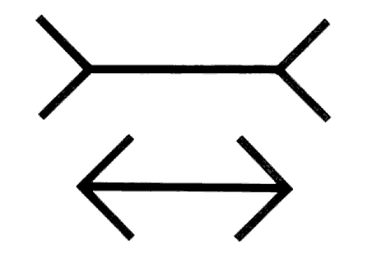
Figure 1. Müller-Lyer Illusion. Horizontal line segments are the same veridical length. Knowledge of the illusion is not sufficient to abolish it.

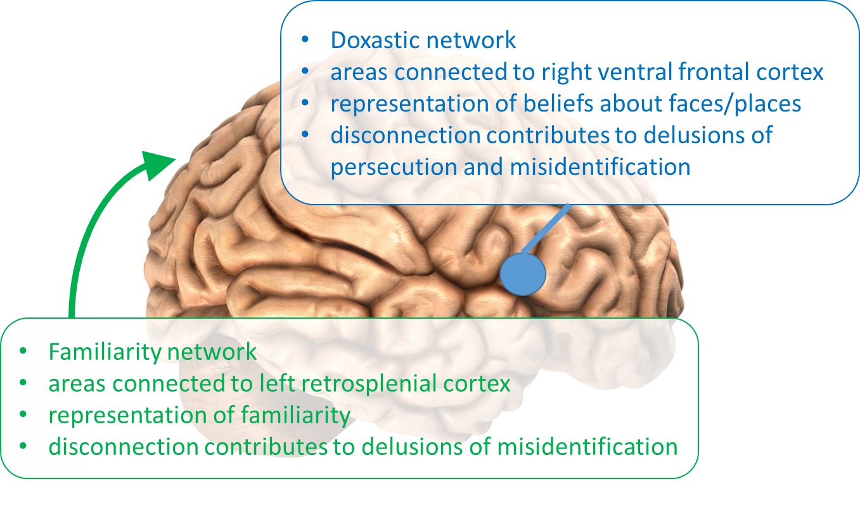
Figure 2. Summary of findings of Darby et al.

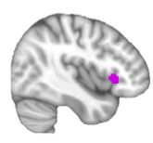
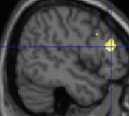
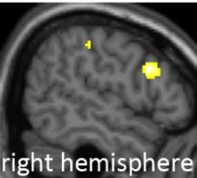
Figure 3. (A) Individuals with psychosis show altered prediction error signal in right dorsolateral prefrontal cortex (Corlett et al., 2007). (B) Right dorsolateral prefrontal activity also correlates with individual differences in “jumping to conclusions” behaviour on the beads task (Furl & Averbeck, 2011). (C) Right ventral frontal cortex is both functionally connected to lesions associated with delusional beliefs and also is associated with unpredicted or surprising stimuli (Darby et al., 2016).
A
B
C

