DUTCH MORTGAGES:

IMPACT OF THE CRISIS ON PROBABILITY OF DEFAULT

Jan Kroot & Evangelos Giouvris

Dutch mortgages: Impact of the crisis on probability of default

Jan Kroot & Evangelos Giouvris

ABSTRACT

This paper analyzes the impact of the financial crisis on the probability of default (PD) for a large Dutch mortgage portfolio covering a period from 2001 until 2012. A statistical model has been developed, which determines the likelihood that a healthy mortgage customer defaults within 12 months. The PD model is based on risk drivers which are related to the characteristics of the customers and their products (internal risk drivers) and to market factors such as stock market illiquidity, GDP, unemployment and house price index (external risk drivers). Data shows that the financial crisis did not seem to have had the expected worsening impact on the observed customer defaults. However, this is the result of simultaneous debt collection improvements. This paper shows how the internal drivers of the model are able to pick up the effect of the collection process improvements (decrease in PD), whereas the external drivers add significant value to the model to also address the crisis effect (increase in PD).

JEL: C1, R3

Keywords: probability of default (PD), Dutch mortgages, liquidity, European debt crisis

Dutch mortgages: Impact of the crisis on probability of default

# 1 Introduction

Banks are required to hold sufficient capital to protect them against unexpected losses. In the Basel II framework, the amount of capital that a bank should hold is calculated on the basis of risk-weighted assets formulas. One of the major components in the derivation of these risk-weighted assets is the probability of default (PD). The PD is a quantitative measure which expresses the likelihood that a financially performing borrower defaults within 12 months. PD models are typically determined separately for different customer segments, such as large corporates, small and medium enterprises, and private individuals.

Extensive literature exists on PD modelling. Typically, loans to businesses require expert modelling, because the number of observed defaults is too low for statistical analysis. Therefore, banks often make use of external ratings from e.g. credit rating agencies (CRAs) such as Standard and Poor’s and Moody’s. Large datasets, suitable for statistical analyses, are available in case either a lot of defaults occur, or when the loan portfolios are large. The latter is the case for retail lending, such as mortgage loans. Literature on statistical models used for PD modelling is also extensive, especially as a result of the upcoming capital regulations in the last couple of decennia. This literature discusses the representativeness and the completeness of the used data, the types of statistical models and the corresponding parameters, and the relevance of application in different regimes of the economic cycle. However, literature about the application of PD models to mortgage portfolios is limited, especially with the inclusion of the data of the recent credit crisis. This paper aims to fill the gap in literature to assess how the crisis has impacted the PD of mortgages. The underlying dataset from March 2001 until October 2012 covers a full economic cycle in the Netherlands and specifically includes the crisis years. Note that this paper is not aiming to introduce a new statistical model, or to prove the completeness of the dataset, because this can already be derived from the fact that the model, for it to be Basel II compliant, has been validated and approved by the relevant regulatory institutions. Additionally, whereas regulatory models typically only include customer and contract information internally available in a bank, the model presented in this paper also incorporates external market information.

This paper investigates the impact of the financial crisis on the PD model for Dutch mortgages, based on data of one of the largest Dutch mortgage providers[1]. There are several reasons to expect that the impact is large. Customers are likely to default due to worsening market factors such as increasing unemployment, declining house prices and tightening borrowing practices. As part of the impact analysis of the crisis, a number of related sub-questions needs to be answered, such as: i) What are the main specificities of the Dutch mortgage market that affect the model? ii) Can a statistical model be constructed in such a way that it picks up the changes in the market and in customer behaviour to come up with an accurate PD estimate on portfolio level? iii) To what extent do changes in collection processes have an effect on the model outcome? In order to answer these questions, the first step is to design a statistical model that can predict the probability of default (PD) accurately. The statistical method that will be applied is the logistic regression method. It searches for relevant risk drivers that can predict the PD level per customer and a calibration level that is conceptually sound. The resulting statistical model can then be used to analyze the impact of the crisis on the PD scores.

This study may serve as a much awaited update on older papers (see e.g. Medema et al., 2009). It also closes a gap in the literature since the financial crisis is incorporated in the analysis and proprietary data is used. In addition, this paper incorporates external macroeconomic factors into its modelling such as stock market liquidity, a variable the authors have not come across in any other relevant study and other qualitative variables such as changes (intensification) in instalment collection processes which lower probability of default (PD). Overall, the authors believe that risk managers, policy makers, academics, bankers, and even macro-economists have a lot to learn from the Dutch experience. Existing models should be enriched to include more external market risk drivers such as macroeconomic variables but also qualitative variables such as changes in internal policies (in this case intensification of collection processes). To summarize, this study adds to the existing body of knowledge by providing a validation methodology for an extended sample that incorporates the financial crisis while at the same time considers external drivers that previous studies have not considered in their modelling and shows that those new variables can actually make a difference.

The remainder of this paper is organised as follows. Section 2 explains the regulatory framework of capital requirements to which the PD model has to comply. Section 3 summarizes the existing literature on PD modelling approaches and their applications to Dutch mortgages specifically. Section 4 provides relevant background information on the Dutch housing market, macro-economic factors and market liquidity. These external factors play an important role in the enhancement of the PD model during the economic downturn. Section 5 presents the set-up of the model, including data collection, the list of possible default risk drivers, the univariate analysis, multivariate analysis, model calibration and the testing and validation of the resulting model. In Section 6, the results are presented. Section 7 summarizes the conclusions of this paper and provides some recommendations for further research.

# 2 Regulatory requirements

Regulatory capital is the amount of capital a bank has to hold, as required by its financial regulator. Requirements are put in place to ensure that a bank does not expose itself to high risks through its lending and investment practices. The greater the risk to which the bank is exposed, the greater the amount of capital the bank needs to hold to safeguard its solvency and overall economic stability.

The main international effort to establish rules around capital requirements has been through the Basel Accords, published by the Basel Committee on Banking Supervision (BCBS), housed at the Bank for International Settlements (BIS). This sets a framework on how [banks](http://en.wikipedia.org/wiki/Bank) must calculate their [capital](http://en.wikipedia.org/wiki/Capital_(economics)). In 1988, the committee decided to introduce a capital measurement system commonly referred to as Basel I; see e.g. BCBS (1998). This framework has been replaced in 2005 by a significantly more complex capital adequacy framework commonly known as Basel II; see e.g. BCBS (2005) and BCBS (2006).

Banks that have implemented the so-called advanced internal rating-based (AIRB) approach may rely on their own internal estimates of risk components in determining the capital requirement for a given exposure. Derivation of the risk-weighted assets depends on the estimates of the following risk components: probability of default (PD), loss given default (LGD) and exposure at default (EAD) and, in some cases, effective maturity (EM). The PD model predicts the likelihood that a default occurs within the next 12 months. The EAD model predicts the level of exposure at the moment of default in relation to the current exposure. The LGD component expresses the percentage of loss to be expected from that EAD in case of a default. The EM formula determines the time-weighted average of the cash flow schedule of a contract or portfolio. For residential mortgages, Basel II does not require explicit maturity adjustment for retail risk-weight functions; see BCBS (2006, §327).

# 3 PD modelling: literature review

The main approach in modelling the probability of default is through classification models; see e.g. Hastie et al. (2001) for an overview. The most popular models in this category are discriminant analysis and probability models; see e.g. Duffie and Singleton (2003) and Harrell (2001). Discriminant analysis assumes that the overall population of borrowers consists of two subpopulations, a group of defaulters and a group of non-defaulters. Based on the borrower characteristics, the analysis determines to which population the borrower belongs. A disadvantage of this approach is that it does not yield PD estimates.

In a probability model, the PD is modelled as a function of the characteristics of the borrower. The logistic regression model used in this paper is an example of a probability model. The characteristics of the borrower are included in the logistic regression model as explanatory variables. Let  be the explanatory variables of customer  at time . Let  be the dependent variable which equals 1 if customer  defaults between time  and  (or  if time is expressed in months), and 0 otherwise. The PD for customer  at time , represented by , is then calculated from



Here,  is an unknown parameter vector, which needs to be estimated by the logistic regression.

The explanatory variables that characterize a borrower’s probability of default incorporate information relevant for assessing the borrower’s ability and willingness to repay its debts, as well as information about the economic environment in which the borrower operates. The information available to estimate the PD can be divided into four categories[2]:

* Borrower risk characteristics: this information is specific to a single borrower. Examples are borrower type, demographics (e.g. age, occupation) and debt-to-income ratio.
* Transaction risk characteristics: this information is specific to the product or the collateral. Examples are loan purpose, house type and loan-to-value ratio.
* Aggregate risk characteristics: this information is the same for multiple borrowers. This category typically includes macroeconomic variables such as house price indices, unemployment, market illiquidity and GDP growth rates.
* Delinquency characteristics: banks are expected to separately identify exposures that are delinquent and those that are not. Examples are number of times delinquent in the past twelve months and number of months since last delinquency occurred.

The explanatory variables are referred to as risk drivers. The drivers can be static or dynamic. For instance, loan-to-value at origination of the contract is a static driver, because it is determined at the start of the contract and does not change over time. In contrast, loan-to-value at reporting date is a dynamic driver, because both the outstanding amount of the loan and the value of the house can change over time. Theoretically, any variable can become a risk driver. It is up to the logistic regression method to determine from the data whether a variable is statistically significant or not. Of course, the most preferable variables to become risk drivers are the ones that can be explained economically.

With the statistical model based on the risk drivers that resulted from the logistic regression, each of the customers is given a model PD score. These scores are calibrated to the long-run average PD. Calibration is the ability of the model to make unbiased estimates of the PDs. Poor calibration may result in a wrong estimation of the long-run average PD and this can have the following consequences: i) Underestimation of PD (this means that the bank may fail to cover risk costs) and ii) Overestimation of PD (this means that the bank may overprice and reject value-adding opportunities).

Since a smaller PD will result in a lower capital reserve, banks have an incentive to underestimate the PDs (Blum, 2007). Therefore, PD models are tested thoroughly by external supervisors. In fact, some PD models are only allowed to be implemented after the supervisors have given their official approval.

The creditworthiness of a borrower depends on both idiosyncratic variables and systematic variables. Idiosyncratic variables entail non-macroeconomic factors, which depend on the characteristics of the individual borrower. Systematic variables entail macroeconomic factors, characterised by the performance of the broader economy. Systematic shifts also affect the behaviour of the borrower; see e.g. Agresti and Finlay (1997) and Sharpe (1963).

In literature, three types of model philosophies are found:

* Point-in-time (PIT): a rating system based on PD models using both idiosyncratic and systematic variables, being fully cyclical. Examples include a variety of market-price based quantitative models, including Merton-style PD models and CDS spread based models; see e.g. Merton (1974) and Duffie (1999).
* Through-the-cycle (TTC): a rating system based on PD models that disregard the systematic variables and take into account the idiosyncratic variables only. Examples include credit ratings and financial ratios based models; see e.g. Beaver (1966) and Altman (1968).
* Hybrid: a rating system based on PD models that reflect individual borrower behaviour and follows the cycle in a dampened way.

TTC ratings will tend to remain more or less constant as macroeconomic conditions change over time. PIT ratings will tend to adjust quickly to a changing economic environment. Between these two extreme cases, hybrid rating systems embody characteristics of both PIT and TTC model philosophies.

With respect to the point-in-time (PIT) and through-the-cycle (TTC) philosophies, literature is not unanimous on preferred approaches. Rating agencies generally assign ratings on a TTC basis whereas banks' internal valuations are often based on a PIT performance; see e.g. IMF (2013). Under Basel II, banks have the choice of adopting PIT or TTC approaches. Some regulators encourage PIT modeling, because the standard errors between observed default rates and PD estimates are lower. They argue that TTC models are poorly suited for internal pricing and risk management purposes; see e.g. Gordy and Howells (2006). In a survey of internal rating systems at large US banks, Treacy and Carey (1998) find that banks tend to focus more narrowly on current conditions in setting ratings than do public rating agencies. This suggests that many US bank rating systems conform more closely to a PIT philosophy.

In contrast, other regulators encourage TTC modeling, because it keeps the capital reserves more stable and pricing and exposure decisions are taken on a more accurate view of the risk over the life of the loan; see e.g. Taylor (2003). In the UK, according to the Financial Services Authority (FSA), most of the approaches are TTC; see FSA (2006). They reverse out cyclical fluctuations, but also those fluctuations associated with non-systemic risk, i.e. changes in credit quality due to factors other than the current economic environment.

Some banks have adopted a hybrid approach, where the bank measures risk using a combination of PIT and TTC approaches. For instance, the PIT measure is scaled to a TTC level given the point in the cycle. Also rating agencies Moody’s and S&P are using hybrid approaches; see e.g. Moody’s (1999) and S&P (2002). The model development in this paper also follows a hybrid approach, where risk drivers based on reporting date imply a PIT characteristic, and calibration based on long-term averages implies a TTC characteristic.

Studies that look into debt default at the household level are mostly empirical in nature. Their main objective is to develop credit ratings that distinguish good borrowers from bad borrowers; see e.g. DeVaney and Lytton (1995). There are two alternative views of home mortgage default behaviour. Jackson and Kaserman (1980) define them as equity theory of default and ability-to-pay theory of default. The equity theory of default involves rational borrowers who attempt to maximize the equity position of the house at each point in time. They cease payments if the market value of the house is lower than the outstanding mortgage balance. According to the ability-to-pay theory of default, debtors will avoid defaulting on their debts as long as their income flows are sufficient to cover the mortgage payments without undue stress. Campbell and Cocco (2010) attempt to identify the main determinants of mortgage default behavior in terms of these two theories. They state that according to the equity theory the ratio between the amount borrowed and the current value of the property (i.e. current LTV) should be the most important factor in the borrower’s decision to default. In the light of the ability-to-pay theory, it is the proportion of the current income that is used to pay off debt (i.e. current DTI) that plays a major role in the decision to default.

The variables LTV and DTI have often been studied in literature. In the papers by Campbell and Dietrich (1983), Vandell and Thibodeau (1985) and Lawrence and Smith (1992), they all conclude that the LTV ratio is a strong determinant of mortgage loan default risk and they also show that the relationship between the two is positively correlated. Furthermore, Stansell and Millar (1976), Vandell (1978) and Ingram and Frazier (1982) confirm the importance of DTI as an explanatory variable of mortgage loan default.

The explanatory factors of a PD model can be mortgage-specific, such as LTV, but can also be macro-economic; see e.g. Burkhard and De Giorgi (2006). The economic environment plays an important role via factors such as unemployment rate, interest rates, and social and demographic developments (e.g. increase in number of divorces). A rise in unemployment means that more people lose their primary source of income, which affects their ability to pay the interest on their loans. The same holds for interest rates. An increase in number of divorces also increases the debt burden of the borrowers. Furthermore, risk drivers of a PD model can be borrower-specific. Various authors have concluded that personal characteristics such as education and income are as important in explaining defaults as the mortgage-specific and macro-economic risk drivers; see e.g. Morton (1975), Ingram and Frazier (1982) and Webb (1982). This could be an explanation for why some households with zero or negative equity do not default, while others with positive equity do.

Specifically for the Netherlands, when house prices began to fall in 2008, many borrowers found themselves in a situation where they owed more on their house than it was worth (i.e. negative equity). For many of them, this impacted their consumption and caused loan delinquencies; see e.g. Buiter (2008) and Calomiris et al. (2012). Going forward, there are several market factors that play a role in the change of creditworthiness of Dutch mortgage owners and hence their PDs. Factors that will continue to support the credit quality of Dutch residential mortgages are the long-term fixed interest rates, the long-term contract maturities, the tax deductibility (see e.g. Glaeser and Shapiro (2002)), a regulated rental market, limited housing supply (see e.g. Kranendonk and Verbruggen (2008)), the provision of the national mortgage guarantee (NHG, to cover a repayment gap after repossession of the house) and borrowers’ liability to repay residual outstanding debt following the sale of a house.

The literature on PD models for Dutch mortgage loans is very limited. Relevant research has been carried out by Medema et al. (2009). This paper also describes a PD model for Dutch mortgages, but the focus is more on the validation methodology of the model. Moreover, their model covers the years 2000 – 2003, so the time span of their sample does not cover a full economic cycle and does not include the sub-prime crisis. This paper aims to fill up this gap in existing literature. The Dutch economy has gone through a boom, recession and partial recovery and this makes it suitable to build a prediction model based on a whole business cycle. This results in a more robust model than one based only on data of a booming house market/economy. Another reason to concentrate in this paper on the Dutch market is that the mortgage debt in Netherlands is in excess of 100% of its GDP, among the highest in the euro zone.

# 4 External factors: Dutch market indicators and their suitability for a prediction model.

Market indicators that are commonly referred to in assessments of a country’s economic circumstances are gross domestic product, unemployment rate and average house prices of the country. The Netherlands experienced uninterrupted growth from 1982 until 2008, with an unprecedented boom in the second half of the 1990s; see (a), in which the gross domestic product (GDP) of the Netherlands is shown, based on data from the World Bank[3]. There was low inflation, low unemployment and strong exports. One legacy of this period is the high mortgage debt (above 100% of GDP), among the highest in the euro zone. The Dutch economy entered into a recession in Q3 2008 (after the fall of Lehman Brothers). Recovery was noticed after 2010, but recession returned in Q4 2011; see (b).

[INSERT ABOUT HERE]

Unemployment has been rising since 2008. In November 2012, the unemployment rate was 7%, according to the Dutch Central Bureau of Statistics (CBS)[4]; see (a). During the recession, the government was forced to boost the economy through stimulus programs and bank bailouts, which resulted in a budget deficit of above 3% of GDP since 2008. The Dutch house price boom lasted until 2008 and was pushed by economic growth; see (b). In the second half of the 1990s, the private sector wages rose by 3.6% annually, while inflation was only 2.7%, leading to significant increases in purchasing power. House prices have been falling since 2008 and even despite modest economic recovery in 2010 and 2011, the Dutch housing market has remained depressed.

[INSERT ABOUT HERE]

It is expected that the combination of a prolonged housing market downturn, rising unemployment, and generally weak macro-economic environment will result in a notable increase in mortgage-related impairment charges for Dutch mortgage lenders over the next few years; see e.g. S&P (2012a). The Dutch government has gradually introduced several housing market reforms over the past few years, to reduce risks for borrowers while avoiding market destabilization; see e.g. Vandevyvere and Zenthöfer (2012). The revised Dutch mortgage lending Code of Conduct, in force since August 2011, includes further tightening of the framework around affordability testing, limited financing by interest-only mortgages (only 50% of the house purchase price) and a capped LTV ratio (at 106% for new borrowers). Since May 2012, new measures also include restrictions on the tax deductibility of interest payments for new mortgages, a permanent reduction of the transaction tax to 2%, and some liberalization of the rental market.

Rating agencies believe that these measures will contribute to further market deterioration in the short to medium term, but that they will have a positive impact in the longer term; see e.g. S&P (2012b) and Fitch (2012). The mortgage market is expected to normalize gradually, as well as the creditworthiness of the Dutch borrowers, such that the banking system will stabilize and systemic risk will reduce. They expect ongoing pressure on the private sector as a result of the continued price correction in the Dutch property market, the recessionary conditions in the euro zone, and measures to reduce the budget deficit; see S&P (2012b). High private sector indebtedness (i.e. leverage) is largely due to the tax deductibility of mortgage interest payments. This has given Dutch people a strong incentive to borrow the maximum for their houses and to pay into insurance products or repayment vehicles.

Another market indicator that precedes, moves along or followsthe economic situation of a country comes from the stock market and is called market illiquidity. It increases in times of crisis. A stock is called illiquid when it cannot easily be sold or exchanged for cash without substantial loss of value. Two commonly used measures of illiquidity are Amihud’s illiquidity ratio and Roll’s implicit spread estimator; see Amihud (2002) and Roll (1984), respectively.

The illiquidity ratio of Amihud is defined as the ratio of the average daily absolute stock return across stocks to the daily average traded volume. This ratio is easily obtained from daily stock data for long time series in most stock markets. The hypothesis on the relationship between stock return and stock liquidity is that return increases with illiquidity, as proposed by Amihud and Mendelson (1986). This is consistent with Kyle’s concept of illiquidity, i.e. the response of price to order flow, and Silber’s thinness measure, i.e. the ratio of absolute price change to absolute excess demand for trading; see Kyle (1985) and Silber (1975), respectively. The Roll variable is defined as the square-root of the auto covariance of stock returns; see Roll (1984).

Naes at al. (2011) find that illiquidity predicts crises in the US. Galariotis and Giouvris (2015) find that this is not necessarily the case for the US using an extended sample and each country in their sample (G7) is a different case. Generalizations cannot easily be made. The Netherlands is not part of the sample in Galariotis and Giouvris so it is not clear if it precedes, moves along or follows the crisis. Therefore, it has been decided to include illiquidity in the sample to see if it affects probability of default at all.

For the Dutch stock market, daily trading volumes and prices of all listed companies have been collected using Datastream[5]. From all daily Amihud ratios, a monthly average has been calculated. shows how the monthly Dutch illiquidity evolved over time in the period January 2000 until March 2013. The illiquidity values are rather volatile, but three clear periods of higher illiquidity can be observed: one period with its peak in September 2002, one with its peak in July 2009 and one that started at the end of 2011 and is still ongoing. During these periods illiquidity reached values above 1.0, whereas between these periods illiquidity was close to 0. also shows the one-year moving average of the illiquidity, which is less volatile and reconfirms the periods of higher illiquidity.

[INSERT ABOUT HERE]

# 5 Model development

For the development of the PD model, data has been collected spanning the period from March 2001 until October 2012. This resulted in a dataset with millions of records containing contract and payment details of Dutch mortgage customers and values of economic indicators of the Netherlands. Initially, several data cleansing and sampling techniques have been applied to the data such that the remaining dataset is accurate and representative. The techniques are standard and ensure that inaccurate records are filtered out, seasonality effects are reduced and customers are selected only once in order to avoid correlation between observation moments (mutually exclusive sampling). Furthermore, the dataset has been split into a development sample to build the model and a testing sample to test the model. Next, a set of 31 variables has been identified as possible risk drivers. The set of variables is presented in of appendix 1 along with the description of each variable. Analysis of patterns in the data reveals information about the performance of a potential risk driver. This analysis is referred to as univariate analysis. A strong pattern does not automatically mean that the corresponding risk driver will end up in the final model, because it might be correlated to other risk drivers or obtain a low ranking in the multivariate analysis. Each pattern has been discussed with business experts to verify whether it makes sense economically and whether it is in line with current and future expectations. To explain the observed patterns, some relevant drivers are explained below (the list is not extensive).

5.1 Internal risk drivers

Internal risk drivers are risk drivers that are related to the characteristics of the customers and their contracts. One internal risk driver is the loan-to-value (LTV) at reporting date. This is a continuous variable, meaning that it can have all values within a certain range and its values can be ordered. One way to present continuous variables is to plot observed defaults against buckets of the risk driver. The observed defaults are the averages per bucket. A line can be fitted through the observation points. shows that for higher LTVs at reporting date the number of observed defaults was higher than for lower LTV values[6]. The trend line with the best fit is a logistic function with R2 = 99%. This variable is accepted as risk driver, because it is expected that the number of defaults increases as the LTV increases.

[INSERT ABOUT HERE]

The next internal risk driver is interest-to-income (ITI). This is a continuous variable with values between 0 and 1. shows that defaults increase when ITI increases. The best fit line is a logistic function with R2 = 99%. The difference in default level between the left and the right of the graph is a factor 3. The variable ITI is accepted as risk driver, because it is expected that the number of defaults increases as the ITI increases.

[INSERT ABOUT HERE]

The number of months since the last delinquency is an internal risk driver represented by a nominal variable, i.e. it consists of a relatively small number of distinct values. A nominal variable does not have an ordinal character like a continuous variable. This delinquency variable is defined for 12 groups. The labels A until K represent the groups of customers who have not been in arrears since 1 month (A) until 11 months (K). Label L represents the group of customers who have not been in arrears at all. In , a bubble plot for this variable is presented, which shows the observed PD percentages for every group (A – L). The size of each bubble corresponds with the frequency. It can be observed how the large majority of the customers has never been in arrears. Moreover, shows how customers, who have been in arrears more recently, have also defaulted more often. It is indeed expected that customers with only a few months since last delinquency have a higher probability to default. Hence, the number of months since the last delinquency is a good risk driver.

[INSERT ABOUT HERE]

5.2 External risk drivers

External risk drivers are affected by external market circumstances. They are not directly related to the characteristics of customers or their contracts and do not distinguish among customers. There are several market variables that move along with the economic situation of the country. They can come from the stock market, such as market illiquidity, which increases in times of crisis, or are related to country indices, such as the GDP, unemployment rate and house price index.

The first possible external risk driver is the illiquidity in the Dutch stock market. Both Amihud and Roll measures have been investigated as possible risk drivers; see e.g. for the development over time of the Amihud illiquidity. The monthly illiquidity values have been added to the dataset: per month, each customer got the same illiquidity value assigned.

The results of the univariate analysis are presented in (a). The best line fit shows how the level of defaults was more or less the same for all values of illiquidity. Only for very small values of illiquidity the number of observed defaults was higher. This is not really the trend that was expected. One would expect an increase in defaults when illiquidity increases. The argument for that would be that in times of high illiquidity the financial stress would also be felt by the customers and would result in more defaults. According to the data, this has not been the case. The R2 of the fit is 21%, which is very low.

[INSERT ABOUT HERE]

Based on the results presented in (a), no conclusion can be drawn yet. The risk driver needs to be investigated further. One way of reasoning is as follows: the absolute value of illiquidity might not be correlated to the changes in defaults, but maybe the changes in illiquidity do. Big changes in illiquidity represent the entry into a recession. Therefore, the relative monthly changes in illiquidity have been investigated in order to test the hypothesis that increases in illiquidity lead to higher defaults and decreases in illiquidity lead to lower defaults. However, univariate analysis shows that the best fit line is again horizontal. This means that the hypothesis is rejected.

Another argument could be that the volatility in illiquidity values is too high, disturbing the results. Therefore, a new variable is defined as the average of the illiquidity values of the preceding 12 months. However, univariate analysis now shows a best fit line, which has a decreasing trend and observation points which are very much scattered across the spectrum (R2 = 23%). This is opposite to what was expected. Hence, this variable is not a good risk driver either.

The last attempt for finding a reliable definition of the illiquidity driver is to consider the illiquidity values with a time lag, because changes in illiquidity might be correlated to delayed defaults. Univariate analyses have been performed with time lags of 1 month up to 6 months, but the results are very similar to those presented in . The same holds for the Roll variable. The univariate results for the Roll variable are very similar to the results for the Amihud variable presented in (a).

The next possible external risk driver is the change in gross domestic product (GDP) of the Netherlands, as presented in (b). It is expected that the number of defaults increase when the changes in GDP are negative and that the number of defaults decrease when the changes in GDP are positive. (b) shows the results of the univariate analysis of quarterly changes in the GDP. It can be observed from the best fit line that there is an upward trend in observed defaults. However, this is not in line with expectations.

The same observation holds for the external variable that represents the change in the unemployment rate in the Netherlands, the development of which is shown in (a). Even though it is expected that the number of defaults increase when the changes in unemployment are positive and that the number of defaults decrease when the changes in unemployment are negative, it can be observed in (a) that the best fit line shows a downward trend.

[INSERT ABOUT HERE]

The last possible external risk driver is the house price index in the Netherlands; see (b). The house price index is expected to be correlated to the number of defaults. The results of the univariate analysis are presented in (b). The best fit line is for a big part horizontal, except for the slightly higher level at the low index values. Here, the R2 is only 7%.

The conclusion from the univariate analysis is that several internal risk drivers show strong predictive power. They are selected to be included in the multivariate analysis, the next step of the model development. In contrast, the external risk drivers have not shown sufficient predictive power in the univariate analysis. In line with the standard multivariate regression approach, they are excluded from the multivariate analysis.

In the multivariate analysis, a logistic regression is performed, which results in the parameter estimates of the logistic function (as presented in the section on PD modelling). Each risk driver obtains a parameter estimate. The parameter estimates hold for all customers. However, in combination with the customer-specific values of the risk drivers, a different PD score is obtained for each customer separately. This PD score is not yet the final PD value. All PD scores are calibrated to the average long-term default percentage over the full development period (i.e. through-the-cycle).

Finally, the performance of the new model has been tested for discriminatory power, robustness, accuracy and concentrations in the PD score distribution. Details of the tests are out of scope of this paper, but the steps taken are summarized as follows: In order to make use of the most recent data, which covers the current financial crisis, out-of-time (OOT) validation was not possible. Instead, an out-of-sample (OOS) validation and an in-sample bootstrapping test have been performed to test the robustness of the model. The dataset has been split into a development sample and an out-of-sample (OOS) testing sample. Normally, a split of about 75% - 25% is used. It must be proven that the samples are representative to the overall dataset, by comparing the statistics of the most important variables. The robustness of the model is tested by a bootstrap analysis: a large number of samples (100 runs) are drawn randomly from the dataset. The logistic regression procedure, with the model risk drivers as fixed input variables, is applied to every sample to determine the estimates and performance of the test models. All resulting estimates are compared to check the variation. If the standard deviation between all estimates and between all PD scores is below a certain threshold, then the variables are stable and significant. This indicates that the model is robust.

The final model based on internal risk drivers has been approved by the Dutch banking regulator to be compliant with the Basel II guidelines for advanced internal rating-based models.

# 6 Results: impact of the crisis on PD

To analyse the performance of the model and the impact of the crisis on the model, PD scores have been calculated based on historical data. This yields the PD values the customers would have had in the past, if the model was already applied at that time, based on the observed values of the risk drivers of all customers individually.

Ultimately, data from the recent financial crisis is included in the dataset, which enables to analyze the impact of the financial crisis on the PD model for Dutch mortgages. There are several reasons to expect that the crisis had a worsening impact on observed defaults. Customers have fallen behind with payments due to worsening market factors such as increasing unemployment, declining house prices and tightening borrowing practices. However, the realized defaults observed in the Dutch mortgage portfolio have shown a downward trend during the crisis. This downward trend is clearly visible in , starting at the beginning of 2008 and decreasing at least until the second half of 2010. Note that the period of observed defaults, used to build the model, ends at the end of 2011, because the last period of 12 months of the dataset is needed for the so-called performance period. The performance period is the period needed to verify whether the customer went into default or not (hence also referred to as observed into-defaults). The last four observed into-defaults (in red) have been added after the model development, namely when more recent data was available.

[INSERT ABOUT HERE]

The downward trend in observed into-defaults is explained by the intensification of the arrears and problem loan management process and further automation of the collection process. These are all process improvements to support customers in preventing defaults, which have led to a decrease in payment arrears and, consequently, the number of defaults.

All risk drivers in the model are internal risk drivers, meaning that they are related to the characteristics of the customers and their contracts. None of these drivers has a direct link to the crisis. One could argue that the crisis has an indirect impact on some of the internal risk drivers, such as the current loan-to-value, because decreasing house prices lead to higher LTVs and therefore higher default risk. However, this relation turned out to be a weak one, based on the development data. The external drivers that have been investigated (i.e. market illiquidity, GDP, unemployment and house price index) do not distinguish among customers, but change over time. These drivers did not end up in the final model, because the univariate analysis showed insufficient predictive power.

The conclusion so far is that the crisis did not seem to have had the expected increasing impact on the PD model. The most important reason for that is that the changes in the collection processes have a stronger influence on the PD development than the crisis: the improvements in the collection processes since 2008 led to a decrease in registered defaults, whereas an increase was expected due to the crisis. The crisis could still have had a worsening impact on the number of defaulting customers, but the default data and, consequently, the PD model depend on more (apparently stronger) factors.

The ability-to-pay of the customers depends on personal factors, such as unemployment, divorce, etc. Since most of these personal factors are affected by market circumstances, it was expected that the external drivers would have a direct correlation with the PD development. And even if this would not hold for every individual customer, it could become apparent on portfolio level. GDP, unemployment and house prices are well-known to have a strong relation with the business cycle. Naes et al. (2011) have found that this is also the case for US stock market liquidity. However, Galariotis and Giouvris (2015) find that this is not necessarily the case for the US using an extended sample. The Netherlands is not part of the sample in Galariotis and Giouvris so from this research it is not clear if it precedes, moves along or follows the crisis. Darius and Radde (2010) state that global liquidity has a significant impact on the build-up in house prices. Even though the univariate analysis did not show a clear trend for these external drivers (because of the strong influence of the collection process on the PD observations), it may still be possible that these drivers had an impact on the customer behaviour. However, this is difficult to prove with the current dataset, because the effect of the collection process cannot be filtered out.

One additional analysis that can be performed is the creation of a new model in which the external drivers are included in the multivariate regression. So, even though the drivers were rejected during the univariate analysis, they are included in the multivariate analysis anyway. It turns out that all four risk drivers end up in the final model, meaning that they provide significant added value to the model in the multivariate regression. in Appendix 2 shows the final list of risk drivers in the multivariate regression. The resulting PD development of the model that includes the external drivers is presented in .

also shows the results of the model without external risk drivers and the observed into-defaults. Note that the model predictions have been made until the end of 2012, because the driver information was available for this period. The into-default observations contain the performance period until the end of 2011 and an additional year of more recent observations. The overall predictive power of the model with external drivers is the same as for the model without external drivers. Two important observations can be made from this graph:

* The overall distance between the line of the model with external drivers and the line of the observed into-defaults is smaller than that for the model without external drivers: the fit has improved from R2 = 42% to R2 = 62%.
* The predicted PD for the model with external drivers increases faster since the start of 2011 than the PD of the model without external drivers.

The new model that includes external drivers is picking up both the process improvement after March 2008 (decrease in PD) and the crisis effect (increase in PD).

The results of the model have been validated with the Out-of-sample (OOS) and the bootstrapping method, as described in Section 5. One of the measures that represents the disciminative power of a multivariate regression model is the so-called C-stat. This is the coefficient of concordance, a concept that relates to pairs of observations, where a relatively risky score is related to a default, and a relatively non-risky score is related to a non-default. A C-stat close to 1 indicates perfect predictions, whereas a value close to 0.5 indicates random predictions. shows that the C-stat of the OOS test set is 83.0%, which is equal to the C-stat of the development set. Moreover, the bootstrapping results show that the C-stat values of the 100 runs vary between 82.7% and 83.2%, with a mean value of 83.0%. Hence, the model is stable and has high predictive power. These C-stat values are slightly lower than the ones found by Medema et al (2009), which are about 89%, but this can be explained by the longer dataset and the fact that the dataset includes the crisis period and process improvement information.

[INSERT ABOUT HERE]

# 7 Conclusions

In this paper, the impact of the financial crisis on the PD model for Dutch mortgages is investigated, based on a dataset of one of the largest Dutch mortgage providers. It is expected that a higher number of defaults occurred during the crisis, because of deteriorated market factors such as increasing unemployment, declining house prices and tightening borrowing practices, leading to more payment delinquencies. However, the crisis did not seem to have had the expected worsening impact on the PD model. The most important reason for that is that the intensification of the arrears and problem loan management process and further automation of the collection process had a stronger influence on the default data than the crisis: the improvements in the collection processes since 2008 led to a decrease in registered defaults.

Logistic regression analysis resulted in a list of internal risk drivers with significant predictive power. Internal risk drivers are variables which are related to the characteristics of the product and the customer behaviour. None of these drivers has a direct link to the crisis. The external drivers that have been investigated are market illiquidity, GDP, unemployment and house price index. These drivers do not distinguish among customers, but change over time in a way correlated to the developments in the economic environment. Univariate analysis revealed that the external drivers did not have significant predictive power to end up in the PD model.

However, the external risk drivers are still believed to have had an impact on the customer behaviour. From the current dataset, the effect of the internal process improvements cannot be filtered out, but a new model can be created in which the external drivers are forced into the multivariate regression, even though they were rejected in the univariate analysis. It turns out that the external variables do add value to the model. The discriminative power of the model does not change with respect to the model without the external drivers, but the fit between the model prediction and the observed defaults improved. Moreover, the predicted PD of the model that includes external drivers increases faster as of the start of 2012 than the PD of the model that excludes external drivers. Hence, the new model that includes external risk drivers is picking up both the internal process improvement (decrease in PD) and the external crisis effect (increase in PD).

From the results presented in this paper, it can be concluded that PD modelling based on internal risk drivers can be improved by including external risk drivers in the multivariate analysis. These external risk drivers apply uniformly to the whole mortgage portfolio, but change over time, yielding a better point-in-time (PIT) approximation of the probability of default (PD). Future research will be based on further enhancement of PD models, including more external market risk drivers and including more recent observed into-defaults to verify the results.

# Figures

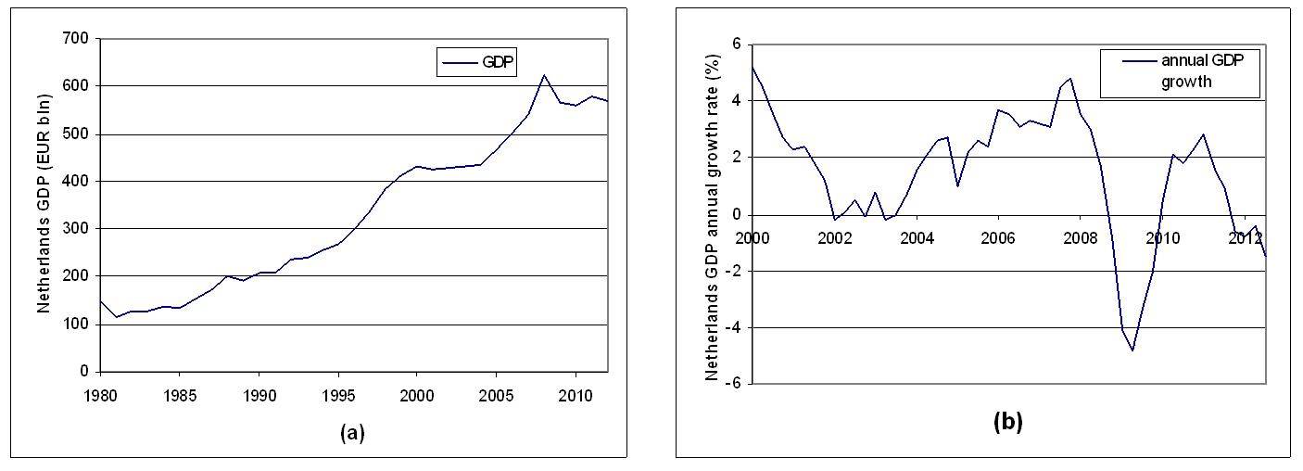

Figure 1: Development over time of (a) GDP in the Netherlands since 1980; (b) annual growth rate of GDP since 2000.

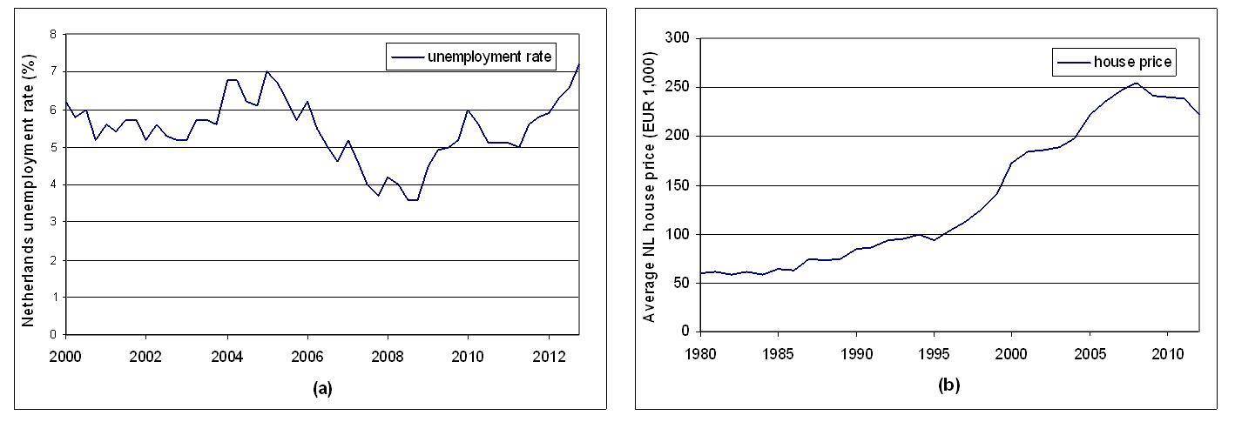

Figure 2: Development over time of (a) unemployment rate in the Netherlands since 2000; (b) average house price since 1980.

dutch illiquidity

Figure 3: Monthly illiquidity and 12-months moving average in the Dutch stock market (January 2000 - March 2013).

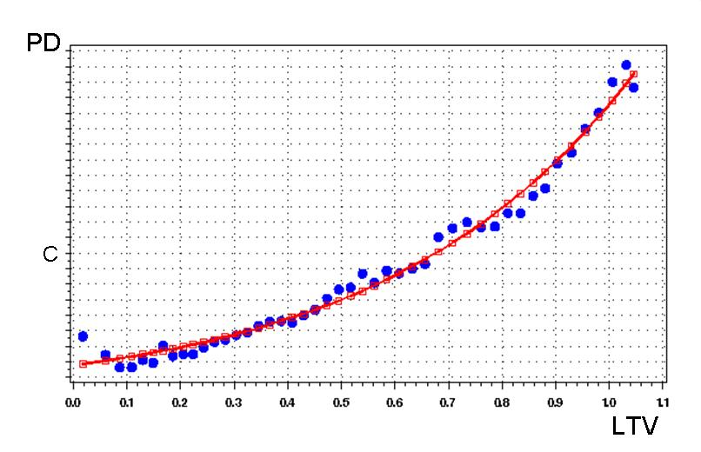

Figure 4: Best fit line for the internal driver representing the loan-to-value (LTV) at reporting date.

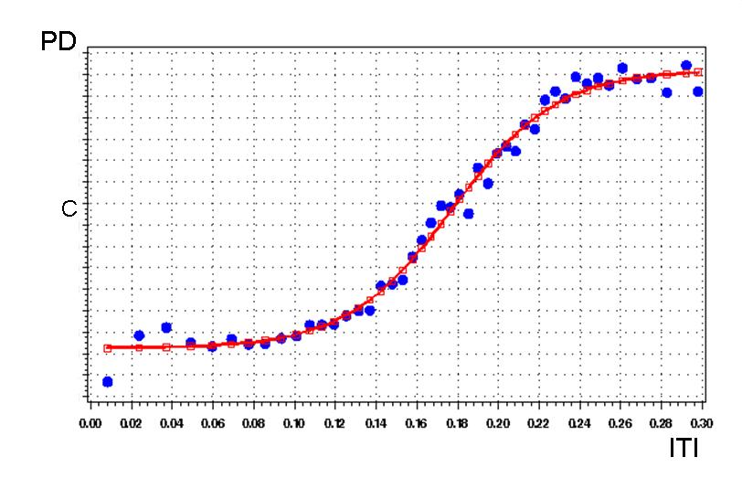

Figure 5: Best fit line for the internal risk driver representing the interest-to-income (ITI).

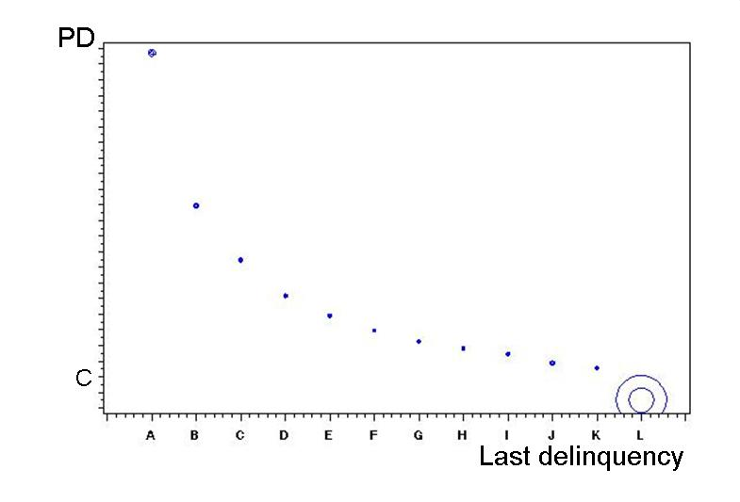

Figure 6: Bubble plot for the internal risk driver representing the number of months since last delinquency.

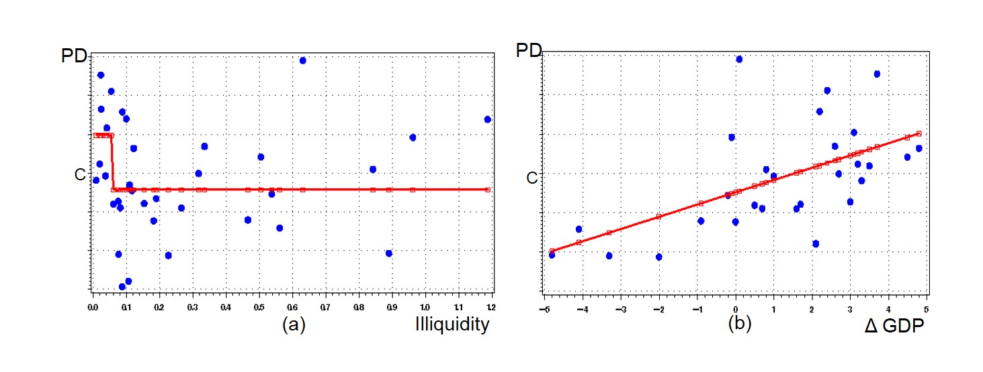

Figure 7: Best fit line for the external risk driver representing (a) the Dutch stock market illiquidity; (b) the quarterly changes in the gross domestic product (GDP) of the Netherlands.

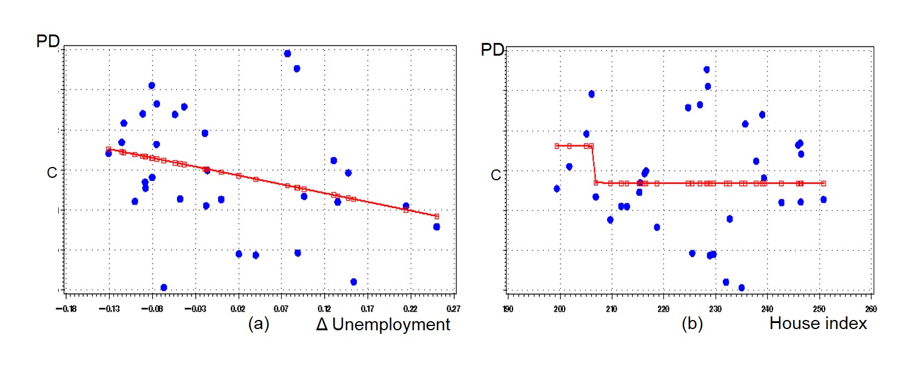

Figure 8: Best fit line for the external driver representing (a) the quarterly changes in the unemployment rate of the Netherlands; (b) the house price index of the Netherlands.

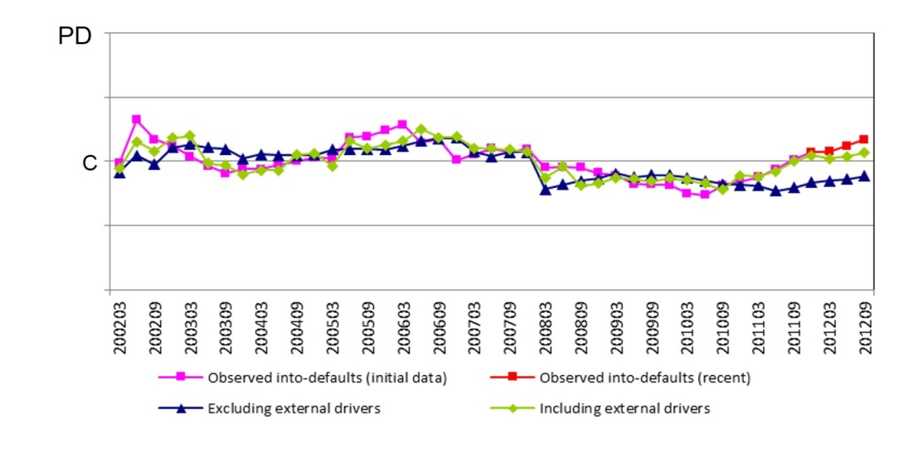

Figure 9: Development over time of the observed into-defaults, the predicted PDs from the model excluding external risk drivers and the predicted PDs from the model including external risk drivers.

Table 1: Model validation results.

|  |  |
| --- | --- |
| **Validation set** | **C-stat** |
| Out-of-Sample (OOS) |  |
| Development sample | 83.0% |
| Test sample | 83.0% |
| In-sample bootstrapping |  |
| Mean | 83.0% |
| Minimum | 82.7% |
| Maximum | 83.2% |

Appendix 1

Table 2: Initial list of possible risk drivers, in alphabetical order.

|  |  |
| --- | --- |
| **Category** | **Description** |
| Age of appraisal | Reporting date minus appraisal date. |
| Age of client | Reporting date minus date of birth. Also age at application is available. |
| Age of relationship with the bank | Reporting date minus contract start date. |
| Collateral type | Variable indicating collateral type. |
| Contract length | The original duration of the contract. |
| Current arrears | The number of periods past due (days/months). |
| DTI | Debt-to-income (DTI) at application moment. |
| External market indicators | Illiquidity in the Dutch stock market and gross domestic product, unemployment rate and house price index in the Netherlands. |
| Guarantee | Government guarantee on any of the loans. |
| Historical arrears | The number of times in arrears the last 3/6/12 months, the number of times in default the last 3/6/12 months, the number of months ago that an arrear situation occurred and the number of months ago that a default situation occurred. |
| Interest rate feature | The duration of the fixed interest rate is available as a continuous variable and as a nominal variable (more or less than 10 years). |
| ITI | Interest to income (ITI) at application moment. The current interest payments divided by income. |
| LTV | Loan-to-value (LTV) at application moment and actual LTV when the customer rating is calculated. The first variant is based on loan and initial cover value, while the second one is based on outstanding and indexed cover value. |
| Marital status | Marital status |
| Number of covers | The number of collaterals. |
| Number of products | The number of loan parts of a client. |
| Product type | An indication of more risky products. |
| Region | The region can be indicated based on postal code. Also a variable to indicate risky city is available. |

**Appendix 2**

Table 3: Final risk drivers for multivariate regression, in alphabetical order.

|  |  |
| --- | --- |
| **Category** | **Description** |
| Collateral type | Variable indicating collateral type. |
| DTI | Debt-to-income (DTI) at application moment. |
| External market indicators | Illiquidity in the Dutch stock market and gross domestic product, unemployment rate and house price index in the Netherlands. |
| Guarantee | Government guarantee on any of the loans. |
| Historical arrears | Last delinquency, the number of times in default the last 12 months and the number of months ago that a default situation occurred. |
| Interest rate feature | The duration of the fixed interest rate is available as a nominal variable (more or less than 10 years). |
| ITI | Interest to income (ITI) at application moment. The current interest payments divided by income. |
| LTV | Loan-to-value (LTV) when the customer rating is calculated based on loan and indexed cover value. |
| Number of products | The number of loan parts of a client. |
| Region | The region can be indicated based on postal code. Also a variable to indicate risky city is available. |

# References

Agresti, A., Finlay, B. (1997). *Statistical methods for the social sciences*, New Jersey: Prentice Hall.

Altman, E.I. (1968). “Financial ratios, discriminant analysis and the prediction of corporate bankruptcy,” Journal of Finance, Vol. 23, No. 4, pp. 589-609.

Amihud, Y. (2002). “Illiquidity and stock returns: cross-section and time-series effects,” *Journal of Financial Markets*, Vol. 5, pp. 31-56.

Amihud, Y., Mendelson, H. (1986). “Asset pricing and the bid–ask spread,” *Journal of Financial Economics*, Vol. 17, pp. 223-249.

BCBS (1998). *International convergence of capital measurement and capital standards*, Bank for International Settlements, Basel, July 1988, updated to April 1998.

BCBS (2005). *International convergence of capital measurement and capital standards; a revised framework*, Bank for International Settlements, Basel, November 2005.

BCBS (2006). *International convergence of capital measurement and capital standards; a revised framework, comprehensive version*, Bank for International Settlements, Basel, June 2006.

Beaver, W. (1966). “Financial ratios as predictors of failure,” Empirical Research in Accounting, Selected Studies, pp. 71-111.

Blum, J.M. (2007). “Why Basel II may need a leverage ratio restriction.” *Journal of Banking and Finance*, Vol. 32, pp. 1699-1707.

Buiter, W.H. (2008). “Housing wealth isn’t wealth,” National Bureau of Economic Research, Working Paper NBER 14204.

Burkhard, J., De Giorgi, E. (2006). “An intensity based non-parametric default model for residential mortgage portfolios,” *Journal of Risk*, Vol. 8, No. 4, pp. 57-95.

Calomiris, C.W., Longhofer, S.D., Miles, W. (2012). “The housing wealth effect: the crucial roles of demographics, wealth distribution and wealth shares, *National Bureau of Economic Research*, Working Paper NBER 17740.

Campbell, J.Y., Cocco, J.F. (2010). “A model of mortgage default”, *Harvard University*, Working Paper.

Campbell, T.S., Dietrich, J.K. (1983). “The determinants of default on insured conventional residential mortgage loans,” *Journal of Finance*, Vol. 38, No. 5, pp. 1569-1581.

Darius, R., Radde, S. (2010). “Can global liquidity forecast asset prices?” *International Monetary Fund*, Working paper, No. 10/196.

DeVaney, S.A., Lytton, R.H. (1995). “Household insolvency: a review of household debt repayment, delinquency, and bankruptcy,” *Financial Services Review*, Vol. 4, No. 2, pp. 137-156

Duffie, D. (1999). “Credit swap valuation,” *Financial Analyst Journal*, Vol. 55, No. 1, pp. 73-87.

Duffie, D., Singleton, K.J. (2003). *Credit Risk: Pricing Measurement and Management*, Princeton University Press, Princeton, NJ.

FSA (2006). “Use of long run probabilities of default, counter-cyclical scaling factors, and the interaction of these with economic cycle stress testing,” *Credit Risk Standing Group*, Financial Services Authority Memorandum, pp. 1-6.

Galariotis, E and Giouvris, E (2015), “On the stock market liquidity and the business cycle: a multi country approach,” *International Review of Financial Analysis,* Vol. 38, pp. 44-69.

Glaeser, E.L., Shapiro, J.M. (2002). “The benefits of the home mortgage interest deduction,” *National Bureau of Economic Research*, Working Paper NBER 9284.

Gordy, M., Howells, B. (2006), “Procyclicality in Basel II: can we treat the disease without killing the patient?” *Journal of Financial Intermediation*, Vol. 15, pp. 395-417.

Harrell, F.E. (2001). *Regression modeling strategies: with applications to linear models, logistic regression, and survival analysis*, New York: Springer-Verlag.

Hastie, T., Tibshirani, R., Friedman, J. (2001). *The elements of statistical learning: data mining, inference, and prediction*, Springer, New York.

IMF (2013). “Rating through-the-cycle: what does the concept imply for rating stability and accuracy?” *International Monetary Fund*, Working paper, No. 13/64.

Ingram, F., Frazier, E. (1982). “Alternative multivariate tests in limited dependent variable models: an empirical assessment,” *Journal of Financial and Quantitative Analysis*, Vol. 17, No. 2, pp. 227-240.

Jackson, J.R., Kaserman, D.L. (1980). “Default risk on home mortgage loans: a test of competing hypotheses,” *Journal of Risk and Insurance*, Vol. 47, No. 4, pp. 678-690.

Kranendonk, H., Verbruggen, J. (2008). “Are houses overvalued in the Netherlands?” *Centraal Plan Bureau*, Memorandum CPB 200.

Kyle, A. (1985). “Continuous auctions and insider trading,” *Econometrica*, Vol. 53, pp. 1315-1335.

Medema, L., Koning, R.H., Lensik, R. (2009) “A practical approach to validating a PD model” *Journal of Banking and Finance, Vol. 33, pp. 701-708*

Merton, R.C. (1974), “On the pricing of corporate debt: the risk structure of interest rates,” *Journal of Finance*, Vol. 29, No. 2, pp. 449-470.

Moody’s Investors Service (1999). *The evolving meaning of Moody’s bond ratings; product of the symbols and definitions standing committee*, Moody’s: New York.

Morton, G. (1975). “A discriminant function analysis of residential mortgage delinquency and foreclosure,” *AREUEA Journal*, Vol. 3, pp. 73-90.

Naes, R., Skjeltorp, J.A., Odegaard, B.A. (2011). “Stock market liquidity and the business cycle,” *Journal of Finance*, Vol. 66, No. 1, pp. 139-176.

Roll, R. (1984). “A simple implicit measure of the effective bid-ask spread in an efficient market,” *Journal of Finance*, Vol. 39, No. 4, pp. 1127-1139.

Sharpe, W.F. (1963). “A simplified model for portfolio analysis”, *Management Science*, Vol. 9, No. 2, pp. 277-293.

Silber, W.L. (1975). “Thinness in capital markets: the case of the Tel Aviv Stock Exchange,” *Journal of Financial and Quantitative Analysis*, Vol. 10, pp. 129-142.

S&P (2002). *Corporate rating criteria; factoring cyclicality into corporate ratings*, Standard and Poor’s, McGraw-Hill: New York.

Stansell, S., Millar, J. (1976). “An empirical study of mortgage payment to income ratios in a variable rate mortgage program,” *Journal of Finance*, Vol. 31, No. 2, pp. 415-425.

Taylor, J. (2003). “Risk grading philosophy: through-the-cycle versus point-in-time,” *RMA Journal*, pp. 32-39.

Treacy, W.F., Carey, M.S. (1998). “Credit risk rating at large US banks,” *Federal Reserve Bulletin*, Vol. 84, No. 11, pp. 897-921.

Vandell, K., Thibodeau, T. (1985). “Estimation of mortgage defaults using disaggregate loan history data”, *AREUEA Journal*, Vol. 15, No. 3, pp. 292-317.

Vandell, K. (1978). “Default risk under alternative mortgage instruments,” *Journal of Finance*, Vol. 33, No. 5, pp. 1279-1296.

Webb, B. (1982). “Borrower risk under alternative mortgage instruments,” *Journal of Finance*, Vol. 37, No. 1, pp. 169-183.

1. The authors are very grateful to ING Netherlands for making the data available for the research in this paper. The results presented in this paper are not meant to provide any specificities of the ING mortgage portfolio, but serve to prove the thesis of this paper that the impact of the crisis on the PD model for Dutch mortgages is observed via the external market risk drivers.
2. This is one more category than the minimum prescribed by Basel II (BCBS (2006, §402)), namely aggregate information.
3. See website of the World Bank: data.worldbank.org
4. See website of the Dutch Central Bureau of Statistics (CBS): www.cbs.nl
5. Datastream is a global financial and macroeconomic database by Thomson Reuters covering equities, stock market indices, currencies, company fundamentals, fixed income securities and key economic indicators for 175 countries and 60 markets.
6. In Figure 4, the constant *c* represents the calibration level, the value of which is not relevant for the research purpose in this paper. The calibration level represents the long-term average PD.