Intention to seek help for early symptoms of dementia in people from South Asian backgrounds

Julia Catherine Hailstone

May, 2015

Research submitted in partial fulfilment of the requirements for the degree of Doctor in Clinical Psychology (DClinPsy)

Royal Holloway, University of London.

**Thesis Overview**

The questionnaire study was led by the author of this Thesis Julia Hailstone (JH), in collaboration with Dr Naaheed Mukadam (NM), UCL, and Professor Gill Livingston (GL), UCL, and with consultation from Dr Tamsin Owen, (TO), Royal Holloway, and Dr Claudia Cooper (CC), UCL.

The questionnaire study was nested within a larger study entitled: Improving access to UK dementia services for the South Asian minority ethnic population: development and pilot of an intervention, led by Clinical Training Fellow Dr Naaheed Mukadam (NM), UCL, as part of her larger four year National Institute for Health Research (NIHR) funded fellowship. The aim of the larger study was to develop an intervention to encourage earlier help-seeking for dementia in South Asians, then to test its effectiveness in a pilot feasibility randomised control trial.

The questionnaire study proceeded in two stages:

Stage 1) Focus groups: NM established focus groups as part of her larger project with the primary aim of developing and validating ideas about the form and content of an intervention to lead people of South Asian origin to earlier presentation to services, which is not described in this Thesis. It was decided in advance of conducting the groups to use the focus groups content to both develop and validate items for the Theory of Planned Behaviour (TPB) questionnaire, as well as for the original aims of the larger study. The groups were also used to pilot items for the questionnaire. Focus groups were facilitated by NM, and GL, CC and Nishin Kherani, (NK), UCL. Further details of the focus groups are provided under “Methods Part 1”.

Stage 2) Questionnaire study: JH carried out a cross-sectional study, to address the study described in this Thesis’s main research aims and hypotheses.

**Acknowledgements**

I would like to thank my supervisors Professor Gill Livingston and Dr Tamsin Owen for their helpful guidance, support and wisdom throughout this research project and writing this Thesis. I would also like to thank Dr Naaheed Mukadam and Gill for their dynamism and enabling me to contribute to such an inspiring intervention study. Particular thanks must also go to Shilpa and Hansa Bavishi, and to the following community organisations: the Hindu Cultural Society North London, Haringey Asian Carers Support Group and Age UK Hillingdon, for their help with recruiting volunteers for the questionnaire study. Lastly, I would like to thank my husband Pete for his unfailing support.

Abstract

Early detection and diagnosis of dementia has been a priority for UK dementia policy; earlier detection has been associated with multiple benefits including avoiding crises and reducing unnecessary institutionalisation. People from South Asian backgrounds are one of several ethnic minority groups that have been found to present late to dementia services, often in response to crises. This Thesis examined attitudes that promote or hinder help-seeking for early symptoms of dementia in people from South Asian backgrounds, using an established model of medical help-seeking: the Theory of Planned Behaviour (TPB). The study proceeded in two stages, firstly focus groups were used to identify and validate culturally-relevant themes for a TPB questionnaire. Secondly, a cross-sectional questionnaire study (N=51) was carried out. The questionnaire study addressed culturally-relevant attitudes related to help-seeking and general knowledge of dementia. Intention to seek help for memory problems was also assessed using a vignette.

The results support the use of the TPB in addressing help-seeking from a GP for memory problems in people from South Asian backgrounds. Two of three TPB direct attitudes: social norms and behavioural attitudes were found to be strong predictors of intention to seek help, whereas perceived control beliefs were not; these findings overlapped with previous studies of professional help-seeking for mental health issues. Culturally relevant attitudes, addressed via indirect TPB beliefs, were also found to significantly influence intention to seek help as implicated in previous qualitative research studies. However, no relationship was found between general knowledge of dementia and intention to seek medical help for memory problems as predicted. This result parallels findings that information interventions do not necessarily translate into increased help-seeking behaviour for mental health issues. Limitations of the present study and future research directions have been suggested, in particular there is a need to compare the present TPB model between ethnic groups to investigate the specificity of the model to people from South Asian backgrounds.

**Table of Contents**

**Thesis Overview2**

**Acknowledgements3**

**Abstract4**

**Table of Contents 5**

List of Tables8

List of Figures9

Glossary: Terms & Abbreviations10

**Introduction12**

Background12

Dementia and minority ethnic groups12

Access to help for dementia in BME groups13

Early detection and diagnosis of dementia13

Memory problems are early symptoms of dementia15

Role of ethnicity in considering inequalities in healthcare access16

Summary: Background18

The Present Study19

South Asian ethnic grouping under investigation19

Reasons for delays in help-seeking in BME and South Asian groups20

Qualitative research studies investigating delays in help-seeking20

Socio-cultural attitudes relating to dementia21

Healthcare attitudes relating to dementia22

Knowledge about dementia22

Quantitative research studies investigating delays in help-seeking 24

Indirect relationships between dementia knowledge and help-seeking24

Direct relationships between dementia knowledge and help-seeking25

The Theory of Planned Behaviour28

Using the TPB to predict help-seeking for dementia.28

Comparison with existing models of help-seeking for dementia.30

Summary: The present study32

Study Aims34

Research Hypotheses35

**Methods36**

Methods Part 1: Focus Groups36

Focus groups: set up36

Focus groups: methods36

Participants36

Procedures37

Analysis of focus group content39

Results & discussion of focus group content40

Demographic and background details of participants 40

Behavioural intention: seeking help from a GP for memory problems.42

Behavioural beliefs42

Normative beliefs43

Control beliefs44

Reflections45

Summary45

Methods Part 2: Questionnaire study methodology47

Measures47

Demographic and background questions47

Assessment of dementia knowledge: Dementia Knowledge Questionnaire 47

TPB questionnaire: final questionnaire development48

Pilot TPB questionnaire data analysis49

Development of the final TPB items49

Participants & recruitment56

Sample size calculation57

Procedures57

Written version of the questionnaire57

Online version of the questionnaire58

Statistical Analyses59

Ethical Considerations59

**Results61**

Participant Characteristics61

Experimental Results63

Study Aim 3: Results63

Summary of results: Aim 364

Hypothesis 1: Results64

Summary of results: Hypothesis 166

Hypothesis 2: Results66

Summary of results: Hypothesis 268

Hypothesis 3: Results68

Summary of results: Hypothesis 369

Further exploratory analyses with the DKQ70

Sensitivity analyses without aetiology item70

Dementia knowledge and background participant characteristics70

Education & the relationship between knowledge and help-seeking72

**Discussion75**

Overview75

Hypothesis 1: Discussion75

Hypothesis 1: Summary77

Hypothesis 2: Discussion78

Hypothesis 2: Summary80

Hypothesis 3: Discussion81

Hypothesis 3: Summary84

Study Aim 3: Discussion85

Aim 3: Summary87

Limitations & further research87

Sample87

Study Design89

Dementia Knowledge Questionnaire measure91

Summary: Limitations and further research92

Clinical Implications94

Use of the questionnaire for future interventions94

Target attitudes for intervention studies95

Summary: Clinical implications97

**Conclusions98**

**References100**

**Appendices113**

**List of Tables**

|  |  |  |  |
| --- | --- | --- | --- |
| Table 1 | Identification of TPB beliefs from thematic analysis of focus groups and individual interviews | p41 |  |
| Table 2 | Summary of TPB intention and three direct attitudes ratings: median and percentile scores, and inter-construct correlation coefficients | p65 |  |
| Table 3 | Pairwise correlations between DKQ scores, intention to seek help for memory problems and three direct TPB attitude ratings | p69 |  |
| Table 4 | Pairwise correlations between DKQ scores and background participant characteristics | p71 |  |
| Table 5 | Comparison of average scores for intention to seek help and DKQ scores between low (n=9) and higher education (n=42) groups | p73 |  |

**List of Figures**

|  |  |  |
| --- | --- | --- |
| Figure 1. | The TPB model (Ajzen, 1991) | p28 |
| Figure 2. | The Socio-cultural Health Belief Model (Sayegh & Knight, 2013) | p31 |
| Figure 3. | Strongly Agree to Strongly Disagree Likert scale used to rate TPB responses | p50 |
| Figure 4. | Clinical vignette presented to participants in the TPB questionnaire | p51 |
| Figure 5. | Three intention items (IN1, IN2, IN3) from the TPB questionnaire | p52 |
| Figure 6. | Three behavioural attitude items (BA1, BA2, BA3) from the TPB questionnaire | p52 |
| Figure 7. | Three social norm items (SN1, SN2, SN3) from the TPB questionnaire | p53 |
| Figure 8. | Three perceived behavioural control items (PBC1, PBC2, PBC3) from the TPB questionnaire | p53 |
| Figure 9. | Three behavioural beliefs (BB1, BB2, BB3) and corresponding outcome evaluations (OE1, OE2, OE3) from the TPB questionnaire | p54 |
| Figure 10. | Four normative beliefs (NB1, NB2, NB3, NB4) and corresponding motivation to comply items (MC1, MC2) from the TPB questionnaire | p55 |
| Figure 11. | One control belief (CB) and corresponding power of control (PoC) from the TPB questionnaire | p56 |
| Figure 12. | Final set of items for the TPB questionnaire | p86 |

**Glossary: Terms & Abbreviations**

|  |  |
| --- | --- |
| Alzheimer’s disease (AD) | The most common cause of dementia in the UK. The disease causes progressive damage to brain cells, resulting in progressive deterioration of cognitive, emotional, behavioural and adaptive functioning. |
| Behavioural Attitudes (BA) | Overall favourable or unfavourable views about whether or not to perform a behaviour, such as views that in general, seeking medical help for memory problems would be beneficial. The TPB predicts that these attitudes are directly related to behavioural intention. |
| Behavioural Beliefs (BB) | Specific beliefs about the consequences of the behaviour or perceived attributes of the behaviour. In the TPB, BBs are indirectly associated with behavioural intention via their influence on BAs. |
| Behavioural Intention (IN) | This refers to intention to perform a behaviour, such as intention to seek medical help for memory problems. The TPB states that behavioural intention determines actual behaviour, and is predicted by three types of direct TPB attitude: BBs, CBs and PBC. |
| Black and minority ethnic groups (BMEs) | BME is defines multiple ethnic groups with a shared minority status in the UK, and is commonly used in research and policy relating to experiences of reduced access to healthcare. |
| Control Beliefs (CB) | Specific beliefs related to factors that hinder or enable behaviour to be carried out. CBs relate both to internal personal factors or skills, or to external factors which influence whether a behaviour can be performed. CBs influence behavioural intention via their influence on PBC. |
| Dementia Knowledge Questionnaire (DKQ) | The DKQ (Graham, Ballard, & Sham, 1997) consists of seven multiple-choice questions assessing four aspects of knowledge about dementia: basic knowledge, epidemiology, aetiology and symptomatology. |
| Health Belief Model (HBM) | The HBM, like the TPB, is a commonly used framework for understanding medical help-seeking. The basic HBM framework predicts that three types of belief: perceived benefits and barriers of seeking help, perceived threats of not seeking help, and appraisals of the threat of an illness and its severity, will influence decisions to seek help. |
| Motivation to Comply (MC) | In the TPB, MC indicates the degree to which a person or group of people can influence a person’s behaviour based on how motivated they are to comply with their views. In order to investigate the between normative beliefs (NB) and behavioural intention in the TPB, each NB and corresponding MC, is multiplied together. |
| Normative Beliefs (NB) | Specific beliefs related to the views of particular individuals or groups. NBs influence behavioural intention via their influence on SNs. |
| Outcome Evaluation (OE) | In the TPB, OEs correspond to the level of desirability of a particular outcome specified by a behavioural belief (BB). In order to investigate the relationship between BBs and behavioural intention, each BB and its corresponding OE are multiplied together. |
| Perceived Behavioural Control (PBC) | Overall judgements related to the perceived difficulty or ease of performing the behaviour, for example views that in general, it would be difficult to see a medical professional for memory problems. In the TPB, PBC not only directly predicts behavioural intention, it can also influence actual behaviour. |
| Power of Control (PoC) | In the TPB, PoC indicates the power that a control belief (CB) has on the likelihood of carrying out the behaviour. In order to investigate the relationship between CBs and behavioural intention, each CB and its corresponding PoC are multiplied together. |
| Social norms (SN) | Attitudes about whether significant people in a person’s life would overall approve or disapprove of the behaviour. For example views that people who are important to me, approve of seeking medical help for memory problems. The TPB predicts that these attitudes are directly related to behavioural intention. |
| Theory of Planned Behaviour (TPB) | Ajzen’s TPB (Ajzen, 1991) is a commonly used model of health behaviours, which can be used to identify attitudes and beliefs which influence medical help seeking behaviours. The TPB states that behavioural intention determines actual behaviour. Intention is predicted by three types of direct attitude: BA, SN and PBC, which are in turn, predicted by three types of indirect belief: BBs, NBs and CBs. |
| Vascular dementia (VaD) | The second most common form of dementia in the UK, caused by problems in blood supply to the brain. Like Alzheimer’s disease, there is progressive damage to brain cells, resulting in progressive deterioration of cognitive, emotional, behavioural and adaptive functioning. |

**Introduction**

**Background**

This section of the Introduction summarises research relevant to investigation of delays in accessing help for dementia in minority ethnic groups.

**Dementia and minority ethnic groups.**

Dementia is a chronic progressive condition in which there is incremental deterioration of cognitive, emotional, behavioural and adaptive functioning. It is a major cause of disability in older age: prevalence statistics show that risk increases from 1 in 14 people over the age of 65, to 1 in 6 people over 80 (Alzheimer's Society, 2012; Knapp & Prince, 2007). Due to the increasing population of older adults, the number of people with dementia in the UK is predicted to double from an estimated 700,000 to 1.4 million by 2050, with associated costs to the UK economy also predicted to double to £50 billion per year (Department of Health, 2009a; Knapp & Prince, 2007). Black and Minority Ethnic (BME) groups currently account for approximately 40% of London residents and 18% of the UK population, and are representing a sharply increasing proportion of the ageing population (Moriarty, Sharif, & Robinson, 2011; Office for National Statistics, 2009). Recent statistics have estimated that there are 15 thousand people from BME backgrounds currently living with dementia in the UK there is increasing awareness that older adult and dementia services need to recognise and respond to their needs (Department of Health, 2009a; Moriarty et al., 2011). However, guidance on how to adapt clinical practice or services is not available, and research is much needed (Department of Health, 2009a; Department of Health, 2009b; Moriarty et al., 2011).

Dementia is the umbrella term which is used to describe the symptoms that occur when the brain is progressively affected by one of a number of different disease processes. The most common cause of dementia in the UK is Alzheimer’s disease (AD) affecting 62% of cases. The second most common cause is Vascular Dementia (VaD) caused by problems in blood supply to the brain, which together with mixed AD and VaD accounts for 27% of cases (Knapp & Prince, 2007); VaD is more common among particular BME groups (Asian and Black Caribbean people), associated with a higher prevalence of vascular disease, hypertension and diabetes in these groups (Adelman, Blanchard, Rait, Leavey, & Livingston, 2011; Moriarty et al., 2011). BME groups have also been found to have a higher incidence of young onset cases[1] and an overall increased prevalence of dementia, which together signifies that there is an increased burden of dementia compared with their White British counterparts (Hinton, Franz, & Friend, 2004; Knapp & Prince, 2007; Moriarty et al., 2011).

**Access to help for dementia in BME groups.**

Inequalities in healthcare access and provision for older people from BME groups are frequently reported in the UK and other English speaking countries, including inequalities in access to dementia care (Department of Health, 2009a; Moriarty et al., 2011). Reduced and delayed diagnoses of dementia, lower rates of prescription of anti-dementia treatments, and decreased access to long-term dementia care provision are described in BMEs (Cooper, Tandy, Balamurali, & Livingston, 2010; Hinton et al., 2004). A common pattern has been found that access to specialist help is often in response to health or behavioural crises, a finding which held across people from BME backgrounds with different socio-economic and educational backgrounds (Cooper et al., 2010; Hinton et al., 2004; Mukadam, Cooper, & Livingston, 2011). Similarly, at the first point of contact with services, people from BME populations are found to exhibit greater severity of cognitive impairment and an increased number of behavioural and psychological symptoms, such as hallucinations, wandering, aggression, paranoia, and problems with activities of daily living (Cooper et al., 2010; Department of Health, 2009b; Sayegh & Knight, 2013). Rather than the emergence of particular symptoms, help-seeking is prompted by severe functional and behavioural problems which render the support provided by carers and family members insufficient (Cooper et al., 2010; Mukadam et al., 2011b).

**Early detection and diagnosis of dementia.**

A key target in UK dementia policy has been to improve the early detection and diagnosis of dementia, following research identifying that only a third of people with dementia in the UK receive a diagnosis (Department of Health, 2009a). Similarly, community surveys have found that the rate of formal help-seeking for people experiencing memory complaints indicative of early dementia is as low as 23 to 26 percent (Jorm et al., 2004; Waldorff & Rishoj, 2008). Although there is not currently a cure for dementia, earlier detection of dementia can avoid crises and reduce unnecessary institutionalisation (Knapp & Prince, 2007; Prince, Bryce, & Ferri, 2011) by improving access to information and support services at mild stages of dementia when cognitive decline is first evident. Not only has earlier diagnosis of dementia been found to be cost-effective, it benefits the person with dementia, and reduces carer and family member stress (Cooper et al., 2010; Department of Health, 2009a; Sayegh & Knight, 2013).

Multiple benefits have been reported, both pharmacological and non-drug treatments for both service users and carers can reduce anxiety and improve daily functioning, and are likely to have maximum effect earlier in the course of the disease (Burns, 2012; Department of Health, 2009a; Mukadam, Livingston, Rantell, & Rickman, 2014). Professional healthcare input early can empower the person with dementia to contribute both to decisions about their care, and to key legal and financial decisions about the future, whilst they still have the capacity to do so (Sayegh & Knight, 2013). Information about symptoms and support services can enable the person and their carers to anticipate changes and make future plans for appropriate levels of support and care which significantly reduces the need for more intensive services (Burns, 2012; Seabrooke & Milne, 2009). For example a brief information and support intervention for relatives at diagnosis was found to decrease care home placement by 28 percent (Banerjee et al., 2007), and early provision of in-home support was demonstrated to decrease use of mainstream services by 22 percent (Gaugler, Kane, Kane, & Newcomer, 2005), thereby enabling the person to live independently for as long as possible.

Local primary care services (GP, health or social workers) are the principle point of contact for individuals in the community, particularly in older adults who are likely to be in regular contact with health professionals for physical health issues (Department of Health, 2009a; Hinton et al., 2004). Primary care is the main gateway to specialist dementia services, and most UK Memory Service referrals are made through the GP (Department of Health, 2009a; Hinton et al., 2004). Furthermore, recent UK dementia policies have aimed to ensure that GPs have the necessary skills to detect and where possible diagnose suspected dementia (Department of Health, 2009a; Iliffe & Pealing, 2010). GPs are also the commonest pathway to diagnosis in BME groups (Mukadam, Cooper, Basit, & Livingston, 2011), and are therefore appropriate targets for interventions to increase BME access to healthcare services for dementia.

**Memory problems are early symptoms of dementia.**

Memory symptoms are the most commonly recognised symptom of dementia, and the cognitive symptom that is most likely to result in help-seeking behaviour (Begum et al., 2013; Clark et al., 2005; Ortiz & Fitten, 2000; Tappen, Gibson, & Williams, 2011). They are an early diagnostic indicator of dementia: criteria require that memory impairment is present in addition to deficits in at least one other cognitive domain such as language or perceptual skills (American Psychiatric Association, 1994). Although memory problems are not indicative of early disease for all types of dementia, autobiographical memory loss is symptomatic of mild cognitive decline in AD and VaD, as well as diagnostic of Mild Cognitive Impairment (MCI), a prodromal form of dementia (Department of Health, 2009a; Harvey, Fox, Rossor, & Rossor, 1999; Hurt, Burns, Brown, & Barrowclough, 2012; Petersen et al., 1999).

Some research has criticised the validity of using subjective memory loss to equate to symptoms of dementia (Elfgren, Gustafson, Vestberg, & Passant, 2010; Jonker, Geerlings, & Schmand, 2000), on the basis that it could indicate mood difficulties or “worried well” status: a term to describe cognitive complaints in individuals without dementia pathology. There has been some criticism of Elfgren and colleagues’ study, including that dementia diagnosis can be complex and inexact science, and that following people up for only three years may not have been sufficient to detect all dementia cases (Begum et al., 2013). Also, medical help-seeking is encouraged in “worried wells” to reassure some individuals that they are healthy, to provide treatment for other curable conditions and to enable ongoing monitoring of individuals who may be in the very early but undetectable stages of disease (Burns, 2012; Department of Health, 2009a; Prince et al., 2011).

**Role of ethnicity in considering inequalities in healthcare access.**

BME is a categorisation which defines multiple ethnic groups with a shared minority group status in the UK, and is commonly used by policy makers in relation to shared experiences of inequalities in access to healthcare (Department of Health, 2009a; Department of Health, 2009b; Moriarty et al., 2011). However, BME is a broad categorisation which is comprised of a number of individual ethnic groups (Sue & Dhindsa, 2006). Ethnic groups typically share a common ancestry, with shared cultural meanings, symbols and practices; groupings are fluid and context dependent, but may manifest for example in commonalities in normative expectations, religion, diet or language (Fernando, 2010). Ethnic groupings aim to categorise individuals into identities which are voluntarily identified with by group members, and are therefore preferred over racial categories by researchers, which may be externally imposed by non-group members (Crewes & Bindon, 1991; Fernando, 2010; Lee, 2009).

Investigation of ethnic differences in relation to health inequalities has been criticised for inappropriately aggregating ethnic groups, oversampling a small number of ethnic groups, or using convenience samples (Bhopal, 1997; Sue & Dhindsa, 2006). Criticism is focused around making generalisations to wider ethnic groupings, such as extending findings from a single ethnic group to “BMEs” without justification, when cultural values and other socioeconomic constraints may differ substantially (Bhopal, 1997; Lee, 2009; Sue & Dhindsa, 2006). Such generalisations may simply be inappropriate, but also have the potential to permit further segregation or discrimination of minority groups (Bhopal, 1997; Lee, 2009). Conversely, there is also a danger in suggesting that the needs of particular ethnic groups (or more broadly “BMEs”) are so different from the majority that they require separate service provision, adaptations which may never materialise and compound unequal treatment (Bhopal, 1997). Guidance for research in BME groups recommends providing a clear rationale for research populations particularly when several ethnic or racial groups are aggregated, and to explain any differences found between ethnic groups, related for example to differences in cultural values, biological predisposition or socioeconomic factors (Bhopal, 1997; Lee, 2009; Sue & Dhindsa, 2006).

Two aspects of ethnicity are considered to be important when addressing ethnic differences in access to healthcare: an ethnic group’s cultural values and beliefs, and factors pertaining to its minority status (Sue & Dhindsa, 2006). Minority status relates to shared experiences of racial prejudice and discrimination which can result in common attitudes or patterns of behaviour across BME groups (Sue & Dhindsa, 2006). An example of overt discrimination is that until recently it has been acceptable practice to exclude people from ethnic minority groups from participating in biomedical research on the basis of being unrepresentative of the majority (Bhopal, 1997; Lee, 2009). Healthcare inequalities may be experienced both directly, for example services may provide inferior care because the staff are prejudiced or insensitive to differences, or may be experienced indirectly via attitudes and beliefs arising from minority-majority ethnic relations such as stereotyping (Sue & Dhindsa, 2006). Socio-economic factors associated with minority status, such as lower educational levels, lower income, and limited English language skills, may contribute further to barriers in accessing appropriate services (Sue & Dhindsa, 2006). Such background factors have also been included in models explaining ethnic differences in care-giving and uptake of formal service support (Knight & Sayegh, 2010; Pinquart & Sorensen, 2005; Sayegh & Knight, 2011).

Culture has been described as: “what is learned, the things one needs to know to meet the standards of others” (Goodenough, 1981); it operates as an internalised frame of reference which influences engagement with healthcare services and uptake of formal care and support services (Sue & Dhindsa, 2006). Cultural beliefs can determine the meaning of diseases or symptoms, for example specific cultural attitudes have been related to stigma around illnesses. In contrast, spiritual and religious beliefs and practices have been related to positive coping strategies for managing stress associated with caring and illness (Dilworth-Anderson & Gibson, 2002; Janevic & Connell, 2001; Lawrence, Murray, Samsi & Banerjee, 2008). Cultural values, such as familial responsibilities for care-giving for elderly relatives and expectations about giving to others have also been found to influence care-giving expectations (Dilworth-Anderson & Gibson, 2002; Janevic & Connell, 2001; Lawrence, Murray, Samsi, & Banerjee, 2008). Cultural influences on “appraisals of burden” associated with caring (such as perceiving caring to be an expected family duty) and “coping resources” available to carers (such as social support from family members), have been incorporated into theoretical models of care-giving, which explain reliance on informal rather than formal care support in minority groups (Chun, Knight, & Youn, 2007; Knight & Sayegh, 2010; Pinquart & Sorensen, 2005; Sayegh & Knight, 2011).

**Summary: Background**

Dementia is a progressive health condition of older age associated with large costs to the economy. BME groups constitute a significant and increasing proportion of the ageing population in the UK and have an increased prevalence of dementia and burden associated with the condition. They experience inequalities in access to dementia care, including reduced diagnoses and presence in dementia specialist care services. In particular, access to services in BMEs occurs later in the illness than their White British counterparts, often as a result of severe functional and behavioural difficulties, or in response to a crisis. The culture and minority status of an ethnic group are both implicated in reduced access to healthcare in BME groups. Common attitudes and beliefs associated with reduced help-seeking may relate to the minority status shared across BMEs, however there may also be independent cultural influences which differ between BME groups. Critiques of ethnic minority research highlight the dangers in using broad ethnic groupings, and recommend justifying aggregating ethnic groups.

Recent government initiatives have focussed on earlier detection and diagnosis of dementia, to avoid crises and reduce unnecessary institutionalisation. Benefits have been found for the individual and their carer and family members, and include access to treatments and services to improve care planning before difficulties reach crisis point. Early detection and diagnosis requires individuals to seek medical help in response to symptoms which may indicate mild dementia, in particular in response to memory problems which are early complaints indicative of common and prodromal types of dementia. Memory problems are the most commonly recognised dementia symptoms. They are also the symptom that is most likely to result in help-seeking. GPs are the main pathway to diagnosis and further specialist help, including in BME populations and are therefore a crucial access point for targeting interventions to increase timely help-seeking for dementia.

**The Present Study**

The following section of the Introduction describes research which relates directly to the topic of this Thesis: intention to seek medical help for early symptoms of dementia in South Asians.

**South Asian ethnic grouping under investigation.**

“South Asian” people are generally defined by the country of origin of the individual or their ancestors; countries of origin include Indian subcontinental regions of India, Bangladesh, Pakistan and Sri Lanka. South Asian countries are the most common non-UK countries of origin living here, constituting approximately 35 to 40% of both London and UK populations (Office for National Statistics, 2009). Census statistics indicate that 1.4 million people classify themselves as Indian, meaning that they are the largest non-White ethnic group in the UK (constituting 2.6% of the population), with Pakistani and Bangladeshi also representing significant proportions of the population (1.8% and 0.7% respectively) (Office for National Statistics, 2011). It is acknowledged that the South Asian ethnic grouping in the UK contains an aggregation of narrower ethnic groupings (for example individuals may classify themselves as Indian or Bangladeshi), and is heterogeneous in a number of respects, such as religion (for example Muslims, Hindus and Sikhs), and first languages (for example: Gujarati, Hindi, Urdu Indian languages). However, it is argued that this grouping is justified by consideration of shared socio-cultural influences which contribute similar challenges in adapting health services and practice to meet their needs (Ahmed & Lemkau, 2000; Rait & Burns, 1997).

South Asian people in the UK are known to have poorer health, and experience barriers in accessing specialist healthcare compared with their white British counterparts (Bhui & Bhugra, 2002; Rait & Burns, 1997). Research shows that South Asians are frequent attenders at GP appointments, but they are less likely to receive follow-up appointments or to leave without an onwards referral, and much less likely to receive consultation from GPs on issues of mental health (Neal et al., 2006; Scaife, Heywood, & Neal, 2000; Wilson & MacCarthy, 1994). Similar to findings in BMEs more broadly, delays in formal help-seeking for dementia symptoms and reduced engagement with specialist dementia services have been described (Bowes & Wilkinson, 2003; La Fontaine, Ahuja, Bradbury, Phillips, & Oyebode, 2007).

Commonalities in socio-cultural values, family values and structure, and health beliefs in South Asians are widely recognised, and have been considered barriers to accessing health services (Ahmed & Lemkau, 2000; Bhui & Bhugra, 2002; Rait & Burns, 1997; Rashid & Jagger, 1992). Collectivist cultural values, in particular a strong sense of obligation towards caring for members of extended family, have been found to influence reliance on informal rather than formal support and services. In particular, values relating to a sense of pride and shame for the family, and respect for patriarchal structures within the family, are strong influences on decision-making related to healthcare (Ahmed & Lemkau, 2000; Time to Change & Rethink, 2010). Shame and stigma for symptoms of mental health or disability are barriers to seeking support from formal healthcare services in South Asians (Ahmed & Lemkau, 2000; Time to Change & Rethink, 2010). Spiritual interpretations of symptoms and religious interventions for illnesses, can also hinder engagement with healthcare professionals (Ahmed & Lemkau, 2000; Fernando, 2010). Language and communication barriers in South Asians, have also been found to influence both initial access to services and obtaining appropriate support from healthcare professionals (Neal et al., 2006; Rait & Burns, 1997; Wilson & MacCarthy, 1994).

**Reasons for delays in help-seeking in BME and South Asian groups.**

***Qualitative research studies investigating delays in help-seeking.*** Studies exploring the reasons behind delays in BME help-seeking for dementia have primarily been qualitative. As described in a systematic review (Mukadam et al., 2011b) these studies have validated previous research findings that seeking professional help occurs at later stages of illness, often in response to crises, after the carers and family members have already coped with significant problems. The majority of studies have been in a single ethnic group and have generalised findings to BMEs more broadly. Four out of a total of 15 BME qualitative studies identified to date involved participants from South Asian backgrounds. Three of these involved South Asian carers of people with dementia and a fourth study explored attitudes towards dementia in South Asian non-carers using clinical vignettes (Bowes & Wilkinson, 2003; La Fontaine et al., 2007; Lawrence et al., 2008; Mukadam et al., 2011a). In this section of the Thesis, barriers to seeking help for dementia will be considered in BME groups, and where possible in relation to evidence in South Asians.

Three main types of barrier were identified across BME groups. The first type of barrier: “socio-cultural attitudes” relate to cultural expectations regarding looking after your own relatives and stigma around seeking help. The second type: “healthcare attitudes” relate to perceived or actual barriers to accessing professional help, this includes beliefs about the consequences of seeking medical help. The third type of barrier: “dementia knowledge” relates to reduced understanding of dementia and differential beliefs about its causes.

*Socio-cultural attitudes relating to dementia.*Socio-cultural beliefs and attitudes have been associated with delays in help-seeking in South Asian and other BME groups. Culturally related beliefs including familial responsibility for caring for elders, and viewing caring for family members as ‘natural, expected and virtuous’ have been associated with decreased external help-seeking in South Asians as well as in other BME groups (Lawrence et al., 2008; Mukadam et al., 2011a; Sun, Ong, & Burnette, 2012). In one study, loss of skills in dementia was not perceived as problematic by a South Asian carer, as household duties were ceded to other family members (Mukadam et al., 2011a). Concerns for the individual’s autonomy, particularly alongside cultural values where respect for elders is important, have also been identified as contributing to delayed consultation with professionals in a number of BME groups, including British South Asians (Clark et al., 2005; Cloutterbuck & Mahoney, 2003; La Fontaine et al., 2007; Mukadam et al., 2011a).

Stigma around dementia, associated with shame around mental illness, was also identified as a barrier to help-seeking in British South Asian and American Asian participants (La Fontaine et al., 2007; Mukadam et al., 2011a; Zhan, 2004). Attitudes in which blame was placed on the individual or with the family for dementia symptoms, related for example to perceptions that dementia symptoms occur as a result of social failings, were further barriers to seeking external help identified in British South Asians and Chinese Americans (Adamson, 2001; Bowes & Wilkinson, 2003; La Fontaine et al., 2007; Neary & Mahoney, 2005; Zhan, 2004).

*Healthcare attitudes relating to dementia****.*** Experiences or beliefs about the healthcare system have also been found to relate to delays in help-seeking. Whereas White carers believed that there was value in getting a diagnosis, BME carers (including South Asians) have expressed beliefs that a diagnosis is pointless (La Fontaine et al., 2007; Mukadam et al., 2011a). Uncertainty about the referral pathway and lack of knowledge about what is available or where to go for help, were barriers identified in several BME groups including South Asians (Cloutterbuck & Mahoney, 2003; La Fontaine et al., 2007; Mukadam et al., 2011a; Zhan, 2004). Specific beliefs that “there was nothing that could be done” for dementia symptoms were identified in South Asian carers and non-carers (Bowes & Wilkinson, 2003; La Fontaine et al., 2007; Mukadam et al., 2011a).

Further attitudes related to reduced help seeking include fear of racial discrimination or being dismissed by professionals, found in BME groups including South Asians (Hinton et al., 2004; La Fontaine et al., 2007; Ortiz & Fitten, 2000). Another attitude reported in South Asian and Asian-American carers, identified wariness of asking for help due to language barriers (Hinton et al., 2004; La Fontaine et al., 2007; Zhan, 2004). Specific beliefs that GPs will dismiss their difficulties were also found in British South Asian non-carers (La Fontaine et al., 2007).

*Knowledge about dementia*.Reduced knowledge about dementia has been associated with delays in help-seeking in a number of studies of BME groups, including in South Asians (Adamson, 2001; Bowes & Wilkinson, 2003; La Fontaine et al., 2007; Mukadam et al., 2011a; Mukadam et al., 2011b). Similarly, increased knowledge about dementia gained through informal conversations with friends or in the community, or through books and the media, were facilitators to help-seeking in studies of African and Hispanic American carers (Cloutterbuck & Mahoney, 2003; Neary & Mahoney, 2005). On the basis of quantitative research investigation, knowledge about dementia has also been incorporated as an influence on decisions about formal help-seeking for dementia in the Socio-Cultural Health Belief model (displayed in Figure 2 and described further below)*.*

Particular aspects of knowledge have been identified as important. It has been found that BME carers are able to detect early symptoms of cognitive decline: forgetfulness was often the first symptom noticed, including in South Asian carers (Mukadam et al., 2011a). Instead, difficulties arise in recognition of symptoms as dementia or Alzheimer’s disease, terms that themselves were often unfamiliar. These were findings reported in both British South Asian carers and non-carers, as well as in other BME groups (Adamson, 2001; Bowes & Wilkinson, 2003; La Fontaine et al., 2007).

Lack of knowledge about dementia has been related to increased reliance on beliefs or attitudes attributing dementia symptoms to other causes (Adamson, 2001; Sayegh & Knight, 2013). Beliefs commonly found in both BME and White British carers are that symptoms are a normal part of healthy ageing (Cloutterbuck & Mahoney, 2003; Mukadam et al., 2011a; Neary & Mahoney, 2005; Ortiz & Fitten, 2000). Commonly reported findings in people from Asian backgrounds are beliefs that symptoms are related to other physical causes such as diabetes, or beliefs that symptoms were being feigned by the individual (South Asian and Chinese participants (Bowes & Wilkinson, 2003; La Fontaine et al., 2007; Mukadam et al., 2011a)). Non-biological misattributions have also been frequently found in BMEs including South Asians, such as psychological explanations (such as depression, stress, “craziness”, or culture shock), or misattributions to social stressors such as isolation or neglect from family members (La Fontaine et al., 2007; Neary & Mahoney, 2005; Watari & Gatz, 2004; Zhan, 2004). Specific spiritual explanations for dementia symptoms have also been associated with reduced help-seeking in people from Asian backgrounds, such as retribution for earlier wrongdoing (found in Chinese Americans and British Asians (Adamson, 2001; Neary & Mahoney, 2005; Zhan, 2004)) or “evil eye” (identified in British South Asians (Bowes & Wilkinson, 2003)).

***Quantitative research studies investigating delays in help-seeking.*** Socio-cultural and healthcare-related attitudes have to date not been explored using quantitative research methods. However, the relationship between knowledge about dementia and help-seeking has been investigated indirectly and directly using quantitative methodology.

*Indirect relationships between dementia knowledge and help-seeking.*Several studies have found a significantly lower level of factual knowledge of dementia in BME groups in comparison with their White counterparts, including in a study in British South Asians (Gray, Jimenez, Cucciare, Tong, & Gallagher-Thompson, 2009; Purandare, Luthra, Swarbrick, & Burns, 2007). This has led to suggestions that interventions to increase dementia knowledge will increase help-seeking. Information campaigns aiming to increase awareness of dementia through dissemination of information via the media have taken place nationally in recent years. The National Dementia Awareness Campaign was launched September 2011 with the aim firstly of encouraging earlier help-seeking for dementia, and secondly of destigmatising dementia with a view to improving the quality of life of people with dementia (Department of Health, 2009a; Department of Health, 2011).

Four key target areas were identified for the National Dementia Awareness campaigns. These were identified primarily from survey research carried out by the Alzheimer’s Society identifying deficits in dementia knowledge across the population, as well as from qualitative research studies investigating reasons for delayed help-seeking in the general population (Department of Health, 2009a; Department of Health, 2011). The first area to target involved provision of basic information about dementia such as that dementia is a common disease that is not a part of healthy ageing. A second target was to disseminate information about risks and how to reduce them by living a healthy lifestyle. A third area relates to recognition and awareness of symptoms: in particular early signs and when to seek help. The fourth target area was to provide information that dispels stigmatising perceptions of dementia, such as promoting messages that people with dementia and their families can live a good quality of life, and that support and treatments are available to help. Policy recommendations specify that campaigns should target at cultural and community groups, however no guidance is provided on how to do this (Department of Health, 2009a; Department of Health, 2011). To date, as highlighted by Mukadam and colleagues (Mukadam, Cooper, & Livingston, 2013) there have been no data presented on the impact of recent campaigns in terms of help-seeking behaviour.

*Direct relationships between dementia knowledge and help-seeking.* Outcomes were presented for an earlier national campaign led by the Alzheimer’s Society in 2008-2009, funded by the Department of Health in England and simultaneously by pharmaceutical companies in Wales and Northern Ireland (Alzheimer's Society, 2009; Alzheimer's Society, 2013). The campaign involved distribution of “Worried about your memory?” leaflets to the public via GP surgeries and pharmacies. Leaflets contained information about memory symptoms and dementia, and encouraged help-seeking from GPs and Alzheimer’s Society resources. Outcomes were positive, such that 44% of respondents reported that they went on to visit their GP, and 41% of respondents reported that they sought help earlier than they would have done after reading the campaign booklet (Alzheimer's Society, 2009). However, firstly this was not a controlled intervention. Secondly, the outcomes were assessed by surveying individuals who responded to the campaign and therefore represented a biased sample of individuals who were interested in receiving and responding to this information.

A pilot study also tested out the effectiveness of an intervention targeting older South Asian patients in a primary health group practice (Seabrooke & Milne, 2009). The written intervention was in the form of a bilingual English and Punjabi leaflet “Ageing and memory problems: the help available” and involved provision of information about common causes of dementia, reversible causes of memory problems, and details of local services. A complimentary letter was sent out with the leaflet, which encouraged people with memory complaints to make an appointment with an Asian nurse in the practice. The results found a short-term increase in help-seeking, as five people from South Asian backgrounds made appointments regarding memory concerns in the following six weeks, compared with no appointments in the preceding three months. However, over a longer 12 month period, no specific outcomes were detailed for South Asian service users, and a very limited increase in minority group referrals was described as part of a wider intervention project. Not only was the impact on medical help-seeking behaviour inconclusive, it did not involve a controlled intervention.

Three cross-sectional studies have directly investigated associations between dementia knowledge and help-seeking. A study of a minority Asian American ethnic group found a relationship between AD knowledge and attitudes towards help-seeking (Watari & Gatz, 2004). The AD knowledge test consisted of sixteen items taken from two existing older instruments (Dieckmann, Zarit, Zarit, & Gatz, 1988; Waxman, Carner, & Klein, 1984). Although the full list of questions was not presented by the authors, the task used in this study appeared to assess attitudes towards dementia help-seeking rather than purely factual dementia knowledge, for example one item presented by the authors tested agreement with the statement: “Alzheimer’s disease is a form of insanity”. Performance on this test was associated with another novel scale which assessed the acceptability of help-seeking for dementia, for example agreement with the following item was tested: “Older people should be able to deal with memory lapses by themselves instead of asking for help.” This test therefore also appeared to address attitudes related to help-seeking for dementia; but the relationship with actual or intended professional help-seeking behaviour was not assessed.

In a second study, formal help-seeking from a range of professional sources (including clergy, lawyers, physicians and other professionals) was found to correlate with performance on an AD knowledge test in a sample of middle-aged American participants (Hodgson & Cutler, 2004). Several issues with the study are identified: professional help-seeking was not exclusively investigating help-seeking from healthcare or medical professionals. Secondly, the sample contained two subgroups of participants, one who had parents with AD, the other who did not, and group membership was found to be highly correlated with both AD knowledge scores and help-seeking behaviour. It was therefore likely to have confounded the relationship between knowledge and help-seeking. A regression model was presented which covaried for group membership, and which also found an association between knowledge and help-seeking behaviour. However, help-seeking behaviour variable was broadened even further to include seeking support not only from the wide selection of professionals described above, but also help-seeking from relatives and informal sources, therefore the results even for “professionals” are ambiguous.

A third cross-sectional study in a non-minority older adult Israeli community sample also reported a significant relationship between dementia knowledge and intention to seek professional help (Werner, 2003). Knowledge of AD symptoms was assessed using ratings of how likely fifteen symptoms were to indicate Alzheimer’s, using a Likert scale from 0 to 4 (where 0 on the scale = definitely not AD, 4=definitely AD), using eleven warning signs of AD (such as memory loss) and four non-warning signs (such as stress). For the warning signs of AD, increased intention to seek professional help was associated with greater certainty that symptoms were AD. No relationship was found between intention to seek help and ratings for non-warning signs, which the authors hypothesised was due to participants indicating they would only seek help for “true” signs of AD. However, any difference in responses to warning and non-warning symptoms was not directly compared. Participants’ ability to differentiate between AD and non-AD symptoms was addressed using a cut-off scores for “symptom endorsement”, such that a symptom was considered “endorsed” as AD if participants rated the symptom as 3 or 4 on the Likert scale, and “not endorsed” for ratings of 0 or 1. These cut-offs were used to show that the majority of participants were able to endorse AD symptoms compared with non-AD symptoms but the relationship between symptom endorsement and intention to seek professional help was not addressed. Further investigation of the relationship between dementia knowledge and intention to seek medical help for symptoms is needed using a more objective measure of AD or dementia knowledge.

**The Theory of Planned Behaviour.**

***Using the TPB to predict help-seeking for dementia.*** Assessment tools are not currently available to quantify culturally relevant help-seeking beliefs in response to dementia symptoms. Ajzen’s Theory of Planned Behaviour (TPB) (Ajzen, 1991) has frequently been used to identify attitudes and beliefs which influence medical help seeking behaviours. TPB measures of help-seeking have not previously been applied in dementia, but have been found to predict a range of health-related behaviours (Armitage & Conner, 2001) including medical help-seeking for mental health problems (Mo & Mak, 2009; Schomerus, Matschinger, & Angermeyer, 2009; Westerhof, Maessen, de Bruijn, & Smets, 2008). The TPB has been also used to identify beliefs which are amenable to modification in interventions to increase help seeking for mental health problems (Demyan & Anderson, 2012).



**Figure 1. The TPB model (Ajzen, 1991)**

The TPB model is displayed in Figure 1. The central assumption of the model is that behavioural intention most accurately determines actual behaviour, an assumption supported by a large body of empirical evidence in healthcare research (Ajzen, 1991). In describing the model here, explanations will use the following behaviour: medical help-seeking for memory problems. In the model, behavioural intention (for example intention to seek medical help for memory problems) is predicted by three types of attitude: personal attitudes about the behaviour, social norms and perceived behavioural control. Behavioural attitudes (BA) represent overall favourable or unfavourable views about whether or not to perform behaviour, such as views that in general seeking medical help for memory problems would be beneficial to me. Social norms (SN) are attitudes addressing whether significant people in a person’s life overall would approve or disapprove of the behaviour, for example views that on the whole people in my life would approve of me seeking medical help for memory problems. Perceived behavioural control (PBC) refers to overall judgements related to the perceived difficulty or ease of performing the behaviour, for example views that in general, it would be difficult to see a medical professional for memory problems. In the model PBC not only influences behavioural intention, but it may also influence actual behaviours (indicated by the dotted line in Figure 1). This accounts situational factors or difficulties of execution which are not under volitional control.

“Direct attitudes” for each of the three constructs are in turn determined by corresponding “indirect beliefs”, which are specific beliefs which are hypothesised to influence the behaviour. In the TPB background factors such as age, education or ethnicity, only influence intention and behaviour through the nature and strength of these indirect beliefs. In the model, BAs are determined by behavioural beliefs (BBs), which are specific beliefs about the consequences of the behaviour or perceived attributes of the behaviour. For example a BB that seeking medical help will reverse memory loss, would in turn influence a direct BA that seeking medical help is beneficial to me. Direct SNs are determined by specific normative beliefs (NBs) related to the views of particular individuals or groups. For example a NB that my friends would encourage help- seeking for memory problems, would influence the SN that overall people in my life will approve of me seeking medical help for memory problems. PBC is determined by control beliefs (CBs), which are beliefs about perceived factors that hinder or enable the behaviour to be carried out. CBs relate both to specific internal personal factors or skills (for example a CB that I am not able to communicate sufficiently in English with my GP), and to external factors (such as lack of available doctor’s appointments). These will in turn influence PBC, for example contributing to a PBC that: overall seeking medical help for memory problems would be difficult.

The TPB model has been used to investigate collectivist cultural attitudes relevant to medical help-seeking for mental health issues in two Chinese studies (Mak & Davis, 2013; Mo & Mak, 2009) in which cultural attitudes were included as indirect beliefs in the TPB model. For example, the influence of family members on help-seeking was investigated using a NB: “My family thinks that I should seek mental health services in the near future” (Mo & Mak, 2009). Both studies compared the original TPB model to an adapted TPB model. The “partial mediation model” included NBs multiple times in the model [2] to reflect the importance of normative beliefs on behaviour in collectivist Chinese culture (Mak & Davis, 2013; Mo & Mak, 2009). The results of the two studies found that the variance explained by the original TPB model was similar to the modified version; in one of these studies the basic TPB explained 56% of the variance compared with 59% with the modified model (Mo & Mak, 2009). As well as being more complex, the partial mediation model has been less well validated than the standard TPB model for explaining healthcare related behaviours.

***Comparison with existing models of help-seeking for dementia.*** Several existing theoretical models have investigated decisions to engage with formal services for memory problems and dementia (Begum et al., 2013; Sayegh & Knight, 2013). The Socio-cultural Health Belief Model is a recent model that has explicitly incorporated ethnic- cultural influences on help-seeking for dementia care-seeking (Sayegh & Knight, 2013). The model displayed in Figure 2, is a development of the Health Belief Model (HBM), a commonly used framework for understanding help-seeking which has been usedin relation to dementia (Hughes, Tyler, Danner, & Carter, 2009; Rosenstock, Stretcher, & Becker, 1988). The basic HBM predicts that three types of belief: appraisals of the threat of an illness and its severity ((1) in Figure 2), the perceived benefits and barriers of seeking help ((2) in Figure 2) and perceived threats of not seeking help ((3) in Figure 2), will influence decisions to seek help. In the updated Socio-cultural HBM displayed in Figure 2 (Sayegh & Knight, 2013), family-centred cultural values and cultural beliefs about dementia, (in addition to dementia knowledge and acculturation[3]), indirectly influence decision to seek help, via the three core HBM beliefs (beliefs numbered 1-3 in Figure 2).

**Figure 2. The Socio-cultural Health Belief Model (Sayegh & Knight, 2013)**

In comparisons of the TPB and the basic HBM, significant overlap has been found, including that perceived threats of taking action (3) and perceived benefits of taking action (2) in the HBM, are similar to BBs in the TPB (Weinstein, 1993). The perceived susceptibility to and severity of dementia (belief (1) in the HBM) are considered to overlap with evaluation and expectancy in the TPB, and perceived barriers to taking action (Belief (2) in the HBM)) correspond to CBs from the TPB (Weinstein, 1993). In the Socio-cultural HBM (Sayegh & Knight, 2013), cultural values and beliefs about dementia indirectly influence the decision to seek dementia care, which is comparable to the way cultural beliefs have been incorporated as indirect beliefs in the TPB model, as previously described (Mak & Davis, 2013; Mo & Mak, 2009).

Comparisons of the TPB and the basic HBM model have found that one of the main differences is that there are no strict guidelines on how the beliefs predict the behaviour in the HBM (Nejad, Wertheim, & Greenwood, 2005); this makes it less amenable to investigating a relatively novel area of research. Similarly, cultural additions to the HBM have been proposed on the basis of attitudes identified as barriers to help-seeking in qualitative studies of BME groups, but their proposed mechanism of influence in the model has not been validated quantitatively to date. An important further difference is that social influences are central to the TPB but not the HBM (Weinstein, 1993). In the TPB, social norms (SN) influence intention via direct SNs and indirect NBs, whereas in the Socio-cultural HBM social influences indicated by “familial cultural values” operate only indirectly. The central importance of SN has been validated in use of both the regular TPB and the modified TPB partial mediation model for quantifying the influence of collectivist Chinese cultural attitudes on help-seeking for mental health (Mak & Davis, 2013; Mo & Mak, 2009). SNs are likely to be of similar importance in capturing the influence of South Asian family values on help-seeking behaviour for dementia (Ahmed & Lemkau, 2000; La Fontaine et al., 2007).

Two further models of health behaviour described in National Institute for Health and Care Excellence (NICE) guidance on behaviour change were considered (Taylor et al., 2006). Firstly the States of Change model (Prochaska & DiClemente, 1983) presents processes of change involved in performing and maintaining a new healthier behaviour. This model is more appropriate for considering health behaviours which require sustained engagement, such as smoking cessation and exercise promotion. In the present study, the TPB (and HBM) model was more suitable for considering factors involved in a one-off behaviour: initial engagement with a GP for memory problems. Secondly the Theory of Reasoned Action (TRA) (Ajzen & Fishbein, 1980), an antecedent to the TPB, was considered. The TPB (Ajzen, 1991) was developed to include Perceived Behaviour Control (PBC) and Control Beliefs (displayed in Figure 2), and the model was chosen over the TRA because these are found to improve its predictive power (Armitage & Conner, 2001; Taylor et al., 2006).

**Summary: The present study**

The sample under investigation is a South Asian ethnic grouping, which includes people from the Indian subcontinent, and constitutes a substantial proportion of the UK BME population. South Asians share common patterns in healthcare behaviour, showing high levels of attendance at GP appointments but facing barriers in accessing further specialist care including services for dementia. Similarities in collectivist values and family structure have been found to influence reliance on informal care rather than formal services and support. Socio-cultural attitudes and health beliefs such as spiritual explanations for illnesses, stigma related to mental health symptoms, as well as communication barriers with healthcare professionals have also been highlighted in relation to health inequalities and justify investigation of common attitudes within this group in relation to delays in dementia help-seeking.

Qualitative research in South Asian and other BME groups has validated findings that there is a substantial delay between noticing symptoms of dementia and consultation with healthcare professionals. Three thematic categories have emerged from qualitative research exploring the reasons for delays in help-seeking in people from South Asian and other BME backgrounds for dementia symptoms. Socio-cultural attitudes, for example expectations that families look after their own, have been found to contribute to delays in seeking external support in South Asians. Secondly, healthcare-related barriers, such as the perception that there is no value in a diagnosis, have also been associated with delayed help-seeking. There have been no studies to date quantifying the relationships between socio-cultural or healthcare related attitudes with help-seeking for dementia symptoms.

Thirdly, qualitative studies in BME and South Asian groups have associated lack of knowledge about dementia with reduced help-seeking; specific difficulties in recognising symptoms as dementia, and misattribution of symptoms to other causes have been found. Quantitatively lower levels of general knowledge has also been described in South Asians compared with their White British counterparts. Recent national dementia awareness campaigns have aimed to increase help-seeking however the impact on behaviour has not been measured. An earlier national campaign led by the Alzheimer’s Society involving dissemination of an information leaflet, and a pilot information intervention in a primary care practice in South Asians, both report positive but inconclusive outcomes in terms of help-seeking. Limitations with three cross-sectional studies which report finding a relationship between knowledge and help-seeking for dementia, means that further investigation using an objective measure of dementia knowledge and a measure of actual or intended medical help-seeking behaviour is needed.

Existing assessment tools are not available for quantifying culturally relevant help-seeking beliefs in response to dementia symptoms. The Socio-cultural HBM is the only existing theoretical model explaining the mechanism of influence of cultural beliefs on decisions to access care for dementia, but cultural adaptations have not been validated to date. The TPB has been found to predict medical help-seeking for a wide range of health issues including mental health problems, although it has not previously been applied in dementia. Both models shows similarities in terms of types of beliefs which have been predicted to influence help-seeking, and in both models indirect beliefs provide a mechanism for testing specific cultural beliefs. The TPB is preferable to the Socio-cultural HBM because it makes predictions about the way beliefs predict behaviour, and is likely to provide a more useful model for investigating the impact of cultural attitudes in South Asians because of the central importance of social normative influences on intention to seek help in the model.

**Study Aims**

The present study firstly aimed to use the TPB to quantify the influence of culturally relevant attitudes on intention to seek help from a GP for memory problems in people from South Asian backgrounds. Commonalities in socio-cultural values, family values and structure, and health beliefs in South Asians are widely recognised, which act as barriers to accessing health services. Socio-cultural and healthcare related attitudes have been associated with delays in help-seeking in BME and South Asian groups in qualitative studies; however the influence of these attitudes on help-seeking have not previously been researched using quantitative methods.

The second main aim of the study was to investigate the relationship between knowledge of dementia and intention to seek medical help for memory problems. Qualitative studies have implicated reduced knowledge in BME and South Asian groups in delayed help-seeking for dementia, and South Asians have been found to have significantly lower levels of knowledge than their White British counterparts. Dementia awareness campaigns and information interventions have aimed to increase help-seeking by increasing knowledge of dementia, but the impact on help-seeking has either not been measured, or have presented inconclusive outcomes. Cross-sectional studies have provided preliminary evidence for an association between dementia knowledge and help-seeking; however limitations with the studies mean that further investigation is warranted using an objective measure of dementia knowledge, and testing association between knowledge and a measure of intention to seek medical help.

The third aim of the study was to use the TPB to develop a validated questionnaire which could be used to assess intention to seek help for memory problems with South Asians in future research and clinical practice. Assessment tools are not currently available to quantify culturally relevant help-seeking beliefs in response to dementia symptoms. The Socio-cultural HBM is the only existing theoretical model explaining cultural influences on profession help-seeking for dementia, but it has not been validated quantitatively. Although the TPB has not previously been applied in dementia, the TPB offers a well researched help-seeking model, which prioritises the influence of social norms, which are likely to be important influences on medical help-seeking in people from South Asian backgrounds.

**Research Hypotheses**

Three research hypotheses were developed from the aims of the study:

1. There will be a significant relationship between the three direct TPB constructs indicated in the TPB (BA, SN, PBC) and intention to seek help from a GP for memory problems.
2. Culturally relevant attitudes investigated via indirect TPB beliefs (BB, NB, CB) will influence intention to seek help from a GP for memory problems in a South Asian sample.
3. There will be a significant relationship between knowledge about dementia and intention to seek help from a GP for memory problems.

**Methods**

This chapter of the Thesis describes the methodology for two stages of the research project:

Stage 1) Focus group methodology & analysis, which formed a preliminary stage in questionnaire development

Stage 2) Final questionnaire study: a full description of the methods used in a cross-sectional questionnaire study to address the three research hypotheses.

**Methods Part 1: Focus Groups**

Part 1 of this chapter describes the methods and analysis of the focus groups, which were used to develop themes for inclusion in the TPB questionnaire, and also to pilot items for the questionnaire.

***Focus groups: set up.***NM established focus groups as part of her larger project (described under “Thesis Overview”) with the primary aim of developing and validating ideas about the form and content of an intervention to lead people of South Asian origin to earlier presentation to services, which is not described in this Thesis. It was decided in advance of conducting the groups to use the focus groups content of both to develop and validate items for the TPB questionnaire and to pilot items for the questionnaire, as well as for the original aims of the larger study.

***Focus group: methods.***

*Participants.* Participant inclusion criteria and recruitment procedures were the same for focus groups and questionnaire studies. South Asian participants aged 18 and over were purposively sampled for both focus groups and the questionnaire only. Participants were recruited on the basis of the country of origin of the individual or their ancestors, from the following Indian subcontinental countries: India, Bangladesh, Pakistan, Nepal and Sri Lanka. First and second generation participants were recruited, which included individuals born in the UK and other countries such as USA and Kenya, provided they identified their ethnicity as from one of the above South Asian countries. Background and demographic details were collected for all participants.

Purposive sampling of participants from community groups and by snowballing were used to enable maximum variation in religion, gender, age, marital status, education levels, as well as those who entered the UK recently, many years ago, or were born here. Community organisations contacted were primarily groups that defined themselves as for South Asians, such as carer or women’s groups, as well as cultural groups named after their country of origin, such as Bangladeshi groups. In addition, organisations which were likely to contain members from the desired backgrounds including Hindu Temples and Mosques were contacted. Recruitment primarily took place by contacting leaders from London community organisations and providing them with a recruitment leaflet (displayed in Appendix A, p113) to disseminate to members. Personal and professional connections of researchers were utilised to identify individuals within organisations to assist in contacting community leaders. In order to widen recruitment to people not actively involved in community organisations, participants were asked to disseminate recruitment leaflets to potential volunteers from outside their organisation. Due to difficulties recruiting community organisations to help to set-up focus groups, NM obtained ethical approval to compensate focus group participants for their time with a £20 Marks and Spencer voucher (information and consent procedures are described further under “Methods Part 2: Questionnaire study methodology: Ethical Considerations”, p59).

*Procedures.* NM set up the focus groups in community settings with the help of leaders within the organisations. She aimed to conduct between three and six groups, each consisting of four to ten participants (Kitzinger, 1995; Onwuegbuzie, Dickinson, Leech, & Zoran, 2009). Where more than 10 individuals volunteered to participate, two focus groups were established in separate rooms. NM interviewed participants individually if less than four participants volunteered for a group, or if individuals volunteered for the study from outside community organisations. Interpreters were used when the community organiser or individual said it would be helpful.

Prior to participation in a focus group, volunteers read an information sheet (displayed in Appendix B, p114), if they had not already done so, and were given the opportunity to ask questions about the study. Willing participants gave written informed consent, to complete a questionnaire, to take part in a discussion group, and to have the content of the discussion audio recorded (participant consent form for the focus group is displayed in Appendix C, p118). Participants were asked to complete one of two versions (pilot or final versions) of the TPB questionnaire prior to the start of the group discussion. As participants completed the forms in a room with other participants, they were asked to keep their answers private. Feedback on pilot versions of the questionnaire was obtained. No feedback was given on their responses to the questionnaire prior to the group discussion. A secondary aim of presenting the vignette and questionnaire prior to focus groups was to direct group discussion towards help-seeking for memory problems as depicted in the vignette, to elicit participants’ views on attitudes captured in the existing questionnaire for validation, and to generate further attitudes.

A focus group script (original script is displayed in Appendix D, p119) was developed by NM to guide the facilitators. Groups were facilitated by NM, with GL, CC and NK. Prior to the start of the focus groups, the researchers introduced themselves and a brief explanation of the purpose of the group was provided. As a starting point for group discussion the clinical vignette of Mrs Chaudry, an older person with memory difficulties (displayed in Figure 4) was read out. Following this, the facilitator asked questions designed to elicit understanding of memory symptoms such as: “Do you think Mrs Chaudry has an illness that is affecting her memory?” Attitudes around seeking help from a doctor for memory problems and the reasons for delays in seeing a doctor were explored by the facilitator, using prompts such as: “Would you get help for memory problems?” and “What would make it more likely you would seek help?” In the second half of the focus group, questions were designed to elicit ideas for the intervention study, which are not discussed here. A debrief about the study was provided at the end of the focus group, and participants were able to ask any questions.

NM and JH created a preliminary version of the TPB questionnaire to pilot in four of the initial focus groups (displayed in Appendix E, p120), developed using TPB guidance and themes identified in previous literature and emerging themes from the focus groups. Following analysis of the pilot TPB data a new and final version of the questionnaire was developed (described below under “Methods Part 2; TPB questionnaire: final questionnaire development”, p48).

***Analysis of focus group content.*** Audio recordings of the focus groups and individual interviews were transcribed by a transcription agency. The content of five focus groups and three individual interviews was used for the purposes of the questionnaire study; interpreters were used in three of the groups for eight participants. JH identified themes related to facilitating or hindering help-seeking for memory problems or dementia using a combined inductive and deductive approach (Fereday & Muir-Cochrane, 2006), which were compared with previous research into barriers to help-seeking for dementia in South Asian and other BME groups. JH considered comments from a minimum of two participants’ to code a novel theme. Themes identified by JH, NM, GL, CC and NK were discussed in parallel for consistency in relation to the content, and to consider the validity of themes in relation to previous research and TPB guidance.

JH selected themes in relation to TPB constructs consultation with NM and GL. This involved categorising themes which captured factors and attitudes that increase or decrease the likelihood of seeking help from a doctor for memory problems in relation to each TPB construct (Ajzen, 2006; Francis et al., 2004). Elicitation questions were used to identify indirect TPB beliefs in keeping with guidance for pilot studies (Ajzen, 2006; Francis et al., 2004). Two elicitation questions for BBs ask: what would be the advantages of seeking help from a GP for memory problems, and secondly what would be the disadvantages of help-seeking. The latter was adapted to consider themes not only related to perceived disadvantages, but also to consider reasons why there are no perceived advantages to help-seeking for memory problems, which was considered more appropriate in considering delays in help-seeking. Two elicitation questions were considered for NBs: who would approve or encourage seeking help from a GP for memory problems, and who would disapprove of this behaviour. In addition to considering normative referents through these elicitation questions, normative beliefs relevant to facilitating or hindering help-seeking were also identified. Two elicitation questions were used to identify CBs: what factors would facilitate seeking help from a GP for memory problems, and what factors would hinder this behaviour. Elicitation questions and associated TPB constructs identified are displayed in Table 1.

The content of themes is discussed below in relation to previous research. From these, JH developed the TPB items for the final version of the questionnaire (described below under “Methods Part 2; TPB questionnaire: final questionnaire development”, p48). After development of the final TPB questionnaire, a further two focus groups and two individual interviews were conducted by NM for the purposes of the intervention study. The content of these were examined by JH to check it overlapped with existing themes identified for the questionnaire study, and to provide further evidence to validate those themes.

***Results & discussion of focus group content.***

*Demographic and background details of participants.* In total, 58 people (34 female) participated in either a focus groups or interviews. The mean age of participants was 60.0 years ((SD=15.1), range 18-83) and people had an average number of years of education of 11.4 years ((SD=6.4), range 0-23 years). A summary of further background and demographic details of participants are displayed in Appendix F, p122. Participants were from a range of South Asian ethnicities (primarily Bangladeshi and Indian), countries of origin (Bangladesh, India, Tanzania and Kenya were most represented) and religious backgrounds (74% were Muslim, 17% were Hindu). Few participants had English as a first language (6 participants, 10%), and a diversity of first languages (mainly Bengali and Gujarati) were represented. Of the 26 focus group participants that were asked questions about their exposure to dementia or AD, 19 indicated that they had known someone well with the condition, and 7 participants indicated that they had some experience of caring for someone.

Table 1 displays the TPB constructs with an illustrative quote, developed from focus group themes and TPB elicitation questions. Further quotes from the focus groups for each of the themes identified are displayed in Appendix G, p123.

Table 1

*Identification of TPB beliefs from thematic analysis of focus groups and individual interviews,*

|  |  |
| --- | --- |
| TPB beliefs | Illustrative quote(s) |
| ***Behavioural beliefs: What are the advantages of seeking help from a GP for memory problems?*** | |
| ● A doctor can provide treatments for memory problems  ● A doctor can provide information about services available to help  ● A doctor can provide an understanding of the cause of memory loss | *FG4-P53: “there are now medicines that can slow the process down.”*  *II-P02:“so it’s basically trying to see if they (GPs) can keep providing that information or just pointing out that these are services that are available.”*  *FG5-P33: “Whatever the problem, financial, a lot of stress, can develop this problem, memory loss. So the first thing is that we need to find out (from a GP is) how and why she is losing her memory, but in the first instance, why, for what reason she is losing her memories”* |
| ***Behavioural beliefs: What are the disadvantages or lack of perceived advantages to seeking help for memory problems?*** | |
| ● Belief that there is nothing that can be done for memory problems/dementia: developed from themes relating to lack of understanding around what can be done for memory problems, and misattribution of memory problems to non-biological causes such as normal ageing | II-P03: *“they don’t think it is a physical issue and they certainly don't think there is a cure for it”*  II-P03: *“Most Asian communities would see it as just part of ageing and losing memory all the time is in a way considered normal.”* |
| ***Normative beliefs: Who would approve or encourage of seeking help from a GP for memory problems?*** | |
| ● Family members should notice memory problems & encourage person to seek medical help | FG5-P34: “*if she forget a lot, then her family members should support her and take her to her GP because in the first stage, well from what I understand, in the first stage as soon as someone notices the symptoms.”* |
| ***Normative beliefs: Who would disapprove or discourage seeking help from a GP for memory problems?*** | |
| ● Community members may discourage help-seeking for memory problems: developed from a theme that there is stigma around dementia in the community associated with mental health problems, and a second theme indicating that stigma leads to hiding of symptoms from others  ● Memory problems are embarrassing: based on the above themes related to stigma and a third theme: that stigma around dementia is related to severe stages of the disease  ● Seeking help from a doctor would mean being disloyal to family members: developed from a theme that there is an expectation and pride in family members looking after their own, and a second theme that respect for hierarchies in families prevents discussion of dementia symptoms | FG4- P51*:“And dementia is one of those things. Any mental issues, one of those things, which people don’t want to talk about. In any community, not just in Asian community, but Asian community’s particularly prone to not talking about things like these”*  FG5- P33:*“All the things are hidden. Sometime something happens, they’re keeping inside like all that, men or women, both sides”*  II-P01*:“usually people associate dementia with those last stage, you can’t recognise anybody, you’re incontinent”*  II-PO3: *“there is also an expectation from first generation of families for their children to look after them and their families to cater for the relative and it is in a way seen as a badge of pride if the family is looking after them whereas there is a lot of stigma in being transferred to mental health services or a care home where they could probably be better looked after.”*  II-P01*:“* *there is a hierarchy in the family and he was the head of the family and you couldn’t quite discuss that he had memory problems with the wider family or whatever”* |
| ***Control beliefs: What factors would help or facilitate seeking help from a GP for memory problems?*** | |
| ● No additional themes identified |  |
| ***Control beliefs: What factors would inhibit or hinder seeking help from a GP for memory problems?*** | |
| ● Memory problems would not be prioritised over physical health problems in GP appointments | FG4-P51: *If it’s a physical manifestation immediate one in front of you that you’ve got a temperature then, fine, the doctor’s helpful enough, there’s not a problem. But for mental health issues, like, things starting early on, for example, things like that, I can foresee major issues going to my doctor and saying, look, I need to get this done.”* |

*Abbreviations:* FG=focus group number, II=individual interview, P=participant number

*Behavioural intention: seeking help from a GP for memory problems.* In keeping with previous research with people from South Asian backgrounds, thematic analysis identified attitudes related to delayed help-seeking from GP: that help should be sought when there is a crisis[4], danger or a serious impact on daily functioning[5], (Bowes & Wilkinson, 2003; La Fontaine et al., 2007; Lawrence et al., 2008; Mukadam et al., 2011a; Mukadam et al., 2011b). This enabled exploration of barriers to help-seeking to help to identify indirect TPB constructs (Ajzen, 2006), displayed in Table 1. Some focus group participants expressed that they would get help as soon as possible[6] for memory symptoms which enabled identification of facilitators of early medical help-seeking for memory problems to develop TPB constructs (displayed in Table 1).

*Behavioural beliefs: what would be the advantages and disadvantages or lack of advantages of seeking help from a GP for memory problems?* Three themes were identified as behavioural attitudes that promote help-seeking, related to knowledge about what a doctor can provide to help with memory problems. This included: treatments, an understanding of the cause of memory loss, and information about services available (displayed in Table 1). Attitudes which promote medical help seeking have rarely been investigated in BME groups but overlap with one of the destigmatising messages of the national dementia awareness campaign, which aims to highlight that there is help available for people with dementia (Department of Health, 2009a; Department of Health, 2011). By highlighting what can be provided for people with memory problems, these three beliefs addressed a barrier to early help-seeking for dementia found in South Asians and other BME groups: the belief that there is nothing that can be done for memory problems (La Fontaine et al., 2007; Mukadam et al., 2011a; Ortiz & Fitten, 2000).

Further barriers to help seeking involved themes related to lack of knowledge about dementia, including limited understanding or recognition of the term “dementia”[7] and a misunderstanding that dementia commonly occurs in young people as well as old people[8]. In addition, barriers related to misattribution of memory symptoms to non-biological causes were found, such as attributions to healthy ageing, to social causes such as loneliness and isolation[9], and also to other mental health issues[10] such as stress or depression, which have been found previously in South Asian and other BME groups (La Fontaine et al., 2007; Mukadam et al., 2011a). Reliance on beliefs or attitudes attributing dementia symptoms to other causes has been related to lack of knowledge about dementia (Adamson, 2001; Sayegh & Knight, 2013). Therefore these misattributions were not separately included as attitudes in the questionnaire as it was considered that these would be captured by assessing general knowledge about dementia.

*Normative beliefs: who would approve or disapprove of seeking help from a GP for memory problems?* Normative referents were identified from a theme identified here that family members will notice memory symptoms and encourage the person to seek medical help. This is consistent with previous research involving South Asians indicating that early symptoms of dementia, such as forgetfulness, are the first symptoms noticed by family members (Mukadam et al., 2011a). Previous studies with South Asian individuals have also found that family members are important influences on medical help-seeking behaviour for dementia (La Fontaine et al., 2007; Lawrence et al., 2008) and therefore they were included as “normative referents” in developing TPB attitudes (displayed in Table 1).

A normative theme identified in the focus groups was that family members are expected to look after their elderly relatives, a barrier to help-seeking also found in previous research in South Asians (La Fontaine et al., 2007; Lawrence et al., 2008; Mukadam et al., 2011a; Mukadam et al., 2011b). Respect for the family hierarchy was another barrier identified here which has previously been reported in other BME groups although not specifically in South Asians ((for example in Black and White Irish carers (Mukadam et al., 2011a)). These two themes were used to develop a TPB normative attitude that “seeking help from a doctor would mean being disloyal to family members”, displayed in Table 1.

Community members were also included as “normative referents” in the TPB questionnaire, with an expectation that beliefs about their views may hinder help-seeking. This was related to themes found here and in previous studies in South Asians identifying stigma and shame surrounding mental health problems in communities (Bowes & Wilkinson, 2003; La Fontaine et al., 2007; Lawrence et al., 2008). Further themes identified that stigma and shame associated with dementia is related to severe stages or symptoms of the disease, and means that symptoms are hidden from others. These themes (displayed in Table 1) led to development of a specific normative attitude that memory problems are embarrassing.

*Control beliefs: what factors would help or hinder seeking help from a GP for memory problems?* Few control beliefs were identified from the thematic analysis. One barrier identified here was that GPs would not prioritise memory problems over physical health problems in short appointments. This theme was developed as a TPB control belief (Table 1) which could act as a barrier to medical help-seeking It partially overlaps with attitudes found in a previous study of perceptions of dementia in South Asian non-carers: that GPs would not be willing to help with symptoms of dementia (La Fontaine et al., 2007). It also relates to beliefs found in South Asian carers related to difficulties with accessing help for dementia: that cognitive impairments were missed by doctors due to concurrent physical health concerns of the person (Mukadam et al., 2011a).

Language and communication barriers are control factors that have been found to hinder help-seeking previously in South Asians (La Fontaine et al., 2007; Mukadam et al., 2011a), but were not identified as barriers affecting help-seeking from a doctor here. In one of the focus groups involving non-English speakers, participants were questioned about language barriers to explore this theme. Several participants expressed that language difficulties were not a barrier due to the availability of interpreters in GP appointments[11], consistent with some previous reports (for example (Rashid & Jagger, 1992)). Therefore, language and communication barriers were not incorporated as themes in the questionnaire.

***Reflections.*** The process of thematic analysis took place within constraints of attempting to identify relationships between culturally-specific attitudes towards memory problems and dementia, and factors or attitudes that promote or hinder help-seeking using the structure of the TPB (Ajzen, 2006). It was necessary to simplify some themes in order to fit attitudes to the TPB structure (Ajzen, 2006). For example attitudes related to misattribution of symptoms did not neatly fit into any of the TPB constructs, and four attitudes related to the impact of stigma were simplified into two normative attitudes. The complexity of themes identified also meant that it was not always possible to predict whether the factor would overall promote or hinder help-seeking, for example when considering attitudes related to the impact of family members, a positive influence on recognising symptoms was found but they were also related to delays in help-seeking.

***Summary.*** The content of focus groups and individual interviews was used to identify attitudes relating to barriers to help-seeking for memory problems as well as those promoting early help-seeking. Themes were used to develop indirect TPB constructs for inclusion in the questionnaire. Behavioural beliefs were developed from themes related to the types of perceived help that can be provided by the doctor for memory symptoms (such as providing treatment). These provided specific attitudes which could also address a more general belief that nothing can be done for memory problems, a barrier to help-seeking identified here and previously.

A number of normative beliefs were identified from thematic analyses, in relation to the impact of the attitudes and perspectives of family members and the community on medical help-seeking. A positive influence of family members was hypothesised, as well as a seemingly contradictory normative attitude that seeking help from a doctor for memory problems means being disloyal to family members. The latter was developed from a barrier identifying that there is an expectation that family members look after their close ones, rather than seek external help. Four themes considering the stigma of mental illness within communities were used to identify community members as a potential negative influence on help seeking behaviour, and to develop a normative belief that seeking help for memory problems would be embarrassing.

Few personal control factors or beliefs were identified from the focus groups. Only one external barrier was developed into a control belief developed from a theme which identified that GPs would not prioritise memory problems in appointments over physical health issues. Analysis of the focus groups was used to develop TPB items in the final questionnaire, which is described further in under “Methods: TPB questionnaire: final questionnaire development” (p48).

**Methods Part 2: Questionnaire study methodology**

Part 2 of this chapter describes the methods used in the final questionnaire study, including development and administration of the measures, details of the study procedures, statistical analyses and ethical considerations.

**Measures.**

The following measures were given to participants as a single questionnaire. All materials were presented in English.

***Demographic & background questions.*** Background and demographic details were requested from focus group and questionnaire participants, questions are displayed in Appendix H, p126. Demographic details collected included age, sex, number of years in education, occupation (or previous occupation if retired) and marital status. Participants’ relevant ethnic-cultural background details were also requested including: ethnicity, number of years spent living in UK, country of birth, first language and religion. In addition to demographic information, personal experience or exposure to someone with dementia or Alzheimer’s Disease (AD) was addressed, as a factor that has been related to help-seeking previously (Hodgson & Cutler, 2004; Werner, 2003). Three questions asked whether participants had any experience of someone known well with dementia, or had acted as a carer of someone with dementia or AD either informally or professionally (displayed in questions 6-8 in Appendix I, p127).

***Assessment of dementia knowledge: Dementia Knowledge Questionnaire.*** All participants completing pilot or final versions of the TPB questionnaire were asked to complete the Dementia Knowledge Questionnaire (DKQ), displayed in questions 1-7 in Appendix I, p127. The DKQ was selected by researchers (NM and GL) for the wider project led by NM as a short accessible measure of general knowledge. The test was also originally validated in UK carers of people with dementia, to demonstrate group differences in dementia knowledge (Graham et al., 1997). It has since been validated in a study which found significantly lower levels of knowledge in South Asian older adults when compared with White British controls (Purandare et al., 2007). Although psychometric properties of the questionnaire are not available (Graham et al., 1997), normative data is available for older adult non-carers from South Asian backgrounds and White British backgrounds respectively (Purandare et al., 2007).

The DKQ consists of seven questions assessing four aspects of knowledge about dementia: basic knowledge, epidemiology, aetiology and symptomatology. The questions are all multiple choice, and five questions include “don’t know” as a response option, which the test authors state is to avoid random guessing (Graham et al., 1997). Three basic knowledge items require understanding that dementia is a disease that affects the brain, mainly affects older adults, and does not have a cure. Two items in the DKQ assess epidemiology of dementia, in which participants must select that there are three or more types of dementia, and that 5-20% of over 65 year olds are affected. Aetiology of dementia is assessed in one question, in which participants are required to select causes of dementia such as “hereditary factors” and “stroke” from a list of six possible causes, in which all but “old age” are scored as correct. A final question assesses dementia symptomatology, in which the effects of dementia on “memory” or “speech” must be chosen, from a list of eight possible symptoms in which all symptoms are scored as correct.

***TPB Questionnaire: final questionnaire development.*** A TPB questionnaire requires assessment of intention to seek help, as well as direct and indirect TPB constructs predicted in the model. TPB guidance is available to construct standardised intention measures and direct attitudes, whereas to develop indirect beliefs guidance recommends carrying out a pilot study, to elicit salient behavioral beliefs, normative beliefs and control beliefs and to pilot questionnaire items (Ajzen, 2006; Francis et al., 2004). In this study focus groups were used to elicit relevant TPB beliefs, and to pilot a version of the questionnaire with some focus group participants. In this section, analysis of the pilot questionnaire data is firstly described, followed by details of developing the final TPB questionnaire items.

***Pilot TPB questionnaire data analysis****.* This section will outline analysis of the data collected from a pilot version of the questionnaire developed by NM and JH. 6 direct TPB items and 2 intention items used in the questionnaire are displayed in Appendix J, p128. Analyses of the pilot questionnaire data (N=15) found that the questionnaire did not reach an acceptable level of internal validity for 6 TPB direct items (Cronbach’s alpha= 0.74). Examination of inter-item correlation coefficients (displayed in Appendix K, p129), found that internal consistency was sufficient for two direct TPB constructs (BA and PBC) but not for SN items (rho=0.24, p=0.40, df=12). Lastly, in order to consider the validity of the TPB constructs for predicting behavioural intention, pairwise correlations between TPB direct items (two items for BA, SN and PBC) and behavioural intention measures (IN1 and IN2) were also calculated (displayed in Appendix K, p129). 5 out of 6 direct TPB items (BA2, SN1, SN2, PBC1, PBC2) were not positively associated with intention measures, and trends towards positive association were not indicated by the majority of correlation coefficients (for example rho values were negative for 5 inter-item correlations).

Due to insufficient internal consistency of the TPB direct constructs (AB, SN, and PBC) and lack of trend towards association with behavioural intention measures, it was decided that JH would develop a new and final version of the TPB questionnaire, in consultation with NM, GL, CC, and TO.

***Development of the final TPB items.***This section of the Methods will outline development of the final TPB questionnaire, including items to address intention to seek help for memory problems, as well as TPB direct attitudes and indirect beliefs. Development of the final questionnaire utilised TPB guidance (Ajzen, 2006; Francis et al., 2004), feedback from the pilot questionnaire, and also, indirect TPB items were developed from themes identified from focus groups. The final TPB questionnaire is displayed in Appendix L, p130.

*TPB questionnaire structure*. To develop a TPB questionnaire the behaviour of interest must be precisely defined. In this study it was defined as: “seeking help from my doctor for memory problems”. “My doctor” was used rather than “my GP” based on feedback from the pilot version of the questionnaire that the word “doctor” would be more familiar. Participants for the final and pilot versions of the questionnaire were asked to respond using 7-point Likert scales in line with TPB guidance (Ajzen, 2006; Francis et al., 2004). In response to feedback on the pilot version of the questionnaire in which several participants requested further explanation of the meaning of scales, the final version of the questionnaire utilised the same Strongly Agree to Stongly Disagree Likert scale as much as possible, and represented the numerical and semantic scale clearly at the beginning of the questionnaire displayed in Figure 3.

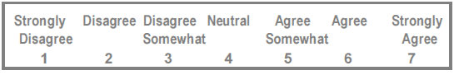

**Figure 3. Strongly Agree to Strongly Disagree Likert scale used to rate TPB responses**

TPB guidance does not provide advice on use of negatively worded items, but recommends reversal of positive and negative scale endpoints where multiple items with identical stems are utilised to reduce acquiescence bias (Francis et al., 2004). However, in response feedback that negatively worded items and reversal of negative endpoints were confusing, items were re-phrased so that for all items strong agreement or positive views in relation to the statement were indicated by a high score on the rating scale. This decision was supported by evidence that reverse worded and scoring of items increase processing time and reduce accuracy of responding (McColl et al., 2001), and are more problematic in BME groups, or non-native speakers (Wong, Rindfleisch, & Burrough, 2003).

*Intention to seek help questions.* In order to assess intention to seek medical help for memory problems, a proxy clinical case vignette measure was used. Clinical case vignettes are commonly used to assess medical help-seeking intention in other TPB studies including for mental health issues (Francis et al., 2004; Mo & Mak, 2009; Schomerus et al., 2009), and have been used to elicit attitudes related to understanding of dementia in South Asians (La Fontaine et al., 2007).

The vignette was developed by NM, GL, CC and JH and is displayed in Figure 4. No modifications of the vignette were suggested during piloting. The vignette featured an older adult aged 70 due to the high incidence of dementia in people over 65 (Alzheimer's Society, 2012; Knapp & Prince, 2007). The vignette was made culturally relevant firstly by using a South Asian name (Mrs Chaudry), and secondly by incorporating familial influences on care-giving found in research with South Asians (Ahmed & Lemkau, 2000), by asking participants to imagine that Mrs Chaudry is a close relative, and that family members had noticed her symptoms. It was considered important to depict memory difficulties that are strongly suggestive of early cognitive and functional decline in AD and VaD (Harvey et al., 1999; Knapp & Prince, 2007; Petersen et al., 1999) such as repeated forgetting of appointments and misplacing keys, in order to assess intention to seek help for early indicators of dementia. At the start of the questionnaire, participants were asked to imagine they were experiencing memory problems like Mrs Chaudry (of the vignette, displayed in Figure 4). The term “memory problems” was used in all questionnaire items, to refer to the problems depicted in the vignette.

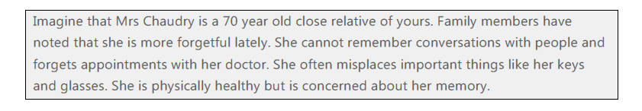

**Figure 4. Clinical vignette presented to participants in the TPB questionnaire**

In order to address issues found with pilot data, three intention items were used rather than two order in order that items could be dropped to improve consistency, and guidance on question construction was closely adhered to (Ajzen, 2006; Francis et al., 2004). In the final draft, participants were asked to imagine that they were experiencing memory problems like Mrs Chaudry and to indicate the extent to which participants agreed with three intention (IN) statements displayed in Figure 5 below, using Strongly Agree to Strongly Disagree Likert scales.



**Figure 5. Three intention items (IN1, IN2, IN3) from the TPB questionnaire**

*TPB direct attitude items.* Direct measures assess overall attitudes related to the three TPB constructs: BA, SN, PBC. Azjen provides structured guidance in terms of question stems and endpoints (Ajzen, 2006; Francis et al., 2004). In order to improve internal consistency of the items for the final version of the questionnaire compared with the pilot version, standardised question stems were used, and three items were used for each TPB construct (rather than two used in the pilot version) in order that items could be dropped to improve consistency (Ajzen, 2006; Francis et al., 2004).

*Behavioural attitudes (BAs)*

Direct BAs involved overall evaluations of the consequences of seeking help from a doctor. Items were developed using standardised question stems (Ajzen, 2006; Francis et al., 2004). Participants were asked to respond using three 7 point Likert scales to indicate the degree to which they value help-seeking, as displayed in Figure 6.



**Figure 6. Three behavioural attitude items (BA1, BA2, BA3) from the TPB questionnaire**

*Social Norms (SN)*

Direct SN questions aimed to capture the overall perceived evaluation of seeking help from a doctor for memory problems by significant others. Normative beliefs were directly assessed with the following standardised questions, using “Strongly agree” to “Strongly disagree” Likert scales:

**Figure 7. Three social norm items (SN1, SN2, SN3) from the TPB questionnaire**

*Perceived Behavioural Control (PBC)*

Direct PBC questions should reflect the perceived ease (PBC1 below), overall sense of control (PBC2) and confidence (PBC3) in being able to seek help from a GP for memory problems. Three question stems suggested in TPB guidance were used and were assessed with Strongly agree to disagree scales:

**Figure 8. Three perceived behavioural control items (PBC1, PBC2, PBC3) from the TPB questionnaire**

*TPB indirect belief items.* Indirect measures aim to address specific beliefs: BB, NB, CBs, which are relevant to intention to seek help from a doctor for memory problems. Themes identified in focus groups (displayed in Figure 1, and described under “Methods) were used to develop beliefs tested in the final questionnaire.

*Behavioural beliefs (BBs)* Indirect attitudes regarding perceived advantages or disadvantages of seeking help from a GP for memory problems were assessed by measuring the strength of the BB and the level of desirability of the outcome (or outcome evaluation (OE)) in keeping with guidance (Ajzen, 2006; Francis et al., 2004). Three themes related to the consequences of seeking help from a GP were identified in focus groups related to perceptions of what a doctor can provide for memory problems: providing treatments (BB1 below), an understanding of the cause of memory loss (BB2), and information about services to help (BB3). Strongly Agree to Strongly Disagree Likert scales were used for participants to respond to the following statements:



**Figure 9. Three behavioural beliefs (BB1, BB2, BB3) and corresponding outcome evaluations (OE1, OE2, OE3) from the TPB questionnaire**

*Normative beliefs (NBs)* Indirect beliefs involve identifying individuals or groups that would approve or disapprove of the behaviour, or attitudes that may influence a decision about whether to seek help from a GP for memory problems. NBs were developed using standardised guidance in which the strength of a belief and the degree of motivation to comply (MC) were assessed. NBs 1 and 2 were developed using two social normative referents that were identified from focus groups themes: firstly family members should encourage help-seeking from a doctor for memory problems, and secondly that community members would discourage help-seeking. Two further normative attitudes were identified from themes in focus groups: memory problems are embarrassing, and that seeking help from a doctor would mean being disloyal to family members, which were included as NBs 3 and 4. Strongly Agree to Strongly Disagree Likert scales were used for participants to respond to the following statements:



**Figure 10. Four normative beliefs (NB1, NB2, NB3, NB4) and corresponding motivation to comply items (MC1, MC2) from the TPB questionnaire**

*For NBs 3 and 4 above, degree of motivation to comply items were not used as it was considered inappropriate to ask participants to rate how much being disloyal or embarrassed would matter to them, as these questions would be considered loaded; TPB guidance recommends omitting measurement of the strength of evaluations if inappropriate, and to instead use a constant value chosen by the researcher (Ajzen, 2006; Francis et al., 2004). An arbitrary value of 1 was selected for both items for the purposes of analyses.

*Control beliefs (CB).* Control beliefs concern beliefs or factors that make it more or less likely that the behaviour will take place, for example affecting the perceived ease of performing the behaviour or confidence in the person’s ability to perform the behaviour. These were measured by assessing the strength of the CB, and the power that each control (PoC) factor has on the likelihood of carrying out the behaviour. Only one CB was developed from a theme identified in focus groups that memory problems would not be prioritised over physical health problems in GP appointments. A Strongly Agree to Strongly Disagree scale was used for the following responses:



**Figure 11. One control belief (CB) and corresponding power of control (PoC) from the TPB questionnaire**

*Weighting indirect beliefs.* In order to analyse the influence of indirect measures in the TPB model, each belief: BB, NB and CB was weighted by the strength of the corresponding outcome evaluation (OE), motivation to comply (MC) or Power of Control (PoC) respectively. For the purposes of analysis of the relationship between indirect beliefs and direct attitudes, each belief was multiplied by the corresponding evaluation: BB*OE, NB*MC, CB*PoCm and the weighted score for each type of belief was summed: ƩBBiOEi,, ƩNBiMCi , ƩCBi PoCi for every participant, to create composite indirect belief scores (Ajzen, 2006; Francis et al., 2004).

**Participants & Recruitment.**

Inclusion criteria and recruitment methods were the same as for focus groups (described under “Methods Part 1; Focus group methods: Participants”, p36), except only English-speaking participants were recruited for the questionnaire. A recruitment leaflet for the questionnaire study was disseminated to community organisations (displayed in Appendix M, p132). No financial compensation was provided for participants who completed the questionnaire only, and due to difficulties recruiting participants, an online version of the questionnaire was created to supplement recruitment. Five focus group participants recruited by NM, completed the final version of the questionnaire; JH recruited all other participants.

Recruitment for the online version of the questionnaire took place in parallel to recruitment for the written version of the questionnaire using the same recruitment strategies (recruitment notice is displayed in Appendix M, p132). In addition, for the online version of the questionnaire, student organisations based at London universities were requested to disseminate the recruitment information via email.

*Sample size calculation.* The sample size calculation indicated that a minimum of 37 participants was needed. This assumed a clinically significant correlation of 0.4 (Dunn & Everitt, 1995) between the combined TPB model and the measure of behavioural intention, and used a 95% confidence level and 80% power (Soper, 2014). A correlation of 0.4 was a conservative estimate; previous studies testing associations between the TPB model and intention to seek help for other mental health problems have demonstrated correlations of between 0.4 and 0.9 (Mo & Mak, 2009; Schomerus et al., 2009).

**Procedures.**

*Written version of the questionnaire.* Written versions of the questionnaire were administered in community settings. Participants were asked to read an information sheet (displayed in Appendix P, p135), and were given the opportunity to ask questions about the study. Written consent (consent form is displayed in Appendix Q, p139) was then obtained. On most occasions, participants completed the forms in a room with other participants; therefore participants were requested to keep their answers private.

Participants were asked if they had any concerns about completing the questionnaire in English. For those participants that had no concerns, the questionnaire was given to them to fill in independently. If participants were unsure that their level of reading and writing in English was sufficient to complete the questionnaire independently, the questionnaire was administered orally by a member of the research team. Following completion of the questionnaire, a debrief about the study was provided by the researcher, and participants were given the opportunity to ask any further questions they had about the study.

*Online version of the questionnaire.* Participants completed the questionnaire via an online link to the questionnaire created using online software (SurveyMonkey, 2014). The questionnaire was accessed by participants by pasting the link to the questionnaire into any internet browser from any computer. Participants were presented with an information sheet on the screen and were required to give their consent (displayed in Appendix R, p142). The information sheet contained telephone and email contact details of the researchers for participants to use if they had any further questions about the study or required any further information. Once consent was given, participants were presented with an online version of the questionnaire.

The online version of the questionnaire was created by JH, and consisted of the same TPB and DKQ items to the written version. In order to maximise response rates to the online questionnaire, guidance recommends starting with easy to answer, closed questions (Schonlau, Fricker, & Elliott, 2002). In the written version of the questionnaire, the majority of the initial background questions used an open response format (displayed in Appendix H, p126). To reduce the need for written answers for the online version of the questionnaire, multiple choice responses were also included for the following background characteristics: religion, country of birth and first language (modified questions are displayed in Appendix N, p133). An “other” response box was created for these items to enable participants to indicate if their responses did not fit any of the options provided.

A written debrief of the study was presented on the screen after participants completed the last item in the questionnaire (displayed in Appendix O, p134). This contained the contact details of researchers again, for participants to use if they had any further questions or concerns, or wished to withdraw their responses from the study.

**Statistical Analyses.**

All statistical analyses were carried out with Stata statistical software (StataCorp, 2007). To test the three main research hypotheses correlational analyses between help-seeking intention ratings and TPB constructs and DKQ scores were conducted respectively. Pearson’s r coefficient was used where parametric assumptions were met, otherwise Spearman's rank correlation coefficient (rho) was used. Prior to these analyses the following reliability checks were carried out: Cronbach’s alpha was used to test the internal consistency of direct TPB constructs and pairwise correlations between each direct and indirect measures of the same construct were conducted (Francis et al., 2004).

To further examine association between the combined contributions of TPB direct constructs and intention to seek help, regression analyses was conducted (Francis et al., 2004). Bootstrapping with 2000 replications was used for regression models where data was non-parametric (Fox, 2008).

## Ethical Considerations.

## All participants gave their informed consent in accordance with the Declaration of Helsinki. Participants understood that their participation was voluntary and could withdraw at any time without giving a reason. The full study (including focus group participation and written and online questionnaire completion) was reviewed and approved by the Psychology Department internal ethical procedure at Royal Holloway, University of London; ethical approval reference: 2013/0371R1. Further details for information and consent procedures for the focus groups, and participation in written and online questionnaires only, are described below.

*Focus group consent and ethics:* Information and written consent forms for participation in a focus group are displayed in Appendices B and C respectively. In addition to ethical approval from Royal Holloway Psychology Department, this part of the study also received National Research Ethics Service approval as part of the larger research study. Research Ethics Committee approval reference 12/LO/1584: Improving access to UK dementia services for the South Asian minority ethnic population: development and pilot of an intervention. Information and consent procedures detailed the compensation of participants for their time with a £20 high street (Marks and Spencer) voucher, and consent to audio recording of their contributions to the discussion group. A potential risk was highlighted in the information sheet, that topics discussed during the focus group may be upsetting, for example if participants have had experience of looking after someone with memory problems or if participants have noticed memory problems themselves. Advice detailed in the information sheet, specified that should participants feel upset they could speak to the researcher after the group, or ring a dementia support helpline number (contact details were provided).

*Written questionnaire consent and ethics:* Information and consent for participation in the written version of the questionnaire are displayed in Appendix P (p135) and Appendix Q (p139), respectively. There were no identified risks of taking part. Participants were not compensated for their time for completing the questionnaire only. This part of the study also received National Research Ethics Service approval as an amendment to the focus group ethics approval (REC approval reference 12/LO/1584).

*Online questionnaire consent and ethics:* Information and consent procedures for the online version of the questionnaire are displayed in Appendix R, p140. Written consent was not possible, therefore participants were required to check boxes online that agreed that they were aged 18 or over, secondly indicated that they understood their participation was voluntary and they could withdraw from the study, and thirdly that they agreed to participate. Online participants were not required to provide any identifying information. There were no identified risks of taking part.

**Results**

**Participant Characteristics**

The results of 51 participants were utilised by JH in the analyses: 26 participants had completed the written version of the questionnaire, 25 completed the online version. A further seven participants consented to the online study; four of these participants completed background and demographic questions only and were not included. The responses of the remaining three participants were excluded as they did not indicate that they were from the specified ethnic background; two participants specified that they were Vietnamese and Malay respectively and one participant did not complete any background items. No participants were excluded from the written version of the questionnaire. The full written questionnaire took between ten and twenty minutes to administer in South Asians who were both first and second language English speakers. The written version of the questionnaire was administered orally by JH for four participants who did not feel confident with reading and writing in English.

Participants were aged between 18 and 85 years (mean (SD) = 50.6 (21.8)), 34 participants (66.6%) were female. The majority of participants (40 participants (78%)) were not UK-born, and had spent from less than one year to 53 years in the UK (mean (SD)= 32.9 (15.0)). Further participant background and demographic characteristics are displayed in Appendix S, p141. As was expected with broad inclusion criteria, participants were from a range of eleven different birth countries, and, a range of religious backgrounds (Hindu and Muslim religions constituted the majority) and first languages (including Gujarati, Hindi and Punjabi) were represented. The largest proportion of individuals (40 participants (78%)) defined their ethnicity as Indian or British Indian. Comparison with demographic data for England and Wales from 2009 suggests that Indian ethnic groups were over-represented, whereas Pakistani and Bangladeshi backgrounds were under-represented compared with national averages[12] (Office for National Statistics, 2009). However, country of birth varied widely within the sample; for example within those that classified themselves as Indian, country of birth varied between eight different countries, including Kenya, Mauritius, India and the UK. In terms of participants’ exposure to dementia, over half (30 participants) stated that they had known someone with dementia or Alzheimer’s disease (AD), and approximately a fifth of participants reported personal experience of caring for someone with the condition, either as a carer for a friend or relative (9 participants) or as a paid carer (2 participants). Comparison with an estimate of the number of dementia carers in the UK[13] (Alzheimer's Society, 2012) suggests that dementia carers were over-represented relative to the general UK population.

In terms of the socio-economic characteristics of the sample, most participants were employed or retired (19 and 20 participants respectively). Current or previous occupations (if retired) indicated a wide range of professions and associated skill level: the largest proportion of participants (16 participants) were professionals with the highest level of skills: Skill Level 4, requiring tertiary education. The second largest grouping of professions (constituting 13 participants), were classified as Skill Level 2, requiring secondary school education, including clerical support and service workers. An informal estimate of years of education was calculated by asking participants to estimate the age that they left education, (or for students their current age was used), then subtracting 5 years: the average age for starting education in many countries including the UK. It was acknowledged that this was a crude method that was likely to have over-estimated years of schooling[14]. Years of education ranged between 2 years to 22 years (mean (SD) = 14.1 years (3.6)), which is substantially higher than the average years of schooling for adults in the UK population (9.4 years (United Nations Development Programme, 2013)), but is comparable to the average London population[15] (Eurostat, 2012). Differences were observed in participant demographics between the online compared with the written versions of the questionnaire. Online participants were younger (t =-8.12, p<0.001, df=49) and had a higher number of years of education (difference in mean=2.86 years, t=2.95, p<0.01, df=42) as would be expected from recruiting some participants for the online questionnaire via London Universities.

**Experimental Results**

The following section of this Thesis describes the experimental analyses, firstly to evaluate development of a reliable and valid TPB questionnaire (Aim 3 of the study). The analyses will then separately address the three research study hypotheses.

***Study aim 3: Evaluation of questionnaire ratings for direct TPB attitudes and intention to seek help*.**  All participants (N=51) completed ratings for three items assessing intention to seek help, and three items for each TPB direct construct (BA, SN, and PBC). A summary of ratings for all TPB items is displayed in Appendix T, p142. The distribution of ratings for all intention and direct TPB attitude items were negatively skewed, indicating that ratings were skewed in the direction of favourable intentions and attitudes towards seeking help from a doctor for memory problems. For example, for intention ratings: 42 participants (82.3%) indicated favourable average ratings of between 5 and 7, 3 participants (5.9%) were undecided (scoring an average rating of 4), and 6 participants (11.8%) indicated unfavourable intentions to seek help, with average ratings of between 1 and 3.

To establish the internal validity of TPB direct attitude and intention items measuring the same construct, inter-item correlations were calculated and are displayed in Appendix U, p143. For consistency, TPB guidance recommends removing items measuring the same construct with correlation coefficients less than 0.3, therefore the scores for one social norm item (SN3) were removed from further analyses. TPB guidance does not make any recommendations with regards to removing items with very high correlations. However, in standard questionnaire design, two items measuring the same construct with very high inter-item correlations (greater than 0.85) indicate redundancy and insufficient discriminant validity (Campbell and Fiske, 1959). One behavioural attitude item (BA1) was removed from further analyses on this basis. To establish the internal consistency of the TPB model Cronbach’s alpha was calculated for the remaining 7 direct TPB items (2 BA items, 2 SN items and 3 PBC items). The results indicated an acceptable level of consistency (α=0.86).

For the purposes of further analyses, the average rating for each direct TPB construct was calculated for 2 BA items, 2 SN items and 3 PBC items, respectively, to create three composite direct attitude scores (BA, SN, PBC). Similarly the average of the three intention scores was calculated to create one composite intention score (IN) (Francis et al., 2004). A summary of TPB intention and direct attitude composite scores (IN, BA, SN, PBC) are displayed in Table 2.

*Summary of results: Aim 3.* A TPB measure with sufficient internal consistency and sufficient item discriminability was developed by eliminating inconsistent or redundant items respectively. The final selection of items contained three items assessing intention to seek help, and seven direct TPB items (2 BA items, 2 SN items and 3 PBC items). The results were negatively skewed, indicating that ratings for attitudes and intention to seek help were broadly in favour of seeking help from a doctor for memory problems.

***Hypothesis 1: There will be a significant relationship between the three direct TPB constructs indicated in the TPB (BA, SN, PBC) and intention to seek help.***Preliminary correlational analyses were carried out to test the hypothesis that each of the three TPB constructs predicts intention to seek help for memory symptoms and are displayed in Table 2. Inter-construct correlation coefficients were all significant, and ranged between 0.60 and 0.74. These analyses provide preliminary support for Hypothesis 1.

Table 2

*Summary of TPB intention and three direct attitudes ratings: median and percentile scores, and inter-construct correlation coefficients*

|  |  |  |  |  |  |  |
| --- | --- | --- | --- | --- | --- | --- |
| Score | Median | 25th -75th% | | Corr with IN | Corr with BA | Corr with SN |
| IN | 6.0 | 5.3 | 7.0 | - | - | - |
| BA | 7.0 | 5.5 | 7.0 | 0.70** | - | - |
| SN | 6.0 | 5.5 | 7.0 | 0.74** | 0.60** | - |
| PBC | 6.0 | 5.0 | 7.0 | 0.64** | 0.72** | 0.67** |

**=p<0.001; IN=composite measure of intention to seek help for memory problems; BA= composite measure of behavioural attitudes; SN= composite measure of social norms; PBC= composite measure of perceived behavioural control; Corr=Spearman’s rho correlation coefficient

In order to address whether each TPB construct independently predicts intention to seek help, a bootstrapped regression analysis (N=51) investigated the extent to which each composite TPB attitude: BA, SN and PBC accounted for variance in intention to seek help.

Overall, the TPB model explained 77% of the variance in intention to seek help for memory problems (R2= 78.0, adjusted R2=76.5; Wald χ2 (2, 49) = 102.6; p<0.0001). Of the direct attitudinal measures, social norms (SN) or anticipated social pressure to seek help, were most strongly associated with intention to seek help (B=0.80, estimated β = 0.63, CI (0.42: 1.17), p<0.001). Behavioural attitudes (BA), or overall appraisals of seeking help as beneficial, were also strongly associated with intention to seek help (B=0.59, estimated β = 0.46, CI (0.25: 0.92), p<0.01). Perceived behavioural control (PBC), the perception that seeking help is under the person’s control, was not significantly associated with intention to seek help in the model (B=-0.12, estimated β = -0.1, CI (-0.49: 0.25), p=0.53). Furthermore, the amount of variance explained by the model was very similar when PBC was removed from the model (R2= 77.5, adjusted R2=76.6; Wald χ2 (1, 50) = 91.4; p<0.0001).

To investigate the possibility that collinearity between direct attitudes was responsible for the non-significant effect of PBC, variance inflation factors (VIFs) were calculated. However, the range of VIFs (2.2 - 3.9) fell within normal limits (VIFs<10).

*Summary of results: Hypothesis 1*. Overall, the TPB model explained 77% of the variance in intention to seek help for memory problems; this was explained by strong associations with social norms and behavioural attitudes. Although the results found that all 3 of the TPB direct attitudes separately predicted intention to seek help for memory problems, perceived control beliefs were not found to significantly independently contribute to intention over and above the effects of the other two types of attitude in the regression analysis.

***Hypothesis 2: Culturally relevant attitudes investigated via indirect TPB beliefs (BB, NB, CB) will influence intention to seek help*.** A summary of indirect belief ratings (3 BBs, 4 NBs and 1 CB) and corresponding evaluations (3 OEs, 2 MCs and PoC ratings) are displayed in Appendix T, p142. To investigate the relationship between indirect TPB beliefs and intention to seek help, the internal consistency of each weighted indirect belief (BB*OE, NB*MC, CB*PoC) with the corresponding direct TPB attitude (BA, SN, PBC) must first be established (Ajzen, 2006; Francis et al., 2004). Following this, the relationship between each belief and intention to seek help can be investigated.

*Indirect behavioural beliefs.* Three behavioural beliefs (BBs), displayed in Figure 9, relate to what a doctor can provide for memory problems in terms of: 1) treatments, 2) understanding of the cause of memory problems and 3) what services are available to help. The three weighted behavioural beliefs were each highly significantly correlated (p<0.001, df=49) with the composite direct BA score (BB1*OE1: rho= 0.71; BB2*OE2: rho= 0.63; BB3*OE3: rho= 0.68) indicating sufficient internal consistency of these beliefs. This demonstrated that greater agreement with these three healthcare related beliefs was associated with more positive attitudes towards help-seeking. The sum of the 3 weighted behavioural beliefs was found to be significantly associated with intention to seek help for memory problems (B=0.02, estimated β = 0.20*;* CI (0.01: 0.03), p<0.001). This supports the hypothesis that indirect behavioural beliefs predict intention to seek help for memory problems.

*Indirect control beliefs.*One control belief (CB) displayed in Figure 11, addressed the belief that doctors would not prioritise memory problems in appointments. The weighted control belief (CB*PoC) was not significantly associated with the direct belief PBC (rho= -0.05, p=0.71, df=49) indicating insufficient consistency with the direct construct. It was also not significantly associated with intention to seek help (rho= 0.01, p=0.94, df=49). This indicates that the indirect control belief tested did not predict intention to seek help for memory problems as hypothesised.

*Indirect normative beliefs.*Four indirect normative beliefs (NBs) displayed in Figure 10, addressed beliefs that: NB1) family members would encourage help-seeking, NB2) community members would discourage help-seeking, NB3) that seeking help from a doctor would mean being disloyal to family members and NB4) that seeking help for memory problems would be embarrassing. Two of the normative beliefs were found to be internally consistent with direct constructs: one of the weighted normative beliefs: NB1*MC1 significantly positively correlated with the direct belief: SN (rho=0.33, p=0.03, df=49), implicating a positive influence of family members on attitudes towards help-seeking. Whereas normative belief: NB4 significantly negatively correlated with SN (rho=-0.41, p<0.05,df=49), indicating that seeking help for memory problems is embarrassing has a negative influence on attitudes towards help-seeking. The two other indirect normative beliefs (NB2*MC2 and NB3) did not indicate sufficient consistency with SN: NB2*MC2 (rho=0.07, p=0.62, df=49), and NB3 rho= -0.09, p=0.55, df=49) and were therefore removed from further analyses.

The combined influence of the two consistent weighted normative beliefs (NB1*MC1 and NB4) was found to be significantly associated with the composite measure of intention (B=0.23, CI: 0.1-0.4; p<0.01). This supports the hypothesis that culturally relevant beliefs addressed in two of the normative beliefs included in the questionnaire, predict intention to seek help for memory problems.

*Summary of results: Hypothesis 2*. The results support the second research hypothesis, finding that five out of eight of the culturally-relevant attitudes addressed in the questionnaire were predictive of intention to seek help for memory problems. Whereas one normative belief, addressing the belief that help-seeking for memory problems is embarrassing, had a negative influence on attitudes, three behavioural beliefs (related to what a doctor can provide for memory problems) and one of the normative beliefs (relating to the influence of family members) were associated with positive attitudes towards help-seeking.

***Hypothesis 3: There will be a significant relationship between knowledge about dementia and intention to seek help.***

*Summary of DKQ scores.* All participants (N=51) completed the DKQ; the scores for each item and subtest are displayed in Appendix V, p144 with the scores of a comparison South Asian sample (Purandare et al., 2007). The total DKQ average score for the present study was substantially higher than Purandare’s sample (present sample Mean (SD) = 8.9 (3.9)); Purandare’s sample median (25-75th percentile) = 3 (2-5). Unfortunately, it was not possible to compare average scores statistically, but comparison of the number of participants scoring each item correct found that a significantly higher proportion of individuals in the present study scored 14 out of 19 items correct (analyses are displayed in Appendix V, p144).

23 focus group participants in the present study also completed the DKQ. This group had an average total DKQ score (mean (SD) = 7.9 (3.9)), which was not significantly different to the present study results (t=-0.99, p=0.33, df=72). As the focus group participants did not complete the final TPB items, their results were not included in further analyses.

The internal consistency of the four subtests of the DKQ was calculated for the present sample (N=51) and found to be low: Cronbach’s alpha=0.56 for five scores. Further analyses were therefore calculated with scores for the four individual subtests as well as the total DKQ score.

*Relationship between DKQ and intention and TPB attitudes.* In order to investigate the relationship between the DKQ and help-seeking, pairwise correlations were carried out between DKQ scores and intention to seek help, as well as with three TPB direct constructs (AB, SN, PBC). Correlations are displayed in Table 3. No significant positive relationships were found between dementia knowledge scores and intention to seek help. Similarly no significant positive relationships were found between dementia knowledge scores and TPB attitudes. However, significant negative correlations were found between the aetiology subtest and intention to seek help and all TPB attitudes respectively.

Table 3

*Pairwise correlations between DKQ scores, intention to seek help for memory problems and three direct TPB attitude ratings*

|  |  |  |  |  |  |
| --- | --- | --- | --- | --- | --- |
| Score | Total DKQ score | Basic Knowledge | Epidemiology | Aetiology | Symptoms |
| IN | -0.18 | 0.04 | 0.06 | -0.35* | -0.04 |
| BA | -0.20 | -0.26 | -0.06 | -0.32* | 0.04 |
| SN | -0.11 | 0.15 | 0.09 | -0.29* | -0.01 |
| PBC | -0.22 | -0.04 | -0.06 | -0.35* | -0.06 |

*p=<0.05; **p=<0.001; IN=composite measure of intention to seek help for memory problems; BA= composite measure of behavioural attitudes; SN= composite measure of social norms; PBC= composite measure of perceived behavioural control.

*Summary of results: Hypothesis 3*. The results did not support the hypothesis that there is a positive relationship between overall dementia knowledge and intention to seek help for memory problems. Similarly, no predictive relationship was found between dementia knowledge and TPB direct beliefs towards help-seeking. However, intention and TPB beliefs were found to negatively correlate with aetiology score. This is an unusual pattern of results suggesting that for this construct greater knowledge is associated with a lower intention to seek help, and less favourable attitudes towards help-seeking.

***Further exploratory analyses with the DKQ.*** As the hypothesised relationship between DKQ and help-seeking (intention or attitudes) was not found, further exploratory analyses were carried out with the DKQ.

*Sensitivity analyses without aetiology item.*An unusual pattern of results was found for the aetiology subtest such that significant negative correlations were found between the aetiology subtest and intention to seek help and all TPB constructs respectively. Also, within the aetiology subtest, scores were found to be lowest for “old age”, which is the only item which is scored as an incorrect cause of dementia. Old age is not a direct cause of dementia but is significantly associated with an increased risk of developing the condition (Knapp & Prince, 2007) and therefore this item may have misled participants. When scores for this item were removed from correlation analyses, no difference in the results was found. No significant relationships were found between total DKQ score and help-seeking intention (rho=-0.01, p=0.95, df=49), or with TPB direct scores (BA (rho=-0.05, p=0.74, df=49), SN (rho=0.07, p=0.64, df=49), or PBC (rho=-0.12, p=0.42, df=49)).

*Summary of results: sensitivity analysis.* Sensitivity analysis indicate that removing scores for the old age item of the Aetiology subtest from the total DKQ score, did not significantly influence the null relationship found between dementia knowledge and intention to seek help for memory problems.

*Dementia knowledge and background participant characteristics.*In order to investigate reasons for higher performance on the DKQ in the present study compared with the study by Purandare and colleagues (scores and differences are displayed in Appendix V, p144) (Purandare et al., 2007), the relationship between DKQ (total and subtest scores)and a selection of background variables was investigated. Background variables were selected on the basis of differences in characteristics between sample groups. Purandare’s study sample was older (average age of 72 years), and as an increase in age has been negatively associated with dementia knowledge previously (Werner, 2003), association with age was investigated. Also, in Purandare’s study, the questionnaire was administered in other languages and therefore the sample was likely to have contained speakers with a lower level of linguistic proficiency than in the present study. Although no measure of language skills was obtained in the present study, it was hypothesised that first language English speakers would have greater linguistic proficiency. A variable was created which indicated whether participants’ first language was English. Lastly, as it was possible that Purandare and colleagues’ sample was less well educated (although education was not reported) years of education was also investigated as this has previously been associated with increased dementia knowledge (Werner, 2001).

Pairwise correlations (reported in Table 4) found that dementia knowledge (total score and the construct of basic knowledge respectively) significantly correlated with years of education. Basic knowledge scores also significantly correlated with first language (English versus not English) such that having English as their first language was associated with an increase in basic knowledge score. Basic knowledge was also found to significantly negatively correlate with age, such that an increase in age resulted in a decrease in knowledge.

Table 4

*Pairwise correlations between DKQ scores and background participant characteristics*

|  |  |  |  |
| --- | --- | --- | --- |
| DKQ score | Age  (yrs) | Education  (yrs) | 1st language  (English v other) |
| Total score | -0.20 | 0.32* | 0.18 |
| Basic knowledge | -0.33* | 0.29* | 0.31* |
| Epidemiology | -0.05 | 0.25 | -0.02 |
| Aetiology | -0.13 | 0.27 | -0.20 |
| Symptomatology | 0.04 | 0.06 | -0.23 |
| Intention | 0.05 | 0.05 | 0.02 |

*p<0.05

*Summary of results: Comparison with previous South Asian sample.* The results found that dementia knowledge (total DKQ score and basic knowledge score) was associated with number of years of education. In addition, basic knowledge about dementia correlated with first language (English versus not English), and was negatively associated with age. The results suggest that demographic differences between our sample and Purandare’s sample group may explain higher scores on the DKQ.

*Education and the relationship between knowledge and help-seeking*. Following findings that knowledge about dementia was significantly associated with years of education, it was hypothesised that in individuals with a low level of education, knowledge about dementia may be more critical to help seeking. Furthermore it was hypothesised that there is an interaction between dementia knowledge and number of years of education, in which an increase in knowledge will increase intention to seek help for memory symptoms for lower educated participants. Exploratory bootstrapped regression analyses were conducted for total dementia knowledge scores and basic knowledge scores respectively, as both scores were significantly associated with years of education. Power calculations indicated that there was sufficient power to detect an effect[16].

For total DKQ score, there were no significant findings[17]. For basic knowledge score, the regression model accounted for less than 1% of the variance in intention (R2=0.37, adjusted R2= -0.17, Wald χ2=19.8, p=0.65), and the overall interaction between years of education and knowledge score was not significant (χ2=6.78, p=0.56). However, three interaction coefficients were significant: the interaction with knowledge score at 10 years of education (B=4.0, CI (0.5:7.5), p=0.03), 11 years of education (B=4.6, CI (0.7:8.5), p=0.02) and 14 years of education (B=4.4, CI (0.6:8.1), p=0.02). None of the higher years of education (up to 22 years of education) showed a significant interaction with knowledge score.

These results suggest that in individuals with lower number of years of education (10, 11 or 14 years), level of basic dementia knowledge may influence intention to seek help. Based on these results and findings of a previous study in which significant differences in dementia knowledge were found between participants with less than 12 years of education, and more than 12 years of education (Werner, 2001), that a critically low pre-secondary school level of education may exist. We investigated a “low education” subgroup within our sample, which included individuals who had left school by the age of 12. This small subgroup (n=9) was compared to the results of other participants with a higher level of education (n=42) on the composite measure of intention to seek help, and within each subgroup associations between intention to seek help and dementia knowledge scores were investigated.

Table 5

*Comparison of average scores for intention to seek help and DKQ scores between low (n=9) and higher education (n=42) group*

|  |  |  |  |
| --- | --- | --- | --- |
|  | Intention **a**  (/7) | Total DKQ  (/19) | Basic Knowledge (/3) |
| Low | 6.0 (5.7 – 6.0) | 7.3 (3.9) | 1.7* (0.7) |
| Higher | 6.0 (5.1 – 7.0) | 9.2 (3.9) | 2.4 (0.8) |

*p<0.05; **a**Medians (25th–75th centiles) are reported due to the non-normality of the data

For intention to seek help, no significant difference between the groups was observed (U=161.0, z=-0.70, p=0.50, df=49). Consistent with findings of an association between dementia knowledge and years of education, the low education group had lower knowledge scores although only the difference in basic knowledge score was significant (t=2.65, p=0.01, df=49). Non-significant findings may have been due to insufficient power: the power for the observed difference in average total DKQ score was 0.38, using α=0.05.

Basic knowledge significantly correlated with intention to seek help (rho=0.72, p=0.03, df=7) in the low education subgroup but not the higher education subgroup (rho= -0.22, p=0.17, df=40).

No significant findings were found for total DKQ score (low subgroup: rho=-0.64, p=0.06, df=7; higher subgroup: rho= -0.19, p=0.22, df=40). This suggests that an increase basic knowledge is associated with increased intention to seek help for memory problems in the low education subgroup.

*Summary of results: relationship between DKQ and education.* The results found little evidence that low education status influenced intention to seek help per se, although analyses are likely to have been underpowered. It is tentatively suggested that in individuals with a low level education (prior to secondary education), increased basic knowledge about dementia is associated with an increase in intention to seek help for memory problems. This is based on interactions found between basic knowledge and intention at lower levels of education, (although results are inconclusive because the overall interaction was not significant), and on the basis of finding of a positive correlation between basic knowledge and intention to seek help in the low but not a higher education subgroup.

**Discussion**

**Overview**

The discussion chapter of the Thesis will firstly consider the results of the analyses in relation to the study’s three research hypotheses. Next, this chapter will consider the third aim of the study, and evaluate the development of a TPB questionnaire assessing intention to seek help for memory problems with South Asians. Lastly, limitations of the research, future research directions and the clinical implications of the results, will be discussed.

**Hypothesis 1: There will be a significant relationship between the three direct TPB constructs indicated in the TPB (BA, SN, PBC) and intention to seek help from a GP for memory problems.**

This study found that willingness to seek help from a doctor for memory symptoms was

largely explained by attitudes and beliefs conceptualized by the TPB (Ajzen, 1991). The amount of variance explained by direct attitudes in the model, 77%, is sizeable compared with 41- 61% of variance found in TPB studies of intention to seek professional help for mental health problems (Mak & Davis, 2013; Mo & Mak, 2009; Schomerus et al., 2009), and in comparison to an average of 39% of variance in behavioural intention explained by the TPB in a meta-analysis of 185 studies (Armitage & Conner, 2001). Willingness to seek help from a doctor for memory problems therefore seems to be strongly related to direct TPB attitudes in a South Asian sample, indicating that they could be useful targets for intervention studies to improve help-seeking.

The results support the hypothesis that there is a significant relationship between two of the direct TPB constructs and intention to seek help. Of the direct attitudes assessed in the model, intention to seek help from a doctor was most strongly related to social norms, followed by attitudes towards the behaviour, which was also strongly related to intention. A relationship between perceived behavioural control and intention was found in separate pairwise analyses, however in the combined TPB model, PBC did not significantly contribute to intention over and above the effects of the other two attitudes. This suggests that it is a less useful target for interventions than the other two types of TPB attitude.

The central importance of social norms here was likely to have contributed to the high level of variance explained by the model. The result indicates that participants that feel social pressure from people that are important to them, would be more likely to indicate that they would seek medical help for memory problems. This result contrasts with TPB studies where social norms have been found to be significantly weaker influence compared with other TPB attitudes on intention (Armitage & Conner, 2001; Hunter, Grunfield, & Ramirez, 2003). Social norms however have been found to be a strong influence in two studies addressing collectivist Chinese cultural influences on seeking professional help for mental health problems (Mak & Davis, 2013; Mo & Mak, 2009), and the strong influence of SN here is also likely to reflect strong collectivist influences on healthcare decisions in South Asians (Ahmed & Lemkau, 2000). This result supports the use of the TPB for measuring help-seeking in South Asians, where social norms have a explicit and direct influence on behaviour, over the Socio-cultural HBM: a recent model addressing cultural influences on dementia help-seeking (displayed in Figure 2) where normative influences have only an indirect influence on behaviour.

Behavioural attitudes, reflecting overall favourable or unfavourable views about whether to seek help from a doctor for memory problems, were also found to be a strong influence on help-seeking intention. This result indicates that participants holding a positive attitude about the benefits of seeking help for memory problems are more likely to indicate that they would seek help for memory problems. This result is in keeping with the findings of numerous TPB studies including studies investigating professional help-seeking for mental health issues, that BAs are a strong (and often the strongest) attitudinal influence on behavioural intention (Ajzen, 1991; Armitage & Conner, 2001; Mo & Mak, 2009; Schomerus et al., 2009).

Perceived behavioural control, assessing overall ease and sense of personal control over seeking help from a doctor for memory problems, was not found to be a significant independent predictor in the model. This was not due to a lack of internal consistency of the construct, as the three items assessing control were sufficiently correlated. This result contrasts with common findings that PBC is a strong predictor of behavioural intention (Ajzen, 1991; Armitage & Conner, 2001). However, in two studies of intention to seek professional help for mental help issues, PBC was also found to be of minor importance compared with other attitudes (Mo & Mak, 2009; Schomerus et al., 2009). In one study, PBC coefficients were low and similarly non-significant in the two TPB models presented (Schomerus et al., 2009). The authors hypothesised that this was due to the perceived ease of seeing a psychiatrist within the context of the German healthcare system. It is possible that the lack of significant influence of PBC here similarly reflects the perceived ease of seeing a GP. Alternatively, in a Chinese study (Mo & Mak, 2009), the authors speculated that findings of a low PBC beta coefficient was because self-efficacy and personal skills were of lesser importance on help-seeking compared with collectivist influences in Chinese culture. It is also possible that the results of the present study reflect the lesser influence of personal control factors on intention to seek help for memory problems in South Asians.

***Hypothesis 1: Summary.*** The results provide strong empirical evidence for the use of the TPB in addressing help-seeking for memory problems in South Asians. Support for the first research hypothesis was found in that two direct TPB attitudes: behavioural and normative attitudes independently predicted intention to seek help from a doctor for memory problems. The strong influence of normative attitudes, which is not always found in TPB research, is likely to reflect collectivist South Asian cultural influences, and may have contributed to high levels of variance explained by the model. The strong influence of behavioural attitudes on intention is a common finding across TPB studies. However, finding that perceived behavioural control did not independently contribute to behavioural intention is not commonly found, and may have been due to the lesser cultural importance of personal control factors on decisions to seek help, or due to the perceived ease of seeing a GP. The strong influence of social norms in the present study validates the use of the TPB model, where normative attitudes have a central and direct influence on behaviour, for quantifying collectivist cultural influences on help-seeking in South Asians, particularly in comparison to another model: the Socio-cultural HBM, where SN have only an indirect influence.

**Hypothesis 2: Culturally relevant attitudes investigated via indirect TPB beliefs (BB, NB, CB) will influence intention to seek help from a GP for memory problems in a South Asian sample.**

Five of eight culturally relevant attitudes investigated via TB indirect beliefs were found to influence intention to seek help from a GP for memory problems in a South Asian sample.

Three behavioural beliefs and two normative beliefs tested were found to be significantly associated with intention and their corresponding direct attitudes (BAs and SNs respectively) as predicted by the TPB model (Ajzen, 1991). This is the first study to quantify the influence of culturally relevant behavioural and normative beliefs in relation to help-seeking for memory problems. The results of the present study suggest that targeting pertinent cultural attitudes and beliefs in intervention studies would influence intention to seek help for memory problems (Ajzen, 1991; Mukadam et al., 2013).

Three behavioural beliefs were found to predict intention to seek help from a doctor for memory problems. These indicated that greater agreement that doctors are able to provide help for memory problems in terms of: treatments, understanding about the cause of problems, and information about services, were associated with increased help-seeking intention. These three beliefs quantified the influence of facilitators of help-seeking found in focus groups, and addressed healthcare related attitudes identified as barriers to help-seeking in previous research in BME groups including South Asians, such as lack of knowledge about what is available to help or where to go for help (Cloutterbuck & Mahoney, 2003; La Fontaine et al., 2007; Mukadam et al., 2011a; Zhan, 2004). In particular it addressed a barrier found in focus groups and previous studies in South Asians: that nothing can be done for memory problems (La Fontaine et al., 2007; Mukadam et al., 2011a).

Two normative beliefs also predicted intention to seek help from a doctor for memory problems. Firstly, a positive influence of family members was found such that views that family members would approve of help-seeking was associated with increased intention to seek help. This was consistent with attitudes found in focus groups, and previous research in people from South Asian backgrounds finding that family members are able to detect early dementia symptoms (such as forgetting) and are important influences on medical help-seeking behaviour for dementia (La Fontaine et al., 2007; Lawrence et al., 2008; Mukadam et al., 2011a). Secondly, a negative association with help-seeking intention was found with the belief that getting help for memory problems would be embarrassing; such that participants that found it more embarrassing were less likely to indicate that they would seek help. This belief addressed the impact of the shame and stigma which has been identified as a socio-cultural barrier to help-seeking previously in South Asian groups (Bowes & Wilkinson, 2003; La Fontaine et al., 2007; Lawrence et al., 2008).

A control belief tested in the study was not associated with intention to seek help in this study. This CB addressed a belief that memory problems would not be prioritised over physical health problems in GP appointments. This was identified as an external barrier to medical help-seeking from the content of focus groups, supported by previous qualitative findings of GP-related barriers in South Asian carers and non-carers (La Fontaine et al., 2007; Mukadam et al., 2011a). A TPB study of help-seeking for depression (Schomerus et al., 2009), which as described above under the discussion of Hypothesis 1 also found a minor influence of direct PBC on intention to seek help, similarly found non-significant effects of external control beliefs on intention to seek help. As for the lack of significance of PBC, the authors also hypothesised that a lack of influence of indirect control beliefs was due to the lack of perceived external barriers to seeking help from a psychiatrist in the German healthcare system. Although our findings are limited by the low internal consistency of this construct, it is possible that external GP-related barriers are not important influences on intention to seek help for memory problems. This was also suggested by the limited number of control beliefs identified in the content of the focus groups and previous research. However, this requires further investigation with more detailed measures of this construct.

Two normative beliefs tested were also not found to be significantly associated with corresponding direct beliefs or with intention to seek help. Firstly, the predicted negative influence of community members on help-seeking for memory problems, and secondly that seeking help means being disloyal to family members, were not found to be consistent with overall social normative influences on help-seeking. These beliefs were developed from stigmatised views of dementia symptoms found in focus groups and previous research in South Asians (Bowes & Wilkinson, 2003; La Fontaine et al., 2007; Mukadam et al., 2011a). It is possible that the complexity of cultural attitudes was not accurately conveyed in the TPB questions constructed, for example expectation that family members care for their relatives may not convey a sense of disloyalty for seeking medical help per se, but rather that seeking external support is considered unnecessary. There may also have been a mixed influence of community members: such as that the perception that some friends within the community would approve of help-seeking whereas others would not. These cultural beliefs require further consideration, as they may be important socio-cultural influences on help-seeking in South Asians.

***Hypothesis 2: Summary.*** This is the first study to have quantified the influence of cultural beliefs on help-seeking for memory problems. The results support the hypothesis that culturally relevant attitudes, investigated via indirect TPB beliefs, influence intention to seek help in a South Asian sample. The results found a positive influence of family members and a negative influence of stigma on intention to seek help for memory problems, supporting attitudes implicated in focus groups and previous qualitative studies in South Asians and BMEs. Similarly, beliefs around what help a doctor can provide for memory problems were also found to significantly influence help-seeking intention. One control belief was not found to be significantly related to intention to seek help, which may be due to the perceived ease of seeing a GP. Also, two normative beliefs developed around themes of stigma around dementia, were not found to be reliable measures of normative influences on intention to seek help, possibly as the questions did not accurately capture relevant attitudes, and require further refinement and investigation.

**Hypothesis 3: There will be a significant relationship between knowledge about dementia and intention to seek help from a GP for memory problems.**

General knowledge of dementia was not associated with intention to seek help for memory problems in South Asians as hypothesised. A null result was found both for the relationship between intention and total score on the DKQ, and also with DKQ subtest scores: basic knowledge, epidemiology, aetiology or symptomatology. DKQ scores were similarly not associated with any of the TPB direct attitudes found to predict help-seeking intention. Although unexpected, this result is not at odds with numerous findings that interventions aiming to increase knowledge have not had any impact on help-seeking for other health conditions (Gulliver, Griffiths, Christensen, & Brewer, 2012; Naylor, Ward, & Polite, 2012; Robertson, 2008). A systematic review of randomised control trial interventions evaluated the impact of mental health literacy on professional help-seeking (Gulliver et al., 2012b). The review found positive effects of literacy on attitudes towards help-seeking, but only one of six studies demonstrated a significant increase in help-seeking behaviour; furthermore the only successful intervention involved psychological therapy as well as information giving (Gulliver et al., 2012b). Similarly, an RCT carried out by Gulliver and colleagues, found that an information intervention improved attitudes towards help-seeking and reduced stigma around mental health, but this did not translate into a significant increase in professional or informal help-seeking behaviour (Gulliver et al., 2012a). The authors argued lack of significant findings was due to an insufficient sample size, however it suggests that simple information provision may have a limited effect on help-seeking behaviour.

A review of UK government information and awareness campaigns for a range of healthcare related issues suggests that although health behaviour can be modified, delivery of messages needs to go beyond simple provision of information (Robertson, 2008). There is increasing evidence in favour of interventions in which there is consideration and tailoring to individual or group attitudes (Bhugra, 2002; Myers et al., 2007; Naylor et al., 2012; Robertson, 2008; Zeh, Sandhu, Cannaby, & Sturt, 2012). The results of the present study support the view that targeting pertinent attitudes and beliefs would more successfully influence intention to seek help for memory problems than broadly increasing factual knowledge about dementia (Mukadam et al., 2013).

The null result differs from the findings of numerous qualitative research studies which have implicated a role for dementia knowledge in barriers to help-seeking in South Asian and other BME groups (Adamson, 2001; Bowes & Wilkinson, 2003; La Fontaine et al., 2007; Mukadam et al., 2011a; Mukadam et al., 2011b), and also from the results of two intervention studies which both involved information provision via a leaflet (Alzheimer's Society, 2009; Seabrooke & Milne, 2009), which reported positive but inconclusive outcomes in terms of help-seeking. Similarly the results of three cross-sectional studies also reported association between dementia knowledge and professional help-seeking attitudes or intention (Hodgson & Cutler, 2004; Watari & Gatz, 2004; Werner, 2003). Limitations of these studies were considered under “Introduction; Quantitative research studies: Direct relationships between dementia knowledge and help-seeking” (p25) and it is possible that methodological differences with the present study may explain different findings.

However, it is tentatively hypothesised from exploratory analyses carried out that increasing rudimentary dementia knowledge, as captured by the “basic knowledge” subtest of the DKQ, may have a positive effect on medical help-seeking for memory problems in individuals who have pre-secondary school levels of education. This was based on interactions found between dementia knowledge and intention to seek help in individuals with lower levels of education, and a significant correlation found between knowledge and intention to seek help in the subset of participants with pre-secondary school levels of education, but not higher numbers of years of education. The “basic knowledge” DKQ subtest required knowledge that dementia affects the brain, mostly affects older people over 60 years, and does not have a cure. This subtest addressed knowledge implicated as influencing help-seeking in focus groups and previous research, including the ability to recognise the term “dementia”, and identify that it is primarily an illness of older age (La Fontaine et al., 2007; Mukadam et al., 2011a). It also overlaps with key areas of knowledge targeted in national awareness campaigns (Department of Health, 2009a; Department of Health, 2011). The results suggest that increasing basic dementia knowledge may result in greater intention to seek help in South Asians that have critically low levels of education and low levels of dementia knowledge.

It is hypothesised that the reason for not finding a relationship found between any aspect of dementia knowledge (including basic knowledge) and help-seeking intention, was above critical levels of education and dementia knowledge in our sample. Higher dementia knowledge scores were found for nearly all subtests of the DKQ, in comparison with a previous study sample of people from South Asian backgrounds (Purandare et al., 2007). Similar results were also found for a smaller sample of South Asian focus group participants completing the DKQ, suggesting that this was not an anomalous finding in South Asians. Information campaigns such as the National Dementia Awareness Campaign in the UK (Department of Health, 2011) are likely to have led to an increase in dementia knowledge in the population since Purandare and colleagues’ study in 2007 (Purandare et al., 2007).

It was hypothesised that the background characteristics of our sample: a high educational level, a younger average age, and having a broadly high level of English language competency (sufficient to be able to complete the questionnaire in English), may have contributed to higher DKQ scores. In exploratory analyses with the dementia knowledge scores, associations were found with age (such that older participants scored lower), years of education (such that increasing scores were associated with higher levels of knowledge), and English language competency (first language speakers performed better than no-first language speakers), overlapping with previous correlates of dementia knowledge in British carers (Werner, 2001; Werner, 2003). In particular, dementia knowledge scores were found to be lower (significantly so for the basic knowledge subtest) in participants with pre-secondary levels of education, which parallels findings of significant differences between White British carers with less than 12 years of education, and greater than 12 years of education (Werner, 2001). It is hypothesised that low (pre-secondary school) levels of education, as well as other background characteristics such as older age and poor English language proficiency, may have prevented exposure to information about dementia accessed through the UK media, and publications available in healthcare settings or on the internet, as speculated previously (Werner, 2001). In the future, when considering the relationship between knowledge and help-seeking, it may be helpful to quantify exposure to information about dementia more directly, in addition to questions about exposure to dementia via caring experiences. This could be quantified for example using a questionnaire assessing exposure to the UK media (Hailstone et al., 2011), and/or through questions about exposure to information sources regarding dementia (Hodgson & Cutler, 2004).

***Hypothesis 3: Summary.*** The results of this study did not support the hypothesis that there would be a significant relationship between general knowledge of dementia and intention to seek medical help for memory problems. The finding of a null relationship with help-seeking parallels research findings that interventions to increase knowledge for mental health issues do not necessarily translate to an increase in professional help-seeking. Across healthcare related behaviours, there is increasing evidence in favour of interventions in which there is consideration and tailoring to individual or group attitudes. This study provides evidence in favour of changing pertinent attitudes towards help-seeking rather than increasing general knowledge about dementia.

The results of exploratory analyses suggest that basic knowledge about dementia may influence help-seeking in individuals with low levels of knowledge and pre-secondary school levels of education. It is therefore hypothesised that above critical levels of education and general dementia knowledge in the present South Asian sample may have prevented finding an association with intention to seek help. High levels of dementia knowledge in the sample compared with a previous South Asian sample tested in 2007 may have been related to recent national dementia awareness campaigns and/or the background characteristics (younger age, higher levels of education and English language proficiency), which enabled exposure to information about dementia, for example in the UK media.

**Study Aim 3: To develop a validated TPB questionnaire for South Asians, which can be used to assess intention to seek help for memory problems in future research and clinical practice.**

This study provides preliminary evidence for the reliability, acceptability and validity of a measure addressing TPB attitudes towards help-seeking from a doctor for memory problems in South Asians. Based on reliability and inter-item analyses, the finalised items consisted of 20 questions: three intention questions, seven direct attitudes (2 BA items, 2 SN items and 3 PC items) and five indirect beliefs with five corresponding outcome evaluations (3 BBs and 3 corresponding OEs, 2 NBs and 2 corresponding MC items). The final reduced set of items are displayed in Figure 12. The proposed measure is both short and accessible: it is estimated that it could be administered in approximately 5-10 minutes without the DKQ, including in people who do not speak English as their first language. It is also amenable to translation into different Asian languages, and could be used as a screening instrument in primary care in people from South Asian backgrounds, provided it could be administered orally in those who were not able to read or write. Further validation of translated and oral modes of administration would be required.

The face and content validity of the questionnaire was established by developing the content of TPB items based on themes identified from focus groups and previous research in South Asians, piloting versions of the questionnaire in these groups, and using feedback from participants to develop the final version. The focus group sample contained individuals that were non-English speaking and had an overall lower educational level, which may have been more representative of the wider South Asian community than the questionnaire sample. The importance of involving service users and carers in research is increasingly recognised (National Institute of Health Research, 2010; Sheldon & Harding, 2010), and although not an explicit part of the research design, over half of participants asked about their exposure to dementia in the focus groups and the questionnaire study knew someone well with dementia or AD, and one fifth or more had experience of caring for someone with the condition. It was also noted informally in feedback that a few participants were experiencing memory problems themselves, adding further to the validity of using the questionnaire with individuals experiencing memory problems or early dementia (National Institute of Health Research, 2010; Sheldon & Harding, 2010).



**Figure 12. Final set of items for the TPB questionnaire; all but two BA items require responses using a Strongly Agree to Strongly Disagree Likert scale**

Analysis of the internal consistency and inter-construct analysis of items suggests it has adequate reliability. Additional research is needed to confirm its other psychometric properties, such as test-retest reliability. Convergent validity would not be possible to directly assess as no analogous questionnaires assessing TPB attitudes have been developed, and the only previous study which assessed intention to seek help from a GP for memory problems, used a similar rating to the present study, in a single question addressing likelihood of seeking help from a family physician[18]. Concurrent or predictive validity could be addressed by comparing performance on the questionnaire between groups with different motivations for seeking medical help (such as participants with and without memory problems) or with different experiences of help-seeking, such comparison of people that have and have not sought help for memory complaints, as compared in a previous study (Hurt et al., 2012). In order to further validate the questionnaire for use in an intervention study, the sensitivity of questionnaire ratings to change would also need to be demonstrated: showing an increase in scores after an intervention compared with before, and greater scores in those receiving an intervention compared with controls (Vermeersch, Lambert & Burlingame, 2000).

***Aim 3: Summary.*** The TPB questionnaire developed in this study is a short accessible measure for assessing intention to seek help. Preliminary evidence is presented for the reliability, acceptability and face and content validity of the measure. Further reliability and validity tests are recommended to confirm its psychometric properties, such as test-retest reliability or concurrent validity by comparison of different groups with differing past-help-seeking behaviour.

**Limitations & further research.**

***Sample.*** The present study used a self-selected sample of South Asians without comparison to a reference group. The “South Asian” ethnic grouping which was used for recruitment and inclusion criteria appeared to be acceptable to participants volunteering for focus groups and the questionnaire only (Sue & Dhindsa, 2006). It is of note that two participants that volunteered for the online study were from South East Asian countries, suggesting that the label “South Asian” is not exclusively recognised by people from the Indian subcontinent. As no reference group was used, it is not possible to consider whether the main findings of the study are specific to South Asians (Sue & Dhindsa, 2006). Comparison of the TPB model between South Asians and a White British control sample and/or other BME ethnic groups is needed to further investigate this.

A possible limitation to the study is that the questionnaire sample was not representative of people from South Asian backgrounds in Greater London. In particular, participants were found, using an informal and crude measure of estimating years of education, that the sample had a higher than average level of education. This may have been in part related to recruiting participants with a sufficient level of English proficiency to complete an English questionnaire (either orally or written), and even higher levels of literacy and IT skills required to independently complete the online questionnaire. However, it is important to note that the questionnaire was developed from focus groups that consisted of a sample that had a lower than average educational level, and less first language English speakers, which may have been more representative. It is also possible that the questionnaire sample was not untypical. Academic and educational success is considered to be a typical cultural expectation within South Asian families (Ahmed & Lemkau, 2000), and it was recently estimated that people of Indian origin in the UK are nearly twice as likely than people of White British ethnicity to have bachelor degrees (Lymperopoulou & Parameshwaran, 2014). Future research using a less crude estimate of education which is suitable for use with people from different countries of origin, for example using participants’ highest level of educational attainment, is needed to further investigate the influence of education on dementia knowledge and help-seeking (Crawford & Allan, 1997).

The majority of respondents in this study indicated favourable intentions towards seeking medical help for memory problems. It is possible that the self-selected sample, which contained around a fifth of participants with experience of someone close to them with dementia, were biased in favour of help-seeking for dementia symptoms. The results also may reveal greater heterogeneity within the “South Asian” ethnic grouping, which has been previously underreported. Over-estimation of minority ethnic differences from majority groups is a criticism of BME healthcare research (Bhopal, 1997; Lee, 2009; Sue & Dhindsa, 2006), and may have led to a bias in favour of reporting barriers to help-seeking in South Asian and more broadly in BME groups. Themes identified from focus groups found attitudes that seeking help for memory problems should occur “as soon as possible”, alongside previously reported views that help-seeking should be delayed until more severe symptoms or problems emerge. Future research should investigate factors influencing variation in medical help-seeking intention for memory problems within South Asians as well as between ethnic groups.

***Study design.*** Our study investigated hypothetical intentions towards help-seeking, and the relationship between intention and actual behaviours when an individual experiences memory symptoms requires investigation. Positive attitudes towards seeking help do not necessary translate into actual help-seeking for other mental health issues (Gulliver et al., 2012a; Gulliver, Griffiths, & Christensen, 2010). The disparity between intention and behaviour has been hypothesised to be due to “help-seeking avoidance” in which stigma around mental health problems acts as a barrier between attitudes and behaviour (Gulliver et al., 2010; Gulliver et al., 2012b; Han, Chen, Hwang, & Wei, 2006). Shame and stigma were incorporated as an indirect influence on intention to seek help in the TPB model used in this study, but whether there is an additional influence in the relationship between intentions and actual help seeking behaviour for memory symptoms as hypothesised by Gulliver and colleagues could be further investigated. The relationship between intention and actual help-seeking could be investigated in people experiencing subjective memory complaints or in people at high risk of developing dementia, such as in a group of older adults.

The TPB model in this study explained a large amount of the variance in intention to seek help for memory problems, which was hypothesised to be due to the central importance of normative attitudes in the TPB model. Comparison with other help-seeking models which have incorporated cultural values and attitudes, such as the Socio-cultural HBM (Sayegh & Knight, 2013) and the partial mediation model, adapted by Mak and colleagues to reflect collectivist Chinese attitudes on help-seeking for mental health issues (Mak & Davis, 2013; Mo & Mak, 2009), is warranted to investigate the optimal model for help-seeking for memory problems in South Asians, or to further validate the use of the existing TPB model.

Using the TPB to capture attitudes in the questionnaire placed constraints on the structure and wording of items (Ajzen, 2006; Francis et al., 2004). Feedback from focus group participants was used to ensure the comprehensibility of items and to develop the final set of questions (described under “Methods: TPB questionnaire: final questionnaire development: Development of the final TPB items ” on p49 - 52). Despite this, it is possible that the wording of items as constrained by the TPB contributed to the lack of consistency of three indirect beliefs tested (NB2, NB3 and CB). However, it is also possible that the content of themes used to develop indirect belief items was not valid. This requires further exploration.

An alternative development of the TPB model could incorporate assessment of family members’ intention to seek help for their loved ones, to reflect collective healthcare decision-making processes within South Asian cultures (Ahmed & Lemkau, 2000). Such an adaptation to the model would provide a mechanism for assessing the impact of interventions to encourage and support help-seeking for family and community members, which we would hypothesise would increase help-seeking from a doctor. It could also address the impact of familial attitudes such as a sense of duty and pride around looking after family members without external support, found in South Asians and other BME groups (La Fontaine et al., 2007; Lawrence et al., 2008; Mukadam et al., 2011a). Disloyalty towards family members for seeking help from a doctor was not found to be a significant barrier in considering an individual’s intention to seek help if they experienced memory problems themselves, but may operate to a greater extent as a barrier to encouraging close ones to seek external help.

Attitudes related to misattribution of dementia symptoms to non-biological causes found in focus groups here, and in previous studies of BME groups (La Fontaine et al., 2007; Neary & Mahoney, 2005; Watari & Gatz, 2004; Zhan, 2004), were not included separately in the TPB questionnaire. This was due to the assumed relationship with lack of knowledge about dementia, and increased reliance on such misattributions (Adamson, 2001; Sayegh & Knight, 2013). However, this relationship warrants further investigation. It is possible that misattributions, such as to healthy ageing (found in people from BME and White British backgrounds (Department of Health, 2009a; Department of Health, 2011; Mukadam et al., 2011a)), or attributions to social causes (which may be relatively culturally specific to South Asians (Mukadam et al., 2013)) may influence help-seeking independently of levels of dementia knowledge.

***Dementia Knowledge Questionnaire measure.*** It is possible that a relationship was not found between DKQ and intention to seek help because the DKQ was not a sufficiently reliable measure of general knowledge about dementia. Exploratory analysis of the DKQ found that the internal consistency of scores for the four subtests was low for the present sample. In particular, an unusual pattern of results was found for the aetiology subtest in which a negative correlation suggested that greater knowledge of causes was associated with less favourable attitudes towards help-seeking and a lower intention to seek help. Unusual patterns of responding to the aetiology subtest have also been found in previous studies; in two studies significant group differences were found on the overall DKQ and on most subtests, but not on this subtest (Graham et al., 1997; Purandare et al., 2007). Limitations with one item in the subtest (old age) were considered under “Results; Further exploratory analyses with the DKQ: Sensitivity analyses without aetiology item” (p70) , although sensitivity analyses removing this item did not alter the results. It is possible that there are further limitations with this subtest, in particular it did not address the most common causes of dementia[19], such as that there are structural and chemical changes in the brain as a result of AD or VaD (Department of Health, 2009a; Department of Health, 2011).

In this Thesis, a null relationship was found between help-seeking and “general dementia knowledge”. This terminology was chosen because the Dementia Knowledge Questionnaire aims to assess four areas of general factual knowledge about dementia. Assessment of “general dementia knowledge” is also of relevance to national awareness campaigns, which aim to increase multiple aspects of dementia knowledge (described further under “Introduction: Indirect relationships between dementia knowledge and help-seeking”, p25). Previous studies reporting a relationship between knowledge and help-seeking have in fact assessed only particular aspects of knowledge, such as symptom recognition (Werner, 2003) or knowledge specifically about AD (Hodgson & Cutler, 2004), rather than multiple or “general” aspects of dementia knowledge. Further research is needed to delineate whether particular areas of knowledge are associated with increased help-seeking.

Developing or selecting a test which assesses aspects of knowledge which have been implicated in research on medical help seeking would be of value for future investigation of the relationship between knowledge and help-seeking and could include basic knowledge DKQ subtest items. Alternatively, the relationship could be investigated with an existing test for example the updated Alzheimer’s Disease Knowledge Scale (Carpenter & Balsis, 2009). This is a reliable and valid test that assesses key aspects of knowledge which have aimed to have been conveyed in the National Dementia Awareness campaign (Department of Health, 2009a; Department of Health, 2011). However, it is a relatively long 30 item test, assessed in fairly complex questions[20], which makes it less amenable for use in primary care settings and with people that do not speak English as a first language.

***Summary: Limitations and further research.*** Limitations with the present study have been identified. The sample in the present study used only South Asian participants without an ethnic control group, and therefore it is not possible to consider whether the results of this study, and in particular the TPB model presented, are specific to this ethnic group. A further limitation of the study was that the sample used may not have been representative of the population of South Asians living in greater London, which may for example have had higher than average levels of education and exposure to dementia via caring experiences. These may have influenced high dementia scores, and/or more favourable intentions towards help-seeking for memory problems. Alternatively, there may be greater heterogeneity in terms of intention to seek help within the South Asian ethnic grouping than previously reported due to a bias in favour of reporting barriers to help-seeking. This requires further investigation both within and between ethnic groups.

The present study investigated help-seeking for memory problems using a proxy measure of behaviour, rather than help-seeking behaviour itself. The relationship between intention to seek help and actual help-seeking for memory problems requires investigation, as disparity has been found previously in relation to help-seeking for mental health issues. In addition, attitudes relating to misattribution of dementia symptoms to other causes were not included in the TPB questionnaire. They require further investigation both in relation to attitudes towards help-seeking and in relation to the assumed relationship between greater reliance on such attitudes in people lacking in dementia knowledge. Further comparison to other models of help-seeking which have incorporated cultural influences, such as the Socio-cultural HBM or the adapted TPB partial mediation model, is also suggested to validate use of the TPB model. An alternative adaptation to the TPB model is proposed which incorporates assessment of family members’ intention to seek help for their loved ones, as family members may be an appropriate target for interventions to increase help-seeking.

Potential limitations were also identified with using the DKQ to assess the relationship between knowledge and intention to seek help for memory problems. It is possible that the DKQ is not a sufficiently reliable measure of general knowledge about dementia. Alternatively, the DKQ may not have targeted critical aspects of knowledge which promote help-seeking for memory problems in South Asians, such as identification of early dementia symptoms. Further validation of the basic knowledge subtest, or further developing a test which includes only aspects of knowledge that are proposed to be relevant to help-seeking, may be useful to further explore the relationship between knowledge and help-seeking.

**Clinical Implications.**

***Use of the questionnaire for future interventions.***The questionnaire developed in this study is well-placed to study the impact of culturally specific interventions to increase help-seeking for memory problems in South Asians. It will be used as part of the larger study under NM (described further under “Thesis Overview”, p3), to evaluate the impact of a culturally specific intervention. The intervention, which has not yet been developed, will use attitudes identified from the content of focus groups and previous research to develop an intervention such as a leaflet or DVD. This will be the first study to develop a culturally specific intervention for South Asians based on relevant attitudes. It will be piloted in a small-scale randomised control intervention in South Asian older adults without a diagnosis of dementia, who will be recruited via GP practices.

The TPB questionnaire could also be used to quantify the impact of information interventions aiming to increase help-seeking for dementia and memory problems. A previous study has tested out the effectiveness of an information leaflet intervention, targeting older South Asian patients from a primary health group practice (Seabrooke & Milne, 2009). The outcome of this intervention was inconclusive and no clear mechanisms for lack of success were able to be offered due to lack of follow-up in participants that did not seek help. A measure of intention such as measured in the TPB, rather than actual behaviour, enables follow-up in individuals that don’t go on to seek help, which is important not only for quantifying the relevance of pertinent attitudes or beliefs, but also to control for confounding factors which could explain behaviour, such as whether a person is experiencing memory complaints which would require help. Differences found between TPB models in help-seekers and non-help-seekers would also provide feedback on ways to refine and further improve any future interventions.

The TPB questionnaire could also be used clinically in GP practices as a screening measure firstly to examine the impact of any information campaigns about dementia. Secondly, with further investigation of the psychometric properties of the questionnaire, it could potentially be used to identify older adults from South Asian backgrounds that have unfavourable attitudes and low intention to seek help for memory problems. Cut-off scores could be developed, such as the arbitrary values selected in Analyses (displayed under “Experimental Results: Study Aim 3: Results”, p63) to quantify the proportions of individuals indicating favourable or unfavourable views towards help-seeking.

***Target attitudes for intervention studies****.* Policy recommendations indicate that there should be targeted dementia awareness campaigns for cultural groups both nationally and in local communities, on the basis of differences in understanding and awareness and stigma responses to dementia, however no guidance is provided on how to adapt existing campaigns (Department of Health, 2009a; Department of Health, 2011). Indirect beliefs which were found to be significantly associated with intention to seek help in the questionnaire are likely to be suitable targets for interventions to increase help-seeking for memory problems in South Asians. BBs found to be significantly associated with intention to seek help, suggest that conveying information about what a doctor can provide for memory problems (treatments, services and understanding of the causes of symptoms) would be beneficial. This overlaps with one of the destigmatising messages prioritised in national awareness campaigns: in which it aims to increase public awareness of support and treatments that are available to help dementia (Department of Health, 2009a; Department of Health, 2011). Information about possible causes of memory problems, and treatments that are available to help, are also messages conveyed in a national Alzheimer’s Society information leaflet campaign: “Worried about your memory?” (Alzheimer's Society, 2009; Alzheimer's Society, 2013). As described in the Introduction (“Quantitative research studies: Direct relationships between dementia knowledge and help-seeking” (p25)), there has been some evidence, albeit inconclusive, that this intervention positively impacted on help-seeking behaviour (Alzheimer's Society, 2009).

NBs found to be significantly associated with intention to seek help in this study, suggest that interventions should address the embarrassment and shame around help-seeking for memory problems. Destigmatising messages are also an important priority for national dementia awareness campaigns, involving messages such as that people with dementia and their families can live a good quality of life with the illness (Department of Health, 2009a; Department of Health, 2011). This was also addressed in the Alzheimer’s society campaign leaflet, for example using a story of a White British person with dementia (Alzheimer's Society, 2013). A further NB associated with intention to seek help addressed the positive role that family members can have on identifying and responding to symptoms. This is not specifically addressed in awareness campaigns, although the Alzheimer’s Society national campaign leaflet provides a written statement on encouraging family members to see their GP if they have memory concerns[21] (Alzheimer's Society, 2013). Further culturally specific adaptations may be needed, for example to further support and encourage the influence of family members on decisions to seek help, and to target specific attitudes related to stigma in South Asians.

Lastly, an interaction between basic knowledge of dementia on medical help-seeking for memory problems in individuals with low levels of education suggests that interventions should address rudimentary dementia knowledge. This subtest required an understanding that the term “dementia” refers to a disease that has a physical basis in the brain, and is common in over 65s, which are key messages which aim to be conveyed in the National Dementia Awareness campaign (Department of Health, 2009a; Department of Health, 2011) and which are incorporated in the Alzheimer’s society campaign leaflet (Alzheimer's Society, 2013). Increased understanding or concern that dementia symptoms have a pathological or biological basis has also been associated with increased help-seeking in previous studies (Begum et al., 2013; Hurt et al., 2012; Mukadam et al., 2013). Additionally, an intervention to increase understanding of the biological causes of depression, has been found to increase positive attitudes towards professional help-seeking (Han et al., 2006). This suggests particular aspects of rudimentary dementia knowledge may be useful content for future interventions.

***Summary: Clinical implications.*** The TPB questionnaire developed in this study can be used to measure the impact of interventions addressing cultural attitudes, such as in NM’s proposed pilot intervention study in South Asians. In addition, it can be used to address the impact of interventions and campaigns aiming to increase knowledge and awareness of dementia, to investigate the relationship with both intention to seek help, and help-seeking attitudes. Using a measure which does not rely on actual behaviour enables identification of attitudes or factors that influence help-seekers versus non-help-seekers, in order to develop and refine interventions. Indirect beliefs identified in the TPB questionnaire provide some initial targets for intervention studies, including specifying what doctors can provide for memory problems, addressing stigmatising attitudes, as well as promoting the influence of family members on encouraging help-seeking. In addition, the results suggest that rudimentary dementia knowledge, in particular that dementia has a biomedical basis, should be addressed. These overlap with aspects of knowledge identified as key messages for national awareness campaigns, but are likely to require further cultural adaptations relevant to South Asians.

**Conclusions**

The results of this Thesis provide strong empirical evidence for the use of the TPB in addressing help-seeking for memory problems in South Asians. The TPB has not previously been used in dementia, but has been used to quantify help-seeking behaviour for other health conditions including mental health issues. Support for the first research hypothesis was found in that two direct TPB attitudes strongly predicted intention to seek help from a doctor for memory problems. Whereas behavioural attitudes are frequently found to be a strong influence on help-seeking intention, the strong influence of social normative attitudes is not common, and is likely to reflect the collectivist influences in South Asian culture. The third attitude: perceived behavioural control was not found to independently contribute to behavioural intention over the effects of the other two attitudes. This pattern of results is not commonly found in TPB studies, however a lesser importance of control beliefs compared with normative attitudes, parallels results found in studies of help-seeking for other mental health issues, and may either the reflect the perceived ease of seeing a GP, or the greater importance of collectivist influences in South Asian culture over personal control factors.

The results of this Thesis also supported the second research hypothesis that culturally relevant attitudes influence intention to seek help for memory problems in South Asians. This is the first study to have quantified the influence of socio-cultural and healthcare-related attitudes on help-seeking for memory problems and provide some initial areas to target in intervention studies. Three behavioural beliefs, indicating the types of support and help a doctor can provide for memory problems, were aligned with healthcare-related barriers identified in previous qualitative research in BMEs. Two normative beliefs, which were aligned with socio-cultural attitudes found to influence help-seeking in previous qualitative research studies in BMEs, reflecting the positive influence of family members and the negative impact of stigma on intention to seek help. Two further normative beliefs and a control belief developed from attitudes in focus groups were investigated and were not found to be associated with intention to seek help, and require further investigation.

The results of this Thesis did not support the third hypothesis that there would be a significant relationship between general knowledge of dementia and intention to seek medical help for memory problems in South Asians. A positive association was predicted on the basis of qualitative research themes, evidence of low levels of dementia knowledge in South Asians, and preliminary but inconclusive evidence from cross-sectional and information intervention studies that greater knowledge increases help-seeking. The null result found in this study is analogous to findings that an increase in knowledge does not equate to increases in help-seeking for other behaviours, such as professional help-seeking for mental health issues. However, it is tentatively suggested that an increase in basic dementia knowledge may increase intention to seek help in individuals with pre-secondary school levels of education.

Assessment tools are not currently available to quantify culturally relevant help-seeking beliefs in response to dementia symptoms. To address the third aim of this Thesis, a short accessible measure for assessing intention to seek help for memory problems in South Asians was developed using the TPB. Preliminary evidence is presented for the reliability, acceptability and face and content validity of the measure. The purpose of the questionnaire is to use it to assess intention to seek help for memory problems with South Asians in future research and clinical practice. It will be used to quantify the results of a pilot intervention in people from Asian backgrounds and could be used to assess the impact of information campaigns or interventions on help-seeking intention or attitudes.

Limitations and future research directions have been suggested from the present study, in particular there is a need for comparison of the TPB model between South Asians and White British controls and/or other ethnic groups to investigate the specificity of the model to the South Asian ethnic grouping. There is also a need to investigate the relationship between intention to seek help and actual help-seeking for memory problems.

References

Adamson, J. (2001). Awareness and understanding of dementia in African/Caribbean and South Asian

families. Health & Social Care in the Community, 9 (6), 391-396.

Adelman, S., Blanchard, M., Rait, G., Leavey, G., & Livingston, G. (2011). Prevalence of dementia in

African-Caribbean compared with UK-born White older people: Two-stage cross-sectional study. British Journal of Psychiatry, 199 (2), 119-125.

Ahmed, S. M. & Lemkau, J. P. (2000). Cultural issues in the primary care of South Asians. Journal of

*Immigrant Health, 2* (2), 89-96.

Ajzen, I. (1991). The Theory of Planned Behavior. Organizational Behavior and Human Decision

*Processes, 50*, 179-211.

Ajzen, I. (2006). Constructing a Theory of Planned Behavior questionnaire. Retrieved from

<http://people.umass.edu/aizen/pdf/tpb.measurement.pdf>.

Alzheimer's Society (2009). Public awareness of dementia: What every commissioner needs to know.

Retrieved from alzheimers.org.uk.

Alzheimer's Society (2012). Dementia 2012: A national challenge. Retrieved from

alzheimers.org.uk/dementia2012.

Alzheimer's Society (2013). Worried about your memory? Booklet (different languages). Retrieved

from alzheimers.org.uk.

American Psychiatric Association (1994). Diagnostic criteria from DSM-IV. Washington DC: The

Association.

Armitage, C. J. & Conner, M. (2001). Efficacy of the Theory of Planned Behaviour: A meta-analytic

review. *British Journal of Social Psychology, 40* (4), 471-499.

Banerjee, S., Willis, R., Matthews, D., Contell, F., Chan, J., & Murray, J. (2007). Improving the

quality of care for mild to moderate dementia: An evaluation of the Croydon Memory Service

Model. *International Journal of Geriatric Psychiatry., 22* (8), 782-788.

Begum, A., Whitley, R., Banerjee, S., Matthews, D., Stewart, R., & Morgan, C. (2013). Help-seeking

response to subjective memory complaints in older adults: Toward a conceptual model.

*Gerontologist, 53* (3), 462-473.

Bhopal, R. (1997). Is research into ethnicity and health racist, unsound, or important science? British

*Medical Journal, 314* (7096), 1751-1756.

Bhugra, D. (2002). Assessing psychiatric problems in ethnic minority patients. Practitioner, 246

(1632), 151-158.

Bhui, K. & Bhugra, D. (2002). Mental illness in Black and Asian minorities: Pathways to care and

outcomes. *Advances in Psychiatric Treatment, 8*, 26-33.

Bowes, A. & Wilkinson, H. (2003). 'We didn't know it would get that bad': South Asian experiences

of dementia and the service response. *Health & Social Care in the Community, 11*, 387-396.

Burns, A. (2012). The benefits of early diagnosis of dementia. *British Medical Journal, 344*.

Carpenter, B. D. & Balsis, S. (2009). The Alzheimer's Disease Knowledge Scale: Development and

psychometric properties. *Gerontologist, 49* (2), 236-247.

Chun, M., Knight, B. G., & Youn, G. (2007). Differences in stress and coping models of emotional

distress among Korean, Korean-American and White-American caregivers. Aging & Mental

*Health, 11* (1), 20-29.

Clark, P. C., Kutner, N. G., Goldstein, F. C., Peterson-Hazen, S., Garner, V., Zhang, R., & Bowles, T.

(2005). Impediments to timely diagnosis of Alzheimer's disease in African Americans.

*Journal of the American Geriatrics Society, 53* (11), 2012-2017.

Cloutterbuck, J. & Mahoney, D. F. (2003). African American dementia caregivers: The duality of

respect. *Dementia, 45* (6), 783-792.

Cooper, C., Tandy, A. R., Balamurali, T. B., & Livingston, G. (2010). A systematic review and meta-

analysis of ethnic differences in use of dementia treatment, care, and research. American

*Journal of Geriatric Psychiatry, 18* (3), 193-203.

Crawford, J. R. & Allan, K. M. (1997). Estimating premorbid WAIS-R IQ with demographic

variables: Regression equation derived from a UK sample. The Clinical Neuropsychologist,

*11*, 192-197.

Crewes, D. E. & Bindon, J. R. (1991). Ethnicity as a taxonomic tool in biomedical and biosocial

research. *Ethnicity & Disease, 1*, 42-49.

Cumming, T. B. & Brodtmann, A. (2011). Can stroke cause neurodegenerative dementia?

*International Journal of Stroke, 6* (5), 416-424.

Demyan, A. L. & Anderson, T. (2012). Effects of a brief media intervention on expectations,

attitudes, and intentions of mental health help seeking. Journal of Counselling Psychology, 59

(2), 222-229.

Department of Health (2009a). Living well with dementia: A national dementia strategy. Retrieved

from

www.dh.gov.uk/en/Publicationsandstatistics/Publications/PublicationsPolicyAndGuidance.

Department of Health (2009b). Managing better mental health care for BME elders. Preston, Lancs:

University of Central Lancashire.

Department of Health (2011). Raising dementia awareness. Retrieved from

https://[www.gov.uk/government/news/raising-dementia-awareness](http://www.gov.uk/government/news/raising-dementia-awareness).

Dieckmann, L., Zarit, S. H., Zarit, J. M., & Gatz, M. (1988). The Alzheimer's Disease Knowledge

Test. *Gerontologist, 28*, 404-407.

Dilworth-Anderson, P. & Gibson, B. E. (2002). The cultural influence of values, norms, meanings,

and perceptions in understanding dementia in ethnic minorities. Alzheimer Disease &

*Associated Disorders, 16 Suppl 2*, S56-S63.

Dunn, G. & Everitt, B. S. (1995). Clinical biostatistics: An introduction to evidence-based medicine.

London: Edward Arnold.

Elfgren, C., Gustafson, L., Vestberg, S., & Passant, U. (2010). Subjective memory complaints,

neuropsychological performance and psychiatric variables in memory clinic attendees: A 3-

year follow-up study. *Archives of Gerontology & Geriatrics, 51* (3), e110-e114.

Eurostat (2012). Regional statistics: Tertiary educational attainment by sex, age group 25-64.

Retrieved from <http://epp.eurostat.ec.europa.eu/portal/page/portal/region_cities/regional_statistics>.

Fereday, J. & Muir-Cochrane, E. (2006). Demonstrating rigor using thematic analysis: A hybrid

approach of inductive and deductive coding and theme development. *International Journal of Qualitative Methods, 5* (1), 1-11.

Fernando, S. (2010). *Mental health, race and culture*. (3rd ed.) New York, NY: Palgrave Macmillan.

Fox, J. (2008). Bootstrapping Regression Models. In Applied Regression Analysis and Generalized

*Linear Models* (2nd ed., pp. 587-606). Thousand Oaks, CA: SAGE Publications.

Francis, J. J., Eccles, M. P., Johnston, M., Walker, A., Grimsham, J., & Foy, R. (2004). Constructing

*questionnaires based on the Theory of Planned Behaviour.* Newcastle upon Tyne, UK: Centre for Health Services Research.

Gaugler, J. E., Kane, R. L., Kane, R. A., & Newcomer, R. (2005). Early community-based service

utilization and its effects on institutionalization in dementia caregiving. *Gerontologist, 45* (2), 177-185.

Goodenough, W. H. (1981). *Culture, language and society*. Menlo Park, CA: Benjamin/Cummings.

Graham, C., Ballard, C., & Sham, P. (1997). Carers' knowledge of dementia and their expressed

concerns. *International Journal of Geriatric Psychiatry, 12* (4), 470-473.

Gray, H. L., Jimenez, D. E., Cucciare, M. A., Tong, H. Q., & Gallagher-Thompson, D. (2009). Ethnic

differences in beliefs regarding Alzheimer disease among dementia family caregivers. *American Journal of Geriatric Psychiatry, 17* (11), 925-933.

Gulliver, A., Griffiths, K. M., & Christensen, H. (2010). Perceived barriers and facilitators to mental

health help-seeking in young people: A systematic review. *BMC Psychiatry, 10* (113), 1-9.

Gulliver, A., Griffiths, K. M., Christensen, H., & Brewer, J. L. (2012a). A systematic review of help-

seeking interventions for depression, anxiety and general psychological distress. *BMC Psychiatry, 12* (81), 1-12.

Gulliver, A., Griffiths, K. M., Christensen, H., Mackinnon, A., Callear, A. L., Parsons, A., . . .

Stanimirovic, R (2012b). Internet-based interventions to promote mental health help-seeking in elite athletes: An exploratory randomized controlled trial. *BMC Psychiatry, 14* (3), 1-12.

Hailstone, J. C., Ridgway, G. R., Bartlett, J. W., Goll, J. C., Buckley, A. D., Crutch, S. J., & Warren,

J. D. (2011). Voice processing in dementia: A neuropsychological and neuroanatomical analysis. *Brain, 134* (2535–2547), 2535-2547.

Han, D. Y., Chen, H. H., Hwang, K. K., & Wei, H. L. (2006). Effects of psychoeducation for

depression on help-seeking willingness: Biological attribution versus destigmatization. *Psychiatry and Clinical Neurosciences, 60* (6), 662-668.

Harvey, R. J., Fox, N. C., Rossor, M. N., & Rossor, M. (1999). Dementia handbook. London: Martin

Dunitz.

Hinton, L., Franz, C., & Friend, J. (2004). Pathways to dementia diagnosis: Evidence for cross-ethnic

differences. *Alzheimer Disease & Associated Disorders, 18* (3), 134-144.

Hodgson, L. G. & Cutler, S. J. (2004). Help seeking for personal concerns about developing

Alzheimer's disease. *Journal of Applied Gerontology, 23* (4), 385-410.

Hughes, T., Tyler, K., Danner, D., & Carter, A. (2009). African American caregivers: An exploration

of pathways and barriers to a diagnosis of Alzheimer's disease for a family member with dementia. *Dementia, 8*, 95-116.

Hunter, M. S., Grunfield, E. A., & Ramirez, A. J. (2003). Help-seeking intentions for breast-cancer

symptoms: A comparison of the self-regulation model and the Theory of Planned Behaviour. *British Journal of Health Psychology, 8* (3), 319-333.

Hurt, C. S., Burns, A., Brown, R. G., & Barrowclough, C. (2012). Why don't older adults with

subjective memory complaints seek help? *International Journal of Geriatric Psychiatry, 27* (4), 394-400.

Iliffe, S. & Pealing, L. (2010). Subjective memory problems. *British Medical Journal, 340*, 1425.

Janevic, M. R. & Connell, C. M. (2001). Racial, ethnic, and cultural differences in the dementia

caregiving experience: Recent findings. *The Gerontologist, 41*, 334-347.

Jonker, C., Geerlings, M. I., & Schmand, B. (2000). Are memory complaints predictive for dementia?

A review of clinical and population-based studies. *International Journal of Geriatric Psychiatry, 15* (11), 983-991.

Jorm, A. F., Butterworth, P., Anstey, K. J., Christensen, H., Easteal, S., Maller, J., & Sachdev, P.

(2004). Memory complaints in a community sample aged 60-64 years: Associations with cognitive functioning, psychiatric symptoms, medical conditions, APOE genotype, hippocampus and amygdala volumes, and white-matter hyperintensities. *Psychological Medicine, 34*, 1495-1506.

Kitzinger, J. (1995). Introducing focus groups. *Britisih Medical Journal, 311*, 299-302.

Knapp, M. & Prince, M. (2007). *Dementia UK: The full report.* London, UK: Alzheimer's Society.

Knight, B. G. & Sayegh, P. (2010). Cultural values and caregiving: The updated sociocultural stress

and coping model. *Journal of Gerontology: Psychological Sciences, 65B* (1), 5-13.

La Fontaine, J., Ahuja, J., Bradbury, N. M., Phillips, S., & Oyebode, J. R. (2007). Understanding

dementia amongst people in minority ethnic and cultural groups. *Journal of Advanced Nursing, 60* (6), 605-614.

Lawrence, V., Murray, J., Samsi, K., & Banerjee, S. (2008). Attitudes and support needs of Black

Caribbean, South Asian and White British carers of people with dementia in the UK. *British Journal of Psychiatry, 193*, 240-246.

Lee, C. (2009). "Race" and "ethnicity" in biomedical research: How do scientists construct and

explain differences in health? *Social Science & Medicine, 68*, 1183-1190.

Lymperopoulou, K. & Parameshwaran, M. (2014). How are ethnic inequalities in education

*changing?* Manchester, UK: Centre on Dynamics of Ethnicity, University of Manchester.

Mak, W. W. & Davis, J. M. (2013). The application of the Theory of Planned Behavior to help-

seeking intention in a Chinese society. *Social Psychiatry and Psychiatric Epidemiology, November 2013* (online), 1-15.

McColl, E., Jacoby, A., Thomas, L., Soutter, J., Bamford, C., Steen, N., . . . Bond, J. (2001). Design

and use of questionnaires: A review of best practice applicable to surveys of health service staff and patients. *Health Technology Assessment, 5* (31), 1-256.

Mo, P. K. & Mak, W. W. (2009). Help-seeking for mental health problems among Chinese: The

application and extension of the Theory of Planned Behavior. *Social Psychiatry and Psychiatric Epidemiology, 44* (8), 675-684.

Moriarty, J., Sharif, N., & Robinson, J. (2011). Black and minority ethnic people with dementia and

*their access to support and services.* London, UK: Social Care Institute for Excellence.

Mukadam, N., Cooper, C., Basit, B., & Livingston, G. (2011a). Why do ethnic elders present later to

UK dementia services? A qualitative study. *International Psychogeriatrics, 23* (7), 1070-1077.

Mukadam, N., Cooper, C., & Livingston, G. (2011b). A systematic review of ethnicity and pathways

to care in dementia. *International Journal of Geriatric Psychiatry, 26* (1), 12-20.

Mukadam, N., Cooper, C., & Livingston, G. (2013). Improving access to dementia services for people

from minority ethnic groups. *Current Opinion in Psychiatry, 26* (4), 409-414.

Mukadam, N., Livingston, G., Rantell, K., & Rickman, S. (2014). Diagnostic rates and treatment of

dementia before and after launch of a national dementia policy: An observational study using English national databases. *BMJ Open, 4* (1), 1-7.

Murayama, N., iseki, E., Tagaya, H., Ota, K., Kasanuki, K., Fujishiro, H., . . .Sato, K. (2013).

Intelligence or years of education:Which is better correlated with memory function in normal elderly Japanese subjects? *Psychogeriatrics, 31* (1), 9-16.

Myers, R. E., Sifri, R., Hislop, T., Rosenthal, M., Vernon, S. W., Cocroft, J., . . . Wender, R.(2007). A

randomized controlled trial of the impact of targeted and tailored interventions on colorectal cancer screening. *Cancer, 110* (9), 2083-2091.

National Collaborating Centre for Mental Health (2007). Dementia: The NICE-SCIE guideline on

*supporting people with dementia and their carers in health and social care.* UK: British Psychological Society & The Royal College of Psychiatrists.

National Institute of Health Research (2010). Involving users in the research process: A 'how to'

*guide for researchers.* London, UK: Research Design Service.

Naylor, K., Ward, J., & Polite, B. N. (2012). Interventions to improve care related to colorectal cancer

among racial and ethnic minorities: A systematic review. *Journal of General Internal Medicine, 27* (8), 1033-1046.

Neal, R. D., Ali, N., Atkin, K., Allgar, V. L., Ali, S., & Coleman, T. (2006). Communication between

South Asian patients and GPs: Comparative study using the Roter Interactional Analysis System. *The British Journal of General Practice, 56* (532), 869-875.

Neary, S. R. & Mahoney, D. F. (2005). Dementia caregiving: The experiences of Hispanic/Latino

caregivers. *Journal of Transcultural Nursing, 16* (2), 163-170.

Nejad, L. M., Wertheim, E. H., & Greenwood, K. M. (2005). Comparison of the Health Belief Model

and the Theory of Planned Behaviour in the prediction of dieting and fasting behaviour. *E-Journal of Applied Psychology: Social Section, 1* (1), 63-74.

Office for National Statistics (2009). Resident population estimates by ethnic group. Newport, UK:

Office for National Statistics.

Office for National Statistics (2011). 2011 Census: Population estimates for the United Kingdom.

Newport, UK: Office for National Statistics.

Onwuegbuzie, A. J., Dickinson, W. B., Leech, N., & Zoran, A. (2009). A qualitative framework for

collecting and analyzing data in focus group research. *International Journal of Qualitative Methods, 8* (3), 1-21.

Ortiz, F. & Fitten, L. J. (2000). Barriers to healthcare access for cognitively impaired older Hispanics.

*Alzheimer Disease & Associated Disorders, 14* (3), 141-150.

Petersen, R. C., Smith, G. E., Waring, S. C., Ivnik, R. J., Tangalos, E. G., & Kokmen, E. (1999). Mild

cognitive impairment: Clinical characterization and outcome. *Archives of Neurology, 56* (3), 303-308.

Pinquart, M. & Sorensen, S. (2005). Ethnic differences in stressors, resources, and psychological

outcomes of family caregiving: A meta-analysis. *Gerontologist, 45* (1), 90-106.

Prince, M., Bryce, R., & Ferri, C. (2011). World Alzheimer Report 2011. The benefits of early

*diagnosis and intervention.* London, UK: KCL Institute of Psychiatry.

Purandare, N., Luthra, V., Swarbrick, C., & Burns, A. (2007). Knowledge of dementia among South

Asian (Indian) older people in Manchester, UK. *International Journal of Geriatric Psychiatry, 22* (8), 777-781.

Rait, G. & Burns, A. (1997). Appreciating background and culture: The South Asian elderly and

mental health. *International Journal of Geriatric Psychiatry, 12* (10), 973-977.

Rashid, A. & Jagger, C. (1992). Attitudes to and perceived use of health care services among Asian

and non-Asian patients in Leicester. *British Journal of General Practice, 42*, 197-201.

Robertson, R. (2008). Kicking bad habits: Using information to promote healthy behaviours.

London, UK: Kings Fund.

Rosenstock, I. M., Stretcher, V. J., & Becker, M. H. (1988). Social learning theory and the Health

Belief Model. *Health Education Quarterly, 15*, 175-183.

Sayegh, P. & Knight, B. G. (2011). The effects of familism and cultural justification on the mental

and physical health of family caregivers. *Journal of Gerontology: Psychological Sciences, 66* (1), 3-14.

Sayegh, P. & Knight, B. G. (2013). Cross-cultural differences in dementia: The Sociocultural Health

Belief Model. *International Psychogeriatrics, 25* (4), 517-530.

Scaife, B., Heywood, P., & Neal, R. (2000). Socio-economic characteristics of adult frequent

attenders in general practice: Secondary analysis of data. *Family Practice, 17*, 298-304.

Schomerus, G., Matschinger, H., & Angermeyer, M. C. (2009). Attitudes that determine willingness

to seek psychiatric help for depression: A representative population survey applying the Theory of Planned Behaviour. *Psychological Medicine, 39* (11), 1855-1865.

Schonlau, M., Fricker, R. D. J., & Elliott, M. N. (2002). Conducting research surveys via email and

*the web*. Santa Monica, CA: RAND.

Seabrooke, V. & Milne, A. (2009). Early intervention and dementia care: Innovation and impact.

*Quality in Ageing and Older Adults, 15* (1), 34-45.

Sheldon, K. & Harding, E. (2010). Good practice guidelines to support the involvement of service

*users and carers in clinical psychology services.* Leicester: British Psychological Society.

Soper, D. S. (2014). *Online statistics calculator*. Retrieved from <http://www.danielsoper.com/>.

StataCorp (2007). Statistical Software: Release 10 [Computer software]. College Station, Texas:

StataCorp Ltd.

Sue, S. & Dhindsa, M. K. (2006). Ethnic and racial health disparities research: Issues and problems.

*Health Education Behavior, 33* (4), 459-469.

Sun, F., Ong, R., & Burnette, D. (2012). The influence of ethnicity and culture on dementia

caregiving: A review of empirical studies on Chinese Americans. *American Journal of Alzheimer's Disease & Other Dementias, 27* (1), 13-22.

SurveyMonkey (2014). <http://www.surveymonkey.com> [Computer software]. Palo Alto, California:

SurveyMonkey Inc.

Tappen, R. M., Gibson, S. E., & Williams, C. L. (2011). Explanations of AD in ethnic minority

participants undergoing cognitive screening. *American Journal of Alzheimer's Disease & Other Dementias, 26* (4), 334-339.

Time to Change & Rethink (2010). Family Matters: A report into attitudes towards mental health

*problems in the South Asian community in Harrow, North West London.* London, UK: Time to Change.

United Nations Development Programme (2013). Human Development Report 2013: Index Data.

Retrieved from <http://hdr.undp.org/en/statistics/hdi>.

Vermeersch, A., Lambert, M. J., & Burlingame, G. M. (2000). Outcome Questionnaire: Item

sensitivity to change. *Journal of Personality Assessment*, *74*, 242.-261.

Waldorff, F. B. & Rishoj, S. (2008). If you don't ask (about memory), they probably won't tell you.

*Journal of Family Practic*e, 57, 41-44.

Watari, K. F. & Gatz, M. (2004). Pathways to care for Alzheimer's disease among Korean Americans.

*Cultural Diversity & Ethnic Minority Psychology, 10* (1), 23-38.

Waxman, H. M., Carner, E. A., & Klein, M. (1984). Underutilization of mental health professionals

by community elderly. *Gerontologist, 24* (1), 23-30.

Weinstein, D. M. (1993). Testing four competing theories of health protective behaviour. *Health*

*Psychology, 12* (4), 324-322.

Werner, P. (2001). Correlates of family caregivers' knowledge about Alzheimer's Disease.

*International Journal of Geriatric Psychiatry, 16*, 32-38.

Werner, P. (2003). Knowledge about symptoms of Alzheimer's disease: Correlates and relationship to

help-seeking behavior. *International Journal of Geriatric Psychiatry, 18* (11), 1029-1036.

Westerhof, G. J., Maessen, M., de Bruijn, R., & Smets, B. (2008). Intentions to seek (preventive)

psychological help among older adults: An application of the Theory of Planned Behaviour. *Aging & Mental Health, 12* (3), 317-322.

Wilson, M. & MacCarthy, B. (1994). GP consultation as a factor in the low rate of mental health

service use by Asians. *Psychological Medicine, 24* (1), 113-119.

Wong, N., Rindfleisch, A., & Burrough, J. (2003). Do reverse worded items confound measures in

cross cultural consumer research? The case of the material values scale. *Journal of Consumer Research, 30* (1), 72-91.

Zeh, P., Sandhu, H. K., Cannaby, A. M., & Sturt, J. A. (2012). The impact of culturally competent

diabetes care interventions for improving diabetes-related outcomes in ethnic minority groups: A systematic review. *Diabetic Medicine, 29* (12), 1237-1252.

Zhan, L. (2004). Caring for family members with Alzheimer's disease: Perspectives from Chinese

American caregivers. *Journal of Gerontological Nursing, 30* (8), 19-29.

**Appendices**

**Appendix A. Recruitment notice for focus groups**

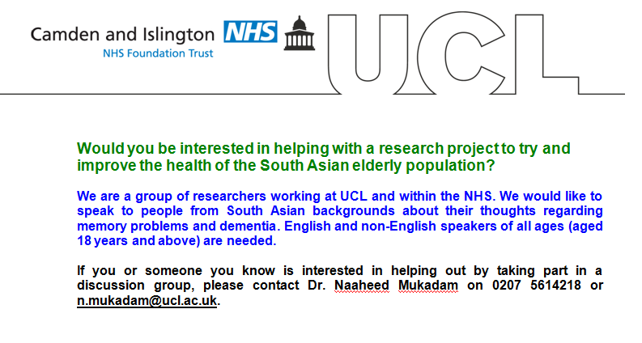

**Appendix B. Information sheet for participation in a focus group**

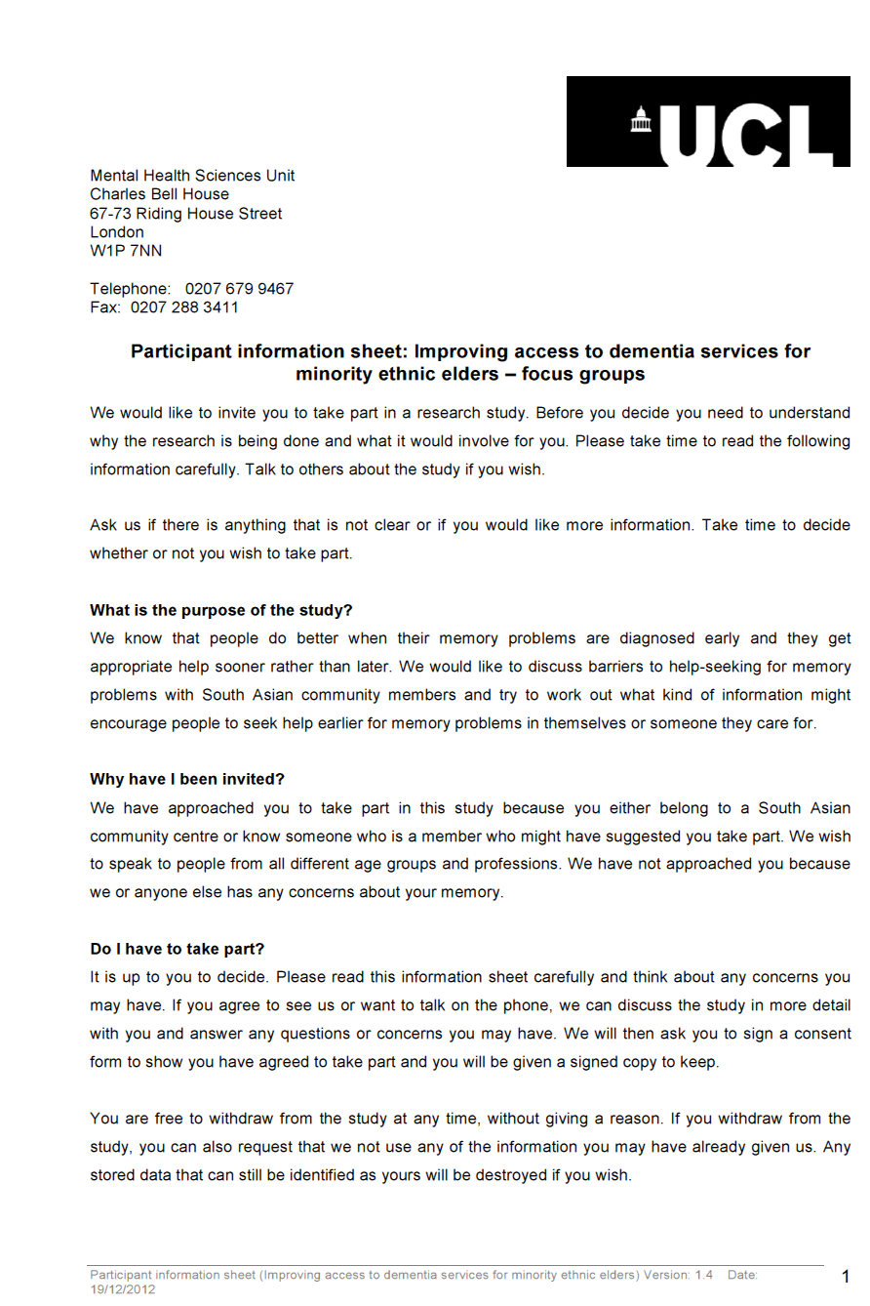

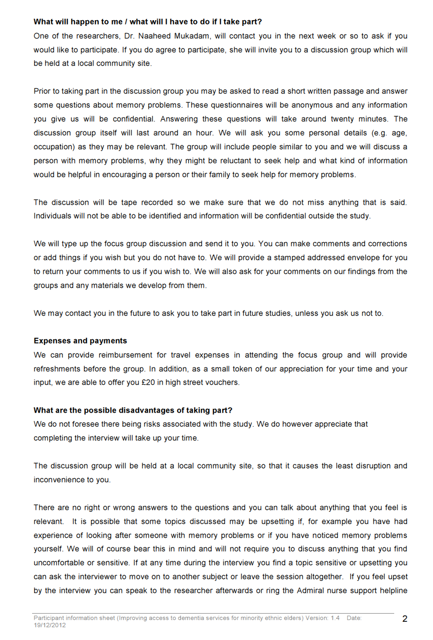

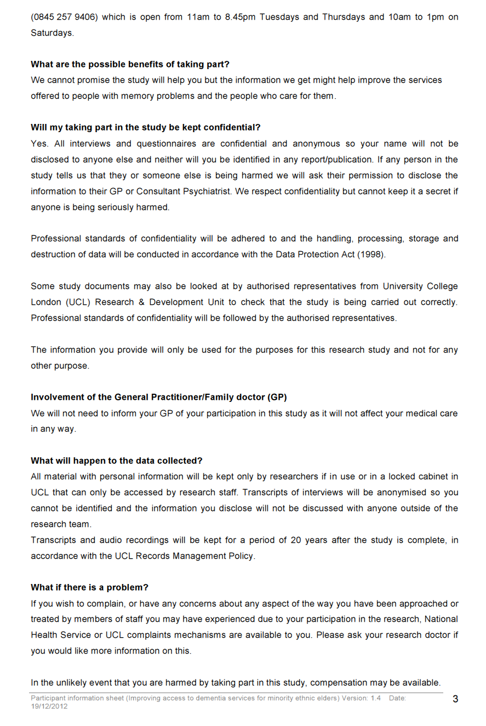

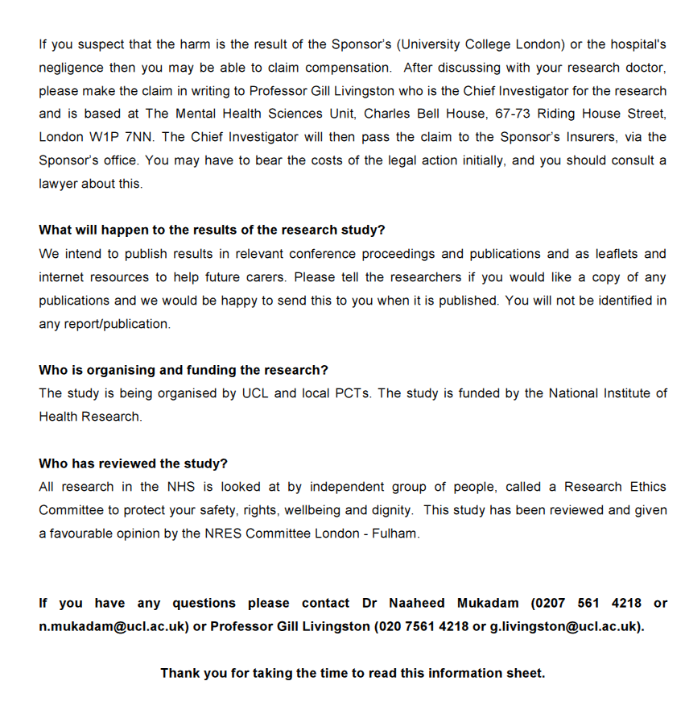

**Appendix C. Consent form for participation in a focus group**

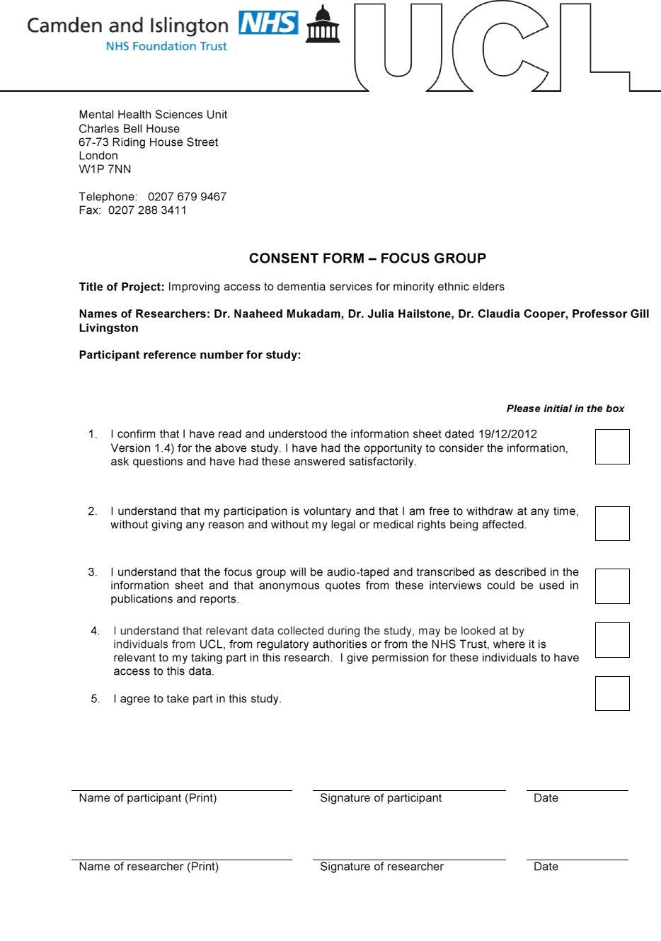

**Appendix D: Original focus group script**

**Introduction of researchers: Thanks….***We are researchers from University College London. We will be recording this group. Everything you say is confidential but we would like you to introduce yourselves for the recording so that the typist can identify you. Our names are...*

**Description of research topic:** *In general, we know a lot of people with dementia don't get help early and many never get help.* *We are interested in how people from the South Asian population, in particular, think about memory problems as they get older and what you think might be helpful.*

*You have just read about Mrs Chaudry. Family members have noted that she is more forgetful lately. She cannot remember conversations with people and forgets appointments with her doctor. She often misplaces important items like her keys and glasses. She is physically healthy but is concerned about her memory.*

**Prompts:**

**-***Do you think Mrs. Chaudry has an illness that is affecting her memory? What do you think the problem is?*

*-Would you get help for memory problems? Everybody forgets things sometimes. What kind of forgetfulness would make you think you should get help?*

**Intervention questions:** *We know that people who get help for memory problems from their doctors earlier in the illness do better overall. They are able to plan for their future better and their families feel more supported. If you or someone close to you had memory problems, what kinds of information would make you more likely to get help for memory problems?*

*What form should the information take? E.g. paper, DVD, video in GP surgery*

*What would encourage you to read/see something about memory problems?*

*What age group would be best suited to receiving this information?*

**If you know of anyone else who may be interested in taking part, please let us know**

**Would you be interested in giving us feed back about any leaflets or information videos we may develop in future?**

**Appendix E. Pilot version of the questionnaire administered to focus group participants**

Imagine that Mrs Chaudry is a 70 year old close relative of yours. Family members have noted that she is more forgetful lately. She cannot remember conversations with people and forgets appointments with her doctor. She often misplaces important things like her keys and glasses. She is physically healthy but is concerned about her memory.

1. Do you think Mrs. Chaudry has an illness that is affecting her memory? (Circle number below)

Definitely not___1__:___2__:___3__:___4__:___5__:___6__:___7___:Definitely

2. What do you think the problem is?

3. Should Mrs Chaudry seek help from her GP?

Definitely not___1__:___2__:___3__:___4__:___5__:___6__:___7___: Definitely

Is there anything that would make you more likely to think she should see her GP?

4. If you had memory problems like Mrs Chaudry, would you seek help from your GP?

Definitely not___1__:___2__:___3__:___4__:___5__:___6__:___7___: Definitely

What would make you more likely to seek help from your GP?

5. Seeking help from a GP for memory problems would be:

Bad___1__:___2__:___3__:___4__:___5__:___6__:___7___: Good

6. Asking for help from a GP for memory problems would be:

Harmful___1__:___2__:___3__:___4__:___5__:___6__:___7___: Beneficial

7. If someone I knew had memory problems, I would try to persuade them to seek help from a doctor:

Strongly disagree___1__:___2__:___3__:___4__:___5__:___6__:___7___:Strongly agree

8. Most people who are important to me would approve of seeking help from a GP for memory problems:

Strongly disagree___1__:___2__:___3__:___4__:___5__:___6__:___7___:Strongly agree

9. My family and friends would not expect people to see a GP if they had memory problems:

Strongly agree___1__:___2__:___3__:___4__:___5__:___6__:___7___: Strongly disagree

10. It is embarrassing to need help from strangers for memory problems:

Strongly disagree___1__:___2__:___3__:___4__:___5__:___6__:___7___:Strongly agree

11. Being embarrassed about needing help from strangers would make me less likely to seek help for memory problems:

Strongly disagree___1__:___2__:___3__:___4__:___5__:___6__:___7___:Strongly agree

12. Being a loyal family member means coping without professional help for as long as possible:

Strongly disagree___1__:___2__:___3__:___4__:___5__:___6__:___7___:Strongly agree

13. Being a loyal family member is important to me:

Strongly disagree___1__:___2__:___3__:___4__:___5__:___6__:___7___:Strongly agree

14. People prefer to hide their memory problems from others:

Strongly disagree___1__:___2__:___3__:___4__:___5__:___6__:___7___:Strongly agree

15. It would be easy to seek help from a doctor for memory problems:

Strongly disagree___1__:___2__:___3__:___4__:___5__:___6__:___7__:Strongly agree

16. It would not be my decision whether or not to see a doctor:

Strongly agree___1__:___2__:___3__:___4__:___5__:___6__:___7___: Strongly disagree

17: Getting the opinion of family and friends about my memory problems would be important to me:

Strongly disagree___1__:___2__:___3__:___4__:___5__:___6__:___7___:Strongly agree

18. Seeking help for memory problems from a GP would depend on what my family and friends thought:

Strongly disagree___1__:___2__:___3__:___4__:___5__:___6__:___7___:Strongly agree

**Appendix F. Focus group and individual interview participant characteristics**

*Number of participants (N) and proportion (%) of total sample (N=58) with each characteristic*

|  |  |  |  |
| --- | --- | --- | --- |
| Characteristic | N (%) | Characteristic | N (%) |
| Exposure to dementia/ADa:  Anyone known well  Cared for as family/friend  Cared for as a professional | N=26  19 (73.1%)  6 (23.1%)  1 (3.8%) | Marital status  Married/living with partner  Single  Widowed  Divorced/Separated  Other | N=66  35 (60.3%)  7 (12.1%)  7 (12.1%)  4 (6.9%)  3 (5.2%) |
| Employment status  Employed  Unemployed  Retired  Student | N=56  25 (43.1%)  17 (29.3%)  12 (20.7%)  2 (3.4%) | Classification of current or previous occupation (Skill level required) b  Professionals (Level 4)  Technicians/Associated professionals (Level 3)  Managerialc  Clerical support workers (Level 2)  Service and sales workers (Level 2)  Machine operators/assemblers (Level 2)  Craft/related trades (Level 2)  Elementary occupations (Level 1) | N=48  9 (15.5%)  4 (6.9%)  1 (1.7%)  4 (6.9%)  15 (25.9%)  2 (3.4%)  1 (1.7%)  12 (20.7%) |
| Ethnicity  Bangladeshi  Indian/British Indian  Pakistani  African Asian | N=58  32 (55.2%)  21 (36.2%)  2 (3.4%)  3 (5.2%) | Religion  Muslim  Hindu  Jainism  Catholic  No religion | N=58  43 (74.1%)  10 (17.2%)  1 (1.7%)  1 (1.7%)  3 (5.2%) |
| Country of birth  Bangladesh  India  Tanzania  Kenya  Uganda  UK  Pakistan  Somalia  Ethiopia  Fiji  East African (country not specified) | N=58  31 (53.4%)  6 (10.3%)  6 (10.3%)  5 (8.6%)  3 (5.2%)  2 (3.4%)  1 (1.7%)  1 (1.7%)  1 (1.7%)  1 (1.7%)  1 (1.7%) | First language  Bengali  Gujarati  English  Hindi  Punjabi  Urdu  Malayalam  Somali  Kutchi | N=58  30 (51.7%)  11 (19.0%)  6 (10.3%)  3 (5.2%)  3 (5.2%)  2 (3.4%)  1 (1.7%)  1 (1.7%)  1 (1.7%) |

a26 out of the 58 focus group participants were asked these questions: percentages represent proportion out of 26 participants bThe International Standard Classification of Occupations (United Nations Statistics Division, 2008) was used to classify participants’ occupations and associated skill level required for the occupation. c No associated skill level indicated.

**Appendix G. Themes identified from focus groups and associated quotes**

|  |  |
| --- | --- |
| Themes for TPB attitudes | Quotes |
| *Behavioural intention: attitudes related to early or delayed seeking help from a GP for memory problems* | |
| Seeking help from a doctor is needed if there is a crisis or safety concerns | FG2- P20: “*He* *said if she falls. I'm asking him which symptoms, when he would advise someone to go to the GP. (..)He also says if he turned on the cooker and left it on.”*  II-PO1: “*people get worried about leaving the cooker on, that they put something on the burner and forgot about it, and then the smoke suddenly starts you know that’s when the trouble starts, before that they don’t (get help)..I think it’s admission that something is really wrong with me mentally.(..) It doesn’t come up (in GP appointments) until you’re into a crisis”* |
| Seeking medical help is needed when memory problems become more serious and impact on daily functioning | II-P56: *“(if)* *they’ve no idea whether it’s afternoon or it’s the day before, have they missed a meal, have they eaten that day, what has happened during that day, then obviously those are causes for alarm.(..) .if I found myself and didn’t know where I was or how I’d got there, then I think it would be a cause for me to be alarmed”*  II-P02: “*we have people that when they can’t take care of themselves but if they have the capacity for the basics like helping with cooking or going for their walks or just taking care of their hygiene and if that is compromised then that is when we seek care but until then it didn’t seem like it was necessary as it wasn’t that severe.”* |
| People should seek medical help for memory symptoms early on | FG4-P53: “*I’m very anxious that if I have such thing I would like to seek help as soon as possible. Because in case it gets worse.”*  II-P44: “*I wouldn’t think twice about suggesting someone seek help.”*  FG5-P34: “*The sooner it is better to cure these sort of peoples. It could be a severely damaged later by the memory lost. She may forget the entire memory she had since childhood . So she needs support from her GP or the hospital, whatever her medical needs is. “* |
| *Behavioural beliefs: what would be the advantages of seeking help from a GP for memory problems?* | |
| GPs can provide treatments | FG4-P53: “*people are more aware of it and they don’t quite hide. People want to have help and there are medicines if one needs it and if you go to the proper person you can slow the process down because there are now medicines that can slow the process down. At least that is a help.”*  FG7-P61:*“when it’s starting age, the beginning, we should imminently go and see your doctor in the first stage, when it starts, there is a cure. It is called Mild [?]-something, about damage, I know, that there is a treatment for that.”* |
| GPs can provide knowledge about services that are available to provide support | II-P56:*“But I did feel that she (Mrs Chaudry in the vignette) should approach a doctor, maybe for a sense of reassurance, maybe to give her a little bit of clarity, so that she would know what she was dealing with.”*  FG7-P61: *“and to find out…to diagnose. They can…the doctor can recommend you the University from wherever you mentioned, to go there, or wherever, to whether, what it is. It is the starting of a dementia, or it’s a memory loss, or some other reasons. We want to know, what is the reason, and how it can be cured? What is the problem?”* |
| GPs can provide knowledge about services that are available to provide support | II-P44:*“Creating the housing, the support people, and it’s literally like a care home around them, so that’s how I would conceptualise it, saying that this is the person affected (by dementia), but there is all this system* *around me*, *so help is available. That a family member can be a carer, and housing, and stuff like that can be… You know, adaptations in the house, stuff like a commode in the room.* *(..) And then carers or Social Services, so it’s like being able to, kind of, picture that there is all this kind of support there.* *”*  II-P02:*“so it’s basically trying to see if they can keep providing that information or just pointing out that these are services that are available.”* |
| *Behavioural beliefs: What are the disadvantages or lack of perceived advantages to seeking help for memory problems?* | |
| Beliefs that nothing can be done for memory problems | FG4-P49: “*I’m afraid I’ve no idea whether there’s actually a pill that you take or they’d go for mental exercises or...?”*  FG4- P52: “*I would really definitely refer them ( Mrs Chaudry in the vignette) to seek medical help or psychiatric help or something. But I don’t know how much that can help them because of their age”*  FG7-P60: *“With other illness, like arthritis or whatever, it’s on yourself, and you can go to doctors and being treated, but this is, you can’t…other people can’t help it.”* |
| South Asian people have little understanding about the term dementia | FG5- P33: “*The problem with the South Asian community, to dementia and lots of things - is not known to them.”*  FG5- P34: “*We aren’t taught about dementia or any disease. But do we know what it is, do we understand what is dementia(..)* *If we know, or a family member knows what dementia is, what stage it is, then it would be easy for the family to identify. If we are talking about jargon, in English, dementia, dementia, I don’t think no one will understand that.”*  FG4-P51: *“Dementia is difficult, other illnesses, becoming a very general word to define every sort of medical...you know, sort of forgetfulness, everything else. (...)..It could be anything really.”* |
| Memory loss/dementia can happen at any age including in younger people | FG1- P21 “*she thinks everyone is like that, young people, old people, everyone has got the same (memory) problems.”*  FG1- P22: “*all of them will be dementia now, because it was so better. Now the young people are going to dementia, like young children.”* |
| Misattribution of symptoms: Dementia/memory problems are a normal part of healthy ageing | II-P03: *“Most Asian communities would see it as just part of ageing and losing memory all the time is in a way considered normal.”*  II-P02: *“they don’t see it (memory problems) as a clinical problem they just see it as old age and you know it’s not something to be worried about.”* |
| Misattribution of symptoms: Memory loss/dementia can have social causes | FG4- P51:*“Children are busy, gone somewhere and they are living alone.(..) So, you know, and they are the kind of people I would...this is purely finger in the air sort of guess, they are probably ones who will start suffering much more..much earlier than anybody else who goes and socialises every..almost every day.”*  FG5- P34: *“the problem is dementia can be cured by the person itself. The more he share his or her pain with others, they get some sort of support from sharing, but with the right people (...)* *The more you share, you get more breathing space, so you can think better. The dementia we can cure or we build ourself.(..)* |
| Memory loss/dementia are caused by other mental health problems (e.g. stress and depression) | FG5- P28: *“And I think that most of the things discussed is stress, work pressure, family problems, which actually lead onto memory loss and dementia later on in life.”*  FG1- P21: “*is it maybe depression affecting dementia?”*  II-P02: *“they would start with that it (memory problems) might be a mental health problem and then they would ask the family doctor and it is most likely then that the family doctor will refer them to a mental health institution.”* |
| *Control factors: What factors would hinder or inhibit seeking help from a GP for memory problems?* | |
| Physical health problems would be prioritised over discussion of memory problems/dementia in GP appointments | FG4-P51: *“my personal view is most doctors are not very good at talking to you about these kind of things...(...) If it’s a physical manifestation immediate one in front of you that you’ve got a temperature then, fine, the doctor’s helpful enough, there’s not a problem. But for mental health issues, like, things starting early on, for example, things like that, I can forsee major issues going to my doctor and saying, look, I need to get this done.”*  FG3-P23: “*She is saying more than two problems they cannot discuss with the GP because they don’t give them enough time and space for discussion.”* |
| *Normative Beliefs: Who would approve or encourage of seeking help from a GP for memory problems?* | |
| Family members should notice problems & encourage person to seek medical help | FG4- P41: *I would like friends and family to help me if they see any changes about my memory.”*  FG5-P34: “*Mrs Chaudry should seek a medical help, to her GP or to local medical centres. Or family member, if she forget a lot, then her family members should support her and take her to her GP because in the first stage, well from what I understand, in the first stage as soon as someone notices the symptoms.”* |
| *Normative Beliefs: Who would disapprove or discourage seeking help from a GP for memory problems?* | |
| Expectation and pride in looking after family members over seeking professional help | II-PO3: *“there is also an expectation from first generation of families for their children to look after them and their families to cater for the relative and it is in a way seen as a badge of pride if the family is looking after them whereas there is a lot of stigma in being transferred to mental health services or a care home where they could probably be better looked after.”*  II-P56: *I think people have a sense that they can provide a better care, or a more caring care, at home, and if they do it themselves..(...) More family support and less of a professional’s care”* |
| Respect for family hierarchy prevents family members from discussing difficulties | II-P01: *there is a hierarchy in the family and he was the head of the family and you couldn’t quite discuss that he had memory problems with the wider family or whatever. It’s just not done, that would be disrespectful.”*  II-P44: *“I mean in Asian communities there’s a lot about respect and how you perceive someone, or you respect someone who is elderly. So one of the problems with dementia with my father was that, first of all, he himself covered it up, because it was his status and his ability, so he was like he was in denial, which made it difficult for us to identify, because he didn’t ask for help”* |
| Stigma associated with mental health issues applies to dementia | II-P03:*“there is a lot of stigma attached to psychiatric problems and memory falls within that domain so they don’t think it is a physical issue and they certainly don't think there is a cure for it. If they were to seek help for memory problems and this would go out into the community it would look bad.”*  FG4- P51*:“And dementia is one of those things. Any mental issues, one of those things, which people don’t want to talk about. In any community, not just in Asian community, but Asian community’s particularly prone to not talking about things like these”*  II-PO1:*“if I say the Hindu Jain culture, especially anything to do with sort of mental faculties, it’s just that you may not have done something in your previous life, you know, that you’re getting some of these problems. There’s a word for all these physical ailments, you know you can get help for it. For mental conditions it’s very very difficult, there’s a huge huge stigma associated with it.”* |
| Stigma means that dementia symptoms are hidden | FG4-P51:*“the old attitudes were you hid your illness of any type, you hid them away, you see, so I think those are now slowly, thankfully dying out and so people are far more forward with, you know, if you’ve got a problem you talk about it, get it sorted out if you can. But there are still, you know, people who don’t want to talk about things.”*  FG5- P33:*“All the things are hidden. Sometime something happens, they’re keeping inside like all that, men or women, both sides, the family problem they’re not discussing it with anyone, with a family member or anyone. They’re gradually going up and up and up, getting worse, and it should be going to be seen by a doctor before then.”* |
| Stigma is associated with severe stages of dementia | II-P01*:“usually people associate dementia with those last stage, you can’t recognise anybody, you’re incontinent”*  FG4- P49: *“dementia is the last stage of memory loss in a way(...) people who are...have dementia not only mentally but sometimes become incontinent or might be a danger to themselves or the society, the might walk away from the house or set the burner on or something,”* |

**Appendix H. Background and demographic items presented in pilot and final written versions of the questionnaire**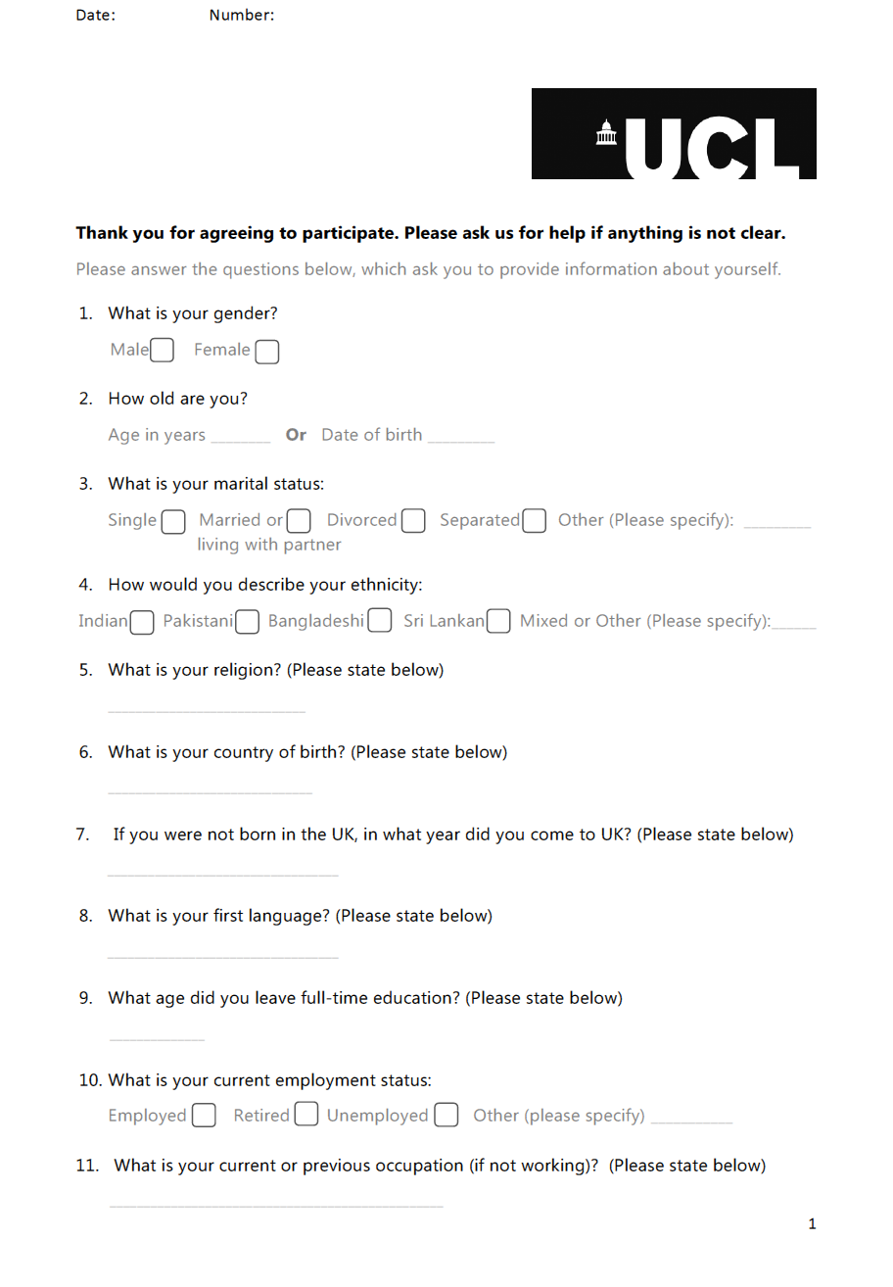

**Appendix I. Dementia Knowledge Questionnaire (items 1-7) and questions about exposure to dementia (items 8-10), presented in pilot and final versions of the questionnaire**

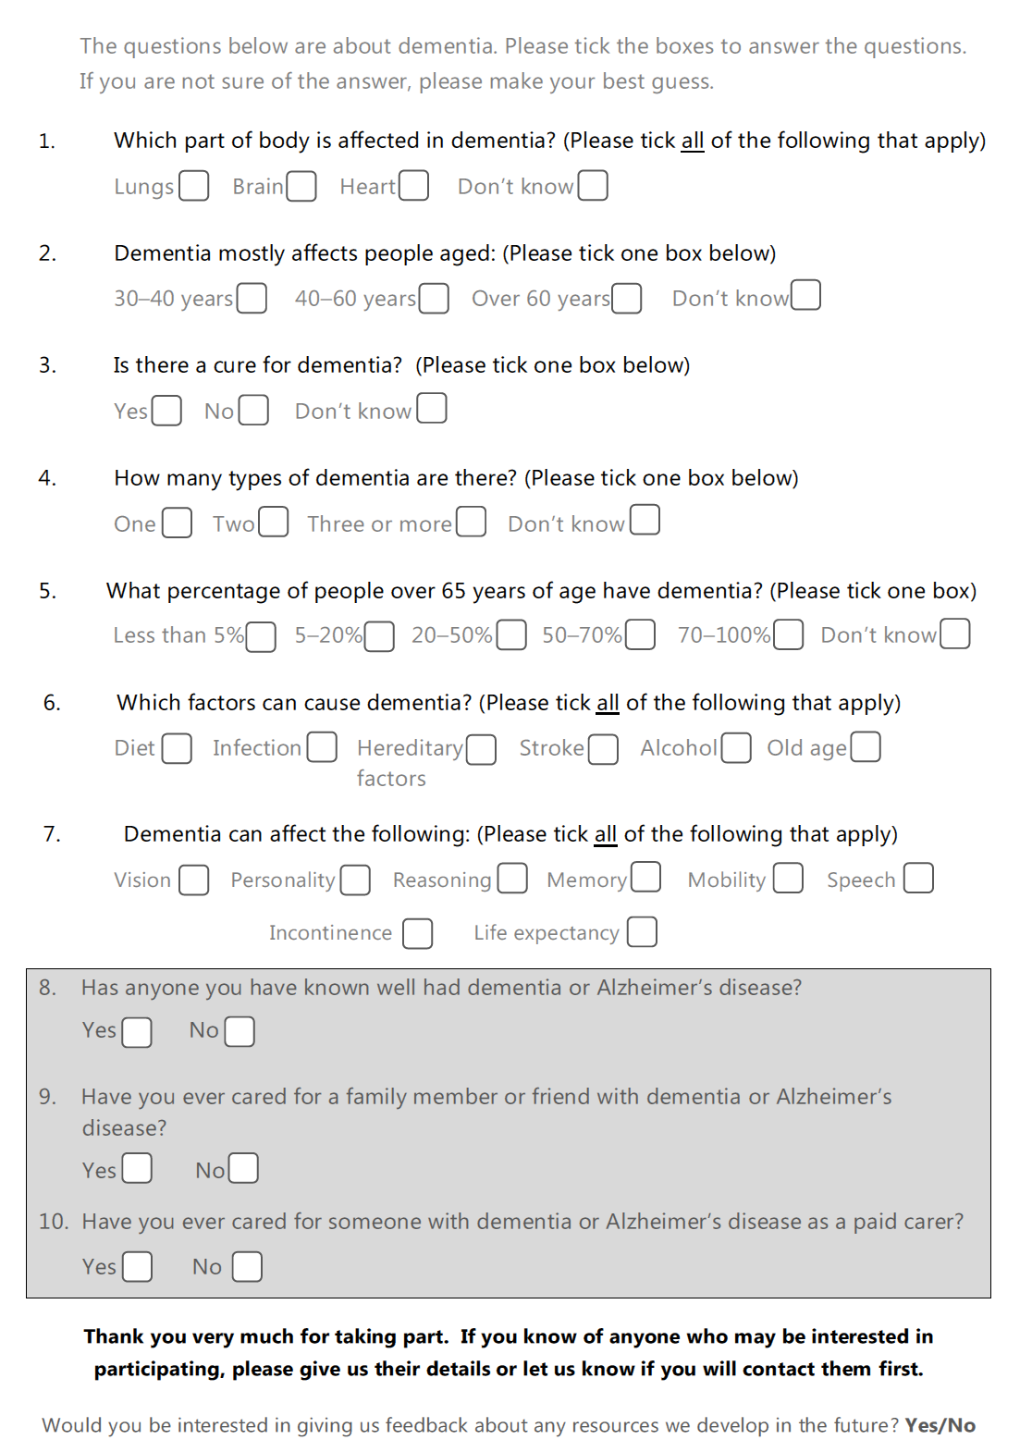

**Appendix J. Pilot questionnaire TPB items**



**Appendix K. Pilot questionnaire data: inter-item and inter-construct correlations between items**

*Pairwise correlations between two intention ratings (IN1 & IN2) and two items for each direct TPB constructs (BA1&BA2, SN1&SN2, PBC1&PBC2)*

|  |  |  |  |  |  |  |  |  |
| --- | --- | --- | --- | --- | --- | --- | --- | --- |
|  | IN1 | IN2 | BA1 | BA2 | SN1 | SN2 | PBC1 | PBC2 |
| IN1 | 1.00 | 0.90** | 0.69** | 0.23 | -0.06 | 0.34a | -0.13 a | 0.09 b |
| IN2 | 0.90** | 1.00 | 0.45 | -0.11 | 0.02 | 0.15 a | -0.34 a | -0.14 b |
| BA1 | 0.69** | 0.45 | 1.00 | 0.75** | 0.00 | 0.73 a ** | 0.16 a | 0.4 b |
| BA2 | 0.23 | -0.11 | 0.75** | 1.00 | -0.28 | 0.59* a | 0.15a | 0.41b |
| SN1 | -0.06 | 0.02 | 0.00 | -0.28 | 1.00 | 0.24 a | 0.21a | 0.20b |
| SN2 | 0.34 a | 0.15 a | 0.73** a | 0.59*a | 0.24 | 1.00 a | 0.45 a | 0.76** b |
| PBC1 | -0.13 a | -0.34 a | 0.16 a | 0.15 a | 0.21 a | 0.45a | 1.00 a | 0.68* b |
| PBC2 | 0.09 b | -0.14 b | 0.41 b | 0.41 b | 0.20 b | 0.76** b | 0.68 * b | 1.00 b |

a n=14 b n=13; *=p<0.05; **= p<0.001

**Appendix L. TPB items presented in the final version of the questionnaire**

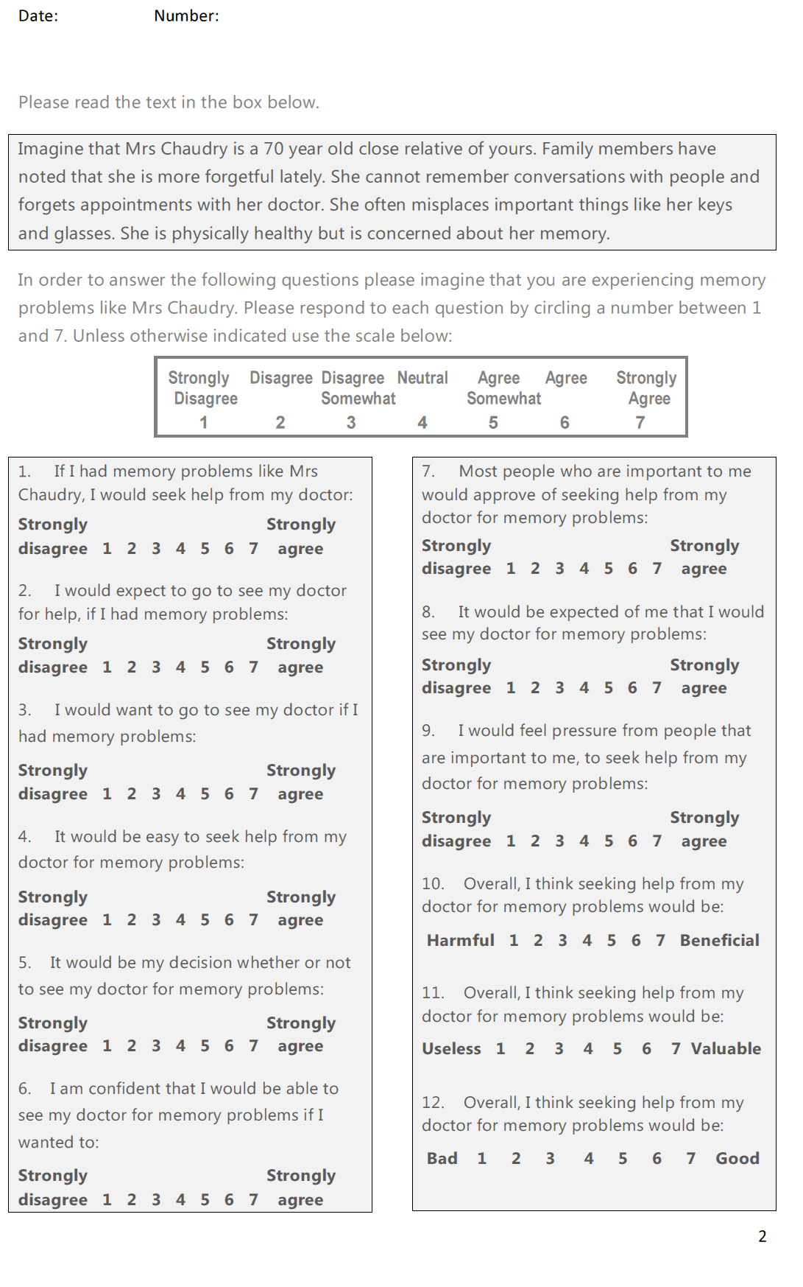

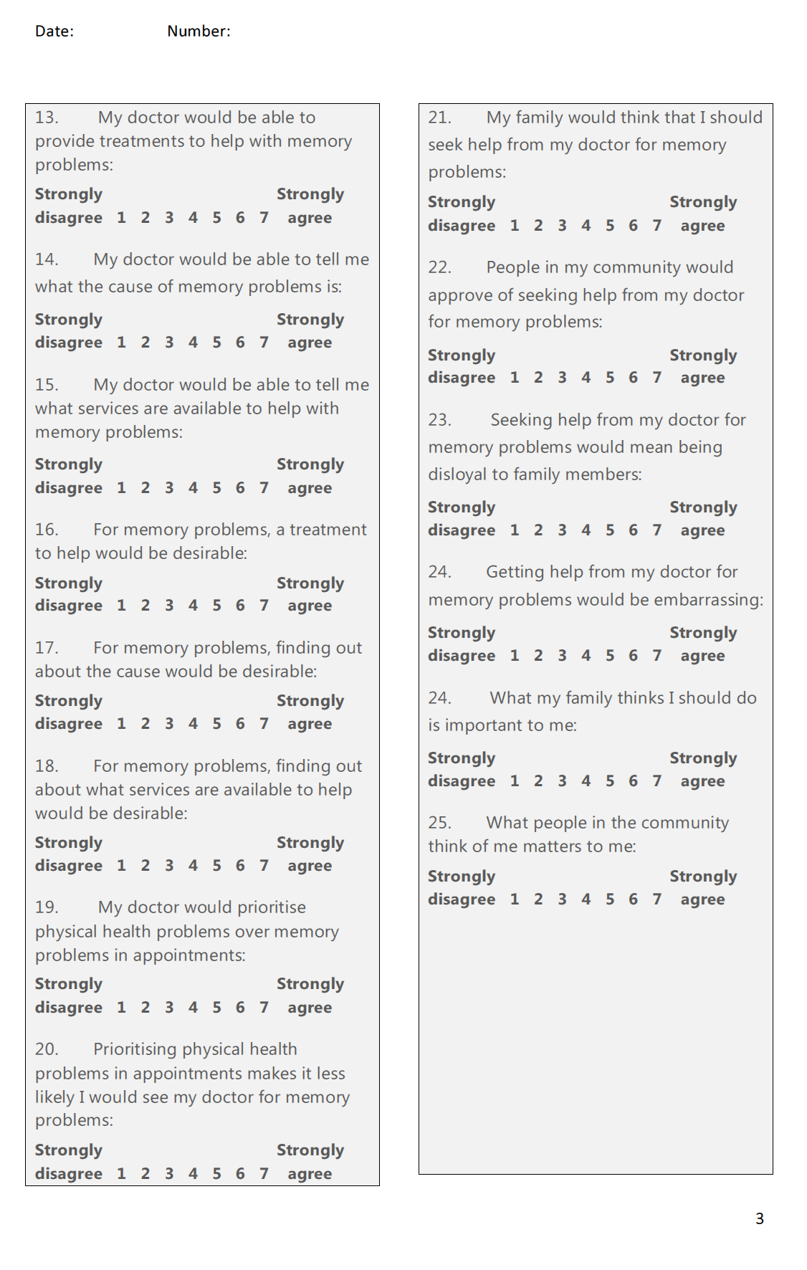

**Appendix M. Recruitment notice for the written and online questionnaire study**

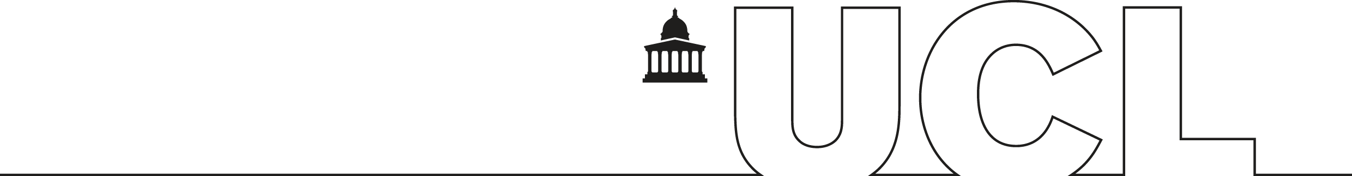

**Would you be interested in helping with a research project to try and improve the health of the South Asian elderly population?**

**We are a group of researchers working at UCL and within the NHS. We would like to hear the views of people from South Asian backgrounds (Indian, Pakistani, Bangladeshi, Sri Lankan, Nepalese, African Indian) regarding memory problems and dementia.**

**We are looking for English speaking volunteers of all ages and backgrounds. Volunteers do not need to have any experience of memory problems themselves.**

**Participation involves answering some questions about memory problems, which takes around 15 minutes. We can meet with volunteers in person or volunteers can complete an online questionnaire by following this link:** <https://www.surveymonkey.com/s/TQB6H8T>.

**Dr Julia Hailstone & Dr Naaheed Mukadam**

[Julia.hailstone.2011@rhul.ac.uk **or 01784 414636**](mailto:Julia.hailstone.2011@rhul.ac.uk%20%20%20or%200207561%204218)

**Please take a slip below with our contact details**

|  |  |  |  |  |  |  |  |  |
| --- | --- | --- | --- | --- | --- | --- | --- | --- |
| **South Asian healthcare research project** Visit <https://www.surveymonkey.com/s/TQB6H8T> Or contact Dr Julia Hailstone on 01784 414 636  [Julia.Hailstone.2011@rhul.ac.uk](mailto:Julia.Hailstone.2011@rhul.ac.uk) | **South Asian healthcare research project** Visit <https://www.surveymonkey.com/s/TQB6H8T> Or contact Dr Julia Hailstone on 01784 414 636  [Julia.Hailstone.2011@rhul.ac.uk](mailto:Julia.Hailstone.2011@rhul.ac.uk) | **South Asian healthcare research project** Visit <https://www.surveymonkey.com/s/TQB6H8T> Or contact Dr Julia Hailstone on 01784 414 636  [Julia.Hailstone.2011@rhul.ac.uk](mailto:Julia.Hailstone.2011@rhul.ac.uk) | **South Asian healthcare research project** Visit <https://www.surveymonkey.com/s/TQB6H8T> Or contact Dr Julia Hailstone on 01784 414 636  [Julia.Hailstone.2011@rhul.ac.uk](mailto:Julia.Hailstone.2011@rhul.ac.uk) | **South Asian healthcare research project** Visit <https://www.surveymonkey.com/s/TQB6H8T> Or contact Dr Julia Hailstone on 01784 414 636  [Julia.Hailstone.2011@rhul.ac.uk](mailto:Julia.Hailstone.2011@rhul.ac.uk) | **South Asian healthcare research project** Visit <https://www.surveymonkey.com/s/TQB6H8T> Or contact Dr Julia Hailstone on 01784 414 636  [Julia.Hailstone.2011@rhul.ac.uk](mailto:Julia.Hailstone.2011@rhul.ac.uk) | **South Asian healthcare research project** Visit <https://www.surveymonkey.com/s/TQB6H8T> Or contact Dr Julia Hailstone on 01784 414 636  [Julia.Hailstone.2011@rhul.ac.uk](mailto:Julia.Hailstone.2011@rhul.ac.uk) |  | **South Asian healthcare research project** Visit <https://www.surveymonkey.com/s/TQB6H8T> Or contact Dr Julia Hailstone on 01784 414 636  [Julia.Hailstone.2011@rhul.ac.uk](mailto:Julia.Hailstone.2011@rhul.ac.uk) |

**Appendix N. Three modified background questions for the online version of the questionnaire**

**6. What is your religion?**

|  |
| --- |
| Description: https://www.surveymonkey.com/i/t.gif Hindu  Description: https://www.surveymonkey.com/i/t.gifMuslim  Description: https://www.surveymonkey.com/i/t.gifSikh  Description: https://www.surveymonkey.com/i/t.gifChristian  Description: https://www.surveymonkey.com/i/t.gifBuddhist  Description: https://www.surveymonkey.com/i/t.gifJewish  Description: https://www.surveymonkey.com/i/t.gifNo religion |
| Other (please specify) |

**7. What is your country of birth?**

|  |
| --- |
| Description: https://www.surveymonkey.com/i/t.gifBangladesh  Description: https://www.surveymonkey.com/i/t.gifIndia  Description: https://www.surveymonkey.com/i/t.gifKenya  Description: https://www.surveymonkey.com/i/t.gifPakistan  Description: https://www.surveymonkey.com/i/t.gifSri Lanka  Description: https://www.surveymonkey.com/i/t.gifTanzania  Description: https://www.surveymonkey.com/i/t.gifUganda  Description: https://www.surveymonkey.com/i/t.gifUK |
| Other (please specify) |

**9. What is your first language?**

|  |
| --- |
| Description: https://www.surveymonkey.com/i/t.gifEnglish  Description: https://www.surveymonkey.com/i/t.gifPunjabi  Description: https://www.surveymonkey.com/i/t.gifGujarati  Description: https://www.surveymonkey.com/i/t.gifBengali  Description: https://www.surveymonkey.com/i/t.gifHindi  Description: https://www.surveymonkey.com/i/t.gifUrdu  Description: https://www.surveymonkey.com/i/t.gifTamil  Description: https://www.surveymonkey.com/i/t.gifMalayalam |
| Other (please specify) |

|  |
| --- |
| **Appendix O. Debrief for the online questionnaire** |

**Thank you for taking part**

**You have completed the questionnaire. Thank you for taking part.**  
  
**Debrief**People from minority ethnic groups have an increased incidence of dementia but access services later in their illness than their White British counterparts. Culturally related beliefs have been found to contribute to delays in help-seeking, including in people from South Asian backgrounds. We know that people do better when their memory problems are diagnosed early and they get appropriate help sooner rather than later.  
  
This questionnaire explores attitudes and beliefs which act as barriers to seeking medical help for memory problems, in people from South Asian backgrounds.   
  
The information we collect from this questionnaire will be used to develop materials which may help to improve access to health services offered to South Asian people with memory problems, and people who care for them.  
  
**Rights**You can withdraw your responses at any time, without giving a reason. All data collected is completely anonymous, therefore if you wish to withdraw, please contact us with details of the date and time that you completed the questionnaire.   
  
**Contact details**If you have any concerns, questions or would like further information about this study, please contact Dr Julia Hailstone (julia.hailstone.2011@rhul.ac.uk or 01784 414636), Dr Naaheed Mukadam (n.mukadam@ucl.ac.uk) or Professor Gill Livingston (g.livingston@ucl.ac.uk)

**Appendix P. Participant information sheet for the written questionnaire** 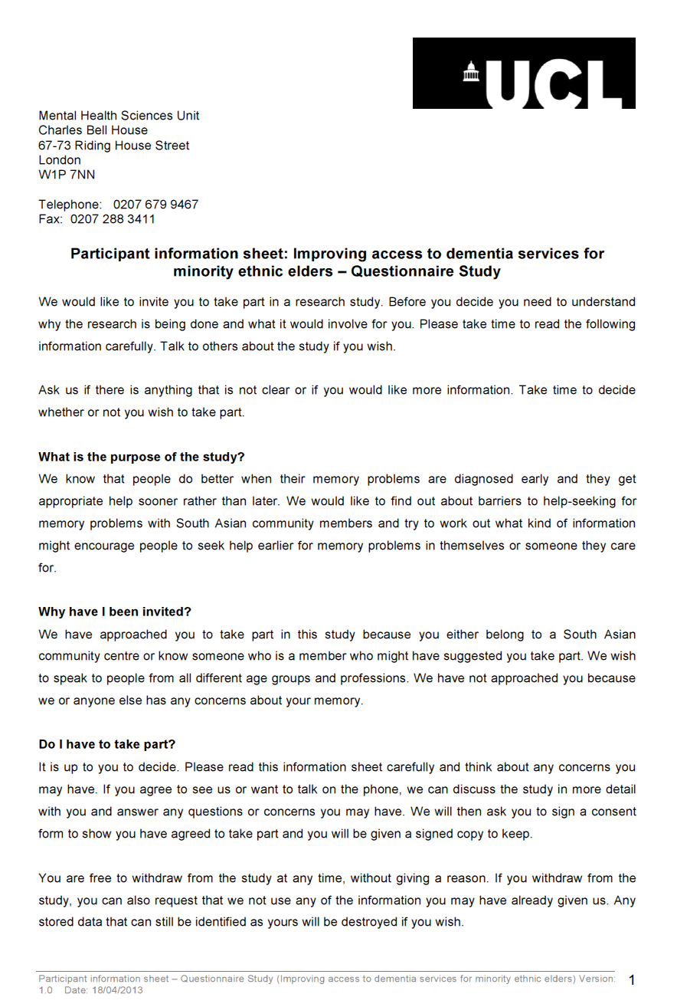

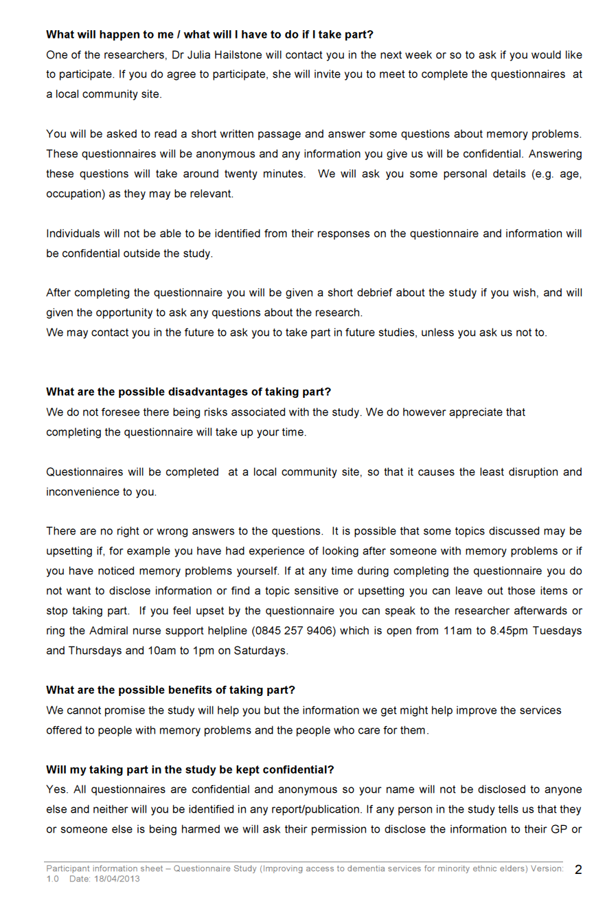

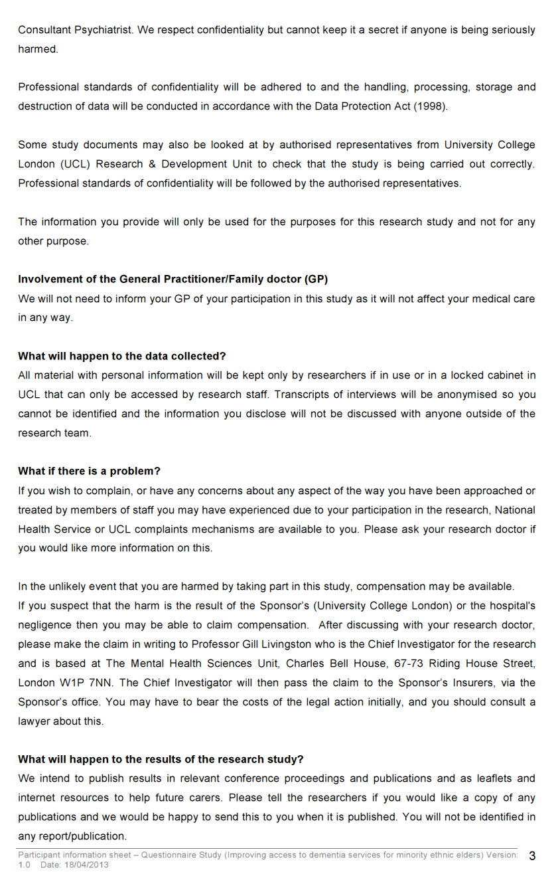

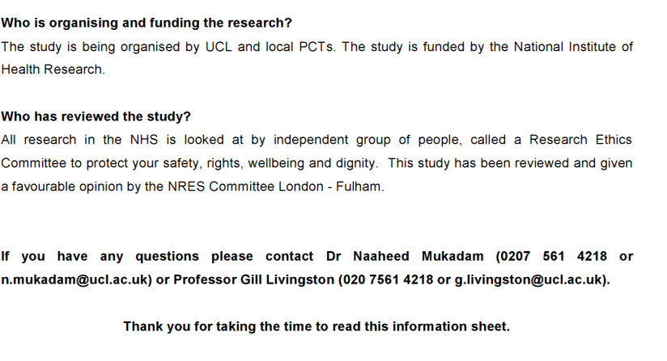

**Appendix Q. Consent form for the written questionnaire**

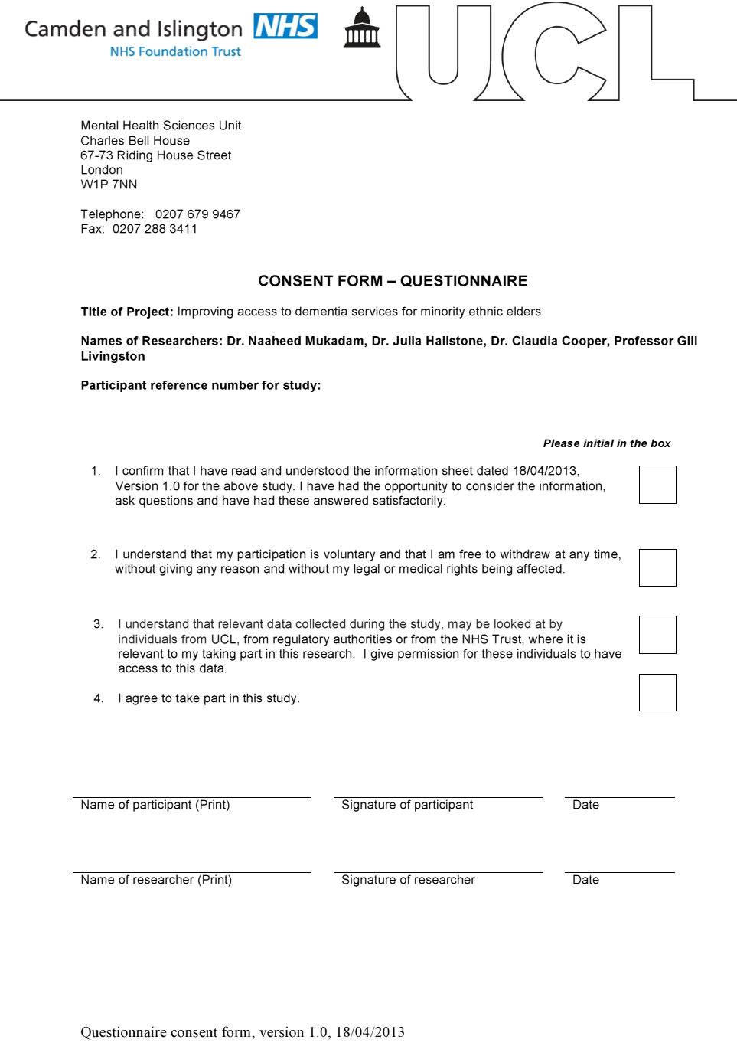

**Appendix R. Information and Consent for the online questionnaire**

**Volunteer Information and Consent**

Thank you for considering volunteering for this research study. Please read the following information and take time to decide whether or not you wish to take part.   
  
**Who do we want to take part?**We would like to invite South Asian people who are from all age groups and backgrounds to take part. We want everyone’s opinions. Volunteers do not need to have any experience of memory problems themselves.   
  
**What will I have to do?**You will be asked to answer some questions about what you think about memory problems. There will also be some questions about your background (such as your age and ethnicity) as they may be relevant. We will not ask for any information which would enable us to identify you. It takes around 15-20 minutes to complete the questionnaire.   
  
We are interested in your views. There are no right or wrong answers to the questions. If at any time during completing the questionnaire you do not want to answer a question, you can leave out that item or stop taking part.   
  
**Will my answers be kept confidential?**Your responses will be recorded and kept strictly confidential and anonymous. You would not be identifiable in any report or publication arising from the results of this study.   
  
**What are the possible disadvantages of taking part?**We do not foresee there being risks associated with taking part. This study has received ethical approval by Royal Holloway, University of London.   
  
We will provide you with a short debrief about this research study at the end of the questionnaire. If you have any questions or would like further information about this study please contact Dr Julia Hailstone (julia.hailstone.2011@rhul.ac.uk or 01784 414636), Dr Naaheed Mukadam (n.mukadam@ucl.ac.uk) or Professor Gill Livingston (g.livingston@ucl.ac.uk)

**Please check the following boxes to give your consent to take part:**

|  |
| --- |
| Description: https://www.surveymonkey.com/i/t.gif  **I am 18 years of age or over**  **I understand that my participation is voluntary and I can stop or withdraw my answers at any time**  **Description: https://www.surveymonkey.com/i/t.gifI agree to take part** |

**Appendix S. Background and demographic characteristics of the questionnaire sample**

*Participant characteristics (N=51): number of participants (N) and proportion of total sample (%) with each characteristic*

|  |  |  |  |
| --- | --- | --- | --- |
| Characteristic | N (%) | Characteristic | N (%) |
| Exposure to dementia/AD: :  Anyone known well  Cared for family/friend  Cared for as a professional | 30 (58.8)  9 (19.6)  2 (3.9) | Marital status  Married/living with partner  Single  Widowed  Divorced | 29 (56.9)  16 (31.4)  4 (7.8)  2 (3.9) |
| Employment status  Retired  Employed  Student  Unemployed  Long-term disabled | 20 (39.2)  19 (37.3)  9 (17.6)  2 (3.9)  1 (2.0) | Classification of current or previous occupation (Skill level required) a,b  Professionals (Level 4)  Managerialc  Associated professionals (Level 3)  Clerical support workers (Level 2)  Service and sales workers (Level 2)  Machine operators/assemblers (Level 2)  Member of armed forces c  Elementary occupation (Level 1) | 16 (31.4)  4 (7.8)  1 (2.0)  6 (11.8)  5 (9.8)  2 (5.6)  1 (2.0)  1 (2.0) |
| Ethnicity  Indian/British Indian  Pakistani  Sri Lankan  Bangladeshi  Nepalese | 40 (78.4)  5 (9.8)  4 (7.8)  1 (2.0)  1 (2.0) | Religion  Hindu  Muslim  Jainism  Sikh  Christian  No religion | 23 (45.1)  8 (15.7)  7 (13.7)  6 (11.8)  4 (7.8)  3 (5.9) |
| Country of birth  India  UK  Kenya  Pakistan  Sri Lanka  Tanzania  Mauritius  Nepal  East African(country not specified)  USA  Fiji  Ethiopia | 12 (23.5)  11 (21.6)  9 (17.6)  4 (7.8)  4 (7.8)  3 (5.9)  3 (5.9)  1 (2.0)  1 (2.0)  1 (2.0)  1 (2.0)  1 (2.0) | First language  English  Gujarati  Hindi  Punjabi  Urdu  Tamil  Sinhala  Telugu  Creole  French | 16 (31.4)  13 (25.5)  7 (13.7)  5 (9.8)  3 (5.9)  2 (3.9)  2 (3.9)  1 (2.0)  1 (2.0)  1 (2.0) |

a N=36 participants responded to this question which included all currently employed and most retired participants. bThe International Standard Classification of Occupations (United Nations Statistics Division, 2008) was used to classify participants’ occupations and associated skill level required for the occupation, where indicated. c No associated skill level indicated.

**Appendix T. Summary of all TPB ratings: intention to seek help, direct attitude and indirect belief ratings**

*Summary of intention and TPB average ratings (scored on a Likert scale between 1 and 7) (N=51)*

|  |  |  |  |  |  |  |  |  |  |
| --- | --- | --- | --- | --- | --- | --- | --- | --- | --- |
| Construct | Median | 25th - 75th % | |  | Construct | | Median | 25th - 75th % | |
| Intention to seek help | | | |  | TPB indirect measures | |  | |  |
|  |  |  |  |  | *Behavioural beliefs* | |  | |  |
| IN1 | 6.0 | 5.0 | 7.0 |  | BB1 | 6.0 | 4.0 | | 7.0 |
| IN2 | 6.0 | 5.0 | 7.0 |  | BB2 | 5.0n | 3.5 | | 6.0 |
| IN3 | 6.0 | 5.5 | 7.0 |  | BB3 | 6.0 | 5.5 | | 7.0 |
| TPB direct measures | | | |  | *Outcome Evaluations* | | | | |
| *Behavioural Attitudes* | |  |  |  | OE1 | 6.0 | 6.0 | | 7.0 |
| BA1 | 7.0 | 6.0 | 7.0 |  | OE2 | 7.0 | 6.0 | | 7.0 |
| BA2 | 7.0 | 5.0 | 7.0 |  | OE3 | 7.0 | 6.0 | | 7.0 |
| BA3 | 7.0 | 6.0 | 7.0 |  | *Normative Beliefs* | |  | |  |
| *Social Norms* | |  |  |  | NB1 | 6.0 | 6.0 | | 7.0 |
| SN1 | 6.0 | 6.0 | 7.0 |  | NB2 | 6.0 | 4.0 | | 7.0 |
| SN2 | 6.0 | 5.0 | 7.0 |  | NB3 | 1.0+ | 1.0 | | 1.0 |
| SN3 | 6.0 | 4.0 | 7.0 |  | NB4 | 1.0+ | 1.0 | | 4.0 |
| *Perceived Behavioural Control* | | |  |  | *Motivation to Comply* | | | | |
| PBC1 | 6.0 | 5.0 | 7.0 |  | MC1 | 5.0 | 4.0 | | 6.0 |
| PBC2 | 6.0 | 5.0 | 7.0 |  | MC2 | 2.0+ | 1.0 | | 4.0 |
| PBC3 | 6.0 | 5.0 | 7.0 |  | *Control Beliefs* |  |  | |  |
|  |  |  |  |  | CB1 | 5.0 | 4.0 | | 6.0 |
|  |  |  |  |  | *Power of Control* | |  | |  |
|  |  |  |  |  | PoC1 | 5.0n | 4.0 | | 6.0 |

All variables were significantly negatively skewed unless indicated:  n =normally distributed;; += significant positive skew

**Appendix U. Internal consistency and item analysis for intention to seek help, and TPB direct attitudes**

*Inter-item correlations (Spearman’s) between intention ratings and direct TPB ratings (N=51)*

|  |  |  |  |  |  |  |  |  |  |  |  |
| --- | --- | --- | --- | --- | --- | --- | --- | --- | --- | --- | --- |
|  | IN1 | IN2 | IN3 | BA1 | BA2 | BA3 | SN1 | SN2 | SN3 | PBC1 | PBC2 |
| IN2 | 0.73** |  |  |  |  |  |  |  |  |  |  |
| IN3 | 0.61** | 0.76** |  |  |  |  |  |  |  |  |  |
| BA2 | 0.57** | 0.71** | 0.64** | 0.86**b |  |  |  |  |  |  |  |
| BA3 | 0.57** | 0.64** | 0.56** | 0.90**b | 0.82** |  |  |  |  |  |  |
| SN1 | 0.39** | 0.57** | 0.49** | 0.37** | 0.66** | 0.27 |  |  |  |  |  |
| SN2 | 0.70** | 0.61** | 0.68** | 0.44** | 0.52** | 0.31* | 0.60** |  |  |  |  |
| SN3 | 0.35* | 0.29* | 0.38** | 0.30* | 0.55** | 0.31* | 0.30* a | 0.36** |  |  |  |
| PBC1 | 0.62** | 0.70** | 0.83** | 0.71** | 0.36* | 0.46** | 0.57** | 0.39** | 0.58** |  |  |
| PBC2 | 0.31* | 0.32* | 0.31* | 0.74** | 0.48** | 0.56** | 0.77** | 0.26 | 0.43** | 0.39** |  |
| PBC3 | 0.31* | 0.46** | 0.41** | 0.59** | 0.30* | 0.38** | 0.37** | 0.31* | 0.32* | 0.61** | 0.72** |

*=p<0.05; **= p<0.001; a rho= 0.297; b rho>0.85

*Note*: Inter-item correlations within each construct are highlighted in grey; IN1, IN2, IN3= three help-seeking intention items; BA1, BA2, BA3 = three direct TPB Behavioural Attitudes items, SN1, SN2, SN3 = three direct TPB Subjective Norms items, and PBC1, PBC2, PBC3 = three direct TPB Perceived Behavioural Control items

**Appendix V. Summary of the DKQ scores for the present sample compared with scores for a South Asian comparison group (Purandare, Luthra, Swarbrick, & Burns, 2007)**

*Average Dementia Knowledge Questionnaire scores: number of individuals (%) scoring each item correctly in the present study (N=51) compared with a South Asian comparison sample (N=196)*

|  |  |  |  |  |  |  |
| --- | --- | --- | --- | --- | --- | --- |
| DKQ Sub-test | | This study | Comparison | | | Difference |
| **Basic Knowledge** | | **N (%)** | **%** | | |  |
| Q1. Which part of body is affected?  (a) lungs (b) *brain* (c) heart (d) dk | | 49 (96.1%) | 20% | | | p<0.001 |
| Q2. Mostly affects people aged?  (a) 30–40 yrs (b) 40–60 yrs (c) *>60* (d) dk | | 39 (76.5%) | 13% | | | p<0.001 |
| Q3. Is there a cure?  (a) yes (b) *no* (c) dk | | 28 (54.9%) | 10% | | | p<0.001 |
| Score Basic Knowledge : Median (25th-75th percentile) (/3) | | 2 (2-3) | 0 (0-1) | | |  |
| **Epidemiology** | |  |  | | |  |
| Q4. How many types?  (a) one (b) two (c) *three or more* (d) dk | | 16 (31.4%) | 4% | | | p<0.001 |
| Q5. Prevalence in over 65s (%)?  (a) <5 (b) *5–20* (c) 20–50 (d) 50–70 (e) 50–100 (f) dk | | 10 (19.6%) | 2% | | | p<0.001 |
| Score Epidemiology :  Median (25th-75th percentile) (/2) | | 0 (0-1) | 0 (0-0) | | |  |
| **Aetiology**  Q6. Which factors can cause dementia? (tick boxes) *all except Old Age receive a point | | | | | | |
| Diet  Infection  Hereditary factors  Stroke  Alcohol  Old age* | 17 (33.3%)  11 (21.6%)  28 (54.9%)  29 (56.9%)  20 (39.2%)  7 (13.7%) | | 13%  4%  13%  11%  15%  51% | | p<0.001  p<0.001  p<0.001  p<0.001  p<0.001  p<0.001 a | |
| Score Aetiology :  Median (25th-75th percentile) (/6) | 2 (1-3) | | 1 (0-1) | |  | |
| **Symptomatology**  Q7. Dementia can affect the following: (tick boxes) *all receive a point | | | | | | |
| Vision  Personality  Reasoning  Memory  Mobility  Speech  Incontinence  Life expectancy | 11 (21.6%)  35 (68.6%)  34 (66.7%)  50 (98.0%)  16 (31.4%)  21 (41.2%)  14 (27.5%)  18 (35.3%) | | | 54%  14%  8%  77%  27%  20%  19%  31% | p<0.01a  p<0.001  p<0.001  p<0.01  p=0.57  p<0.01  p=0.18  p=0.56 | |
| Score Symptomatology :  Median (25th-75th percentile) (/8) | 3 (2-6) | | | 3 (1-3) |  | |
| **Total Score**  Median (25th-75th percentile) (/19) | 8.9 (3.9) b | | | 3 (2-5) |  | |

a A greater number of Purandare’s sample scored these items correct; for all other scores a greater proportion of individuals in the present study scored the item correct. bTotal DKQ scores were normally distributed, therefore the mean and standard deviation are presented. *Note*: Correct answers are shown in italics

1. Young onset is a rare form of dementia which occurs in people under 65 years, and accounts for only 2% of known dementia cases in the UK (Knapp & Prince, 2007)
2. A “partial mediation model” was used in which normative beliefs not only directly predict behavioural intention (as in the original TPB model), but also indirectly influence a person’s own attitudes and sense of personal control over help-seeking.
3. Acculturation refers to the extent to which the values and norms of UK culture have been adopted (Ahmed & Lemkau, 2000)
4. For example one participant (II-PO1) stated: “*people get worried about leaving the cooker on, that they put something on the burner and forgot about it, and then the smoke suddenly starts you know that’s when the trouble starts(..)It doesn’t come up (in GP appointments) until you’re into a crisis”*
5. For example one participant (II-PO2) stated: “*if they have the capacity for the basics like helping with cooking or going for their walks or just taking care of their hygiene and if that is compromised then that is when we seek care but until then it didn’t seem like it was necessary as it wasn’t that severe.”*
6. For example one participant (FG4-P53) stated: “*I’m very anxious that if I have such thing I would like to seek help as soon as possible. Because in case it gets worse.”*
7. For example one participant (FG5- P34) stated: “*If we know, or a family member knows what dementia is, what stage it is, then it would be easy for the family to identify. If we are talking about jargon, in English, dementia, dementia, I don’t think no one will understand that.”*
8. For example one participant (FG1- P12) stated: “*all of them will be dementia now, because it was so better. Now the young people are going to dementia, like young children.”*
9. FG4- P52: *“People who are very lonely, they get these sort of things because they can’t talk to anybody and anything like that.”*
10. FG5- P28: *“And I think that most of the things discussed is stress, work pressure, family problems, which actually lead onto memory loss and dementia later on in life.”*
11. For example, one participant (FG1: P11) stated: “*No (there are not difficulties related to not speaking English) because they (GPs) can give the interpreter*.”
12. National statistics (Office for National Statistics, 2009) indicate that of Asian/British Asian groups approximately 45% are Indian, 31% are Pakistani, 12% are Bangladeshi, and 12% are “other Asian”.
13. The Alzheimer’s Society (Alzheimer's Society, 2012) estimates that there are 670,000 people in the UK acting as the primary carer for someone with dementia, which crudely equates to approximately 0.01% of the population. This is likely to be an underestimate of numbers of people supporting friends and family members in a non-primary caring capacity.
14. Educational levels can be diverse depending on country of schooling (Murayama et al., 2013). Most participants had not attended standard educational system in the UK, and informal feedback from participants indicated that several participants had breaks in schooling.
15. Recent demographic data indicates that between 46 and 63% of adults living in London have University degrees (Eurostat, 2012).
16. Power was calculated to equal 0.92, using α=0.05, n=51, 3 predictors, for a modest effect size (f2= 0.15) (Soper, 2014).
17. For the total DKQ: the regression model accounted for less than 1% of the variance in intention (R2=0.24, adjusted R2=-0.40, Wald χ2=19.80, p=1.00), and the overall interaction between years of education and knowledge score was not significant (χ2=1.08, p=1.00). In addition, no interaction coefficients were significant.
18. Werner and colleagues’ study asked participants to rate how likely (on a five-point scale) they would seek help from one of seven sources of professional help: family physician, psychiatrist, psychologist, neurologist, nurse, social worker (Werner, 2003).
19. The aetiology subtest involves recognising less common causes of dementia. Infection, diet, alcohol, and hereditary factors are not common causes of dementia (Harvey et al., 1999; National Collaborating Centre for Mental Health, 2007), and although stroke is a common cause of VaD, it is a taxonomy that is associated with a separate illness to dementia (Cumming & Brodtmann, 2011).
20. An example of a true/false question taken from the Alzheimer’s Disease Knowledge Test (Carpenter & Balsis, 2009) is: “When a person with AD becomes agitated, a medical examination might reveal other health problems that caused the agitation.”
21. Written information in the “Worried about your memory” Alzheimer’s Society leaflet (Alzheimer's Society, 2013) states: “If you are concerned about the memory of someone close to you, encourage them to visit their GP. You might start the conversation by gently asking the person if they’ve been feeling any different from usual or are struggling with anything.”