**Plant associated *Bacillus* spp. alter life history traits of the specialist insect, *Brevicoryne brassicae* L.**

**Kiran R. Gadhave*1 and Alan C. Gange1**

*1School of Biological Sciences, Royal Holloway University of London, Egham, Surrey, TW20 0EX, UK*

*Corresponding author:

Kiran Gadhave

Tel: +44 1784 443188

Email: PVBA211@live.rhul.ac.uk

Running title: *Bacillus* suppress cabbage aphid growth and development

**Abstract**

1. Numerous soil-dwelling *Bacillus* species form mutualistic relationships with plants, in which the hosts derive an array of benefits, including the alteration of nutrient and chemical content. Despite such ubiquitous and intimate *Bacillus*-plant associations, the role of these bacteria in affecting the performance of specialist foliage-feeding insects is largely unknown.
2. We studied the effects of individual and mixed treatments of *B. cereus, B. subtilis* and *B. amyloliquefaciens* on calabrese growth and important life history characteristics and the population dynamics of the specialist phloem-feeding aphid, *Brevicoryne brassicae*.
3. All *Bacillus* species negatively affected the life history traits and supressed the populations of *B. brassicae* in varying magnitudes. The differences in aphid populations and number of leaves infested increased swiftly towards the end of the experiment and were at peak 71 days after sowing.
4. *B. cereus* was the most effective treatment in reducing *B. brassicae* growth rates, followed by the mixture of species, *B. amyloliquefaciens* and *B. subtilis* treatments. However, no synergistic or additive effects of bacteria were found.
5. Overall,plant growth promoting *Bacillus* species significantly suppress the growth and development of *B. brassicae* and show great potential for their use in an integrated biological control programme for this pest.

**Keywords**: *B. amyloliquefaciens, B. cereus, B. subtilis,* tritrophic interactions, rhizobacteria, insect

# Introduction

Plant associated benign bacteria provide direct as well as indirect plant growth benefits such as biofertilization and phytostimulation, stress control, antibiosis, induction of systemic resistance and competition with pathogens for nutrients and niches (Lugtenberg & Kamilova, 2009). Recent studies show that plant growth promoting (PGP) rhizobacteria benefit plants not only via manipulation of plant biochemistry (Brock *et al*., 2013), but also through extension of their effects on higher trophic levels (Pineda *et al*., 2013; Saravanakumar *et al*., 2008). *Bacillus cereus* Frankland & Frankland, *Bacillus subtilis* (Ehrenberg) Cohn, and *Bacillus amyloliquefaciens* Priest are the principalplant growth promoting *Bacillus* species that colonize roots persistently, produce stable endospores and synthesize a range of broad spectrum bioactive molecules (Halverson *et al*., 1993; Idriss *et al*., 2002; Sharaf-Eldin *et al*., 2008). Their effects on plant qualitative and quantitative traits and anti-pathogenic activities have been well reported (Asaka & Shoda, 1996; Chowdhury *et al*., 2013; Dutta *et al*., 2013), however a lot less is known about whether and how they modify the life history characteristics of insects, in plant mediated tri-trophic interactions.

A few earlier studies have reported neutral to negative consequences of insects feeding on *Bacillus*-treated plants (Pineda *et al*., 2010). Herman *et al*. (2008) showed that *B. amyloliquefaciens* and *B. subtilis* colonization of sweet pepper roots did not affect infestation of foliage by the generalist aphid, *Myzus persicae* Sulzer in thefield.Conversely, two different studies reported negative results of *Bacillus* colonization on insect infestation; the development of the whitefly, *Bemisia tabaci* Gennadius was retarded on *B. subtilis*-inoculated tomato plants grown in laboratory conditions (Valenzuela-Soto *et al*., 2010), and cucumber beetles; *Diabrotica undecimpunctata* Linnaeus and *Acalymma vittatum* Fabricius infestations were reduced on *B. pumilus*-treated cucumber plants in the field (Zehnder *et al*., 1997). However, none of these studies reported whether these bacteria influenced the insect life history traits, which would have explained the reduction in insect infestation more effectively. The literature is too limited to make any generalizations, but the effects of *Bacillus* on insects appear to be specific to plant and insect species, and the degree of insect specialism.

The specialist phloem feeder, cabbage aphid (*Brevicoryne brassicae* L.)infests crops in the cabbage family and causes losses via reduction in yield, marketability and via spread of viral diseases (Blackman & Eastop, 2000). The life cycle of this species is multifaceted and involves both sexual as well as asexual modes of reproduction, which facilitates rapid colonization and multiplication on plants, and adaptation over changing environmental conditions (Ruiz-Montoya *et al*., 2003). The use of pesticides is currently a widely adopted strategy to manage *B. brassicae* field infestations. Such excessive pesticide usage on directly consumed, short-duration vegetable crops ahead of harvest could harm human and ecosystem health (Theiling & Croft, 1988) and contributes to the development of rapid resistance to insecticides (Ahmad & Akhtar, 2013). The use of *Bacillus* as a potential indirect biological control agent of cabbage aphids has not been explored. Therefore, it is critical to understand whether PGP *Bacillus* affects the life history traits of the cabbage aphids.

The aims of this laboratory study were to determine the effects of *B. cereus*, *B. subtilis* and *B. amyloliquefaciens*, when applied individually and in mixture, on *B. brassicae* (i) life history characteristics, namely pre-reproductive period, fecundity (in a period equivalent to reproductive period as a measure of reproductive potential), intrinsic and instantaneous rates of increase and (ii) population (aphid and nymph counts), colonization and development (infested leaf counts) at different time points. Furthermore, effects of treatments on plant performance were measured using number of leaves as a measure of size, also enabling the proportion of leaves infested to be recorded. We hypothesised that calabrese (*Brassica oleracea* L.) inoculation with individual and mixed *Bacillus* spp. would negatively affect the life history characteristics of *B. brassicae*, which would eventually result in supressed population development on this crop.

**Materials and Methods**

## Experimental setup

Calabrese cv. Green Sprouting (Country Value Seeds, UK) seeds were surface sterilized using the procedure of Bhalla & Singh (2008). Briefly, 5 ml of seeds were placed in a 50 ml sterile screw cap tube containing 2%, 40 ml sodium hypochlorite and then the tube was vigorously shaken for 20 minutes. The subsequent steps were performed in a laminar flow cabinet. Sodium hypochlorite was discarded, seeds were washed with 40 ml sterile distilled water five times, and decanted in a sterile petriplate. The 50 µl water from the last wash was plated on lysogeny broth (LB) agar plates, which were later incubated at 30ºC for 3 days to crosscheck if the seed surface sterilization had worked. With sterile forceps, 25 randomly picked surface sterilized seeds were transferred to each of six sterile 120×120×15 mm squared petriplates containing a sterile reduced strength Murashige and Skoog (MS) seed germination medium. Seeds were allowed to germinate in the dark at 20ºC for 10 days. After the emergence of seedlings, two vigorous individuals were randomly selected and transplanted to 1 l sterilized plastic pots containing approximately 800 ml sterile John Innes No. 3 (JA Bowers, UK) compost. The pots were sterilized in 1% Virkon (DuPont, UK) solution for 2 days and then dried overnight in a laminar flow cabinet. The compost was dried in hot air oven at 70ºC for 3 days, sealed in Fisherbrand sterilization bags (Fisher Scientific, UK) and autoclaved twice, with an interval of 3 days, at 121ºC for 60 minutes.

## Bacterial inoculation and aftercare

The bacterial cultures; *B. amyloliquefaciens* subsp. plantarum FZB42BGSC10A6, *B. subtilis* NRRLB23051 and *B. cereus* No. 8 FW Athal were obtained from Dr B. Raymond (Imperial College London, UK) and were cryopreserved at -80ºC in 80% (v/v) glycerol stock. Each bacterium was recovered on a 20 ml LB broth, allowed to incubate overnight on a 37ºC rotary shaker, and serially diluted to 10-5 in 0.85% saline water. After incubation, 50µl, 10-5 dilution of each bacterium was spread on LB agar medium individually to determine the viable bacterial population count [colony forming units per ml (cfu/ml)] after incubation. In a laminar air flow cabinet, the bacteria were applied to the pots through drenching, immediately after transplanting. In total, 50 plants were arranged in five different treatments; control (240 ml sterile distilled water), *B. amyloliquefaciens*, *B. subtilis* and *B. cereus* (240 ml, 108 cfu/ml suspension in each individual and distinct treatment) and mixed (240 ml, 108 cfu/ml mixed suspension, containing80 ml of each bacteria), with 10 replicates of each treatment. The same quantity and concentration of bacterial suspensions were applied once more, two weeks after planting to ensure the appropriate bacterial colonization.

Each pot was transferred to a 410×630 mm, 40 µm Fisherbrand polypropylene sterilization bag (Fisher Scientific, UK) and sealed at the top with autoclaving tape to ensure hygienic growing conditions. The bags were placed in a constant environment room (20ºC, 65% relative humidity, 18 h light: 6 h dark) and monitored daily for seedling establishment and survival. After 7 days, one of the two seedlings was removed and one healthy seedling per pot was retained. Plants were irrigated twice a week with sterile distilled water to inhibit other bacterial contaminants on roots and to maintain utmost possible sterile growing conditions. After a month, once the colonization of specific bacterial species was encouraged in initial clean growing conditions, plants were taken out of sterilization bags. Plants were regularly randomized for the position under the light racks, and watered with distilled water thereafter.

*Aphid bioassay*

Prior to the aphid bioassay, each experimental plant was placed in a Fisherbrand polypropylene sterilization bag again to avoid interplant movement of *B. brassicae* adults and nymphs. Based on plant size, one of the two different sized bags (310×660 mm and 410×630 mm) were used. To each bag, 150×300 mm insect rearing net was attached to avoid excess humidity and to maintain proper aeration for normal aphid colony development. The mixed clones of *B. brassicae* on field calabrese plants were obtained from Sussex, UK. This culture was maintained on calabrese plants in an insect rearing cage at above specified constant environmental conditions for 10 months. This relatively long period helped *B. brassicae* to acclimatize to the laboratory conditions and to avoid any bias in results due to change in environmental conditions, host plant shift and modes of reproduction.

At 45 days after transplanting, three viviparous, apterous and similar sized *B. brassicae* adults were introduced randomly on all experimental plants using a fine paintbrush and allowed to feed, colonize and reproduce. After reproduction, the four youngest (less than 24 h old) neonate nymphs were retained and the mothers and excess neonate nymphs were discarded. The non-repeated measures, through which *B. brassicae* reproduction was monitored on each plant included: (1) the pre-reproduction periods (period in days from larviposition to first reproduction) of the first three adults developed from the retained neonate nymphs (2) the fecundity of those first three adults in a period equivalent to pre-reproduction period (3) the intrinsic rate of increase (*rm*),

where, *Md*= the average number of progenies produced in a period equivalent to pre-reproductive period and *d*= average pre-reproductive period (Wyatt & White, 1977) and (4) the instantaneous rate of increase (*ri*), measuring a population increase ability over specified time (Hall, 1964) and calculated as

$$r_{i}=\frac{\log_{e}\left(\frac{Nt}{No}\right)}{t}$$

where, *Nt*= final number of aphids, *No*= initial number of aphids and *t*= change in time (in days). Each different leaf containing three distantly located colonies of neonates on each plant were marked and numbered with a marker pen and monitored every alternate day to record the pre-reproductive periods and fecundity. All experimental plants were monitored for a variety of aphid infestation parameters, which were recorded in repeated measures, every three days. This observation interval was standardised and considered as optimum for development of a measurable variation in aphid parameters. The repeated measures included total number of (5) nymphs (6) adults and (7) leaves infested, which were recorded in 9, 8 and 7 observation sets (repeated measures, once in three days) respectively, depending upon *B. brassicae* growth, reproduction and development. Since five aphids are sufficient to build an aphid colony, the leaf was considered as infested when the numbers of aphids present were five or more. Number of leaves on each plant were counted 71 days after sowing to determine the effects of *Bacillus* spp. treatments on calabrese growth and to analyse the overall percentage of leaves infested at the end. The factors, namely number of overlapping generations (up to 4), longevity of the F1 progeny (approx. 25 days) and feasibility of counting aphids (high aphid count on control plants) were taken into consideration while concluding the experiment 71 days after sowing.

*Statistical analyses*

The non-repeated aphid growth parameters namelypre-reproduction period, fecundity, intrinsic and instantaneous rates of increase, number of leaves and percent leaves infested were analyzed using a linear model (LM) procedure in R version 3.0.2 (R Development Core Team, 2015), with treatments as a fixed factor. For those parameters that failed to meet the assumptions of normality, the log or square root transformations were used. The repeated measures namely number of nymphs, adults and leaves infested were analyzed using generalized linear mixed effect model (GLMER procedure, nlme and lme4 libraries in R) (Bates *et al*., 2014; Pinheiro *et al*., 2015) using treatments as a fixed effect parameter, time as a random effect and interaction terms (treatments: time) to determine if there was a significant effect of treatments over time and if treatments followed different temporal patterns. The best of the possible four GLMER models was selected on the basis of Akaike Information Criterion (AIC) values (Bolker *et al*., 2009) and the count data for repeated measures were analysed with Poisson distribution with a log link function. The ‘Anova’ function from the ‘car’ package in R was used to report Chi-squared and p-values for treatment, time and interaction effects.

**Results**

*Aphid bioassay*

*1. Pre-reproductive period*

The mean pre-reproductive periods of the first 3 developed aphids were significantly longer on *B. cereus* and *B. amyloliquefaciens* treated plants (Table 1, Fig. 1a). The prolonged pre-reproductive period suggests slower growth of *B. brassicae* on these plants, compared to the controls, on which the shortest pre-reproductive spans were recorded. The mixed treatment tended to shorten the pre-reproductive periods, however, they were not significant at p>0.05 level. The early reproductive maturity of *B. brassicae* contributed towards their rapid population built up on control plants.

*2. Fecundity*

*B. brassicae* fecundity, recorded in a period equivalent to the pre-reproductive period (<18 days), was highest on control plants, but significantly lower on *B. cereus* treated plants (Fig. 1b). Although *B. subtilis, B. amyloliquefaciens* and mixed treated plants tended to reduce fecundity, it was not significant at 0.05 level.

*3. Intrinsic rate of increase (rm)*

*B. brassicae* intrinsic growth rates on untreated plants were higher compared to those on treated plants (Fig. 1c). Significantly lower intrinsic growth rates were observed on *B. cereus,* *B. amyloliquefaciens* and mixed treated calabrese plants, as a result of relatively less fecund adults and their significantly longer pre-reproductive periods. The pre-reproductive periods and fecundity cumulatively affected intrinsic growth rates and showed a similar trend of variation across control and treated plants.

*4. Instantaneous rate of increase (ri)*

The overall increase in *B. brassicae* populations over the entire observation period was highest on untreated plants and significantly lower on all treated plants (Fig. 1d). The intrinsic and instantaneous rates of increase of *B. brassicae* showed similar patterns suggesting that there was a consistent change in number of aphids. Although the mixed treatment was effective in reducing intrinsic and instantaneous rates of increase, no additive effects of bacterial mixture were observed.

*5. Number of nymphs and adults*

*B. brassicae* showed varied degree of colonization and multiplication on untreated and differently treated calabrese plants (Fig. 2a). Untreated plants showed rapid and consistently higher average aphid counts over the experimental period compared with treated individuals. The significant treatment, time and interaction terms showed that the *Bacillus* spp. treatments reduced nymph and adult counts, but that certain treatments followed different time patterns (Table 2). On treated plants, aphid count reductions were much more prominent beyond 63 days after sowing. Of the treated plants, the aphid count was lowest on *B. cereus* treated plants. On both untreated as well as treated plants, a large variation was observed in aphid counts from plant to plant.

*6. Number of leaves infested*

The mean number of leaves infested increased rapidly on untreated plants and gradually on the treated ones over the entire experimental duration (Fig. 2b). In response to the fluctuations in the numbers of infesting aphids, a parallel consistent pattern of change in leaf infestation was observed. The significant treatment and time factors showed the negative effects of *Bacillus* treatments on number of leaves infested, whereas the non-significant interaction term showed that the treatments followed a similar temporal pattern of change.

*7. Percent leaves infested*

None of the *Bacillus* spp. treatments significantly changed the total number of leaves compared to control (Table 1). However, the percentage of leaves infested at 71 days after sowing were significantly reduced in all treated plants, with the lowest in *B. amyloliquefaciens* treated plants (Fig. 3).

**Discussion**

The performance of the specialist aphid *B. brassicae* on *B. cereus, B. amyloliquefaciens* and mixed treated plants showed major decline in rates of increase, final population and number of leaves infested. Showing discrepancy with earlier studies on *Pseudomonas* (Van Oosten *et al*., 2008; Pineda *et al*., 2012), for the first time, we demonstrated the potential of plant growth promoting *Bacillus* spp. to negatively affect the life history traits of this pest species. Pineda *et al*. (2012) reported both positive and null effects of *Arabidopsis* root colonization with *Pseudomonas fluorescens* WCS417r on green peach aphid (*Myzus persicae*) and *B. brassicae* respectively. Van Oosten *et al*. (2008) showed that *P. fluorescens* WCS417r triggered induced systemic resistance in *Arabidopsis* against the generalist, *Spodoptera exigua* Hubner, but not against the specialist, *Pieris rapae* Linnaeus.

The disparity observed in the life history traits of *B. brassicae* reared on control and treated calabrese may perhaps be attributed to biochemical changes that *Bacillus* may have triggered. Earlier studies suggest that rhizobacteria can manipulate the quality of plant as a food material via constitutive and induced changes (Brock *et al*., 2013; Kang *et al*., 2014). Thus, the fecundity of *B. brassicae* adult aphids and progenies may have been directly influenced by either changes in amino acid composition or glucosinolates (Nevo & Coll, 2001; Jahn *et al*., 2005). Furthermore, Cole *et al*. (1997) & Kos *et al*. (2012) showed that the intrinsic rate of increase of B. brassicae was significantly associated with glucosinolate and phloem amino acid concentrations. *Bacillus* spp. may also have triggered systemic resistance in calabrese through an interaction of jasmonic and salicylic acid plant signalling pathways, which likely affected overall aphid growth and infestation. The exact mechanism of bacterial-induced resistance in calabrese would merit further investigation.

The negative effects of *Bacillus* on pre-reproductive periods and fecundity were extended to *B. brassicae* nymphs, adults and eventually, infested leaf counts. These effects were relatively slow in the beginning and subsequently developed gradually over the experimental duration of 71 days. Furthermore, the performance of *B. brassicae* was reduced later, on physiologically older plants, possibly due to changes in plant amino acid composition, as suggested by Karley *et al*. (2002), who showed that *M. persicae* performed better on younger plant developmental stages than older ones. At 71 days after sowing, the total number of leaves was not significantly different between control and *Bacillus* spp. treated plants. However, the number of leaves infested varied considerably, which suggests that the observed differences in *B. brassicae* infestation levels were primarily due to treatment effects and were independent of any variation in total leaf numbers.

On all treated plants, the instantaneous (ri) and intrinsic (rm) rates of increase of cabbage aphid were significantly reduced, except for *B. subtilis* plants, on which ri was significantly lower, but rm was not. The highest rates were observed on control and the lowest on *B. cereus* treated plants, which suggests that the effects of treatments were consistent despite these two indices measuring different parameters. The ri considered the reproductive ability of an entire population. Conversely, rm considered the reproductive potential of only the first three adults due to practical limitations in counts. Secondly, ri determined the change in population over the duration of the experiment, whereas rm considered an approximate initial period equivalent to the pre-reproductive period. The overall *B. brassicae* intrinsic rates of increase were lower than those reported by Satar *et al*. (2005), when the mean intrinsic rate of increase of this aphid on cabbage leaves, at 20ºC, was 0.25 aphid aphid-1 day-1. In the present study, the mean intrinsic rates were highest in aphids fed on control plants (0.08 aphid aphid-1 day-1) and lowest on *B. cereus* treated plants (0.04 aphid aphid-1 day-1). The overall intrinsic rates were lower possibly due to differences in host plants (cabbage vs calabrese) and the duration for which observations were recorded to compute intrinsic rates (entire reproductive period vs reproductive period equivalent to pre-reproductive period).

The individual and mixed *Bacillus* treatments showed varied results on each of the *B. brassicae* life history traits studied. To varied extents, the three individual *Bacillus* treatments were more effective in suppressing growth than the mixed treatment and thus no additive effects of *Bacillus* species were observed in any of the *B. brassicae* traits. This could possibly be due to competition between different *Bacillus* species for plant carbon and niches in the rhizosphere (Hibbing *et al*., 2010). Furthermore, rhizobacteria-mediated changes in relative abundances of naturally occurring plant-associated microbial communities (Conn & Franco, 2004) may have influenced life history traits via changes in plant defensive signalling.

The excessive use of multiple pesticides to control aphid infestations in Brassicaceae crops often leads to increase in pesticide resistance (Ahmad & Akhtar, 2013). The application of PGP *Bacillus* to the soil could be potentially useful to reduce the current substantial use of pesticides in *B. brassicae* management. *Bacillus* species mediated alteration of *B. brassicae* life history traits and reduced infestation highlights the potential of this group of common soil bacteria in integrated pest management programs. Furthermore, reduced pesticide application will not only help minimise the agricultural input costs and insecticidal resistance, but also preserve the natural enemies in crop ecosystems and alleviate the detrimental effects of pesticides on human and ecosystem health.

*Conclusions*

*Bacillus* spp. treatments to calabrese clearly supressed the infestation and affected important life history characteristics of *B. brassicae*. The extent to which various *Bacillus* species altered different traits varied within and between individual and the mixed treatments. All *B. brassicae* traits were negatively affected on *B. cereus* treated plants, which thereby offered the highest aphid resistance to calabrese followed by mixed species, *B. amyloliquefaciens* and *B. subtilis* treatments. However, total leaf counts remained unaffected in treated plants showing no direct calabrese growth promotion. The results suggest that *Bacillus* spp. can be used as a potential agent in an integrated control programme of this pest. Further research should aim to explore the effects of *Bacillus* spp. on (1) plant amino acid and glucosinolate profiles (2) aphid and natural enemy population dynamics and (3) plant biomass in field conditions. If the effects of *Bacillus* spp. addition are also realised in field conditions, a novel, cheap and sustainable pest management strategy can be developed.

## **Acknowledgements**

We thank Ben Raymond for providing bacterial cultures, Andrew Matthews for his help while setting up experiment and Royal Holloway, University of London for funding.

# References

Ahmad, M. & Akhtar, S. (2013) Development of insecticide resistance in field populations of *Brevicoryne brassicae* (Hemiptera: Aphididae) in Pakistan. *Journal of Economic Entomology*, **106**, 954-958.

Asaka, O. & Shoda, M. (1996) Biocontrol of *Rhizoctonia solani* damping-off of tomato with *Bacillus subtilis* RB14. *Applied and Environmental Microbiology*, **62**, 4081-4085.

Bates, D., Maechler, M., Bolker, B. & Walker, S. (2014) lme4: Linear mixed-effects models using Eigen and S4. R package version 1.1-7. http://CRAN.R-project.org/package=lme4

Bhalla, P.L. & Singh, M.B. (2008) Agrobacterium-mediated transformation of *Brassica napus* and *Brassica oleracea*. *Nature Protocols*, **3**, 181-189.

Blackman, R.L. & Eastop, V.F. (2000) Aphids on the world crop pests: an identification and information guide, 2 edn. John Wiley and Sons, London.

Bolker, B.M., Brooks, M.E., Clark, C.J., Geange, S.W., Poulsen, J.R., Stevens, M.H.H., & White, J.-S.S. (2009) Generalized linear mixed models: a practical guide for ecology and evolution. *Trends in Ecology & Evolution*, **24**, 127-135.

Brock, A.K., Berger, B., Mewis, I., & Ruppel, S. (2013) Impact of the PGPB *Enterobacter radicincitans* DSM 16656 on growth, glucosinolate profile, and immune responses of *Arabidopsis thaliana*. *Microbial Ecology*, **65**, 1-10.

Chowdhury, S.P., Dietel, K., Randler, M., Schmid, M., Junge, H., Borriss, R., Hartmann, A., & Grosch, R. (2013) Effects of *Bacillus amyloliquefaciens* FZB42 on lettuce growth and health under pathogen pressure and its impact on the rhizosphere bacterial community. *PLoS ONE*, **8**, e68818.

Cole, R.A. (1997) The relative importance of glucosinolates and amino acids to the development of two aphid pests *Brevicoryne brassicae* and *Myzus persicae* on wild and cultivated brassica species. *Entomologia Experimentalis et Applicata*, **85**, 121-133.

Conn, V.M. & Franco, C.M. (2004) Effect of microbial inoculants on the indigenous actinobacterial endophyte population in the roots of wheat as determined by terminal restriction fragment length polymorphism. *Applied and Environmental Microbiology*, **70**: 6407-6413.

Dutta, S., Rani, T.S., & Podile, A.R. (2013) Root exudate-induced alterations in *Bacillus cereus* cell wall contribute to root colonization and plant growth promotion. *PloS ONE*, **8**, e78369.

Hall, D.J. (1964) An experimental approach to the dynamics of a natural population of *Daphnia galeata mendotae*. *Ecology*, **45**, 94-112.

Halverson, L.J., Clayton, M.K., & Handelsman, J. (1993) Population biology of *Bacillus cereus* UW85 in the rhizosphere of field-grown soybeans. *Soil Biology and Biochemistry*, **25**, 485-493.

Herman, M.A.B., Nault, B.A., & Smart, C.D. (2008) Effects of plant growth-promoting rhizobacteria on bell pepper production and green peach aphid infestations in New York. *Crop Protection*, **27**, 996-1002.

Hibbing, M.E., Fuqua, C., Parsek, M.R. & Peterson, S.B. (2009) Bacterial competition: surviving and thriving in the microbial jungle. *Nature Reviews Microbiology*, **8**: 15-25.

Idriss, E.E., Makarewicz, O., Farouk, A., Rosner, K., Greiner, R., Bochow, H., Richter, T., & Borriss, R. (2002) Extracellular phytase activity of *Bacillus amyloliquefaciens* FZB45 contributes to its plant-growth-promoting effect. *Microbiology*, **148**, 2097-2109.

Jahn, G.C., Almazan, L.P., & Pacia, J.B. (2005) Effect of nitrogen fertilizer on the intrinsic rate of increase of *Hysteroneura setariae* (Thomas)(Homoptera: Aphididae) on rice (*Oryza sativa* L.). *Environmental Entomology*, **34**, 938-943.

Kang, S.-M., Radhakrishnan, R., You, Y.-H., Joo, G.-J., Lee, I.-J., Lee, K.-E., & Kim, J.-H. (2014) Phosphate solubilizing *Bacillus megaterium* MJ1212 regulates endogenous plant carbohydrates and amino scids contents to promote mustard plant growth. *Indian Journal of Microbiology*, in press.

Karley, A., Douglas, A., & Parker, W. (2002) Amino acid composition and nutritional quality of potato leaf phloem sap for aphids. *Journal of Experimental Biology*, **205**, 3009-3018.

Kos, M., Houshyani, B., Achhami, B.B., Wietsma, R., Gols, R., Weldegergis, B.T., Kabouw, P., Bouwmeester, H.J., Vet, L.E. & Dicke, M. (2012) Herbivore-mediated effects of glucosinolates on different natural enemies of a specialist aphid. *Journal of Chemical Ecology* **38**, 100-115.

Lugtenberg, B. & Kamilova, F. (2009) Plant-growth-promoting rhizobacteria. *Annual Review of Microbiology*, **63**, 541-556.

Nevo, E. & Coll, M. (2001) Effect of nitrogen fertilization on *Aphis gossypii* (Homoptera: Aphididae): variation in size, color, and reproduction. *Journal of Economic Entomology*, **94**, 27-32.

Pineda, A., Soler, R., Weldegergis, B.T., Shimwela, M.M., Van Loon, J.J., & Dicke, M. (2013) Non‐pathogenic rhizobacteria interfere with the attraction of parasitoids to aphid‐induced plant volatiles via jasmonic acid signalling. *Plant, Cell & Environment*, **36**, 393-404.

Pineda, A., Zheng, S.J., Van Loon, J.J.A., & Dicke, M. (2012) Rhizobacteria modify plant-aphid interactions: a case of induced systemic susceptibility. *Plant Biology*, **14**, 83-90.

Pineda, A., Zheng, S.J., van Loon, J.J.A., Pieterse, C.M.J., & Dicke, M. (2010) Helping plants to deal with insects: the role of beneficial soil-borne microbes. *Trends in Plant Science*, **15**, 507-514.

Pinheiro, J., Bates, D., DebRoy, S., Sarkar, D. & R Core Team (2015) Linear and Nonlinear Mixed Effects Models. R: A language and environment for statistical computing. R package version 3.1-120. R Foundation for Statistical Computing, Vienna, Austria. http://CRAN.R-project.org/package=nlme

R Core Team (2015) R: A language and environment for statistical computing. R Foundation for Statistical Computing, Vienna, Austria. ISBN 3-900051-07-0, URL http://www.R-project.org/

Ruiz-Montoya, L., Nunez-Farfan, J., & Vargas, J. (2003) Host-associated genetic structure of Mexican populations of the cabbage aphid *Brevicoryne brassicae* L.(Homoptera: Aphididae). *Heredity*, **91**, 415-421.

Saravanakumar, D., Lavanya, N., Muthumeena, B., Raguchander, T., Suresh, S., & Samiyappan, R. (2008) *Pseudomonas fluorescens* enhances resistance and natural enemy population in rice plants against leaffolder pest. *Journal of Applied Entomology*, **132**, 469-479.

Satar, S., Kersting, U., & Ulusoy, M.R. (2005) Temperature dependent life history traits of *Brevicoryne brassicae* (L.)(Hom., Aphididae) on white cabbage. *Turkish Journal of Agriculture and Forestry*, **29**, 341-346.

Sharaf-Eldin, M., Elkholy, S., Fernandez, J.-A., Junge, H., Cheetham, R., Guardiola, J., & Weathers, P. (2008) *Bacillus subtilis* FZB24 (R) affects flower quantity and quality of saffron (*Crocus sativus*). *Planta Medica*, **74**, 1316.

Theiling, K. M. and Croft, B. (1988) Pesticide side-effects on arthropod natural enemies: a database summary. *Agriculture, Ecosystems & Environment,* **21,** 191-218.

Valenzuela-Soto, J.H., Estrada-Hernandez, M.G., Ibarra-Laclette, E., & Delano-Frier, J.P. (2010) Inoculation of tomato plants (*Solanum lycopersicum*) with growth-promoting *Bacillus subtilis* retards whitefly *Bemisia tabaci* development. *Planta*, **231**, 397-410.

Van Oosten, V.R., Bodenhausen, N., Reymond, P., Van Pelt, J.A., Van Loon, L.C., Dicke, M., & Pieterse, C.M.J. (2008) Differential effectiveness of microbially induced resistance against herbivorous insects in *Arabidopsis*. *Molecular Plant-Microbe Interactions*, **21**, 919-930.

Wyatt, I.J. & White, P.F. (1977) Simple estimation of intrinsic increase rates for aphids and tetranychid mites. *Journal of Applied Ecology*, **14**, 757-766.

Zehnder, G., Kloepper, J., Yao, C., & Wei, G. (1997) Induction of systemic resistance in cucumber against cucumber beetles (Coleoptera: Chrysomelidae) by plant growth-promoting rhizobacteria. *Journal of Economic Entomology*, **90**, 391-396.

# Tables

**Table 1** The effects of individual and mixed *Bacillus* treatments on important *B. brassicae* life history traits (linear model procedure, y=intercept +1×slope). Each t-value represents a comparison over the control.

|  |  |  |  |  |  |  |  |  |  |  |  |  |
| --- | --- | --- | --- | --- | --- | --- | --- | --- | --- | --- | --- | --- |
|  | B. c. | | | B. s. | | | B. a. | | | Mixed | | |
| Est | t | P | Est | t | P | Est | t | P | Est | t | P |
| Aphid  Pre-reproductive period (days) | 5.50 | **3.46** | **0.001** | 1.55 | 0.88 | 0.38 | 4.00 | **2.52** | **0.01** | 3.20 | 2.02 | 0.05 |
| Fecundity | -3.90 | **-2.13** | **0.04** | -3.17 | -1.57 | 0.12 | -0.66 | -0.36 | 0.71 | -1.41 | -0.77 | 0.44 |
| Intrinsic rate of increase (rm) | -0.04 | **-3.87** | **<0.001** | -0.02 | -1.72 | 0.09 | 0.02 | **-2.45** | **0.01** | -0.02 | **-2.06** | **0.04** |
| Instant. rate of increase (ri)  Plant  Number of leaves | -0.03  3.00 | **-5.24**  1.46 | **<0.001**  0.15 | -0.01  2.00 | **-2.07**  0.92 | **0.04**  0.36 | -0.02  1.50 | **-2.90**  0.73 | **0.006**  0.46 | -0.02  1.10 | **-3.56**  0.53 | **<0.001**  0.59 |
| Percent leaves infested | -29.13 | **-2.70** | **0.009** | -28.57 | **-2.51** | **0.01** | -46.31 | **-4.29** | **<0.001** | -38.91 | **-3.6** | **<0.001** |

Significant effects are in bold. Est= Estimate, B. c.= *B. cereus*, B. s.= *B. subtilis*, B. a.= *B. amyloliquefaciens*

**Table 2** The individual (treatments, time) and interaction terms (treatment: time) of count data on *B. brassicae* nymphs, adults and infested leaves (GLMER procedure)

|  |  |  |  |
| --- | --- | --- | --- |
|  | ***χ*²** | df | P |
| **No. of nymphs** | | | |
| Treatment | **4730.43** | **4** | **<0.001** |
| Time (quadratic) | **1089.59** | **2** | **<0.001** |
| Treatment: time (quadratic) | **350.45** | **8** | **<0.001** |
| **No. of adults** | | | |
| Treatment | **652.90** | **4** | **<0.001** |
| Time (quadratic) | **908.81** | **2** | **<0.001** |
| Treatment: time (quadratic) | **30.20** | **8** | **<0.001** |
| **No. of leaves infested** |  |  |  |
| Treatment | **226.97** | **4** | **<0.001** |
| Time (quadratic) | **304.82** | **1** | **<0.001** |
| Treatment: time (quadratic) | 3.84 | 4 | 0.426 |

Significant effects are in bold.

## 

## **Figure legends**

**Figure 1** Effects of *Bacillus* spp. treatments on *B. brassicae* reproductive performance (mean ± SE); (a) pre-reproductive period (b) fecundity (c) intrinsic rate of increase and (d) instantaneous rate of increase. Different letters represent mean values that are significantly different and abbreviations; B. c., B. s. and B. a. represent *B. cereus*, *B. subtilis* and *B. amyloliquefaciens* treatments respectively.

**Figure 2** Changes in (a) *B. brassicae* counts (b) number of leaves infested across control and treated plants (mean ± SE) over time.

**Figure 3** Total number of leaves and leaves infested at 71 days after sowing (mean ± SE) across control and treated plants. The notations; B. c., B. s. and B. a. represent *B. cereus*, *B. subtilis* and *B. amyloliquefaciens* treatments respectively.

## Figure 1

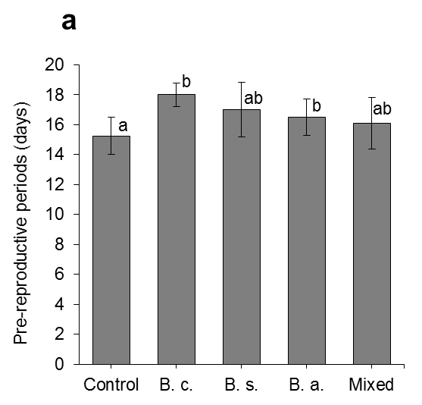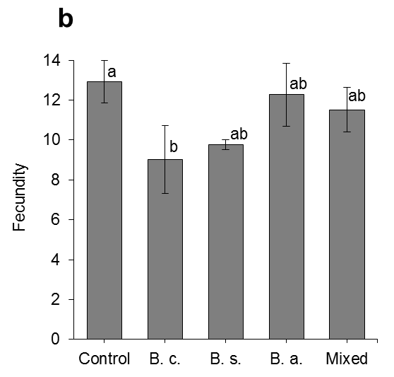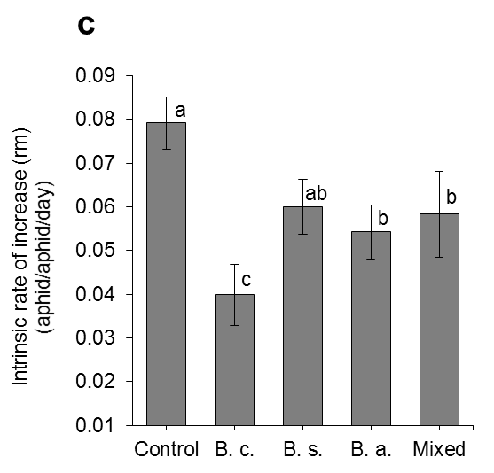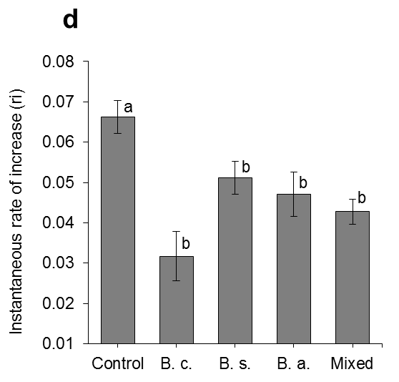

## Figure 2

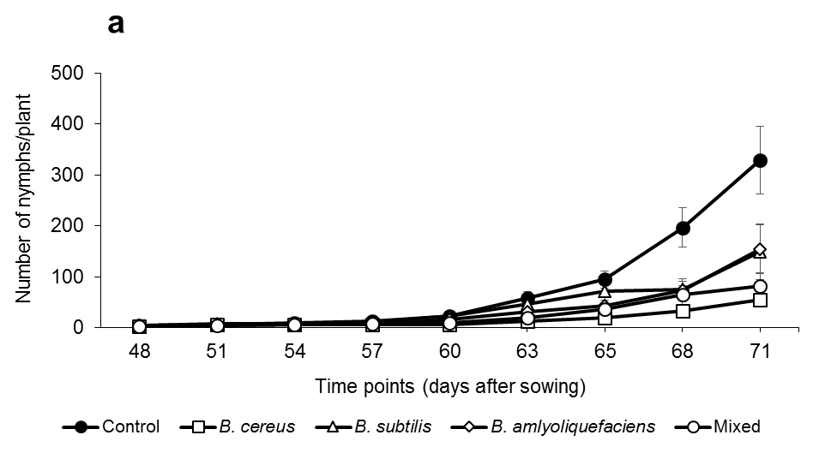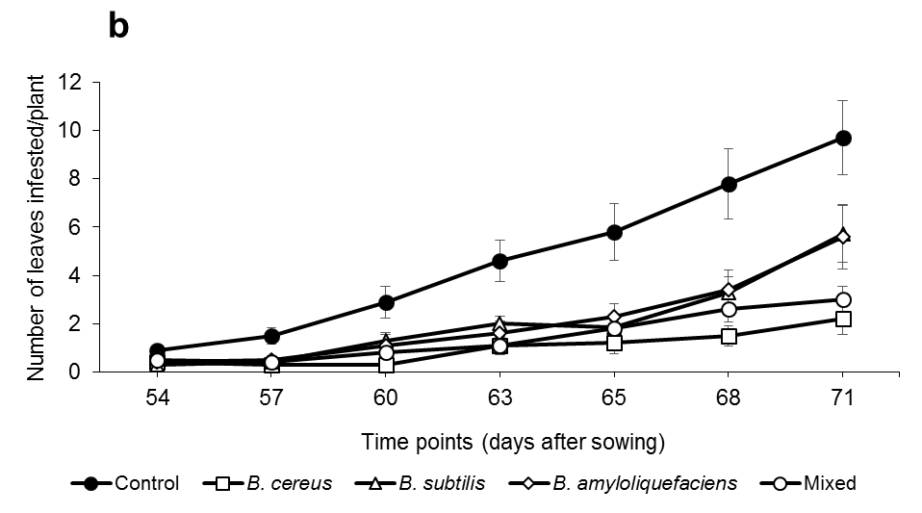

*Figure 3*