Abstract
This article describes the author’s experience of preparing a text-commentary for the Online Companion to The Worlds of Roman Women. Companion provides a collection of unadapted Latin texts, with hyperlinked grammatical support, by or about Roman women from all parts of Roman society; it also places each text in its cultural and social context. Preparing a commentary with a feminist focus offers a unique teaching resource for Companion's target audience of intermediate Latin learners because of the otherwise neglected aspects of Roman culture and the Latin language that emerge from this approach. The process of creating a commentary for Companion has multiple benefits for Latinists at all levels. It provides an on-going professional development opportunity for pre-collegiate teachers, graduate students, and both pre-tenure and post-tenure university faculty by maintaining and improving contributors’ proficiency with Latin and enhancing their knowledge of Roman cultural practices and perspectives. The article outlines the process of identifying a suitable text, creating grammatical glosses, and collaboratively editing the commentary into its final form. The article explores the value of Companion as a teaching tool within the classroom, and encourages others to join the collaborative project of increasing the range of Companion’s texts. The more people who participate in this venture, the greater the benefits for our students.

Keywords: Latin pedagogy, text-commentary, grammar, intermediate Latin, feminism, gender equality.

Ovid and His Ars: Preparing A Commentary
For The Online Companion To The Worlds Of Roman Women

1. Introduction
The work of preparing a Latin text-commentary may appear a daunting prospect, seen as a time-consuming activity reserved for those who are creating a substantial edition for a prestigious press or a new version of some long-neglected work. The finished product is indispensable to Latin teachers and the profession at large, but the process is generally conceptualized as the work of a solitary researcher. However, as a teacher and early career researcher, I have found the process of preparing a text-commentary on a smaller scale within a supportive and collaborative community both instructive and rewarding. The experience has both enhanced my own proficiency with Latin and deepened my understanding of Roman cultural expectations.
In this article, I want to share my experience of preparing a text-commentary and a brief introductory essay for the Online Companion to The Worlds of Roman Women. The experience of preparing a resource in this way offers valuable benefits for Latinists at all levels, including graduate students, pre-collegiate teachers and university faculty; its explicit feminist focus also serves to counter some of the issues raised by the traditional commentary form. I hope to encourage readers of Teaching Classical Languages to participate in a project that offers opportunities for personal development and professional collaboration. I also intend to cast some light on the process of using modern digital resources to create a text-commentary.

2. An Overview of the Worlds of Roman Women Project and Companion
The feminist pedagogy underpinning first The Worlds of Roman Women and now Companion seeks to offer a range of materials for teaching Latin that counter the gender bias embedded “in contemporary textbooks, readers, and methods of learning Latin” (Churchill 89). The Worlds of Roman Women is a print text anthology designed for Latin students at the intermediate level, set in the context of cultural history from the perspective of an underrepresented population. The essays, Latin passages and illustrations are organized under rubrics that introduce attitudes towards and expectations of women from differing social groups who lived in the ancient Roman world. The online Companion serves as a website that both supplements the print textbook with additional passages and acts as a freestanding resource; it uses modern technology to enhance the student’s experience of reading Latin. Its virtual nature means that Companion can be constantly enlarged, updated and improved.
The special nature of preparing a Companion commentary is markedly different from writing a commentary for an established press. If we take the Cambridge green and yellow series as a point of comparison, four key differences emerge. First, Companion aims to reach language learners at the intermediate level, while the green and yellow volumes see advanced undergraduate and graduate readers as their audience. This means that the kind of information contained in Companion glosses is fundamentally different to the entries in the green and yellow volumes. Of course, commentaries aimed at intermediate Latin readers are also available from traditional publishers, but these do not share the other unique qualities of Companion. Second, Companion adopts a consistent feminist approach to its texts; its goal is to “make available and promote unadapted Latin texts and material evidence about Roman women’s lives within the context of the world they inhabited” (Raia 28). The green and yellow series, by contrast, has the broader goal of making accessible “both texts traditionally considered canonical and texts which have not enjoyed popularity until recently but are eminently suitable for reading with or by students at those levels” (Cambridge University Press website). Other traditional presses tend to share this approach, making Companion’s explicit feminist perspective and freely available content all the more valuable.
Third, the structure of Companion means that preparing a passage is a far less intensive or prolonged commitment than taking on the creation of a completely new edition. Because of the length of passages appropriate for intermediate students, contributors can choose to prepare a short inscription or a brief extract rather than an entire text. The workload this entails is much easier to balance alongside other teaching and research obligations, and so provides a much lower bar to becoming a contributor to Companion than producing a traditional print text-commentary. As such, taking on the preparation of a text-commentary becomes feasible not only for college faculty, but also pre-collegiate teachers and graduate students. Fourth, contributing to Companion thus becomes an important opportunity for professional development, in that it allows a contributor to deepen their Latin proficiency and familiarity with Roman culture through engaging with a clearly defined and manageable text they have selected as particularly relevant for their own interests or suitable for their students.
Companion’s feminist focus participates in an ongoing dialogue about the importance teaching women in classics. Historically women were excluded both from the classroom and the curriculum, given Latin’s position as a sign of privilege and authority among a male elite (see Fowler 341-2). Students are presented with a world in which the dominant perspective is that of the upper-class white male. The ancient world becomes limited to one small sphere of activity, with hierarchies of value often set in the male-inhabited classrooms of the nineteenth century. Within my own praxis, I feel uncomfortable presenting material in a language class that unreflectively adopts patriarchal assumptions about the world when I feel strongly about asking students to interrogate those hierarchies in other areas of my teaching. Companion seeks to address both these inherited deficiencies, by providing more material that features women for teachers to use to widen all students’ conception of the ancient world, and providing resources which engage female students by showing them otherwise hidden aspects of their gender’s historical experience.
The desirability of such resources has been widely recognised since Laurie Churchill called for a range of strategies “to promote the empowerment of students, especially women students” in the Latin classroom (92). Women are hard to find in traditional Latin textbooks such as Wheelock and the Oxford Latin Course, which continue to have significant weaknesses in their representation of women. As John Gruber-Miller’s analysis of chapter 19 of the Oxford Latin Course shows, while independent female characters do exist, they tend to not go beyond stereotypes, and rarely capitalise on the possibility of exploring the wider context in which Roman women lived (26-8). These problems seem extremely similar to those identified by Alice Garrett and Polly Hoover in Wheelock’s Latin, the Oxford Latin Course, the Cambridge Latin Course and Ecce Romani at the start of the new millennium (Garrett; Hoover). The absence of women from the texts that learners encounter during their formative years of language acquisition has several undesirable consequences. As female students encounter no figures with whom they feel they can connect, both their learning and their commitment to continue with the language to higher levels are negatively affected. The types of passages gathered in Companion provide an antidote to these two common afflictions.
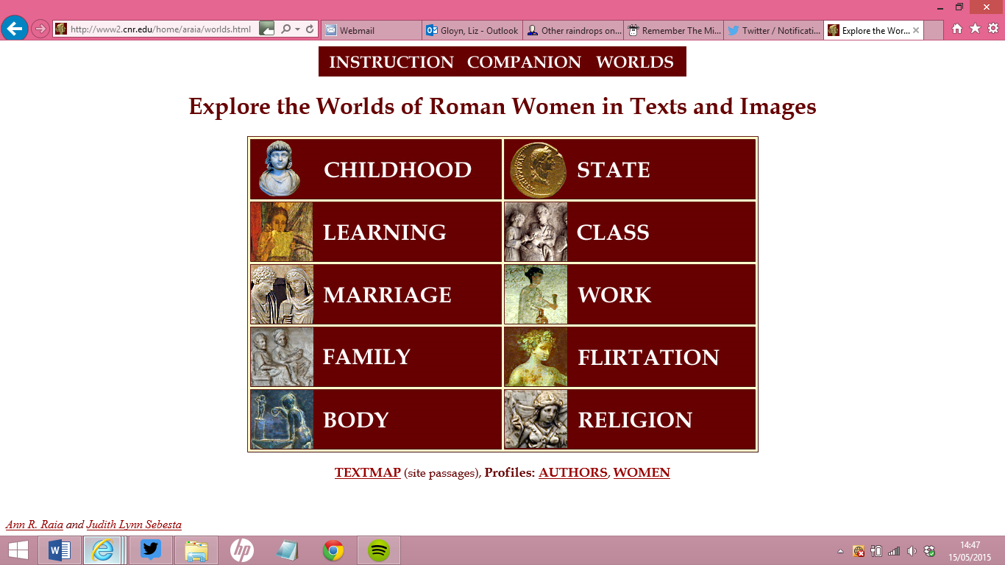 Companion’s texts are divided into ten Worlds representing various areas of Roman women’s experience, such as Marriage, Family, State or Religion; this structure enables teachers to concentrate on one particular area, sample texts from across a broad range of topics, or assign passages based on their difficulty. Each passage has a brief introductory essay focused on the woman who is the subject of the selection, including links to useful supplementary resources and images. The images in particular help support the often challenging task of incorporating material culture into language teaching. The Latin text contains hyperlinks to vocabulary and grammar aids, as well as further relevant images. The grammatical glosses encourage student independence in translating outside of the classroom, and prepare them for working with the sort of glosses that appear in a more traditional commentary. The range of passages gives female students an opportunity to relate to the personalities and activities of the women in the text and to use their learning to reflect upon their own lives; it provides male students with an alternative perspective on antiquity, and a chance to thoughtfully engage with lived experience that differs from theirs because of gender as well as chronology. All students gain a deeper understanding of the hierarchical and status-based nature of Roman society.
I use Companion in my own teaching, most recently for students with one or two year’s prior experience of university-level Latin. I use it as a source of passages for students to practice unseen translation as homework, and have been pleased with the results. Students at different levels of language proficiency benefit from the variety of passages and the range of content and difficulty available for me to assign. I can set passages of increasing difficulty throughout the semester as students increase their confidence and skill level; stronger students enjoy the exposure to ‘real’ Latin, and weaker students are supported by the glosses provided. My students appreciate the fact that Companion is available electronically and free, and so easy for them to use and access. They also find that the background information provided in the introductory essay provides the scaffolding that prepares them to translate the assigned passage with confidence. The number of easy passages on the site, including many inscriptions, also allows Companion to be incorporated from the first year of teaching (see DiBiasie for the value of using non-conventional texts like inscriptions and graffiti early in classrooms).
As a long-term member of the Companion team, I am now an Editorial Consultant with the project, as well as a repeat contributor of Latin text-commentaries. My first submission was Tacitus’ account of the death of Pompeia Paulina, Seneca the younger’s wife, which forms part of the World of Marriage and is categorised as an intermediate-level passage. The second is in the World of Class, and is a passage from Seneca’s Consolation to Helvia, which describes his aunt’s courage after her husband, the prefect of Egypt, died in a shipwreck that she survived, and is categorised as challenging. I prepared both these passages while writing my doctoral thesis, which examined the ethics of the family in Seneca’s philosophical works. Both of these passages featured prominently in my research, so it seemed natural to offer text-commentaries on material with which I was very familiar. They raised questions about the role of elite women in their husbands’ public lives; they also both participated in some way in the Roman moral tradition of exempla, demonstrating how women too could offer ethical models worthy of imitation.

3. The Process of Developing A Text-Commentary
3a. Selecting A Text
The selection of a text is guided in the first instance by the contributor’s interests and inclinations. A contributor might select something grounded in their current research, a passage that they would like to have the resources to teach, or something that will expand their expertise and cultural knowledge as they prepare it. For my third contribution, I decided to propose a section of Ovid’s Ars Amatoria. I had spent a long time working with prose in general and Seneca in particular; the Companion passage format offered the opportunity to return to poetry in a comparatively low-risk environment with a manageable selection of text. I also wanted to prepare a text-commentary for Companion’s World of Body, which was less fully populated than other Worlds. The Ars seemed perfect for my purposes.
While the first two books of Ovid’s poetic handbook on seduction address male readers, the third book offers women advice designed to make them equally cunning players of the romantic game. The praeceptor even goes as far as advising women on the most flattering position to adopt during sex according to their body type. Although such explicit passages are not appropriate for Companion’s high school users, the praeceptor also pronounces on posture, how to dress and other topics that are suitable for a young adolescent audience. The Ars as a text appeals to teenage and young adult students because of its playful treatment of flirting and courtship. It also looks surprisingly modern when placed next to fashion magazines targeted at their demographic, which offer instructions on the correct choice of make-up, hair-styles and clothing as well as broader life-style issues.
The overlap between ancient and modern offers an opportunity for students to interrogate both the target text and features of contemporary culture, and ideally to reflect critically upon the purpose and motivations of both. Various activities could enable students to further explore these distinctions:
- Get students to bring in an advice column from a newspaper or magazine and compare the contents with Ovid -- this could apply to book three more widely for older students.
- Review the vocabulary used in the passage and discuss the ways in which it reinforces a male perspective on female beauty standards.
- Ask students to rewrite the passage from the perspective of one of Ovid’s female readers, or as if the praeceptor were a woman rather than a man. Depending on student ability, this assignment would work in English or Latin.
- Assign students a response paper in which they consider how the passage reinforces the established gender hierarchies of Roman society, and whether they see similar mechanisms at work around them.
- Ask students to compose their own love and relationship advice in Latin.
- Students could illustrate or act out the sorts of behaviours that Ovid identifies as undesirable, to bring out the comic aspects of the poem’s ridiculous and unrealistic gender expectations.
Once a contributor has identified a passage or text they feel is suitable, they consult with the editors of Companion, Ann Raia and Judith Sebesta, to ensure that the selected passage harmonises with site’s stated goals. This collaborative approach ensures that the needs of everyone involved in the project are met. We identified three possibilities from book three of the Ars, based on the World I had selected and Companion’s overall aims: 3.235-250, in which a mistress mistreats her slave hairdresser; 3.255-280, on minimising defects in appearance; and 3.281-310, on adjusting one’s laughter and walk to attract a man. Ultimately I rejected the first two passages. The first felt as if it belonged to the World of Class than the World of Body, and the second passage used potentially problematic technical language to describe Roman dress. The third passage felt like the appropriate choice because of its approachable subject matter, its straightforward vocabulary and its sly humour, which students would appreciate. The passage I selected from the Ars also offers a springboard to various possible activities in the classroom, beyond grammar analysis:
- Read the Ars passage alongside other passages from Companion that focus on the female body and the correct way to inhabit it. Ask students to consider the difference between Ovid’s attitude and, for instance, the sort of physical behaviour expected of a matrona.
- Companion’s image database of female figures in various poses, including the pudicitia pose, could provide a material culture entry point into the text, as students compare artistic representations of female body posture with Ovid’s descriptions. These images are available throughout the site, for instance in the images of marriage list.
- Ask students to compare the presentation of women in the passage, and book three of the Ars more broadly, with the presentation of women in a different medium -- inscriptions, graffiti, or a different literary genre -- to see which qualities are emphasised in different sorts of texts, and the difference between literary and archaeological representations.
- The passage could serve as an entry into a wider research assignment into the representation of the female body in Roman love poetry.
- Ask students to write two book reviews of the Ars Amatoria, one for an ancient Roman publication and one for a modern newspaper or magazine.
- In class, give students presentation topics, either individually or in groups, relating to the Ars and to Ovid; grade them both on the quality of their presentation, and on their ability to use the Ars passage in their answer. (This suggestion is modelled on Anne Leen’s group presentation activity for Propertius 4.11.)
- Use Ann Raia’s Text-Commentary Project as part of the course assessment for advanced Latin students, and ask students to prepare a commentary themselves on a text of their or the instructor’s choice. Some passages produced through such assignments now form part of Companion’s corpus.

3b. First Steps In Preparing The Text-Commentary
After an appropriate text has been agreed on, the contributor generates a standard version of the original Latin, a first draft of the commentary notes, and an introductory essay. The first stage of this process is a review of recent scholarship. In my case, this process was facilitated by Roy Gibson’s 2003 commentary on Ars Amatoria 3, which highlighted current trends of thought as well as significant issues of textual emendation. While Companion tends to use OCT texts as standard, should there be any differences of interpretation raised by more recent academic work, then the contributor is free to alter the submitted text to reflect those advances. Generating the Latin itself was very straightforward for me, in part because of Gibson’s work, and also because the section of the Ars I had chosen was relatively uncontroversial; I was faced with only a few decisions about punctuation and alternative readings for a handful of words. Contributors who submit inscriptions often face more difficult challenges of reconstructing damaged text or interpreting barely-visible lettering on the monument with which they are working.
Once I had decided my position on the text and studied the scholarship, I began the process of writing grammatical glosses. A recent response to the 2014 Cloelia survey asking for wish list items colleagues would value in their teaching asked for “simpler commentaries that help students read without translating for them or bogging them down with details” (Gloyn and Jeppesen-Wigelsworth 19). Companion’s glosses aim to do just this by offering generous grammatical support in accessible and straightforward language. Their goal is to aid students in traditional classrooms and support independent learners who may not be attached to a formal institution. The glosses always list the meaning of a word that is relevant to the given passage first -- in the case of my passage, this policy was particularly important since I was preparing the only surviving Latin sentence in which the word lacunae means dimples! The glosses also provide grammatical assistance and suggestions to help weaker students navigate complicated syntax, although as a rule they do not provide word-for-word translations of phrases. This strategy enables Companion to include passages that contain, for example, eccentric poetic constructions or Tacitean syntactical complexities. A gloss might explain why a verb is in the subjunctive, identify the role a seemingly random genitive plays in a sentence, or gently suggest students translate ut as a preposition rather than a conjunction. Sometimes the dictionary entry alone is sufficient, as that will signal to students that, for instance, an unfamiliar noun belongs to the fourth rather than the second declension, and so may be in a wider number of cases than they initially thought.
The differences between the glosses provided by Companion and more traditional commentaries are best illustrated through example. Although the Cambridge green and yellow series does not have an edition of the Ars Amatoria, we can compare the glosses provided in Andrew Dyck’s 2013 edition of Cicero’s Pro Marco Caelio with those offered by Maria Marsilio for the extract of the speech she prepared for Companion (14.33-4). The opening sentence of Cicero’s address to Clodia in the persona of her ancestor Appius Claudius Caecus provides enough material to show the contrast. The line goes as follows:
Qui profecto, si exstiterit, sic aget ac sic loquetur: “Mulier, quid tibi cum Caelio, quid cum homine adulescentulo, quid cum alieno?”
In Dyck’s edition, this whole sentence is the subject of a single paragraph length gloss, which focuses primarily on the nature of prosopopoeia. The reader is referred to the OLD for cum “indicating the person or thing with whom or which a relationship, business, etc. exists”; the gloss notes the pejorative register of mulier and adulescentus as well as the emphatic final position of cum alieno; and Dyck cites three secondary sources as part of the familiar scholarly apparatus to support these observations. However, this gloss is clearly aimed at the more advanced reader who is interested in rhetorical strategies and will follow up the directions for further reading; there is little here for the student still struggling with unfamiliar vocabulary or constructions. By contrast, Marsilio glosses profecto, si, Caelio, adulescentulo and alieno. She provides translation options for the vocabulary and gives historical details about Marcus Caelius Rufus to contextualise the excerpt. She notes that si introduces the protasis of a future more vivid condition, identifies profecto as an adverb, and points out the diminutive form of adulescentus and the implication that Caelius is much younger than Clodia without offering any further interpretative direction. There is no mention of secondary literature, and the grammatical explanations are self-supporting. Marsilio’s glosses meet the intermediate student’s need for clear grammatical signposts, vocabulary support and enough socio-historical background to make sense of the passage without excessive specifics.
The preparation of grammatical glosses is, for me, the most time-consuming and creative part of generating a text-commentary. All of us who teach language know that it is one thing to translate a passage to your own satisfaction and understand its meaning, but quite another to explain the grammatical underpinning of the syntax to another person. For me, working through these grammatical knots to write glosses reinforced my ability to clarify them clearly in my own classroom, and strengthened my general Latin language skills. Engaging with complex grammatical questions in a text which was new to me meant that I sharpened my familiarity with Latin syntax more broadly, and helped improve my proficiency both in translation and explanation. The benefits of contributing to Companion thus include not only the end users of the passage but also each individual collaborator.
The final task involved in this initial stage is writing the introductory essay. This introduction needs to serve several purposes. It must put the passage in its broader context, particularly when it is a brief selection from a longer work, without overwhelming the student with detail. It must bring the woman in the passage into focus as subject rather than object (Raia 33); it should also “alert the reader to prejudices of source and culture as well as to bias embedded in genre conventions” (Raia 32) so that they are prepared to interpret the passage within its socio-historical framework. To get all of this into a readable five hundred words or so is a challenge in itself! However, the feminist focus required in the essay also presents contributors with its own particular difficulties. Moving women to the centre of our view means “the whole enterprise of understanding and teaching history is transformed”, and so our approach to otherwise familiar material must, in its turn, be completely transformed too (Garrett).
Contributors benefit from the experience of Ann Raia and Judith Sebesta in refining their introductory essays. The collaborative aspect of the project means they are able to offer advice on how to avoid common problems in constructing this part of a text-commentary. The most frequent issue that they encounter is that first drafts of introductory essays tend not to focus on the woman featured in the passage and her particular experience, but instead offers more traditional interpretations that privilege patriarchal concerns such as the activities of women’s male relatives (Raia 33). My previous two essays, on Pompeia Paulina and Seneca the younger’s aunt, both initially suffered from this fault; I provided as much historical background as I could find for them, but in ways that privileged the lives of their husbands and sons. One way to circumvent this issue, which I used successfully in the essay on Pompeia Paulina, is to begin with the genealogy of the woman, including her mother’s name where known; this starting point leads more easily into a biographical sketch of the woman rather than details about the text in which she appears or of her famous male relatives.
However, writing the introductory essay for the Ars excerpt presented a different challenge. In this case, there is no specific woman upon whom to focus the essay. The passage only mentions generalised women, whom Ovid holds up to his female readers as embodying behaviour they should avoid. My first attempt at drafting the essay approached the passage by outlining the context of the poem, Ovid’s envisaged audience for the passage, and the fact that it ultimately teaches women how to please men, not how to take control of their own romantic lives. These areas seemed to me to cope with the passage’s focus on generalised rather than specific women, and to contextualise the passage within the wider playful yet problematic world of the Ars Amatoria as a whole. As the process of shared review made clear, in taking this approach I still fell into the trap of making the essay about a man -- in this case Ovid as poet -- rather than Roman women and their lives, but my initial draft helped me to identify the key issues that the introductory essay for this passage should address.

3c. Refining and Publishing The Text-Commentary
When I had prepared a version of the Latin text and drafted the glosses and introductory essay, I e-mailed the three initial documents to Companion’s co-editors. At this stage, Ann reviews the documents, makes suggestions for edits and further glosses, and returns the materials for the contributor to approve the changes. This is the first of several collaborative stages involved in the editing process. Our discussion about the Ars focused on Ann’s questions about the glosses and text that I had sent her, where she brought a fresh perspective to some phrases for which I had found it difficult to write brief, helpful glosses. We agreed the best way to clarify some of the explanations, and how to handle the places where I had chosen to follow Gibson’s version of the text rather than the OCT. We also ensured that my documents were in line with Companion’s house style.
After I had made the agreed changes to my master document, Ann took the information and coded the passage into a webpage. She identified appropriate images to illustrate the text, which students access by pressing an SPQR button alongside the passage. For instance, next to the line in which Ovid compares a girl with a raucous laugh to an ass at a millstone, the SPQR button links to a picture of an ass working at a mill so students can see what Ovid refers to. She also hyperlinked the text to the glosses, laid out the introductory essay and included a sample picture to head the passage. Once the preliminary version of the webpage was complete, Ann sent me a link to it for my thoughts.
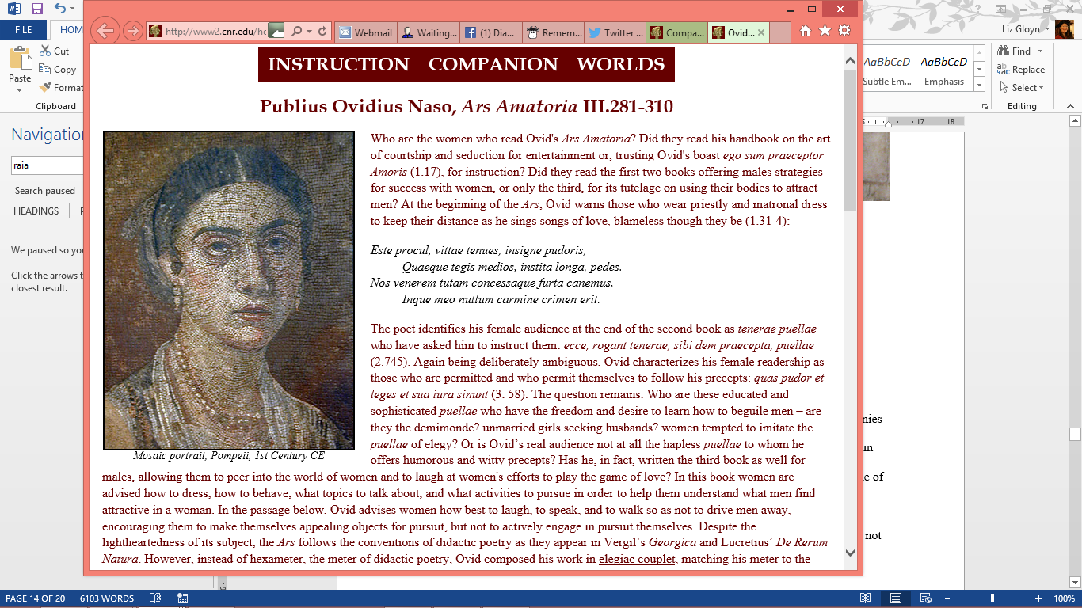 For the picture that accompanies the introductory essay, she had chosen an illustration of a woman from a mosaic portrait in Pompeii. We discussed whether a different image might be more suitable; I suggested one of the Tanagra figurines, but it seemed wise to avoid cultural dissonance given that they are Hellenistic rather than Roman. Other options turned out to be few and far between. I had not realised that few ancient images survive of a woman, or anybody else, smiling or laughing. The obvious exceptions are the satyr scenes on Greek vases, and potentially some statues of old women normally classified as drunk, but women tend to wear expressions that are more enigmatic than amused. The face from the Pompeii mosaic has one of those expressions, so it remains the image used on the final version of the webpage.
The editing process also made significant differences to the introductory essay. To shift the focus away from Ovid himself, I included a new section on who the women reading Ovid’s poem would have been, bringing out the comparison between the Ars and other didactic literature. This strategy allowed me to address the lived experience of women in the ancient world who would have had access to Ovid’s text, thus encouraging students to consider the number of women who would have had the intellectual training to engage with a poem that is both playful and mindful of its literary antecedents. The editors also noted that my first draft explored themes more related to Companion’s World of Flirtation. As a result of their feedback, I emphasised the physical aspects of the text that Ovid suggests rather than concentrating on his flirtation strategies, bringing out themes more relevant to the World of the Body as I had initially planned.
After the contributor and editor have approved the first version of the webpage, the final stage of the publication process begins. This phase once more draws on the collaborative strengths of Companion through its team of editorial consultants and collaborators, all of whom have submitted passages to Companion themselves. The editor sends the team a link to the draft webpage, and asks them to offer any suggestions for improvement that they may have. When I am serving in this role, I normally look for glosses that either do not make sense to me as a translator or seem potentially confusing for weaker intermediate students; additional information that would enrich the glosses or introductory essay; and errors of punctuation or syntax. The collaborative process means that in essence each new passage is peer-reviewed several times over. The process of sharing work with a larger group of reviewers also gives the contributor a broader perspective on their own approach to the language, highlighting areas where they might adopt alternative methods of explaining a grammatical concept or offering fresh insights into how to approach a passage.
Once additional edits have been implemented, a link to the passage is added to the relevant World homepage, the TextMap page, and the Recent Additions section of Companion. The passage now becomes accessible to teachers and students, and is ready to be used. However, unlike a printed version of a text-commentary, a passage does not necessarily remain the same once it has been posted. Companion welcomes suggestions for improvement and corrections of errors discovered by those who are using the texts with students, and so can report back on how they are received in practice; this means that every passage is a constantly evolving resource, tested by use. The online format allows such improvements to be made quickly and simply, and thus involves a wider community in the collaborative work of enhancing the resources Companion offers.

4. Reflections
After my passage went live, Judith Sebesta was one of the first people to use it in the classroom. She reported two very different responses from her male and female students. The female students found the passage fascinating and wanted to read more of the Ars; one male student’s response was best summed up “you’ve got to be kidding”. Judith feels this reaction was grounded in surprise that Ovid would offer this kind of advice, as if the idea that the Romans might too have participated in games of seduction was completely unexpected. Both reactions reveal student engagement with the passage, of surprise that the ancient world can be so similar to our own and of curiosity to discover more about the poem. These students thus demonstrated two key results I hoped to achieve by adding this passage to Companion -- they were challenged to widen their comfortable perceptions of what the ancient world was like, and they actively responded to the text they were studying, rather than dutifully translating it because it was put in front of them without connecting to the material.
From a personal perspective, working with this passage from the Ars provided me with a valuable opportunity to deepen my knowledge of Roman culture in ways which turned out to be unexpectedly beneficial for my broader academic work. The Ars belongs to the subgenre of erotodidacticism, that is, literature that seeks to teach about good erotic practice. I first came across this concept when preparing the introductory essay, but had no inkling of how useful I would subsequently find it. Shortly after submitting the Companion passage, I began work on a conference paper on the Priapea that argued that the corpus distinguishes between male and female kinds of erotic knowledge. The background I had become familiar with while researching the Ars was invaluable in shaping my initial ideas, which I am continuing to develop into an article. My experience illustrates how preparing a well-chosen passage for Companion can strengthen a contributor’s knowledge of Roman society as well as draw on prior expertise, with unexpected beneficial consequences both for scholarship and in the classroom.
I also found the experience valuable from a professional development perspective. It gave me an opportunity to improve my knowledge of a genre with which I had not previously worked with professionally in any depth, and an author who is perennially popular with students. My grasp of Latin syntax inevitably benefited from close examination of and engagement with a manageable amount of text; the move to poetry from my usual focus on prose also gave me an opportunity to familiarise myself with a different literary genre. My confidence with these kinds of texts increased as a result of preparing the text-commentary, thus enabling me to teach passages like this in the classroom more confidently, both in terms of the language and the cultural context.
The final professional benefit of engaging with Companion is joining and cooperating with a network of new colleagues to create new material. Companion’s electronic form enables interaction with scholars across continents, just as Companion itself is freely available to anybody in the Anglophone world who is interested in Latin. The larger the network of contributors, the richer the resources that Companion offers will become -- and the more resources teachers will have in their classrooms to combat the gender stereotypes prevalent in other teaching materials. If this article has encouraged you to join the Companion team, or you would like to find out more, please get in touch with Ann Raia at araia@cnr.edu, with any particular passage or theme that you would like to explore -- she is always delighted to hear from potential contributors.
In conclusion, the process of preparing a text-commentary for Companion offers the opportunity to engage in commentary work and to deepen one’s knowledge of Roman gender relations without the obligations of committing to a full edition of a text. It also enables contributors to offer something to the wider community of teachers and learners of Latin, particularly those at the intermediate level. The broader use of Companion in classrooms will remind teachers and learners alike that not all Romans were men, and not all Roman women belonged to the elite. By representing the breadth and variety of life in Rome and its provinces, we give our students a better understanding of the richness of the ancient world.

Cited Works
Churchill, Laurie J. “Is There A Woman In This Textbook? Feminist Pedagogy and Elementary Latin.” When Dead Tongues Speak: Teaching Beginning Greek and Latin. Ed. John Gruber-Miller. New York: Oxford University Press, 2006. 86-112. Print.
DiBiasie, Jacqueline. “Promoting Women In The Latin Classroom With Graffiti.” Cloelia 4 (2014): 35-40. Web. 16 May 2015. <https://drive.google.com/file/d/0B1_wqv8nHuSROVZrX0ROME5FVTg/view>
Dyck, Andrew. Cicero: Pro Marco Caelio. Cambridge: Cambridge University Press, 2013. Print.
Fowler, R. “ ‘On Not Knowing Greek:’ The Classics And The Woman Of Letters.” The Classical Journal 78.4 (1983): 337-349. Print.
Garrett, Alice. “Teaching Latin With A Feminist Consciousness.” Classics Technology Centre. Web. 24 Dec 2014. <http://ablemedia.com/ctcweb/netshots/lat101garrett1.html>
Gibson, Roy. Ovid, Ars Amatoria Book 3. Cambridge: Cambridge University Press, 2003. Print.
Gloyn, Liz and Alison Jeppesen-Wigelsworth. “2014 Survey on Pedagogy.” Cloelia 4 (2014): 5-20. Web. 23 Dec 2014. <https://drive.google.com/file/d/0B1_wqv8nHuSROVZrX0ROME5FVTg/view>
Gruber-Miller, John. “Six Categories For Assessing The Representation Of Women In Textbooks.” Cloelia 4 (2014): 24-27. Web. 23 Dec 2014. <https://drive.google.com/file/d/0B1_wqv8nHuSROVZrX0ROME5FVTg/view>
Hoover, Polly. “Contextual Learning And Latin Language Textbooks.” The Classical World 94.1: 56-60. Print.
Maher, Frances A. “Toward A Richer Model Of Feminist Pedagogy: A Comparison Of ‘Liberation’ And ‘Gender’ Models For Learning And Teaching.” The Journal of Education 169.3: 91-100. Print.
Marsilio, Maria. “M. Tullius Cicero, Pro Caelio 33-34.” The Online Companion To “The Worlds Of Roman Women. Web. 23 Dec 2014. <http://www2.cnr.edu/home/araia/cicero_clodia.html>
Raia, Ann. “A Companion For The Feminist Transformation Of The Latin Curriculum.” Cloelia 4 (2014): 28-35. Web. 23 Dec 2014. <https://drive.google.com/file/d/0B1_wqv8nHuSROVZrX0ROME5FVTg/view>
Raia, Ann and Judith Sebesta, eds. The Online Companion To “The Worlds Of Roman Women”. Web. 20 Sept. 2014. <http://www2.cnr.edu/home/araia/companion.html>

This article began life as a series of informal blog posts. I thank Ann Raia and Judith Sebesta both for the opportunity to collaborate with Companion, and for their helpful comments on various drafts of the manuscript. John Gruber-Miller and TCL’s two anonymous referees also offered invaluable advice on improving and developing the piece.
This approach arguably draws on the model of liberation pedagogy articulated by Paulo Freire to enable the “the classroom empowerment of oppressed and silent groups in opposition to the dominant exploitative ideology” (Maher 92); it privileges gender as the focus of that liberation without risking an essentialist approach to female nature. The focus on gender also permits other inequalities, such as those created by class and free/unfree status, to surface within that framework.
As Churchill remarks, “the underrepresentation of women is a major concern, since research has shown that noninclusion of women and girls in materials used to each them seriously impairs their ability to learn” (89); a failure to grasp a subject will have a natural impact on a student’s desire to progress with it.
University instructors can, of course, further encourage their students to act as independent learners by directing them to a translation of the full poem.
Examples include Catullus 36; Tacitus, Annales 11.12 on Messalina; Virgil, Aeneid 7.803-817 on Camilla; and Valerius Maximus, Factorum et Dictorum Memorabilia 8.3.1 on Maesia.
As an example, in line 281, I followed Gibson in reading aque rather than the manuscripts in reading atque; the gloss reads “Although all the MSS read atque, most scholars prefer this emendation (see Roy K. Gibson, ed. Ovid, Ars Amatoria Book 3, Cambridge 2003)”.
Many of the pictures used come from VRoma, an associated project based around a virtual learning environment that has an extensive online image library.
Personal communication to Ann Raia, 10th July 2011; personal communication to myself, 20th October 2014.
Personal communication to myself, 28th December 2014.

