Jaw-bone discovery reveals more about secret sex lives of Neanderthals and early humans
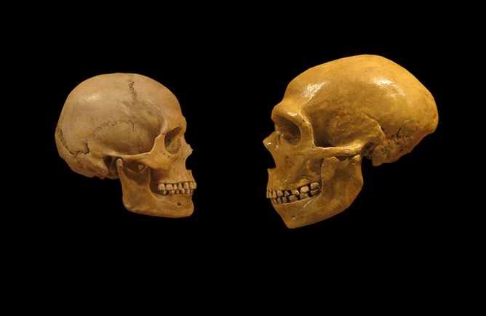The look of love? Human meets Neanderthal. DrMikeBaxter/wikimedia, CC BY-SA
A fossilised jaw bone of one of Europe’s earliest modern human, discovered in a cave in Romania, has unveiled fresh evidence about what Neanderthals and humans got up to some 40,000 years ago. Geneticists have found that the individual had between 8 per cent and 11 per cent of its genome derived from Neanderthals – which is far more than any other modern human skeleton sequenced so far.
In the past decade, the analysis of ancient DNA from fossil skeletons of anatomically modern humans has revealed a startling fact: some of our direct ancestors had sex with Neanderthals, producing fertile offspring. Prior to these genetic revelations, anthropological researchers were divided between those who firmly believed that such unions either did not occur, or that they could not have yielded sexually fertile offspring, because the differences between early modern humans and Neanderthal genomes would have been too great.
A well-known modern example of this kind of cross-breeding is that between a horse and a donkey, which yields a sterile offspring (the mule).
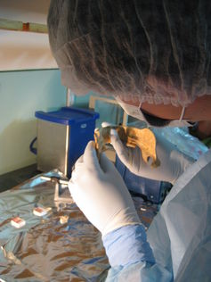The researchers prepared two DNA extracts from 25 and 10 mg of bone powder taken from the jawbone. Svante Pääbo, Max Planck Institute for Evolutionary Anthropology
Now that the closeness between the DNA of early modern humans and Neanderthals has been established, geneticists have begun to find a few rare fossils that contain a mixture of the two. A new study presents the latest and perhaps most intriguing of these discoveries: A fossil jawbone of a male, human skull that has been radiocarbon dated at 37,000 to 42,000 years ago. The fossils came from a site called Peştera cu Oase in Romania, making it one of the oldest early modern humans known from Europe.
The fact that this individual carried more Neanderthal DNA than any other anatomically modern human ever tested is surprising and means that the mating between a Neanderthal and a modern human took place as recently as in his great-grandfather’s generation. Statistical analysis of the DNA composition of the skeleton suggests that the person carried as much as 8-11% Neanderthal genes in his DNA.

The enigma of modern Europeans' DNA
Surprisingly, in spite of the two populations being in contact for many thousands of years, there is no DNA evidence for interbreeding between Neanderthals and the ancestors of the Europeans living today. In fact, segments of Neanderthal DNA turn up in modern human DNA from East Asians and Native Americans far more than they do from Europeans. But if the anatomically modern human population of ice-age Romania did interbreed with Neanderthals, then why didn’t the Neanderthal DNA signature carry through to modern Europeans?
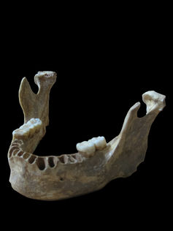Analysis revealed the Oase man was no direct ancestor of modern Europeans Svante Pääbo, Max Planck Institute for Evolutionary Anthropology
The research sheds some light on this conundrum as well. It appears that the ancient Romanians were not the direct ancestors of modern Europeans. Instead it was immigrant populations of early humans originating from the Middle East and southeast Europe that passed on their genes while sweeping through Europe, bringing farming and animal husbandry with them. This new lifestyle replaced the hunter-gather way of life that had characterised all previous human societies.
Other ancient skeletons of modern humans from Eurasia help flesh out the story of relations between Neadnerthals and humans from the last ice age. An individual from the Kostenki 14 site in western Russia shared from 1.7-3.8% DNA with Neanderthals (Location 2 on the map). This skeleton was dated to 36,000-39,000 years old, and the individual was more closely related to later Europeans than to East Asians.
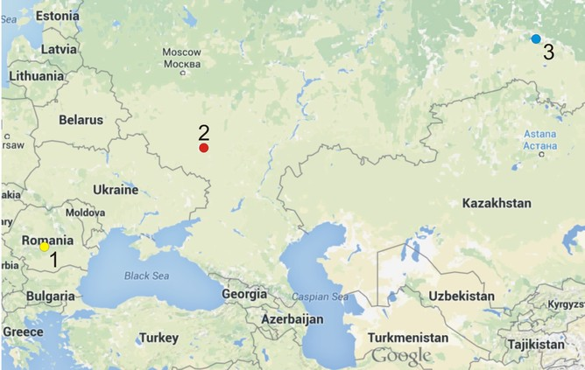Map showing the location of three recently found fossil skeletons that contain a mixture of modern human and Neanderthal DNA Author provided
Meanwhile, a 45,000-year-old fossil skeleton from the Ust’-Ishim site in Western Siberia contained from 0.4 to 3.6% Neanderthal DNA (Location 3 on the map).
The studies of the Kostenki 14 and Ust’-Ishim specimens show that gene flow from Neanderthals to modern humans at these sites occurred well before these individuals lived. In the latter case, it could have been around a thousand years before the Ust’-Isham individual lived – much earlier than in Romania.
The fascinating findings, made thanks to the rapid advances in genome sequencing that we’ve seen over the past decade, represent important but small pieces of the puzzle describing the origin of the humans living today. No doubt will many more secrets be unveiled in the near future.

