Do infant vocabulary skills predict school-age language and literacy outcomes?

Fiona J. Duff
Gurpreet Reen
Kim Plunkett
Kate Nation

Department of Experimental Psychology
University of Oxford

Word count = 6172

Abstract
Background: Strong associations between infant vocabulary and school-age language and literacy skills would have important practical and theoretical implications: Pre-school assessment of vocabulary skills could be used to identify children at risk of reading and language difficulties, and vocabulary could be viewed as a cognitive foundation for reading. However, evidence to date suggests predictive ability from infant vocabulary to later language and literacy is low. This study provides an investigation into, and interpretation of, the magnitude of such infant to school-age relationships.
Methods: Three hundred British infants whose vocabularies were assessed by parent report in the second year of life (between 16 and 24 months) were followed up on average 5 years later (ages ranged from 4 to 9 years), when their vocabulary, phonological and reading skills were measured.
Results: Structural equation modelling of age-regressed scores was used to assess the strength of longitudinal relationships. Infant vocabulary (a latent factor of receptive and expressive vocabulary) was a statistically significant predictor of later vocabulary, phonological awareness, reading accuracy and reading comprehension (accounting for between 4 and 18% of variance). Family risk for language or literacy difficulties explained additional variance in reading (approximately 10%) but not language outcomes.
Conclusions: Significant longitudinal relationships between pre-literacy vocabulary knowledge and subsequent reading support the theory that vocabulary is a cognitive foundation of both reading accuracy and reading comprehension. Importantly however, the stability of vocabulary skills from infancy through to later childhood is too low to be sufficiently predictive of language outcomes at an individual level – a finding that fits well with the observation that the majority of ‘late talkers’ resolve their early language difficulties. For reading outcomes, prediction of future difficulties is likely to be improved when considering family history of language/literacy difficulties alongside infant vocabulary levels.
Keywords: infancy, language, reading, longitudinal studies, family history
This paper sets out to answer the question of whether infant vocabulary – as measured by parental report during the second year of life – predicts school-age language and literacy outcomes. This is a research question of both practical and theoretical import.
The first word that a child utters represents an important milestone in development. Parents take great delight at the advent of their child’s speech, and express significant concern if this seems delayed. As noted by Paul and Roth (2011), a child’s failure to acquire their first spoken words, in the absence of any explanatory syndrome, is the most common reason for referral for early intervention (American Speech-Language Hearing Association, 2006). Such factors feed into a drive for early assessment of language abilities and early identification of language difficulties – especially in a milieu which emphasizes the importance of early intervention (e.g., Allen, 2011; Bercow, 2008). Regarding child language development, a question to be asked is whether these hopes and aims can be realised.
There are two main strands of evidence that inform these issues. The first strand takes a dichotomous approach and compares the outcomes of late talking children with those who showed no such delays. The second takes a continuous approach and considers the overall strength of the association between attainments in infancy and later childhood in an unselected sample of children.
The term ‘late talkers’ is used to refer to 18- to 35-month-olds who are slow to develop spoken language in the absence of any known primary cause (Rescorla, 2011). Various criteria have been used in the literature to identify late talkers, but the most common is those children who perform in the lowest 10th percentile for their age on a parental report of expressive vocabulary (the MacArthur-Bates Communicative Development Inventory (CDI) – Fenson et al., 1994). A review by Rescorla (2011) provides a comprehensive summary of the late talker literature. From this, it is clear that the majority of late talkers resolve their language difficulties by school-age. At most, late talkers carry a sub-clinical risk: Although the language and literacy scores of children who were late talkers subsequently fall in the average range, they are oftentimes reported as being significantly below those of their typically-developing peers. Rescorla (2011) also observes that the majority of children who go on to be categorised as having a language delay were not classified as late talkers in infancy. This high rate of false positives and false negatives suggests a lack of stability in language development from infancy through to the school years.
This apparent low stability in early language is supported by findings of studies that have adopted a continuous approach to exploring the issue. A number of large population-based studies have employed multifactorial models that incorporate a host of familial, demographic, perinatal and developmental measures to predict language outcomes. Reilly et al. (2010) reported on outcomes of over 1500 Australian 4-year-olds whose vocabulary skills had been measured at 2 years. Their multifactorial model with 13 predictors explained 23.6% of variance in receptive language and 30.1% of variance in expressive language. An arguably low proportion of this variance (4.7% and 9.5%, respectively) was explained by children’s earlier language skills (late talking status at 2 years).
A study of nearly 4000 Dutch infants by Henrichs et al. (2011) conveys similar findings. Their multifactorial model with 15 predictors could only account for 17.7% of variance in expressive vocabulary at 30 months. Expressive vocabulary scores at 18 months accounted for 11.5% of the explained variance. A follow-up report by Ghassabian et al. (2013) of nearly 3000 of these children at 6 years of age indicates that predictive ability diminishes over time. Using a similar set of predictors, 15.2% of variance in vocabulary comprehension at 6 years could be accounted for; expressive and receptive vocabulary skills at 18 months together explained only 1.8% of the variance, and expressive vocabulary at 2.5 years explained only 2.0%.
In all, the evidence points more towards discontinuity than continuity of language skills from infancy to early childhood. This is a disappointing finding with respect to hopes for early identification and remediation of language difficulties. However, given that the discontinuity is not absolute (i.e., infant vocabulary skills are able to explain some of the variance in later language, and some late talkers do show persistent language delay), research has endeavoured to identify additional factors that might improve predictability of language outcomes. A helpful summary of risk factors for persistent language difficulties is provided by Paul and Roth (2011) and includes presence of receptive as well as expressive difficulties, and a family history of language or literacy difficulties (e.g., Bishop et al., 2012; Ghassabian et al., 2013; Reilly et al., 2010; Zambrana, Pons, Eadie, & Ystrom, 2014). That family history is a significant predictor of longer-term language delay dovetails well with the fact that pre-school vocabulary skills differentiate between children with a family history of dyslexia who do and do not go on to receive a dyslexic diagnosis (e.g., Scarborough, 1990). This issue will be pursued further in the present study.
Although many studies have investigated the longitudinal relationship from infant vocabulary to later language skills, far fewer studies have considered reading as an outcome measure, despite the theoretical significance of this association. A critical line of investigation in the reading research literature has been to identify the cognitive skills that underpin the development of reading; that is, to determine causal pathways. Experimental training studies provide the only true test of causality. However, longitudinal correlational studies are an essential forerunner to these in establishing the ‘logic of causal order’ (Davis, 1985), insomuch as they can demonstrate that a cause precedes its effect in time. With respect to reading, the most informative longitudinal investigations are those wherein a supposed causal factor is measured before reading has begun to develop. Infant vocabulary is an ideal measure in this regard.
Exploration of causal relations, however, must be set within a clear theoretical framework (Hulme & Snowling, 2009). We can ask, then: why might vocabulary be causally related to reading? In their simple view of reading, Gough and Tunmer (1986) highlighted the two main components of reading: reading accuracy (mapping from print to sound) and reading comprehension (mapping from print to meaning). It is clear why vocabulary should relate to comprehension: at the most basic level, the meaning of a text cannot be understood if the meanings of its constituent words (vocabulary knowledge) are not known. In school-age children, strong evidence for a causal relationship between vocabulary and reading comprehension has emerged from longitudinal studies (e.g., Muter, Hulme, Snowling, & Stevenson, 2004) and training studies (e.g., Clarke, Snowling, Truelove, & Hulme, 2010; Fricke, Bowyer-Crane, Haley, Hulme, & Snowling, 2013).
The proposed mechanisms by which vocabulary might influence reading accuracy are more debated. There is discussion over whether vocabulary affects reading accuracy directly or indirectly (e.g., Dickinson, McCabe, Anastasopolous, Peisner-Feinberg, & Poe, 2003). An indirect role is proposed by the lexical restructuring hypothesis, which suggests that increased vocabulary knowledge forces a fine-tuning of phonological representations, in turn facilitating reading accuracy (Metsala & Walley, 1998). In contrast, the self-teaching hypothesis ascribes vocabulary a direct role in reading accuracy: incorrect decoding attempts can be corrected if a child has the target word stored in their spoken vocabulary (Share, 1995). On this view, vocabulary knowledge will be more helpful for reading aloud words with exceptional rather than regular spellings – a prediction in keeping with the triangle model of reading aloud (Plaut, McClelland, Seidenberg, & Patterson, 1996). There is certainly some evidence that vocabulary is associated with reading accuracy in school-age children. For example, variations in vocabulary knowledge at school age predict variations in later word reading (Ricketts, Nation, & Bishop, 2007); and children are better at learning to read an unfamiliar written word if it is already in their spoken vocabulary (Duff & Hulme, 2010). However, unequivocal evidence that vocabulary exerts a causal influence on the development of word reading is still lacking.
In sum, though there is evidence from school-age children that vocabulary plays a role in the development of reading accuracy and reading comprehension – to varying degrees – evidence of significant pathways from infant vocabulary skills to school-age reading outcomes would still serve to strengthen this knowledge base. Few such studies in non-clinical samples exist. Lee (2011) tracked over 1000 American infants who had their expressive vocabularies assessed via the CDI at 24 months. Correlations with language and literacy skills measured subsequently at 3 through to 11 years were reported. For reading outcomes, the magnitude of the correlation coefficients varied little as a function of age, yielding average correlations of r = .23 for word reading accuracy and r = .27 for passage reading comprehension. Though highly statistically reliable (on account of the large sample size), these coefficients reflect small-sized effects (Cohen, 1992). Nonetheless, this was taken as evidence that, “expressive vocabulary at age 2 is… crucial to subsequent literacy development” (p. 83).
The present study aims to address some of the issues highlighted above through a longitudinal follow-up of 300 British infants initially assessed in their second year of life. Specifically, we seek to test whether there are significant longitudinal relationships between infant vocabulary and school-age language and literacy skills and whether considering a child’s family history can improve prediction over time. This is the first study to ask these specific questions in the UK context. We aim to interpret our findings and their application to theory and practice on the basis of the magnitude of the observed effects.

Method
Participants
Participants were drawn from a sample of children who had previously taken part in research at the University of Oxford’s BabyLab. Ethical approval was granted by the Central University Research Ethics Committee at the University of Oxford. To be considered for this study, children needed to have had an Oxford Communicative Development Inventory (OCDI – see below) completed at some point between 16 and 24 months of age (t1), and had to fall between Reception Year (age 4-5) and Year 4 (age 8-9) at the time of follow-up testing (t2). This yielded 939 children whose families were contacted by the research team. Of these, informed parental consent for participation was given for 321 children in 159 different schools in and around Oxfordshire. In total, 300 children (159 boys) completed the follow-up assessment. The mean age of the sample was 6;09 (1;03), with a range of 4;05 to 9;05. The number of children in each age group was: age 4 = 1, age 5 = 64, age 6 = 70, age 7 = 79, age 8 = 57, age 9 = 29. As an indication of socioeconomic status (SES), the Index of Multiple Deprivation (IMD) was calculated based on postcode data. IMD returns rank-ordered data, with 1 being the highest level of deprivation and 32,482 the lowest level. The median rank for the full sample was 25,954 (range 3,346 to 32,444). This is higher (i.e., less deprived) than the national average of 16,241, but similar to Oxfordshire’s average of 21,809 (Department for Communities and Local Government, 2011).
Measures
Infant vocabulary measure (t1). The Oxford Communicative Development Inventory (OCDI; Hamilton, Plunkett, & Schaffer, 2000) – an Anglicised adaptation of the American CDI (Fenson et al., 1994) – was completed in infancy. Parents were required to indicate which of the 416 words on the checklist their child was able to understand (CDI comprehension) and understand and say (CDI production).
School-age measures (t2).
Vocabulary knowledge. The Receptive and Expressive One Word Picture Vocabulary Tests (Brownell, 2000) were administered. To tap receptive vocabulary, children heard a series of graded words, and were required to select the corresponding picture from four alternatives for each word (test/re-test reliability = .78 to .93). For expressive vocabulary, children were asked to name a series of graded pictures (test/re-test reliability = .88 to .91).
Phonological awareness. The Elision subtest of the Comprehensive Test of Phonological Processing (Wagner, Torgesen, & Rashotte, 1999) was administered. For each orally presented word, children were asked to delete a sublexical unit and supply the word that remained (e.g., popcorn without corn leaves pop; bold without b leaves old) (test/re-test reliability = .79 to .88).
Reading accuracy. Children of all ages completed the Diagnostic Test of Word Reading Processes (Forum for Research into Language and Literacy, 2012), which involved reading aloud lists of graded nonwords, regular words and exception words (reliability, α = .99).
Reading comprehension. Passage reading comprehension was assessed via the York Assessment of Reading Comprehension (Snowling et al., 2009). Children in Year 1 and above (age 5 upwards) were required to read aloud two short stories and after each story to answer a series of eight related questions. The two stories that individual children read were dictated by their level of reading accuracy (reliability, α = .48 to .77).
Nonverbal ability. The Matrices subtest of the British Abilities Scale II (Elliot, Smith, & McCulloch, 1997) was given to measure nonverbal reasoning. Children were presented with an incomplete matrix of abstract figures and were instructed to choose the correct shape from an array of six to complete the matrix (test/re-test reliability = .64).
Procedure
Each child was tested individually in person at school, in their home, or in the Department of Experimental Psychology, University of Oxford. Sessions lasted for approximately 1 hour and all tests were administered by members of the research team.

Results
Sample characteristics in infancy and school-age
The age at which children had their vocabulary knowledge measured in infancy via the OCDI varied from 16 to 24 months. The average number of words comprehended and produced is broken down by age group in Table 1. These cross-sectional data indicate that the number of words known and used increased month-by-month, and show that there was wide variability in performance at each month.
Multiple OCDIs were available for 100 of the children. Correlation analyses indicated that across an average lag of 4 months (range = 1 to 8), the test/re-test reliability coefficients were .75 for comprehension and .70 for production (ps < .001).
Summary statistics for performance on the cognitive measures taken at t2 are given in Table 2. At a group level, the children are performing in the high-average range on all measures.
Modelling longitudinal relationships
Owing to the variability in the ages at which children were seen both in infancy and later childhood, age was regressed out of all raw scores at each time point. In this way, the analyses probe what the strengths of the relationships between infant vocabulary and school-age outcomes are independent of the effects of age. Structural equation modelling, using maximum likelihood estimation and implemented in MPlus version 7.11 (Muthén & Muthén, 1998-2012), was applied to explore these relationships.
In the first model (Figure 1), school-age outcomes were predicted from just one independent variable: infant vocabulary. The model provides an excellent fit to the data. The first step in the analyses was to form latent variables where possible. It can be seen in Figure 1 that the factor loadings for the latent variables of infant vocabulary, and later vocabulary, reading accuracy, and reading comprehension are all high. Owing to only having one measure of phonological awareness, this had to remain as an observed variable (which renders it relatively less reliable).
The arrows and numerals to the far right of Figure 1 indicate the concurrent correlations between the t2 variables. All correlations are highly reliable (ps < .001). Reading comprehension correlates very strongly with reading accuracy and school-age vocabulary; and moderately with phonological awareness. In addition, reading accuracy correlates strongly with phonological awareness, and of a similar magnitude with school-age vocabulary. Finally, there is a moderate correlation between phonological awareness and school-age vocabulary. These inter-correlations are all lawful given what is known about how various aspects of reading and language relate.
The pathways from infant vocabulary to the school-age outcomes quantify the strength of these longitudinal relationships in terms of standardized beta weights. All pathways are highly reliable (ps < .002). As an example, the β weight of .40 indicates that a 1 SD increase in infant vocabulary corresponds to an increase of .40 SD in school-age vocabulary. Finally, by subtracting the residual variances (shown next to each outcome) from 1, the amount of variance explained in each outcome by infant vocabulary can be derived. Thus, infant vocabulary accounts for 16% of variance in later vocabulary, 4% in phonological awareness, 11% in reading accuracy and 18% in reading comprehension.
A second model was constructed which also included family risk for reading and language difficulties as a predictor of outcomes. Parents were asked to report whether their child had any first-degree relatives with language difficulties, reading difficulties, or dyslexia (see Online Appendix for details). Data were returned for 139 children, of whom 29 were classified as having an isolated reading risk, 9 with an isolated language risk, and 5 with a combined risk. In the model shown, missing data are dealt with using maximum likelihood estimation. When the model was re-run with listwise deletion (i.e., only including children with questionnaire data), path weights from family risk to school-age outcomes only differed by a maximum of .01.
Figure 2 shows that family risk is not significantly related to school-age vocabulary or phonological awareness. This is reflected in the fact that the amount of variance explained in these outcomes is changed little by the addition of family risk into the model (the two predictors explain 16% of variance in vocabulary outcomes, and 6% in phonological awareness). In contrast, family risk is a highly significant predictor of reading accuracy and reading comprehension, explaining additional unique variance in these outcomes: At-risk children are predicted to perform approximately one third of a standard deviation below their no-risk peers on reading. The amount of variance explained in reading outcomes is significantly higher with the addition of this second predictor; together, infant vocabulary and family risk explain 21% of variance in reading accuracy and 30% in reading comprehension.

Discussion
In this study, we reported on the language and literacy outcomes of 300 British children approximately 5 years after their vocabulary had been assessed by parental report in their second year of life. Infant vocabulary (a combined measure of vocabulary comprehension and production) was a highly statistically significant predictor of later outcomes. While a similar conclusion has been reached before (e.g., Lee, 2011), we must be careful to consider the size of these effects in order to discern whether they are practically meaningful, so as to avoid over-interpreting statistically significant but small effects (see Paul & Roth, 2011, for a similar concern).
Infant vocabulary was found to account for 4% of variance in later phonological awareness, 11% in reading accuracy, 16% in vocabulary, and 18% in reading comprehension. These values are larger than those reported by Lee (2011), when calculating the average variance explained by 24-month vocabulary production in school-age outcomes (5% for reading accuracy, 7% for expressive vocabulary and 7% for reading comprehension). However, it must be stated that even in the present study, the majority of variance in all outcome measures remained unexplained by infant vocabulary. Findings from previous studies suggest that a family risk for language or literacy difficulties may be an important predictor of poor language or literacy outcomes, in addition to infant vocabulary level (Bishop et al., 2012; Lyytinen, Eklund, & Lyytinen, 2005; Reilly et al., 2010). When added to our model, family risk was a statistically significant predictor of reading but not language outcomes; it accounted for an additional 10% of variance in reading accuracy and 12% in reading comprehension.
Focusing first on school-age vocabulary as an outcome, infant vocabulary was able to account for only 16% of variance. This figure is low when considering the fact that at both time points a latent factor of the comprehension and production of individual words was modelled. Nevertheless, it is similar to that reported by Rescorla (2009), who found that parent-report of vocabulary at age 2 accounted for 17% of variance in a composite score of vocabulary and grammar at age 17. Furthermore, these relatively weak longitudinal relationships fit well with the robust observation that the majority of children identified as late talkers resolve their apparent language difficulties by school-age (Rescorla, 2011). Thus, the present study joins with others in concluding that vocabulary knowledge when measured by parental report before 2 years is not a sufficiently reliable predictor of language outcomes, and therefore not a sufficiently sensitive indicator of risk for language delay and need for early intervention (e.g., Bishop et al., 2012; Dale, Price, Bishop, & Plomin, 2003; Ghassabian et al., 2013; Justice, Bowles, Turnbull, & Skibbe, 2009).
This low longitudinal stability might simply be explained by measurement issues relating to the OCDI. For example, it could be the case that the OCDI production scale is not an adequately reliable, comprehensive or objective measure of early language ability. However, low stability of language status from infancy to school-age has been reported even when alternative measurement tools have been used – such as parental report of word combinations, or parental report of production and comprehension of words and sentences (e.g., the Ages and Stages Questionnaire), and experimenter assessment of receptive vocabulary (e.g., Peabody Picture Vocabulary Test) (Dollaghan & Campbell, 2009; Poll & Miller, 2013; Zambrana et al., 2014).
It therefore seems reasonable to conclude that the lack of stability in vocabulary skills across time is attributable to the young age at which vocabulary skills were initially measured in the present study (16 to 24 months). However, it remains unclear from the literature at which age language becomes sufficiently stable to be used for predicting poor outcomes. Large epidemiological studies show that the rates of persistence versus resolution of language delay are similar, regardless of whether children are tracked from 1.5 to 2.5 years (Henrichs et al., 2011) or from 3 to 5 years (Zambrana et al., 2014), suggesting that measurement at 3 years of age is still too early to be reliably informative at an individual level. At the very least, it seems that presence of a language difficulty at the onset of formal learning (around 4.5 to 5.5 years) is a particular risk factor for poor language and literacy outcomes (Bishop & Adams, 1990; Justice et al., 2009).
Turning to school-age reading as an outcome, infant vocabulary on its own explained 11% of variance in later reading accuracy and 18% in reading comprehension. As would be expected, we see that infant vocabulary enjoys a stronger longitudinal relationship with the more semantic-laden measure of reading. Note that the longitudinal relationship between vocabulary and reading comprehension is markedly lower than the concurrent relationship (R² = .18 vs. .66, in model 1). This difference provides another indication of the low developmental stability in early vocabulary. Although these data are correlational in nature, the study design – set within a clear theoretical framework – enables us to comment on causal pathways. Given that vocabulary was initially measured long before the emergence of reading, this rules out any uncertainty regarding the direction of effects, thus providing evidence for the ‘logic of causal order’ (Davis, 1985). Early vocabulary can be viewed, therefore, as a plausible antecedent of reading development. Indeed, the causal relationship between vocabulary and reading comprehension has been demonstrated through robust training studies (e.g., Clarke et al., 2010; Fricke et al., 2013). Such clear-cut evidence is not available regarding the relationship between vocabulary and reading accuracy; however, the present results provide important evidence at least for the plausibility of this causal relationship, and ought to give rise to more training studies which probe this connection.
Although the pathways from infant vocabulary to school-age reading were highly statistically significant, note again that the strengths of the relationships are too low to have predictive ability regarding outcomes at the individual level. However, once family risk for reading/language difficulties was entered into the model, 21% of variance in reading accuracy and 30% in reading comprehension were accounted for. These figures are impressive in view of the fact that there was an average lag of 5 years between assessments. Infants with delayed vocabulary development and a family risk for language/literacy difficulties therefore appear to be at heightened risk for developing reading difficulties (e.g., Lyytinen et al., 2005; Scarborough, 1990).
While this study has various strengths (e.g., longitudinal design, robust statistical methods), it inevitably has its weaknesses. Our decision to collapse across ages in the analyses to increase statistical power means that our findings do not speak to whether the relationship between infant vocabulary and later reading and language outcomes changes with age. Furthermore, our findings regarding reading comprehension outcomes might be limited by this skill having been assessed at a relatively young age for the majority of children. Finally, the fact that our opportunity sample performed in the high average range on all outcome measures prevented any analyses which involved prediction of diagnostic categories such as specific language impairment or dyslexia. Along with the recognition of the low response rate for participating in this study (34%), this limits the extent to which the results might generalise to the population at large.

Conclusion
Findings from this study speak to both theoretical and practical issues of current importance. At a theoretical level, we have provided good evidence for the plausibility of viewing vocabulary as an early causal influence on later reading accuracy and reading comprehension. At a practical level, we have shown that a measure of vocabulary taken before two years of age is not a sufficiently reliable predictor of language outcomes. However, infants in their second year of life with delayed vocabulary development and a family history of language/literacy difficulties have an elevated risk of developing reading difficulties. Such children might particularly benefit from close monitoring and even early structured language and literacy input (e.g., Fricke et al., 2013; Hamilton, 2013).

Key Points
- There is a drive towards early intervention as a means of preventing later language and literacy difficulties. Assessment methods with long-term reliability are thus needed for identifying at-risk children.
- This study presents the first UK investigation of the relationship between parent-report of infant vocabulary skills and school-age language and literacy outcomes, considering also the impact of family history of language/literacy difficulties.
- Infant vocabulary significantly predicted school-age vocabulary; however, the relationship is not sufficiently strong enough for parent report of vocabulary skills at 16-24 months to be used to predict an individual child’s language outcomes.
- Infant vocabulary and family history significantly predicted school-age reading. Children with small vocabularies together with a family risk are more likely to develop reading difficulties.

Acknowledgements
The authors wish to acknowledge Julia Dilnot and Jane Ralph for their help with data collection and entry; Suzy Styles and Nadja Althaus for assistance with the infant data retrieval; and Charles Hulme for statistical advice. This research was funded by the Nuffield Foundation (grant number EDU/4006, awarded to Kate Nation and Kim Plunkett).

Correspondence
Correspondence should be addressed to: Kate Nation, Department of Experimental Psychology, University of Oxford, South Parks Road, Oxford, OX1 3UD; kate.nation@psy.ox.ac.uk.

References
Allen, G. (2011). Early intervention: The next steps – An independent report to Her Majesty’s government. Cabinet Office: London.
American Speech-Language Hearing Association (2006). Incidence and prevalence of communication disorders and hearing loss in children. Rockville, MD: Author.
Bercow, J. (2008). The Bercow report: A review of service for children and young people (0-19) with speech, language and communication needs (SLCN). DCSF: London.
Bishop, D.V.M., Holt, G., Line, E., McDonald, D., McDonald, S., & Watt, H. (2012). Parental phonological memory contributes to prediction of outcome of late talkers from 20 months to 4 years: a longitudinal study of precursors of specific language impairment. Journal of Neurodevelopmental Disorders, 4:3. DOI: 10.1186/1866-1955-4-3

Bishop, D.V.M. & Adams, C. (1990). A prospective study of the relationship between Specific Language Impairment, phonological disorders and reading retardation. Journal of Child Psychology and Psychiatry, 31, 1027-1050. DOI: 10.1111/j.1469-7610.1990.tb00844.x

Brownell, R. (2000). Expressive and Receptive One Word Picture Vocabulary Tests 2nd Edition. Academic Therapy Publications, Novato: California.
Clarke P.J., Snowling M.J., Truelove E., Hulme C. (2010). Ameliorating children’s reading comprehension difficulties: A randomised controlled trial. Psychological Science, 21, 1106-1116. DOI: 10.1177/0956797610375449
Cohen, J. (1992). A power primer. Psychological Bulletin, 112, 155-159. DOI: 10.1037/0033-2909.112.1.155
Dale, P.S., Price, T.S., Bishop, D.V.M., Plomin, R. (2003). Outcomes of early language delay 1. Predicting persistent and transient language difficulties at 3 and 4 years. Journal of Speech, Language, and Hearing Research, 46, 544-560. DOI: 10.1044/1092-4388(2003/044)
Davis, J.A. (1985). The logic of causal order. Thousand Oaks, CA: Sage.

Department for Communities and Local Government (2011, March). English indices of deprivation 2010: Overall. Retrieved August 20, 2014, https://www.gov.uk/government/publications/english-indices-of-deprivation-2010
Dickinson, D.K., McCabe, A., Anastasopoulos, L., Peisner-Feinberg, E.S., & Poe, M.D. (2003). The comprehensive language approach to early literacy: The interrelationship among vocabulary, phonological sensitivity, and print knowledge among preschool-aged children. Journal of Educational Psychology, 95, 465-481. DOI: 10.1037/0022-0663.95.3.465
Dollaghan, C.A. & Campbell, T.F. (2009). How well do poor language scores at ages 3 and 4 predict poor language scores at age 6? International Journal of Speech-Language Pathology, 11, 358-36. DOI: 10.1080/17549500903030824
Duff, F.J. & Hulme, C. (2012). The role of children's phonological and semantic knowledge in learning to read words. Scientific Studies of Reading, 16(6), 504-525. DOI: 10.1080/10888438.2011.598199
Elliot, C.D., Smith, P., & McCulloch, K. (1997). British Ability Scales II. Windsor: NFER Nelson.
Fenson, L., Dale, P.S., Reznick, J.S., Bates, E., Thal, D.J., & Pethick, S.J. (1994). Variability in early communicative development. Monographs for the Society for Research in Child Development, 59, 1-185. DOI: 10.2307/1166093
Forum for Research into Language and Literacy (2012). Diagnostic Test of Word Reading Processes. London: GL Assessment.
Fricke, S., Bowyer-Crane, C., Haley, A.J., Hulme, C., & Snowling, M.J. (2013). Efficacy of language intervention in the early years. Journal of Child Psychology and Psychiatry, 54, 280-29. DOI: 10.1111/jcpp.12010
Ghassabian, A., Rescorla, L., Henrichs, J., Jaddoe, V.W., Verhulst, F.C., & Tiemeier, H. (2013). Early lexical development and risk of verbal and nonverbal cognitive delay at school age. Acta Paediatrica, 103, 70-80. DOI: 10.1111/apa.12449
Gough, P.B. & Tunmer, W.E. (1986). Decoding, reading and reading disability. Remedial and Special Education, 7, 6-10. DOI: 10.1177/074193258600700104
Hamilton, A., Plunkett, K., & Schafer, G. (2000). Infant vocabulary development assessed with a British communicative development inventory. Journal of Child Language, 27, 689-705.
Hamilton, L. (2013). The role of the home literacy environment in the early literacy development of children at family-risk of dyslexia. PhD thesis, University of York.
Henrichs, J., Rescorla, L., Schenk, J.J., Schmidt, H.G., Jadooe, V.W.V., Hofman, A., Raat, H., Verhulst, F.C., & Tiemeier, H. (2011). Examining continuity of early expressive vocabulary development: The Generation R study. Journal of Speech, Language, and Hearing Research, 54, 854-869. DOI: 0.1044/1092-4388(2010/09-0255)
Hulme, C. & Snowling, M.J. (2009). Developmental disorders of language learning and cognition. Oxford: Blackwell.
Justice, L.M., Bowles, R.P., Turnbull, K.L.P., & Skibbe, L.E. (2009). School readiness among children with varying histories of language difficulties. Developmental Psychology, 45, 460-476. DOI: 10.1037/a0014324
Lee, J. (2011). Size matters: Early vocabulary as a predictor of language and literacy competence. Applied Psycholinguistics, 32, 69-92. DOI: 10.1017/S0142716410000299
Lyytinen, P., Eklund, K., & Lyytinen, H. (2005). Language development and literacy skills in late-talking toddlers with and without familial risk for dyslexia. Annals of Dyslexia, 55, 166-192. DOI: 10.1007/s11881-005-0010-y
Metsala, J.L. & Walley, A.C. (1998). Spoken vocabulary growth and the segmental restructuring of lexical representations: Precursors to phonemic awareness and early reading ability. In J.L. Metsala & L.C. Ehri (Eds.), Word recognition in beginning literacy (pp. 89-120). Mahwah, New Jersey: Erlbaum.
Muter, V., Hulme, C., Snowling, M.J., & Stevenson, J. (2004). Phonemes, rimes and language skills as foundations of early reading development: Evidence from a longitudinal study. Developmental Psychology, 40, 665-681. DOI: 10.1037/0012-1649.40.5.665
Muthén, L.K. & Muthén, B.O. (1998-2012). Mplus User’s Guide. Seventh Edition. Los Angeles, CA: Muthén & Muthén.
Paul, R. & Roth, F.P. (2011). Characterizing and predicting outcomes of communication delays in infants and toddlers: Implications for clinical practice. Language, Speech, and Hearing Services in Schools, 42, 331-340. DOI: 10.1044/0161-1461(2010/09-0067)
Plaut, D.C., McClelland, J.L., Seidenberg, M., & Patterson, K. (1996). Understanding normal and impaired word reading: Computational principles in quasi-regular domains. Psychological Review, 103, 56-115. DOI: 10.1037/0033-295X.103.1.56
Poll, G.H. & Miller, C.A. (2013). Late talking, typical talking, and weak language skills at middle childhood. Learning and Individual Differences, 26, 177-184. DOI: 10.1016/j.lindif.2013.01.008
Reilly, S., Wake, M., Ukoumunne, O.C., Bavin, E., Prior, M., Cini, E., Conway, L., Eadie, P., & Bretherton, L. (2010). Predicting language outcomes at 4 years of age: Findings from early language in Victoria study. Pediatrics, 126, e1530-e1537. DOI: 10.1542/peds.2010-0254
Rescorla, L. (2009). Age 17 language and reading outcomes in late-talking toddlers: Support for a dimensional perspective on language delay. Journal of Speech, Language, and Hearing Research, 52, 16-30. DOI: 10.1044/1092-4388(2008/07-0171)
Rescorla, L. (2011). Late Talkers: Do good predictors of outcome exist? Developmental Disabilities Research Reviews, 17, 141-150. DOI: 10.1002/ddrr.1108
Ricketts, J., Nation, K., & Bishop, D.V.M. (2007). Vocabulary is important for some, but not all reading skills. Scientific Studies of Reading, 11, 235-257. DOI: 10.1080/10888430701344306.
Scarborough, H.S. (1990). Very early language deficits in dyslexic children. Child Development, 61, 1728-1734. DOI: 10.1111/j.1467-8624.1990.tb03562.x.
Share, D.L. (1995). Phonological recoding and self-teaching: Sine qua non of reading acquisition. Cognition, 55, 151-218. DOI: 10.1016/0010-0277(94)00645-2
Snowling, M.J., Stothard, S.E., Clarke, P., Bowyer-Crane, C., Harrington, A., Truelove, E., & Hulme, C. (2009). York Assessment of Reading for Comprehension. London: GL Assessment.
Wagner, R.K., Torgesen, J.K., & Rashotte, C.A. (1999). Comprehensive Test of Phonological Processes. Austin, TX: Pro-Ed.
Zambrana, I.M., Pons, F., Eadie, P., & Ystrom, E. (2014). Trajectories of language delay from age 3 to 5: persistence, recovery and late onset. International Journal of Language and Communication Disorders, 49, 304-316. DOI: 10.1111/1460-6984.12073.

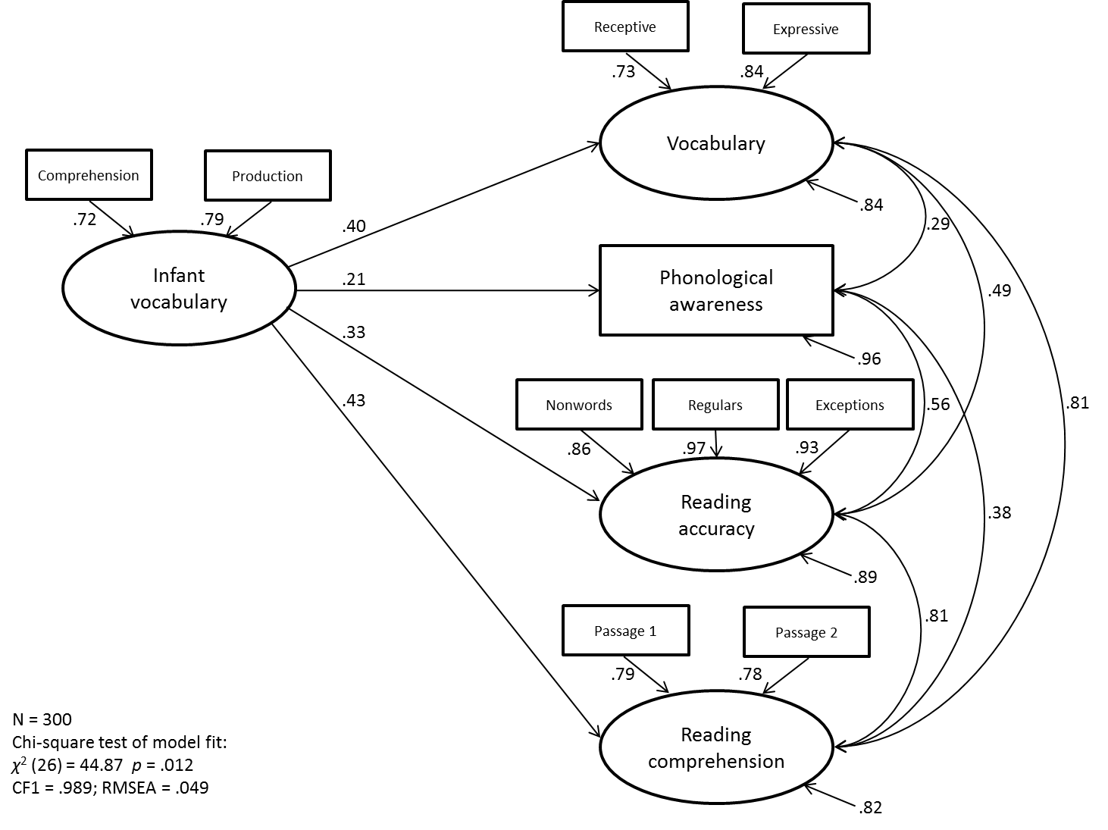

Figure 1: A structural equation model with infant vocabulary predicting school-age language and literacy outcomes

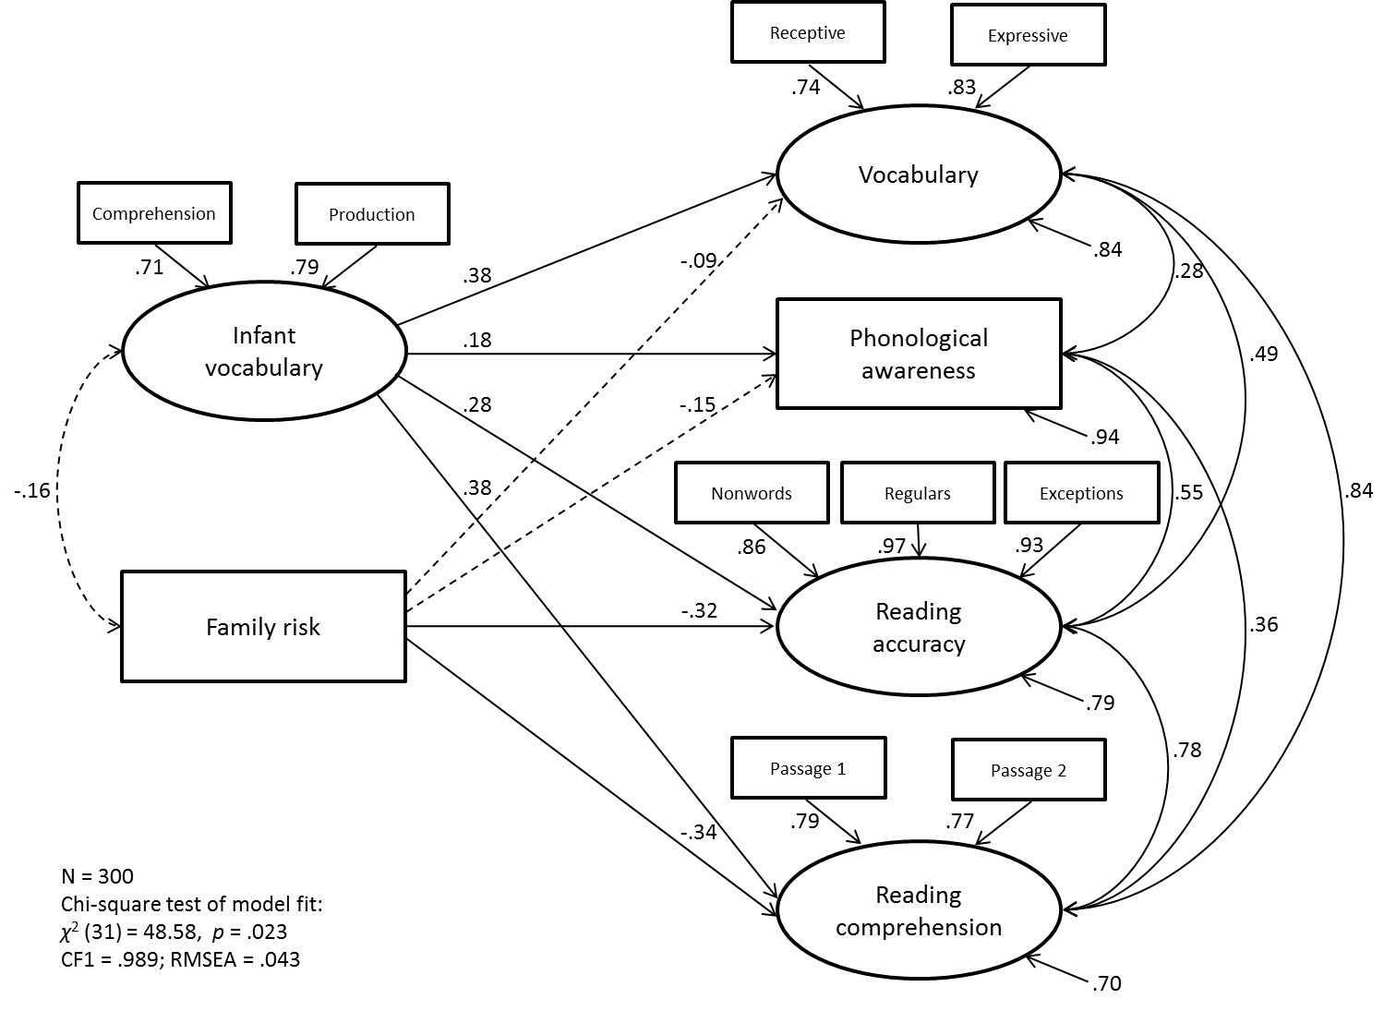

Figure 2: A structural equation model with infant vocabulary and family risk for reading/language difficulties predicting school-age language and literacy outcomes. Dashed lines represent non-significant paths.

Table 1: Average OCDI comprehension and production scores (max. 416) at t1 by age group
Age | N | OCDI Comprehension |  |  | OCDI Production
 |  | Mean (SD) | Range |  | Mean (SD) | Range
16 | 51 | 150.92 (73.87) | 3–319 |  | 31.47 (36.92) | 0–174
18 | 104 | 207.03 (90.19) | 4–409 |  | 59.19 (63.91) | 0–331
19 | 32 | 212.75 (74.26) | 84–359 |  | 55.53 (41.16) | 6–178
20 | 7 | 251.14 (75.84) | 192–414 |  | 113.14 (127.05) | 7–372
21 | 38 | 261.92 (85.49) | 85–412 |  | 128.61 (100.15) | 5–369
22 | 17 | 306.18 (80.27) | 124–397 |  | 191.71 (103.72) | 34–337
24 | 51 | 339.29 (57.25) | 172–416 |  | 220.98 (110.57) | 9–402
Total | 300 | 234.19 (99.85) | 3–416 |  | 99.15 (103.29) | 0–402

Table 2: Standardised scores on cognitive measures at t2
t2 measure | N | Mean (SD) | Range
Word reading accuracy¹ | 275 | 111.19 (14.99) | 71–131
Reading comprehension¹ | 225 | 114.91 (8.05) | 77–133
Receptive vocabulary¹ | 299 | 115.97 (12.12) | 80–146
Expressive vocabulary¹ | 300 | 112.00 (14.33) | 64–146
Nonverbal IQ² | 274 | 57.81 (10.22) | 22–80
¹Standard score, M=100, SD=15; ²T score, M=50, SD=10.

Some children participated in multiple research studies at the BabyLab in infancy, and for each study the OCDI was always administered.
Note that the phonological awareness variable was the only observed and not latent variable in the models; its consequent lower reliability as a measure may in part explain its lower associations with other variables.

