Being ‘near-Arctic’: a Critical Geopolitics of contemporary British policy towards the Far North

Duncan Michael Depledge

This thesis is submitted to Royal Holloway, University of London
for the degree of PhD
September, 2014

Declaration of Authorship

I ………………………………………………, hereby declare that this thesis and the work presented in it is entirely my own. Where I have consulted the work of others, this is always clearly stated.

Signed: ______________________

Date: ________________________

Abstract

The thesis offers a Critical Geopolitics of contemporary British policy towards the Arctic (c. 2007-2014). British interest in the Arctic has grown over the past decade in response to profound shifts in the very materiality of the Arctic region (conceived as an assemblage of sea-ice, other natural systems and various forms of human activity). This interest has been expressed through a variety of textual, affective and material interventions (together constituting a ‘discourse’) by British policymakers. However, the various agencies involved in producing these policy interventions are far more diffuse, drawing in an array of human and non-human actors, sites, practices and affects that variously facilitate, frustrate and interfere with policy outcomes. This, in turn, raises critical questions about who and/or what counts as ‘Britain’ in an Arctic context, and who and/or what actors and interests are being supported and resisted by these policy interventions. In response to these questions, the thesis makes three core claims: 1) that what has counted as British interest in the Arctic has changed considerably over the past four centuries, undermining the at times taken-for-granted claim that Britain is an ‘Arctic’ or ‘near-Arctic’ State; 2) that contemporary British policy toward the Arctic is actualised in diffuse ways as a consequence of the multiple sites, actors, practices and affects involved; and 3) that this multiplicity poses a policy problem which the British government’s ‘Arctic Policy Framework’ white paper has been designed to resolve. However, as the thesis concludes, far from resolving the contemporary controversies in British Arctic policy, the Arctic Policy Framework emerges as only providing a precarious settlement which continues to be interfered with by a range of human as well as non-human agents.

Contents

Abstract 3
Contents 4
List of Figures 7
List of Maps 8
List of Acronyms 9
Acknowledgements 12
1. Introduction 14
1.1 Introducing the thesis 14
1.2 Thesis structure 20
2. Contributing to a Critical Polar Geopolitics 24
2.1 Introduction 24
2.2 Arctic Geopolitics 27
2.2.1 The return of ‘Geopolitics’ 27
2.2.2 Locating an ‘Arctic Geopolitics’ 30
2.3 A Critical (Polar) Geopolitics 34
2.3.1 Polar Geography and the Arctic 34
2.3.2 A Critical Geopolitics of the Arctic 35
2.4 The State and State practices as ‘effects’ 38
2.5 Geopolitical assemblages 43
2.5.1 Assemblages and Geography 43
2.5.2 Assemblages of State power 47
2.5.3 Attending to non-humans 50
2.6 Chapter summary 51
3. Entangled in policymaking: ‘thinking with assemblages’ as a method of research 55
3.1 Introduction 55
3.2 Thinking with assemblage as a framework for method 60
3.3 Becoming an insider to British Arctic policymaking 64
3.3.1 Affecting government officials 66
3.3.2 Invitations 68
3.3.3 Citations 69
3.4 Delimiting a method assemblage: the thesis as ‘apparatus’ 71
3.5 Situating messy methods in Critical Geopolitics 75
3.6 Chapter summary 80
4. Producing proximity: Britain as the Arctic’s “nearest neighbour” 82
4.1 Introduction 82
4.2 The search for northern passages and resources in the Arctic regions (1500-1900) 85
4.3 Britain and the Arctic as continuous spaces (1900-1980) 94
4.3.1 Strategic proximity 95
4.3.2 Material proximity 100
4.4 Disrupting British-Arctic relations (1980-present) 103
4.5 Chapter summary 112
5. From London and Cambridge to Ny Ålesund and beyond: actualising British policy toward the Arctic (2007-2013) 115
5.1 Introduction 115
5.2 Assembling British Arctic policies 118
5.2.1 Ministry of Defence 119
5.2.2 British Arctic Science 136
5.2.3 Polar Regions Department 153
5.3 Chapter summary 168
6. A precarious settlement: the British Arctic policy ‘apparatus’ 171
6.1 Introduction 171
6.2 Assemblage/Apparatus 173
6.3 Assembling the British Arctic policy apparatus 175
6.4 Hierarchy, authority, intent 177
6.5 Interference 180
6.5.1 Other Government Actors 182
6.5.2 Parliament 183
6.5.3 Environmental non-governmental organisations (NGOs) 186
6.5.4 Arctic States 191
6.5.5 The Arctic 193
6.6 The Arctic Policy Framework: A precarious settlement? 194
6.6.1 Assembling the Arctic Policy Framework 195
6.6.2 Fortifying the apparatus 203
6.6.3 The precariousness of the Arctic Policy Framework 204
6.7 Chapter summary 211
7. Conclusions 213
8. Recommendations for the review of British Arctic policy 223
Bibliography 230
Appendix A: The UK’s engagement with the Arctic 255
Appendix B: List of Interviews 258
Appendix C: Events Attended 263

List of Figures

The first number corresponds with the Chapter in which the figure features (i.e. Fig. 3.1 is the first figure in Chapter 3).

Fig. 3.1. View over Iqaluit, the largest city in the Canadian Territory of Nunavut.

Fig. 3.2. Remains provide a material reminder of Britain’s historical presence in the Canadian North.

Fig. 3.3. The main building of the Royal United Services Institute in Whitehall, London.

Fig. 5.1. Photographs taken by the PHOT team on board HMS Illustrious during Exercise Cold Response 2012.
Fig. 5.2. Main building of the Ministry of Defence in London.

Fig. 5.3. Major EU Projects with British participation.

Fig. 5.4. The NERC Arctic research station in Ny Ålesund, Svalbard.

Fig. 5.5. RSS James Clark Ross docked in Ny Ålesund, Svalbard.

Fig. 5.6. Outside the Polar Regions Department in the Foreign and Commonwealth Office.

Fig. 6.1. Extract from the Environmental Audit Committee (HC 333, 2013, Q41- Q43).

Fig. 6.2. BP and Rosneft sign cooperation agreement in 2011.

Fig. 6.3. Greenpeace protesters unfurl a ‘Save the Arctic’ flag atop The Shard, in London.

Fig. 6.4. Examples of graphics used in the APF to show dynamism of the Arctic.

List of Maps

The first number corresponds with the Chapter in which the map features (i.e. Map. 2.1 is the first map in Chapter 2).

Map 2.1. ‘The Natural Seats of Power’.

Map 4.1. Mercator Hondius Map of the Arctic published in 1606.

Map 4.2. The sixteenth century search for ‘northern passages’.

Map 4.3. The nineteenth century search for the ‘Northwest Passage’.

Map 4.4. The hunt for resources from the sixteenth to the nineteenth century.

Map 4.5. Map of the North Pole published in the English Atlas.

Map 4.6. Map of the Northern Hemisphere by John Thomson.
Map 4.7. Map of the North Pole in 1920.

Map 4.8. The Greenland-Iceland-UK Gap.

Map 4.9. The ‘Northern Waters’.

Map 4.10. Britain and the Arctic imagined as a continuous strategic space.

Map 4.11. Britain and the Arctic imagined as sharing material features.

Map 4.12. The extent of the Arctic and sub-Arctic regions as defined by Armstrong et al. is indicated by the shaded area.

Map 4.13. The shaded areas represent the claims of the five Arctic Ocean littoral States - Canada (yellow), USA (teal), Russia (green), Denmark (red), and Norway (orange). The two unshaded areas towards the middle indicate the remaining area of the ‘global commons’.

Map 4.14. A composite map showing multiple ways of thinking British-Arctic relations since the sixteenth century indicating the different kinds of geographies they produced.

Map 5.1. The geographic spread of universities and National Research Centres implicated in British Arctic science by participation in NERC-funded projects during the International Polar Year 2007-8.

Map 5.2. The geographic spread of universities and National Research Centres implicated in British Arctic science by participation in NERC-funded Arctic Research Programme.

Map 6.1. The purple dotted line indicates the area Greenpeace is seeking to protect as a global sanctuary (Source: Greenpeace 2014).

List of Acronyms

ACCESS Arctic Climate Change, Economy and Society
ACIA Arctic Climate Impacts Assessment
AEPS Arctic Environmental Protection Strategy
ASFR Arctic Security Forces Roundtable
ANT Actor-Network Theory
APF Arctic Policy Framework
ARP Arctic Research Programme
BAS British Antarctic Survey
BIS Business, Innovation and Skills
DCDC Development, Concepts and Doctrine Centre
DECC Department of Energy and Climate Change
DEFRA Department for Environment, Food and Rural Affairs
DFID Department for International Development
DfT Department for Transport
EAC Environmental Audit Committee
EEZ Exclusive Economic Zone
ESED Environment, Science and Energy Department
ESRC Economic and Social Research Council
EXCR Exercise Cold Response
FCO Foreign & Commonwealth Office
FPA Foreign Policy Analysis
FST Foundation for Science and Technology
GBSC Global Biodiversity Sub-Committee
GST Global Strategic Trends Programme
IASC International Arctic Science Committee
IBRU International Boundaries Research Unit
ICE-ARC Ice, Climate, Economics – Arctic Research on Change
IGY International Geophysical Year
IISS International Institute for Strategic Studies
INTERACT International Network for Terrestrial Research and Monitoring in the Arctic
IOC International Oil Company
IPCC Intergovernmental Panel on Climate Change
IPO International Programme Office
IPY International Polar Year
IR International Relations
LSE London School of Economics and Political Science
MCA Maritime & Coastguard Agency
MOD Ministry of Defence
MOU Memorandum of Understanding
NARF National Arctic Research Forum
NERC Natural Environment Research Council
NGO Non-Governmental Organisation
NOC National Oceanography Centre
NRT Non-Representational Theory
NSIDC National Snow and Ice Data Center
POST Parliamentary Office of Science and Technology
PRD Polar Regions Department
PSC Polar Sciences Committee
PSWG Polar Science Working Group
RFTG Response Force Task Group
RGS Royal Geographical Society
RUSI Royal United Services Institute
SAMS Scottish Association for Marine Science
SAO Senior Arctic Official
SDSR Strategic Defence and Security Review
SGNWA Study Group on Northern Waters and the Arctic
SIOS Svalbard Integrated Observing System
SPRI Scott Polar Research Institute
STS Science and Technology Studies
TNC Transnational Company
UKTI UK Trade & Industry
USGS US Geological Survey
UNCLOS UN Convention on the Law of the Sea
UNFCCC UN Framework Convention on Climate Change

Acknowledgements

First and foremost I would like to acknowledge that the foundations for this project were provided by financial support I received through my ESRC CASE studentship, which included a substantial contribution from the Royal United Services Institute (RUSI) in London. For this, I am especially grateful to Professor Michael Clarke, the Director-General of RUSI, for putting his confidence in the project, together with the ESRC and the Department of Geography at Royal Holloway.
The support of two further individuals was crucial to the realisation of this project. The first was my supervisor, Klaus Dodds, who ever since our first chance meeting provided me with expert advice, encouragement and friendship for which I will always be grateful. The second was Tobias Feakin who, as Director of National Security and Resilience during our shared time at RUSI, was unrelenting in his support for this project. I also thank Alasdair Pinkerton who served admirably as a ‘second supervisor’, especially when it came to bringing the thesis to conclusion.
I could not have undertaken my fieldwork without the willingness of my interviewees to find time to speak with me, often on multiple occasions. Although many of them, by necessity, remain anonymous in this thesis, I gratefully acknowledge their involvement. Elana Wilson Rowe, Paal Hilde, Kristine Offerdal and Lionel Camus welcomed me warmly during the time I spent in Norway and I am appreciative to them and their colleagues for hosting me. The UK Ministry of Defence also deserves a special mention for allowing me to participate in the 2012 iteration of Exercise Cold Response as an observer on board HMS Illustrious, an experience I hope I never forget.
It would be remiss of me not to mention the support I have also received from other colleagues and friends. I thank Peder Roberts, Corine Wood-Donnelly, Drew Foxall and Matt Benwell for their collaboration and supportive conversations at various points during this project. A special note of thanks must also go to Jenny Kynaston, in the Department of Geography, at Royal Holloway for helping me to produce a series of maps that feature in this thesis.
My final note of thanks goes to my wife Alice, my parents, my brother and his partner, who with their love and patience have done more than anyone to help me to keep everything in perspective during the ups and downs of this project. They will inevitably do the same when I embark on the next one.

1. Introduction

1.1 Introducing the thesis
For centuries, British scholars have explored, studied, speculated, and written about the Arctic. The breadth of literature that already exists on historical encounters between Britain and the Arctic is considerable, encompassing a range of scholarly interests from studies of explorers, scientists and writers (including their voyages, their discoveries, and their literature), to the strategic battles fought by Britain in the Arctic during the two world wars and the Cold War (see, for example, Spufford 1996; David 2000; Potter 2007; Woodman, 2007; Hill 2008). In contrast, only a few scholars have broached the question of whether the Arctic continues to matter to Britain in the early 21st Century (Archer 2011a; 2011b; Depledge 2013a; 2013b; 2013c; Depledge and Dodds 2011; 2012; 2014; Dodds and Powell 2013a; Rogers 2012).
Among more recent studies (at least since the end of the Cold War), some of the most considered accounts of British-Arctic relations have tended to focus on how the Arctic has been ‘encountered’ and ‘consumed’ imaginatively by the broader British population. This includes, for example, lectures at the Royal Geographical Society (RGS) in London where, since the mid-nineteenth century, explorers have recounted their Arctic adventures; newspapers which provided, at times, feverish coverage of the voyages of Sir John Franklin and others; literary works including Mary Shelley’s Frankenstein (first published in 1818) and Charlotte Brönte’s Jane Eyre (first published in 1847); and other forms of public spectacle exhibiting life in the Arctic, such as the ‘Arctic diorama’ which was displayed in Vauxhall in London in 1848 (Spufford 1996; David 2000; Potter 2007; Hill 2008).
These more imaginative engagements with the Arctic as a ‘white horizon’ or ‘last great wilderness’ have perhaps obscured the importance of taking seriously the ways in which the changing materiality of the Arctic in the early twenty-first century also matter to Britain for a range of commercial, scientific, environmental and strategic reasons. This is despite the fact that since at least 2007, British government and research council papers have included a series of statements about the contemporary importance of the Arctic to the United Kingdom. For example:
“The UK, as a nation and as a member of the European Union, has pressing concerns in the Arctic” (NERC 2007a, p. 2).

“The speed of climate change in the Arctic and the associated impacts and opportunities mean that ‘business as usual’ with respect to the way the UK interacts with the region (both politically and commercially), is unlikely to be a sustainable or viable approach” (GBSC 2008, p. 2).

“Today, as the Arctic’s closest neighbour, the UK continues to engage actively in and with the Arctic in a multitude of different ways” (FCO 2011).

“The inextricable links between the Arctic and global processes means that non-Arctic States such as the UK have legitimate interests and roles to play in finding solutions to many of the most pressing issues facing the Arctic” (HMG 2013, p. 7).

“Horizon scanning has identified the Arctic region is critical to the UK’s national interests” (HMG 2014, p. 25).

Even at the height of Cold War tensions in the late 1970s and 1980s, when parts of the Arctic loomed large in the strategic maps of British policy practitioners, scholarly interventions from British political scientists and political geographers were rare. Notable exceptions could be found only in the work of a handful of British scholars including Terence Armstrong, Geoffrey Till, Clive Archer and David Scrivener (Armstrong et al. 1978; Archer and Scrivener 1982; 1986; Till 1988). These scholars all contributed to studies of the so-called ‘Northern Waters’ and the ‘Northern Flank’ (Archer and Scrivener 1986; Till 1988).
The broader lack of apparent interest from political scientists and political geographers in the Arctic stood in stark contrast to natural scientists. From centres such as the Scott Polar Research Institute (SPRI) in Cambridge, natural scientists have for decades played a significant role in alerting the British government to the increasing dynamism of the Arctic as a natural system (or systems), as well as the implications of this dynamism for British interests. It is an imbalance which is likely explained by the fact that the British natural/environmental scientific community has for a long time been more active in the Arctic than the political science community. Political scientists/geographers, in contrast, have tended to regard the Arctic as a politically and socially barren ‘frozen wasteland’, rather than a ‘lived in’ or ‘lively’ space (Dodds and Powell 2013b).
Over the past decade, reports concerning diminishing summertime sea-ice, the potential for new maritime routes to Asia, developments in extractive technologies, demand for resources and a succession of unexpectedly cold winters in Northern Europe attributed to changes in the geophysical make-up of the Arctic, has stimulated renewed interest from political scientists/geographers in finding ways to make sense of the potential implications of Arctic change for Britain. This is evidenced by recent publications in the journals of major London-based think-tanks working on foreign and defence policy (Blunden 2009; 2012; Murgatroyd 2009; Depledge and Dodds 2011; 2012; 2014; Rogers 2012; Depledge 2013a); the ESRC-funded seminar series Polar Geopolitics: Knowledges, Resources and Legal Regimes (2010-2011) led by the geographers Richard Powell and Klaus Dodds (see also Powell and Dodds 2014); the conference organised by the Department of Politics and International Studies at the University of Hull on ‘The Future of the High North and Challenges for Maritime Governance’ in September 2012; the privately organised Poles Apart conference at the Royal United Services Institute in October 2013; and the workshop on ‘International Law, State Sovereignty and the Ice-Land-Water Interface’ organised by Durham University’s International Boundaries Research Unit (IBRU) in June 2014.
At the same time, non-State actors, including British-based International Oil Companies (IOCs), environmental non-governmental organisations (NGOs) and firms providing financial services from the City of London, have also become increasingly vocal about their interests in the Arctic. Many of these stakeholders participated in a meeting chaired by the Foreign and Commonwealth Office (FCO) in Oban, Scotland in 2008, the report from which concluded that the British government needed “to facilitate greater [non-government] stakeholder participation in decision making” on Arctic policy (GBSC 2008, p. 6). Since then, the global insurance market Lloyds of London has published a significant study of the financial opportunities and risks emerging in the Arctic titled ‘Arctic Opening: Opportunity and Risk in the High North’ (Lloyd’s 2012). The professional services firm Ernst & Young has similarly published a study of opportunities in the oil and gas sector (Ernst & Young 2013). Meanwhile, the business law firm DWF has worked closely with the government body UK Trade and Industry (UKTI) to run two seminars on ‘Mining in the High North: Sustainable Opportunities for UK Businesses’ (London, 18 March 2014) and ‘The Arctic Challenge: Opportunities for UK Industry and Research’ (Liverpool, 10 June 2014). In July 2014, the inaugural meeting of Arctic Hub: London offered a further indication of growing commercial interest in the Arctic. Elsewhere, Greenpeace has made headlines for its ‘Save the Arctic’ campaign (which included a dramatic stunt in July 2013 that saw six activists climb London’s tallest building, popularly known as The Shard) and a WWF-led consortium of environmental groups has published a set of ‘principles’ that the consortium argues should shape British Arctic policy (WWF 2012). In August 2014, well-known British actress Emma Thompson visited the Arctic and contributed further to a ‘celebrity’ polar geopolitics (Benwell et al. 2012). Parliamentary interest in the Arctic has also grown, as reflected by the questions posed to ministers since 2007, debates in the House of Lords (in 2007 and 2010) and the Environmental Audit Committee inquiry ‘Protecting the Arctic’ (2012-13). Most recently, in July 2014, the House of Lords established a new ad-hoc Select Committee on the Arctic to further explore Britain’s evolving relationship with the region (with a report expected in March 2015).
It is towards these (re)emerging Arctic-related policy debates involving political geographers (as well as other political scientists), British government actors and other stakeholders that this thesis is directed, focussed as it is on the development of contemporary British Arctic policy. In approaching these debates, the thesis has been guided by two principal objectives. The first has been to produce an account of contemporary British interest(s) in the Arctic, primarily as it relates to a ‘formal’ and ‘practical’ geopolitics of government actors and other ‘elite’ stakeholders which are actively assembling British government policies and interests in the Arctic (Ó Tuathail 1996). While it may have been fruitful to explore a ‘popular’ geopolitics involving both media coverage and broader public interest in the Arctic, doing so would not have fit with the immediate interests of the Economic and Social Research Council (ESRC) CASE partnership with the Royal United Services Institute (RUSI) which underpins this thesis (see Chapter 3). Moreover, too broad a focus would likely have diminished the depth of this particular study. In part, this is because the second objective pursued in this thesis was to better understand the theoretical contribution that ‘thinking with assemblages’ (as defined by McFarlane and Anderson 2011) and ‘apparatuses’ (see Legg 2011) could make to the study of geopolitics and foreign policy, using British government policy toward the Arctic as a case study. This second objective links the thesis to a broader conversation currently taking place in Geography, and the political and social sciences more widely, about the value of an emerging ‘Critical Geopolitics of the Polar Regions’ (see Dodds and Powell 2013b; Powell and Dodds 2014), and a renewed interest in what might best be termed ‘geopolitical materialism’.,
It is important to recognise that the development of a ‘Critical Polar Geopolitics’ is not about generating more comparative studies of the geopolitics of the Arctic and Antarctica in the vein of past political geographers such as Sanjay Chaturvedi (1996). Chaturvedi’s approach, developed at SPRI, was part of a broader British tradition to think of the Arctic and the Antarctica together on account of their geophysical semblances – literally as ‘cold places’. However, as Powell and Dodds (2014) note, there is still a tendency, in some quarters, for Britain’s interest in the Arctic to be interpreted as a natural and logical extension of its historical presence in Antarctica. Such an approach is rightly rejected by Dodds and Powell who argue that what should unite interest in the Arctic and Antarctica is the fact that these spaces have tended to attract narratives of exceptionalism in which they are “represented as passive spaces, simply awaiting ever-greater human impact and intervention” (Dodds and Powell 2013b, p. 4). A more Critical Polar Geopolitics is, in contrast, concerned with the ways in which the Arctic and Antarctica are “fundamentally lively and lived in spaces” (Dodds and Powell 2013b, p. 4).
It is within this emerging field of interest in a Critical Polar Geopolitics that my thesis is situated. Such an approach encourages us to consider the Arctic as an unsettled space where actors from both within and beyond the region (State and non-State, human and non-human) are attempting to redefine the future of the Arctic in different ways including: as an extension of the national territories of the ‘Arctic’ States; as a homeland for indigenous peoples; as a scientific frontier; as a global resource province; as an environmental sanctuary; and as a passageway between East and West. Timo Koivurova’s (2010) idea of the Arctic as a ‘region-in-change’ is particularly powerful because it raises the prospect that ‘traditional’ Arctic actors such as Britain need to remain invested in the processes that are redefining the Arctic or else their own status as ‘Arctic’ or ‘near-Arctic’ actors may be unsettled. How this investment is being retained and reinforced – at times in opportunistic and creative ways – is one of the main issues addressed by this thesis.
Thinking with assemblages is shown to be useful in this regard precisely because it helps us to make sense of how actors (State and non-State, human and non-human), sites and practices come together (or are brought together) in assemblages to produce, support, resist and interfere with narratives concerning Britain’s Arctic ‘actorness’. The extent of these effects emerges as a consequence of interventions by British-based actors in the real world: including the production of texts (such as the 2013 Arctic Policy Framework white paper) and emotional affects (including, for example, attempts to reassure allies such as Norway that Britain will support them in a crisis akin to the Russian annexation of Crimea in 2014), as well as the physical movement of bodies, finance, equipment and infrastructure into and out of the Arctic (for scientific, military and commercial purposes). Once deployed, these textual, affective and material elements produce different assemblages of British-Arctic relations. In ‘thinking with assemblages’ such interventions are understood to be performed by a multiplicity of actors, State and non-State, human as well non-human, which facilitate, frustrate, resist and interfere with one another’s interests. Where ‘thinking with assemblages’ is found wanting in this thesis is that it fails to explain how certain actors (in this case the British government) may attempt to order emerging assemblages through the construction of apparatuses that seek to assert a dominant assemblage of British-Arctic relations (stabilised by on-going textual, affective and physical labour).
These theoretical concerns have generally been ignored by scholars of International Relations (IR), including those in the more process-oriented sub-field of Foreign Policy Analysis (where the tendency is still to focus exclusively on human actors as opposed to non-human actors), and have only recently started to be foregrounded in critical geopolitical analysis (Müller 2008; 2013; McFarlane and Anderson 2011; Dittmer et al. 2011). Here, thinking with assemblages and apparatuses is used as a productive mechanism for thinking about British Arctic policy; specifically that British Arctic policy is a precarious apparatus aimed at managing continually evolving assemblages of sites, actors (human and non-human), practices and affects. This stands in contrast to those who would posit the development of British Arctic policy as a self-evident and inevitable response to Arctic change. Such inevitability is all too commonly claimed in the broader rush to prophesy about the future of the Arctic; an approach that tends to naturalise sites, actors, acts and interests which might be otherwise contested (see, for example, Emmerson 2013). This, in turn, underplays the possibility that even within Britain, multiple futures for the Arctic are being worked towards by different actors.

1.2 Thesis structure
The thesis is structured as follows. In Chapter 2 I bring together various strands of inquiry from different bodies of literature primarily produced by geographers and IR scholars to investigate the possibility of expanding critical geopolitical inquiry in ways that take ‘thinking with assemblages’ seriously as an analytical tool. This agenda, which I situate within an emerging Critical Polar Geopolitics, aims to draw attention to the way in which both Arctic actors, and the Arctic itself, are constituted as geopolitical effects of various textual (including the visual), practical and affective performances which make material interventions in the world. The chapter concludes by considering how control of these constitutive processes is sought through the construction of apparatuses that attempt to arrest and order geopolitical relations (specifically in this case, between Britain and the Arctic).
In Chapter 3 I turn to account for the way in which ‘thinking with assemblages’ helped me to make sense of what I encountered over the course of my research into British Arctic policymaking. I also emphasise the ‘messiness’ of my own experience of investigating emerging British Arctic policy assemblages, an approach which was often more reliant on opportunity, contingency and positionality – all of which had to be cultivated – rather than on a rigorous investigative structure. In so doing, it became obvious that I was not simply investigating assemblages/apparatuses of British-Arctic relations, but also actively co-constituting them. This discussion is then set within recent debates about methods in contemporary Critical Geopolitics, particularly as they relate to more ethnographic approaches.
Chapter 4 is the first of three chapters based on empirical research. Specifically, it explores how Britain has come to be thought of as an ‘Arctic’, or more precisely, a ‘near-Arctic’ State. This is a claim which has been made repeatedly in contemporary British policy statements about the Arctic, and is closely associated with geographical determinism (Britain is naturally ‘proximate’ to the Arctic) and a broadly ahistorical understanding of international relations (Britain has long been and continues to be ‘Arctic’/‘near-Arctic’). Instead, I argue that Britain has no a priori identity as an ‘Arctic’ or ‘near-Arctic’ State. In providing an overview of the past four hundred years of relations between Britain and the Arctic (a history that predates ‘Britain’ as it exists today), I contend that that far from having a long-established and consistent relationship with the Arctic, the geopolitical imperative to produce Britain as an ‘Arctic’ or ‘near-Arctic’ State is a relatively modern phenomenon driven by the contemporary geopolitics of the Arctic.
Chapter 5 shifts the analytical focus to contemporary British policy toward the Arctic (2007-2013). Having looked at where the idea of the UK as a ‘near-Arctic’ State comes from in the previous chapter, this chapter is concerned with the question: ‘how is contemporary UK policy towards the Arctic actualised?’ The chapter considers a range of social-material-affective practices occurring in various sites involving different combinations of State and non-State actors (including non-humans). In so doing, I aim to show that the State is far more entangled with non-State – and indeed non-human – actors in the production of its Arctic policies and interests than is usually acknowledged, something which, in turn, impacts the possibility of actualising policy in socio-material-affective terms.
In Chapter 6, the last of the three empirical chapters, I investigate a specific attempt made by the British government to control how British policy toward the Arctic is actualised through the production of a policy apparatus to contain the multiplicity of sites, actors, practices and affects encountered in the two previous chapters. This apparatus reflects a specific way of ‘framing’ – or ‘freezing’ – the Arctic as a specific kind of assemblage; of ‘being’ Arctic (or at least near-Arctic); and of ‘practicing’ Arctic policy across government and its non-State allies. In the end, however, I show that this apparatus can only be considered a precarious settlement since it continues to be contested and interfered with by other actors (including non-humans).
The conclusions of this thesis are presented in Chapter 7. A set of policy recommendations to the British government are laid out in Chapter 8 to reflect a commitment underscored by the CASE studentship to engage stakeholders from beyond academia with the findings of the thesis. Specifically, these policy recommendations are directed at the House of Lords Committee on the Arctic which at the time of writing has issued a call for written evidence to support their inquiry into British Arctic policy. A striking feature of this thesis is that I have enjoyed near-constant conversations and meetings with those responsible for constructing, promoting and implementing British policy towards the Arctic. The policy recommendations therefore represent a culmination of ideas and suggestions that have enjoyed some prior exposure. Another striking feature is the timeliness of this intervention, as at the time of writing, contemporary British Arctic policy continues to be contested by a variety of different actors including parliamentarians, environmental NGOs, businesses and the Arctic itself.
***
Lastly, I want to make it clear to the reader that this thesis is part of a broader portfolio of published work that I have authored and co-authored (Depledge 2013a; 2013b; 2013c; Depledge and Dodds 2011; 2012; 2014). These other papers are written in a predominantly policy-focussed style. In contrast, this thesis is more theoretically-focussed, essentially providing an exposition of the theoretical underpinnings of my engagement with British Arctic policymaking between 2010 and 2014. The need for such a division of labour was re-emphasised to me in July 2014 at the British Academy workshop on ‘21st Century Diplomacy: Bridging the academic-foreign policy divide’ at Cumberland Lodge. The workshop proved revealing of the extent to which academics still have to engage with fellow academics and policy practitioners in substantially different ways, often requiring the use of different languages and registers.

2. Contributing to a Critical Polar Geopolitics

2.1 Introduction
In 2009, Oran Young, an eminent professor of International Relations (IR), asked:
“Are we now witnessing another shift in Arctic politics, such that we will look back on the 1990s and the first years of this century as a cooperative moment separating two periods of geopolitical tension in the Arctic?” (Young 2009, p. 74).

To answer ‘yes’ would imply that there had been a resurgence of the kinds of State behaviour predicted by ‘(neo) realist’ IR theory which stipulates that international politics is essentially driven by a universal problem of zero-sum competition between States. However, Young did not think the answer would be ‘yes’ because the development of complex institutional and cooperative frameworks in the Arctic in the 1990s would prevent a return to zero-sum competition. For Young, cooperation was still more likely than conflict, even with the emergence of new national interests relating to the Arctic’s increasingly accessible resources and shipping lanes (Young 2009).
The timing of Young’s intervention reflected a broader resurgence of interest among academics, think-tank analysts and policy practitioners in applying traditional IR theory in their analyses of Arctic geopolitics in the early 21st Century. In particular, (neo) Realist IR scholars have argued that we are witnessing the emergence of a new ‘great game’ in international politics as both Arctic and non-Arctic States compete to secure their Arctic interests. (Neo) Liberal institutionalists, while accepting this basic premise, are more optimistic about the potential to strengthen and expand the process of building cooperative frameworks and institutions that was started in the 1990s. Debates now abound about the relative potential for cooperation and conflict in the Arctic, particularly as its material resources (minerals, fisheries, continental shelves, waters) become more attractive to various State, commercial, environmentalist and indigenous actors (Blunden 2009; Holtsmark and Smith-Windsor 2009; Young 2009; Wegge 2011; Murray 2012; Berkman and Vylegzhanin 2013).
What is inferred in this emerging body of literature rooted in IR theory and Classical Geopolitics is that peace (between States) in the Arctic has only lasted because the region has been so peripheral to global affairs in the post-Cold War period. At the same time, ‘positivist’ IR claims about the ‘reality’ of the international system have been buttressed by a resurgence of interest among a number of scholars and practitioners in rooting their analyses in the supposedly ‘fixed’ geographical dimensions of State power expressed in terms of ‘calculable’ territory, population and material resources (Hannah 2009); an approach we might more typically associate with that of ‘classical’ geopoliticians such as Halford Mackinder, Alfred Mahan and Nicholas Spykman (see, for example, Antrim 2010; Rogers 2012; Kaplan 2012). Girding claims and counter-claims in these debates is the basic assumption that a seasonally ice-free Arctic (something never seen before in human history) is no longer easily dismissed to the periphery of global affairs and carries with it a very real risk of inter-State conflict over resources, maritime access and sovereign rights (Berkman and Young 2009; Ebinger and Zambetakis 2009).
The relative simplicity of the conflict-cooperation dualism regularly deployed by IR scholars in their analyses of Arctic may seem appealing to policymakers. Such an approach lends itself to rapid assessments: either the Arctic is in a state of conflict to which policymakers must urgently respond (with diplomacy and potentially military force), or it is in a state of cooperation, allowing policymakers to relax and focus their attention elsewhere. In practice, however, the Arctic is rarely in a state of either pure conflict or cooperation. Conflict and cooperation may persist at different levels reflecting the interests and stakeholders involved. For example, Britain, Norway and Russia may be in conflict over the legal status of the Svalbard archipelago under the terms of the treaty on Spitsbergen (1925), while at the same time cooperating over oil and gas development in the Barents Sea. Moreover, the emphasis on ‘fixed’ geographical features (and the associated empowerment of traditional geographical analysis) that underlies much of IR theory (including the conflict-cooperation dualism) does little to explain how the geopolitics of the Arctic might change over time in relation to the dynamic material realities of both the Arctic environment and human activity in the region. This, in turn, hinders the possibility of mid- to long-term policy planning for the Arctic.
This chapter, then, is primarily focussed on drawing attention to the prospect of a novel theoretical agenda, rooted in political geography rather than IR, through which to inform Arctic policymaking in Britain (one which is also more widely applicable to other State and non-State actors). I bring together a number of strands of inquiry from different bodies of literature in order to show how the contemporary geopolitics of the Arctic can be investigated through – and help to construct – an alternative analytical lens. Rather than argue that there is anything inevitable about what is happening in the Arctic, this alternative lens draws attention to the way in which both the Arctic (as a region), and Arctic actors, are constituted as geopolitical objects as an effect of various textual (including the visual), practical and affective performances which make material interventions in the world. I see this theoretical agenda as part of both the Critical Polar Geopolitics set out by Richard Powell and Klaus Dodds, as well as Critical Geopolitics (a sub-field of political geography) more broadly. With regard to the latter, my approach is intended specifically as a response to recent calls for Critical Geopolitics to engage more seriously with the constitutive effects of geopolitical praxis (Dittmer et al 2011; Müller 2008; 2013), while trying to remaining attentive to the concerns of policymakers (MacDonald in Jones and Sage 2010).
Structurally, this chapter consists of four parts. The first engages with historical and contemporary accounts of ‘Arctic Geopolitics’ with a particular focus on the enduring influence of IR scholars. Although human and physical geographers have been studying the Arctic for more than a century, the Arctic has only recently attracted interest from political geographers. Notable exceptions include Armstrong et al. (1978) and Chaturvedi (1996). The reasons for this renewed interest are explored further in the second part of the chapter which attends to the foundations that Critical Geopolitics – and more specifically an emerging Critical Polar Geopolitics – provides for my own theoretical agenda. The third part of the chapter shifts the focus to the broader work of political geographers attending to the nature of the ‘State’ and ‘State practices’. Thinking of the State and its practices as ‘effects’ rather than fully-formed objects opens the door to questioning how the State (and indeed other ‘taken-for-granted’ objects including the ‘Arctic’ itself) and its effects are constituted from heterogeneous elements (including non-human elements) which produce their own forms of agency. The fourth part of the chapter attends to recent work by social and cultural geographers to explain these constitutive processes as assemblages and apparatuses that seek to arrest and order geopolitical relations (specifically, in the case of this thesis, between Britain and the Arctic). The theoretical agenda I describe across these four sections is summarised in the conclusion at the end of the chapter.

2.2 Arctic Geopolitics

2.2.1 The return of ‘Geopolitics’
The term ‘Geopolitics’ was coined by the Swedish political scientist Rudolf Kjellen in the late 1890s to account for the largely ‘fixed’ geographical bestowments of the State (its resources and its natural endowments). The capitalised ‘G’ is significant for it denotes a geopolitical tradition that largely emerged in Europe and North America during the late nineteenth and early twentieth centuries., However, by the end of the Second World War, the term had largely fallen out of favour with this group of scholars. This was principally because of the association of Geopolitik with expansionist Nazi foreign policy before and during the Second World War. From the post-war 1940s to the 1960s the study of statecraft and foreign policy in the West moved under the purview of the newly emerging disciplines of IR and Strategic Studies (Hepple 1986; Ó Tuathail and Dalby 1998).
Western interest in ‘Geopolitics’ was, however, revived again in the 1970s when Henry Kissinger, a US National Security Adviser and later Secretary of State, used it as a synonym for ‘balance-of-power’ theory (Hepple 1986). The ‘balance-of-power’ trope was increasingly used by IR scholars to explain the changing international political economic and environment during the 1960s and 1970s (Hepple 1986). The entanglement of the term with its usage in IR theory was evident as revived accounts of Geopolitics shared much of the same conceptual language as (neo)Realist and (neo)Liberal institutionalist theory, with due emphasis on modern nation-States as the central actors in an inherently anarchic international system; where levels of conflict and cooperation are largely determined by balance-of-power politics, the strength of international institutions, and/or State preferences over the use of ‘hard’ and ‘soft’ power (Waltz 1979; Keohane and Nye 1989; Nye 2004).
By the end of the Cold War, some scholars had started to argue that advanced capitalist societies were breaking out of the space-time constraints implied by historical and geographical differences, and that globalisation would spread universal values (democracy, human rights and the free market) to all corners of the world (see, for example, O’Brien 1992; Fukuyama 1992). However, Al Qaeda’s attack on the World Trade Centre in New York in 2001 checked such optimism, especially in the US. Two years later, Thomas P. M. Barnett, an adviser to the US Office of the Secretary of Defence, published an online essay titled ‘The Pentagon’s New Map’. Geography clearly still mattered to Barnett, as he described a fault line between the “Functioning Core” of modernity where “globalization is thick” and the “Non-Integrating Gap” where modernity is rejected and the next generation of global terrorists is incubating (Barnett 2003). In 2012, another adviser to the US Department of Defense, Robert D. Kaplan, published The Revenge of Geography in which he claimed to invoke ‘Classical’ geopolitical theory to understand the geographical pivots of history and the evolving global scene (Kaplan 2012).
Despite criticism from a number of political geographers (see, for example, Fall 2012; Dittmer 2013a), the work of Kaplan, Barnett and others has nevertheless marked a broader resurgence of interest from practitioners and professionals of statecraft in theories of geographical/geopolitical determinism in the early 21st century. A recent paper published in the journal Geopolitics by scholars from the United States Air Force Academy has even made the case for a ‘Neo-Classical Geopolitics’ in which geography and the environment are revived as causal factors (albeit under the guise of probabilism) in global politics (Haverluk et al. 2014). For practitioners and professionals of statecraft, geography, then, classical geopolitical ideas about the power of ‘fixed’ geographical features have been resurgent among those seeking a more secure basis (literally solid ground) from which to confront the complexity and dynamism that increasingly characterises global politics.
In Britain, although there has perhaps been more circumspection about returning to the language of geopolitical determinism, this kind of (neo)Realist thinking continues to inform statecraft. In 2010, the IDEAS Centre (part of the London School of Economics and Political Science) published a pamphlet comprised of short essays written by some of the leading thinkers in the British foreign policy community (Kitchen 2010). These ‘wise’ elder statesmen (and they were indeed all male contributors) – comprised of former senior civil servants, ambassadors and Secretaries of State – were invited to speculate on ‘The Future of UK Foreign Policy’ in terms of the UK’s core interests, and the capacities and resources available to pursue them. Uniting the six essays included in the pamphlet were the authors’ shared assumptions about the essence of world politics including: the primacy of the State as a unitary, container-like actor; the possibility (and indeed the necessity) of deploying cold, hard, rational thinking towards foreign policy (as opposed to emotional, impassioned, irrational thinking); and the relative stability of State foreign policy processes and interests. This was despite their recognition that since the end of the Cold War, the external international system has supposedly become more complex as a consequence of greater interdependence between States (i.e. globalisation) and rival non-State actors including transnational corporations (TNCs), transnational diasporas, non-governmental organisations (NGOs) and terrorist networks. Belief in the idea of an international system comprised of rival unitary, container-like, actors with definable interests has proven remarkably persistent – to the point of banality – especially among policymakers and statesmen (Taylor 1994; Agnew 1994). While the term ‘Geopolitics’ may not have been used explicitly by these statesmen, its basic spatial logic (in particular its emphasis on fixed rather than fluid geographical features) continues to be entwined with their thinking about the contemporary demands of foreign policy and global politics.

2.2.2 Locating an ‘Arctic Geopolitics’
When Mackinder published his seminal paper on ‘The Geographical Pivot of History’ in the Geographical Journal in 1904, the Arctic was largely on the periphery of the European and North American geopolitical imagination – Mackinder’s map labelled the Arctic simply as an ‘Icy Sea’ to Russia’s north (see Map 2.1). Ambitious attempts to negotiate more direct trade routes between Europe
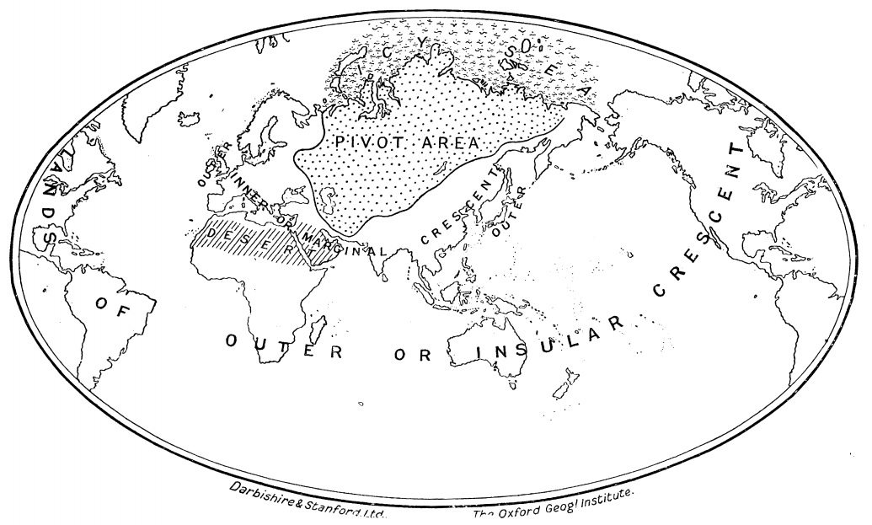
Map 2.1. ‘The Natural Seats of Power’ (Source: Mackinder 1904).

and Asia through the Northwest Passage had failed and the ‘heroic age of polar exploration’ was largely coming to an end (Maxtone-Graham 2000). For Mackinder himself, the Arctic featured simply as an impenetrable barrier to Russia’s northern perimeter and counted little to the geopolitical machinations of the imperial powers of Europe: “She [Russia] can strike on all sides and be struck from all sides, save the north” (Mackinder 2006, p. 37). Although advocates of development in the North American Arctic (most notably Vilhjálmur Stefánnson) portrayed a ‘friendly’ Arctic, they ultimately failed to persuade governments in Washington, Ottawa and even London, that the Arctic had more economic and geopolitical value than Mackinder and others had allowed (Stefánnson 1921; Emmerson 2010; Stuhl 2013).
It was not until the outbreak of the First World War in 1914 that the Arctic started to assume greater geopolitical significance in Western capitals, primarily as a consequence of the need for Britain to use maritime routes through the Arctic to provide support to its allies in Russia (in Murmansk and Arkhangelsk) and protect its coal-mining interests on Svalbard (which also potentially offered a strategic position from which Germany could strike at the British Isles). When the Second World War broke out in 1939, convoys of Allied ships once again navigated Arctic sea routes to resupply what was now the Soviet Union, while a battle ensued between Allied and Axis forces in Northern Norway to disrupt the operations of weather stations, which provided valuable data to the war efforts of both sides further south in Europe (Liversidge 1960; Woodman 2007). By the time the Second World War had turned into the Cold War, Arctic resources – “land, air, waters, ocean basin, the continental margin, bays, inlets, rivers, peninsulas, mountains, etc.” – were thought to have become “a military liability” for Western defence planners (Chaturvedi 1996, p. 83). The Arctic was increasingly seen by these planners as a frontier primarily for military-led (through patronage of the earth sciences and setting of research priorities) efforts to locate the Arctic in mental maps of the Cold War. Moreover, there was also an imperative to find ways – through the testing of bodies and equipment – of overcoming the physicality of Arctic spaces (on land, sea and ice) in preparation for potential Third World War operations (Doel 2003; Farish 2006).
By the 1980s, more determined efforts were being made in IR and Strategic Studies (in academic centres across Europe and North America) to account for the strategic importance of the Arctic. This was linked to the resurgence of tensions during the 1970s and 1980s between the US and the Soviet Union (the so-called second Cold War) and the increase in armaments/assets being sent to the Arctic. According to Clive Archer, the Arctic had become “much more a nest of military activity than ever before” (Archer 1988a, p. 138). From the late 1970s and through the 1980s, publications on the military-strategic situation in the Arctic proliferated (Roucek 1983; Archer and Scrivener 1986; Critchley 1987; Haydon 1988; Till 1988), as did proposals for arms control (Purver 1984; 1988), de-nuclearisation (Grimsson 1985) and international regimes (Skagestad 1975) in the Arctic. However, with the exception of Roucek (1983) – and despite the resurgence of interest in the term ‘Geopolitics’ under Kissinger – very little was being written about the ‘Geopolitics’ of the Arctic. The language of geographical determinism did not seem to appeal to mainstream IR scholars who, in the 1970s and 1980s, were becoming increasingly attentive to theories of Liberal institutionalism and international cooperation.
In the latter years of the Cold War and the early post-Cold War period the attention of mainstream IR remained focussed on resolving inter-State differences through the pursuit of stronger international regimes (Young 1985; Young and Chekasov 1992). Although differences remained within different schools of IR, in broad terms, the immediate post-Cold War period was characterised by optimism that States were more likely to engage in positive-sum, cooperative international regimes, than return to zero-sum competition that characterised classical IR theory and Geopolitics (Østreng 1999).
Such assumptions appeared to be reinforced by Mikhail Gorbachev’s attempts to ease East-West tensions during the mid-late 1980s, particularly through region-based arms control: the Soviet Union presented initiatives for Asia-Pacific, the Mediterranean and the Arctic (Purver 1988). Part of Gorbachev’s strategy in the Arctic – the Murmansk Initiative (1987) – was to de-politicise and de-securitise East-West relations by re-focussing attention on softer ‘civilian’ challenges relating to international science, environmental protection and economic development; challenges posited as potential sources of East-West cooperation in the Arctic since at least the 1970s (Armstrong et al. 1978; Purver 1988). Lincoln Bloomfield, for example, suggested that the Arctic could potentially provide a different kind of testing ground; one where in addition to military exercises and scientific investigations, new forms of international cooperation might be tested (Bloomfield 1981). However, at the time, Oran Young warned that the Arctic was still too dominated by military-strategic concerns for there to be effective international cooperation in the region (Young 1985). Later, the Murmansk Initiative appeared to change this. Although Gorbachev’s proposals were not entirely novel, they are widely regarded as having given impetus to on-going developments, helping to reframe the Arctic not as a theatre of military-strategic operations, but as a site for institution-building similar to what Bloomfield had proposed.
Throughout the 1990s, institutional developments – including the establishment of the International Arctic Science Committee (1990), the International Arctic Social Science Association (1990), the Northern Forum (1991), the Arctic Environmental Protection Strategy (1991) and the Arctic Council (1996) – fuelled, and were fuelled by, broader debates involving experts on international governance, law and institutions in the Arctic (Young and Chekasov 1992; Hoel 1993; Rothwell 1996; Østreng 1999; Keskitalo 2007; Heininen and Southcott 2010). These institutional developments centred primarily on international scientific cooperation and environmental protection. The traditional concerns of IR theory, particularly those relating to military-strategic concerns and balance-of-power politics, were largely displaced by the relative decline of military-strategic interest in the region. However, as Young notes, the cooperative arrangements that developed in the Arctic differed “significantly from the sort of arrangements envisioned in most research on international relations” since they lacked the authority to produce binding decisions or regulations (Young 2005, p. 10). Regional cooperation in the Arctic came to be centred on institutions such as the Arctic Council which largely precluded discussions of ‘hard’ issues involving security- and defence-related activities. The Arctic was consequently seen to be on the periphery of Western strategic interests, both physically and imaginatively. Experts with a keen geographical focus on the development of international institutions in the Arctic remained largely in the minority of mainstream IR scholarship.
Nevertheless, since the turn of the century there has been a palpable sense that the Arctic is once again rejecting its place on the periphery of global affairs. As I noted in the introduction to this chapter, by the end of the 2000s a number of scholars were questioning whether we were seeing the return of ‘Geopolitics’ and (neo)Realism/(neo)Liberalism in the Arctic (Dittmer et al. 2011). An emblematic source of these concerns was the much-cited paper by former US Coastguard captain Scott Borgerson published in Foreign Affairs in 2008. In it, Borgerson warned that the essential features of the international system were extending into the Arctic signalling a “coming anarchy” among States with interests in the region (Borgerson 2008, p. 71). What was once regarded as a different kind of geopolitical stage – a largely remote space where international relations, and, specifically, new forms of cooperation, thrived on the periphery of global affairs – was now being brought back into line with the ‘natural laws’ of the international system as Arctic sea-ice retreated further and further each summer. This, in turn, has raised the prospect that the Arctic, despite its distinct (and dynamic) materialities, should no longer been seen as an exceptional or theoretically testing space in global politics.

2.3 A Critical (Polar) Geopolitics

2.3.1 Polar Geography and the Arctic
The readiness with which simplistic geopolitical tropes about the present and future Arctic are being deployed by foreign policy practitioners and the international news media is increasingly the subject of important contributions from political geographers (Dodds and Powell 2013b; Powell and Dodds 2014). Geographers, broadly-speaking, have a long history of contributing to Arctic research. The most direct contribution has come through the geographical sciences (including, for example, glaciology, ice coring, meteorology and oceanography). Human geographers have also made a valuable contribution through their research on issues relating to legacies of colonialism, scientific nationalism, nation-building projects, environmental security and attempts to protect indigenous cultures, most notably in Canada and Greenland (Farish 2006; 2013; Bravo and Rees 2006; Bravo and Triscott 2011; Powell 2007; 2008a; 2008b). However, as I noted earlier, until recently, political geographies – and especially a Critical Geopolitics – of the Arctic have largely been neglected.
Richard Powell has suggested that one of the reasons for this neglect stems from a tendency for scholars of ‘the North’ to stress the exceptionality of different parts of the Arctic. As Powell notes: “calls for the application of social and political theories to northern milieux are usually greeted with antipathy” by so-called ‘northernist’ scholars (Powell 2010, p. 76). These ‘northernists’ have, for example, tended to ignore the important roles that IR and legal scholars – who tend to treat the Arctic as a homogenous region – play in informing the foreign policy and space-making practices of States; policies that continue to dominate the kinds of activities which are promoted or tolerated in northern spaces (albeit shaped more or less by resistance and influence from local populations). At the same time, the kinds of important nuances gained from showing local sensitivity are being overrun by simplistic geopolitical tropes. This, as Powell argues, has opened a space for critical political geographers to make a significant contribution to debates about the present and future Arctic, particularly those able to operate beyond the scale of the local while remaining attuned to local differences and sensitivities which are often swept away in the grand geopolitical narratives so readily appropriated by foreign policy practitioners, political commentators and the media (Powell 2010).

2.3.2 A Critical Geopolitics of the Arctic
‘Critical Geopolitics’ – as defined by two of its founding fathers, Gearóid Ó Tuathail and Simon Dalby – refers to an expanding constellation of studies by political geographers which target the reductive reasoning associated with classical ‘Geopolitics’ and related (mainly neo-realist) problematics in International Relations (Dalby and Ó Tuathail 1996). Specifically, Critical Geopolitics has sought to counter the use of simplistic geographical tropes to legitimise (primarily State-led) violence aimed at other actors who have been rendered as threatening (primarily to the State) in one way or another (Dalby 2010). Over the past two decades since Ó Tuathail and Agnew published their influential paper on practical geopolitical reasoning on American foreign policy (a paper that remains a key referent for Critical Geopolitics), critical geopolitical inquiry has expanded considerably to take account of formal (intellectuals seeking to guide geopolitical conduct), practical (the routine, oft-repeated and taken-for-granted assumptions of foreign policy practitioners about how the world really is) and popular (banal and everyday ‘texts’ about the world presented and consumed through museums, art galleries, magazines, cartoons, television, radio, film, music and video games) modes of geopolitical reasoning (Ó Tuathail and Agnew 1992; Ó Tuathail 1996; Ó Tuathail and Dalby 1998; Power and Campbell 2010).
Today these intellectual boundaries are still being stretched, not least as a consequence of interventions to address ‘popular’ (Sharp 1993; Dittmer 2005; Dodds 2006) ‘feminist’ (Hyndman 2001; 2004; 2010), and ‘subaltern’ (Sharp, 2011) geopolitics. Nigel Thrift’s (2000, p. 381) criticism that critical geopolitical inquiry in the 1990s appeared too “mesmerised” by “texts and images” has also helped drive a deeper theoretical engagement with how geopolitics is performed in practice (Müller 2008; 2013), as well as the geopolitical dimensions of ‘affect’ (Adey and Anderson 2012; Dittmer 2013b) and ‘vibrant materialisms’ (Depledge 2013d; Dittmer 2013c).
Over the last few years, a number of British-based political geographers have brought the insights of Critical Geopolitics to bear on the foreign policy and other space-making practices currently being performed in the Arctic by both States and other stakeholders, including indigenous people, NGOs and private industry (Dodds 2008; 2010a; 2010b; Powell 2010; 2011; Steinberg 2010; Dittmer et al. 2011). The Arctic has long been subjected to the machinations of statecraft, not just in the Arctic States but also in non-Arctic States including Britain, France, Germany, China, India, South Korea and Singapore. Both the Ilulissat Declaration (2008) which was signed by the five Arctic Coastal States (the US, Canada, Norway, Denmark and Russia) and the corresponding declaration by the Inuit Circumpolar Council on ‘Sovereignty in the Arctic’ (2009) represented assertions of sovereignty and influence (over land, sea and ice) that sought to demarcate what kind of space the Arctic is, what kinds of activities might take place there, and who can authorise and perform those activities (Nicol 2010). Such performances have become visible to the broader public as a consequence of the growing media coverage of the search for oil, gas and other mineral resources; scientific investigations relating to climate change; legal disputes involving indigenous peoples; the upgrading and testing of military forces and infrastructure; and the diplomatic activities of the eight Arctic States and international organisations such as the Arctic Council (including, but not limited to, the Ilulissat Declaration in 2008, and the Norway-Russia Barents Sea maritime delimitation treaty in 2010). Given how closely these machinations are bound up with projections of the future importance of the Arctic (whether for the purpose of science, shipping, resource development, indigenous rights or environmental protection), there is an urgent need to attend to the ways contemporary geographical knowledge is being invoked to secure certain future outcomes as well (Dodds 2012).
A common theme throughout Klaus Dodds’ work on the Arctic, and his collaborative efforts with others (Dittmer et al. 2011; Dodds and Ingimundarson 2012; Dodds and Powell 2013b; Powell and Dodds 2014), is his emphasis on the need to take seriously the way in which Arctic spaces are actively being re-written and refigured as State policymakers, indigenous peoples, lawyers, military strategists, shareholders and other stakeholders attempt to make sense of the material changes (in terms of both human activity and the environment) occurring in the Arctic. In particular, Dodds has drawn attention to the practices and performances of these stakeholders – to the visual as much as the textual – and to the siting, sighting and citing of the Arctic’s place in global affairs (Dodds 2009; 2010a; 2010b; see also Ó Tuathail 1996). Together with Jason Dittmer, Alan Ingram and Sami Moisio, Dodds has also opened up a complementary path of inquiry into the production and consumption of ‘everyday’ geopolitics of the Arctic, by “following the embodied performances and material traces of the discourse of Arctic geopolitics both within and outside the region” through museum exhibitions, scientific expeditions and so-called ‘sovereignty patrols’ (Dittmer et al. 2011, p. 212).
This body of work speaks to a more ‘lively’ sense of the Arctic, where competition, resistance and negotiation over Arctic discourses are endemic as indigenous peoples, scientists, environmentalists, military strategists, politicians and the private sector enrol, and are enrolled by, each other as well as the Arctic environment ‘itself’ – as “ocean currents, sea ice formation and extreme weather” (Dodds 2010b, p. 66) – in a perpetual social-material struggle to shape and disclose the past, present and future of Arctic affairs. As Philip Steinberg (another British-based political geographer writing about contemporary Arctic geopolitics) has noted, attending to this struggle demands a “lively geopolitics” that stands firmly opposed to the reductionist, taken-for-granted, and largely uncontested geopolitical reasoning which continues to be practised among ‘intellectuals of statecraft’ and the media (Steinberg 2010, p. 83). As Dodds and Powell argue in a statement worth quoting here again in full, engaging with such ‘mess’ (Law 2004, see also Chapter 3 of this thesis) means acknowledging the ways in which Arctic and Antarctic spaces are:
“being shaped by human and nonhuman forces which sometimes facilitate but also frustrate projects such as infrastructural development, resource extraction and sovereignty exercises. Too often the Arctic and Antarctic are represented as passive spaces, simply awaiting ever-greater human impact and intervention. While humans have their own material and indeed geophysical agency, these are fundamentally lively and lived spaces” (Dodds and Powell 2013b, p. 4).

Rather than attempt to make sense of this lively ‘mess’, the reductionist reasoning of ‘practical’ geopolitics has produced an oversimplified narrative of Arctic geopolitics rooted in the ‘self-evident’ truths at the heart of classical ‘Geopolitics’ and (neo)Realist IR theory: that what is happening in the Arctic is simply an extension of the ‘great game’ States play to secure their own interests with an anarchic international system (Borgerson 2008; Howard 2009). However, it is precisely the messiness of Arctic geopolitics (and concomitant concerns for who or what gets to speak for and about Arctic geographies) which political geographers must engage with if a Critical Polar Geopolitics is to be developed further.

2.4 The State and State practices as ‘effects’
As the pace of environmental and technological change has accelerated over the past 20-30 years, it has become increasingly difficult to exclude the influence of material forces from analyses of world affairs. During the 1980s and 1990s, determinism (whether geographical, historical, economic, technological or otherwise) was challenged across the social sciences by investigations of ‘discourse’ and, more specifically, the ways in which discourses are implicated in relations of power/knowledge and shape our understanding of ‘reality’. It was this ‘turn’ towards the social, to discourse analysis, which provided the intellectual underpinnings of Critical Geopolitics (Ó Tuathail and Agnew 1992). The resurgence of interest (stoked by the interventions of Kaplan, Barnett and others) in geographical determinism has added yet more fuel to the debate about whether natural or social forces are the decisive factor in world affairs, or whether these forces can be reconciled under a single analytical framework (Kelly 2006; Haverluk et al. 2014).
On both sides, geography (as a set of ‘fixed’ geographical features) has essentially been presented as the stage on which world affairs unfold. According to the logic of geographical determinism, this stage is relatively stable, resting on enduring and objectively knowable geographies which shape the course of world affairs. According to a constructivist logic this direction comes from the way in which ‘vulnerable’ geographies are invested with meaning and used to justify specific configurations of power by the human actors that occupy the stage (Depledge 2013d). As the geographer Nigel Clark observes, both approaches have largely partaken “in the same restricted economies”, albeit with a different emphasis on whom or what is directing the action (Clark cited in Yusoff et al. 2012, p. 976; see also Clark 2011). One way this economy might be opened up is to rethink how these actions are constituted in practice as assemblages of heterogeneous elements each of which produce forms of agency that facilitate, frustrate and interfere with one another. Constituted in this way, both actors and actions are seen more as effects of specific ordering processes, than as pre-existing objects of analysis.
Traditional ‘realist’ (and more recent neo-realist) approaches to the analysis of foreign policymaking have generally figured the State as the primary actor in international affairs motivated by the maximisation of self-interests according to rational calculations. The unitary nature of this State actor is taken-for-granted, part of what IR scholars refer to as the ‘billiard ball model’ of international relations (Hobson 2000). The implication of this model is that whatever happens internally within a State’s domestic realm has little if any bearing on their behaviour in the international realm. Attention is centred primarily on the foreign policies adopted by States, rather than on how these policies are constituted.
When Martin Müller recently called for Critical Geopolitics to take seriously the need to investigate the social-material practices of geopolitical ordering that take place across a range of different kinds of organisations (including grass roots initiatives, churches, government ministries, States, international institutions and transnational networks), he was arguing that Critical Geopolitics was at risk of falling into the same trap of assuming that forms of organisation such as the State exist “as given actors without looking at what exactly fashions them with agency” (Müller 2012 p. 379). Importantly, as Müller also notes, such an agenda actually fits well with one of the original aims of Critical Geopolitics to investigate geopolitical praxis, exemplified in the work, for example, of Merje Kuus (2011a; 2011b) on EU policymaking processes, and James Sidaway (1998) on the Southern Africa Development Community.
Müller’s (2012) call for Critical Geopolitics to open up the black box of the organisation also fits well with the theoretical agenda of a sub-discipline of IR known as Foreign Policy Analysis (FPA). According to some of its proponents, FPA has long-promised to open:
“the black box of domestic politics and policymaking in an effort to understand choices in global politics…[and] the stories behind foreign policy decisions” (Garrison 2003, p. 155).

FPA is generally recognised to have emerged in the 1950s and 1960s in parallel with, and as a critical challenge to, IR theory. As Rainer Baumann and Frank Stengel note:
“FPA from its outset in the 1950s emphasised the need to disaggregate the state and to look at the dynamics that explain foreign policy” (Baumann and Stengel 2013, p. 3).

More specifically, Juliet Kaarbo has argued that FPA is focussed on:
“the interface between institutions, agents and rules with the aim of showing how these led to the foreign policy choices made by the collective agents known as states” (Kaarbo 2003, p. 162).

The problem of State-centrism in IR is at the core of FPA. Specifically, FPA offers an analysis of the role human agency (singly and in groups) plays in both defining and acting in the international system (Hudson, 2005; Baumann and Stengel, 2013). This has put FPA at odds with the broader debates in IR theory which have tended to focus on how the structure of the international system determines the actions and interests of States whether one looks to the neorealism of Kenneth Waltz, the (neo)Liberalism of Robert Keohane and Joseph Nye or the constructivism of Alexander Wendt (Hudson 2005; Houghton, 2007). This tension should not be seen as diminishing the value FPA brings to the study of foreign policy, but instead is indicative of the struggle IR as a discipline has had with an inherent (neo-Realist and neo-Liberal) conservatism among many of its scholars who maintain that a grand theory of IR can still be discovered, at the expense of attending to the more ‘creative’/ ‘opportunistic’ processes and ‘becomings’ at work in world politics (see, for example, Connelly 2010). FPA in contrast “has made the case for middle-range theorizing that pushes beyond the confines of the assumptions of general international relations theories” by opening up the foreign policy apparatuses of States to critical interrogation (Garrison 2003, p. 155).
Nevertheless, in their recent review of contemporary FPA, Baumann and Stengel (2013) argue that State-centrism remains prevalent in most FPA analyses. In their review of 111 articles from between 2005-2010 in the sub-field’s flagship journal Foreign Policy Analysis, the authors found few papers going beyond the traditional State-centrism of IR theory. This is despite the fact that for more than a decade FPA scholars have acknowledged that non-State actors (private businesses, NGOs, the media and the general public) are increasingly involved in the foreign policymaking practices of ‘Western Liberal democracies’ such as the US, UK, France and Germany. These non-State actors are not just seen as rivals to State organs, but as active producers of foreign policy from inside the State (Garrison et al. 2003; Hill 2003). And yet the issue identified by Baumann and Stengel (2013) is that most FPA analyses continue to assume the lasting stability of the internal workings of the State; that dynamism in world politics continues to be primarily located outside the State in the tumult of the international system, rather than in the way foreign policy is being practised.
Part of the issue seems to stem from a compulsion among FPA analysts to examine how foreign policy is practised at times of crisis. As Erik Stern notes:
“Crises tend to capture the attention of leaders and scholars alike, sometimes to the neglect of other fundamental but less thrilling aspects of national and international politics. Events such as the Korean Crisis, the Cuban Missile Crisis, the Energy Crises of the mid-1970s, Chernobyl, the Gulf War, Mad Cow Disease, and September 11, 2001, demand our attention and cast long political and intellectual shadows” (Stern 2003, p. 183).

Meanwhile, the more mundane aspects of foreign policy (which have long been of interest to Critical Geopolitics) relating, for example, to the sustaining of bilateral relations and geopolitical influence in different parts of the world over middle and longer terms appear to remain largely neglected in FPA (Garrison 2003). While it is understandable that FPA scholars are attracted to analysing how foreign policy is practised at times of crisis, it also skews the focus of research towards a small number of predominantly State actors, namely the leader and his or her closest advisers, and their actions in response to whatever crisis is being faced. In contrast:
“routine issues of little importance to the leader are handed further down in the bureaucracy…membership in the decision group widens [beyond the leader and his close advisers] and varies in terms of who is included” (Garrison 2003, p. 180).

Yet it is this latter aspect of foreign policy that is often overlooked. If the internal workings of foreign policy practices are to be opened up fully to investigation and scrutiny, the more mundane aspects (people, objects, words, affects) must also be addressed.
The need to investigate the more mundane foreign policy making practices deserves to be taken seriously. When the Labour party in Britain returned to power in 1997 as ‘New Labour’, the expansion of commercial diplomacy was part of a Blairite agenda to increase public-private partnerships across government, with the consequence of involving more private businesses in the planning, implementation and evaluation of foreign policy (Breslin 2004; Lee 2004). The parallel push from the Labour government to develop an ‘ethical’ approach to foreign policy also saw the Foreign and Commonwealth Office (FCO) open its doors “to an impressive and unprecedented degree to a wide range of external actors, including NGOs, academic institutes and members of diasporas in Britain” (Porteous 2005, p. 285). The contributions of a wider range of stakeholders have therefore become increasingly visible in the development of British foreign policy (see also Gaskarth 2013).
Moreover, since the global financial crisis in 2008, in Britain and elsewhere in Europe there has been considerable political pressure to bring down the cost of ‘government’ across nearly all sectors, including foreign ministries, creating further demand for an ‘outsourcing’ of State functions. As traditional ‘State’ bureaucracies are scaled back, non-State actors are increasingly involved in performing the functions of the ‘State’ providing research, expertise and assessments that traditional bureaucracies are not able to resource or perform effectively. A tradition for unilateralism is being eroded as the State increasingly shares information and engages with not just the private sector, but with an array of non-State actors including NGOs, academia, the media and the broader public.
Just how novel and extensive (beyond Britain) this phenomenon is remains open to debate and further research, but what is apparent is that the involvement of non-State actors in British foreign policy is increasingly visible, especially as it relates to more routinized practices. This includes, for example, the involvement of non-State actors in working groups used to test the assumptions of government officials, or in the drafting process (for example, as reviewers) for various policy papers. Nevertheless, most studies of foreign policy continue to centre on State actors. As Baumann and Stengel (2013) suggest then, a challenge for FPA and other analysts of foreign policy is to find ways of taking better account of how non-State actors are entangled with traditional bureaucratic mechanisms to produce the ‘State’, the implications this has for how foreign policy is formulated in different States, and how this, in turn, impacts ‘national’ framings of, and interventions in, world politics.
Rather than see the growing involvement of non-State actors in the functioning of the ‘State’ as the scaling back of the ‘State’ itself, an alternative hypothesis is that non-State actors are increasingly becoming entangled in the policymaking practices of the ‘State’; in short, what counts as the ‘State’ or ‘State policy’ is increasingly co-produced by traditional ‘State’ actors (ministers, departments, agencies, parliamentary committees) and an array of non-State actors (including NGOs, private businesses, academia, the media and the general public). Here, the ontological status of the ‘State’ as an object of analysis is intentionally disrupted to reveal its internal workings (an approach both FPA scholars and political geographers will recognise). Instead of seeing the inside of the ‘State’ as an aggregate of mechanisms, institutions and practices, a number of political geographers (for example, Painter 2006; Jeffrey 2006) have recently suggested that the ‘State’ is a symbolic resource which various actors draw on to produce effects (drawing on earlier clams by the political theorist Timothy Mitchell (1991) that the ‘State’ is an effect, or set of effects). In other words, the ‘State’ is only actualised to the extent that actions are undertaken in its name. Passports and other official documents are not issued by the State but by actors acting in the name of the State. States do not go to war – people go to war in the name of the State. The ‘State’ only exists so long as people go on acting as if it does; or as Jeffrey puts it, what counts as the ‘State’ is “not a pre-existing set of institutions, distinct from society, but rather…a series of practices that reproduce the ‘idea’ of the state” (Jeffrey 2006, p. 204). Thus, to function, the ‘State’ depends on various practices being performed. Who or what performs these practices is less important than the fact that they do so on behalf of some shared notion of the ‘State’.
Theorising the ‘State’ in this way radically opens up questions of who, where and/or what counts as an actor in foreign policy specifically, and the functioning of the State more broadly (including in terms of the geopolitical reasoning and space-making practices of concern to Critical Geopolitics). One way to address these questions this is by attending to State practices through recent thinking about assemblages.

2.5 Geopolitical assemblages

2.5.1 Assemblages and Geography
In Geography, thinking with assemblages is now a regular point of departure for researchers concerned with all manner of social-natural phenomena ranging from mountaineering equipment (Barratt 2012) and the on-going emergence of a 300 year old church (Edensor 2011), to conservation and resource management programmes (Murray Li 2007; Bear 2013), to Unmanned Aerial Vehicles (Williams 2011), to government policy (Depledge 2013b), to constructs such as cities (Parker 2009; McFarlane 2011a), States (Moisio and Paasi 2013) and regions (Allen and Cochrane 2007), to ideas of ‘territory’ (Painter 2010), ‘scale’ (Legg 2009) and the ‘global’ (Braun 2006), and even more besides.
This interest in assemblages draws on a broader socio-material ‘turn’ made by a number of social and cultural geographers in the 1990s and early 2000s who were sympathetic to the provocations posed by the relational ontologies of Actor-Network Theory (ANT), and later ‘Non-Representational Theory’ (NRT) (Bingham 1996; Murdoch 1997; Thrift 2007; Anderson and Harrison 2010). These geographers sought to draw attention to how the world is ‘lived’, ‘encountered’ and ‘rendered meaningful’ in everyday encounters with bodies, objects and practices that exist in dynamic relations with one another, rather than being pre-figured by disembodied symbols and ideas that separate matter from meaning (the basis of social constructivism). Critical Geopolitics – which in the 1990s was primarily focussed on the identity and representations of geographical space (Dodds 2001) – has been a relative latecomer to this socio-material ‘turn’, although it has started to engage through greater attention to how geopolitical praxis constructs assemblages comprised not just of human actors but of multiple elements drawn from across space and time (Depledge 2013d; see also Dittmer et al. 2011; Dittmer 2013c; Müller 2012; 2013).
Thinking with assemblages, then, is part of a broader concern in the social sciences for a “general reconstitution of the social that seeks to blur divisions of social-material, near-far, and structure-agency” (Anderson and McFarlane 2011, p. 124; see also Latour 2005; DeLanda 2006). The notion of ‘assemblage’ orientates us towards thinking the world around us as an on-going composition of multiple, overlapping and intersecting elements which emerge as a consequence of relations which develop between heterogeneous elements (whether human, non-human, living, non-living, material or immaterial). For example, John Allen and Allan Cochrane’s work on ‘regional assemblages’ shows how a region – in their case the South East of England – only exists as a region to the extent that an assemblage of agencies, partnerships and institutions, operating across a range of sites and relying on variety of different practices are able to perform it into a contingent existence, and not because of any preformed socio-material territorial parameters (Allen and Cochrane 2007).
Significantly, assemblages direct attention toward processes of territorialisation and de-territorialisation (Deleuze and Guattari 2004). Assemblages always attempt to claim ‘territory’ from combinations of spatio-temporal elements which are gathered, marked, and held together as a consequence of various forms of agency (human as well as non-human). However, this ‘territory’ can also collapse as the same elements disperse, leading to a form of de-territorialisation. To put this in more concrete terms, we might think about the division of the world into discreet, container-like nation-States as a form of territorialisation where pieces of land, sea and air, along with groups of peoples and resources are gathered, marked and held together as country-assemblages in an international system. Some have argued that the phenomenon of globalisation has worked to disperse these territorialisations – a process of de-territorialisation – through the drawing of new connections between the various elements involved that explicitly undermines our sense of the world as divided into separate States. However, as Elden (2005) reminds us, globalisation has also been a form of re-territorialisation as these new networks have created alternatively territorialised geographical assemblages of their own.
An assemblage is not simply the sum of relations between parts (i.e. its properties) and as such thinking with assemblages stands apart from other relational ontologies (most notably ANT). To explain this, a number of geographers, including myself, have found it useful to draw a distinction between thinking with assemblages and ANT, two approaches that at times appear closely related, but which have different implications for how we approach the world around us (Greenhough 2011; Anderson et al. 2012a; Bear 2013; Depledge 2013d). Whereas thinking with assemblages draws attention to the contingent nature of some ‘thing’ (whether an object, body, instrument, institution, policy or practice), its capacities and its potential to be otherwise, ANT is more focussed on the labour through which some ‘thing’ has come to be achieved or realised in its current form (also as a contingent achievement) (Callon 1986; Law and Hassard 1999; Latour 2005). Thus in ANT, when relations break down, an object ceases to exist. In ‘thinking with assemblages’, the object may simply become other.
Each element in an assemblage is understood to retain its own autonomous capacity to otherwise relate to the things around it; in other words, the durability of an assemblage is dependent on the on-going stability of its constituent elements. This stability may more or less easily be disrupted at any moment; a process which is perhaps best explained by Manuel DeLanda who has developed the closest approximation yet to a ‘theory’ of assemblages (DeLanda 2006). DeLanda (who describes his work as a potential ‘neo-assemblage theory’ or ‘assemblage 2.0’ – an elaboration of ideas originally posited by Gilles Deleuze and Felix Guattari in A Thousand Plateaus (2004) – argues that the properties of an element are the known (or knowable) parts of an element; what is seen as the real state of affairs. Meanwhile, the capacity of an element is a marker of unknown potential. Capacities may become properties and properties may revert to being capacities at any time; the transformation from capacity to property and property to capacity being unleashed in the course of an element’s relations with others (including other assemblages) around it (DeLanda 2006).
Following Deleuze, DeLanda refers to this defining feature of assemblages as the ‘relations of exteriority’ (Delanda 2006). The identity, performance and affects of an assemblage are always historically contingent on the interplay of properties and capacities between constituent and autonomous elements. Jane Bennett’s (2010) example of a blackout which occurred in North America in 2003 illustrates this point: in Bennett’s account, the capability of an electrical grid to supply power to North America was contingent on an assemblage of the specific properties of coal, sweat, electromagnetic fields, computer programs, electron streams, profit motives, heat, lifestyles, nuclear fuel, plastic, fantasies of mastery, static, legislation, water, economic theory, wire and wood and more to cohere in such a way that electricity could be produced, transferred and put to use. When new elements appeared (and others seemed to disappear) in the assemblage on 14 August 2003 – including human decisions to withdraw a number of generators, a brush fire, and a number of trees – different properties were brought into play. In turn, the coherence of the assemblage was altered to such an extent that instead of facilitating the production, transferral and use of electricity, it became a barrier to the flow leading to a major blackout. In both cases, success and failure were contingent on the interplay of constituent elements and not some external force. In other words, the agency for what happened was distributed across the assemblage, not in any specific part, property, relation or external force. That is not to say that some elements (human or otherwise) in the assemblage were not more or less responsible for the initial durability and later transformation of the electrical grid assemblage, but that none were fully responsible. There is rarely a single ‘site of reform’ to use Bennett’s term, which, in turn, reaffirms the need, when investigating assemblages, to consider a much broader range of sites, practices and actors than we would if were to think any one part, property or relation capable of being fully responsible for the durability or transformation of an assemblage.
Thinking with assemblages can therefore be said to be about orientating oneself toward the idea that despite human efforts to stabilise and structure our knowledge (and inhabitation) of the world around (through scientific and technical expertise), the world and all the things of which it is comprised is to lesser or greater extent always on-going. Other relational ontologies see such networks/assemblages as reducible either to the properties of their parts or to the relations between parts (Anderson et al. 2012b). The point that Deleuze – and later DeLanda – makes is that any given element may differ in terms of both its properties and its relations depending on the assemblage (or assemblages) it is part of from one spatio-temporal moment to the next. Thinking through assemblages therefore offers an alternative path to privileging either parts or relations, one that seeks to reconcile the tensions between the separate autonomies of the constituent parts of an assemblage (each of which are more or less involved in the composition, durability and transformation of the assemblage), with the idea that what emerges in an assemblage is still a coherent achievement, a performance, an entity that has a real presence in, and a real effect on, the world it helps constitute. Thinking with assemblages must, as Anderson et al. (2012a; 2012b) argue in conversation with other geographers, therefore mark a commitment to both a form of realism and a form of materialism; albeit one which seeks to account for the on-going emergence of diverse entities, without generalising in advance about their causality or constitution.

2.5.2 Assemblages of State power
John Allen and Alan Cochrane have used the term assemblage to grasp what they describe as a “topological account of state spatiality” (Allen and Cochrane 2010, p. 1072). This, these authors argue, stands in contrast to more traditional approaches (used in Political Geography and IR) of disaggregating State power along horizontal or vertical axes. Specifically, Allen and Cochrane note that thinking topologically allows us to address the issue of hierarchy among various actors through notions of reach rather than height. As Allen and Cochrane put it:
“Topological thinking suggests that the powers of the state are not so much ‘above us’ as more or less present through mediated and realtime connections, some direct, others more distanciated. Indeed, what is arguably novel about the state’s spatiality in the current moment is its ability to exercise its hierarchical powers of reach in ways that reflect a topological appreciation of space and place” (Allen and Cochrane 2010, p. 1073).

In this schema, ‘State’ actors still predominate and are able to use the idea of the ‘State’ to enrol and mobilise ‘non-State’ actors in foreign policy and space-making practices. We can see this in the way ‘State’ actors attempt to organise their relations with ‘non-State’ actors by hosting meetings, funding research, inviting ‘non-State’ actors to provide expert advice, using ‘non-State’ actors as evidence, and more. All of these actions are about managing access to the State ‘apparatus’ through a form of administrative labour that determines who or what is internal to the foreign policymaking of the State and who or what is external (and potentially rival) to this process. State actors are therefore integral to actualising the ‘State’ in a specific form and ensuring that it is felt intensely by others. By bringing back a notion of hierarchy, it also makes it possible to see how some actors are better able to function on behalf of the ‘State’ than others, something which is reflected empirically in the work of Alex Jeffrey (2006; 2012) on rebuilding the ‘State’ in the Brčko District in Bosnia, and in Fiona McConnell’s (2012) study of the Tibetan Government in Exile.
However, such a view of agency should not preclude the possibility that different elements within an assemblage may attempt to calculate, control, interfere with or otherwise structure ‘policy’ responses in the name of the ‘State’. As Allen and Cochrane (2010) go on to argue, approaching assemblages of State power topologically helps us to understand how ‘State’ actors do not only reach out to ‘non-State’ actors, but that ‘non-State’ actors are increasingly reaching in to ‘State’ actors in order to affect changes to how the State is actualised (in terms of interests and functions). Arguably, what we have seen in Britain since at least 1997 is a weakening of ‘State’ actors and a strengthening of ‘non-State’ actors in affecting this ‘controversy’ (Callon 1986). This does not mean that the idea of the ‘State’ is felt any less intensely by these and other actors, only that the assemblage of elements involved in actualising the ‘State’ is shifting, and is likely to continue shifting.
‘State’ and ‘non-State’ actors should therefore be understood as engaged in constant negotiations to delimit the State ‘apparatus’. Michel Foucault defined an ‘apparatus’ or ‘dispositif’ as:
“a thoroughly heterogeneous ensemble consisting of discourses, institutions, architectural forms, regulatory decisions, laws, administrative measures, scientific statements, philosophical, moral and philanthropic propositions – in short, the said as much as the unsaid….The apparatus itself is the system of relations that can be established between these elements...[which has] a dominant strategic function” (Foucault 1980, p. 194).

The geographer Stephen Legg has drawn attention to the way such Foucauldian apparatuses intersect with Deleuzian assemblages. Following Legg:
“apparatuses are a type of assemblage, but one more prone to (in the sense of anticipating, provoking, achieving and consolidating) re-territorialisation, striation, scaling and governing” (Legg 2011, p. 131).

However, although apparatuses emphasise the orderly over the generative, “they cannot be assumed to achieve the order they desire” (Legg 2011, p. 131).
Specifically, Legg observes that for Foucault “apparatuses appear to be similar to assemblages in their heterogeneity, but quickly become mechanisms of entrapment” (Legg, 2011, p. 130). An apparatus may therefore better be represented as a specific kind of assemblage aimed at arresting and ordering heterogeneous elements, especially their potential to be otherwise. However, as an assemblage, such an apparatus is equally vulnerable to the dynamism and excessive capacities of its constituent elements, or put differently, it contains the roots of its own potential to fail or be transformed. As Legg notes “apparatus and assemblage thus emerge as one and part of each other” (Legg, 2011, p. 131). Apparatuses, as assemblages, must be addressed in terms of stability and instability, durability and transformation. At the same time, assemblages that are apparatuses must be addressed in terms of order and disorder, security and insecurity.

2.5.3 Attending to non-humans
As it has been deployed by social and cultural geographers, assemblage thinking has also brought attention to the myriad ways in which the agency of non-humans affects encounters both between humans, and between humans and the world they are part of. Although not unique in this regard, theories of assemblages/apparatuses offer a way for us to acknowledge elements of the material world as active constituents in geopolitical machinations, to the extent that they more or less influence the stability of these machinations through their relations with other elements and other assemblages. They exhibit their own agency – what Jane Bennett (2010) calls the ‘force of things’ – in both facilitating and resisting the way in which foreign policy (and the ‘State’ more broadly) is actualised. ‘Things’ do this by remaining stable over time, breaking down unexpectedly, or behaving in unanticipated ways.
All this is not to suggest that the natural world is deterministic of the social world; thinking with assemblages escapes this debate altogether in starting from a position of treating humans and non-humans as analytically symmetrical. Although there are many different ways of thinking about assemblages (Anderson and McFarlane, 2011), the broader point to take from such approaches is that foreign policy is not simply a set of shared ideas (or social constructions); it is actualised through affective physical material including bodies (ministers, civil servants, advisers), technologies (buildings, offices, computers, communications) and environments (mostly benign but potentially at risk from sudden natural disasters such as floods, fires and earthquakes, as well as longer-term changes such as to the sea-ice conditions in the Arctic, which may disrupt but also at times demand shifts in foreign policy).
As the foreign policies of States are stretched to embrace an ever-greater number of natural and technical phenomena, ranging from bacteria and viruses, to biodiversity and the global climate, to robotics and cyberspace, the potential for foreign policy to be achieved, distorted or disrupted increasingly depends on the ability of humans to comprehend and engage with the world around them, as well as ‘bounce back’ from crises. Faced with this challenge, it is perhaps unsurprising that notions of risk and resilience are becoming more central to the way both State and non-State actors think about relations with the ‘outside’ world. Although these terms are contested, both ‘risk’ and ‘resilience’ recognise that there are things in the world that are beyond the control of any single actor (State, organisation, individual or other), whether that is the impact of a natural event (such as Hurricane Katrina in the US or super-typhoon Haiyan in the Philippines), breakdowns in technology that see spy-drones crash landing or being captured, or ‘untrained’ bodies leaking troves of classified materials to the global public. It is in these uncontrolled spaces that non-human agencies are more likely to be felt. And it follows that foreign policy and space-making practices, and the ‘State’ itself, are not just effects of human actions, but of relations between humans and non-humans that assemble, or are assembled, with effect.

2.6 Chapter summary
Thinking with assemblages is valuable not simply because of what it proffers about the fragility of relations between State and non-State actors, but because it also invites analysis of the non-human agents that are entangled with foreign policy and State-making practices. It is important to note that a number of political geographers are already rightly wary of pushing the boundaries of critical geopolitical inquiry too far (Jones and Sage 2010). Fraser MacDonald, for example, has warned that Critical Geopolitics may be in danger of losing sight of the ‘big things’ if too much time – and this is primarily in response to the turn in Critical Geopolitics towards ‘non-representational theory’ to which interest in ‘thinking with assemblages’ is partly related – is spent attending to the more mundane practices of policymakers (MacDonald in Jones and Sage 2010, p. 318). Elsewhere, Simon Dalby has called for critical geopolitical inquiry to stay focussed specifically on the problem of how geographical reasoning is used to legitimate (military) violence against others (Dalby 2010). Such concerns raise the prospect that critical geopolitical inquiry might be overstretched by attending to a more lively Arctic geopolitics. However, to address Dalby’s concern first, it seems overly cautious to limit critical geopolitical inquiry to instances of military violence, particularly when scholars in IR have for decades made a distinction between ‘hard’ and ‘soft’ power. Such a distinction might similarly apply to the instruments of violence that States are capable of deploying against one another without resorting to military force (relating, for example, to the exclusion, displacement and suppression of alternative voices). Moreover, there are few limits on what kinds of actors (human as well as non-human) such violence might be perpetrated against. If violence can be perpetrated in other ways then, arguably, Critical Geopolitics has a responsibility to address them as well.
MacDonald’s invocation not to ignore the ‘big things’ when addressing the ‘little things’ is important, and indeed ‘thinking with assemblages’ should not come at the expense of attending to the “the latest speech by Dick Cheney” (MacDonald in Jones and Sage 2010, p. 318). Significantly, thinking with assemblages is not necessarily about introducing new actors into critical geopolitical inquiry – many scholars recognise that studies of foreign policy and statecraft now have to go beyond the State. What is different about thinking with assemblages, then, is how it offers an alternative way of understanding how these different actors relate to one another – facilitating, frustrating, interfering and inhibiting one another’s agency. Such an approach matters to an assessment of the ‘big things’ because it provides a way of understanding how tensions, inconsistencies, opportunism and creativity are riven through geopolitical discourse, ultimately producing more or less precarious settlements of spatial contests. Attending to the emergent nature of these dynamics further prevents the possibility of finally foreclosing alternative geopolitical outcomes.
Closely related to this agenda is the need for ‘thicker’ regional knowledge of the elements embroiled in polar geopolitics. Such a requirement demands scholars embrace the messiness of geopolitical arrangements as they are encountered in local and regional contexts. As Ó Tuathail has argued, geographical ignorance is one of the reasons that ‘intellectuals of statecraft’ find it easier to resort to simplified geopolitical tropes when it comes to justifying foreign policy. In fact, it helps make these justifications sound even more convincing (Ó Tuathail 2003; Ó Tuathail 2010). Ó Tuathail suggests such ignorance stems partly from the rapid growth of systems analysis and technical intelligence since the 1960s (displacing human intelligence and area studies in the process). The spread of these systems have given (some) States a ‘global eye’ through which to monitor world affairs, a process which produces enormous quantities of data often devoid of geographical context. This, in turn, has led to what Ó Tuathail describes as “‘thin’ universal theorizing about world affairs” at the expense of ‘thick’ geographical understanding with which to contextualise data (Ó Tuathail 2003, p. 655). It is striking for example, how the geopolitical claims made by policy practitioners and analysts, about the Arctic are often more rooted in environmental determinism as monitored through incomplete satellite data, rather than observations on the ground (or at sea) – a literal form of ‘geopolitical remote sensing’ (Moisio and Harle 2006). However, as Powell has warned, in pursuing ‘thicker’ knowledge of the Arctic we must be careful to remain relevant to the conduct of foreign policy, where the Arctic is typically treated as a ‘totality’. Experts must therefore still be able to couch their local and regional knowledge of the Arctic in more general terms if they are to contribute to discussions about the ‘big things’ (Powell 2010).
Yet as Ó Tuathail notes, developing local and regional expertise can be challenging. In the case of the Arctic, travelling to and working in the North is complicated by financial expense, issues of access (some parts of the Arctic are harder to reach than others at different times of the year), and, in some cases, the necessity of working with indigenous communities (producing further challenges around language and culture). This can impose costs which a full-time academic may not be able to afford. The time needed to develop local and regional expertise is also less conducive to ‘practical’ geopolitical reasoning which, as noted earlier, tends to rely on taken-for-granted assumptions which quickly affix and calibrate local findings within a global whole, without having to conduct in-depth analysis of empirical material from the local (Ó Tuathail 2003; Ó Tuathail 2010). The main task of a Critical Polar Geopolitics should therefore be, as Ó Tuathail suggests for Critical Geopolitics more broadly, to focus on “the disjunctures and contradictions” in the relationship between foreign policy discourse and practice, and the grounded local, rather than an active re-writing of the total (Ó Tuathail 2010, p. 263).
Such an approach contributes to a Critical Polar Geopolitics, and Critical Geopolitics more broadly, by remaining inherently sensitive to the possibility that both the Arctic, and Arctic actors – as well as other geopolitical phenomena in general – are always still becoming. In other words, such an approach constitutes an analytical lens that implies that the future of the Arctic is still contested. Moreover, it suggests that States – including Britain – and other actors which make taken-for-granted claims, either about their own relations with the Arctic (for example about being ‘Arctic’ or ‘near-Arctic’) or about the future of the Arctic (as a military theatre, resource province, environmental sanctuary or otherwise), would find it valuable to show greater sensitivity to how these claims are constituted. Cultivating sensitivity to these geopolitical assemblages would lend itself to assessments of the relative strengths of these claims and the connections that constitute them. Understanding how these connections are constituted, and how they can be affected, would, in turn, open up the possibility that they can be manipulated in ways that make them more effective as the basis for making claims relating to the geopolitics of the Arctic. At the same time, from a critical perspective, attending to the constitution of Arctic geopolitics in this way can help empower human actors (State as well as non-State) to explore the possibility of assembling alternative Arctic futures.

3. Entangled in policymaking: ‘thinking with assemblages’ as a method of research

3.1 Introduction
In 2010, I travelled to Canada as part of the British delegation to the Canada-UK Colloquia. That year, the Colloquium had taken as its focus ‘The Arctic and the Northern Dimension of World Issues’ in order to explore Canada and Britain’s mutual Arctic interests (Struzik 2010). The Colloquium provided me with an opportune moment to begin my engagement with contemporary British Arctic policymaking. The two delegations were comprised mainly of parliamentarians, public officials and academics, as well as representatives of the private sector and environmental non-governmental organisations (NGOs). As such, the delegation illustrated the potential for a wide range of stakeholders to engage with government policymaking officials. While the Colloquium itself did not produce policy in a direct sense, it did create a situation where the presence of government officials – on both sides – was indicative of their openness to being affected by other kinds of actors (they were not there to simply impart British policy). For the Canadian delegation, the decision to host the main part of the Colloquium (a one and half day conference) in Iqaluit (see Fig. 3.1) appeared also to be a deliberate attempt to use the very materiality of Canada’s northern environs (reflecting both Canada’s administrative successes, and the challenges it still faced – especially relating to Inuit communities – in the North) to affect further the attitudes of British stakeholders towards not just the Canadian Arctic, but the Arctic more broadly.,
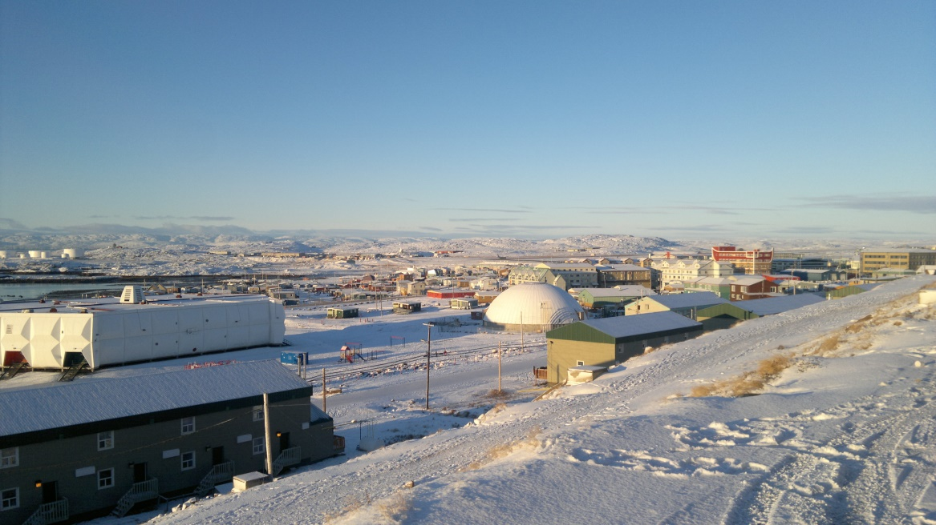
Fig. 3.1. View over Iqaluit, the largest city in the Canadian Territory of Nunavut
(Source: photograph taken by author, 2010).

As the British and Canadian delegations journeyed together first around Ottawa, and then Iqaluit, exchanging views in a range of formal briefings (in Ottawa and at the official one and a half day conference in Iqaluit) and informal settings (including museum tours, during flights, and over drinks in hotel bars in the evening), it became apparent to me that contemporary British Arctic policymaking might prove a complex phenomenon to comprehend.
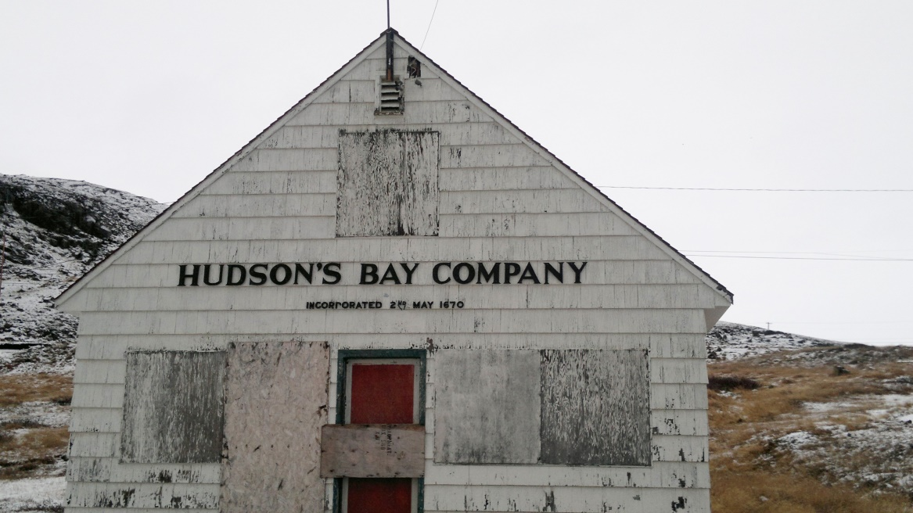
Fig. 3.2. Remains provide a material reminder of Britain’s historical presence in the Canadian North (Source: photograph taken by author, 2010).

In 2010, the British government had not produced anything akin to the Arctic Policy Framework white paper which it published in 2013. This was despite the fact that a meeting of British Arctic stakeholders chaired by the Foreign and Commonwealth Office (FCO) in Oban, Scotland in 2008, had produced a report which suggested that “greater coordination and communication is needed across Government, Research Councils and wider Stakeholders”, as well as calling for “the development of an overall UK ‘Arctic Statement’” (GBSC 2008, p. 2). In fact, as I learned from an FCO Official shortly after the Colloquium, the British government’s view in 2010 was that producing such a document (essentially a ‘Strategy’ for British engagement with the Arctic) “could be more of hindrance to UK engagement with Arctic states”, especially if the Arctic States read it as an attempt to exert undue British influence in the region (FCO Official I, 17 Jan 2011).
My involvement in the Canada-UK Colloquium ultimately suggested to me that there were a number of different features of ‘British Arctic policymaking’ with which I would have to engage over the course of my research for this thesis. First, British Arctic policymaking seemed to involve more than just government officials to the extent that these officials might put themselves in situations where they could be affected by the influence of other non-State actors. This was perhaps the least surprising feature to encounter, as the influence of non-State actors – at least in Western Liberal democracies – in foreign policymaking processes has been observed by foreign policy scholars for some time (see, for example, Hill 2003; Neack 2003). Similarly, geographers attending to ‘policy mobilities’ and the “socio-institutional character of policy-making processes” have sought to go beyond geographically bounded fields of policymaking from where all policy is assumed to emanate (for example, the government office, the government department, the capital city) (Peck and Theodore 2012, p. 22). This is in order to better attend to the multiplicity of sites and situations where the effects and affects of policies are felt, facilitated, resisted and interfered with by other sources of agency (State and non-State, human as well as non-human) (see also McCann and Ward 2012).
Second, the sites of British Arctic policymaking seemed to matter to the extent that the bodies and materialities encountered specifically in Iqaluit appeared to be used to influence members of the British delegation. This also opened up the possibility that other forms of non-human agency were being enrolled to affect the British delegation in non-representational terms (where the bodies and materialities of Iqaluit were allowed to ‘speak for themselves’, see Bennett 2010). This necessarily leads to a requirement to study “situations” of policymaking that happen in places beyond those sites generally identified as sources of policy – this can include everything from “conferences, seminars, workshops, guest lectures, fact-finding field trips, site visits, walking tours, to formal and informal dinners and trips to cafes and bars”, and much more besides (McCann and Ward 2012, p. 47). As I noted in Chapter 2, that this should be a feature of ‘British Arctic policymaking’ might not come as a surprise to social and cultural geographers who since the early 1990s have expanded their engagement with non-representational and actor-network theories. However, political geographers, and in particular those working in the sub-field of Critical Geopolitics, have only recently started to attend to non-human agencies and other non-representational affects (Depledge 2013d; Dittmer 2013b; Dodds 2012).
The third feature which I have alluded to above was that it became apparent to me that there was no such thing as ‘British Arctic policy’ existing as a coherent object that could be studied. Attending to British Arctic policymaking in my research would therefore demand engagement with a wide array of actors operating (or gathered together) as a loose network rather than an organised body (Allen and Cochrane 2010). The potential for these actors to facilitate, interfere with and frustrate one another’s ambitions was palpable in Iqaluit, especially when one delegate raised the possibility that the protection of polar bears might mean more to British citizens than the creation of socio-economic opportunities in the Arctic for Canadian Inuit (a sensitive issue for the Canadian government). Other delegates were quick to distance themselves from assembling British Arctic policy in this way, demonstrating the potential for multiple (at times conflicting) assemblages of British Arctic policy to exist at the same time.
Admittedly, I was not capable of defining these three features in these terms at the beginning of this project. As I explain below, my understanding of what I encountered in Iqaluit has developed over the course of my research. I was, however, provoked by what happened in Iqaluit to look for a more fluid approach to studying British Arctic policymaking. Rather than see British Arctic policymaking as an organised affair, directed primarily by government actors (and in particular the Polar Regions Department (PRD) of the FCO) who could potentially explain British Arctic policymaking to me through documentation and interviews, I decided to try to approach British Arctic policymaking through a broader range of encounters with State and non-State actors, involving a variety of different sites and practices. Where my approach to policymaking breaks from the geographical literature on policy mobilities is to the extent that rather than following British Arctic policy around various sites (as a kind of mutable mobile in actor-network terms), my interest came to be in how different aspects of an emerging Arctic policy apparatus – an apparatus that represents the ‘official’ Arctic policies and interests of the British government – have been assembled across multiple sites, involving various kinds of actors and practices (with various affects). Similarly, in attending to non-human agencies my approach is also distinct from Foreign Policy Analysis (FPA) which continues to focus on human decision makers (Hudson 2012).
From 2010-2014 my ‘fieldwork’ encompassed the following:
- 48 interviews including with British parliamentarians (3 – including one former minister), current and former government officials (26), current and former government scientists (6), non-government scientists and other academics (7), and representatives from the private sector (2), environmental NGOs (2) and journalists (2);
- attendance at multiple policy conferences and seminars;
- acting as an academic observer on board the Royal Navy helicopter carrier HMS Illustrious during Exercise Cold Response (EXCR) in northern Norway in 2012;
- participation in a Ministry of Defence (MOD) study group on the Polar Regions (2013);
- following the coverage of the Environmental Audit Committee (EAC) inquiry ‘Protecting the Arctic’ inquiry (2012-13);
- acting as a reviewer for a government policy paper;
- a period of six weeks spent in Norway with Norwegian government officials and scientists to better understand Norwegian perceptions of British Arctic policies and interests.

As I suggested in the introduction to this chapter, my understanding of what I encountered in Ottawa and Iqaluit was not immediate but developed over time. What was made apparent in Iqaluit was that there was no single ‘British Arctic policy’ – British Arctic policymaking was incoherent, involving a wide range of actors operating in disparate sites. Their interests and practices overlapped periodically (for example, in their coming together in Iqaluit), but were not underpinned by any structure in the sense that there was no explicit demand for these actors to work together on a ‘coherent’ policy toward the Arctic. This chapter, then, is intended to provide a path for the reader to follow me into a set of specific, historically-localisable entanglements with British Arctic policymaking to show why I have drawn the conclusions that I have. At the same time I remain committed to the claim that the world “necessarily exceeds our capacity to know [it]”, which is to say that all of my conclusions remain alive to the possibility that the things I have encountered retain a potential to be assembled otherwise (Law 2004, p. 6).
This chapter on method proceeds as follows. In the next section I consider how I came to use recent thinking in geography about assemblages as a framework for method. Following this, I reflect on the implications that my own positionality as a relational element in assemblages of British Arctic policymaking had for this project. I then turn to consider how my positionality also influenced the scope of this project. Lastly, I situate my more messy approach to method in recent debates in Critical Geopolitics about discourse and ethnography.

3.2 Thinking with assemblage as a framework for method
I first sought to address the multiplicity of actors, sites and practices of British Arctic policymaking as a kind of ‘Actor-Network’ (Callon 1986; Law and Hassard 1999; Latour 2005). Actor-Network Theory (ANT) was initially developed from science and technology studies (STS) as a way to explain how elements can both exhibit individual forms of agency (as actors) and produce collective effects (as a more or less coherent network) simultaneously. More radically, ANT is attentive to the agencies exhibited by non-humans as much as it is to those of humans, meaning that as an approach it is far more suited to exploring how the ‘world’ might be collectively achieved through combinations of textual, bodily, material, and affective elements. Some of these achievements – for example, to describe Europe as a continent – may be ‘black boxed’ to the extent that relations between elements are so tightly fixed that they are incredibly difficult to break down and can broadly be taken-for-granted as ‘facts’. Other achievements – such as British Arctic policy, for example – are more susceptible to change as the elements involved are relatively disparate. This, in turn, makes it harder to speak in terms of the ‘facts’ of British Arctic policy.
My early interest in ANT led me to focus on ‘tracing’ the elements (sites, actors, practices) involved in British Arctic policymaking (Latour 2005). Instead of relying on the government officials in the PRD of the FCO who were nominally responsible for representing Britain’s Arctic interests abroad, I sought to engage as many actors as I could find which were, in one way or another, engaged in some aspect of British Arctic policymaking. Other government departments in Britain have become increasingly engaged in foreign policy as a consequence of the internationalisation of their own policy interests (whether they relate to science, crime, energy, climate change or business, among others). This demanded seeking out those government officials in different departments and agencies with some form of responsibility for policies that related to the Arctic (including government scientists working at National Research Centres). Beyond government, it meant seeking out those actors which were regularly engaged by government officials for their advice on Arctic-related matters; or whose own Arctic-related practices (for example, commercial activities) had a bearing on government interests (ultimately this included representatives from think-tanks, environmental NGOs, academia and private business). To achieve this I primarily relied on the technique of ‘snowballing’ – asking informants and studying materials to identify further actors to engage with over the course of the research (Tracy 2012).
Between 2010 and 2014 I was able to interview 48 of these government officials, scientists and representatives of non-State actors (see Appendix B). More were approached who did not appear willing to speak with me despite repeated requests (particularly in the private sector). In addition, I had regular encounters with these actors at various policy conferences, workshops and small meetings which took place in different sites across the country (London, Liverpool, Cambridge and Hull – see Appendix C). Moreover, I also participated in practical engagements with some of these actors, including, for example, as a member of a MOD study group, as a reviewer of a draft government policy paper, and as an observer of British involvement in a military exercise held in the Norwegian Arctic. In addition to these human actors, the tracing of more-than-human elements (material and affective) required that I was attentive to the sites in which these encounters with occurring. I sought to cultivate an awareness of the agency of these materials by following Jane Bennett’s (2010) suggestion to resist attempting to ‘demystify’ every encounter by explaining it through human agency alone. The value of EXCR to the British military, for example, rested on giving personnel the experience of being in an Arctic environment which could not be conveyed in the same way through representation in texts (see Chapter 5).
However, over the course of my early encounters with British Arctic policymaking I started to become dissatisfied with ANT as an explanatory framework for what I was experiencing. On reflection, I think the problem was that in attempting to make sense of contemporary British Arctic policy, I was trying to account for what was essentially an emergent phenomenon. After all, it was not until 2013 that the British government published a white paper officially setting out its position on the Arctic. As others have pointed out, an ANT-based approach is perhaps more suited to explaining how some ‘thing’ has come to be contingently achieved or realised in its current form (Greenhough 2011; Bear 2013). What ANT is less attentive to is anticipating the ways in which that ‘thing’ might continue to change in the future (Bear 2013). As such, ANT is more like a dissection of an already realised object (and the multiple ways that same object might be realised), rather than how alternative outcomes might yet be realised (Greenhough 2011). Had my research project started in 2013 with the publication of the British government’s Arctic Policy Framework white paper and an interest in ‘dissecting’ how that white paper came to be realised, then ANT might have been a more useful approach. However, from 2010-2013 when most of my fieldwork was undertaken, whether this white paper would ever be produced was far more unclear.
It was in reading about the experiences of other geographers (notably Greenhough 2011; Allen 2011; Legg 2011; and later Bear 2013) that I started to become more attentive to the potential of ‘thinking with assemblages’. Both Greenhough and Bear make an important distinction between thinking with assemblages and thinking with ANT. As Bear put it (with reference to Greenhough):
“The focus of ANT is often on ‘what is required’, whereas a Deleuzian assemblage approach is more likely to emphasize ‘what is possible’ (Bear 2013, p. 25)”.

This emphasis on ‘what is possible’ points to one of the key tenets of assemblage theory – while ANT typically focusses on one actor-network at a time, thinking with assemblages attends to a potential for multiplicity to the extent that, British Arctic policymaking for example, might best be understood in terms of multiple networks (‘assemblages’) of human and non-human elements that at times overlap or cohere, but at other times interfere with or frustrate one another (Anderson et al. 2011). What might be described as ‘British Arctic policymaking’ can therefore have multiple forms that may or may not relate to one another directly (other than to the extent that they are all labelled as forms of ‘British Arctic policymaking’). At the same time, the emphasis on ‘what is possible’ also points to the fluidity of assemblages. Thinking with assemblages is constantly attentive to the way in which assemblages are always shifting as elements intermingle or disperse depending on their various entanglements with other elements (McFarlane and Anderson 2011; Anderson et al. 2012a; 2012b).
To illustrate this with a concrete example, the Canada-UK Colloquium involved the coming together of a distinct set of actors (government officials, other non-State actors, and the Arctic environment) which jointly affected the process of British Arctic policymaking. After the Colloquium these actors dispersed. However, the process of British Arctic policymaking continued, albeit through different combinations of actors (for example, government officials, foreign dignitaries, parliamentary committees and departmental buildings), temporalities (invoking historical relations – see Chapter 4) and spaces (including London, Cambridge, Oslo, Iqaluit). Between 2010 and 2013, it was far from clear whether these multiple assemblages of ‘British Arctic policymaking’ would eventually produce a coherent ‘British Arctic Policy’. By ‘thinking with assemblages’, I found I was better able to address the liveliness of the things that I was encountering during my fieldwork; not least their potential to facilitate, interfere with and frustrate one another’s attempts to affect contemporary British policy toward the Arctic (delimiting its boundaries and rendering it more or less coherent depending on the actors involved).

3.3 Becoming an insider to British Arctic policymaking
The application of assemblage thinking has also been relevant to how I have understood my own positionality within this project. The importance of attending to one’s own positionality during the research process is now largely taken-for-granted in textbooks of qualitative research (see, for example, Hennink et al. 2010; Tracy 2012). As these textbooks suggests, positionality in this sense includes both embodied traits (race, gender, appearance) as well as other kinds of traits relating to how the researcher represents him- or herself to, or is perceived by, others. However, the concept of ‘positionality’ is complicated by thinking with assemblages. This is because the researcher necessarily has to be seen as a relational element in the very assemblages that he or she is trying to research. As a relational element, the researcher has a capacity both to affect and be affected by other elements in these assemblages.
To make sense of my own positionality during this project it is first necessary to consider the impact that the CASE partnership between the Economic and Social Research Council (ESRC), Royal Holloway and the Royal United Services Institute (RUSI) had on my identity as a researcher. As a consequence of this partnership, I was positioned at RUSI, a leading defence and security policy think-tank based in Whitehall (essentially the political heartland of London), for two days a week (see Fig. 3.3). In my role as a RUSI researcher I was responsible for producing policy-relevant material relating to British foreign and defence policy (more on this below). As a consequence of my positioning at RUSI, I quickly gained a considerable degree of credibility as an Arctic policy expert among the emerging British Arctic policymaking elite, rooted in their perceptions about the kinds of experts that RUSI employs (a credibility that other researchers may have to develop over a longer period of time (Mullings 1999)).
The process of ‘becoming an insider’ was manifested in various ways. Between 2010 and 2014, in addition to authoring and co-authoring papers for policy-facing journals including The RUSI Journal and International Affairs, my position at RUSI also involved managing requests to provide advice to government officials (primarily those involved in defence and foreign policy), presenting Arctic-related material at policy-facing conferences, and provision of assistance to the organisation of the Poles Apart conference (2013), as well as other policy-related events, including the inaugural meeting of Arctic Hub: London (2014). However, three moments in particular stand out from my field work as examples of how, between 2010 and 2014, I was becoming enrolled in a British Arctic policymaking elite (a process which furthermore substantiates the claim that such an elite exists).

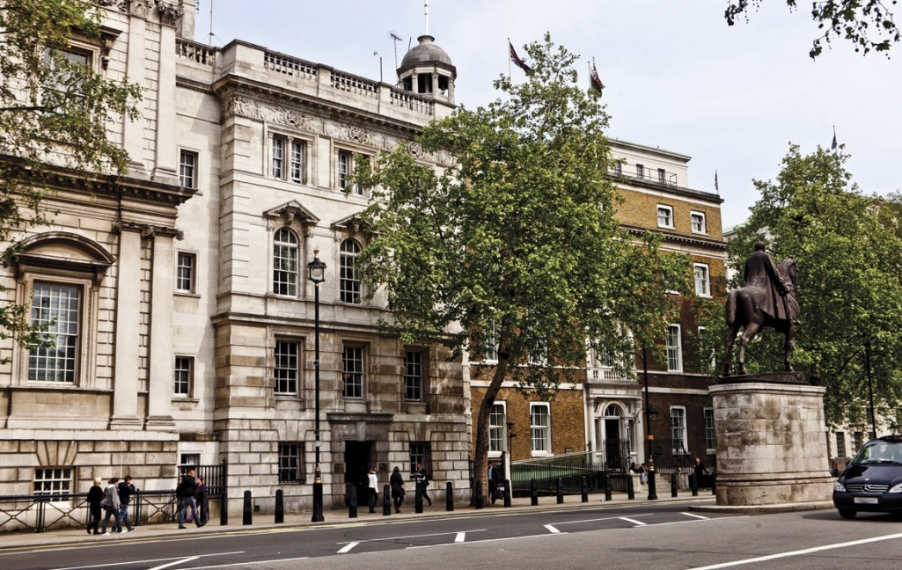
Fig. 3.3. The main building of the Royal United Services Institute in Whitehall, London
(Source: Sixty-One Whitehall, 2014).

3.3.1 Affecting government officials
In December 2012 I met with a British government official who I had encountered frequently over the course of my research. Just over a year before, this government official had agreed to be interviewed by me as part of my research. Following that first meeting, we stayed in touch, promising to keep each other informed of any developments in British-Arctic relations that we thought might be of interest to each other. We met twice more in 2012 before meeting again in December; the first of these meetings took place when this official agreed to provide me with a read-out of his department’s recent Arctic-related activities; a second meeting followed in order that he could introduce me to one of his colleagues who was also working on Arctic-related issues within the department. Our final meeting in December (just after this official had rotated on to work in another part of government, albeit still partly on Arctic issues) was organised so that I could offer him my own developing expertise to assist him with his Arctic-related work.
These meetings exemplify the way in which I was moving from a position of being a relative outsider who was only able to access the world of this government official through an interview, to being a relative insider who was allowed to see confidential information and eventually called upon to offer my own expertise and views. In part this related to my broader positionality as an employee of RUSI where I was seen as a ‘credible’ commentator on Arctic affairs. However, the shift also related to the rapport that I was building with this government official as a consequence of our constructive meetings. Merje Kuus has been critical of researchers that get too close to policy elites on the grounds that doing so risks the researcher becoming entrapped, especially if the only reason he or she is gaining a certain level of access is because he or she has become a useful insider (Kuus 2013). However, being useful to an informant is often a necessary condition for securing any kind of engagement. Even non-elite actors, who are generally regarded as easier to access, may require some form of recompense or other sense of benefit for participating in a study. Moreover, Kuus’ critique seems to assume that policy elites have no interest in constructive engagements where they too might be affected, and instead are simply trying to (ab)use the researcher for their own predetermined ends.
To think of interviews and other meetings as a kind of constructive engagement between researchers and informants is not unusual in itself – the researcher rarely, if ever, simply extracts data from informants (Legard et al. 2003). In their paper on engaging with policymakers, Peck and Theodore similarly note the possibility of ‘constructive engagements’ wherein researchers:
“become active participants in the exchange and evaluation of…policy knowledge and practice, albeit in the context of a reflexive and critical orientation rather than as cheerleaders for favoured [policy] models” (Peck and Theodore 2012, p. 27)

In such a situation, the researcher and his or her informants are therefore perhaps better regarded as ‘co-producers’ of interview data to the extent that the interview itself is a means through which the researcher and the informant can develop a shared understanding of the subject in question (Tanggaard 2007; 2009). Conceptualised in this way, these kinds of engagement are also ‘acts of assembly’ as disparate knowledges are connected together. As such, both I, the researcher, and my informants were enlivened by our encounters with one another – both were changed by the end of each encounter as a consequence of the interaction that had taken place.
Indeed, what I found over the course of my research, with other informants as well, is that I was frequently asked for my thoughts about the subject in hand, suggesting that my informants also saw the interview as an opportunity to construct shared knowledges, rather than to simply impart a ‘line’. In short, as relational elements themselves, my informants appeared open to being affected. One moment in particular exemplified this openness in at least some of my informants to being affected (and indeed my own capacity to affect). During the meeting I had in December 2012 with the aforementioned government official, I asked about a specific development in the British government’s policy toward the Arctic which he had been involved in. He replied:
“You know, it’s funny…it was after speaking with you that I had the idea to do that” (MOD Official I, 15 Dec 2012)

While I cannot reveal the details of what ‘that’ was, his response was revealing of the impact that I was beginning to have on British Arctic policymaking as a consequence of the research that I was doing. Both of us were relational elements with the capacity to affect one another, and in turn, the broader British Arctic policy assemblage which we were both helping to produce through our actions.

3.3.2 Invitations
As I found myself becoming increasingly part of the emerging British Arctic policymaking elite between 2010 and 2014, a number of unexpected opportunities to observe and participate in specific government practices relating to British Arctic policymaking started to emerge:
- In February 2012, I was invited to observe the Royal Navy during EXCR.
- In March 2012, I was invited by the FCO to participate in an internal government seminar as one of three panellists to discuss British and Chinese interests in the Arctic (the audience was primarily comprised of government officials from various departments and agencies).
- In November 2012, I was invited to participate in a MOD study group as a subject-matter expert on Arctic issues.

These invitations were significant to the extent that they were indicative of how I was increasingly being seen by government actors as someone to engage with precisely because I was working on emerging British Arctic policy. These invitations were at least partly a consequence of the fact that I had actively sought to cultivate my own position among the loose group of actors with expertise and interests in the Arctic. This was achieved because I reached out to these other actors – for example, by circulating papers that I had authored/co-authored – to make myself (and the expertise I embodied) known to them. As a consequence, I was increasingly known for being part of a relatively small group of non-government actors with expertise and interest in the Arctic.
As with many of my interviews, I did not feel that these invitations represented attempts by government officials to impose their agenda onto my research. Of course, there was an element of government interest to be aware of. For example, as I discuss in Chapter 5, part of the reason why the MOD invited ‘subject-matter experts’ to participate in their study group was to help legitimise their findings. Nevertheless, the decision to engage other actors was again about government officials opening themselves up to being affected by others. In particular, both the FCO seminar and the MOD study group were further examples of more ‘constructive engagements’ whereby I was working together with government officials to assemble British Arctic policies and interests, rather than serving as a ‘useful insider’ through which their own position could be reinforced.

3.3.3 Citations
A third example of how I was becoming an insider to British Arctic policymaking stemmed from the way in which other actors were deliberately attempting to enrol my research into their assemblages of British Arctic policy. This was perhaps the most troubling aspect of my entanglement with British Arctic policymaking to the extent that I found I had a capacity to affect how British Arctic policy was being assembled in ways which I had little control over. The most striking example of this was when I found that a paper that I had co-authored was cited in the Environmental Audit Committee’s (EAC) second report from its inquiry ‘Protecting the Arctic’. As I discuss in Chapter 6, the EAC inquiry was specifically trying to assemble British-Arctic relations according to a logic of environmental protection and good stewardship. The paper that I had a co-authored was being used by the EAC to help reinforce the EAC’s conclusions and recommendations to government. As it happened, I was not too concerned with how this paper had been used by the EAC in their report as they did not use it in a way that was contrary to the findings of the paper. Nevertheless, this example is illustrative of the way in which I did not always have control over how I was being forced into relations with different aspects of British Arctic policymaking. As a consequence, it became apparent to me the importance of remembering that as I engaged with British Arctic policymaking, I would need to negotiate my relations with others in order to limit their capacity to use my research in ways that were contrary to how I had intended it to relate to emerging British Arctic policies and interests.
* * *
Before proceeding further, I think it is important at this point to further pre-empt the potential claim this ‘closeness’ to my research data is a form of contamination. Such a claim is typically rooted in positivist approaches to the social/political science that reify ‘distance’ between the researcher and that which is being researched as a proxy for claims of a God’s eye view, neutrality, purity and replicability. All research is inevitably affected by the positionality of the researcher, not least because the researcher’s assumptions, questions and choice of method always shape the gathering of data in some way or another (Barad 2007). The process of ‘becoming an insider’ to British Arctic policymaking revealed a great deal about how difficult it is to encounter an assemblage without disturbing it. In constructing shared knowledge with my informants, participating in study groups, publicising my papers and generally being ‘present’ or ‘absent’ in certain situations, I inevitably formed relations with other elements in the assemblage (and brought a host of new elements with me – ideas, papers, etc.) – elements which were similarly open to being affected by engaging with my research. My own explicit inclusion and exclusion as a relational element within the British Arctic policymaking elite proved important to how those assemblages/apparatuses were not only performed, but also how they were assembled in the first place. Moreover, as different elements engaged with me in different ways I found myself being implicated in multiple, overlapping and at times conflicting assemblages of British Arctic policy.
It was, then, to a large extent as a consequence of my activities at RUSI that I became very much a part of an emerging British Arctic policymaking ‘elite’. As my expertise of Arctic-related issues developed, and my contact with foreign policy, defence and other government officials, as well as foreign dignitaries, parliamentarians and representatives from environmental NGOs increased, my positionality shifted from being a researcher on the edge of a policymaking ‘elite’ – where access to that elite was primarily achieved through interviews – to one who was regularly invited to engage in ‘policymaking practices’ (whether as a reviewer of a government policy paper, a participant in a departmental study group, a co-organiser of policy-facing events, an observer to military exercise, or as someone simply to meet with occasionally to garner their views).

3.4 Delimiting a method assemblage: the thesis as ‘apparatus’
Positioned as I was at RUSI from 2010 to 2014, I was very much in the right place at the right time to be able to engage with the emergence of contemporary British Arctic policy. In spatial terms, although there have been a number of policy-related activities in other parts of Britain (including Liverpool, Hull, Oban and Glasgow), most of British Arctic policymaking has occurred in London and the surrounding area (especially Cambridge). These policy-related activities have for the most part involved gatherings of government officials, scientists, other academics and representatives of NGOs, think-tanks and the private sector. The kinds of gatherings I am referring to here include everything from small meetings to larger workshops, seminars and conferences. Entangled as I was with this British Arctic policymaking elite, I found myself in many of the same sites, and engaged in some of the same practices as they were. This has led me to put a strong emphasis on these sites and practices in this thesis. As a result, the thesis is strongly focussed on what was happening in London and the surrounding area where most Arctic policy-related activity appeared to be taking place. More specifically, it is focussed primarily on those meetings, workshops, seminars and conferences which were ‘policy-facing’, by which I mean the development of Britain’s Arctic policies and interests were a key part of the discussion.
In focussing on the practices of a British Arctic policymaking elite primarily cited in London, there was a distinct geography to my research. Moreover, the focus on contemporary British Arctic policymaking situates this project at a specific historical juncture encompassing a period of policymaking from 2010 to 2014. Delimiting my research according to these geographical and historical boundaries had important implications for the kinds of assemblages that I have been able to encounter over the course of this thesis. This was a necessary trade-off in terms of giving me sufficient opportunity to become part of the primarily London-centric British Arctic policymaking elite (essentially by being present in London, and participating in the kinds of practices described above). Even within London, alternative positionings might have been possible, albeit they would likely have produced their own specific emphases. For example, had I been positioned within a British-based company located in the City of London, I would likely have become entangled far more with the kinds of assemblages that the private sector are constructing with reference to British-Arctic relations. Similarly, if I had been positioned within an environmental NGO, my focus is likely to have been directed towards how British-Arctic relations are being assembled through various forms of campaigning and direct action. As it happened, positioned as I was at a policy-focussed think-tank, the emphasis in this thesis remained centred primarily on how British Arctic policy was being assembled rather than on private sector interests or environmental campaigns (this is reflected in the fact that almost half of the interviews undertaken with British stakeholders during this project were with current and former government officials).
Being part of a primarily London-centric British Arctic policymaking elite also produced other absences in this project. Dittmer et al. (2011) have elsewhere noted the significance of popular assemblages of the Arctic that are suggestive of how people might think about the Arctic in everyday terms. Television programmes including Frozen Planet (2011) and The Arctic with Bruce Parry (2011) have attracted millions of weekly viewers. There have been numerous exhibitions at various British museums across the country including, among others, the National Maritime Museum in Greenwich, the Royal Geographical Society and the Royal Society in London, the Scott Polar Research Institute in Cambridge, the University of Dundee Museum in Dundee, and the Maritime Museum in Hull. British tourists visit the Arctic participating in cruises, camping trips and other kinds of excursions that allow them to experience the region for themselves. The government together with the Royal Geographical Society has also encouraged schools to take an interest in the Arctic through tools such as the Discovering the Arctic website. Fictional encounters should not be ignored either, whether in popular books such as Philip Pullman’s Northern Lights trilogy (1995-2000), Sarah Moss’ Cold Earth (2010) and Ian McEwan’s Solar (2011), or blockbuster movies such as G.I. Joe: Rise of Cobra (2009) and Man of Steel (2013). These kinds of popular encounters are saturated with geopolitics (Dittmer and Dodds 2008). However, these elements were rarely part of the discussions when I was with other British Arctic policymakers. This absence has, in turn, been reflected in the scope of this thesis.
Similarly, as part of this project I have not spent a significant amount of time investigating historical archives that may well have shed more light on how British-Arctic relations have been assembled by various actors in the past. In my encounters with the British Arctic policymaking elite in London, there was little evidence to suggest that these actors themselves had spent much time exploring historical archives – Britain’s historical connections and legacies – including those of British geographers – in the Arctic tended to be assumed rather than accounted for in most discussions. This has again produced an absence that this thesis – which has been primarily concerned with contemporary policy assemblages – necessarily reflects. That said, the analysis presented in Chapter 4 of this thesis does draw on evidence from the historical record (from Hansard, the Scott Polar Research Institute and the Royal Geographical Society) to illustrate some of the many different ways assemblages of British-Arctic relations have manifested in the past. However, I use this material to unsettle contemporary policy claims, rather than to reconstruct historical assemblages.
This thesis, then, produces its own set of presences and absences, largely as a consequence of how I have been entangled (or not entangled) with emerging assemblages of British-Arctic relations. My approach has also relied on a more messy, exploratory method to the extent that I have had to trace emerging assemblages of British Arctic policy by positioning myself in a range of sites where British Arctic policy is being assembled, practiced and performed (from seminar rooms in London to aircraft carriers in the Norwegian Sea), as well as more traditional methods involving interviews and documentary analysis.
In embracing this messier approach I have been influenced by the work of the sociologist John Law. In After Method: Mess in Social Research (2004), Law argues that every method provides its own ‘method assemblage’ to the extent that every method necessarily has to craft dividing lines between what is made present, what is made absent, and what is still unknown. Law’s critique of conventional ways of conceptualising method is largely summarised in the following passage:
“Method hopes to act as a set of short-circuits that link us in the best possible way with reality, and allow us to return more or less quickly from that reality to our place of study with findings that are reasonably secure, at least for the time-being” (Law 2004, p. 10).

The problem for Law is that this idealised view of method does not reflect the messiness of research as it is actually practised. Nor does it capture the way in which method actually helps constitute the very world it seeks to describe. For Law, rather than represent as ‘fact’ a reality that exists a priori and externally to the research process, method is used to gather together and inscribe the world with a specific account of reality, which the researcher then negotiates with others (past and present) to create a shared account of reality. As Law stresses, this is not to claim that ‘anything goes’, that the world can be anything we believe it to be. The need to negotiate our accounts of reality with others (human as well as non-human, living as well as non-living) more or less delimits a ‘realm of the possible’, which is bounded in social, cultural and material terms.
While the boundaries of this realm are never fully fixed, shifting them can be costly. This is because these boundaries may be policed and maintained through a variety of social and cultural institutions and practices, or by the very materiality of the world. For example, the realm of what is possible for a doctoral thesis such as this one is delimited by my own personal capacities as a researcher (intellectual, physical, etc.), the regulations set by my academic institution (quality of research, word length, deadline for completion, etc.) as well as the possibility of encountering the objects of my research, and potential for these capacities, regulations and objects to behave in unanticipated ways which could undermine my account of the research project per se. Shifting any of these boundaries requires more or less work, whether that means studying more as a way of improving my intellectual capacity, attempting to persuade my academic institution to change its regulations, finding different ways of encountering my research objects, or engaging more deeply with the enrolment of my research objects in support of the account I provide. While all of these may be desirable objectives, the practicalities of achieving them within the social, institutional and material constraints I have been under would require an investment of time and resources which have simply not been available to me.
To think of this thesis as a kind of method ‘assemblage’ is therefore a necessary component in thinking with assemblages more broadly, precisely because it forces us to account for the cuts we make to delimit the scope of our research. Accordingly, this thesis – like the British Arctic policy with which it is primarily concerned – and the methods that underpin it, must also be regarded as a kind of ‘apparatus’ which I have created to delimit my encounters with British Arctic policymaking. This thesis has a strategic function to the extent that it provides the basis of my submission for a qualification. Given this strategic function – which leads to the crafting and enacting of boundaries – in the terminology I have adopted I prefer to refer to this assemblage as a method apparatus (and will do hereafter). As an apparatus, this thesis does not offer a claim to universal completeness of the problem of British-Arctic relations as it does not offer a total delimitation of this assemblage. Put differently, as an apparatus this thesis does not report on reality, but helps perform and order its existence. Alternative “realities, manifest absences and Othernesses, resonances and patterns of one kind or another” already being enacted by others, may interfere or be interfered with, by this thesis, and it is these interferences which must be negotiated away if shared knowledge is to hold across multiple accounts of various realities (Law 2004, p. 143).

3.5 Situating messy methods in Critical Geopolitics
Since its inception in the late 1980s, Critical Geopolitics for the most part sought to unsettle textual representations of geopolitical spaces and identities, particularly those that are used to differentiate and legitimise violence against ‘Others’ (Dodds 2001; Dalby 2010). The kinds of texts investigated include classical geopolitical doctrines (Ó Tuathail 1994; Ó Tuathail 1996), official government policy documents and speeches (Dalby 1990; Ó Tuathail 1992), government records (Dodds 1994), magazines (Sharp 1993), cartoons (Dodds 2007), comic books (Dittmer 2005) and films (Dodds 2006). This focus on texts was rooted in the emergence of discourse analysis as a popular methodology among constructivists across the social sciences, including in IR and political geography (Müller 2008). Consequently, as Müller has noted elsewhere, the “fascination with texts as the encapsulation of geopolitics must be understood within the disciplinary trajectory of Human Geography and the social sciences at large” (Müller 2013, p. 50).
Critical Geopolitics has been critiqued for this ‘fascination with texts’ for some time. As noted in Chapter 2, more than a decade ago the geographer Nigel Thrift questioned the way in which critical geopolitical inquiry appeared “mesmerised” by “texts and images” (Thrift 2000, p. 381). Thrift’s criticism was rooted in his broader interest in the possibilities of ‘non-representational theory’ (NRT) (Thrift 2007). Despite the label, NRT, like Critical Geopolitics, is less a coherent theory and more a way of thinking which emphasises the importance of attending to those facets of the world that escape easy representation. Put simply, a policy document that states Britain is interested in the Arctic only represents the existence and expression of British interest in the Arctic. It does not capture where that interest comes from, how it has been configured, whether it is contested, whether it might be understood in different ways by different actors, whether there is more to it, or how it might be encountered or experienced. Only by attending to the bodies, objects, sites, affects and practices that assemble and perform such textual representations can we begin to account for what the representation of British interest in the Arctic actually does in practice.
A number of political geographers have responded to this critique by arguing for the concept of ‘discourse’ to be expanded to include more than texts (see, for example, Müller 2008; 2013; Pain and Smith 2008; Dittmer et al. 2011; Kuus 2011b; McConnell 2009; Painter 2006). In this body of work, discourse has broadly been re-conceptualised as something constituted from interactions between actors, practices and affects (where actors include more than just humans, and texts are just one kind of practice). Such an approach takes seriously the way in which texts are mediated in all kinds of ways. Put simply, a shared a representation of the world cannot be achieved through texts alone. Such an achievement is contingent upon how those texts are circulated, received, supported, subverted and resisted by those who encounter and consume them (intentionally or not). While not wanting to sound disparaging of important studies that have taken place under the rubric of Critical Geopolitics, the tendency to focus on textual representations – whether produced in ‘elite’ (policy documents, speeches) or ‘popular’ (cartoons, magazines) form – has largely led to a preoccupation with the capacity of autonomous acting individuals or groups to create, shape and deploy all-powerful discourses in strategic ways, with less consideration of what actually happens to these discourses in encounters with others (human as well as non-human).
The turn towards a more practical understanding of discourse among political geographers has necessarily had implications for the kinds of methods being deployed in their research. In particular, a number of political geographers have sought to take seriously the potential of ethnographic methods to produce a deeper understanding of how discourse is realised in practice (Megoran 2006; McConnell 2009). Recognising that ‘ethnography’ itself is a contested term across the social sciences, Megoran defines it as:
“an extended sojourn amongst a group of people where the researcher immerses himself or herself in daily life, continuously reflecting on meticulously kept fieldnotes, to learn the social understandings of the group in its own terms” (Megoran 2006, p. 625).

Drawing on ethnographic methods, Megoran was able to produce a detailed account of the disconnect that existed in Uzbekistan and Kyrgyzstan between elite representations of the situation in the Uzbekistan-Kyrgyzstan Ferghana Valley boundary, and the everyday experiences of those living there (Megoran 2006). McConnell has used an ethnographic approach in Tibet to show how in practice, ‘sovereignty’ as an effect can be achieved by entities which are not formally represented as ‘sovereign’ (McConnell 2009).
Both a wider sense of ‘discourse’, and the possibilities offered by ethnographic method were of relevance to the approach I adopted to produce this thesis. As I noted in Chapter 2, ‘thinking with assemblages’ is very much attentive to going beyond representational theories which are rooted in the examination of texts. Indeed, political geographers such as Martin Müller and Jason Dittmer have similarly embraced assemblage thinking as a way to attend to how discourses are realised in practice (Muller 2008; 2013, Dittmer 2013a; 2013b). Moreover, it is arguable that an ethnographic method may be particularly relevant for the study of assemblages/apparatuses, mainly because the emphasis of such an approach is placed on tracing connections and associations, and ‘following’ actors as they intervene in the world around them through processes of assembly, disassembly, reassembly and subversion. This is achieved through participating in the daily life of research subjects, not just interviewing them, but watching how they encounter and (dis)associate with other elements as they go about their interventions in local and everyday life. Dittmer, for example, in his work on the model United Nations, used an explicitly ethnographic approach to better understand the role ‘laughter’ was playing in constituting geopolitical discourses (Dittmer 2013b).
More recently, Richard Powell has called for “an ethnographically-informed voice for the Arctic at a scale beyond the local or community” to which the emerging Critical Polar Geopolitics (discussed in Chapter 2) might contribute (Powell 2010, p. 76). Powell has argued that the arrival of lawyers, energy economists and military strategists in the Arctic needs to be taken seriously as their assemblages of an Arctic region as a kind of ‘totality’ are more likely to resonate with totalising discourses of global politics than they are with local/indigenous voices (see also Ó Tuathail 2003). An ethnographic engagement with the Arctic may therefore be useful to the extent that it might illustrate further discrepancies between how life in the Arctic is represented in ‘elite’ texts, and how life is actually lived in the Arctic.
However, the possibility of adopting a predominantly ethnographic method in this project was rendered problematic by issues of positionality. When the key sites for the production of assemblages and apparatuses are government departments, military bases, headquarters of private companies, and diplomatic summits, the researcher is unlikely to be able to maintain a sustained presence. Since RUSI retains its own independence, even positioned as I was within an emerging British Arctic policymaking elite in London, I was never likely to secure an ‘extended sojourn’ among those assembling British Arctic policy on a daily basis (Megoran 2006; see also Ó Tuathail 2010). This problem forms the basis of Merje Kuus’ recent scepticism about relying exclusively on ethnography to study what goes on among governmental and organisational elites; a scepticism which I share. As Kuus argues:
“Ethnographic fieldwork is challenging, especially in efforts to ‘study up’ and take elite circles as the object of analysis. The stereotypical image of international (geo)politics as a high-brow operation in the proverbial smoke-filled rooms discourages fieldwork – it indeed implies that if a practice can be observed first-hand by an academic, it is not real geopolitics. There is a kernel of truth in this simplification. The effects of foreign policies can be observed in numerous settings, but its conception inside the more insular echelons of the state apparatus is much less visible. It is one thing to recognise the analytical value of ethnographic fieldwork; it is quite another to do it” (Kuus 2013, p. 116).

Kuus goes on to argue that the term ‘ethnography’ can lend a veneer of access to research subjects which rarely delivers on its promise in studies of elites. Similarly, Ó Tuathail has questioned the extent to which Critical Geopolitics can be localised “in the closeted world of decision makers” and thus whether an ethnographic approach can offer more than what can already be achieved through interviews and documentary analysis (Ó Tuathail 2010, p. 257).
The methods used in studies of Critical Geopolitics are diversifying as discourse is being re-conceptualised to mean more than ‘elite’ texts. As researchers seek ever-more encounters with actors, practices, materials and affects that are also constitutive of geopolitical discourse, and cast their nets more widely, there is a need to be reflexive about what is and is not being encountered. The far messier approach to method deployed in this thesis reflects my own attempt to manage the problem of developing a thicker knowledge of the sites, actors and practices involved in assembling emerging British Arctic policy, while at the same time being unable to enjoy the level of access that most ethnographies depend on (even off the record there were some materials that I simply was not allowed access to). As such the messy method deployed in this thesis – drawing on documentary analysis, interviews, and opportunistic encounters – is perhaps best seen as situated within the kind of ‘grounded critical geopolitical inquiry’ that Ó Tuathail has called for, essentially involving a range of methods to locate “disjunctures and contradiction” between representations and practice, rather than attempting fully to reassemble life as it is lived by different kinds of actors (Ó Tuathail 2010, p. 263). My approach has also been highly opportunistic to the extent that I sought to embrace every opportunity that I could to spend time entangled with practices of British Arctic policymaking in a variety of different sites, but this does not add up to the kind of ethnographies produced by Megoran (2006) and McConnell (2009), among others. Such an approach was also necessary to the extent that I wanted to engage with a broader assemblage of sites than might otherwise have been allowed had I stayed ‘in situ’ with one set of British Arctic policymaking actors; a decision reflected in what Peck and Theodore have described as:
“the inescapable trade-off between situational depth….achievable in long-duration, single-site ethnographies…and those ‘low-flying’ (but flying nevertheless), network-centric perspectives that privilege cross-conjunctural reach over sustained, in situ engagement” (Peck and Theodore 2012, p. 25).

3.6 Chapter summary
This chapter has shown how ‘thinking with assemblages’ has helped me to make sense of both my methods and my positionality during this research project. Specifically, I have drawn attention to the way in which I was becoming an insider to British Arctic policymaking over the course of the project (albeit never fully inside) as a consequence of my unique positionality which was rooted in a CASE collaboration between the ESRC, Royal Holloway and RUSI. This process of becoming an insider was revealing of the way in which both I and those I engaged with over the course of my researcher were relational elements in assemblages of British Arctic policymaking, capable of affecting one another in our encounters.
Moreover, I have made the case in this chapter, following other political geographers, for inquiries into geopolitical discourse to be expanded to investigate more than text (taken here to include the visual), by attending to the multiple sites, actors and practices that are entangled with the constitution and performance of this discourse. As such, I have sought to break free of the ‘bounded field’ implied by ‘government policy’ in order to better attend to a multiplicity of sites and situations where the effects of policies are felt, facilitated, resisted and interfered with by other sources of agency.
I have also emphasised the messiness of my method apparatus, a necessary consequence of attempting to find various ways of glimpsing the processes through which Britain’s policies and interests in the Arctic are assembled, many of which lie beyond the public space. This demanded an opportunistic approach involving chance meetings and a willingness to look for agency in sites, actors and practices not typically associated with the production and practice of government policy. However, such an approach also demanded that I actively cultivate my own position among a loose assemblage of actors with expertise and interests in the Arctic. Making myself useful to the process of assembling government policies and interests towards the Arctic, meant that I found myself invited into the very sites where other actors, practices and affects could be glimpsed or felt in ways that might not otherwise have been encountered (for example, through interviews or text-based research). While there was a price to pay, in terms of not being able to reveal all of these sites, actors and practices in my thesis, what I gained was still greater than if I had not been a participant in these assemblages at all (indeed, no research method can produce an encounter with every element of interest).
Lastly, this chapter has been revealing of both the policy-centric and London-centric nature of this project. As a consequence of my positionality and the aims of the project to produce policy-relevant material, the scope was necessarily narrowed to focus primarily on British Arctic policy assemblages. Other assemblages relating to encounters between British business and the Arctic, environmental NGOs and the Arctic, and the broader population and the Arctic were therefore a necessary absence. Similarly, the focus on tracing contemporary British Arctic policymaking significantly reduced the necessity of engaging with the historical archive.

4. Producing proximity: Britain as the Arctic’s “nearest neighbour”

4.1 Introduction
In 2011, the Polar Regions Department (PRD) of the Foreign and Commonwealth Office (FCO) released a statement on its website detailing Britain’s interests in the Arctic. An important feature of this statement is the way in which a traditional, fixed understanding of geography measured in terms of topographical distance is invoked as a basis for contemporary British interest in the Arctic. As the opening paragraph reads:
“Today, as the Arctic’s closest neighbour, the UK continues to engage actively in and with the Arctic in a multitude of different ways” (FCO 2011).

This claim of geographical proximity to the Arctic has been invoked repeatedly by the FCO. As an FCO briefing paper published in 2011 noted:
“Although the UK is not an Arctic state, it is a close neighbour” (FST 2011, p. 3).

The claim was repeated in both written and oral evidence submitted by the FCO to the parliamentary Environmental Audit Committee (EAC) in 2012. As the then-FCO Minister responsible for the polar regions at the time, Henry Bellingham remarked that:
“As far as our interests are concerned, we are obviously not an Arctic Council Member but we are the Arctic’s closest neighbour and we have, I would suggest, a significant stake in the sustainable future of the Arctic” (HC 171, 2012, ev. 93).

Moreover, Bellingham repeated the claim again:
“Of course, as we are the nearest neighbour to the Arctic, as a non-sovereign country I think of all the Observer States we are the one that is taken the most seriously” (HC 171, 2012, ev. 101).

Most recently, the Arctic Policy Framework (APF) white paper published in 2013 states:
“The UK is the northernmost country outside of the eight Arctic States; the northern tip of the Shetland Islands being only 400km south of the Arctic Circle.

This closeness, combined with a long tradition of exploration, has given the UK a historic interest in the Arctic that dates back to the voyages of discovery” (HMG 2013, p. 7, emphasis added).

Ostensibly, there seems to be little reason for the British government to invoke geography as relative distance in this way in order to justify its contemporary interests in the Arctic. The APF goes on to state as much:
“However, the UK’s interests go much further than simple geographical proximity or historical endeavour” (HMG 2013, p. 7, emphasis added).

And yet, the frequency with which this claim of geographical proximity has been made since 2011, typically as a starting point for government justifications of broader British interests in the Arctic, suggests otherwise.
Before 2011, the invocation of geographical proximity – in traditional, topographical terms – to produce Britain as the Arctic’s ‘nearest’ or ‘closest’ neighbour appears broadly absent. There was, for example, no mention of Britain’s geographical proximity to the Arctic in the report from the FCO-chaired meeting of British Arctic stakeholders in Oban in 2008 (GBSC 2008). Nor was a claim of geographical proximity invoked in an internal paper produced by the FCO in 2009 (FCO 2009). Moreover, Michael Richardson, the former Head of the PRD (1992-2007) told me he was not aware of this kind of geographical language being used to justify British interest in the Arctic while he was in post (Richardson, 9 Jul 2014). Although his successor Jane Rumble, who remains the Head of the PRD today, suggested to me in correspondence that the language of ‘nearest neighbour’ has been common phrasing since she first joined the department in 2003, this claim does not appear to be supported by the publicly available documentation.
If the move to invoke Britain’s geographical proximity (traditionally understood in topographical terms as noted above) is a recent phenomenon, then it seems important to ask why this has happened, and with what effect. The second question is perhaps easier to answer. Britain’s claim of geographical proximity works to naturalise Britain’s ‘near-Arctic’ identity in a way which girds the legitimacy of British interest(s) in the Arctic, while at the same time distinguishing its interest from that which is emerging in other parts of the world. As more and more States, from Asia (China, India, Japan, South Korea and Singapore) and Europe (France, Germany, Italy and Poland, among others) have demonstrated greater interest in the Arctic (through bilateral agreements, applications for observership status at the Arctic Council, and material investments in science and infrastructure in the Arctic), there appears to have been a greater effort from the British government to distinguish Britain’s Arctic ‘actorness’ (Dittmer et al. 2011). Claiming simple geographical proximity, understood in terms of fixed topographies, has become an important part of this process.
This chapter is used to consider Britain’s past relations with the Arctic to show why the question of geographical proximity is predominantly a contemporary concern for British Arctic policy. The contention is that far from having a long-established relationship with the Arctic as a consequence of simple geographical proximity (understood in fixed, topographical terms), Britain’s relations with the Arctic, since the sixteenth century, have changed considerably, both in geographical scope and intensity. In identifying some of the multiple and emerging assemblages of British-Arctic relations that have existed in the past (gathering together specific sites, actors and practices), this chapter works to unsettle contemporary attempts by the British government to take-for-granted Britain’s ‘near-Arctic’ identity. The aim is therefore to provide a basis for understanding British-Arctic relations as rooted in topology (i.e. the scope and intensity of connections between Britain and the Arctic) rather than topography (i.e. a natural consequence of the distance between Britain and the Arctic as measured on a map). This, in turn, provides the justification for examining the contemporary formation of British Arctic Policy (in Chapters 5 and 6) as an attempt to order and control the on-going dynamism of British-Arctic relations for the benefit of British interests, rather than simply a delimitation of British interests determined by the facts of natural geography (as proponents of classically-informed geopolitical inquiry might argue – see for example, Rogers 2012, and more broadly Kaplan 2012).
The chapter is structured as follows. The next three sections provide an overview of some of the ways in which Britain and the Arctic have been connected in the past, and how these relations have evolved in tandem with broader developments rooted in discovery, science, international relations, and the changing materiality of the Arctic. In short, relations between Britain and the Arctic in the period from the sixteenth century to the end of the nineteenth century are understood to have been dominated by the search for ‘northern’ maritime passageways, the hunt for resources on land and at sea, and developments in theories of polar geography. For much of the twentieth century, relations between Britain and the Arctic came to be influenced far more by the strategic imperatives of war, although science was also prominent (in part related to preparations for further wars, and in part because, having mapped the Arctic, all that was left for explorers and scientists was the deeper investigation of the materiality of the Arctic itself). Towards the end of the twentieth century, British-Arctic relations began to be dominated by the Arctic governance issues that were emerging with the ending of the Cold War. Following this overview of three historical periods, the chapter reflects on how as these relations shifted, so too did the actors, sites and practices involved in assemblages of British Arctic policy. This implies a fluidity in British-Arctic relations that is masked by contemporary attempts to take-for-granted Britain’s ‘natural’ place in the Arctic. My conclusions are summarised at the end of the chapter.
Before proceeding, there is one caveat to stress. Despite having a historical emphasis, this chapter should not be read as an attempt to reconstruct historical assemblages in detail as one might in a history or a historical geography of British-Arctic relations stretching over centuries. Rather, it should be read as an attempt to illustrate some of the many ways in which different assemblages of British-Arctic relations have manifested in the past in order to unsettle contemporary attempts to take-for-granted Britain’s identity as an ‘Arctic’ or ‘near-Arctic’ State. As such this chapter is more of a tactical intervention as befits critical geopolitical inquiry (Ó Tuathail 1996).

4.2 The search for northern passages and resources in the Arctic regions (1500-1900)
In the early sixteenth century, English explorers launched a first wave of expeditions to find ‘northern’ passages through the Arctic (Wallis 1984; Craciun 2010). Backed by merchants from Bristol and London, these explorers sailed towards the unknown regions of the north. Unsure what they would discover, passage was sought across the pole, as well as in the northwest and the northeast. However, in the early seventeenth century the search for a new maritime route to Asia was abandoned.
Viewed as an assemblage of English- (later British-) Arctic relations, this first wave of expeditions to seek out ‘northern’ passages to Asia gathered together all kinds of actors, sites and practices. There were explorers with an appetite for adventure which at times included a religious conviction that a northern route to Asia was a divine bestowment on the English nation that would allow them to circumvent the blockade imposed by the Spanish and Portuguese on more southerly trade routes (under the terms of the Treaty of Tordesillas 1494). Merchants from cities such as Bristol and London provided financial support to the expeditions in the hope that they would gain access to lucrative markets in Asia for their goods (especially woollen cloths – see Wallis 1984). The Crown also provided support for these expeditions in return for a share of the wealth and prestige that such expeditions might bring. At the same time these expeditions came to be entangled with the development of new theories in polar geography (across Europe) about what might exist in the unknown regions of the north. The map of the North Pole painted by the Flemish geographer and cartographer Gerardus Mercator was emblematic of the mysteries that shrouded sixteenth century understandings of the geography of the Arctic (see Map 4.1).
In particular, the concept of an ‘Open Polar Sea’ had great currency among leading geographers. There was also considerable debate among geographers and explorers about whether a northwest or northeast passage would prove more accessible (Wallis 1984). Each time an expedition returned with new discoveries, would-be explorers were well placed to win further backing from sponsors willing to support deeper investigations into the north. In the context of these discoveries, the frozen waters of the Arctic also became an agent in English/British-Arctic relations, not least because of the way in which pack ice in the Arctic continued to frustrate attempts to prove both the geographical and religious theories that continued to drive English explorers to the north. However, as the discoveries lessened, and successive expeditions ended in failure (and often death), the limits of English explorers in the face of the Arctic’s material rigidity were realised.

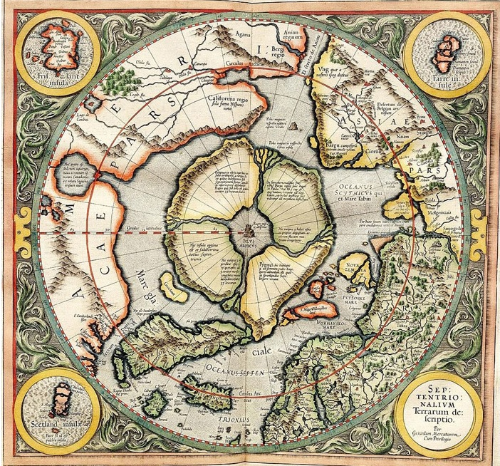
Map 4.1. Mercator Hondius Map of the Arctic published in 1606
(Source: Canadian Geographic, 2013).

In the sixteenth and early seventeenth centuries, English interest in the Arctic was geographically diffuse to the extent that passage was sought wherever it might prove possible. Geographical debates about whether to pursue passage through the Open Polar Sea, the northwest or the northeast remained unsettled so the relationship between the English and the Arctic had a broad geography (see Map 4.2). In contrast, when the British returned to the Arctic to search for a northern maritime passage in the early nineteenth century, the focus explicitly centred on the possibility of discovering the Northwest Passage (see Map 4.3). This narrower geographical focus was a consequence of changes in the broad assemblage of actors, sites and practices that underpinned British interest(s) in the Arctic over the centuries since the first wave of expeditions in the sixteenth and early seventeenth centuries. 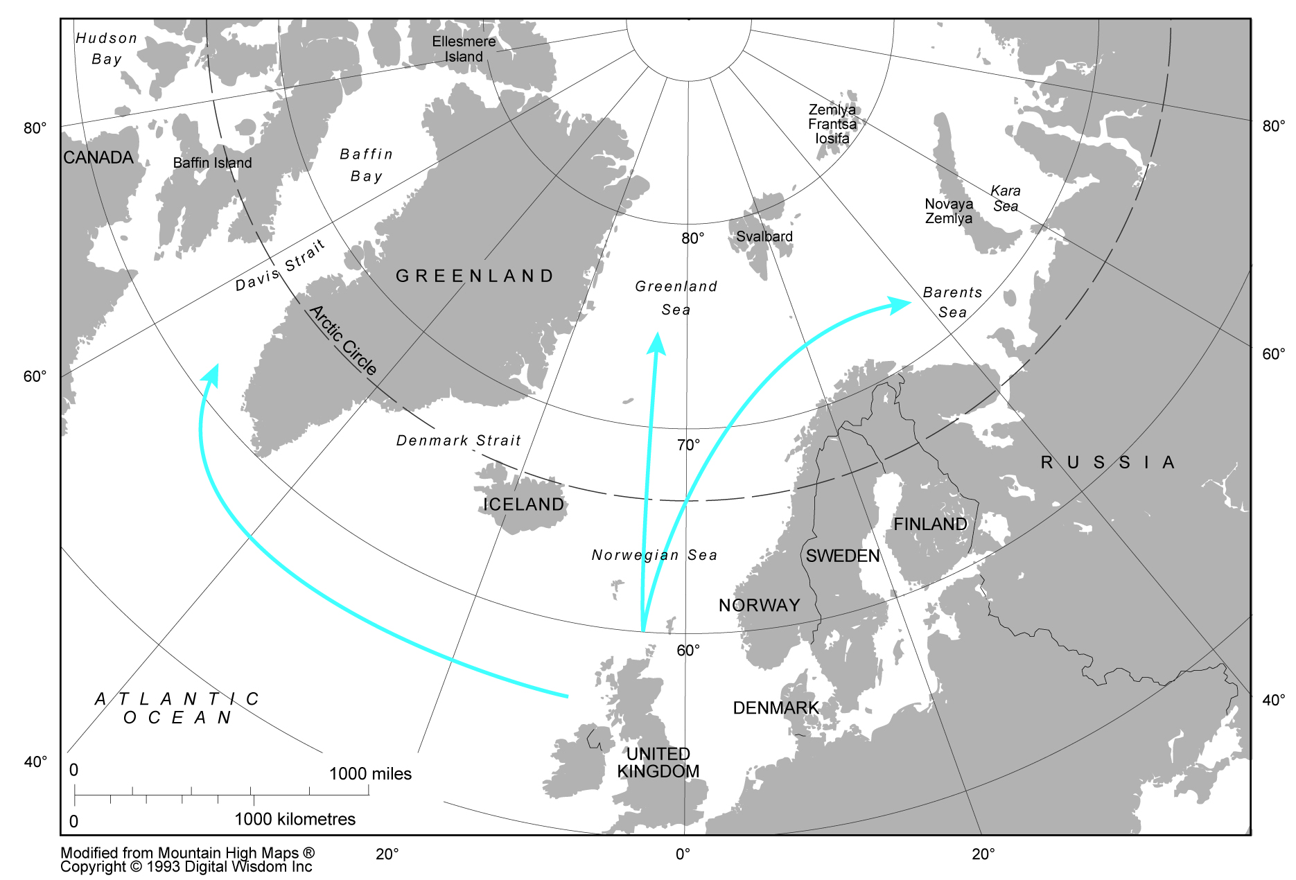
Map 4.2. The sixteenth century search for ‘northern passages’
(Modified from Mountain High Maps Copyright 1993 Digital Wisdom Inc.).

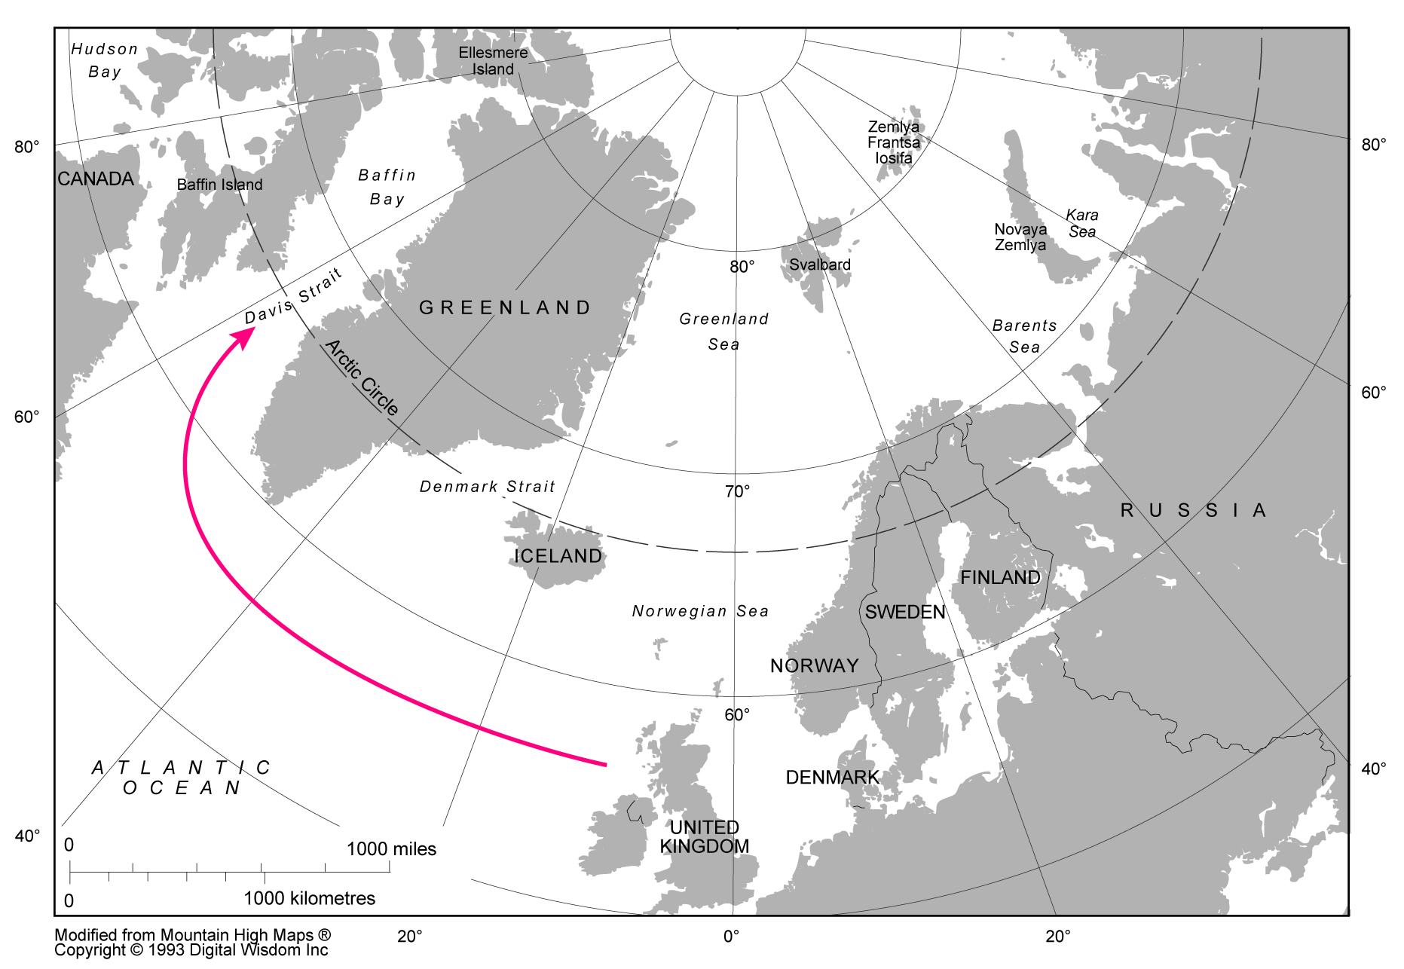
Map 4.3. The nineteenth century search for the ‘Northwest Passage’
(Modified from Mountain High Maps Copyright 1993 Digital Wisdom Inc.).

The searches for ‘northern’ passages in the sixteenth and early seventeenth centuries were significant not only for the ways in which they produced encounters with a ‘frozen ocean’ but because they were part of a broadening opening up of ‘Arctic regions’ to English and later British actors. However, the search for northern passages was not only a maritime affair. Expeditions also proceeded on foot to explore and map the coastal regions of the North American and Eurasian continents. Both continents were becoming part of the ‘Unending Frontier’ imagined by English and other European explorers as they searched for resources and trading routes in what was interpreted as terra nullius to feed the growth of their nations (Richards 2003). On exploring the northern parts of the Eurasian continent the English set up trade relations with Muscovy (later Russia) through the Muscovy Company. Later the English presence was extended through the Muscovy Company to the sea areas around Spitsbergen where significant whaling and sealing was possible. On the North American continent, the Hudson’s Bay Company (which like the Muscovy Company was backed by a Royal Charter from the Crown guaranteeing their rights in Arctic regions) played a key role in establishing British territories intended to open up North America to English settlers and merchants. Discoveries made in the Davis Strait along the western coast of Greenland created further opportunities for whaling which were seized upon by ships sailing from northern English towns and cities such as Whitby and Hull. English whalers, sealers, fur trappers, miners and traders were all part of this emerging economy centred not on finding passage to Asia, but on extracting value (see Map 4.4).
This booming activity in Arctic regions was reflected in the maps emerging in the seventeenth and eighteenth centuries. Moses Pitt’s inclusion of Janssonius’ map (from 1650) of the North Pole in the English Atlas (1680) demonstrates a dramatic improvement in the cartography of the northern regions compared to that of Mercator (see Map 4.5). Although much of the Arctic Ocean remains undiscovered there is a much clearer sense of the shape of the North American and northern Eurasian continents, as well as islands and archipelagos such as Greenland, Iceland, Spitsbergen and Novaya Zemlya. The map (see Map 4.6) by the celebrated Edinburgh cartographer John Thomson, in 1814, is suggestive of how just over a century later, much more was known about the northern regions of Eurasia, while the labelling of the ‘Arctic icy sea’ is suggestive of the impossibility of a northeast passage to Asia.
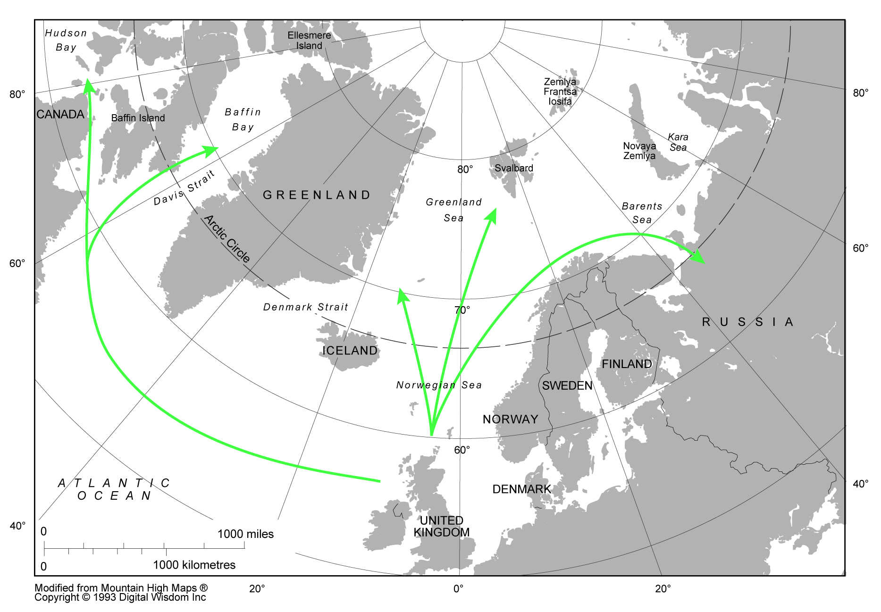
Map 4.4. The hunt for resources from the sixteenth to the nineteenth century
(Modified from Mountain High Maps Copyright 1993 Digital Wisdom Inc.).

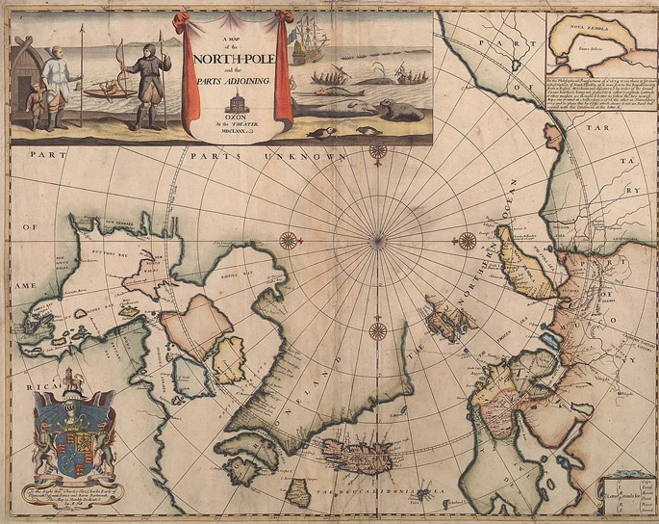
Map 4.5. Map of the North Pole published in the English Atlas
(Source: Canadian Geographic, 2013).

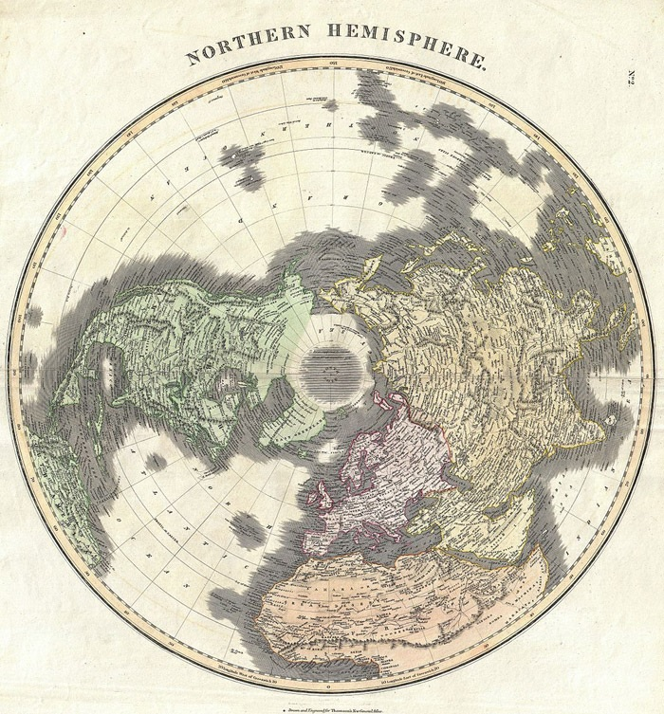
Map 4.6. Map of the Northern Hemisphere by John Thomson
(Source: Canadian Geographic, 2013).

The development of resources in the Arctic also had more direct consequences in England (later Britain), not least in the way that the fortunes of various cities were caught up with the whaling industry. The British Arctic Whaling Unit (BAW) at the University of Hull estimates that 35 ports (among them London, Hull, Liverpool, Exeter, Whitby, Newcastle, Sunderland, Lynn, Scarborough, Dartmouth, Dundee, Aberdeen and Peterhead reflecting a broad geographical spread across England and Scotland), hundreds of ships and thousands of men were actively involved in the Arctic whaling industry in the eighteenth century. Moreover, whale oil, whale bone and baleen became important everyday commodities in the lives of British citizens, providing thousands more with work in the manufacturing industry to both power the whaling industry (for example, through shipbuilding) and to make use of the resources that were being returned (in lamps, machine lubricants, soaps, paints, dress hoops and corsets). The BAW also notes that the Arctic whaling industry performed a valuable service to the British State by providing “regularly seagoing employment” to hundreds of mariners who might serve the Royal Navy in times of war. However, the whaling industry never proved sustainable. British whaling was part of a much broader European endeavour, producing competition especially with Dutch and French (and later American) whalers. In addition to conflict with other whalers, the BAW suggests that, in the seventeenth century, overfishing forced whalers further and further north towards Arctic pack ice making whaling more dangerous and profits less certain. The assemblage of British-Arctic relations brought about by the British Arctic whaling industry was ultimately dependent on sufficient stocks of whales, access to whaling grounds and demand for whale products. In the end it was a combination of overfishing and loss of demand for whale products in the nineteenth century that started the terminal decline of British Arctic whaling (although the last British Arctic whalers survived until the beginning of the twentieth century).
By the early nineteenth century, then, it was predominantly the northwest Arctic Ocean that remained unexplored. The search for a passage through the northeast was all but abandoned as British attention centred on the North American continent. As well as a narrower geographic focus, this nineteenth century assemblage of British interest in the Arctic was also dominated by different actors. While the first wave of expeditions to search out ‘northern passages’ had been underpinned by merchants seeking lucrative gains in Asian markets, and the hunt for resources by companies with Royal Charters, the second wave of expeditions launched in the nineteenth century were led by the Admiralty of the Royal Navy. The involvement of the Admiralty brought a different assemblage of actors, sites and practices to the fore in the search for the Northwest Passage. The narrower geographical focus has already been mentioned but it should also be noted that the timing of the second wave of expeditions followed a specific development: English whalers operating in waters to the west of Greenland had brought back reports of changing sea-ice conditions that suggested the frozen ocean was in retreat. This changing materiality provided an opportune moment for a renewed attempt on what was still a vastly unexplored part of the Arctic, including the possibility of discovering an Open Polar Sea; a theory which still found support in the nineteenth century, not least from the Second Admiralty Secretary John Barrow, who has been accredited as an important driving force behind the renewed search for the Northwest Passage (Craciun 2010).
The Admiralty also appeared motivated by more practical concerns. With the ending of the Napoleonic Wars (1799-1815), the Royal Navy was left with an excess of ships and officers. Many of these ships were ‘bomb ships’ with strengthened hulls suitable for attempting to push through pack ice, while officers were seeking opportunities to advance their careers (Maxtone-Graham 2000; Hill 2008). The Second Admiralty Secretary, John Barrow, who has been widely accredited with driving forward the renewed search for the Northwest Passage saw in these expeditions the opportunity to make use of spare ships and enhance the careers of Royal Navy officers. Such expeditions would also maintain a large stock of well-drilled sailors used to operating in tough environments and available to be pressed into service should there be another war.
A further motivation stemmed from the Admiralty’s belief that to discover the Northwest Passage would bring a great deal of glory and prestige to the British Empire. As Barrow recorded in 1846, to have not gone in search of the Northwest Passage (and the Open Polar Sea through which it must necessarily pass) when the sea-ice appeared to be receding “would have been little short of an act of national suicide; or to say the least of it, an egregious piece of national folly” (Barrow 2011, p. 16). The thought that any nation but the British should make this discovery was a powerful motivation for Barrow.
What is significant about this period from 1500 to 1990 to the argument made in this chapter is how the question of proximity seemed to be of little consequence to the expression of British interests in the Arctic – the Arctic was terra nullius, part of an unending frontier for European explorers. The very fact that Barrow and others tended to discuss the ‘Arctic regions’ (plural) furthermore suggests that there was little conception of the Arctic as a single, discreet region before the twentieth century (the Arctic was not even fully mapped until the twentieth century). The question of Britain’s topographical proximity was broadly irrelevant to the extent that Britain’s presence in the Arctic manifested in terms of its actions and interests, rather than needing to be justified by natural geography. Even the religious conviction that underpinned the divine claim of early explorers appears more rooted in the sense of the English nation as supported by God, rather than because the geography of the British Isles somehow awarded it primacy over the Arctic. When Barrow justified his attempts on the Northwest Passage in the 1840s he talked about the history of British endeavour in the Arctic, not its natural geography (Barrow 2011). Moreover, attempts by British explorers to ‘inhabit’ Arctic sea-ice as if it were another terrestrial space, are suggestive of a belief that the British Empire could manifest anywhere providing little reason to justify Arctic interests in terms of geographical proximity to the British Isles (Craciun 2010). All this is not to say geography did not matter from the sixteenth to the nineteenth century, only that it did not appear to provide an a priori justification for British activity in the Arctic. Geography was only one of many constitutive elements in this activity.

4.3 Britain and the Arctic as continuous spaces (1900-1980)
By 1914, on the eve of the First World War, British interest in the Arctic had markedly diminished. British presence in the Arctic had already been reduced in 1880 by the transferral of Britain’s ‘Arctic’ territories in North America to Canada. The high profile British presence in the Arctic for much of the nineteenth century had given way to a more distanced relationship, maintained primarily through the learned societies in London. In particular, the Royal Geographical Society (RGS) remained an important site for the discussion of the latest expeditions to the Arctic, albeit ones carried out by foreign explorers such as Fridtjof Nansen, Roald Amundsen and Robert Peary. The British government, however, having given up on Arctic exploration largely as a consequence of the intractability of the frozen ocean, was more focussed on expeditions to Antarctica and the race for the South Pole (perhaps more comfortable with a terrestrial rather than a maritime environment – see Craciun 2010). Amundsen’s success navigating the Northwest Passage (1903-1906) and Peary’s attaining of the geographic North Pole (1909) left little else to interest British explorers in pursuing further expeditions to the Arctic (albeit there were still areas of the Arctic Ocean to be mapped beyond Greenland – see Map 4.7). 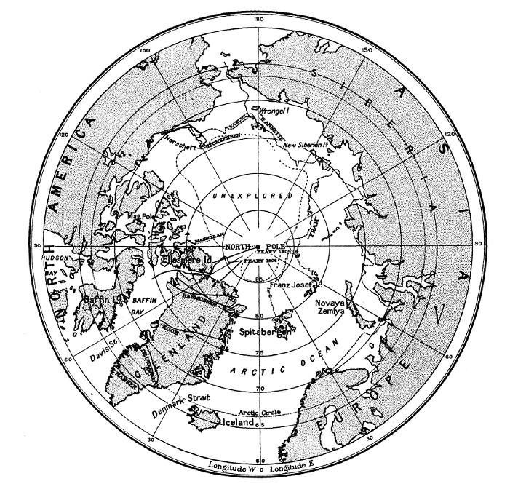
Map 4.7. Map of the North Pole in 1920
(Source: Debenham 1921).

As Clements Markham of the RGS noted in 1902 the exploration of the Arctic was nearly over. Specifically, he pointed to the voyages of the Norwegian explorer Fridtjof Nansen as having “finally removed the veil which concealed the secret of the Arctic Regions” (Markham 1902, p. 482). Quite what this secret was, or whether there were multiple secrets, is unclear, although one might speculate that it related primarily to filling in the empty spaces of Britain’s Arctic maps with a sense that the Arctic was now ‘known’.

4.3.1 Strategic proximity
It was not until the First World War started in 1914 that the Arctic – or at least the European Arctic – became a significant issue again for the British government. Despite a lack of government interest since the late nineteenth century, British actors were still active in the Arctic in the early twentieth century. The depletion of fish stocks in Britain’s near waters saw British fishermen begin to venture further out towards Iceland, Greenland, Bear Island and the White Sea. British companies were also engaged in coal-mining on the Spitsbergen archipelago. As such British actors were engaging with different kinds of Arctic materiality. Fish and coal were being exploited instead of whales, and this, in turn, refigured the geographical scope of British-Arctic relations, shifting it from the Northwest Passage and the North Pole (prominent in the nineteenth century) to the European Arctic. These connections assumed strategic importance after the outbreak of the First World War. For example, in 1917, the Council of the RGS wrote to the British Secretary of State for Foreign Affairs warning of the threat that Germany might pose should it take control of the Spitsbergen archipelago. Significantly, the letter stressed Spitsbergen’s “relative proximity to the British isles…only some sixty to seventy-two hours steaming from Scottish ports” (RGS 1918, pp. 246-7). The Council advised that Britain should seek a resolution of the sovereignty issue in order to keep Spitsbergen out of German possession.
In 1918, parliamentarians were also discussing the threat to British interests posed by German submarine operations around Spitsbergen (HC Deb, 18 June, 1918). Moreover, the collapse of the Eastern Front and Russia’s descent into Civil War led to a brief expansion of the British war effort in the Arctic. Archangel and Murmansk in northern Russia were suddenly of much greater concern due to the stockpiles of munitions and food supplies that the Allied forces had sent there to reinforce Russia. Unwilling to allow these supplies to fall under German or Bolshevist control, the Allied forces continued to maintain troops (including 15,000 British soldiers) in the region until 1919 to safeguard Allied war material and support the ailing Provisional Russian Government in its fight against the Bolshevists (HL Deb, 20 Feb, 1919). Throughout this period (1918-19) the sea lines of communication that passed through Arctic waters to northern Russia were therefore also of critical interest to Britain.
The assemblage of British-Arctic relations that emerged during the First World War saw British interests in the European Arctic entangled with the strategic concerns of the war. In strategic terms, the European Arctic was constructed as part of a continuous space extending from the British Isles where British domination had to be achieved in order to protect British interests. The relative absence of sea-ice in the warmer waters of the European Arctic was no doubt significant here since it helped produce the conditions under which German forces might threaten Britain from the European Arctic (whether by cutting of sea lines of communication to Russia, attacking British interests on Spitsbergen, or using Spitsbergen as a launch pad for an attack on Britain itself).
The materiality of the Arctic encountered in the European Arctic during the First World War exhibited a different kind of agency to that seen in the assemblages described above from the sixteenth to the nineteenth century. These earlier assemblages had broadly gathered around two problematics: finding a maritime passage through the frozen ocean and the development of resources. In the case of the first problematic, the frozen ocean posed a material barrier to British interests. In the case of the second problematic, the materiality of the Arctic (especially around Greenland, Iceland and Spitsbergen, as well as the northern territories of North America and Russia) was relevant to the extent that it could be tapped for various kinds of resources (furs, whale oil, baleen, among others), but was also vulnerable to overexploitation. However, the problematic defining the First World War assemblage of British Arctic interests was the relative permissiveness of the European Arctic – a consequence of the warmer waters stretching from the Norwegian Sea to the Barents Sea. The same problematic emerged for Britain during the Second World War. The coming together of the war in Europe with the permissiveness of the European Arctic to the conduct of war similarly demanded the conceptualising of the European Arctic as an extension of the strategic space of the Second World War. This essentially demanded the filling of European Arctic spaces with military forces to protect convoys and sea lines of communication between Britain and northern Russia. British forces were also active in Northern Norway as part of a struggle to secure and disrupt weather stations providing critical information to the war effort further south (Liversidge 1960).
From the sixteenth to the nineteenth century, English and later British activity in the Arctic was certainly facilitated by Britain’s relative topographical closeness to the Arctic but was arguably not a defining feature. The sense that Britain’s destiny lay in the Arctic was perhaps more rooted in religious conviction, technological capability and emerging sense of ‘Empire’ that fostered the belief that there was nowhere in the world that Britain could not go (and in that way Britain’s topographical proximity to the Arctic was relatively unexceptional). In contrast, the wars in Europe during the First and Second World Wars rendered Britain’s closeness to the European Arctic problematic. The threat from Germany demanded the European Arctic was included in strategic maps of the two world wars. A similar demand occurred during the Cold War – the overriding framing of Britain’s geographic position – as one corner of the Greenland-Iceland-UK (GIUK) ‘gap’ (see Map 4.8) – positioned Britain as an important gatekeeper to the North Atlantic Ocean and the European Arctic. In strategic terms, even the Spitsbergen archipelago was being rendered proximate in some quarters (by the RGS, for example). However, geography was still only one of a number of co-constitutive elements in this strategic assemblage. Other elements included the fact that Britain was by far the most fortified and capable European NATO member, in military terms, meaning that it was best placed to defend the ‘gap’ (Western forces stationed on Greenland and Iceland were small in comparison).
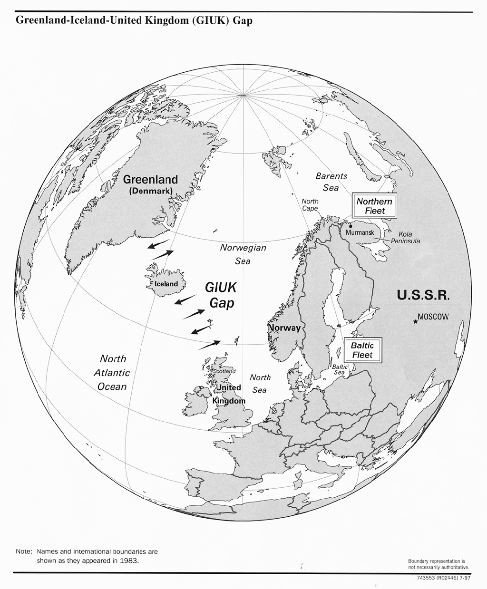
Map 4.8. The Greenland-Iceland-UK Gap
(Source: Fisher 1997).

The ratcheting up of tensions between NATO and the Soviet Union in the 1970s and 1980s (the so-called ‘Second Cold War’) brought greater urgency to the problem of Britain’s geographical proximity to the Arctic. The establishing of the Study Group on Northern Waters and the Arctic (SGNWA) at the Scottish Branch of the International Affairs was responsive to this. The focus of the Study Group was suggestive of how Britain’s principal strategic interest in the Arctic continued to be related to the warmer maritime spaces of the Atlantic and the European Arctic which bordered the Arctic Ocean (see Map 4.9). Archer and Scrivener described these spaces as important because of “the areas they join”, providing sea lines of
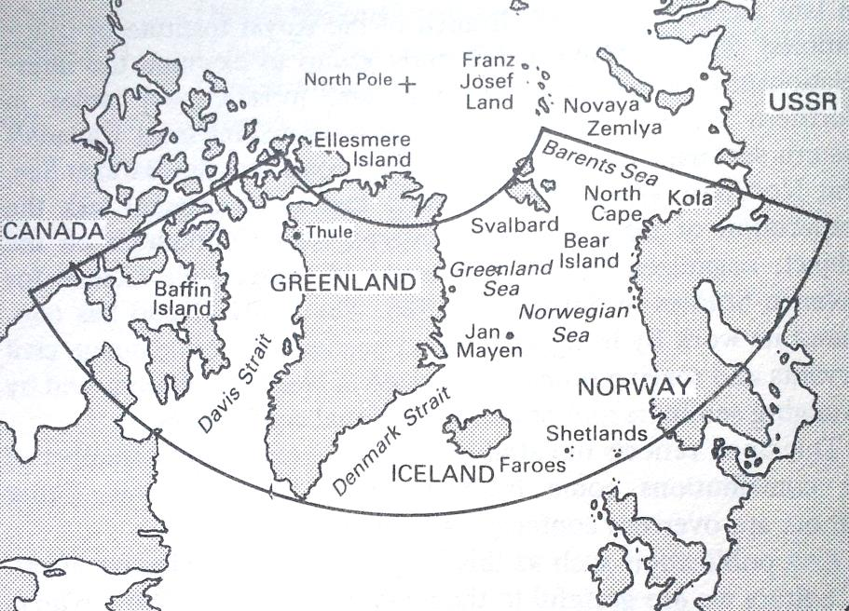
Map 4.9. The ‘Northern Waters’
(Source: Archer and Scrivener 1986).

communication between North America and Western Europe, as well as the approaches to the Arctic Ocean (Archer and Scrivener, 1986, p. 1). However, they also mattered for their economic value (as a source of living and non-living resources feeding the economies of North America and Western Europe), not least because of the potential risk this posed for NATO unity, as demonstrated by the ‘Cod Wars’ between Britain and Iceland over fishing rights in the 1950s and 1970s (Jónsson 1982). Another way British military planners conceptualised ‘northern spaces’ was as part of NATO’s broader definition of the ‘Northern Flank’ (Till 1988). The terminology of the Northern Flank encompassed the terrestrial interests of NATO’s Nordic members as well as the maritime spaces defined as the ‘Northern Waters’ (Archer 1988b). However, whether defined as the ‘Northern Waters’ or the ‘Northern Flank’, what was common to both assemblages of British strategic interest was that British relations with the Arctic continued to be defined in terms of a continuous strategic space delimited in this case by the extent of the ‘Northern Waters’/‘Northern Flank’ (see Map 4.10). Moreover, Britain’s presence in these mostly European Arctic spaces was demanded by the strategic imperatives of the Cold War.
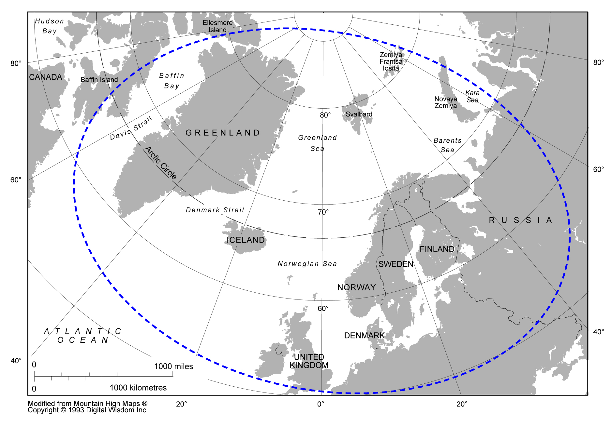
Map 4.10. Britain and the Arctic imagined as a continuous strategic space
(Modified from Mountain High Maps Copyright 1993 Digital Wisdom Inc.).

4.3.2 Material proximity
The strategic imperatives of the two world wars and the Cold War underpinned an assemblage of British-Arctic relations that centred attention on both the challenges (for example, the defence of the GIUK gap) and the opportunities (for example, the reinforcement of Norway) relating to the strategic space Britain shared with the Arctic. However, this was not the only way in which Britain related to the Arctic in the twentieth century. Also significant were Britain’s extensive scientific and economic interests. Attending to these is important because they are suggestive of two further developments in British-Arctic relations in the twentieth century; the development of a scientific understanding of Britain’s shared materiality with the Arctic (rooted in shared geography, oceanography, meteorology and ecosystems); and the development of new legal-political barriers to British economic interests (discussed in section 4.4. below).
Evidence from debates held at the RGS after the First World War is suggestive of the extent to which what British interest remained in the Arctic was primarily underpinned by the need for further scientific investigation rather than the pursuit of national glories. In 1920, for example, Frank Debenham, the first director of the newly established Scott Polar Research Institute (SPRI) at the University of Cambridge triggered a discussion at the RGS on the future of polar exploration in which he argued that there was a growing body of opinion that expeditions to the poles were no longer about discovery:
“In the past the keynote of pioneer geographical work has been discovery – the search after new facts; in the future it must inevitably become to a greater and greater extent exploration, with its concomitant research into the detail of geographical factors already known in outline and into their bearing upon human polity” (Debenham 1921, p. 183).

For Debenham, the need to more deeply investigate the Arctic was also underpinned by economic incentives:
“It may be said at once that, judged by the past and over a long period, polar exploration in the northern hemisphere has paid. It is characteristic of polar work that the avowed objects of most expeditions have rarely been attained, but that in the course of those attempts, discoveries were made of much value” (Debenham 1921, p. 186).

This was, for Debenham, a role that would be fulfilled by SPRI as it pursued its objective to become a new “centre for polar research” comprising research rooms, museums, records, libraries and other collections (Debenham 1921, p. 198).
SPRI elevated the University of Cambridge as a key site/actor in British polar science and geography. However, polar science was also being developed in other academic institutions. The lack of State funds for Arctic expeditions saw the emergence of the universities of both Cambridge and Oxford as the main proponents of scientific expeditions to the Arctic from the 1920s onwards. Both universities organised multiple expeditions to Greenland, Spitsbergen, Iceland and the Canadian Arctic, typically with financial support from the learned societies (including the Royal Geographical Society, the Royal Geological Society and the Royal Society), financial endowments and personal funds of those involved in the expeditions. There was also some support from the Admiralty, a reflection perhaps of its growing strategic interest in the European Arctic. James Wordie of the RGS would eventually note that these expeditions “marked a completely new phase of Arctic exploration from this country” (Chetwode et al. 1939, p. 133). In 1931, the SPRI began cataloguing these expeditions in the journal Polar Record, the first issue of which set its aim as “an attempt…merely to record the chief polar events…a resume of polar news…international in scope” (Polar Record 1931, p. 1). That such a record was deemed necessary suggested there was something almost banal about polar expeditions in this period as new knowledge and new technology (most notably the advent of the aeroplane) combined to facilitate much greater access to both the Arctic and Antarctica. Moreover, that this journal was produced in Britain was also suggestive of the prominent role British scientists and geographers were playing in the scientific investigation of the Arctic in the interwar period.
In the context of this chapter, these university-led expeditions were especially significant to the extent that they sought to further scientific understanding of how Britain and the Arctic possess a shared materiality. Most of the expeditions undertaken by the universities of Cambridge and Oxford (as recorded in the journals of the RGS and the SPRI) were concerned with the investigation of geology, meteorology, ecology and ornithology, essentially connecting these physical characteristics of the Arctic with those of Britain. This, in turn, strengthened the scientific basis for seeing Britain and the Arctic as possessing a shared materiality,
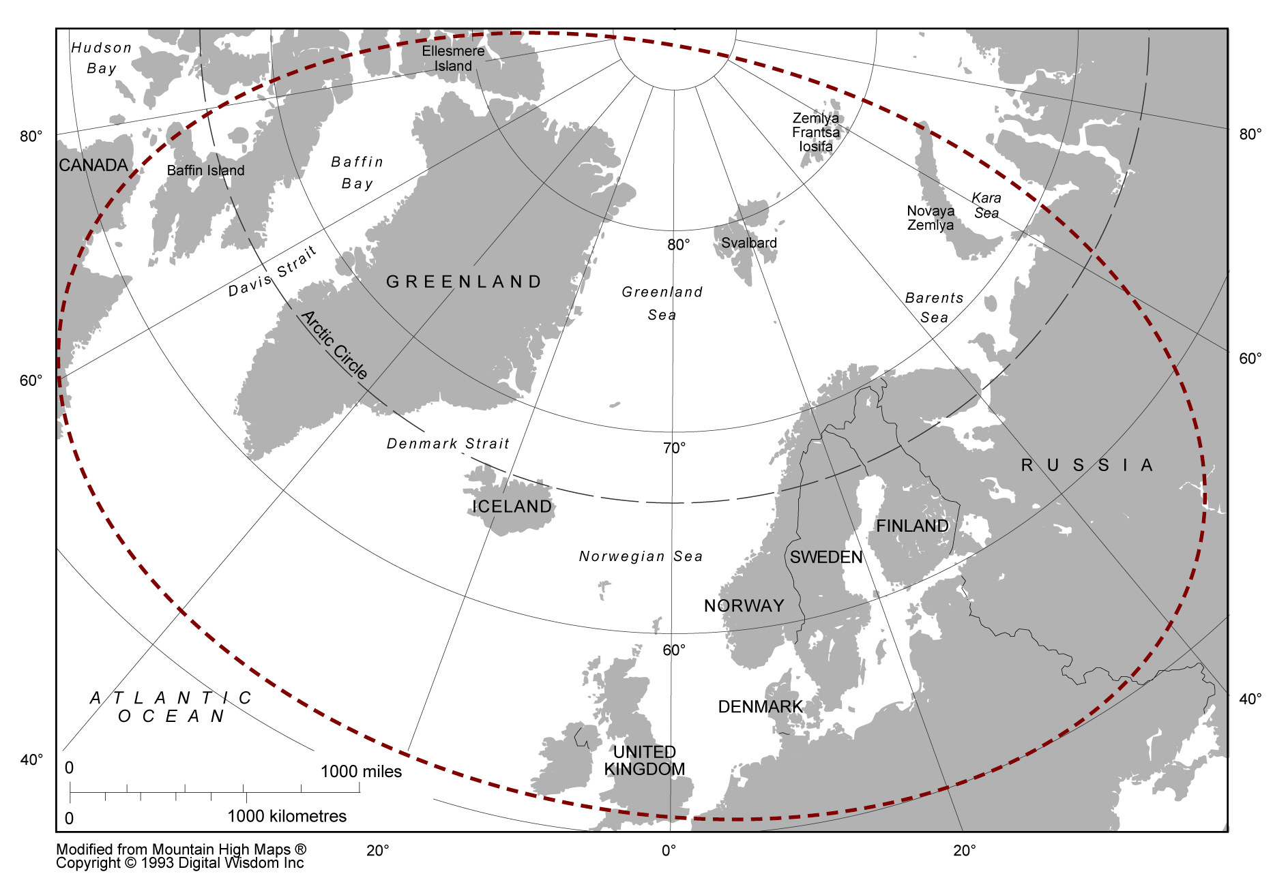
Map 4.11. Britain and the Arctic imagined as sharing material features
(Modified from Mountain High Maps Copyright 1993 Digital Wisdom Inc.).
rooted, for example, in the identification of parts of Scotland as geologically sub-Arctic, as well as in shared ecosystems. Significantly, just as the strategic imperative of the two world wars and the Cold War had created a sense of shared British-Arctic strategic space, this scientific sense of shared materiality between Britain and the Arctic was also rooted in the physical topographical proximity of the British Isles to the Arctic (Map 4.11).

4.4 Disrupting British-Arctic relations (1980-present)
The emergence of assemblages of British-Arctic relations rooted in the strategic imperatives of the two world wars and the Cold War, as well as the scientific investigation of the Arctic, are indicative of how Britain and various Arctic regions have been produced as occupiers of shared space (whether one thinks in terms of ‘strategic space’ or ‘material space’). What these logics shared with those from the sixteenth to the nineteenth century was that neither was dependent on an a priori justification of British interest in the Arctic rooted in geographical proximity. Prior to the twentieth century, the imperial imagination associated with the emergence of the British Empire was suggestive of the way the Arctic regions were thought of as just another part of the world where Britain would try to extend its empire. During the two world wars and the Cold War, the Arctic regions became part of a shared strategic space of concern to military planners. Meanwhile for scientists, shared physical materialities were being discovered, rather than assumed. In all of these cases, Britain’s geographical position was a constitutive element in, rather than the cause of, their assembly.
However, while Britain’s proximity to Arctic regions was being assembled according to strategic and scientific logics, other kinds of logic emerging in the twentieth century would eventually prove disruptive to this notion of proximity. Two of these logics – the assertion of sovereign rights and geopolitical boundaries in the Arctic – have been fundamental to a political-legal process that, by the 1990s, positioned Britain firmly outside a newly defined, discreet Arctic ‘region’. In 1925, the Canadian government amended its Northwest Territories Act to extend its sovereignty claim in the Arctic as far as the North Pole according to the sector principle. This decision made Canada the first State to establish a formal claim of sovereignty in the North American Arctic. In Europe, the Treaty of Spitsbergen had also come into force, establishing Norwegian sovereignty over the Spitsbergen archipelago. A year later, the Central Executive Committee of the Soviet Union declared that all lands and islands between the Soviet Union and the North Pole lay under its sovereign jurisdiction (also according to the sector principle). These claims formed the subsequent basis for the carving up of large swathes of the Arctic that would eventually bring much of the region under the sovereign authority of the eight Arctic States (Canada, Russia, Norway, Finland, Sweden, Denmark and the United States).
The struggle to assert sovereignty in Arctic regions was also bound up with broader developments in maritime law. After the Second World War a number of States (among the first were Chile, Peru and Iceland) sought to extend their territorial waters from the customary three nautical miles to up to twelve nautical miles, as well as declaring Exclusive Economic Zones (EEZ) of up to 200 nautical miles primarily to protect fishing rights. Together with the proclamation in 1945 by the US that it possessed exclusive rights to the natural resources of the subsoil and sea-bed of the continental shelf extending from the US beneath the high seas, these political developments provided the basis for the eventual negotiation of the United Nations Convention on the Law of the Sea (UNCLOS), signed in 1982. Under UNCLOS, every signatory was given the right to declare territorial waters up to twelve nautical miles and an EEZ of up to 200 nautical miles. Moreover, any signatory was allowed to extend its sovereignty beyond the limits of its EEZ if it could prove that the sea-bed was an extension of a continental shelf originating from its shores.
Over the course of the twentieth century, then, new geopolitical boundaries were being drawn-up around the Arctic regions, enforced by the authority of the Arctic States and later the UNCLOS. Since Britain no longer possessed any Arctic territories (having passed these to Canada in 1880), it was very much on the outside of these geopolitical developments. Whereas in the past British actors had enjoyed unfettered access to the Arctic on the basis of their capacities as naval and scientific expertise, this access was increasingly being complicated by these geopolitical developments. The implications were different depending on the actors involved and which part of the Arctic was being accessed. The Cold War with the Soviet Union meant that British actors were largely cut off from the Soviet Arctic. However, elsewhere Britain retained considerable access to Arctic regions as a consequence of relations with the other Arctic States (most of which were NATO allies). British capabilities for Arctic science and NATO helped ensure military and scientific actors continued to gain relatively easy access to the area described by Archer and Scrivener as the ‘Northern Waters’ (see above).
However, for Britain’s economic actors, especially the British fishing industry, the new geopolitical boundaries proved more challenging to negotiate. This was manifest most explicitly in the three ‘Cod Wars’ that occurred between Britain and Iceland between 1958 and 1976 (Jónsson 1982). The Cod Wars were conflicts over fishing rights around Iceland. From 1958 onwards, Iceland progressively extended the boundaries of its exclusive fishery zone to keep other European fishing nations such as Britain away from Iceland’s fish stocks. Britain resisted each attempt, often leading to violent skirmishes, but was ultimately forced as a consequence of international pressure to accept Iceland’s rights to impose an exclusive zone extending 200 nautical miles from its shores. The problems facing the British fishing industry were further compounded by the development of a common fisheries policy by the European Community which substantially reduced Britain’s ability to fish in Norwegian and Russian waters.
The development of new geopolitical boundaries in the Arctic attracted scholarly attention in the 1970s. In 1978, Terence Armstrong, in collaboration with two North American scholars George Roberts and Graham Rowley, published what at the time became a definitive textbook of the political and economic geography of the Arctic and sub-Arctic regions. This work drew together many of the scientific discoveries of the twentieth century in a compendium outlining the political and economic value of the circumpolar Arctic. Significantly, as the title – The Circumpolar North – suggests Armstrong et al. were intent on producing the Arctic as a single, discreet region defined by a concept of circumpolarity that united Canada, Russia, Norway, Iceland, Denmark, Sweden, Finland and the United States as ‘Arctic States’ (Armstrong et al. 1978). The primacy of these States is asserted through the dedication of separate chapters to their Arctic features. Britain, as can be observed from the following map drawn from Armstrong et al., was situated as just outside this emerging region (see Map 4.12).
Armstrong et al. concluded The Circumpolar North with a prediction that “it is unlikely that the circumpolar countries will ever become an exclusive group”, a stark reflection of the Cold War context in which they were writing (Armstrong et al. 1978, p. 278). Nevertheless, by the late 1980s, their description of the Arctic as a discreet ‘circumpolar’ region was being turned into a geopolitical reality. As I have
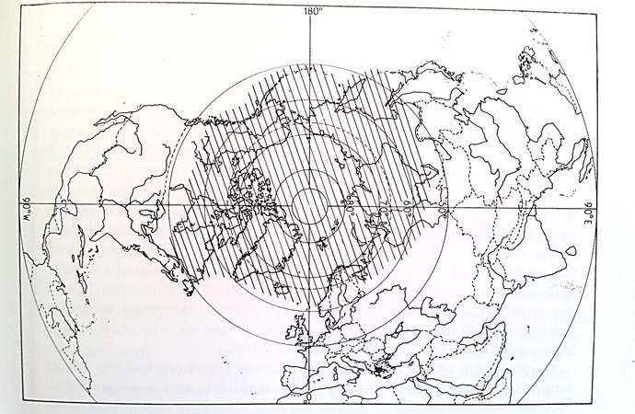
Map 4.12. The extent of the Arctic and sub-Arctic regions as defined by Armstrong et al. is indicated by the shaded area (Source: Armstrong et al 1978).

indicated with a colleague elsewhere, the term ‘circumpolar north’ swiftly appeared to gain popularity after 1978 (Depledge and Roberts, n.d.). Further momentum for international negotiations between the so-called ‘Arctic-rim States’ (the terminology of which suggested that large parts the Arctic Ocean might still have been understood as exempt from sovereignty claims) was generated in 1987 when the then-Soviet Premier, Mikhail Gorbachev, called for a joint effort from both the Eastern and Western blocs to lower military tensions in the Arctic. Gorbachev declared this was “for the benefit of national economies and other human interests of the near-Arctic states, for Europe and the international community” (Gorbachev 1987, p. 4).
By the early 1990s, international negotiations were underway between the Arctic-rim States. In 1990 the International Arctic Science Committee (IASC) was established. This was followed by the Arctic Environmental Protection Strategy (AEPS) in 1991. Non-rim States with considerable interests in the Arctic – especially relating to Arctic science – including Britain were only allowed to join these organisations later, and in the case of the AEPS, only as an observer. Effectively, a division between Arctic and non-Arctic States was being institutionalised, underscoring the fact that only eight States could claim sovereign rights in the Arctic. As such, these negotiations reflected the growing institutionalisation of a circumpolar Arctic ‘region’ (Keskitalo 2004; Heininen & Southcott 2010; Powell 2011). As Carina Keskitalo notes in her research on the construction of this discreet Arctic ‘region’:
“the end of the Cold War in particular yielded the possibility to organize on a circumpolar basis and beyond traditional security concerns into the eight-state region” (Keskitalo 2004, p. 3).

The establishment of the Arctic Council in 1996 further cemented the primacy of the eight Arctic States, while those States with long historical legacies in the Arctic (including Britain, France, and the Netherlands, among others) were placed firmly outside the newly assembled Arctic ‘region’.
Nevertheless, the emphasis placed on international scientific cooperation in the Arctic since the end of the 1980s helped constitute the means through which Britain could seek to retain a presence in the Arctic. This presence, however, appears to have related more to British polar science capabilities than its topographical proximity to the Arctic. In 1986, the National Environmental Research Council (NERC) created a Polar Sciences Committee (PSC) tasked with developing an appropriate remit for coordinating British scientific interests in the Arctic. Specifically, the PSC established a working group to produce Britain’s first strategy for Arctic science in what was essentially the first attempt at figuring out what the Arctic science community in Britain was capable of achieving collectively (Cox, 24 Jun 2014). Significantly, this strategy document, titled ‘Britain and the Arctic’, stresses that Britain’s long history of scientific endeavour justified the bolstering of its scientific presence in the region (for example, by pursuing membership of IASC) (NERC 1989). Moreover, it describes British science as a national asset that essentially underpins and enhances Britain’s continued international status and influence in the Arctic (NERC 1989).
The centrality of science to the continued projection of British influence into the Arctic was further reinforced by the NERC’s decision in 1990 to establish a National Arctic Research Forum (NARF) to act as a forum for information exchange between Britain’s national research councils, government departments, the SPRI, the University of Aberdeen and the British-based oil company BP (which had been developing onshore oil resources in Alaska since the 1960s) (SGNWA, 15 February 1991). The NARF was used to coordinate Britain’s application to join the IASC. This application process was itself significant to the extent that it was indicative of the increasing pressure on Britain in the early 1990s to prove it was an ‘Arctic actor’. The IASC’s founding membership had consisted of the eight Arctic-rim States – it was made clear to Britain that it was not a natural (geographically-speaking) member of IASC and as such would have to demonstrate its international scientific credentials for Arctic research (SGNWA, 15 February 1991). The development of a British Arctic science strategy and establishment of the NARF were both driven, at least in part, by this demand from the Arctic States that non-Arctic States such as Britain must justify their continued involvement in Arctic affairs.
This pressure was also evident in the decision taken in 1996 by Michael Richardson, the then-head of the Polar Regions Section, that his section should assume lead responsibility for British relations with the Arctic. Richardson suggested to me that “Britain risked being left out” at a time when the Arctic States were becoming increasingly inward-looking (Richardson, 9 Jul 2014). Such concerns were also evident in the minutes from a meeting of the Study Group on Northern Waters and the Arctic in April 1996 (SGNWA, 22 April 1996). In particular, anxieties were expressed that between 1992 and 1995, Britain had been perceived by the international community as having a dwindling interest in Arctic affairs, something which might even threaten Britain’s continued membership of the IASC (and although not explicitly mentioned, presumably the AEPS as well). Looking ahead, the minutes suggest there was an expectation, at least from within the Study Group, that with the NARF dissolved, the PRD and the NERC would need to rethink how to achieve better coordination across a range of British Arctic interests (including commercial opportunities, fisheries and science), capitalise on the slender resources the government was prepared to accord to the Arctic, and ensure that feedback from various Arctic-related meetings was properly reported and disseminated to British Arctic stakeholders (SGNWA, 22 April 1996). Reflecting on this, Richardson suggested to me that the key concern at the time was to find ways of demonstrating that Britain “had the capability to act in the Arctic” to ensure Britain remained part of Arctic affairs (Richardson, 9 Jul 2014). In contrast, and as I noted earlier, Richardson could not recall “the language of being just south of the Arctic Circle” being used as the basis for justifying Britain’s continued presence in the Arctic (Richardson, 9 Jul 2014).
Since the formation of the Arctic Council in 1996, the Arctic States have further strengthened their sovereign rights in the region. An oft-cited map produced by Durham University’s International Boundaries Research Unit (IBRU) is demonstrative of just how much of the Arctic is now either claimed or in the process of potentially being claimed by the Arctic States in accordance with their legal rights under UNCLOS (Map 4.13).
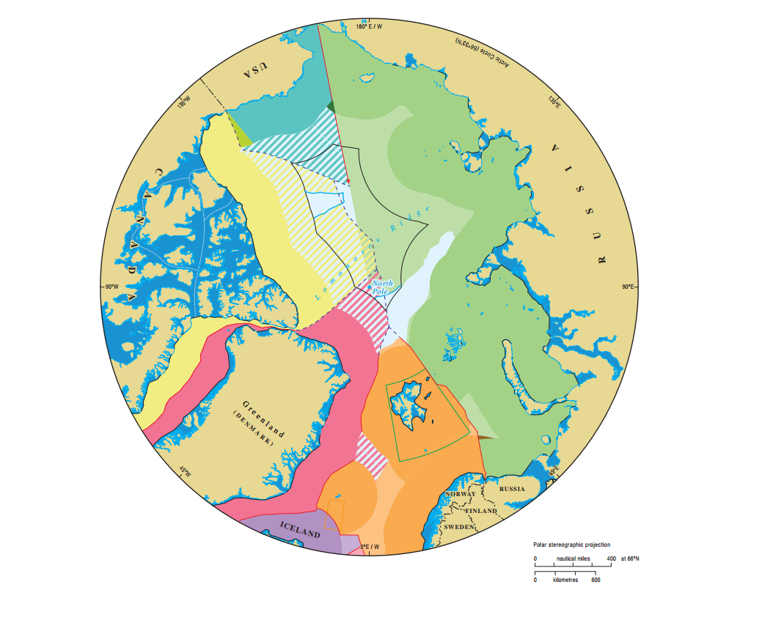
Map 4.13. The shaded areas represent the claims of the five Arctic Ocean littoral States - Canada (yellow), USA (teal), Russia (green), Denmark (red), and Norway (orange). The two unshaded areas towards the middle indicate the remaining area of the ‘global commons’
(Source: IBRU 2014).

This trend towards the reinforcement of the primacy of the Arctic States has been largely driven by a series of developments since the turn of the century. In 2000, the US Geological Survey (USGS) published the results of its ‘World Petroleum Assessment’ (USGS 2000). The assessment, which was based on the statistical likelihood of locating undiscovered petroleum resources, produced limited results about the Arctic but they were enough to attract the interest of the oil and gas industry in Britain and elsewhere (Bailey 2007). A fuller assessment of Arctic petroleum reserves, undertaken by the USGS in 2008, produced more substantial results which suggested that the Arctic might contain up to 13% of the world’s undiscovered oil reserves and up to 30% of the undiscovered natural gas reserves (USGS 2008). Although onshore oil and gas reserves have been developed since the 1960s, the findings of the USGS, when set alongside the rapid decline in the Arctic summer sea-ice minima (in 2007 the summer sea-ice minima hit a record low), generated considerable interest in the Arctic’s future offshore potential for oil and gas development. Significantly, the most accessible and abundant reserves were predicted to be discovered in areas already within the sovereign jurisdiction of the Arctic Ocean littoral States (Canada, the US, Russia, Denmark and Norway). Coinciding with the USGS assessments, the Arctic Ocean littoral States have also been gathering scientific data to help define the extent of their continental shelves, essentially to allow them to claim sovereign rights in large swathes of the Arctic. As the IBRU map above shows, these claims could potentially give Arctic States sovereign rights over most of the Arctic region, further reinforcing their primacy.
However, their attempts to do so have been complicated by non-Arctic actors (States as well as non-States) offering alternative political-legal solutions that favour a greater internationalisation of Arctic geopolitics. Prominent among these was the resolution adopted by the Parliament of the European Union in 2008 calling for:
“the adoption of an international treaty for the protection of the Arctic, having as its inspiration the Antarctic Treaty” (EUPARL 2008).

In 2010, Rear Admiral Yin Zhuo of China was reported to have commented that:
“The Arctic belongs to all the people around the world as no nation has sovereignty over it” (Chang 2010).

Moreover, in 2012, Greenpeace launched a campaign to ‘Save the Arctic’ by declaring at least part of the Arctic region a ‘global sanctuary’ (Greenpeace 2012). Nevertheless, despite these attempts, the Arctic Ocean littoral States have for their part stood by their own declaration – commonly known as the Ilulissat Declaration – issued in 2008 stating that:
“by virtue of their sovereignty, sovereign rights and jurisdiction in large areas of the Arctic Ocean the five coastal states are in a unique position to address [Arctic] possibilities and challenges” (ID 2008).

Britain’s capacity to effect change in the region is therefore increasingly limited to what is permitted by the Arctic States – primarily scientific and, more recently, emerging economic interests. There has also been demand from Norway for Britain to retain something of a military presence close to the region as a form of deterrence to any potential Russian aggression. However, none of these connections position Britain inside the boundaries of the new Arctic region. This is the context in which the British government appears to have first started to describe Britain as the Arctic’s “closest neighbour”, seemingly to naturalise Britain’s presence in Arctic affairs (FCO 2011) albeit from a position outside (yet proximate to) the Arctic region.
The continuing prominence of science as the core justification for British interest in the Arctic (as well as being the cornerstone of international cooperation in the Arctic) may well be the key to this claim – some British scientists continue to emphasise the ‘shared materiality’ of Britain and the Arctic. As Cynan Ellis-Evans, the Director of the NERC’s Arctic Office, put it to me:
“arguably we are an Arctic nation [geophysically, rather than geopolitically], we are not a rim nation but on the other hand what’s happening in the Arctic influences us and what we do influences the Arctic” (Ellis-Evans, 12 Oct 2011).

Dr Sheldon Bacon, from the National Oceanographic Centre in Southampton, also alluded to this shared materiality in his recent evidence provided to the House of Lords Committee on the Arctic:
“If you start in the Shetland Islands and go five miles west, you only have to go down 500 metres into the ocean to find a freezing cold body of Arctic water, so the Arctic is part of our territorial waters” (HL Com, 15 July 2014).

As other ways of potentially expressing Britain’s Arctic identity have disappeared over the centuries (for example, the loss of Britain’s Arctic territories, or the absence of the strategic imperative of war), it is perhaps unsurprising that the government has resorted to attempting to ‘naturalise’ Britain’s ‘Arctic-ness’ in science, particularly as a consequence of anxieties that Britain might lose its place in the Arctic affairs, both as the Arctic States tighten their grip on the region, and other actors from around the world begin to crowd Britain out. Moreover, at a time when outsider interest in the Arctic is growing more broadly, topographical science is one of the few remaining tools at the government’s disposal to distinguish Britain’s Arctic-ness from that of others who can claim similarly levels of topological connectivity with the Arctic.

4.5 Chapter summary
The purpose of this chapter has been to unsettle contemporary attempts to naturalise Britain’s ‘near-Arctic’ identity. This has been achieved by considering how English/British relations with the Arctic have changed over time. Since the sixteenth century, all kinds of assemblages of English/British-Arctic relations have emerged (and some have also dissipated), each involving different (sometimes overlapping) sets of actors, sites and practices. Viewed on a historical scale, these assemblages are suggestive of the fluid (at times overlapping) topological geographies of English/British-Arctic relations (see Map 4.14). Opening up these relations has been revealing of the quite distinct interests, geographies and histories of British scientists, merchants, explorers, naval officers and government officials in the Arctic. Britain’s past relations with the Arctic are an effect of all these relations and more, indicating the importance of looking beyond State actors when studying how Britain is connected to the Arctic, as well as the rest of the world more broadly. As a
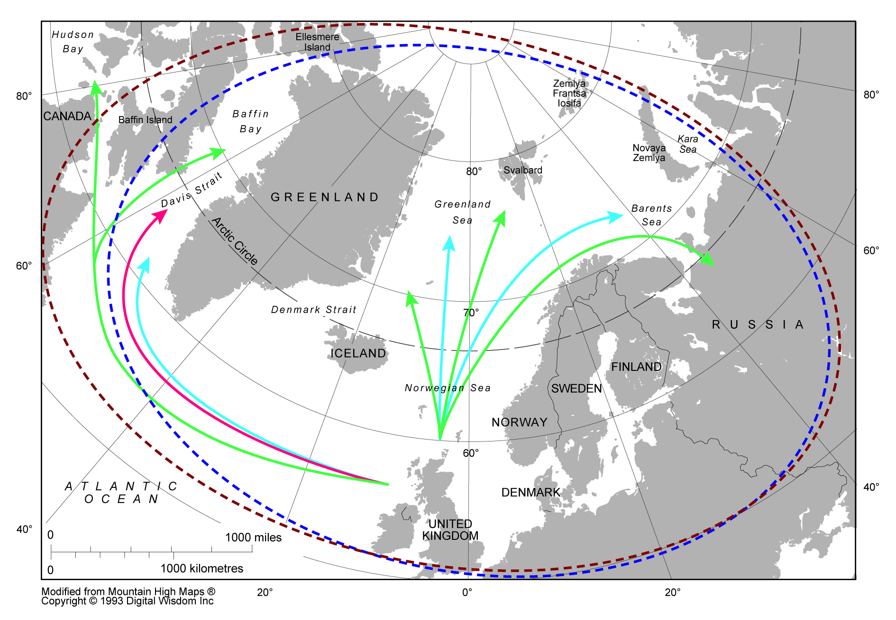
Map 4.14. A composite map showing multiple ways of thinking British-Arctic relations since the sixteenth century indicating the different kinds of geographies they produced
(Modified from Mountain High Maps Copyright 1993 Digital Wisdom Inc.).

consequence of this fluidity, the assembling of the Arctic as a single, discreet region is viewed as a modern phenomenon rooted in twentieth and early twenty-first century geopolitical settlements. Prior to this development, there was little need for Britain to attempt to justify its Arctic interests on the basis of geographical proximity. As this chapter has illustrated, over the centuries Britain’s presence in Arctic spaces has been seen as a divine right, an extension of imperial power and a strategic imperative. However, as the political and legal barriers to Britain’s on-going presence in the Arctic have increased, so too has the requirement for Britain to demonstrate its ‘Arctic-ness’. Since the end of the Cold War, Britain has been constrained by its identity as a non-Arctic State – a deference that is made explicitly apparent in contemporary policy documents that continue to emphasise the primacy of the eight Arctic States. The prominent role that science continues to play in the Arctic has leant itself to the naturalising of Britain’s Arctic identity as a proximate State. In so doing Britain is able to claim that is not just ‘Arctic’, but more ‘Arctic’ than other non-Arctic actors. The government’s hope is that this will help improve access for British actors to emerging scientific and economic opportunities as well as influence the emerging governance framework.
However, such a claim oversimplifies and to some extent masks the extent to which Britain has been and continues to be fundamentally entangled with the Arctic. Specifically it overshadows the sheer amount of labour that has constituted Britain’s past and present relations, and indeed is involved in preparing for future engagements. For more than four centuries, English/British actors have been active in discovering and mapping the Arctic regions, exploiting Arctic resources, and filling the region with bodies, ships, scientific equipment and all kinds of other infrastructure. Britain’s contemporary interest in the Arctic is rooted far more in these topological connections that allow materials, bodies and ideas to circulate between Britain and the Arctic, than it is in Britain’s natural geography. That is not to say topography has not played its part – it has been and remains a co-constitutive element of English/British-Arctic relations. However, it has not previously provided an a priori basis for expressing British interest in the region.
In unsettling this claim of Britain’s natural Arctic interests, the chapter creates the space for considering how contemporary British Arctic policy is rooted in similar labour comprising multiple sites, actors and practices. Moreover it is suggestive of the way in which contemporary interests, rather than being geographically determined, are produced through the kinds of connections that Britain continues to maintain (and has the capacity to pursue) with the Arctic. As such this chapter rejects attempts to oversimplify contemporary British Arctic policy, and Arctic geopolitics more broadly, as topographically-determined, and instead emphasises the historically contingent, if not somewhat arbitrary and precarious, nature of contemporary geopolitical settlements in the Arctic, of which Britain is a part.

5. From London and Cambridge to Ny Ålesund and beyond: actualising British policy toward the Arctic (2007-2013)

5.1 Introduction
In 2007, there were at least two major geopolitical events in the Arctic, both of which had significant material implications. The first was the Arktika expedition to the sea-bed directly below the North Pole. The expedition was privately-led and associated with the Explorers Club, an international professional society committed to exploration (McDowell and Batson 2007). The idea to dive to the sea-bed beneath the North Pole in mini-submersibles was initially developed by an Australian businessman, Mike McDowell. During the 1990s, McDowell, through his friendship with the prominent Russian scientist and parliamentarian Artur Chilingarov, found Russia to be an obvious partner in the project given its technological assets and experience of operating in Arctic waters. Logistically, then, the Arktika expedition was primarily a Russian endeavour involving Russian personnel and surface ships (including a nuclear icebreaker) as well as technologically-advanced Mir mini-submersibles and air assets. Funding for the expedition came primarily from a wealthy Swedish businessman, Fredrik Paulsen, who, like McDowell and Chilingarov, was also a member of the Explorers Club. The rest of the funding was raised in Russia by Chilingarov. Having reached the sea-bed beneath the North Pole on 2 August 2007, the expedition left behind a number of materials including a commemorative plaque, a time capsule and a small rust-proof metal Russian flag (to mark the expedition as a Russian achievement). It was this last act that caused the greatest controversy. For many Western commentators the planting of the Russian flag on the sea-bed was interpreted as a symbolic and material intervention by Russia to claim sovereignty over the Arctic, and part of a broader reassertion of Russian foreign policy that threatened to reignite Cold War rivalries with the West (Chivers 2007; Reynolds 2007; Borgerson 2007; 2008).
The second event occurred two months later when the National Snow and Ice Centre (NSIDC) in the US reported that the extent of Arctic sea-ice cover at the end of the melt season for 2007 had reached its lowest-ever level since satellite measurements began in 1979 (NSIDC 2007). A number of commentators read this event together with the Arktika expedition (and other material developments such as the release of the USGS report on potential oil and gas reserves in the Arctic in 2008) to make provocative statements about the potential for the Arctic to become a future geopolitical ‘hotspot’ based on relatively simplistic projections about future resource use, shipping potential and national interests (Byers 2009; Howard 2009; Emmerson 2010; Sale and Potapov 2010). The emerging geopolitical intrigue was further consolidated in 2008 when the five Arctic Ocean littoral States jointly issued the Ilulissat Declaration (Dodds 2008; 2013).
In Britain, these events received widespread coverage from major news outlets, with many of the stories published about the Arctic between 2007 and 2008 focussing either on the rapid sea-ice melt (Adam 2007; Eccleston 2008; Black 2008; Connor 2008), or on the Russian-led ‘rush’ for Arctic resources (Parfitt 2007; Reynolds 2007; Meo 2008). Alarmism featured heavily in these news stories as they raised the prospect of the eventual disappearance of sea-ice from the Arctic, the possibility of an international scramble for territory and resources, and the capacity of a resurgent Russia to cause conflict in the region. This alarmism also spilled over into the British Parliament. From August 2007 to November 2008, the FCO was asked by MPs on three separate occasions to publicly comment on what was happening in the Arctic, particularly with reference to the “staking of territorial claims” and Britain’s involvement in international negotiations relating to the Arctic (HC WA, 25 Oct, 2007; HC WA, 22 Jul, 2008; HC WA, 20 Oct, 2008). Ministers from DEFRA, and the newly established DECC were questioned to see what government evaluations had been made of the recent reports of Arctic sea-ice melt (HC WA, 18 Jun, 2008; HC WA, 17 Nov, 2008; HC WA, 25 Nov, 2008). The MOD meanwhile was being asked by MPs to give assurances that, in light of Russia’s “massive rearmament programme” and “naked invasion of Georgia” (in 2008), Britain could still undertake submarine and Arctic warfare (HC WA, 03 Nov, 2008).
Both the Arktika expedition, and the record summer sea-ice minima in 2007, may be seen as markers that triggered a resurgence of interest in the Arctic among a number of British parliamentarians and policymakers. It is important not to overstate the level of this interest – the former Defence Secretary Liam Fox remembers being laughed at by other parliamentarians for raising defence concerns about the Arctic in 2008 (Fox, 14 Nov 2011). Similarly, the former FCO Minister, Meg Munn recalled very little interest in Arctic affairs in the rest of Whitehall while she was in post at the FCO between 2007 and 2008. This was despite the fact Britain was a lead player in the International Polar Year (IPY) 2007-8. Nevertheless, in 2008, the FCO and the MOD were asked to conduct a “review of Britain’s longer-term strategic interests in Arctic matters and how Britain should best engage with Arctic States on issues of mutual interest” (HC Deb, 02 Jul, 2008). The FCO also commissioned the Scottish Association of Marine Science (SAMS) to produce a report on the condition of British Arctic science. This preceded the meeting chaired by the FCO in Oban, Scotland (where the SAMS is based) to assess the extent of wider British stakeholder interests in the Arctic. In January 2009, Baroness Ann Taylor, then-Minister for International Defence and Security, made reference to the development of a British Arctic Strategy in the MOD. Although this document was never made publicly available, it has been indicated to me since, by two separate former government officials, that this document was in fact a classified paper produced by the MOD’s Development Concepts and Doctrine Centre (DCDC) as part of its Global Strategic Trends Programme (GST).
The events of 2007 provide the starting point for this chapter’s examination of contemporary British interest in, and policy toward, the Arctic. By the beginning of this project in 2010, there was already growing activity among a number of British parliamentarians and policy practitioners in response to the emerging demands of the changing Arctic (in both physical environmental and geopolitical terms). This was reflected further by the Canada-UK Colloquia’s decision to focus on the changing Arctic in 2010. In 2011, following the Colloquium on Arctic issues, the Polar Regions Department (PRD) produced its first public statement on British Arctic interests (see Appendix A), essentially triggering the beginning of a public process of defining why the Arctic matters to Britain in the early 21st century. This process was somewhat precariously concluded with the publication of the government’s Arctic Policy Framework (APF) in 2013 (see Chapter 6).
Theoretically, the chapter continues to take seriously the concept of assemblage as I explore how different sites, actors and practices have been caught up in various attempts to actualise British policies towards the Arctic. The term ‘actualise’ is used to convey the sense in which British Arctic policies are socio-material-affective phenomena that exist in the world – in other words, they are more than just textual representations (McFarlane 2011a). The aim of the chapter is to show how various assemblages have emerged around Britain’s scientific, defence and diplomatic interests are sited; the various actors (human as well as non-human) involved, and the kinds of practices deployed (textual, physical, affective). In addition to complicating traditional notions of who, or what, is involved in policymaking, I also show how British Arctic policy is rarely defined or actioned in one place. Thus, what might appear to be an intensely local response to a problem – a ‘Whitehall’ response to the problem of British-Arctic relations – is found to be produced through a network of geographically disparate sites where Arctic policies are co-produced and co-implemented through a variety of actors and practices (Cochrane and Ward 2012). How these sites, actors and practices interact, are connected, or are disrupted, is therefore critical to how policies are actually realised, as well as their effectiveness.
Structurally the chapter involves the presentation of three cases from my empirical research involving the ways in which the MOD, the British Arctic science community and the PRD (embedded in the FCO) have each produced different aspects of British Arctic policy in an array of sites, involving different actors and practices. Other possible case studies might have focussed on the role of other government departments such as DECC or UKTI. However, I found these organisations much harder to access (reflecting the issues of positionality discussed in Chapter 3). The findings are summarised in the concluding section of this chapter, which also leads the way to the examination in Chapter 6 of the PRD’s attempt to capture and represent this multiplicity of policy formulations in a single apparatus.

5.2 Assembling British Arctic policies
The remainder of this chapter is used to consider three ‘policy assemblages’ from my empirical research on contemporary British Arctic policy. These policy assemblages were encountered in my various engagements with the Ministry of Defence (MOD), the British Arctic science community, and the Polar Regions Department (PRD) of the Foreign and Commonwealth Office (FCO) between 2010 and 2013. As assemblages, these policies reflect gatherings of multiple actors, sites and practices that come together to produce effects. Significantly, there is little evidence to suggest that any of these actors were acting in accordance with any single source of authority – in other words, they were not all part of a common British Arctic policy as set out by the government. Instead, between 2010 and 2013, the MOD, the Arctic science community, and the PRD all appear to have been responding to changes occurring in the Arctic in accordance with broader policy goals in which the Arctic was envisioned as a broadly unexceptional space. How these different policies might be coordinated across government was still (and arguably still is) being negotiated as part of the process that eventually led to the publication of the Arctic Policy Framework (APF) white paper. In each case, I also consider how these encounters rested on more than textual representations of Britain’s Arctic ‘actorness’, and its Arctic-related policies and interests, by attending to the material and affective dimensions of various practices through which policies were actualised.

5.2.1 Ministry of Defence
The end of the Cold War brought about a significant shift in Britain’s defence posture. During the 1990s, British defence officials demonstrated far more concern for the development of the Armed Forces’ expeditionary capabilities than the territorial defence of Europe against the Soviet Union (Coker 1992; Robertson 1997; Dodd and Oakes 1998). This shift was closely linked to Britain’s involvement in more distant conflicts around the world in places such as Bosnia, Kosovo, Sierra Leone, Iraq and Afghanistan. The collapse of the Soviet Union and Russia’s subsequent introversion in the 1990s meant that what interest remained within the MOD in the Arctic primarily related to Britain’s nuclear deterrence policy (involving nuclear-armed submarines continuing to operate beneath the Arctic sea-ice as they had during the Cold War), cold weather training in Northern Scandinavia and post-Cold War clean-up operations (Archer 2011a).,
However, by the mid-2000s, it was evident that at least parts of the defence community were once again becoming interested in the Arctic region. This seems to have been largely connected to the climate change agenda set by the Labour government (1997-2010). The latter was committed to securing an international agreement to mitigate climate change. The findings of the Arctic Climate Impact Assessment (ACIA), released in 2004, ensured that the Arctic itself was very much at the centre of debates about climate change. As part of this agenda, and on the back of academic research undertaken in the 1990s, the Blair government was increasingly voicing the argument that urgent action on climate change was needed to reduce the potential for future climate-related conflicts around the world. As Foreign Secretary, Margaret Beckett was instrumental in raising the issue of ‘climate security’ at the UN Security Council in 2007 (Beckett 2007).
In 2007, the Development, Concepts and Doctrine Centre (DCDC) released the third edition of its Global Strategic Trends (GST) programme which makes projections about future strategic issues (DCDC 2007). Already before the Arktika expedition and the record summer sea-ice minima in the summer of 2007, this document provided evidence that actors within the defence community were asking questions about the future strategic importance of the Arctic particularly as it related to energy security and sea lines of communication. However, after the Arktika expedition and record summer sea-ice minima, the level of attention to these issues increased further. A year after these events, a classified internal regional survey of the Arctic was produced by the defence community to offer a strategic assessment of the next three decades of likely change in the Arctic. Following this survey, the number of references to the Arctic in later editions of the publicly available GST increased dramatically. A simple word count shows that while the third edition in 2007 included the word ‘Arctic’ eight times, the fourth edition in 2010 included twenty references. The fifth edition published in 2014 included 145 references. This trend is suggestive of the extent to which interest from the defence community has been growing since 2007 (and especially since the election of the Conservative-Liberal Democrat Coalition government in 2010 – see below). Another indication can be taken from the reference the FCO Minister, Meg Munn, made in 2008 to a joint FCO-MOD review of Britain’s strategic interests in the Arctic (HC Deb, 02 Jul, 2008). Also relevant, was the broader deterioration of relations with Russia in 2007 and 2008 following suspected Russian-led cyber-attacks on Estonia and the short Russia-Georgia war. The anxiety this provoked in a number of NATO Member States (especially in the Nordic and Baltic regions) prompted NATO to hold a joint conference with Iceland on Arctic security. Speaking at this event, Baroness Ann Taylor, a British defence minister at the time, declared:
“we have heard several times today that just a few years ago the idea of a full-blown NATO security conference on the High North would have seemed fanciful and some might have denied the problem.

But now it is accepted that as the Arctic icecap melts the strategic significance of the region is changing. Today, in having this discussion we are explicitly acknowledging that the changing Arctic climate has serious implications for us all” (Taylor 2009).

Moreover she added:
“The UK government is evaluating the challenges and opportunities of a melting Arctic. The UK MOD has developed its first Arctic Strategy and this was endorsed by the Defence Board in December 2008” (Taylor 2009, emphasis added).

Even so, although these developments suggest the MOD’s strategic interest (as opposed to more practical interests relating to submarine-based nuclear deterrence, cold weather training and nuclear clean-up operations) in the Arctic was already growing from at least the mid-2000s, it was the election of the Conservative-Liberal Democrat Coalition government, in 2010, which appeared to trigger the most substantial shift in the MOD’s attitude toward the region. Two somewhat related-developments appear to have been key. The first was that the election of the Coalition government resulted in the Conservative MP and long-standing shadow-Defence Secretary, Liam Fox, being appointed Secretary of State for Defence. In interviews, Fox was identified by British defence officials as being behind the revitalisation of British interest in the Arctic (MOD Official I, 19 Oct 2011; MOD Official IV, 8 Mar 2012). As one British defence official put it:
“I think it’s safe to say that Liam Fox has put the Arctic on the agenda at the MOD in a way that it has not previously been” (MOD Official I, 19 Oct 2011).

Fox himself described his role to me, during an interview in his office at Westminster in 2011, as one of having been the “prime driver” – one might say an embodiment – of the Arctic agenda within the current government after having spent years (since at least 2008) pushing the issue while part of the Opposition (something which Fox admitted “used to generate hilarity within Parliament” as other MPs could not see why the Arctic mattered to Britain – Fox, 14 Nov 2011). Nevertheless, the presence of Fox and other interested officials in government, although in the minority, proved to be important enablers that ensured at least some discussion of Arctic geopolitics within the defence community.
According to defence officials I spoke with, another significant figure was Sir Gerald Howarth who served as a defence minister between 2010 and 2012 (MOD Official I, 19 Oct 2011; MOD Official IV, 8 Mar 2012). Howarth, like Fox, had raised concerns in Parliament about Russia’s ambitions, including in the Arctic (HC WA, 03 Nov, 2008). Howarth also appears to have been an important source of continuity after Liam Fox was replaced as defence secretary, convincing Philip Hammond of the importance of Britain’s strategic interests in Norway and the High North (MOD Official I, MOD Official VII, 26 April 2012).
In addition to these individuals’ personal interests in the Arctic, the second development was the decision by the Coalition government on gaining office to immediately conduct a Strategic Defence and Security Review (SDSR) to assess the role, capabilities and budget of the MOD and the Armed Forces for the first time since 1998. Although the Arctic was not directly mentioned, the decision to consider the future challenges of climate change and energy security implicitly involved reassessing Britain’s Arctic interests (most notably because of Britain’s increasing reliance on gas and oil imports from Norway and the apparent resurgence of Russia after the short Russo-Georgia war) (HMG 2010a). It was made clear to me by one defence official that although the main SDSR document may not have referred to the Arctic, the region did feature in discussions and documents that the SDSR drew upon (MOD Official I, 19 Oct 2011). Since these developments, the Arctic has remained on the MOD’s agenda, even despite the fact that one of the key actors, Liam Fox, was replaced by Philip Hammond as Defence Secretary in 2011. More than one defence official suggested that Hammond “didn’t bat an eyelid” when asked to sign the Memorandum of Understanding on Defence Cooperation with Norway, and that he was also fully supportive of the newly formed Northern Group of Defence Ministers which at the time was expected to take the High North as its focus (MOD Official I, MOD Official VII, 26 April 2012). In addition to the Northern Group which has continued to meet (albeit not always on Arctic-specific issues), the MOD has also established an Arctic desk officer (in 2013) and has undertaken another classified strategic survey of the Polar Regions ahead of the next SDSR in 2015 (discussed in more detail below).

5.2.1.1 Arctic policies
Since 2010, the MOD’s interest has primarily centred on the European Arctic and relations with Norway. This stance relates to three broader policy objectives that set the context for much of the MOD’s work (and importantly render the Arctic remarkably unexceptional). The first relates to Britain’s energy security. In 2009, the publication of the Wicks Review of Britain’s energy security helped to crystallise emerging concern in Parliament about the decline of Britain’s North Sea oil and gas reserves. Britain, the report noted, was: “moving from a position of relative energy independence to one of significant dependence on energy imports”, marking a fundamental shift in Britain’s relationship with global energy markets (Wicks 2009, p. 1). The energy security challenge had already been identified as a national security risk in the UK’s first National Security Strategy published in 2008 (HMG 2008). Liam Fox and other conservative MPs, such as Ian Taylor, then in Opposition, were particularly concerned about the need to safeguard the increasing quantity of energy imports that were coming from Norway (MOD Official I, 19 Oct 2011; Fox, 14 Nov 2011). As Taylor put it to Parliament in 2008:
“If a pipeline somewhere else is blown up, it is a problem for us if it is part of our supply. Who protects Norway? We forget that the Russians are also encroaching on the Arctic circle, and any threat to Norwegian supply would be a grave problem for us” (HC Deb, 30 Jan, 2008).

Two defence officials separately explained to me that after becoming the Secretary of State for Defence in 2010, Fox made bilateral relations with Norway a priority for the MOD precisely because he viewed Britain’s energy security to be a strategic concern (MOD Official I, 19 Oct 2011; MOD Official IV, 8 Mar 2012). Of particular concern was the potential for Norway’s push into the offshore Arctic (in the search for new oil and gas fields with which to sustain production and future exports to Britain) to demand an extension of Britain’s security reach into the European Arctic, essentially to ensure the security of the infrastructure that supplies Britain with Norwegian oil and gas. Significantly, there is evidence to suggest that there was also an affective-material dimension underpinning the concerns of both Fox and his defence minister Gerald Howarth. As a defence official explained to me in 2012, both Fox and Howarth appeared to have been personally affected by visits they had made to the Norwegian Arctic, noting that:
“until people have experienced it, they don’t realise how big and how empty northern areas are…Norway is very much on its own in the North” (MOD Official IV, 8 Mar 2012).

A second broader policy objective for the MOD relates to maintaining Britain’s military capabilities. This has relevance for the Arctic as much as it does anywhere else in the world where Britain has defence and security interests. As such, the Arctic has been caught up with extensive debates about the future of the British Armed Forces, both in terms of capability requirements and where they are likely to be operating in the future. The SDSR undertaken in 2010 actually reduced Britain’s Arctic-related military capabilities by shutting down the Nimrod maritime patrol aircraft that were capable of monitoring northern waters. However, Britain’s Arctic capabilities were already relatively small, primarily involving the on-going training of Royal Marine Commandos in Northern Norway since the 1970s. The lack of surface warships available to the Royal Navy has further limited British military capabilities in the Arctic as naval presences in other parts of the world have been prioritised. The SDSR itself was heavily criticised by both commentators and parliamentarians who suggested that the process had happened too quickly, focussing more on driving down costs than on assessing what kind of strategic role Britain should play in the world (HC 197, 2014). In preparing for the next SDSR in 2015, the MOD has been keen to ensure that it has conducted a more thorough assessment of Britain’s strategic interests, as well as the capability requirements necessary to meet them. The MOD’s growing interest in the Arctic has been reflected in this broader policy process.
A third broader policy objective, relates to Britain’s commitments to the NATO alliance. Under Article V of the North Atlantic Treaty, Britain may be called to assist any alliance member that is under armed attack. As one of the two biggest European NATO powers (the other being France), it is reasonable to expect that Britain would become involved in any major military conflict that might break out in the Arctic. While most of the Arctic members of NATO (notably US, Canada and Denmark) have downplayed the need for a NATO presence in the Arctic, Norway has been keen to stress the importance of maintaining NATO’s capacity to act in the region (for example, hosting semi-regular joint Arctic exercises for NATO members). Even without Britain’s energy interests in Norway, there is then a demand on Britain that, if required under Article V, it should be able offer military support to its allies, at least in the European Arctic. This is the MOD’s longest standing objective in the Arctic, dating back to the formation of the NATO alliance, the banality of which was captured in an interview with a British defence official who – when asked about Britain’s security interests in the Arctic – stated that “clearly we have a responsibility through Article 5 to NATO Arctic countries and Norway is really quite significant in that” (MOD Official I, 19 Oct 2011).

5.2.1.2 Arctic practices
The broader policy objectives outlined above have manifested in different kinds of socio-material-affective performances by the MOD and the Armed Forces in relation to the Arctic. Two of these performances – participation in Exercise Cold Response (already a semi-regular event before 2010) and the undertaking of a ‘Polar Regions Study’ ahead of the 2015 SDSR – are considered in more detail below. Britain’s participation in the Northern Group of Defence Ministers (which Liam Fox played a lead role in establishing) and the Arctic Security Forces Roundtable (ASFR) offer further interesting examples of how the MOD’s broader policy objectives manifest as different kinds of performances in the Arctic. However, both the Northern Group and the ASFR were much harder to research due to limited access to officials and publicly available materials. In the case of EXCR and the Polar Regions Study, my own positionality (as an observer in the former and a participant in the latter) was especially valuable for experiencing how MOD policies towards the Arctic play out in practice (on my positionality as a researcher in this project, see Chapter 3).
Exercise Cold Response
In 2012, Britain took part in a joint military exercise hosted by the Norwegian government known as Exercise Cold Response (EXCR). Fifteen nations (all members of NATO or NATO’s Partnership for Peace Programme) took part in the exercise, the purpose of which was:
“to improve and practice capabilities in high intensity- and multi-threat operations during cold weather conditions” (NJH 2012, p. 1).

Exercises like this have taken place off the coast of Northern Norway since the start of the Cold War, but for Britain, EXCR 2012 was especially significant as it was the first opportunity for MOD to demonstrate physically Britain’s military capabilities in the Arctic since the election of the Coalition government (and, importantly, the renewed emphasis in the MOD on relations with Norway). Moreover, it was the first time that the UK Response Force Task Group (RFTG) (only established by the SDSR in 2010) would exercise in the Arctic. The RFTG is the UK’s global rapid response force and as such is expected to be the most likely responder to a short-notice military contingency in the Arctic. Thus, while Britain’s participation in the 2012 rendition of EXCR was part of a historical legacy of training and exercising in the Arctic, it was also a way for the MOD to pursue two of the objectives noted above: namely, to offer a material demonstration that Britain still retained the military capacity to defend its strategic interests in the ‘near-Arctic’ (especially as this related to energy); and to provide affective reassurance to Britain’s NATO allies (most notably Norway) that it could still contribute to the security architecture of the region.
For Britain, the experience of EXCR was for the most part sited in Northern Norway, although planning and performance reviews are also likely to have taken place in London and Oslo, as well as at military ports and bases across Britain, before and after the event (essentially the circulation of bodies, hardware and texts relating to the exercises ensured that the geography of EXCR was not limited to a topographical area of northern Norway). Even so, Britain’s involvement in EXCR was in part closely predicated on the inclusion of Northern Norway in this geography. In addition to the long legacy of Anglo-Norwegian defence cooperation in Norway’s High North, the near-Arctic is of specific strategic concern to Britain due to its energy relationship with Norway. In short, the Norwegian Arctic is probably the part of the Arctic most relevant to Britain’s security in the contemporary context and as such it makes sense to participate in these exercises. Moreover, it was suggested to me by British defence officials that Britain’s proximity to Norway helps to reduce the economic cost of participation. In contrast, the North American Arctic is far more expensive to reach and is of far less strategic interest to Britain (MOD Official I, MOD Official VII, 26 April 2012).
Another important aspect of the geography of EXCR is that it was complicated by the creation of fictitious place names to use during the exercise. In ‘reality’, the exercises took place in the fjords and mountains between Harstad and Tromsø. However, this material geography was subsumed by that of the imaginative geographies of EXCR which rested on the invasion of ‘Borgland’ by neighbouring ‘Gardarland’. Taking out the ‘real’ place names was partly diplomatic – Russian authorities have been critical of such exercises, arguing they are directed at Russia – but may also have been about de-emphasising the ‘Arctic’ itself to help Defence ministries from NATO members justify their participation on the grounds that it was for ‘cold weather training’ (that would, for example, be applicable in the mountains of Afghanistan) rather than an attempt to build an unnecessary security architecture for the Arctic. Even in Britain, the primary objectives of the exercises ostensibly focussed on operational effectiveness in hostile environments, rather than the Arctic per se.
Britain’s performance in EXCR rested on a range of different actors. The Armed Forces contribution was comprised of three warships, navy personnel, helicopters and Royal Marine commandos. These forces were not selected by accident. As part of the aforementioned RFTG, it was specifically these ships, their equipment, and their crews, that needed to be entrained with capabilities to operate in the extreme conditions posed by the Arctic. In addition to these forces, MOD officials in London and Oslo provided political support for EXCR, and, presumably, the Armed Forces involved also relied on a wider support base linking them back to their bases in Britain. My own role should not be ignored. I was one of three (that we knew of) MOD-approved observers on board HMS Illustrious during part of EXCR. While we were there to undertake our own research, we also offered a channel through which the Armed Forces could communicate their objectives in EXCR to broader publics. This openness on the part of the MOD in part related to their interest in publicising Britain’s defence capabilities in the Arctic (to both domestic and international audiences).
A range of other actors also mattered to the performance of EXCR, most obviously the personnel and hardware of the other fourteen nations involved. Interoperability with these other nations is an important source of strength and credibility for Britain in the Arctic helping to magnify its presence (i.e. as part of a military alliance, and not just as Britain). Moreover, as Commander Paddy McAlpine, Commander UK Task Group observed in a press release:
“Transporting marines, vehicles and equipment to the right place at the right time, usually under cover of darkness, in freezing conditions, from three different ships using helicopters and landing craft is a huge challenge” (Royal Navy 2012).

As McAlpine’s statement implies, the Arctic was not seen as a static element in EXCR. The unpredictable weather (a consequence of dynamic wind, ice and snow conditions – for example, as ice and snow build up, markings on the flight deck are obscured posing a significant risk to helicopter operations) meant that the Armed Forces constantly had to adapt their operations to meet mission parameters. An abiding memory from being on board HMS Illustrious during EXCR was the sound at night of efforts to keep the flight deck clear of ice which could be heard throughout the officer’s deck on which we were quartered. Yet without these extreme and unpredictable conditions, bodies and hardware cannot be tested in accordance with operational aims. In other words, Britain’s capacity to act in Arctic conditions had to be demonstrated through a material encounter with those conditions, rather than inferred from other performances and texts. The unpredictability of the agency exhibited by the Arctic was therefore crucial to the performance of EXCR.
In addition to the intentions, actors (human and non-human) and sites involved in the performance of EXCR, the MOD also had to engage in various kinds of labour if it was to meet its objectives. Labour in this sense takes multiple forms. First, there was a requirement of physical labour to mobilise the UK task group (comprised of a specific set of units for the reason outlined above) and supporting structures in order to ensure the necessary British forces were present in Northern Norway for the exercises. These forces also had to be coordinated with those of the other nations involved – this was especially important for Britain since its ships were providing the springboard for joint amphibious operations involving the Dutch, US, Norwegian and British forces. The performance of EXCR itself required additional labour in the form of warship, helicopter and troop movements practiced in such a way as to meet the exercise parameters
Second, there was a requirement of textual labour which I have already alluded to above. However, in addition to the presence of ‘observers’ who would tell stories about EXCR (and, from an MOD perspective publicise Britain’s strategic Arctic interests, presence and capabilities), the MOD also had its own reporters and photographers recording events and issuing press releases emphasising both the importance and the success of the exercises. As a quote from a senior British officer carried in an article published by the Royal Navy put it:
“This has been an excellent exercise. I’m delighted with the way we worked so closely with our Dutch colleagues, building on our long-standing relationship, and I’m convinced that all personnel who took part will have benefitted hugely from the experience of operating in such a harsh environment” (Royal Navy 2012).

Time spent with the PHOT (photography) team on board HMS Illustrious was also illuminating of the extent to which the MOD wanted to be ‘seen’ to be participating in EXCR, in this case producing Britain’s Arctic presence through the production of images that provided a specific narrative of the performance – of British competence in cold weather – which was then presented on the official news pages of the Royal Navy (for examples see Fig. 5.1).
This combination of physical and textual labour also had a more intangible dimension to the extent that it was necessary for producing a certain kind of affective atmosphere around EXCR. For example, the forces that Britain sent to participate were designed to reassure both Britain’s allies, and critics at home, that Britain was committed to and capable of defending its interests in the ‘near’ Arctic. Moreover, Britain’s central role in coordinating joint operations helped to generate a sense of authority and leadership that further reinforced the centrality of British forces to the international effort. A second example of this kind of affect comes from the way in which British forces bought into the ‘fiction’ of EXCR; that there had indeed been an invasion of Gardarland that needed to be repelled under a UN mandate. Such fictions lend a sense of urgency to proceedings, which while not analogous to the ‘real thing’, do make it possible for the forces involved to experience, practice and address potential ‘what-if’ scenarios by rehearsing responses (Adey and Anderson 2012).
Taken together, the assemblage of interests, sites, actors and practices that gathered around EXCR enabled the MOD to pursue Britain’s strategic interests in the European Arctic and its responsibilities under the NATO alliance. To realise these objectives, the MOD took seriously the need to mobilise certain bodies and hardware that would essentially ‘prove’ Britain’s commitment to, and capabilities, in the Arctic. In addition to the physical manifestation of this (in the form of warships, helicopters, troops flowing into the Arctic, albeit for a limited period of time), these practices also had an affective dimension related to producing confidence among domestic and international audiences in Britain’s ability to not only be part of the security architecture of the near-Arctic, but also to lead it. The textual dimension – essentially the interviews, reports and photographs that flowed out from EXCR – was therefore only one facet of the discourse that emerged around Britain’s participation in EXCR, heavily reinforced by the MOD’s physical and affective performances.
However, it is also necessary to note that these performances were not necessarily straightforward; a simple imparting of MOD policy through bodies and materials mobilised in the Arctic. Where the objectives of EXCR for Britain were most seriously threatened was in a material collision between HMS Illustrious and a Norwegian tug boat, no doubt facilitated at least in part by the hostile environmental conditions in which they were operating, and the stress and fatigue being suffered by military bodies in the course of having to respond to a simulated reality. This accident would also have reminded the MOD (and indeed broader audiences) of the vulnerability of Royal Navy warships engaged in Arctic operations, not least because the Royal Navy still does not have any warships with ice-strengthened hulls.
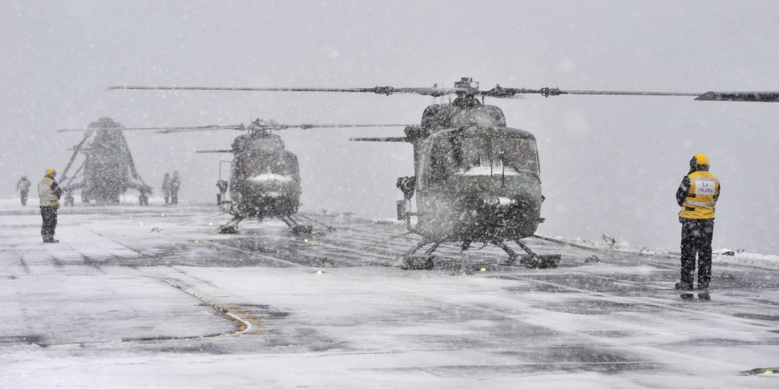
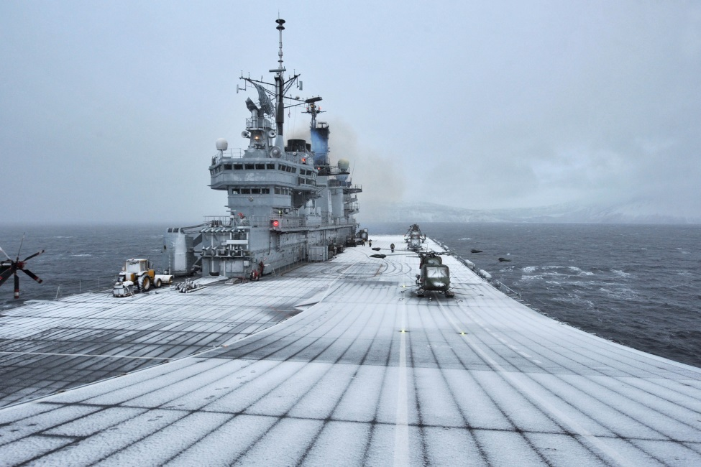
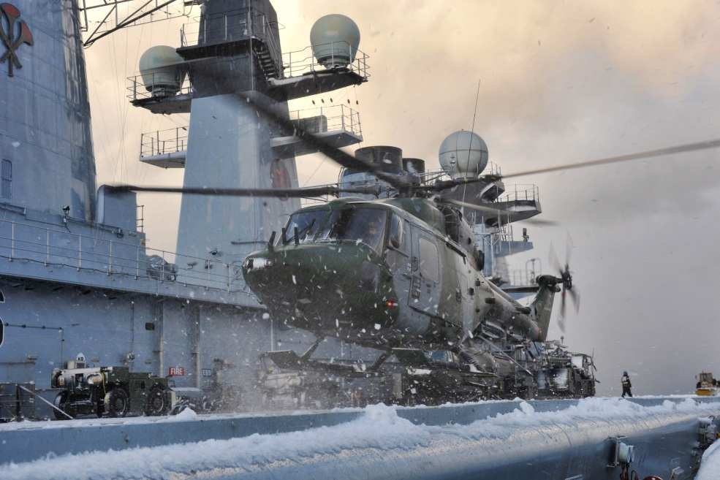
Fig. 5.1. Photographs taken by the PHOT team on board HMS Illustrious during Exercise Cold Response 2012 (Source: Crown Copyright, 2012).

Although it did not appear to happen in this case, the accident should perhaps be seen as a reminder that performances can go wrong, with potentially negative consequences for the affects being sought (for example, in terms of providing a demonstration or reassurance of capability).
Polar Regions Study
To prepare for the next SDSR in 2015, the MOD initiated a two-year programme (2012-2013) to study the changing strategic context of different regions and issues relevant to British defence and security (MOD Official II, MOD Official III, 7 Feb 2012). Growing concerns about whether Britain can defend its interests in the Arctic were reflected in the decision to include an assessment of the Polar Regions (not just Antarctica where Britain has sovereignty claims). As part of this, the MOD needed to be particularly attentive to potential future demands on Britain to participate in the security architecture of the Arctic, and whether there is a requirement for the MOD to increase its material investment in the Arctic (essentially bringing future scenarios into a contemporary policy assemblage) (MOD Official II, MOD Official III, 7 Feb 2012). The dual focus on Antarctica and the Arctic was not intended to suggest that Britain faced the same geopolitical challenges at both poles, but was a recognition of the similar material challenges faced in these regions (particularly in terms of operating in extreme cold climates, icy waters and coping with long periods of light and dark).
It is therefore important to note that the Arctic (and the Polar Regions more broadly) was not receiving special treatment vis-à-vis other parts of the world (reflecting a broader approach to security and foreign policy in the British government which has a global outlook). Nevertheless, the decision to attend to the changing strategic context in the Arctic (and not just Britain’s traditional Antarctic interests which include military commitments in the South Atlantic) was still significant given the broader MOD objectives outlined earlier; specifically the need to assess what future demand there might be for Britain to participate in the security architecture of the Arctic in the future. The decision to commission this study might also be understood as a reflection of an atmosphere emerging within the MOD, relating particularly to a sense of uncertainty over what the future might hold, but also optimism that this could be assuaged. As two defence officials explained to me, the purpose of the study was to “prepare the ground for making informed policy options to inform policy decisions” primarily by attempting to understand what the Arctic will look like in the future – the knowns as well as the unknowns (MOD Official II, MOD Official III, 7 Feb 2012).
The epicentre for the Polar Regions Study was the departmental building of the MOD in Whitehall, London (Fig. 5.2). However, activities relating to the study were far more diffuse geographically. Part of the study was undertaken at DCDC, the MOD think-tank sited in Shrivenham, outside of London. The MOD also worked with the University of Hull in the north of England to bring together a conference in 2012 that gathered British and international experts and expertise in one place (reminding us of Hull’s historical maritime links with the Arctic in the process). Further information about where MOD officials travelled for research purposes was not made available to me; although it seems fair to expect that they also initiated dialogues with their counterparts in other defence ministries, especially Norway.
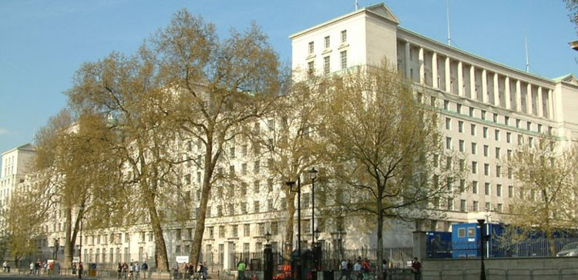
Fig. 5.2. Main building of the Ministry of Defence in London
(Source: Wikimedia Commons, 2004).

What emerges from this account is a diffuse geography of actors and sites where the activities surrounding the Polar Region Study were particularly intense. These sites were connected topologically by the mobility of a small group of defence officials and non-State experts engaged in the study. This mattered because the high degree of mobility exhibited, along with the limited number of sites involved, meant that much of the work could be carried out relatively discretely. Defence officials observed when interviewed that the MOD was not keen to publicise the fact that the study was being undertaken at the time, for fear of being seen, domestically and internationally, as trying to “securitise” a region where Britain has no sovereign jurisdiction (MOD Official II, MOD Official III, 7 Feb 2012).
The Polar Regions Study brought together multiple actors including both State and non-State actors. The study was led by a small team of defence officials from the MOD primarily with links to the Royal Navy. In addition to the defence officials from the MOD, the study also involved a host of non-State actors from academia, research centres, London-based think-tanks (I was invited to represent RUSI), environmental NGOs and the financial services sector. At the workshop event, the MOD lead on the project stated that we had been selected for being subject-matter experts on the polar regions. As noted earlier, the MOD also appears to have been in contact with other defence ministries, most notably Norway. The Polar Regions Study was, then, not simply a MOD project, but involved a range of non-State actors, the significance of which is explored below. Perhaps in more mundane ways than during EXCR, non-human actors also mattered to the Polar Regions Study. Little things such as draft documents, pre-reads and participant lists (and of course the technologies used to produce them) were important for both consolidating and sharing information among the participants in order that they would arrive prepared for meetings.
Like EXCR, the MOD’s Polar Regions Study also involved various kinds of labour. The physical labour had at least three aspects. The first was that the Polar Regions Study required the MOD to select and mobilise the human actors that would be involved. As with EXCR, this required specifically targeting a set of experts that would contribute to the goals of the programme; the ultimate aim being “to build up a credible knowledge based across academia and Whitehall” and ensuring that many sectors (academic, public, private, civil society) were represented (MOD Official II, MOD Official III, 7 Feb 2012). However, since many of these actors are not based in London, they had to be brought in either electronically (via email or telephone) or physically. Likewise, the conference organised in Hull required that as many of these actors as possible could be mobilised to travel to the north of England. A second aspect of the physical labour involved the preparation and circulation of texts to share and consolidate information, or for the purposes of comment and review (i.e. soliciting feedback). Much of this work was undertaken electronically, a quicker and cheaper way of sharing information than physically bringing people together in London or elsewhere. Nevertheless, there was also an interest in having some physical meetings for face to face discussion, so a third aspect of physical labour involved the convening of conferences and workshops where experts could gather for the purpose of sharing expertise (these were supplemented by smaller meetings between MOD officials and specific experts).
Essentially, this physical labour was directed at providing the means through which the MOD could gather together information on the Arctic from a broad base of expertise. Crucially, however, the fact that MOD retained control of this process meant that it could also decide who to include and exclude during different parts of study. This implied a logistical and administrative form of labour involving the production of participant lists, invitations and screenings through which the MOD exercised a degree of control over who they would allow to scrutinise, or indeed interfere with, their policies. At the same time the MOD could claim the process had been open to external review and, as such, their findings represented a broader collective view. My own involvement for example started with a series of meetings with MOD officials. I attended the conference in Hull and a further workshop at the MOD in London to comment on initial findings. At that point my involvement ended as I was not one of those chosen to review the final findings. This kind of banal administrative labour was also crucial for ensuring that the MOD remained in control of the information being generated by the study, preventing it from circulating more widely where it might cause controversy that, in turn, could undermine the achievement of the study.
The textual labour involved in the Polar Regions Study rather straightforwardly refers to production of various texts that eventually culminated with the final study paper (which remains classified). These texts were drafted primarily by MOD officials before being sent out to experts for comment and review, a process sustained throughout the study as the MOD officials worked through stages of gathering together initial findings, towards producing a final draft. Due to the classified nature of the study, it is impossible to comment on the contents of this text, although one might fairly assume that the primary aim of this textual labour was to produce a paper that went some way toward addressing the MOD’s uncertainties about the Arctic by clarifying the extent of Britain’s interest in, and commitment to, the Arctic, as well as the specific geography of those interests.
As with EXCR then, the textual dimension of the Polar Region Study was only one facet of an emerging policy assemblage surrounding the MOD’s interest in the Arctic. The Polar Regions Study required an assemblage of interests, sites, actors and practices for its performance – a performance aimed at addressing the MOD’s uncertainties over what the future might hold in the Arctic, and how Britain should respond. Much of this assemblage was internalised through an emphasis on secrecy (performed through an administrative process of selective exclusion and restrictions on what could be discussed beyond the study group) aimed at ensuring that the information produced during the study did not circulate too widely. This was further suggestive of concerns about how the performance of the study itself might have an affective dimension that would prove provocative to other actors concerned about whether Britain might be trying to securitise Arctic issues.

5.2.2 British Arctic Science
In 2011, the PRD described the British scientific community as “the motor of British activity in the Arctic” (FCO 2011). As I illustrated in Chapter 4, British scientists have undertaken scientific investigations in the Arctic for more than a century. Today, the British Arctic science community is large and diverse. In 2011, it encompassed at least 77 British institutions (including 46 universities and 20 research institutes) and more than 500 individual scientists who had registered Arctic interests with the NERC (HMG 2013). Over the past decade, over £50 million has been invested in 138 research projects (HMG 2013). Moreover, British scientists and institutions have also been involved in a series of Arctic projects funded by the EU (see Fig. 5.3). The depth of British Arctic science has also been demonstrated at the UK Arctic Science Conferences held every two years since 2009.
Nevertheless, the NERC has long-identified a lack of integration across the British Arctic science community as a persistent problem. As the NERC’s first Arctic Strategy in 1989 stated:
“The political need for a national Arctic research programme has been much less than in the Antarctic. Consequently, although currently the UK is undertaking research in the Arctic, it is relatively small scale, fragmented and does not comprise a coherent programme conforming to any broad policy guidelines” (NERC 1989, p. 1).

International Network for Terrestrial Research and Monitoring in the Arctic (INTERACT) | An infrastructure project for building research and monitoring capacity in the European Arctic.
Arctic Climate Change, Economy and Society (ACCESS) | Assessing the impact of climate change on marine transportation, fisheries, marine mammals, oil and gas extraction and Arctic governance.
Svalbard Integrated Observing System (SIOS) | An infrastructure project for coordinating and developing scientific research capacity on Svalbard.
Ice, Climate, Economics – Arctic Research on Climate Change  (ICE-ARC) | Assessing current and future changes in Arctic sea and the consequences for Arctic economies and societies.
Fig. 5.3. Major EU Projects with British participation.

This statement is indicative of the extent to which, in a polar context, the national scientific effort in Britain has traditionally been directed towards Antarctica, principally through the British Antarctic Survey (BAS). Britain has never had an analogous scientific presence in the Arctic, principally because the priority afforded to Antarctica (where Britain has a sovereign claim to territory) by the British government meant that the BAS (or indeed other National Research Centres) had too few resources to invest in comparable activity in the Arctic.
Julian Dowdeswell, the Director of the SPRI (2002-present) suggested to me that politically it has been much harder for Britain to establish a national science programme in Arctic since it would essentially require attempting to do so in another State’s sovereign territory (Dowdeswell, 9 Feb 2012). This helps explain why most national scientific efforts in the Arctic (from countries around the world, including Britain) are sited on the Svalbard archipelago which is governed by an alternative model of sovereignty as stipulated under the Spitsbergen Treaty of 1920. In contrast to National Research Centres, British universities have perhaps benefitted from being more independent from the State, which, in turn, facilitated a greater presence in the Arctic for much of the twentieth century, ever since the first university expeditions in the 1920s. Government interest before the late 1980s was far less apparent. However, without a nationally coordinated programme with long-term funding, the activities of the university community have largely involved short-term projects, with fragmented outputs – essentially the very problem described by the NERC in 1989 (Dowdeswell, 9 Feb 2012). This, in turn, has made it harder to actualise a cohesive Arctic science policy.
However, since the early 2000s, there has been a much greater effort within some sections of the British Arctic science community to integrate more closely its activities in the Arctic at the national level. Two developments in particular have been drivers. The first was the release of successive scientific assessments by the Arctic Climate Impacts Assessment (ACIA) working group of the Arctic Council, and the UN Intergovernmental Panel on Climate Change (IPCC) in the early 2000s that provided evidence of both the impacts of climate change on the Arctic, and the implications that changes in the Arctic environment could have for the rest of the world. The involvement of British scientists in both ACIA and the IPCC (including at lead-author level on the reports) was indicative of the extent to which they were embedded with the process of bringing global attention to climate change as well as the impacts of climate change in the Arctic specifically. As one former government scientist noted to me, it had become:
“increasingly clear that the Arctic was where major change was taking place. That didn’t mean there wasn’t change taking place in the Antarctic that needed to be addressed, but we became more and more aware of the incredibly rapid melt back of Arctic sea ice, Greenlandic ice and the glaciers on Svalbard, and all the various changes associated with that…we needed to pay more attention to the Arctic” (Rapley, 6 Jun 2013).

The second development related more directly to intellectual trends within the British science community. The emergence of Earth System Science as a field of study in Britain in the 1990s prompted scientists to take seriously how changes in different parts of the world, including the polar regions, were connected through various feedbacks and teleconnections (Lenton, 20 Jun 2013; Leakey, 21 Mar 2014). By 2007, Earth System Science had come to underpin the NERC’s broader science strategy, Next Generation Science for Planet Earth (2007-2012), which stressed the need to understand better the implications of global environmental change for Britain (NERC 2007b). The NERC’s Polar Science Working Group (PSWG) emphasised the need for “particular attention to polar change” as part of this strategy (NERC 2007a, p. 17). Moreover, scientists I spoke to suggested to me that there was also broad recognition that Britain was one of only a few countries capable of contributing a bi-polar perspective to Earth System Science (Garnett, 4 Oct 2011; Rapley, 6 Jun 2013).
These trends broadly coalesced into the International Polar Year (IPY) 2007-8, the planning for which had mostly been led by British scientists and social scientists since 2004. The IPY itself is discussed in more detail below, however it is worth emphasising the significance that the IPY had for the British Arctic science community. According to scientists I interviewed, the IPY not only increased Britain’s visibility as a valuable contributor to the international scientific effort in the Arctic, it also demonstrated the value of Arctic science to Britain itself, so much so that after investing £5 million in Arctic science during the IPY, the NERC went on to invest a further £15 million in an Arctic science programme (2010-2015) coordinated by a new Arctic Office, which was established in 2009 (Ellis-Evans, 12 Oct 2011; Rapley, 6 Jun 2013). Planning for a follow-up programme to begin in 2016 is also now underway.

5.2.2.1 Arctic policies
The objectives of the British science community in the Arctic are broad and diverse, around which are gathered a diffuse assemblage (if not multiple assemblages) of actors and practices. This, in turn, makes it more difficult to delimit the specific objectives of the British Arctic science community per se. In the case of government-led science (i.e. the science produced in National Research Centres) the actors involved include both scientists and policy practitioners. As such the science undertaken has both scientific objectives (related to the advancement of scientific observations, theories and models) and policy objectives (related, for example, to British foreign policy and commercial interests). Attempts led by the NERC and individual government scientists since the late 1980s – and more recently, the PRD – to develop and enhance Britain’s scientific presence in the Arctic in a more coordinated way at the national level (essentially the focus here) must therefore be seen as having both scientific and policy-related objectives.
The imperative to increase British scientific in the Arctic was set out by the NERC’s PSWG in 2007 when it outlined six areas of strategic importance where Arctic science could contribute to central components of the NERC’s broader strategy towards polar science (NERC 2007a). The NERC’s decision to increase its funding of Arctic science in the 2000s was largely rooted in an emerging sense of urgency relating to the need for scientists to be able to make more accurate predictions about how the Arctic was changing, and the likely implications for broader global processes (Garnett, 4 Oct 2011). This, in turn, suggested that the material changes in the Arctic were demanding a response from scientists. Moreover, scientists that I spoke to suggested that the ACIA and the IPCC had served to undermine scientific confidence in existing models of the Earth System, something which also created demand for more science to be done in the Arctic to address the paucity of data from a critical Earth System region (Ellis-Evans, 12 Oct 2011; Lenton, 20 Jun 2013). This, in turn, fed the principal objective at the national level of enhancing Britain’s scientific presence in the Arctic in order to undertake scientific investigations that will contribute to a greater understanding of the Arctic itself, its role in the Earth System, and the implications that changes in the region could have for British interests (domestically and overseas).
A second objective relates to the NERC’s long-standing pursuit of a more integrated British Arctic science community. The problem of fragmentation outlined by the NERC in 1989 persisted through the 1990s and 2000s, and continues today. One former BAS official pointed out to me that, recently, British scientists have been publishing nearly as many papers on the Arctic as they have on Antarctica. However, the difference in their visibility and impact stems from the fact that while the Antarctic research community is well-integrated at a national level through the research and logistic conduit provided by the BAS (allowing British scientists mutually to reinforce the impact of one another’s findings), the Arctic research community is still too diffuse and this can be exacerbated by the lack of a long-term infrastructural presence to help provide more focus and coherence (Ellis-Evans, 14 Mar 2014). This diffuseness has, in turn, been interpreted as a vulnerability since individual scientists appear unable to generate the same level of impact as those working together to coordinate their research as well as the dissemination of their findings. The second objective at the national level, then, has been to pursue a similar level of integration among the Arctic science community as the Antarctic community essentially by constructing an apparatus (manifesting initially as the NERC’s Arctic Strategy in 1989, and later in the establishment of the NERC’s Arctic Office and Arctic Research Programme in 2009 – see below) through which the assemblage that has gathered around the objectives of government-led Arctic science can be tightened and have greater collective impact (Rapley, 6 Jun 2013; Ellis-Evans, 14 Mar 2014).
A third national level objective relates to the broader ambitions of the British government in the Arctic. Since at least 2003, FCO officials have recognised the diplomatic leverage that can be gained by contributing high quality to science to Arctic fora, especially the Arctic Council. For example, in a short paper on ‘Diplomacy in the “High North”’, a senior FCO Official observed:
“British science and technology will also help to strengthen participation in Arctic affairs. Science diplomacy is now a reality. There are many circumstances in which developing international relations begins with cooperation on science and environmental issues” (Fry 2003, p. 14).

The PRD has been a particularly strong proponent of enhancing the role of the British science community in the Arctic; for example, by providing a small amount of funding for a British scientist, Professor Terry Callaghan, to work as a lead-author on the Arctic Council’s ACIA report. At the time, the BAS still did very little in terms of Arctic science, and the PRD instead focussed on working with other scientists and National Research Centres, such as the Scottish Association for Marine Science (SAMS) in Oban, Scotland (Leakey, 21 Mar 2014). Reflecting the SAMS’ prominence within the British Arctic science community, the PRD commissioned it to produce a report on the state of British Arctic science. The SAMS was then used by the PRD to host the meeting of British Arctic stakeholders in 2008, further reflecting its connectedness to broader government policy interests (despite being geographically quite distant from the Whitehall community).
A NERC official I spoke with suggested to me that there was also interest from the FCO in using the NERC to deliver more Arctic science. For example, both the FCO and the Parliamentary Office for Science and Technology (POST) were involved in the development of the NERC’s science plan for the Arctic Research Programme (Garnett, 4 Oct 2011). It seems this was an area where the FCO may have felt it could leverage greater influence at the Arctic Council – and bilaterally with the Arctic States – while at the same time avoiding many of the geopolitical sensitivities that have been emerging over the past decade, particularly those relating to the sovereign rights of the Arctic States. Affectively-speaking, scientific practices have tended to cause far less controversy between States since the end of the Cold War. The third objective at the national level, then, has been to enhance Britain’s scientific presence in the Arctic in order to increase Britain’s diplomatic leverage at the Arctic Council and other regional fora, as well as global negotiations on issues such as climate change, so that Britain can better intervene in the international dimensions of Arctic geopolitics.
More broadly, this push to increase British activity in Arctic science was also closely entangled with the government’s ambition to push climate change up the domestic and international agenda. Since the Coalition government took office in 2010, the government’s more explicit focus on prosperity has revealed the way in which British Arctic science is also entangled with a range of economic interests relating to new opportunities in shipping and resource extraction for British-based companies, and in financial services for the City for London. Recent winter extremes of cold weather and precipitation in British have also led to a renewed focus in understanding how changes in the Arctic might threaten the British economy., A fourth national level objective for the British Arctic science community has therefore been to use science to generate knowledge of ‘frontier environments’ for new commercial activities where there might be opportunities for British-based firms (see Dodds and Powell 2013a).

5.2.2.2 Arctic practices
Two closely related practices have been central to attempts to provide greater coordination of the British Arctic science community at the national level: Britain’s leadership in the IPY 2007-8 and the implementation of the NERC’s Arctic Research Programme. The physical, textual and affective dimensions of these practices are considered together in more detail below.
International Polar Year (2007-8) and the NERC’s Arctic Research Programme
In 2007, Britain took part in the International Polar Year (IPY) 2007-8 together with 62 other nations. The IPY was the biggest gathering of international scientists since the International Geophysical Year (IGY) in 1957-8. The purpose, as in previous iterations in 1882-3 and 1932-3, was to gather scientists from around the world to work together “in a concentrated burst of polar science and exploration” (IPO 2007, p. 3). Although Britain participated in previous IPYs, as well as the IGY, this latest instantiation was of particular significance to the British Arctic science community. As the Director of the NERC’s Arctic Office, Cynan Ellis-Evans put it to me, the IPY “kick-started” much of the recent national effort in Britain to develop a more integrated British Arctic science community with an enhanced role internationally (Ellis-Evans, 14 Mar 2014). Even before the IPY formally concluded in 2010, the NERC had started to develop a dedicated programme of Arctic research to follow on from the IPY (from 2011 to 2016), sustaining and building on the progress that Britain was starting to make in establishing itself as a more significant player in the international Arctic science community.
If the IPY, then, was used as an opportunity to put the British scientific community on the ‘Arctic’ map, then the Arctic Research Programme (ARP) was used to sustain this position and help to establish Britain as a major player in the Arctic science (NERC 2010). Just as the mobilisation of marines, helicopters and aircraft carriers during Exercise Cold Response demonstrated British military capacity to operate in the Arctic, and showed Britain cared about reassuring its Northern European allies, so too the mobilisation of scientists and scientific infrastructure during the IPY and the ARP offers a demonstration (physically and affectively) of the capacities of British Arctic science that, in turn, girds scientific partnerships with Arctic States, the EU and others in the international community. Taken together, the IPY and ARP have thus been at the core of Britain’s approach to addressing the objectives outlined above; namely the demands for more Arctic science, closer integration of the British Arctic science community, and a more coordinated informational resource for informing broader British political, economic and social interests, while at the same time responding to affective demands relating to both concerns and excitement about the changes occurring in the Arctic.
In the context of the IPY and the ARP, the most important sites within Britain were the various universities and National Research Centres that have participated in Arctic-related projects over the past decade (in other words, where Arctic-related activities are at their most intense – see Maps 5.1-5.2). The NERC’s offices in Swindon represent one site where efforts to coordinate British Arctic science have been increased. However, more significant was the siting of the International Programme Office (IPO) for the IPY at the headquarters of the BAS in Cambridge (a city with its own extensive legacy of connections to polar science, not just through the BAS but also the SPRI). This essentially established the BAS as the hub of the Britain’s Arctic science community during the IPY. After the IPO was closed at the end of the IPY, the NERC decided that the BAS should also be the site for its Arctic Office. The NERC intended that the Arctic Office should become the main national organ for integrating the broader British Arctic science community (established in 2009). The BAS site was of specific value to the NERC because the BAS was already the lead National Research Centre for NERC polar science and logistics (which included responsibility for the NERC research station on Svalbard, as well as aircraft and research ships used for polar research).
Beyond Britain, the NERC’s research station in Ny Ålesund on the Svalbard archipelago has also grown in importance since the early 2000s (Fig 5.4).
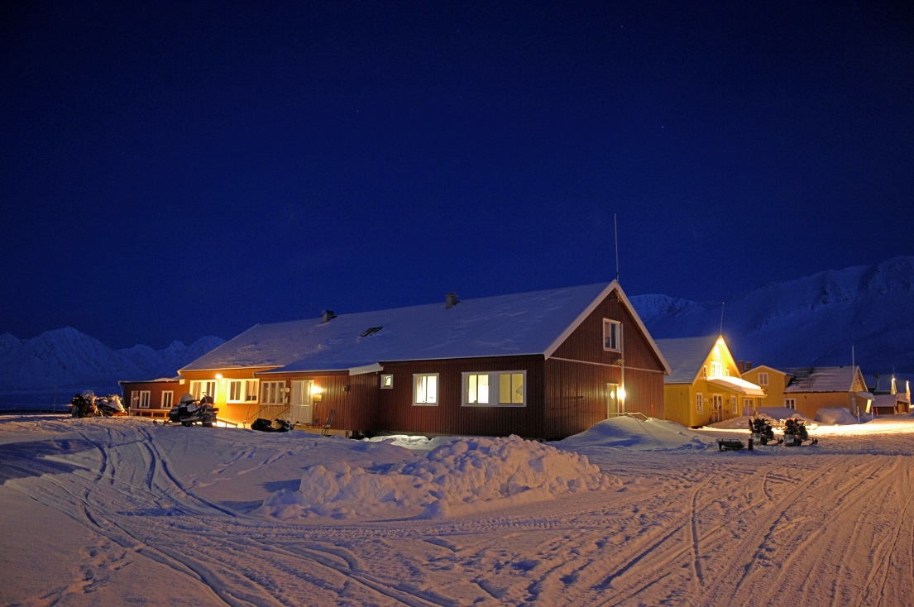
Fig 5.4. The NERC Arctic research station in Ny Ålesund, Svalbard
(Source: British Antarctic Survey, 2013).

However, one of the most valuable aspects of IPY was the fact that it gave the British Arctic science community (and the international science community more broadly) access to sites across the Arctic (and the Antarctic) that might otherwise have been inaccessible due to issues of national sovereignty, or simply because of their very remoteness. As one BAS scientist noted:
“Because of their remote location, we are normally able to get only limited snapshots of important processes that are occurring in the polar regions. IPY allows us to organise sets of co-ordinated measurements at different sites in both polar regions that will help us to understand the underlying principles behind what we observe. This in turn will allow us to estimate how the atmosphere, ocean, ice and biota will alter as climate changes” (BAS, n.d.).

The development of memoranda of understanding (MOU) between Britain and Canada (2010) and Britain and Norway (2012) have also been explicitly concerned with improving Britain’s access to sites in the Arctic beyond its research station on Svalbard. The MOU with Norway, for example, has been used to facilitate access for British scientists on a new Norwegian research ship. Although Britain has its own ‘mobile site’ in the form of the RSS James Clark Ross, it is largely restricted logistically to the eastern Arctic Ocean. British scientists therefore remain reliant on accessing berths on Russian, Norwegian and Canadian research ships if British scientists are to be able to travel deeper into the Arctic (Ellis-Evans, 12 Oct 2011).
As I noted earlier, the British Arctic science community involves a much more diffuse assemblage of actors than is typical of a government department like the MOD, precisely because, historically, there has been no top-down mechanism to shape it. Britain is actually quite unusual in this regard as many of the countries with science programmes in the Arctic coordinate much of their scientific activity through national institutes. This includes both Arctic (for example, the Norwegian Polar Institute in Norway, or the Canadian Polar Commission in Canada) and non-Arctic States (for example, the Alfred Wegenar Institute in Germany, or the Korean Polar Research Institute in South Korea). While Britain has an analogue in Antarctica through the British Antarctic Survey, it has traditionally lacked a national programme of Arctic research. This situation has slowly started to change as a consequence of increasing NERC investment in Arctic science in the 2000s. Although this science is being undertaken by scientists from a range of institutes, all of the activities undertaken through the ARP are coordinated through the Arctic Office. The NERC itself was supported by the British government more broadly to increase its investment in Arctic science (Garnett, 4 Oct 2011). For example, although the prime driver for the development of the ARP was the scientific challenge to better understand and predict the rapid changes that are taking place in the Arctic, as I indicated earlier, the NERC was also under pressure from government more broadly to increase its investment in Arctic science (Garnett, 4 Oct 2011).
However, perhaps more significant to the assemblage of the British Arctic science community are the individual scientists that have helped foster closer collaboration. This is significant because it is suggestive of the room that exists for individuals to affect broader assemblages of interests. Just as Liam Fox was instrumental in refiguring the MOD’s interest in the Arctic, individual personalities
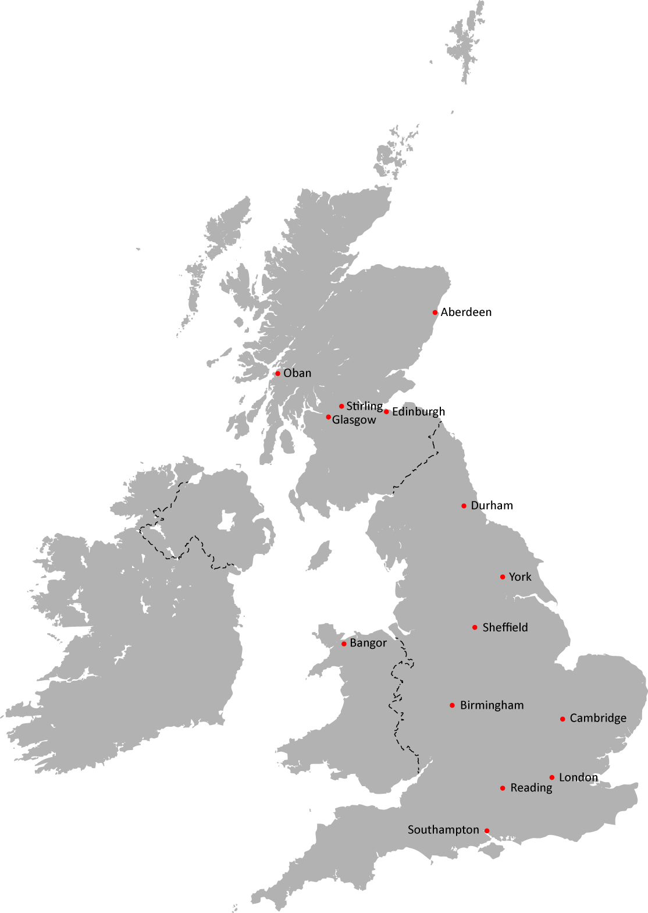
Map 5.1. The geographic spread of universities and National Research Centres implicated in British Arctic science by participation in NERC-funded projects during the International Polar Year 2007-8 (Modified from Mountain High Maps Copyright 1993 Digital Wisdom Inc.).

The institutions involved were the University of Edinburgh; University College London; Macauley Land Use Research Institute; Centre for Ecology and Hydrology; Heriot-Watt University; Scottish Universities Environment Research Centre; University of York; Durham University; University of Sheffield; University of Birmingham; University of Stirling; British Antarctic Survey; National Oceanography Centre; Scottish Association for Marine Science; University of Southampton; Bangor University; University of Reading; and Royal Holloway.
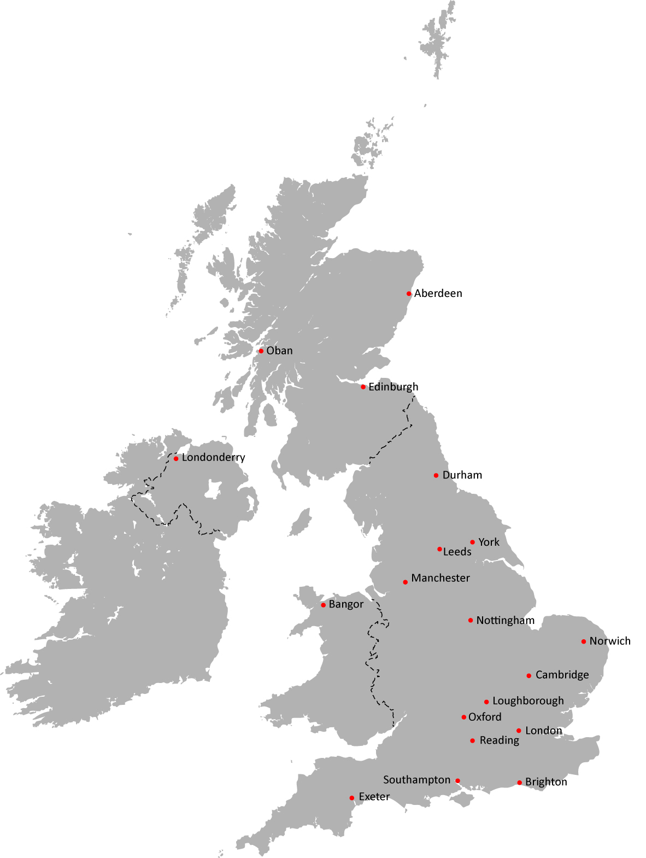
Map 5.2. The geographic spread of universities and National Research Centres implicated in British Arctic science by participation in NERC-funded Arctic Research Programme (Modified from Mountain High Maps Copyright 1993 Digital Wisdom Inc.).

The institutions involved are the University of Reading; University of Exeter; University of Leeds; University of York; University of Manchester; British Antarctic Survey; University of East Anglia; National Oceanography Centre; University of Oxford; University College London; Bangor University; University of Southampton; Scottish Association for Martine Science; University of Cambridge; Royal Holloway; Centre for Ecology and Hydrology; University of Edinburgh; University of Sussex; Loughborough University; University of Nottingham; University of Aberdeen; Durham University; British Geological Survey; and the University of Ulster.
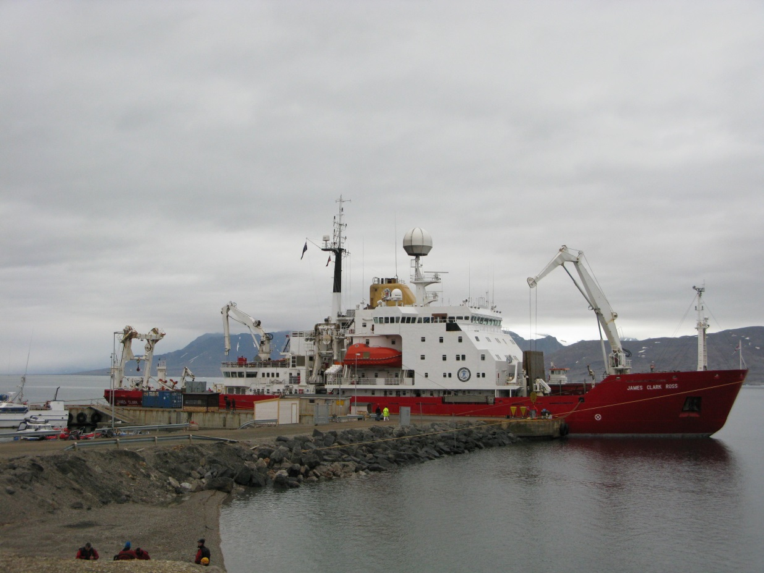
Fig 5.5. RSS James Clark Ross docked in Ny Ålesund, Svalbard
(Source: British Antarctic Survey, 2009).

have also been important within the British Arctic science community (suggesting that formal policy processes are accompanied by a range of informal processes related to individual interests, initiatives, connections and enthusiasms). For example, the former director of the BAS, Professor Chris Rapley, is widely regarded to have been a key architect in the development of the IPY (along with others such as Cynan Ellis-Evans, and notwithstanding the involvement of other scientists from abroad). These individuals, acting on their own initiative, or in small groups, were at the centre of developing the IPY programme and encouraging government funding agencies, including the NERC to put money into it (Rapley, 6 Jun 2013; Ellis-Evans, 14 Mar 2014). Likewise, when one looks through the funding awards granted by the IPY and the ARP, the names of individual scientists are equally as prominent as their institutional affiliations, something which is suggestive of the way in which it is often the expertise, reputations and personal networks embodied by individual scientists that drives the performance of British Arctic science, rather than institutional actors.
In addition to the individuals and organisations involved in the administration and performance of British Arctic science, it is also necessary to consider the importance of non-human actors. Of particular importance are the capacities of Britain’s polar equipment and infrastructure which include Twin-Otter Aircraft, Royal Research Ships, the research station on Svalbard, satellites and Royal Navy submarines, as well as a host of other equipment. These logistics have been utilised in a variety of ways: for the projection of scientists into the Arctic to collect data, but also as a bartering tool with another nations. For example, the MOU signed between Britain and Canada in 2008 explicitly states their joint intent to exchange and share polar infrastructure and logistics in order to allow British science access to more sites in the Arctic (and conversely greater access for Canadian scientists in Antarctica) (FCO 2008). The polar logistics specifically possessed by Britain have therefore been crucial for enhancing the capacity of the British science community to operate in the Arctic. Where there have been shortfalls in this equipment, other solutions have been sought. For example, as I alluded to earlier, the RSS James Clark Ross has only limited capability to operate in icy waters. For British scientists to get deeper into the Arctic, they are dependent on their ability to access more advanced research ships from other nations such as Norway, as well as the EU. The possibility that this could change in the future also partly depends on non-humans – whether one considers future changes to the sea-ice or the development of new equipment (such as British plans for a new polar research vessel).
Lastly, in terms of the actors involved in the performance of British Arctic science, the Arctic itself must be taken into account. As awareness among British scientists about the importance of the Arctic to the Earth System, as well as the implications changes in the Arctic environment can have for Britain, the extent to which the Arctic is demanding of scientific attention has become increasingly obvious. As the Director of the NERC Arctic Office suggested to me, although change is the norm in the Arctic, it is the fact that it is changing so quickly that has prompted concern (Ellis-Evans, 14 Mar 2014). A number of scientists also noted how observations made about how the Arctic is changing have undermined many of the scientific models used to predict changes in the Earth System, including climate change. As one scientist put it:
“[O]bserved changes in the Arctic have had a big impact on the scientific community as they have become less confident about the capacity for their models to capture the complexity of the changes taking place there…the Arctic was therefore a ‘reality check’ which upped the ante for the scientific community” (Lenton, 20 Jun 2013).

At the same time, specifically with regard to the British Arctic science community one should not disregard the influence that Antarctica continues to play, most notably through the pressure that it generates on Britain to maintain a strong scientific presence on the continent. The BAS is perhaps the most obvious actor in Britain to lead a ‘national’ Arctic science programme, however, its long-standing commitments in Antarctica is a constant pressure on its limited resources. It is notable from the projects funded by the NERC during the IPY and later through the ARP, just how small the BAS’ presence still is in the Arctic, despite operating Britain’s polar logistics (comprising both administrative and material functions). It is only because the BAS’ Arctic presence is being bolstered with the support of many of the other actors described above, that the BAS is beginning to emerge as a credible player in Arctic science, both domestically and internationally (Ellis-Evans, 12 Oct 2011).
As we saw earlier in relation to the MOD, in addition to the sites and actors just outlined, the actualisation of the IPY and the ARP also required specific forms of physical and textual labour. The physical labour has principally focussed on actually carrying out Arctic science, something which has required the mobilisation and circulation of funds, scientists and other logistics between sites in Britain (such as universities and National Research Centres) and sites in the Arctic (such as the NERC research station on Svalbard). Physical labour has also taken the form of establishing a centre to coordinate and integrate the work of the British Arctic science community. Since 2009, the NERC’s Arctic Office in Cambridge has actively monitored and coordinated the activities funded by the ARP, essentially providing a national hub for the British Arctic science community. Cynan Ellis-Evans, the Director of the Arctic Office told me that part of his role is to help build links both among scientists, partly by encouraging non-ARP funded Arctic science projects to also share information and coordinate activities with the Arctic Office (Ellis-Evans, 12 Oct 2011). The Arctic Office also circulates information to the various government departments that have expressed interest in the Arctic (including the FCO, MOD, DEFRA and DECC), and has represented the British Arctic science community at international fora, such as the working groups of the Arctic Council.
Second, there has been considerable textual labour by the NERC, the FCO and others involved in the IPY and the ARP. This has ranged from the reporting of activities involving the British Arctic community through press releases, websites and various forms of social media, particularly those relating to the IPY and the ARP (for example, the Discovering the Arctic website) to the production of various science strategy documents (see, for example, NERC 2007a; 2007b; 2010). The purpose of this has essentially been to delimit and frame the activities of the British Arctic science community during the IPY and under the ARP, demonstrating in particular the extent of these activities, who and what is involved in them, and their importance to Britain. The production of these texts is vital not only for scientists themselves as they pursue further funding from the NERC and other agencies, but also for the British government more broadly since they are used to underpin Britain’s claim that it is a major scientific player in the Arctic (which, in turn, is used to legitimise British policies and interests in the Arctic in geopolitical terms).
Third, there is also an affective dimension to the IPY and ARP. Historically, Britain is well-regarded internationally for the quality of scientific research in Antarctica. In the Arctic this reputation has typically been attached to individual scientists working on specific projects, rather than to the British Arctic science community in general (a consequence of the highly fragmented character of this community for most of the twentieth and early twenty-first centuries). However, Britain’s lead role in developing and coordinating the IPY programme and the NERC’s funding of the £15 million ARP have both been at least partly aimed at increasing credibility of Britain’s claims about the importance of Arctic science (enhancing Britain’s science-based diplomacy at organisations such as the Arctic Council, but also bilaterally), as has the announcement of plans for the development of a new polar research ship intended to expand the capacities of British polar science. When deciding whether to bid for the Chair of the Joint IPY organising committee, or to host the IPO, the latter path was chosen precisely because if the IPY was successful, “Britain would deservedly get a large degree of credit for it” (credit that might have just as easily gone to another nation) (Rapley, 6 Jun 2013). Affectively-speaking, then, this kind of labour has been about inspiring confidence, both domestically and internationally, in the idea that the British Arctic science community is becoming a major player in the international Arctic science community.

5.2.3 Polar Regions Department
Until 1990, the British policy lead in the Arctic had been held by the now obsolete Maritime and Aviation Department. Lead responsibility for Arctic-related issues was then passed to the newly formed Environment, Science and Energy Department (ESED) ahead of the 1992 UN Conference on Environment and Development (UNCED) conference in Rio De Janiero, Brazil. At the time Britain’s Arctic profile was falling, as the ESED prioritised international negotiations relating to global conventions on biodiversity and climate change over specific Arctic interests relating to scientific cooperation and research. The minutes from a meeting of the Study Group on Northern Waters and the Arctic (SGNWA) in 1996 indicate that elements of the British government were becoming increasingly concerned about the general decline of British involvement in Arctic affairs between 1992 and 1995. Specifically, the minutes record:
“[T]here was a danger that the Arctic states would perceive the UK as having a dwindling interest in Arctic affairs, and this might have resulted in the UK losing its observer status in AEPS” (SGNWA, April 22, 1996).

As the minutes go on to note: “there is currently a desire to elevate the UK presence at Arctic meetings” (SGNWA, April 22, 1996). In May 1995, responsibility for managing Britain’s representation in Arctic affairs was therefore passed to the PRD of the FCO – a unit historically responsible for managing the British Antarctic Territory and British interests under the Antarctic Treaty System. As with Fox in the MOD and Rapley in the BAS, in the early 1990s, the FCO’s interest in the Arctic was also largely personality driven, in this case by Michael Richardson, the Head of the PRD who was concerned that Britain was being “left out” of Arctic affairs, especially since the Arctic States were becoming more inward-looking (Richardson, 9 July 2014). Richardson told me that he was able to bring Arctic issues under the responsibility of the PRD with minimal resistance from other government actors because no one else was willing to put departmental resources into Arctic issues, further reflecting the broader lack of interest in the Arctic across the British government at the time (Richardson, 9 July 2014).
When the Arctic Council was established in 1996, Britain immediately became a permanent observer to its proceedings (following earlier observer engagement with the AEPS). Given the internal discussions in government at the time (as indicated by the minutes of the Study Group referred to earlier), it is perhaps unsurprising that this was the case. As the minutes go on to indicate: “The UK interest is to keep a strong foot in the door of Arctic cooperative activities” (SGNWA, April 22, 1996). This reinforces the argument made in Chapter 4 that Britain risked being cut off from the Arctic by the emergence of new geopolitical boundaries around the region. At the time, Britain hoped (with US support) that it could secure an ‘elevated’ observer status at the Arctic Council but this was ultimately checked by the position of the Arctic States that all observers were the same (Scrivener, 1999). Richardson suggested to me that one of the key challenges facing observers was that the Arctic States would only consider giving them a greater role if they brought more financial resources to the Arctic (essentially to buy their way in), but that for Britain this was unacceptable not least because the Arctic States themselves had developed economies (Richardson, 9 July 2014). In the years that followed, the Arctic Council’s focus on local environment issues and the welfare of the indigenous peoples of the Arctic had less relevance to British interests, largely because they are regarded by the British government as domestic issues for the Arctic States to address. As a consequence, British involvement in the Arctic Council and the PRD’s involvement in Arctic affairs more broadly, remained limited in the late 1990s, and primarily involved understanding how the Arctic Council worked, and how it might develop in the future. (Rumble, 5 Oct 2011; FCO Former Official I, 27 Oct 2011; PRD Official I, 20 Jun 2013).
This stance started to shift in the early 2000s. In 2002, Iceland took over the Chair of the Arctic Council. Under Iceland’s Chair, there was a considerable impetus to increase the global exposure of the Arctic Council (Willis and Depledge, 2015). Jane Rumble, the Head of the PRD (2007-present) told me that at the same time, Britain and the Netherlands were trying to increase the role of observers in the work of the Arctic Council. “[A]s a demonstration of the UK’s leading role in the global climate change debate at that time, and as a demonstration of the UK’s desire to be engaged with Arctic science”, the FCO provided a small amount of funding to support the participation of a British scientist, Terry Callaghan, as a lead-author on the ACIA report published in 2004 (Rumble, 5 Oct 2011). This ‘foray’ into the Arctic was also about supporting the FCO’s broader objectives relating to the emerging climate change agenda and the need to ensure British scientists were able to access the Arctic for the purposes of their scientific investigations (Rumble, 5 Oct 2011).
There was, then, already growing interest in the Arctic within the PRD, as well as the FCO more broadly before 2007. An important step change had occurred in 2004 with the publication of the ACIA report (Rumble, 5 Oct 2011). Nevertheless, the events of 2007 were still pivotal, primarily because the planting of the Russian flag beneath the North Pole, and the record summer sea-ice minima, impacted the wider government’s consciousness of Arctic issues (Rumble, 5 Oct 2011). In Parliament, there was a more widespread realisation of the implications that a seasonally ice-free Arctic could potentially have for science, energy, shipping, defence, fisheries and the environment (as evidenced by questions asked of the FCO, DEFRA and MOD, and debates in the House of Lords – see Chapter 4). As a consequence, the PRD started to embark on a series of reviews to assess the implications of Arctic changes for Britain. As I have noted previously, the SAMS was commissioned to assess the condition of British Arctic science, while the FCO and MOD also embarked on a joint project to review “the UK’s longer-term strategic interest in Arctic matters and how the UK should best engage with Arctic states on issues of mutual interest” (HC Deb, 02 Jul, 2008).
As the Arctic Council and Britain’s broader interests in the Arctic have evolved, so too has the role of the PRD as Britain’s Arctic policy lead, responsible for representing the policy interests of the whole government. Since 2009, the PRD has chaired a cross-Whitehall network of British government officials from various departments and agencies with interests in the Arctic. This network has generally met twice a year in order to provide other government departments and agencies with an opportunity to raise issues, exchange information and agree positions ahead of Arctic Council meetings. Moreover, since 2011, the PRD has led the process of authoring a series of government statements outlining British policies and interests in the Arctic (FCO 2011; FST 2011, HMG 2013). 2007, then, marked something of a fillip for the PRD’s work on Arctic affairs, which, in turn, has put the PRD at the heart of the process of delimiting British Arctic policies and interests.

5.2.3.1 Arctic policies
The FCO’s objectives in the Arctic appear to have been stated explicitly for the first time in a briefing paper released through the Foundation for Science and Technology (FST) in December 2011. This paper identifies the FCO as having the primary policy lead for issues relating to Arctic governance, bilateral relations with Arctic States and “other countries with an active interest in Arctic issues”, and engagement with the indigenous peoples of the Arctic (FST 2011, p. 3). The specific objectives of the PRD have subsequently developed in response to two demands: its responsibility to represent Britain at the Arctic Council; and the broader priorities of the FCO.
With regards to the former, as an observer State, Britain has no formal voice in the Arctic Council. The PRD’s first objective is therefore to find ways of ensuring that Britain is rendered visible in fora such as the Arctic Council. As one PRD Official put it “we have to be visible when we go there” (PRD Official I, 20 Jun 2013). A related objective is to ensure that the Arctic Council remains the primary forum for the discussion of Arctic affairs. Since 2008, when the PRD chaired a meeting of ‘UK Arctic stakeholders’ in Oban, Scotland, considerable emphasis has been placed on supporting the Arctic Council as the primary intergovernmental forum for the discussion of Arctic affairs (despite concerns about the degree to which it engages observer States like Britain) (GBSC 2008). This objective has been repeated explicitly on multiple occasions, most recently in the Arctic Policy Framework (APF) which states:
“The UK will support the Arctic Council as the pre-eminent regional forum for discussing Arctic issues and the stability it provides for discussion amongst Arctic States” (HMG 2013, p. 13).

The need for greater coordination of British interests and activities was stressed during the aforementioned stakeholders meeting in Oban, the report from which concluded: “the need for better coordination across the whole of the UK sphere of interests” (GBSC 2008, p. 6). An assemblage of British Arctic stakeholders had gathered around the PRD’s interest in allowing other actors (from science, commerce and environmental sectors) to inform government policy towards the Arctic. Moreover, the PRD coordinates the involvement of other government departments and scientists in the working groups of the Arctic Council where Britain can potentially have a much greater input into discussions. The PRD’s third objective with regards to Arctic affairs has therefore been to provide a source of coordination to an assemblage involving both State and non-State Arctic stakeholders in Britain.
With regards to the FCO’s broader priorities, the PRD also has various other objectives it must pursue in the Arctic. Government assumptions about the relevance of Britain to the Arctic are in part bound up with how governmental officials understand what kind of actor Britain is, and its role in the world. In 2010, the Foreign Secretary William Hague noted that the newly elected Coalition government would pursue:
“…a distinctive foreign policy…that builds up British engagement in the parts of the globe where opportunities as well as threats increasingly lie; that is at ease within a networked world” (Hague 2010).

Hague’s speech is emblematic of the way in which Britain has typically been produced by the current government as an outward-looking trading nation embedded in a global network of States. This identity, as a globally interested trading nation, is used to underscore the view that the security and prosperity of Britain depends on the free flow of goods, ideas and services around the world; a dependence that drives Britain’s commitment to a rules-based international system (Depledge 2014). As I argued in Chapter 4, such an outlook has often been frustrated by the materiality of the Arctic in the past (essentially the frozen ocean provided a barrier to the search for ‘northern passages’). However, while the ice-cap might now be seen as becoming more permissive of Britain’s global ‘identity’ (a combination of technological development and environmental change), the emergence of new geopolitical boundaries continue to frustrate British foreign policy in the Arctic. Britain’s interest in the Arctic is therefore connected to Britain’s broader foreign policy objectives which reflect a demand for Britain to be everywhere at once (within the boundaries of international law, rather than beyond the boundaries of arbitrary regional claims by the Arctic States). This much is reflected in the APF which states Britain’s vision for the Arctic as:
“The UK will work towards an Arctic that is safe and secure; well governed in conjunction with indigenous peoples and in line with international law; where policies are developed on the basis of sound science with full regard to the environment; and where only responsible development takes place” (HMG 2013, p. 7).

Specifically, two priorities stand out. The first is that Britain seeks to influence the shape of the international system in order to create a more stable world which enhances prosperity and security (HMG 2010b). This priority was stated explicitly in relation to the Arctic in the FCO briefing paper made public in 2011:
“the government is working bilaterally and multilaterally to ensure a stable, peaceful Arctic, well governed by Arctic states working in collaboration with international partners” (FST 2011, p. 3).

The second and related objective concerns what has become known as the FCO’s ‘growth and prosperity agenda’, or perhaps more commonly as ‘commercial diplomacy’. This has led to a much closer working relationship between the FCO, DFID and UKTI, especially in Britain’s overseas missions (including in Arctic States). This broader FCO agenda has also had a bearing on the Arctic to the extent that various commercial actors in Britain, from International Oil Companies (IOCs), to mining companies, to tourist operators, to financial service providers in the City of London have become increasingly interested in the economic potential that is emerging as a consequence of the unprecedented environmental changes taking place in the Arctic (as well as technological improvements). This ‘commercial dimension’ was stated clearly in the APF:
“The UK will encourage UK business to engage directly with the Arctic Council, Arctic states, indigenous peoples and other actors, as appropriate. The UK will facilitate responsible business activity in the region by UK companies” (HMG 2013, p. 23).

In relation to the FCO’s broader priorities, then, the PRD is also working towards the twin objectives of maintaining Britain’s international influence and creating new economic opportunities for British-based firms.
As with the previous cases examined, it is worth emphasising that the PRD’s objectives were also constituted by, and as such reflect, the presence of certain kinds of affective atmospheres between 2007 and 2013. Initially, this related to broader uncertainty and concern among both State and non-State actors about the implications that climate change would have for Britain and its overseas interests – and specifically the impact changes in the Arctic could have. This, in turn, helped constitute the PRD’s objective of seeking closer cooperation with the Arctic Council, specifically to help British scientists gain access to the Arctic. Since 2010, there has been increased government-wide focus on the economic recovery, a consequence of which has been much greater interest in the potential to exploit new economic opportunities in the Arctic, driving, for example, closer cooperation between the PRD and UKTI on Arctic issues (PRD Official I, 20 Mar 2014). Both of these objectives are firmly rooted in the PRD’s broader interest of maintaining the UK’s influence at the Arctic Council, which is increasingly discussing commercial opportunities (for example, through the newly formed Arctic Economic Council) as well as science (the Arctic Council’s traditional focus). The concern implicit in the PRD’s consideration of how best to remain engaged with the Arctic Council on both science and commercial opportunities – particularly in terms of how best to express Britain’s interests without provoking a hostile response from the Arctic States – helps to explain why there has been so much debate in Britain between various stakeholders (State as well as non-State) over recent years about exactly what Britain’s policies and interests are in the Arctic, and how they should be expressed.

5.2.3.2 Arctic practices
Since 2008, these policies have been pursued through at least two practices: 1) the role the PRD performs at meetings of the Arctic Council; and 2) the PRD’s production of a series of policy statements that culminated in the publication of the APF in 2013. As the below demonstrates, both practices had considerable physical, textual and affective dimensions.

Arctic Council
At the highest level, Britain is one of the few observers to have sent representation from London to every meeting of the Senior Arctic Officials (SAOs), as well as Ministerial meetings. However, at the working group level, engagement has largely proceeded along an ad-hoc basis. One PRD Official told me that this was because it has long been a principle for the FCO to direct its limited resources towards issues of “mutual interest”, primarily science and sustainable development (PRD Official I, 20 Jun 2013). The intensity of Britain’s engagement with the Arctic Council has therefore proceeded largely in line with what has dominated the Arctic Council’s agenda. It follows that since 2002, the major preoccupation with climate change both in Britain and in the Arctic Council has coincided with a period of much more intense engagement. Similarly, as the Council’s focus has turned towards opportunities for economic development under the Canadian chairmanship (2013-2015), Britain has continued to sustain this higher level of engagement. The PRD’s performances at the Arctic Council (including the labour undertaken domestically to inform these performances) are therefore essential for meeting the objectives of maintaining Britain’s influence in Arctic affairs, facilitating greater access to the Arctic for scientists and British-based commercial entities, and showing respect for, as well as reinforcing, the current international governance framework for the Arctic.
In terms of the actors involved in the performance of Britain’s observership at the Arctic Council, the number of officials an observer State can send to Arctic Council meetings varies depending on the Chair. Typically Britain is represented by just one or two PRD officials (at the March 2014 meeting in Yellowknife, Britain only sent one official). PRD officials specifically are Britain’s main representatives the Arctic Council because the PRD is the part of the FCO that has the best overview of British Arctic interests and Arctic affairs more broadly. However, this overview is generated through interactions between PRD officials and a much broader set of State and non-State actors. For example, since 2009 the PRD has chaired the British government’s cross-Whitehall network for the Arctic which typically meets every six months. This network is comprised of officials who are nominated as Arctic policy leads for various government departments (including the MOD, DEFRA, DECC, DfT and BIS). The network is usually convened ahead of Arctic Council meetings in order to discuss the Arctic Council agenda. These meetings are used by the PRD to inform policy leads from other government departments about the Arctic Council’s priorities, but also to gather information from these departments that may include issues they would like the PRD to raise with Arctic States. In addition to the cross-Whitehall network, the PRD may also reach out to specific departments – for example, the PRD has been working closely with UKTI on the Arctic Economic Council – or government scientists from National Research Centres such as the SAMS, the BAS and the NOC, and increasingly the NERC’s Arctic Office, which serves as a coordinating body for the wider British Arctic science community. Moreover, there may be meetings between the PRD and various non-State actors, including representatives of NGOs and the private sector, as well as think-tanks and academia to discuss priorities. Thus, when PRD officials attend, they do so as the ‘face’ of a much wider network of State and non-State actors which are typically relegated to the hinterland while the Arctic Council is in session (Rumble, 5 Oct 2011).
The non-human elements involved in the performance of Britain’s ‘observership’ are perhaps far less apparent until Arctic Council meetings are underway. Many of the most notable elements actually seem to work against this performance. For example, in the past the absence of signs, flags and allocated seating for observer States, was exaggerated by the signs, flags and allocated seating used to render visible the Arctic States (PRD Official I, 20 Mar 2014). Likewise, Arctic Council documents may be circulated between the Arctic States but kept away from observer States (PRD Official I, 20 Mar 2014). The presence of these elements serves to reinforce the collective identity of Britain and others as ‘observer’ States with little distinction between them as separate actors (thus Britain is only rendered visible as an ‘observer’ and not as the nation-State ‘Britain’). However, as one PRD Official explained to me, other ‘things’ may be mobilised in response; for example, through the circulation of a document such as the British government’s white paper on Arctic policy (PRD Official I, 20 Mar 2014). The bodies of the officials also become more important as embodiments of Britain working in the margins to represent British interests. Without these kinds of elements, it would become virtually impossible to distinguish Britain’s presence from the presence of other observers. Lastly, the fact that officials have to travel to the Arctic to attend Arctic Council meetings means that the Arctic itself is also an important element in this assemblage, particularly to the extent that it is often difficult and expensive to reach. This, in turn, conditions the capacity of the PRD to participate in meetings unless sufficient resources (in terms of both time and money) are made available to PRD officials.
As with the other assemblages explored in this chapter involving the MOD and the British Arctic science community, the performance of Britain’s ‘observership’ at the Arctic Council has also been contingent on specific kinds of labour that actualise Britain’s presence at meetings. Physically, aside from the need for bodies (i.e. PRD officials) to travel to wherever the meetings are being held, there is very little that Britain can do during SAO and Ministerial meetings other than be present in the room. The only opportunity for officials from observer States to engage with other delegates (from Arctic States, and other observer States) is informally during coffee breaks, lunches and evening functions. As one PRD Official put it to me “the vast majority of the work of all of the observer States is done in the margins…we are always primed for the coffee breaks” (PRD Official I, 20 Mar 2014). During these breaks, the PRD officials seek out other delegates in order to discuss certain interests and issues, but also to make it clear that Britain is present at the meeting. At times, this is facilitated by handing out documents – for example, in September 2013 PRD officials used a meeting of the SAOs to distribute copies of Britain’s recently published APF white paper.
The textual labour involved in this performance is also limited and largely informal. As an observer, Britain cannot make proposals or statements unless invited – part of a process of selective exclusion administered by the Arctic States to reinforce the insider-outside divide. Policy ‘lines’ must be delivered verbally during informal discussions that take place in the margins of meetings. Beyond this, there is very little that PRD officials are able to produce in terms of an official text. Essentially they are there to observe, and as such have no mandate from the British government to negotiate. As one PRD Official put it to me “being an observer limits government levers in the Arctic” (PRD Official I, 20 Mar 2014). After meetings, PRD officials will prepare a read-out for dissemination to the rest of the FCO and the cross-Whitehall network, creating an official record of events which includes commentary from the officials involved about whether there are any implications for the government and possible responses, but beyond that, the performance of being an ‘observer’ requires very little textual labour (PRD Official I, 20 Mar 2014).
Arguably it is the more intangible, affective dimensions of this labour that are the most important to the performance of Britain’s ‘observership’. With regards to the Arctic Council, this is felt in at least three ways. The first is that the presence of PRD officials at these meetings is intended to demonstrate that Britain is supportive of the Arctic Council. As I alluded to earlier, the decision to send officials from the ‘capital’ (i.e. London) is important in this respect because Arctic States recognise it as a sign of diplomatic commitment to the Arctic Council. The second is that much of the work that goes on informally in the margins is about emphasising Britain’s distinct interests and capabilities in the Arctic. As a PRD Official noted to me, Britain is actively trying to correct a perception emerging in the Arctic Council that the observer States represent one bloc of collective interests. As this official put it, “the UK is keen not to be seen as part of a bloc as it has its own distinct view to express”, even more so since the number of observers was expanded from six to twelve in 2013 (including five Asian nations) (PRD Official I, 20 Mar 2014). The third relates to domestic perceptions about the Arctic. Part of the PRD’s performance at the Arctic Council is about demonstrating Britain’s commitment to its Arctic interests to stakeholders at home to show that the government is actively engaging with Arctic issues.
Given the limits to the physical and textual dimensions of what the PRD can achieve at the Arctic Council, it is striking how much of the PRD’s objectives actually appear to be achieved through these more intangible affective performances (showing commitment, support, interest and simply turning up and being seen to participate). It is also suggestive of the extent to which different policy objectives require different configurations of material-textual-affective assemblages that bring different elements to the fore in different contexts.
Arctic Policy Statements
To help clarify Britain’s policies and interests in the Arctic, the PRD has actively sought to disseminate texts that set out Britain’s approach to Arctic issues. Starting in 2009, the PRD together with the MOD produced a report titled ‘The Arctic: Strategic Issues for the UK’ (FCO 2009). This was followed in 2011 by the PRD-authored briefing paper titled ‘UK and the Arctic: Summary of UK Government Policy’ which was disseminated at a small workshop involving government officials, academics, NGOs and representatives from the private sector to assess British Arctic interests, and later published publicly in the FST Journal (FST 2011). In 2011, the PRD also posted a statement on the FCO’s website with the title ‘The UK’s Engagement in the Arctic’ (FCO 2011). And in 2012, the PRD submitted evidence to the EAC inquiry, which was a further statement of British Arctic policy (HC 171, 2012). In October 2013, this process culminated in the publication of the British government’s first-ever white paper on the Arctic titled ‘Adapting to Change: UK policy towards the Arctic’ (but more commonly referred to as the Arctic Policy Framework, or APF). The APF has since been positioned as the definitive statement of Britain’s Arctic policies and interests, and as a platform for future engagement with the region. However, as the above suggests, the process leading up to the publication of the APF clearly took far longer, and was far more extensive (in terms of the actors, sites and practices involved), than might otherwise be assumed if we were to focus on the production of the 2013 white paper alone.
The production of the APF in its current form has been contingent on textual and other practices that have taken place across a variety of sites. The PRD offices in the FCO in Whitehall have been central to this assemblage, as it was PRD officials who drafted not just the APF, but also many of the ‘predecessor’ documents referred to above. Meetings between PRD officials and other actors (including representatives from environmental NGOs and oil and gas companies, as well as government scientists) also took place at the FCO in Whitehall (see Fig. 5.5).
However, this was not the only site of engagement. For example, during the drafting process for the APF, PRD officials frequently visited the sites of other government departments, as well as non-State actors including think-tanks, NGOs and the private sector. The Palace of Westminster and Portcullis House in Whitehall were also important sites, as they were places where the PRD were subjected to parliamentary scrutiny (whether in the House of Lords or at hearings of the Environmental Audit Committee). Beyond London, there were workshops and conferences in places such as Liverpool, Hull and Oban which also attracted PRD engagement precisely because these were sites of discussion and debate about Britain’s Arctic policies and interests. Similarly, the FCO’s diplomatic missions in the Arctic States, as well as Arctic Council meetings, were mobilised as sites where the PRD could gather and disseminate information and feedback relating to on-going development of Britain’s policy positions and interests in the Arctic. In short, from 2007-2013 the PRD could be found stretched across a broad assemblage of sites in order to be present in those places where debates about Britain’s future in the Arctic were at their most intense.
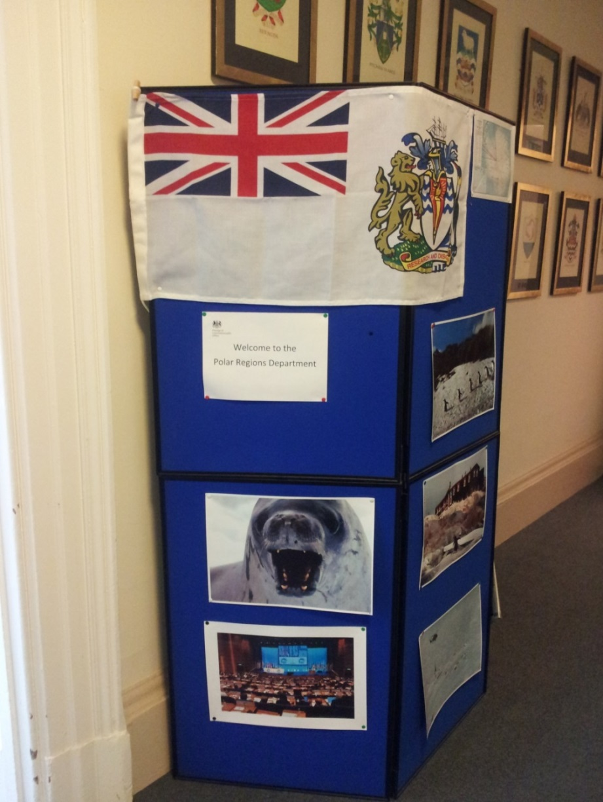
Fig. 5.6. Outside the Polar Regions Department in the Foreign and Commonwealth Office
(Source: photograph taken by author, 2013).

Most of the actors involved in the assembly of the APF have already been alluded to. What needs to be stressed is that the APF and its predecessor documents were collectively produced as a consequence of debates and discussions involving a plethora of State and non-State actors. While PRD officials may have controlled the drafting process, the process itself was informed by their engagement with other government officials, parliamentarians, academics, think-tanks, NGOs and the private sector. Moreover, it was informed by demands placed on Britain by both the Arctic States, and the Arctic itself. With regards to the former, the oft-repeated declarations by Arctic States – epitomised by the 2008 Ilulissat Declaration, as well as by debates in the Arctic Council about the role of observer States – emphasised the need for non-Arctic States to respect the sovereignty of the Arctic States. This demanded that the PRD and other government actors were careful in how they framed their policy statements (for example, by deliberately avoiding the affect-laden term ‘strategy’). With regards to the latter, the unprecedented speed with which events are occurring in the Arctic, as both the ‘geo’ and ‘politics’ undergo considerable change, has demanded increased engagement from the PRD on specific issues relating to Arctic governance, as well as scientific and economic interests.
The other non-State actors involved in this process have been more mundane (relating mostly to the forms of mobility and communication that helped hold together the assemblage emerging around the production of the APF). Most notable were the various documents that circulated between actors (the PRD papers as well as the reports and minutes emerging from Parliament, studies by NGOs and academic papers). These documents consolidated different policy positions as well as information that could be used to inform the drafting process. The drafting process itself was also dependent on the production and circulation of documents. A striking example was the decision by the PRD to circulate drafts of the APF to various academics and representatives of NGOs and the private sector, among others, in order that they could be reviewed – paper rather than electronic copies were used in order to minimise the potential for these early drafts to be circulated more widely. Perhaps more importantly, over the period in question, these documents were the most obvious physical manifestation of British Arctic policy (literally thoughts and ideas put into physical text). The production of both electronic and paper copies of the APF and the various predecessor documents have allowed the PRD, and the British government more broadly, to disseminate statements about British policy and interests in the Arctic to a much wider audience, at much greater speed, than would have been possible if the PRD had only relied on bodies of PRD officials to ‘spread the word’ through their own encounters.
The production of the APF involved a range of performances including the drafting of texts, email communications and the engagement of other government officials and non-State actors at various consultations, workshops and conferences across a wide variety of sites. This kind of physical administrative labour provided the means through which PRD officials could gather together an assemblage of actors to inform, debate and review the policy statements that they was drafting (ultimately culminating in the publication of the APF). One of the more interesting aspects of this labour was that much of it was instigated beyond the PRD. For example, the ESRC Polar Geopolitics series (2010-2011) was not dependent on the participation of PRD officials – the seminars would have taken place regardless. However, as sites of intense debate and discussion about Britain and the Arctic, the PRD likely felt its presence was warranted and possibly even demanded at events such as these, in part to inform the debates with their own perspectives, but also to gather information. Even more demanding was the parliamentary inquiry held by the EAC to which the PRD was called to give evidence, which required the physical involvement of PRD officials to attend hearings and a great deal of preparation in terms of briefing ministers and responding to parliamentary scrutiny.
The textual labour involved in the production of the APF related to the work that went into drafting not just the APF, but also the predecessor documents outlined above. These texts were drafted primarily by PRD officials, but ultimately were collectively authored due to the involvement of other government departments and non-State actors in both informing and reviewing their contents. Perhaps the most interesting aspect of the textual labour related to the long-running debate about what actually constituted a sufficient statement of policy or strategy. As I noted above, the need for such a statement was raised in the House of Lords in 2007, yet between 2007 and 2013 this statement was redrafted and represented in a number of ways – as a report on the Britain’s Arctic interests, as a website, as a briefing paper, as evidence and, most recently, as a white paper (the APF). Even the white paper raises questions about what actually counts as a ‘strategy’ given the tensions over whether a ‘policy framework’ and a ‘strategy’ amount to the same thing (Depledge 2013c).
Indeed, the question about whether a policy framework counts as a strategy is also revealing of more intangible affects that the production of the APF has involved. The PRD has regularly insisted that the APF is a strategy in ‘all but name’ with two intended affects. The first is to reassure domestic audiences that the PRD, and the British government more broadly, is taking seriously its Arctic interests by adopting a strategic approach that attends to the concerns of a variety of different stakeholders in Britain (including scientists, NGOs and the City of London). The second is simultaneously to indicate that Britain is respectful of the fact that according to established international law, most of the Arctic falls under the sovereign jurisdiction of the Arctic States. Diplomatically, it would be unseemly to ‘strategise’ in another country’s sovereign territory. The wording of the APF (and indeed previous statements of British Arctic policy) is therefore intended to reassure the Arctic States that Britain continues to support their sovereign rights and jurisdictions in the Arctic. It is also arguable that this approach is part of presenting Britain as a ‘model’ observer of Arctic affairs in light of increased global interest in the Arctic, and the decision at the Arctic Council Ministerial in Kiruna in 2013 to expand the number of official observer States from six to twelve (Depledge and Dodds 2014).
At first glance, the production of the APF appears heavy in textual labour (given the extensive effort by the PRD to develop an appropriate policy statement between 2008 and 2013). However, as this account suggests, once again there is more to assembling a discourse than simply producing a text. The PRD officials who were ostensibly the authors were themselves reliant on practices that involved mobilising a much larger set of State as well as non-State actors to engage in the process of debating, drafting, reviewing and disseminating these texts. Moreover, much of this activity was undertaken in a range of different sites where British Arctic policy was being intensely debated – the PRD essentially had to stretch itself to encompass as many of these sites as possible, in order to gather and disseminate information relating to the production of these policy texts.

5.3 Chapter summary
This chapter, informed by recent geographical research on policy assemblages, as well as attempts in Critical Geopolitics to attend to the material and affective dimensions of discourse, has demonstrated some of the ways – through policies and practices relating to defence, science and diplomacy – British policy towards the Arctic is being actualised (Cochrane and Ward 2012; McCann and Ward 2012; Müller 2008, 2013). The purpose has been to emphasise that the assembling of policy discourses is about far more than simply producing texts (the traditional focus of discourse analysis). Such texts can only be actualised – that is have effects on the world – through material and affective interventions which, in turn, requires the mobilisation of all kinds of resources (bodies, equipment, money, time). The essentially finite availability of such resources (for example, due to budgetary pressures) contradicts the possibility of making ‘blanket’ interventions that cover a topographical container-space that terms like ‘Britain’ and ‘the Arctic’ typically conjure up. Instead, what we have seen in Britain between 2007 and 2013 is a series of more ‘surgical’ interventions that have delimited what British Arctic policy actually is in practice: a diffuse assemblage of actors (State and non-State, human and non-human) and activities (physical, textual and affective) that topologically connect disparate sites (from London and Cambridge to Ny Ålesund and beyond) where encounters between ‘Britain’ and the ‘Arctic’ are at their most intense. Specifically, this chapter has also revealed the importance of the affective dimensions of these interventions, especially for a country such as Britain which has limited resources for intervening in the Arctic. All of the discourses above sought to produce specific affects, at home and abroad, that project Britain as a confident and committed actor in the Arctic, whether for the purposes of defence, science or diplomacy. The need for Britain to “punch above its weight” in the Arctic, as one interviewee put it, stresses exactly this point that bodies, materials, practices and texts alone are insufficient unless they are laden with productive affect (Ellis-Evans, 14 Mar 2014).
While, the term ‘Arctic policy’ symbolises and frames this social-material-affective arrangement, delimiting the boundaries of the actors (human as well as non-human), sites and practices represented, it also casts a shadow over the possibility that these interventions might be otherwise. To have an ‘Arctic policy’ is to produce a precarious assemblage contingent on the gathering together and holding in place of specific actors, practices and affect that, in turn, actualise its effects in the world through specific interventions. The implication is double-edged. On the one hand, a top-down authority – for example, the British government – can attempt to alter the effects of British Arctic policy by adjusting the physical, textual and affective dimensions of its interventions. This gives the British government scope to develop and evolve its policies toward the Arctic by making different kinds of interventions. On the other hand, and as I explore in more depth in Chapter 6, internal instability and external pressures can also contrive to reshape or frustrate the kinds of interventions that Britain makes in the Arctic. The government therefore faces a constant struggle to retain control over its Arctic policy assemblage. This, in turn, has demanded the introduction of a policy apparatus through which Britain’s interventions in Arctic affairs are to be directed and controlled. This policy apparatus, as well as various sources of interference from multiple State and non-State actors, is the focus of Chapter 6.

6. A precarious settlement: the British Arctic policy ‘apparatus’

6.1 Introduction
In July 2013, Mark Simmonds, the FCO Minister for the Polar Regions announced to the parliamentary Environmental Audit Committee (EAC) that the British government was preparing a white paper to set out British policies and interests in the Arctic. As Simmonds declared in his statement:
“The policy framework document is to pull together all the different strands [of British Arctic policy] to ensure a successful future for the Arctic” (HC 333, 2013, ev. 13).

Ostensibly, the announcement of this white paper was a response to the EAC’s report from its ‘Protecting the Arctic’ inquiry (2012-2013). However, as I have shown in Chapter 5, the white paper was also a logical expansion of previous government statements made since Oban in 2008.
Up to now, this thesis has principally been concerned with elaborating some of the multiple histories, geographies, actors, interests, encounters and practices that underpin the various ways in which Britain’s Arctic ‘actorness’, the ‘Arctic’ itself, and relations between the two, have been constituted. This multiplicity has been conceptualised in terms provided by recent thinking in the sub-discipline of human geography on assemblages as multiple gatherings of sites, actors (human and non-human, State and non-State) and practices that come together in ways which impact (and are also impacted by) other social-material-affective arrangements in the world (see, for example, Anderson and McFarlane 2011). Yet the inescapable conclusion of thinking with assemblages is that what counts as an assemblage can be stretched to include virtually anything. Without a disciplining force, every ‘thing’ can be made to more or less relate to everything else. The process of assembling – of relating emergent elements to one another, often in creative ways – allows for British-Arctic relations to encompass almost anything without ever being delimited fully. This, in turn, raises all kinds of possibilities for not only what might be considered part of such assemblages, but also what may inevitably be missed or marginalised (Swanton 2010).
Acknowledging this indeterminacy is central for understanding how it is that British-Arctic assemblages can at one moment be about State relations, the next as about patterns of bird migration, the next as about nineteenth century images of seemingly distant places, and the next as about all of them together or something else entirely. Similarly, it allows for the Arctic to be simultaneously imagined as a set of sites to which Britain is topologically connected through science and commerce, and as single discreet region to which the British Isles are topographically proximate. This is because British-Arctic assemblages are always still emerging as more encounters occur between Britain and the Arctic in a virtually infinite number of “contact zones” involving the human and the non-human, the physical and the imaginative (Swanton 2010, p. 447). However, when we attempt to take account of all these different interacting phenomena (the elements and relations involved, and the contact zones in which they mix) thinking British-Arctic relations fully becomes an incredibly complex, if not virtually impossible task. In this final empirical chapter, I consider how the British government has sought to address this multiplicity by engraining a specific way of ‘framing’ – or ‘freezing’ – the Arctic as a specific kind of assemblage; of ‘being’ Arctic (or at least near-Arctic); and of ‘practicing’ Arctic policy across government and its non-State allies. IR scholars might recognise such an apparatus as a kind of ‘strategic narrative’ that emphasises the ways in which actors attempt to control the representation of relations between different elements (Roselle et al. 2014). However, a crucial difference between a narrative and an apparatus rests on the fact that an apparatus is understood as also having material and affective dimensions.
The purpose of thinking with apparatuses is to restore a sense of hierarchy, authority and intentionality to thinking with assemblages. Assemblages themselves – as diffuse, indeterminate gatherings of elements that more or less relate to themselves – may be understood as politically neutral. However, attempts to order, delimit and put assemblages to use – as apparatuses – are invariably loaded with interests and intentions that favour one ordering over another. This claim echoes that of the anthropologist, Stef Jansen, who has considered how a process of ‘reconciliation’ in Bosnia and Herzegovina has been used to suppress alternative ways of thinking the future – in short, the future is depoliticised and history becomes teleological (Jansen 2013). The suggestion in this chapter is that the APF white paper similarly functions to suppress conflict among British Arctic stakeholders by producing a master apparatus through which British policies and interests in the Arctic are represented. At the same time, this apparatus also has a material dimension – to the extent that it is embodied in a document that can be circulated around the world – as well as an affective dimension – the very fact that it exists is potentially enough to change how other actors look at Britain as an Arctic actor, even before the document is read. This notion of the APF as a settlement was made explicit to me during an interview with a government official who described the development of the APF as an opportunity “to get on the front foot with government Arctic messaging”, arguing that for a long time others beyond the government had led Britain’s Arctic narrative (PRD Official I, 20 Jun 2013). There was, as this official put it, a need to “correct and objectify” the narrative of Britain’s relationship with the Arctic, implying that the government faced competition from other actors to define British Arctic policy (PRD Official I, 20 Jun 2013).
The chapter is organised as follows: first consideration is given to what it means to conceive of emerging British Arctic policy as a ‘policy apparatus’ rather than what other geographers have preferred to term as a ‘policy assemblage’ (Prince 2010; McFarlane 2011b; McCann and Ward 2012), or, more simply, as just an ‘assemblage’ (Murray Li 2007; Allen 2011). The second part of the chapter looks specifically at the contours of this apparatus. The third part of the chapter considers the value of taking into account the role of hierarchy, authority and intent in the process of assembling the emerging policy apparatus. The fourth part attends to the on-going problem posed to this apparatus by various sources of interference stemming from other government and non-government actors including environmental NGOs, Parliament and the eight Arctic States. The final part of the chapter considers the extent to which the APF, published in 2013, has provided a ‘precarious settlement’, and suggests a number of outstanding challenges that may yet undermine it.

6.2 Assemblage/Apparatus
The move I make to distinguish an ‘apparatus’ from an ‘assemblage’ is not intended as mere wordplay. Such a distinction carries analytical value which I put to use in the remainder of this chapter, particularly to the extent that it restores a sense of hierarchy, authority and intentionality to what would otherwise appear as rather passively conceived assemblages. To the extent that Human Geographers have sought to address this apparent passivity, my argument is complementary to that of other scholars. Eugene McCann, for example, describes the “purposive gathering of people, institutional capacities, expertise, models, techniques, technologies, political sustenance, etc.” as a “veritable intervention” in the “politics of the assemblage” (McCann 2011, p. 144, emphasis added). Russell Prince has described the “political and technical work [that] is required to make the assemblage cohere” (Prince 2010, p. 172). Similarly, Colin McFarlane has argued that “policy assemblages” can “be captured, structured and storied more effectively and with greater influence by particular actors or processes than others” (McFarlane 2011b, p. 208).
Where I diverge from these other geographers, however, is in following Stephen Legg’s (2011) argument that we might usefully describe specific kinds of assemblages as ‘apparatuses’ in order to distinguish between those assemblages that come together passively (‘assemblages’), and those that are deliberately gathered together and fashioned in a specific way (‘apparatuses’). As such, “apparatuses appear to be similar to assemblages in their heterogeneity, but quickly become mechanisms of entrapment” (Legg 2011, p. 130). This stands in contrast to Deleuze’s definition of an ‘assemblage’ in which unity rests on ‘co-functioning’:
“[I]t is a symbiosis, a ‘sympathy’. It is never filiations which are important but alliances, alloys; these are not successions, lines of descent, but contagions, epidemics, the wind” (Deleuze cited in Anderson et al. 2012a).

While assemblages are tenuous formations that gather and disperse according to their own logics, apparatuses should be:
“considered a type of assemblage, but one more prone to (in the sense of anticipating, provoking, achieving and consolidating) re-territorialisation, striation, scaling and governing” (Legg 2011, p. 131).

Apparatuses are assemblages which as McFarlane puts it, “have become structured, hierarchalised and narrativised through profoundly unequal relations of power, resource and knowledge” (McFarlane 2011b, p. 208). Apparatuses therefore serve as ‘exemplars’ of desired assemblages in which certain parts and certain relationships are given more priority than others (McCann 2011). In short, it is the constant push by specific actors (human as well as non-human) for order, rather than a general ambivalence towards it, that sets apparatuses apart from other assemblages.
This is not to argue that apparatuses, like assemblages more broadly, cannot fall apart. In Legg’s reading of Deleuze:
“rather than ordering and capturing omniscient foresight, apparatuses get muddled and mix things up, producing subjectivities which escape and need to be reinserted into ‘multiplicity’, forcing a constant reconsideration of the ‘new’”(Legg 2011, p. 131).

Apparatuses, as assemblages, are vulnerable to the extent that the parts and relations they gather together may interact in unpredictable ways that interfere with the established order. Moreover, ‘things’ from outside may reach into the assemblage to unsettle what has already been gathered. Both of these vulnerabilities are explored in this chapter.

6.3 Assembling the British Arctic policy apparatus
The main conclusion asserted in the official report of the 2008 meeting of British Arctic stakeholders in Oban, Scotland was explicit about the need for “better coordination across the whole of the UK sphere of interests [in the Arctic]” (GBSC 2008, p. 6). This conclusion reflected a growing desire across a range of State and non-State actors in Britain (including government officials, environmental NGOs, the private sector, scientists and other academics) to see the government adopt a more coherent policy position on the Arctic. In other words, an array of conflicting assemblages relating to stakeholder interests in everything from Arctic science, to fisheries, mineral resources, defence, shipping and the environment needed to be brought to order, with the government posited as being in the most appropriate position to do so.
As a consequence, emerging British policy toward the Arctic (at least since the Oban meeting in 2008) has involved trying to make British-Arctic relations appear more coherent. The word ‘make’ is significant for two reasons. First, it implies discipline; in other words Britain and the Arctic are being forced to appear in certain ways and what emerges is therefore a consequence of power relations contested by actors with different visions of what this should look like. Second, it implies assembly; in other words Britain and the Arctic are being made into some ‘thing’ (and not something else), suggesting a form of creativity at work in the government (in collaboration with non-State partners) to “produce, reinforce and perform” British-Arctic relations (Pinkerton and Benwell 2014, p. 15; see also Swanton 2010; Jeffrey 2012, and more broadly Hawkins 2013). In short, official ‘British Arctic’ policy is an apparatus for assembling ‘British-Arctic’ relations in ways that produce the Arctic as a specific kind of space, and Britain as a specific kind of actor in relation to that space (which as Chapter 4 suggested, may be complicated by the extent to which Arctic is seen as a shared or discreet space).
The first formalised account of British policy toward the Arctic was produced in 2011 when the Polar Regions Department (PRD) uploaded a policy statement to the FCO’s website titled ‘The UK’s Engagement in the Arctic’ (FCO 2011). Later in 2011, the PRD produced a briefing paper which largely reasserted this initial statement, but with more attention to specific issues facing Britain in the Arctic (FST 2011). In 2012, the written evidence provided by the PRD to the Environmental Audit Committee (EAC) may be read as a further statement of British policy toward the Arctic which was much longer than anything previously produced, and was specifically written to justify the British government’s contemporary policies and interests in the Arctic (see HC 171, 2012, ev. 171-188).
All three statements produced Britain, the Arctic, and relations between the two, in broadly consistent terms. The Arctic was assembled as a space which is topographically proximate to Britain (“the Arctic’s closest neighbour” – FCO 2011), and comprised of a range of different things: from fragile environment and ecosystems, to Arctic States, international fora, trade routes, fishing grounds, communities, economies and mineral reserves. Britain was assembled as an actor with long-standing historical interests in the Arctic (“The UK has played an active role in Arctic affairs since the voyages of discovery…which began in the 16th century” – FCO 2011). What counted as British interest and activity in the Arctic was stretched to encompass an array of different elements including the British explorers who set out to discover the Arctic from the sixteenth century onwards, students who study the region, tourists who enjoy the scenery and the wildlife, British-based NGOs which were trying to conserve and the protect the Arctic environment, diplomats and other government officials who engage bilaterally and multilaterally with the Arctic States and international regimes, scientists who work across the region, and various commercial interests. Lastly, the relationship between Britain and the Arctic was generally assembled in asymmetrical terms, with the Arctic tending to appear as a stretchable ‘space’ in which Britain ‘acted’, or was able to ‘act’, in certain ways. For the most part what was assembled was an active Britain seeking to continue acting in what is ordered as a largely passive Arctic. Nevertheless, the Arctic itself is also invoked as a discreet region which makes certain demands of Britain (“developments in the region will affect the UK’s interests more than ever” – FST 2011, p. 3), and as such the Arctic can also be considered an actor despite the overriding claim that it is for the most part a passive space. Likewise, Britain at times is assembled as a space where political, economic and environmental changes in the Arctic have consequences.
‘Britain’ and the ‘Arctic’ were further delimited by what was left out of these policy statements, lending further weight to the argument that a particular kind of assemblage was being shaped through a process of inclusion and exclusion. For example, defence issues were not mentioned in any of the documents produced by the PRD between 2011 and 2012. There may have been good reasons this absence – it has not been considered very diplomatic to discuss military interests in the Arctic given the principal focus of the Arctic States, and the Arctic Council in particular, on improving international cooperation in the region. At the same time, in practical terms it should not necessarily be taken-for-granted that the government officials who authored the policy texts are either knowledgeable about, or interested in, all aspects of potential British-Arctic relations (for example, relations with indigenous peoples). What was assembled in the policy statements by the PRD, its broader Whitehall network of government departments and agencies, and representatives of consulted stakeholder groups (from, for example, environmental NGOs, the City of London and the oil and gas industry) between 2011 and 2012 was largely what was considered necessary (rather than comprehensive) for telling a particular story of British-Arctic relations; of ordering British-Arctic relations in a specific way that enabled Britain to appear as a certain kind of actor in the Arctic, while to a lesser degree also producing an Arctic demanding of a certain kind of British (and more broadly international) attention and intervention.

6.4 Hierarchy, authority, intent
It might be tempting to think that the assembling of this apparatus has been a relatively straightforward process involving PRD officials gathering together various elements comprising Britain, the Arctic and relations between the two, in order to produce an account of Britain’s policies and interests in the Arctic (almost as described in the epigraph to this chapter). Such a view would fit well with traditional top-down notions of State power and hierarchy, whereby the authority of the State is invested in specific actors (in this case the PRD) who, in turn, exercise that authority over the other actors arranged below it. However, the evidence gathered here is suggestive of a far more complex hierarchy at work in the production of British Arctic policy, one where ‘reach’ is more relevant than ‘height’ (Allen and Cochrane 2010). In short, the power to set out British policy toward the Arctic is not invested in a single authority, but is produced through negotiations between various actors within and beyond the government. As such, as I noted above, it was not just the PRD that was involved in assembling British Arctic policy, but a broader network of Whitehall government departments and representatives from consulted stakeholder groups. Nevertheless, a policy lead – in this case the PRD – was still required to harness, shape and cajole what was gathered by ‘reaching out’ to or ‘drawing within close reach’ other actors to engage them in negotiations over British Arctic policy (Allen and Cochrane 2010). The PRD has been an obvious choice for serving as the policy lead on British Arctic policy since the mid-1990s when it assumed responsibility for the coordination of British policies and interests in the Arctic. Moreover, the PRD’s role representing Britain at the Arctic Council demands that it has an overview of government activity. Other government departments are far less invested in having an overarching approach to the Arctic as their roles and responsibilities are more sector-specific (limited for example, to environmental, energy or commercial issues).
Allen and Cochrane’s argument helps to account for why early attempts to express Britain’s Arctic interests (for example, through the conference report prepared by the Global Biodiversity Sub-Committee (GBSC) after the Oban meeting of British Arctic stakeholders in 2008, or the joint strategy paper prepared by the FCO and MOD in 2009 which was not circulated publicly until released under an Freedom of Information request in 2011) seem to have lacked authority. This lack of authority was evident in the fact that in 2011, various actors were still calling for a clear exposition of British Arctic policy (Struzik 2010; HL Deb, 06 Dec, 2010). Although it is arguable that this lack of clarity from the British government might have been intentional – a kind of creative disorder designed to prevent the FCO and the government more broadly from being pinned down on its Arctic policies and interests – it is still indicative of the way in which a more ordered account of British policy emerged (or was creatively produced) over time, rather than being a self-evident statement awaiting presentation by the government. In fact, it was not until the PRD posted its first policy statement on the FCO’s website in 2011 that it was possible for the government to claim it had any kind of formalised public policy position on the Arctic (a claim made ‘real’ by its embodiment in the ‘materiality’ of the webpage).
The PRD’s capacity to produce such a statement reflected its growing authority in 2011 to assemble a policy apparatus for the Arctic. This authority was the effect of a number of converging developments. The PRD already possessed a degree of long-standing responsibility for the expression of Arctic policy stemming back to 1996, when the Arctic was first problematised by the British government as primarily a foreign policy issue (for which the FCO is the long-established lead department), rather than an environment or transport issue (as it had been previously). Related to this, when the PRD represents Britain in Arctic fora such as the Arctic Council, it does so on behalf of the whole of the British government. As such, there is a requirement for the PRD to represent the policy interests of all government departments. This was made explicit in the evidence provided by the PRD to the EAC in 2012 which notes:
“The FCO has overall policy responsibility for bilateral and multi-lateral engagement on Arctic issues working closely with individual departments on their policy responsibilities” (HC 171, 2012, ev. 177).

The PRD’s authority over the emerging Arctic policy apparatus has been further reinforced by other practices. For example, since 2009, the PRD has convened and chaired a Cross-Whitehall Arctic Group that brings together (or draws within reach) representatives from government departments and agencies with policy interests in the Arctic. One of the main purposes of this group is to enable the PRD to gain an informed view of the whole spectrum of government activities related to Arctic policy, in order that it can better support those policies in Arctic fora (PRD Official I, 20 Mar 2014). A more long-standing practice (at least since 1996), is the role the PRD performs in liaising with non-government stakeholders on commercial, environmental and scientific issues on behalf of the rest of the government (again reaching out to and drawing actors within the PRD’s reach). It is striking how, for example, at workshops, seminars and conferences it has typically been PRD officials who present the government’s ‘Arctic policy’. Officials from other departments and agencies tend only to present on narrower remits relating to specific aspects of British Arctic policy (for example, energy, defence, environment, transport, among others). There are then a whole range of practices involving reaching out to, but also drawing in close, other State and non-State actors that imbue the PRD specifically, with the authority to produce an Arctic policy apparatus on behalf of the British government (and, as such, are practices upon which the PRD depends for its authority).
The intent to produce such an apparatus took a longer time to establish than the authority. As I have already alluded to above, the PRD’s first formalised statement of British policy toward the Arctic was not published until 2011, three years after the meeting of Arctic stakeholders that the PRD chaired in Oban. The text itself is relatively short, outlining seven broad policy interests in the Arctic and justifying these interests on the basis of historical, geographical and practical relations between Britain and the Arctic. It was arguably an attempt to test the impact that such a policy statement might have, both on domestic and international audiences – essentially to see how much Britain’s interests in the Arctic could be taken-for-granted and still be considered as legitimate, reasonable and considered. The tentative nature of such an approach would reflect the broader hesitancy of the PRD even to publish such a statement. Two reasons why a more detailed statement had been resisted were rooted in concerns about how the Arctic States might react (to what could be perceived as Britain demanding something from them), and whether such a statement would ultimately limit Britain’s ability to adapt to the pace of change in such a region (reflecting the idea of an apparatus being a constraining force) (FCO Official I, 17 Jan 2011). Significantly, as I demonstrate below, it was interference from other sources that largely produced a shift in this stance – interference that was suggestive of the far more complicated lines of authority at work within the hierarchy of actors producing British Arctic policy.

6.5 Interference
I use the term ‘interference’ to draw attention to the fact that other actors in the British-Arctic assemblage are not simply a resource for the PRD to draw on in order to produce British Arctic policy. Moreover, interference can imply both support and resistance. As I illustrate below, the more detailed statements of policy that followed later in 2011 and in 2012 were prepared in response to specific pressures (for example, from the parliamentary Environmental Audit Committee) to be more forthcoming about how Britain was defining its policies and interests in the Arctic. In part this was brought about because in drawing other actors close, the PRD necessarily invited in other actors that had more or less capacity to influence the shape of the emerging policy apparatus (for example, by asking other stakeholders for their input into the policymaking process). At the same time, a factor not acknowledged by Allen and Cochrane (2010) is that other actors also have the capacity to reach into the emerging apparatus in order to effect changes to what it actualises in terms of British Arctic policy. While these other actors might lack the PRD’s authority – as lead policy department – to produce British Arctic policy on behalf of the whole of the British government, what is shown below is that the interweaving of different hierarchical arrangements between State and non-State actors can produce criss-crossing lines of authority that allow actors other than the PRD to interfere with aspects of the emerging apparatus.
In Chapter 5, I considered how British Arctic policy is being produced through different kinds of physical, textual and affective labour. It is perhaps unsurprising then that the different forms of interference outlined here – from environmental NGOs, to Parliament, the Arctic States and the Arctic itself – also have material, textual and affective dimensions. The material dimension includes everything from the changing materiality of the Arctic, to convening and attending meetings of Arctic stakeholders, to the production of reports and other documents, to spectacular publicity stunts, and more besides. As I also show below, texts have been produced by non-government actors and parliamentarians containing counter-narratives that conjure up alternative futures for Britain, the Arctic, and relations between the two. This has been done in ways that produce Britain as a steward of an endangered Arctic, rather than as an exploiter of its natural resources. There is also an affective dimension to this interference to the extent that much of what has been described above has been aimed, or had the effect of, undermining public and parliamentary confidence in the government’s policies towards the Arctic, as well as the government’s own confidence in what it might previously have taken-for-granted about Britain’s interests in the Arctic. This affective pressure has in part come from the public pressure that environmental NGOs and the EAC have been able to generate through their respective practices that posit these actors as more ‘caring’ of (than the British government), and in some cases, even self-appointed ‘saviours’ of the Arctic (of which Greenpeace’s ‘Save the Arctic’ campaign is emblematic). However, as I show below, this threat to the government’s confidence is also an effect of how the changing materiality of the Arctic is creating uncertainty about future opportunities and risks in the region.

6.5.1 Other Government Actors
The first source of interference with the PRD’s policies for the Arctic comes from other government actors. DECC, DfT, MCA, DEFRA, BIS, MOD and the FCO are all more or less engaged with Arctic issues as a consequence of broader policy concerns which the Arctic impacts – whether that relates to shipping, defence, science, climate change or energy security. However, none of these departments are concerned with the Arctic per se. As Jane Rumble, the Head of the PRD, put it to me in 2011, much of British policy toward the Arctic is unexceptional to the extent that, as a non-Arctic State, it is questionable what benefit there would be from separating the Arctic dimension from broader government policies relating, for example, to climate change, transport, defence, energy or commerce. Instead each of these departments contributes expertise collectively through the cross-government network on the Arctic as appropriate (Rumble, 5 Oct 2011).
This position was also made explicit in 2011, when the PRD produced a briefing paper that was revealing of the multiple lines of authority within government when it came to different aspects of Arctic policy. For example, DECC’s mandate to deliver on broader government interest in energy and climate change gives it considerable influence over how Britain approaches issues of energy and climate change in the Arctic. What is striking when speaking with DECC officials, for example, is that they do not regard the Arctic in exceptional terms (DECC Official I, DECC Official II, 27 Oct 2011). DECC’s policies, which are principally about addressing climate change and energy security, apply as much to the Arctic as they do anywhere else in the world (DECC 2012). Similarly, DEFRA’s responsibility for fisheries, the MOD’s responsibilities for defence, and even the FCO’s broader commitment to commercial diplomacy and other bilateral/multilateral relations (for example, with specific Arctic States, NATO and the EU) all treat the Arctic as part of a much broader policy agendas. This challenges both the sense of Arctic ‘exceptionalism’ in which the development of an official British Arctic policy per se is rooted, as well as the broader geopolitical claim that the Arctic might be conceived as a single, discreet region toward which policy can be or, should be, directed. These broader policies set the context for much of the government’s interest in the Arctic and as such necessarily interfere with the apparatus being developed by the PRD, not least because the authority and the resources to address these issues reside elsewhere in government. While the PRD can coordinate these policy interests, and seek to increase coherence across government, it cannot determine everything that other government departments do with regards to the Arctic, particularly since they often relate to broader departmental objectives and the other assemblages that these are caught up in. It is for this reason that the PRD has to gather input from other government departments before it can effectively represent British policy toward the Arctic, essentially submitting itself to interference from other government actors.

6.5.2 Parliament
A second source of interference in emerging British Arctic policy has come from the Houses of Parliament. As I highlighted in Chapter 4, since 2007 the Arctic has received increased attention from both the House of Commons (primarily through questions to ministers) and the House of Lords (debates on the Arctic were held in 2007 and 2010). While it is important not to overstate the impact that these questions and debates have had on emerging government policy towards the Arctic, they are suggestive of Parliament’s ability to exhibit agency that interferes with the emerging Arctic policy apparatus. The 2007 and 2010 debates in the House of Lords were critical of the government for lacking a coherent policy or strategy through which to coordinate Britain’s Arctic policies and interests (HL Deb, 15 Jan, 2007; HL Deb, 06 Dec, 2010). Similarly, the House of Commons has been a site where anxieties have been raised about whether Britain is sufficiently engaged in the Arctic to pursue its interests (HC WA, 25 Oct, 2007; HC Deb, 30 Jan, 2008; HC WA, 03 Nov, 2008). The expression of these concerns in Parliament has, then, been a further source of pressure on the government to explicate more clearly its policies and interests in the Arctic, rather than simply rely on more taken-for-granted assumptions about what constitutes British-Arctic relations.
The most explicit and significant form of parliamentary interference in emerging British Arctic policy has come from the Environmental Audit Committee (EAC), a cross-government Parliamentary Select Committee comprised of MPs representing various political parties (Conservative, Labour, Liberal Democrat and Green). The EAC was established in 1997 under the Labour government (1997-2010) to audit the performance of government departments and non-departmental public bodies against targets for sustainable development and environmental protection. Since then it has undertaken inquiries on a wide range of environmental issues relevant to the British government, including climate change. In line with this raison d’être, in 2012 the EAC announced that it would launch an inquiry into what more the British government “could do to protect the Arctic as retreating ice opens the region up to oil drilling, new shipping routes and new fishing grounds” (EAC 2012). During an interview, the Chair of the EAC, Joan Walley, explained to me that three factors were driving the inquiry: the widespread coverage of the record summer Arctic sea-ice minima in 2007; the growing prominence of the Arctic Council as a regional governance organisation; and the fact that the subject ‘naturally’ followed previous work by the EAC on the impacts of climate change (Walley, 23 Oct 2012).
The EAC inquiry was a significant source of interference in the emerging Arctic policy apparatus for a number of reasons. First, the EAC had the power to demand evidence from government officials and ministers explaining their justifications for British policy toward the Arctic. This is another example of how Parliament can interfere by making the government publicly justify its actions – forcing them to make detailed statements that expose more of the ‘hinterland’ on which their assumptions rest, rather than simply relying on taken-for-granted assumptions about what constitutes British Arctic policy (Law 2004). The particularly lively encounter that occurred during a hearing in the summer of 2013 between Caroline Lucas (representing the EAC) and the Parliamentary Under Secretary of State at the Foreign Office, Mark Simmonds (representing the PRD) made it explicitly clear that there were alternative ways to conceive of Britain’s interests in the Arctic (relating to broader concerns about climate change), other than the version espoused by the FCO which focussed on the compatibility of Arctic oil and gas development with broader climate change goals (HC 333, 2013, ev. 13 – see Fig. 6.1). As part of this process, it was the EAC that was drawing the PRD and other actors within reach, and indeed critical scrutiny.
Caroline Lucas: Let me just clarify what you are saying. Are you saying that you do not think there is a limit to the number of fossil fuels we can exploit and still remain within the two degrees target? You think we can still remain below two degrees and exploit whatever hydrocarbons we find?

Mark Simmonds: To meet the two degrees target the focus has to be on the emissions, and there are other factors that are clearly going to potentially have a more significant impact on either meeting or not meeting the target than the quantity of hydrocarbons that is extracted. For example, permafrost, which is, again, something that is particularly relevant to parts of the Arctic. I think the other factor in all this—

Caroline Lucas: Can I just stop you there? That seems an extraordinary thing to say. Obviously the role of permafrost is going to become much more serious the warmer the world becomes, the warmer the planet becomes. The warmer the planet becomes, the more fossil fuels we burn. So to think that the total quantity of fossil fuels that we are burning is not the principal driver of emissions one way or another, whether directly or indirectly, seems to me to be strange.

Mark Simmonds: Going back to your point, I don’t see that a moratorium in terms of the Arctic or a moratorium in terms of limiting the number of hydrocarbons and extraction is necessarily going to reduce overall gas emissions. I think that where you have to be careful with this is you have to strike a balance—as the Arctic States and the Arctic Council are doing, as we did in response to the Committee’s excellent report—between meeting the two degrees target and also allowing economic growth and socioeconomic development to take place.

Caroline Lucas: That encapsulates exactly what is wrong with the Government’s approach, and indeed many other governments’ approaches. They talk about there being a balance, but what we are actually saying there is that there has to be a balance between whether or not we have a liveable planet into the future and whether or not we have economic growth. To think that those two things can be traded off against each other seems to me to be at the root of what is wrong with the Government’s approach on this. What the Carbon Tracker report is saying, as are many others, increasingly, is that there is an amount of emissions into the atmosphere beyond which, if we go that much further, no matter how much we might think it is important for growth—and we can have that discussion as to whether or not fossil fuels are so important for growth—we really increase the risks of catastrophic climate change. The whole frame of reference that you are using to say there is a balance seems to me to be wrong, because there are some absolutes here; would you not accept there are some absolutes?

Mark Simmonds: No, I don’t agree with that. I think it is perfectly possible—although I accept very challenging—to meet the two degrees target, and I certainly believe that there is a necessity to have a balance.

Fig. 6.1. Extract from the Environmental Audit Committee (HC 333, 2013, Q41- Q43).

A second form of interference was enabled by the EAC’s authority to make recommendations to government regarding the future direction of emerging Arctic policy. This was an important opportunity for the EAC to exert its influence over, or reach into, the policy apparatus. Again, it is important not to overstate the significance of these recommendations – they are after all, non-binding. However, a response from the government to the recommendations (which produced an alternative vision of British-Arctic relations) was still demanded. This, in turn, required even further labour from government officials, either to acknowledge the recommendations and rework their apparatus accordingly, or to reject the recommendations and justify the reassertion of the apparatus in its original form.
A third form of parliamentary interference stemmed from the enabling role that the EAC played in allowing other kinds of actors to also interfere with the emerging Arctic policy apparatus. In all, fifteen actors other than representatives of the British government (from scientists, to environmental NGOs, to foreign States, and private companies, among others) were given the opportunity to provide oral evidence at the EAC hearings. A further nine non-government actors also submitted written evidence. The EAC inquiry therefore became an opportunity for all kinds of narratives about British-Arctic relations to be put forward, a number of which more or less stood counter to the official narrative being put forward by the Minister and PRD officials. Fundamentally, the inquiry was therefore revealing of all kinds of tensions between different aspects of the British Arctic assemblage, which the Arctic policy apparatus had implicitly or explicitly supressed. This included, for example, uncertainty over: the rate of environmental change in the region; the threat posed by the potential destabilisation of methane deposits in the Arctic sea-bed; the extent of potential economic opportunities; the threat posed by development to Arctic ecosystems; future oil and gas demand in Britain and the rest of the world; and whether oil companies had sufficient plans in place to manage the risks associated with drilling for oil in the Arctic (HC 171, 2012). Significantly, the sense of uncertainty created by these different sources of interference was enough to persuade the government into agreeing to prepare a new and more detailed policy statement on the Arctic – the Arctic Policy Framework (which I come back to below) – to clarify its position on these various issues.

6.5.3 Environmental non-governmental organisations (NGOs)
In the Arctic, environmental matters were a core concern of both the Arctic Environmental Protection Strategy (AEPS) and later the Arctic Council. As a consequence, international environmental NGOs have been particularly prominent in Arctic geopolitics since the early 1990s. WWF, for example, have operated a global Arctic programme since 1992 with offices in every Arctic country except for Iceland, and observer status at the Arctic Council. Other international environmental NGOs, most prominently Greenpeace, have also been extensively engaged in campaigns to foster greater global public awareness of the intrinsic value of the Arctic environment, both to local communities and to the rest of the world.
Princen and Finger (1994) describe NGOs as critical change agents for two reasons. The first is because they provide a level of legal, financial and political organisation that can influence decision-making through their ability to undertake independent research and monitoring activities with which to hold government account. Moreover, NGOs have the capacity to engage in forms of direct action and protest that governments cannot, at least under the traditional conventions of diplomacy. The second is because, typically, NGOs actively promote fundamental change – something which governments are generally less inclined towards. In short, NGOs often provide alternative visions of the future, which have the potential to unsettle status quo representations of the world. Scholars working on the history of NGOs in Britain have observed their increasing impact on policy formation since 1945 (Hilton 2011). It is perhaps unsurprising, therefore, to find that international environmental NGOs with offices in Britain (for example, Greenpeace and WWF), alongside national NGOs (for example, Platform), have sought to interfere with the emergence of British Arctic policy in order to promote their broader objectives in the Arctic. At the same time, NGOs may also find themselves invited to meetings in order to lend their legitimacy to the process of developing policy (for example, governments can show they have consulted with NGOs). There is, then, also a form of managed interference enabled by the administrative and logistical processes of assembling policy.
These environmental NGOs have sought to interfere with emerging British Arctic policy in multiple ways. The first is through the publication of reports containing narratives that counter the government’s formal policy statements. For example, in 2011, Platform produced a report which was critical of the Department for Energy and Climate Change’s (DECC) apparent involvement in a deal between the British-based international oil company (IOC) BP, and the Russian State oil company Rosneft, for a ‘Global and Arctic Strategic Alliance’ which would include a joint endeavour to explore for oil in the Russian Arctic (Platform 2011, see also Fig. 6.2). Although the report was aimed principally at DECC’s role in the deal, it contained implicit criticism of the policies being outlined at the time by the PRD.
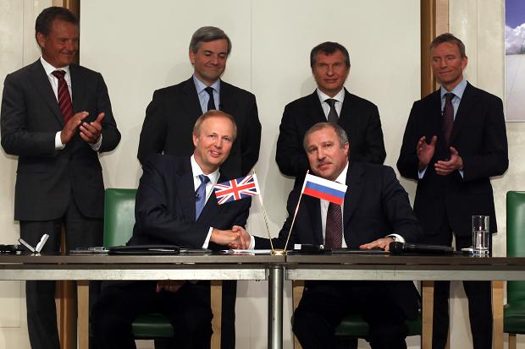
Fig. 6.2. BP and Rosneft sign cooperation agreement in 2011. The Secretary of State for Energy and Climate Change, Chris Huhne, watches on, second from the left, back row
(Source: Platform 2011).

This criticism was rooted in Platform’s claim that it was untenable for the British government to support Arctic oil and gas development, while at the same time pushing objectives relating to the Arctic environment, and to global climate change more broadly. In short, the report was intended to highlight the apparent hypocrisy of the British government in order to generate political pressure that would push it to revise its policy position towards oil and gas development in the Arctic. As the report concludes:
“The role played by the British foreign policy apparatus regarding Arctic oil extraction has to be opened up to parliamentary and public scrutiny. Open debate on Britain’s future a potential ‘Arctic [energy] state’ should be conducted prior to any further promotion of Arctic drilling by public bodies” (Platform 2011 p. 36).

In 2011, WWF-UK adopted a different strategy for interfering with emerging British Arctic policy by convening a conference at which it published a set of nine principles “to inform a Policy Statement on UK Interests in the Arctic” (WWF 2012). The principles were developed by a consortium of environmental NGOs, together with academics and other experts on Arctic issues. Strikingly, the principles are presented in terms of ‘what we the UK’ should do, rather than setting up the government and environmental NGOs as opponents (WWF 2012). While the principles propose an alternate vision of what Britain’s role should be in the Arctic, they are also a starting point for negotiation and engagement between environmental NGOs and government actors. Also striking is the implicit suggestion that Britain did not already have a ‘policy statement’ on the Arctic in 2012. The WWF and its allies deemed texts such as the FCO’s ‘Arctic’ webpage, and the briefing paper on British Arctic policy that was published through the FST, insufficient as statements of policy. This, in turn, suggested that for organisations like WWF, the texts produced by the FCO were not enough to convince them that their concerns about the environment were being taken seriously. This was not necessarily because of the wording of Britain’s environment-related Arctic interests, but more likely because of the way in which they were compounded with other interests that environmental NGOs thought were incompatible (as expressed by Caroline Lucas in Fig. 6.1). In rejecting these texts, the environmental NGOs were attempting to undermine the apparatus that the government was trying to construct. In attempting to push the government to restate its policies towards the Arctic in more detail, the WWF and its partners were ultimately unpicking the taken-for-granted assumption that the government had already made a sufficient statement of its policies and interests in the Arctic.
A third kind of strategy – spectacular forms of direct action – has been primarily adopted by Greenpeace. Perhaps the most emblematic event to occur in Britain took place in July 2013, when six Greenpeace activists scaled the exterior of one of London’s tallest buildings – commonly known as The Shard – and, upon reaching the summit, unfurled a banner with the words ‘Save the Arctic’ written on it.
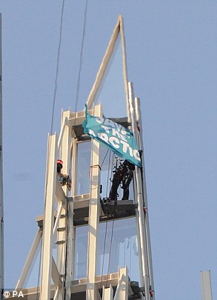
Fig. 6.3. Greenpeace protesters unfurl a ‘Save the Arctic’ flag atop The Shard, in London
(Source: London Evening Standard, 12 July 2013).

The climb was part of Greenpeace’s global campaign to ‘Save the Arctic’, launched in 2012 with the aim of “pushing for a UN resolution demanding a global sanctuary around the pole and a ban on oil drilling and unsustainable fishing in the wider Arctic” (Greenpeace 2012). The climb itself lasted around fifteen hours and was covered extensively by newspapers, television crews and social media, generating considerable publicity for the Greenpeace campaign. This particular act was aimed at increasing public pressure on Shell, a British-based IOC with plans to drill for oil in Arctic waters. However, indirectly, such direct action is also capable of interfering with emerging British Arctic policy. The ensuing publicity creates opportunities for Greenpeace activists to reach a broader audience with their message of possible alternative futures for the Arctic (for example, to constitute it as an environmental sanctuary), to the one espoused by the British government (as a region where environmental protection must be balanced against opportunities to exploit resources). This, in turn, can have the effect of generating public and parliamentary pressure on the government to reassess its emerging Arctic policies as they become subject to wider scrutiny.

6.5.4 Arctic States
A fourth source of interference in emerging British Arctic policy has come from the eight Arctic States (the US, Canada, Russia, Norway, Sweden, Finland, Denmark and Iceland). These States have considerable authority to set the terms by which Britain is capable of engaging in the Arctic. This is a consequence of the accepted norms of the international system that give the five Arctic Ocean coastal States (in particular) sovereign jurisdiction over much of the Arctic region. It was, for example, this authority that allowed the Arctic States to exclude Britain from becoming a member of either the Arctic Environmental Protection Strategy (AEPS) or the Arctic Council in the 1990s – full membership was reserved for the eight Arctic States. Britain was instead consigned to being an observer to both of these processes and organisations. The attempt (discussed in Scrivener 1999) in the late 1990s to increase Britain’s influence in the Arctic Council by seeking a more enhanced observer status was similarly suppressed by the authority of the Arctic States to set the terms of how non-Arctic States such as Britain could engage with the region (one example might be the British government’s adoption of its own kind of ‘rim-speak’ in presenting Britain as a ‘near-Arctic’ neighbour in order to justify its interests), with consequences for the kinds of policies such States could adopt. Britain’s exclusion from the Arctic was further reinforced by the five Arctic Ocean littoral States (the US, Canada, Russia, Denmark and Norway) in 2008 when they issued the joint statement known as the ‘Ilulissat Declaration’ (ID) which privileges the authority of the five coastal States to address the “possibilities and challenges” emerging in the Arctic Ocean on the basis of their “sovereignty, sovereign rights and jurisdiction” across large areas (ID 2008, p. 1).
Today, much of Britain’s formal diplomatic engagement with the Arctic continues to be contingent on rules determined by the Arctic States. In 2013, at the Arctic Council Ministerial meeting in Kiruna, the Arctic States adopted an ‘observer manual for subsidiary bodies’ explicitly setting out the terms of engagement between non-Arctic States such as Britain (as well as other observer organisations) and the Arctic Council. This document notes, for example, that “decisions at all levels in the Arctic Council are the exclusive right and responsibility of the eight Arctic States with the involvement of the Permanent Participants”; that “the primary role of observers is to observe”; that observers may not sit at the main table; and that observer status may be suspended at any time at the discretion of the Arctic Council Member States (Arctic Council 2013).
As well as explicitly setting out the terms on which Britain may engage with the Arctic Council, the Arctic States have also been able to interfere more generally with the emerging British Arctic policy apparatus as a consequence of their broader capacity to exclude Britain from the region. This interference has occurred in different ways. Canada and Russia, for example, have generally appeared more resistant to allowing non-Arctic States and organisations (such as NATO and the EU) to have a more visible presence in the Arctic as a consequence of concerns about sovereignty, the environment and national security. Mindful of this, one of the reasons most frequently cited by PRD officials as to why Britain should not develop a formal Arctic Strategy is that it puts diplomatic relations with some of the Arctic States at risk. As, Jane Rumble, the Head of the PRD put it during an EAC hearing:
“Going to an announced strategy is potentially welcomed by some of the Arctic States, but others of them feel that for another observer country to have a strategy, basically over their national jurisdiction and their territory is a bit sensitive” (HC 171, 2012, ev. 100).

Indeed, other Arctic States have sought to interfere in emerging British Arctic policy on a bilateral basis by actively encouraging Britain to make a stronger statement of its policies and interests in the Arctic. At the EAC, the ambassadors of Sweden and Norway both expressed their support for such a move, emphasising in particular the value that an expanded role for British science could bring to the Arctic (HC 171, 2012).
This ‘pressure’ continued at a conference at the Royal United Services Institute in October 2013, when the Icelandic President, Ólafur Ragnar Grímsson, similarly called on Britain to expand its presence in the Arctic, although his view was that this should come through increased business and investment rather than science per se (Morrell 2013). In addition, since 2011, the Norwegian Embassy in London has also, on an annual basis, taken parties of parliamentarians, civil servants, military personnel, policy analysts and academics from Britain on ‘study tours’ of the Norwegian High North in part to promote British interest in the Arctic and strengthen Anglo-Norwegian collaboration in the region. Meanwhile, the Swedish and Finnish governments have funded a forum for the study of Arctic climate change and security at the International Institute for Strategic Studies (IISS), another London-based defence and security think-tank. This forum, along with other initiatives such as the joint Norwegian Embassy and Royal Geographical Society seminars on the Arctic (organised annually since 2012), are demonstrative of the extent to which the Nordic States in particular have actively sought to promote certain kinds of high-level political interest from the British government on Arctic issues. Britain’s Arctic policy then is not only interfered with at home, but also from abroad as different Arctic States place different demands on Britain to express or restrict its Arctic ‘actorness’ in certain ways.

6.5.5 The Arctic
It is also important to recognise that the changing materiality of the Arctic has proven to be a source of interference in the emerging Arctic policy apparatus, not least because of uncertainty about how this materiality will continue to change in the future. Already, the image of the Arctic as a relatively barren, frozen frontier, primarily of interest to scientists, has been unsettled by a combination of economic, technological and environmental developments that have impacted everything from the materiality of Arctic sea-ice and glaciers to permafrost, boreal forests, oceanic and atmospheric conditions, ecosystems and more (Dodds 2012). The resulting transformation of the Arctic as a geopolitical stage, in turn, has had consequences for the kinds of activities that Britain and others now envisage as increasingly possible in the Arctic, relating for example to the expansion of shipping, offshore hydrocarbon development and tourism (Depledge 2013d).
The claim made by the FCO Minister, Mark Simmonds, at an EAC hearing in July 2013 (to hear the government’s response to the EAC’s report on ‘Protecting the Arctic’), that the emerging policy apparatus needed to be adaptable, seemed to be a specific acknowledgement of the potential for the Arctic to continue changing in material terms as a consequence of environmental change, as well as the relative success of human attempts to develop the region on behalf of both local communities and more distant populations:
“I certainly see it as a living document and, as either the ice melts or other aspects change and alter, or indeed as the evidence changes, then of course the document will be up for discussion” (HC 333, 2013, ev. 16).

This, in turn, was likely to generate both new risks and opportunities that Britain needed to be able to react to. In an affective sense, the language of risk and opportunities is suggestive of various hopes and fears emerging as a consequence of British relations with a changing Arctic (hope and fear both imply a belief that things could be otherwise and are thus intimately connected with the anticipation of change). For example, the hope that has emerged as a consequence of environmental and technological developments in the Arctic – especially the expectation that the material capacity of the Arctic can help Britain address risks to its energy security – helps to explain the government’s hesitancy to discount the development of Arctic oil and gas reserves, despite the environmental risks involved. At the same time, there is also fear about the unprecedented material changes taking place in the Arctic – especially about dangerous tipping points in Arctic systems relating to the Greenland ice sheet and stores of methane trapped in the sea-bed and in permafrost – which helps to explain why the government has also sought to support scientific research to understand better and make predictions about the changing materiality of the Arctic (for example, through the NERC’s Arctic Research Programme). As these examples suggest, it is important not to discount the changing materiality of the Arctic assemblage as a source of interference in emerging British Arctic policy. Certain facets of the Arctic’s materiality (the environment, the threat of tipping points, the deposits of oil and gas reserves, the relative success of various industries to pursue various activities) necessarily interfere with the kinds of relations that the British government might expect, hope, long for and even fear to have with region as it continues to change in various ways.

6.6 The Arctic Policy Framework: A precarious settlement?
On the 17th October 2013, the British government published its first-ever white paper setting out its policies and interests in the Arctic (HMG 2013). The document, titled ‘Adapting to Change: UK policy towards the Arctic’, was prepared by the Polar Regions Department (PRD) in consultation with other government actors (departments, agencies, scientists), as well as non-State actors including environmental NGOs, the private sector and academics. As a white paper, the APF is a far more formalised text than previous statements of government policy toward the Arctic (FCO 2011; FST 2011; HC 171, 2012). That the drafting of the document was led by the PRD should not be surprising given the emerging hierarchy described earlier in this chapter. As I noted above, the PRD has long been the most obvious policy lead for British policy toward the Arctic because it is the only department that requires a comprehensive overview of the ways in which Britain and the Arctic are connected (as a consequence of the fact that the PRD represents Britain’s Arctic interests in international fora such as the Arctic Council).

6.6.1 Assembling the Arctic Policy Framework
The APF appears primarily to have been produced in response to interference from the Environmental Audit Committee (EAC). Although there had been pressure on the government to produce a more formal statement of policy since at least the 2008 meeting of British Arctic stakeholders in Oban, the very public parliamentary scrutiny provided by the EAC eventually pushed the government to act. Even during the inquiry, the FCO Minister and Head of the PRD appeared hesitant to produce a more detailed policy statement (HC 171, 2012). However, the conclusions of the EAC inquiry into what more the government could and should be doing to protect the Arctic included an explicit recommendation for the government:
“to begin the development of an Arctic Strategy to bring together the UK’s diverse interests in the Arctic and engage all stakeholders” (HC 171, 2012, p. 73).

Although the government was not obliged to follow this recommendation, it nevertheless agreed, in its response to the EAC, the:
“need to communicate its Arctic policy effectively, both with domestic and international partners, and to keep its policy current towards this changing environment” (HC 858, 2013, p. 1).

As a consequence, the government announced that it was:
“committed to producing and publishing a policy framework for the Arctic in 2013” (HC 858, 2013, pp. 1-2).

The process through which the APF was assembled is demonstrative of the way in which the offices of the PRD were at the centre of its production. The formal process of producing the APF started in January 2013, immediately after the government’s response was delivered to the EAC, when PRD officials met to discuss what structure the document should take. Before anything was written, this was followed by a two hour meeting with the Cross-Whitehall Arctic Network of other government departments and agencies with interests in the Arctic. At this meeting, these other actors were informed of the PRD’s plans and encouraged to participate in the process by taking ownership of those sections which were most relevant to their own Arctic-related policies. Further input from other government actors was gathered through bilateral meetings. It was only after this extensive consultation with other government actors that the PRD prepared a first draft of the APF. This draft was then circulated among other government actors for review. In addition, these other departments and agencies were asked to populate those sections of text, for which they held the policy lead, with further information. All of this material was then consolidated into a second draft by the PRD. At this point, the PRD also sought input from other areas of the FCO, as well as the diplomatic missions of the Arctic States based in London. The second draft was then sent out again for review. This time, the PRD reached out further, inviting experts and representatives from environmental NGOs, the private sector and other stakeholder groups for their input. The final draft was then prepared based on this feedback. After receiving ministerial approval from the government, the APF was published in the public domain.
The APF itself consists of a foreword from the Minister for the Polar Regions, Mark Simmonds, and a series of chapters detailing different aspects of Britain’s policies and interests in the Arctic (as well as demands the Arctic is making of Britain). The first chapter, ‘The Arctic: an overview’, assembles the Arctic as a site of specific interest to Britain. The Arctic which is produced recognises the relevance of all kinds of elements to British-Arctic relations including: indigenous peoples, Arctic States, glaciers, sea-ice, permafrost, atmosphere, minerals, mammals, birds, fish, sea-ice, freshwater, carbon dioxide, oil and gas deposits, climate change and pollutants, tourists and cruise ships. Graphics are used to show how the Arctic is changing over time in terms of sea-ice concentration/distribution and surface air temperatures, emphasising the ways in which the Arctic is being unsettled by environmental forces (see Fig. 6.4).
The remaining chapters gather together the various ways that Britain is connected to the Arctic. The second chapter is notable for the way it details what kind of future Britain envisions for the Arctic, and the principles of respect, leadership and cooperation required to achieve it. The Arctic is assembled in a way
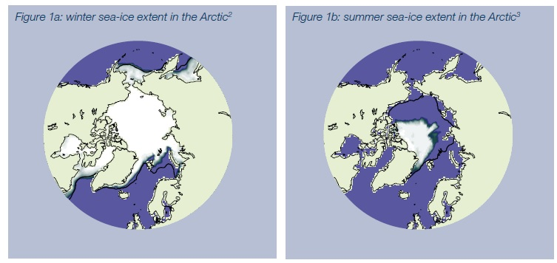
Fig. 6.4. Examples of graphics used in the APF to show dynamism of the Arctic
(Source: HMG 2013).

which suggests it is a place which makes demands on, and has impacts on Britain through its “inextricable links” to global processes whether climatic, environmental, social, legal or economic (HMG 2013, p. 7). Britain is assembled as a topographically proximate country, with a long tradition of exploration and historic interest in the Arctic. However, other ‘inextricable links’ are also identified as Britain is presented as an actor which has not just interests in the Arctic, but a role to play in meeting the challenges that are emerging in the region. Specifically, this role is described as one of stewardship, although throughout the rest of the APF, Britain is produced as having multiple roles relating to Arctic governance, environmental protection, scientific activity, security and commercial opportunities for British-based companies.
At least as important as the narratives that the APF embodies are the material and affective functions that the APF performs as an apparatus of British Arctic policy. In particular, there are four functions which stand out: 1) to assert the government’s authority of British-Arctic relations; 2) to affirm the geographies of these relations; 3) to de-conflict relations between the government and other actors; and 4) to set out a ‘code of conduct’ for government actors over how these relations should be conducted, at least publicly.

6.6.1.1 Asserting the government’s authority
The first function performed by the APF – as an apparatus – has been to consolidate, and to an extent, re-territorialise the authority of the British government over relations between Britain and the Arctic by embodying its apparatus in a government white paper (material that serves as a powerful statement of policy). In particular, both the report of the EAC inquiry into British policy toward the Arctic, and the WWF-led attempt to push the government to committing to a set of principles (developed by a consortium of environmental NGOs) from which to develop Arctic policy, posed discursive challenges to the relatively weak statements of policy that had been made by the government between 2008 and 2013. The interference of these actors (among the other sources of interference accounted for earlier) served to weaken the government’s capacity to set out Britain’s interests and policies in the Arctic on its own terms. This was made explicitly clear to me during an interview referred to earlier) with a PRD Official who observed that one of the main purposes of the APF was to help the British government “get on the front foot with Arctic messaging” (PRD Official I, 20 Jun 2013). The APF, this official hoped, would be a “sensible, pragmatic piece” that would “correct and objectify” the narrative of the Britain’s relationship with the Arctic (PRD Official I, 20 Jun 2013).
The APF, then, was intended to rationalise Britain’s policies in the Arctic according to pragmatism. The appeal to rationalism itself was a tactic that sought to invoke a commitment by the authors of the APF only to reflect the reality of British-Arctic relations in a way which was free of the kinds of moral subjectivity arguably displayed by other actors such as the EAC and environmental NGOs. By invoking ‘rationality’ as the basis of the APF, the PRD officials also intended to communicate a definitive statement that would settle debates about what Britain should be doing in the Arctic, in order to provide a stable platform which government as well as non-government actors could use as the basis for extending their reach into the Arctic. In the terms used by Legg, as “a re-territorialising force within assemblages”, the APF functioned as an attempt to normalise, governmentalize and, I would add, homogenise the way in which British Arctic policy is assembled and performed regardless of the sites, bodies, objects and practices involved (Legg 2009, p. 239).

6.6.1.2 Affirming the geographies of British-Arctic relations
A second function performed by the APF has been to affirm the geographies of British-Arctic relations in both topographical and topological terms. Since at least 2011, the PRD has asserted Britain’s topographical proximity to the Arctic (as the Arctic’s ‘closest neighbour’) as an important factor determining the region’s importance to Britain (even with the potential uncertainty of a referendum in Scotland in September 2014 – see below). This topography has been invoked to raise concerns about militarisation, environmental pollution and climate change, all of which could potentially impact Britain directly because of its relative ‘closeness’ to region. At the same time, the APF functions to shape and stretch the topology of British-Arctic relations in ways that attempt to draw the Arctic within reach of Britain, not on the basis of geographical distance, but because of things – such as diplomats, investment, technology, companies, pollution, fisheries and the weather –that circulate between Britain and the Arctic to varying degrees of intensity. The more intense of these relations – relating for example, to science and commercial opportunities – have the effect of making the Arctic seem much closer to Britain geographically. In contrast, less intense relations – regarding for example, indigenous communities – have the effect of making the Arctic seem much further away.
For the most part, then, both topologically and topographically, the APF is focussed on affirming the heterogeneity of the Arctic’s geography, rather than specific sites of interest. Although some of these sites are specified – most prominently around Norway and Svalbard – it is striking how much of the topography of British-Arctic relations is relatively undefined. Likewise, only a few specific sites in Britain, such as the City of London and Cambridge, are mentioned in the text as relevant to British Arctic policy (although as previous chapters have shown this might be extended to include a far broader set of sites from across the British Isles). This suggests that the British government is being careful not to rule out any part of the Arctic – or Britain – from its policies and interests, producing the Arctic not as a set of sites but as a single, discreet region to be engaged. At the same time, the government is also being careful to avoid making specific commitments relating to emerging opportunities and risks in different parts of the Arctic. This, in turn, implies that the APF functions as blanket of policies and interests to be thrown over the entire Arctic region in the broadest terms possible, while its local implications are left open to negotiation.

6.6.1.3 De-conflicting relations
A third function performed by the APF has been to supress tensions between different facets of British-Arctic relations. Perhaps the biggest challenge the British government has had to address so far relates to the apparent contradiction in its policies towards environmental protection and resource exploitation in the Arctic. In recent years, DECC officials have repeatedly insisted that the British government cannot discount supporting the development of offshore Arctic oil and gas resources for the straightforward reason that the development of these resource may either directly or indirectly release pressure on Britain’s energy security (Barton 2011). The growing potential for offshore oil and gas development (as well as other resources) in the Arctic has also been seen by the British government as a possible commercial opportunity for British-based firms (FCO Official IV, 11 Apr 2012). As such, the government’s policy on resource development has been to pursue emerging opportunities in the Arctic wherever they emerge.
At the same time, the British government has also called for the highest environmental standards possible to be adopted in the Arctic in recognition of the potentially catastrophic impacts oil spills, other forms of pollution and overfishing could have on the Arctic environment, as well as the potential reputational damage this could cause to Britain and British-based companies. The government has been lobbied hard on this front by environmental NGOs that have publicly cast doubt over whether Britain has been living up to their responsibilities as stewards of the Arctic environment, as well as its commitments under the legally binding Climate Change Act of 2008 and the UNFCCC process.
This contradiction between Britain’s energy and environmental protection policies in the Arctic exists precisely because of the multiple actors and agencies involved in producing British policy toward the Arctic (described earlier). While the government has broadly sought to perform both roles (as ‘steward’ and ‘exploiter’), other actors – most prominently environmental NGOs – have sought to polarise energy and environmental policy as diametrically opposed and ultimately incompatible. A similar view was taken by the EAC during its inquiry into what the government should do to ‘protect’ the Arctic. The EAC concluded that the government was prioritising Arctic oil and gas development, and ultimately not doing enough to live up to its responsibilities as an environmental steward (in part by hiding behind the ‘excuse’ that the Arctic lay under the sovereign jurisdiction of others).
The APF functions as an attempt to suppress these tensions through the use of the rhetorical devices that present British policy toward Arctic energy and the Arctic environment as mutually compatible. This is achieved in a relatively simple way. Separate chapters on the ‘environmental dimension’ (Chapter 4) and the ‘commercial dimension’ (Chapter 5) separate out environmental and commercial policy as different issues that can be pursued in tandem. At the same time, Chapter 5 – ‘The commercial dimension’ – also makes it explicitly clear that the environmental dimension provides the basis for the commercial dimension of British activity, implying that without sound environmental policies to underpin it, the government’s commercial policies in the Arctic will also fail. Thirdly, the chapter on the commercial dimension distinguishes between ‘responsible development’ and ‘irresponsible development’, and unsurprisingly puts the British government’s policies in the former category. What ultimately emerges from the APF is a compound narrative that seeks to undermine claims by environmental NGOs and others that environmental and commercial policies in the Arctic cannot be pursued together. This compound narrative, in turn, functions as a way of trying to manage relations internal to the policy apparatus (i.e. in order to present unity outwardly).
It is worth stressing at this point that this is not a new tactic. In 2011, the then-FCO Minister for the Arctic, Henry Bellingham responded to a question in the House of Commons by invoking a similar compound narrative:
“The Government recognises both the contribution that could be made to global and UK energy security by developing Arctic hydrocarbon resources and the threats posed to the fragile Arctic environment by climate change and by the development this may allow as remote areas become more accessible. However, given proper safeguards, we do not believe such development and protection are incompatible” (HC WA, 18 Jan, 2011).

However, in the past such statements have rarely allayed the concerns raised by critics of British government policy, as evidenced by the fact that the apparent contradiction between the government’s commercial and environmental policies in the Arctic was repeatedly brought up during the EAC inquiry, both by representatives of environmental NGOs and members of the committee. Explicitly, the EAC noted in its last report before the publication of the APF (and after the British government had responded to its initial findings) that:
“The Government failed to offer a coherent argument for its view that future oil and gas exploration is compatible with efforts to contain global warming to 2°C” (HC 333, 2013, p. 3).

And, moreover, that:
“Oil companies and regulators are not yet in a position to demonstrate that they can ensure that oil and gas operations will be undertaken in the safest possible way in the Arctic” (HC 333, 2013, p. 3).

The difference between the APF and previous statements of British government policy toward the Arctic is that the case for a mutually compatible approach to energy and environment policy is made in much more detail than it has been in the past. This detail matters because it is revealing of the extent to which the government is under pressure to justify its actions and explain its understanding of why the Arctic is demanding of attention, rather than assume that its policies can simply be taken-for-granted. The APF is used to show that the government has thought about the different issues raised by environmental risks and commercial opportunities, and has settled on a rational and pragmatic response that attempts to de-conflict Britain’s environmental and energy-related policies and interests.

6.6.1.4 Establishing a ‘code of conduct’
A fourth function performed by the APF has been to establish a ‘code of conduct’ for how British actors (State, as well as their non-State allies, including commercial actors engaged in shipping, resource exploitation and tourism, and environmental NGOs engaged in direct action) are to approach and operate in the Arctic. Much of this conduct is set out in Chapter 2 of the APF – ‘The UK’s approach to the Arctic’ – but it permeates the entire document, most notably through the sub-headings under every chapter heading which remind readers that Britain will “work towards an Arctic that is safe and secure” (HMG 2013, p. 7); “promote an Arctic where policies are developed on the basis of sound science” (HMG 2013, p. 17); and “promote an Arctic where only responsible development takes place” (HMG 2013, p. 23). Chapter 2 sets out the principles underpinning British policy towards the Arctic: ‘Respect’, ‘Leadership’ and ‘Cooperation’. The implicit assumption is that any action that is not in accordance with these principles is likely to be counter-productive to Britain’s influence and interests in the Arctic. The rest of the APF suggests that this ‘code of conduct’ in the Arctic is not only applicable to the British government, but also to non-State allies. For example, the broader UK scientific community is exhorted to show leadership in Arctic science, while British-based environmental NGOs are called on to continue promoting awareness and understanding of the Arctic environment. Moreover, British-based businesses are expected to partake in responsible environmental practices if they want British government support to facilitate access to opportunities in the region.
In setting out a ‘code of conduct’ for Britain in the Arctic, the APF also functions as a tool to legitimise Britain’s policies and interests in the Arctic to an international audience. Throughout the APF, considerable emphasis is placed on the need for Britain to respect the limits of its reach in the Arctic. This is done in recognition of the fact that the Arctic States exercise sovereign jurisdiction over large swathes of the Arctic, and that parts of the Arctic are populated by indigenous communities (which in some cases possess considerable political agency within their domestic – some might claim ‘paternalistic’ – State) that depend on the local environment for their survival. Arguably this language of respect, cooperation and knowing the limits of one’s own reach, is used to present Britain as a ‘model observer’ in terms of its conduct towards the region, at a time when ‘outsider interest’ in the Arctic is growing dramatically (Depledge and Dodds 2014). The notable absence (for British readers at least) of any reference to the outstanding political question about how the Spitsbergen Treaty of 1920 should be applied in the Arctic including the continental shelf and maritime areas such as the exclusive economic zone (Britain, Norway and Russia all apply different interpretations) adds further weight to the argument that the APF functions as an apparatus that conducts how Britain can publicly express its policies and interests in the Arctic (at least publicly) while at the same time suppressing more ‘sensitive’ issues that threaten diplomacy.

6.6.2 Fortifying the apparatus
The apparatus produced by the APF is more than simply text. The functions performed by the apparatus have been fortified by the practices that surrounded the APF’s production and the material embodiment of the APF in a government document that can circulate widely. In terms of the practices involved in the production of the APF, the lack of any firm hierarchy in the British government to determine which departments or agencies are primarily responsible for Arctic policy puts the PRD in a relatively weak position in terms of authorship. As a result, PRD officials could not draft the APF on their own. Other government actors had to be enrolled in the process to help populate the APF with policies that these others actors were willing to take ownership of, and to ensure the APF was representative of the ‘whole-of-government’ to the greatest extent possible. While reaching out to other government actors increased the capacity of these other actors to interfere with the drafting process, securing this engagement ultimately strengthened the APF as an apparatus. Although the PRD’s control over the authorship of the policy document was weakened, the effect was to bring more government actors within reach of the apparatus’ effects (particularly important in terms of the conduct of conduct), putting the PRD in a stronger position to speak on behalf of the British government by reducing the risk (although not completely) of other government actors adopting conflicting positions. A similar effect of extending the apparatus’ reach was sought by sending early drafts of the APF out for review by non-State actors. Doing so essentially gave non-State actors a chance to interfere in the drafting process (albeit in a managed way by the PRD which set the timeline for the process and reviewed the feedback), which, in turn, would potentially give them a stake in supporting the overall success of the apparatus in the long-term.
The material embodiment of the APF in a government document has also strengthened the APF by creating an object, which is “both fixed and made mobile” (Freeman 2012 p. 14). While the text of the APF may be reviewed and amended in years to come, the apparatus it represents will likely remain the principal means for British policies and interests towards the Arctic. Strikingly, one of the first acts undertaken by PRD officials after the publication of the APF was to hand out copies of the document to diplomatic officials representing Arctic States at the Arctic Council. However, the launch in London was low key, perhaps to avoid provoking further resistance and interference from Parliament and environmental NGOs (PRD Official I, 20 Mar 2014). Importantly, the APF now stands as the principal statement of government policy toward the Arctic to which all inquiries are directed. The embodiment of the apparatus in a single document therefore works to create the impression that British policies and interests in the Arctic are ahistorical and uncontested. As such it provides a platform that fortifies the emerging apparatus by effectively attempting to settle past conflicts between various actors about Britain’s policies and interests, while at the same time providing the starting point from which all further British engagement with the Arctic should proceed.

6.6.3 The precariousness of the Arctic Policy Framework
Nevertheless, the on-going challenge facing the PRD and the British government more broadly is that the APF remains an inherently precarious settlement that will continue to be interfered with by other actors (human and non-human, State and non-State). In part, this is by design. As I noted earlier, while presenting the government’s plans for producing the APF to the EAC, the FCO Minister, Mark Simmonds, stressed that the APF was to be a ‘living’ document, attuned to the risks and opportunities for Britain emerging in a rapidly change Arctic. As Simmonds put it:
“The framework document when it comes out won’t be fixed. I certainly see it as a living document and, as either the ice melts or other aspects change and later, or indeed as the evidence changes, then of course the document will be up for discussion” (HC 333, 2013, ev. 16).

As well as demonstrating attentiveness to the liveliness of contemporary Arctic geopolitics, Simmonds’ statement was also suggestive of the government’s confidence that the fundamental structure of the apparatus the PRD has produced is both flexible and resilient enough to respond to this inherent liveliness of the Arctic itself (the dynamic materiality of the Arctic has itself been complicit in the demand for a living document). Specifically, Simmonds suggested that the PRD-led Cross-Whitehall Arctic Group was a sufficient mechanism for ensuring that the apparatus can adapt to an array of changing circumstances, from ‘ice melt’ to ‘other aspects of change’ (which elsewhere in his response to the EAC, Simmonds defines as related to shipping, fishing, tourism, mineral extraction and governance) (HC 333, 2013). What Simmonds’ describes suggests that the APF provides a settled structure through which to manage British policy toward the Arctic; an apparatus, which as I have shown, comprises practices, materials, sites and affects relating to the PRD, the Cross-Whitehall Arctic Group, other government departments and agencies, and non-State actors including environmental NGOs, scientists and other academics, and the private sector.
However, in light of the issues raised earlier in this chapter, it is arguable that this flexibility and call for resilience is strategic – an affective intervention by Simmonds, the PRD, and the government more broadly, that suggests the emerging apparatus is more powerful than it really is. This is because while the APF has produced a broad narrative to convey Britain’s policies and interests in the Arctic – with affective implications implying that Britain is a committed, present and model non-Arctic State – as yet it appears to have had very few material consequences for the constitution of the Arctic as geopolitical space (or indeed Britain’s relationship with that space). In short, the apparatus appears to have done little to extend the government’s reach into the Arctic, or to influence the emerging materiality of the region. While this might in part relate to the fact that at the time of writing the material effects of the apparatus are still unclear, there are also a number of outstanding issues that reflect the precariousness of the apparatus as it has currently been constituted by the government. These issues (see below), in turn, suggest that the APF is still underpowered in terms of its capacity to direct British Arctic policy. Fundamentally, the PRD, and the government more broadly, are dependent on other actors, over which the government has only limited influence, to make these interventions.
First, the British government’s capacity to drive commercial interest in the Arctic is limited largely by the policies of the Arctic States and what might loosely be termed ‘market forces’. The APF makes it explicitly clear that:
“the decision to invest in commercial projects in the Arctic is a matter for the individual companies concerned and the relevant national authorities of the Arctic States in whose jurisdiction they take place” (HMG 2013, p. 23).

The British government itself is not investing in the commercial aspects of its Arctic policies and interests, beyond helping to create the conditions under which British business could pursue opportunities should they choose to. Ultimately, most of the ‘commercial’ dimension of British Arctic policies and interests is dependent on actions taken by the Arctic States (to create a regulatory environment for domestic and global commerce to take place) and British-based commercial firms. With regards to the latter, the decision to pursue opportunities in the Arctic will likely depend on a much broader set of considerations relating to the economics of operating in the Arctic. In 2012, Lloyds of London found that expected investment in the Arctic could reach $100bn or more over the next decade, but that the final figure would likely be complicated by the “high risk/potentially high reward nature of Arctic investment” (Lloyd’s 2012, p. 6). Very little, if any, of this investment is likely to come from the British government, suggesting that whether or not Britain’s commercial interests in the Arctic are realised in material terms is situated for the most part beyond the reach of the emerging apparatus (notwithstanding what the Government might do to facilitate deals should commercial actors express interest).
Second, the British government is only able to exert limited authority over the behaviour of international environmental NGOs which have offices in, and members from, Britain. Greenpeace, in particular, continues to be a source of interference in British-Arctic relations as it continues its ‘Save the Arctic’ campaign. This campaign is primarily seeking signatures from around the world to support the creation of an environmental sanctuary at the North Pole, protected from potential economic development (see Map 6.1).
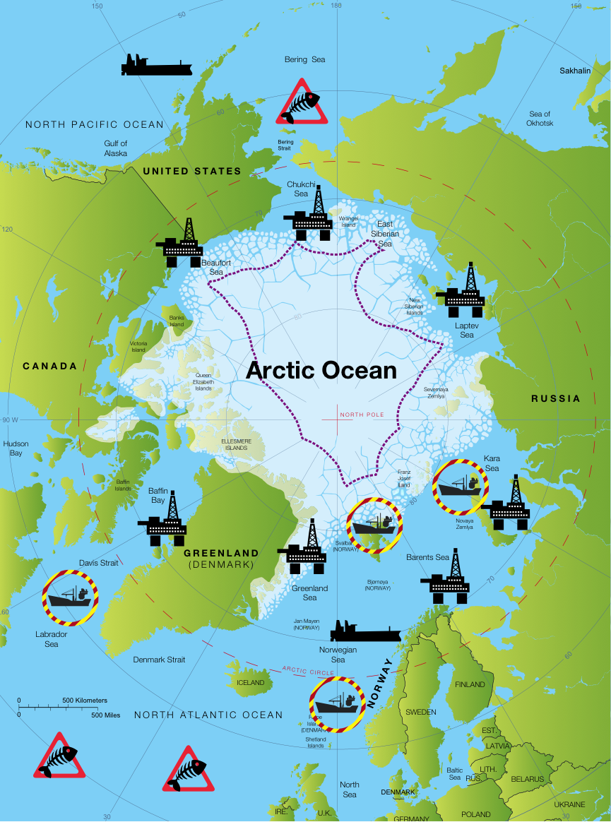
Map 6.1. The purple dotted line indicates the area Greenpeace is seeking to protect as a global sanctuary (Source: Greenpeace 2014).

However, the Greenpeace campaign also contains less passive elements. In September 2013, 30 Greenpeace activists, including six from Britain, were arrested by the Russian authorities for attempting to scale an oil rig in the Russian offshore Arctic. The arrest of the activists attracted considerable attention from around the globe, but the presence of British citizens demanded the involvement of the British government to help secure their release. This, in turn, drew attention to the contested status of Russian Arctic waters, particularly the fact that Britain and others disagree with Russia (an Arctic State) about the legal status of those areas beyond Russia’s territorial waters (Flake 2013). The British government was in an awkward position as the actions of Greenpeace potentially raised questions about the extent to which Britain was committed to its claims in the APF that a fundamental principle of British engagement in the Arctic is “Respect for the sovereign rights of the Arctic States to exercise jurisdiction over their territory” (HMG 2013, Foreword). The fact that what counts as ‘territory’ is contested by different actors was exposed by the actions of the Greenpeace actors, and was revealing of a potential vulnerability in the geopolitical foundations on which the APF apparatus was established. While the British government might want to present Britain as a model observer, actions by environmental NGOs with offices in Britain, such as those taken by the Greenpeace activists in offshore Russia, continue to retain the potential to unsettle this vision by threatening Britain’s image as a ‘model observer’, despite the claims made in the APF.
Third, the apparatus is weakened by the way in which it formalises a relatively loose hierarchy of departments and agencies within government. Ostensibly, the Cross-Whitehall Arctic Group is intended to ensure greater coherence and coordination of interests across government. However, the PRD’s broader lack of authority to push certain government policies and interests means that it also lacks the resources that other departments and agencies can mobilise. As with the commercial dimension of Britain’s Arctic policies and interests, the PRD remains dependent on other actors to perform material interventions in the Arctic – namely those government departments and agencies with lead policy responsibility for issues which affect and are affected by the Arctic. However, for these other departments, the Arctic may not be a priority concern, meaning that the resources required to make material interventions continue to be located beyond the reach of the APF to mobilise.
Fourth, the APF is vulnerable to uncertainties about how the Arctic itself is changing in material terms (both in terms of the environment and human development). The potential impact of tipping points in Arctic environmental systems or the pace of potential economic developments relating to oil and gas extraction and shipping, lies not only beyond Britain’s control, but also beyond its full comprehension (Lenton 2012). This, in turn, creates uncertainty over how Britain might need to adapt its policies in the future, and what kinds of actors it will be dependent upon to do so. While this ‘liveliness’ is broadly recognised by the APF, it remains to be seen whether the structures put in place by the apparatus (namely the option for the Cross-Whitehall Arctic Group to review and revise the APF), will be sufficiently capable of monitoring and responding to developments in the Arctic as potentially rapid changes unfold (or indeed whether there will be demand for the PRD to be further resourced to address this vulnerability). To the extent that the apparatus can never be fully secured against what might emerge in the Arctic, there remains an inherent risk the apparatus will always to some extent fail to manage the abundance of changes occurring the region, particularly the possibility that unanticipated transformations will dramatically alter the conditions of British-Arctic relations.
Finally, there is a ‘wildcard’ that the APF does not address publicly. In September 2014, there will be a Scottish referendum to decide whether Scotland will remain part of the United Kingdom. According to Alyson Bailes, the Scottish Office and Scottish government were not consulted during the process of drafting the APF, suggesting that the issue of Scotland’s role in the assembling of British Arctic policies and interests has either been taken-for-granted or ignored (Bailes 2014). Yet as Bailes describes:
“Scotland is the nearest part of the UK to the Arctic, with a larger proportional stake both in fishing and hydrocarbon sector, and more natural ports of call for Arctic shipping. It is more directly exposed to the working of Arctic climate change, and is far more likely to be affected (and asked to help) in any major disasters affecting the European High North” (Bailes 2014).

At the very least, a ‘Yes’ vote in the Scottish referendum will disrupt the oft-repeated claim made by the FCO that Britain is the Arctic’s closest neighbour, but it may have further implications if Scotland decides to develop an ‘Arctic Strategy’ of its own. Even with a ‘No’ vote, Scotland may still pursue the ‘Arctic Strategy’ called for by the MP, Angus Robertson, in an article titled “High time to join our friends in the North and face the Arctic challenge” (Robertson 2011). For the reasons outlined by Bailes, an independent Scotland would have a very strong case for justifying its own involvement in organisations such as the Arctic Council (as an observer State) and for developing the long-standing relationship between the Scottish and Norwegian energy sectors (a historical legacy of UK-Norwegian cooperation in the North Sea). Johnstone (2012) has even argued that Scotland sees itself as more Nordic than the rest of Britain, and this too could have consequences for the kinds of economic and cultural cooperation it might pursue with Norway, Sweden, Finland, Denmark and Iceland, with the rest of Britain potentially excluded from emerging Scotland-Arctic assemblages. Scotland, then, may well escape the apparatus provided by the APF, in which case it may also prove to be a considerable source of interference in the realisation of Britain’s policies and interests in the Arctic, especially where the government has sought to justify these interests through a sense of topographical proximity rather than topological connection.
The precariousness of the APF as an apparatus is in part a symptom of what cannot yet be known – the effectiveness of the apparatus in anticipating and responding to the changing materiality of the Arctic. Yet it is also symptomatic of a broader lack of commitment from the British government to making material interventions in the Arctic that would help secure the policies and interests stated in the APF. Since the publication of the APF, the only visible significant commitment by the government to making a material intervention in the Arctic is the announcement of an intention to develop a new world class scientific research ship with icebreaker capabilities (at a cost of approximately £200 million – see Amos 2014). However, from the government statements issued so far, this ship is being built to replace existing capacity (as Britain’s other two polar research ships are close to retirement) rather than develop additional capacity for Arctic science. Moreover, the ship itself is far more likely to be deployed in Antarctica than in the Arctic (Amos 2014).
Without material interventions to reinforce and sustain British policies and interests in the region, the emerging apparatus will continue to look precarious, especially since it is much easier to re-write a narrative than it is to displace investment in bodies, infrastructure and other materials used to embody and perform British-Arctic relations. While on the one hand this lends a degree of flexibility to the emerging apparatus, it is unlikely to effect material change either in the Arctic, or in relations between Britain and the Arctic.

6.7 Chapter summary
Taking seriously the value in making an analytical distinction between an ‘assemblage’ and an ‘apparatus’ (Legg 2009; 2011), this chapter has set out various ways in which emerging British Arctic policy functions as an apparatus of the British government through which British-Arctic relations are ordered, represented and performed. In doing so, the chapter has attended to: how this apparatus has been assembled by the PRD; how other actors (State and non-State, human and non-human) have sought to interfere with this process of assembly; how the APF functions to manage this interference; and the on-going precariousness of the APF as it seeks to retain authority over how British-Arctic relations are performed. In particular, the chapter has emphasised the importance of taking into account the criss-crossing lines of hierarchy, authority and intent that have characterised, and continue to characterise the assembling of the government’s Arctic policy apparatus. One effect of this approach has been to show that British Arctic policy does not emanate from a single site, nor is it imposed by a top-down authority. Instead it has been negotiated, primarily under the lead of the Polar Regions Department of the FCO, which reached out to all kinds of State and non-State actors during the process of assembling and maintaining the apparatus. However, these negotiations have also been a consequence of other actors attempting to reach into the emerging apparatus in order to interfere with its functioning.
A second effect of the approach adopted in this chapter has been to show that there are limits to what the emerging apparatus – as it is currently embodied by the APF – can achieve as a consequence of both its limited reach and its apparent inability as yet to effect real material change in the Arctic, or in relations between Britain and the Arctic. With regards to the former, a range of actors from environmental NGOs, to other government actors, to the materiality of the Arctic itself, have been shown to have the capacity to act beyond the reach of the apparatus in ways that may unsettle the various functions it is trying to perform. With regards to the latter, the chapter has argued that the impact of the APF as an apparatus has so far primarily been felt in textual and affective terms, with little material impact in the world. The current lack of material intervention to embody the discourse of the apparatus might be read as a source of flexibility that allows the British government to adapt its apparatus in accordance with developments in British-Arctic relations. However, this kind of ‘wait and see approach’ is unlikely to effect any significant developments either in the Arctic, or in relations between Britain and the Arctic, on its own.

7. Conclusions

When the Arctic Policy Framework (APF) was published October 2013, the British government appeared to have settled the problem of British-Arctic relations raised at the 2008 meeting of British Arctic stakeholders in Oban. The APF followed more than five years of debate about how the British government should express its Arctic identity, policies and interests. Over the course of this debate a range of actors were engaged, including both government and non-government stakeholders, as well as the Arctic States. At the same time, consideration was given to the dynamic materiality of the Arctic itself, a consequence of on-going changes in the environment, as well as human activity in the region relating to the development of intergovernmental organisations as well as commercial, scientific and military infrastructure. Moreover, in framing it as a ‘living document’ the British government presented the APF as being adaptable enough to account for future dynamism in British-Arctic relations. Thus, when announcing the launch of the APF, Mark Simmonds, the Minister for the Polar Regions, was able to declare:
“Adapting To Change: UK policy towards the Arctic sets out for the first time the detail of the UK’s interests in the Arctic, how we will work with Arctic States and the wider international community, and what expertise the UK can offer to help meet some of the long-term challenges facing the region” (GOV.UK 2013).

Another FCO Official told me in the margins of an Arctic-related policy event later that year that the APF would now provide the platform from which further British interest in the Arctic could be developed. To modify a quote from an FCO Official used in Chapter 6, the narrative of Britain’s Arctic interests had seemingly been ‘corrected and objectified’.
Yet the APF was not launched with great publicity. Instead, the British government opted for a ‘soft launch’: a press release with ministerial statements. Over the following week, few media outlets even covered the news; the most significant being The Guardian newspaper which is the only major British news outlet to report regularly on Arctic affairs (Harvey 2013). Meanwhile, PRD officials circulated copies of the APF among the Senior Arctic Officials (SAOs) of the Arctic Council and solicited feedback from the Arctic States. This ‘soft’ approach seemed to suggest a lack of confidence among government officials in the APF’s ability to settle all of the long-standing issues raised, in particular, by non-government stakeholders. At the same time, such an approach was likely also a response to diplomatic anxieties about how the white paper might be received by the Arctic States, especially Canada and Russia, which have traditionally been more resistant to non-Arctic States demanding anything from the Arctic. Thus, in addition to not wanting publicly to reopen debates about the compatibility of Britain’s environmental and commercial interests in the Arctic, the British government also appears to have been wary of the potential for a pushback from the Arctic States which might further undermine the settlement provided by the APF.
Given these sensitivities, as well as what had already been achieved in terms of producing the APF, it seems unlikely, then, that the British government would have expected the announcement from the House of Lords Liaison Committee in March 2014 that an ad-hoc committee would be established to:
“consider recent and expected changes in the Arctic and their implications for the UK and its international relations” (Parliament 2014).

The ‘Arctic Committee’ was proposed by Lord Tugendhat after an initial attempt by the House of Lords to set up a Select Committee on Foreign Affairs was rejected on account that its focus would be too broad. With less than a year left in the parliamentary session, the Arctic was seen as a more manageable topic (HL Paper 145, 2014 pp. 15-16). A striking feature of the Liaison Committee’s decision was that while it fully acknowledged the publication of the APF in October 2013, it did not mention the parliamentary Environmental Audit Committee (EAC) that preceded it. Nor was the EAC mentioned by Lord Teverson (the Chair of the committee) in an interview he gave for the committee website in which he set out the committee’s agenda (Teverson 2014). If anything, the justification for the committee offered in the Liaison Committee’s report is that it was the APF (rather than the EAC inquiry that preceded it) which had brought the Arctic to their attention, and which deserved further investigation:
“Such an inquiry would be particularly timely, as in October 2013 the Government published an Arctic policy framework…The publication of this policy framework reflects growing recognition of the opportunities and risks presented by the opening up of access to the Arctic” (HL Paper 145, 2014, p. 15).

One FCO Official I spoke to suggested that the work of the EAC and the House of Lords committee amounted to separate inquiries that reflected their differing interests. While both are concerned with the same topics – commerce, science, the environment and governance – where they differ is in their emphasis (PRD Official I, 28 Jun 2014). For the EAC, these topics were engaged on the basis of what their likely impacts would be on the Arctic environment (as befitting an inquiry with the title ‘Protecting the Arctic’). In contrast, the House of Lords committee is engaging with these topics on the basis of their implications for British relations with, and influence in, the Arctic. This difference in emphasis is revealing of the multiple ways in which British-Arctic relations continue to be assembled by different actors, despite the government’s efforts to ‘correct and objectify’ the narrative of these relations. Moreover, it is not a process the government can ignore as the Minister for the Polar Regions will be expected to respond to the committee’s findings, and defend that response during a debate in the House of Lords (expected to take place in 2015).
The launching of a new parliamentary committee to investigate British Arctic policy is therefore suggestive of the on-going precariousness of the APF even as the government attempts to retain an adaptable posture. The House of Lords inquiry (paralleling the Environmental Audit Committee inquiry discussed in Chapter 6) will again require the government to justify its Arctic policies and interests while at the same time giving voice to other actors (serving as witnesses) to present alternative ways of articulating and performing British-Arctic relations. It seems likely then that even the approach on which the APF is based – namely, the need for Britain to retain a relatively open and adaptable posture towards the Arctic – will be tested over the course of this parliamentary inquiry.
Other sources of interference in the government’s assembly of British Arctic policy are also likely to matter going forward. Greenpeace’s ‘Save the Arctic’ campaign is expected to continue for the foreseeable future. British-based businesses interested in pursuing opportunities in the Arctic are also likely to continue seeking support from government, particularly where their activities may face extensive reputational and political risks. The recent deterioration of relations with Russia over issues in Ukraine has already triggered a response from the British-based oil and gas industry, with BP warning that on-going sanctions will threaten their operations in Russia, which includes interests in the offshore Arctic (Rankin 2014). In the event of a ‘yes’ vote in the Scottish Referendum on 18 September 2014, British-Arctic relations could be further complicated, not least if the British government persists in attempting to naturalise Britain’s Arctic identity in terms of topographical claims of proximity. At the same time, the content of the APF may be undermined by the changing materiality of British-Arctic relations. This could include, for example, a sudden mass-release of methane in the Arctic as a consequence of permafrost melt; a major disaster involving a cruise ship or oil rig; or another financial crisis in the British economy that forces the government to re-prioritise the monetary, bodily and material resources (whether scientific, diplomatic or military) that underpin current Arctic-related practices. The policies and interests represented in the APF are therefore precariously balanced on the material capacity of British government actors and other stakeholders to deliver them.
The Arctic itself will also continue to pose a problem for British-Arctic relations. Considerable uncertainty remains within both the British and the broader international Arctic science community about the scale and speed of environmental changes in the Arctic. As a consequence, the Arctic still provokes anxiety in the scientific community about whether the world is already locked into a climate change trajectory which will bring about dramatic ‘tipping points’ in the Earth System. Such ‘tipping points’ would be felt globally through impacts on weather systems and sea-level rise which, in turn, could affect the long-term sustainability of food production and freshwater supplies in different parts of the world. At the same time, new discoveries and new connections between sites, actors and practices demonstrative of how the Arctic’s materiality may continue to be valued in different ways. For example, while there has been much discussion, over the past decade, of the oil and gas reserves which may be discovered in the Arctic, in Britain there is now growing interest in other forms of mining that are revealing of another dimension of the Arctic’s materiality as a store of iron, gold and other precious metals. According to one survey of the global mining industry, Arctic countries currently comprise the top seven most attractive mining destinations in the world (GOV.UK 2014). Mining activities necessarily produce a different topology of British-Arctic relations to oil and gas activities as a consequence of the focus on land rather than offshore environments. British policymakers and other stakeholders will need to remain mindful of the material contingency of the Arctic, as well as the labour involved in shaping it. The Arctic does not simply emerge as a resource province, or as the site of a tipping point in the Earth System. Such productions of the Arctic as a certain kind of space depend on the kinds of labour being applied; labour that may be textual, material or affective to the extent that different things are written about, acted out, and felt about the Arctic in response to the material development of the region. These material developments should be understood as a combination of environmental change and changing human activities, whether that involves scientists drawing attention to the implications of climate change, or businesses attempting to monetise various facets of the Arctic’s materiality (as hydrocarbons, rare earth metals, fish and other resources). Both necessarily have consequences for how we value different aspects of the Arctic as a material space, and how we connect to it. Moreover, as this materiality changes over time, new encounters will become possible, allowing a further intermingling and recombining of actors, sites, practices and affects in Britain and the Arctic that will further reinforce the dynamic nature of British-Arctic relations in ways we may not yet even be able to imagine.
Thinking with assemblages in this thesis has offered a way of making sense of the different ways sites, actors and practices, across Britain and beyond, are connected as co-producers of British Arctic policy, and how these connections are changing alongside material developments in both broader British interests and Arctic geopolitics. In Chapter 5, I focussed specifically on how the MOD, the FCO and British Arctic science community all produce British Arctic policy through different assemblages of actors, sites and practices. While these assemblages at times overlap (for example, when the FCO turns to scientists to support diplomacy), in the past they have also shown a capacity to act independently (for example, the MOD decides whether to participate in Exercise Cold Response, while individual scientists were prominent in driving forward Britain’s involvement in the International Polar Year 2007-8). What is made apparent in Chapter 6, in thinking about other sources of pressure on British Arctic policy, is that there are also actors beyond government that more or less affect British-Arctic relations through relatively independent actions. This includes both environmental campaigners and businesses seeking political cover from the government when things go wrong (for example, in the case of a potential oil spill, or if British citizens are arrested for participating in environmentalist campaigns). Viewed in this way, how actors, sites and practices are assembled in practice runs contrary to the expectation that the PRD is the sole source of Arctic policy development in Britain. Moreover, it is suggestive of the way in which the PRD’s own practices are complicated by the potential for all kinds of other government and non-government stakeholders to pursue policies and activities with Arctic dimensions without necessarily going through the PRD first. It was striking to me over the course of this project how, during the various policy-facing conferences and workshops I attended, the PRD appeared to bear the brunt of criticisms about British Arctic policy, even where it had little capacity act. While the PRD has taken a lead role in trying to coordinate British Arctic policies and interests, it still has little capacity to direct how other government departments and non-government stakeholders pursue the Arctic dimensions of their own policies and interests.
The APF emerges as a significant response to these multiples sources of, and pressures on, British-Arctic relations precisely because it attempts to order them according to a single narrative that allows the government to represent British Arctic policy in straightforward terms (without the messiness and multiplicity that underpins it). At present, the PRD is perhaps the only government actor with the capacity to represent British Arctic policy in these cross-government terms and as such the bodies and resources available to the PRD are critical for setting out British Arctic policy. As a consequence of the need for the PRD to represent multiple interests in accordance with international diplomatic norms, it is therefore perhaps unsurprising that the APF appears to be a relatively weak statement of policy. Similarly, the extent to which the PRD is willing to allow other actors to engage with the process also reflects the overall assemblage of British Arctic policy. Were another department invested with the lead authority to develop the APF, it is likely that different concerns would be foregrounded. While there are benefits to be accrued from an open process – not least in terms of enrolling non-government actors to support the APF – expanding the number of elements involved also creates the potential for contestation and interference, which is ultimately destabilising.
Thinking with assemblages has also pointed to the importance of attending to more than just textual representations of British Arctic policy; to also consider the material and affective dimensions of policy practices that various actors are engaged in. In particular, Chapter 5 of this thesis has emphasised how the actualisation of various British government policies depend at least as much on material and affective interventions as they do on text and this, in turn, has implications for thinking through how textual commitments are supported in practice. Using a broader conception of the term, ‘discourse’ was understood to have material and affective, as well as textual dimensions, realised, for example, through the actual sending of British warships to the Arctic to participate in exercises that demonstrate Britain’s commitment to its allies in the region, rather than only making rhetorical claims to this effect. Similarly, the production of the APF has created a physical document that PRD officials can circulate to other actors to demonstrate that Britain is committed to realising its interests in the Arctic in more than just rhetoric. The extent to which the House of Lords inquiry may impact British-Arctic relations will similarly need to be assessed as much in terms of the inquiry’s material and affective dimensions (to the extent that the inquiry gathers actors in specific sites, produces reports and generates intangible ‘atmospheres’ that more or less affect the way in which other actors respond to the inquiry), as in terms of the content of the texts that are likely to emerge. Likewise, the impact of a potential ‘yes’ vote in the Scottish referendum will also need to be assessed in terms of the intangible reactions it generates from other Arctic States and stakeholders, and the capacity of Scotland to mobilise bodies, finance, equipment and infrastructure to actualise new topological connections that are distinct from British-Arctic relations. Even if these resources can be mobilised, they will be topologically-targeted (i.e. they will only impact a limited number of sites), complicating the possibility of making blanket statements about Scottish/British-Arctic relations.
Britain may claim to be a significant actor in the Arctic but such a claim must always be buttressed with material activity, whether relating to scientific, military, economic or diplomatic practices (among others). Moreover, in attempting to make the most of this activity, there is also an affective dimension to consider in terms of more intangible impacts on how British activities in the Arctic are received. While this may allow Britain to ‘punch above its weight’ (to seem more influential than its material interventions might otherwise suggest), it also harbours risk to the extent that Britain might be seen to be trying to interfere in the sovereign jurisdictions of others (even when material activity is limited). To understand British Arctic policies as ‘policy assemblages’, then, is to take seriously the way in which the textual, material and affective dimensions of policy practices co-produce policy outcomes.
Where this thesis has perhaps proven most revealing, however, is in drawing out an issue which I take to be the crux of the problem of British Arctic policy: the framing of British policies and interests in the Arctic as being policies and interests towards the Arctic. Put differently, the geopolitical developments surrounding the emergence of a discreet ‘Arctic’ region have come to overshadow the fact that in practice Britain’s various relations with the Arctic are broadly heterogeneous (and as Chapter 4 argued, this has been the case for centuries). Significantly, the PRD appears to have been well aware of this fact since at least 2011. Jane Rumble, the Head of the PRD, was clear in emphasising to me that in the Arctic:
“there is no homogeneity so you don’t make [the Arctic] all the same. So the way the UK views the Russian Arctic is quite different to the way it views the Norwegian Arctic which is quite different to way it views the Canadian Arctic…clearly it’s a region linked by this frozen sea but once you break that down into what does it mean for governments then you have to be quite regional about it” (Rumble, 5 Oct 2011).

At the same time, Rumble was also prepared to admit that there was pressure to show that the British government was taking the Arctic seriously, leading the PRD to produce statements outlining Britain’s policies and interests in the region (Rumble, 5 Oct 2011). This, in turn, was reflected in the language of the PRD’s first policy statements which emphasised Britain’s “engagement in the Arctic” (FCO 2011). However, by the time the APF was published, the language had shifted towards one emphasising British policy “towards the Arctic” (HMG 2013). Although one should perhaps be careful not to read too much into this changing language, it is suggestive of the struggle the PRD has faced, while developing a policy apparatus for the Arctic, in conceptualising the geography of British-Arctic relations, and whether this geography should be seen in terms of a set of topological connections to different parts of the Arctic, or a topographical proximity to a discreet Arctic region. This much is made clear in Chapter 4 which shows how the PRD has sought to naturalise British-Arctic relations on the basis of the topographical proximity of the British Isles to a circumpolar Arctic ‘region’. Doing so, however, appears to contradict the claim that the British government does not see the Arctic as a homogeneous region. Thus while in practice, British Arctic policy may be actualised through multiple sites, practices and actors entangled with the Arctic in heterogeneous way, the language of British Arctic policy continues to frame the Arctic as a discreet, homogeneous region.
In part this takes us back to the problem of multiplicity to the extent that in attempting to define British Arctic policy in singular terms, the government is unable to speak to the multiple audiences of British Arctic policy at the same time. After all, it makes sense to think of the Arctic as a discreet region when engaging with the Arctic Council (which has institutionalised the Arctic as a discreet geopolitical entity) or, for example, with those scientists who investigate the Arctic as a discreet component of an Earth System. However, when engaging with scientists investigating specific aspects of Arctic materiality, with the business community on a specific economic interest, or with States on bilateral terms, the Arctic necessarily becomes fragmented, and the idea of an overarching ‘policy toward the Arctic’ anathema to what is being actualised in practice.
This contradiction regarding whether to frame the Arctic as ‘single’ or ‘multiple’ space remains at the heart of contemporary debates about British Arctic policy. It affected the EAC inquiry to the extent that in seeking the ‘protection of the Arctic’, the Committee struggled to show sensitivity to the multiple jurisdictional regimes, materialities and local community interests at work in the Arctic. It affected the writing of the APF to the extent that the government had to include both sides of the contradiction as it attempted to speak to multiple audiences through a single document. And it is likely to affect the House of Lords Committee on the Arctic if the committee continues framing British-Arctic relations in singular terms. If Britain is to have a policy towards the ‘Arctic’, it would best be defined in terms of what is shared and common as well as exceptional to the Arctic as a discreet region rather than used as an attempt to reconcile different interests which produce British-Arctic relations in fundamentally different ways for a variety of purposes (see Chapter 8).
In considering how the findings of this thesis might be further developed in the future the issue of my own positionality in this project returns to the fore. It is no doubt evident to the reader that there remain a number of silences in this thesis relating to different aspects of British-Arctic relations. The role of British-based commercial actors and environmental NGOs has been touched on but remains relatively underexplored primarily because these entities were not as accessible to a RUSI employee as government. In the case of the former, the private sector exercises a considerable degree of commercial secrecy while also excluding outsiders from conferences and seminars by imposing prohibitively high financial costs on attendance. In the case of the latter, environmental NGOs already receive a high degree of exposure in public debates. The apparent disinterest of certain NGOs in engaging with this project might further be indicative of their wariness towards working with an employee at a security and defence think-tank. Similarly the focus of this thesis has been skewed towards specific government actors (the FCO, MOD and the British Arctic science community). Other departments and agencies, including the DECC, DEFRA and DfT, remain underexplored. Further silences relate to the fact that I never fully became an insider to the British Arctic policymaking process meaning that there were aspects of the assemblage that I simply could not access. These silences are primarily a consequence of the assemblage-based approach that underpins this project. This approach relied above all on positionality and access to the extent that I could only research what I was able to encounter, and what I encountered was broadly determined by the willingness of various actors to engage with me (which itself was determined to a large extent by my joint positionality as a doctoral student and research analyst at a foreign and defence policy-focussed think-tank).
Addressing these silences is likely to remain problematic for as long as I retain the positionality that I have done throughout this thesis. This, in turn, is suggestive of the potential need to develop multiple positionalities if one is to make sense of broader assemblages of British-Arctic relations. After all, thinking with assemblages constantly emphasises the problem of multiplicity and so it makes sense to think about whether multiple assemblages can be encountered from a single position (which this thesis suggests it is not). Whether multiple positionalities can be pursued be a single researcher, or whether this requires a collaborative effort is a question that needs to be further considered as part of any future development of the methods used in this thesis.

8. Recommendations for the review of British Arctic policy

As a commitment to the ESRC CASE studentship that underpins this project, this final chapter sets out a series of policy recommendations which are based on the findings of this thesis. As I noted in the introductory chapter, these policy recommendations represent the culmination of ideas and suggestions that have enjoyed some prior exposure during conversations with other members of an emerging British Arctic policy elite. Specifically, the recommendations presented here are directed at the House of Lords Committee on the Arctic which is currently investigating the “implications of recent and expected changes in the Arctic and their implications for the UK and its international relations” (Parliament 2014). The style of presentation reflects the requirements of the House of Lords Committee for short, succinct statements of evidence to address one or more of the questions that the Committee has set out for inquiry.,
***
Summary
- The Arctic region is undergoing an unprecedented period of dramatic change primarily as a consequence of climate change. First and foremost this is affecting the lives of the four million people (including minority indigenous populations who directly depend on the Arctic’s biological resources to sustain their way of life), for example, through the damage melting permafrost is causing to homes, transportation links and other types of infrastructure. More broadly, parts of the Arctic region are becoming more permissive of all kinds of human activity relating to resource extraction, science, militarisation, shipping and tourism. These developments are emerging as a consequence of environmental changes, technological innovation, changes in governance and new economic incentives. It is in the interaction of these drivers that new opportunities and new risks are arising, and all four factors (i.e. environment, technology, governance and economics) must be considered when assessing future trends in the region.

- UK Arctic policies are complicated by the problem of whether to treat the Arctic as a single, discreet region, or as a patchwork of places, which are of more or less interest to British-based scientists, environmental NGOs, businesses and other stakeholders. If the UK is to have a holistic strategy towards the Arctic region, it would best be defined in terms of what is shared and common as well as exceptional to the Arctic as a discreet region, rather than used as an attempt to reconcile different interests (science, energy security, commerce, defence), which produce UK Arctic policy in fundamentally different ways for various purposes.

Issues

- The UK is implicated in all four of the above drivers of Arctic change.

- Greenhouse gas emissions, black carbon and other forms of pollution produced by British industry, transport and homes negatively impact the Arctic environment and those that live there. At the same time, for the UK, positioned as it is in the mid-latitudes, changes in oceanic, atmospheric and cryospheric conditions in the Arctic may lead to further repeats of the very cold winters experienced in 2009 and 2010 (the cost of which was felt through increased demand for heating and disruption to the UK’s transport infrastructure).

- The British economy is a hive of innovation. Much of the Arctic is still seen as a frontier environment. The hostile environmental conditions associated with the extreme cold, sea-ice, the effects of magnetism and extreme day/night variation have implications for navigation, communications, scientific equipment and infrastructure resistance, as well as the mental and bodily performance of those visiting the Arctic. Increased interest in developing human activity in the Arctic will necessarily depend on, and drive, further technological development creating opportunities which British National Research Centres, universities and businesses can and do bid for and deliver (for example, a number of UK scientific institutions are partners in major EU-funded Arctic science programmes including ICE-ARC and INTERACT).

- As the British economy recovers from the global financial crisis of 2008, new opportunities to secure the UK’s long-term prosperity are being sought globally. The Arctic is not exceptional in this regard. Nevertheless, the Arctic (e.g. Greenland, Alaska and the Russian offshore continental shelf) has attracted specific interest from British-based IOCs (BP and Shell), and smaller operators (for example, Cairn Energy and Tullow Oil) which are now dependent on their ability to find and develop new, large oil and gas fields in order to meet their projections of future global energy demand. However, growing resource nationalism means that IOCs are increasingly limited to securing minority shares in joint ventures led by national enterprises (for example, Rosneft in Russia), and/or exploring for resources in technologically challenging conditions that depend on high-risk investments. While the Arctic offers an opportunity to IOCs, they will constantly be assessing the investment risks against market prices for oil and gas, as well as other ventures relating to deep-sea drilling and shale gas. The economic incentives to operate in the Arctic are therefore highly dynamic and related to other variables. The recent conflict with Russia over Crimea/Ukraine further highlights the potential for political risks to threaten long-term commercial ventures.

- The eight Arctic states (US, Canada, Russia, Norway, Iceland, Finland, Sweden and Denmark) exercise sovereign rights over much of the Arctic Ocean. A number of these states are seeking to extend their sovereignty with legal reference to the UN Law of the Sea Convention (UNCLOS) and Commission on the Limits of the Continental Shelf (CLCS). The US has not ratified UNCLOS but considers the ‘Law of the Sea’ part of customary international law. In addition to these provisions, the Arctic states established the Arctic Council in 1996. The Arctic Council has emerged as the primary diplomatic forum for exchanging views and reaching consensus on Arctic issues. There are now 12 observer states (including the UK), which attend the Arctic Council to observe meetings and participate in the scientific working groups.

- Recently the Arctic Council has helped to establish an independent Arctic Economic Council (AEC) where commercial opportunities in the Arctic can be considered. The Arctic Security Forces Roundtable (ASFR) provides a forum for the Arctic states and a number of observer nations (including the UK) to discuss collective security challenges facing the Arctic. Arguably, this tripartite arrangement of the Arctic Council, AEC and ASFR means that there is now a multi-dimensional framework in place which covers a broad range of issues relating to the Arctic, although all three forums are still in their infancy. The UK is involved as an observer in every dimension.

- The biggest challenge facing international governance in the region concerns how relations are managed between Russia and the other Arctic states (and arguably the Arctic observer states). Russian Arctic policy is typically represented in the West in aggressive, expansionist terms, often without appreciating that the development of Russia’s Arctic Zone (which Russia hopes to turn into its national resource base by 2020) is hugely dependent on outside investment, technology and expertise. On the one hand then, Russia is likely to continue seeking cooperation from North America, Europe and East Asia. On the other hand, no one should ignore the fact that Russia offers its own interpretation of how international treaties apply to both the Svalbard archipelago and freedom of navigation through Russia’s Exclusive Economic Zone and the Northern Sea Route. Conflict in either of these areas (whether independently or as an extension of other conflicts – i.e. the current crisis over Ukraine/Crimea) will likely lead to the marginalisation of Russia – the largest Arctic state – and negatively disrupt the activities of the Arctic Council, AEC and ASFR.

- The UK’s current security posture toward the Arctic is rooted in providing strategic reassurance to Norway (a major exporter of energy to the UK) and the broader Nordic/Baltic region. The UK currently lacks the expensive naval capabilities required to operate surface warships in icy waters. However, the area of strategic interest to the UK (primarily covering parts of the Norwegian, Greenland and Barents seas) is characterised by warmer waters where surface warships can operate without ice-strengthened hulls. The greater challenge for defence is to maintain a watching brief to assess whether to increase deployments in these waters. For example, in light of the recent deterioration of relations between NATO and Russia, the UK may be asked to increase its presence in near-Arctic waters in support of Nordic and Baltic allies (in September 2014, the government announced that the UK would lead a new NATO joint expeditionary force comprising the UK, Denmark, Norway, Estonia, Latvia, and Lithuania, and the Netherlands). How the UK responds will need to be weighed against other strategic priorities in the wider world.

- UK Arctic policy, as it is set out in the Arctic Policy Framework (2013) appears broadly cognisant of the above issues. The government’s current approach is to devolve responsibility for different policy areas to those departments with the appropriate level of policy expertise to lead on the government’s response. The Cross-Whitehall Arctic Network, chaired by the Polar Regions Department (PRD) of the Foreign and Commonwealth Office, provides an important mechanism for information sharing and coordination of interests. The PRD remains the most logical lead department for coordinating UK Arctic policy as it represents the UK at the Arctic Council and as such requires a holistic view of British interests and activities.

- Arguably, there are two significant challenges facing the further development of UK Arctic policy.

- The first concerns communication. In practice, British interest in the Arctic is heterogeneous, often limited to specific sites and activities, rather than the Arctic as a whole. There is a disjuncture, then, between what happens in practice and the presentation of British policy in the Arctic as British policy toward the Arctic. The APF currently obscures the fact that few actors in the UK consider the Arctic to be a single, discreet space (indeed the ‘Arctic region’ is arguably a post-Cold War geopolitical construct). Similarly, this creates a further problem that the PRD, as the UK’s ‘Arctic Face’, is often unfairly assumed to exercise full responsibility for the development and delivery of UK Arctic policy. The work of other departments appears to be rarely recognised or scrutinised publicly in the same level of detail.

- The second concerns the material delivery of UK Arctic policy. Britain currently is not in a position to compete with other Arctic states and Arctic Council observers (such as Norway, Russia, Korea and China) in terms of the financial and material resources that it can commit to the Arctic. This is because budgets for science and defence are prioritised elsewhere. The lack of state enterprises means that the decision to pursue economic opportunities rests with British-based businesses themselves (although they might work with government to alleviate political risks). In governance terms, as an observer, the UK only has a limited role in the Arctic Council, AEC and ASFR. Use of the UK’s polar logistics (including the planned future research vessel) will continue to be prioritised in Antarctica to support Britain’s South Atlantic interests (although NERC’s Arctic Office and Arctic Research Programme will continue to direct a small proportion of the UK’s polar resources to the Arctic).

Recommendations

- The government needs to decide on, and publicise, the priority it affords to the UK’s Arctic interests, relative to other geographic regions. These priorities will not be uniform across government (science, commerce, diplomacy and defence will have different requirements). Even if resources for delivering Arctic policies remain limited, re-emphasising the British government’s commitment to the region will help the UK to punch above its weight, diplomatically, scientifically and economically.

- The government should appoint a special representative to the Arctic who is accountable for the delivery of UK Arctic policies. The special representative should not be an ambassador (as this would conflict with the country ambassadors already in post in Arctic states) or a minister (as the UK does not have ministerial representation at the Arctic Council). The special representative should chair the Cross-Whitehall Network Group with support from the PRD and have the authority to scrutinise policy development across government. This will create a clear line of accountability in the delivery of UK Arctic policy across all of the government departments involved in Arctic policy development and provide a rallying point for stakeholders (including business and environmental NGOs with Arctic interests). The special representative may be based in the PRD but should exclusively focus on Arctic issues (leaving responsibility for Antarctica to the PRD and relevant ministers).

- The Arctic Policy Framework should be reframed as a set of policies to be pursued in the Arctic rather than toward the Arctic. Doing so allows for a clearer expression of geographical variation and prioritisation of interests, reducing the potential for the government to be accused of pursuing contradictory policies.

- The government should commit to updating the Arctic Policy Framework at least every 5 years in line with the electoral cycle (while also being prepared to respond to more sudden developments) to reflect the changing priorities and resource capabilities of the UK in the Arctic. As such, the next full review of the APF should take place in 2015. As part of this review, every government department involved in Arctic policy development should be required to reassess whether the priority afforded to their Arctic-related interests is still appropriate given the current dynamism of regional developments.

Bibliography

Published Sources
Adam, D. (2007). Loss of Arctic ice leaves experts stunned, The Guardian. Available from http://www.theguardian.com/environment/2007/sep/04/climatechange (accessed 20 May 2014).
Adey, P. and Anderson, B. (2012). Anticipating emergencies: technologies of preparedness and the matter of security, Security Dialogue, Vol. 43, No. 2, pp. 99-117.
Agnew, J. (1994). The territorial trap: the geographical assumptions of international relations theory, Review of International Political Economy, Vol. 1, No. 1, pp. 53-80.
Allen, J. (2011). Powerful assemblages?, AREA, Vol. 43, No. 2, pp. 154-157.
Allen, J. and Cochrane, A. (2007). Beyond the Territorial Fix: Regional assemblages, politics and power, Regional Studies, Vol. 41, No. 9, pp. 1161-1175.
Allen, J. and Cochrane, A. (2010). Assemblages of State Power: Topological shifts in the organization of government and politics, Antipode, Vol. 42, No. 5, pp. 1071-1089.
Amos, J. (2014). George Osborne orders new icebreaker for UK polar science, BBC News. Available from: http://www.bbc.co.uk/news/science-environment-27129690 (accessed 28th May 2014).
Anderson, B. and McFarlane, C. (2011). Assemblage and Geography, AREA, Vol. 43, No. 2, p. 124-127.
Anderson, B., Kearnes, M., McFarlane, C. and Swanton, D. (2012a). On Assemblages and Geography, Dialogues in Human Geography, Vol. 2, No. 2, pp. 171-189.
Anderson, B., Kearnes, M., McFarlane, C., and Swanton, D. (2012b). Materialism and the politics of assemblage, Dialogues in Human Geography, Vol. 2, No. 2, pp. 212-215.
Anderson, B. and Harrison, P., eds. (2010). Taking-Place: Non-Representational Theories and Geography (Ashgate: Farnham).
Antrim, C. (2010). The next geographical pivot: The Russian Arctic in the twenty-first century, Naval War College Review, Summer, pp. 15-38.
Archer, C. (1988a). General features of political development and possibilities for cooperation in the Arctic, Current Research on Peace and Violence, Vol. 11, No. 4, pp. 137-145.
Archer, C. (1988b). The political and economic context, in G. Till (ed.) Britain and NATO’s Northern Flank (The MacMillan Press Ltd: Basingstoke), pp. 3-20.
Archer, C. (2011a). Norway and the UK: a defence and security perspective, British Politics Review, Vol. 6, No. 4, p. 4.
Archer, C. (2011b). The United Kingdom and the Arctic, Baltic Rim Economies, Vol. 4, p. 2.
Archer, C. and Scrivener, D. (1982). Frozen Frontiers and Resource Wrangles: Conflict and Cooperation in Northern Waters, International Affairs, Vol. 59, No. 1, pp. 59-76.
Archer, C. and Scrivener, D., eds. (1986). Northern Waters (Barnes & Noble: Totowa).
Arctic Council (2013). Observer Manual for Subsidiary Bodies. Available from: http://www.arctic-council.org/index.php/en/about-us/arctic-council/observers (accessed 26 August 2014).
Armstrong, T., Rogers, G. and Rowley, G. (1978). The Circumpolar North (London: Methuen & Co Ltd).
Bailes, A. (2014). The UK and the Arctic – Where is Scotland?, Scottish Global Forum. Available from: http://www.scottishglobalforum.net/uk-arctic-strategy-jan-2014.html (accessed 20 May 2014).
Bailey, A. (2007). USGS: 25% Arctic oil, gas estimate a reporter’s mistake, Petroleum News. Available from: http://www.petroleumnews.com/pntruncate/347702651.shtml (accessed 10 August 2014).
Barad, K. (2007). Meeting the Universe Halfway: Quantum Physics and the Entanglement of Matter and Meaning (Duke University Press: London).
Barnett, T. (2003). The Pentagon’s New Map, Esquire. Available from http://www.esquire.com/features/ESQ0303-MAR-WARPRIMER (accessed 17 May 2014).
Barratt, P. (2012). ‘My magic cam: a more-than-representational account of the climbing assemblage, AREA, Vol. 44, No. 1, pp. 46-53.
Barrow, J. (2011). Voyages of Discovery and Research within the Arctic Regions: From the Year 1818 to the Present Time (Cambridge: Cambridge University Press).
BAS (n.d.). International Polar Year 2007-2009, British Antarctic Survey. Available from: http://www.antarctica.ac.uk/indepth/ipy/index.php (accessed 20 May 2014).
Baumann, R. and Stengel, F. (2013). Foreign policy analysis, globalisation and non-state actors: state-centric after all?, Journal of International Relations and Development, (online, in press), pp. 1-33.
BBC News (2011). Snow travel chaos ‘cost £280m a day’¸ BBC News. Available from: http://www.bbc.co.uk/news/uk-12735961 (accessed 20 May 2014).
Bear, C. (2013). Assembling the sea: materiality, movement and regulatory practices in the Cardigan Bay scallop fishery, Cultural Geographies, Vol. 20, No. 1, pp. 21-41.
Beckett, M. (2007). The Case for Climate Security. Lecture by the Foreign Secretary, the Rt. Hon. Margaret Beckett MP at the Royal United Services Institute, London, May 10th. Available from: https://www.rusi.org/events/past/ref:E464343E93D15A/info:public/infoID:E4643430E3E85A/ (accessed 10 August 2014).
Bennett, J. (2010). Vibrant Matter: A political ecology of things (Duke University Press: Durham).
Benwell, M., Dodds, K., and Pinkerton, A. (2012). Celebrity Geopolitics, Political Geography , Vol. 31, No. 7, pp. 405-407.
Berkman, P. and Vylegzhanin, A., eds. (2013). Environmental Security in the Arctic Ocean (Springer: Dordrecht).
Berkman, P. and Young, O. (2009). Governance and environmental change in the Arctic Ocean, Science, Vol. 324, pp. 339-340.
Bingham, N. (1996). Object-ions: from technological determinism towards geographies of relations’, Environment and Planning D: Society and Space, Vol. 14, No. 6, pp. 244-260.
Black, R. (2008). Arctic sea ice melt ‘even faster’, BBC News. Available from: http://news.bbc.co.uk/1/hi/7461707.stm (accessed 20 May 2014).
Bloomfield, L. (1981). The Arctic: last unmanaged frontier, Foreign Affairs, Vol. 60, No. 1, pp. 87-105.
Blunden, M. (2009). The new problem of Arctic stability, Survival, Vol. 51, No. 5, pp. 121-142.
Blunden, M. (2012). Geopolitics and the Northern Sea Route, International Affairs, Vol. 88, No. 1, pp. 115-129.
Borgerson, S. (2007). An ice Cold War, New York Times. Available from: http://www.nytimes.com/2007/08/08/opinion/08borgerson.html_r=0 (accessed 20 May 2014).
Borgerson, S. (2008). Arctic meltdown: the economic and security implications of global warming, Foreign Affairs, Vol. 87, No. 2, pp. 63-77.
Bormann, N. and Sheehan, M. (2009). Securing Outer Space (Routledge: New York).
Braun, B. (2006). Environmental issues: global natures in the space of assemblage, Progress in Human Geography, Vol. 30, No. 5, pp. 644-654.
Bravo, M. and Rees, W. (2006). Cryo-Politics: Environmental Security and the future of Arctic navigation, Brown Journal of World Affairs, Vol. 13, No. 1, pp. 205-215.
Bravo, M. and Triscott, N., eds. (2011). Arctic Geopolitics and Autonomy (Hatje Cantz: Ostfildern).
Breslin, S. (2004). Beyond diplomacy? UK relations with China since 1997, British Journal of Politics and International Relations, Vol. 6, pp. 409-425.
British Library (2010). Polar Geopolitics, British Library Social Science Collection Guides. Available from: http://tinyurl.com/p35sgh4 (accessed 7 May, 2014).
Byers, M. (2009). Who Owns the Arctic? Understanding Sovereignty Disputes in the North (Douglas and McIntyre: Vancouver).
Callon, M. (1986). Some elements of a sociology of translation: domestication of the scallops and the fishermen of St Brieuc Bay, in J. Law, ed., Power, Action and Belief: A New Sociology of Knowledge? (Routledge: London), pp. 196-223.
Carrell, S. (2013). Scottish independence: islands consider their own ‘home rule’, The Guardian. Available from: http://www.theguardian.com/politics/2013/mar/17/scottish-independence-islands-home-rule (accessed 10 August 2014).
Chang, G. (2010). China’s Arctic play, The Diplomat. Available from: http://thediplomat.com/2010/03/chinas-arctic-play/ (accessed 10 August 2014).
Chaturvedi, S. (1996). The Polar Regions: A Political Geography (John Wiley: Chichester).
Chetwode, P., Russell, R., Wordie, J., Jennings, J., Odell, N. and King, A. (1939). The Imperial College expedition to Jan Mayen Island: discussion, The Geographical Journal, Vol. 94, No. 2, pp. 131-134.
Chivers, C. (2007). Russians plant flag on the Arctic seabed, New York Times. Available from: http://files.explore.org/files/Russians%20Plant%20Flag%20on%20the%20Arctic%20Seabed.pdf (accessed 10 August 2014).
Clark, N. (2011). Inhuman Nature: Sociable Life on a Dynamic Planet (Sage: Delhi).
Cochrane, A. and Ward, K. (2012). Researching the geographies of policy mobility: confronting the methodological challenges, Environment and Planning A, Vol. 44, pp. 5-12.
Coker, C. (1992). Britain’s defence options, The World Today, Vol. 48, No. 4, pp. 72-75.
Connelly, W. (2010). A World of Becoming (Duke University Press: Durham).
Connor, S. (2008). Has the Arctic melt passed the point of no return?, The Independent. Available from http://www.independent.co.uk/environment/climate-change/has-the-arctic-melt-passed-the-point-of-no-return-1128197.htm (accessed 20 May 2014).
Craciun, A. (2010). The Frozen Ocean, PMLA, Vol. 125, No. 3, pp. 693-702.
Critchley, W. (1987). The Arctic, International Journal, Vol. 42, No. 4, pp. 769-788.
Dalby, S. (1990). American security discourse: the persistence of geopolitics, Political Geography Quarterly, Vol. 9, pp. 171-178.
Dalby, S. (2010). Recontextualising violence, power and nature: the next twenty years of critical geopolitics?, Political Geography, 29 (5), pp. 280-288.
Dalby, S. and Ó Tuathail, G. (1996). The critical geopolitics constellation: problematizing fusions of geographical knowledge and power, Political Geography, Vol. 15, No. 6/7, pp. 451-456.
David, R. G. (2000). The Arctic in the British Imagination 1818-1914 (Manchester University Press: Manchester).
DCDC (2007). The DCDC Global Strategic Trends Programme 2007-2036: Third Edition.
Debenham, F. (1921). The future of Polar exploration, The Geographical Journal, Vol. 57, No. 3, pp. 182-200.
DECC (2012). Energy Security Strategy (The Stationary Office: London).
DECC (2013). Digest of United Kingdom Energy Statistics (DUKES) 2013 (The Stationary Office: London).
DeLanda, M. (2006). A New Philosophy of Society (Bloomsbury: London).
Deleuze, G. and Guattari, F. (2004). A Thousand Plateaus (Continuum: London).
Depledge, D. (2013a). Emerging UK Arctic Policy, International Affairs, Vol. 89, No. 6, pp. 1445-1457.
Depledge, D. (2013b). Assembling a (British) Arctic, The Polar Journal, Vol. 3, No. 1, pp. 163-177.
Depledge, D. (2013c). What’s in a name? A UK Arctic Policy Framework for 2013, The Geographical Journal, Vol. 179, No. 4, pp. 369-372.
Depledge, D. (2013d). Geopolitical material: assemblages of geopower and the constitution of the geopolitical stage, Political Geography (online, in press).
Depledge, D. (2014). (Re)Assembling Britain’s ‘Arctic’, in R. Powell and K. Dodds, eds., Polar Geopolitics? Knowledges, Resources and Legal Regimes (Edward Elgar: Cheltenham), pp. 183-200.
Depledge, D. and Dodds, K. (2011). The UK and the Arctic: The strategic gap, RUSI Journal, Vol. 156, No. 3, pp. 72-79.
Depledge, D. and Dodds, K. (2012). Testing the Northern Flank: The UK, Norway and Exercise Cold Response, RUSI Journal, Vol. 157, No. 4, pp. 72-78.
Depledge, D. and Dodds, K. (2014). ‘No “Strategy” please, we’re British’: The UK and the Arctic Policy Framework, RUSI Journal, Vol. 159, No. 1, pp. 24-31.
Dittmer, J. (2005). Captain America’s empire: reflections on identity, popular culture and post-9/11 geopolitics, Annals of the Association of American Geographers, Vol. 95, pp. 626-43.
Dittmer, J. (2013a). Geographer’s revenge, The New Inquiry. Available from: http://thenewinquiry.com/essays/geographers-revenge (accessed 8 May 2014).
Dittmer, J. (2013b). Humour at the Model United Nations: the role of laughter in constituting geopolitical assemblages, Geopolitics, Vol. 18, No. 3, pp. 493-513.
Dittmer, J. (2013c). Geopolitical assemblages and complexity, Progress in Human Geography, Vol. 38, No. 3, pp. 385-401.
Dittmer, J. and Dodds, K. (2008). Popular Geopolitics past and future: fandom, identities and audiences, Geopolitics, Vol. 13, No. 3, pp. 437-457.
Dittmer, J., Moisio, S., Ingram, A. and Dodds, K. (2011). Have you heard the one about the disappearing ice? Recasting Arctic geopolitics, Political Geography, Vol. 30, No. 4, pp. 202-214.
Dodd, T. and Oakes, M. (1998). The Strategic Defence Review White Paper, House of Commons Research Paper, 98/91.
Dodds, K. (1994). Geopolitics in the Foreign Office: British representations of Argentina 1945-1961, Transactions of the Institute of British Geographers, Vol. 19, No. 3, pp. 273-290.
Dodds, K. (2001). Political geography III: critical geopolitics after ten years, Progress in Human Geography, Vol. 25, No. 3, pp. 469-484.
Dodds, K. (2002). Pink Ice: Britain and the South Atlantic Empire (London: I. B. Tauris).
Dodds, K. (2006). Popular geopolitics and audience dispositions: James Bond and the Internet Movie Database (IMDb), Transactions of the Institute of British Geographers, Vol. 31, pp. 116-130.
Dodds, K. (2007). Steve Bell’s eye: Cartoons, geopolitics and the visualization of the “war on terror”, Security Dialogue, Vol. 38, pp. 157-177.
Dodds, K. (2008). Icy Geopolitics, Environment and Planning D: Society and Space, Vol. 26, No 4, pp. 1-6.
Dodds, K. (2009). From frozen desert to maritime domain: new security challenges in an ice-free Arctic, Swords and Ploughshares, Vol. 17, No. 3, pp. 11-14.
Dodds, K. (2010a). A Polar Mediterranean? Accessibility, resources and sovereignty in the Arctic Ocean, Global Policy, Vol. 1, No. 3, pp. 303-311.
Dodds, K. (2010b). Flag planting and finger pointing: the Law of the Sea, the Arctic and the political geographies of the outer continental shelf, Political Geography, Vol. 20, No. 2, pp. 63-73.
Dodds, K. (2012). Anticipating the Arctic and the Arctic Council: pre-emption, precaution and preparedness, Polar Record. Available on CJO 2012: doi: 10.1017/S0032247412000198.
Dodds, K. (2013). The Ilulissat Declaration (2008): The Arctic States, “Law of the Sea” and Arctic Ocean, SAIS Review of International Affairs, Vol. 33, No. 2, pp. 45-55.
Dodds, K. and Atkinson, D., eds. (2000). Geopolitical Traditions: A Century of Geopolitical Thought (Routledge: London).
Dodds, K. and Hemmings, A. (2013). Britain and the British Antarctic Territory in the wider geopolitics of the Antarctic and the Southern Ocean, International Affairs, Vol. 89, no. 6, pp. 1429-1444.
Dodds, K. and Ingimundarson, V. (2012). Territorial nationalism and Arctic geopolitics: Iceland as an Arctic coastal state, The Polar Journal, Vol. 2, No. 1, pp. 21-37.
Dodds, K. and Powell, R. (2013a). The Arctic Policy Framework and beyond: The UK as a Polar actor, RUSI Newsbrief, November, pp. 24-26
Dodds, K. and Powell, R. (2013b). Polar geopolitics: new researchers on the Polar Regions, The Polar Journal, Vol. 3, No. 1, pp. 1-8.
Doel, R. (2003). Constituting the postwar Earth Sciences: The military’s influence on the Environmental Sciences in the USA after 1945, Social Studies of Science, Vol. 33, No. 5, pp. 635-666.
EAC (2012). Environmental Audit Committee launches inquiry into protecting the Arctic, Parliament. Available from: http://www.parliament.uk/business/committees/committees-a-z/commons-select/environmental-audit-committee/news/new-inquiry---protecting-the-arctic/ (accessed 20 May 2014).
Ebinger, C. and Zambetakis, E. (2009). The geopolitics of Arctic melt, International Affairs, Vol. 85, No. 6, pp. 1215-1232.
Eccleston, P. (2008). North pole ice ‘may disappear by September’, The Telegraph. Available from http://www.telegraph.co.uk/earth/earthnews/3345666/North-Pole-ice-may-disappear-by-September.html (accessed 20 May 2014).
Edensor, T. (2011). Entangled agencies, material networks and repair in a building assemblage: the mutable stone of St Ann’s Church, Manchester, Transactions of the Institute of British Geographers, Vol. 36, No. 2, pp. 238-252.
Elden, S. (2005). Missing the point: globalization, deterritorialization and the space of the world, Transactions of the Institute of British Geographers, Vol. 30, No. 1, pp. 8-19.
Emmerson, C. (2010). The Future History of the Arctic (The Bodley Head: London).
Emmerson, C. (2013). Attraction of the North Pole, The World Today, August & September, pp. 14-19.
Ernst & Young (2013). Arctic Oil and Gas. Available from: http://www.ey.com/Publication/vwLUAssets/Arctic_oil_and_gas/$FILE/Arctic_oil_and_gas.pdf (accessed 10 August 2014).
EUPARL (2008). European Parliament resolution of 9 October 2008 on Arctic governance. Available from: http://www.europarl.europa.eu/sides/getDoc.do?type=TA&reference=P6-TA-2008-0474&language=EN (accessed 10 August 2014).
Evening Standard (2013). Six held after Shard climb protest, London Evening Standard. Available from: http://www.standard.co.uk/panewsfeeds/six-held-after-shard-climb-protest-8704429.html (accessed 10 August 2014).
Fall, J. (2012). Review of Robert Kaplan ‘Revenge of Geography’, Society and Space Open Site. Available from: http://tinyurl.com/o9tcasx (accessed 8 May 2014).
Farish, M. (2006). Frontier engineering: from the globe to the body in the Cold War Arctic, The Canadian Geographer, Vol. 9, No. 2, pp. 177-196.
Farish, M. (2013). The lab and the land: overcoming the Arctic in Cold War Alaska, Isis, Vol. 104, No. 1, pp. 1-29.
FCO (2008). Canada-UK Memorandum of Understanding concerning cooperation in polar research, GOV.UK. Available from: https://www.gov.uk/government/publications/canada-uk-polar-research-memorandum-of-understanding (accessed 26 August 2014).
FCO (2011). The UK’s Engagement in the Arctic, FCO Website, no longer online (accessed 29 May 2012).
Fisher, B. (1997). A Cold War Conundrum: The 1983 Soviet War Scare, Centre for the Study of Intelligence. Available from: https://www.cia.gov/library/center-for-the-study-of-intelligence/csi-publications/books-and-monographs/a-cold-war-conundrum/source.htm (accessed 14 August 2014).
Flake, L. (2013). Navigating an ice-free Arctic, The RUSI Journal, Vol. 158, No. 3, pp. 44-52.
Foucault, M. (1980). The Confession of the Flesh (1977) interview, in C. Gordon, ed., Power/Knowledge: Selected Interviews and Other Writings (Random House: New York), pp. 194-228.
Freeman, J. (2012). Reverb: policy making in wave form, Environment and Planning A, Vol. 44, pp. 13-20.
Fry, G. (2003). Arctic Diplomacy, The Journal of the Foundation for Science and Technology, Vol. 18, No. 1, pp. 13-14.
FST (2011). Knowledge into action; development in the Arctic Region, roundtable discussion held at the Royal Society on 14th December, 2011. Available from http://www.foundation.org.uk/events/pdf/20111214_Summary.pdf (accessed 11 October 2013).
Fukuyama, F. (1992). The End of History and the Last Man (Free Press: New York).
Garrison, J., ed. (2003). Foreign Policy Analysis in 20/20: a symposium, International Studies Review, Vol. 5, pp. 155-202.
Gaskarth, J. (2013). British Foreign Policy (Polity Press: Cambridge).
GBSC (2008). UK-Arctic Stakeholders report of conference held at the Scottish Association for Marine Sciences, Oban 10-12 March 2008, Global Biodiversity Sub-Committee. Available from http://www.jncc.gov.uk/page-4628 (accessed 20 May 2014).
Gerhardt, H., Steinberg, P., Tasch, J., Fabiano, S. and Shields, R. (2010). Contested sovereignty in a changing Arctic, Annals of the Association of American Geographers, Vol. 100, No. 4, pp. 992-1002.
Glassner, M. (1990). Neptune’s Domain: A Political Geography of the Sea (Unwin Hyman: London).
Gorbachev, M. (1987). Mikhail Gorbachev’s speech in Murmansk at the ceremonial meeting on the occasion of the Order of Lenin and the Gold Star to the City of Murmansk. Available from: http://teacherweb.com/FL/CypressBayHS/JJolley (accessed 2 February 2014).
GOV.UK (2013). Respecting the Arctic, promoting UK interests, GOV.UK. Available from: https://www.gov.uk/government/news/respecting-the-arctic-promoting-uk-interests (accessed 11 August 2014).
GOV.UK (2014). Opportunities for UK mining companies in the Arctic region, GOV.UK. Available from: https://www.gov.uk/government/world-location-news/opportunities-for-uk-mining-companies-in-the-arctic-region (accessed 11 August 2014).
Greenhough, B. (2011). Assembling an island laboratory, AREA, Vol. 43, No. 2, pp. 134-138.
Greenpeace (2012). Stars launch Save the Arctic campaign, Greenpeace. Available from: http://www.greenpeace.org.uk/media/press-releases/stars-launch-save-arctic-campaign-20120621 (accessed 20 May 2014).
Grimsson, O. (1985). Nordic nuclear-free options, Bulletin of the Atomic Scientists, Vol. 2, No. 10, pp. 25-28.
Hague, W. (2010). Britain’s Foreign Policy in a Networked World, speech delivered by the Foreign Secretary, at the Locarno Room, FCO, London, on 1 July 2010. Available from: https://www.gov.uk/government/speeches/britain-s-foreign-policy-in-a-networked-world—2 (accessed 20 May 2014).
Hannah, M. (2009). Calculable territory and the West German census boycott movements of the 1980s, Political Geography, Vol. 28, No. 1, pp. 66-75.
Harvey, F. (2013). UK aims to become hub for Arctic oil exploration, The Guardian. Available from: http://www.theguardian.com/environment/2013/oct/17/uk-hub-arctic-oil-exploration-greenpeace (accessed 10 August 2014).
Haverluk, T., Beauchemin, K. and Mueller, B. (2014). The three critical flaws of Critical Geopolitics: towards a Neo-Classical Geopolitics, Geopolitics, Vol. 19, No. 1, pp. 19-39.
Hawkins, H. (2013). For Creative Geographies: Geography, Visual Arts and the Making of Worlds (Routledge: New York).
Haydon, P. (1988). The strategic importance of the Arctic: understanding the military issues, Canadian Defence Quarterly, Spring, pp. 27-34.
Heininen, L. and Southcott, C., eds. (2010). Globalization of the Circumpolar North (University of Alaska Press: Fairbanks).
Hennink, M., Hutter, I. and Bailey, A. (2010). Qualitative Research Methods (Sage: London).
Hepple, L. (1986). The revival of geopolitics, Political Geography Quarterly, Vol. 5, No. 4, pp. S21-S36.
Hetherington, K. and Law, J. (2000). Guest Editorial, Environment and Planning D: Society and Space, Vol. 18, No. 2, pp. 127-132.
Hill, C. (2003). The Changing Politics of Foreign Policy (Palgrave MacMillan: Basingstoke).
Hill, J. (2008). White Horizon: The Arctic in the Nineteenth-Century British Imagination (Albany: New York Press).
Hilton, M. (2011). Politics is ordinary: Non-governmental organizations and political participation in contemporary Britain, Twentieth Century British History, Vol. 22, No. 2, pp. 230-268.
HMG (2008). The National Security Strategy of the United Kingdom: Security in an interdependent world (The Stationary Office: London).
HMG (2010a). Securing Britain in an Age of Uncertainty: The Strategic Defence and Security Review. Available from: www.official-documents.gov.uk (accessed 20 May 2014).
HMG (2010b). A Strong Britain in an Age of Uncertainty: The National Security Strategy. Available from: www.official-documents.gov.uk (accessed 20 May 2014).
HMG (2013). Adapting to Change: UK Policy Towards the Arctic. Available from: www.official-documents.gov.uk (accessed 20 May 2014).
HMG (2014). The UK National Strategy for Maritime Security. Available from: www.official-documents.gov.uk (accessed 10 August 2014).
Hobson, J. (2000). The State and International Relations (Cambridge University Press: Cambridge).
Hoel, A. H. (1993). Arctic Development: Economics and Environmental Aspects. Resources, Development and Environment in the Arctic (Nordic Council: Reykjavik).
Holtsmark, S. and Smith-Windsor, B., eds. (2009). Security prospects in the High North: geostrategic thaw or freeze? (NATO Defence College: Rome).
Houghton, D. (2007). Reinvigorating the study of Foreign Policy decision making: toward a constructivist approach, Foreign Policy Analysis, Vol. 3, pp. 24-45.
Howard, R. (2009). The Arctic Gold Rush: The New Race for Tomorrow’s Natural Resources, (Continuum: London).
Hudson, V. (2005). Foreign Policy Analysis: Actor-Specific Theory and the ground of International Relations, Foreign Policy Analysis, Vol. 1, pp. 1-30.
Hudson, V. (2012). The history and evolution of foreign policy analysis, in S. Smith, A. Hadfield and T. Dunne, Foreign Policy: Theories, Actors, Cases (Oxford University Press: Oxford), pp. 13-34.
Hyndman, J. (2001). Towards a feminist geopolitics, The Canadian Geographer, Vol. 45, No. 2, pp. 210-222.
Hyndman, J. (2004). Mind the gap: bridging feminist and political geography through geopolitics, Political Geography, Vol. 23, No. 3, pp. 307-322.
Hyndman, J. (2010). The question of ‘the political’ in critical geopolitics: querying the ‘child soldier’ in the ‘war on terror’, Political Geography, Vol. 29, pp. 247-255.
IPO (2007). The UK and the International Polar Year 2007-2008 (International Programme Office: Cambridge).
ID (2008). Ilulissat Declaration. Available from: http://www.oceanlaw.org/downloads/arctic/Ilulissat_Declaration.pdf (accessed 20 May 2014).
Jakobson, L. and Peng, J. (2012). China’s Arctic Aspirations, SIPRI Policy Paper no. 34. Available from: http://books.sipri.org/product_info?c_product_id=449 (accessed 10 August 2014).
Jansen, S. (2013). If reconciliation is the answer, are we asking the right questions?, Studies in Social Justice, Vol.7, No. 2, pp. 229-243.
Jeffrey, A. (2006). Building state capacity in post-conflict Bosnia and Herzegovina: The case of the Brčko District, Political Geography, Vol. 25, pp. 203-227.
Jeffrey, A. (2012) The Improvised State: Sovereignty, Performance and Agency in Dayton Bosnia (Wiley-Blackwell: Oxford).
Johnstone, R. (2012). An Arctic Strategy for Scotland?, in L. Heininen, ed., Arctic Year Book (Northern Research Forum: Akureyri).
Jones, L. and Sage, D. (2010). New directions in critical geopolitics: an introduction. With contributions of: Gearóid Ó Tuathail, Jennifer Hyndman, Fraser MacDonald, Emily Gilbert and Virginie Mamadouh, GeoJournal, Vol. 75, pp. 315-325.
Jónsson, H. (1982). Friends in Conflict: The Anglo-Icelandic Cod Wars and the Law of the Sea (London: Hurst).
Kaarbo, J. (2003). Foreign Policy Analysis in the Twenty-First Century: back to comparison, forward to identity and ideas, in J. Garrison, ed., Foreign Policy Analysis in 20/20: a symposium, International Studies Review, Vol. 5, pp. 156-163.
Kaplan, R. (2012). The Revenge of Geography (New York: Random House).
Kelly, P. (2006). A Critique of Critical Geopolitics, Geopolitics, Vol. 11, No. 1, pp. 24-53.
Keohane, R. and Nye, J. (1989). Power and Interdependence: World Politics in Transition (Little-Brown: Boston).
Keskitalo, C. (2004). Negotiating the Arctic: The Construction of an International Region (Abingdon: Routledge).
Keskitalo, C. (2007). International region-building: Development of the Arctic as an international region, Cooperation and Conflict, Vol. 42, No. 2, pp. 187-205.
Kitchen, N., ed. (2010). The Future of UK Foreign Policy (LSE IDEAS: London).
Koivurova, T. (2010). Limits and possibilities of the Arctic Council in a rapidly changing scene of Arctic governance, Polar Record, Vol. 46, No. 2, pp. 146-156.
Kuus, M. (2011a). Bureaucracy and place in the European Quarter, Global Networks, Vol. 11, No. 4, pp. 421-439.
Kuus, M. (2011b). Policy and Geopolitics: Bounding Europe in EUrope, Annals of the Association of American Geographers, Vol. 101, No. 5, pp. 1140-1155.
Kuus, M. (2013). Foreign Policy and Ethnography: A sceptical intervention, Geopolitics, Vol. 18, No. 1, pp. 115-131.
Latour, B. (2005). Re-assembling the social (Oxford University Press: Oxford).
Law, J. and Hassard, J. (1999). Actor Network Theory and After (Oxford: Blackwell/Sociological Review).
Law, J. (2004). After Method: Mess in Social Science Research (Routledge: Abingdon).
Lee, D. (2004). The growing influence of business in U.K. diplomacy, International Studies Perspectives, Vol. 5, pp. 50-54.
Legard, R., Keegan, J. and Ward, K. (2003). In-depth interviews, in J. Ritchie and J. Lewis, eds., Qualitative Research Practice (Sage: London), pp. 138-168.
Legg, S. (2009). Of scales, networks and assemblages: the League of Nations apparatus and the scalar sovereignty of the Government of India, Transactions of the Institute of British Geographers, Vol. 34, No. 2, pp. 234-253.
Legg, S. (2011). Assemblage/apparatus: using Deleuze and Foucault, AREA, Vol. 43, No. 2, pp. 128-133.
Lenton, T. (2012). Arctic climate tipping points, Ambio, Vol. 41, No. 1, pp. 10-22.
Liversidge, D. (1960). The Third Front (Souvenir Press: London).
Lloyd’s (2012). Arctic Opening: opportunity and risk in the High North (Lloyd’s: London).
Mackinder, H. (2006). The Geographical Pivot of History, in G. Ó Tuathail, S. Dalby and P. Routledge, eds., The Geopolitics Reader (Routledge: Abingdon), pp. 34-38.
Markham, C. (1902). Arctic problems, The Geographical Journal, Vol. 20, No. 5, pp. 481-484.
Marroni, E. and Asmus, M. 2013. Geopolitical strategy for the territorialism of oceans and seas, International Journal of Geosciences, Online, pp. 1051-1054.
Maxtone-Graham, J. (2000). Safe Return Doubtful: The Heroic Age of Polar Exploration (Constable: London).
McCann, E. (2011). Veritable inventions: cities, policies and assemblage, AREA, Vol. 43, No. 2, pp. 143-147.
McCann, E. and Ward, K. (2012). Assembling urbanism: following policies and ‘studying through’ the sites and situations of policy making, Environment and Planning A, Vol. 44, pp. 42-51.
McConnell, F. (2009). De facto, displaced, tacit: The sovereign articulations of the Tibetan Government-in-Exile, Political Geography, Vol. 28, No. 6, pp. 343-352.
McConnell, F. (2012). Governmentality to practise the state? Constructing a Tibetan population in exile, Environment and Planning D: Society and Space, Vol. 30, pp. 78-95.
McDowell, M. and Batson, P. (2007). Last of the firsts: diving to the real North Pole, Flag Report, No. 42. Available from: http://www.explorers.org/flag_reports/Mike_McDowell_Flag_42_Report.pdf (accessed 11 August 2014).
McFarlane, C. (2011a). The city as assemblage: dwelling and urban space, Environment and Planning D: Society and Space, Vol. 29, pp. 649-671
McFarlane, C. (2011b). Assemblage and critical urbanism, City: analysis of urban trends, culture, theory, policy, action, Vol. 15, No. 2, pp. 204-224.
McFarlane, C. and Anderson, B. (2011). Thinking with assemblage, AREA, Vol. 43, No. 2, pp. 162-164.
Megoran, N. (2006). For ethnography in political geography: experiencing and reimagining Ferghana Valley boundary closures, Political Geography, Vol. 25, pp. 622-640.
Meo, N. (2008). Russia leads scramble for Arctic, The Telegraph. Available from: http://www.telegraph.co.uk/news/worldnews/europe/russia/2570295/Russia-leads-scramble-for-Arctic.htm (accessed 20 May 2014).
Met Office (2014). The Recent Storms and Floods in the UK. Available from: http://www.metoffice.gov.uk/media/pdf/n/i/Recent_Storms_Briefing_Final_07023.pdf (accessed 26 August 2014).
Mitchell, T. (1991). The limits of the State: Beyond Statist approaches and their critics, The American Political Science Review, Vol. 81, No. 1, pp. 77-96.
Moisio, S. and Harle, V. (2006). The limits of geopolitical remote sensing, Eurasian Geography and Economics, Vol. 47, No. 2, pp. 204-210.
Moisio, S. and Paasi, A. (2013). Beyond State-centricity: Geopolitics of changing State spaces¸Geopolitics, Vol. 18, No. 2, pp. 255-266.
Morrell, P. (2013). Official report of the event, Poles Apart Conference. Available from: http://polesapartconference.org.uk/index.php/conference-follow-up (accessed 25 May 2014).
Mullings, B. (1999). Insider or outsider, both or neither: some dilemmas of interviewing in a cross-cultural setting, Geoforum, Vol. 30, No. 4, pp. 337-350.
Murdoch, J. (1997). Towards a geography of heterogeneous associations, Progress in Human Geography, Vol. 21, No. 3, pp. 321-337).
Murgatroyd, C. (2009). Defence and the Arctic – Go with the Floe?, RUSI Journal, Vol. 154, No. 4, pp. 82-86.
Murray, R. (2012). Arctic politics in the emerging multipolar system: challenges and consequences, The Polar Journal, Vol. 2, No. 1, pp. 7-20.
Murray Li, T. (2007). Practices of assemblage and community forest management, Economy and Society, Vol. 36, No. 2, pp. 263-293.
Müller, M. (2008). Reconsidering the concept of discourse for the field of critical geopolitics: Towards discourse as language and practice, Political Geography, Vol. 27, No. 3, pp. 322-338.
Müller, M. (2012). Opening the black box of the organization: socio-material practices of geopolitical ordering, Political Geography, Vol. 31, pp. 379-388.
Müller, M. (2013). Text, discourse, affect and things, in K. Dodds, J. Sharp and M. Kuus, eds., The Ashgate Research Companion to Critical Geopolitics (Ashgate: Aldershot), pp. 49-68.
Neack, L. (2003). The New Foreign Policy: U.S. and Comparative Foreign Policy in the 21st Century (Rowman & Littlefield: Oxford).
Neocleous, M. (2013). Resisting resilience, Radical Philosophy. Available from: http://www.radicalphilosophy.com/commentary/resisting-resilience (accessed 10 August 2014).
NERC (1989). Britain in the Arctic: A Strategy for British Research in the Arctic (Swindon: Swindon Press).
NERC (2007a). NERC Polar Science Working Group Report 16 November 2007, NERC. Available from: http://www.arctic.ac.uk/wp-content/uploads/sites/8/sites/8/2012/01/polar_science_working_group_report.pdf (accessed 20 May 2014).
NERC (2007b). Next Generation Science for Planet Earth: NERC Strategy 2007-2012 (NERC: Swindon).
NERC (2010). NERC Arctic Research Programme for the UK: Communication, Engagement & Knowledge Exchange: A Strategy 2010-2016. Available from: http://www.nerc.ac.uk/research/funded/programmes/arctic/arctic-strategy.pdf (accessed 26 August 2014).
NERC (2013). The Business of the Environment: Our Strategic Direction (NERC: Swindon).
Neumann, I. (2012). At Home with the Diplomats: Inside a European Foreign Ministry (Cornell University Press: Ithaca).
Neumann, I. (2013). Diplomatic Sites: A Critical Inquiry (Hurst & Company: London).
Nicol, H. (2010). Reframing sovereignty: Indigenous Peoples and Arctic states, Political Geography, Vol. 29, No. 2, pp. 78-80.
NJH (2012). Press Release: Exercise Cold Response 2012, Norwegian Joint Headquarters. Available from: http://www.norge.fi/PageFiles/591341/IEPR%20-%20Exercise%20Cold%20Response%202012.pdf (accessed 20 May 2014).
NSIDC (2007). Arctic sea ice shatters all previous record lows, NSIDC Newsroom. Available from http://nsidc.org/news/newsroom/2007_seaiceminimum/20071001_pressrelease.html (accessed 20 May 2014).
Nye, J. (2004). Soft Power: The Means to Success in World Politics (Public Affairs: New York).
Ó Tuathail, G. (1992). The Bush administration and the “end of the Cold War”: a critical geopolitics of US foreign policy in 1989, Geoforum, Vol. 23, pp. 437-452.
Ó Tuathail, G. (1994). The critical reading/writing of geopolitics: re-reading/writing Wittfogel, Bowman and Lacoste, Progress in Human Geography, Vol. 18, pp. 313-332.
Ó Tuathail, G. (1996). Critical Geopolitics (University of Minnesota Press, Minneapolis).
Ó Tuathail, G. (2003). Re-asserting the regional: political geography and geopolitics in world thinly known, Political Geography, Vol. 23, pp. 653-655.
Ó Tuathail, G. (2006). General Introduction: Thinking critically about geopolitics, in G. Ó Tuathail, S. Dalby and P. Routledge, eds., The Geopolitics Reader (Abingdon: Routledge).
Ó Tuathail, G. (2010). Localizing geopolitics: disaggregating violence and return in conflict regions, Political Geography, Vol. 29, pp. 256-265.
Ó Tuathail, G. and Agnew, J. (1992). Geopolitics and discourse: practical geopolitical reasoning in American foreign policy, Political Geography, Vol. 11, No. 2, pp. 190-204.
Ó Tuathail, G. and Dalby, S., eds. (1998). Rethinking Geopolitics (Routledge: London).
O’Brien, R. (1992). Global Financial Integration: The End of Geography (Council on Foreign Relations: New York).
Osbourne, H. (2014). UK flood clean-up costs could hit £1bn, insurance expert warns, The Guardian. Available from: http://www.theguardian.com/business/2014/feb/10/flooding-costs-one-billion-pounds-insurance-expert-warns-rising-premiums (accessed 20 May 2014).
Pain, R., and Smith, S., eds. (2008). Fear: Critical Geopolitics and Everyday Life (Ashgate: Aldershot).
Painter, J. (2006). Prosaic geographies of stateness, Political Geography, Vol. 25, pp. 752-774.
Painter, J. (2010). Rethinking territory, Antipode, Vol. 42, No. 5, pp. 1090-1118.
Parfitt, T. (2007). Russia Arctic gold rush, The Guardian. Available from: http://www.theguardian.com/world/2007/aug31/russia-arctic (accessed 20 May 2014).
Parker, C. (2009). Tunnel-bypasses and minarets of capitalism: Amman as neoliberal assemblage, Political Geography, Vol. 28, No. 2, pp. 110-120.
Parliament (2014). Arctic Committee is announced, Parliament. Available from: http://www.parliament.uk/business/committees/committees-a-z/lords-select/arcticcom/news/arctic-cttee-announced/ (accessed 10 August 2014).
Peck, J. and Theodore, N. (2012). Follow the policy: a distended approach, Environment and Planning A, Vol. 44, pp. 21-30.
Pinkerton, A. and Benwell, M. (2014). Rethinking popular geopolitics in the Falklands/Malvinas sovereignty dispute: Creative diplomacy and citizen statecraft, Political Geography, Vol. 38, pp. 12-22.
Platform (2011). Arctic Anxiety: BP, British Foreign Policy and the rush for polar oil. Available from http://www.platformlondon.org (accessed May 20 2014).
Polar Record (1931). Foreword, Polar Record, Vol. 1, No. 1, p. 1.
Porteous, T. (2005). British government policy in sub-Saharan Africa under New Labour, International Affairs, Vol. 81, No. 2, pp. 281-297.
Potter, R. A. (2007). Arctic Spectacles: The Frozen North in Visual Culture, 1818-1875 (University of Washington Press: Baltimore).
Powell, R. (2007). “The rigours of an arctic experiment”: the precarious authority of field practices in the Canadian High Arctic 1958-1970, Environment and Planning A, Vol. 39, pp. 1794-1811.
Powell, R. (2008a). Becoming a geographical scientist: oral histories of Arctic fieldwork, Transactions of the Institute of British Geographers, Vol. 33, No. 4, pp. 548-565.
Powell, R. (2008b). Science, sovereignty and nation: Canada and the legacy of the International Geophysical Year 1957-58, Journal of Historical Geography, Vol. 34, No. 4, pp. 618-638.
Powell, R. (2010). Lines of possession? The anxious constitution of a polar geopolitics, Political Geography, Vol. 29, No. 2, pp. 74-77.
Powell, R. (2011). From the Northern Dimension to Arctic Strategies? The European Union’s envisioning of the high latitudes, in L. Bialasiewicz, ed., Europe in the World: EU Geopolitics and the Making of European Space (Farnham: Ashgate), pp. 105-126.
Powell, R. and Dodds, K., eds. (2014). Polar Geopolitics?: Knowledges, Resources and Legal Regimes (Edward Elgar: Cheltenham).
Power, M. and Campbell, D. (2010). The state of critical geopolitics, Political Geography, Vol. 29, pp. 243-246.
Prince, R. (2010). Policy transfer as policy assemblage: making policy for the creative industries in New Zealand, Environment and Planning A, Vol. 42, pp. 169-186.
Princen, T. and Finger, M., eds. (1994). Environmental NGOs in World Politics: Linking the local and the global (Abingdon: Routledge).
Purver, R. (1984). Security and arms control at the Poles, International Journal, Vol. 39, No. 4, pp. 888-910.
Purver, R. (1988). Arctic security: the Murmansk Initiative and its impact, Current Research on Peace and Violence, Vol. 11, No. 4, pp. 147-158.
Rankin, J. (2014). BP fears sanctions over stake in Russian oil firm will hit profits, The Guardian. Available from: http://www.theguardian.com/business/2014/jul/29/bp-sanctions-russian-oil-profits (accessed 10 August 2014).
RGS (1918). British interests in Spitsbergen, The Geographical Journal, Vol. 51, No. 4, pp. 245-249.
Reynolds, P. (2007). Russia ahead in Arctic ‘gold rush’, BBC News. Available from: http://news.bbc.co.uk/1/hi/6925853.stm (accessed 20 May 2014).
Robertson, A. (2011). High time to join our friends in the North and face the Arctic challenge, The Scotsman. Available from: http://www.scotsman.com/news/angus-robertson-high-time-to-join-our-friends-in-the-north-and-face-the-arctic-challenge-1-1987989 (accessed May 20 2014).
Robertson, G. (1997). The Strategic Defence Review, RUSI Journal, Vol. 142, No. 5, pp. 1-5.
Rogers, J. (2012). Geopolitics and the “Wider North”, RUSI Journal, Vol. 157, No. 6, pp. 42-53.
Roselle, L., Miskimmon, A. and O’Loughlin, B. (2014). Strategic narrative: a new means to understand soft power, Media, War & Conflict, Vol. 7, No. 1, pp. 70-84.
Rothwell, D. (1996). The Polar Regions and the Development of International Law (Cambridge University Press: Cambridge).
Roucek, J. (1983). The geopolitics of the Arctic, American Journal of Economics and Sociology, Vol. 42, no. 4, pp. 463-471.
Royal Navy (2012). Sailors and marines come in from the cold as Arctic war games end, Royal Navy. Available from: http://webarchive.nationalarchives.gov.uk/+/http://www.royalnavy.mod.uk/sitecore/content/home/news-and-events/latest-news/2012/march/22/120321-cold-response-end (accessed 26 August 2014).
Sale, R. and Potapov, E. (2010). The Scramble for the Arctic: Ownership, Exploitation and Conflict in the Far North (Frances Lincoln: London).
Scrivener, D. (1999). Arctic environmental cooperation in transition. Polar Record, Vol. 35, No. 192, pp. 51-58.
Sidaway, J. (1998). The (geo)politics of regional integration: the example of the Southern African Development Community?, Environment and Planning D: Society and Space, Vol. 16, No. 5, pp. 549-576.
Sidaway, J. (2001). Intervention: Iraq/Yugoslavia: banal geopolitics, Antipode, Vol. 33, No. 4, pp. 601-609.
Shadian, J. and Tennberg, M., eds. (2009). Legacies and Change in Polar Sciences: Historical, Legal and Political Reflections on the International Polar Year (Ashgate: Farnham).
Sharp, J. (1993). Publishing American Identity: popular geopolitics. myth and the Reader’s Digest, Political Geography, Vol. 12, pp. 491-503.
Sharp, J. (2011). Subaltern geopolitics: Introduction, Geoforum, Vol. 42, No. 3, pp. 271-273.
Skagestad (1975). The frozen frontier: models for international cooperation, Cooperation and Conflict, Vol. 10, No. 3, pp. 167-187.
Sparke, M. (2006). A neoliberal nexus: economy, security and the biopolitics of citizenship on the border, Political Geography, Vol. 25, No. 2, pp. 151-180.
Spufford, F. (1996). “I May Be Some Time”: Ice and the English Imagination (Faber: London).
Stefánnson, V. (1921). The Friendly Arctic: The Story of Five Years in Polar Regions (Macmillan: London).
Steinberg, P. (2010). You are (not) here: On the ambiguity of flag planting and finger pointing in the Arctic, Political Geography, Vol. 29, No. 2, pp. 81-84.
Stern, E. (2003). Crisis studies and Foreign Policy Analysis: insights, synergies and challenges, in J. Garrison, ed., Foreign Policy Analysis in 20/20: A Symposium, International Studies Review, Vol. 5, pp. 183-191.
Struzik, E. (2010). The Arctic and Northern Dimensions of World Issues, 2010 Canada-UK Colloquium Rapporteur’s Report. Available from: http://www.queensu.ca/canuk/sites/webpublish.queensu.ca.canukwww/files/files/2010Report.pdf (accessed 20 May 2014).
Stuhl, A. (2013). The politics of the “New North”: putting history and geography at stake in Arctic futures, The Polar Journal, Vol. 3, No. 1, pp. 94-119.
Swanton, D. (2010). Flesh, metal, road: tracing the machinic geographies of race, Environment and Planning D: Society and Space, Vol. 28, pp. 447-467.
Tanggaard, L. (2007). The research interview as discourses crossing swords: the researcher and apprentice on crossing roads, Qualitative Inquiry, Vol. 13, No. 1, pp. 160-176.
Tanggaard, L. (2009). The research interview as a dialogical context for the production of social life and personal narratives, Qualitative Inquiry, Vol. 15, No. 9, pp. 1498-1515.
Taylor, A. (2009). Joint NATO/Icelandic Government conference (Security Prospects in High North), Reykjavik, Iceland, speech delivered by the Minister for International Defence and Security, at the Joint NATO/Icelandic Government conference, Reykjavik, Iceland on 29 January 2009. Available from: http://webarchive.nationalarchives.gov.uk/+/http:/www.mod.uk/DefenceInternet/AboutDefence/People/Speeches/MinISD/20090129JointNatoicelandicGovernmentConferencesecurityProspectsInHighNorthReykjavicIceland.htm (accessed 20 May 2014).
Taylor, P. (1994). The state as container: territoriality in the modern world-system, Progress in Human Geography, Vol. 18, No. 2, pp. 151-162.
Teverson, R. (2014). Transcript – YouTube interview, Interview with Lord Teverson, Chairman, Committee on the Arctic. Available from: http://www.parliament.uk/documents/lords-committees/arctic/arctic-committee-appointment-youtube-transcript.pdf (accessed 10 August 2014).
Thrift, N. (2000). It’s the little things, in K. Dodds and D. Atkinson, eds., Geopolitical Traditions: A Century of Geopolitical Thought, (Routledge: London), pp. 380-387.
Thrift, N. (2007). Non-Representational Theory: Space, Politics, Affect (Routledge: Abingdon).
Till, G., ed. (1988). Britain and NATO’s Northern Flank (MacMillan: Basingstoke).
Tracy, S. (2012). Qualitative Research Methods: Collective Evidence, Crafting Analysis, Communicating Impact (Wiley-Blackwell: Chichester).
USGS (2008). Circum-Arctic Resource Appraisal: Estimates of undiscovered oil and gas north of the Arctic Circle. Available from: http://pubs.usgs.gov/fs/2008/3049/ (accessed 6 September 2014).
Vannini, P., Baldacchino, G., Guay, L., Royle, S. and Steinberg, P. (2009). Recontinentalizing Canada: Arctic ice’s liquid modernity and the imagining of a Canadian archipelago, Island Studies Journal, Vol. 4, No. 2, pp. 121-138.
Wallis, H. (1984). England’s search for the northern passages in the sixteenth and early seventeenth centuries, Arctic, Vol. 37, No. 4, pp. 453-472.
Waltz, K. (1979). Theory of International Politics (McGraw Hill: New York).
Wegge, N. (2011). The political order in the Arctic: power structures, regimes and influence, Polar Record, Vol. 47, no. 241, pp. 165-176.
Wicks, M. (2009). Energy Security: A National Challenge in a Changing World (London: DECC).
Williams, A. (2011). Enabling persistent presence? Performing the embodied geopolitics of the Unmanned Aerial Vehicle assemblage, Political Geography, Vol. 30, pp. 381-390.
Willis, M. and Depledge, D. (2015). How we learned to stop worrying about China’s Arctic ambitions: Understanding China’s admission to the Arctic Council, 2004-2013, in Leif Christian Jensen and Geir Hønneland, eds., Handbook on the Politics of the Arctic (Edward Elgar: Cheltenham).
Woodman, R. (2007). Arctic Convoys 1941-1945 (Pen and Sword Books: Barnsley).
WWF (2012). UK Arctic Principles: Principles to inform a policy statement on UK interests in the Arctic. Available from: http://assets.wwf.org.uk/downloads/ukarctic_principles.pdf (accessed 20 May 2014).
Young, O. (1985). The Age of the Arctic, Foreign Policy, Vol. 61, Winter, pp. 160-179.
Young, O. (2005). Governing the Arctic: From Cold War theatre to mosaic of cooperation, Global Governance, Vol. 11, No. 1, pp. 9-15.
Young, O. (2009). Whither the Arctic? Conflict or cooperation in the circumpolar north, Polar Record, Vol. 45, No. 232, pp. 73-82.
Young, O. and Chekasov, A. (1992). International cooperation in the Arctic: opportunities and constraints, in F. Griffiths, ed., Arctic Alternatives: Civility or Militarism in the Circumpolar North (Samuel Stevens: Toronto), pp. 9-25.
Yusoff, K., (2012). Geopower: a panel on Elizabeth Grosz’s Chaos, Territory, Art: Deleuze and the Framing of the Earth. With contributions of: Kathryn Yusoff, Elizabeth Grosz, Nigel Clark, Arun Saldanha and Catherine Nash, Environment and Planning D: Society and Space, Vol. 30, pp. 971-988.
Østreng, W., ed. (1999). National Security and International Environmental Cooperation in the Arctic – the case of the Northern Sea Route (Kluwer: Dordrecht).
Unpublished Sources
Barton, C. (2011). The UK Government’s International Energy Security Strategy, speech delivered to the Westminster Energy Forum, London, on 24 March 2011. No web source available.
Depledge, D. and Roberts, P. (n.d.). Into the Arctic: historicizing the circumpolar north, working paper.
Dolata, P. (2013). Arctic (Geo)Politics: An Emerging Research Agenda, presentation given at Arctic Frontiers in Tromsø, Norway (23 January 2013).
FCO (2009). The Arctic: Strategic Issues for the UK, FCO Strategy Unit. Shared with me by an FCO official.
Mills, R. (2009). UK Government Arctic Policy, presentation delivered at the International Ocean Steward Forum, Southampton, 10-12 June 2009. Available from http://www.oceanstewardship.com/IOSF%202009/Presentations_2009/RMills_2009.pdf (accessed 30 August 2011).
SGNWA, 15 February 1991. Minutes of the Northern Waters and Arctic Study Group.
SGNWA, 22 April 1996. Minutes of the Northern Waters and Arctic Study Group.
Hansard – UK Parliament
*HC – House of Commons
*HL – House of Lords
*Deb - Debate
*WA – Written answers to Questions
HC Deb, 18 Jun, 1918, vol. 107, col. 246.
HL Deb, 20 Feb, 1919, vol. 33, col. 267-80.
HC Deb, 30 Oct, 1919, vol. 120, col. 849-51.
HC Deb, 27 Jun, 1933, vol. 279, col. 1405.
HC Deb, 21 Feb, 1979, vol. 963, col. 585-94.
HL Deb, 30 Oct, 2001, vol. 627, col. 1294-6.
HC Deb, 10 Apr, 2002, vol. 383, col. 291-2W.
HC Deb, 06 Nov, 2002, vol. 392, col. 390-1W.
HL Deb, 26 May, 2004, vol. 661, col. 1330-89.
HL Deb, 30 Jun, 2004, vol. 663, col. 313-50.
HL Deb, 08 Nov, 2004, vol. 666, col. 610-2.
HL, 19 Nov 2007, col. 651.
HL Deb, 22 Nov, 2007, vol. 696, col. 978.
HC WA, 25 Oct, 2007, col.587W.
HL Deb, 15 Jan, 2007, vol. 688, col. 502-517.
HC Deb, 30 Jan, 2008, vol. 471, col. 390.
HC WA, 18 Jun, 2008, col. 929W.
HC Deb, 02 Jul, 2008, vol. 478, col. 287WH-294WH.
HC WA, 20 Oct, 2008, col. 92W.
HC Deb, 30 Oct, 2008, vol. 481. col. 1070-1135.
HC WA, 22 Jul, 2008, col. 1118W.
HC WA, 03 Nov, 2008, col. 12.
HC WA, 17 Nov, 2008, col. 105W.
HC WA, 25 Nov, 2008, col. 1165W.
HL Deb, 06 Dec, 2010, vol. 723, col. 84-97.
HC WA, 18 Jan, 2011, col. 700W.
HC 171, 20 Sep, 2012.
HC 858, 15 Jan, 2013.
HC 333, 27 Jul, 2013.
HC 197, 07 Jan, 2014.
HL Paper 145, 17 Mar, 2014.
House of Lords Committee on the Arctic, Evidence Session No. 2, 15 July, 2014 (uncorrected transcript).

Appendix A: The UK’s engagement with the Arctic

Text taken from: http://www.fco.gov.uk/en/global-issues/polar-regions/uk-engagement-arctic/ downloaded on 29 May 2012 by the author.
The UK has played an active role in Arctic affairs since the voyages of discovery, searching for the fabled Northern sea route to China, which began in the 16th century. The names of bays and rivers, in what is now the Canadian Arctic, bear witness to the bravery of men like Sir Martin Frobisher, Henry Hudson and Sir John Franklin, while further south and east British sailors were just as active, with Hugh Willoughby’s 1553 expedition amongst the first into the region.
Today, as the Arctic’s closest neighbour, the UK continues to engage actively in and with the Arctic in a multitude of different ways. Key British interests in the Arctic include:
- The protection of the Arctic environment and ecosystem,
- Supporting and encouraging the continued co-operation among the Arctic States, for example through the Arctic Council,
- The effects of climate change on the Arctic and the Arctic as a barometer of climate change,
- The potential of the Arctic to strengthen energy security and the sustainable use and safe extraction of resources,
- The opening up of the Arctic to increased shipping and the issues related to that, including the new Polar Shipping Code,
- The sustainable management of any new fishing grounds in the Arctic,
- The study of the region by UK scientists.
And range from students using the Discovering the Arctic website to help learn more about the region, to tourists enjoying the dramatic natural scenery and wildlife, to scientists studying glaciers in the heart of Greenland. British environmental NGOs are active in Arctic conservation, including protection of the Arctic environment and its iconic species, such as the polar bear.
The UK is party to, and at the forefront of discussions in, numerous conventions relating to the Arctic. We have a clear and legitimate interest in the continued well-being of the Arctic marine and terrestrial environment, and the sustainable future development of the region’s resources.
The effects of climate change are already being felt in the Arctic and are likely to continue more profoundly than perhaps anywhere else on earth. Consequently, understanding the region and responding to these rapid changes, many of which will have global effects, present many urgent challenges and opportunities for collective action.
The UK’s overriding aim has always been to work closely and cooperatively with the Arctic States on these issues and the UK is keen to continue to engage bilaterally and multilaterally with all the Arctic States. This is one of the reasons we value our State Observer status at the Arctic Council and continue to support its work and the work of its working groups. The UK has engaged with and supported the Council, and its precursor the Arctic Environmental Protection Strategy, since its inception. The FCO has represented the UK at every Council meeting and British experts have also engaged with many of the working groups, particularly on issues relating to Arctic biodiversity, climate change, natural resources and shipping.
Science research and technology is the motor of British activity in the region and is at the forefront of Government policy as well. British scientists have been actively engaged in Arctic science since the days of the early explorers. In 2010 the UK’s Natural Environment Research Council (NERC) launched a new £15m Arctic research programme focusing on understanding the effects and processes of rapid Arctic climate change. British scientists work across the Arctic region, including at the UK’s permanent research base at the international science hub in Ny-Ålesund, Svalbard, and also through a UK/Canada Memorandum of Understanding, which aims to facilitate the exchange of scientific knowledge, expertise and facilities. The UK is also a member of the International Arctic Science Committee (IASC) and plays a major role in the development of a number of monitoring and observation systems. For more on UK Arctic science visit NERC website or the Scott Polar Research Institute website
The UK has an interest in Arctic energy research and new frontiers for future exploration. Applied energy technology is another British strength relevant to the Arctic. We also have an interest in working with other countries to share knowledge and best practice that we have developed in licensing and regulation of UK offshore oil and gas production. Our role as an international leader for action to prevent dangerous climate change and to build a low-carbon economy also relates to our interest in the sustainable development of Arctic resources.
In addition to the environmental impacts, the decline of Arctic sea ice could open up new trade routes, fishing grounds and hydrocarbon extraction opportunities. The UK is concerned about environmental protection and sustainable development and will seek to promote and support our business interests in these areas in line with our legal obligations as parties to international agreements relevant to the Arctic. The UK is also very actively involved in the International Maritime Organisation’s work on developing a mandatory polar shipping code.
Although the UK is not an Arctic State we do have a long history and strong interests in the region. We firmly believe non-Arctic States have a legitimate interest in the future of the Arctic because of the global consequences of a melting Arctic. The UK will to continue to engage and participate constructively in all relevant issues.

Appendix B: List of Interviews

The following is a list of persons interviewed between 2010 and 2014 as part of this research project. Where necessary (as agreed with my interviewees) the anonymity of my sources has been protected. Other details, such as location of interview and title, have also been withheld in places where this information could be used to easily identify interviewees.
Parliamentarians
Liam Fox Former Secretary of State for Defence (2010-2011)
Westminster Palace, 14 November 2011
Andrew Rosindell Chair, All Party Parliamentary Group for the Polar Regions (2011-present)
Portcullis House, London, 20 October 2011
Joan Walley Chair, Environmental Audit Committee (2010-present)
Portcullis House, London, 23 October 2012

Current and Former Civil Servants
Ned Garnett Natural Environmental Research Council
Telephone, 4 October 2011
Jane Rumble Head of the Polar Regions Department, Foreign and Commonwealth Office (2007-present)
Foreign and Commonwealth Office, London, 5 October 2011
Michael Richardson Former Head of the Polar Regions Section, Foreign and Commonwealth Office
Telephone, 9 July 2014
Rod Johnson Chief Coastguard, Maritime & Coastguard Agency
Maritime & Coastguard Agency, Southampton, 11 November 2011
PRD Official I Polar Regions Department, Foreign and Commonwealth Office
Foreign and Commonwealth Office, London, 20 June 2013
Foreign and Commonwealth Office, London, 20 March 2014
FCO Official I Foreign and Commonwealth Office
Foreign and Commonwealth Office, London, 17 January 2011
FCO Official II Foreign and Commonwealth Office
Foreign and Commonwealth Office, London, 18 October 2011
FCO Official III Foreign and Commonwealth Office
8 March 2012
FCO Official IV Foreign and Commonwealth Office
Oslo, 11 April 2012
FCO Official V Foreign and Commonwealth office
Telephone, 13 August 2014
FCO Former Official I Foreign and Commonwealth Office
Telephone, 27 October, 2011
MOD Official I Ministry of Defence
Ministry of Defence, London, 19 October 2011
Ministry of Defence, London, 8 December 2011
Ministry of Defence, London, 26 April 2012
Strand Palace Hotel, London, 15 December 2012
MOD Official II Ministry of Defence
Royal United Services Institute, London, 7 February 2012
MOD Official III Ministry of Defence
Royal United Services Institute, London, 7 February 2012
Royal United Services Institute, London, 27 September 2012
MOD Official IV Ministry of Defence
8 March 2012
MOD Official V Ministry of Defence
Royal United Services Institute, London, 12 August 2014
MOD Official VI Ministry of Defence
Telephone, 13 August 2014
MOD Official VII Ministry of Defence
Ministry of Defence, 26 April 2012
MOD Former Official I Ministry of Defence
Royal United Services Institute, 21 February 2012
UKTI Official I UK Trade & Industry
Telephone, 25 October 2011
DECC Official I Department for Energy and Climate Change
Department for Energy and Climate Change, 27 October 2011
DECC Official II Department for Energy and Climate Change
Department for Energy and Climate Change, 27 October 2011
MCA Official I Maritime & Coastguard Agency
Maritime & Coastguard Agency, Southampton, 11 November 2011
MCA Official II Maritime & Coastguard Agency
Maritime & Coastguard Agency, Southampton, 11 November 2011
UKHO Official I UK Hydrographic Office
Telephone, 3 June 2013
POST Official I Parliamentary Office for Science and Technology
Parliamentary Office for Science and Technology, London, 17 October 2011
POST Official II Parliamentary Office for Science and Technology
Parliamentary Office for Science and Technology, London, 17 October 2011

Current and Former Government Scientists
Chris Rapley Former Director of the British Antarctic Survey (1998-2007)
Telephone, 6 June 2013
Cynan Ellis-Evans Head of NERC Arctic Office (2009-present)
British Antarctic Survey, Cambridge, 12 October 2011
Telephone, 14 March 2014
Robert Culshaw Former Deputy Director of the British Antarctic Survey (2006-2012)
British Antarctic Survey, Cambridge, 8 November 2011
Government Scientist British Antarctic Survey
British Antarctic Survey, Cambridge, 28 June 2013
Telephone, 13 March 2014
Ray Leakey Scottish Association for Marine Sciences
Telephone, 21 March 2014
Nick Cox Ny Ålesund Base Commander, British Antarctic Survey
Telephone, 24 June 2014

Non-Government Scientists and Other Academics
Al Fraser Imperial College
Imperial College, London, 31 October 2011
Clive Archer Manchester Metropolitan University
Royal United Services Institute, London, 24 November 2011
Julian Dowdeswell Director, Scott Polar Research Institute (2002-present)
Scott Polar Research Institute, Cambridge, 9 February 2012
Terry Callaghan University of Sheffield
Telephone, 21 May 2012
Peter Wadhams University of Cambridge
University of Cambridge, Cambridge, 12 March 2013
Tim Lenton University of Exeter
London, 20 June 2013
Dougal Goodman Foundation for Science & Technology
Foundation for Science & Technology, London, 3 October 2011

Private Sector
Anton Mifsud-Bonnici BP
BP, London, 10 October 2011
Michael Kingston DWF
Telephone, 17 July 2014

Environmental NGOs
Anna Galkina Platform
London, 3 November 2011
Rod Downie WWF
WWF, Woking, 27 May 2014
Journalists
Andrew Ward Financial Times
Telephone, 24 October 2011
Terry McCalister The Guardian
The Guardian, London, 26 April 2012

Appendix C: Events Attended

The following is a list of events I attended between 2010 and 2014 as part of this research project. Only events which I deemed to be policy-facing – i.e. events where the development of British Arctic policy was a key part of the discussion – are included as this list is intended to demonstrate the variety of sites in which I encountered other members of an emerging British Arctic policy elite.

‘Canada-UK Colloquium: The Arctic and Northern Dimensions of World Issues’
Iqaluit, 5-6 November 2010
‘RUSI Arctic Roundtable’
RUSI, London, 18 March 2011
‘On Thin Ice: New Principles for the UK in a Changing Arctic’
WWF, London, 26 September 2011
‘Exploring in the Arctic’
The Geological Society, London, 11 October 2011
‘Inaugural Reception of the Polar Regions (Arctic & Antarctic) A.P.P.G’
Westminster Hall, London, 9 November 2011
‘Celebrating the Roald Amundsen South Pole Expedition Centenary: Breaking the Ice – Exploring Polar Potentials’
The Royal Norwegian Embassy and the Royal Geographical Society, London, 1 December 2011
‘Carl Bildt on Arctic Security and Development’
IISS, London, 21 February 2012
‘The US Security Community and the Arctic’
IISS, London, 23 March 2012
‘Arctic Opening: Opportunity and Risk in the High North’
Chatham House and Lloyds, London, 31 May 2012
‘The Future of the High North and the Challenges for Maritime Governance’
University of Hull, Hull, 10 September 2012
‘MOD Polar Studies Workshop’
Ministry of Defence, London, 29 January 2013
‘Policy Workshop: UK Policy Interests in the Polar Regions’
University of Oxford, 13 September 2013
‘The Situation in the Arctic’
The Royal Norwegian Embassy, London, 19 February 2013
‘Poles Apart?’
RUSI, London, 29 October 2013
‘The Thawing Arctic: Climate Change, Resources and Sea Routes’
The Royal Norwegian Embassy and the Royal Geographical Society, London, 28 November 2013
‘Inaugural Meeting of the Arctic Hub: London’
RUSI, London 24 July 2014

The breadth of this social scientific scholarship is also demonstrated in the British Library’s Polar Geopolitics bibliography published in 2010. There is, of course, also a significant body of scientific literature written on the Arctic.
Paralleled today by coverage of how Arctic sea ice is changing and the imagining of potentially apocalyptic futures.
Displays which also have a contemporary parallel in the form of the BBC’s Frozen Planet (2011) and The Arctic with Bruce Parry (2011) television programmes that similarly present the public with accounts of ‘life in the Arctic’.
As has been most recently set out in a British government white paper entitled: ‘Adapting to Change: UK Policy Towards the Arctic’ (HMG 2013). This white paper is analysed extensively in this thesis.
Throughout this thesis the terms ‘Britain’ and ‘United Kingdom’ (or ‘UK’) are used interchangeably. Recognising that these terms are not always historically accurate, every effort has been made to delineate distinct English, Scottish, Welsh and Irish/Northern Irish histories when necessary.
This statement is no longer available from the website of the Foreign and Commonwealth Office but is reproduced in full in Appendix A.
Notwithstanding the work of the Study Group on Northern Waters at the Scottish Branch of the Royal Institute for International Affairs, which is discussed in more detail in Chapter 4 of this thesis.
A third category of social and cultural scientists based in Britain should not be ignored here as they too have led and contributed to important studies of life in the Arctic (see, for example, the work led by Piers Vitebsky at the Scott Polar Research Institute since 1986). However, the British government still shows little interest in engaging with local and indigenous Arctic communities.
As Chapter 4 shows, there has been long-standing commercial interest from British actors in the Arctic for centuries. Even in the last decade, the Foundation for Science and Technology in London (which describes itself as a neutral platform for policy debates), for example, has actively sought to engage government and commercial stakeholders in debates about economic opportunities in the Arctic at the Royal Society in London (25 February 2003) and at the Greenwich Forum in London (18 November 2003).
Although as I explain in Chapter 3, for the purposes of this thesis, I focus primarily on government policy actors rather than environmental NGOs or commercial entities.
Petra Dolata from King’s College London raised the prospect of a similar conversation in the field of International Relations when she suggested case studies of the Arctic might reveal novel theoretical features that could force a rethinking of the discipline’s dominant conceptions of the international system (Dolata 2013).
The concept of a ‘new materialism’ was most recently explored at conferences hosted by the International Studies Association in Toronto (2014) and the Millennium Journal in London (2012). Within Political Geography, Jason Dittmer and Ian Klinke announced in 2014 a new book series to be published by Rowman International on ‘Geopolitics bodies, material worlds’.
At the same time, this notion of ‘traditional Arctic actors’ is loaded with opportunities for a country such as Britain to distinguish its Arctic identity from other, more recent, Arctic actors (most obviously Asian States such as Japan, South Korea, China, India and Singapore).
However, the London School of Economics and Political Science’s (LSE) Millennium: Journal of International Studies annual conference in 2012 on ‘Materialism and World Politics’ (20-22 October) is suggestive of growing interest in the field of IR as well.
Parallel losses of restraint are being seen to have similar consequences for other remote spaces in Antarctica (Dodds and Hemmings 2013), the deep oceans (Marroni and Asmus 2013) and even outer space (Bormann and Sheehan 2009).
Notwithstanding the need to maintain these cooperative arrangements through the kinds of textual, material and affective labour I consider in Chapter 5.
The focus on Britain in this thesis is largely a consequence of my own positionality as a researcher at a British academic institution with a scholarship in part funded by the Economic and Social Research Council (ESRC) which has a mandate to support research that has policy relevance for the British government.
See the policy recommendations made in Chapter 8 of this thesis.
Martin Glassner also wrote a chapter on the political geography of the Arctic Ocean in his book Neptune’s Domain: A Political Geography of the Sea (1990).
Readers should remember that the term geopolitics is somewhat problematic to the extent that there is a ‘Geopolitics’ – a defined field of study that emphasises geographical determinism which has fallen in and out of favour over the past century – and a ‘geopolitics’ broadly used by those discussing international affairs which is often used synonymously to refer to realist or neorealist approaches to IR theory.
The term was also taken up in Britain by the geographer Halford J. Mackinder. In the US, President Theodore Roosevelt (1901-1909) and his adviser Isaiah Bowman, another geographer also used it. Before the Second World War, ‘Geopolitics’, or more precisely, Geopolitik featured prominently in the writings of a number of influential Germans, including Karl Haushofer and Adolf Hitler (Ó Tuathail 2006).
For an account of varied geopolitics traditions since the 1890s see the edited collection by Dodds and Atkinson (2000).
A book of the same title followed in 2005.
On banal geopolitics see, for example, Sidaway (2001).
The Arctic Council’s original mandate was to provide a forum for international scientific cooperation and environmental protection.
On the dynamic materialities of the Arctic see Vannini et al. (2009) and Gerhardt et al. (2010).
What Dalby and Ó Tuathail observed in 1996 remains true today: Critical Geopolitics is still emerging (Dalby and Ó Tuathail 1996).
In his critique of critical geopolitics, Phil Kelly (2006) argues that ‘classical’ geopolitics is more useful to practitioners of statecraft concerned with the political status quo, while ‘critical’ geopolitics is more useful to movements promoting ‘alternative’ political outcomes. Nevertheless, Kelly proposes that the former may be strengthened and improved by greater engagement with the criticisms raised by the latter.
Both of these examples prove relevant in Chapter 5 of this thesis.
While Painter (2006) has also argued it is important to recognise that far from being a coherent unit across time and space, what counts as the ‘State’ is inherently uneven – felt more intensely in some spatial-temporal contexts than in others – he seems to overlook the fact that the ‘State’ is felt most intensely among the individuals, institutions and mechanisms that have traditionally (for hundreds of years at least) claimed to act as the ‘State’. For these elements, typically government departments and agencies, the idea of the ‘State’ is something which is intensely felt, permeating every aspect of their actions to the point where ministers and civil servants may always claim to be acting on behalf of the ‘State’. As such, these elements continue to occupy a prominent role in ‘assemblages of State power’ (Allen and Cochrane, 2010). In contrast, non-State actors act on behalf of themselves, yet this does not preclude them from performing functions that are ‘State-like’ (McConnell, 2012), or indeed are part of the State apparatus. Thus, while there remains a distinction to be made between ‘State’ and ‘non-State’ actors on which to base analyses of policymaking practices, it is still important to retain a sense of hierarchy between the two.
The turn towards neo-liberal logics that emphasise a ‘smaller’ State, the outsourcing of State functions, privatisation and individual responsibility offers an exemplar of how shifting assemblages are blurring the roles of traditional State actors with those of (often transnational) non-State actors in producing the effect of the ‘State’ (Sparke 2006).
For a critical take on resilience see Neocleous (2013).
I return to the issue of what critical geopolitics should aim to achieve in Chapter 3.
The Canada-UK Colloquia, established in 1971, brings together on an annual basis British and Canadian parliamentarians, government officials, academics, business leaders, graduates and other opinion formers to discuss themes of immediate concern to both countries. Held under Chatham House Rule, the aim of the conference is to stimulate dialogue between British and Canadian experts in order to produce policy relevant outcomes (for example, briefing and research papers). The Colloquia are supported by the British Foreign and Commonwealth Office and the Canadian Department of Foreign Affairs and International Trade, as well as through private sponsorship.
To participate in the Colloquium I had to apply for one of the two available positions in the British delegation reserved for postgraduate students.
As part of a tour around Iqaluit, we were also shown buildings that belonged to the Hudson’s Bay Company (a company initially founded by English fur traders who once controlled what is now most of Canada’s northwest territories) perhaps to emphasise the historical links between Britain and Canada in the Arctic (see Fig 3.2). Britain’s Arctic history is discussed in Chapter 4 of this thesis.
A similar approach has been adopted by the Norwegian government which, on an annual basis since at least 2011, has taken delegations of British Arctic policymakers (parliamentarians, government officials, academics, and representatives of think tanks and the private sector) on ‘High North Study Tours’ during which they can experience Norway’s Arctic (including the successes achieved by Norway, and challenges that remain).
The British government continues to wrestle with the terminology surrounding its Arctic policy statements (Depledge 2013c).
Whether this sensitivity was specifically aimed at Canada (after the Canada-UK Colloquium) is unclear, although it is perhaps worth noting that only two years earlier, Canada and the other Arctic Ocean littoral States (Norway, Russia, Denmark and the US) had issued what became known as the ‘Ilulissat Declaration’ (2008) to remind the world of their sovereignty in Arctic maritime spaces under the ‘Law of the Sea’ as customary international law. During the Colloquium, we were also reminded by the Canadian delegation of Canada’s disappointment with the European Parliament’s attempts to draw up an ‘Arctic Strategy’ or even an ‘Arctic Treaty, and to impose a ban on the trade in seal products which Canada argues is important to Inuit livelihoods.
I define 'policy conferences and seminars' as those attended by government officials and other policy practitioners (in contrast, for example, to academic or industry conferences). See Appendix C for details of policy conferences and seminars attended.
In focussing on how the world is ‘achieved’, ANT stands in stark contrast to ‘realist’ theories that argue the world as an object to be uncovered, and ‘social constructivist’ theories that argue the world only exists to the extent that it can be represented in language and symbols.
ANT has appealed to geographers keen to explore more ‘relational’ notions of space. Instead of seeing space in terms of ‘fixed’ topographies measured quantitatively, space is seen in terms of ‘fluid’ topologies which must be measured in terms of the number of connections they involve and the intensity with which these connections are felt. Geographers discussed ANT in a special issue of Environment and Planning D: Society and Space (see Hetherington and Law 2000).
I started by preparing an initial set of actors to engage. This list was developed on the basis of three searches. The first involved using an internet search engine to find British government officials, parliamentarians, scientists and other academics, environmental NGOs and representatives of the private sector who had made pronouncements on British Arctic policies and interests. This was followed by a second internet search for publicly available documentary material relating to British Arctic policy. The third search involved looking at delegate lists from policy conferences such as the NATO Advanced Research Workshop on ‘Environmental Security in the Arctic Ocean’ which was held at the Scott Polar Research Institute in Cambridge in 2010. These search produced an initial set of actors and documentary materials to engage with, from which I could then begin the process of ‘snowballing’.
These practical engagements are the subject of Chapter 5 of this thesis.
As evidenced by a paper I co-authored with Klaus Dodds in 2011 exploring the advantages and disadvantages affecting the British government’s position on whether to produce an Arctic strategy paper (Depledge and Dodds 2011).
The papers by Greenhough, Allen and Legg were all part of a special issue of the journal AREA published in 2011 on the subject of thinking with assemblage in Geography (see also McFarlane and Anderson 2011).
See also the discussion in Chapter 2.
However, labelling in this context is a disciplinary practice that human actors use to delimit the boundaries of an assemblage – it is not inherent to the assemblage. This issue is explored further below in the discussion of ‘apparatuses’.
For example, actors including the Environmental Audit Committee wanted Britain to have a clear ‘Arctic Strategy’, while other government actors tended to resist this on the basis that British government policy was directed towards global interests rather than a specific region.
As a British, white, male, my passage into a policy community dominated by the same traits was likely smoother than it might have been for others.
This complicates traditional notions of what it means to undertake ‘objective’ or ‘critical’ research particularly when studying ‘worlds’ which are normally difficult to access (including those of policymakers, the military and big business): an issue I return to below.
See, for example, Depledge (2013a); Depledge and Dodds (2011; 2012; 2014).
In introducing this series of meetings I have had to be deliberately vague. In each government department there are only a few officials working on Arctic policy. It is for this reason that I have not mentioned their positions or the name of the government department in which they worked. This in order to protect the anonymity of the government officials mentioned (something which I agreed to at the time in the hope that it would allow officials to be more open about their work).
Although I have focussed on the invitations sent to me by government officials, I was also being engaged by the broader British Arctic policymaking elite to the extent that I was invited to attend other conferences and seminars hosted by think-tanks (for example, the International Institute for Strategic Studies forum on Arctic Climate Change & Security which launched in February 2012) and environmental NGOs (for example, WWF’s ‘On Thin Ice: New Principles for the UK in a Changing Arctic’ in September 2010) , as well as parliamentary events (for example, the launch of the All Party Parliamentary Group on the Polar Regions (Arctic & Antarctica) in June 2011).
This issue was hotly debated at the British Academy workshop on ‘21st Century Diplomacy: Bridging the foreign policy and academic divide’ at Cumberland Lodge in July 2014.
See the references to Depledge and Dodds (2011) on p. 57, p. 59, p. 63 and p. 66 of the EAC’s second report (HC 171, 2012).
This might, for example, have demanded seeking a more explicit encounter with any actors that I thought were misrepresenting my research in order to address how it was being used.
In an approach recognisable, for example, in the work of Merje Kuus (2011a; 2011b).
Similarly a more specific positioning among scientists or the military would likely have produced different kinds of emphases in terms of the assemblages of British-Arctic relations I might have encountered.
See the Discovering the Arctic website available at www.discoveringthearctic.org.uk (accessed 30 August 2014).
A charge that may also be levelled at contemporary Foreign Policy Analysis.
The work of the political scientist Iver Neumann is an obvious contrast here since he actually was employed by the Norwegian Foreign Ministry in which he did much of his ethnographic research (Neumann 2012; 2013).
It is worth noting that Kuus and Ó Tuathail are likely informed by their experiences attempting to work with EU and US policymakers, in contrast to Megoran and McConnell, for example, who’s worked centred on more accessible actors.
This statement was posted to the FCO website in 2011 but was lost when the British government reorganised its web services under GOV.UK in October 2012. The statement has since been superseded by the publication of the Arctic Policy Framework white paper. For the interest of the reader, the original statement has been reproduced in full in Appendix A based on a version downloaded by the author on 29 May 2012.
Further evidence to this is effect is suggested by the lack of references to geographical proximity in Fry (2003) and Mills (2009) which provide further expositions by FCO officials of British Arctic interests.
In addition to producing Britain as the Arctic’s ‘closest’ neighbour, it is arguable that the Arctic Policy Framework also attempts to produce Britain as the Arctic’s ‘model’ neighbour (see Depledge and Dodds 2014).
See the website of the British Arctic Whaling Unit. Available from http://www.hull.ac.uk/baw/ (accessed 10 August 2014).
See footnote 67.
See footnote 67.
The role of the Royal Geographical Society in fostering these debates was significant to the extent that they were often attended by members of the House of Lords and other parliamentarians who provided a conduit to government.
However, as the conflicts with Iceland over fishing rights, and a later conflict with Norway over the delimitation of the Norwegian continental shelf (both of which were related to issues addressed by the eventual development of the UN Convention on the Law of the Sea), in other areas of interest (primarily economic), new barriers were being erected between Britain and the Arctic. Significantly, as I will turn to in 4.4, these barriers were the product of political and legal developments in the twentieth century that would eventually locate Britain firmly outside the Arctic region.
Given the context, Gorbachev’s reference to ‘near-Arctic’ States should not be assumed to include Britain but rather the eight Arctic States nearest the Arctic Ocean.
The Polar Regions Section later became the Polar Regions Unit, and in 2012 was renamed the Polar Regions Department (PRD). Hereafter, I refer to it as the Polar Regions Department or simply PRD.
Nascent tensions between NATO and Russia have been revived periodically over the last decade as a consequence of the 2007 cyber-attacks on Estonia, 2008 Russia-Georgia war, and, most recently, the 2014 crisis over Ukraine.
Britain is not alone in making such a move. For example, since at least 2012, Chinese officials have regularly described China as a ‘near-Arctic State’ as well (Jakobson and Peng 2012). The EU has also claimed a degree of natural proximity to the Arctic by virtue of the fact that three Arctic States are EU members (Denmark, Sweden and Finland). Other potentially ‘proximate’ non-Arctic States such as Germany have preferred to couch their engagement in terms of interests.
Author email correspondence with Meg Munn, 10 March 2014.
As I suggested in Chapter 2, focussing on textual representation alone can only tell part of the story of emerging British Arctic policy.
The Royal Marines have trained in Norway since the 1970s.
In 2003, Britain joined the Arctic Military Environmental Cooperation (1996-2006) to assist with the decommissioning of Russian nuclear submarines in northwest Russia, work which has continued under the British Global Threat Reduction Programme.
Unfortunately, access to this document is still restricted.
The author was unable to get hold of the first and second editions of the Global Strategic Trends Programme.
Philip Hammond himself was replaced by Michael Fallon in July 2014. At the time of writing it has been too early to evaluate the level of Fallon’s interest in the Arctic.
Defence officials I spoke with refused to discuss with me the activities of British submarines in the Arctic, implying that there are some aspects to this assemblage that necessarily remain hidden to the public and foreign governments
In 2012, the UK imported 46% of its oil imports and 55% of its gas imports from Norway (DECC 2013).
Canada has rejected the need for a NATO presence around North America citing its own security arrangements with the US as sufficient.
In addition to the Britain’s regular participation in EXCR since 2006, other recent exercises in the Arctic involving British forces include Arctic Roller (Canada) and Loyal Arrow (Northern Scandinavia).
This was pointed out to myself and other observers on board HMS Illustrious during Exercise Cold Response by Major General Ed Davis, Commander of UK Amphibious Forces and Commandant General of the Royal Marines.
Two of us later wrote an article about EXCR for the RUSI Journal – see Depledge and Dodds (2012).
To take another example from my own experience during EXCR, getting from the shore to HMS Illustrious was supposed to require a short helicopter flight. However, blizzard-like conditions meant that instead a fellow observer and I had to travel by landing craft to HMS Bulwark first, before being flown to HMS Illustrious when the weather improved, providing a small window of opportunity to get us where we were supposed to be. Clearly, this was not a serious issue, but it is easy to see how the unpredictability of the environment can force changes in operational planning and execution.
As a Norwegian defence official put it: “[Such exercises] are more fundamental than being able to respond to what you don’t really know is going to happen. It is about having the expertise available to do something if it is required” (Norwegian official cited in Depledge and Dodds (2012)).
Other more secretive aspects of this commitment, such as the presence of British nuclear submarines in the Arctic, were not a visible part of this assemblage.
Between 2010-13, Liam Fox (Secretary of State for Defence), Philip Hammond (Secretary of State for Defence) and Gerald Howarth (Minister for International Security Strategy) all made ministerial visits to Norway in which the Arctic was discussed. In 2012, the UK and Norwegian Defence ministries signed a Memorandum of Understanding ‘On the Enhancement of Bilateral Defence Co-Operation’ which included reference to the need for enhanced cooperation on ‘strategic surveillance and situational awareness in the High North. Defence officials also participated in High North Study Tours organised by the Norwegian Embassy in London.
The BAS was only established as a NERC research centre in 1967, prior to which it was part of the Colonial Office (a forerunner to the FCO). Before 1962, the BAS was known as the Falkland Islands Dependencies Survey (FIDS), the origins of which lay in a British wartime expedition – Operation Tabarin – to strengthen British claims in the South Atlantic and establish research bases in Antarctica. After the Second World War ended, Britain maintained this presence in Antarctica ostensibly for the purposes of scientific research. However, since its formation, the BAS has always been about more than science, intimately entangled as it is with Britain’s attempts to consolidate its influence and maintain sovereignty over its South Atlantic possessions and its suspended claim (under the terms of the Antarctic Treaty System) to the British Antarctic Territory (Dodds 2002).
Whereby Norway came to be recognised as the de facto sovereign authority from 1925.
And this, in turn, was closely tied to the political leadership being shown under the Labour government in the early-2000s to push climate change up the international agenda (as described in the introduction to this chapter).
The PSWG was comprised of representatives from both national research centres and universities and as such represented a broad set of stakeholders from the British Arctic science community.
The six areas are: ice sheets and their contribution to sea level rise; the thermohaline circulation; the role of polar processes in atmospheric composition; the impact of change on biodiversity; the importance of ice core and palaeo-oceanonographic records; and the developing resource potential of the Arctic.
This, in turn, is suggestive of the extent to which diffuseness is a problem in assemblages – something which apparatuses are mobilised to address. I return to this issue in Chapter 6, where I consider how the government has tried to address the diffuseness of British Arctic policy more broadly through the construction of a policy apparatus.
More broadly, the significant role that science and scientists play in Arctic geopolitics has attracted considerable attention from scholars representing a range of disciplines including Geography and International Relations (see, for example, the edited collection of papers in Shadian and Tennberg (2009)).
Significantly, Ray Leakey, the lead author of this report, suggested that if such a project were commissioned today it would probably be given to the NERC’s Arctic Office to produce. His point is illustrative of the extent to which the SAMS has been (and continues to be) an important actor (and site) in the British Arctic science community, even though it has since been partly displaced by the Arctic Office in Cambridge (Leakey, 21 Mar 2014).
A point emphasised by the NERC’s latest science strategy, titled The Business of the Environment, which is explicitly focussed on identifying ways to manage the environment while pursuing business, escaping poverty and growing economies (NERC 2013).
In 2011, the Department for Transport reported to a Parliamentary Committee that freezing weather over the 2010-11 winter cost the UK economy £280m a day in transport disruption alone (BBC News 2011). More recently, insurance experts anticipate that the floods and storms during the winter of 2013-14 could cost up to £1bn (Osbourne 2014). Both events have tentatively been linked to changing sea-ice dynamics in the Arctic (Met Office 2014).
However, it is important to re-emphasise that while the IPY and the ARP are the focus of this section, they do not account for all of the activities relating to the UK Arctic Science community. These nationally-led practices are entangled with a myriad of other activities relating, for example, to the participation of UK scientists and institutions in EU-funded programmes, as well as various bilateral and multilateral consortia of international scientists.
Although the SAMS had played a prominent role working with the PRD on reviewing the state of Arctic science, as an independent research centre (with NERC contracts) it would have been a far less logical choice to host the Arctic Office due to the lack of comparable logistical capacities.
In addition to geopolitical pressure, there is also considerable scientific pressure to continue operating in Antarctica. As one scientist suggested to me, Arctic change needs to be addressed because of its short term implications over the next decade. However, in the longer-term, changes in Antarctica will also have potentially huge implications for British interests. As such, the UK should focus on finding new resources for Arctic science, rather than drawing them from the UK’s Antarctic science programmes (Government Scientist, 28 Jun 2013).
Given the different funding models used for Arctic and Antarctic science, it is difficult to offer a comparison of the two. However, a rough rule of thumb suggested to me by the Director of the NERC Arctic Office is that the British funding for Antarctic science is approximately ten times higher than funding for Arctic science (Author email correspondence with Cynan Ellis-Evans, 10 Sept 2014).
The NERC was the first funding agency in the world to commit funds to the IPY.
The Chair of the Arctic Council rotates between the eight Member States (Canada, US, Russia, Iceland, Finland, Norway, Denmark and Sweden) every two years.
This need to ensure continued access remains a prominent concern of the FCO, particularly in the light of the recent decision of the Arctic Council in Kiruna (2013) to accept the applications of a number of new observer States which, among other things, have considerable financial resources to invest in science.
Previous statements of Arctic policy have typically focussed on broader government engagement rather than the specific roles of the PRD and other government departments and agencies in delivering Arctic policy.
In 2011, the FCO launched a new Charter for Business setting out seven commitments to support UK businesses overseas and attract investors to the UK, including: incorporating the views of UK business and drawing on the best available economic analysis in pursuing our foreign policy and the UK’s bilateral relationships; using the FCO’s knowledge of other countries to help UK businesses identify and pursue new opportunities, manage risks and build relationships; and lobbying on behalf of UK business interests overseas.
The Arctic Council formally meets every six months with the Arctic States represented by their Senior Arctic Officials (SAO), and the Permanent Participants by their representatives. Every two years there is a Ministerial meeting to hand over the ‘Chair’.
The size of the British delegation has always been comparable with that of other long-standing European observers, however, in meetings building up to the Kiruna Ministerial in 2013, a number of Asian observers sent larger delegations. This was curtailed in Kiruna by the Swedish chair which put a size limit on observer delegations (often just one or two representatives), a policy which has been continued by the Canadian chair since (Author email correspondence with a PRD official, 4 August 2014).
Notably, since the last Ministerial meeting in Kiruna, allocated signs and flags have in fact been introduced, suggesting that it is becoming much easier for observers to be ‘visible’ at Arctic Council meetings.
This argument is developed from earlier claims made in Depledge (2013b).
One interviewee, who preferred to remain anonymous, told me that this was actually the third attempt to establish such a network suggesting that, at least in the past, the PRD has struggled to attract interest from other government departments in the initiative. That the latest iteration of the network has continued to meet since 2011 is furthermore suggestive of the growing level of interest across government in Arctic affairs. This interview was undertaken in 2011 (other details are withheld to protect the interviewee’s anonymity).
Significantly, for non-State actors this is suggestive of their capacity to take on ‘State-like’ functions through their ability to intervene in the shaping of policy.
See Greenpeace’s Save the Arctic website available from www.savethearctic.org (accessed 30 August 2014).
Over the course of the inquiry government officials called to give evidence came from the FCO, DECC, DfT, MCA, the Met Office and NERC’s Arctic Office.
It is worth noting that even with the publication of the Arctic Policy Framework (discussed in 6.6) and the conclusion of the EAC inquiry ‘Protecting the Arctic’, parliamentary interference looks set to continue. In December 2013, the House of Commons Defence Committee declared it intends “to conduct further work during 2014 on the growing strategic importance of the Far North” (HC 197, 2014, p. 22). Moreover, in April 2014 the Parliamentary Liaison Committee recommended the establishment of a House of Lords ad hoc committee on the Arctic to report by the end of the 2014-2015 session (HL Paper 145, 2014). There is also nascent potential for the All-Party Parliamentary Group for the Polar Regions (Arctic & Antarctic) to increase its scrutiny of emerging British Arctic policy, which was established after 2010 Canada UK Colloquia on the Arctic and the Northern Dimension to World Affairs.
Since the 1980s, the emergence of environmental NGOs around the world has been dramatic, not only in terms of the number of organisations, but also in terms of budgets, memberships and participation in intergovernmental fora (Princen and Finger 1994). Moreover, international recognition of the need for governments to recognise and value public participation through civil society organisations in decision-making processes related to environmental matters was enshrined in the Rio Declaration on Environment and Development in 1992.
Other Greenpeace actions have received considerable attention in Britain. For example, in September 2013, the arrest, by Russia, of 30 Greenpeace campaigners, who were attempting to scale the Prirazalomaya oil rig in the Barents Sea, was covered extensively by the British media, and drew considerable attention from the government which spoke out on behalf of the British citizens involved. The protesters were eventually released after months in captivity while their vessel, the Arctic Sunrise was impounded by Russian authorities until June 2014.
The reason The Shard was chosen for the climb was because it could be seen from three of Shell’s office buildings in London, including its headquarters.
My own positionality (discussed in Chapter 3) saw me invited to participate in a High North Study tour in 2014 but I was not able to attend for personal reasons.
Defence policy being the principal exception.
This interview took place while the APF was being drafted.
It is possible that this issue has not been ignored but simply is not discussed publicly as part of a broader government policy to continue working as normal until the referendum result is decided.
Although this is further complicated by attempts by Shetland Islanders to distinguish themselves from Scotland (Carrell 2013).
Relating, for example, to the extent of government support for environmental protection and commercial enterprise in the Arctic.
Ad-hoc committees are a new type of House of Lords select committee created in order to address issues of specific interest to Parliament. As such, ad-hoc committees provide for opportunistic engagements with topical issues albeit to a tight timescale before they are dissolved.
Ad-hoc committees are appointed by the House of Lords Liaison Committee on the basis of available resources (both in financial and personnel terms – Lords need to be available to serve).
On 19 March 2014, UKTI led a seminar for the mining industry titled ‘Mining in the High North: Sustainable Opportunities for UK Businesses’.
The noticeable difference in style reflects the need to write in different registers for different audiences (academic and policymaking, for example).
The questions are set out on the Committee’s website: http://www.parliament.uk/business/committees/committees-a-z/lords-select/arcticcom/.

