High temporal frequency adaptation compresses time in the Flash-Lag illusion

Authors: Edward Rowland & Szonya Durant
Contact details
Department of Psychology
Royal Holloway, University of London
Egham Hill
Egham, Surrey
TW20 0EX
Email: Edward.Rowland.2009@live.rhul.ac.uk, Szonya.Durant@rhul.ac.uk

Keywords: time perception, psychophysics, motion perception, visual illusions.

Abstract
Previous research finds that 20Hz temporal frequency (TF) adaptation causes a compression of perceived visual event duration. We investigate if this temporal compression affects further time-dependent percepts, implying a further functional role for duration perception mechanisms. We measure the effect of 20 Hz flicker adaptation on Flash-Lag, an illusion whereby an observer perceives a moving object displaced further along its trajectory compared to a spatially localized briefly flashed object. The illusion scales with object speed; therefore, it has a fixed temporal component. By comparing adaptation at 5Hz and 20Hz we show that 20Hz TF adaptation reduces perceived Flash-Lag magnitude significantly, with no effect at 5Hz, whereas the opposite pattern of adaptation was seen on perceived speed. There is a significant effect of 20Hz adaptation on the perceived duration of a moving bar. This suggests that 20Hz TF adaptation has compressed the fixed temporal component of the Flash-Lag illusion, implying the mechanism underlying duration perception also has effects on judging spatial relationships in dynamic stimuli.

Introduction
A spate of recent research suggests that the perceived duration of visual events is compressed in specific spatial locations after adapting to properties of visual stimuli in those locations. Such properties include temporal frequency (TF) ( Burr, Tozzi, and Morrone, 2007; Johnston, Arnold, & Nishida, 2006) contrast gain (Bruno & Johnston, 2010) and motion (Curran & Benton, 2012; Marinovic & Arnold, 2011). These findings indicate that the visual system computes event duration based upon localized low-level visual properties and perceived duration is malleable in a spatially specific manner. Investigating whether this duration mechanism has a functional role Marinovic and Arnold (2011) find compressing perceived visual duration does not affect action timing, concluding there must be separate timing mechanisms responsible for vision and action. We ask a similar question by exploring if duration perception has a functional role in the visual perception of space and motion. To do this, the study measures the effect of 20Hz TF adaptation, shown to compress perceived duration (Johnston et al., 2006) on the Flash-Lag illusion where an observer views an object moving on a predictable path, perceiving the object displaced further along its motion path relative to a spatially localized flash. The Flash-Lag induced displacement can be described as increasing in proportion to object speed (Nijhawan, 1994). Although Wojtach, Sung, Truong, and Purves (2008) found a nonlinear relationship when extending the tested range over faster speeds, over the range 10°/s - 40°/s a linear relationship provides a good approximation. This linear relationship can be expressed as perceiving the bar advanced by a fixed amount of time relative to the flash (Durant & Johnston, 2004), i.e. the same time travelled at a higher speed leads to larger displacement. There is little consensus on what causes this ‘lag’ (Eagleman & Sejnowski, 2000, 2007; Krekelberg & Lappe, 2000a, 2000b; Patel, Ogmen, Bedell, & Sampath, 2000; Whitney & Murakami, 1998) but if this time component is compressed in the same way as perceived duration, this implicates the same underlying mechanisms playing a role. Hogendoorn, Verstraten, and Johnston (2010) indirectly investigated the same question using a paradigm reliant on the presentation of several moving clock faces, one of which was cued at a given time point, with participants reporting the position of the clock hand at the cued time. The perceived positions were compared with and without flicker adaptation. Although they never explicitly report the size of the Flash-Lag effect, from their results we can infer an increased temporal component – in the opposite direction to what we would hypothesise, as high temporal frequency adaptation compresses duration (Johnston et al., 2006), so would be expected to reduce the temporal component. Our work aims to investigate this further by using the simplest form of the Flash-Lag effect and reducing it to a purely perceptual question of perceived alignment, removing any possible effect of shifting attention to the cued clock and reducing reliance on memory to judge position. Furthermore, by comparing the effect of adaptation on two speeds we can build a fuller description of the specific effect of flicker adaptation on the Flash-Lag illusion. High TF adaptation also reduces perceived speed (Hammett, Thompson, & Bedingham, 2000; Johnston et al., 2006; Smith & Edgar, 1994; Thompson, 1983), which could also reduce the Flash-Lag effect if it is dependent on perceived speed, thus the effect of perceived speed must be ruled out to infer direct duration adaptation, as in the Hogendoorn et al. (2010) study. Therefore, this study contains two main experiments, one measuring the effect of low and high TF adaptation on the Flash-Lag illusion and a second measuring the effect of low and high TF adaptation on the perceived speed of the moving object. Additionally we run a control experiment to verify that temporal duration compression has been induced in our stimulus set up. We find change in perceived speed cannot fully explain the change in Flash-Lag, concluding that TF adaptation compresses the Flash-Lag time component.

Materials and Methods

3.1 Participants and equipment
The same six participants (authors ER and SD with four naive participants) with normal or corrected to normal visual acuity participated in Flash-Lag and speed experiments. Stimuli were displayed on a linearized display Sony Trinitron monitor in a darkened room using a resolution of 800×600 and refresh rate of 100Hz with a Cambridge Research Systems (CRS) ViSaGe system controlled by Mathworks MATLAB v7.5.0. Participants viewed stimuli with aid of a chinrest at a distance of 57cm from the screen and gave responses on a CRS CT6 remote button box with a CRS VET eye tracking system used to check fixation. Data analysis was performed using Mathworks MATLAB v7.5.0 with the Palamedes toolbox (Kingdom & Prins, 2009) used for bootstrapping. An internal ethics board granted approval to perform this experiment in accordance with guidelines from the British Psychological Society, which follow the declaration of Helsinki.

3.2 Flash-Lag Experiment Procedure
Participants fixated upon a centrally positioned red circle (0.5° diameter) with a mid-grey background (63 cdm⁻²). In the 5Hz and 20Hz conditions, an adapting square-wave grating (36.4° x 6°, spatial frequency 2 cycles/degree - chosen to lie within a detectable range, allowing for many cycles to be displayed and it also approximates bar width) appeared centered on screen (Figure 1a), with a counter-phase flicker in a sinusoidal temporal pattern (Luminance: 41 - 82cdm⁻², Michelson contrast: 0.333). For the control, no adapting grating was shown. A white (124 cdm⁻²) horizontally moving bar (0.33° x 0.67°) appeared at one of four points , either 2° above/below fixation and 10° left/right of fixation and moved toward fixation (all measurements are to the centre of the bar). The bar appeared ~0.6s after the adaptor with the exact appearance and disappearance positions jittered +/- 1° trial-to-trial (Figure 1b). At a point along the bar’s trajectory, a white circular flash (diameter: 0.33°) appeared (10ms, 1 frame) vertically on the opposite side to the bar, 2° away from fixation, horizontally jittered +/- 2° from fixation (Figure 1c) and the bar continued moving until it reached the horizontally opposite side of fixation, where it disappeared. Participants judged if the bar was to the left or the right of the flash by button press as a 2AFC. The displacement between bar and flash varied across a range of +/- 5° with 1° steps in a method of constant stimuli procedure. Each displacement was shown 8 times except for ER where the range was +/- 4° with 0.5° steps, shown 12 times. We chose three adaptation conditions: a no adaptation control, 5Hz and 20Hz TF adaptation (15s initial, 5s top-up) with the two speed (18.2°s⁻¹, 27.3°s⁻¹) conditions, this makes six conditions in total. Trials are blocked according to adaptation condition. Blocks were carried out in separate sessions. The no adaptation block was shown first to confirm the Flash-Lag illusion was apparent at least one of the two speed conditions with each adapting condition randomly ordered afterwards, with the two speeds and flash displacements randomly interleaved.
Insert Figure 1

3.3 Speed Experiment Procedure
We measured perceived speed by asking participants to indicate which of two bars moving in opposite directions has the greatest speed by button press to measure the effect of TF adaptation on perceived speed. One bar acted as the standard, moved at one of two speeds (18.2° s⁻¹, 27.3°s⁻¹), the same as in the Flash-Lag condition. The comparison bar varied in speed trial-by-trial in a range from 9.1° s⁻¹ to 27.3° s⁻¹ for the 18.2°s⁻¹ speed condition and 18.2° s⁻¹ to 36.4° s⁻¹ for 27.3°s⁻¹ speed condition, with 2.3°steps, each shown 8 times in a random order, in a method of constant stimuli procedure. As our aim with this experiment was to measure the effect of the above TF adaptation on perceived speed of the moving bar, we needed to make sure the comparison bar was unaffected by adaptation otherwise this would have underestimated the effect of adaptation. Receptive fields in motion sensitive retinotopic maps across the Medial Temporal area are quite large (~9° in humans) (Amano, Wandell, & Dumoulin, 2009) , so we positioned the comparison bar 11° away from the adapting stimulus, where no adaptation will occur, in fact Ayhan, Bruno, Nishida, and Johnston (2009) show that TF adaptation drops off by around 3° distance from the adaptor. The difference in the eccentricity of the bars may affect relative perceived speed even with no adaptation (baseline), but it is the change from the measured baseline that is of interest. The adaptation conditions and adaptation length are the same as Flash-Lag (Figure 1a), except a very low TF (0.1Hz) adaptor was used to equate attentional effects in the control condition as unlike in Flash-Lag, the adapter only covers part of the stimulus. Without this, the adaptor would have drawn attention to the standard (top) over the comparison (bottom) bar in the 5Hz and 20Hz conditions but not the control. This control adaptor TF should not affect the perceived speed of the moving bar, so comparing this condition to the effect of 5/20Hz flicker adaptation is the best, most comparable way of measuring the effect of 5/20Hz flicker on the perception of the speed of the bar considering we are interested in the perceived difference in speed caused by adaptation. Participants fixated as in the Flash-Lag experiment. Two bars (0.33°x0.67°) appeared (Figure 1d) on diagonally opposite sides of fixation (8° horizontally and 2°above fixation for the standard and 17° below for the comparison bar) and moved on a horizontal trajectory to the horizontally opposite side of fixation (Figure 1e). The appearance and disappearance positions of both bars are jittered +/- 4° trial-by-trial as was the onset time +/- 35ms for the slower speed and +/-17.5ms for the higher speed, which made it impossible for the participant to accurately judge which bar was fastest by the bar that moved across the length of its trajectory first. Separate blocks are presented for each adaptation/speed combination each adaptation condition was presented in separate sessions and ordered randomly with a break given between the speed blocks in the same session to avoid carry over effects of speed/temporal frequency adaptation. Participants indicated which bar appeared faster with a button press in a 2AFC.

3.4 Duration Experiment Procedure

A third experiment was performed to test if the adaptor causes a compression of perceived duration with our moving bar stimulus. While 20Hz TF adaptation causes duration compression with gratings (Burr, Tozzi, & Morrone, 2007; Johnston et al., 2006) and a high speed adaptor causes duration compression with dot texture stimuli (Curran & Benton, 2012) and a moving object (Marinovic & Arnold, 2011), no experiment has shown duration compression of a moving object with a 20Hz TF flickering grating. Therefore, we ran this experiment to check if the same effect responsible for compression of event duration has an effect on the Flash-Lag time component. The equipment is the same as the previous two experiments; the display was linearized with mid grey and white and participants fixated on a red fixation point as previously, while the same adapting stimulus appeared 3° above fixation covering the length of the screen. A white bar, same size as before of 600ms duration appeared 3° above fixation and moved horizontally at one of two speeds (18.2° s⁻¹, 27.3°s⁻¹) as in the previous experiments. The duration of the bar was defined by the distance the bar moves before it disappeared (10.92° or 16.38° for the two speeds respectively). Once the first bar has disappeared, there was a short, jittered delay (0.2-0.7s) before the comparison bar appears 3° below fixation and the adaptor, far enough apart to avoid adapting the comparison bar, as duration effects are spatially specific (Ayhan et al., 2009). The comparison bar starts at the opposite side of the screen, moving in the opposite direction to the standard at one of the two same speeds. The duration of the comparison was varied between 300-900ms in 50ms steps, so the distance travelled varies between 5.46° and 16.48° with 0.91° steps for the low and 8.19° and 24.57° with 1.37° steps for the high speed. The horizontal center point of each bar path was jittered by + or - one third of the total bar path about fixation so the start and end points are unpredictable. Once the comparison bar disappeared the participant indicated by button press which bar appeared for the longer duration. In each block, defined by the adaptation condition (0.1, 5 and 20Hz TF), each of the two directional combinations (standard moving left to right, comparison right to left and vice versa) was shown once for each of the four speed combinations (low-low, low-high, high-low, high-high), giving a total of eight measures for each different duration per block and these are interleaved within each of the three blocks. One session contained three blocks – one for each adaptation condition and participants performed two sessions in total on separate days. The control (0.1Hz) condition was always shown first so it was possible to check if they were performing the task correctly before proceeding onto the 5 and 20Hz blocks. The presentation order of the two adapting blocks (5 and 20Hz) was counterbalanced across participants. In total four participants took part, including the authors with two naïve to the purpose of the study. One possibility in this task was participants use bar path length as a cue to judge duration, as the bar duration was defined by distance travelled. However, as the experiment required comparisons between bars with different in speeds and directions and the bars have jittered start and end points, this means that bar path length was not always a reliable cue. Therefore, we can take participants’ responses as a measure of perceived duration. In addition, there was enough data (eight repetitions per duration) to estimate psychometric functions for trials where bars have different and same speeds independently. This allowed comparisons of participant performance when the distance cue was more informative (when bars are the same speed) or less informative (when the bars have different speeds), to show if this cue has a significant effect on performance.

3.5 Psychophysical analysis
In all experiments, we fitted a logistic psychometric function to the participant’s response ratios, taking the 50% point on the curve as the point of subjective equality (PSE). This is interpreted as where the bar and flash are perceived as aligned in the Flash-Lag experiment, at what speed both bars are perceived to have the same speed in the speed measurement and the time the standard bar was perceived to persist on screen. In both Flash-Lag and Speed experiments ER and SD both repeated each measurement four times with a curve fitted to each and the PSE and standard error of the measurement calculated. Naïve participants performed each measurement once, a curve is fitted and bootstrapping can be used to estimate the standard error for each participant. As such, the measurements for the authors are more accurate, but can be analyzed together with the naïve participants as they measured the same thing, but with more trials. For the duration experiment both the naïve participants and authors participate in two blocks that make up a single measurement to which a curve was fitted. As such, there is no difference between them in their analysis. In addition to fitting a curve to all trials from each adaptation condition, curves were fitted for trials where the bars were of different speeds, so trials where the speeds were the same were discarded and visa-versa where the two bar speeds matched. For each participant there were three different measures for each adaptation condition: one for different bar speeds, one for the same bar speeds and one for both bar speeds.

4. Results

4.1 The Effect of Temporal Frequency Adaptation on Flash-Lag
All participants have a measured Flash-Lag effect in the expected direction for the 27.3 °s⁻¹ bar speed, and only one does not for the lower bar speed, with a larger Flash-Lag at the higher speed as expected. We compare the mean across participants separately for each condition to examine the effect of adaptation (Figure 2a). A repeated measures ANOVA for the 27.3° s⁻¹ speed condition shows the change in Flash-Lag caused by adaptation is significant (F_{2,10}=4.31, p<0.05) with planned contrasts showing this is driven by the difference between control and 20Hz adaptation conditions (F₅=18.14, p<0.01), not change between 5Hz and control ( F₅=0.11, p=0.76). There is no significant effect for the 18.2° s⁻¹ speed condition (F_{2,10}=0.41, p =0.68).
Insert Figure 2

4.2 The Effect of Temporal Frequency Adaptation on Perceived Speed
The baseline measure for both speeds is greater than the comparison bar speed (Figure 2b) and one sample t-tests show this to be significant for both speeds (18.2° s⁻¹: t₅ = 2.68, p < 0.05. 27.3° s⁻¹: t₅ = 4.14, p < 0.01). Objects in peripheral vision appear slower (Johnston & Wright, 1986) and the adapter may draw attention to the standard bar (Cavanagh, 1992), which makes it appear faster these effects would account for our results, however it is the effect that adaptation has on the baseline measure that is of interest. As with the Flash-Lag experiment, we average across participants’ PSEs to compare the effect of adaptation on perceived speed (Figure 2b) separately for the two bar speed conditions. Repeated measures ANOVA shows that the change in perceived speed is significant at the slower speed (F_{2,10} = 5.49, p<0.05) but not quite at the faster speed (F_{2,10}=2.81, p =0.15, Greenhouse-Geisser corrected). At the lower speed, planned contrasts show a significant difference between control condition and 5Hz adaptation (F₂= 16.68, p<0.05) but not 20Hz (F₂=0.45, p=0.53). In summary 5Hz adaptation has the effect of increasing perceived speed at the slower speed and no effect on Flash-Lag, whereas 20Hz has the effect of decreasing Flash-Lag at the higher speed and no effect on perceived speed.

Insert Figure 3

4.3 Effect of temporal frequency on perceived duration
As before, we fit curves for participants individually to estimate PSEs and then average the PSEs together to measure the effect. Repeated measures ANOVA shows a significant effect of temporal frequency when all trials are considered, (F_{3,6}=5.63, p < 0.05) and where only trials with different speeds are considered (F_{3,6}=11.61, p < 0.01) but not where only trials with the same speed are (F_{3,6}=0.24, p =0.80). Planned contrasts between both 5 and 20Hz with the control condition show that where trials with all speed combinations and only different bar speed trials are considered the effect at 5Hz is not significant (All: t₃ = 0.489, p = 0.54. Diff: t₃ = 2.474, p = 0.21) while 20Hz is significant for trials comparing the duration of bars moving at different speeds (t₃ =13.17, p < 0.05) but not quite when all trials are considered (t₃ = 7.919, p = 0.067). Overall, this experiment shows that 20Hz TF adaptation appears to compress the perceived duration of a moving bar, when comparing two bars moving at different speeds, i.e. when the distance travelled by the bar cannot be used as a cue.

4.4 Does Change in Flash-Lag Match Change in Perceived Speed?
The pattern of the above results demonstrates an apparent dissociation between adaptation’s effect on perceived Flash-Lag and perceived speed. We see in some conditions a drop in the size of Flash-Lag, whereas in some conditions perceived speed is increased, which should also increase the size of the Flash-Lag, if indeed Flash-Lag is dependent on perceived speed. The pattern of perceived speed adaptation is as would be expected, where adapting to low TF flicker causes a repulsion of speed – a perceived increase and vice versa for high TF (Hammett et al., 2000; Smith & Edgar, 1994; Thompson, 1983). This means we are able to measure an effect on perceived speed and an effect of Flash-Lag, but they do not correspond. To confirm further that this is not due to lack of power and move away from comparing averages, we compared individual Flash-Lag measurements against the corresponding Flash-Lag predictions based on the change in perceived speed of the bar for each participant, assuming a linear relationship between Flash-Lag and perceived speed. We mentioned above that whilst the relationship between Flash-Lag and perceived speed is mostly linear at lower speeds, in fact it appears to be better described as logarithmic over a wider range of speeds (Wojtach et al., 2008). Figure 3 shows a logarithmic relationship would predict for the higher speed (where we observe a significant change in Flash-Lag, but not speed), a change in perceived speed to have a smaller effect on Flash-Lag than a linear relationship. This would make a reduction in perceived speed an even weaker explanation for the measured reduction in Flash-Lag. Therefore, by assuming a linear as opposed to logarithmic relationship we are pitting the hypothesis that 20Hz adaptation changes the time component of Flash-Lag against the strongest possible alternative hypothesis where change in speed is responsible for observed changes in Flash-Lag. In Figure (2c) we see the change in Flash-Lag magnitude is underestimated if based on change in perceived speed after 20Hz adaptation at the high speed, which is not the case in any of the other conditions, as is confirmed by a comparison of predicted and measured Flash-Lags (2-tailed, paired sample t-tests,18.2°s⁻¹: 5Hz t₅=-0.211, p=.841, 20Hz t₅=0.343, p = 0.746; 27.3° s⁻¹: 5Hz t₅=1.061, p =0.337, 20Hz t₅=3.590, p <0.05). However, we only measure a significant difference in perceived duration after 20Hz adaptation, not perceived speed, indicating duration compression effects of 20Hz adaptation has a stronger effect on Flash-Lag. Plotting each individual’s data predicted by speed only versus measured Flash-Lag (Figure 4) shows a weak positive but non-significant correlation between these measures across all conditions (2-tailed Pearson’s: r₂₄ = 0.333, p = 0.11) reinforcing the finding that while perceived speed might have an effect on Flash-Lag it cannot fully explain the results collected. To measure the magnitude of this effect we calculate the time constant of each condition by: time constant = Flash-Lag/perceived speed. For control and 5Hz adaptation, we found average time constants of 54.2ms and 56.2ms for the lower and 64.0ms and 59.3ms for the higher speed respectively, fitting with previous estimates of flash-lag magnitude. At 20 Hz we found 50.8ms and 47.1ms time constants, consistent with the time component shrinking by 8.3% (-3.4ms) in the slower speed condition, and 32.5% (-16.9ms) in the faster speed condition. This reduction in Flash-Lag time component is less than the reduction in perceived bar duration which was 34ms (5.6%) for all trials and 47ms (7.8%) for trials with bars of different speeds.
Insert Figure 4

5. Discussion
We show two key findings in this study. The first is that TF adaptation changes the magnitude of the Flash-Lag effect and second, the change in Flash-Lag is not attributable to a change in perceived speed alone. In particular, Flash-Lag is reduced for the 20Hz adaptation condition only, by more than would be expected by speed adaptation alone, in a manner that is consistent with the compression of the fixed time window associated with the Flash-Lag effect. Our estimation puts this compression of time at 32.5%, close to previous reports of around 22% ( Burr et al., 2007; Johnston et al., 2006). We further confirm that duration compression does occur in our stimulus set-up. This implies that reducing perceived duration has an effect on these computations, which implicitly rely on duration based calculations. The lack of significant reduction in Flash-Lag at the slower speed after 20Hz adaptation may be due to the smaller baseline Flash-Lag displacement in this condition, making it harder to measure a reduction in perceived offset. This effect on Flash-Lag ties in with results showing that both perceived time and space are compressed across saccadic eye movements, thought to arise from shifts in receptive fields anticipating eye movement, indicating an interlinked perception of time and space (Morrone, Ross, & Burr, 2005). This is similar to what our experiments suggest, in that a compression of time is associated with a compression of space – in this case a reduced Flash-Lag offset, i.e. we show the compression with a moving object rather than eye movements. The mechanisms behind the effect shown by (Morrone et al., 2005) are not clear, but saccades suppress Magnocelluar activity (Ross, Burr, & Morrone, 1996) and the attenuation of the Flash-Lag effect may be linked to the adaptation of the magnocellular (M) pathway, which is particularly sensitive to high TF flicker, as has been suggested by Johnston et al. (2006). It is possible then for computations carried out in the Magnocellular pathway to affect both perception of time and space simultaneously. This would also link our work in with results showing a reduction in the Flash-Lag effect when equiluminant stimuli (to which the M pathway is less sensitive) have luminance noise added (Chappell & Mullen, 2010). However, in the past, other work (Hogendoorn et al., 2010) has demonstrated that high speed TF adaptation causes a moving clock hand to be perceived further around a clock face than an un-adapted hand after accounting for change in perceived speed - the opposite direction to our finding. Furthermore, in the above study Experiment 3 shows that a hand on a clock face in an area adapted to a 20Hz temporal frequency stimulus is perceived ahead of a hand in an unadapted area or adapted to 5Hz when the outer circumference of the clock briefly (20ms) changes colour 1-2s after onset of the clock stimulus, which our data apparently contradicts. Hogendoorn et al. (2010) explain this as a shift in the representation of the time course of events. Our explanation for our results is the Flash-Lag temporal component is compressed by high temporal frequency adaptation that reduces the (illusory) distance between moving bar and flash. We randomly varied the duration of the moving bar (the clocks were always presented for the same amount of time), and the relative position of the bar to the flash was not in any way connected by the task to the perceived duration of the bar. This requires the participants to focus on judging the perceptual offset, not when in the time course of the moving bar did the flash appear, so the explanation for (Hogendoorn et al., 2010) does not quite apply to our results. Rather, by measuring the Flash-Lag explicitly as a relative spatial judgment participants are reliant on the fixed temporal component used in this calculation and it is this that is compressed. We also find evidence of 20Hz TF flicker adaptation reducing the duration of a moving object that has not previously been demonstrated before, although this effect is smaller (47ms or a 7.8% perceived reduction from the actual duration of 600ms) than other reports that put duration compression magnitude at ~20% (Burr et al., 2007; Johnston et al., 2006) as well as our estimates of Flash-Lag time component compression. This may be due to (as we have seen) the bar trajectory providing an additional cue to duration. Also our estimate of compression does not allow for the fact that the change in perceived speed may have also had some effect. Importantly however, we are not claiming that it is the reduction in perceived bar duration per se that reduces the size of the Flash-Lag magnitude, as there is still a great deal of debate as to what underlies the temporal component of the Flash-Lag illusion. However, we can say that the same effect of 20Hz temporal frequency adaptation that reduces perceived event duration here and repeatedly in literature (Ayhan et al., 2009; Burr et al., 2007; Johnston et al., 2006) also compresses the time component in the Flash-Lag illusion.

6. Conclusion
Although we cannot differentiate between the different Flash-Lag theories with our data, the main conclusion is that as all these theories rely on a fixed averaging/predictive/delay time component, and that component is compressed by high TF adaptation, suggesting that duration perception is intimately linked with motion and position computations, rather than being a separate process. Previously it has been suggested that the Flash-Lag illusion may be due to compensatory mechanisms, but interestingly in this example as the Flash-Lag magnitude is reduced, this provides a more veridical perception of the stimulus, which may be advantageous in an environment containing rapid change (signaled by high TF flicker), where such compensatory mechanisms may not update speedily enough. Specifically, locally malleable time perception may play a key role in position calculations.

7. Acknowledgements
The authors would like to thank Dr. Inci Ayhan and Prof. Johannes Zanker for their helpful comments throughout this study.

8. References

9. Figures
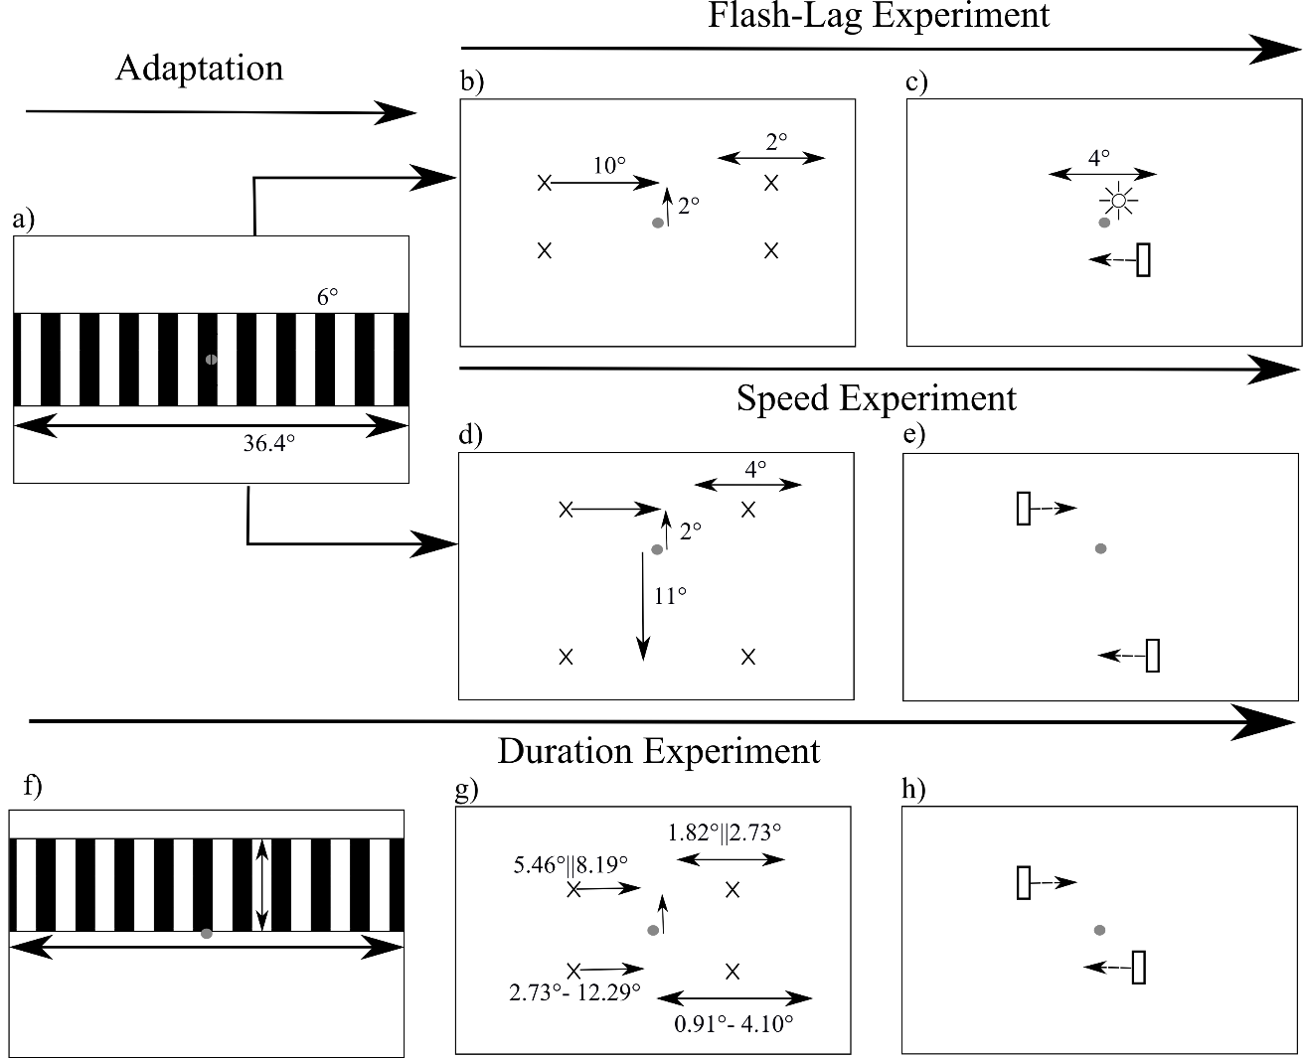

Figure 1: Stimulus diagrams. Frame a) shows adaptation phase, common to all conditions except the Flash-Lag control and duration experiment. Frames b) and c) show the Flash-Lag condition. In b) the bar appears at one of four crosses positioned 10° horizontally and 2° vertically from fixation, marking the points where the bar may appear on a particular trial before moving toward the opposite cross and disappearing. The appearance and disappearance position is chosen randomly on each trial with a 2° horizontal jitter. Frame c) shows the bar below and flash above fixation. The flash appears on the opposite side of fixation to the bar randomly jittered 4° horizontally about fixation for each trial. Frames d) and e) show the speed condition with d) showing the positioning of the bars where the standard bar appears at one of two points 8° horizontally and 2° above from fixation with the comparison bar again appears at one of two points 14° below and 8°horizontally from fixation. Similar to Flash-Lag the appearance and disappearance of each bar is jittered by 4°. Both bars are shown in e), they appear at diagonally opposite locations so move in opposite directions. f) shows the adaptor for the duration experiment. g) shows positions of bars, the top two crosses and associated arrows give the position and jitter for the standard bar of duration 600ms for the high and low speed condition in the form low||high. The bottom two crosses and arrows give the position and jitter for the comparison bar, the distances vary depending on speed and duration of the comparison in the form min-max. h) shows the two bars moving in opposite directions.

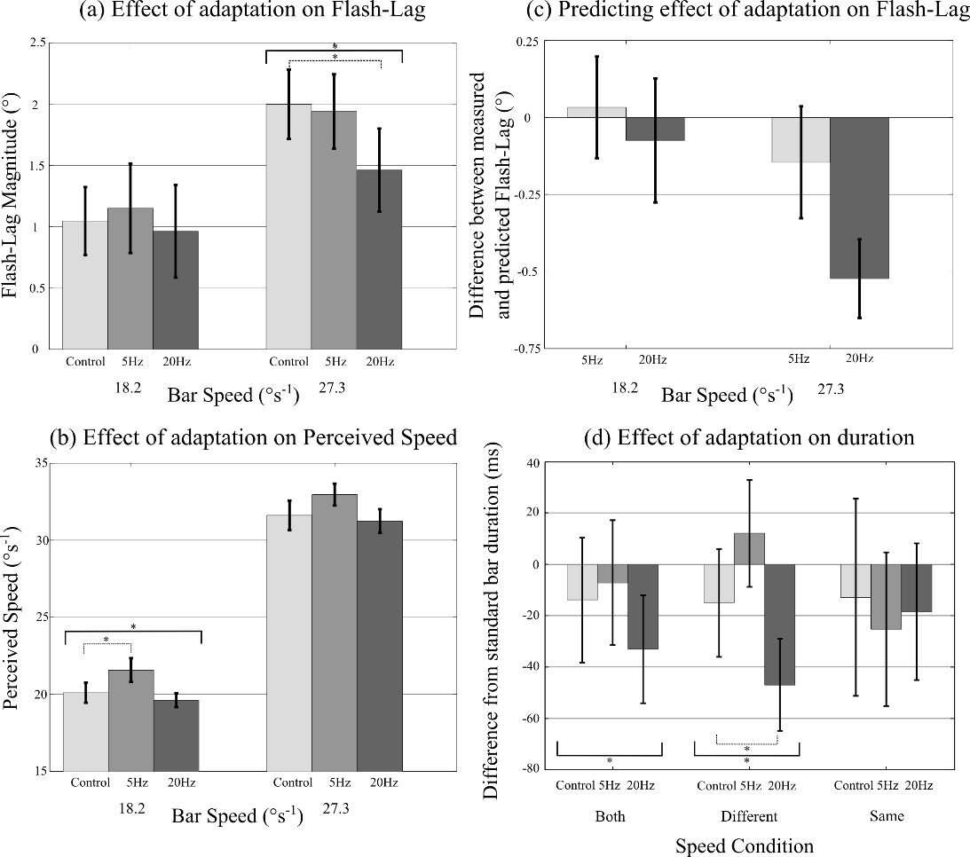
Figure 2. Results showing mean and standard error (N=6) for Flash-Lag (a) where there is significant difference between control and 20 Hz adaptation in the faster speed condition, and Speed experiments (b) where there is a significant difference between control and 5Hz adaptation in the slower speed condition, * indicates significance at the 5% level with solid lines showing overall significant ANOVA and dashed lines indicating significant planned comparisons. (c) shows the mean of the differences between predicted and measured change in Flash-Lag after adaptation, error bars show standard error (N=6). Measured change shows a significantly greater reduction than predicted for 20Hz adaptation at the faster speed but not for any other, * shows significant effect at the 5% level. (d) Shows differences in perceived duration of a moving bar of 600ms where the standard and the comparison are moving at the same speed (18.2° s⁻¹ or 27.3° s⁻¹), different speeds (one bar 18.2° s⁻¹, the other 27.3° s⁻¹) or both different and same speeds. There is a significant effect of adaptation on Both and Different conditions (* with solid lines) using ANOVA and a significant difference between 20Hz and control for different speeds ( * with dashed line) in planned comparisons. Error bars show standard error (N=4).
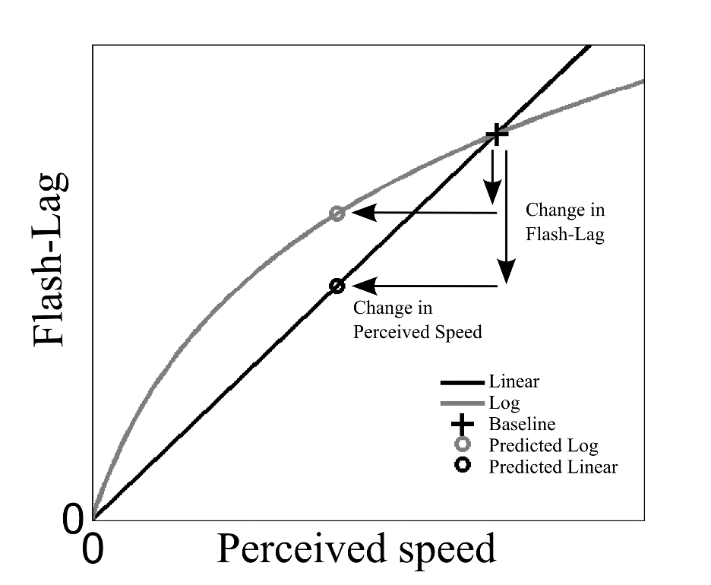
Figure 3: A linear relationship between speed and Flash-Lag passing through the origin and the baseline measure always predicts a larger change in the Flash-Lag Illusion given an observed change in perceived speed than a logarithmic relationship passing through the origin and the baseline measure. This means assuming a linear as opposed to logarithmic relationship between speed and Flash-Lag gives the strongest test when compared to the duration compression hypothesis.

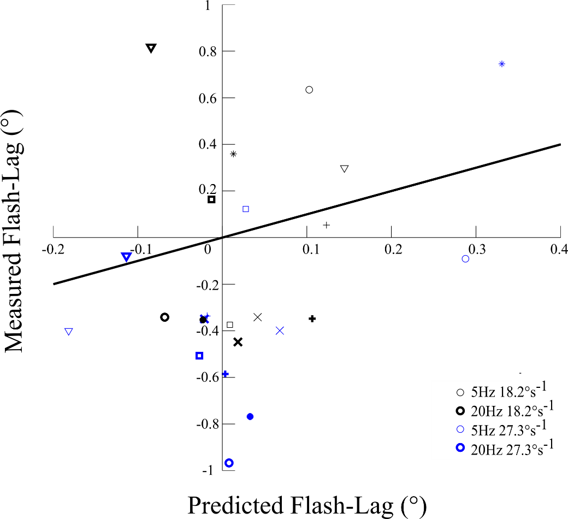
Figure 4: Scatter plot of predicted from change in perceived speed versus measured change in Flash-Lag effects after TF adaptation. Black shows slow while blue shows fast speeds with 20Hz results for both speeds are in bold and different symbols indicated different participants. Comparing results with the line of equality show all but a single participant have a larger than predicted drop in Flash-Lag for the 20Hz faster speed indicating change in perceived speed alone cannot explain the change in Flash-Lag for five out of six individuals.

Amano, K., Wandell, B. A., & Dumoulin, S. O. (2009). Visual field maps, population receptive field sizes, and visual field coverage in the human MT+ complex. Journal of neurophysiology, 102(5), 2704-2718.
Ayhan, I., Bruno, A., Nishida, S., & Johnston, A. (2009). The spatial tuning of adaptation-based time compression. J Vis, 9(11), 2.1-12. doi: 10.1167/9.11.2
Bruno, A., & Johnston, A. (2010). Contrast gain shapes visual time. Frontiers in Psychology, 1. doi: 10.3389/fpsyg.2010.00170
Burr, D., Tozzi, A., & Morrone, M. C. (2007). Neural mechanisms for timing visual events are spatially selective in real-world coordinates. Nature Neuroscience, 10(4), 423-425. doi: 10.1038/nn1874
Cavanagh, P. (1992). Attention-based motion perception. Science, 257(5076), 1563-1565. doi: 10.1126/science.1523411
Chappell, M., & Mullen, K. T. (2010). The Magnocellular visual pathway and the flash-lag illusion. Journal of Vision, 10(11). doi: 10.1167/10.11.24
Curran, W., & Benton, C. P. (2012). The many directions of time. Cognition, 122(2), 252-257. doi: 10.1016/j.cognition.2011.10.016
Durant, S., & Johnston, A. (2004). Temporal dependence of local motion induced shifts in perceived position. Vision Research, 44(4), 357-366. doi: http://dx.doi.org/10.1016/j.visres.2003.09.022
Eagleman, D. M., & Sejnowski, T. J. (2000). Motion integration and postdiction in visual awareness. Science, 287(5460), 2036-2038.
Eagleman, D. M., & Sejnowski, T. J. (2007). Motion signals bias localization judgments: A unified explanation for the flash-lag, flash-drag, flash-jump, and Frohlich illusions. Journal of Vision, 7(4), 3.
Hammett, S. T., Thompson, P. G., & Bedingham, S. (2000). The dynamics of velocity adaptation in human vision. Current Biology, 10(18), 1123-1126. doi: http://dx.doi.org/10.1016/S0960-9822(00)00698-9
Hogendoorn, H., Verstraten, F. A., & Johnston, A. (2010). Spatially localized time shifts of the perceptual stream. Frontiers in Psychology, 1.
Johnston, A., Arnold, D. H., & Nishida, S. (2006). Spatially localized distortions of event time. Curr Biol, 16(5), 472-479. doi: 10.1016/j.cub.2006.01.032
Johnston, A., & Wright, M. J. (1986). Matching velocity in central and peripheral vision. Vision Research, 26(7), 1099-1109. doi: http://dx.doi.org/10.1016/0042-6989(86)90044-1
Kingdom, F., & Prins, N. (2009). Psychophysics: a practical introduction: Academic Press.
Krekelberg, B., & Lappe, M. (2000a). A model of the perceived relative positions of moving objects based upon a slow averaging process. Vision Research, 40(2), 201-215. doi: 10.1016/s0042-6989(99)00168-6
Krekelberg, B., & Lappe, M. (2000b). The Position of Moving Objects. Science, 289(5482), 1107. doi: 10.1126/science.289.5482.1107a
Marinovic, W., & Arnold, D. H. (2011). Separable temporal metrics for time perception and anticipatory actions. Proceedings of the Royal Society B: Biological Sciences, rspb20111598.
Morrone, M. C., Ross, J., & Burr, D. (2005). Saccadic eye movements cause compression of time as well as space. Nature Neuroscience, 8(7), 950-954.
Nijhawan, R. (1994). Motion extrapolation in catching. Nature, 370(6487), 256-257. doi: 10.1038/370256b0
Patel, S. S., Ogmen, H., Bedell, H. E., & Sampath, V. (2000). Flash-lag effect: differential latency, not postdiction. Science, 290(5494), 1051-1051.
Ross, J., Burr, D., & Morrone, C. (1996). Suppression of the magnocellular pathway during saccades. Behavioural Brain Research, 80(1–2), 1-8. doi: http://dx.doi.org/10.1016/0166-4328(96)00012-5
Smith, A. T., & Edgar, G. K. (1994). Antagonistic comparison of temporal frequency filter outputs as a basis for speed perception. Vision Research, 34(2), 253-265. doi: 10.1016/0042-6989(94)90337-9
Thompson, P. (1983). Discrimination of moving gratings at and above detection threshold. Vision Research, 23(12), 1533-1538. doi: http://dx.doi.org/10.1016/0042-6989(83)90166-9
Whitney, D., & Murakami, I. (1998). Latency difference, not spatial extrapolation. Nature Neuroscience, 1(8), 656-657.
Wojtach, W., Sung, K., Truong, S., & Purves, D. (2008). An empirical explanation of the flash-lag effect. PNAS, 105(42), 16338 - 16343. doi: 10.1073/pnas.0808916105

