**BIOMARKER ANALYSIS OF ORGANIC CARBON RICH CARBONATES AND SHALES OF THE MESO-NEOPROTEROZOIC SETE LAGOAS, PARACATÚ AND SERRA DO GARROTE FORMATIONS, SÃO FRANCISCO BASIN, BRAZIL AND THE EARLY CAMBRIAN SIRIUS PASSET LAGERSTÄTTE, GREENLAND**

By

Jamie Webb

Submitted in partial fulfilment of the requirements for the degree of Master of Science in Petroleum Geochemistry in the Faculty of Science Agriculture and Engineering



**Newcastle University**

**School of Civil Engineering and Geosciences**

Newcastle upon Tyne

Tyne and Wear

NE1 7RU

United Kingdom

August 23, 2013

DECLARATION:

I hereby certify that this work is my own, except where otherwise acknowledged, and that it has not been submitted previously for a degree at this, or any other university

Jamie Webb

ACKNOWLEDGEMENT:

Thank you to Dr. Martin Jones for his input and guidance throughout the dissertation process; Tracy Thompson, Bernard Bowler and Philip Green for their help with sample preparation and running Rock-Eval, TOC, GC and GC-MS analyses; Maria (Emi) Bertoni (Ph.D. candidate, Royal Holloway University of London) for the Brazilian samples and her informative assistance with all work involving Brazil; and Dr. Howard Armstrong (Durham University) for the samples from Greenland. Also, thank you to my family and friends for their love and support during my fantastic year abroad in Newcastle.

**ABSTRACT**:

The purpose of this work was to determine the thermal maturity and source rock potential of the Sete Lagoas, Paracatú and Serra do Garrote formations of the São Francisco Basin of Brazil, and the Sirius Passet Lagerstätte of Greenland. Rock-Eval, Total Organic Carbon (TOC), Gas Chromatography (GC) and Gas Chromatography-Mass Spectrometry (GC-MS) analyses were completed on 14 Mesoproterozoic-Early Cambrian samples at Newcastle University. Present day organic carbon content was measured by Rock-Eval and TOC and determined to be low, but assuming a higher hydrogen index at the time of deposition, within a marine environment, the samples were determined to once be potential source rocks. The Serra do Garrote and Paracatú formations had the highest hydrocarbon producing potential. GC and GC-MS established the presence and syngeneity of specific biological marker compounds, and these compounds were then used to calculate thermal maturity parameters. The samples were found to be overmature, but there is low confidence in this interpretation, due to parameter inversion at high temperatures. Biomarkers confirmed deposition of organic matter occurred to be within a marine depositional environment beneath a stratified water column, with bottom waters being dysoxic-anoxic. The presence of the flowering plant biomarker, oleanane, in some samples, potentially indicated the biomarkers are non-syngenetic

**KEY WORDS**: Biomarker, Maturity Parameters, Neoproterozoic, São Francisco Basin, Source rock, Cambrian Lagerstätte, Gas chromatography-mass spectrometry

**TABLE OF CONTENTS**

|  |  |
| --- | --- |
| CHAPTER 1: INTRODUCTION |  |
| 1.1 Introduction, Aim and Objectives | 10 |
| 1.2 Life During the Mesoproterozoic-Early Cambrian | 11 |
| 1.3 Literature Review | 13 |
| 1.4 Formation Descriptions | 15 |
| 1.4.1 Brazil | 15 |
| 1.4.2 Greenland | 17 |
| 1.5 Sample Locations | 18 |
| 1.6 Source Rock Potential and Thermal Maturity | 21 |
| 1.7 Biomarkers | 23 |
| 1.7.1 Saturated hydrocarbons | 24 |
| 1.7.2 Aromatic hydrocarbons | 25 |
| CHAPTER 2: EXPERIMENTAL METHODS |  |
| 2.1 Samples | 27 |
| 2.2 Laboratory Materials | 27 |
| 2.3 Sample Preparation | 28 |
| 2.4 Total Organic Carbon (TOC) Analysis | 28 |
| 2.5 Rock-Eval Pyrolysis | 28 |
| 2.6 Restoration of Original Source Rock Potential | 29 |
| 2.7 Solvent Extraction and Bitumen Separation | 30 |
| 2.8 Gas Chromatography (GC) | 32 |
| 2.9 Gas Chromatography-Mass Spectrometry (GC-MS) | 32 |
| 2.10 Peak Integration and Quantification | 33 |
| 2.11 Error Measurement | 34 |
| CHAPTER 3: RESULTS |  |
| 3.1 Organic Carbon Content, Source Rock Potential and Maturity Parameters | 35 |
| 3.2 Hydrocarbon Compositional Analysis | 36 |
| 3.3 Biomarker-based Thermal Maturity Parameters | 39 |
| 3.4 Original Source Rock Potential | 42 |
| 3.5 Gas Chromatography Derived Indicators | 44 |
| 3.5.1 Sete Lagoas Formation | 47 |
| 3.5.2 Paracatú Formation | 47 |
| 3.5.3 Serra do Garrote Formation | 47 |
| 3.5.4 Sirius Passet Lagerstätte | 47 |
| 3.6 Source indicating Biomarkers and Unidentified Peaks | 48 |
| 3.7 Syngeneity of Biomarkers | 53 |
| 3.8 Errors in Calculated Parameters and Sample Contamination | 53 |
| CHAPTER 4: DISCUSSION |  |
| 4.1 Organic Carbon Content and Source Rock Potential | 56 |
| 4.2 Thermal Maturity | 57 |
| 4.3 Confidence in Thermal Maturity Parameters | 58 |
| 4.4 Original Source Rock Potential | 59 |
| 4.5 Depositional Environment, Redox Conditions and Organic Matter Input | 60 |
| 4.6 Syngeneity of Biomarkers | 62 |
| CHAPTER 5: CONCLUSION | 63 |
| CHAPTER 6: FUTURE WORKK | 65 |
| CHAPTER 7: SUMMARY | 67 |
| REFERENCES | 69 |
| APPENDIX A: Summary of constituents and equations of calculated maturity parameters | A1 |
| APPENDIX B: Summary of restored original TOC, PI and HI for a variety of original HI values | A2 |
| APPENDIX C: Gas chromatograms | A3 |
| APPENDIX D: GC-MS mass chromatograms | A5 |
| APPENDIX E: Peak area values | A13 |
| APPENDIX F: Summary of calculated parameters using GC and GC-MS peak areas | A18 |
| APPENDIX G: Summary of Peak Quantitation Values | A19 |
| **LIST OF TABLES, FIGURES AND GRAPHS** |  |
| CHAPTER 1: INTRODUCTION |  |
| Figure 1.1 Map of Rodinia during the Neoproterozoic | 13 |
| Figure 1.2 Stratigraphic columns of the São Francisco Basin units | 16 |
| Figure 1.3 Summary of eastern Greenland stratigraphy | 18 |
| Figure 1.4 Brazilian sample location map | 20 |
| Figure 1.5 Map of Greenland sample locations | 21 |
| Table 1.1 Summary of source rock potential parameters | 22 |
| Table 1.2 Summary of maturation and generation parameters | 23 |
| Figure 1.6 Chart of converting between MPI and Rc at different Ro values | 26 |
| CHAPTER 3: RESULTS |  |
| Table 3.1 Summary of the measured source rock richness parameters | 35 |
| Graph 3.1 Summary of present day source rock potential indicating parameters | 36 |
| Figure 3.1 Comparison of two GC chromatograms from samples VLSFRK and VZCF001-15, with n-alkanes identified in the first. | 37 |
| Figure 3.2 m/z 191 mass chromatogram with hopanes identified. | 38 |
| Table 3.2 Summary of parameters calculated from GC-MS mass chromatograms | 38 |
| Table 3.3 Summary of biomarker and non-biomarker parameters | 38 |
| Table 3.4 Summary of maturity parameters of all Brazilian samples | 39 |
| Table 3.5 Summary of maturity parameters for the Sirius Passet Lagerstätte | 40 |
| Figure 3.3 Summary of biomarker maturity parameters and their equilibrium points over the oil generation window | 41 |
| Table 3.6 Summary of restored original TOC | 43 |
| Table 3.7 Summary of source and redox condition parameters | 45 |
| Graph 3.2 Summary of depositional setting oxygen availability, based on Pr/Ph ratios | 46 |
| Graph 3.3 Summary of oxygen conditions based on Pr/*n*-C17 versus Ph/*n*-C18 values | 46 |
| Figure 3.4 m/z 217 mass chromatogram of MASW3.32 denoting the presence of 24-*n*-propylcholestane | 48 |
| Figure 3.5 m/z 205 mass chromatogram of SP110724-1 1.12m denoting the presence of 2α- and 3β-methylhopane | 48 |
| Table 3.8 Summary of steranes/hopanes ratio | 49 |
| Figure 3.6 Sterane isomer composition ternary plot | 50 |
| Figure 3.7 m/z 191 mass chromatogram and mass spectrum, showing the presence of 28,30-bisnorhopane in sample SP110724-1, 3.31m | 50 |
| Figure 3.8 m/z 191 mass chromatogram and mass spectrum, showing the presence of gammacerane in Sete Lagoas sample U1S2 | 51 |
| Figure 3.9 Gas chromatogram showing x-compounds and *n*-alkanes within the Sete Lagoas Formation for samples U1S3, U1S2 and S1.1 | 51 |
| Figure 3.10 GC-MS m/z 85 mass chromatogram showing the secondary alkane series | 52 |
| Figure 3.11 m/z 191 mass chromatogram and corresponding mass spectrum of 46.446min peak | 52 |
| Figure 3.12 Gas chromatogram of sample SP110723-1 0.16m C showing the unidentified peak | 53 |
| Figure 3.13 GC chromatogram of Blank sample | 53 |
| Graph 3.4 Summary of parameter values and their standard deviation | 54 |
| Table 3.9 Table of parameter labels from Graph 3.6.1 | 55 |
| APPENDIX A: Summary of constituents and equations of calculated maturity parameters |  |
| Table A.1 Summary of maturity parameters components | A1 |
| Table A.2 Summary of biomarker and non-biomarker parameter components | A1 |
| APPENDIX B: Summary of restored original TOC, PI and HI |  |
| Table B.1 Summary of restored original TOC parameters | A2 |
| APPENDIX D: GC-MS mass chromatograms |  |
| Figure D.1 m/z 178 | A5 |
| Figure D.2 m/z 192 | A5 |
| Figure D.3 m/z 128 | A6 |
| Figure D.4 m/z 142 | A7 |
| Figure D.5 m/z 156 | A8 |
| Figure D.6 m/z 170 | A8 |
| Figure D.7 m/z 191 | A9 |
| Figure D.8 m/z 217 | A10 |
| Figure D.9 m/z 231 | A11 |
| Figure D.10 Blank sample TIC | A12 |
| APPENDIX E: Peak area values |  |
| Table E.1 Summary of Sete Lagoas peak areas | A13 |
| Table E.2 Summary of Serra do Garrote and Paracatú peak areas | A15 |
| Table E.3 Summary of Sirius Passet Lagerstätte peak areas | A17 |
| APPENDIX F: Summary of parameters using GC and GC-MS peak areas |  |
| Table F.1 Summary of biomarker based parameters for the Sete Lagoas, Serra do Garrote and Paracatú formations | A18 |
| Table F.2 Summary of biomarker based parameters for the Sirius Passet Lagerstätte | A18 |
| APPENDIX G: Summary of Peak Quantitation Values |  |
| Table G.1 Summary of Serra do Garrote and Paracatú St and H peak quantitation | A19 |
| Table G.2 Summary of Sete Lagoas St and H peak quantitation | A20 |
| Table G.3 Summary of Sirius Passet Lagerstätte St and H peak quantitation | A21 |
| Table G.4 Summary of Serra do Garrote and Paracatú aromatic peak  quantitation | A22 |
| Table G.5 Summary of Sete Lagoas aromatic peak quantitation | A24 |
| Table G.6 Summary of Sirius Passet Lagerstätte aromatic peak quantitation | A24 |
|  |  |
|  |  |

CHAPTER 1: INTRODUCTION

**1.1 Introduction, Aim and Objectives**

The shortening supply of conventional hydrocarbon reserves worldwide has led to increased interest in frontier petroleum systems and plays. Proven Neoproterozoic petroleum systems existing in Oman and Africa (Craig et al., 2009) have magnified interest in the Neoproterozoic São Francisco Basin of eastern Brazil and Early Cambrian Sirius Passet Lagerstätte of Greenland. The Brazilian basin may contain potential hydrocarbon source rocks and a viable petroleum system, deposited during ‘Snowball Earth’ type events, and is currently being explored by multi-national oil companies, including Petrobras, BG and Shell (Hoffman & Schrag, 2002; Reuters, 2012). Natural gas is pervasive throughout the ~379,000km2 basin, and there has been evidence of oil in several recently drilled boreholes, however, the location of the source rocks is under debate (Duarte, 2008). Potential Brazilian source rocks include the glaciogenic Sete Lagoas, Serra do Garrote and Paracatú formations (Duarte, 2008). The Sirius Passet Lagerstätte of Greenland, contained within the Transitional Buen Formation, has rarely been studied due to its remote location, but the dark-coloured formation contains numerous anthropod fossils, leading to the interpretation it is an organic rich unit, and therefore a potential source rock (Ineson & Peel, 2011).

The main aim of this work was to determine the thermal maturity of the four formations, and determine if they have, or once had, potential as viable hydrocarbon source rocks. And specifically, if they could be potential source rocks for thermogenic gas found seeping throughout the São Francisco Basin (Martins-Neto, 2009). In order to achieve this, the objectives of the project were as follows. Thermal maturity assessment of 14 Mesoproterozoic-Early Cambrian samples using Rock-Eval pyrolysis (e.g. Espitalié et al., 1977), gas chromatography (GC) and gas chromatography-mass spectrometry (GC-MS). Investigation of the presence and syngeneity of biological marker (biomarker) hydrocarbon compounds in the rock samples using GC and GC-MS, and measurement of thermal maturity parameters from these compound distributions. Measurement of present day organic carbon content and hydrocarbon potential of the samples was completed using total organic carbon (TOC) analysis and Rock-Eval. Estimation of the original TOC and hydrocarbon potential of the samples was also completed, and assumed the organic matter type based on a marine depositional environment for all samples.

**1.2 Life During the Mesoproterozoic-Early Cambrian**

The Mesoproterozoic (1.6-1.0 Ga) and Neoproterozoic (1000-542Ma), represent an Earth unlike anything seen today, where atmospheric oxygen levels were 10-20% of present levels, and the deep ocean was largely anoxic to euxinic (Holland, 2006). Strong climatic variations during the Neoproterozoic produced three global glaciations that potentially covered the entire Earth, producing a ‘Snowball Earth’ (Olcott et al., 2005). Global or near-global glaciations include the Sturtian (~740-647 Ma), Marinoan (~660-635Ma), and smaller Gaskiers (~580Ma) glaciations, and possibly a fourth, pre-Sturtian but poorly age constrained, Kaigas glaciation (Frimmel et al., 1996; Bechstadt et al., 2009). Snowball Earths were possible due to anomalously low concentrations of CO2 in the atmosphere, and aided by an ice-albedo feedback loop after ice reached within 30° of the equator (Donnadieu et al., 2004; Macdonald et al., 2010). Following each glaciation were sea level transgressions, and consequent deposition of possible organic matter rich source rock, consisting largely of marine planktonic organisms (Bechstadt et al., 2009).

The Neoproterozoic is subdivided into the Tonian (1000-850Ma), Cryogenian (850-630Ma) and Ediacaran (630-542Ma) periods (Lottaroli et al., 2009). During the Neoproterozoic, marine life experienced little diversity and was mainly microbial until the Ediacaran, and then followed by extreme diversification during the Cambrian explosion at 542 Ma (Olcott et al., 2005; Little, 2009). It is thought during glacial periods the aquatic organisms would have experienced an evolutionary bottleneck, however this has not been verified in previous work (Olcott et al., 2005; Little, 2009). Olcott et al. (2005) hypothesized that sunlight would have penetrated the ice, thereby stimulating biological communities below. Deposition of the Sirius Passet Lagerstätte also occurred in the marine environment, but not following a glaciation (Ineson & Peel, 2011).

During the Cryogenian, all landmass was clustered at the equator, with the São Francisco craton around 20-30° latitude during deposition of the Sete Lagoas Formation, based on magnetic evidence (Babinski, 2007). All landmass formed a supercontinent known as Rodinia, which was undergoing break-up, starting approximately 825Ma, as can be seen in Figure 1.1 (Li et al, 2003; Li et al., 2007). During deposition of glaciogenic sediments on the São Francisco craton, it was contiguous with the Congo craton, and stratigraphy there closely resembles that found in Brazil (Olcott et al., 2005).

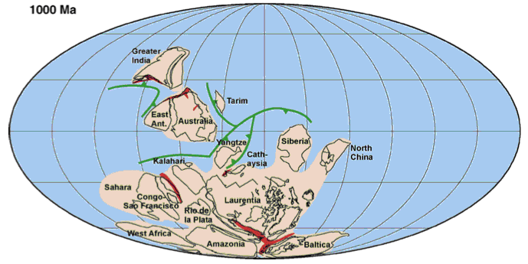

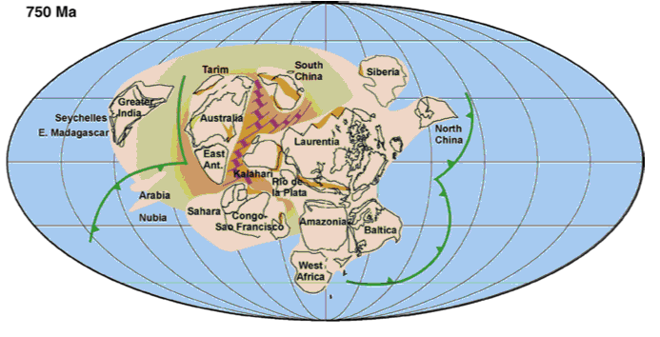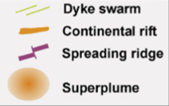Macintosh HD:Users:jamiewebb:Desktop:Screen Shot 2013-07-17 at 1.31.19 PM.png

Figure 1.1 Map of Rodinia during the Neoproterozoic (modified from Li et al., 2007)

**1.3 Literature Review**

There is very little published literature relevant to this present study. A recently completed University of Maryland undergraduate dissertation by Little (2009) for the Lagoa de Jacaré Formation, a stratigraphically younger formation within the Bambuí Group, determined a similar depositional environment to the Sete Lagoas during the Neoproterozoic in Brazil. Using biomarker based maturity parameters Little (2009) determined this formation to be thermally immature. Little (2009) identified green sulphur bacteria, indicative of a stratified water column and photic zone anoxia, were present during deposition in a reducing environment, based on hydrocarbon marker compounds she identified in their GC-MS m/z 133 mass chromatograms. She also determined the presence of cyanobacteria, and to a lesser extent, eukaryotes, within the accumulated organic matter (Little, 2009).

An overview of global climate and depositional environment during the Neoproterozoic was published in 2009 by The Geological Society of London (Craig et al., 2009). ‘Global Neoproterozoic Petroleum Systems: The Emerging Potential in North Africa’ establishes the presence of proven Neoproterozoic petroleum systems in North Africa, and therefore validates the investigation into these types of systems in South America, as at this time the São Francisco craton was united with the Congo craton (Craig et al., 2009).

Work by Olcott et al. (2005) outlined the types and abundances of organisms within the Neoproterozoic water column. There are currently no modern analogues to the Neoproterozoic depositional environment, with perhaps the exception of the Ross Sea in Antarctica (Olcott et al., 2009), and inferences must be made through detailed biomarker analyses, or core work. The presence of viable marine communities during global glaciations indicated that sunlight could penetrate through the ‘Snowball Earth’, allowing for the potential of a widespread source rock to be deposited (Olcott et al., 2005).

Sial et al. (2009) provided a detailed overview of stratigraphic and structural history of the São Francisco craton. The descriptions include the depositional environments and various lithologies associated with the Sete Lagoas, Serra do Garrote and Paracatú formations. A similar description was completed by Ineson and Peel (2011) for the Sirius Passet Lagerstätte.

**1.4 Formation Descriptions**

The Neoproterozoic has a limited range of published data available, typically of poor quality due to over maturity, and age dating is difficult due to the variety of dating techniques used and lack of trace and body fossils (Huuse et al., 2012).

**1.4.1 Brazil**

The relationship between the three Brazilian formations is unclear due to lack of stratigraphic or fossiliferous correlation through the basin. The Bambuí Group was deposited during three regressive megacycles after the Sturtian glaciation in a foreland basin on the São Francisco craton (Martins-Neto et al., 2001). The 200-250m thick Sete Lagoas Formation overlies the synglacial, diamictitic Jequitaí Formation, and at its base has been age dated to 740±22Ma (Babinski et al., 2007; Sial et al., 2009). The base of the Sete Lagoas consists of a cap dolostone, followed by marls, limestone, and dolostone, deposited during two shallowing-up cycles in a shallow water platform environment (Marshak & Alkmim, 1989; Sial et al., 2009). Thermal maturation determination was completed for the stratigraphically younger Lagoa do Jacaré by Little (2009), who determined it to be immature through measurement of common biomarker parameters. Little (2009) also determined deposition to have occurred within a stratified water column, due to the presence of aryl isoprenoids indicative of bacteria living in conditions of photic zone euxinia, and this is thought to be true of the Sete Lagoas Formation as well. The stratigraphy of the basin is summarized in Figure 1.2.

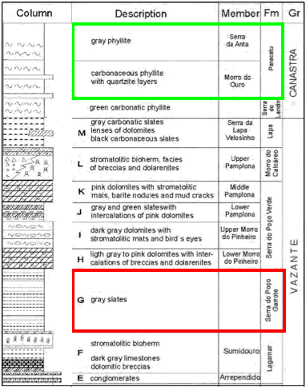

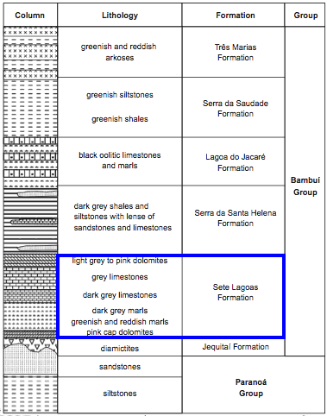

Figure 1.2 Stratigraphic columns of the São Francisco Basin units (modified from Sial et al., 2009)

Possibly age equivalent to the Bambuí Group are the marine pelites and dolostones of the Vazante Group (Misi et al., 2007; Pimentel et al., 2011). This is a controversial interpretation, as new Re-Os age dating evidence suggests the potential source rock of this group, the Serra do Garrote slate, is of late Mesoproterozoic age (Azmy et al., 2008; Pimentel et al., 2011). This age division potentially makes these sediments associated with the Kaigas glaciation, not the Sturtian, like the Sete Lagoas (Pimentel et al., 2011) The Vazante Group is likely to have been deposited between 925-750Ma (Alkmim & Martins-Neto, 2012). The marine Serra do Garrote is approximately 400m thick and was deposited on a passive margin (Sial et al., 2009; Pimentel et al., 2011). Pyrite and quartzite intercalations are present in this formation (Pimentel et al., 2011). Olcott et al. (2005) analysed the overlying Serra do Poco Formation in the Paracatú region, noting it had attained thermal maturity, and that due to the low volume of bitumen present, the samples were very susceptible to contamination by migrating hydrocarbons, drilling fluid, improper handling and extant biota. It was also noted by Olcott et al. (2005) that biomarker distributions varied between the carbonate-rich and organic rich intervals. It was determined the organic matter was cyanobacterially derived, due to the presence of 2α-methylhopanes; gammacerane present indicated a stratified water column and the presence of isorenieratene indicated a sulfidic photic zone (Olcott et al., 2005). Combined, these factors suggest sunlight could penetrate sea ice, or the ice did not cover the Earth entirely (Olcott et al., 2005). As deformation and metapmorphism decrease towards east, and the formation reaches granulite facies in centre of the Brasilia Belt (Rodrigues, 2008).

The Canastra Group contains the Paracatú Formation, consisting of deep water to platformal interbedded carbonaceous phyllites and quartzites, formed during a regressive megacycle (Rodrigues, 2008; Pimentel et al., 2011). It is thought to have a maximum depositional age of 1.03Ga, using zircon dating, on a passive margin and be of greenschist to amphibolite facies (Silva, 2003; Rodrigues, 2008; Alkmim & Martins-Neto, 2012). The Canastra Group is considered to be equivalent to the Paranoá Group, which underlies the Bambuí Group locally (Alkmim & Martins-Neto, 2012). The source rock potential of this formation has not been investigated previously.

**1.4.2 Greenland**

The Sirius Passet Lagerstätte is an arthropod-dominated, fossiliferous unit within the Transitional Buen Formation of Greenland (Ineson & Peel, 2011). Due to its remote location, it has only been visited a few times. Deposition occurred on the edge of a carbonate platform during the Early Cambrian (Ineson & Peel, 2011). The sediment is a finely laminated silt and clay-rich mudstone, with the laminations indicating poor oxygenation at the sediment-water interface (Ineson & Peel, 2011). The stratigraphy of northern Greenland is summarized in Figure 1.3.

Sedimentation occurred through suspension in a low energy environment, with arthropods likely inhabiting a nearby, more oxygenated slope environment (Ineson & Peel, 2011). The presence of horizontal burrows indicates periodically dysoxic bottom conditions (Ineson & Peel, 2011). Accumulation potentially occurred in the disphotic zone, as arthropods found in the Lagerstätte have no eyes, and were therefore, not exposed to light (Ineson & Peel, 2011). After deposition the sediments were deformed and then uplifted by the Franklinian Orogeny, experiencing greenschist metamorphic grade during the Ellesmerian Orogeny (Ineson & Peel, 2011). Chloritoid porphyroblasts present on bedding planes are another indicator of maturity as they form under temperatures of at least 300°C (Vidal et al, 1999; Ineson & Peel, 2011). Dykes are present near the outcrop, which could potentially alter the biomarkers. Total organic carbon was reported by Vidal & Peel (1999) to be 2wt%, although the source rock potential of the formation has not been examined.

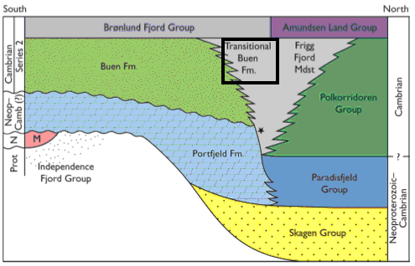

Figure 1.3 Summary of eastern Greenland stratigraphy, including the Sirius Passet Lagerstätte containing Transitional Buen Formation (Ineson & Peel, 2011)

**1.5 Sample Locations**

Five samples from the Sirius Passet Lagerstätte outcrop in Greenland, along with three samples from the Paracatú Formation, five samples from the Sete Lagoas Formation, and two samples from the Serra do Garrote Formation of the São Francisco Basin, eastern Brazil were collected. The locations of samples from Brazil are plotted in Figure 1.4, and from Greenland in Figure 1.5. The Serra do Garrote samples were collected from the Votorantim Mining Company core VZCF001 from between depths of 265-325m subsurface (M. Bertoni, *pers.comm.).* The Paracatú Fm. samples were collected from the MASW03 core provided by the Votorantim Mining Company, from between depths of 0-55m subsurface (M.Bertoni, *pers.comm.).* Four Sete Lagoas samples were collected from the Lhoist mine, core LMR1009-01. U4.S13 was taken from between 35-47m depth from within the dolomite, while samples U1S2, U1S3, and U1S9 were taken from between 157-163m subsurface, in the banded argillite (M. Bertoni, *pers.comm*.). The final Sete Lagoas sample, S1.1, was taken from an argillite outcrop, exposed at 9°41.528 S/43°58.821 W, on the southeastern edge of the basin (M.Bertoni, *pers. comm.).* Samples for the Paracatú and Serra do Garrote formations were selected by a Brazilian geologist based on high carbonaceous content or presence of graphitic content, low levels of deformation, and minimal or lack of fluid interaction (including quartz cementation) (M. Bertoni, *pers.comm.).* The Sete Lagoas samples were selected based on potentially rich organic intervals identified through fieldwork, open pit mine observations and previously drilled cores (M. Bertoni, *pers. comm.).*

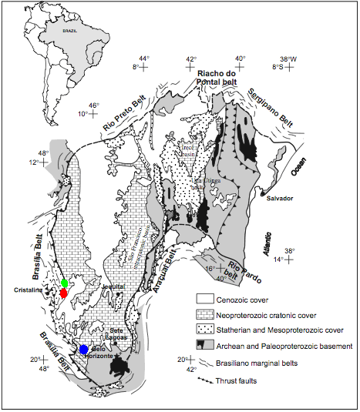

Figure 1.4 Brazilian sample location map where red indicates Serra do Garrote samples, green is Paracatú samples and blue is Sete Lagoas samples (modified from Sial et al., 2009)

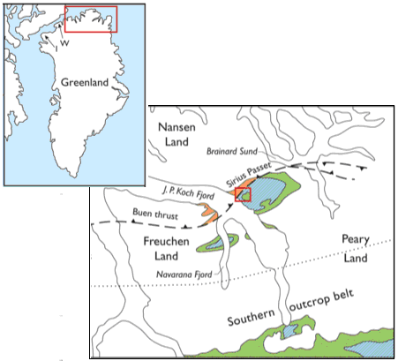

Macintosh HD:Users:jamiewebb:Desktop:Screen Shot 2013-07-17 at 2.03.57 PM.png

Figure 1.5 Summary of Greenland sample locations (modified from Ineson & Peel, 2011)

The Greenland samples were taken from outcrop on the northern end of Greenland. SP-110723-1 0.16m was taken from flaggy bedded, silty mudstone (H. Armstrong, *pers. comm*.). SP-110724 samples were taken from a second outcrop, with sample 1.12m taken from wavy dark grey mudstone, sample 3.31m taken from a higher up wavy dark grey mudstone, and sample 54m taken from a laminated, dark grey silty mudstone (H. Armstrong, *pers. comm*.). Sample SP-110725-1 2.2m was taken from a third outcrop of laminated silty mudstone (H. Armstrong, *pers. comm*.).

**1.6 Source Rock Potential and Thermal Maturity**

The potential for a source rock to produce and expel hydrocarbon is based on the concentration of organic carbon, measured as TOC, and kerogen type. As all formation were deposited in a marine environment, the kerogen type was assumed to be type II, although it was suggested by Bechstadt et al. (2009) to be type I/II. Type I kerogens have the highest potential to produce hydrocarbon, due to the hydrogen to carbon ratio, and will primarily produce oil. Presently, Type I kerogens are associated with algal lake environments, such as the Green River Oil Shale, USA. Type II kerogens have the next highest potential to produce, and are formed by deposition of marine algal material. They produce a combination of oil and gas. Type III kerogens are terrestrial and were not considered in this dissertation, as deposition of rock occurred before the onset of land plants. The fourth kerogen, Type IV, has no potential to produce oil or gas, and represents severely altered or overmature organic matter (Dembicki, 2009). The parameters used to measure source rock potential, TOC, S1 and S2, and published interpretations based on the various values are summarized in Table 1.1.

The final factor in a viable source rock is temperature, as a rock needs to be heated to 60-160°C to produce oil and thermogenic gas (Hunt, 1996). Thermal maturities can be measured using Tmax and PI from Rock-Eval, as well as converting biomarker parameters to a reflectance equivalent (Req). The temperature equivalents needed to reach thermal maturation are summarized in Table 1.2.

|  |  |  |  |
| --- | --- | --- | --- |
| **Source Potential** | **TOC** (wt%) | **S1** (mg HC/ g rock) | **S2** (mg HC/ g rock) |
| Poor | <0.5 | <0.5 | <2.5 |
| Fair | 0.5-1 | 0.5-1 | 2.5-5 |
| Good | 1-2 | 1-2 | 5-10 |
| Very Good | 2-4 | 2-4 | 10-20 |
| Excellent | >4 | >4 | >20 |

Table 1.1 Summary of source rock potential parameters (modified from Peters & Cassa, 1994).

|  |  |  |  |
| --- | --- | --- | --- |
| **Maturity** | **Ro (%)** | **Tmax (°C)** | **PI (S1/S1+S2)** |
| Immature | 0.20-0.60 | <435 | <0.10 |
| Early Oil Generation | 0.60-0.65 | 435-445 | 0.10-0.15 |
| Peak Oil Generation | 0.65-0.90 | 445-450 | 0.25-0.40 |
| Late Oil Generation | 0.90-1.35 | 450-470 | >0.40 |
| Postmature, Gas Generation | >1.35 | >470 | - |

Table 1.2 Summary of maturation and generation parameters for a viable source rock (modified from Peters et al., 2005)

**1.7 Biomarkers**

Biological marker compounds (biomarkers) are derived from biolipids and other organic structures of living organisms (Peters et al., 2005). Bacteria, Eukarya, and Archaea each produce specific biomarkers that can be related back to their individual cell structure. Biomarkers are used to indicate varying degrees of thermal alteration, depositional environment of the source, and occurrence of biodegradation. As organic matter undergoes burial, compaction and heating, the biomarkers contained within the source rock alter to become more thermodynamically stable, referred to as the geologic forms of the biomarkers. In general, biomarkers are resistant to weathering and biodegradation, which makes them applicable in many environments and circumstances. Biomarkers are broken into several main categories based on their precursor molecules. This dissertation investigated both saturated and aromatic hydrocarbon compounds, but did not include polar non-hydrocarbon fractions. The saturated hydrocarbon compounds reviewed here included n-alkanes, hopanes, steranes, acyclic isoprenoids and diamondoids, and the aromatic fraction included tri-aromatic biomarkers and polycyclic aromatic hydrocarbons (PAHs). Within a source rock, biomarkers are contained within bitumen, which is organic matter that is soluble in organic solvents, and are also bound to kerogen, though kerogen-bound biomarkers were not investigated in this work. Biomarkers can be either syngenetic or non-syngenetic, meaning they are original to the rock, or introduced after lithification, respectively (Little, 2009). Non-syngenetic biomarkers can be introduced by allochthonous hydrocarbons flowing through the rock (Little, 2009). Syngeneity is important because what the biomarkers are indicating may not represent the original source rock, but its contaminants.

**1.7.1 Saturated hydrocarbons**

One component compound class of this fraction are the hopanes, which originate from bacteriohopanetetrol and other related biohopanoids in prokaryotes. They have stereocentres on the C-17 and C-21carbon atoms, and these centres can have hydrogen in either the α or β position (Peters et al., 2005). Hopanes with carbon numbers greater than C30 are referred to as homohopanes. Three hopane maturity parameters were measured from the m/z 191 mass chromatogram, and include Ts/Tm and the C31 and C32 homohopane isomerisation ratios. The homohopane ratios reach equilibrium at the onset of oil generation. Ts/Tm reaches equilibrium at a value of 100 at the end of the condensate-wet gas window.

Steranes are formed by the diagenesis of sterols, including cholesterol, originally from eukaryotic organisms (and some prokaryotes) and are found in source rocks and petroleum (Peters et al., 2005). Steranes have many stereomeric configurations, and the important centres occur at C-14, C-17 and C-20. Sterane maturity parameters calculated in this work include the C29ββ/ββ+αα and C29 ααα 20S/S+R. The first ratio reaches isomerisation during peak oil generation, and the second at the onset of the condensate-wet gas window. The total steranes divided by total hopanes can also be used as an indicator of eukaryotic versus prokaryotic input into organic matter.

The two acyclic isoprenoids measured in this dissertation are phytane (C20) (Ph) and pristane (C19) (Pr). Both Ph and Pr can be formed by the loss of a hydroxyl group and the double bond in phytol, a side chain of chlorophyll a, but phytane can also be derived from biphytanyl ether lipids from Archae (Peters et al, 2005). The amount of Pr to Ph increases with increased maturity, but their relative concentrations are also indicative of depositional environment since phytol is transformed to pristane when the environment undergoes oxidising conditions, and phytane under reducing conditions (Peters et al., 2005).

Diamondoids are commonly found in petroleum and consist of carbon-carbon bonds in a diamond-like cage (Peters et al., 2005; Wei et al., 2007). Diamondoids do not occur in living organisms and are generated during diagenesis, and with increased thermal stress (Wei et al., 2007). It is likely through reactions with Lewis acids that adamantanes and diamantanes are formed from tricycloalkanes (Petrov et al, 1974; Fort, 1976; Wei et al., 2007) Due to their thermal stability they can be used for maturation determination at higher thermal maturities, into the dry gas generation window and beyond. Diamondoids can also be used to determine the extent of oil-to-gas cracking, as diamondoids become concentrated in the remaining oil portion (Peters et al., 2005; Wei et al., 2007)

**1.7.2 Aromatic hydrocarbons**

Aromatic hydrocarbons are unsaturated carbon rings and their side chains, with delocalized electrons (Peters et al., 2005). These compounds have increased stability at higher thermal maturity, making the maturation parameters extend further into the oil window than saturated hydrocarbon parameters. Aromatic hydrocarbons are not biosynthesized, and are thought to originate from naphthenic and olefinic precursors, and formed during diagenesis (Peters et al., 2005). However, due to the aromatisation process, the precursor is difficult to identify (Peters et al., 2005). Monoaromatic steroids were not examined in this work, as with increased maturity they transform to triaromatic steroids, due to aromatisation and the loss of a methyl group (Peters et al., 2005). Also with increased maturation of triaromatics, the short-chain homologues increase relative to longer chain aromatics, allowing maturation to be quantitated using TA I/I+II, where TA I is C20+21 and TA II is C26-28 S+R. These peak areas are measured from the m/z 231 mass chromatogram.

Polycyclic aromatic hydrocarbons consist of several benzene rings, and those examined here include phenanthrene and naphthalene, and their methylhomologs. The maturity parameters based on these compounds extend over the oil generation window, and can be used to rank the thermal maturity of samples. The methylphenanthrene index uses the changing relationship between phenanthrene and the methylphenanthrenes with maturity to convert a MPI value to a vitrinite reflectance equivalent. One problem with this conversion to be noted is it is non-linear, as for every MPI value there are two possible Rc values, as seen in Figure 1.6.

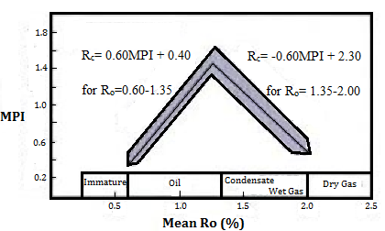

Figure 1.6 Chart of converting between MPI and Rc at different Ro values (modified from Peters et al., 2005)

Other aromatic maturity parameters calculated in this work include the methylphenanthrene ratio (MPR), dimethylnaphthalene ratio (DMR), trimethylnaphthalene ratio (TMR), methylnaphthalene ratio (MNR) and ethylnaphthalene ratio (ENR), all of which increase with increasing maturity, due to thermal rearrangement of compounds (Peters et al., 2005). A summary of the components of each ratio is summarized in Appendix A.

CHAPTER 2: EXPERIMENTAL METHODS

**2.1 Samples**

In total, 16 samples were analysed for TOC, Rock-Eval, and for total (saturated plus aromatic) hydrocarbon fraction analysis by gas chromatography (GC) and gas chromatography-mass spectrometry (GC-MS). Sample SP110723-1 (0.16m) was divided into three separate aliquots and analysed as three separate samples in order to assess analytical reproducibility and errors. A blank sample was also run for quality control and error measurements.

A standard North Sea oil sample was included in the analysis to aid in peak identification, as GC and GC-MS peaks were more easily identifiable owing to a more standard hydrocarbon compound distribution.

**2.2 Laboratory Materials**

The low concentration of biomarkers within the samples ensured extra care was taken so as not to contaminate the samples. Glassware used in laboratory procedures was soaked in 5% Decon detergent overnight, and then cleaned using a strong detergent and acid rinse in the laboratory dishwasher. Glassware and other lab equipment, including personal spatulas, were rinsed with dichloromethane (DCM) three times before use. Organic solvents used, including DCM, petroleum ether and methanol, were re-distilled in-house using an all-glass 30 plate Oldershaw still to purify the solvent. The first 200mL of solvent run through was discarded, and the rest kept for use in the lab.

Silica used was first cleaned by Soxhlet extraction for 24 hours using a solution of DCM to methanol (93:7 v/v), and was then activated by heating at 110°C overnight. The silica was also covered and stored at this temperature when not in use. The copper filings, used to remove elemental sulphur during Soxhlet extraction, were activated by rinsing six times with 2M hydrochloric acid (HCl), then rinsing with methanol six times, and finally rinsing with DCM six times. This rinsing was completed beneath the fume-hood, and all solvents and acid disposed of in the appropriate containers. The copper was stored submerged in DCM in a covered flask to ensure it was not later exposed to oxygen. The silica activation, glassware cleansing and solvent distillation were completed by Tracy Thompson.

**2.3 Sample Preparation**

The core and outcrop samples were placed in aluminium foil and broken up by a rock hammer. The rock fragments were then evenly distributed between the rings of a dichloromethane-cleaned Tema mill, and crushed to yield between ~5-25g sample. Sample crushing was completed by Tracy Thompson.

**2.4 Total Organic Carbon (TOC) Analysis**

TOC analysis was carried out by Philip Green using a Leco CS230 Carbon-Sulphur analyser. 0.1g of sample was placed in a porous crucible, which was then filled with 4M hydrochloric acid heated to 60-70°C, to remove any carbonates present. The acid was then drained, the sample and crucible rinsed with deionised water and dried at 65°C overnight. The organic carbon content was then measured.

**2.5 Rock-Eval Pyrolysis**

Rock-Eval analyses were completed by Tracy Thompson using a Delsi Instruments Rock-Eval Oil Show Analyser (O.S.A). A crushed sample (~100mg) of rock was weighed into a crucible, which was then inserted into the automatic sampler carriage. After initiation of the analysis, the crucible entered the oven to undergo pyrolysis through a set temperature program. The temperature program starts at 90°C for 2 minutes, followed by 300°C for 3 minutes. The temperature then increases by 25°C/minute until the temperature reaches 600°C. The total run time for Rock-Eval pyrolysis is approximately 17 minutes. During the first stage free gaseous hydrocarbons were volatilised to produce a S0 peak, as recorded by a flame ionisation detector (FID). Next, free liquid hydrocarbons were volatilised to produce a S1 peak. During the third and final stage, heavy hydrocarbons were volatilised and kerogen cracked. The hydrocarbons produced by this heating form the S2 peak and the temperature at which maximum hydrocarbons are released corresponds to Tmax (°C). S1 and S2 peaks are recorded in mg HC/g rock, and terms S1, S2 and Tmax are as defined by Tissot and Welte (1984). These peaks can also be used to calculate:

1. Hydrogen Index (HI): (S2/TOC)*100 in mg HC/g rock
2. Transformation Ratio or Production Index (PI): S1/S1+S2) (unitless)

HI is used as a measure of source rock potential and PI measures the level of maturation (Tissot & Welte, 1984).

**2.6 Restoration of Original Source Rock Potential**

The original source rock potential was calculated using equations 3,4 and 5 from Jarvie et al. (2007).

(3) HIo = (% type I *750) + (% type II *450) + (% type III * 125) + (% type IV * 50)

100 100 100 100

(4) TRHI = 1 - HIpd [1200-HIo (1-PIo)]

HIo [1200-HIpd (1-PIpd)]

(5) TOCo = HIpd (TOCpd/(1+k))*83.33 _

[HIo (1-TRHI)(83.33-(TOCpd/(1+k)))] – [HIpd (TOCpd/ (1+k))]

% Type I corresponds to the percentage of kerogen type I in the sample. TOCo and TOCpd are the original and present day organic carbon content (%), respectively, HIo and HIpd are the original and present day hydrogen indices, TRHI is the fractional conversion of HIo to HIpd, and PIpd and PIo are present day and original production indices, respectively. PIo is assumed to be 0.02 for immature rocks (Peters et al., 2005). 83.33 represents the carbon in hydrocarbons and 1200 is the maximum amount of hydrocarbon that can be generated from 83.33% carbon (Jarvie et al., 2007). Value k is a correction factor based on the changing amounts of residual carbon in each kerogen type with increased maturity (Jarvie et al., 2007).

(6) k = TRHI * CR (Jarvie et al., 2007)

Where CR is residual carbon, and equals 50% for type I, 15% for type II and 0% for types III and IV (Jarvie et al., 2007).

A variety of HIo values were substituted into the equation (HIo=350, 400, 600), and corresponded to estimated values for a type II or type I/II kerogen. TOCpd, and PIpd and HIpd were measured by TOC analyser and Rock-Eval, respectively. This was done as HIo is not known, and can only be measured with immature samples, and therefore a corresponding range of TOC values were calculated.

**2.7 Solvent Extraction and Bitumen Separation**

The samples were extracted in a Soxhlet extractor for 24h. The Soxhlet was used as opposed to the Soxtec due to low TOC and time restraints. To prepare the Soxhlet, cellulose thimbles and cotton wool were pre-extracted for four hours using of solvent of 93:7 DCM to methanol. 200mL of solvent and 3-4 anti-bumping granules were placed in the 250mL round-bottom flask placed below the thimble-containing Soxhlet on the heating element. Both the Soxhlets and flasks were rinsed with dichloromethane. Care was taken to ensure the pre-extracted thimbles and cotton wool did not come in contact with contaminants after extraction by using tweezers cleaned with dichloromethane to transfer them to foil to be dried in the fume-hood. After drying, each thimble and a piece of cotton wool were weighed on a piece of foil, and then a crushed sample added into the thimble, plugged at the top with cotton wool, and re-weighed. The cotton wool kept the sample contained within the thimble during extraction so only the extractable organic matter was found within the solvent. Care was taken not to spill crushed sample on the rim of the thimble during sample transfer. The thimble and sample were then placed back into a clean Soxhlet, and placed above a 250mL round bottom flask containing 200mL of new solvent mixture, 3-4 granules, and 3 spatula scoops of activated copper, and run for 24hours. Care was taken to ensure the Soxhlets did not run dry.

After extraction was complete, the 250mL round bottom flask containing both the solvent and extract was partially evaporated on a rotary evaporator, and then transferred to a 100mL round bottom flask by pipette, and the larger flask rinsed three times with DCM. The smaller flask was then evaporated down to near dryness. The contents were then transferred to a 3mL vial using 1mL of DCM to rinse the flask. The volume of the solvent and extract was kept low for the following transfer to a chromatographic column. A full open column liquid chromatographic fractionation was not performed because the amount of extract from each sample was so low. This forced a variation on the common fractionation, as described below.

A small piece of pre-extracted cotton wool was pushed to the base of a dry 20cm Pasteur pipette and then 7.5cm of activated silica was packed into the column above it. The 1mL of solvent and extract was pipetted onto the top of the silica and followed by 10mL of a mixture of 20% DCM in petroleum ether. This solvent was continually added as space in the column became available, as the previous solvent dripped through the silica and out the column to be collected in a 100mL round bottom flask with the combined saturated and aromatic hydrocarbon fractions of the sample. It is assumed the polar compounds remained in the silica in the pipette.

The flask was then placed on the rotary evaporator until nearly dry and then the combined saturates and aromatics fraction and solvent was transferred to a 3mL vial and evaporated down to ~100μL using a low intensity nitrogen stream. This volume was then transferred to a tapered insert within a 3mL vial, along with 97.4701ng of internal standard (IS) heptadecylcyclohexane (HDCH) added as 10μL of a 97.4701μg/mL solution in DCM. The sample fraction was then evaporated using a nitrogen stream to 50μL.

**2.8 Gas Chromatography (GC)**

A Thermo Trace gas chromatograph was used to produce chromatograms used in n-alkane and acyclic isoprenoid peak quantitation. The GC used a fused silica capillary column (30m length, 0.25mm diameter), coated with a HP-5 dimethyl poly-siloxane film with a thickness of 0.25μm, as the stationary phase. The hydrogen carrier gas had a flow rate of 1mL/min. The temperature in the GC oven started at 50°C for 2 minutes before being increased by 5°C/min. up to 310°C, where the final temperature was held for 20 minutes. The injector was at a temperature of 280°C and the flame ionization detector (FID) was at a temperature of 310°C. Atlas software by Thermo Scientific was used to process the GC data. GC was completed by Tracy Thompson.

**2.9 Gas Chromatography-Mass Spectrometry (GC-MS)**

After GC analyses, the vial tops were changed (to prevent contamination from the pierced septa) and the samples were topped up to 50μL with DCM. An Agilent 5975C Mass Spectrometer coupled with an Agilent 7890A Gas Chromatograph to analyse the combined aliphatic and aromatic hydrocarbon fractions from each sample. An aliquot (1μL) of sample was injected into the GC by an Agilent 7683B auto-sampler, where the sample then stayed at 50°C for 2 minutes before the temperature increased by 5°C/min. up to 310°C. The final temperature of 310°C was held for 20 minutes, giving a total run time of 74 minutes. The GC-MS was first run in scan mode (m/z 50-600 every 3 seconds) and then in selected ion mode (SIM) at 35ms dwell time. Bernard Bowler carried out the GC-MS analysis. Agilent ChemStation software was used to process the GC-MS data.

Scan mode was run only for samples MASW 3.32, VZCF001-015, SP110723-1 0.16m C, U1S2 and the standard North Sea oil. This combination of samples included all formations and provided a reasonable overview of samples. The spectra and mass chromatograms were used to identify compounds based on their mass spectral fragmentation patterns, relative retention time and elution patterns in comparison with published data (Peters et al., 2005).

For this analysis, a common suite of ions was run, including m/z 85, 191, 178, 217, 231, and 253, as well as a suite of diamondoid-based ions, including m/z 85, 135, 136, 140, 149, 187, 188, 192, 201, 239, 240 and 244. The diamondoid suite was only run for the above-mentioned 5 samples. These ion sets were run separately so as not to decrease the resolution and sensitivity of the analyses.

**2.10 Peak Integration and Quantification**

In order to calculate biomarker and non-biomarker ratios, the peak area for each compound was integrated and then quantified. N-alkanes and acyclic isoprenoids were integrated in Atlas and all others, including hopanes, steranes, and aromatics steroidal hydrocarbons, were integrated using ChemStation on their respective m/z trace. In ChemStation, RTE Integrator was used. Each peak was individually examined to determine if an appropriate integration had been completed by the computer, and if not, then manual integration was completed using an average peak base.

Once the peak area was determined, the peaks were quantitated using the equation below:

Response Factor = [(Peak area of IS)/(amount compound)] / [(Peak area of compound)/(amount IS)] (Peters et al., 2005)

As quantitative authentic standards of each analyte were not available, a response factor of 1 was assumed for all analytes, making the calculations semi-quantitative.

The semi-quantitation of analytes was therefore calculated by:

[(Peak area of analyte) x (amount IS)] / (Peak area of IS) (Peters et al., 2005)

A list of all peaks areas and peak quantitation are summarized in Appendices E and G, respectively.

**2.11 Error Measurement**

Analytical error was measured using the SP110724-1 0.16m triplicate (A, B and C) samples. The standard deviation (σ)was determined based on the average values of the parameters measured on these samples. The standard deviations were assumed to be the same for all other samples. The Blank sample was used to assess the introduction of any contaminants during the entire analysis process, including extraction, separation, GC and GC-MS.

CHAPTER 3: RESULTS

**3.1 Organic Carbon Content, Source Rock Potential and Maturity Parameters**

The organic carbon content of the Sete Lagoas, Paracatú, Serra do Garrote and Sirius Passet Lagerstätte samples was assessed by TOC analyses. Organic richness was measured by TOC and Rock-Eval HI, S1 and S2 values, which are summarized in Table 3.1.

|  |  |  |  |  |  |  |  |  |
| --- | --- | --- | --- | --- | --- | --- | --- | --- |
| Sample | Group | Formation | TOC | S1 | S2 | HI | PI | Tmax |
|  |  |  | % | mg HC /g rock | mg HC /g rock |  |  | °C |
| U1S9 | Bambuí | Sete Lagoas | 0.48 | 0.05 | 0.17 | 29 | 0.23 | 596 |
| U1S2 | 0.22 | 0.03 | 0.04 | 16 | 0.36 | 332 |
| U1S3 | - | 0.04 | 0.08 | - | 0.40 | - |
| U4.S13 | - | 0.00 | 0.00 | - | 0.00 | - |
| S1.1 | 0.01 | 0.03 | 0.19 | *1850 | 0.11 | 541 |
| MASW03.33 | Canastra | Paracatú | 2.10 | 0.08 | 0.12 | 6 | 0.40 | - |
| MASW03.35 | 1.80 | 0.06 | 0.12 | 4 | 0.33 | 297 |
| MASW03.32 | - | 0.06 | 0.08 | 3 | 0.45 | - |
| VZCF001-2 | Vazante | Serra do Garrote | 2.20 | 0.06 | 0.25 | 8 | 0.17 | - |
| VZCF001-15 | 1.00 | 0.04 | 0.06 | 6 | 0.20 | - |
| SP110723-1 0.16m avg. |  | Sirius Passet Lagerstätte | 0.87 | 0.10 | 0.09 | 10 | 0.53 | 584 |
| SP110724-1 1.12m | 0.98 | 0.00 | 0.10 | 10 | - | 587 |
| SP110724-1 3.31m | 0.70 | 0.00 | 0.10 | 14 | - | 429 |
| SP110724-1 54m | 0.40 | 0.00 | 0.13 | 33 | - | 488 |
| SP110725-1 2.2m | 0.60 | 0.00 | 0.13 | 22 | - | 300 |

Table 3.1 Summary of the measured source rock richness parameters. * denotes an anomalous HI value.

Low TOC, S1 and S2 values were seen in all samples, indicating the source rock potential for all formations to be of poor to fair potential, based on definitions summarized in Table 1.1, Section 1.6. Poor-fair designations were assigned when values spanned both poor and fair categories. However, the very low Hydrogen Index (HI) values indicate no current hydrocarbon producing potential. The S1.1 HI value is anomalous, probably due to a lower TOC value relative to S2. The Paracatú and Serra do Garrote samples have the highest TOC and S2 values, though the latter are very low compared to petroleum source rocks (Peters, 1986). These formations have the highest present day potential to produce hydrocarbon, as illustrated in Graph 3.1.

Graph 3.1 Summary of present day source rock potential indicating parameters

Thermal maturity was assessed using Tmax and PI from Rock-Eval, and values are summarized in Table 3.1. PI values for the Sirius Passet Lagerstätte could not always be calculated due to null values for S1. There is a large spread in both the Tmax and PI values. Tmax values range from 297-596°C, which indicates a maturity range from apparently immature to highly overmature. The onset of the oil generation window occurs at 435°C and moves to condensate generation at 455°C, and onto dry gas generation at 475°C (Peters et al., 2005). The PI values range from 0.00-0.53, and the oil window is taken from 0.10-0.40 (Peters et al., 2005), also indicating a spread from apparently immature to highly overmature.

**3.2 Hydrocarbon Compositional Analysis**

Hydrocarbon compositional analyses were carried out using Gas Chromatography (GC) and Gas Chromatography-Mass Spectrometry (GC-MS) mass chromatograms. Comparisons between samples were completed by overlaying chromatograms, after ensuring identical scales. This was possible as all samples were run in a single batch. A standard North Sea oil, VSLFRK, was also run in conjunction with the Brazilian and Greenland samples, for easier peak identification and comparison of retention times, as the samples did not exhibit standard peak distributions. This is seen in Figure 3.1, noting a separate y-axis scaling. A GC chromatogram is a spectrum of peaks that indicate the time each analyte elutes from the column, and using an internal standard these peaks can be quantitated, thereby quantitating the amount of each analyte.

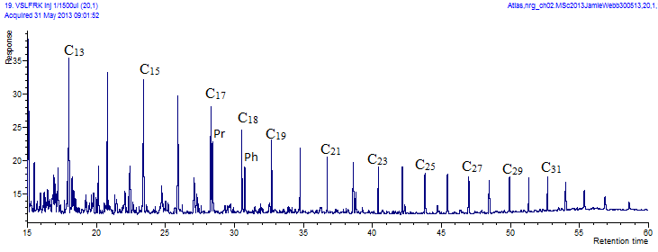



Figure 3.1 Comparison of two GC chromatograms from samples VLSFRK and VZCF001-15, with n-alkanes identified in the first.

GC-MS mass chromatograms were used to identify specific compounds based on their retention times and elution order. Single Ion Monitoring mass chromatograms represent a plot of mass-to-charge ratios against time, and are used to monitor selected ions, for example m/z 191 is used to identify hopanes, as seen in Figure 3.2. The parameters measured from GC and GC-MS and their corresponding chromatograms are summarized in Table 3.2 and 3.3.

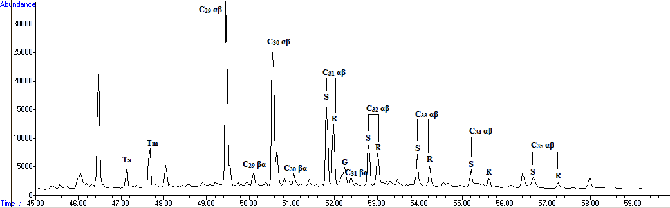

Figure 3.2 m/z 191 mass chromatogram with hopanes identified.

|  |  |
| --- | --- |
| **Parameter** | **m/z** |
| Methylphenanthrene index (MPI) | 178,  192 |
| Methylphenanthrene ratio (MPR) | 192 |
| Dimethylnaphthalene ratio (DNR) | 156 |
| Trimethylnaphthalene ratio (TNR) | 170 |
| Methylnaphthalene ratio (MNR) | 142 |
| Ethylnaphthalene ratio (ENR) | 156 |
| TA I/(TA I + TA II) | 231 |
| C29 St 20S/S+R, C29 St ββ/ββ+αα | 217 |
| C31 and C32 H 22S/S+R, Ts/Tm | 191 |
| Steranes/hopanes | 191, 217 |

Table 3.2 Summary of parameters calculated from appropriate GC-MS mass chromatograms (after Peters et al., 2005)

|  |  |
| --- | --- |
| **Parameter** | **Type** |
| Odd-Even Predominance (OEP) | GC |
| Pr/Ph | GC |
| Pr/*n*-C17 | GC |
| Ph/*n*-C18 | GC |

Table 3.3 Summary of biomarker and non-biomarker parameters as calculated from GC chromatograms (after Peters et al., 2005)

**3.3 Biomarker-based Thermal Maturity Parameters**

Thermal maturity was assessed using a variety of biomarker and non-biomarker maturity parameters. The values of which are summarized in Tables 3.4 and 3.5. Other biomarker parameters were calculated and are summarized in Appendix F, along with a summary of the parameters constituents and their identifying GC and GC-MS chromatograms in Appendices C and D, respectively.

|  |  |  |  |  |  |  |  |  |  |  |
| --- | --- | --- | --- | --- | --- | --- | --- | --- | --- | --- |
| **Formation** | Sete Lagoas | | | | | Paracatú | | | Serra do Garrote | |
| Core | LMR1009 | | | | Outcrop | MASW03 | | | VZCF001 | |
| Sample | **U1S9** | **U1S2** | **U1S3** | **U4.S13** | **S1.1** | **33** | **35** | **32** | **2** | **15** |
| Rc MPI-1  1.35-2.00 | 2.02 | 2.04 | 1.90 | 1.78 | 1.84 | 2.23 | - | 2.09 | 1.95 | 2.08 |
| TNR | 2.14 | 1.29 | 1.42 | 1.32 | 1.27 | 1.51 | - | 2.39 | 2.18 | 2.58 |
| MNR | 1.74 | 2.08 | 1.77 | 1.95 | 1.55 | 1.91 | - | 1.27 | 1.51 | 1.6 |
| TAI/I+II | 0.15 | 0.12 | 0.14 | 0.14 | 0.13 | 0.20 | - | 0.36 | 0.14 | 0.25 |
| C29 St ββ/ββ+αα | 0.41 | 0.38 | 0.36 | 0.35 | 0.47 | 0.44 | - | 0.35 | 0.41 | 0.44 |
| C29 St 20S/S+R | 0.34 | 0.3 | 0.25 | 0.38 | 0.39 | 0.41 | - | 0.23 | 0.45 | 0.28 |
| C31 H 22S/S+R | 0.56 | 0.57 | 0.56 | 0.56 | 0.55 | 0.57 | - | 0.55 | 0.43 | 0.57 |
| Ts/Tm | 0.42 | 0.44 | 0.43 | 0.48 | 0.42 | 0.39 | - | 0.45 | 0.35 | 0.55 |
| Ph/*n*-C18 | - | 0.12 | 0.15 | 1.02 | 1.38 | 0.27 |  | 0.37 | 0.26 | 0.23 |
| OEP | - | 1.75 | 1.44 | 0.98 | 2.07 | *14.16 | - | 1.14 | 2.84 | 2.24 |

Table 3.4 Summary of maturity parameters for the all Brazilian samples. *denotes anomalous OEP value due to an anomalously large C25 peak.

|  |  |  |  |  |  |
| --- | --- | --- | --- | --- | --- |
| **Formation** | Sirius Passet Lagerstätte | | | | |
| Outcrop | SP110723-1 | SP110724-1 | | | SP110725-1 |
| Sample | **0.16m** | **1.12m** | **3.31m** | **54m** | **2.2m** |
| Rc MPI-1  1.35-2.00 | - | 1.99 | 2.12 | 2.13 | 2.06 |
| TNR | 1.36 | 1.44 | 1.41 | 1.39 | 1.39 |
| MNR | 1.54 | 1.67 | 1.38 | 1.53 | 1.4 |
| TAI/I+II | 0.11 | 0.19 | 0.09 | 0.25 | 0.14 |
| C29 St ββ/ββ+αα | 0.46 | 0.47 | 0.39 | 0.41 | 0.45 |
| C29 St 20S/S+R | 0.36 | 0.39 | 0.46 | 0.22 | 0.45 |
| C31 H 22S/S+R | 0.57 | 0.56 | 0.60 | 0.56 | 0.56 |
| Ts/Tm | 0.31 | 0.35 | 0.50 | N/A | 0.44 |
| Ph/*n*-C18 | 0.23 | 0.55 | 0.40 | 0.41 | 0.42 |
| OEP | 0.83 | 1.38 | 2.90 | 0.99 | 1.52 |

Table 3.5 Summary of maturity parameters for the Sirius Passet Lagerstätte, Transitional Buen Formation

The C31 homohopane ratio becomes fully isomerised at the onset of the oil generation window with a value of ~0.6 (Peters et al., 2005), and for all samples this has been reached. The C29 St ββ/ββ+αα and C29 St 20S/S+R ratios do not become fully isomerised until peak to late oil generation, and these ratios have not reached equilibrium for any sample. Ts/Tm values increase with increasing maturity to 1.0, and measured values range from 0.30-0.55, however a strong facies dependency can play a critical role in this calculation as there is the potential for co-elution with tricyclic terpanes (Seifert & Moldowan, 1978). The triaromatic steroid ratio (TA I/I+II) reaches equilibrium at the onset of the wet gas-condensate window, covering the largest range of any thermal maturity parameter measured. Values of 10-60, which comprises all samples, except SP110723-1 0.16m C with a value of 0.09, indicates peak oil generation. The TNR and MNR ratios increase with increase maturity, as does Ph/*n*-C18. The three parameters do not agree precisely, but a general correlation is seen. The MPI-1 Rc value can be directly correlated to equivalent vitrinite reflectance, where the oil window is Ro = 0.60-1.35%, wet-gas window is Ro = 1.35-2.0% and dry gas window is Ro >2.0% (Peters & Cassa, 1994). The Rc MPI-1 values calculated are based on the supposition the Ro are between 1.35-2.0%, as there is a separate equation for lesser values. OEP values near 1 indicate thermal maturity, and increasing values potentially indicate increased terrestrial organic matter. A summary of these parameters and their correlation to the oil window is summarized in Figure 3.3.

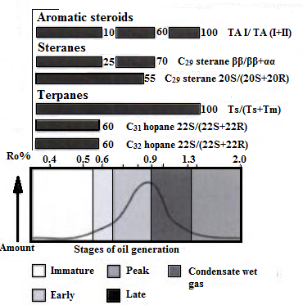

Figure 3.3 Summary of biomarker maturity parameters and their equilibrium points over the oil generation window (modified from Peters et al., 2005)

All parameters correlate reasonably with each other, with the exception of Rc MPI which shows overmaturity, and seem to indicate the samples are of early to peak oil generative potential. However, this is misleading as biomarker parameters, including those calculated, are known to invert or display erratic behaviour at high maturities (Peters & Moldowan, 1991; Farrimond et al., 1998). This will be discussed further in Section 4.4. Due to the wide scatter in PI and Tmax data from the Rock-Eval pyrolysis, and potential maturity issues of the biomarker parameters, these maturity values cannot be accurately compared. Low confidence in thermal maturation determinations is a common problem for source rocks of this age (e.g. McArthur Basin, Summons et al., 1988).

Diamondoid-based maturity parameters could not be calculated from GC-MS because the diamondoid peaks were in too low abundances to be distinguished from the background peak scatter. Future work could include the use of a diamondoid specific I.S., such as deuterated D4-diamantane or D4-adamantane, to better establish the peak retention positions, more sensitive or selective mass spectrometry (e.g. GC-MS-MS) as well as the analysis of a larger amounts of sample, for better peak definition (Wei et al., 2007).

**3.4 Original Source Rock Potential**

The original producing potential of the rock could be estimated using calculations from Rock-Eval HI, TOC and S2 values. However, the original HI values of immature analogues of the samples were not available and thus could not be measured. A range of HIo values were therefore used, assuming a Type II or Type I/II kerogen mix, as indicated in literature (Bechstadt et al., 2009). HIo values used included 300, 450 and 600. These values were chosen because a HIo of 300 represents the low end of the HI value range for a Type II kerogen, and HIo=600 represents the high end of this range (Peters & Cassa, 1994). HIo=450 was chosen as an intermediate value, as it represents the average of 300 and 600. A representative kerogen composition was calculated for each HIo value using the least number of possible kerogen types. There are an infinite number of kerogen compositions possible to achieve each HIo value, but they were calculated as follows after Jarvie et al. (2009): HIo values of 300 represent a kerogen composition of 62.5% Type II and 37.5% Type IV, a value of 450 represents 100% Type II, and a final value of 600 represents 50% Type I and 50% Type II. The HIo and TOCo values were calculated according to the equations shown in Section 2.6. A TOCo for each estimated HIo is compared to the present day measured TOC and summarized in Table 3.6.

|  |  |  |  |  |  |
| --- | --- | --- | --- | --- | --- |
| **Sample** | **Formation** | **TOCmeasured** | **TOCo300** | **TOCo450** | **TOCo600** |
|  |  | % | % | % | % |
| U1S9 | Sete Lagoas | 0.48 | 0.58 | 0.66 | 0.71 |
| U1S2 | Sete Lagoas | 0.22 | 0.27 | 0.30 | 0.33 |
| U1S3 | Sete Lagoas | - | - | - | - |
| U4.S13 | Sete Lagoas | - | - | - | - |
| S1.1 | Sete Lagoas | 0.01 | 0.00 | 0.00 | 0.00 |
| MASW03.33 | Paracatú | 2.10 | 2.68 | 3.05 | 3.29 |
| MASW03.35 | Paracatú | 1.80 | 2.28 | 2.60 | 2.80 |
| MASW03.32 | Paracatú | - | - | - | - |
| VZCF001-2 | Serra do Garrote | 2.20 | 2.81 | 3.2 | 3.45 |
| VZCF001-15 | Serra do Garrote | 1.00 | 1.24 | 1.41 | 1.52 |
| SP110723-1 0.16m | Sirius Passet Lagerstätte | 0.87 | 1.08 | 1.22 | 1.32 |
| SP110724-1 1.12m | Sirius Passet Lagerstätte | 0.98 | - | - | - |
| SP110724-1, 3.31m | Sirius Passet Lagerstätte | 0.70 | - | - | - |
| SP110724-1, 54m | Sirius Passet Lagerstätte | 0.40 | - | - | - |
| SP110725-1, 2.2m | Sirius Passet Lagerstätte | 0.60 | - | - | - |

Table 3.6 Summary of restored original TOC for HIo values of 300, 450 and 600

Original TOC could not be calculated for some samples due to a missing variable, including present day S2, HI or PI. The Serra do Garrote and Paracatú formations have the best potential, followed by the Sirius Passet Lagerstätte, and then the Sete Lagoas. As the HIo increases, the TOCo increases, thereby increasing the original hydrocarbon producing potential. This makes the equations using HIo=600 have the highest TOCo. The Serra do Garrote and Paracatú formations have the best TOCo for all calculated HIo values, and require lower HIo values to be excellent potential source rocks. The Sete Lagoas and Sirius Passet Lagerstätte remain poorer quality source rocks even when attributing a maximum of HIo=600.

**3.5 Gas Chromatography Derived Indicators**

The GC produced a chromatogram for the total hydrocarbon fraction from each sample and these were used to identify n-alkanes and the acyclic isoprenoids, pristane and phytane. The Mesoproterozoic-Early Cambrian samples exhibited abnormal distributions of n-alkanes. A typical present day sample is more heavily concentrated in lower carbon number n-alkanes, with the amount decreasing with increasing carbon number, as seen in the standard North Sea sample, VSLFRK. This was not the case for the Brazilian and Greenland samples. In general, the chromatograms showed a predominance of *n*-C14-19 alkanes, indicating a predominantly marine algal input. This distribution has also been seen in the McArthur Basin (Summons et al., 1988). The Pr/Ph ratios, as indicated in Table 3.7 and Graph 3.2, show deposition in a dysoxic to anoxic environment. This environment was confirmed with a Pr/*n*-C17 vs Ph/*n*-C18 plot, as seen in Figure 3.3.

|  |  |  |  |  |  |  |
| --- | --- | --- | --- | --- | --- | --- |
| **Formation** | **Sample** | **Lithology** | **OEP** | **Pr/Ph** | **Pr/*n*-C17** | **Ph/*n*-C18** |
| Sete Lagoas | U1S9 | Argillite | - | - | - | - |
| U1S2 | Argillite | 1.75 | 0.95 | 0.57 | 0.78 |
| U1S3 | Argillite | 1.44 | 0.75 | 0.56 | 0.93 |
| U4.S13 | Dolomite | 0.98 | 1.04 | 0.84 | 1.02 |
| S1.1 | Marl/argillite | 2.07 | 0.43 | 0.59 | 1.38 |
| Paracatu | MASW 03.33 | Slate | 14.16 | 1.09 | 1.25 | 1.36 |
| MASW 03.32 | Slate | 1.14 | 1.34 | 1.04 | 0.95 |
| MASW 03.35 | Slate | - | - | - | - |
| Serra do Garrote | VZCF001-2 | Slate | 2.84 | 1.06 | 1.00 | 0.88 |
| VZCF001-15 | Slate | 2.24 | 1.25 | 1.24 | 0.83 |
| Sirius Passet Lagerstätte | SP110724-1 0.16m avg. | Mudstone | 0.83 | 2.26 | 0.62 | 0.23 |
| SP110724-1 1.12m | Mudstone | 1.38 | 1.84 | 1.41 | 0.37 |
| SP110724-1 3.31m | Mudstone | 2.90 | 1.19 | 1.10 | 0.42 |
| SP110724-1 54m | Mudstone | 0.99 | 1.90 | 1.07 | 0.33 |
| SP110725-1 2.2m | Mudstone | 1.52 | 1.22 | 1.16 | 0.45 |

Table 3.7 Summary of source and redox condition parameters, as calculated from GC chromatograms



Graph 3.2 Summary of depositional setting oxygen availability, based on Pr/Ph ratios (from pIGI software)



Graph 3.3 Summary of oxygen conditions in the depositional environment based on Pr/*n*-C17 versus Ph/*n*-C18 values (from pIGI software).

**3.5.1 Sete Lagoas Formation**

Sample U4.S13 has a large unresolved complex mixture (UCM) over n-C21+, possibly indicating biodegradation. Sample S1.1, taken from outcrop, shows a near equal amount of short chain to long chain alkanes, different from *n*-C14-19 alkane predominance. All samples show a large unknown peak between C28 and C29. Sample U1S9 was not run for GC analysis.

**3.5.2 Paracatú Formation**

Sample MASW03.35 was lost during the separation process. Sample MASW03.33 exhibits a very high OEP due to an anomalously large C25 peak, which does not appear to be due to co-elution, and is unexplained.

**3.5.3 Serra do Garrote Formation**

The Serra do Garrote GC traces exhibit a higher than typical OEP relative to the other Brazilian samples. The lower weight n-alkanes predominate, however there is an increase in peak height for *n*-C27, *n*-C29 and *n*-C31, relative to the nearby even numbered peaks, possibly indicating an increased terrestrial source relative to other formation samples. OEP values near 3 corroborate this.

**3.5.4 Sirius Passet Lagerstätte**

All Greenland samples are more heavily concentrated in lower molecular weight *n*-alkanes and show an UCM from *n*-C16-21. Sample SP110724-1 3.31m shows an increase in the OEP, due to an increase in peak height of *n*-C27, *n*-C29 and *n*-C31, potentially due to an increase in terrestrially sourced organic matter.

**3.6 Source indicating Biomarkers and Unidentified Peaks**

Biomarkers were identified and quantified using appropriate peaks in GC-MS Single Ion Monitoring (SIM) mass chromatograms. The presence or absence of specific markers links separate aspects of the depositional environment, redox conditions and components of the organic matter. The presence of 24-*n*-propylcholestane and its isopropyl isomer in m/z 217 mass chromatograms are seen in Sirius Passet Lagerstätte and Paracatú samples (e.g. Figure 3.4). 2α- and 3β-methylhopane are present in the m/z 205 mass chromatograms in all samples except the dolomitic U4.S13 sample (e.g. Figure 3.5). The corresponding indices were not measured as GC/MS/MS for m/z 412→191 and 426→205 were not completed. Both 24-*n*-propylcholestane and 2α- and 3β-methylhopanes were identified based on peak retention times and through comparison to published peak elution orders (Collister et al., 1992; Love et al., 2009), making the confidence in these interpretations moderate.

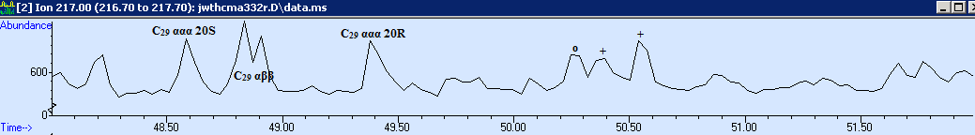

Figure 3.4 m/z 217 mass chromatogram of MASW3.32 where + denotes 24-isopropylcholestane and indicates demosponges, while o denotes 24-*n*-propylcholestane.

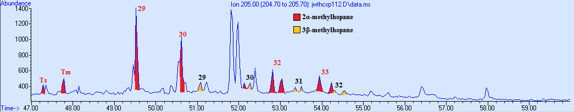

Figure 3.5 m/z 205 mass chromatogram of SP110724-1 1.12m denoting the presence of 2α- and 3β-methylhopane

|  |  |
| --- | --- |
| **Sample** | **Steranes/hopanes** |
| U1S9 | 0.54 |
| U1S2 | 0.91 |
| U1S3 | 0.72 |
| U4.S13 | 0.4 |
| S1.1 | 1.32 |
| MASW03.33 | 0.72 |
| MASW03.35 | - |
| MASW03.32 | 0.66 |
| VZCF001-2 | 0.45 |
| VZCF001-15 | 0.53 |
| SP110723-1, 0.16m avg | 0.39 |
| SP110724-1, 1.12m | 0.51 |
| SP110724-1, 3.31m | 0.32 |
| SP110724-1, 54m | 0.58 |
| SP110725-1, 2.2m | 0.53 |

Table 3.8Summary of steranes/hopanes ratio, calculated using (C27-29ααα [20S+20R] + αββ [20S+20R] steranes/C29-33αβ hopanes [22S+22R])

The steranes/hopanes ratio indicates the amount of eukaryotic input relative to bacterial input (Moldowan et al., 1985). The values increase from 0.32 to 1.32, as seen in Table 3.8, indicating increasing eukaryotic input. Sterane isomer composition on m/z 217 indicates a large input from plankton and algae into organic matter, as seen in Figure 3.6.

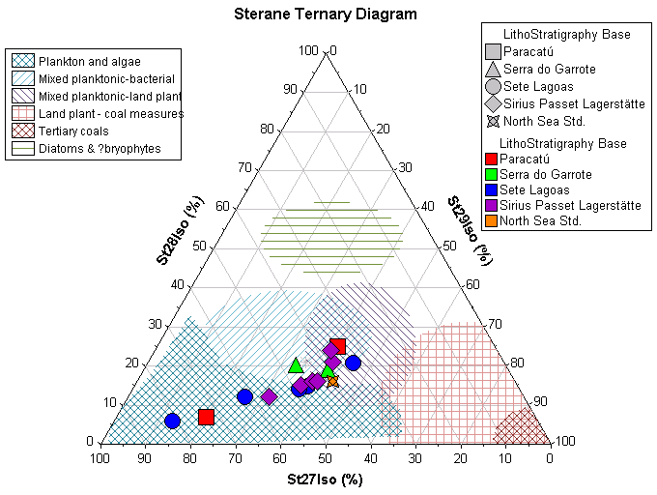

Figure 3.6 Sterane isomer composition ternary plot indicating organic matter contributors (from pIGI software)

28, 30-bisnorhopane is present in sample SP110724-1 3.31m, as can be seen in Figure 3.7 (Peters et al., 2005). Gammacerane is found within most Sete Lagoas samples and SP110724-1 2.2m from Greenland, as seen in Figure 3.8.

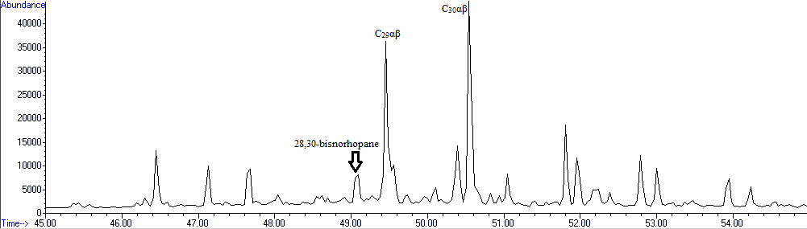

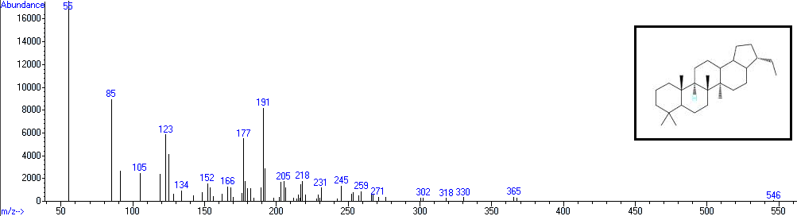

Figure 3.7 m/z 191 mass chromatogram and mass spectrum of arrowed peak showing the presence of 28,30-bisnorhopane in Greenland sample SP110724-1, 3.31m

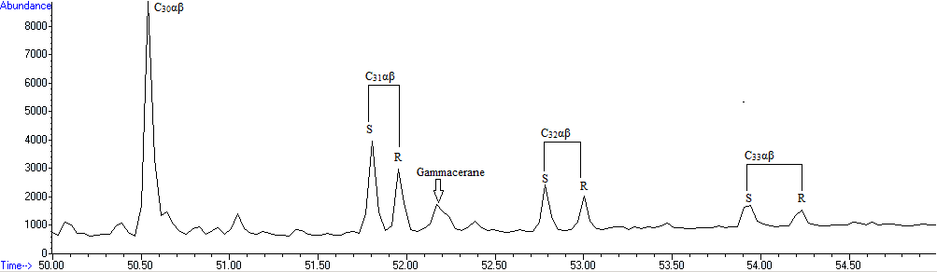

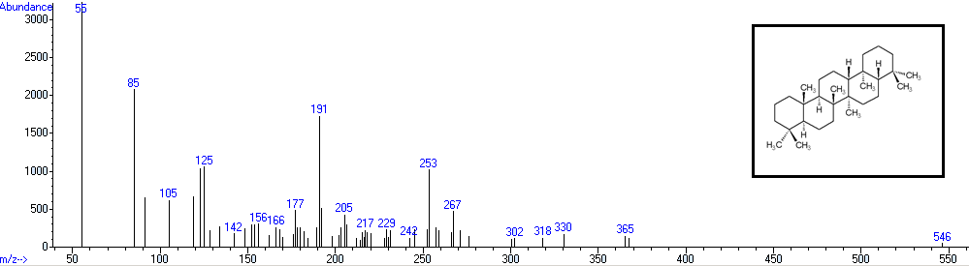

Figure 3.8 m/z 191 mass chromatogram and mass spectrum of arrowed peak showing the presence of gammacerane in Sete Lagoas sample U1S2

Mid-chain monomethyl alkanes, also known as X-compounds, are a common component of Neoproterozoic-early Cambrian oils and source rocks (Love et al., 2008), and are seen to elute on GC chromatograms, Figure 3.9. While another prominent alkane series is present on GC-MS m/z 85 traces, as seen in Figure 3.10. It is best seen in the Sirius Passet Lagerstätte samples, although present in samples from Brazil as well.

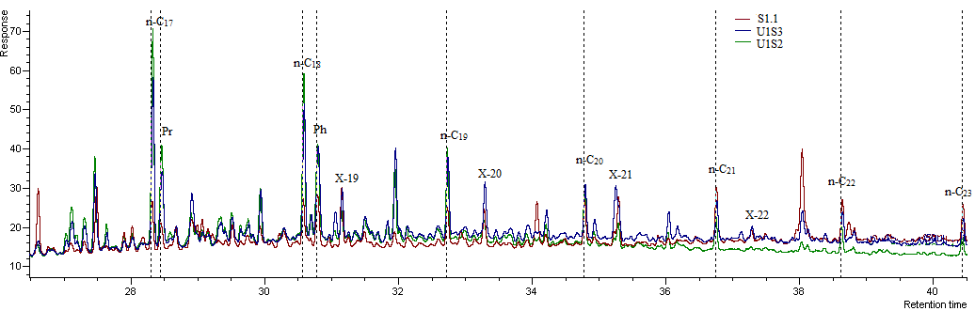

Figure 3.9 Gas chromatogram showing x-compounds and *n*-alkanes within the Sete Lagoas Formation for samples U1S3, U1S2 and S1.1

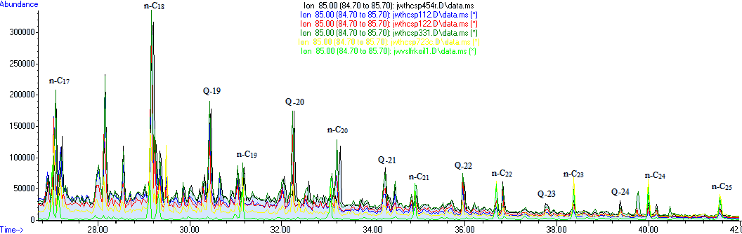

Figure 3.10 GC-MS m/z 85 mass chromatogram showing the secondary alkane series, labelled similarly to X-compounds but termed Q-series, present within samples from Greenland

A large unidentifiable peak occurs in the m/z 191 mass chromatogram and GC traces. The peak occurs at 46.446min and co-elutes with C27 αββ sterane. In sample SP110723-1 0.16m C it can be seen in Figure 3.11 that the peak elutes within the tricyclic terpane area. This unidentifiable peak is also prominent between *n*-C28 and *n*-C29 on gas chromatograms, as seen in Figure 3.12.

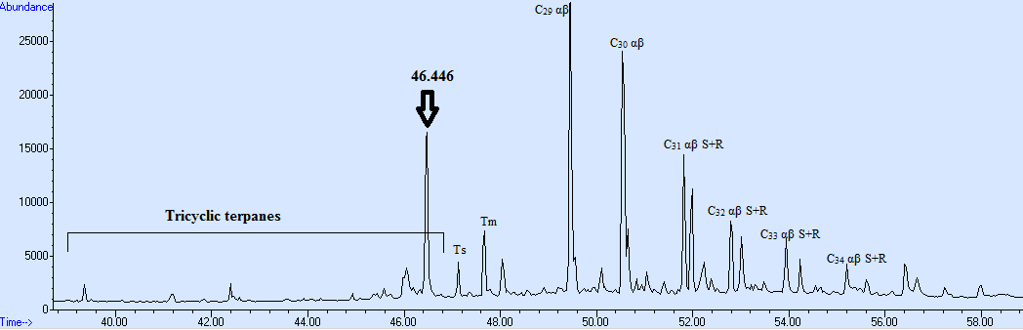

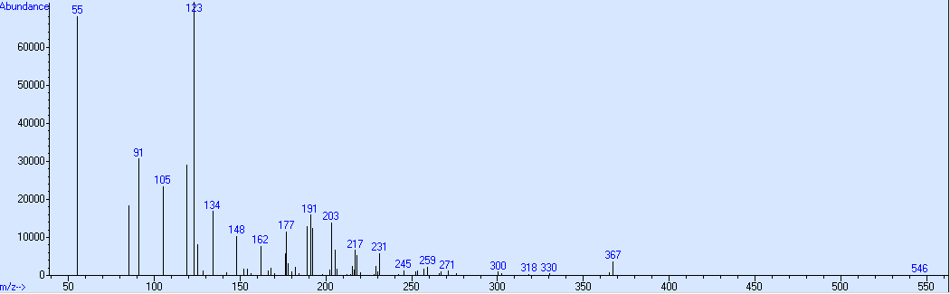

Figure 3.11 m/z 191 mass chromatogram and corresponding mass spectrum of 46.446min peak

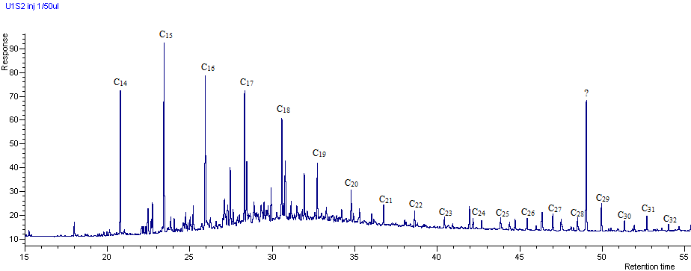

Figure 3.12 Gas chromatogram of the hydrocarbon fraction from sample SP110723-1 0.16m C showing the unidentified peak

**3.7 Syngeneity of Biomarkers**

A common biomarker originating from angiosperms is oleanane, however as flowering plants were not present until the Mesozoic, it should not be present in the sample set. The presence of oleanane in Greenland samples SP110724-1 3.31m and 2.2m, Serra do Garrote sample VZCF001-15 and Sete Lagoas samples U1S2, U1S3 and U1S9 indicates that at least some of the biomarkers present may be non-syngenetic.

**3.8 Errors in Calculated Parameters and Sample Contamination**

The Blank sample indicates some contamination did occur in the analytical process, as seen in Figure 3.13. However, the contaminant peak height values are low. Contamination likely occurred during separation or by contact with GC vial rubber lids.

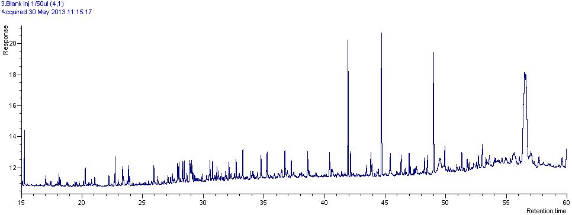

Figure 3.13 GC chromatogram of Blank sample, indicating contamination during the analytical process

The standard deviation of each parameter calculated was quantitated using an averaged value for the SP110723-1 0.16m triplicate A, B and C samples. The average parameter value and its corresponding standard deviation are shown in Graph 3.4 and Table 3.9. The error was not calculated for the methylphenthrene index (MPI) or its corresponding Rc, due to poor peak resolution in the SP110723-1 0.16m samples. The MPR and ENR are seen to have the largest standard deviations.

Graph 3.4 Summary of parameter values and their corresponding standard deviation

|  |  |  |  |  |
| --- | --- | --- | --- | --- |
| Parameter | Column | Average | ST DEV | % rel. ST DEV |
| MPI | 1 | N/A | N/A | N/A |
| Rc MPI | 2 | N/A | N/A | N/A |
| MPR | 3 | 1.50 | 0.39 | 25.84 |
| DNR | 4 | 3.26 | 0.10 | 3.19 |
| TNR | 5 | 1.36 | 0.01 | 0.54 |
| MNR | 6 | 1.54 | 0.09 | 5.91 |
| ENR | 7 | 2.22 | 0.41 | 18.37 |
| TAI/TAI+TAII | 8 | 0.11 | 0.02 | 14.14 |
| C29 St ββ/ββ+αα | 9 | 0.46 | 0.00 | 0.69 |
| C29 ST 20 S/S+R | 10 | 0.36 | 0.01 | 1.65 |
| C31 H 22S/S+R 191 | 11 | 0.57 | 0.00 | 0.86 |
| C31 H 22S/S+R 205 | 12 | 0.57 | 0.01 | 1.48 |
| C32 H 22S/S+R | 13 | 0.53 | 0.00 | 0.90 |
| Ts/Ts+Tm | 14 | 0.31 | 0.01 | 4.01 |
| steranes/hopanes | 15 | 0.37 | 0.02 | 4.39 |
| OEP | 16 | 0.73 | 0.09 | 12.97 |
| Pr/Ph | 17 | 2.31 | 0.13 | 5.60 |
| Pr/*n*-C17 | 18 | 0.62 | 0.11 | 17.71 |
| Ph/*n*-C18 | 19 | 0.23 | 0.01 | 4.46 |

Table 3.9 Table of parameter labels corresponding to columns in Graph 3.4

CHAPTER 4: DISCUSSION

**4.1 Organic Carbon Content and Source Rock Potential**

A cut off of 2% TOC was used as the lower limit of hydrocarbon producing potential (Peters, 1986). The Paracatú and Serra do Garrote formations surpass this cut-off and have the best potential, whereas the Sete Lagoas and Sirius Passet Lagerstätte do not. However, the S2 values of all formations are too low to produce hydrocarbons, and therefore none of the samples will generate hydrocarbon in the future. All samples had low amounts of hydrocarbons present at the onset of pyrolysis, and few hydrocarbons were generated with heating. This was expected due to the age of the potential source rocks, because if the rocks once had the potential to produce, they may have already done so, thereby expelling converted organic carbon in the form of oil or gas, and decreasing the S2 and TOC values. The generally low concentrations of organic matter detected had implications for the GC and GC-MS analyses, as there were very low amounts of saturated and aromatic hydrocarbon compounds available to analyse.

The very low HI values measured place the kerogen type as Type IV for all samples (e.g. Dembicki, 2009), with the exception of S1.1, which had an anomalously high HI. This anomaly is not due to genuine high potential, but to a lower TOC value relative to S2 and also, very low measured values mean that small measurement errors could have resulted in very large errors in the calculated HI ratio. Type IV is unlikely to have been the original kerogen type, as it is known all formations were deposited under marine conditions, typically of Type II kerogen, as discussed in Section 1.6.

Sedimentary organic carbon dominated by inertinite, has source potential considerably lower than a rock of the same TOC percentage but composed of amorphous organic matter (Peters & Cassa, 1994). Weathering can also degrade organic carbon (e.g. Leythaeuser, 1973) and was considered when evaluating samples taken from outcrop gathered, S1.1 and the Lagerstätte samples. The Sete Lagoas outcrop sample, S1.1, had the lowest organic carbon content, even though it is of comparable organic facies to samples U1S2 and U1S9.

**4.2 Thermal Maturity**

The Tmax and PI values are too variable to allow an accurate interpretation of maturity using Rock-Eval pyrolysis, and the variations are not explained by sampling variability or contamination. Possible explanations for PI variability include contamination by migrating hydrocarbon, bitumen adsorption onto clay minerals, and low organic matter (Peters et al., 2005). The Tmax can also be greatly affected by low organic carbon content, and this is the most likely cause of diversity in maturity values (Peters et al., 2005).

It is interesting to note the differences in the maturity parameters within the Sete Lagoas Formation, with the carbonate, U4.S13, and outcrop, S1.1, samples showing increased maturity relative to the shaley samples. Variations in parameters based on carbonate versus shale lithologies were also noted by Olcott et al. (2005). This variability could be due to decreased peak resolution associated with decreased organic carbon content within U4.S13 and S1.1. Also, different lithologies have separate organic matter inputs and this variation could lead to inconsistencies in the measured parameters. For example, maturity ratios involving isomerization are not simply based on a single changing component, but several, and the impact each component has on the ratio overall is not known and may change with increasing maturity (Farrimond et al., 1998). This is discussed in further detail in Section 4.4. The change in organic matter inputs has been studied by Radke et al. (1985) through work with Type II and III kerogens and their effects on aromatic maturity parameters. They note fluctuations in aromatic parameters due to the varying organic matter (Radke et al., 1985).

No direct correlation can be made between vitrinite reflectance values and subsurface temperatures; however, hydrocarbon is generated from 60-160°C, with thermogenic gas beyond 160°C (Tissot et al., 1987; Hunt, 1996). These values are less than the metamorphic grades proposed for the Serra do Garrote, granulite facies (Rodrigues, 2008), and Paracatú, greenschist to amphibolite facies (Rodrigues, 2008). Within the São Francisco Basin, maturity decreases from the outer edges, particularly in the highly metamorphosed Brasiliano Belt, near the sample locations, towards the centre of the basin (Sial et al., 2009). The maximum temperatures reached are likely associated with the Brasiliano orogeny, at which time the basin reached maximum deposition (Sial et al., 2009). Ineson & Peel (2011) indicated temperatures of at least 300°C in the Sirius Passet Lagerstätte, although it is unknown if chloritoid porphyroblasts occurred within this sampled section.

**4.3 Confidence in Thermal Maturity Parameters**

Confidence in the measured and calculated thermal maturity of this sample set is low. This is due in part to the low organic matter content in the samples affecting the Rock-Eval, GC and GC-MS analyses, but also to the overmaturity of the samples themselves. Due to the amount of time the samples have spent undergoing thermal maturation, the components of the biomarker maturity parameters are very low, and only represent a small amount of what was once available. It is known that particularly in phosphatic lithologies, as examined here, a reversal of isomerisation ratios can occur at high maturities (Peters & Moldowan, 1991). These reversals are attributed to variations in the unidentified, complex mechanisms controlling the generation and degradation of parameter components, and therefore the parameters (Peters & Moldowan, 1991).

Peters & Moldowan (1991) noted a reversal in C31 and C32 homohopane isomerisation ratios at high temperatures. This reversal and general erratic behaviour is also seen in sterane isomerisation ratios (C29 ββ/ββ+αα and 20S/S+R) and Ts/Ts+Tm (Farrimond et al., 1998). Specifically, Farrimond et al. (1998) note that at Tmax >456°C, the Ts ratio is seen to invert. These temperatures are lower than the overmature samples, and therefore it can be inferred that these reversals likely explain why the data indicates a maturity of early-peak oil generation.

It should be noted the sample set examined here was too small and overmature to first display regularly increasing maturity parameters, and then the erratic behaviour and reversals seen in high maturity samples. The reader is directed to Farrimond et al. (1998), where these trends are displayed for an Eocene claystone from the Barents Sea.

**4.4 Original Source Rock Potential**

Even with an increase in original HI value to 600, based on a maximum HI value for a Type II kerogen as reported by Peters & Cassa (1994), the Sete Lagoas only has fair potential to produce. This designation is based on TOC between 0.5-1.0%, as defined by Peters & Cassa (1994). This makes it an unlikely source of gas seeping at surface in the Paracatú River.

Because the original HI is unknown, a large number of assumptions were made in order to generate the TOCo. This renders low confidence in these calculations. The value of HIo=600 infers the largest number of assumptions, as the primary productivity and preservation conditions would need to be ideal within the marine environment for this value to occur. Therefore, supposing less than ideal conditions (HIo<600) decreases the magnitude of the assumptions and confirms the Serra do Garrote and Paracatú more likely to be the sources of hydrocarbon found in the São Francisco Basin.

**4.5 Depositional Environment, Redox Conditions and Organic Matter Input**

The presence of specific biomarker compounds can signify different aspects of the depositional environment, including water column stratification and specific inputs to organic matter (Peters et al., 2005). The identification of some of these marker compounds in the samples was made difficult due to the low biomarker concentrations and the low signal (analyte peak height) to noise. Decreasing biomarker concentrations are known to occur with increasing maturity likely due to either dilution of non-biomarker material, such as *n*-alkanes, generated from kerogen, and cracking of remaining biomarker molecules (van Graas, 1990).

The presence of 24-*n*-propylcholestane indicates a marine algal source, while its isopropyl isomer indicates the presence of demosponges in the depositional environment (McCaffrey et al., 1994; Love et al., 2009). These markers are present in Sirius Passet Lagerstätte and Paracatú samples. They are also found in work completed by Little (2009) on the Lagoa do Jacaré Formation, Bambuí Group. The absence of these markers in all samples could be due to the low concentrations of organic matter analysed. The presence of 2α- and 3β-methylhopane indicates the presence of cyanobacteria and methanogenic proteobacteria, respectively, as well as marine pelagophyte algae in the depositional environment (Collister et al., 1992; Love et al., 2009).

In general, the Meosproterozoic to Early Cambrian organic matter is composed of dominantly prokaryotes, and has inputs from eukaryotes, including demosponges. The sterane isomer composition correlates well with typical Proterozoic oils and source rocks, and indicated it is likely composed of both red, (increased C27 input) and green, (increased C29 input) algae (Kelly, 2009). The presence of red algae may indicate a nearer shoreline depositional environment than green algae dominated organic matter (Kelly, 2009).

The presence of 28, 30-bisnorhopane suggests an anoxic depositional environment and was biosynthesized at the oxic-anoxic interface by chemoautotrophic bacteria (Peters et al., 2005). Gammacerane also indicates a stratified water column during deposition in a marine setting (Peters et al., 2005). This corresponds to the Pr/Ph values and Pr/*n*-C17 vs. Ph/*n*-C18 plot, which also show a dysoxic-anoxic environment of deposition.

Mid-chain monomethyl alkanes (X-compounds) were first identified in the Huqf oils of Oman and are commonly found in Proterozoic oils and source rocks (Grantham et al., 1987). The source of these peaks is not known, however a bacterial source has been proposed (Thiel et al., 1999; Grosjean et al., 2009). The other prominent alkane series present in GC-MS m/z 85 chromatograms has unclear origins, and could not be found in previous literature.

The large unidentified peak on the m/z 191 mass chromatograms could be a C29 tricyclic terpane, however without injecting an authentic standard, there is no certainty. Another possibility is it could be a sesquiterpane, due to the large m/z 123 peak in the mass spectrum. Some sesquiterpanes are the products of hopanoid diagenetic alteration (Weston et al., 1989). The reason for the large peak height is unclear, as its origin is unknown.

**4.6 Syngeneity of Biomarkers**

The presence of oleanane is possibly explained by contamination by flow through of hydrocarbons from a post-Mesozoic source. Babinski et al. (1999) has suggested a large scale fluid percolation event occurring around 520 Ma that may have altered the thermal history of the present Brazilian biomarkers. However, another explanation could be the use of oil-based drilling mud during coring. Both Vazante Group samples were suspected to be contaminated due to a strong pine odour coming from the extracted bitumen. The presence of abietane on the GC-MS TIC could not be established, possibly due to generally low peak intensities, and the presence of a complex mixture of saturates and aromatics in a single TIC. As the samples were fine-grained slates, mudstones and argillites, biodegradation has not affected the biomarkers (Peters et al., 2005). Finally, thermal maturity in the Sirius Passet Lagerstätte may have been overprinted by the nearby presence of igneous intrusions, although the location of these dykes relative to the sampling area is not known (Ineson & Peel, 2011).

CHAPTER 5: CONCLUSION

The Mesoproterozoic to Early Cambrian samples had very low volumes of organic matter present, making analysis and interpretation of biomarkers difficult, as well as complicating Rock-Eval analysis. This is common in rocks of this age, as they have experienced low levels of maturation for an extended period of time, and the organic matter present is only a small representation of the organic constituents once present in the rock (Summons et al., 1988).

The Sete Lagoas, Paractú, Serra do Garrote and Sirius Passet Lagerstätte were presently not found to be potential source rocks, due to the low measured amounts of S1, S2, TOC and HI. Restoration of the potential original TOC indicated the formations once had the potential to produce hydrocarbon. This calculation is based on the assumption of a Type II, marine algal kerogen. The Serra do Garrote and Paracatú formations displayed the highest hydrocarbon producing potential, while even using the highest likely HIo, the Sirius Passet Lagerstätte and Sete Lagoas Formation are unlikely to be potential source rocks.

The biomarker maturity parameters measured a large variety of maturities, as did Rock-Eval generated Tmax and PI. There is low confidence in the values measured and calculated, as the C31 and C32 22S/S+R isomerisation ratios, C29 ααα 20S/S+R, C29 ββ/ββ+αα and Ts/Tm ratios place the samples within the early maturity oil window, while literature indicates the sample areas to be overmature. Overmature values are seen in the Rc MPI values, all of which are near 2.0%Ro. These temperatures are hot enough to generate thermogenic gas. The sterane and hopane biomarker maturity parameters are thought to be inverted or exhibiting erratic behaviour due to the high maturity, although the sample set is too small to demonstrate this. A comparison with Rock-Eval maturity values, Tmax and PI, could not be completed due to the large variability in the Rock-Eval data, likely due to low volumes of organic matter analysed.

The depositional environment of these formations was found to be aligned with that determined by previous studies, such as Ineson & Peel (2011), Little (2009) and Olcott et al. (2005). Whereby, prokaryote-rich, marine organic matter filtered through a stratified water column to accumulate on the dysoxic-anoxic seafloor. Prokaryotes, including cyanobacteria and methanogenic proteobacteria, and eukaryotes, including demosponges, contributed to the organic matter, as identified on their respective mass chromatograms. The stratified water column was indicated by the presence of gammacerane.

The presence of oleanane in some Serra do Garrote, Sete Lagoas and Sirius Passet Lagerstätte indicates the samples have potentially been contaminated by post-Permian hydrocarbons, as oleanane is a common biomarker of angiosperms, which did not evolve until then. This has implications for the syngeneity of all the biomarkers, with the potentially the exception of the Paracatú Formation where no oleanane was found. Another possible explanation is the use of oil-based drilling mud during coring. Further work with authentic standards is needed to better determine if the biomarkers are original.

CHAPTER 6: FUTURE WORK

The largest problem encountered during this dissertation was the low volume of biomarkers available for analysis. The low volume delivers poor peak resolution on GC and GC-MS, and is more easily contaminated by external sources. The biomarker concentration could be resolved by increasing the total volume of sample extracted. This would also allow an open column chromatographic separation to be performed so the saturate and aromatic hydrocarbon fractions could be analysed separately, using GC and GC-MS. Separate analyses would make peak identification and quantitation more accurate, as it would decrease the number of co-eluting, or near co-eluting, compounds.

Also, analysing the samples using GC/MS/MS would be of value to better ascertain the peak areas and help confirm peak identities. This would be most helpful for biomarkers that act as indicators of the depositional setting, such as gammacerane, oleanane and 28, 30-bisnorhopane. These three markers were all found in low concentrations, and analyses of both the parent and daughter ions would grant more confidence in the interpretations. Confirmation of compounds by the co-injection of an authentic standard during GC-MS analysis would also be useful.

Due to the large variability in Tmax and biomarker data, a further thermal maturity study that could be performed is bitumen reflectance. Due to the likely lack of vitrinite in these ancient samples, a bitumen reflectance analysis could be performed and the values then converted to VRo%, for comparison with the Rc MPI% values. Analysing the bitumen would also give an indication of whether it is autochthonous or allochthonous, and a better picture of whether the samples have been contaminated by migrating hydrocarbon.

As no hydrocarbons are presently found in the samples analysed, due to the low S1 values, a full basin model would be useful for the further exploration of hydrocarbon in the São Francisco basin and northern Greenland. This would allow a better understanding of potential migration pathways, reservoirs and seals. An evaluation of the structural history of each setting would allow for an estimation of the length of time and temperature each rock spent within the oil or gas generation windows. As well as, the effects of structuring on trap integrity and migration.

CHAPTER 7: SUMMARY

1. Rock-Eval, TOC, GC and GC-MS analyses were performed for 14 samples from the Sete Lagoas, Paracatú and Serra do Garrote formations of the São Francisco Basin, Brazil, and the Sirius Passet Lagerstätte of northern Greenland, to assess the organic richness, depositional environment and thermal maturity of the samples.
2. The low volumes of organic matter present in the samples did not allow for conclusive thermal maturity data to be ascertained from Rock-Eval analysis. This also had implications for the peak resolution of the saturate and aromatic hydrocarbon fractions.
3. The samples were potential source rocks in the past, as indicated by the restored original organic carbon content, with the Serra do Garrote and Paracatú formations having the best potential to produce hydrocarbon.
4. The large variability in biomarker maturity parameters gave low confidence to the interpretation the samples are overmature.
5. The sample locations have reached temperatures great enough to generate gas, such as found seeping into the Paracatú River. Temperatures are lowest in the basin centre and greatest towards the edges, particularly within the Brasilia Belt (Sial et al., 2009).
6. Biomarkers indicate deposition of organic matter in a marine environment. With the presence of gammacerane and the Pr/Ph ratio indicating a stratified water column during deposition. The presence of 28, 30-bisnorhopane is sample SP110724-1 3.31m signifies anoxic bottom waters.
7. The presence of oleanane in several samples indicates the biomarkers have been contaminated, as oleanane is suggestive of angiosperms present within the organic matter. Migrating hydrocarbons or oil-based drilling mud are possible sources of this contaminant.
8. Although gas is pervasive through-out the São Francisco Basin, only residual oil and bitumen has been found in previously drilled boreholes. Further basin modelling studies are needed to establish if the Sete Lagoas, Paracatú and Serra do Garrote formations have sourced commercial hydrocarbon accumulations in the basin. As the Sirius Passet Lagerstätte is exposed at surface, more exploratory coring subsurface would help to better establish its viability as a petroleum system source rock.

REFERENCES

Azmy, K., Kendall, B., Creaser, R.A., Heaman, L., & Oliveira, T.F., 2008. Global correlation of the Vazante Group, São Francisco Basin, Brazil: Re-Os and U-Pb radiometric age constraints, *Precambrian Research,* **164**, 160-172.

Babinski, M., Vieira, L.C., & Trindade, R.I.F., 2007. Direct dating of the Sete Lagoas Cap Carbonate (Bambuí Group, Brazil), and implications for Neoproterozoic glacial events, *Terra Nova*, **19**, 1-6.

Bechstädt, T., Jäger, H., Spence, G. & Werner, G., 2009. Late Cryogenian (Neoproterozoic) glacial and post-glacial succession at the southern margin of the Congo Craton, northern Namibia: facies, palaeogeography and hydrocarbon perspective. *In*: Craig, J., Thurow, J., Thusu, B., Whitham, A. & Abutarruma, Y. (eds.) *Global Neoproterozoic Petroleum Systems: The Emerging Potential in North Africa, Geological Society of London Special Publication*, **326** 255-287.

Craig, J., Thurow, J., Thusu, B., Whitham, A. & Abutarruma, Y., 2009. Global Neoproterozoic petroleum systems: the emerging potential in North Africa. *In*: Craig, J., Thurow, J., Thusu, B., Whitham, A. & Abutarruma, Y. (eds.) *Global Neoproterozoic Petroleum Systems: The Emerging Potential in North Africa, Geological Society of London Special Publication*, **326**, 1-25.

Dembicki, H., 2009. Three common source rock evaluation errors made by geologists during prospect or play appraisals, *American Association of Petroleum Geologists Bulletin*, **93**, 341-356.

Donnadieu, Y., Goddéris, Y., Ramstein, G., Nédélec, A., & Meert, J., 2004. A ‘snowball Earth’ climate triggered by continental break-up through changes in runoff, *Nature*, **428**, 303-306.

Duarte, K.S., 2008. Tenth Round Sao Francisco Basin powerpoint. [www.brasil-rounds.gov.br](http://www.brasil-rounds.gov.br). Accessed 06/16/2013.

Espitalié, J., Laporte, J.L., Madec, M. *et al*., 1977. Méthode rapide de charactérisation des roches meres, de leur potential pétrolier et de leur degree d’évolution, *Revue de l’Institut Francais du petrole*, **32**, 23-42.

Farrimond, P., Taylor, A. & TelnÆs, N., 1998. Biomarker maturity parameters: the role of generation and thermal degradation, *Organic Geochemistry*, **29**, 1181-1197.

Fort, R.C., 1976. Rearrangements leading to adamantanes. *In*: Fort, R.C. (ed.) Adamantane: The Chemistry of Diamond Molecules, 35–66.

Frimmel, H.E., Klötzli, U.S. & Siegfried, P.R., 1996. New Pb-Pb single zircon age constraints on the timing of Neoproterozoic glaciation and continental break-up in Namibia, *Journal of Geology*, **104**, 459-469.

Grantham, P.J., Lijmbach, G.W.M., Posthuma, J, Hughes Clark, M.W. & Willink, R.J., 1987. Origin of crude oils in Oman, *Journal of Petroleum Geology*, **11**, 61-80.

Grosjean, E., Love, G.D., Stalvies, C., Fike, D.A. & Summons, R.E., 2009. Origin of petroleum in the Neoproterozoic-Cambrian South Oman Salt Basin, *Organic Geochemistry*, **40**, 87-110.

Hoffman, P.F. & Schrag, D.P., 2002. The Snowball Earth hypothesis: testing the limits of global change, *Terra Nova*, **14**, 129–155.

Holland, H.D., 2006. The oxygenation of the atmosphere and oceans, *Philosophical Transactions of the Royal Society Biological Sciences*, **361**, 903-915.

Hunt, J.M., 1996. Petroleum Geochemistry and Geology, 2nd ed., W.H. Freeman and Co., new York, 743pp.

Huuse, M., Redfern, J., Le Huron, D.P., Dixon, R.J., Moscariello, A., & Craig, J., 2012. Glaciogenic reservoirs and hydrocarbon systems. *In*: Huuse, M., Redfern, J., Le Heron, D.P., Dixon, R.J., Moscariello, A. & Craig, J. (eds.) *Glaciogenic reservoirs and hydrocarbon systems, Geological Society of London Special Publications*, **368**, 1-28.

Ineson, J.R. & Peel, J.S., 2011. Geological and depositional setting of the Sirius Passet Lagerstätte (Early Cambrian), North Greenland, *Canadian Journal of Earth Science*, **48**, 1259-1281.

Jarvie, D.M., Hill, R.J., Ruble, T.E. & Pollastro, R.M., 2007. Unconventional shale-gas systems: the Mississippian Barnett Shale of north-central Texas as one model for thermogenic shale-gas assessment, *AAPG Bulletin*, **91**, 475-499.

Kelly, A.E., 2009. Hydrocarbon biomarkers for biotic and environmental evolution through the Neoproterozoic-Cambrian transition, Ph.D. thesis, Massachusettes Institute of Technology, p.154.

Kirschvink, J.L., 1992. Late Proterozoic low-latitude glaciation: the snowball Earth. *In*: Schopf, J.W. & Klein, C. (eds.) The Proterozoic Biosphere, Cambridge University Press, Cambridge, 51-52.

Leythaeuser, D., 1973. Effects of weathering on organic matter in shales, *Geochimica et Cosmochimica Acta*, **37**, 113-120.

Li, Z.X., Li, X.H., Kinny, P.D., Wang, J., Zhang, S., & Zhou, H., 2003. Geochronology of Neoproterozoic syn-rift magmatism in the Yangtze Craton South China and correlations with other continents: evidence for a mantle superplume that broke up Rodinia, *Precambrian Research*, **122**, 85–109.

Li, Z.X., Bogdanova, S.V., Collins, A.S., Davidson, A., De Waele, B., Ernst, R.E., Fitzsimons, I.C.W., Fuck, R.A., Gladkochub, D.P., Jacobs, J., Karlstrom, K.E., Lu, S., Natapov, L.M., Pease, V., Pisarevsky, S.A., & Thrane, K., 2007. Assembly, configuration, and break-up history of Rodinia: A synthesis. *Precambrian Research*, **160**, 179-210.

Little, J., 2009. Biomarker analysis of carbon rich shales in the Neoproterozoic Bambui Group, Brazil. <http://www.geol.umd.edu/undergraduates/paper/paper_little.pdf> Accessed 16/03/2013.

Lottaroli, F., Craig, J. & B., Thusu, 2009. Neoproterozoi-Early Cambrian (Infracambrian) hydrocarbon prospectivity of north Africa: a synthesis. *In*: Craig, J., Thurow, J., Thusu, B., Whitham, A. & Abutarruma, Y. (eds.) *Global Neoproterozoic Petroleum Systems: The Emerging Potential in North Africa, Geological Society of London Special Publication*, **326**,137–156.

Love, G.D., Stalvies, C., Grosjean, E., Meredith, W., & Snape, C.E., 2008. Analysis of molecular biomarkers covalently bound within Neoproterozoic sedimentary kerogen. *In*: Kelley, P.H.& Bambach, R.K. (eds.) F*rom Evolution to Geobiology: Research Questions Driving Paleontology at the Start of a New Century, Paleontological Society Short Course, October 4, 2008*, *Paleontological Society Papers*, **14**, 67-83.

Love, G.D., Grosjean, E., Stalvies, C., Filke, D.A., Grotzinger, J.P., Bradley, A.S., Kelly, A.E., Bhatia, M., Meredith, W., Snape, C.E., Bowring, S.A., Condon, D.J. & Summons, R.E., 2009. Fossil steroids record the appearance of Demospongiae during the Cryogenian period, *Nature*, **457**, 718-721.

Macdonald, F.A., Schmitz, M.D., Crowley, J.L., Roots, C.F., Jones, D.S., Maloof, A.C., Strauss, J.V., Cohen, P.A., Johnston, D.T., & Schrag, D.P., 2010. Calibrating the Cryogenian, *Science*, **327**, 1241-1243.

Marshak, S. & Alkmim, F.F., 1989. Proterozoic contraction/extension tectonics of the southern São Francisco region, Minas Gerais, Brazil, *Tectonics*, **8**, 555–571.

Martins-Neto, M.A., Pedrosa-Soares, A.C. & Lima, S.A.A., 2001. Tectono-sedimentary evolution of sedimentary basins from Late Paleoproterozoic to Late Neoproterozoic in the São Francisco craton and Araçuaí fold belt, eastern Brazil, *Sedimentary Geology*, **141**, 343-370.

Martins-Neto, M., 2009. The Neoproterozoic São Francisco Basin, Eastern Brazil, Geologic evolution and petroleum system, AAPG international Conference and Exhibition 15-18 November 2009, Rio de Janeiro, Brazil, abstract.

Misi, A., Kaufman, A.J., Veizer, J., Powis, K., Azmy, K., Boggiani, P., Gaucher, C., Teixeira, J., Sanches, A., & Iyer, S., 2007. Chemostratigraphy correlation of Neo- proterozic successions in South America, *Chemical Geology,* **237**, 143-167.

Olcott, A.N., Sessions, A.L., Corsetti, F.A., Kaufman, A.J. & de Oliviera, T.F., 2005. Biomarker evidence for photosynthesis during Neoproterozoic glaciation, *Science*, **310**, 471-473.

Peters, K.E., 1986. Guidelines for evaluating petroleum source rock using programmed pyrolysis, *AAPG Bulletin*, **70**, 318-329.

Peters, K.E. & Moldowan, J.M., 1991. Effects of source, thermal maturity, and biodegradation on the distribution and isomerization of homohopanes in petroleum, *Organic Geochemistry*, **17**, 47-61.

Peters, K.E. & Cassa, M.R., 1994. Applied source rock geochemistry. *In*: Magoon, L.B. & Dow, W.G. (eds.) *The petroleum system –from source to trap*, *AAPG Memoir*, **60**, 94-120.

Peters, K.E., Walters, C.C., & Moldowan, J.M., 2005. The Biomarker Guide, Vol. 1 & 2, Biomarkers and Isotopes in Petroleum Exploration and Earth History. The University Press, Cambridge, 1155pp.

Petrov, A., Arefjev, D.A., & Yakubson, Z.V., 1974. Hydrocarbons of adamantane series as indices of petroleum catagenesis process. *In*: Tissot, B., Bienner, F. (eds.) Advances in Organic Geochemistry 1973, Editions Technip, Paris, 517–522.

Pimentel, M.M., Rodrigues, J.B., DellaGiustina, M.E.S., Junges, S., Matteini, M., & Armstrong, R., 2011. The tectonic evolution of the Neoproterozoic Brasília Belt, central Brazil, based on SHRIMP and LA-ICPMS U-Pb sedimentary provenance data: a review, *Journal of South America Earth Sciences,* **31**, 345-357.

Pinto, C.P. & Martins-Neto, M.A., 2001. Bacia do São Francisco*. Geologia e Recursos Naturais,* p. 245.

Radke, M., Schaefer, R.G., Leythaeuser, D., & Teichmuller, M., 1980. Composition of soluble organic matter in coals: relation to rank and liptinite fluorescence, *Geochimica et Cosmochimica Acta,* **44**, 1787–1800.

Reuters, 2012. About exploration in the São Francisco Basin. <http://uk.reuters.com/article/2012/07/11/brazil-anp-idUSL2E8IB4JA20120711> Accessed 08/20/2013.

Rodrigues, J.B., 2008. Proveniência dos sedimentos dos grupos Canastra, Ibia, Vazante e Bambuí. Um estudo de zircões detriticos e idades modelo Sm-Nd. PhD thesis, Instituto de Geociências da Universidade de Brasília, Brasília, p.129.

Seifert W. K. & Moldowan J. M., 1979. The effect of biodegradation on steranes and terpanes in crude oils, *Geochimica et Cosmochimica Acta,* **43**, 111-126.

Sial, A.N., Dardenne, M.A., Misi, A., Pedreira, A.J., Gaucher, C., Ferreira, V.P., Silva Filho, M.A., Uhlein, A., Pedrosa-Soares, A.C., Santos, R.V., Egydio-Silva, M., Babinski, M., Alvarenga, C.J.S., Fairchild,T.R., & Pimentel, M.M., 2009. The São Francisco Palaeocontinent. *In*: Gaucher, C., Sial, A.N., Halverson, G.P., Frimmel, H.E. (eds): Neoproterozoic-Cambrian Tectonics, Global Change and Evolution: a focus on southwestern Gondwana. Developments in Precambrian Geology, 16, Elsevier, pp. 31269.

Silva, C.H., 2003. Evolução geológica da Faixa Brasília na região de Tapira, sudoeste de Minas Gerais. *Tese de Doutoramento,* IGCE-UNESP, 102p.

Summons, R.E., Powell, T.G., & Boreham, C.J., 1988. Petroleum geology and geochemistry of the Middle Proterozoic McArthus Basin, Northern Australia: III. Composition of extractable hydrocarbons, *Geochimica et Cosmochimica Acta*, **52**, 1747-1763.

Thiel, V., Jenisch, A., Wörheide, G., Löwenberg, A., Reitner, J., & Michaelis, W., 1999. Mid-chain branched alkanoic acids from ‘‘living fossil” demosponges: a link to ancient sedimentary lipids?, *Organic Geochemistry*, **30**, 1–14.

Tissot, B.P & Welte, D.H., 1984. Petroleum Formation and Occurrence. Springer-Verlag, New York.

Tissot, B.P., Pelet, R. & Ungerer, P., 1987, Thermal history of sedimentary basins, maturation indices, and kinetics of oil and gas generation, *AAPG Bulletin*, **71**, 1445-1466.

Toledo M.A.S. & Zalán P.V., 1998. Reservoir Facies in the Proterozoic São Francisco Basin – Mid-Continent of Brazil. *In*: Int. Conference & exhibition, AAPG, Rio de Janeiro, *Extended Abstracts*, 220-221.

Van Graas, G.W., 1990. Biomarker maturity parameters for high maturities: Calibration of the working range up to the oil/condensate threshold, *Organic Geochemistry*, **16**, 1025-1032.

Vidal, G. & Peel, J.S., 1993. Acritarchs from the Lower Cambrian Buen Formation in North Greenland. Grønlands Geologiske Undersøgelse, Bulletin 164, 35 p.

Volkman, J.K., Barrett, S.M., Dunstan, G.A. & Jeffrey, S.W., 1994. Sterol biomarkers for microalgae from the green algal class Prasinophyceae, *Organic Geochemistry*, **21**, 1211-1218.

Vidal, O., Goffé, B., Bousquet, R., & Parra, T., 1999. Calibration and testing of an empirical chloritoid-chlorite Mg–Fe exchange thermometer and thermodynamic data for daphnite, *Journal of Metamorphic Geology*, **17**, 25–39.

Wei, Z., Moldowan, J.M., Zhang, S., Hill, R., Jarvie, D.M., Wang, H., Song, F., & Fago, F., 2007. Diamondoid hydrocarbons as a molecular proxy for thermal maturity and oil cracking: Geochemical models from hydrous pyrolysis, *Organic Geochemistry*, **38**, 27-249.

Weston, R.J., Philp, R.P., Sheppard, C.M. & Woolhouse, A.D., 1989. Sesquiterpanes, diterpanes and other higher terpanes in oils from the Taranaki Basin of New Zealand, *Organic Geochemistry*, **14**, 405-421.

**APPENDIX A**: Summary of constituents and equations of calculated maturity parameters

|  |  |  |  |
| --- | --- | --- | --- |
| **Parameter** | **m/z** | **Equation** | **Comments** |
| Methylphenanthrene index (MPI) | 178,  192 | 1.5 (2-MP+3-MP)  (P+9-MP+1-MP) | -used to calculate a reflectance equivalent |
| Rc from MPI | - | For Rm 0.60-1.35%:  Rc=(0.6*MPI)+0.4  For Rm 1.35-2.00%:  Rc=(-0.6*MPI)+2.3 | -samples can show identical MPI but have different maturities |
| Methylphenanthrene ratio (MPR) | 192 | 2-MP  1-MP | -increases with maturity |
| Dimethylnaphthalene ratio (DNR) | 156 | (2,6-DMN+2,7-DMN)  1,5-DMN | -increases with maturity |
| Trimethylnaphthalene ratio (TNR) | 170 | 2,3,6-TMN _  (1,4,6-TMN+1,3,5-TMN) | -increases with maturity |
| Methylnaphthalene ratio (MNR) | 142 | 2-MN  1-MN | -increases with maturity |
| Ethylnaphthalene ratio (ENR) | 156 | 2-EN  1-EN | -increases with maturity |
| TA I/(TA I + TA II) | 231 | (C20+C21) _  (C20+C21+ C26-C28 (20S+R)) | -increases with maturity |
| C29 St 20S/S+R | 217 | C295α,14α,17α(H)-sterane 20S/(20S+R) | -increases from 0-0.5 with maturity |
| C29 St ββ/ββ+αα | 217 | C295α,14β,17β(S+R)/  [C295α,14β,17β(S+R)+ C295α,14α,17α(S+R)] | -increases from 0-70 with maturity |
| C31 H 22S/S+R | 191 | C3117α homohopane 22S/(22S+R) | -increases from 0-60 with maturity |
| C32 H 22S/S+R | 191 | C3217α homohopane 22S/(22S+R) | -increases from 0-60 with maturity |
| Ts/Tm | 191 | Ts/(Ts+Tm) | -increases from 0-100 with maturity |
| Steranes/hopanes | 191, 217 | (C27-29 ααα [20S+20R] + αββ [20S+20R] steranes/C29-33 αβ hopanes [22S+22R]) | -input of eukaryotes versus prokaryotes increases with increase in ratio (Kelly, 2009) |

Table A.1 Summary of maturity parameters calculated from appropriate GC-MS chromatograms (after Peters et al., 2005)

|  |  |  |  |
| --- | --- | --- | --- |
| **Parameter** | **Type** | **Equation** | **Comments** |
| Odd-Even Predominance (OEP) | Maturity | (C25+6C27+C29)  (4C26+4C28) | =~1, thermally mature  >>1, immature with land plant input |
| Pr/Ph | Redox conditions | Pr/Ph | <0.8, anoxic carbonate or hypersaline environment  <1, anoxic  >1, oxic  >3, terrigenous OM |
| Pr/*n*-C17 | Maturity, redox conditions | Pr/n-C17 | -decreases with maturity |
| Ph/*n*-C18 | Maturity, redox conditions | Ph/n-C18 | -decreases with maturity |

Table A.2 Summary of biomarker and non-biomarker parameters as calculated from GC chromatograms (after Peters et al., 2005)

**APPENDIX B**: Summary of restored original TOC, PI and HI for a variety of original HI values

|  |  |  |  |  |  |  |  |  |  |  |
| --- | --- | --- | --- | --- | --- | --- | --- | --- | --- | --- |
| **Sample** | **Formation** | **TOC (wt%)** | **HI** | **PI** | **HIo = 300** | **TOCo = 300** | **HIo = 450** | **TOCo = 450** | **HIo = 600** | **TOCo = 600** |
| U1S9 | Sete Lagoas | 0.48 | 29.5 | 0.23 | 300 | 0.58 | 450 | 0.66 | 600 | 0.71 |
| U1S2 | Sete Lagoas | 0.22 | 15.9 | 0.36 | 300 | 0.27 | 450 | 0.30 | 600 | 0.33 |
| U1S3 | Sete Lagoas | - | - | 0.40 | 300 | - | 450 | - | 600 | - |
| U4.S13 | Sete Lagoas | - | - | 0.00 | 300 | - | 450 | - | 600 | - |
| S1.1 | Sete Lagoas | 0.01 | 1850.0 | 0.11 | 300 | 0.00 | 450 | 0.00 | 600 | 0.00 |
| MASW3.33 | Paracatú | 2.1 | 5.7 | 0.40 | 300 | 2.68 | 450 | 3.05 | 600 | 3.29 |
| MASW3.35 | Paracatú | 1.8 | 3.6 | 0.33 | 300 | 2.28 | 450 | 2.60 | 600 | 2.80 |
| MASW3.32 | Paracatú | - | 2.5 | 0.45 | 300 | - | 450 | - | 600 | - |
| VZCF001-2 | Serra do Garrote | 2.2 | 7.5 | 0.17 | 300 | 2.81 | 450 | 3.20 | 600 | 3.45 |
| VZCF001-15 | Serra do Garrote | 1 | 6.0 | 0.20 | 300 | 1.24 | 450 | 1.41 | 600 | 1.52 |
| SP110723-1 0.16m | Sirius Passet Lagerstätte | 0.87 | 10.3 | 0.53 | 300 | 1.08 | 450 | 1.22 | 600 | 1.32 |

Table B.1Summary of restored original TOC parameters

**APPENDIX C**: Gas chromatograms

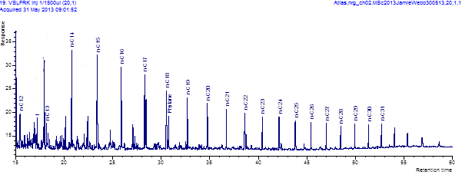































**APPENDIX D**: GC-MS mass chromatograms

Figure D.1 m/z 178 for Paracatú, Serra do Garrote, Sete Lagoas and Sirius Passet Lagertstätte, respectively

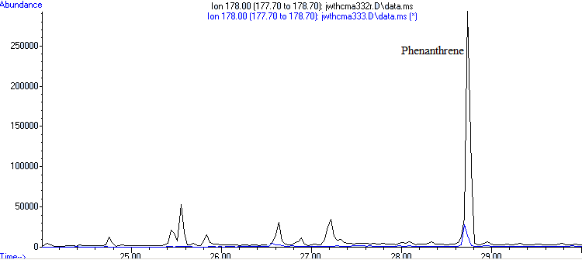

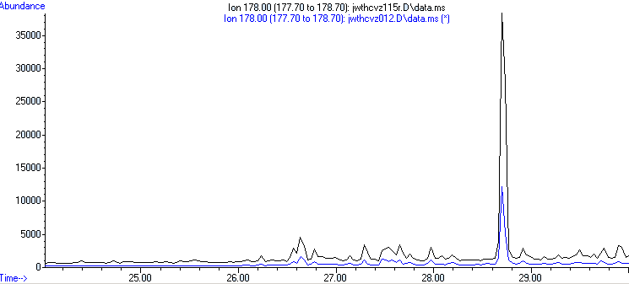

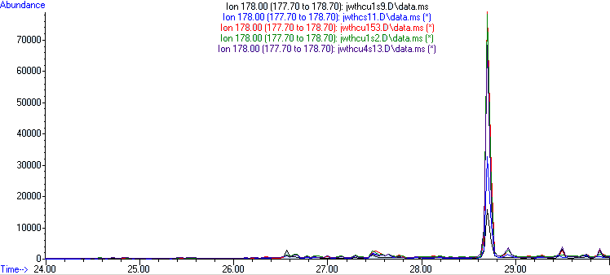

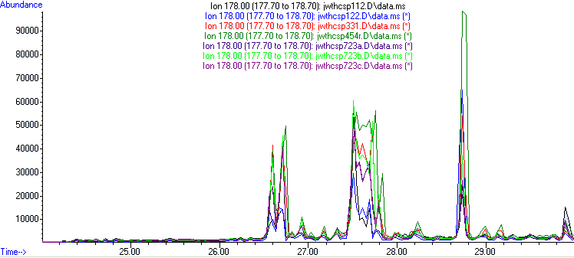

Figure D.2 m/z 192 for Paracatú, Serra do Garrote, Sete Lagoas and Sirius Passet Lagertstätte, respectively

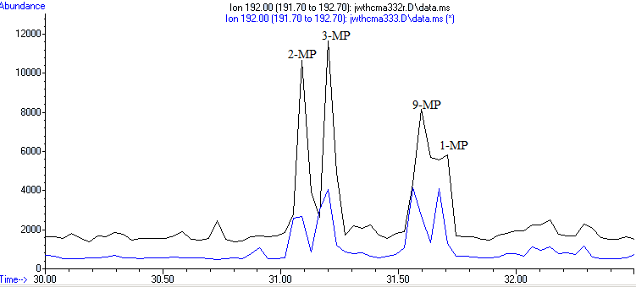

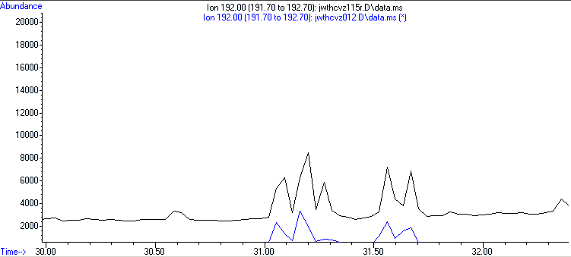

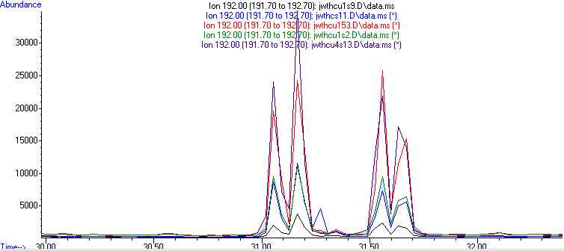

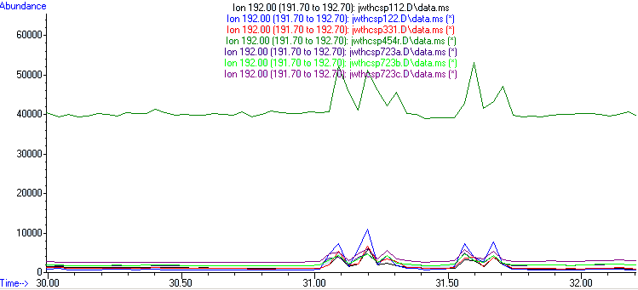

Figure D.3 m/z 128 for Paracatú, Serra do Garrote, Sete Lagoas and Sirius Passet Lagertstätte, respectively

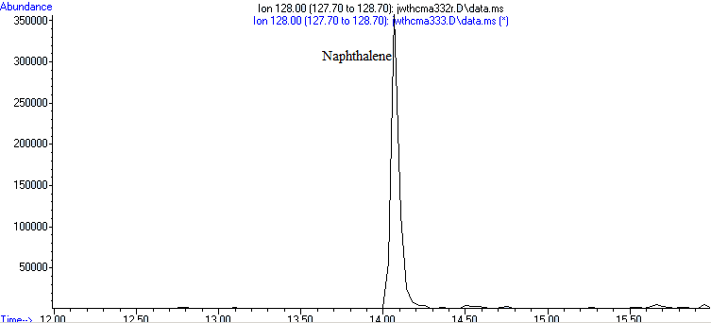

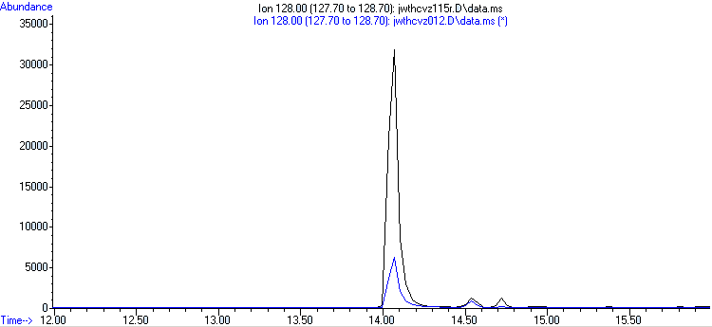

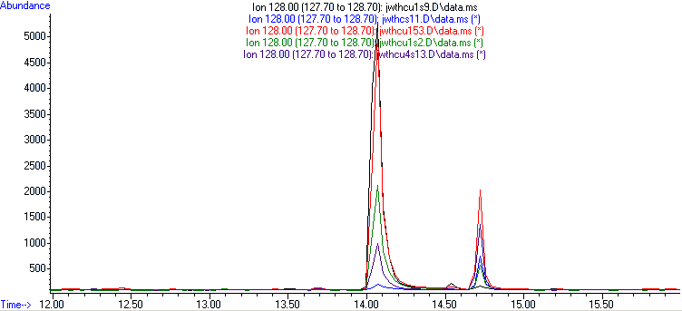

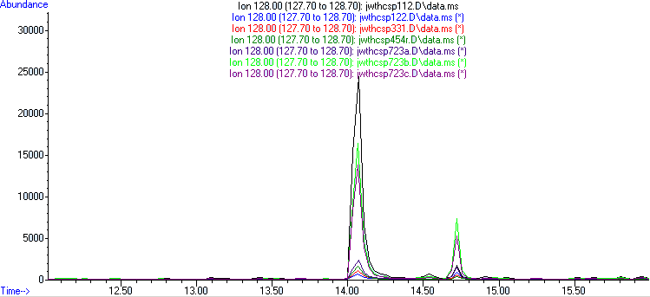

Figure D.4 m/z 142 for Paracatú, Serra do Garrote, Sete Lagoas and Sirius Passet Lagertstätte, respectively

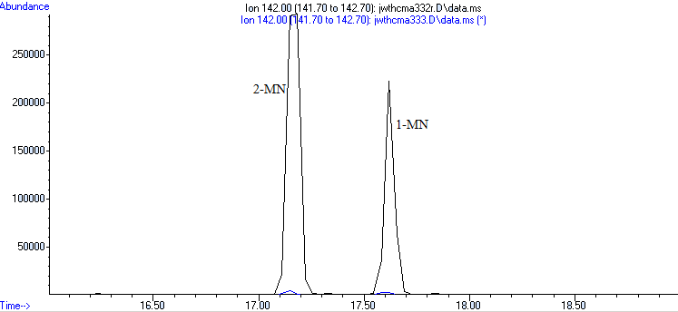

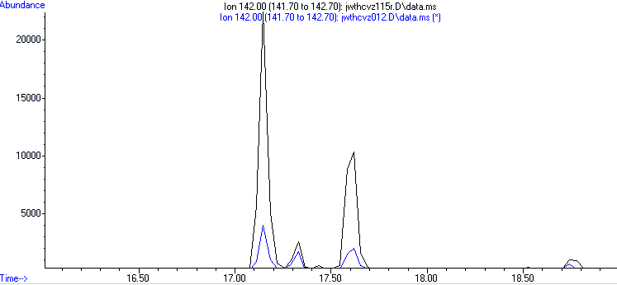

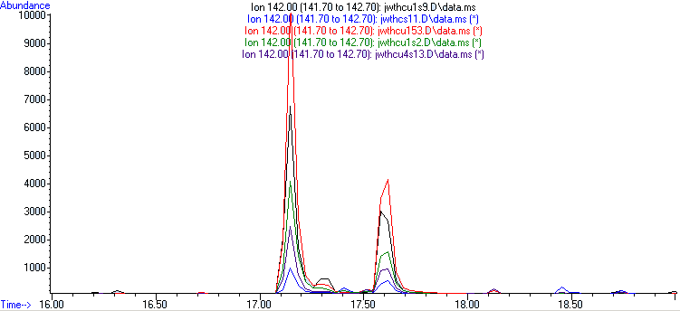

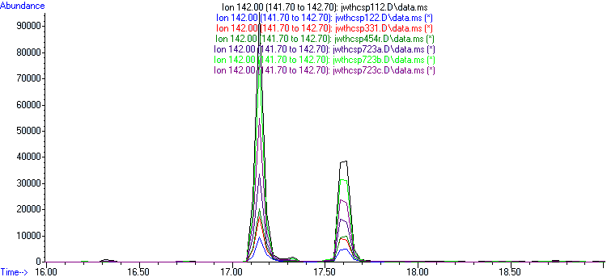

Figure D.5 m/z 156 for Paracatú, Serra do Garrote, Sete Lagoas and Sirius Passet Lagertstätte, respectively

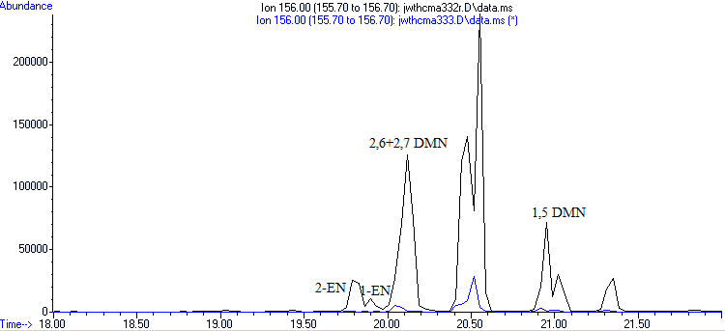

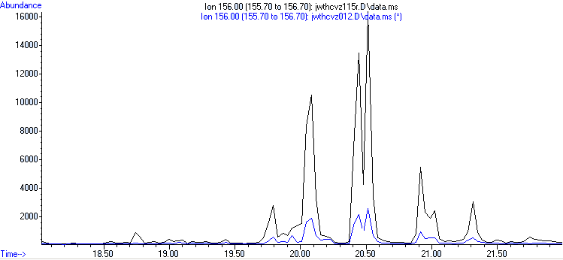

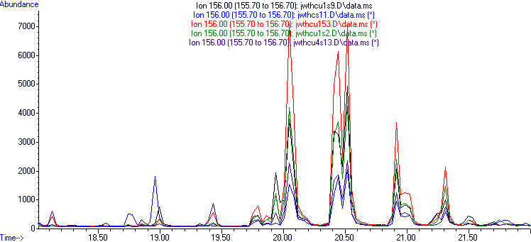

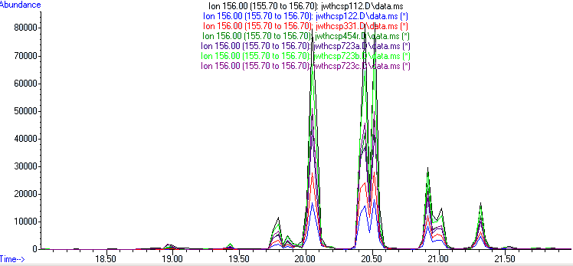

Figure D.6 m/z 170 for Paracatú, Serra do Garrote, Sete Lagoas and Sirius Passet Lagertstätte, respectively

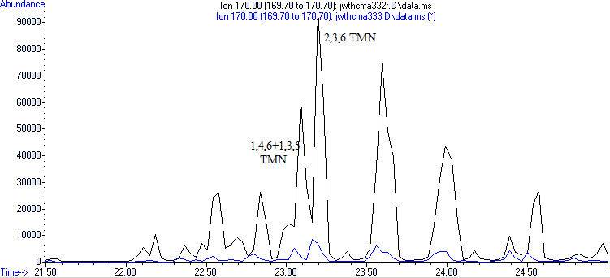

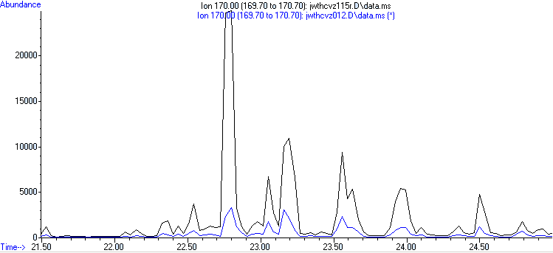

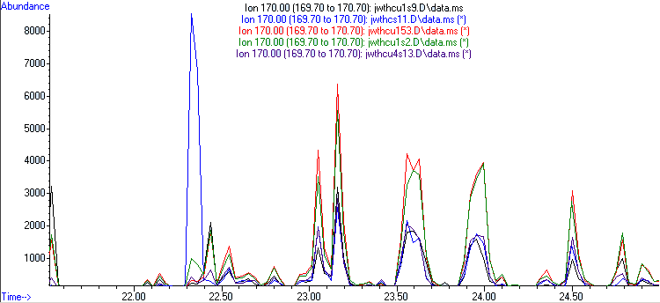

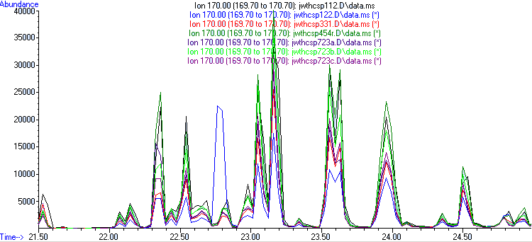

Figure D.7 m/z 191 for the North Sea Standard, Paracatú, Serra do Garrote, Sete Lagoas and Sirius Passet Lagertstätte, respectively

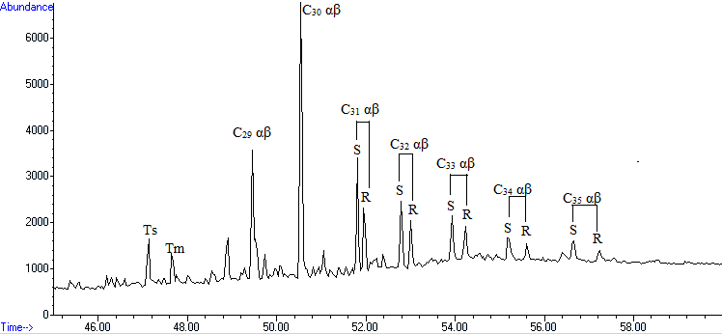

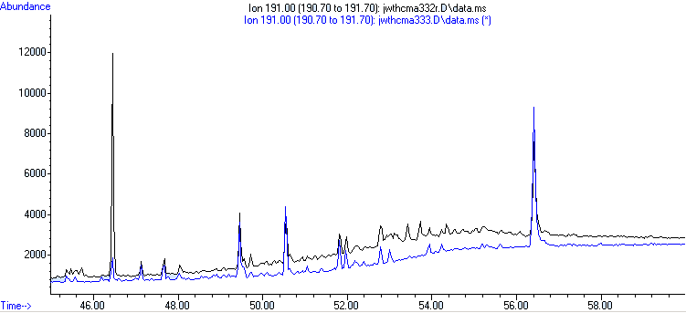

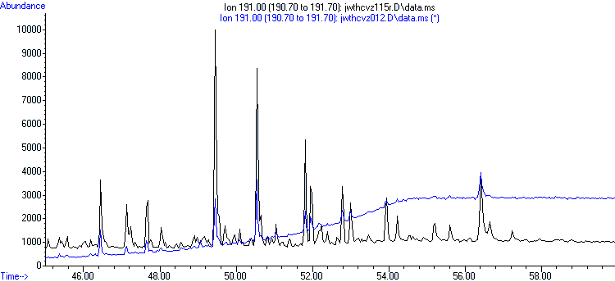

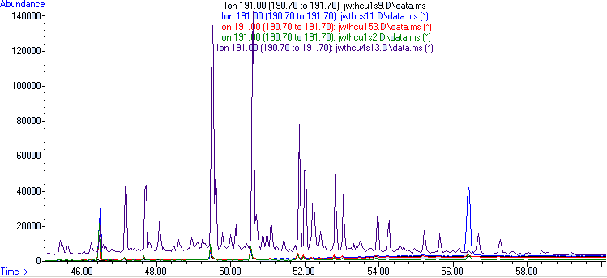

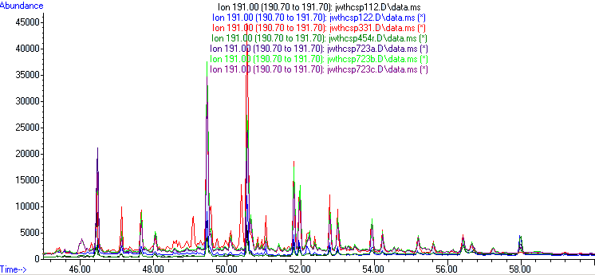

Figure D.8 m/z 217 for the SP110724-1 3.31m, Paracatú, Serra do Garrote, Sete Lagoas and Sirius Passet Lagertstätte, respectively

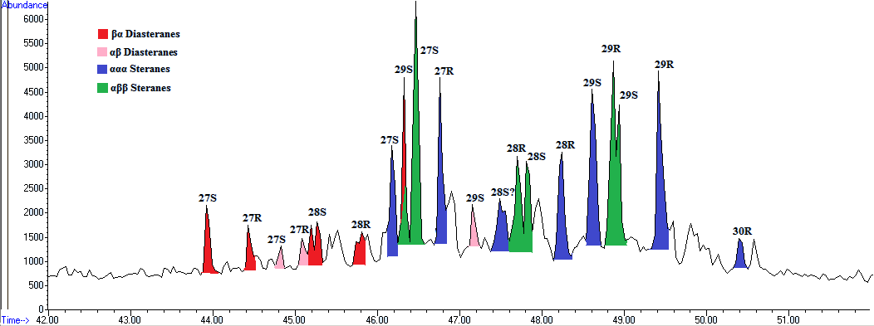

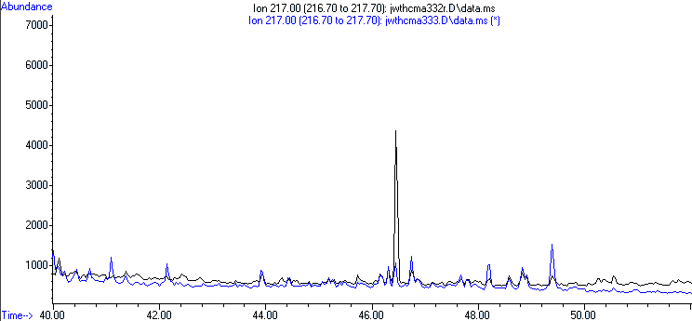

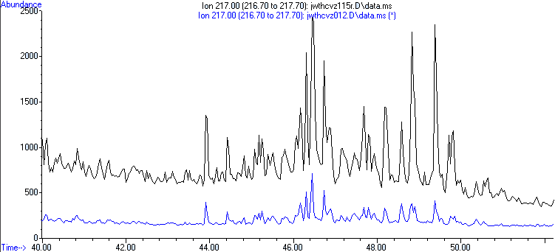

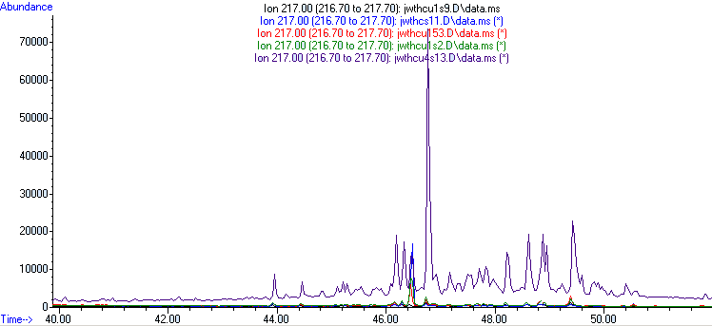

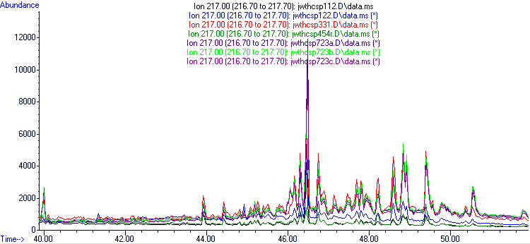

Figure D.9 m/z 231 for the North Sea Standard, Paracatú, Serra do Garrote, Sete Lagoas and Sirius Passet Lagertstätte, respectively

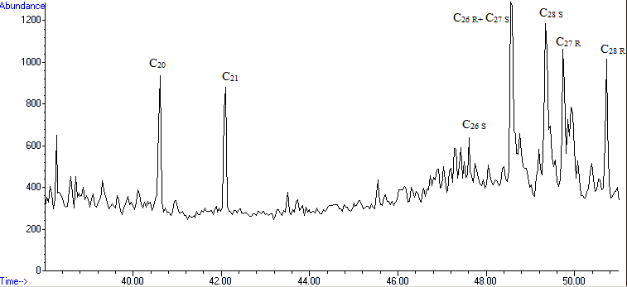

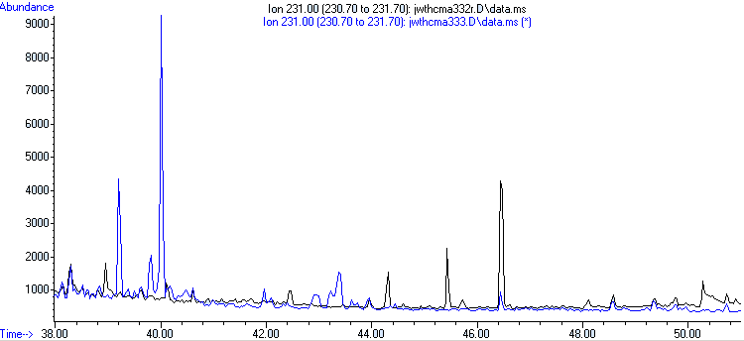

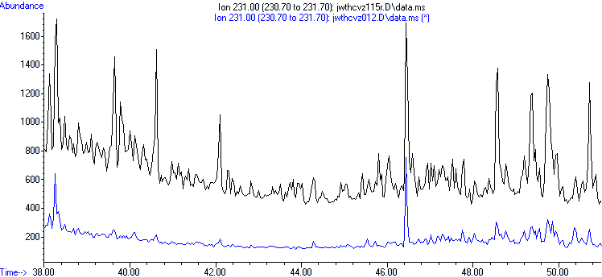

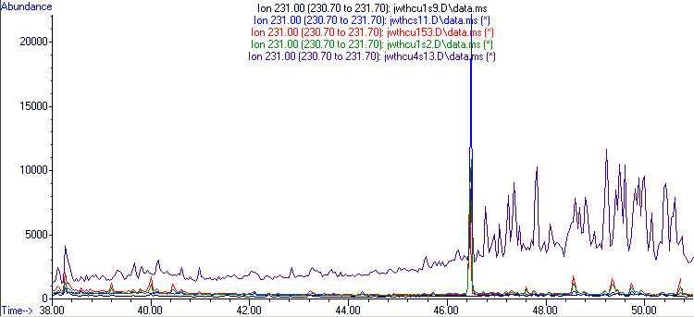

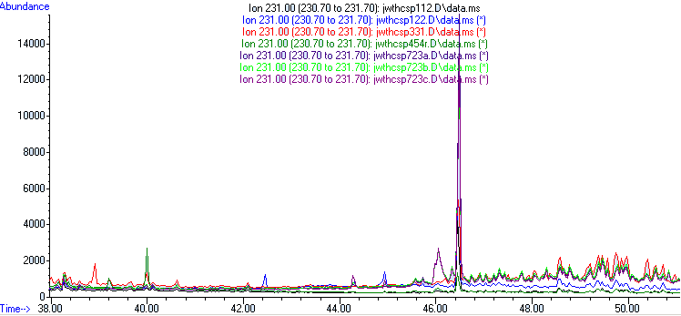

Figure D.10 Blank sample TIC

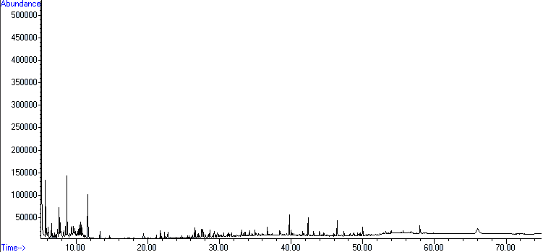

**APPENDIX E**: Peak area values

|  |  |  |  |  |  |  |  |  |  |  |  |  |  |  |  |  |
| --- | --- | --- | --- | --- | --- | --- | --- | --- | --- | --- | --- | --- | --- | --- | --- | --- |
| **Ion** | | **Compound Name** | | **Retention Time (min)** | | | **Peak Area** | | | | | | | | | |
|  | | | | | | | **U4.S13** | | **U1S9** | | **U1S2** | | | **U153** | | **S1.1** |
| **178** | | Phenanthrene | | 28.700 | | | 212761 | | 54054 | | | 239171 | | 248830 | | 102485 |
| **192** | | 2-MP | | 31.054 | | | 86398 | | 6586 | | | 30352 | | 66560 | | 28025 |
|  | | 3-MP | | 31.163 | | | 99395 | | 11920 | | | 39668 | | 83869 | | 38252 |
|  | | 9-MP | | 31.561 | | | 82529 | | 8353 | | | 31261 | | 78337 | | 25098 |
|  | | 1-MP | | 31.634 | | | 67691 | | 7707 | | | 25674 | | 59947 | | 24245 |
| **128** | | Naphthalene | | 14.069 | | | 4422 | | 26136 | | | 10576 | | 22664 | | 282 |
| **142** | | 2-MN | | 17.148 | | | 8350 | | 24120 | | | 15136 | | 33946 | | 3442 |
|  | | 1-MN | | 17.582 | | | 4274 | | 13854 | | | 7286 | | 19191 | | 2225 |
| **156** | | 2-EN | | 19.791 | | | 1243 | | 1897 | | | 1658 | | 2866 | | 762 |
|  | | 1-EN | | 19.864 | | | 600 | | 1299 | | | 986 | | 1451 | | 406 |
|  | | 2,6+2,7-DMN | | 20.045 | | | 9596 | | 13608 | | | 17334 | | 29281 | | 6005 |
|  | | 1,5-DMN | | 20.986 | | | 2208 | | 3409 | | | 3783 | | 5415 | | 2751 |
| **170** | | 1,4,6+1,3,5-TMN | | 23.051 | | | 6205 | | 4373 | | | 12600 | | 13265 | | 6060 |
|  | | 2,3,6-TMN | | 23.159 | | | 8212 | | 9343 | | | 16293 | | 18789 | | 7679 |
| **231** | | C20 | | 40.615 | | | 1984 | | 267 | | | 1128 | | 1984 | | 743 |
|  | | C21 | | 42.100 | | | 1610 | | 85 | | | 1000 | | 1610 | | 332 |
|  | | C26 S | | 47.750 | | | 724 | | 541 | | | 1267 | | 724 | | 697 |
|  | | C26 R+C27 S | | 48.546 | | | 5630 | | 300 | | | 4018 | | 5619 | | 1580 |
|  | | C28 S | | 49.343 | | | 6390 | | - | | | 4391 | | 6316 | | 1775 |
|  | | C27 R | | 49.742 | | | 4339 | | 1082 | | | 2910 | | 4270 | | 1867 |
|  | | C28 R | | 50.719 | | | 5059 | | - | | | 2988 | | 5059 | | 1319 |
| **191** | | Ts | | 47.134 | | | 178720 | | 3679 | | | 8305 | | 5763 | | 3425 |
|  | | Tm | | 47.641 | | | 190783 | | 5172 | | | 10445 | | 7618 | | 4822 |
|  | | 28,30-bisnorhopane | | 49.090 | | | - | | - | | | - | | - | | - |
|  | | C29 αβ | | 49.452 | | | 635259 | | 14323 | | | 35487 | | 25898 | | 16034 |
|  | | C29 βα | | 50.104 | | | - | | - | | | - | | - | | - |
|  | | Oleanane | | 50.393 | | | - | | 1167 | | | 2260 | | 2019 | | - |
|  | | C30 αβ | | 50.538 | | | 663391 | | 18939 | | | 30946 | | 26893 | | 17820 |
|  | | C30 βα | | 51.045 | | | - | | - | | | - | | 2686 | | - |
|  | | C31 αβ 22R | | 51.951 | | | 207282 | | 5324 | | | 7761 | | 8144 | | 5300 |
|  | | C31 αβ S | | 51.806 | | | 268789 | | 6675 | | | 10194 | | 10359 | | 6565 |
|  | | Gammacerane | | 52.168 | | | - | | 4637 | | | 6030 | | 5474 | | 0 |
|  | | C32 αβ R | | 53.001 | | | 103286 | | 3683 | | | 4157 | | 5287 | | 4132 |
|  | | C32 αβ S | | 52.784 | | | 148707 | | 4213 | | | 5661 | | 6313 | | 4628 |
|  | | C33 αβ R | | 54.232 | | | 72843 | | 0 | | | 2606 | | 2803 | | 1932 |
|  | | C33 αβ S | | 53.943 | | | 94565 | | 0 | | | 4146 | | 4800 | | 4613 |
|  | | C34 αβ R | | 55.608 | | | 40714 | | N/A | | | 1455 | | 1847 | | 1523 |
|  | | C34 αβ S | | 55.174 | | | 58462 | | 0 | | | 2293 | | 3618 | | 3603 |
|  | | C35 αβ R | | 56.659 | | | 0 | | 0 | | |  | | 0 | | 0 |
|  | | C35 αβ S | | 56.405 | | | 5215 | | 0 | | | 18726 | | 11090 | | 283243 |
| **Ion** | **Compound Name** | | **Retention Time (min)** | | **Peak Area** | | | | | | | | | |
|  | | | | | **U4.S13** | **U1S9** | | **U1S2** | | **U153** | | | **S1.1** | |
| **217** | C27 βα S diasterane | | 43.911 | | 21926 | 1662 | | 3789 | | 3085 | | | 2510 | |
|  | C27 βα R diasterane | | 44.418 | | 17201 | 1243 | | 2258 | | 1814 | | | 1560 | |
|  | C27 ααα S | | 46.156 | | 76640 | 3153 | | 6447 | | 4365 | | | 3064 | |
|  | C27 ααα R | | 46.301 | | 37200 | 1982 | | 4705 | | 3927 | | | 2862 | |
|  | C27 αββ S | | 46.410 | | 41733 | 1193 | | 35216 | | 17228 | | | 54777 | |
|  | C27 ααα R | | 46.736 | | 271090 | 3220 | | 10921 | | 5182 | | | 4628 | |
|  | C29 αβ S diasterane | | 47.170 | | 33536 | - | | - | | - | | | - | |
|  | C28 ααα S | | 48.583 | | 35482 | 1621 | | 2469 | | 2225 | | | 841 | |
|  | C28 αββ R | | 47.677 | | 16295 | 1128 | | 2471 | | 2001 | | | 1402 | |
|  | C28 αββ S | | 47.786 | | 20893 | 794 | | 1527 | | 1395 | | | 1106 | |
|  | C28 ααα R | | 48.220 | | 53497 | 2332 | | 4237 | | 3926 | | | 1630 | |
|  | C29 ααα S | | 48.583 | | 80698 | 2584 | | 4498 | | 4014 | | | 2141 | |
|  | C29 αββ S+R | | 48.909 | | 115997 | 5341 | | 9240 | | 9226 | | | 4876 | |
|  | C29 ααα R | | 49.379 | | 130189 | 5113 | | 10304 | | 12079 | | | 3388 | |
|  | C30 ααα R | | 50.357 | |  | 422 | | 621 | | 1608 | | | 2849 | |

Table E.1 Sete Lagoas peak areas

|  |  |  |  |  |  |  |
| --- | --- | --- | --- | --- | --- | --- |
| **Ion** | **Compound Name** | **Retention Time (min)** | **Peak Area** | | | |
|  | | | **VZCF001-15** | **VZCF001-2** | **MASW 3.33** | **MASW 3.32** |
| **217** | C27 βα S diasterane | 43.911 | 4111 | 989 | 2090 | - |
|  | C27 βα R diasterane | 44.418 | 2395 | 750 | 1067 | - |
|  | C27 ααα S | 46.156 | 5341 | 1469 | 2190 | 834 |
|  | C27 ααα R | 46.301 | 4797 | 997 | 1838 | 1243 |
|  | C27 αββ S | 46.410 | 12143 | 2077 | 2656 | 14455 |
|  | C27 ααα R | 46.736 | 4065 | 1188 | 2855 | 2534 |
|  | C29 αβ S diasterane | 47.170 | 3411 | - | - | - |
|  | C28 ααα S | 48.583 | 2097 | 702 | 832 | 632 |
|  | C28 αββ R | 47.677 | 3416 | 630 | 1404 | 417 |
|  | C28 αββ S | 47.786 | 1768 | 431 | 730 | 0 |
|  | C28 ααα R | 48.220 | 5374 | 771 | 3903 | 800 |
|  | C29 ααα S | 48.583 | 4152 | 1081 | 1630 | 1173 |
|  | C29 αββ S+R | 48.909 | 11894 | 1706 | 3847 | 2247 |
|  | C29 ααα R | 49.379 | 10913 | 1343 | 5482 | 1688 |
|  | C30 ααα R | 50.357 | 700 | - | - | - |

Table E.2 Paracatu and Serra do Garrote peak areas

|  |  |  |  |  |  |  |  |  |  |  |  |  |  |  |  |  |  |  |  |  |  |
| --- | --- | --- | --- | --- | --- | --- | --- | --- | --- | --- | --- | --- | --- | --- | --- | --- | --- | --- | --- | --- | --- |
| **Ion** | | | **Compound Name** | | | **Retention Time (min)** | | | | **Peak Area** | | | | | | | | | | | |
|  | | |  | | |  | | | | VZCF001-15 | | | VZCF001-2 | | | | MASW 3.33 | | MASW 3.32 | | |
| **178** | | | Phenanthrene | | | 28.700 | | | | 54932 | | | 42072 | | | | 98387 | | 945109 | | |
| **192** | | | 2-MP | | | 31.054 | | | | 5569 | | | 7592 | | | | 10050 | | 33036 | | |
|  | | | 3-MP | | | 31.163 | | | | 8214 | | | 10720 | | | | 14711 | | 29925 | | |
|  | | | 9-MP | | | 31.561 | | | | 6468 | | | 7397 | | | | 15580 | | 32523 | | |
|  | | | 1-MP | | | 31.634 | | | | 5560 | | | 6442 | | | | 10072 | | 20560 | | |
| **128** | | | Naphthalene | | | 14.069 | | | | 141719 | | | 27831 | | | | 3787 | | 1222740 | | |
| **142** | | | 2-MN | | | 17.148 | | | | 73132 | | | 12663 | | | | 18063 | | 1352076 | | |
|  | | | 1-MN | | | 17.582 | | | | 45659 | | | 8392 | | | | 14222 | | 708932 | | |
| **156** | | | 2-EN | | | 19.791 | | | | 11389 | | | 1950 | | | | 4698 | | 115108 | | |
|  | | | 1-EN | | | 19.864 | | | | 3070 | | | 730 | | | | 1768 | | 39440 | | |
|  | | | 2,6+2,7-DMN | | | 20.045 | | | | 96369 | | | 16343 | | | | 24388 | | 671624 | | |
|  | | | 1,5-DMN | | | 20.986 | | | | 20746 | | | 2812 | | | | 9613 | | 220227 | | |
| **170** | | | 1,4,6+1,3,5-TMN | | | 23.051 | | | | 23236 | | | 5656 | | | | 16530 | | 225275 | | |
|  | | | 2,3,6-TMN | | | 23.159 | | | | 59927 | | | 12352 | | | | 39575 | | 340702 | | |
| **231** | | | C20 | | | 40.615 | | | | 4307 | | | 282 | | | | 1801 | | 1076 | | |
|  | | | C21 | | | 42.100 | | | | 2412 | | | 193 | | | | 1286 | | 454 | | |
|  | | | C26 S | | | 47.750 | | | | 1060 | | | 319 | | | | 311 | | 189 | | |
|  | | | C26 R+C27 S | | | 48.546 | | | | 4105 | | | 563 | | | | 1328 | | 1645 | | |
|  | | | C28 S | | | 49.343 | | | | 4229 | | | 571 | | | | 1575 | | 1271 | | |
|  | | | C27 R | | | 49.742 | | | | 6793 | | | 845 | | | | 1041 | | 1221 | | |
|  | | | C28 R | | | 50.719 | | | | 3540 | | | 582 | | | | 1228 | | 1610 | | |
| **191** | | | Ts | | | 47.134 | | | | 12716 | | | 1630 | | | | 2549 | | 2042 | | |
|  | | | Tm | | | 47.641 | | | | 10298 | | | 2981 | | | | 3131 | | 3220 | | |
|  | | | 28,30-bisnorhopane | | | 49.090 | | | | - | | | - | | | | - | | - | | |
|  | | | C29 αβ | | | 49.452 | | | | 35596 | | | 8639 | | | | 10003 | | 12277 | | |
|  | | | C29 βα | | | 50.104 | | | | - | | | - | | | | - | | - | | |
|  | | | Oleanane | | | 50.393 | | | | 1347 | | | - | | | | - | | - | | |
|  | | | C30 αβ | | | 50.538 | | | | 33914 | | | 10102 | | | | 13596 | | 8677 | | |
|  | | | C30 βα | | | 51.045 | | | | - | | | - | | | | - | | - | | |
|  | | | C31 αβ 22R | | | 51.951 | | | | 10939 | | | 2860 | | | | 3729 | | 3318 | | |
|  | | | C31 αβ S | | | 51.806 | | | | 14700 | | | 2125 | | | | 4531 | | 4363 | | |
|  | | | Gammacerane | | | 52.168 | | | | - | | | - | | | | - | | - | | |
|  | | | C32 αβ R | | | 53.001 | | | | 6106 | | | 1436 | | | | 2463 | | - | | |
|  | | | C32 αβ S | | | 52.784 | | | | 10686 | | | 1791 | | | | 2894 | | 6589 | | |
|  | | | C33 αβ R | | | 54.232 | | | | 4333 | | | 435 | | | | 1495 | | 965 | | |
|  | | | C33 αβ S | | | 53.943 | | | | 7462 | | | - | | | | 2632 | | - | | |
|  | | | C34 αβ R | | | 55.608 | | | | 2722 | | | - | | | | 800 | | - | | |
|  | | | C34 αβ S | | | 55.174 | | | | 4704 | | | - | | | | 1365 | | - | | |
|  | | | C35 αβ R | | | 56.659 | | | | 5329 | | | - | | | | - | | 1499 | | |
|  | | | C35 αβ S | | | 56.405 | | | | 17127 | | | 5465 | | | | 39316 | | 25427 | | |
| **Ion** | | **Compound Name** | | | **Peak Area** | | | | | | | | | | | | | | | | | | | |
|  | |  | | | SP110723 0.16m | | | | | | | | | SP110724 | | | | | | | | | SP110725 | |
|  | |  | | | A | | | B | | | C | | | 54m | | 3.31m | | | | 1.12m | | | 2.2m | |
| **178** | | Phenanthrene | | |  | | |  | | |  | | | 437858 | | 170311 | | | | 69069 | | | 236601 | |
| **192** | | 2-MP | | | 12493 | | | 6256 | | | 9872 | | | 41420 | | 13022 | | | | 10102 | | | 25169 | |
|  | | 3-MP | | | 13004 | | | 14341 | | | 11271 | | | 37876 | | 18662 | | | | 15439 | | | 36386 | |
|  | | 9-MP | | | 12265 | | | 9372 | | | 12625 | | | 33988 | | 14060 | | | | 11032 | | | 26195 | |
|  | | 1-MP | | | 6589 | | | 5574 | | | 6678 | | | 29996 | | 10559 | | | | 8086 | | | 17723 | |
| **128** | | Naphthalene | | | 11658 | | | 72215 | | | 55970 | | | 7827 | | 5576 | | | | 112340 | | | 3129 | |
| **142** | | 2-MN | | | 112733 | | | 244017 | | | 175134 | | | 71293 | | 60046 | | | | 307486 | | | 33672 | |
|  | | 1-MN | | | 77931 | | | 149956 | | | 112350 | | | 46531 | | 43639 | | | | 184600 | | | 24063 | |
| **156** | | 2-EN | | | 22414 | | | 35896 | | | 27006 | | | 22554 | | 14140 | | | | 43419 | | | 8004 | |
|  | | 1-EN | | | 11743 | | | 17417 | | | 10087 | | | 6554 | | 5600 | | | | 19421 | | | 3512 | |
|  | | 2,6+2,7-DMN | | | 161936 | | | 259830 | | | 196586 | | | 195526 | | 114430 | | | | 322997 | | | 67078 | |
|  | | 1,5-DMN | | | 51085 | | | 77037 | | | 60818 | | | 66022 | | 35025 | | | | 90082 | | | 24175 | |
| **170** | | 1,4,6+1,3,5-TMN | | | 62778 | | | 84673 | | | 66994 | | | 96901 | | 57495 | | | | 96401 | | | 38829 | |
|  | | 2,3,6-TMN | | | 85013 | | | 115238 | | | 91708 | | | 134485 | | 80811 | | | | 138773 | | | 54097 | |
| **231** | | C20 | | | 1069 | | | 1462 | | | 767 | | | 865 | | 1447 | | | | 476 | | | 900 | |
|  | | C21 | | | 761 | | | 741 | | | 532 | | | 917 | | 1345 | | | | 641 | | | 767 | |
|  | | C26 S | | | 2058 | | | 2080 | | | 1686 | | | 346 | | 1955 | | | | 502 | | | 782 | |
|  | | C26 R+C27 S | | | 3203 | | | 3481 | | | 2588 | | | 1210 | | 5146 | | | | 1089 | | | 2627 | |
|  | | C28 S | | | 4088 | | | 4046 | | | 3701 | | | 1569 | | 7322 | | | | 1182 | | | 2240 | |
|  | | C27 R | | | 4167 | | | 4098 | | | 3633 | | | 1312 | | 8620 | | | | 1115 | | | 2609 | |
|  | | C28 R | | | 1630 | | | 1725 | | | 884 | | | 784 | | 4405 | | | | 902 | | | 1647 | |
| **191** | | Ts | | | 13665 | | | 14048 | | | 11880 | | | - | | 33325 | | | | 3099 | | | 6034 | |
|  | | Tm | | | 31051 | | | 29810 | | | 28278 | | | - | | 33573 | | | | 5843 | | | 7546 | |
|  | | 28,30-bisnorhopane | | | - | | | - | | | - | | | - | | 27519 | | | | - | | | - | |
|  | | C29 αβ | | | 123602 | | | 131781 | | | 117969 | | | 13210 | | 135139 | | | | 24677 | | | 31882 | |
|  | | C29 βα | | | 9828 | | | 11260 | | | 9713 | | | - | | 18751 | | | | - | | | 2212 | |
|  | | Oleanane | | | - | | | - | | | - | | | - | | 54842 | | | | - | | | 2536 | |
|  | | C30 αβ | | | 106305 | | | 111309 | | | 99850 | | | 13998 | | 175778 | | | | 20011 | | | 42102 | |
|  | | C30 βα | | | 8206 | | | 11571 | | | 6553 | | | - | | 27823 | | | | - | | | 4805 | |
|  | | C31 αβ 22R | | | 43597 | | | 46733 | | | 38805 | | | 4177 | | 39749 | | | | 7708 | | | 9491 | |
|  | | C31 αβ S | | | 57131 | | | 63104 | | | 52832 | | | 5295 | | 59781 | | | | 9848 | | | 12038 | |
|  | | Gammacerane | | | - | | | - | | | - | | | - | | - | | | | - | | | 10272 | |
|  | | C32 αβ R | | | 28512 | | | 30224 | | | 26076 | | | 2689 | | 26356 | | | | 4363 | | | 6077 | |
|  | | C32 αβ S | | | 31050 | | | 34105 | | | 29253 | | | 3430 | | 35659 | | | | 5656 | | | 7801 | |
|  | | C33 αβ R | | | 12971 | | | 14193 | | | 11716 | | | 1186 | | 16922 | | | | 2349 | | | 3555 | |
|  | | C33 αβ S | | | 19884 | | | 20507 | | | 17751 | | | 5260 | | 24740 | | | | 4748 | | | 8679 | |
|  | | C34 αβ R | | | 7473 | | | 7705 | | | 6449 | | | 932 | | 8275 | | | | 1160 | | | 1981 | |
|  | | C34 αβ S | | | 14181 | | | 10933 | | | 14346 | | | 1269 | | 16394 | | | | 2627 | | | 4439 | |
|  | | C35 αβ R | | | 14059 | | | 11174 | | | 12840 | | | - | | 12918 | | | | 3698 | | | 8002 | |
|  | | C35 αβ S | | | 15872 | | | 16068 | | | 19415 | | | 11593 | | 20595 | | | | 11870 | | | 19642 | |
| **Ion** | **Compound Name** | | | **Peak Area** | | | | | | | | | | | | | | | | | | | |
|  | | | | SP110723 0.16m | | | | | | | | SP110724 | | | | | | | | | SP110725 | | |
| A | | | B | | C | | | 54m | | | 3.31m | | | 1.12m | | | 2.2m | | |
| **217** | C27 βα S diasterane | | | 5067 | | | 5309 | | 4470 | | | 2970 | | | 3051 | | | 3192 | | | 3192 | | |
|  | C27 βα R diasterane | | | 3435 | | | 3631 | | 2842 | | | 1588 | | | 2149 | | | 1727 | | | 1727 | | |
|  | C27 ααα S | | | 18437 | | | 18983 | | 5554 | | | 2302 | | | 3879 | | | 2742 | | | 2742 | | |
|  | C27 ααα R | | | 9396 | | | 9245 | | 8989 | | | 2264 | | | 3003 | | | 2879 | | | 2879 | | |
|  | C27 αββ S | | | 39848 | | | 35533 | | 37702 | | | 3384 | | | 18054 | | | 13694 | | | 13694 | | |
|  | C27 ααα R | | | 11015 | | | 11743 | | 10015 | | | 2532 | | | 3727 | | | 3331 | | | 3331 | | |
|  | C29 αβ S diasterane | | | - | | | 2445 | | - | | | - | | | - | | | - | | | - | | |
|  | C28 ααα S | | | 5137 | | | 6036 | | 5039 | | | 654 | | | 1725 | | | 1128 | | | 1128 | | |
|  | C28 αββ R | | | 6812 | | | 6810 | | 5496 | | | 1638 | | | 2816 | | | 1430 | | | 1430 | | |
|  | C28 αββ S | | | 5826 | | | 5754 | | 5653 | | | 876 | | | 6241 | | | 956 | | | 956 | | |
|  | C28 ααα R | | | 7301 | | | 7540 | | 6619 | | | 3748 | | | 2770 | | | 1465 | | | 1465 | | |
|  | C29 ααα S | | | 12103 | | | 12640 | | 10678 | | | 1486 | | | 5602 | | | 2584 | | | 2584 | | |
|  | C29 αββ S+R | | | 27823 | | | 30392 | | 25721 | | | 4689 | | | 10172 | | | 5904 | | | 5904 | | |
|  | C29 ααα R | | | 21167 | | | 23248 | | 19306 | | | 5133 | | | 6715 | | | 4074 | | | 4074 | | |
|  | C30 ααα R | | | 9411 | | | 9587 | | 8335 | | | 845 | | | 1273 | | | - | | | - | | |

Table E.3 Sirius Passet Lagerstatte peak areas

**Appendix F**: Summary of calculated parameters using GC and GC-MS peak areas

|  |  |  |  |  |  |  |  |  |  |
| --- | --- | --- | --- | --- | --- | --- | --- | --- | --- |
| **Parameter** | **VZCF001-15** | **VZCF001-2** | **U4.S13** | **U1S9** | **U1S2** | **U1S3** | **S1.1** | **MASW 3.32** | **MASW 3.33** |
| MPI | 0.37 | 0.58 | 0.87 | 0.47 | 0.43 | 0.67 | 0.76 | 0.36 | 0.12 |
| Rc MPI | 0.62 | 0.75 | 0.92 | 0.68 | 0.66 | 0.80 | 0.86 | 0.61 | 0.47 |
| MPR | 1.00 | 1.18 | 1.28 | 0.85 | 1.18 | 1.11 | 1.16 | 1.00 | 1.61 |
| DNR | 4.65 | 5.81 | 4.35 | 3.99 | 4.58 | 5.41 | 2.18 | 2.54 | 3.05 |
| TNR | 2.58 | 2.18 | 1.32 | 2.14 | 1.29 | 1.42 | 1.27 | 2.39 | 1.51 |
| MNR | 1.60 | 1.51 | 1.95 | 1.74 | 2.08 | 1.77 | 1.55 | 1.27 | 1.91 |
| ENR | 3.71 | 2.67 | 2.07 | 1.46 | 1.68 | 1.98 | 1.88 | 2.66 | 2.92 |
| TAI/TAI+TAII | 0.25 | 0.14 | 0.14 | 0.15 | 0.12 | 0.14 | 0.13 | 0.36 | 0.20 |
| C29 St 20S/S+R | 0.28 | 0.45 | 0.38 | 0.34 | 0.30 | 0.25 | 0.39 | 0.23 | 0.41 |
| C29 St ββ/ββ+αα | 0.44 | 0.41 | 0.35 | 0.41 | 0.38 | 0.36 | 0.47 | 0.35 | 0.44 |
| C31 H 22S/S+R | 0.57 | 0.43 | 0.56 | 0.56 | 0.57 | 0.56 | 0.55 | 0.55 | 0.57 |
| C32 H 22S/S+R | 0.64 | N/A | 0.59 | 0.53 | 0.58 | 0.54 | 0.53 | 0.54 | N/A |
| Ts/Tm | 0.55 | 0.35 | 0.48 | 0.42 | 0.44 | 0.43 | 0.42 | 0.45 | 0.39 |
| Steranes/hopanes | 0.53 | 0.45 | 0.40 | 0.54 | 0.91 | 0.72 | 1.32 | 0.66 | 0.72 |
| OEP | 2.24 | 2.84 | 0.98 | N/A | 1.75 | 1.44 | 2.07 | 1.14 | 14.16 |
| Pr/Ph | 1.25 | 1.06 | 1.04 | N/A | 0.95 | 0.75 | 0.43 | 1.34 | 1.09 |
| Pr/*n*-C17 | 1.24 | 1.00 | 0.84 | N/A | 0.57 | 0.56 | 0.59 | 1.04 | 1.25 |
| Ph/*n*-C18 | 0.83 | 0.88 | 1.02 | N/A | 0.78 | 0.93 | 1.38 | 0.95 | 1.36 |

Table F.1 Calculated parameters for Sete Lagoas, Paracatu and Serra do Garrote formations

|  |  |  |  |  |  |  |  |
| --- | --- | --- | --- | --- | --- | --- | --- |
| **Parameter** | **SP110723 0.16m A** | **SP110723 0.16m B** | **SP110723 0.16m C** | **SP110724 54m** | **SP110724 3.31m** | **SP110725 2.2m** | **SP110724 1.12m** |
| MPI | N/A | N/A | N/A | 0.29 | 0.30 | 0.40 | 0.52 |
| Rc MPI | N/A | N/A | N/A | 0.57 | 0.58 | 0.64 | 0.71 |
| MPR | 1.90 | 1.12 | 1.48 | 1.38 | 1.23 | 1.42 | 1.25 |
| DNR | 3.17 | 3.37 | 3.23 | 2.96 | 3.27 | 2.77 | 3.59 |
| TNR | 1.35 | 1.36 | 1.37 | 1.39 | 1.41 | 1.39 | 1.44 |
| MNR | 1.45 | 1.63 | 1.56 | 1.53 | 1.38 | 1.40 | 1.67 |
| ENR | 1.91 | 2.06 | 2.68 | 3.44 | 2.53 | 2.28 | 2.24 |
| TAI/TAI+TAII | 0.11 | 0.12 | 0.09 | 0.25 | 0.09 | 0.14 | 0.19 |
| C29 St 20S/S+R | 0.36 | 0.35 | 0.36 | 0.22 | 0.46 | 0.45 | 0.39 |
| C29 St ββ/ββ+αα | 0.46 | 0.46 | 0.46 | 0.41 | 0.39 | 0.45 | 0.47 |
| C31 H 22S/S+R | 0.57 | 0.57 | 0.58 | 0.56 | 0.60 | 0.56 | 0.56 |
| C32 H 22S/S+R | 0.52 | 0.53 | 0.53 | N/A | 0.58 | 0.56 | 0.56 |
| Ts/Tm | 0.31 | 0.32 | 0.30 | N/A | 0.50 | 0.44 | 0.35 |
| Steranes/hopanes | 0.39 | 0.37 | 0.36 | 0.58 | 0.32 | 0.53 | 0.51 |
| OEP | 0.83 | 0.73 | 0.64 | 0.99 | 2.90 | 1.52 | 1.38 |
| Pr/Ph | 1.04 | 1.06 | 1.02 | 1.90 | 1.19 | 1.22 | 1.84 |
| Pr/*n*-C17 | 0.75 | 0.55 | 0.57 | 1.07 | 1.10 | 1.16 | 1.41 |
| Ph/*n*-C18 | 0.50 | 0.50 | 0.53 | 0.33 | 0.42 | 0.45 | 0.37 |

Table F.2 Calculated parameters for Sirius Passet Lagerstatte

**Appendix G**: Summary of Peak Quantitation Values

|  |  |  |  |  |  |  |  |  |
| --- | --- | --- | --- | --- | --- | --- | --- | --- |
|  | **VZCF001-15** | | **VZCF001-2** | | **MASW 3.32** | | **MASW 3.33** | |
| **Compound** | Amount (ng) | Amount (ppm) | Amount (ng) | Amount (ppm) | Amount (ng) | Amount (ppm) | Amount (ng) | Amount (ppm) |
| Ts | 63.14 | 1.26 | 43.00 | 0.86 | 19.86 | 0.40 | 24.08 | 0.48 |
| Tm | 51.14 | 1.02 | 78.64 | 1.57 | 24.40 | 0.49 | 37.97 | 0.76 |
| C29 αβ | 176.76 | 3.54 | 227.89 | 4.56 | 77.94 | 1.56 | 144.78 | 2.90 |
| C29 βα | 0.00 | 0.00 | 0.00 | 0.00 | 0.00 | 0.00 | 0.00 | 0.00 |
| C30 αβ | 168.40 | 3.37 | 266.48 | 5.33 | 105.94 | 2.12 | 102.33 | 2.05 |
| C30 βα | 0.00 | 0.00 | 0.00 | 0.00 | 0.00 | 0.00 | 0.00 | 0.00 |
| C31 αβ R | 54.32 | 1.09 | 75.44 | 1.51 | 29.06 | 0.58 | 39.13 | 0.78 |
| C31 αβ S | 72.99 | 1.46 | 56.06 | 1.12 | 35.31 | 0.71 | 51.45 | 1.03 |
| C32 αβ R | 30.32 | 0.61 | 0.00 | 0.00 | 19.19 | 0.38 | 0.00 | 0.00 |
| C32 αβ S | 53.06 | 1.06 | 0.00 | 0.00 | 22.55 | 0.45 | 77.70 | 1.55 |
| C33 αβ R | 21.52 | 0.43 | 0.00 | 0.00 | 0.00 | 0.00 | 0.00 | 0.00 |
| C33 αβ S | 37.05 | 0.74 | 0.00 | 0.00 | 0.00 | 0.00 | 57.76 | 1.16 |
| C34 αβ R | 13.52 | 0.27 | 0.00 | 0.00 | 0.00 | 0.00 | 0.00 | 0.00 |
| C34 αβ S | 23.36 | 0.47 | 0.00 | 0.00 | 0.00 | 0.00 | 0.00 | 0.00 |
| C35 αβ R | 26.46 | 0.53 | 0.00 | 0.00 | 0.00 | 0.00 | 0.00 | 0.00 |
| C35 αβ S | 85.05 | 1.70 | 0.00 | 0.00 | 306.35 | 6.13 | 299.86 | 6.00 |
|  |  |  |  |  |  |  |  |  |
| C27 βα S diasterane | 20.41 | 0.41 | 26.09 | 0.52 | 16.29 | 0.33 | 0.00 | 0.00 |
| C27 βα R diasterane | 11.89 | 0.24 | 19.78 | 0.40 | 8.31 | 0.17 | 0.00 | 0.00 |
| C27 αβ S diasterane | 0.00 | 0.00 | 0.00 | 0.00 | 0.00 | 0.00 | 0.00 | 0.00 |
| C27 αβ R diasterane | 0.00 | 0.00 | 0.00 | 0.00 | 0.00 | 0.00 | 0.00 | 0.00 |
| C27 ααα S | 26.52 | 0.53 | 38.75 | 0.78 | 17.06 | 0.34 | 0.00 | 0.00 |
| C29 βα S diasterane | 23.82 | 0.48 | 26.30 | 0.53 | 14.32 | 0.29 | 14.66 | 0.29 |
| C27 αββ S | 0.00 | 0.00 | 0.00 | 0.00 | 0.00 | 0.00 | 0.00 | 0.00 |
| C27 ααα R | 0.00 | 0.00 | 0.00 | 0.00 | 22.25 | 0.44 | 29.88 | 0.60 |
| C29 βα R diasterane | 0.00 | 0.00 | 0.00 | 0.00 | 0.00 | 0.00 | 0.00 | 0.00 |
| C29 αβ S diasterane | 16.94 | 0.34 | 0.00 | 0.00 | 0.00 | 0.00 | 0.00 | 0.00 |
| C28 ααα R | 0.00 | 0.00 | 0.00 | 0.00 | 30.41 | 0.61 | 0.00 | 0.00 |
| C29 ααα S | 20.62 | 0.41 | 28.52 | 0.57 | 12.70 | 0.25 | 13.83 | 0.28 |
| C29 αββ S+R | 59.06 | 1.18 | 45.00 | 0.90 | 29.98 | 0.60 | 26.50 | 0.53 |
| C29 ααα R | 54.19 | 1.08 | 35.43 | 0.71 | 42.72 | 0.85 | 19.91 | 0.40 |
| C30 ααα R | 3.48 | 0.07 | 0.00 | 0.00 | 0.00 | 0.00 | 0.00 | 0.00 |

Table G.1 Sterane and hopane peak quantitations for the Serra do Garrote and Paracatu formations

|  |  |  |  |  |  |  |  |  |
| --- | --- | --- | --- | --- | --- | --- | --- | --- |
|  | U4.S13 | | U1S9 | | U1S2 | | U153 | |
| **Compound** | Amount (ng) | Amount (ppm) | Amount (ng) | Amount (ppm) | Amount (ng) | Amount (ppm) | Amount (ng) | Amount (ppm) |
| Ts | 454.60 | 9.09 | 894.25 | 17.88 | 39.51 | 0.79 | 23.41 | 0.47 |
| Tm | 485.29 | 9.71 | 1257.15 | 25.14 | 49.69 | 0.99 | 30.95 | 0.62 |
| C29 αβ | 1615.88 | 32.32 | 3481.46 | 69.63 | 168.81 | 3.38 | 105.21 | 2.10 |
| C29 βα | 0.00 | 0.00 | 0.00 | 0.00 | 0.00 | 0.00 | 0.00 | 0.00 |
| C30 αβ | 1687.43 | 33.75 | 4603.46 | 92.07 | 147.21 | 2.94 | 109.26 | 2.19 |
| C30 βα | 0.00 | 0.00 | 0.00 | 0.00 | 0.00 | 0.00 | 10.91 | 0.22 |
| C31 αβ R | 527.25 | 10.55 | 1294.09 | 25.88 | 36.92 | 0.74 | 33.09 | 0.66 |
| C31 αβ S | 683.71 | 13.67 | 1622.48 | 32.45 | 48.49 | 0.97 | 42.08 | 0.84 |
| C32 αβ R | 262.72 | 5.25 | 895.22 | 17.90 | 19.77 | 0.40 | 21.48 | 0.43 |
| C32 αβ S | 378.26 | 7.57 | 1024.04 | 20.48 | 26.93 | 0.54 | 25.65 | 0.51 |
| C33 αβ R | 185.29 | 3.71 | 0.00 | 0.00 | 12.40 | 0.25 | 11.39 | 0.23 |
| C33 αβ S | 240.54 | 4.81 | 0.00 | 0.00 | 19.72 | 0.39 | 19.50 | 0.39 |
| C34 αβ R | 103.56 | 2.07 | 0.00 | 0.00 | 0.00 | 0.00 | 0.00 | 0.00 |
| C34 αβ S | 148.71 | 2.97 | 0.00 | 0.00 | 0.00 | 0.00 | 0.00 | 0.00 |
| C35 αβ R | 0.00 | 0.00 | 0.00 | 0.00 | 0.00 | 0.00 | 0.00 | 0.00 |
| C35 αβ S | 0.00 | 0.00 | 0.00 | 0.00 | 0.00 | 0.00 | 0.00 | 0.00 |
|  |  |  |  |  |  |  |  |  |
| C27 βα S diasterane | 55.77 | 1.12 | 403.98 | 8.08 | 18.02 | 0.36 | 12.53 | 0.25 |
| C27 βα R diasterane | 43.75 | 0.88 | 302.13 | 6.04 | 10.74 | 0.21 | 7.37 | 0.15 |
| C27 αβ S diasterane | 0.00 | 0.00 | 0.00 | 0.00 | 0.00 | 0.00 | 0.00 | 0.00 |
| C27 αβ R diasterane | 0.00 | 0.00 | 0.00 | 0.00 | 0.00 | 0.00 | 0.00 | 0.00 |
| C27 ααα S | 0.00 | 0.00 | 766.39 | 15.33 | 30.67 | 0.61 | 17.73 | 0.35 |
| C29 βα S diasterane | 0.00 | 0.00 | 481.76 | 9.64 | 22.38 | 0.45 | 15.95 | 0.32 |
| C27 αββ S | 0.00 | 0.00 | 289.98 | 5.80 | 0.00 | 0.00 | 0.00 | 0.00 |
| C27 ααα R | 0.00 | 0.00 | 782.68 | 15.65 | 51.95 | 1.04 | 21.05 | 0.42 |
| C29 βα R diasterane | 0.00 | 0.00 | 0.00 | 0.00 | 0.00 | 0.00 | 0.00 | 0.00 |
| C29 αβ S diasterane | 85.30 | 1.71 | 0.00 | 0.00 | 0.00 | 0.00 | 0.00 | 0.00 |
| C28 ααα R | 136.08 | 2.72 | 566.83 | 11.34 | 20.16 | 0.40 | 15.95 | 0.32 |
| C29 ααα S | 205.27 | 4.11 | 628.09 | 12.56 | 21.40 | 0.43 | 16.31 | 0.33 |
| C29 αββ S+R | 295.06 | 5.90 | 1298.22 | 25.96 | 43.95 | 0.88 | 37.48 | 0.75 |
| C29 ααα R | 331.16 | 6.62 | 1242.80 | 24.86 | 49.02 | 0.98 | 49.07 | 0.98 |
| C30 ααα R | 0.00 | 0.00 | 102.57 | 2.05 | 2.95 | 0.06 | 6.53 | 0.13 |

Table G.2 Sterane and hopane peak quantitations for the Sete Lagoas Formation

|  |  |  |  |  |  |  |  |  |
| --- | --- | --- | --- | --- | --- | --- | --- | --- |
|  |  |  | SP110723 0.16m | | | | | |
|  | S1.1 | | A | | B | | C | |
| **Compound** | Amount (ng) | Amount (ppm) | Amount (ng) | Amount (ppm) | Amount (ng) | Amount (ppm) | Amount (ng) | Amount (ppm) |
| Ts | 20.61 | 0.41 | 83.53 | 1.67 | 59.97 | 1.20 | 60.12 | 1.20 |
| Tm | 29.02 | 0.58 | 189.81 | 3.80 | 127.26 | 2.55 | 143.10 | 2.86 |
| C29 αβ | 96.51 | 1.93 | 755.57 | 15.11 | 562.57 | 11.25 | 596.98 | 11.94 |
| C29 βα | 0.00 | 0.00 | 60.08 | 1.20 | 48.07 | 0.96 | 49.15 | 0.98 |
| C30 αβ | 107.26 | 2.15 | 649.83 | 13.00 | 475.18 | 9.50 | 505.29 | 10.11 |
| C30 βα | 0.00 | 0.00 | 50.16 | 1.00 | 49.40 | 0.99 | 33.16 | 0.66 |
| C31 αβ R | 31.90 | 0.64 | 266.50 | 5.33 | 199.50 | 3.99 | 196.37 | 3.93 |
| C31 αβ S | 39.51 | 0.79 | 349.24 | 6.98 | 269.39 | 5.39 | 267.36 | 5.35 |
| C32 αβ R | 24.87 | 0.50 | 174.29 | 3.49 | 129.03 | 2.58 | 131.96 | 2.64 |
| C32 αβ S | 27.86 | 0.56 | 189.81 | 3.80 | 145.59 | 2.91 | 148.03 | 2.96 |
| C33 αβ R | 0.00 | 0.00 | 79.29 | 1.59 | 60.59 | 1.21 | 59.29 | 1.19 |
| C33 αβ S | 27.77 | 0.56 | 121.55 | 2.43 | 87.54 | 1.75 | 89.83 | 1.80 |
| C34 αβ R | 0.00 | 0.00 | 0.00 | 0.00 | 0.00 | 0.00 | 0.00 | 0.00 |
| C34 αβ S | 0.00 | 0.00 | 0.00 | 0.00 | 46.67 | 0.93 | 72.60 | 1.45 |
| C35 αβ R | 0.00 | 0.00 | 85.94 | 1.72 | 68.59 | 1.37 | 64.98 | 1.30 |
| C35 αβ S | 1704.81 | 34.10 | 97.02 | 1.94 | 12.78 | 0.26 | 98.25 | 1.96 |
|  |  |  |  |  |  |  |  |  |
| C27 βα S diasterane | 15.11 | 0.30 | 30.97 | 0.62 | 22.66 | 0.45 | 22.62 | 0.45 |
| C27 βα R diasterane | 9.39 | 0.19 | 21.00 | 0.42 | 15.50 | 0.31 | 14.38 | 0.29 |
| C27 αβ S diasterane | 0.00 | 0.00 | 0.00 | 0.00 | 0.00 | 0.00 | 0.00 | 0.00 |
| C27 αβ R diasterane | 0.00 | 0.00 | 0.00 | 0.00 | 0.00 | 0.00 | 0.00 | 0.00 |
| C27 ααα S | 18.44 | 0.37 | 112.70 | 2.25 | 81.04 | 1.62 | 0.00 | 0.00 |
| C29 βα S diasterane | 17.23 | 0.34 | 57.44 | 1.15 | 39.47 | 0.79 | 45.49 | 0.91 |
| C27 αββ S | 0.00 | 0.00 | 0.00 | 0.00 | 0.00 | 0.00 | 0.00 | 0.00 |
| C27 ααα R | 27.86 | 0.56 | 67.33 | 1.35 | 50.13 | 1.00 | 50.68 | 1.01 |
| C29 βα R diasterane | 0.00 | 0.00 | 0.00 | 0.00 | 0.00 | 0.00 | 0.00 | 0.00 |
| C29 αβ S diasterane | 0.00 | 0.00 | 0.00 | 0.00 | 10.44 | 0.21 | 0.00 | 0.00 |
| C28 ααα R | 9.81 | 0.20 | 44.63 | 0.89 | 32.19 | 0.64 | 33.50 | 0.67 |
| C29 ααα S | 12.89 | 0.26 | 73.98 | 1.48 | 53.96 | 1.08 | 54.04 | 1.08 |
| C29 αββ S+R | 29.35 | 0.59 | 170.08 | 3.40 | 129.74 | 2.59 | 130.16 | 2.60 |
| C29 ααα R | 20.39 | 0.41 | 129.39 | 2.59 | 99.25 | 1.98 | 97.70 | 1.95 |
| C30 ααα R | 17.15 | 0.34 | 57.53 | 1.15 | 40.93 | 0.82 | 42.18 | 0.84 |

Table G.3 Sterane and hopane peak quantitations for the Sirius Passet Lagerstatte (A)

|  |  |  |  |  |  |  |  |  |
| --- | --- | --- | --- | --- | --- | --- | --- | --- |
|  | **SP110724** | | | | | | **SP110725** | |
|  | **54m** | | **3.31m** | | **1.12m** | | **2.2m** | |
| **Compound** | Amount (ng) | Amount (ppm) | Amount (ng) | Amount (ppm) | Amount (ng) | Amount (ppm) | Amount (ng) | Amount (ppm) |
| Ts | 0.00 | 0.00 | 20.71 | 0.41 | 21.68 | 0.43 | 16.38 | 0.33 |
| Tm | 0.00 | 0.00 | 20.86 | 0.42 | 40.88 | 0.82 | 20.48 | 0.41 |
| C29 αβ | 57.11 | 1.14 | 83.98 | 1.68 | 172.67 | 3.45 | 86.54 | 1.73 |
| C29 βα | 0.00 | 0.00 | 11.65 | 0.23 | 0.00 | 0.00 | 6.00 | 0.12 |
| C30 αβ | 60.52 | 1.21 | 109.24 | 2.18 | 140.02 | 2.80 | 114.28 | 2.29 |
| C30 βα | 0.00 | 0.00 | 17.29 | 0.35 | 0.00 | 0.00 | 13.04 | 0.26 |
| C31 αβ R | 18.06 | 0.36 | 24.70 | 0.49 | 53.93 | 1.08 | 25.76 | 0.52 |
| C31 αβ S | 22.89 | 0.46 | 37.15 | 0.74 | 68.91 | 1.38 | 32.68 | 0.65 |
| C32 αβ R | 0.00 | 0.00 | 16.38 | 0.33 | 30.53 | 0.61 | 16.50 | 0.33 |
| C32 αβ S | 0.00 | 0.00 | 22.16 | 0.44 | 39.58 | 0.79 | 21.17 | 0.42 |
| C33 αβ R | 0.00 | 0.00 | 10.52 | 0.21 | 16.44 | 0.33 | 9.65 | 0.19 |
| C33 αβ S | 0.00 | 0.00 | 15.38 | 0.31 | 33.22 | 0.66 | 23.56 | 0.47 |
| C34 αβ R | 0.00 | 0.00 | 0.00 | 0.00 | 0.00 | 0.00 | 5.38 | 0.11 |
| C34 αβ S | 0.00 | 0.00 | 10.19 | 0.20 | 18.38 | 0.37 | 12.05 | 0.24 |
| C35 αβ R | 24.88 | 0.50 | 8.03 | 0.16 | 0.00 | 0.00 | 21.72 | 0.43 |
| C35 αβ S | 50.12 | 1.00 | 12.80 | 0.26 | 83.06 | 1.66 | 53.32 | 1.07 |
|  |  |  |  |  |  |  |  |  |
| C27 βα S diasterane | 12.84 | 0.26 | 4.13 | 0.08 | 22.33 | 0.45 | 8.28 | 0.17 |
| C27 βα R diasterane | 6.87 | 0.14 | 3.38 | 0.07 | 12.08 | 0.24 | 5.83 | 0.12 |
| C27 αβ S diasterane | 0.00 | 0.00 | 0.00 | 0.00 | 0.00 | 0.00 | 0.00 | 0.00 |
| C27 αβ R diasterane | 0.00 | 0.00 | 0.00 | 0.00 | 0.00 | 0.00 | 0.00 | 0.00 |
| C27 ααα S | 9.95 | 0.20 | 8.75 | 0.18 | 19.19 | 0.38 | 10.53 | 0.21 |
| C29 βα S diasterane | 9.79 | 0.20 | 7.23 | 0.14 | 20.14 | 0.40 | 8.15 | 0.16 |
| C27 αββ S | 0.00 | 0.00 | 0.00 | 0.00 | 0.00 | 0.00 | 0.00 | 0.00 |
| C27 ααα R | 10.95 | 0.22 | 9.15 | 0.18 | 23.31 | 0.47 | 10.12 | 0.20 |
| C29 βα R diasterane | 0.00 | 0.00 | 0.00 | 0.00 | 0.00 | 0.00 | 0.00 | 0.00 |
| C29 αβ S diasterane | 0.00 | 0.00 | 0.00 | 0.00 | 0.00 | 0.00 | 0.00 | 0.00 |
| C28 ααα R | 16.20 | 0.32 | 7.54 | 0.15 | 10.25 | 0.21 | 7.52 | 0.15 |
| C29 ααα S | 6.42 | 0.13 | 11.95 | 0.24 | 18.08 | 0.36 | 15.21 | 0.30 |
| C29 αββ S+R | 20.27 | 0.41 | 16.39 | 0.33 | 41.31 | 0.83 | 27.61 | 0.55 |
| C29 ααα R | 22.19 | 0.44 | 14.07 | 0.28 | 28.51 | 0.57 | 18.23 | 0.36 |
| C30 ααα R | 3.65 | 0.07 | 2.70 | 0.05 | 0.00 | 0.00 | 3.46 | 0.07 |

Table G.3 Sterane and hopane peak quantitations for the Sirius Passet Lagerstatte (B)

|  |  |  |  |  |  |  |  |  |
| --- | --- | --- | --- | --- | --- | --- | --- | --- |
|  | **VZCF001-15** | | **VZCF001-2** | | **MASW 3.32** | | **MASW 3.33** | |
| **Compound** | (ng) | (ppm) | (ng) | (ppm) | (ng) | (ppm) | (ng) | (ppm) |
| Naphthalene | 703.72 | 14.07 | 734.15 | 14.68 | 29.51 | 0.59 | 14419.92 | 288.40 |
| 2-MN | 363.15 | 7.26 | 334.04 | 6.68 | 140.75 | 2.81 | 15945.19 | 318.90 |
| 1-MN | 226.73 | 4.53 | 221.37 | 4.43 | 110.82 | 2.22 | 8360.52 | 167.21 |
| 2-EN | 56.55 | 1.13 | 51.44 | 1.03 | 36.61 | 0.73 | 1357.48 | 27.15 |
| 1-EN | 15.24 | 0.30 | 19.26 | 0.39 | 13.78 | 0.28 | 465.12 | 9.30 |
| 2,6+2,7-DMN | 478.53 | 9.57 | 431.11 | 8.62 | 190.03 | 3.80 | 7920.54 | 158.41 |
| 1,5-DMN | 103.02 | 2.06 | 74.18 | 1.48 | 74.90 | 1.50 | 2597.16 | 51.94 |
| 1,4,6+1,3,5-TMN | 115.38 | 2.31 | 149.20 | 2.98 | 128.80 | 2.58 | 2656.69 | 53.13 |
| 2,3,6-TMN | 297.57 | 5.95 | 325.83 | 6.52 | 308.37 | 6.17 | 4017.94 | 80.36 |
| C20 TA | 21.39 | 0.43 | 7.44 | 0.15 | 14.03 | 0.28 | 12.69 | 0.25 |
| C21 TA | 11.98 | 0.24 | 5.09 | 0.10 | 10.02 | 0.20 | 5.35 | 0.11 |
| C26 S TA | 5.26 | 0.11 | 8.41 | 0.17 | 2.42 | 0.05 | 2.23 | 0.04 |
| C26 R+C27 S TA | 20.38 | 0.41 | 14.85 | 0.30 | 10.35 | 0.21 | 19.40 | 0.39 |
| C28 S TA | 21.00 | 0.42 | 15.06 | 0.30 | 12.27 | 0.25 | 14.99 | 0.30 |
| C27 R TA | 33.73 | 0.67 | 22.29 | 0.45 | 8.11 | 0.16 | 14.40 | 0.29 |
| C28 R TA | 17.58 | 0.35 | 15.35 | 0.31 | 9.57 | 0.19 | 18.99 | 0.38 |
| Phenanthrene | 272.77 | 5.46 | 1109.81 | 22.20 | 766.63 | 15.33 | 11145.78 | 222.92 |
| 2-MP | 27.65 | 0.55 | 200.27 | 4.01 | 78.31 | 1.57 | 389.60 | 7.79 |
| 3-MP | 40.79 | 0.82 | 282.78 | 5.66 | 114.63 | 2.29 | 352.91 | 7.06 |
| 9-MP | 32.12 | 0.64 | 195.12 | 3.90 | 121.40 | 2.43 | 383.55 | 7.67 |
| 1-MP | 27.61 | 0.55 | 169.93 | 3.40 | 78.48 | 1.57 | 242.47 | 4.85 |

Figure G.4 Aromatic peak quantitations for the Serra do Garrote and Paracatu formations

|  |  |  |  |  |  |  |  |  |
| --- | --- | --- | --- | --- | --- | --- | --- | --- |
|  | **U4.S13** | | **U1S9** | | **U1S2** | | **U153** | |
| **Compound** | (ng) | (ppm) | (ng) | (ppm) | (ng) | (ppm) | (ng) | (ppm) |
| Naphthalene | 11.25 | 0.22 | 6352.82 | 127.06 | 50.31 | 1.01 | 92.07 | 1.84 |
| 2-MN | 21.24 | 0.42 | 5862.79 | 117.26 | 72.00 | 1.44 | 137.91 | 2.76 |
| 1-MN | 10.87 | 0.22 | 3367.46 | 67.35 | 34.66 | 0.69 | 77.97 | 1.56 |
| 2-EN | 3.16 | 0.06 | 461.10 | 9.22 | 7.89 | 0.16 | 11.64 | 0.23 |
| 1-EN | 1.53 | 0.03 | 315.74 | 6.31 | 4.69 | 0.09 | 5.89 | 0.12 |
| 2,6+2,7-DMN | 24.41 | 0.49 | 3307.66 | 66.15 | 82.46 | 1.65 | 118.96 | 2.38 |
| 1,5-DMN | 5.62 | 0.11 | 828.62 | 16.57 | 18.00 | 0.36 | 22.00 | 0.44 |
| 1,4,6+1,3,5-TMN | 15.78 | 0.32 | 1062.93 | 21.26 | 59.94 | 1.20 | 53.89 | 1.08 |
| 2,3,6-TMN | 20.89 | 0.42 | 2270.98 | 45.42 | 77.51 | 1.55 | 76.33 | 1.53 |
| C20 TA | 5.05 | 0.10 | 64.90 | 1.30 | 5.37 | 0.11 | 8.06 | 0.16 |
| C21 TA | 4.10 | 0.08 | 20.66 | 0.41 | 4.76 | 0.10 | 6.54 | 0.13 |
| C26 S TA | 1.84 | 0.04 | 131.50 | 2.63 | 6.03 | 0.12 | 2.94 | 0.06 |
| C26 R+C27 S TA | 14.32 | 0.29 | 72.92 | 1.46 | 19.11 | 0.38 | 22.83 | 0.46 |
| C28 S TA | 16.25 | 0.33 | 0.00 | 0.00 | 20.89 | 0.42 | 25.66 | 0.51 |
| C27 R TA | 11.04 | 0.22 | 263.00 | 5.26 | 13.84 | 0.28 | 17.35 | 0.35 |
| C28 R TA | 12.87 | 0.26 | 0.00 | 0.00 | 14.21 | 0.28 | 20.55 | 0.41 |
| Phenanthrene | 541.19 | 10.82 | 13138.78 | 262.78 | 1137.73 | 22.75 | 1010.90 | 20.22 |
| 2-MP | 219.77 | 4.40 | 1600.84 | 32.02 | 144.38 | 2.89 | 270.41 | 5.41 |
| 3-MP | 252.83 | 5.06 | 2897.37 | 57.95 | 188.70 | 3.77 | 340.73 | 6.81 |
| 9-MP | 209.92 | 4.20 | 2030.34 | 40.61 | 148.71 | 2.97 | 318.25 | 6.37 |
| 1-MP | 172.18 | 3.44 | 1873.32 | 37.47 | 122.13 | 2.44 | 243.54 | 4.87 |

Figure G.5 Aromatic peak quantitations for the Sete Lagoas Formation

|  |  |  |  |  |  |  |  |  |
| --- | --- | --- | --- | --- | --- | --- | --- | --- |
|  |  |  | **SP110723 0.16m** | | | | | |
|  | **S1.1** | | **A** | | **B** | | **C** | |
| **Compound** | (ng) | (ppm) | (ng) | (ppm) | (ng) | (ppm) | (ng) | (ppm) |
| Naphthalene | 1.70 | 0.03 | 71.26 | 1.43 | 308.29 | 6.17 | 283.24 | 5.66 |
| 2-MN | 20.72 | 0.41 | 689.13 | 13.78 | 1041.71 | 20.83 | 886.26 | 17.73 |
| 1-MN | 13.39 | 0.27 | 476.38 | 9.53 | 640.16 | 12.80 | 568.55 | 11.37 |
| 2-EN | 4.59 | 0.09 | 137.01 | 2.74 | 153.24 | 3.06 | 136.66 | 2.73 |
| 1-EN | 2.44 | 0.05 | 71.78 | 1.44 | 74.35 | 1.49 | 51.05 | 1.02 |
| 2,6+2,7-DMN | 36.14 | 0.72 | 989.90 | 19.80 | 1109.22 | 22.18 | 994.82 | 19.90 |
| 1,5-DMN | 16.56 | 0.33 | 312.28 | 6.25 | 328.87 | 6.58 | 307.77 | 6.16 |
| 1,4,6+1,3,5-TMN | 36.47 | 0.73 | 383.76 | 7.68 | 361.47 | 7.23 | 339.02 | 6.78 |
| 2,3,6-TMN | 46.22 | 0.92 | 519.68 | 10.39 | 491.95 | 9.84 | 464.09 | 9.28 |
| C20 TA | 4.47 | 0.09 | 6.53 | 0.13 | 6.24 | 0.12 | 3.88 | 0.08 |
| C21 TA | 2.00 | 0.04 | 4.65 | 0.09 | 3.16 | 0.06 | 2.69 | 0.05 |
| C26 S TA | 4.20 | 0.08 | 12.58 | 0.25 | 8.88 | 0.18 | 8.53 | 0.17 |
| C26 R+C27 S TA | 9.51 | 0.19 | 19.58 | 0.39 | 14.86 | 0.30 | 13.10 | 0.26 |
| C28 S TA | 10.68 | 0.21 | 24.99 | 0.50 | 17.27 | 0.35 | 18.73 | 0.37 |
| C27 R TA | 11.24 | 0.22 | 25.47 | 0.51 | 17.49 | 0.35 | 18.38 | 0.37 |
| C28 R TA | 7.94 | 0.16 | 9.96 | 0.20 | 7.36 | 0.15 | 4.47 | 0.09 |
| Phenanthrene | 616.85 | 12.34 | 0.00 | 0.00 | 0.00 | 0.00 | 0.00 | 0.00 |
| 2-MP | 168.68 | 3.37 | 76.37 | 1.53 | 26.71 | 0.53 | 49.96 | 1.00 |
| 3-MP | 230.24 | 4.60 | 79.49 | 1.59 | 61.22 | 1.22 | 57.04 | 1.14 |
| 9-MP | 151.06 | 3.02 | 74.97 | 1.50 | 40.01 | 0.80 | 63.89 | 1.28 |
| 1-MP | 145.93 | 2.92 | 40.28 | 0.81 | 23.80 | 0.48 | 33.79 | 0.68 |

Figure G.6 Aromatic peak quantitations for the Sirius Passet Lagerstatte (A)

|  |  |  |  |  |  |  |  |  |
| --- | --- | --- | --- | --- | --- | --- | --- | --- |
|  | **SP110724** | | | | | | **SP110725** | |
|  | **54m** | | **3.31m** | | **1.12m** | | **2.2m** | |
| **Compound** | (ng) | (ppm) | (ng) | (ppm) | (ng) | (ppm) | (ng) | (ppm) |
| Naphthalene | 33.84 | 0.68 | 3.47 | 0.07 | 786.06 | 15.72 | 8.49 | 0.17 |
| 2-MN | 308.23 | 6.16 | 37.32 | 0.75 | 2151.52 | 43.03 | 91.40 | 1.83 |
| 1-MN | 201.17 | 4.02 | 27.12 | 0.54 | 1291.67 | 25.83 | 65.32 | 1.31 |
| 2-EN | 97.51 | 1.95 | 8.79 | 0.18 | 303.81 | 6.08 | 21.73 | 0.43 |
| 1-EN | 28.34 | 0.57 | 3.48 | 0.07 | 135.89 | 2.72 | 9.53 | 0.19 |
| 2,6+2,7-DMN | 845.33 | 16.91 | 71.11 | 1.42 | 2260.05 | 45.20 | 182.07 | 3.64 |
| 1,5-DMN | 285.44 | 5.71 | 21.77 | 0.44 | 630.32 | 12.61 | 65.62 | 1.31 |
| 1,4,6+1,3,5-TMN | 418.94 | 8.38 | 35.73 | 0.71 | 674.53 | 13.49 | 105.40 | 2.11 |
| 2,3,6-TMN | 581.43 | 11.63 | 50.22 | 1.00 | 971.01 | 19.42 | 146.84 | 2.94 |
| C20 TA | 3.74 | 0.07 | 0.90 | 0.02 | 3.33 | 0.07 | 2.44 | 0.05 |
| C21 TA | 3.96 | 0.08 | 0.84 | 0.02 | 4.49 | 0.09 | 2.08 | 0.04 |
| C26 S TA | 1.50 | 0.03 | 1.21 | 0.02 | 3.51 | 0.07 | 2.12 | 0.04 |
| C26 R+C27 S TA | 5.23 | 0.10 | 3.20 | 0.06 | 7.62 | 0.15 | 7.13 | 0.14 |
| C28 S TA | 6.78 | 0.14 | 4.55 | 0.09 | 8.27 | 0.17 | 6.08 | 0.12 |
| C27 R TA | 5.67 | 0.11 | 5.36 | 0.11 | 7.80 | 0.16 | 7.08 | 0.14 |
| C28 R TA | 3.39 | 0.07 | 2.74 | 0.05 | 6.31 | 0.13 | 4.47 | 0.09 |
| Phenanthrene | 1893.02 | 37.86 | 105.84 | 2.12 | 483.29 | 9.67 | 642.22 | 12.84 |
| 2-MP | 179.07 | 3.58 | 8.09 | 0.16 | 70.69 | 1.41 | 68.32 | 1.37 |
| 3-MP | 163.75 | 3.28 | 11.60 | 0.23 | 108.03 | 2.16 | 98.76 | 1.98 |
| 9-MP | 146.94 | 2.94 | 8.74 | 0.17 | 77.19 | 1.54 | 71.10 | 1.42 |
| 1-MP | 129.68 | 2.59 | 6.56 | 0.13 | 56.58 | 1.13 | 48.11 | 0.96 |

Figure G.6 Aromatic peak quantitations for the Sirius Passet Lagerstatte (B)