The art of Betweenness-Or seeing it whole

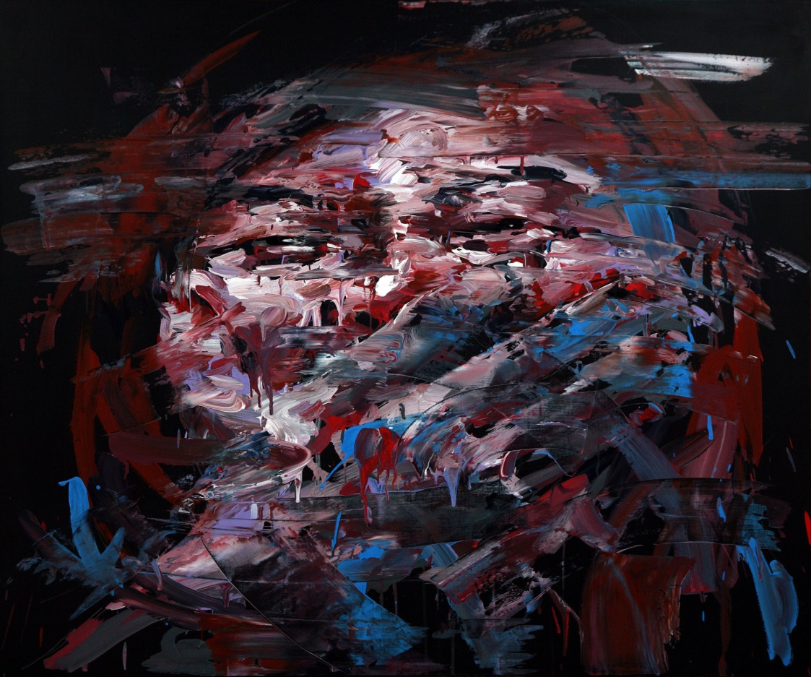

Shin Kwangoho
Untitled http://www.behance.net/wip/72079/148163

Hello all, as promised I’m writing with an update of how things are progressing with the project and also to put some meat on the bone of the concept of betweenness and its relationship to art. I apologise for the delay but as you’ll see I’ve been productive. Firstly, some nuts and bolts. I’ve provisionally booked a room 101 in the politics and international relations department on the 13th November at 2pm. I’m hoping that Yuiko Asaba, PhD music will play the Tango or whatever music she feels as appropriate. Her research is pertinent, as well as being a beautiful piece of research, as she is a Japanese national who came to the UK to learn the violin. She then went to Buenos Aires and fell in love with the tango. Her research is looking at the Tango as expressing socio-political and economic themes. I’ve been brought to tears in many seminars but at her initial presentation they were tears of joy at such a wonderful seminar with its use of music and speech (and wine). I’m also hoping to have the meeting streamed to New York where Alissa Mello is thinking about incorporating betweenness into her work in the theatre. In terms of the November meeting I have been thinking about how to engage with colleagues outside of my own discipline. To be honest even engaging with colleagues in my own discipline about the concept of betweenness is difficult enough. So I had a think about how I could do this and came up with the bright idea of making a film (I should have learnt by now to be suspicious of bright ideas). A very painful experience but I managed to complete a short film (5 mins) on my position in terms of what problems betweenness attempts to address within my own discipline and broadly how art, defined in a broad sense, can be useful in developing social and political theory beyond its present conceptual constraints. Dan Rebellato, Professor of Contemporary Theatre RHUL, has agreed to act as an informal advisor for the project. I will be approaching Richard Alston-lead in the college’s ‘Society, Representation and Cultural Memory’ College Research Theme- to see about accessing funding streams. Lastly, I will also be applying to the Social Science faculty for funds for the November workshop. In what follows I’ve tried to be as brief as possible-difficult. It covers a lot of ground and if you have any questions please ask. If you wish to attend, be informed of further events, or wish to contribute by Skype please contact me at this email address.
Michael.murphy.2012@live.rhul.ac.uk

Beginnings

In fleshing out betweenness I feel it is best to start with how I arrived at the concept and then also to be clear what it is not. My research is into the field of cosmopolitanism. Cosmopolitanism is a mesmerising concept. Cosmopolitanism, it is claimed, offers the opportunity to draw on growing global interconnectivity to frame new forms of experience and sociability. These would move beyond the dominance of a euro-centric world view. However, many complain that the cosmopolitan ethic relies on the dominant Euro-American understanding of progress, self and completeness. This is then used to justify the imposition of these on those understood not to have met these standards. This criticism continues that the cosmopolitan sets aside the consequences of colonialism and what has been described as the underside of ‘modernity’ in which the Other was a constructed in the European imagination. However, what emerges is that both sides, I’m being brief here, despite claiming to have moved beyond Eurocentric ideas, at a fundamental level, are tied to or respond through the Western intellectual tradition. In particular, the idea of a distinct and autonomous self, and its relationship to reason and freedom. The effect of this is that both totalise society through an illusion of singularity either through individualistic accounts or on ones that draw on ideas of collectivism, in which difference is understood only in absolute terms. Both positions seek ideational perfectibility in an imperfect being.
And like any kind of ontological assumption it precedes empirical study and structure that study in profound ways. These are inescapably mediated by the conceptual and linguistic apparatus that we bring to bear when producing knowledge of the world. Our assumptions of the world are intimately related to how we think, come to know and test our knowledge, and then communicate this knowledge. The concepts that we use to explain and describe the world are part of a cosmology that is profoundly embedded and enacted in political and social projects, in remembering and forgetting, and in even how we experience bodies and thought itself. In relying on a principle as axiomatic value this prepares the ground for excluding other available decision making procedures, means of reasoning, forms of knowing and knowledge, and conceptions of what it is to be human and live with others. It also fails to address the nature and dynamic of power within society as well as failing to acknowledge the inevitability and non-teleological of nature of social change. It provides little opportunity to re-examine our way of thinking about ourselves, our societies and the institutions that act at the national and inter-national level. I describe this as diegetic knowledge-we are accustomed to it, it forms part of the reality that we know and come to value our lives through and the world that we have created. But at the same time non-diegetic knowledge, from the outside, unsettles us: it points towards contradictions in the form and content of experience. The non-diegetic confronts us and subverts the language of command; we cannot control it. This should not be understood as a static, homogenous process, in which right or wrong, good or bad are clearly defined. It is at the stage when the contradictions or anomalies become too startling, when incompleteness becomes apparent, that theory begins in the transformation from a normal science to the revolutionary.
In this sense social and political thought does represent a form of considered fiction. As with all genres of fiction it asks from its audience the suspension of disbelief. The discourse of the political and the social is formed within a cultural context and its prominence and legitimacy is dependent of how broadly this is shared. And that makes sense. It is through these narratives that cultural, social and political legitimacy is founded. These are intra and inter-constitutive and establish the opportunities, tensions, desires and creativity of life through and across the boundaries of a community. In recent years there have been new and interesting contributions, at least within the ‘Western’ academic community which they understand as new, concerning the nature of the self and its relationship to other. These have, in general terms, attempted to move away from treating thought as a historical artefact, to become less focused on the linguistic and semantic analyse of its metaphorical effects and to become engaged in the everyday reality and consequences of the diversity of humanity. It calls for an approach to thought, and as such cosmopolitanism, that recognises the individual as embedded, embodied and acting through social relationships. It is an understanding that blurs the assumption of a distinct and autonomous self and other but which maintains the experienced reality of individuality and relationality. It asks the question; “Who are we?” This does, in my opinion, offer an innovative and provocative way forward from Western thought’s preoccupation with a distinct and autonomous self; its detached relationship to itself, to other and the world. This research trend indicates the possibility of grounding politics not simply on shared experiences, common goals and a commonality of interests but also one informed by the multitude of ways that human beings have expressed their understanding of their contingent, diverse and imperfect lives; their understanding of being human through which to ground cosmopolitanism. However, these calls for a re-evaluation of the cosmopolitan agenda through the prism of a non- distinct and autonomous self and other remain firmly within the auspices of the European and American mind.
However, there is another cosmopolitan opportunity from which to draw on in terms of analytical, normative and ultimately experiential possibilities that does not represent a journey through one ideal or another, of radical Self-dislocation and Other-relocation. What it does require is the acceptance of the the ‘rude’ and ‘savage’ tongue of the barbarian alongside the critical, a critical that is itself based on tradition, through which to re-consider what we have come to understand as truths of the human condition. If an orientation towards world openness is central to the cosmopolitan imagination and represents an opportunity for our cognitive map to be examined then surely other cognitive approaches would provide an opportunity to critically re-examine thought and “Who we think we are?” In this respect Hinduism, Buddhism, and Confucianism all represent conceptual paradigms that can be described as constituting a radical critique of thinking and its relationship to how we make sense of ourselves, others and the world.

The Art of Betweenness-or seeing it whole

In terms of my own work this leads to a fundamental critique of reason, forms of reasoning and their use in the public space, public reasoning and the construction of institutions through which these are legitimatised and power exercised at inter and intra-national levels. So where does art come in?
The scene was set for the antithesis between art and science in Plato’s Republic. The artist is banished from the city, the politic, for having been neither a Lycurgus nor a Solon. It is thus commencing with Plato that good government comes to be seen as fundamentally separate from and a better world than that of art. And amongst the myths that we experience as real in the world ourselves is this universalizing progress of a “culture of logic and rationality the West inherited from ancient Greece.” The longing of all demythologizing of Enlightenment thinkers for making the world calculable, unified and controlled comes through formal logic, abstraction, and sign. This has swept through a European mind and now the rest of humanity and is rooted in a universalising interpretation of history, time, space, power and subsequently of ‘progress.’ It is both created and creating.
Truth beyond the number, beyond the distance between subject and object, becomes an illusion. These arithmetical and geometrical propositions become the axioms in which the individual is reduced to a hermetically sealed construction of self-interest, suspicion and fear. It would be reasonable to argue, as I do, that ‘Western’ social and political thought is hierarchical and reproaches the self-definitions of all cultures except the modern West. Even recent attempts to embrace the Other are a romantic ideal in which the ‘West’ stands paternally over a submissive concubine. It may appear that these research themes, in terms of global thought, offer a wealth of resources for representation and cultural dialog. However, by maintaining a social ontology of existence that is reduced to abstractions, that maintain the legacy of the theoretical as well as the geo-political-epistemic separation of what is understood as art, philosophy and religion, between the image and the sign, the poetic and the treatise, social and political thought fails to account for, or even acknowledge the experience of interdependence of individuals-to see it as a whole. Here the ‘West’s’ thought provides permission to be free, as if cultures other than the ‘West’ have not considered questions such as what it is to be human and how I should live with my neighbor. They hem in the debate. It views these world views as NIH-not invented here and therefore of little value.
This simplification of global epistemic communities and by implication its normative conclusions have been central to the Western intellectual tradition, its sense of superiority and global burden as well as providing rich research material for many academics. However knowledge is only ever knowledge so far.In the discipline of anthropology researchers are beginning to address the analytical simplification of individualism and collectivism. The tension between the concepts of the individual self and the dividual self, considered as cultural ideologies, was considered as incommensurable and incompatible. However, new research is showing that in all cultural setting relationality and individuality operate. In neuroscience recent research is providing empirical evidence for a fundamental connectedness of people through their shared social networks that accounts to a surprisingly large extent for their behaviour in various domains of life. What is emerging is an understanding of self that is intimately ‘entangled’ with, though dynamically modulated by culture, its world and which seems to explain many aspects of social cognition. If a science of the social and the political is meant to achieve illumination of the human condition then practicing social and political thought as if it were a historical artefact seems parochial. The irony, and it is an irony noted by Toscano (2012: p.65) but more pertinently by de-colonial thinkers like Walter Mignolo, is that most of the social scientific investigations that are carried out within universities are largely irrelevant in terms of everyday experience- or seeing it as a whole. In terms of the relevance of social enquiry Toscano surely is quite right to note that it would appear to be ‘problematic’ that television shows like ‘The wire’ and ‘Debtocracy’ provide more accessible routes to the critical encounter of self, other and the world than is provided through universities. However, Art, the poetic, the mystical, the religious, it is claimed, are incapable of truth and wanders like an itinerant. Art is art: Science is science.
And yet your consciousness is confronted by ghosts and shadows. The artist’s role is the ritual as social dramas. Its method is to draw on the individual or group, in memorial or in which suppressed thoughts, denied behaviors, and withheld emotions which could be purifyingly shared with others. The meaning and narratives of the past that we live out are of critical importance in establishing who we are, our sense of ourselves and of our cultures. Memory and forgetting each provide the presupposition for the existence of the other. However, in “Deep remembering” we disclose the involvedness of events and an involvedness of identity. Memory is never only individual. Memory is never only social. Memory is experienced as private and as social at the same time. The ritual space of remembering and forgetting are logicoepistemological spaces/practices; affective, socio-political-economic and somatic. Not as a slide that dissolves boundaries from the “I” to the “we” to “other.” These are not categories ‘in-between’. Rather these spaces presupposes a cultural and social habitat which become internalized in the form of behavioral dispositions to think, to reason, to perceive, and even to feel in a certain way. Consciousness and memory are not abstract forces; they are experienced in specific contexts, instances, and narratives and about what the story is to be told. Victims may be reduced to silence or unable to speak but they are always present. The appeal to memory as opposed to its dynamic content carries specific ideological emphasis and assumptions about history and subjectivity. In maintaining an absolute ontology and epistemology that proceeds practice when producing knowledge Art becomes an indigenous instance that pledges itself as ideological repetition, an acquiescent imitation without the ability to see it whole. But Art is the fact of an event. Arts truth is the instance of non-absolute truth: Betweenness.This shared human ethical 4 dimensional space (including time) goes beyond modern concepts of individuality and collectivism in response to the question “Who are we?”
For Watsuji Tetsurō we are more than what we think we are. Watsuji in his Rinrigaku, or “study of ethics,” refers to the boundary between two people as “betweeness” (aidagara 間柄): “Betweeness consists in the fact that self and other are divided from each other … and at the same time that what is thus divided becomes unified” (Watsuji, 1996, p. 35). For Watsuji the “nonduality of self and other” is the fundamental component of betweenness.It is an ethics that positions a non-dualistic self (interdependence of mind-body) that is not only individual or only social but mutuality interactive within both spheres of activity. Therefore, any ethical inquiry can succeed only by subjectively grasping the historical realities of human existence through an understanding of its expressions. Like Heidegger, Watsuji sees a close relationship between space and time. However, unlike Heidegger, Watsuji is not willing to acknowledge that because the historical nature of human existence is discovered in space that space is ultimately a temporal phenomenon. Rather, space should be fully recognized as a fundamental structure of human existence. According to Watsuji space has two aspects in terms of the human condition; it is concerned with creativity and meaning creation. This individual is not the atomised individual conceptualised according to Cartesian principles. This individual is neither similar to the liberal version of the rational, self-interested individual, nor the communitarian individual who is committed to community bonds (e.g., Etzioni, 1998; Oldfield, 1998). The commitment to the web of relationships aims to create and recreate social systems that support such interactions which are able to respond to individuality and relationality.
Being human does not mean merely an individual or merely social but both together in a mutually negating and incessantly on-going negation of one by the other (Ningen). This also constitutes their interconnected union. Ningen (being human as a public and private entity) denotes the unity of the contradictories. Without this dialectical structure in mind, we cannot understand the essence of Ningen (being human) (Tetsurō, 1937 [1996]). Unlike the Hegelian syntheses were thesis and antithesis is blended and preserved, synthesis for Watsuji following Nishida’s meaning of ‘to preserve’ is radically different. Here preservation is preservation without blending. What is preserved is exactly the thesis as it is and the antithesis as it is without any transformation. What is added with the identity of self-contradiction is the idea that all individual entities are unique and separated and yet are mutually unconstrained and interfused, and that the two concepts are needed to give a fuller account of experiential reality and public space as experienced. In the constant flux of existence, the perspective from which a group of people may be seen as a totality is never fixed. This stands in contrast to Levinas’s idea of totalization which always seeks to impose a static definition upon the other or assimilate the other into an unchanging, non-negotiable relationship that would be visible, as it were, from the outside. For Watsuji totality is illusionary and fleeting, passing and creating from event to event with new tensions and opportunities arising. Completeness is never achieved. What is stressed is that apparent contradictions may be at best be penultimate statements and that more profound insights may be found when we position these contradictions within an underlying system
At this level of philosophical anthropology and ‘social ontology of existence’ develops the import of Watsuji’s commitment to aesthetics (Shields, 2011). Betweenness is above all, says Watsuji, characterized by a “reciprocal relationship” of giving and taking. For Watsuji our first connection with this space, the body, is more than “mere physiological object” (Watsuji 1996, 61). The human body is subjective yet at the same time is always saturated with expressive meaning. The dynamics of carnal expression within social contexts serve as the lived space of betweenness. In experiencing a commonality of contingent space and meaning we are relating to something internal to ourselves of which we are only a part but enact meaning between one’s own and others inner states and not overt behaviour in such a way that I have immediate perceptual and emotional access to them. Furthermore, this body cannot be thought of as separate from mind; the body becomes an ethical and epistemological site; a social body. This “subjective extendedness” of the social self, this repositioning of consciousness, allow us to remap the corporeal connections among people and to explore how different prejudices of subjectivity are inter-reliant and recursive. In challenging traditional boundaries among bodies and among minds as well as between bodies and minds also permits us to rethink the interdependent nature of “subjectivity” and “objectivity.”
This space of betweenness differs from that of ‘between,’ ‘the stranger’, the ‘in-between’ and ‘hybridity’ in the work of Simmel, Anzaldúa, Rumford, or liminality (Turner).It is not a category between categories, or a geometrical, or third space. It refers directly to the structure of the self. Aidagara is both a boundary that differentiates oneself from another and, at the same time, a connection that binds them together it is the network which provides humanity with a social meaning. The production of social life is not reducible to self or society but is recursive, creative, and created. It takes us past the linguistic formulation to the pre-objective immediacy, the role of embodiment in human semiotics, and the priority of action that leads to inter-subjectivity and intra-subjectivity. It takes us past the semantic and metaphorical grounds of an autonomous and distinct self that have previously been used to privilege the Western experience, historically, methodological, analytically, and opens the way to theoretically engage with other models of being by taking account of betweenness.
While the individuals still maintain a certain amount of independence in their actions, they are basically determined by the group, and the group in turn is determined (tensions and opportunities) by these actions, or in other words by the individuals betweenness. In order for this to work, Watsuji argued, betweenness required language (cultural signs) as the most basic element. And as the sign is not reducible to the verbal this can be extended to Art. This is of significance precisely because of the particular way in which the artist expresses the interdependence of individuals in creation and artistic experience: as being created and creating. Jarillo de la Torre (2013) notes Alfred Gell’s remark that “[t]he essential alchemy of art … is to make what is not out of what is, and to make what is out of what is not”. Although we tend to comprehend reality as a factual given, reality is not always realistic. For Watsuji understanding gains more breadth when we realise that fact is determined by betweenness but also how this contains the potentiality for shaping it, having the potential to transcend the limitations of the pre-given. In stressing the potentiality of the ‘betweenness’ of individuality and relationality, provides a framework for Art to explore other conceptual frameworks of being and therefore as a means of framing new forms of experience and sociability. Like in the painting by Shin Kwangoho at the top of this paper it draws our attention to social tension, the effect on the individual but also to our own culpability. The painting also highlights the relationship between the individual artist and a wider consciousness. Our concept of betweeness, situated as it is through our 'new' understanding of the relationship between self and other creates space for three things:
- Knowledge of ourselves; what are the limits that this betweenness places on my existence
- Create space within shared difference
- Create space within self and within other
Art is never just art: Science is never just science. Rather than construct a methodical position that is inherently normative and that is operated from a position of privilege, either as self or other as totalities, betweenness situates me in the world: as possessing individuality and being embedded in social consciousness. Rather than isolating questions of culture from those of politics and economics, and to mask inequalities, and relations of power and dominance, betweenness, highlights these concerns. Therefore, the purpose of the Art of Betweenness is to illuminate sociocultural processes in ways that cut across the facts of reality and in the ways in which we see things and understand them. The Art of Betweenness opens up theoretical and methodological mediations which prompt a different kind making of knowledge completely-seeing it whole. But as being created and being creating this must take it past its origins. This will require the development of a new theoretical language. This language must be able to overcome the epistemic artefact and come to account for how societies have expressed individuality and relationality and their relationship (tension and opportunities) and how it may illuminate our own condition. But this only becomes problematic if we consider the legacy of Western social and political thought, and the reality that it creates and so is creating, as historical artefacts and not as acts of betweenness. It would mean situating these and then enlarging the vocabulary, diction and grammar in order to reflect the richness of human articulation of being-in-the-world. If explanatory or descriptive words are at stake human languages have sufficient means to provide from, after all in this time of a cosmopolitan turn, the multitude of articulations the resources through which to interrogate thought and lived practice. In ‘seeing it whole’ the panoramic and embodied 4 dimensional space of betweenness repositions Art and Science.

References
Chaudary, Nandita PERSISTENT PATTERNS IN CULTURAL NEGOTIATIONS OF THE SELF: USING DIALOGICAL SELF THEORY TO UNDERSTAND SELF-OTHER DYNAMICS WITHIN CULTURE, International Journal for Dialogical Science, Fall, 2008. Vol. 3, No. 1, 9-30.
Immordino-Yang. Mary Helen, The Smoke Around Mirror Neurons: Goals as Sociocultural and Emotional Organizers of Perception and Action in Learning, International Mind, Brain, and Education Society and Wiley Periodicals, Inc, 2008.
Jarillo de la Torre, Sergio, (2013). Art and Anthropology beyond Beautiful Representations: The Material Hyperreality of Artistic Ethnography. http://www.soclabo.org/index.php/laboratorium/article/view/87/846
Kalmanson Leah. "Levinas in Japan: The Ethics of Alterity and the Philosophy of No-Self."Continental Philosophy Review Vol. 43, No. 2 (2010).
Rasmussen, Susan PERSONHOOD, SELF, DIFFERENCE, AND DIALOGUE (COMMENTARY ON CHAUDHARY) International Journal for Dialogical Science, Fall, 2008. Vol. 3, No. 1, 31-54.
Seth, Sanjay., (2004). Reason or Reasoning? Clio or Siva, Social Text 78, Vol. 22 22, No. 1, Spring.
Shields . James. M. The Art of Aidagara: Ethics, Aesthetics, and the Quest for an Ontology of Social Existence in Watsuji Tetsurō's Rinrigaku. Asian Philosophy 19 (3):265-283 (2011)
Stramignoni, Igor. Seizing Truths: Art, Politics, Law. http://www.lse.ac.uk/collections/law/wps/WPS2010-14_Stramignoni.pdf
Tetsuro ,Watsuji. (Trans. Robert Carter) Watsuji Tetsuro's Rinrigaku: Ethics in Japan (Suny Series in Modern Japanese Philosophy) University of New York Press (1937 [1996]).
Toscano, A. (2012), Seeing it whole: staging totality in social theory and art. The Sociological Review, 60: 64–83.
Yuasa, Yasuo. (1987), The Body: Toward an Eastern Mind-Body Theory, T. P. Kasulis, (Ed.), Nagatomo Shigenori and T. P. Kasulis, (Trans.), Albany: State University Press of New York.

I use the term diegetic, a term used to describe sound in the theatre as it conveys the relationship between experience and mind-body, as opposed to distinct and separate entities.
This follows the Japanese convention of the family name first. What follows can only be such a brief description of Watsuji’s work.

