[Royal Holloway, University of London logo](http://www.rhul.ac.uk/) [ESRC - Economic & Social Research Council](http://www.esrcsocietytoday.ac.uk/ESRCInfoCentre/index_academic.aspx) [](http://en.wikipedia.org/wiki/File:Uok_Logo_PMS294_PC.png)

**Values Break the Link between British National Identification and Islamophobia: A series of social psychological studies**

Funded by the **ESRC** (Economic and Social Research Council), RES-000-22-2704

Investigators: Dr. Anat **Bardi**, Royal Holloway University of London

Dr. Tendayi **Viki**, University of Kent

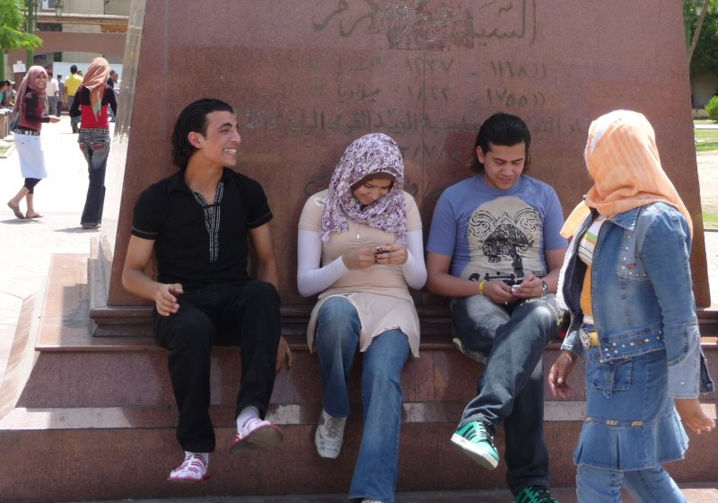

**Background**

Islamophobia refers to the intolerance of Muslims, and the tendency to view them as a threatening homogenous minority. The 9/11 terrorist attacks and the 7/7 bombings in the London Underground have resulted with prejudice against the Muslim community and the wish to exclude them from society.

Previous research suggests that stronger national identification may motivate the wish to exclude Muslims from Society.

**Our Research**

Our rationale:

* Muslims in Britain differ from non-Muslim Brits in their beliefs.
* The value Tolerance is defined as ‘tolerance of different ideas and beliefs’
* So **we expected** that:
  1. For people who value tolerance of different beliefs, identifying with their country would not translate to being prejudiced against those with different beliefs, and in this case, Muslims. Hence they would not wish to exclude them from society even if they identify with being British.
  2. Similarly, if we can make people think about tolerance values and think about how it relates to concrete situations we would see the same effect as if they actually hold tolerance values, i.e., the level in which they identify with being British will not be linked to being prejudiced against Muslims and wanting to exclude them from society

In **Study 1** we examined our first expectation. We gave students questionnaires of British national identification, a value questionnaire, and a questionnaire asking about the wish to exclude Muslims from society.

In all studies, only data from non-Muslims were included in the statistical analyses.

We found:

1. In general, the more students identify with being British the more they wish to exclude Muslims from society, but:
2. Not if they value tolerance. Those who value tolerance do not wish to exclude Muslims from society whether they identify with their country (Britain) or not.

In Studies 2 and 3 we wanted to see if we could break this link between national identification and the wish to exclude Muslims from society in an experiment. Study 2 was with students and Study 3 was with the general population.

In our experiments, the participants completed questionnaires of British national identification and Muslim exclusion after they completed a task that made them think about one of the following 3 values:

1. **Tolerance** – expected to reduce the link between national identification and Muslim exclusion
2. **Security** – expected to increase the link between national identification and Muslim exclusion (because Muslims are often viewed as a threat)
3. **Stimulation** – (our control group) expected to show the usual links between national identification and Muslim exclusion (because this value is not relevant to the issue)

We found:

* Exactly what we expected in Study 3 (general population):
  + The strongest link between British national identification and Muslim exclusion was for those people who were asked to think about **security** values.
  + A weaker, but still positive, link between national identification and Muslim exclusion for those who were asked to think about **stimulation** values.
  + No link between national identification and the wish to exclude Muslims in those who were asked to think about **tolerance** values
* In Study 2 (students) we found the same pattern for tolerance and stimulation values, but security values showed the same effect as tolerance values, possibly because students rejected these values.

Overall Conclusion:

**Valuing tolerance is linked with low prejudice against Muslims.**

**Valuing tolerance or thinking about tolerance values and linking it to situations can break the link between national identification and Islamophobia. C:\Documents and Settings\utjt010.CC\Local Settings\Temporary Internet Files\Content.IE5\7Z3O4WSB\MC900056602[1].wmf**

For further details, please don’t hesitate to contact us:

Dr. Anat Bardi:

Email: [Anat.Bardi@RHUL.AC.UK](mailto:Anat.Bardi@RHUL.AC.UK),

Telephone: +44-(0)1784-443524

Web page: <http://pure.rhul.ac.uk/portal/en/persons/anat-bardi(4fc58259-a4f2-4dab-a0a8-2961dbce44bd).html)>

Dr. Tendayi Viki:

Email: [G.T.Viki@kent.ac.uk](mailto:G.T.Viki@kent.ac.uk)

Telephone: +44-(0)1227-824110

Web page: http://www.kent.ac.uk/psychology/people/vikit/